Course Audit Recommendations

Client: McMaster
Course: Les soins essentiels
Reviewer: Amanda Darling

11/24/2017

Evaluation Matrix
Scoring
0 = Missing/Broken, 1 = Poor, 2 = Needs Improvement, 3 = Good, 4 = Excellent

Criteria | Score | Notes
Navigation/Welcome Section  Navbars, homepage, and instructions facilitate user-friendly navigation. | 4 | Nice work!
Visual Appearance  Modern, professional, high-quality, and consistent appearance is used throughout course. | 3 | See comment in “Recommendations”
Content Organization  Content is organized, relevant, and of appropriate length given the course’s learning outcomes and constraints. | 3 | Some pages feel a little long due to dense text, but the course is organized in the most logical way and current page breaks feel natural, so I wouldn’t suggest any specific changes. Content is clear and pertinent. Modules should be numbered in the Table of Contents.
Media and Resources  Content uses a variety of media, presentation devices, resources, and job-aids to support and engage learners. | 3 | See comment in “Recommendations”
Engagement Strategy  Course includes frequent and varied activities that promote engagement and interaction. | 4 | Through surveys, discussions and questions like the « Déterminez vos forces et réfléchissez » section, learners are highly engaged. I particularly like how the discussion board can be used for caregivers to connect with others in a similar situation.
Engagement Quality  Assessment instructions and questions are clear. Assessments are varied, designed effectively, and provide insightful feedback. | 4 | Great!
Responsive Design  Course content and assets are responsively designed for use on devices of various sizes. | 4 | No problems here.
Accessibility  Course content meets accessibility standards (WCAG 2.0 AA) and ensures screen readability. | 4 | No problems here. I used my screenreader in sections, and it successfully read the text and informed me of links. (NOTE: tables with more than two columns often pose a particular problem for screenreaders – I didn’t find any glaring problems in this course, but it’s something to keep in mind for other courses you develop if accessibility is a priority.)
Brightspace Tool Use  Course effectively uses Brightspace LE tools (Discussions, Quizzes, Assignments, etc.) | 4 | Good job!

Recommendations
This is one of the best courses I’ve evaluated. It’s excellent! In addition to the points listed in the evaluation matrix, I look for a good mix of content with facts/figures and story-based info (which you have in the form of your case studies – nice job!) and diversity representation (which you have in your images – again, good work!). I also particularly liked how you invited feedback from your learners on the content in your end-of-module surveys. With your attitude of wanting to deliver the best experience for your learners, I already feel I’m in good hands as one of your learners.
Module Numbers
In module 4, there’s the sentence « Plus de détails à ce sujet seront abordés dans module 5. » and in module 5, « Au module 6, vous avez accès à quelques ressources qui pourront vous aider à faire la traduction au besoin. » While you do have numbers within each module on their introduction page, listing them before the module title on the Table de matières page will make for easier navigation, particularly when you have more than three modules.
1 : Vous et le rôle de proche aidant
2 : Votre trousse de proche aidant ...
3 : Naviguer les systèmes de santé …
4 : L’importance de prendre soin de vous
5 : Offre active…
6 : Ressources

Document to Print
Plan de soutien du proche aidant – this is a long document to print.
While it looks nice in colour, it will print in grey, which may make some coloured boxes hard to read. I’d recommend offering the PDF in black and white and dividing this document: on-hand manual (optional to print) and then separate forms to print, and the user only has to download and print those forms that are applicable to their personal/medical caregiving situation.

Module Banner Images
The images for modules 1, 3 and 6 were cropped correctly between the initial image and their use as part of the banner. Modules 2, 4 and 5 had banner images that were not correctly cropped because the heads were cut off. Perhaps whomever was responsible for 1, 3 and 6 could lend a hand to make these elements look as professional as the rest of the course (which is great).
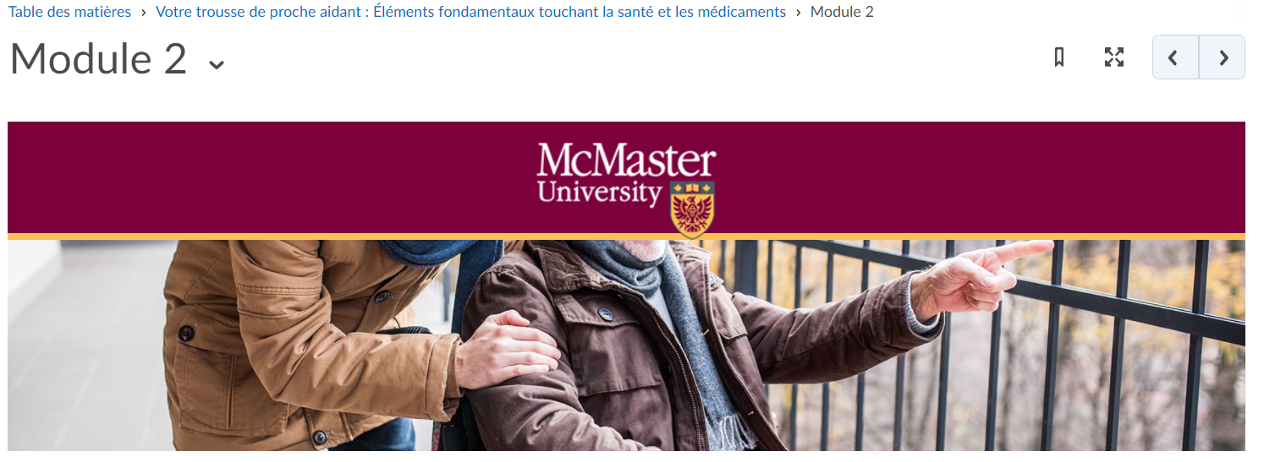

Miscellaneous
The quotation from Barbara on the Résumé page of module 4 lacks a last name. Is this an error? If no last name is available, I assume this quotation is a personal reflection from a caregiver. If that’s the case, you could add “proche aidant” after her name to give them impression that she’s in the same situation as your learners, which will help them feel further engaged in the content.
The sentence about covid 19 in the section « Court séjour dans un foyer de soins de longue durée » made me pause as a potential future caregiver. Since your sentence isn’t actually related to illness at all, I might not want to link “care home” and “covid” in my learners’ minds. I would be afraid of putting my loved one in a care home for fear of them catching illnesses like covid, and the point of this section is to encourage caregivers to take a break from caregiving for their own mental/physical health. I think you can cut this sentence completely.
Finally, if you haven’t already -- join the Instructional Design Best Practices Community Group to share ideas and learn tips from D2L instructional designers and other Brightspace users.
Overall – thank you on behalf of all caregivers for creating this course (like your quotation about the four types of people, I will be becoming a caregiver as my parents age). This is a wonderful resource for French-speaking caregivers.

About D2L
D2L is the software leader that makes learning experiences better. The company’s cloud-based platform is easy to use, flexible, and smart. With Brightspace, organizations can personalize the experience for every learner to deliver real results. The company is a world leader in learning analytics: its platform predicts learner performance so that organizations can take action in real-time to keep learners on track. Brightspace is used by learners in higher education, K-12, and the enterprise sector, including the Fortune 1000. D2L has operations in the United States, Canada, Europe, Australia, Brazil, and Singapore.

Contact Us
Phone: 1-519-772-0325 (Worldwide)
Toll Free: 1-888-772-0325 (North America)
+44-203-695-8580 (United Kingdom and Europe)
0-800-452-069 (New Zealand)
1-800-778-631 (Australia)
0-800-891-4507 (Brazil)
Fax: 1-519-772-0324
Email: ContactUs@D2L.com
Facebook: facebook.com/D2LInc
Twitter: @D2L
Web: www.D2L.com
© 2017 D2L Corporation.

The D2L family of companies includes D2L Corporation, D2L Ltd, D2L Australia Pty Ltd, D2L Europe Ltd, D2L Asia Pte Ltd, and D2L Brasil Soluções de Tecnologia para Educação Ltda.

All D2L marks are trademarks of D2L Corporation. Please visit D2L.com/trademarks for a list of D2L marks.

Second Review by D2L
January 25 2022
From: Amanda Darling <Amanda.Darling@D2L.com>
Hello all,
I hope you’re doing well and staying warm! I had the chance to review Les Soins Essentiels again, and again my thought was “what a well-designed course with such useful, engaging content”. Even though I knew what was coming, I was still impressed. 😊
I have no additional feedback. The PDF to print is still a long document that may be difficult to read if printed on a black and white printer, but I understand why you may not have the desire or time to apply the suggestions I offered at the moment.
If you continue developing courses with the same care and attention as Les Soins Essentiels, your learners will be a very lucky group indeed!
Take care,
Amanda

