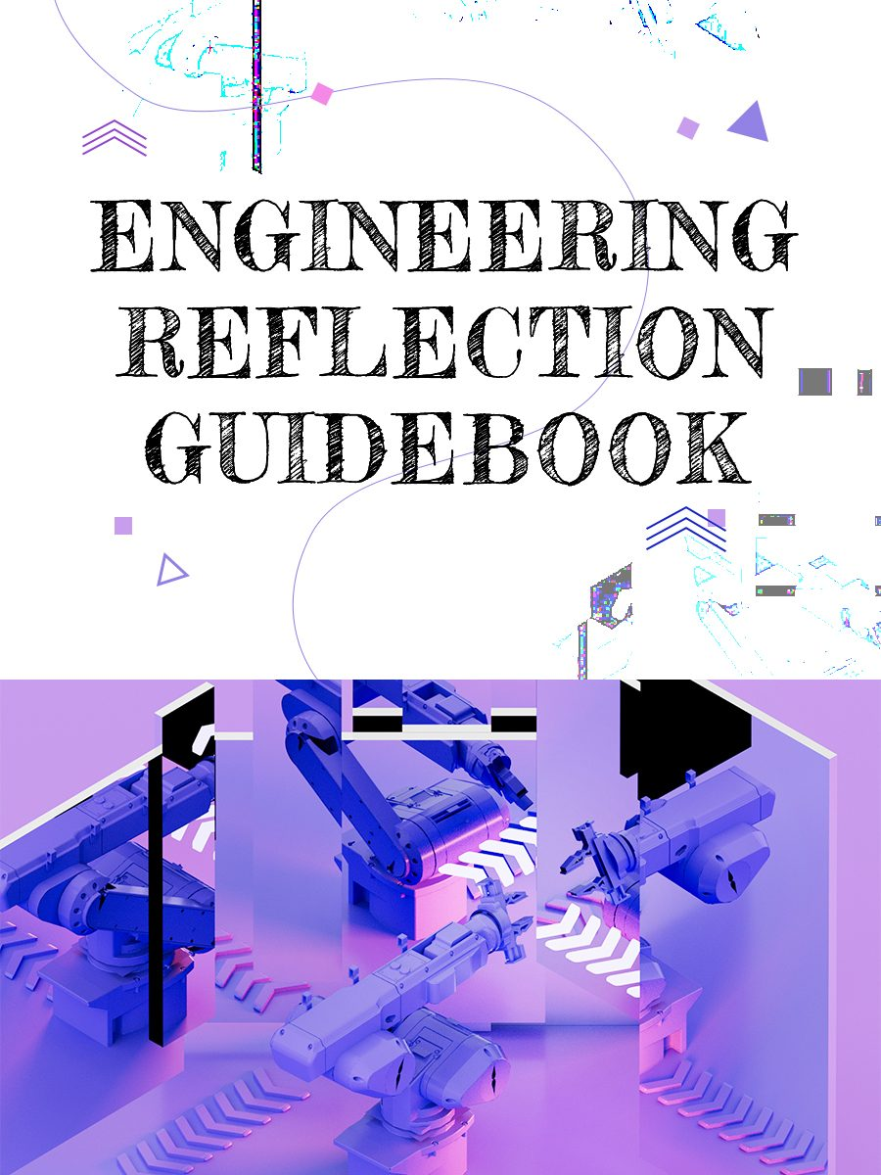

Engineering Reflection Guidebook

Engineering Reflection Guidebook

Kyle Ansilio; Shelir Ebrahimi; and Alanna Carter

Engineering Reflection Guidebook by eCampus Ontario is licensed under a Creative Commons Attribution-NonCommercial-ShareAlike 4.0 International License, except where otherwise noted.

Contents
- Introduction
- Main Body
- Student Guide to Reflection
- Assessing Written Reflection
- Student Reflection Example
- Instructor Reflection Toolkit

1

Introduction
In a rapidly changing world, universities are preparing students by developing learner-centered experiential learning programs. Experiential learning (EL) courses are developed to build a foundation for undergraduate engineering students to become lifelong learners. The role of reflection is fundamental in all experiential education courses to generate learning by connecting theory to practice, deepen it by challenging learners’ thinking, and document it by producing tangible expressions of the new understandings they gain by integrating experience and disciplinary knowledge.
EL programs are successful in training students with well-defined technical and analytical skills. However, all too often, the assumption is that non-technical skills, such as reflection, are acquired automatically during a degree, which is not true. As with other areas of competence, students need to be actively taught these skills and given opportunities to develop and practice them until they can be used easily and competently.
In response to the training gap in the engineering experiential learning curriculum, a team at McMaster has created a series of online modules, in the format of this Pressbook, that focuses on the development of essential skills for success in experiential learning programs.
This “Engineering Reflection Guidebook” is intended to expand experiential learning course offerings through a series of interactive modules for students as well as instructional teams. The developed resource includes two interactive modules: one for training undergraduate students on writing a reflection based on the “What? So what? Now what?” model, and another to guide instructional teams with evaluating and providing feedback on a reflection essay. This book also provides an instructor toolkit to help teaching teams create their own reflection assignments based on the learning outcomes of their courses.
This project is made possible with funding by the Government of Ontario and through eCampusOntario’s support of the Virtual Learning Strategy. To learn more about the Virtual Learning Strategy visit: https://vls.ecampusontario.ca
Resource Development Team at McMaster University:
Project Lead: Shelir Ebrahimi, PhD. P.Eng., Assistant Professor of Chemical Engineering Department | Educational Developer, Online Learning Specialist: Alanna Carter, MacPherson Institute | Educational Developer & Reflection Subject Matter expert: Kyle Ansilio, Faculty of Engineering
Content Creator: Raymond Tolentino | Content Developer & Content Creator: Eva Mueller | Media Designer & Content Creator: Jacob Krone

For any comments, questions, or concerns, please contact project lead, Shelir Ebrahimi via shelir.ebrahimi@mcmaster.ca
Note: Engineering Reflection Guidebook is licensed under CC BY-NC-SA license.

Student Guide to Reflection

Introduction
Reflection is a means of extracting more learning from our experiences, leading to deep understanding of knowledge, connections to other contexts, and an improved sense of self-efficacy.
This module provides students with essential knowledge of written reflection, including the topics of fundamental reflection and strategies in writing reflection.

Modes of Learning
In this module, students will use the following modes of learning:
- A video
- A short assessment
- A writing activity
This module will take approximately 60 minutes to complete.

Intended Learning Outcomes
By the end of this module, participants will be able to…
- Identify the fundamental components of written reflections
- Write a simple, written reflection using the ‘What? So what? Now what?’ framework

Key Terms & Concepts
An interactive H5P element has been excluded from this version of the text. You can view it online here:
https://ecampusontario.pressbooks.pub/engineeringreflectiontoolkit/?p=5#h5p-1

Topic 1: Basics of Reflection
It is important to understand the essential principles behind written reflection. The following video will walk you through the fundamental process of reflection, examples of what reflection looks like, and why we should reflect as lifelong learners.

One or more interactive elements has been excluded from this version of the text. You can view them online here: https://ecampusontario.pressbooks.pub/engineeringreflectiontoolkit/?p=5
Watch Basics of Reflection in full screen.

Quiz
Complete the short quiz below by matching the statements on the right with the corresponding section of the ‘What? So What? Now What?’ model on the left.

An interactive H5P element has been excluded from this version of the text. You can view it online here:
https://ecampusontario.pressbooks.pub/engineeringreflectiontoolkit/?p=5#h5p-2

Topic 2: Writing a Reflection
Now that you’ve gained a better understanding of what reflection is and why we do it, it’s your turn to practice. The following video will provide you will an example of a student’s written reflection to prepare you for writing your own.

One or more interactive elements has been excluded from this version of the text. You can view them online here: https://ecampusontario.pressbooks.pub/engineeringreflectiontoolkit/?p=5
Watch Writing a Reflection in full screen.
Reflection Example
Below is a text copy of the reflection example provided in the video:
In the fourth year of my undergraduate program, I participated in a laboratory activity in which we were to compare the theoretical levels of xenon in the McMaster Nuclear Reactor (MNR) with the actual data logs recorded by the reactor operators. This lab report was done individually. One aspect that made me nervous was that I was not comparing theoretical xenon level directly to recorded xenon level, but rather I had to calculate the measured xenon levels based on the activities recorded by the operators. I was nervous that I would not be able to interpret the operators’ notes correctly, which would then make it very hard to compare to a theoretical model.
Initially after converting the operator records, I found that the data was not fitting the theoretical levels whatsoever. I was really discouraged by this, so I referred to the course readings to see where I might have missed vital information. After looking back, I had realized that I missed two important, yet subtle, steps in converting the data. I had not accounted for the fact that the polarity of the two measurements were reversed, and so I needed to flip one of the graphs. I also missed an offset, meaning I had to shift one of the graphs down. After making these corrections, the data was a perfect fit! Seeing the two graphs line up was very fulfilling, and it was the result of applying knowledge that I had learned, while also identifying knowledge that I had misunderstood or missed entirely the first time.
This lab was important to nuclear engineering because xenon levels are what dictates whether a reactor can be powered on or not. By going through this lab, I am now aware how, as a reactor operator, I would be able to judge the status of reactor based on these readings. Having recognized the calculations that I did not do properly the first time, I feel much more confident about never forgetting those steps again.

Reflection Writing Activity
Think of an important educational experience that you’ve had and, on a separate piece of paper or in a Word document, write a reflection about it. Be sure to address each point of the ‘What? So what? Now what?’ model.
Use the questions below to guide your thinking and writing about each section of the model.
An interactive H5P element has been excluded from this version of the text. You can view it online here:
https://ecampusontario.pressbooks.pub/engineeringreflectiontoolkit/?p=5#h5p-3
Here is an example of a student working through the reflective process.

References
Ambrose, S. A. (2013). Undergraduate engineering curriculum: The ultimate design challenge. The Bridge, 43(2), 16-23
Ash, S. L., & Clayton, P. H. (2009). Generating, deepening, and documenting learning: The power of critical reflection in applied learning. Journal of Applied Learning in Higher Education, 1(1), 25-48.
Borton, T. (1970). Reach, touch, and teach (pp. 75-91). New York. McGraw-Hill.
CPREE. (n.d.) What is Reflection? Consortium to Promote Reflection in Engineering Education (CPREE). http://cpree.uw.edu/what-is-reflection/
Dewey, J. (1966). Democracy and education: An introduction to the philosophy of education. The Free Press.
Driscoll, J. (1994). Reflective practice for practice. Senior Nurse, 14(1), 47-50.
Rolfe, G., Freshwater, D., & Jasper, M. (2001). Critical Reflection for Nursing and the Helping Professions: A User’s Guide. Palgrave.
Ryan, M. (2013). The pedagogical balancing act: Teaching reflection in higher education. Teaching in Higher Education, 18(2), 144-155.
Turns, J. A., Sattler, B., Yasuhara, K., Borgford-Parnell, J. L., & Atman, C. J. (2014). Integrating reflection into engineering education. [Paper Presentation]. 121st ASEE Annual Conference & Exposition, Indianapolis. https://depts.washington.edu/cpreeuw/wordpress/wp-content/uploads/2015/07/Integrating-Reflection-ASEE-2014.pdf

Assessing Written Reflection

Introduction
As the process of reflection can vary dramatically from individual to individual, grading the written reflections of students can be difficult to standardize. This chapter focuses on attitudes and resources that may be used when evaluating students’ written reflections.

Modes of Learning
In this module, students will use the following modes of learning:
- A short video
- An exercise in evaluating written reflection
This module will take approximately 20 minutes to complete.

Intended Learning Outcomes
By the end of this module, participants will be able to…
- Evaluate the quality of a written reflection using a rubric

Key Terms & Concepts
- Reflection: A thoughtful and intentional analysis of an experience. Reflections examine the author’s knowledge and skills prior to an experience, how their understanding has changed as a result of that experience, and what their plan would be for similar experiences in the future.

Topic 1: Assessing Reflection
The following video will walk you through two rubrics that may be used to assess reflection, as well as an example of a written reflection that is evaluated using a rubric.
Here are links to the two rubrics outlined in the video.
- Brock University Critical Reflection Rubric
- University of Edinburgh Reflection Evaluation for Learners’ Enhanced Competencies Tool (REFLECT) Rubric (scroll to section called ‘Analytical rubric’)

One or more interactive elements has been excluded from this version of the text. You can view them online here: https://ecampusontario.pressbooks.pub/engineeringreflectiontoolkit/?p=38
Watch Assessing Reflection in full screen.
Reflection Example
Below is a text copy of the reflection example provided in the video:
Firstly, the most obvious thing that I discovered was the advantage of working as part of a group. I learned that good teamwork is the key to success in design activities when time and resources are limited. As everyone had their own point of view, many different ideas could be produced, and I found the energy of group participation made me feel more energetic about contributing something.
Secondly, I discovered that the choice of materials was not as important as the design when it comes to making standing structures. With the Impromptu Design activities, we used some simple materials such as straws, string, and balloons, but were still able to apply our understanding of stress and strain in order to build structures to specified constraints. I learned that every design has its weaknesses and strengths, and working with a group can help discover what they are. In future designs, I will ensure that every member of my team is heard, and that stress and strain analyses of our designs are done as early as possible.

References
Ambrose, S. A. (2013). Undergraduate engineering curriculum: The ultimate design challenge. The Bridge, 43(2), 16-23.
Ash, S. L., & Clayton, P. H. (2009). Generating, deepening, and documenting learning: The power of critical reflection in applied learning. Journal of Applied Learning in Higher Education, 1(1), 25-48.
Borton, T. (1970). Reach, touch, and teach (pp. 75-91). New York McGraw-Hill.
CPREE. (n.d.) What is Reflection? Consortium to Promote Reflection in Engineering Education (CPREE). http://cpree.uw.edu/what-is-reflection/
Dewey, J. (1966). Democracy and education: An introduction to the philosophy of education. The Free Press.
Driscoll, J. (1994). Reflective practice for practice. Senior Nurse, 14(1), 47-50.
Rolfe, G., Freshwater, D., & Jasper, M. (2001). Critical Reflection for Nursing and the Helping Professions: A User’s Guide. Palgrave.
Ryan, M. (2013). The pedagogical balancing act: Teaching reflection in higher education. Teaching in Higher Education, 18(2), 144-155.
Turns, J. A., Sattler, B., Yasuhara, K., Borgford-Parnell, J. L., & Atman, C. J. (2014). Integrating reflection into engineering education. [Paper Presentation]. 121st ASEE Annual Conference & Exposition, Indianapolis. https://depts.washington.edu/cpreeuw/wordpress/wp-content/uploads/2015/07/Integrating-Reflection-ASEE-2014.pdf

Additional Resources
For instructors or teaching assistants that would like to learn more about embedding reflection in curriculum, please visit the Instructor Reflection Toolkit.

Student Reflection Example
Below is a student example of how to work through the reflective process. McMaster engineering student, Ali Hamdy, reflects on his experience working at IBM by using the ‘What? So What? Now What?’ model.

One or more interactive elements has been excluded from this version of the text. You can view them online here: https://ecampusontario.pressbooks.pub/engineeringreflectiontoolkit/?p=48
Watch Student Reflection Example in full screen.
Below is Ali’s written reflection.
After the third year of my undergraduate program at McMaster University (Computer Engineering & Society – Min. Business), I was fortunate in receiving an opportunity to work as a S.W.A.T. developer at IBM Canada. However, due to the pandemic, this job was shifted to an online, work from home role, but it was initially meant to be done at the IBM Laboratory in the city of Markham. Prior to starting my role, I actively reached out to (at the time) current interns, asking for more information regarding the role, and, through what they communicated to me, I researched and learned more about the technologies and skills necessary to excel at IBM. At the start, I was nervous, and it was a nerve-racking experience as I was thrown into what seemed to be a whole new “professional” world. However, as I delved deeper and adjusted to my role, I became extremely thankful and excited about all the new learning opportunities and knowledge that was available to me.
I learned a lot about project management, role setting, and time management as the role was extremely fast paced and required us to deliver on a variety of projects in a very short amount of time. As a result, one of the major new skills I learned was how to learn and apply knowledge in 2-week intervals, but, because of the massive amounts of work we were taking on, I also ran into the issue of burnout. This again was an amazing opportunity for me to learn the skill of saying “no.” Funnily enough, when reflecting on this, it seems like such a trivial concept; however, I cannot emphasize how important it is. Looking at prior knowledge that I had brought with me, in many instances, I had the chance to utilize a lot of the programming knowledge that I had previously learnt throughout my undergraduate career and exhibit my professional communication and networking skills, which I had built prior through running my club MacChangers. In my opinion, this was an awesome opportunity, and I would say it went exceptionally well. Next time round, I think I’ll be a lot more cognizant of my personal health and workloads, and I’ll make sure to accept more opportunities which allow me to further develop and grow.
After going through this experience, I wish to become more knowledgeable and develop expertise in more specific technologies. However, in doing so, I also wish to stay up to date with the latest emerging technologies that are associated with the exponentially fast-growing tech field. Also, I have made it a mandate for myself to continue excelling in all my future endeavours and always give my tasks my utmost best effort. In the future, if given a similar situation, I will develop deeper personal connections with my colleagues and try to better my communication with them as I have learned that this is the best way to overcome any obstacles that come my way. Along with that, I will always try to find love in what I do as I have found that this is the best way to excel at your work.

Instructor Reflection Toolkit
“Sometimes, you have to look back in order to understand the things that lie ahead.”
– Yvonne Woon
This Reflection Toolkit was created by a team at McMaster University. It is available to instructors who want their students to engage in meaningful reflection experiences. Resources may be used as is or adapted for different teaching contexts.

