Accessibility Report for Psychoactive Substance Use and Social Policy
For Revision Submitted April 11, 2022
Using WAVE checker v.3.1.6 on Chrome extension, the checker identifies 1 contrast error from the header and a redundant link; on the WAVE website, https://wave.webaim.org/, the same web page address will show 2 color contrast errors.
Page |  | Title | Accessibility |  | Important Errors |  | Notes
 |  | Cover | 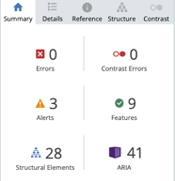
 |  | LAND ACKNOWLEDGEMENT | 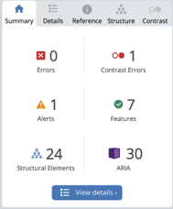 |  | Low contrast |  | 1 contrast error from header, redundant link in footer  in Malala Theme
 |  | Adopting or Adapting the book | 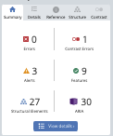 |  | Low contrast
 |  | Acknowledgments | 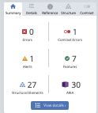 |  | Low contrast
 |  | Attributions | 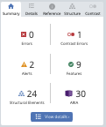 |  | Low contrast
 |  | Accessibility Statement | 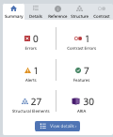 |  | Low contrast
 |  | COURSE & E-BOOK INTRODUCTION | 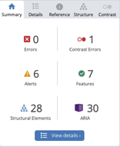 |  | Low contrast |  | Long alt-text for bolded red font
Chapter 1 Cover |  |  |  | 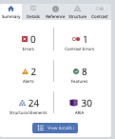 |  | Low contrast
1.0 |  | Introduction | 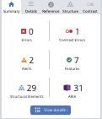 |  | Low contrast
1.1 |  | What are Psychoactive Drugs | 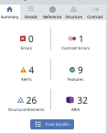 |  | Low contrast
1.2 |  | Psychoactive Drug Classifications & Effects | 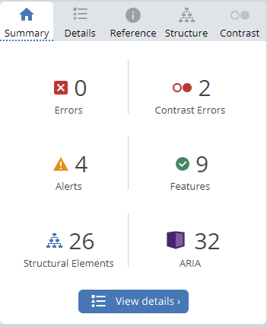 |  | Low contrast
1.3 |  | Legal Versus illegal Drugs | 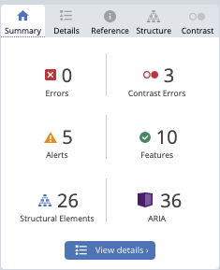 |  | Low contrast on 2 H5P images
1.4 |  | Uses of Psychoactive Drugs | 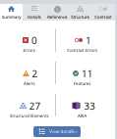 |  | Low contrast
1.5 |  | Learning About Psychoactive Drugs | 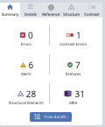 |  | Low contrast
1.6 |  | Chapter Summary | 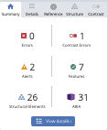 |  | Low contrast |  | Wave thinks theres issues with the Jacqueline Lewis bc its not a heading
1.7 |  | Required Course Materials | 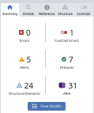 |  | Low contrast
1.8 |  | Chapter Assignment | 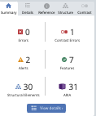 |  | Low contrast
1.9 |  | References & Media Attributions | 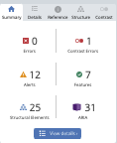 |  | Low contrast
Chapter 2 | Social Determinants of Health & Substance Use |  |  | 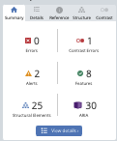 |  | Low contrast
2.0 |  | Introduction | 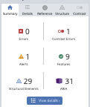 |  | Low contrast
2.1 |  | Understanding Social Determinants of Health | 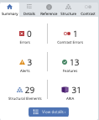 |  | Low contrast
2.2 |  | Upstream & Downsteam Interventions | 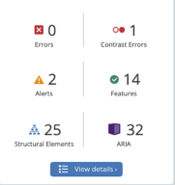 |  | Low contrast
2.3 |  | Social Determinants of Health & Substance Use | 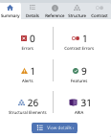 |  | Low contrast
2.4 |  | Disparities in Health | 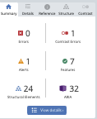 |  | Low contrast
2.5 |  | Primary & Secondary Prevention | 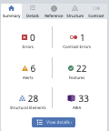 |  | Low contrast
2.6 |  | Canadian Examples | 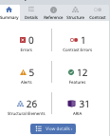 |  | Low contrast
2.7 |  | Next Steps for Canada | 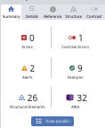 |  | Low contrast
2.8 |  | Chapter Summary | 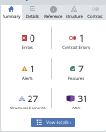 |  | Low contrast
2.9 |  | Required Course Materials | 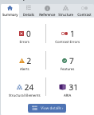 |  | Low contrast
2.10 |  | Chapter Assignment | 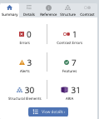 |  | Low contrast
2.11 |  | References & Media Attributions | 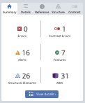 |  | Low contrast
Chapter 3 |  | Early Canadian Drug Policy | 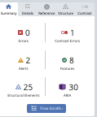 |  | Low contrast
3.0 |  | Introduction | 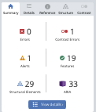 |  | Low contrast
3.1 |  | History of Canadian Drug Policy & Prohibition | 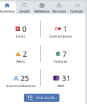 |  | Low contrast (watch video orange)
3.2 |  | The Temperance Movement & Alcohol Prohibition in Canada | 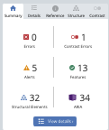 |  | Low contrast |  | 2 Headings out of order
3.3 |  | POPULATIONS TARGETED FOR SUBSTANCE USE | 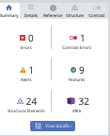 |  | Low contrast
3.4 |  | EARLY CANADIAN DRUG POLICIES | 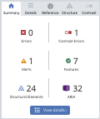 |  | Low contrast
3.5 |  | MORAL REFORMERS & EARLY CANADIAN DRUG PROHIBITION | 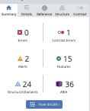 |  | Low contrast
3.6 |  | CHAPTER SUMMARY | 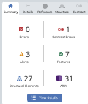 |  | Low contrast
3.7 |  | CHAPTER ASSIGNMENT | 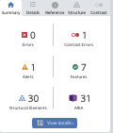 |  | Low contrast
3.8 |  | References & Media Attributions | 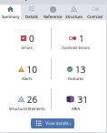 |  | Low contrast
Chapter 4 |  | Contemporary Canadian Drug Policies & Their Impact | 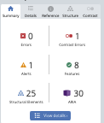 |  | Low contrast
4.0 |  | Introduction | 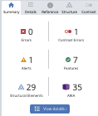 |  | Low contrast
4.1 |  | Canadian Drug Policy | 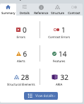 |  | Low contrast
4.2 |  | DRUG PROHIBITION & THE WAR ON DRUGS IN CANADA | 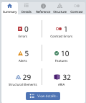 |  | Low contrast
4.3 |  | CANADIAN COMMISSIONS, COMMITTEES & TASK FORCES ON DRUGS | 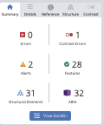 |  | Low contrast
4.4 |  | COSTS & CONSEQUENCES OF CANADA’S CURRENT APPROACH TO PSYCHOACTIVE SUBSTANCES | 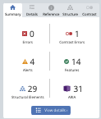 |  | Low contrast
4.5 |  | STATUS OF CANADIAN DRUG POLICY TODAY | 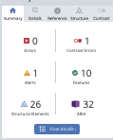 |  | Low contrast
4.6 |  | CHAPTER SUMMARY | 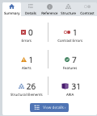 |  | Low contrast
4.7 |  | REQUIRED COURSE MATERIALS | 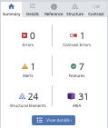 |  | Low contrast
4.8 |  | CHAPTER ASSIGNMENT | 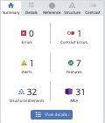 |  | Low contrast
4.9 |  | References & Media Attributions | 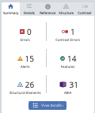 |  | Low contrast
Chapter 5 |  | International Drug Policies | 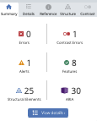 |  | Low contrast
5.0 |  | INTRODUCTION | 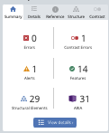 |  | Low contrast
5.1 |  | HISTORY OF INTERNATIONAL DRUG CONTROLS | 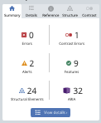 |  | Low contrast
5.2 |  | THE THREE INTERNATIONAL DRUG CONVENTIONS | 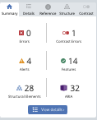 |  | Low contrast
5.3 |  | RECENT CHANGES RELATING TO INTERNATIONAL DRUG POLICY | 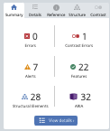 |  | Low contrast
5.4 |  | CHAPTER SUMMARY | 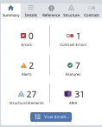 |  | Low contrast
5.5 |  | REQUIRED COURSE MATERIALS | 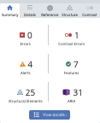 |  | Low contrast
5.6 |  | CHAPTER ASSIGNMENT | 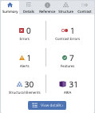 |  | Low contrast
5.7 |  | REFERENCES & MEDIA ATTRIBUTIONS | 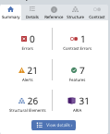 |  | Low contrast
Chapter 6 |  | DRUG PROHIBITION & THE WAR ON DRUGS – COSTS & CONSEQUENCES | 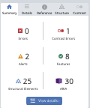 |  | Low contrast
6.0 |  | INTRODUCTION | 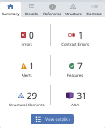 |  | Low contrast
6.1 |  | THE WAR ON DRUGS | 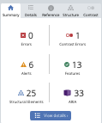 |  | Low contrast
6.2 |  | DRUG WAR COSTS | 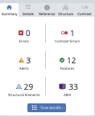 |  | Low contrast
6.3 |  | IMPACTS ON MARGINALIZED POPULATIONS | 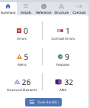 |  | Low contrast
6.4 |  | MOVING BEYOND DRUG CRIMINALIZATION | 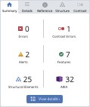 |  | Low contrast
6.5 |  | CHAPTER SUMMARY | 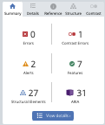 |  | Low contrast
6.6 |  | REQUIRED COURSE READINGS | 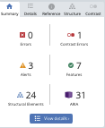 |  | Low contrast
6.7 |  | CHAPTER ASSIGNMENT | 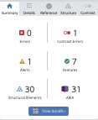 |  | Low contrast
6.8 |  | REFERENCES & MEDIA ATTRIBUTIONS | 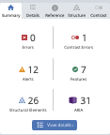 |  | Low contrast
Chapter 7 |  | ALTERNATIVE DRUG CONTROL POLICIES | 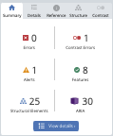 |  | Low contrast
7.0 |  | INTRODUCTION | 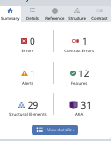 |  | Low contrast
7.1 |  | WHAT IS DECRIMINALIZATION? | 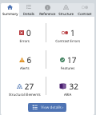 |  | Low contrast
7.2 |  | EXAMPLES OF DECRIMINALIZATION | 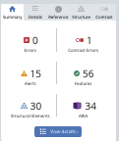 |  | Low contrast
7.3 |  | WHAT IS LEGALIZATION? | 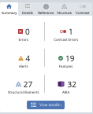 |  | Low contrast
7.4 |  | Examples of LEGALIZATION | 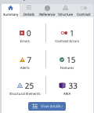 |  | Low contrast
7.5 |  | CHAPTER SUMMARY | 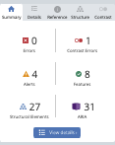 |  | Low contrast
7.6 |  | REQUIRED COURSE materials | 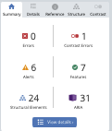 |  | Low contrast
7.7 |  | CHAPTER ASSIGNMENT | 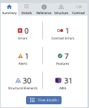 |  | Low contrast
7.8 |  | REFERENCES & MEDIA ATTRIBUTIONS | 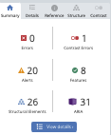 |  | Low contrast
Chapter 8 |  | STIGMA & PEOPLE WITH SUBSTANCE USE DISORDERS | 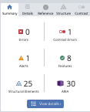
8.0 |  | INTRODUCTION | 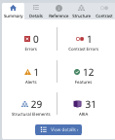 |  | Low contrast
8.1 |  | WHAT IS STIGMA? | 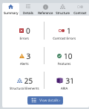 |  | Low contrast
8.2 |  | TYPES OF STIGMA | 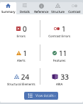 |  | Low contrast
8.3 |  | RECOGNIZING THE IMPACTS OF STIGMA | 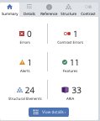 |  | Low contrast
8.4 |  | A HEALTH CONDITION, NOT A MORAL FAILING | 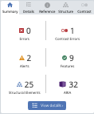 |  | Low contrast
8.5 |  | IMPLICATIONS OF STIGMATIZING DRUG POLICY | 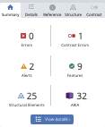 |  | Low contrast
8.6 |  | PERSON-FIRST LANGUAGE | 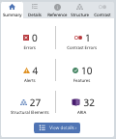 |  | Low contrast
8.7 |  | INVOLVING PEOPLE WITH LIVED & LIVING EXPERIENCE (PWLLE) | 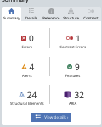 |  | Low contrast
8.8 |  | CHAPTER SUMMARY | 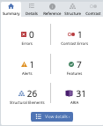 |  | Low contrast
8.9 |  | REQUIRED COURSE MATERIALS | 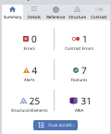 |  | Low contrast
8.10 |  | CHAPTER ASSIGNMENT | 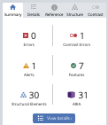 |  | Low contrast
8.11 |  | REFERENCES & MEDIA ATTRIBUTIONS | 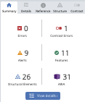 |  | Low contrast
Chapter 9 |  | UNDERSTANDING SUBSTANCE USE DISORDERS |  |  | Low contrast
9.0 |  | INTRODUCTION | 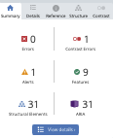 |  | Low contrast
9.1 |  | COMMON MISPERCEPTIONS ABOUT SUBSTANCES & SUBSTANCE USE | 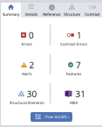 |  | Low contrast
9.2 |  | WHAT IS THE MEANING OF SUBSTANCE USE DISORDER (SUD)? | 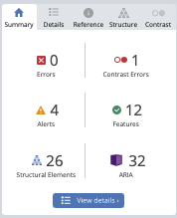 |  | Low contrast
9.3 |  | RISK FACTORS ASSOCIATED WITH SUD | 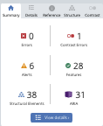 |  | Low contrast
9.4 |  | IMPACT OF COVID-19 ON PEOPLE EXPERIENCING SUDS | 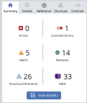 |  | Low contrast
9.5 |  | AN APPROACH EMPHASIZING WELLNESS & COMPASSIONATE | 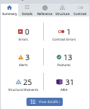 |  | Low contrast
9.6 |  | CHAPTER SUMMARY | 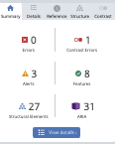 |  | Low contrast
9.7 |  | REQUIRED COURSE MATERIALS | 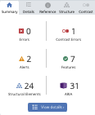 |  | Low contrast
9.8 |  | CHAPTER ASSIGNMENT | 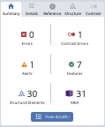 |  | Low contrast
9.9 |  | REFERENCES & MEDIA ATTRIBUTIONS | 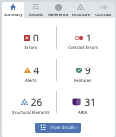 |  | Low contrast
Chapter 10 |  | HARM REDUCTION & TREATMENT | 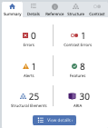 |  | Low contrast
10.0 |  | INTRODUCTION | 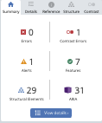 |  | Low contrast
10.1 |  | WHAT IS HARM REDUCTION? | 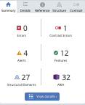 |  | Low contrast
10.2 |  | HARM REDUCTION MYTHS AND FACTS | 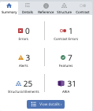 |  | Low contrast
10.3 |  | EMERGENCE OF HARM REDUCTION | 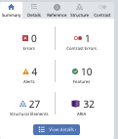 |  | Low contrast
10.4 |  | KEY ISSUES IN HARM REDUCTION | 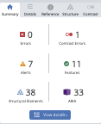 |  | Low contrast
10.5 |  | RECENT CANADIAN POLICY CHANGES | 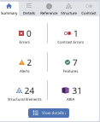 |  | Low contrast
10.6 |  | HR EXAMPLES | 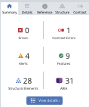 |  | Low contrast
10.7 |  | HARM REDUCTION BENEFITS | 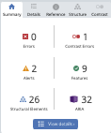 |  | Low contrast
10.8 |  | CHAPTER SUMMARY | 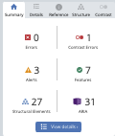 |  | Low contrast
10.9 |  | REQUIRED COURSE MATERIALS | 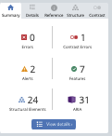 |  | Low contrast
10.10 |  | CHAPTER ASSIGNMENT | 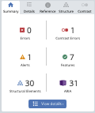 |  | Low contrast
10.11 |  | REFERENCES & MEDIA ATTRIBUTIONS | 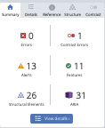 |  | Low contrast
BACK MATTER
 |  | CHAPTER REVIEWS |  |  | Low contrast
 |  | APPENDIX – Materials Used with Permission | 