1 Welcome to Transforming Assessment
Scene ID 🔒 | 07bc4b09-b7e9-43f2-a08d-58b032c5774d

Type | Source Text
Scene name | Welcome to Transforming Assessment

1.1 Transforming Assessment
Preview Image | 

Type | Source Text
Slide name | Transforming Assessment
Alt text for Transforming Assessment Logo | Logo: Transforming Assessment, Strategies for Higher Education
Button: Start Course - Normal state | START COURSE

1.2 Navigation Overview
Slide ID 🔒 | 07fe50bb-ada8-43e0-bd58-cda69d597108
Preview Image | 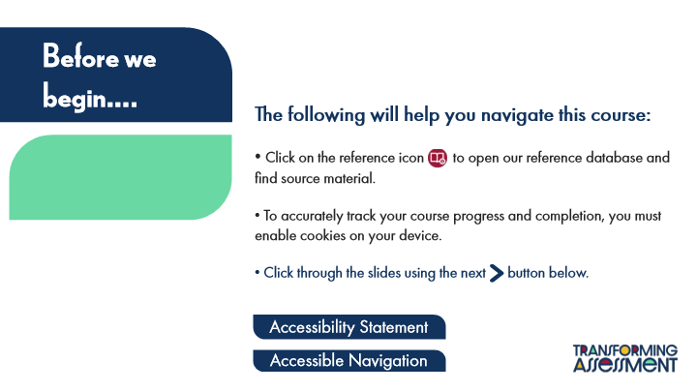

Type | Text
Slide name | Navigation Overview
Slide Title | Before we begin….
Body Text | The following will help you navigate this course:
 | Click on the reference icon to open our reference database and find source material.
 | To accurately track your course progress and completion, you must enable cookies on your device.
 | Click through the slides using the next button below.
Alt text for Icon: Reference | Button: Reference Icon – click on this icon to open a reference from the reference database in a new window
Button: Show Accessibility Notes 1 - Normal state | Accessibility Statement
Button: Show Accessibility Notes - Normal state | Accessible Navigation

Slide Layer: Accessible Navigation
Layer ID 🔒 | 158292d2-8930-4bd1-ac59-0647861831a5
Preview Image | 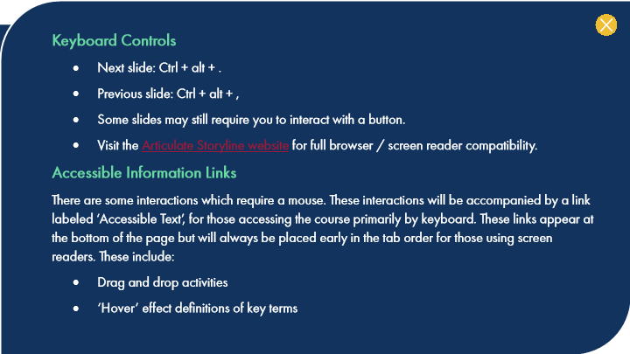

Type | Translation
Alt text for Group 1 | Button: Close Accessibility Notes Layer
Body Text | Keyboard Controls
 | Next slide: Ctrl + alt + .
 | Previous slide: Ctrl + alt + ,
 | Some slides may still require you to interact with a button.
 | Visit the
 | Articulate Storyline website
 | for full browser / screen reader compatibility.
 | Accessible Information Links
 | There are some interactions which require a mouse. These interactions will be accompanied by a link labeled ‘Accessible Text’, for those accessing the course primarily by keyboard. These links appear at the bottom of the page but will always be placed early in the tab order for those using screen readers. These include:
 | Drag and drop activities
 | ‘Hover’ effect definitions of key terms

Slide Layer: Accessibility Statement
Layer ID 🔒 | 866582b7-aa90-40e1-aee2-83559329aeb6
Preview Image | 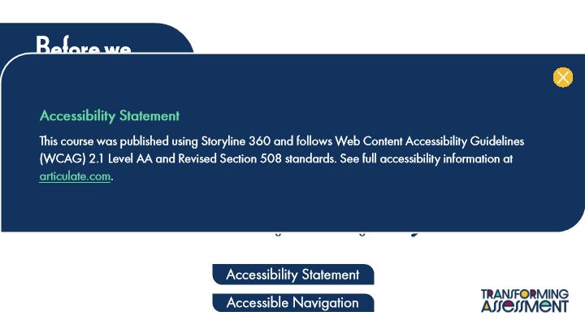

Type | Translation
Alt text for Group 1 | Button: Close Accessibility Notes Layer
Body Text | Accessibility Statement
 | This course was published using Storyline 360 and follows Web Content Accessibility Guidelines (WCAG) 2.1 Level AA and Revised Section 508 standards. See full accessibility information at
 | articulate.com
 | .

Slide Layer: Airtable Demo
Layer ID 🔒 | d4e5e654-a423-4955-95f5-a0ec8c04982e
Preview Image | 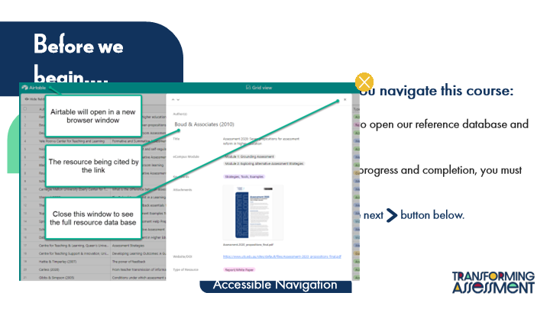

Type | Translation
Alt text for Group 1 | Button: Close Airtable Demo Layer
Alt text for Picture 1 | Image: Screen capture of an the Air Table Reference Database, demonstrating that the reference can be closed to access the full database.

1.3 Acknowledgements & License
Slide ID 🔒 | 92522796-7d12-429f-82bd-c0a377165ec6
Preview Image | 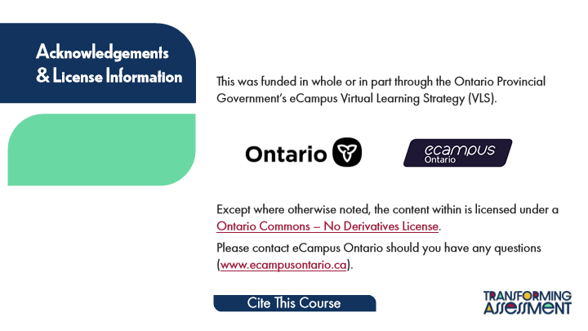

Type | Translation
Slide name | Acknowledgements & License
Slide Title | Acknowledgements
 | & License Information
Body Text | This was funded in whole or in part through the Ontario Provincial Government’s eCampus Virtual Learning Strategy (VLS).
 | Except where otherwise noted, the content within is licensed under a
 | Ontario Commons – No Derivatives License
 | .
 | Please contact eCampus Ontario should you have any questions (
 | www.ecampusontario.ca
 | ).
Button: Cite This Course - Normal state | Cite This Course

Slide Layer: Cite This Course
Layer ID 🔒 | 5a780b22-4cdd-4358-9243-13cdd318b736
Preview Image | 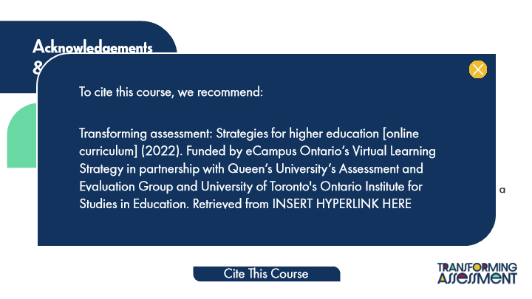

Type | Translation
Body Text | To cite this course, we recommend:
 | Transforming assessment: Strategies for higher education [online curriculum] (2022). Funded by eCampus Ontario’s Virtual Learning Strategy in partnership with Queen’s University’s Assessment and Evaluation Group and University of Toronto's Ontario Institute for Studies in Education. Retrieved from INSERT HYPERLINK HERE

1.4 Course Contributors
Slide ID 🔒 | fd82195e-fdda-4fb2-97d3-b06633194a9b
Preview Image | 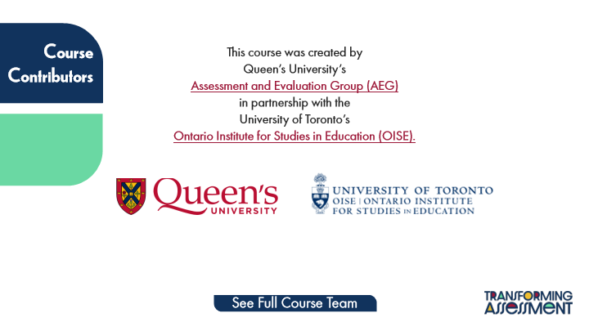

Type | Translation
Slide name | Course Contributors
Slide Title | Course
 | Contributors
Body Text 1 | This course was created by
 | Queen’s University’s
 | Assessment and Evaluation Group (AEG)
 | in partnership with the
 | University of Toronto’s
 | Ontario Institute for Studies in Education (OISE).
Button: Cite This Course 1 - Normal state | See Full Course Team

1.5 About this Course
Slide ID 🔒 | e67adf57-84c1-468d-9db9-9147599d2df4
Preview Image | 

Type | Translation
Slide name | About this Course
Slide title | About this course…

Slide Layer: Tab 1
Layer ID 🔒 | 45d27dff-6866-434d-9d08-2fad3519eda1
Preview Image | 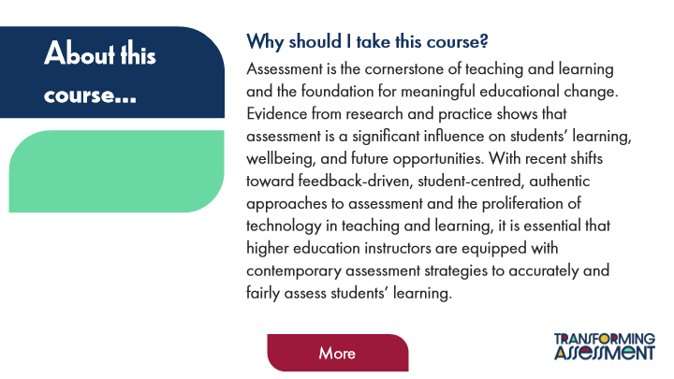

Type | Translation
Subtitle 1 | Why should I take this course?
Body Text 1 | Assessment is the cornerstone of teaching and learning and the foundation for meaningful educational change. Evidence from research and practice shows that assessment is a significant influence on students’ learning, wellbeing, and future opportunities. With recent shifts toward feedback-driven, student-centred, authentic approaches to assessment and the proliferation of technology in teaching and learning, it is essential that higher education instructors are equipped with contemporary assessment strategies to accurately and fairly assess students’ learning.
Button: More - Normal state | More

Slide Layer: Tab 2
Layer ID 🔒 | 04116945-2f8f-4fcf-9513-9144a74b875b
Preview Image | 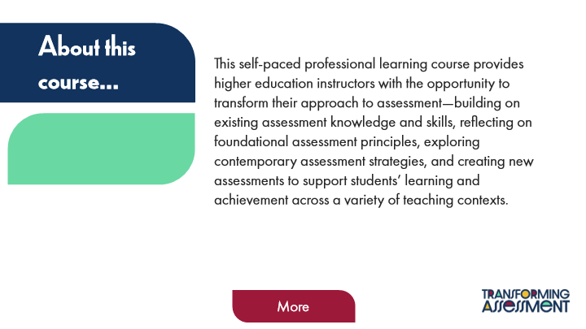

Type | Translation
Body Text 2 | This self-paced professional learning course provides higher education instructors with the opportunity to transform their approach to assessment—building on existing assessment knowledge and skills, reflecting on foundational assessment principles, exploring contemporary assessment strategies, and creating new assessments to support students’ learning and achievement across a variety of teaching contexts.
Button: More - Normal state | More

Slide Layer: Tab 3
Layer ID 🔒 | 078ca63e-b01d-42ec-b936-6ade74d5124c
Preview Image | 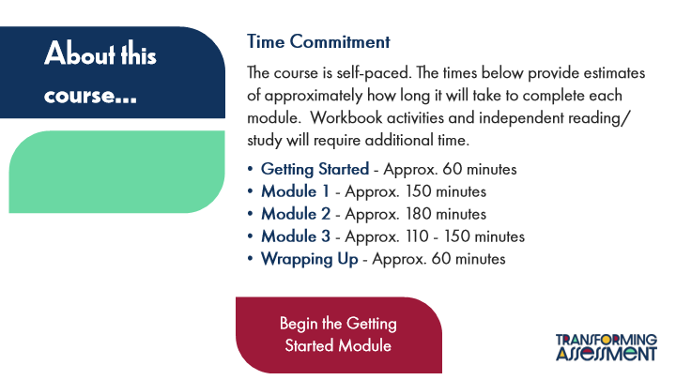

Type | Translation
Subtitle 2 | Time Commitment
Body Text 3 | The course is self-paced. The times below provide estimates of approximately how long it will take to complete each module. Workbook activities and independent reading/study will require additional time.
 | Getting Started
 | - Approx. 60 minutes
 | Module 1
 | - Approx. 150 minutes
 | Module 2
 | - Approx. 180 minutes
 | Module 3
 | - Approx. 110 - 150 minutes
 | Wrapping Up
 | - Approx. 60 minutes
Button: Next Slide - Normal state | Begin the Getting
 | Started Module

2 Getting Started
Scene ID 🔒 | 60ac4f1e-9284-4698-9d6f-1d93e7bfbe15

ID 🔒 | Type | Source Text | Translation
e60 | Scene name | Getting Started | Getting Started

2.1 Getting Started
Slide ID 🔒 | a0944647-0e9f-425f-98e1-fc93309f6977
Preview Image | 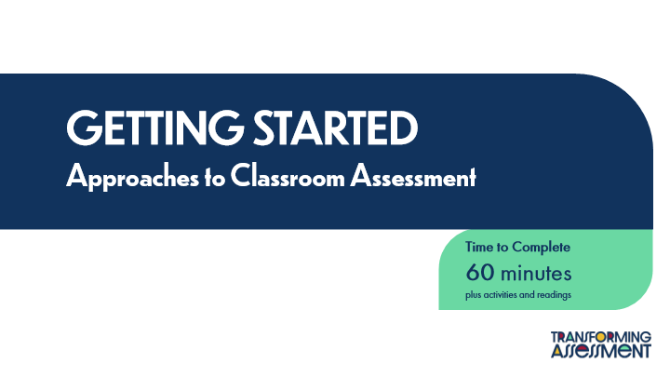

Type | Translation
Slide name | Getting Started
Module Title | GETTING STARTED
 | Approaches to Classroom Assessment
Round Diagonal Corner 2 | Time to Complete
 | 60 minutes
 | plus activities and readings

2.2 About You
Slide ID 🔒 | 7c97235e-b05d-4e23-bf44-88934307d4be
Preview Image | 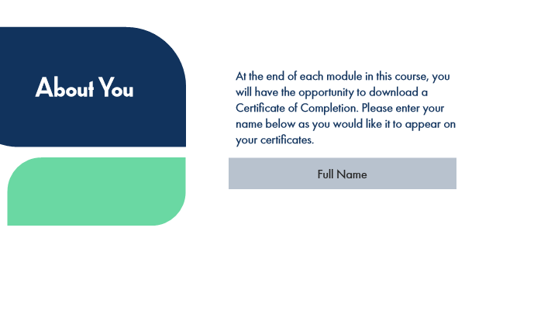

Type | Translation
Slide name | About You
Body Text | At the end of each module in this course, you will have the opportunity to download a Certificate of Completion. Please enter your name below as you would like it to appear on your certificates.
Slide Title | About You
Text Entry Field - Enter your full name | Full Name

2.3 Course Learning Outcomes
Slide ID 🔒 | a6bcba5a-f836-437e-91c1-1277d78d9de2
Preview Image | 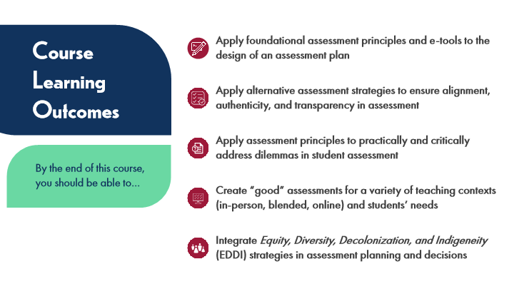

Type | Translation
Slide name | Course Learning Outcomes
Text Box 1 | Apply foundational assessment principles and e-tools to the design of an assessment plan
Slide Title | Course Learning Outcomes
Text Box 2 | Apply alternative assessment strategies to ensure alignment, authenticity, and transparency in assessment
Text Box 3 | Apply assessment principles to practically and critically address dilemmas in student assessment
Subtitle | By the end of this course, you should be able to…
Text Box 4 | Create “good” assessments for a variety of teaching contexts (in-person, blended, online) and students’ needs
Text Box 5 | Integrate Equity, Diversity, Decolonization, and Indigeneity (EDDI) strategies in assessment planning and decisions

2.4 Experienced Practitioners on Taking This Course
Slide ID 🔒 | c2b87450-74c0-4a27-8747-5c9ee6a1607b
Preview Image | 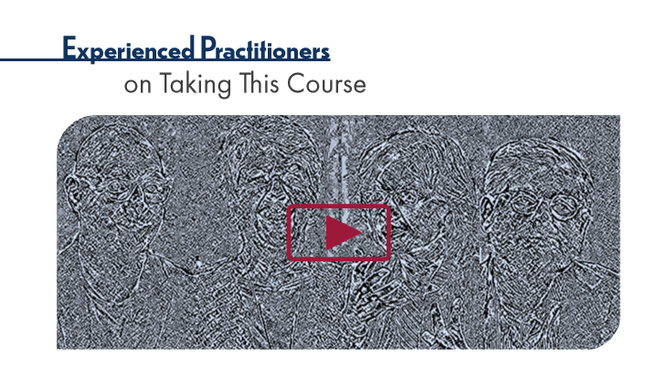

Type | Translation
Slide name | Experienced Practitioners on Taking This Course
Slide Title 1 | Experienced Practitioners
Slide Title 2 | on Taking This Course

2.5 Engaging With This Course
Slide ID 🔒 | af1f9692-9a56-4a62-80ef-d8a7cea41c47
Preview Image | 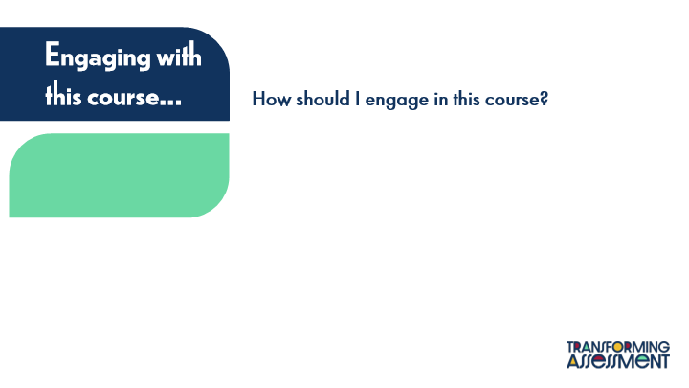

Type | Translation
Slide name | Engaging With This Course
Slide Title | Engaging with this course…
Subtitle 1 | How should I engage in this course?

Slide Layer: Tab 1
Layer ID 🔒 | 91158963-b3e9-4e5d-9995-2577d013f298
Preview Image | 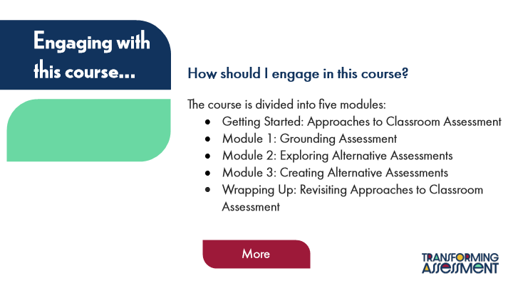

Type | Translation
Text Box 1 | The course is divided into five modules:
 | Getting Started: Approaches to Classroom Assessment
 | Module 1: Grounding Assessment
 | Module 2: Exploring Alternative Assessments
 | Module 3: Creating Alternative Assessments
 | Wrapping Up: Revisiting Approaches to Classroom Assessment
Button: More - Normal state | More

Slide Layer: Tab 2
Layer ID 🔒 | 6cc03ea3-90ff-4127-acae-ab0b67dd4e5e
Preview Image | 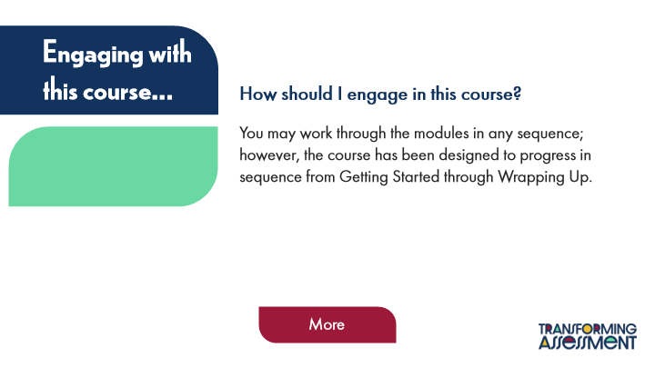

Type | Translation
Text Box 2 | You may work through the modules in any sequence; however, the course has been designed to progress in sequence from Getting Started through Wrapping Up.
Button: More - Normal state | More

Slide Layer: Tab 3
Layer ID 🔒 | eb46620b-545c-43bc-9263-a461da7dbc38
Preview Image | 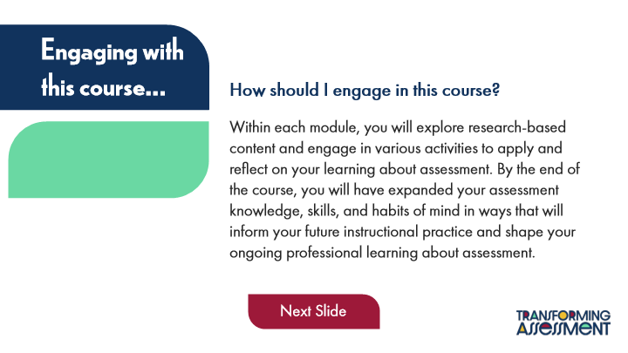

Type | Translation
Text Box 3 | Within each module, you will explore research-based content and engage in various activities to apply and reflect on your learning about assessment. By the end of the course, you will have expanded your assessment knowledge, skills, and habits of mind in ways that will inform your future instructional practice and shape your ongoing professional learning about assessment.
Button - Normal state | Next Slide

2.6 Course Resources
Slide ID 🔒 | bb741032-1460-4620-8613-9e8998df639d
Preview Image | 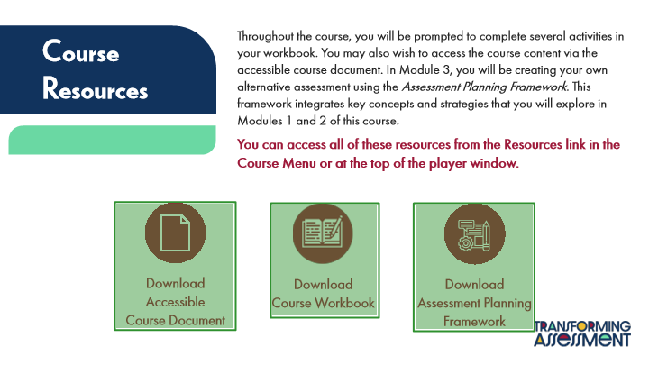

Type | Translation
Slide name | Course Resources
Text Box 6 | Throughout the course, you will be prompted to complete several activities in your workbook. You may also wish to access the course content via the accessible course document. In Module 3, you will be creating your own alternative assessment using the Assessment Planning Framework. This framework integrates key concepts and strategies that you will explore in Modules 1 and 2 of this course.
 | You can access all of these resources from the Resources link in the Course Menu or at the top of the player window.
Text Box 5 | Course Resources
Text Box 8 | Download
 | Accessible Course Document
Text Box 7 | Download
 | Course Workbook
Text Box 9 | Download
 | Assessment Planning Framework

2.7 Activity: KWL
Slide ID 🔒 | 46a6465f-b3f4-4a72-87b8-4960fefa202e
Preview Image | 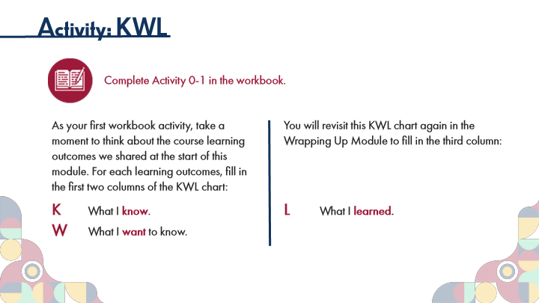

Type | Translation
Slide name | Activity: KWL
Main Title 1 | Activity: KWL
Text Box 1 | Complete Activity 0-1 in the workbook.
Text Box 4 | As your first workbook activity, take a moment to think about the course learning outcomes we shared at the start of this module. For each learning outcomes, fill in the first two columns of the KWL chart:
 | K
 | What I
 | know
 | .
 | W
 | What I
 | want
 | to know.
Text Box 3 | You will revisit this KWL chart again in the Wrapping Up Module to fill in the third column:
 | L
 | What I
 | learned
 | .

2.8 Experienced Practitioners on Assessment Orientation
Slide ID 🔒 | 841a69b8-a803-4cf0-a170-4f20410ca707
Preview Image | 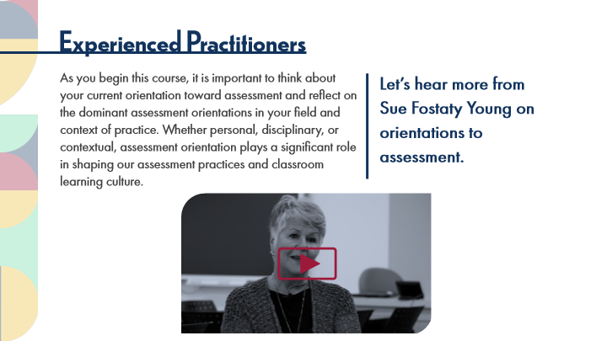

Type | Translation
Slide name | Experienced Practitioners on Assessment Orientation
Main Title 1 | Experienced Practitioners
Main Body 1 | As you begin this course, it is important to think about your current orientation toward assessment and reflect on the dominant assessment orientations in your field and context of practice. Whether personal, disciplinary, or contextual, assessment orientation plays a significant role in shaping our assessment practices and classroom learning culture.
Text Box 1 | Let’s hear more from Sue Fostaty Young on orientations to assessment.

2.9 Pause and Reflect on Assessment Orientation
Slide ID 🔒 | 55db22a2-bd09-4dd5-8819-1bdfdf786113
Preview Image | 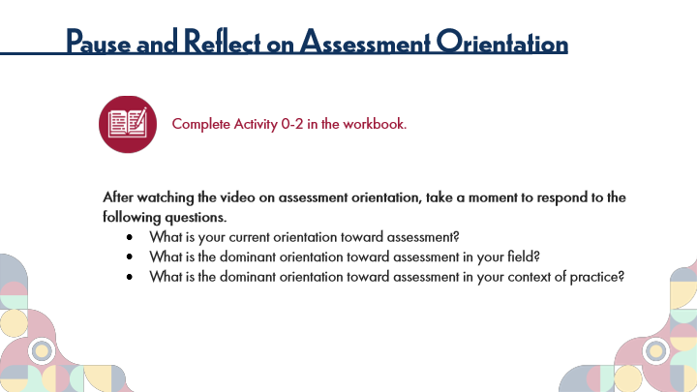

Type | Translation
Slide name | Pause and Reflect on Assessment Orientation
Main Title 1 | Pause and Reflect on Assessment Orientation
Text Box 6 | Complete Activity 0-2 in the workbook.
Text Box 7 | After watching the video on assessment orientation, take a moment to respond to the following questions.
 | What is your current orientation toward assessment?
 | What is the dominant orientation toward assessment in your field?
 | What is the dominant orientation toward assessment in your context of practice?

2.10 ACAI: Introduction
Slide ID 🔒 | 79f2bbf6-25aa-42f2-87f9-816dd6ea7ee8
Preview Image | 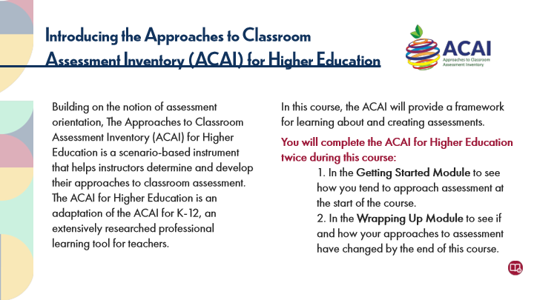

Type | Translation
Slide name | ACAI: Introduction
Main Title 1 | Introducing the Approaches to Classroom
 | Assessment Inventory (ACAI) for Higher Education
Text Box 1 | Building on the notion of assessment orientation, The Approaches to Classroom Assessment Inventory (ACAI) for Higher Education is a scenario-based instrument that helps instructors determine and develop their approaches to classroom assessment. The ACAI for Higher Education is an adaptation of the ACAI for K-12, an extensively researched professional learning tool for teachers.
Text Box 2 | In this course, the ACAI will provide a framework for learning about and creating assessments.
 | You will complete the ACAI for Higher Education twice during this course:
 | 1. In the Getting Started Module to see how you tend to approach assessment at the start of the course.
 | 2. In the Wrapping Up Module to see if and how your approaches to assessment have changed by the end of this course.

2.11 ACAI: Your Assessment Profile
Slide ID 🔒 | 688202f0-9db1-4fe9-a4d3-e8bcc2b8ca7c
Preview Image | 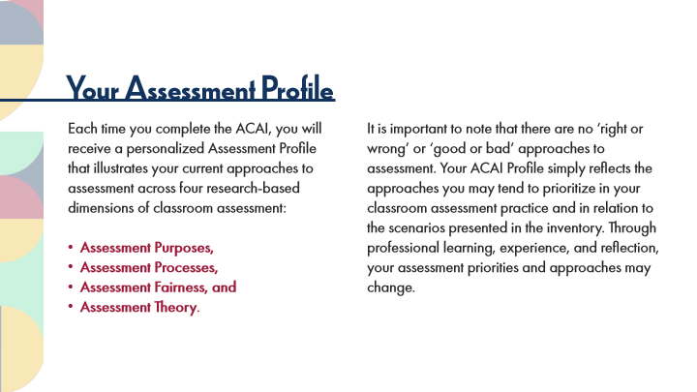

Type | Translation
Slide name | ACAI: Your Assessment Profile
Main Title 1 | Your Assessment Profile
Text Box 1 | Each time you complete the ACAI, you will receive a personalized Assessment Profile that illustrates your current approaches to assessment across four research-based dimensions of classroom assessment:
 | Assessment Purposes,
 | Assessment Processes,
 | Assessment Fairness, and
 | Assessment Theory.
Text Box 2 | It is important to note that there are no ‘right or wrong’ or ‘good or bad’ approaches to assessment. Your ACAI Profile simply reflects the approaches you may tend to prioritize in your classroom assessment practice and in relation to the scenarios presented in the inventory. Through professional learning, experience, and reflection, your assessment priorities and approaches may change.

2.12 Experienced Practitioners on the ACAI
Slide ID 🔒 | e01daf43-7b7d-4abc-9f51-07415a8b22bf
Preview Image | 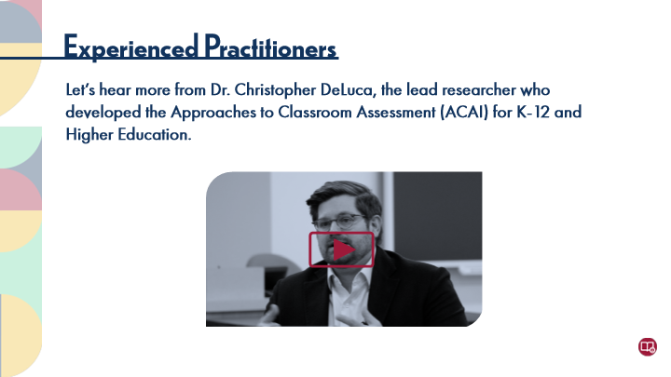

Type | Translation
Slide name | Experienced Practitioners on the ACAI
Main Title 1 | Experienced Practitioners
Text Box 1 | Let’s hear more from Dr. Christopher DeLuca, the lead researcher who developed the Approaches to Classroom Assessment (ACAI) for K-12 and Higher Education.

2.13 Activity: Complete the ACAI
Slide ID 🔒 | a54c66c9-f656-4b8f-8210-67a5772cdb12
Preview Image | 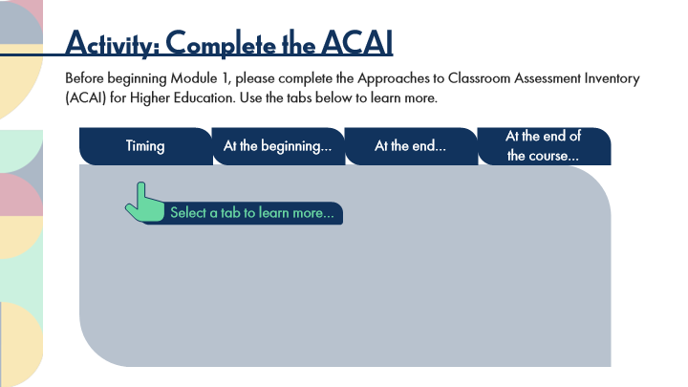

Type | Translation
Slide name | Activity: Complete the ACAI
Main Title 1 | Activity: Complete the ACAI
Text Box 1 | Before beginning Module 1, please complete the Approaches to Classroom Assessment Inventory (ACAI) for Higher Education. Use the tabs below to learn more.
Tab button 1 - Normal state | Timing
Tab button 2 - Normal state | At the beginning…
Tab button 3 - Normal state | At the end…
Tab button 4 - Normal state | At the end of
 | the course…
Text Box 2 | Select a tab to learn more…

Slide Layer: End of the course
Layer ID 🔒 | 15193d1e-5ca5-448d-9d75-52ddd53ea601
Preview Image | 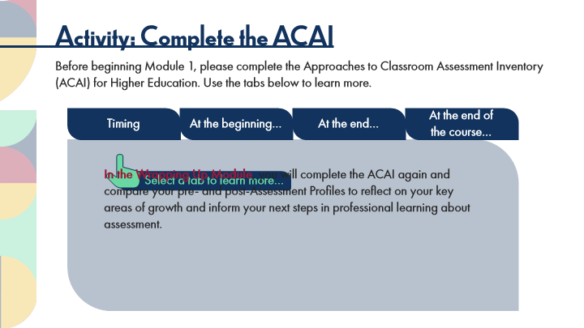

Type | Translation
Main Body 1 | In the Wrapping Up Module
 | , you will complete the ACAI again and compare your pre- and post-Assessment Profiles to reflect on your key areas of growth and inform your next steps in professional learning about assessment.

Slide Layer: End of the ACAI
Layer ID 🔒 | 407a8d82-6313-4b12-bd89-693ea359e8cc
Preview Image | 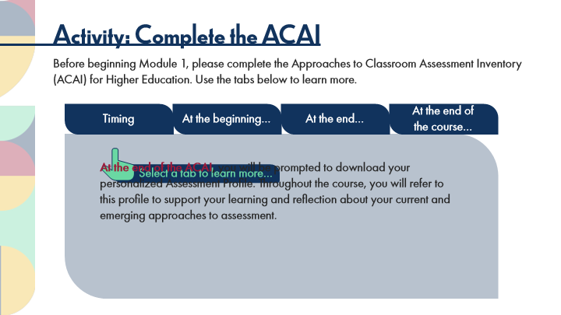

Type | Translation
Main Body 1 | At the end of the ACAI
 | , you will be prompted to download your personalized Assessment Profile. Throughout the course, you will refer to this profile to support your learning and reflection about your current and emerging approaches to assessment.

Slide Layer: Beginning the ACAI
Layer ID 🔒 | 7c909f3c-b117-4468-a781-6c34714965fa
Preview Image | 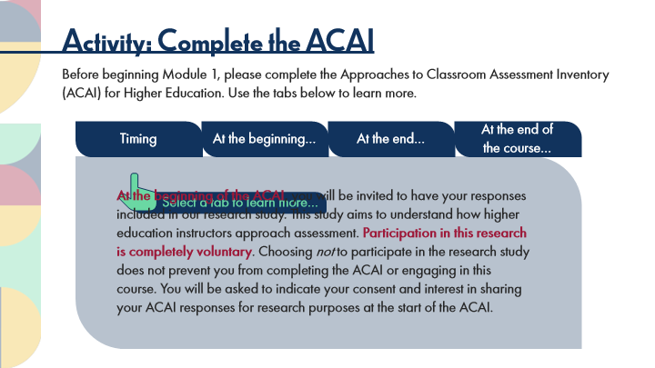

Type | Translation
Main Body 1 | At the beginning of the ACAI
 | , you will be invited to have your responses included in our research study. This study aims to understand how higher education instructors approach assessment.
 | Participation in this research is completely voluntary
 | . Choosing not to participate in the research study does not prevent you from completing the ACAI or engaging in this course. You will be asked to indicate your consent and interest in sharing your ACAI responses for research purposes at the start of the ACAI.

Slide Layer: TIming
Layer ID 🔒 | 2f555bf9-e75a-41bc-9a79-1882c688ac6a
Preview Image | 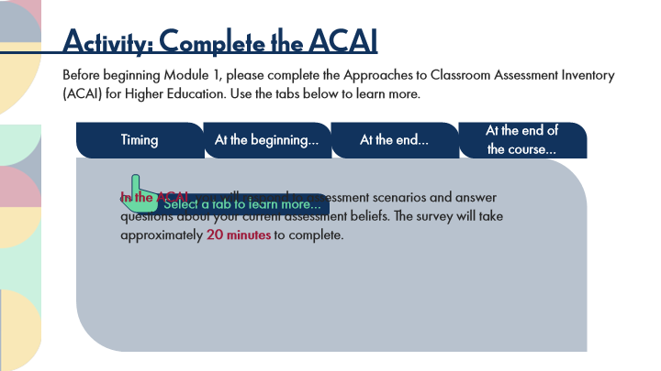

Type | Translation
Main Body 1 | In the ACAI
 | , you will respond to assessment scenarios and answer questions about your current assessment beliefs. The survey will take approximately
 | 20 minutes
 | to complete.

2.14 Activity: Link to the ACAI
Slide ID 🔒 | 8cf30870-69d8-4468-80cf-18717683024f
Preview Image | 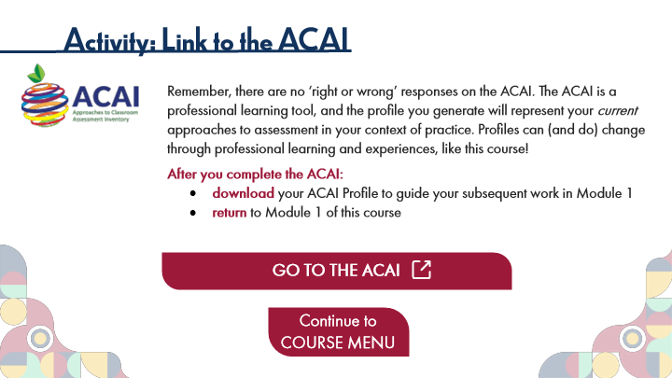

Type | Translation
Slide name | Activity: Link to the ACAI
Main Title 1 | Activity: Link to the ACAI
Text Box 7 | Remember, there are no ‘right or wrong’ responses on the ACAI. The ACAI is a professional learning tool, and the profile you generate will represent your current approaches to assessment in your context of practice. Profiles can (and do) change through professional learning and experiences, like this course!
 | After you complete the ACAI:
 | download
 | your ACAI Profile to guide your subsequent work in Module 1
 | return
 | to Module 1 of this course
Round Diagonal Corner 2 - Normal state | GO TO THE ACAI
Round Diagonal Corner 1 - Normal state | Continue to COURSE MENU

3 Course Menu
Scene ID 🔒 | fb536079-b72e-466f-9a7a-fe2124e93d1d

Type | Translation
Scene name | Course Menu

3.1 Course Menu
Slide ID 🔒 | 32a63ced-fe3a-41ea-9195-c97f69af468a
Preview Image | 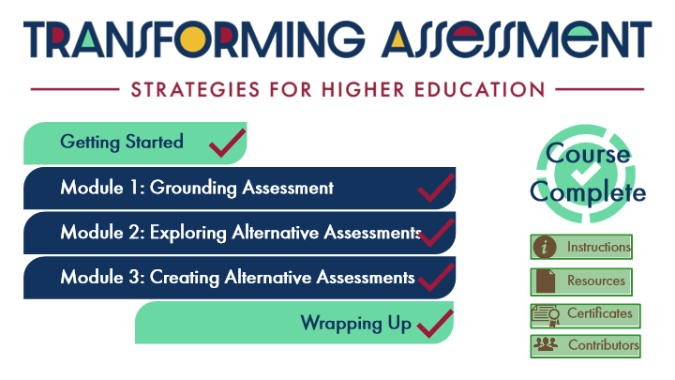

Type | Translation
Slide name | Course Menu
Alt text for Picture 1 | Logo: Transforming Assessment: Strategies for Higher Education
Button - Normal state | Getting Started
Notification Icon: Course Complete | Course Complete
Button - Normal state | Module 1: Grounding Assessment
Button - Hover state | Module 1: Grounding Assessment
Button - Normal state | Module 2: Exploring Alternative Assessments
Button - Hover state | Module 2: Exploring Alternative Assessments
Text Box 4 | Instructions
Button - Normal state | Module 3: Creating Alternative Assessments
Button - Hover state | Module 3: Creating Alternative Assessments
Text Box 1 | Resources
Text Box 2 | Certificates
Button - Normal state | Wrapping Up
Button - Disabled state | Complete modules to unlock
Text Box 3 | Contributors

Slide Layer: Instructions
Layer ID 🔒 | 6ad70441-187b-47e1-a9ce-d7bd8a927771
Preview Image | 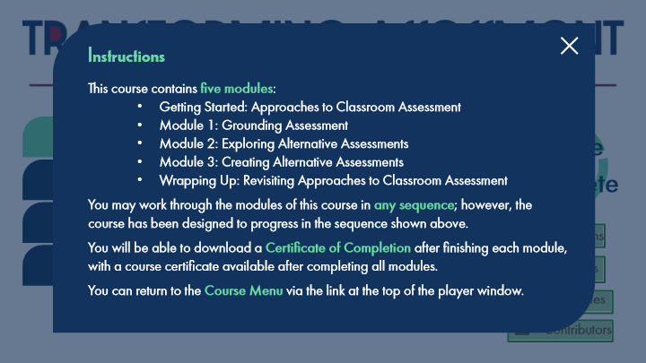

Type | Translation
Text Box 1 | Instructions
Text Box 2 | This course contains
 | five modules
 | :
 | Getting Started: Approaches to Classroom Assessment
 | Module 1: Grounding Assessment
 | Module 2: Exploring Alternative Assessments
 | Module 3: Creating Alternative Assessments
 | Wrapping Up: Revisiting Approaches to Classroom Assessment
 | You may work through the modules of this course in
 | any sequence
 | ; however, the course has been designed to progress in the sequence shown above.
 | You will be able to download a
 | Certificate of Completion
 | after finishing each module, with a course certificate available after completing all modules.
 | You can return to the
 | Course Menu
 | via the link at the top of the player window.

4 Module 1: Grounding Assessment
Scene ID 🔒 | 046c38ae-e4b9-4231-a260-76f5e2ad7543

Type | Translation
Scene name | Module 1: Grounding Assessment

4.1 Module 1: Grounding Assessment
Slide ID 🔒 | c6f80d6c-cb19-4c52-8118-d1f409402953
Preview Image | 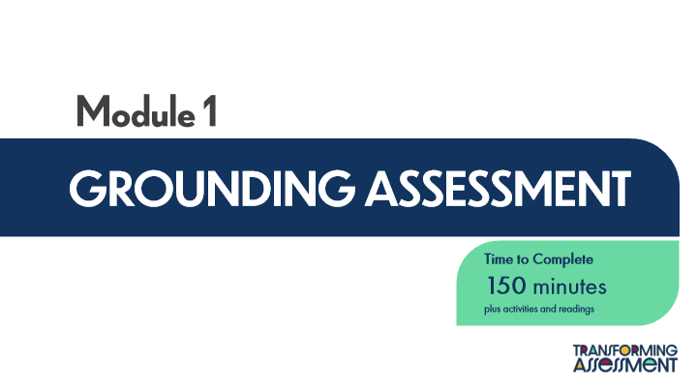

Type | Translation
Slide name | Module 1: Grounding Assessment
Module Title 1 | Module 1
Module Title 2 | GROUNDING ASSESSMENT
Round Diagonal Corner 2 | Time to Complete
 | 150 minutes
 | plus activities and readings

4.2 Learning Outcomes
Slide ID 🔒 | 9d4a9977-1d06-4e15-a294-ffcfd9560679
Preview Image | 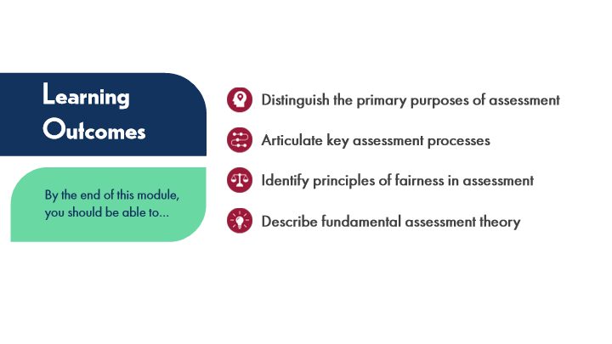

Type | Translation
Slide name | Learning Outcomes
Slide Title | Learning Outcomes
Text Box 1 | Distinguish
 | the primary purposes of assessment
Text Box 2 | Articulate key assessment processes
Text Box 3 | Identify principles of fairness in assessment
Subtitle | By the end of this module, you should be able to…
Text Box 4 | Describe
 | fundamental assessment theory

4.3 What is Assessment?
Slide ID 🔒 | db4f446b-825c-4be2-b95d-6c5e43d5cfbd
Preview Image | 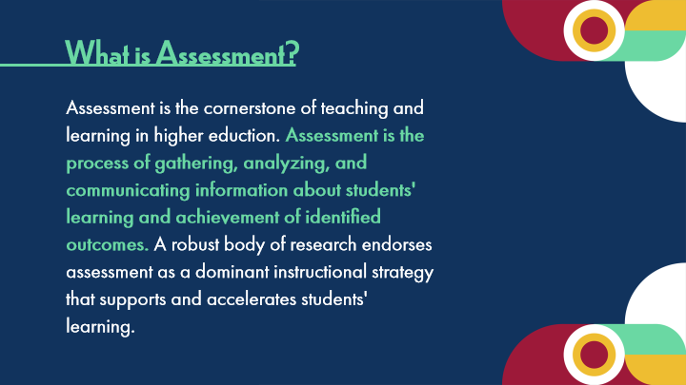

Type | Translation
Slide name | What is Assessment?
Slide Title | What is Assessment?
Body Text | Assessment is the cornerstone of teaching and learning in higher eduction.
 | Assessment is the process of gathering, analyzing, and communicating information about students' learning and achievement of identified outcomes.
 | A robust body of research endorses assessment as a dominant instructional strategy that supports and accelerates students' learning.

4.4 Quote
Slide ID 🔒 | fceac395-d781-44ca-9bae-f210c89beed4
Preview Image | 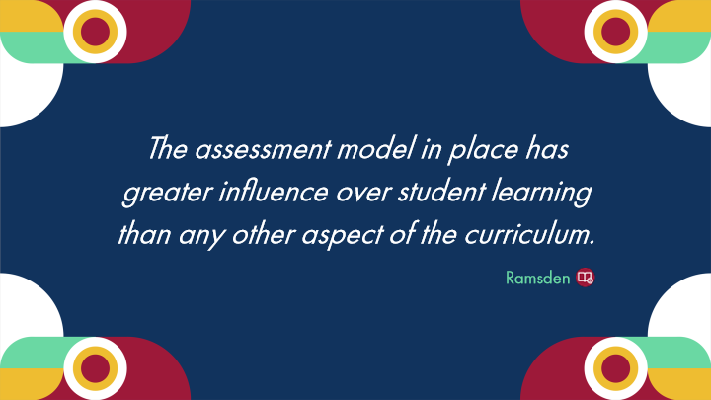

Type | Translation
Slide name | Quote
Text Box 1 | The assessment model in place has greater influence over student learning than any other aspect of the curriculum.
Text Box Author | Ramsden

4.5 Experienced Practitioners
Slide ID 🔒 | 448466e1-eb64-47db-a3ed-300ab7365b81
Preview Image | 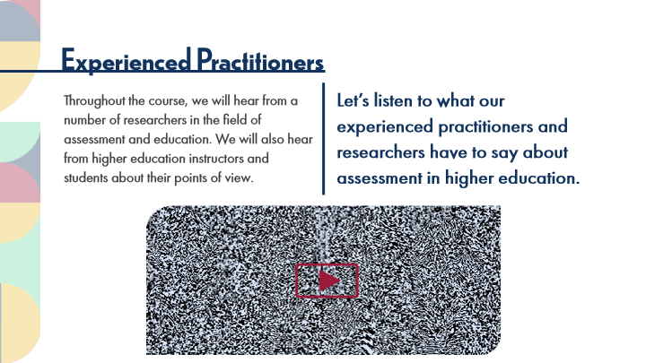

Type | Translation
Slide name | Experienced Practitioners
Slide Title | Experienced Practitioners
Text Box 1 | Throughout the course, we will hear from a number of researchers in the field of assessment and education. We will also hear from higher education instructors and students about their points of view.
Text Box 2 | Let’s listen to what our experienced practitioners and researchers have to say about assessment in higher education.

4.6 Contemporary Assessment
Slide ID 🔒 | 735aa90f-b1c8-495c-b954-f63a4987d451
Preview Image | 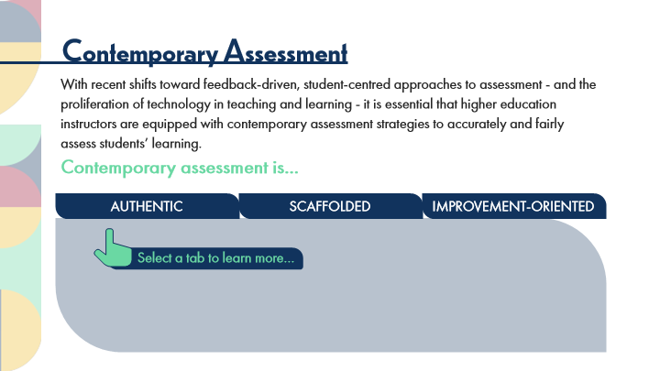

Type | Translation
Slide name | Contemporary Assessment
Slide Title | Contemporary Assessment
Body Text 1 | With recent shifts toward feedback-driven, student-centred approaches to assessment - and the proliferation of technology in teaching and learning - it is essential that higher education instructors are equipped with contemporary assessment strategies to accurately and fairly assess students’ learning.
 | Contemporary assessment is…
Tab Button 2 - Normal state | AUTHENTIC
Tab Button 1 - Normal state | SCAFFOLDED
Tab Button 3 - Normal state | IMPROVEMENT-ORIENTED
Instruction | Select a tab to learn more…

Slide Layer: Authentic
Layer ID 🔒 | 6e8c9aef-7821-4b16-9d68-703f43f6e53b
Preview Image | 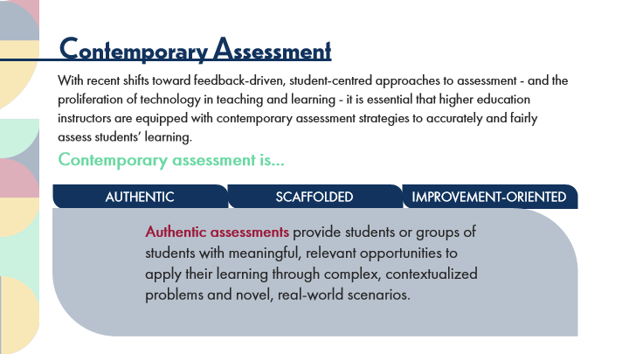

Type | Translation
Text Box 1 | Authentic assessments
 | provide students or groups of students with meaningful, relevant opportunities to apply their learning through complex, contextualized problems and novel, real-world scenarios.

Slide Layer: Scaffolded
Layer ID 🔒 | 65627796-81f3-40f1-bfe8-afd1429ca1c9
Preview Image | 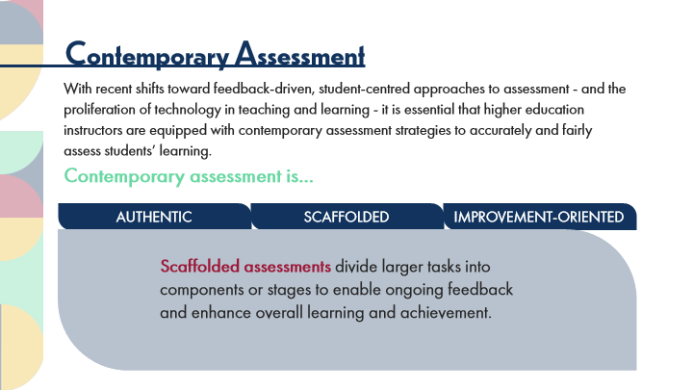

Type | Translation
Text Box 2 | Scaffolded assessments
 | divide larger tasks into components or stages to enable ongoing feedback and enhance overall learning and achievement.

Slide Layer: Improvement
Layer ID 🔒 | fd91bbe0-f5eb-4fd1-8fe5-8dbb6bff57c3
Preview Image | 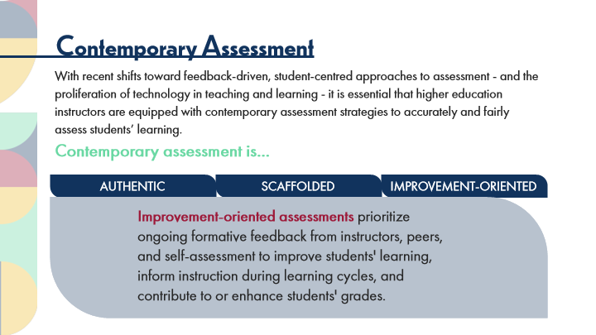

Type | Translation
Text Box 3 | Improvement-oriented assessments
 | prioritize ongoing formative feedback from instructors, peers, and self-assessment to improve students' learning, inform instruction during learning cycles, and contribute to or enhance students' grades.

4.7 Benefits of Contemporary Assessment
Slide ID 🔒 | ea067634-e1d3-43a7-9965-7472163276b0
Preview Image | 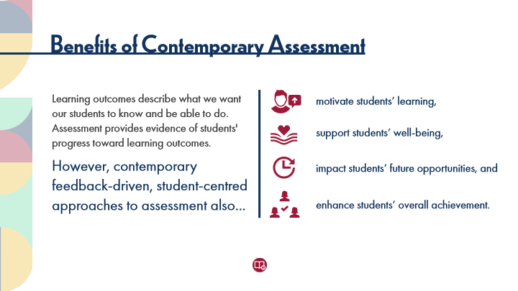

Type | Translation
Slide name | Benefits of Contemporary Assessment
Slide Title | Benefits of Contemporary Assessment
Text Box 1 | Learning outcomes describe what we want our students to know and be able to do. Assessment provides evidence of students' progress toward learning outcomes.
Text Box 3 | motivate students’ learning,
Text Box 4 | support students’ well-being,
Text Box 2 | However, contemporary feedback-driven, student-centred approaches to assessment also...
Text Box 5 | impact students’ future opportunities, and
Text Box 6 | enhance students’ overall achievement.

4.8 Using the ACAI
Slide ID 🔒 | 520e6731-c9a1-435f-a26f-d5857430821a
Preview Image | 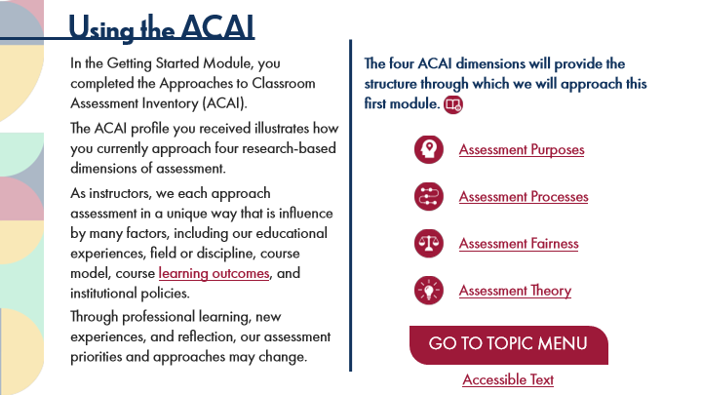

Type | Translation
Slide name | Using the ACAI
Slide Title | Using the ACAI
Text Box 2 | The four ACAI dimensions will provide the structure through which we will approach this first module.
Text Box 1 | In the Getting Started Module, you completed the Approaches to Classroom Assessment Inventory (ACAI).
 | The ACAI profile you received illustrates how you currently approach four research-based dimensions of assessment.
 | As instructors, we each approach assessment in a unique way that is influence by many factors, including our educational experiences, field or discipline, course model, course
 | learning outcomes
 | , and institutional policies.
 | Through professional learning, new experiences, and reflection, our assessment priorities and approaches may change.
Text Box 3 | Assessment Purposes
Text Box 4 | Assessment Processes
Text Box 5 | Assessment Fairness
Text Box 6 | Assessment Theory
Button - Normal state | GO TO TOPIC MENU
Text Box 1 | Accessible Text

Slide Layer: Rollover: Learning Outcomes
Layer ID 🔒 | 7d7cfc16-a55e-4389-9aac-5622e5edaca1
Preview Image | 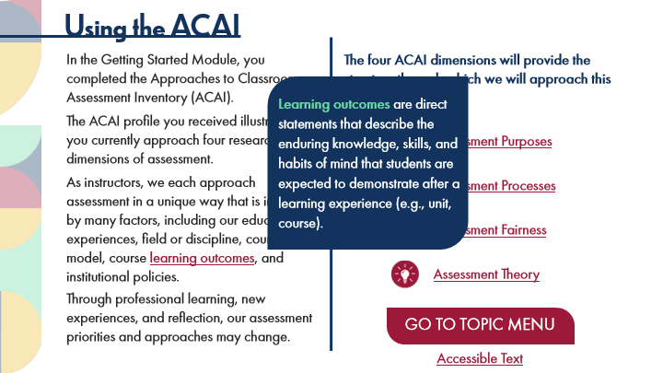

Type | Translation
Text Box 1 | Learning outcomes
 | are direct statements that describe the enduring knowledge, skills, and habits of mind that students are expected to demonstrate after a learning experience (e.g., unit, course).

Slide Layer: Rollover: Assessment Purposes
Layer ID 🔒 | ea38082b-82d5-486c-8783-937ccc41a543
Preview Image | 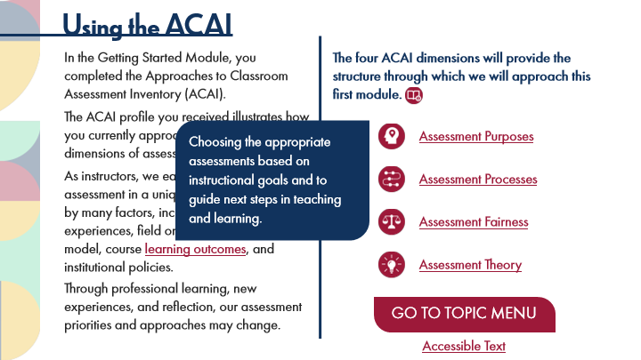

ID 🔒 | Type | Source Text | Translation
HKI | Text Box 1 | Choosing the appropriate assessments based on instructional goals and to guide next steps in teaching and learning. | Choosing the appropriate assessments based on instructional goals and to guide next steps in teaching and learning.

Slide Layer: Rollover: Assessment Processes
Layer ID 🔒 | 3ff4b802-5837-48c0-ae39-10cd46ab3d5c
Preview Image | 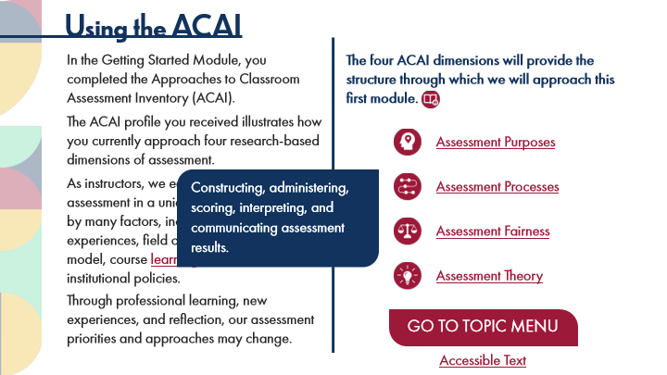

Type | Translation
Text Box 1 | Constructing, administering, scoring, interpreting, and communicating assessment results.

Slide Layer: Rollover: Assessment Fairness
Layer ID 🔒 | 9df3a693-11e9-425d-a423-0d9f86b44c76
Preview Image | 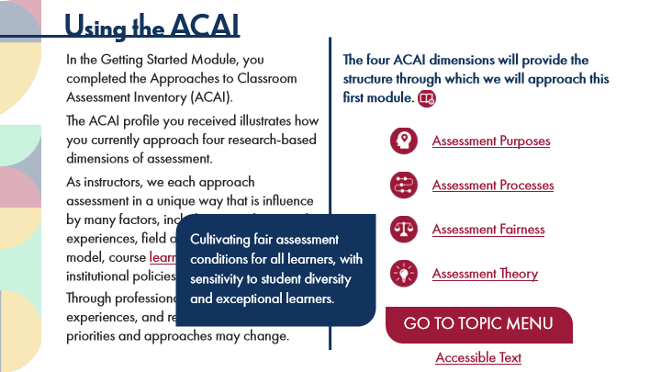

Type | Translation
Text Box 1 | Cultivating fair assessment conditions for all learners, with sensitivity to student diversity and exceptional learners.

Slide Layer: Rollover: Assessment Theory
Layer ID 🔒 | dffa27a0-eec7-4a8c-914a-354ddb46f6e8
Preview Image | 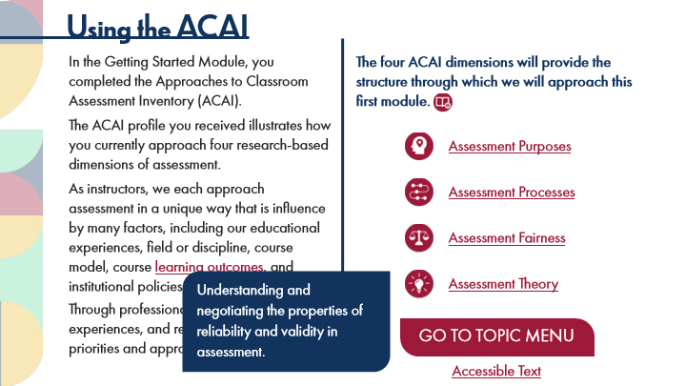

Type | Translation
Text Box 1 | Understanding and negotiating the properties of reliability and validity in assessment.

4.9 Module 1: Topic Menu
Slide ID 🔒 | 0672a642-9331-4458-8501-b8c58028bf48
Preview Image | 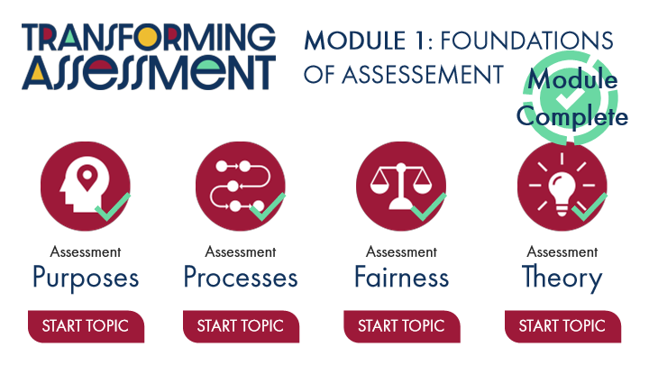

Type | Translation
Slide name | Module 1: Topic Menu
Module Title | MODULE 1: FOUNDATIONS OF ASSESSEMENT
Message: | Module
 | Complete
Title 1 | Assessment
Title 3 | Assessment
Title 01 6 | Assessment
Title 01 7 | Assessment
Title 2 | Purposes
Title 4 | Processes
Title 01 8 | Fairness
Title 01 9 | Theory
Button: Assessment Purposes Topic - Normal state | START TOPIC
Button: Assessment Processes Topic - Normal state | START TOPIC
Button: Assessment Fairness Topic - Normal state | START TOPIC
Button: Assessment Theory Topic - Normal state | START TOPIC

Slide Layer: Instructions
Layer ID 🔒 | bb4fb15d-a582-4026-8f49-806dd218237f
Preview Image | 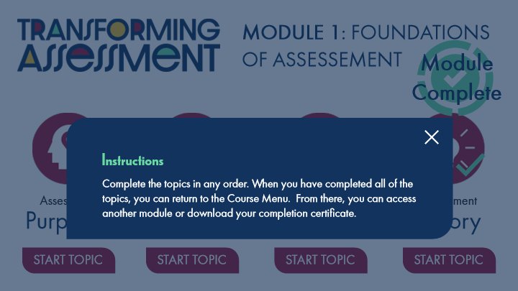

Type | Translation
Text Box 1 | Instructions
Text Box 2 | Complete the topics in any order. When you have completed all of the topics, you can return to the Course Menu. From there, you can access another module or download your completion certificate.

5 Topic 1: Assessment Purposes
Scene ID 🔒 | e1ca290a-5d96-48de-a383-96452216588d

ID 🔒 | Type | Source Text | Translation
Gg8 | Scene name | Topic 1: Assessment Purposes | Topic 1: Assessment Purposes

5.1 Assessment Purposes Title Page
Slide ID 🔒 | 3ed1a3b5-4f0f-4142-a3ba-a71db40aeeda
Preview Image | 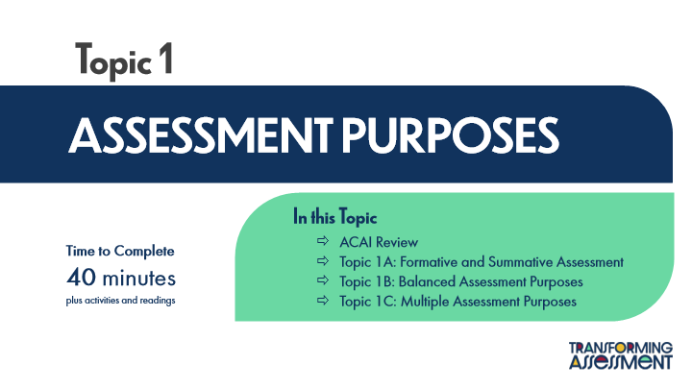

Type | Translation
Slide name | Assessment Purposes Title Page
Main Title 1 | Topic 1
Main Title 2 | ASSESSMENT PURPOSES
Text Box 1 | In this Topic
 | ACAI Review
 | Topic 1A: Formative and Summative Assessment
 | Topic 1B: Balanced Assessment Purposes
 | Topic 1C: Multiple Assessment Purposes
Text Box 2 | Time to Complete
 | 40 minutes
 | plus activities and readings

5.2 ACAI Review: Assessment Purposes
Slide ID 🔒 | 193a55b6-fd2d-4c3e-a1a4-e9b1e06b6d3f
Preview Image | 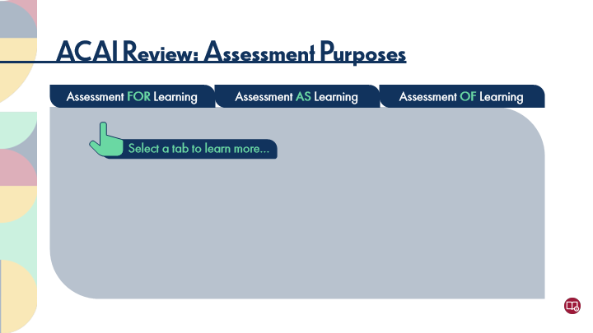

Type | Translation
Slide name | ACAI Review: Assessment Purposes
Main Title | ACAI Review: Assessment Purposes
Tab Button 1 - Normal state | Assessment
 | FOR
 | Learning
Tab Button 2 - Normal state | Assessment
 | AS
 | Learning
Tab Button 3 - Normal state | Assessment
 | OF
 | Learning
Text Box 1 | Select a tab to learn more…

Slide Layer: For Learning
Layer ID 🔒 | a4d17c69-9214-47ac-989c-143ac7a03e6a
Preview Image | 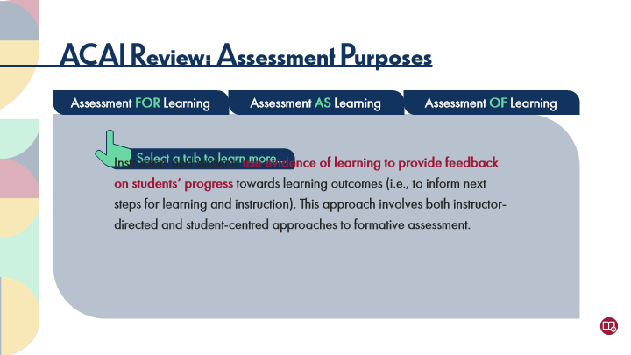

Type | Translation
Main Body 1 | Instructors and students
 | use evidence of learning to provide feedback on students’ progress
 | towards learning outcomes (i.e., to inform next steps for learning and instruction). This approach involves both instructor-directed and student-centred approaches to formative assessment.

Slide Layer: As Learning
Layer ID 🔒 | 6c2e8cdf-8df6-467e-8332-096b9dc5cd44
Preview Image | 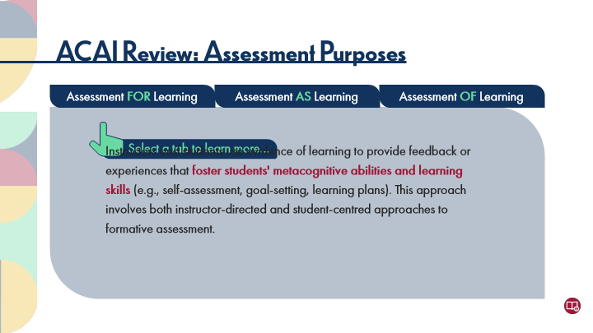

Type | Translation
Main Body 1 | Instructors and students use evidence of learning to provide feedback or experiences that
 | foster students' metacognitive abilities and learning skills
 | (e.g., self-assessment, goal-setting, learning plans). This approach involves both instructor-directed and student-centred approaches to formative assessment.

Slide Layer: Of Learning
Layer ID 🔒 | 21bdaebd-982d-4ba3-9521-02c24a332ff7
Preview Image | 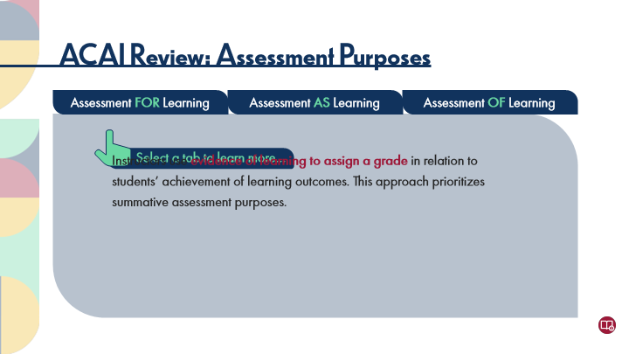

Type | Translation
Main Body 1 | Instructors use
 | evidence of learning to assign a grade
 | in relation to students’ achievement of learning outcomes. This approach prioritizes summative assessment purposes.

5.3 ACAI Reflections: Assessment Purposes
Slide ID 🔒 | e9446594-2ea3-4bda-941c-09d1d9797704
Preview Image | 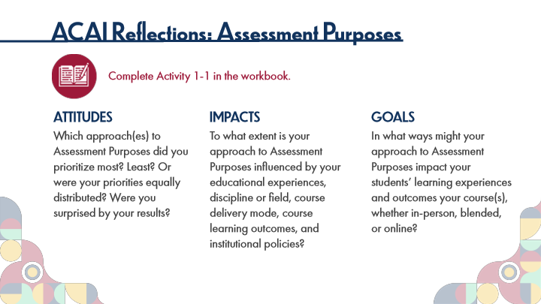

Type | Translation
Slide name | ACAI Reflections: Assessment Purposes
Main Title 1 | ACAI Reflections: Assessment Purposes
Text Box 1 | Complete Activity 1-1 in the workbook.
Text Box 2 | ATTITUDES
 | Which approach(es) to Assessment Purposes did you prioritize most? Least? Or were your priorities equally distributed? Were you surprised by your results?
Text Box 3 | IMPACTS
 | To what extent is your approach to Assessment Purposes influenced by your educational experiences, discipline or field, course delivery mode, course learning outcomes, and institutional policies?
Text Box 4 | GOALS
 | In what ways might your approach to Assessment Purposes impact your students’ learning experiences and outcomes your course(s), whether in-person, blended, or online?

5.4 Key Points: Assessment Purposes
Slide ID 🔒 | be40fa62-4f53-448c-bce7-4ad14579f50d
Preview Image | 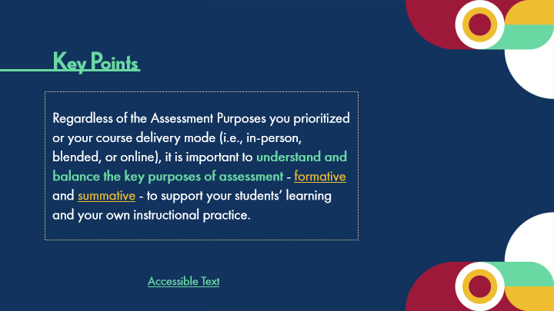

Type | Translation
Slide name | Key Points: Assessment Purposes
Text Box 1 | Key Points
Body | Regardless of the Assessment Purposes you prioritized or your course delivery mode (i.e., in-person, blended, or online), it is important to
 | understand and balance the key purposes of assessment
 | -
 | formative
 | and
 | summative
 | - to support your students’ learning and your own instructional practice.
Text Box 2 | Accessible Text

Slide Layer: Rollover: Formative
Layer ID 🔒 | 42506d31-29bf-4436-b79d-c0573e049da8
Preview Image | 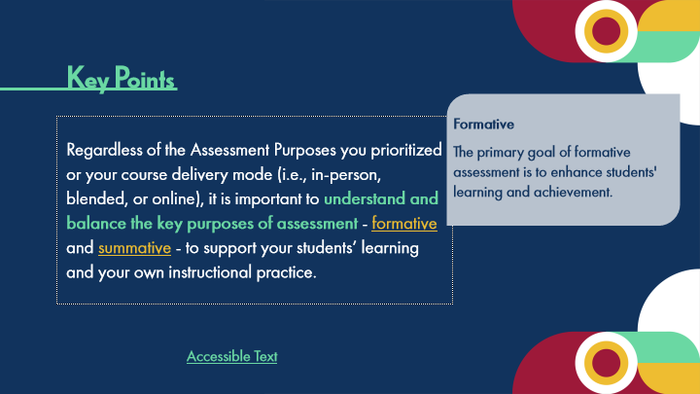

Type | Translation
Text Box 1 | Formative
 | The primary goal of formative assessment is to enhance students' learning and achievement.

Slide Layer: Rollover: Summative
Layer ID 🔒 | 3e5408ed-057e-4058-8040-76fec76c0564
Preview Image | 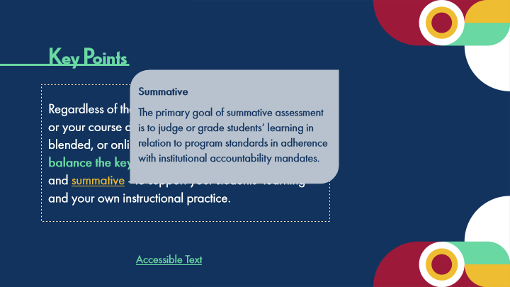

Type | Translation
Text Box 1 | Summative
 | The primary goal of summative assessment is to judge or grade students’ learning in relation to program standards in adherence with institutional accountability mandates.

5.5 Topic 1A: Formative and Summative Assessment
Slide ID 🔒 | f0213fc7-9f7e-4498-9753-847c72dabe2f
Preview Image | 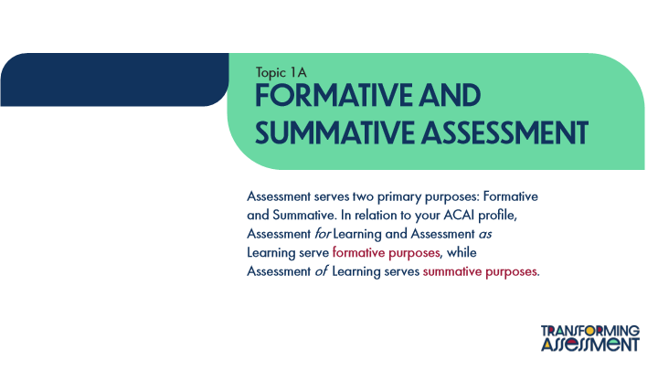

Type | Translation
Slide name | Topic 1A: Formative and Summative Assessment
Text Box 1 | Topic 1A
Main Title | Formative and
 | Summative Assessment
Main Body | Assessment serves two primary purposes: Formative and Summative. In relation to your ACAI profile, Assessment for Learning and Assessment as Learning serve
 | formative purposes
 | , while Assessment of Learning serves
 | summative purposes
 | .

5.6 Distinctions between Formative and Summative Assessment
Slide ID 🔒 | 287af5b1-1932-4438-9254-731af7bc59fa
Preview Image | 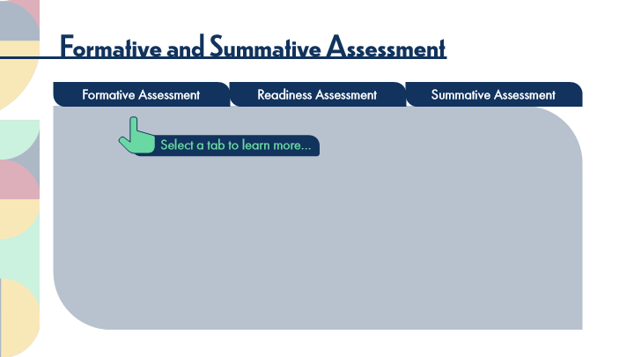

Type | Translation
Slide name | Distinctions between Formative and Summative Assessment
Main Title | Formative and Summative Assessment
tab button 1 - Normal state | Formative Assessment
tab button 2 - Normal state | Readiness Assessment
tab button 3 - Normal state | Summative Assessment
Pointer Text | Select a tab to learn more…

Slide Layer: Summative
Layer ID 🔒 | e472c253-f802-4dde-ad5e-4a04910dda14
Preview Image | 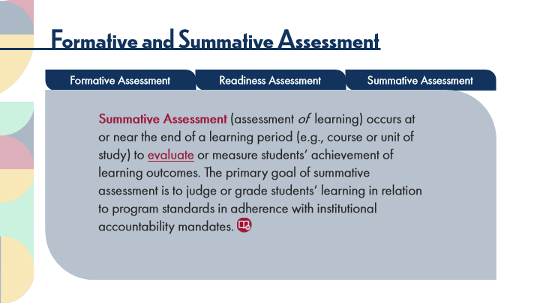

Type | Translation
Main Body 1 | Summative Assessment
 | (assessment of learning) occurs at or near the end of a learning period (e.g., course or unit of study) to
 | evaluate
 | or measure students’ achievement of learning outcomes. The primary goal of summative assessment is to judge or grade students’ learning in relation to program standards in adherence with institutional accountability mandates.

Slide Layer: Readiness
Layer ID 🔒 | bbf2f159-7f95-4e56-bd83-b94a98fa30f8
Preview Image | 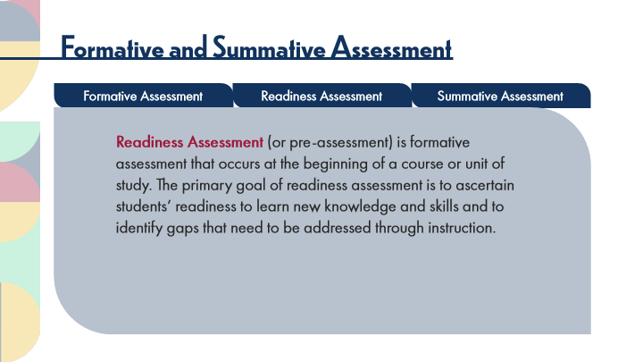

Type | Translation
Main Body 1 | Readiness Assessment
 | (or pre-assessment)
 | is formative assessment that occurs at the beginning of a course or unit of study. The primary goal of readiness assessment is to ascertain students’ readiness to learn new knowledge and skills and to identify gaps that need to be addressed through instruction.

Slide Layer: Formative
Layer ID 🔒 | 957a2e22-1062-4620-a7b6-b30d73648631
Preview Image | 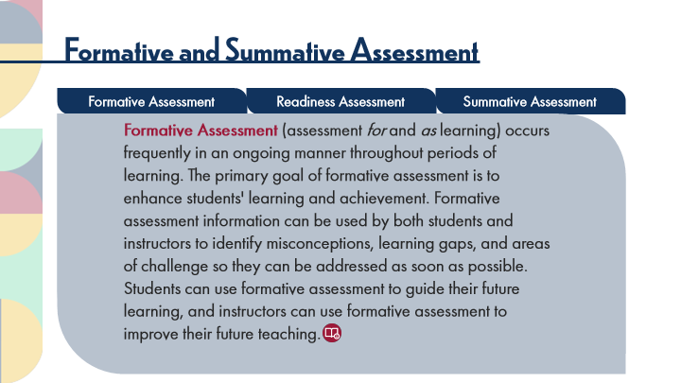

Type | Translation
Main Body 1 | Formative Assessment
 | (assessment for and as learning) occurs frequently in an ongoing manner throughout periods of learning. The primary goal of formative assessment is to enhance students' learning and achievement. Formative assessment information can be used by both students and instructors to identify misconceptions, learning gaps, and areas of challenge so they can be addressed as soon as possible. Students can use formative assessment to guide their future learning, and instructors can use formative assessment to improve their future teaching.

Slide Layer: Rollover: Evaluate
Layer ID 🔒 | 772834ac-84df-4321-adc1-a1f5c6353fcd
Preview Image | 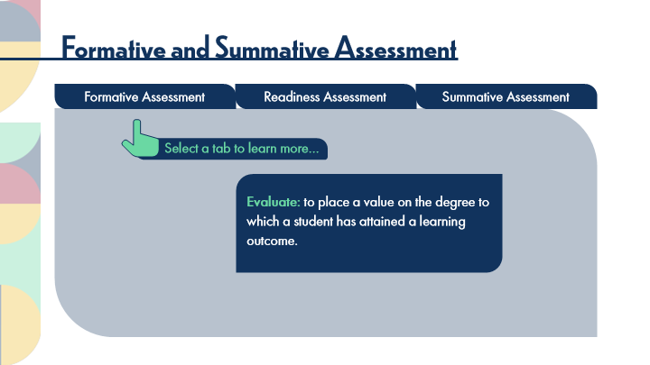

Type | Translation
Text Box 1 | Evaluate:
 | to place a value on the degree to which a student has attained a learning outcome.

5.7 A Chef's Story
Slide ID 🔒 | 872c1af7-22f5-4750-be2b-af7784bb8208
Preview Image | 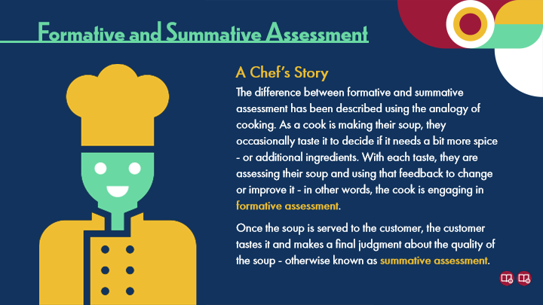

Type | Translation
Slide name | A Chef's Story
Main Title 1 | Formative and Summative Assessment
Text Box 2 | A Chef’s Story
Text Box 1 | The difference between formative and summative assessment has been described using the analogy of cooking. As a cook is making their soup, they occasionally taste it to decide if it needs a bit more spice - or additional ingredients. With each taste, they are assessing their soup and using that feedback to change or improve it - in other words, the cook is engaging in
 | formative assessment
 | .
 | Once the soup is served to the customer, the customer tastes it and makes a final judgment about the quality of the soup - otherwise known as
 | summative assessment
 | .

5.8 Purposes, Types, and Strategies
Slide ID 🔒 | 227f5ecb-9501-460f-aa61-6c98833fb622
Preview Image | 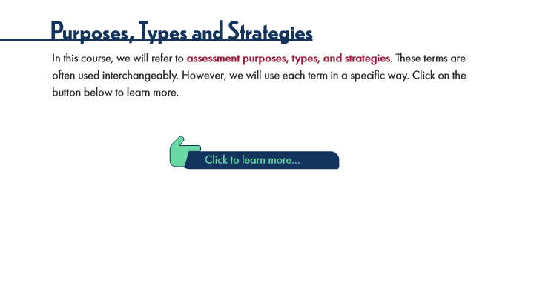

Type | Translation
Slide name | Purposes, Types, and Strategies
Main Title 1 | Purposes, Types and Strategies
Text Box 1 | In this course, we will refer to
 | assessment purposes, types, and strategies
 | . These terms are often used interchangeably. However, we will use each term in a specific way. Click on the button below to learn more.
Text Box 2 | Click to learn more…

Slide Layer: Purposes
Layer ID 🔒 | 6ae7c5a9-947b-4078-9e5f-11a41de64cae
Preview Image | 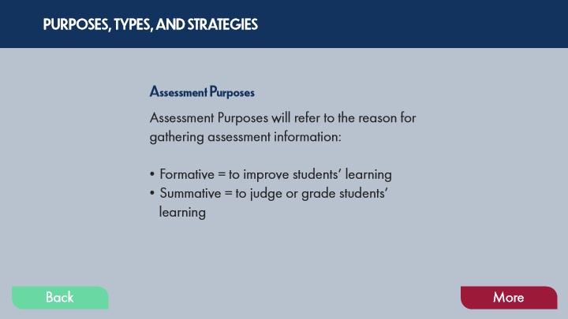

Type | Translation
Text Box 8 | PURPOSES, TYPES, AND STRATEGIES
Text Box 10 | Assessment Purposes
Text Box 9 | Assessment Purposes will refer to the reason for gathering assessment information:
 | Formative = to improve students’ learning
 | Summative = to judge or grade students’ learning
Button - Normal state | Back
Button - Down state | Back
Button - Normal state | More

Slide Layer: Types
Layer ID 🔒 | 81a95c20-88fc-4c6c-84d0-96f69d5334c2
Preview Image | 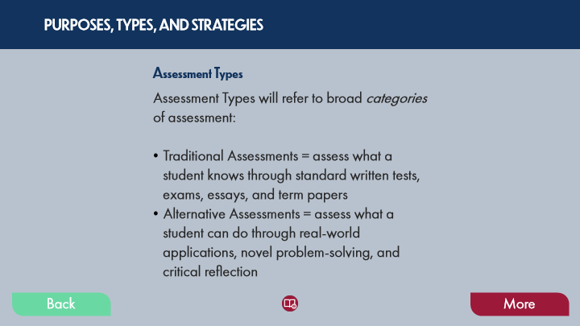

Type | Translation
Text Box 1 | PURPOSES, TYPES, AND STRATEGIES
Text Box 3 | Assessment Types
Text Box 2 | Assessment Types will refer to broad categories of assessment:
 | Traditional Assessments = assess what a student knows through standard written tests, exams, essays, and term papers
 | Alternative Assessments = assess what a student can do through real-world applications, novel problem-solving, and critical reflection
Button - Normal state | Back
Button - Down state | Back
Button - Normal state | More

Slide Layer: Strategies
Layer ID 🔒 | 7d347025-68b0-403a-a7e0-e5e3cb350bed
Preview Image | 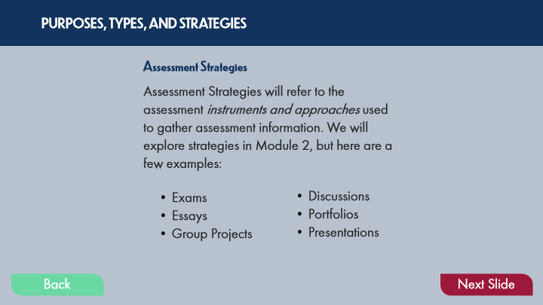

Type | Translation
Text Box 1 | PURPOSES, TYPES, AND STRATEGIES
Text Box 3 | Assessment Strategies
Text Box 2 | Assessment Strategies will refer to the assessment instruments and approaches used to gather assessment information. We will explore strategies in Module 2, but here are a few examples:
Text Box 5 | Discussions
 | Portfolios
 | Presentations
Text Box 4 | Exams
 | Essays
 | Group Projects
Button - Normal state | Back
Button - Down state | Back
Button - Normal state | Next Slide

5.9 Key Points: Formative and Summative Assessment
Slide ID 🔒 | cd9e63eb-cd55-4e42-9aae-10a2d40887d6
Preview Image | 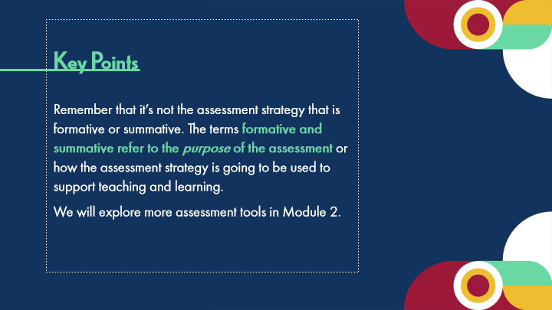

Type | Translation
Slide name | Key Points: Formative and Summative Assessment
Body | Key Points
 | Remember that it’s not the assessment strategy that is formative or summative. The terms
 | formative and summative refer to the purpose of the assessment
 | or how the assessment strategy is going to be used to support teaching and learning.
 | We will explore more assessment tools in Module 2.

5.10 Experienced Practitioners on Formative and Summative Assessment
Slide ID 🔒 | cb794f9e-41a7-4019-ad0b-71d9e900df72
Preview Image | 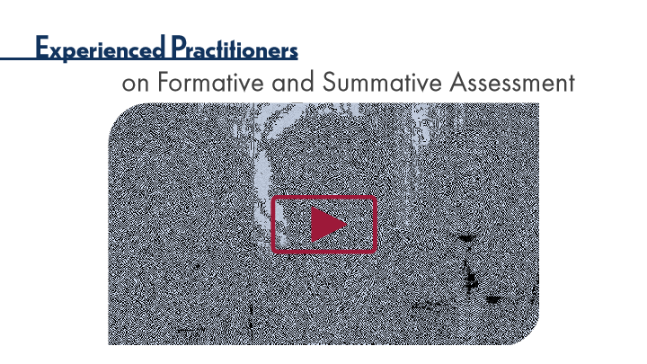

Type | Translation
Slide name | Experienced Practitioners on Formative and Summative Assessment
Main Title 1 | Experienced Practitioners
Main Title 2 | on Formative and Summative Assessment

5.11 Topic 1B: Balanced Assessment Purposes
Slide ID 🔒 | 8abc3b0b-a8df-4a50-9903-671839698e3d
Preview Image | 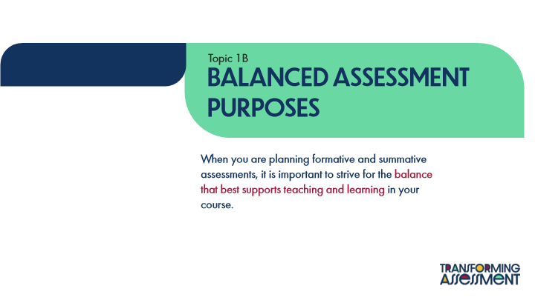

Type | Translation
Slide name | Topic 1B: Balanced Assessment Purposes
Text Box 1 | Topic 1B
Main Title 1 | Balanced Assessment
 | Purposes
Main Body | When you are planning formative and summative assessments, it is important to strive for the
 | balance that best supports teaching and learning
 | in your course.

5.12 POV: Student Perspectives
Slide ID 🔒 | dacaa5d1-2f29-4555-9f48-ada2de426bea
Preview Image | 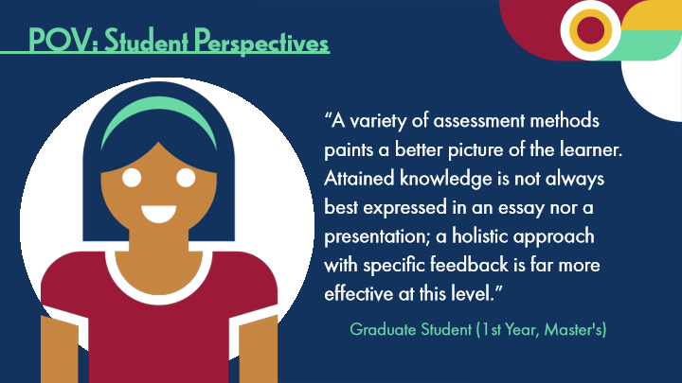

Type | Translation
Slide name | POV: Student Perspectives
Main Title 1 | POV: Student Perspectives
Text Box 1 | “A variety of assessment methods paints a better picture of the learner. Attained knowledge is not always best expressed in an essay nor a presentation; a holistic approach with specific feedback is far more effective at this level.”
Text Box 2 | Graduate Student (1st Year, Master's)

5.13 Grading
Slide ID 🔒 | 0c56d964-a0b9-49c1-b637-18a43d6d34ae
Preview Image | 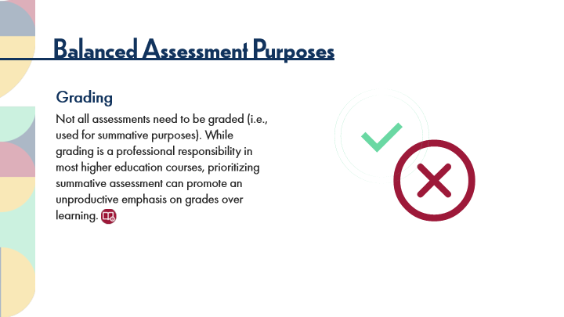

Type | Translation
Slide name | Grading
Main Title 1 | Balanced Assessment Purposes
Text Box 1 | Grading
 | Not all assessments need to be graded (i.e., used for summative purposes). While grading is a professional responsibility in most higher education courses, prioritizing summative assessment can promote an unproductive emphasis on grades over learning.

5.14 Foster a Learning Culture
Slide ID 🔒 | 2856532e-36cd-4ce2-8cd3-1e63c18dab38
Preview Image | 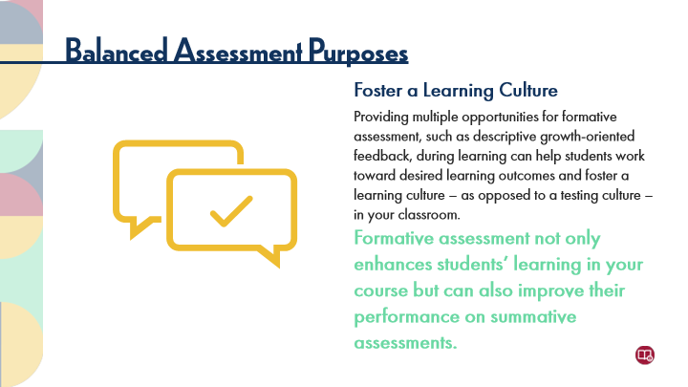

Type | Translation
Slide name | Foster a Learning Culture
Main Title 1 | Balanced Assessment Purposes
Text Box 2 | Foster a Learning Culture
 | Providing multiple opportunities for formative assessment, such as descriptive growth-oriented feedback, during learning can help students work toward desired learning outcomes and foster a learning culture – as opposed to a testing culture – in your classroom.
Text Box 4 | Formative assessment not only enhances students’ learning in your course but can also improve their performance on summative assessments.

5.15 A Balanced Approach
Slide ID 🔒 | 5e8b3f3b-a046-44aa-9f9c-4b9bda66e9b6
Preview Image | 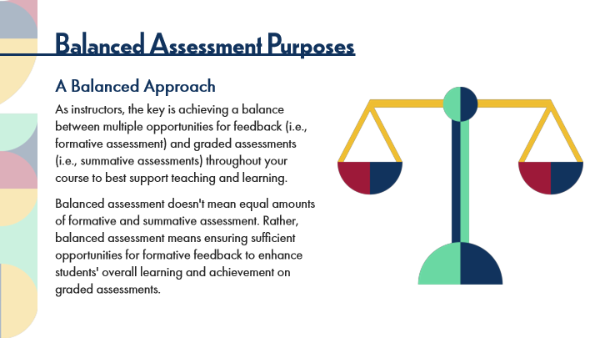

Type | Translation
Slide name | A Balanced Approach
Main Title 1 | Balanced Assessment Purposes
Text Box 3 | A Balanced Approach
 | As instructors, the key is achieving a balance between multiple opportunities for feedback (i.e., formative assessment) and graded assessments (i.e., summative assessments) throughout your course to best support teaching and learning.
 | Balanced assessment doesn't mean equal amounts of formative and summative assessment. Rather, balanced assessment means ensuring sufficient opportunities for formative feedback to enhance students' overall learning and achievement on graded assessments.

5.16 Activity: Balanced Assessment Purposes
Slide ID 🔒 | c9aa929a-d37b-4ed0-972e-a8385f18f464
Preview Image | 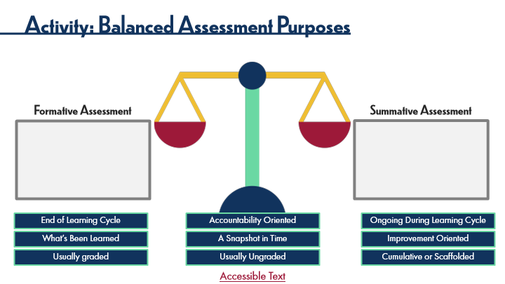

Type | Translation
Slide name | Activity: Balanced Assessment Purposes
Main Title 1 | Activity: Balanced Assessment Purposes
Text Box 5 | Formative Assessment
Text Box 4 | Summative Assessment
S1 | End of Learning Cycle
S3 | Accountability Oriented
F1 | Ongoing During Learning Cycle
S2 | What’s Been Learned
S4 | A Snapshot in Time
F2 | Improvement Oriented
S5 - Normal state | Usually graded
F4 | Usually Ungraded
F3 | Cumulative or Scaffolded
Text Box 6 | Accessible Text
Alt text for Text Box 6 | Link to Accessible Text PDF. If you are not using a mouse for this course, please skip this activity and read the PDF text.
Slide Notes | Paul Black (1998), who is often lauded as the forefather of these concepts, described the difference between these terms using the analogy of cooking. As a cook is making her soup, she occasionally tastes it to decide if it needs a bit more spices or ingredients. With each taste, she is assessing her soup and using that feedback to change or improve it - in other words, the cook is engaging in formative assessment. Once the soup is served to the customer, the customer tastes it and makes a final judgment about the quality of the soup - otherwise known as summative assessment.

Slide Layer: Instructions
Layer ID 🔒 | d88cc0ed-b507-4eaf-b18b-a87dfbadf26a
Preview Image | 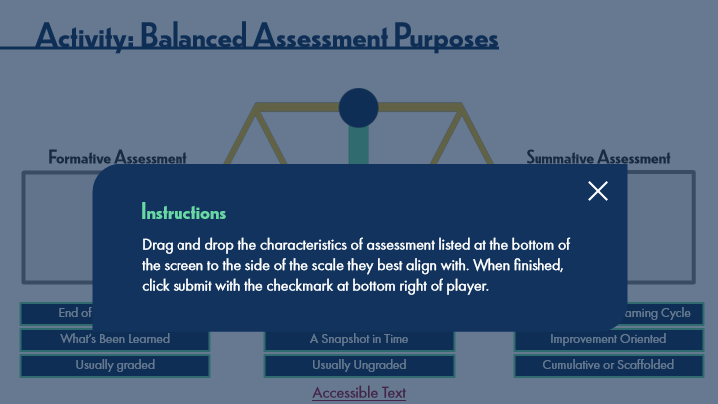

Type | Translation
Text Box 1 | Instructions
Text Box 2 | Drag and drop the characteristics of assessment listed at the bottom of the screen to the side of the scale they best align with. When finished, click submit with the checkmark at bottom right of player.

Slide Layer: Correct
Layer ID 🔒 | 13bfb695-189b-40a9-a178-bc4b8bddf8d7
Preview Image | 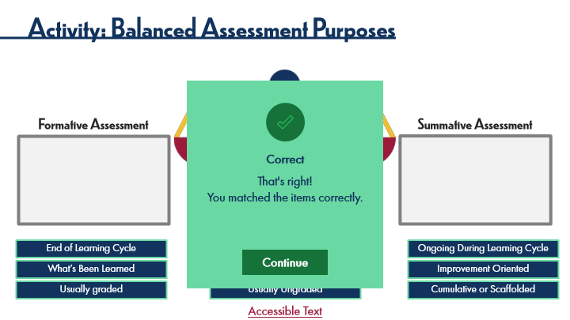

Type | Translation
Text Box | Correct
Text Box | That's right!
 | You matched the items correctly.

5.17 Experienced Practitioners on Balanced Assessments
Slide ID 🔒 | fcaa829b-9d73-448e-8459-c883a0e718e5
Preview Image | 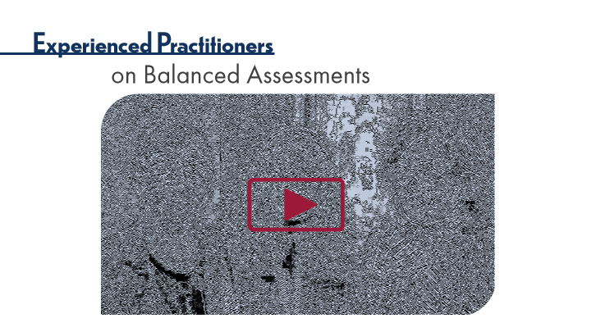

Type | Translation
Slide name | Experienced Practitioners on Balanced Assessments
Main Title 1 | Experienced Practitioners
Main Title 2 | on Balanced Assessments

5.18 Topic 1C: Multiple Assessment Purposes
Slide ID 🔒 | 2f29e6e3-20a2-4b66-8903-8d7894570020
Preview Image | 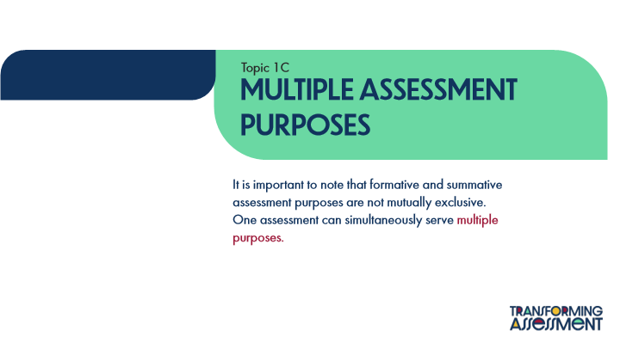

Type | Translation
Slide name | Topic 1C: Multiple Assessment Purposes
Text Box 1 | Topic 1C
Main Title | Multiple Assessment
 | Purposes
Main Body | It is important to note that formative and summative assessment purposes are not mutually exclusive. One assessment can simultaneously serve
 | multiple purposes.

5.19 It Goes Both Ways
Slide ID 🔒 | 56ce8039-11b7-4bb8-b10d-3d5c40be1f3d
Preview Image | 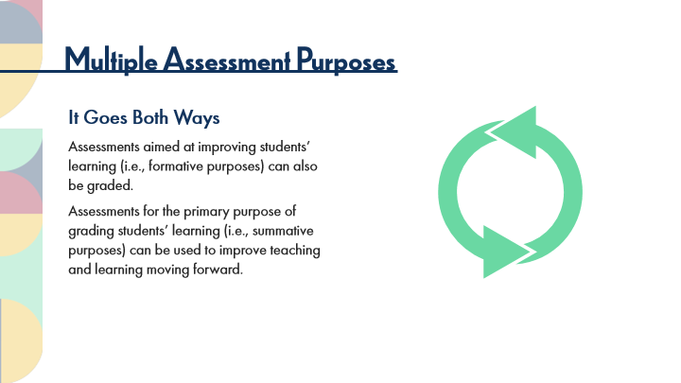

Type | Translation
Slide name | It Goes Both Ways
Main Title 1 | Multiple Assessment Purposes
Text Box 1 | It Goes Both Ways
 | Assessments aimed at improving students’ learning (i.e., formative purposes) can also be graded.
 | Assessments for the primary purpose of grading students’ learning (i.e., summative purposes) can be used to improve teaching and learning moving forward.

5.20 Overlapping Purposes
Slide ID 🔒 | 297b51fd-9b95-4e46-a89c-d33b611006a9
Preview Image | 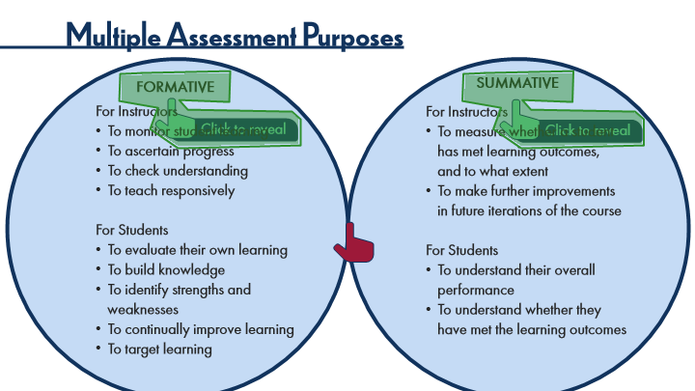

Type | Translation
Slide name | Overlapping Purposes
Main Title 1 | Multiple Assessment Purposes
Text Box 6 | SUMMATIVE
Text Box 5 | FORMATIVE
Text Box 1: Formative Body - Normal state | For Instructors
 | To monitor student learning
 | To ascertain progress
 | To check understanding
 | To teach responsively
 | For Students
 | To evaluate their own learning
 | To build knowledge
 | To identify strengths and weaknesses
 | To continually improve learning
 | To target learning
Text Box 2: Summative Body - Normal state | For Instructors
 | To measure whether a student has met learning outcomes, and to what extent
 | To make further improvements in future iterations of the course
 | For Students
 | To understand their overall performance
 | To understand whether they have met the learning outcomes
Text Box 7 | Click to reveal
Text Box 8 | Click to reveal
Slide Notes | Paul Black (1998), who is often lauded as the forefather of these concepts, described the difference between these terms using the analogy of cooking. As a cook is making her soup, she occasionally tastes it to decide if it needs a bit more spices or ingredients. With each taste, she is assessing her soup and using that feedback to change or improve it - in other words, the cook is engaging in formative assessment. Once the soup is served to the customer, the customer tastes it and makes a final judgment about the quality of the soup - otherwise known as summative assessment.

Slide Layer: Instructions
Layer ID 🔒 | 67f4ab4e-3a9f-4f45-be9b-aa78e3d03109
Preview Image | 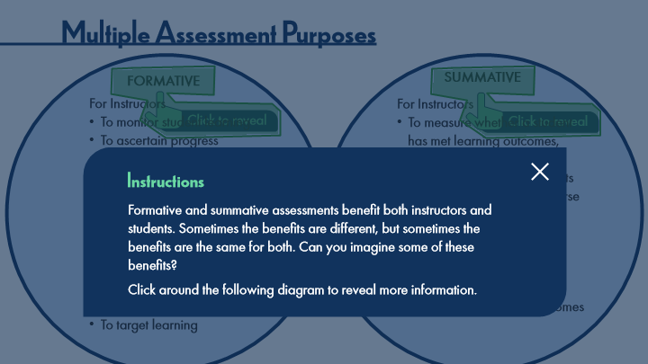

Type | Translation
Text Box 1 | Instructions
Text Box 2 | Formative and summative assessments benefit both instructors and students. Sometimes the benefits are different, but sometimes the benefits are the same for both. Can you imagine some of these benefits?
 | Click around the following diagram to reveal more information.

Slide Layer: Merge Circles
Layer ID 🔒 | 2916c9e2-c50f-4654-965b-89f6f9a36840
Preview Image | 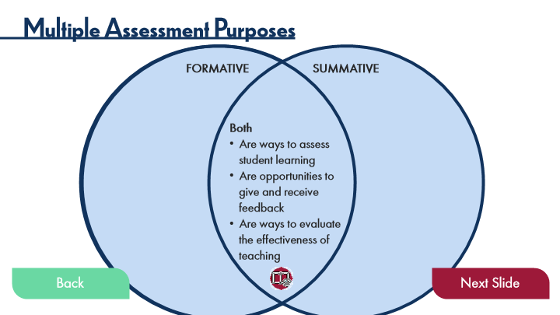

Type | Translation
Main Title 1 | Multiple Assessment Purposes
Text Box 1 | FORMATIVE
Text Box 2 | SUMMATIVE
Text Box 3 | Both
 | Are ways to assess student learning
 | Are opportunities to give and receive feedback
 | Are ways to evaluate the effectiveness of teaching
Button: - Normal state | Back
Button: - Down state | Back
Button: - Normal state | Next Slide

5.21 POV: Student Perspectives
Slide ID 🔒 | 576b8059-b4b0-4185-9f4f-af998332e3e0
Preview Image | 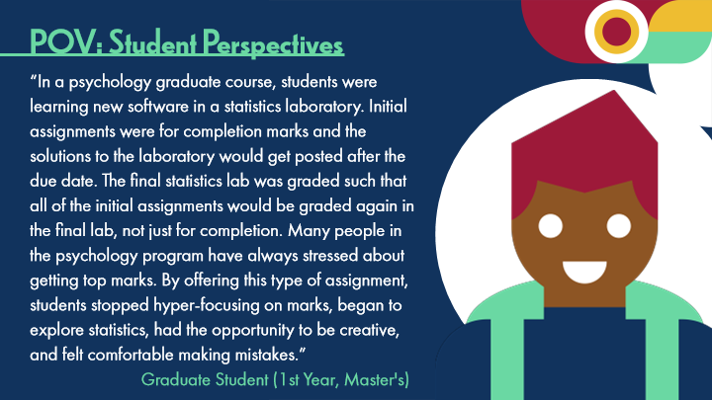

Type | Translation
Slide name | POV: Student Perspectives
Main Title 1 | POV: Student Perspectives
Text Box 1 | “In a psychology graduate course, students were learning new software in a statistics laboratory. Initial assignments were for completion marks and the solutions to the laboratory would get posted after the due date. The final statistics lab was graded such that all of the initial assignments would be graded again in the final lab, not just for completion. Many people in the psychology program have always stressed about getting top marks. By offering this type of assignment, students stopped hyper-focusing on marks, began to explore statistics, had the opportunity to be creative, and felt comfortable making mistakes.”
Text Box 2 | Graduate Student (1st Year, Master's)

5.22 Experienced Practitioners on Multiple Assessment Purposes
Slide ID 🔒 | 8deac504-8e1f-47fd-ac8e-9ba31b8026e7
Preview Image | 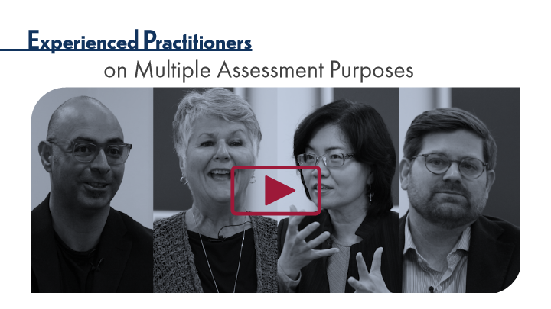

Type | Translation
Slide name | Experienced Practitioners on Multiple Assessment Purposes
Main Title 1 | Experienced Practitioners
Main Title 2 | on Multiple Assessment Purposes

5.23 Thinking Forward: Assessment Purposes
Slide ID 🔒 | 7eee381c-3712-4c4a-a525-acdeebb0febc
Preview Image | 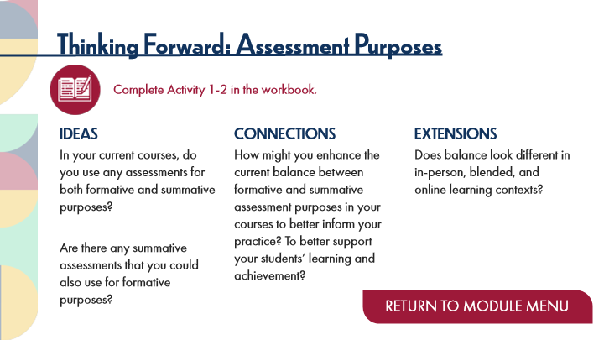

Type | Translation
Slide name | Thinking Forward: Assessment Purposes
Main Title 1 | Thinking Forward: Assessment Purposes
Text Box 7 | Complete Activity 1-2 in the workbook.
Text Box 1 | IDEAS
 | In your current courses, do you use any assessments for both formative and summative purposes?
 | Are there any summative assessments that you could also use for formative purposes?
Text Box 2 | CONNECTIONS
 | How might you enhance the current balance between formative and summative assessment purposes in your courses to better inform your practice? To better support your students’ learning and achievement?
Text Box 3 | EXTENSIONS
 | Does balance look different in in-person, blended, and online learning contexts?
Button - Normal state | RETURN TO MODULE MENU

6 Topic 2: Assessment Processes
Scene ID 🔒 | 201ace7f-196c-4b81-8251-d1cdbfc5dda5

Type | Translation
Scene name | Topic 2: Assessment Processes

6.1 Assessment Processes Title Page
Slide ID 🔒 | 1dc25b36-fc04-406f-9650-a7882840c4ea
Preview Image | 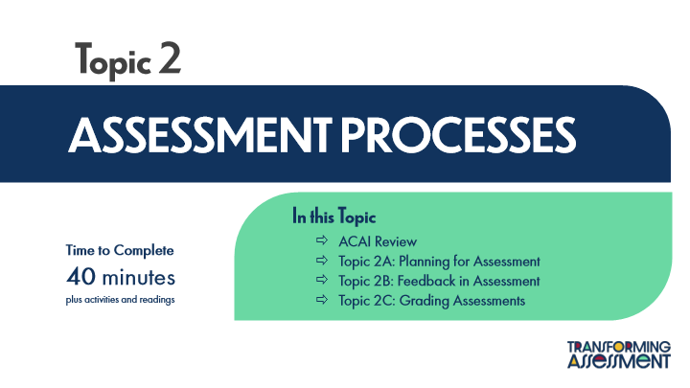

Type | Translation
Slide name | Assessment Processes Title Page
Main Title 1 | Topic 2
Main Title | ASSESSMENT PROCESSES
Text Box 1 | In this Topic
 | ACAI Review
 | Topic 2A: Planning for Assessment
 | Topic 2B: Feedback in Assessment
 | Topic 2C: Grading Assessments
Text Box 2 | Time to Complete
 | 40 minutes
 | plus activities and readings

6.2 ACAI Review: Assessment Processes
Slide ID 🔒 | cb98269f-8dcf-4cf7-92ed-bcb6a95f74b9
Preview Image | 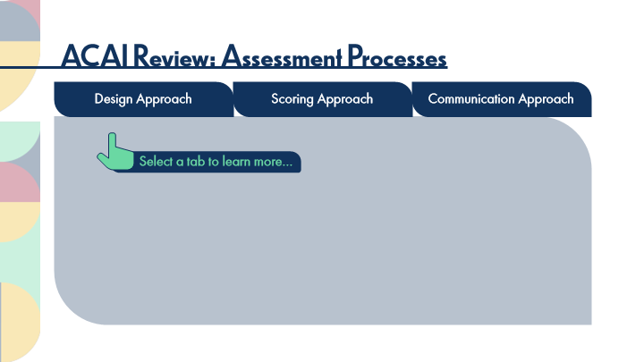

Type | Translation
Slide name | ACAI Review: Assessment Processes
Main Title | ACAI Review: Assessment Processes
tab button 1 - Normal state | Design Approach
tab button 2 - Normal state | Scoring Approach
tab button 3 - Normal state | Communication Approach
Text Box 1 | Select a tab to learn more…

Slide Layer: Design
Layer ID 🔒 | 54ec14d4-d5ac-4ff5-8234-4450c7dfe638
Preview Image | 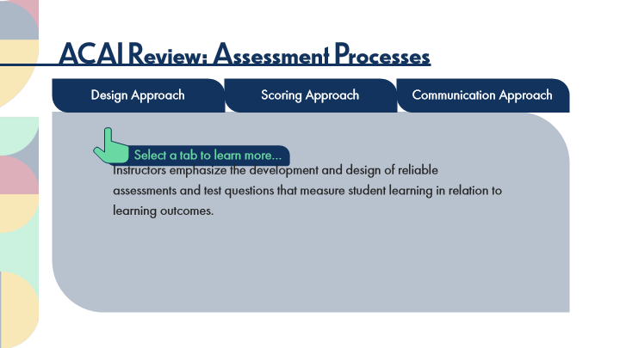

Type | Translation
Main Body 1 | Instructors emphasize the development and design of reliable assessments and test questions that measure student learning in relation to learning outcomes.

Slide Layer: Administration
Layer ID 🔒 | 0a504626-de31-4cab-af17-7d634fa9556c
Preview Image | 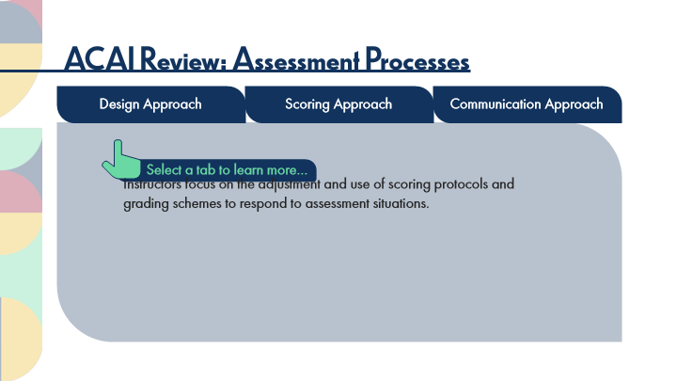

Type | Translation
Main Body 2 | Instructors focus on the adjustment and use of scoring protocols and grading schemes to respond to assessment situations.

Slide Layer: Communication
Layer ID 🔒 | 3e3d7e68-e408-4fee-bcc5-f03f55adade2
Preview Image | 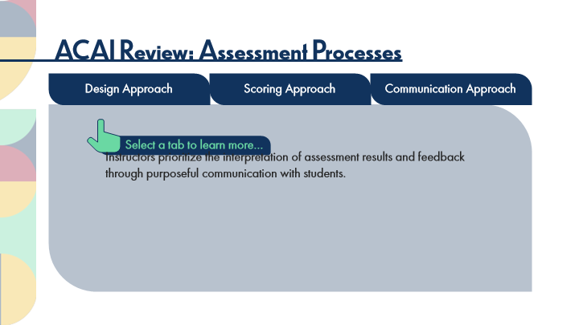

Type | Translation
Main Body 2 | Instructors prioritize the interpretation of assessment results and feedback through purposeful communication with students.

6.3 ACAI Reflections: Assessment Processes
Slide ID 🔒 | c1fe3ea5-d970-4bff-912d-bb78120cf6fa
Preview Image | 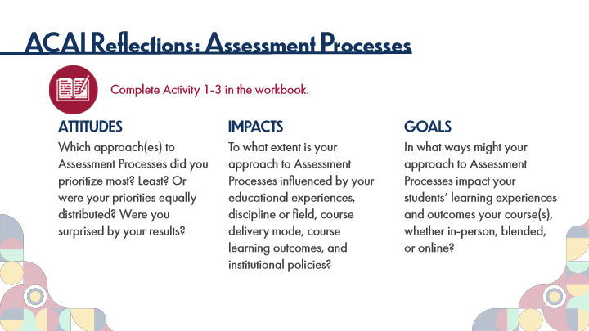

Type | Translation
Slide name | ACAI Reflections: Assessment Processes
Main Title 1 | ACAI Reflections: Assessment Processes
Text Box 1 | Complete Activity 1-3 in the workbook.
Text Box 2 | ATTITUDES
 | Which approach(es) to Assessment Processes did you prioritize most? Least? Or were your priorities equally distributed? Were you surprised by your results?
Text Box 3 | IMPACTS
 | To what extent is your approach to Assessment Processes influenced by your educational experiences, discipline or field, course delivery mode, course learning outcomes, and institutional policies?
Text Box 4 | GOALS
 | In what ways might your approach to Assessment Processes impact your students’ learning experiences and outcomes your course(s), whether in-person, blended, or online?

6.4 Key Points: Assessment Processes
Slide ID 🔒 | 1b560e3f-9ec3-4d1b-9baa-6db94e0dd827
Preview Image | 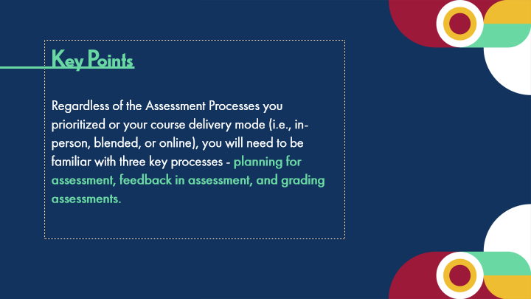

Type | Translation
Slide name | Key Points: Assessment Processes
Body | Key Points
 | Regardless of the Assessment Processes you prioritized or your course delivery mode (i.e., in-person, blended, or online), you will need to be familiar with three key processes -
 | planning for assessment, feedback in assessment, and grading assessments.

6.5 Topic 2A: Planning for Assessment
Slide ID 🔒 | 23fe78cf-2250-4480-a4c2-5469f6ef3d10
Preview Image | 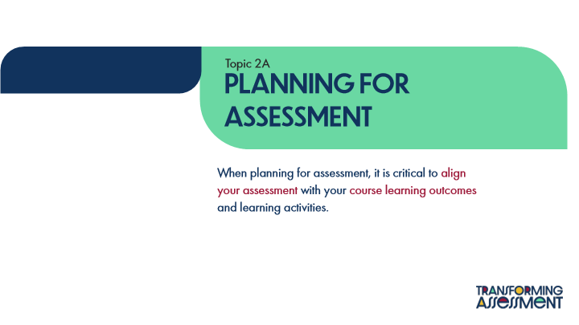

Type | Translation
Slide name | Topic 2A: Planning for Assessment
Text Box 1 | Topic 2A
Main Title | Planning for
 | Assessment
Main Body | When planning for assessment, it is critical to
 | align your assessment
 | with your
 | course learning outcomes
 | and learning activities.

6.6 What are learning outcomes?
Slide ID 🔒 | f69988b4-f79e-44fe-a178-b562aa73b741
Preview Image | 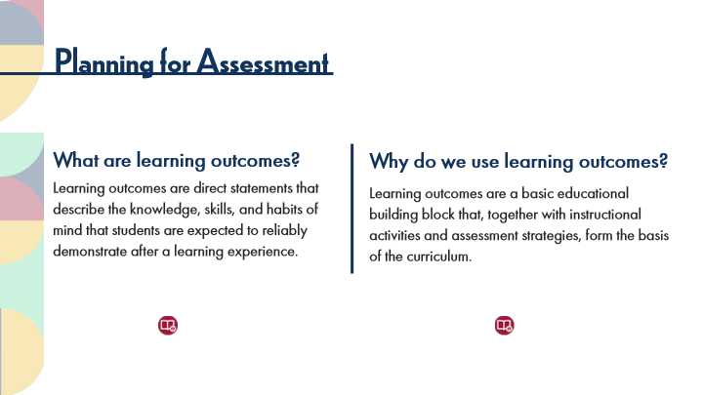

Type | Translation
Slide name | What are learning outcomes?
Main Title 1 | Planning for Assessment
Text Box 1 | What are learning outcomes?
 | Learning outcomes are direct statements that describe the knowledge, skills, and habits of mind that students are expected to reliably demonstrate after a learning experience.
Text Box 2 | Why do we use learning outcomes?
 | Learning outcomes are a basic educational building block that, together with instructional activities and assessment strategies, form the basis of the curriculum.

6.7 How do learning outcomes help?
Slide ID 🔒 | c596312f-96af-44d5-a87f-64fe6da4816d
Preview Image | 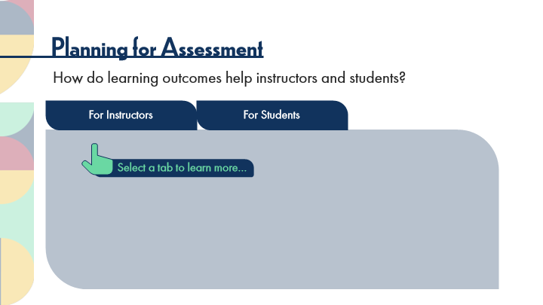

Type | Translation
Slide name | How do learning outcomes help?
Main Title 1 | Planning for Assessment
Text Box 1 | How do learning outcomes help instructors and students?
Tab Button 1 - Normal state | For Instructors
Tab Button 2 - Normal state | For Students
Text Box 2 | Select a tab to learn more…

Slide Layer: For Instructors
Layer ID 🔒 | 4b258784-a04e-4cf7-91f5-5c7dc45fe1bc
Preview Image | 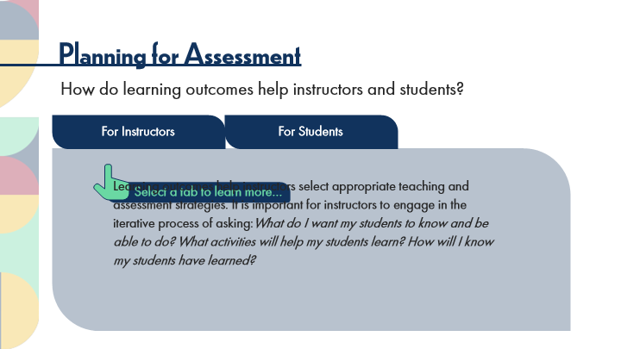

Type | Translation
Main Body 1 | Learning outcomes help instructors select appropriate teaching and assessment strategies. It is important for instructors to engage in the iterative process of asking:What do I want my students to know and be able to do? What activities will help my students learn? How will I know my students have learned?

Slide Layer: For Students
Layer ID 🔒 | a050dd9d-18a8-424d-a3c1-9bf051e31d92
Preview Image | 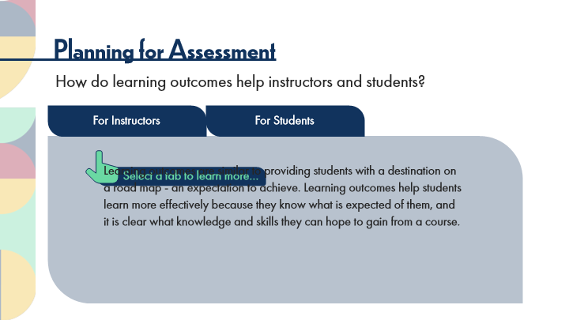

Type | Translation
Main Body 1 | Learning outcomes are similar to providing students with a destination on a road map - an expectation to achieve. Learning outcomes help students learn more effectively because they know what is expected of them, and it is clear what knowledge and skills they can hope to gain from a course.

6.8 Activity: Planning For Assessment Instructions
Slide ID 🔒 | dd90d9d9-5e82-4d41-a56e-4af39ccb60e0
Preview Image | 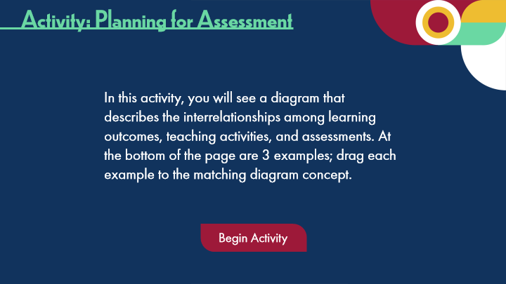

Type | Translation
Slide name | Activity: Planning For Assessment Instructions
Main Title 1 | Activity: Planning for Assessment
Text Box 1 | In this activity, you will see a diagram that describes the interrelationships among learning outcomes, teaching activities, and assessments. At the bottom of the page are 3 examples; drag each example to the matching diagram concept.
Round Diagonal Corner 1 - Normal state | Begin Activity

6.9 Activity: Planning For Assessment
Slide ID 🔒 | 5c4b017a-950f-486f-afdb-47b846544599
Preview Image | 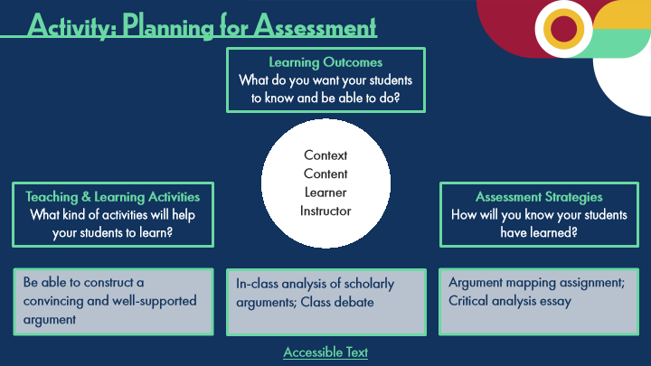

Type | Translation
Slide name | Activity: Planning For Assessment
Main Title 1 | Activity: Planning for Assessment
Text Box 2 | Learning Outcomes
 | What do you want your students to know and be able to do?
Text Box 1 | Context
 | Content
 | Learner
 | Instructor
Text Box 3 | Teaching & Learning Activities
 | What kind of activities will help your students to learn?
Text Box 4 | Assessment Strategies
 | How will you know your students have learned?
Text Box 5 | Be able to construct a convincing and well-supported argument
Text Box 6 | Argument mapping assignment;
 | Critical analysis essay
Text Box 7 | In-class analysis of scholarly arguments; Class debate
Text Box 8 | Accessible Text
Alt text for Text Box 8 | Accessible Activity Text Link. If you are not using a mouse for this course, skip this activity and access the PDF.

Slide Layer: Correct
Layer ID 🔒 | b6d34c9b-89ad-49bf-ae0c-05713866d988
Preview Image | 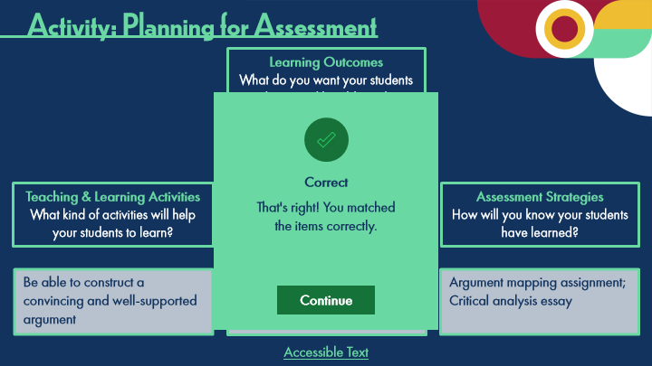

Type | Translation
Text Box | Correct
Text Box | That's right! You matched
 | the items correctly.

Slide Layer: Incorrect
Layer ID 🔒 | c42b298e-1025-4706-94de-899360be7721
Preview Image | 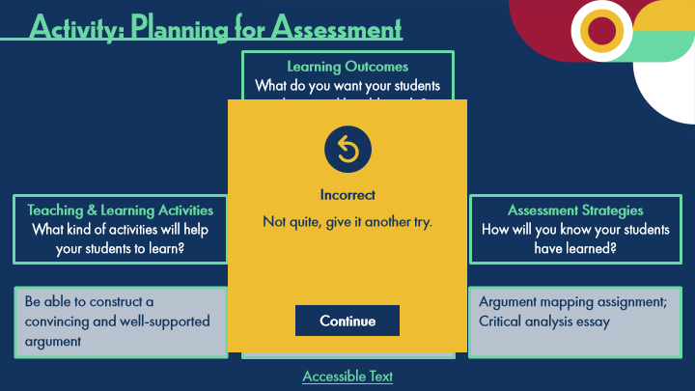

Type | Translation
Text Box | Incorrect
Text Box | Not quite, give it another try.

6.10 Experienced Practitioners on Planning for Assessment
Slide ID 🔒 | 082bacf8-5d9f-4f56-97e1-d8fdcd8882ca
Preview Image | 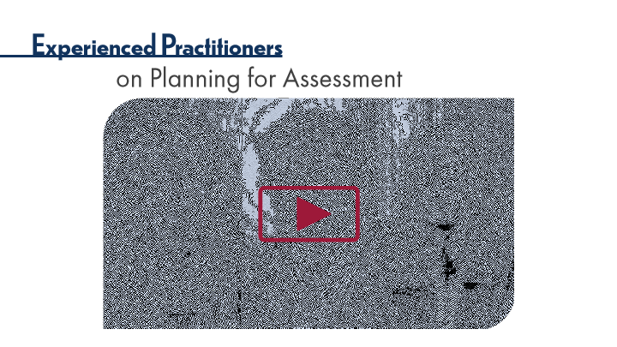

Type | Translation
Slide name | Experienced Practitioners on Planning for Assessment
Main Title 1 | Experienced Practitioners
Main Title 2 | on Planning for Assessment

6.11 Topic 2B: Feedback in Assessment
Slide ID 🔒 | 83314bd9-8df5-44c0-8d71-8c423d8b972f
Preview Image | 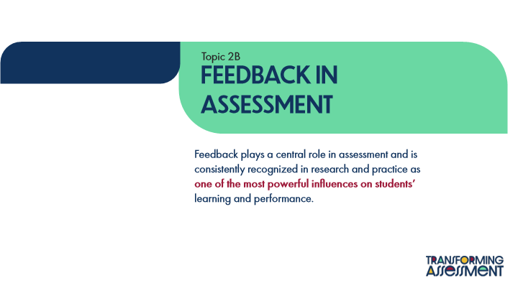

Type | Translation
Slide name | Topic 2B: Feedback in Assessment
Text Box 1 | Topic 2B
Main Title 1 | Feedback in
 | Assessment
Main Body | Feedback plays a central role in assessment and is consistently recognized in research and practice as
 | one of the most powerful influences on students’
 | learning and performance.

6.12 Defining Feedback
Slide ID 🔒 | 277aae14-da1e-4bbf-a2f1-35ed27238589
Preview Image | 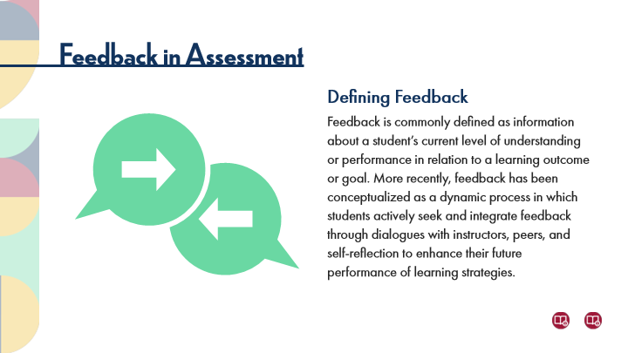

Type | Translation
Slide name | Defining Feedback
Main Title 1 | Feedback in Assessment
Text Box 1 | Defining Feedback
 | Feedback is commonly defined as information about a student’s current level of understanding or performance in relation to a learning outcome or goal. More recently, feedback has been conceptualized as a dynamic process in which students actively seek and integrate feedback through dialogues with instructors, peers, and self-reflection to enhance their future performance of learning strategies.

6.13 Quote
Slide ID 🔒 | 6f39e51b-7dc0-48a9-8551-6f79de0fd836
Preview Image | 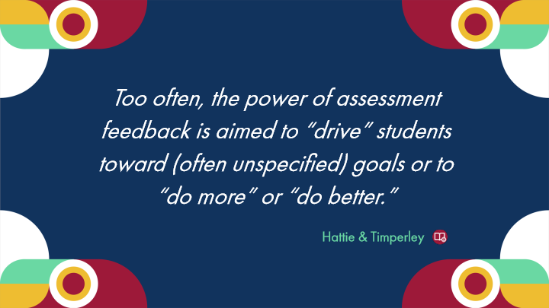

Type | Translation
Slide name | Quote
Text Box 1 | Too often, the power of assessment feedback is aimed to “drive” students toward (often unspecified) goals or to “do more” or “do better.”
Text Box 2 | Hattie & Timperley

6.14 Experienced Practitioners on Feedback in Assessment
Slide ID 🔒 | ecaa8d66-4ae8-4a5b-8a4b-4afd3e511ad2
Preview Image | 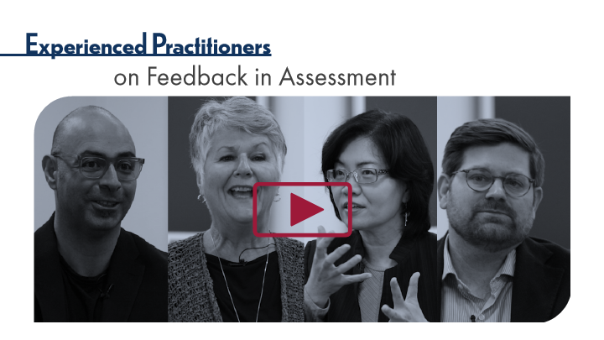

Type | Translation
Slide name | Experienced Practitioners on Feedback in Assessment
Main Title 1 | Experienced Practitioners
Main Title 2 | on Feedback in Assessment

6.15 Characteristics of Feedback
Slide ID 🔒 | 3d986803-f62d-40c8-8393-fa20934336aa
Preview Image | 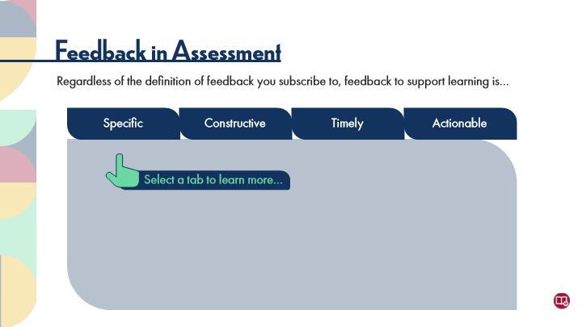

Type | Translation
Slide name | Characteristics of Feedback
Main Title 1 | Feedback in Assessment
Text Box 1 | Regardless of the definition of feedback you subscribe to, feedback to support learning is…
tab button 1 - Normal state | Specific
tab button 2 - Normal state | Constructive
tab button 3 - Normal state | Timely
tab button 4 - Normal state | Actionable
Text Box 2 | Select a tab to learn more…

Slide Layer: Specific
Layer ID 🔒 | 59ac5b98-702a-4c87-b4be-198e98b5dd1a
Preview Image | 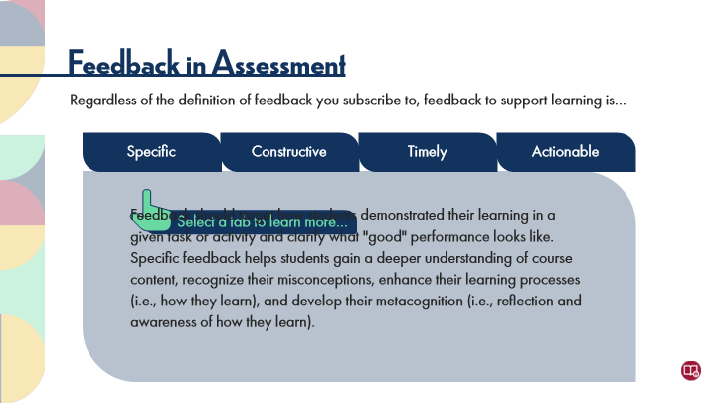

Type | Translation
Main Body 1 | Feedback should target how students demonstrated their learning in a given task or activity and clarify what "good" performance looks like. Specific feedback helps students gain a deeper understanding of course content, recognize their misconceptions, enhance their learning processes (i.e., how they learn), and develop their metacognition (i.e., reflection and awareness of how they learn).

Slide Layer: Constructive
Layer ID 🔒 | 9116b6bf-66ca-4a3c-a218-366162651cbc
Preview Image | 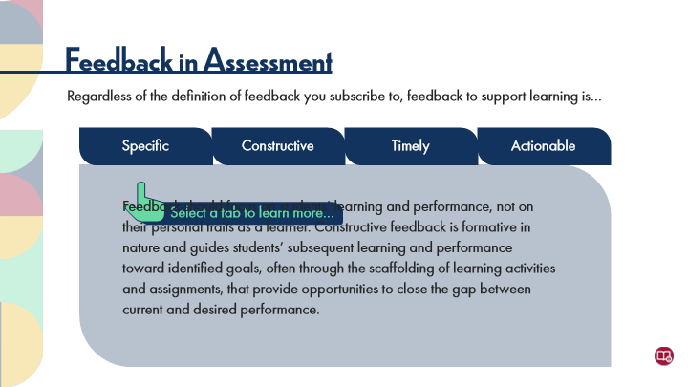

Type | Translation
Main Body 1 | Feedback should focus on students’ learning and performance, not on their personal traits as a learner. Constructive feedback is formative in nature and guides students’ subsequent learning and performance toward identified goals, often through the
 | scaffolding
 | of learning activities and assignments, that provide opportunities to close the gap between current and desired performance.

Slide Layer: Timely
Layer ID 🔒 | 640aea6e-da7a-4ebf-8b39-df2925090afb
Preview Image | 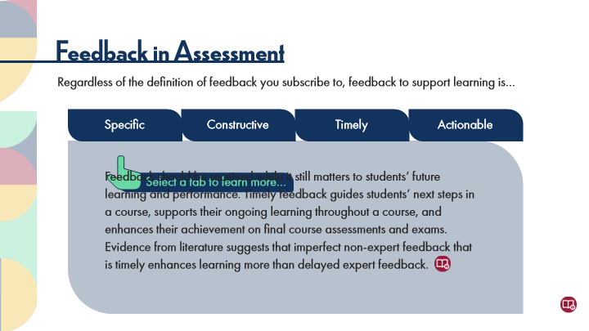

Type | Translation
Main Body 1 | Feedback should be received while it still matters to students’ future learning and performance. Timely feedback guides students’ next steps in a course, supports their ongoing learning throughout a course, and enhances their achievement on final course assessments and exams. Evidence from literature suggests that imperfect non-expert feedback that is timely enhances learning more than delayed expert feedback.

Slide Layer: Actionable
Layer ID 🔒 | b4aa3f0c-3aeb-4189-8c26-38e3887d6d98
Preview Image | 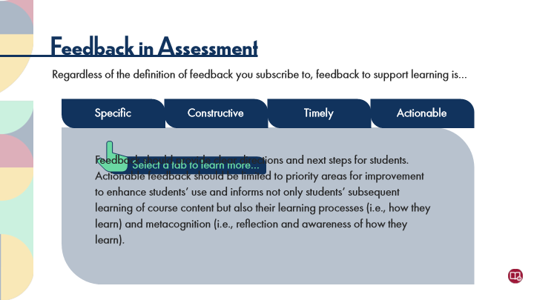

Type | Translation
Main Body 1 | Feedback should provide clear directions and next steps for students. Actionable feedback should be limited to priority areas for improvement to enhance students’ use and informs not only students’ subsequent learning of course content but also their learning processes (i.e., how they learn) and metacognition (i.e., reflection and awareness of how they learn).

6.16 Quote
Slide ID 🔒 | 61dcc6cc-bf6e-4c43-83ae-271accde2cdf
Preview Image | 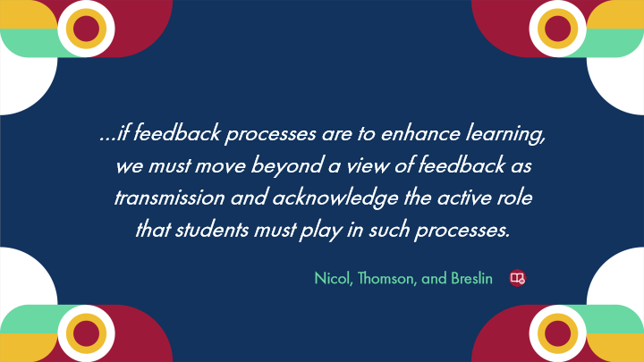

Type | Translation
Slide name | Quote
Text Box 1 | …if feedback processes are to enhance learning, we must move beyond a view of feedback as transmission and acknowledge the active role that students must play in such processes.
Text Box 2 | Nicol, Thomson, and Breslin

6.17 Sources of Feedback
Slide ID 🔒 | fd5aef3d-d55d-49d3-b43d-9bc43522c7f2
Preview Image | 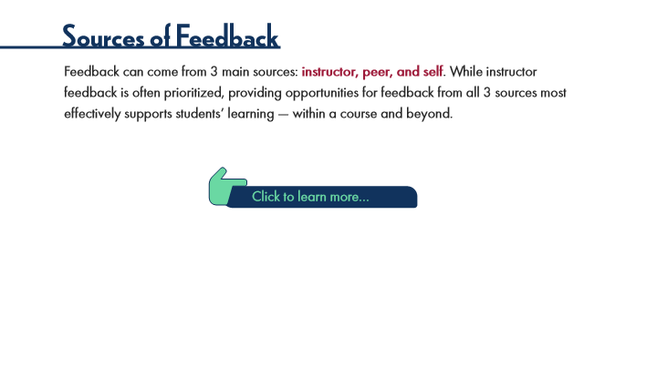

Type | Translation
Slide name | Sources of Feedback
Main Title 1 | Sources of Feedback
Text Box 1 | Feedback can come from 3 main sources:
 | instructor, peer, and self
 | . While instructor feedback is often prioritized, providing opportunities for feedback from all 3 sources most effectively supports students’ learning — within a course and beyond.
Text Box 2 | Click to learn more…

Slide Layer: Definitions
Layer ID 🔒 | 83047560-7e88-4d12-a658-be399f32f41e
Preview Image | 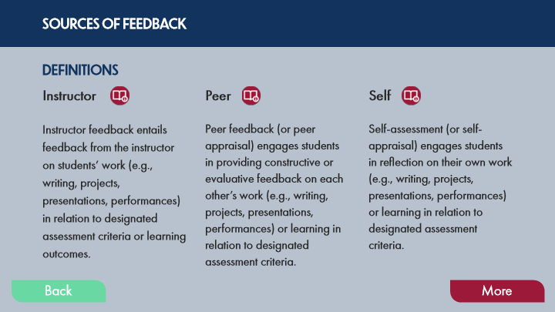

Type | Translation
Text Box 8 | SOURCES OF FEEDBACK
Text Box 4 | DEFINITIONS
Text Box 1 | Instructor
Text Box 2 | Peer
Text Box 3 | Self
Text Box 5 | Instructor feedback entails feedback from the instructor on students’ work (e.g., writing, projects, presentations, performances) in relation to designated assessment criteria or learning outcomes.
Text Box 6 | Peer feedback (or peer appraisal) engages students in providing constructive or evaluative feedback on each other’s work (e.g., writing, projects, presentations, performances) or learning in relation to designated assessment criteria.
Text Box 7 | Self-assessment (or self-appraisal) engages students in reflection on their own work (e.g., writing, projects, presentations, performances) or learning in relation to designated assessment criteria.
Button - Normal state | Back
Button - Down state | Back
Button - Normal state | More

Slide Layer: Purpose
Layer ID 🔒 | 3d4b5f75-4ae3-4a92-ab3b-ede92623f132
Preview Image | 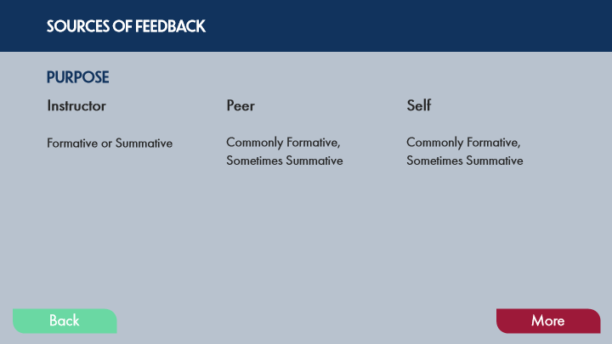

Type | Translation
Text Box 8 | SOURCES OF FEEDBACK
Text Box 4 | PURPOSE
Text Box 1 | Instructor
Text Box 2 | Peer
Text Box 3 | Self
Text Box 5 | Formative or Summative
Text Box 6 | Commonly Formative, Sometimes Summative
Text Box 7 | Commonly Formative, Sometimes Summative
Button - Normal state | Back
Button - Down state | Back
Button - Normal state | More

Slide Layer: Examples
Layer ID 🔒 | d1b737cf-0434-4073-864f-39b610f119ab
Preview Image | 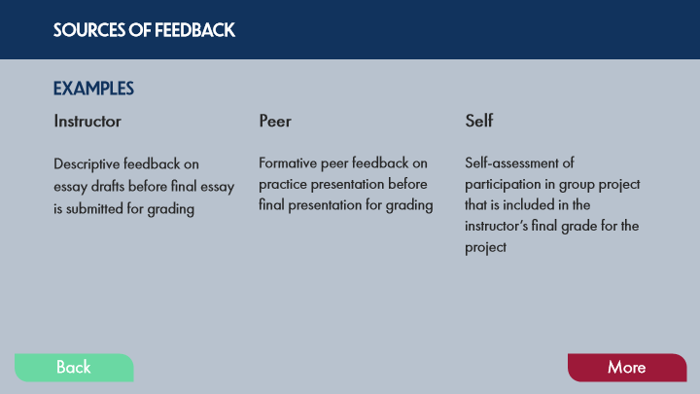

Type | Translation
Text Box 8 | SOURCES OF FEEDBACK
Text Box 4 | EXAMPLES
Text Box 1 | Instructor
Text Box 2 | Peer
Text Box 3 | Self
Text Box 5 | Descriptive feedback on essay drafts before final essay is submitted for grading
Text Box 6 | Formative peer feedback on practice presentation before final presentation for grading
Text Box 7 | Self-assessment of participation in group project that is included in the instructor’s final grade for the project
Button - Normal state | Back
Button - Down state | Back
Button - Normal state | More

Slide Layer: Benefits of Instructor
Layer ID 🔒 | 9f5e8e91-83a5-47b5-9f55-2755ac2dd4b8
Preview Image | 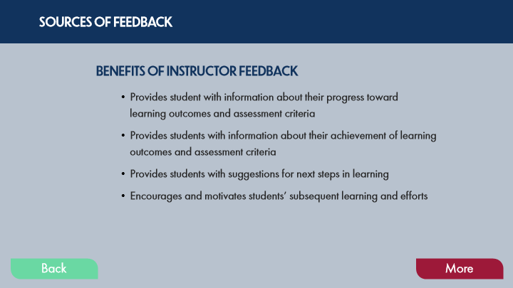

Type | Translation
Text Box 8 | SOURCES OF FEEDBACK
Text Box 4 | BENEFITS OF INSTRUCTOR FEEDBACK
Text Box 5 | Provides student with information about their progress toward learning outcomes and assessment criteria
 | Provides students with information about their achievement of learning outcomes and assessment criteria
 | Provides students with suggestions for next steps in learning
 | Encourages and motivates students’ subsequent learning and efforts
Button - Normal state | Back
Button - Down state | Back
Button - Normal state | More

Slide Layer: Benefits of Peer
Layer ID 🔒 | 0d89cb32-afb7-4391-8261-d52f5e4266f6
Preview Image | 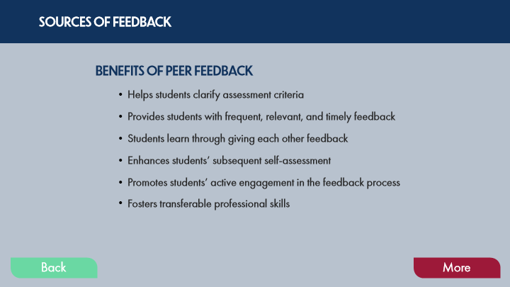

Type | Translation
Text Box 8 | SOURCES OF FEEDBACK
Text Box 4 | BENEFITS OF PEER FEEDBACK
Text Box 5 | Helps students clarify assessment criteria
 | Provides students with frequent, relevant, and timely feedback
 | Students learn through giving each other feedback
 | Enhances students’ subsequent self-assessment
 | Promotes students’ active engagement in the feedback process
 | Fosters transferable professional skills
Button - Normal state | Back
Button - Down state | Back
Button - Normal state | More

Slide Layer: Benefits of Self
Layer ID 🔒 | 50677082-b86f-408c-9634-798364f355e3
Preview Image | 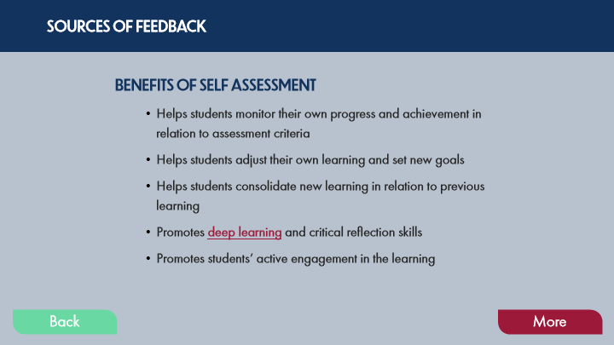

Type | Translation
Text Box 8 | SOURCES OF FEEDBACK
Text Box 4 | BENEFITS OF SELF ASSESSMENT
Text Box 5 | Helps students monitor their own progress and achievement in relation to assessment criteria
 | Helps students adjust their own learning and set new goals
 | Helps students consolidate new learning in relation to previous learning
 | Promotes
 | deep learning
 | and critical reflection skills
 | Promotes students’ active engagement in the learning
Button - Normal state | Back
Button - Down state | Back
Button - Normal state | More

Slide Layer: Closing
Layer ID 🔒 | 2c7a7efa-3933-410d-bc56-b10a894c1feb
Preview Image | 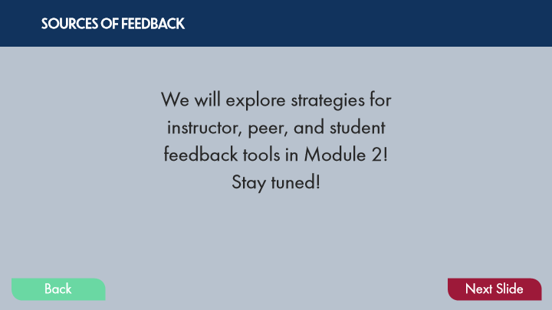

Type | Translation
Text Box 8 | SOURCES OF FEEDBACK
Text Box 9 | We will explore strategies for instructor, peer, and student feedback tools in Module 2! Stay tuned!
Button - Normal state | Back
Button - Down state | Back
Button - Normal state | Next Slide

Slide Layer: Rollover: Deep Learning
Layer ID 🔒 | a5102281-750a-4090-bbf2-c09c3a65d9b2
Preview Image | 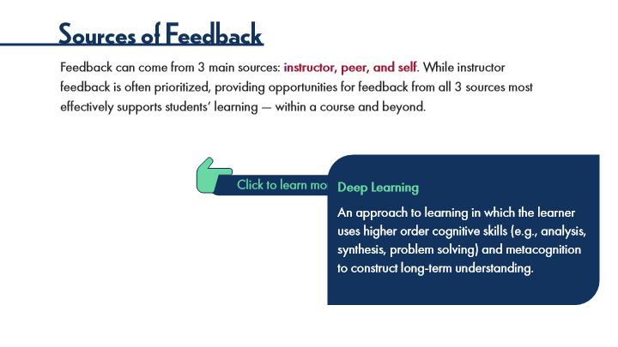

Type | Translation
Text Box 1 | Deep Learning
 | An approach to learning in which the learner uses higher order cognitive skills (e.g., analysis, synthesis, problem solving) and metacognition to construct long-term understanding.

6.18 POV: Student Perspectives
Slide ID 🔒 | cf388ccb-e4b5-4c91-8200-8a05e9057b26
Preview Image | 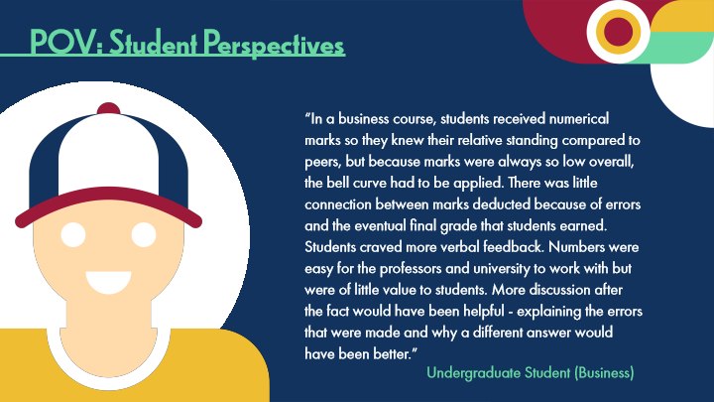

Type | Translation
Slide name | POV: Student Perspectives
Main Title 1 | POV: Student Perspectives
Text Box 1 | “In a business course, students received numerical marks so they knew their relative standing compared to peers, but because marks were always so low overall, the bell curve had to be applied. There was little connection between marks deducted because of errors and the eventual final grade that students earned. Students craved more verbal feedback. Numbers were easy for the professors and university to work with but were of little value to students. More discussion after the fact would have been helpful - explaining the errors that were made and why a different answer would have been better.”
Text Box 2 | Undergraduate Student (Business)

6.19 Experienced Practitioners on Feedback in Online Contexts
Slide ID 🔒 | 99212705-ec2d-4353-98f9-9c7ad8be6738
Preview Image | 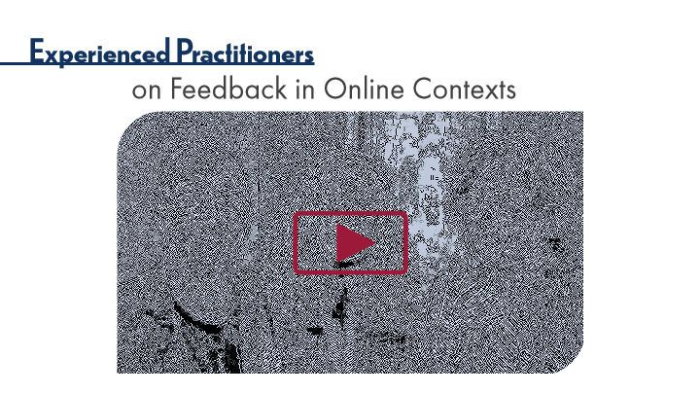

Type | Translation
Slide name | Experienced Practitioners on Feedback in Online Contexts
Main Title 1 | Experienced Practitioners
Main Title 2 | on Feedback in Online Contexts

6.20 Pause and Reflect on Feedback
Slide ID 🔒 | 15d43fda-c72a-484b-b7d9-b6962c4d2173
Preview Image | 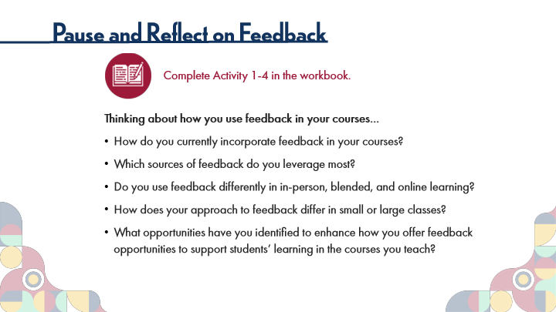

Type | Translation
Slide name | Pause and Reflect on Feedback
Main Title 1 | Pause and Reflect on Feedback
Text Box 6 | Complete Activity 1-4 in the workbook.
Text Box 7 | Thinking about how you use feedback in your courses…
 | How do you currently incorporate feedback in your courses?
 | Which sources of feedback do you leverage most?
 | Do you use feedback differently in in-person, blended, and online learning?
 | How does your approach to feedback differ in small or large classes?
 | What opportunities have you identified to enhance how you offer feedback opportunities to support students’ learning in the courses you teach?

6.21 Topic 2C: Grading Assessments
Slide ID 🔒 | ebc24d79-d962-4486-b82e-faad091d932c
Preview Image | 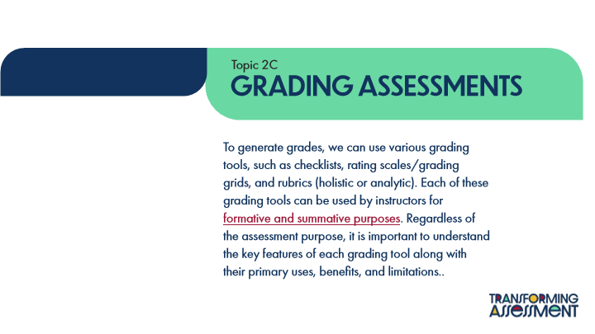

Type | Translation
Slide name | Topic 2C: Grading Assessments
Text Box 1 | Topic 2C
Main Title | Grading Assessments
Main Body | To generate grades, we can use various grading tools, such as checklists, rating scales/grading grids, and rubrics (holistic or analytic). Each of these grading tools can be used by instructors for
 | formative and summative purposes
 | . Regardless of the assessment purpose, it is important to understand the key features of each grading tool along with their primary uses, benefits, and limitations..

Slide Layer: Rollover: See Module 1
Layer ID 🔒 | 5c7e4a11-818f-403a-98dc-c88499ec7f4b
Preview Image | 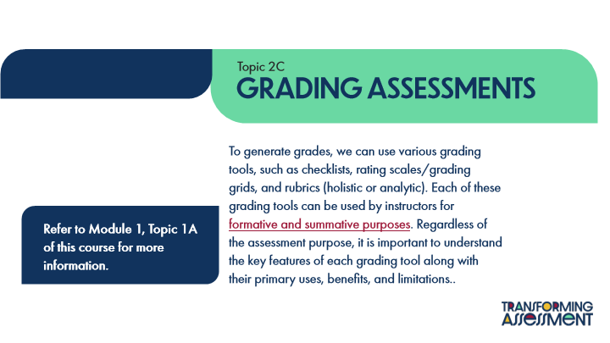

Type | Translation
Text Box 1 | Refer to Module 1, Topic 1A of this course for more information.

6.22 Grading Tools
Slide ID 🔒 | 96eae04c-ed78-4109-a379-dcc1fc58b13d
Preview Image | 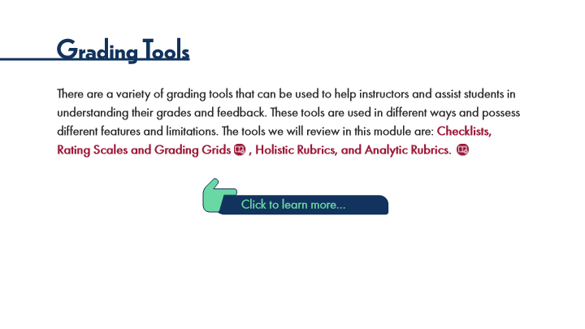

Type | Translation
Slide name | Grading Tools
Main Title 1 | Grading Tools
Text Box 3 | There are a variety of grading tools that can be used to help instructors and assist students in understanding their grades and feedback. These tools are used in different ways and possess different features and limitations. The tools we will review in this module are:
 | Checklists, Rating Scales and Grading Grids , Holistic Rubrics, and Analytic Rubrics.
Text Box 2 | Click to learn more…

Slide Layer: Analytic Rubrics
Layer ID 🔒 | 5bada911-860c-4244-8e30-5bf8ef44f47d
Preview Image | 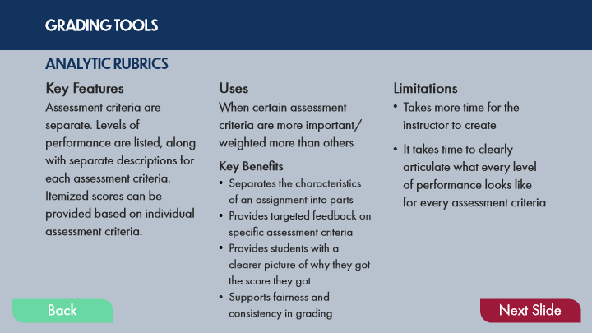

Type | Translation
Text Box 8 | GRADING TOOLS
Text Box 4 | ANALYTIC RUBRICS
Text Box 1 | Key Features
Text Box 2 | Uses
Text Box 3 | Limitations
Text Box 5 | Assessment criteria are separate. Levels of performance are listed, along with separate descriptions for each assessment criteria. Itemized scores can be provided based on individual assessment criteria.
Text Box 6 | When certain assessment criteria are more important/weighted more than others
 | Key Benefits
 | Separates the characteristics of an assignment into parts
 | Provides targeted feedback on specific assessment criteria
 | Provides students with a clearer picture of why they got the score they got
 | Supports fairness and consistency in grading
Text Box 7 | Takes more time for the instructor to create
 | It takes time to clearly articulate what every level of performance looks like for every assessment criteria
Round Diagonal Corner 2 - Normal state | Back
Round Diagonal Corner 2 - Down state | Back
Round Diagonal Corner 1 - Normal state | Next Slide

Slide Layer: Holistic Rubrics
Layer ID 🔒 | 7a4f9ba3-20bc-469c-86ac-aedaadd8ccce
Preview Image | 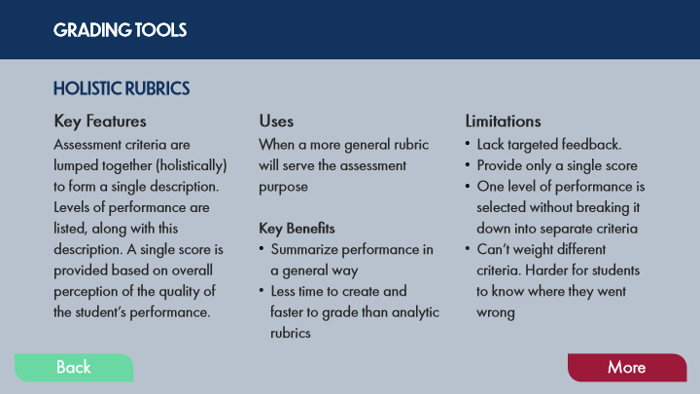

Type | Translation
Text Box 8 | GRADING TOOLS
Text Box 4 | HOLISTIC RUBRICS
Text Box 1 | Key Features
Text Box 2 | Uses
Text Box 3 | Limitations
Text Box 5 | Assessment criteria are lumped together (holistically) to form a single description.
 | Levels of performance are listed, along with this description. A single score is provided based on overall perception of the quality of the student’s performance.
Text Box 6 | When a more general rubric will serve the assessment purpose
 | Key Benefits
 | Summarize performance in a general way
 | Less time to create and faster to grade than analytic rubrics
Text Box 7 | Lack targeted feedback.
 | Provide only a single score
 | One level of performance is selected without breaking it down into separate criteria
 | Can’t weight different criteria. Harder for students to know where they went wrong
Round Diagonal Corner 2 - Normal state | Back
Round Diagonal Corner 2 - Down state | Back
Round Diagonal Corner 1 - Normal state | More

Slide Layer: Rating Scales and Grading Grids
Layer ID 🔒 | 91903e5d-6b21-4dbc-9f07-976054cd3700
Preview Image | 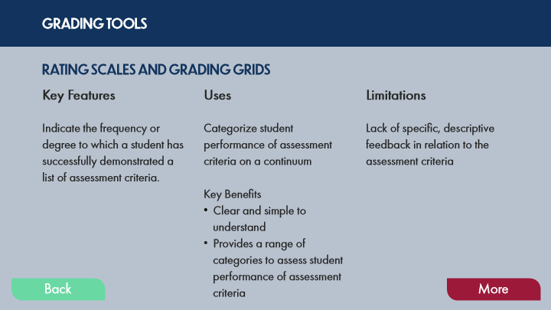

Type | Translation
Text Box 8 | GRADING TOOLS
Text Box 4 | RATING SCALES AND GRADING GRIDS
Text Box 1 | Key Features
Text Box 2 | Uses
Text Box 3 | Limitations
Text Box 5 | Indicate the frequency or degree to which a student has successfully demonstrated a list of assessment criteria.
Text Box 6 | Categorize student performance of assessment criteria on a continuum
 | Key Benefits
 | Clear and simple to understand
 | Provides a range of categories to assess student performance of assessment criteria
Text Box 7 | Lack of specific, descriptive feedback in relation to the assessment criteria
Round Diagonal Corner 2 - Normal state | Back
Round Diagonal Corner 2 - Down state | Back
Round Diagonal Corner 1 - Normal state | More

Slide Layer: Checklists
Layer ID 🔒 | d6ac5b86-0494-4c2a-bfb2-8c6f6968d238
Preview Image | 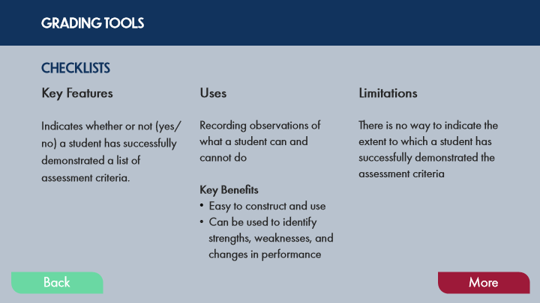

Type | Translation
Text Box 8 | GRADING TOOLS
Text Box 4 | CHECKLISTS
Text Box 1 | Key Features
Text Box 2 | Uses
Text Box 3 | Limitations
Text Box 5 | Indicates whether or not (yes/no) a student has successfully demonstrated a list of assessment criteria.
Text Box 6 | Recording observations of what a student can and cannot do
 | Key Benefits
 | Easy to construct and use
 | Can be used to identify strengths, weaknesses, and changes in performance
Text Box 7 | There is no way to indicate the extent to which a student has successfully demonstrated the assessment criteria
Round Diagonal Corner 2 - Normal state | Back
Round Diagonal Corner 2 - Down state | Back
Round Diagonal Corner 1 - Normal state | More

6.23 POV: Instructor Perspectives
Slide ID 🔒 | 820791d1-771e-4795-8833-cb6d9338bc02
Preview Image | 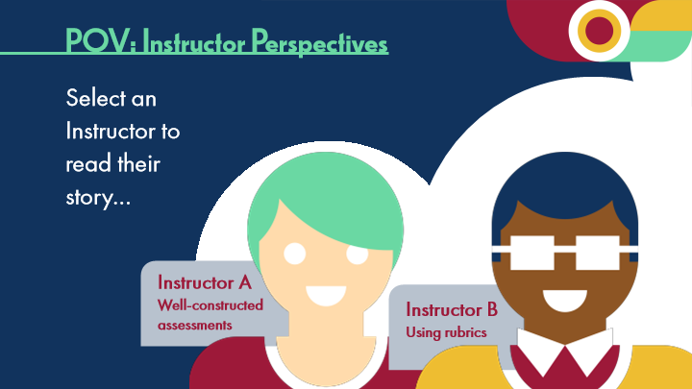

Type | Translation
Slide name | POV: Instructor Perspectives
Main Title 1 | POV: Instructor Perspectives
Text Box 3 | Select an Instructor to read their story…
Text Box 4 | Instructor A
 | Well-constructed assessments
Text Box 5 | Instructor B
 | Using rubrics

Slide Layer: Rollover: See Module 2
Layer ID 🔒 | 903ce760-051a-4d9c-8306-b3f48d8f13fe
Preview Image | 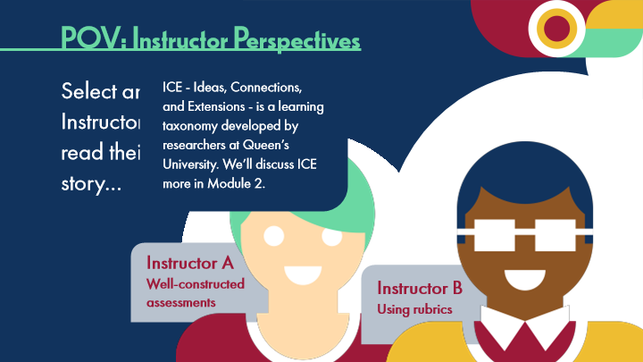

Type | Translation
Text Box 1 | ICE - Ideas, Connections, and Extensions - is a learning taxonomy developed by researchers at Queen’s University. We’ll discuss ICE more in Module 2.

Slide Layer: Occupational Therapy
Layer ID 🔒 | d990d489-5bcc-4a4a-bb8d-678abbdecb9b
Preview Image | 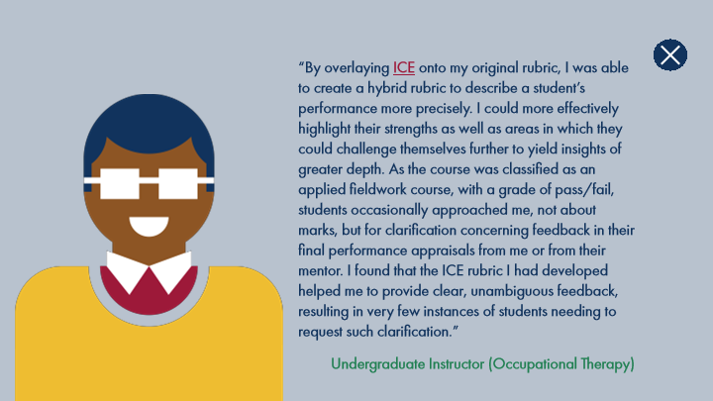

Type | Translation
Text Box 1 | “By overlaying
 | ICE
 | onto my original rubric, I was able to create a hybrid rubric to describe a student’s performance more precisely. I could more effectively highlight their strengths as well as areas in which they could challenge themselves further to yield insights of greater depth. As the course was classified as an applied fieldwork course, with a grade of pass/fail, students occasionally approached me, not about marks, but for clarification concerning feedback in their final performance appraisals from me or from their mentor. I found that the ICE rubric I had developed helped me to provide clear, unambiguous feedback, resulting in very few instances of students needing to request such clarification.”
Text Box 2 | Undergraduate Instructor (Occupational Therapy)

Slide Layer: Pathophysiology
Layer ID 🔒 | 66e816a3-2057-4f91-b315-bca0de5f53e4
Preview Image | 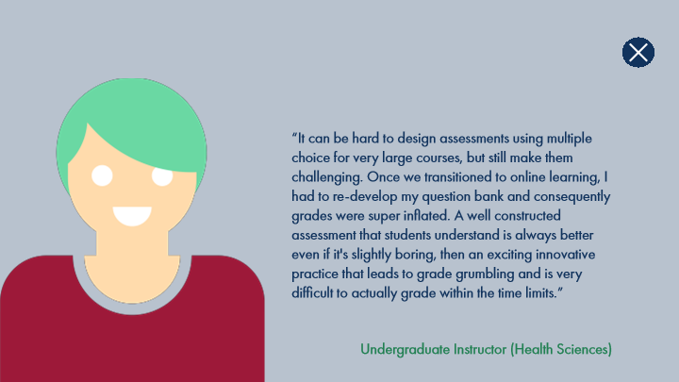

Type | Translation
Text Box 1 | “It can be hard to design assessments using multiple choice for very large courses, but still make them challenging. Once we transitioned to online learning, I had to re-develop my question bank and consequently grades were super inflated. A well constructed assessment that students understand is always better even if it's slightly boring, then an exciting innovative practice that leads to grade grumbling and is very difficult to actually grade within the time limits.”
Text Box 2 | Undergraduate Instructor (Health Sciences)

6.24 Experienced Practitioners on Grading Assessments
Slide ID 🔒 | c41f3e37-8997-4887-be89-8a8f054191f3
Preview Image | 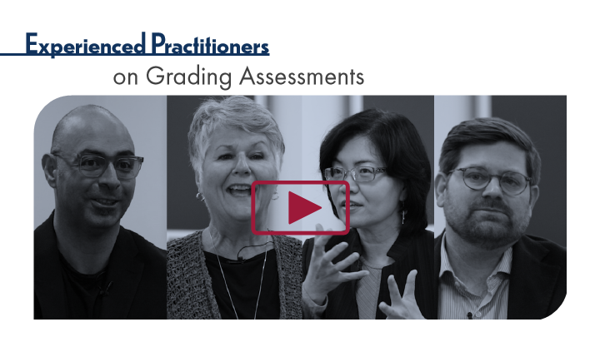

Type | Translation
Slide name | Experienced Practitioners on Grading Assessments
Main Title 1 | Experienced Practitioners
Main Title 2 | on Grading Assessments

6.25 Thinking Forward: Assessment Processes
Slide ID 🔒 | 0ff0fc83-1ef2-4229-9b0c-f6c476e8fd45
Preview Image | 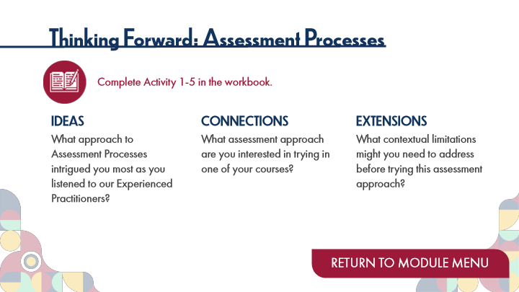

Type | Translation
Slide name | Thinking Forward: Assessment Processes
Main Title 1 | Thinking Forward: Assessment Processes
Text Box 6 | Complete Activity 1-5 in the workbook.
Text Box 3 | IDEAS
 | What approach to Assessment Processes intrigued you most as you listened to our Experienced Practitioners?
Text Box 4 | CONNECTIONS
 | What assessment approach are you interested in trying in one of your courses?
Text Box 5 | EXTENSIONS
 | What contextual limitations might you need to address before trying this assessment approach?
Button - Normal state | RETURN TO MODULE MENU

7 Topic 3: Assessment Fairness
Scene ID 🔒 | de7395a9-c41c-425a-a376-bc83f1165597

Type | Translation
Scene name | Topic 3: Assessment Fairness

7.1 Assessment Fairness Title Page
Slide ID 🔒 | d85740a0-d4f9-4f34-b3ae-0ce4788cb5b8
Preview Image | 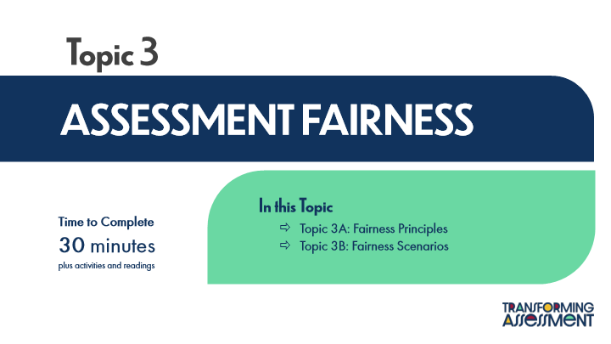

Type | Translation
Slide name | Assessment Fairness Title Page
Main Title 1 | Topic 3
Main Title | ASSESSMENT FAIRNESS
Text Box 1 | In this Topic
 | Topic 3A: Fairness Principles
 | Topic 3B: Fairness Scenarios
Text Box 2 | Time to Complete
 | 30 minutes
 | plus activities and readings

7.2 ACAI Review: Assessment Fairness
Slide ID 🔒 | 74f456da-a0e2-4f95-b8f3-6d5791093379
Preview Image | 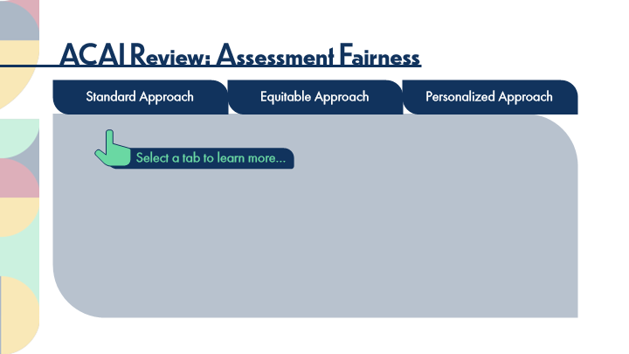

Type | Translation
Slide name | ACAI Review: Assessment Fairness
Main Title | ACAI Review: Assessment Fairness
tab button 1 - Normal state | Standard Approach
tab button 2 - Normal state | Equitable Approach
tab button 3 - Normal state | Personalized Approach
Text Box 1 | Select a tab to learn more…

Slide Layer: Standard Approach
Layer ID 🔒 | b6030a0c-d41a-4d21-b603-b7539b325512
Preview Image | 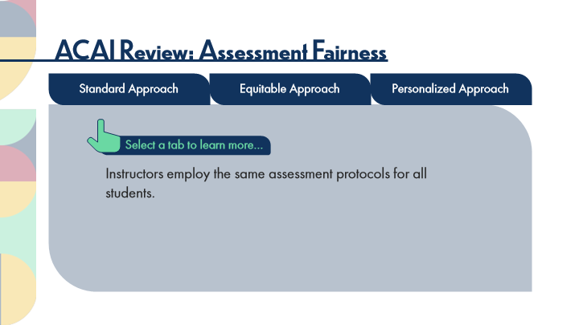

Type | Translation
Main Body 1 | Instructors employ the same assessment protocols for all students.

Slide Layer: Equitable Approach
Layer ID 🔒 | 9a8c2063-4280-4f68-90bd-a7dcbfb9a074
Preview Image | 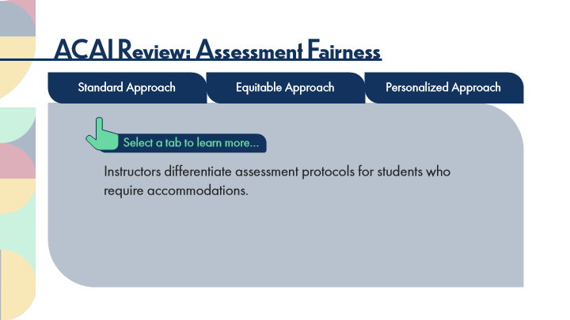

Type | Translation
Main Body 1 | Instructors differentiate assessment protocols for students who require accommodations.

Slide Layer: Personalized Approach
Layer ID 🔒 | d8ffff6c-566b-4833-9d11-15e3b5dd16e4
Preview Image | 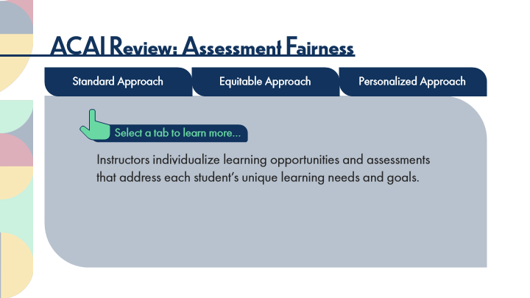

Type | Translation
Main Body 1 | Instructors individualize learning opportunities and assessments that address each student’s unique learning needs and goals.

7.3 ACAI Reflections: Assessment Fairness
Slide ID 🔒 | 34253099-7f7d-4791-969a-49d88351ece3
Preview Image | 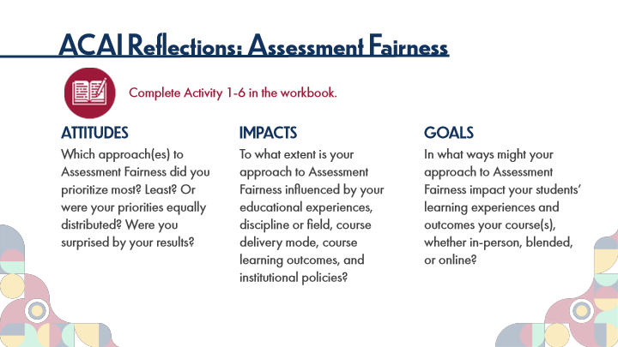

Type | Translation
Slide name | ACAI Reflections: Assessment Fairness
Main Title 1 | ACAI Reflections: Assessment Fairness
Text Box 6 | Complete Activity 1-6 in the workbook.
Text Box 3 | ATTITUDES
 | Which approach(es) to Assessment Fairness did you prioritize most? Least? Or were your priorities equally distributed? Were you surprised by your results?
Text Box 4 | IMPACTS
 | To what extent is your approach to Assessment Fairness influenced by your educational experiences, discipline or field, course delivery mode, course learning outcomes, and institutional policies?
Text Box 5 | GOALS
 | In what ways might your approach to Assessment Fairness impact your students’ learning experiences and outcomes your course(s), whether in-person, blended, or online?

7.4 Key Points: Assessment Fairness
Slide ID 🔒 | 71ff72c4-d8f3-4bcc-8c3f-83aea6841e6a
Preview Image | 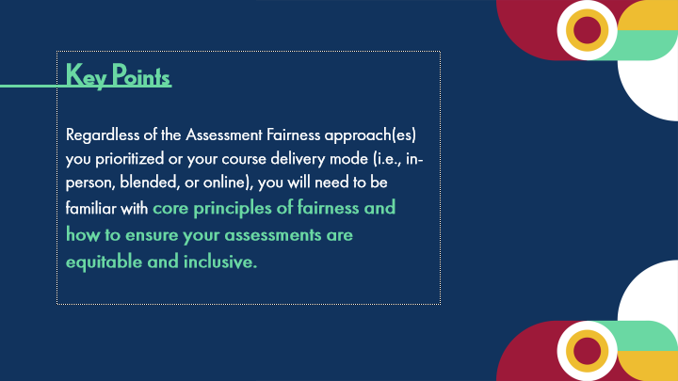

Type | Translation
Slide name | Key Points: Assessment Fairness
Body | Key Points
 | Regardless of the Assessment Fairness approach(es) you prioritized or your course delivery mode (i.e., in-person, blended, or online), you will need to be familiar with
 | core principles of fairness and how to ensure your assessments are equitable and inclusive.

7.5 Topic 3A: Fairness Principles
Slide ID 🔒 | f371ce90-200f-4fa6-8b55-5e83356f21a7
Preview Image | 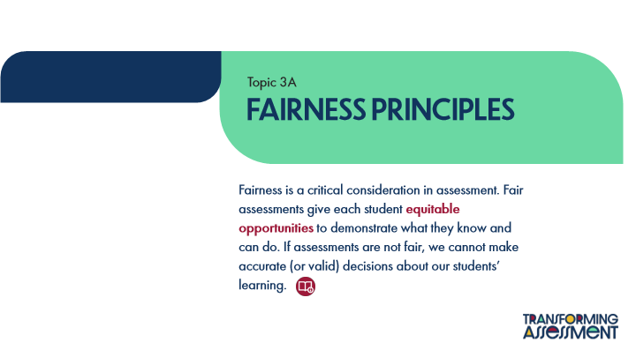

Type | Translation
Slide name | Topic 3A: Fairness Principles
Text Box 1 | Topic 3A
Main Title | Fairness principles
Main Body | Fairness is a critical consideration in assessment. Fair assessments give each student
 | equitable opportunities
 | to demonstrate what they know and can do. If assessments are not fair, we cannot make accurate (or valid) decisions about our students’ learning.

7.6 Fairness Principles
Slide ID 🔒 | be3ecf40-330a-4910-91d9-4c290e860059
Preview Image | 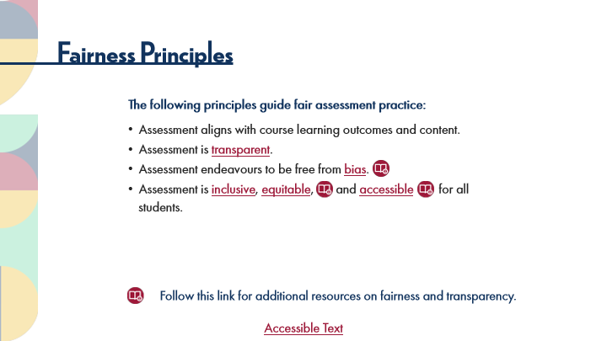

Type | Translation
Slide name | Fairness Principles
Main Title 1 | Fairness Principles
Text Box 1 | The following principles guide fair assessment practice:
 | Assessment aligns with course learning outcomes and content.
 | Assessment is
 | transparent
 | .
 | Assessment endeavours to be free from
 | bias
 | .
 | Assessment is
 | inclusive
 | ,
 | equitable
 | , and
 | accessible
 | for all students.
Text Box 2 | Follow this link for additional resources on fairness and transparency.
Text Box 3 | Accessible Text
Alt text for Text Box 3 | Accessible Activity Text Link. If you are not using a mouse for this course, skip this activity and access the PDF.

Slide Layer: Rollover: Accessible
Layer ID 🔒 | 3572b081-12e8-42be-bcb7-3885e2137ab7
Preview Image | 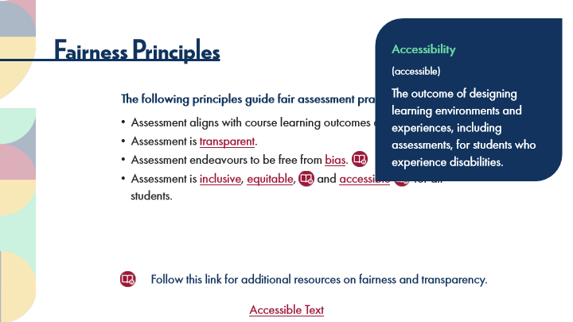

Type | Translation
Text Box 1 | Accessibility
 | (accessible)
 | The outcome of designing learning environments and experiences, including assessments, for students who experience disabilities.

Slide Layer: Rollover: Equitable
Layer ID 🔒 | 5d266d13-172d-499b-a18b-fa9a7ba33da2
Preview Image | 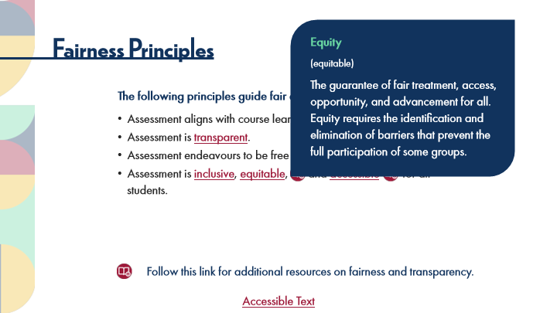

Type | Translation
Text Box 1 | Equity
 | (equitable)
 | The guarantee of fair treatment, access, opportunity, and advancement for all. Equity requires the identification and elimination of barriers that prevent the full participation of some groups.

Slide Layer: Rollover: Inclusive
Layer ID 🔒 | e7e1d733-fc04-4285-85e7-e899a419ecef
Preview Image | 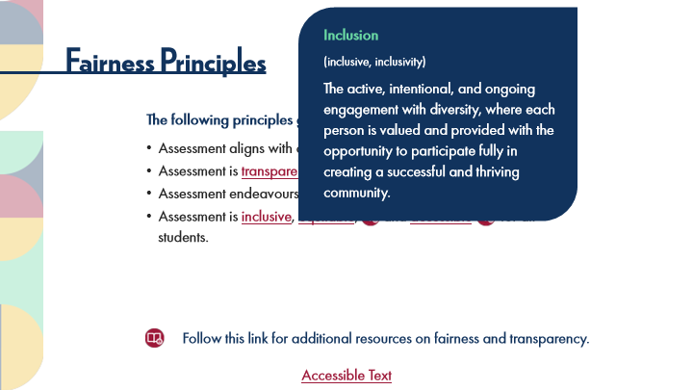

Type | Translation
Text Box 1 | Inclusion
 | (inclusive, inclusivity)
 | The active, intentional, and ongoing engagement with diversity, where each person is valued and provided with the opportunity to participate fully in creating a successful and thriving community.

Slide Layer: Rollover: Bias
Layer ID 🔒 | 78dab942-81bd-4c5e-88e7-6136611091b4
Preview Image | 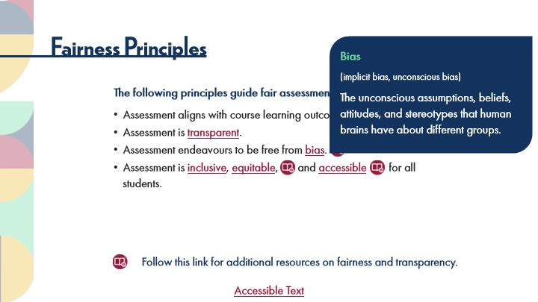

Type | Translation
Text Box 1 | Bias
 | (implicit bias, unconscious bias)
 | The unconscious assumptions, beliefs, attitudes, and stereotypes that human brains have about different groups.

Slide Layer: Rollover: Transparent Assessment
Layer ID 🔒 | 6878ef3d-c5d8-435e-bbc4-bf5abfcdef68
Preview Image | 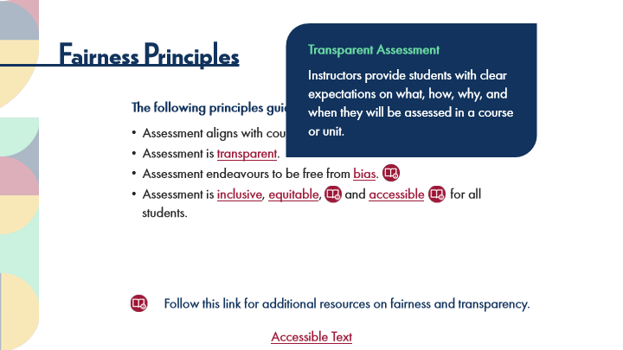

Type | Translation
Text Box 1 | Transparent Assessment
 | Instructors provide students with clear expectations on what, how, why, and when they will be assessed in a course or unit.

7.7 6 Tips to Ensure Fair Assessment
Slide ID 🔒 | 70e8ccb4-a7b5-4b19-aa07-a62789989d44
Preview Image | 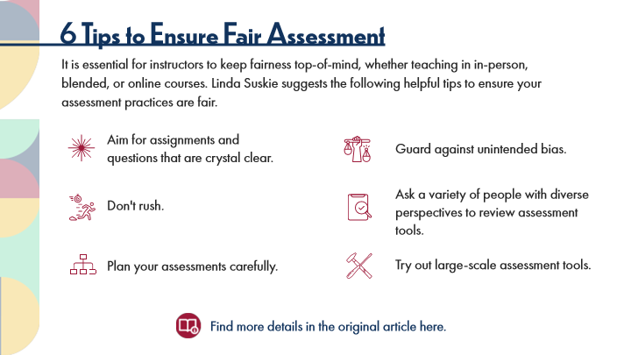

Type | Translation
Slide name | 6 Tips to Ensure Fair Assessment
Main Title 1 | 6 Tips to Ensure Fair Assessment
Text Box 1 | It is essential for instructors to keep fairness top-of-mind, whether teaching in in-person, blended, or online courses. Linda Suskie suggests the following helpful tips to ensure your assessment practices are fair.
Text Box 5 | Aim for assignments and questions that are crystal clear.
Text Box 6 | Guard against unintended bias.
Text Box 7 | Ask a variety of people with diverse perspectives to review assessment tools.
Text Box 3 | Don't rush.
Text Box 8 | Try out large-scale assessment tools.
Text Box 4 | Plan your assessments carefully.
Text Box 2 | Find more details in the original article here.

7.8 Quote
Slide ID 🔒 | 7caf748a-67c6-4117-a2d2-bd136008e4e4
Preview Image | 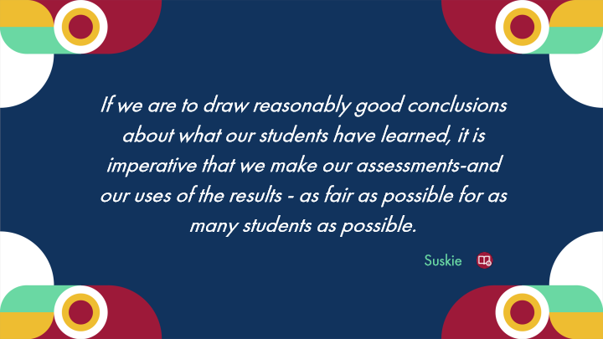

Type | Translation
Slide name | Quote
Text Box 1 | If we are to draw reasonably good conclusions about what our students have learned, it is imperative that we make our assessments-and our uses of the results - as fair as possible for as many students as possible.
Text Box 2 | Suskie

7.9 Experienced Practitioners on Fairness Principles
Slide ID 🔒 | e425f6d2-d544-439f-a6d8-fc008627c3af
Preview Image | 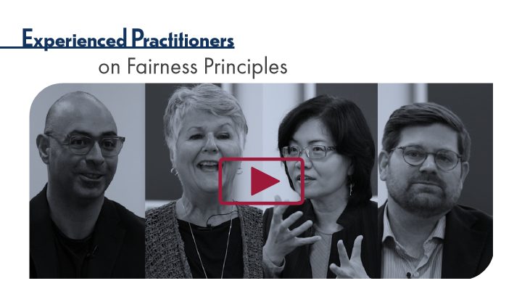

Type | Translation
Slide name | Experienced Practitioners on Fairness Principles
Main Title 1 | Experienced Practitioners
Main Title 2 | on Fairness Principles

7.10 Topic 3B: Fairness Scenarios
Slide ID 🔒 | 2a81fa8f-8854-43da-9f3d-0dfd30ec5db4
Preview Image | 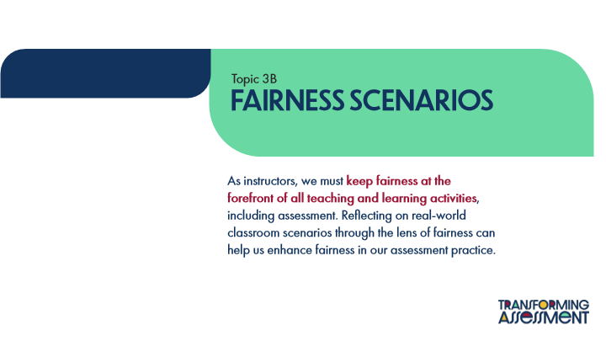

Type | Translation
Slide name | Topic 3B: Fairness Scenarios
Text Box 1 | Topic 3B
Main Title 1 | FAIRNESS SCENARIOS
Main Body | As instructors, we must
 | keep fairness at the forefront of all teaching and learning activities
 | , including assessment. Reflecting on real-world classroom scenarios through the lens of fairness can help us enhance fairness in our assessment practice.

7.11 POV: Student Perspectives
Slide ID 🔒 | c4be20af-c07c-440c-8764-5181d571a806
Preview Image | 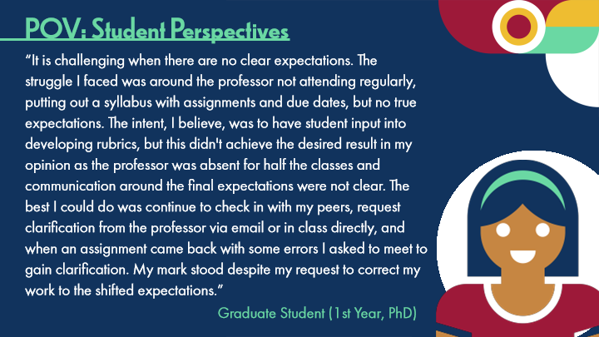

Type | Translation
Slide name | POV: Student Perspectives
Main Title 1 | POV: Student Perspectives
Text Box 1 | “It is challenging when there are no clear expectations. The struggle I faced was around the professor not attending regularly, putting out a syllabus with assignments and due dates, but no true expectations. The intent, I believe, was to have student input into developing rubrics, but this didn't achieve the desired result in my opinion as the professor was absent for half the classes and communication around the final expectations were not clear. The best I could do was continue to check in with my peers, request clarification from the professor via email or in class directly, and when an assignment came back with some errors I asked to meet to gain clarification. My mark stood despite my request to correct my work to the shifted expectations.”
Text Box 2 | Graduate Student (1st Year, PhD)

7.12 Scenario Introduction
Slide ID 🔒 | 36f3ce6a-d98a-4378-be92-8e6e1a90b262
Preview Image | 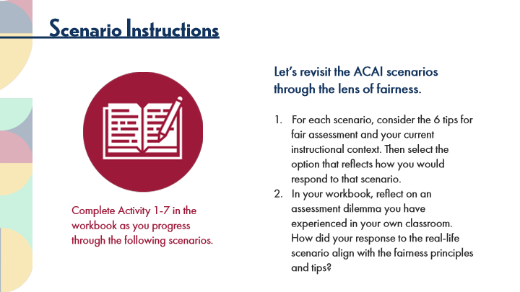

Type | Translation
Slide name | Scenario Introduction
Main Title 1 | Scenario Instructions
Text Box 1 | Let’s revisit the ACAI scenarios through the lens of fairness.
 | For each scenario, consider the 6 tips for fair assessment and your current instructional context. Then select the option that reflects how you would respond to that scenario.
 | In your workbook, reflect on an assessment dilemma you have experienced in your own classroom. How did your response to the real-life scenario align with the fairness principles and tips?
Text Box 2 | Complete Activity 1-7 in the workbook as you progress through the following scenarios.

7.13 Fairness Scenario 1
Slide ID 🔒 | f0bdba45-4122-4ee8-a969-bdbe443879c7
Preview Image | 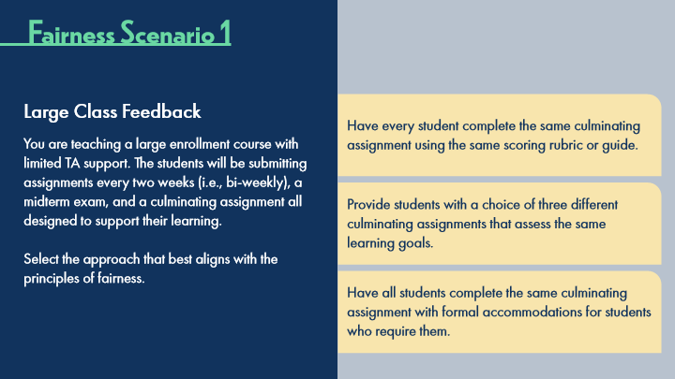

Type | Translation
Slide name | Fairness Scenario 1
Main Title 1 | Fairness Scenario 1
Text Box 2 | Large Class Feedback
Button: Top Option - Normal state | Have every student complete the same culminating assignment using the same scoring rubric or guide.
Text Box 1 | You are teaching a large enrollment course with limited TA support. The students will be submitting assignments every two weeks (i.e., bi-weekly), a midterm exam, and a culminating assignment all designed to support their learning.
 | Select the approach that best aligns with the principles of fairness.
Button: Middle Option - Normal state | Provide students with a choice of three different culminating assignments that assess the same learning goals.
Button: Bottom Option - Normal state | Have all students complete the same culminating assignment with formal accommodations for students who require them.

Slide Layer: Top Answer
Layer ID 🔒 | 474b6043-1323-4305-82cf-dc58e1659c43
Preview Image | 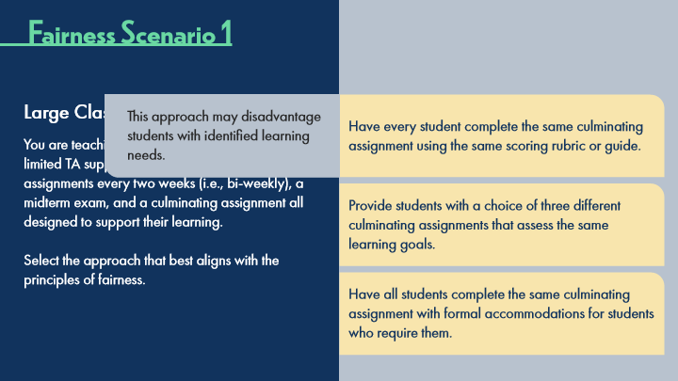

Type | Translation
Text Box 1 | This approach may disadvantage students with identified learning needs.

Slide Layer: Middle Answer
Layer ID 🔒 | a425ddcf-5d68-4775-ba92-0221cbe6d8a6
Preview Image | 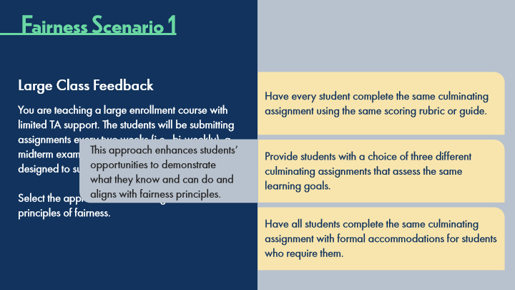

Type | Translation
Text Box 1 | This approach enhances students’ opportunities to demonstrate what they know and can do and aligns with fairness principles.

Slide Layer: Bottom Answer
Layer ID 🔒 | b0d2f34a-c000-45ac-8b6a-f6f6098ceaeb
Preview Image | 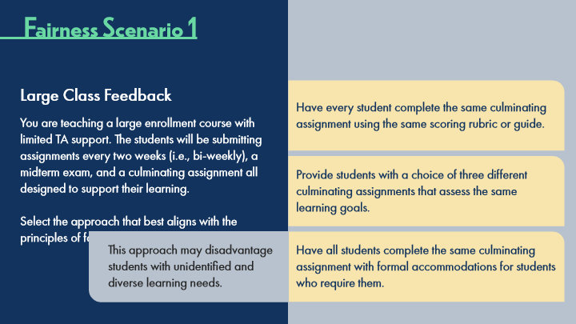

Type | Translation
Text Box 1 | This approach may disadvantage students with unidentified and diverse learning needs.

7.14 Fairness Scenario 2
Slide ID 🔒 | d8693148-c25a-4223-859d-1c2c8757f324
Preview Image | 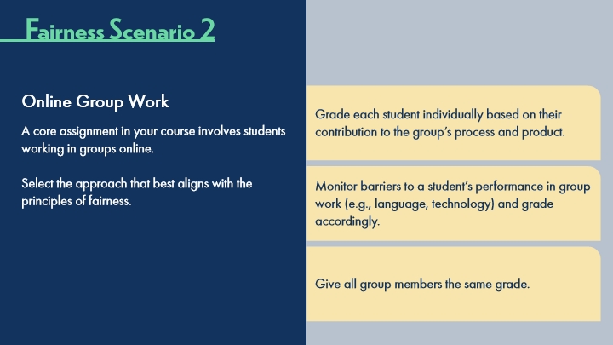

Type | Translation
Slide name | Fairness Scenario 2
Main Title 1 | Fairness Scenario 2
Text Box 2 | Online Group Work
Button: Top Option - Normal state | Grade each student individually based on their contribution to the group’s process and product.
Text Box 1 | A core assignment in your course involves students working in groups online.
 | Select the approach that best aligns with the principles of fairness.
Button: Middle Option - Normal state | Monitor barriers to a student’s performance in group work (e.g., language, technology) and grade accordingly.
Button: Bottom Option - Normal state | Give all group members the same grade.

Slide Layer: Top Answer
Layer ID 🔒 | 3631faed-5345-47b8-bd26-356d45fbc68b
Preview Image | 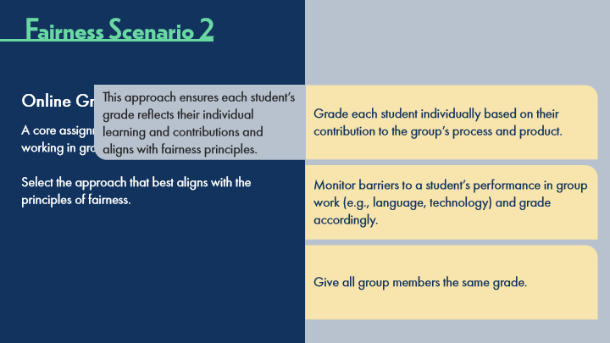

Type | Translation
Text Box 1 | This approach ensures each student’s grade reflects their individual learning and contributions and aligns with fairness principles.

Slide Layer: Middle Answer
Layer ID 🔒 | 1963e606-9272-445d-a981-b58d55694293
Preview Image | 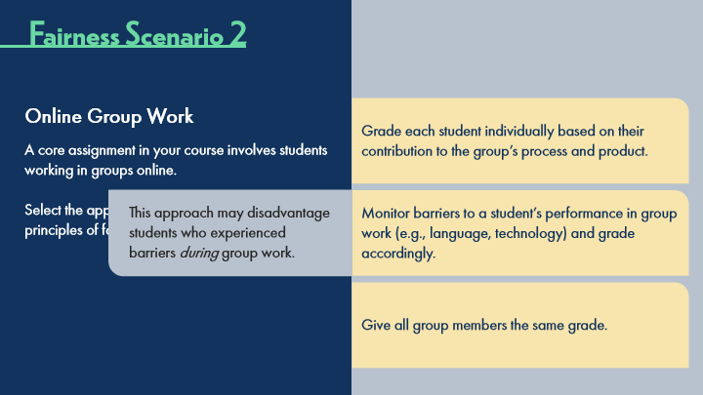

Type | Translation
Text Box 1 | This approach may disadvantage students who experienced barriers during group work.

Slide Layer: Bottom Answer
Layer ID 🔒 | bba7ac48-47a2-46e6-b362-f903af2c0c99
Preview Image | 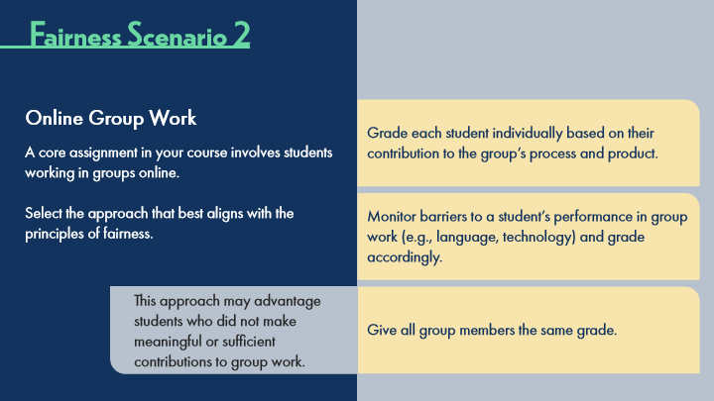

Type | Translation
Text Box 1 | This approach may advantage students who did not make meaningful or sufficient contributions to group work.

7.15 Fairness Scenario 3
Slide ID 🔒 | 63dd4b9d-a77a-4a17-8b8b-e01c97dcddc8
Preview Image | 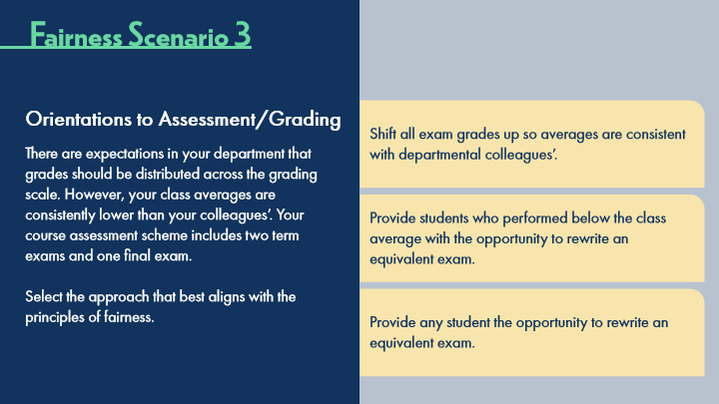

Type | Translation
Slide name | Fairness Scenario 3
Main Title 1 | Fairness Scenario 3
Text Box 2 | Orientations to Assessment/Grading
Button: Top Option - Normal state | Shift all exam grades up so averages are consistent with departmental colleagues’.
Text Box 1 | There are expectations in your department that grades should be distributed across the grading scale. However, your class averages are consistently lower than your colleagues’. Your course assessment scheme includes two term exams and one final exam.
 | Select the approach that best aligns with the principles of fairness.
Button: Middle Option - Normal state | Provide students who performed below the class average with the opportunity to rewrite an equivalent exam.
Button: Bottom Option - Normal state | Provide any student the opportunity to rewrite an equivalent exam.

Slide Layer: Top Answer
Layer ID 🔒 | c6b35139-eae5-47d4-99fa-c9d71faffa2e
Preview Image | 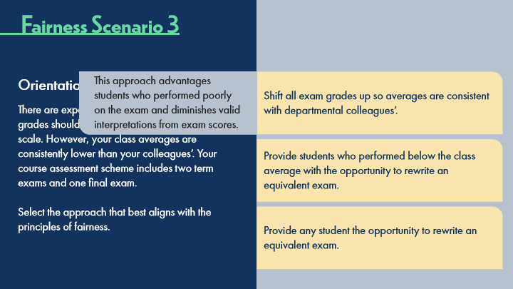

Type | Translation
Text Box 1 | This approach advantages students who performed poorly on the exam and diminishes valid interpretations from exam scores.

Slide Layer: Middle Answer
Layer ID 🔒 | a084713d-c0cc-46b5-b22e-50190f7ce220
Preview Image | 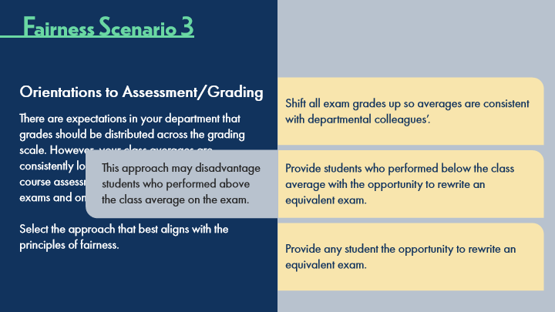

Type | Translation
Text Box 1 | This approach may disadvantage students who performed above the class average on the exam.

Slide Layer: Bottom Answer
Layer ID 🔒 | 336ac05b-1ec6-4eca-9abb-32575d28e230
Preview Image | 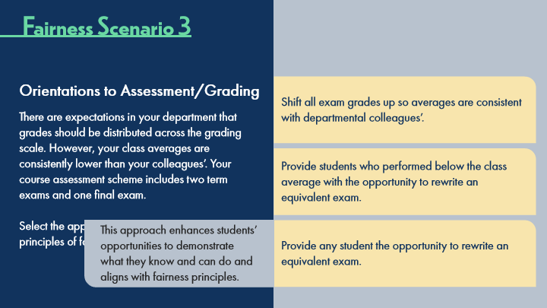

Type | Translation
Text Box 1 | This approach enhances students’ opportunities to demonstrate what they know and can do and aligns with fairness principles.

7.16 Fairness Scenario 4
Slide ID 🔒 | fdf21175-6c0b-413f-bb17-1703ed781c54
Preview Image | 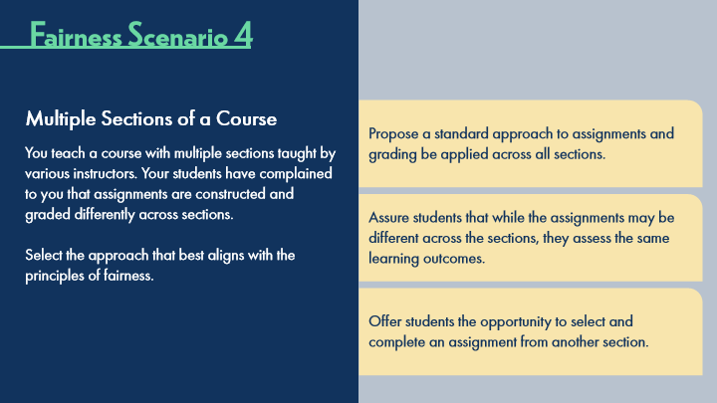

Type | Translation
Slide name | Fairness Scenario 4
Main Title 1 | Fairness Scenario 4
Text Box 2 | Multiple Sections of a Course
Button: Top Option - Normal state | Propose a standard approach to assignments and grading be applied across all sections.
Text Box 1 | You teach a course with multiple sections taught by various instructors. Your students have complained to you that assignments are constructed and graded differently across sections.
 | Select the approach that best aligns with the principles of fairness.
Button: Middle Option - Normal state | Assure students that while the assignments may be different across the sections, they assess the same learning outcomes.
Button: Bottom Option - Normal state | Offer students the opportunity to select and complete an assignment from another section.

Slide Layer: Middle Answer
Layer ID 🔒 | e14f1e08-7ae0-4473-8728-c38041941242
Preview Image | 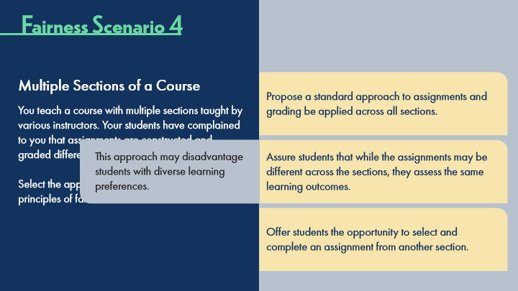

Type | Translation
Text Box 1 | This approach may disadvantage students with diverse learning preferences.

Slide Layer: Top Answer
Layer ID 🔒 | cdd48716-6683-4d9d-9881-6ae78ae74153
Preview Image | 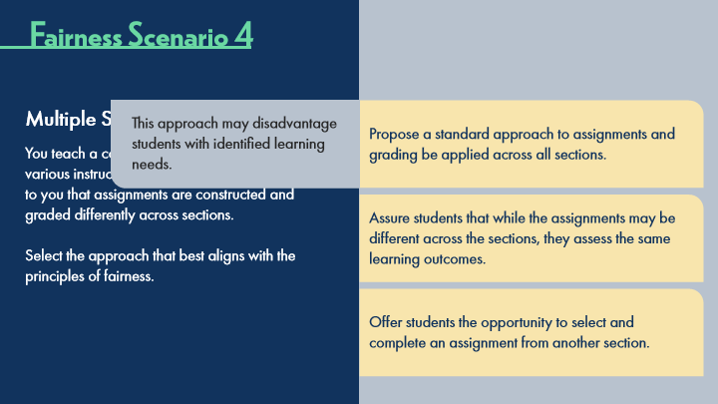

Type | Translation
Text Box 1 | This approach may disadvantage students with identified learning needs.

Slide Layer: Bottom Answer
Layer ID 🔒 | ec422540-b9ae-425f-9399-7d323cb74135
Preview Image | 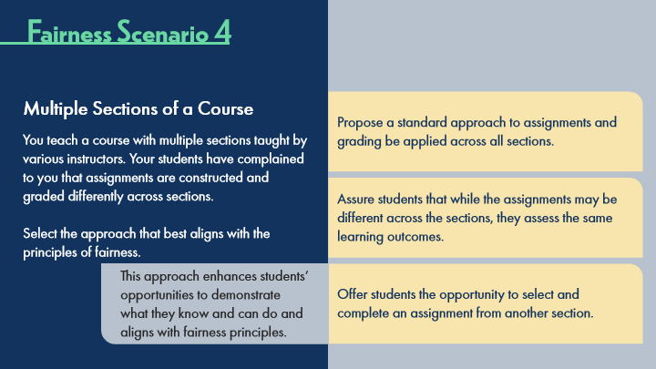

Type | Translation
Text Box 1 | This approach enhances students’ opportunities to demonstrate what they know and can do and aligns with fairness principles.

7.17 Fairness Scenario 5
Slide ID 🔒 | 61445fb9-df10-408e-bea5-7cb55de06fe7
Preview Image | 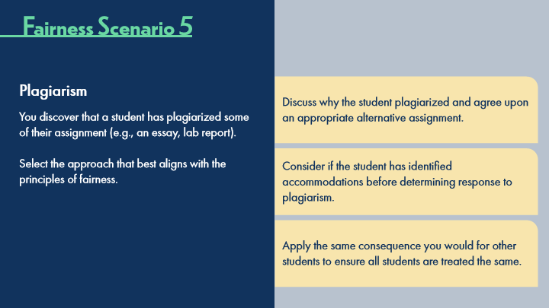

Type | Translation
Slide name | Fairness Scenario 5
Main Title 1 | Fairness Scenario 5
Text Box 2 | Plagiarism
Button: Top Option - Normal state | Discuss why the student plagiarized and agree upon an appropriate alternative assignment.
Text Box 1 | You discover that a student has plagiarized some of their assignment (e.g., an essay, lab report).
 | Select the approach that best aligns with the principles of fairness.
Button: Middle Option - Normal state | Consider if the student has identified accommodations before determining response to plagiarism.
Button: Bottom Option - Normal state | Apply the same consequence you would for other students to ensure all students are treated the same.

Slide Layer: Top Answer
Layer ID 🔒 | f44bcb0a-d74c-46b1-a9b3-8b84ac77ee3f
Preview Image | 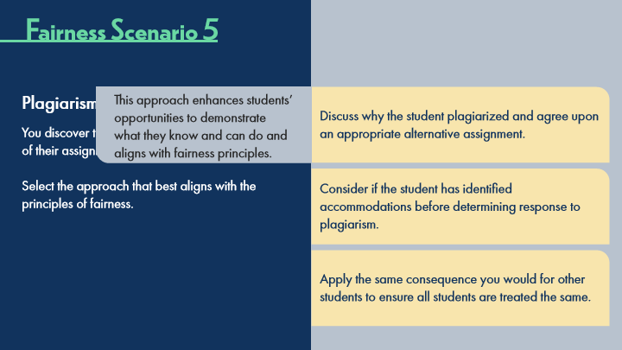

Type | Translation
Text Box 1 | This approach enhances students’ opportunities to demonstrate what they know and can do and aligns with fairness principles.

Slide Layer: Middle Answer
Layer ID 🔒 | 51b46d63-eb34-48cf-a1da-b722759e57b7
Preview Image | 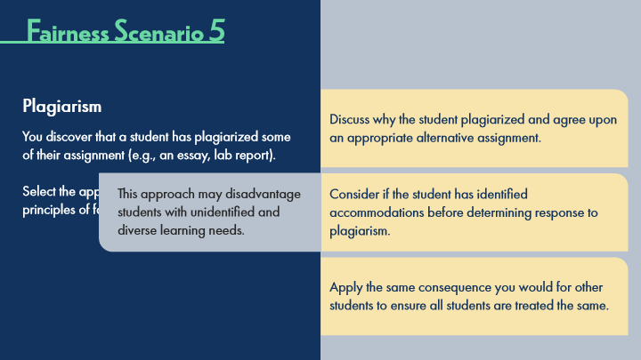

Type | Translation
Text Box 1 | This approach may disadvantage students with unidentified and diverse learning needs.

Slide Layer: Bottom Answer
Layer ID 🔒 | 3bcc05b0-8fa2-429f-9878-409b5a7fd74a
Preview Image | 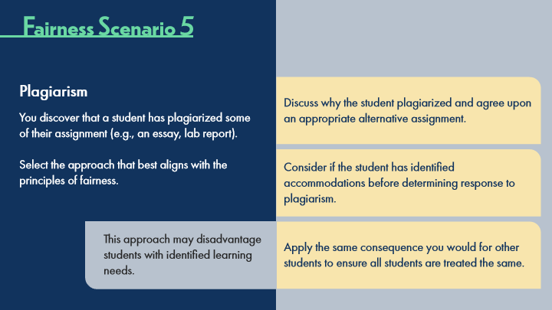

Type | Translation
Text Box 1 | This approach may disadvantage students with identified learning needs.

7.18 Workbook Activity
Slide ID 🔒 | a7b56fc6-92af-46ff-a066-ac921dca71e3
Preview Image | 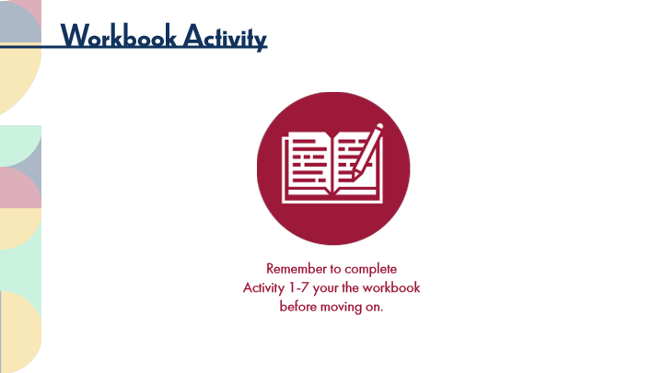

Type | Translation
Slide name | Workbook Activity
Main Title 1 | Workbook Activity
Text Box 2 | Remember to complete
 | Activity 1-7 your the workbook before moving on.

7.19 POV: Instructor Perspectives
Slide ID 🔒 | ab576ed9-66b6-4e55-ae8e-b15ee85c1c66
Preview Image | 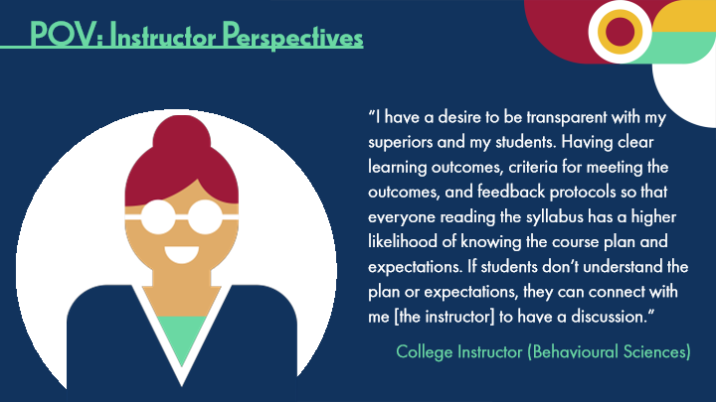

Type | Translation
Slide name | POV: Instructor Perspectives
Main Title 1 | POV: Instructor Perspectives
Text Box 1 | “I have a desire to be transparent with my superiors and my students. Having clear learning outcomes, criteria for meeting the outcomes, and feedback protocols so that everyone reading the syllabus has a higher likelihood of knowing the course plan and expectations. If students don’t understand the plan or expectations, they can connect with me [the instructor] to have a discussion.”
Text Box 2 | College Instructor (Behavioural Sciences)

7.20 Thinking Forward: Assessment Fairness
Slide ID 🔒 | 4cf81317-deb7-4111-8569-9eb693270aae
Preview Image | 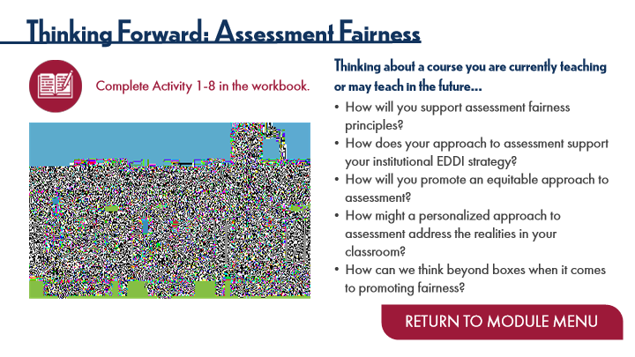

Type | Translation
Slide name | Thinking Forward: Assessment Fairness
Main Title 1 | Thinking Forward: Assessment Fairness
Text Box 3 | Thinking about a course you are currently teaching or may teach in the future…
 | How will you support assessment fairness principles?
 | How does your approach to assessment support your institutional EDDI strategy?
 | How will you promote an equitable approach to assessment?
 | How might a personalized approach to assessment address the realities in your classroom?
 | How can we think beyond boxes when it comes to promoting fairness?
Text Box 6 | Complete Activity 1-8 in the workbook.
Button - Normal state | RETURN TO MODULE MENU

8 Topic 4: Assessment Theory
Scene ID 🔒 | a7a7f2f6-c817-431f-a0d7-79f99cd74d72

Type | Translation
Scene name | Topic 4: Assessment Theory

8.1 Assessment Theory Title Page
Slide ID 🔒 | 0cc80aa6-0967-47cf-a485-e51f76079c29
Preview Image | 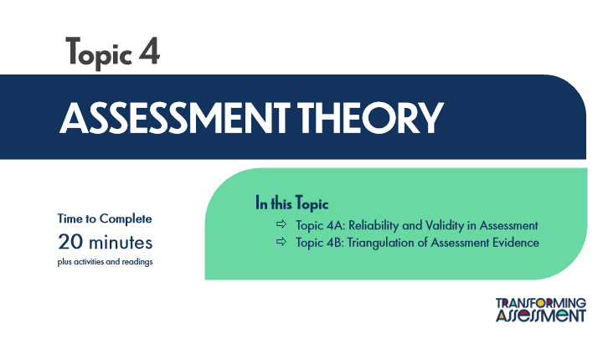

Type | Translation
Slide name | Assessment Theory Title Page
Main Title 1 | Topic 4
Main Title | ASSESSMENT THEORY
Text Box 1 | In this Topic
 | Topic 4A: Reliability and Validity in Assessment
 | Topic 4B: Triangulation of Assessment Evidence
Text Box 2 | Time to Complete
 | 20 minutes
 | plus activities and readings

8.2 ACAI Review: Assessment Theory
Slide ID 🔒 | 0321bb3a-aca6-4853-9d19-aba884fb3616
Preview Image | 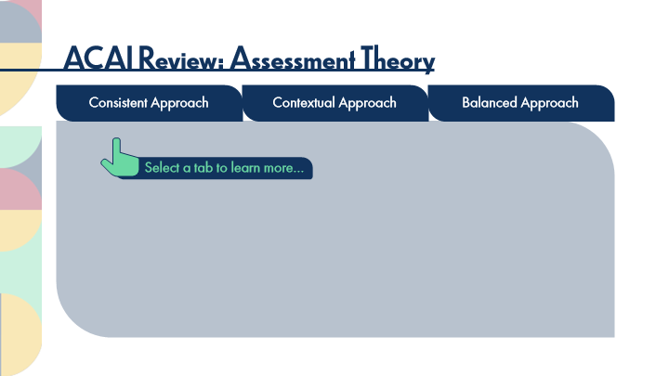

Type | Translation
Slide name | ACAI Review: Assessment Theory
Main Title | ACAI Review: Assessment Theory
tab button 1 - Normal state | Consistent Approach
tab button 2 - Normal state | Contextual Approach
tab button 3 - Normal state | Balanced Approach
Text Box 1 | Select a tab to learn more…

Slide Layer: Consistent
Layer ID 🔒 | 6fee3551-96fd-446d-91fe-f8062a475e88
Preview Image | 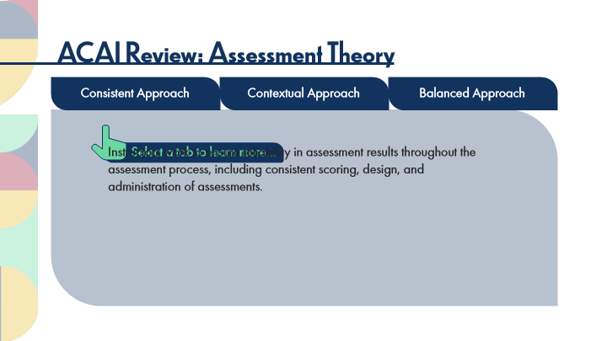

Type | Translation
Main Body 1 | Instructors work to ensure reliability in assessment results throughout the assessment process, including consistent scoring, design, and administration of assessments.

Slide Layer: Contextual
Layer ID 🔒 | 2410d5fd-a582-41a5-98c8-f08129da10b0
Preview Image | 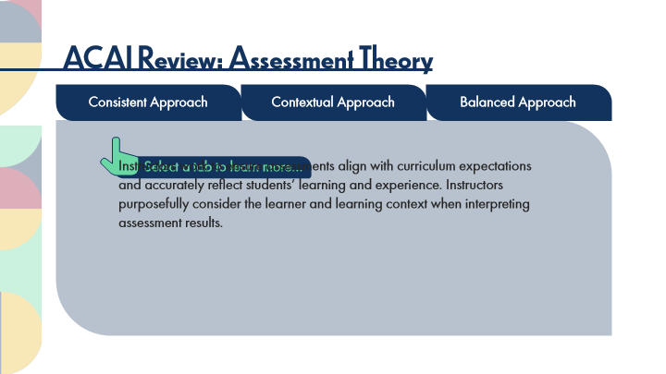

Type | Translation
Main Body 1 | Instructors work to ensure assessments align with curriculum expectations and accurately reflect students’ learning and experience. Instructors purposefully consider the learner and learning context when interpreting assessment results.

Slide Layer: Balanced
Layer ID 🔒 | 4e253aed-cc1b-4eca-8bbe-1b30d2626011
Preview Image | 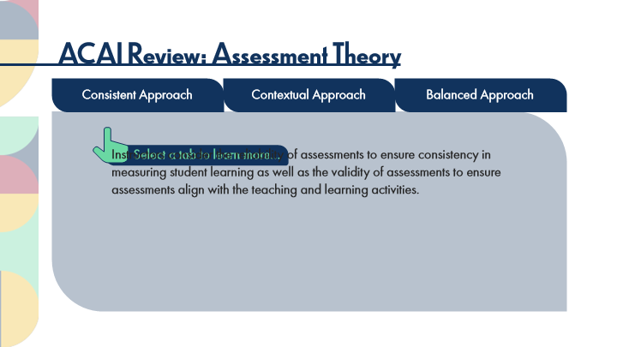

Type | Translation
Main Body 1 | Instructors consider the reliability of assessments to ensure consistency in measuring student learning as well as the validity of assessments to ensure assessments align with the teaching and learning activities.

8.3 ACAI Reflections: Assessment Theory
Slide ID 🔒 | a85bba20-2920-4c2b-9d5c-ea70bb96714f
Preview Image | 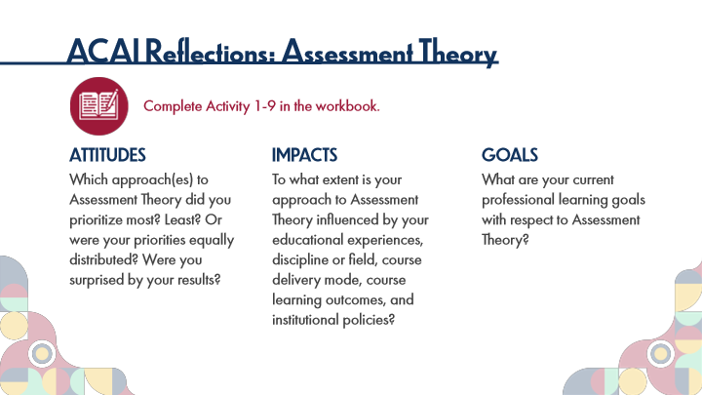

Type | Translation
Slide name | ACAI Reflections: Assessment Theory
Main Title 1 | ACAI Reflections: Assessment Theory
Text Box 6 | Complete Activity 1-9 in the workbook.
Text Box 3 | ATTITUDES
 | Which approach(es) to Assessment Theory did you prioritize most? Least? Or were your priorities equally distributed? Were you surprised by your results?
Text Box 4 | IMPACTS
 | To what extent is your approach to Assessment Theory influenced by your educational experiences, discipline or field, course delivery mode, course learning outcomes, and institutional policies?
Text Box 5 | GOALS
 | What are your current professional learning goals with respect to Assessment Theory?

8.4 Key Points: Assessment Theory
Slide ID 🔒 | a4d71e80-a0c0-4ed8-aaca-c91509ca8cbc
Preview Image | 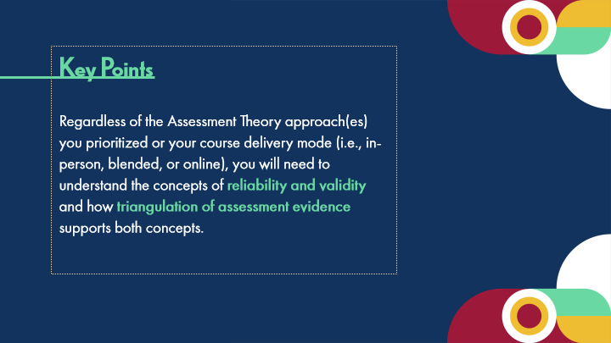

Type | Translation
Slide name | Key Points: Assessment Theory
Body | Key Points
 | Regardless of the Assessment Theory approach(es) you prioritized or your course delivery mode (i.e., in-person, blended, or online), you will need to understand the concepts of
 | reliability
 | and
 | validity
 | and how
 | triangulation of assessment evidence
 | supports both concepts.

8.5 Topic 4A: Reliability and Validity
Slide ID 🔒 | edaa04cf-0f4a-4fa4-9150-5d37a8c6708a
Preview Image | 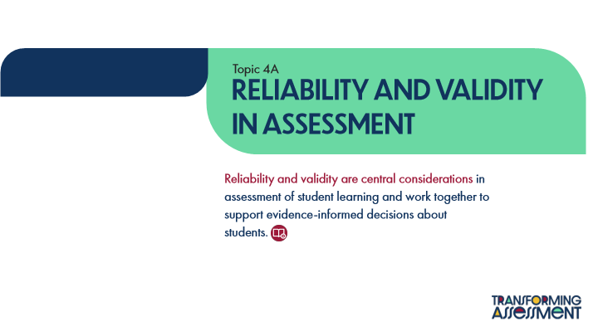

Type | Translation
Slide name | Topic 4A: Reliability and Validity
Text Box 1 | Topic 4A
Main Title | Reliability and Validity in Assessment
Main Body | Reliability and validity are central considerations
 | in assessment of student learning and work together to support evidence-informed decisions about students.

8.6 Distinctions between Reliability and Validity
Slide ID 🔒 | 4bd76b36-b943-4465-bc00-0fbc1f325d5b
Preview Image | 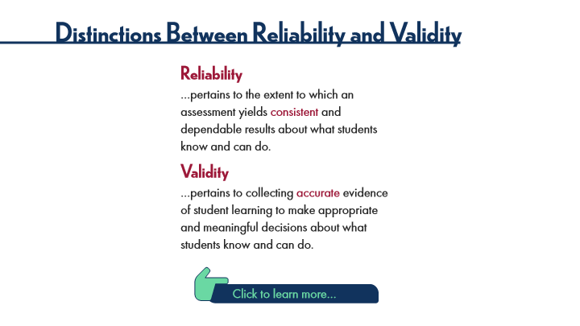

Type | Translation
Slide name | Distinctions between Reliability and Validity
Main Title 1 | Distinctions Between Reliability and Validity
Text Box 5 | Reliability
Text Box 3 | …pertains to the extent to which an assessment yields
 | consistent
 | and dependable results about what students know and can do.
Text Box 6 | Validity
Text Box 4 | …pertains to collecting
 | accurate
 | evidence of student learning to make appropriate and meaningful decisions about what students know and can do.
Text Box 2 | Click to learn more…

Slide Layer: Validity
Layer ID 🔒 | 43230645-3a55-477a-89fc-48dc3fd0d538
Preview Image | 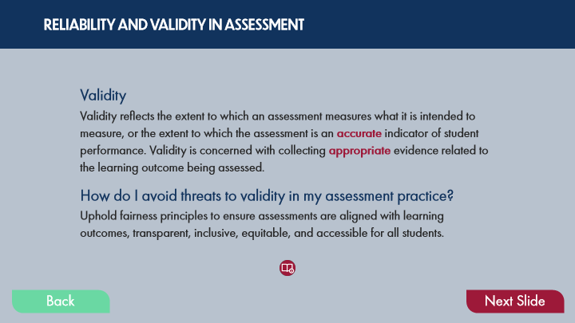

Type | Translation
Text Box 3 | RELIABILITY AND VALIDITY IN ASSESSMENT
Text Box 8 | Validity
Text Box 7 | Validity reflects the extent to which an assessment measures what it is intended to measure, or the extent to which the assessment is an
 | accurate
 | indicator of student performance. Validity is concerned with collecting
 | appropriate
 | evidence related to the learning outcome being assessed.
Text Box 5 | How do I avoid threats to validity in my assessment practice?
Text Box 6 | Uphold fairness principles to ensure assessments are aligned with learning outcomes, transparent, inclusive, equitable, and accessible for all students.
Button - Normal state | Back
Button - Down state | Back
Button - Normal state | Next Slide

Slide Layer: Reliability
Layer ID 🔒 | b7189594-203e-4b48-8a22-34e3319a2efa
Preview Image | 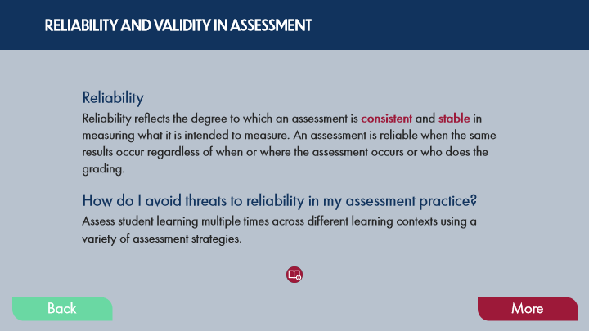

Type | Translation
Text Box 8 | RELIABILITY AND VALIDITY IN ASSESSMENT
Text Box 10 | Reliability
Text Box 9 | Reliability reflects the degree to which an assessment is
 | consistent
 | and
 | stable
 | in measuring what it is intended to measure. An assessment is reliable when the same results occur regardless of when or where the assessment occurs or who does the grading.
Text Box 4 | How do I avoid threats to reliability in my assessment practice?
Text Box 5 | Assess student learning multiple times across different learning contexts using a variety of assessment strategies.
Button - Normal state | Back
Button - Down state | Back
Button - Normal state | More

8.7 Interactions of Reliability and Validity
Slide ID 🔒 | 07a6a8ac-a95a-42f5-b2bc-d2e24357ffef
Preview Image | 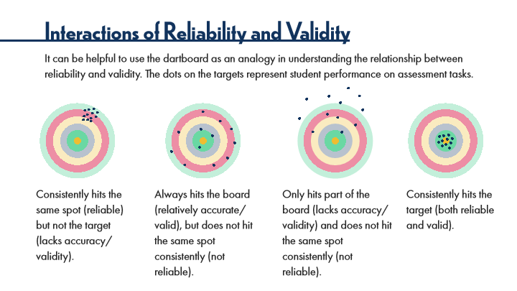

Type | Translation
Slide name | Interactions of Reliability and Validity
Main Title 1 | Interactions of Reliability and Validity
Text Box 2 | It can be helpful to use the dartboard as an analogy in understanding the relationship between reliability and validity. The dots on the targets represent student performance on assessment tasks.
Text Box 3 | Consistently hits the same spot (reliable) but not the target (lacks accuracy/validity).
Text Box 4 | Always hits the board (relatively accurate/valid), but does not hit the same spot consistently (not reliable).
Text Box 5 | Only hits part of the board (lacks accuracy/validity) and does not hit the same spot consistently (not reliable).
Text Box 6 | Consistently hits the target (both reliable and valid).

8.8 Activity: Reliability and Validity, Part 1
Slide ID 🔒 | b51349e0-219b-416b-b720-19fd44a66031
Preview Image | 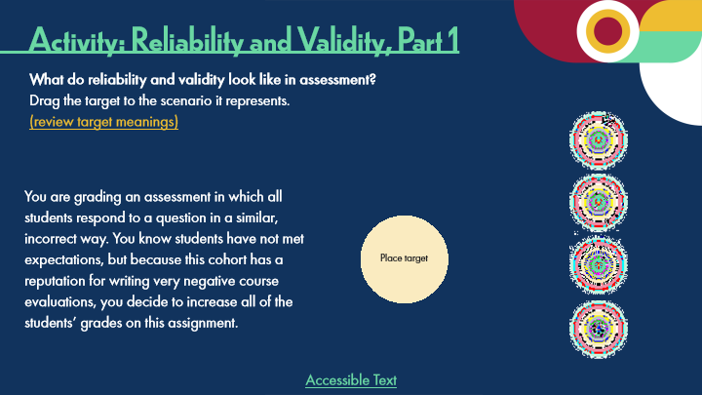

Type | Translation
Slide name | Activity: Reliability and Validity, Part 1
Main Title 1 | Activity: Reliability and Validity, Part 1
Text Box 5 | What do reliability and validity look like in assessment?
 | Drag the target to the scenario it represents.
 | (review target meanings)
Text Box 3 | You are grading an assessment in which all students respond to a question in a similar, incorrect way. You know students have not met expectations, but because this cohort has a reputation for writing very negative course evaluations, you decide to increase all of the students’ grades on this assignment.
Text Box 7 | Place target
Text Box 8 | Accessible Text
Alt text for Text Box 8 | Accessible Activity Text Link. If you are not using a mouse for this course, skip this activity and access the PDF.

Slide Layer: Correct
Layer ID 🔒 | 7bf4a5dd-df33-4fc9-a3a8-24529a835a19
Preview Image | 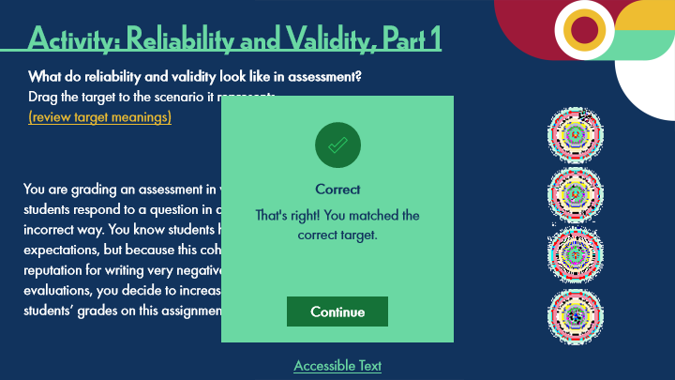

Type | Translation
Text Box | Correct
Text Box | That's right! You matched the
 | correct target.

Slide Layer: Incorrect
Layer ID 🔒 | 748e94d8-aada-47ec-80a3-06494066c2d8
Preview Image | 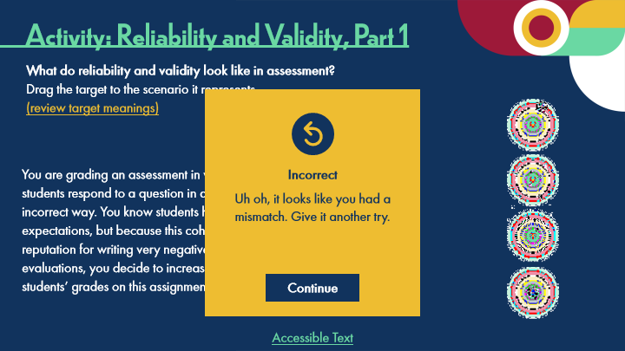

Type | Translation
Text Box | Incorrect
Text Box | Uh oh, it looks like you had a mismatch. Give it another try.

Slide Layer: Try Again
Layer ID 🔒 | 663984d4-e94a-4728-9dec-fcf2939dde79
Preview Image | 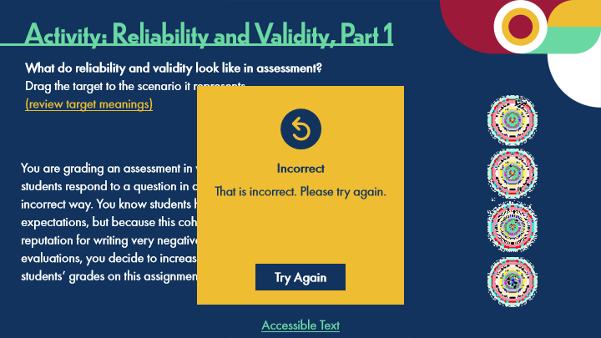

Type | Translation
Text Box | Incorrect
Text Box | That is incorrect. Please try again.

8.9 Activity: Reliability and Validity, Part 2
Slide ID 🔒 | f89d3820-c735-4e14-8730-2ed69a71de85
Preview Image | 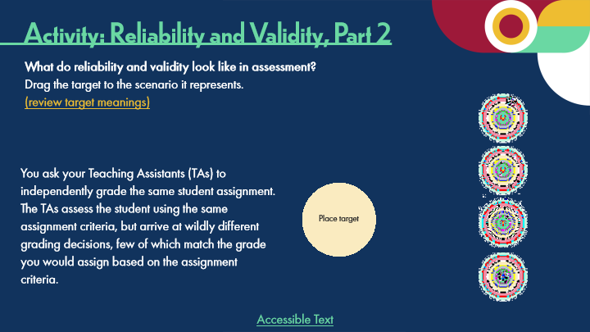

Type | Translation
Slide name | Activity: Reliability and Validity, Part 2
Main Title 1 | Activity: Reliability and Validity, Part 2
Text Box 5 | What do reliability and validity look like in assessment?
 | Drag the target to the scenario it represents.
 | (review target meanings)
Text Box 6 | You ask your Teaching Assistants (TAs) to independently grade the same student assignment. The TAs assess the student using the same assignment criteria, but arrive at wildly different grading decisions, few of which match the grade you would assign based on the assignment criteria.
Text Box 8 | Place target
Text Box 9 | Accessible Text
Alt text for Text Box 9 | Accessible Activity Text Link. If you are not using a mouse for this course, skip this activity and access the PDF.

Slide Layer: Correct
Layer ID 🔒 | 87ed6a4a-4e48-42bd-a691-13d611174ada
Preview Image | 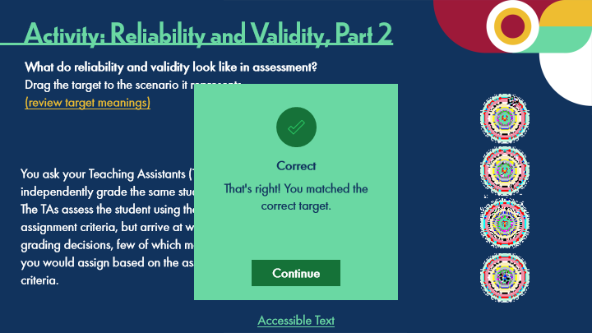

Type | Translation
Text Box | Correct
Text Box | That's right! You matched the
 | correct target.

Slide Layer: Incorrect
Layer ID 🔒 | 0b8fb225-23f7-49a5-8351-000dd18de6db
Preview Image | 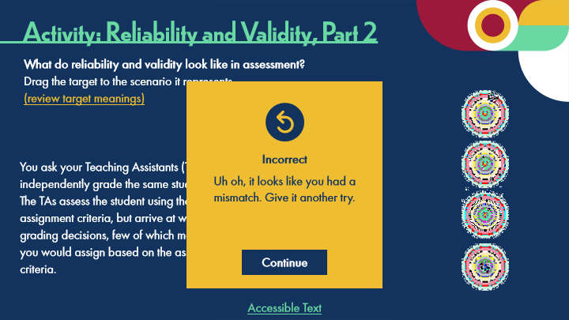

Type | Translation
Text Box | Incorrect
Text Box | Uh oh, it looks like you had a mismatch. Give it another try.

Slide Layer: Try Again
Layer ID 🔒 | 745da48e-384f-488e-809c-dbd7292b6418
Preview Image | 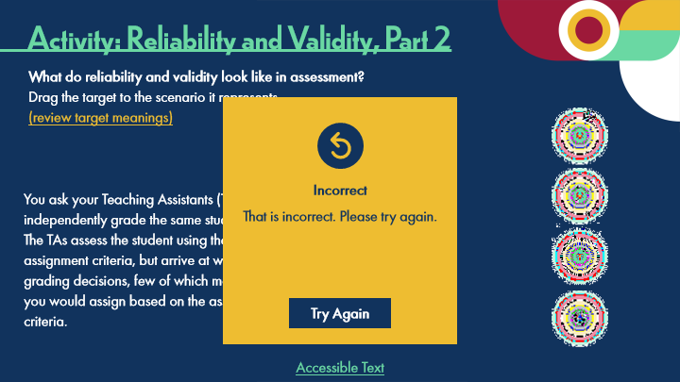

Type | Translation
Text Box | Incorrect
Text Box | That is incorrect. Please try again.

8.10 Key Question
Slide ID 🔒 | 1d895c3b-9828-4764-87e4-fc5dc038876d
Preview Image | 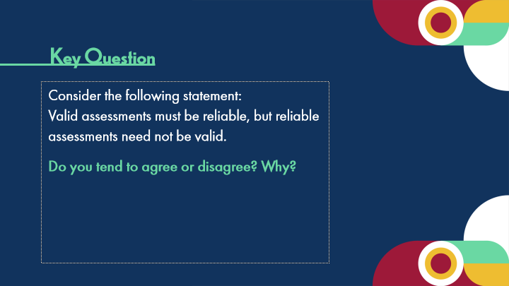

Type | Translation
Slide name | Key Question
Text Box 1 | Key Question
Body | Consider the following statement:
 | Valid assessments must be reliable, but reliable assessments need not be valid.
 | Do you tend to agree or disagree? Why?

8.11 Pause and Reflect on Reliability and Validity
Slide ID 🔒 | d9f5f073-fdf0-43e0-8ab5-f5bfc0e9b092
Preview Image | 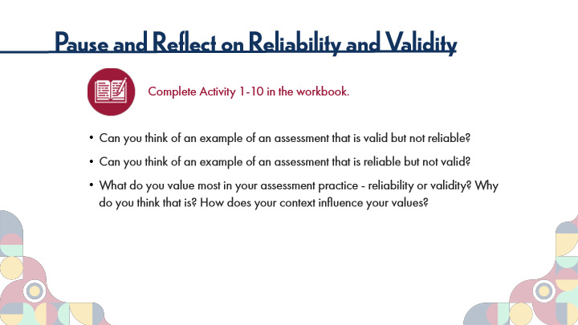

Type | Translation
Slide name | Pause and Reflect on Reliability and Validity
Main Title 1 | Pause and Reflect on Reliability and Validity
Text Box 6 | Complete Activity 1-10 in the workbook.
Text Box 7 | Can you think of an example of an assessment that is valid but not reliable?
 | Can you think of an example of an assessment that is reliable but not valid?
 | What do you value most in your assessment practice - reliability or validity? Why do you think that is? How does your context influence your values?

8.12 Experienced Practitioners on Reliability and Validity
Slide ID 🔒 | 2da92cf9-b21a-41aa-a2bc-82cd220c643b
Preview Image | 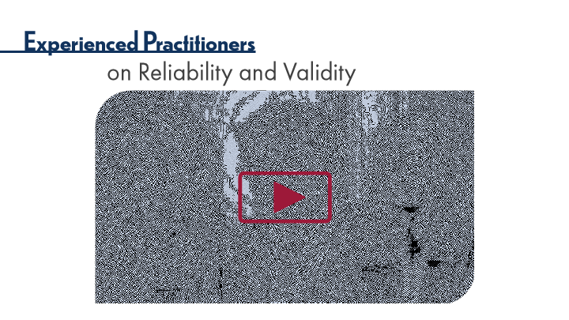

Type | Translation
Slide name | Experienced Practitioners on Reliability and Validity
Main Title 1 | Experienced Practitioners
Main Title 2 | on Reliability and Validity

8.13 Topic 4B: Triangulation of Assessment Evidence
Slide ID 🔒 | 5de1a1af-95b3-4829-9dd0-3aeec718683f
Preview Image | 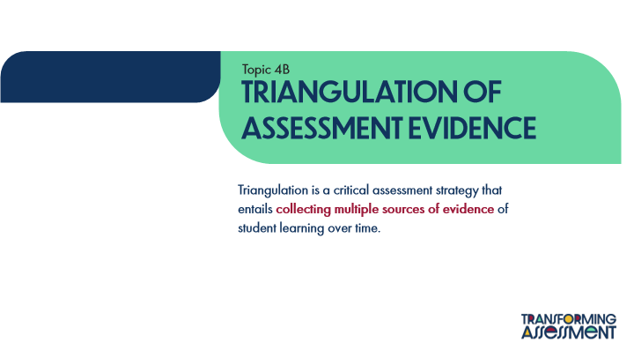

Type | Translation
Slide name | Topic 4B: Triangulation of Assessment Evidence
Text Box 1 | Topic 4B
Main Title 1 | TRIANGULATION OF ASSESSMENT EVIDENCE
Main Body | Triangulation is a critical assessment strategy that entails
 | collecting multiple sources of evidence
 | of student learning over time.

8.14 The Importance of Triangulation
Slide ID 🔒 | 0aa33a39-e1e3-4034-a37f-9bf31ad59157
Preview Image | 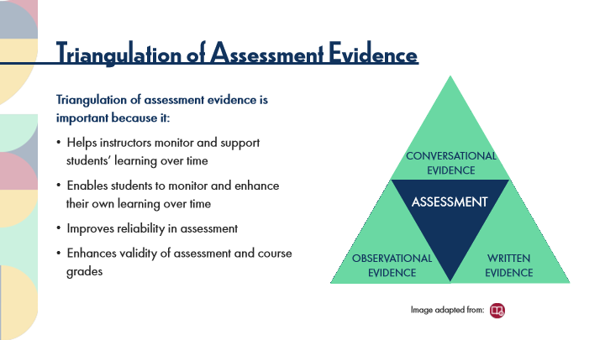

Type | Translation
Slide name | The Importance of Triangulation
Main Title 1 | Triangulation of Assessment Evidence
Alt text for Image 1 | Graphic showing a triangle. At the center of the triangle is the word ‘assessment’. At each of the three points of the triangle are the phrases: ‘conversational evidence’, ‘observational evidence’, and ‘written evidence’.
Text Box 1 | Triangulation of assessment evidence is important because it:
 | Helps instructors monitor and support students’ learning over time
 | Enables students to monitor and enhance their own learning over time
 | Improves reliability in assessment
 | Enhances validity of assessment and course grades
Text Box 6 | CONVERSATIONAL
 | EVIDENCE
Text Box 3 | ASSESSMENT
Text Box 5 | OBSERVATIONAL
 | EVIDENCE
Text Box 4 | WRITTEN
 | EVIDENCE
Text Box 2 | Image adapted from:

8.15 Key Points: Assessment Theory
Slide ID 🔒 | 5b1eb406-1f04-4d21-a07e-7069a5088e03
Preview Image | 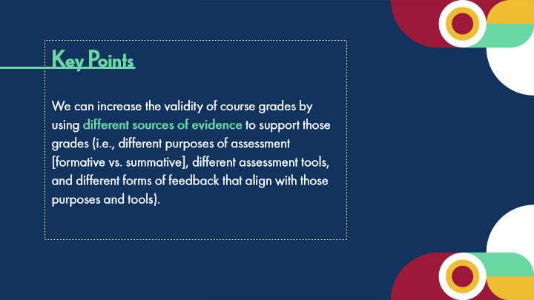

Type | Translation
Slide name | Key Points: Assessment Theory
Body | Key Points
 | We can increase the validity of course grades by using
 | different sources of evidence
 | to support those grades (i.e., different purposes of assessment [formative vs. summative], different assessment tools, and different forms of feedback that align with those purposes and tools).

8.16 Experienced Practitioners on Triangulation in Assessment
Slide ID 🔒 | 18633a88-0b39-428f-a701-08644d11cf02
Preview Image | 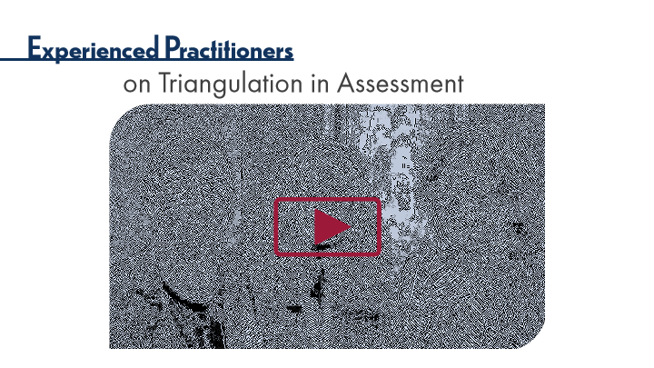

Type | Translation
Slide name | Experienced Practitioners on Triangulation in Assessment
Main Title 1 | Experienced Practitioners
Main Title 2 | on Triangulation in Assessment

8.17 POV: Instructor Perspectives
Slide ID 🔒 | 1a2f8831-b449-4807-b587-f5654b33ebe7
Preview Image | 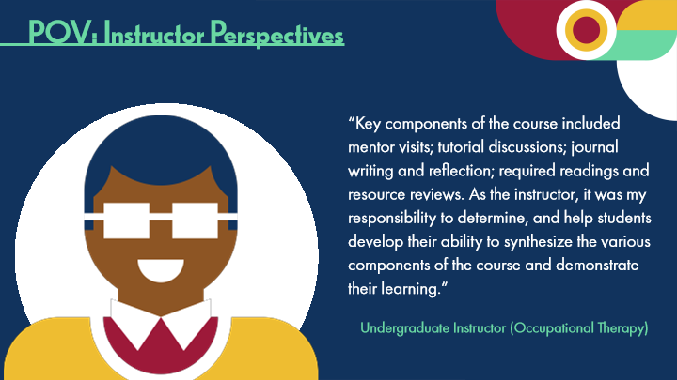

Type | Translation
Slide name | POV: Instructor Perspectives
Main Title 1 | POV: Instructor Perspectives
Text Box 1 | “Key components of the course included mentor visits; tutorial discussions; journal writing and reflection; required readings and resource reviews. As the instructor, it was my responsibility to determine, and help students develop their ability to synthesize the various components of the course and demonstrate their learning.”
Text Box 3 | Undergraduate Instructor (Occupational Therapy)

8.18 Thinking Forward: Assessment Theory
Slide ID 🔒 | 7591385e-3ec7-4a08-98d7-0af9db1c999e
Preview Image | 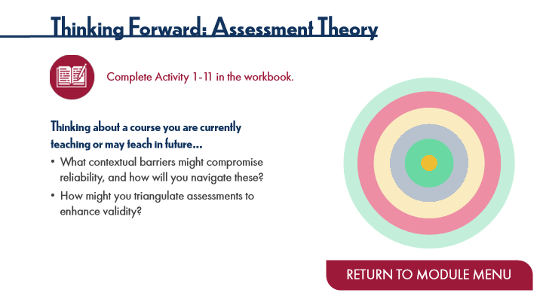

Type | Translation
Slide name | Thinking Forward: Assessment Theory
Main Title 1 | Thinking Forward: Assessment Theory
Text Box 6 | Complete Activity 1-11 in the workbook.
Text Box 3 | Thinking about a course you are currently teaching or may teach in future…
 | What contextual barriers might compromise reliability, and how will you navigate these?
 | How might you triangulate assessments to enhance validity?
Button - Normal state | RETURN TO MODULE MENU

9 Module 2: Exploring Alternative Assessments
Scene ID 🔒 | ef0dd568-f74d-4163-aa40-d4371a763b5c

Type | Translation
Scene name | Module 2: Exploring Alternative Assessments

9.1 Module 2: Exploring Alternative Assessment Strategies
Slide ID 🔒 | 75546ebc-58f0-4f18-87c5-8edd08b56e87
Preview Image | 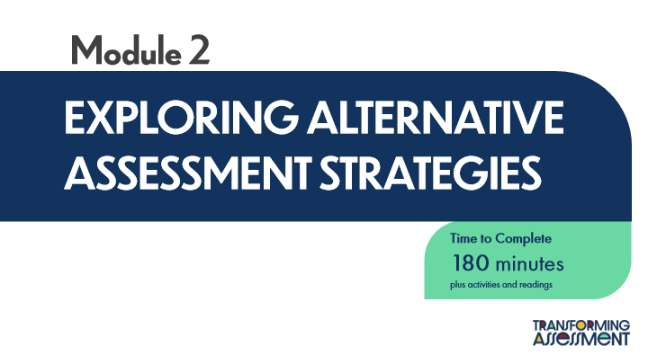

Type | Translation
Slide name | Module 2: Exploring Alternative Assessment Strategies
Main Title 1 | Module 2
Main Title | EXPLORING ALTERNATIVE ASSESSMENT STRATEGIES
Round Diagonal Corner 2 | Time to Complete
 | 180 minutes
 | plus activities and readings

9.2 Learning Outcomes
Slide ID 🔒 | 05a3a51a-5f7e-4336-a9a1-ca3fd5676987
Preview Image | 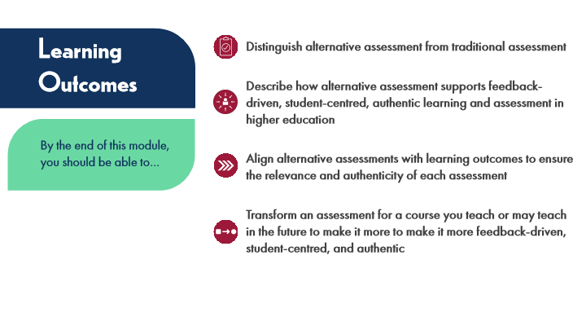

Type | Translation
Slide name | Learning Outcomes
Text Box 5 | Learning Outcomes
Text Box 1 | Distinguish alternative assessment from traditional assessment
Text Box 2 | Describe how alternative assessment supports feedback-driven, student-centred, authentic learning and assessment in higher education
Text Box 6 | By the end of this module, you should be able to…
Text Box 3 | Align alternative assessments with learning outcomes to ensure the relevance and authenticity of each assessment
Text Box 4 | Transform an assessment for a course you teach or may teach in the future to make it more to make it more feedback-driven, student-centred, and authentic

9.3 Activation
Slide ID 🔒 | 4c260d30-6344-47c6-af1e-80cd4a437525
Preview Image | 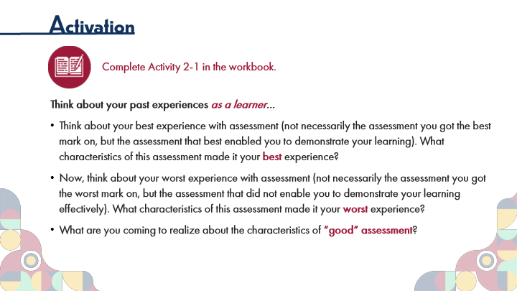

Type | Translation
Slide name | Activation
Main Title 1 | Activation
Text Box 6 | Complete Activity 2-1 in the workbook.
Text Box 7 | Think about your past experiences
 | as a learner
 | …
 | Think about your best experience with assessment (not necessarily the assessment you got the best mark on, but the assessment that best enabled you to demonstrate your learning). What characteristics of this assessment made it your
 | best
 | experience?
 | Now, think about your worst experience with assessment (not necessarily the assessment you got the worst mark on, but the assessment that did not enable you to demonstrate your learning effectively). What characteristics of this assessment made it your
 | worst
 | experience?
 | What are you coming to realize about the characteristics of
 | “good” assessment
 | ?

9.4 Quote
Slide ID 🔒 | 662e9f7e-aa7f-427e-a37f-ba6063e3a66c
Preview Image | 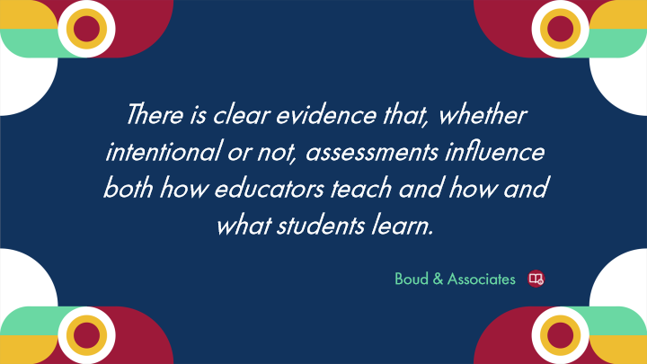

Type | Translation
Slide name | Quote
Text Box 1 | There is clear evidence that, whether intentional or not, assessments influence both how educators teach and how and what students learn.
Text Box 2 | Boud & Associates

9.5 Module 2 Introduction
Slide ID 🔒 | 35b282ce-4ef8-45bb-9e9b-d9951655922c
Preview Image | 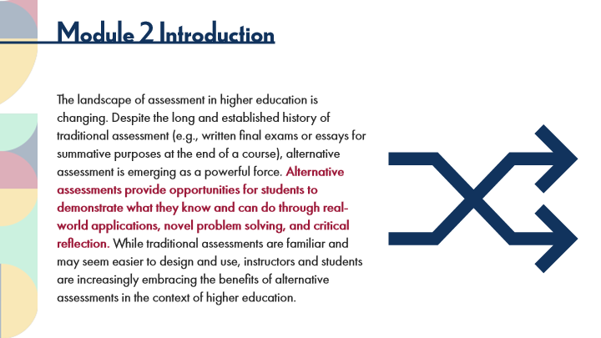

Type | Translation
Slide name | Module 2 Introduction
Main Title 1 | Module 2 Introduction
Text Box 1 | The landscape of assessment in higher education is changing. Despite the long and established history of traditional assessment (e.g., written final exams or essays for summative purposes at the end of a course), alternative assessment is emerging as a powerful force.
 | Alternative assessments provide opportunities for students to demonstrate what they know and can do through real-world applications, novel problem solving, and critical reflection.
 | While traditional assessments are familiar and may seem easier to design and use, instructors and students are increasingly embracing the benefits of alternative assessments in the context of higher education.

9.6 Key Points: Alternative Assessments
Slide ID 🔒 | f9037d16-9e4a-4774-b1d4-9af606dfb10e
Preview Image | 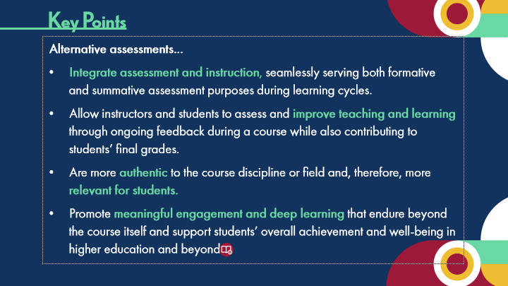

Type | Translation
Slide name | Key Points: Alternative Assessments
Text Box 1 | Key Points
Body | Alternative assessments…
 | Integrate assessment and instruction,
 | seamlessly serving both formative and summative assessment purposes during learning cycles.
 | Allow instructors and students to assess and
 | improve teaching and learning
 | through ongoing feedback during a course while also contributing to students’ final grades.
 | Are more
 | authentic
 | to the course discipline or field and, therefore, more
 | relevant for students.
 | Promote
 | meaningful engagement and deep learning
 | that endure beyond the course itself and support students’ overall achievement and well-being in higher education and beyond.

9.7 Activity Instructions
Slide ID 🔒 | aba19b20-e6c5-44c0-8920-9c07f5f661eb
Preview Image | 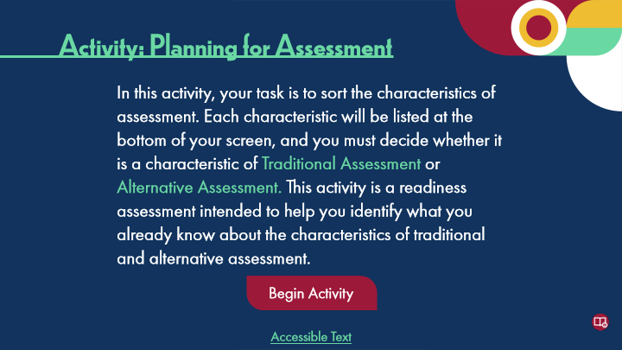

Type | Translation
Slide name | Activity Instructions
Main Title 1 | Activity: Planning for Assessment
Text Box 1 | In this activity, your task is to sort the characteristics of assessment. Each characteristic will be listed at the bottom of your screen, and you must decide whether it is a characteristic of
 | Traditional Assessment
 | or
 | Alternative Assessment.
 | This activity is a readiness assessment intended to help you identify what you already know about the characteristics of traditional and alternative assessment.
Round Diagonal Corner 1 - Normal state | Begin Activity
Text Box 2 | Accessible Text
Alt text for Text Box 2 | Accessible Activity Text Link. If you are not using a mouse for this course, skip this activity and access the PDF. This accessible document covers the next 4 slides as part of this single activity.

9.8 Activity: Characteristics of Alternative Assessment
Slide ID 🔒 | 966f7eec-9fd0-4b86-9c88-7e7b245e7c81
Preview Image | 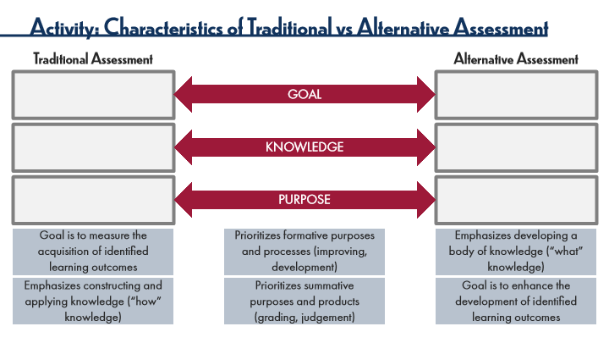

Type | Translation
Slide name | Activity: Characteristics of Alternative Assessment
Main Title 1 | Activity: Characteristics of Traditional vs Alternative Assessment
Text Box 5 | Traditional Assessment
Text Box 4 | Alternative Assessment
Goal | GOAL
Knowledge | KNOWLEDGE
Purpose | PURPOSE
Draggable 1 | Goal is to measure the acquisition of identified learning outcomes
Draggable 2 | Prioritizes formative purposes and processes (improving, development)
Draggable 3 | Emphasizes developing a body of knowledge (“what” knowledge)
Draggable 4 | Emphasizes constructing and applying knowledge (“how” knowledge)
Draggable 5 | Prioritizes summative purposes and products (grading, judgement)
Draggable 6 | Goal is to enhance the development of identified learning outcomes
Slide Notes | Paul Black (1998), who is often lauded as the forefather of these concepts, described the difference between these terms using the analogy of cooking. As a cook is making her soup, she occasionally tastes it to decide if it needs a bit more spices or ingredients. With each taste, she is assessing her soup and using that feedback to change or improve it - in other words, the cook is engaging in formative assessment. Once the soup is served to the customer, the customer tastes it and makes a final judgment about the quality of the soup - otherwise known as summative assessment.

Slide Layer: Correct
Layer ID 🔒 | ecef5131-e1ad-49d8-bd97-2fa8c1c76d15
Preview Image | 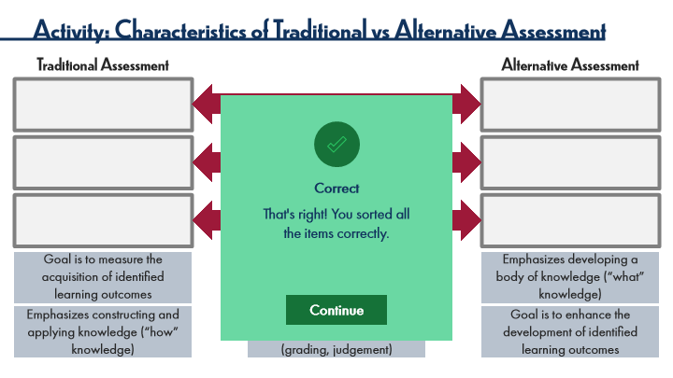

Type | Translation
Text Box | Correct
Text Box | That's right! You sorted all
 | the items correctly.
AltText for Continue - 1 Normal state | Button: Continue
Alt text for Continue | Button: Continue

Slide Layer: Incorrect
Layer ID 🔒 | 52419450-f5bc-45ad-ac10-cd9c540ddecb
Preview Image | 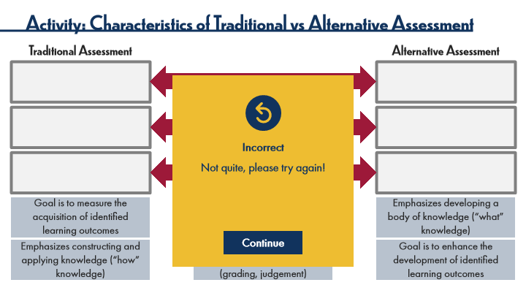

Type | Translation
Text Box | Incorrect
Text Box | Not quite, please try again!
AltText for Continue - 1 Normal state | Button: Continue
Alt text for Continue | Button: Continue

Slide Layer: Try Again
Layer ID 🔒 | e064596e-0599-4f27-9577-ed20c40fbaec
Preview Image | 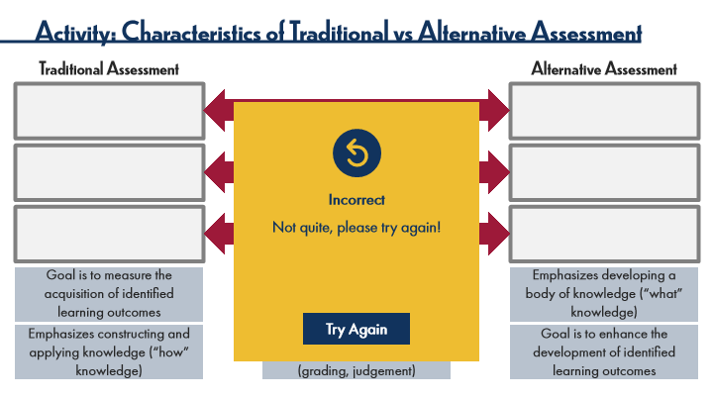

Type | Translation
Text Box | Incorrect
Text Box | Not quite, please try again!
AltText for Try Again - 1 Normal state | Button: Try Again
Alt text for Try Again | Button: Try Again

9.9 Activity: Characteristics of Alternative Assessment
Slide ID 🔒 | ed074e4f-ebb3-4c9d-bb68-a173e036e0da
Preview Image | 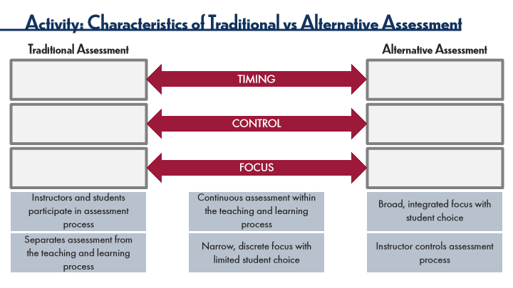

Type | Translation
Slide name | Activity: Characteristics of Alternative Assessment
Main Title 1 | Activity: Characteristics of Traditional vs Alternative Assessment
Text Box 5 | Traditional Assessment
Text Box 4 | Alternative Assessment
Timing | TIMING
Control | CONTROL
Focus | FOCUS
Draggable 1 | Instructors and students participate in assessment process
Draggable 2 | Continuous assessment within the teaching and learning process
Draggable 3 | Broad, integrated focus with student choice
Draggable 4 | Separates assessment from the teaching and learning process
Draggable 5 | Narrow, discrete focus with limited student choice
Draggable 6 | Instructor controls assessment process
Slide Notes | Paul Black (1998), who is often lauded as the forefather of these concepts, described the difference between these terms using the analogy of cooking. As a cook is making her soup, she occasionally tastes it to decide if it needs a bit more spices or ingredients. With each taste, she is assessing her soup and using that feedback to change or improve it - in other words, the cook is engaging in formative assessment. Once the soup is served to the customer, the customer tastes it and makes a final judgment about the quality of the soup - otherwise known as summative assessment.

Slide Layer: Correct
Layer ID 🔒 | 6ee0b633-7d93-450b-81ca-3db8b669ccd2
Preview Image | 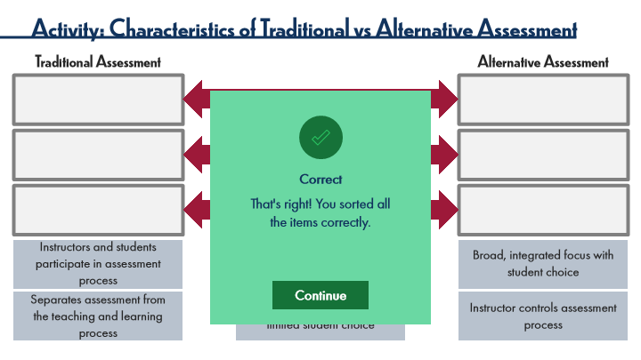

Type | Translation
Text Box | Correct
Text Box | That's right! You sorted all
 | the items correctly.
AltText for Continue - 1 Normal state | Button: Continue
Alt text for Continue | Button: Continue

Slide Layer: Incorrect
Layer ID 🔒 | 4a892541-dddf-40c3-be74-cd462d2f2700
Preview Image | 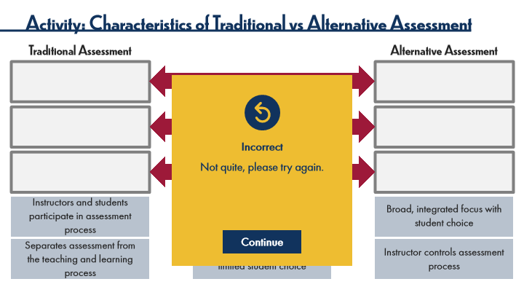

Type | Translation
Text Box | Incorrect
Text Box | Not quite, please try again.
AltText for Continue - 1 Normal state | Button: Continue
Alt text for Continue | Button: Continue

Slide Layer: Try Again
Layer ID 🔒 | bf591c7c-8975-4b3a-9287-55b9ba2f40b1
Preview Image | 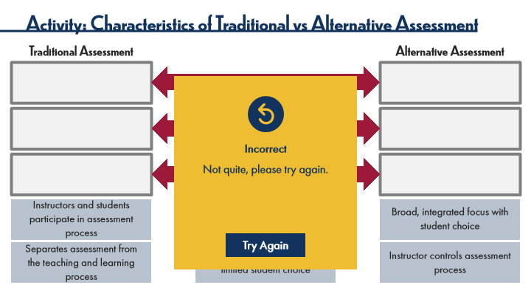

Type | Translation
Text Box | Incorrect
Text Box | Not quite, please try again.
AltText for Try Again - 1 Normal state | Button: Try again
Alt text for Try Again | Button: Try again

9.10 Activity: Characteristics of Alternative Assessment
Slide ID 🔒 | f59c154f-a6f8-48bd-b145-792e72205128
Preview Image | 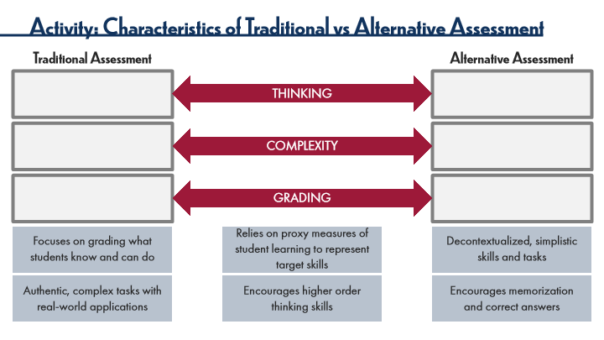

Type | Translation
Slide name | Activity: Characteristics of Alternative Assessment
Main Title 1 | Activity: Characteristics of Traditional vs Alternative Assessment
Text Box 5 | Traditional Assessment
Text Box 4 | Alternative Assessment
Thinking | THINKING
Complexity | COMPLEXITY
Grading | GRADING
Draggable 1 | Focuses on grading what students know and can do
Draggable 2 | Relies on proxy measures of student learning to represent target skills
Draggable 3 | Decontextualized, simplistic skills and tasks
Draggable 4 | Authentic, complex tasks with real-world applications
Draggable 6 | Encourages higher order thinking skills
Draggable 7 | Encourages memorization and correct answers
Slide Notes | Paul Black (1998), who is often lauded as the forefather of these concepts, described the difference between these terms using the analogy of cooking. As a cook is making her soup, she occasionally tastes it to decide if it needs a bit more spices or ingredients. With each taste, she is assessing her soup and using that feedback to change or improve it - in other words, the cook is engaging in formative assessment. Once the soup is served to the customer, the customer tastes it and makes a final judgment about the quality of the soup - otherwise known as summative assessment.

Slide Layer: Correct
Layer ID 🔒 | ab5a4207-a2bf-4fd7-8fc8-2f523682a9da
Preview Image | 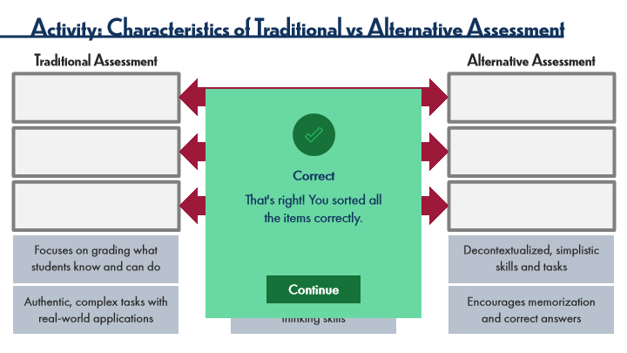

Type | Translation
Text Box | Correct
Text Box | That's right! You sorted all
 | the items correctly.
AltText for Continue - 1 Normal state | Button: Continue
Alt text for Continue | Button: Continue

Slide Layer: Incorrect
Layer ID 🔒 | 407510b5-c7d8-4ace-82df-f1226419532f
Preview Image | 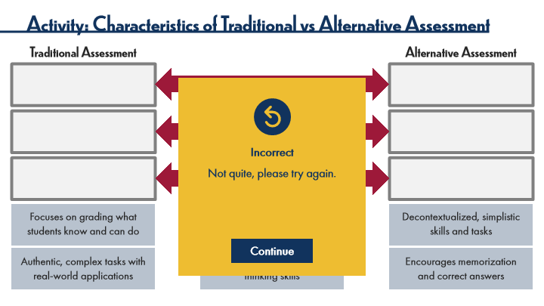

Type | Translation
Text Box | Incorrect
Text Box | Not quite, please try again.
AltText for Continue - 1 Normal state | Button: Continue
Alt text for Continue | Button: Continue

Slide Layer: Try Again
Layer ID 🔒 | 0b894221-11d0-4324-82d0-c37b81cb1989
Preview Image | 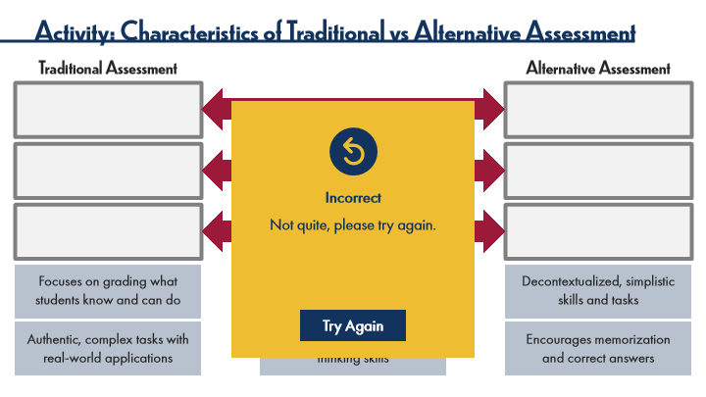

Type | Translation
Text Box | Incorrect
Text Box | Not quite, please try again.
AltText for Try Again - 1 Normal state | Button: Try Again
Alt text for Try Again | Button: Try Again

9.11 Activity: Characteristics of Alternative Assessment
Slide ID 🔒 | b07bb4ff-9dd8-4ae4-9d75-9d66db3a96c7
Preview Image | 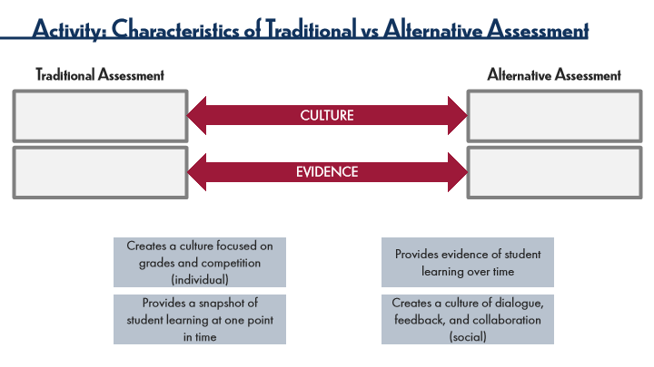

Type | Translation
Slide name | Activity: Characteristics of Alternative Assessment
Main Title 1 | Activity: Characteristics of Traditional vs Alternative Assessment
Text Box 5 | Traditional Assessment
Text Box 4 | Alternative Assessment
Culture | CULTURE
Evidence | EVIDENCE
Draggable 1 | Creates a culture focused on grades and competition (individual)
Draggable 2 | Provides evidence of student learning over time
Draggable 3 | Provides a snapshot of student learning at one point in time
Draggable 4 | Creates a culture of dialogue, feedback, and collaboration (social)
Slide Notes | Paul Black (1998), who is often lauded as the forefather of these concepts, described the difference between these terms using the analogy of cooking. As a cook is making her soup, she occasionally tastes it to decide if it needs a bit more spices or ingredients. With each taste, she is assessing her soup and using that feedback to change or improve it - in other words, the cook is engaging in formative assessment. Once the soup is served to the customer, the customer tastes it and makes a final judgment about the quality of the soup - otherwise known as summative assessment.

Slide Layer: Well done!
Layer ID 🔒 | 081fc081-ec5b-430d-a736-62e3e3fe0d22
Preview Image | 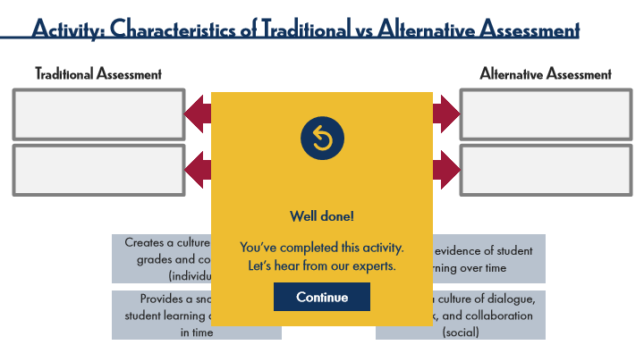

Type | Translation
Text Box | Well done!
Text Box | You’ve completed this activity.
 | Let’s hear from our experts.
AltText for Continue - 1 Normal state | Button: Continue
Alt text for Continue | Button: Continue

9.12 Experienced Practitioners on Alternative Assessments
Slide ID 🔒 | 3c3391d5-13db-4910-a72d-9c7dca1dd6e3
Preview Image | 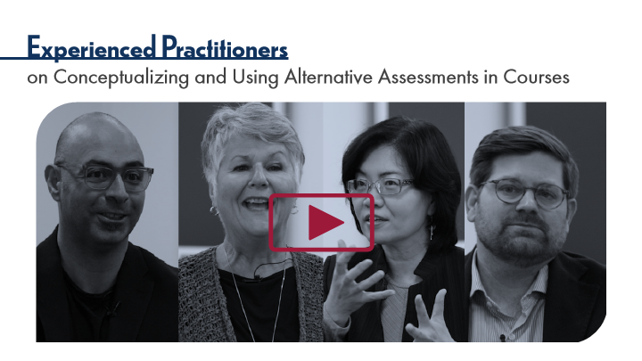

Type | Translation
Slide name | Experienced Practitioners on Alternative Assessments
Main Title 1 | Experienced Practitioners
Main Title 2 | on Conceptualizing and Using Alternative Assessments in Courses

9.13 Summary
Slide ID 🔒 | 3a275137-6843-48cf-9a78-e3d3eed38cb3
Preview Image | 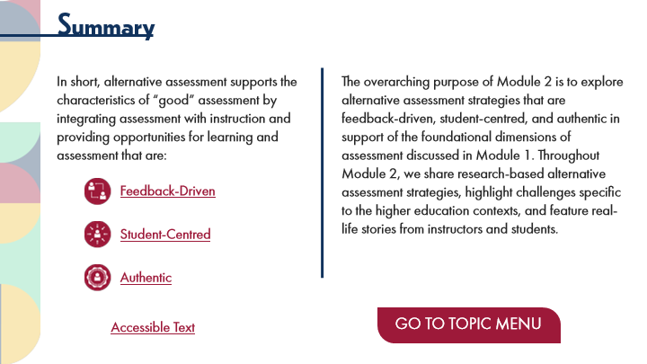

Type | Translation
Slide name | Summary
Main Title 1 | Summary
intro | In short, alternative assessment supports the characteristics of “good” assessment by integrating assessment with instruction and providing opportunities for learning and assessment that are:
Text Box 5 | The overarching purpose of Module 2 is to explore alternative assessment strategies that are feedback-driven, student-centred, and authentic in support of the foundational dimensions of assessment discussed in
 | Module 1
 | . Throughout Module 2, we share research-based alternative assessment strategies, highlight challenges specific to the higher education contexts, and feature real-life stories from instructors and students.
Text Box 1 | Feedback-Driven
Text Box 2 | Student-Centred
Text Box 3 | Authentic
Button - Normal state | GO TO TOPIC MENU
Text Box 6 | Accessible Text
Alt text for Text Box 6 | Accessible Activity Text Link. If you are not using a mouse for this course, the mouse rollover information is duplicated in this PDF.

Slide Layer: Authentic
Layer ID 🔒 | 10aacd5f-2c42-4452-b757-dccaa4f85bf8
Preview Image | 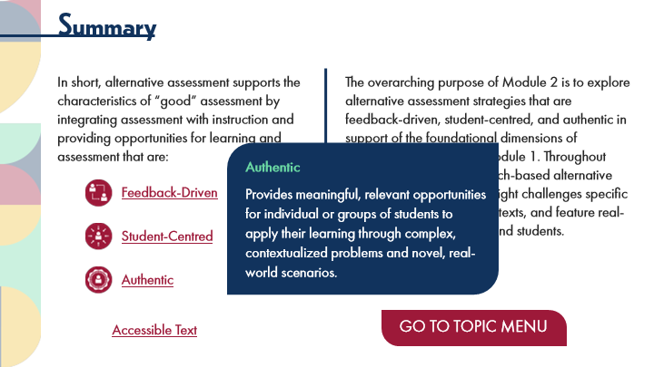

Type | Translation
Text Box 1 | Authentic
Text Box 2 | Provides meaningful, relevant opportunities for individual or groups of students to apply their learning through complex, contextualized problems and novel, real-world scenarios.

Slide Layer: Student Centred
Layer ID 🔒 | 6b5a0978-28fc-4381-b5c7-7236796936aa
Preview Image | 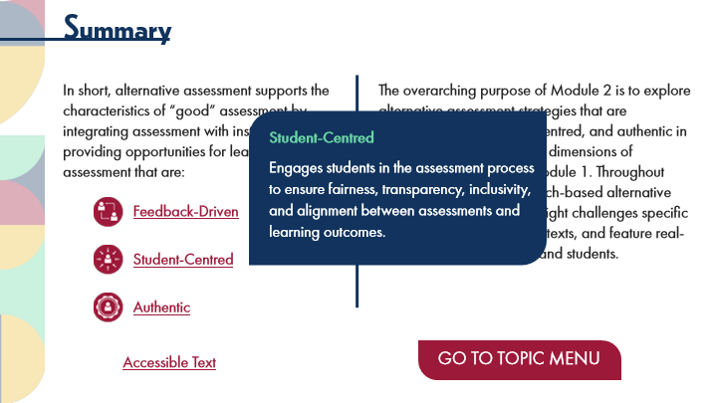

Type | Translation
Text Box 1 | Student-Centred
Text Box 2 | Engages students in the assessment process to ensure fairness, transparency, inclusivity, and alignment between assessments and learning outcomes.

Slide Layer: Feedback Driven
Layer ID 🔒 | d1e20874-dd88-44cf-9df7-9961b604db67
Preview Image | 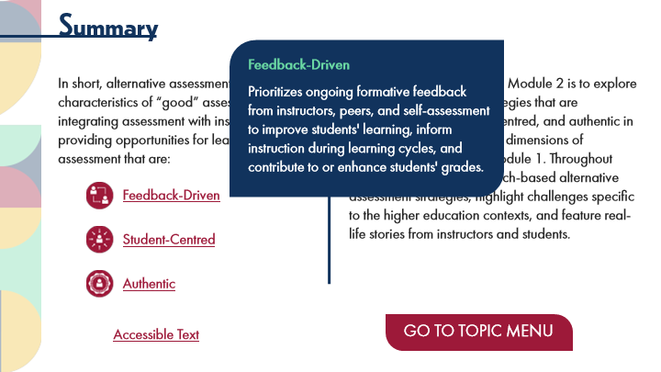

Type | Translation
Text Box 1 | Feedback-Driven
Text Box 2 | Prioritizes ongoing formative feedback from instructors, peers, and self-assessment to improve students' learning, inform instruction during learning cycles, and contribute to or enhance students' grades.

9.14 Module 2: Topic Menu
Slide ID 🔒 | 19183b64-e744-426d-b9e6-918a559fd5f4
Preview Image | 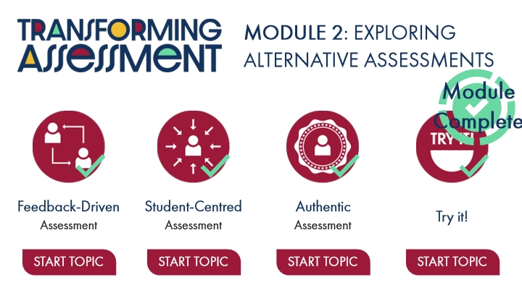

Type | Translation
Slide name | Module 2: Topic Menu
Module Title | MODULE 2: EXPLORING ALTERNATIVE ASSESSMENTS
Message: | Module
 | Complete
Title 01 | Feedback-Driven
Title 01 4 | Student-Centred
Title 01 6 | Authentic
Title 01 8 | Try it!
Title 01 3 | Assessment
Title 01 5 | Assessment
Title 01 7 | Assessment
Button: Feedback-Driven Assessment Topic - Normal state | START TOPIC
Button: Student-Centred Assessment Topic - Normal state | START TOPIC
Button: Authentic Assessment Topic - Normal state | START TOPIC
Button: Try it! Topic - Normal state | START TOPIC

Slide Layer: Instructions
Layer ID 🔒 | 208fb377-a3c1-4cdf-9ff3-991a161989f3
Preview Image | 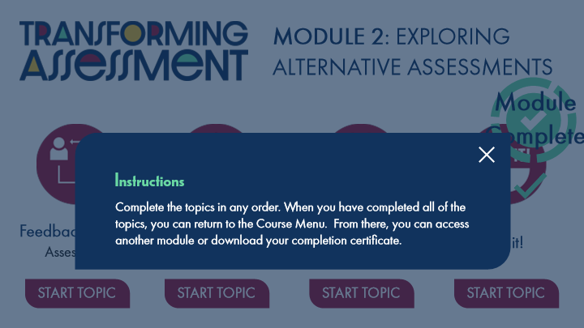

Type | Translation
Text Box 1 | Instructions
Text Box 2 | Complete the topics in any order. When you have completed all of the topics, you can return to the Course Menu. From there, you can access another module or download your completion certificate.

Slide Layer: Completion
Layer ID 🔒 | 6ce43c73-fac1-4878-969d-1773e71d2197
Preview Image | 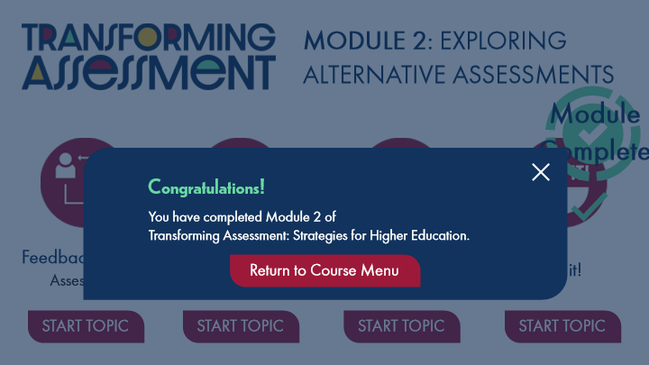

Type | Translation
Text Box 1 | Congratulations!
Text Box 2 | You have completed Module 2 of
 | Transforming Assessment: Strategies for Higher Education.
Button - Normal state | Return to Course Menu

10 Topic 1: Feedback-Driven Assessment
Scene ID 🔒 | 8cb3eaba-061b-4188-9457-7194ede69def

Type | Translation
Scene name | Topic 1: Feedback-Driven Assessment

10.1 Feedback Driven Assessment Title Page
Slide ID 🔒 | 2579b516-4d72-4d80-8f9a-6e736a7b9fbe
Preview Image | 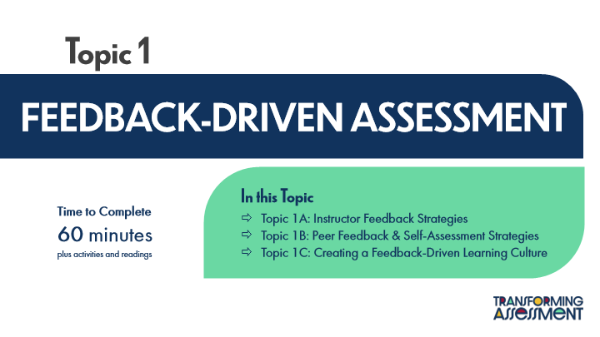

Type | Translation
Slide name | Feedback Driven Assessment Title Page
Main Title 1 | Topic 1
Main Title | FEEDBACK-DRIVEN ASSESSMENT
Text Box 1 | In this Topic
 | Topic 1A: Instructor Feedback Strategies
 | Topic 1B: Peer Feedback & Self-Assessment Strategies
 | Topic 1C: Creating a Feedback-Driven Learning Culture
Text Box 2 | Time to Complete
 | 60 minutes
 | plus activities and readings

10.2 Reviewing Effective Feedback
Slide ID 🔒 | 1bf72551-cc0d-4b06-a8b1-3627787c32fb
Preview Image | 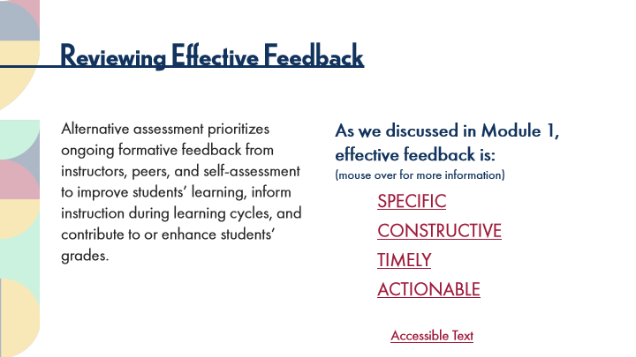

Type | Translation
Slide name | Reviewing Effective Feedback
Main Title 1 | Reviewing Effective Feedback
Text Box 4 | As we discussed in Module 1, effective feedback is:
 | (mouse over for more information)
 | SPECIFIC
 | CONSTRUCTIVE
 | TIMELY
 | ACTIONABLE
Text Box 1 | Alternative assessment prioritizes ongoing formative feedback from instructors, peers, and self-assessment to improve students’ learning, inform instruction during learning cycles, and contribute to or enhance students’ grades.
Text Box 5 | Accessible Text
Alt text for Text Box 5 | Accessible Activity Text Link. If you are not using a mouse for this course, the mouse rollover text is duplicated in this PDF.

Slide Layer: Rollover: Actionable
Layer ID 🔒 | c9647973-fb06-4765-9d55-38773025ea39
Preview Image | 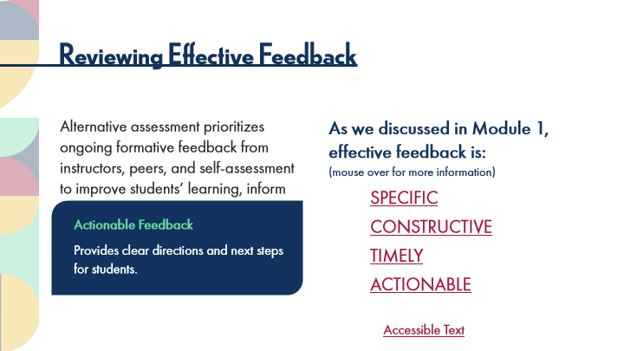

Type | Translation
Text Box 1 | Actionable Feedback
 | P
 | rovides clear directions and next steps for students.

Slide Layer: Rollover: Timely
Layer ID 🔒 | f39a6141-34e2-4aa1-8964-b2f1732ed20e
Preview Image | 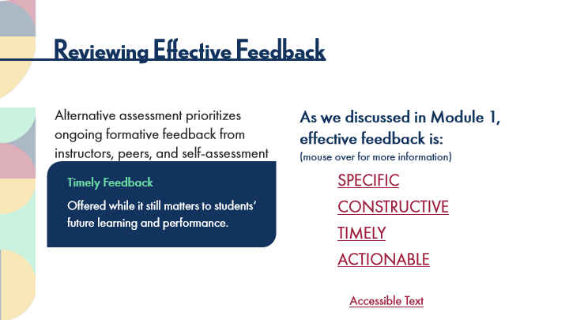

Type | Translation
Text Box 1 | Timely Feedback
 | Offered while it still matters to students’ future learning and performance.

Slide Layer: Rollover: Constructive
Layer ID 🔒 | 57a1391d-72cd-4034-9e64-dd8a6149500b
Preview Image | 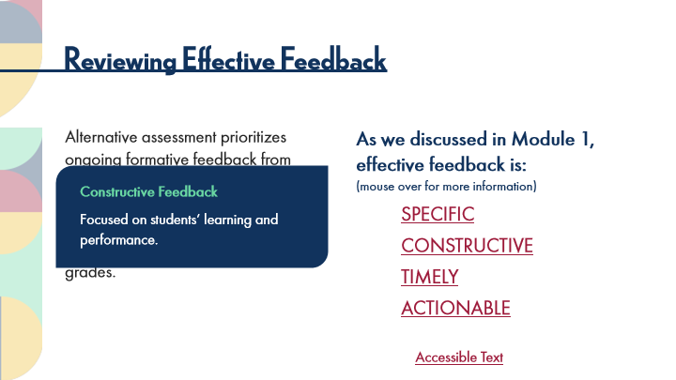

Type | Translation
Text Box 1 | Constructive Feedback
 | Focused on students’ learning and performance.

Slide Layer: Rollover: Specific
Layer ID 🔒 | 059157b8-2bfe-49ac-9581-f76611a1d64c
Preview Image | 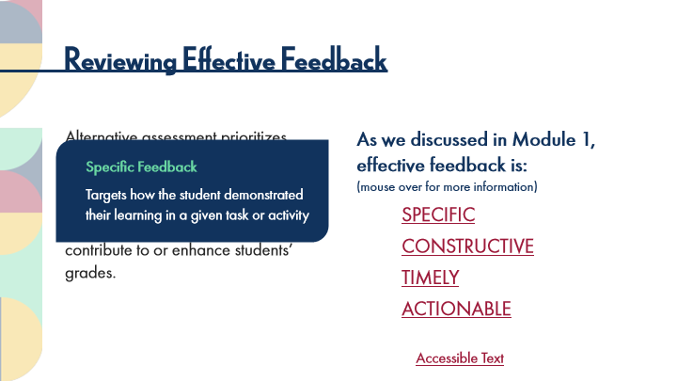

Type | Translation
Text Box 1 | Specific Feedback
 | Targets how the student demonstrated their learning in a given task or activity

10.3 POV: Student Perspectives
Slide ID 🔒 | b03f5fc6-c926-40f4-8a3a-8d043e8734a4
Preview Image | 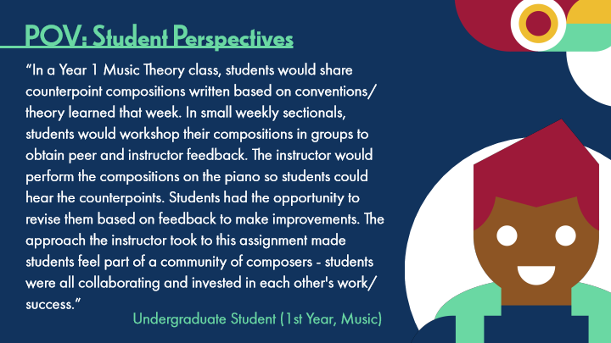

Type | Translation
Slide name | POV: Student Perspectives
Main Title 1 | POV: Student Perspectives
Text Box 1 | “In a Year 1 Music Theory class, students would share counterpoint compositions written based on conventions/theory learned that week. In small weekly sectionals, students would workshop their compositions in groups to obtain peer and instructor feedback. The instructor would perform the compositions on the piano so students could hear the counterpoints. Students had the opportunity to revise them based on feedback to make improvements. The approach the instructor took to this assignment made students feel part of a community of composers - students were all collaborating and invested in each other's work/success.”
Text Box 2 | Undergraduate Student (1st Year, Music)

10.4 Topic 1A: Instructor Feedback Strategies
Slide ID 🔒 | dd702eca-5c68-4df1-a108-c0c71cb5abec
Preview Image | 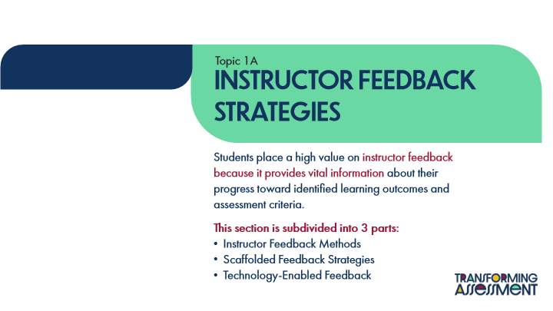

Type | Translation
Slide name | Topic 1A: Instructor Feedback Strategies
Text Box 1 | Topic 1A
Main Title | INSTRUCTOR FEEDBACK STRATEGIES
Main Body | Students place a high value on
 | instructor feedback because it provides vital information
 | about their progress toward identified learning outcomes and assessment criteria.
 | This section is subdivided into 3 parts:
 | Instructor Feedback Methods
 | Scaffolded Feedback Strategies
 | Technology-Enabled Feedback

10.5 Feedback in Alternative Assessments
Slide ID 🔒 | fb8e12d6-2727-49c2-82b7-287081b9aa24
Preview Image | 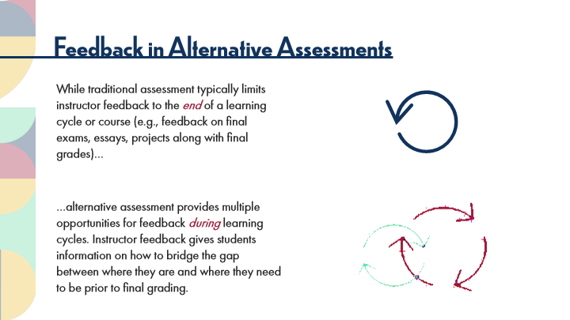

Type | Translation
Slide name | Feedback in Alternative Assessments
Main Title 1 | Feedback in Alternative Assessments
Text Box 1 | While traditional assessment typically limits instructor feedback to the
 | end
 | of a learning cycle or course (e.g., feedback on final exams, essays, projects along with final grades)…
Text Box 2 | …alternative assessment provides multiple opportunities for feedback
 | during
 | learning cycles. Instructor feedback gives students information on how to bridge the gap between where they are and where they need to be prior to final grading.

10.6 Honest and Constructive Feedback
Slide ID 🔒 | 95ddf034-5970-4039-8553-a6108dd157d9
Preview Image | 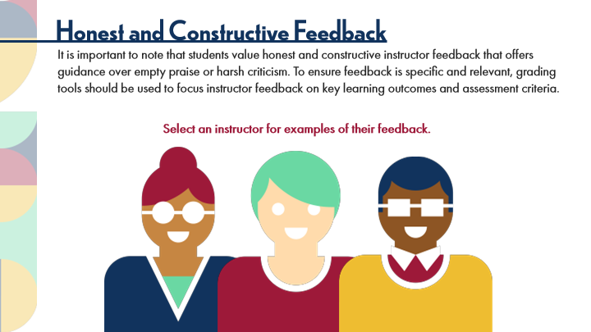

Type | Translation
Slide name | Honest and Constructive Feedback
Main Title 1 | Honest and Constructive Feedback
Text Box 1 | It is important to note that students value honest and constructive instructor feedback that offers guidance over empty praise or harsh criticism. To ensure feedback is specific and relevant, grading tools should be used to focus instructor feedback on key learning outcomes and assessment criteria.
Text Box 2 | Select an instructor for examples of their feedback.
Alt text for Image: Instructor 1 | Button: Image of Instructor 1
Alt text for Image: Instructor 2 | Button: Image of Instructor 2
Alt text for Image: Instructor 3 | Button: Image of Instructor 3

Slide Layer: Instructor: Specific and Relevant
Layer ID 🔒 | d20b2364-4dc4-4869-afa5-a59815e7ed52
Preview Image | 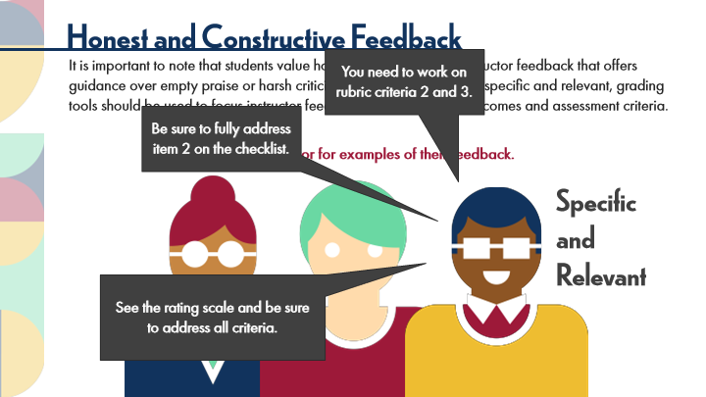

Type | Translation
Rectangular Caption 3 | You need to work on rubric criteria 2 and 3.
Rectangular Caption 2 | Be sure to fully address item 2 on the checklist.
Text Box 2 | Specific and Relevant
Rectangular Caption 1 | See the rating scale and be sure to address all criteria.

Slide Layer: Instructor: Harsh Criticism
Layer ID 🔒 | 7d18c172-93b7-4226-9163-4a394c2498e4
Preview Image | 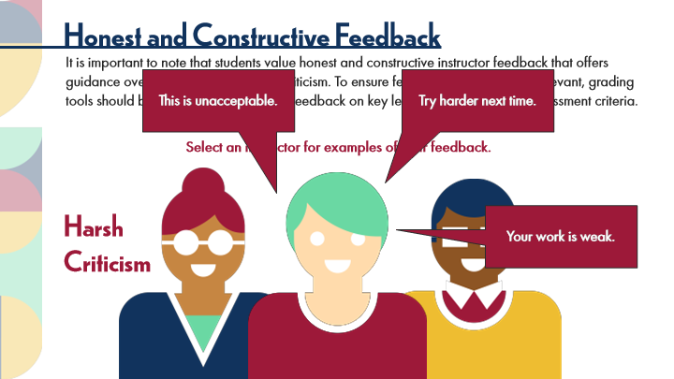

Type | Translation
Rectangular Caption 1 | This is unacceptable.
Rectangular Caption 2 | Try harder next time.
Text Box 1 | Harsh Criticism
Rectangular Caption 3 | Your work is weak.

Slide Layer: Instructor: Empty Praise
Layer ID 🔒 | 84ba93df-518d-42c6-8756-a63d7c4e3c77
Preview Image | 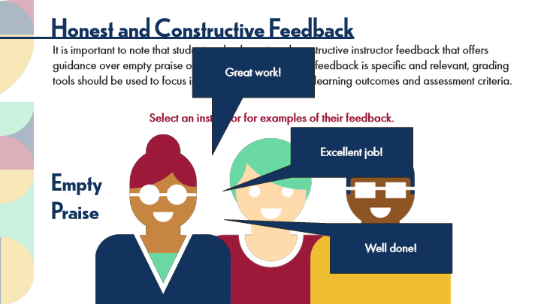

Type | Translation
Rectangular Caption 1 | Great work!
Rectangular Caption 2 | Excellent job!
Text Box 1 | Empty Praise
Rectangular Caption 3 | Well done!

10.7 POV: Student Perspectives
Slide ID 🔒 | 563329e8-8975-4111-815a-68dda3a41f10
Preview Image | 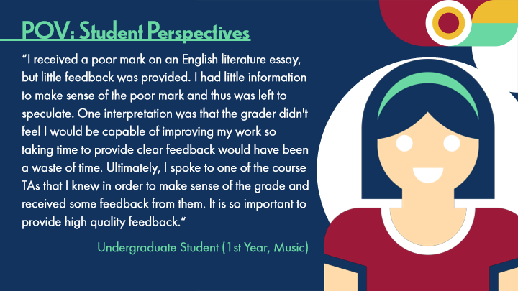

Type | Translation
Slide name | POV: Student Perspectives
Main Title 1 | POV: Student Perspectives
Text Box 1 | “I received a poor mark on an English literature essay, but little feedback was provided. I had little information to make sense of the poor mark and thus was left to speculate. One interpretation was that the grader didn't feel I would be capable of improving my work so taking time to provide clear feedback would have been a waste of time. Ultimately, I spoke to one of the course TAs that I knew in order to make sense of the grade and received some feedback from them. It is so important to provide high quality feedback.“
Text Box 2 | Undergraduate Student (1st Year, Music)

10.8 Intructor Feedback Strategies
Slide ID 🔒 | d11334ea-ca49-4241-a762-4f4cac5a80eb
Preview Image | 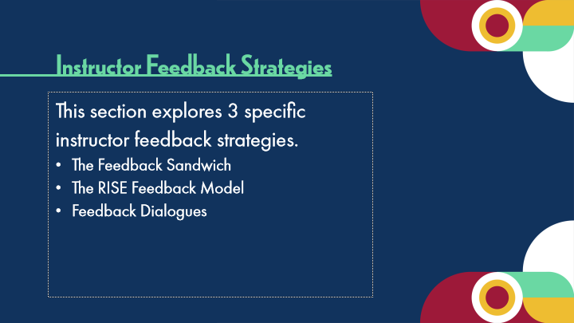

Type | Translation
Slide name | Instructor Feedback Strategies
Text Box 1 | Instructor Feedback Strategies
Body | This section explores 3 specific instructor feedback strategies.
 | The Feedback Sandwich
 | The RISE Feedback Model
 | Feedback Dialogues

10.9 The Feedback Sandwich
Slide ID 🔒 | 6be57754-41e1-4258-862d-8c3e071c383f
Preview Image | 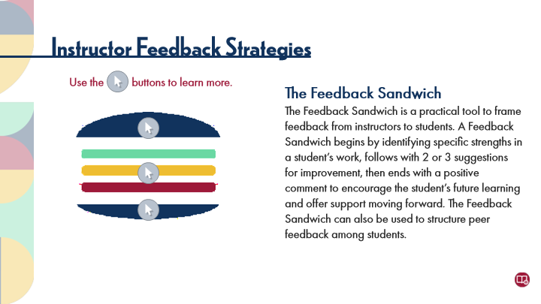

Type | Translation
Slide name | The Feedback Sandwich
Main Title 1 | Instructor Feedback Strategies
Text Box 2 | Use the buttons to learn more.
Text Box | Hotspot buttons
Text Box | Clicking on hotspot buttons will reveal more information about the images you see in the course.
Text Box 1 | The Feedback Sandwich
 | The Feedback Sandwich
 | is a practical tool to frame feedback from instructors to students. A Feedback Sandwich begins by identifying specific strengths in a student’s work, follows with 2 or 3 suggestions for improvement, then ends with a positive comment to encourage the student’s future learning and offer support moving forward. The Feedback Sandwich can also be used to structure peer feedback among students.
Text Box | Start with…
Text Box | Strengths in their work.
Text Box | Then add…
Text Box | 2 or 3suggestions on how to improve.
Text Box | Then..
Text Box | End with positive feedback.
Alt text for Picture 1 | Button: Reference

10.10 RISE Feedback model
Slide ID 🔒 | 1036ea86-81a7-4b3d-b5c2-e4fe28cd366c
Preview Image | 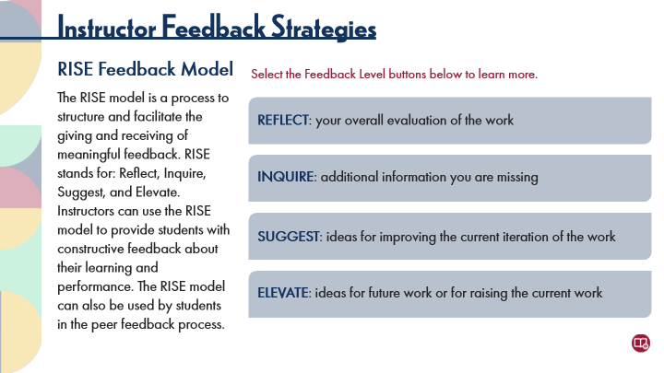

Type | Translation
Slide name | RISE Feedback model
Main Title 1 | Instructor Feedback Strategies
Text Box 1 | RISE Feedback Model
 | The RISE model is a process to structure and facilitate the giving and receiving of meaningful feedback. RISE stands for: Reflect, Inquire, Suggest, and Elevate. Instructors can use the RISE model to provide students with constructive feedback about their learning and performance. The RISE model can also be used by students in the peer feedback process.
Text Box 6 | Select the Feedback Level buttons below to learn more.
Button 1 - Normal state | REFLECT
 | : your overall evaluation of the work
Button 2 - Normal state | INQUIRE
 | : additional information you are missing
Button 3 - Normal state | SUGGEST
 | : ideas for improving the current iteration of the work
Button 4 - Normal state | ELEVATE
 | : ideas for future work or for raising the current work

Slide Layer: Elevate
Layer ID 🔒 | 81799ff2-ca33-4e9e-adce-93b613c2812d
Preview Image | 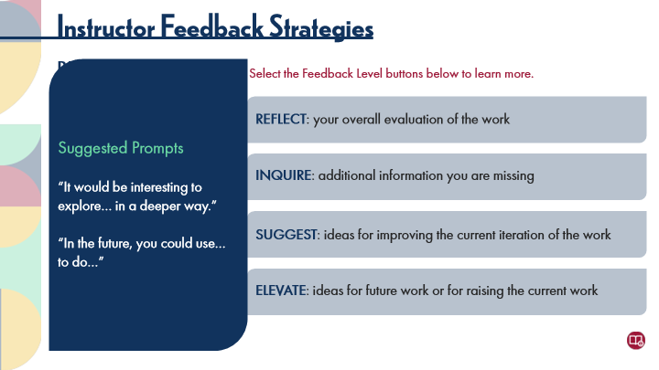

Type | Translation
Round Diagonal Corner 1 | Suggested Prompts
 | “It would be interesting to explore… in a deeper way.”
 | “In the future, you could use… to do…”

Slide Layer: Suggest
Layer ID 🔒 | 10f18d49-f79e-4a61-9bd4-41723b4f4442
Preview Image | 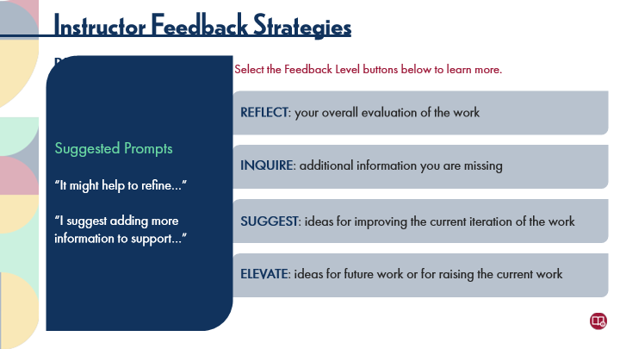

Type | Translation
Round Diagonal Corner 1 | Suggested Prompts
 | “It might help to refine…”
 | “I suggest adding more information to support…”

Slide Layer: Inquire
Layer ID 🔒 | 7acee74e-6da6-49e8-b9e7-a2c8aadd137c
Preview Image | 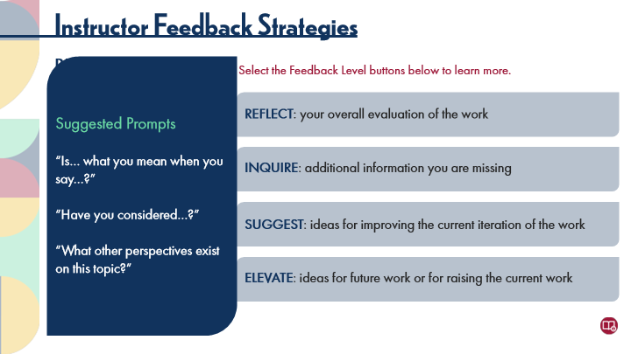

Type | Translation
Round Diagonal Corner 1 | Suggested Prompts
 | “Is… what you mean when you say…?”
 | “Have you considered…?”
 | “What other perspectives exist on this topic?”

Slide Layer: Reflect
Layer ID 🔒 | 70590d68-5cb7-408e-8304-274dc4d37a7d
Preview Image | 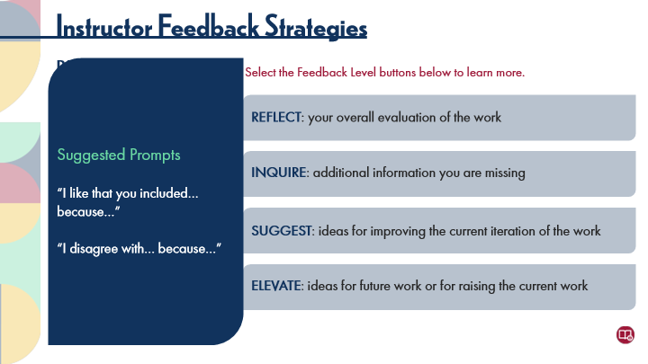

Type | Translation
Round Diagonal Corner 1 | Suggested Prompts
 | “I like that you included… because…”
 | “I disagree with… because…”

10.11 Feedback Dialogues
Slide ID 🔒 | 55b6e235-72b1-49cb-9c0b-a4b9cbe95bf6
Preview Image | 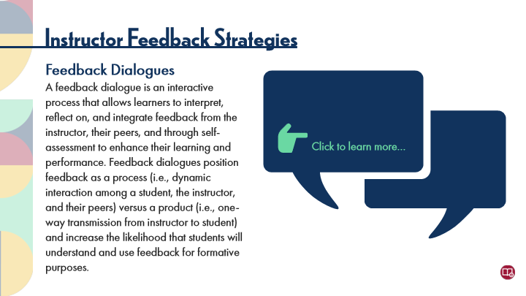

Type | Translation
Slide name | Feedback Dialogues
Main Title 1 | Instructor Feedback Strategies
Text Box 1 | Feedback Dialogues
 | A feedback dialogue is an interactive process that allows learners to interpret, reflect on, and integrate feedback from the instructor, their peers, and through self-assessment to enhance their learning and performance. Feedback dialogues position feedback as a process (i.e., dynamic interaction among a student, the instructor, and their peers) versus a product (i.e., one-way transmission from instructor to student) and increase the likelihood that students will understand and use feedback for formative purposes.
Text Box 2 | Click to learn more…

Slide Layer: Creating opportunities
Layer ID 🔒 | 78ad750c-d6fb-4033-ad6d-cfef73b117a4
Preview Image | 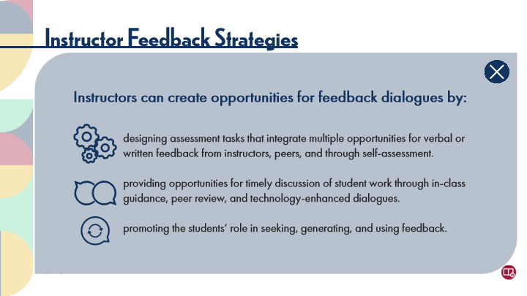

Type | Translation
Text Box 2 | Instructors can create opportunities for feedback dialogues by:
Text Box 1
 | designing assessment tasks that integrate multiple opportunities for verbal or written feedback from instructors, peers, and through self-assessment.
 | providing opportunities for timely discussion of student work through in-class guidance, peer review, and technology-enhanced dialogues.
 | promoting the students’ role in seeking, generating, and using feedback.

10.12 Pause and Reflect on Feedback Strategies
Slide ID 🔒 | 81932dee-1641-47ae-a0e6-848585df1077
Preview Image | 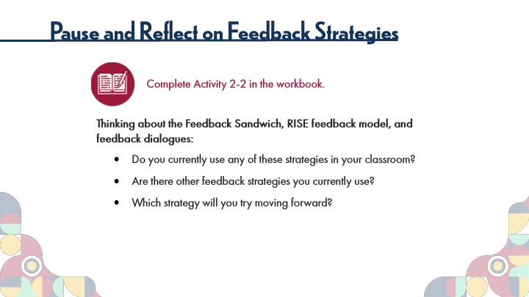

Type | Translation
Slide name | Pause and Reflect on Feedback Strategies
Main Title 1 | Pause and Reflect on Feedback Strategies
Text Box 6 | Complete Activity 2-2 in the workbook.
Text Box 7 | Thinking about the Feedback Sandwich, RISE feedback model, and feedback dialogues:
 | Do you currently use any of these strategies in your classroom?
 | Are there other feedback strategies you currently use?
 | Which strategy will you try moving forward?

10.13 Scaffolded Feedback Strategies
Slide ID 🔒 | 11327a2c-faa5-4c60-a44d-52bcf93ee7b4
Preview Image | 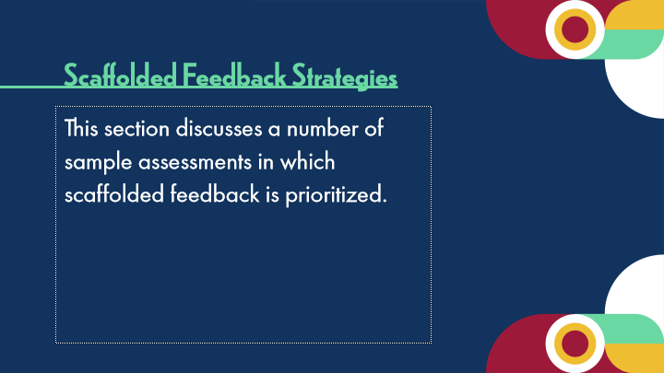

Type | Translation
Slide name | Scaffolded Feedback Strategies
Text Box 1 | Scaffolded Feedback Strategies
Body | This section discusses a number of sample assessments in which scaffolded feedback is prioritized.

10.14 Scaffolded Feedback Strategies
Slide ID 🔒 | efde7bc8-07cf-4e10-8807-6761bbe5071d
Preview Image | 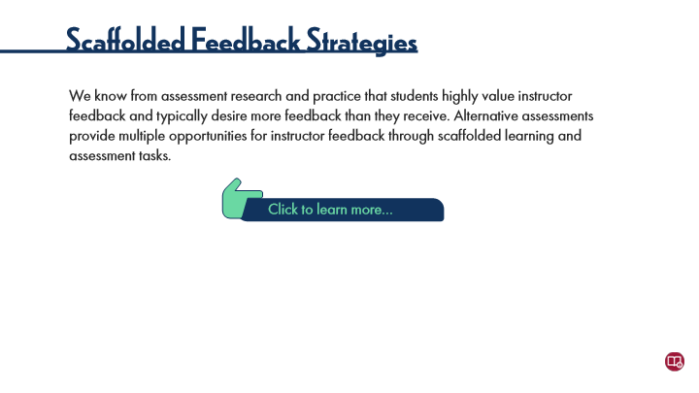

Type | Translation
Slide name | Scaffolded Feedback Strategies
Main Title 2 | Scaffolded Feedback Strategies
Text Box 1 | We know from assessment research and practice that students highly value instructor feedback and typically desire more feedback than they receive. Alternative assessments provide multiple opportunities for instructor feedback through scaffolded learning and assessment tasks.
Text Box 2 | Click to learn more…

Slide Layer: Opportunities for Grading
Layer ID 🔒 | 95ac2c98-9c6a-47dd-81bd-b66982422b30
Preview Image | 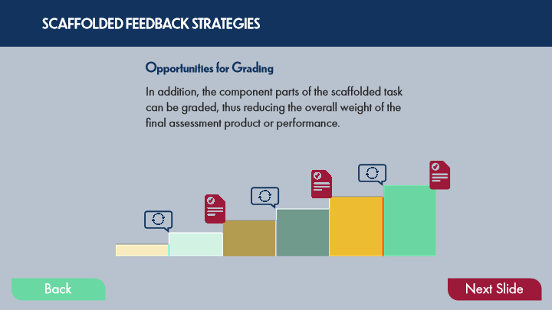

Type | Translation
Text Box 4 | SCAFFOLDED FEEDBACK STRATEGIES
Text Box 3 | Opportunities for Grading
Text Box 2 | In addition, the component parts of the scaffolded task can be graded, thus reducing the overall weight of the final assessment product or performance.
Alt text for Picture 1 | Graphic that shows the same feedback opportunities as students take each step. The graphic now also shows that every other step up might contain and opportunity for grading - thus layering feedback and grading.
Button - Normal state | Back
Button - Down state | Back
Button - Normal state | Next Slide

Slide Layer: Opportunities for Feedback
Layer ID 🔒 | 3a4ee142-d4f5-472c-b1a6-30b01dfd6b29
Preview Image | 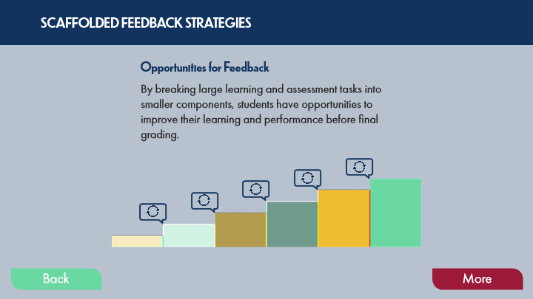

Type | Translation
Text Box 4 | SCAFFOLDED FEEDBACK STRATEGIES
Text Box 3 | Opportunities for Feedback
Text Box 2 | By breaking large learning and assessment tasks into smaller components, students have opportunities to improve their learning and performance before final grading.
Alt text for Group 1 | Graphic showing a cycle image at each of the steps indicating that each step up is an opportunity for feedback.
Alt text for Picture 1 | Scaffold1.png
Button - Normal state | Back
Button - Down state | Back
Button - Normal state | More

Slide Layer: Scaffolded Tasks
Layer ID 🔒 | 92289b13-af44-4e40-a3bd-93291a14b645
Preview Image | 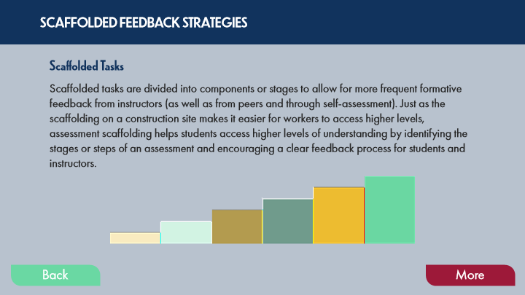

Type | Translation
Text Box 8 | SCAFFOLDED FEEDBACK STRATEGIES
Text Box 10 | Scaffolded Tasks
Text Box 9 | Scaffolded tasks are divided into components or stages to allow for more frequent formative feedback from instructors (as well as from peers and through self-assessment). Just as the scaffolding on a construction site makes it easier for workers to access higher levels, assessment scaffolding helps students access higher levels of understanding by identifying the stages or steps of an assessment and encouraging a clear feedback process for students and instructors.
Alt text for Picture 1 | Graphic showing steps going up at regular intervals from right to left.
Button - Normal state | Back
Button - Down state | Back
Button - Normal state | More

10.15 POV: Instructor Perspectives
Slide ID 🔒 | 2639a0bb-8b2b-431a-b35b-2f9e3510fd19
Preview Image | 

Type | Translation
Slide name | POV: Instructor Perspectives
Main Title 1 | POV: Instructor Perspectives
Text Box 1 | “I love scaffolding assessments (breaking them down into smaller chunks that lead into a larger project) for my students. I also like to incorporate practical formative assessments to help solidify their understanding and to help bridge the practice-theory gap.”
Text Box 2 | University Instructor (Education)

10.16 Effects of Scaffolded Feedback
Slide ID 🔒 | a0196c2b-00fa-406d-b8f3-2ef86cf37875
Preview Image | 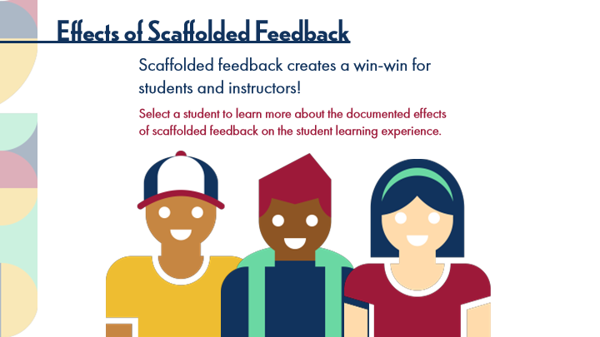

Type | Translation
Slide name | Effects of Scaffolded Feedback
Main Title 1 | Effects of Scaffolded Feedback
Text Box 3 | Scaffolded feedback creates a win-win for students and instructors!
Text Box 2 | Select a student to learn more about the documented effects of scaffolded feedback on the student learning experience.

Slide Layer: Student 3
Layer ID 🔒 | 4edc2946-7e7c-4805-bfb5-3a6a435d2c65
Preview Image | 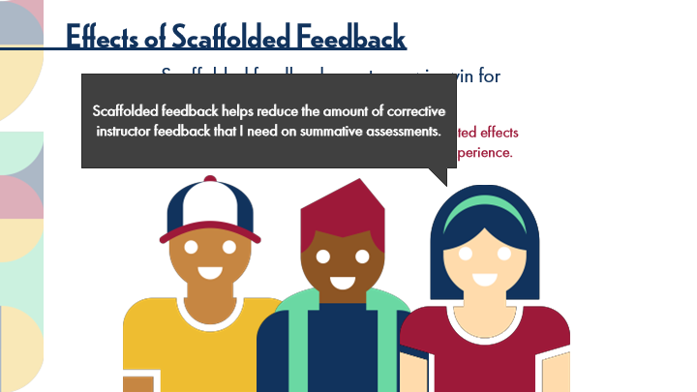

Type | Translation
Rectangular Caption 3 | Scaffolded feedback helps reduce the amount of corrective instructor feedback that I need on summative assessments.

Slide Layer: Student 2
Layer ID 🔒 | 59a43ff7-d69b-4b53-b183-16559b39d5f0
Preview Image | 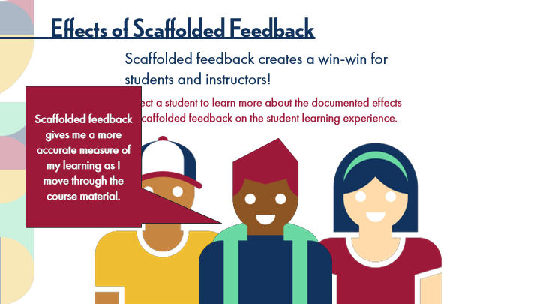

Type | Translation
Rectangular Caption 2 | Scaffolded feedback gives me a more accurate measure of my learning as I move through the course material.

Slide Layer: Student 1
Layer ID 🔒 | b6728298-c1b8-4a26-aa8c-89a89e3ddc81
Preview Image | 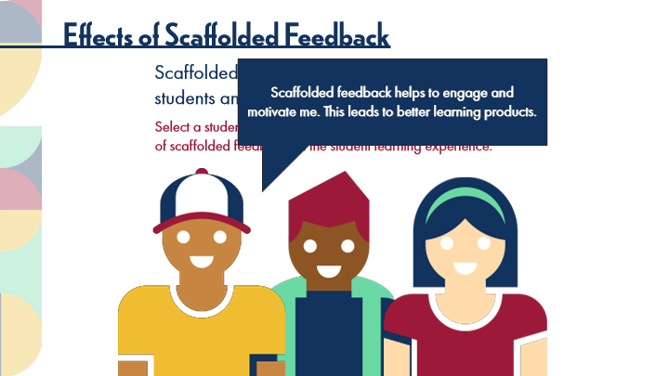

Type | Translation
Rectangular Caption 1 | Scaffolded feedback helps to engage and motivate me. This leads to better learning products.

10.17 POV: Instructor Perspectives
Slide ID 🔒 | 15b03512-b3b3-4370-b514-dea7cc25fb74
Preview Image | 

Type | Translation
Slide name | POV: Instructor Perspectives
Main Title 1 | POV: Instructor Perspectives

Slide Layer: Text 3
Layer ID 🔒 | b4609145-3435-4ec8-909b-081cae87ebc5
Preview Image | 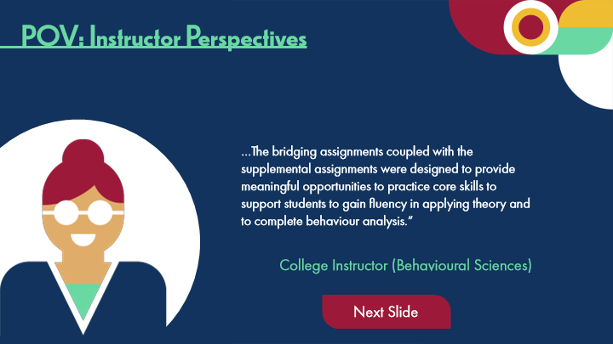

Type | Translation
Text Box 1 | …The bridging assignments coupled with the supplemental assignments were designed to provide meaningful opportunities to practice core skills to support students to gain fluency in applying theory and to complete behaviour analysis.”
Text Box 2 - Normal state | College Instructor (Behavioural Sciences)
Button - Normal state | Next Slide

Slide Layer: Text 2
Layer ID 🔒 | e52fd17c-a8ce-4b8c-b7af-e5cb260c4e9a
Preview Image | 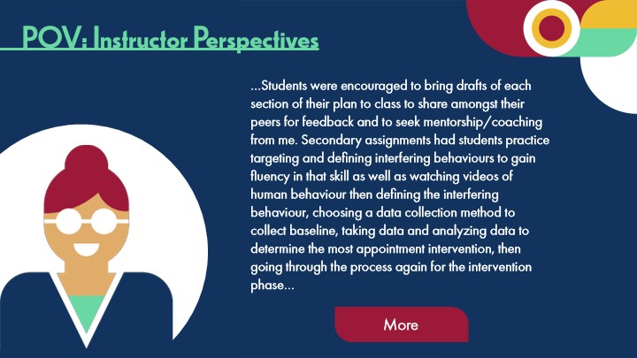

Type | Translation
Text Box 1 | …Students were encouraged to bring drafts of each section of their plan to class to share amongst their peers for feedback and to seek mentorship/coaching from me. Secondary assignments had students practice targeting and defining interfering behaviours to gain fluency in that skill as well as watching videos of human behaviour then defining the interfering behaviour, choosing a data collection method to collect baseline, taking data and analyzing data to determine the most appointment intervention, then going through the process again for the intervention phase…
Button - Normal state | More

Slide Layer: Text 1
Layer ID 🔒 | ca434207-50e1-481d-a1ff-300237a3edaf
Preview Image | 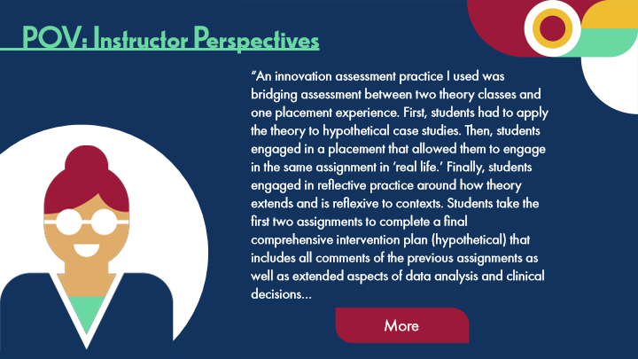

Type | Translation
Text Box 1 | “An innovation assessment practice I used was bridging assessment between two theory classes and one placement experience. First, students had to apply the theory to hypothetical case studies. Then, students engaged in a placement that allowed them to engage in the same assignment in ’real life.’ Finally, students engaged in reflective practice around how theory extends and is reflexive to contexts. Students take the first two assignments to complete a final comprehensive intervention plan (hypothetical) that includes all comments of the previous assignments as well as extended aspects of data analysis and clinical decisions…
Button - Normal state | More

10.18 Examples of Scaffolded Assessments
Slide ID 🔒 | 1042ae47-40df-47c9-a425-565e9122c611
Preview Image | 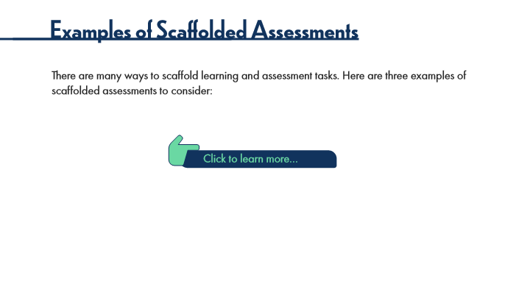

Type | Translation
Slide name | Examples of Scaffolded Assessments
Main Title 2 | Examples of Scaffolded Assessments
Text Box 1 | There are many ways to scaffold learning and assessment tasks. Here are three examples of scaffolded assessments to consider:
Text Box 2 | Click to learn more…

Slide Layer: Multi-Stage Assignment
Layer ID 🔒 | 20121352-05d2-4a8d-9288-f6e8876f011a
Preview Image | 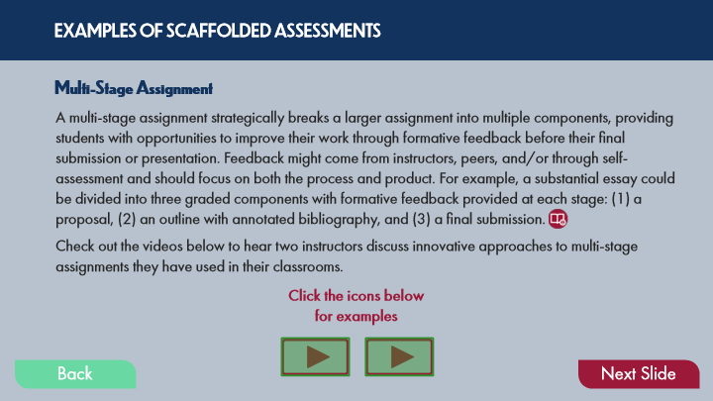

Type | Translation
Text Box 6 | EXAMPLES OF SCAFFOLDED ASSESSMENTS
Text Box 9 | Multi-Stage Assignment
Text Box 8 | A multi-stage assignment strategically breaks a larger assignment into multiple components, providing students with opportunities to improve their work through formative feedback before their final submission or presentation. Feedback might come from instructors, peers, and/or through self-assessment and should focus on both the process and product. For example, a substantial essay could be divided into three graded components with formative feedback provided at each stage: (1) a proposal, (2) an outline with annotated bibliography, and (3) a final submission.
 | Check out the videos below to hear two instructors discuss innovative approaches to multi-stage assignments they have used in their classrooms.
Instruction 3 | Click the icons below for examples
Button - Normal state | Back
Button - Down state | Back
Button - Normal state | Next Slide

Slide Layer: e-Portfolio Example
Layer ID 🔒 | 6872f584-5519-493f-bd72-0e01bf94ad2f
Preview Image | 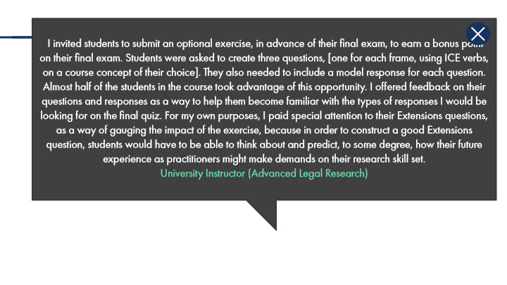

Type | Translation
Rectangular Caption 1 | I invited students to submit an optional exercise, in advance of their final exam, to earn a bonus point on their final exam. Students were asked to create three questions, [one for each frame, using ICE verbs, on a course concept of their choice]. They also needed to include a model response for each question. Almost half of the students in the course took advantage of this opportunity. I offered feedback on their questions and responses as a way to help them become familiar with the types of responses I would be looking for on the final quiz. For my own purposes, I paid special attention to their Extensions questions, as a way of gauging the impact of the exercise, because in order to construct a good Extensions question, students would have to be able to think about and predict, to some degree, how their future experience as practitioners might make demands on their research skill set.
 | University Instructor (Advanced Legal Research)

Slide Layer: e-Portfolio
Layer ID 🔒 | da6d96ae-1921-4e88-846d-bced212f1a68
Preview Image | 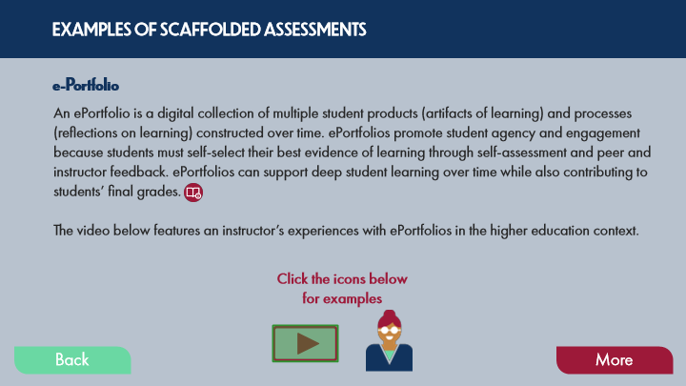

Type | Translation
Text Box 6 | EXAMPLES OF SCAFFOLDED ASSESSMENTS
Text Box 9 | e-Portfolio
Text Box 8 | An ePortfolio is a digital collection of multiple student products (artifacts of learning) and processes (reflections on learning) constructed over time. ePortfolios promote student agency and engagement because students must self-select their best evidence of learning through self-assessment and peer and instructor feedback. ePortfolios can support deep student learning over time while also contributing to students’ final grades.
 | The video below features an instructor’s experiences with ePortfolios in the higher education context.
Instruction 2 | Click the icons below for examples
Button - Normal state | Back
Button - Down state | Back
Button - Normal state | More

Slide Layer: Multi-Stage Exam Example
Layer ID 🔒 | 808113ae-2190-4649-8ec8-4359566553ee
Preview Image | 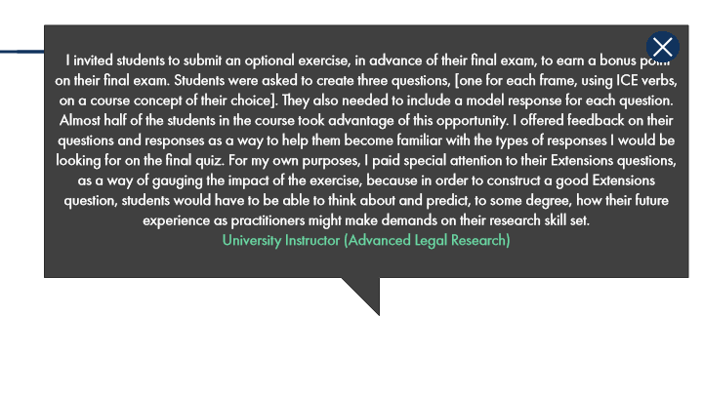

Type | Translation
Rectangular Caption 1 | I invited students to submit an optional exercise, in advance of their final exam, to earn a bonus point on their final exam. Students were asked to create three questions, [one for each frame, using ICE verbs, on a course concept of their choice]. They also needed to include a model response for each question. Almost half of the students in the course took advantage of this opportunity. I offered feedback on their questions and responses as a way to help them become familiar with the types of responses I would be looking for on the final quiz. For my own purposes, I paid special attention to their Extensions questions, as a way of gauging the impact of the exercise, because in order to construct a good Extensions question, students would have to be able to think about and predict, to some degree, how their future experience as practitioners might make demands on their research skill set.
 | University Instructor (Advanced Legal Research)

Slide Layer: Multi-Stage Exams
Layer ID 🔒 | 5f2fab76-3bcc-4b90-8f95-e6933510ec7d
Preview Image | 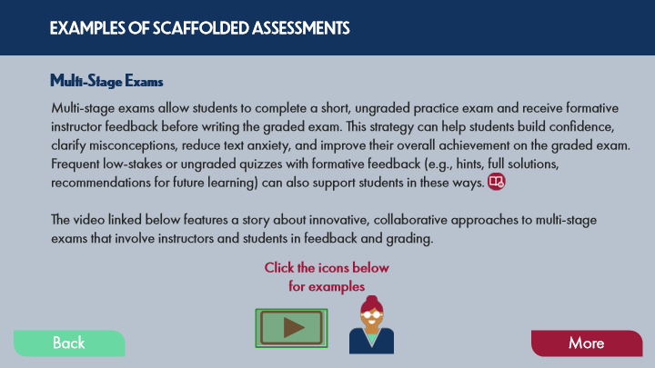

Type | Translation
Text Box 8 | EXAMPLES OF SCAFFOLDED ASSESSMENTS
Text Box 10 | Multi-Stage Exams
Text Box 9 | Multi-stage exams allow students to complete a short, ungraded practice exam and receive formative instructor feedback before writing the graded exam. This strategy can help students build confidence, clarify misconceptions, reduce text anxiety, and improve their overall achievement on the graded exam. Frequent low-stakes or ungraded quizzes with formative feedback (e.g., hints, full solutions, recommendations for future learning) can also support students in these ways.
 | The video linked below features a story about innovative, collaborative approaches to multi-stage exams that involve instructors and students in feedback and grading.
Instruction 1 | Click the icons below for examples
Button - Normal state | Back
Button - Down state | Back
Button - Normal state | More

10.19 Experienced Practitioners on Scaffolded Assessments
Slide ID 🔒 | 40f5b5a1-33ad-45f9-b549-c93823c1a286
Preview Image | 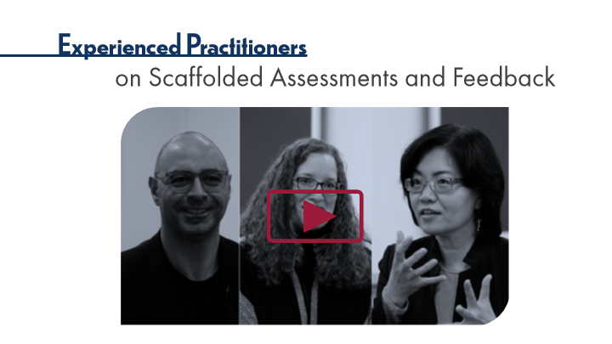

Type | Translation
Slide name | Experienced Practitioners on Scaffolded Assessments
Main Title 1 | Experienced Practitioners
Main Title 2 | on Scaffolded Assessments and Feedback

10.20 Pause and Reflect on Scaffolded Assessments
Slide ID 🔒 | 457bcc82-55c4-438e-8b45-59d78a6b5e38
Preview Image | 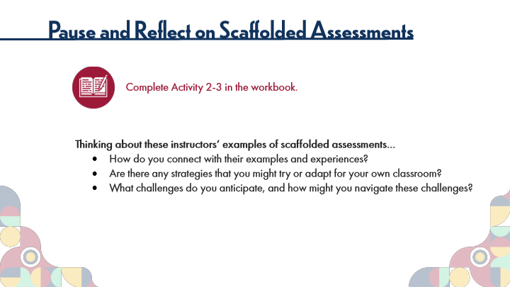

Type | Translation
Slide name | Pause and Reflect on Scaffolded Assessments
Main Title 1 | Pause and Reflect on Scaffolded Assessments
Text Box 6 | Complete Activity 2-3 in the workbook.
Text Box 7 | Thinking about these instructors’ examples of scaffolded assessments…
 | How do you connect with their examples and experiences?
 | Are there any strategies that you might try or adapt for your own classroom?
 | What challenges do you anticipate, and how might you navigate these challenges?

10.21 Technology-Enabled Feedback
Slide ID 🔒 | 32eaef88-45f0-48de-86e1-d821b0df2bce
Preview Image | 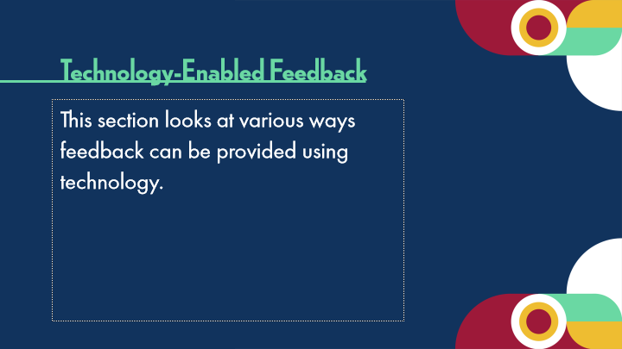

Type | Translation
Slide name | Technology-Enabled Feedback
Text Box 1 | Technology-Enabled Feedback
Body | This section looks at various ways feedback can be provided using technology.

10.22 Technology-Enabled Approaches
Slide ID 🔒 | b2893997-a87d-4daf-bb10-6d1b532948d4
Preview Image | 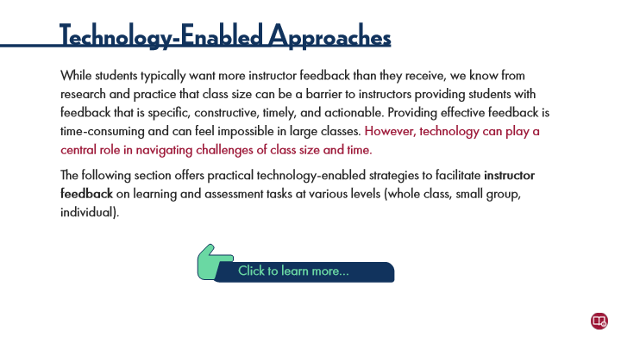

Type | Translation
Slide name | Technology-Enabled Approaches
Main Title 2 | Technology-Enabled Approaches
Text Box 1 | While students typically want more instructor feedback than they receive, we know from research and practice that class size can be a barrier to instructors providing students with feedback that is specific, constructive, timely, and actionable.
 | Providing effective feedback is time-consuming and can feel impossible in large classes.
 | However, technology can play a central role in navigating challenges of class size and time.
 | The following section offers practical technology-enabled strategies to facilitate instructor feedback on learning and assessment tasks at various levels (whole class, small group, individual).
Text Box 2 | Click to learn more…

Slide Layer: Written Feedback
Layer ID 🔒 | 5b3d03ae-40d2-484b-bbdd-a5244c4f75da
Preview Image | 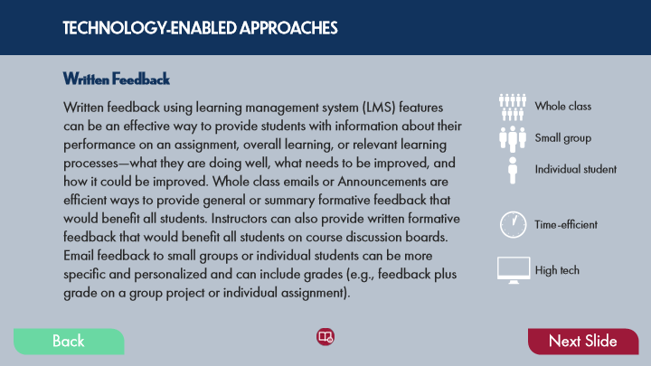

Type | Translation
Text Box 16 | TECHNOLOGY-ENABLED APPROACHES
Text Box 9 | Written Feedback
Text Box 8 | Written feedback using learning management system (LMS) features can be an effective way to provide students with information about their performance on an assignment, overall learning, or relevant learning processes—what they are doing well, what needs to be improved, and how it could be improved. Whole class emails or Announcements are efficient ways to provide general or summary formative feedback that would benefit all students. Instructors can also provide written formative feedback that would benefit all students on course discussion boards. Email feedback to small groups or individual students can be more specific and personalized and can include grades (e.g., feedback plus grade on a group project or individual assignment).
Text Box 11 | Whole class
Text Box 13 | Small group
Text Box 12 | Individual student
Text Box 14 | Time-efficient
Text Box 15 | High tech
Button - Normal state | Back
Button - Down state | Back
Button - Normal state | Next Slide

Slide Layer: Automated Feedback
Layer ID 🔒 | d14db42b-2815-41bd-8235-187ba0a2a012
Preview Image | 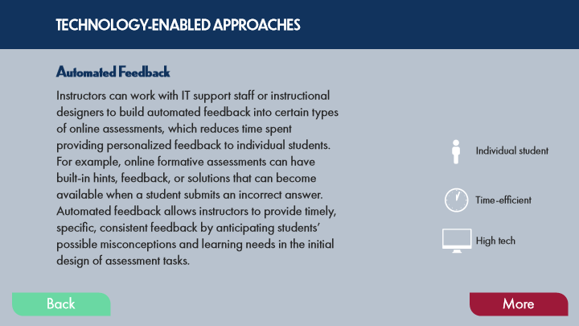

Type | Translation
Text Box 10 | TECHNOLOGY-ENABLED APPROACHES
Text Box 9 | Automated Feedback
Text Box 8 | Instructors can work with IT support staff or instructional designers to build automated feedback into certain types of online assessments, which reduces time spent providing personalized feedback to individual students. For example, online formative assessments can have built-in hints, feedback, or solutions that can become available when a student submits an incorrect answer. Automated feedback allows instructors to provide timely, specific, consistent feedback by anticipating students’ possible misconceptions and learning needs in the initial design of assessment tasks.
Text Box 12 | Individual student
Text Box 14 | Time-efficient
Text Box 15 | High tech
Button - Normal state | Back
Button - Down state | Back
Button - Normal state | More

Slide Layer: Audio Video Feedback
Layer ID 🔒 | d0c7122d-5e5b-429d-9d3b-363a6a50a11e
Preview Image | 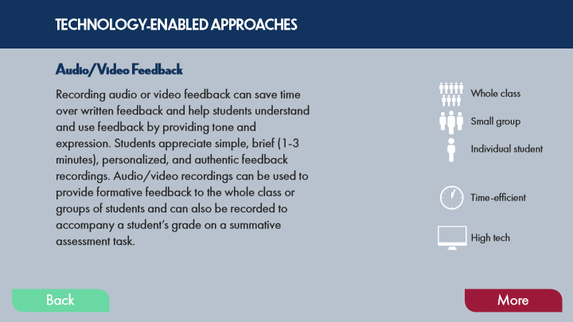

Type | Translation
Text Box 8 | TECHNOLOGY-ENABLED APPROACHES
Text Box 10 | Audio/Video Feedback
Text Box 9 | Recording audio or video feedback can save time over written feedback and help students understand and use feedback by providing tone and expression. Students appreciate simple, brief (1-3 minutes), personalized, and authentic feedback recordings. Audio/video recordings can be used to provide formative feedback to the whole class or groups of students and can also be recorded to accompany a student’s grade on a summative assessment task.
Text Box 12 | Whole class
Text Box 16 | Small group
Text Box 15 | Individual student
Text Box 13 | Time-efficient
Text Box 14 | High tech
Button - Normal state | Back
Button - Down state | Back
Button - Normal state | More

10.23 Pause and Reflect on Technology-Enabled Feedback
Slide ID 🔒 | 3737b5e7-762c-47b1-a486-029b60b0aaab
Preview Image | 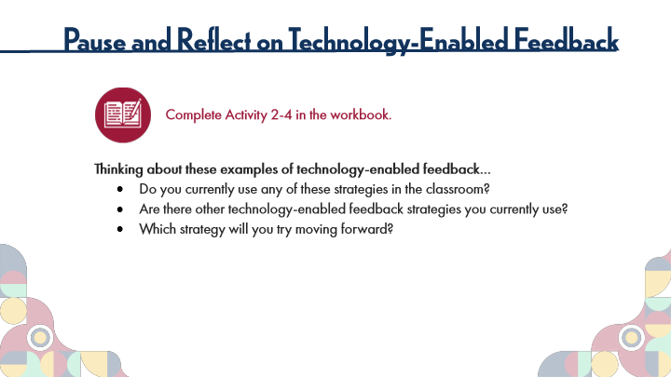

Type | Translation
Slide name | Pause and Reflect on Technology-Enabled Feedback
Main Title 1 | Pause and Reflect on Technology-Enabled Feedback
Text Box 6 | Complete Activity 2-4 in the workbook.
Text Box 7 | Thinking about these examples of technology-enabled feedback…
 | Do you currently use any of these strategies in the classroom?
 | Are there other technology-enabled feedback strategies you currently use?
 | Which strategy will you try moving forward?

10.24 Instructor Feedback: New Directions
Slide ID 🔒 | 41001923-08b7-4d60-b2ba-0ef906aafad6
Preview Image | 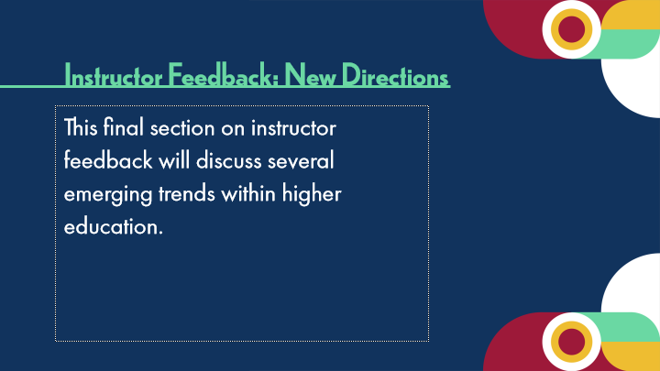

Type | Translation
Slide name | Instructor Feedback: New Directions
Text Box 1 | Instructor Feedback: New Directions
Body | This final section on instructor feedback will discuss several emerging trends within higher education.

10.25 Feedback Trends
Slide ID 🔒 | 7cfd47da-6027-4a14-b61e-20b6e1440b10
Preview Image | 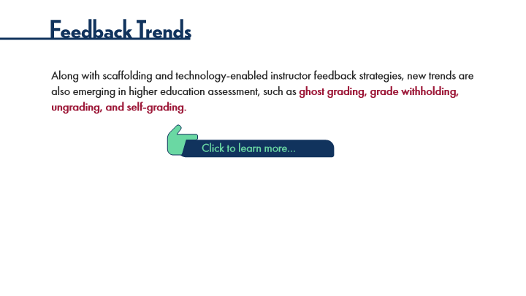

Type | Translation
Slide name | Feedback Trends
Main Title 2 | Feedback Trends
Text Box 1 | Along with scaffolding and technology-enabled instructor feedback strategies, new trends are also emerging in higher education assessment, such as
 | ghost grading, grade withholding, ungrading, and self-grading.
Text Box 2 | Click to learn more…

Slide Layer: Self-grading
Layer ID 🔒 | 49398df1-e31a-450b-ab82-b932f84c1299
Preview Image | 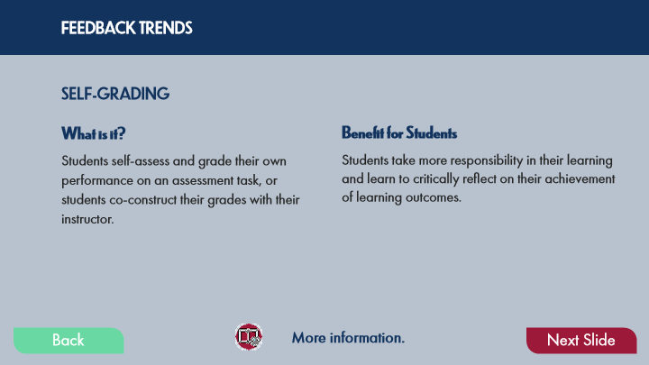

Type | Translation
Text Box 15 | FEEDBACK TRENDS
Text Box 20 | SELF-GRADING
Text Box 18 | Benefit for Students
Text Box 17 | What is it?
Text Box 16 | Students self-assess and grade their own performance on an assessment task, or students co-construct their grades with their instructor.
Text Box 19 | Students take more responsibility in their learning and learn to critically reflect on their achievement of learning outcomes.
Text Box 21 | More information.
Button - Normal state | Back
Button - Down state | Back
Button - Normal state | Next Slide

Slide Layer: Ungrading
Layer ID 🔒 | cc2d0b7f-7b8f-4ffe-a339-0fd87cc5509a
Preview Image | 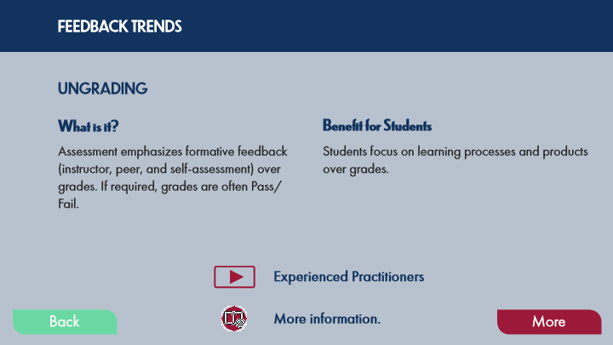

Type | Translation
Text Box 15 | FEEDBACK TRENDS
Text Box 20 | UNGRADING
Text Box 18 | Benefit for Students
Text Box 17 | What is it?
Text Box 16 | Assessment emphasizes formative feedback (instructor, peer, and self-assessment) over grades. If required, grades are often Pass/Fail.
Text Box 19 | Students focus on learning processes and products over grades.
Text Box 22 | Experienced Practitioners
Text Box 21 | More information.
Button - Normal state | Back
Button - Down state | Back
Button - Normal state | More

Slide Layer: Grade Withholding
Layer ID 🔒 | 150a47b8-91c7-4634-bccc-4b3dca9b6e9a
Preview Image | 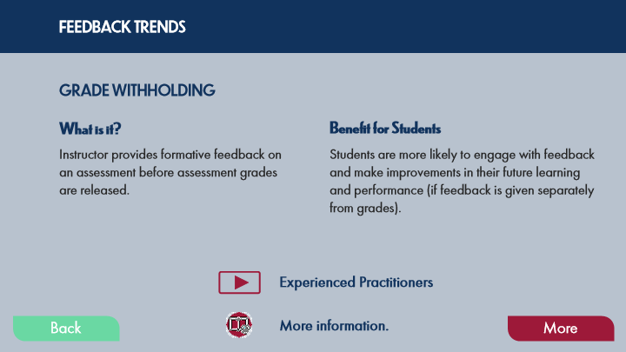

Type | Translation
Text Box 14 | FEEDBACK TRENDS
Text Box 19 | GRADE WITHHOLDING
Text Box 17 | Benefit for Students
Text Box 16 | What is it?
Text Box 15 | Instructor provides formative feedback on an assessment before assessment grades are released.
Text Box 18 | Students are more likely to engage with feedback and make improvements in their future learning and performance (if feedback is given separately from grades).
Text Box 21 | Experienced Practitioners
Text Box 20 | More information.
Button - Normal state | Back
Button - Down state | Back
Button - Normal state | More

Slide Layer: Ghost Grading
Layer ID 🔒 | e6064672-4972-4eac-bf9b-3c016ccbffbb
Preview Image | 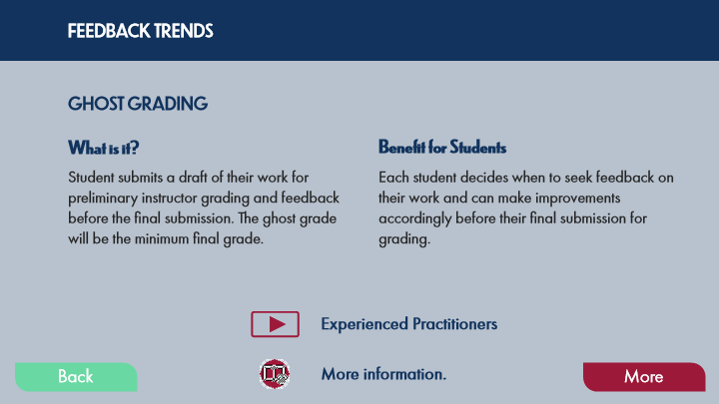

Type | Translation
Text Box 19 | FEEDBACK TRENDS
Text Box 17 | GHOST GRADING
Text Box 15 | Benefit for Students
Text Box 10 | What is it?
Text Box 9 | Student submits a draft of their work for preliminary instructor grading and feedback before the final submission. The ghost grade will be the minimum final grade.
Text Box 16 | Each student decides when to seek feedback on their work and can make improvements accordingly before their final submission for grading.
Text Box 20 | Experienced Practitioners
Text Box 18 | More information.
Button - Normal state | Back
Button - Down state | Back
Button - Normal state | More

10.26 Pause and Reflect on Feedback Trends
Slide ID 🔒 | cced385d-846d-4288-b385-5905d9530f91
Preview Image | 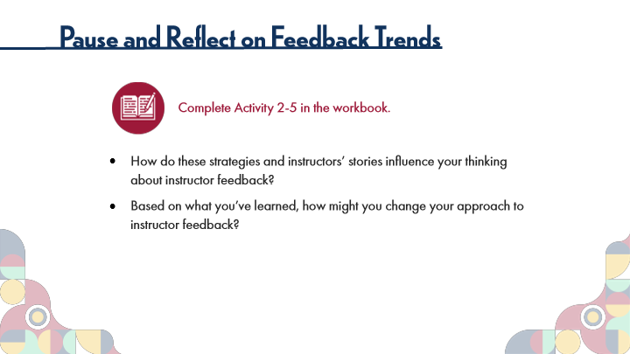

Type | Translation
Slide name | Pause and Reflect on Feedback Trends
Main Title 1 | Pause and Reflect on Feedback Trends
Text Box 1 | Complete Activity 2-5 in the workbook.
Text Box 2 | How do these strategies and instructors’ stories influence your thinking about instructor feedback?
 | Based on what you’ve learned, how might you change your approach to instructor feedback?

10.27 Topic 1B: Peer Feedback and Self-Assessment Strategies
Slide ID 🔒 | b535c406-a609-4265-b9d1-e48cae9f8c08
Preview Image | 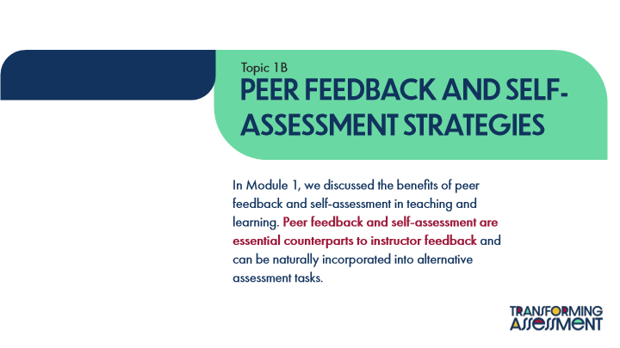

Type | Translation
Slide name | Topic 1B: Peer Feedback and Self-Assessment Strategies
Text Box 1 | Topic 1B
Main Title | Peer feedback and self-assessment strategies
Main Body | In Module 1, we discussed the benefits of peer feedback and self-assessment in teaching and learning.
 | Peer feedback and self-assessment are essential counterparts to instructor feedback
 | and can be naturally incorporated into alternative assessment tasks.

10.28 Defining Peer Feedback & Self-Assessment
Slide ID 🔒 | e994ec3e-3afc-4527-947a-bf138d5c9b4d
Preview Image | 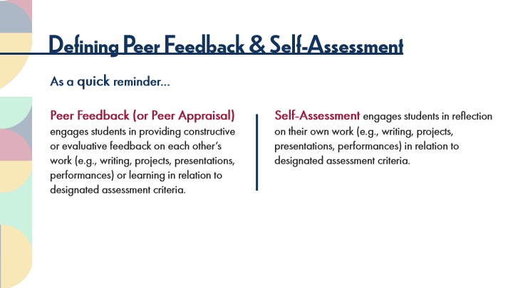

Type | Translation
Slide name | Defining Peer Feedback & Self-Assessment
Main Title 1 | Defining Peer Feedback & Self-Assessment
Text Box 3 | As a
 | quick
 | reminder…
Text Box 1 | Peer Feedback (or Peer Appraisal)
 | engages students in providing constructive or evaluative feedback on each other’s work (e.g., writing, projects, presentations, performances) or learning in relation to designated assessment criteria.
Text Box 2 | Self-Assessment
 | engages students in reflection on their own work (e.g., writing, projects, presentations, performances) in relation to designated assessment criteria.

10.29 Test Your Knowledge
Slide ID 🔒 | b79b743c-ec4c-425c-896f-6c2215e68886
Preview Image | 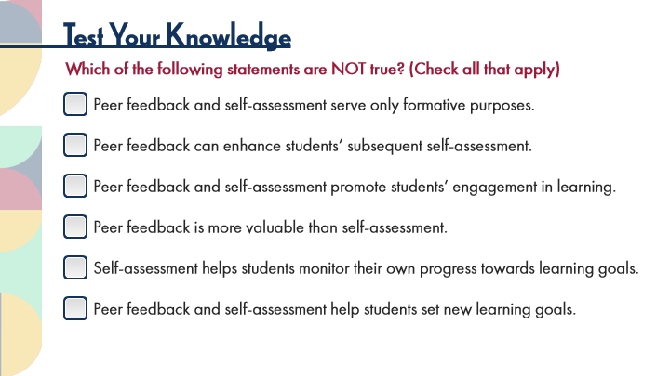

Type | Translation
Slide name | Test Your Knowledge
Main Title 1 | Test Your Knowledge
Text Box 3 | Which of the following statements are NOT true? (Check all that apply)
Check Box 1 - Normal state | Peer feedback and self-assessment serve only formative purposes.
Check Box 2 - Normal state | Peer feedback can enhance students’ subsequent self-assessment.
Check Box 3 - Normal state | Peer feedback and self-assessment promote students’ engagement in learning.
Check Box 4 - Normal state | Peer feedback is more valuable than self-assessment.
Check Box 5 - Normal state | Self-assessment helps students monitor their own progress towards learning goals.
Check Box 6 - Normal state | Peer feedback and self-assessment help students set new learning goals.

Slide Layer: Correct
Layer ID 🔒 | fed06819-ac82-46ce-8d42-ac911ad070a2
Preview Image | 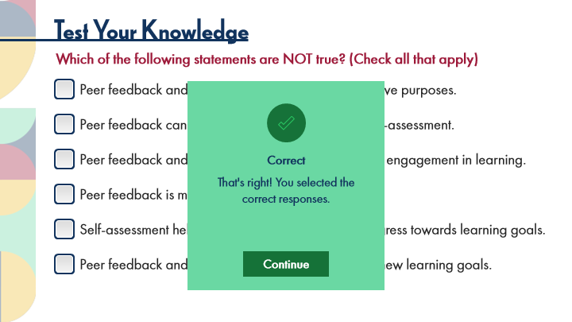

Type | Translation
Text Box | Correct
Text Box | That's right! You selected the
 | correct responses.
AltText for Continue - 1 Normal state | Button: Continue
Alt text for Continue | Button: Continue

Slide Layer: Try Again
Layer ID 🔒 | 26804c28-4bed-433d-b816-324967c2525b
Preview Image | 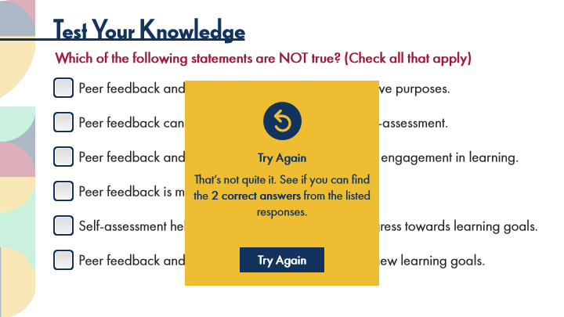

Type | Translation
Text Box | Try Again
Text Box | That’s not quite it. See if you can find the 2 correct answers from the listed responses.
AltText for Try Again - 1 Normal state | Button: Try Again
Alt text for Try Again | Button: Try Again

10.30 Scaffolded Peer Feedback & Self-Assessment
Slide ID 🔒 | a608f718-4425-4fa3-971e-f221d60ee9c9
Preview Image | 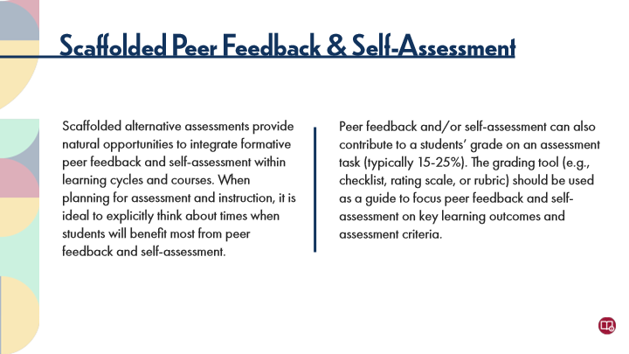

Type | Translation
Slide name | Scaffolded Peer Feedback & Self-Assessment
Main Title 1 | Scaffolded Peer Feedback & Self-Assessment
Text Box 2 | Peer feedback and/or self-assessment can also contribute to a students’ grade on an assessment task (typically 15-25%). The grading tool (e.g., checklist, rating scale, or rubric) should be used as a guide to focus peer feedback and self-assessment on key learning outcomes and assessment criteria.
Text Box 1 | Scaffolded alternative assessments provide natural opportunities to integrate formative peer feedback and self-assessment within learning cycles and courses. When planning for assessment and instruction, it is ideal to explicitly think about times when students will benefit most from peer feedback and self-assessment.

10.31 POV: Instructor Perspectives
Slide ID 🔒 | 53bbced4-9748-40f3-92f2-08e430cb89fb
Preview Image | 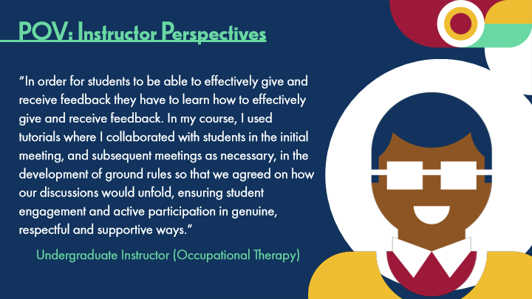

Type | Translation
Slide name | POV: Instructor Perspectives
Main Title 1 | POV: Instructor Perspectives
Text Box 1 | “In order for students to be able to effectively give and receive feedback they have to learn how to effectively give and receive feedback. In my course, I used tutorials where I collaborated with students in the initial meeting, and subsequent meetings as necessary, in the development of ground rules so that we agreed on how our discussions would unfold, ensuring student engagement and active participation in genuine, respectful and supportive ways.”
Text Box 2 | Undergraduate Instructor (Occupational Therapy)

10.32 Peer Feedback Strategies
Slide ID 🔒 | f9d8927d-2fc1-4505-851b-a2e9948cb112
Preview Image | 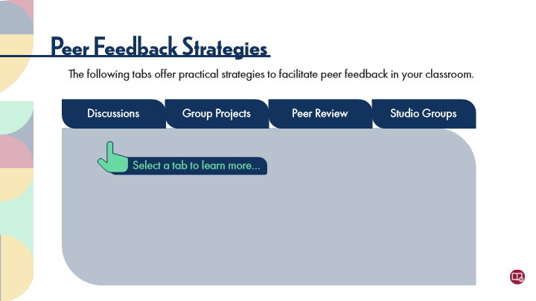

Type | Translation
Slide name | Peer Feedback Strategies
Main Title 1 | Peer Feedback Strategies
Text Box 1 | The following tabs offer practical strategies to facilitate peer feedback in your classroom.
Tab Button 1 - Normal state | Discussions
Tab Button 2 - Normal state | Group Projects
Tab Button 3 - Normal state | Peer Review
Tab Button 4 - Normal state | Studio Groups
Text Box 2 | Select a tab to learn more…

Slide Layer: Studio Groups
Layer ID 🔒 | f7aa3797-95dc-4a1b-b308-ec1f03a92851
Preview Image | 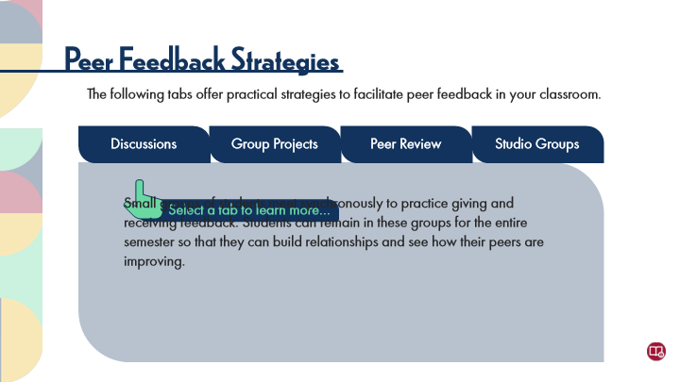

Type | Translation
Main Body 1 | Small groups of students meet synchronously to practice giving and receiving feedback. Students can remain in these groups for the entire semester so that they can build relationships and see how their peers are improving.

Slide Layer: Peer Review
Layer ID 🔒 | eb88a0b2-79a8-498d-842a-113d2fa57e57
Preview Image | 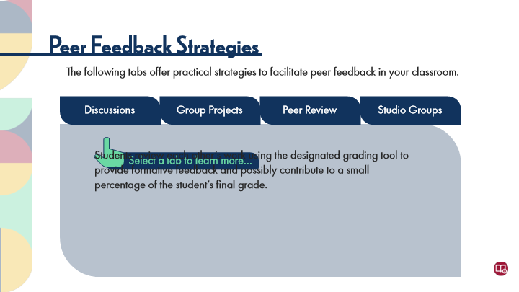

Type | Translation
Main Body 1 | Students review each other’s work using the designated grading tool to provide formative feedback and possibly contribute to a small percentage of the student’s final grade.

Slide Layer: Group Projects
Layer ID 🔒 | fa1488e7-8f1f-41ae-b02e-9f178304e2e8
Preview Image | 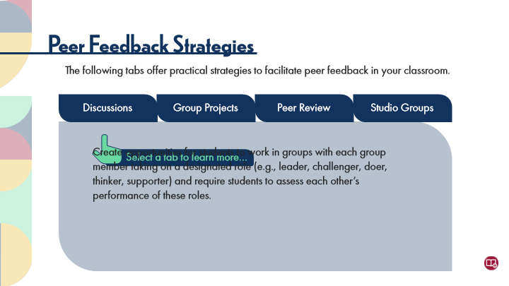

Type | Translation
Main Body 1 | Create opportunities for students to work in groups with each group member taking on a designated role (e.g., leader, challenger, doer, thinker, supporter) and require students to assess each other’s performance of these roles.

Slide Layer: Discussions
Layer ID 🔒 | 78050762-ac48-4d17-80e3-de5210e9d578
Preview Image | 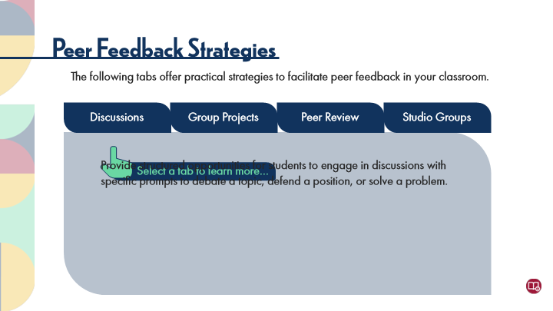

Type | Translation
Main Body 1 | Provide structured opportunities for students to engage in discussions with specific prompts to debate a topic, defend a position, or solve a problem.

10.33 Self-Assessment Strategies
Slide ID 🔒 | 1539b87f-789e-4eeb-8560-699b0e24f242
Preview Image | 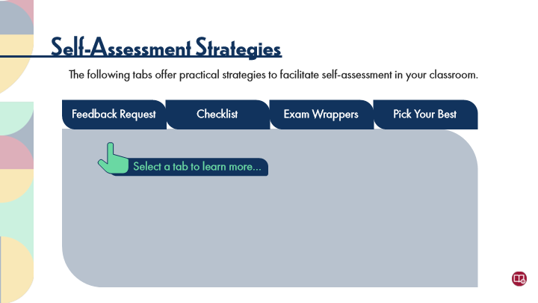

Type | Translation
Slide name | Self-Assessment Strategies
Main Title 1 | Self-Assessment Strategies
Text Box 3 | The following tabs offer practical strategies to facilitate self-assessment in your classroom.
Tab Button 1 - Normal state | Feedback Request
Tab Button 2 - Normal state | Checklist
Tab Button 3 - Normal state | Exam Wrappers
Tab Button 4 - Normal state | Pick Your Best
Text Box 2 | Select a tab to learn more…

Slide Layer: Pick Your Best
Layer ID 🔒 | 77670653-3f3e-4c1e-9f90-cdc0a34e25c4
Preview Image | 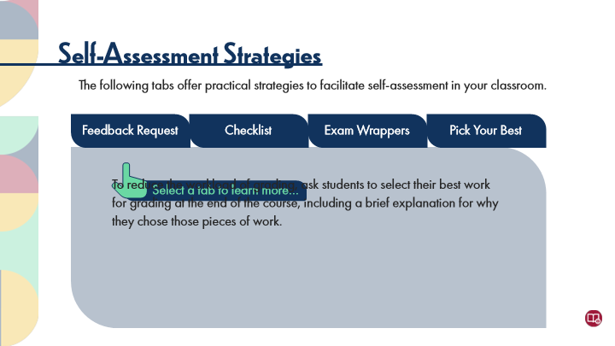

Type | Translation
Main Body 1 | To reduce the workload of grading, ask students to select their best work for grading at the end of the course, including a brief explanation for why they chose those pieces of work.

Slide Layer: Exam Wrappers
Layer ID 🔒 | 594c9b36-d327-4e39-80be-1d1af8260164
Preview Image | 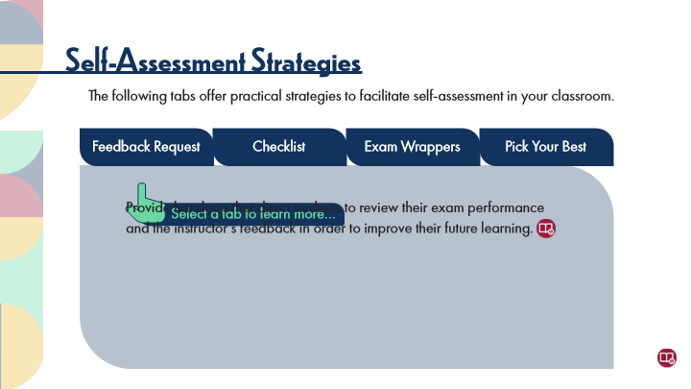

Type | Translation
Main Body 1 | Provide handouts that direct students to review their exam performance and the instructor’s feedback in order to improve their future learning.

Slide Layer: Checklist
Layer ID 🔒 | 4cc277e5-f937-4a95-82d7-e728f2ca7542
Preview Image | 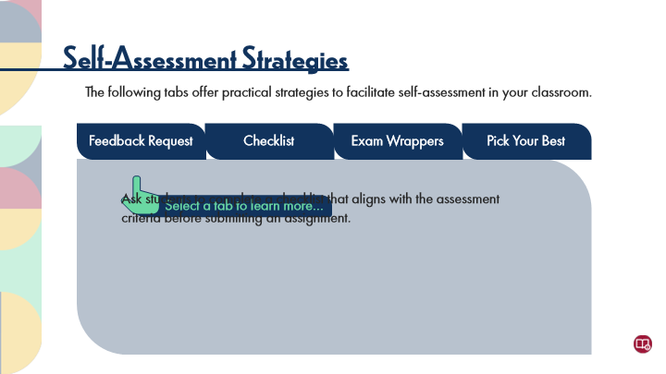

Type | Translation
Main Body 1 | Ask students to complete a checklist that aligns with the assessment criteria before submitting an assignment.

Slide Layer: Feedback Request
Layer ID 🔒 | 427d1eed-e6a5-4495-9199-e1027936a459
Preview Image | 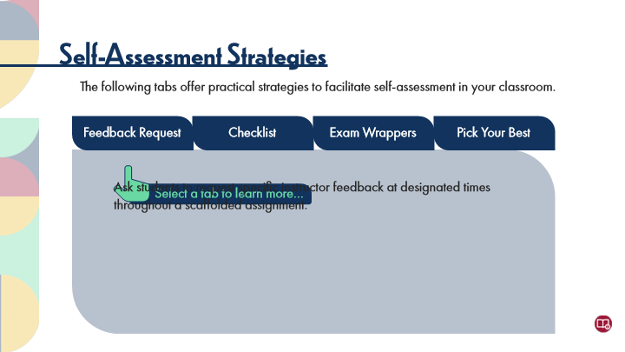

Type | Translation
Main Body 1 | Ask students to request specific instructor feedback at designated times throughout a scaffolded assignment.

10.34 Experienced Practitioners on Peer Feedback and Self-Assessment
Slide ID 🔒 | eb77efc3-756e-4762-9ed3-32c226c4efe3
Preview Image | 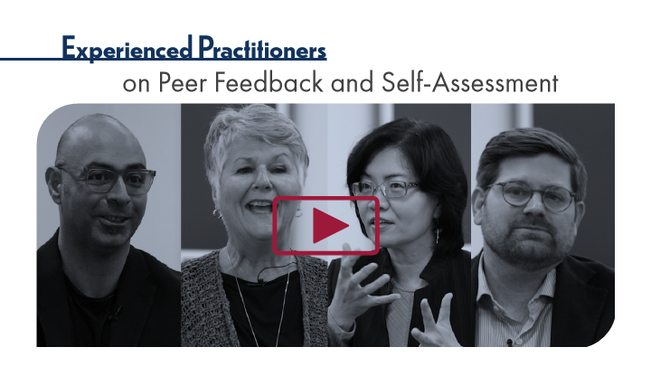

Type | Translation
Slide name | Experienced Practitioners on Peer Feedback and Self-Assessment
Main Title 1 | Experienced Practitioners
Main Title 2 | on Peer Feedback and Self-Assessment

10.35 POV: Instructor Perspectives
Slide ID 🔒 | 4d0badd6-82d3-45ff-8dcf-e53ffd8a4c4e
Preview Image | 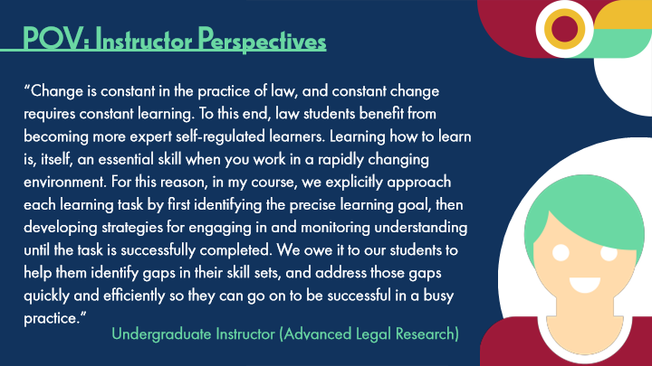

Type | Translation
Slide name | POV: Instructor Perspectives
Main Title 1 | POV: Instructor Perspectives
Text Box 1 | “Change is constant in the practice of law, and constant change requires constant learning. To this end, law students benefit from becoming more expert self-regulated learners. Learning how to learn is, itself, an essential skill when you work in a rapidly changing environment. For this reason, in my course, we explicitly approach each learning task by first identifying the precise learning goal, then developing strategies for engaging in and monitoring understanding until the task is successfully completed. We owe it to our students to help them identify gaps in their skill sets, and address those gaps quickly and efficiently so they can go on to be successful in a busy practice.”
Text Box 2 | Undergraduate Instructor (Advanced Legal Research)

10.36 Activity: Peer Feedback and Self-Assessment
Slide ID 🔒 | 414b34d5-8bfb-4aaf-835c-23f94418a44e
Preview Image | 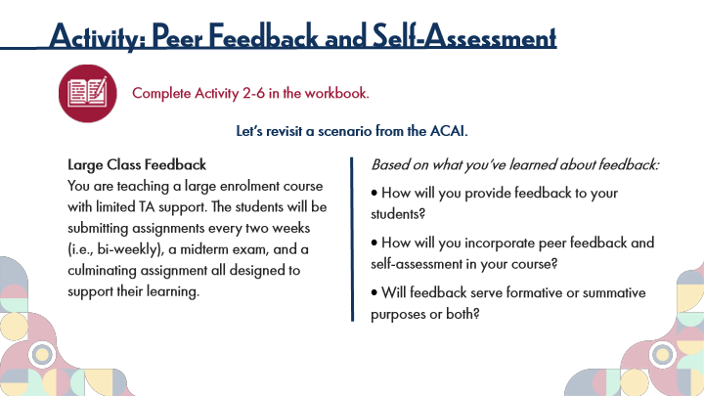

Type | Translation
Slide name | Activity: Peer Feedback and Self-Assessment
Main Title 1 | Activity: Peer Feedback and Self-Assessment
Text Box 1 | Complete Activity 2-6 in the workbook.
Text Box 2 | Let’s revisit a scenario from the ACAI.
Text Box 4 | Large Class Feedback
 | You are teaching a large enrolment course with limited TA support. The students will be submitting assignments every two weeks (i.e., bi-weekly), a midterm exam, and a culminating assignment all designed to support their learning.
Text Box 3 | Based on what you’ve learned about feedback:
 | How will you provide feedback to your students?
 | How will you incorporate peer feedback and self-assessment in your course?
 | Will feedback serve formative or summative purposes or both?

10.37 5 Principles of Instructor and Peer Feedback
Slide ID 🔒 | 7967a45b-f550-4148-8e73-b358af3d8a17
Preview Image | 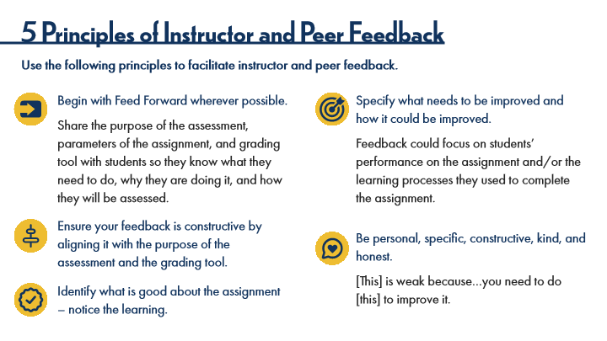

Type | Translation
Slide name | 5 Principles of Instructor and Peer Feedback
Main Title 1 | 5 Principles of Instructor and Peer Feedback
Text Box 1 | Use the following principles to facilitate instructor and peer feedback.
Text Box 4 | Begin with Feed Forward wherever possible.
 | Share the purpose of the assessment, parameters of the assignment, and grading tool with students so they know what they need to do, why they are doing it, and how they will be assessed.
Text Box 3 | Specify what needs to be improved and how it could be improved.
 | Feedback could focus on students’ performance on the assignment and/or the learning processes they used to complete the assignment.
Text Box 5 | Ensure your feedback is constructive by aligning it with the purpose of the assessment and the grading tool.
Text Box 7 | Be personal, specific, constructive, kind, and honest.
 | [This] is weak because…you need to do [this] to improve it.
Text Box 6 | Identify what is good about the assignment – notice the learning.

10.38 Topic 1C: Creating a Feedback-Driven Learning Culture
Slide ID 🔒 | 25e8da09-6ece-4124-a06c-ae19556b7b93
Preview Image | 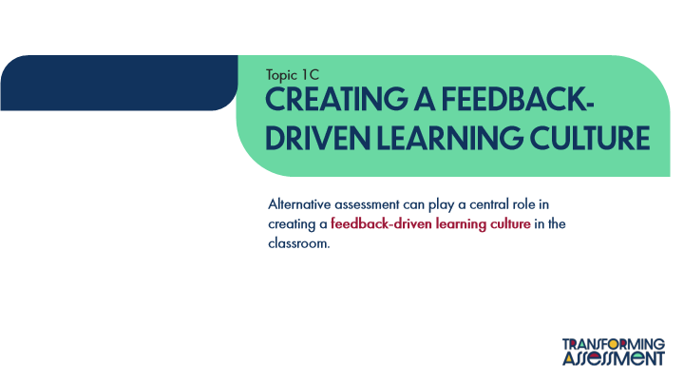

Type | Translation
Slide name | Topic 1C: Creating a Feedback-Driven Learning Culture
Text Box 1 | Topic 1C
Main Title | Creating A Feedback-Driven Learning Culture
Main Body | Alternative assessment can play a central role in creating a
 | feedback-driven learning culture
 | in the classroom.

10.39 Core Strategies
Slide ID 🔒 | 77d1c6eb-e289-48c7-b0c2-984cb86721c2
Preview Image | 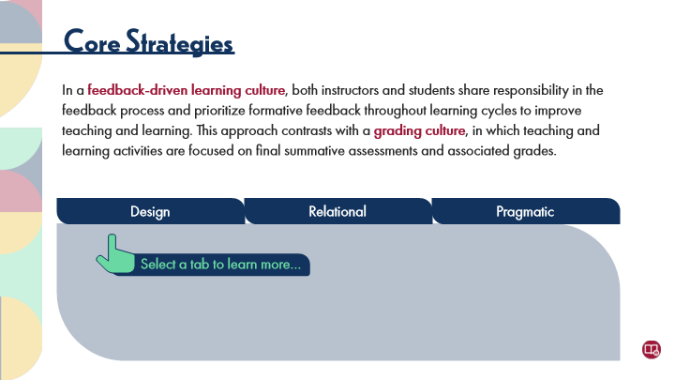

Type | Translation
Slide name | Core Strategies
Main Title | Core Strategies
Main Body | In a
 | feedback-driven learning culture
 | , both instructors and students share responsibility in the feedback process and prioritize formative feedback throughout learning cycles to improve teaching and learning. This approach contrasts with a
 | grading culture
 | , in which teaching and learning activities are focused on final summative assessments and associated grades.
button 2 - Normal state | Design
button 1 - Normal state | Relational
button 3 - Normal state | Pragmatic
Text Box 1 | Select a tab to learn more…

Slide Layer: Pragmatic
Layer ID 🔒 | e73a9b61-c34e-49ea-905b-03b9b7760c28
Preview Image | 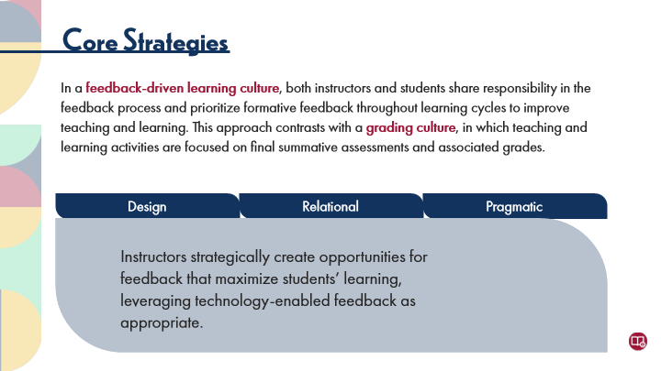

Type | Translation
Main Body 1 | Instructors strategically create opportunities for feedback that maximize students’ learning, leveraging technology-enabled feedback as appropriate.

Slide Layer: Relational
Layer ID 🔒 | 3e6a23ae-6ebe-4a3f-b279-9d7c5021d21c
Preview Image | 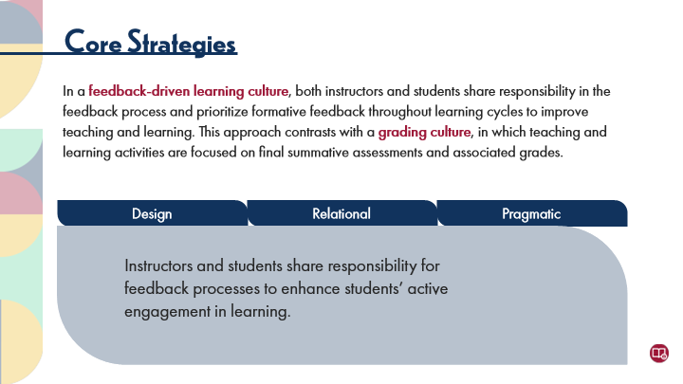

Type | Translation
Main Body 1 | Instructors and students share responsibility for feedback processes to enhance students’ active engagement in learning.

Slide Layer: Design
Layer ID 🔒 | b327d75d-a810-4432-9e8b-6d0eb4fcf2e5
Preview Image | 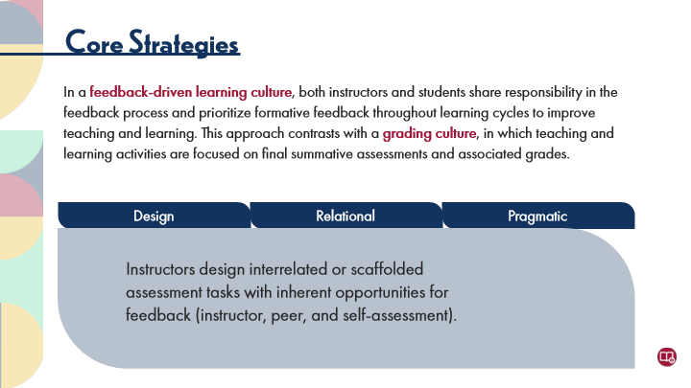

Type | Translation
Main Body 1 | Instructors design interrelated or scaffolded assessment tasks with inherent opportunities for feedback (instructor, peer, and self-assessment).

10.40 Experienced Practitioners on Grading vs Learning Cultures
Slide ID 🔒 | fa6bac5c-48d0-404f-bf1a-999d1456634c
Preview Image | 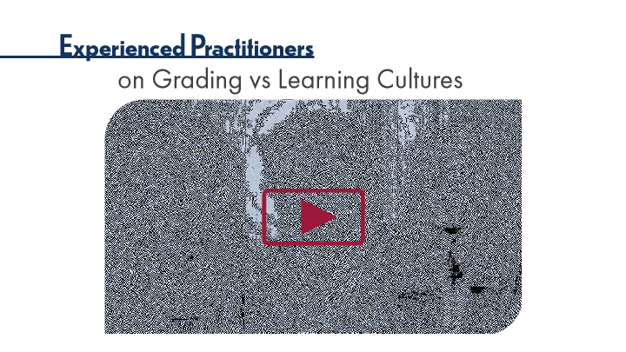

Type | Translation
Slide name | Experienced Practitioners on Grading vs Learning Cultures
Main Title 1 | Experienced Practitioners
Main Title 2 | on Grading vs Learning Cultures

10.41 Thinking Forward: Feedback-Driven Assessment
Slide ID 🔒 | 71954f14-1394-4eb0-84d2-e75e61ee6db4
Preview Image | 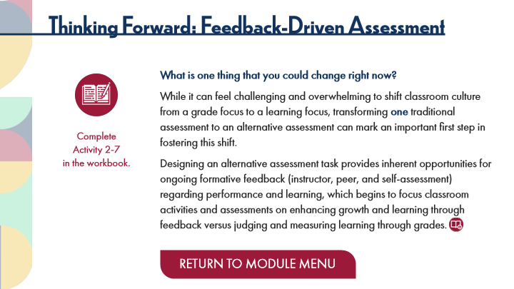

Type | Translation
Slide name | Thinking Forward: Feedback-Driven Assessment
Main Title 1 | Thinking Forward: Feedback-Driven Assessment
Text Box 1 | What is one thing that you could change right now?
 | While it can feel challenging and overwhelming to shift classroom culture from a grade focus to a learning focus, transforming
 | one
 | traditional assessment to an alternative assessment can mark an important first step in fostering this shift.
 | Designing an alternative assessment task provides inherent opportunities for ongoing formative feedback (instructor, peer, and self-assessment) regarding performance and learning, which begins to focus classroom activities and assessments on enhancing growth and learning through feedback versus judging and measuring learning through grades.
Text Box 4 | Complete
 | Activity 2-7
 | in the workbook.
Round Diagonal Corner 1 - Normal state | RETURN TO MODULE MENU

11 Topic 2: Student-Centred Assessment
Scene ID 🔒 | d05c1607-a37e-419f-86a6-ff0ccd7013b2

Type | Translation
Scene name | Topic 2: Student-Centred Assessment

11.1 Student-Centred Assessment Title Page
Slide ID 🔒 | d254ec7e-30af-40e5-b819-35b091716016
Preview Image | 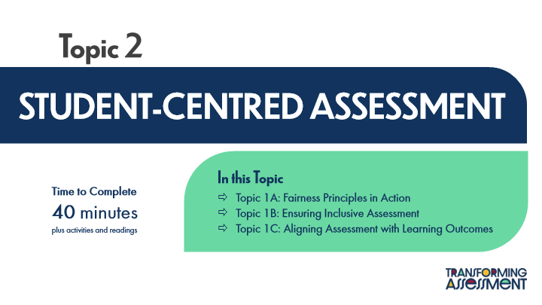

Type | Translation
Slide name | Student-Centred Assessment Title Page
Main Title 1 | Topic 2
Main Title | STUDENT-CENTRED ASSESSMENT
Text Box 1 | In this Topic
 | Topic 1A: Fairness Principles in Action
 | Topic 1B: Ensuring Inclusive Assessment
 | Topic 1C: Aligning Assessment with Learning Outcomes
Text Box 2 | Time to Complete
 | 40 minutes
 | plus activities and readings

11.2 Sage on the Stage vs Guide on the Side
Slide ID 🔒 | db59bb7e-2027-42dd-a746-3299690c05aa
Preview Image | 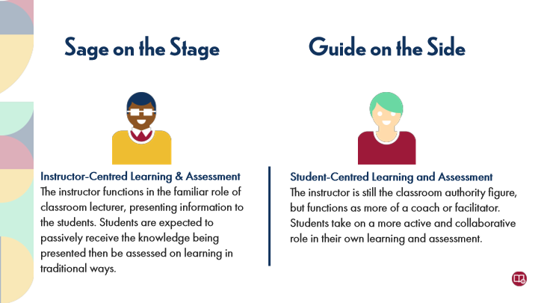

Type | Translation
Slide name | Sage on the Stage vs Guide on the Side
Main Title 1 | Sage on the Stage
Main Title 2 | Guide on the Side
Text Box 1 | Instructor-Centred Learning & Assessment
 | The instructor functions in the familiar role of classroom lecturer, presenting information to the students. Students are expected to passively receive the knowledge being presented then be assessed on learning in traditional ways.
Text Box 2 | Student-Centred Learning and Assessment
 | The instructor is still the classroom authority figure, but functions as more of a coach or facilitator. Students take on a more active and collaborative role in their own learning and assessment.

11.3 Test Your Knowledge
Slide ID 🔒 | 6e8da8bd-c0a0-4bd5-8a4f-0571e092693e
Preview Image | 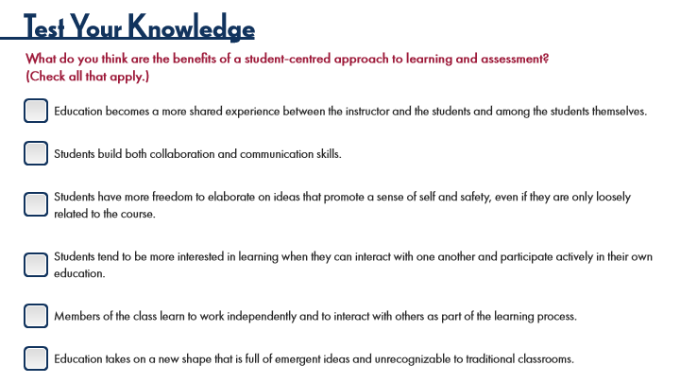

Type | Translation
Slide name | Test Your Knowledge
Main Title 1 | Test Your Knowledge
Text Box 3 | What do you think are the benefits of a student-centred approach to learning and assessment? (Check all that apply.)
Check Box 1 - Normal state | Education becomes a more shared experience between the instructor and the students and among the students themselves.
Check Box 2 - Normal state | Students build both collaboration and communication skills.
Check Box 3 - Normal state | Students have more freedom to elaborate on ideas that promote a sense of self and safety, even if they are only loosely related to the course.
Check Box 4 - Normal state | Students tend to be more interested in learning when they can interact with one another and participate actively in their own education.
Check Box 5 - Normal state | Members of the class learn to work independently and to interact with others as part of the learning process.
Check Box 6 - Normal state | Education takes on a new shape that is full of emergent ideas and unrecognizable to traditional classrooms.

Slide Layer: Correct
Layer ID 🔒 | 2b4c6a15-5e5d-431e-971f-8e4d4d15828b
Preview Image | 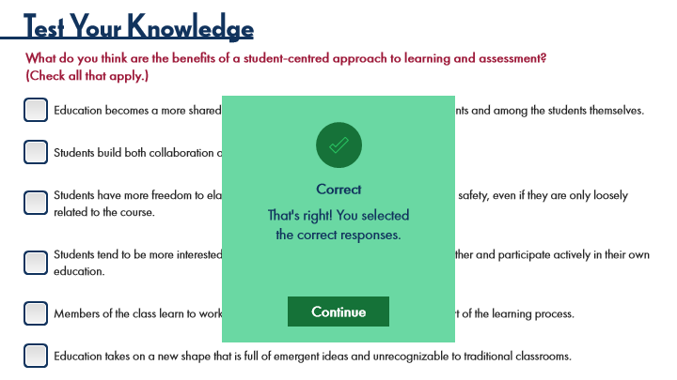

Type | Translation
Text Box | Correct
Text Box | That's right! You selected
 | the correct responses.
AltText for Continue - 1 Normal state | Button: Continue
Alt text for Continue | Button: Continue

Slide Layer: Try Again
Layer ID 🔒 | 59877e11-a8ae-4130-8760-75759b5f4931
Preview Image | 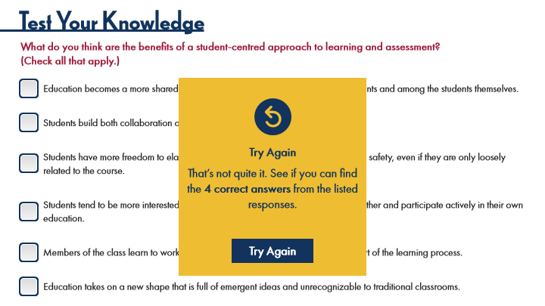

Type | Translation
Text Box | Try Again
Text Box | That’s not quite it. See if you can find the 4 correct answers from the listed responses.
AltText for Try Again - 1 Normal state | Button: Try again
Alt text for Try Again | Button: Try again

11.4 “Good” Assessment Design
Slide ID 🔒 | 925daf9b-394d-48a3-8ca5-b102b2b1a97c
Preview Image | 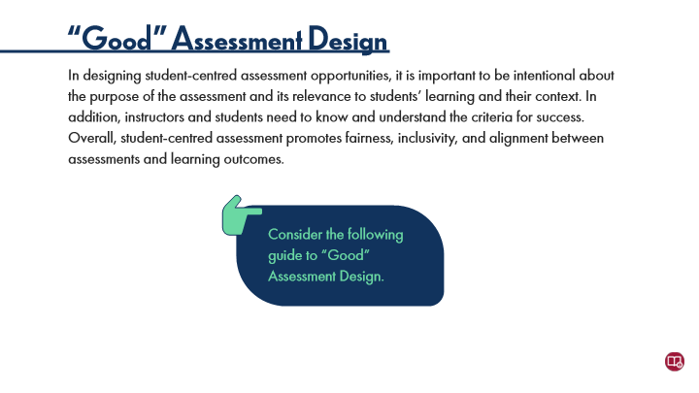

Type | Translation
Slide name | “Good” Assessment Design
Main Title 1 | “Good” Assessment Design
Text Box 1 | In designing student-centred assessment opportunities, it is important to be intentional about the purpose of the assessment and its relevance to students’ learning and their context. In addition, instructors and students need to know and understand the criteria for success. Overall, student-centred assessment promotes fairness, inclusivity, and alignment between assessments and learning outcomes.
Text Box 2 | Consider the following guide to “Good” Assessment Design.

Slide Layer: Purposes
Layer ID 🔒 | 56b306b7-82d6-42b3-aa0f-df70def95692
Preview Image | 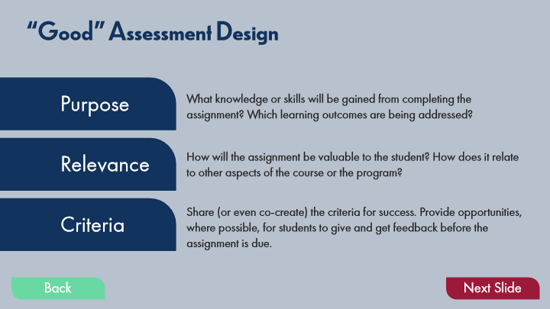

Type | Translation
Main Title 1 | “Good” Assessment Design
Text Box 1 | Purpose
Text Box 4 | What knowledge or skills will be gained from completing the assignment? Which learning outcomes are being addressed?
Text Box 5 | How will the assignment be valuable to the student? How does it relate to other aspects of the course or the program?
Text Box 7 | Relevance
Text Box 6 | Share (or even co-create) the criteria for success. Provide opportunities, where possible, for students to give and get feedback before the assignment is due.
Text Box 8 | Criteria
Button - Normal state | Back
Button - Down state | Back
Button - Normal state | Next Slide

11.5 Experienced Practitioners on "Good" Assessment Design
Slide ID 🔒 | 51a5f63c-d7ca-4bc1-964a-f1b737e9a31f
Preview Image | 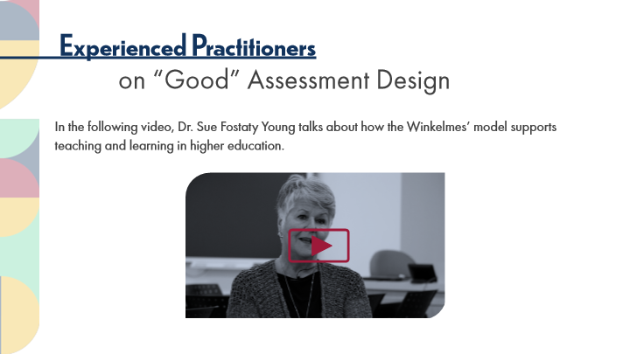

Type | Translation
Slide name | Experienced Practitioners on "Good" Assessment Design
Main Title 1 | Experienced Practitioners
Main Title 2 | on “Good” Assessment Design
Main Body 1 | In the following video, Dr. Sue Fostaty Young talks about how the Winkelmes’ model supports teaching and learning in higher education.

11.6 Pause and Reflect on Student-Centered Assessment
Slide ID 🔒 | 740f84a7-6f10-4c49-b84a-b6377a53c3ea
Preview Image | 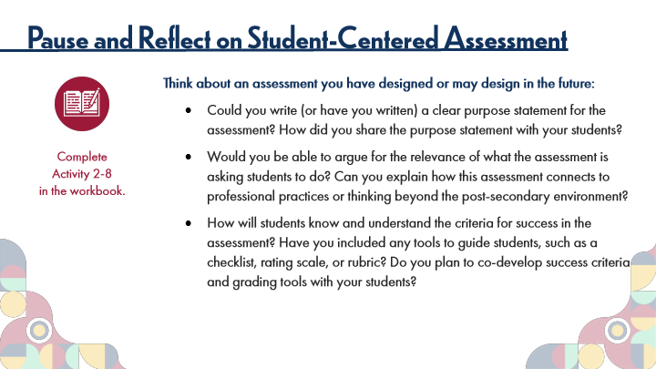

Type | Translation
Slide name | Pause and Reflect on Student-Centered Assessment
Main Title 1 | Pause and Reflect on Student-Centered Assessment
Text Box 2 | Think about an assessment you have designed or may design in the future:
 | Could you write (or have you written) a clear purpose statement for the assessment? How did you share the purpose statement with your students?
 | Would you be able to argue for the relevance of what the assessment is asking students to do? Can you explain how this assessment connects to professional practices or thinking beyond the post-secondary environment?
 | How will students know and understand the criteria for success in the assessment? Have you included any tools to guide students, such as a checklist, rating scale, or rubric? Do you plan to co-develop success criteria and grading tools with your students?
Text Box 1 | Complete
 | Activity 2-8
 | in the workbook.

11.7 Topic 2A: Fairness Principles in Action
Slide ID 🔒 | 83416bf0-3894-416a-bbad-6341dd59a038
Preview Image | 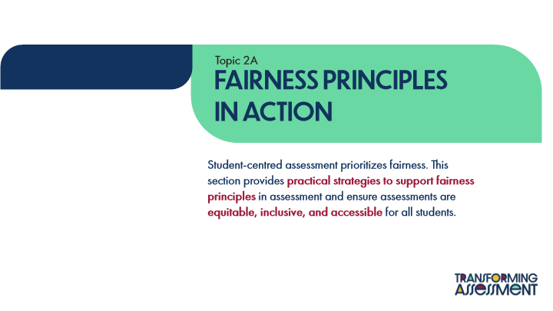

Type | Translation
Slide name | Topic 2A: Fairness Principles in Action
Text Box 1 | Topic 2A
Main Title | Fairness Principles
 | in Action
Main Body | Student-centred assessment prioritizes fairness. This section provides
 | practical strategies to support fairness principles
 | in assessment and ensure assessments are
 | equitable, inclusive, and accessible
 | for all students.

11.8 Activity Instructions: The Fairness Principles
Slide ID 🔒 | 83e95141-d125-4f1f-b5c5-2c8bff3833cb
Preview Image | 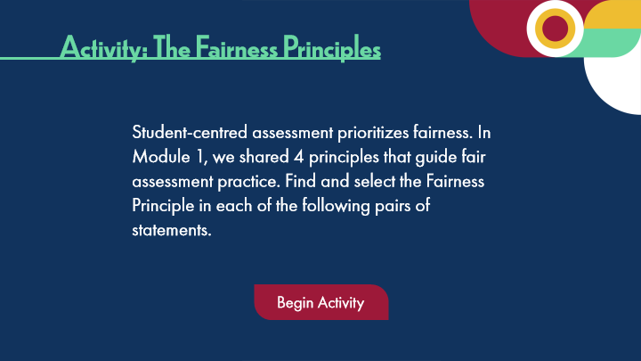

Type | Translation
Slide name | Activity Instructions: The Fairness Principles
Main Title 1 | Activity: The Fairness Principles
Text Box 1 | Student-centred assessment prioritizes fairness. In Module 1, we shared 4 principles that guide fair assessment practice. Find and select the Fairness Principle in each of the following pairs of statements.
Button - Normal state | Begin Activity

11.9 Activity: The Fairness Principles
Slide ID 🔒 | 8a9e93f9-6c79-428f-827c-4d4de34b9844
Preview Image | 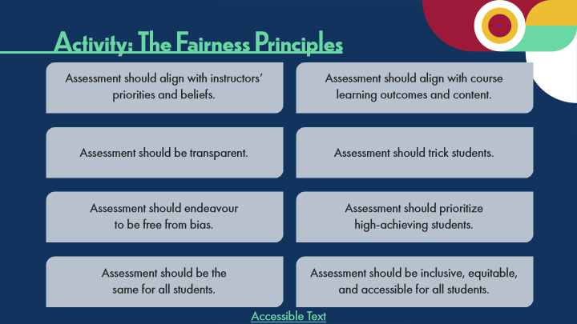

Type | Translation
Slide name | Activity: The Fairness Principles
Main Title 1 | Activity: The Fairness Principles
Choice 1A - Normal state | Assessment should align with instructors’ priorities and beliefs.
Choice 1B - Normal state | Assessment should align with course learning outcomes and content.
Choice 2A - Normal state | Assessment should be transparent.
Choice 2B - Normal state | Assessment should trick students.
Choice 3A - Normal state | Assessment should endeavour
 | to be free from bias.
Choice 3B - Normal state | Assessment should prioritize
 | high-achieving students.
Choice 4A - Normal state | Assessment should be the
 | same for all students.
Choice 4B - Normal state | Assessment should be inclusive, equitable, and accessible for all students.
Link: Accessible Text | Accessible Text
Alt text for Link: Accessible Text | Accessible Activity Text Link. If you are not using a mouse for this course, skip this activity and access the PDF.

Slide Layer: Try Again.
Layer ID 🔒 | 2cb4fea8-87cb-4ef8-a118-5716d9de1e47
Preview Image | 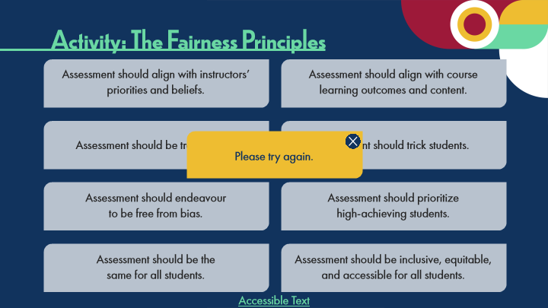

Type | Translation
Text Box 1 | Please try again.

11.10 Experienced Practitioners on Principles of Fair Assessment
Slide ID 🔒 | d344a309-3014-4ce8-8304-ee0aa46e9b94
Preview Image | 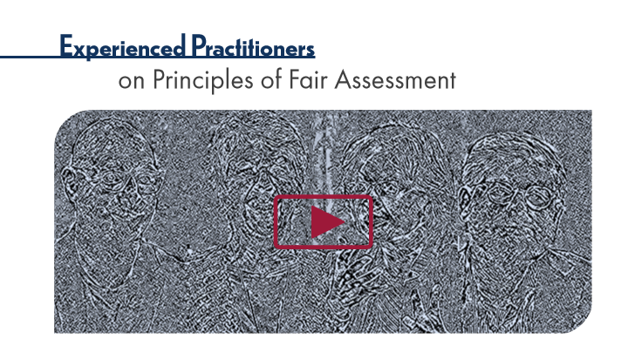

Type | Translation
Slide name | Experienced Practitioners on Principles of Fair Assessment
Main Title 1 | Experienced Practitioners
Main Title 2 | on Principles of Fair Assessment

11.11 Student-Centred Strategies for Fairness
Slide ID 🔒 | 12338013-e441-4513-aec4-3705ddf1fac2
Preview Image | 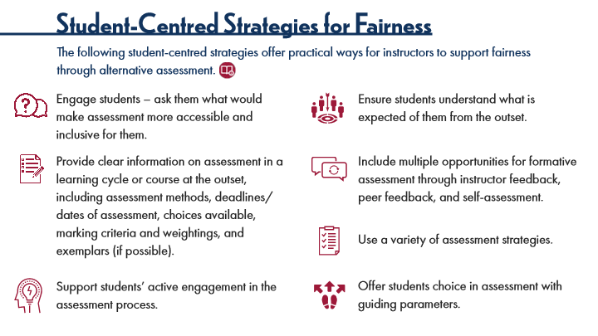

Type | Translation
Slide name | Student-Centred Strategies for Fairness
Main Title 1 | Student-Centred Strategies for Fairness
Text Box 1 | The following student-centred strategies offer practical ways for instructors to support fairness through alternative assessment.
Text Box 5 | Engage students – ask them what would make assessment more accessible and inclusive for them.
Text Box 4 | Ensure students understand what is expected of them from the outset.
Text Box 3 | Provide clear information on assessment in a learning cycle or course at the outset, including assessment methods, deadlines/dates of assessment, choices available, marking criteria and weightings, and exemplars (if possible).
Text Box 6 | Include multiple opportunities for formative assessment through instructor feedback, peer feedback, and self-assessment.
Text Box 8 | Use a variety of assessment strategies.
Text Box 7 | Offer students choice in assessment with guiding parameters.
Text Box 9 | Support students’ active engagement in the assessment process.

11.12 Pause and Reflect on Fairness Strategies
Slide ID 🔒 | accedace-e7aa-4dc6-8073-3fee4453166d
Preview Image | 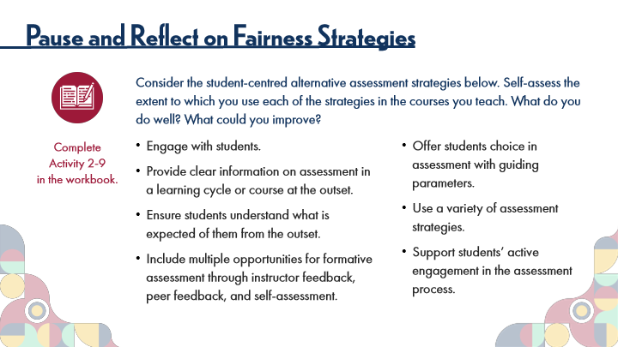

Type | Translation
Slide name | Pause and Reflect on Fairness Strategies
Main Title 1 | Pause and Reflect on Fairness Strategies
Text Box 2 | Consider the student-centred alternative assessment strategies below. Self-assess the extent to which you use each of the strategies in the courses you teach. What do you do well? What could you improve?
Text Box 3 | Engage with students.
 | Provide clear information on assessment in a learning cycle or course at the outset.
 | Ensure students understand what is expected of them from the outset.
 | Include multiple opportunities for formative assessment through instructor feedback, peer feedback, and self-assessment.
Text Box 4 | Offer students choice in assessment with guiding parameters.
 | Use a variety of assessment strategies.
 | Support students’ active engagement in the assessment process.
Text Box 1 | Complete
 | Activity 2-9
 | in the workbook.

11.13 Topic 2B: Ensuring Inclusive Assessment
Slide ID 🔒 | 7d39a628-4188-4d15-a1c3-ab3bb805dc20
Preview Image | 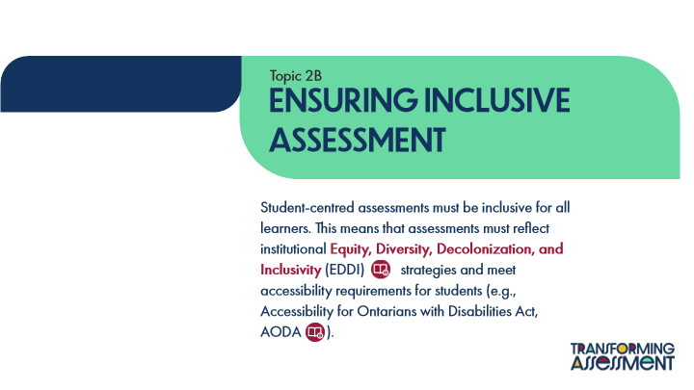

Type | Translation
Slide name | Topic 2B: Ensuring Inclusive Assessment
Text Box 1 | Topic 2B
Main Title | Ensuring Inclusive Assessment
Main Body
 | Student-centred assessments must be inclusive for all learners. This means that assessments must reflect institutional
 | Equity, Diversity, Decolonization, and Inclusivity
 | (EDDI) strategies and meet accessibility requirements for students (e.g., Accessibility for Ontarians with Disabilities Act, AODA ).

11.14 Universal Design for Learning (UDL)
Slide ID 🔒 | 867fd47a-ecef-48e1-8b89-db3da010e485
Preview Image | 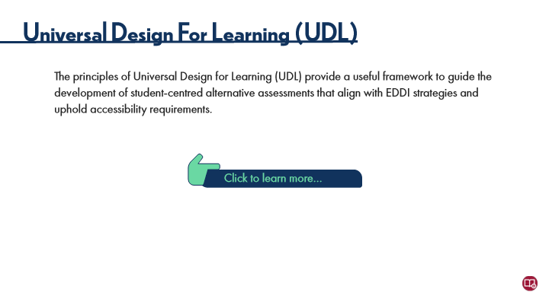

Type | Translation
Slide name | Universal Design For Learning (UDL)
Main Title 1 | Universal Design For Learning (UDL)
Text Box 6 | The principles of Universal Design for Learning (UDL) provide a useful framework to guide the development of student-centred alternative assessments that align with EDDI strategies and uphold accessibility requirements.
Text Box 2 | Click to learn more…

Slide Layer: Holistic Rubrics
Layer ID 🔒 | 12d14f82-53f0-4f9e-88d7-32f842893931
Preview Image | 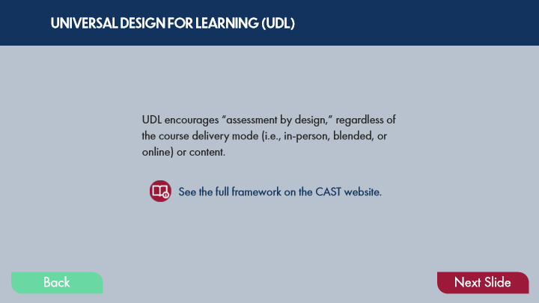

Type | Translation
Text Box 3 | UNIVERSAL DESIGN FOR LEARNING (UDL)
Text Box 1 | UDL encourages “assessment by design,” regardless of the course delivery mode (i.e., in-person, blended, or online) or content.
Text Box 2 | See the full framework on the CAST website.
Button - Normal state | Back
Button - Down state | Back
Button - Normal state | Next Slide

Slide Layer: UDL Main points
Layer ID 🔒 | adbadf49-99e0-4be8-af2c-acabaf12d16a
Preview Image | 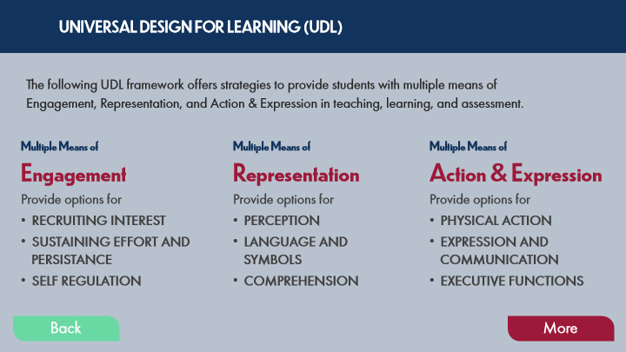

Type | Translation
Text Box 5 | UNIVERSAL DESIGN FOR LEARNING (UDL)
Text Box 1 | The following UDL framework offers strategies to provide students with multiple means of Engagement, Representation, and Action & Expression in teaching, learning, and assessment.
Text Box 2 | Multiple Means of
 | Engagement
 | Provide options for
 | RECRUITING INTEREST
 | SUSTAINING EFFORT AND PERSISTANCE
 | SELF REGULATION
Text Box 3 | Multiple Means of
 | Representation
 | Provide options for
 | PERCEPTION
 | LANGUAGE AND SYMBOLS
 | COMPREHENSION
Text Box 4 | Multiple Means of
 | Action & Expression
 | Provide options for
 | PHYSICAL ACTION
 | EXPRESSION AND COMMUNICATION
 | EXECUTIVE FUNCTIONS
Button - Normal state | Back
Button - Down state | Back
Button - Normal state | More

Slide Layer: Block paragraph
Layer ID 🔒 | ff7cb89c-f1ab-489a-8a87-373d612bc00f
Preview Image | 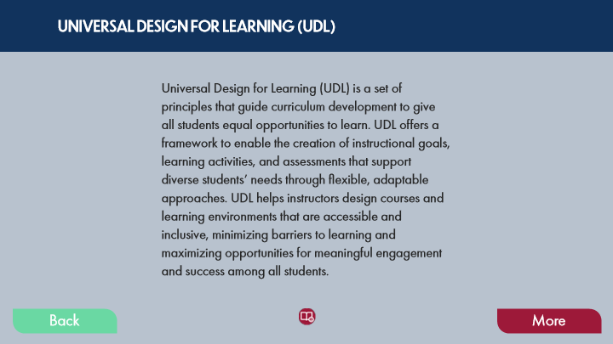

Type | Translation
Text Box 2 | UNIVERSAL DESIGN FOR LEARNING (UDL)
Text Box 1 | Universal Design for Learning (UDL) is a set of principles that guide curriculum development to give all students equal opportunities to learn. UDL offers a framework to enable the creation of instructional goals, learning activities, and assessments that support diverse students’ needs through flexible, adaptable approaches. UDL helps instructors design courses and learning environments that are accessible and inclusive, minimizing barriers to learning and maximizing opportunities for meaningful engagement and success among all students.
Button - Normal state | Back
Button - Down state | Back
Button - Normal state | More

11.15 UDL Tips for Assessment
Slide ID 🔒 | d3e7afe1-815f-43ad-acc8-183a6bdf5b7b
Preview Image | 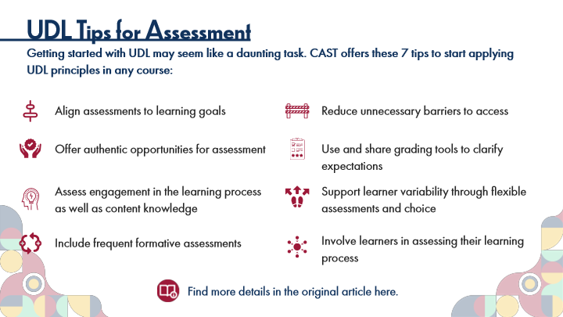

Type | Translation
Slide name | UDL Tips for Assessment
Main Title 1 | UDL Tips for Assessment
Text Box 1 | Getting started with UDL may seem like a daunting task. CAST offers these 7 tips to start applying UDL principles in any course:
Text Box 5 | Align assessments to learning goals
Text Box 7 | Reduce unnecessary barriers to access
Text Box 10 | Use and share grading tools to clarify expectations
Text Box 3 | Offer authentic opportunities for assessment
Text Box 4 | Assess engagement in the learning process as well as content knowledge
Text Box 8 | Support learner variability through flexible assessments and choice
Text Box 11 | Involve learners in assessing their learning process
Text Box 6 | Include frequent formative assessments
Text Box 2 | Find more details in the original article here.

11.16 Pause and Reflect on UDL in Assessment
Slide ID 🔒 | c3311f7a-9a18-4336-9340-bce004d18cc0
Preview Image | 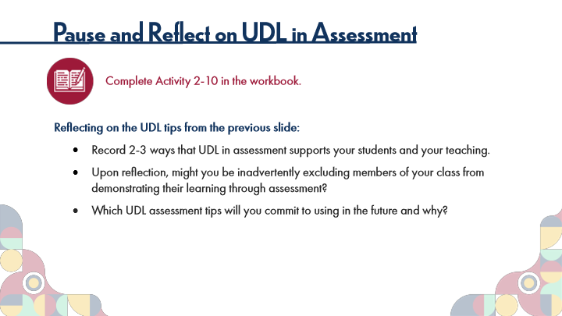

Type | Translation
Slide name | Pause and Reflect on UDL in Assessment
Main Title 1 | Pause and Reflect on UDL in Assessment
Text Box 6 | Complete Activity 2-10 in the workbook.
Text Box 7 | Reflecting on the UDL tips from the previous slide:
 | Record 2-3 ways that UDL in assessment supports your students and your teaching.
 | Upon reflection, might you be inadvertently excluding members of your class from demonstrating their learning through assessment?
 | Which UDL assessment tips will you commit to using in the future and why?

11.17 Equity, Diversity, Decolonization, and Inclusivity (EDDI)
Slide ID 🔒 | 7c5fe722-a7c0-45d5-8c0c-a981d0780742
Preview Image | 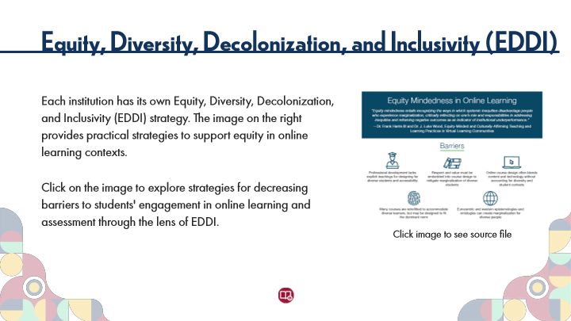

Type | Translation
Slide name | Equity, Diversity, Decolonization, and Inclusivity (EDDI)
Main Title 1 | Equity, Diversity, Decolonization, and Inclusivity (EDDI)
Text Box 3 | Each institution has its own Equity, Diversity, Decolonization, and Inclusivity (EDDI) strategy. The image on the right provides practical strategies to support equity in online learning contexts.
 | Click on the image to explore strategies for decreasing barriers to students' engagement in online learning and assessment through the lens of EDDI.
Text Box 4 | Click image to see source file

11.18 Pause and Reflect on EDDI in Assessment
Slide ID 🔒 | 117c9fc9-7978-4abc-831e-fdbbad6608a2
Preview Image | 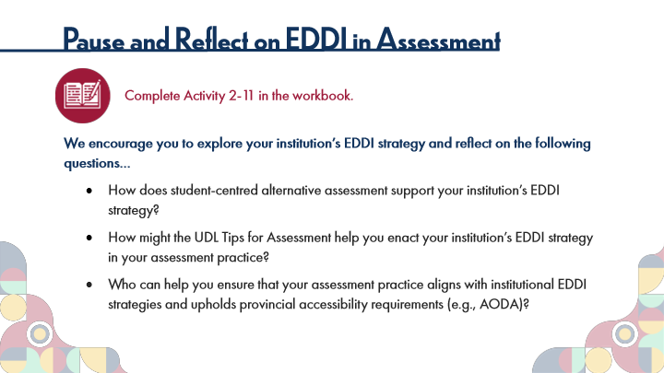

Type | Translation
Slide name | Pause and Reflect on EDDI in Assessment
Main Title 1 | Pause and Reflect on EDDI in Assessment
Text Box 6 | Complete Activity 2-11 in the workbook.
Text Box 7 | We encourage you to explore your institution’s EDDI strategy and reflect on the following questions…
 | How does student-centred alternative assessment support your institution’s EDDI strategy?
 | How might the UDL Tips for Assessment help you enact your institution’s EDDI strategy in your assessment practice?
 | Who can help you ensure that your assessment practice aligns with institutional EDDI strategies and upholds provincial accessibility requirements (e.g., AODA)?

11.19 Activity: Inclusive Assessment
Slide ID 🔒 | 2ac145d6-283c-438e-a6d8-f43f4491ec6d
Preview Image | 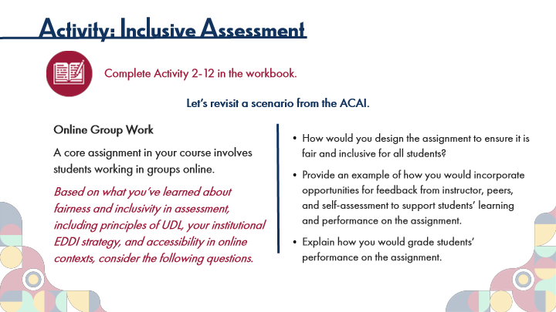

Type | Translation
Slide name | Activity: Inclusive Assessment
Main Title 1 | Activity: Inclusive Assessment
Text Box 1 | Complete Activity 2-12 in the workbook.
Text Box 2 | Let’s revisit a scenario from the ACAI.
Text Box 4 | Online Group Work
 | A core assignment in your course involves students working in groups online.
 | Based on what you’ve learned about fairness and inclusivity in assessment, including principles of UDL, your institutional EDDI strategy, and accessibility in online contexts, consider the following questions.
Text Box 3 | How would you design the assignment to ensure it is fair and inclusive for all students?
 | Provide an example of how you would incorporate opportunities for feedback from instructor, peers, and self-assessment to support students’ learning and performance on the assignment.
 | Explain how you would grade students’ performance on the assignment.

11.20 Topic 2C: Aligning Assessment with Learning Outcomes
Slide ID 🔒 | 2588e9fb-4777-4754-8756-a7c64095e12a
Preview Image | 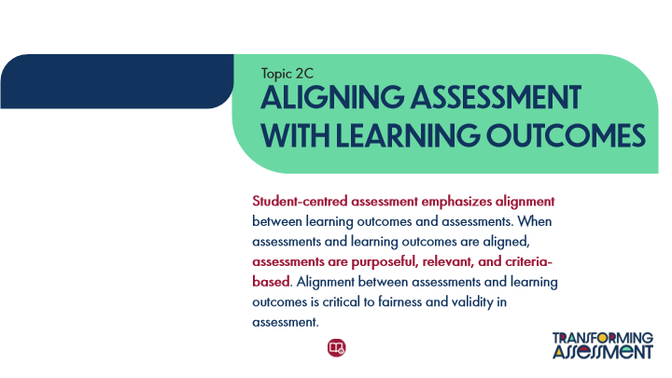

Type | Translation
Slide name | Topic 2C: Aligning Assessment with Learning Outcomes
Text Box 1 | Topic 2C
Main Title | ALIGNING ASSESSMENT WITH LEARNING OUTCOMES
Main Body | Student-centred assessment emphasizes alignment
 | between learning outcomes and assessments. When assessments and learning outcomes are aligned,
 | assessments are purposeful, relevant, and criteria-based
 | . Alignment between assessments and learning outcomes is critical to fairness and validity in assessment.

11.21 Review of Learning Outcomes
Slide ID 🔒 | 03105e98-6e43-410b-9a38-21f1449ca5a7
Preview Image | 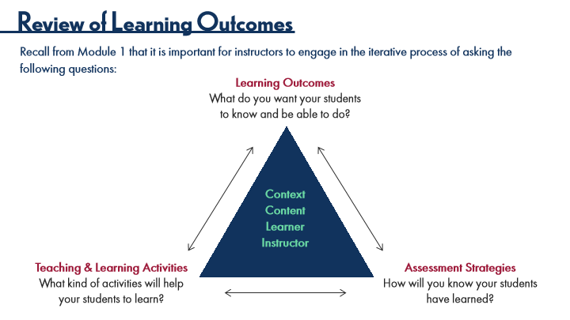

Type | Translation
Slide name | Review of Learning Outcomes
Main Title 1 | Review of Learning Outcomes
Text Box 5 | Recall from Module 1 that it is important for instructors to engage in the iterative process of asking the following questions:
Text Box 2 | Learning Outcomes
 | What do you want your students to know and be able to do?
Text Box 1 | Context
 | Content
 | Learner
 | Instructor
Text Box 3 | Teaching & Learning Activities
 | What kind of activities will help your students to learn?
Text Box 4 | Assessment Strategies
 | How will you know your students have learned?

11.22 Resources for Learning Outcomes
Slide ID 🔒 | 46389930-2cc4-4ca3-854a-914026182fdc
Preview Image | 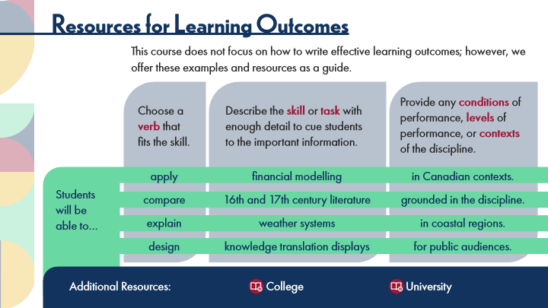

Type | Translation
Slide name | Resources for Learning Outcomes
Main Title 1 | Resources for Learning Outcomes
Text Box 3 | This course does not focus on how to write effective learning outcomes; however, we offer these examples and resources as a guide.
Text Box 10 | Provide any
 | conditions
 | of performance,
 | levels
 | of performance, or
 | contexts
 | of the discipline.
Text Box 8 | Choose a
 | verb
 | that fits the skill.
Text Box 9 | Describe the
 | skill
 | or
 | task
 | with enough detail to cue students to the important information.
Text Box 5 | apply
 | compare
 | explain
 | design
Text Box 6 | financial modelling
 | 16th and 17th century literature
 | weather systems
 | knowledge translation displays
Text Box 7 | in Canadian contexts.
 | grounded in the discipline.
 | in coastal regions.
 | for public audiences.
Text Box 4 | Students will be able to…
Text Box 11 | Additional Resources:
Text Box 12 | College
Text Box 13 | University

11.23 Deciding on Assessment Strategies
Slide ID 🔒 | 80d1b54d-e14b-4727-a1ca-8bc3dffa21a8
Preview Image | 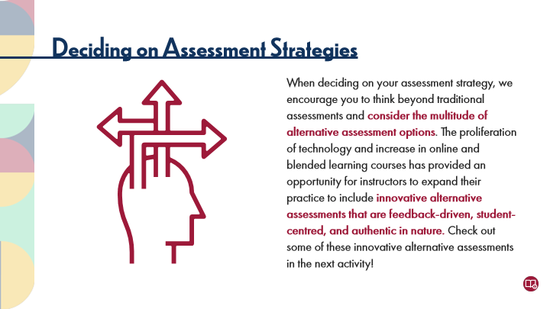

Type | Translation
Slide name | Deciding on Assessment Strategies
Main Title 1 | Deciding on Assessment Strategies
Text Box 1 | When deciding on your assessment strategy, we encourage you to think beyond traditional assessments and
 | consider the multitude of alternative assessment options
 | . The proliferation of technology and increase in online and blended learning courses has provided an opportunity for instructors to expand their practice to include
 | innovative alternative assessments that are feedback-driven, student-centred, and authentic in nature.
 | Check out some of these innovative alternative assessments in the next activity!

11.24 Activity Instructions
Slide ID 🔒 | 628e471f-ab67-4e85-bc3d-e70514b0b88b
Preview Image | 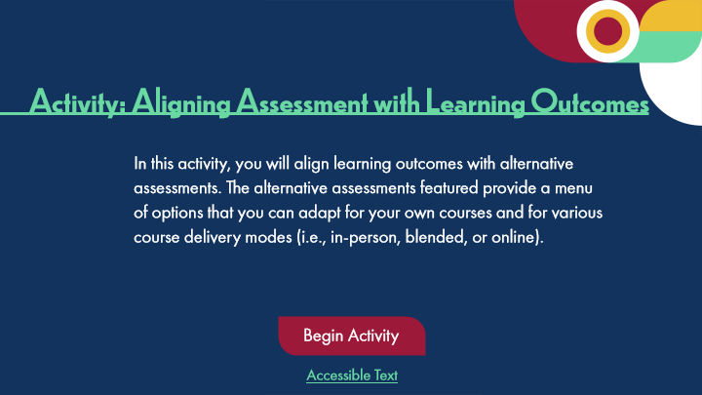

Type | Translation
Slide name | Activity Instructions
Main Title 1 | Activity: Aligning Assessment with Learning Outcomes
Text Box 1 | In this activity, you will align learning outcomes with alternative assessments. The alternative assessments featured provide a menu of options that you can adapt for your own courses and for various course delivery modes (i.e., in-person, blended, or online).
Round Diagonal Corner 1 - Normal state | Begin Activity
Text Box 2 | Accessible Text
Alt text for Text Box 2 | Accessible Activity Text Link. If you are not using a mouse for this course, skip this activity and access the PDF. This accessible document covers the next 4 slides as part of this single activity.

11.25 Activity: Aligning Assessment 1
Slide ID 🔒 | 98b1be90-093e-4228-9ca4-7de0ceb6edf8
Preview Image | 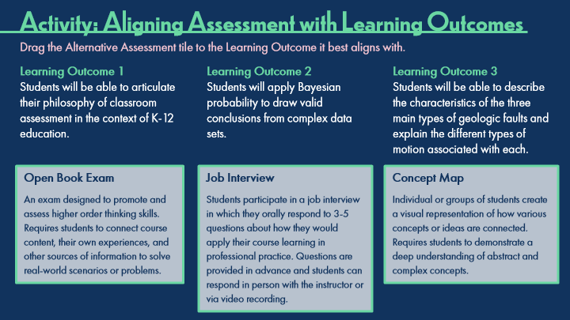

Type | Translation
Slide name | Activity: Aligning Assessment 1
Main Title 1 | Activity: Aligning Assessment with Learning Outcomes
Instructions | Drag the Alternative Assessment tile to the Learning Outcome it best aligns with.
LO1 | Learning Outcome 1
 | Students will be able to articulate their philosophy of classroom assessment in the context of K-12 education.
LO2 | Learning Outcome 2
 | Students will apply Bayesian probability to draw valid conclusions from complex data sets.
LO3 | Learning Outcome 3
 | Students will be able to describe the characteristics of the three main types of geologic faults and explain the different types of motion associated with each.
A2 | Open Book Exam
 | An exam designed to promote and assess higher order thinking skills. Requires students to connect course content, their own experiences, and other sources of information to solve real-world scenarios or problems.
A1 | Job Interview
 | Students participate in a job interview in which they orally respond to 3-5 questions about how they would apply their course learning in professional practice. Questions are provided in advance and students can respond in person with the instructor or via video recording.
A3 | Concept Map
 | Individual or groups of students create a visual representation of how various concepts or ideas are connected. Requires students to demonstrate a deep understanding of abstract and complex concepts.

Slide Layer: Correct
Layer ID 🔒 | ac05373c-f4fb-42ec-87bf-89988ec21a76
Preview Image | 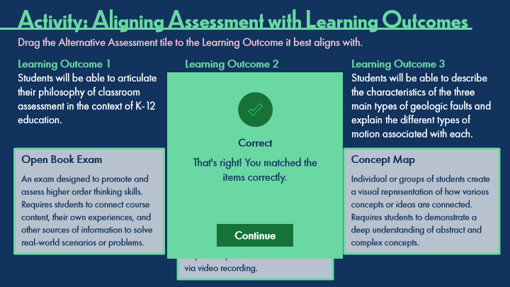

Type | Translation
Text Box | Correct
Text Box | That's right! You matched the
 | items correctly.
AltText for Continue - 1 Normal state | Button: Continue
Alt text for Continue | Button: Continue

Slide Layer: Incorrect
Layer ID 🔒 | 6da25344-2dbc-4944-9fa9-21330a2109f4
Preview Image | 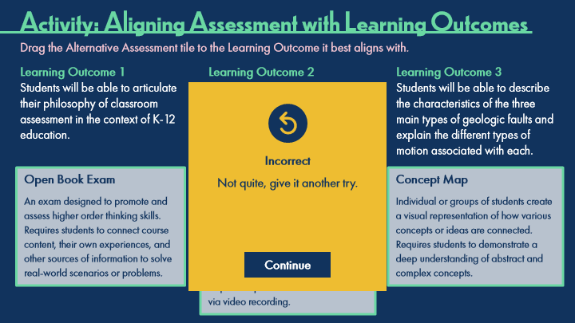

Type | Translation
Text Box | Incorrect
Text Box | Not quite, give it another try.
AltText for Continue - 1 Normal state | Button: Continue
Alt text for Continue | Button: Continue

Slide Layer: Try Again
Layer ID 🔒 | f1684ddc-7843-49ac-a6c1-7ad183912a52
Preview Image | 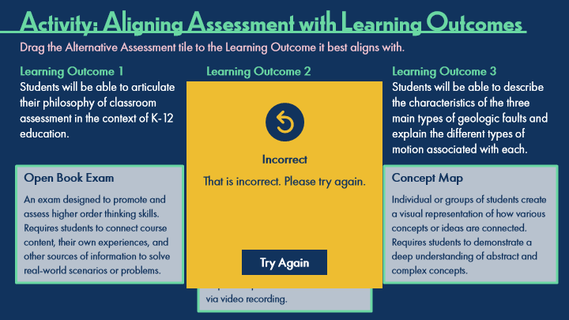

Type | Translation
Text Box | Incorrect
Text Box | That is incorrect. Please try again.
AltText for Try Again - 1 Normal state | Button: Try Again
Alt text for Try Again | Button: Try Again

11.26 Activity: Aligning Assessment 2
Slide ID 🔒 | 107761b2-6627-445e-ab7f-dc2fa252bfa6
Preview Image | 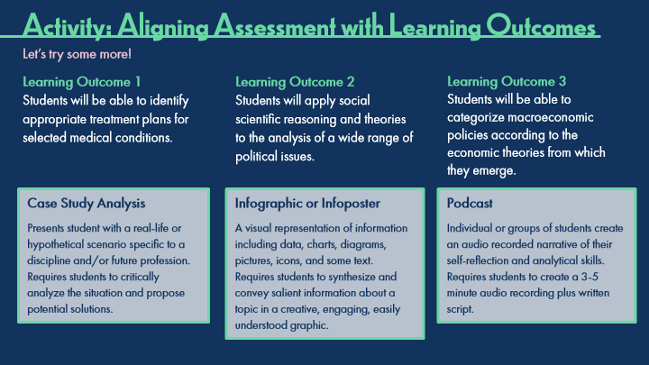

Type | Translation
Slide name | Activity: Aligning Assessment 2
Main Title 1 | Activity: Aligning Assessment with Learning Outcomes
Text Box 8 | Let’s try some more!
LO1 | Learning Outcome 1
 | Students will be able to identify appropriate treatment plans for selected medical conditions.
LO2 | Learning Outcome 2
 | Students will apply social scientific reasoning and theories to the analysis of a wide range of political issues.
LO3 | Learning Outcome 3
 | Students will be able to categorize macroeconomic policies according to the economic theories from which they emerge.
A1 | Case Study Analysis
 | Presents student with a real-life or hypothetical scenario specific to a discipline and/or future profession. Requires students to critically analyze the situation and propose potential solutions.
A3 | Infographic or Infoposter
 | A visual representation of information including data, charts, diagrams, pictures, icons, and some text. Requires students to synthesize and convey salient information about a topic in a creative, engaging, easily understood graphic.
A2 | Podcast
 | Individual or groups of students create an audio recorded narrative of their self-reflection and analytical skills. Requires students to create a 3-5 minute audio recording plus written script.

Slide Layer: Correct
Layer ID 🔒 | be51d95e-dfcc-48f8-8c46-df7e4823d68f
Preview Image | 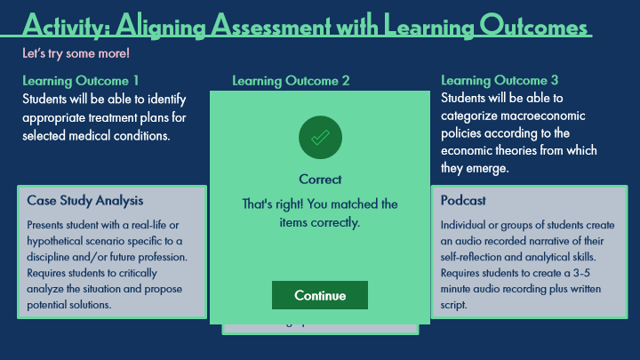

Type | Translation
Text Box | Correct
Text Box | That's right! You matched the
 | items correctly.

Slide Layer: Incorrect
Layer ID 🔒 | 4d167d05-f3ca-4247-9f9d-55ff289346a7
Preview Image | 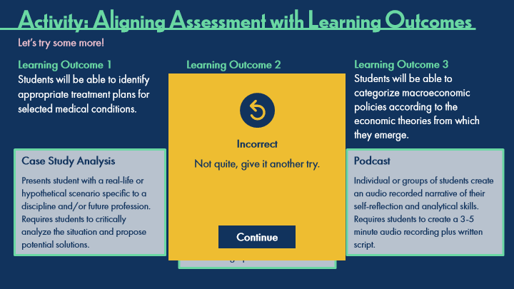

Type | Translation
Text Box | Incorrect
Text Box | Not quite, give it another try.

Slide Layer: Try Again
Layer ID 🔒 | da0617b0-ed15-4cf5-9a49-b77e8c512e79
Preview Image | 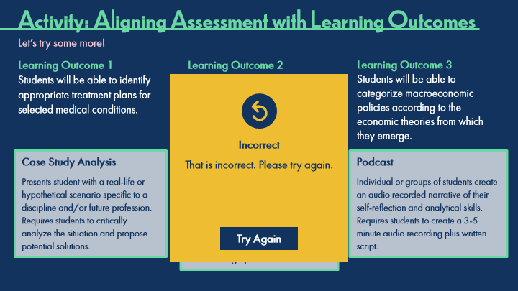

Type | Translation
Text Box | Incorrect
Text Box | That is incorrect. Please try again.

11.27 Activity: Aligning Assessment 3
Slide ID 🔒 | f3347290-0edb-438d-9670-cb19160dce22
Preview Image | 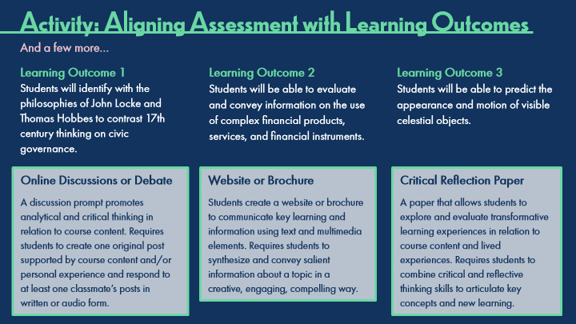

Type | Translation
Slide name | Activity: Aligning Assessment 3
Main Title 1 | Activity: Aligning Assessment with Learning Outcomes
Text Box 8 | And a few more…
LO1 | Learning Outcome 1
 | Students will identify with the philosophies of John Locke and Thomas Hobbes to contrast 17th century thinking on civic governance.
LO2 | Learning Outcome 2
 | Students will be able to evaluate and convey information on the use of complex financial products, services, and financial instruments.
LO3 | Learning Outcome 3
 | Students will be able to predict the appearance and motion of visible celestial objects.
A3 | Online Discussions or Debate
 | A discussion prompt promotes analytical and critical thinking in relation to course content. Requires students to create one original post supported by course content and/or personal experience and respond to at least one classmate’s posts in written or audio form.
A2 | Website or Brochure
 | Students create a website or brochure to communicate key learning and information using text and multimedia elements. Requires students to synthesize and convey salient information about a topic in a creative, engaging, compelling way.
A1 | Critical Reflection Paper
 | A paper that allows students to explore and evaluate transformative learning experiences in relation to course content and lived experiences. Requires students to combine critical and reflective thinking skills to articulate key concepts and new learning.

Slide Layer: Correct
Layer ID 🔒 | 2a9b1641-c51c-4881-bd24-d5e782172fd0
Preview Image | 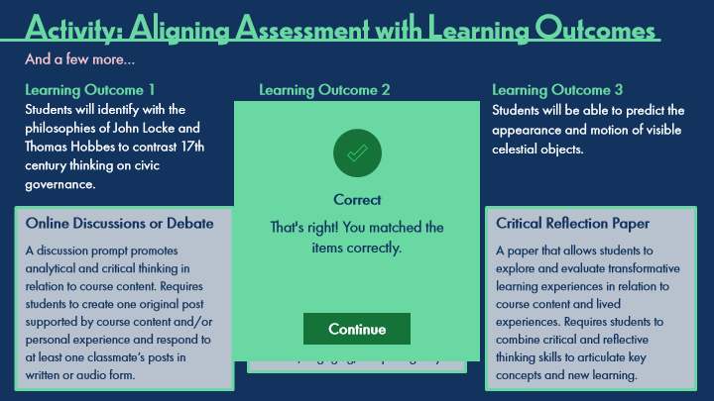

Type | Translation
Text Box | Correct
Text Box | That's right! You matched the
 | items correctly.

Slide Layer: Incorrect
Layer ID 🔒 | 1ca9394e-cfae-4944-8b46-eb1e382edce5
Preview Image | 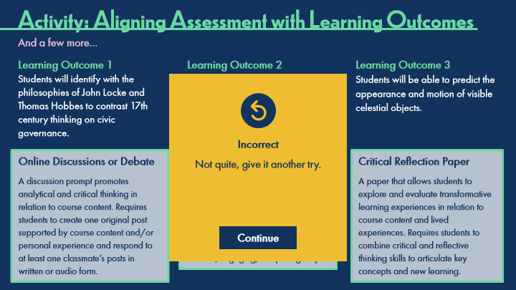

Type | Translation
Text Box | Incorrect
Text Box | Not quite, give it another try.

Slide Layer: Try Again
Layer ID 🔒 | 056cee35-7f85-4f88-be54-512b6a1cf66a
Preview Image | 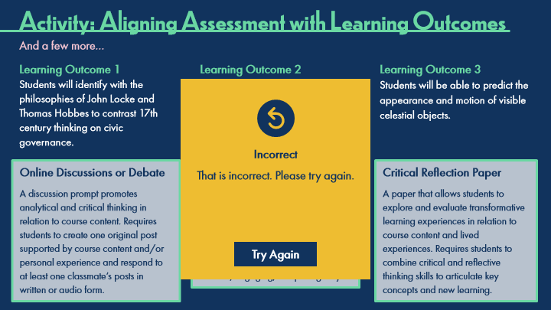

Type | Translation
Text Box | Incorrect
Text Box | That is incorrect. Please try again.

11.28 Activity: Aligning Assessment 4
Slide ID 🔒 | 90bc184c-78b6-49c6-968f-6f310d1fa240
Preview Image | 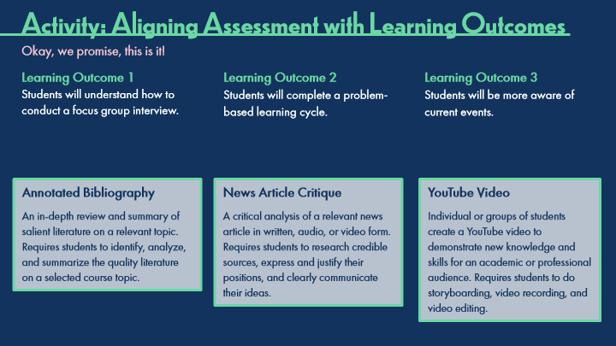

Type | Translation
Slide name | Activity: Aligning Assessment 4
Main Title 1 | Activity: Aligning Assessment with Learning Outcomes
Text Box 8 | Okay, we promise, this is it!
LO1 | Learning Outcome 1
 | Students will understand how to conduct a focus group interview.
LO2 | Learning Outcome 2
 | Students will complete a problem-based learning cycle.
LO3 | Learning Outcome 3
 | Students will be more aware of current events.
A2 | Annotated Bibliography
 | An in-depth review and summary of salient literature on a relevant topic. Requires students to identify, analyze, and summarize the quality literature on a selected course topic.
A3 | News Article Critique
 | A critical analysis of a relevant news article in written, audio, or video form. Requires students to research credible sources, express and justify their positions, and clearly communicate their ideas.
A1 | YouTube Video
 | Individual or groups of students create a YouTube video to demonstrate new knowledge and skills for an academic or professional audience. Requires students to do storyboarding, video recording, and video editing.

Slide Layer: Correct
Layer ID 🔒 | 008361e1-d081-47dc-a786-4a2454fde1ed
Preview Image | 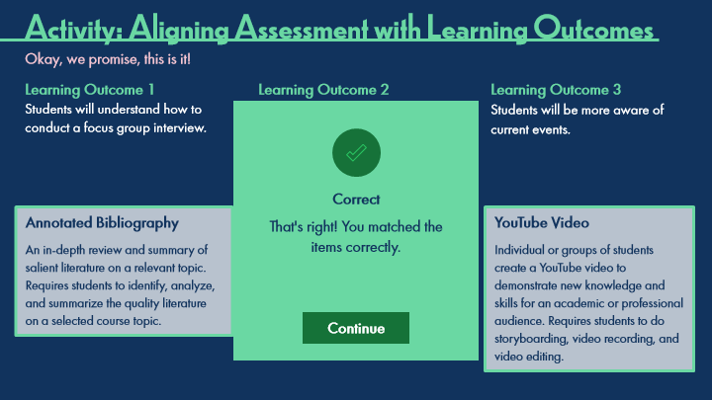

Type | Translation
Text Box | Correct
Text Box | That's right! You matched the
 | items correctly.

Slide Layer: Incorrect
Layer ID 🔒 | 36ca25ac-7c8f-4586-8756-d539dc8b2908
Preview Image | 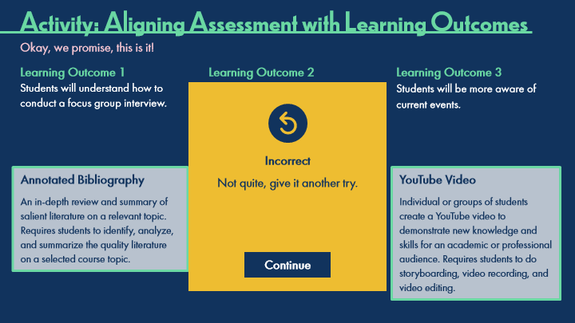

Type | Translation
Text Box | Incorrect
Text Box | Not quite, give it another try.

Slide Layer: Try Again
Layer ID 🔒 | 40cd6f38-8a23-47c3-b4e2-c3afd8d57cbf
Preview Image | 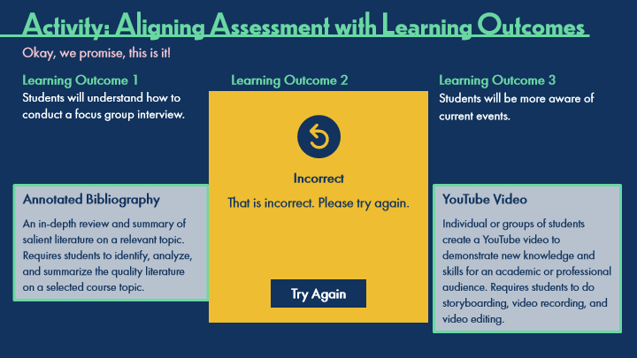

Type | Translation
Text Box | Incorrect
Text Box | That is incorrect. Please try again.

11.29 Thinking Forward: Aligning Assessment
Slide ID 🔒 | 2f54a1e5-4897-4924-9d66-c94a88452461
Preview Image | 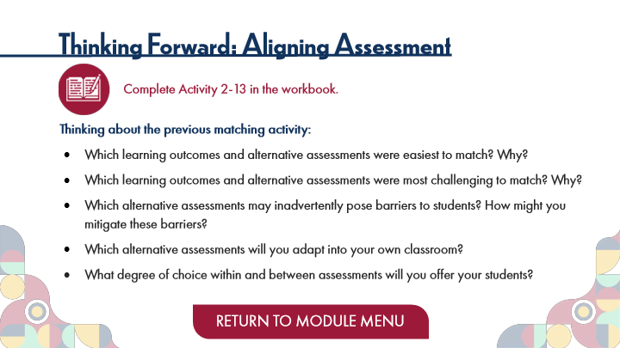

Type | Translation
Slide name | Thinking Forward: Aligning Assessment
Main Title 1 | Thinking Forward: Aligning Assessment
Text Box 6 | Complete Activity 2-13 in the workbook.
Text Box 7 | Thinking about the previous matching activity:
 | Which learning outcomes and alternative assessments were easiest to match? Why?
 | Which learning outcomes and alternative assessments were most challenging to match? Why?
 | Which alternative assessments may inadvertently pose barriers to students? How might you mitigate these barriers?
 | Which alternative assessments will you adapt into your own classroom?
 | What degree of choice within and between assessments will you offer your students?
Button - Normal state | RETURN TO MODULE MENU

12 Topic 3: Authentic Assessment
Scene ID 🔒 | b13a7748-06dd-4d7a-a783-d4dcfdb28b2b

Type | Translation
Scene name | Topic 3: Authentic Assessment

12.1 Authentic Assessment Title Page
Slide ID 🔒 | 8e6a7fe2-4516-4226-bf5d-842470bea130
Preview Image | 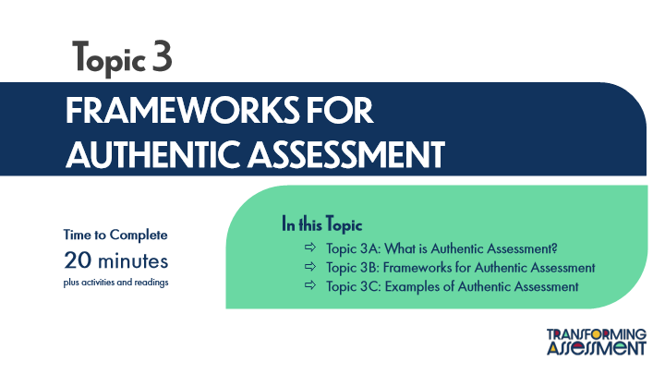

Type | Translation
Slide name | Authentic Assessment Title Page
Main Title 1 | Topic 3
Main Title | FRAMEWORKS FOR
 | AUTHENTIC ASSESSMENT
Text Box 1 | In this Topic
 | Topic 3A: What is Authentic Assessment?
 | Topic 3B: Frameworks for Authentic Assessment
 | Topic 3C: Examples of Authentic Assessment
Text Box 2 | Time to Complete
 | 20 minutes
 | plus activities and readings

12.2 Activation: Authentic Assessment
Slide ID 🔒 | 9d681937-c1a2-464e-9f3b-85fa4b22c0eb
Preview Image | 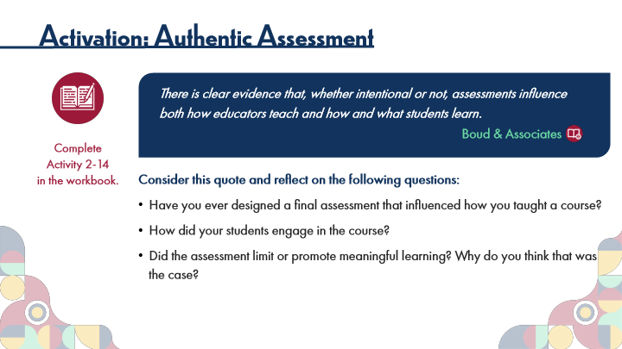

Type | Translation
Slide name | Activation: Authentic Assessment
Main Title 1 | Activation: Authentic Assessment
Text Box 8 | There is clear evidence that, whether intentional or not, assessments influence both how educators teach and how and what students learn
 | .
Text Box 9 | Boud & Associates
Text Box 10 | Complete
 | Activity 2-14
 | in the workbook.
Text Box 7 | Consider this quote and reflect on the following questions:
 | Have you ever designed a final assessment that influenced how you taught a course?
 | How did your students engage in the course?
 | Did the assessment limit or promote meaningful learning? Why do you think that was the case?

12.3 Topic 3A: What is Authentic Assessment?
Slide ID 🔒 | 336c7e94-f24c-45f5-bbed-fae0f8774075
Preview Image | 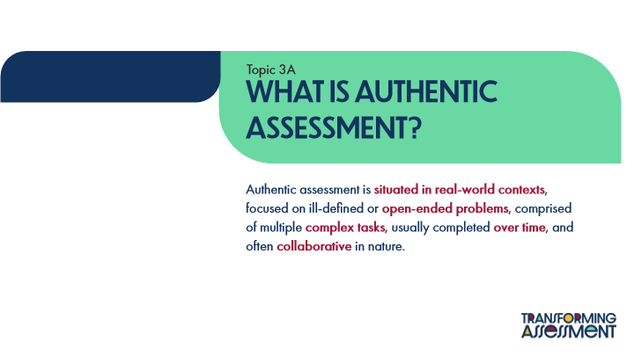

Type | Translation
Slide name | Topic 3A: What is Authentic Assessment?
Text Box 1 | Topic 3A
Main Title | What is Authentic Assessment?
Main Body | Authentic assessment is
 | situated in real-world contexts
 | , focused on ill-defined or
 | open-ended problems
 | , comprised of multiple
 | complex tasks
 | , usually completed
 | over time
 | , and often
 | collaborative
 | in nature.

12.4 Defining Authentic Assessment
Slide ID 🔒 | 84067c6d-7ecb-44d6-8041-878dab6ced4a
Preview Image | 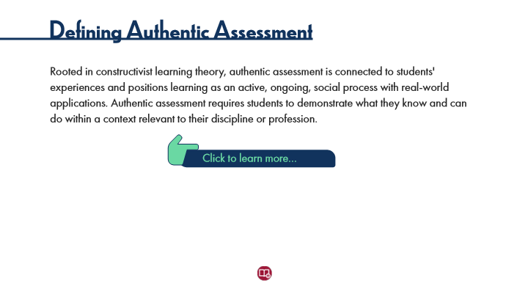

Type | Translation
Slide name | Defining Authentic Assessment
Main Title 1 | Defining Authentic Assessment
Text Box 1 | Rooted in constructivist learning theory, authentic assessment is connected to students' experiences and positions learning as an active, ongoing, social process with real-world applications. Authentic assessment requires students to demonstrate what they know and can do within a context relevant to their discipline or profession.
Text Box 2 | Click to learn more…

Slide Layer: Rollover: Higher Order Thinking Skills
Layer ID 🔒 | 8b90c76c-2245-4d10-a704-ac567bf8a60f
Preview Image | 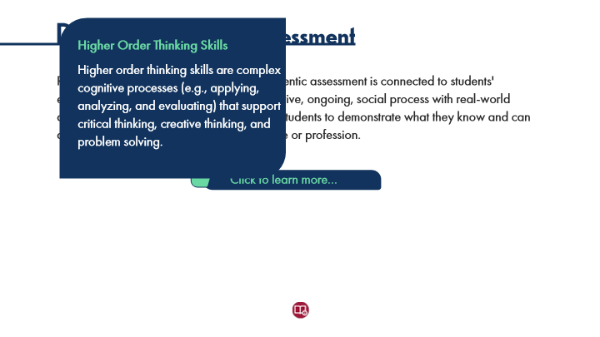

Type | Translation
Text Box 1 | Higher Order Thinking Skills
 | Higher order thinking skills are complex cognitive processes (e.g., applying, analyzing, and evaluating) that support critical thinking, creative thinking, and problem solving.

Slide Layer: Support Instructor
Layer ID 🔒 | 30efa523-df91-4524-a512-52a4791ec1b8
Preview Image | 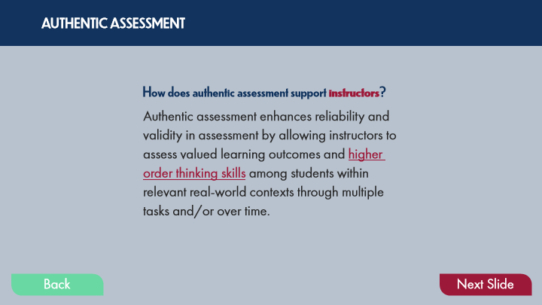

Type | Translation
Text Box 1 | AUTHENTIC ASSESSMENT
Text Box 3 | How does authentic assessment support
 | instructors
 | ?
Text Box 2 | Authentic assessment enhances reliability and validity in assessment by allowing instructors to assess valued learning outcomes and
 | higher order thinking skills
 | among students within relevant real-world contexts through multiple tasks and/or over time.
Button - Normal state | Back
Button - Down state | Back
Button - Normal state | Next Slide

Slide Layer: Support Students
Layer ID 🔒 | 17d324da-4d7c-49f3-afd7-f7445e7e7b9f
Preview Image | 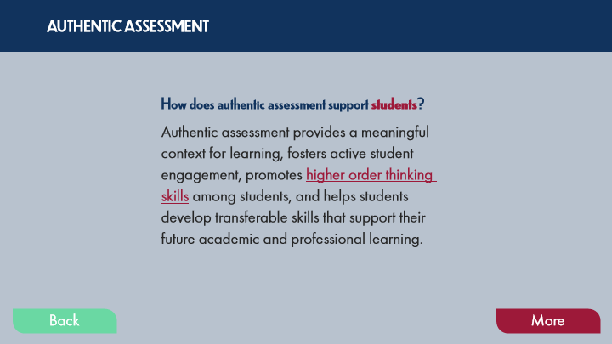

Type | Translation
Text Box 8 | AUTHENTIC ASSESSMENT
Text Box 10 | How does authentic assessment support
 | students
 | ?
Text Box 9 | Authentic assessment provides a meaningful context for learning, fosters active student engagement, promotes
 | higher order thinking skills
 | among students, and helps students develop transferable skills that support their future academic and professional learning.
Button - Normal state | Back
Button - Down state | Back
Button - Normal state | More

12.5 Topic 3B: Frameworks for Authentic Assessment
Slide ID 🔒 | 1b8a0a7f-eca2-42ba-8dea-dd3629b51d0d
Preview Image | 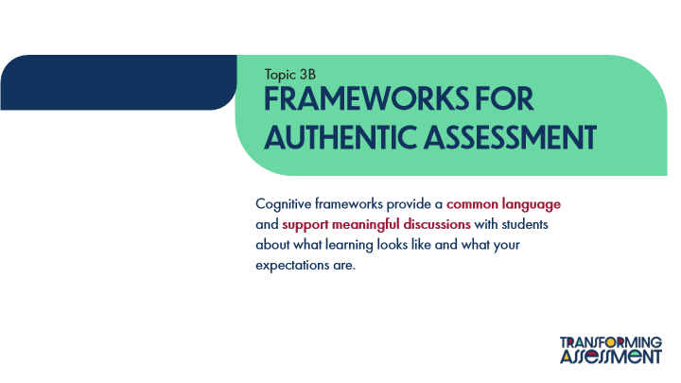

Type | Translation
Slide name | Topic 3B: Frameworks for Authentic Assessment
Text Box 1 | Topic 3B
Main Title | Frameworks For Authentic Assessment
Main Body | Cognitive frameworks provide a
 | common language
 | and
 | support meaningful discussions
 | with students about what learning looks like and what your expectations are.

12.6 Cognitive Frameworks
Slide ID 🔒 | 90ad935a-6739-4fcc-a135-9ca4ec7fe63f
Preview Image | 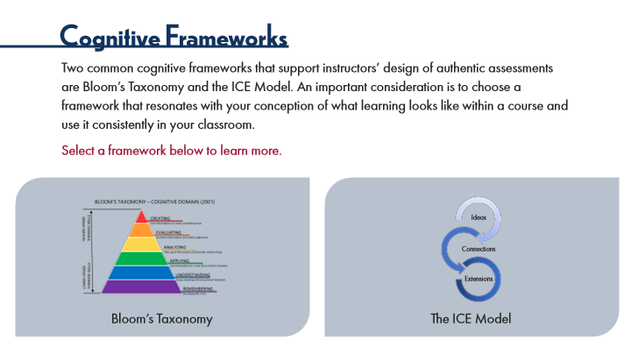

Type | Translation
Slide name | Cognitive Frameworks
Main Title 1 | Cognitive Frameworks
Text Box 1 | Two common cognitive frameworks that support instructors’ design of authentic assessments are Bloom’s Taxonomy and the ICE Model. An important consideration is to choose a framework that resonates with your conception of what learning looks like within a course and use it consistently in your classroom.
 | Select a framework below to learn more.
Text Box 4 | Ideas
Text Box 5 | Connections
Text Box 6 | Extensions
Text Box 2 | Bloom’s Taxonomy
Text Box 3 | The ICE Model

Slide Layer: ICE
Layer ID 🔒 | e7ae5241-9cf6-45b6-b8ab-aec87f13ca59
Preview Image | 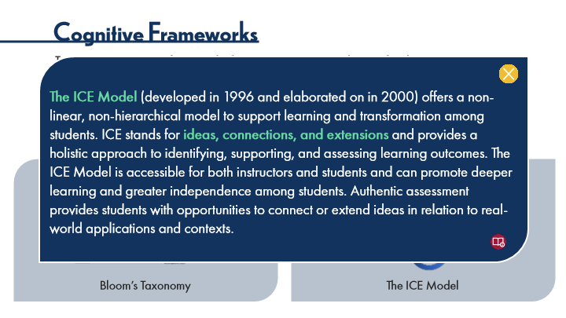

Type | Translation
Text Box 2 | The ICE Model
 | (developed in 1996 and elaborated on in 2000) offers a non-linear, non-hierarchical model to support learning and transformation among students. ICE stands for
 | ideas, connections, and extensions
 | and provides a holistic approach to identifying, supporting, and assessing learning outcomes. The ICE Model is accessible for both instructors and students and can promote deeper learning and greater independence among students. Authentic assessment provides students with opportunities to connect or extend ideas in relation to real-world applications and contexts.

Slide Layer: Bloom
Layer ID 🔒 | 981ccdad-a109-4a10-96c1-afc37c2d113a
Preview Image | 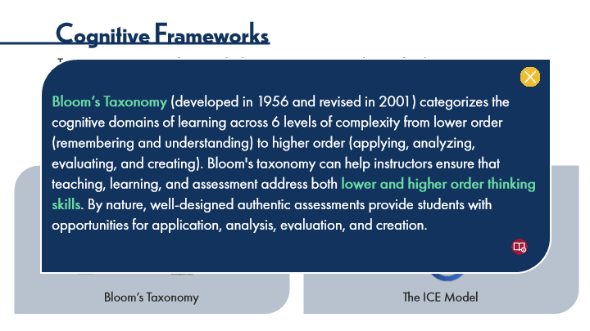

Type | Translation
Text Box 10 | Bloom’s Taxonomy
 | (developed in 1956 and revised in 2001) categorizes the cognitive domains of learning across 6 levels of complexity from lower order (remembering and understanding) to higher order (applying, analyzing, evaluating, and creating). Bloom's taxonomy can help instructors ensure that teaching, learning, and assessment address both
 | lower and higher order thinking skills
 | . By nature, well-designed authentic assessments provide students with opportunities for application, analysis, evaluation, and creation.

12.7 Activity: Bloom's Taxonomy
Slide ID 🔒 | 00a13de8-bf93-46b2-929e-ee7f8b81d2cf
Preview Image | 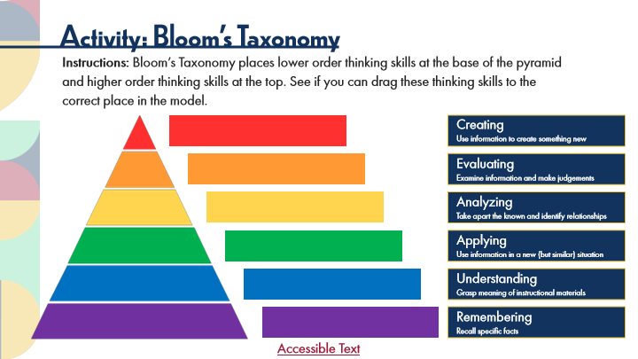

Type | Translation
Slide name | Activity: Bloom's Taxonomy
Main Title 1 | Activity: Bloom’s Taxonomy
Text Box 1 | Instructions: Bloom’s Taxonomy places lower order thinking skills at the base of the pyramid and higher order thinking skills at the top. See if you can drag these thinking skills to the correct place in the model.
drag1 | Creating
 | Use information to create something new
drag2 | Evaluating
 | Examine information and make judgements
drag3 | Analyzing
 | Take apart the known and identify relationships
drag4 | Applying
 | Use information in a new (but similar) situation
drag5 | Understanding
 | Grasp meaning of instructional materials
drag6 | Remembering
 | Recall specific facts
Text Box 2 | Accessible Text
Alt text for Text Box 2 | Accessible Activity Text Link. If you are not using a mouse for this course, skip this activity and access the PDF.

Slide Layer: Correct
Layer ID 🔒 | 9901197b-8f97-4c99-9cca-c837c112653e
Preview Image | 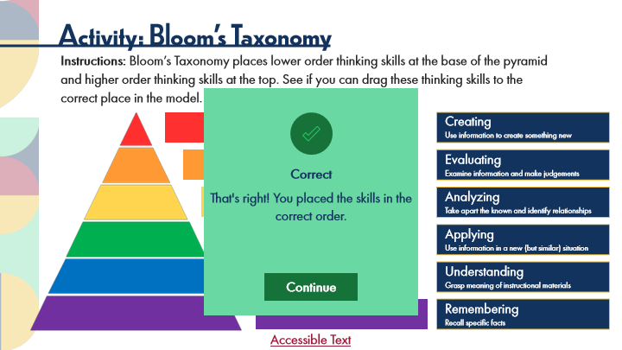

Type | Translation
Text Box | Correct
Text Box | That's right! You placed the skills in the correct order.

Slide Layer: Incorrect
Layer ID 🔒 | 5b0b4f17-3d88-4fe7-b774-6c2cfcc952c1
Preview Image | 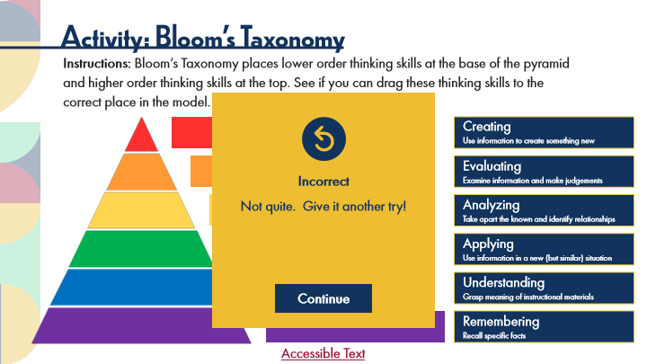

Type | Translation
Text Box | Incorrect
Text Box | Not quite. Give it another try!

Slide Layer: Try Again
Layer ID 🔒 | 3dac3a4f-922d-412f-87d6-5214eda45c9b
Preview Image | 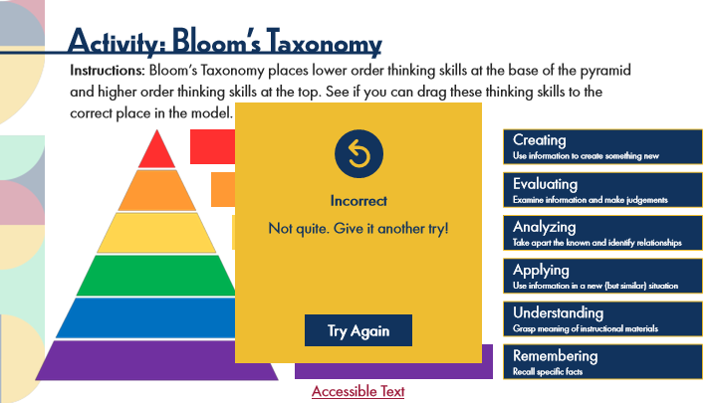

Type | Translation
Text Box | Incorrect
Text Box | Not quite. Give it another try!

12.8 Activity: The ICE Model
Slide ID 🔒 | 0a2f5e5b-6e99-4cc2-8a82-95be67f1059c
Preview Image | 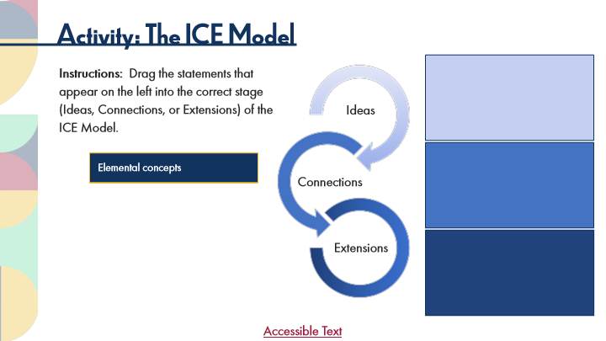

Type | Translation
Slide name | Activity: The ICE Model
Main Title 1 | Activity: The ICE Model
Text Box 1 | Instructions: Drag the statements that appear on the left into the correct stage (Ideas, Connections, or Extensions) of the ICE Model.
Text Box 2 | Ideas
Drag 9 | Fundamentals/basic facts
Drag 8 | Discrete skills
Drag 7 | Postulate or anticipate outcomes
Drag 6 | Relate new learning to what is already known
Drag 5 | Extrapolate to novel situations
Drag 4 | Understand implications
 | of learning
Drag 3 | Ability to articulate relationships
Drag 2 | Combine two or more
 | discrete skills
Drag 1 | Elemental concepts
Text Box 3 | Connections
Text Box 4 | Extensions
Text Box 5 | Accessible Text
Alt text for Text Box 5 | Accessible Activity Text Link. If you are not using a mouse for this course, skip this activity and access the PDF.

Slide Layer: Correct
Layer ID 🔒 | e6a67dac-5fe1-4b05-8b56-f555b9a0586c
Preview Image | 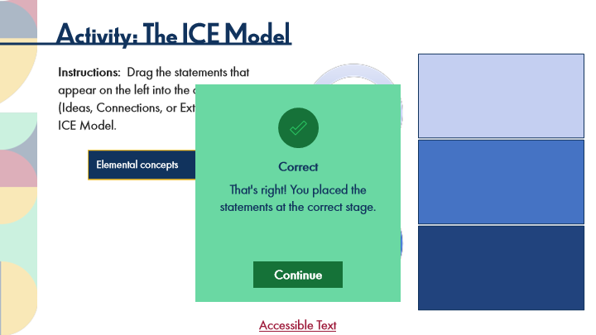

Type | Translation
Text Box | Correct
Text Box | That's right! You placed the
 | statements at the correct stage.

Slide Layer: Incorrect
Layer ID 🔒 | dc9f93ad-f3e8-4071-82f4-d5333659bced
Preview Image | 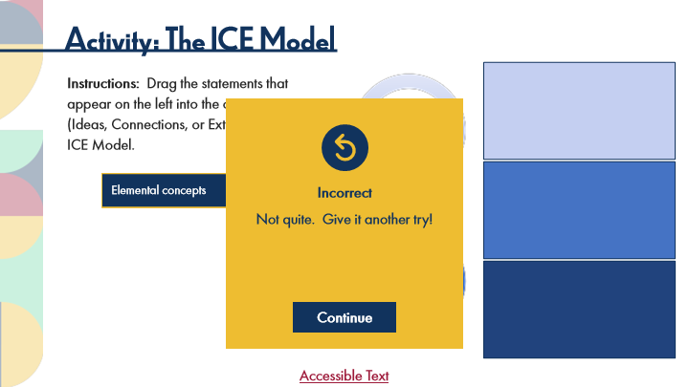

Type | Translation
Text Box | Incorrect
Text Box | Not quite. Give it another try!

Slide Layer: Try Again
Layer ID 🔒 | 2ebabace-163b-43d8-86f5-7e3c21f6f12c
Preview Image | 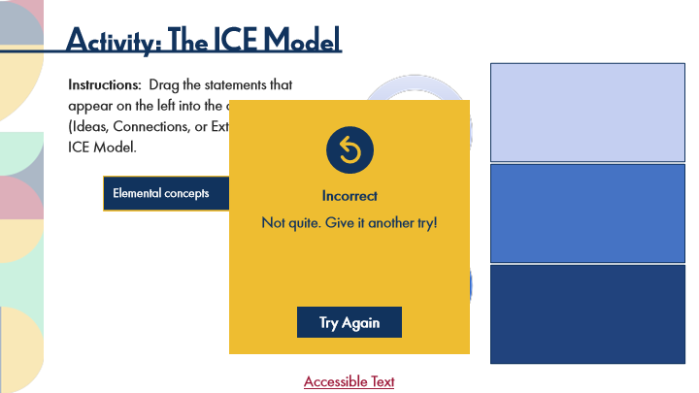

Type | Translation
Text Box | Incorrect
Text Box | Not quite. Give it another try!

12.9 Experienced Practitioners on Cognitive Frameworks
Slide ID 🔒 | cdd539c5-a374-45ba-9544-fab4cdc0ce95
Preview Image | 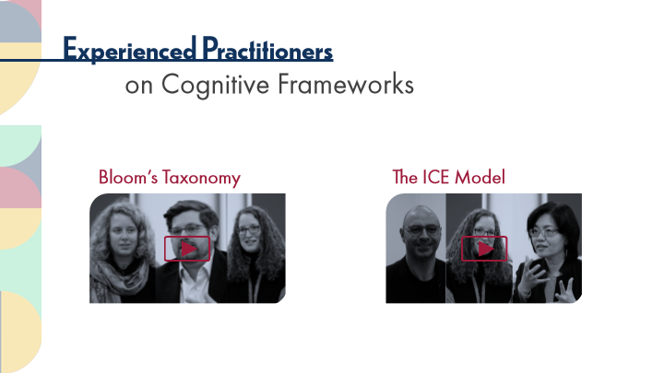

Type | Translation
Slide name | Experienced Practitioners on Cognitive Frameworks
Main Title 1 | Experienced Practitioners
Main Title 2 | on Cognitive Frameworks
Text Box 1 | Bloom’s Taxonomy
Text Box 2 | The ICE Model

12.10 Pause and Reflect on Cognitive Frameworks
Slide ID 🔒 | 92025ec3-8596-46e2-bea4-eef85ced3cdb
Preview Image | 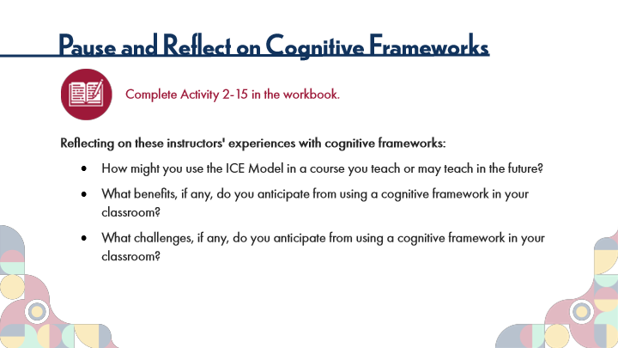

Type | Translation
Slide name | Pause and Reflect on Cognitive Frameworks
Main Title 1 | Pause and Reflect on Cognitive Frameworks
Text Box 6 | Complete Activity 2-15 in the workbook.
Text Box 7 | Reflecting on these instructors' experiences with cognitive frameworks:
 | How might you use the ICE Model in a course you teach or may teach in the future?
 | What benefits, if any, do you anticipate from using a cognitive framework in your classroom?
 | What challenges, if any, do you anticipate from using a cognitive framework in your classroom?

12.11 Topic 3C: Examples of Authentic Assessment
Slide ID 🔒 | 54a03722-8894-4ef3-877d-1a0cdf442172
Preview Image | 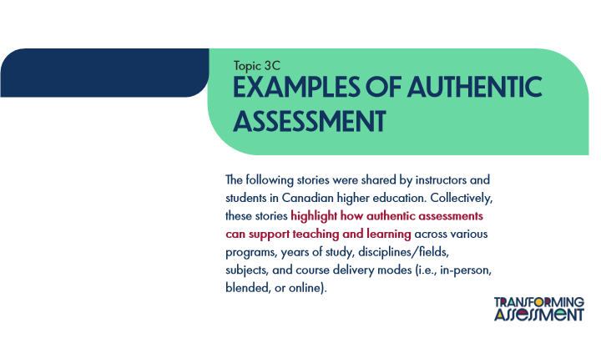

Type | Translation
Slide name | Topic 3C: Examples of Authentic Assessment
Text Box 1 | Topic 3C
Main Title | Examples of Authentic Assessment
Main Body | The following stories were shared by instructors and students in Canadian higher education. Collectively, these stories
 | highlight how authentic assessments can support teaching and learning
 | across various programs, years of study, disciplines/fields, subjects, and course delivery modes (i.e., in-person, blended, or online).

12.12 POV: Student Perspectives
Slide ID 🔒 | 6931ded2-1552-459b-8112-5770f1adb0b4
Preview Image | 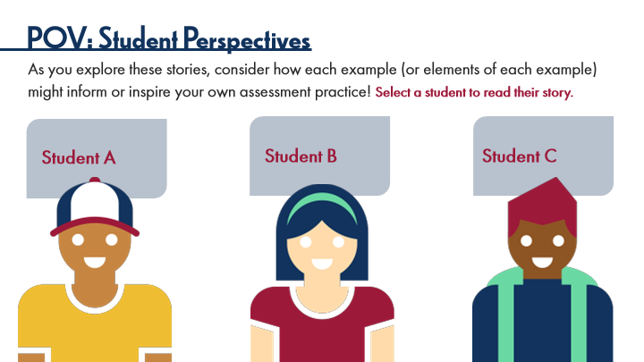

Type | Translation
Slide name | POV: Student Perspectives
Main Title 1 | POV: Student Perspectives
Text Box 3 | As you explore these stories, consider how each example (or elements of each example) might inform or inspire your own assessment practice!
 | Select a student to read their story.
Text Box 5 | Student B
Text Box 6 | Student C
Text Box 4 | Student A

Slide Layer: Student A
Layer ID 🔒 | a778a484-717e-4365-88be-0f6e503d737d
Preview Image | 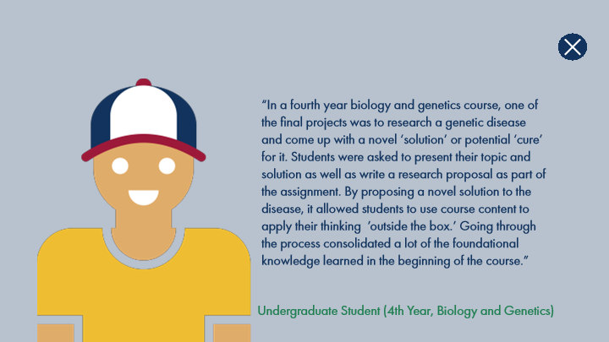

Type | Translation
Text Box 1 | “In a fourth year biology and genetics course, one of the final projects was to research a genetic disease and come up with a novel ‘solution’ or potential ‘cure’ for it. Students were asked to present their topic and solution as well as write a research proposal as part of the assignment. By proposing a novel solution to the disease, it allowed students to use course content to apply their thinking ’outside the box.’ Going through the process consolidated a lot of the foundational knowledge learned in the beginning of the course.”
Text Box 2 | Undergraduate Student (4th Year, Biology and Genetics)

Slide Layer: Student B
Layer ID 🔒 | d7ad2bc2-b82c-4e3c-ad7b-c2963af99153
Preview Image | 

Type | Translation
Text Box 3 | “In a first year PhD program evaluation course, one of the assignments involved the participation in a national case study competition with a group of classroom peers. The assessment had several tiers, including preparing for the competition, participating in the competition, completing a reflective summary of learning in relation to the Canadian Evaluation Society competencies, and engaging in a group reflection process. During the competition, groups engaged in a real-world evaluation task by receiving a case and working together to develop a Request for Proposal. The competition, while intense, was a means to learn the practical skills of collaboration with people who you may or may not know, to determine roles, to outline a work plan prior to the competition, and to respond on the day of competition to the enormous task of completing a huge document.
Button - Normal state | More

Slide Layer: Student B2
Layer ID 🔒 | 78f2e061-c6e2-46e5-8045-b5305c242d21
Preview Image | 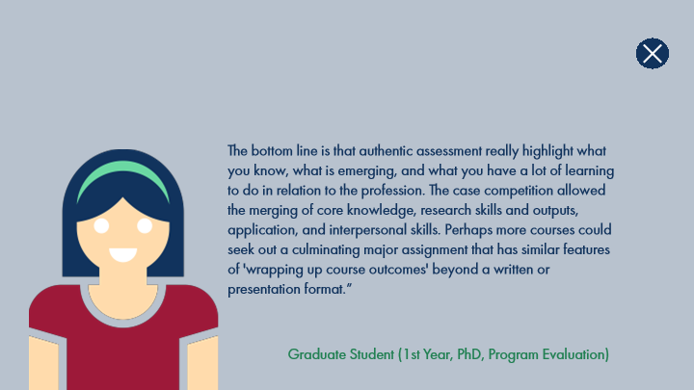

Type | Translation
Text Box 1 | The bottom line is that authentic assessment really highlight what you know, what is emerging, and what you have a lot of learning to do in relation to the profession. The case competition allowed the merging of core knowledge, research skills and outputs, application, and interpersonal skills. Perhaps more courses could seek out a culminating major assignment that has similar features of 'wrapping up course outcomes' beyond a written or presentation format.”
Text Box 2 | Graduate Student (1st Year, PhD, Program Evaluation)

Slide Layer: Student C
Layer ID 🔒 | 7f5ad219-e795-45fe-be1d-a6ecd976637d
Preview Image | 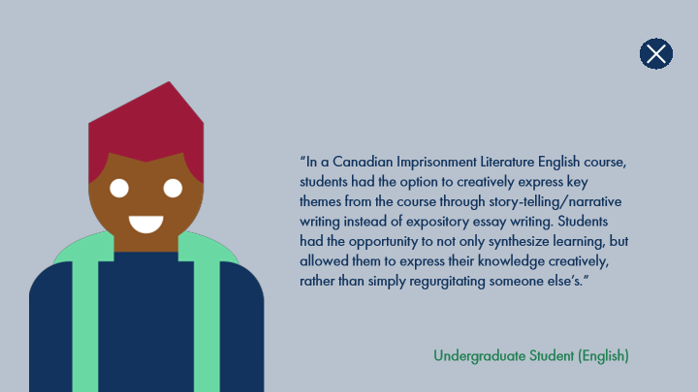

Type | Translation
Text Box 1 | “In a Canadian Imprisonment Literature English course, students had the option to creatively express key themes from the course through story-telling/narrative writing instead of expository essay writing. Students had the opportunity to not only synthesize learning, but allowed them to express their knowledge creatively, rather than simply regurgitating someone else’s.”
Text Box 2 | Undergraduate Student (English)

12.13 Experienced Practitioners on Authentic Assessment
Slide ID 🔒 | c32f97a7-148a-477e-a743-d65089581308
Preview Image | 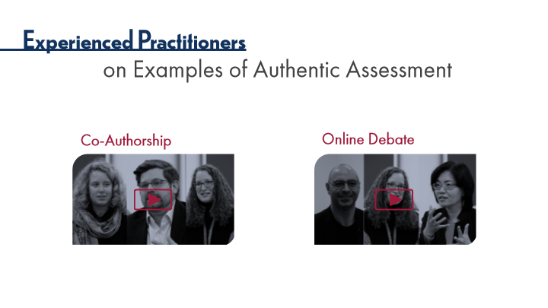

Type | Translation
Slide name | Experienced Practitioners on Authentic Assessment
Main Title 1 | Experienced Practitioners
Main Title 2 | on Examples of Authentic Assessment
Text Box 2 | Online Debate
Text Box 1 | Co-Authorship

12.14 Thinking Forward on Authentic Assessment
Slide ID 🔒 | b6f7b1a0-4f16-40cd-85d8-67d0e24dd716
Preview Image | 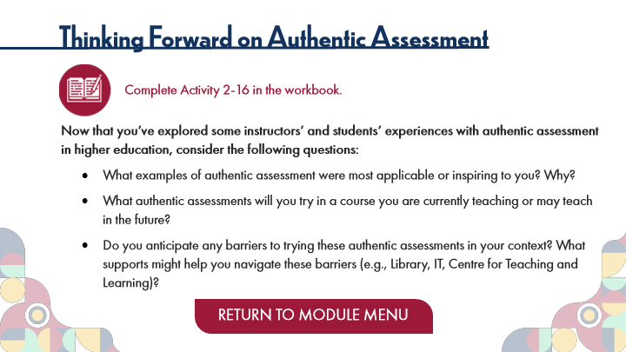

Type | Translation
Slide name | Thinking Forward on Authentic Assessment
Main Title 1 | Thinking Forward on Authentic Assessment
Text Box 6 | Complete Activity 2-16 in the workbook.
Text Box 7 | Now that you’ve explored some instructors’ and students’ experiences with authentic assessment in higher education, consider the following questions:
 | What examples of authentic assessment were most applicable or inspiring to you? Why?
 | What authentic assessments will you try in a course you are currently teaching or may teach in the future?
 | Do you anticipate any barriers to trying these authentic assessments in your context? What supports might help you navigate these barriers (e.g., Library, IT, Centre for Teaching and Learning)?
Button - Normal state | RETURN TO MODULE MENU

13 Topic 4: Try it!
Scene ID 🔒 | 1f696de6-ec4b-49ef-a19d-f2286cd32e57

Type | Translation
Scene name | Topic 4: Try it!

13.1 Try it! Title Page
Slide ID 🔒 | f71e793b-bee7-418b-ad73-37cd8ae292b7
Preview Image | 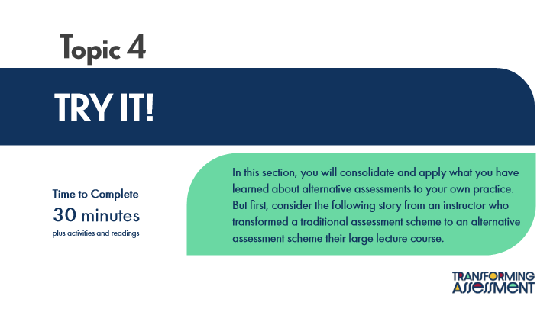

Type | Translation
Slide name | Try it! Title Page
Main Title 1 | Topic 4
Main Title | TRY IT!
Text Box 1 | In this section, you will consolidate and apply what you have learned about alternative assessments to your own practice. But first, consider the following story from an instructor who transformed a traditional assessment scheme to an alternative assessment scheme their large lecture course.
Text Box 2 | Time to Complete
 | 30 minutes
 | plus activities and readings

13.2 POV: Instructor Perspectives
Slide ID 🔒 | b311ae0d-e525-4bc1-9e0b-665f17e5f61e
Preview Image | 

Type | Translation
Slide name | POV: Instructor Perspectives
Main Title 1 | POV: Instructor Perspectives

Slide Layer: Text 4
Layer ID 🔒 | 893d589f-be05-4823-b8f8-a929481dfcb5
Preview Image | 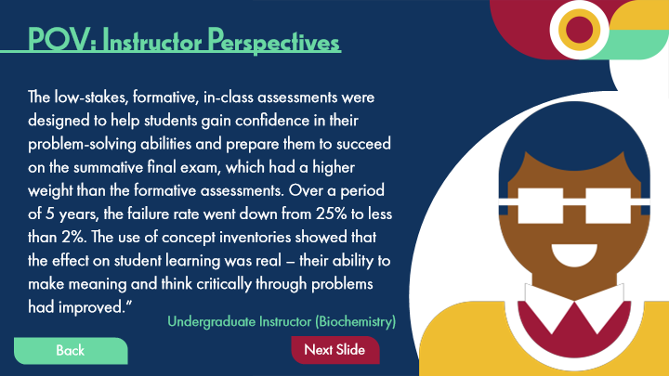

Type | Translation
Text Box 1 | The low-stakes, formative, in-class assessments were designed to help students gain confidence in their problem-solving abilities and prepare them to succeed on the summative final exam, which had a higher weight than the formative assessments. Over a period of 5 years, the failure rate went down from 25% to less than 2%. The use of concept inventories showed that the effect on student learning was real – their ability to make meaning and think critically through problems had improved.”
Text Box 2 | Undergraduate Instructor (Biochemistry)
Button - Normal state | Next Slide
Button - Normal state | Back
Button - Down state | Back

Slide Layer: Text 3
Layer ID 🔒 | 44a4468a-6365-44ea-b72d-45fe3388ea9e
Preview Image | 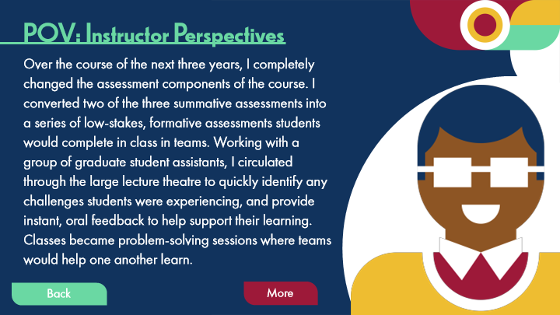

Type | Translation
Text Box 1 | Over the course of the next three years, I completely changed the assessment components of the course. I converted two of the three summative assessments into a series of low-stakes, formative assessments students would complete in class in teams. Working with a group of graduate student assistants, I circulated through the large lecture theatre to quickly identify any challenges students were experiencing, and provide instant, oral feedback to help support their learning. Classes became problem-solving sessions where teams would help one another learn.
Button - Normal state | More
Button - Normal state | Back
Button - Down state | Back

Slide Layer: Text 2
Layer ID 🔒 | 17b60c79-aec7-4ec8-ba7f-8734c3df2f0b
Preview Image | 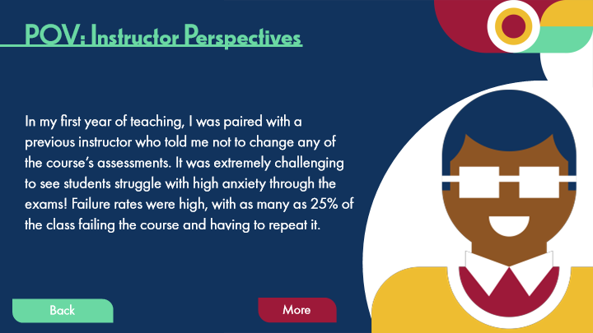

Type | Translation
Text Box 1 | In my first year of teaching, I was paired with a previous instructor who told me not to change any of the course’s assessments. It was extremely challenging to see students struggle with high anxiety through the exams! Failure rates were high, with as many as 25% of the class failing the course and having to repeat it.
Button - Normal state | More
Button - Normal state | Back
Button - Down state | Back

Slide Layer: Text 1
Layer ID 🔒 | 99b39316-ea13-4a06-be9b-915d62615130
Preview Image | 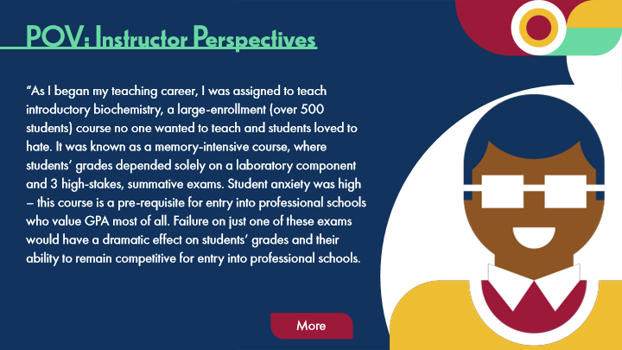

Type | Translation
Text Box 1 | “As I began my teaching career, I was assigned to teach introductory biochemistry, a large-enrollment (over 500 students) course no one wanted to teach and students loved to hate. It was known as a memory-intensive course, where students’ grades depended solely on a laboratory component and 3 high-stakes, summative exams. Student anxiety was high – this course is a pre-requisite for entry into professional schools who value GPA most of all. Failure on just one of these exams would have a dramatic effect on students’ grades and their ability to remain competitive for entry into professional schools.
Button - Normal state | More

13.3 Try it out!
Slide ID 🔒 | ef527377-8140-4382-912b-2e437230d29f
Preview Image | 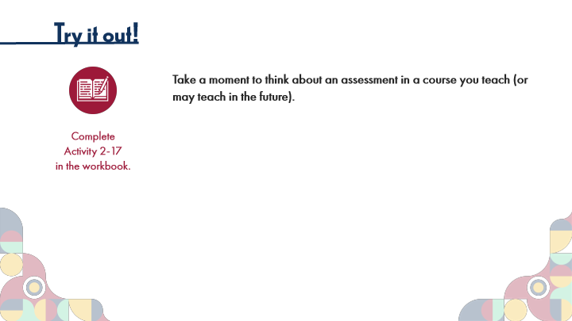

Type | Translation
Slide name | Try it out!
Main Title 1 | Try it out!
Instruction | Take a moment to think about an assessment in a course you teach (or may teach in the future).
Text Box 8 | Complete
 | Activity 2-17
 | in the workbook.

Slide Layer: Text 3
Layer ID 🔒 | 638127cc-a84d-44a8-82d2-6b2ee9a2a430
Preview Image | 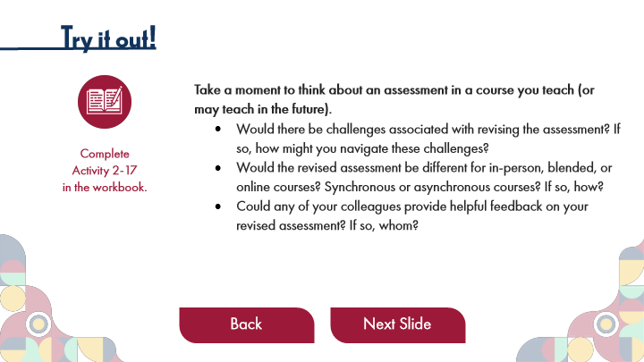

Type | Translation
text 3 1 | Would there be challenges associated with revising the assessment? If so, how might you navigate these challenges?
 | Would the revised assessment be different for in-person, blended, or online courses? Synchronous or asynchronous courses? If so, how?
 | Could any of your colleagues provide helpful feedback on your revised assessment? If so, whom?
Button 1 - Normal state | Back
Button - Normal state | Next Slide

Slide Layer: Text 2
Layer ID 🔒 | 67369b99-ec33-4732-b120-5905b64f3b91
Preview Image | 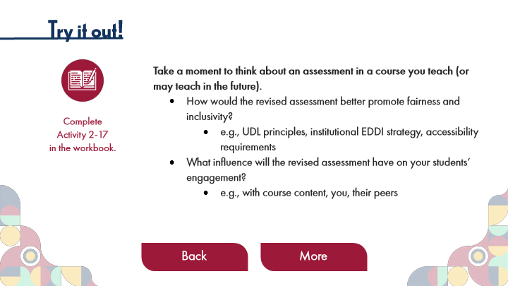

Type | Translation
text 2 1 | How would the revised assessment better promote fairness and inclusivity?
 | e.g., UDL principles, institutional EDDI strategy, accessibility requirements
 | What influence will the revised assessment have on your students’ engagement?
 | e.g., with course content, you, their peers
Button 2 - Normal state | Back
Button 1 - Normal state | More

Slide Layer: Text 1
Layer ID 🔒 | 21ebe7f4-67ed-4332-93e2-ed3ddb0bf022
Preview Image | 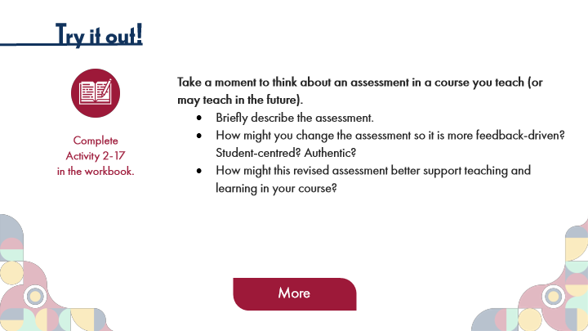

Type | Translation
text 1 1 | Briefly describe the assessment.
 | How might you change the assessment so it is more feedback-driven? Student-centred? Authentic?
 | How might this revised assessment better support teaching and learning in your course?
Button - Normal state | More

13.4 Thinking Forward on “Good” Assessment
Slide ID 🔒 | 2e81c165-52ac-4479-91c1-3b2b61e3cc71
Preview Image | 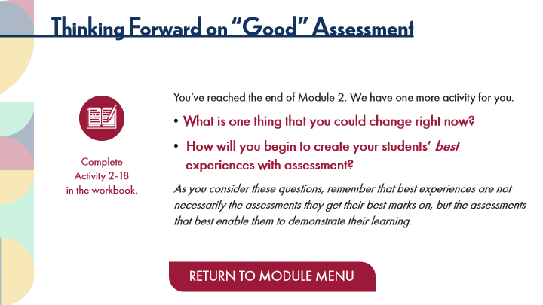

Type | Translation
Slide name | Thinking Forward on “Good” Assessment
Main Title 1 | Thinking Forward on “Good” Assessment
Text Box 1 | You’ve reached the end of Module 2. We have one more activity for you.
 | What is one thing that you could change right now?
 | How will you begin to create your students’ best experiences with assessment?
 | As you consider these questions, remember that best experiences are
 | not necessarily the assessments they get their best marks on, but the assessments that best enable them to demonstrate their learning.
Text Box 4 | Complete
 | Activity 2-18
 | in the workbook.
Button - Normal state | RETURN TO MODULE MENU

14 Module 3: Creating Alternative Assessments
Scene ID 🔒 | d163ab56-0c72-4a55-9d09-01076144a39b

Type | Translation
Scene name | Module 3: Creating Alternative Assessments

14.1 Module 3: Creating Alternative Assessments
Slide ID 🔒 | 11d210db-dced-4a6f-9a54-5327e4f0319b
Preview Image | 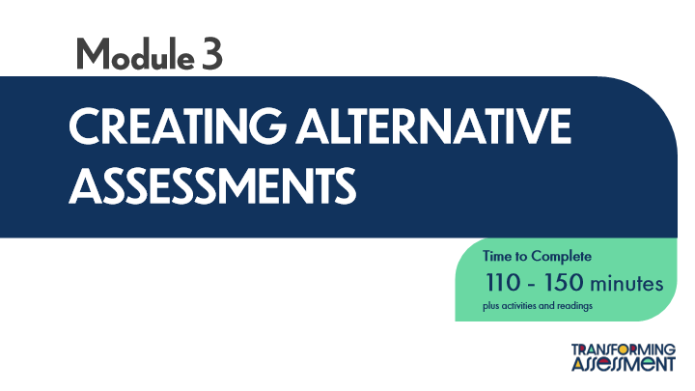

Type | Translation
Slide name | Module 3: Creating Alternative Assessments
Main Title 1 | Module 3
Main Title | CREATING ALTERNATIVE ASSESSMENTS
Round Diagonal Corner 2 | Time to Complete
 | 110 - 150 minutes
 | plus activities and readings

14.2 Learning Outcomes
Slide ID 🔒 | 9be17cf4-7963-40f5-906c-80a7f205e892
Preview Image | 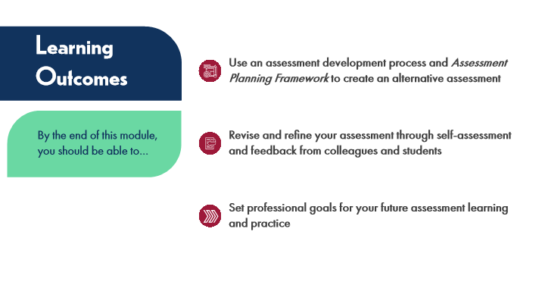

Type | Translation
Slide name | Learning Outcomes
Text Box 5 | Learning Outcomes
Text Box 1 | Use an assessment development process and Assessment Planning Framework to create an alternative assessment
Text Box 2 | Revise and refine your assessment through self-assessment and feedback from colleagues and students
Text Box 6 | By the end of this module, you should be able to…
Text Box 3 | Set professional goals for your future assessment learning and practice

14.3 Module 3: Introduction
Slide ID 🔒 | c6bd9ad1-6118-4f45-9cfe-f77894224ed6
Preview Image | 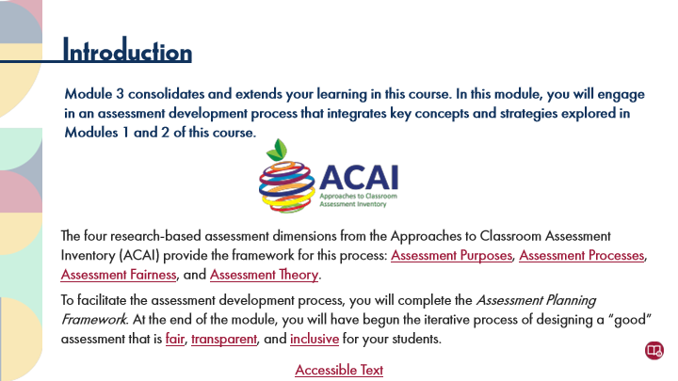

Type | Translation
Slide name | Module 3: Introduction
Main Title 1 | Introduction
Text Box 3 | Module 3 consolidates and extends your learning in this course. In this module, you will engage in an assessment development process that integrates key concepts and strategies explored in Modules 1 and 2 of this course.
Text Box 4 | The four research-based assessment dimensions from the Approaches to Classroom Assessment Inventory (ACAI) provide the framework for this process:
 | Assessment Purposes
 | ,
 | Assessment Processes
 | ,
 | Assessment Fairness
 | , and
 | Assessment Theory
 | .
 | To facilitate the assessment development process, you will complete the Assessment Planning Framework. At the end of the module, you will have begun the iterative process of designing a “good” assessment that is
 | fair
 | ,
 | transparent
 | , and
 | inclusive
 | for your students.
Text Box 5 | Accessible Text
Alt text for Text Box 5 | Accessible Activity Text Link. If you are not using a mouse for this course, and access the PDF for the rollover text on this page.

Slide Layer: Rollover: Inclusive
Layer ID 🔒 | d4e81969-4090-4c20-874a-f7f3c601fd30
Preview Image | 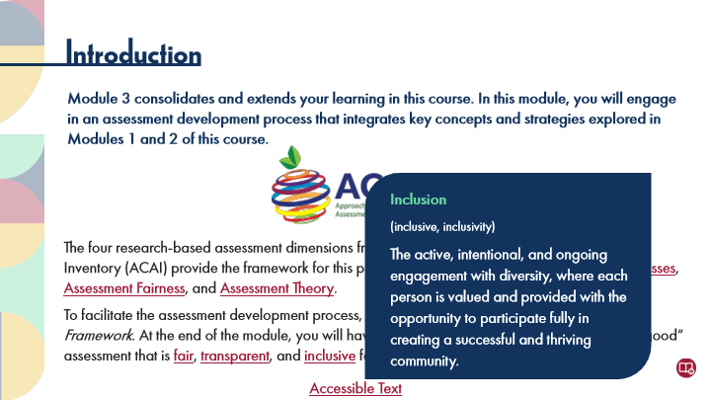

Type | Translation
Text Box 1 | Inclusion
 | (inclusive, inclusivity)
 | The active, intentional, and ongoing engagement with diversity, where each person is valued and provided with the opportunity to participate fully in creating a successful and thriving community.

Slide Layer: Rollover: Transparent Assessment
Layer ID 🔒 | 1d135ca0-8714-427f-afbd-9bb94db74f2c
Preview Image | 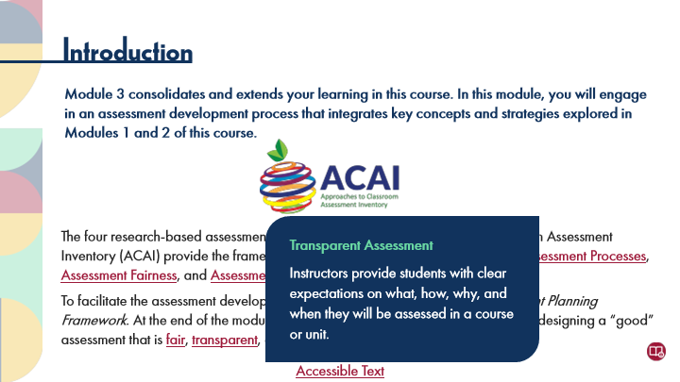

Type | Translation
Text Box 1 | Transparent Assessment
 | Instructors provide students with clear expectations on what, how, why, and when they will be assessed in a course or unit.

Slide Layer: Rollover: Principles of Fair Assessment
Layer ID 🔒 | cb34ad0e-cf36-4443-8eeb-f6f6944ecb67
Preview Image | 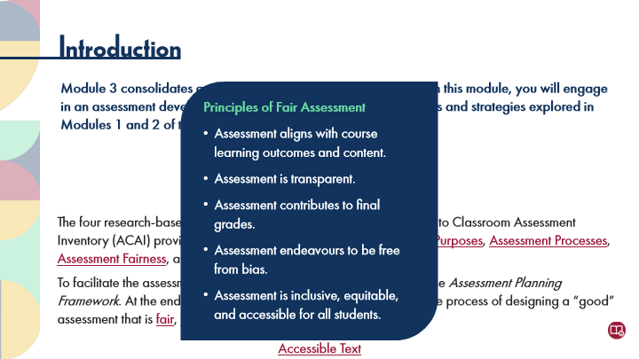

Type | Translation
Text Box 1 | Principles of Fair Assessment
 | Assessment aligns with course learning outcomes and content.
 | Assessment is transparent.
 | Assessment contributes to final grades.
 | Assessment endeavours to be free from bias.
 | Assessment is inclusive, equitable, and accessible for all students.

Slide Layer: Rollover: Assessment Theory
Layer ID 🔒 | 4b4ea2ce-765a-4eae-b388-8cfe0fee77bd
Preview Image | 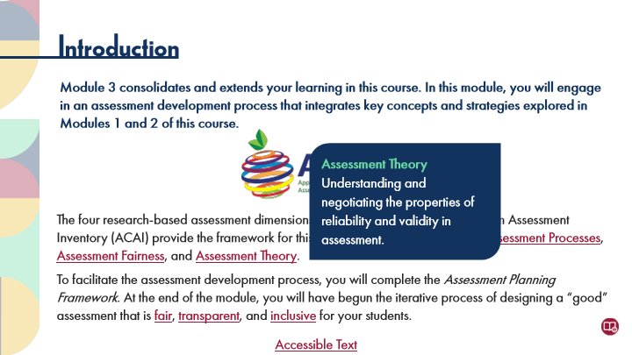

Type | Translation
Text Box 1 | Assessment Theory
 | Understanding and negotiating the properties of reliability and validity in assessment.

Slide Layer: Rollover: Assessment Fairness
Layer ID 🔒 | c63ed35d-0a27-47a7-b541-8296c8fa8835
Preview Image | 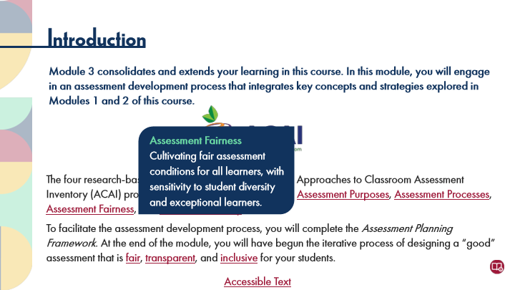

Type | Translation
Text Box 1 | Assessment Fairness
 | Cultivating fair assessment conditions for all learners, with sensitivity to student diversity and exceptional learners.

Slide Layer: Rollover: Assessment Processes
Layer ID 🔒 | 05580f8d-963c-434a-be3e-c1c7e02598b6
Preview Image | 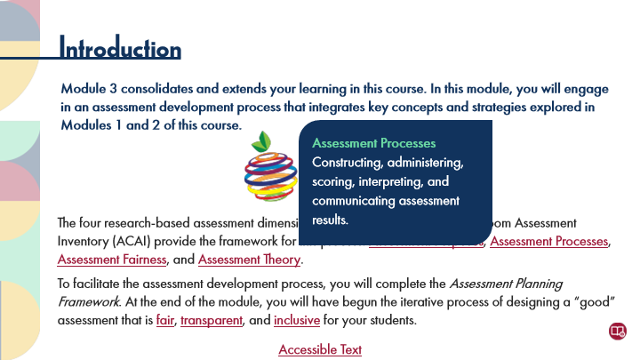

Type | Translation
Text Box 1 | Assessment Processes
 | Constructing, administering, scoring, interpreting, and communicating assessment results.

Slide Layer: Rollover: Assessment Purposes
Layer ID 🔒 | fb015e48-b2c9-4f25-a23b-0459ece0c027
Preview Image | 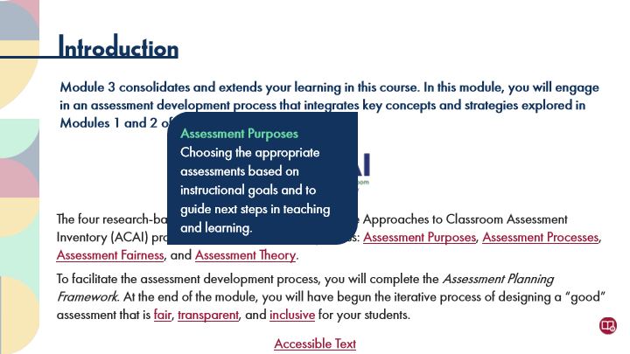

Type | Translation
Text Box 1 | Assessment Purposes
 | Choosing the appropriate assessments based on instructional goals and to guide next steps in teaching and learning.

14.4 Key Points: Creating Alternative Assessments
Slide ID 🔒 | 5307b2e1-43b0-4aee-a1a9-4a4139d966bb
Preview Image | 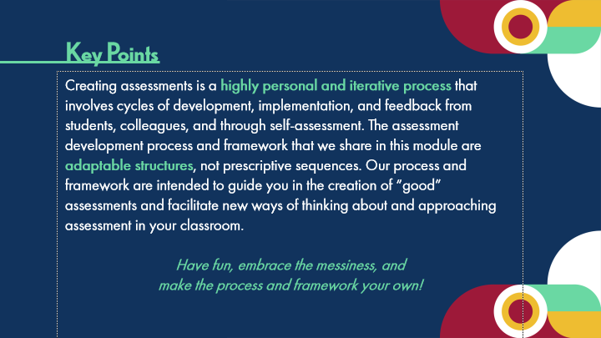

Type | Translation
Slide name | Key Points: Creating Alternative Assessments
Text Box 1 | Key Points
Body | Creating assessments is a
 | highly personal and iterative process
 | that involves cycles of development, implementation, and feedback from students, colleagues, and through self-assessment. The assessment development process and framework that we share in this module are
 | adaptable structures
 | , not prescriptive sequences. Our process and framework are intended to guide you in the creation of “good” assessments and facilitate new ways of thinking about and approaching assessment in your classroom.
 | Have fun, embrace the messiness, and
 | make the process and framework your own!

14.5 Activation
Slide ID 🔒 | 8149c4b1-be04-441c-96c2-a3abf5f081c8
Preview Image | 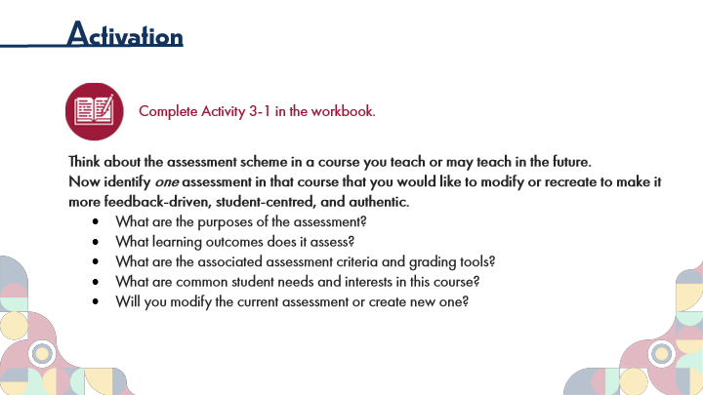

Type | Translation
Slide name | Activation
Main Title 1 | Activation
Text Box 6 | Complete Activity 3-1 in the workbook.
Text Box 7 | Think about the assessment scheme in a course you teach or may teach in the future.
 | Now identify one assessment in that course that you would like to modify or recreate to make it more feedback-driven, student-centred, and authentic.
 | What are the purposes of the assessment?
 | What learning outcomes does it assess?
 | What are the associated assessment criteria and grading tools?
 | What are common student needs and interests in this course?
 | Will you modify the current assessment or create new one?

14.6 Module 3: Topic Menu
Slide ID 🔒 | 8cbb627d-c292-49f0-b030-612df5160896
Preview Image | 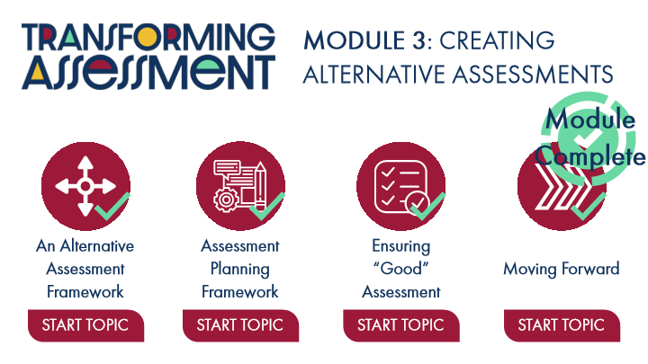

Type | Translation
Slide name | Module 3: Topic Menu
Text Box 2 | MODULE 3: CREATING ALTERNATIVE ASSESSMENTS
Alt text for Picture 1 | Logo: Transforming Assessment
Notification Icon: Module Complete | Module
 | Complete
Title 01 | An Alternative
 | Assessment Framework
Title 01 4 | Assessment Planning Framework
Title 01 6 | Ensuring “Good” Assessment
Title 01 8 | Moving Forward
Button: An Alternative Assessment Framework - Normal state | START TOPIC
Button: Assessment Planning Framework - Normal state | START TOPIC
Button: Ensuring Good Assessment - Normal state | START TOPIC
Button: Moving Forward - Normal state | START TOPIC

Slide Layer: Instructions
Layer ID 🔒 | 91ee4d42-6add-46ce-83fa-707dbe9583e7
Preview Image | 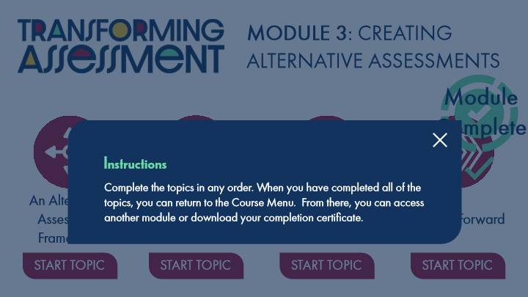

Type | Translation
Text Box 1 | Instructions
Text Box 2 | Complete the topics in any order. When you have completed all of the topics, you can return to the Course Menu. From there, you can access another module or download your completion certificate.

Slide Layer: Completion
Layer ID 🔒 | 55d27078-0a7f-4b66-8528-b971d882d756
Preview Image | 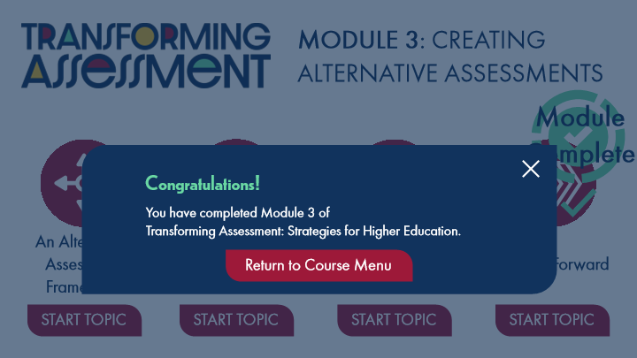

Type | Translation
Text Box 1 | Congratulations!
Text Box 2 | You have completed Module 3 of
 | Transforming Assessment: Strategies for Higher Education.
Button - Normal state | Return to Course Menu

15 Topic 1: An Alternative Assessment Framework
Scene ID 🔒 | 73f2eeae-1d5c-42cb-a91f-b0edb41fdf86

Type | Translation
Scene name | Topic 1: An Alternative Assessment Framework

15.1 An Alternative Assessment Framework Title Page
Slide ID 🔒 | ffd002e0-0150-4e23-b103-a876d4eb40d4
Preview Image | 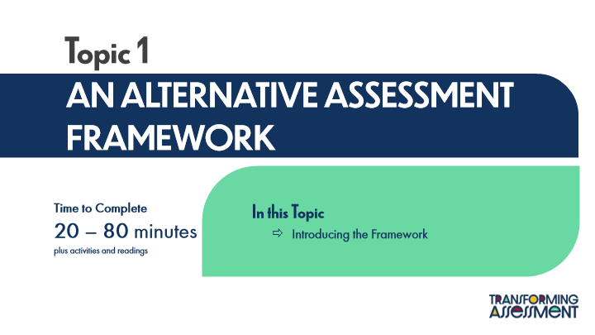

Type | Translation
Slide name | An Alternative Assessment Framework Title Page
Main Title 1 | Topic 1
Main Title | AN ALTERNATIVE ASSESSMENT FRAMEWORK
Text Box 2 | Time to Complete
 | 20 – 80 minutes
 | plus activities and readings
Text Box 1 | In this Topic
 | Introducing the Framework

15.2 Notes on the Framework
Slide ID 🔒 | 86d92081-ea4e-4d26-8959-0389c32a653e
Preview Image | 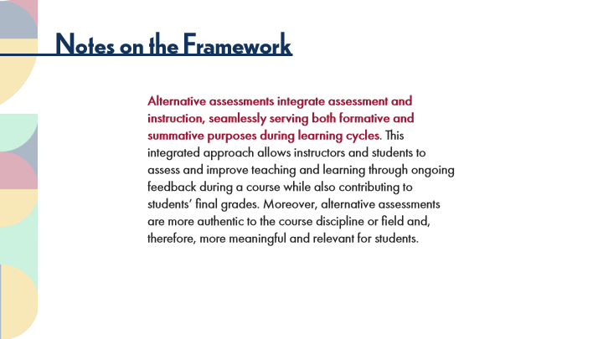

Type | Translation
Slide name | Notes on the Framework
Main Title 1 | Notes on the Framework
Text Box 3 | Alternative assessments integrate assessment and instruction, seamlessly serving both formative and summative purposes during learning cycles
 | . This integrated approach allows instructors and students to assess and improve teaching and learning through ongoing feedback during a course while also contributing to students’ final grades. Moreover, alternative assessments are more authentic to the course discipline or field and, therefore, more meaningful and relevant for students.

15.3 Activity: Assessment Framework Instructions
Slide ID 🔒 | 5bfc1a8a-d5b0-4c46-999d-eb79700faf5e
Preview Image | 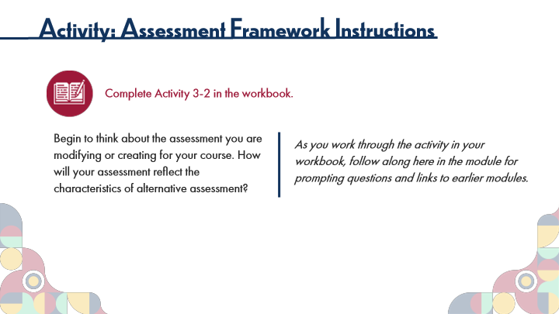

Type | Translation
Slide name | Activity: Assessment Framework Instructions
Main Title 1 | Activity: Assessment Framework Instructions
Text Box 1 | Complete Activity 3-2 in the workbook.
Text Box 4 | Begin to think about the assessment you are modifying or creating for your course. How will your assessment reflect the characteristics of alternative assessment?
Text Box 3 | As you work through the activity in your workbook, follow along here in the module for prompting questions and links to earlier modules.

15.4 Activity: Assessment Framework, Part 1
Slide ID 🔒 | 495cb09c-9870-4c09-9781-ebf153ee6c19
Preview Image | 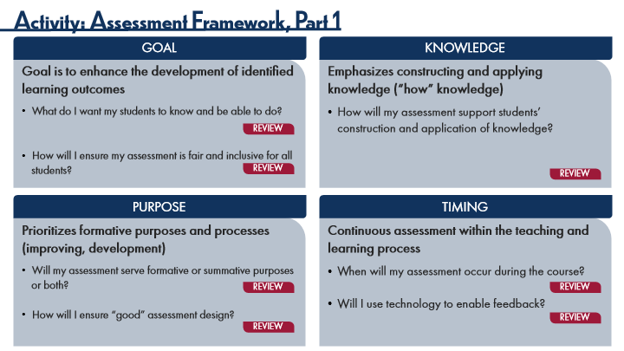

Type | Translation
Slide name | Activity: Assessment Framework, Part 1
Main Title 1 | Activity: Assessment Framework, Part 1
Round Diagonal Corner 2 | GOAL
Round Diagonal Corner 5 | KNOWLEDGE
Round Single Corner Rectangle 8 | Goal is to enhance the development of identified learning outcomes
 | What do I want my students to know and be able to do?
 | How will I ensure my assessment is fair and inclusive for all students?
Round Single Corner Rectangle 9 | Emphasizes constructing and applying knowledge (“how” knowledge)
 | How will my assessment support students’ construction and application of knowledge?
Button: Review 1 - Normal state | REVIEW
Button: Review 2 - Normal state | REVIEW
Button: Review 3 - Normal state | REVIEW
Round Diagonal Corner 7 | PURPOSE
Round Diagonal Corner 9 | TIMING
Round Single Corner Rectangle 10 | Prioritizes formative purposes and processes (improving, development)
 | Will my assessment serve formative or summative purposes or both?
 | How will I ensure “good” assessment design?
Round Single Corner Rectangle 11 | Continuous assessment within the teaching and learning process
 | When will my assessment occur during the course?
 | Will I use technology to enable feedback?
Button Review 4 - Normal state | REVIEW
Button: Review 6 1 - Normal state | REVIEW
Button: Review 6 - Normal state | REVIEW
Button: Review 5 - Normal state | REVIEW

15.5 Activity: Assessment Framework, Part 2
Slide ID 🔒 | 1155b29c-9943-449e-b483-c990514ccd58
Preview Image | 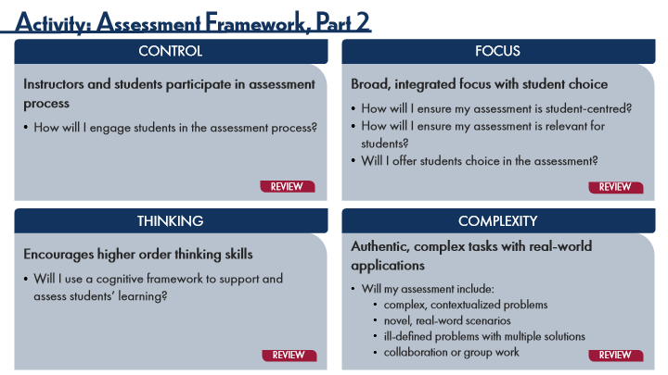

Type | Translation
Slide name | Activity: Assessment Framework, Part 2
Main Title 1 | Activity: Assessment Framework, Part 2
Round Diagonal Corner 2 | CONTROL
Round Diagonal Corner 5 | FOCUS
Round Single Corner Rectangle 8
 | Instructors and students participate in assessment process
 | How will I engage students in the assessment process?
Round Single Corner Rectangle 9
 | Broad, integrated focus with student choice
 | How will I ensure my assessment is student-centred?
 | How will I ensure my assessment is relevant for students?
 | Will I offer students choice in the assessment?
Button: Review 1 - Normal state | REVIEW
Button: Review 2 - Normal state | REVIEW
Round Diagonal Corner 7 | THINKING
Round Diagonal Corner 9 | COMPLEXITY
Round Single Corner Rectangle 10
 | Encourages higher order thinking skills
 | Will I use a cognitive framework to support and assess students’ learning?
Round Single Corner Rectangle 11 | Authentic, complex tasks with real-world applications
 | Will my assessment include:
 | complex, contextualized problems
 | novel, real-word scenarios
 | ill-defined problems with multiple solutions
 | collaboration or group work
Button: Review 3 - Normal state | REVIEW
Button: Review 3 1 - Normal state | REVIEW

15.6 Activity: Assessment Framework, Part 3
Slide ID 🔒 | 5851059a-5d45-4d7b-aad7-cb1198e7f914
Preview Image | 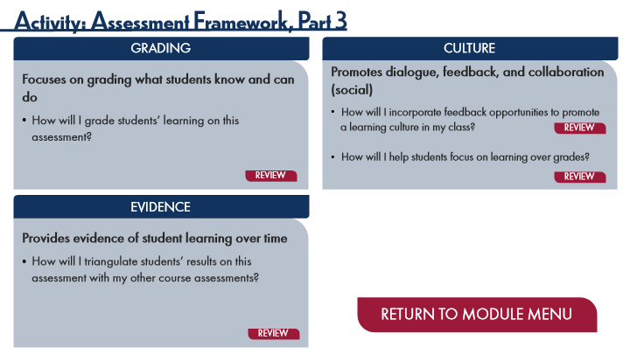

Type | Translation
Slide name | Activity: Assessment Framework, Part 3
Main Title 1 | Activity: Assessment Framework, Part 3
Round Diagonal Corner 2 | GRADING
Round Diagonal Corner 5 | CULTURE
Round Single Corner Rectangle 8
 | Focuses on grading what students know and can do
 | How will I grade students’ learning on this assessment?
Round Single Corner Rectangle 9 | Promotes dialogue, feedback, and collaboration (social)
 | How will I incorporate feedback opportunities to promote a learning culture in my class?
 | How will I help students focus on learning over grades?
Button: Review 2 - Normal state | REVIEW
Button: Review 1 - Normal state | REVIEW
Button: Review 3 - Normal state | REVIEW
Round Diagonal Corner 7 | EVIDENCE
Round Single Corner Rectangle 10
 | Provides evidence of student learning over time
 | How will I triangulate students’ results on this assessment with my other course assessments?
Button - Normal state | RETURN TO MODULE MENU
Button: Review 4 - Normal state | REVIEW

16 Topic 2: Assessment Planning Framework
Scene ID 🔒 | d50a5558-d94d-44fb-9edc-f9e1cac5103e

Type | Translation
Scene name | Topic 2: Assessment Planning Framework

16.1 Assessment Planning Framework Title Page
Slide ID 🔒 | 4f757f0f-2273-4a0b-bf0d-b5045bebb31b
Preview Image | 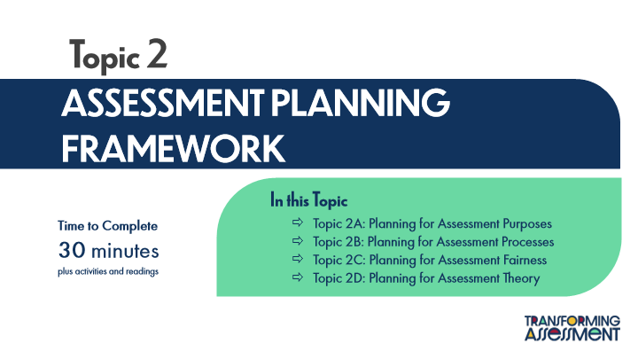

Type | Translation
Slide name | Assessment Planning Framework Title Page
Main Title 1 | Topic 2
Main Title | ASSESSMENT PLANNING FRAMEWORK
Text Box 1 | In this Topic
 | Topic 2A: Planning for Assessment Purposes
 | Topic 2B: Planning for Assessment Processes
 | Topic 2C: Planning for Assessment Fairness
 | Topic 2D: Planning for Assessment Theory
Text Box 2 | Time to Complete
 | 30 minutes
 | plus activities and readings

16.2 Assessment Planning Framework
Slide ID 🔒 | 0dec0645-9bfd-41e0-96de-021312f58ad0
Preview Image | 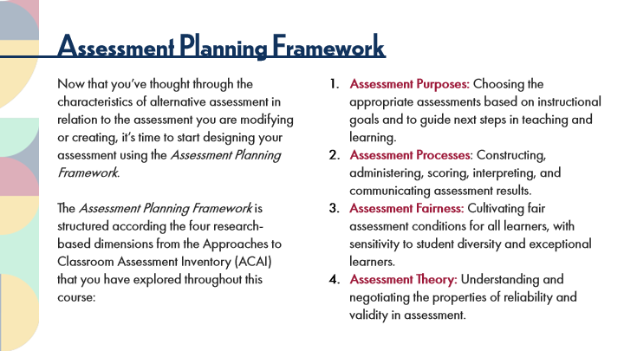

Type | Translation
Slide name | Assessment Planning Framework
Main Title 1 | Assessment Planning Framework
Text Box 3 | Now that you’ve thought through the characteristics of alternative assessment in relation to the assessment you are modifying or creating, it’s time to start designing your assessment using the Assessment Planning Framework.
 | The Assessment Planning Framework is structured according the four research-based dimensions from the Approaches to Classroom Assessment Inventory (ACAI) that you have explored throughout this course:
Text Box 4 | Assessment Purposes:
 | Choosing the appropriate assessments based on instructional goals and to guide next steps in teaching and learning.
 | Assessment Processes
 | : Constructing, administering, scoring, interpreting, and communicating assessment results.
 | Assessment Fairness:
 | Cultivating fair assessment conditions for all learners, with sensitivity to student diversity and exceptional learners.
 | Assessment Theory:
 | Understanding and negotiating the properties of reliability and validity in assessment.

16.3 Engaging with the Framework
Slide ID 🔒 | e61db3e2-56b4-45a3-b9a6-7d6984c934da
Preview Image | 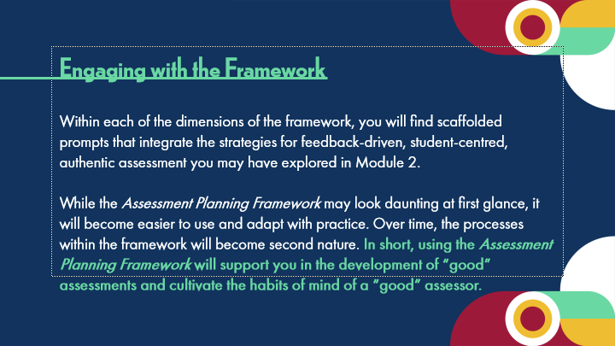

Type | Translation
Slide name | Engaging with the Framework
Body | Engaging with the Framework
 | Within each of the dimensions of the framework, you will find scaffolded prompts that integrate the strategies for feedback-driven, student-centred, authentic assessment you may have explored in Module 2.
 | While the Assessment Planning Framework may look daunting at first glance, it will become easier to use and adapt with practice. Over time, the processes within the framework will become second nature.
 | In short, using the Assessment Planning Framework will support you in the development of “good” assessments and cultivate the habits of mind of a “good” assessor.

16.4 Topic 2A: Planning for Assessment Purposes
Slide ID 🔒 | 4d0328d9-568d-4e37-995a-0e759ef70333
Preview Image | 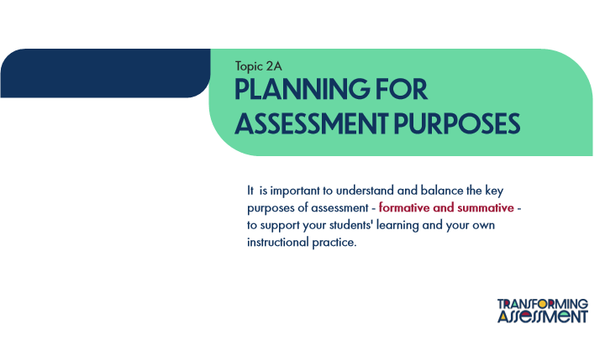

Type | Translation
Slide name | Topic 2A: Planning for Assessment Purposes
Text Box 1 | Topic 2A
Main Title | Planning for ASSESSMENT PURPOSES
Text Box 2 | It is important to understand and balance the key purposes of assessment -
 | formative and summative
 | - to support your students' learning and your own instructional practice.

16.5 Distinctions between Formative and Summative
Slide ID 🔒 | bc7d1052-c464-4592-9163-3d2a3d3b0934
Preview Image | 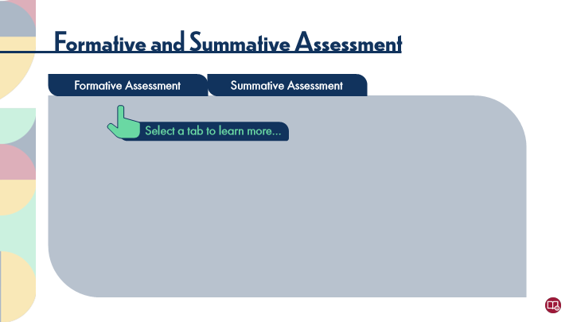

Type | Translation
Slide name | Distinctions between Formative and Summative
Main Title | Formative and Summative Assessment
tab button 1 - Normal state | Formative Assessment
tab button 2 - Normal state | Summative Assessment
Pointer Text | Select a tab to learn more…

Slide Layer: Summative
Layer ID 🔒 | 1f0bb911-44dd-4e85-b7bd-e36ef225bcc3
Preview Image | 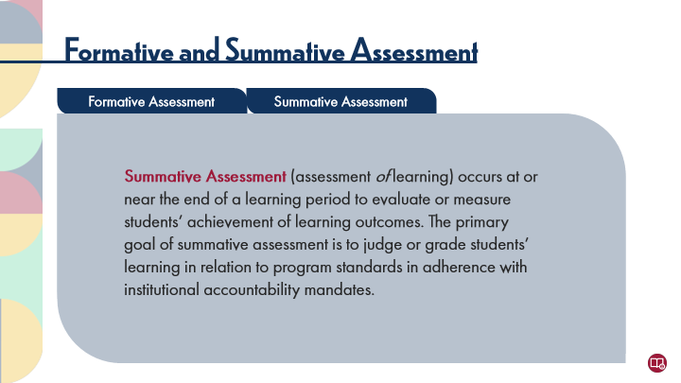

Type | Translation
Main Body 1 | Summative Assessment
 | (assessment of learning) occurs at or near the end of a learning period to evaluate or measure students’ achievement of learning outcomes. The primary goal of summative assessment is to judge or grade students’ learning in relation to program standards in adherence with institutional accountability mandates.

Slide Layer: Formative
Layer ID 🔒 | 40008fd6-06d6-46fc-8b8f-7951545eada1
Preview Image | 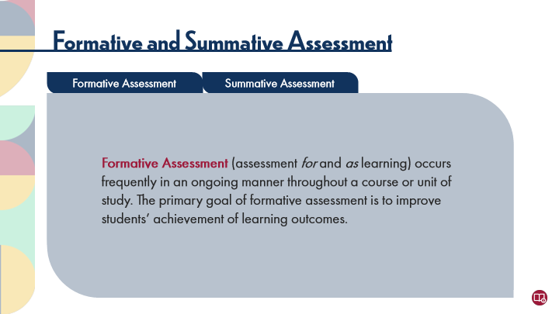

Type | Translation
Main Body 1 | Formative Assessment
 | (assessment for and as learning) occurs frequently in an ongoing manner throughout a course or unit of study. The primary goal of formative assessment is to improve students’ achievement of learning outcomes.

16.6 Activity: Assessment Purposes
Slide ID 🔒 | 5e85a5c4-9a4f-475c-8748-8aa74e930fc3
Preview Image | 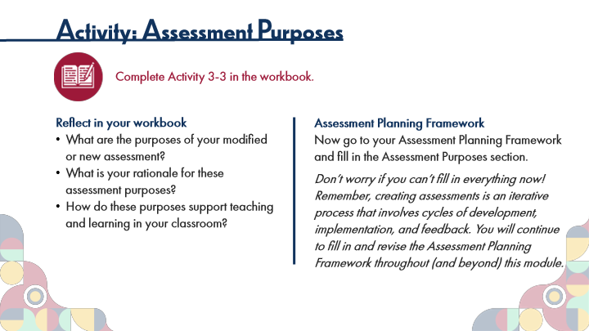

Type | Translation
Slide name | Activity: Assessment Purposes
Main Title 1 | Activity: Assessment Purposes
Text Box 1 | Complete Activity 3-3 in the workbook.
Text Box 3 | Assessment Planning Framework
 | Now go to your Assessment Planning Framework and fill in the Assessment Purposes section.
 | Don’t worry if you can’t fill in everything now! Remember, creating assessments is an iterative process that involves cycles of development, implementation, and feedback. You will continue to fill in and revise the Assessment Planning Framework throughout (and beyond) this module.
Text Box 4 | Reflect in your workbook
 | What are the purposes of your modified or new assessment?
 | What is your rationale for these assessment purposes?
 | How do these purposes support teaching and learning in your classroom?

16.7 Topic 2B: Planning for Assessment Processes
Slide ID 🔒 | 449ad4e8-333b-4977-9fb1-9981000abd29
Preview Image | 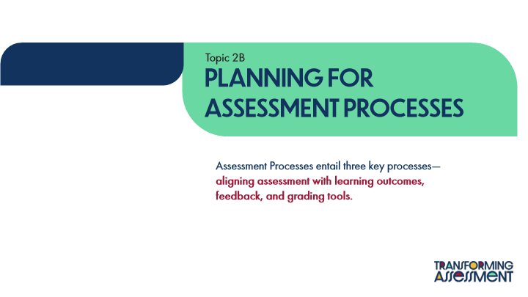

Type | Translation
Slide name | Topic 2B: Planning for Assessment Processes
Text Box 1 | Topic 2B
Main Title | PLANNING FOR ASSESSMENT PROCESSES
Text Box 2 | Assessment Processes entail three key processes—
 | aligning assessment with learning outcomes, feedback, and grading tools.

16.8 Review of Learning Outcomes
Slide ID 🔒 | e289a8b4-c0c2-4dd3-8e10-3db33076418f
Preview Image | 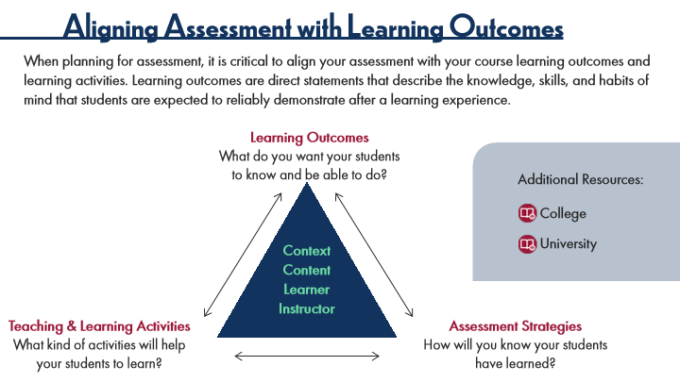

Type | Translation
Slide name | Review of Learning Outcomes
Main Title 1 | Aligning Assessment with Learning Outcomes
Text Box 5 | When planning for assessment, it is critical to align your assessment with your course learning outcomes and learning activities. Learning outcomes are direct statements that describe the knowledge, skills, and habits of mind that students are expected to reliably demonstrate after a learning experience.
Text Box 2 | Learning Outcomes
 | What do you want your students to know and be able to do?
Text Box 6 | Additional Resources:
Text Box 7 | College
Text Box 8 | University
Text Box 1 | Context
 | Content
 | Learner
 | Instructor
Text Box 3 | Teaching & Learning Activities
 | What kind of activities will help your students to learn?
Text Box 4 | Assessment Strategies
 | How will you know your students have learned?

16.9 Activity: Aligning Assessment
Slide ID 🔒 | 1c6d7565-f54e-4632-8ae0-dfe64469d347
Preview Image | 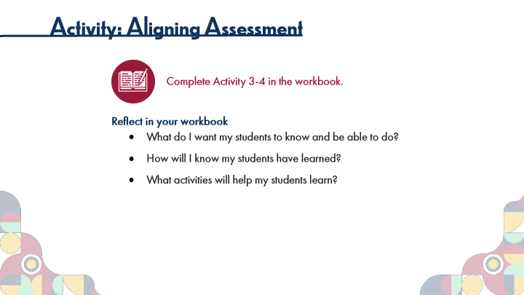

Type | Translation
Slide name | Activity: Aligning Assessment
Main Title 1 | Activity: Aligning Assessment
Text Box 1 | Complete Activity 3-4 in the workbook.
Text Box 4 | Reflect in your workbook
 | What do I want my students to know and be able to do?
 | How will I know my students have learned?
 | What activities will help my students learn?

16.10 Authentic Assessments
Slide ID 🔒 | 227dc566-728d-4da4-85ac-bb0aaa686c8b
Preview Image | 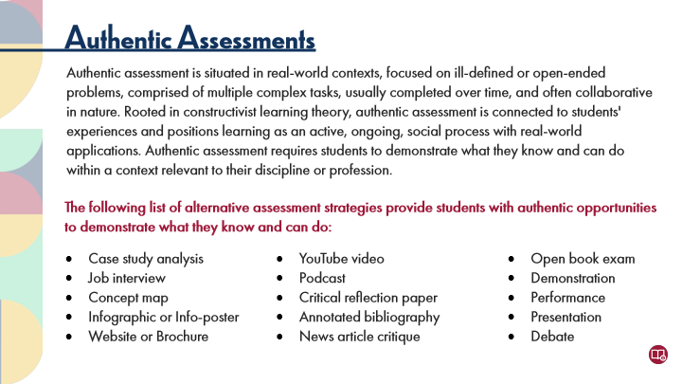

Type | Translation
Slide name | Authentic Assessments
Main Title 1 | Authentic Assessments
Text Box 1 | Authentic assessment is situated in real-world contexts, focused on ill-defined or open-ended problems, comprised of multiple complex tasks, usually completed over time, and often collaborative in nature. Rooted in constructivist learning theory, authentic assessment is connected to students' experiences and positions learning as an active, ongoing, social process with real-world applications. Authentic assessment requires students to demonstrate what they know and can do within a context relevant to their discipline or profession.
Text Box 2 | The following list of alternative assessment strategies provide students with authentic opportunities to demonstrate what they know and can do:
Text Box 4 | Case study analysis
 | Job interview
 | Concept map
 | Infographic or Info-poster
 | Website or Brochure
Text Box 5 | YouTube video
 | Podcast
 | Critical reflection paper
 | Annotated bibliography
 | News article critique
Text Box 3 | Open book exam
 | Demonstration
 | Performance
 | Presentation
 | Debate

16.11 Activity: Authentic Assessments
Slide ID 🔒 | c0c20df1-5d3e-45b8-b0fa-eacc02d5a216
Preview Image | 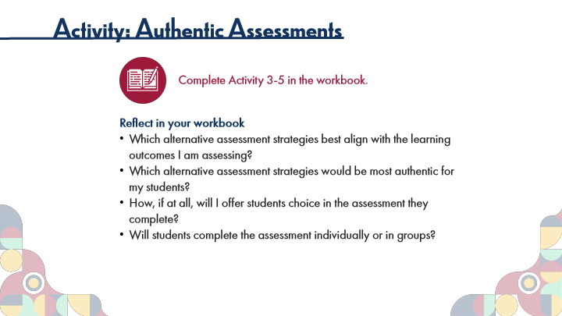

Type | Translation
Slide name | Activity: Authentic Assessments
Main Title 1 | Activity: Authentic Assessments
Text Box 1 | Complete Activity 3-5 in the workbook.
Text Box 4 | Reflect in your workbook
 | Which alternative assessment strategies best align with the learning outcomes I am assessing?
 | Which alternative assessment strategies would be most authentic for my students?
 | How, if at all, will I offer students choice in the assessment they complete?
 | Will students complete the assessment individually or in groups?

16.12 Sources of Feedback
Slide ID 🔒 | 3bfeed18-3758-4c3f-8b8f-0d6ddaa0626f
Preview Image | 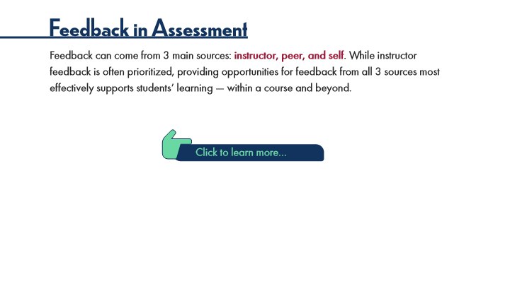

Type | Translation
Slide name | Sources of Feedback
Main Title 1 | Feedback in Assessment
Text Box 1 | Feedback can come from 3 main sources:
 | instructor, peer, and self
 | . While instructor feedback is often prioritized, providing opportunities for feedback from all 3 sources most effectively supports students’ learning — within a course and beyond.
Text Box 2 | Click to learn more…

Slide Layer: Purpose
Layer ID 🔒 | d75ee7d1-ec29-4c21-abe3-46256c6172e3
Preview Image | 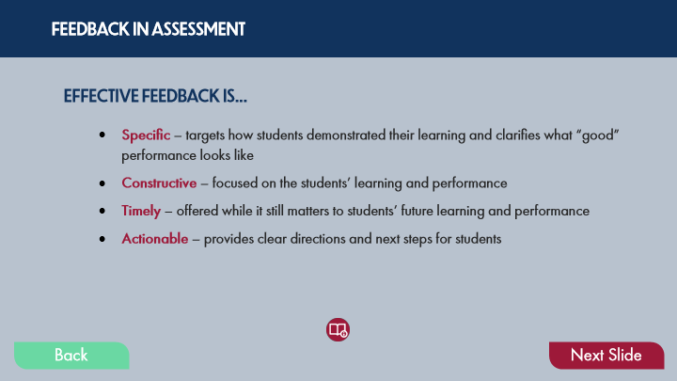

Type | Translation
Text Box 8 | FEEDBACK IN ASSESSMENT
Text Box 4 | EFFECTIVE FEEDBACK IS…
Text Box 5 | Specific
 | – targets how students demonstrated their learning and clarifies what “good” performance looks like
 | Constructive
 | – focused on the students’ learning and performance
 | Timely
 | – offered while it still matters to students’ future learning and performance
 | Actionable
 | – provides clear directions and next steps for students
Button - Normal state | Back
Button - Down state | Back
Button - Normal state | Next Slide

Slide Layer: Definitions
Layer ID 🔒 | 6a73c68e-3cc0-4334-9b2b-bcea01b7cd6c
Preview Image | 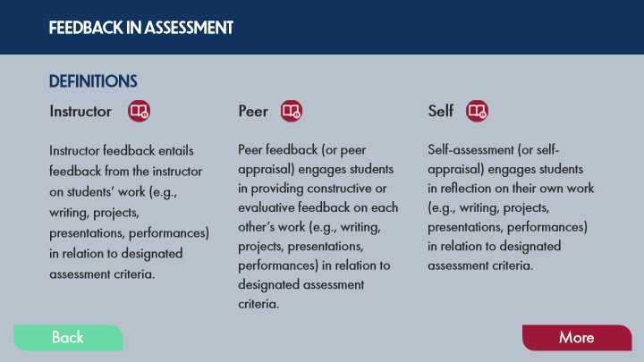

Type | Translation
Text Box 8 | FEEDBACK IN ASSESSMENT
Text Box 4 | DEFINITIONS
Text Box 1 | Instructor
Text Box 2 | Peer
Text Box 3 | Self
Text Box 5 | Instructor feedback entails feedback from the instructor on students’ work (e.g., writing, projects, presentations, performances) in relation to designated assessment criteria.
Text Box 6 | Peer feedback (or peer appraisal) engages students in providing constructive or evaluative feedback on each other’s work (e.g., writing, projects, presentations, performances) in relation to designated assessment criteria.
Text Box 7 | Self-assessment (or self-appraisal) engages students in reflection on their own work (e.g., writing, projects, presentations, performances) in relation to designated assessment criteria.
Button - Normal state | Back
Button - Down state | Back
Button - Normal state | More

16.13 Activity: Feedback in Assessment
Slide ID 🔒 | 0431a117-6970-40c8-a5b0-c44929995eee
Preview Image | 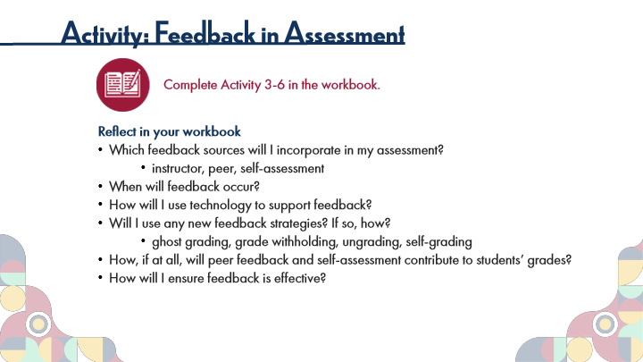

Type | Translation
Slide name | Activity: Feedback in Assessment
Main Title 1 | Activity: Feedback in Assessment
Text Box 1 | Complete Activity 3-6 in the workbook.
Text Box 4 | Reflect in your workbook
 | Which feedback sources will I incorporate in my assessment?
 | instructor, peer, self-assessment
 | When will feedback occur?
 | How will I use technology to support feedback?
 | Will I use any new feedback strategies? If so, how?
 | ghost grading, grade withholding, ungrading, self-grading
 | How, if at all, will peer feedback and self-assessment contribute to students’ grades?
 | How will I ensure feedback is effective?

16.14 Cognitive Frameworks
Slide ID 🔒 | 4c2e49a4-4d3a-4dfc-a9c3-9d6113aeafd2

Preview Image

Type | Translation
Slide name | Cognitive Frameworks
Main Title 1 | Cognitive Frameworks
Text Box 1 | Two common cognitive frameworks that support instructors’ design of authentic assessments are Bloom’s Taxonomy and the ICE Model. An important consideration is to choose a framework that resonates with your conception of what learning looks like within a course and use it consistently in your classroom.
 | Select a framework below to learn more.
Text Box 4 | Ideas
Text Box 5 | Connections
Text Box 6 | Extensions
Text Box 2 | Bloom’s Taxonomy
Text Box 3 | The ICE Model

Slide Layer: ICE
Layer ID 🔒 | df9feb74-e6de-4092-94b6-da3374c699b4
Preview Image | 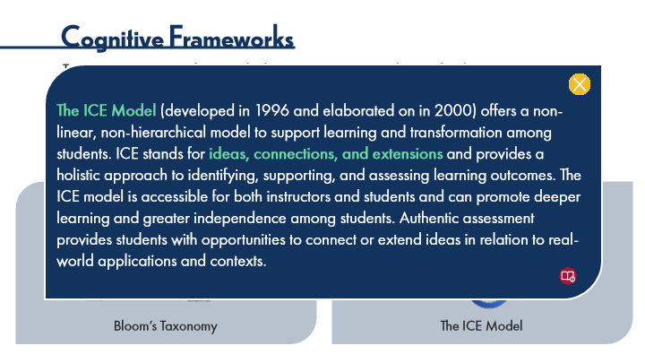

Type | Translation
Text Box 2 | The ICE Model
 | (developed in 1996 and elaborated on in 2000) offers a non-linear, non-hierarchical model to support learning and transformation among students. ICE stands for
 | ideas, connections, and extensions
 | and provides a holistic approach to identifying, supporting, and assessing learning outcomes. The ICE model is accessible for both instructors and students and can promote deeper learning and greater independence among students. Authentic assessment provides students with opportunities to connect or extend ideas in relation to real-world applications and contexts.

Slide Layer: Bloom
Layer ID 🔒 | 2f3f16a8-a4b5-47ac-8487-6e1cc4235e9d

Preview Image

Type | Translation
Text Box 10 | Bloom’s Taxonomy
 | (developed in 1956 and revised in 2001) categorizes the cognitive domains of learning across 6 levels of complexity from lower order (remembering and understanding) to higher order (applying, analyzing, evaluating, and creating). Bloom's taxonomy can help instructors ensure that teaching, learning, and assessment address both
 | lower and higher order thinking skills
 | . By nature, well-designed authentic assessments provide students with opportunities for application, analysis, evaluation, and creation.

16.15 Activity: Cognitive Frameworks
Slide ID 🔒 | 3aa2d9c6-343d-48aa-8903-c6219220f3a5
Preview Image | 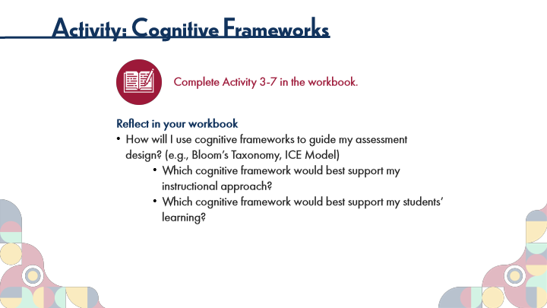

Type | Translation
Slide name | Activity: Cognitive Frameworks
Main Title 1 | Activity: Cognitive Frameworks
Text Box 1 | Complete Activity 3-7 in the workbook.
Text Box 4 | Reflect in your workbook
 | How will I use cognitive frameworks to guide my assessment design? (e.g., Bloom’s Taxonomy, ICE Model)
 | Which cognitive framework would best support my instructional approach?
 | Which cognitive framework would best support my students’ learning?

16.16 Grading Tools
Slide ID 🔒 | f7597f73-ac98-4c0b-bdd9-fda3a6c14dfd
Preview Image | 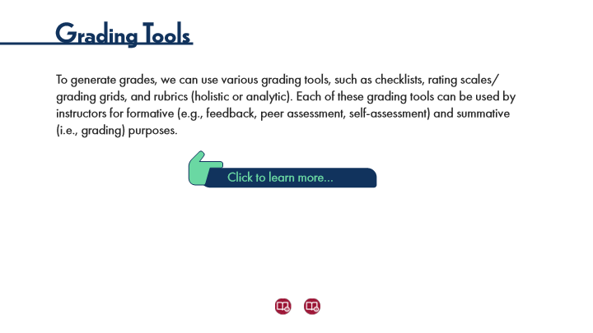

Type | Translation
Slide name | Grading Tools
Main Title 1 | Grading Tools
Text Box 1 | To generate grades, we can use various grading tools, such as checklists, rating scales/grading grids, and rubrics (holistic or analytic). Each of these grading tools can be used by instructors for formative (e.g., feedback, peer assessment, self-assessment) and summative (i.e., grading) purposes.
Text Box 2 | Click to learn more…

Slide Layer: Analytic Rubrics
Layer ID 🔒 | a7e23576-9505-48b2-b4b7-c884ab0afc51
Preview Image | 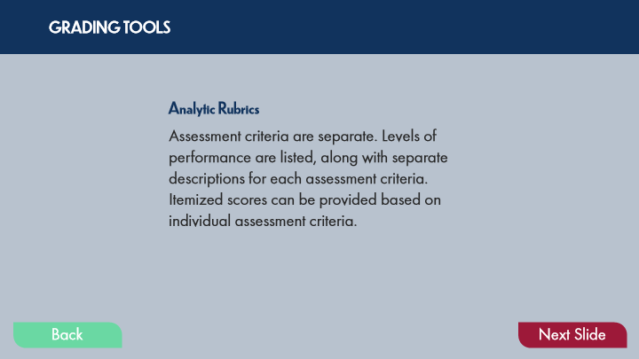

Type | Translation
Text Box 1 | GRADING TOOLS
Text Box 3 | Analytic Rubrics
Text Box 2 | Assessment criteria are separate. Levels of performance are listed, along with separate descriptions for each assessment criteria. Itemized scores can be provided based on individual assessment criteria.
Button - Normal state | Back
Button - Down state | Back
Button - Normal state | Next Slide

Slide Layer: Holistic Rubrics
Layer ID 🔒 | 65e5e8fe-a5a5-46cb-b7b0-beaecc06ab75
Preview Image | 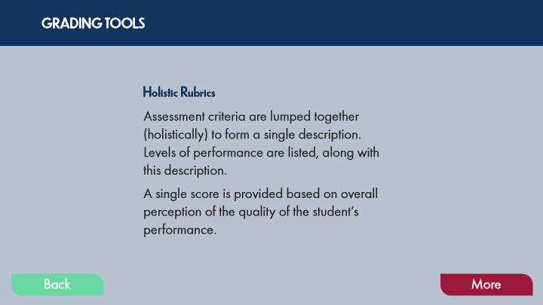

Type | Translation
Text Box 8 | GRADING TOOLS
Text Box 10 | Holistic Rubrics
Text Box 9 | Assessment criteria are lumped together (holistically) to form a single description.
 | Levels of performance are listed, along with this description.
 | A single score is provided based on overall perception of the quality of the student’s performance.
Button - Normal state | Back
Button - Down state | Back
Button - Normal state | More

Slide Layer: Rating Scales
Layer ID 🔒 | 1045d906-54ee-4326-a1f3-ec1b95f7f0f2
Preview Image | 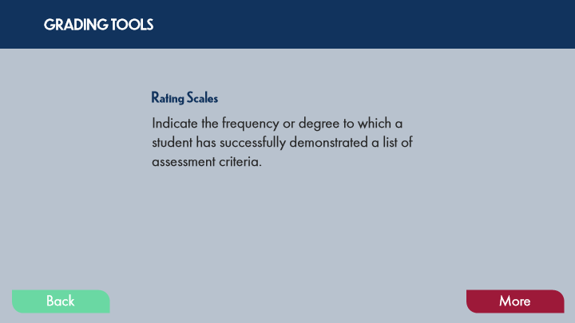

Type | Translation
Text Box 8 | GRADING TOOLS
Text Box 10 | Rating Scales
Text Box 9 | Indicate the frequency or degree to which a student has successfully demonstrated a list of assessment criteria.
Button - Normal state | Back
Button - Down state | Back
Button - Normal state | More

Slide Layer: Checklists
Layer ID 🔒 | f9a58885-a6d5-4723-82b6-dcfbfcd83163
Preview Image | 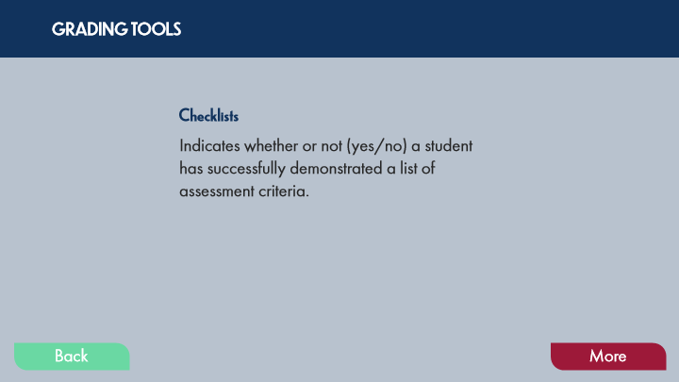

Type | Translation
Text Box 8 | GRADING TOOLS
Text Box 10 | Checklists
Text Box 9 | Indicates whether or not (yes/no) a student has successfully demonstrated a list of assessment criteria.
Button - Normal state | Back
Button - Down state | Back
Button - Normal state | More

16.17 Activity: Assessment Processes
Slide ID 🔒 | a2268c0d-4709-4871-8010-4de08776eef7
Preview Image | 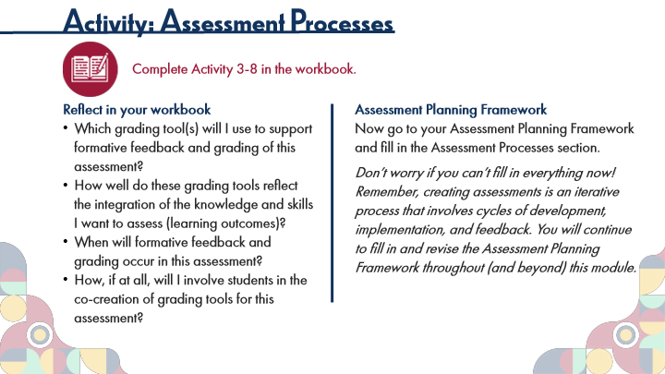

Type | Translation
Slide name | Activity: Assessment Processes
Main Title 1 | Activity: Assessment Processes
Text Box 1 | Complete Activity 3-8 in the workbook.
Text Box 4 | Reflect in your workbook
 | Which grading tool(s) will I use to support formative feedback and grading of this assessment?
 | How well do these grading tools reflect the integration of the knowledge and skills I want to assess (learning outcomes)?
 | When will formative feedback and grading occur in this assessment?
 | How, if at all, will I involve students in the co-creation of grading tools for this assessment?
Text Box 3 | Assessment Planning Framework
 | Now go to your Assessment Planning Framework and fill in the Assessment Processes section.
 | Don’t worry if you can’t fill in everything now! Remember, creating assessments is an iterative process that involves cycles of development, implementation, and feedback. You will continue to fill in and revise the Assessment Planning Framework throughout (and beyond) this module.

16.18 Topic 2C: Planning for Assessment Fairness
Slide ID 🔒 | b4b0e4e3-5fc8-4bfe-b869-8e3d015614fc
Preview Image | 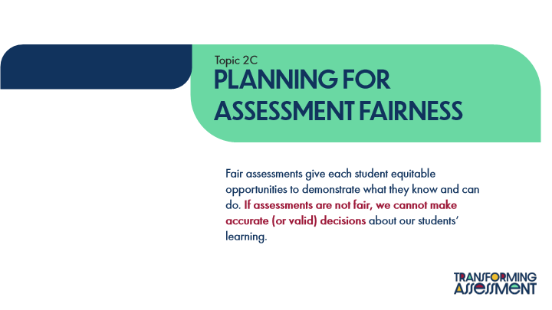

Type | Translation
Slide name | Topic 2C: Planning for Assessment Fairness
Text Box 1 | Topic 2C
Main Title | PLANNING FOR ASSESSMENT Fairness
Text Box 2 | Fair assessments give each student equitable opportunities to demonstrate what they know and can do.
 | If assessments are not fair, we cannot make accurate (or valid) decisions
 | about our students’ learning.

16.19 Student-Centred Strategies for Fairness
Slide ID 🔒 | 7cbfc51d-3717-4cfe-9cc6-bdf84f797888

Preview Image

Type | Translation
Slide name | Student-Centred Strategies for Fairness
Main Title 1 | Student-Centred Strategies for Fairness
Text Box 1 | The following student-centred strategies offer practical ways for instructors to support fairness through alternative assessment.
Text Box 5 | Engage students – ask them what would make assessment more accessible and inclusive for them.
Text Box 4 | Ensure students understand what is expected of them from the outset.
Text Box 3 | Provide clear information on assessment in a learning cycle or course at the outset, including assessment methods, deadlines/dates of assessment, choices available, marking criteria and weightings, and exemplars (if possible).
Text Box 6 | Include multiple opportunities for formative assessment through instructor feedback, peer feedback, and self-assessment.
Text Box 8 | Use a variety of assessment strategies.
Text Box 7 | Offer students choice in assessment with guiding parameters.
Text Box 9 | Support students’ active engagement in the assessment process.

16.20 Activity: Assessment Fairness
Slide ID 🔒 | e59cf3f5-4b5d-4fce-a25d-8d472add979b
Preview Image | 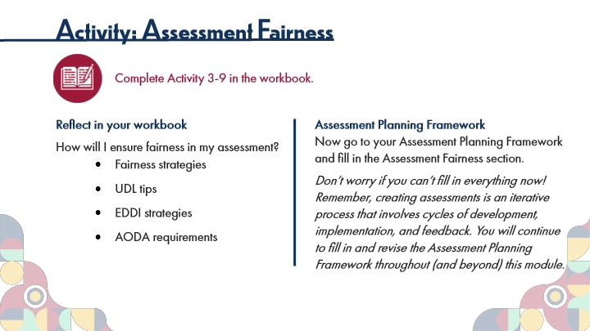

Type | Translation
Slide name | Activity: Assessment Fairness
Main Title 1 | Activity: Assessment Fairness
Text Box 1 | Complete Activity 3-9 in the workbook.
Text Box 4 | Reflect in your workbook
 | How will I ensure fairness in my assessment?
 | Fairness strategies
 | UDL tips
 | EDDI strategies
 | AODA requirements
Text Box 3 | Assessment Planning Framework
 | Now go to your Assessment Planning Framework and fill in the Assessment Fairness section.
 | Don’t worry if you can’t fill in everything now! Remember, creating assessments is an iterative process that involves cycles of development, implementation, and feedback. You will continue to fill in and revise the Assessment Planning Framework throughout (and beyond) this module.

16.21 Topic 2D: Planning for Assessment Theory
Slide ID 🔒 | a6845113-d9e3-4f1a-adb8-7573dfde9e64
Preview Image | 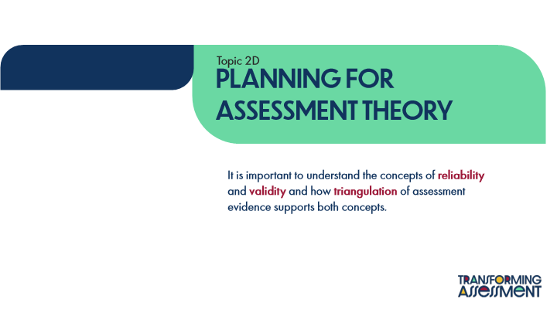

Type | Translation
Slide name | Topic 2D: Planning for Assessment Theory
Text Box 1 | Topic 2D
Main Title | PLANNING FOR ASSESSMENT Theory
Text Box 2 | It is important to understand the concepts of
 | reliability
 | and
 | validity
 | and how
 | triangulation
 | of assessment evidence supports both concepts.

16.22 Distinctions between Reliability and Validity
Slide ID 🔒 | d185c735-d0c2-4b28-b02c-a84dc6b29c2c
Preview Image | 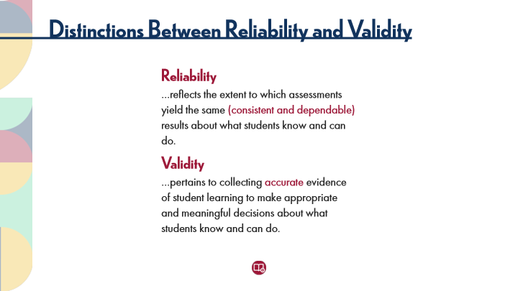

Type | Translation
Slide name | Distinctions between Reliability and Validity
Main Title 1 | Distinctions Between Reliability and Validity
Text Box 5 | Reliability
Text Box 3 | …reflects the extent to which assessments yield the same
 | (consistent and dependable)
 | results about what students know and can do.
Text Box 6 | Validity
Text Box 4 | …pertains to collecting
 | accurate
 | evidence of student learning to make appropriate and meaningful decisions about what students know and can do.

16.23 The Importance of Triangulation
Slide ID 🔒 | 2159650b-a126-4adb-ad50-a519c092517d
Preview Image | 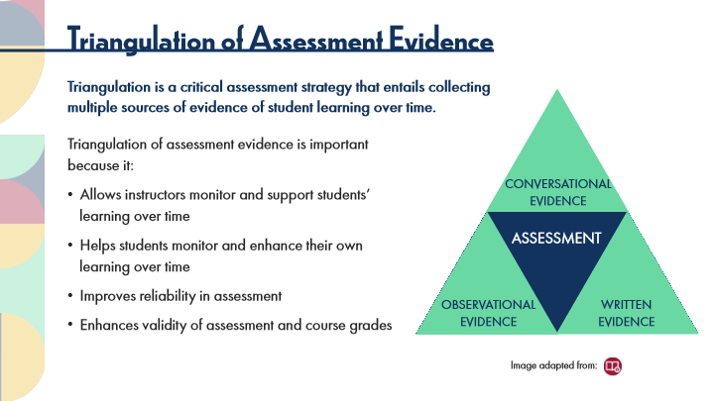

Type | Translation
Slide name | The Importance of Triangulation
Main Title 1 | Triangulation of Assessment Evidence
Text Box 7 | Triangulation is a critical assessment strategy that entails collecting multiple sources of evidence of student learning over time.
Alt text for Image Triangulation | Graphic showing a triangle. At the center of the triangle is the word ‘assessment’. At each of the three points of the triangle are the phrases: ‘conversational evidence’, ‘observational evidence’, and ‘written evidence’.
Text Box 1 | Triangulation of assessment evidence is important because it:
 | Allows instructors monitor and support students’ learning over time
 | Helps students monitor and enhance their own learning over time
 | Improves reliability in assessment
 | Enhances validity of assessment and course grades
Text Box 6 | CONVERSATIONAL
 | EVIDENCE
Text Box 3 | ASSESSMENT
Text Box 5 | OBSERVATIONAL
 | EVIDENCE
Text Box 4 | WRITTEN
 | EVIDENCE
Text Box 2 | Image adapted from:

16.24 Activity: Assessment Theory
Slide ID 🔒 | 3aa6b836-e114-421e-aa7f-2bfe6c3012f0
Preview Image | 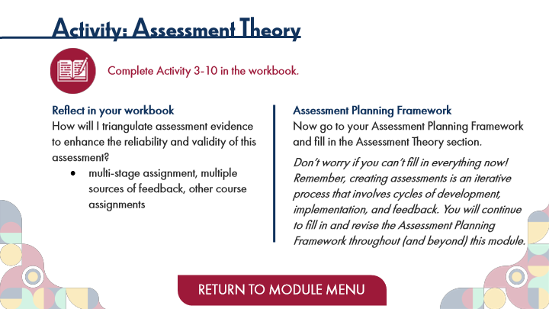

Type | Translation
Slide name | Activity: Assessment Theory
Main Title 1 | Activity: Assessment Theory
Text Box 1 | Complete Activity 3-10 in the workbook.
Text Box 4 | Reflect in your workbook
 | How will I triangulate assessment evidence to enhance the reliability and validity of this assessment?
 | multi-stage assignment, multiple sources of feedback, other course assignments
Text Box 3 | Assessment Planning Framework
 | Now go to your Assessment Planning Framework and fill in the Assessment Theory section.
 | Don’t worry if you can’t fill in everything now! Remember, creating assessments is an iterative process that involves cycles of development, implementation, and feedback. You will continue to fill in and revise the Assessment Planning Framework throughout (and beyond) this module.
Button - Normal state | RETURN TO MODULE MENU

17 Topic 3: Ensuring "Good" Assessments
Scene ID 🔒 | 2a130824-8157-4420-adcc-e8cc7a97fa1a

Type | Translation
Scene name | Topic 3: Ensuring "Good" Assessments

17.1 Ensuring "Good" Assessments Title Page
Slide ID 🔒 | fddac4ff-c103-4ee4-92c0-e6d1ac37a096
Preview Image | 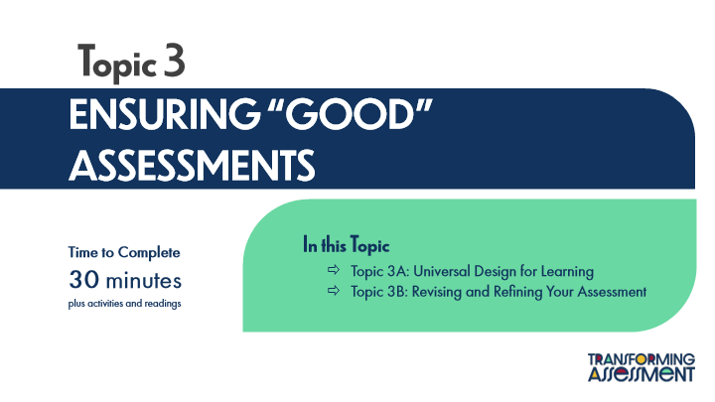

Type | Translation
Slide name | Ensuring "Good" Assessments Title Page
Main Title 1 | Topic 3
Main Title | ENSURING “GOOD” ASSESSMENTS
Text Box 1 | In this Topic
 | Topic 3A: Universal Design for Learning
 | Topic 3B: Revising and Refining Your Assessment
Text Box 2 | Time to Complete
 | 30 minutes
 | plus activities and readings

17.2 Characteristics of “Good” Assessment
Slide ID 🔒 | d7b63f90-d048-4feb-83f7-15273290afd7
Preview Image | 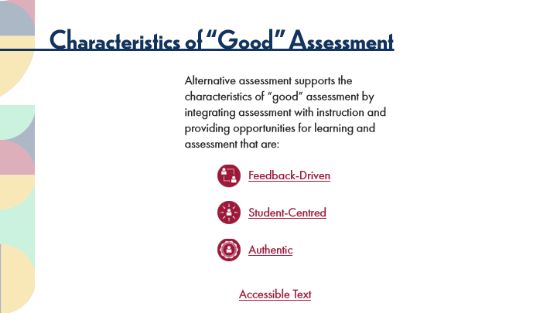

Type | Translation
Slide name | Characteristics of “Good” Assessment
Main Title 1 | Characteristics of “Good” Assessment
intro | Alternative assessment supports the characteristics of “good” assessment by integrating assessment with instruction and providing opportunities for learning and assessment that are:
Text Box 1 | Feedback-Driven
Text Box 2 | Student-Centred
Text Box 3 | Authentic
Text Box 4 | Accessible Text
Alt text for Text Box 4 | Accessible Activity Text Link. If you are not using a mouse for this course, access the PDF for the mouse rollover text from this slide.

Slide Layer: Feedback Driven
Layer ID 🔒 | 04303ce6-68c0-4f9d-88cf-d736b26ee7b2
Preview Image | 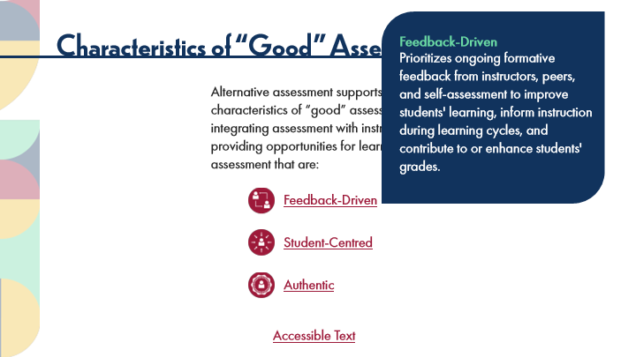

Type | Translation
Text Box 1 | Feedback-Driven
Text Box 2 | Prioritizes ongoing formative feedback from instructors, peers, and self-assessment to improve students' learning, inform instruction during learning cycles, and contribute to or enhance students' grades.

Slide Layer: Student Centred
Layer ID 🔒 | a868beab-98ca-4441-924c-6800471b65dd
Preview Image | 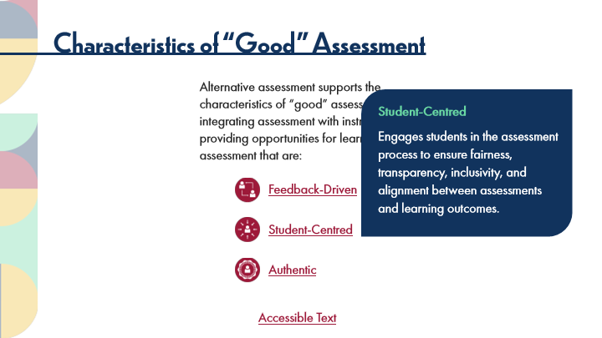

Type | Translation
Text Box 1 | Student-Centred
Text Box 2 | Engages students in the assessment process to ensure fairness, transparency, inclusivity, and alignment between assessments and learning outcomes.

Slide Layer: Authentic
Layer ID 🔒 | 8f561115-dfda-4895-8135-4eed4d1a405b
Preview Image | 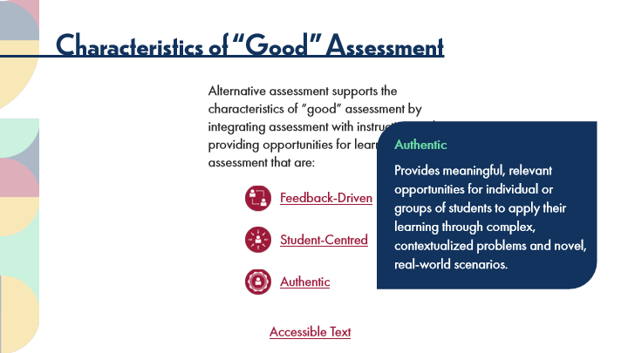

Type | Translation
Text Box 1 | Authentic
Text Box 2 | Provides meaningful, relevant opportunities for individual or groups of students to apply their learning through complex, contextualized problems and novel, real-world scenarios.

17.3 Topic 3A: Universal Design for Learning (UDL)
Slide ID 🔒 | d3b1f07a-c39a-49b3-b31e-7d83a6e167e9
Preview Image | 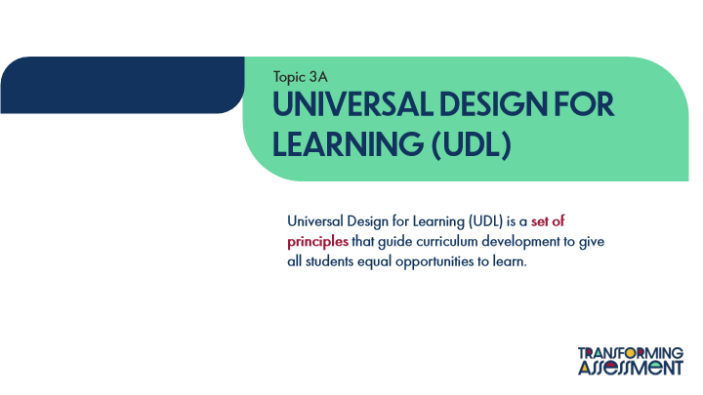

Type | Translation
Slide name | Topic 3A: Universal Design for Learning (UDL)
Text Box 1 | Topic 3A
Main Title | Universal Design for Learning (UDL)
Text Box 2 | Universal Design for Learning (UDL) is a
 | set of principles
 | that guide curriculum development to give all students equal opportunities to learn.

17.4 UDL Framework
Slide ID 🔒 | a70c147e-5ff8-4550-951a-fbb14382408b
Preview Image | 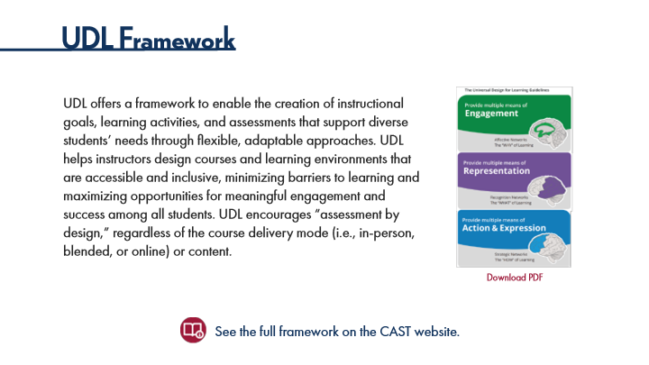

Type | Translation
Slide name | UDL Framework
Main Title 1 | UDL Framework
Text Box 6 | UDL offers a framework to enable the creation of instructional goals, learning activities, and assessments that support diverse students’ needs through flexible, adaptable approaches. UDL helps instructors design courses and learning environments that are accessible and inclusive, minimizing barriers to learning and maximizing opportunities for meaningful engagement and success among all students. UDL encourages “assessment by design,” regardless of the course delivery mode (i.e., in-person, blended, or online) or content.
Text Box 8 | Download PDF
Text Box 7 | See the full framework on the CAST website.

17.5 UDL Tips for Assessment
Slide ID 🔒 | d63de3b1-ff86-417d-947d-6d25e30b4814
Preview Image | 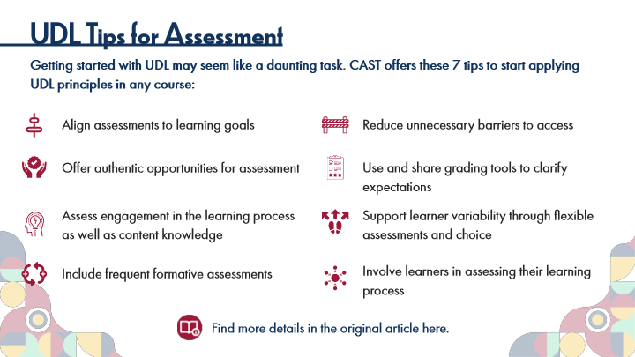

Type | Translation
Slide name | UDL Tips for Assessment
Main Title 1 | UDL Tips for Assessment
Text Box 1 | Getting started with UDL may seem like a daunting task. CAST offers these 7 tips to start applying UDL principles in any course:
Text Box 5 | Align assessments to learning goals
Text Box 7 | Reduce unnecessary barriers to access
Text Box 10 | Use and share grading tools to clarify expectations
Text Box 3 | Offer authentic opportunities for assessment
Text Box 4 | Assess engagement in the learning process as well as content knowledge
Text Box 8 | Support learner variability through flexible assessments and choice
Text Box 11 | Involve learners in assessing their learning process
Text Box 6 | Include frequent formative assessments
Text Box 2 | Find more details in the original article here.

17.6 Activity: Applying UDL
Slide ID 🔒 | dec5ad47-e933-4c7e-8eef-1b2cecec5acd
Preview Image | 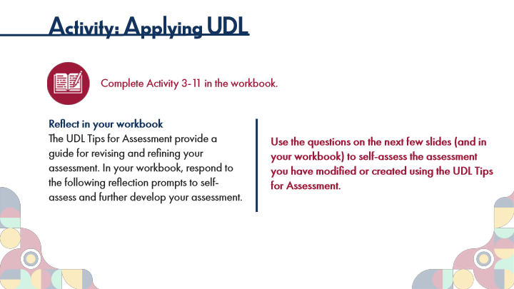

Type | Translation
Slide name | Activity: Applying UDL
Main Title 1 | Activity: Applying UDL
Text Box 1 | Complete Activity 3-11 in the workbook.
Text Box 4 | Reflect in your workbook
 | The UDL Tips for Assessment provide a guide for revising and refining your assessment. In your workbook, respond to the following reflection prompts to self-assess and further develop your assessment.
Text Box 5 | Use the questions on the next few slides (and in your workbook) to self-assess the assessment you have modified or created using the UDL Tips for Assessment.

17.7 Activity: Applying UDL, Part 1
Slide ID 🔒 | de2dfdaa-e8e5-4627-b820-8e2ea0b9d071
Preview Image | 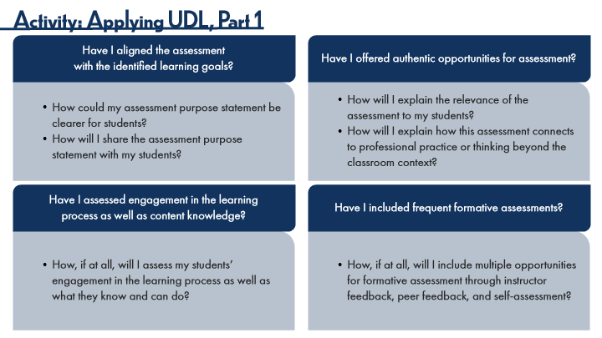

Type | Translation
Slide name | Activity: Applying UDL, Part 1
Main Title 1 | Activity: Applying UDL, Part 1
Round Diagonal Corner 2 | Have I aligned the assessment
 | with the identified learning goals?
Round Diagonal Corner 3 | Have I offered authentic opportunities for assessment?
Round Single Corner Rectangle 8 | How could my assessment purpose statement be clearer for students?
 | How will I share the assessment purpose statement with my students?
Round Single Corner Rectangle 9 | How will I explain the relevance of the assessment to my students?
 | How will I explain how this assessment connects to professional practice or thinking beyond the classroom context?
Round Diagonal Corner 4 | Have I assessed engagement in the learning
 | process as well as content knowledge?
Round Diagonal Corner 5 | Have I included frequent formative assessments?
Round Single Corner Rectangle 10 | How, if at all, will I assess my students’ engagement in the learning process as well as what they know and can do?
Round Single Corner Rectangle 11 | How, if at all, will I include multiple opportunities for formative assessment through instructor feedback, peer feedback, and self-assessment?

17.8 Activity: Applying UDL, Part 2
Slide ID 🔒 | 08b1b6d9-99f0-41b2-9b1d-27df1487187d
Preview Image | 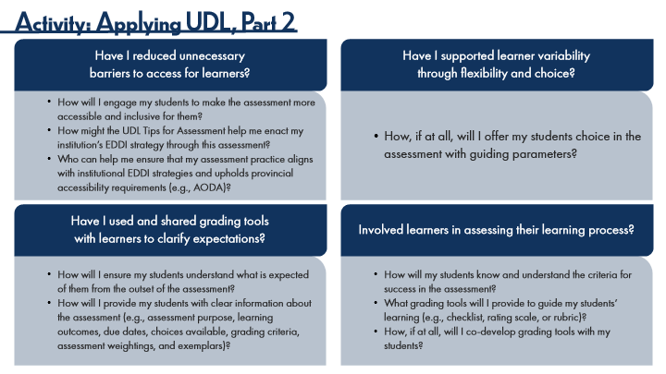

Type | Translation
Slide name | Activity: Applying UDL, Part 2
Main Title 1 | Activity: Applying UDL, Part 2
Round Diagonal Corner 2 | Have I reduced unnecessary
 | barriers to access for learners?
Round Diagonal Corner 3 | Have I supported learner variability
 | through flexibility and choice?
Round Single Corner Rectangle 8 | How will I engage my students to make the assessment more accessible and inclusive for them?
 | How might the UDL Tips for Assessment help me enact my institution’s EDDI strategy through this assessment?
 | Who can help me ensure that my assessment practice aligns with institutional EDDI strategies and upholds provincial accessibility requirements (e.g., AODA)?
Round Single Corner Rectangle 9 | How, if at all, will I offer my students choice in the assessment with guiding parameters?
Round Diagonal Corner 4 | Have I used and shared grading tools
 | with learners to clarify expectations?
Round Diagonal Corner 5 | Involved learners in assessing their learning process?
Round Single Corner Rectangle 10 | How will I ensure my students understand what is expected of them from the outset of the assessment?
 | How will I provide my students with clear information about the assessment (e.g., assessment purpose, learning outcomes, due dates, choices available, grading criteria, assessment weightings, and exemplars)?
Round Single Corner Rectangle 11 | How will my students know and understand the criteria for success in the assessment?
 | What grading tools will I provide to guide my students’ learning (e.g., checklist, rating scale, or rubric)?
 | How, if at all, will I co-develop grading tools with my students?

17.9 Activity: Applying UDL, Part 3
Slide ID 🔒 | c5a5592b-3bf9-4163-8364-38719691f222
Preview Image | 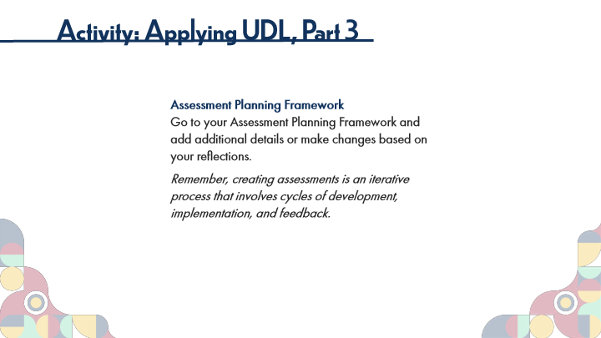

Type | Translation
Slide name | Activity: Applying UDL, Part 3
Main Title 1 | Activity: Applying UDL, Part 3
Text Box 2 | Assessment Planning Framework
 | Go to your Assessment Planning Framework and add additional details or make changes based on your reflections.
 | Remember, creating assessments is an iterative process that involves cycles of development, implementation, and feedback.

17.10 Topic 3B: Revising and Refining Your Assessment
Slide ID 🔒 | 5940f7ff-b66d-4e23-955b-b079510fd454
Preview Image | 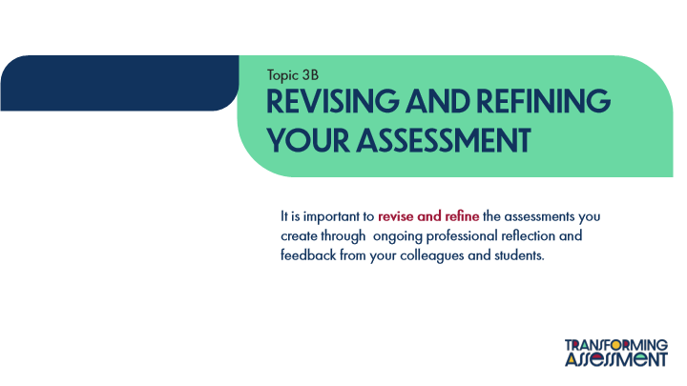

Type | Translation
Slide name | Topic 3B: Revising and Refining Your Assessment
Text Box 1 | Topic 3B
Main Title | REVISING AND REFINING YOUR ASSESSMENT
Text Box 2 | It is important to
 | revise and refine
 | the assessments you create through ongoing professional reflection and feedback from your colleagues and students.

17.11 Activity: Revising and Refining Your Assessment
Slide ID 🔒 | 159a7f00-48f2-4101-ae3b-9330aeb35f24
Preview Image | 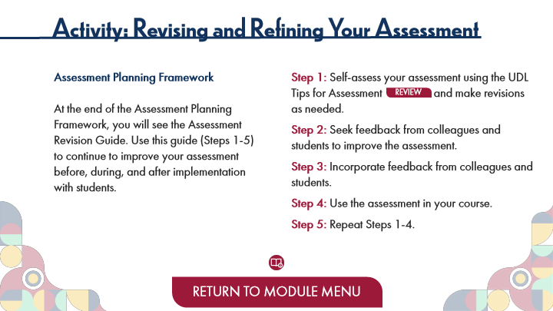

Type | Translation
Slide name | Activity: Revising and Refining Your Assessment
Main Title 1 | Activity: Revising and Refining Your Assessment
Text Box 2 | Assessment Planning Framework
 | At the end of the Assessment Planning Framework, you will see the Assessment Revision Guide. Use this guide (Steps 1-5) to continue to improve your assessment before, during, and after implementation with students.
Text Box 3 | Step 1:
 | Self-assess your assessment using the UDL Tips for Assessment and make revisions as needed.
 | Step 2:
 | Seek feedback from colleagues and students to improve the assessment.
 | Step 3:
 | Incorporate feedback from colleagues and students.
 | Step 4:
 | Use the assessment in your course.
 | Step 5:
 | Repeat Steps 1-4.
Button: Review UDL Tips for Assessment - Normal state | REVIEW
Button - Normal state | RETURN TO MODULE MENU

18 Topic 4: Moving Forward
Scene ID 🔒 | b93a6afa-a90b-4d58-980a-bc8675403ff1

Type | Translation
Scene name | Topic 4: Moving Forward

18.1 Moving Forward Title Page
Slide ID 🔒 | cd7ea913-8de5-4f17-9df1-20d1d5518db7
Preview Image | 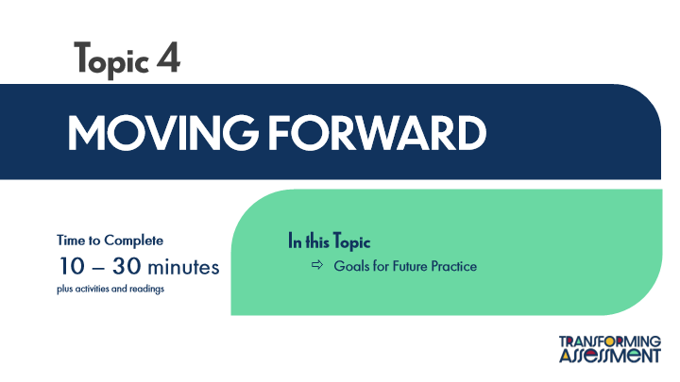

Type | Translation
Slide name | Moving Forward Title Page
Main Title 1 | Topic 4
Main Title | MOVING FORWARD
Text Box 1 | In this Topic
 | Goals for Future Practice
Text Box 2 | Time to Complete
 | 10 – 30 minutes
 | plus activities and readings

18.2 Activity: Goals for Professional Learning and Practice
Slide ID 🔒 | d247a2bc-8e69-4bc2-ab10-7b6fa7282d2d
Preview Image | 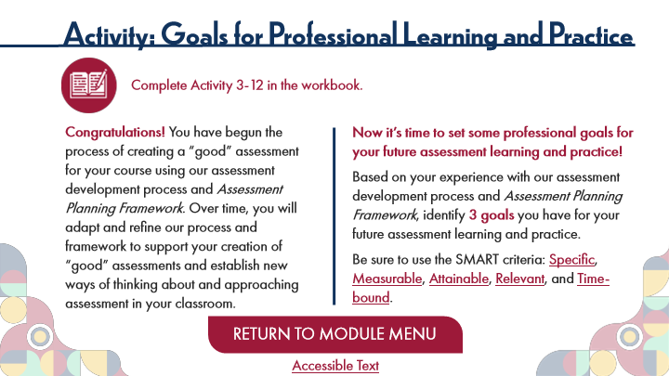

Type | Translation
Slide name | Activity: Goals for Professional Learning and Practice
Main Title 1 | Activity: Goals for Professional Learning and Practice
Text Box 4 | Complete Activity 3-12 in the workbook.
Text Box 3 | Now it’s time to set some professional goals for your future assessment learning and practice!
 | Based on your experience with our assessment development process and Assessment Planning Framework, identify
 | 3 goals
 | you have for your future assessment learning and practice.
 | Be sure to use the SMART criteria:
 | Specific
 | ,
 | Measurable
 | ,
 | Attainable
 | ,
 | Relevant
 | , and
 | Time-bound
 | .
Text Box 2 | Congratulations!
 | You have begun the process of creating a “good” assessment for your course using our assessment development process and Assessment Planning Framework. Over time, you will adapt and refine our process and framework to support your creation of “good” assessments and establish new ways of thinking about and approaching assessment in your classroom.
Button - Normal state | RETURN TO MODULE MENU
Text Box 5 | Accessible Text
Alt text for Text Box 5 | Accessible Activity Text Link. If you are not using a mouse for this course, access the PDF for the mouse rollover info from this slide.

Slide Layer: Specific
Layer ID 🔒 | b369ec33-ba86-41fc-91f1-e41ead129e15
Preview Image | 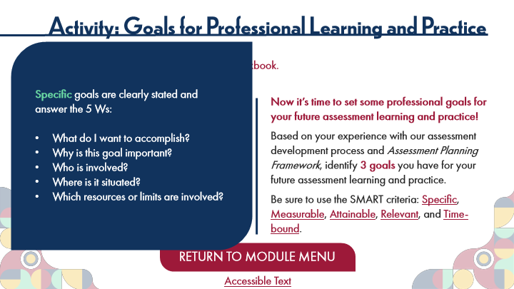

Type | Translation
Round Diagonal Corner 1 | Specific
 | goals are clearly stated and
 | answer the 5 Ws:
 | What do I want to accomplish?
 | Why is this goal important?
 | Who is involved?
 | Where is it situated?
 | Which resources or limits are involved?

Slide Layer: Measurable
Layer ID 🔒 | ec79ff6a-7101-4664-8440-3671493c1676
Preview Image | 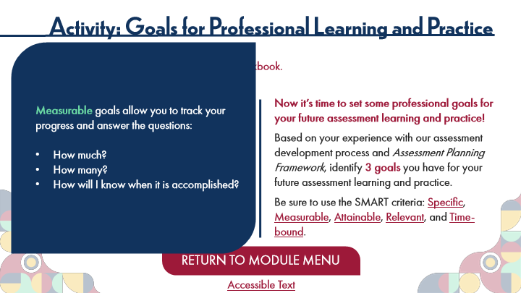

Type | Translation
Round Diagonal Corner 1 | Measurable
 | goals allow you to track your progress and answer the questions:
 | How much?
 | How many?
 | How will I know when it is accomplished?

Slide Layer: Attainable
Layer ID 🔒 | cd4d8dc7-3c30-453f-890c-f87b983464a8
Preview Image | 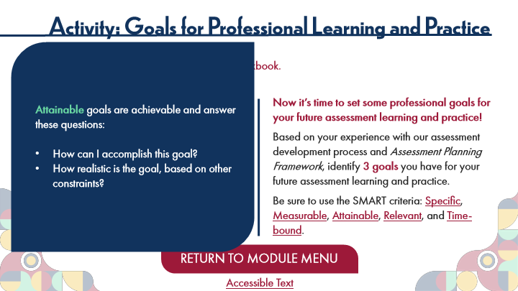

Type | Translation
Round Diagonal Corner 1 | Attainable
 | goals are achievable and answer these questions:
 | How can I accomplish this goal?
 | How realistic is the goal, based on other constraints?

Slide Layer: Relevant
Layer ID 🔒 | 78c6a5e0-a476-4b41-ab1b-590f02e8a63c
Preview Image | 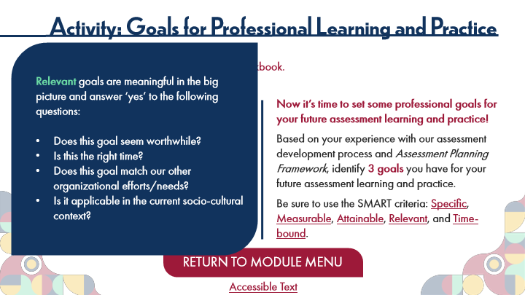

Type | Translation
Round Diagonal Corner 1 | Relevant
 | goals are meaningful in the big picture and answer ‘yes’ to the following questions:
 | Does this goal seem worthwhile?
 | Is this the right time?
 | Does this goal match our other organizational efforts/needs?
 | Is it applicable in the current socio-cultural context?

Slide Layer: Time-Bound
Layer ID 🔒 | ddc5d6e4-5226-42c9-9c52-b646642cf46a
Preview Image | 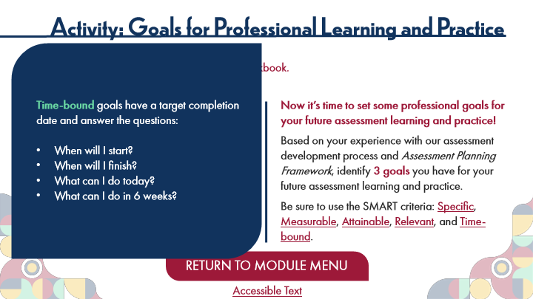

Type | Translation
Round Diagonal Corner 1 | Time-bound
 | goals have a target completion date and answer the questions:
 | When will I start?
 | When will I finish?
 | What can I do today?
 | What can I do in 6 weeks?

19 Wrapping Up
Scene ID 🔒 | f4078c07-ae42-4c57-b9c5-76b7b9673f14

Type | Translation
Scene name | Wrapping Up

19.1 Wrapping Up
Slide ID 🔒 | ae809850-337c-4add-bb0c-8c8c883bbf18
Preview Image | 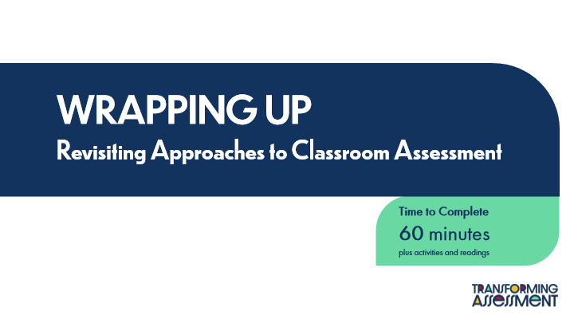

Type | Translation
Slide name | Wrapping Up
Main Title | WRAPPING UP
 | Revisiting Approaches to Classroom Assessment
Round Diagonal Corner 2 | Time to Complete
 | 60 minutes
 | plus activities and readings

19.2 Congratulations
Slide ID 🔒 | ea5a2e60-9d91-4bb4-b512-64d16556eb6d
Preview Image | 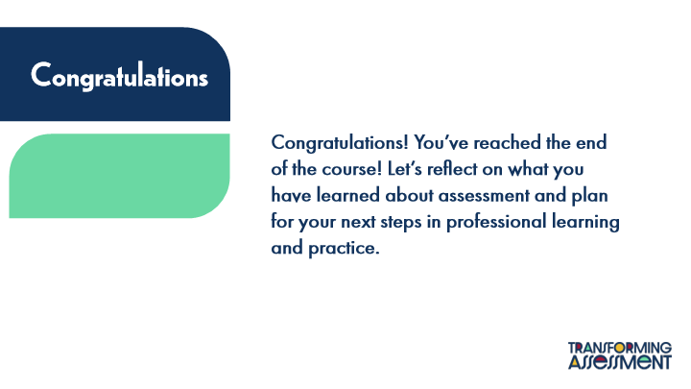

Type | Translation
Slide name | Congratulations
Text Box 5 | Congratulations
Text Box 6 | Congratulations! You’ve reached the end of the course! Let’s reflect on what you have learned about assessment and plan for your next steps in professional learning and practice.

19.3 Course Learning Outcomes Review
Slide ID 🔒 | c01c28ac-4aec-41e0-a725-35bffd7dce46
Preview Image | 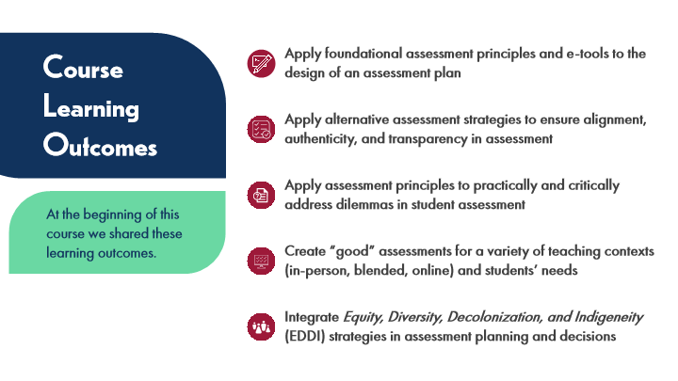

Type | Translation
Slide name | Course Learning Outcomes Review
Text Box 1 | Apply foundational assessment principles and e-tools to the design of an assessment plan
Text Box 5 | Course Learning Outcomes
Text Box 2 | Apply alternative assessment strategies to ensure alignment, authenticity, and transparency in assessment
Text Box 3 | Apply assessment principles to practically and critically address dilemmas in student assessment
Text Box 6 | At the beginning of this course we shared these learning outcomes.
Text Box 4 | Create “good” assessments for a variety of teaching contexts (in-person, blended, online) and students’ needs
Text Box 7 | Integrate Equity, Diversity, Decolonization, and Indigeneity (EDDI) strategies in assessment planning and decisions

19.4 Reflecting Back
Slide ID 🔒 | 1f3cdaa3-8cb2-433c-bc1e-82b9c6a16448
Preview Image | 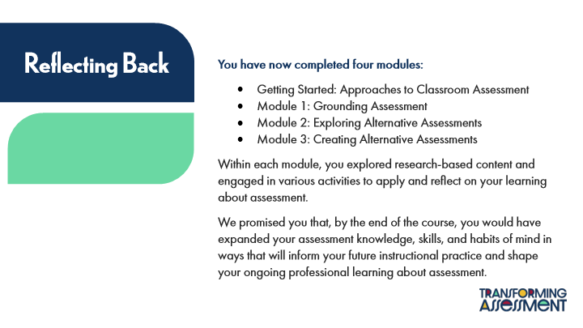

Type | Translation
Slide name | Reflecting Back
Round Diagonal Corner 1 | Reflecting Back
Text Box 6 | You have now completed four modules:
 | Getting Started: Approaches to Classroom Assessment
 | Module 1: Grounding Assessment
 | Module 2: Exploring Alternative Assessments
 | Module 3: Creating Alternative Assessments
 | Within each module, you explored research-based content and engaged in various activities to apply and reflect on your learning about assessment.
 | We promised you that, by the end of the course, you would have expanded your assessment knowledge, skills, and habits of mind in ways that will inform your future instructional practice and shape your ongoing professional learning about assessment.

19.5 Activity: KWL Revisited
Slide ID 🔒 | 4e9a4bfe-ead7-45d3-92e1-8d4d81ebd0c3
Preview Image | 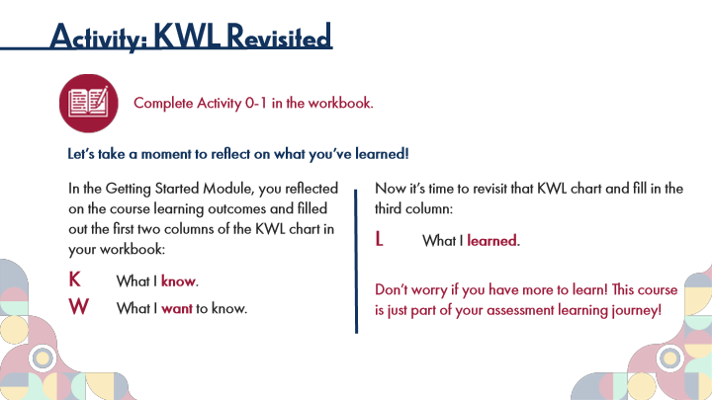

Type | Translation
Slide name | Activity: KWL Revisited
Main Title 1 | Activity: KWL Revisited
Text Box 1 | Complete Activity 0-1 in the workbook.
Text Box 5 | Let’s take a moment to reflect on what you’ve learned!
Text Box 4 | In the Getting Started Module, you reflected on the course learning outcomes and filled out the first two columns of the KWL chart in your workbook:
 | K
 | What I
 | know
 | .
 | W
 | What I
 | want
 | to know.
Text Box 3 | Now it’s time to revisit that KWL chart and fill in the third column:
 | L
 | What I
 | learned
 | .
 | Don’t worry if you have more to learn! This course is just part of your assessment learning journey!

19.6 Revisiting the ACAI
Slide ID 🔒 | 34cdf7e6-141a-49fe-9201-e2df0245a1f6
Preview Image | 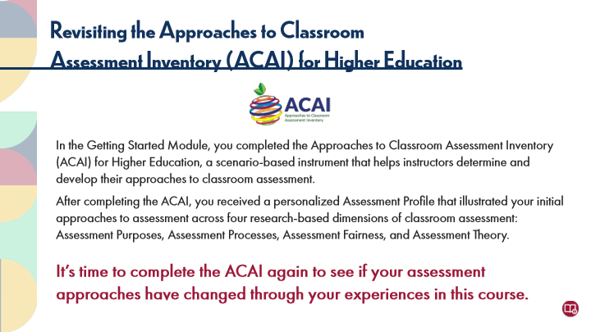

Type | Translation
Slide name | Revisiting the ACAI
Main Title 1 | Revisiting the Approaches to Classroom
 | Assessment Inventory (ACAI) for Higher Education
Text Box 1 | In the Getting Started Module, you completed the Approaches to Classroom Assessment Inventory (ACAI) for Higher Education, a scenario-based instrument that helps instructors determine and develop their approaches to classroom assessment.
 | After completing the ACAI, you received a personalized Assessment Profile that illustrated your initial approaches to assessment across four research-based dimensions of classroom assessment: Assessment Purposes, Assessment Processes, Assessment Fairness, and Assessment Theory.
 | It’s time to complete the ACAI again to see if your assessment approaches have changed through your experiences in this course.

19.7 Activity: Complete the ACAI
Slide ID 🔒 | 31869b3e-87fa-4a44-bb86-1c210fd7aae6
Preview Image | 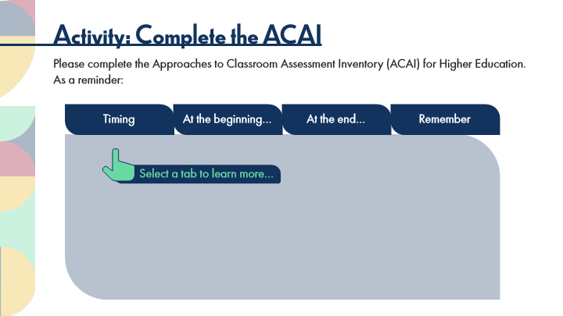

Type | Translation
Slide name | Activity: Complete the ACAI
Main Title 1 | Activity: Complete the ACAI
Text Box 1 | Please complete the Approaches to Classroom Assessment Inventory (ACAI) for Higher Education.
 | As a reminder:
Tab Button 1 - Normal state | Timing
Tab Button 2 - Normal state | At the beginning…
Tab Button 3 - Normal state | At the end…
Tab Button 4 - Normal state | Remember
Text Box 2 | Select a tab to learn more…

Slide Layer: Tips to Remember
Layer ID 🔒 | 4fd22c3d-a101-46cb-80d3-993788e2947e
Preview Image | 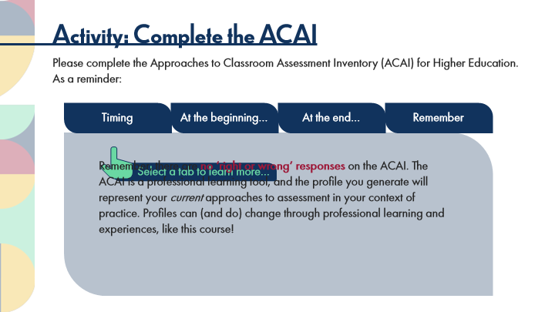

Type | Translation
Main Body 1 | Remember, there are
 | no ‘right or wrong’ responses
 | on the ACAI. The ACAI is a professional learning tool, and the profile you generate will represent your current approaches to assessment in your context of practice. Profiles can (and do) change through professional learning and experiences, like this course!

Slide Layer: End of the ACAI
Layer ID 🔒 | 92eb05ae-1a5d-4659-85cb-7fbc439bb131
Preview Image | 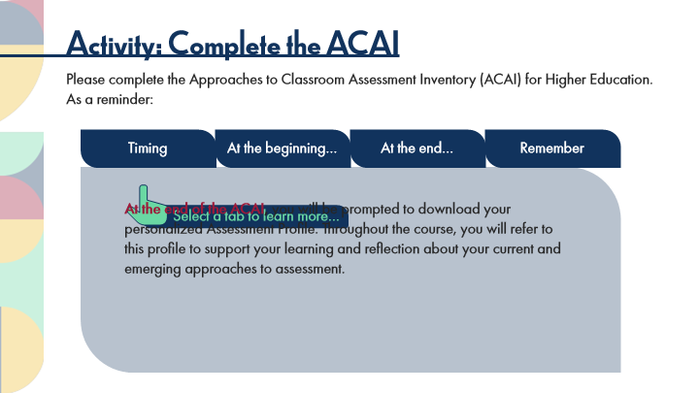

Type | Translation
Main Body 1 | At the end of the ACAI
 | , you will be prompted to download your personalized Assessment Profile. Throughout the course, you will refer to this profile to support your learning and reflection about your current and emerging approaches to assessment.

Slide Layer: Beginning the ACAI
Layer ID 🔒 | d86e9165-bef1-4da0-81ea-25f7966dd8c5
Preview Image | 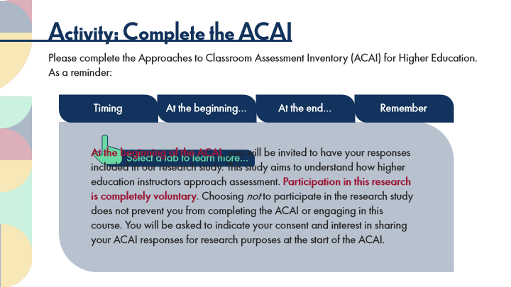

Type | Translation
Main Body 1 | At the beginning of the ACAI
 | , you will be invited to have your responses included in our research study. This study aims to understand how higher education instructors approach assessment.
 | Participation in this research is completely voluntary
 | . Choosing not to participate in the research study does not prevent you from completing the ACAI or engaging in this course. You will be asked to indicate your consent and interest in sharing your ACAI responses for research purposes at the start of the ACAI.

Slide Layer: TIming
Layer ID 🔒 | df70a46d-c5b6-49d3-82c5-6ac764b90dea
Preview Image | 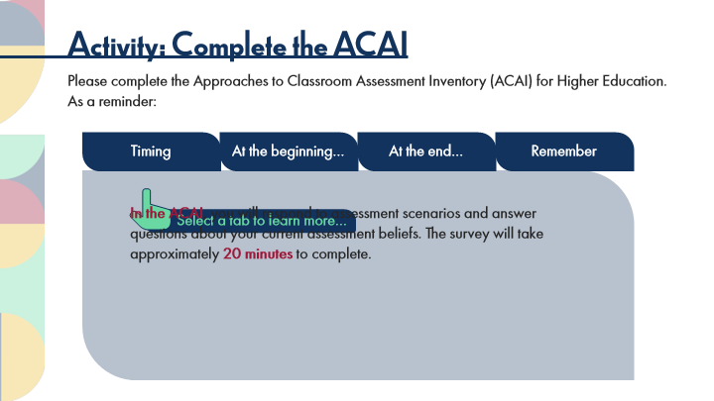

Type | Translation
Main Body 1 | In the ACAI
 | , you will respond to assessment scenarios and answer questions about your current assessment beliefs. The survey will take approximately
 | 20 minutes
 | to complete.

Slide Layer: Rollover: Scaffolding
Layer ID 🔒 | 42c2703a-a756-4d29-8dac-d4fe77050d59
Preview Image | 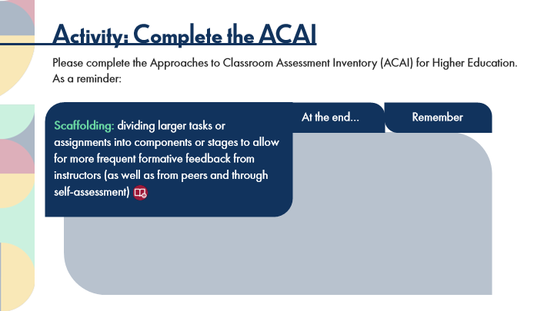

Type | Translation
Text Box 1 | Scaffolding:
 | dividing larger tasks or assignments into components or stages to allow for more frequent formative feedback from instructors (as well as from peers and through self-assessment)

19.8 Activity: Link to the ACAI
Slide ID 🔒 | 041910aa-8201-4e5e-99fb-0bb4de6d7103
Preview Image | 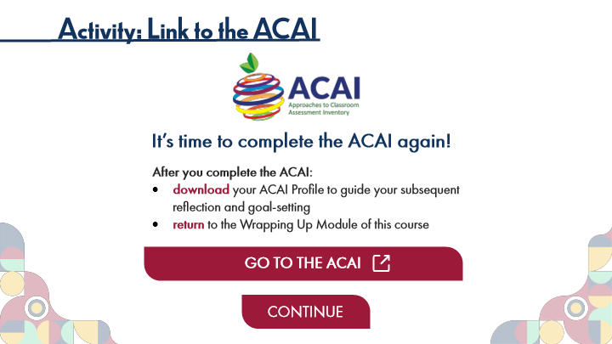

Type | Translation
Slide name | Activity: Link to the ACAI
Main Title 1 | Activity: Link to the ACAI
Alt text for Picture 1 | Logo with Text: ACAI Approaches to Classroom Assessment Inventory
Text Box 7 | It’s time to complete the ACAI again!
Text Box 8 | After you complete the ACAI:
 | download
 | your ACAI Profile to guide your subsequent reflection and goal-setting
 | return
 | to the Wrapping Up Module of this course
Button - Normal state | GO TO THE ACAI
Button - Normal state | CONTINUE

19.9 Pause and Reflect on Your ACAI Profile
Slide ID 🔒 | 3b9852a9-0305-4e56-8af3-fee7d62ce515
Preview Image | 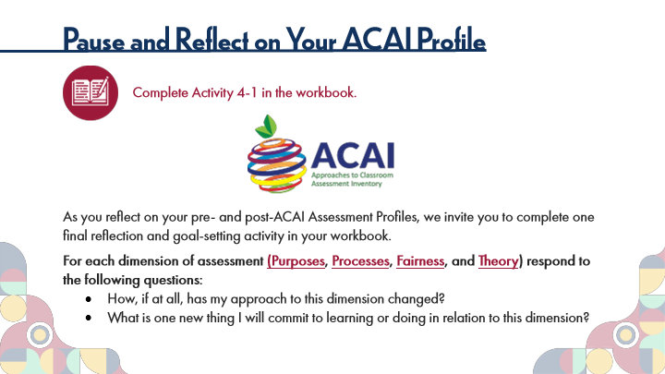

Type | Translation
Slide name | Pause and Reflect on Your ACAI Profile
Main Title 1 | Pause and Reflect on Your ACAI Profile
Text Box 6 | Complete Activity 4-1 in the workbook.
Text Box 7 | As you reflect on your pre- and post-ACAI Assessment Profiles, we invite you to complete one final reflection and goal-setting activity in your workbook.
 | For each dimension of assessment
 | (Purposes
 | ,
 | Processes
 | ,
 | Fairness
 | , and
 | Theory
 | ) respond to the following questions:
 | How, if at all, has my approach to this dimension changed?
 | What is one new thing I will commit to learning or doing in relation to this dimension?

Slide Layer: Purposes
Layer ID 🔒 | deea59cc-05f8-4408-bd3f-432d7c196c3f
Preview Image | 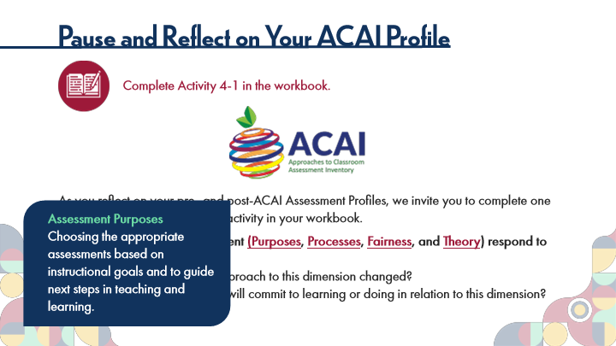

Type | Translation
Round Diagonal Corner 1 | Assessment Purposes
 | Choosing the appropriate assessments based on instructional goals and to guide next steps in teaching and learning.

Slide Layer: Processes
Layer ID 🔒 | e68f17de-f15c-4537-a182-12e9a799ae8a
Preview Image | 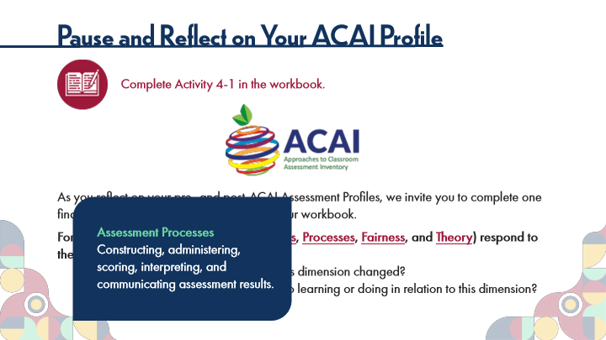

Type | Translation
Round Diagonal Corner 1 | Assessment Processes
 | Constructing, administering, scoring, interpreting, and communicating assessment results.

Slide Layer: Fairness
Layer ID 🔒 | f745e561-cda2-46aa-813c-45e518697a0b
Preview Image | 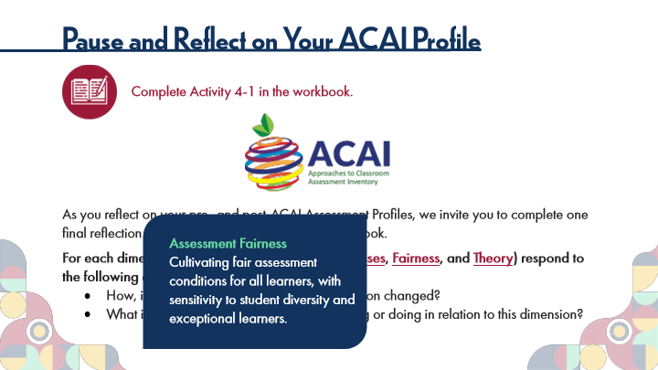

Type | Translation
Round Diagonal Corner 1 | Assessment Fairness
 | Cultivating fair assessment conditions for all learners, with sensitivity to student diversity and exceptional learners.

Slide Layer: Theory
Layer ID 🔒 | 70658e50-8283-4f15-8690-dbeeaf57ea74
Preview Image | 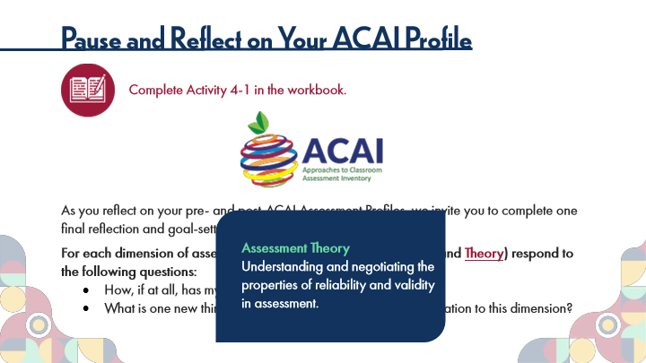

Type | Translation
Round Diagonal Corner 1 | Assessment Theory
 | Understanding and negotiating the properties of reliability and validity in assessment.

19.10 Experienced Practitioners on Moving Forward
Slide ID 🔒 | 7fc6a4cd-b248-498e-b5a3-87d3115bfd30
Preview Image | 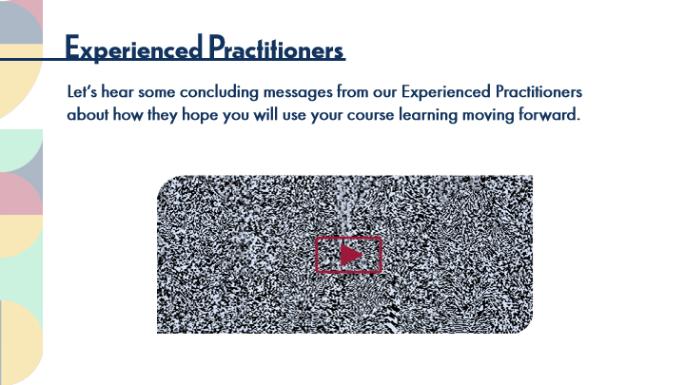

Type | Translation
Slide name | Experienced Practitioners on Moving Forward
Main Title 1 | Experienced Practitioners
Text Box 1 | Let’s hear some concluding messages from our Experienced Practitioners about how they hope you will use your course learning moving forward.

19.11 Closing Words
Slide ID 🔒 | b01745fd-5bc3-43e1-939a-5df8aeb091e2
Preview Image | 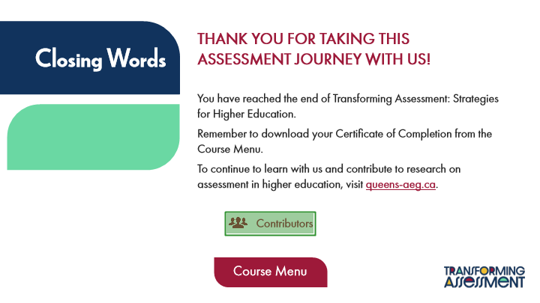

Type | Translation
Slide name | Closing Words
Text Box 6 | Thank you for taking this
 | assessment journey with us!
Text Box 5 | Closing Words
Text Box 7 | You have reached the end of Transforming Assessment: Strategies for Higher Education.
 | Remember to download your Certificate of Completion from the Course Menu.
 | To continue to learn with us and contribute to research on assessment in higher education, visit
 | queens-aeg.ca
 | .
Text Box 10 | Contributors
Alt text for Hotspot 3 | Button: Visit Course Contributors Page
Button - Normal state | Course Menu

20 Single Pages
Scene ID 🔒 | 38a3b9a0-1c75-4a40-a443-3eafad534c30

Type | Translation
Scene name | Single Pages

20.1 Course Contributors
Slide ID 🔒 | 67c35f19-0020-405d-ba92-038f0ed466ee
Preview Image | 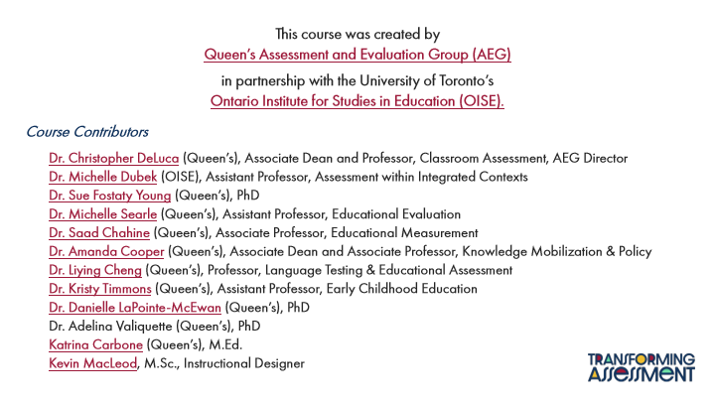

Type | Translation
Slide name | Course Contributors
Text Box 2 | This course was created by
 | Queen’s Assessment and Evaluation Group (AEG)
Text Box 3 | in partnership with the University of Toronto’s
 | Ontario Institute for Studies in Education (OISE).
Text Box 1 | Course Contributors
 | Dr. Christopher DeLuca
 | (Queen’s), Associate Dean and Professor, Classroom Assessment, AEG Director
 | Dr. Michelle Dubek
 | (OISE), Assistant Professor, Assessment within Integrated Contexts
 | Dr. Sue Fostaty Young
 | (Queen’s), PhD
 | Dr. Michelle Searle
 | (Queen’s), Assistant Professor, Educational Evaluation
 | Dr. Saad Chahine
 | (Queen’s), Associate Professor, Educational Measurement
 | Dr. Amanda Cooper
 | (Queen’s), Associate Dean and Associate Professor, Knowledge Mobilization & Policy
 | Dr. Liying Cheng
 | (Queen’s), Professor, Language Testing & Educational Assessment
 | Dr. Kristy Timmons
 | (Queen’s), Assistant Professor, Early Childhood Education
 | Dr. Danielle LaPointe-McEwan
 | (Queen’s), PhD
 | Dr. Adelina Valiquette (Queen’s), PhD
 | Katrina Carbone
 | (Queen’s), M.Ed.
 | Kevin MacLeod
 | , M.Sc., Instructional Designer

