The Decolonial Struggle – Manual



“The Decolonial Struggle” work is licensed under a **Creative Commons Attribution-NonCommercial-ShareAlike 4.0 International License.**

**Exceptions** to this license are the videos and the associated PDFs, which are licensed under a **Creative Commons Attribution-NonCommercial-NoDerivatives 4.0 International License.**

Contents

Accessibility Statement 3

Folder Components 3

Course Development Overview and Rationale 3

LMS Set Up: Overview 4

Basic Set Up 4

Course Components 4

Course Home Page (optional) 4

Syllabus 5

Timeline 6

Modules 6

Videos 7

Video 7

Accessible PDFs 7

Articulate RISE Module (“Your Module Bundles”) 7

Assessments 8

Instructions 8

Rubrics 9

Live Sessions 9

Course Feedback Surveys 9

Course Questions Forum (optional) 9

Helpful Links (optional) 9

# Accessibility Statement

We developed this course with a commitment to accessibility and usability for all learners.

The accessibility of this course was assessed using the [Accessibility Checklist for OER Development developed by Conestoga Library Services](https://lib.conestogac.on.ca/adapt-create-oers/oer-accessibility). The course authors have addressed all known accessibility issues to the best of their abilities.

The following known accessibility issues persist and may cause difficulties for some persons with disabilities:

* Links open in new tabs.

# Folder Components

The folder contains all the necessary items for you to create the course in your institution’s LMS. The folder contains the following folders and files:

1. **Common Cartridge**
2. **Course Documentation** (back up Word files – not for import directly to LMS)
   1. Assessments and Activities (all instructions and rubrics)
   2. Syllabus
   3. Timeline and Module Overviews
3. **Multimedia:** 
   1. Videos
      1. Accessible PDFs (alternative format to video files)
      2. Video files (mp4)
   2. Your Module Bundles
      1. Accessible PDF (alternative format to interactive RISE module)
      2. RISE SCORM package (requires license – see “RISE Modules” section for preview link for options)

# Course Development Overview and Rationale

This Indigenous‐developed online course attends to the role of decolonial thought and practice in building more just, equitable, and socially responsible communities in settler colonial states such as Canada. The development of this course responds to the Truth and Reconciliation Commission’s (TRC) 2015 ‘Calls to Action’ report, which calls on post‐secondary institutions to provide educational opportunities related to topics and issues significant to Indigenous Peoples and their communities. Students gain valuable knowledge and skills that prepare and empower them to make personal and systemic changes for a more equitable and sustainable future, challenging them to critically examine the ways in which settler colonialism and decolonization have shaped the social, political, historical and economic landscapes of settler states such as Canada and the United States. The course centres the relational dynamics between non‐Indigenous and Indigenous Peoples in settler states and their institutions. Students learn about the challenges of decolonization, how various forms of settler colonialism impact the relationship between Indigenous and non‐Indigenous Peoples, and the various ways that these groups can work collaboratively towards decolonization through processes of ‘unlearning’.

# LMS Set Up: Overview

## Basic Set Up

1. Import Common Cartridge
2. Upload SCORM file for RISE module (“Your Module Bundles”) (optional – can use preview link instead if your institution doesn’t have a RISE license) (see “RISE Module “Your Module Bundles”)
3. Host videos (see videos)
4. Add accessible PDFs (see videos)
5. Add internal links (e.g., to dropboxes, etc.). These course components will be [bracketed in blue]. Keep the phrasing and add links only.
6. Add institutional/course-specific info (e.g., in the syllabus, homepage, help, etc.). These prompts will be [bracketed in red]. Add your own information.

# Course Components

## Course Home Page (optional)

The course home page is where general course information is displayed. In the Queen’s University LMS, distinct information contained within widgets (which do not export in the common cartridge) may be applicable to your institution and you may want to add and display the same institution-specific information or similar on your course home page, as follows:

* Course announcements: These are general course updates, messages from the instructor, etc., that get sent out to the course participants when published.
* Teaching Team resources: This widget usually contains helpful resources for the teaching team such as LMS training videos, a TA resource guide, information on migrating grades out of the LMS, a guide for video-conferencing software, etc.
* Teaching Team: This widget typically contains quick info on the teaching team, e.g., names and photos of the instructor and TA(s). It may also link to a separate HTML page with additional information like photos, bios, and contact information.
* Course Essentials: This might include essential resources like a video on how to navigate the LMS course, a link to the library, or other timely information.
* Accommodations and Considerations: In the Queen’s LMS, this widget contains quick links for students to submit a Letter of Accommodations or to request academic consideration.

These components are all optional to include.

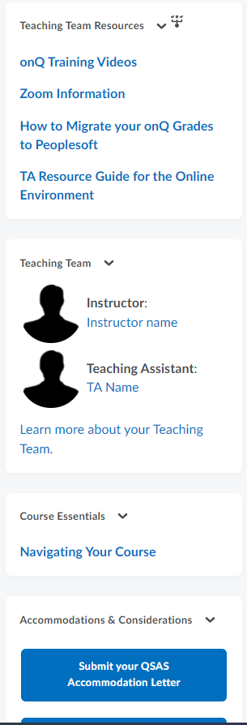

Figure 1: A screenshot of some of the widgets that appear in D2L on the course home page.

# Syllabus

The syllabus contains four sections: Information, Assessments, Communication, and Policies. You may wish to strip any sections of the syllabus that do not pertain to your course or institution. Feel free to remake the syllabus in a way that fits with your templates and processes.

Within the syllabus, anywhere you see a placeholder [bracketed in red], institutional or course-specific details are required. For sustainability purposes, the syllabus currently does not contain dates or links to assessments within the course. Assigned weekly materials and assessment due dates are found in the modules and timeline.

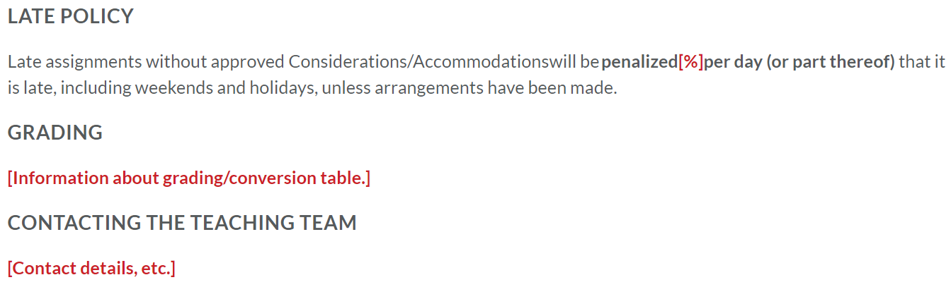

Figure 2: A screenshot of a small section of the syllabus showing some text bracketed in red.

## Timeline

The current timeline shows all relevant course dates, including assessments, as well as links to other important course information.

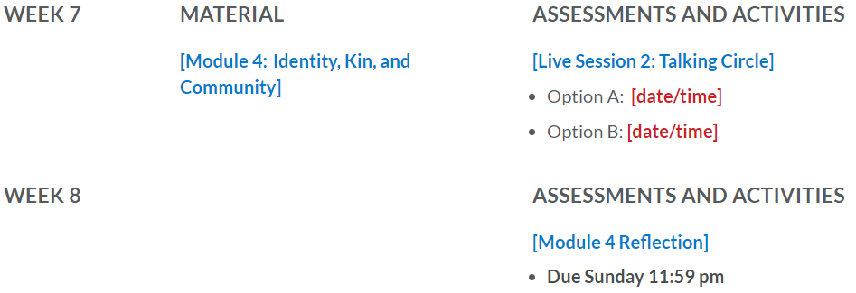

For sustainability purposes, the timeline currently is the only spot within the course where dates are designed to appear that this information will only ever need to be updated in the timeline. Anywhere you see a resource or course component [bracketed in blue], input a link to the associated resource/course component. Anywhere you see details [bracketed in red], input information specific to the delivery of your course (i.e., dates and times).

## Modules

The Modules (aka Module Overviews) are made up of six sections – the Overview, Key Concepts and Terminology, Learning Outcomes, Required Materials, Guiding Questions, and Weekly Activities.

Anywhere you see a resource or course component [bracketed in blue], input a link to the associated resource/course component. You will need to input links to the timeline, SCORM package content, videos, assessment overview pages, and PDFs. For sustainability purposes, the modules do not currently refer to any dates.

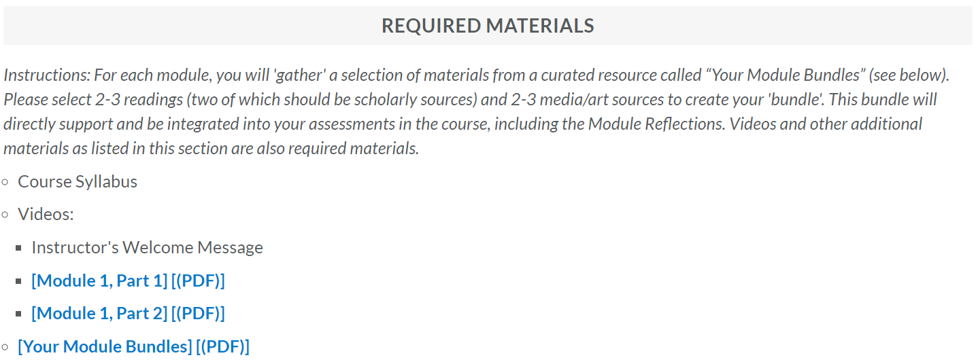

Figure 3: The Required Materials section of the Module 1 Overview page with some text bracketed in blue.

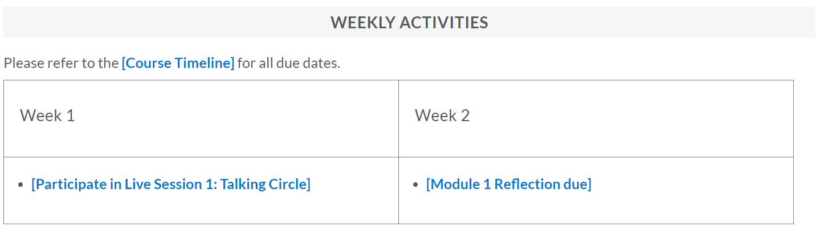

Figure 4: The Weekly Activities section of the Module 1 Overview page with some text bracketed in blue.

## Videos

Video files will need to be hosted and then linked.

A folder of transcripts is provided. These video transcripts have been reviewed and corrected for accurate spelling of Indigenous languages. You are encouraged to include these transcripts with the videos.

You’ll notice that there is a placeholder in Module 1 for an “Instructor's Welcome Message”. The instructor facilitating the course (if relevant) may wish to record a video welcoming the students to the course and providing an overview. If not, delete this placeholder.

Accessible PDFs have also been provided to accompany each video, except for the interview. You are encouraged to include these PDFs with the videos to support students with accessibility needs.

## Articulate RISE Module (“Your Module Bundles”)

This resource is a curated list of resources for the course, including readings, websites, videos, etc.

For a general understanding of the procedure, the following are basic instructions for how to upload the Rise SCORM package in D2L (this may be different in your LMS).

1. Download SCORM package from the public folder ‘The Decolonial Struggle’ on SharePoint.
2. Upload the zipped SCORM package to Manage Files.
3. Unzip the package contents in Manage Files.
4. If linking to the Rise content in the Module Overviews (like we have), input the text that you will be hyperlinking (e.g., in our course it is called “Your Module Bundles”).
5. Link to the Rise content by creating a hyperlink to the file called “index.html”. This is found by following this path: the-decolonial-struggle-your-module-bundles-scorm12-XX71Ahns (or your file name if you’ve renamed it) > scormcontent > index.html

To get an idea of what the resource looks like in RISE, and to help you confirm whether there are any issues with images or otherwise once you import the package, please use this preview link: [Rise Preview Link](https://can01.safelinks.protection.outlook.com/?url=https%3A%2F%2Frise.articulate.com%2Fshare%2F3EymBvDjho7_ewM5ixDtOGqdGUQiYGCF&data=04%7C01%7Cdanielle.dsouza%40queensu.ca%7C638d0fdb732745ce0e5d08d9f6f045e0%7Cd61ecb3b38b142d582c4efb2838b925c%7C1%7C0%7C637812334085331899%7CUnknown%7CTWFpbGZsb3d8eyJWIjoiMC4wLjAwMDAiLCJQIjoiV2luMzIiLCJBTiI6Ik1haWwiLCJXVCI6Mn0%3D%7C3000&sdata=E%2Bl00TZ80az665Y8Q2xfcZS5vE03SC5QA%2FwG4busgpM%3D&reserved=0).

Once you have imported the SCORM package contents, you may wish to check the links to ensure that they are still live and functioning.

If your institution has a license with Articulate 360 (Rise 360) and you would like to be given access to an editable copy of the Rise module, please contact the team at [asomm@queensu.ca](mailto:asomm@queensu.ca) and we will share a copy of the course with you.

## Assessments

There are four assessments within this course, all of which are submission-based. Some set up tasks related to the assessments:

* Create dropboxes for students to submit their work
* If your LMS uses embedded rubrics, you may want to create these in your LMS and link them to their respective assessment (please see the course documentation for rubrics as Word docs); HTML versions of the rubrics are also provided.

### Instructions

Each assessment includes similar sections (e.g., Assessment Overview and Learning Outcomes, Background/Rationale section, Support and Resources, and the Instructions for students that provide procedural steps for completing the assessments). “Quick Links” are included on the left-hand side of each assessment page. Anywhere you see a resource or course component [bracketed in blue], input a link to the associated resource/course component. These link to the assessment dropbox, the assessment rubric, and any other pertinent resources for students.

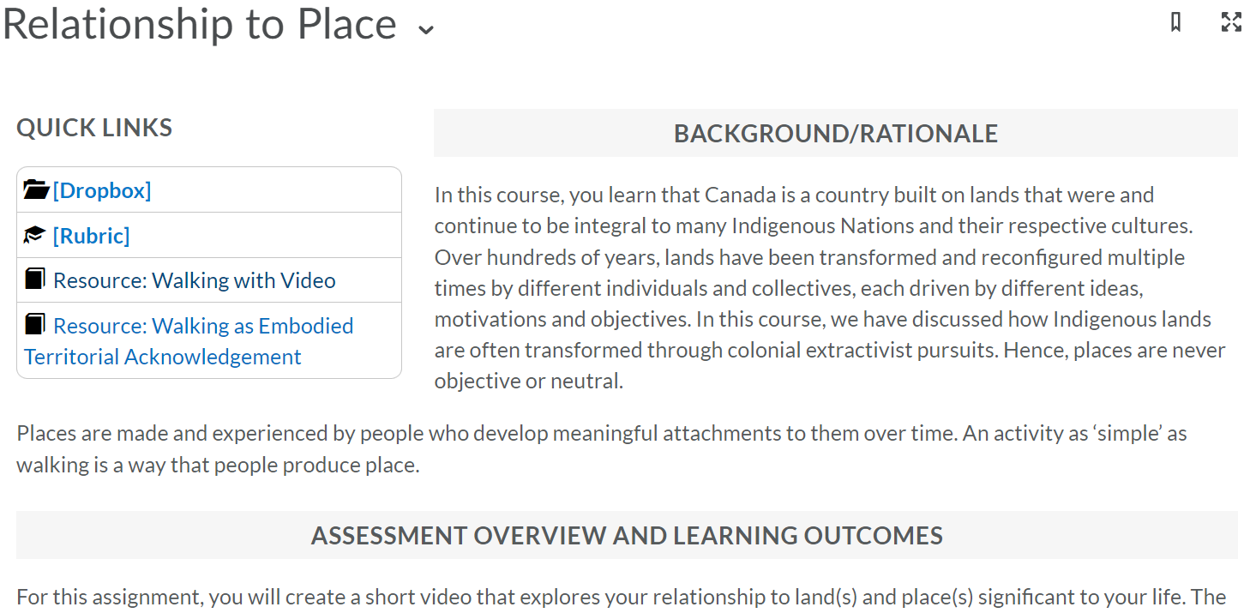

Figure 5: A screenshot of a small section of the Relationship to Place assessment showing some Quick Link text bracketed in blue.

### Rubrics

Each assessment within this course has an associated rubric. The embedded rubrics could not be exported with the common cartridge so you will note that they have been added as Word documents in the folder and have also been recreated as HTML pages for the LMS. You may wish to use the Word document for the associated rubric for each assessment to create an embedded rubric within your LMS for evaluation purposes. If your LMS doesn’t have embedded rubrics, you may want to provide a link to the relevant HTML pages required. Quick Links were designed to link to the rubrics so that expectations are transparent for students.

## Live Sessions

The Timeline and Modules include Live Sessions scheduled at recommended points in the course. You may wish to move these sessions to different weeks, depending on the schedules of the instructors, students, etc. You can also reframe these live sessions as needed (i.e., they are currently “talking circles” but could be content review sessions, office hours, etc.).

## Course Feedback Surveys

The Course Feedback Surveys are offered in the course package as a tool for the instructor to collect feedback to identify and address student needs during the course delivery and to revise the course between offerings. Note that although the surveys are exported with the common cartridge, they may import to your LMS as quizzes.

## Course Questions Forum (optional)

You may wish to include a Course Questions Forum in the discussion section of your course. Here, students can ask questions to the teaching team for the rest of the class to see and for the teaching team to publicly respond to and provide timely support for students.

## Helpful Links (optional)

At our institution, this page contains timely links to support students with immediate questions they may encounter. If you plan to use this in your course, it might contain links to the institution writing centre, library resources, resources for BIPOC and/or 2SLGBTQIA+ students, important dates and deadlines, accessibility services, IT support pages, or other learning and student wellness resources available to students through the institution.