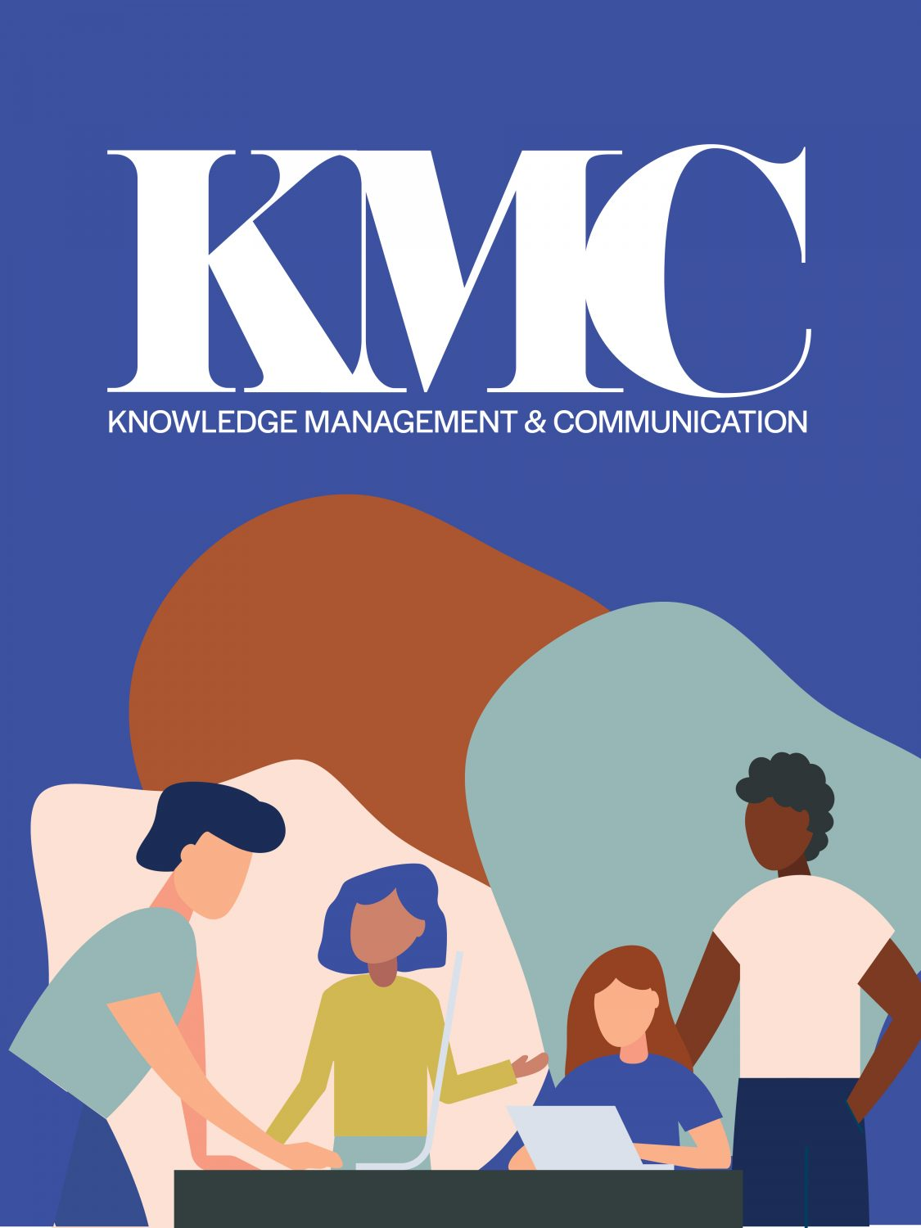

Knowledge Management and Communication

Knowledge Management and Communication

Ontario University Research Collaboration
Cathy Bruce; Bradley Maclean; Connor Loughlean; Dana Capell; David Hobson; David Phipps; Doug Knox; Elizabeth Shantz; Farzana Crocco; Jason Muloongo; Jayne Morrish; Jessica Bowes; Jim Banting; Julie Gregory; Katrina Keefer; Les Jacobs; Margo Langford; Michelle Stringer; Shawna Reibling; Stephanie Whitney; and Steve De Brabandere
Lillian Chumbley; James Bailey; and Ashley Horne

Knowledge Management and Communication by Trent University is licensed under a Creative Commons Attribution-NonCommercial-ShareAlike 4.0 International License, except where otherwise noted.

Contents
- About This Module
- Funding Recognition
- Land Acknowledgement
- Introduction to Knowledge Management and Communication
- Introduction to Knowledge Management and Communications | Synopsis
- Introduction to Knowledge Management and Communications | Setting the Scene
- Introduction to Knowledge Management and Communications | Video Introduction
- Introduction to Knowledge Management and Communications | Learning Outcomes & Resources
- Introduction to Knowledge Management and Communications | Activities Checklist
- Introduction to Knowledge Management and Communications | Definitions
- Introduction to Knowledge Management and Communications | The Need
- Introduction to Knowledge Management and Communications | The What
- Introduction to Knowledge Management and Communications | Models and Frameworks
- Introduction to Knowledge Management and Communications | Models and Frameworks 2
- Introduction to Knowledge Management and Communications | Models and Frameworks 3
- Introduction to Knowledge Management and Communications | Building a KMb Plan
- Introduction to Knowledge Management and Communications | Building a Communication Plan: Toolkits
- Introduction to Knowledge Management and Communications | Clear Language Communication
- Introduction to Knowledge Management and Communications | How to use Clear Language
- Introduction to Knowledge Management and Communications | Module Assessment Tool and Evaluation Guide
- Introduction to Knowledge Management and Communications | Summary and a Look Ahead
- Introduction to Knowledge Management and Communications | Credits
- Communication Tools and Strategies
- Communication Tools and Strategies | Synopsis
- Communication Tools and Strategies | Setting the Scene
- Communication Tools and Strategies | Video Introduction
- Communication Tools and Strategies | Learning Outcomes & Resources
- Communication Tools and Strategies | Activities Checklist
- Communication Tools and Strategies | Introduction to Communication Plans
- Communication Tools and Strategies | Understanding Communication Plans
- Communication Tools and Strategies | Strategy vs. Plan
- Communication Tools and Strategies | Components of Communication Plans: Define your goals
- Communication Tools and Strategies | Key Components of a Communication Plan | Define your audience and channels
- Communication Tools and Strategies | Key Components of a Communication Plan | Determining your message and content
- Communication Tools and Strategies | Key Components of a Communication Plan | Measuring success
- Communication Tools and Strategies | Best Practices and Key Considerations
- Communication Tools and Strategies | Brand Guidelines
- Communication Tools and Strategies | Communicating with a non-academic audience
- Communication Tools and Strategies | Understanding your Value Proposition
- Communication Tools and Strategies | Presentation Development and Delivery
- Communication Tools and Strategies | Communicating with media
- Communication Tools and Strategies | Other considerations
- Communication Tools and Strategies | Communications Resources and Templates
- Communication Tools and Strategies | Communication Tools and Resources
- Communication Tools and Strategies | Communications Resources and Templates | Presentation Tools
- Communication Tools and Strategies | Communications Resources and Templates | Communication Tools
- Communication Tools and Strategies | Module Assessment Tool and Evaluation Guide
- Communication Tools and Strategies | Summary and a Look Ahead
- Communication Tools and Strategies | Curated links
- Communication Tools and Strategies | Credits
- Community Engagement and Collaboration
- Community Engagement and Collaboration | Synopsis
- Community Engagement and Collaboration | Setting the Scene
- Community Engagement and Collaboration | Video Introduction
- Community Engagement and Collaboration | Activities Checklist
- Community Engagement and Collaboration | Re-introduction to Sharing and Using Knowledge and the “Knowledge-to-Action Gap”
- Community Engagement and Collaboration | Re-introduction to Sharing and Using Knowledge and the “Knowledge-to-Action Gap” 2
- Community Engagement and Collaboration | Worksheet Sections 1 to 10
- Community Engagement and Collaboration | Learning Outcomes and Resources
- Community Engagement and Collaboration | Introduction to key considerations for community engagement within KMb
- Community Engagement and Collaboration | Module Assessment Tool and Evaluation Guide
- Community Engagement and Collaboration | Introduction to community engagement within the knowledge mobilization process
- Community Engagement and Collaboration | CONTINUUM OF ENGAGEMENT
- Community Engagement and Collaboration | VALUING COMMUNITY-BASED KNOWLEDGE
- Community Engagement and Collaboration | COMMUNITY-BASED PARTICIPATORY RESEARCH PRINCIPLES, BENEFITS & SUPPORT IMPLICATIONS
- Community Engagement and Collaboration | Curated Links
- Community Engagement and Collaboration | Community engagement and the Lavis model for KMb
- Community Engagement and Collaboration | Considerations | Accessibility
- Community Engagement and Collaboration | Considerations | Equity, diversity, and inclusion
- Community Engagement and Collaboration | Considerations | Capacity to collaborate
- Community Engagement and Collaboration | Considerations | Readiness to Collaborate
- Community Engagement and Collaboration | Considerations | Staffing
- Community Engagement and Collaboration | Considerations | Budget
- Community Engagement and Collaboration | Considerations | Funding Opportunities
- Community Engagement and Collaboration | Introduction to some early recommendations for tracking and evaluating community engagement within KMb
- Community Engagement and Collaboration | Introduction to some early recommendations for tracking and evaluating community engagement within KMb 2
- Community Engagement and Collaboration | Curated Links 2
- Community Engagement and Collaboration | Worksheet Section 17
- Community Engagement and Collaboration | Case Studies
- Community Engagement and Collaboration | Brock University Lifespan Development Research Institute - Community Advisory Groups
- Community Engagement and Collaboration | Brock University Social Justice Research Institute – Community Partnerships
- Community Engagement and Collaboration | Final Worksheet Review and Post-Assessment
- Community Engagement and Collaboration | Summary and a Look Ahead
- Community Engagement and Collaboration | Curated Links
- Community Engagement and Collaboration | Credits
- Social Media
- Social Media | Synopsis
- Social Media | Setting the Scene
- Social Media | Video Introduction
- Social Media | Learning Outcomes & Resources
- Social Media | Social Media as Communication Tools
- Social Media | Understanding Social Media
- Social Media | Understanding Social Media 2
- Social Media | Similarities and Differences of Communications Tools
- Social Media | Types of Social Media Tools
- Social Media | Determining your Social Media Use Case
- Social Media | Social Media Audience Demographics
- Social Media | What is your Digital Identity
- Social Media | Your Academic Institution and Social Media Accounts
- Social Media | Your Social Media Strategy
- Social Media | Institutional Social Media Supports
- Social Media | Planning your Social Media Strategy
- Social Media | Planning your Social Media Strategy | Articulate who you are on Social Media
- Social Media | Planning your Social Media Strategy | Identify your Audience
- Social Media | Planning your Social Media Strategy | Set a Goal
- Social Media | Planning your Social Media Strategy | How to Measure Success of the Goal
- Social Media | Planning your Social Media Strategy | How to Measure Success of the Goal | Altmetrics
- Social Media | Planning your Social Media Strategy | Outline Tactics to Achieve the Goal
- Social Media | Completing your social media strategy
- Social Media | How to Share Content Effectively
- Social Media | Examples of Social Media Strategies
- Social Media | Documenting your Digital Content
- Social Media | Best Practices of Common Social Media Platforms
- Social Media | Best Practices of Common Social Media Platforms | Twitter
- Social Media | Best Practices of Common Social Media Platforms | Facebook
- Social Media | Best Practices of Common Social Media Platforms | YouTube
- Social Media | Best Practices of Common Social Media Platforms | LinkedIn
- Social Media | Best Practices of Common Social Media Platforms | Pinterest
- Social Media | Best Practices of Common Social Media Platforms | Medium.com
- Social Media | Creating an Online Presence for you Academic Conference
- Social Media | Get Ready to Share your Digital Content
- Social Media | Integrating your Social Media Strategy and Communications Plan
- Social Media | Module Assessment Tool and Evaluation Guide
- Social Media | Summary and a Look Ahead
- Social Media | Curated Links
- Social Media | Credits
- Data Sharing and Usage
- Data Sharing and Usage | Synopsis
- Data Sharing and Usage | Setting the Scene
- Data Sharing and Usage | Video Introduction
- Data Sharing and Usage | Learning Goals and Resources
- Data Sharing and Usage | Activities Checklist
- Data Sharing and Usage | What is Data?
- Data Sharing and Usage | Categories of Rights/Obligations Associated with Data
- Data Sharing and Usage | Intellectual Property Rights and Use Considerations related to data
- Data Sharing and Usage | Personal Health Information Protection Act (PHIPA)
- Data Sharing and Usage | General Data Protection Regulations (GDPR)
- Data Sharing and Usage | GDPR Checklist
- Data Sharing and Usage | Indigenous Data
- Data Sharing and Usage | First Nations Principles of Ownership, Control, Access, and Possession (OCAP)
- Data Sharing and Usage | Data Mapping
- Data Sharing and Usage | Data Sharing/Transfer Agreements with Partners
- Data Sharing and Usage | Credits
- Data Sharing and Usage | Summary and a Look Ahead
- IP and Commercialization
- IP and Commercialization | Synopsis
- IP and Commercialization | Setting the Scene
- IP and Commercialization | Introductory Video
- IP and Commercialization | Curated Links
- IP and Commercialization | Learning Outcomes & Resources
- IP and Commercialization | Activities Checklist
- IP and Commercialization | Technology Transfer
- IP and Commercialization | Technology Transfer | Research and Discovery
- IP and Commercialization | Technology Transfer | Readiness
- IP and Commercialization | Intellectual Property Basics
- IP and Commercialization | Intellectual Property Basics | Patents and Trademarks
- IP and Commercialization | IP Strategy
- IP and Commercialization | Curated Links 2
- IP and Commercialization | Introduction to Entrepreneurship
- IP and Commercialization | Introduction to Entrepreneurship | Types of Entrepreneurship
- IP and Commercialization | Introduction to Entrepreneurship | De-risking Inventions from Academia
- IP and Commercialization | Curated Links 3
- IP and Commercialization | Value Propositions & Positioning
- IP and Commercialization | Market Analysis
- IP and Commercialization | Curate Links 4
- IP and Commercialization | Commercialization & Managing Intellectual Property
- IP and Commercialization | Commercialization & Managing Intellectual | Validation
- IP and Commercialization | Managing your Intellectual Property Assets
- IP and Commercialization | Curated Links 6
- IP and Commercialization | Module Assessment Tool and Evaluation Guide
- IP and Commercialization | Summary and a Look Ahead
- IP and Commercialization | Credits
- Resources on Influencing Policy
- Resources on Influencing Policy | Setting the Scene
- Resources on Influencing Policy | Video Introduction
- Resources on Influencing Policy | Learning Outcomes & Resources
- Resources on Influencing Policy | Activities Checklist
- Resources on Influencing Policy | The Co-Produced Pathways to Impact Framework (CPPI)
- Resources on Influencing Policy | Writing a Policy Brief
- Resources on Influencing Policy | Holding an Accessible Policy Brief Meeting
- Resources on Influencing Policy | Credits
- Culminating Assessment: Creating a Knowledge Management and Communication Plan
- Culminating Assessment | Synopsis
- Culminating Assessment | Setting the Scene
- Culminating Assessment | Introductory Video
- Culminating Assessment | Activities Checklist
- Culminating Assessment | Learning Outcomes & Resources
- Culminating Assessment | Creating the KMb
- Culminating Assessment | Evaluation Criteria
- Culminating Assessment | Credits
- References

1
Researchers across the natural sciences, sciences, engineering, businesses, humanities and social sciences in Ontario are rapidly generating important findings and new knowledge as leaders in Canada and internationally. However, managing and communicating that knowledge is rarely part of formal training or ‘know-how’. Further, researchers may not have explicit strategies for connecting with industry and government partners to move the knowledge forward. Knowledge Management is an integrated approach to defining, structuring, retaining and sharing knowledge. It also involves networking, building community partnerships, and understanding market uses. Knowledge Management has at its core, the purpose of sharing knowledge in a strategic approach with the right partners at the right time in order to reduce overlap, inform policy and decision-making, and accelerate innovations. This project will involve eight higher education institutions working together to generate a series of learning modules that can be bundled for a professional development program and/or micro-credential for students and early career researchers.

2

Funding Recognition

This project is made possible with funding by the Government of Ontario and through
eCampusOntario’s support of the Virtual Learning Strategy. To learn more about the Virtual
Learning Strategy visit: https://vls.ecampusontario.ca.



3

Land Acknowledgement
Collaborating Ontario universities involved in this project recognize that the work took place on traditional Indigenous territories across the province. We acknowledge that there are 46 treaties and other agreements that cover the territory now called Ontario.
We encourage you to research and learn the traditional people, territories, languages and treaties of the land on which you study and learn.

I

Introduction to Knowledge Management and Communication

What approach would you like to take in order to share and exchange knowledge with non-academic stakeholders? How will you manage your data effectively? How might you communicate research findings, and ultimately increase the impact of your research?

1

Introduction to Knowledge Management and Communications | Synopsis

Knowledge management and communication of research has become increasingly important to research funders, decision-makers in industry, government and the community, and members of the public. A strong knowledge management strategy (developing or using systems to manage access and use of your data) and a strong communication plan (moving your research knowledge in focused ways and more broadly) will help you to maximize the impact of your research – ultimately influencing social, health, environmental or economic changes within Canada and beyond.
This course will walk you through the various components of knowledge management and communication. You’ll learn how to manage and share your data, tools to communicate your research, principles of social media engagement, guidelines to engage with communities, support for intellectual property management and commercialization, and strategies to engage with policy-makers.
This introductory module will help you to think more deeply about knowledge management and mobilization. You’ll learn about various definitions and models of knowledge mobilization, the benefits of engaging with end users, and the basics of plain language communication – supporting you to start building a knowledge mobilization plan of your own.

2

Introduction to Knowledge Management and Communications | Setting the Scene

Let’s assume you are preparing to apply for a large grant, either on your own or with a team. You are incredibly excited about this new program of research – not only is the research question academically novel, but the research focuses on a question that’s being asked by decision-makers in government, industry and the community as well.

As you start to think about the proposal, though, a number of questions come to mind.
- There’s so much potential for impact in this work – how can you plan to maximize that impact from the very start of the project?
- Who else is interested in this area, and how should you involve them in the project?
- What kind of data, products or knowledge might result from this research, and how can you best share them to ensure others can use this information?
- What are funders even looking for in a knowledge mobilization plan?
You know that these questions will take some time to answer and decide to learn more about knowledge management to ensure that this project uses best practices, has a solid plan to communicate research to partners and stakeholders, and is well-positioned to achieve the impact you know this project can have.
This Knowledge Management and Communication course will support your research, your strategy and provide you with tangible products for career development.

3

Introduction to Knowledge Management and Communications | Video Introduction

An interactive H5P element has been excluded from this version of the text. You can view it online here:
https://ecampusontario.pressbooks.pub/knowledgemanagement/?p=90#h5p-3

4

Introduction to Knowledge Management and Communications | Learning Outcomes & Resources


Proposed Learning Goals
By the end of the module, you will be able to:
- Demonstrate an understanding of the skills required for effective knowledge management and research communications.
- Understand why knowledge management and research communications are important and learn about the barriers or challenges for researchers and industry/government/community members.
- Identify the key elements of a knowledge management and communications plan
- Learn about the basic principles of effective clear language communication.

Learning Resources and Readings
In order to complete the module, you will need to consult a variety of readings and resources that are linked throughout the module.
If there are specific areas of this module that you wish to explore in more detail, we have suggested a list of materials in the Deeper Dive section that can help further your understanding.

5

Introduction to Knowledge Management and Communications | Activities Checklist


In order to successfully complete this module, you should:
- Complete assigned readings
- Work through each module page
- Complete interactive activities
- Complete and submit self assessment
- Review the deeper dive materials

6

Introduction to Knowledge Management and Communications | Definitions
This short course will provide you with a foundation in knowledge management and communication of research, supporting your efforts to manage and mobilize research findings with government, industry, researchers, the broader community and the public. This particular module focuses on the basics of knowledge management and communication; to begin, we review a few of the definitions used in this course.
We use the term knowledge management here to describe all of the various activities involved in storing and managing data as well as sharing research data with the broader community, which may include knowledge mobilization and communication of findings, forms of knowledge creation and collaboration, data sharing and intellectual property protection, and commercialization, among others.

Knowledge mobilization is a term used to describe the various activities that help move knowledge between those who create it and those who could use it. The goal of knowledge mobilization is to make research accessible, relevant and useful to non-academic audiences – supporting the movement of knowledge into active use and ultimately resulting in positive impacts for society. There are many definitions of knowledge mobilization; in some cases this definition is inclusive of activities such as commercialization and IP protection, while in other cases knowledge mobilization is considered to be distinct[1][2]. Sometimes knowledge mobilization is informational in nature, and focuses on a linear dissemination of knowledge from producer to end user, while in other cases, knowledge mobilization activities may span a variety of other activities focused on exchange of knowledge or co-production of knowledge or innovation by research users and producers.[3]
There are a variety of activities that can be part of knowledge mobilization, including:
- Knowledge synthesis
- Knowledge dissemination
- Knowledge co-creation
- Knowledge exchange
- Evaluation of research impact
Although the activities involved in knowledge mobilization are not new, the terminology and emergence of knowledge mobilization as a distinct field are relatively recent[4]. As such, there is variation in both the definition of knowledge mobilization and the terminology used to describe this process. Other terms may include knowledge translation, knowledge transfer, knowledge exchange, knowledge brokering, knowledge communication, research extension, knowledge co-production, or even K* – an acronym meant to incorporate the various terms that describe this umbrella of activities. The terminology of choice largely differs based on sector or geographic location.
Knowledge mobilization also overlaps significantly with strategic communication activities; the major difference is in the content of these activities, with strategic communications often having a goal of supporting an institution’s goals and strategic plan, and knowledge mobilization more focused on sharing the results of research with a specific goal of uptake and use. That said, the boundary between these functions is not always that clear-cut, with science communicators and research-based communications professionals sharing overlapping functions.

Read the field note on
.
End users or stakeholders is a term we use in this course to describe those individuals who could use research or make decisions informed by evidence. They may be individuals in government, industry or civil society – for example, policy-makers, practitioners, educators, decision-makers, or individuals are all possible end users of research.
Research producers describes those individuals who primarily conduct research; this may include those in academia, as well as scientists in government or industry.

7

Introduction to Knowledge Management and Communications | The Need
Within academia, knowledge is mostly mobilized to other academics through a few traditional mechanisms: publications, conference presentations, and student training, for example. Data is often generated and kept within the lab or labs of the researcher. There are a number of challenges that make it difficult to share knowledge with non-academic audiences, including:
- Language: The terminology used in academia can often be difficult for non-academics to understand. Both academic jargon and the complex writing structure used in academic publications can be barriers to the understanding and use of research by non-academics, some of whom may come from different sectors and backgrounds.
- Access: The cost of accessing journal publications is often tremendous for those who do not belong to an institution or organization that maintains journal subscriptions. Additionally, end users may not hear about emerging research or know where to look for publications, which means that simply making research open access may not solve the access issue.
- Time and capacity: The large volume of published research can present a barrier to end users who may be pressed for time and juggling multiple competing priorities. Furthermore, they may have difficulty identifying high-quality, relevant research or interpreting conflicting findings.
- Relevance: The possible application of research knowledge and products is not always clear; messages may not be specifically actionable or tailored to target audiences, and the relevance of knowledge to their context may not be well understood or articulated.
We know from end users that they may have difficulty accessing, understanding, interpreting and applying research knowledge. These challenges often result in a significant gap between the current science and policy or practice decisions. This discrepancy – termed the knowledge to action gap – can be significant. For example, estimates suggest that in a public health context, it can take 17 years for new evidence to reach clinicians.5
Knowledge mobilization is a process that is meant to ‘bridge the gap’ – creating connections between those who produce research and those who could use it, and sometimes breaking down these silos to encourage co-production of mutually beneficial knowledge. By connecting researchers and end users, we can encourage two-way flow of information – encouraging evidence-informed decisions and policy- or practice-informed research.

8

Introduction to Knowledge Management and Communications | The What
An interactive H5P element has been excluded from this version of the text. You can view it online here:
https://ecampusontario.pressbooks.pub/knowledgemanagement/?p=290#h5p-4
Take a moment to browse through this website designed to help share the products and findings of research related to teacher and student efficacy, the effectiveness of alternative models of professional learning for teachers, the use of technology in the mathematics classroom, as well as teaching and learning in the difficult-to-learn areas of fractions and algebra with a wide audience.

9

Introduction to Knowledge Management and Communications | Models and Frameworks
There are various models, frameworks and ways of understanding the process of knowledge sharing. In this section, we will outline a few of the more commonly used models.

Integrated vs. end-of-grant knowledge mobilization
Knowledge mobilization can happen anytime before, during or after a research project; however, many knowledge mobilization professionals use the classification proposed by the Canadian Institutes of Health Research, which proposes two distinct forms of knowledge mobilization: integrated and end-of-grant2.

In end-of-grant knowledge mobilization, the focus is on sharing the results of a research project after they are collected – often after a project is complete. Thus, end-of-grant knowledge mobilization is more focused on one-way dissemination of knowledge from the research community to potential end users. End-of-grant knowledge mobilization can include a variety of methods to disseminate research – conferences, workshops, meetings, written or online products, documents or websites, social media, commercialization, patents, licenses, and many more as appropriate to the audience. In Module 3, you’ll dive deeper into developing a communications strategy, and will learn more about specific methods in various other modules.
Integrated knowledge mobilization focuses on engagement with end users throughout the research process. End users may be engaged in project planning, development of research questions and methods, collection of data, dissemination of results, and evaluation of impacts. Integrated knowledge mobilization may be more time-consuming and complex than end-of-grant knowledge mobilization, due to additional inputs and time required for consultation and engagement, but is widely regarded as more likely to lead to uptake and impact of research, as the research and dissemination will include end user input and may thus be more relevant, applicable and trusted. You’ll learn more about integrated knowledge mobilization and community engagement in Module 5.
When engaging with stakeholders as part of an integrated knowledge mobilization strategy, consideration needs to given to how you can ethically and respectfully engage with these stakeholders or communities – ensuring that engagement yields reciprocal benefits, allowing time to build trust, being aware and working to address power imbalances, and recognizing and respecting various forms of knowledge. This is especially important when working with communities that have been historically disadvantaged or have not benefited from research conducted on and within the community in the past, such as Indigenous communities. If this is you, we recommend reading “
”. Later modules focus on sharing data with Indigenous communities and key considerations for community engagement.

10

Introduction to Knowledge Management and Communications | Models and Frameworks 2

‘Knowledge to Action’ Framework
In 2006, Ian Graham and colleagues proposed a new model to illustrate the process of knowledge mobilization6. This model is meant to capture the process of knowledge creation, as well as the movement of this knowledge into use and all associated tasks to evaluate and sustain this use.
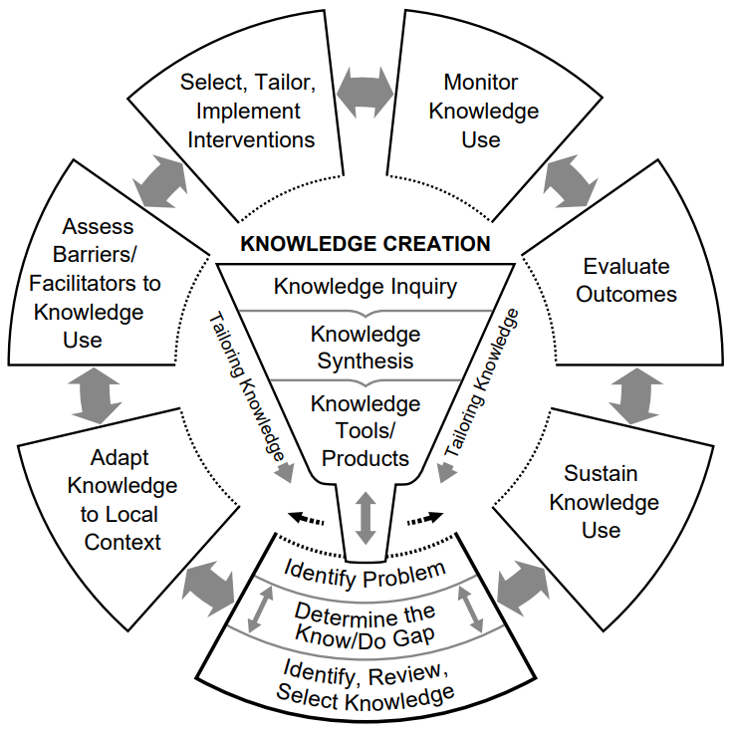

Knowledge creation
The process of knowledge creation comprises three elements: knowledge inquiry, synthesis, and creation of knowledge tools or products.
Knowledge inquiry consists of primary research and associated publications.
Knowledge synthesis includes the aggregation and evaluation of research; for example, systematic reviews and meta-analysis.
Knowledge tools and products are many of the products that are created to share results with end users.

Action cycle
- The action cycle is meant to represent the activities required for the knowledge produced in the knowledge creation funnel to be effectively used for decision-making. It includes the following activities:
- Assessment of an issue, problem or gap which requires application of knowledge
- Identification, review and selection of the appropriate knowledge to address this problem
- Tailoring and adaptation of this knowledge to the local context and the relevant audience
- Identification of barriers that could make uptake and use of this knowledge more difficult (individual, organization and systematic barriers) and supports that could facilitate uptake and use of knowledge
- Selection and tailoring of interventions; this includes the choice and creation of dissemination mechanisms and should be informed by the assessment of the problem, local context and barriers and facilitators to knowledge use.
- Monitoring of knowledge use; this includes assessment of the initial outcomes of the knowledge mobilization activity, including potential changes in knowledge, attitudes, behaviour and decisions that may result; as a result of this monitoring, the intervention or activity can be adapted for best effect.
- Evaluation of impact assesses the resulting changes from knowledge use; that is, are the desired changes or benefits happening?
- Finally, the knowledge use can be sustained, which can be maintained through a cycle of evaluating barriers, uptake and outcomes, and adapting as necessary to ensure continued use of the research.
The Knowledge to Action Cycle is one of the formative models in the field, and serves as a useful model to understand the many elements involved in creating knowledge, adapting it for specific audiences, and implementing and evaluating activities to share this knowledge with end users.

11

Introduction to Knowledge Management and Communications | Models and Frameworks 3

Co-Produced Pathway to Impact
The Knowledge to Action cycle, and other linear models of knowledge mobilization, are useful ways of thinking about the process of knowledge production and knowledge use. However, in the case of integrated knowledge mobilization, they may not accurately represent some of the complexity and interplay between research producers and research users at all stages of the research process. For this reason, David Phipps and colleagues developed the Co-Produced Pathway to Impact7 – a model that illustrates the feedback loops between researchers and partners at all stages of the research process.
This model builds on previous logic models in the field, outlining the activities and benefits of interaction at each of four stages:
- Research: The activities encompassed in research production, which may be completed by the researcher, the partner, or collaboratively.
- Dissemination: Activities to share research, including written, online and in-person dissemination mechanisms.
- Uptake: After dissemination, an organization will share research information internally and determine its utility and potential use.
- Implementation: The research may be used to inform products, policies and services within or beyond the organization.
- Impact: This is the result that implementation may have; it can include environmental, economic, health or societal impacts, among others.
The model recognizes that at each stage, activities will be completed by the researchers and partners independently, but some activities will also be completed collaboratively; it also recognizes the iterative and cyclical nature of this process.
One or more interactive elements has been excluded from this version of the text. You can view them online here: https://ecampusontario.pressbooks.pub/knowledgemanagement/?p=299#oembed-1
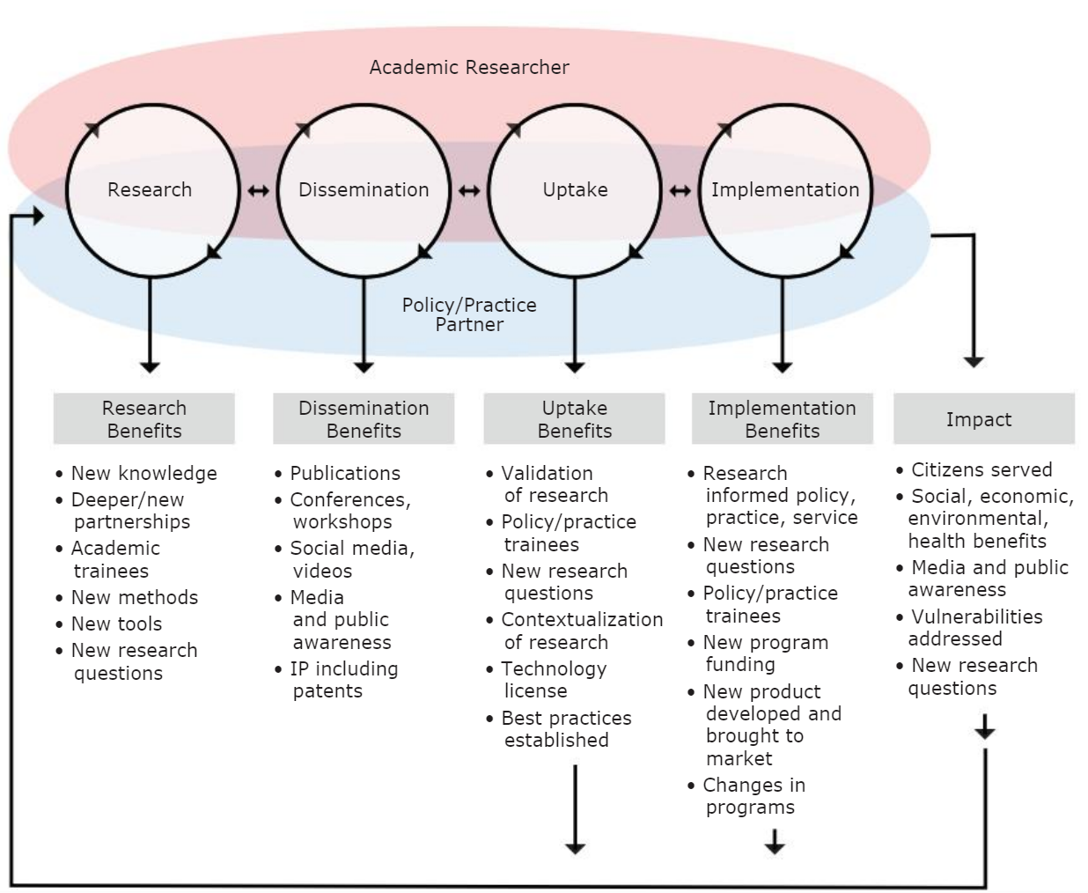

Benefits of Knowledge Mobilization
Although knowledge mobilization can take time, it is very important that researchers have a knowledge mobilization plan in order to identify and facilitate impact beyond academia. Knowledge mobilization can have a number of benefits, including:
- Increased relevance of research to user concerns
- Improved trust and strengthened relationships between researchers and end users
- Clear communication and better understanding of research results
- Changes in knowledge, attitudes or behaviour
- Impacts on social, environmental, economic or health outcomes
Read

12

Introduction to Knowledge Management and Communications | Building a KMb Plan

Questions to Consider

Now that we’ve introduced some key terms, definitions and models of knowledge management and communication, we are ready to review the fundamental questions that you should consider as you develop a knowledge management and communication plan for your project. Whether you are planning on an integrated or end-of-grant approach, these questions will help you to develop a strong plan to mobilize your research – this plan can be integrated into grant applications, used to clarify partnership requests, or help to clarify and improve your strategy for mobilizing knowledge.
John Lavis and colleagues propose 5 basic questions that any researcher can consider when developing a KMb plan8. They include:
- Audience: To whom should research knowledge be transferred?
- Message: What knowledge should be transferred to decision-makers?
- Messenger: By whom should the knowledge be transferred?
- Mechanism: How should the knowledge be transferred?
- Impact: With what effect should the knowledge be transferred?
Although the questions framed this way are oriented more towards the development of an end-of-grant knowledge mobilization plan, they can also form the basis of an integrated communication plan. Below, we break down various sub-questions and elements to consider.

Audience
A key part of developing a knowledge mobilization plan is clearly identifying the target end user audience(s) for the research.
- Identification may include identifying target groups of people, specific organizations or even specific individuals within the organization.
- You may have more than one target audience, and can develop a separate knowledge mobilization plan for each audience.
- As you identify your audience, also consider why they might be interested in your research. What are the problems that they face that this research might address? What are their goals, mandate and context?
- Finally, consider how they want to be involved in the project. Will they be simply informed through one-way communication of knowledge, or will they be involved in the project itself – and how?
You will be asked this question a number of times over the duration of this course. This is because it is an absolutely key element of knowledge management and mobilization – whether you are developing a communications plan, diving into social media, understanding your value proposition for commercialization, or communicating with policy-makers.

Message
As part of developing a knowledge mobilization plan, you will also need to consider the message that should be shared with this audience. Crafting a message includes considering the following questions:
- What background and context needs to be shared with end users to ensure your message is understood?
- Conversely, what information can be removed because it is not needed?
- What language will you use to share this information? Use of clear language is frequently advised.

Messenger
Crafting an effective message also requires a careful choice of messenger. Consider:
- Who is a trusted source of information? In some cases, academics are not always the most trusted source.
- When should the messenger deliver the message? In some cases, timing may be an issue (consider busy times for your target audience – for example, planting or harvest season for farmers, political cycles, etc)

Mechanism
A mechanism must be chosen to share results with the end user audience. There are a large variety of possible mechanisms:
- Print (fact sheets, policy briefs, reports, handbooks, case studies, databases, FAQs, research summaries, etc)
- Media (video, podcast, media interview, press release, magazine article, etc)
- Digital (website, app, webinar, social media, blogs, listserv, etc)
- Personal communications (meetings, workshops, presentations, lunch and learns, phone calls, town halls, field days, communities of practice, ‘champions’, etc).
Many other possible mechanisms are not listed here. Selection of a mechanism should rely on your knowledge of your audience, message and messenger, as well as practical considerations like budget and capacity.
Tip: A few best practices to keep in mind when choosing a knowledge mobilization mechanism include:
- Where possible, active or interactive strategies may be more effective than passive strategies.
- Multiple mechanisms, working together, may be more effective than a single mechanism.
- If possible, develop or test your mechanism with a member of your target audience to gather feedback.

Impact
The final question to consider is, with what impact will the knowledge be transferred. In other words, what is your goal? Do you want to:
- Generate awareness
- Change opinions or attitudes
- Share knowledge, experience or tools
- Build capacity, relationships or skills
- Change behaviour
- Inform policy, practice or investment decisions
- Influence social, cultural, economic, health or environmental impacts
Will you evaluate your progress towards this impact? If so, how? This evaluation strategy should be built into your project from the beginning.

Learn more about
.

13

Introduction to Knowledge Management and Communications | Building a Communication Plan: Toolkits
Although there are a plethora of KMb toolkits that exist, we wanted to share two in particular.
- The Knowledge Translation Planning Template, created by Melanie Barwick at the Hospital for Sick Children, offers researchers a checklist that walks you through various questions to create a knowledge mobilization plan. Take a moment to read through the checklist.
- The Knowledge Mobilization Toolkit, created by the Ontario Centre of Excellence for Child and Youth Mental Health, offers a more in-depth series of questions to build a knowledge mobilization plan, and also shares examples of knowledge mobilization projects. Take a moment to read through the questions and project examples.

Activity (15 min)

Using either the Barwick model or the KMb Toolkit, create an initial plan for a current, past or future research project. If the audiences or activities listed in these toolkits aren’t appropriate for your research, simply replace them with ones that work better for your context. Using either of these models should help you think through all 5 of the Lavis questions: Audience, Message, Messenger, Mechanism, and Impact.

Learn more about
, from the agriculture and food sector.
What are others doing? Review some case studies of knowledge mobilization.

14

Introduction to Knowledge Management and Communications | Clear Language Communication
For research communications to have the desired impacts it is important that they be easy to read, easy to understand, and easy to use. Why? Because the audience for research may not have the same academic background or use the same language as the people who produce it. Academic language is well known for being complex, dense and full of field-specific terminology, which makes it difficult for non-experts to understand. As such, clear language is an important component of any knowledge mobilization initiative.

What is Clear Language?
There are many different definitions, but essentially, clear language is about using clear, concise messaging and organization to produce messaging that is appropriate for the audience. Plainlanguage.gov suggests that with clear language, the audience should be able to “Find what they need; understand what they find; and use what they find to meet their needs.”
Clear language is not about over-simplifying your message, removing necessary content, or being patronizing to your audience. Instead, it’s about removing unneeded complexity to increase understanding. As a clear language writer, it is important that you
- know your purpose or goals,
- understand your reader, and
- make communication choices based on your goals and reader.

Why use clear language?
Clear language is important, too, because literacy – defined as the ability to understand and use printed information in daily activities, at home, at work and in the community – is still an issue in Canada. Data from 2003 suggests that only 52% of Canadians over 15 had the minimum level of literacy required to function well at work and in daily living. This means that nearly half of Canadians had low levels of literacy.
The following reading describes why scientists need clear language: Scientists Need Plain Language.

15

Introduction to Knowledge Management and Communications | How to use Clear Language
To write in clear language, there are a number of best practices we cover in brief below.

Avoid Jargon
Jargon – unnecessarily complicated, technical language – is a major issue when specialists try to communicate with non-specialists. Jargon is useful when communicating with other specialists with the same background, as it serves as a shorthand to make communication easier. However, it makes it hard for non-specialist readers to understand your meaning.
As much as possible, try to avoid the use of jargon in your writing. A small number of terms that are essential can be used if defined, but try to avoid using many of them, as it makes it much more difficult for readers to understand.

Activity: Jargon terms
Suggest a less jargon-filled option.
- Participants read assertions whose veracity was either affirmed or denied by the subsequent presentation of an assessment word.
- The researcher investigated the phenotypic properties of the analogous poultry ovum.
- Others…

Use Short, Simple Words and Phrases
Clear language is not only about reducing the use of jargon – field-specific terminology – but also about reducing the complexity of all of the words and phrases you choose to use. Is there a simpler word you could choose instead? For example, instead of choosing a more complex word such as commence, consider whether you could use a simpler word, such as start or begin instead.
Clear language is also about reducing the use of phrases where a single word will do. For example, instead of using the phrase due to the fact that, you could use because as a simpler alternative. Review a list of the frequent complex words and their simpler alternatives.
Reducing the use of unnecessary preambles is another important part of clear language. Unnecessary preambles are those phrases that don’t add substance or important information to the sentence, and can even weaken the point they introduce. You’ll know it’s an unnecessary preamble if you can remove it without changing the meaning of the sentence it is used in. For example, unnecessary preambles may include it is important to note that or in this regard it is significant that.
Finally, avoid the use of double negatives, which make your meaning confusing to readers.
An interactive H5P element has been excluded from this version of the text. You can view it online here:
https://ecampusontario.pressbooks.pub/knowledgemanagement/?p=318#h5p-5

Avoid acronyms
Another general rule of clear language is to avoid or minimize the use of acronyms, particularly with an audience that doesn’t regularly use those acronyms. For example, instead of using the acronyms N&P, you could spell out these terms as nitrogen and phosphorus – or, as an even more plain language alternative, you could use the term nutrients. Similarly, instead of referring to EPT (Ephemeroptera, Plecoptera, and Trichoptera), you could use their common names – Mayflies, stoneflies, and caddisflies – or simply refer to them as insects, depending on the knowledge level of your audience.

Organize your content
Another important part of clear language is clear organization of content and clear design. Good organization helps the reader to easily find the information they are looking for; usually, clear language writers start with the most important idea first, and add supporting detail later. Good design is important to make content easily understandable. Read more about good design principles.

Watch the video:
.

16

Introduction to Knowledge Management and Communications | Module Assessment Tool and Evaluation Guide
Submission of KMb plan and self-assessment of success in KMb plan development.

17

Introduction to Knowledge Management and Communications | Summary and a Look Ahead
In this module, we learned what is included in knowledge management and communication, sometimes referred to as Knowledge Mobilization. We learned about why it’s needed, various models of knowledge sharing, and the 5 questions to consider when building a knowledge management and communication plan. Finally, we learned about principles of clear language writing that we can use to share knowledge with stakeholders.

Final Thoughts

After completing this introductory model, you are ready to dive into more detail about your knowledge management and communication plan – to understand how to maximize your impact through data sharing (Module 2), developing a communications strategy (Module 3), planning for social media use (Module 4), community engagement (Module 5), commercialization and IP protection (Module 6), and working with policy-makers (Module 7).

18

Introduction to Knowledge Management and Communications | Credits

Subject Matter Experts
- Elizabeth Shantz, Knowledge Mobilization Manager, University of Guelph

Industry, Government and Community Partners
- Doug Knox, Partner, EQ Alliance
- Cathy Bruce, Trent University
- Ashley Horne, Trent University

Designers and Editors
- Dana Capell, Educational Developer, Trent University
- Lillian Chumbley, eLearning Designer, Trent University
- James Bailey, Multimedia eLearning Design Specialist, Trent University
- Bethany Brown, Graphic Designer

II

Communication Tools and Strategies

How effective is your current communication with internal and external stakeholders?

19

Communication Tools and Strategies | Synopsis

This module addresses the importance of creating and maintaining a clear communications plan and strategy. Topics covered in this module include the steps to create a communications plan, best practices for communicating your research and academic activity, and tools and platforms for interactive communication.

20

Communication Tools and Strategies | Setting the Scene
You may feel that your attention is all on the research and you haven’t paid attention to communicating your progress to colleagues, collaborators, funders or the public. You may have had limited interaction with your institution’s marketing and communications department or any concentrated effort to communicate beyond their lab group and colleagues. However, now is the time to start developing an effective communications strategy and plan. Along the way, you will learn that there is a lot more that goes into communication than what meets the eye.

21

Communication Tools and Strategies | Video Introduction

An interactive H5P element has been excluded from this version of the text. You can view it online here:
https://ecampusontario.pressbooks.pub/knowledgemanagement/?p=107#h5p-2

22

Communication Tools and Strategies | Learning Outcomes & Resources

Proposed Learning Goals
By the end of the module, you will be able to:
- Understand the elements of a communications plan
- Understand the steps to develop an effective communications plan
  - Learn how to set communication goals
  - Determine how to identify key audiences
  - Learn the importance of having a clear message

- Identify important considerations for developing an effective communications strategy

Learning Resources and Readings
In order to complete the module, you will need to consult a variety of readings and resources that are linked throughout the module. You will be instructed to read any content that is required, all other readings and resources are supplementary.

23

Communication Tools and Strategies | Activities Checklist

In order to successfully complete this module, you should:
- Complete assigned readings
- Work through each module page
- Complete interactive activities
- Complete and submit module assessment
- Review the deeper dive materials

24

Communication Tools and Strategies | Introduction to Communication Plans

“Science isn’t finished until it’s communicated.” – Sir Mark Walport From The Principles of Scientific Communication


Hubspot, a leading developer of marketing, sales and customer service tools, defines a communications plan as a plan that “enables you to effectively deliver information to appropriate stakeholders. The plan will identify the messages you need to promote, to whom you’re targeting those messages, and on which channel(s).”9 Applying this definition to an academic environment, your communications plan is the concentrated effort to communicate with key stakeholders about your research or academic activities.
This section will provide a high-level overview of what a communications plan is, why having one is important, and the key steps to develop an effective communications plan. This section will also introduce various key concepts and definitions that will be important as you move through the rest of this module.

25

Communication Tools and Strategies | Understanding Communication Plans

Importance of a Communication Plan
In a technology-enabled society, information is shared more quickly and in higher volumes than ever before. There is more competition to reach your intended audience. As a result, it is of the utmost importance to plan your communication strategy to ensure that your message reaches your stakeholders to cut through the noise. Having an effective communications plan enables you (and your organization) to effectively deliver information to your stakeholders and measure the success of your communication efforts.

Some other important reasons to have a communications plan include:
- Clarifies the goals and objectives of you research
- Clarifies the relationship with your audience and how to reach them
- Allows for a greater contribution towards shared value when information flows seamlessly between stakeholders
- Enables you to measure the success of different communication tactics
- Creates a shared responsibility and accountability among your team
- Enables you to identify areas of improvement in your communication strategy
- Creates a sense of community amongst your key internal and external stakeholders
- Allows your team to spend effort and resources more efficiently
- Contributes to a better workplace culture
- Establish buy in with senior management and other funders
- Establish your research and academic expertise with media and other outlets

Understanding different types of communication
Communication comes in a variety of forms, all of which serve their own unique purpose. In order to develop an effective communications plan it is important to understand these different communication types and the purpose of each.
Human communication consists of four different forms: verbal, non-verbal, written, and visual. Communication to any audience and through any medium contains some or all of these forms of communication. For the purpose of this module, we will concentrate on type and direction of communication based on their audience and objective.

Type: Internal vs. External
- Internal Communication is any communication that occurs between members of your team. Internal communication is generally used to ensure all members of your team have a shared understanding of the project or research, which enables them to work together as efficiently as possible.
Some examples of internal communication include a shared calendar or events or group chat platform, research protocols and internal papers and boiler plate messages.
- External Communication is any form of communication targeted to stakeholders outside of your team. These stakeholders could include other university personnel, industry partners, the academic community, or potential customers. External communication can serve a variety of purposes and is the most widely used form in a communications plan aimed at reaching external audiences.
An example of external communication is an email or newsletter.

Direction: One-way vs. Two-way
- One-way communication is used to share information with stakeholders without the expectation that they will respond or interact with the information. The content of this communication type is typically informative in nature and is used to educate or inform your audience on a specific piece of information.

An example of one-way communication is a newsletter to share updates on your research progress. This can be used to keep your audience up to date on your research in a low-stakes way. The audience is being asked to consume the information. They are educated about your research.
- Two-way communication is any communication that has the goal of starting a dialogue with your stakeholders. External communication is typically focused on information gathering, fact finding, or community engagement. In two-way communication you are sharing information with your audience with the expectation of receiving engagement or information in return.
An example of two-way communication is a survey that you circulate to potential industry partners to gauge their interest in specific parts of your research. You are inviting your audience to be involved in your research and a response is demanded of them, so that they become invested advocates in your work.
These terms will be used throughout the module to refer to specific types of communication within your communications plan. You might choose to focus on a combination of multiple communication forms to achieve your communication goals. The forms you select to utilize will change greatly depending on your field of study, your target audience, and objective.
Section 3 of this module will discuss specific tools that can be used to achieve these specific communication goals.

26

Communication Tools and Strategies | Strategy vs. Plan
This article by Medium, does a great job at outlining the difference between a communication strategy and plan. To summarize, your strategy defines the “why”, while your plan defines the “how”.
Some other key differences highlighting in this Medium article include:
- Strategy is flexible, a plan is fixed. In other words, strategy is focused on the bigger picture and as a result has the ability to be more flexible than a plan which is typically focused on more granular details and is more difficult to change on the fly.
- Strategy is ongoing until review, a plan is based on a timeframe for a specific project or season.
Before you can undergo any planning, you need to know what the strategy is. This usually includes:
- Business objectives
- Brand objectives
- Stakeholders
- Key messages
- Issues and risks
- Audience / audience insight
Once you’re clear on what the overarching aim is, you can then start to think about how you’re going to use this insight to reach your target audience, which will eventually lead to your communication plan. Your plan should include:
- Strategy overview
- Channels
- Tactics
- Timings
- Resource
Key components of a communications plan
A typical communications plan can be broken down into 5 sections.
- Stakeholder / Audience
- Objectives
- Message / Content
- Delivery Methods
- Frequency / Time
It is also important to note that the creation of a communications plan is an iterative process that changes, based on your evaluation of the communication plan once you begin implementing the plan.
The rest of this section will cover the key steps to create an effective communications plan. These steps are:


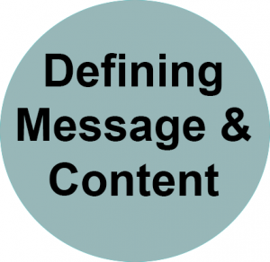

After working through these four steps you should have a draft of your communication plan. Throughout the rest of the module, various reflection questions will be posed for you to think about. It is suggested that you take notes as you move through the next four sections to help you when it comes time to actually build your own communications plan!

27

Communication Tools and Strategies | Components of Communication Plans: Define your goals

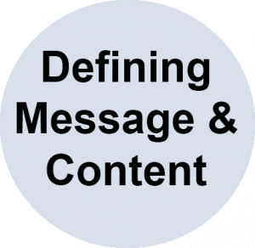

The first step to develop an effective communications plan is to clearly define your goals. In order to build the rest of your communications plan you first to have to understand what you hope to get out of your communication plan. To help you start thinking about your goals consider the following questions:
Are your motivations intrinsic or extrinsic in nature?10
- Extrinsic motivation prioritizes external outcomes such as money or recognition.
- Intrinsic motivations focus on internal rewards such as passion for education and the joy of problem solving.
- Your motivations will greatly influence the audience, content, and channels you decide to use in your communications plan.
What outcomes do you hope to achieve by developing a communications plan?
- Some examples of desired outcomes include:
  - Recognition from industry partners
  - Intellectual contributions to the academic community
  - Increased recognition by senior leadership at your institution
  - Engagement and interest in your research from undergraduate and graduate students at your institution
  - Interest from media outlets about your research and academic activities
  - Attract funders of your research or buyers of your patent.

SMART Goal framework
When thinking about your goals it is recommended to follow the SMART goal framework. The SMART goal framework is a proven effective goal setting method. When setting goals for your communications plan make sure you follow these criteria:
- Specific
- Measurable
- Attainable
- Relevant
- Time-bound
Read more
and how they apply to a communications plan.

28

Communication Tools and Strategies | Key Components of a Communication Plan | Define your audience and channels


Audience
The next step in developing an effective communications plan is to determine who your audience is. Building on the goals that you define in step one, you must now determine what audiences you need to reach in order to achieve this goal.
Below are some examples of key audiences based on the examples of desired outcomes provided in step 1.
Desired Outcome / Goal | Examples of Target Audience
Recognition from industry partners | Industry partners
Recognition from the academic community | Specific academic journals, other researchers
Increased recognition by senior leadership at your institution | Senior Leadership, Research Chairs, Marketing and Communications department
Engagement and interest in your research from undergraduate and graduate students at your institution | Students, teaching assistants, teaching faculty, student clubs
Interest from media outlets about your research and academic activities | Marketing and Communications department, newspaper outlets, radio stations, television stations
The importance of having a clearly defined target audience will be discussed further in Module 5: Community Engagement and the Lavis Model for KMb.

Channels
Once you have identified your target audience, you must determine the channels they use for communication. By determining the channels you target audience uses you will be able to target the channels that you should be using in order to achieve your communications goals.
For example, undergraduate students may be easier to reach on platforms such as a website or a flyer in the cafeteria, but may not be as active reading the Globe and Mail. On the other hand, senior leadership may be easier to reach through specifically targeted briefs, internal communications, networking opportunities, or word of mouth.

With this information in mind, ask yourself the following questions:
- Who is the audience?
- What platforms / channels does your audience use?
Some examples of platforms and channels include:
- Social Media – Twitter, Instagram, Facebook, etc. (covered in the next module)
- Media Outlets – Radio, television, newspapers
- Internal communications – newsletters, emails
- Networking / Word of mouth – conferences, events, presentations
We will discuss some of these channels / platforms throughout the rest of the module.
If you have more than one target audience you will have to complete this exercise multiple times for each segment. There may be an overlap in channels between your various target audiences but it is important to make sure you keep them separate for now as the content and message may be different for each. To start, it is recommended that you focus on your primary audience and return to your secondary audiences at a later time.

29

Communication Tools and Strategies | Key Components of a Communication Plan | Determining your message and content
Now that you have your goals clearly defined and have identified the audiences you must reach in order to reach those goals, it is time to consider what content you need to produce in order to reach your communication goals.

Existing Content

First take stock of what content you already have readily available. You may already have content ready that just needs to be modified in order to fit the desire audience and platform. For instance – an infographic could be a more engaging way to communicate the value of your research to someone from outside academia, such as a magazine publisher or industry partner.
Take a few moments to brainstorm the following questions:
- What content do you already have available?
- Is this content something your target audience would be interested in?
- What form is your existing content in (video, images, text, etc.)?
- Could this content be adapted to fit the channels / platforms outlined in step 2?

Criteria to evaluate your content
In the event that you do not have any suitable content available, you may need to start creating new content that fits your communications plan. The form this content comes in will vary greatly depending on various factors such as:

What type of content does your audience want to see?
Put yourself in the shoes of your audience. Are they interested in reading technical write-ups of your research, or would they prefer an easy to read image that explains your research at a high-level? When in doubt, use two-way communication to ask your audience what type of content they are interested in! Provide a way for your audience to respond to any content you communicate.

What types of content does your selected platform accept?
Most platforms and channels have technical limitations on the types of content that can be shared or posted. For example, it may be difficult to include videos in a newsletter, but platforms such as Reddit greatly favour visual content such as photos or video. If you are submitting an op/ed to a newspaper, your research may need to be presented in clear language, inverted pyramid writing style.

Queens University:

Types of content that are the most effective on your desired platform
Every communication channel has different types of content that does a better job at reaching your specific targeted audience than others. Understanding which content should be used on which channels will have a significant impact on the effectiveness of your communications plan. To determine what type of content to use on each platform the best strategy is to look at what type of content is receiving a high amount of views and engagement on your target platform. This can be done by finding articles that highlight the best practices for a given platform, or by examining popular content on a platform.
For example, this Hubspot article highlights some methods to make your newsletter standout, which results in an increased open rate. On social platforms such a reddit, you can be easy to identify popular content by sorting the posts by number of upvotes. For example, some of the top posts on /r/Technology and /r/AskAcademia are links to news articles that other users have found to be interesting. News articles and updates about your research activities could be shared on these subreddits to increase visibility.

Messaging
The messaging of your communication can be just as important as the type / format of your content. When in doubt always refer back to your SMART goals to make sure the messaging of your communications contributes towards achieving your goal. If your goal is to increase interest from funders, you need to ensure that your message is engaging and interesting to that audience in particular.

Language is important
Depending on the audience you are trying to reach you may need to adjust the type of language you use to describe your research and academic activity. Using technical terminology may be appropriate if you are communicating with other academics from your field of study, but may not be as appropriate for communicating with media outlets We will discuss this topic in more detail in the next section of this module.

Frequency
There are a number of factors in your communications plan that will determine how frequently you should be communicating. Your audience, content, and channels all have a direct impact on determining frequency.

Channel / Platforms
The frequency of your communications will vary greatly on the type of platform or channel you decide to utilize. Certain software-based communication tools use algorithms that favour certain posting frequency. In addition, certain platforms perform better at certain times in the day. Newspapers and other outlets have specific publishing frequencies that determine the best times to send out news releases. It is important to conduct your own research to determine the specific best times and frequency for your selected channels. One of the leading newsletter platforms, Mailchimp, has found that Monday to Thursdays from approximately 8 am to 12 pm appears to be the best time to send email campaigns. This trend is particularly true for professionals, government agencies, and non-profits.

Content
The type of content you are producing may also impact the frequency of posting you are able to maintain. Some forms of content, such as videos, may be time consuming to develop and may not be a sustainable content form for your team. It is important to recognize and plan around the limitations of your team and budget.
With all forms of content, it is important to consider and apply the principles of Accessibility and EDI (Equity, Diversity, and Inclusion). These important considerations will be discussed in further detail in module 5.

Audience
Depending on your target audience and the corresponding channel, you may need to adjust your frequency in order to attract the attention of your target audience. Similar to your channel and platform, this will come down to conducting your own research in order to determine a frequency that works for the specific audience you are trying to communicate with or the platform you are using.

30

Communication Tools and Strategies | Key Components of a Communication Plan | Measuring success
Your communications plan is a living document, meaning it will constantly be adapted based on the success and failures you experience in the process of actioning your communications plan. It is important to build a reflective component into your communications plan to improve and optimize your plan.
To start, you need to define what success looks like to you and your team. This definition of success should relate directly to the SMART goals that you created in Step 1. Success may be tied to specific metrics of a communications platform (open rate of your newsletter for example), or they may be tied to the desired outcomes of your plan. In either case, understanding what success looks like is vital to the overall success of your communications plan.
Building on the examples provided in step 1, below are some examples of specific metrics and measurements you can use to measure success.
Desired Outcome / Goal | Example of metrics and measurements that indicate success
Recognition from industry partners | Number of partnerships with industry, number of follow up inquiries, mentions in an industry publication that received your news release
Recognition from the academic community | Number of times cited in scholarly articles
Increased recognition by senior leadership at your institution | Mentions at leadership meetings, recognition in internal communications and newsletters
Engagement and interest in your research from undergraduate and graduate students at your institution | Number of inquires from students about joining your lab group, views on social media posts, engagement in surveys
Acknowledgement from media outlets about your research and academic activities | Inquiries from media outlets, Marketing and Communications department, # of medio mentions (see section on media monitoring)
Take a few moments to think about what success looks like for your communications plan. How does this vision of success relate to your SMART goals?

Key Performance Indicators (KPIs)
Key Performance Indictors (KPIs) are important measures of your progress towards a specific result. Having clear KPIs in your communications plan can help your team maintain a clear focus on achieving your goals. Setting targets and tracking progress is an important part of managing your KPIs.
The terms “leading indicator” and “lagging indicator” are often used when describing KPIs. Leading Indicators results in future benefits that may not immediately be noticeable. Lagging Indicators represent how successful your actions were at achieving results in the past. It is important to recognize the difference between these two types of indicators and to understand why it is important to have both types of indicators in your overall plan.

To learn more about “leading” and “lagging” indicators read
.
Effective KPIs achieve the following11
- Provide objective evidence of progress towards achieving a desired result
- Measure what is intended to be measured to help inform better decision making
- Offer a comparison that gauges the degree of performance change over time
- Include a balance between leading and lagging indicators.

What if “success” isn’t achieved?
If you did not achieve your intended goals after working through these four steps, it is time to reflect on what you could improve and adapt in your communications plan. Ask yourself the following questions to help pinpoint areas of improvement.
- Was the goal of my communications plan clearly defined using the SMART goal framework?
- Does my intended audience match with the goals set in step 1?
- Is my content and platform the correct choice for my intended audience?
- Did my KPI measure my goal?
- Are there any external factors that may have impacted my ability to reach my audience (for example – did a holiday or other important event, or significant surprise news story take the spotlight away from your message).
Identifying the best way to communicate your research is an iterative process that will vary greatly depending on your target audience, area of study, type of content, selected platform, and many other external factors not covered in this module. If you are not able to achieve your desired results, keep changing certain aspects of your communications plan and measure the results. Eventually you will find the winning formula that effectively and efficiently communicates your research and academic activities to your intended audience.

31

Communication Tools and Strategies | Best Practices and Key Considerations
In the next section of this module we will look at some specific best practices to help you refine and improve your communication strategy. These best practices range from general tips for presenting your research, to ways to communicate with specific stakeholders such your lab team or the media.
Build a healthy lab culture that encourages sharing “Culture eats strategy for breakfast.” – Peter Drucker
Strong external communication starts with a healthy lab culture. Improving communication between you and your team can greatly improve your ability to action your communication plan, and can even increase the team’s motivation for contributing to your plan. There are numerous advantages to developing a healthy culture of sharing within your team.

Read
For example, creating a healthy culture within your team can:
- create a shared sense of responsibility within your team
- turn your lab employees into ambassadors for your brand
- prepare your lab employees to share updates and information about your research to interested third-parties or potential collaborators
- inject a diverse set of perspectives and opinions on challenges or barriers faced during your research
- allow for “outside of the box” thinking
- improve team morale, boosting the overall efficiency and quality of work
- include EDI related bullet point i.e. ensure your lab represents the diversity of your university community.
In a recent study published by the University of Toronto, researchers found that a healthy lab environment is “central to the well-being of all those involved in the research enterprise, and the quality of research depends on it.” In order to promote a healthy lab, the report suggests “a multi-pronged approach to promoting a health lab culture” which covers the following five areas:
- Provide leadership to integrate Dimensions as a foundation of a healthy lab culture
- Provide positive incentives for healthy lab practices
- Provide lab management training for post-doctoral fellows and faculty members
- Provide enhanced support for early career researchers
- Provide procedures to help researchers raise and deal with concerns safely
Building a healthy and strong culture within your team is a great way to improve internal communication. Once strong internal communication has been established, you will find it much easier to gain commitment from your team to execute on your communication plan. When everyone on the team is aligned with the same goals, feels valued, and is passionate about the work, it becomes easy to share your stories and content to external stakeholders. Never underestimate the value a healthy team culture can bring to your communication strategy.


32

Communication Tools and Strategies | Brand Guidelines

Develop brand guidelines for your team
Consistency is key. Developing and utilizing guidelines to guide the communication of your brand can help to add a sense of professionalism to your various channels and messages. These guidelines may already be available for your institution, and your lab or research group guidelines should also be consistent with the institutional brand. Creating and following brand guidelines are important for various reasons including:
- Ensures consistency – Some of the most effective brands a have consistent and recognizable brands. Having clear brand guidelines helps to ensure that all content is cohesive and relates to the overall brand of your lab group.
- Sets standards and guides – Sets rules help to keep styling simple. By having clear expectations of what colours, fonts, and styles will be used can help speed up the content creation process and ensure professional looking products.
- Eliminates confusion – Related to consistency, by eliminating variables in your brand identity, brand guidelines can help to eliminate any potential confusion from your target audience regarding a difference in style.
- Transfer of knowledge – Assists with the transfer of knowledge from employee to employee. By having clear guidelines and instructions for the use of your lab’s brand, you reduce the risk of losing that knowledge during any potential staff turnover.
Brand guidelines do not have to be limited to the visual components of your brand. Incorporating topics such the mission, vision, and values of your brand can also be useful. Below is a list of key topics you should aim to address when developing your brand guidelines:
- Specific colour scheme
- Font and styles to be used
- Instructions for use of any logos
- Any important graphic images or layout conventions
- Mission, Vision, Values
- Tone, Voice and Key messaging
- Any other information that will help your target audience connect and engage with your brand
- Templates for things like presentations, posters, etc.
Some other tips to develop effective brand guidelines include:
- Keep the guidelines concise and to the point
- Be sure to consult and adhere to your institution’s brand guidelines
- Use language such as ‘must’, ‘always’, and ‘never’ to avoid any confusion in the guidelines
Once your brand guidelines are set, it is important to setup some time to ensure that everyone on your team understands the guidelines and understands their importance. Training your team on the guidelines can be a useful exercise to get their commitment to the guidelines, and to hear their feedback on the guidelines. By having your team involved in the process of creating and refining your brand identify and guidelines you will contribute to the healthy culture, ready to implement a strong communications strategy, that was discussed in the previous section.

33

Communication Tools and Strategies | Communicating with a non-academic audience
When you spend so much time and effort into a specific area of research, it can often be challenging to explain said research to people from outside your field of study. The video below shows a great example of how research can be perceived and understood by a non-academic audience.
One or more interactive elements has been excluded from this version of the text. You can view them online here: https://ecampusontario.pressbooks.pub/knowledgemanagement/?p=153#oembed-1
Although this example is of an academic looking to commercialize their research, the exchange in this video exemplifies a challenge that many academics and researchers may run into if they do not recognize the importance of matching the target audience with the content.
After going through the steps to develop a communications plan, you have likely concluded that your target audience will include both academic and non-academic personnel. When talking to non-academic personnel or academics from outside your field of study, you may need to alter your language and messaging to ensure that communication remains clear. The video above is a great example of what not to do when put in this type of situation.
Inside Higher Education outlined some best practices to keep in mind when communicating with audiences from outside your field of expertise:
- Get to the big picture first
- Speak slowly and clearly, but show your excitement for the topic
- Use simple language and sentences
- Repeat key points in multiple ways
- Relate the content to your audience’s life experiences
- Be self-aware and audience aware
- Be concise
Following these seven tips will greatly improve your ability to clearly and concisely communicate the importance and value of your presentation to an audience that may not understand some of the more technical or complicated aspects of your research or academic activities. These communication tips can also be useful when communicating with someone who is not a native speaker in the language you are using. By adapting your communication style, you can greatly increase the size of your target audience beyond those who have the knowledge, education and expertise to understand the intricacies of your research.
This concept of effectively communicating and engaging with communities will be discussed further in Module 5.

34

Communication Tools and Strategies | Understanding your Value Proposition
Understanding how to clearly explain your value proposition is an important skill to master when approaching audiences beyond your field of study. A Value Proposition is a promise of value to be delivered, communicated and acknowledged by a given audience. your value proposition is the “so what?” of your message and content. If you are not able to clearly convey the value you are adding to your audience, it will be challenging to attract and engage them in your research and you will not achieve your communication aims
You might have a different value proposition for each target audience identified in your communications plan. For example, the value proposition for students to be engaged in your content is the opportunity to learn and potentially develop their skills in an exciting area of research. They might also be looking to build their CV for graduate school. The value proposition for an industry partner may be a collaborative project that could yield financial benefits for the organization.
Ensuring that your value proposition aligns with your communications plan is vital. If you aren’t able to demonstrate value to your target audience you will fail to gain their engagement, which will directly impact your KPIs and the overall effectiveness of your communications plan.
To start thinking about how to develop a value proposition for your research, ask the following questions:
- What is the problem that your research solves?
- Who is experiencing the problem?
- Where does the problem present itself?
- Why is it important that this problem be solved?
- How is your proposed solution better than existing alternatives?
If you are able to clearly answer these questions through your communication plan, you should have no problem engaging the audience experiencing the problem (assuming you are using the correct channels to reach them!).
Further Reading: “Made to Stick” by Chip and Dan Health is a great resource that dives further into methods to create messages that will stick with your audience.

Read

35

Communication Tools and Strategies | Presentation Development and Delivery
The art of developing and delivering an effective presentation as one of your communications plan content pieces can take years to perfect. As an academic, you most likely have some experience with delivering presentations to an audience of students and other academic professionals. You have also likely attended various lectures or presentations that failed to capture your attention or interest. This section will provide some best practices and guidelines to assist you in improving your presentation skills.
One or more interactive elements has been excluded from this version of the text. You can view them online here: https://ecampusontario.pressbooks.pub/knowledgemanagement/?p=387#oembed-1

Development
The content of any given presentation will vary greatly depending on the audience, environment, and the intended purpose. This article by Wiley outlines a “formula” for delivering academic presentations. According to this formula, the ideal academic presentation should contain the following components:
- Introduction/Overview/Hook
- Theoretical Framework/Research Question
- Methodology/Case Selection
- Background/Literature Review
- Discussion of Data/Results
- Analysis
- Conclusion
This framework provides a good starting point for communicating the most important information in a concise and logical matter. When determining the content for your presentation, remember to think about what content your audience is interested in and how you can bring value to them through your presentation.

Delivery
The cliché “practice makes perfect” is not accurate, instead the phrase should be “practice makes almost perfect”. No matter how much you practice there will always be room for improvement in your presentation skills. When reflecting on your own presentation skills, think of the following areas for potential improvement.
- Frame your presentation around a specific problem or question
- Tell an overarching story that ties your presentation together
- Show your passion for the topic and connect with your audience
- Focus on what content your audience is looking to get out of the presentation.
- Try to predict the questions that may be generated by your presentation and incorporate them into your presentation.
- In a business setting, follow Guy Kawasaki’s 10-20-30 rule. Meaning, each presentation should contain no more than 10 slides, last no more than 20 minutes, and use a font size no less than 30 point.
It is also important to think about any questions your intended audience asks, so that you can adjust your delivery on the fly to answer the questions posed by your audience. Make a note of any questions for your intended audience to incorporate the answers into the next iteration of your presentation for that specific audience. It is not uncommon to have 3-4 different versions of the same presentation, tailored to different audiences and communication channels.

36

Communication Tools and Strategies | Communicating with media
Attempting to communicate with the media can be an intimidating endeavor and can easily feel out of reach for those without past experiences or connections with media outlets. The truth is it can be challenging to get the media to pay attention to your research, but if you are able to get their attention the benefits can be substantial.
Advantages of communicating with media outlets
Communicating your research to the media: a guide for researchers published by Taylor & Francis Group outlines some important reasons why communicating with the media is something every researcher should keep in mind when developing their communications plan. This resource outlines several reasons why communicating your research to the media is beneficial:
- It benefits society
- It informs policy
- It encourages accurate reporting
- It connects public communities
- It raises awareness
- It can inspire future generations
- Provides an opportunity to acknowledge your funders
While all of these benefits are great to acknowledge, perhaps the main benefit of communicating with the media is the ability to reach a larger or very specific audience. When attempting to communicate with the media it is important to remember the best practices for communicating with non-academic audiences that were covered earlier in this section.

For further reading on the advantages of benefits of communicating with the media,
.

How to get noticed by the media
When it comes to getting your research and expertise noticed by the media, adhering to media outlet timelines, and being persistent is some of the best advice that can be provided. Interest from media outlets depends greatly on the volume of stories being submitted at a given time, type of story they are looking for, and what is happening in the wider world. Unexpected world events can pre-empt a story about your research. Although there are many moving pieces when it comes to communicating with media, some best practices for getting noticed include:

- Work with your institution’s Public Affairs or External Communications department to create a ‘pitch’ about your work
- Request to be added to a topic-specific experts list (Example – Ontario Tech University’s “Find an Expert” page)
- Publish attention grabbing news releases with strong lede sentence or paragraph
- Leverage your network to nurture contacts within the media
- Build a strong web presence, supported by good search engine keywords to be visible to the media searching for expertise online
- Attempt to learn more about what a chosen media outlet looks for. (Example – The Tyee submission guidelines)
Even after following all of these pieces of advice, it may still take time for you to get noticed by the media. Remember, persistence and patience in key. Don’t get discouraged if your work is bumped by an earthquake or political coup. As you make discoveries or have findings to share or high interest publications throughout your career, you will have multiple opportunities to share your expertise. While you are waiting to hear back, continually refine your key messages and communications products and interview skills.

Media Monitoring
Media Monitoring is the act of listening and watching information sources for discussions about your brand, industry, competitors, and any specific topic. Media monitoring can be useful to track conversations around your area of research at all times. Media monitoring also helps to monitor any mentions of your brand/university or your competition/colleagues, track relevant hashtags, and track trends in your industry or area of research. Just as academics monitor the literature in their field, media monitoring applies the same principles to popular media.

How to monitor

Keeping track of the conversation on all of the various communication channels used around the world can be exhausting. Media monitoring tools simplify and automate the process.
There are a wide variety of media monitoring tools available, each with their own advantages, disadvantages, and cost structures. Mediatoolkit recently published a list of their top 5 Media Monitoring Tools. Their top five list is as follows:
- Mentionlytics
- AgoraPulse
- Mediatoolkit
- Brandwatch
- Meltwater
To read more about each of these tools visit Mediatoolkit to read the full article. If you are interested in using these tools, ask your institutional media relations team which one they use. They may even be able to give you access to an expensive tool or set up monitoring searches. University librarians can also be helpful to set up media monitoring searches on your behalf.

Activity (5 min)
Create a basic Google Alert for your name or area of expertise.

What to monitor
To determine what phrases, words and topics you would like to monitor, it is important to consult your communications plan. The overall goal of your communications plan will directly impact the channels and topics you decide to monitor using the tools above. Once you have reminded yourself what you are attempting to achieve with media monitoring, begin thinking of what following areas of focus:
- Yourself
- Your Competition
- Your Industry / Research Area
- Your Partners, Suppliers, and Vendors
- Your research team
For a deeper dive on the topic of Media Monitoring read
from Agility PR.

37

Communication Tools and Strategies | Other considerations
So far in this module, we have covered a lot of best practices for developing a strong communication plan and strategy. Below are a few additional best practices that are important to reflect on when developing your communications plan.

Ask for Feedback

It is worth repeating and emphasizing to ask for feedback, as it is critical to the continuous improvement of your communications plan. When trying to determine what is and isn’t working in your communications plan, the best plan of action is to ask your audience! The amount of valuable information you can collect by circulating a brief survey amongst your target audience or community is astonishing. If you are not sure what to improve about your communications try asking the following questions:
- What type of content are your interested in seeing?
- What format would you like to see this content be delivered in?
- What platforms do you use most frequently?
- What times and how frequently do you use these platforms?
- What other content provided do you regularly watch / view?
Posing these questions in a multiple-choice format can help increase the likelihood that your audience with interact with the survey, and will help to give your audience an idea of the type of answers you are looking for. Having an open-ended option can also be useful to catch any potential answers you did not think of when creating the survey. We will discuss some tools to help you analyze and track responses to surveys in the next section.

Look to existing content in your sector
It is better to build on the past successes of others from your industry or sector rather than starting from scratch. Look to researchers or academics from other institutions that you think have a great communication for inspiration. Look to see their analytics, or media monitoring if they are publicly available. If one of your ‘competitors’ are successful reaching a particular audience, look to see the types of content, messaging and channels they are using to reach and engage those audiences.
If one of your colleagues in your field are mentioned repeatedly in the media or excel in a specific type of communications (op/eds, textbooks etc.) Examine what they are doing and ask them to advise you. The more information about your area of expertise is made available to the public, the larger the impact your field will have on society.
As mentioned in section 1, finding the best way to communicate your research to specific audiences is through an iterative process, and may require some trial and error to find the best methods for your needs. By looking to other existing content you may be able to save a significant amount of time by removing some unknown variables from the equation.
There are several professional organizations that can assist you with this, including:
- Consult EAB
- Science Writers and Communicators of Canada
- TED Fellows Program

Leverage existing institution-specific communication resources

Most (if not all) post-secondary institutions have a wide range of resources and supports to assist faculty, staff, and students with their communication efforts. These resources are designed to enable communication within the organization, and to external stakeholders. When developing your communication plan it is strongly encouraged that you take advantage of these existing resources and supports. They may also be able to advise on measurement and ways to increase the communication of your research to enhance your capability and training through communications in your next grant application to SSHRC, NSERC, or CIHR.
Some examples of typical resources that exist at post-secondary institutions include:
- Internal newsletters
- Externally facing news bulletin
- Reputational campaigns
- Various social media channels
- On-campus radio station
In addition, your marketing and communications department contains experts with a wide range of communications skills experience and expertise. Leveraging these subject matter experts could be a tremendous asset to you and your colleagues when seeking to enhance your communication strategy.

38

Communication Tools and Strategies | Communications Resources and Templates
There is no shortage of communications plan templates available on the internet. With so many resources at the ready, it can be difficult to decipher which resources are trusted, reliable, and useful. Below are a few resources and tools that support communication plans that come highly recommended by communications specialists around the world. The resources below can help you articulate the specific tactics, and resources available to fulfil your communications goals.
Hubspot is a platform of marketing, sales and customer service tools. Beyond their wide range of tools, including their well-known customer relationship management (CRM) platform, Hubspot also hosts an impressive library of useful resources on a variety of communication topics. Some examples of the topics covered in Hubspot’s blog repository include:
- How to Write Email Newsletters That People Actually Want to Read
- How to Write a Great Value Proposition
- 10 Content Curation Tools Every Marketer Needs
- How to Write an Effective Communications Plan
Your institution, faculty or department may already have a template they like to use.
Miro is an online whiteboard and visual collaboration platform. Alongside the usual whiteboard features, Miro has over 20 integrations with other apps such as Slack, Jira, Dropbox, Google Drive, and Monday.com (which will talk about next). Miro even has embedded video, chat and commenting systems so you don’t need to leave the platform to communicate with your team while collaborating on a Miro board.
Miro also hosts a library of templates to help you and your team start collaborating within seconds. Some note-worthy templates from Miro include:
- Meeting Agendas
- Website Wireframing
- Competitive Analysis Charts
- Communications Plans
- Newsletters
- Infographics and more
This feature-rich platform is extremely useful for any team that values collaboration.
Monday.com is designed to help teams and individuals improve their work processes using their flexible open platform. Monday is self described as a “visual platform that manages everything” and it does exactly that if in the right hands. Create your own workflow or draw from their impressive template library to create a visual, easy and intuitive dashboard for communications plan. Monday is a fantastic way to keep track of your KPIs and monitor your progress towards your communication goals.
ClickUp is another fantastic project management software that could be used instead of Monday.com.

39

Communication Tools and Strategies | Communication Tools and Resources
The final section of this module will take a look at some specific tools and platforms that can help to improve your communication with various key stakeholders. The tools covered in this section will be divided into four categories:
- Resources and Templates
- Presentations Tools
- Internal Communication Tools
- External Communication Tools
Each of these categories will include useful tools for specific tactics within your communications plan. While you don’t need to use all of these tools to have an effective communications plan, it is recommended that you explore each of the tools and resources outlined in this section to gain an understanding of the different types of paid and free tools that exist.
Before using any of these tools, be sure to consult your institutional web services, information technology, and communications departments for any existing tools or policies. For example, if your entire institution uses Google email accounts, it may be more practical to use Google Chats instead of WhatsApp or Slack. Every institution is different; therefore, it is of the upmost importance that you understand consult the experts at your university before starting down the wrong path.

12 13

40

Communication Tools and Strategies | Communications Resources and Templates | Presentation Tools
Visual Content can be a great way to get the attention of your target audience. Visual content can come in a wide variety of forms and can range in complexity from quick photos of your lab to videos with high production value. Below we will discuss a few tools that can help you to integrate a visual component to the content identified in your communications plan.

Slideshows and Infographics
When it comes to maintaining the attention and interest of your audience, the visuals of a presentation can be just as important as the content and can effectively illustrate your message. There are plenty of software tools to help you develop and deliver slideshow presentations (PowerPoint and Google Slides for example), but when it comes to creating visually stunning presentations there are some better options available. Consider using any of the following resources to improve the visual representation of your research which could be incorporated into a presentation, included on your website, or featured in a newsletter.

Adobe Spark – Build a presentation that will capture your audience’s attention with the help of Adobe Spark. Explore Adobe Spark’s professionally designed presentation templates to get you inspired, then choose one to remix and customize. Drop-in your information, add your own images, or even organize information with icons. Share your presentation digitally via email, link sharing, or by uploading it to your social platforms. It’s as easy as choosing a template, customizing, and sharing. Adobe Spark is also renowned for its analytics to help you understand what content really resonates with viewers.
Canva – Want to create unique visuals for your presentation but have no experience with Photoshop or any other creative tools? Canva uses a drag-and-drop format to enable anyone to create visually attractive presentations and assets with minimal effort or expertise. Canva is great for creating slideshow presentations, social media assets, newsletters, infographics, and more! The best part is that Canva has thousands of free image, photos and templates to get you started!
Prezi – Prezi enables you to customize just about every aspect of your presentation with very limited limitations. Prezi also has a lot of other unique features such as the ability to show your presentation on top of your webcam video, and the ability to freely navigate between slides. Visit Prezi’s website to see some of these unique features for yourself!
Piktochart is a web-based application which enables the user to quickly and easily concert text or data into an engaging and visually appealing piece of content. Just like the tools mentioned above, Piktochart requires no design experience or knowledge, is incredibly user friendly, and has an impressive library of templates and images to get you started!

Additional Infographic resources:
Infographics – A Great Way To Simplify Complex Science!
The Power of using Infographics to Communicate Science
Information is beautiful
Chemunicate
We All Count

Video
Creating video content can be incredibly time consuming. Although there is certainly an art to creating and editing video, there are tools available to make video creation much more attainable for those who are not experts.
Openshot looks and feels like a traditional video editor. You can upload your own footage to Openshot, trim, slice, add transitions, titles, audio, and more. If you want to quickly add a professional feel to some video you shot on your cell phone then Openshot definitely worth a look! Best of all – Openshot is completely free!
Vimeo just like Openshot, Vimeo is very easy to use and has all of the usual video editing features. What sets Vimeo apart is their free library of resources and templates. In addition, Vimeo has a massive collection of stock videos and images for you to use in your video creation!
Your institution may have internal software of resources you can access to make professional quality videos. Or even check out your campus “maker space” for tips and resources.
Videos created using the resources above can be used in a variety of ways including:
- Inclusion on your institutional website
- Inclusion in a newsletter or news release
- Submission to SSHRC storytellers contest
- Application to NSERC PromoScience Program

41

Communication Tools and Strategies | Communications Resources and Templates | Communication Tools

Internal Communication Tools
Implementing your communication plan starts with you team. Before you can communicate your message to your target audience, you need to be able to clearly and concisely communicate within your team. Your team needs to be able to all access the same communications resources, including style and brand guidelines, templates and brand stories. Building on the best practices addressed in the last section, below are a few tools to assist you in taking your internal team communication to the next level.

Collaborative Documents
Using programs such as the Microsoft 365 and Google Workspace enables teams to work collaboratively on documents simultaneously. Being able to contribute to a document at the same time can greatly improve the efficiency of your team and removes the need to track different versions of the same document.

Team Communication
The importance of keeping an open line of communication with your team cannot be stressed enough. Situations will arise where an email won’t reach your team fast enough, and your message cannot wait until the next work day. In times where the speed of communication is of the utmost importance, a team communication platform such as Slack and WhatsApp really show their value. Both of these platforms have mobile and web-based versions making it incredibly easy to get your entire team on the platform in moments. Both platforms have their unique advantages and features that make may make one more suitable than the other for your particular team. If you aren’t already using one of these platforms (or something similar) I strongly suggest you take a look at Slack or WhatsApp to greatly enhance your team’s communication with minimal effort.

External Communication Tools

Website Builders
Before discussing different website building tools, it is important to note that your institutional web services or information and communications technology department can also provide you with insight into what web resources will support your needs. Before building your own website be sure to ask your institution if there are any professional branded website options available. See planning your digital ecosystem in the next module to explore your website and online content options.
Having a visible and active online presence is critical to the overall performance of your communications plan. It is a publicly accessible place where all your intended audiences, and lab/ research group members can access your up to date materials. Your academic open access publications, linked to your institutional repository, can also be found here. External communication tools such as Reddit, Newsletters, or Social Media direct your audiences to your content on your website Having a website provides a platform for your audience to learn more about your team, sign up for your newsletter, read news releases, and find other ways to connect with you. Put simply, a website has the potential to tie all of your collateral for your communication channels together in one easy to access spot. More details on how to set up your digital ecosystem will be covered in the social media module.
Modern website building tools have made building your own website easier. Many institutions also provide webpages for faculty members and their research labs to share their research outputs. Two of the most popular website builders on the market are Squarespace and Wix. Both of these platforms use a user-friendly interface which allows anyone to master the platform quickly. Template libraries, drag and drop content blocks, and analytic tools are key features of both of these builders. Some other great builders are Webflow and GoDaddy. Each platform has various price points depending on the type of features you are looking to include on your website.
As with all of the resources mentioned in this module, explore all of the options that are available to you before making your choice. Most of the tools introduced in this module have free trials so you can test if the platform is a good fit for your needs.

Community / Audience Specific Platforms
Some communities and audiences use specific platforms to gather to exchange information and ideas. These platforms are typically very useful for generating interest in your content and for gauging if your content and message is a suitable fit for that audience. Below are few examples of platforms that be leveraged to reach specific communities depending on who your target audience is.
Discord is self-described as “the easiest way to talk over voice, video, and text”. Discord was originally adopted by video game players who used the platform to communicate with one another while in-game. Discord has since grown to attract individuals from across the technology sector to create Discord “servers” dedicated to topics such as Python, Artificial Intelligence, Engineers, and, of course, Game Development. Discord could be used to reach communities that have expressed interested in a specific area, increase view to your website, and generate excitement about your research in the community.
Reddit is a network of communities focused on just about every passion, hobby, and interest that one can think of. There are thousands of active communities, called “subreddits”, on this platform that cover a wide range of topics and sectors.
To name a few subreddits that may of interest to academics and researcher:
- r/research – with 12.2 thousand members
- r/academia – with 37.6 thousand members
- r/professors – with 93 thousand members
- r/technology – with 10.8 million members
- r/AskAcademia – with 434 thousand members
Reddit is typically known as a source of jokes and “memes”, but the platform is also a great source of valuable information and is an excellent way to reach a specific community with your content. It is also worth noting that many post-secondary institutions have their own unofficial subreddits which are used almost exclusively by the students of that institution.
Research Facilities Navigator is a directory of publicly funding research facilities from across Canada that are seeking to collaborate with industry, government, and other academics. Created by the Canada Foundation for Innovation in 2013, the Navigator is a unique platform designed to help Canadian academics and researchers connect with each other. This platform could be used to promote your own content and facility, or could be used to reach other academics for potential collaborations. Your institution will have a contact (usually located in research services) that will be able to add your information to the Navigator.

Newsletters
If you are able to generate a mailing list of the various audiences you want to communicate with, creating a regular newsletter can be a fantastic way to keep your audiences engage and up to date with your latest academic activities and research. Once you have a website, you can use it as a place to gather subscribers who want to know more about your research and them to your mailing list. Below are a couple of platforms that can help you create, distribute, segment, and monitor your newsletters.
Mailchimp and iContact are both marketing platform designed to help their users manage and communicate with their audiences. Both platforms use a drag and drop builder to make it incredibly easy to make a nice looking newsletter. With automated mailing, the ability to create multiple audience segment, template library and real-time analytics to measure your KPIs, both of these platforms are great options help you get started with your newsletter!

Surveys
Surveys can be used to quantify the effectiveness of your communication plan, and to learn more about your target audience. Survey tools such as Qualtrics and Google Surveys are two examples of Survey Tools that can help you to capture and monitor the experience of your customers, employees, and clients.
Survey tools can help to remove some of the guesswork that is mentioned throughout the module. By collecting feedback directly from your target audience, you will be able to make informed improvements to your communication strategy and plan.
Your institution may subscribe to Qualtrics or another survey tool, which can be used both for research and gathering feedback from your audiences.

Social Media
Social media has emerged as an effective way to reach digital audiences. In many ways, modern communication is built around social media. Many of the platforms and tools mentioned above create content specifically designed for and/or are connected in to a social media network such as Twitter, LinkedIn, or Facebook. Social Media as a sub-section of your overall communications plan which will help you reach the goals of your communications strategy, will be covered in its own module.

42

Communication Tools and Strategies | Module Assessment Tool and Evaluation Guide
Using the template provided below, complete a communications plan template for your research and / or academic activity. Include at least 3 different goals for your communications plan, and the corresponding audiences, channels, and messages. Refer back to the steps outlined in part 1, the best practices discussed in part 2, and the various tools and channels introduced in part 3.

Communications Strategy
You will be assessed using the following criteria:
You can also complete the chart using the attached Word document. You will want to save your answers regardless of the format you choose.

43

Communication Tools and Strategies | Summary and a Look Ahead
This module introduced a variety of concepts and best practices to help establish effective internal and external communications in an academic setting. From developing a clear plan, to identifying important tools to assist with communicating, you should feel comfortable with your ability to communicate with internal and external stakeholders after completing this module. Now that you have a general understanding of the principles of identifying and engaging your target audience, it is time to address one of the most powerful communication tools available – social media.

Final Thoughts
By taking the time to actively think about their communications plan and strategy, you can feel a lot more confident in their ability to communicate your research breakthrough to the world. At the end of this module you should have a clear idea of your goals, target audience, and already have ideas of the types of content you will develop to reach those interested in implementing their research in practice, policy, etc. You also have a plan to implement various strategies to improve the communication between the other members of your lab/research group. You are ready to start spreading the word about your innovation, and already have ideas for a monthly newsletter and brand-new website. Maybe you used to think of communications as a chore, but now have a new outlook on what a strong communications strategy could mean for the success of your research and future research funding for you and your students.

44

Communication Tools and Strategies | Curated links

- Carmichael, Kayla. “How to Write an Effective Communications Plan [+Template]” Huspot. January 19, 2021. https://blog.hubspot.com/marketing/communications-plan
- Heath, Chip, and Dan Heath. Made to Stick: Why Some Ideas Survive and Others Die. New York: Random House, 2007.
- Jakić, Irma. “5 Media Monitoring Tools You Don’t Want to Miss Out”. Mediatoolkit. February 16, 2021.
- https://www.mediatoolkit.com/blog/5-media-monitoring-tools-you-dont-want-to-miss-out/
- Reinhart Reithmeier and Sarah Williams, Promoting a Healthy Lab Culture at the University of Toronto, University of Toronto, 2020, https://research.utoronto.ca/reports-publications-metrics/promoting-healthy-lab-culture-u-t#:~:text=The%20Promoting%20a%20Healthy%20Lab,office%20space%20or%20field%20work
- Taylor and Francis Group. “Communicating your research to the media: a guide for researchers”https://authorservices.taylorandfrancis.com/wp-content/uploads/2018/02/Communicating_Research_Choosing_to_engage_with_media.pdf
- Terry O’Connor, Communications and Outreach for Science Laboratories and Facilities: Best Practice Advice for Directors, CEOs, and Communications Managers, The Interactions Collaboration, 2017 http://www.interactions.org/sites/default/files/2017-03/Interactions-Comms_US_Letter_0.pdf
- Amanda Bongers and Donal Macartney Principles of Science Communication https://ecampusontario.pressbooks.pub/scientificcommunication/front-matter/introduction/

45

Communication Tools and Strategies | Credits

Subject Matter Experts
- Connor Loughlean, Ontario Tech University, Subject Matter Expert and Project Manager
- Reviewed by, Shawna Reibling, Wilfrid Laurier University, Subject Matter Expert
- Reviewed by, Jason Muloongo, Ontario Tech University, Subject Matter Expert

Industry, Government and Community Partners
- Cathy Bruce, Trent University
- Ashley Horne, Trent University

Designers and Editors
- Dana Capell, Educational Developer, Trent University
- Lillian Chumbley, eLearning Designer, Trent University
- James Bailey, Multimedia eLearning Design Specialist, Trent University
- Bethany Brown, Graphic Designer

III

Community Engagement and Collaboration
How does your knowledge mobilization work reflect community need and community-held knowledge? What are the best and most equitable ways to engage with the community around knowledge mobilization, communication and research in general?

46

Community Engagement and Collaboration | Synopsis
This module asks us to start thinking about how we might engage with community members around knowledge mobilization (KMb) and research projects. The module outlines key findings from the literature about community engagement within the research/KMb context, revisits the Lavis model from Module One with an emphasis on engagement, discusses some important considerations for community engagement and KMb work, highlights considerations for how a researcher/team might evaluate their community engagement work, and presents several real-world community engagement case studies.

47

Community Engagement and Collaboration | Setting the Scene
You have learned a lot about what knowledge mobilization is and how you can communicate your research findings. But what about the community that your work is focused on? What about the partners and stakeholders involved in or related to your research? How can you work to make sure that your research is focused on community-need and that it authentically engages the community? And that research results are shared with the community? These questions are complex and there is no one size fits all answer, but this module should help you to better understand what community engagement is and how you can appropriately and authentically integrate people with lived experience into their research work.

48

Community Engagement and Collaboration | Video Introduction

An interactive H5P element has been excluded from this version of the text. You can view it online here:
https://ecampusontario.pressbooks.pub/knowledgemanagement/?p=427#h5p-6

49

Community Engagement and Collaboration | Activities Checklist

In order to successfully complete this module, you should:
- Complete pre-assessment quiz
- Work through each module page and review the curated resources and readings
- Complete the module worksheet and evaluation
- Complete post-assessment quiz
- Review the deeper dive materials and learning resources

50

Community Engagement and Collaboration | Re-introduction to Sharing and Using Knowledge and the “Knowledge-to-Action Gap”
As you have learned in the previous modules, often there are times when knowledge, like research, needs to have a specific plan (e.g., a communication plan, a social media plan, a data ownership plan) designed to ensure that it has the impact and influence that it is expected to. This issue may be, in part, due to two main issues. First, it may be the result of a failure on the part of subject/content matter experts (e.g. academic researchers) to appropriately share knowledge. Or, it may be the result of a failure on the part of context experts (e.g. community members/practitioners with lived experience of the topic being investigated) to appropriately act on created knowledge. This disconnect between subject/content matter and context experts is commonly called the ‘knowledge-to-action gap’.
Take the time to watch this video from the Evidence Exchange Network that illustrates the knowledge-to-action gap in action long before any of us were born…
One or more interactive elements has been excluded from this version of the text. You can view them online here: https://ecampusontario.pressbooks.pub/knowledgemanagement/?p=442#oembed-1
EENet Video from EENet on Vimeo.
After watching the EENet video, you can see that there has probably always been an issue around the appropriate sharing and use of knowledge, and that this gap still exists on some level in contemporary society. In fact, research has shown that it may take roughly 17 years for 14% of research to find its way into practice! This phenomenon has been colloquially referred to as the ‘17 year odyssey’ of research 14151617 . Please note that there are numerous reasons behind the length of time between research and practice, which go beyond the scope of this module – the above citations provide important background on these if you are interested in learning more on this topic.

51

Community Engagement and Collaboration | Re-introduction to Sharing and Using Knowledge and the “Knowledge-to-Action Gap” 2
Looking at healthcare-related examples of the knowledge-to-action gap, Graham and Tetroe18 point out that 30-40% of patients may not be receiving care that adheres to the most current scientific evidence and that 20-25% of provided care may not be needed or may, in fact, be harmful 19 20 21. Research also has shown that we could see at least a 10% reduction in cancer mortality through effective use of “state- of-the-art therapies”22 . However, Graham and Tetroe18 also outlined that there may be problems with the adoption of treatments and research prematurely (i.e. moving research into practice too quickly), before the information/research has been shown to be beneficial or accurate. In other words, pushing information out too quickly and/or in uncareful ways can be ineffective and even harmful.

With all of the above information in mind, we can see that the issue of closing the knowledge-to-action gap is a complex one; research findings need to be translated in order to close the gap, but translation needs to be done carefully and thoughtfully and with science, safety, and context for the knowledge at the forefront. And this is where the broader field of Knowledge Management and Communication comes into play to support the closing of the knowledge-to-action gap. Specifically, a major aspect of knowledge mobilization is dedicating resources to create bridges between subject/content matter and context experts to g
et all of the most updated, relevant, and accurate information into action appropriately. And overall, the knowledge mobilization field has a major focus on “getting the right information to the right people in the right format at the right time, so as to influence decision-making” 23 , or as defined by SSHRC24:
The reciprocal and complementary flow and uptake of research knowledge between researchers, knowledge brokers and knowledge users—both within and beyond academia—in such a way that may benefit users and create positive impacts within Canada and/or internationally, and, ultimately, has the potential to enhance the profile, reach and impact
of social sciences and humanities research.
But how can content/subject matter and context experts come together to bridge the gap between what is known and what is being done? This is where community engagement comes into play within the KMb process. In particular, the focus of community engagement within KMb is on facilitating appropriate and authentic exchanges between content/subject matter and context experts to ensure that there is a collaborative, equitable, and respectful feedback loop between knowledge of different types and the people or groups that can use that knowledge.
Additionally, authentic community engagement may help to combat certain biases/assumptions that individuals may bring to the KMb process. For example, sometimes it may be thought that if an academic/researcher has disseminated knowledge in open and accessible formats, that knowledge users/context experts will automatically access, understand, and integrate the information into their work — but this is not necessarily the case. In modules 3 & 4 you learned that considering the needs and communication methods of your intended audiences is an important part of sharing research findings. Community engagement work and knowledge exchange is an additional way to help everyone involved gain a better understanding of how, when, and why knowledge is needed and used, and in general lessen assumptions around knowledge use and uptake.
The main take-away here is that community engagement within KMb work exists to ensure that there is a connection and collaboration between content/subject matter and context experts, and, as will be discussed in later sections of this module, the level and type of connection and collaboration exists on a wide spectrum of engagement that has numerous considerations.
Looking ahead, the following sections of this module ask you to dive deeper into the community engagement by considering research and other information about various community engagement strategies as well as important considerations for researchers and collaborators when undertaking community engagement work.

52

Community Engagement and Collaboration | Worksheet Sections 1 to 10

Activity
Now that you have completed this section of the module it is time to check in with the module worksheet. Please review the worksheet now and complete sections 1 to 10 within.

53

Community Engagement and Collaboration | Learning Outcomes and Resources

Proposed Learning Goals
By the end of the module, you will be able to:
- Understand what community engagement and collaboration involves
- Understand key considerations for community engagement within a knowledge creation and mobilization paradigm
- Gain an introductory understanding of the evaluation of community engagement work

Learning Resources and Readings
In order to complete the module, you can consult the following resources and readings to compliment your learning. Please note that there are many additional curated resources and readings highlighted throughout the module.
- Principles of Community Engagement (2nd ed.) developed by Clinical and Translational Science Awards Consortium Community Engagement Key Function Committee Task Force on the Principles of Community Engagement (2011) and available online at https://www.atsdr.cdc.gov/communityengagement/index.html
- Tools and guides From Research to Practice: A knowledge transfer planning guide developed by Reardon, Lavis and Gibson for the Institute for Work & Health (2006) available online at https://www.iwh.on.ca/tools-and-guides/from-research-to-practice-kte-planning-guide.
- Community-Based Research Toolkit: A Project Development Checklist developed by the Centre for Studies on Poverty and Social Citizenship at Carleton University (2019) available online at https://carleton.ca/cspsc/research-toolkit/

54

Community Engagement and Collaboration | Introduction to key considerations for community engagement within KMb
By this point in the module you should have a good understanding of what community engagement is within the KMb process. Moreover, you should see how community-based collaboration may help to facilitate more effective and authentic uptake and integration of research knowledge by and with context experts. From all of the above sections of this module, it also should be clear that community engagement within the KMb process can be very complicated and is an ongoing process. Community engagement requires specific support and time to build relations and sustain mutual trust with everyone involved. Moreover, considerations about how and when to engage with communities/context experts should be based within continuua of engagement that will vary depending on the community in question, as well as the projects’ purpose, timeline, and desired deliverables.
In this section of the module we consider several key considerations for community engagement within KMb. It is important to note that the information within this module section is presented in a broad list of considerations, which is not exhaustive of all possible considerations. This is because KMb and community engagement considerations are best shaped and informed by community and project specific contexts and needs. One key consideration that is not fully highlighted here is data management and we recommend that you refer back to module 2 to learn more about data management and consider how those principles may apply to your community engagement work (e.g., data sharing agreements, etc.).
NOTE: As you make your way through this section of the module, you will be asked continually to reference the module worksheet.

55

Community Engagement and Collaboration | Module Assessment Tool and Evaluation Guide
There are two main assessment tools for this module.
- The first assessment tool is a pre-post quiz to be completed before and after reviewing the module content.
- The second assessment tool is a community engagement module worksheet for you to complete as you work through the materials.
Additionally, there are interactive activities and thought questions included throughout the module content, which are intended to encourage you to take the time to reflect on the learnings and the broader application of the content as you progress through the module.

Pre-Assessment Quiz
An interactive H5P element has been excluded from this version of the text. You can view it online here:
https://ecampusontario.pressbooks.pub/knowledgemanagement/?p=438#h5p-7

56

Community Engagement and Collaboration | Introduction to community engagement within the knowledge mobilization process
Across disciplines and beyond academia, it is becoming increasingly common to acknowledge the importance of community engagement – in research. For example, in a 2012 article published in the Journal of Law, Medicine & Ethics, Roman Isler & Corbie-Smith25 noted:
For decades, the dominant research paradigm has oftentimes included… little involvement from communities. However, concerns about the relevance and applicability of the processes and outcomes of such research have led to calls for greater community engagement in the research process. As such, there has been a shift in emphasis from simply recruiting research participants from community settings to engaging community members more broadly in all aspects of the research process (p. 904).
Likewise, in a 2013 article in the Archives of Physical Medicine and Rehabilitation26, Bowen & Graham state that “this evolution, from transfer to engagement, in KT [knowledge transfer] theory and practice is occurring alongside, and in response to, other challenges to traditional research approaches, and reflects increasing societal expectations that knowledge must not only be scientifically valid, but also socially robust” (p. s5). Indeed, from a public health perspective, “engaging community members in the research process is often the missing link to improving the quality and outcomes of health promotion activities, disease prevention initiatives, and research studies”27.
As you learned in Module One, this type of work can be referred to as ‘knowledge exchange’ and they make the case that “exchange relationships can bring about a cultural shift that facilitates the ongoing use of research knowledge among decision-makers and a more decision-relevant culture among researchers”. While more research is needed to better comprehend the impacts of community engagement on research, and vice versa, many researchers outline evidence of benefits to ongoing collaboration and engagement around policy development in the Canadian context as well as more broadly (Worton et al. 2017). 28
This need for community engaged research (sometimes shortened to CEnR) has been clearly recognized by the 68 National Cancer Institute Comprehensive Cancer Centers and 62 medical research institutions that are members of the Clinical and Translational Science Award consortium, which have been mandated to engage communities in their work and to disseminate evidence-based strategies (Goodman et al. 2017, p. 19). 29
But what do we mean by community engagement? To start, you can find the principles of community engagement as defined by the Clinical and Translational Science Awards Consortium in Chapter Two of this online resource:

Clinical and Translational Science Awards Consortium Community Engagement Key Function Committee Task Force on the Principles of Community Engagement (2011). Principles of Community Engagement (2nd ed.). Retrieved from

In a 2018 scoping review of 20 years of academic work, Beaulieu, Breton, & Brousselle30 “define engaged scholarship as a true academic posture, rooted in the values of social justice and citizenship, that prompts academics and universities… to work in ways that will build mutually beneficial and reciprocal bridges between university activity and civil society” (p. 12). A central point that emerges from this and other work in this area is that establishing relationships built on mutual trust and commitment is central to community engagement work, which itself is reliant on asking KMb-informed questions and implementing associated strategies that authentically address community-specific knowledge generation and access concerns. Of course, this is necessarily long-term work that requires time, resources and openness (see also, Goodman et al. 2017)29. We explore these and other key considerations for community engagement later in this module. Before that, let’s now consider various roles communities might take in community-engaged research and various ways that community-engaged research might function within the KMb process.

57

Community Engagement and Collaboration | CONTINUUM OF ENGAGEMENT
When considering the role of community in community-engaged research and other KMb efforts, it is common to present the various options as spectrums of involvement. For example, in this article Attygalle 31 presents a spectrum from more (Community Owned) to less (Community Informed) community involvement as well as associated benefits, risks, conditions, power, roles, ways of working, and methods of engagement.
Likewise, Rosa Gonzalez32 represents this continuum as one that ranges from no community engagement (i.e. marginalization) through to full community engagement (i.e. community ownership) and provides an associated spectrum of goals, activities, and other important considerations to facilitate equitable decision-making in this resource.
By comparison, in Chapter One of Principles of Engagement, ATSDR presents a model that moves from community outreach through to shared leadership, highlighting related levels of impact, trust, and communication flow.
Like other models in the area, these draw from the Spectrum of Public Participation developed by the International Association for Public Participation, also known as the IAP2 Spectrum of Public Participation, which distinguishes various goals of community engagement initiatives (i.e. from inform through to empower) and related levels of community authority (i.e. from less to more community involvement).
Before moving on, check out this video that provides a very brief summary of each of these five levels of engagement, which are framed in terms of levels of participation:

One or more interactive elements has been excluded from this version of the text. You can view them online here: https://ecampusontario.pressbooks.pub/knowledgemanagement/?p=455#oembed-1
Levels of Participation from Lynne Cazaly on Vimeo.

Another relevant resource is the work of Arnstein (1969) that outlines the ladder of engagement. Arnstein, S. R. (1969). A ladder of citizen participation. J Am Inst Planners 35 (4): 216-224.
Whether presented as community empowerment, shared leadership, or community ownership, each of these continua make clear that our engagement goals and methods are inextricably linked. At the same time, each of these models represent community engagement in relation to degrees of control over process (e.g. decision making) and diversity of members (e.g. inclusion of people with direct, lived knowledge about the issues at hand). We return to considerations related to power, equity, diversity, and inclusion in a later section of this module. Before that, let’s now consider in more depth the pivotal roles of community members within CEnR and KMb work.

58

Community Engagement and Collaboration | VALUING COMMUNITY-BASED KNOWLEDGE
A founding principle of community-engaged research and KMb work is that academic-researchers (i.e. subject/content matter experts) are not the only knowledge holders or creators. Rather, one of the main strengths and driving motivations of academic-community endeavours is to share and build knowledge and other assets and resources among and across diverse teams so as to co-create evidence-based findings.
One group whose knowledge is increasingly valued in this type of work is people directly affected by the topics being investigated — that is: context experts. Indeed, it is increasingly common to accept that without equitable engagement and participation of members of this group, community-engaged research efforts are not “authentic”. To learn more about this group, read this paper by Lisa Attygalle34 who defines context experts as “people with lived experience of the situation, including children and youth. They are the people who experientially know about the issue”:
In the online article you were just asked to read, Attygalle34 draws on case studies to demonstrate that authentic community engagement requires more than inclusion of context experts; it also requires incorporating education and empowerment as integral aspects of engagement processes and outcomes. In this same piece, Attygalle also highlights five associated lessons and eight questions to consider when designing and promoting authentic community engagement.
This conceptualization of, and emphasis on, community members as equal knowledge creation partners is aligned with relational worldviews and related decolonizing, feminist, qualitative research methodologies35. It also is a central premise of community-based participatory research — a point to which we return more directly in the next section of this module. For now, take the time to consider some of these overlaps by reading journal articles, each of which point to different strategies for developing research-based relationships that authentic, equitable, and ethical:
- Fletcher, F., Hibbert, A., Hammer, B., & Ladouceur, S. (2017). Beyond Collaboration: Principles and Indicators of Authentic Relationship Development in CBPR. Journal of Community Engagement and Scholarship, 9 (2), 1-11. https://digitalcommons.northgeorgia.edu/jces/vol9/iss2/9/
- Goddard-Durant, S., Sieunarine, J. A. and Doucet, A. (2021). Decolonising Research with Black Communities: Developing Equitable and Ethical Relationships between Stakeholders. Families, Relationships and Societies, 10(1), 189-196. Retrieved from http://www.andreadoucet.com/
In the first of the learning resources, the authors Fletcher et al. discuss three principles of authentic relationship development they find to be generalizable across contexts (i.e. reciprocal capacity building; relational accountability; honouring cultural and personal boundaries). They also propose two further possible indicators (i.e. adaptability; shared values) that emerged based on their specific case study comparison. By comparison, in the second learning resource, the authors Goddard-Durant et al. highlight two strategies the differentially situated team members found useful when working to develop an equitable and ethical academic-community research relationship: prioritising their working relationship over the research process; sharing voice and power.

With these case studies in mind, now take the time to engage this learning resource (notably the embedded video), which pushes us to think beyond community engagement and collaboration to think about information governance and data sovereignty.
Drawing broadly on these learning resources, a key take-away, beyond including community members in academic research projects, is that increasingly there is an expectation that we make concerted efforts to develop, support, and nurture research-based relationships. Such relationships are defined in terms of “deep human connections [… that] involve an active and deliberative decision to co-learn with the community, to privilege community knowledge, and to conceive of our program and research goals as shared experiences rather than deliverables” (Fletcher et al. 2017, p. 3). At the same time, the learning resources presented in this module section represent community engagement and collaboration as necessary but not sufficient aspects of authentic, ethical, and equitable relationships (see also, Abresch et al. 2021). Following this view, community-engaged research and KMb teams are encouraged to be critical of hierarchical models of knowledge creation in favour of those that simultaneously build upon the strengths of content and context experts and complicate normative understandings of who is and is not — who can and cannot be — knowledge holders, users, and creators.
As elaborated in the next section, community involvement is a key characteristic of community-based participatory research. As this focus becomes more pervasive, it also is becoming integrated into institutional missions and funding requirements (recall, Clinical and Translational Science Awards Consortium Community Engagement Key Function Committee Task Force on the Principles of Community Engagement, 2001; Goodman et al. 2017). Unsurprisingly, this pervasive focus on community engagement also is associated with related efforts to measure various aspects of community-engaged research and KMb work35 . In later sections of this module, we consider some budgeting and funding opportunities to support this kind of work and present some early recommendations for tracking and evaluating community collaborations within KMb. Before that, let’s now consider links between what you just learned and community-based participatory research principles and strategies, as well as some related resources to further help guide you in this work.

59

Community Engagement and Collaboration | COMMUNITY-BASED PARTICIPATORY RESEARCH PRINCIPLES, BENEFITS & SUPPORT IMPLICATIONS
Perhaps the defining characteristics of community-based participatory research (CBPR) are that it takes place in community settings and is directly shaped by insights from people in those settings (see, Strand, 2003). In their explanation, Sanchez et al. (2021) state: “The furthest point on the CEnR [community-engaged research] continuum, shared leadership, is where CBPR [community-based participatory research] resides, implying strong bidirectional and equitable relationship between researchers with communities” (p. 2, osanriginal emphasis). Following these explanations, insofar as they also are characterized by equitable inclusion of diverse context expert perspectives, community-engaged research and KMb can be understood as umbrella terms for a range of activities that fall under this broader category. Check out this online resource for a brief overview of defining aspects of action research and community-based participatory research from San Francisco State University.
Now, check out these online resources for more in-depth discussions of the main principles of community-based participatory research as well as benefits and drawbacks of various these models:
- Health Outreach Partners (2011, October 1). Applying Principles of Community-Based Participatory Research to Your Program. Health Outreach Blog. https://outreach-partners.org/2011/10/01/applying-principles-of-community-based-participatory-research-to-your-program/
- Weiner, J. & McDonald, J. (2013) Three Models of Community-Based Participatory Research. Issue Briefs. Leonard Davis Institute of Health Economics: University of Pennsylvania. https://repository.upenn.edu/ldi_issuebriefs/108/
As elsewhere in this module, a key point to emerge from these learning resources is that CBPR — including various community engagement efforts — is intended to build and strengthen community-university relationships and related capacities to support co-creation of rigorous, evidence-based knowledge (including — ideally — project inputs, processes, and outcomes) that is aligned with community-level needs, wants, and definitions 37 38 39 40 41.
To help you to further consider advantages and challenges associated with CBPR, read these open-access academic journal articles:
Rasmus, S. M. (2014). Indigenizing CBPR: Evaluation of a Community-Based and Participatory Research Process Implementation of the Elluam Tungiinun (Towards Wellness) Program in Alaska. American Journal of Community Psychology, 54 (1/2), 170-179. https://onlinelibrary.wiley.com/doi/abs/10.1007/s10464-014-9653-3
- This author outlines an evaluation of a CBPR project within an indigenous community and discusses community perceptions of the CBPR process — from implementation, involvement, ownership, outcomes and challenges. The results of the evaluation described in this article reveal four themes that were key for the CBPR project’s success — (1) process development, (2) community participation, (3) partnership and (4) ownership. The main challenges to CBPR cited within this example were language barriers, inclusiveness, and maintaining involvement (p. 10). The author discusses how outcomes of the CBPR project appear to extend “well beyond the manifest ‘outcome’ variables related” (p. 13) to the project in areas such as “ increases in intergenerational interaction, conflict resolution, communication in families, empowerment of the Elders, and overall contributed to a more open and connected social climate in the community” (p. 13). These findings were related to broader community-based outcomes and taken to suggest that “the value of conceptualizing and assessing CBPR outcomes as involving effects that ripple across multiple levels and many aspects of community life” (p. 13).
Roura, Maria, Sonia Dia, Joseph W, LeMaster & Anne McFarlene (2021). Participatory health research with migrants: Opportunities, challenges, and ways forward. Health Expectations 24(2): 188-197. Retrieved from https://onlinelibrary.wiley.com/doi/full/10.1111/hex.13201
- Drawing on related literature, the authors highlight five opportunities and five challenges associated with conducting health research with migrants.
Taken together, the resources presented in this module section support this assertion made by Sanchez et al. (2021, p. 11):
In sum, the CBPR Model as an implementation framework, with its corresponding tools, is grounded in authentic community participation and, through this participation, advancing social change and health equity, promoting emancipatory processes, and addressing power inequities. The Model and tools promote new ways of thinking and new opportunities for partnerships to address the underlying conditions that contribute to poor health and that need to be addressed, even as new protocols, practices, and programs are adopted.
Another important point that emerges from this module section is that, as a non-traditional approach to research that supports broad social action and change, community-based participatory research (and community-university partnerships more broadly) require increased and sustained institutional resources (see also, Allen et al. 2011; Beaulieu, Breton & Brousselle, 2018) as well as modified and consistent evaluation frameworks (see, Luger, Hamilton & True, 2020; Plummer et. al., 2021; Worton et al. 2017). We explore the topic of evaluation in more depth in a later module section. Before that, below is a short, curated, non-exhaustive list of resources to further support your CBPR and related community engagement and KMb learning and planning.

60

Community Engagement and Collaboration | Curated Links
Below are some additional resources that may support your learning on community engagement within a research context.
- Campus Connect. (2021). Making the Case for Community Engaged Scholarship (CES). Retrieved from https://compact.org/tenure-and-promotion-repository/making-the-case-for-ces/Campus Compact, which is a US based “national coalition of colleges and universities committed to the public purposes of higher education”, has developed a list of resources to help researchers make the case for community engaged scholarship.
- Chin (2019) completed a doctoral dissertation for the University of British Columbia on a community and wellbeing research project, entitled Best Practices in Community Engagement. This resource also includes a Principles for Engagement Framework Checklist resource.
- Groundwork USA, which is a US based “network of local organizations devoted to transforming the natural and built environment of low-resource communities”, has developed a resource that highlights tips for “engaging historically underrepresented populations in visioning and planning”.
- Jordan and colleagues (2007), as a part of the Community-Campus Partnerships for Health, have created a package for faculty and committee members around considering community-engaged scholarship within the review, promotion, and tenure (RPT) process. This resource is important, because the RPT process “has been identified as a key challenge influencing higher education’s success in the formation of meaningful community higher-education partnerships” (p. 66). The above cited article provides useful background on the importance of community-engaged scholarship within the RPT process and information on how the package was developed. ​​The full Package is available on the Community-Campus Partnerships for Health website at https://ccphealth.org. Please note that this resource can also be used as a tool for planning your own career while doing CBPR work.
- Jull and colleagues (2020) have outlined how the Canadian Institutes of Health (CIHR) Research Guidelines for Health Research Involving Aboriginal People present a potential framework to “guide research with Indigenous people in ways that promote equitable partnerships within Western-oriented academic settings” (p. 22). There is also a plain language piece on this article that reviews the findings and recommendations, which is available online here https://theconversation.com/indigenous-community-research-partnerships-can-help-address-health-inequities-152705
- The University of South Florida has created a Community-Engaged Scholarship Toolkit for faculty based on the Community-Engaged Scholarship Review, Promotion & Tenure Package (Jordan et al. 2007). This toolkit reviews some important terms and distinctions for faculty (e.g. “How is engagement different from ‘outreach’?”, “What makes an activity ‘scholarship’?”, etc.). This toolkit also draws from various sources to outline the “Characteristics of quality community-engaged scholarship”, which include:
Clear Academic and Community Change Goals
Adequate Preparation in Content Area and Grounding in the Community
Appropriate Methods: Rigor and Community Engagement
Significant Results: Impact on the Field and the Community
Effective Presentation/Dissemination to Academic and Community Audiences
Reflective Critique: Lessons Learned to Improve the Scholarship and Community Engagement
Leadership and Personal Contribution
Consistently Ethical Behavior: Socially Responsible Conduct of Research and Teaching
- Neufeld and colleagues (2019) have outlined a process for developing guidelines around conducting ethical research in heavily researched communities, particularly those that are marginalized. The background for this work is that research with marginalized communities often “benefits researchers disproportionately and leaves such communities feeling exploited, misrepresented, and exhausted” (p. 1). This specific resource focused on the Downtown Eastside neighborhood of Vancouver, Canada, where local academic researchers collaborated to “explore how [they] could work together to encourage more respectful, community-responsive research and discourage exploitative or disrespectful research” (p. 1). The resource further outlines a series of collaborative workshops that aimed to discuss community experiences around research and expectations for ethical research. The results of the workshops and resulting guidelines have been summarized in a report entitled “Research 101: A manifesto for ethical research in the Downtown Eastside”, which is available online at http://bit.ly/R101Manifesto(the citation for the report is Boilevin, L., Chapman, J., Deane, L., Doerksen, C., Fresz, G., Joe, D. J., … & Winter, P. (2019). Research 101: A manifesto for ethical research in the Downtown Eastside).
- Phipps, D. (2021). Tenure and promotion is an issue for engaged scholars but maybe not for the reason you think. Research Impact Canada. Retrieved from http://researchimpact.ca/tenure-and-promotion-is-an-issue-for-engaged-scholars-but-maybe-not-for-the-reason-you-think/Research Impact Canada, which is a network that supports researchers, students and their partners to demonstrate the contribution to and impact of research excellence, has published an opinion-piece blog post entitled Tenure and promotion is an issue for engaged scholars but maybe not for the reason you think, written by David Phipps (2021). This blog post reviews some key considerations for tenure and promotion (T&P) for engaged scholars, as there can be challenges in how to best present community engagement from a scholarship lens. Within the post, Phipps further notes that T&P policies may not be the main issue for recognizing community engagement, but that the implementation of the policies may be where struggles arise. Phipps concludes the post by outlining some resources that may help support institutions in “[changing] their T&P policies to better accommodate engaged scholarship” and reviews some examples of how community-engaged scholarship has been incorporated within T&P policies at two institutions.
- Queen’s University Office of Indigenous Initiatives. (n.d.). Indigenous Research Training. Retrieved from https://www.queensu.ca/indigenous/decolonizing-and-indigenizing/community-research-partnerships-trainingQueen’s University’s Office of Indigenous Initiatives offers online open education training around Indigenous Community Research Partnerships.

61

Community Engagement and Collaboration | Community engagement and the Lavis model for KMb
As outlined in Module One, Lavis and colleagues8 have created an effective framework for conceptualizing and approaching KMb. In the following section of this module you will be asked to revisit the Lavis model, but now with a broader focus on community engagement and knowledge exchange.

The Lavis model and community engagement
As a reminder, the Lavis model8 outlines five basic questions that may help to guide KMb work, this questions are:
- What should be transferred to decision makers (the message)?
- To whom should research knowledge be transferred (the target audience)?
- By whom should research knowledge be transferred (the messenger)?
- How should research knowledge be transferred (the knowledge-transfer processes and supporting communications infrastructure)?
- With what effect should research knowledge be transferred (evaluation)?
The Lavis model has been outlined and reviewed in the Tools and guides
From Research to Practice: A knowledge transfer planning guide developed by Reardon, Lavis and Gibson for the Institute for Work & Health (2006), which is available online at https://www.iwh.on.ca/tools-and-guides/from-research-to-practice-kte-planning-guide. This guide is based on the knowledge exchange model, which posits that KMb requires mutually beneficial relationships to be built, developed and maintained across a project.
Take some time now to review the above outlined guide by Reardon and colleagues, and complete the worksheets that are included within it while focusing on your own research project/area. Each worksheet further elaborates on the five basic questions put forth by Lavis and requires that you work to consider the broader experiences, needs and knowledge held by context experts related to your work.
Now that you have reviewed the planning guide and worksheets, work through the thought questions outlined below:
- Which type of message relates the most to your research/project? Why?
- What was most challenging about thinking deeper to understand your audiences? Why?
- Are there any transfer methods that you could use within your research/project that are not mentioned in the guide? How could you engage with the community to learn more about which transfer methods are most applicable for them?
- Which of the three types of impact described in the guide was most challenging for you to consider? Why?

Quick note on theory of change and context
Within the broader consideration of the Lavis model, it also is important to remember that individuals will sit at different levels in terms of their interest, ability, and willingness to engage with and adopt community engagement processes/KMb. There are various theories of behaviour change that should be considered within this note on considering individual context — such as the theory of diffusion of innovations developed by E.M. Rogers in 196242 and the social behavioural change model42.
The consideration of theory of change/behaviour change goes beyond the scope of this module, but we have included some relevant references below if you would like more information:
- Dobbins, M., Ciliska, D., Cockerill, R., Barnsley, J., & DiCenso, A. (2002). A framework for the dissemination and utilization of research for health‐care policy and practice. Worldviews on Evidence‐based Nursing presents the archives of Online Journal of Knowledge Synthesis for Nursing, 9(1), 149-160. https://sigmapubs.onlinelibrary.wiley.com/doi/abs/10.1111/j.1524-475X.2002.00149.x
- Gainforth, H. L., Latimer-Cheung, A. E., Athanasopoulos, P., & Ginis, K. A. M. (2013). Examining the effectiveness of a knowledge mobilization initiative for disseminating the physical activity guidelines for people with spinal cord injury. Disability and health journal, 6(3), 260-265. https://www.sciencedirect.com/science/article/abs/pii/S1936657413000149
- Gainforth, H. L., Latimer-Cheung, A. E., Athanasopoulos, P., Moore, S., & Ginis, K. A. M. (2014). The role of interpersonal communication in the process of knowledge mobilization within a community-based organization: a network analysis. Implementation Science, 9(1), 1-8. https://implementationscience.biomedcentral.com/articles/10.1186/1748-5908-9-59
- Granovetter, M. S. (1973). The strength of weak ties. American journal of sociology, 78(6), 1360-1380.

62

Community Engagement and Collaboration | Considerations | Accessibility
According to Accessibility Services Canada, accessibility refers to the design of products, devices, services, or environments for people who experience disabilities. Ontario has laws to improve accessibility for people with disabilities, including the Accessibility for Ontarians with Disabilities Act (AODA), the Ontario Human Rights Code, and the Ontario Building Code.
Accessibility should be considered within all of your KMb and community engagement work, and oftentimes community partners, stakeholders and representatives can provide real-world feedback around accessibility within projects that they are collaborating on.
Some relevant resources that may help you consider accessibility within your own work include:
- The AODA
  - https://www.ontario.ca/laws/statute/05a11
  - https://www.aoda.ca

- AODA requirements for education institutions
  - https://www.aoda.ca/aoda-requirements-for-educational-institutions/

- World Wide Web Consortium’s Web Accessibility Initiative
  - https://www.w3.org/WAI/
  - https://www.w3.org/WAI/fundamentals/accessibility-intro/
  - https://www.w3.org/WAI/videos/standards-and-benefits/

Activity
After reviewing the above resources on accessibility, please revisit the module worksheet and complete section 11.

63

Community Engagement and Collaboration | Considerations | Equity, diversity, and inclusion
Commonly referred to as EDI, equity, diversity, and inclusion focuses on the several considerations that researchers should examine within their research teams and projects (including community engagement and KMb), which are described below. Please note that the below definitions come directly from the University of British Columbia Equity and Inclusion Office’s Equity and Inclusion Glossary of Terms.
Equity refers to achieving parity in policy, process and outcomes for historically and/or currently underrepresented and/or marginalized people and groups while accounting for diversity. It considers power, access, opportunities, treatment, impacts and outcomes, in three main areas:
- Representational equity: the proportional participation at all levels of an institution;
- Resource equity: the distribution of resources in order to close equity gaps; and
- Equity-mindedness: the demonstration of an awareness of, and willingness to, address equity issues.

Diversity is a concept meant to convey the existence of difference.
Differences in the lived experiences and perspectives of people that may include race, ethnicity, colour, ancestry, place of origin, political belief, religion, marital status, family status, physical disability, mental disability, sex, gender identity or expression, sexual orientation, age, class, and/or socio-economic situations.
Inclusion is an active, intentional, and continuous process to address inequities in power and privilege, and build a respectful and diverse community that ensures welcoming spaces and opportunities to flourish for all.
Some other relevant resources that may help you with EDI considerations within your own work include:
- Housed within SSHRC, the New Frontiers in Research Fund (NFRF) has developed a guide entitled Best Practices in Equity, Diversity and Inclusion in Research (2021). While this resource is specific to the NFRF program it presents definitions, resources and guidance that is relevant across disciplines and programs. https://www.sshrc-crsh.gc.ca/funding-financement/nfrf-fnfr/edi-eng.aspx
- The University of Kansas Center for Community Health and Development has developed the Collaborating for Equity and Justice Toolkit (n.d.), which outlines 6 principles of collaborating for equity and justice, including definitions, resources, books and articles, and case studies. https://myctb.org/wst/CEJ/Pages/home.aspx
- Land acknowledgements often are mentioned when EDI is discussed, as they are an important part of Indigenization/Decolonization efforts. However, as outlined by the University of British Columbia Equity and Inclusion Office “it is important to note that inclusion and Indigenization/Decolonization are two seemingly related concepts with distinct histories, contexts, and frames of reference. It cannot be assumed inclusion is a substitute for Indigenization/Decolonization” (n.d.). Below are some resources that discuss land acknowledgements and Indigenous community partnerships, it is recommended that you refer back to your own institution’s resources for more information and support around how to appropriately recognize the land on which you are conducting your work.

  - Canadian Association of University Teachers. (n.d). Guide to Acknowledging First Peoples & Traditional Territory. Retrieved from https://www.caut.ca/content/guide-acknowledging-first-peoples-traditional-territory
  - Rudder, K. (2019). Hayden King and others question the effectiveness of land acknowledgements. The Eyeopener. Retrieved from https://theeyeopener.com/2019/01/hayden-king-and-others-question-the-effectiveness-of-land-acknowledgemenets/
  - Girratana, M. (2021). Land Acknowledgement Practices: Functions, Efficacy, Controversy, and Union College [Video]. Retrieved from – https://digitalworks.union.edu/steinmetzsymposium/steinmetz_2021/oralpresentations/275/
  - Native Governance Centre. (2019). Guide to Indigenous Land Acknowledgement. Retrieved from https://nativegov.org/a-guide-to-indigenous-land-acknowledgment/
  - Jones, A. et al. (n.d.). Territory Acknowledgement. Native Land Digital. Retrieved from https://native-land.ca/resources/territory-acknowledgement/
  - U.S. Department of Arts and Culture. (2017, October 3). #HonorNativeLand [Video]. YouTube. Retrieved from ​​https://www.youtube.com/watch?v=ETOhNzBsiKA

Activity
After reviewing the above resources on accessibility, please revisit the module worksheet and complete section 12.

64

Community Engagement and Collaboration | Considerations | Capacity to collaborate
Another important consideration is your capacity to collaborate, as well as the community’s capacity to collaborate. As outlined by the Centre for Studies on Poverty and Social Citizenship (CSPSC) at Carleton University (2019), capacity generally refers to the resources needed to successfully, and confidently, accomplish the project. All aspects of community engagement should consider, and respect, everyone’s individual capacity to collaborate — and it is very important to have open discussions around capacity throughout projects. Specifically, CSPSC’s Community-Based Research Toolkit: A Project Development Checklist, notes that:
Discussing realistic expectations and limitations can clarify the research process and help buffer against issues down the road (time crunches, disagreements, etc.). Undertaking an effective research project is a lot of work, so ensuring that the capacity exists for it to be accomplished is important to avoid any mid-term realizations that it’s too much to do. (p. 10)
Another important note around capacity is that nonprofit community partners may specifically struggle with capacity to collaborate in larger projects — which is a further limitation to these groups being authentically and equitably engaged. Gregory and Howard (2009) have noted that many nonprofits may exist in a “starvation cycle”, where they lack reliable funding for critical infrastructure to support the ongoing functioning of an organization (please note that the reasons behind this “starvation cycle” are complicated and go beyond the scope of this module, for more in-depth information refer to the work by Gregory and Howard, 2009). Overall, capacity should inform a group’s discussion and expectations. Additionally, the above-mentioned checklist by CSPSC (2019) references several resources for assessing and mapping community assets, which may help to support an understanding of capacity.

Activity
After reviewing the above resources on accessibility, please revisit the module worksheet and complete section 14.

65

Community Engagement and Collaboration | Considerations | Readiness to Collaborate
In order to effectively collaborate and engage with the community, an individual and/or team needs to be ready and prepared to do so. The North American Association for Environmental Education (NAAEE) has developed a series of checklists for individuals, groups organizations and communities to use in order to assess their readiness for community collaboration. The NAAEE checklists are based on the work by Ayre, Clough and Norris (2002) in their Facilitating Community Change Handbook, and form a useful tool for considering if a project or team is prepared and motivated to commit to a community project. Items noted in the checklists include points such as “I am open to people who don’t look or act like me”, “our group understands the values and principles behind leading a community collaborative”, “these organizations or sponsors are committed to continuous quality improvement and are committed for the long haul” and “We have enough acceptance from the larger community to move our effort ahead” (NAAEE). Take some time to review this resource and consider your own readiness to collaborate.

Activity
After reviewing the above resources on accessibility, please revisit the module worksheet and complete section 13.

66

Community Engagement and Collaboration | Considerations | Staffing
Moving further into the concept capacity, another important consideration within community engagement work in KMb is having the appropriate type and amount of support in the form of staffing, or as it is commonly referred to: backbone support. The Collective Impact Forum and FSG, which is an organization that provides tools and training for individuals and organizations working around collective impact, have created the Backbone Starter Guide: A Summary of Major Resources about the Backbone (n.d.). This resource summarizes what the authors call the “five core elements” key to collective impact — having a common agenda, shared elements, mutually reinforcing activities, continuous communication and backbone support (p. 5). Focusing on the element of backbone support, the authors refer to this piece as the key supporting infrastructure in the form of “an independent, dedicated staff [who] provides support and key functions for the sustained operation of the collective impact initiative” (p. 5). The authors outline the “six essential functions for backbone support” as guiding vision and strategy, supporting aligned activities, establishing shared measurement practices, cultivating community engagement and ownership, advising policy and mobilizing resources (p. 8-9). This resource also outlines different types of backbone support for different projects and the related considerations, such as budget and the pros/cons around different types of support roles. Take some time to review this resource and consider the type of backbone support that your project may require.
Collective Impact Forum & FSG. (n.d.). Backbone Starter Guide: A Summary of Major Resources about the Backbone from FSG and the Collective Impact Forum. Retrieved from https://www.collectiveimpactforum.org/sites/default/files/Backbone%20Starter%20Guide.pdf

Activity
After reviewing the above resources on accessibility, please revisit the module worksheet and complete section 15.

67

Community Engagement and Collaboration | Considerations | Budget
As is clear from all of the above sections of this module, community engagement within KMb is complex and takes dedicated time and resources. Given the complexity of community engagement, budget is also an important component within your engagement work. Budget generally refers to the expenses related to the project. Budget considerations are very specific to an individual project and may include various items such as:
- Salary/support for backbone support (see point above for more resources/information on backbone support)
- Compensation for contributions from community partners/stakeholders (e.g. compensation or honoraria for time involved)
- Collaborative meeting costs (e.g. space, food, travel, etc.)
- Costs for KMb projects/resources (e.g. creation, distribution, etc.)
- Conference and publication costs
Some important pieces that may impact budgeting for community engagement include the project timeline, rules and restrictions from funding sources for the project (if applicable), and contributions (i.e. cash and in-kind) from your home institution and your community partners/stakeholders. Working with your institution’s Research Office can help you determine the policies (i.e., Tri-Council honoraria rules, REB rules) that guide the determination of these costs.

Activity
After reviewing the above resources on accessibility, please revisit the module worksheet and complete section 16.

68

Community Engagement and Collaboration | Considerations | Funding Opportunities
With budget in mind from the above section, it also is important to consider funding opportunities that may be available to support community engagement work. Below we have curated a non-exhaustive list of potential funding opportunities relevant to community engagement work within research/academics.
- SSHRC Partnership Grants – https://www.sshrc-crsh.gc.ca/about-au_sujet/partnerships-partenariats/index-eng.aspx
  - Partnership Engage Grants – https://www.sshrc-crsh.gc.ca/funding-financement/programs-programmes/partnership_engage_grants-subventions_d_engagement_partenarial-eng.aspx
  - Partnership Development Grants – https://www.sshrc-crsh.gc.ca/funding-financement/programs-programmes/partnership_development_grants-subventions_partenariat_developpement-eng.aspx
  - Partnership Grants – https://www.sshrc-crsh.gc.ca/funding-financement/programs-programmes/partnership_grants_stage1-subventions_partenariat_etape1-eng.aspx

- SSHRC Connection Grants – https://www.sshrc-crsh.gc.ca/funding-financement/programs-programmes/connection_grants-subventions_connexion-eng.aspx
- NSERC Alliance Grants – https://www.nserc-crsng.gc.ca/innovate-innover/alliance-alliance/index_eng.asp
- CIHR Healthy Cities Research Initiative – https://cihr-irsc.gc.ca/e/51570.html
- Mitacs Accelerate- https://www.mitacs.ca/en/programs/accelerate
- Mitacs Elevate – https://www.mitacs.ca/en/programs/elevate
- City-Studio –
  - https://www.durham.ca/en/citystudio/index.aspx
  - https://citystudiovancouver.com

Activity
After reviewing the above resources on accessibility, please revisit the module worksheet and complete section 16.

69

Community Engagement and Collaboration | Introduction to some early recommendations for tracking and evaluating community engagement within KMb
How do you know if your community engagement work is going well? How engaged are your community partners? Are your community partnerships and collaborators happy with the information that they are receiving and the way that they are receiving it? Are you missing the mark in any of your community engagement work?
These are all very important questions to consider around community engagement and KMb. In fact, as Goodman and colleagues (2017) have stated, “measuring the extent of partner engagement is of critical importance both as partnerships are developing and as a predictor of outcomes in the larger study” (p. 19). Moreover, there has been a call for researchers to enhance their work evaluating community engagement within their projects, with MacQueen and colleagues (2015) stating that:

There is a critical need to enhance work in evaluating community engagement—to ensure that the work on the ground reflects the intentions expressed in the guidelines, and also to investigate the contribution of specific community engagement practices for making research responsive to community needs and concerns. We encourage further research in this area, and recommend that research groups nest evaluation mechanisms in their community engagement practices to be able to develop a refined and evidence-based understanding of what aspects of current community engagement work is effective, and to identify areas where further work is needed. (p. 7)
But how do you measure the success and impact of community engagement? One way to do this is through tracking and evaluation. Evaluation of your community engagement can help you assess your engagement and collaboration efforts, and it is a key component to your project’s success.
A very high-level definition of evaluation is that it is the rigorous collection of valuable, reliable, and useful information about a program or project for the purposes of one or more of the following: programs and organizational improvement, oversight and compliance, assessment of worth, and knowledge development (Mark, Henry & Julnes, 2000). Additionally, evaluation involves “the systematic collection of information about the activities, characteristics, and outcomes of programs, for use by people to reduce uncertainties, improve effectiveness, and make decisions” (Patton, 2008, p. 39). In general, evaluation involves systematically collecting information and analyzing it to see whether your efforts match what you set out to do (Whitman & Wadud, 2013) and can be considered “assisted sensemaking” (Mark, Henry & Julnes, 1999, p. 179) that can help you, your team and your partners/stakeholders determine where things are going right and where you may need to make some changes to your process.
There is no single way of doing evaluation. The evaluation process that you develop and implement will depend on the project and community needs and circumstances, the KMb strategies used, and the changes the team would like to see collectively.

Chapter 7 “Program Evaluation and Evaluating Community Engagement” of the resource entitled “Principles of Community Engagement”, developed by the Clinical and Translational Science Awards Consortium Community Engagement Key Function Committee Task Force on the Principles of Community Engagement (2011), presents an excellent overview of the background and key aspects of community engagement evaluation, take some time to review that chapter before continuing with this module section: https://www.atsdr.cdc.gov/communityengagement/

70

Community Engagement and Collaboration | Introduction to some early recommendations for tracking and evaluating community engagement within KMb 2

Background
Following the above resource, conceptually, evaluation is similar to validity testing in statistics. When you are looking at validity you are checking the degree to which a measure measures what it is supposed to measure, and when you are evaluating your community engagement you are checking the degree to which your engagement efforts had the impact that you intended and that those with whom you were engaging felt authentically involved in the process.
The Ontario Centre of Excellence for Child and Youth Mental Health has developed six key considerations for evaluating KMb, but these considerations also apply to community engagement work. Take a moment to review these six considerations below:
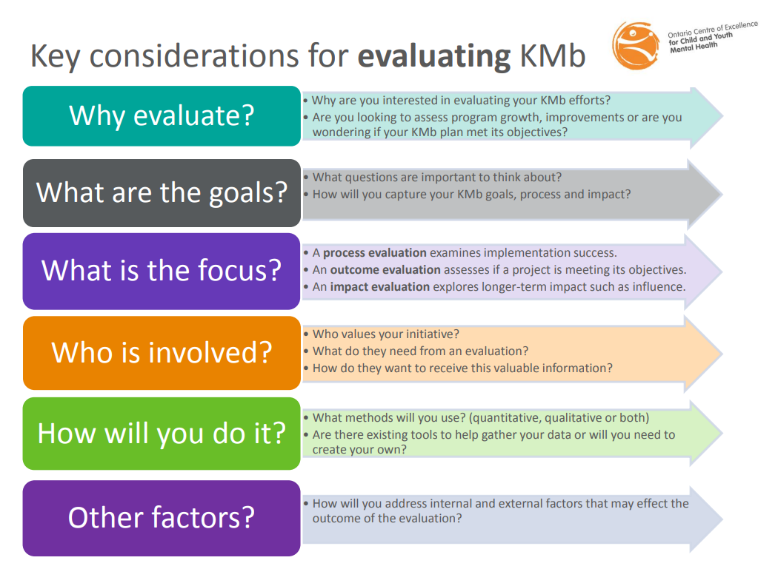
Source: Ontario Centre of Excellence for Child and Youth Mental Health (n.d.). Evaluating KMb.
When reviewing the six considerations above, what comes to mind around how you could evaluate your community engagement work?

Theories and guiding principles for evaluating community engagement
There are various theories around the ways to evaluate community engagement and numerous indicators to choose from when evaluating, but one of the most important pieces to remember is to collaborate and communicate with your community partners when working towards an evaluation. For example, South and Phillips (2014) examined community engagement within the public health system and found that there may be numerous challenges in the “measurement” of community engagement and that evaluations can sometimes oversimplify the complexities of community engagement work.
When developing and coordinating an evaluation of community engagement it is critically important that researchers and their community partners work together in a systems approach – and that evaluations should be done with, not on, community partners/stakeholders. South and Phillips (2014) put forth the following eight ‘guiding principles’ that may be important to consider within evaluation of community engagement (noting that this work has public health lens, but that the implications are relevant for broader KMb work as well):
- Communities should be considered an integral component of health systems.
- Communities should be involved in identifying appropriate outcomes and defining success.
- Evaluation should not seek to control complexity because community engagement approaches are complex, dynamic interventions.
- Evaluation should be sufficiently flexible to measure unanticipated effects.
- Evaluation needs to build a thick description and explanation of the nature of participation.
- Where quantitative methods are used, social indicators that track changes in health determinants, including social structures, need to be given equal weight to individual behaviour change.
- The purpose of the evaluation should be clearly defined in relation to the information needs of different stakeholders: policy makers, professionals, academics and communities.
- Funding streams need to shift to encompass funding of whole system evaluations.
Clearly evaluation of community engagement within community engagement and KMb is complex, so how can one set out to run an authentic and accurate evaluation of their engagement collaborations? What resources are available to support this type of evaluation work? Several of the KMb toolkits and planning templates outlined throughout this course highlight the importance of evaluation within KMb and present some indicators that may be relevant for your work. Below we have curated a non-exhaustive list of resources that may support your evaluation plans around your community engagement work.

71

Community Engagement and Collaboration | Curated Links 2
- Center for Community Health and Development at the University of Kansas. (n.d.). Community Tool Box. Retrieved from https://ctb.ku.edu/en/table-of-contents
The Community Tool Box, which is a free online resource for individuals working towards social impact and community engagement run by the Center for Community Health and Development at the University of Kansas, has a list of 46 chapters around community-building, chapters 1, 2, 36, 37, 38 and 39 all comment on evaluating community programs and initiatives.
- Goodman, M. S., Thompson, V. L. S., Arroyo Johnson, C., Gennarelli, R., Drake, B. F., Bajwa, P., … & Bowen, D. (2017). Evaluating community engagement in research: quantitative measure development. Journal of community psychology, 45(1), 17-32. Retrieved from https://onlinelibrary.wiley.com/doi/epdf/10.1002/jcop.21828
After an in-depth review of community engaged research (an umbrella term for the numerous forms of research that have community engagement at the core), Goodman and colleagues (2017) noted that tools for measuring and evaluation of community engaged research and community engagement have been primarily focused on qualitative approaches. In turn this team has begun the development of a quantitative measure for assessing the level of engagement among collaborating community members based on 11 engagement principals with numerous items and Likert scale response options for each. Take some time to review the above article by Goodman and colleagues and their quantitative community engagement measure in Appendix A of the article.
- Innoweave. (n.d.). Developmental Evaluation self-assessment tool. Retrieved from https://innoweave.ca/streams/developmental-evaluation/
Innoweave, which is a network of coaches and tools for social innovation, has created the Developmental Evaluation self-assessment tool to help teams determine their readiness and suitability for a developmental evaluation approach. Developmental evaluation is well-suited for teams developing KMb and impact work within multifaceted contexts.
- Luger, T. M., Hamilton, A. B., & True, G. (2020). Measuring community‐engaged research contexts, processes, and outcomes: a mapping review. The Milbank Quarterly, 98(2), 493-553. Retrieved from https://onlinelibrary.wiley.com/doi/full/10.1111/1468-0009.12458
This resource provides examples of different strategies/tools that fall under each of the measurement areas that emerged from the authors mapping review of contexts; processes; outcomes within measurement of community-engaged research.
- National Collaborating Centre for Methods and Tools. (n.d.). Registry of Methods and Tools for Evidence-Informed Decision Making. Retrieved from https://www.nccmt.ca/knowledge-repositories/registry
The National Collaborating Centre for Methods and Tools, based out of McMaster University’s School of Nursing, coordinates the Registry of Methods and Tools for Evidence-Informed Decision Making which is “a repository of curated resources to support evidence-informed decision-making” (n.d.). This repository is searchable and includes numerous resources around evaluation. One important note is that the resources included are mainly related to KMb in public health, so may not apply across different disciplines.
- Pencheon, D. (2008). The Good Indicators Guide: Understanding how to use and choose indicators. The NHS Institute for Innovation and Improvement. Retrieved from https://webarchive.nationalarchives.gov.uk/20170106081109/http://www.apho.org.uk/resource/item.aspx?RID=44584
The NHS Institute for Innovation and Improvement, now a part of Public Health England, has developed the The Good Indicators Guide: Understanding how to use and choose indicators (2008), which is a resource for anyone in the healthcare sector looking to use indicators to monitor and improve performance. An important note from the authors of this resource is that the two most critical sections are section 2. Indicators – the important principles (page 5) and section 7. Criteria for good indicators and good indicator sets (page 23) – “If you only read two sections from this guide, read these!”.
- Ontario Centre of Excellence for Child and Youth Mental Health. (2013) Program Evaluation Toolkit. Ottawa, Ontario. Retrieved from https://www.cymh.ca/Modules/ResourceHub/?id=6d1cdf70-8a99-4432-aba6-e19862da6857
The Ontario Centre of Excellence for Child and Youth Mental Health has developed the Program evaluation toolkit: Tools for planning, doing and using evaluation, which contains resources for planning, doing and using program evaluation.
- Tamarack Institute. (n.d.). Evaluating Community Impact. Retrieved from https://www.tamarackcommunity.ca/evaluatingcommunityimpact
The Tamarack Institute, an institute focused on supporting and developing community engagement around major social issues in Canada, has cultivated numerous resources on evaluating impact at a community level. You will note that the majority of the resources available via the Tamarack Institute are focused on collective impact via numerous impact metrics.
- University of Calgary Knowledge Exchange team. (n.d.). Knowledge Engagement Impact Assessment Toolkit. Retrieved from https://research.ucalgary.ca/engage-research/knowledge-engagement/ke-toolkit
The University of Calgary’s Knowledge Exchange team has developed the Knowledge Engagement (KE) Impact Assessment Toolkit (n.d.), which is based on the REAP Self-Assessment Model out of the University of Bradford). The REAP Self-Assessment Model focuses on four principles (Reciprocity, Externalities/Reach, Access and Partnership) and the KE Impact Assessment Toolkit highlights impact indicators based on these four principles in a matrix for researchers to review and complete at different stages of their projects/KMb/community engagement work.
- Sudsawad, P. (2007). Knowledge translation: Introduction to models, strategies, and measures. Austin, TX: Southwest Educational Development Laboratory, National Center for the Dissemination of Disability Research. Retrieved from https://ktdrr.org/ktlibrary/articles_pubs/ktmodels/index.html
The University of Wisconsin-Madison and the National Center for the Dissemination of Disability Research has developed the Knowledge Translation: Introduction to Models, Strategies, and Measures (2007) resource. Within this resource there is a section on measures of knowledge use that includes considerations and a framework for measuring knowledge use.
- Phipps, D.J., Johnny, M. and Poetz, A. (forthcoming) Demonstrating impact – considerations for collecting and communicating the evidence of impact. In The Impactful Academic. Ed. Wade Kelley. Emerald Publishing, Bingley, UK. Retrieved from TBD link to be inserted when available.
Research Impact Canada, which is a network that supports researchers, students and their partners to demonstrate the contribution to and impact of research excellence, has developed a report entitled Demonstrating impact – considerations for collecting and communicating the evidence of impact (forthcoming) to “[allow] the user to collect the evidence that describes the narrative of the research impact” (p. 1), with a focus on engaging with key stakeholders, like community members, partners, etc. around their input on the engagement process and KMb work. Within this document there is a stakeholder interview guide in Appendix A that can be used to lead an interview of community partners around their involvement in a research and KMb project. This interview guide has been developed to capture rich qualitative data and statements from various stakeholders within a project. After reviewing the interview guide, how do you think that you could incorporate qualitative interviews such as this into your project?
- Worton, S., Loomis, C., Pancer, S., Nelson, G., & Peters, R. D. (2017). Evidence to impact: A community knowledge mobilisation evaluation framework. Gateways: International Journal of Community Research and Engagement, 10, 121-142. Retrieved from https://epress.lib.uts.edu.au/journals/index.php/ijcre/article/view/5202/6046#
Worton and colleagues (2017) have presented a community-based framework for evaluating “short-term knowledge use in community settings” (p. 125), after noting that “despite the existence of numerous knowledge-to-action strategies, minimal attention has been directed towards evaluating knowledge mobilisation” (p. 124). While the Community Knowledge Mobilization Evaluation (CKME) Framework presented within this work is mainly focused on evaluating KMb and knowledge use in the community, it also presents several interesting lines of inquiry that could be posed to community partners, particularly those underpinning the final CKME model in figure two of the above cited article (p. 135). After reviewing the CKME model, how do you think that you could rephrase the questions included in the model to evaluate your KMb and community engagement work with partners?

72

Community Engagement and Collaboration | Worksheet Section 17

Activity
Now that you have completed this section of the module it is time to check in with the module worksheet. Please review the worksheet now and complete sections 17 within.

73

Community Engagement and Collaboration | Case Studies
Below we have curated a number of case studies of community engagement within the KMb and research context for you to review. Each case study has associated thought questions for you to work through in order to increase your learning in relation to these real-world examples.


74

Community Engagement and Collaboration | Brock University Lifespan Development Research Institute - Community Advisory Groups
Brock University, located in the Niagara Region, houses several research institutes, one being the Lifespan Development Research Institute (Lifespan Institute) – www.brocku.ca/lifespan. The Lifespan Institute is a multidisciplinary collaboration of over 80 researchers and numerous external organizations dedicated to studying human development across the lifespan and its associated KMb. The Lifespan Institute includes a diverse group of researchers with interests in:
- Understanding human development across the lifespan, and the factors that influence stability or change
- Understanding factors that impact on mental and physical health, brain function, learning, behaviour, etc.
A key part of the mandate of the Lifespan Institute is to build capacity for lifespan research and its associated KMb through:
- Promoting interdisciplinary research collaborations, with initiatives that work to build bridges across and within areas of interest,
- Creating opportunities for members to host workshops/mini-conferences, etc.,
- Promoting the integration of the community within our research and KMb activities, and
- Providing opportunities for KMb through training, community engagement, partnerships, and grant support.
Some of the Lifespan Institute’s KMb activities that relate to the above mandate include:
- Capacity building for members and their students around KMb (e.g. free-of-charge KMb workshop,
- International community speaker series focused on topics of relevance in lifespan development research,
- Grant support for members and their students around KMb,
- Supporting members’ KMb initiatives,
- Social media work, and
- Community engagement in the form of several advisory groups.
The below video will review the Lifespan Institute community engagement groups. Please take a moment to watch this video now and then review the thought questions included at the end of this case study.

An interactive H5P element has been excluded from this version of the text. You can view it online here:
https://ecampusontario.pressbooks.pub/knowledgemanagement/?p=499#h5p-8
You can learn more about Lifespan Institute online. If you have specific questions about this case study, the Lifespan Institute can be contacted at lifespan@brocku.ca

Thought questions:
- How could you work with a community advisory group within your KMb and research projects?
  - How could this type of community engagement benefit your work?
  - What challenges can you think of around working with a community advisory group?

- What capacity and resources would working with an advisory board require?
- How could you work to ensure that the principles of equity, diversity and inclusion are respected and incorporated in a community advisory group?

75

Community Engagement and Collaboration | Brock University Social Justice Research Institute – Community Partnerships
Another Brock University research institute is the Social Justice Research Institute (SJRI). With 80+ affiliates from across the University and over 80 participating members (including past and current Brock staff and students, as well as community activists and partners), SJRI’s primary mission is to create and mobilize knowledge that addresses contemporary social problems, opens pathways to progressive social change, and ultimately, helps to build a more just society in and beyond the Niagara Region.
SJRI supports research-based community partnerships through three inter-connected models:
- making Community Engagement Grants available to affiliated members;
- providing access to the Project Facilitator to support community collaborations by helping source external funding (e.g. from government and from private foundations) and supporting team-building (e.g. trust and skills development) among members and community organizations;
- making other SJRI members and resources directly available to community-university teams to support the fulfillment of their specific research needs.
Learn more about recent and ongoing SJRI Community Partnerships.
Now, let’s take a deeper dive into one of these case studies, which involved a team of Brock University researchers working in collaboration with peer researchers from the Fort Erie Native Friendship Centre (FENFC) to study barriers to employment engagement for Indigenous residents of Fort Erie as well as programs, supports, or resources that would assist Indigenous individuals to apply for, obtain, and remain in employment.
Together, this team has produced a Research Brief and Research Report. In addition, they have mobilized project-related knowledge in co-authored articles published in academic journal articles. This partnership has also led to further research collaborations, including the same FENFC-Brock team working on a project on Indigenous approaches to eldercare, funded by a McMaster University-based SSHRC-CIHR Partnership Grant project (led by Dr. Allison Williams). The team also is working on other projects under a new Brock University SSHRC Partnership Grant, Reimagining Care/Work Policies, led by Andrea Doucet. From this research, Andrea Doucet, Eva Jewell, and Vanessa Watts recently presented a paper entitled “Anishinaabe and feminist ecological social imaginaries of knowledge making: The Ethics of care, and ethico-onto-epistemological research practices” at the 2021 Care Ethics Research Consortium conference. These examples demonstrate the way the team’s community-university research partnership has generated more research relationships and opportunities.
Please take the time to watch this video VIDEO of a roundtable talk the team gave at the Native American and Indigenous Studies Association (NAISA) conference in July 2021 during which they reflected on their experiences working as part of a community-university research team. Afterward, please take the time to reflect on the associated thought questions included below.

An interactive H5P element has been excluded from this version of the text. You can view it online here:
https://ecampusontario.pressbooks.pub/knowledgemanagement/?p=502#h5p-9
If you would like to learn more about the SJRI, please visit them online. If you have specific questions about this case study, please contact sjri@brocku.ca

Thought questions
- What are some complications/tensions that can arise when doing this kind of collaborative work?
- What are some outcomes — expected and unexpected — that may emerge from community-university partnerships?
- Review the USAI Research Framework published by the Ontario Federation of Indigenous Friendship Centres and consider: in what ways does this model differ from western frameworks which continue to be prioritized in post-secondary educational institutions?

76

Community Engagement and Collaboration | Final Worksheet Review and Post-Assessment

Activity
Congratulations, you have completed all of the module content! Now it is time for a final check in with the module worksheet. Please review the worksheet now and complete section 18 of the worksheet. After you have completed the final section of the worksheet please complete the self-assessment evaluation guide included within.
It is also time to complete the post-assessment quiz for the module. Please complete the quiz below.
An interactive H5P element has been excluded from this version of the text. You can view it online here:
https://ecampusontario.pressbooks.pub/knowledgemanagement/?p=505#h5p-7

77

Community Engagement and Collaboration | Summary and a Look Ahead
This module presented a high-level introduction to community engagement within the KMb process. The main topics touched on were:
- A re-introduction to KMb and the knowledge-to-action gap — focusing on the question “how can content/subject matter and context experts come together to bridge the gap between what is known and what is being done?” This module section pointed to community engagement as a key practice for ensuring that the knowledge-to-action gap is closed with both content/subject matter and context experts collaborating together authentically and respectfully.
- The next section of this module dove deeper into what community engagement is — highlighting background research on the need for knowledge exchange and community engaged research (CEnR), and then reviewing various roles communities might take in CEnR and different ways that CEnR might function within the KMb process. At the end of this section of the module you worked your way through the first 10 questions of the module worksheet.
- We then revisited the Lavis model for KMb and you were asked to review the model’s five questions with a focus on community engagement and knowledge exchange — looking to external resources on how the community might collaborate within your KMb work.
- We then moved on to a non-exhaustive list of key considerations for community engagement work — such as accessibility, EDI, readiness to collaborate, capacity to collaborate, staffing, budget and associated funding opportunities. Throughout this section you were asked to revisit the module worksheet and review the key considerations in the context of your own work.
- Next we discussed evaluation of community engagement in KMb, highlighting various resources for examples of how you might be able to evaluate your own community engagement work.
- The module concluded with several case studies of community engagement work within research settings.
Next you will be learning about commercialization within KMb and then a module on how to influence policy within your research and KMb work. Throughout the next modules make sure to keep the lens of community engagement at the forefront of this work — asking how, why and when you could integrate the community within this work, and how you would make sure that the engagement was meaningful!

Final Thoughts
“Without the involvement of everyone, especially affected populations, [decision-makers are] likely to misunderstand the problem, develop ill-fitting solutions, and maintain existing patterns of dominance and privilege”
– Abresch et al., 2021.
You now have the ability authentically engage with your community, meeting them where they are and recognizing the knowledge and different resources that they each bring to your research and KMb process. The tools you have learned can be used as you move ahead through your KMb journey.
In the next unit, we will be looking at how to take the plans we have developed and use social media to share our message and expertise.

78

Community Engagement and Collaboration | Curated Links
- Archie, M. L., Clark, S., & Braus, J. (2017). Community engagement: guidelines for excellence. North American Association for Environmental Education (NAAEE). (https://cdn.naaee.org/sites/default/files/community_engagement_-_guidelines_for_excellence.pdf
- Canadian Institutes of Health Research. (2012). Guide to knowledge translation planning at CIHR: integrated and end-of-grant approaches. Canadian Institutes of Health Research. https://cihr-irsc.gc.ca/e/45321.html
- Clinical and Translational Science Awards Consortium Community Engagement Key Func-tion Committee Task Force on the Principles of Community Engagement. (2011). Principles of Community Engagement. NIH Publication No. 11–7782. http://www.atsdr.cdc.gov/communityengagement/
- Hewitt, T. (2021). Imagining the Future of Knowledge Mobilization: Perspectives from UNESCO Chairs. Canadian Commission for UNESCO. https://en.ccunesco.ca/-/media/Files/Unesco/Resources/2021/01/ImaginingFutureOfKnowledgeMobilization.pdf
- Ontario Federation of Indigenous Friendship Centres. (2012). USAI Research Framework. [PDF]. https://ofifc.org/research/
- Parry, D., Salsberg, J., Macaulay, A. C., & FCPC, C. (2009, 2015). A guide to researcher and knowledge-user collaboration in health research. Ottawa: Canadian Institutes of Health Research. https://cihr-irsc.gc.ca/e/44954.html

Other Resources and References
- Abresch, C., Grimm, B., Lyons, K., Maloney, S. & Tibbits, M. (2021) Who gets included in Collective Impact: A mixed methods study of CI initiatives. Community Development Ahead of print, 1-15. https://doi.org/10.1080/15575330.2021.1941161
- Accessibility Services Canada. (n.d.). Definitions. https://accessibilitycanada.ca/aoda/definitions
- Allen, M. L., Culhane-Pera, K. A., Pergement, S. & Thiede Call, K. (2011). A Capacity Building Program to Promote CBPR Partnerships between Academic Researchers and Community Members. Clinical Translation Science, 4(6), 428-433. https://doi.org/10.1111/j.1752-8062.2011.00362.x
- Arnstein, S. R. (1969). A ladder of citizen participation. J Am Inst Planners 35 (4): 216-224.
- Attygalle, L. (2020). Understanding Community-Led Approaches to Community Change. Tamarack Institute. https://www.tamarackcommunity.ca/library/paper-understanding-community-led-approaches-community-change-lisa-attygalle
- Attygalle, L. (2017). The Context Experts. Tamarack Institute. https://www.tamarackcommunity.ca/library/the-context-experts
- Ayre, D., Clough, G. and Norris, T. (2002). Facilitating Community Change Handbook. The Grove Consultants and International Community Initiatives, LLC p. 9-13
- Balas, E. A., & Boren, S. A. (2000). Managing clinical knowledge for health care improvement. Yearbook of medical informatics, 9(01), 65-70.
- Balas, E. A., Weingarten, S., Garb, C. T., Blumenthal, D., Boren, S. A., & Brown, G. D. (2000). Improving preventive care by prompting physicians. Archives of internal medicine, 160(3), 301-308. https://jamanetwork.com/journals/jamainternalmedicine/fullarticle/1729683
- Balazs, C. L. & Morello-Frosch, R. (2013). The Three R’s: How Community Based Participatory Research Strengthens the Rigor, Relevance and Reach of Science. Environmental Justice 6(1), 9-16. https://doi.org/10.1089/env.2012.0017
- Barwick, M.A. (2008, 2013, 2019). Knowledge Translation Planning Template. Ontario: The Hospital for Sick Children. https://www.sickkids.ca/en/learning/continuing-professional-development/knowledge-translation-training/knowledge-translation-planning-template-form/
- Barwick, M., Phipps, D., Coriandoli, R., Johnny, M., & Myers, G. (2014). Knowledge translation and strategic communications: Unpacking differences and similarities for scholarly and research communications. https://www.researchgate.net/publication/315503298_Knowledge_Translation_and_Strategic_Communications_Unpacking_Differences_and_Similarities_for_Scholarly_and_Research_Communications
- Beaulieu, M., Breton, M. & Brousselle, A. (2018). Conceptualizing 20 years of engaged scholarship: A scoping review. PLoS ONE, 13(2), 1-17. https://doi.org/10.1371/journal.pone.0193201
- Bennet, A., Bennet, D., Fafard, K., Fonda, M., Lomond, T., Messier, L., & Vaugeois, N. (2007). Knowledge mobilization in the social sciences and humanities. Frost, WV: Mqi Press. https://www.researchgate.net/publication/273062902_Knowledge_mobilization_in_the_social_sciences_and_humanities_moving_from_research_to_action
- Bowen, S. J. & Graham, I. (2013). From knowledge translation to engaged scholarship: Promoting research relevance and utilization. Archives of Physical Medicine and Rehabilitation, 94(1), S3-8.
- Campus Connect. (2021). Making the Case for Community Engaged Scholarship (CES). https://compact.org/tenure-and-promotion-repository/making-the-case-for-ces/
- Canadian Association of University Teachers. (n.d). Guide to Acknowledging First Peoples & Traditional Territory. https://www.caut.ca/content/guide-acknowledging-first-peoples-traditional-territory
- Cazaly, L. (n.d). Levels of Participation [Video]. Vimeo https://vimeo.com/93902630
- Center for Community Health and Development at the University of Kansas. (n.d.). Community Tool Box. https://ctb.ku.edu/en/table-of-contents
- Centre for Studies on Poverty and Social Citizenship. (2019). Community-Based Research Toolkit: A Project Development Checklist. Carleton University. doi: http:/doi.org/10.22215/cspsc-2019-02. https://carleton.ca/cspsc/research-toolkit/
- Chando, S., Tong, A., Howell, M., Dickson, M., Craig, J.C., DeLacy, J., Eades, S.J., & Howard, K. (2021). Stakeholder perspectives on the implementation and impact of Indigenous health interventions: A systematic review of qualitative studies. Health Expectations, 24(3), 731-743. https://doi.org/10.1111/hex.13230
- Chin, S. (2019). Best Practices for Community Engagement (Doctoral dissertation, University of British Columbia). https://open.library.ubc.ca/soa/cIRcle/collections/graduateresearch/66428/items/1.0386712
- Clinical and Translational Science Awards Consortium Community Engagement Key Function Committee Task Force on the Principles of Community Engagement (2011). Principles of Community Engagement (2nd ed.). https://www.atsdr.cdc.gov/communityengagement/index.html
- Collective Impact Forum, & FSG. (n.d.). Backbone Starter Guide: A Summary of Major Resources about the Backbone from FSG and the Collective Impact Forum. https://www.collectiveimpactforum.org/sites/default/files/Backbone%20Starter%20Guide.pdf
- Dobbins, M., Ciliska, D., Cockerill, R., Barnsley, J., & DiCenso, A. (2002). A framework for the dissemination and utilization of research for health‐care policy and practice. Worldviews on Evidence‐based Nursing presents the archives of Online Journal of Knowledge Synthesis for Nursing, 9(1), 149-160. https://sigmapubs.onlinelibrary.wiley.com/doi/abs/10.1111/j.1524-475X.2002.00149.x
- Doucet, A. & Mauthner, N.S. (2012). Knowing Responsibly: Ethics, Feminist Epistemologies and Methodologies in Ethics in T. Miller, Birch, M., Mauthner, M., & Jessop, J. (Eds.), Qualitative Research (2nd ed., pp. 123-145). Retrieved from http://www.andreadoucet.com/
- Evidence Exchange Network. [EENet]. (2012). EENet Video [Video]. Vimeo. https://vimeo.com/45757954
- First Nations Information Governance Centre. (n.d.). Understanding OCAPÒ. The First Nations Principles of OCAPÒ, https://fnigc.ca/ocap-training/
- Fletcher, F., Hibbert, A., Hammer, B., & Ladouceur, S. (2017). Beyond Collaboration: Principles and Indicators of Authentic Relationship Development in CBPR. Journal of Community Engagement and Scholarship, 9 (2), 1-11. https://digitalcommons.northgeorgia.edu/jces/vol9/iss2/9/
- Ford, L., Kaluzny, A. D., & Sondik, E. (1990). Diffusion and adoption of state-of-the-art therapy. In Seminars in oncology, 17(4), 485-494.
- Gainforth, H. L., Latimer-Cheung, A. E., Athanasopoulos, P., Moore, S., & Ginis, K. A. M. (2014). The role of interpersonal communication in the process of knowledge mobilization within a community-based organization: a network analysis. Implementation Science, 9(1), 1-8. https://implementationscience.biomedcentral.com/articles/10.1186/1748-5908-9-59
- Gainforth, H. L., Latimer-Cheung, A. E., Athanasopoulos, P., & Ginis, K. A. M. (2013). Examining the effectiveness of a knowledge mobilization initiative for disseminating the physical activity guidelines for people with spinal cord injury. Disability and health journal, 6(3), 260-265. https://www.sciencedirect.com/science/article/abs/pii/S1936657413000149
- Girratana, M. (2021). Land Acknowledgement Practices: Functions, Efficacy, Controversy, and Union College [Video]. https://digitalworks.union.edu/steinmetzsymposium/steinmetz_2021/oralpresentations/275/
- Goddard-Durant, S., Sieunarine, J. A. and Doucet, A. (2021). Decolonising Research with Black Communities: Developing Equitable and Ethical Relationships between Stakeholders. Families, Relationships and Societies, 10(1), 189-196. http://www.andreadoucet.com/
- Gonzalez, R. (2020). Spectrum of Community Engagement to Ownership. Facilitating Power. https://www.facilitatingpower.com/spectrum_of_community_engagement_to_ownership
- Goodman, M. S., Thompson, V. L. S., Arroyo Johnson, C., Gennarelli, R., Drake, B. F., Bajwa, P., … & Bowen, D. (2017). Evaluating community engagement in research: quantitative measure development. Journal of community psychology, 45(1), 17-32. https://onlinelibrary.wiley.com/doi/epdf/10.1002/jcop.21828
- Graham, I. D., Logan, J., Harrison, M. B., Straus, S. E., Tetroe, J., Caswell, W., & Robinson, N. (2006). Lost in knowledge translation: time for a map? Journal of continuing education in the health professions, 26(1), 13-24. https://onlinelibrary.wiley.com/doi/pdfdirect/10.1002/chp.47
- Graham, I. D., & Tetroe, J. (2007). How to translate health research knowledge into effective healthcare action. Healthc Q, 10(3), 20-22. http://ihpme.webservices.utoronto.ca/Assets/IHPME+Digital+Assets/IHPME/hpme/events/hsr07/graham4.pdf
- Granovetter, M. S. (1973). The strength of weak ties. American journal of sociology, 78(6), 1360-1380.
- Green, L. W. (2008). Making research relevant: if it is an evidence-based practice, where’s the practice-based evidence? Family practice, 25(suppl_1), i20-i24. https://academic.oup.com/fampra/article/25/suppl_1/i20/542034
- Green, L. W., Ottoson, J. M., Garcia, C., & Hiatt, R. A. (2009). Diffusion theory and knowledge dissemination, utilization, and integration in public health. Annual review of public health, 30. https://www.annualreviews.org/doi/full/10.1146/annurev.publhealth.031308.100049
- Gregory, A. G., & Howard, D. (2009). The nonprofit starvation cycle. Stanford Social Innovation Review, 7(4), 49-53. http://www.macc-mn.org/Portals/1/Document-library/Research/SSIR%20Nonprofit%20starvation%20Cycle%202009.pdf
- Grol, R. (2001). Successes and failures in the implementation of evidence-based guidelines for clinical practice. Medical care, II46-II54.
- Groundwork USA. (2018). Best Practices for Meaningful Community Engagement. https://groundworkusa.org/wp-content/uploads/2018/03/GWUSA_Best-Practices-for-Meaningful-Community-Engagement-Tip-Sheet.pdf
- Health Outreach Partners (2011, October 1). Applying Principles of Community-Based Participatory Research to Your Program. Health Outreach Blog. https://outreach-partners.org/2011/10/01/applying-principles-of-community-based-participatory-research-to-your-program/
- Innoweave. (n.d.). Developmental Evaluation self-assessment tool. https://innoweave.ca/streams/developmental-evaluation/
- International Association for Public Participation. (n.d.) Core Values, Ethics, Spectrum – The 3 Pillars of Public Participation. Advancing the practice of public participation. https://www.iap2.org/page/pillars
- Israel, B. A., Coombe, C.M., Cheezum, R.R., Schultz, A. J., McGranaghan, R.J., Lichtenstein, R., Reyes, A.G., Clement, J. & Burris, A. (2010). Community-Based Participatory Research: A Capacity-Building Approach for Policy Advocacy Aimed at Eliminating Health Disparities. American Journal of Public Health, 100(11), 2094-2102. doi: 10.2105/AJPH.2009.170506
- Jordan, C. M., Joosten, Y. A., Leugers, R. C., & Shields, S. L. (2009). The community-engaged scholarship review, promotion, and tenure package: A guide for faculty and committee members. Metropolitan Universities, 20(2), 66-86. https://journals.iupui.edu/index.php/muj/article/view/20391
- Jones, A. et al. (n.d.). Territory Acknowledgement. Native Land Digital. https://native-land.ca/resources/territory-acknowledgement/
- Jull, J., King, A., King, M., Graham, I. D., Morton Ninomiya, M. E., Jacklin, K., … & Moore, J. E. (2020). A Principled Approach to Research Conducted with Inuit, Métis, and First Nations People: Promoting Engagement Inspired by the CIHR Guidelines for Health Research Involving Aboriginal People (2007-2010). The International Indigenous Policy Journal, 11(2), 1-30.
- Jull, J., King, A., Mashford-Pringle, A., ​​Desnomie, C., Manitowabi, D., Walker, J., … & Ferrazzi, P. (2020, March 16). Indigenous community research partnerships can help address health inequities. The Conversation. https://theconversation.com/indigenous-community-research-partnerships-can-help-address-health-inequities-152705
- Graham, I. D., Morton Ninomiya, M. E., Jacklin, K., … & Moore, J. E. (2020). A Principled Approach to Research Conducted with Inuit, Métis, and First Nations People: Promoting Engagement Inspired by the CIHR Guidelines for Health Research Involving Aboriginal People (2007-2010). The International Indigenous Policy Journal, 11(2), 1-30.
- Lavis, J., Robertson, D., Woodside, J., McLeod, C., & Abelson, J. (2003a). How can research organizations more effectively transfer research knowledge to decision makers? Millbank Quarterly, 81(2), 221-248. https://www.ncbi.nlm.nih.gov/pmc/articles/pmc2690219/
- Lavis, J. (2003b, March 13). How Can Research Organizations More Effectively Transfer Research Knowledge to Decision Makers? [Presentation]. World Health Organization, Geneva, Switzerland. https://pdfs.semanticscholar.org/50c5/429ce338c7a9f2e69d080f1cfdaf96ab74b4.pdf
- Lee, N. R., & Kotler, P. (2019). Social marketing: Behavior change for social good. Sage Publications.
- Levin, B. (2008, May). Thinking about knowledge mobilization. In an invitational symposium sponsored by the Canadian Council on Learning and the Social Sciences and Humanities Research Council of Canada. (pp. 15-18). https://www.oise.utoronto.ca/rspe/UserFiles/File/KM%20paper%20May%20Symposium%20FINAL.pdf
- Lomas, J. (2000). Essay: Using ‘Linkage And Exchange’ To Move Research Into Policy At A Canadian Foundation: Encouraging partnerships between researchers and policymakers is the goal of a promising new Canadian initiative. Health affairs, 19(3), 236-240. https://www.healthaffairs.org/doi/full/10.1377/hlthaff.19.3.236
- Luger, T.A., Hamilton, A.B., & True, G. (2020) Measuring Community-Engaged Research Contexts, Processes, Outcomes: A Mapping Review. The Milbank Quarterly, 98(2), 493-553. https://onlinelibrary.wiley.com/doi/full/10.1111/1468-0009.12458
- Mark, M. M., Henry, G. T., & Julnes, G. (1999). Toward an integrative framework for evaluation practice. American Journal of Evaluation, 20(2), 177-198. https://www.researchgate.net/profile/Gary-Henry/publication/252162424_Toward_an_Integrative_Framework_for_Evaluation_Practice1/links/00b495329bd6bdc7a3000000/Toward-an-Integrative-Framework-for-Evaluation-Practice1.pdf
- Mark, M. M., Henry, G. T., & Julnes, G. (2000). Evaluation: An integrated framework for understanding, guiding, and improving policies and programs. Jossey-Bass.
- MacQueen, K. M., Bhan, A., Frohlich, J., Holzer, J., & Sugarman, J. (2015). Evaluating community engagement in global health research: the need for metrics. BMC Medical Ethics, 16(1), 1-9. https://bmcmedethics.biomedcentral.com/articles/10.1186/s12910-015-0033-9
- McGlynn, E. A., Asch, S. M., Adams, J., Keesey, J., Hicks, J., DeCristofaro, A., & Kerr, E. A. (2003). The quality of health care delivered to adults in the United States. New England Journal of Medicine, 348(26), 2635-2645.
- National Collaborating Centre for Methods and Tools. (n.d.). Registry of Methods and Tools for Evidence-Informed Decision Making. https://www.nccmt.ca/knowledge-repositories/registry
- Native Governance Centre. (2019). Guide to Indigenous Land Acknowledgement. https://nativegov.org/a-guide-to-indigenous-land-acknowledgment/
- Neufeld, S. D., Chapman, J., Crier, N., Marsh, S., McLeod, J., & Deane, L. A. (2019). Research 101: A process for developing local guidelines for ethical research in heavily researched communities. Harm reduction journal, 16(1), 1-11. https://harmreductionjournal.biomedcentral.com/articles/10.1186/s12954-019-0315-5
- The North American Association for Environmental Education. (n.d.). Checklists for Assessing Readiness to Under take Community Collaboration. https://naaee.org/sites/default/files/checklists_for_assessing_readiness.pdf
- Ontario Centre of Excellence for Child and Youth Mental Health (n.d.). Evaluating KMb. http://www.kmbtoolkit.ca/evaluating
- Ontario Centre of Excellence for Child and Youth Mental Health. (2013) Program Evaluation Toolkit. Ottawa, Ontario. https://www.cymh.ca/Modules/ResourceHub/?id=6d1cdf70-8a99-4432-aba6-e19862da6857
- Ontario Neurotrauma Foundation. (n.d.). Glossary of Terms. https://web.archive.org/web/20080616184315/http://www.onf.org/knowledge/glossary.htm
- Patton, M. Q. (2008). Utilization-focused evaluation. Sage publications.
- Pencheon, D. (2008). The Good Indicators Guide: Understanding how to use and choose indicators. The NHS Institute for Innovation and Improvement. https://webarchive.nationalarchives.gov.uk/20170106081109/http://www.apho.org.uk/resource/item.aspx?RID=44584
- Phipps, D.J., Johnny, M. and Poetz, A. (forthcoming) Demonstrating impact – considerations for collecting and communicating the evidence of impact. In The Impactful Academic. Ed. Wade Kelley. Emerald Publishing, Bingley, UK.
- Phipps, D. (2021). Tenure and promotion is an issue for engaged scholars but maybe not for the reason you think. Research Impact Canada. http://researchimpact.ca/tenure-and-promotion-is-an-issue-for-engaged-scholars-but-maybe-not-for-the-reason-you-think/
- Plummer, R., Witkowski, S., Smits, A., & Dale, G. (2021) The issue of performance in Higher education institution – Community partnerships: A Canadian perspective. Journal of Higher Education Policy and Management, Ahead of print, 1-20. https://doi.org/10.1080/1360080X.2020.1858386
- Queen’s University Office of Indigenous Initiatives. (n.d.). Indigenous Research Training. https://www.queensu.ca/indigenous/decolonizing-and-indigenizing/community-research-partnerships-training
- Rasmus, S. M. (2014). Indigenizing CBPR: Evaluation of a Community-Based and Participatory Research Process Implementation of the Elluam Tungiinun (Towards Wellness) Program in Alaska. American Journal of Community Psychology, 54 (1/2), 170-179. https://onlinelibrary.wiley.com/doi/abs/10.1007/s10464-014-9653-3
- Reardon, R., Lavis, J., & Gibson, J. (2006). From research to practice: A knowledge transfer planning guide. http://www.iwh.on.ca/from-research-to-practice.
- Rogers, E. M. (2010). Diffusion of innovations. Simon and Schuster.
- South, J., & Phillips, G. (2014). Evaluating community engagement as part of the public health system. J Epidemiol Community Health, 68(7), 692-696. http://eprints.leedsbeckett.ac.uk/2013/1/Evaluating%20Community%20engagement_Final%20accepted%20version.pdf
- Roman Isler, M., & Corbie-Smith, G. (2012). Practical Steps to Community Engaged Research: From Inputs to Outcomes. Journal of Law, Medicine & Ethics, 40(4), 904-914. DOI: 10.1111/j.1748-720X.2012.00719.x
- Roura, Maria, Sonia Dia, Joseph W, LeMaster & Anne McFarlene (2021). Participatory health research with migrants: Opportunities, challenges, and ways forward. Health Expectations 24(2): 188-197. https://onlinelibrary.wiley.com/doi/full/10.1111/hex.13201
- Rudder, K. (2019). Hayden King and others question the effectiveness of land acknowledgements. The Eyeopener. https://theeyeopener.com/2019/01/hayden-king-and-others-question-the-effectiveness-of-land-acknowledgemenets/
- Sanchez, V., Sanchez-Youngman, S., Dickson, E., Burgess, E., Haozous, E., Trickett, E., Baker, E., & Wallerstein, N. (2021). CBPR Implementation Framework for Community-Academic Partnerships. American Journal of Psychology, 67(3/4), 284-296. https://doi.org/10.1002/ajcp.12506
- Sanders Thompson, V. L., Ackermann, N. Bauer, K.L., Bowen, D.J., & Goodman, M.S. (2020). Strategies of community engagement in research: definitions and classifications. Translational Behavioral Medicine, 11(2), 441-451. https://doi.org/10.1093/tbm/ibaa042
- San Francisco State University. (n.d.) Differences Between Community-Based Research, Community-Based Participatory Research, and Action Research. Institute for Civic and Community Engagement. https://icce.sfsu.edu/content/differences-between-community-based-research-community-based-particpatory-research-and
- Schuster, M. A., McGlynn, E. A., & Brook, R. H. (1998). How good is the quality of health care in the United States?. The Milbank Quarterly, 76(4), 517-563.
- Smith, L. T. (2012). Decolonizing Research Methodologies: Research and Indigenous Peoples. Zed Books.
- Social Sciences and Humanities Research Council. (n.d). Definitions of Terms. https://www.sshrc-crsh.gc.ca/funding-financement/programs-programmes/definitions-eng.aspx#km-mc
- South, J., & Phillips, G. (2014). Evaluating community engagement as part of the public health system. J Epidemiol Community Health, 68(7), 692-696. https://eprints.leedsbeckett.ac.uk/id/eprint/2013/1/Evaluating%20Community%20engagement_Final%20accepted%20version.pdf
- Strand, K. (2003). Community-Based Research and Higher Education: Principles and Practices. Jossey-Bass.
- Sudsawad, P. (2007). Knowledge translation: Introduction to models, strategies, and measures. Austin, TX: Southwest Educational Development Laboratory, National Center for the Dissemination of Disability Research. https://ktdrr.org/ktlibrary/articles_pubs/ktmodels/index.html
- Tamarack Institute. (n.d.). Evaluating Community Impact. https://www.tamarackcommunity.ca/evaluatingcommunityimpact
- Tetroe, J. (2007). Knowledge translation at the Canadian Institutes of Health Research: a primer. Focus Technical Brief, 18, 1-8. https://ktdrr.org/ktlibrary/articles_pubs/ncddrwork/focus/focus18/
- University of British Columbia Equity and Inclusion Office. (n.d.). Equity & Inclusion Glossary of Terms. https://equity.ubc.ca/resources/equity-inclusion-glossary-of-terms
- University of Calgary Knowledge Exchange team. (n.d.). Knowledge Engagement Impact Assessment Toolkit. https://research.ucalgary.ca/engage-research/knowledge-engagement/ke-toolkit
- University of South Florida, Office of Community Engagement and Partnerships. (n.d.). Community-engaged Scholarship Toolkit. https://www.usf.edu/engagement/faculty/community-engaged-scholarship-toolkit.aspx
- U.S. Department of Arts and Culture. (2017, October 3). #HonorNativeLand [Video]. YouTube. ​​https://www.youtube.com/watch?v=ETOhNzBsiKA
- Weiner, J. & McDonald, J. (2013) Three Models of Community-Based Participatory Research. Issue Briefs. Leonard Davis Institute of Health Economics: University of Pennsylvania. https://repository.upenn.edu/ldi_issuebriefs/108/
- Whitman, A., & Wadud, E. (2013). Measuring Success: Evaluating Comprehensive Community Initiatives. Community Tool Box. https://ctb.ku.edu/en/table-of-contents/evaluate/evaluate-community-initiatives/measure-success/main
- Worton, S., Loomis, C., Pancer, S., Nelson, G., & Peters, R. D. (2017). Evidence to impact: A community knowledge mobilisation evaluation framework. Gateways: International Journal of Community Research and Engagement, 10, 121-142. http://dx.doi.org/10.5130/ijcre.v10i1.5202

79

Community Engagement and Collaboration | Credits

Subject Matter Experts
- Julie Gregory, Brock University – author
- Jayne Morrish, Brock University – author
- Alex Gill, Ryerson University – reviewer

Industry, Government and Community Partners
- Cathy Bruce, Trent University
- Ashley Horne, Trent University

Designers and Editors
- Dana Capell, Educational Developer, Trent University
- Lillian Chumbley, eLearning Designer, Trent University
- James Bailey, Multimedia eLearning Design Specialist, Trent University
- Bethany Brown, Graphic Designer

IV

Social Media

How can the use of social media enhance the impact of my research program?

80

Social Media | Synopsis
This module asks us to start thinking about how we might use social media to share our research expertise, our research outputs, and begin building a robust social media strategy that we are able to maintain over time. Topics covered in this module include types of social media, when to include social media in your research program, designing a social media strategy, learning to use popular social media tools, and measuring the success of your social media strategy.

81

Social Media | Setting the Scene
At this point you may have starting thinking about all the people who need to know more about your research and innovations. You have created a communications strategy, but we need to consider how to incorporate social media for maximum impact.
While you have probably heard about Twitter and other social media platforms and you may wonder if there is room for your research to be found by policy makers amongst the cat videos and TikTok memes shared on social media networks. Your communication strategy shares their findings with those interested in implementing their results in workplaces, products and classrooms. Are policy makers, employers, and other academics part of these networks? Many of your colleagues and students are using social media to interact with colleagues and share their research stories. You even know of colleagues who post and share videos of their own work.
You can see people glued to their phones and you may have realized that to make an impact with the over 53% of the world’s population that uses social media, you will need to create a social media strategy. Along the way, you will learn that a social media strategy is more than creating a cool username and posting photos of cats.

82

Social Media | Video Introduction

An interactive H5P element has been excluded from this version of the text. You can view it online here:
https://ecampusontario.pressbooks.pub/knowledgemanagement/?p=517#h5p-10

83

Social Media | Learning Outcomes & Resources

Proposed Learning Goals
By the end of the module, you will be able to:
- Determine when to use social media tools.
- Identify your social media ecosystem.
- Create a social media strategy.
- Learn about popular social media tools and how to use them.

Learning Resources and Readings
In order to complete the module, you will need to consult a variety of readings and resources that are linked throughout the module. You will be instructed to read any content that is required and view embedded video presentations, all other readings and resources are supplementary.

84

Social Media | Social Media as Communication Tools
“Digital literacy will become an essential skill in a scientist’s tool kit” – Osterrieder, 2013 45
Before we start the content, answer the following question.
An interactive H5P element has been excluded from this version of the text. You can view it online here:
https://ecampusontario.pressbooks.pub/knowledgemanagement/?p=522#h5p-11

85

Social Media | Understanding Social Media
Social media tools are “computer-based tools that facilitate the sharing of ideas, thoughts, and information through the building of virtual networks and communities”.46 Due to the networked and interactive nature of social media tools, a specific strategy is required to leverage social media effectively within a larger communications strategy.

Wikipedia provides an
of types of social media and their evolution and history.
Social media tools are quickly becoming part of a standard communications tactics. According to Smart Insight, as of July 2021, 53.6% of the world’s population uses social media, including social media and messenger services. 47
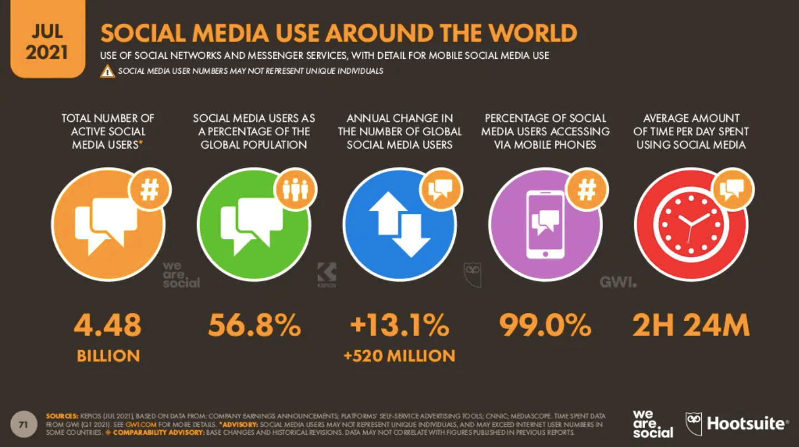
A social media strategy is complementary to a communications plan. Both plans incorporate different types of knowledge mobilization products to share research outputs with targeted audiences. Communication plans, knowledge mobilization plans, and social media plans are all concerned with effectively engaging audiences with research outputs and researcher expertise.
Communication plans outline specific tactics to “push” content to audiences, or create ways for audiences to “pull” content from a trusted source. Social media plans also engage in “push” and/or “pull” tactics, with the primary goal of sharing and exchanging content within networks of users.
The overarching aim of a social media plan is to provide content into a specific social media network. Once your content is shared in the network and is discovered by other users, other social media users within a network share your content amongst themselves organically. This organic sharing of your content, based on the attributes of the content and your position as a trusted user within the network, expands the reach and impact of research via social media.
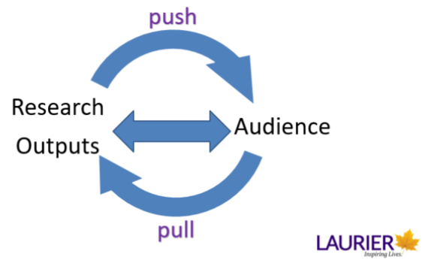

86

Social Media | Understanding Social Media 2
Social media networks are filled with individuals, organizations, brands and labs. Each share through social media bring eyeballs to your content.
As well as networks of people, social media provides a set of specific tools to interact online. Due to the changing natures of the evolving set of tools available, it is also important to understand the basic concepts around how all social media tools and networks operate. The following two videos explain how social media tools work and the concepts they are based on.

One or more interactive elements has been excluded from this version of the text. You can view them online here: https://ecampusontario.pressbooks.pub/knowledgemanagement/?p=530#oembed-1

One or more interactive elements has been excluded from this version of the text. You can view them online here: https://ecampusontario.pressbooks.pub/knowledgemanagement/?p=530#oembed-2

87

Social Media | Similarities and Differences of Communications Tools
Traditional Communication Tools | Social Media Tools
Time is required to publish on media i.e. printed and then distributed through couriers or posted. | ⁴5
Distinct distribution network i.e. newspaper sellers, booksellers, newspaper website. | ⁴5
Informational, hard for audience to “talk back” i.e. letter to publisher to reach an author. | ⁴5
“One–to-many” communication. | “One-to-many” communication as well as “one-to-one” communication.
Often mediated by a third party i.e. newspaper publisher. | Direct communication with audience.
Requires physical planning i.e. book launch or author reading. | Requires message planning i.e. composing tweets on behalf of author.
Content is static. | Content can be updated after initial publication.
Specific single publication date. | long tail of the internet
Barwick, Melanie & Phipps, David & Myers, Gary & Johnny, Michael & Coriandoli, Rossana. (2014).
. Scholarly and Research Communication. 5. 10.22230/src.2014v5n3a175.

The A-Z Guide of Social Media for Academics, Times Higher Education

Long Tail of the Internet
The long tail of the internet (coined by Chris Anderson) is a concept of having equal impact over time. The graph below shows the same amount of area under the graph in two regions. This is applicable to social media as sharing research outputs on the internet, through social media networks, allows access over time. This means that research products that have a “big launch in popularity when published” (area in blue), do not have an advantage over products tailored to specific audiences that can find the research outputs over time (area in orange).
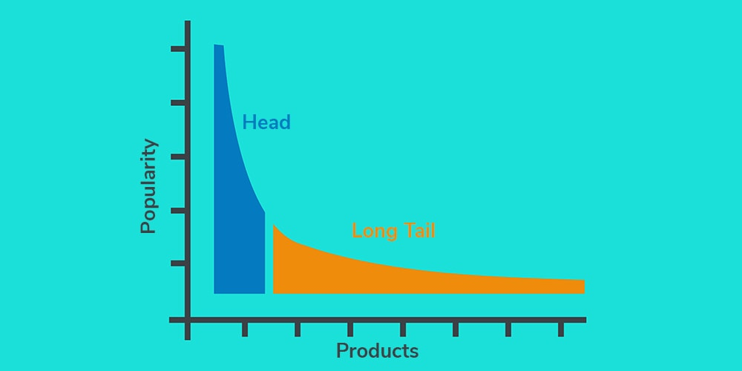
One or more interactive elements has been excluded from this version of the text. You can view them online here: https://ecampusontario.pressbooks.pub/knowledgemanagement/?p=532#oembed-1

88

Social Media | Types of Social Media Tools
Social media tools fall into different categories based on what they are used for. Hootsuite, a popular social media-planning tool, outlines 10 different types of social media.

- Media sharing networks – share photos, videos and other media
- Social networks – connect with people
- Discussion forums – share news and ideas
- Bookmarking and content curation networks – find and review businesses
- Blogging and publishing networks – publish content online
- Interest-based networks – shop online
- Sharing economy networks – trade goods and services
- Anonymous social networks – communication anonymously
Types of social media via Hootsuite
This module will examine a few popular examples of social media tools you might want to use as part of a social media strategy to reach your academic colleagues, your research funders, potential policy makers, and all those interested in your research:
- Twitter (social networking tool example).
- Facebook (social networking tool example).
- YouTube (media sharing tool example).
- Instagram (social networking tool example).
- LinkedIn (social networking tool example).
- Pinterest (social bookmarking tool example).
- Medium (discussion forum example).
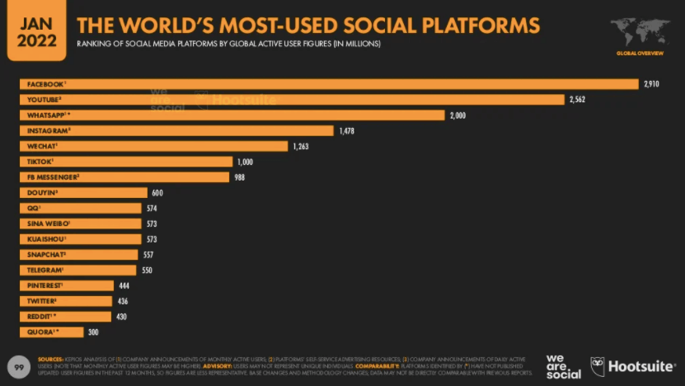
There are other social media tools that will not be explored in detail in this module including ResearchGate or Academia.edu, two examples of social networking tools for academics. The purpose of this module is to explore social media tools that are used to share research with multiple audiences, not solely academic audiences. TikTok will also not be explored in detail as its use by academics to reach audiences interested in their research is just emerging, although the video provides a compelling argument for individual academic use of TikTok to support an academic writing practice.

(by a historian)

89

Social Media | Determining your Social Media Use Case
In the previous module, the communications plan you created outlined the key audiences who would be interested in your research results/outputs. Determining whether the audiences you are trying to reach are on social media is the first step to determining if you need a social media plan. These audiences may be:
- potential employers who will hire you for your expertise
- potential research users
- potential conference hosts looking for experts to give a keynote address
- colleagues in your field who may turn into research collaborators
- colleagues who are at the same career stage as you who may turn into professional mentors or supports
- practitioners working in the field who want to implement your finding in their work
- interested members of the public

Activity
Now that you have completed this section of the module it is time to check in with the module worksheet. Please review the worksheet now and complete sections 1 to 10 within.
To determine your social media use case, you must first determine if the audience you are trying to reach is on social media. More specifically, which social media tool to use to reach them? In the pre-test question, a list of common social media networks was given: Twitter, Facebook, YouTube, Instagram, and LinkedIn.
To determine who is part of your social media network, explore common networks and search for either specific audience members (i.e. you academic colleagues), or specific policy users, organizations, etc.
- Twitter: How to Find People on Twitter
- Facebook: How to Find People or Businesses of Interest on Facebook
- YouTube: YouTube Search
- LinkedIn: People Search
- Instagram: How to Find Someone on Instagram Without an Account
For example, Wilfrid Laurier University is a core partner in Global Water Futures, a pan-Canadian research program that is funded in part by the Canada First Research Excellence Fund. This research program has multiple faculty, student and staff members across multiple universities. Researchers working within this research network share their work through Twitter, Instagram, and LinkedIn. And the program has created infographics to describe the work. Below is the GWF Twitter profile, that lists 3,181 followers for any researcher working in the area of water research can explore following on Twitter. Exploring followers on Twitter accounts can well populate your social media networks.
Use the Social Media Worksheet to record which social media network and user names of your audiences that you can find on social media, then complete the quiz.

One or more interactive elements has been excluded from this version of the text. You can view them online here: https://ecampusontario.pressbooks.pub/knowledgemanagement/?p=539

90

Social Media | Social Media Audience Demographics
A different audience uses each social media tool. Think about your audiences identified when developing your communications plan, those same audiences may also use social media. However, audiences may differ across major social media platforms. The following basic demographics apply to US users of major platforms:
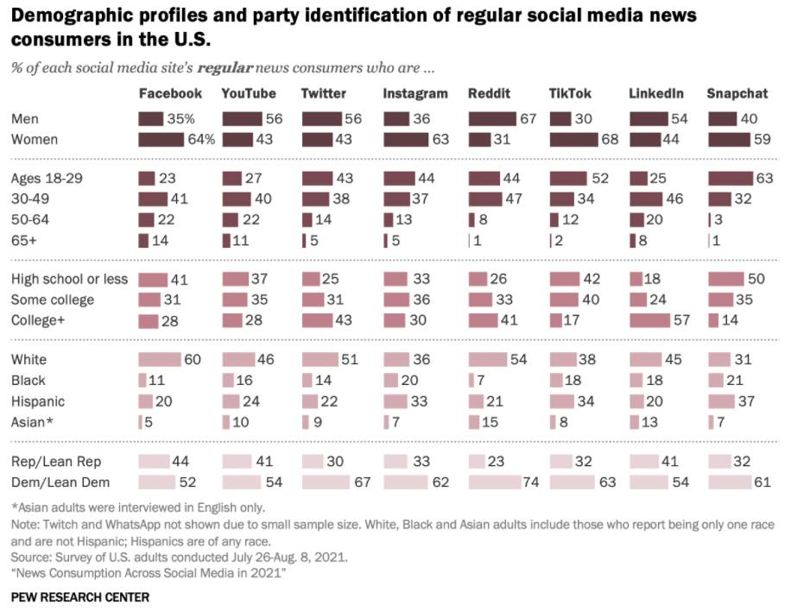
Table from

Twitter

- Number of daily active users: 187 million
- Largest age group: 30-49 (44%)
- Gender: 43% female, 54% male
- Time spent per day/week: 3.53 minutes per session
- 42% of Twitter users are degree-holders (compared to 31% of Americans). This means your academic colleagues are more likely to be on Twitter.
(Sprout Social Media’s 2021 report)

Facebook

- Number of monthly active users: 2.7 billion
- Largest age group: 25-34 (26.3%)
- Gender: 44% female, 56% male
- Time spent per day: 38 minutes
(Sprout Social Media’s 2021 report)

YouTube

- Number of monthly active users: 2 billion
- Largest age group: 15-25
- Gender: 72% of all female internet users and 72% of all male internet users
- Time spent per day: 41.9 minutes among viewers 18 and older
- Popularity is only increasing due to COVID lockdowns and growth of video content.
(Sprout Social Media’s 2021 report)

TikTok

- # of monthly active users: 100 million
- Largest age group: 18-24
- Gender: 59% female, 41% male
- Time spent per day: 45+ minutes
- TikTok is notably seeing growing use among adults, therefore the platform may change from its current focus on younger users.
(Sprout Social Media’s 2021 report)

Instagram

- Number of monthly active users: 1 billion
- Largest age group: 25-34 (33.1%)
- Gender: 57% female, 43% male
- Average time spent per day: 29 minutes
- Second largest network work (after Facebook) and the second most popular platform with teens.
(Sprout Social Media’s 2021 report)

LinkedIn

- Number of total users: 738 million
- Largest age group: 46-55
- Gender: 51% male, 49% female
- 63% of LinkedIn users access the network monthly, and 22% weekly.
(Sprout Social Media’s 2021 report)

Pinterest

- Number of monthly active users: 400+ million
- Largest age group: 30-49
- Gender: 78% female, 22% male
- Time spent per day: 14.2 minutes
(Sprout Social Media’s 2021 report)

91

Social Media | What is your Digital Identity

Researchers on Social Media
More and more it is necessary for potential audiences to find out about your research either through an institutional social media account or through a research project or investigator’s social media channels. There are many existing resources for learning about how to engage on social media. Here are just a few:
- Building an Online Research Profile through Social Media
- 6 reasons why you need a social media strategy

Once you have identified that your audiences are on social media and found a few connections who are on social media networks, you should begin building your networks. There is no point in posting content if you do not have any connections/followers. However before you find your colleagues or potential colleagues and funders online, you need to consider your online identity. Watch the following presentation that covers some questions to consider when formulating your online identity.

An interactive H5P element has been excluded from this version of the text. You can view it online here:
https://ecampusontario.pressbooks.pub/knowledgemanagement/?p=547#h5p-12

Activity
After reviewing the above resources, please revisit the module worksheet. Complete the following:
- Document your existing content and online identity.
- Write the biography for your research group Twitter account.

92

Social Media | Your Academic Institution and Social Media Accounts
Institutions and companies have their own guidelines that you can use to guide your posting practices. These can be especially helpful if multiple people are using a social media account, in the case of a laboratory account. It can also be helpful to develop sample social media posts to guide your own posting.
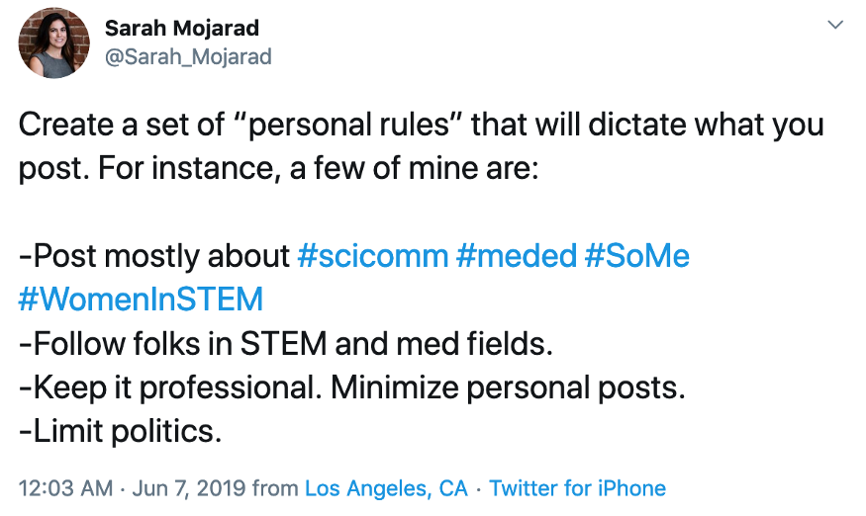
Examples:
- Tufts University Social Media Policies
- Wilfrid Laurier University Social Media Guidelines
In addition to avoiding racist or sexist behaviours online, or sharing misinformation, your institution may have guidelines and policies that outline branding and other institutional norms to be used on social media accounts. The previous module discussed brand guidelines in detail.

Leveraging Existing Institution-Specific Communication Tools and Guidelines
Although researchers’ social media accounts are not governed by their institutions, there are supports and resources available from your institution. Researchers can amplify the reach of research shared online by leveraging the supports offered by their institution. Be sure to tag them in your posts.
Many institutions provide helpful resources, along with experts, to help you implement your social media plan, for instance: Iowa State University social media communications plan
As well, universities post public lists of social media accounts that you can tag to promote your work within your institutional network on social media. Many departments, programs and research groups and projects have their own accounts. You can even explore lists of accounts that users create within social media networks.
Examples:
- Wilfrid Laurier University Social media accounts
- Wilfrid Laurier University Lists of Twitter Users:
  - Northern Researchers
  - Laurier Researchers
  - Laurier Research Projects

93

Social Media | Your Social Media Strategy

An interactive H5P element has been excluded from this version of the text. You can view it online here:
https://ecampusontario.pressbooks.pub/knowledgemanagement/?p=555#h5p-13

Social Media in your Research Program
Since at least 2016, Canadian research funders have called for increased “…availability of findings that result from the research they fund, including research publications and data, to the widest possible audience, and at the earliest possible opportunity”. (Preamble, Tri-Agency Open Access Policy on Publications).
The adjudication process reflects this call through the inclusion of knowledge mobilization and highly qualified personnel (HQP)/student training plans as part of research funding applications.

Incorporating Social Media in your Research Funding Applications
Social media can be incorporated as part of student training plans and knowledge mobilization plans. Using social media, along with traditional communications tools will allow you to reach specific targeted audiences with your research results. Social media can also be used to promote your research program’s successes to your funders.

Students and others who receive specialized training in academic research environments are often referred to by the term “highly qualified personnel” (HQP) by research funders.

Activity: Acknowledging your Funders and Social Media
Please revisit the module worksheet and answer the following question.
Is your research funded by a Tri-agency funder? If yes, add them as an audience in your social media plan as an audience.

Funder | Twitter | Facebook | LinkedIn
SSHRC | @SSHRC_CRSH | facebook.com/ ResearchFunding/ | linkedin.com/company/ social-sciences-and-humanities-research-council
NSERC | @NSERC_CRSNG | facebook.com/ nserccanada | linkedin.com/company/ nserc-crsng
CIHR | @CIHR_IRSC | facebook.com/ HealthResearchInCanada | N/A
CFI | @innovationCA | facebook.com/cfifci | N/A
Mitacs | @mitacsCanada | facebook.com/Mitacs | linkedin.com/company/ mitacs

94

Social Media | Institutional Social Media Supports

Activity
Complete the following quiz.

An interactive H5P element has been excluded from this version of the text. You can view it online here:
https://ecampusontario.pressbooks.pub/knowledgemanagement/?p=560#h5p-26
Record the results of this quiz in your worksheet and add links to any documents available from your insitution. Also, List the social media accounts related to your research institution (department, faculty) and researchers that you work with to the worksheet.

Once you are ready to launch your social media account, let your department, faculty and institutional social media team know so that they can follow you and amplify your posts.

95

Social Media | Planning your Social Media Strategy
A successful social media strategy leverages existing content to reach new audiences, transforms content to suit each social media channel and finds new online networks to share research outputs.
“A strategy is where you’re headed. A plan is how you will get there.“ ⁴⁸
A social media strategy defines how you will use social media to achieve your communications aims and the social media tools used to achieve this. It outlines the goals and measurable objectives for using social media, and the target outcomes you want to achieve. You will also need a plan but without a clear strategy, how do you prioritize the activities for a plan? Think strategy first, plan second. ⁴⁹
TIP: A social media strategy guides your efforts when engaging in social media. To avoid burn out, start implementing your plan on only one social media tool, with limited tactics.
There are many different templates available to create a social media strategy. Overall, they contain the following elements:
- Articulate who you are on social media.
- Identify your audience.
- Set a goal(s).
- Determine how to measure success of that goal.
- Outline tactics to achieve the goal.



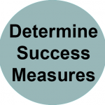
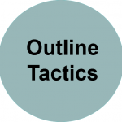

96

Social Media | Planning your Social Media Strategy | Articulate who you are on Social Media


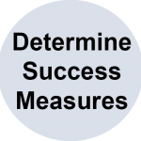
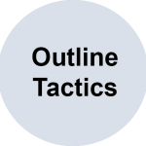
This involves determining a clear digital identity as outlined in Part 1. Other social media users should be able to understand what your area of expertise is clearly. You can also use the key messages you created in module 3 to determine the tone and style of your words and images on your account. Branding guidelines can also be helpful.
The tone on social media, whether very informal or formal, is always conversational and may use shorthand language. Familiarize yourself with common shorthand terms.
Use a social media management tool like Hootsuite to set up listening streams to monitor relevant keywords and accounts in real-time.

Etiquette matters in real life and also when engaging online. Familiarize yourself with social media etiquette specific to the platform you are using.

97

Social Media | Planning your Social Media Strategy | Identify your Audience

In addition to the audiences articulated in Module 3, that you have now found online in Part 1, consider exploring the following questions to accurately determine the social media habits of your audience:
Who are they? | (E.g. job title, age, location, etc.)
What are they interested in that you can provide? | (E.g. educational content, case studies, new products, etc.)
Where do they usually hang out online? | (E.g. Facebook, Instagram, etc. or niche platforms)
When do they look for the type of content you can provide? | (E.g. weekends, during their daily commute, etc.)
Why do they consume the content? | (E.g. to get better at their job, to stay up to date with something, etc.)
How do they consume the content? | (E.g. read blogs, listen to podcasts, watch videos, etc.)
(From Social Media Marketing Strategy)
Determining the answers to these questions will help your target your tactics for maximum impact.

TIP: A persona is a term used to describe a very detailed description of the attributes of your audience, so that you can share your content with them in the most impactful way. (
)

98

Social Media | Planning your Social Media Strategy | Set a Goal
To measure success of your social media strategy, first define what success looks like. Some examples of goals are:
- Awareness: How far is your message spreading?
- Engagement: How many people are engaging with your message?
- Drive traffic to your website or paper: Are people visiting your website?
- Share of voice: How are you doing compared to a leader in your field on the same platform
(Adapted from Neil Patel)
In your worksheet, there are two goals for you to work through to articulate related tactics and measures:
- Increase individual brand awareness – the brand is you and your research.
- Drive traffic to our content – help people on social media find your papers and other research outputs.

99

Social Media | Planning your Social Media Strategy | How to Measure Success of the Goal
Measuring what you are trying to achieve is important to see if your efforts are paying off. Many social media platforms provide detailed analytics that measure performance. Here is an example of a dashboard recording changes in measurements over a specific time period:
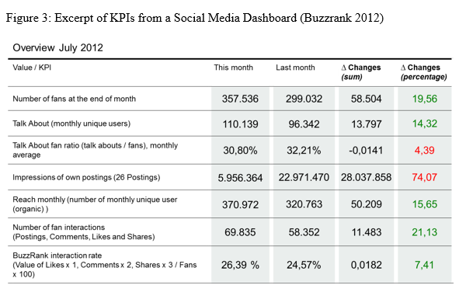
Excerpt of KPIs from Social Media Dashboard via
Key performance indicators of that goal and how they can be measured. Examples:
Key Performance Indicator (KPI) | How to Measure
Increase in followers over time | Track KPI at regular intervals
Number of shares, ‘likes’, clicks on a particular post | Track KPI at regular intervals
Number of clicks to website or downloads of a particular resource | Assign a unique URL to a resource when you share it (i.e. bit.ly URL)
Number of comments on a post | Count them and track over time
Use of your unique hashtag | Use a social metrics tracking tool or count over time.

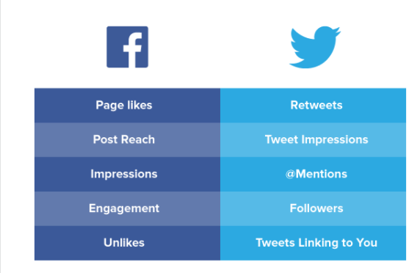
(Suggested measures for Facebook and Twitter)
Tip: Find out if your institution has a team that can provide analytics about your work on your institutional website.
To understand further how your social networks are accessing your content, and how effective your social media plan is, install analytics on your website. This will allow you to find out how many visitors your website has, where they come from, what parts of your website they look at, and for how long. This information can be valuable in locating your research on your website and how effectively you are directing traffic to your website.
The open access institutional repository hosted by the library at Wilfrid Laurier University displays a good example of the download analytics from the repository.
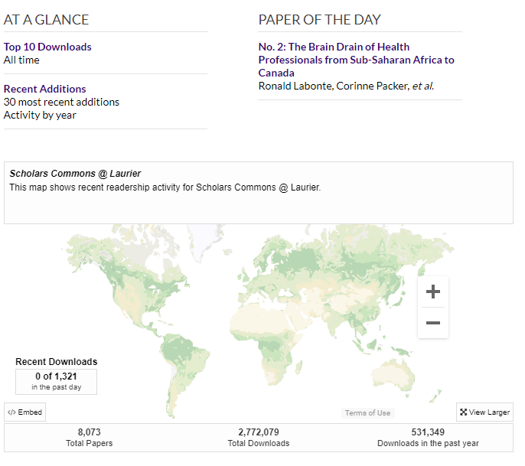

100

Social Media | Planning your Social Media Strategy | How to Measure Success of the Goal | Altmetrics
Similar to the way traditional academic outputs are measured by citations, which contribute to a calculated h-index, impact through social media is measured by Altmetrics. Altmetrics are metrics and qualitative data that report who is talking about and engaging with your research online. Altmetrics are used by institutions, researchers, publishers and funders to track impacts.

One or more interactive elements has been excluded from this version of the text. You can view them online here: https://ecampusontario.pressbooks.pub/knowledgemanagement/?p=609#oembed-1

An interactive H5P element has been excluded from this version of the text. You can view it online here:
https://ecampusontario.pressbooks.pub/knowledgemanagement/?p=609#h5p-14
Altmetric is a service that tracks your altmetrics. You can also track the reach of your work through using URL trackers for resources you share on the web. Bitly and other URL trackers, assign a specific, unique URL to an existing URL to track how that URL is shared over time. If you wanted to compare sharing a link to your latest publication on Twitter vs. LinkedIn, you can create a unique URL to share on each platform and then compare the website traffic from each of those links to your website.
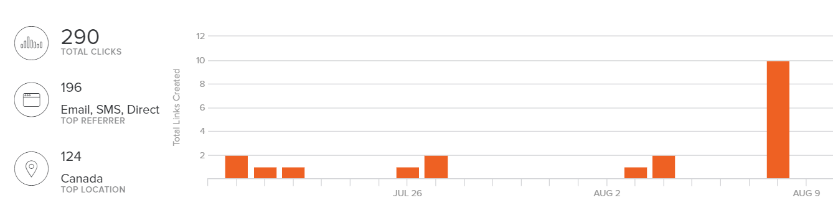


101

Social Media | Planning your Social Media Strategy | Outline Tactics to Achieve the Goal
A general question to ask is: “What are we going to share on where?” and outline the content themes for each social media platform:
Facebook
Instagram
Twitter
(Social media platform)
(From Social Media Marketing Strategy)
The worksheet gives a few examples to help you construct your own tactics.

How to Avoid Common Pitfalls – Tone, Etiquette
When planning your content to be shared on your social media channels, obey the etiquette law of thirds:
- One third of your content should consist of responding and replying to content posted by others.
- One third of your content should be sharing content created by others that relates to your content. In this case, you are selecting specific information and indicating that the information is reliable, accurate, and applicable to your field. Examples are sharing colleagues’ new publications or sharing news stories related to your work.
- One third of your content should consist of sharing specifically your content.
TIP: always read fully any article or information you share to ensure that you not endorsing information that you do not whole-heartedly support. Examine the source of any information you share to guard against sharing misinformation from disreputable sources. Perhaps include a disclaimer in your biography.
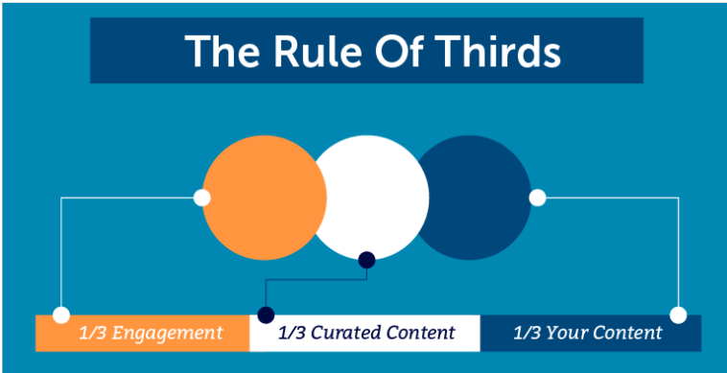
Resource: Top 10 Ways to Avoid Twitter Suspension
As you complete your Social Media Content Worksheet, you will identify content available to share through social media channels. One tactic to consider is to repurpose your content. For example:
- Turn quotes and stats from research reports into share-worthy graphics (ref)
- Use data from a case study to drive a debate or discussion on Facebook. (ref)
- Take tips from a listicle (“12 Ways to X…”) and outline them as a series of scheduled tweets. (ref)
Read
Once the strategy is determined, the plan can be created. The plan can include specifics such as: implementation details of tactics to achieve a goal: content, content calendar, how and when to measure success, who implements the tactics and at what timing. The next exercise will develop the content portion of the social media plan.

Read

102

Social Media | Completing your social media strategy
Many social media strategies include budgets to pay a social media channel to get your content in front of as many eyeballs as possible. These marketing strategies can be implemented with the help of your institution or as a separate campaign. Begin with authentic, unpaid interactions and then explore these options.

Activity
Complete the Social Media Strategy using the Worksheet – Social Media.
If your research partners are on social media, have them share your work. Either talk to them directly or tag them in your post. They can be active partners in your social media plan.
Sharing content effectively and helping your content reach your targeted audience requires leveraging key features of social media, and perspective on using these tools, as outlined in the next section.

103

Social Media | How to Share Content Effectively

How to Manage Social Media and Your Time
“A bigger challenge is to continue tweeting regularly once you have started, which is essential to habit change” – Ten simple rules for getting started on Twitter as a scientist
Beyond establishing a habit, ensure that you are creating value for yourself by using social media to find information you might find elsewhere. For example, follow a granting agency on Twitter to find out about upcoming deadlines or announcements.
Another way to keep posting regularly is to schedule time to do social media into your day or week. Just like exercise, once it is scheduled in your calendar, you have to do it!

Read
: a discussion of social media and procrastination.

Plan your social media posts in advance, so content can be posted even if you are not online, or content might be posted on specific days to coincide with specific themes (#sharkweek, #BlackinSTEM, #univresearch, #socialworkweek).

Read
.
Social media planning tools like Twittimer or Hootsuite, allow you to compose a tweet in the system, that is automatically posted to Twitter at a particular selected time in the future. Other tools like Hootsuite, allow you to schedule posts for multiple social media platforms within one tool. For example, Facebook and Twitter. However, avoid posting the exact same post to different social media tools, called cross posting, for the following reasons:
- Different platforms use different image sizes and different message lengths.
- Different platforms require different tone of writing and message.
- Research has found different image content performs well on different platforms (ref)
- Users will follow you on multiple platforms and expect to receive different content on different platforms.
Finally, use a content calendar to plan your content in advance, and on specific days.

How to Manage your Social Media Account Passwords
Use a password manager to remember your passwords. Use a secure password and do not share it with anyone. If you are employing a student to work on your social media, ensure that the Principal Investigator on the project, as well as the student has access to the up-to-date password.

How to Effectively Deal with Online Harassment
If in doubt of ill intent, provide further information, as this scientist does in the example below:



Other times, ignoring, reporting or blocking the account is appropriate. Twitter has an extensive help guide of what to do when you experience harassment on Twitter. Your institution will have social media and public relations experts on staff to help you if you experience harassment. Find out who they are and how to contact them BEFORE you have a problem. They may also have supports or assistance available to you to prepare you for any issues online.

Read

104

Social Media | Examples of Social Media Strategies

Social Media Campaign vs. Ongoing Engagement
As well as engaging on a regular basis through social media, another strategy is to post on a very specific topic during a specific time limited event or a campaign. An example of a campaign is sharing your marine mammal research during the week-long #sharkweek event:
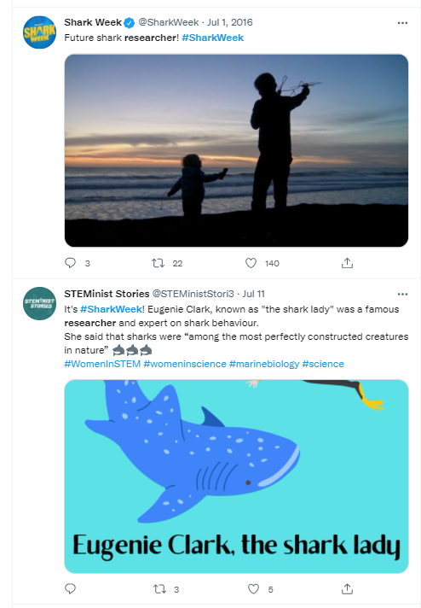
If you don’t have enough photo or video content to post a new photo every 2-3 days on Instagram or if you do not have an established audience on a particular channel, ask your academic institution’s social media team if they have any “social media takeover” opportunities.
Social media takeovers are short-term campaigns that are an opportunity to share your research expertise through an established social media account, with a large audience, all on one day or event. For example, taking over an Instagram account to share video of an on-going field experiment or the performance of a creative work.

Sharing your Communications Content onto Social Media
Creating social media content may be as easy as repurposing the content available in your own digital ecosystem or transforming other products created through your communications plan into online assets. For example:
An academic poster can become a tweet
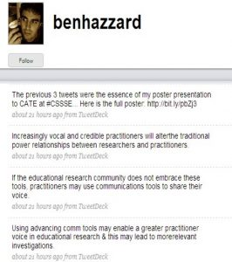
If your journal article has a graphical abstract, share it.
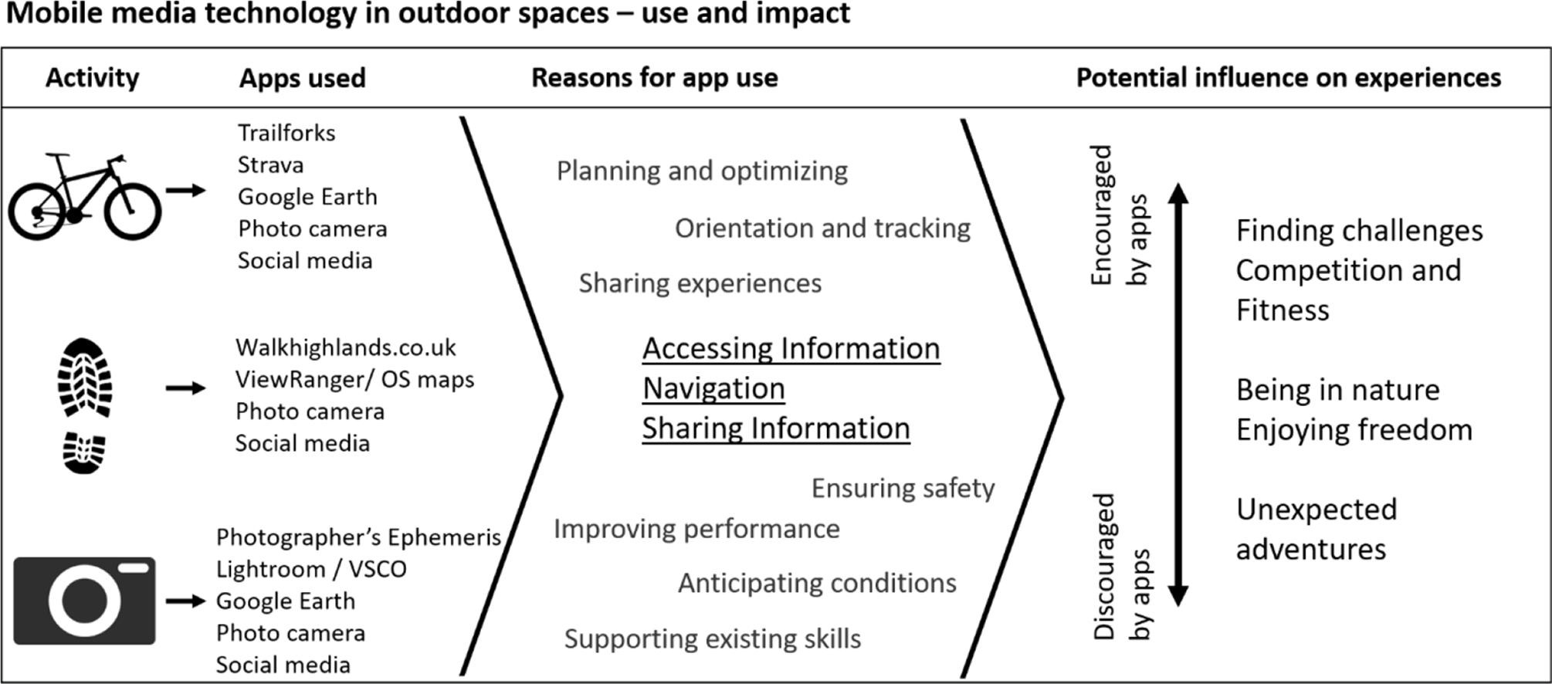
There is some research showing their effectiveness over social media
- Chapman, S. J., Grossman, R. C., FitzPatrick, M. E. B., & Brady, R. R. W. (2019). Randomized controlled trial of plain English and visual abstracts for disseminating surgical research via social media. Journal of British Surgery, 106(12), 1611-1616.
- Ibrahim, A. M., Lillemoe, K. D., Klingensmith, M. E., & Dimick, J. B. (2017). Visual abstracts to disseminate research on social media: a prospective, case-control crossover study. Annals of surgery, 266(6), e46-e48.
Read
An academic paper can become an infographic, which can be shared in a tweet
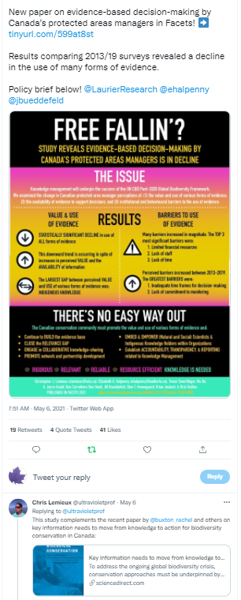
A paper can become a news story, which is shared in a tweet

An op/ed article publishing in an online op/ed network like The Conversation, can extend teh reach of your op/ed through its Canadian Press partners or republishing guidelines. You can then share the link to your op/ed through your social media networks. Perhaps your university is a partner in The Conversation and you can get detailed analytics of how your op/ed performs through The Conversation. Have any of your university colleagues published an op/ed through The Conversation? If so, make a note of those authors and add them into your networks. Potentially even flag them as collaborators on your next op/ed!
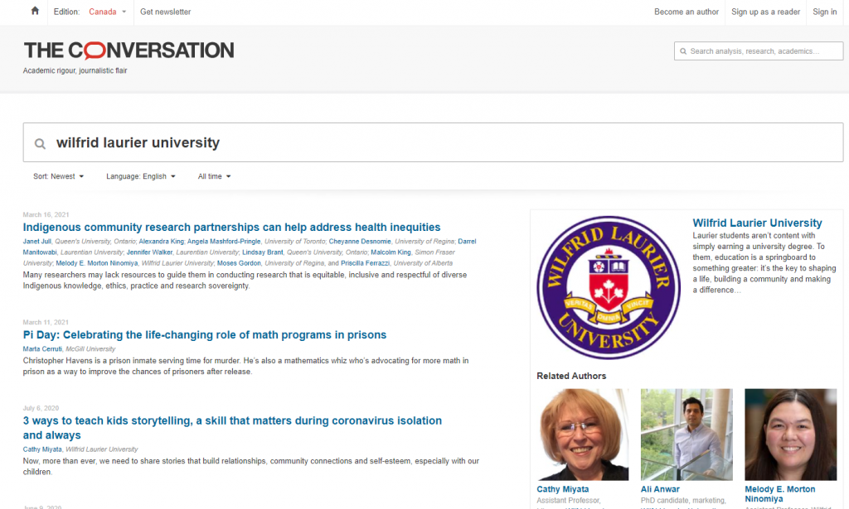
Listing of authors based at Wilfrid Laurier University who have published on The Conversation.

105

Social Media | Documenting your Digital Content

Activity
The following steps will allow you to document your existing digital and non-digital content to prepare to share it through social media.
Complete columns 1-5 of the Social media content worksheet to document your digital ecosystem/online content.
List the title of all your research outputs and materials emerging from the communications plan (column 1). List the location, either online or offline (column 2). Aim to have all materials available online. Most peer reviewed journal publications can be uploaded to your institutional repository, respecting the journal publication policy. For example: papers, abstracts, conference posters, presentations, webinars, recruitment posters, etc. If you don’t know the open access publication policy of the journal, look it up on SHERPA/Romeo.
Search for your name online (using Google or another web search engine) and add all the elements of your digital identity in columns 1-5. Determine if any of these outputs can be shared on social media “as-is” or altered to be appropriate to be used on a social media channel? For example, many academic publishers are asking for visual abstracts to accompany paper submissions to journals. Could you share the visual abstract as an image in a tweet, with a link to the full journal article or paper?
Make a list of all the “social media ready” research outputs in columns 3-5. If the resource is not ready to share on social media, make a note in column 6. Ensure you have recorded all of the text, documents, audio recordings (interviews, podcasts) and images (videos, photos) in the following categories:
- All the results when you google your name
- Your website, either personal or institutional
- Open access publications in your institutional repository
- Online peer reviewed journal publications and research outputs
- Finally, your existing social media content.
That is it for now. In next section, you will complete the rest of the worksheet.

Example Entry
1 | 2 | 3 | 4 | 5 | 6 | 7 | 8 | 9 | 10 | 11
Research Output | Location (URL) | Type of output | Does it have an image? | Location (file or URL) | Social Media to post on: | Related Twitter users | Audience | Related hashtag(s) | Tweet text | Date to post
Example: An examination of how rainbows have been anthropomorphized between 1960 – 1995. | Journal website (www.doi.org/1234z) | Full paper published in Frontiers in Psychology | Yes, Visual abstract | On desktop rainbows_abstract.jpg | Twitter account @DrSociology

106

Social Media | Best Practices of Common Social Media Platforms

An interactive H5P element has been excluded from this version of the text. You can view it online here:
https://ecampusontario.pressbooks.pub/knowledgemanagement/?p=638#h5p-15
Each social media platform has its own features that attract specific audiences and users. In Part 1, you determined which tool is most suitable for your use. In Part 2, you determined what you have to share on social media and which of your targeted audiences are on which social media. This section outlines how to post on social media platforms for success.
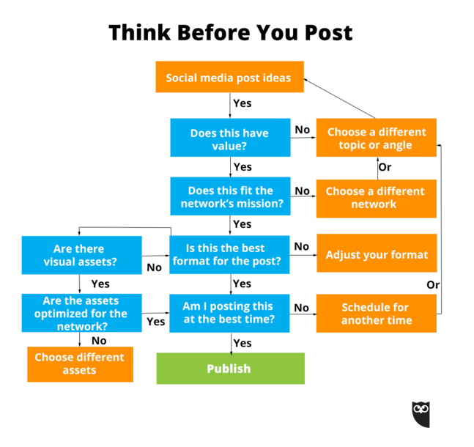
Hootsuite graphic via Social Media Etiquette for Business Owners: 25 Do’s & Don’ts
If you are unsure what size and resolution of image to use in your social media post, use a tool like Canva to create your image or post, which has pre-sized templates for each social media tool. Use a tool like landscape, free social media image resizer to change the size of your visuals between social media platforms.

107

Social Media | Best Practices of Common Social Media Platforms | Twitter

Twitter Basics
- Micro-blogging service to post short messages.
- Length: maximum 280 characters per message.
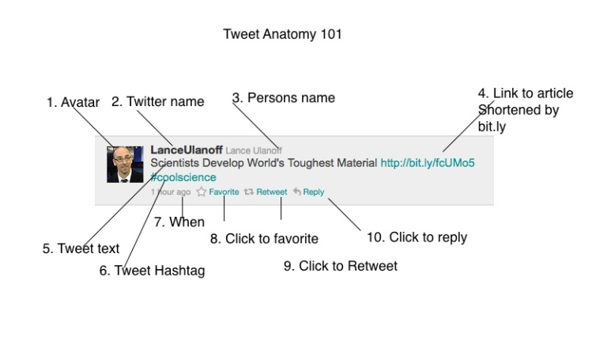
The perfect tweet is:
- Front loaded. Put the most important words at the start of the tweet to catch a follower’s eye.
- Scannable. Write simply and concisely. You want followers to “get” it first go.
- Specific. Make your content valuable and useful. Make it matter to your followers.
- Active. Use strong verbs and skip the adjectives and adverbs.
- Focused. Limit yourself to one idea per tweet. The rest can go in a blog post.
- Compelling. Give followers a reason to click through. Clickbait headlines work for a reason!
- Short. You may have 280 characters now, but you don’t have to use them all!
- On brand. Your tweets should sound like you. Re-read to check you’re on brand.
(From Breaking the Internet: How to Write The Perfect Tweet)

Examples of things you can tweet (ref)
- Questions to invite feedback
- Interesting news items you’ve found
- Interesting photographs
- Replies to other people’s tweets
- Retweets of other people’s tweets
- Details of new publications or resources you’ve produced
Read

Best practices
- Twitter etiquette guide: 20 Essential Twitter Rules You’ve Probably Never Heard
- Ten simple rules for getting started on Twitter as a scientist – this article contains a wonderful list of Twitter terms to know.
- A beginner’s guide to joining academic Twitter
- Using Twitter in university research, teaching and impact activities A guide for academics and researchers Amy Mollett, Danielle Moran and Patrick Dunleavy. London School of Economics Public Policy Group. – this compendium shares definitions of Twitter terms and provides an academic lens on Twitter activity. The technical information is no longer accurate, but the style advice is relevant.
- Add images to your tweet using the Canva Twitter post template
- Best time to post: Monday 6– 9 p.m., Thursday 10 a.m.(ref)
Training Resources:
and

108

Social Media | Best Practices of Common Social Media Platforms | Facebook

Facebook Basics
- Long form posts to a social network.
- 63, 206 character limit in posts.
- Popular with First Nations communities.

Best Practices
- Share your research using high quality images and clear language text.
- Add images to your Facebook post using the Canva template
- Best time to post: Tuesday, Wednesday and Friday 9 a.m.–1 p.m. (ref)
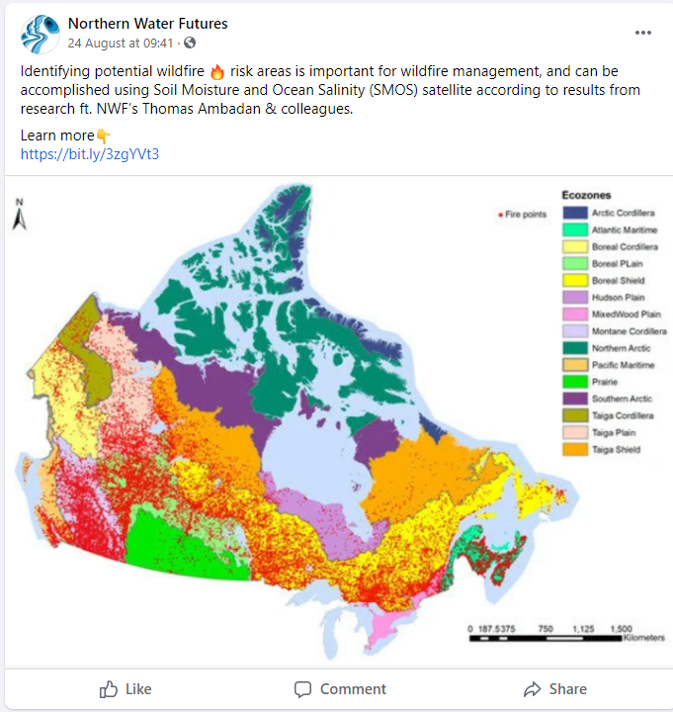
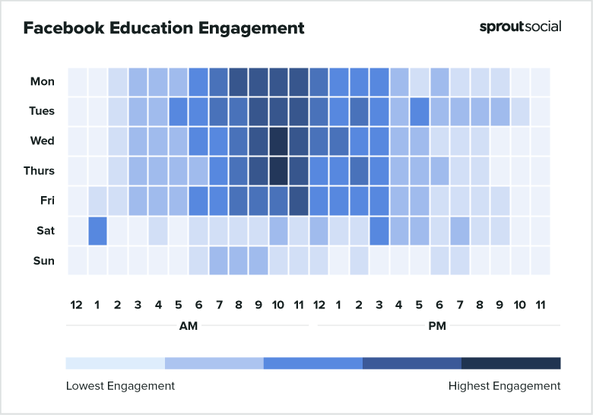
Example Facebook post by research group Northern Water Futures

Training Resources

109

Social Media | Best Practices of Common Social Media Platforms | YouTube

YouTube Basics
YouTube hosts uploaded videos that can be viewed, commented on, and rated on the site itself, or embedded into other websites.

Best practices
- Add images to your channel to make it attractive: video thumbnails, channel art.
- Group your videos by sub-topic or projects on your channel.
- If your audience uses primarily mobile phone to access the internet, videos are mobile friendly.
- Videos can be publicly searchable or set to be accessed by only those who have the link to the video. Use this feature if the audience for your video is small or deals with content you only want to share with a small group.
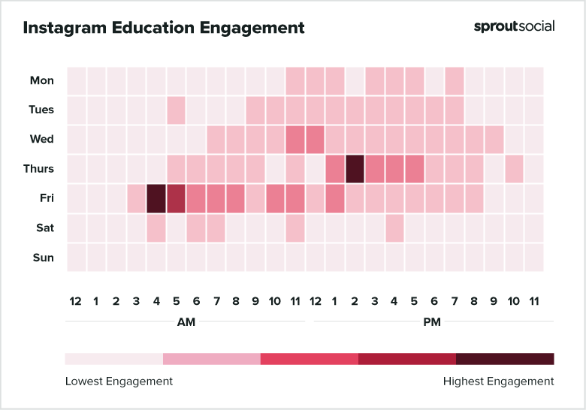

Training Resources

110

Social Media | Best Practices of Common Social Media Platforms | LinkedIn

LinkedIn Basics
- Centered on professional thought leadership and career growth.
- Used heavily by recruiters, business to business communication.
- Length of post: maximum 1300 characters

Best practices
One or more interactive elements has been excluded from this version of the text. You can view them online here: https://ecampusontario.pressbooks.pub/knowledgemanagement/?p=653#oembed-1
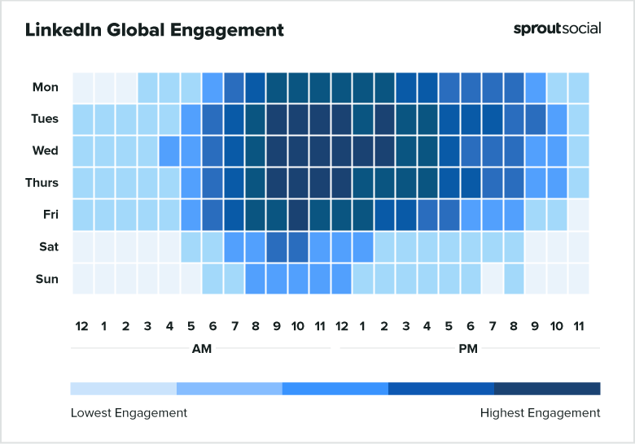
(From Sprout Social)

Training Resources:

111

Social Media | Best Practices of Common Social Media Platforms | Pinterest

Pinterest Basics
- Social bookmarking tool where users can save ideas for projects and interests with virtual bookmarks called “pins.”
- Users can create boards to organize the links they find online by specific topics. These boards can be accessed by others and pinned to their boards.

Outside Magazine shares article interviewing shark experts via Pinterest

Best practices
- Create beautiful pins with a Canva pin template.
- Ensure your descriptions of the pin are accurate.
- Link directly to the content you want to share from the pin.
Training Resources

112

Social Media | Best Practices of Common Social Media Platforms | Medium.com

The Basics
- A large network of writers.
- Uses tags and discoverability to reach new audiences with your writing.
- Users can follow specific writers and be notified when they post new content.
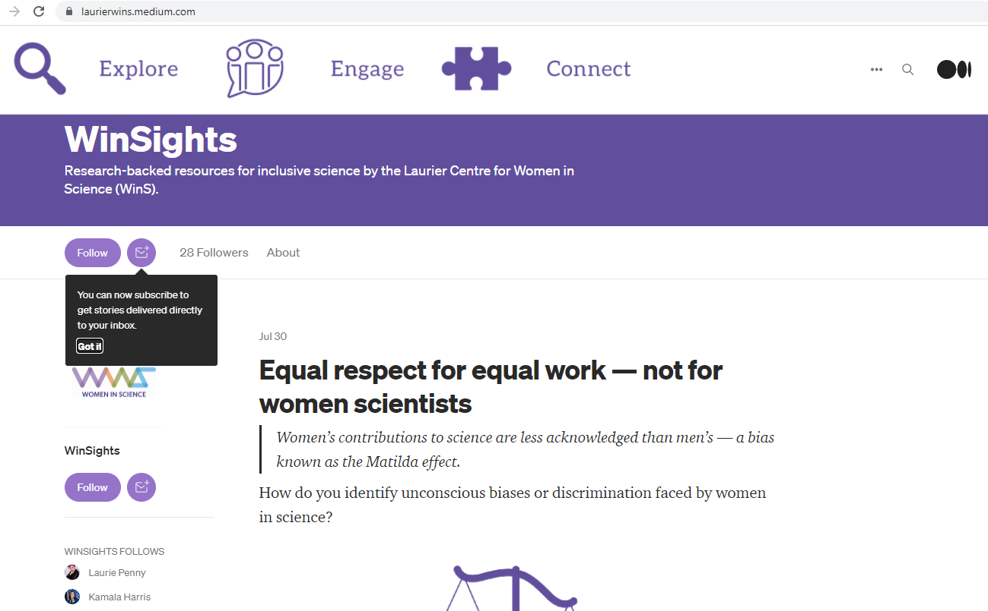

Laurier Centre for Women in Science Medium page

Best practices
- Write a compelling heading.
- Use graphics to illustrate your writing. The example below uses clear language and a graphic to illustrate the content of the article. Often these articles are written in inverted pyramid style.
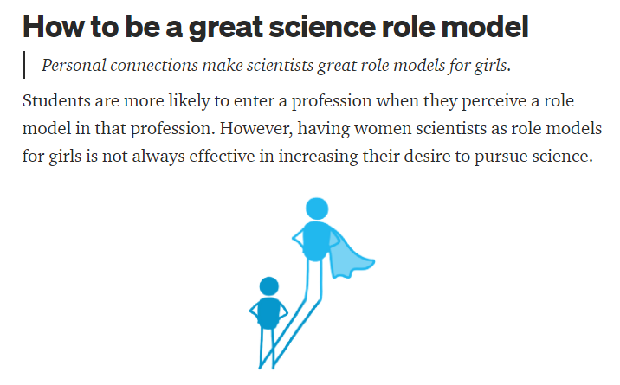
An example of clear and compelling messaging via Laurier Centre for Women in Science Medium

Training Resources

113

Social Media | Creating an Online Presence for you Academic Conference

An interactive H5P element has been excluded from this version of the text. You can view it online here:
https://ecampusontario.pressbooks.pub/knowledgemanagement/?p=676#h5p-17

114

Social Media | Get Ready to Share your Digital Content

Activity
Now that you have completed this section of the module it is time to check in with the module worksheet. Complete columns 6-11 of the Social media content worksheet outlining how you will share your available online content.

In the first section of Social Media, you determined which social media tool(s) your intended audience(s) were using. For those resources ready to be shared online, indicate which tool and account you will share this resource in column 6.
List others in your network that are on Twitter who can be mentioned in your post in column 7. In the example, student co-authors and the journal are listed. Anyone who can potential share the posting in their networks should be listed. Do not forget to add any institutional supports identified in Part 2. In column 8, list specific audiences who you want to see your post. In the example, project funders are tagged. You determined this in an earlier exercise.
Next, look up any hashtags you can use to share your post with followers of specific hashtags and list them in column 9. Note that in the example, #weather was a popular hashtag found alongside #rainbows, however this was for posts relating to the scientific causes of rainbows, not sociological articles related to rainbows and therefore not used. Another strategy to use to get your post noticed it to include a hashtag that is popular on the platform. In this example, #univresearch is used because multiple universities use this hashtag to tag their research outputs.
The Berkeley media studies group provides an extensive listing of possible news hooks or events that you can use to add the relevant hashtag to your post. Another strategy is to link your op/ed to something trending in popular culture i.e. recent movie release.
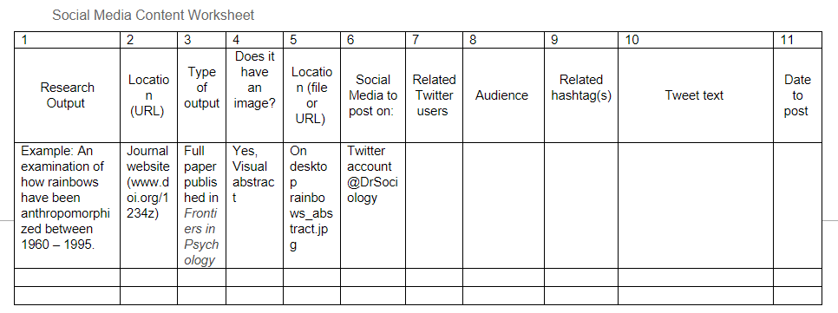
Berkley news hook/holiday calendar
Compose your tweet in column 10. Keep it under 280 characters. If you know a specific user you want to share your post has a long user name, keep your post short enough to include the retweet in the 280 character limit. A bitly shortened URL is used for tracking interactions with that link. i.e. who clicks on it and the details of that user.
Tip: An institutional account is tagged “@LaurierGrad”. This leverages that Jay and Priya are graduate students, and notifies @LaurierGrad to share this tweet about their students in their social media networks.
Finally, determine when you are going to schedule your post (column 11). Use a content calendar to ensure that you align your posts with specific events (if applicable). For example, if your research if related to holidays or awareness days, schedule posts during that time, leveraging the related hashtags.
As well, examine this column once it is populated to ensure that you publish regularly and consistently.
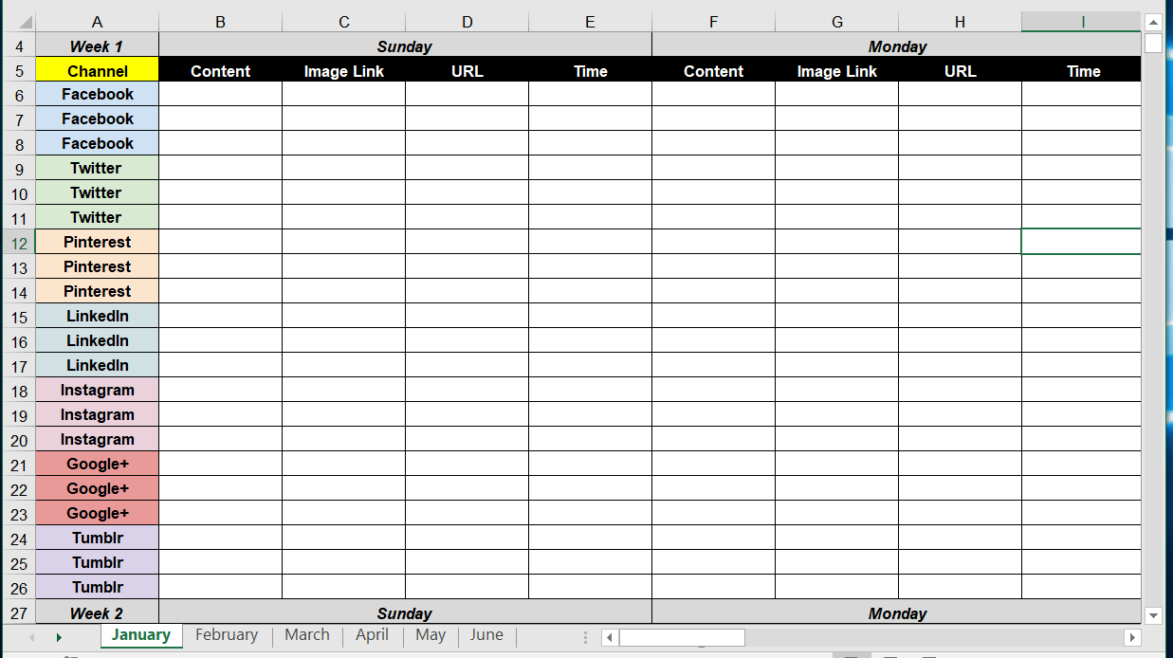
(Example content calendar to schedule social media posts)

Social Media Content Worksheet
1 | 2 | 3 | 4 | 5 | 6 | 7 | 8 | 9 | 10 | 11
Research Output | Location (URL) | Type of output | Does it have an image? | Location (file or URL) | Social Media to post on: | Related Twitter users | Audience | Related hashtag(s) | Tweet text | Date to post
Example: An examination of how rainbows have been anthropomorphized between 1960 – 1995. | Journal website (www.doi.org/1234z) | Full paper published in Frontiers in Psychology | Yes, Visual abstract | On desktop rainbows_abstract.jpg | Twitter account @DrSociology |  |  |  | Proud of my @DrSociology lab members @LaurierGrad @Jay334 and @Priya734 for their work on our new paper about rainbows, published in @FrontPsychol bitly.com/234TT #rainbow #sociology @SSHRC_CRSH @LaurierResearch | Sept 23, 2022

115

Social Media | Integrating your Social Media Strategy and Communications Plan
When integrating social media into your communications plan, ensure both plans have consistent branding issues and leverage research outputs across both plans. This presentation explores examples of using both traditional and social media communication tools in share research outputs integrated into the research project and at the end of a research project.
An interactive H5P element has been excluded from this version of the text. You can view it online here:
https://ecampusontario.pressbooks.pub/knowledgemanagement/?p=668#h5p-16
After completing the previous modules you have:
- Created a communications strategy (module 3)
- turned your research outputs into content to share on social media (Part 3 exercise)
- Seen examples of how to integrate your social media into your communications plan, you are ready to go forth and share your research knowledge and outputs.
If multiple researchers and students are using a lab or research group social media account or doing communications tasks, ensure that roles and responsibilities are clearly defined in your strategy.

Read

116

Social Media | Module Assessment Tool and Evaluation Guide
At this point, you should have completed all of the sections of the Social Media Worksheet.

You will be assessed using the following criteria:
 | Completed?
Item | Yes | No
Part 1: Social Media as Communication Tools
Quiz: Pretest
Part 1c Exercise 1: Document your Social Media Network
Part 1d Quiz: Which social media tool should you use to share your research?
Part 1g Exercise: Document your existing online content and online identity
Part 1h Exercise: Write the biography for your research group Twitter account
Part 2: Your Social Media Strategy
Quiz: Pretest
Quiz: Is your research funded by a Tri-agency funder?
Quiz: Do you have any institutional social media supports?
Exercise: List the social media accounts related to your research institution and researchers that you work with
Exercise: Complete your social media strategy
Cumulative exercise: Documenting your digital content: Columns 1-5
Part 3: Best Practices of Common Social Media Platforms
Quiz: Pretest
Cumulative exercise: Social Media Content Worksheet: Columns 6-11

117

Social Media | Summary and a Look Ahead
This module has reviewed how researchers might use social media to share research expertise, research outputs, and begin building a robust social media strategy to reach specific audiences to build longer-term research partnerships and impact. Topics covered in this module included types of social media, when to include social media in your research program, designing a social media strategy, learning to use popular social media tools, and determining success of your social media strategy.
The next module will build on this work to cover how to collaborate with the community around knowledge mobilization. Working with broader context experts may help you to better understand the social media habits of those that you’re looking to engage with and expand your social media reach!”

Final Thoughts
By creating a specific social media strategy and learning which tools can reach specific audiences interested in your research work, you are probably thankful that the process is not as daunting as you may have thought it was.

Your research team members have a role in implementing either the social media plan and/or the communications plan. Existing research outputs like clear language papers and posters can be repurposed to reach new audiences through social media networks. You now have concrete metrics to report your success in sharing your research outcomes and products on your next funding grant application.

Your students have been active in building their scholarly networks, reputations and also shared the research outcomes with an even bigger audience than you alone could reach. Although there are new social media tools emerging every day, you have a strategy for evaluating if your intended audience is using the new social media tool and if you should jump on that new tool. There is no doubt that you will build research collaborations and profile as a communicator of impactful research. Your work will reach new audiences on social media who can use and amplify the impact of your research outputs.

118

Social Media | Curated Links

Communicating your Research Using Social Media
- Junghwan Kevin Dong, Colleen Saunders, Benjamin W. Wachira, Brent Thomas, Teresa M. Chan, Social media and the modern scientist: a research primer for low- and middle-income countries, African Journal of Emergency Medicine, Volume 10, Supplement 2, 2020, Pages S120-S124, ISSN 2211-419X, https://doi.org/10.1016/j.afjem.2020.04.005.
- Medecins sans Frontiers (2020). Patient Multimedia engagement toolkit: Harnessing Social and Digital Media to Better Reach Vulnerable Populations. https://msf-transformation.org/news/patient-multimedia-engagement-toolkit/
- Kirsty Wallis (2020). London School of Economics Impact of Social Sciences blog: How an audience-first approach to social media increases engagement with your research. https://blogs.lse.ac.uk/impactofsocialsciences/2020/08/06/how-an-audience-first-approach-to-social-media-increases-engagement-with-your-research/
- Ritesh Chugh, Robert Grose & Stephanie A. Macht (2021). Social media usage by higher education academics: A scoping review of the literature. Education and Information Technologies, Volume 26, Pages 983-999. https://doi.org/10.1007/s10639-020-10288-z
- Amanda Bongers and Donal Macartney Principles of Science Communication. Ch. 18: Social Media. https://ecampusontario.pressbooks.pub/scientificcommunication/front-matter/introduction/

Social Media Tools
- Amy Mollett, Cheryl Brumley, Chris Gilson, Sierra Williams. (2017). Communicating Your Research with Social Media: A Practical Guide to Using Blogs, Podcasts, Data Visualisations and Video. SAGE Publishing. https://uk.sagepub.com/en-gb/eur/communicating-your-research-with-social-media/book245914.
- Amy Mollett, Cheryl Brumley, Chris Gilson Sierra Williams (2017). Blog post: 10 ways to use social media to get your research noticed. https://www.timeshighereducation.com/blog/10-ways-use-social-media-get-your-research-noticed
- Get Social Media Strategy Certified by Actionable Marketing Institute
- Mark Carrigan (2019). Social Media for Academics, 2nd Edition. Sage Publishing. https://uk.sagepub.com/sites/default/files/upm-assets/110609_book_item_110609.pdfhttps://uk.sagepub.com/sites/default/files/upm-assets/110609_book_item_110609.pdfh
- The Academic Designer: Communications for Professors and Researchers https://theacademicdesigner.com/blog/

Open Access Resource
- Government of Canada Tri-Agency Funder Toolbox

Other Resources and References
- University of Kent: Social Media Guides
- University of Toronto: Evidence for Social Media as an Effective Knowledge Dissemination Strategy
- EDUCAUSE: Faculty and Digital Presences

119

Social Media | Credits

Subject Matter Experts
- Shawna Reibling, Knowledge Mobilization Officer, Wilfrid Laurier University
- Stephanie Whitney, Manager, Research Partnerships, Wilfrid Laurier University

Industry, Government and Community Partners
- Doug Knox, Partner, EQ Alliance
- Cathy Bruce, Trent University
- Ashley Horne, Trent University

Designers and Editors
- Dana Capell, Educational Developer, Trent University
- Lillian Chumbley, eLearning Designer, Trent University
- James Bailey, Multimedia eLearning Design Specialist, Trent University
- Bethany Brown, Graphic Designer

V

Data Sharing and Usage


120

Data Sharing and Usage | Synopsis
This module is intended to familiarize learners/participants with key concepts and importance of data sharing and intellectual property. Specifically, learners/participants will explore the importance of data sharing, security and intellectual property from the perspective of researchers, research institutions, industry, government, and not-for-profit/community partners.
Intended Audience/Learner: Graduate students studying at post-secondary institutions; early career academic faculty at post-secondary institutions or research institutes.

121

Data Sharing and Usage | Setting the Scene
As we check in with an overview of this module, let’s set the stage for how you will tackle this section of the course. To enhance your potential research discovery, you may want to conduct a study that entails the collection and use of personal health information. This study will hopefully lead to a publication or the development of a technology that might be commercialized – such as an algorithm using AI to predict how a research discovery could impact industry. In this example, before you undertake this type of study, it would be important to ensure a strong familiarity of the concepts associated with data, together with an understanding of the laws, regulations and intellectual property considerations that may come into play.

122

Data Sharing and Usage | Video Introduction

An interactive H5P element has been excluded from this version of the text. You can view it online here:
https://ecampusontario.pressbooks.pub/knowledgemanagement/?p=685#h5p-18

123

Data Sharing and Usage | Learning Goals and Resources

Proposed Learning Goals
By the end of the module, you will be able to:
- Identify and understand the key terms/laws/regulations related to data sharing and associated intellectual property rights.
- Demonstrate an understanding of considerations required for effective use of data in research projects.
- Understanding the evolving frame of reference for Indigenous data sovereignty.
- Learn the process for mapping the flow of data for a research project.
- Learn about some of the contractual language used related to data in research.

Learning Resources and Readings
In order to complete the module, you will need to consult:
- Data Ownership. Dr. Teresa Scassa. CIGI Paper No. 187. ⁵0
- Indigenous Data Sovereignty – Retooling Indigenous Resurgence for Development. Dr. Chidi Oguamanam. CIGI Paper No. 234.⁵1
- A guide to copyright (Government of Canada – CIPO) ⁵²
- Personal Health Health Information Protection Act (Ontario) ⁵³
- What is GDPR, the EU’s new data protection law? ⁵⁴
Start by watching the following video on Canadian copyright.
One or more interactive elements has been excluded from this version of the text. You can view them online here: https://ecampusontario.pressbooks.pub/knowledgemanagement/?p=49#oembed-1

124

Data Sharing and Usage | Activities Checklist

In order to successfully complete this module, you should:
- Complete assigned readings
- Work through each module page
- Complete and submit self assessment

125

Data Sharing and Usage | What is Data?
To frame the learning objectives for this module, it will be important to define data and related terms and concepts. Consider three categories of data (from Robin Kichin, The Big Data Revolution: Big Data, Open Data, Data Infrastructure & their consequences, 2014):
Representative data | Typically involves measurement (e.g., annual precipitation, age)
Implied data | Inferred to fill an absence of data (e.g., voter preferences from social media posts
Derived Data | Produced from other data (e.g., predictive outcome data)

Information vs. facts
- Don’t conflate information and facts.
- Think of facts as building blocks.
- Robert Losee’s definition “Information is one or more statements of facts that are received by a human and that have some form of worth to the recipient.

Bias in Data
Data does not exist independently of the ideas, instruments, practices, contexts and knowledge used to generate, process and analyze them. Data should be considered non-neutral.⁵⁰

Ownership and/or Intellectual Property Protection of Data
- Laws and regulations as they relate to data are evolving. For example, in Canada Bill C-11 has completed the first reading. This potential legislation would update Canada’s laws related to privacy and personal information (somewhat following the recent changes in the European Union).
- Treatment under various laws and regulations may depend on the specific data and geographical use.
- Value to industry partners typically related to implied or derived data
- Many laws and regulations focus on representative data.
- In addition to copyright, ownership and use rights may be established by agreement
(Source – Data Ownership. Dr. Teresa Scassa. CIGI Paper No. 187)

126

Data Sharing and Usage | Categories of Rights/Obligations Associated with Data
Public Domain
Consent
Agreement
Copyright

Personal Health Information
Personal health information is identifying information about an individual relating to their health and health care, such as:
- Clinical information
- Family history
- Health provider
- Health number

Research Data Management
Research data are primary source materials supporting your research, and can be used as evidence to validate your findings and results.
With the accelerating pace at which information can be generated and shared in today’s networked society, researchers face new considerations, opportunities and risks when working with data. Research data is a significant asset generated during the course of research, and has the potential to benefit other researchers if managed appropriately. Some research data requires added layers of security to ensure it’s safe keeping.
RDM refers to the processes applied throughout the lifecycle of a research project to guide the collection, documentation, storage, sharing, and preservation of research data.
This course is focused on the considerations related to creating (or collecting), processing, and analyzing data for research. Researchers should consider developing a Research Data Management plan during the planning stages of a research project.
(Source – Queen’s University Library – link)

Bias in Data
Data do not exist independently of the ideas, instruments, practices, contexts and knowledge used to generate, process and analyze them. Data should be considered non-neutral.
(Source – Data Ownership. Dr. Teresa Scassa. CIGI Paper No. 187)

Indigenous Data
Understanding the First Nations Principles of OCAP™: Our Road Map to Information Governance
From Dr. Oguamanam (CIGI Papers No. 234 — December 2019):
“Indigenous data sovereignty includes the capability of Indigenous peoples to analyze and interpret research results and negotiate their application as a consequential and transformative exercise of self-determined development.”
Data sovereignty in its simplest form refers to a state’s interest in exercising sovereign authority and control through laws and regulations relating to the data it collects or the data collected within or relating to its jurisdiction
Data sovereignty is viewed as a tool for resurgence.
Indigenous peoples are colonial-based structures for research and data generation in their territories to their desire for self-determination and self-governance.
Ownership, Control, Access and Possession (OCAP) governance is a principle for the conduct and modelling of research and Indigenous data sovereignty for self-determination. This is a key aspect of Indigenous peoples’ relationship with data.
Ownership refers to the relationship of First Nations to their cultural knowledge, data, and information. This principle states that a community or group owns information collectively in the same way that an individual owns his or her personal information.
Control affirms that First Nations, their communities, and representative bodies are within their rights in seeking to control over all aspects of research and information management processes that impact them. First Nations control of research can include all stages of a particular research project-from start to finish. The principle extends to the control of resources and review processes, the planning process, management of the information and so on.
Access refers to the fact that First Nations must have access to information and data about themselves and their communities regardless of where it is held. The principle of access also refers to the right of First Nations’ communities and organizations to manage and make decisions regarding access to their collective information. This may be achieved, in practice, through standardized, formal protocols.
Possession While ownership identifies the relationship between a people and their information in principle, possession or stewardship is more concrete: it refers to the physical control of data. Possession is the mechanism by which ownership can be asserted and protected.
(Source – Dr. Oguamanam. CIGI Papers No. 234 — December 2019, The First Nations Information Governance Centre – www.fnigc.ca).

127

Data Sharing and Usage | Intellectual Property Rights and Use Considerations related to data

Copyright
Please watch this video, created by the Canadian Intellectual Property Office related to copyright.
One or more interactive elements has been excluded from this version of the text. You can view them online here: https://ecampusontario.pressbooks.pub/knowledgemanagement/?p=29#oembed-1

Components needed for Copyright
Originality in Canadian copyright law has three main components:
- To be original, a work must not be a mere copy of another work.
- It must also be the product of an exercise of skill and judgment.
- Implicit in the skill and judgment requirement is the further requirement that there be a human author.

Rights
Copyright is the exclusive legal right to produce, reproduce, publish or perform an original literary, artistic, dramatic or musical work. The creator is usually the copyright owner. However, an employer—for example, a film studio—may have copyright in works created by employees unless there is an agreement in place stating otherwise.
(Source – CIPO website)
Key Considerations
- Original work is automatically protected by copyright the moment it is created.
- A creator can register a copyrighted work with the Canadian Intellectual Property Office. A certificate is issued that may be used as evidence of copyright ownership.
- Copyright protection exists in Canada for the life of the creator plus 50 years following the creator’s death.

128

Data Sharing and Usage | Personal Health Information Protection Act (PHIPA)
Please review this article for the Information and Privacy Commissioner of Ontario on FAQs related to the Province of Ontario PHIPA.
PHIPA establishes rules for the collection, use and disclosure of personal health information that includes the following considerations related to any such data:
- Consent
- Confidentiality
- Individuals right to access personal health information (PHI)
- Ability to withhold or withdraw consent
- Delineate clear rules for use in fundraising or marketing purposes
- Delineate research purposes/uses for PHI

What is Personal Health Information
Personal health information is “identifying information” about an individual, whether oral or recorded if the information:
- relates to the individual’s physical or mental condition, including family
- medical history,
- relates to the provision of health care to the individual,
- is a plan of service for the individual,
- relates to payments, or eligibility for health care or for coverage for healthcare,
- relates to the donation of any body part or bodily substance or is derived
- from the testing or examination of any such body part or bodily substance,
- is the individual’s health number or
- identifies a health care provider or a substitute decision-maker for the
- individual.

Custodian
A custodian is a person or organization listed in PHIPA that, as a result of their or its power or duties or work set out in PHIPA, has custody or control of personal health information.

Protection of Personal Health Information under PHIPA
Health information custodians who have custody or control of your personal health information are required to:
- Help the custodian to comply with their obligations under PHIPA
- Ensure that agents of the custodian are appropriately informed of their duties
- Respond to inquiries from the public about their information practices,
- Respond to requests for access and corrections to information,
- Receive complaints about alleged breaches of PHIPA;
- Produce a written public statement that describes:
- How an individual may obtain access to or request corrections to records of personal health information,
- How to make a complaint to the custodian and to the Commissioner under PHIPA;
- Obtain consent when collecting, using and disclosing personal health information, except in limited circumstances where PHIPA allows the practice without consent;
- Take steps to ensure that the custodian only collects, uses or discloses personal health information as permitted or required by PHIPA;
- Take precautions to safeguard against theft, loss, as well as unauthorized collection, use, disclosure, copying, modification or disposal of personal health information;
- Notify you, at the first reasonable opportunity, of the theft or loss or of the unauthorized use or disclosure of personal health information;
- Make note of and inform, at the first reasonable opportunity, of any uses and disclosures of personal health information that occurred outside of their information practices and without consent;
- Report certain privacy breaches to the Commissioner;
- Ensure that health records are accurate, up-to-date and complete as necessary for the purposes which they are used or disclosed;
- Ensure that your health records are retained, transferred and disposed of in a secure manner;
- Ensure that all employees, staff and other agents are appropriately informed of their duties and obligations under PHIPA.
(Source – Information and Privacy Commissioner of Ontario)

129

Data Sharing and Usage | General Data Protection Regulations (GDPR)
One or more interactive elements has been excluded from this version of the text. You can view them online here: https://ecampusontario.pressbooks.pub/knowledgemanagement/?p=698#oembed-1
The General Data Protection Regulations (GDPR) is European Union (EU) legislation which became effective May 25, 2018, governing the collection and use of personal data in the EU. The GDPR replaces the Data Protection Directive 95/46/EC. The GDPR codifies and unifies the data privacy laws across all the EU member countries, the UK and some EEC states, and is applicable to any resident of the European Union and, most importantly, for any company doing business with residents of the EU. Specifically, the extended jurisdiction of the GDPR states clearly that it applies to all companies processing the personal data of subjects residing in the Union.

Seven Principles
- Lawfulness, fairness and transparency.
- Purpose limitation.
- Data minimisation.
- Accuracy.
- Storage limitation.
- Integrity and confidentiality (security)
- Accountability.

Definition
‘Personal Data’ means any information relating to an identified or identifiable natural person (‘data subject’); an identifiable natural person is one who can be identified, directly or indirectly, in particular by reference to an identifier such as a name, an identification number, location data, an online identifier or to one or more factors specific to the physical, physiological, genetic, mental, economic, cultural or social identity of that natural person.
‘Controller’ means the natural or legal person, public authority, agency or other body which, alone or jointly with others, determines the purposes and means of the processing of personal data; where the purposes and means of such processing are determined by Union or Member State law, the controller or the specific criteria for its nomination may be provided for by Union or Member State law;
‘Processor’ means a natural or legal person, public authority, agency or other body which processes personal data on behalf of the controller
‘Processing’ means any operation or set of operations which is performed on personal data or on sets of personal data, whether or not by automated means, such as collection, recording, organisation, structuring, storage, adaptation or alteration, retrieval, consultation, use, disclosure by transmission, dissemination or otherwise making available, alignment or combination, restriction, erasure or destruction

When does GDPR apply?
- The processing of personal data in the context of the activities of an establishment of a controller or a processor in the European Union, regardless of whether the processing takes place in the EU or not.
- The processing of personal data of data subjects who are in the EU by a controller or processor not established in the EU, where the processing activities are related to:
  - The offering of goods or services, irrespective of whether a payment of the data subject is required, to such data subjects in the EU; or the monitoring of their behaviour as far as their behaviour takes place within the EU.
  - The processing of personal data by a controller not established in the EU, but in a place where Member State law applies by virtue of public international law.

Joint Controllers
If two or more parties jointly determine the purposes and means of processing, they are considered joint controllers.
- The controllers shall in a transparent manner determine their respective responsibilities for compliance with the obligations under GDPR, including in relation to the exercising of the rights of the data subject and their respective duties to provide information in accordance with the Regulations, by means of an arrangement between them unless, and in so far as, the respective responsibilities of the controllers are determined by Union or Member State law to which the controllers are subject. The essence of the arrangement must be made available to the data subject.
- Regardless of the arrangement between the joint controllers, the data subject may exercise his or her rights under this Regulation in respect of and against each of the controllers.

Controller Representatives
Controllers not established in the EU but collecting personal information in the EU, must designate in writing a representative in the EU. The representative must be established in one of the Member States where the data subjects, whose personal data are processed in relation to the offering of goods or services to them, or whose behaviour is monitored, are.
The representative must be mandated by the controller or to be addressed in addition to or instead of the controller by the supervisory authorities and data subjects, on all issues related to processing, for the purposes of ensuring compliance with this Regulation. The designation of the representative does not affect any legal action being initiated against the controller themselves.

Processor Obligations
Processors must provide sufficient guarantees that they implement appropriate technical and organisational measures in such a manner that processing will meet the requirements of this Regulation and ensure the protection of the rights of the data subject.
Processor shall not engage another processor without prior specific or general written authorisation of the controller.
Processing by a processor shall be governed by a contract or other legal act under Union or Member State law, that is binding on the processor with regard to the controller and that sets out the subject-matter and duration of the processing, the nature and purpose of the processing, the type of personal data and categories of data subjects and the obligations and rights of the controller.
The processor will:
- Process the personal data only on documented instructions from the controller, including with regard to transfers of personal data to a third country
- Ensure that persons authorised to process the personal data have committed themselves to confidentiality
- Implement appropriate security measures, assessed in terms of a variety of factors including the sensitivity of the data, the risks to individuals associated with any security breach, the state of the art, the costs of implementation and the nature of the processing
- Assist the controller by taking appropriate technical and organisational measures, insofar as this is possible, for the fulfilment of the controller’s obligation to respond to requests for exercising the data subject’s rights.
- At the choice of the controller, delete or return all the personal data to the controller after the end of the provision of services relating to processing, and delete existing copies.
- Make available to the controller all information necessary to demonstrate compliance with the obligations of a processor in Article 28 and allow for and contribute to audits, including inspections, conducted by the controller or another auditor mandated by the controller.

130

Data Sharing and Usage | GDPR Checklist

Activity
Review the GDPR Interactive Checklist.

An interactive H5P element has been excluded from this version of the text. You can view it online here:
https://ecampusontario.pressbooks.pub/knowledgemanagement/?p=711#h5p-19

131

Data Sharing and Usage | Indigenous Data
Learners should appreciate a number of initiatives existing with respect to frame of reference for data derived from Indigenous communities. This landscape is complex and evolving. where possible researchers should consults with indigenous scholars t review the relevant frame of references for a given research study.. The following are outlined in brief:
- United Nations Declaration
- Aboriginal Children’s Hurt and Health Initiative
- National Inuit Strategy on Research
- First Nations Principals (Ownership, Control, Access, Possession)

United Nations Declaration on the Right of Indigenous Peoples
- take all measures necessary to ensure the laws of Canada are consistent with the Declaration
- prepare and implement an action plan to achieve the Declaration’s objectives
- table an annual report on the progress to align the laws of Canada and on the action plan
This Act requires that the action plan include measures:
- to address injustices, combat prejudice and eliminate all forms of violence, racism and discrimination against Indigenous peoples, including elders, youth, children, persons with disabilities, women, men and gender-diverse and two-spirit persons
- to promote mutual respect and understanding, as well as good relations including through human rights education
- related to the monitoring , oversight and follow up, recourse or remedy or other accountability with respect to the implementation of the Declaration.
(Government of Canada)

Aboriginal Children’s Hurt and Health Initiative
Learners should become familiar with the three guiding principles involved in the ACHH Initiative work:
- Allyship and Advocacy
- Anti-Racism
- Two-eyed Seeing
Guiding principles – ACHH

Nations Inuit Strategy on Research
Learners should gain an appreciation for the five priority areas for the National Inuit Strategy on Research:
- Advance Inuit governance in research;
- Enhance the ethical conduct of research;
- Align funding with Inuit research priorities;
- Ensure Inuit access, ownership, and control over data and information; and
- Build capacity in Inuit Nunangat research
Resource

132

Data Sharing and Usage | First Nations Principles of Ownership, Control, Access, and Possession (OCAP)
From Dr. Oguamanam (CGI Papers No. 234 – December 2019):
“Indigenous data sovereignty includes the capabiity of Indigenous peoples to analyze and interpret research resutls and neegotiate the application as a consequequential and transformative exercise in self-determined development.”
Data sovereignty in its simpletst form refers to ta stat’s interest in excerising sovereign authorithy and control through laws and regulations relating to the data it collects or the data collected within or relating to its jurisdiction.
Data sovereignty is viewed as a tool for resurgence.
Indigenous peoples are opposed to colonial-based structures for research and data generation an din their research desire for self-determination, self-governance and to retain ownership of study data.
Ownership, Control, Access, and Possession (OCAP) governance is a principle for the conduct and modelling of research and Indigenous data sovereignty for self-determination. This is a key aspect of Indigenous peoples’ relationship with data.
Ownership refers to the relationship of First Nations to their cultural knowledge, data, and information. This principle states that a community or group owns information collectively in the same way that an individual owns his or her personal information.
(Source – Dr. Oguamanam CGI Papers No. 234 – December 2019)

133

Data Sharing and Usage | Data Mapping
Data Mapping, the process of taking an inventory of and tracking the flow of data that is collect, processed, analyzed and/or published in a research project. This exercise of ‘following’ data from the beginning to the end of a research project can provided a framework to understand the relevant legal, compliance or regulation applicable in a given research project.
A comprehensive data map helps to ensure all collaborators on a research project understand the flow of data together with an understanding of the laws, regulations, and/or compliance together with any intellectual property rights considerations should be considered.
The following are key considerations in creating a data map:
- Types of data being collected
- Purpose for each type of data being collected
- Timing for data collection
- Ownership of the data
- Flow of the data (e.g., via paper, electronic storage)
- Locations data will reside or be used
- Plans for data security
- Plans for secure transfer of data
- Internal and external team members involved in the project

Activity
Using the a data mapping tool, to map the data for your research. For instance, a research question could be completed online related to a discovery.

Read

134

Data Sharing and Usage | Data Sharing/Transfer Agreements with Partners

Importance of Data Sharing/Transfer Agreements
- Monitor and manage the chain of custody for data
- Ensure compliance with applicable laws, ethics protocols and regulations
- Establish confidentiality terms of reference for data (may also be established via a separate confidentiality agreement)
- Establish ‘rules’ for publication or public disclosure
- Clarifies use and ownership for commercialization purposes
- Retention of rights for continued academic research purposes

135

Data Sharing and Usage | Credits

Subject Matter Experts
- Queen’s University Partnerships and Innovation

Industry, Government and Community Partners
- Cathy Bruce, Trent University
- Ashley Horne, Trent University

Designers and Editors
- Dana Capell, Educational Developer, Trent University
- Lillian Chumbley, eLearning Designer, Trent University
- James Bailey, Multimedia eLearning Design Specialist, Trent University
- Bethany Brown, Graphic Designer

136

Data Sharing and Usage | Summary and a Look Ahead
In this module, we explored the question of what is data. We discussed ownership and intellectual property. In continuing to set the stage for the rest of the modules, definitions of personal health information, research data management and bias in data.

Final Thoughts
After learning about important consideration to collecting, storing and using data we will be spending time looking at Intellectual property and commercialization in more detail.

VI

IP and Commercialization


137

IP and Commercialization | Synopsis
This module asks us to start thinking about how research can be brought to market. How can its purpose be successfully communicated to industry, end-users, and society in a way that it can be quickly and efficiently adopted into public use while generating a profit?
There are many factors to consider in determining commercialization potential of research and inventions, among those considerations are:
- What real world problems does it address?
- How is it solving that problem?
- What impact could it have?
- Who would be interested in using it?
- Would someone pay to use it?
- What costs are involved?
- Do other inventions exist to solve the same problem?
- What are the barriers that need to be removed before fully commercializing the product? (i.e., regulatory, safety and efficacy testing, patents, etc.)

138

IP and Commercialization | Setting the Scene
Your research has yielded promising results, the work has led you to improve upon an existing product which has increased its efficiency. You believe that many people and processes could benefit from this product improvement and think it may have great commercial value. You understand that it is important to protect your intellectual property, however you are unsure how to go about acquiring those protections and how to get started on the path to commercialization.
Through the next module we will explore various aspects of Intellectual Property Management, the Technology Transfer Process, and Commercialization.

139

IP and Commercialization | Introductory Video

An interactive H5P element has been excluded from this version of the text. You can view it online here:
https://ecampusontario.pressbooks.pub/knowledgemanagement/?p=722#h5p-20

140

IP and Commercialization | Curated Links
- Association of University Technology Managers. (2021, August). Frequently Asked Questions. https://autm.net/about-tech-transfer/what-is-tech-transfer/tech-transfer-faq/
- Organisation for Economic Cooperation and Development. (2018, October). Oslo Manual 2018: Guidelines for Collecting, Reporting and Using Data on Innovation, 4th Edition. https://www.oecd.org/innovation/oslo-manual-2018-9789264304604-en.htm
- Organisation for Economic Cooperation and Development. (2015, October). The Innovation Imperative: Contributing to Productivity, Growth and Well-Being. https://www.oecd.org/innovation/the-innovation-imperative-9789264239814-en.htm
- Tech Transfer Central. Online Resources. https://techtransfercentral.com/online-resources/
- Walker, B. (2015, January). Innovation vs. Invention: Make the Leap and Reap the Rewards. https://www.wired.com/insights/2015/01/innovation-vs-invention/
- The Journal of Technology Transfer. https://www.springer.com/journal/10961?gclid=CjwKCAjw7–KBhAMEiwAxfpkWJbsw_eXFWvBJY1x-w7ts1L_Vc2eKgOLo609ut5wxCxP6cdSY5Hg8RoCZFEQAvD_BwE
- Hen, M. (2010). Intellectual Property Policies at Canadian Universities. http://summit.sfu.ca/system/files/iritems1/13596/IP-Policy-Introduction-January-2010FINALCombined.pdf

141

IP and Commercialization | Learning Outcomes & Resources

Proposed Learning Goals
By the end of the module, you will be able to:
- Identify various types of intellectual property (IP) and what IP rights and protections exist, as well as how to use and leverage IP for commercial purposes
- Identify the Technology Readiness Level of a new technology or research project
- Describe the technology transfer process and understand the process and importance of de-risking a new technology or business model concept
- Use the Business Model Canvas and Value Proposition Canvas to map out the key elements of a business plan and the value of a new product or technology

Learning Resources and Readings
In order to complete the module, you will need to consult a variety of readings and resources that are linked throughout the module.
If there are specific areas of this module that you wish to explore in more detail, we have suggested a list of materials in the Deeper Dive section that can help further your understanding.

142

IP and Commercialization | Activities Checklist

In order to successfully complete this module, you should:
- Work through each module page
- Complete assigned readings and video viewings
- Complete interactive activities
- Complete and submit the value proposition assessment

143

IP and Commercialization | Technology Transfer

The Difference between an Invention and an Innovation
An invention is sparked by the idea to create something new; it is something that hasn’t been created before by anyone else. That invention, that “novel thing”, could be a physical device, a composition, or a method or process. It is important to recognize that not all inventions are innovations – it is the use of an invention that differentiates it as an innovation. Innovation doesn’t exist until there is a customer who will utilize the invention to have impact. So, while an invention is the “something” new that has been created, innovation is leveraging that invention to respond to challenges that exist and create change.
The following are examples of inventions which had little or no worldly impact. These are not innovations!
- Nose pick, USD430934S
- Anti-eating face cage, US4344424
- Urinal headrest, US6681419
The following are examples of inventions that became significant innovations! These were leveraged to improve a process, address a real need, and benefit society, the businesses using them, and the end users.
- Amazon’s 1-Click Checkout, CA 2246933, made for ordering items over the internet faster and easier
- Lipitor (cholesterol inhibitor), US4681893A, lowers blood cholesterol and lipids in humans to prevent cardiovascular disease
- Global positioning system, US3789409, a navigational system using satellites and passive range finding techniques
Commonly researchers are the party responsible for creating an invention, and through the technology transfer process the inventions are brought to industry partners to be (hopefully) introduced into common use.

What is Technology Transfer?
Technology transfer is the process of formally transferring a new technology, invention or knowledge and its associated intellectual property rights from the creator (inventor) or owner to a second party or organization, most often to commercialize the technology in the general market. Most modern universities have dedicated staff in a Technology Transfer Office (TTO) to help researchers and academics with this process. Researchers and content creators should work in close collaboration with their TTO, if one exists.
Most often, technologies transferred are the direct outputs generated by researchers (students, staff, faculty) in their publicly funded projects at universities, colleges and other research institutes. Universities typically transfer technologies//inventions to industry for commercial development through a process involving; the disclosure of inventions, filing patent applications prior to publishing the scientific research, and eventually licensing the commercial rights of the technology/invention to an industry partner willing to develop and sell new products based on the technology/invention. A person(s) who conceptualizes a novel technology or invention is often called a “creator” or an “inventor” within the technology transfer ecosystem, both terms are used in this module. As well, the term “invention” and “technology” are often used interchangeably to mean the “thing or IP” that is being developed into a commercial product or social good.
One or more interactive elements has been excluded from this version of the text. You can view them online here: https://ecampusontario.pressbooks.pub/knowledgemanagement/?p=728#oembed-1
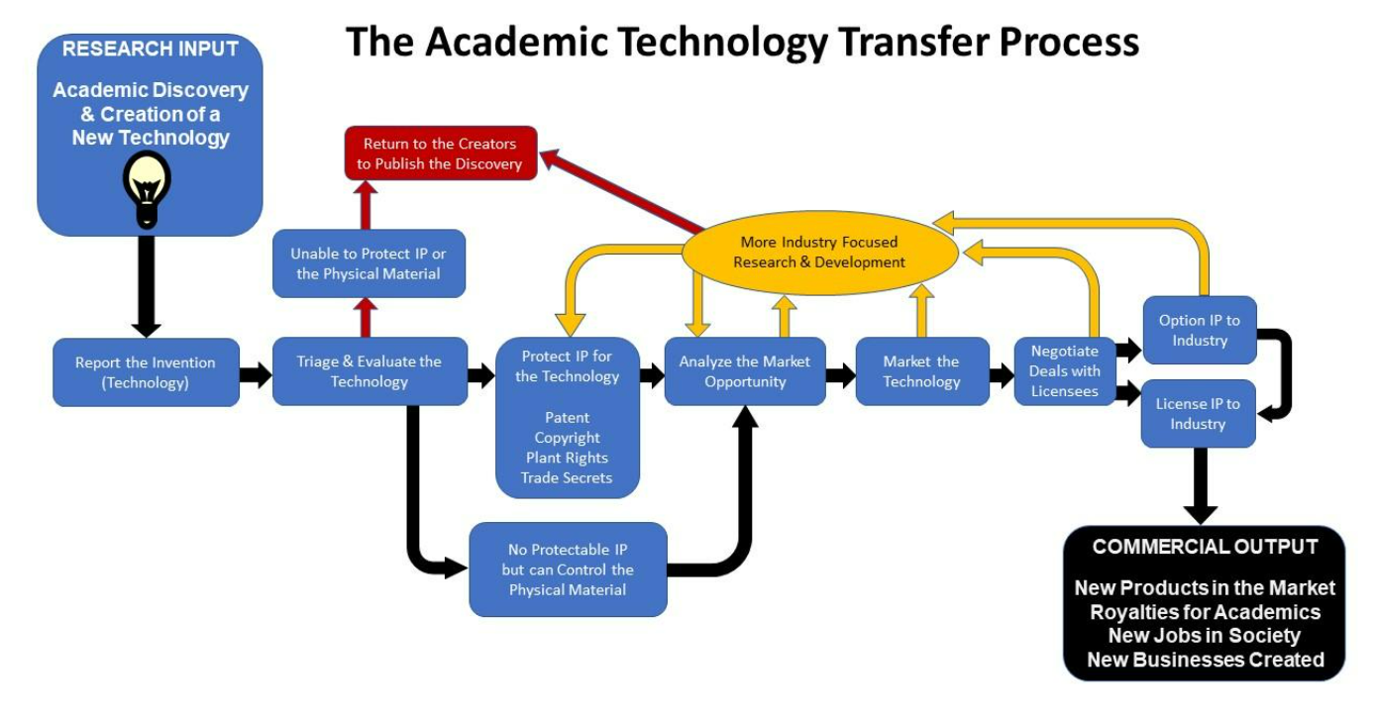
(Long Description)

144

IP and Commercialization | Technology Transfer | Research and Discovery
The technology transfer process is most often used by non-profit, publicly funded colleges, universities, government laboratories, and research institutions that are experts in conducting research, discovering scientific knowledge, and developing novel technologies. While there are many inventions out in the world with no real-world applications these entities are focused on using research methods to find potential solutions to today’s real problems. Their discoveries and inventions are intended to be shared with others to make a difference in the world. In an ideal world, the researchers are in close contact with people, stakeholders, stewards, and organizations that experience the problem and best understand the intricate details about the problem that need to be solved. In this way research can be conducted in parallel with a process that constantly evaluates what solutions, even at their most early stages of development, might be feasible in the real world or commercial market. This market discovery or awareness can help researchers conduct more impactful research results.

Reporting of an Invention
Depending on the non-profit entity where the invention originated, the first step is often to disclose(report) the invention created by the researchers to the administration to evaluate the commercial potential of the invention. Policies vary by institution with some allowing inventors to own their inventions and have the choice to work with or without their employer, and others require all inventions to be owned by their employer (often a university) as a condition of employment. Inquire with your own institution or search the WIPO Database of Intellectual Property Policies from Universities and Research Institutions for the policies relevant to your work. For this module we have assumed that the researcher is willingly allowing the employer (university) to take control of the invention. In most cases the employer has a Technology Transfer Office (TTO) which will receive the Report of Invention. The technology transfer professionals on staff will help researchers understand policies on how intellectual property (IP) and commercialization is managed at their specific institution, check if any intellectual property rights are restricted or encumbered as a condition in the project funding agreement related to the research that created the invention, and provide information and guidance on proceeding to the next step in the process.

Assessment
One of the TTO’s hardest jobs is to properly assess and evaluate the commercial potential or societal impact of a new invention. Each invention has a unique set of characteristics that helped the invention get to its current level of development. A TTO will use this information to predict if an invention (and any associated IP) can be protected, and at what cost, and estimate the potential commercial value of an invention, once it is used to make a commercial product or social good. This assessment involves a comprehensive worldwide prior-art search (literature, website, competitors products, and patent databases), and a market opportunity analysis.
The prior art search will determine if the invention is novel, non-obvious and useful (and commercially viable), and therefore may qualify for protections (e.g. patents). Searches are conducted using comprehensive academic journal databases such as Academic Search Premier, Scholars Portal Journals, Web of Science (often available free at academic institutions) and free online patent application databases like the Canadian Patents Database, Google Patents, the PATENTSCOPE database, USPTO, Espacenet, etc.
The market analysis looks to determine if the invention would have commercial value by assessing how the invention works to solve a problem, the audience or target market that would be interested in such a solution, any competitive products or companies that exist and the scale of the potential opportunities. Large unsolved costly problems that affect many people or companies have much greater commercial value or social impact than those that only affect a small number of people and have small costs to them. Therefore, estimating the potential market size of the problem is critical to understand before anyone is going to invest time and funds into developing the technology into a product to solve the problem. The better one understands the problem from the customer’s perspective, the more likely a product will be developed that actually solves the problem. Another important characteristic of a technology is its current level of development or maturity, often called the Technology Readiness Level (TRL). Some inventions may not be sufficiently developed (i.e. proven) to be of interest to commercial partners, and further research may be necessary before real product development, investment, and partnerships can begin.

Protection
It is important to ensure proper protections are in place for an invention before starting the process of adding additional resources to develop a potential commercial product. In many cases, an invention must be kept confidential until a thorough analysis is completed by the TTO or the company developing the invention. If researchers need to discuss their invention with anyone outside of their team or control then they should only do so after executing a Non-Disclosure Agreement – to keep such discussions legally confidential. If an invention is made public by website postings, publication, or conference presentations, then considerable commercial value will be lost, especially in the opportunity to secure a granted patent. Most, but not all, commercial opportunities require some form of restriction on the rights of others to use the invention, and in most cases product developers demand the exclusive right to use the invention and associated intellectual property for commercial purposes (i.e. to build new products). In addition, these protections are a legal recognition of the ownership of the invention, which helps to prevent theft and imposters from assuming credit for the inventor’s work.
Inventions can be protected by various forms of intellectual property rights such as patents, copyright, trademarks, industrial designs, integrated circuit designs, proprietary use agreements, and trade secrets. These various types of protection often encourage investment from third parties to help the rights-owner commercialize their invention because they have exclusive rights and therefore have the potential to hold back the competition in the intended new product market. However, the laws governing IP are slightly different in each country, therefore take care to understand the different rights, rules, and regulations of your jurisdiction of interest. For example, a patent application can be filed in Canada or the USA by an inventor for up to one year after the inventor made a public presentation describing his/her invention. No such grace period exists in Europe.
In general, it is best to submit a patent application to the intellectual property office in the country of interest (i.e. CIPO for Canada and USPTO for USA) prior to making any invention public via a presentation, abstract, publication, etc.. This will maximize the probability of obtaining an approved patent (often takes many years) which improves the current commercial value of the invention (i.e. IP may result in a granted patent). Alternatively, a trade secret has no formal registration process, and its value is almost entirely based on the fact that it is a secret, has very limited distribution (sometimes only a few people), and it has security protocols maintained in-house by the inventor or owner to keep it secret.

Marketing
With protections pending (such as a patent application under examination by CIPO), or in place (patent granted), it is time to start marketing and advertising the invention to prospective partners/companies that should want to license the invention to expand their business or support their innovation and product development goals. Marketing plans can include targeted print and digital advertising, telephone calls, email campaigns and meetings. A TTO should leverage all existing relationships with companies in addition to searching for new market opportunities. Cooperation among fellow academic TTOs is common as they help each other tap into each other’s networks to connect with potential licensees or buyers of new inventions and IP. One of the common outcomes that occur as TTOs talk with assumed customers, partners, and potential licensees is that it allows the TTO to validate the problem and market opportunity that the invention might solve. The problem cannot be validated in the office, it must occur by talking to many customers, licensees, or intermediaries that experience the problem, and then the value and configuration of potential solutions (i.e. invention) can be determined much more accurately.

Agreement Negotiation
If the negotiating parties are uncomfortable with the usefulness or quality of an invention, they may decide to execute an option agreement first to give the potential licensee/partner the right to use, test, and evaluate the invention. An option agreement (e.g. experimental use agreement) allows the potential licensee to conduct trials with the invention under close to realistic use-conditions, for a limited time before entering into a definitive license agreement. This “kick the tires” period can be months or even years, depending on how hard and long it takes to convert an invention into a real product.
Once a serious licensee has been found, and the quality of the current invention is not a concern, then a license agreement must be negotiated, which often takes weeks to months. The negotiation will finalize the terms of the agreement which will grant the licensee the rights to commercialize the invention in exchange for financial compensation (i.e. annual license fees, royalties, milestone payments, and other potential considerations). Some other terms that will be negotiated include the jurisdictions where commercialization of the invention is allowed, reporting requirements, and duration of the contract.

Post-License Follow-up
Once a license agreement has been executed it will describe the future obligations of each party (i.e. licensee and licensor), deadlines for completion, and the actions that one party may take if the other party fails to perform their obligations (called breach of agreement). These follow-up obligations/activities are intended to ensure that the relationship and common goals to commercialize the invention are maintained for the duration of the license. These obligations/activities often include the submission of annual reports, licensing payments, royalty payments, investment in further research, regulatory approvals or the launch of new products based on the licensed invention and term renewals, to name a few.
An interactive H5P element has been excluded from this version of the text. You can view it online here:
https://ecampusontario.pressbooks.pub/knowledgemanagement/?p=734#h5p-21

145

IP and Commercialization | Technology Transfer | Readiness

Technology Readiness Level (TRL)
As mentioned previously, the Technology Readiness Level (TRL) of an invention is assessed at several points in the technology transfer process to evaluate the maturity of the current invention to better understand its commercial feasibility. If an invention has a very low TRL (e.g. TRL 2) then it may be prudent for the TTO to delay any commercial development and return the invention to the researchers to conduct further research. This is often the case with technologies that take a long time to develop in markets where licensees (often big corporate companies) need absolute proof of efficacy in a realistic setting or environment before they will commit a big investment to commercialize the invention. Some inventions work well in the lab or in vitro experiments, but when they are used in an industrial setting or in the field they do not perform. Many licensees demand data and validation of the performance of an invention at a higher TRL (e.g. TRL 6) before they will execute an option or license.
TRLs were first developed by Stan Sadin with NASA in 1974 and have since been adopted, improved, and modified for use by many industries, government organizations, funders and investors. The current TRL scale places technologies into one of nine levels depending on its maturity at the time of the assessment. Funding programs and some projects often evaluate the current TRL of a technology and predict where on the TRL scale it will be at the end of the project timeline.
The nine TRL levels are:
- TRL 1 – Basic Principles Observed
- TRL 2 – Technology Concept Formulated
- TRL 3 – Experimental Proof-of-Concept Created
- TRL 4 – Prototype Validated in the Lab
- TRL 5 – Prototype Validated in the Field
- TRL 6 – Prototype Demonstrated in an Industrial Relevant Field
- TRL 7 – Prototype Demonstrated under Industrial Operational Environment
- TRL 8 – Final Testing and Evaluation
- TRL 9 – Successful Deployment
Read
, Innovation Canada
Finally, take a moment to watch this short video on the TRL Scale and how it can be used to gauge an inventions maturity on the path to commercialization.
What are technology readiness levels? 2:20, by PatSnap Academy (https://www.youtube.com/watch?v=o9ZNL_zzkbY
Manufacturing Readiness Level (MRL)
Another important tool is the Manufacturing Readiness Level (MRL) which is used to evaluate a supply company’s readiness to start manufacturing finished products. MRLs were developed by the US Department of Defense in collaboration with industry. These are very useful for assessing when a potential supplier might be ready to manufacture a specific product.
Entrepreneurs and start-up companies often out-source the manufacturing process of their first products and therefore MRLs can help guide this process to reduce manufacturing risks and maximize the quality of the intended product.
- MRL 1 – Basic manufacturing implications identified
- MRL 2 – Manufacturing concepts identified
- MRL 3 – Manufacturing proof of concept developed
- MRL 4 – Capability to produce the technology in a laboratory environment.
- MRL 5 – Capability to produce prototype components in a production relevant environment.
- MRL 6 – Capability to produce a prototype system or subsystem in a production relevant environment
- MRL 7 – Capability to produce systems, subsystems, or components in a production representative environment.
- MRL 8 – Pilot line capability demonstrated. Ready to begin low-rate production.
- MRL 9 – Low-rate production demonstrated. Capability in place to begin Full Rate Production.
- MRL 10 – Full rate production demonstrated and lean production practices in place.

One or more interactive elements has been excluded from this version of the text. You can view them online here: https://ecampusontario.pressbooks.pub/knowledgemanagement/?p=736#oembed-1

Manufacturing Readiness Level (MRL)
Another important tool is the Manufacturing Readiness Level (MRL) which is used to evaluate a supply company’s readiness to start manufacturing finished products. MRLs were developed by the US Department of Defense in collaboration with industry. These are very useful for assessing when a potential supplier might be ready to manufacture a specific product.
Entrepreneurs and start-up companies often out-source the manufacturing process of their first products and therefore MRLs can help guide this process to reduce manufacturing risks and maximize the quality of the intended product.
- MRL 1 – Basic manufacturing implications identified
- MRL 2 – Manufacturing concepts identified
- MRL 3 – Manufacturing proof of concept developed
- MRL 4 – Capability to produce the technology in a laboratory environment.
- MRL 5 – Capability to produce prototype components in a production relevant environment.
- MRL 6 – Capability to produce a prototype system or subsystem in a production relevant environment
- MRL 7 – Capability to produce systems, subsystems, or components in a production representative environment.
- MRL 8 – Pilot line capability demonstrated. Ready to begin low-rate production.
- MRL 9 – Low-rate production demonstrated. Capability in place to begin Full Rate Production.
- MRL 10 – Full rate production demonstrated and lean production practices in place.
Read
. Technology Transfer and Commercialization.

146

IP and Commercialization | Intellectual Property Basics

What is Intellectual Property
Intellectual Property (IP) is an umbrella term referring to the intangible assets that are creations of human intellect and creative pursuits. The term includes inventions, symbols, logos, pictures, designs, literary and artistic works, and more.
It is possible to have some types of IP protected to legally preserve rights of ownership, use and value. These IP rights are made effective by the laws governing the use, ownership and enforcement of IP in a specific country. Formal IP rights are associated with patents, trademarks, copyright, etc., which will be discussed in more detail below. All IP rights are ‘negative rights’ meaning that the owner of the IP rights has the legal power to stop others from using the owner’s IP within a specific territory, limited within a country in which the laws apply. It is the responsibility of the owner of the IP rights to take positive action to stop others from infringing on their IP rights. There is no IP policing agent in any government administration – once granted the IP rights, it is the owner’s job to police the territory. In short it gives the owner the right to take an infringing party to court and stop them through litigation.
Within Canada the Canadian Intellectual Property Office (CIPO) is responsible for administering, processing, examining, and granting most types of IP rights. Connect with your Technology Transfer Office or seek independent legal counsel if you have particular questions on IP and how to use your IP rights to protect your creative works.
For a quick overview, watch this video from CIPO introducing different types of IP.
One or more interactive elements has been excluded from this version of the text. You can view them online here: https://ecampusontario.pressbooks.pub/knowledgemanagement/?p=740#oembed-1

The Importance of Intellectual Property Rights
Various types of IP rights exist under the protections of IP law which legally preserve the rights and use of the IP by the creators and owners. The rights commonly thought of when discussing IP law include patents, trademarks, copyright, and industrial design. Trade secrets are also a form of IP rights; this right relies on the protection of confidential information by a limited group of people, and in Canada is not protected under legal statute or through a formal registration process.
It is crucial to protect IP assets for several reasons. IP rights define ownership over the IP asset to recognize the efforts of the creator(s), and they are used to prevent others from copying, using, selling, leasing, manufacturing your IP, or taking credit for your innovative ideas and inventions. Even if another party is able to independently recreate the same IP asset without malice, the owner of the IP rights has the power to stop them from using it. If the IP is of interest to industry for commercial use, there can be significant commercial value in owning or controlling the IP rights.
Industry and businesses can have great interest in acquiring IP rights that may allow them to gain a competitive edge over others in the market. As such, IP rights can reap many financial benefits for owners, creators, and other stakeholders, if they are actively used to protect an attractive commercial product. In short, IP rights, when used well, slow down or stop competing businesses from producing, selling, importing, exploiting, or using products or services which incorporate unique IP assets. If an owner decides to register their IP assets with the intellectual property office within a country, then fees will apply. Generally, government registration fees are most expensive for patents, trademarks would be the next most expensive IP right fee followed by industrial design, and copyrights are often the cheapest fee types. In Canada, trade secrets, which are by far the most common form of IP asset, are not registered with any agency and therefore have no official registration fees.

147

IP and Commercialization | Intellectual Property Basics | Patents and Trademarks

Patents
A patent is a time-limited IP right granted by a government which gives exclusive rights to make, use, and sell an invention to its owner. Fees for filing and maintaining patents, as well as criteria for having a patent granted, can vary between countries. It is important to recognize that patents are limited to the country in which the patent is granted in – global patents do not exist. One of the limitations of filing patents is that they are expensive to file, so if you wish to patent your invention in many countries, you have to file an application in each country you plan to sell or manufacture your invention and it gets expensive very quickly.
Within Canada, patents are valid for up to 20 years from the date of filing. In order for an invention to be patentable it must be useful, novel, and non-obvious. Almost all inventions have some practical use, therefore this is a low bar. However, novelty means that the IP or invention incorporating the IP is the ‘first in the world’ to demonstrate your invention. This is a very high bar to pass. Novelty does not mean that the invention must be an entirely new device, process, or product as many patents are granted for novel improvements to an existing invention. Non-obviousness means that the IP or invention incorporating the IP, would not be a predictable, logical, development by another person with ‘average skills in the art’ specific to the field of your IP. This too is a very high bar because researchers are improving methods and products continuously, so an improvement in one field can easily be transferred to another field where it can yield predictable improvements. This logical transfer makes the improvement obvious and therefore unpatentable.
The criteria for patentability are important to keep in mind, particularly when IP arises from academic works. For example, previous scientific publications can render a future invention unpatentable as it would no longer be considered novel because the publication makes the invention known to the general public. Inventors and creators often destroy novelty, and therefore the opportunity to obtain a patent because they publish their invention (in whole or in part) too early.
Take a moment to quickly do a few basic searches for patents, use keywords related to projects you are working on or use a random choice of keywords. Spend no more than 5 minutes on this activity. CIPO Canadian Patents Database – Basic Search

Trademark
A trademark is a recognizable symbol, design, word, phrase, or feature that distinguishes the goods and services of a business or brand from another. By registering a trademark, companies protect their unique brand and product identities.
While patents grant exclusive rights for a set period and then expire becoming available for use by any entity, trademarks grant exclusive use for a set period of time with the option for ongoing renewals. Within Canada, trademarks preserve the exclusive right of use for a 10-year period with the option to renew in additional 10-year increments.
A trademark registered and approved in Canada by the Canadian Intellectual Property Office (CIPO) may consist of one, or any combination of, the following: designs, 3D shapes, colours, words, tastes, scents, sounds, textures, moving images, holograms, and/or packaging. Certification marks may also be registered as a trademark. The purpose of a certification mark is to identify that a certain good or service meets a defined standard.

Activity
Try searching for a trademark related to your own last name, or other keywords or business names of interest to you. Spend no more than 5 minutes on this activity.
CIPO Canadian Trademark Database – Trademark Search

Browse the following images for some examples of Trademarks
- Hologram on credit card
- Shape of the Toblerone chocolate bar
- Tiffany Co. blue colour
- Nike “Just Do It” Slogan

Copyright
“Simply put, copyright means the right to copy, and copyright law prohibits others from copying specific types of works without permission. Copyright is the exclusive legal right to produce, reproduce, publish or perform an original literary, artistic, dramatic or musical work.”55
While other IP rights are granted by a governing body, copyright exists as soon as original work is created and in most cases that work remains under copyright until 50 years after the creator’s death. It should be noted that this timeframe can vary; copyright in the United States lasts 70 years after the creators’ death. In Canada it is possible to receive a certificate of registration which can be used as further proof of copyright, should a copyright claim go to court.
Licensing and assigning copyright to another individual or organization is a way to generate income from the associated works. Creative Commons is an additional option to consider as a copyright holder to make the creative works easily available for public use and distribution. Through a variety of Creative Commons license types, icons, and simple language is used to clearly articulate if and how people and organizations may use, share, or build upon your work.

Industrial Design
Industrial design protections focus on the visual appearance of a product, or how it looks in 2D and/or 3D space. This includes its shape, configuration, pattern, and ornaments or any combinations of those features. Once again, the CIPO is the governing body for industrial design registration within Canada. Any new design can be registered for exclusive right of use for up to 15 years.

Trade Secrets
Trade secrets are confidential information with value dependent upon its secrecy. While they are recognized as an IP asset, Canadian IP law does not offer any formal registration process or IP rights enforced by legal statute for its protection. A trade secret only protects information if the information is kept secret. Trade secrets are protected by using legal contracts and confidentiality agreements whenever a trade secret is shared or exchanged. It is reasonable and prudent for the owner of a trade secret to demand that other parties wishing to access the trade secret sign a confidentiality or non-disclosure agreement to keep the secret safe. If the trade secret is disclosed contrary to the agreement, then the owner can take the disclosing party to court for breach of contract and be awarded damages to be paid by the disclosing party. Unfortunately, this award does not return the former secret to its confidential status – as it is now in the public domain.

Plant Breeders’ Rights
Administered by the Canadian Food Inspection Agency (CFIA), Plant Breeders’ Rights (PBR) protect newly developed plant varieties and preserve exclusive rights related to the propagation of the plant, similar to a patent protecting an invention. Two varying lengths of PBR protection exist; one for protecting trees and vines (including related rootstock), which lasts 25 years, and one for all other plant varieties, with protections lasting 20 years. To be granted PBR protection it must be demonstrated that a variety is new, contains at least one distinct characteristic from known varieties, uniform, and stable over successive generations.
Outside of Canada these rights may be referred to as Plant Variety Rights. As with patents it is necessary to apply for these protections to be granted by each national/regional office.

Integrated Circuit Topographies
With the rapid development of electronics and microchips in almost any complex product today, governments around the world have passed laws to protect the three-dimensional design of electronic circuits embodied in the integrated circuits of these products. Consequently, any original integrated circuit topography (in whole or in part) can be registered with CIPO – if granted these IP rights last for 10 years from the date the application was submitted.
An interactive H5P element has been excluded from this version of the text. You can view it online here:
https://ecampusontario.pressbooks.pub/knowledgemanagement/?p=742#h5p-22

148

IP and Commercialization | IP Strategy
An IP strategy is developed to leverage IP assets to achieve set goals and can be leveraged to gain and maintain a competitive advantage in the target market(s) and drive business growth. IP strategies may be targeted to a single type of IP or encompass multiple types. Firstly, it is important to understand the intended goals of the IP being created.
In a research environment this means evaluating the intent and future goals of the research and the potential IP outcomes. What does the researcher hope to accomplish and what is the intended use? Actions taken during the research and discovery stage can impact what IP rights can be applied for later. For example, if a discovery is published in a scholarly journal the publication is covered by copyright law; but the discovery is now considered public knowledge, impacting the patentability of the discovery and future monetary benefits and innovation edge that may have resulted from licensing, etc.
For many inventions, especially those with a long regulatory pathway (e.g. pharmaceuticals), the amount of follow-on development required is so great that no company would make an investment without a patent in place. The patent acts as a protection on their investment as well as the IP. So, a missed opportunity to apply for IP rights, or a desire by the inventor to make an invention free to the public, may backfire if it can never secure enough funding to develop the IP into a product that can be used by the public.
Once an understanding of the possible IP outcomes and the goals of use have been defined, it is possible to outline how the generated IP should be managed. The IP management plan may exist with focus on a single project or exist at a larger scale, managing all the IP connected with a lab or business. The plan may also consider costs and risks associated with the IP and its options for protection. In addition to describing the intended goals, the operational plan will define the types of IP involved and the steps required to manage that IP in accordance with the overarching goals. In the case of an invention that arises from research, an IP plan should provide instructions on the collection and management of research and prototype data and restrict any public disclosure or publication until patent applications have been filed.
With an IP management plan in place, it is time to follow through and execute that planning. The IP plan will have outlined all the personnel involved and their distinct roles and responsibilities. Everyone involved will now follow through on those tasks. Communication is key to mitigate risks and achieve the set goals.
An IP strategy is not a static creation, it should grow and evolve in response to the ever-changing market conditions. Most IP strategies are based on a core IP asset – for example the formula for a new cancer drug protected by a patent. Then additional IP can be developed and protected, for example:
- The manufacturing methods (patents or trade secrets) to make the drug or finished product
- The synthesis of critical ingredients (patent)
- Pricing relationships with suppliers of raw materials (confidential information – trade secret)
- The use of the drug in new ways (improvement patent, proprietary data for treating a rare disease)
- A kit or combination product that uses the drug (patent, copyright, trademark)
- A companion diagnostic test that helps select the best patients and conditions to use the drug (new patent)
- A new business service using digital technologies to connect and educate customers on the effects and timely use of the drug (copyright, software encryption trade secret, trade mark)
- Creation of brands and logos to heighten awareness of the drug and maximize trust in the drug (copyrights and trademarks)
- Creating single source production when trade secrets are critical to production
- and anything else involved in the value chain to bring a new drug to market that adds value to the final customer.
All the IP, not just the patents, must remain aligned with the current and future goals of the business. This may include modifying the existing IP, developing entirely new IP, combining IP from other fields in new ways, and splitting IP up for use in various fields of use, and using non-exclusive license agreements to maximize commercial adoption. While a patent may last up to 20 years, new discoveries may render it obsolete over time; the only way to maintain your competitive advantage in the long term is to continually create useful new IP. This is the basis of the innovation economy.

Commercialization of Intellectual Property
IP can be an incredibly valuable asset – businesses often utilize IP to gain a competitive edge in the market, expand into new markets, grow the business, build partnerships, and raise funds. If there is adequate demand for the invention, IP creators have several options to commercialize their work.
Entrepreneurial minded creators may opt to commercialize the IP themselves, selling goods and services directly to customers. This option involves an extensive amount of effort on behalf of the creator, from sourcing production options, conducting market analysis, packaging product, and shipping, etc. A creator undertakes a significant amount of risk when choosing to commercialize the IP themselves, as they will be solely responsible for all aspects of managing the IP, business needs, and related costs. However, great risk comes with the potential for great rewards. The creator could not only gain recognition for the invention but also reap financial gains. Companies such as Blackberry and Shopify are successful examples of this commercialization option.
Alternatively, a creator may choose to assign IP rights to another party. In academic research or industrial joint ventures, this is sometimes done in advance of a discovery, through institutional policies, research collaboration agreements, or contracts. Assignment of rights can be a way to mitigate risk; the creator is still acknowledged for their work, and may still make financial gains, but they are effectively selling their right of ownership to the assignee.
Licensing of IP is another option for commercializing IP, in which the owner enters into a legal agreement where both parties have agreed to set terms allowing for the use of the IP. In this case, the owner maintains ownership of the IP and the licensee is allowed use of the IP under the conditions agreed upon, usually in exchange for fees and/or royalties. Again, this method helps mitigate or share risks. The terms of the agreement may designate territories, costs sharing, or other terms that are meant to benefit both the licensor and the licensee.
Take a moment to watch this brief video on a few of the options to commercialize IP and how this can be a beneficial and profitable process.
One or more interactive elements has been excluded from this version of the text. You can view them online here: https://ecampusontario.pressbooks.pub/knowledgemanagement/?p=745#oembed-1

149

IP and Commercialization | Curated Links 2
- 4iP Council. (2020, November 2). Webinar: Why Researchers Need an IP Strategy. https://www3.wipo.int/wipogreen/en/news/2020/news_0035.html
- Canadian Intellectual Property Office. IP Academy. http://www.ic.gc.ca/eic/site/cipointernet-internetopic.nsf/eng/h_wr04234.html
- Blank, S. (2019, January). The Fatal Flaw of the Three Horizons Model. https://steveblank.com/2019/01/08/the-fatal-flaw-of-the-three-horizons-model/
- Department of Industry. (2020-07-10). Intellectual property: It’s yours. Own it. https://www.ic.gc.ca/eic/site/cipointernet-internetopic.nsf/eng/wr04312.html#Trademarks
- Gale, C. (2021, March 5). Valuing Patents: The Importance of a Patent Strategy for Business of all Sizes. Lexology. https://www.lexology.com/library/detail.aspx?g=bdc654db-d92c-4031-8ce1-d7eec397683a
- Wilson, P. (2020, January 10). Capturing value: IP as a driver for investment. Lexology. https://www.lexology.com/library/detail.aspx?g=221c7d6e-19bb-4cb7-9e76-ca1095433d00

150

IP and Commercialization | Introduction to Entrepreneurship
This next section is a collection of knowledge, perceptions, and projections for charting a journey into entrepreneurship. The content here is intended to help individuals develop an entrepreneurial mindset, stress the importance of discipline and use of evidence, to encourage budding entrepreneurs to dig deeper and accurately assess risks before making any large commitments.
The topic of entrepreneurship is always an interesting and evolving discussion. There are as many views of entrepreneurship as there are business models and industry sectors, so it is important to keep up on current best practices to survive in the long run. There is no single correct method to pursue entrepreneurial ventures but there certainly are quicker, more efficient, and more disciplined methods that have much higher success rates.
Four prominent thinkers/writers in this space are Eric Reis (The Lean Start-Up), Alexander Osterwalder (Business Model Generation), Bill Aulet (Disciplined Entrepreneurship) and Steve Blank (The Start-Up Owner’s Manual). These authors have shared their methods to evaluate, start, and grow start-up ventures using clear, disciplined, structured, and data-based methods. Where a scientist has a very clear materials & method in an academic paper, these authors have tried to provide the same repeatability and structure to starting new ventures. For disciplined scientists interested in becoming an entrepreneur, this is a gift and much of their materials can be found online for free, for example most of the principles and methods developed by Steve Blank can be freely accessed at SteveBlank.com. However, if you are serious it would be prudent to invest and buy these books for your reference library.
In one of his most recent writings, The Class that Changed the Way Entrepreneurship is Taught, Blank makes the case for experiential learning in the article. The premise is that by accessing and using many of the tools that are available to entrepreneurs, regardless of their current environment, almost all budding entrepreneurs can gain the structured knowledge needed to successfully move toward a new business venture.
Innovation and entrepreneurship are two closely related words used in today’s global verbiage. Some may think those words mean the same thing, but using them interchangeably would be a mistake. They revolve around the same idea, but it is critical to understand the difference. Innovation is applying your creativity to solve a problem and implement a solution. Entrepreneurship is the activity of setting up a new business, and taking on financial risks to pursue a profit, create social impact or even create a new business from or within an existing business.

What is Entrepreneurship?
Entrepreneurship is the act of being an entrepreneur or “one who undertakes innovations, finance, and uses business acumen to transform innovations into economic goods”. This may result in new organizations or may be part of revitalizing mature organizations in response to a perceived opportunity or changing the target market. The most obvious form of entrepreneurship is that of starting a new business (referred to as a start-up company). When entrepreneurship is describing activities within a large organization it is often referred to as intrapreneurship.
An entrepreneur is defined as anyone who creates or organizes a new venture (often a start-up, but not always), then continues to be an active participant in the operation of that venture until it is stable and, ideally, self-sustaining. They learn continually in order to recognize opportunities with the potential for innovation. They use resources economically in order to create innovative products that deliver a competitive edge based on differentiation. Often, they are called “founders” and they are typically the first shareholder, usually maintaining the majority of the shares of the start-up company in its first few years. Simply put, an entrepreneur is anyone who launches and continues to run their own company. They bring together people (skills), products (or technology to build products or services), and financial assets (cash) to form a company aiming to solve a market problem that will generate revenue for the company

Characteristics of an Entrepreneur
Entrepreneurs are people who have a passion for creating change in the world. They need a certain set of skills or qualities to be effective leaders and innovators. According to Louis J. Filion (2021) successful entrepreneurs innovate by recognizing opportunities to make moderately risky decisions that lead to actions that require the efficient use of resources that contribute to added value.
Looking bit closer to home, successful Canadian entrepreneur, Arlene Dickenson, finds that successful entrepreneurs:
- Always question the status quo
- Think security is defined by being in charge of your own destiny
- Are doing something that makes them scared and excited each and everyday
- See opportunities where others do not and are always thinking “I thought of that years ago”
- Wake up in the middle of the night thinking about work in a good way, and
- Embrace the messiness of the entrepreneurial work/life balance
According to Gallup’s research, the best business-builders rely on a set of 10 key traits which help meet the demands of a start-up and lead them to success. Those traits are confidence, the ability to delegate, determination, disruptive thinking, independence, knowledge-seeking, profitability-focused, relationship builders, the ability to manage risks, and the ability to sell ideas. Gallup has developed an assessment, the Builder Profile 10, designed to identify a person’s dominant entrepreneurial traits, for a small fee. Many of these traits can be learned and certainly with discipline proven methods such as those described by Steve Blank and Eric Reis can be followed to improve any entrepreneur’s opportunity to succeed.
Contrary to popular media attention, the most successful entrepreneurs are middle aged or older, like Henry Ford, Vera Wang, and Martha Stewart. Research from Daniel Kim at Wharton notes that the most successful entrepreneurs in the USA are in their mid-40s. Why? Because they have much more life experience behind them that helps them make better decisions and to assess risks and opportunities more effectively. Older entrepreneurs have stronger social ties, established relationships with suppliers and potential hires as well as more financial wealth to contribute which can cushion a start-up during tough times. According to Daniel Kim, “there seems to be this very consistent finding that the likelihood of entrepreneurial success rises with age” (Kim, 2019). Entrepreneurs in their 20s have the lowest probability of creating a high-growth company. Examples like Bill Gates and Mark Zuckerberg are very much a rare anomaly.

151

IP and Commercialization | Introduction to Entrepreneurship | Types of Entrepreneurship
Though entrepreneurship is the overall process of developing, launching, and running a business, there are several general types of entrepreneurship.

Small Business Entrepreneurship
Small business entrepreneurship is the act of starting a business without turning it into a large conglomerate or opening many chains (franchising). A single-location restaurant, a retail shop, a doctor’s office, or a small consulting firm would all be examples of small business entrepreneurship. This type of business is very dependent on the founder’s efforts alone, therefore the maximum financial profit is limited by their available hours and personal energy.
This type of entrepreneurship usually involves personal investment and success is tied to profits that the individual uses as their main source of income. They are often called lifestyle businesses, because they support the founder’s personal lifestyle, and are based almost entirely on the founder’s personal efforts. Therefore, they are not easily scaled up into a larger business. These individuals are not seeking investors and will only take a loan if it helps to continue their business operation, growth and scaling up are not important goals.
For highly experienced academic researchers, consulting is a common and attractive route into small business entrepreneurship. Using their highly specialized subject matter expertise, researchers, faculty, post-doctoral fellows, or even graduate students, can easily transform their specialized educational background into a fee-for-service business by providing consulting services to businesses and organizations outside the academic ecosystem. Academics often have the latest understanding of leading-edge research in their area of expertise. This deep knowledge base can be used to provide guidance and opinions to industry partners or even government organizations that are unable to understand, interpret, or vision a path forward for complex new research results.
This type of business model is often set up as a sole proprietorship or as a simple corporation with only one employee (the academic researcher) or no employees with the academic as the main shareholder. The small business corporation model is often chosen to control shareholder liability and to enable more retained earnings to remain within the corporation at a lower tax rate. A corporate model can also enable reinvestment in business building activities, enhance the business image, and instill greater trust from potential clients. Some academics can even specialize in providing scientific opinions to lawyers and the courts during litigation of matters involving complex science or patent disputes based on scientific inventions.
Before venturing into consulting, it is imperative for academics or industry experts to ensure they have the freedom to do so based on their existing employment agreement and that the consulting topic is not a conflict of interest or conflict of commitment between their consulting client and their academic research projects. Almost all public academic institutions allow researchers (faculty/staff/students) to perform private consulting outside of work hours, provided it is not in conflict with institutional policies. If unsure, check your institutional policies or connect with your human resources advisor.

Scalable Start-up Entrepreneurship
Scalable start-ups usually begin with a founder who has a unique idea and the vision to create and scale-up (grow) the company until it is highly profitable (or for social ventures, fully sustainable) and often continue to grow the company to be the leader in the market.
These businesses begin on a very small scale, often as just the seeds of an idea. The idea is then nurtured and scaled, typically through the involvement of outside investors, until it becomes something much larger. These companies must grow to survive because often they are not profitable until they are very big and benefiting from huge economies of scale. Many Silicon Valley digital technology companies fall under this model; they begin in the founder’s garage, academic research lab, or home office before eventually scaling up into large multinational corporate businesses. Amazon, the world’s largest corporation by market capitalization, did not report a profit for the first 10 years.
Listen to Steve Blank discussing start-up companies.
One or more interactive elements has been excluded from this version of the text. You can view them online here: https://ecampusontario.pressbooks.pub/knowledgemanagement/?p=751#oembed-1

Social Entrepreneurship
Social entrepreneurship seeks innovative solutions to community-based problems. Social entrepreneurs are willing to take on the risk and effort to create positive changes in society through their initiatives. In other words, a social entrepreneur launches an organization that’s fundamentally about working towards enacting positive social, cultural, or environmental change, in addition to generating profits. Often the initiatives function as a non-profit organization, non-governmental organization or B-corporation. The social change in question may support environmental conservation, racial justice, international development, enhanced health care, or education in underserved communities, populations or regions of the world. They can vary in size from a few employees/stakeholders to thousands or even millions of employees/stakeholders.

Intrapreneurship
Sometimes, entrepreneurs work within the context of a larger, established company. Imagine someone that works at a large automotive manufacturing company. Through careful market research, they have realized there is a high demand for motorcycles, and that the company has many of the technologies and processes in place to branch into motorcycle production. If the idea is approved the company moves to fund and launch a brand-new motorcycle division, or spin out company.
Within large organizations (for profit, not-for-profit, academia, and even government), an “intrapreneur” is a person who acts like an entrepreneur but within the constraints of a larger company and for the benefit of the company that employs them. These people are agile, resilient, tenacious, passionate, visionary, and they don’t fear failure. These people survive because the corporate culture of the company has purposely allowed and supported an ecosystem to encourage such behaviour (within limits) because it might just develop the next big innovative product, process, or business model for the company. In short, they have the freedom to act like an entrepreneur and take risks within the security of a larger company. For example, Google is known to be intrapreneurship friendly, allowing their employees to spend up to 20% of their time to pursue projects of their choice.

Academic Entrepreneurship
The academic entrepreneur is an entrepreneur primarily focused on using their research results, and the knowledge generated while working in an academic setting, to support innovation and the creation of new products and services. The goal of the academic entrepreneur is to transfer their new knowledge and discoveries into the real world where it will have the greatest impact. The technology transfer process (described previously) is directly linked to academic entrepreneurs.
These entrepreneurs want to expand their role beyond academic research and knowledge creation and assume a role in a start-up or new venture. As either a scientist, researcher, product developer or advisor they aim to ensure their research results (often patent pending) have the best chance of being converted into a viable, marketable, and sustainable product adopted by industry and customers. Unused knowledge has little impact, but new products and services (commercial or social) that solve real problems in society, can have huge positive impact.
Academic entrepreneurship is a form of knowledge mobilization that is facilitated through the academic researcher’s participation in a start-up. For many academic entrepreneurs, the goal is not to quit academia and become a business leader or CEO. Instead, they assume the role of Chief Scientific Officer, VP Research, or similar scientific advisory role that enables them to steward the complex knowledge generated from years of research, so that it can be properly used by a start-up venture led by experienced business leaders.

152

IP and Commercialization | Introduction to Entrepreneurship | De-risking Inventions from Academia
Many inventions resulting from academia are not aligned with customers’ wants and needs, are too difficult or costly to manufacture or distribute, or are limited to small market opportunities. As a result, industry partners are unwilling to invest in product development until the invention is de-risked – in other words, more advanced on the TRL scale and there is evidence of strong market demand. Essentially, industry wants to adopt inventions that solve validated problems and work well in the real world under simulated or actual customer conditions, and often at an industrial scale. Industry adopters don’t want inventions that are only proven to work in the lab under very artificial, small-scale conditions.
Much can go wrong when technology is transferred for the lab to the market, and these risks can be costly. If market demand has been validated, then the next step is to “de-risk” inventions by advancing them closer to a final product. In looking to de-risk an academic invention, researchers often have difficulty securing funding (often called gap funding), industry partners to participate in collaborative research, and pilot plant testing facilities.
Once adequately de-risked, the university or academic entrepreneur (depending on who owns the invention), will negotiate a license or sale agreement to transfer it to an industry partner for commercial product development. The partner now takes on the responsibility to convert the invention, often with a patent pending, into a usable product that can be brought to market. Once a product is sold to and used by customers, then the invention has started to become an innovation. Not all new products are innovations – but those that are first to market and based on leading edge research, usually are.
To further innovation, the industry partner (licensee) often hires graduate students that were involved in the creation of the invention. In this way their creativity and deep knowledge beyond what might be described in a patent application can be transferred and used by the partner to advance further innovation. These newly hired graduate students, who turn into seasoned employees, often return to the same research institute or university as the industrial partner in a future collaborative research project and the cycle repeats.
The process of converting an invention into an innovation can take much longer than the time to create the original invention in the lab. Product optimization is often a slow, detailed, and arduous path to find the product-market fit that will survive long enough in the market and generate a profit. Many good inventions never make it to market or are quickly abandoned by companies because they were unable to generate a reasonable profit.
An interactive H5P element has been excluded from this version of the text. You can view it online here:
https://ecampusontario.pressbooks.pub/knowledgemanagement/?p=753#h5p-23

153

IP and Commercialization | Curated Links 3
- Abuja, P.M., Carapina, T., de Kort, M., Raess, M., Tieken, C., Wagstaff, N. (2019). Academia – Industry Collaboration Best Practices Guide. https://eatris.eu/wp-content/uploads/2019/12/CORBEL_Academia_Industry_Collaboration_Best_Practices_Guide.pdf
- Blank, S. (2021, July 13). The Class that Changed the Way Entrepreneurship is Taught. https://steveblank.com/2021/07/13/this-class-changed-the-way-entrepreneurship-is-taught/
- Business Development Bank of Canada. How to become an entrepreneur: Do you have what it takes? https://www.bdc.ca/en/articles-tools/start-buy-business/start-business/how-become-entrepreneur
- Harroch, R. (2016, December 16). 17 Key Lessons for Entrepreneurs Starting a Business. https://www.forbes.com/sites/allbusiness/2016/12/16/17-key-lessons-for-entrepreneurs-starting-a-business/?sh=7d2d5bc164db
- Hayes, A. (2021, February 26). Entrepreneur. https://www.investopedia.com/terms/e/entrepreneur.asp
- Kim, D. (2019, November 12). Why older entrepreneurs have the edge [Audio podcast episode]. In Knowledge@Wharton. https://knowledge.wharton.upenn.edu/article/age-of-successful-entrepreneurs/
- Louis Jacques Filion, 2021. Chapter 8, Defining the entrepreneur; In World encyclopedia of entrepreneurship: 2021
- Miller, K., Alexander, A., Cunningham, J. Albats, E. (2018). Entrepreneurial academics and academic entrepreneurs: A systematic literature review. International Journal of Technology Management, 77(1/2/3):9. https://www.researchgate.net/publication/325164974_Entrepreneurial_academics_and_academic_entrepreneurs_A_systematic_literature_review

154

IP and Commercialization | Value Propositions & Positioning
Product-Market fit for an invention or new product occurs when you have demonstrated that the product’s value proposition creates real value by generating gains for customers or relieving their pains. Before we can search for the best fit, we must fully understand our invention’s value proposition.
Securing funding for research and commercialization projects can be a highly competitive process. Applications to a specific funding pool are made because the proposed research will fill a gap in knowledge or solve a pressing industry need, and successful applicants will be those who position their proposals in the best light, convincing the funders that they have the right teams, demonstrated experience, resources, and solutions to meet the stated need.
When commercializing an invention, the product or service is more attractive to investors or potential licensees when supported by market data demonstrating a defined target market with strong demand for the invention or a potential product, if one is not yet fully developed, a realistic cost to get to market, and a convincing value proposition..
The following sections will examine the importance of value propositions and market analysis for commercialization in more detail.

What is a Value Proposition and Why is it Needed?
A value proposition is a foundational element of business, communications, and marketing. As we learned in Module 3 It is the promise that something of value, or benefit, will be delivered to a select audience from the actions taken by that business or project. It is a clear and concise statement that summarizes why an audience should choose the presented solution by defining what is being done (the solution) and why the solution is uniquely different and important to the target audience. For a business a value proposition could be how their product solves a common problem in a new way for customers, while a research value proposition can position why a research project should be selected for funding above all others.
Before a value proposition can be developed, written, and improved, considerable research must be conducted to understand what end-users need. Do everything possible, including talking to a hundred potential customers if needed, to fully understand the problem experienced by customers. This is called Problem Validation. The next step is to determine what potential customers value, how they want their problems solved, which gains are most important to them, and which pains they desperately need removed. This is done by exploring the various ways your invention or product might provide a benefit to the customer. With these things in mind a clear value proposition can be crafted.
The main components to any value proposition are:
- Identification of the target audience (customer/end-user)
- Identification of their need or the opportunity
- A description of the proposed solution
- A statement of end benefit

Writing a Value Proposition Statement
Several templates exist that can support the writing of a value proposition statement. Below are two guiding formulas that exist along with associated examples:

Value Proposition Formula (condensed from Moore, G. A., 1991)
For [target customer] who [statement of need/opportunity] the [product name] is a [product category] that [statement of benefit].
An example of a value proposition statement based on the above formula is: For elite athletes who struggle with jetlag, our research on the bioavailability of melatonin supplements will provide travel recovery solutions that will help them to be more competitive at international competitions.
Where,
- target customer = elite athletes
- statement of need/opportunity = struggle with jetlag
- product name & category = research on bioavailability of melatonin supplements
- statement of benefit = provide travel recovery solutions that will help them to be more competitive at international competitions

Value Proposition Formula (Blank, S., 2011)
We help (X) do (Y) by doing (Z).
An example of a value proposition statement based on the above formula is: We help elite athletes to overcome jetlag by providing recovery solutions through our research into the bioavailability of melatonin supplements.
Where,
- X = elite athletes
- Y = overcome jetlag
- Z = providing recovery solutions through our research into the bioavailability of melatonin supplements

Understanding the Audience, Customers, and Stakeholders
Crafting and evaluating a convincing value proposition statement relies on developing an understanding of the target audience or customer. This includes knowing what tasks or intentions they have, what difficulties are encountered in preparing for or executing those tasks, and how positive outcomes or aspirations are measured or gauged. Developing customer personas, or conducting customer surveys, can provide insights into customer perspectives and help inform the development and validation of your value proposition statement.
Customer personas are imaginary characters developed to be representatives of real customers based on facts, data, and behaviours from the targeted audience types. By having a clear idea of who the intended audience is it is possible to determine what their specific needs, feelings, and pain points might be.

Value Proposition Canvas
With a clear understanding of the customer and their needs, the next step is to ensure those needs fit with the proposed solutions and benefits of your value proposition. The Value Proposition Canvas is a tool that can help demonstrate the fit between the customer profile and the proposed value proposition validating the need or desire for the product or service. If the Value Proposition Canvas shows a misalignment of customer profile and the proposed value proposition, a re-evaluation is needed – either of the target audience, as perhaps another demographic or group would be more attracted to the proposed value proposition, or a re-evaluation of the proposed value proposition to craft a statement that resonates with the customer.
To gain more familiarity with the Value Proposition Canvas and its use watch this video from Strategyzer.
One or more interactive elements has been excluded from this version of the text. You can view them online here: https://ecampusontario.pressbooks.pub/knowledgemanagement/?p=757#oembed-1
Review the chart to consider examples of each types of value Proposition.
Customer Jobs | Customer Pains | Customer Gains | Value Prop. Products and Services | Value Prop. Pain Relievers | Value Prop. Gain Creators
Achieve Personal Best Performance | Long Recovery Time | Optimize Sleep During Travel | Bioavailable Melatonin | Reduce Jetlag Recovery Time | Safe and Effective Supplement
Land on the Podium | Poor Performance | Better Health and Wellbeing/ Well Rested | Research Based Recovery Strategy | Increase focus and improved quality of sleep
 | Competition Drugs/Treatment Restrictions |  | Natural Solution
Now that you’ve had an opportunity to try using the Value Proposition Canvas in this activity, try it out with your own projects. Visit Strategyzer to access a copy of the Value Proposition Canvas and try it out to analyze your own ideas.

155

IP and Commercialization | Market Analysis
When looking at commercializing a product or service offering, conducting a thorough market analysis can provide valuable insight into product-market fit, opportunities, market influencers and trends, audiences, and competitors. These insights can help inform how to best proceed with commercialization efforts, evaluate progress, and scale the business opportunity. The next sections will look more closely at various aspects of a market analysis report and why the information gathered is important in deciding commercialization activities.

Market Research
“Market research is the process of determining the viability of a new service or product through research conducted directly with potential customers. Market research allows a company to discover the target market and get opinions and other feedback from consumers about their interest in the product or service” (Twin, A, 2020).
Primary market research involves talking directly to customers and end-users to gather unfiltered and unedited feedback, opinions, and data on a specific market opportunity. This is a time-consuming process often conducted by one-on-one interviews or individual surveys, but it is tremendously valuable as it provides insights into the customer that you would never have predicted. These insights are useful to maximize the value your invention or new product may provide to a customer.
Secondary research is a process that collects information and data about the customer or market from other market researchers (or companies) that have conducted the primary research. Secondary research can be misleading because it has already been filtered, processed and compiled into a summary or protocol. However, secondary research is much faster, cheaper, and easier to obtain, therefore it is useful, but with some degree of caution on its validity related to your specific invention or product. Academics often have excellent access to abundant secondary research through their libraries and databases. It can be tempting to only do secondary research, but this is a mistake. Entrepreneurs, especially academic ones, must get out and take an active role in talking with potential customers if they are truly committed to the commercialization process.
Again, market research highlights the importance of knowing the target audience to inform decision making activities related to commercialization. While a value proposition may be informed by a theoretical audience based on facts, market research is seeking and assessing the audience’s interests and feedback from real consumers. Interviews, surveys, focus groups, product testing and other activities provide insights that can help guide commercialization efforts by defining specific market categories and appropriate sales messaging, defining pricing parameters (i.e., what customers are willing to pay for the product/service), and outlining satisfaction measures and key marketable features.
For example, by observing customers using a product, it may be found that the item is used in ways that are not expected, therefore opening a potential new market; or they may encounter difficulties using the product, helping refine the product design. Additionally, if a consumer is only willing to pay $13 for a product and the final cost of the product is $17 (for production and profit margin), the parties considering commercialization of that product may want to re-evaluate production costs or source new part manufacturers. They may also choose not to commercialize the product as the consumer pricing may indicate a non-viable business plan.

Competitive Analysis
Competitive analysis, often called competitive intelligence, is an investigation into the direct and indirect businesses that produce products or services that currently, or will likely in the future, compete with your proposed product that you would like to commercialize. Direct competitors are those companies, individuals, and their products sold that are very similar to your planned product, while indirect competitors are those that offer a different type of product or service that provides the same functional solution to the market problem that exists in your target market. Indirect competitors may provide different value propositions through different features, but they solve or eliminate the same problem that you are trying to solve but in a different way.
Competitive assessments must be done in detail if you aim to identify strategies to out-compete, circumvent, outsell, or out-market a strong competitor. Competitive analysis must take into consideration existing threats in the market and future threats. Which products (companies) must I out-compete today, and which companies are likely to enter the market in the future? Depending on your time horizon, these secondary entrants can be a greater threat than those currently in the market.
Many larger companies do not desire to be first to market, allowing small, early entrants to experiment and play in the market, which provides valuable information on the market potential and customer behaviour. Once they have adequately analyzed the market with a few small competitors fighting it out and growing, these larger companies, seeing that there is a profit to be made in this new market space, buy the smaller companies and integrate them into their larger corporation, or they massively out-spend them on sales, marketing, and product development. Google uses this strategy. Consequently, some entrepreneurs start new companies with a very short time horizon of only a few years, because they fully expect a large established corporation to take them over once they are recognized as a threat. This is one type of an “exit” that a founding entrepreneur may take, and it often pays very well, but now they need to create another business to get back in the game.
Understanding the strengths and weaknesses of a competitor is a continual process that never stops – “an innovation arms race” to see who can develop and improve products and delight customers the fastest. This competitive analysis can be leveraged to develop a commercialization strategy. Knowing where competitors exist in the market can help you identify a gap in the market in which your new product could be positioned to thrive. However, if you fill this gap, the competition is likely to follow. Never expect the competition to allow you to steal market share without them trying to take it back. Small companies are nimble and may respond quickly while larger companies are slower, but eventually the competition will challenge you.
First, any competitive analysis must start with identifying all the companies in the target market and those that you predict are likely to enter it. Common tools used by entrepreneurs to conduct analyses of your competition include:
- A simple product-to-product feature comparison
- A list of competitive market characteristics (target market, customer type, price, distribution and sales channels used, marketing strategy used, environmental impact, value-propositions, positioning statements, web traffic, and any other business metric you can obtain about your competitor’s product)
- PESTEL Analysis which looks at the political, economic, socio-cultural, technological, environmental and legal factors affecting a specific target market
- A SWOT table (Strengths, Weaknesses, Opportunities, Threats)
- A Four Corner Analysis developed by Michael Porter that documents your competitor’s drivers and assumptions (i.e. motivation) and their capabilities and strategy (actions)
- A financial analysis using traditional accounting statements and ratios
- Interviews with customer using similar or competing products
- and many more
Most importantly, the entrepreneur must try to be objective and remove their personal bias from the analysis. This is very difficult due to the high level of passion most entrepreneurs have for their invention, product and start-up company. If possible get an arms-length third party to do the analysis so they can be sufficiently critical and unbiased. Results can be tabulated or placed within a more visual framework – like a perceptual map. A few simple examples of how to visualize your competitor’s strengths and weaknesses are mapped below.

Perceptual Mapping: The Benefit of Visualizing Your Competitive Landscape
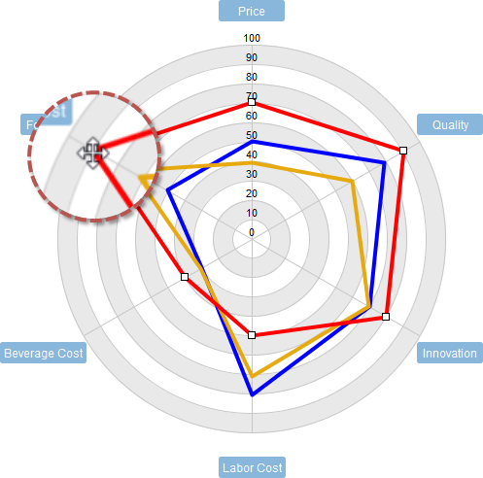
Competitive Analysis with Radar Chart

156

IP and Commercialization | Curate Links 4
- Baldassarre, B., Calabretta, G., Bocken, N.M.P., Jaskiewicz, T. (2017). Bridging sustainable business model innovation and user-driven innovation: A process for sustainable value proposition design. Journal of Cleaner Production, 147, 175-186. https://www.researchgate.net/publication/312546229_Bridging_Sustainable_Business_Model_Innovation_and_User-driven_Innovation_A_Process_for_Sustainable_Value_Proposition_Design
- Osterwalder, A., Pigneur, Y., Bernarda, G., Smith, A. Papadakos, T., (2014). Value Proposition Design: How to Create Products and Services Customers Want. https://www.strategyzer.com/books/value-proposition-design
- Thiel, P,, and Masters, B., (2014) Zero to One, notes on start-ups, or how to build the future. https://www.penguinrandomhouse.com/books/234730/zero-to-one-by-peter-thiel-with-blake-masters/
- Bland, D. J. (2020, October 29). Validate Your Value Proposition with Online Ads: How to test with real customers. https://www.strategyzer.com/blog/how-to-acquire-customers-using-online-ads-that-connects-to-your-value-proposition-canvas
- Blank, S. (2011). How to Build and Web Startup – Lean LaunchPad Edition. https://steveblank.com/2011/09/22/how-to-build-a-web-startup-lean-launchpad-edition/
- Lake, L. (2019, October 18). How to Develop a Value Proposition for Your Business. https://www.thebalancesmb.com/develop-your-value-proposition-2295755
- Moore, G. A. (1991). Crossing the chasm: Marketing and selling technology products to mainstream customers. New York, N.Y.: Harper Business.
- Twin, A. (2020). Market Research. https://www.investopedia.com/terms/m/market-research.asp
- Twin, A. (2020). Value Proposition. https://www.investopedia.com/terms/v/valueproposition.asp

157

IP and Commercialization | Commercialization & Managing Intellectual Property

Commercialization Process
The path to commercialize a potential product, technology, or service based on new research and knowledge is a complex, interconnected series of decisions and associated actions which need to be customized to fit with the current and predicted market conditions. These steps or decisions must be developed simultaneously because each decision can affect the viability of several commercial paths that a new product or service may follow. Individual decisions completed now, must be connected to a desired, predicted future opportunity. These decisions aim to maximize the probability that a new product or service will capture adequate customer demand (traction in the market) to eventually generate repeatable and reliable income that matches the needs of the organization (for profit corporation, not for profit, or social enterprise).
This section will focus on using new research and knowledge to create new products and services that will be sold by for-profit companies (traditional corporate commercialization). There are dozens of business decisions to be made when planning to commercialize a new product, such as: facility location, product design, target market, supply chain partners, manufacturing process and cost, quality level, inventory control, regulatory approvals, packaging design, logistics/shipping, distribution, financial and shareholder support, branding, marketing strategy, sales process and cycle, and general business administration. We will address only a few of the touchpoints that are key to the successful development of a new product and enterprise. For clarity, when we mention products, this term includes services and technologies which are not physical products, as well.
The process of commercializing a new product is based on the collection of relevant objective data and information that, when analyzed, will support and validate your business assumptions. It is extremely important to validate your assumptions about the current and future market opportunities before you get too far down the path of creating a commercial product. This section provides a window into freely available tools and resources that will assist you to collect data and information to validate your unique set of business assumptions. The biggest assumption of all is that customers will buy your product if you build it! Customers do not buy products because they are elegant, sophisticated, state of the art technologies, they buy solutions to their problems that just might happen to be sophisticated technology. As a researcher, be careful not to fall in love with your solution (or technology) because you have invested so many years developing it. Fall in love with solving the problem anyway possible that is sustainable and, if needed by your business model, profitable.
The main steps to complete before you commercialize a new product are:
- Market Validation: Do customers have a problem and are they demanding a solution?
- Technical Validation: Can a product be built and designed to uniquely solve the customer’s problem?
- Economic Validation: Can sufficient profit be generated by product sales to maintain the company?
If you answered yes to all three and you have data to support your answer, then you are on your way to commercialize your potential product. The key here is to do all the hard work to discover and test each of your many hypotheses for a potential product by generating data specific to your product, market, and customer segment. This validation is critical before moving forward and often it is an iterative process requiring a return to the beginning to generate new hypotheses, and to reframe and refine hypotheses and product features, before finding a product that is feasible. The process often yields unexpected results about the customer and market opportunity for which this process may generate a new solution or product more suitable to solve the customer’s problem. For researchers this is very similar to running experiments to prove or disprove a scientific theory, except the laboratory is now the real world and real people who may be potential customers.
Just assuming “yes”, is using hope and luck and is almost always a poor and risky decision. Remember, good entrepreneurs are risk managers, not unsubstantiated risk takers. Know the probability and impact of negative events happening before you make big decisions so you can minimize your risks and maximize your gains.

158

IP and Commercialization | Commercialization & Managing Intellectual | Validation

Market Validation
In slightly more detail, here are 12 commonly used questions that entrepreneurs ask to initially assess a new market opportunity or the attractiveness of a new commercial product.
- What is the unmet market need (the Pain)?
- What is your solution (Pain Relief), and does it work?
- Is it protectable?
- Can you obtain required regulatory approvals? Who are the customers, now and in the future?
- What is your competitive advantage?
- Which companies are already in this space and who will likely enter in the future?
- What is the market potential?
- Is it scalable?
- Can you produce/manufacture it?
- Can you sell it and …convince new customers to try it?
- Can you make a profit?
The commercialization process starts with validating market demand. It is imperative that you can obtain data to validate that real customers have an unmet need (often called a market gap) that a hypothetical new product can satisfy. This is an experimental process, and it is not linear, as you hypothesize, test, reformulate, test again until you converge on a validated understanding of what product will satisfy the customer. It is imperative to confirm that customers have a real problem they want solved, preferably an urgent big problem, and that there is demand (market pull) for the new product being launched. Ideally you want to determine what customers are currently spending (time, money, or other resources) to solve or deal with their problem. This is pain you hope to remove from their life if they use your product. Sometimes customers don’t even realize they have a problem until it is described and quantified by someone else. Market research and customer discovery are the key pillars of any market validation process. Customers may not know exactly what they want, but they do know what problems they have experienced which need better solutions, and they are willing to pay to make those problems go away, thereby making their life happier, easier, cheaper, faster, or more convenient.
Many entrepreneurs make the mistake of building a product first and then they go looking for someone who needs it. This is called a technology or market push because customers did not ask for the product and consequently the entrepreneur now has an uphill battle to convince customers they need this new product, even though they are content currently living without it. The chances of success are much higher when you properly validate a customer’s problem and then design the product to best solve it. This is called a technology or market pull and is the basis of the common statement that “necessity is the mother of invention”.

Technical Validation
The next step is to validate the technical feasibility of your solution. Can you build a solution that will solve customer’s problems and keep them delighted? This is largely an engineering problem that never stops as the prototype or actual product is continually updated using feedback from potential and existing customers.
You must have a clear and detailed understanding about what customers want and then include these most important features into your potential product design – often called a Minimum Viable Product (MVP) or a Minimum Lovable Product (MLP). An MVP is not a finished product, but is more of a prototype or tool that you can use to test your hypotheses about customer’s wants and needs. All of this must be within your capabilities of engineering and production with a key focus on the level of Quality-Cost-Schedule that will delight customers but minimize production costs and maximize profit. If you can’t build it at a Quality-Cost-Schedule that generates repeat sales and profit – then you should consider pivoting your business to solve a different customer problem. If you don’t have an MVP yet or don’t understand the features you should place in your MVP then you need to backtrack and do more ideation, brainstorming, and design work that follows directly out of all the market research and customer discovery that you should have completed during the market validation phase. Once you have an MVP, then you should also start estimating what it will take to scale up manufacturing or production to the minimum level of production (units) that you predict the market can realistically absorb. Seeking examples of comparable products is one way to estimate costs and feasibility.
Next, every new product has to be accepted and integrated in a customer’s existing routine, processes, and technical systems, whatever they are. If a new product requires significant and costly changes to a customer’s existing equipment, then the new product will be difficult to sell. It can be cheaper and less painful to live with the problem than to adopt and integrate the new product. This resistance to change is common in large highly integrated industrial production systems. One small change can be very disruptive, so it is ideal to design products to work with existing systems, if required.

Product Development Process
Before embarking on product development ensure that you have fully validated the customer problem and the market opportunity. It is easy for scientists to migrate towards product development where they can use their strengths to design a solution. Avoid creating a solution too early because this can consume a lot of time – be sure you are creating something customers are asking for.
A general Product Development Process involves five main steps and can often loop back several times before reaching a final product design.
- Conceptualize: Develop many concepts for new products and test as many as possible.
- Engineer: Pick the best designs and fit these designs to your manufacturing and regulatory constraints, such as quality, cost, scalability, strength, life cycle, recyclability, safety, etc.
- Prototype: Build pre-production prototypes (MVPs) and test them under simulated conditions and then show these to customers to get feedback to help you optimize a final design.
- Manufacture: Set-up, test, and optimize your production and manufacturing processes.
- Evaluate: Return to any of the previous steps as often as needed to find your final attractive technically validated product that you want to commercialize.
Anyone working through this process can encounter unexpected roadblocks that make a potential product unattractive. Therefore, this process almost always needs to be repeated several times and must incorporate feedback from customers, suppliers, and distributors to continually improve the design. Several iterations are often required as the process repeats from conceptualization to manufacturing, but this process cannot go on forever, so at some point a design must be selected that is reasonably close to the customer’s needs.
If you take too long to technically validate your design, then you may be too late to be first to market and the competition may be first to satisfy customers and displace you. Being “first to market” can sometimes be an advantage that many innovative companies use to capture market share and keep customers loyal for a long time. However, being first is expensive and often has the steepest learning curve, so being second or third can also be advantageous as you can learn from the mistakes of the pioneer that launched first and avoid costly mistakes. It is important to capture new customers, but it is even more important to keep existing customers coming back and buying more products and services. If you have a long-term perspective, then your goal may be to develop the ability to innovate faster than your competition. So, where you start with your first product may be less important than how fast you can develop better successive products.
Now that you have a potential product that has been technically validated, we can move to the next step, economics! How will you monetize your product?

Economic Validation:
What is the business model you plan to use to make a profit repeatedly? You have identified a market gap and a product to fill it but how are you going to generate revenue and profits to sustain your business perpetually.
Common business models used by businesses today to sell products or services include:
- Manufacturing: Make products from raw materials for use by other industrial customers up the supply chain. The production of auto parts depends on these.
- Retailing: Sell products to customers, from a physical store. Visit any large mall and you will see almost nothing but retail stores.
- Distribution model: Buy finished products in bulk from manufacturers or importers and deliver and sell them to retailers at a higher price.
- Razor blades model: Sell break even or even money losing products to customers but then charge a high premium/profit to purchase consumable needed to reuse the product. Razor blades and laser printers are common examples.
- Advertising model: Sell advertising space to other companies that want to be seen adjacent to your attractive enticing content. This is how Soap Opera TV shows operated.
- Subscription model: Sell a service, for a regular monthly fee. Bell Telephone is an example.
- Bundling model: Selling two or more products together as a unit. Many cable or internet packages are sold this way.
- Freemium model: Give away limited free services but offer enhanced services much more valuable services for a fee. This is commonly used online with software-as-a-service (SaaS).
- Leasing model: Sell customers the right to use a large expensive asset, but not purchase it. Commercial real estate and construction equipment are often leased.
- Marketplace model: Create an easy-to-use place (physical or online) that brings buyers and sellers together and capture a small percentage of their sales transactions. This is often referred to as E-commerce. Amazon is an example.
- Franchising model: Sell licenses to other entrepreneurs (other businesses) that want to operate their business using your trademark, brand name and products. Many fast-food chains, like Tim Hortons are examples.
Whatever business model you use, it needs to be tailored to fit with your company. A very useful free tool for developing your business model is the Business Model Canvas created by Strategyzer, which is freely available under a Creative Commons License.
The business model canvas is an organized and disciplined way to work through validating and invalidating all the hypotheses you have generated for your business and creating new ones along the way. It is an iterative process that lets you record what you have learned from testing your hypotheses so you can use evidence and data to move towards the most feasible and viable business model. It is a living document and not just a form to be completed at one point in time. All the content added to your Business Model Canvas must be validated by obtaining data and feedback from direct communication with customers, suppliers, and partners (face-to-face or virtual interviews are best). The business model canvas should be used, reviewed and changed regularly even after your business is established.
The Business Model Canvas enables you to see the big picture that includes the most critical elements that will make your product and company successful. Completing the Canvas forces the entrepreneur to be disciplined and detailed enough to ensure the most important components of their business are explicitly understood and visible which should help the entrepreneur make better business decisions.
The common critical elements of any business are described in the Business Model Canvas. These include Customer Segments, Customer Relationships, Channels, Value Proposition, Revenue Streams, Cost Structure, Key Activities, Key Resources, and Key Partnerships. Take some time to review the various categories (boxes) used in the Business Model Canvas.

What Comes Next
Now you need to put it all together and consider what to do next. Is it worth starting a new business or is it better to license your invention to another company that already has experience bringing similar products to market for similar customers? More often than not, academic inventions are licensed to other existing mature companies. This is why almost every university in North America has a Technology Transfer Office (TTO). The invention, new technology, or product may not support a viable business model that can sustain an entirely new company, at this time. So, working/cooperating with your current university, college, or research institute can often provide access to many useful resources trained to enable and transfer new technologies to industry partners who have a proven track record of bringing new products to market.
However, if you believe you have developed a viable business model and you can source the people, equipment, and funds to move forward, then the next task is to create your company (sole proprietorship, partnership, corporation, non-profit, B Corp or other legal entity) and most importantly fund it (self-funded or using investors). Then you must start the gigantic task of operating your start-up company by putting your business model in place.
Operating your start-up and executing to plan is well beyond the scope of this course but you are off to a good start now that you have validated the market, technology, and business model. But remember, to quote Steve Blank: “A startup is a temporary organization designed to search for a repeatable and scalable business model.” The goal of a start-up is to find that optimized business model that will enable it to grow and stay in business perpetually. As the start-up operates it will need to pivot many times until eventually creating the product that delights enough customers to generate repeat sales and profits. Once you have established repeatable sales and hopefully see continual growth in sales, then you can focus on becoming more efficient, and profitable.

159

IP and Commercialization | Managing your Intellectual Property Assets
Intellectual Property (IP) is an important asset of any business, and it must be managed like all other critical resources that give a business a competitive advantage (i.e. investment capital, cash flow, people, technology, and research). For this module, we will limit our discussion about managing IP for a start-up corporation that sells physical products and some associated services that support the products sold.
To remain competitive or better as a leader in a market segment, companies need to continually create new, protectable IP which they can use to create or support new products that will repeatedly delight existing and new customers. The engine that creates new IP is a group of highly creative customer-focused employees. By default, IP is owned by the person who created it, unless specific employee-employer relationships/agreements are put in place. Consequently, it is imperative that all employees and working founders of a start-up company sign legal agreements that assign their human efforts (creative output and inventions) to the start-up company. In this way, the company can use this new IP unencumbered to build whatever new products that will support the company growth strategy. If such agreements are not put in place, then when an employee leaves the company – as often they will over time – then they may be legally entitled to take the IP they created with them. This leakage of IP can be detrimental to the survival of a company and is viewed very negatively by investors as it could greatly increase the level of competition. So, the first step in IP management is to ensure that all the existing IP needed to create and sell products is owned by the start-up company. If you are a founder and currently working for another company but considering creating your start-up company, then you must keep your new ideas generated outside of your current job responsibilities separate from your current job. You should also read all legal agreements you have with your current employer to ensure you do not have any obligations to them now or after you quit your job to become an entrepreneur.
Next, you may ask what IP should I create and protect first? This depends on the product and business model and different IP tools are used depending on what you determine are your core IP assets. Most often you want to protect anything that is critical to building or selling your new product. Most founders start by protecting any critical and secret knowledge they have that helps them build their products and company. These “Trade Secrets” are first protected by high security protocols on who has access to them and secondly by ensuring all people who need to know the trade secret sign a Non-Disclosure Agreement as part of their employment or supplier/customer relationship with the company. This enables the company to share trade secrets with those who need to use them but prevent them from being shared with competitors or being placed into the public domain for anyone to use. There is no guarantee that it will remain a secret forever since other creative people (your competition) can independently figure out the same trade secret legally and on their own. By far the greatest volume of IP in businesses is protected as a trade secret. Therefore, the first agreement you need new employees to execute is a Non-Disclosure Agreement as a condition of employment to keep those useful secrets in the company.
The product and company name may change but the functional or esthetic appearance of your product will likely remain the same for some time. Therefore, most entrepreneurs will invest in utility patents, industrial designs (or design patents depending on the country), and Trademarks (or Service marks) linked to their products. However, it can take 3 to 5 years of patent prosecution (arguing with the patent examiner) before a patent application is allowed. Being the first to file a patent application is critical to maximize the probability of it being approved. Those who file second for the same invention, have no chance of securing a patent.
Patents do not guarantee business success, but for certain products like a new drug, new smart phone, or new industrial machine, a patent may be absolutely required to secure investors and stay in business. From a strategy perspective companies use patents to slow down the competition and prevent them from making direct copies of products. Therefore, a company needs to continually file new patents to support launching new products in the future, when their old patents expire. It is an innovation arms race. If you are interested in what Google or Apple might sell in 3 to 5 years, then go and read the patent applications they are filing today. After a short 12 to 18 month confidentiality period, all patent applications are freely available to the public (visit CIPO or USPTO).
The biggest factors to consider before filing patent applications are: available budget; the potential market size of the country of interest; the probability of securing strong broad patent claims that adequately protect the invention; and the time frame needed for a patent to enter patent prosecution (i.e. be the first to file to ensure it meets the novelty criteria).
First determine if you have a deadline to file your patent application. For researchers, this may be the date of the first publication describing the invention in a prestigious journal like Nature. In most cases, patent applications should be filed before the first public disclosure. If you can wait to publish, then it may allow you to advance the invention and delay spending on patent fees until just before your first publication. However, if you are in a race with other well-funded research teams waiting to publish may allow the other team to swoop in, barring you from obtaining a patent later. It’s a judgement call.
Next, analyze the prior art (which you should have already done in great depth) to determine how novel and non-obvious your invention is. If the invention is only slightly different from existing prior art then it will be very difficult to obtain a patent with strong broad claims that protect all possible uses. A patent with narrow claims limited to one or two specific uses of the invention is much less valuable than one with broad claims that cover a platform of various finished products. If probabilities suggest you will only get narrow claims approved by the patent examiner, then it may not be worth pursuing a patent in dozens of countries, it may be more cost effective to only file patents in Canada and the USA which will provide a sufficient market size to support your business goals. Filing in Europe, to double the protected market size, can cost up to five times more. This is often why most companies file patents in the USA, because it is one large, lucrative market that can be protected with a single patent. In the future China and India will soon be this attractive too. The goal is to file in the largest most lucrative countries (markets) that fit within your budget. If you have not allocated at least $10,000 CAD to your patent budget for the first two years of patent filing and prosecution, then your options will be very limited. $10,000 CAD may seem like alot, but there is tremendous value in hiring a professional patent agent to draft the patent application and manage prosecution.
A common cost-effective approach by small companies and Technology Transfer Offices at research institutes is to first file a US Provisional Patent Application in the USA (cost approx. $2,000-$5,000 CAD depending on the quality and complexity). This application is confidential and is essentially a draft (incomplete application) that is valid for one year, but must be converted into a US Regular Patent Application (cost approx. $3,000) and/or another country’s national patent application (cost varies by country but approx. $1,000 and up each), or a Patent Cooperation Treaty (PCT) Application (cost Approx. $4,000-6,000). These regular applications or the PCT application are the final application/data that are evaluated by the patent examiners in each country.
If your plan is to protect your invention globally, then filing a PCT Application will enable you to put your application on hold for another 18 months until you must convert the PCT into individual applications for each of the potential 152 countries that you choose to enter, again costs vary, but $1,000 and up each.
Once you start filing individual patent applications in each country, costs go up dramatically as you now must argue and prosecute each of these applications with the patent examiner in each country. For example, to file in the USA, prosecute until you get a granted patent and pay for the maintenance fees for the full 20-year term will cost at least $30,000 USD.
As an entrepreneur with limited funds you can start patent filings, and maybe even patent prosecution, but if you don’t have a wealthy partner, banker, or investor on board, you can spend a lot of money before even the first patent gets approved (if ever approved!). Plan carefully according to your budget and business strategy. The cost of patent filing and prosecution is one of the reasons a researcher partners with their research institute’s TTO, because the TTO often has the funding to pay for a reasonable patent prosecution plan, providing the TTO is in control of commercialization.
So, where should the IP be protected? If you can afford it, in every country you plan to sell a significant volume of product. Patents are by far the most expensive IP protection tool, but not the only one. Alternatively, while industrial design, trademark, and copyright registrations are much less expensive, they offer less protection as well. For truly disruptive functional inventions, utility patents are the preferred tool. (Review Intellectual Property Basics section).
Rarely do start-up companies have enough funds to cover every market, in that case the largest markets are of the highest priority to file for protections in. For Canadian companies this often means Canada, USA, and maybe Mexico, but if you have a disruptive technology and strong investors, then you want to go global and generally protect IP where the greatest number of people or companies reside with disposable funds, which often means North America, Europe, China, and India. Whatever you choose, try to be cost-effective since most patents that are filed never actually get used or make any money – file carefully!
If you are creating a product that does not need to change for 10-20 years then patents are great, because they provide long-term protection for the functionality or design of your stable product. However, if your product has a short lifespan, (i.e. 1-3 years), as is the case for most software programs, then by the time a patent is approved and enforceable, the product is obsolete and replaced with a newer version. So, using encryption to keep your software product as a trade secret may work better and offer protections longer than a patent that fully describes your invention.
To protect your brand, product image, website, or advertising, trademarks are most often used. Trademarks become more valuable as your company becomes more successful and it generates a bigger more positive reputation. Being first to file a trademark is less important than having a complete package of protected trademarks in all the markets you expect to sell products. If needed, you can change your company or product name when your company is a small start-up because you have almost no reputation or customer awareness. But whatever name, graphic or logo you decide to trademark, you want to be able to obtain similar IP protection for all the major countries you plan to enter. It is important to do a detailed search for existing IP (prior art) prior to filing any new IP applications. For websites, most people register their domain name or Uniform Resource Locator (URL) address with private organizations such as Go Daddy Canada, Web.com, or Rebel.ca. Your web domain name can be very similar to your company name or very different depending on the domain availability and your advertising strategy.
Lastly, one of the drawbacks about IP protection is that the owner of the IP must police it themselves. If you are not prepared to take the time and spend the money to stop others infringing on your legally protected IP, then you are better off saving your money and protecting other assets that you will actively protect. And sometimes, you may have to secure an investor that is willing to fund you to stop infringing companies, but if the market is lucrative enough, you will find support to enforce your IP, as long as you share the rewards with them.

160

IP and Commercialization | Curated Links 6
- Blank, S. (2014, July 1). How Investors Make Better Decisions. The Investment Readiness Level. https://steveblank.com/2014/07/01/how-investors-make-better-decisions-the-investment-readiness-level/
- Canadian Association for Graduate Studies. (2005). A Guide to Intellectual Property for Graduate Students and Postdoctoral Scholars. http://www.cags.ca/documents/publications/working/Guide_Intellectual_Property.pdf
- Osterwalder, A. and Pigneur, Y., (2010). Business Model Generation: A Handbook for Visionaries, Game Changers, and Challengers. https://www.strategyzer.com/books/business-model-generation
- Carter, J. The Best New Product Development Process: Faster Product Development and a Roadmap to Your Next Successful Product. https://www.tcgen.com/product-development-process
- Dotta, P. The Right Roadmap to Build an MVP: From Idea to Launch. https://altar.io/the-roadmap-to-build-an-mvp-from-idea-to-launch/
- Eby, K. (2021, July 20). Innovation for Everyone: Everything You Need to Know About New Product Development. https://www.smartsheet.com/all-about-new-product-development-process
- Government of Canada, Panel on Research Ethics. Chapter 9: Research Involving the First Nations, Inuit and Métis Peoples of Canada. https://ethics.gc.ca/eng/tcps2-eptc2_2018_chapter9-chapitre9.html
- Sarvaiya, D. (2020, June 20). How Startups can Build an MVP (Caveat: No Shortcuts!). https://www.business2community.com/startups/how-startups-can-build-an-mvp-caveat-no-shortcuts-02320812

161

IP and Commercialization | Module Assessment Tool and Evaluation Guide

Activity
Write three values proposition statements related to your own work(s) with each value proposition being written for different audience or persona. For each statement provide a brief description of the targeted audience or persona. Each of the three statements should utilize one of the writing formulas presented in this module.

Scoring
- Description of audience or persona (2 marks)
- Written in alignment with one of the two formulas introduced (1 mark)
- States target audience (1 mark)
- States opportunity/audience problem or need (1 mark)
- Identifies product/proposed solution (1 mark)
- Includes a statement of benefit (1 mark)
- Correct spelling and grammar are used (1 mark)
- The value proposition is written in a way that effectively communicates value to the target audience. (2 marks)

162

IP and Commercialization | Summary and a Look Ahead
After exploring various aspects of IP Management, the Technology Transfer Process, and Commercialization, you feel confident that you have an appropriate path forward to protect and commercialize your research. You have scheduled a meeting with your institution’s technology transfer officer to begin patent searches and assessments of the invention prior to applying for a patent.
Additionally, you are applying for an early form of commercialization funding, a market validation grant. In the application you plan on using the value proposition you developed for this module in hopes of securing the funding, which will support market research efforts to accurately determine the market potential of the invention.

Final Thoughts
In the next module we will be discussing influencing policy through a series of resources.

163

IP and Commercialization | Credits

Subject Matter Experts
- Doug Knox, Partner, EQ Alliance
- David Hobson, Manager, Technology Transfer & Entrepreneurship, University of Guelph
- Steve de Brabandere, Director, Technology Transfer & Industry Liaison, University of Guelph
- Jessica Bowes, Assistant Vice-President Research, Innovation & Knowledge Mobilization, University of Guelph
- Michelle Stringer, Project Coordinator, University of Guelph

Industry, Government and Community Partners
- Kamil Chatila-Amos, Co-Founder, Neophyto Foods Inc.
- Alexandra Coccari, Senior Program Manager, Bioenterprise Corporation Canada
- Luke Gartner, Senior Research Advisor, Ontario Ministry of Agriculture, Food and Rural Affairs
- Johannes Dyring, Assistant Vice-President, Business Development and Strategic Initiatives, Ryerson University (renaming in process)
- John MacRitchie, Assistant Vice-President, Zone Learning and Strategic Initiatives, Ryerson University (renaming in process)
- Vigen Nazarian, Senior Commercialization Specialist, Executive in Residence, Ryerson University (renaming in process)
- Harry Gandhi, Director, Innovation Boost Zone, Ryerson University (renaming in process)
- Cathy Bruce, Trent University
- Ashley Horne, Trent University

Designers and Editors
- Dana Capell, Educational Developer, Trent University
- Lillian Chumbley, eLearning Designer, Trent University
- James Bailey, Multimedia eLearning Design Specialist, Trent University
- Bethany Brown, Graphic Designer

VII

Resources on Influencing Policy

Does your research have implications for public policy? How can you communicate with policy makers so that your findings can help create evidence-based change?

164

Resources on Influencing Policy | Setting the Scene
Your research has yielded important data and results. Drawing on your Knowledge Management and Communication plan, you have shared many of these insights with academics and communities of interest. However, you may also wish to ensure that your research reaches decision makers within governmental and non-governmental organizations, so that your findings can inform public policy and create widespread change. To do that you will need to learn ways to identify, contact, and communicate effectively with policy makers through policy briefs and accessible workshops.

165

Resources on Influencing Policy | Video Introduction

An interactive H5P element has been excluded from this version of the text. You can view it online here:
https://ecampusontario.pressbooks.pub/knowledgemanagement/?p=780#h5p-24

166

Resources on Influencing Policy | Learning Outcomes & Resources

Proposed Learning Goals
By the end of the module, you will be able to:
- understand the theory underpinning successful collaborations between researchers and policy makers.
- write a concise and compelling policy brief.
- organize and run an effective workshop that helps policy makers understand and implement research data into policy solutions

Learning Resources and Readings
In order to complete the module, you will need to consult a variety of readings and resources that are linked throughout the module.
- Phipps, D.J., Cummings, J. Pepler, D., Craig, W. and Cardinal, S. (2016). The Co-Produced Pathway to Impact describes Knowledge Mobilization Processes. Journal of Community Engagement and Scholarship, 9(1): 31-40. http://jces.ua.edu/the-co-produced-pathway
- Canadian Institutes of Health Research. (2015). Guide to knowledge translation planning at CIHR: Integrated and end-of-grant approaches. https://cihr-irsc.gc.ca/e/45321.html

167

Resources on Influencing Policy | Activities Checklist

In order to successfully complete this module, you should:
- Work through each module page
- Engage with materials within a Udemy course and IRDC website.
- Complete and submit the module assessment
- Review the deeper dive materials

168

Resources on Influencing Policy | The Co-Produced Pathways to Impact Framework (CPPI)
As all of the modules in this course have stressed, disseminating your findings and insights is essential throughout and at the end of your research project. However, dissemination alone may not be sufficient if you want to reach public policy makers. The Co-Produced Pathways to Impact (CPPI) model can help researchers create the conditions for impacting policy decisions by collaborating with public policy makers.
The CPPI model was created out of a need for a practical framework; it encompasses the interrelated realms of research, knowledge translation and/or commercialization and can be used for both planning and evaluation. It has been adopted by several federally-funded organizations within Canada including the Networks of Centres of Excellence (NCE) program and individual NCEs such as Kids Brain Health Network, PREVNet and CellCAN.
The CPPI framework encompasses four key stages:
- dissemination
- uptake
- implementation
- impact
One or more interactive elements has been excluded from this version of the text. You can view them online here: https://ecampusontario.pressbooks.pub/knowledgemanagement/?p=808#oembed-1
In order to learn more about the CPPI framework and apply its principles to your research, you can engage with an existing free Udemy course on “achieving research impact.” The course is made up of 1.5 hours of short (2-3 minute) videos that explain how CPPI can help researchers craft an impact strategy.
Starting with a high-level overview of the CPPI framework, this course will take you through each stage of the framework from dissemination to impact, with worksheets for planning and evaluation at each stage. As the course progresses, you will get a closer and more detailed understanding of this multi-layered and practical framework.
In the CPPI course, you’ll learn how to plan and create indicators to evaluate your research and associated KT and commercialization project (or program) components in a way that sets you up to achieve impact using the logic model that underpins the CPPI.
You will also learn the importance of ongoing stakeholder engagement throughout all stages from research to impact, and how setting up your project in response to end-user (‘target audience’ or ‘customer’) need(s) right from the start is key. Finally, you’ll explore what stakeholder engagement can look like at each stage of the framework in terms of roles, levels of engagement, types of contributions to, and benefits gained from the project.
By the end of engaging with this resource, you’ll have valuable skills that will help you plan your projects, centred around achieving and assessing short-, medium- and long-term impact(s).

The
is free, and you will receive a certificate of completion upon finishing the course.

169

Resources on Influencing Policy | Writing a Policy Brief
Many academic researchers are familiar with presenting research to their peers through conference presentations and articles in scholarly journals. However, these formats may not reach policy makers. After all, would a policy-maker have a subscription to the appropriate journals, or attend the relevant conferences?
One key way to reach and influence many policy makers is to write a formal policy brief, the format of which is different from an academic paper. In the video you watched in part I of this module, you learned about the basic structure of the policy brief. You may wish to review this section of the video now, which begins as 20:14 of the video.

You can become more familiar with how to write a policy brief by working through the International Development Research Centre’s (IRDC)
Engage with these materials with care as you will be drafting your own policy brief in the final assessment for this module.

170

Resources on Influencing Policy | Holding an Accessible Policy Brief Meeting
Even after you write a formal policy brief, you may need to take further steps to engage policy makers by meeting with policy makers and members of their teams. When you do, it is important that the meeting be accessible to reduce barriers for participation and that it be set up for successful knowledge mobilization.
This section will introduce practical tips, resources, and skills needed to host an accessible and inclusive policy briefing. By engaging with this section, you will explore answers to the following questions:
- Why is event planning important for knowledge mobilization?
- What is an accessible and inclusive event?
- Why should you plan an accessible and inclusive event?
- How can you plan an accessible and inclusive event?
Key Resource:Research Impact Canada provides interactive videos and exercises that will walk you through each stage of hosting an inclusive policy briefing:
- Stage 1: Planning the event
- Stage 2: Hosting the event
- Stage 3: Evaluating the event
Access the materials and exercises.

171

Resources on Influencing Policy | Credits

Subject Matter Experts
- David J. Phipps, PhD, MBA, Assistant VP Research Strategy & Impact, Office of Research Services/Division of VP Research & Innovation, York University
- Katrina Keefer, Trent University
- Dana Capell, Senior Educational Developer, Trent University
- Dr. Cathy Bruce, (A)Vice President, Research and Innovation, Trent University

Designers and Editors
- Lillian Chumbley, eLearning Designer, Trent University
- James Bailey, Multimedia eLearning Design Specialist, Trent University
- Bethany Brown, Graphic Designer

VIII

Culminating Assessment: Creating a Knowledge Management and Communication Plan

How can you apply what you have learned in this course to your own research project or program?

172

Culminating Assessment | Synopsis
This module provides instructions and guidance for the culminating assessment for this course: writing a Knowledge Management and Communication plan for a research project or program. In writing your plan, you will draw on what you have learned from the modules and the work you have completed on assessments throughout the course. Your goal is to develop a cohesive Knowledge Management and Communication plan that can serve many purposes. Not only will your plan fulfill the requirements of this credential, but it can also be incorporated into your research dossier as well as repurposed for grant applications. Most importantly, you can apply your newly crafted plan to your research program in order to further the impact of your research.

173

Culminating Assessment | Setting the Scene
Having completed this course on Knowledge Management and Communication, you now have the skills and knowledge to consider how you can communicate with diverse audiences about your research. You also know that if you think about mobilizing knowledge early on in your research, you will be more effective in furthering the impact of your findings. You have many ideas about different audiences and mechanisms of communication, but you have learned that you need to coordinate these efforts into a cohesive plan. So now it is time to write a formal Knowledge Management and Communication Plan.
Working carefully through all the aspects of your plan will help you to
- Access new audiences for your research
- Increase funding success rates
- Enhance the impact of your research
- Complete an important component of your research dossier

174

Culminating Assessment | Introductory Video

An interactive H5P element has been excluded from this version of the text. You can view it online here:
https://ecampusontario.pressbooks.pub/knowledgemanagement/?p=790#h5p-25

175

Culminating Assessment | Activities Checklist

In order to successfully complete this module, you should:
- Complete module content, including instruction for writing your KMb
- Gather your notes and assessment works from the course modules
- Complete interactive activities
- Using the plan outline as a guide, outline each section
- Draft your Knowledge Management and Communication Plan

176

Culminating Assessment | Learning Outcomes & Resources

Proposed Learning Goals
By the end of the module, you will be able to:
- Apply key concepts from the course to your own research project/program.
- Understand the elements of a comprehensive Knowledge and Communication Plan.
- Synthesize information from different modules in order to create a cohesive Knowledge Management and Communication plan.
- Write concise and professional prose and summarized charts that explain the message, audience, communications mechanisms and engagement strategy, and potential impact of your research.

Learning Resources and Readings
In order to complete the module, you will need to consult a variety of readings and resources that are linked throughout the module.
If there are specific areas of this module that you wish to explore in more detail, we have suggested a list of materials in the Deeper Dive section that can help further your understanding.

177

Culminating Assessment | Creating the KMb
The culminating task for this course provides you with the opportunity to apply what you have learned about knowledge management, communication, and mobilization to your own research program or project by writing a Knowledge Management and Communication (KMb) plan that addresses Lavis et al.’s (2003) five key questions:
- Audience: To whom should your research knowledge be transferred?
- Message: What knowledge should be transferred to decision-makers?
- Messenger: By whom should the knowledge be transferred?
- Mechanism: How should the knowledge be transferred?
- Impact: With what effect should the knowledge be transferred?
As you worked through each of the modules in this course, you completed assessment worksheets that addressed key learning objectives from the module. Your responses to these worksheets have laid the groundwork for your plan, which is the culminating assessment. You should review and incorporate your work on these assessments into your plan.
In order to complete this culminating assignment, you will need to choose a past, current, or future research program or project on which to focus. We encourage you to choose a project about which you are excited and that you believe shows particular promise. That way, your efforts to create a KMC Plan will be spent in service of widening the impact of important research.

Outline of Knowledge Management and Communication Plan
Your plan should draw on the work you completed throughout the course and contain all of the sections and sub-sections below. If a particular section is not relevant to your project, please explain why.
Part I: Defining Your Message: This section should explain the context, message, and data sources for your research. Make sure to use plain language , so that diverse audiences can understand your research goals and outcomes. You may also find it helpful to review the guidelines for forming value propositions in Module 2.
A. Overview of your research
- What is the research problem or issue that your research addresses?
- How does your research address this issue? Is there something unique about the way in which you examine or seek solutions to this problem?
- Why is this research significant?
- Are there content and context experts and/or community stakeholders that may be relevant to this research?
B. Data Management Plan: In this section, you should explain any important considerations in terms of data sharing and usage. Make sure to review Module 5 as you complete this section.
- Data: Describe the categories of data used in your project. Try to use terminology proposed in 5.1
- Data Map: Using either prose, a diagram or a chart such as the one shown in the Module 5 worksheet, identify the following for each of the major data sources used in your research:
- Method of collection/timing
- Ownership of data
- Flow of data
- Location of data storage
- Data security
- Team members involved
- Data Sharing Considerations
  - Are there regulations or policies that govern the security and storage of data used in your research? If so, how will you ensure that you fulfil these obligations?
  - Are there regulations or policies that govern the ownership and dissemination of data used in your research? If so, how will you ensure that you fulfil these obligations?

Part II: Identifying and Engaging Your Audiences: In this section, you will define your goals for communicating your research and identify the audiences with whom you should communicate. If your project includes community stakeholders and/or it is a community-based research project, you will want to consider a community engagement plan that will involve these essential groups not only as audiences, but as participants in your research.
A. Defining Communication Goals: List the communication goals for your project or program. You may find helpful Module Two’s guidance on “Defining Your Goals” as well as the work you completed in the Module 2 assessment worksheet.
B. Audiences: List each of the distinct audiences with whom you plan to communicate about your research. As you do, you may wish to consult the work you completed for the Module 2 and Module 3 assessments . For each audience, explain the following information:
- Why is this group an important stakeholder or audience for your research? What is their connection to your research problem, data, or findings?
- For projects with community stakeholders and/or that involve community based research, how you can create two-way communication or use community engagement techniques that will allow these to provide their own expertise and substantially inform your project?
- Are there organizations or institutions that could provide you with access to this audience?
- Are there any accessibility or EDI considerations that you should keep in mind when engaging with this audience?
Part III: Mechanisms of Communication: In this section, you will explain how you will communicate with different audiences, including communities that your research affects.
A. Communicating within your institution: Are there channels within your institution (such as newsletters, offices, or organizations) that can help further your communication goals?
Communicating with the Media:
- What aspects of your research might be of interest to the media? Are there print or online media that seem particularly promising?
- Are there particular audiences with whom the media would be especially helpful in communicating?
- How do you plan to monitor the media about your research?
C. Social Media Plan: Consider how social media could help communicate your research. You can respond in prose to the following questions, or, if you prefer, create a chart like the one below (you do not need to include both).
- What is your social media use case? Which platforms could you use to connect with particular audiences? Explain why you would choose these platforms.
- What institutions and organizations could you leverage to further your social media networks?
- What tools could you use to help plan and track your social media posts?
Audience | Social Media Platform | Aids to Building Networks | Types of Posts/Content

D. Other External Communication Tools: Are there other tools, such as websites, newsletters, or surveys that you could use to make information about your research available to different audiences?
E. Which of the above mechanisms would be particularly important in engaging in two-way communication with communities affected by your research? In the case of community-based research, are there platforms that would be particularly useful to involving community members in your research?
F. Summary of Communications and Engagement Plan: Using information from Parts II and III of this report, create a chart or diagram, like the one below (also see the Module 2 worksheet) that outlines your KMC plan.
Communication Goal | Audience | Community Engagement Considerations | Message/Value Proposition |  | Content Type | Indicators of success
Part IV: Furthering Your Impact: In this final section, you will explore the possible commercialization and policy applications of your research.
A. Property Strategy:

- Do you need to seek protections for IP created as a result of your project?
- Are there aspects of your research that should not be shared publically?
B. Commercialization Plan
- Are there target commercial audiences for your research?
- Can you define a commercial value proposition for these audiences?
- How could you carry out a market analysis on commercial applications of your findings?
- How could you provide market, technical, and financial validation for a commercial application of your findings?
C. Plan to Influence Policy: Using the policy brief you developed as part of the module 7 assessment, summarize the following policy implications associated with your research:
- Explain the policy problem your research addresses.
- What audiences or stakeholders influence policies relevant to your research?
- What specific policy recommendations or applications stem from your research?
- Beyond the communications mechanisms that you have outlined, are there other strategies you could use to communicate your research to policy stakeholders?
Part VI: Conclusion
A. Evaluation: How will you evaluate the effectiveness of your KMCb plan? Consider the sections on “Key Performance Indicators” in Module 2 and “Recommendations for tracking and evaluating community engagement” in Module 3 as you write this section.
B. Significance of KMC Plan
- Explain the importance of creating a KMC and Community Engagement plan.
- Why is developing a KMC plan particularly important for your research program/project? Are there sections of the plan that are particularly important to your work?

178

Culminating Assessment | Evaluation Criteria
 | Excellent | Very Competent | Somewhat Competent | Needs Improvement
 | Makes effective and integrated use of key concepts and terms from the course modules with fluency, conveying thorough understanding of course content. | Makes appropriate use of key terms and concepts from course modules. Demonstrates accurate knowledge of most course content. | Makes little reference to course content. May use concepts inaccurately or reflect gaps in understanding of course content. | Makes few or no references to course content and/or contains significant errors. Demonstrates little understanding of course content.
 | Thoroughly and thoughtfully addresses each section of the outline with detail. Provides relevant references to/examples from research project and course material throughout. | Addresses each section of the outline. A few sections may lack detail or lack supporting examples from research project and course material. | Addresses some but not all of the sections with no explanation of why sections are missing. Some explanations are overly general and lack examples. | Does not address most of the sections. Most explanations are vague or lack examples.
 | Plan demonstrates a creative, complex, and cohesive approach to communications that reflects an appreciation for the complexity of knowledge management and community engagement. | Plan demonstrates a thoughtful and cohesive approach to communications. Some sections may lack creativity or fail to address the complexity of knowledge management and community engagement. | Plan is thoughtful but reflects a lack of cohesion, creativity or complexity. Some sections may be overly simplistic in their approach to communications, knowledge management, or community engagement. | Plan is overly simplistic and fails to demonstrate an understanding of the complexity of knowledge management and community engagement.
 | Plan is clear, concise, and accessible to a non-expert audience. Prose are free of errors in grammar and syntax. | Plan is clear and concise, but may contain some jargon. Prose are mostly free of errors in grammar and syntax. | Plan is inaccessible or difficult to understand. Prose contain many errors in grammar and syntax. | Errors in grammar, syntax, and style make it difficult to understand key ideas and concepts.

179

Culminating Assessment | Credits

Subject Matter Experts
- Dana Capell, Senior Education Developer, Trent University
- Dr. Cathy Bruce, (A)Vice President, Research and Innovation, Trent University

Designers and Editors
- Lillian Chumbley, eLearning Designer, Trent University
- James Bailey, Multimedia eLearning Design Specialist, Trent University
- Bethany Brown, Graphic Designer

1

References
1SSHRC (2019, June 17). Guidelines for effective knowledge mobilization. https://www.sshrc-crsh.gc.ca/funding-financement/policies-politiques/knowledge_mobilisation-mobilisation_des_connaissances-eng.aspx
2CIHR (2015, March 19). Guide to Knowledge Translation Planning at CIHR: Integrated and End-of-Grant Approaches. https://cihr-irsc.gc.ca/e/45321.html
3Shaxson, L.; Bielak, A.T.; et al. (2012). Expanding our understanding of K* (KT, KE, KTT, KMb, KB, KM, etc.). A concept paper emerging from the K* conference held in Hamilton, Ontario, Canada, April 2012. United Nations University, Institute for Water, Environment and Health (UNU-INWEH), Hamilton, Ontario, Canada.
4Levesque, P. [Peter Norman Levesque] (2009, March 27). Origin of Knowledge Mobilization [Video]. YouTube. https://www.youtube.com/watch?v=E1p5IfEcarU
5Morris, Z.S., Wooding, S., & Grant, J. (2011). The answer is 17 years, what is the question: understanding time lags in translational research. J.R. Soc Med; 13 04(12): 510-520.
6 Graham I, Logan J, Harrison M, Straus S, Tetroe J, Caswell W, Robinson N (2006) Lost in knowledge translation: time for a map?. J Contin Educ Health Prof. 26: 13-24.
7 Phipps, D., Cummings, J., Pepler, D., Craig, W., & Cardinal, S. (2016). The Co-Produced Pathway to Impact Describes Knowledge Mobilization Processes. Journal of Community Engagement and Scholarship; 9(1), 31-40.
8 Lavis, J. N., Robertson, D., Woodside, J. M., McLeod, C. B., Abelson, J., & Knowledge Transfer Study Group (2003). How can research organizations more effectively transfer research knowledge to decision makers?. The Milbank quarterly, 81(2), 221–172. https://doi.org/10.1111/1468-0009.t01-1-00052 https://www.ncbi.nlm.nih.gov/pmc/articles/PMC2690219/
9 Carmichael, Kayla. “How to Write an Effective Communications Plan [+Template]” Huspot. January 19, 2021. https://blog.hubspot.com/marketing/communications-plan
10 Intrinsic Motivation (2010)
11 What is a Key Performance Indicator (KPI)? KPI.org, n.d.
12 Lankow, J., Ritchie, J., & Crooks, R. (2012). Infographics: The power of visual storytelling. John Wiley & Sons.
13 Smiciklas, M. (2012). The power of infographics: Using pictures to communicate and connect with your audiences. Que Publishing.
14 Balas & Boren, 2000
15Balas et al. 2000
16 Green, 2008
17 Green, 2009
18 Graham and Tetroe
19Grol, 2001
20 McGlynn et al. 2003
21 Schuster et al. 1998
22 (Ford et al. 1990)
23 (Ontario Neurotrauma Foundation, n.d.)
24 SSHRC15
25 2012 article published in the Journal of Law, Medicine & Ethics, Roman Isler &Corbie-Smith
26 2013 article in the Archives of Physical Medicine and Rehabilitation, Bowen & Graham
27 (Goodman et al. 2017, p. 18)
28 Worton et al. 2017
29 Goodman et al. 2017, p. 19
30 Beaulieu, Breton, & Brousselle
31 Attygalle, L. (2020). Understanding Community-Led Approaches to Community Change. Tamarack Institute. https://www.tamarackcommunity.ca/library/paper-understanding-community-led-approaches-community-change-lisa-attygalle
32 Gonzalez, R. (2020). Spectrum of Community Engagement to Ownership. Facilitating Power. https://www.facilitatingpower.com/spectrum_of_community_engagement_to_ownership
33 Clinical and Translational Science Awards Consortium Community Engagement Key Function Committee Task Force on the Principles of Community Engagement (2011) Principles of Community Engagement (2nd ed.) https://www.atsdr.cdc.gov/communityengagement/index.html
34 Attygalle, L. (2017). The Context Experts. Tamarack Institute. https://www.tamarackcommunity.ca/library/the-context-experts
35 Doucet & Mauthner, 2012; Smith, 2012
36 (see also, Plummer et al. 2020)
37-41(see, Balazs & Morello-Frosch, 2013; Chando et al. 2021; Israel et al. 2010; Luger, Hamilton & True, 2020; Sanders Thompson et al. 2020)
42 Rogers, E. M. (2010). Diffusion of innovations. Simon and Schuster.
44 Lee, N. R., & Kotler, P. (2019). Social marketing: Behavior change for social good. Sage Publications.
45 Osterrieder, A. The value and use of social media as communication tool in the plant sciences. Plant Methods 9, 26 (2013). https://doi.org/10.1186/1746-4811-9-26
46 https://www.investopedia.com/terms/s/social-media.asp
47 https://www.smartinsights.com/social-media-marketing/social-media-strategy/new-global-social-media-research/
48 https://buffer.com/library/social-media-marketing-strategy/
50 Data Ownership. Dr. Teresa Scassa. CIGI Paper No. 187. link
51 Indigenous Data Sovereignty – Retooling Indigenous Resurgence for Development. Dr. Chidi Oguamanam. CIGI Paper No. 234. link
52 A guide to copyright (Government of Canada – CIPO) – link
53 Personal Health Health Information Protection Act (Ontario) – link
54 What is GDPR, the EU’s new data protection law? – link

Other Resources
- Abresch, C., Grimm, B., Lyons, K., Maloney, S. & Tibbits, M. (2021) Who gets included in Collective Impact: A mixed methods study of CI initiatives. Community Development Ahead of print, 1-15. https://doi.org/10.1080/15575330.2021.1941161
- Accessibility Services Canada. (n.d.). Definitions. https://accessibilitycanada.ca/aoda/definitions
- Allen, M. L., Culhane-Pera, K. A., Pergement, S. & Thiede Call, K. (2011). A Capacity Building Program to Promote CBPR Partnerships between Academic Researchers and Community Members. Clinical Translation Science, 4(6), 428-433. https://doi.org/10.1111/j.1752-8062.2011.00362.x
- Arnstein, S. R. (1969). A ladder of citizen participation. J Am Inst Planners 35 (4): 216-224.
- Attygalle, L. (2020). Understanding Community-Led Approaches to Community Change. Tamarack Institute. https://www.tamarackcommunity.ca/library/paper-understanding-community-led-approaches-community-change-lisa-attygalle
- Attygalle, L. (2017). The Context Experts. Tamarack Institute. https://www.tamarackcommunity.ca/library/the-context-experts
- Ayre, D., Clough, G. and Norris, T. (2002). Facilitating Community Change Handbook. The Grove Consultants and International Community Initiatives, LLC p. 9-13
- Balas, E. A., & Boren, S. A. (2000). Managing clinical knowledge for health care improvement. Yearbook of medical informatics, 9(01), 65-70.
- Balas, E. A., Weingarten, S., Garb, C. T., Blumenthal, D., Boren, S. A., & Brown, G. D. (2000). Improving preventive care by prompting physicians. Archives of internal medicine, 160(3), 301-308. https://jamanetwork.com/journals/jamainternalmedicine/fullarticle/1729683
- Balazs, C. L. & Morello-Frosch, R. (2013). The Three R’s: How Community Based Participatory Research Strengthens the Rigor, Relevance and Reach of Science. Environmental Justice 6(1), 9-16. https://doi.org/10.1089/env.2012.0017
- Barwick, M.A. (2008, 2013, 2019). Knowledge Translation Planning Template. Ontario: The Hospital for Sick Children. https://www.sickkids.ca/en/learning/continuing-professional-development/knowledge-translation-training/knowledge-translation-planning-template-form/
- Barwick, M., Phipps, D., Coriandoli, R., Johnny, M., & Myers, G. (2014). Knowledge translation and strategic communications: Unpacking differences and similarities for scholarly and research communications. https://www.researchgate.net/publication/315503298_Knowledge_Translation_and_Strategic_Communications_Unpacking_Differences_and_Similarities_for_Scholarly_and_Research_Communications
- Beaulieu, M., Breton, M. & Brousselle, A. (2018). Conceptualizing 20 years of engaged scholarship: A scoping review. PLoS ONE, 13(2), 1-17. https://doi.org/10.1371/journal.pone.0193201
- Bennet, A., Bennet, D., Fafard, K., Fonda, M., Lomond, T., Messier, L., & Vaugeois, N. (2007). Knowledge mobilization in the social sciences and humanities. Frost, WV: Mqi Press. https://www.researchgate.net/publication/273062902_Knowledge_mobilization_in_the_social_sciences_and_humanities_moving_from_research_to_action
- Bowen, S. J. & Graham, I. (2013). From knowledge translation to engaged scholarship: Promoting research relevance and utilization. Archives of Physical Medicine and Rehabilitation, 94(1), S3-8.
- Campus Connect. (2021). Making the Case for Community Engaged Scholarship (CES). https://compact.org/tenure-and-promotion-repository/making-the-case-for-ces/
- Canadian Association of University Teachers. (n.d). Guide to Acknowledging First Peoples & Traditional Territory. https://www.caut.ca/content/guide-acknowledging-first-peoples-traditional-territory
- Cazaly, L. (n.d). Levels of Participation [Video]. Vimeo https://vimeo.com/93902630
- Center for Community Health and Development at the University of Kansas. (n.d.). Community Tool Box. https://ctb.ku.edu/en/table-of-contents
- Centre for Studies on Poverty and Social Citizenship. (2019). Community-Based Research Toolkit: A Project Development Checklist. Carleton University. doi: http:/doi.org/10.22215/cspsc-2019-02. https://carleton.ca/cspsc/research-toolkit/
- Chando, S., Tong, A., Howell, M., Dickson, M., Craig, J.C., DeLacy, J., Eades, S.J., & Howard, K. (2021). Stakeholder perspectives on the implementation and impact of Indigenous health interventions: A systematic review of qualitative studies. Health Expectations, 24(3), 731-743. https://doi.org/10.1111/hex.13230
- Chin, S. (2019). Best Practices for Community Engagement (Doctoral dissertation, University of British Columbia). https://open.library.ubc.ca/soa/cIRcle/collections/graduateresearch/66428/items/1.0386712
- Clinical and Translational Science Awards Consortium Community Engagement Key Function Committee Task Force on the Principles of Community Engagement (2011). Principles of Community Engagement (2nd ed.). https://www.atsdr.cdc.gov/communityengagement/index.html
- Collective Impact Forum, & FSG. (n.d.). Backbone Starter Guide: A Summary of Major Resources about the Backbone from FSG and the Collective Impact Forum. https://www.collectiveimpactforum.org/sites/default/files/Backbone%20Starter%20Guide.pdf
- Dobbins, M., Ciliska, D., Cockerill, R., Barnsley, J., & DiCenso, A. (2002). A framework for the dissemination and utilization of research for health‐care policy and practice. Worldviews on Evidence‐based Nursing presents the archives of Online Journal of Knowledge Synthesis for Nursing, 9(1), 149-160. https://sigmapubs.onlinelibrary.wiley.com/doi/abs/10.1111/j.1524-475X.2002.00149.x
- Doucet, A. & Mauthner, N.S. (2012). Knowing Responsibly: Ethics, Feminist Epistemologies and Methodologies in Ethics in T. Miller, Birch, M., Mauthner, M., & Jessop, J. (Eds.), Qualitative Research (2nd ed., pp. 123-145). Retrieved from http://www.andreadoucet.com/
- Evidence Exchange Network. [EENet]. (2012). EENet Video [Video]. Vimeo. https://vimeo.com/45757954
- First Nations Information Governance Centre. (n.d.). Understanding OCAPÒ. The First Nations Principles of OCAPÒ, https://fnigc.ca/ocap-training/
- Fletcher, F., Hibbert, A., Hammer, B., & Ladouceur, S. (2017). Beyond Collaboration: Principles and Indicators of Authentic Relationship Development in CBPR. Journal of Community Engagement and Scholarship, 9 (2), 1-11. https://digitalcommons.northgeorgia.edu/jces/vol9/iss2/9/
- Ford, L., Kaluzny, A. D., & Sondik, E. (1990). Diffusion and adoption of state-of-the-art therapy. In Seminars in oncology, 17(4), 485-494.
- Gainforth, H. L., Latimer-Cheung, A. E., Athanasopoulos, P., Moore, S., & Ginis, K. A. M. (2014). The role of interpersonal communication in the process of knowledge mobilization within a community-based organization: a network analysis. Implementation Science, 9(1), 1-8. https://implementationscience.biomedcentral.com/articles/10.1186/1748-5908-9-59
- Gainforth, H. L., Latimer-Cheung, A. E., Athanasopoulos, P., & Ginis, K. A. M. (2013). Examining the effectiveness of a knowledge mobilization initiative for disseminating the physical activity guidelines for people with spinal cord injury. Disability and health journal, 6(3), 260-265. https://www.sciencedirect.com/science/article/abs/pii/S1936657413000149
- Girratana, M. (2021). Land Acknowledgement Practices: Functions, Efficacy, Controversy, and Union College [Video]. https://digitalworks.union.edu/steinmetzsymposium/steinmetz_2021/oralpresentations/275/
- Goddard-Durant, S., Sieunarine, J. A. and Doucet, A. (2021). Decolonising Research with Black Communities: Developing Equitable and Ethical Relationships between Stakeholders. Families, Relationships and Societies, 10(1), 189-196. http://www.andreadoucet.com/
- Gonzalez, R. (2020). Spectrum of Community Engagement to Ownership. Facilitating Power. https://www.facilitatingpower.com/spectrum_of_community_engagement_to_ownership
- Goodman, M. S., Thompson, V. L. S., Arroyo Johnson, C., Gennarelli, R., Drake, B. F., Bajwa, P., … & Bowen, D. (2017). Evaluating community engagement in research: quantitative measure development. Journal of community psychology, 45(1), 17-32. https://onlinelibrary.wiley.com/doi/epdf/10.1002/jcop.21828
- Graham, I. D., Logan, J., Harrison, M. B., Straus, S. E., Tetroe, J., Caswell, W., & Robinson, N. (2006). Lost in knowledge translation: time for a map? Journal of continuing education in the health professions, 26(1), 13-24. https://onlinelibrary.wiley.com/doi/pdfdirect/10.1002/chp.47
- Graham, I. D., & Tetroe, J. (2007). How to translate health research knowledge into effective healthcare action. Healthc Q, 10(3), 20-22. http://ihpme.webservices.utoronto.ca/Assets/IHPME+Digital+Assets/IHPME/hpme/events/hsr07/graham4.pdf
- Granovetter, M. S. (1973). The strength of weak ties. American journal of sociology, 78(6), 1360-1380.
- Green, L. W. (2008). Making research relevant: if it is an evidence-based practice, where’s the practice-based evidence? Family practice, 25(suppl_1), i20-i24. https://academic.oup.com/fampra/article/25/suppl_1/i20/542034
- Green, L. W., Ottoson, J. M., Garcia, C., & Hiatt, R. A. (2009). Diffusion theory and knowledge dissemination, utilization, and integration in public health. Annual review of public health, 30. https://www.annualreviews.org/doi/full/10.1146/annurev.publhealth.031308.100049
- Gregory, A. G., & Howard, D. (2009). The nonprofit starvation cycle. Stanford Social Innovation Review, 7(4), 49-53. http://www.macc-mn.org/Portals/1/Document-library/Research/SSIR%20Nonprofit%20starvation%20Cycle%202009.pdf
- Grol, R. (2001). Successes and failures in the implementation of evidence-based guidelines for clinical practice. Medical care, II46-II54.
- Groundwork USA. (2018). Best Practices for Meaningful Community Engagement. https://groundworkusa.org/wp-content/uploads/2018/03/GWUSA_Best-Practices-for-Meaningful-Community-Engagement-Tip-Sheet.pdf
- Health Outreach Partners (2011, October 1). Applying Principles of Community-Based Participatory Research to Your Program. Health Outreach Blog. https://outreach-partners.org/2011/10/01/applying-principles-of-community-based-participatory-research-to-your-program/
- Innoweave. (n.d.). Developmental Evaluation self-assessment tool. https://innoweave.ca/streams/developmental-evaluation/
- International Association for Public Participation. (n.d.) Core Values, Ethics, Spectrum – The 3 Pillars of Public Participation. Advancing the practice of public participation. https://www.iap2.org/page/pillars
- Israel, B. A., Coombe, C.M., Cheezum, R.R., Schultz, A. J., McGranaghan, R.J., Lichtenstein, R., Reyes, A.G., Clement, J. & Burris, A. (2010). Community-Based Participatory Research: A Capacity-Building Approach for Policy Advocacy Aimed at Eliminating Health Disparities. American Journal of Public Health, 100(11), 2094-2102. doi: 10.2105/AJPH.2009.170506
- Jordan, C. M., Joosten, Y. A., Leugers, R. C., & Shields, S. L. (2009). The community-engaged scholarship review, promotion, and tenure package: A guide for faculty and committee members. Metropolitan Universities, 20(2), 66-86. https://journals.iupui.edu/index.php/muj/article/view/20391
- Jones, A. et al. (n.d.). Territory Acknowledgement. Native Land Digital. https://native-land.ca/resources/territory-acknowledgement/
- Jull, J., King, A., King, M., Graham, I. D., Morton Ninomiya, M. E., Jacklin, K., … & Moore, J. E. (2020). A Principled Approach to Research Conducted with Inuit, Métis, and First Nations People: Promoting Engagement Inspired by the CIHR Guidelines for Health Research Involving Aboriginal People (2007-2010). The International Indigenous Policy Journal, 11(2), 1-30.
- Jull, J., King, A., Mashford-Pringle, A., ​​Desnomie, C., Manitowabi, D., Walker, J., … & Ferrazzi, P. (2020, March 16). Indigenous community research partnerships can help address health inequities. The Conversation. https://theconversation.com/indigenous-community-research-partnerships-can-help-address-health-inequities-152705
- Graham, I. D., Morton Ninomiya, M. E., Jacklin, K., … & Moore, J. E. (2020). A Principled Approach to Research Conducted with Inuit, Métis, and First Nations People: Promoting Engagement Inspired by the CIHR Guidelines for Health Research Involving Aboriginal People (2007-2010). The International Indigenous Policy Journal, 11(2), 1-30.
- Lavis, J., Robertson, D., Woodside, J., McLeod, C., & Abelson, J. (2003a). How can research organizations more effectively transfer research knowledge to decision makers? Millbank Quarterly, 81(2), 221-248. https://www.ncbi.nlm.nih.gov/pmc/articles/pmc2690219/
- Lavis, J. (2003b, March 13). How Can Research Organizations More Effectively Transfer Research Knowledge to Decision Makers? [Presentation]. World Health Organization, Geneva, Switzerland. https://pdfs.semanticscholar.org/50c5/429ce338c7a9f2e69d080f1cfdaf96ab74b4.pdf
- Lee, N. R., & Kotler, P. (2019). Social marketing: Behavior change for social good. Sage Publications.
- Levin, B. (2008, May). Thinking about knowledge mobilization. In an invitational symposium sponsored by the Canadian Council on Learning and the Social Sciences and Humanities Research Council of Canada. (pp. 15-18). https://www.oise.utoronto.ca/rspe/UserFiles/File/KM%20paper%20May%20Symposium%20FINAL.pdf
- Lomas, J. (2000). Essay: Using ‘Linkage And Exchange’ To Move Research Into Policy At A Canadian Foundation: Encouraging partnerships between researchers and policymakers is the goal of a promising new Canadian initiative. Health affairs, 19(3), 236-240. https://www.healthaffairs.org/doi/full/10.1377/hlthaff.19.3.236
- Luger, T.A., Hamilton, A.B., & True, G. (2020) Measuring Community-Engaged Research Contexts, Processes, Outcomes: A Mapping Review. The Milbank Quarterly, 98(2), 493-553. https://onlinelibrary.wiley.com/doi/full/10.1111/1468-0009.12458
- Mark, M. M., Henry, G. T., & Julnes, G. (1999). Toward an integrative framework for evaluation practice. American Journal of Evaluation, 20(2), 177-198. https://www.researchgate.net/profile/Gary-Henry/publication/252162424_Toward_an_Integrative_Framework_for_Evaluation_Practice1/links/00b495329bd6bdc7a3000000/Toward-an-Integrative-Framework-for-Evaluation-Practice1.pdf
- Mark, M. M., Henry, G. T., & Julnes, G. (2000). Evaluation: An integrated framework for understanding, guiding, and improving policies and programs. Jossey-Bass.
- MacQueen, K. M., Bhan, A., Frohlich, J., Holzer, J., & Sugarman, J. (2015). Evaluating community engagement in global health research: the need for metrics. BMC Medical Ethics, 16(1), 1-9. https://bmcmedethics.biomedcentral.com/articles/10.1186/s12910-015-0033-9
- McGlynn, E. A., Asch, S. M., Adams, J., Keesey, J., Hicks, J., DeCristofaro, A., & Kerr, E. A. (2003). The quality of health care delivered to adults in the United States. New England Journal of Medicine, 348(26), 2635-2645.
- National Collaborating Centre for Methods and Tools. (n.d.). Registry of Methods and Tools for Evidence-Informed Decision Making. https://www.nccmt.ca/knowledge-repositories/registry
- Native Governance Centre. (2019). Guide to Indigenous Land Acknowledgement. https://nativegov.org/a-guide-to-indigenous-land-acknowledgment/
- Neufeld, S. D., Chapman, J., Crier, N., Marsh, S., McLeod, J., & Deane, L. A. (2019). Research 101: A process for developing local guidelines for ethical research in heavily researched communities. Harm reduction journal, 16(1), 1-11. https://harmreductionjournal.biomedcentral.com/articles/10.1186/s12954-019-0315-5
- The North American Association for Environmental Education. (n.d.). Checklists for Assessing Readiness to Under take Community Collaboration. https://naaee.org/sites/default/files/checklists_for_assessing_readiness.pdf
- Ontario Centre of Excellence for Child and Youth Mental Health (n.d.). Evaluating KMb. http://www.kmbtoolkit.ca/evaluating
- Ontario Centre of Excellence for Child and Youth Mental Health. (2013) Program Evaluation Toolkit. Ottawa, Ontario. https://www.cymh.ca/Modules/ResourceHub/?id=6d1cdf70-8a99-4432-aba6-e19862da6857
- Ontario Neurotrauma Foundation. (n.d.). Glossary of Terms. https://web.archive.org/web/20080616184315/http://www.onf.org/knowledge/glossary.htm
- Patton, M. Q. (2008). Utilization-focused evaluation. Sage publications.
- Pencheon, D. (2008). The Good Indicators Guide: Understanding how to use and choose indicators. The NHS Institute for Innovation and Improvement. https://webarchive.nationalarchives.gov.uk/20170106081109/http://www.apho.org.uk/resource/item.aspx?RID=44584
- Phipps, D.J., Johnny, M. and Poetz, A. (forthcoming) Demonstrating impact – considerations for collecting and communicating the evidence of impact. In The Impactful Academic. Ed. Wade Kelley. Emerald Publishing, Bingley, UK.
- Phipps, D. (2021). Tenure and promotion is an issue for engaged scholars but maybe not for the reason you think. Research Impact Canada. http://researchimpact.ca/tenure-and-promotion-is-an-issue-for-engaged-scholars-but-maybe-not-for-the-reason-you-think/
- Plummer, R., Witkowski, S., Smits, A., & Dale, G. (2021) The issue of performance in Higher education institution – Community partnerships: A Canadian perspective. Journal of Higher Education Policy and Management, Ahead of print, 1-20. https://doi.org/10.1080/1360080X.2020.1858386
- Queen’s University Office of Indigenous Initiatives. (n.d.). Indigenous Research Training. https://www.queensu.ca/indigenous/decolonizing-and-indigenizing/community-research-partnerships-training
- Rasmus, S. M. (2014). Indigenizing CBPR: Evaluation of a Community-Based and Participatory Research Process Implementation of the Elluam Tungiinun (Towards Wellness) Program in Alaska. American Journal of Community Psychology, 54 (1/2), 170-179. https://onlinelibrary.wiley.com/doi/abs/10.1007/s10464-014-9653-3
- Reardon, R., Lavis, J., & Gibson, J. (2006). From research to practice: A knowledge transfer planning guide. http://www.iwh.on.ca/from-research-to-practice.
- Rogers, E. M. (2010). Diffusion of innovations. Simon and Schuster.
- South, J., & Phillips, G. (2014). Evaluating community engagement as part of the public health system. J Epidemiol Community Health, 68(7), 692-696. http://eprints.leedsbeckett.ac.uk/2013/1/Evaluating%20Community%20engagement_Final%20accepted%20version.pdf
- Roman Isler, M., & Corbie-Smith, G. (2012). Practical Steps to Community Engaged Research: From Inputs to Outcomes. Journal of Law, Medicine & Ethics, 40(4), 904-914. DOI: 10.1111/j.1748-720X.2012.00719.x
- Roura, Maria, Sonia Dia, Joseph W, LeMaster & Anne McFarlene (2021). Participatory health research with migrants: Opportunities, challenges, and ways forward. Health Expectations 24(2): 188-197. https://onlinelibrary.wiley.com/doi/full/10.1111/hex.13201
- Rudder, K. (2019). Hayden King and others question the effectiveness of land acknowledgements. The Eyeopener. https://theeyeopener.com/2019/01/hayden-king-and-others-question-the-effectiveness-of-land-acknowledgemenets/
- Sanchez, V., Sanchez-Youngman, S., Dickson, E., Burgess, E., Haozous, E., Trickett, E., Baker, E., & Wallerstein, N. (2021). CBPR Implementation Framework for Community-Academic Partnerships. American Journal of Psychology, 67(3/4), 284-296. https://doi.org/10.1002/ajcp.12506
- Sanders Thompson, V. L., Ackermann, N. Bauer, K.L., Bowen, D.J., & Goodman, M.S. (2020). Strategies of community engagement in research: definitions and classifications. Translational Behavioral Medicine, 11(2), 441-451. https://doi.org/10.1093/tbm/ibaa042
- San Francisco State University. (n.d.) Differences Between Community-Based Research, Community-Based Participatory Research, and Action Research. Institute for Civic and Community Engagement. https://icce.sfsu.edu/content/differences-between-community-based-research-community-based-particpatory-research-and
- Schuster, M. A., McGlynn, E. A., & Brook, R. H. (1998). How good is the quality of health care in the United States?. The Milbank Quarterly, 76(4), 517-563.
- Smith, L. T. (2012). Decolonizing Research Methodologies: Research and Indigenous Peoples. Zed Books.
- Social Sciences and Humanities Research Council. (n.d). Definitions of Terms. https://www.sshrc-crsh.gc.ca/funding-financement/programs-programmes/definitions-eng.aspx#km-mc
- South, J., & Phillips, G. (2014). Evaluating community engagement as part of the public health system. J Epidemiol Community Health, 68(7), 692-696. https://eprints.leedsbeckett.ac.uk/id/eprint/2013/1/Evaluating%20Community%20engagement_Final%20accepted%20version.pdf
- Strand, K. (2003). Community-Based Research and Higher Education: Principles and Practices. Jossey-Bass.
- Sudsawad, P. (2007). Knowledge translation: Introduction to models, strategies, and measures. Austin, TX: Southwest Educational Development Laboratory, National Center for the Dissemination of Disability Research. https://ktdrr.org/ktlibrary/articles_pubs/ktmodels/index.html
- Tamarack Institute. (n.d.). Evaluating Community Impact. https://www.tamarackcommunity.ca/evaluatingcommunityimpact
- Tetroe, J. (2007). Knowledge translation at the Canadian Institutes of Health Research: a primer. Focus Technical Brief, 18, 1-8. https://ktdrr.org/ktlibrary/articles_pubs/ncddrwork/focus/focus18/
- University of British Columbia Equity and Inclusion Office. (n.d.). Equity & Inclusion Glossary of Terms. https://equity.ubc.ca/resources/equity-inclusion-glossary-of-terms
- University of Calgary Knowledge Exchange team. (n.d.). Knowledge Engagement Impact Assessment Toolkit. https://research.ucalgary.ca/engage-research/knowledge-engagement/ke-toolkit
- University of South Florida, Office of Community Engagement and Partnerships. (n.d.). Community-engaged Scholarship Toolkit. https://www.usf.edu/engagement/faculty/community-engaged-scholarship-toolkit.aspx
- U.S. Department of Arts and Culture. (2017, October 3). #HonorNativeLand [Video]. YouTube. ​​https://www.youtube.com/watch?v=ETOhNzBsiKA
- Weiner, J. & McDonald, J. (2013) Three Models of Community-Based Participatory Research. Issue Briefs. Leonard Davis Institute of Health Economics: University of Pennsylvania. https://repository.upenn.edu/ldi_issuebriefs/108/
- Whitman, A., & Wadud, E. (2013). Measuring Success: Evaluating Comprehensive Community Initiatives. Community Tool Box. https://ctb.ku.edu/en/table-of-contents/evaluate/evaluate-community-initiatives/measure-success/main
- Worton, S., Loomis, C., Pancer, S., Nelson, G., & Peters, R. D. (2017). Evidence to impact: A community knowledge mobilisation evaluation framework. Gateways: International Journal of Community Research and Engagement, 10, 121-142. http://dx.doi.org/10.5130/ijcre.v10i1.5202

