Nurse Practitioner Essential Skills

Virtual Simulation Experience–

Facilitator Guide

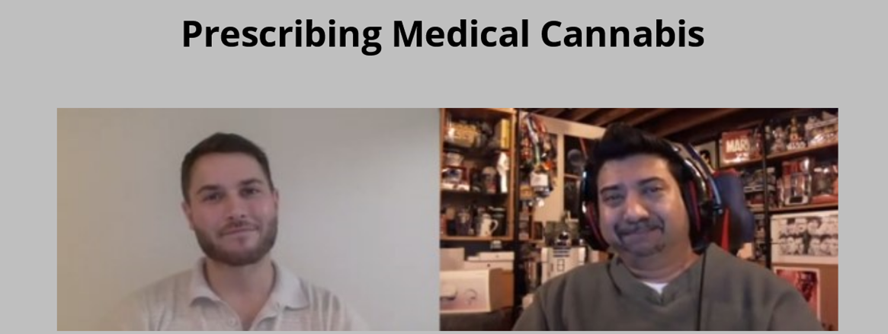

Medical Cannabis

This work is licensed under an Ontario Commons License – No Derivatives
except where otherwise noted

Project Team

Faculty Leads

Erin Ziegler, NP-PHC, PhD (she/her)

Assistant Professor, Daphne Cockwell School of Nursing, Ryerson University

eziegler@ryerson.ca

Marian Luctkar-Flude, RN, PhD, CCSNE, FNCEI (she/her)

Associate Professor, Queen’s University, School of Nursing

Co-President, Canadian Alliance of Nurse Educators using Simulation

mfl1@queensu.ca

Jane Tyerman, RN, PhD, CCSNE (she/her)

Assistant Professor, University of Ottawa, School of Nursing

Co-President, Canadian Alliance of Nurse Educators using Simulation

jtyerman@queensu.ca

Subject Matter Experts

Luisa Barton, NP-PHC, BScN, MN, DNP (she/her)

Assistant Professor, Athabasca University

Matthew Canning, NP-PHC, MN (he/him)

Technical Support

Aiden Tyerman (he/him)
Queen's University, School of Nursing/CAN-Sim
Game Assembly Assistant
Lillian Chumbley, MA (she/her)
Trent University
eLearning Specialist and AODA Compliance Specialist

Actors
We would like to acknowledge the important contribution of all the actors who took part in this project. Due to the sensitive nature of the content of the virtual simulations we will not be publishing the names of the actors. We would also like to stress that the opinions expressed by the actors in the virtual simulations does not reflect their own personal opinions.

***To protect the safety of the actors it is not permitted to extract, manipulate, or repost any video clips from the virtual simulations, as permission to use the actors’ images are only valid within the context of the virtual simulation package as created by the project team***

Land Acknowledgement

The recording of this scenario was completed at Ryerson University in Toronto, Ontario. Toronto is in the 'Dish With One Spoon Territory’. The Dish With One Spoon is a treaty between the Anishinaabe, Mississaugas and Haudenosaunee that bound them to share the territory and protect the land. Subsequent Indigenous Nations and peoples, Europeans and all newcomers have been invited into this treaty in the spirit of peace, friendship and respect.

Funding Acknowledgement

This project was made possible with funding by the Government of Ontario and through eCampus Ontario’s support of the Virtual Learning Strategy.

To learn more about the Virtual Learning Strategy visit: https://vls.ecampusontario.ca

Collaborator Acknowledgement

This virtual simulation was developed in collaboration with the Canadian Alliance of Nurse Educators using Simulation (CAN-Sim) using the CAN-Sim virtual simulation design process.

To learn more about CAN-Sim visit: http://can-sim.ca/

Learning Objectives

By the end of this virtual simulation experience, learners will be able to:
1. To understand terminology and components of cannabis from a dispensary vs underground to confirm a clients use
2. To assess indications and contraindications for medical cannabis for an individual with chronic pain and anxiety to determine an appropriate management plan
3. To complete the medical documents from Health Canada to prescribe medical cannabis
4. To provide education about cannabis administration with a client to promote safety
5. To provide appropriate follow up with the client to assess the effectiveness of the plan of care.

Pre-Simulation Preparation

Case Summary
Raj is a constructor worker, aged 42 years old. His physical work involves demolition, and he has experienced “wear and tear on his joints”. He has been diagnosed with degenerative disc pain, neuropathic pain but is not a surgical candidate. When his pain was first managed, he was treated with short courses of opioids. Has been using cannabis and opioids he obtains from a co-worker. He doesn’t want to use opioids at work due to sedation and the risks of the construction sites.

Suggested Pre-Readings

College of Family Physicians of Canada – Medical Cannabinoids: Guideline Summary - https://www.cfpc.ca/CFPC/media/Resources/Addiction- Medicine/Cannabinoid_Guidelines_One-Pager.pdf
Allan, et al. (2018). Simplified guideline for prescribing medical cannabinoids in primary care. Canadian Family Physician, 64, 111-120. https://www.cfp.ca/content/cfp/64/2/111.full.pdf
Toward Optimized Practice (2018). PEER simplified guidelines: Medical cannabinoids. https://actt.albertadoctors.org/CPGs/Lists/CPGDocumentList/Medical-Cannabinoids-CPG.pdf
Canadian Pharmacists Association (2018). Cannabis for medical purposes evidence guide. https://www.pharmacists.ca/cpha-ca/assets/File/education-practice- resources/Cannabis_EvidenceGuide_2018.pdf
CADTH (2019). Medical Cannabis for the treatment of Chronic Pain: A review of clinical effectiveness and guidelines. https://www.cadth.ca/sites/default/files/pdf/htis/2019/RC1153%20Cannabis%20Chronic%20 Pain%20Final.pdf
Government of Canada (2018). Information for Health Care Professionals: Cannabis (marihuana, marijuana) and the cannabinoids. https://www.canada.ca/en/health-canada/services/drugs- medication/cannabis/information-medical-practitioners/information-health-care- professionals- cannabis-cannabinoids.html
College of Nurses of Ontario. Medical Cannabis - https://www.cno.org/en/learn-about-standards- guidelines/educational-tools/ask-practice/medical-marijuana/

Pre-Briefing
Delivery Methods
The prebriefing for a virtual simulation can be delivered in different ways:
- Synchronous in-person
- Synchronous virtual
- Asynchronous virtual
- Written
- Hybrid
General components of a Pre-briefing Script for Virtual Simulations
- Orientation:
  - Review of learning outcomes
  - Review of scenario/case summary
  - Review of guidelines/models/frameworks relevant to the simulation
  - Instructions for completing the virtual simulation experience
- Psychological safety:
  - Rules of conduct for completing simulations in groups (if applicable) including fiction contract and confidentiality
  - Rules of conduct for debriefing (in-person or virtually)
  - List of wellness resources for students experiencing distress

Components of Prebriefing for NP Essential Skills Virtual Simulation Experiences
Each of the virtual simulations highlights one of several evidence-based models, frameworks or strategies related to addressing racial microaggressions in clinical settings. Each experience does not cover all the possibilities and is meant to give learners options that they can choose to apply in their own practice. Thus, there are no true “correct” or “incorrect” responses to the clinical decision points. Our goal is to empower learners by providing examples of how to respond to different microaggressions in the clinical setting.

For more information about Prebriefing and establishing psychological safety during a virtual simulation please see the following publications
Dale-Tam, J., Thompson, K., & Dale, L. (2021). Creating psychological safety during a virtual simulation session. Clinical Simulation in Nursing, 57, 14-17. https://doi.org/10.1016/j.ecns.2021.01.017
INACSL Standards Committee, McDermott, D.S., Ludlow, J., Horsley, E., & Meakim, C. (2021). Healthcare Simulation Standards of Best Practice Prebriefing: Preparation and briefing. Clinical Simulation in Nursing, 58, 9-13. https://doi.org/10.1016/j.ecns.2021.08.008

Virtual Simulation Experience

Link to access Medical Cannabis:

https://www.can-sim.ca/games/npcannabise1/story_html5.html

Debriefing & Reflection

Reflective Questions for Asynchronous Self-Debrief:

- How would you rate your confidence in counseling a patient on the use of medical cannabis?
- What are key considerations when assessing a patient for medical cannabis?
- You are a new graduate nurse practitioner working in primary care, this is your first patient request for medical cannabis. How would you manage this situation differently?
- How do THC and CBD differ?
- What are some other conditions that can be treated with medical cannabis?
- Did you feel adequately prepared for this scenario?
For additional information and guidance on debriefing virtual simulations please see the following publications:

Atthill, S., Witmer, D., Luctkar-Flude, M., & Tyerman, J. (2021). Exploring the impact of a virtual asynchronous debriefing method following a virtual simulation game to support clinical decision making. Clinical Simulation in Nursing, 50, 10-18. https://doi.org/10.1016/j.ecns.2020.06.008
Goldsworthy, S., Goodhand, K., Baron, S., Button, D., Hunter, S., McNeill, L., Budden, F., McIntosh, A., Kay, C., Fasken, L. (2022). Co-debriefing virtual simulations: An international perspective. Clinical Simulation in Nursing, 63, 1-4. https://doi.org/10.1016/j.ecns.2021.10.007
Goldsworthy, S., & Verkuyl, M. (2021). Facilitated virtual synchronous debriefing: A practical approach. Clinical Simulation in Nursing, 59, 81-84. https://doi.org/10.1016/j.ecns.2021.06.002
Harder, N., Lemoine, J., Chernomas, W., & Osachuk, T. (2021). Developing a trauma-informed psychologically safe debriefing framework for emotionally stressful simulation events. Clinical Simulation in Nursing, 51, 1-9. https://doi.org/10.1016/j.ecns.2020.11.007
Luctkar-Flude, M., Tyerman, J., Verkuyl, M., Goldsworthy, S., Harder, N., Wilson-Keates, B., Kruizinga, J., & Gumapac, N. (2021). Effectiveness of debriefing methods for virtual simulation: A systematic review. Clinical Simulation in Nursing, 57, 18-30. https://doi.org/10.1016/j.ecns.2021.04.009
Verkuyl, M., Atack, L., McCulloch, T., Lui, L., Betts, L., Lapum, J.L., Hughes, M., Mastrilli, P. & Romaniuk, D. (2018). Comparison of Debriefing Methods Following a Virtual Simulation: An Experiment. Clinical Simulation in Nursing. https://doi.org/10.1016/j.ecns.2018.03.002
Verkuyl, M., MacKenna, V., & St. Amant. (2021). Using self-debrief after a virtual simulation: The process. Clinical Simulation in Nursing, 57, 48-52. https://doi.org/10.1016/j.ecns.2021.04.016

