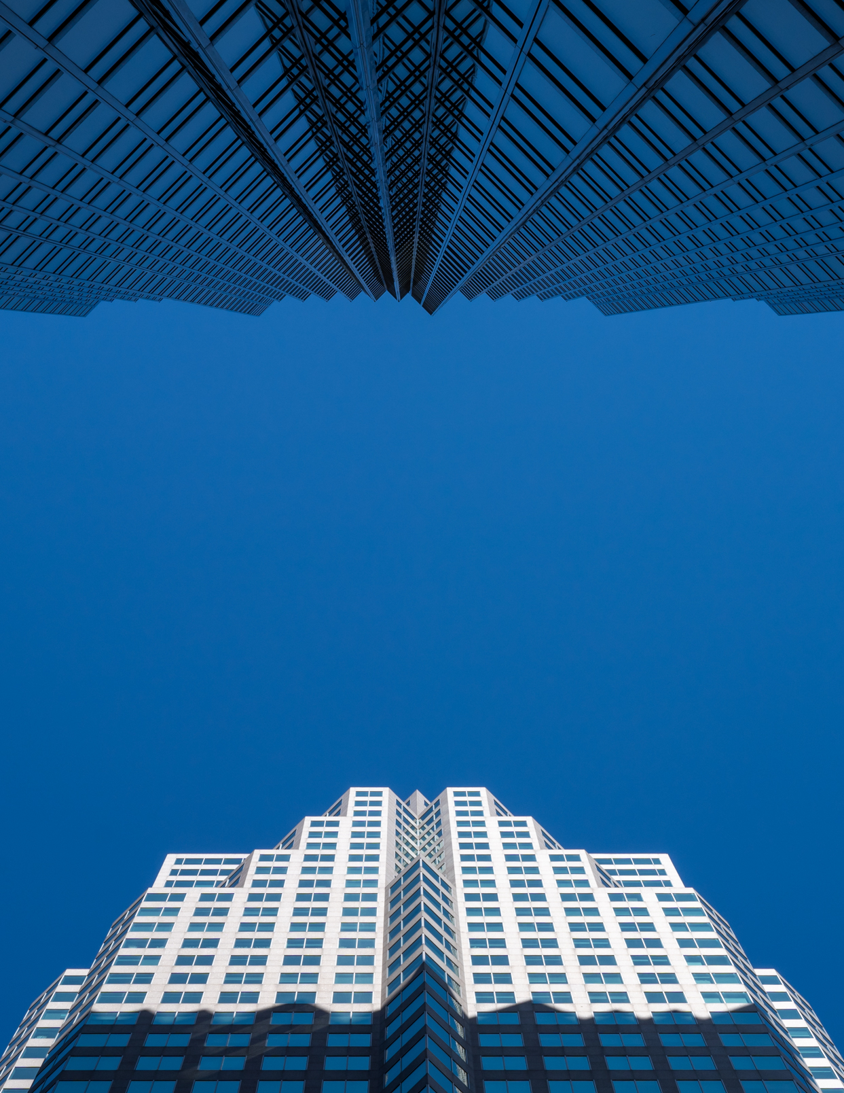
THE GUIDE
TO MATHEMATICS OF
BUSINESS AND FINANCE

Maksim Sokolov

1st edition

License: Attribution – Non-Commercial - Share Alike (CC BY-NC-SA)
This is the first edition of the guide: typos, errors and inconsistencies are possible. If noticed, please notify the author at maksim.sokolov [the “at” sign] senecacollege.ca. Please be specific in the explanation of the issue.
Table of Contents
Introduction 5
About the guide 5
Structure and topic dependency 5
Advice to students 5
Prerequisite knowledge and necessary supplies 7
About the author 7
0. Essentials review 9
Exponents 9
Logarithms 12
Distributive property 13
Equations 13
Exercises 16
1. Percent 17
Exercises 21
2. Compound percent change 22
Exercises 26
3. Simple and compound interest 27
Simple rate vs compound rate 27
Rate and term for compound interest 33
Calculator and Excel techniques for simple and compound interest computations 36
Exercises 45
4. Equivalent payments 47
Exercises 52
5. Equivalent rates 53
Calculator and Excel techniques to find equivalent rates 56
Exercises 58
6. Annuities 59
Simple ordinary annuities 59
General ordinary annuities 62
Simple due annuities 63
General due annuities 65
Calculator and Excel techniques for finding $PV$ and $FV$ of annuities 66
Exercises 71
7. Composite annuity problems 72
Exercises 77
8. Finding $PMT$, $n$ and $i$ of annuities 78
Finding payment 78
Finding the number of payments 78
Calculator and Excel techniques for finding $PMT$, $n$ and $i$ of annuities 84
Exercises 91
9. Perpetuities 92
Perpetuities as infinite term annuities 92
Obtaining annuity $FV$ and $PV$ formulas by trading perpetuities 95
Exercises 98
10. Fixed income securities 99
Simple securities issued at the face value (GIC, PN) 99
Simple securities issued at the discounted value (CP, T-bill) 100
Bonds 101
Calculator and Excel techniques for computing bond prices 104
Exercises 107
11. Amortization of loans 108
Plain amortization 108
Amortization with rounded payments 112
Amortization under variable rates 113
Calculator and Excel techniques for amortization of loans 115
Exercises 123
12. Net Present Value (Case Studies) 125
The NPV of an initiative 125
The NPV of a choice 126
Exercises 129
13. Sequences of discounts 130
Exercises 133
14. Exchange rates 134
Exercises 138
15. Payment terms and cash discounts 139
Exercises: 141
16. Price structure: markup and markdown 142
Exercises 145
17. Break-even analysis 146
Exercises 150
Solutions: 0. Essentials review 151
Solutions: 1. Percent 154
Solutions: 2. Compound percent change 156
Solutions: 3. Simple and compound interest 158
Solutions: 4. Equivalent payments 163
Solutions: 5. Equivalent rates 165
Solutions: 6. Annuities 166
Solutions: 7. Composite annuity problems 169
Solutions: 8. Finding $PMT$, $n$ and $i$ of annuities 172
Solutions: 9. Perpetuities 177
Solutions: 10. Fixed Income Securities 181
Solutions: 11. Amortization of loans 184
Solutions: 12. Net Present Value (Case Studies) 191
Solutions: 13. Sequences of discounts 194
Solutions: 14. Exchange rates 196
Solutions: 15. Payment terms and cash discounts 199
Solutions: 16. Price structure: markup and markdown 203
Solutions: 17. Break-even analysis 206

Introduction

About the guide

This guide covers foundational topics of business and financial mathematics usually discussed in a typical one semester course offered by business schools of Canadian Colleges of Applied Arts and Technology. The guide is suitable for diploma or degree-level courses.

The academic philosophy of the guide is based on the following five pillars:

- Briefness. The focus is only on the essential information.
- Algebraic method. The priority is given to algebraic problem solving. However, essential calculator and Excel techniques are also discussed in the guide.
- Logical flow. One topic sets the foundation for another topic. Careful reading without skipping is necessary.
- Examples. Topics are explained using many carefully selected examples. There are also end-of-chapter exercises with full solutions.
- No memorization. If used properly, the guide must lead to the level of understanding allowing to solve problems without having to remember many formulas and without using a formula sheet.

Structure and topic dependency

The guide consists of four main sections:

- Foundations (Chapters 0-2). These chapters are highly recommended to work on regardless of the level of prior preparation.
- Mathematics of Finance (Chapters 3-12). Chapters 1-9 must be studied in sequence without skipping any information. Each chapter in this sequence sets the foundation for the next chapter. Chapters 10-12 can be studied in any order, but only after Chapters 1-9 have been fully understood.
- Mathematics of Business (Chapters 13-17). These chapters can be studied in any order, but only after Chapters 0-2 have been fully understood.
- Solutions to the end of chapter exercises. Solutions are provided for every end-of-chapter problem.

Advice to students

Read the chapters carefully.

Every page of this guide contains must-know information. Each example has been carefully selected and contributes to the necessary level of understanding. End-of-chapter exercises provide additional examples and must be done for complete understanding. Therefore, it is necessary to work on each chapter without skipping any information. Please do not proceed to the next chapter until the previous chapters have been fully understood. Be honest with yourself: if you feel that you have not understood a part well, read it again. Use a pen and paper when reading: verify every calculation by yourself. Mathematics is learned with a pen.

Do end-of-chapter exercises.

Yes, mathematics is learned by practice. Mathematics is akin to arts and sports: no one can learn to sprint fast only by reading about sprinting and no one can make a good drawing only by observing an artist. Exercises given at the end of each chapter provide the necessary amount of practice to ensure that the material is properly mastered. Moreover, the end-of-chapter exercises illustrate many additional aspects of the topics discussed in the chapters.

When solving mathematical problems, the main mistake students make is looking into solutions as soon as the first difficulty is encountered. In fact, it is important to go through the “productive struggle”. This means accepting the unpleasant feelings of confusion and frustration (which are quite natural byproducts of solving good mathematical problems) as positive signs of becoming stronger. Such productive struggle in mathematical problem solving is similar to a hard workout at a gym.

If a problem is confusing, this is a good thing: there is something new to learn. This is true even when the problem is not phrased well or contains a typo! Re-read the problem and ask yourself if you have understood all terms. Re-read the chapter again. Try to solve the problem multiple times, checking calculations carefully and trying new approaches. Clarify all concepts involved and never resort to guessing. If you have a feeling of fuzziness surrounding some concepts, it is a sure sign that you need to work more on understanding them. Use the provided solutions as a last resort only. The solutions given at the end of this guide are concise on purpose. They are designed to make you think about the solution, so you can receive the necessary amount of the productive struggle. And always remember that you can ask your professor!

Even if you are confident that you can solve a problem, solve it carefully still. Make sure you can obtain the exact answer. Do not dismiss a problem as “obvious” or “easy”. All problems given in this guide are worth solving. There are no “unnecessary” problems. Some problems are harder and are designed to provoke careful thinking, while some problems are easier, designed to develop automaticity.

Disregard unavailing beliefs and foster positive attitude.

Educational research has shown that those students who struggle with mathematics usually hold unavailing beliefs about their mathematical abilities. These are beliefs of the type: “I am not good at math, so I am destined to fail”.

The problem with such beliefs is that they cannot lead to any positive action. Students holding such beliefs have a “fixed mindset”, instead of a “growth mindset”. The fixed mindset does not give a student any opportunity to grow academically. For example, if the student tells themselves that they are not good at mathematics, then this would be the end of the story – this student will not put the necessary effort into understanding mathematics.

It is important to know that academic success of a student is mostly controlled by the student. The more effort a student will put into a subject, the more results the student will see. Instead of unavailing beliefs, adapt useful beliefs that can stimulate positive action. For example, “If I attend the classes, read the textbook, do the exercises and ask questions, I will definitely succeed”.

If you do not get satisfactory results, search for an explanation which is actionable and will lead to concrete steps for improvement. Ask yourself honest questions: “Did I attend and actively participate in classes?”, “Did I read all material carefully?”, “Did I do all exercises, accepting and even enjoying the productive struggle?”, “Did I ask questions when things were unclear?”. Your answers to these questions will provide you with ideas for improving your preparation.

Prerequisite knowledge and necessary supplies

Strong knowledge of basic arithmetic is required (such as the BEDMAS technique). Entry-level algebra knowledge is strongly preferred (although some basics will be reviewed briefly in Chapter 0).

Students are strongly advised to have the following calculator:

Texas Instruments BAII Plus Business Analyst (or BAII Plus Professional calculator): all calculator techniques given in this guide are based on this calculator.

The BAII calculator must be set before the first use to round numbers properly:

$$〈2ND〉 〈∙〉 〈9〉 〈ENTER〉$$

A computer with Microsoft Excel is recommended to take the full advantage of the Guide. Excel techniques are also discussed in the book.

About the author

Maksim Sokolov has been teaching post-secondary mathematics since 2005. He holds Ph.D. in mathematics, B.Sc. and M.Sc. in mathematics, M.Ed. in post-secondary mathematics education and the PRM (PRMIA’s Professional Risk Manager) designation. Maksim is a professor of mathematics at Seneca School of Business.

The author’s special gratitude goes to professors Bill Giannos, Padma Gopinath and Kevin Pitts, as well as many diligent students who have been very kind in carefully reading the guide and providing a lot of important feedback. The author is also grateful to Sarah Arliss, Lisa Ballantyne, Shahrzad Farzinpak and Cristina Italia for their ongoing support.

Foreword by Professor Padma Gopinath

Rich communication, logic, creative and vibrant approach are many of the drivers to stimulate mathematical thinking.

In this guide, Maksim Sokolov has done just that!

Maksim is an established expert in financial mathematics and financial risk measurement. This ensures that the readers of this guide are exposed to a highly balanced and thoughtful approach to foundational mathematics of business and finance. In this guide, Maksim has embraced rich communication and a robust, vibrant approach that stimulates deep thinking and understanding of all main methods discussed.

As a reviewer of this guide, it was awesome for me to navigate through many insights and creative approaches to many topics. This guide has a very specific purpose: to be very concise and a bit more advanced than a typical textbook. It can be used as a standalone textbook or as a supplement to another textbook.

It is my pleasure to share that learners of mathematics of business and finance will find this guide exceptionally useful to fine-tune their learning and enhance their understanding of many topics.

Best wishes!

Padma Gopinath
MBA., M.Sc., B.Ed.-Adult Ed., B.Ed., CAIIB.,
6-Sigma Green belt, (Business Analysis)

 TERP10 ERP
Professor,
School of Management & Entrepreneurship
Seneca College

PART I: FOUNDATIONS

Essentials review

We start by reviewing important material from algebra which will be used in the future chapters.

Exponents

Given any number $a$ (the base) and any whole positive number $n$ (the power or the exponent), we say that the base $a$ is raised to the power of $n$ if:

$$a^{n}=\underset{n times}{\underbrace{a×a×a×⋯×a}}$$

Example 0.1: Find $3^{4}$.
$$3^{4}=3×3×3×3=81$$

$∎$End of the example.

Exponents describe how the value of an asset changes over time.

For example, assume that an investment of $1 can grow to $2 in 1 year. If the investment is kept for another year, it will double again and will become ${\$2}^{2}$, or $4. Over 5 years, the investment of $1 will become ${\$2}^{5},$or $32. In this example, the base describes how strong the investment grows (it doubles every year), and the power shows how long the investment grows for (5 years).

As you will see in more detail in the next chapters, the base describes the strength of the change, whereas the exponent describes how long the change takes place.

In this book we will encounter $a^{x}$ where the exponent $x$ can be any number (not necessarily a whole positive number). What mathematical meaning do such exponents have? We will learn this step by step.

Given any number $a$ and a whole positive number $n$, we define $a^{1/n}$ as a number $b$, such that

$$b^{n}=a$$

Exponents of the type $1/n$ are also called “roots”. In general, $a^{1/n}$ is called “the $n$-th root of $a$” and sometimes is written as $\sqrt[n]{a}$. The simplest root is the “square root” $a^{1/2}$, which is most frequently known as $\sqrt{a}$. For example, $\sqrt{9}$ is equal to $3$ because $3^{2}=9$.

Example 0.2: Find ${81}^{0.25}$.

${81}^{0.25}$ is ${81}^{1/4}.$This is a number $b$, such that

$$b^{4}=81$$

From Example 0.1 we can see that $b=3.$ Therefore, ${81}^{0.25}=3$. Note that there is also another possible answer: $b=-3$. This is because ${\left(-3\right)}^{4}=81$. However, we will use (and mention) only the positive roots.

$∎$End of the example.

All exponents (and, in fact, all numbers) that we will encounter in this book will be rational numbers. These are the numbers that have the form $m/n$, where $n$ and m are whole numbers (n cannot be 0). For example, any number with a finite number of decimal digits can be represented in this form. For example, 2.56341 can be represented as 256,341/100,000.

Given any number $a$ and whole positive numbers $n$ and $m$, the number $a^{m/n}$ can be found in the following way:
$$a^{m/n}={\left(a^{1/n}\right)}^{m}$$

Example 0.3: Find ${81}^{0.75}$.

${81}^{0.75}$ is ${81}^{3/4}.$ Using what we calculated in Example 0.2:

$${81}^{3/4}={\left({81}^{1/4}\right)}^{3}=3^{3}=27$$
$∎$End of the example.

Negative exponents are understood in the following way $(x>0 and a≠0)$:

$$a^{-x}=\frac{1}{a^{x}}$$

Example 0.4: Find ${81}^{-0.75}$.

From Example 0.3:
$${81}^{-0.75}=\frac{1}{{81}^{0.75}}=\frac{1}{27}=0.\overline{037}$$

Note that the line on top of the decimal part of the number means that that part is infinitely repeated.

$∎$End of the example.

The following exponent properties are important in problem solving:

$$a^{x}a^{y}=a^{x+y}$$

$${\left(a^{x}\right)}^{y }=a^{xy}$$

$${\left(ab\right)}^{x}=a^{x}b^{x}$$

We have covered all cases, except the case of raising a number into the power of 0. It is possible to show that $a^{0}=1$. Indeed,

$${a^{x}=a}^{x+0}=a^{x}×a^{0}$$

$$a^{x}=a^{x}×a^{0}$$

This is only possible if $a^{0}=1$.

Take for example, $2^{0}.$Financially speaking this represents an investment of $1, which is supposed to double each time period. Of course, after 0 time periods, such investment is equal to $1. Thus: $1×2^{0}=2^{0}=1.$

It is very easy to compute exponents with the BAII calculator.

Calculator Example 0.1: Find $4^{3.93}$.

$$〈4〉 〈y^{x}〉 〈3.93〉 〈=〉$$

The answer is 232.3249 rounded to four decimal places.
$∎$End of the calculator example.

Calculator Example 0.2: Find ${\left(\frac{6}{5}\right)}^{-\frac{7}{4}}$.

The first way:
$$〈6〉 〈÷〉 〈5〉 〈y^{x}〉 〈(〉 〈7〉 〈÷〉 〈4〉 〈+|-〉 〈)〉 〈=〉$$

The second way (using the calculator memory):

$$〈7〉 〈÷〉 〈4〉 〈+|-〉 〈=〉 〈STO〉 〈1〉$$

$$〈6〉 〈÷〉 〈5〉 〈y^{x}〉 〈RCL〉 〈1〉 〈=〉$$

The answer is 0.7268 rounded to four decimal places.
$∎$End of the calculator example.

Logarithms

In this book we will only need very basic knowledge of logarithms.

An exponent statement $a^{x}=b$ can be written equivalently using the language of logarithms:

$$\log_{a}{b}=x$$

We read this as “logarithm of $b$ with base $a$ equals to $x$”. In other words, when we find the logarithm of $b$ with base $a$, we find the power that $a$ must be raised into, to obtain $b$.

Example 0.5: Find $\log_{2}{16}$.

Since $2^{4}=16,$ we have: $\log_{2}{16}=4.$
$∎$End of the example.

Example 0.6: Find $\log_{81}{27}$.

From Example 0.3 we know that ${81}^{0.75}=27.$ Therefore, $\log_{81}{27}=0.75.$

$∎$End of the example.

Of special interest to financial mathematics is Euler’s number $e$. This number, if approximated to 10 decimal digits, is:
$$e= 2.7182818285$$

Logarithms with the base equal to $e$ are called natural logarithms. Instead of writing “$\log_{e}{b"}$, there is a convention to write “$\ln{b}"$. All financial calculators have the capability to calculate natural logarithms. For this reason, we will use only natural logarithms in this book.

Calculator Example 0.3: Find $\ln{5}$.
$$〈5〉 〈LN〉$$

The answer is 1.6094 rounded to four decimal places. Let’s verify this result:

$$〈2.7182818285〉 〈y^{x}〉 〈1.6094〉 〈=〉$$

Since we input rounded values, for both $e$ and the power, we do not obtain exactly 5, but 4.99981044.
$∎$End of the calculator example.

One of the main logarithm properties is the power property. For the natural logarithms, this property is:
$$\ln{a^{x}=x\ln{a}}$$

The most important application of the power property is in solving equations involving an unknown power (see Example 0.11 below).

Distributive property

We will need to use the distributive property occasionally. In its simplest form, this property states that for any three numbers, $a$, $b$ and $c$:

$$a\left(b+c\right)=ab+ac$$

It is quite easy to open brackets using this property. For example:

$$2\left(4+2\right)=2×4+2×2=12$$

Creating the brackets (that is factoring out the common factor) is usually a bit more challenging.

Example 0.7: Find the common factor and use the distributive property to factor it out: $6x^{2}+3x$.
$$6x^{2}+3x= \left(3x\right)×\left(2x\right)+(3x)×1=3x(2x+1)$$

$∎$End of the example.

The distributive property also works for addition and subtraction of any number of numbers. For example, the following formulas are valid:

$$a\left(b-c\right)=ab-ac$$

$$a\left(b+c-d\right)=ab+ac-ad$$

Equations

We will review basics of solving several types of equations met in this book. It is best to learn the technique from examples.

Example 0.8: Find $x$ from the equation: $5x=3x+8$.

We must group all terms containing the unknown quantities on one side of the equation, so that the other side of the equation will contain only the known quantity. To achieve this, we will first subtract $3x$ from both sides of the given equation:

$$5x-3x=3x+8-3x$$

$$5x-3x=8$$

$$2x=8$$
Now, we will divide both sides by 2:
$$\frac{2x}{2}=\frac{8}{2}$$

$$x=4$$
$∎$End of the example.

Example 0.9: Find $x$ from the following equation: $\frac{8}{4-x}=1.6$.

We multiply both sides by $4-x$:

$$\frac{8}{4-x}(4-x)=1.6(4-x)$$

$$8=1.6(4-x)$$

We open the brackets using the distributive property:

$$8=6.4-1.6x$$
This is the same as:
$$6.4-1.6x=8$$

Subtract 6.4 from both sides:
$$6.4-1.6x-6.4=8-6.4$$

$$-1.6x=8-6.4$$

$$-1.6x=1.6$$
Divide both sides by $-1.6$:
$$\frac{-1.6x}{-1.6}=\frac{1.6}{-1.6}$$

$$x=- 1$$
$∎$End of the example.

Example 0.10: Find $x$ from the equation: $x^{4}=6$.

We raise both sides of the equation into power 1/4:

$${\left(x^{4}\right)}^{1/4}=6^{1/4}$$

$$x^{4/4}=6^{1/4}$$

$$x^{1}=6^{1/4}$$

$$x=6^{1/4}=1.5651$$

The answer has been rounded to four decimal places.
$∎$End of the example.

Being able to solve equations of the type met in Example 0.10 is very important for business and financial mathematic since such equations lead to finding the strength of change.

Example 0.11: Find $x$ from the equation: $4^{x}=6$.

We take the natural logarithm on both sides:

$$\ln{4^{x}=\ln{6}}$$

Using the logarithm power property:

$$x\ln{4=\ln{6}}$$
Dividing both sides by $\ln{4}:$

$$\frac{x\ln{4}}{\ln{4}}{=\frac{\ln{6}}{\ln{4}}}$$

$$x=\frac{\ln{6}}{\ln{4}}=1.2925$$

The answer has been rounded to four decimal places.

Note that we have chosen the natural logarithm here because financial calculators can work with such logarithms. In fact, this equation could be solved more directly. Indeed, from the definition of the logarithm it follows that:

$$x=\log_{4}{6}$$

Using a calculator capable to compute such logarithms (for example, a scientific calculator), we obtain:
$$x=1.2925$$
$∎$End of the example.

Equations of the type met in Example 0.11 are also very important for business and financial mathematic since they lead to finding how long the change takes place.

Exercises

In questions 1-8, find the given quantities without a calculator:

- ${ 27}^{1/3}$
- ${ 125}^{2/3}$
- ${ 256}^{0.75}$
- $8×(4^{-1.5})$
- ${ 2.5}^{0}×{36}^{1.5}+{16}^{-0.5}$
- $\log_{4}{64}$
- $\log_{256}{64}$
- $\log_{25}{5}$

In questions 9-11, find the given quantities with a calculator and round the answers to four decimal places:

- ${ 3.45}^{6.89}$
- $\ln{9.87}$
- $\frac{3^{4.67}}{\ln{5}}+\frac{\ln{7}}{5^{3.89}}$

Find the unknown from the equations given in questions 12 – 18. Use a calculator if necessary (for calculator solutions, round the answers to four decimal places).

- $4x+5=2x+9$
- $2\left(y-3\right)=y+5$
- $\frac{4}{ 3+x}=\frac{24}{{\left(3+x\right)}^{2}}$
- ${ x}^{4}=7$
- ${ 4y}^{6}=10$
- ${ 5}^{x}=11$
- ${ 5×2.3}^{y}=11$

Answers:

1. 3; 2. 25; 3. 64; 4. 1; 5. 216.25; 6. 3; 7. 0.75; 8. 0.5; 9. 5,076.6072; 10. 2.2895; 11. 105.0745; 12. 2; 13. 11; 14. 3; 15. 1.6265; 16. 1.1650; 17. 1.4899; 18. 0.9466.

Percent

The word percent is derived from per + cent. Per means “for each” and cent means “hundred”. These words can be experienced in our everyday life:

- The car consumes 8 litres per (that is, for each) 100 kilometers.
- This century (that is, hundred years) has seen enormous technological growth.

Therefore, the word percent means “per each hundred”. Instead of the word percent, the symbol % is frequently used, just as the symbol $ is used instead of the word dollar.

We can use this literal meaning to solve percent problems. For example, let’s find 20% of $300 using only the meaning of the word percent.

Remembering that the symbol % stands for the word percent, 20% of $300 means taking $20 out of each $100, when we have 3 bundles of $100. The results in $20 + $20 + $20 = $60. Therefore, 20% of $300 is $60.

Let’s now take a bit more interesting example:

Example 1.1: What is 20% of $43.25?

Since $43.25 is one hundred times 0.4325, using the meaning of the word percent we can answer this question by taking 0.4325 twenty times. This will result in $8.65. Or we can take another (equivalent) approach. The following statement will help us:

20 per hundred is the same as 0.2 per one

This means that we can speak about the rate per one as an equivalent measurement to the rate per hundred (that is, percent). The rate per one is more convenient in calculations than percent. This is because any quantity is an obvious quantity of ones. In our example, we have 43.25 ones. Taking 0.2 per one, given 43.25 ones, results in

$$43.25 × 0.2 = 8.65$$
$∎$End of the example.

In general, for $R\%$, the equivalent rate per one is

$$r=\frac{R}{100}$$

So, the fact “$P is R\% of B"$, can be written in two equivalent formulas:

$$P=B×\left(\frac{R}{100}\right)$$

$$P=B×r$$
Several notes:

- B is usually called the base.
- Frequently P is called the portion. In some cases, this is confusing since by portion we understand a part of something. But it can be that P is bigger than B. For example, $200 is 200% of $100. Strictly speaking, we cannot call $200 a portion of $100. Therefore, it is preferrable to call P a product, meaning the product of the multiplication of B and r.
- Frequently the rate per one is called the decimal form of percent, in the sense of a number having non-zero decimal digits. This can be confusing since there are instances of the rate per one being a whole number. For example, for 200% the rate per one is 2, and this is a whole number. Therefore, the rate per one is a more appealing term.

Example 1.2: A mirrorless camera was sold in a Toronto store for $1,864.49 including the harmonized sales tax (HST). Keeping in mind that the HST rate is 13% in Ontario, what is the tax amount included in the selling price?

We do not know the base $B$, but we can build the following equation to find the base:

$$B+0.13B=1,864.49$$
Factoring out $B$:
$$B(1+0.13)=1,864.49$$

$$1.13B=1,864.49$$

It is helpful to take a note that the meaning of the last equation is: 113% of B is $1,864.49.

We can find $B$ now:
$$B= \frac{1,864.49}{1.13}=1,649.99$$

Using $B$, we are ready to find the tax amount included in the price:

$$Tax amount=1,864.49-1,649.99=214.50$$

The same tax amount could also be found in another way:

$$Tax amount=1,649.99×0.13= 214.50$$

$∎$End of the example.

Example 1.3: Feruza lives in Canada and earned $160,000 in 2022. How much federal income tax did Feruza pay in 2022?

In 2022, the federal income tax (FIT) was to be computed using the following table:

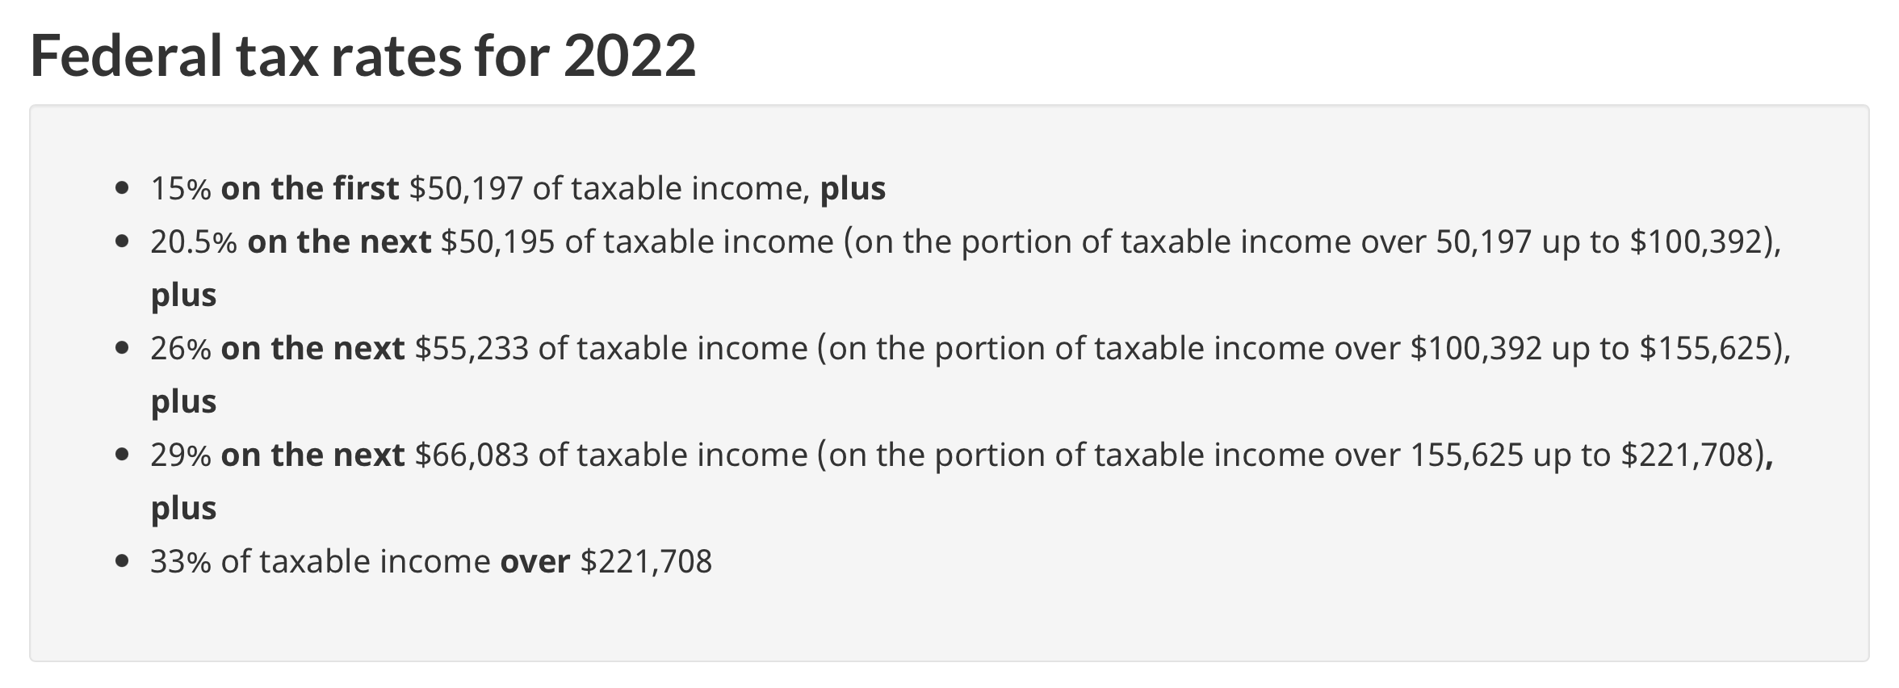

Using this table:

$$FIT=50,197×0.15+50,195×0.205+55,233×0.26+\left(160,000-155,625\right)×0.29$$

$$FIT=33,448.86$$

$∎$End of the example.

Of special interest to the mathematics of finance are rates higher than 100% and their compounding.

For example, 104% has the equivalent rate per one equal to 1.04. Therefore, if we want to find 104% of $230, we can find the product in the following way:

$$230×1.04 = 239.20$$

Thus, $239.20 is 104% of $230.

Let’s now investigate what happens if we compound 104% several times. By compounding we mean applying 104% several times.

Example 1.4: Find 104% of $230, compounded 3 times.

We must first find 104% of 230, which is 239.20. Then, 239.20 becomes a new base and we must next find 104% of 239.20, which is 248.768. This, in turn, becomes a new base and in our third iteration, we must find 104% of 248.768, which is 258.72, rounded to two decimals (note that we have rounded only the final answer, not the intermediate results).

The way we have found 104% compounded 3 times is not efficient. We can notice that, essentially, we have done the following:

$$([230 × 1.04] ×1.04) ×1.04 = 258.72$$

But this is the same as:

$$230×\left(1.04×1.04×1.04\right)=230×{\left(1.04\right)}^{3}=258.72$$

$∎$End of the example.

From here we can immediately understand that percent compounding (when the percent at each iteration is the same) creates an exponent. The exponent makes it very easy to calculate compounded percentages for any number of compounds.

Example 1.5: Find 104% of $230, compounded 30 times.

Solution:
$$230×{\left(1.04\right)}^{30}=745.98$$

$∎$End of the example.

This shows quite clearly the formula for $P$, when $P is R\% of B,$ compounded $n$times:

$$P= B×{\left(\frac{R}{100}\right)}^{n}$$

This formula, but with r representing the equivalent rate per one for $R\%$, becomes:

$$P= B×r^{n}$$

In your future study of financial mathematics, you will see how valuable these formulas are.

Exercises

- Find 0.005% of $45,670.
- What percent is $4.5 of $4,500?
- $65 is 0.5% of what amount?
- Find 0.4% of $456.87.
- Find 105% of $34.56.
- What percent is $5,614 of $5,510?
- Sameer paid $1,948.81 for a computer in Montreal. If the harmonized sales tax in Quebec is 14.975%, what is the tax amount included in the price?
- Find the federal tax amount for the following annual income amounts in Canada: (a) $60,000 (b) $100,000 (c) 150,000 (d) 200,000.
- Find 103% of $37.88, compounded 15 times.
- Over the past 10 years, each annual profit of Alpha industries was 112% of the previous year. If the initial profit 10 years ago was $800,000, what was the profit reported at the end of 10 years?
- [Challenge] Assume that potatoes are 99% water by weight. Yesterday you purchased 100kg of potatoes. Overnight the potatoes dehydrated and became 98% water. What is the new weight of the potatoes?

Answers:

1. $2.28; 2. 0.1%; 3. $13,000; 4. $1.83; 5. $36.29; 6. 101.89%; 7. $253.82; 8. (a) $9,539.17, (b) $17,739.17, (c) $30,717.61, (d) $45,048.86; 9. $59.02; 10. $2,484,678.57; 11. 50kg.

Compound percent change

Consider the following two statements:

To increase an amount by 4% is the same as to find 104% of the amount.

To decrease an amount by 4% is the same as to find 96% of the amount.

While these statements may seem obvious, the idea they convey is very powerful since it allows us to significantly simplify computations. We will see shortly how.

What is $100 increased by 4%? The answer can be found in two steps:

Step 1: Find 4% of $100. The result is $4.
Step 2: Add $4 to $100. The result is $104.

While this two-step solution is logical and correct, it is not efficient. A much better approach would be to find the result in just one step:

$$100×1.04=104$$

In other words, instead of adding 4% to the amount, we have simply found 104% of the amount. The reason why the one-step solution is much better than the two-step solution becomes apparent if we begin to solve for compound increases. To illustrate this, let’s consider the following example.

Example 2.1: What is $100 increased by 4%, 20 times?

If we tried to follow the two-step process for each increase, we would have to make 40 steps in total to answer this question. But if we realize that increasing by 4% is the same as finding 104% of the amount, we can see that we are dealing with the compound percent which we already know how to work with (see Examples 1.4 and 1.5). With this realisation, the solution becomes:
$$100×{\left(1.04\right)}^{20}=219.11$$
$∎$End of the example.

Whenever we increase an amount by $R\%$ , we must find $(100 + R)\%$ of the amount. If we are given an initial value $V_{i}$, then the value after the increase by $R\%$ (the final value $V_{f})$ is found in the following way:
$$V_{f}=V_{i}\left(\frac{100+R}{100}\right)$$

This formula will become simpler if instead of $R\%$ we will work with the equivalent rate per one r (note that 100% is represented by the rate per one equal to 1):

$$V_{f}=V_{i}\left(1+r\right)$$

This formula can be easily modified for the case of compound increases, such as when the initial value is increased by $R\% n$ times. The final value after $n$ compound increases is computed using the following formula:

$$V_{f}=V_{i}{\left(1+r\right)}^{n}$$

For the case of compound decreases, the logic is the same. The only difference is that r will be negative.

It is important to know how to find r and n. First, we will see how algebra can be used to find $r$ without compounding. Then we will see how to find $r$ and $n$ for the case of compound increases.

Example 2.2: Having been increased by some percent, $410 became $450. What was the percent increase?

Our equation is:
$$410\left(1+r\right)=450$$

From here we will find r:
$$\frac{410\left(1+r\right)}{410}=\frac{450}{410}$$

$$1+r= \frac{450}{410}$$

$$r= \frac{450}{410}-1=0.097560976$$

This r corresponds to 9.76% increase, rounded to two decimals.

Of course, this problem could be also solved directly by finding the amount of increase ($40) and then dividing this amount by the initial value:

$$r=\frac{40}{410}=9.76\%$$
$∎$End of the example.

Example 2.3: Having been increased by the same percent 5 times, $410 became $450. What was each percent increase?

It is advisable to review Example 0.10 before studying this example. Here, we have the compound process:
$$410{\left(1+r\right)}^{5}=450$$

The first step in the solution is to isolate ${\left(1+r\right)}^{5}:$

$${\left(1+r\right)}^{5}= \frac{450}{410}$$

The next step is to make the exponent on the left side equal to one. This is easily done by finding the reciprocal exponent on both sides:

$${\left[{\left(1+r \right)}^{5}\right]}^{\frac{1}{5}}= {\left(\frac{450}{410}\right)}^{\frac{1}{5}}$$

$${\left(1+r \right)}^{\frac{5}{5}}= {\left(\frac{450}{410}\right)}^{\frac{1}{5}}$$

$$1+r= {\left(\frac{450}{410}\right)}^{\frac{1}{5}}$$

And finally, we can find r:
$$r= {\left(\frac{450}{410}\right)}^{\frac{1}{5}}-1= 0.018792482$$

This r corresponds to 1.88% increase, rounded to two decimals.

$∎$End of the example.
Notes:

- If you compare Examples 2.2 and 2.3 you will notice that five compound increases of 1.88% are equivalent to one increase of 9.76% (within the tolerance level of rounding that we made in each answer).

- From Example 2.3, you can see the formula for the compound change r (the compound change is an increase if $r$is positive and a decrease if $r$ is negative). This compound change is also known as $RoC$ (Rate of Change). The rate of change is found in the following way:
$$RoC= {\left(\frac{V_{f}}{V_{i}}\right)}^{\frac{1}{n}}-1$$

Example 2.4: Having been increased by 1% several times, $410 exceeded $450. How many times has the increase been compounded?

It is advisable to review Example 0.11 before studying this example. We have the following equation:
$$410×{(1+0.1)}^{n}=450$$

First, let’s isolate ${1.01}^{n}$:
$${1.01}^{n}= \frac{450}{410}$$

To find n from here we must apply the same logarithm on both sides. The reason we use a logarithm is because it has a very nice property (the logarithm power property – see Chapter 0), allowing us to convert the exponent into the multiplication.

$$\ln\left({1.01}^{n}\right)=\ln\left(\frac{450}{410}\right)$$

$$n\ln{1.01}=\ln\left(\frac{450}{410}\right)$$

$$n= \frac{\ln\left(\frac{450}{410}\right)}{\ln{1.01}}$$

Natural logarithms are easily computable with a calculator, so we find n:

$$n=9.36$$

This means that we will exceed $450 if we compound the process 10 times. In fact, rounding up makes us exceed $450 by $2.90 (please verify this).

$∎$End of the example.
Example 2.4 gives us a hint to find the formula for n:

$$n= \frac{\ln\left(\frac{V_{f}}{V_{i}}\right)}{\ln{(1+RoC)}}$$

In this formula, $V_{i}$is the initial value, $V_{f}$is the final value, and RoC is the rate per one corresponding to the change in each iteration of the compound process.

Exercises

- What is $3,400 increased by 4%? Solve in one line (do not use two steps).
- After a decrease by 0.8%, the amount became $50,430. What was the amount before the decrease?
- What is $9,020 increased by 5%, 7 times?
- What is $650 decreased by 0.6%, 20 times?
- After 15 increases, $560 became $730. Find the rate of change at each iteration.
- With the rate of each decrease of 0.9%, $1,890 became $560 after a number of decreases. How many decreases were there? Round up to the next whole number.
- A stock, the initial price of which was $57, had an average daily increase of 3%. How many whole days had it increased this way until it went over $200?
- What daily increase rate would be required for a stock to grow from $300 to $340 in 5 days?
- [Challenge] Nigora invested in a portfolio of bonds. There were three bonds in the portfolio: $A$ valued at $3,000, $B$ valued at $2,300 and $C$ valued at $5,200. In three years, the value of these bonds grew by 19%, 6% and 15% respectively. (a) What was the overall percent change of the whole portfolio in three years? (b) What was the average annual change of the whole portfolio?

Answers:

1. $3,536; 2. $50,836.69; 3. $12,692.05; 4. $576.29; 5. 1.78%; 6. 135; 7. 43 days; 8. 2.53%; 9. (a) 14.17% (b) 4.52%.

PART II: MATHEMATICS OF FINANCE

Simple and compound interest

Simple rate vs compound rate

Interest is a payment for borrowing someone’s money. The longer the money is being held, the more interest must be paid. And the riskier the borrower is, the higher is the interest rate that will be charged. By risk here we mean here the probability of default of the borrower.

From the point of view of calculation, interest rate is a percent rate applied to the money borrowed. Usually, interest rate is quoted per annum, that is, per year.

The amount invested is called the present value and the amount this present value grows to is called the future value. The general idea is the following:

$$Future Value=Present Value+Interest Amount$$

We will explore the concept of interest in depth, using the following example.

Example 3.1: $1,000 is invested at 4% per annum for two years. How much can this amount grow to in two years and what can be the interest earned? Explore various scenarios for the growth (simple and compound).

There are two main scenarios here. The money can grow in the simple way, or in one of compound ways. Let’s see how these scenarios play out.

SCENARIO 1 (Simple Interest Rate)

If the money grows in the simple way, 4% is earned each year, so that 8% is earned over 2 years. We have the situation that $1,000 is increased by 8% over the two-year period. Therefore, the simple future value becomes:

$$S=1,000\left(1+0.04 × 2\right)$$

$$S=1,000×1.08=1,080$$

We say that $1,000 grows to $1,080 at the simple interest rate of 4% per annum.

To find the interest amount, we subtract the amount invested from the future value:

$$I=1,080-1,000=80$$

We say that $80 is the simple interest amount earned. It must be clear that the simple interest amount is also possible to find directly, without using the future value:

$$I=1000×0.04×2=80$$

SCENARIO 2 (Compound Interest Rates)

Another scenario is compounding of interest. In this scenario, an amount grows in the simple way for some period, and is then reinvested, together with the accrued interest, to grow for another period. It is crucial to know how frequently the amount is reinvested. The number of times the amount is reinvested per year (each time with the accrued interest) is known as the compounding frequency.

Different compounding frequencies produce different future values. Therefore, Scenario 2 has various sub-scenarios, depending on how frequently the rate is compounded. Let’s look at several such sub-scenarios.

Annually compounded rate: if the interest is compounded annually, the amount grows at the simple interest rate for one year and is reinvested after that year, together with the accrued interest, for another year. The future value under the annual rate compounding becomes:
$$FV=[1,000×1.04]×1.04=1,000{\left(1.04\right)}^{2}=1,081.60$$

Notice that we have increased $1,000 by 4% two times.

The interest amount is found by subtracting the present value from the future value:

$$I=1,081.60-1,000=81.60$$

The annual compounding gave the investor an extra $1.60 of interest after two years, compared to the simple interest. This is because $40 of interest earned over the first year was reinvested together with the original investment of $1,000 to grow for another year (notice that 1.6 is 4% of 40).

Semi-annually compounded rate (2 times a year): if the interest is compounded semi-annually, the amount grows at the simple interest rate for 6 months and is then reinvested, together with the accrued interest, for another six months, and so on. The future value under semi-annual compounding becomes:

$$FV=1,000{\left(1+\frac{0.04}{2}\right)}^{2×2}=1082.43$$

Notice that we have increased $1,000 by 2% four times.

These three reinvestments made after each six-month period gave the investor the interest amount of $82.43. This is $2.43 more than the simple interest.

Compounding can be of any frequency, and the higher the frequency of compounding is, the higher the future value becomes. Below we show the future values under several more compounding frequencies:

Quarterly compounded rate (4 times a year):

$$FV=1,000{\left(1+\frac{0.04}{4}\right)}^{4×2}=1082.86$$

$$I=82.86$$

Monthly compounded rate (12 times a year):

$$FV=1,000{\left(1+\frac{0.04}{12}\right)}^{12×2}=1083.14$$

$$I=83.14$$

Daily compounded rate (365 times a year):

$$FV=1,000{\left(1+\frac{0.04}{365}\right)}^{365×2}=1083.28$$

$$I=83.28$$

As you can see, investing with compound rates (Scenario 2) allows for many possibilities for the future values, and thus, the interest amounts. Each possibility is defined by the frequency of the rate compounding.
$∎$End of the example.

Example 3.1 shows something very important: the future value of an investment or a loan depends on whether the rate is meant to be simple or compounded with a certain frequency.

In Example 3.1 we have seen that if an investment based on a simple interest rate were not locked, the simple interest rate could be artificially converted to a compound interest rate by reinvesting. This is how Scenario 2 was possible. But is it possible to convert a compound rate into a more frequently compounded rate by a more frequent reinvesting? The answer is “no”. Try to show this (see Exercise 18).

Financial institutions always ensure that the investments they design (or the loans the provide) accrew interest in the intended way. If the simple interest rate is implied, the investment is locked to prevent any reinvestment during the term. If the compound interest rate is implied, all periodic reinvestments are made automatically.

Whenever we solve financial problems, we must always verify if we are given a simple rate or a compounded rate (with a certain compounding frequency). If the rate is compounded, you will see a phrase such as: “4% compounded semi-annually”. And if you don’t see such a phrase, a simple rate is implied.

From Scenario 1 of Example 3.1 you can see that the growth under the simple interest rate can be summarized by the following formulas:

$$S=P\left(1+rt\right)$$

$$S=P+Prt$$

$$I=Prt$$

$$I=S-P$$

In these formulas, $S$ is the simple future value, $P$is the present value invested at the simple annual interest rate per one $r$ for $t$ years, and $I$is the interest amount.

From Scenario 2 of Example 3.1 we can deduce that if $PV$ is invested for $t$ years at $J\%$ per year, compounded $m$ times per year, the future value is equal to

$$FV=PV{\left(1+\frac{j}{m}\right)}^{mt}$$

$$I=FV-PV$$

Here j is the rate per one corresponding to J%, that is

$$j= \frac{J}{100}$$

With the periodic rate per one $i=j/m$ and the total number of periods $n=mt$, the formula for the future value under the compound rates can be simplified:

$$FV=PV{(1+i)}^{n}$$

$J\%$ (and the equivalent rate per one $j$) is called the nominal rate. Nominal rate is the rate per year, also known as APR (annual percentage rate). In contrast, the periodic rate $i$ is the rate per period (a period can be, but not limited to: a day, a month, 3 months, 6 months and one year).

Let’s look at two more examples, which will illustrate typical problems involving simple and compound rates.

Example 3.2: Alpha Industries took a loan at 3.5% p.a. for 214 days. If they could close the loan by paying $56,000.00, what was the loan amount? What was the interest paid?

In this problem we see “p.a.” qualifier for the rate. This stands for “per annum”. Since no compounding information is mentioned, the simple rate is implied. This also means that the account was locked for 214 days to make it impossible to artificially compound the rate. Let’s use the simple future value formula:

$$S=P \left(1+rt\right)$$
From here:
$$P=\frac{S}{1+rt}=S {\left(1+rt\right)}^{-1}$$

We can now substitute all given values. Note that to find the number of years $t$, we divide the given number of days by 365. Unless we are given that the period takes place during a leap year, we always assume a 365-day year.

$$P=56,000 {\left(1+0.035 ×\frac{214}{365}\right)}^{-1}$$

$$P=54,873.96$$

The interest amount is calculated in the following way:

$$I=S-P$$

$$I=56,000-54,873.96=1,126.04$$

Another way to find the interest amount is to use “$I=Prt$” formula:

$$I=54,873.96×0.035×\frac{214}{365}=1,126.04$$

$∎$End of the example.

Example 3.3: Beta Industries took a loan for 5 years. For the first 2 years the loan was subject to 3.5% compounded monthly and for the remaining 3 years the rate became 4% compounded quarterly. If Beta could close the loan by paying $100,500 at the end of 5 years, what was the original loan amount? What was the interest paid?

In this problem the loan was subject to two different interest rates, both rates compounded.

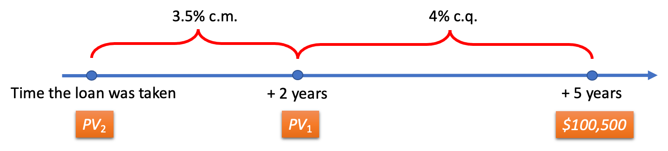

In this diagram, $PV_{1}$ is the amount which, if invested at 4% compounded quarterly for 3 years, must grow to $100,500. ${PV}_{2}$ is the amount which, if invested at 3.5% compounded monthly for 2 years, must grow to $PV_{1}$. In other words, $PV_{2}$ first grows to $PV_{1}$ which, in turn, grows to $100,500. The idea of the solution is to move backwards in time from $100,500 to $PV_{2}$.

At first, we find the present value $PV_{1}$ of $100,500 discounting it for 3 years at 4% compounded quarterly (that is 4 times per year). We use the following formula to find it:

$$PV=\frac{FV}{{\left(1+i\right)}^{n}}=FV{\left(1+i\right)}^{-n}$$

$$PV_{1}=100,500{\left(1+\frac{0.04}{4}\right)}^{-4×3}=89,188.64714$$

Notice that we are not rounding the value we found, because this is not the final answer. Also notice that PV₁ is 2 years in the future from the time the loan was taken. Therefore, we need another step, to discount PV₁ for 2 years at 3.5% compounded monthly (that is 12 times per year):
$$PV_{2}=89,188.64714{\left(1+\frac{0.035}{12}\right)}^{-12×2}=83,167.42$$

While it took us two steps to find the present value at the time of the loan, we could have solved this problem in one line:

$$PV_{2}=100,500{\left(1+\frac{0.04}{4}\right)}^{-4×3}{\left(1+\frac{0.035}{12}\right)}^{-12×2} =83,167.42$$

The interest amount is:
$$I=FV-{PV}_{2}$$

$$I=100,500- 83,167.42=17,332.58$$

$∎$End of the example.

Rate and term for compound interest

Using the techniques explored in Examples 2.3 and 2.4 (please analyze those examples very carefully to fully understand what we are going to discuss now), we can also solve problems for the rate and the term:

Example 3.4: What nominal rate, compounded semi-annually, is required for $4,500 to earn $300 of interest in 1 year and 2 months?

Adapting the $RoC$formula, we have the formula for the periodic rate $i:$

$$i= {\left(\frac{FV}{PV}\right)}^{\frac{1}{n}}-1$$

Note that:
$$n=m × t= 2×\left(1+\frac{2}{12}\right)=2.\overline{3}$$

We have:
$$i= {\left(\frac{4,800}{4,500}\right)}^{\frac{1}{2.\overline{3}}}-1$$

$$i= 0.028045438$$

Remember that we have found the periodic rate. We still need to find the nominal rate:

$$j=i×m=0.028045438×2=5.61\%$$
$∎$End of the example.

Example 3.5: How much time is required for an amount to double at 3% compounded daily?

The formula for $n$ is:
$$n= \frac{\ln\left(\frac{FV}{PV}\right)}{\ln{(1+i)}}$$

When an amount doubles, $FV$ is equal to $2PV$. In other words, each dollar grows to become two dollars:
$$n= \frac{\ln\left(\frac{2PV}{PV}\right)}{\ln\left(1+\frac{0.03}{365}\right)}=\frac{\ln\left(\frac{2}{1}\right)}{\ln\left(1+\frac{0.03}{365}\right)}$$

$$n= 8,433.64 days$$

We will round up to the next day (ensuring that the amount at least doubles):

$$n= 8,434 days$$

Now we can convert this number to another style of time reporting, for example, to years and days: 23 years and 39 days.
$∎$End of the example.

NOTE: One can assume that a simple rate is always worse than a compounded rate of the same magnitude (for investments). In fact, this is not true. In cases when an investment is made for a term which is shorter than the compounding period, the future value under the simple rate is higher.

Example 3.6: At which rate is it better to invest an amount for 6 months: at 10% compounded annually or at 10% p.a.?

Let’s invest $1,000 at 10% compounded annually for 6 months:

$$1,000{(1+0.1)}^{0.5}=1,048.81$$

Now, let’s invest $1,000 at 10% p.a. (simple interest):

$$1,000\left(1+0.1×0.5\right)=1,050.00$$

As you can see, the simple rate produced the higher future value.

$∎$End of the example.

The following example will put together several topics we have discussed in this chapter.

Example 3.7: Over 5 years, the investment of $4,000 earned compounded quarterly interest amount of $1,000. (a) How much more time (in years and months) would be necessary for the investment to accumulate at least $1,000 of additional interest if the investment continues to grow at the same rate? (b) What simple interest rate would make $4,000 investment grow to $6,000 over the same time? (c) What semi-annually compounded interest rate would make $4,000 investment grow to $6,000 over the same time?

- First, we must find the quarterly compounded periodic interest rate which was active during the first 5 years:
$$i= {\left(\frac{4,000+1,000}{4,000}\right)}^{\frac{1}{4×5}}-1=0.011219651$$

By the way, this periodic rate translates into the nominal rate of 4.488% compounded quarterly. However, for our next calculations knowing this nominal rate is unnecessary (we will only use the periodic rate).

Now, let’s find the time necessary to accumulate $1,000 of additional interest. We know that $5,000 available at the end of 5 years must accumulate $1,000 of interest:

$$n= \frac{\ln\left(\frac{6,000}{5,000}\right)}{\ln\left(1+0.011219651\right)}=16.34118985 quarters$$

This number of quarters translates to approximately 4 years and 1.024 months. Since the problem mentions that at least $1,000 of interest must be accumulated, we round up the number of months to the whole number and obtain the answer: 4 years and 2 months.

- From part (a) we know that $2,000 of interest is earned over 36.34118985 quarters. We must find the simple interest rate $r$ which ensures this:

$$I=Prt$$

$$2,000=4,000×r×\left(\frac{36.34118985 }{4}\right)$$

$$r=5.50\% p.a.$$

- Again, using the information from part (a) and looking for the semi-annually compounded rate, we obtain:

$$n=\frac{36.34118985 }{2}=18.17059493$$

$$i= {\left(\frac{6,000}{4,000}\right)}^{\frac{1}{n}}-1=0.022565183$$

Using this periodic rate, we find the nominal rate compounded semi-annually:

$$j=i×2=4.51\%$$

$∎$End of the example.

Simple and compound interest review: https://youtu.be/BYd8ij_ijC0

Calculator and Excel techniques for simple and compound interest computations

When solving problems involving simple interest, it is frequently required to find the number of days between dates. This task is best handled with technology.

Calculator Example 3.1: A loan for $30,000 was given on September 18, 2020. It matured on May 28, 2021. If the interest amount paid was $560, what was the annual simple interest rate on the loan?

Note that 2020 was a leap year; it had 366 days. 2021 was a regular year having 365 days. The first part of the term was during the leap year and the second part was during the regular year.

We will use BAII calculator to find the number of days between dates. In this calculator, the date September 18, 2020, must be encoded as the number 9.1820 (in the format: Month.DayYear). December 31, 2020, is encoded as the number 12.3120.

Step 1: Find the number of days between September 18, 2020, and December 31, 2020 (September 18 is not included in the term since it is the day the loan was taken. The calculator will exclude the first day automatically).

First, access the “DATE” functionality and enter September 18, 2020:

$$〈2ND〉 〈1〉 〈9.1820〉 〈ENTER〉$$

Press $〈↓〉$and enter December 31, 2020:

$$〈12.3120〉 〈ENTER〉$$

To find the number of days between dates, press $〈↓〉$ and make sure you see “DBD” displayed. Press $〈CPT〉$. You should see the result: 104. Enter this result into calculator’s memory slot number 1:
$$〈STO〉 〈1〉$$

Step 2: Similarly, find the number of days between December 31, 2020, and May 28, 2021 (December 31 is excluded from this calculation, since it was included in the previous calculation):

$$〈2ND〉 〈1〉 〈12.3120〉 〈ENTER〉 〈↓〉 〈5.2821〉 〈ENTER〉 〈↓〉 〈CPT〉$$

You should see the result: 148. Enter this result into calculator’s memory slot number 2:

$$〈STO〉 〈2〉$$

Step 3: Find the number of years between September 18, 2020, and May 28, 2021:

$$\frac{104}{366}+\frac{148}{365}=0.689632458$$

In the calculator this is solved in the following way:

$$〈RCL〉 〈1〉 〈÷〉 〈366〉 〈+〉 〈(〉 〈RCL〉 〈2〉 〈÷〉 〈365〉 〈)〉 〈=〉$$

Record the result in memory slot number 3:

$$〈STO〉 〈3〉$$

Step 4: Find the simple interest rate:

$$I=Prt$$

$$r= \frac{I}{Pt}$$

$$r= \frac{560}{30,000×0.689632458}=0.027067558$$

In the calculator this computation can be done in the following way:

$$〈560〉 〈÷〉 〈(〉 〈30000〉 〈×〉 〈RCL〉 〈3〉 〈)〉 〈=〉$$

Thus, the answer to this problem is that the simple interest rate on the loan is 2.71%, rounded to two decimal places.
$∎$End of the calculator example.

BAII calculator also has helpful functionality for solving compound interest problems.

Calculator Example 3.2: Fill the empty cells of the table ($PV$ is the present value, $FV$ is the future value, $n$ is the total number of periods, $J$is the nominal rate and $m$ is the number of compounding periods per year):

 | $$PV$$ | $$FV$$ | $$n$$ | $$J$$ | $$m$$
A | $2,000 |  | 10 | 5% | 12
B |  | $3,000 | 15 | 3% | 4
C | $4,500 | $5,000 |  | 4% | 2
D | $7,000 | $7,900 | 1095 |  | 365

Of course, each of the problems A-D is solvable using regular calculator functionality based on formulas we have discussed in this chapter. But BAII also has so-called “TVM” (“Time Value of Money”) functionality which can solve compound interest problems. We will show both approaches.

- The future value is found in the following way:

$$FV= {2,000\left(1+\frac{0.05}{12}\right)}^{10}=2,084.91$$

Option 1: Using the regular BAII functionality:

$$〈0.05〉 〈÷〉 〈12〉 〈+〉 〈1〉 〈y^{x}〉 〈10〉 〈×〉 〈2000〉 〈=〉$$

Option 2: Using the TVM functionality, you will engage the third row of keys in the BAII calculator. At the start of the calculation, you must clear the calculator. To do this press:

$$〈CE|C〉 〈2ND〉 〈FV〉$$

Enter total number of periods “N”:
$$〈10〉 〈N〉$$

Enter the annual interest percent “I/Y”, and the compounding frequency per year “C/Y” (in the context of the current problem, “P/Y” is the same as “C/Y”):

$$〈5〉 〈I/Y〉 〈2ND〉 〈I/Y〉 〈12〉 〈ENTER〉 〈CE|C〉$$

Enter $PV$:
$$〈2000〉 〈PV〉$$

Finally, we are ready to find the $FV$:
$$〈CPT〉 〈FV〉$$

The result is $2,084.91.

Note that the calculator gave this result as a negative number. This is because the $PV$ had been entered as a positive number. The calculator distinguishes between an amount incoming and an amount outgoing. In this case, we simply drop the negative sign once we receive the result.

Also note that you can check what was entered in each key of the TVM by pressing $〈RCL〉 〈needed key〉.$ For example, to check what was entered in “N”, press:

$$〈RCL〉 〈N〉$$

$$PV= {3,000\left(1+\frac{0.03}{4}\right)}^{-15}=2,681.92$$

Option 1: Using the regular BAII functionality:

$$〈0.03〉 〈÷〉 〈4〉 〈+〉 〈1〉 〈y^{x}〉 〈15〉 〈+|-〉 〈×〉 〈3000〉 〈=〉$$

Option 2: Using the TVM:
$$〈CE|C〉 〈2ND〉 〈FV〉$$

Enter values:
$$〈15〉 〈N〉$$

$$〈3〉 〈I/Y〉 〈2ND〉 〈I/Y〉 〈4〉 〈ENTER〉 〈CE|C〉$$

$$〈3000〉 〈FV〉$$

We are ready to find the $PV$:
$$〈CPT〉 〈PV〉$$

The result is $2,681.92.

$$n= \frac{\ln\left(\frac{5,000}{4,500}\right)}{\ln\left(1+\frac{0.04}{2}\right)}=5.32$$

Option 1: Using the regular BAII functionality:

$$〈5000〉 〈÷〉 〈4500〉 〈=〉 〈LN〉 〈STO〉 〈1〉$$

$$〈0.04〉 〈÷〉 〈2〉 〈+〉 〈1〉 〈=〉 〈LN〉 〈STO〉 〈2〉$$

$$〈RCL〉 〈1〉 〈÷〉 〈RCL〉 〈2〉 〈=〉$$

Option 2: Using the TVM:
$$〈CE|C〉 〈2ND〉 〈FV〉$$

Enter values:
$$〈4〉 〈I/Y〉 〈2ND〉 〈I/Y〉 〈2〉 〈ENTER〉 〈CE|C〉$$

Note that the future value and the present value must have opposite signs – the calculator must distinguish the amount incoming and the amount outgoing:

$$〈4500〉 〈PV〉 〈5000〉 〈+|-〉 〈FV〉$$

We are ready to find $N$:
$$〈CPT〉 〈N〉$$

The result is 5.32.

$$i= {\left(\frac{7,900}{7,000}\right)}^{\frac{1}{1095}}-1=0.000110465$$

$$j=i×365=4.03\%$$

Option 1: Using the regular BAII functionality:

$〈7900〉 〈÷〉 〈7000〉 〈=〉 〈y^{x}〉 〈(〉 〈1〉 〈÷〉 〈1095〉 〈)〉 〈-〉 〈1〉 〈=〉$

$$〈×〉 〈365〉 〈=〉$$

Option 2: Using the TVM:
$$〈CE|C〉 〈2ND〉 〈FV〉$$

Enter values:
$$〈2ND〉 〈I/Y〉 〈365〉 〈ENTER〉 〈CE|C〉$$

Note that the future value and the present value must have opposite signs – the calculator must distinguish the amount incoming and the amount outgoing:

$$〈7000〉 〈PV〉 〈7900〉 〈+|-〉 〈FV〉$$

$$〈1095〉 〈N〉$$

We are ready to find $I/Y$:
$$〈CPT〉 〈I/Y〉$$

The result is 4.03%.
$∎$End of the calculator example.

Excel Example 3.1 (same as Calculator Example 3.1): A loan for $30,000 was given on September 18, 2020. It matured on May 28, 2021. If the interest amount paid was $560, what was the annual simple interest rate on the loan?

2020 was a leap year; it had 366 days. 2021 was a regular year having 365 days. The first part of the term was during the leap year and the second part was during the regular year.

Step 1: Find the number of days between September 18, 2020, and December 31, 2020 as well as the number of days between January 1, 2021, and May 28, 2021:

Enter all dates (B2 is the same as A3, since the first day in the range is “day 0”, which will not be counted as a part of the term):

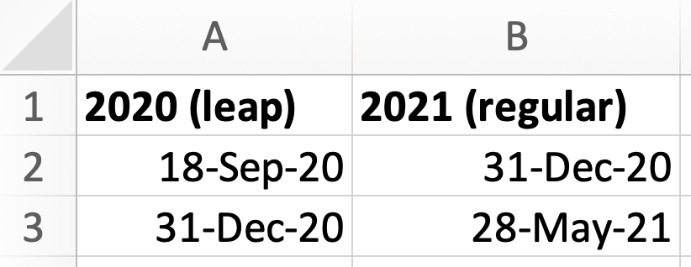

Calculate the number of days in 2020 and 2021 separately (simply subtract the earlier date from the later date; note that the first date is not counted):

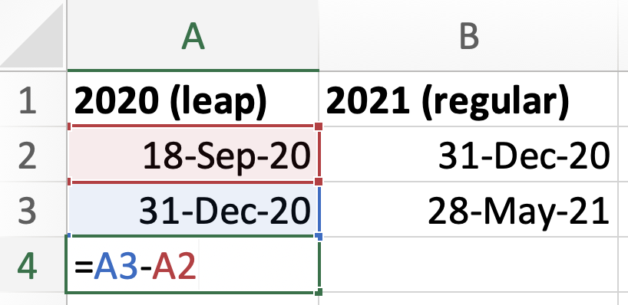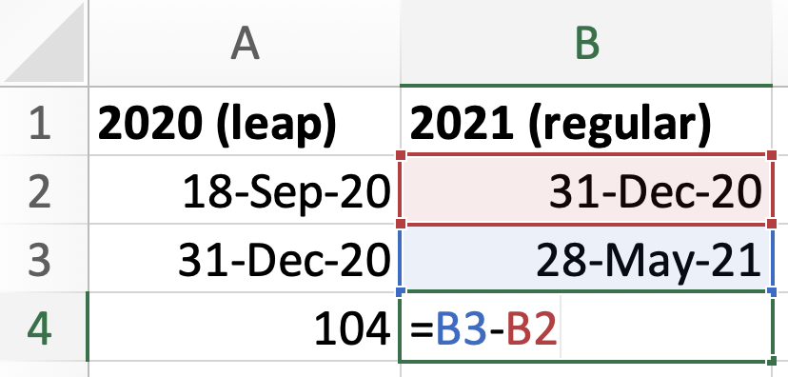

Step 2: Find the number of years between September 18, 2020 and May 28, 2021:

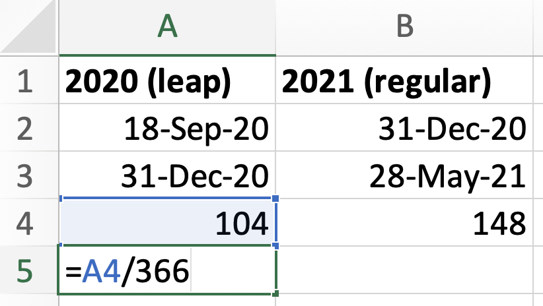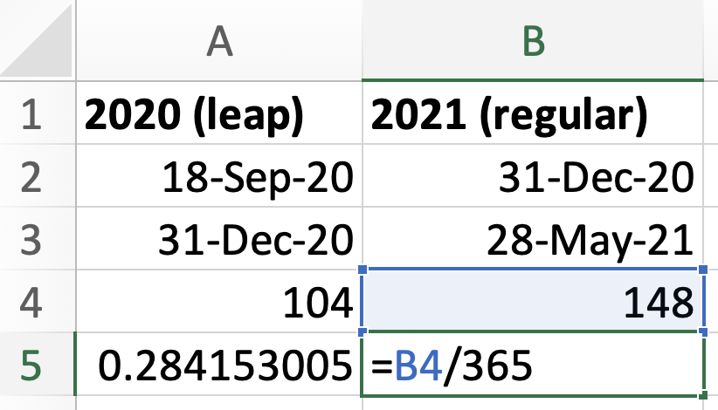
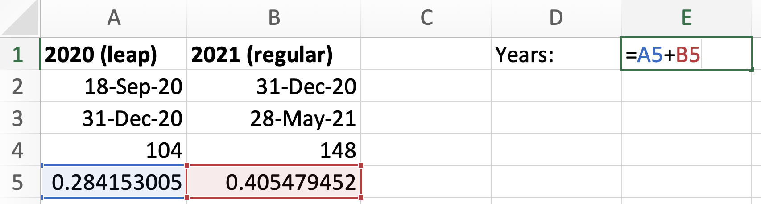
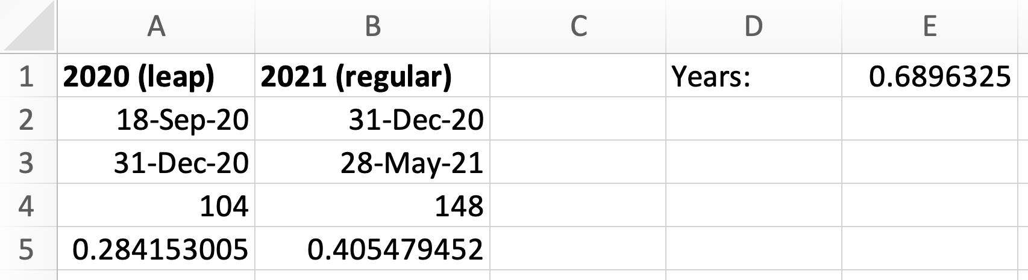

Step 3: Enter the given information about the principal and the loan amount, then find the rate:

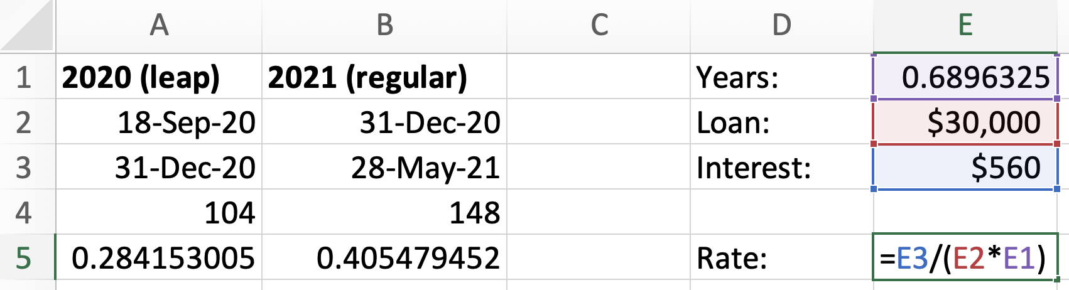
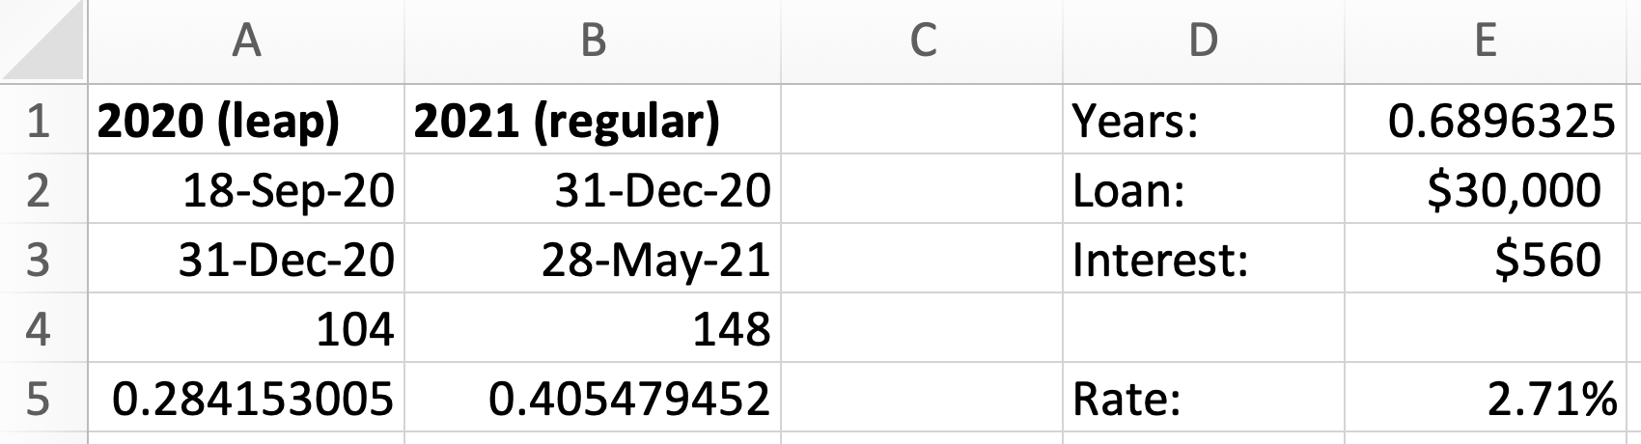

Note that cell E5 has been set to display the result as percent rounded to two decimals.

$∎$End of the Excel example.

Excel Example 3.2 (Same as Calculator Example 3.2): Fill the empty cells of the table ($PV$ is the present value, $FV$ is the future value, $n$ is the total number of periods, $J$is the nominal rate and $m$ is the number of compounding periods per year):

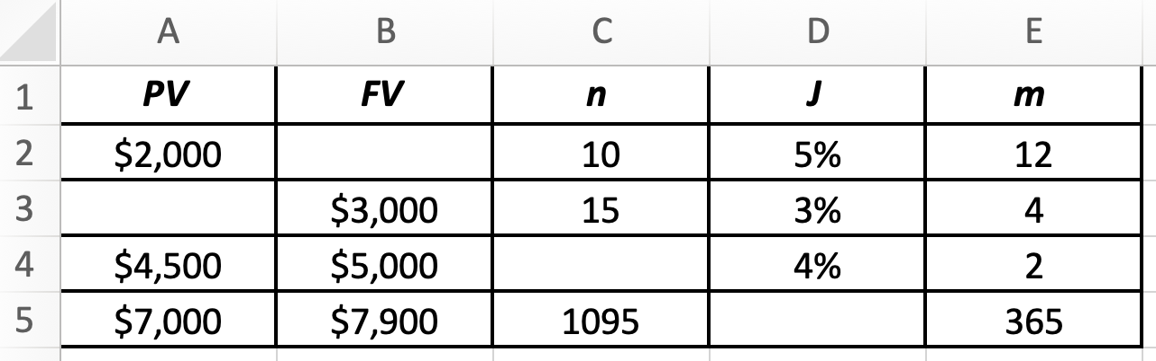

To fill cell B2, we will use Excel’s FV() formula. Notice that in this formula, you must enter the periodic rate “rate”, the number of periods “nper”, 0 “pmt” (because there are no periodic payments after the PV had been paid and until the FV was collected), 0
“type” (in fact, this parameter is optional; it has no influence when periodic payments are equal to 0 and can be omitted).

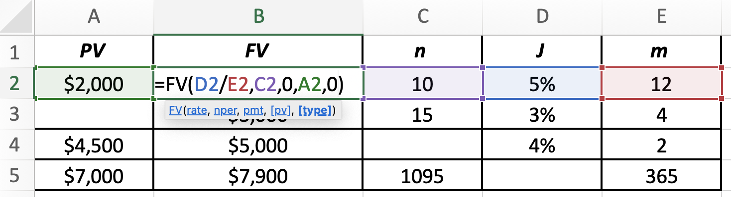
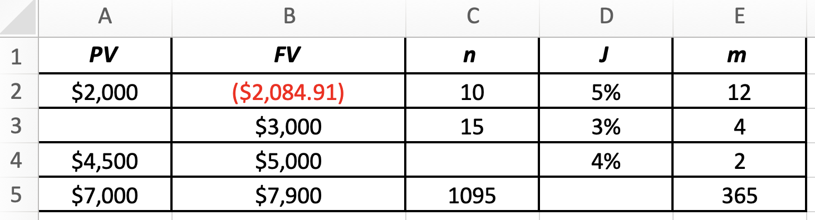

The result Excel has generated is a negative amount. This is because Excel distinguishes between amounts incoming and amounts outgoing: we entered the $PV$ as a positive amount into the function, therefore, Excel generated $FV$ as a negative amount. Filling cell A3 is similar to what we did in B2, but we use Excel’s PV() function:

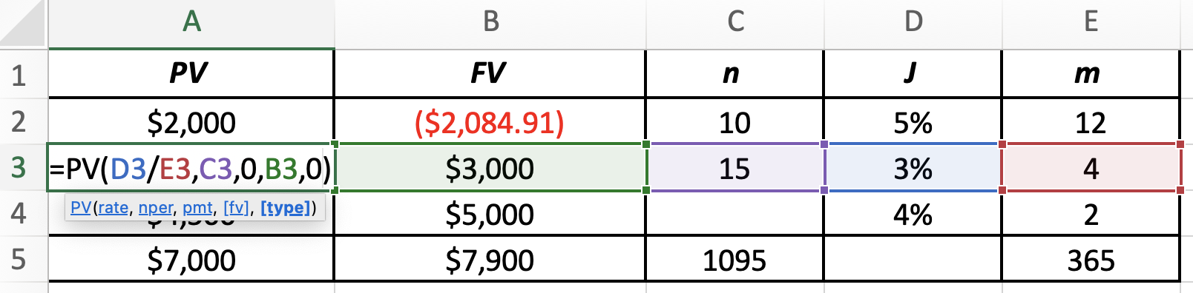
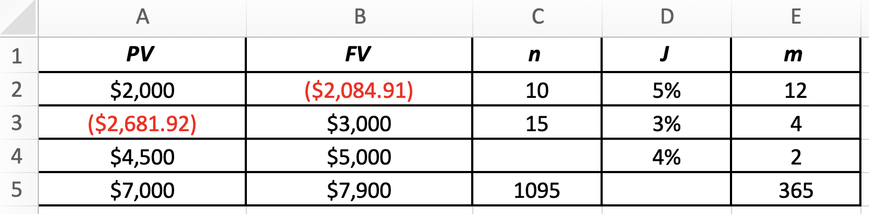

Cell C4 is filled with Excel’s NPER() command (note that FV and PV must be entered with opposite signs):

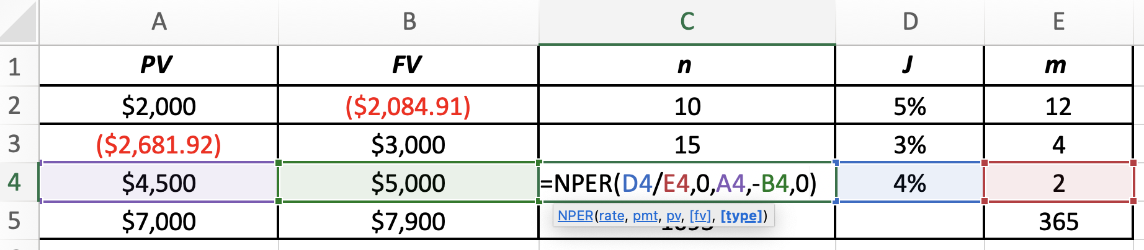
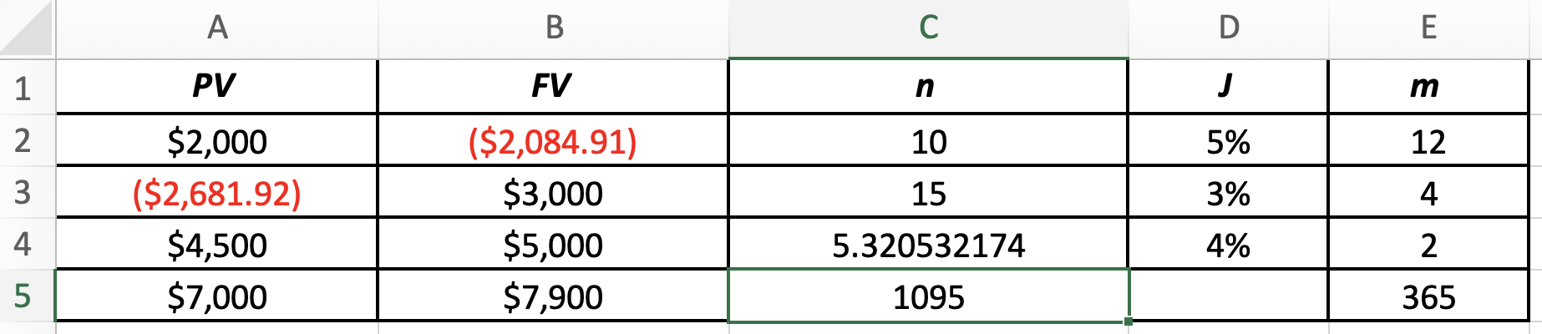

Finally, cell D5 is filled using RATE() command. In this command, leave “guess” empty. RATE() finds periodic rate; therefore, we must multiply it by the number of compounding periods per year. The signs of PV and FV must be opposite:

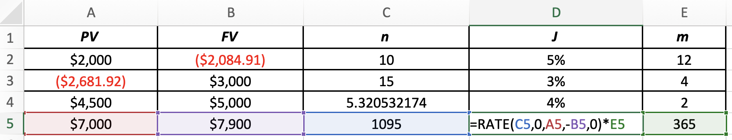

The finalized table is shown below (we made all signs positive, for all values):

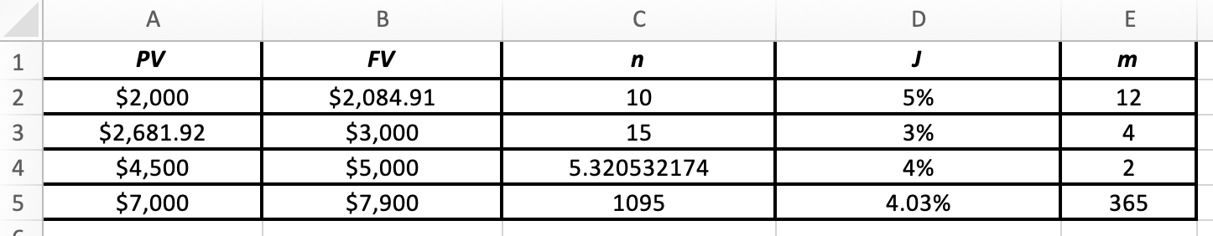

$∎$End of the Excel example.

Review: compound interest with algebra and Excel: https://youtu.be/39iqtgygKDE

Exercises

- $9,000 was borrowed on November 6, 2016 and returned with interest on July 5, 2017. If the simple interest rate on the loan was 3% p.a., calculate the amount of interest charged (notice that 2016 was a leap year).
- Which of the two options would you select? Explain your choice by showing all calculations. Option A: Investing at 10% compounded semi-annually. Option B: Investing at 9.8% compounded daily.
- Jacky invested $1,560 at 6 % p.a.. How many days will it take for her investment to grow to at least $1,585?
- What simple interest rate is required to earn $62 in interest in 345 days, if $628 is invested today?
- Jeffrey loaned $2,280 to a small business at 4.3% compounded quarterly for 1 year and 3 months. How much would the business have to repay him at the end of the period?
- Samantha deposited $5,760 into a variable-rate investment account. For 2 years 6 months, her investment grew at 3% compounded semi-annually. Then, for the next 2 years, her investment continued to grow at 2% compounded daily. What was accumulated value in the account?
- Devin is expected to settle a loan by paying $4,200. What amount should he pay if he decides to settle the loan four months earlier? The interest rate is 2.5% compounded monthly.
- Hassan invested an amount of $5,880 in a mutual fund. After 2 years and 6 months the accumulated value of his investment was $7,580. What is the nominal interest rate of the investment if interest is compounded monthly?
- Harpreet invested $6,000 at 4% compounded quarterly. How many years and months will it take her to earn $1,000 in interest?
- Polina borrowed $11,279 on January 24, 2018, and returned the loan with interest on September 4, 2018. If the simple interest rate on the loan was 3.5% p.a., calculate the amount of interest Polina paid.
- Jamshid invested $2,760 at 2.09% p.a.. How many days will it take for his investment to grow to $2,791?
- Beta Inc. invested $40,000 at 4.5% compounded monthly. Calculate the time period (in years) which would be required for this amount to grow to $55,000.
- Jacob invested $3,797 in a mutual fund. After 5 years and 6 months the accumulated value of his investment was $4,414. What is the nominal interest rate of the investment if interest is compounded daily?
- James wishes to have $97,500 in 13 years. How much should he invest in a fund that earns 4.1% compounded monthly during the first 6 years and 3.9% compounded semi-annually thereafter? What will be the interest earned?
- Over 3 years, the investment of $34,000 earned compounded monthly interest amount of $5,000. (a) How much more time (in years and months) would be necessary for the investment to accumulate at least $10,000 of additional interest if the investment continues to grow at the same rate? (b) What simple interest rate would make the same $34,000 investment grow to $49,000 over the same time? (c) What daily compounded interest rate would make the same $34,000 investment grow to $49,000 over the same time? (d) What annually compounded interest rate would make the same $34,000 investment grow to $49,000 over the same time?
- [Challenge] Use your knowledge of compounded interest to explain why $2^{0}=1$.
- [Challenge] Using your knowledge of compounded interest, explain the meaning of $\sqrt{2}$.
- [Challenge] Show that a more frequent reinvestment of a compound rate does not lead to a more frequently compounded rate. For example, show this by reinvesting a semi-annually compounded rate every quarter.

Answers:

- $178.16; 2. B; 3. 98 days; 4. 10.44%; 5. $2,405.21; 6. $6,458.39; 7. $4,165.18; 8. 10.2%; 9. 3 years and 11 months (rounded up to the next month); 10. $241.19; 11. 197 days; 12. 7.09 years; 13. 2.74%; 14. $58,200.81 and $39,299.19; 15. (a) 5 years (b) 5.52% (c) 4.58% (d) 4.68%.

Equivalent payments

In finance, there is an important term “The Time Value of Money”. This simply means that money changes value over time: $1,000 today is not the same as $1,000 in 1 year from now. This happens not only due to inflation. The main contributor to the change of value is the investment opportunity: $1,000 can earn interest over 1 year. And even if the money is not invested (even if it is kept in a chequing account for a year), the concept of the time value of money leads to the interest lost.

If we assume the interest rate to be 10% p.a. (simple interest rate) for both borrowing and lending, then $1,000 today is equivalent to $1,100 in 1 year from now. This equivalency has a practical meaning:

If $1,100 is available to us one year from now, it is possible to borrow $1,000 today and return the loan with interest 1 year from now. Thus, we end up with $1,000 today.

If $1,000 is available to us today, but if we need the money in 1 year from now, we can invest this $1,000 and receive $1,100 in 1 year from now.

Therefore, given 10% p.a., there is no difference between having $1,000 today and $1,100 in 1 year from now.

Of course, this statement is subject to several complications which can be met in real life: there may be transaction fees involved, the lending rate may be different from the borrowing rate, etc. All these complications can be mathematically addressed for specific scenarios. In our guide, however, we will always assume a simplified situation when money can be borrowed or invested with ease, at the same interest rate.

The main takeaway is that it is always important to connect each amount to the time the amount is available. Money value is time dependent. When comparing amounts which are located at different times, the necessary interest must be incorporated into the analysis.

Let’s discuss several examples which will clarify the situation.

Example 4.1: With 4% compounded monthly, what amount in 7 years from now is equivalent to $7,500 available in 2 years from now?

These problems are common in the business world. For example, a company may be interested to replace a payment of $7,500 due in 2 years from now by another payment to be made in 7 years from now.

In problems such as this, it is helpful to draw a timeline.

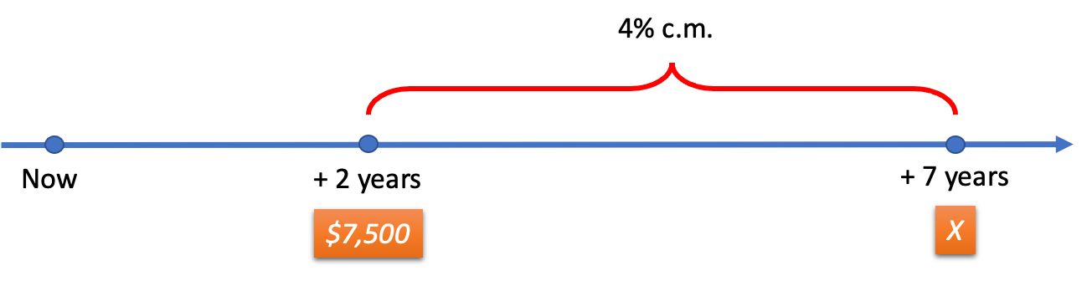

The unknown amount $X$ in 7 years from now must be equivalent to $7,500, available in 2 years from now. This means that if $7,500 is received 2 years from now and invested for 5 years, it must become $X$. In other words, $X$ must be the future value of $7,500:

$$X=7,500{\left(1+\frac{0.04}{12}\right)}^{12×5}=9,157.47$$

So, at 4% c.m., $7,500 in two years from now is equivalent to $9,157.47 in 7 years from now (within the rounding tolerance).

$∎$End of the example.

Example 4.2: Alpha Industries had to pay for the equipment supplied by Beta Corporation two years ago. Unfortunately, Alpha could not pay the amount in time and asked Beta the permission to pay later. Beta calculated that they must charge Alpha $50,452.00 if the payment is made 4 years from now. How much did Alpha have to pay 2 years ago, if the interest rate is 2% compounded semi-annually?

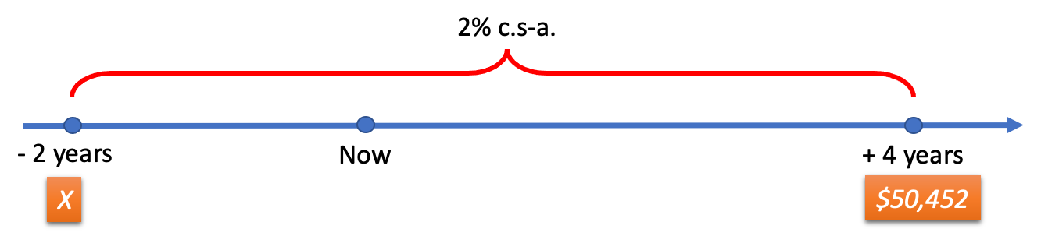

We can understand the situation in the following way: if Beta received the payment $X$ two years ago, they could have invested it for six years and would obtain $50,452 in four years from now. Therefore, $50,452 is the future value of $X$, and thus $X$ is the present value of $50,452:
$$X=50,452{\left(1+\frac{0.02}{2}\right)}^{-2×6}=44,773.59.$$

Alpha had to pay $44,773.59 two years ago but received the permission of Beta to pay $50,452.00 in four years from now, keeping in mind that the interest rate is 2% compounded semi-annually.

$∎$End of the example.

The ideas discussed in examples 4.1 and 4.2 can be combined into a problem when a payment must be found which is equivalent to several other payments.

Example 4.3: What payment made 6 months from now is equivalent to two payments, $6,700 due 9 months ago (but not paid) and $3,400 due in 1 year and 3 months from now? Assume the interest rate to be 3% compounded quarterly.

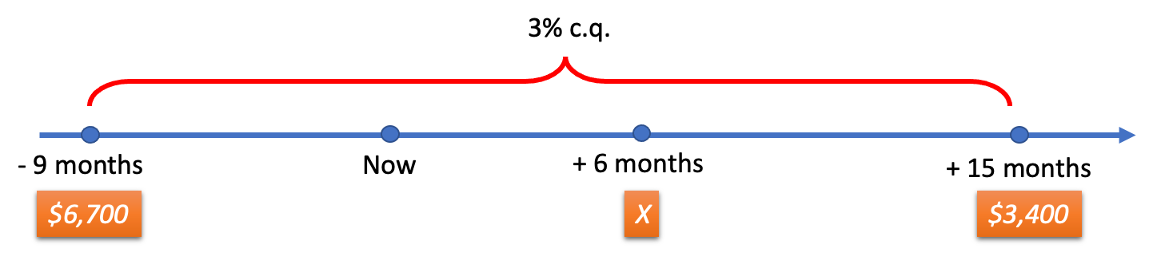

$X$is the sum of two values: the future value of $6,700 and the present value of $3,400:

$$X=6,700{\left(1+\frac{0.03}{4}\right)}^{5}+3,400{\left(1+\frac{0.03}{4}\right)}^{-3}=10,279.68$$

$∎$End of the example.

Example 4.4: Alpha Industries would like to replace $43,000 that is due in 5 years from now by two equal payments: one to be made today, and another to be made in 3.5 years from now. Find those payments if the rate is 6% compounded daily.

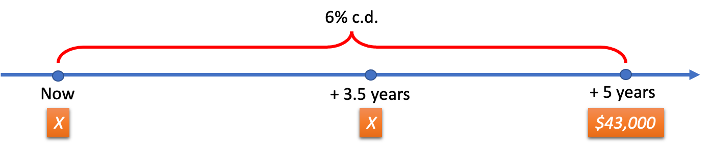

For better understanding, note that if there was no interest, we would have a very simple equation:
$$X+X=43,000$$

To solve this problem accounting for the interest, we need to select the so-called focal date. This is the date to which all amounts must be brought to, to be fairly compared. Let’s say, the focal date is selected to be 5 years from now. This means that $43,000 viewed from the position of the focal date is the same amount, $43,000. However, both equal payments are in the past in relation to the focal date. More exactly, the first payment $X$ is 5 years in the past, and the second payment $X$ is 1.5 years in the past, if both payments are viewed from the focal date (that is from the position of 5 years from now). Therefore, we must adjust both payments by finding their future values to make sure they are time-aligned with $43,000. The sum of these adjusted payments must be equal to $43,000:

$$\left[FV of X invested for 5 years\right]+[FV of X invested for 1.5 years]=43,000$$

More exactly:

$$X{\left(1+\frac{0.06}{365}\right)}^{365×5}+X{\left(1+\frac{0.06}{365}\right)}^{365×1.5}=43,000$$

Factor out $X$:
$$X\left[{\left(1+\frac{0.06}{365}\right)}^{365×5}+{\left(1+\frac{0.06}{365}\right)}^{365×1.5}\right]=43,000$$

From here, find $X$:

$$2.443991719 X=43,000$$

$$X=\frac{43,000}{2.443991719}=17,594.17$$

Note: The choice of the focal date changes the solution, but does not change the result, if the interest rate is compounded (the change of the focal date would change the result in the case of the simple interest rate, however). Nevertheless, in compound interest problems, the focal date should always be chosen carefully to simplify calculations. For instance, if in Example 4.4 we selected the focal date to be 1 year from now, the answer ($$17,594.17$) would be the same. However, the solution would become more complicated:

$$X{\left(1+\frac{0.06}{365}\right)}^{365}+X{\left(1+\frac{0.06}{365}\right)}^{-365×2.5}=43,000{\left(1+\frac{0.06}{365}\right)}^{-365×4}$$

This solution is more complicated because we need to modify $43,000, which we would not have to do if the focal date were selected at the same time as $43,000 (five years from now).

$∎$End of the example.

There are situations when an obligation is subject to previously agreed-upon interest rate and term and is locked as such (more about such obligations is explained in Chapter 10). The following example will demonstrate how an equivalent amount can be found for such obligations.

Example 4.5: Nyko Inc. currently has two obligations. The first obligation is a 10-year loan of $100,000 Nyko took 5 years ago at 3% compounded monthly. The second obligation is a 5-year loan of $150,000 Nyko took 1 year ago at 4% compounded monthly. What is total loan amount in terms of today’s money, if Nyko can now make investments at 3.5% compounded semi-annually?

The two loans Nyko took are contracts that Nyko must adhere to.

The first loan must mature to ${FV}_{1}$:

$${FV}_{1}=100,000{\left(1+\frac{0.03}{12}\right)}^{12×10}=134,935.3547$$

The second loan must mature to ${FV}_{2}$:

$${FV}_{2}=150,000{\left(1+\frac{0.04}{12}\right)}^{12×5}=183,149.4891$$

The problem becomes: which amount today is equivalent to two amounts, one of $134,935.3547 due 5 years from now, and another of $183,149.4891 due 4 years from now, if the interest rate is 3.5% compounded semi-annually? This amount $X$ is found in the following way:

$$X=134,935.3547{\left(1+\frac{0.035}{2}\right)}^{-2×5}+183,149.4891{\left(1+\frac{0.035}{2}\right)}^{-2×4}=272,859.45$$

This means that Nyko would have to earmark $272,859.45 today, to be able to close its two obligations when they mature.

Exercises

- A payment of $1,892 was due 280 days ago, and a payment of $3,840 is due in 134 days from today. What single payment today would be equivalent to these two original payments? Assume that money earns 2.9% compounded daily.
- Fatima’s reports show that there are two payments owed to her. The first payment of $1,350 is due 20 months from today, and the second payment of $1,650 was due 23 months ago, but not paid. What single payment can Fatima collect today instead of these two originally scheduled payments? Assume that money earns 3.2% compounded monthly.
- Jennifer must make payments of $1,085 today and $1,245 two years from today. She renegotiates to repay the debt by a single payment 7 months from today. How much is Jennifer’s single payment if the interest rate is 5.7% compounded quarterly?
- Daniel would like to make a single payment 2 years from now to replace $3,350 due 2 years ago (but not paid), and $3,450 scheduled in 4 years from now. How much should Daniel’s payment be if the rate is 3% compounded monthly?
- Michelle’s debt can be paid by payments of $3,125 scheduled in 4 years from now, and $6,175 scheduled in 3 years from now. What single payment would settle the debt 2 years from now if money is worth 4% compounded monthly?
- A payment of $5,000 in two years from now is to be replaced by two equal payments, one today and another in 5 years from now. If the rate is 4% compounded annually, find the size of each replacement payment.
- Delta Incorporated would like to renegotiate the payment of $400,000 it owes to Alpha Industries one year from today. Delta would like to pay two equal payments instead: one in 3 years from now and the other in 5 years from now. How much is each payment? The interest rate is 3% compounded monthly.
- Jamshid took two loans: (1) Three years ago, a 5-year loan of $7,000 at the simple interest rate of 5% p.a. and (2) Two years ago, a 3-year loan of $3,000 at 4.7% compounded daily. Today, Jamshid decided to close these two loans. How much must he pay if the current interest rate is 4.5% compounded quarterly?

Answers:

1. $5,733.90; 2. $3,034.20; 3. $2,270.49; 4. $7,025.88; 5. $8,818.39; 6. $2,537.30; 7. 218,712.10; 8. $11,303.99

Equivalent rates

One of the most important topics in compound rates is rate equivalency. The best way to learn this topic is by an example:

Example 5.1: Which interest rate, compounded semi-annually, is equivalent to 6% compounded daily?

When we say that one rate is equivalent to another, we mean that the same amount invested at these rates for the same time must produce equal future values.

For our example this means that if you invest $1 for 1 year at 6% compounded daily, you must have the same future value as if you invested $1 for 1 year at a rate compounded semi-annually. We can write this statement mathematically:

$$\$1{\left(1+\frac{0.06}{365}\right)}^{365×1}=\$1{\left(1+i_{2}\right)}^{2×1}$$

Here $i_{2}$is the unknown periodic rate compounded semi-annually. Since multiplication by 1 does not change the values, we can rewrite our equation in a simplified way:

$${\left(1+\frac{0.06}{365}\right)}^{365}={\left(1+i_{2}\right)}^{2}$$

We can solve this equation by taking the reciprocal exponent (see Example 2.3 which used a similar technique):
$${\left(1+\frac{0.06}{365}\right)}^{\frac{365}{2}}=1+i_{2}$$
Finally:
$${i_{2}=\left(1+\frac{0.06}{365}\right)}^{\frac{365}{2}}-1$$

$$i_{2}=0.030451993$$

Here $i_{2}$is the periodic rate compounded semi-annually. We must find the nominal rate:

$$j_{2}=i_{2}×m=0.030451993×2=6.09\%$$

Therefore, 6.09% compounded semi-annually is equivalent to 6% compounded daily (within the rounding tolerance). This means that there is no difference which rate to choose: you will end up with the same benefit by selecting either one of the two.

$∎$End of the example.

From Example 5.1, one can deduce the following formula for finding the equivalent rate:
$${i_{2}=\left(1+i_{1}\right)}^{\frac{m_{1}}{m_{2}}}-1$$

In this formula, $i_{1}$is the given periodic rate, compounded $m_{1}$ times per year and, $i_{2}$is the equivalent periodic rate, compounded $m_{2}$ times per year.

It is important to note that if two compound rates are equivalent for 1 year, they are equivalent for any duration of time. This can be seen from the following equation, showing two equal future values of $1 invested for some time $t$ at equivalent periodic rates $i_{1}$ and $i_{2}$:

$${\left(1+i_{1}\right)}^{m_{1}t}={\left(1+i_{2}\right)}^{m_{2}t}$$

It immediately follows from here that $t$ can be deleted on both sides without affecting the equality:
$${\left(1+i_{1}\right)}^{m_{1}}={\left(1+i_{2}\right)}^{m_{2}}$$

Therefore, it is sufficient to ensure that two compound rates are equivalent for 1 year. This is enough to guarantee their equivalency for any duration of time.

However, when speaking of equivalency of the simple rate to a compound rate, time plays an important role and must always be considered.

Example 5.2: Which interest rate, compounded monthly, is equivalent to 6% p.a. over 260 days?

Notice that in this problem the term is mentioned because we must find the equivalency of a compound rate to the given simple rate. If $1 is invested for 260 days at both rates and the future values are equalized, the equation becomes:

$${1+0.06×\frac{260}{365} = \left(1+i\right)}^{12×\frac{260}{365}}$$

$${\left(1+0.06×\frac{260}{365}\right)}^{\frac{365}{12×260}}=1+i$$

$$i={\left(1+0.06×\frac{260}{365}\right)}^{\frac{365}{12×260}}-1$$

$$i=0.004908106; j=5.89\%$$

$∎$End of the example

Keep in mind the following important fact:

The equivalency of compound interest rates is independent of time.

This fact makes one more reason due to which compound rates are widespread in business and finance.

Since there are many different types of compound rates (e.g., daily, monthly, semi-annually, etc.), it is convenient to select a standard rate that will help to compare investments or loans in a unified way. This standard rate is called the effective rate, and it is the nominal rate compounded annually.

Going forward, for the effective rate we will use the letter f. The reason compounded annually rate is selected to be the standard is because it is unique: for it, the nominal rate and the periodic rate coincide, which offers computational convenience. Let’s explore the application of the effective rate by an example.

Example 5.3: Bank A charges 8.73% compounded monthly for loans. Bank B charges 8.71% compounded daily for loans. Find the effective rate to decide which bank offers the better terms.

The effective rate is, by definition, the rate compounded annually. All we need to do is to find equivalent effective rates to the rates given in the problem. We start with bank A:

$${i_{2}=\left(1+i_{1}\right)}^{\frac{m_{1}}{m_{2}}}-1$$

$${i_{2}=\left(1+\frac{0.0873}{12}\right)}^{\frac{12}{1}}-1$$

$${i_{2}=\left(1+\frac{0.0873}{12}\right)}^{\frac{12}{1}}-1$$

$$i_{2}= 0.0909$$

Using the notation for the effective rate, $f_{A}= 9.09\%$

Similarly, for Bank B:
$${f_{B}=\left(1+\frac{0.0871}{365}\right)}^{365}-1= 9.10\%$$

Using these effective rates, we can compare both banks. Since 9.09% is lower than 9.10%, bank A is preferrable to take a loan from.
$∎$End of the example.

Revisit Example 3.7. Analyzing that example with the knowledge you gained in this chapter, you will make the following observations: 4.488% compounded quarterly is equivalent to 4.51% compounded semi-annually for any duration of time. The simple rate of 5.50% p.a. is equivalent to each of those two rates only for the term of 4 years and 1.024 months.

Calculator and Excel techniques to find equivalent rates

Calculator Example 5.1 (compare to Example 5.1): Which interest rate, compounded semi-annually, is equivalent to 6% compounded daily?

The BAII calculator cannot compute the equivalent nominal rate directly. It must compute the effective rate first.

First, activate ICONV (Interest Conversion) functionality in BAII:

$$〈2ND〉 〈2〉$$

Once you see “NOM=” displayed, enter the given nominal rate and then its compounding frequency “C/Y”:

$〈6〉 〈ENTER〉 〈↑〉 〈365〉 〈ENTER〉$

Press $〈↑〉$, and you should see “EFF=” being displayed. This means that the calculator is ready to compute the effective rate, equivalent to 6% compounded daily. Press $〈CPT〉$ to compute it. You should see the result: 6.183131068.

Since you need the nominal rate compounded semi-annually, press $〈↓〉$ to return to compounding frequency and enter the new required frequency:

$$〈2〉 〈ENTER〉$$

Now, press $〈↓〉$ to get to “NOM=” display and press $〈CPT〉$ to compute the nominal rate. You should see the result 6.090398678.

$∎$End of the calculator example.

Excel Example 5.1 (compare to Example 5.1): Which interest rate, compounded semi-annually, is equivalent to 6% compounded daily?

Excel cannot compute the equivalent nominal rate directly. It must compute the effective rate first. The effective rate is computed using Excel’s function EFFECT().

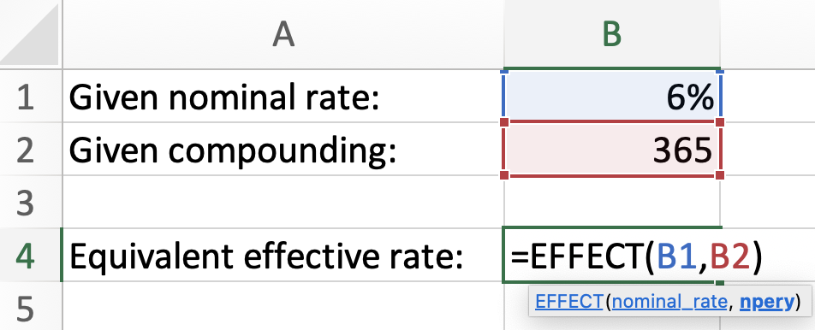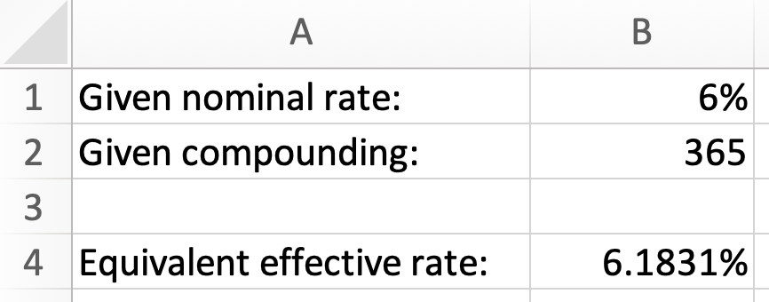

Now, we can find the nominal rate compounded semi-annually using function NOMINAL():

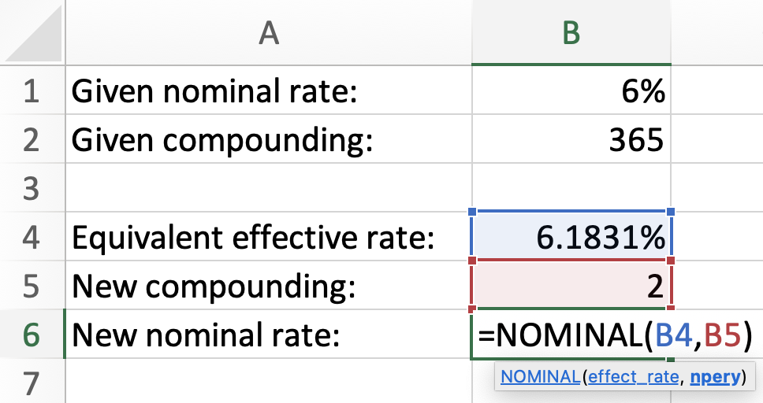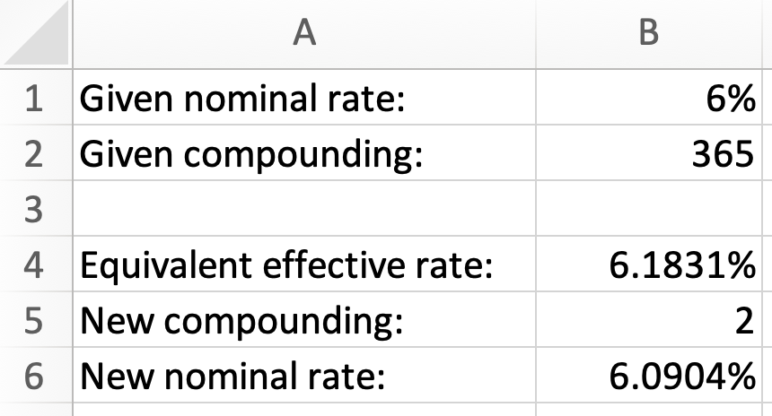

Or, the whole operation can be done in one line using EFFECT() inside NOMINAL():

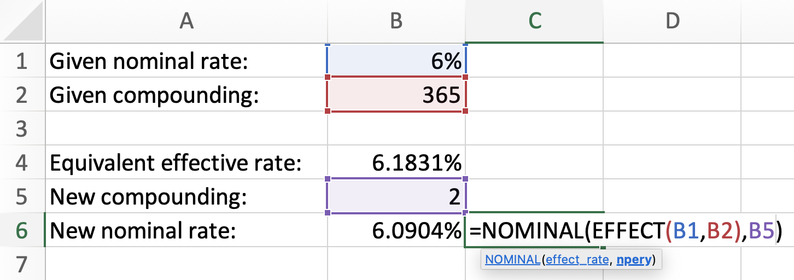

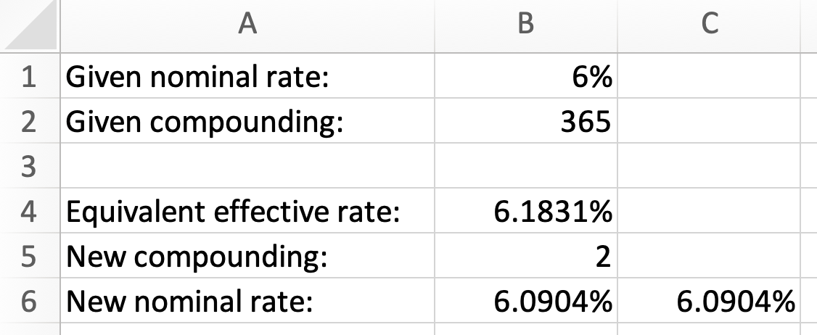

$∎$End of Excel example.

Exercises

- An investment of $4,000 have grown to $5,650 in 6 years. What was the effective rate for this investment?
- What nominal rate, compounded quarterly, is equivalent to the effective rate of 4%?
- What nominal interest rate, compounded quarterly, is equivalent to 8% compounded monthly?
- The Bank of York offers an investment opportunity by providing an interest rate of 6.88% compounded semi-annually. The Bank of Markham provides an equivalent nominal interest rate, compounded monthly. Find the nominal interest rate offered by the Bank of Markham.
- What nominal rate of interest compounded daily is equivalent to 7.70% compounded monthly?
- Kate invested at a simple interest rate of 5.8% for 5 years. What effective interest rate would ensure that Kate has the same investment benefit over 5 years?
- [Challenge] What interest rate, compounded every 1 year and 3 months is equivalent to 9% compounded monthly?

Answers:

1. 5.92%; 2. 3.94%; 3. 8.05%; 4. 6.78%; 5. 7.68%; 6. 5.22%; 7. 9.49%

Annuities

An annuity is a sequence of payments spread over time in a specific way. More exactly:

- Each payment is the same in size.
- Time intervals between each payment and the next payment are the same in length.
- The rate of interest is the same for the whole time.

Annuities are met everywhere in business and even in everyday life. Examples are numerous: mortgage and rent payments, vehicle lease and finance agreements, pension funds (such as RRSP), education investments (such as RESP), etc.

There are four main types of annuities, depending on when the payments are made and how compatible the interest rate is with the annuity payment frequency. You will learn about these types as you continue reading. We start with the so-called simple ordinary annuity and later we will study the other types.

Simple ordinary annuities

The simple ordinary annuity is the most important annuity. This is because any other type of annuity must be converted into the simple ordinary annuity for all necessary calculations. On a timeline, a simple ordinary annuity looks like this:

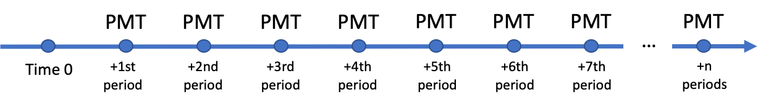

In this diagram, time 0 represents the start of the annuity and time “+n periods” represents the end of the annuity. The annuity has $n$ payments. The payments are the same in size (PMT), each period is the same in length and the interest rate is the same for all $n$ periods. Each payment is happening at the end of each period (this makes the annuity ordinary). The interest rate compounds as many times per year as there are annuity payments per year (this makes the annuity simple). We will return to the terms simple and ordinary later in this section when we define all main types of annuities.

Let’s consider two detailed examples which will demonstrate the mathematics of simple ordinary annuities.

Example 6.1: Jose invested $200 at the end of every month in an account earning 4% compounded monthly for 3 years. How much will Jose accumulate at the end of 3 years?

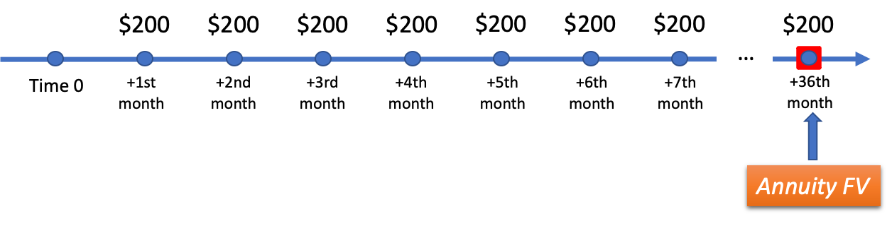
This problem requires to find one amount, at the end of 3 years, which is equivalent to 36 contributions of $200, each made at the end of every month. This equivalent amount is called the future value of the annuity.

This future value can be found in this way:

$$FV=200{\left(1+\frac{0.04}{12}\right)}^{35}+200{\left(1+\frac{0.04}{12}\right)}^{34}+ … +200{\left(1+\frac{0.04}{12}\right)}^{1}+200$$

Of course, this is a lot of calculation. The good news is that there is a “shortcut” formula which produces the same result, but in a much more compact way. For this annuity, the formula for the future value is:
$$FV= PMT\left[\frac{{(1+i)}^{n}-1}{i}\right]$$

In this formula: $PMT$ is the payment of the annuity, $i$ is the periodic rate and $n$ is the total number of payments. Using this formula, we find:

$$i=\frac{0.04}{12}$$

$$FV= 200\left[\frac{{\left(1+i\right)}^{36}-1}{i}\right]$$

$$FV=7,636.31$$

This means that Jose will have $7,636.31 in the account at the end of 3 years.

$∎$End of the example.

Example 6.2: Rumeysa took a loan requiring payments of $200 at the end of every quarter for 4 years. How much is the loan amount if the interest rate is 2% compounded quarterly?

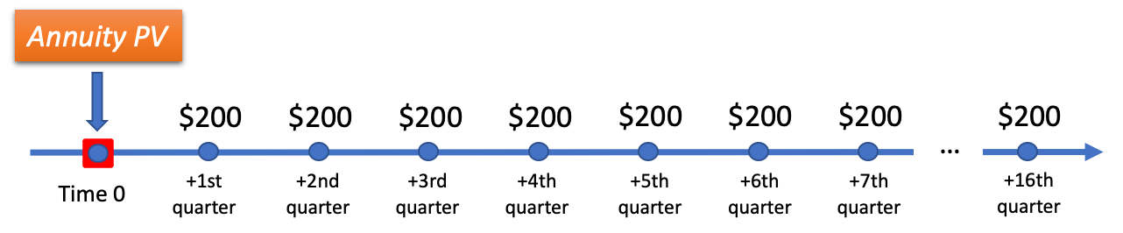

This problem requires to find one amount, at the time the loan is taken, which is equivalent to 16 payments of $200, each made at the end of every quarter. This equivalent amount is called the present value of the annuity.

This present value can be found in this way:

$$PV=200{\left(1+\frac{0.02}{4}\right)}^{-1}+200{\left(1+\frac{0.02}{4}\right)}^{-2}+ … +200{\left(1+\frac{0.02}{4}\right)}^{-16}$$

Again, the good news is that there is a “shortcut” formula which produces the same result in a much more compact way. For this annuity, the formula for the present value is:

$$PV= PMT\left[\frac{{1-(1+i)}^{-n}}{i}\right]$$

Using this formula, we can quickly find the present value:

$$i=\frac{0.02}{4}$$

$$PV= 200\left[\frac{{1- \left(1+i\right)}^{-16}}{i}\right]$$

$$PV=3,067.99$$

This means that after Rumeysa takes a $3,067.99 loan, she will have to pay $200 at the end of every quarter for 4 years to pay it off.
$∎$End of the example.

Examples 6.1 and 6.2 give an idea of how to find the future value and the present value for simple ordinary annuities.

There are four types of annuities:

Simple annuity: the number of payments per year (the payment frequency) is the same as the number of rate compounding periods per year (the rate compounding frequency).
General annuity: the payment frequency is not the same as the rate compounding frequency.
Ordinary annuity: each payment is made at the end of each period.
Due annuity: each payment is made at the beginning of each period.

Some of these types can be combined in the same annuity: it is possible to speak about simple ordinary, general ordinary, simple due and general due annuities.

Both examples 6.1 and 6.2 are about simple ordinary annuities.
A very important fact is that the formulas for FV and PV that we used in those examples are valid only for simple ordinary annuities.

If an annuity is not a simple ordinary annuity, it must be converted into an equivalent simple ordinary annuity for all calculations.

General ordinary annuities

If an annuity is general, the rate compounding frequency does not match the payment frequency. The technique to overcome this mismatch is to convert the rate: we must find the equivalent rate having the compounding frequency matching the payment frequency.

Example 6.3: Nigora decided to save for a vacation and began making contributions of $400 at the end of every month. The account where Nigora contributes earns 3% compounded semi-annually. If she makes such contributions for 2 years, how much money will she save? How much interest will Nigora earn?

In this problem we are required to find the future value of the annuity. This annuity is a general ordinary. It is general because the rate compounding frequency (2 times per year) is not equal to the payment frequency (12 times per year), and it is ordinary because the contributions are made at the end of every period.

We must convert this annuity into an equivalent simple ordinary annuity to be able to use the formula for $FV$. To convert this general annuity into a simple annuity, we must convert the rate. This means that we must find the rate, compounded monthly, which is equivalent to 3% compounded semi-annually. We already know how to solve such problems (see Example 5.1):
$${i_{2}=\left(1+\frac{0.03}{2}\right)}^{\frac{2}{12}}-1=0.002484517$$

This rate $i_{2}$ is the periodic rate compounded monthly, which is equivalent to the nominal rate 3% compounded semi-annually. Note that we do not need to find the nominal rate corresponding to the periodic rate${ i}_{2}$, because the annuity formula for $FV$ requires a periodic rate. With this new rate $i_{2}$, our annuity becomes the simple annuity (since the rates are equivalent, the new simple annuity is equivalent the original general annuity).

Since with the new rate $i_{2},$the annuity has become simple ordinary, we can use the formula for $FV$:
$$FV= PMT\left[\frac{{(1+i)}^{n}-1}{i}\right]$$

We insert the payment, the converted rate, and the total number of payments:

$$FV= 400\left[\frac{{\left(1+i_{2}\right)}^{12×2}-1}{i_{2}}\right]=9,879.35$$

The second question of the problem is to find the interest earned. For this, we must subtract all payments Nigora will have made from the total amount she will have saved (that is, from the future value of the annuity).

$$I=9,879.35-400×24=279.35$$

$∎$End of the example.

Simple due annuities

How can we convert a due annuity into an equivalent ordinary annuity? The process is to replace each payment made at the beginning of each interval by an equivalent payment made at the end of each interval. Make sure to review Chapter 4 carefully to understand the explanation that follows.

Notice that:
PMT received at the beginning of each period

is equivalent to
$PMT\left(1+i\right)$ received at the end of each period.

If we replace each payment $PMT$, made at the beginning of each period, by its equivalent payment $PMT\left(1+i\right)$, made at the end of each period, we will replace the due annuity by an equivalent ordinary annuity. Therefore, with the updated payments, our simple due annuity becomes the simple ordinary annuity. The diagram below depicts this situation:

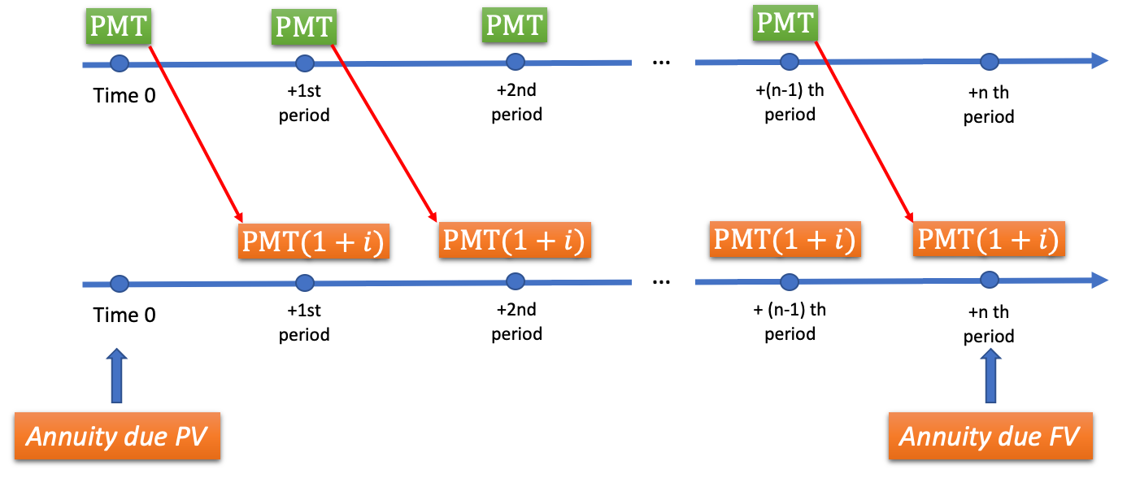

Example 6.4: A pension fund will allow Michael to withdraw $2,000 at the beginning of every month for the next 20 years. How much is in Michael’s pension fund at the start of the annuity, if the fund earns 5% compounded monthly?

Notice that
$2,000 received at the beginning of every month

is equivalent to
$\$2,000\left(1+\frac{0.05}{12}\right)$ received at the end of every month.

If we replace all payments of $\$2000$ made at the beginning of every month by their equivalent payments $\$2,000\left(1+\frac{0.05}{12}\right)$ made at the end of every month, we will replace the due annuity by an equivalent ordinary annuity. With the updated payments, our simple due annuity becomes a simple ordinary annuity.

Recall that for a simple ordinary annuity, the formula for $PV$ is:

$$PV= PMT\left[\frac{{1-(1+i)}^{-n}}{i}\right]$$

Using this formula, we can find the present value (notice that we used the modified payments here, which we highlighted):
$$i=\frac{0.05}{12}$$

$$PV= 2,000\left(1+i\right)\left[\frac{{1- \left(1+i\right)}^{-12×20}}{i}\right]=304,313.34$$

$∎$End of the example.

General due annuities

Now we can combine the techniques we have learned. If the annuity is general due, we first convert the rate and then replace each beginning-of-period payment by its equivalent end-of-period payment.

Example 6.5: What is the purchase price of the car if it can be paid off by paying $500 at the beginning of every month for 5 years? The rate of financing is 4.5% compounded daily. What is the interest amount charged for the loan?

This is the problem about $PV$ of a general due annuity. First, we must convert the rate compounded daily to the equivalent periodic rate compounded monthly:

$${i_{2}=\left(1+\frac{0.045}{365}\right)}^{\frac{365}{12}}-1=0.003756808$$

With this periodic rate $i_{2}$, our annuity becomes a simple annuity.

Now we must replace each payment of $\$500$ at the beginning of each month by its equivalent payment $\$500\left(1+i_{2}\right)$at the end of each month. With the updated payment, the due annuity becomes an ordinary annuity. With these changes, we are ready to use our formula for the $PV$:
$$PV= 500\left(1+i_{2}\right)\left[\frac{{1- \left(1+i_{2}\right)}^{-12×5}}{i_{2}}\right]=26,915.08$$

The interest amount charged is found by subtracting the price of the car (the $PV$) from all the payments made:
$$I=500×60-26,915.08=3,084.92$$

$∎$End of the example.

Example 6.6: Assume that the interest rate is 2.5% compounded monthly. What is the future value of 10 payments of $100, each made at the beginning of every 3 months? What is the interest earned?

This problem is about the $FV$ of a general due annuity. First, we convert the given rate to the equivalent periodic rate compounded quarterly:

$${i_{2}=\left(1+\frac{0.025}{12}\right)}^{\frac{12}{4}}-1=0.00626303$$

With this periodic rate $i_{2}$, our annuity becomes a simple annuity. Now we must replace each payment of $\$100$ at the beginning of each quarter by its equivalent payment $\$100\left(1+i_{2}\right)$at the end of each quarter. With the updated payment, the due annuity becomes an ordinary annuity. With these changes, we are ready to use our formula for the $FV$:
$$FV= 100(1+i_{2})\left[\frac{{\left(1+i_{2}\right)}^{10}-1}{i_{2}}\right]=1,035.10$$

The interest earned is found by subtracting the combined payments from the future value:

$$I=1,035.10-100×10=35.10$$

$∎$End of the example.

The following diagram will help you remember how to approach annuity problems:

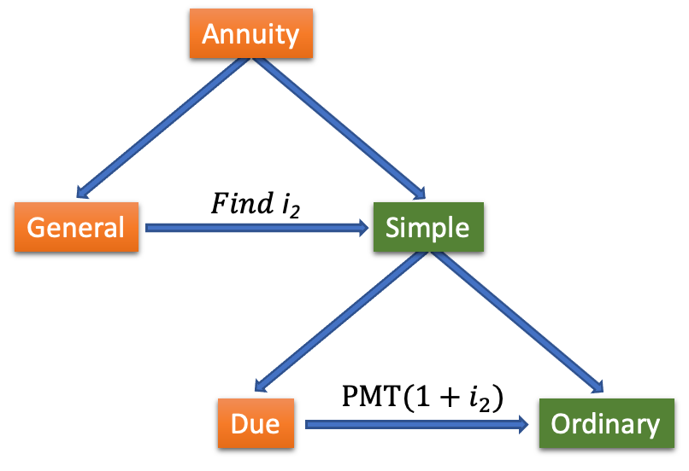

This diagram shows that when encountering an annuity, the first thing to do is to assess if the annuity is simple or general. If it is general, convert the rate: find the equivalent periodic rate $i_{2}$ with which the annuity becomes simple. Then, if the annuity is due, multiply the payment by $\left(1+i_{2}\right)$. Note that if the annuity is a simple annuity to begin with, $i_{2}$ and $i$ are equal.

Calculator and Excel techniques for finding $PV$ and $FV$ of annuities

After you have a strong grasp of the calculation of $PV$and $FV$ of annuities based on the formulas, you can learn how to calculate the $PV$and $FV$ using the BAII calculator or Excel.

Calculator Example 6.1 (compare to Example 6.3): Nigora decided to save for a vacation and began making contributions of $400 at the end of every month. The account where Nigora contributes earns 3% compounded semi-annually. If she makes such contributions for 2 years, how much money will she save?

For annuity calculations, you will engage the third row of keys of the BAII calculator. The third row is dedicated to the Time Value of Money (TVM) calculations. At the start of the calculation, you must clear the calculator. To do this press:

$$〈CE|C〉 〈2ND〉 〈FV〉$$

Because this is an ordinary annuity, we must first set the calculator to the “ORD” mode. First check if the calculator has already been set to this mode. If no “BGN” is displayed on the screen (in small letters above 0, when the calculator is turned on), the calculator is already in the “END” mode. If there is BGN displayed when the calculator is turned on, press:
$$〈2ND〉 〈PMT〉$$

This way you have entered the secondary functionality of the button $〈PMT〉$. This functionality is to change the mode from “ORD” to “BGN” and back. Now press:

$$〈2ND〉 〈ENTER〉 〈CE|C〉$$

Make sure that after this operation, you only see 0 being displayed (no “BGN” is being displayed).

Now we are ready to enter all values. Enter total number of periods “N”:

$$〈12〉 〈×〉 〈2〉 〈=〉 〈N〉$$

Enter the annual interest percent “I/Y”, the payment frequency “P/Y” and the compounding frequency “C/Y”:

$$〈3〉 〈I/Y〉 〈2ND〉 〈I/Y〉 〈12〉 〈ENTER〉 〈↑〉 〈2〉 〈ENTER〉 〈CE|C〉$$

Enter payment “PMT” (since payment is the amount outgoing, it must be entered negative):
$$〈400〉 〈+|-〉 〈PMT〉$$

Finally, we are ready to find the $FV$:

$$〈CPT〉 〈FV〉$$
The result is $9,879.35.
$∎$End of the calculator example.

Calculator Example 6.2 (Compare to Example 6.5): What is the purchase price of the car if it can be paid off by paying $500 at the beginning of every month for 5 years? The rate of financing is 4.5% compounded daily. What is the interest amount charged for the loan?

At the start of the calculation, you must clear the calculator. To do this press:

$$〈CE|C〉 〈2ND〉 〈FV〉$$

Because this is a due annuity, we must first set the calculator to the “BGN” mode. First check if the calculator has already been set to this mode. If “BGN” is displayed on the screen (in small letters above 0, when the calculator is turned on), the calculator is already in the “BGN” mode. If there is no BGN displayed when the calculator is turned on, press:

$$〈2ND〉 〈PMT〉$$

$$〈2ND〉 〈ENTER〉 〈CE|C〉$$

Make sure that after this operation, you see “BGN” displayed together with 0, when the calculator is turned on.

Now we are ready to enter all values. Enter total number of periods “N”:

$$〈12〉 〈×〉 〈5〉 〈=〉 〈N〉$$

Enter the annual interest percent “I/Y”, the payment frequency “P/Y” and the compounding frequency “C/Y”:

$$〈4.5〉 〈I/Y〉 〈2ND〉 〈I/Y〉 〈12〉 〈ENTER〉 〈↑〉 〈365〉 〈ENTER〉 〈CE|C〉$$

Enter payment “PMT” (since payment is the amount outgoing, it must be entered as a negative amount):
$$〈500〉 〈+|-〉 〈PMT〉$$

Finally, we are ready to find the $PV$:

$$〈CPT〉 〈PV〉$$

The result is $26,915.08.
$∎$End of the calculator example.

Excel Example 6.1 (compare to Example 6.3): Nigora decided to save for a vacation and began making contributions of $400 at the end of every month. The account where Nigora contributes earns 3% compounded semi-annually. If she makes such contributions for 2 years, how much money will she save?

Since the annuity is general, we must convert the rate first. In Excel, this is a process involving two steps: first, we must find the equivalent effective rate. Then, we must find the needed nominal rate using the effective rate. The function for finding the equivalent effective rate is EFFECT(), and the function for finding the equivalent nominal rate based on a given effective rate is NOMINAL().
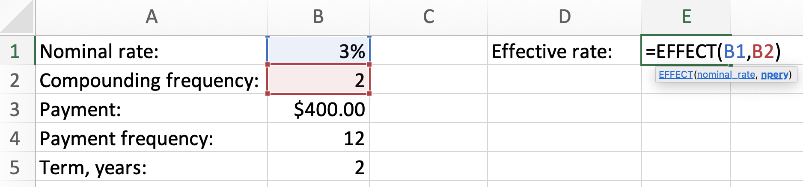
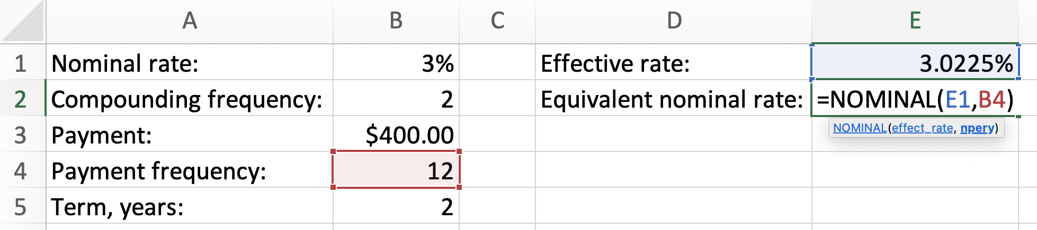
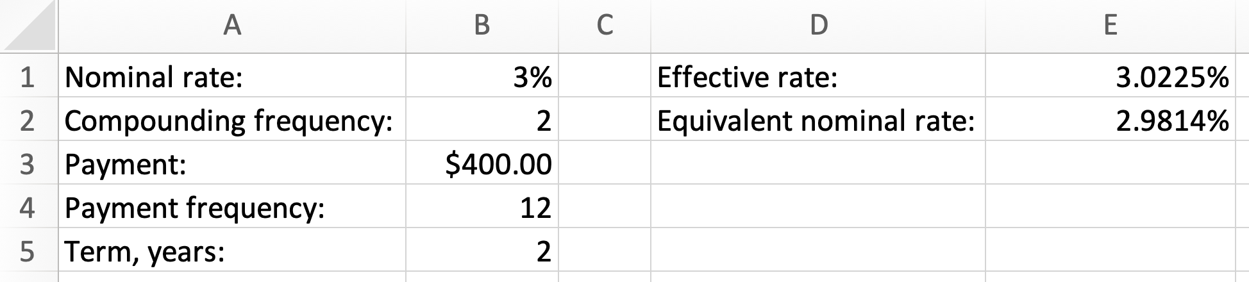

In cell E2 we now have the nominal rate compounded monthly and equivalent to 3% compounded semi-annually.
Next, we will use Excel’s formula FV() for finding the future value. Note that this formula requires the periodic rate (not the nominal rate). The payment must be negative to designate that this is an amount outgoing (this will give FV positive, as an amount incoming). The last argument (“type”) of the formula must be either “0” or “1”. Here “0” stands for the ordinary annuity and “1” stands for the due annuity.

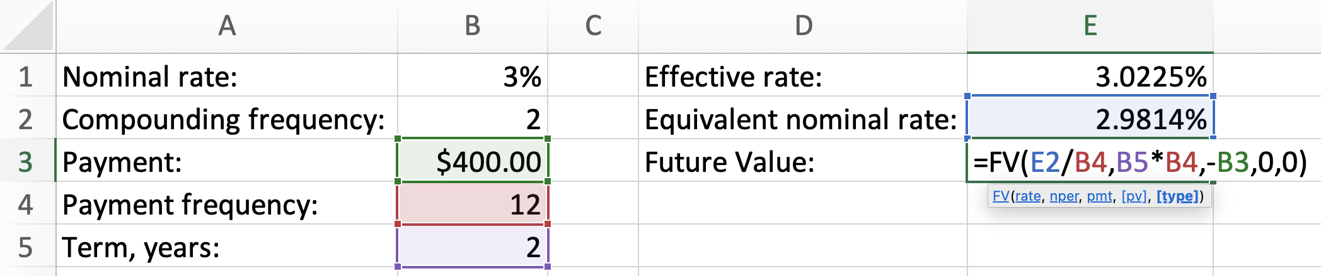
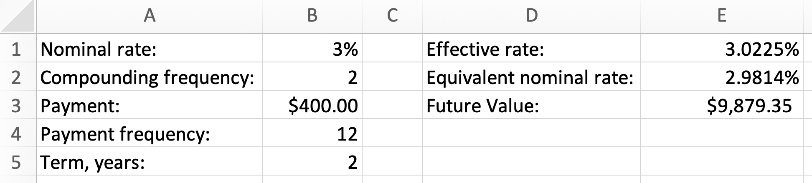
$∎$End of the Excel example.

Excel Example 6.2 (Compare to Example 6.5): What is the purchase price of the car if it can be paid off by paying $500 at the beginning of every month in 5 years. The rate of financing is 4.5% compounded daily. What is the interest amount charged for the loan?

The process is similar to Excel Example 6.1, Notice that because the annuity is due, the last argument of the Excel function PV() is “1”:

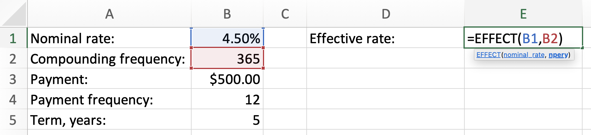
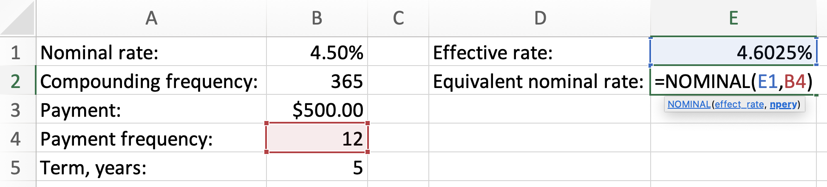
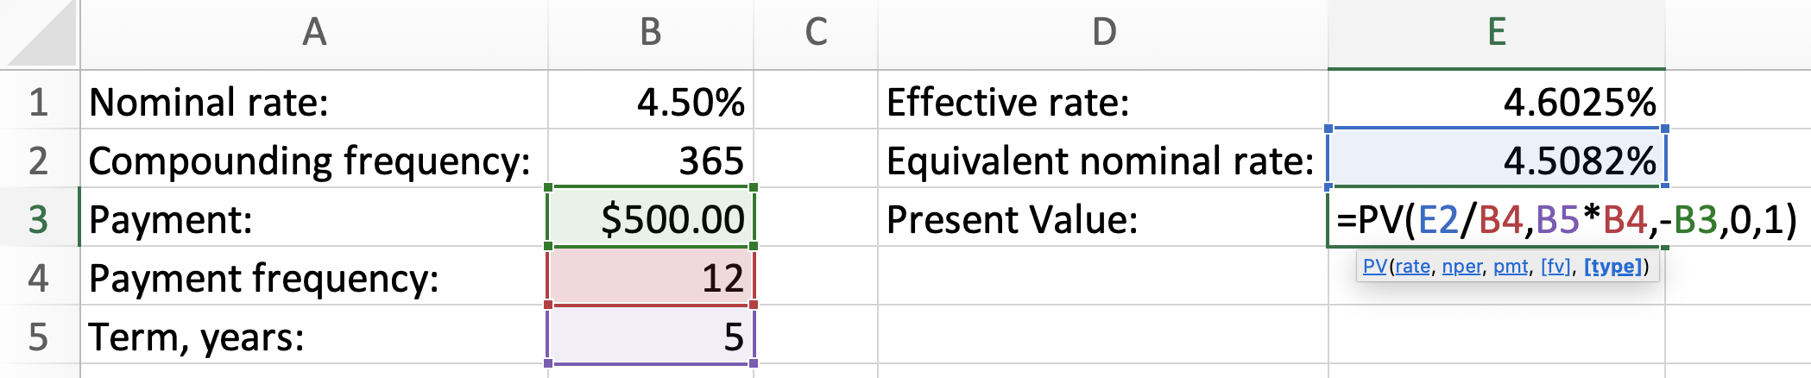
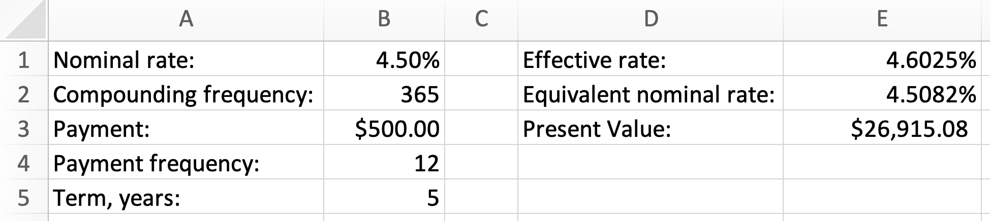

$∎$End of the Excel example.

Exercises

- Sinex Inc. financed the purchase of a machine with a loan at 4% compounded quarterly. This loan will be settled by making payments of $2,500 at the end of every quarter for 18 years. (a) What was the amount of the loan? (b) What was the total amount of interest charged?
- Stratex Inc. invested in bonds. This investment provided the annual rate of return of 4% compounded semi-annually. (a) If Stratex invested $10,000 at the beginning of every 6-month period, how much money will it accumulate at the end of 5 years and 6 months? (b) How much interest will it earn?
- If you save $5 at the beginning of every day, how much money will you accumulate in 10 years? Assume that you can save money at 3.5% compounded semi-annually.
- For his business, Hassan financed equipment by paying $2,000 at the beginning of every year for 10 years at 4.6% compounded quarterly. What was the value of the equipment at the start of the annuity? How much interest would be paid over 10 years?
- What amount can be borrowed today at 5.7% compounded annually, if you are able to pay $3,700 at the beginning of every year for 10 years to return this borrowed amount?
- What amount can yield $1,000 at the beginning of each month for 5 years, if the amount earns 2.5% compounded monthly?
- Michael paid off his student loan in 7 years with payments of $475 made at the end of each month. The interest rate on his loan was 4.7% compounded semi-annually. What was the amount of the loan?
- Linara opened an investment account. She made an initial investment of $15,000 and additionally decided to contribute $300 at the end of every month. How much interest will Linara earn by the end of 5 years, if the interest rate is 3.4% compounded semi-annually?
- Jashanpreet leased a car. The lease agreement required 36 beginning-of-month payments of $560. The residual value of the car was $25,000, 3 years from the time the lease was taken. What was the price of the car, if the effective rate was 4.8%?
- [Challenge] $1,000 is invested today at 5% compounded monthly. Find the future value of this investment in 5 years from today, using an annuity formula.
- [Challenge] Today is the first day of a month. Alex asked his bank if he could invest some amount today, to be able to pick up $1,000 in the middle of every month, each month, for 24 months. How much money must Alex invest today, if the rate is 4% compounded monthly?

Answers:

1. (a) $127,875.98 (b) $52,124.02; 2. (a) 124,120.90 (b) 14,120.90; 3. $21,817.45; 4. (a) $16,420.45 (b) $3,579.55; 5. $29,198.15; 6. $56,463.79; 7. $33,996.09; 8. $$4,332.76$; 9. $40,563.02; 10. $$1,283.36$; 11. $23,066.60.

Composite annuity problems

When we look at an annuity problem, we can encounter the following situations:

- The start of the annuity is delayed (the annuity is deferred).
- There a wait time after the annuity has matured.
- The interest rate changes during the annuity term.
- The payment structure changes during the annuity term.

The above 4 cases are the most frequent reasons why composite annuity problems arise in problems. By composite problems we mean either the problems when an annuity is combined with an additional growth or discounting process or when a problem combines several annuities. We will now consider 4 examples, illustrating each case.

Example 7.1 (Deferred annuity): What is the loan amount, if it requires 40 quarterly payments of $200 with the first payment made 2 years from the time the loan was taken? The interest rate for the whole time is 3% compounded daily.

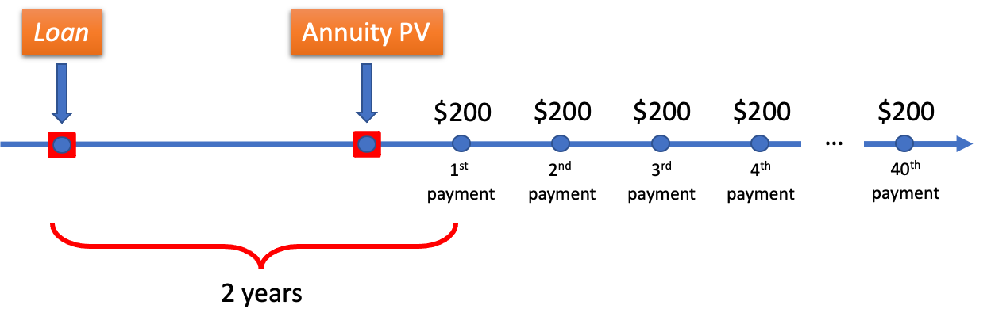

First, we must find the present value of the annuity. We will treat this annuity as a general ordinary annuity.
$${i_{2}=\left(1+\frac{0.03}{365}\right)}^{\frac{365}{4}}-1=0.007527885$$

$$PV= 200\left[\frac{{1- \left(1+i_{2}\right)}^{-40}}{i_{2}}\right]=6,885.66972$$

We are not rounding the $PV$, since we are not done yet. This $PV$ is located 7 quarters in the future from the time the loan was taken. This means that we must still find the equivalent amount at the time of the loan. This equivalent amount is the present value of $$6,885.66972$. Let’s call this amount ${PV}^{*}$:

$$PV^{*}=6,885.66972{\left(1+i_{2}\right)}^{-7 }=6,533.51.$$

This problem can also be solved in another way: finding the PV of a due annuity and discounting this present value 8 quarters to the time the loan was taken.

$∎$End of the example.

Example 7.2 (Wait time after the end of the annuity): After investing $700 at the beginning of every 6 month and making the last payment at the end of 4 years and 6 months, Sandeep waited 3 more years before picking up the amount. How much money did Sandeep pick up at the end of 7 years and 6 months? The interest rate was 4% compounded monthly for all time.

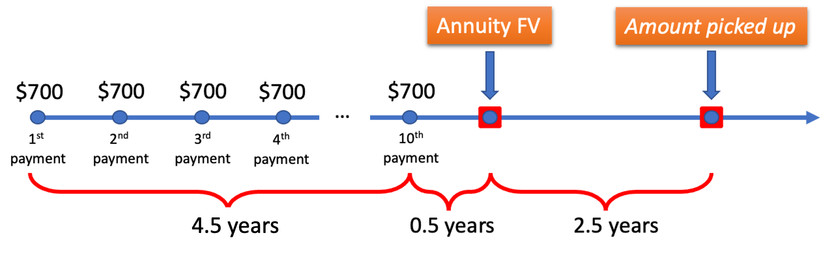

This is a general due annuity. The last payment is made at the end of 4 years and 6 months. Because this is a due annuity, its future value is located one period ahead of the last payment on the timeline. This means that our annuity ends 5 years from the time the first investment of $700 is made (in other words, the future value of the annuity is located 5 years since the first payment on the timeline). Let’s find the future value of this annuity:

$${i_{2}=\left(1+\frac{0.04}{12}\right)}^{\frac{12}{2}}-1=0.020167409$$

$$FV= 700\left(1+i_{2}\right)\left[\frac{{\left(1+i_{2}\right)}^{10}-1}{i_{2}}\right]=7,825.371313$$

This $FV$ will continue to grow for 2.5 years:

$${FV}^{*}=7,825.371313{(1+i_{2})}^{5}=8,646.93$$

$∎$End of the example.

Example 7.3 (Change of rate during the term): Omega Industries took a loan to build its new facility. The loan required end-of-month payments of $5,000 for 5 years. For the first 3 years the interest rate on the loan was 3% compounded monthly and for the remaining 2 years, the rate became 3% compounded daily. What was the loan amount?

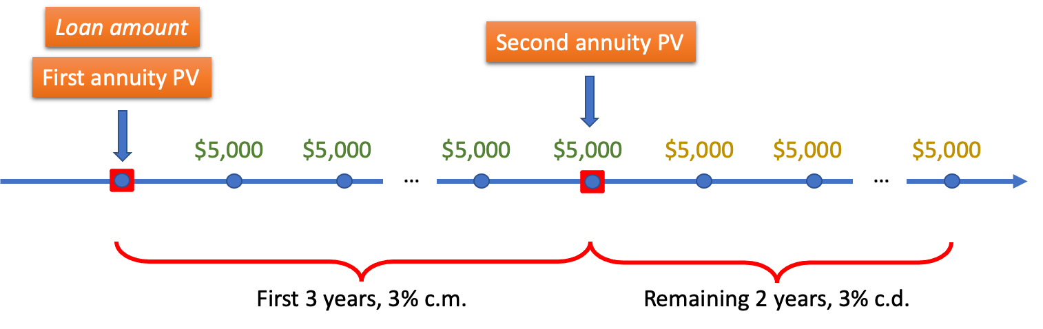

Because the rate changes, we deal with two annuities (remember that one annuity cannot have different rates). The first annuity spans the first three years, and the second annuity spans the remaining 2 years. Let’s find present values for the first and the second annuity.

- First annuity (simple ordinary):

$$i=\frac{0.03}{12}$$

$$PV_{1}= 5,000\left[\frac{{1- \left(1+i\right)}^{-12×3}}{i}\right]=171,932.3255$$

- Second annuity (general ordinary):

$${i_{2}=\left(1+\frac{0.03}{365}\right)}^{\frac{365}{12}}-1=0.002503025$$

$$PV_{2}= 5,000\left[\frac{{1- \left(1+i_{2}\right)}^{-12×2}}{i_{2}}\right]=116,325.5528$$

- Adjusting the PV of the second annuity:

$PV_{2}$is the amount located 3 years in the future from the time the loan was taken. We must modify this amount by moving it to the time of the loan (that is, we must find its present value):
$${PV}_{2}^{*}=116,325.5528{\left(1+\frac{0.03}{12}\right)}^{-12×3 }=106,325.4914$$

Notice that we used 3% compounded monthly to find ${PV}_{2}^{*}$ because this was the rate active for the first 3 years.

- Finding the loan amount:

$$Loan amount=PV_{1}+{PV}_{2}^{*}=171,932.3255+106,325.4914=278,257.82$$

$∎$End of the example
Example 7.4 (Change of payments during the term): For the first 4 years, Amreen made beginning-of-quarter contributions of $500 to her savings account. At the end of the 4th year, Amreen increased her contributions by $100 (with the last increased contribution being 6 years and 9 months from the first contribution of $500). How much money did Amreen save at the end of 7 years? The rate for all 7 years was 2% compounded annually.

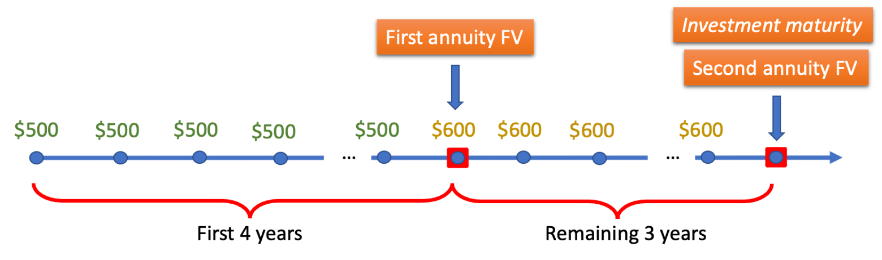

We can solve this problem by finding the future value of each annuity, modifying the first future value by moving it 3 years into the future and then summing the future value of the second annuity with the modified future value of the first annuity (a similar process to Example 7.3, but for the future values). However, this problem can be solved more efficiently if we notice that this problem can be represented by two annuities which have the future values 7 years from now:
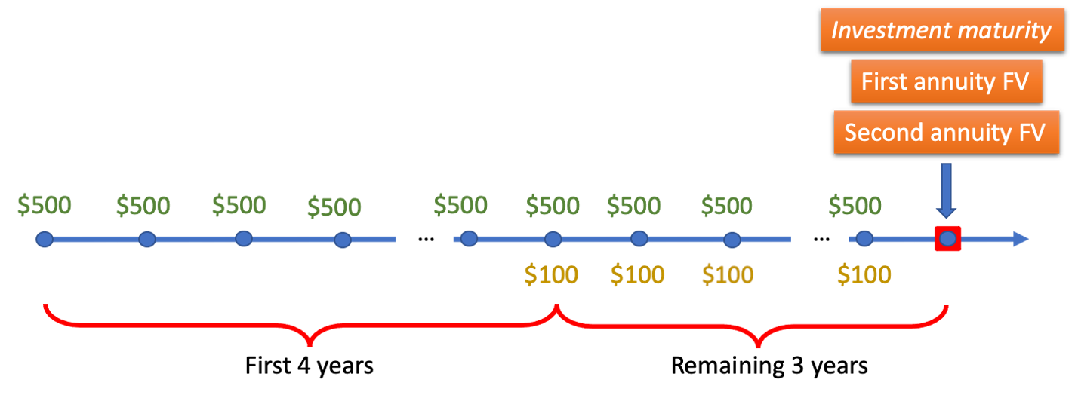

So, we must now find two annuity future values, and both will be located at the same time on the timeline (7 years from now).

- First annuity (general due):

$${i_{2}=\left(1+\frac{0.02}{1}\right)}^{\frac{1}{4}}-1=0.004962932$$

$$FV_{1}= 500\left(1+i_{2}\right)\left[\frac{{\left(1+i_{2}\right)}^{4×7}-1}{i_{2}}\right]=15,053.9638$$

- Second annuity (general due):

$$FV_{2}= 100\left(1+i_{2}\right)\left[\frac{{\left(1+i_{2}\right)}^{4×3}-1}{i_{2}}\right]=1,239.424123$$

- Finding the total maturity value:

$$Maturity value=FV_{1}+FV_{2}=15,053.9638+1,239.424123=16,293.39$$

$∎$End of the example.

Exercises

- Larry made deposits of $1,200 at the end of every 6 months for 8 years. He then stopped making contributions. Calculate the accumulated value in his account 6 years after the last deposit, if money earned 8% compounded semi-annually over the entire 14 year period?
- What is the accumulated value at the end of 7 years of the following investment structure: $400 is invested at the end of every month for all 7 years. At the end of 3 years, the interest rate switched from 3.4% compounded monthly to 3.6% compounded semi-annually.
- To pay for his loan, Jason paid $500 at the beginning of each quarter. During the first 6 years the rate was 2.8% compounded daily, and at the end of 6 years the rate switched to 3% compounded daily. Jason made the last payment exactly 9 years since the day of the loan. What was the loan amount?
- The rate for the whole term of the annuity (9 years) stayed 5% compounded semi-annually. At the end of 3 years, the payments of the annuity changed from $300 at the end of every month to $500 at the end of every month. Find the present value and the future value of this annuity.
- The first payment for a loan was made 6 months from the time the loan was taken. Then, 30 more payments followed, each made at the end of every month. Each payment amounted to $400. What was the loan amount if the rate was 5.2% compounded quarterly?

Answers:

- $ 41,930.13; 2. $38,066.67; 3. $16,340.02; 4. FV = $57,708.41, PV = $37,000.67; 5. $11,336.46.

Three additional problems are in the video: https://youtu.be/D0YUHXspAYM

Finding $PMT$, $n$ and $i$ of annuities

Finding payment

Finding the payment of an annuity is not difficult once students have mastered the main techniques for finding $PV$ and $FV$ of annuities. The following example will illustrate this.

Example 8.1: How much must be contributed at the beginning of every month to accumulate $340,000 in 9 years? Assume that the interest rate is 4% compounded annually.

$${i_{2}=\left(1+\frac{0.04}{1}\right)}^{\frac{1}{12}}-1=0.00327374$$

$$340,000= PMT(1+i_{2})\left[\frac{{(1+i_{2})}^{12×9}-1}{i_{2}}\right]$$

That is, everything is known here except the $PMT$. The same thing written differently:

$$340,000\text{= }PMT × A$$

where
$$A= \left(1+i_{2}\right)\left[\frac{{\left(1+i_{2}\right)}^{12×9}-1}{i_{2}}\right]=129.728584$$

Now the monthly contribution can be found:

$$PMT= \frac{340,000}{A}=2,620.86$$

Note that the contribution is rounded to two decimals, since it cannot be made with more than two decimals. This means that a discrepancy may result in the required future value. In practice, this discrepancy must be rectified by the last payment.

$∎$End of the example.

Finding the number of payments

To find the term of an annuity, we must perform some algebra on the main formulas for the $PV$ and $FV$ of annuities, keeping in mind the logarithm power property (please review Example 2.6). For instance, starting with the future value formula for a simple ordinary annuity, we can obtain the formula for $n$:
$$FV= PMT\left[\frac{{(1+i)}^{n}-1}{i}\right]$$

$$\frac{FV}{PMT}=\left[\frac{{(1+i)}^{n}-1}{i}\right]$$

$$\frac{i× FV}{PMT}={(1+i)}^{n}-1$$

$$1+\frac{i× FV}{PMT}={(1+i)}^{n}$$

Taking logarithm on both sides and using the logarithm power property:

$$\ln\left[1+\frac{i× FV}{PMT}\right]=n×ln\left[1+i\right]$$

$$n= \frac{\ln\left[1+\frac{i× FV}{PMT}\right]}{\ln\left[1+i\right]}$$

Using the same technique, one can obtain the formula for the case of the present value of a simple ordinary annuity (try to obtain this formula yourself):

$$n= -\frac{\ln\left[1-\frac{i× PV}{PMT}\right]}{\ln\left[1+i\right]}$$

Note that in the formulas above, n is the number of payments, not periods.

If an annuity is general, we must convert the rate. And if the annuity is due, we must replace each payment by the payment multiplied by $(1+i)$. Let’s explore several examples which will show how to find the number of payments.

Example 8.2: How many payments of $4000, each made at the end of every 6 month are necessary to pay off a loan of $45,000? The interest rate on the loan is 4.5% compounded quarterly. How much time does it take to deplete the loan?

$${i_{2}=\left(1+\frac{0.045}{4}\right)}^{\frac{4}{2}}-1=0.022626563$$

$$n= -\frac{\ln\left[1-\frac{i× PV}{PMT}\right]}{\ln\left[1+i\right]}$$

$$n= -\frac{\ln\left[1-\frac{i_{2}× 45,000}{4,000}\right]}{\ln\left[1+i_{2}\right]}=13.1295553$$

This answer means that 13 whole payments and 1 partial payment is required. That is, 14 payments in total.

It is beneficial to investigate this problem deeper to understand what the last payment is equal to. For this, let’s find what part of the loan amount the thirteen whole payments cover:

$$PV= 4000\left[\frac{{1- \left(1+i_{2}\right)}^{-13}}{i_{2}}\right]=44,617.44272$$

At the time the loan was taken, 13 whole payments were worth the amount of $44,617.44. This means that, at the time the loan was taken, the thirteen whole payments would leave the balance unpaid:

$$Balance=45,000-44,617.44272=382.5572785$$

Since this balance is located at the time the loan was taken, it needs to be adjusted to be at the time when the fourteenth payment will have to be paid:

$$Last payment=382.5572785{\left(1+i_{2}\right)}^{14}=523.28$$

So, to close the loan, 13 payments of $4,000 and one last payment of $523.28 are required. Note that there is a formula to obtain the last payment directly through the periodic payment and the decimal part of $n.$ See the footnote .

Answering the question about the time: because each payment is made at the end of each 6-month period, it requires 14 such periods to cover this loan. Since each period is 6 months long, the time to deplete the loan is 7 years.
$∎$End of the example.

Example 8.3: To pay off a loan of $56,000, Jason would need to pay $400 at the beginning of every month. If the interest rate on the loan is 3.4% compounded daily, how long will it take Jason to pay off the loan?
$${i_{2}=\left(1+\frac{0.034}{365}\right)}^{\frac{365}{12}}-1=0.00283722$$

The annuity is due: we must multiply each payment by $(1+i_{2})$.

$$n= -\frac{\ln\left[1-\frac{i_{2}× 56,000}{400\left(1+i_{2}\right)}\right]}{\ln\left[1+i_{2}\right]}=178.01$$

There are 179 payments in total: 178 whole payment and 1 partial payment. Keep in mind that in a due annuity, the first payment happens at the time the loan is taken. Therefore, 179 payments translate into 178 months to repay the loan (that is 14 years and 10 months) .

$∎$End of the example.

Example 8.4: How many end-of-month deposits of $560 are necessary to accumulate $34,000? Assume the interest rate for the investment is 4.2% compounded monthly.

$$n= \frac{\ln\left[1+\frac{i× FV}{PMT}\right]}{\ln\left[1+i\right]}$$

Keeping in mind that $i=0.042/12=0.0035,$

$$n= \frac{\ln\left[1+\frac{0.0035× 34,000}{560}\right]}{\ln\left[1.0035\right]}=55.14895574$$

That is, 55 whole payments and one partial payment is required. Let’s find this partial payment. For this we first find the balance after 55 whole payments (that is, amount accumulated after 55 payments):

$$FV= 560\left[\frac{{(1+i)}^{55}-1}{i}\right]=33,899.06191$$

The last payment must be contributed a month later, so $33,899.06191$ will grow for another month:
$$33,899.06191\left(1+i\right)=34,017.71$$

This shows that the last contribution must be negative, namely -$17.71! This is because the interest added over the last month exceeded the necessary future value. So, in this problem, there are 55 whole contributions of $560 and a last withdrawal of $17.71 to obtain exactly $34,000. In total, there are 56 transactions.

Note that there is a formula to obtain the last payment directly through the periodic payment and the whole part of $n.$ See the footnote .
$∎$End of the example.

Our last example will put together everything we have learned in this chapter:

Example 8.5: To save $30,000, Sanjar contributed some amount at the end of every month for 4 years into an account earning 3% compounded semi-annually. If Sanjar decided to leave the saved $30,000 in the account while continuing making the same monthly contributions, how much more time is necessary for him to reach a total savings of $50,000?

We first need to find the payment. Of course, we start by converting the rate:

$${i_{2}=\left(1+\frac{0.03}{2}\right)}^{\frac{2}{12}}-1=0.002484517$$

From the annuity FV formula, it follows that:

$$30,000= PMT\left[\frac{{(1+i_{2})}^{48}-1}{i_{2}}\right]$$

$$PMT= \frac{30,000}{50.91235062}=589.25$$

Now, we will use these contributions to find the number of them to save $50,000:

$$n= \frac{\ln\left[1+\frac{i_{2}× 50,000}{589.25}\right]}{\ln\left[1+i_{2}\right]}=77.09 \sim 78 contributions$$

It takes 78 contributions to save $50,000. We know that it took 48 months to save the first $30,000. So, the additional time necessary to save $20,000 is equal to 30 months or 2 years and 6 months.
$∎$End of the example.

Example 8.5 can have an interesting version:

Example 8.6: In addition to making an initial investment of $30,000, Sanjar contributed $589.25 at the end of every month into an account earning 3% compounded semi-annually. How much time is necessary for him to reach the total savings of $50,000?

Using $i_{2}$ from Example 8.5, we can build the following equation:

$$30,000{(1+i_{2})}^{n}+589.25\left[\frac{{(1+i_{2})}^{n}-1}{i_{2}}\right]=50,000$$

This equation means that we have simultaneous growth of $30,000 and the growth of the annuity payments, both growths resulting in $50,000. From this equation, we must find the number of payments (remember, we know $i_{2}$):

$$30,000{(1+i_{2})}^{n}+\frac{589.25}{i_{2}}{(1+i_{2})}^{n}-\frac{589.25}{i_{2}}=50,000$$

$${(1+i_{2})}^{n}\left[30,000+\frac{589.25}{i_{2}}\right]=50,000+\frac{589.25}{i_{2}}$$

$${(1+i_{2})}^{n}=\frac{50,000+\frac{589.25}{i_{2}}}{30,000+\frac{589.25}{i_{2}}}$$

Now we take logarithms on both sides and use the logarithm power property:

$$n=\frac{ln\left[\frac{50,000+\frac{589.25}{i_{2}}}{30,000+\frac{589.25}{i_{2}}}\right]⁡}{\ln{(1+i)}}=29.09 \sim 30 contributions$$

30 contributions converted to time is 30 months, or 2 years and 6 months.

$∎$End of the example.

From Example 8.6, we can deduce the following formula (try to see for yourself how):

$$n=\frac{ln\left[\frac{PMT+i×FV}{PMT+i×PV}\right]⁡}{\ln{(1+i)}}$$

This formula gives the number of payments necessary to save $FV$, given a $PV$ in the account. Notice that if $PV$ is equal to 0, we have our regular formula for n. Of course, this formula is for simple ordinary annuities. For general and due annuities, the usual modifications must be made ($i_{2}$ must be found for general annuities and payments must be multiplied by ($1+i)$ for due annuities).

Calculator and Excel techniques for finding $PMT$, $n$ and $i$ of annuities

Calculator Example 8.1 (Compare to Example 8.1): How much must be contributed at the beginning of every month to accumulate $340,000 in 9 years? Assume that the interest rate is 4% compounded annually.

At the start of the calculation, clear the calculator. To do this press:

$$〈CE|C〉 〈2ND〉 〈FV〉$$

Because this is a due annuity, we must first set the calculator to the “DUE” mode. First check if the calculator has already been set to this mode. If no “BGN” is displayed on the screen (in small letters above 0, when the calculator is turned on), the calculator is the “END” mode. To set the calculator to the required “BGN” mode, press:

$$〈2ND〉 〈PMT〉$$

$$〈2ND〉 〈ENTER〉 〈CE|C〉$$

Make sure that after this operation, “BGN” is being displayed.

Now we are ready to enter all the values. Enter total number of periods “N”:

$$〈12〉 〈×〉 〈9〉 〈=〉 〈N〉$$

Enter the annual interest percent “I/Y”, the payment frequency “P/Y” and the compounding frequency “C/Y”:

$$〈4〉 〈I/Y〉 〈2ND〉 〈I/Y〉 〈12〉 〈ENTER〉 〈↑〉 〈1〉 〈ENTER〉 〈CE|C〉$$

Since $340,000 must be accumulated, we enter this amount as $FV$:

$$〈340000〉 〈FV〉$$

We are ready to find the $PMT$:

$$〈CPT〉 〈PMT〉$$

The result is $2,620.86 (The calculator gave this answer as a negative amount, because PMT is the amount outgoing. We simply drop the negative sign).

$∎$End of the calculator example.

Calculator Example 8.2 (Compare to Example 8.3): To pay off a loan of $56,000, Jason would need to pay $400 at the beginning of every month. If the interest rate on the loan is 3.4% compounded daily, how many payments are there?
Clear the calculator and set to the “BGN” mode.

Enter the annual interest percent “I/Y”, the payment frequency “P/Y” and the compounding frequency “C/Y”:

$$〈3.4〉 〈I/Y〉 〈2ND〉 〈I/Y〉 〈12〉 〈ENTER〉 〈↑〉 〈365〉 〈ENTER〉 〈CE|C〉$$

$PV$is equal to $56,000. We must enter this in the calculator:

$$〈56000〉 〈PV〉$$

The periodic payment is $400 (it must be entered into the calculator as a negative amount, since it is the amount outgoing):

$$〈400〉 〈+|-〉 〈PMT〉$$

We are ready to find the total number of periods:

$$〈CPT〉 〈N〉$$

The result is 178.01, meaning that there are 179 payments in total.

$∎$End of the calculator example.

Calculator Example 8.3 (Compare to Example 8.6): In addition to making an initial investment of $30,000, Sanjar contributed $589.25 at the end of every month into an account earning 3% compounded semi-annually. How much time is necessary for him to reach the total savings of $50,000?

Clear the calculator and set to the “END” mode.

Enter the annual interest percent “I/Y”, the payment frequency “P/Y” and the compounding frequency “C/Y”:

$$〈3〉 〈I/Y〉 〈2ND〉 〈I/Y〉 〈12〉 〈ENTER〉 〈↑〉 〈2〉 〈ENTER〉 〈CE|C〉$$

$PV$is equal to $30,000. We must enter this in the calculator as a negative amount (as the amount outgoing):
$$〈30000〉 〈+|-〉 〈PV〉$$

Each periodic payment is $589.25 and is also an amount outgoing:

$$〈589.25〉 〈+|-〉 〈PMT〉$$

$FV$is equal to $50,000. This amount must be entered positive, since this will be the amount incoming:
$$〈50000〉 〈FV〉$$

We are ready to find the total number of periods:

$$〈CPT〉 〈N〉$$

The result is 29.09, meaning that 30 payments are necessary.

$∎$End of the calculator example.

Calculator Example 8.4. What nominal rate, compounded daily, is required for 34
end-of-quarter payments of $500 to produce the future value of $20,000?

This problem is unsolvable (with high precision) with algebra and can be solved only with technology.

Clear the calculator and set to the “END” mode.

Enter the payment frequency “P/Y” and the compounding frequency “C/Y”:

$$〈2ND〉 〈I/Y〉 〈4〉 〈ENTER〉 〈↑〉 〈365〉 〈ENTER〉 〈CE|C〉$$

The periodic payment is $500:

$$〈500〉 〈+|-〉 〈PMT〉$$

$FV$is equal to $20,000:
$$〈20000〉 〈FV〉$$

Total number of periods is 40:
$$〈34〉 〈N〉$$

We are ready to find the rate:
$$〈CPT〉 〈I/Y〉$$

The result is 3.83% compounded daily.

$∎$End of the calculator example.

Excel Example 8.1 (Compare to Example 8.1): How much must be contributed at the beginning of every month to accumulate $340,000 in 9 years? Assume that the interest rate is 4% compounded annually.

First, we must find the nominal rate compounded monthly, equivalent to 4% compounded annually:

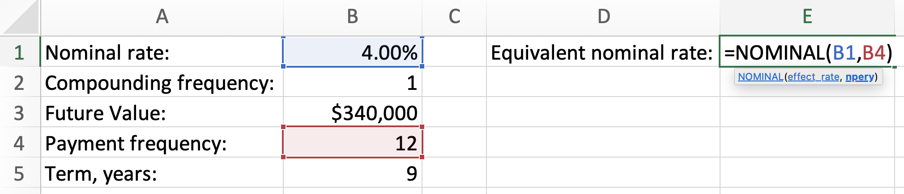
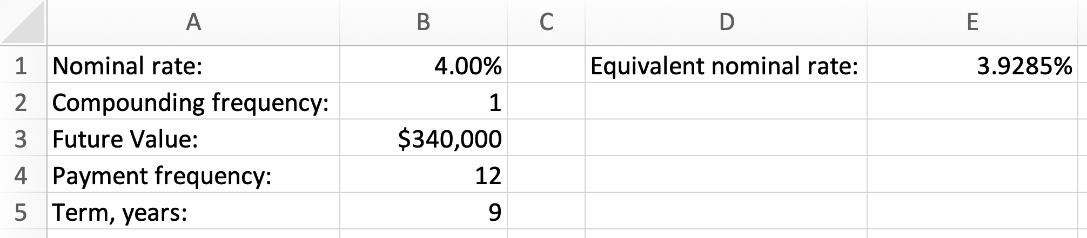

Then, we use Excel’s PMT() formula to find the payment. Remember that the $PV$ is equal to 0 and that because the annuity is due, we enter “type” argument of the formula equal to “1”:

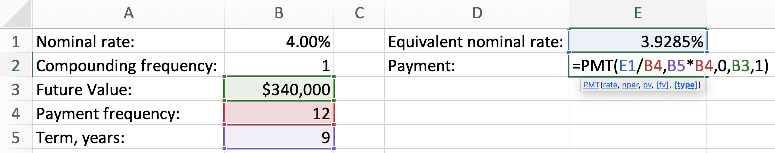
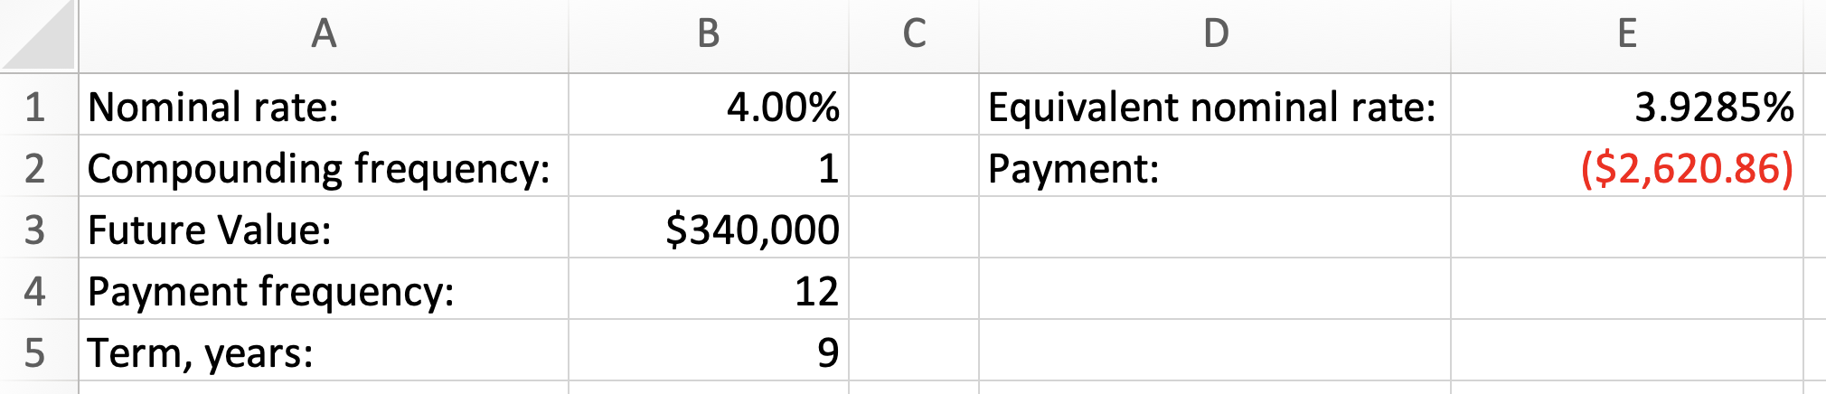

Note that the result we obtained is shown negative because the payment is the amount outgoing.

$∎$End of the Excel example.

Excel Example 8.2 (Compare to Example 8.3): To pay off a loan of $56,000, Jason would need to pay $400 at the beginning of every month. If the interest rate on the loan is 3.4% compounded daily, how many payments are there?

We start by converting the rate. For this we combine EFFECT() and NOMINAL() functions into one function (Make sure to review Excel Example 6.1 for more details).

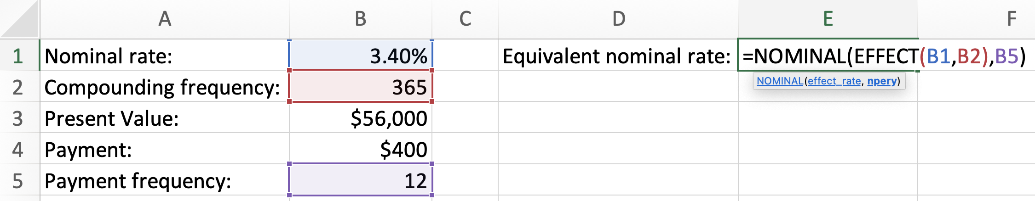

To find the total number of periods, we will use Excel’s NPER() function:

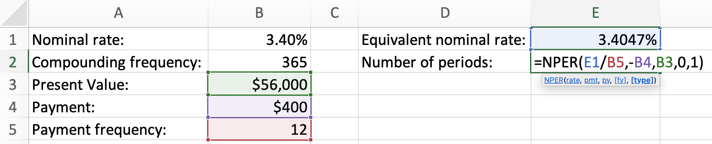
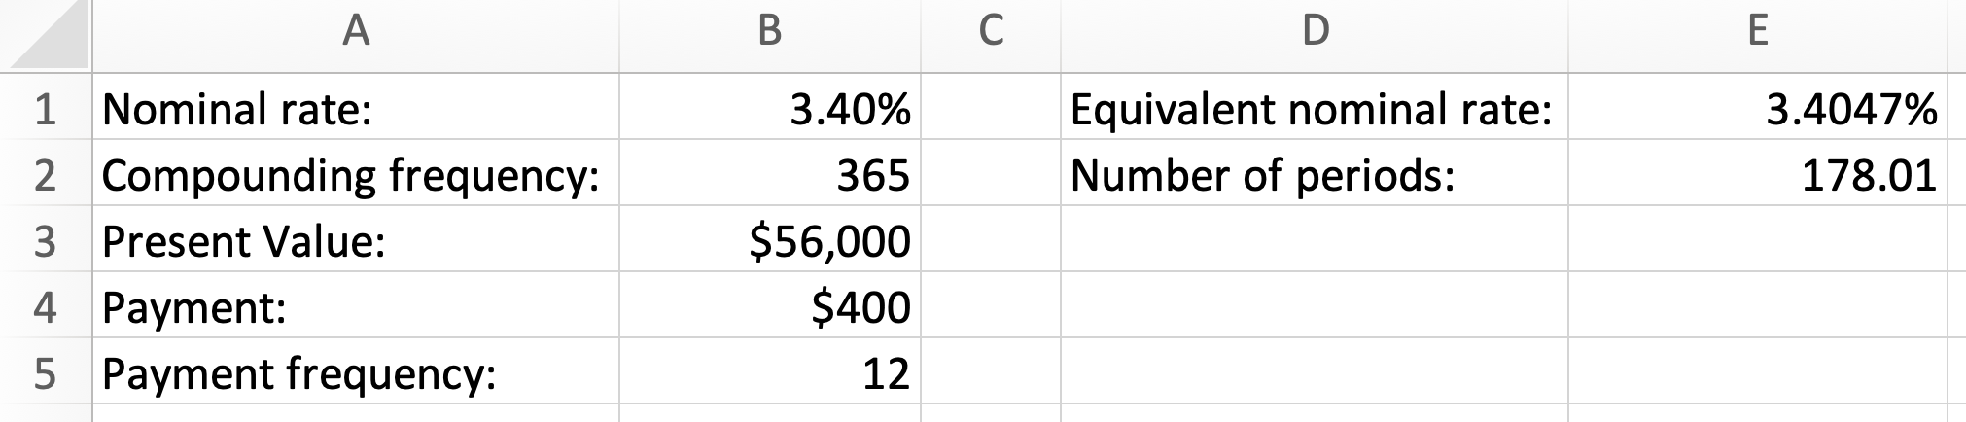

$∎$End of the Excel example.

Calculator Example 8.3 (Compare to Example 8.6): In addition to making an initial investment of $30,000, Sanjar contributed $589.25 at the end of every month into an account earning 3% compounded semi-annually. How much time is necessary for him to reach the total savings of $50,000?

Once you have understood Example 8.6 and Excel Example 8.2, the following Excel solution must be clear:

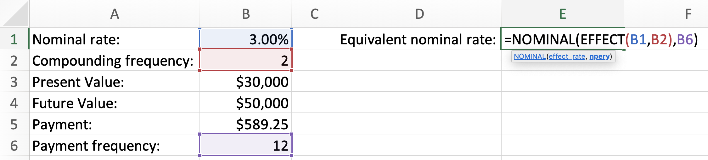
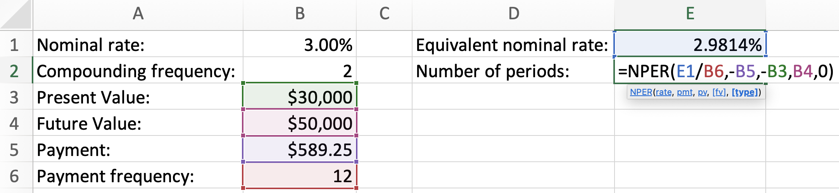
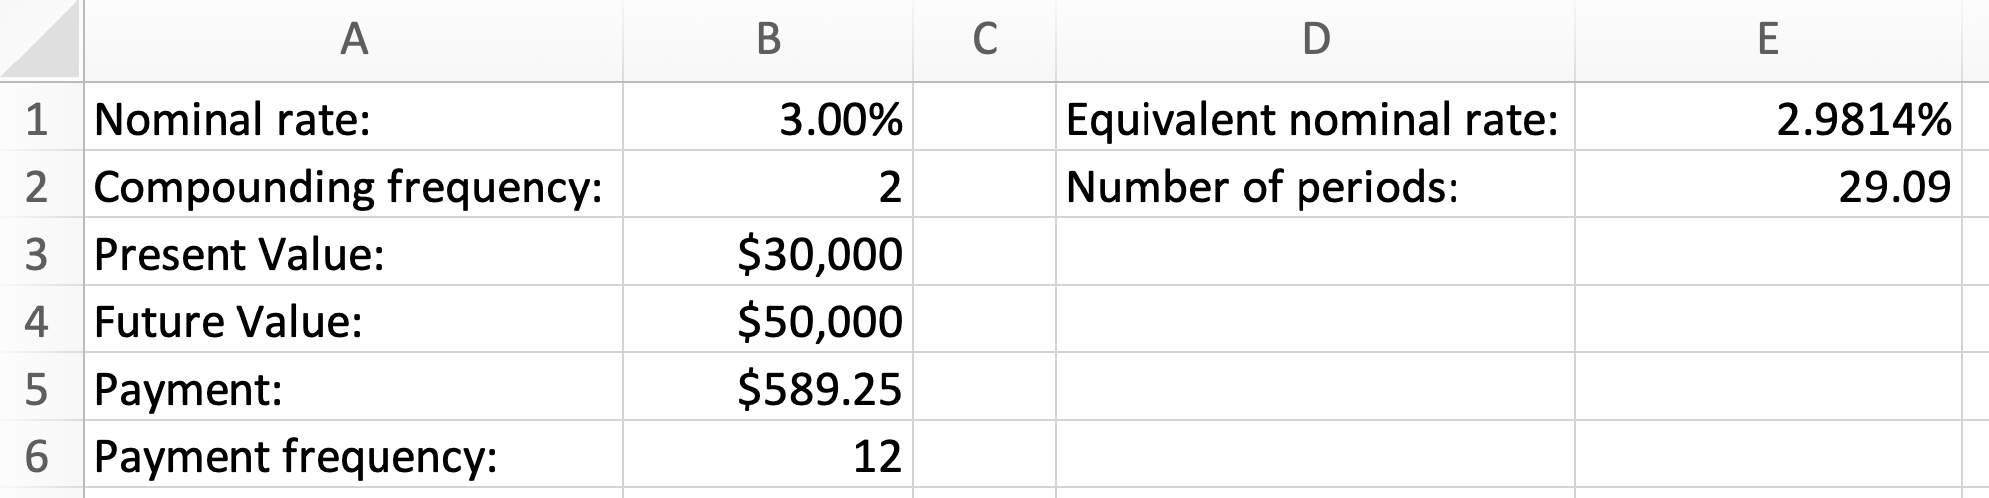

$∎$End of the Excel example.

Calculator Example 8.4: What nominal rate, compounded daily, is required for 34
end-of-quarter payments of $500 to produce the future value of $20,000?

We will use Excel’s function RATE(). The last argument of this function, “guess”, can be left empty.

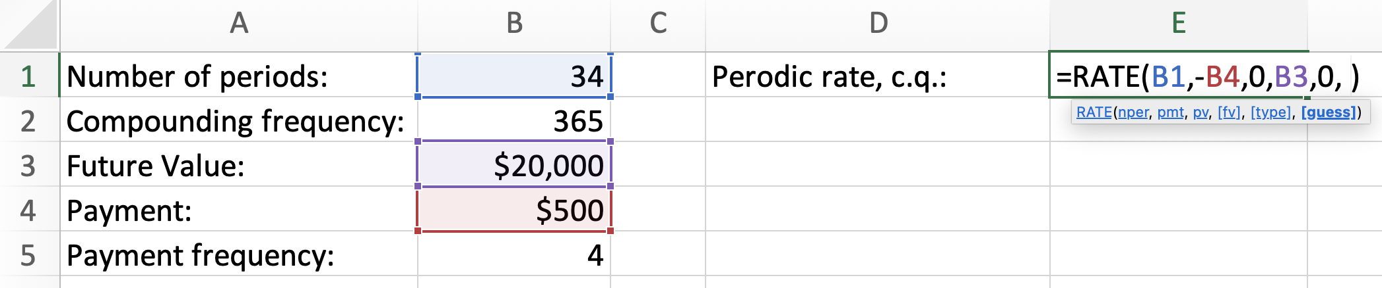
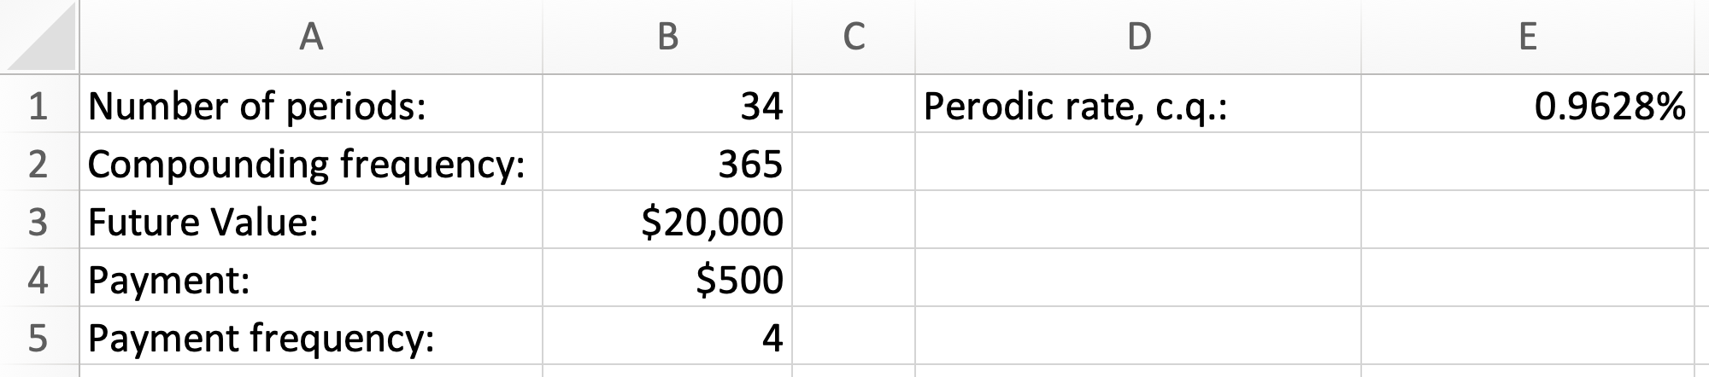

We have found the periodic rate, compounded quarterly. We must find the equivalent nominal (that is, annual) rate, compounded daily:

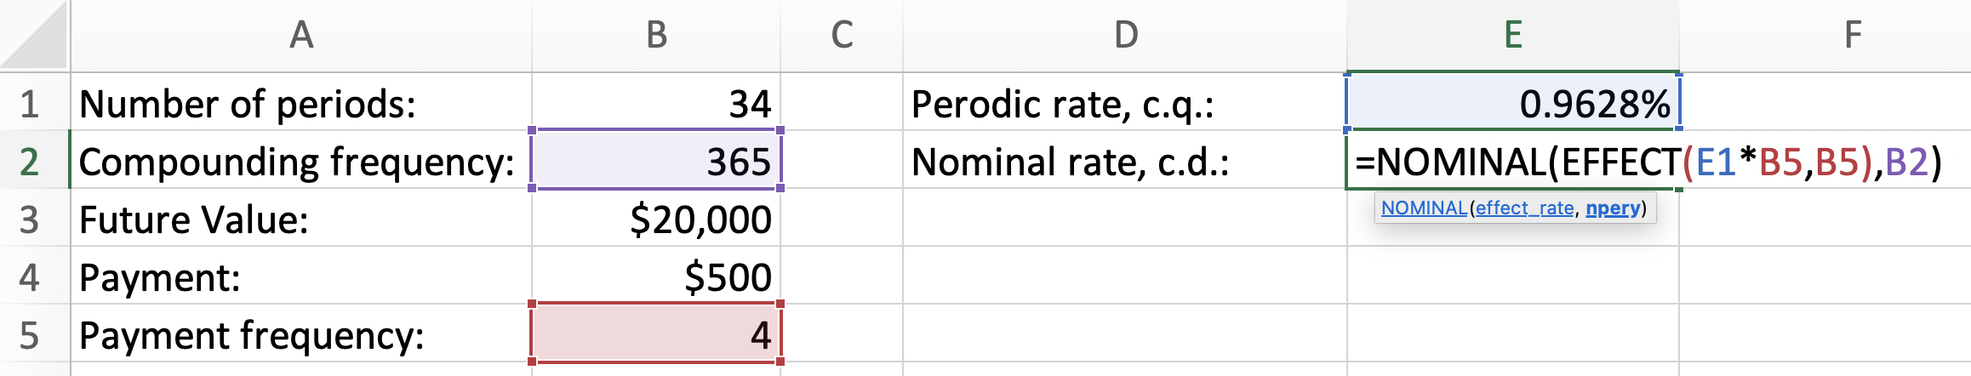
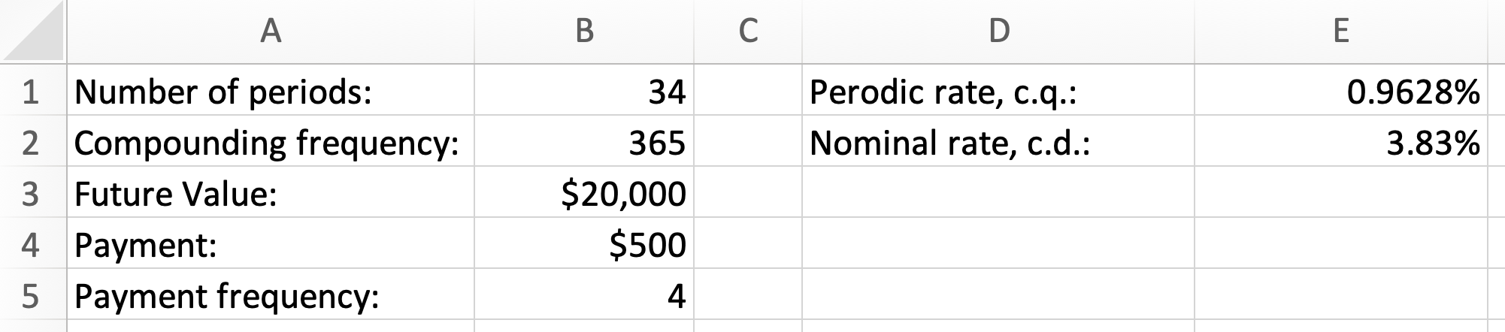

$∎$End of the Excel example.

Annuities review with algebra and Excel: https://youtu.be/GRtomwg05L4
Composite annuities review with algebra and Excel: https://youtu.be/D0YUHXspAYM

Exercises

- Sam financed a car worth $42,000 for 4 years. If the cost of borrowing was 4.2% compounded annually, calculate the size of the payment that is required to be made at the end of each month.
- In 5 years, Anna would like to have $45,000 in her account. If she can save money at 5.1% compounded annually, calculate the size of the deposit that she should be making at the end of each month.
- Andrea decided to save $7,000 for her trip over 2 years. If she found an investment opportunity of 5.5% compounded monthly, calculate the size of the monthly deposit that Andrea needs to make at the end of each month.
- You plan to save money to purchase a trailer. You can only afford to deposit $4,800 at the end of every six months into an account that earns interest at 4% compounded semi-annually. How many payments will you have to make to save at least $30,000? What is the last payment?
- How many beginning-of-month payments of $500 are required to pay off a loan of $10,500? The loan was borrowed at 3.4% compounded monthly. How many years and month does it take to pay off this loan?
- How many end-of-month deposits of $500 are required to pay off a car loan of $35,000 which was taken at 5.6% compounded semi-annually? What is the last deposit?
- How many whole and partial payments are required to accumulate $60,000 for a down payment, if you invest $1,000 at the beginning of every 6 month period at 4.2% compounded monthly?
- You have taken a loan of $45,000, which requires you to pay $5,000 at the end of every year. How many years will it take you to clear this loan? Assume that the rate of borrowing is 6.4% compounded daily.
- If your bank offered 2.3% compounded daily for your investments, how many years does it take to save $50,000, if you deposit $4,000 at the end of every half-year?
- How many beginning-of-the-quarter whole deposits of $223 are required to grow to $4,460, if the deposits are earning 2.7% compounded quarterly.
- Jaspreet took a loan of $50,000 at 4.50% compounded quarterly. The loan contract requires payments of $2,000 to be made at the beginning of each quarter. How many payments will Jaspreet have to make to pay off the loan? How much time does it take to pay off the loan?
- How long (in years and months) does it take for $10,000 to grow to $30,000 at 4% compounded monthly if, simultaneously with this growth, $150 is contributed at the beginning of every month.
- DYKO Bank offered compounded monthly rate which allowed Dev to pay off the loan of $5,000 in 3 years by making end-of-quarter payments of $420. What was the nominal rate on the loan?

Answers:
1. $950.60; 2. $661.97; 3. $276.59; 4. 6 payments, $4,521.02; 5. 22 payments, 1 year and 9 months; 6. 85 deposits, 364.46; 7. 38 whole and 1 partial payment; 8. 15 years; 9. 6 years; 10. 18 whole deposits; 11. 30 payments, 7 years and 3 months; 12. 7 years and 9 months; 13. 0.49%.

Perpetuities

Perpetuities as infinite term annuities

Let’s assume that you have invested $10,000 at 6% compounded monthly. At the end of the first month, you can collect the interest amount of $50. This is calculated in the following way:

$$I=10,000×\frac{0.06}{12}=50$$

After you have collected this interest amount one month after your investment, if the original $10,000 remains in the account for another month, you can collect $50 again two months after your investment. In fact, if you never remove the investment of $10,000 from the account, you can collect $50 of interest at the end of every month forever (provided that the interest rate does not change).

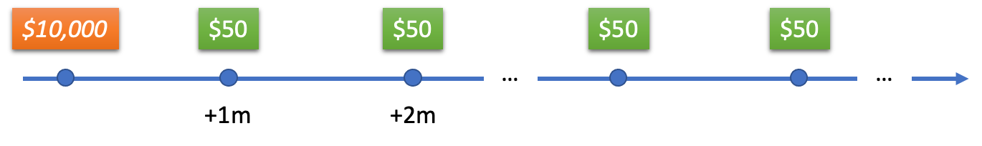
We say that the investment of $10,000 created a perpetuity. More exactly, a perpetuity is a never-ending sequence of payments, such that:

- Each payment is the same in size.
- Each time interval between payments is the same in length.
- The interest rate never changes.

Notice that a perpetuity is an annuity with an infinite term. As is the case with annuities, we can talk about simple, general, due, and ordinary perpetuities. These types of perpetuities are defined the same way as we defined them when we studied annuities (see Chapter 6).

The present value of a perpetuity (also called the price of a perpetuity) is the amount of money that must be kept in the account to guarantee the uninterrupted periodic interest payments. In the situation we began this chapter with, this amount is $10,000. Below are several more examples which will demonstrate the mathematics of perpetuities.

Example 9.1: How much must be invested today, to create a perpetuity providing payments of $73 at the end of every quarter? The interest rate is guaranteed to be 4% compounded daily, forever.

The rate compounding frequency does not coincide with the payment frequency. We call such perpetuity a “general perpetuity” (as opposed to a “simple perpetuity”, in which case the rate compounding frequency would be equal to the payment frequency). First, we must convert 4% compounded daily to the equivalent rate compounded quarterly (see Chapter 5):

$$i_{2}={\left(1+\frac{0.04}{365}\right)}^{\frac{365}{4}}-1=0.010049614$$

Note that here $i_{2}$ is the periodic rate per quarter.

Now we must find the amount $PV$ which, if invested at $i_{2}$, will yield interest amount of $73. This amount can be found from the following equation:

$$PV×i_{2}=73$$
Solving for $PV$:
$$PV= \frac{73}{i_{2}}=7,263.96$$

Thus, $PV$ is equal to $7,263.96, rounded to two decimal places.
$∎$End of the example.

Example 9.2: The stream of profits from an investment is $35 at the beginning of every 6 months. What is the present value of the profits? The interest rate is fixed at 3.5% compounded semi-annually.

The perpetuity is such that the payments are made at the beginning of each 6-month period. Such a perpetuity is called a “due perpetuity” (as opposed to an “ordinary perpetuity” in which case the payments would be made at the end of each time interval). Note that the present value of a due perpetuity is equal to the present value of an ordinary perpetuity plus the first payment. The equation to find the present value of the perpetuity without the first payment (that is, the price of the ordinary perpetuity):

$${PV}_{ord}×\frac{0.035}{2}=35$$

$${PV}_{ord}= \frac{35}{0.0175}$$

To find the present value of the required due perpetuity, we add the first payment:

$${PV}_{due}= \frac{35}{0.0175}+35$$

We can write the same calculation as:

$${PV}_{due}= \frac{35+35×0.0175}{0.0175}=\frac{35(1+0.0175)}{0.0175}$$

Now you can see that solving for due perpetuity requires modifying the payment by multiplying it by $(1+i)$. Computing, we obtain that ${PV}_{due}$ is equal to $2,035.

$∎$End of the example.

Examples 9.1 and 9.2 show that the present value of an ordinary simple perpetuity can be found using a very simple formula:
$$PV= \frac{PMT}{i}$$

where $PMT$ is the periodic payment and $i$is the periodic interest rate. If the perpetuity is general, the rate must be converted and if the perpetuity is due, the payment must be multiplied by $(1+i)$.

In practice, we often encounter perpetuities when an investment yields a stream of periodic income for an indefinitely long time in the future.

Example 9.3: Purchasing a shop will bring Yassir the profit of $1,230 at the end of every month. The expenses associated with keeping the shop operational will require $1,000 every 6 months, starting two years from the time the shop is purchased. If Yassir can invest money at 5% compounded monthly, how much does it make sense for Yassir to pay for the shop?

First, we find the present value of the profits. Treating the stream of monthly profits as a simple ordinary perpetuity, we find:

$${PV}_{profits}= \frac{PMT}{i}=\frac{1,230}{\left(\frac{0.05}{12}\right)}=295,200.00$$

Second, we find the present value of the expenses, treating the expenses as the general due perpetuity:
$$i_{2}={\left(1+\frac{0.05}{12}\right)}^{\frac{12}{2}}-1=0.025261868$$

$${PV}_{expenses}= \frac{1,000\left(1+i_{2}\right)}{i_{2}}=40,585.35456$$

This present value is located two years in future from the time of the shop purchase. Discounting this present value two years to the present, we obtain:

$${PV}_{expenses}^{*}= 40,585.35456{\left(1+i_{2}\right)}^{-4}=36,730.78$$

Subtracting the expenses from the profits:

$${PV}_{profits}-{PV}_{expenses}^{*}=258,469.22$$

This means that Yassir should not pay more than $258,469.22 for the shop. If the price were higher, Yassir could make more money by investing at 5% compounded monthly.

$∎$End of the example.

Sometimes perpetuities are securities that can be bought or sold.

Example 9.4: Assume that a perpetuity paying 8% at the end of every year was sold by the Government of Canada on January 1, 1935, for $1,000,000. If the Government of Canada decided to buy this perpetuity back on January 1, 2023, how much must it pay? Also assume that as of January 1, 2023, the interest rate for the Government of Canada is 2% compounded annually for unlimited terms.

When the Government of Canada sold the perpetuity in 1935, they needed to raise money. At that time, they were ready to pay annual interest of 8% for an unlimited term. This means that the perpetuity paid $80,000 to the buyer at the end of every year. On December 31, 2022, the Government of Canada made its scheduled payment of $80,000. Next day, on January 1, 2023, the Government of Canada closed the perpetuity by paying one amount equivalent to all future interest payments, subject to the current interest rate. This is the meaning of buying the perpetuity back. The price of buying back is the present value of the ordinary perpetuity:

$$PV= \frac{80,000}{0.02}=4,000,000$$

Thus, if the Government of Canada pays $4,000,000 on January 1, 2023, they will no longer need to pay the periodic payments, in essence making the original perpetuity cancelled.

$∎$End of the example.

Obtaining annuity $FV$ and $PV$ formulas by trading perpetuities

The information in this section is optional but can be useful for students wishing to understand annuity formulas.

As we have already seen in this chapter, you can purchase a security (called an ordinary perpetuity), which will pay to you the same periodic payment $PMT$ the end of every period, forever. If the periodic interest rate is $i$ (compounded with the same frequency as the frequency of periodic payments), the price of this security must be $\frac{PMT}{i}$.

Selling an ordinary perpetuity is the same as taking a loan of $\frac{PMT}{i}$. Making periodic payments $PMT$ at the end of every period is paying the interest on this loan. Later, the same perpetuity can be bought, meaning that the principal of the loan $\frac{PMT}{i}$ is returned, which closes the loan. For the current discussion, we assume that the interest for buying back is the same as the interest at the time of sale.

Let’s sell an ordinary perpetuity today and buy the same perpetuity $n$ periods from today. Doing this, we will make the periodic payments $n$ times. In other words, by selling an ordinary perpetuity today and buying the same perpetuity later, we create an ordinary annuity.

Let’s see this process in detail.

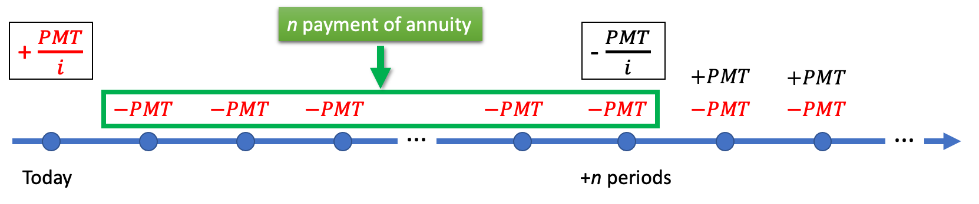

When you sell or buy something, you generate cash flows. Buying generates a negative cash flow and selling generates a positive cash flow.

When you sell a perpetuity today (that is, you take a loan), your cash flow today is + $\frac{PMT}{i}.$ You must make periodic payments $PMT$for this loan at the end of every period. If you buy the same perpetuity $n$ periods from today (that is, you invest), your cash flow as of $n$ periods from today is $-\frac{PMT}{i}$. You will receive periodic payments $PMT$ from this investment. Starting from $n+1$ period, the payments received from the investment will cancel the payments paid for the loan.

The first $n$payments form an annuity. The future value of all payments of this annuity at the time $n$ is $FV_{annuity}$. The present value of all payments of this annuity today is $PV_{annuity}$.

The total cash flow as of $n$ periods from today must be equal to 0 (because perpetuities are fairly exchanged for the periodic payments):

$$\frac{PMT}{i}{\left(1+i\right)}^{n} - \frac{PMT}{i} -FV_{annuity}=0$$

$$FV_{annuity}=\frac{PMT}{i}{\left(1+i\right)}^{n} - \frac{PMT}{i}$$

$$FV_{annuity}= PMT\left[ \frac{{(1+i)}^{n}-1}{i} \right]$$

The right side is the formula for the future value of a simple ordinary annuity.

The total cash flow as of today must be equal to 0 as well:

$$\frac{PMT}{i} - \frac{PMT}{i} {(1+i)}^{-n} -PV_{annuity}=0$$

$$PV_{annuity}=\frac{PMT}{i} - \frac{PMT}{i} {(1+i)}^{-n}$$

$$PV_{annuity}= PMT\left[ \frac{{(1+i)}^{n}-1}{i} \right]$$

The right side is the formula for the present value of a simple ordinary annuity.

Problems 7 and 8 are the examples of these techniques.

Exercises

- Find the price of a perpetuity providing $400 at the end of every month if the cost of money is 3% compounded quarterly.
- How much money must a university put into a perpetual account earning 2.3% compounded daily, if the university would like to pay $1,200 scholarship from this account at the beginning of every year?
- Nadine would like to set up a perpetual donation fund. She has agreed with her bank to deposit some amount today so that, starting three years from today, $50 can be paid towards the donation every quarter. If the bank agreed to guarantee 3% compounded semi-annually, what is the deposit amount?
- What is the most you should pay for a business opportunity today that will provide monthly income of $200 starting 3 years from now? The maintenance of this opportunity will require semi-annual expenses of $350 starting 4 years from now. Assume that your cost of money is 4% compounded quarterly for unlimited terms.
- FSL group invested $500,000 to build a new store. The store will begin bringing profits of $40,000 per year starting one year from now. What nominal rate, compounded semi-annually, will the store yield?
- A perpetuity carrying 4.5% annual interest rate and paying end-of-month payments was sold for $50,000. 7 years later (next day after the scheduled interest payment), when the market rate became 5% compounded daily, the perpetuity was bought back. What was the buy-back price?
- [Challenge] Find the future value of the following annuity by trading perpetuities: the annuity term is 5 years, the payments of $500 are made at the end of every month and the interest rate is 3% compounded monthly.
- [Challenge] Find the present value of the following annuity by trading perpetuities: the annuity term is 5 years, the payments of $500 are made at the end of every month and the interest rate is 3% compounded monthly.

Answers:

1. $160,399.34; 2. $52,777.86; 3. $6,165.45; 4. $38,452.93; 5.7.85%; 6. $44,909.40; 7.32,323.36; 8. $27,826.18.

Fixed income securities

Fixed income securities are debt instruments with fully predictable cash flows. There are many types of such securities, and a separate book must be written to describe them adequately. This chapter is not designed to provide a comprehensive coverage of fixed-income securities. Here we will highlight several such securities and demonstrate how the mathematics of interest rates can be used for their valuation.

Simple securities issued at the face value (GIC, PN)

Both Guaranteed Investment Certificates (GICs) and Promissory Notes (PNs) are the examples of securities which earn simple interest over fixed (locked) terms. Such a security is issued in the exchange of an amount, called the face value. At the end of the locked term the security matures, paying the face value together with the simple interest amount accrued.

GICs are standardized securities that are locked for the duration of their term: an investor cannot close GICs before their maturity. Because they are locked, investors expect higher returns (as opposed to unlocked accounts with an equivalent risk profile).

PNs are written by companies or individuals when they borrow money. These notes guarantee the interest payout at maturity and thus are being locked, just as GICs. Whereas GICs are standardized, PNs can be fine-tuned based on borrower-lender negotiations. GICs usually carry less risk of default compared to PNs because they are offered by well-established trust companies, whereas PNs can be issued by a company or an individual carrying any risk level. Of course, the risk profile of the borrower defines the amount of interest offered.

Because GICs and PNs are locked for the duration of the term and because all interest is paid at once at maturity, the interest rate they bear can be quoted as a simple interest rate. Using simple interest rate makes such instruments straightforward for borrowers and investors.

Example 10.1: At the time of its maturity, Alisa will earn $2,340 of interest from the 4-year GICs, bearing 3% p.a. How much did she invest into the GICs?

$$P=\frac{I}{rt}=\frac{2,340}{0.03×4}=19,500$$

Thus, Alisa invested $19,500 four years before GICs matured. Alisa could not withdraw the amount before maturity, since GICs are locked investments.
$∎$End of the example.

Example 10.2: New World Corporation (NWC) issued a 200-day promissory note with the face value of $100,000 and bearing 6.5% per annum. What was the value of the note for NWC eighty days later if, at that time, the corporation could invest money at 5.3% compounded semi-annually?

The note must mature in 200 days according to the rate specified in the note. The maturity value must be:
$$S=P\left(1+rt\right)$$

$$S=100,000\left(1+0.065×\frac{200}{365}\right)=103,561.64$$

This means that NWC must have $103,561.64 ready to pay once the note matures 200 days since the issue date. The value of the note 120 days before maturity is the present value based on the current investment rate:

$$PV=FV{(1+i)}^{-n}$$

$$PV=103,561.64{\left(1+\frac{0.053}{2}\right)}^{-2×\frac{120}{365}}=101,795.84$$

In other words, knowing that it must pay $103,561.64 at maturity, 120 before the maturity NWC would have to invest $101,795.84.
$∎$End of the example.

Simple securities issued at the discounted value (CP, T-bill)

Commercial papers (CPs) and Treasury Bills (T-bills) are other examples of locked debt instruments based on the simple interest rate. Typically, their maturity value (the face value or the par value) is set in advance, so that these securities are issued at a discounted price to account for the necessary interest.

CPs are issued by companies and are unsecured short-term dept instruments. T-bills are issued and backed by governments and have very low risk profile (sometimes even risk-free profile). Of course, low risk profile means that T-bills will pay low interest.

Example 10.3: On September 18, 2020, Galt Pizza issued a commercial paper having the face value of $10,000. If the paper was issued at $9,880 and its maturity day was December 17, 2020, what was the rate it yielded?

This was a 90-day commercial paper which earned $120 of interest over the 90 days. We can now find the interest rate (notice that 2020 was a leap year):

$$r=\frac{I}{Pt}=\frac{120}{9,880×\left(\frac{90}{366}\right)}=4.94\%$$

$∎$End of the example.

Example 10.4: A hedge fund bought a new 181-day, $100,000 T-bill for $99,216.34. After 114 days, the hedge fund sold the T-bill to yield 2.8%. (a) What was the yield of the T-bill at the time of the issue? (b) What was the price the hedge fund sold the T-bill for? (c) What was the annual rate of return the hedge fund realised over the time it held the T-bill?

- Here $100,000 is the maturity value (the face value of the T-bill). The yield rate at the time of issue is computed in the following way:

$$r=\frac{I}{Pt}=\frac{100,000-99,216.34}{99,216.34×\left(\frac{181}{365}\right)}=1.59\%$$

- At the time of the sale, the T-bill had 67 days left until maturity. We are looking for the simple present value:
$$P=S{\left(1+rt\right)}^{-1}$$

$$P=100,000{\left(1+0.028×\frac{67}{365}\right)}^{-1}=99,488.66$$

The T-bill was sold by the hedge fund for $99,488.66.

- The annual rate of return realised over 114 days:

$$r=\frac{I}{Pt}=\frac{99,488.66-99,216.34}{99,216.34×\left(\frac{114}{365}\right)}=0.88\%$$

This means that the hedge fund would have been better off not selling the T-bill early and instead waiting until maturity to realize a better return (since 1.59% is better than 0.88%). However, the sale could be necessary to raise funds for other (more profitable) investments.
$∎$End of the example.

Bonds

Bonds are debt instruments which pay an annuity of interest payments (coupons) over a fixed term. At the end of the term, the face value of the bond (which is the original loan amount) is paid together with the last coupon payment.

The following examples will demonstrate the mathematical structure of these securities.

Example 10.5: Alberta Petroleum (AP) issued a 10-year bond paying 3% semi-annual coupons and having the face value $50,000. (a) What is the value of the coupons at the time of the bond issue? (b) What is the value of the face value at the time of the bond issue? (c) What is the value of the bond at the time of the bond issue? (d) If AP’s cost of money does not change after 5 years, what is the price of the 5-year-old bond?

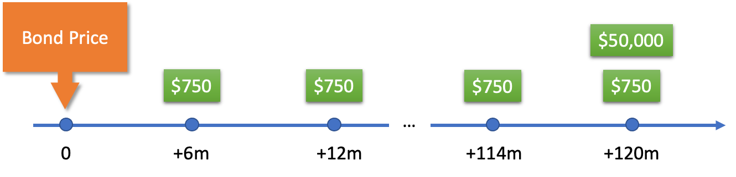

- This bond pays coupons at the end of every 6 months. The coupon rate of 3% is quoted as an annual rate. Each coupon size is therefore computed in the following way:

$$C=50,000×\frac{0.03}{2}=750$$

At the time of the bond issue, 3% compounded semi-annually is AP’s cost of debt. The value of the coupons at the time of the bond issue is the present value of the annuity:

$$i=\frac{0.03}{2}$$

$${PV}_{coupons}= 750\left[\frac{{1-\left(1+i\right)}^{-2×10}}{i}\right]=12,876.48$$

- The face value is $50,000 paid at the end of the bond’s life. At the time of the bond issue (that is 10 years prior to the bond maturity), the face value is worth:

$${PV}_{face value}=50,000{\left(1+i\right)}^{-2×10}=37,123.52$$

- The value of the whole bond at the time of the bond issue:

$${{PV}_{bond}=PV}_{coupons}+{PV}_{face value}=12,876.48+37,123.52=50,000$$

- An investor buying this bond 5 years from the time of its issue, will receive all the remaining coupons and the face value. So, the price must be:

$${PV}_{ bond}=750\left[\frac{{1-\left(1+i\right)}^{-2×5}}{i}\right]+50,000{\left(1+i\right)}^{-2×5}=50,000$$

$∎$End of the example.

Example 10.5 demonstrates that a new bond is always issued at its face value. If the risk profile of an issuing institution does not change (so the cost of money stays the same), the price of the old bond will equal to its face value. In this case, it is said that the bond is selling at par. However, in most cases, the risk profile of the issuing institution changes as time goes by. The price of the old bond then either increases or decreases to accommodate this change of the rate.

Example 10.6: What is the price of a 10-year $20,000 bond sold 4 years before its maturity, if the bond carries 4.5% monthly coupon? Assume that at the time of the sale, new $20,000 4-year bonds by the same company carry 4% semi-annual coupons.

The situation is such that when the 10-year bond was issued, the cost of debt for the issuing company was 4.5% compounded monthly. After 6 years, the cost of debt became 4% compounded semi-annually, so the new bond reflected the new rate. What happens to the price of the old bond? Before answering this question exactly, we can analyze the situation less formally.

The old bond available in the market 4 year before its maturity pays bigger interest than the newly issued 4-year bond, but it also has the same face value. The newly issued bond price must be equal to its face value (that is, equal to $20,000). Because the old bond is more attractive than the new bond, the price of the old bond must be higher than that of the new bond (which is $20,000): it must be sold at premium.

Using the current cost of debt (4% compounded semi-annually) we can calculate the exact price of the 6-year-old bond. First, we find the monthly coupon size:

$$C=20,000×\frac{0.045}{12}=75$$

Since the coupons form a general annuity, we must convert the rate first and then find the price of the bond:
$$i_{2}={\left(1+\frac{0.04}{2}\right)}^{\frac{2}{12}}-1=0.00330589$$

$${PV}_{ bond}=75\frac{{1-\left(1+i_{2}\right)}^{-12×4}}{i_{2}}+20,000{\left(1+i_{2}\right)}^{-12×4}=20,393.64$$

As we predicted, the price of the old bond ($20,393.64) is higher than its face value ($20,000). The old bond is sold at the premium of $393.64.

Note that both bonds, the old and the new, carry the same investment benefits to the bond holders 4 years prior to maturity. That benefit is 4.5% compounded semi-annually. From an investor perspective, it does not matter which bond to buy. Remember that while being more attractive in terms of the bigger coupons, the old bond is equivalently less attractive in terms of its price. The higher bond price negates the advantage of the bigger coupons.

$∎$End of the example.

Example 10.7: A $35,000 bond carrying 6% annual coupons was bought 7 years before maturity to yield 6.7% compounded annually. What was the bond price?

Similar to our analysis in Example 10.6, we can predict that the bond price must have been below the face value: the bond must have been sold at discount. This is because the bond offered smaller coupons than the current interest rate yielded.

$${PV}_{ bond}=2,100\frac{{1-\left(1+0.067\right)}^{-7}}{0.067}+35,000{\left(1+0.067\right)}^{-7}=33,665.70$$

The bond was sold at the discount of $1,334.30.
$∎$End of the example.

Example 10.8: What promissory note would provide an equivalent investment benefit to a $10,000, 2-year bond, bearing 5% quarterly coupons?

Let’s compute the amount of interest paid by the bond 2 years from now:

$$i=\frac{0.05}{4}$$

$${FV}_{ coupons}=125\left[\frac{{\left(1+i\right)}^{4×2}-1}{i}\right]=1,044.86$$

The promissory note is based on the simple interest. $1,044.86 is 10.4486% of $10,000 over two years, or 5.2243% per annum. Therefore, we can state the conditions for the equivalent promissory note: it is $10,000, 2-year promissory note, bearing 5.2243% p.a.

$∎$End of the example.

Calculator and Excel techniques for computing bond prices

Please review calculator and Excel techniques from Chapter 6 and 8 before reading further.

Calculator Example 10.1 (compare to Example 10.6): What is the price of a 10-year $20,000 bond sold 4 years before its maturity, if the bond carries 4.5% monthly coupon? Assume that at the time of the sale, new $20,000 4-year bonds by the same company carry 4% semi-annual coupons.

At the start of the calculation, you must clear the calculator. To do this press:

$$〈CE|C〉 〈2ND〉 〈FV〉$$

The calculator must be set to the “END” mode.

Now we are ready to enter all values. Enter total number of periods “N”:

$$〈12〉 〈×〉 〈4〉 〈=〉 〈N〉$$

Enter the annual interest percent “I/Y”, the payment frequency “P/Y” and the compounding frequency “C/Y”:

$$〈4〉 〈I/Y〉 〈2ND〉 〈I/Y〉 〈12〉 〈ENTER〉 〈↑〉 〈2〉 〈ENTER〉 〈CE|C〉$$

Now we must enter the face value and the coupons. The face value is the $FV$. Each coupon is the $PMT$. These values must be entered with negative signs, since they are both amounts outgoing.
$$〈20000〉 〈+|-〉 〈FV〉$$

Enter payment “PMT” (since payment is the amount outgoing, it must be entered negative):

$$〈20000〉 〈×〉 〈0.045〉 〈÷〉 〈12〉 〈=〉 〈+|-〉 〈PMT〉$$

Finally, we are ready to find the price of the bond:

$$〈CPT〉 〈PV〉$$

The result is $20,393.64.

$∎$End of the calculator example.

Excel Example 10.1 (compare to Example 10.6): What is the price of a 10-year $20,000 bond sold 4 years before its maturity, if the bond carries 4.5% monthly coupon? Assume that at the time of the sale, new $20,000 4-year bonds by the same company carry 4% semi-annual coupons.

First, we find the coupon size:

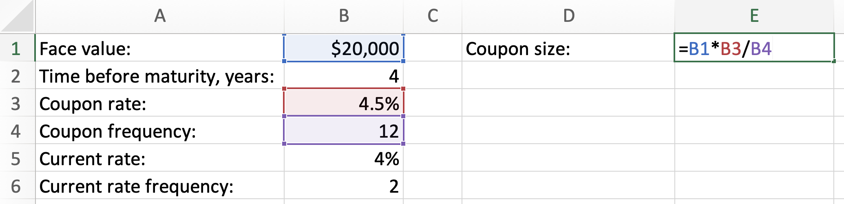

Then, we convert the rate:

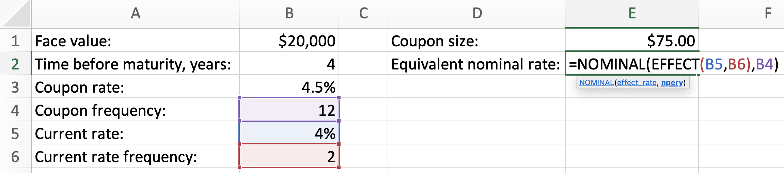

Finally, we find the bond price:

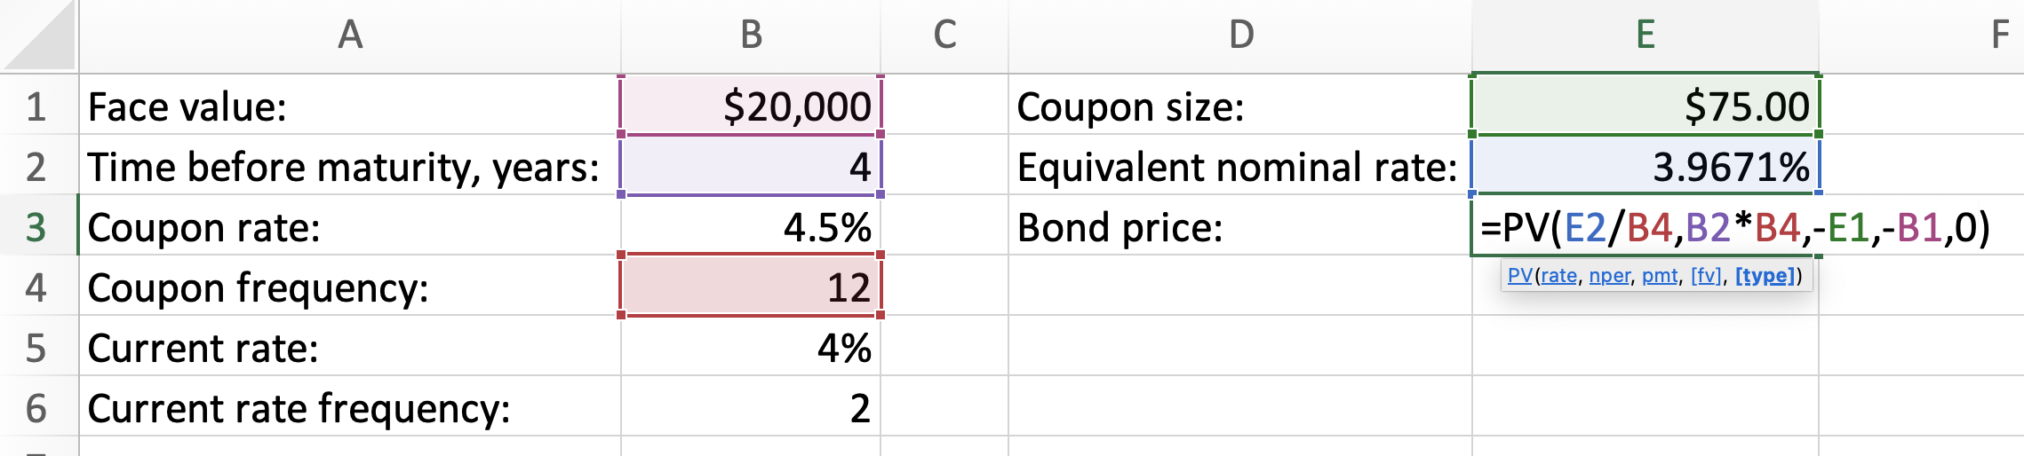
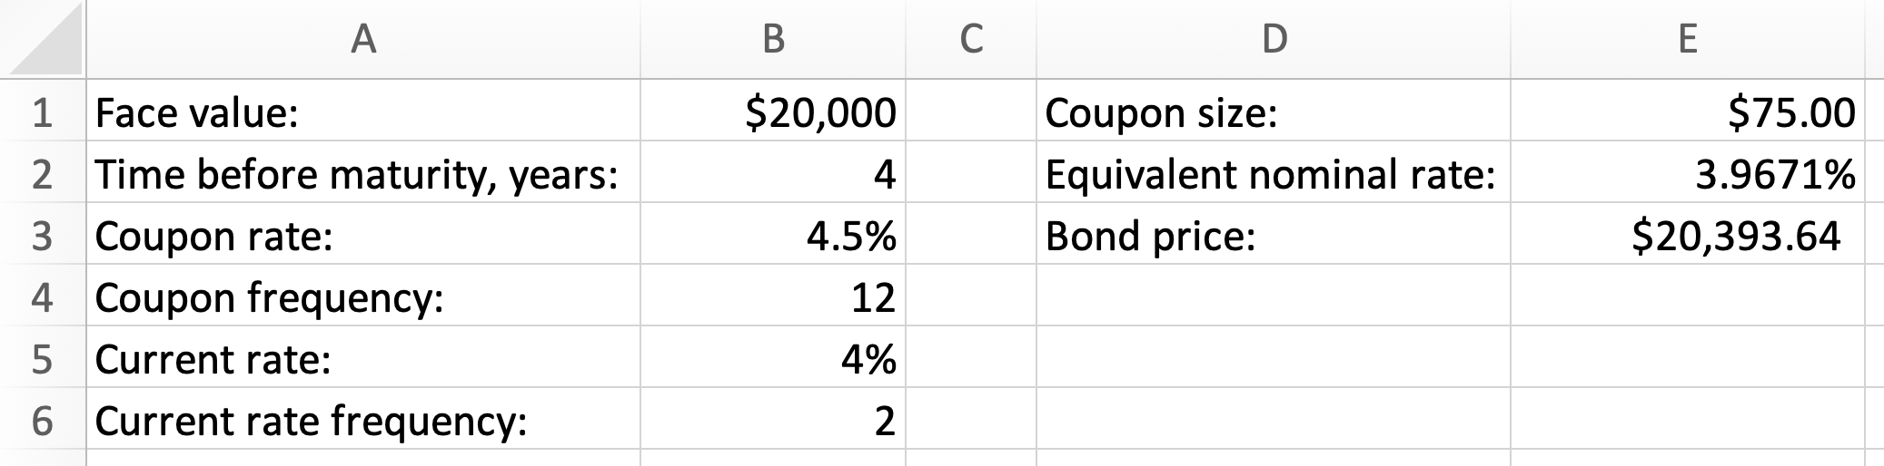

$∎$End of the Excel example.

Exercises

- What is the yield of a $20,000, 250-day promissory note which matures to $20,300?
- How much money must be invested into a 3-year GIC yielding 3.5% p.a., to earn $1,200 of interest?
- A 180-day commercial paper with the face value of $15,000 had the yield of 2.7%. What was the investment value of the GIC at the date of issue?
- Atlas Inc. issued a 4.8% p.a., 120-day promissory note, with the face value of $75,000. What was the value of the note 50 days before maturity if, at that time, Atlas’s cost of capital was 3.3% compounded monthly?
- What is the term of $100,000 T-bill, offering the rate of return of 1.5% and having the price of $99,261.66 at the time of issue?
- A 91-day, $200,000 T-bill was issued at the price of $198,912.95. Thirty days before maturity, the T-bill was sold to yield 1.7%. (a) What was the yield of the T-bill on the day of the issue? (b) How much was the T-bill sold for? (c) What was the annual rate of return realised while holding the T-bill?
- “Bond stripping” means selling coupons of a bond separately from its face value. An investor stripped a 15-year, $35,000 bond carrying 3.4% quarterly coupons. The stripping occurred 5 years before the bond’s maturity, when new 5-year bonds of the same company carried 3% quarterly coupons. (a) How much did the investor sell the coupons for? (b) How much did the investor sell the face value for? (c) How much would the whole bond have been priced 5 years before its maturity, if the investor had not stripped the bond?
- Find the price of a 10-year, $40,000 bond, sold 6 years before maturity to yield 2.3% compounded semi-annually. This bond carries 2% monthly coupons.
- Find the premium or discount for a bond sold 4 years before maturity, if the bond having the face value of $25,000 and bearing 5.7% semi-annual coupons was sold to yield 5% compounded daily.
- [Challenge] Orange Cafe would like to issue either a promissory note or a bond. The promissory note being considered has the face value of $50,0000, locks the term of 3 years, and promises 4.6% p.a. What bond, carrying semi-annual coupons would be equivalent to the promissory note?

Answers:

1. 2.19%; 2. $11,428.57; 3. $14,802.90; 4. $75,840.42; 5. 181 days; 6. (a) 2.19% (b) $199,720.94 (c) 2.43%; 7.35,647.78; 8. $39,352.60; 9. Premium $570.45; 10. 3-year, $50,000 bond carrying semi-annual coupons of $1,088.96.

Amortization of loans

Plain amortization

Consider the following situation: a loan amount of $100,000 has been taken at 5% compounded monthly for 3 years. To pay this loan off, end-of-month payments are to be made. From this information we can find that the periodic payment is equal to $2,997.09 (verify that this is so – use the techniques of Chapter 8). Let’s investigate the structure of the first two payments.

THE FIRST PAYMENT. The first payment will contain the interest amount accrued on the whole loan during the first month:
$$I_{1}=100,000×\frac{0.05}{12}=416.67$$

The remaining part of the first payment will go to the repayment of the principal. Thus, the principal repaid in the first payment is:

$$P_{1}=2,997.09-416.67=2,580.42$$

This means that the first payment consists of two parts:

$$PMT_{1}=P_{1}+I_{1}=2,580.42+416.67=2,997.09$$

THE SECOND PAYMENT. Now, let’s look at the structure of the second payment. After the first payment has been made, the loan balance becomes:

$$B_{2}=100,000-2,580.42=97,419.58$$

The second payment will contain the following interest and principal components:
$$I_{2}=97,419.58×\frac{0.05}{12}=405.91$$

$$P_{2}=2,997.09-405.91=2,591.18$$

So, the second payment consists of two parts:

$$PMT_{2}=P_{2}+I_{2}=2,591.18+405.91=2,997.09$$

FULL AMORTIZATION STRUCTURE. It is possible to continue this process for the remaining 34 payments. Each payment is the same in size, but each payment contains different proportions of the interest paid and the principal repaid. The later the payment is, the bigger proportion of the principal repaid it contains. This is because the loan principal is diminishing after each payment and therefore it requires lower interest amount in the upcoming payment. The last payment will deplete the loan. We can see all amortization information in the amortization table:

Month number | Beginning of  month balance | End-of-month  Payment size | Interest paid | Principal repaid
1 | $ 100,000.00 | $ 2,997.09 | $ 416.67 | $ 2,580.42
2 | $ 97,419.58 | $ 2,997.09 | $ 405.91 | $ 2,591.18
3 | $ 94,828.40 | $ 2,997.09 | $ 395.12 | $ 2,601.97
4 | $ 92,226.43 | $ 2,997.09 | $ 384.28 | $ 2,612.81
5 | $ 89,613.62 | $ 2,997.09 | $ 373.39 | $ 2,623.70
6 | $ 86,989.92 | $ 2,997.09 | $ 362.46 | $ 2,634.63
7 | $ 84,355.28 | $ 2,997.09 | $ 351.48 | $ 2,645.61
8 | $ 81,709.68 | $ 2,997.09 | $ 340.46 | $ 2,656.63
9 | $ 79,053.04 | $ 2,997.09 | $ 329.39 | $ 2,667.70
10 | $ 76,385.34 | $ 2,997.09 | $ 318.27 | $ 2,678.82
11 | $ 73,706.52 | $ 2,997.09 | $ 307.11 | $ 2,689.98
12 | $ 71,016.54 | $ 2,997.09 | $ 295.90 | $ 2,701.19
13 | $ 68,315.35 | $ 2,997.09 | $ 284.65 | $ 2,712.44
14 | $ 65,602.91 | $ 2,997.09 | $ 273.35 | $ 2,723.74
15 | $ 62,879.17 | $ 2,997.09 | $ 262.00 | $ 2,735.09
16 | $ 60,144.07 | $ 2,997.09 | $ 250.60 | $ 2,746.49
17 | $ 57,397.58 | $ 2,997.09 | $ 239.16 | $ 2,757.93
18 | $ 54,639.65 | $ 2,997.09 | $ 227.67 | $ 2,769.42
19 | $ 51,870.23 | $ 2,997.09 | $ 216.13 | $ 2,780.96
20 | $ 49,089.26 | $ 2,997.09 | $ 204.54 | $ 2,792.55
21 | $ 46,296.71 | $ 2,997.09 | $ 192.90 | $ 2,804.19
22 | $ 43,492.52 | $ 2,997.09 | $ 181.22 | $ 2,815.87
23 | $ 40,676.65 | $ 2,997.09 | $ 169.49 | $ 2,827.60
24 | $ 37,849.05 | $ 2,997.09 | $ 157.70 | $ 2,839.39
25 | $ 35,009.66 | $ 2,997.09 | $ 145.87 | $ 2,851.22
26 | $ 32,158.45 | $ 2,997.09 | $ 133.99 | $ 2,863.10
27 | $ 29,295.35 | $ 2,997.09 | $ 122.06 | $ 2,875.03
28 | $ 26,420.32 | $ 2,997.09 | $ 110.08 | $ 2,887.01
29 | $ 23,533.32 | $ 2,997.09 | $ 98.06 | $ 2,899.03
30 | $ 20,634.28 | $ 2,997.09 | $ 85.98 | $ 2,911.11
31 | $ 17,723.17 | $ 2,997.09 | $ 73.85 | $ 2,923.24
32 | $ 14,799.93 | $ 2,997.09 | $ 61.67 | $ 2,935.42
33 | $ 11,864.50 | $ 2,997.09 | $ 49.44 | $ 2,947.65
34 | $ 8,916.85 | $ 2,997.09 | $ 37.15 | $ 2,959.94
35 | $ 5,956.91 | $ 2,997.09 | $ 24.82 | $ 2,972.27
36 | $ 2,984.64 | $ 2,997.09 | $ 12.44 | $ 2,984.65

Note: In the amortization table, the interest amounts are shown rounded to two decimals. However, their full unrounded values are used to construct the table. A financial institution will always round the payment (which must be actually paid every month) but will keep all intermediate calculations using unrounded values. Careful reader will notice that in our table, the last payment must be 1 cent smaller, due to the periodic payment rounding to two decimals (notice that the balance repaid in the last period is one cent higher than the beginning balance for that period).

We can also see the payment structure in the amortization chart (in this chart the height of each bar is equal to the payment amount $2,997.09:

Using the amortization table, we can answer many questions. For example:

Question a: What is the balance after the 25th payment? Answer: $32,158.45.

Question b: What is the interest included in the 30th payment? Answer: $85.98.

But how can we answer such questions without building an amortization table? We can learn the approach from the following example:

Example 11.1: A loan of $100,000 is amortized by end-of-month payments at 5% compounded monthly for 3 years. (a) What is the balance after the 25th payment? (b) How much interest is included in the 26th payment and how much of the principal is repaid in the 26th payment? (c) What is the interest included in the 30th payment? (d) What is the interest included in the last 15 payments?

This example uses the same data we used to build the amortization table and we already answered questions (a) and (c) with the help of the table. However, in this example, we will answer these questions without using the table.

- To understand how to find the balance after the 25th payment, we can view the situation in the following way. Assume that there are two separate accounts, a “loan account” and a “payment account”. The loan account keeps track of the current loan disregarding the periodic payments. There, the loan of $100,000 grows at 5% compounded monthly. The payment account keeps track of the total value of all periodic payments. There, periodic payments of $2,997.09 grow as an annuity at 5% compounded monthly. As soon as the 25th payment has been contributed, we can compare the balances of the loan account and the savings account.

At the end of 25 months, the loan of $100,000 will grow to:

$$FV_{loan}=100,000{\left(1+\frac{0.05}{12}\right)}^{25}=110,954.5258$$

This means that the balance of the loan account is $110,954.53. If we wanted to close the loan at the end of 25 months, we would have to pay this amount.

Let’s see how much money are in the payment account by the end of 25 months:

$$i=\frac{0.05}{12}$$

$$FV_{payments}=2,997.09\left[\frac{{\left(1+i\right)}^{25}-1}{i}\right]=78,796.07921$$

This means as soon as the 25th payment has been made, $78,796.08 is in the payment account.

Withdrawing the available money from the payment account and using it to pay for the loan, we can find the balance of the loan right after the 25th payment (that is the starting balance for the 26-th period):

$$B_{26}=FV_{loan}-FV_{payments}=32,158.44659$$

- Once we know the starting balance for the 26th period, we can find the interest included and the principal repaid in the 26th payment:

$$I_{26}=B_{26}×\frac{0.05}{12}=133.99$$

$$P_{26}=2,997.09-133.99=2,863.10$$

- To find the interest amount included in the 30th payment, we will first need to find the balance after the 29th payment, following the technique described in part (a) of this example:
$$B_{30}=100,000{\left(1+i\right)}^{29}-2,997.09\left[\frac{{\left(1+i\right)}^{29}-1}{i}\right]=20,634.28424$$

Using this balance, we can find the interest included in the 30th payment:

$$I_{30}=B_{30}×\frac{0.05}{12}=85.98$$

- To find the interest included in the last 15 payments, let’s find the balance after 21 payments (found as 36 - 15 = 21):

$$B_{22}=100,000{\left(1+i\right)}^{21}-2,997.09\left[\frac{{\left(1+i\right)}^{21}-1}{i}\right]=43,492.52371$$

To pay off this balance, 15 payments of $2,997.09 will be made. Therefore, the interest included in the last 15 payments is:

$$I=2,997.09×15 -43,492.52371=1,463.83$$

In fact, the interest included in the last 15 payments will be one cent smaller: $1,463.82. This is because the last payment is 1 cent smaller (due to each payment being rounded to two decimals).

$∎$End of the example.

Amortization with rounded payments

In many situations, periodic payments are rounded, for convenience. This rounding leads to the change in the amortization term and a different last payment.

Example 11.2: A mortgage valued at $700,000 is to be amortized at 5.8% compounded semi-annually for 30 years, with monthly payments rounded to the next $100. (a) What is the term based on the rounded payments? (b) What is the last payment? (c) How much interest will be paid?

- End-of-month payments are assumed (we always assume end-of-period payments when nothing is mentioned about this in the problem). We must first find the periodic payment rounded to the nearest cent. This payment is equal to $4,076.62 (see Chapter 8 for finding the payment). Rounding each payment to the next $100 means that each payment must become $4,100.00. Because each rounded periodic payment is bigger, the mortgage will be paid sooner. Using the techniques of Chapter 8, we can find that the number of months required to pay the loan off using the updated payments is 354.6154187. Therefore, there will be 354 whole payments of $4,100 and the last partial payment, or 355 payments in total. Thus, the updated term is 29 years and 7 months.
- In Chapter 8, we demonstrated how to find the last payment. One way to find the last payment would be to find the balance after all whole payments (after 354 payments) and then adding one month worth of interest to this balance. However, a more convenient way to find the last payment is by using the formula:

$$Last payment=PMT\left[\frac{1-{\left(1+i_{2}\right)}^{-d}}{i_{2}}\right](1+i_{2})$$

In this formula, $d$ is the decimal part of the number of periods (in our case, $d$ is 0.6154187). Using this formula, we can find the last payment:
$$i_{2}={\left(1+\frac{0.058}{2}\right)}^{\frac{2}{12}}-1=0.004775945$$

$$Last payment=4,100\left[\frac{1-{\left(1+i_{2}\right)}^{-0.6154187}}{i_{2}}\right]\left(1+i_{2}\right)=2,525.53$$

- The interest paid is calculated by subtracting the loan amount from the sum of all payments:

$$I=\left(4,100.00×354+2,525.53\right)-700,000=753,925.53$$

Thus, over 29 years and 7 months, more interest will be paid than the amount of the loan!

$∎$End of the example.

Amortization under variable rates

For long term loans, the lender usually cannot fix the rate for the whole term. Instead, the lender would guarantee the rate for some initial term (a micro-term), and then would update the rate for the next micro-term based on the current market conditions. There may be many such micro-terms during the whole term of the mortgage.

Example 11.3: Nadia bought a house by signing a 25-year mortgage agreement. The price of the house was $890,000 and the interest rate for the first 5-year term was 3.7% compounded semi-annually. (a) What was the monthly payment for the mortgage during the first 5-year term? (b) What was the monthly payment during the second 5-year term, if the interest rate for the second term became 4.2% compounded semi-annually?

- Note that if it is not mentioned explicitly that the payments are made at the end of each period, this is what is assumed. The payment for the first 5-year term is computed under the assumption that the rate will stay 3.7% compounded semi-annually for the whole 25-year term of the mortgage (even though this rate is guaranteed for the first five years only).
$$i_{2}={\left(1+\frac{0.037}{2}\right)}^{\frac{2}{12}}-1=0.003059831$$

$$890,000= PMT\left[\frac{1-{\left(1+i_{2}\right)}^{-12×25}}{i_{2}}\right]$$

From the above, we find the payment:

$$PMT=4,537.97$$

- At the beginning of the second 5-year term, the rate changed to 4.2% compounded semi-annually. It is best to think about this situation in the following way: a new mortgage is taken for 20 years which is based on the updated balance and the updated rate. Let’s find the balance after the first 5-year term (remember that during the first 5-year term, the rate was 3.7% compounded semi-annually, for which we already calculated $i_{2}$ and the payment):

$$B_{61}=890,000{\left(1+i_{2}\right)}^{60}-4,537.97\left[\frac{{\left(1+i_{2}\right)}^{60}-1}{i_{2}}\right]=770,680.7831$$

We are not rounding the balance, because it will not be cashed out and will be used for further calculation. As was mentioned above, we now need to find the payment for the new mortgage of $770,680.7831 amortized over 20 years at 4.2% compounded semi-annually.
$$i_{2}={\left(1+\frac{0.042}{2}\right)}^{\frac{2}{12}}-1=0.003469762$$

$$770,680.7831= PMT\left[\frac{1-{\left(1+i_{2}\right)}^{-12×20}}{i_{2}}\right]$$

$$PMT=4,736.93$$

As is expected, the payment became higher, since the interest rate increased. This payment will stay until the end of the second 5-year term.

$∎$End of the example.

While Example 11.3 focused on only the first two terms, we can demonstrate how the payments changed for the whole duration of the mortgage, if we know how the interest rates changed:

Beginning-of-term Balance | Term | Interest rate, compounded monthly | Periodic payment
$890,000.00 | 5-year | 3.70% | $4,537.97
$770,680.78 | 5-year | 4.20% | $4,736.93
$633,347.21 | 5-year | 3.95% | $4,658.77
$461,926.45 | 5-year | 4.40% | $4,756.26
$255,995.33 | 5-year | 4.80% | $4,802.00

Based on this table, we can calculate the total amount of interest that was paid for this mortgage:

$$I=\left(4,537.97+4,736.930+4,658.770+4,756.26+4,802.00\right)×60-890,000$$

$$I=519,515.80$$

We also can find the amount of interest paid during each term. For this, we subtract the principal repaid during the term from all the payments made during the term. For example, the amount of interest paid during the third 5-year term is

$$I_{3rd term}=4,658.77×60-\left(633,347.21-461,926.45\right)=108,105.44$$

Calculator and Excel techniques for amortization of loans

Please review calculator and Excel techniques of Chapters 6 and 8 before reading this section.

Calculator Example 11.1 (compare to Example 11.1): A loan of $100,000 is amortized by end-of-month payments at 5% compounded monthly for 3 years. (a) What is the balance after the 25th payment? (b) How much interest is included in the 26th payment and how much of the principal is repaid in the 26th payment?

Option 1: Clear the TVM and set the calculator to the “END” mode.

Enter total number of periods “N”:

$$〈12〉 〈×〉 〈3〉 〈=〉 〈N〉$$

Enter the annual interest percent “I/Y”, the payment frequency “P/Y” and the compounding frequency “C/Y”:

$$〈5〉 〈I/Y〉 〈2ND〉 〈I/Y〉 〈12〉 〈ENTER〉 〈↑〉 〈12〉 〈ENTER〉 〈CE|C〉$$

The $PV$is equal to 100,000 and this is an amount incoming. We must enter this in the calculator:
$$〈100000〉 〈PV〉$$

Compute $PMT$:

$$〈CPT〉 〈PMT〉$$

The result must be -$2,997.08971.

Having computed the payment, we proceed to answering question (a). We don’t have to re-enter the interest rate, the present value and the payment, since they are already in the system. We only update the number of periods and the compute the balance:

$$〈25〉 〈N〉 〈CPT〉 〈FV〉$$

The result is -$32,158.45. This result is negative which means that this is the money we owe (this is the balance after the first 25 payments). Let this result stay on the screen of the calculator.

Question (b) is then answered straightforwardly:

$$〈×〉 〈0.05〉 〈÷〉 〈12〉 〈=〉$$

The result is -$133.99. This means that $133.99 of interest is included into the 26th payment. Let this result stay on the screen of the calculator. Finally, find the principal repaid in the 26th payment:

$$〈+〉 〈RCL〉 〈PMT〉 〈+|-〉 〈=〉$$

The result is $2,863.10

Option 2: Clear the TVM and set the calculator to the “END” mode. Enter total number of periods “N”:
$$〈12〉 〈×〉 〈3〉 〈=〉 〈N〉$$

Enter the annual interest percent “I/Y”, the payment frequency “P/Y” and the compounding frequency “C/Y”:

$$〈5〉 〈I/Y〉 〈2ND〉 〈I/Y〉 〈12〉 〈ENTER〉 〈↑〉 〈12〉 〈ENTER〉 〈CE|C〉$$

The $PV$is equal to 100,000 and this is an amount incoming. We must enter this in the calculator:
$$〈100000〉 〈PV〉$$

Compute the payment:

$$〈CPT〉 〈PMT〉$$

From here, we will use “AMORT” functionality:

$$〈2ND〉 〈PV〉$$

You should see “P1 = 1” being displayed. The calculator shows that it has period 1 as the starting period. Instead, enter 25 for both starting (P1) and ending (P2) periods:

$$〈25〉 〈ENTER〉 〈↓〉 〈25〉 〈ENTER〉$$

Press $〈↓〉$ one more time to see the balance after 25 payments: “BAL = 32,158.45419”. This answers question (a). To answer question (b), you must update the periods:

$$〈↑〉 〈26〉 〈ENTER〉 〈↑〉 〈26〉 〈ENTER〉$$

Now you can see the principal repaid in the 26th payment:

$$〈↓〉 〈↓〉 〈↓〉$$

The result is “PRN = -2,863.096151”

And you can see the interest included into the 26th payment after pressing $〈↓〉$ one more time: “INT = -133.9935591”. This answers question (b).

“AMORT” functionality is especially useful for solving more complex problems than what we have in this example (for example, finding interest included between two periods).

$∎$End of the calculator example.

Calculator Example 11.2 (compare to Example 11.2): A mortgage valued at $700,000 is to be amortized at 5.8% compounded semi-annually for 30 years, with monthly payments rounded to the next $100. (a) What is the updated term? (b) What is the last payment?

Clear the TVM and set the calculator to the “END” mode.

Enter total number of periods “N”:

$$〈12〉 〈×〉 〈30〉 〈=〉 〈N〉$$

Enter the annual interest percent “I/Y”, the payment frequency “P/Y” and the compounding frequency “C/Y”:

$$〈5.8〉 〈I/Y〉 〈2ND〉 〈I/Y〉 〈12〉 〈ENTER〉 〈↑〉 〈2〉 〈ENTER〉 〈CE|C〉$$

The $PV$is equal to 700,000 and this is an amount incoming. We must enter this in the calculator:
$$〈700000〉 〈PV〉$$

Compute $PMT$:
$$〈CPT〉 〈PMT〉$$

The result must be -$4,076.62. Based on this result we must input the rounded payment back into “PMT”:
$$〈4100〉 〈+|-〉 〈PMT〉$$

We proceed to answering question (a):

$$〈CPT〉 〈N〉$$

The result is 354.6154187. This means that the updated term is 355 months. Let this result stay on the screen of the calculator.

Now we are ready to answer question (b). Remember that the calculation of the last payment is based on annuity due present value with “N” being the decimal part of the total number of periods:

$$〈-〉 〈354〉 〈=〉 〈N〉$$

Set the calculator to “BGN” mode:

$$〈2ND〉 〈PMT〉 〈2ND〉 〈ENTER〉 〈CE|C〉$$

Proceed to compute the last payment:

$$〈CPT〉 〈PV〉$$

The result is $2,525.53.
$∎$End of the calculator example.

Excel Example 11.1 (compare to Example 11.1): A loan of $100,000 is amortized by end-of-month payments at 5% compounded monthly for 3 years. (a) What is the balance after the 25th payment? (b) How much interest is included in the 26th payment and how much of the principal is repaid in the 26th payment?

We must first find the payment:

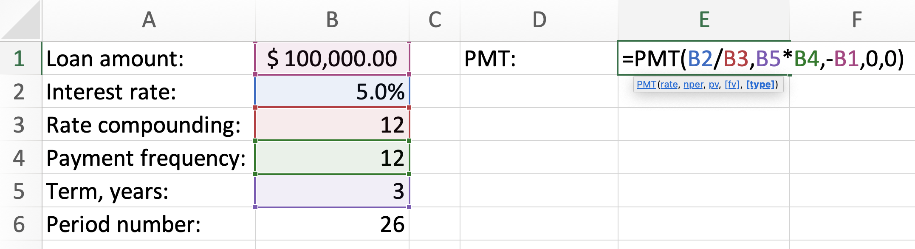

Then we can answer question (a):

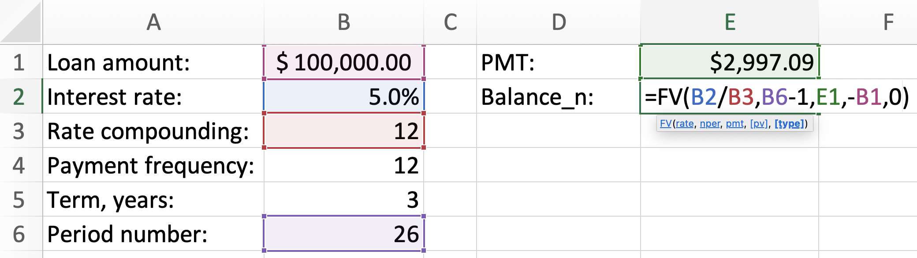

Finally, we answer question (b):

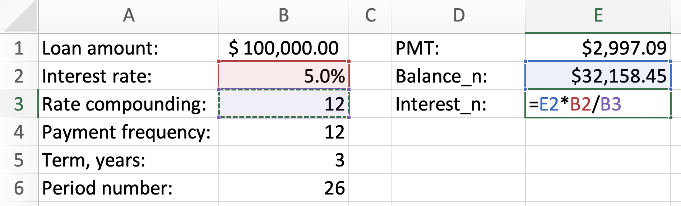

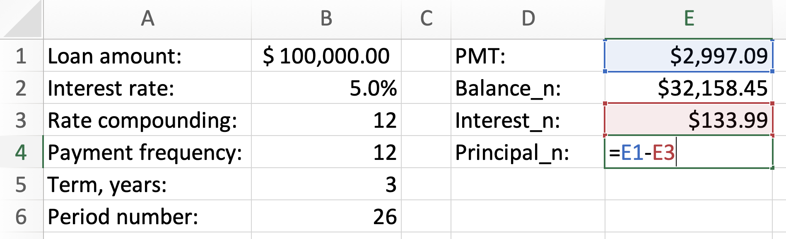

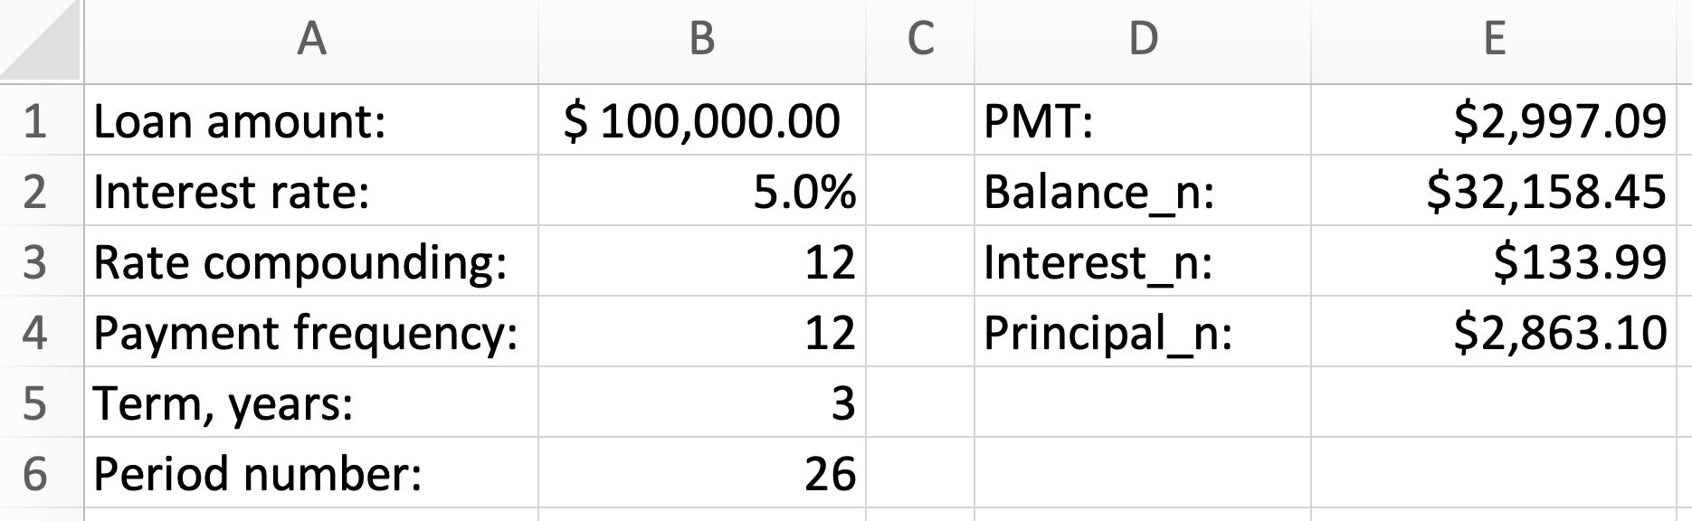

We have answered all required questions of this example. To add to this example, we can mention that in Excel there are functions IPMT() and PPMT(), which allow to find the interest included in the payment and the principal repaid by the payment directly, without having to compute the balance first:

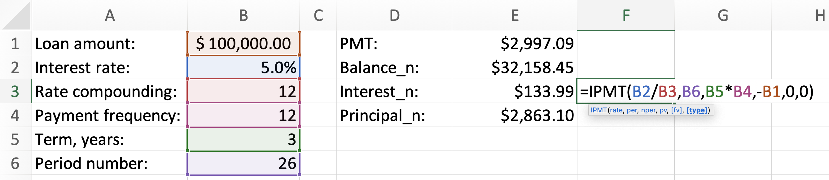

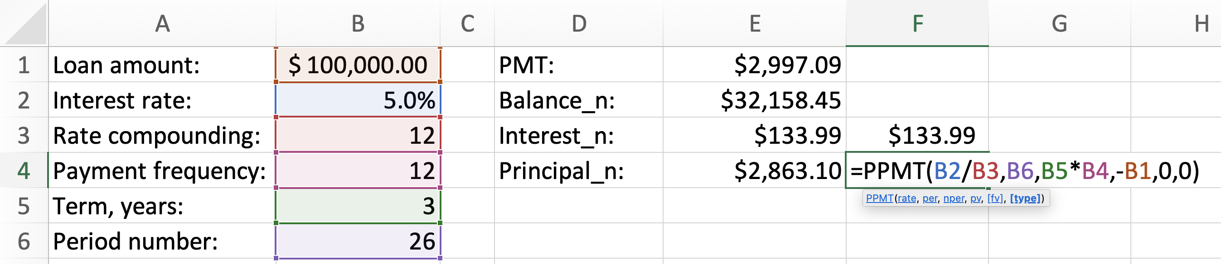

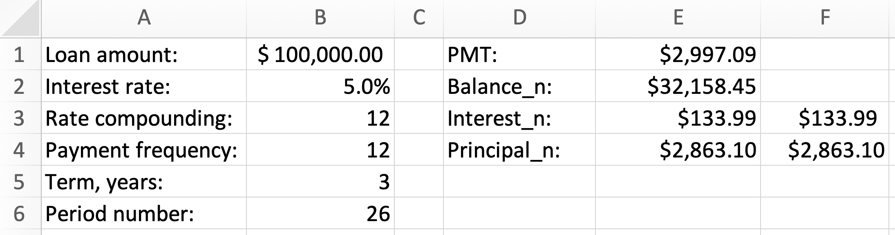

$∎$End of the Excel example.

Excel Example 11.2 (compare to Example 11.2): A mortgage valued at $700,000 is to be amortized at 5.8% compounded semi-annually for 30 years, with monthly payments rounded to the next $100. (a) What is the updated term? (b) What is the last payment?

We first find the payment, and then we find the updated term:

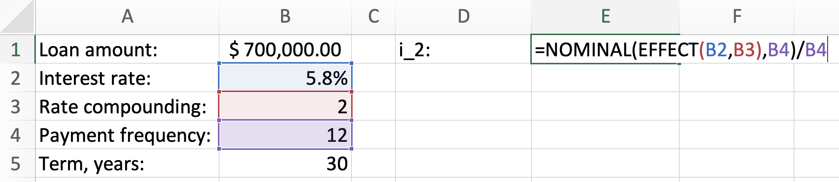

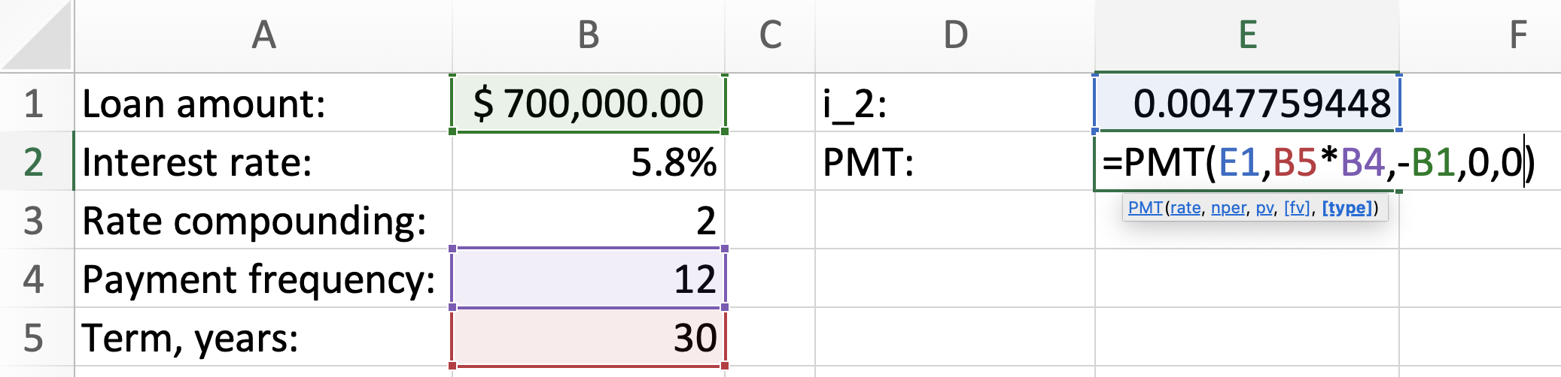

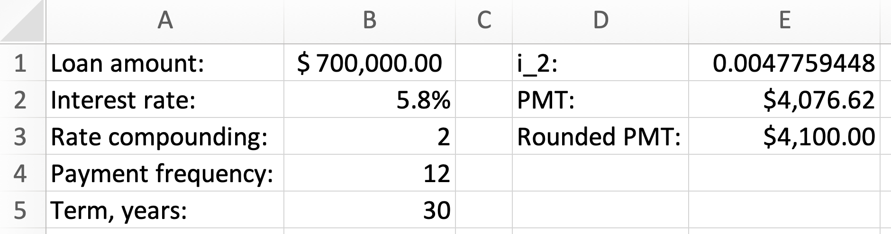

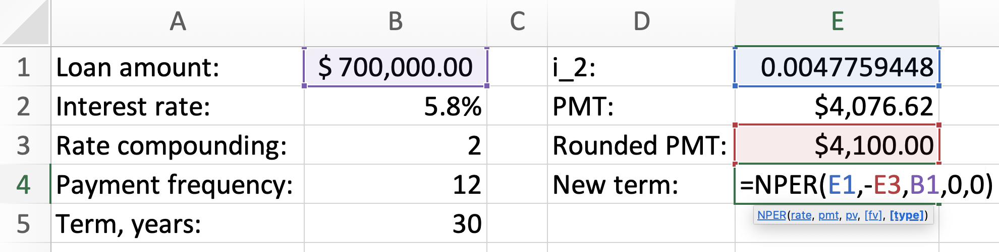

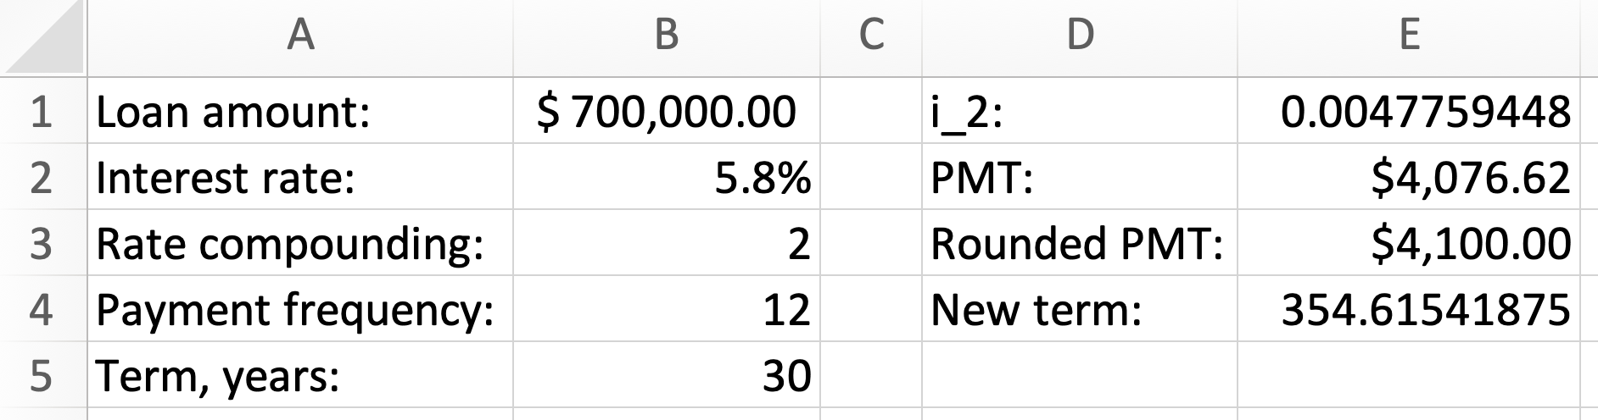

We proceed to finding the final payment:

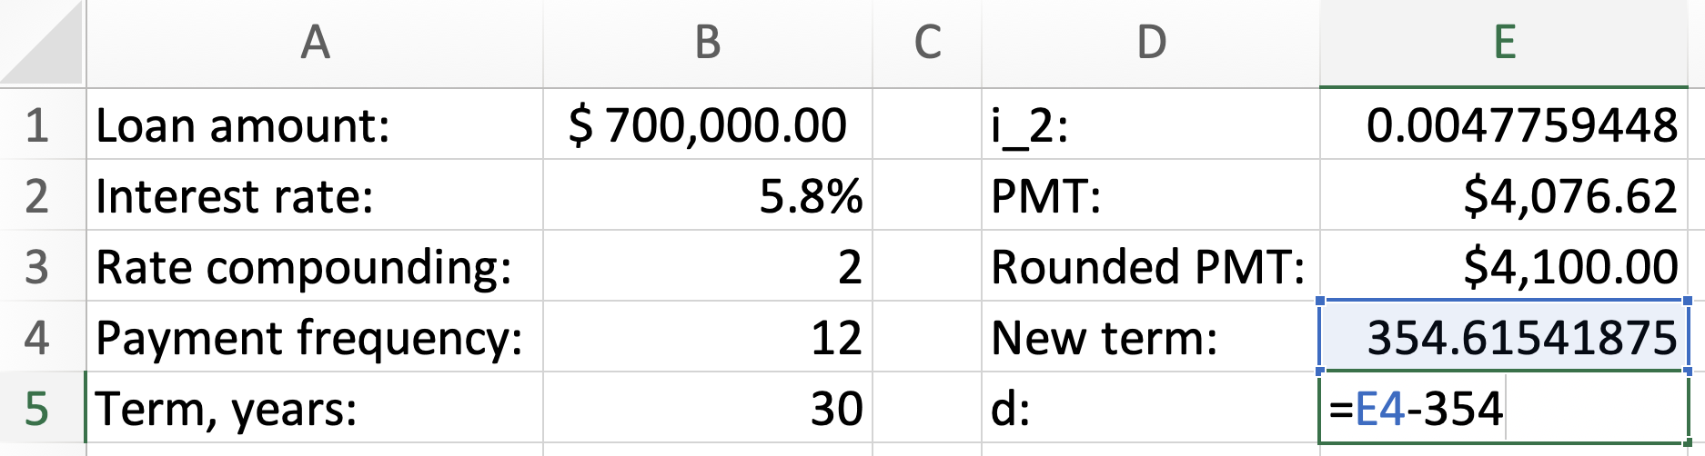

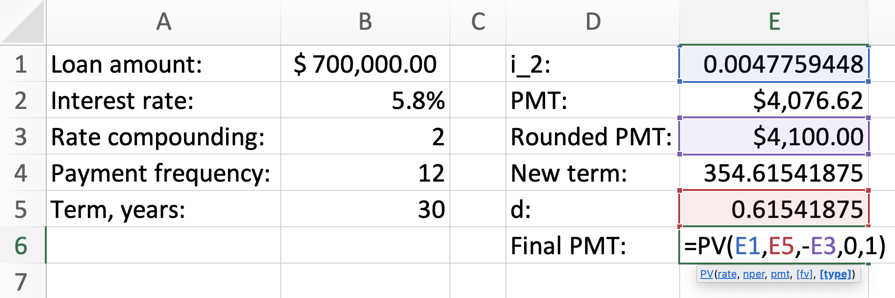
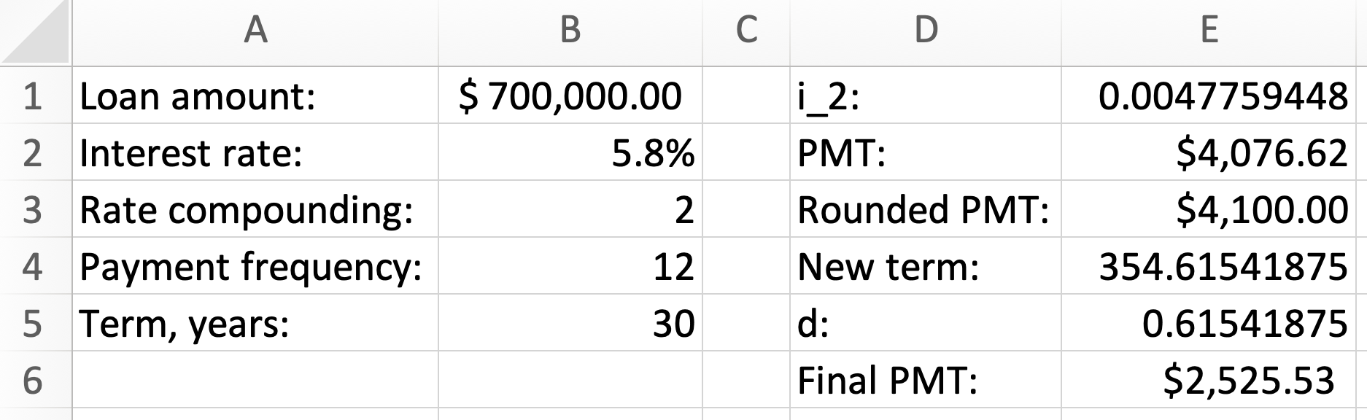

$∎$End of the Excel example.

Exercises

When working on these exercises, round the periodic payment to two decimals.

- Hyper Inc. amortized a loan of $500,000 by agreeing to make semi-annual payments subject to 3.4% compounded semi-annually for 2 years. (a) Build the amortization table (b) Use the table to find what interest is included in the last 2 payments. Solve this problem without the TVM calculator or Excel functionality (round the periodic payment, the interest included into each payment and the balance repaid in each payment to two decimals. To accommodate the discrepancy resulting due to such rounding, modify the payment structure of the last period as needed).
- $305,000 loan is amortized over 10 years. (a) Find the balance at the beginning of the 15th payment period if the loan is subject to 4.3% compounded daily and the payments are to be every month. (b) Find the total amount of interest to be paid for this loan (assume that the final payment is the same as all other periodic payments).
- Nassim was offered $650,000 house to be amortized over 30 years. Based on this offer, Nassim asked the bank to round the monthly payments to the next $50. If the interest rate is 5.1% compounded semi-annually, answer: (a) What is the updated term of the mortgage? (b) What is the balance after 20 payments have been made? (c) What is the interest included into the 21st payment? (d) What principal is repaid in the 45th payment? (e) What is the final payment?
- Nicole’s $810,000 mortgage was subject to 4.6% compounded semi-annually for the first 3-year term. The mortgage was amortized by monthly payments made over 20 years. (a) Find the principal amount repaid in the 8th payment. (b) Find the periodic payment in the second 3-year term, when the interest rate became 4.2% compounded semi-annually. (c) Find the interest amount paid during the second 3-year term.
- A loan of $560,000 is to be amortized over 15 years by making semi-annual payments. If the interest rate on the loan is 6.2% compounded monthly, find the interest included, and the principal repaid in the first 5 payments.
- Ming’s mortgage of $480,000 was amortized over 20 years. The interest rate was 3.9% compounded semi-annually for the first 5-year term. In the second 5-year term, the interest rate became 4.1% compounded semi-annually. By how much did the payments change following the change of the rate?
- Silvija signed a mortgage agreement for her apartment which she bought for $560,000. The mortgage term based on the payments rounded to two decimals is 25 years (assume that the final payment is the same as the other payments). If the interest rate is 4% compounded semi-annually, and if Silvija would like to round her mortgage payments to the higher $100, answer the following questions: (a) What will the last payment be? (a) How much of the total interest will she save due to rounding the payments to the higher $100?
- [Challenge] Since amortized payments must be rounded to two decimals, the final payment in an amortization schedule is almost always slightly different due to such rounding. Find the final payment for $450,000 loan amortized at 6.7% compounded semi-annually over 20 years by end-of-month payments.

Answers:

1. (a) see solutions (b) $6,500.67; 2. (a) $275,793.68 (b) $70,928.80; 3. (a) 29 years and 3 months (b) $633,002.85 (c) $2,662.12 (d) $981.97 (e) $800.61; 4. (a) $2,129.30 (b) $5,000.19 (c) $85,596.51; 5. Interest $84,200.52, Principal $61,256.63; 6. Payments increased by $38.62; 7. (a) $2,594.05 (b) $11,118.95; 8. $3,381.60.

Net Present Value (Case Studies)

One of the most important approaches in business decision making is evaluating a business initiative in terms of its net present value (NPV). There are two types of NPV analysis: the NPV of an initiative and the NPV of a choice. You are required to understand the previous chapters well to take the full advantage of this chapter (review Chapters 4, 6, 7, 9).

The NPV of an initiative

The NPV of an initiative is defined as the present value of all future cash flows. All outgoing amounts must be taken as negative cashflows whereas all incoming amounts must be taken as positive cashflows. The resulting net present value shows the profit or loss generated by an initiative.

Example 12.1: DV Electric is considering investing in the construction of a new sustainable power station. The plan is to complete the construction in 4 years from now. The station will provide a perpetual stream of profits estimated in terms of the beginning-of-year amounts of $124,800, starting 4 years from now. To build the station, DV Electric will have to outlay $100,000 immediately, and another $200,000 two years from now. To maintain the station, $10,000 per month will be required starting one month after the construction is complete. Furthermore, a government grant of $15,000 per year, starting immediately, will help covering the company’s costs. (a) What is the net present value of this initiative if the cost of money is 7.6% compounded semi-annually? (b) Should DV Electric invest into this initiative?

- To know how profitable this initiative is, we must find the net present value of all cash flows. Let’ start with the positive cashflows. The stream of profits can be considered as a general ordinary perpetuity starting three (note: not four) years from now (review Chapter 7 for composites and Chapter 9 for perpetuities):
$$i_{2}={\left(1+\frac{0.076}{2}\right)}^{\frac{2}{1}}-1=0.077444$$

$${PV}_{profits}=\frac{124,800}{i_{2}}{(1+i_{2})}^{-3}=1,288,376.183$$

The government grant is a general perpetuity due:

$${PV}_{grant}=\frac{15,000}{i_{2}}(1+i_{2})=208,688.3425$$

Now, let’s focus on the negative cash flows. The present value of all outlays:

$${PV}_{outlays}=100,000+200,000{\left(1+i_{2}\right)}^{-2}=272,282.2685$$

The maintenance costs form a general ordinary perpetuity starting four years from now:

$$i_{2}={\left(1+\frac{0.076}{2}\right)}^{\frac{2}{12}}-1=0.006235323$$

$${PV}_{maintenance}=\frac{10,000}{i_{2}}{(1+i_{2})}^{-12×4}=1,190,041.739$$

We are ready to find the NPV:

$$NPV={PV}_{profits}+{PV}_{grant}-{PV}_{outlays}-{PV}_{maintenance}$$

$$NPV=34,740.52$$

- The NPV is positive, which means that this initiative is worth considering. However, in today’s money the profit is only $34,740.52 which may be insufficient for a large company to enter a long-term commitment. We must remember that our analysis is based on a simplified model which does not capture many aspects of this business initiative. The management will need to evaluate all the risks and the opportunities which may arise from this investment. Finding the NPV is a crucial tool in this decision-making process.

$∎$End of the example.

The NPV of a choice

The NPV of a choice is calculated when there are two competing initiatives, and one of them must be chosen. The first initiative is set to be the main option, with the second initiative is set to be an alternative option. The NPV of choice is obtained by subtracting the NPV of the alternative option from the NPV of the main option. The following example shows how this technique can be used in personal finance to choose between buying or selling an apartment. In the same example, we will also encounter so-called constant growth perpetuities and annuities.

Example 12.2: Mei is thinking of buying an apartment. Based on the bank’s estimate, purchasing the apartment will require $50,000 down payment and payments of $3,700 at the beginning of every month for the next 25 years. Maintenance fees for the apartment will be $500 at the end of the first month, and will increase, on average, by 0.07% each month. A similar apartment, which is closer to Mei’s workplace, will require beginning-of-month rent payments, the first of which is $2,600, all maintenance inclusive. On average, the rent payments are expected to grow by 0.004% every month. If she decides to rent, Mei will save on gas and car maintenance expenses each month for the next 30 years. These expenses will start with $300 and will increase, on average, by 0.2% each month. What should Mei do: should she buy the apartment or rent the one which is closer to her work, if the cost of money is 4.5% compounded semi-annually?

Of course, this situation is a simple model and does not capture many considerations. A real-life situation would require a much more detailed analysis. There is also an assumption that the apartment, if Mei buys it, will not be sold by Mei after she pays it off (she and her family will continue living in it).

The main option: buying the apartment. Let’s calculate first how much money Mei will have to spend to buy and maintain the apartment. The mortgage payments represent a general due annuity:
$$i_{2}={\left(1+\frac{0.045}{2}\right)}^{\frac{2}{12}}-1=0.00371532$$

$${PV}_{mortgage}=50,000+3,700\left[\frac{1-{\left(1+i_{2}\right)}^{-12×25}}{i_{2}}\right](1+i_{2})=720,989.7301$$

Mei and her family will pay maintenance even after the apartment is paid off. The maintenance fees form a so-called constant growth perpetuity:

$${PV}_{maintenance}=\frac{500}{i_{2}-0.0007}=165,819.9032$$

We must include gas and car maintenance expenses. These expenses form a so-called constant growth annuity.
$${PV}_{gas}=300\left[\frac{1-{\left(\frac{1+0.002}{1+i_{2}}\right)}^{12×30}}{i_{2}-0.002}\right]=80,410.80856$$

We are ready to find the net present value of buying (note that there are no positive cash flows to consider):

$$N{PV}_{buy}={-PV}_{mortgage}-{PV}_{maintenance}-{PV}_{gas}=-967,220.44$$

Alternative option: renting a similar apartment. If Mei chooses to rent instead, she and her family will have to pay rent payments in perpetuity. This is a constant growth due perpetuity:
$${PV}_{rent}=\frac{2600\left(1+i_{2}\right)}{i_{2}-0.0004}=787,151.8181$$

$$N{PV}_{rent}=-787,151.81$$

Decision. The NPV of the choice to buy is the difference of the present values:

$${NPV}_{buy vs rent}=-967,220.44-(-787,151.81)=-180,068.62$$

The NPV of the choice for buying versus renting is negative. The meaning of this is that if Mei buys the apartment, it will cost her $180,068.63 more than renting a similar apartment, in terms of today’s money (based on the model with all the assumptions). Does this mean that she should not buy the apartment and rent instead? Since our model is very simple and does not capture many important things, the answer is not that clear. Mei will need to bring many more factors into this consideration. But the net present value approach will be an important tool in her decision making. The most difficult problem is in identifying all the necessary data we used in this example, such as the growth rates for the maintenance fees, car expenses and rent payments.

$∎$End of the example.

Exercises

- Buying a new store requires three outlays to the previous store owner: $2,000,000 immediately, $1,500,000 three months from now and $500,000 one year from now. In addition, the preparations of the store for opening will require spending $10,000 at the beginning of every month for half year. After the store opens at the end of 6 months from now, the ongoing operating expenses will be $22,000 at the end of every month. The store is expected to generate $1,400 end-of-day profits starting from the time the store opens. The cost of money is 5.6% compounded quarterly. (a) What is the net present value of the store? (b) Based on this model, is it worth buying the store?

- Liem is considering getting a car. He has two options: to buy or to lease. Buying would cost $600 at the beginning of every month for 7 years. If Liem buys the car, he will have to spend $1,200 for new tires at the end of 4 years and $1,500 for new breaks at the end of 5 years. At the end of 7 years, Liem thinks that he will be able to sell this car for 30% of its current price. Instead of buying the car, Liem can lease 2 similar cars, one after another. The first 4-year lease will cost $400 at the beginning of every month and the second 3-year lease will cost $500 at the beginning of every month. No repairs will be required for the leased cars. If the effective interest rate is 4%, (a) What is the NPV of the choice of buying one car vs leasing two cars? (b) What should Liem do?

- [Challenge] A factory is considering buying a new machine. The machine must be financed by end-of-month payments of $25,600 for 2 years. If the machine starts functioning immediately, it will require maintenance expenses of $3,200 at the end of the first quarter and, because the machine will deteriorate over time, these expenses will increase by 0.1% each quarter, on average. The machine will generate profits at the end of every month. Since the operators are expected to learn to use the machine more efficiently over time, these profits are expected to increase by 2.5% each month for 25 months, starting from $3,000 at the end of the first month. Then, the profits will continue but will not increase anymore. (a) What is the net present value of the machine, if the cost of money is 6.8% compounded monthly? (b) Should the factory buy the machine, based on this model?

Answers:

1. (a) $318,174.37 (b) Yes; 2. (a) -$4,001.84. (b) Lease two cars; 3. (a) $175,067.63 (b) Yes.

PART III: MATHEMATICS OF BUSINESS

Sequences of discounts

Consider the following simple situation: a manufacturer buys raw materials, pays wages and has other expenses to produce a product. In total, assume that the manufacturer spent $120 to produce the product. This expenditure is called the net price. The manufacturer would like a distributor to buy the product for $130. With this deal, the manufacturer made $10 per product. The distributor then sells the product to a wholesaler for $140 also making $10 per product. Similarly, the wholesaler then sells the product to a retailer for $150 and the retailer finally sells the product to a consumer for $160. This price is called the list price (or MSRP – manufacturer’s suggested retail price).

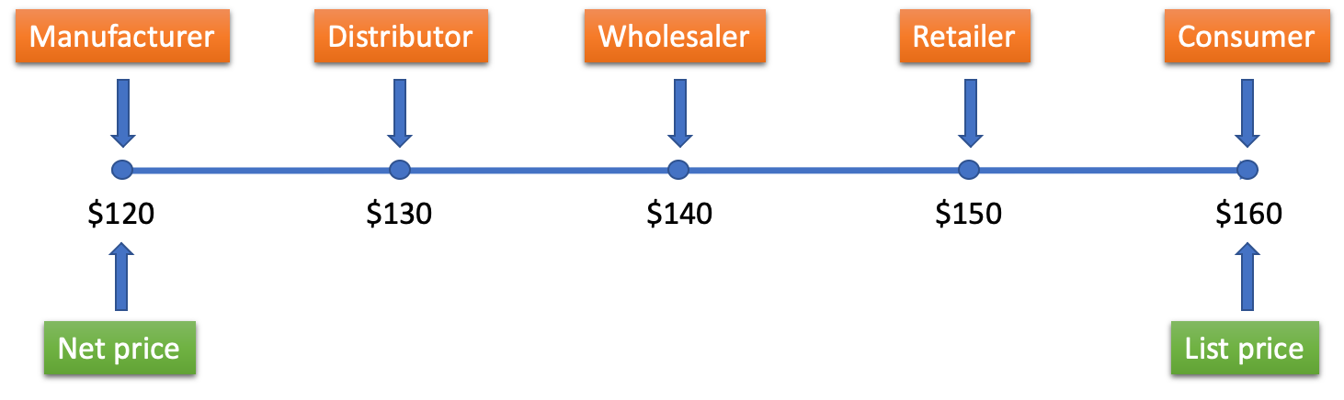

In this supply chain, each party made $10.

Let’s look at this chain in a different way.

The retailer pays $10 less for the product than the consumer. This means that the retailer has 6.25% discount from the list price. Similarly, the wholesaler has 6.67% discount from the retailer’s price, the distributor has 7.14% discount from the wholesaler’s price, and the manufacturer has 7.69% discount from the distributor’s price.

Therefore, this supply chain has the following equality:

$$160\left(1-0.0625\right)\left(1-0.0667\right)\left(1-0.0714\right)\left(1-0.0769\right)=120$$

In general, a supply chain has the following equation:

$$L\left(1-d_{1}\right)\left(1-d_{2}\right)\left(1-d_{3}\right)…\left(1-d_{n}\right)=N$$

In this equation, $L$ is the list price (the price before the discounts), $N$ is the net price (the price after the discounts), and $d_{1},d_{2},d_{3},…d_{n}$ are the discount rates.

The same equation also arises from other business situations. For example, a product can be originally offered for the list price, and then the product could be discounted several times until it is sold for the net price.

Example 13.1: A computer was sold to a customer for $800 after it had been discounted four times: two times by 5% and two times by 10%. What was the original price of the computer?
$$L\left(1-d_{1}\right)\left(1-d_{2}\right)\left(1-d_{3}\right)…\left(1-d_{n}\right)=N$$

$$L{\left(1-0.05\right)}^{2}{\left(1-0.1\right)}^{2}=800$$

$$L=\frac{800}{{0.95}^{2}×{0.9}^{2}}=1,094.35$$

So, the list price was $1,094.35.

$∎$End of the example.

When comparing one sequence of discounts to another, it is very important to be able to calculate the single equivalent discount rate. This is a single discount rate which is equivalent to a given sequence of discount rates. In other words, we must be able to find a discount $d_{e}$ which does the same job as a sequence of discount rates $d_{1},d_{2},d_{3},…d_{n}$. This means that the following equation must be true:

$$1-d_{e}= \left(1-d_{1}\right)\left(1-d_{2}\right)\left(1-d_{3}\right)…\left(1-d_{n}\right)$$

From this equation, we immediately obtain the formula for the single equivalent discount rate:

$$d_{e}= 1-\left(1-d_{1}\right)\left(1-d_{2}\right)\left(1-d_{3}\right)…\left(1-d_{n}\right)$$

Example 13.2: What is the single equivalent discount rate for a supply chain having the following sequence of discount rates: 4%, 3% and 2%?

$$d_{e}= 1-\left(1-d_{1}\right)\left(1-d_{2}\right)\left(1-d_{3}\right)…\left(1-d_{n}\right)$$

$$d_{e}= 1-\left(1-0.04\right)\left(1-0.03\right)\left(1-0.02\right)=8.74\%$$

This means that one discount rate of 8.74% is equivalent to three discount rates of 4%, 3% and 2% (within the rounding tolerance level).

$∎$End of the example.

Example 13.3: Which sequence of discount rates will produce the lower net price for the same list price? A: 13%, 12% and 9% or B: 14%, 14% and 6%?

For A:

$$d_{e}= 1-\left(1-0.13\right)\left(1-0.12\right)\left(1-0.09\right)=30.33\%$$

For B:

$$d_{e}= 1-{\left(1-0.14\right)}^{2}\left(1-0.06\right)=30.48\%$$

Sequence B has the higher single equivalent discount rate; therefore, it will have the lower net price.

$∎$End of the example.

Example 13.4: A supply chain involves four equal discount rates, resulting in the single equivalent discount rate of 20%. How big is each discount?

$$0.2= 1-{\left(1-d\right)}^{3}$$

$${\left(1-d\right)}^{3}=0.8$$

$$1-d={\left(0.8\right)}^{\frac{1}{3}}$$

$$d={1-\left(0.8\right)}^{\frac{1}{3}}$$

$$d=7.17\%$$

$∎$End of the example.

Exercises

- Speakers are listed by a manufacturer for $720, less trade discount rates of 7% and 6%. What further rate of discount rate should be given to bring the net price to $587?
- What is the list price, if you know that after the series of three discount rates of 8%, 7% and 4%, the net price has become $560?
- What is a single rate of discount which is equivalent to a series of three discount rates of 15%, 10%, 5%?
- The supply chain of manufacturer A involves three trade discount rates 18%, 15% and 13%. The supply chain of manufacturer B involves one trade discount rate of 40.41%. If both manufacturers have the same list price, which manufacturer has the lower net price? Show all calculations.
- If you are interested in a lower net price, which sequence of discount rates would you select? A: 7 discount rates of 4% or B: 4 discount rates of 7%?
- [Challenge] What is the average discount rate in a supply chain which offers the list price that is 45% higher than the net price? The supply chain has 5 participants.

Answers:

- 6.74%; 2. $681.78; 3. 27.33%; 4. A has 39.36%, so B is the answer; 5. A is 24.86%, B has 25.19%, so B must be selected; 6. 8.87%.

Exchange rates

To understand the mathematics behind exchange rate problems, let’s consider an example which may seem not to relate to exchange rates at the first glance.

Let’s assume that there is a broker of a special kind. This broker has access to a market where the broker can either buy a product for $100 or sell this product to the market for $100. Because the price is the same for buying and selling, we can say that the broker can exchange the product to the money and back.

Assume that there are customers of the broker who would like to buy this product from the broker or sell this product to the broker. These customers do not have access to the market, so they cannot buy or sell the product for $100.

In this situation, what can the broker do to make $10 every time a customer buys the product from the broker or sells the product to the broker? The answers are very simple:

- If the customer wants to buy the product from the broker, the broker will buy the product from the market for $100 and then will sell the product to the customer for $110.

- If the customer wants to sell the product to the broker, the broker will buy the product from the customer for $90 and then will sell the product to the market for $100.

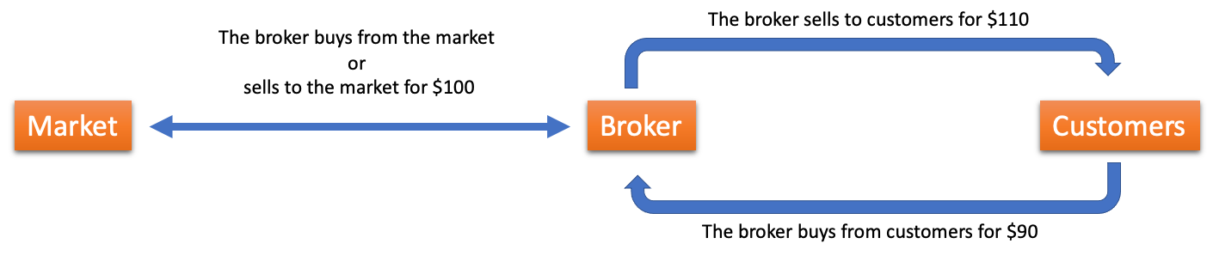

If we call the market price of $100 an exchange price, we can say that the broker’s selling price is the exchange price plus the commission of $10 and the broker’s buying price is the exchange price minus the commission of $10.

We can now connect this example with the topic of exchange rates. In this case, the broker (which is most often a bank) has an exclusive access to the foreign exchange market. The broker can buy currency from the market or can sell currency to this market at the same price. The price of a unit of currency at which the bank sells or buys in this market is called the exchange rate (or the interbank rate, or the mid-rate). The broker’s main goal is to make commission by selling to or buying from its customers, who do not have direct access to the market.

When a bank sells currency to its customers, the bank will add commission to the domestic side of the exchange rate. The price at which a bank sells a unit of currency to its customers is called the selling rate or the selling price.

When a bank buys currency from its customers, the bank will subtract commission from the domestic side of the exchange rate. This price at which the bank buys a unit of currency from the customers is called the buying rate or the buying price.

When solving problems, always remember that domestic currency cannot be a product. The domestic currency cannot be bought or sold. Only foreign currency can be a product to be bought or sold. Commission can only be earned in the domestic currency; this is the reason why we add commission to or subtract commission from the domestic side of the exchange rate. Therefore, for example, a bank in Canada cannot sell CAD to you.

Example 14.1: If a tourist would like to buy CA$ 3,400 from a bank in Toronto, how much in US dollars must the tourist pay? The exchange rate is US$ 1 = CA$ 1.3202 and the bank charges 2.2% commission to buy or sell currency.

Even though the problem mentions the tourist buying Canadian dollars, we must always look at the situation from the position of the broker (in this case, the bank). Since the bank is in Canada, CAD is the domestic currency. The USD is the product the bank buys or sells. Here the Canadian bank will buy USD paying with CAD; therefore, the buying rate is needed to solve this problem. When we find the buying rate, we subtract commission from the domestic side of the exchange rate (that is, we decrease the exchange rate by the commission percent):

The buying rate:
$$US\$ 1=CA\$ 1.3202(1-0.022)$$

$$US\$ 1=CA\$ 1.2911556$$

Using this buying rate, we find the amount in US dollars the bank can buy by paying CA$3,400. For this, we use the proportion:

$$\frac{US\$ 1}{CA\$ 1.2911556}=\frac{US\$ X}{CA\$ 3,400}$$

$$US\$ X= \frac{3,400}{1.2911556}=2,633.30$$

So, the tourist pays US$ 2,633.30 to obtain CA$ 3,400.

Another possible solution: The bank takes $X$ USD from the tourist and converts this amount to CAD in the foreign exchange market, obtaining 1.3202X CAD. After the bank takes 2.2% commission from this amount, the tourist receives 3,400 CAD:

$$1.3202X\left(1-0.022\right)=3400$$

$$X= \frac{3,400}{1.3202(1-0.022)}=2,633.30$$

$∎$End of the example.

Example 14.2. If a tourist would like to buy CA$ 3,400 from a bank in New York, how much in US dollars must the tourist pay? The exchange rate is US$ 1 = CA$ 1.3202 and the bank charges 2.2% commission to buy or sell currency.

Note that this example is almost the same as example 14.1 but the bank is now in the USA. This means that CAD is the product that the bank buys or sells. In this case, the bank will sell CAD; therefore, the selling rate is needed. When we find the selling rate, we add commission to the domestic side of the exchange rate (that is, we increase the exchange rate by the commission percent):

Selling rate:
$$US\$ 1.022=CA\$ 1.3202$$

Using this selling rate, we find the number of USD the bank will receive as payment for CA$3,400:
$$\frac{US\$ 1.022}{CA\$1.3202}=\frac{US\$ X}{CA\$ 3,400}$$

$$US\$ X= \frac{3,400×1.022}{1.3202}=2,632.03$$

The tourist will receive CA$ 3,400 and will pay US$ 2,632.03.

Another possible solution: The bank converts 3,400 CAD at the foreign exchange market and receives $\frac{3400}{1.3202}$ USD. Then the bank adds commission of 2.2% to this amount:

$$\frac{3,400}{1.3202}\left(1+0.022\right)=2,632.03$$

This is the USD amount the tourist must pay to the bank.
$∎$End of the example.

Example 14.3: What is the commission rate that a Canadian bank charges if the selling rate is US$ 1 = CA$ 1.3286 and the exchange rate is US$ 1 = CA$ 1.3202.

Since this is the selling rate, the commission is added to the domestic side of the exchange rate:

$$1.3202\left(1+r\right)=1.3286$$

$$r= \frac{1.3286}{1.3202}-1=0.64\%$$

$∎$End of the example.

Exercises

- If the exchange rate is US$1 = C$1.1277, and if the bank in Canada charges 0.9% commission to buy or sell currencies, how many US dollars can you buy for C$4,200?
- If the exchange rate is US$1 = C$1.2145, and if the bank in Canada charges 1.5% commission to buy or sell currencies, how many CAD will you receive if you sell US$ 4,000?
- If the exchange rate is C$1 = US$0.81, and if the bank in Canada charges 2% commission to buy or sell currencies, how much CAD should you have to purchase US$ 3,500?
- A Canadian bank quoted their buying rate as US$1 = CA$1.2972. If the exchange rate was US$1 = C$1.3202, what was the rate of commission the bank charged?
- How many US dollars would you receive if you exchanged C$ 8,700 in a Toronto bank which charges commission of 2.9%. The exchange rate is US$ 1 = C$1.2963.
- Anna wanted to buy an online course from a US university for US$ 850. Anna contacted her local Toronto bank to arrange the payment. The exchange rate was US$1 = C$1.3077 and the bank charged 0.77% commission to buy or sell currencies. How much, in Canadian dollars, did Anna pay for the course?
- How would the solution change in Problem 1 if the bank were in the USA?
- How would the solution change in Problem 2 if the bank were in the USA?
- [Challenge] Assume that money can be borrowed or invested at 3% compounded annually in France and at 4.5% compounded semi-annually in Canada. The current exchange rate at a Canadian bank is 1 EURO = 1.3904 CAD. Analyzing historical data, an investor thinks that 6 months from now, the exchange rate will be 1 CAD = 0.7314 EURO. If the bank charges 0.5% commission to buy or sell currency at any time, how much Euro will the investor be able to earn after 6 months, by borrowing 100,000 Euro today (assuming that the investor’s prediction is correct)?

Answers:

1. US$ 3,691.17; 2. CA$ 4,785.13; 3. CA$ 4,407.41; 4. 1.74%; 5. US$ 6,522.26; 6. CA$1,120.10; 7. 3,690.88; 8. CA$ 4,786.21; 9. 1,458.40 Euro.

Payment terms and cash discounts

When one business makes a purchase from another business, usually the payment is not required immediately. Instead, an invoice is given with payment terms. The terms specify when the invoice must be paid together with the incentives to pay early. For example, the terms can be specified as
$\frac{4}{5}, \frac{2}{10}, \frac{n}{15}$.

These are not fractions, but they look like fractions. The top of each “fraction” is the percent discount offered, and the bottom of each “fraction” is the number of days from the invoice date the discount is available (keep in mind that the day the invoice is day zero). $n$ means the “net price”, or “no discount”.

More exactly in our example, 4% discount is given if the invoice is paid within the first 5 days from the invoice date, 2% discount is given if the invoice is paid any time from day 6 up to day 10 from the invoice date, and net price (the invoice amount without a discount) is paid if the invoice is paid on day 11 or after.

Example 15.1: Aleph corporation obtained an invoice for $45,000 on September 22, 2022, with the following terms: $\frac{5}{10}, \frac{3}{15}, \frac{n}{30}$. How much must Aleph pay on (a) September 24 (b) October 2 (c) October 5 (d) October 7 (e) October 12?

- September 24 is day 2 from the invoice date (which is day zero). Because this is within the 10 days when 5% discount is given, Aleph will pay $42,750:

$$45,000\left(1-0.05\right)=42,750$$

- October 2 is day 10 from the invoice date. This is the last day when 5% discount is given, and Aleph will pay $42,750.
- October 5 is day 13 from the invoice date. This falls in the second discount window, where 3% discount is given (this window covers days 11-15 from the invoice date). Therefore, Aleph will pay $43,650:

$$45,000\left(1-0.03\right)=43,650$$

- October 7 is day 15 from the invoice date. This is the last day of 3% discount. Therefore, Aleph will pay $43,650.
- October 12 is day 20 from the invoice date. This is more than 15 days and the net price must be paid, that is, there is no discount. Aleph must pay the full amount $45,000.

$∎$End of the example.

Sometimes, there are not enough funds to pay off an invoice in full. Hence, only a part of the invoice is paid within the discount window and the remaining amount is paid later. In such cases, a credit for the paid part is given.

Example 15.2: Beta corporation obtained an invoice for $200,000 with terms $\frac{7}{15}, \frac{n}{30}.$ If Beta paid $100,000 towards this invoice within the first 15 days of the invoice date, what would the balance be?

When Beta paid $100,000, it paid out some portion $X$ of the invoice. This portion is called the credit. How big is this credit? This is the amount which is, if discounted by 7%, must be equal to $100,000:
$$X\left(1-0.07\right)=100,000$$

$$X= \frac{100,000}{0.93}=107,526.88$$

Thus, by paying $100,000, Beta covered $107,526.88 of the invoice. Therefore, the balance (the amount that remains to be paid) is

$$200,000-107,526.88=92,473.12$$
$∎$End of the example.
Example 15.3: With the terms $\frac{3}{15}, \frac{n}{30},$what percent of an invoice must be paid during the discount period, to reduce the balance in half?

Let’s use A to denote the invoice amount. Then, the credit given must be $A/2$ to make the balance equal to $A/2$. The partial payment $P$ must satisfy the following equation:

$$P= \frac{A}{2}\left(1-0.03\right)$$

From this equation, we can easily find $P$:

$$P= 0.485A$$

This means that the partial payment must be 48.5% of the invoice amount to reduce the balance by 50%.
$∎$End of the example

Exercises:

- On January 5, 2018, Atlas Inc. received an invoice for $200,000 with terms 2/10, 1/30. (a) If Atlas Inc. made the full payment for the invoice on January 15, 2018, how much was the payment? (b) If Atlas Inc. made the full payment for the invoice on February 4, 2018, how much was the payment?
- Mike purchased furniture for $8,400 and received an invoice dated February 5, 2017, with terms 2.5/10, n/30. He made a partial payment of $3,600 on February 10, 2017, and the balance on February 20, 2017. What was the balance?
- Andrea purchased raw materials for her factory and received an invoice for $16,000 dated May 17, 2018, with terms 3/10, 2.3/15, n/30. She made a partial payment of $10,000 on June 1, 2018, and the balance on June 16, 2018. What was the total Andrea paid for the invoice?
- An amount of $7,700 is paid during the discount period against an invoice of $10,780 and with terms $x$/5, n/10. What is $x$ if the outstanding balance is $2,410.43?
- Given the invoice of $170,000 and the terms 4/20, n/30, what payment made during the discount period will make the balance of the invoice equal to $10,000?
- [Challenge] An invoice payment terms are: 5/10, 3/15, n/30. Two equal partial payments were made. The first payment was made during the first discount period and the second payment was made during the second discount period. What percent of the invoice amount was each partial payment, if the balance became 30% of the invoice amount?
- [Challenge] An invoice payment terms are: 7/10, 5/15, n/30. Three equal payments were made. The first payment was made during the first discount period, the second payment was made during the second discount period and the third payment was made during the “no discount” period. What percent of the invoice amount was each payment?
- [Challenge] Omega International, a Toronto-based company, purchased machines from a German manufacturer and on November 28, 2022, received a euro-denominated invoice with terms: 4/3, 2.5/5, n/10. Omega paid this invoice off by making the following payments in Canadian dollars: $100,000 on December 1, $150,000 on December 3, and $143,570 on December 8. All payments were first converted to the euro by a German bank and then applied to the invoice. The bank’s exchange rates were: 1 EURO = 1.4102 CAD on December 1, 1 EURO = 1.4057 CAD on December 3 and 1 EURO = 1.4097 CAD on December 8. The bank always charged 1.5% commission for buying or selling currency. What was the payable amount mentioned on the invoice?

Answers:

1. (a) $196,000 and (b) $198,000; 2. $4,707.69; 3. $15,764.59; 4. 8; 5. $153,600; 6. 33.6%; 7. 31.97%; 8. 280,878.14 Euro.

Price structure: markup and markdown

Any selling price (S) can be represented as the sum of the cost ($C$), the overhead expense ($E$) and the required profit ($P$):
$$S=C+E+P$$

The cost and the overhead expense form the amount that is called the break-even price ($B$E):

$$BE=C+E$$

The overhead expense and the profit form an amount that is called the markup ($M$):

$$M=E+P$$

Each component of the price structure can be given as an amount or as a rate. For example, if the selling price of pair of shoes is $110 and the cost is $70, the markup can be mentioned as $40, or as 36.36% of the selling price, or as 57.14% of the cost. When solving problems, it is very important to notice what base amount the markup is the percent of.

Example 16.1: A laptop has the selling price of $1,200. If the markup is 30% of the cost, what is the cost?
$$S=C+M$$

$$1,200=C+0.3C$$

Factoring out $C$:
$$1,200=1.3C$$

$$C= \frac{1,200}{1.3}=923.08$$

$∎$End of the example.

Example 16.2: If the markup rate is 30% of the cost, what is the markup rate of the selling price?

For each $1 of the cost, the markup is $0.3. Therefore, for each $1 of the cost, the selling price is $1.3. It is now easy to find the markup rate of the selling price:

$$M_{S}=\frac{0.3}{1.3}=23.08\%$$

$∎$End of the example.

Sometimes there is a discount offered. This means that the regular selling price is reduced by some amount, and this amount is called the markdown. As a result, the profit is reduced (in the following equation $P_{red}$ is the reduced profit and $r$ is the rate of markdown):

$$P_{red}=S(1-r)-BE$$

Example 16.3: Abby’s Flowers buys flowers for $2 each. Overhead expenses incurred are 10% of the selling price and the required profit is 40% of the selling price of each flower. (a) How much must each flower be sold for? (b) If Abby’s Flowers decided to offer a discount of 60% for all flowers what will be the profit or loss during the sale for each flower?

(a)
$$S=C+E+P$$

$$S=2+0.1S+0.4S$$

Grouping S on the left side and factoring it out, we obtain:

$$S-0.1S-0.4S=2$$

$$0.5S=2$$

$$S= \frac{2}{0.5}=4$$

(b)
$$P_{red}=S(1-r)-BE$$

$$P_{red}=S(1-r)-(C+E)$$

$$P_{red}=4(1-0.6)-(2+0.1×4)$$

$$P_{red}=-0.8$$

This means that there is a loss of 80 cents for each flower during the sale.

$∎$End of the example.

Example 16.4. A store sells furniture sets. The markup for the set is 40% of the selling price. The cost of the set is $900 and the overhead expense is 15% of the selling price. What markdown rate will allow the store to break even?

First, let’s find the selling price:
$$S=C+M$$

$$S=900+0.4S$$

$$0.6S=900$$

$$S=1,500$$

Next, we find the break-even price:

$$BE=C+E$$

$$BE=900+0.15×1,500$$

$$BE=1,125$$

With this, we are ready to find the necessary markdown rate:

$$1,500\left(1-r\right)=1,125$$

$$r= 1-\frac{1125}{1500}$$

$$r=0.25=25\%$$

Note that this markdown rate could also be found right away by dividing the amount of discount by the regular selling price:

$$r= \frac{1,500-1,125}{1,500}=25\%.$$

$∎$End of the example.

Exercises

- What is the markup rate of the cost, if the markup rate of the selling price is 14%?
- The cost of a pump is $1,200. The overhead expenses are 9% of the cost and the required profit is 12% of the selling price. Calculate the selling price of the pump.
- The regular selling price of a product is $109. The markup rate of the selling price is 18% and the operating expenses are 4% of the cost. If, during a sale, the product was discounted by 10%, calculate the profit or loss realized.
- A laptop has a regular selling price of $1,200. The operating expenses are 13% of the cost and the required profit is 5% of the cost. You decided to make a promotional sale. What markdown rate should you apply to sell the laptop exactly at its break-even price? Could you solve this problem if you didn’t know the selling price?
- Omega Industries reported that their markup rate of the cost was 23%. However, you would like to know their markup rate of the selling price. Do you have sufficient information to calculate it? If yes, calculate it.
- A jewellery store sells a necklace for $1,870. The rate of markup of the cost is 36%. What is the dollar amount of markup?
- PetSmart sells fish tanks for $106. The operating expenses are 33% of the cost and the profit is 26% of the cost. During a sale, the fish tanks were marked down by 41%. What was the profit or loss during the sale?
- The operating expenses are $A$% of the selling price, and the profit is 0.5$A$% of the selling price. If the markup rate of the cost is 34%, find $A$.
- [Challenge] The markup rate of the cost is 27%. If the markdown rate is 30% and the expenses are half of the markup, what percent of the selling price is the loss?
- [Challenge] The expenses are 0.3$A$% of the cost, the profit is 0.7$A$% of the cost. The markdown rate is $A$%. What is $A$, if the product was sold at 40% of its cost during the sale?

Answers:

1. 16.28%; 2. $1,486.36; 3. Profit $5.14 4. 4.24%; 5. 18.7%; 6. $495.00; 7. Loss of $26.13; 8. 16.92; 9. 19.37%; 10. 77.46.

Break-even analysis

The following equation is of high importance for any business:

$$TR=TC+NI$$

$TR$ stands for the total revenue, which is the amount paid to a business by its customers.
$TC$ stands for the total cost, which is the amount the business spends.
$NI$ stands for the net income, which is the profit made by the business.

Note that this equation is similar to the equation we learned in the previous chapter, S = BE + P.
The difference is that the previous chapter studied the price structure for one given product, whereas this chapter studies collective performance of many products.

Let’s assume that a business sells $N$ products for price $S$ for each product. Then:

$$TR=S×N$$

Each product has a cost, which we call the variable cost, and denote as $VC$. The reason we say that this cost is variable is because this cost changes depending on the number of products sold. If, for example, one product is sold, the cost to the business is $VC$, but if two products are sold, the cost to the business becomes $2VC$. We can speak about total variable cost, $TVC$:

$$TVC=VC × N$$

There is another type of cost to a business, which is the fixed cost, $FC$. This is the cost which does not change with the number of products sold. This cost can arise from paying rent, for example: no matter how many products have been sold, the rent must be paid for. Total variable costs and fixed costs together comprise the total costs, $TC$:

$$TC=TVC+FC$$

$$TC=VC×N+FC$$

Putting it all together we can write our main equation in the expanded form:

$$S×N=VC×N+FC+NI$$

When $N$I of a business is equal to 0, the business beaks even.

Example 17.1: Omega industries produces and sells hydraulic press units. The following data is known for this business. Each unit is sold for $15,000 and costs $3,400 to produce. Omega pays rent $20,000 per month for the production facility and $30,000 each month for wages. Omega can produce 1,000 machines per year. Find (a) annual break-even volume (b) annual break-even revenue and (c) break-even percent to capacity.

- Let’s use our notation for all data of this problem:

$$S=15,000$$

$$VC=3,400$$

And since we are asked about annual break-even numbers, we must find the annual fixed costs:

$$FC=(30,000+20,000)×12=600,000/year$$

When the business breaks even, the net income must be 0, and the equation we must work with is the following:

$$TR=TC$$

In the expanded form, this equation becomes:

$$S×N=VC×N+FC$$

Substituting all values:

$$15,000N=3,400N+600,000$$

From here we can find $N$:

$$15,000N-3,400N= 600,000$$

$$11,600N= 600,000$$

$$N=51.72$$

When a business sells non-divisible products, the usual practice is to round up the number of products sold. Therefore, Omega must sell 52 units to break even. This number is the break-even volume.

Omega will not make any profit and will not incur any loss when it sells 52 units. The sale of 52 units goes towards paying off the fixed costs. Starting from the sale of the 53rd unit, Omega will begin to contribute to its net income.

- The break-even revenue is the dollar amount which corresponds to the break-even volume:

$$BE revenue=52×15,000=\$780,000$$

- Since the capacity is 1,000 units per year, Omega breaks even at 5.2% to capacity:

$$BE \% to capacity= \frac{52}{1,000}=5.2\%$$

This number means that Omega has 94.8% of capacity to make its net income.

$∎$End of the example.

Example 17.2: Gamma Stores has the following daily sales data: total revenue is $98,000, total variable costs are $32,000 and total fixed costs are $15,000. (a) What is the daily break-even revenue? (b) What are the variable costs after the business breaks even?

- This problem may be confusing to students since there is no specific product given. In fact, Gamma may be selling many different products. But the trick is to analyze what happens per each dollar of sales. The variable cost of each dollar of sales is found in the following way:

$$98,000×VC=32,000$$

$$VC= \frac{32,000}{98,000}=0.326530612$$

This means, that it costs around 33 cents to make $1 of sales.

At the break-even number of dollars $N$, the total revenue must be equal to the total cost:

$$TR=TC$$

$$1 × N=0.326530612×N+15,000$$

$$0.673469388×N=15,000$$

$$N=22,272.73$$

Thus, Gamma breaks even when it has revenue of $22,272.73.

- After the business had broken even, it sold $75,727.27. This amount included the following variable costs:

$$75,727.27×0.326530612=24,727.27$$

$∎$End of the example.

A very helpful notion is that of the contribution margin, CM:

$$CM=S-VC$$

Using the contribution margin, solutions to many problems can be simplified. Consider the formula for the number of products to be sold ($N$), to pay off the fixed costs and make the net income:
$$N= \frac{FC+NI}{CM}$$

The meaning of this formula is very simple. The contribution margin is the amount which goes towards paying off the fixed costs and making the net income, so this formula finds how many times the contribution margin can fit inside the fixed costs and the net income.

With the notion of the contribution margin, Example 13.1 can be solved in the following way:

$$N= \frac{FC}{CM}=\frac{600,000}{15,000-3,400}=51.72.$$

Let’s use the contribution margin in the following example:

Example 17.3: What is the variable cost per item, if it is known that to make the monthly net income of $450,000, Phi Industries sold 3,000 machines? The company charged $2,300 for each machine and had the monthly fixed costs of $100,000.

$$x= \frac{FC+NI}{CM}$$

$$3,000= \frac{100,000+450,000}{2,300-VC}$$

$$3,000(2,300-VC)= 550,000$$

$$2,300-VC= 183.33$$

$$VC=2,116.67$$
$∎$End of the example.

Exercises

- A company manufactures TVs and sells them for $1,122. The variable cost to manufacture each TV is $660.The fixed costs are $360,000 per month. The production capacity is 20,000 TVs per month. (a) What is the break-even number of TVs per month? (b) Calculate the break-even number of TVs as percent to capacity. (c) How many TVs must be sold, for the company to have the net income of $50,000?
- If you sell products for $40 per unit, which have variable costs of $25 per unit, what fixed costs can ensure that you will break even by selling 1,000 units?
- Gamma Inc. reported that their total annual fixed costs are $500,000 and their total variable costs are $110,000 for the year. If their annual sales revenue appeared to be $1,100,000, what was their break-even annual revenue? What was their net income?
- Last year, the fixed costs of a downtown bicycle store amounted to $19,110. The store sold 624 bicycles resulting in the annual net income of $42,042. If the variable cost of each bicycle was $137, what was the selling price of each bicycle?
- [Challenge] Forward Corporation reported that the variable cost portion of their post-break-even revenue was $30,460. (a) What was their net income, if the total revenue was $400,000 and Forward broke-even at 40% of their total revenue? (b) What was the contribution rate (that is, the percent representing the contribution margin per each dollar of sales)? (c) What were the total variable costs? (d) What were the fixed costs?
- [Challenge] At what revenue would the Forward Corporation from Exercise 5 break even, if they manage to make their contribution rate equal to 89%, while keeping the total revenue and the fixed costs unchanged? What would their net income become? By what percent would they increase their net income?

Answers:

- (a) 780 (b) 3.9% (c) 888; 2. $15,000; 3. $555,555.56 and $490,000; 4. $235; 5. (a) $209,540, (b) 87.31% (c) $50,766.67 (d) $139,693.33; 6. $156,958.80, $216,306.67, 3.23%

Business mathematics review: https://youtu.be/nrtZxprlPTg

PART IV: SOLUTIONS

Solutions: 0. Essentials review

- ${27}^{1/3}$

$27$ is $3^{3}$. Therefore, ${27}^{1/3}=3.$

- ${125}^{2/3}$

$125$ is $5^{3}$. This means that ${125}^{1/3}=5.$ Take power 2 now: $5^{2}=25.$

- ${256}^{0.75}$

0.75 is ¾. $256$ is $4^{4}$. This means that ${256}^{1/4}=4.$ Take power 3 now: $4^{3}=64.$

- $8×(4^{-1.5})$

First, find $4^{-1.5}$. 1.5 is 3/2. $4$ is $2^{2}$. This means that $4^{1/2}=2.$ $2^{-3}=\frac{1}{2^{3}}=\frac{1}{8}$.
Finally: $8×\frac{1}{8}=1$

- ${2.5}^{0}×{36}^{1.5}+{16}^{-0.5}$

$${2.5}^{0}=1.$$

  - is 3/2. $36$ is $6^{2}$. Therefore ${36}^{1/2}=6.$ $6^{3}=216$

0.5 is 1/2. $16$ is $4^{2}$. This means that ${16}^{1/2}=4.$ ${16}^{-1/2}=\frac{1}{4}=0.25$

$${2.5}^{0}×{36}^{1.5}+{16}^{-0.5}=1×216+0.25=216.25$$

- $\log_{4}{64}$

$4^{3}=64.$ Therefore, $\log_{4}{64=3}$

- $\log_{256}{64}$

${256}^{0.75}=64.$ Therefore, $\log_{256}{64=0.75}$ (see problem 3)

- $\log_{25}{5}$

${25}^{0.5}=5.$ Therefore, $\log_{25}{5=0.5}$

- ${3.45}^{6.89}$

$$〈3.45〉 〈y^{x}〉 〈6.89〉 〈=〉$$

The result is 5,076.6072

- $\ln{9.87}$

$$〈9.87〉 〈LN〉 〈=〉$$

The result is 2.2895

- $\frac{3^{4.67}}{\ln{5}}+\frac{\ln{7}}{5^{3.89}}$

$$〈3〉 〈y^{x}〉 〈4.67〉 〈÷〉 〈(〉 〈5〉 〈LN〉 〈)〉 〈=〉 〈STO〉 〈1〉$$
$$〈7〉 〈LN〉 〈÷〉 〈(〉 〈5〉 〈y^{x}〉 〈3.89〉 〈)〉 〈+〉 〈RCL〉 〈1〉 〈=〉$$

The result is 105.0745

- $4x+5=2x+9$

$$4x-2x=9-5$$

$$2x=4$$

$$x=\frac{4}{2}=2$$

- $2\left(y-3\right)=y+5$

$$2y-6=y+5$$

$$2y-y=5+6$$

$$y=11$$

- $\frac{4}{3+x}=\frac{24}{{\left(3+x\right)}^{2}}$

$$4=\frac{24}{3+x}$$

$$4\left(3+x\right)=24$$

$$12+4x=24$$

$$4x=12$$

$$x=3$$

- $x^{4}=7$

$$x^{4/4}=7^{1/4}$$

$$x=1.6265$$

- ${4y}^{6}=10$

$$y^{6}=\frac{10}{4}$$

$$y^{6}=2.5$$

$$y^{6/6}={2.5}^{1/6}$$

$$y=1.1650$$

- $5^{x}=11$
$$x\ln{5}=\ln{11}$$

$$x= \frac{\ln{11}}{\ln{5}}=1.4899$$

- ${5×2.3}^{y}=11$

$${2.3}^{y}=\frac{11}{5}$$

$$y\ln{2.3}=\ln{2.2}$$

$$x= \frac{\ln{2.2}}{\ln{2.3}}=0.9466$$

Solutions: 1. Percent

- Find 0.005% of $45,670.

$$45,670×0.00005=2.28$$

- What percent is $4.5 of $4,500?

$$\frac{4.5}{4,500}=0.001=0.1\%$$

- $65 is 0.5% of what amount?

$$0.005B=65$$

$$B= \frac{65}{0.005}=13,000$$

- Find 0.4% of $456.87.

$$456.87×0.004=1.83$$

- Find 105% of $34.56.

$$34.56×1.05=36.29$$

- What percent is $5,614 of $5,510?

$$5,510r=5,614$$

$$r= \frac{5,614}{5,510}=1.01887= 101.89\%$$

- Sameer paid $1,948.81 for a computer in Montreal. If the harmonized sales tax in Quebec is 14.975%, what is the tax amount included in the price?

$$B+0.14975B=1,948.81$$

$$B(1+0.14975)=1,948.81$$

$$B=\frac{1,948.81}{1.14975}=1,694.99$$

$$Tax amount=1,948.81-1,694.99=253.82$$

- Find the federal tax amount for the following annual income amounts in Canada: (a) $60,000 (b) $100,000 (c) 150,000 (d) 200,000.

To solve this problem, use the table:

- $50,197×0.15+\left(60,000-50,197\right)×0.205=9,539.17$

- $50,197×0.15+\left(100,000-50,197\right)×0.205=17,739.17$

- $50,197×0.15+50,195×0.205+(150,000-100,392)×0.26= 30,717.61$

- $50,197×0.15+50,195×0.205+55,233×0.26+(200,000-155,625)×0.29= 45,048.86$

- Find 103% of $37.88, compounded 15 times.

$${37.88\left(1.03\right)}^{15}=59.02$$

- Over the past 10 years, each annual profit of Alpha industries was 112% of the previous year. If the initial profit 10 years ago was $800,000, what was the profit reported at the end of 10 years?
$${800,000\left(1.12\right)}^{10}=2,484,678.57$$

- [Challenge] Assume that potatoes are 99% water by weight. Yesterday you purchased 100kg of potatoes. Overnight the potatoes dehydrated and became 98% water. What is the new weight of the potatoes?

Yesterday, the potatoes consisted of 99kg of water and 1kg of flesh. Today, after the dehydration, the potatoes still contain 1kg of flesh, since the flesh does not evaporate. This 1kg of flesh is 2% of the potatoes’ new weight, $x$.

$$0.02x= 1$$

$$x=50$$

Solutions: 2. Compound percent change

- What is $3,400 increased by 4%? Solve in one line (do not use two steps).

$$3,400\left(1+0.04\right)=3,536$$

- After a decrease by 0.8% the amount became $50,430. What was the amount before the decrease?
$$V_{i}\left(1-0.008\right)=50,430$$

$$V_{i}=50,836.69$$

- What is $9,020 increased by 5%, 7 times?

$$9,020{\left(1+0.05\right)}^{7}=12,692.05$$

- What is $650 decreased by 0.6%, 20 times?

$$650{\left(1-0.006\right)}^{20}=576.29$$

- After 15 increases, $560 became $730. Find the rate of change at each iteration.

$$RoC= {\left(\frac{730}{560}\right)}^{\frac{1}{15}}-1=0.017830957$$

- With the rate of each decrease of 0.9%, $1,890 became $560 after a number of decreases. How many decreases were there? Round up to the next whole number.

$$n=\frac{ln⁡\left(\frac{560}{1,890}\right)}{ln⁡(1-0.009)}=134.5459 \sim 135$$

- A stock, the initial price of which was $57, had an average daily increase of 3%. How many whole days had it increased this way until it went over $200?

$$n=\frac{ln⁡\left(\frac{200}{57}\right)}{ln⁡(1+0.03)}=42.4667 \sim 43$$

- What daily increase rate would be required for a stock to grow from $300 to $340 in 5 days?
$$RoC= {\left(\frac{340}{300}\right)}^{\frac{1}{5}}-1=0.025348576$$

- [Challenge] Nigora invested in a portfolio of bonds. There were three bonds in the portfolio: $A$ valued at $3,000, $B$ valued at $2,300 and $C$ valued at $5,200. In three years, the value of these bonds grew by 19%, 6% and 15% respectively. (a) What was the overall percent change of the whole portfolio in three years? (b) What was the average annual change for the whole portfolio?

The initial total investment is $3,000 + $2,300 + $5,200 = $10,500.

In three years, $A$ grows to: $\$3,000\left(1+0.19\right)=3,570$.
In three years, $B$ grows to: $\$2,300\left(1+0.06\right)=2,438$.
In three years, $C$ grows to: $\$5,200\left(1+0.15\right)=5,980$.

After three years, the total investment grows to $3,570 + $2,438 + $5,980 = $11,988

- Overall percent change:

$$\frac{11,988-10,500}{10,500}=14.17\%$$

- The average annual change is the compound change:

$$RoC= {\left(\frac{11,988}{10,500}\right)}^{\frac{1}{3}}-1=4.52\%$$

Note that an incorrect solution would be to take the result of (a) and divide it by 3: $14.17\%÷3=4.72\%.$

Solutions: 3. Simple and compound interest

- $9,000 was borrowed on November 6, 2016 and returned with interest on July 5, 2017. If the simple interest rate on the loan was 3% p.a., calculate the amount of interest charged (notice that 2016 was a leap year).

2016 is a leap year. The term includes 55 days in 2016 and 186 days in 2017.

$$I=9,000×0.03×\left(\frac{55}{366}+\frac{186}{365}\right)=178.16$$

- Which of the two options would you select? Explain your choice by showing all calculations. Option A: Investing at 10% compounded semi-annually. Option B: Investing at 9.8% compounded daily.

Let’s invest $1,000 for 1 year and compare the future values:

Option A:
$$1,000{\left(1+\frac{0.1}{2}\right)}^{2}=1,102.50$$

Option B:

$$1,000{\left(1+\frac{0.098}{365}\right)}^{365}=1,102.95$$

9.8% compounded daily (Option B) is better for investments.

- Jacky invested $1,560 at 6 % p.a.. How many days will it take for her investment to grow to at least $1,585?
$$25=1,560×0.06×\frac{d}{365}$$

$$d= \frac{25×365}{1560×0.06}=97.49 \sim 98$$

- What simple interest rate is required to earn $62 in interest in 345 days, if $628 is invested today?
$$62=628×r×\frac{345}{365}$$

$$r= \frac{62×365}{628×345}=0.1044=10.44\%$$

- Jeffrey loaned $2,280 to a small business at 4.3% compounded quarterly for 1 year and 3 months. How much would the business have to repay him at the end of the period?

$$2,280{\left(1+\frac{0.043}{4}\right)}^{4×\left(1+\frac{3}{12}\right)}=2,405.21$$

- Samantha deposited $5,760 into a variable-rate investment account. For 2 years 6 months, her investment grew at 3% compounded semi-annually. Then, for the next 2 years, her investment continued to grow at 2% compounded daily. What was accumulated value in the account?

$$5760{\left(1+\frac{0.03}{2}\right)}^{2×\left(2+\frac{6}{12}\right)}{\left(1+\frac{0.02}{365}\right)}^{365×2}=6,458.39$$

- Devin is expected to settle a loan by paying $4,200. What amount should he pay if he decides to settle the loan four months earlier? The interest rate is 2.5% compounded monthly.
$$4200{\left(1+\frac{0.025}{12}\right)}^{-4}=4,165.18$$

- Hassan invested an amount of $5,880 in a mutual fund. After 2 years and 6 months the accumulated value of his investment was $7,580. What is the nominal interest rate of the investment if interest is compounded monthly?
$$i={\left(\frac{7580}{5880}\right)}^{\frac{1}{30}}-1=0.008501146; j=i×12=10.20\%$$

- Harpreet invested $6,000 at 4% compounded quarterly. How many years and months will it take her to earn $1,000 in interest?

$$n=\frac{\ln\left(\frac{7000}{6000}\right)}{\ln\left(1+\frac{0.04}{4}\right)}=15.4920155 quarters$$

$$3.873003876 years \sim 3 years, 11 month$$

- Polina borrowed $11,279 on January 24, 2018, and returned the loan with interest on September 4, 2018. If the simple interest rate on the loan was 3.5% p.a., calculate the amount of interest Polina paid.

$$I=11,279×0.035×\frac{223}{365}=241.19$$

- Jamshid invested $2,760 at 2.09% p.a.. How many days will it take for his investment to grow to $2,791?
$$31=2,760×0.0209×\frac{d}{365}$$

$$d= \frac{31×365}{2,760×0.0209}=196.15 \sim 197$$

- Beta Inc. invested $40,000 at 4.5% compounded monthly. Calculate the time period (in years) which would be required for this amount to grow to $55,000.

$$n=\frac{\ln\left(\frac{55,000}{40,000}\right)}{\ln\left(1+\frac{0.045}{12}\right)}=85.0801225 months$$

$$7.090010208 years$$

- Jacob invested $3,797 in a mutual fund. After 5 years and 6 months the accumulated value of his investment was $4,414. What is the nominal interest rate of the investment if interest is compounded daily?

$$i={\left(\frac{4,414}{3,797}\right)}^{\frac{1}{2,007.5}}-1=0.000075007; j=i×365=2.74\%$$

- James wishes to have $97,500 in 13 years. How much should he invest in a fund that earns 4.1% compounded monthly during the first 6 years and 3.9% compounded semi-annually thereafter? What will be the interest earned?

$$97,500{\left(1+\frac{0.041}{12}\right)}^{-12×6}{\left(1+\frac{0.039}{2}\right)}^{-2×7}=58,200.81$$

$$I=97,500.00-58,200.81=39,299.19$$

- Over 3 years, the investment of $34,000 earned compounded monthly interest amount of $5,000. (a) How much more time (in years and months) would be necessary for the investment to accumulate at least $10,000 of additional interest if the investment continues to grow at the same rate? (b) What simple interest rate would make the same $34,000 investment grow to $49,000 over the same time? (c) What daily compounded interest rate would make the same $34,000 investment grow to $49,000 over the same time? (d) What annually compounded interest rate would make the same $34,000 investment grow to $49,000 over the same time?

Part (a)
$$i= {\left(\frac{34,000+5,000}{34,000}\right)}^{\frac{1}{12×3}}-1=0.003818414$$

$$n= \frac{\ln\left(\frac{49,000}{39,000}\right)}{\ln\left(1+0.003818414\right)}=59.89245117 months$$

Since the problem mentions that at least $10,000 of interest must be accumulated, we round up the number of months, and obtain the answer: 5 years.

Part (b)
$$15,000=34,000×r×\left(\frac{36+59.89245117}{12}\right)$$

$$r=5.52\% p.a.$$

Part (c)
$$n=365×\left(\frac{95.89245117}{12}\right)=2,916.728723$$
$$i= {\left(\frac{49,000}{34,000}\right)}^{\frac{1}{n}}-1=0.000125306$$

$$j=i×365=4.58\%$$

Part (d)
$$n=\frac{95.89245117}{12}=7.991037598$$
$$i= {\left(\frac{49,000}{34,000}\right)}^{\frac{1}{n}}-1=0.04679562$$

$$j=i=4.68\%$$

- [Challenge] Use your knowledge of compounded interest to explain why $2^{0}=1$.

Think about the future value of $1 invested at 100% per period, for 0 periods:

$$FV=1{\left(1+1\right)}^{0}=2^{0}$$

Because there is no time for $1 to grow (since there are 0 periods), $1 must remain $1. This explains why $2^{0}$ must be equal to 1.

- [Challenge] Using your knowledge of compounded interest, explain the meaning of $\sqrt{2}$

$1 invested at 100% per period for half of the period (also see the explanation for problem 16 above.

- [Challenge] Show that a more frequent reinvestment of a compound rate does not lead to a more frequently compounded rate. For example, show this by reinvesting a semi-annually compounded rate every quarter.

For example, let’s take an investment designed to grow at 10% compounded semi-annually for one year. Trying to artificially convert this rate into 10% compounded quarterly, we will reinvest every quarter:

$$FV=PV{\left(1+\frac{0.1}{2}\right)}^{2×\frac{1}{4}}{\left(1+\frac{0.1}{2}\right)}^{2×\frac{1}{4}}{\left(1+\frac{0.1}{2}\right)}^{2×\frac{1}{4}}{\left(1+\frac{0.1}{2}\right)}^{2×\frac{1}{4}}$$

$$FV=PV{\left(1+\frac{0.1}{2}\right)}^{2×\frac{4}{4}}$$

$$FV=PV{\left(1+\frac{0.1}{2}\right)}^{2}$$

As you can see, 10% compounded semi-annually remained the same, despite more frequent reinvestment. Because of this reason, investments based on the compounded rates do not need to be locked for reinvestments (not so for the simple rate).

Solutions: 4. Equivalent payments

- A payment of $1,892 was due 280 days ago, and a payment of $3,840 is due in 134 days from today. What single payment today would be equivalent to these two original payments? Assume that money earns 2.9% compounded daily.

$$X=1,892{\left(1+\frac{0.029}{365}\right)}^{280}+3,840{\left(1+\frac{0.029}{365}\right)}^{-134}=5,733.90$$

- Fatima’s reports show that there are two payments owed to her. The first payment of $1,350 is due 20 months from today, and the second payment of $1,650 was due 23 months ago, but not paid. What single payment can Fatima collect today instead of these two originally scheduled payments? Assume that money earns 3.2% compounded monthly.
$$X=1,350{\left(1+\frac{0.032}{12}\right)}^{-20}+1,650{\left(1+\frac{0.032}{12}\right)}^{23}=3,034.20$$

- Jennifer must make payments of $1,085 today and $1,245 two years from today. She renegotiates to repay the debt by a single payment 7 months from today. How much is Jennifer’s single payment, if the interest rate is 5.7% compounded quarterly?

$$X=1,085{\left(1+\frac{0.057}{4}\right)}^{4×\frac{7}{12}}+1,245{\left(1+\frac{0.057}{4}\right)}^{-4×\frac{17}{12}}=2,270.49$$

- Daniel would like to make a single payment 2 years from now to replace $3,350 due 2 years ago (but not paid), and $3,450 scheduled in 4 years from now. How much should Daniel’s payment be if the rate is 3% compounded monthly?

$$X=3,350{\left(1+\frac{0.03}{12}\right)}^{12×4}+3,450{\left(1+\frac{0.03}{12}\right)}^{-12×2}=7,025.88$$

- Michelle’s debt can be paid by payments of $3,125 scheduled in 4 years from now, and $6,175 scheduled in 3 years from now. What single payment would settle the debt 2 years from now if money is worth 4% compounded monthly?

$$X=3,125{\left(1+\frac{0.04}{12}\right)}^{-12×2}+6,175{\left(1+\frac{0.04}{12}\right)}^{-12}=8,818.39$$

- A payment of $5,000 in two years from now is to be replaced by two equal payments, one today and another in 5 years from now. If the rate is 4% compounded annually, find the size of each replacement payment.

$$5,000=x{\left(1+0.04\right)}^{2}+x{\left(1+0.04\right)}^{-3}$$

$$5,000=x{[\left(1.04\right)}^{2}+{\left(1.04\right)}^{-3}]$$

$$5,000=1.970596359x$$

$$x=2,537.30$$

- Delta Incorporated would like to renegotiate the payment of $400,000 it owes to Alpha Industries one year from today. Delta would like to pay two equal payments instead: one in 3 years from now and the other in 5 years from now. How much is each payment? The interest rate is 3% compounded monthly.

$$400,000=x{\left(1+\frac{0.03}{12}\right)}^{-12×2}+x{\left(1+\frac{0.03}{12}\right)}^{-12×4}$$

$$400,000=x\left[{\left(1+\frac{0.03}{12}\right)}^{-12×2}+{\left(1+\frac{0.03}{12}\right)}^{-12×4}\right]$$

$$400,000=x\left[{\left(1+\frac{0.03}{12}\right)}^{-12×2}+{\left(1+\frac{0.03}{12}\right)}^{-12×4}\right]$$

$$400,000=1.828888314x$$

$$x=218,712.10$$

- Jamshid took two loans: (1) Three years ago, a 5-year loan of $7,000 at the simple interest rate of 5% p.a. and (2) Two years ago, a 3-year loan of $3,000 at 4.7% compounded daily. Today, Jamshid decided to close these two loans. How much must he pay if the current interest rate is 4.5% compounded quarterly?

$${FV}_{1}=7,000\left(1+0.05×5\right)=8,750.00$$

$${FV}_{2}=3,000{\left(1+\frac{0.047}{365}\right)}^{365×3}=3,454.242588$$

The problem becomes: which payment today is equivalent to two payments, one of $8,750 due 2 years from now, and another of $3,454.242588 due 1 year from now, if the interest rate is 4.5% compounded quarterly? This payment $X$ is found in the following way:

$$X=8,750{\left(1+\frac{0.045}{4}\right)}^{-4×2}+3,454.242588{\left(1+\frac{0.045}{4}\right)}^{-4}=11,303.99$$

Solutions: 5. Equivalent rates

- An investment of $4,000 have grown to $5,650 in 6 years. What was the effective rate for this investment?
$$f= {\left(\frac{5,650}{4,000}\right)}^{\frac{1}{6}}-1=5.92\%$$

- What nominal rate, compounded quarterly, is equivalent to the effective rate of 4%?

$$i_{2}={\left(1+0.04\right)}^{\frac{1}{4}}-1=0.009853407; j_{2}=i_{2}×4=3.94\%$$

- What nominal interest rate, compounded quarterly, is equivalent to 8% compounded monthly?
$$i_{2}={\left(1+\frac{0.08}{12}\right)}^{\frac{12}{4}}-1=0.02013363; j_{2}=i_{2}×4=8.05\%$$

- The Bank of York offers an investment opportunity by providing an interest rate of 6.88% compounded semi-annually. The Bank of Markham provides an equivalent nominal interest rate, compounded monthly. Find the nominal interest rate offered by the Bank of Markham.
$$i_{2}={\left(1+\frac{0.0688}{2}\right)}^{\frac{2}{12}}-1=0.005652842; j_{2}=i_{2}×12=6.78\%$$

- What nominal rate of interest compounded daily is equivalent to 7.70% compounded monthly?
$$i_{2}={\left(1+\frac{0.077}{12}\right)}^{\frac{12}{365}}-1=0.000210307; j_{2}=i_{2}×365=7.68\%$$

- Kate invested at a simple interest rate of 5.8% for 5 years. What effective interest rate would ensure that Kate has the same investment benefit over 5 years?

$$\left(1+0.058×5\right){=(1+f)}^{5}$$
$$f={\left(1+0.058×5\right)}^{\frac{1}{5}}-1=5.22\%$$

- [Challenge] What interest rate, compounded every 1 year and 3 months is equivalent to 9% compounded monthly?

Compounding every 1 year and 3 months is compounding 0.8 times per year.
$$i_{2}={\left(1+\frac{0.09}{12}\right)}^{\frac{12}{0.8}}-1=0.118602594; j_{2}=i_{2}×0.8=9.49\%$$

Solutions: 6. Annuities

- Sinex Inc. financed the purchase of a machine with a loan at 4% compounded quarterly. This loan will be settled by making payments of $2,500 at the end of every quarter for 18 years. (a) What was the amount of the loan? (b) What was the total amount of interest charged?
$$PV= 2,500\left[\frac{{1- \left(1+\frac{0.04}{4}\right)}^{-4×18}}{\frac{0.04}{4}}\right]=127,875.98$$

$$I=2,500×4×18-127,875.98=52,124.02$$

- Stratex Inc. invested in bonds. This investment provided the annual rate of return of 4% compounded semi-annually. (a) If Stratex invested $10,000 at the beginning of every 6-month period, how much money will it accumulate at the end of 5 years and 6 months? (b) How much interest will it earn?
$$FV= 10,000\left(1+\frac{0.04}{2}\right)\left[\frac{{\left(1+\frac{0.04}{2}\right)}^{11}-1}{\frac{0.04}{2}}\right]=124,120.90$$

$$I=124,120.90-10,000×11=14,120.90$$

- If you save $5 at the beginning of every day, how much money will you accumulate in 10 years? Assume that you can save money at 3.5% compounded semi-annually.

$$i_{2}={\left(1+\frac{0.035}{2}\right)}^{\frac{2}{365}}-1=0.000095066$$

$$FV= 5\left(1+i_{2}\right)\left[\frac{{\left(1+i_{2}\right)}^{365×10}-1}{i_{2}}\right]=21,817.45$$

- For his business, Hassan financed equipment by paying $2,000 at the beginning of every year for 10 years at 4.6% compounded quarterly. What was the value of the equipment at the start of the annuity? How much interest would be paid over 10 years?
$$i_{2}={\left(1+\frac{0.046}{4}\right)}^{\frac{4}{1}}-1=0.046799601$$

$$PV= 2000\left(1+i_{2}\right)\left[\frac{{1- \left(1+i_{2}\right)}^{-10}}{i_{2}}\right]=16,420.45$$

$$I=2,000×10-16,420.45=3,579.55$$

- What amount can be borrowed today at 5.7% compounded annually, if you are able to pay $3,700 at the beginning of every year for 10 years to return this borrowed amount?

$$PV= 3,700\left(1+0.057\right)\left[\frac{{1- \left(1+0.057\right)}^{-10}}{0.057}\right]=29,198.15$$

- What amount can yield $1,000 at the beginning of each month for 5 years, if the amount earns 2.5% compounded monthly?

$$PV= 1,000\left(1+\frac{0.025}{12}\right)\left[\frac{{1- \left(1+\frac{0.025}{12}\right)}^{-12×5}}{\frac{0.025}{12}}\right]=56,463.79$$

- Michael paid off his student loan in 7 years with payments of $475 made at the end of each month. The interest rate on his loan was 4.7% compounded semi-annually. What was the amount of the loan?
$$i_{2}={\left(1+\frac{0.047}{2}\right)}^{\frac{2}{12}}-1=0.003878858$$

$$PV= 475\left[\frac{{1- \left(1+i_{2}\right)}^{-12×7}}{i_{2}}\right]=33,996.09$$

- Linara opened an investment account. She made an initial investment of $15,000 and additionally decided to contribute $300 at the end of every month. How much interest will Linara earn by the end of 5 years, if the interest rate is 3.4% compounded semi-annually?

$15,000 grows independently of the annuity:

$${FV}_{1}=15000{\left(1+\frac{0.034}{2}\right)}^{2×5}=17,754.18693$$

Now let’s find the future value of the annuity:
$$i_{2}={\left(1+\frac{0.034}{2}\right)}^{\frac{2}{12}}-1=0.00281347$$

$${FV}_{2}= 300\left[\frac{{\left(1+i_{2}\right)}^{12×5}-1}{i_{2}}\right]=19,578.57751$$

Total future value at the end of 5 years:

$${FV}_{1}+{FV}_{2}=37,332.76$$

Interest amount:
$$37,332.76-15,000-300×12×5=4,332.76$$

- Jashanpreet leased a car. The lease agreement required 36 beginning-of-month payments of $560. The residual value of the car was $25,000, 3 years from the time the lease was taken. What was the price of the car, if the effective rate was 4.8%.

Present value of annuity payments (we remind that an effective rate is the rate compounded annually):
$$i_{2}={\left(1+\frac{0.048}{1}\right)}^{\frac{1}{12}}-1=0.003914608$$

$${PV}_{1}= 560\left(1+i_{2}\right)\left[\frac{{1- \left(1+i_{2}\right)}^{-36}}{i_{2}}\right]=18,843.19898$$

Present value of the residual value:

$${PV}_{2}=25000{\left(1+0.048\right)}^{-3}=21,719.81695$$

The price of the car:
$${PV}_{1}+{PV}_{2}=40,563.02$$

- [Challenge] $1,000 is invested today at 5% compounded monthly. Find the future value of this investment in 5 years from today, using an annuity formula.

Find the rate per 5 years ($i_{2}$), compounded every five years, which is equivalent to 5% compounded monthly:
$$i_{2}={\left(1+\frac{0.05}{12}\right)}^{\frac{12}{0.2}}-1=0.283358679$$

Now find the future value with the annuity formula (this is a due annuity with only one payment):

$$FV= 1000\left(1+i_{2}\right)\left[\frac{{\left(1+i_{2}\right)}^{1}-1}{i_{2}}\right]=1,283.36$$

- [Challenge] Today is the first day of a month. Alex asked his bank if he could invest some amount today, to be able to pick up $1,000 in the middle of every month, each month, for 24 months. How much money must Alex invest today, if the rate is 4% compounded monthly?
$PV= 1,000{\left(1+\frac{0.04}{12}\right)}^{0.5}\left[\frac{{1- \left(1+\frac{0.04}{12}\right)}^{-24}}{\frac{0.04}{12}}\right]=23,066.6$

Solutions: 7. Composite annuity problems

- Larry made deposits of $1,200 at the end of every 6 months for 8 years. He then stopped making contributions. Calculate the accumulated value in his account 6 years after the last deposit, if money earned 8% compounded semi-annually over the entire 14 year period?

$$FV= 1200\left[\frac{{\left(1+\frac{0.08}{2}\right)}^{16}-1}{\frac{0.08}{2}}\right]{\left(1+\frac{0.08}{2}\right)}^{12}=41,930.13$$

- What is the accumulated value at the end of 7 years of the following investment structure: $400 is invested at the end of every month for all 7 years. At the end of 3 years, the interest rate switched from 3.4% compounded monthly to 3.6% compounded semi-annually.
$$FV_{1}=400\left[\frac{{\left(1+\frac{0.034}{12}\right)}^{12×3}-1}{\frac{0.034}{12}}\right]=15,137.47312$$

$$FV_{1}^{*}=15,137.47312{\left(1+\frac{0.036}{2}\right)}^{2×4}=17,459.65303$$

$$i_{2}={\left(1+\frac{0.036}{2}\right)}^{\frac{2}{12}}-1=0.002977744$$

$$FV_{2}= 400\left[\frac{{\left(1+i_{2}\right)}^{12×4}-1}{i_{2}}\right]=20,607.01352$$

$$FV_{1}^{*}+FV_{2}=38,066.67$$

- To pay for his loan, Jason paid $500 at the beginning of each quarter. During the first 6 years the rate was 2.8% compounded daily, and at the end of 6 years the rate switched to 3% compounded daily. Jason made the last payment exactly 9 years since the day of the loan. What was the loan amount?
$$i_{2}={\left(1+\frac{0.028}{365}\right)}^{\frac{365}{4}}-1=0.007024287$$

$$PV_{1}= 500\left(1+i_{2}\right)\left[\frac{{1- \left(1+i_{2}\right)}^{-4×6}}{i_{2}}\right]=11,084.89454$$

$$i_{2}={\left(1+\frac{0.03}{365}\right)}^{\frac{365}{4}}-1=0.007527885$$

Notice that the last payment is made exactly at the end of 9 years (therefore you can see 13 payments in the exponent below).

$$PV_{2}= 500\left(1+i_{2}\right)\left[\frac{{1- \left(1+i_{2}\right)}^{-(4×3+1)}}{i_{2}}\right]=6,216.441966$$

$$PV_{2}^{*}=6,216.441966{\left(1+\frac{0.028}{365}\right)}^{-365×6}=5,255.126913$$

$$PV_{1}+{PV}_{2}^{*}=16,340.02$$

- The rate for the whole term of the annuity (9 years) stayed 5% compounded semi-annually. At the end of 3 years, the payments of the annuity changed from $300 at the end of every month to $500 at the end of every month. Find the present value and the future value of this annuity.
$$i_{2}={\left(1+\frac{0.05}{2}\right)}^{\frac{2}{12}}-1=0.004123915$$

Present value:

$$PV_{1}= 300\left[\frac{{1-\left(1+i_{2}\right)}^{-12×9}}{i_{2}}\right]=26,103.88795$$

$$PV_{2}= 200\left[\frac{{1-\left(1+i_{2}\right)}^{-(12×6+1)}}{i_{2}}\right]=12,585.02437$$

$$PV_{2}^{*}=12,585.02437{\left(1+i_{2}\right)}^{-35}=10,896.77991$$

$${PV_{1}+PV}_{2}^{*}=37,000.67$$

Future value:

$$FV_{1}= 300\left[\frac{{\left(1+i_{2}\right)}^{12×9}-1}{i_{2}}\right]=40,713.1564$$

$$FV_{2}= 200\left[\frac{{\left(1+i_{2}\right)}^{(12×6+1)}-1}{i_{2}}\right]=16,995.25778$$

$$FV_{1}+FV_{2}=57,708.41$$

- The first payment for a loan was made 6 months from the time the loan was taken. Then, 30 more payments followed, each made at the end of every month. Each payment amounted to $400. What was the loan amount if the rate was 5.2% compounded quarterly?
$$i_{2}={\left(1+\frac{0.052}{4}\right)}^{\frac{4}{12}}-1=0.00431469$$

$$PV= 400\left[\frac{{1-\left(1+i_{2}\right)}^{-31}}{i_{2}}\right]{\left(1+i_{2}\right)}^{-5}=11,336.46$$

Solutions: 8. Finding $PMT$, $n$ and $i$ of annuities

- Sam financed a car worth $42,000 for 4 years. If the cost of borrowing was 4.2% compounded annually, calculate the size of the payment that is required to be made at the end of each month.

$$i_{2}={\left(1+\frac{0.042}{1}\right)}^{\frac{1}{12}}-1=0.003434379$$

$$42,000= PMT\left[\frac{{1- \left(1+i_{2}\right)}^{-12×4}}{i_{2}}\right]$$

$$PMT= \frac{42,000}{44.18257904}=950.60$$

- In 5 years, Anna would like to have $45,000 in her account. If she can save money at 5.1% compounded annually, calculate the size of the deposit that she should be making at the end of each month.

$$i_{2}={\left(1+\frac{0.051}{1}\right)}^{\frac{1}{12}}-1=0.004153777$$

$$45,000=PMT\left[\frac{{\left(1+i_{2}\right)}^{12×5}-1}{i_{2}}\right]$$

$$PMT= \frac{45,000}{67.9792514}=661.97$$

- Andrea decided to save $7,000 for her trip over 2 years. If she found an investment opportunity of 5.5% compounded monthly, calculate the size of the monthly deposit that Andrea needs to make at the end of each month.

$$7,000=PMT\left[\frac{{\left(1+\frac{0.055}{12}\right)}^{12×2}-1}{\frac{0.055}{12}}\right]$$

$$PMT= \frac{7,000}{25.30856018}=276.59$$

- You plan to save money to purchase a trailer. You can only afford to deposit $4,800 at the end of every six months into an account that earns interest at 4% compounded semi-annually. How many payments will you have to make to save at least $30,000? What is the last payment?
$$n=\frac{ln⁡\left(1+\frac{FV×i}{PMT}\right)}{ln⁡(1+i)}=\frac{ln⁡\left(1+\frac{30,000×\frac{0.04}{2}}{4,800}\right)}{ln⁡\left(1+\frac{0.04}{2}\right)}=5.947848934$$

5 whole and 1 partial payment, 6 payments in total.

$$FV (after 5 payments)= 4,800\left[\frac{{\left(1+\frac{0.04}{2}\right)}^{5}-1}{\frac{0.04}{2}}\right]=24,979.39277$$

$$24,979.39277\left(1+\frac{0.04}{2}\right)=25,478.98062$$

$$Last payment=30,000-25,478.98062=4,521.02$$

- How many beginning-of-month payments of $500 are required to pay off a loan of $10,500? The loan was borrowed at 3.4% compounded monthly. How many years and month does it take to pay off this loan?

$$n=-\frac{\ln\left(1-\frac{PV×i}{PMT\left(1+i\right)}\right)}{\ln\left(1+i\right)}=-\frac{\ln\left(1-\frac{10,500×\frac{0.034}{12}}{500\left(1+\frac{0.034}{12}\right)}\right)}{\ln\left(1+\frac{0.034}{12}\right)}=21.61818122$$

21 whole and 1 partial payment, 22 payments in total. 21 months or 1 year and 9 months.

- How many end-of-month deposits of $500 are required to pay off a car loan of $35,000 which was taken at 5.6% compounded semi-annually? What is the last deposit?

$$i_{2}={\left(1+\frac{0.056}{2}\right)}^{\frac{2}{12}}-1=0.004613136$$

$$n=-\frac{\ln\left(1-\frac{PV×i}{PMT}\right)}{\ln\left(1+i\right)}=-\frac{\ln\left(1-\frac{35,000×i_{2}}{500}\right)}{\ln\left(1+i_{2}\right)}=84.72846278$$

84 whole and 1 partial deposit, 85 deposit in total.

$$PV \left(as of 84 deposits\right)= 500\left[\frac{{1- \left(1+i_{2}\right)}^{-84}}{i_{2}}\right]=34,753.54019$$

$$Present balance=35,000-34,753.54019=246.4598118$$

$$246.4598118{\left(1+i_{2}\right)}^{85}=364.46$$

- How many whole and partial payments are required to accumulate $60,000 for a down payment, if you invest $1,000 at the beginning of every 6 month period at 4.2% compounded monthly?
$$i_{2}={\left(1+\frac{0.042}{12}\right)}^{\frac{12}{2}}-1=0.02118461$$

$$n=\frac{ln⁡\left(1+\frac{FV×i}{PMT\left(1+i_{2}\right)}\right)}{ln⁡(1+i)}=\frac{ln⁡\left(1+\frac{60,000×i_{2}}{1,000\left(1+i_{2}\right)}\right)}{ln⁡\left(1+i_{2}\right)}=38.5709333$$

38 whole and 1 partial payment.

- You have taken a loan of $45,000, which requires you to pay $5,000 at the end of every year. How many years will it take you to clear this loan? Assume that the rate of borrowing is 6.4% compounded daily.

$$i_{2}={\left(1+\frac{0.064}{365}\right)}^{\frac{365}{1}}-1=0.066086418$$

$$n=-\frac{\ln\left(1-\frac{PV×i}{PMT}\right)}{\ln\left(1+i\right)}=-\frac{\ln\left(1-\frac{45,000×i_{2}}{5,000}\right)}{\ln\left(1+i_{2}\right)}=14.11560645$$

14 whole and 1 partial payment. Since the period is a year, it takes 15 years.

- If your bank offered 2.3% compounded daily for your investments, how many years does it take to save $50,000, if you deposit $4,000 at the end of every half-year?

$$i_{2}={\left(1+\frac{0.023}{365}\right)}^{\frac{365}{2}}-1=0.011566013$$

$$n=\frac{ln⁡\left(1+\frac{FV×i}{PMT}\right)}{ln⁡(1+i)}=\frac{ln⁡\left(1+\frac{50,000×i_{2}}{4,000}\right)}{ln⁡\left(1+i_{2}\right)}=11.74241584$$

12 semi-annual payments or 6 years.

- How many beginning-of-the-quarter whole deposits of $223 are required to grow to $4,460, if the deposits are earning 2.7% compounded quarterly.

$$n=\frac{ln⁡\left(1+\frac{FV×i}{PMT(1+i)}\right)}{ln⁡(1+i)}=\frac{ln⁡\left(1+\frac{4,460×\frac{0.027}{4}}{223\left(1+\frac{0.027}{4}\right)}\right)}{ln⁡\left(1+\frac{0.027}{4}\right)}=18.70504723$$

18 whole deposits.

- Jaspreet took a loan of $50,000 at 4.50% compounded quarterly. The loan contract requires payments of $2,000 to be made at the beginning of each quarter. How many payments will Jaspreet have to make to pay off the loan? How much time does it take to pay off the loan?
$$n=-\frac{\ln\left(1-\frac{PV×i}{PMT\left(1+i\right)}\right)}{\ln\left(1+i\right)}=-\frac{\ln\left(1-\frac{50,000×\frac{0.045}{4}}{2000\left(1+\frac{0.045}{4}\right)}\right)}{\ln\left(1+\frac{0.045}{4}\right)}=29.13135041$$

30 beginning-of-quarter payments, of 29 quarters (7 years and 3 months).

- How long (in years and months) does it take for $10,000 to grow to $30,000 at 4% compounded monthly if, simultaneously with this growth, $150 is contributed at the beginning of every month.
$$n=\frac{ln\left[\frac{PMT×(1+i)+i×FV}{PMT×(1+i)+i×PV}\right]⁡}{\ln{(1+i)}}$$

$$i=\frac{0.04}{12}$$

$$n=\frac{ln\left[\frac{150\left(1+i\right)+i×30,000}{150\left(1+i\right)+i×10,000}\right]⁡}{\ln\left(1+i\right)}=92.98 \sim 93 months (7 years and 9 months)$$

- DYKO Bank offered compounded monthly rate which allowed Dev to pay off the loan of $5,000 in 3 years by making end-of-quarter payments of $420. What was the nominal rate on the loan?

This problem is unsolvable (with high precision) with algebra and can be solved only with technology. Clear the calculator and set to the “END” mode.

$$〈2ND〉 〈I/Y〉 〈4〉 〈ENTER〉 〈↑〉 〈12〉 〈ENTER〉 〈CE|C〉$$

$$〈420〉 〈+|-〉 〈PMT〉$$

$$〈5000〉 〈PV〉$$

$$〈12〉 〈N〉$$

$$〈CPT〉 〈I/Y〉$$

The result is 0.49% compounded monthly (rounded to two decimals).

Solutions: 9. Perpetuities

- Find the price of a perpetuity providing $400 at the end of every month if the cost of money is 3% compounded quarterly.
$$i_{2}={\left(1+\frac{0.03}{4}\right)}^{\frac{4}{12}}-1=0.002493776$$

$$PV= \frac{400}{i_{2}}=160,399.34$$

- How much money must a university put into a perpetual account earning 2.3% compounded daily, if the university would like to pay $1,200 scholarship from this account at the beginning of every year?

$$i_{2}={\left(1+\frac{0.023}{365}\right)}^{\frac{365}{1}}-1=0.023265798$$

$$PV= \frac{1,200\left(1+i_{2}\right)}{i_{2}}=52,777.86$$

- Nadine would like to set up a perpetual donation fund. She has agreed with her bank to deposit some amount today so that, starting three years from today, $50 can be paid towards the donation every quarter. If the bank agreed to guarantee 3% compounded semi-annually, what is the deposit amount?

$$i_{2}={\left(1+\frac{0.03}{2}\right)}^{\frac{2}{4}}-1=0.007472084$$

$$PV= \frac{50}{i_{2}}=6,691.573614$$

$${PV}^{*}=6,691.573614{\left(1+i_{2}\right)}^{-11}=6,165.45$$

The problem can also be solved using the due perpetuity $PV$, then discounted by 12 quarters.

- What is the most you should pay for a business opportunity today that will provide monthly income of $200 starting 3 years from now? The maintenance of this opportunity will require semi-annual expenses of $350 starting 4 years from now. Assume that your cost of money is 4% compounded quarterly for unlimited terms.

We first find the resent value of the income:

$$i_{2}={\left(1+\frac{0.04}{4}\right)}^{\frac{4}{12}}-1=0.003322284$$

$${PV}_{income}= \frac{200}{i_{2}}{\left(1+i_{2}\right)}^{-35}=53,601.54$$

Second, we find the present value of the expenses:
$$i_{2}={\left(1+\frac{0.04}{4}\right)}^{\frac{4}{2}}-1=0.0201$$

$${PV}_{expenses}= \frac{350}{i_{2}}{\left(1+i_{2}\right)}^{-7}=15,148.61$$

Subtracting the expenses from the profits:

$${PV}_{income}-{PV}_{expenses}=38,452.93$$

- FSL group invested $500,000 today to build a new store. The store began bringing profits of $40,000 per year starting one year from now. What nominal rate, compounded semi-annually, does the store yield?

Assuming that $f$ is an unknown effective rate (we must use the effective rate, that is annually compounded rate, since the perpetuity has annual payments)):

$$500,000=\frac{40,000}{f}$$

$$f=\frac{40,000}{500,000}=0.08$$

Now we must convert the effective rate into the needed semi-annually compounded rate:
$$j=\left[{(1+0.08)}^{\frac{1}{2}}-1\right]×2= 7.85\%$$

- A perpetuity carrying 4.5% annual interest rate and paying end-of-month payments was sold for $50,000. 7 years later (next day after the scheduled interest payment), when the market rate became 5% compounded daily, the perpetuity was bought back. What was the buy-back price?

As sold, the perpetuity promised payments:

$$PMT=50,000×\frac{0.045}{12}=187.50$$

The buy-back price:
$$i_{2}={\left(1+\frac{0.05}{365}\right)}^{\frac{365}{12}}-1=0.004175073$$

$$PV= \frac{187.5}{i_{2}}=44,909.40$$

- [Challenge] Find the future value of the following annuity by trading perpetuities: the annuity term is 5 years, the payments of $500 are made at the end of every month and the interest rate is 3% compounded monthly.

Today, selling the perpetuity that pays $500 at the end of every month brings an incoming cash flow:

$${PV}_{seling}= \frac{500}{\left(\frac{0.03}{12}\right)}=200,000$$

Buying the perpetuity back 5 years from now (assuming the same interest rate), requires the payment of:

$${PV}_{buying}= \frac{500}{\left(\frac{0.03}{12}\right)}=200,000$$

Thus, we have $200,000 incoming today, and $200,000 outgoing 5 years form today. Investing the incoming $200,000 for 5 years, and paying the outgoing $200,000 at the end of 5 years, we will end up with the following amount (5 years from today):

$$200,000{\left(1+\frac{0.03}{12}\right)}^{12×5}-200,000=32,323.36$$

This is the future value of the annuity.

- [Challenge] Find the present value of the following annuity by trading perpetuities: the annuity term is 5 years, the payments of $500 are made at the end of every month and the interest rate is 3% compounded monthly.

Today, selling the perpetuity that pays $500 at the end of every month brings an incoming cash flow:

$${PV}_{seling}= \frac{500}{\left(\frac{0.03}{12}\right)}=200,000$$

Buying the perpetuity back 5 years from now (assuming the same interest rate), requires the payment of:

$${PV}_{buying}= \frac{500}{\left(\frac{0.03}{12}\right)}=200,000$$

Thus, we have $200,000 incoming today, and $200,000 outgoing 5 years from today. Investing a part of the incoming amount to ensure that we will be able to pay the outgoing $200,000 five years from today, we end up with the following amount today:
$$200,000- 200,000{\left(1+\frac{0.03}{12}\right)}^{-12×5}=27,826.18$$

This is the present value of the annuity.

Solutions: 10. Fixed Income Securities

- What is the yield of a $20,000, 250-day promissory note which matures to $20,300?

$$r= \frac{300}{20,000×\left(\frac{250}{365}\right)}=2.19\%$$

- How much money must be invested into a 3-year GIC yielding 3.5% p.a., to earn $1,200 of interest?
$$P= \frac{1,200}{0.035×3}=11,428.57$$

- A 180-day commercial paper with the face value of $15,000 had the yield of 2.7%. What was the investment value of the commercial paper at the date of issue?

$$P=15,000{\left(1+0.027×\frac{180}{365}\right)}^{-1}=14,802.90$$

- Atlas Inc. issued a 4.8% p.a., 120-day promissory note, with the face value of $75,000. What was the value of the note 50 days before maturity if, at that time, Atlas’s cost of capital was 3.3% compounded monthly?

The guaranteed maturity value of the promissory note:

$$S= 75,000\left(1+0.048×\frac{120}{365}\right)=76,183.56$$

The discounted value of this guaranteed maturity value:

$$PV=76,183.56{\left(1+\frac{0.033}{12}\right)}^{-12×\frac{50}{365}}=75,840.42$$

- What is the term of $100,000 T-bill, offering the rate of return of 1.5% and having the price of $99,261.66 at the time of issue?

$$t= \frac{738.34}{99,261.66×0.015}=0.495888006 years$$

$$d=t×365=181 days$$

- A 91-day, $200,000 T-bill was issued at the price of $198,912.95. Thirty days before maturity, the T-bill was sold to yield 1.7%. (a) What was the yield of the T-bill on the day of the issue? (b) How much was the T-bill sold for? (c) What was the annual rate of return realised while holding the T-bill?

$$r= \frac{200,000-198,912.95}{198,912.95×\left(\frac{91}{365}\right)}=2.19\%$$

$$P=200,000{\left(1+0.017×\frac{30}{365}\right)}^{-1}=199,720.94$$

(c)
$$r= \frac{199,720.94-198,912.95}{198,912.95×\left(\frac{61}{365}\right)}=2.43\%$$

- “Bond stripping” means selling coupons of a bond separately from its face value. An investor stripped a 15-year, $35,000 bond carrying 3.4% quarterly coupons. The stripping occurred 5 years before the bond’s maturity, when new 5-year bonds of the same company carried 3% quarterly coupons. (a) How much did the investor sell the coupons for? (b) How much did the investor sell the face value for? (c) How much would the whole bond have been priced 5 years before its maturity, if the investor had not stripped the bond?

- The coupon size is

$$C=35,000×\frac{0.034}{4}=297.5$$

Now we are ready to find the present value of the coupons:

$${PV}_{coupons}=297.5\left[\frac{{1-\left(1+\frac{0.03}{4}\right)}^{-4×5}}{\frac{0.03}{4}}\right]=5,506.14$$

$${PV}_{face value}=35,000{\left(1+\frac{0.03}{4}\right)}^{-4×5}=30,141.64$$

(c)

$${PV}_{bond}={PV}_{coupons}+{PV}_{face value}=35,647.78$$

- Find the price of a 10-year, $40,000 bond, sold 6 years before maturity to yield 2.3% compounded semi-annually. This bond carries 2% monthly coupons.
$$i_{2}={\left(1+\frac{0.023}{2}\right)}^{\frac{2}{12}}-1=0.001907547$$

$${PV}_{bond}=66.67\left[\frac{{1-\left(1+i_{2}\right)}^{-12×6}}{i_{2}}\right]+40,000{\left(1+i_{2}\right)}^{-12×6}=39,352.60$$

- Find the premium or discount for a bond sold 4 years before maturity, if the bond having the face value of $25,000 and bearing 5.7% semi-annual coupons was sold to yield 5% compounded daily.
$$i_{2}={\left(1+\frac{0.05}{365}\right)}^{\frac{365}{2}}-1=0.025313365$$

$${PV}_{bond}=712.5\left[\frac{{1-\left(1+i_{2}\right)}^{-2×4}}{i_{2}}\right]+25,000{\left(1+i_{2}\right)}^{-2×4}=25,570.45$$

The premium is $570.45.

- [Challenge] Orange Cafe would like to issue either a promissory note or a bond. The promissory note being considered has the face value of $50,0000, locks the term of 3 years, and promises 4.6% p.a. What bond, carrying semi-annual coupons would be equivalent to the promissory note?

The bond price must be $50,000 since the loan amount must be the same as received from the promissory note. Since the bond must carry semi-annual coupons, we must convert 4.6% p.a. to the rate, compounded semi-annually (see also Example 5.2):

$$1+0.046×3= {\left(1+i\right)}^{2×3}$$

$$i={\left(1+0.046×3\right)}^{\frac{1}{6}}-1=0.021779167$$

This means that each coupon of the bond must be:

$$C=50,000×0.021779167=1,088.96$$

Therefore, the bond we are looking for is a 3-year, $50,000 bond carrying semi-annual coupons of $1,088.96.

Solutions: 11. Amortization of loans

- Hyper Inc. amortized a loan of $500,000 by agreeing to make semi-annual payments subject to 3.4% compounded semi-annually for 2 years. (a) Build the amortization table (b) Use the table to find what interest is included in the last 2 payments. Solve this problem without the TVM calculator or Excel functionality (round the periodic payment, the interest included into each payment and the balance repaid in each payment to two decimals. To accommodate the discrepancy resulting due to such rounding, modify the payment structure of the last period as needed).

The periodic payment is found in the following way:

$$500,000=PMT\left[\frac{1-{\left(1+\frac{0.034}{2}\right)}^{-2×2}}{\frac{0.034}{2}}\right]$$

$$PMT=130,357.27$$

The first 6-months period. The composition of the first payment is as follows:

$$I_{1}=500,000×\frac{0.034}{2}=8,500$$

$$P_{1}=130,357.27-8,500=121,857.27$$

The second 6-months period. The balance for the second period becomes:

$$B_{2}=500,000-121,857.27=378,142.73$$

The composition of the second payment is as follows:

$$I_{2}=378,142.73×\frac{0.034}{2}=6,428.43$$

$$P_{2}=130,357.27-6,428.43=123,928.84$$

The third 6-months period. The composition of the third payment is as follows:

$$B_{3}=378,142.73-123,928.84=254,213.89$$

$$I_{3}=254,213.89×\frac{0.034}{2}=4,321.64$$

$$P_{3}=130,357.27-4,321.64=126,035.63$$

The fourth and last 6-months period. The composition of the fourth payment is as follows:

$$B_{4}=254,213.89-126,035.63=128,178.26$$

$$I_{4}=128,178.26×\frac{0.034}{2}=2,179.03$$

$$P_{4}=130,357.27-2,179.03=128,178.24$$

Notice that
$$B_{5}=128,178.26-128,178.24=0.02$$

The discrepancy ($0.02) should be added to the last payment. Based on the above calculations, we can construct the amortization table:

Period number | Starting Balance | Payment | Interest | Principal
1 | $500,000.00 | $130,357.27 | $8,500.00 | $121,857.27
2 | $378,142.73 | $130,357.27 | $6,428.43 | $123,928.84
3 | $254,213.89 | $130,357.27 | $4,321.64 | $126,035.63
4 | $128,178.26 | $130,357.29 | $2,179.03 | $128,178.26

Part (b) is answered easily based on the table:

$$4,321.64+\$2,179.03=6,500.67$$

- $305,000 loan is amortized over 10 years. (a) Find the balance at the beginning of the 15th payment period if the loan is subject to 4.3% compounded daily and the payments are to be made every month. (b) Find the total amount of interest to be paid for this loan (assume that the final payment is the same as all other periodic payments).

$$i_{2}={\left(1+\frac{0.043}{365}\right)}^{\frac{365}{12}}-1=0.003589549$$

$$305,000=PMT\left[\frac{1-{\left(1+i_{2}\right)}^{-12×10}}{i_{2}}\right]$$

$$PMT=3,132.74$$

$$B_{15}=305,000{\left(1+i_{2}\right)}^{14}-3,132.74\left[\frac{{\left(1+i_{2}\right)}^{14}-1}{i_{2}}\right]=275,793.68$$

$$I=3,132.74×120-305,000=70,928.80$$

- Nassim was offered $650,000 house to be amortized over 30 years. Based on this offer, Nassim asked the bank to round the monthly payments to the next $50. If the interest rate is 5.1% compounded semi-annually, answer: (a) What is the updated term of the mortgage? (b) What is the balance after 20 payments have been made? (c) What is the interest included into the 21st payment? (d) What principal is repaid in the 45th payment? (e) What is the final payment?

$$i_{2}={\left(1+\frac{0.051}{2}\right)}^{\frac{2}{12}}-1=0.004205535$$

$$650,000=PMT\left[\frac{1-{\left(1+i_{2}\right)}^{-12×30}}{i_{2}}\right]$$

$$PMT=3,507.89$$

$$Rounded PMT=3,550$$

$$n=-\frac{\ln\left(1-\frac{i_{2}×650,000}{3,550}\right)}{\ln\left(1+i_{2}\right)}=350.2251576$$

There are 351 total payments. The updated term is 29 years and 3 months.

- Balance after 20 payments:

$$B_{21}=650,000{\left(1+i_{2}\right)}^{20}-3,550\left[\frac{{\left(1+i_{2}\right)}^{20}-1}{i_{2}}\right]=633,002.848$$

- Interest included into the 21st payment:

$$I_{21}=B_{21}×i_{2}=2,662.12$$

- Principal repaid in the 45th payment:

$$B_{45}=650,000{\left(1+i_{2}\right)}^{44}-3,550\left[\frac{{\left(1+i_{2}\right)}^{44}-1}{i_{2}}\right]=610,630.5329$$

$$P_{45}=3550-B_{45}×i_{2}=981.97$$
- The final payment:

$$d=350.2251576-350=0.2251576$$

$$Final payment=3550\left[\frac{1-{\left(1+i_{2}\right)}^{-d}}{i_{2}}\right]\left(1+i_{2}\right)=800.61$$

- Nicole’s $810,000 mortgage was subject to 4.6% compounded semi-annually for the first 3-year term. The mortgage was amortized by monthly payments made over 20 years. (a) Find the principal amount repaid in the 8th payment. (b) Find the periodic payment in the second 3-year term, when the interest rate became 4.2% compounded semi-annually. (c) Find the interest amount paid during the second 3-year term.

$$i_{2}={\left(1+\frac{0.046}{2}\right)}^{\frac{2}{12}}-1=0.003797105$$

$$810,000=PMT\left[\frac{1-{\left(1+i_{2}\right)}^{-12×20}}{i_{2}}\right]$$

$$PMT=5,149.21$$

$$B_{8}=810,000{\left(1+i_{2}\right)}^{7}-5,149.21\left[\frac{{\left(1+i_{2}\right)}^{7}-1}{i_{2}}\right]=795,318.7231$$

$$P_{8}={5,149.21- B}_{8}×i_{2}=2,129.30$$

$$B_{37}=810,000{\left(1+i_{2}\right)}^{36}-5,149.21\left[\frac{{\left(1+i_{2}\right)}^{36}-1}{i_{2}}\right]=730,171.4082$$

We now find the new $i_{2}$ and the new payment:

$$i_{2}={\left(1+\frac{0.042}{2}\right)}^{\frac{2}{12}}-1=0.003469762$$

$$730,171.4082=PMT\left[\frac{1-{\left(1+i_{2}\right)}^{-12×17}}{i_{2}}\right]$$

$$PMT=5,000.19$$

- Using $B_{37}$, payment and $i_{2}$ from part (b):

$$B_{73}={B_{37}\left(1+i_{2}\right)}^{36}-5,000.19\left[\frac{{\left(1+i_{2}\right)}^{36}-1}{i_{2}}\right]=635,761.0739$$

The interest paid during the second term is:

$$I=5,000.19×36-(730,171.4082-635,761.0739)=85,596.51$$

- A loan of $560,000 is to be amortized over 15 years by making semi-annual payments. If the interest rate on the loan is 6.2% compounded monthly, find the interest included, and the principal repaid in the first 5 payments.
$$i_{2}={\left(1+\frac{0.062}{12}\right)}^{\frac{12}{2}}-1=0.031403186$$

$$560,000=PMT\left[\frac{1-{\left(1+i_{2}\right)}^{-2×15}}{i_{2}}\right]$$

$$PMT=29,091.43$$

$$B_{6}={560,000\left(1+i_{2}\right)}^{5}-29,091.43\left[\frac{{\left(1+i_{2}\right)}^{5}-1}{i_{2}}\right]=498,743.374$$

The principal repaid in the first 5 payments:

$$P_{1st 5 payments}=560,000-498,743.374=61,256.63$$

The interest repaid in the first 5 payments:

$$I_{1st 5 payments}=29,091.43×5-61,256.63=\$84,200.52$$

- Ming’s mortgage of $480,000 was amortized over 20 years. The interest rate was 3.9% compounded semi-annually for the first 5-year term. In the second 5-year term, the interest rate became 4.1% compounded semi-annually. By how much did the payments change following the change of the rate?

$$i_{2}={\left(1+\frac{0.039}{2}\right)}^{\frac{2}{12}}-1=0.003223904$$

$$480,000=PMT\left[\frac{1-{\left(1+i_{2}\right)}^{-12×20}}{i_{2}}\right]$$

$${PMT}_{1st term}=2,875.60$$

$$B_{61}=480,000{\left(1+i_{2}\right)}^{60}-2,875.60\left[\frac{{\left(1+i_{2}\right)}^{60}-1}{i_{2}}\right]=392,238.8604$$
$$i_{2}={\left(1+\frac{0.041}{2}\right)}^{\frac{2}{12}}-1=0.003387843$$

$$392,238.8604=PMT\left[\frac{1-{\left(1+i_{2}\right)}^{-12×15}}{i_{2}}\right]$$

$${PMT}_{2nd term}=2,914.22$$

Change in payments:

$$2,914.22-2,875.60=38.62$$

- Silvija signed a mortgage agreement for her apartment which she bought for $560,000. The mortgage term based on the payments rounded to two decimals is 25 years (assume that the final payment is the same as the other payments). If the interest rate is 4% compounded semi-annually, and if Silvija would like to round her mortgage payments to the higher $100, answer the following questions: (a) What will the last payment be? (a) How much of the total interest will she save due to rounding the payments to the higher $100?

$$i_{2}={\left(1+\frac{0.04}{2}\right)}^{\frac{2}{12}}-1=0.00330589$$

$$560,000=PMT\left[\frac{1-{\left(1+i_{2}\right)}^{-12×25}}{i_{2}}\right]$$

$$PMT=2,945.71$$

$$Rounded PMT=3,000$$

$$n=-\frac{\ln\left(1-\frac{i_{2}×560,000}{3,000}\right)}{\ln\left(1+i_{2}\right)}=290.8644913$$

$$d=290.8644913-290=0.8644913$$

$$Final payment=3000\left[\frac{1-{\left(1+i_{2}\right)}^{-d}}{i_{2}}\right]\left(1+i_{2}\right)=2,594.05$$

$$I_{unrounded}=2,945.71×300-560,000=323,713.00$$

$$I_{rounded}=3000×290+2,594.05-560,000=312,594.05$$

$$Difference=323,713.00-312,594.05=11,118.95$$

- [Challenge] Since amortized payments must be rounded to two decimals, the final payment in an amortization schedule is almost always slightly different due to such rounding. Find the final payment for $450,000 loan amortized at 6.7% compounded semi-annually over 20 years by end-of-month payments.

$$i_{2}={\left(1+\frac{0.067}{2}\right)}^{\frac{2}{12}}-1=0.005506958$$

$$450,000=PMT\left[\frac{1-{\left(1+i_{2}\right)}^{-12×20}}{i_{2}}\right]$$

$$PMT=3,383.85$$

$$n=-\frac{\ln\left(1-\frac{i_{2}×450,000}{ 3,383.85}\right)}{\ln\left(1+i_{2}\right)}=239.9993323$$

$$d=239.9993323-239=0.9993323$$

$$Final payment=3,383.85\left[\frac{1-{\left(1+i_{2}\right)}^{-d}}{i_{2}}\right]\left(1+i_{2}\right)=3,381.60$$

Solutions: 12. Net Present Value (Case Studies)

- Buying a new store requires three outlays to the previous store owner: $2,000,000 immediately, $1,500,000 three months from now and $500,000 one year from now. In addition, the preparations of the store for opening will require spending $10,000 at the beginning of every month for half year. After the store opens at the end of 6 months from now, the ongoing operating expenses will be $22,000 at the end of every month. The store is expected to generate $1,400 end-of-day profits starting from the time the store opens. The cost of money is 5.6% compounded quarterly. (a) What is the net present value of the store? (b) Based on this model, is it worth buying the store?

$${PV}_{outlays}=2,000,000+1,500,000{\left(1+\frac{0.056}{4}\right)}^{-1}+500,000{\left(1+\frac{0.056}{4}\right)}^{-4}$$

$${PV}_{outlays}=3,952,243.158$$

$$i_{2}={\left(1+\frac{0.056}{4}\right)}^{\frac{4}{12}}-1=0.004645057$$

$${PV}_{preparations}= 10,000\left[\frac{1-{\left(1+i_{2}\right)}^{-6}}{i_{2}}\right]\left(1+i_{2}\right)=59,310.72371$$

$${PV}_{expenses}=\frac{22,000}{i_{2}}{\left(1+i_{2}\right)}^{-6}=4,606,337.454$$
$$i_{2}={\left(1+\frac{0.056}{4}\right)}^{\frac{4}{365}}-1=0.000152372$$

$${PV}_{profits}=\frac{1,400}{i_{2}}{\left(1+i_{2}\right)}^{-365×0.5}=8,936,065.705$$

$${NPV}_{store}={PV}_{profits}-{PV}_{outlays}-{PV}_{preparations}-{PV}_{expenses}=318,174.37$$

- The NPV is positive, which means that buying the store is profitable.

- Liem is considering getting a car. He has two options: to buy or to lease. Buying would cost $600 at the beginning of every month for 7 years. If Liem buys the car, he will have to spend $1,200 for new tires at the end of 4 years and $1,500 for new breaks at the end of 5 years. At the end of 7 years, Liem thinks that he will be able to sell this car for 30% of its current price. Instead of buying the car, Liem can lease 2 similar cars, one after another. The first 4-year lease will cost $400 at the beginning of every month and the second 3-year lease will cost $500 at the beginning of every month. No repairs will be required for the leased cars. If the effective interest rate is 4%, (a) What is the NPV of the choice of buying one car vs leasing two cars? (b) What should Liem do?

Main option - buying the car:
$$i_{2}={\left(1+\frac{0.04}{1}\right)}^{\frac{1}{12}}-1=0.00327374$$

$${PV}_{car payments}= 600\left[\frac{1-{\left(1+i_{2}\right)}^{-12×7}}{i_{2}}\right]\left(1+i_{2}\right)=44,145.50381$$

$${PV}_{tires and breaks}=1,200{\left(1+0.04\right)}^{-4}+1,500{\left(1+0.04\right)}^{-5}=2,258.655689$$

$${PV}_{selling the car}={44,145.50×0.3×\left(1+0.04\right)}^{-7}=10,064.08555$$

$${NPV}_{buying the car}={PV}_{selling the car}-{PV}_{car payments}-{PV}_{tires and breaks}=-36,340.07395$$

Alternative option - leasing two cars:

$${PV}_{1st lease}= 400\left[\frac{1-{\left(1+i_{2}\right)}^{-12×4}}{i_{2}}\right]\left(1+i_{2}\right)=17,798.74418$$

$${PV}_{2nd lease}= 500\left[\frac{1-{\left(1+i_{2}\right)}^{-12×3}}{i_{2}}\right]\left(1+i_{2}\right){\left(1+i_{2}\right)}^{-12×4}=14,539.48962$$

$${NPV}_{leasing two cars }=-{PV}_{1st lease}-{PV}_{2nd lease}=-32,338.2338$$

NPV of choice:

$${NPV}_{buying vs leasing}=-36,423.77638-\left(-32,338.2338\right)=-4,001.84$$

- Since the NPV of choice is negative, leasing two cars is better than buying one car.

- [Challenge] A factory is considering buying a new machine. The machine must be financed by end-of-month payments of $25,600 for 2 years. If the machine starts functioning immediately, it will require maintenance expenses of $3,200 at the end of the first quarter and, because the machine will deteriorate over time, these expenses will increase by 0.1% each quarter, on average. The machine will generate profits at the end of every month. Since the operators are expected to learn to use the machine more efficiently over time, these profits are expected to increase by 2.5% each month for 25 months, starting from $3,000 at the end of the first month. Then, the profits will continue but will not increase anymore. (a) What is the net present value of the machine, if the cost of money is 6.8% compounded monthly? (b) Should the factory buy the machine, based on this model?

$$i=\frac{0.068}{12}$$

$${PV}_{payments}= 25,600\left[\frac{1-{\left(1+i\right)}^{-12×2}}{i}\right]=572,938.0882$$

$$i_{2}={\left(1+\frac{0.068}{12}\right)}^{\frac{12}{4}}-1=0.017096515$$

$${PV}_{expenses}=\frac{3,200}{i_{2}-0.001}=198,800.7927$$

$${PV}_{increasing profits}=3,000\left[\frac{1-{\left(\frac{1+0.025}{1+i}\right)}^{25}}{i-0.025}\right]=94,608.79574$$

$${PV}_{constant proits}=\left[\frac{3,000{\left(1+0.025\right)}^{25}}{i}\right]{\left(1+i\right)}^{-25}=852,197.7149$$

$$NPV={PV}_{increasing profits}+{PV}_{constant profits}-{PV}_{payments}-{PV}_{expenses}=175,067.63$$

The machine is worth buying, since the NPV is positive.

Solutions: 13. Sequences of discounts

- Speakers are listed by a manufacturer for $720, less trade discount rates of 7% and 6%. What further rate of discount should be given to bring the net price to $587?

$$720\left(1-0.07\right)\left(1-0.06\right)\left(1-d\right)=587$$

$$d= 1-\frac{587}{720×0.93×0.94}=0.0674=6.74\%$$

- What is the list price, if you know that after the series of three discount rates 8%, 7% and 4%, the net price has become $560?

$$L\left(1-0.08\right)\left(1-0.07\right)\left(1-0.04\right)=560$$

$$L= \frac{560}{0.92×0.93×0.96}=681.78$$

- What is a single rate of discount which is equivalent to a series of three discount rates of 15%, 10%, 5%?

$$d_{e}=1-\left(1-0.15\right)\left(1-0.1\right)\left(1-0.05\right)=27.33\%$$

- The supply chain of manufacturer A involves three trade discount rates 18%, 15% and 13%. The supply chain of manufacturer B involves one trade discount rate of 40.41%. If both manufacturers have the same list price, which manufacturer has the lower net price? Show all calculations.

$$d_{e}\left(for A\right)=1-\left(1-0.18\right)\left(1-0.15\right)\left(1-0.13\right)=39.36\%$$

$$39.36\%<40.41\%→B has lower net price$$

- If you are interested in a lower net price, which sequence of discount rates would you select? A: 7 discount rates of 4% or B: 4 discount rates of 7%?

$$d_{e}\left(for A\right)=1-{\left(1-0.4\right)}^{7}=24.86\%$$

$$d_{e}\left(for B\right)=1-{\left(1-0.7\right)}^{4}=25.19\%$$

$$24.86\%<25.19\%→B has lower net price$$

- What is the average discount rate in a supply chain which offers the list price that is 45% higher than the net price? The supply chain has 5 participants.

In a supply chain involving 5 participants, there are 4 discounts involved.

Keep in mind that $L=1.45N$:

$${1.45N(1-d)}^{4}=N$$

$${1.45(1-d)}^{4}=1$$

$${(1-d)}^{4}=\frac{1}{1.45}$$

$$1-d={\left(\frac{1}{1.45}\right)}^{1/4}$$

$$d=1-{\left(\frac{1}{1.45}\right)}^{\frac{1}{4}}=8.87\%$$

Solutions: 14. Exchange rates

- If the exchange rate is US$1 = C$1.1277, and if the bank in Canada charges 0.9% commission to buy or sell currencies, how many US dollars can you buy for C$4,200?

$$Selling rate:US\$1=C\$1.1277(1+0.009)$$

$$\frac{1}{1.1277×1.009}=\frac{x}{4,200}$$

$$x= \frac{4,200}{1.1277×1.009}=3,691.17$$

- If the exchange rate is US$1 = C$1.2145, and if the bank in Canada charges 1.5% commission to buy or sell currencies, how many CAD will you receive if you sell US$ 4,000?

$$Buying rate:US\$1=C\$1.2145(1-0.015)$$

$$\frac{1}{1.2145(1-0.015)}=\frac{4,000}{x}$$

$$x= 4,000×1.2145(1-0.015)=4,785.13$$

- If the exchange rate is C$1 = US$0.81, and if the bank in Canada charges 2% commission to buy or sell currencies, how much CAD should you have to purchase US$ 3,500?

$$Selling rate:C\$1(1+0.02)=US\$0.81$$

$$\frac{1.02}{0.81}=\frac{x}{3,500}$$

$$x= \frac{3,500×1.02}{0.81}=4,407.41$$

- A Canadian bank quoted their buying rate as US$1 = CA$1.2972. If the exchange rate was US$1 = C$1.3202, what was the rate of commission the bank charged?

$$1.3202\left(1-r\right)=1.2972$$

$$r=1-\frac{1.2972}{1.3202}=1.74\%$$

- How many US dollars would you receive if you exchanged C$ 8,700 in a Toronto bank which charges commission of 2.9%. The exchange rate is US$ 1 = C$1.2963.

$$Selling rate:US\$1=C\$1.2963(1+0.029)$$

$$\frac{1}{1.2963×1.029}=\frac{x}{8,700}$$

$$x= \frac{8,700}{1.2963×1.029}=6,522.26$$

- Anna wanted to buy an online course from a US university for US$ 850. Anna contacted her local Toronto bank to arrange the payment. The exchange rate was US$1 = C$1.3077 and the bank charged 0.77% commission to buy or sell currencies. How much, in Canadian dollars, did Anna pay for the course?

$$Selling rate:US\$1=C\$1.3077(1+0.0077)$$

$$\frac{1}{1.3077×1.0077}=\frac{850}{x}$$

$$x= 850×1.3077×1.0077=1,120.10$$

- How would the solution change in Problem 1 if the bank were in the USA?

$$Buying rate:US\$1(1-0.009)=C\$1.1277$$

$$\frac{1-0.009}{1.1277}=\frac{x}{4,200}$$

$$x= \frac{4,200(1-0.009)}{1.1277}=3,690.88$$

- How would the solution change in Problem 2 if the bank were in the USA?

$$Selling rate:US\$1(1+0.015)=C\$1.2145$$

$$\frac{1.015}{1.2145}=\frac{4,000}{x}$$

$$x= \frac{4,000×1.2145}{1.015}=4,786.21$$

- Assume that money can be borrowed or invested at 3% compounded annually in France and at 4.5% compounded semi-annually in Canada. The current exchange rate at a Canadian bank is 1 EURO = 1.3904 CAD. Analyzing historical data, an investor thinks that 6 months from now, the exchange rate will be 1 CAD = 0.7314 EURO. If the bank charges 0.5% commission to buy or sell currency at any time, how much Euro will the investor be able to earn after 6 months, by borrowing 100,000 Euro today (assuming that the investor’s prediction is correct)?

The investor’s plan is the following.

Step 1. The investor borrows 100,000 EURO at 3% compounded annually for 6 months.

Step 2. The investor converts the borrowed money to CAD at the Canadian bank. This is subject to the buying rate:

$$1 EURO=1.3904\left(1-0.005\right) CAD$$

$$\frac{1}{1.3904\left(1-0.005\right)}=\frac{100,000}{x}$$

$$x=138,344.80 CAD$$

Step 3. The obtained Canadian dollars are invested at 4.5% compounded semi-annually for 6 months in Canada:
$$138,344.80 {\left(1+\frac{0.045}{2}\right)}^{1}=141,457.56$$

Step 4. At the end of 6 months, the investor buys Euro at the Canadian bank. This is subject to the selling rate:

$$1(1+0.005) CAD=0.7314 EURO$$

$$\frac{1.005}{0.7314 }=\frac{141,457.56}{x}$$

$$x=102,947.32 EURO$$

Step 5. The investor returns the dept taken in Step 1. The amount due is:

$$100,000{\left(1+0.03\right)}^{0.5}=101,488.92$$

The investor makes a profit in Euro:

$$102,947.32-101,488.92=1,458.40$$

Solutions: 15. Payment terms and cash discounts

- On January 5, 2018, Atlas Inc. received an invoice for $200,000 with terms 2/10, 1/30. (a) If Atlas Inc. made the full payment for the invoice on January 15, 2018, how much was the payment? (b) If Atlas Inc. made the full payment for the invoice on February 4, 2018, how much was the payment?

$$(a) 200,000\left(1-0.02\right)=196,000$$
$$(b) 200,000\left(1-0.01\right)=198,000$$

- Mike purchased furniture for $8,400 and received an invoice dated February 5, 2017 with terms 2.5/10, n/30. He made a partial payment of $3,600 on February 10, 2017, and the balance on February 20, 2017. What was the balance?

$$Credit=\frac{3,600}{1-0.025}=3,692.31$$

$$Balance= 8,400- 3,692.31=4,707.69$$

- Andrea purchased raw materials for her factory and received an invoice for $16,000 dated May 17, 2018 with terms 3/10, 2.3/15, n/30. She made a partial payment of $10,000 on June 1, 2018, and the balance on June 16, 2018. What was the total Andrea paid for the invoice?
$$Credit=\frac{10,000}{1-0.023}=10,235.41$$

$$Balance= 16,000-10,235.41=5,764.59$$

$$Total=10,000+5,764.59=15,764.59$$

- An amount of $7,700 is paid during the discount period against an invoice of $10,780 and with terms $X$/5, n/10. What is $X$ if the outstanding balance is $2,410.43?

$$10,780-\frac{7,700}{1-x}=2,410.43$$

$$10,780-2,410.43=\frac{7,700}{1-x}$$

$$7,700=8,369.57(1-x)$$

$$x=1-\frac{7,700}{8,369.57}=0.08$$

- Given the invoice of $170,000 and the terms 4/20, n/30, what payment made during the discount period will make the balance of the invoice equal to $10,000?
$$10,000= 170,000-\frac{P}{1-0.04}$$

$$P= 160,000\left(1-0.04\right)=153,600$$

- An invoice payment terms are: 5/10, 3/15, n/30. Two equal partial payments were made. The first payment was made during the first discount period and the second payment was made during the second discount period. What percent of the invoice amount was each partial payment, if the balance became 30% of the invoice amount?

Let A be the invoice amount and P be the size of each partial payment. Then the equation is:
$$A-\frac{P}{0.95}-\frac{P}{0.97}=0.3A$$

$$0.7A=\frac{P}{0.95}+\frac{P}{0.97}$$

$$0.7A=P\left[\frac{1}{0.95}+\frac{1}{0.97}\right]$$

$$0.7A=2.083559414P$$

$$P=\frac{0.7}{2.083559414}A=0.336A$$

This means that $P$ is 33.6% of $A$.

- An invoice payment terms are: 7/10, 5/15, n/30. Three equal payments were made. The first payment was made during the first discount period, the second payment was made during the second discount period and the third payment was made during the “no discount” period. What percent of the invoice amount was each payment?

Let A be the invoice amount and P be the size of each partial payment. Then the equation is:
$$A=\frac{P}{0.93}+\frac{P}{0.95}+P$$

$$A=P\left[\frac{1}{0.93}+\frac{1}{0.95}+1\right]$$

$$A=3.127900396P$$

$$P=\frac{1}{3.127900396}A=0.3197A$$

This means that $P$ is 31.97% of $A$.

- Omega International, a Toronto-based company, purchased machines from a German manufacturer and on November 28, 2022, received a euro-denominated invoice with terms: 4/3, 2.5/5, n/10. Omega paid this invoice off by making the following payments in Canadian dollars: $100,000 on December 1, $150,000 on December 3, and $143,570 on December 8. All payments were first converted to the euro by a German bank and then applied to the invoice. The bank’s exchange rates were: 1 EURO = 1.4102 CAD on December 1, 1 EURO = 1.4057 CAD on December 3 and 1 EURO = 1.4097 CAD on December 8. The bank always charged 1.5% commission for buying or selling currency. What was the payable amount mentioned on the invoice?

All CAD payments were converted to Euro and then applied to the invoice. In all cases, the German bank bought CAD, so the bank applied the buying rate.

The first payment:

$$1-0.015 EURO=1.4102 CAD$$

$$\frac{0.985}{1.4102 }=\frac{x}{100,000}$$

$$x=69,848.25 EURO$$

The credit received for the first payment:

$$Credit=\frac{69,848.25}{1-0.04}=72,758.59$$

The second payment:

$$1-0.015 EURO=1.4057 CAD$$

$$\frac{0.985}{1.4057 }=\frac{x}{150,000}$$

$$x=105,107.78 EURO$$

The credit received for the second payment:

$$Credit=\frac{105,107.78 }{1-0.025}=107,802.85$$

The third payment:

$$1-0.015 EURO=1.4097 CAD$$

$$\frac{0.985}{1.4097 }=\frac{x}{143,570}$$

$$x=100,316.70 EURO$$

The invoice total is (in EURO):

$$72,758.59+107,802.85+100,316.70=280,878.14$$

Solutions: 16. Price structure: markup and markdown

- What is the markup rate of the cost, if the markup rate of the selling price is 14%?

$$C=S-0.14S=0.86S$$

$$M=0.14S$$

$$M_{C}= \frac{0.14S}{0.86S}=16.28\%$$

- The cost of a pump is $1,200. The overhead expenses are 9% of the cost and the required profit is 12% of the selling price. Calculate the selling price of the pump.

$$S=1,200+0.09×1,200+0.12S$$

$$0.88S=1,308$$

$$S=1,486.36$$

- The regular selling price of a product is $109. The markup rate of the selling price is 18% and the operating expenses are 4% of the cost. If, during a sale, the product was discounted by 10%, calculate the profit or loss realized.

$$C=109-0.18×109=89.38$$

$$E=89.38×0.04=3.58$$

$$BE=C+E=92.96$$

$$P_{red}=109\left(1-0.1\right)-92.96=5.14$$

- A laptop has a regular selling price of $1,200. The operating expenses are 13% of the cost and the required profit is 5% of the cost. You decided to make a promotional sale. What markdown rate should you apply to sell the laptop exactly at its break-even price? Could you solve this problem if you didn’t know the selling price?

$$1,200=C+0.13C+0.05C$$

$$1,200=1.18C$$

$$C= \frac{1,200}{1.18}=1,016.95$$

$$BE=1,016.95+0.13×1,016.95=1,149.15$$

$$1,200\left(1-r\right)=1,149.15$$

$$r= 1-\frac{1,149.15}{1,200}=4.24\%$$

To solve this problem without a given selling price, simply repeat the same steps, using “per $1 of the selling price” approach.

- Omega Industries reported that their markup rate of the cost was 23%. However, you would like to know their markup rate of the selling price. Do you have sufficient information to calculate it? If yes, calculate it.

$$S=C+0.23C=1.23C$$

$$M=0.23C$$

$$M_{S}= \frac{0.23C}{1.23C}=18.7\%$$

- A jewellery store sells a necklace for $1,870. The rate of markup of the cost is 36%. What is the dollar amount of markup?

$$C=1,870-0.36×C$$

$$C= \frac{1,870}{1.36}=1,375$$

$$M=1,870-1,375=495$$

- PetSmart sells fish tanks for $106. The operating expenses are 33% of the cost and the profit is 26% of the cost. During a sale, the fish tanks were marked down by 41%. What was the profit or loss during the sale?

$$106=C+0.33C+0.26C$$

$$106=1.59C$$

$$C= \frac{106}{1.59}=66.67$$

$$P_{red}=106\left(1-0.41\right)-\left(66.67+0.33×66.67\right)=-26.13$$

- The operating expenses are $A$% of the selling price, and the profit is 0.5$A$% of the selling price. If the markup rate of the cost is 34%, find $A$.

Let’s find the markup rate of the selling price.

$$S=C+0.34C=1.34C$$

$$M=0.34C$$

$$M_{S}= \frac{0.34C}{1.34C}=25.3731343\%$$

Now proceed to finding $A$ (keep in mind that $M=E+P)$:

$$25.3731343=A+0.5A$$

$$25.3731343=1.5A$$

$$A=16.92$$

- The markup rate of the cost is 27%. If the markdown rate is 30% and the expenses are half of the markup, what percent of the selling price is the loss?

$$S=1.27C$$

$$P_{red}=S_{red}-C-E$$

$$P_{red}=1.27\left(1-0.3\right)C-C-0.5×0.27C$$

$$P_{red}=1.27\left(1-0.3\right)C-C-0.135C$$

$$P_{red}=-0.246C$$

$$P_{red}=-\frac{0.246}{1.27}S=-0.1937S$$

- The expenses are 0.3$A$% of the cost, the profit is 0.7$A$% of the cost. The markdown rate is $A$%. What is $A$, if the product was sold at 40% of its cost during the sale?

In our solution, we use the letter $a$ as the rate per one, corresponding to $A$%.

$$S=C\left(1+0.3a+0.7a\right)=C(1+a)$$

Let’s apply the markdown:

$$C\left(1+a\right)\left(1-a\right)=0.4C$$

$$1-a^{2}=0.4$$

$$a^{2}=0.6$$

$$a=0.7746=77.46\%$$

Solutions: 17. Break-even analysis

- A company manufactures TVs and sells them for $1,122. The variable cost to manufacture each TV is $660. The fixed costs are $360,000 per month. The production capacity is 20,000 TVs per month. (a) What is the break-even number of TVs per month? (b) Calculate the break-even number of TVs as percent to capacity. (c) How many TVs must be sold, for the company to have the net income of $50,000?

$$a. N= \frac{360,000}{1,122-660}=779.22 \sim 780$$

$$b. BE \% to capacity= \frac{780}{20,000}=3.9\%$$

$$c. N= \frac{360,000+50,000}{1,122-660}=887.45 \sim 888$$

- If you sell products for $40 per unit, which have variable costs of $25 per unit, what fixed costs can ensure that you will break even by selling 1,000 units?

$$1,000= \frac{FC}{40-25}$$

$$FC=15,000$$

- Gamma Inc. reported that their total annual fixed costs are $500,000 and their total variable costs are $110,000 for the year. If their annual sales revenue appeared to be $1,100,000, what was their break-even annual revenue? What was their net income?

For each dollar of the selling price (or taking selling price as $1):

$$VC= \frac{110,000}{1,100,000}=0.1$$

$$BE= \frac{500,000}{1-0.1}=555,555.56$$

$$NI=TR-TVC-FC$$

$$NI=1,100,000-110,000-500,000=490,000$$

- Last year, the fixed costs of a downtown bicycle store amounted to $19,110. The store sold 624 bicycles resulting in the annual net income of $42,042. If the variable cost of each bicycle was $137, what was the selling price of each bicycle?

$$TR=TC+NI$$

$$624S=624×137+19,110+42,042$$

$$624S=146,640$$

$$S= \frac{146,640}{624}=235$$

- Forward Corporation reported that the variable cost portion of their post-break-even revenue was $30,460. (a) What was their net income, if the total revenue was $400,000 and Forward broke-even at 40% of their total revenue? (b) What was the contribution rate (that is, the percent representing the contribution margin per each dollar of sales)? (c) What were the total variable costs? (d) What were the fixed costs?

- Forward broke even at $160,000. After it broke even, it sold $240,000. Of this volume, $30,460 were spent on the variable costs. Therefore, the net income was:

$$240,000-30,460=209,540$$

- $209,540 of net income was made by selling $240,000, and this is after the company had broken even. Therefore, the contribution rate is:

$$\frac{209,540}{240,000}=0.873083333$$

- The total variable costs are:

$$400,000×(1-0.873083333)=50,766.67$$

- We will use the formula:
$$FC=TR-TVC-NI$$

$$FC=400,000-50,766.67-209,540=139,693.33$$

- At what revenue would the Forward Corporation from Exercise 5 break even, if they manage to make their contribution rate equal to 89%, while keeping the total revenue and the fixed costs unchanged? What would their net income become? By what percent would they increase their net income?

$$TVC=400,000×\left(1-0.89\right)=44,000$$

$$NI=TR-TVC-FC=400,000-44,000-139,693.33=216,306.67$$

$$\% increase of the net income=\left(\frac{216,306.67}{209,540}-1\right)×100=3.23\%$$

https://creativecommons.org/licenses/by-nc-sa/4.0/ (When using this guide in full or in part, please quote as: “The Guide to Mathematics of Business and Finance (1st edition)” by Maksim Sokolov). In your adaptation, please explain what modifications have been made to the text.
For negative bases, the powers of the type $1/n$ with an even $n$ generate so-called complex numbers. But we don’t need to worry about such situations in this guide.
A note for curious students: some numbers we will encounter (such as $\sqrt{2}$ or $e$) will be irrational numbers (meaning that they cannot be represented as $m/n$. However, in practice they will be always approximated by a rational number. Thus, such rational approximations are used for practical applications instead of the irrational numbers themselves.
If we perform an operation (adding a number, multiplying by a number, etc.) on one side of the equation, we must perform the same operation on the other side of the equation, for the equality to hold.
We remind that the distributive property in this case is: $a\left(b-c\right)=ab-ac$.
$〈6〉 〈y^{x}〉 〈(〉 〈1〉 〈÷〉 〈4〉 〈)〉 〈=〉$ OR $〈1〉 〈÷〉 〈4〉 〈=〉 〈STO〉 〈1〉 〈6〉 〈y^{x}〉 〈RCL〉 〈1〉 〈=〉$
We remind that this propery is: $\ln{a^{x}=x\ln{a}}$
$〈6〉 〈LN〉 〈÷〉 〈(〉 〈4〉 〈LN〉 〈)〉 〈=〉$ OR $〈4〉 〈LN〉 〈STO〉 〈1〉 〈6〉 〈LN〉 〈÷〉 〈RCL〉 〈1〉 〈=〉$
https://www.canada.ca/en/revenue-agency/services/tax/individuals/frequently-asked-questions-individuals/canadian-income-tax-rates-individuals-current-previous-years.html
We apply the natural logarithm $\ln{(x)}$in this problem because financial calculators work best with the natural logarithms. In fact, any other logarithm would solve the problem. See Example 0.11 for details.
In contrast to the simple interest, there is no way to find the compound interest amount directly, without using the future value.
Each term we saw, such as “monthly compounding”, is understood not in the sense of physical time periods, but rather in the sense of equal time intervals per year. For example, when we speak about monthly compounding, we speak about compounding 12 times per year (not reinvesting at the beginning of each physical month). In fact, the difference is not very significant: $100,000 investment made at 5% compounded 12 times per year (we defined such rate as “monthly compounded”) will result in 1 cent higher future value after one year, than the same investment made at 5% compounded at the beginning of every physical month.
Note that an investment is also a loan, depending on which side of the transaction we look at.
Keep in mind that $\frac{1}{a}=a^{-1}.$
The term discounting here means finding the present value.
Remember that $\frac{1}{a^{x}}=a^{-x}.$
The practice of rounding up the number of time periods (up to the next whole period) is very common, even if “at least” or similar qualifier is not present in the problem. Sometimes, however, regular rounding to a specified number of decimals (not rounding up to the whole period) is done instead. If the period is a day, either rounding up or regular rounding to the whole number is made, depending on the accepted convention. Make sure to check with the standard accepted by your course.
“P/Y” stands for “Payments per Year”. The TVM functionality of BAII is primarily designed for situations where there are periodic payments (annuities). We have periodic payments in this problem all equal to 0. When the periodic payments are equal to 0, the number of compounds per year, “C/Y”, and the number of payments per year, “P/Y”, must coincide. By default, once “P/Y” is entered, “C/Y” will be automatically set by the calculator to equal to “P/Y”.
When someone is asked “How much money would you earn over 1 year, if $1,000 is kept in your desk drawer?”, usually the answer is $0. In fact, the earning is negative – and this is the interest amount lost.
Another reason is that investments under compound rates are not required to be locked to prevent more frequent reinvestments (see Exercise 18 of Chapter 3).
The explanation of why the annuity formulas work can be found in Chapter 9.
Think about this example: to purchase a product, you must insert money into a machine which accepts only US dollars. If you have Canadian dollars, there is a mismatch. To resolve it, you must convert your CAD to the USD (that is, you must obtain the equivalent USD amount to your CAD amount). After the conversion of the currency, the machine will accept the payment. With this analogy, think about our FV and PV annuity formulas as computation machines which accept only a specific rate. If we have a rate which is not accepted by these machines, we must convert it to an equivalent rate with which the machines will work.
If the decimal part of $n$ is $d$, then the formula for the last payment for $PV$ is: $$Last payment for PV=PMT\left\lceil \frac{1-{\left(1+i\right)}^{-d}}{i}\right\rceil (1+i)$$ This formula is the same for due and ordinary annuities. For general annuities, the rate must be converted.
To understand this better, imagine a due annuity with only two payments, one made today, and another made in one month from today. There are two payments ($n=2)$, but it takes only one month to pay off the loan.
If the whole part of $n$ is $w$, then the formula for the last payment for $FV$ is: $$Last payment for FV=PMT\left\lceil 1+\frac{{\left(1+i\right)}^{n}-{\left(1+i\right)}^{w+1}}{i}\right\rceil$$ This formula is the same for due and ordinary annuities. For general annuities, the rate must be converted.
There is a caveat: in the solution we rounded the payments to two decimals, as we must do since Sanjar cannot pay with higher precision than cents. Here, the discrepancy resulting from this rounding is ignored: we still assume that 48 payments of 589.25 will yield the savings of exactly $30,000 (in reality, it is 30,000.10).
This is not the situation we saw in Example 9.4 when the interest of buying back (2%) was different from the interest at the time of sale (8%).
It is possible for these securities to earn compound rates, but there is no advantage to use compound rates where simple interest rate works well. We remind that the main reason for the use of compound rates is to avoid investors bypassing the quoted interest rate by reinvesting: future values based on given compound rates cannot be increased by reinvesting with a higher than intended frequency. If an investment is not locked (as in a savings account) or if there is interest payout before the maturity of a security (as in bonds), compound interest must be used.
The rate is compounded semi-annually, because the interest (that is, each coupon) is paid semi-annually.
The payment amount of $2,997.09 can be found in the way specified in Chapter 8 (see Example 8.1).
Notice that this is the formula for an annuity due present value. When finding the last payment of a loan, this formula is used for loans based on both ordinary and due annuities.
Students frequently make a mistake here: they amortize the loan for the duration of the first micro-term only (5 years in this case). This is an error because the mortgage is taken for 25 years, not for 5 years. Therefore, the mortgage must be amortized over the whole term, using the rate guaranteed for the first 5 years.
The constant growth perpetuity has all the features of the constant payment perpetuity which we studied in Chapter 9. The difference is that the payments are allowed to grow at the rate equal to $g$ per period, starting with the first payment $PMT$. The present value of an ordinary simple constant growth perpetuity is: $$PV=\frac{PMT}{i-g}$$ The necessary adjustments must be made for general and due perpetuities.
The constant growth annuity has all the features of the constant payment annuity which we studied in Chapter 6. The difference is that the payments are allowed to grow at the rate equal to $g$ per period, starting with the first payment $PMT$. The present value and the future value of an ordinary simple constant growth annuity is: $$PV=PMT\left[\frac{1-{\left(\frac{1+g}{1+i}\right)}^{n}}{i-g}\right] FV=PMT\left[\frac{{(1+i)}^{n}-{\left(1+g\right)}^{n}}{i-g}\right]$$ The necessary adjustments must be made for general and due perpetuities.
This problem requires knowledge of the material of Chapter 3.
Note that there exist special arrangements, such as EOM (End Of Month) and ROG (Receipt Of Goods). In EOM invoices, day zero is the last day of the month during which the invoice is issued. In ROG invoices, day zero is the day the goods have been received. If there is EOM or ROG arrangement, the payment terms will specify this, for example: $$\frac{4}{5}, \frac{2}{10}, \frac{n}{15}, EOM or \frac{4}{5}, \frac{2}{10}, \frac{n}{15}, ROG$$
In other words, we can match Gamma’s business with another, equivalent business, which sells only one product, for $1 each. This way, 98,000 of such products of $1 each are sold in the equivalent business.

