VLS 2.0 – Academic Success Strategies in a Virtual Environment
  - Instructions for Course Adaptation

Importing into Blackboard
There are two stages to importing the template into your Blackboard course:
- Download the import package from the eCampusOntario VLS Collection.
- Import the template using the Import Package/View Logs tool in Blackboard.

Assuming you have already completed Stage 1, proceed to Stage 2:

Stage 2: Import the template into your Blackboard course
- Look for the menu on the left side of the screen. Scroll down and select the “Packages and Utilities” menu item. Then select the “Import Package/View Logs” option.
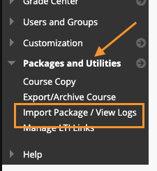
- The “Import Package/View Logs” screen will appear on right side main panel. Select the “Import Package” button.
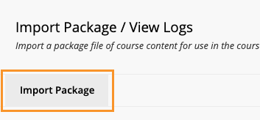
- Click the “Browse Local Files” button under the “Select a Package” section. The computer file explorer window should appear. Find and select the template zip package downloaded from eCampusOntario VLS Collection.
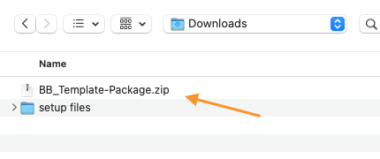
- Once the template package has successfully uploaded, it will appear beside the “Selected File” and “File Name” field. Scroll down to the “Select Course Materials” section and check the “Content Areas” option. Then select Submit to continue. Follow the on-screen prompts until your template has been successfully added.
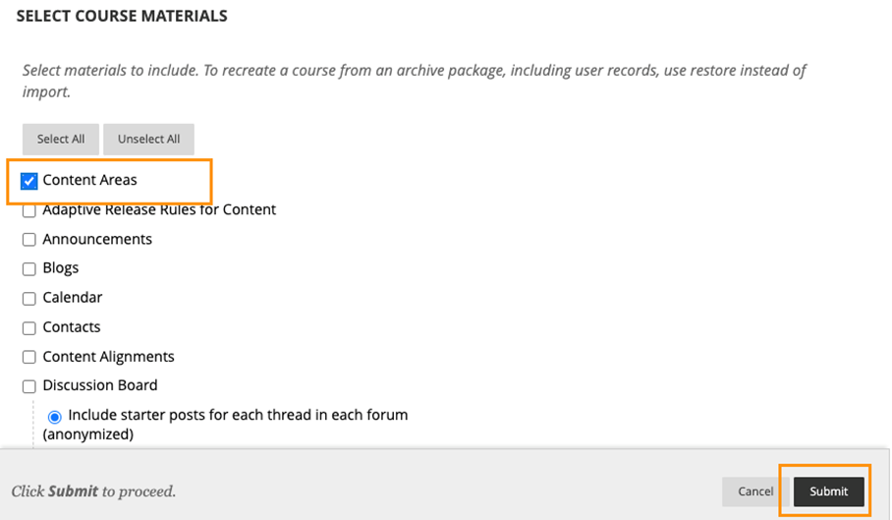

To use the template, locate the “Faculty-How-To Guide” module. This module contains pages that will help you to use the template. The module contains the “Add-template-to-course” which will walk you through adding the template pages to your course along with a page, titled “Interactive-Components”. This page which includes interactive components that are available for you to add to your course content. The “Interactive-Components” page includes brief instructions for adding the components to your content.

Happy Developing!

This project is made possible with funding by the Government of Ontario and through eCampusOntario’s support of the Virtual Learning Strategy. To learn more about the Virtual Learning Strategy visit: https://vls.ecampusontario.ca.

This work is licensed under Creative Commons Attribution-NonCommercial-ShareAlike 4.0 International.

Quiz Builder Instructions
The Quiz Builder helps you to build an interactive formative (practice) quiz that you can embed into your course content. The quiz builder is easy to use with only three steps:
- Setup
- Customize
- Copy Code

Step 1: Setup
The Quiz Builder can be customized based on your needs. In this step, you will setup your quiz based on the following options:
Option | Description
Number of Questions per Quiz | Specify the number of questions you would like to feature in your practice quiz. You will be able to select the types of questions in your quiz when you customize your quiz in Step 2.
Number of Options per Question | Specify the maximum number of options available for each question. This option will apply to multiple choice, multi-select or reorder question types. If your quiz questions will not all have the same number of options, enter the highest number of options. You can leave unnecessary options blank in a question to omit them. Example: if a quiz consists of one question with four options and one question with six options, enter “6” and leave the two extra options blank for the question that has four options.
Randomize Question Order | This allows you to randomize the order of quiz questions when a student loads or refreshes the content page.
Add Panel | This allows you to enclose your question in a formatted panel container. It adds a style element to the quiz.
Panel Type | If you choose to add a panel, you can also make the panel collapsible. This is useful if your quiz contains several questions and you want to reduce scrolling.

Once you are happy with your quiz setup and are ready to proceed to Step 2, click the “Generate Code” button, then click “OK”.

Step 2: Customize
You can customize your quiz and add content to your quiz questions using the following options:
Option | Description
Panel Title (if applicable) | If you choose to have a panel, you can give it a title. Example: Check Your Knowledge.
Question Type | Select the type of question from the available options. The question fields will change based on the type of question you pick.
Question Text (required) | Type or paste the text for your question. This field is required.
Option Text (if applicable) | The option text may not be available, depending on the question type. You may leave options blank to omit those options from displaying for the question.
Include hint or feedback type for each question | You can add either a hint or feedback for students. A hint will provide a clue for students who are stuck answering the question. Feedback will give students a deeper understanding of the correct answer.
The Correct Option(s) (required if applicable) | This option is required if the question requires a correct selection. Example: multiple choice, multi-select or true or false questions.
Randomize the options order (if applicable) | You may customize this option for each question. If applicable to the question type, you can choose to randomize the order of question options when a student loads or refreshes the content page.
Next and Previous Chevron buttons | Use the left and right chevron buttons to move between questions if your quiz contains more than one question.

Click the “Push to Preview” button once you are ready to preview your quiz, then click “OK”. If you are happy with the quiz preview, proceed to Step 3. Otherwise, return to Step 1 or Step 2 to edit your quiz. (Note: if you edit Step 1 you will need to re-enter the information in Step 2.)

Step 3: Copy Code
Click the “Copy Embed Code </>” button to copy the embed code to be pasted into your course content.

