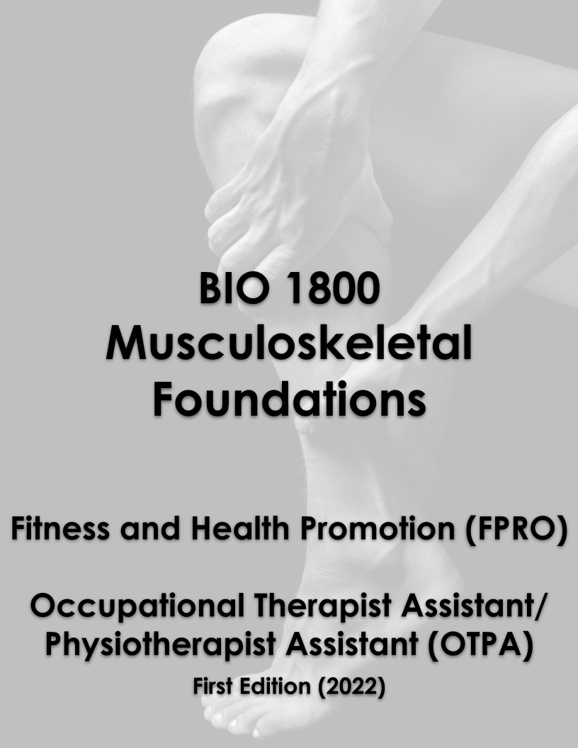
TABLE OF CONTENTS
1 | AN INTRODUCTION TO MOVEMENT 11
Introduction 11
1.1 Anatomical Terminology 12
Learning Objectives 12
Anatomical Position 12
Regional Terms 13
Directional Terms 13
Body Planes 15
Body Cavities 16
Subdivisions of the Posterior (Dorsal) and Anterior (Ventral) Cavities 17
1.2 Types of Body Movements 17
Learning Objectives 17
Flexion and Extension 20
Abduction and Adduction 20
Circumduction 20
Rotation 20
Supination and Pronation 21
Dorsiflexion and Plantar Flexion 21
Inversion and Eversion 21
Protraction and Retraction 21
Depression and Elevation 22
Upward Rotation and Downward Rotation 22
Opposition and Reposition 22
Key Terms 23
2 | AN INTRODUCTION TO BONES AND JOINTS 26
Introduction 26
2.1 The Functions of the Skeletal System 27
Learning Objectives 27
Support, Movement, and Protection 27
Mineral Storage, Energy Storage, and Hematopoiesis 29
2.2 Bone Classification 29
Learning Objectives 29
Long Bones 30
Short Bones 30
Flat Bones 31
Irregular Bones 31
Sesamoid Bones 31
2.3 Bone Structure 32
Learning Objectives 32
Gross Anatomy of Bone 32
Bone Cells and Tissue 34
Compact and Spongy Bone 35
Compact Bone 35
Spongy (Cancellous) Bone 36
2.4 Bone Formation and Development 36
Learning Objectives 36
Cartilage Templates 37
Intramembranous Ossification 37
Endochondral Ossification 38
How Bones Grow in Length 40
How Bones Grow in Diameter 40
Bone Remodeling 40
2.5 Classification of Joints 41
Learning Objectives 41
Structural Classification of Joints 41
Functional Classification of Joints 41
Synarthrosis 42
Amphiarthrosis 42
Diarthrosis 43
2.6 Fibrous Joints 44
Learning Objectives 44
Suture 44
Syndesmosis 45
Gomphosis 45
2.7 Cartilaginous Joints 46
Learning Objectives 46
Synchondrosis 46
Symphysis 47
2.8 Synovial Joints 47
Learning Objectives 47
Structural Features of Synovial Joints 48
Additional Structures Associated with Synovial Joints 49
Types of Synovial Joints 50
Pivot Joint 52
Hinge Joint 52
Condyloid Joint 52
Saddle Joint 52
Plane Joint 52
Ball-and-Socket Joint 53
Key Terms 55
3 | MUSCLE TISSUE 58
Introduction 58
3.1 Overview of Muscle Tissues 59
Learning Objectives 59
3.2 Skeletal Muscle 60
Learning Objectives 60
Skeletal Muscle Fibers 61
The Sarcomere 62
The Neuromuscular Junction 63
Excitation-Contraction Coupling 63
The Sliding Filament Model of Contraction 65
Relaxation of a Skeletal Muscle 67
3.3 Types of Muscle Contractions 67
Learning Objectives 67
The Length-Tension Range of a Sarcomere 68
3.4 Types of Muscle Fibers 69
Learning Objectives 69
Exercise and Muscle Performance 71
Endurance Exercise 71
Resistance Exercise 72
Key Terms 73
4 | THE NERVOUS SYSTEM 75
Introduction 75
4.1 Basic Structure and Function of the Nervous System 76
Learning Objectives 76
The Central and Peripheral Nervous Systems 76
Components of the Central Nervous System 77
The Cerebrum 77
The Diencephalon 77
Brain Stem 78
The Cerebellum 79
The Spinal Cord 79
Functional Divisions of the Nervous System 80
Controlling the Body 80
Basic Functions 80
4.2 Nervous Tissue 81
Learning Objectives 81
Neurons 81
Parts of a Neuron 81
4.3 The Function of Nervous Tissue 83
Learning Objectives 83
Motor Units 86
4.4 The Action Potential 87
Learning Objectives 87
Electrically Active Cell Membranes 87
The Membrane Potential 88
The Action Potential 88
Key Terms 91
5 | THE AXIAL SKELETON 94
Introduction 94
5.1 Divisions of the Skeletal System 95
Learning Objectives 95
The Axial Skeleton 96
The Appendicular Skeleton 97
5.2 The Skull 97
Learning Objectives 97
Anterior View of Skull 98
Lateral View of Skull 99
Bones of the Brain Case 99
Parietal Bone 100
Temporal Bone 100
Frontal Bone 101
Occipital Bone 102
Sphenoid Bone 103
Ethmoid Bone 104
Sutures of the Skull 106
Facial Bones of the Skull 107
Maxillary Bone 107
Palatine Bone 107
Zygomatic Bone 108
Nasal Bone 108
Lacrimal Bone 108
Inferior Nasal Conchae 108
Vomer Bone 108
Mandible 108
The Orbit 108
Hyoid Bone 109
5.3 The Vertebral Column 110
Learning Objectives 110
Regions of the Vertebral Column 111
Curvatures of the Vertebral Column 111
General Structure of a Vertebra 113
Regional Modifications of Vertebrae 114
Cervical Vertebrae 114
Thoracic Vertebrae 116
Lumbar Vertebrae 117
Sacrum and Coccyx 118
Intervertebral Discs and Ligaments of the Vertebral Column 118
Intervertebral Disc 118
Ligaments of the Vertebral Column 119
5.4 The Thoracic Cage 120
Learning Objectives 120
Sternum 121
Ribs 121
Parts of a Typical Rib 122
Rib Classifications 122
5.5 Embryonic Development of the Axial Skeleton 122
Learning Objectives 122
Development of the Skull 122
Development of the Vertebral Column and Thoracic Cage 124
Key Terms 125
6 | THE APPENDICULAR SKELETON 130
Chapter Objectives 130
Introduction 130
6.1 The Pectoral Girdle 131
Learning Objectives 131
Clavicle 134
Scapula 134
6.2 Bones of the Upper Limb 136
Learning Objectives 136
Humerus 136
Ulna 137
Radius 139
Carpal Bones 139
Metacarpal Bones 142
Phalanx Bones 142
6.3 The Pelvic Girdle and Pelvis 144
Learning Objectives 144
Hip Bone 144
Ilium 145
Ischium 146
Pubis 146
Pelvis 146
Comparison of the Female and Male Pelvis 147
6.4 Bones of the Lower Limb 148
Learning Objectives 148
Femur 148
Patella 150
Tibia 151
Fibula 153
Tarsal Bones 153
Metatarsal Bones 154
Phalanges 154
Arches of the Foot 155
6.5 Development of the Appendicular Skeleton 156
Learning Objectives 156
Ossification of Appendicular Bones 156
Key Terms 156
7 | THE MUSCULAR SYSTEM 165
Chapter Objectives 165
Introduction 165
7.1 Interactions of Skeletal Muscles, Their Fascicle Arrangement, and Their Lever Systems 166
Learning Objectives 166
Interactions of Skeletal Muscles in the Body 166
Patterns of Fascicle Organization 167
The Lever System of Muscle and Bone Interactions 169
7.2 Naming Skeletal Muscles 170
Learning Objectives 170
7.3 Axial Muscles of the Head, Neck, and Back 173
Learning Objectives 173
Muscles That Move the Head 173
Muscles of the Posterior Neck and the Back 174
7.4 Axial Muscles of the Abdominal Wall, and Thorax 176
Learning Objectives 176
Muscles of the Abdomen 176
Muscles of the Thorax 178
The Diaphragm 178
The Intercostal Muscles 179
7.5 Muscles of the Pectoral Girdle and Upper Limbs 180
Learning Objectives 180
Muscles That Position the Pectoral Girdle 181
Muscles That Move the Humerus 182
Muscles That Move the Elbow and Forearm 185
Muscles That Move the Wrist, Hand, and Fingers 188
Muscles of the Arm That Move the Wrists, Hands, and Fingers 188
Intrinsic Muscles of the Hand 189
7.6 Appendicular Muscles of the Pelvic Girdle and Lower Limbs 191
Learning Objectives 191
Muscles of the Thigh 192
Muscles That Move the Feet and Toes 195
Key Terms 199
8 | JOINTS OF THE BODY 207
Chapter Objectives 207
Introduction 207
8.1 Types of Body Movements at Synovial Joints 207
Learning Objectives 207
Table 8.1 208
Flexion and Extension 210
Abduction and Adduction 211
Circumduction 211
Rotation 211
Supination and Pronation 211
Dorsiflexion and Plantar Flexion 212
Inversion and Eversion 212
Protraction and Retraction 212
Depression and Elevation 212
Upward Rotation and Downward Rotation 212
Opposition and Reposition 212
8.2 Anatomy of Selected Synovial Joints 213
Learning Objectives 213
Articulations of the Vertebral Column 213
Shoulder Joint 214
Elbow Joint 215
Hip Joint 216
Knee Joint 217
Ankle and Foot Joints 220
Key Terms 222

1 | AN INTRODUCTION TO MOVEMENT

Figure 1.1 A Body in Motion The muscular system allows us to move, flex and contort our bodies in multiple planes of movement.
Chapter Objectives

After studying this chapter, you will be able to:
- Use appropriate anatomical terminology to identify key body structures, body regions, and directions in the body
- Use appropriate anatomical terminology to identify types of movement

Introduction
Though you may approach a course in anatomy and physiology strictly as a requirement for your field of study, the knowledge you gain in this course will serve you well in many aspects of your life. An understanding of anatomy and physiology is not only fundamental to any career in the health professions, but it can also benefit your own health. Familiarity with the human body can help you make healthful choices and prompt you to take appropriate action when signs of injury or illness arise. At some point, everyone will have a problem with some aspect of his or her musculoskeletal system and your knowledge can help you to be a better parent, spouse, partner, friend, colleague, or caregiver.

1.1 Anatomical Terminology

Learning Objectives
By the end of this section, you will be able to:
- Demonstrate the anatomical position
- Describe the human body using directional and regional terms
- Identify three planes most commonly used in the study of anatomy
- Distinguish between the posterior (dorsal) and the anterior (ventral) body cavities, identifying their subdivisions and representative organs found in each
- Describe serous membrane and explain its function
Anatomists and health care providers use terminology that can be bewildering to the uninitiated. However, the purpose of this language is not to confuse, but rather to increase precision and reduce medical errors. For example, is a scar “above the wrist” located on the forearm two or three inches away from the hand? Or is it at the base of the hand? Is it on the palm-side or back-side? By using precise anatomical terminology, we eliminate ambiguity. Anatomical terms derive from ancient Greek and Latin words. Because these languages are no longer used in everyday conversation, the meaning of their words does not change.
Anatomical terms are made up of roots, prefixes, and suffixes. The root of a term often refers to an organ, tissue, or condition, whereas the prefix or suffix often describes the root. For example, in the disorder hypertension, the prefix “hyper-” means “high” or “over,” and the root word “tension” refers to pressure, so the word “hypertension” refers to abnormally high blood pressure.

Anatomical Position
To further increase precision, anatomists standardize the way in which they view the body. Just as maps are normally oriented with north at the top, the standard body “map,” or anatomical position, is that of the body standing upright, with the feet at shoulder width and parallel, toes forward. The upper limbs are held out to each side, and the palms of the hands face forward as illustrated in Figure 1.2. Using this standard position reduces confusion. It does not matter how the body being described is oriented, the terms are used as if it is in anatomical position. For example, a scar in the “anterior (front) carpal (wrist) region” would be present on the palm side of the wrist. The term “anterior” would be used even if the hand were palm down on a table.
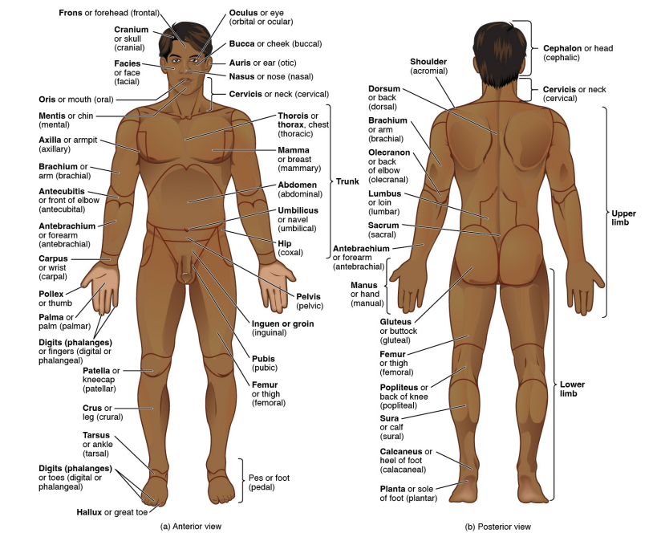
Figure 1.2 Regions of the Human Body The human body is shown in anatomical position in an (a) anterior view and a (b) posterior view. The regions of the body are labeled in boldface.
A body that is lying down is described as either prone or supine. Prone describes a face-down orientation, and supine describes a face up orientation. These terms are sometimes used in describing the position of the body during specific physical examinations or surgical procedures.

Regional Terms
The human body’s numerous regions have specific terms to help increase precision (see Figure 1.2). Notice that the term “brachium” or “arm” is reserved for the “upper arm” and “antebrachium” or “forearm” is used rather than “lower arm.” Similarly, “femur” or “thigh” is correct, and “leg” or “crus” is reserved for the portion of the lower limb between the knee and the ankle. You will be able to describe the body’s regions using the terms from the figure.

Directional Terms
Certain directional anatomical terms appear throughout this and any other anatomy textbook (Figure 1.3). These terms are essential for describing the relative locations of different body structures. For instance, an anatomist might describe one band of tissue as “inferior to” another or a physician might describe a tumor as “superficial to” a deeper body structure. Commit these terms to memory to avoid confusion when you are studying or describing the locations of particular body parts.
- Anterior (or ventral) Describes the front or direction toward the front of the body. The toes are anterior to the foot.
- Posterior (or dorsal) Describes the back or direction toward the back of the body. The popliteus is posterior to the patella.
- Superior (or cranial) describes a position above or higher than another part of the body proper. The orbits are superior to the oris.
- Inferior (or caudal) describes a position below or lower than another part of the body proper; near or toward the tail (in humans, the coccyx, or lowest part of the spinal column). The pelvis is inferior to the abdomen.
- Lateral describes the side or direction toward the side of the body. The thumb (pollex) is lateral to the digits.
- Medial describes the middle or direction toward the middle of the body. The hallux is the medial toe.
- Proximal describes a position in a limb that is nearer to the point of attachment or the trunk of the body. The brachium is proximal to the antebrachium.
- Distal describes a position in a limb that is farther from the point of attachment or the trunk of the body. The crus is distal to the femur.
- Superficial describes a position closer to the surface of the body. The skin is superficial to the bones.
- Deep describes a position farther from the surface of the body. The brain is deep to the skull.
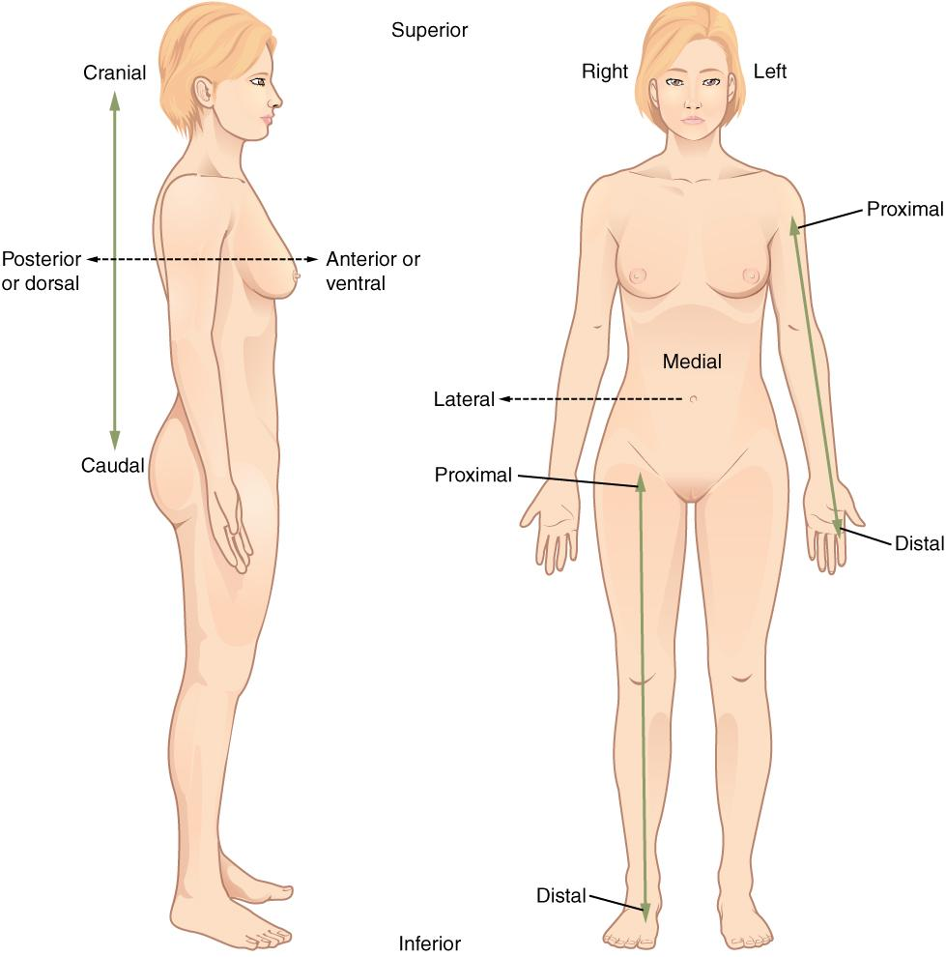
Figure 1.3 Directional Terms Applied to the Human Body Paired directional terms are shown as applied to the human body.

Body Planes
A section is a two-dimensional surface of a three-dimensional structure that has been cut. Modern medical imaging devices enable clinicians to obtain “virtual sections” of living bodies. We call these scans. Body sections and scans can be correctly interpreted, however, only if the viewer understands the plane along which the section was made. A plane is an imaginary two-dimensional surface that passes through the body. There are three planes commonly referred to in anatomy and medicine, as illustrated in Figure 1.4.
- The sagittal plane is the plane that divides the body or an organ vertically into right and left sides. If this vertical plane runs directly down the middle of the body, it is called the midsagittal or median plane. If it divides the body into unequal right and left sides, it is called a parasagittal plane or less commonly a longitudinal section.
- The frontal plane is the plane that divides the body or an organ into an anterior (front) portion and a posterior (rear) portion. The frontal plane is often referred to as a coronal plane. (“Corona” is Latin for “crown.”)
- The transverse plane is the plane that divides the body or organ horizontally into upper and lower portions. Transverse planes produce images referred to as cross sections.
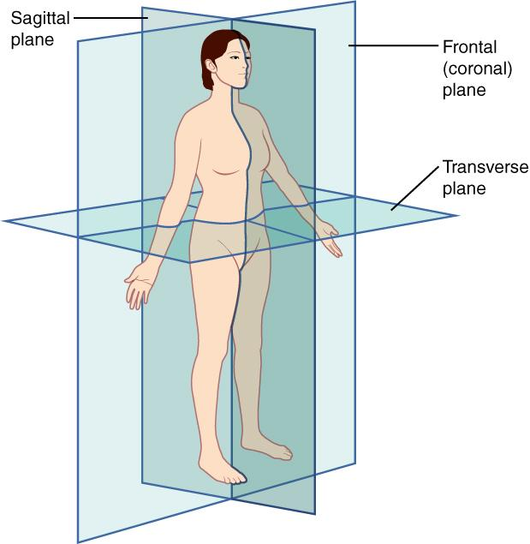
Figure 1.4 Planes of the Body The three planes most commonly used in anatomical and medical imaging are the sagittal, frontal (or coronal), and transverse plane.

Body Cavities
The body maintains its internal organization by means of membranes, sheaths, and other structures that separate compartments. The dorsal (posterior) cavity and the ventral (anterior) cavity are the largest body compartments (Figure 1.5). These cavities contain and protect delicate internal organs, and the ventral cavity allows for significant changes in the size and shape of the organs as they perform their functions. The lungs, heart, stomach, and intestines, for example, can expand and contract without distorting other tissues or disrupting the activity of nearby organs.
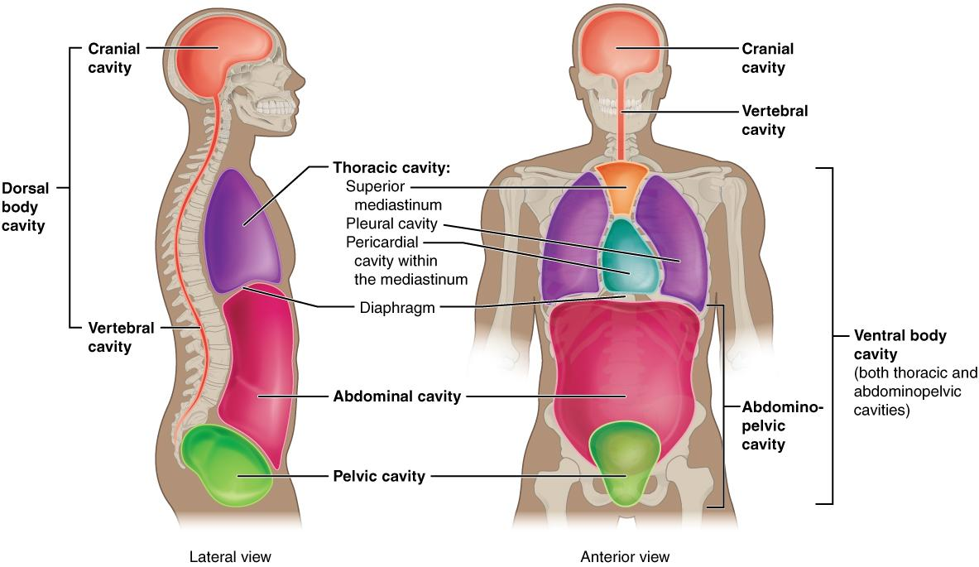
Figure 1.5 Dorsal and Ventral Body Cavities The ventral cavity includes the thoracic and abdominopelvic cavities and their subdivisions. The dorsal cavity includes the cranial and spinal cavities.

Subdivisions of the Posterior (Dorsal) and Anterior (Ventral) Cavities
The posterior (dorsal) and anterior (ventral) cavities are each subdivided into smaller cavities. In the posterior (dorsal) cavity, the cranial cavity houses the brain, and the spinal cavity (or vertebral cavity) encloses the spinal cord. Just as the brain and spinal cord make up a continuous, uninterrupted structure, the cranial and spinal cavities that house them are also continuous. The brain and spinal cord are protected by the bones of the skull and vertebral column and by cerebrospinal fluid, a colorless fluid produced by the brain, which cushions the brain and spinal cord within the posterior (dorsal) cavity.
The anterior (ventral) cavity has two main subdivisions: the thoracic cavity and the abdominopelvic cavity (see Figure 1.5). The thoracic cavity is the more superior subdivision of the anterior cavity, and it is enclosed by the rib cage. The thoracic cavity contains the lungs and the heart, which is located in the mediastinum. The diaphragm forms the floor of the thoracic cavity and separates it from the more inferior abdominopelvic cavity. The abdominopelvic cavity is the largest cavity in the body. Although no membrane physically divides the abdominopelvic cavity, it can be useful to distinguish between the abdominal cavity, the division that houses the digestive organs, and the pelvic cavity, the division that houses the organs of reproduction.

1.2 Types of Body Movements

Learning Objectives
By the end of this section, you will be able to:
- Define the different types of body movements
- Identify the joints that allow for these motions
The body has a tremendous range of movement. Each movement at a joint results from the contraction or relaxation of the muscles that are attached to the bones on either side of the articulation. Movement types are generally paired, with one being the opposite of the other. Body movements are always described in relation to the anatomical position of the body: upright stance, with upper limbs to the side of body and palms facing forward. Refer to Figure 1.6 as you go through this section.
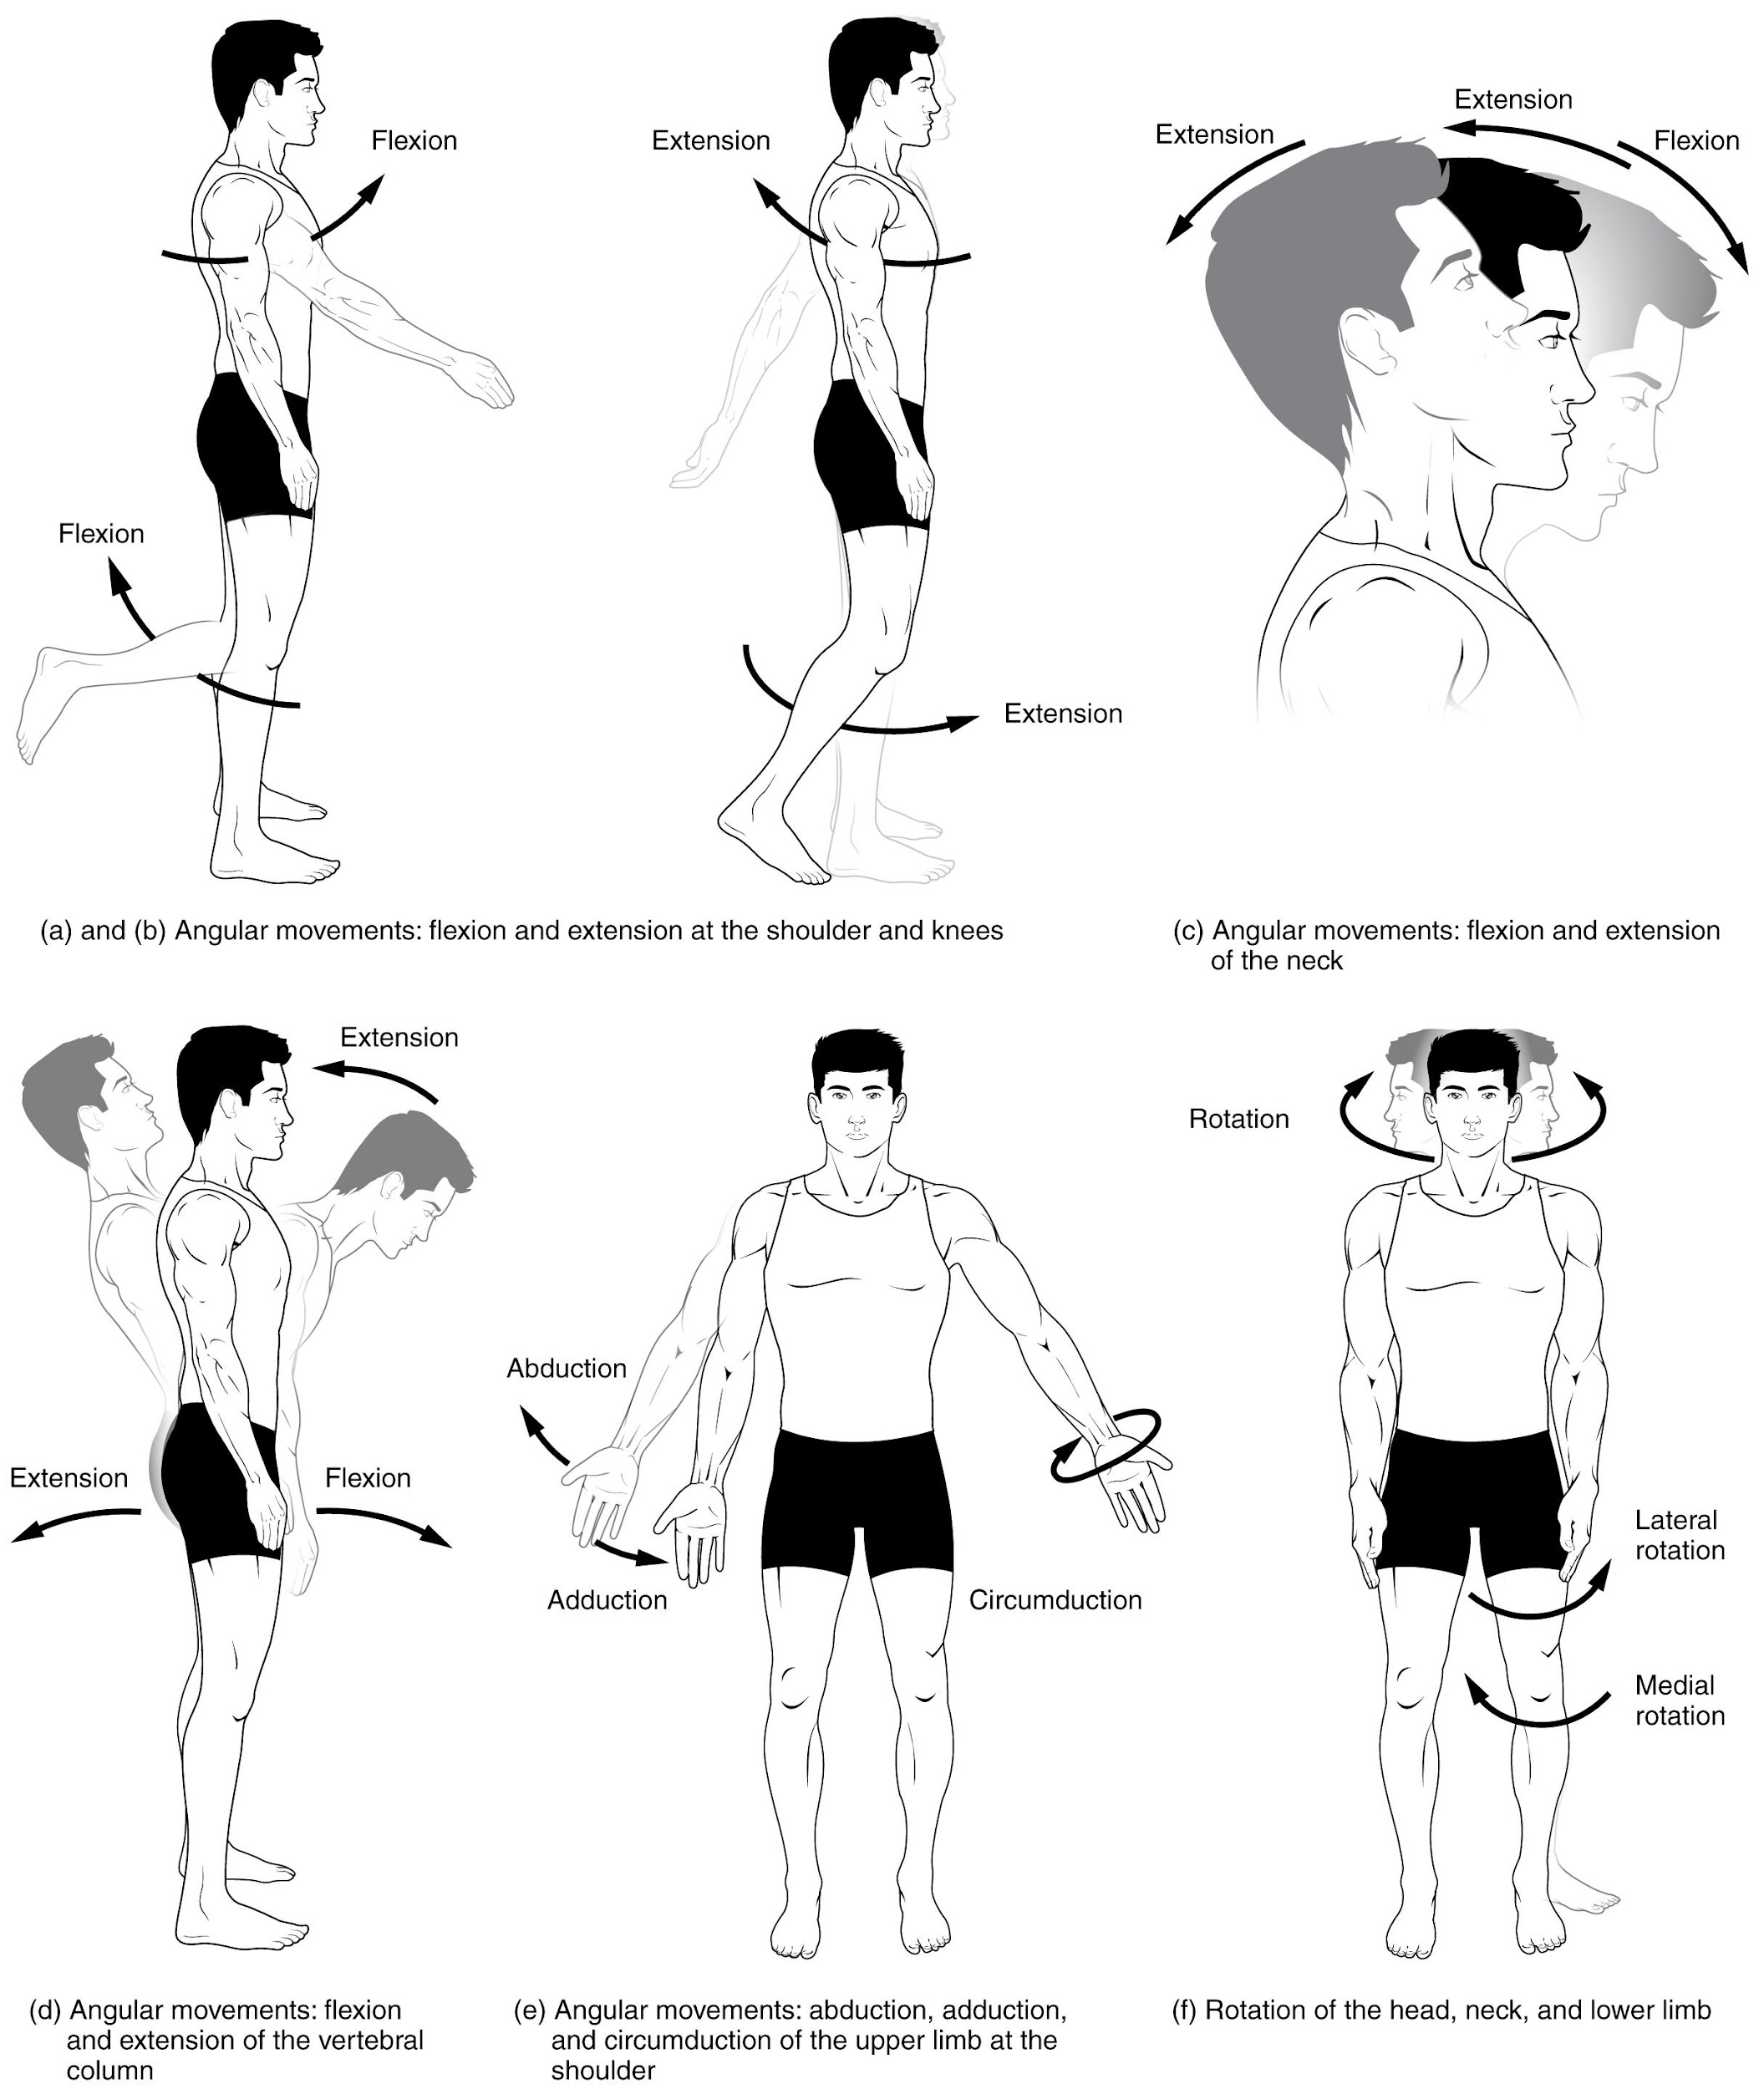
Figure 1.6 Movements of the Body, Part 1 Synovial joints give the body many ways in which to move. (a)–(b) Flexion and extension motions are in the sagittal (anterior–posterior) plane of motion. These movements take place at the shoulder, hip, elbow, knee, wrist, metacarpophalangeal, metatarsophalangeal, and interphalangeal joints. (c)–(d) Anterior bending of the head or vertebral column is flexion, while any posterior-going movement is extension. (e) Abduction and adduction are motions of the limbs, hand, fingers, or toes in the coronal (medial–lateral) plane of movement. Moving the limb or hand laterally away from the body, or spreading the fingers or toes, is abduction. Adduction brings the limb or hand toward or across the midline of the body, or brings the fingers or toes together. Circumduction is the movement of the limb, hand, or fingers in a circular pattern, using the sequential combination of flexion, adduction, extension, and abduction motions. (f) Turning of the head side to side or twisting of the body is rotation. Medial and lateral rotation of the upper limb at the shoulder or lower limb at the hip involves turning the anterior surface of the limb toward the midline of the body (medial or internal rotation) or away from the midline (lateral or external rotation).
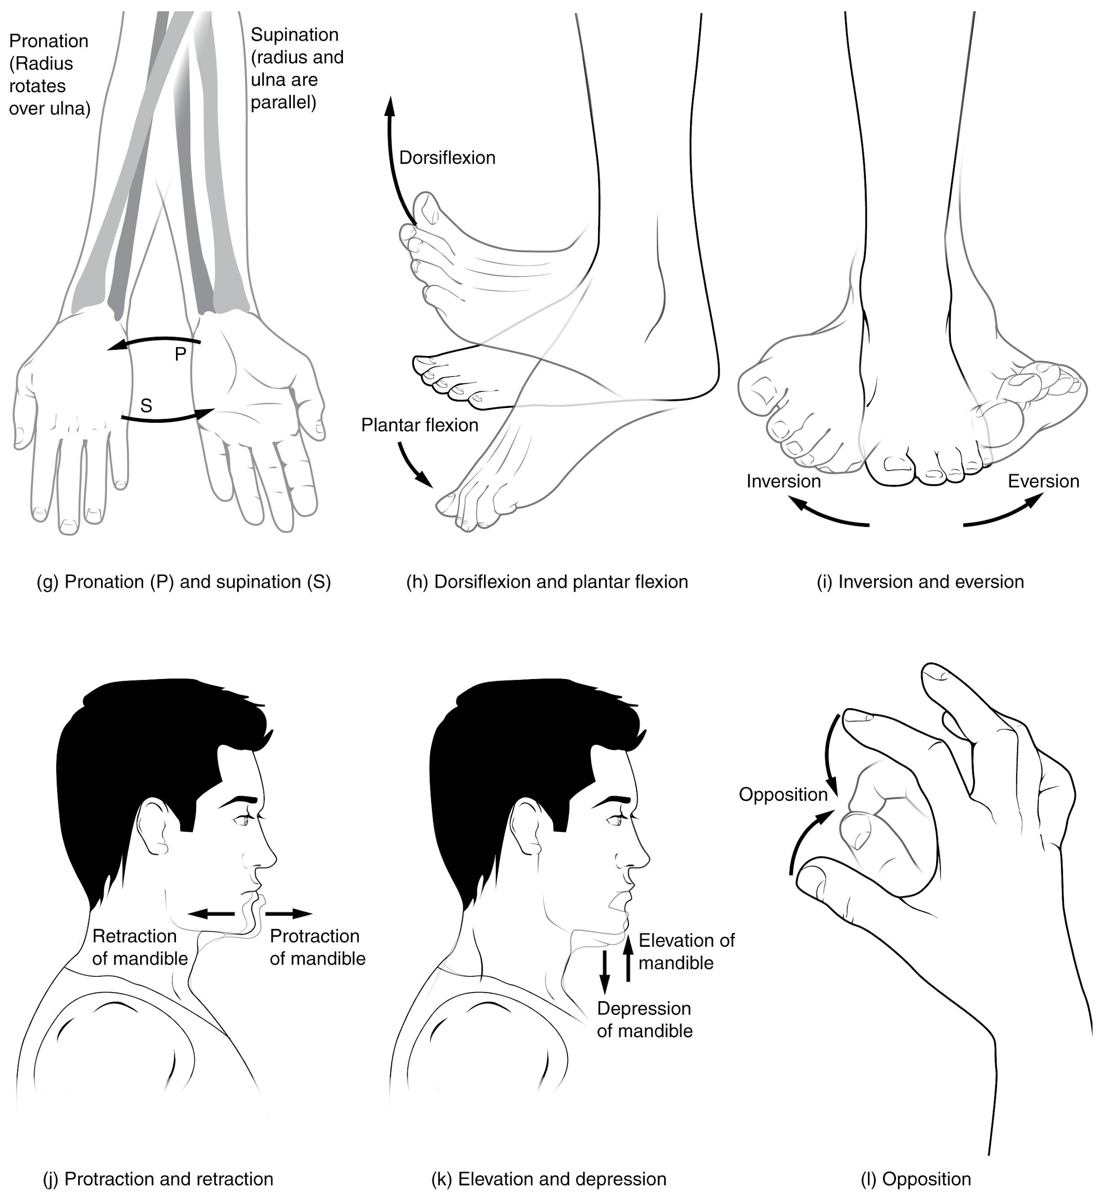0
Figure 1.7 Movements of the Body, Part 2 (g) Supination of the forearm turns the hand to the palm forward position in which the radius and ulna are parallel, while forearm pronation turns the hand to the palm backward position in which the radius crosses over the ulna to form an "X." (h) Dorsiflexion of the foot at the ankle joint moves the top of the foot toward the leg, while plantar flexion lifts the heel and points the toes. (i) Eversion of the foot moves the bottom (sole) of the foot away from the midline of the body, while foot inversion faces the sole toward the midline. (j) Protraction of the mandible pushes the chin forward, and retraction pulls the chin back. (k) Depression of the mandible opens the mouth, while elevation closes it. (l) Opposition of the thumb brings the tip of the thumb into contact with the tip of the fingers of the same hand and reposition brings the thumb back next to the index finger.

Flexion and Extension
Flexion and extension are typically movements that take place within the sagittal plane and involve anterior or posterior movements of the neck, trunk, or limbs. For the vertebral column, flexion is an anterior (forward) bending of the neck or trunk, while extension involves a posterior-directed motion (bending backward). Lateral flexion of the vertebral column occurs in the coronal plane and is defined as the bending of the neck or trunk toward the right or left side.
In the limbs, flexion decreases the angle between the bones (bending of the joint), while extension increases the angle and straightens the joint. For the upper limb, all anterior-going motions are flexion and all posterior-going motions are extension. These include anterior-posterior movements of the arm at the shoulder, the forearm at the elbow, the hand at the wrist, and the fingers at the metacarpophalangeal and interphalangeal joints. In the lower limb, bringing the thigh forward and upward is flexion at the hip joint, while posterior-going motion of the thigh is extension. Knee flexion is the bending of the knee to bring the foot toward the posterior thigh, and extension is the straightening of the knee.
Hyperextension is the abnormal or excessive extension of a joint beyond its normal range of motion, thus resulting in injury. Similarly, hyperflexion is excessive flexion at a joint. Hyperextension injuries are common at hinge joints such as the knee or elbow.

Abduction and Adduction
Abduction and adduction motions occur within the coronal plane and involve medial-lateral motions of the limbs, fingers, toes, or thumb. Abduction moves the limb laterally away from the midline of the body, while adduction is the opposing movement that brings the limb toward the body or across the midline. For example, abduction is raising the arm at the shoulder joint, moving it laterally away from the body, while adduction brings the arm down to the side of the body. Similarly, abduction and adduction at the wrist moves the hand away from or toward the midline of the body. Spreading the fingers or toes apart is also abduction, while bringing the fingers or toes together is adduction.

Circumduction
Circumduction is the movement of a body region in a circular manner, in which one end of the body region being moved stays relatively stationary while the other end describes a circle. It involves the sequential combination of flexion, adduction, extension, and abduction at a joint (see Figure 1.6e).

Rotation
Rotation can occur within the vertebral column, at a pivot joint, or at a ball-and-socket joint. Rotation of the neck or body is the twisting movement produced by the summation of the small rotational movements available between adjacent vertebrae. At a pivot joint, one bone rotates in relation to another bone. This is a uniaxial joint, and thus rotation is the only motion allowed at a pivot joint. For example, at the atlantoaxial joint, the first cervical (C1) vertebra (atlas) rotates around the dens, the upward projection from the second cervical (C2) vertebra (axis). This allows the head to rotate from side to side as when shaking the head “no.” The proximal radioulnar joint is a pivot joint formed by the head of the radius and its articulation with the ulna. This joint allows for the radius to rotate along its length during pronation and supination movements of the forearm.
Rotation can also occur at the ball-and-socket joints of the shoulder and hip. Here, the humerus and femur rotate around their long axis, which moves the anterior surface of the arm or thigh either toward or away from the midline of the body. Movement that brings the anterior surface of the limb toward the midline of the body is called medial (internal) rotation. Conversely, rotation of the limb so that the anterior surface moves away from the midline is lateral (external) rotation (see Figure 1.6f). Be sure to distinguish medial and lateral rotation, which can only occur at the multiaxial shoulder and hip joints, from circumduction, which can occur at either biaxial or multiaxial joints.

Supination and Pronation
Supination and pronation are movements of the forearm. In the anatomical position, the upper limb is held next to the body with the palm facing forward. This is the supinated position of the forearm. In this position, the radius and ulna are parallel to each other. When the palm of the hand faces backward, the forearm is in the pronated position, and the radius and ulna form an X-shape.
Supination and pronation are the movements of the forearm that go between these two positions. Pronation is the motion that moves the forearm from the supinated (anatomical) position to the pronated (palm backward) position. This motion is produced by rotation of the radius at the proximal radioulnar joint, accompanied by movement of the radius at the distal radioulnar joint. The proximal radioulnar joint is a pivot joint that allows for rotation of the head of the radius. Because of the slight curvature of the shaft of the radius, this rotation causes the distal end of the radius to cross over the distal ulna at the distal radioulnar joint. This crossing over brings the radius and ulna into an X-shape position. Supination is the opposite motion, in which rotation of the radius returns the bones to their parallel positions and moves the palm to the anterior facing (supinated) position. It helps to remember that supination is the motion you use when scooping up soup with a spoon (see Figure 1.7g).

Dorsiflexion and Plantar Flexion
Dorsiflexion and plantar flexion are movements at the ankle joint, which is a hinge joint. Lifting the front of the foot, so that the top of the foot moves toward the anterior leg is dorsiflexion, while lifting the heel of the foot from the ground or pointing the toes downward is plantar flexion. These are the only movements available at the ankle joint (see Figure 1.7h).

Inversion and Eversion
Inversion and eversion are complex movements that involve the multiple plane joints among the bones of the foot. Inversion is the turning of the foot to bring the soles of the foot toward the midline, while eversion turns the bottom of the foot away from the midline. The foot has a greater range of inversion than eversion motion (see Figure 1.7i).

Protraction and Retraction
Protraction and retraction are anterior-posterior movements of the scapula or mandible. Protraction of the scapula occurs when the shoulder is moved forward, as when pushing against something or throwing a ball. Retraction is the opposite motion, with the scapula being pulled posteriorly and medially, toward the vertebral column. For the mandible, protraction occurs when the lower jaw is pushed forward, to stick out the chin, while retraction pulls the lower jaw backward. (See Figure 1.7j.)

Depression and Elevation
Depression and elevation are downward and upward movements of the scapula or mandible. The upward movement of the scapula and shoulder is elevation, while a downward movement is depression. These movements are used to shrug your shoulders. Similarly, elevation of the mandible is the upward movement of the lower jaw used to close the mouth or bite on something, and depression is the downward movement that produces opening of the mouth (see Figure 1.7k).

Upward Rotation and Downward Rotation
Upward and downward rotation are movements of the scapula and are defined by the direction of movement of the glenoid cavity. These motions involve rotation of the scapula around a point inferior to the scapular spine and are produced by combinations of muscles acting on the scapula. During upward rotation, the glenoid cavity moves upward as the medial end of the scapular spine moves downward. This is a very important motion that contributes to upper limb abduction. Without upward rotation of the scapula, the greater tubercle of the humerus would hit the acromion of the scapula, thus preventing any abduction of the arm above shoulder height. Upward rotation of the scapula is thus required for full abduction of the upper limb. Downward rotation occurs during limb adduction and involves the downward motion of the glenoid cavity with upward movement of the medial end of the scapular spine.

Opposition and Reposition

Opposition is the thumb movement that brings the tip of the thumb in contact with the tip of a finger. This movement is produced at the first carpometacarpal joint, which is a saddle joint formed between the trapezium carpal bone and the first metacarpal bone. Thumb opposition is produced by a combination of flexion and abduction of the thumb at this joint. Returning the thumb to its anatomical position next to the index finger is called reposition (see Figure 1.7l).
Interactive Link
Watch this video that reviews the three planes of the body and describes the movements that occur in each plane. What movements occur in the transverse plane?

Key Terms

abdominopelvic cavity division of the anterior (ventral) cavity that houses the abdominal and pelvic viscera

abduction movement in the coronal plane that moves a limb laterally away from the body; spreading of the fingers

adduction movement in the coronal plane that moves a limb medially toward or across the midline of the body; bringing fingers together

anatomical position standard reference position used for describing locations and directions on the human body

anterior describes the front or direction toward the front of the body; also referred to as ventral

anterior cavity larger body cavity located anterior to the posterior (dorsal) body cavity; includes the serous membrane-lined pleural cavities for the lungs, pericardial cavity for the heart, and peritoneal cavity for the abdominal and pelvic organs; also referred to as ventral cavity

caudal describes a position below or lower than another part of the body proper; near or toward the tail (in humans, the coccyx, or lowest part of the spinal column); also referred to as inferior

circumduction circular motion of the arm, thigh, hand, thumb, or finger that is produced by the sequential combination of flexion, abduction, extension, and adduction

cranial describes a position above or higher than another part of the body proper; also referred to as superior

cranial cavity division of the posterior (dorsal) cavity that houses the brain

deep describes a position farther from the surface of the body

depression downward (inferior) motion of the scapula or mandible

distal describes a position farther from the point of attachment or the trunk of the body

dorsal describes the back or direction toward the back of the body; also referred to as posterior

dorsal cavity posterior body cavity that houses the brain and spinal cord; also referred to the posterior body cavity

dorsiflexion movement at the ankle that brings the top of the foot toward the anterior leg

downward rotation movement of the scapula during upper limb adduction in which the glenoid cavity of the scapula moves in a downward direction as the medial end of the scapular spine moves in an upward direction

elevation upward (superior) motion of the scapula or mandible

eversion foot movement involving the intertarsal joints of the foot in which the bottom of the foot is turned laterally, away from the midline

extension movement in the sagittal plane that increases the angle of a joint (straightens the joint); motion involving posterior bending of the vertebral column or returning to the upright position from a flexed position

flexion movement in the sagittal plane that decreases the angle of a joint (bends the joint); motion involving anterior bending of the vertebral column

frontal plane two-dimensional, vertical plane that divides the body or organ into anterior and posterior portions

hyperextension excessive extension of joint, beyond the normal range of movement

hyperflexion excessive flexion of joint, beyond the normal range of movement

inferior describes a position below or lower than another part of the body proper; near or toward the tail (in humans, the coccyx, or lowest part of the spinal column); also referred to as caudal

inversion foot movement involving the intertarsal joints of the foot in which the bottom of the foot is turned toward the midline

lateral describes the side or direction toward the side of the body

lateral flexion bending of the neck or body toward the right or left side

lateral (external) rotation movement of the arm at the shoulder joint or the thigh at the hip joint that moves the anterior surface of the limb away from the midline of the body

medial describes the middle or direction toward the middle of the body

medial (internal) rotation movement of the arm at the shoulder joint or the thigh at the hip joint that brings the anterior surface of the limb toward the midline of the body

opposition thumb movement that brings the tip of the thumb in contact with the tip of a finger

plane imaginary two-dimensional surface that passes through the body

plantar flexion foot movement at the ankle in which the heel is lifted off of the ground

posterior describes the back or direction toward the back of the body; also referred to as dorsal

posterior cavity posterior body cavity that houses the brain and spinal cord; also referred to as dorsal cavity

pronated position forearm position in which the palm faces backward

pronation forearm motion that moves the palm of the hand from the palm forward to the palm backward position

prone face down

protraction anterior motion of the scapula or mandible

proximal describes a position nearer to the point of attachment or the trunk of the body

reposition movement of the thumb from opposition back to the anatomical position (next to index finger)

retraction posterior motion of the scapula or mandible

rotation movement of a bone around a central axis (atlantoaxial joint) or around its long axis (proximal radioulnar joint; shoulder or hip joint); twisting of the vertebral column resulting from the summation of small motions between adjacent vertebrae

sagittal plane two-dimensional, vertical plane that divides the body or organ into right and left sides

section in anatomy, a single flat surface of a three-dimensional structure that has been cut through

spinal cavity division of the dorsal cavity that houses the spinal cord; also referred to as vertebral cavity

superficial describes a position nearer to the surface of the body

superior describes a position above or higher than another part of the body proper; also referred to as cranial

supinated position forearm position in which the palm faces anteriorly (anatomical position)

supination forearm motion that moves the palm of the hand from the palm backward to the palm forward position

supine face up

thoracic cavity division of the anterior (ventral) cavity that houses the heart, lungs, esophagus, and trachea

transverse plane two-dimensional, horizontal plane that divides the body or organ into superior and inferior portions

upward rotation movement of the scapula during upper limb abduction in which the glenoid cavity of the scapula moves in an upward direction as the medial end of the scapular spine moves in a downward direction

ventral describes the front or direction toward the front of the body; also referred to as anterior

ventral cavity larger body cavity located anterior to the posterior (dorsal) body cavity; includes the serous membrane-lined pleural cavities for the lungs, pericardial cavity for the heart, and peritoneal cavity for the abdominal and pelvic organs; also referred to as anterior body cavity

2 | AN INTRODUCTION TO BONES AND JOINTS
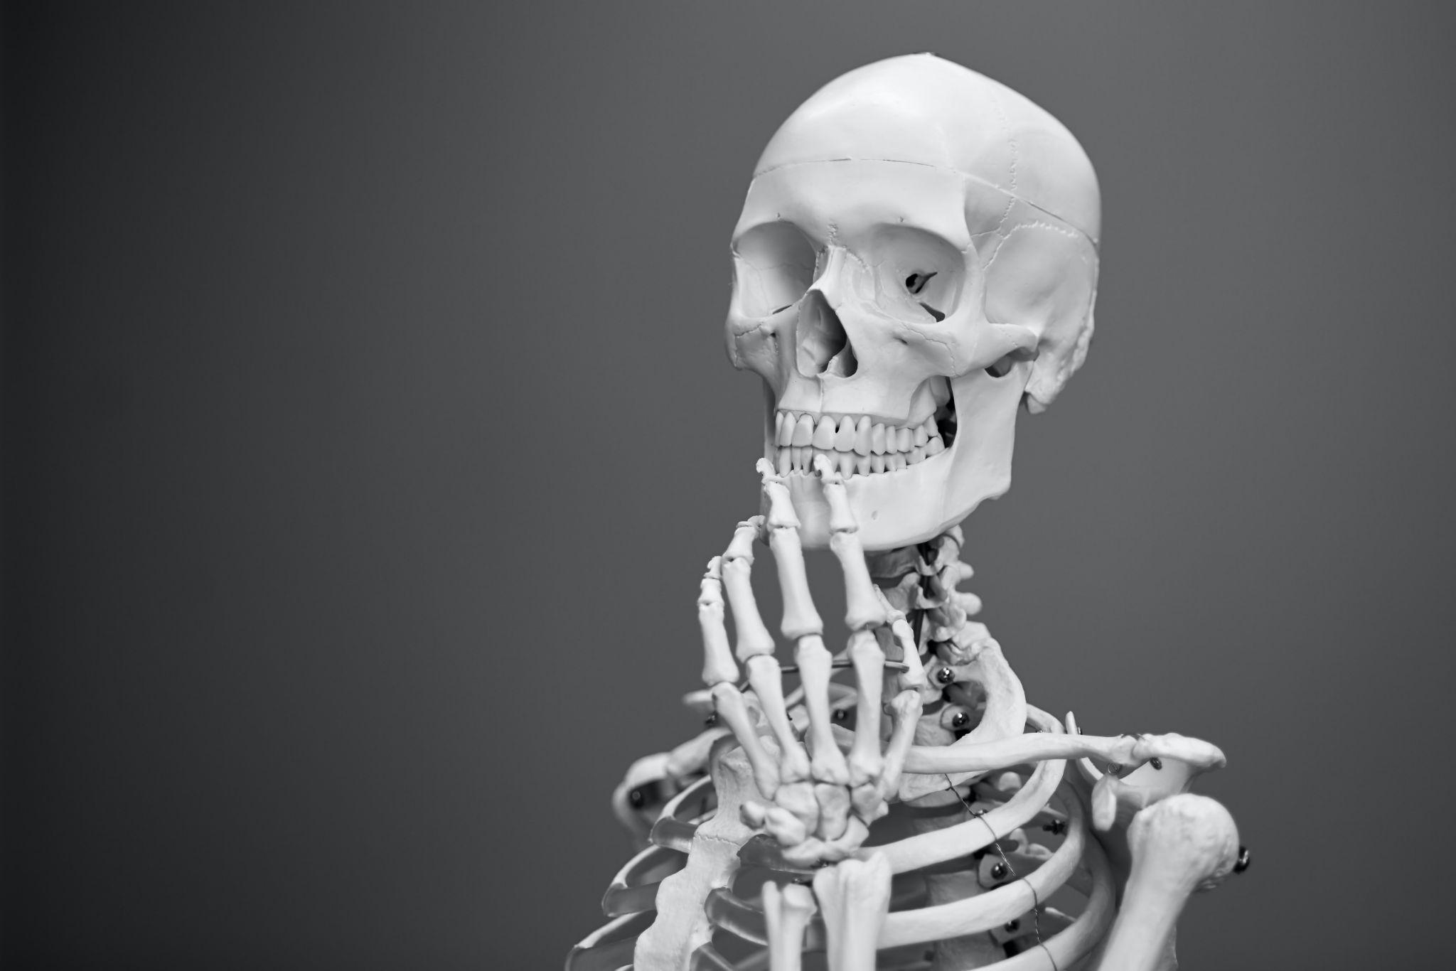
Figure 2.1 The Bones of the Human Body The bones of our body and the joints created by the connection of our bones play an important role in our body’s protection and function.
Chapter Objectives

After studying this chapter, you will be able to:
- Describe the functions of the skeletal system and its two major subdivisions
- List and describe the functions of bones
- Describe the classes of bones
- Discuss the process of bone formation and development
- Discuss both functional and structural classifications for body joints
- Describe the characteristic features for fibrous, cartilaginous, and synovial joints and give examples of each

Introduction
The skeletal system forms the rigid internal framework of the body. It consists of the bones, cartilages, and ligaments. Bones support the weight of the body, allow for body movements, and protect internal organs. Cartilage provides flexible strength and support for body structures such as the thoracic cage, the external ear, and the trachea and larynx. At joints of the body, cartilage can also unite adjacent bones or provide cushioning between them. Ligaments are the strong connective tissue bands that hold the bones at a moveable joint together and serve to prevent excessive movements of the joint that would result in injury.
Each bone of the body serves a particular function, and therefore bones vary in size, shape, and strength based on these functions. For example, the bones of the lower back and lower limb are thick and strong to support your body weight. Similarly, the size of a bony landmark that serves as a muscle attachment site on an individual bone is related to the strength of this muscle. Muscles can apply very strong pulling forces to the bones of the skeleton. To resist these forces, bones have enlarged bony landmarks at sites where powerful muscles attach. This means that not only the size of a bone, but also its shape, is related to its function.
The adult human body has 206 bones, and with the exception of the hyoid bone in the neck, each bone is connected to at least one other bone. Joints are the location where bones come together. Many joints allow for movement between the bones. At these joints, the articulating surfaces of the adjacent bones can move smoothly against each other. However, the bones of other joints may be joined to each other by connective tissue or cartilage. These joints are designed for stability and provide for little or no movement. Importantly, joint stability and movement are related to each other. This means that stable joints allow for little or no mobility between the adjacent bones. Conversely, joints that provide the most movement between bones are the least stable. Understanding the relationship between joint structure and function will help to explain why particular types of joints are found in certain areas of the body.

2.1 The Functions of the Skeletal System

Learning Objectives
By the end of this section, you will be able to:
- Define bone, cartilage, and the skeletal system
- List and describe the functions of the skeletal system
Bone, or osseous tissue, is a hard, dense connective tissue that forms most of the adult skeleton, the support structure of the body. In the areas of the skeleton where bones move (for example, the ribcage and joints), cartilage, a semi-rigid form of connective tissue, provides flexibility and smooth surfaces for movement. The skeletal system is the body system composed of bones and cartilage and performs the following critical functions for the human body:
- supports the body
- facilitates movement
- protects internal organs
- produces blood cells
- stores and releases minerals and fat

Support, Movement, and Protection
The most apparent functions of the skeletal system are the gross functions—those visible by observation. Simply by looking at a person, you can see how the bones support, facilitate movement, and protect the human body.
Just as the steel beams of a building provide a scaffold to support its weight, the bones and cartilage of your skeletal system compose the scaffold that supports the rest of your body. Without the skeletal system, you would be a limp mass of organs, muscle, and skin.
Bones also facilitate movement by serving as points of attachment for your muscles. While some bones only serve as a support for the muscles, others also transmit the forces produced when your muscles contract. From a mechanical point of view, bones act as levers and joints serve as fulcrums (Figure 2.2). Unless a muscle spans a joint and contracts, a bone is not going to move.
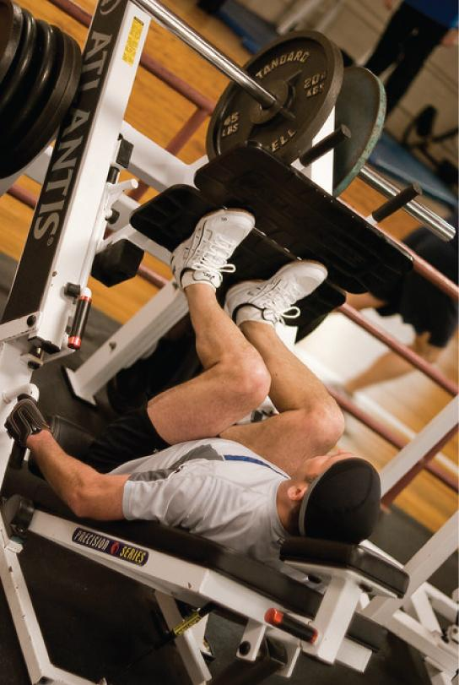
Figure 2.2 Bones Support Movement Bones act as levers when muscles span a joint and contract. (credit: Benjamin J. DeLong)
Bones also protect internal organs from injury by covering or surrounding them. For example, your ribs protect your lungs and heart, the bones of your vertebral column (spine) protect your spinal cord, and the bones of your cranium (skull) protect your brain (Figure 2.3).
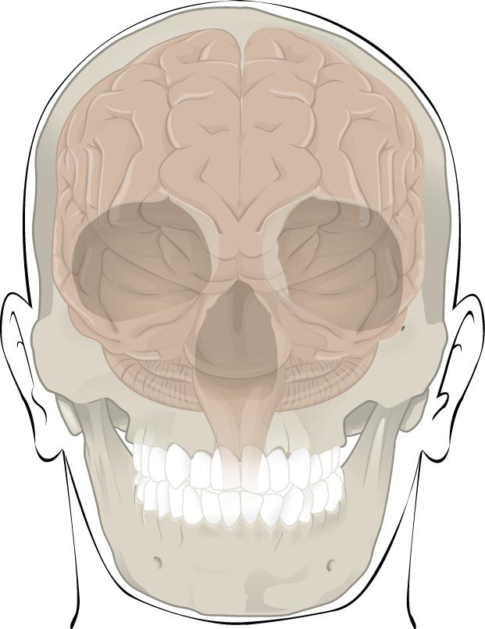
Figure 2.3 Bones Protect Brain The cranium completely surrounds and protects the brain from non-traumatic injury.

Mineral Storage, Energy Storage, and Hematopoiesis
On a metabolic level, bone tissue performs several critical functions. For one, the bone matrix acts as a reservoir for a number of minerals important to the functioning of the body, especially calcium, and phosphorus. These minerals, incorporated into bone tissue, can be released back into the bloodstream to maintain levels needed to support physiological processes. Calcium ions, for example, are essential for muscle contractions and controlling the flow of other ions involved in the transmission of nerve impulses.
Bone also serves as a site for fat storage and blood cell production. The softer connective tissue that fills the interior of most bone is referred to as bone marrow (Figure 2.4). There are two types of bone marrow: yellow marrow and red marrow. Yellow marrow contains adipose tissue; the triglycerides stored in the adipocytes of the tissue can serve as a source of energy. Red marrow is where hematopoiesis—the production of blood cells—takes place. Red blood cells, white blood cells, and platelets are all produced in the red marrow.
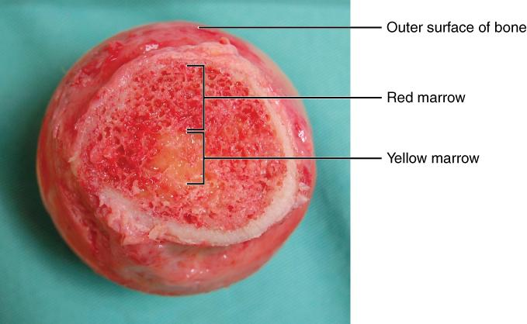
Figure 2.4 Head of Femur Showing Red and Yellow Marrow The head of the femur contains both yellow and red marrow. Yellow marrow stores fat. Red marrow is responsible for hematopoiesis. (credit: modification of work by “stevenfruitsmaak”/Wikimedia Commons)

2.2 Bone Classification

Learning Objectives
By the end of this section, you will be able to:
- Classify bones according to their shapes
- Describe the function of each category of bones
The 206 bones that compose the adult skeleton are divided into five categories based on their shapes (Figure 2.5). Their shapes and their functions are related such that each categorical shape of bone has a distinct function.
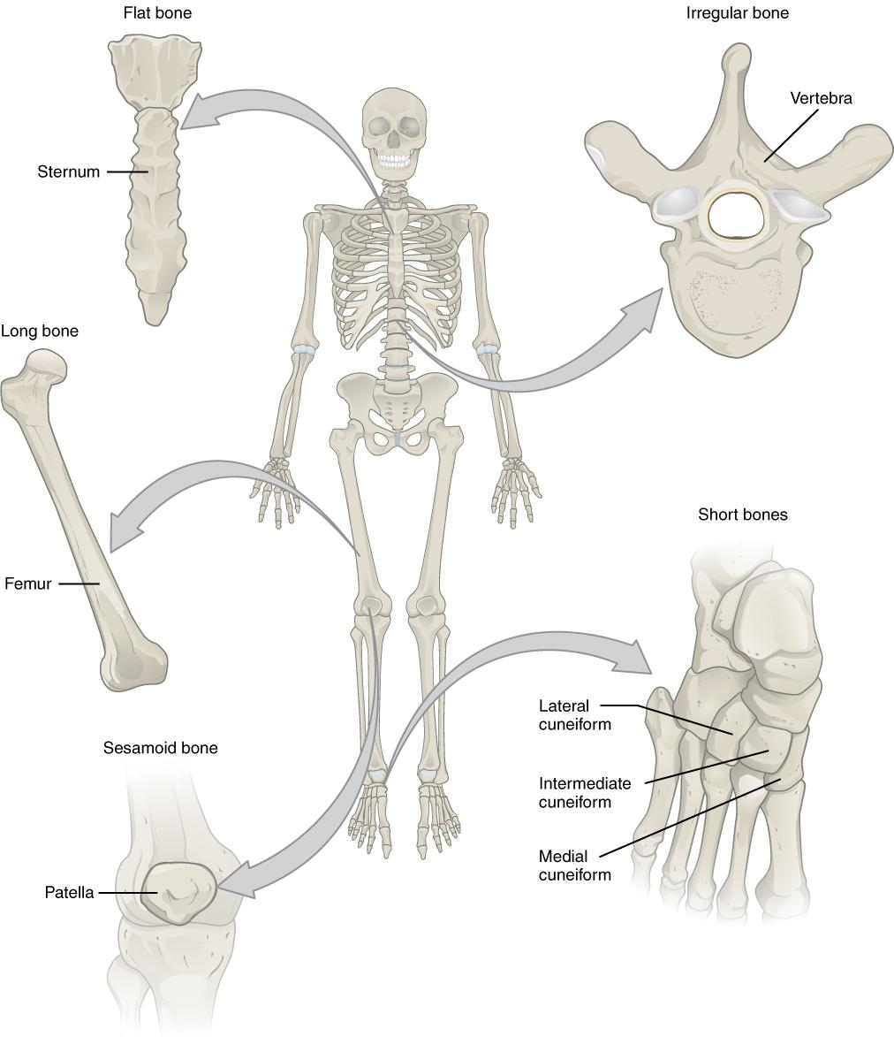
Figure 2.5 Classifications of Bones Bones are classified according to their shape.

Long Bones
A long bone is one that is cylindrical in shape, being longer than it is wide. Keep in mind, however, that the term describes the shape of a bone, not its size. Long bones are found in the arms (humerus, ulna, radius) and legs (femur, tibia, fibula), as well as in the fingers (metacarpals, phalanges) and toes (metatarsals, phalanges). Long bones function as levers; they move when muscles contract.

Short Bones
A short bone is one that is cube-like in shape, being approximately equal in length, width, and thickness. The only short bones in the human skeleton are in the carpals of the wrists and the tarsals of the ankles. Short bones provide stability and support as well as some limited motion.

Flat Bones
The term “flat bone” is somewhat of a misnomer because, although a flat bone is typically thin, it is also often curved. Examples include the cranial (skull) bones, the scapulae (shoulder blades), the sternum (breastbone), and the ribs. Flat bones serve as points of attachment for muscles and often protect internal organs.

Irregular Bones
An irregular bone is one that does not have any easily characterized shape and therefore does not fit any other classification. These bones tend to have more complex shapes, like the vertebrae that support the spinal cord and protect it from compressive forces. Many facial bones, particularly the ones containing sinuses, are classified as irregular bones.

Sesamoid Bones
A sesamoid bone is a small, round bone that, as the name suggests, is shaped like a sesame seed. These bones form in tendons (the sheaths of tissue that connect bones to muscles) where a great deal of pressure is generated in a joint. The sesamoid bones protect tendons by helping them overcome compressive forces. Sesamoid bones vary in number and placement from person to person but are typically found in tendons associated with the feet, hands, and knees. The patellae (singular = patella) are the only sesamoid bones found in common with every person. Table 2.1 reviews bone classifications with their associated features, functions, and examples.
Bone Classifications
Bone Classification | Features | Function(s) | Examples
Long | Cylinder-like shape, longer than it is wide | Leverage | Femur, tibia, fibula, metatarsals, humerus, ulna, radius, phalanges
Short | Cube-like shape, approximately equal in length, width, and thickness | Provide stability, support, while allowing for some motion | Carpals, tarsals
Flat | Thin and curved | Points of attachments for muscles; protect internal organs | Sternum, ribs, scapulae, cranial bones
Irregular | Complex shape | Points of attachments for muscles; protect internal organs | Vertebra, facial bones
Sesamoid | Small and round; embedded in tendons | Protect tendons from compressive forces | Patellae
Table 2.1

2.3 Bone Structure

Learning Objectives
By the end of this section, you will be able to:
- Identify the anatomical features of a bone
- Describe the histology of bone tissue
- Compare and contrast compact and spongy bone
- Identify the structures that compose compact and spongy bone
Bone tissue (osseous tissue) differs greatly from other tissues in the body. Bone is hard and many of its functions depend on that characteristic hardness. Later discussions in this chapter will show that bone is also dynamic in that its shape adjusts to accommodate stresses. This section will examine the gross anatomy of bone first and then move on to its histology.

Gross Anatomy of Bone
The structure of a long bone allows for the best visualization of all of the parts of a bone (Figure 2.6). A long bone has two parts: the diaphysis and the epiphysis. The diaphysis is the tubular shaft that runs between the proximal and distal ends of the bone. The hollow region in the diaphysis is called the medullary cavity, which is filled with yellow marrow. The walls of the diaphysis are composed of dense and hard compact bone.
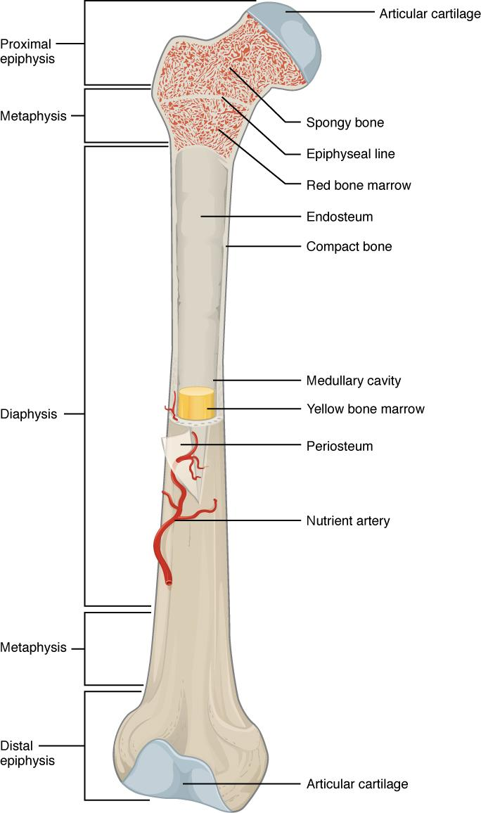
Figure 2.6 Anatomy of a Long Bone A typical long bone shows the gross anatomical characteristics of bone.
The wider section at each end of the bone is called the epiphysis (plural = epiphyses), which is filled with spongy bone. Red marrow fills the spaces in the spongy bone. Each epiphysis meets the diaphysis at the metaphysis, the narrow area that contains the epiphyseal plate (growth plate), a layer of hyaline (transparent) cartilage in a growing bone. When the bone stops growing in early adulthood (approximately 18–21 years), the cartilage is replaced by osseous tissue and the epiphyseal plate becomes an epiphyseal line.
The medullary cavity has a delicate membranous lining called the endosteum (end- = “inside”; oste- = “bone”), where bone growth, repair, and remodeling occur. The outer surface of the bone is covered with a fibrous membrane called the periosteum (peri- = “around” or “surrounding”). The periosteum contains blood vessels, nerves, and lymphatic vessels that nourish compact bone. Tendons and ligaments also attach to bones at the periosteum. The periosteum covers the entire outer surface except where the epiphyses meet other bones to form joints (Figure 2.7). In this region, the epiphyses are covered with articular cartilage, a thin layer of cartilage that reduces friction and acts as a shock absorber.
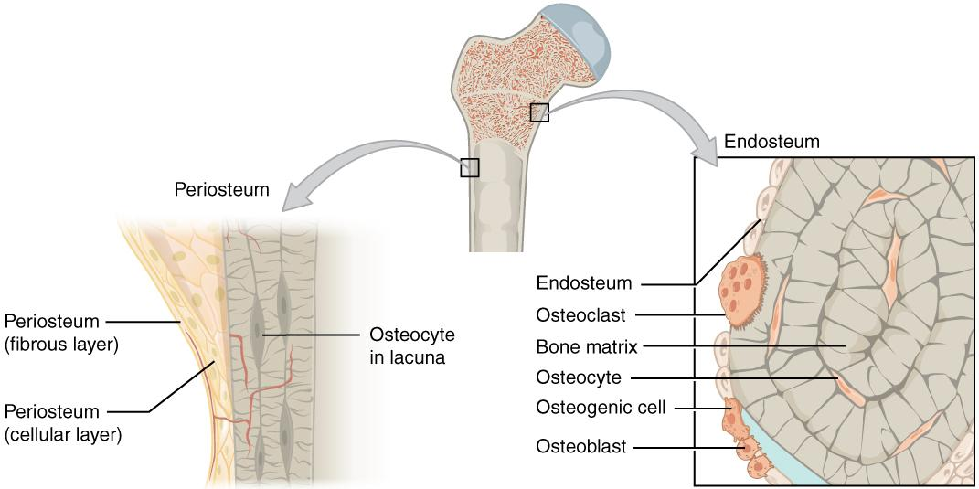
Figure 2.7 Periosteum and Endosteum The periosteum forms the outer surface of bone, and the endosteum lines the medullary cavity.
Flat bones, like those of the cranium, consist of a layer of spongy bone, lined on either side by a layer of compact bone (Figure 2.8). The two layers of compact bone and the interior spongy bone work together to protect the internal organs. If the outer layer of a cranial bone fractures, the brain is still protected by the intact inner layer.
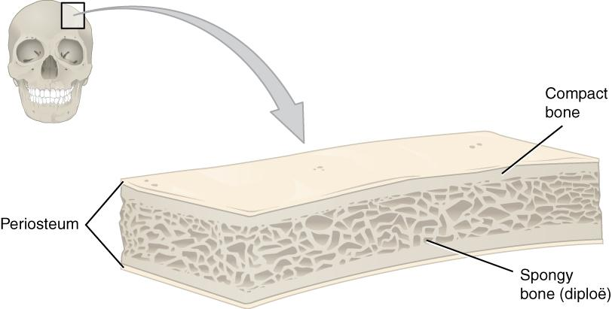
Figure 2.8 Anatomy of a Flat Bone This cross-section of a flat bone shows the spongy bone (diploë) lined on either side by a layer of compact bone.

Bone Cells and Tissue
Bone contains a relatively small number of cells. Although bone cells compose a small amount of the bone volume, they are crucial to the function of bones. Four types of cells are found within bone tissue: osteoblasts, osteocytes, osteogenic cells, and osteoclasts (Figure 2.9).
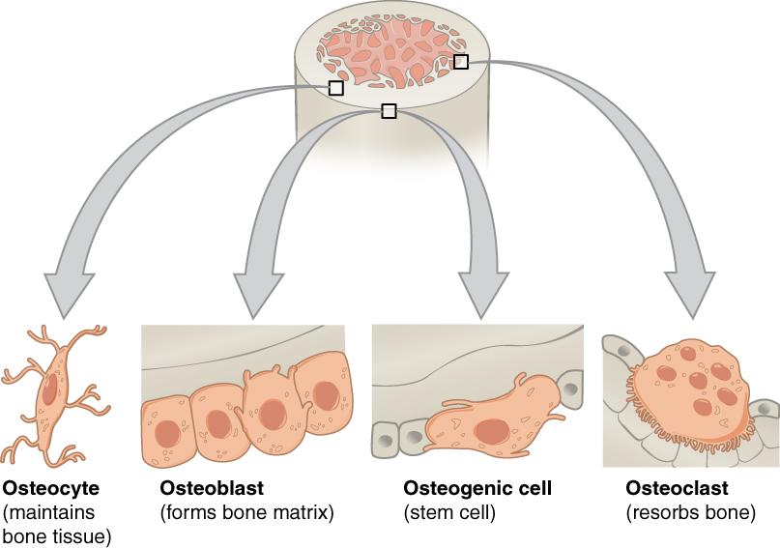
Figure 2.9 Bone Cells Four types of cells are found within bone tissue. Osteogenic cells are undifferentiated and develop into osteoblasts. When osteoblasts get trapped within the calcified matrix, their structure and function changes, and they become osteocytes. Osteoclasts develop from monocytes and macrophages and differ in appearance from other bone cells.
The osteoblast is the bone cell responsible for forming new bone and is found in the growing portions of bone, including the periosteum and endosteum. Osteoblasts, which do not divide, synthesize and secrete the collagen matrix and calcium salts. As the secreted matrix surrounding the osteoblast calcifies, the osteoblast become trapped within it; as a result, it changes in structure and becomes an osteocyte, the primary cell of mature bone and the most common type of bone cell.
Osteogenic cells are undifferentiated with high mitotic activity and they are the only bone cells that divide. Immature osteogenic cells are found in the deep layers of the periosteum and the marrow. They differentiate and develop into osteoblasts.
The dynamic nature of bone means that new tissue is constantly formed, and old, injured, or unnecessary bone is dissolved for repair or for calcium release. The cell responsible for bone resorption, or breakdown, is the osteoclast. Osteoclasts are continually breaking down old bone while osteoblasts are continually forming new bone. The ongoing balance between osteoblasts and osteoclasts is responsible for the constant but subtle reshaping of bone. Table 2.2 reviews the bone cells, their functions, and locations.

Bone Cells
Cell Type | Function | Location
Osteogenic cells | Develop into osteoblasts | Deep layers of the periosteum and the marrow
Osteoblasts | Bone formation | Growing portions of bone, including periosteum and endosteum
Osteocytes | Maintain mineral concentration of matrix | Entrapped in matrix
Osteoclasts | Bone resorption | Bone surfaces and at sites of old, injured, or unneeded bone
Table 2.2

Compact and Spongy Bone
The differences between compact and spongy bone are best explored via their histology. Most bones contain compact and spongy osseous tissue, but their distribution and concentration vary based on the bone’s overall function. Compact bone is dense so that it can withstand compressive forces, while spongy (cancellous) bone has open spaces and supports shifts in weight distribution.

Compact Bone
Compact bone is the denser, stronger of the two types of bone tissue (Figure 2.10). It can be found under the periosteum and in the diaphyses of long bones, where it provides support and protection.
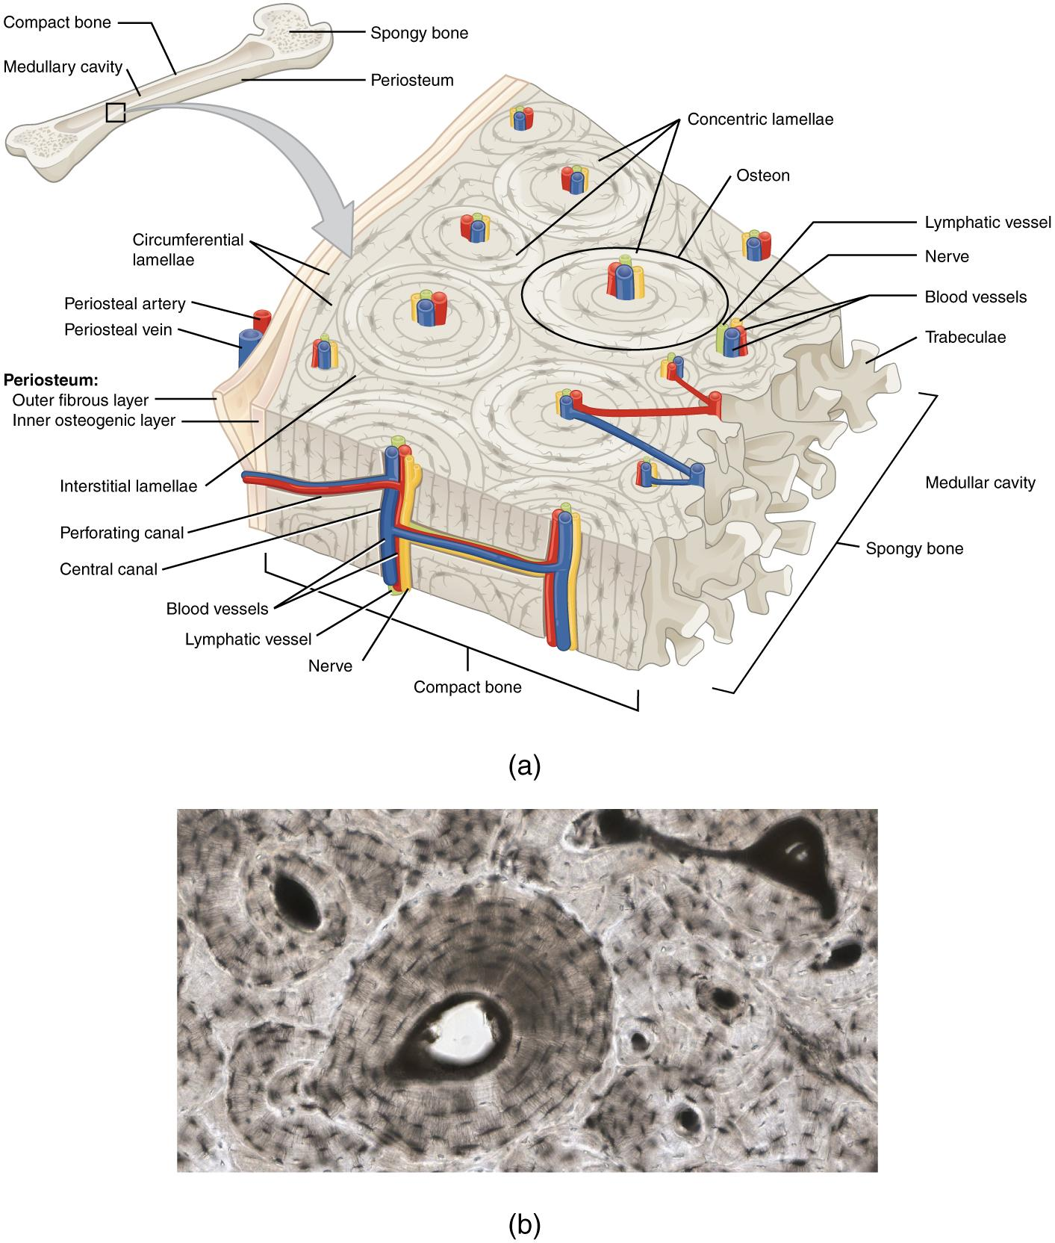
Figure 2.10 Diagram of Compact Bone This cross-sectional view of compact bone shows the basic structural unit, the osteon.
The microscopic structural unit of compact bone is called an osteon, or Haversian system. Each osteon is composed of concentric rings of calcified matrix called lamellae (singular = lamella). Running down the center of each osteon is the central canal, or Haversian canal, which contains blood vessels, nerves, and lymphatic vessels.

Spongy (Cancellous) Bone
Like compact bone, spongy bone, also known as cancellous bone, contains osteocytes, but they are not arranged in concentric circles. Instead, the osteocytes are found in a lattice-like network of matrix spikes called trabeculae (singular = trabecula) (Figure 2.11). The trabeculae may appear to be a random network, but each trabecula forms along lines of stress to provide strength to the bone. The spaces of the trabeculated network provide balance to the dense and heavy compact bone by making bones lighter so that muscles can move them more easily. In addition, the spaces in some spongy bones contain red marrow, protected by the trabeculae, where hematopoiesis occurs.
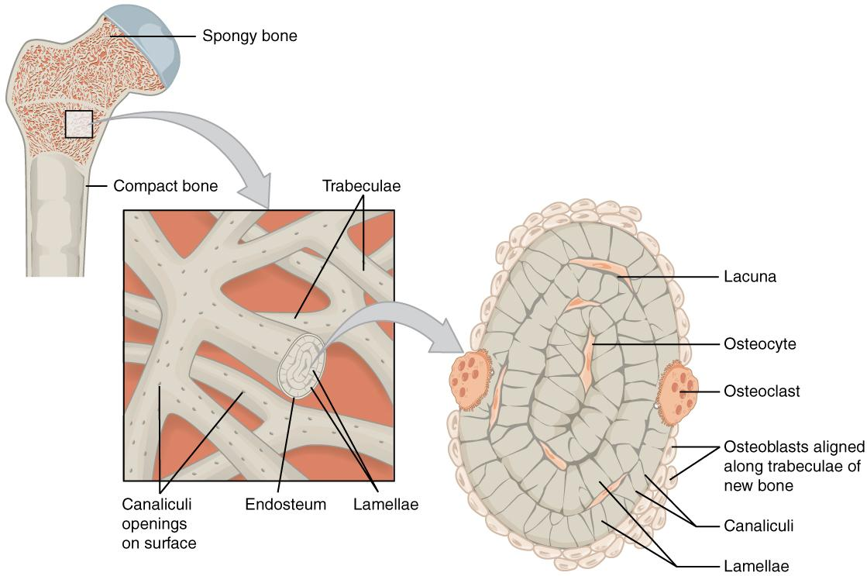
Figure 2.11 Diagram of Spongy Bone Spongy bone is composed of trabeculae that contain the osteocytes. Red marrow fills the spaces in some bones.

2.4 Bone Formation and Development

Learning Objectives
By the end of this section, you will be able to:
- Explain the function of cartilage
- List the steps of intramembranous ossification
- List the steps of endochondral ossification
- Explain the growth activity at the epiphyseal plate
- Compare and contrast the processes of modeling and remodeling
In the early stages of embryonic development, the embryo’s skeleton consists of fibrous membranes and hyaline cartilage. By the sixth or seventh week of embryonic life, the actual process of bone development, ossification (osteogenesis), begins. There are two osteogenic pathways—intramembranous ossification and endochondral ossification—but bone is the same regardless of the pathway that produces it.

Cartilage Templates
Bone is a replacement tissue; that is, it uses a model tissue on which to lay down its mineral matrix. For skeletal development, the most common template is cartilage. During fetal development, a framework is laid down that determines where bones will form. This framework is a flexible, semi-solid matrix produced by chondroblasts. As the matrix surrounds and isolates chondroblasts, they are called chondrocytes.
Throughout fetal development and into childhood growth and development, bone forms on the cartilaginous matrix. By the time a fetus is born, most of the cartilage has been replaced with bone. Some additional cartilage will be replaced throughout childhood, and some cartilage remains in the adult skeleton.

Intramembranous Ossification
During intramembranous ossification, compact and spongy bone develops directly from sheets of mesenchymal (undifferentiated) connective tissue. The flat bones of the face, most of the cranial bones, and the clavicles (collarbones) are formed via intramembranous ossification.
The process begins when mesenchymal cells in the embryonic skeleton gather together and begin to differentiate into specialized cells (Figure 2.12a). Some of these cells will differentiate into capillaries, while others will become osteogenic cells and then osteoblasts. Although they will ultimately be spread out by the formation of bone tissue, early osteoblasts appear in a cluster called an ossification center.
The osteoblasts secrete osteoid, uncalcified matrix, which calcifies (hardens) within a few days as mineral salts are deposited on it, thereby entrapping the osteoblasts within. Once entrapped, the osteoblasts become osteocytes (Figure 2.12b). As osteoblasts transform into osteocytes, osteogenic cells in the surrounding connective tissue differentiate into new osteoblasts.
Osteoid (unmineralized bone matrix) secreted around the capillaries results in a trabecular matrix, while osteoblasts on the surface of the spongy bone become the periosteum (Figure 2.12c). The periosteum then creates a protective layer of compact bone superficial to the trabecular bone. The trabecular bone crowds nearby blood vessels, which eventually condense into red marrow (Figure 2.12d).
Intramembranous ossification begins in utero during fetal development and continues on into adolescence. At birth, the skull and clavicles are not fully ossified nor are the sutures of the skull closed. This allows the skull and shoulders to deform during passage through the birth canal. The last bones to ossify via intramembranous ossification are the flat bones of the face, which reach their adult size at the end of the adolescent growth spurt.
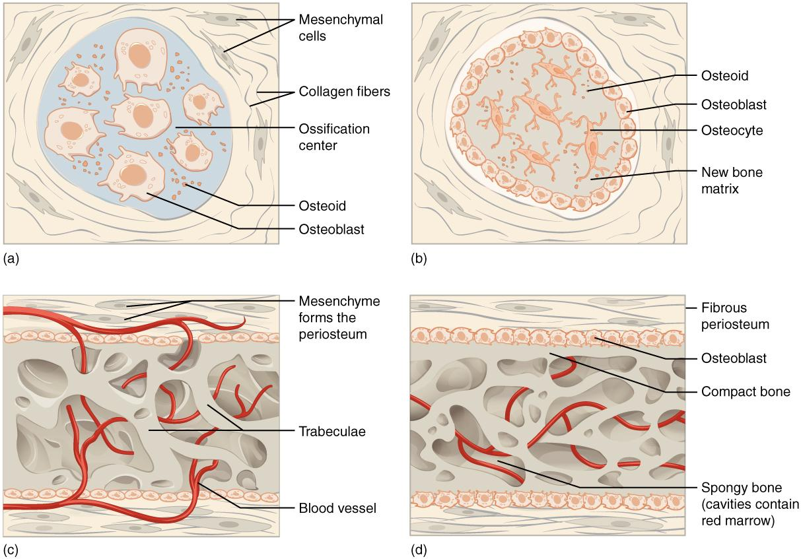
Figure 2.12 Intramembranous Ossification Intramembranous ossification follows four steps. (a) Mesenchymal cells group into clusters, and ossification centers form. (b) Secreted osteoid traps osteoblasts, which then become osteocytes. (c) Trabecular matrix and periosteum form. (d) Compact bone develops superficial to the trabecular bone, and crowded blood vessels condense into red marrow.

Endochondral Ossification
In endochondral ossification, bone develops by replacing hyaline cartilage. Cartilage does not become bone. Instead, cartilage serves as a template to be completely replaced by new bone. Endochondral ossification takes much longer than intramembranous ossification. Bones at the base of the skull and long bones form via endochondral ossification.
In a long bone, for example, at about 6 to 8 weeks after conception, some of the mesenchymal cells differentiate into chondrocytes (cartilage cells) that form the cartilaginous skeletal precursor of the bones (Figure 2.13a). Soon after, the perichondrium, a membrane that covers the cartilage, appears Figure 2.13b).
As more matrix is produced, the chondrocytes in the center of the cartilaginous model grow in size. As the matrix calcifies, nutrients can no longer reach the chondrocytes. This results in their death and the disintegration of the surrounding cartilage. Blood vessels invade the resulting spaces, not only enlarging the cavities but also carrying osteogenic cells with them, many of which will become osteoblasts. These enlarging spaces eventually combine to become the medullary cavity.
As the cartilage grows, capillaries penetrate it. This penetration initiates the transformation of the perichondrium into the bone-producing periosteum. Here, the osteoblasts form a periosteal collar of compact bone around the cartilage of the diaphysis. By the second or third month of fetal life, bone cell development and ossification ramps up and creates the primary ossification center, a region deep in the periosteal collar where ossification begins (Figure 2.13c).
While these deep changes are occurring, chondrocytes and cartilage continue to grow at the ends of the bone (the future epiphyses), which increases the bone’s length at the same time bone is replacing cartilage in the diaphyses. By the time the fetal skeleton is fully formed, cartilage only remains at the joint surface as articular cartilage and between the diaphysis and epiphysis as the epiphyseal plate, the latter of which is responsible for the longitudinal growth of bones. After birth, this same sequence of events (matrix mineralization, death of chondrocytes, invasion of blood vessels from the periosteum, and seeding with osteogenic cells that become osteoblasts) occurs in the epiphyseal regions, and each of these centers of activity is referred to as a secondary ossification center (Figure 2.13e).
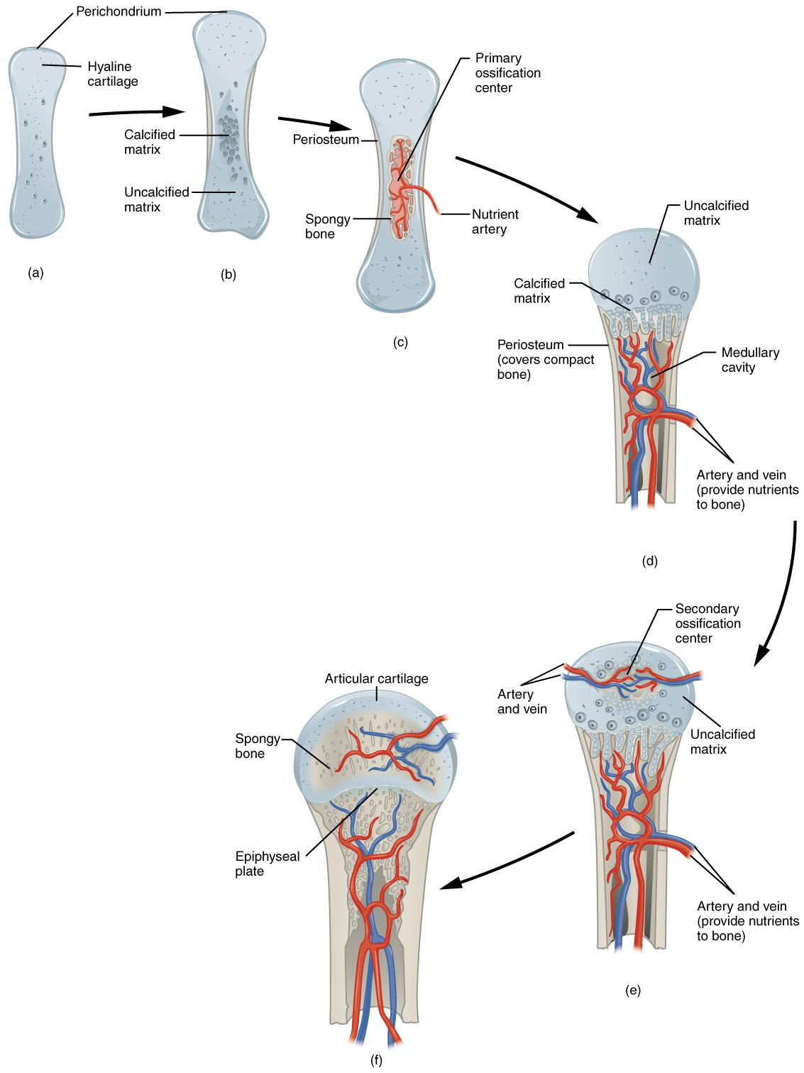
Figure 2.13 Endochondral Ossification Endochondral ossification follows five steps. (a) Mesenchymal cells differentiate into chondrocytes. (b) The cartilage model of the future bony skeleton and the perichondrium form. (c) Capillaries penetrate cartilage. Perichondrium transforms into periosteum. Periosteal collar develops. Primary ossification center develops. (d) Cartilage and chondrocytes continue to grow at ends of the bone. (e) Secondary ossification centers develop. (f) Cartilage remains at epiphyseal (growth) plate and at joint surface as articular cartilage.

How Bones Grow in Length
The epiphyseal plate is the area of growth in a long bone. It is a layer of hyaline cartilage where ossification occurs in immature bones. On the epiphyseal side of the epiphyseal plate, cartilage is formed. On the diaphyseal side, cartilage is ossified, and the diaphysis grows in length.
Bones continue to grow in length until early adulthood. The rate of growth is controlled by hormones. When the chondrocytes in the epiphyseal plate cease their proliferation and bone replaces the cartilage, longitudinal growth stops. All that remains of the epiphyseal plate is the epiphyseal line (Figure 2.14).
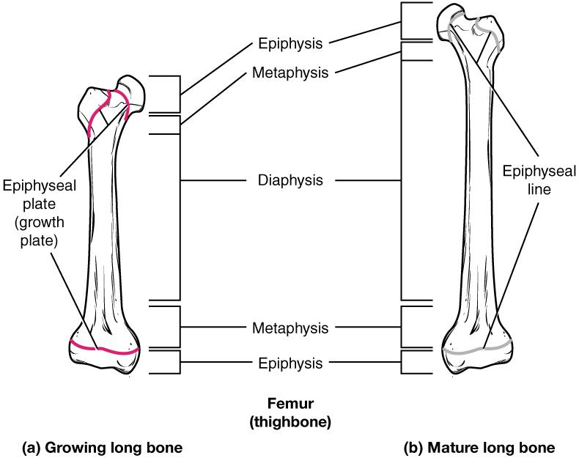
Figure 2.14 Progression from Epiphyseal Plate to Epiphyseal Line As a bone matures, the epiphyseal plate progresses to an epiphyseal line. (a) Epiphyseal plates are visible in a growing bone. (b) Epiphyseal lines are the remnants of epiphyseal plates in a mature bone.

How Bones Grow in Diameter
While bones are increasing in length, they are also increasing in diameter; growth in diameter can continue even after longitudinal growth ceases. This is called appositional growth. Osteoclasts resorb old bone that lines the medullary cavity, while osteoblasts, via intramembranous ossification, produce new bone tissue beneath the periosteum. The erosion of old bone along the medullary cavity and the deposition of new bone beneath the periosteum not only increase the diameter of the diaphysis but also increase the diameter of the medullary cavity. This process is called modeling.

Bone Remodeling
The process in which matrix is resorbed on one surface of a bone and deposited on another is known as bone modeling. Modeling primarily takes place during a bone’s growth. However, in adult life, bone undergoes remodeling, in which resorption of old or damaged bone takes place on the same surface where osteoblasts lay new bone to replace that which is resorbed. Injury, exercise, and other activities lead to remodeling. About 5 to 10 percent of the skeleton is remodeled annually just by destroying old bone and renewing it with fresh bone.

2.5 Classification of Joints

Learning Objectives
By the end of this section, you will be able to:
- Distinguish between the functional and structural classifications for joints
- Describe the three functional types of joints and give an example of each
- List the three types of diarthrodial joints
A joint, also called an articulation, is any place where adjacent bones or bone and cartilage come together (articulate with each other) to form a connection. Joints are classified both structurally and functionally. Structural classifications of joints take into account whether the adjacent bones are strongly anchored to each other by fibrous connective tissue or cartilage, or whether the adjacent bones articulate with each other within a fluid-filled space called a joint cavity. Functional classifications describe the degree of movement available between the bones, ranging from immobile, to slightly mobile, to freely moveable joints. The amount of movement available at a particular joint of the body is related to the functional requirements for that joint. Thus immobile or slightly moveable joints serve to protect internal organs, give stability to the body, and allow for limited body movement. In contrast, freely moveable joints allow for much more extensive movements of the body and limbs.
Interactive Link
Watch this video that explores the relationship between joint mobility and joint stability. What is an example of a joint that is mobile, but not very stable? What is an example of a joint that is stable, but not very mobile?

Structural Classification of Joints
The structural classification of joints is based on whether the articulating surfaces of the adjacent bones are directly connected by fibrous connective tissue or cartilage, or whether the articulating surfaces contact each other within a fluid-filled joint cavity. These differences serve to divide the joints of the body into three structural classifications. A fibrous joint is where the adjacent bones are united by fibrous connective tissue. At a cartilaginous joint, the bones are joined by hyaline cartilage or fibrocartilage. At a synovial joint, the articulating surfaces of the bones are not directly connected, but instead come into contact with each other within a joint cavity that is filled with a lubricating fluid. Synovial joints allow for free movement between the bones and are the most common joints of the body.

Functional Classification of Joints
The functional classification of joints is determined by the amount of mobility found between the adjacent bones. Joints are thus functionally classified as a synarthrosis or immobile joint, an amphiarthrosis or slightly moveable joint, or as a diarthrosis, which is a freely moveable joint (arthroun = “to fasten by a joint”). Depending on their location, fibrous joints may be functionally classified as a synarthrosis (immobile joint) or an amphiarthrosis (slightly mobile joint). Cartilaginous joints are also functionally classified as either a synarthrosis or an amphiarthrosis joint. All synovial joints are functionally classified as a diarthrosis joint.

Synarthrosis
An immobile or nearly immobile joint is called a synarthrosis. The immobile nature of these joints provide for a strong union between the articulating bones. This is important at locations where the bones provide protection for internal organs. Examples include sutures, the fibrous joints between the bones of the skull that surround and protect the brain (Figure 2.15), and the manubriosternal joint, the cartilaginous joint that unites the manubrium and body of the sternum for protection of the heart.
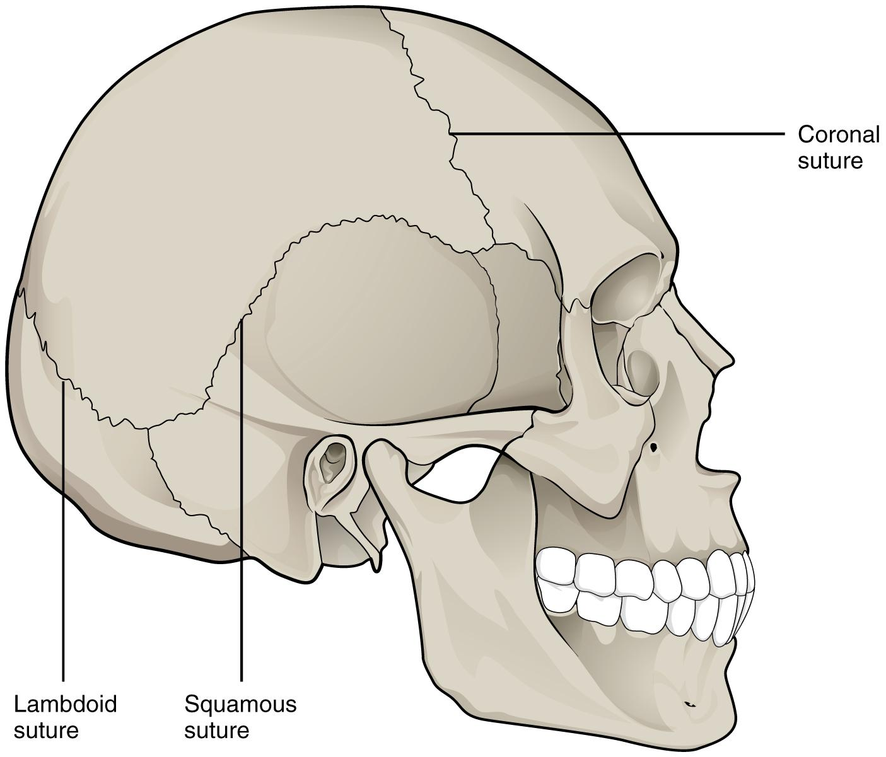
Figure 2.15 Suture Joints of Skull The suture joints of the skull are an example of a synarthrosis, an immobile or essentially immobile joint.

Amphiarthrosis
An amphiarthrosis is a joint that has limited mobility. An example of this type of joint is the cartilaginous joint that unites the bodies of adjacent vertebrae. Filling the gap between the vertebrae is a thick pad of fibrocartilage called an intervertebral disc (Figure 2.16). Each intervertebral disc strongly unites the vertebrae but still allows for a limited amount of movement between them. However, the small movements available between adjacent vertebrae can sum together along the length of the vertebral column to provide for large ranges of body movements.
Another example of an amphiarthrosis is the pubic symphysis of the pelvis. This is a cartilaginous joint in which the pubic regions of the right and left hip bones are strongly anchored to each other by fibrocartilage. This joint normally has very little mobility. The strength of the pubic symphysis is important in conferring weight-bearing stability to the pelvis.
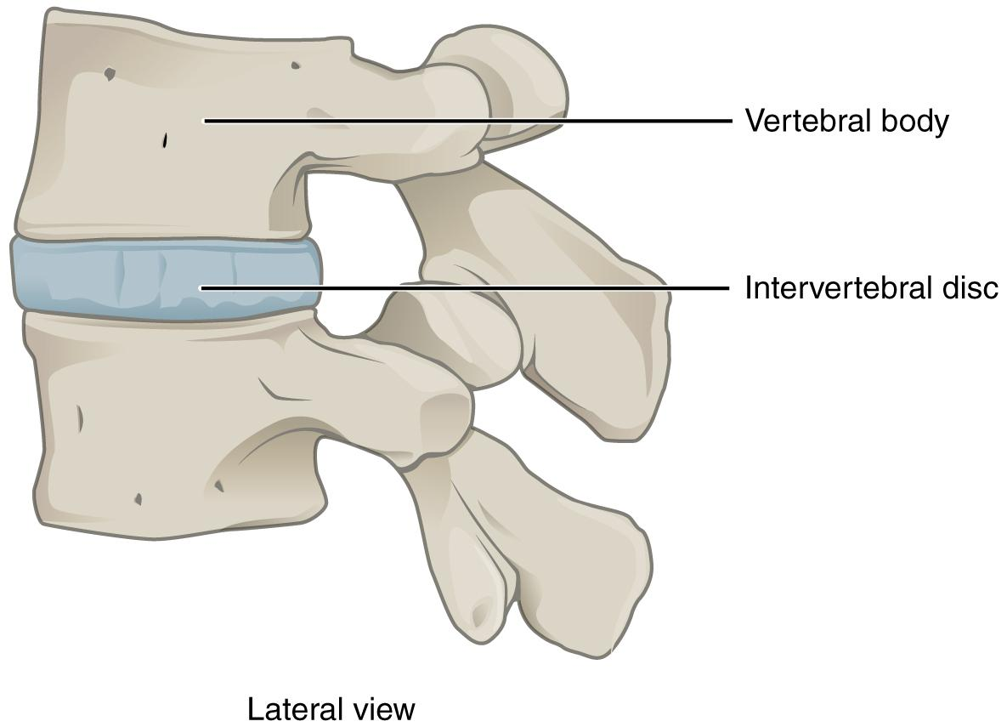
Figure 2.16 Intervertebral Disc An intervertebral disc unites the bodies of adjacent vertebrae within the vertebral column. Each disc allows for limited movement between the vertebrae and thus functionally forms an amphiarthrosis type of joint. Intervertebral discs are made of fibrocartilage and thereby structurally form a symphysis type of cartilaginous joint.

Diarthrosis
A freely mobile joint is classified as a diarthrosis. These types of joints include all synovial joints of the body, which provide the majority of body movements. Most diarthrotic joints are found in the appendicular skeleton and thus give the limbs a wide range of motion. These joints are divided into three categories, based on the number of axes of motion provided by each. An axis in anatomy is described as the movements in reference to the three anatomical planes: transverse, frontal, and sagittal. Thus, diarthroses are classified as uniaxial (for movement in one plane), biaxial (for movement in two planes), or multiaxial joints (for movement in all three anatomical planes).
A uniaxial joint only allows for a motion in a single plane (around a single axis). The elbow joint, which only allows for bending or straightening, is an example of a uniaxial joint. A biaxial joint allows for motions within two planes. An example of a biaxial joint is a metacarpophalangeal joint (knuckle joint) of the hand. The joint allows for movement along one axis to produce bending or straightening of the finger, and movement along a second axis, which allows for spreading of the fingers away from each other and bringing them together. A joint that allows for the several directions of movement is called a multiaxial joint (polyaxial or triaxial joint). This type of diarthrotic joint allows for movement along three axes (Figure 2.17). The shoulder and hip joints are multiaxial joints. They allow the upper or lower limb to move in an anterior-posterior direction and a medial-lateral direction. In addition, the limb can also be rotated around its long axis. This third movement results in rotation of the limb so that its anterior surface is moved either toward or away from the midline of the body.
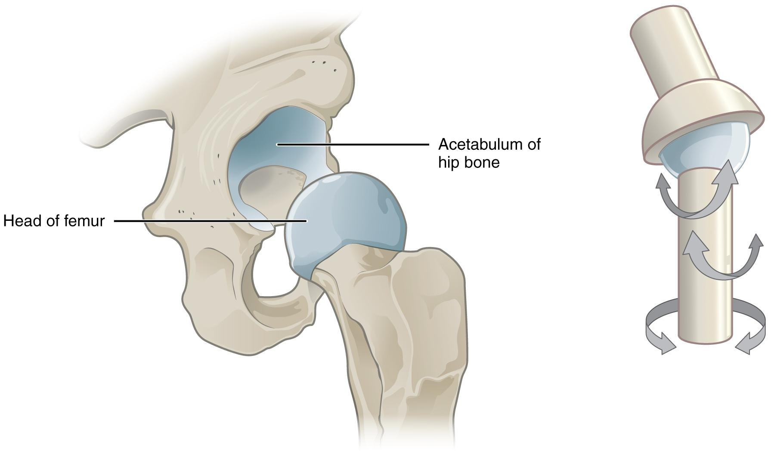
Figure 2.17 Multiaxial Joint A multiaxial joint, such as the hip joint, allows for three types of movement: anterior-posterior, medial-lateral, and rotational.

2.6 Fibrous Joints

Learning Objectives
By the end of this section, you will be able to:
- Describe the structural features of fibrous joints
- Distinguish between a suture, syndesmosis, and gomphosis
- Give an example of each type of fibrous joint
At a fibrous joint, the adjacent bones are directly connected to each other by fibrous connective tissue, and thus the bones do not have a joint cavity between them (Figure 2.18). The gap between the bones may be narrow or wide. There are three types of fibrous joints. A suture is the narrow fibrous joint found between most bones of the skull. At a syndesmosis joint, the bones are more widely separated but are held together by a narrow band of fibrous connective tissue called a ligament or a wide sheet of connective tissue called an interosseous membrane. This type of fibrous joint is found between the shaft regions of the long bones in the forearm and in the leg. Lastly, a gomphosis is the narrow fibrous joint between the roots of a tooth and the bony socket in the jaw into which the tooth fits.

Suture
All the bones of the skull, except for the mandible, are joined to each other by a fibrous joint called a suture. The fibrous connective tissue found at a suture (“to bind or sew”) strongly unites the adjacent skull bones and thus helps to protect the brain and form the face. In adults, the skull bones are closely opposed and fibrous connective tissue fills the narrow gap between the bones. The suture is frequently convoluted, forming a tight union that prevents most movement between the bones. (Figure 2.18a.) Thus, skull sutures are functionally classified as a synarthrosis, although some sutures may allow for slight movements between the cranial bones.
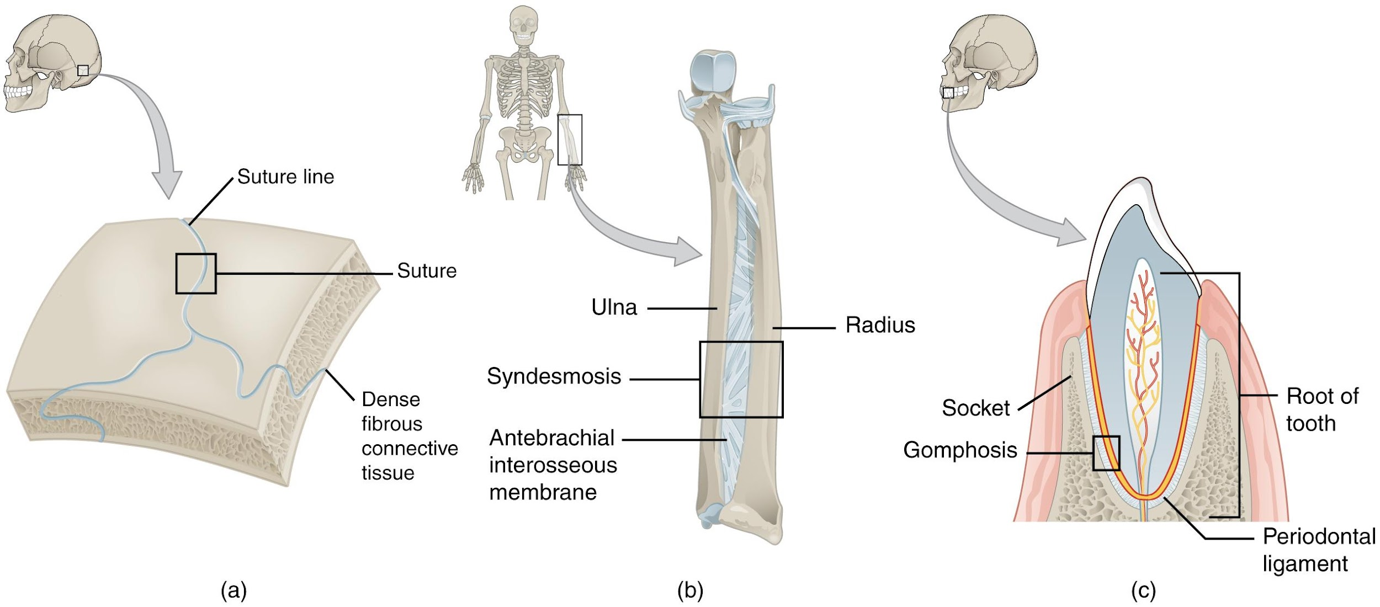
Figure 2.18 Fibrous Joints Fibrous joints form strong connections between bones. (a) Sutures join most bones of the skull. (b) An interosseous membrane forms a syndesmosis between the radius and ulna bones of the forearm. (c) A gomphosis is a specialized fibrous joint that anchors a tooth to its socket in the jaw.

Syndesmosis
A syndesmosis (“fastened with a band”) is a type of fibrous joint in which two parallel bones are united to each other by fibrous connective tissue. The gap between the bones may be narrow, with the bones joined by ligaments, or the gap may be wide and filled in by a broad sheet of connective tissue called an interosseous membrane.
In the forearm, the wide gap between the shaft portions of the radius and ulna bones are strongly united by an interosseous membrane (Figure 2.18b). Similarly, in the leg, the shafts of the tibia and fibula are also united by an interosseous membrane. In addition, at the distal tibiofibular joint, the articulating surfaces of the bones lack cartilage and the narrow gap between the bones is anchored by fibrous connective tissue and ligaments on both the anterior and posterior aspects of the joint. Together, the interosseous membrane and these ligaments form the tibiofibular syndesmosis.
The syndesmoses found in the forearm and leg serve to unite parallel bones and prevent their separation. However, a syndesmosis does not prevent all movement between the bones, and thus this type of fibrous joint is functionally classified as an amphiarthrosis. In the leg, the syndesmosis between the tibia and fibula strongly unites the bones, allows for little movement, and firmly locks the talus bone in place between the tibia and fibula at the ankle joint. This provides strength and stability to the leg and ankle, which are important during weight bearing. In the forearm, the interosseous membrane is flexible enough to allow for rotation of the radius bone during forearm movements. Thus in contrast to the stability provided by the tibiofibular syndesmosis, the flexibility of the antebrachial interosseous membrane allows for the much greater mobility of the forearm.
The interosseous membranes of the leg and forearm also provide areas for muscle attachment.

Gomphosis
A gomphosis (“fastened with bolts”) is the specialized fibrous joint that anchors the root of a tooth into its bony socket within the maxillary bone (upper jaw) or mandible bone (lower jaw) of the skull (Figure 2.18c). Due to the immobility of a gomphosis, this type of joint is functionally classified as a synarthrosis.

2.7 Cartilaginous Joints

Learning Objectives
By the end of this section, you will be able to:
- Describe the structural features of cartilaginous joints
- Distinguish between a synchondrosis and symphysis
- Give an example of each type of cartilaginous joint
As the name indicates, at a cartilaginous joint, the adjacent bones are united by cartilage, a tough but flexible type of connective tissue. These types of joints lack a joint cavity and involve bones that are joined together by either hyaline cartilage or fibrocartilage (Figure 2.19). There are two types of cartilaginous joints. A synchondrosis is a cartilaginous joint where the bones are joined by hyaline cartilage. Also classified as a synchondrosis are places where bone is united to a cartilage structure, such as between the anterior end of a rib and the costal cartilage of the thoracic cage. The second type of cartilaginous joint is a symphysis, where the bones are joined by fibrocartilage.
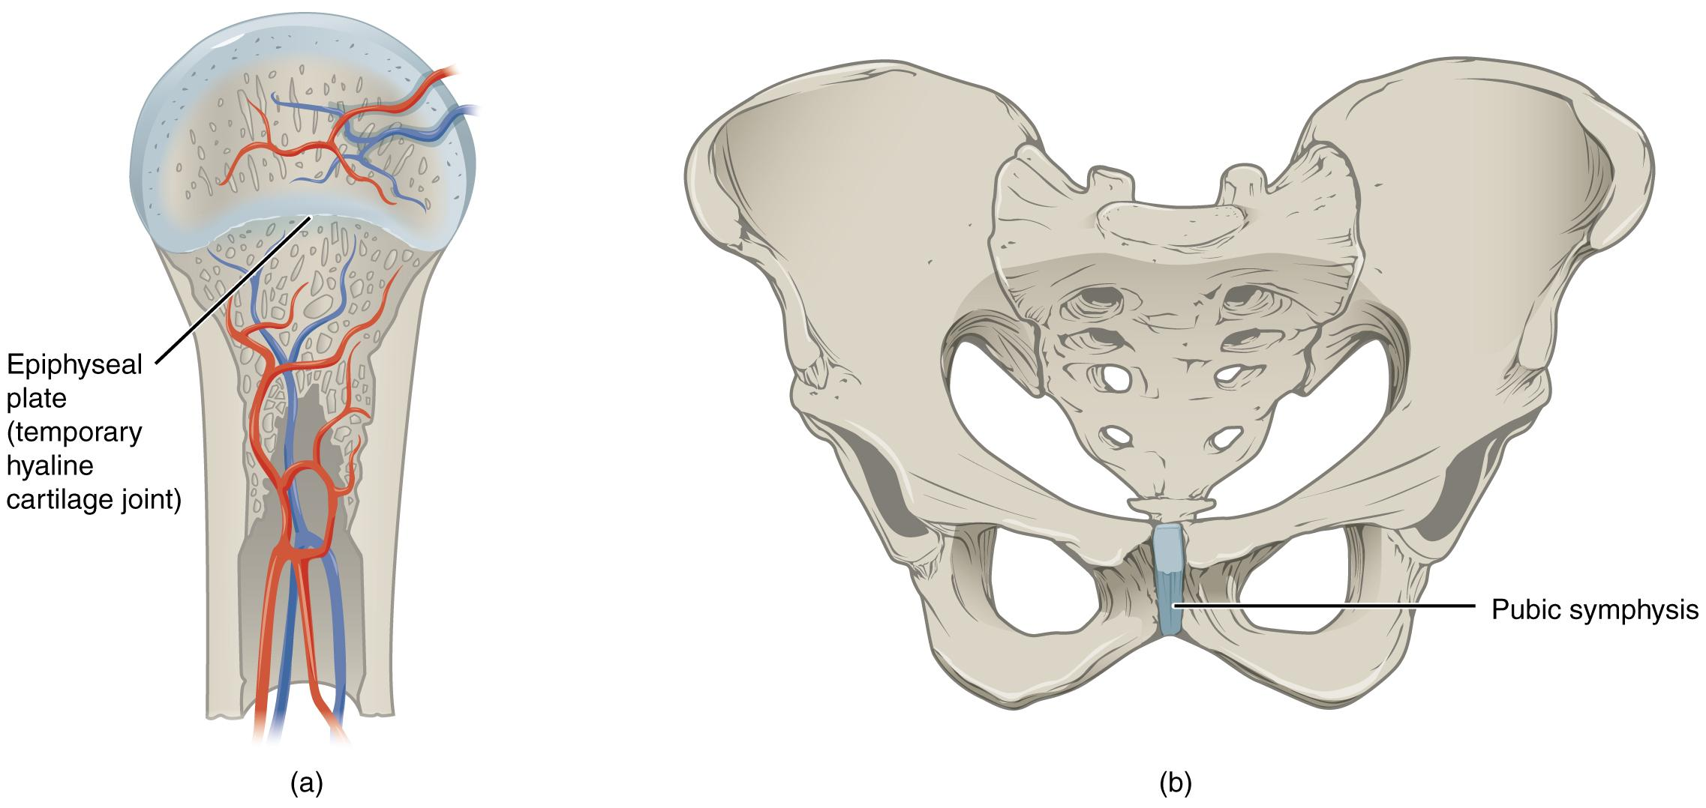
Figure 2.19 Cartilaginous Joints At cartilaginous joints, bones are united by hyaline cartilage to form a synchondrosis or by fibrocartilage to form a symphysis. (a) The hyaline cartilage of the epiphyseal plate (growth plate) forms a synchondrosis that unites the shaft (diaphysis) and end (epiphysis) of a long bone and allows the bone to grow in length. (b) The pubic portions of the right and left hip bones of the pelvis are joined together by fibrocartilage, forming the pubic symphysis.

Synchondrosis
A synchondrosis (“joined by cartilage”) is a cartilaginous joint where bones are joined together by hyaline cartilage, or where bone is united to hyaline cartilage. A synchondrosis may be temporary or permanent. A temporary synchondrosis is the epiphyseal plate (growth plate) of a growing long bone. The epiphyseal plate is the region of growing hyaline cartilage that unites the diaphysis (shaft) of the bone to the epiphysis (end of the bone). The epiphyseal plate is considered to be a temporary synchondrosis because in the late teens growth of the cartilage eventually stops and the epiphyseal plate is completely replaced by bone, fusing the epiphysis and diaphysis into one single adult bone.

Examples of permanent synchondroses are found in the thoracic cage. One example is the first sternocostal joint, where the first rib is anchored to the manubrium by its costal cartilage. (The articulations of the remaining costal cartilages to the sternum are all synovial joints.) Additional synchondroses are formed where the anterior end of the other 11 ribs is joined to its costal cartilage. Unlike the temporary synchondroses of the epiphyseal plate, these permanent synchondroses retain their hyaline cartilage and thus do not ossify with age. Due to the lack of movement between the bone and cartilage, both temporary and permanent synchondroses are functionally classified as a synarthrosis.
Interactive Link
Visit this website to view a radiograph (X-ray image) of a child’s hand and wrist. The growing bones of child have an epiphyseal plate that forms a synchondrosis between the shaft and end of a long bone. Being less dense than bone, the area of epiphyseal cartilage is seen on this radiograph as the dark epiphyseal gaps located near the ends of the long bones, including the radius, ulna, metacarpal, and phalanx bones. Which of the bones in this image do not show an epiphyseal plate (epiphyseal gap)?

Symphysis
A cartilaginous joint where the bones are joined by fibrocartilage is called a symphysis (“growing together”). Fibrocartilage is very strong because it contains numerous bundles of thick collagen fibers, thus giving it a much greater ability to resist pulling and bending forces when compared with hyaline cartilage. This gives symphyses the ability to strongly unite the adjacent bones, but can still allow for limited movement to occur. Thus, a symphysis is functionally classified as an amphiarthrosis.
The gap separating the bones at a symphysis may be narrow or wide. Examples in which the gap between the bones is narrow include the pubic symphysis and the manubriosternal joint. At the pubic symphysis, the pubic portions of the right and left hip bones of the pelvis are joined together by fibrocartilage across a narrow gap. Similarly, at the manubriosternal joint, fibrocartilage unites the manubrium and body portions of the sternum.
The intervertebral symphysis is a wide symphysis located between the bodies of adjacent vertebrae of the vertebral column. Here a thick pad of fibrocartilage called an intervertebral disc strongly unites the adjacent vertebrae by filling the gap between them. The width of the intervertebral symphysis is important because it allows for small movements between the adjacent vertebrae. In addition, the thick intervertebral disc provides cushioning between the vertebrae, which is important when carrying heavy objects or during high-impact activities such as running or jumping.

2.8 Synovial Joints

Learning Objectives
By the end of this section, you will be able to:
- Describe the structural features of a synovial joint
- Discuss the function of additional structures associated with synovial joints
- List the six types of synovial joints and give an example of each
Synovial joints are the most common type of joint in the body (Figure 2.20). A key structural characteristic for a synovial joint that is not seen at fibrous or cartilaginous joints is the presence of a joint cavity. This fluid-filled space is the site at which the articulating surfaces of the bones contact each other. Also unlike fibrous or cartilaginous joints, the articulating bone surfaces at a synovial joint are not directly connected to each other with fibrous connective tissue or cartilage. This gives the bones of a synovial joint the ability to move smoothly against each other, allowing for increased joint mobility.
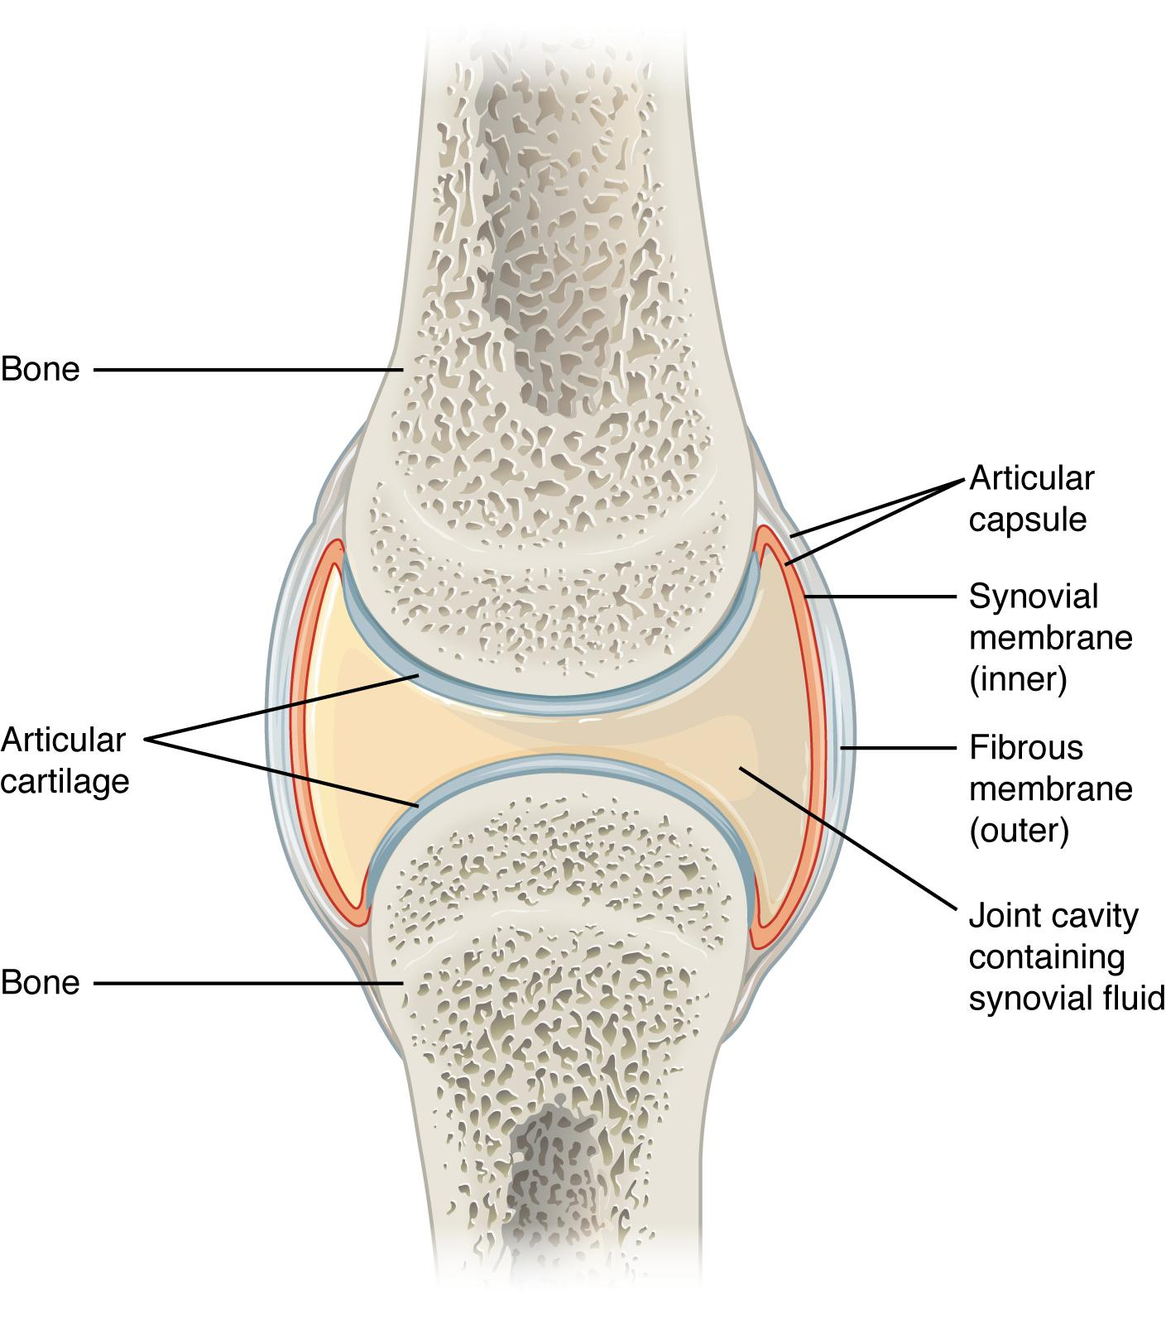
Figure 2.20 Synovial Joints Synovial joints allow for smooth movements between the adjacent bones. The joint is surrounded by an articular capsule that defines a joint cavity filled with synovial fluid. The articulating surfaces of the bones are covered by a thin layer of articular cartilage. Ligaments support the joint by holding the bones together and resisting excess or abnormal joint motions.

Structural Features of Synovial Joints
Synovial joints are characterized by the presence of a joint cavity. The walls of this space are formed by the articular capsule, a fibrous connective tissue structure that is attached to each bone just outside the area of the bone’s articulating surface. The bones of the joint articulate with each other within the joint cavity.
Friction between the bones at a synovial joint is prevented by the presence of the articular cartilage, a thin layer of hyaline cartilage that covers the entire articulating surface of each bone. However, unlike at a cartilaginous joint, the articular cartilages of each bone are not continuous with each other. Instead, the articular cartilage acts like a Teflon® coating over the bone surface, allowing the articulating bones to move smoothly against each other without damaging the underlying bone tissue. Lining the inner surface of the articular capsule is a thin synovial membrane. The cells of this membrane secrete synovial fluid (synovia = “a thick fluid”), a thick, slimy fluid that provides lubrication to further reduce friction between the bones of the joint. This fluid also provides nourishment to the articular cartilage, which does not contain blood vessels. The ability of the bones to move smoothly against each other within the joint cavity, and the freedom of joint movement this provides, means that each synovial joint is functionally classified as a diarthrosis.
Outside of their articulating surfaces, the bones are connected together by ligaments, which are strong bands of fibrous connective tissue. These strengthen and support the joint by anchoring the bones together and preventing their separation. Ligaments allow for normal movements at a joint, but limit the range of these motions, thus preventing excessive or abnormal joint movements. Ligaments are classified based on their relationship to the fibrous articular capsule. An extrinsic ligament is located outside of the articular capsule, an intrinsic ligament is fused to or incorporated into the wall of the articular capsule, and an intracapsular ligament is located inside of the articular capsule.
At many synovial joints, additional support is provided by the muscles and their tendons that act across the joint. A tendon is the dense connective tissue structure that attaches a muscle to bone. As forces acting on a joint increase, the body will automatically increase the overall strength of contraction of the muscles crossing that joint, thus allowing the muscle and its tendon to serve as a “dynamic ligament” to resist forces and support the joint. This type of indirect support by muscles is very important at the shoulder joint, for example, where the ligaments are relatively weak.

Additional Structures Associated with Synovial Joints
A few synovial joints of the body have a fibrocartilage structure located between the articulating bones. This is called an articular disc, which is generally small and oval-shaped, or a meniscus, which is larger and C-shaped. These structures can serve several functions, depending on the specific joint. In some places, an articular disc may act to strongly unite the bones of the joint to each other. At other synovial joints, the disc can provide shock absorption and cushioning between the bones. Finally, an articular disc can serve to smooth the movements between the articulating bones. Some synovial joints also have a fat pad, which can serve as a cushion between the bones.
Additional structures located outside of a synovial joint serve to prevent friction between the bones of the joint and the overlying muscle tendons or skin. A bursa (plural = bursae) is a thin connective tissue sac filled with lubricating liquid. They are located in regions where skin, ligaments, muscles, or muscle tendons can rub against each other, usually near a body joint (Figure 2.21). Bursae reduce friction by separating the adjacent structures, preventing them from rubbing directly against each other. Examples include the subacromial bursa that protects the tendon of shoulder muscle as it passes under the acromion of the scapula, and the suprapatellar bursa that separates the tendon of the large anterior thigh muscle from the distal femur just above the knee.
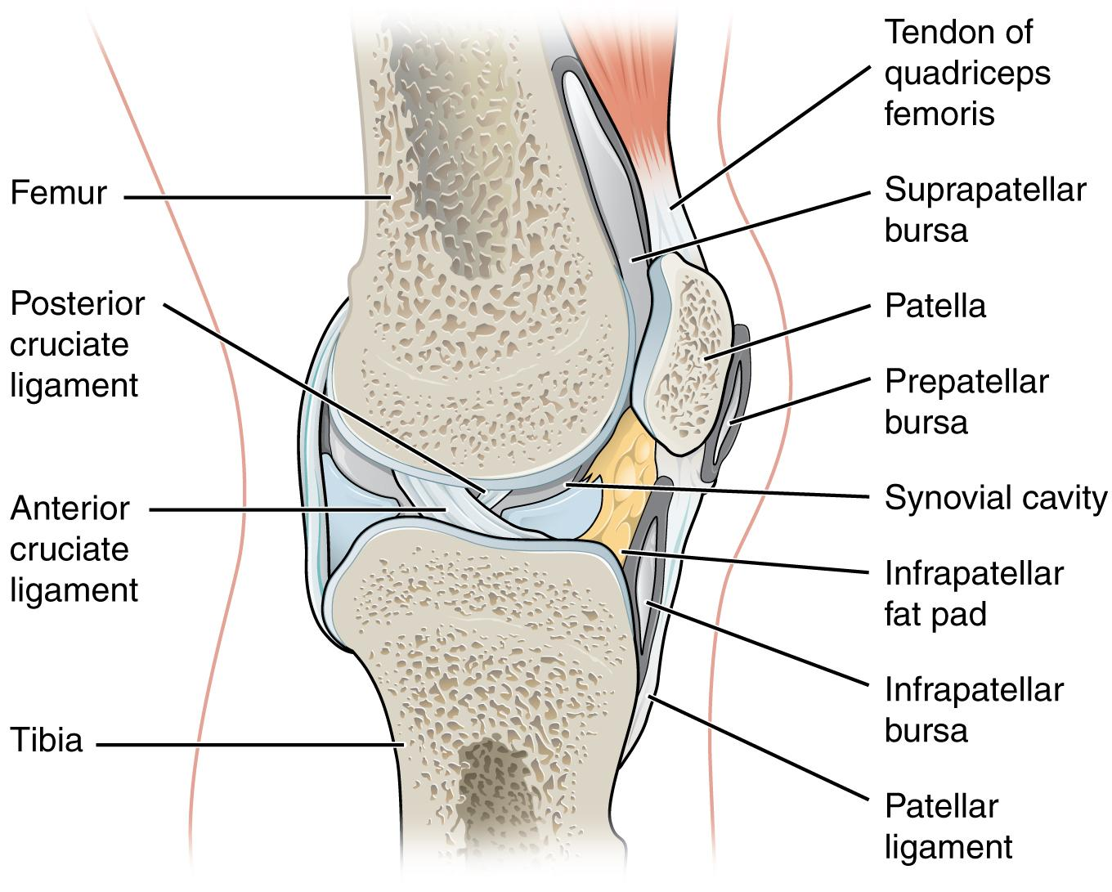
Figure 2.21 Bursae Bursae are fluid-filled sacs that serve to prevent friction between skin, muscle, or tendon and an underlying bone. Three major bursae and a fat pad are part of the complex joint that unites the femur and tibia of the leg.
A tendon sheath is similar in structure to a bursa, but smaller. It is a connective tissue sac that surrounds a muscle tendon at places where the tendon crosses a joint. It contains a lubricating fluid that allows for smooth motions of the tendon during muscle contraction and joint movements.
Homeostatic Imbalances
Bursitis
Bursitis is the inflammation of a bursa near a joint. This will cause pain, swelling, or tenderness of the bursa and surrounding area, and may also result in joint stiffness. Bursitis is most commonly associated with the bursae found at or near the shoulder, hip, knee, or elbow joints.
Bursitis can be either acute (lasting only a few days) or chronic. It can arise from muscle overuse, trauma, excessive or prolonged pressure on the skin, rheumatoid arthritis, gout, or infection of the joint. Repeated acute episodes of bursitis can result in a chronic condition. Treatments for the disorder include antibiotics if the bursitis is caused by an infection, or anti-inflammatory agents, such as nonsteroidal anti-inflammatory drugs (NSAIDs) or corticosteroids if the bursitis is due to trauma or overuse. Bursitis can also be improved through physiotherapy treatment is the inflammation of the bursa is being caused by musculoskeletal imbalances. Chronic bursitis may require that fluid be drained, but additional surgery is usually not required.

Types of Synovial Joints
Synovial joints are subdivided based on the shapes of the articulating surfaces of the bones that form each joint. The six types of synovial joints are pivot, hinge, condyloid, saddle, plane, and ball-and socket-joints (Figure 2.22).
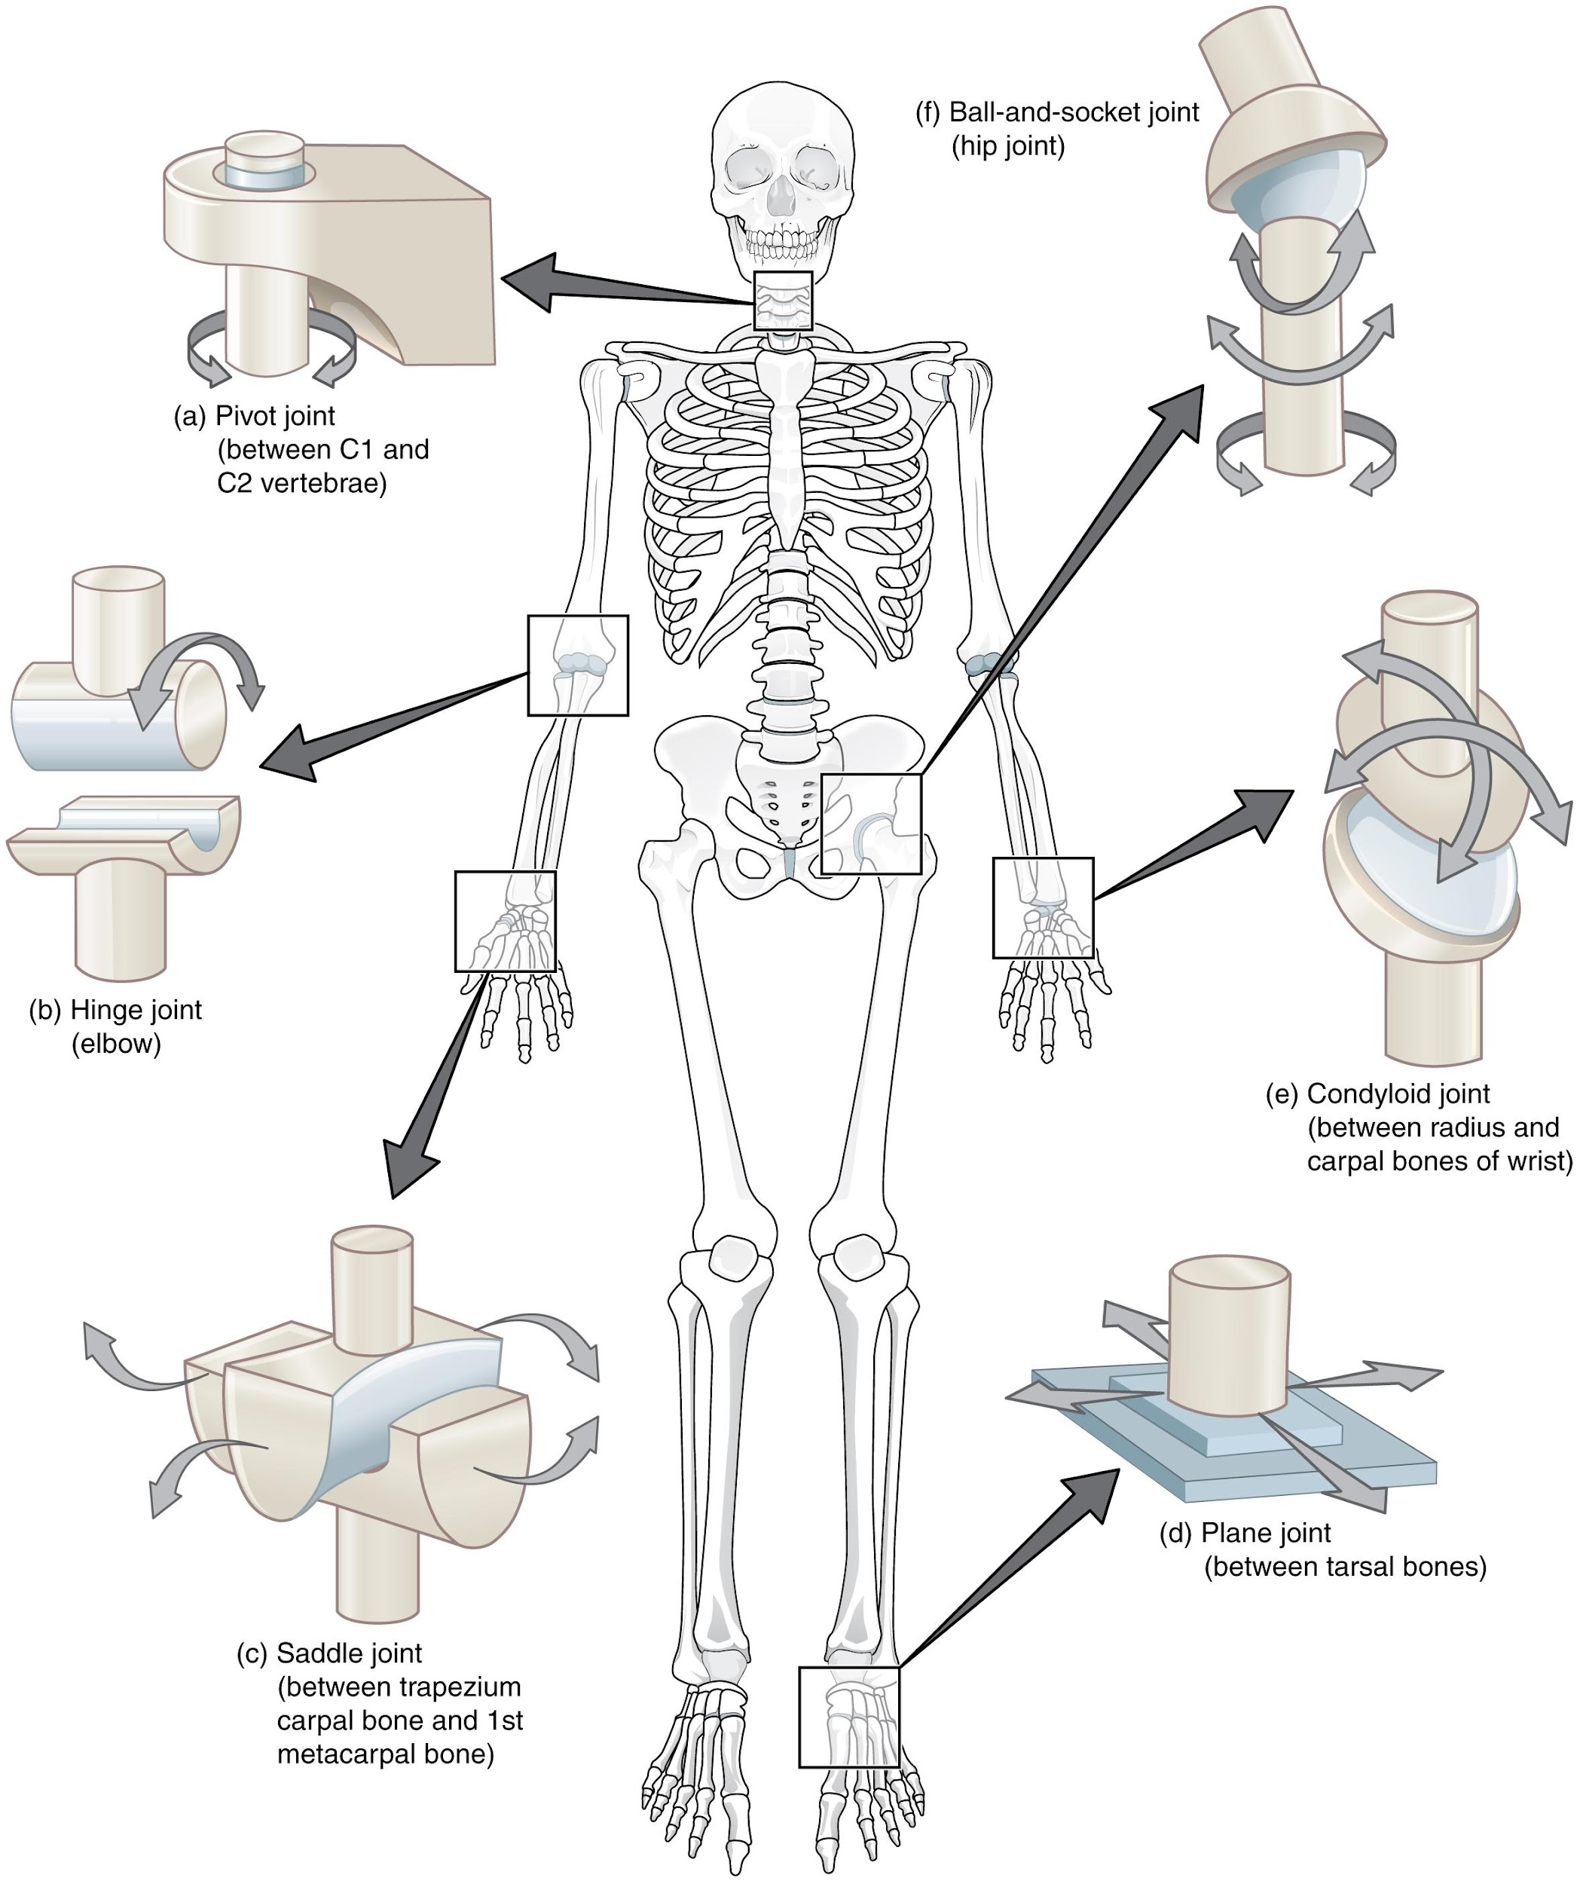
Figure 2.22 Types of Synovial Joints The six types of synovial joints allow the body to move in a variety of ways. (a) Pivot joints allow for rotation around an axis, such as between the first and second cervical vertebrae, which allows for side-to-side rotation of the head. (b) The hinge joint of the elbow works like a door hinge. (c) The articulation between the trapezium carpal bone and the first metacarpal bone at the base of the thumb is a saddle joint. (d) Plane joints, such as those between the tarsal bones of the foot, allow for limited gliding movements between bones. (e) The radiocarpal joint of the wrist is a condyloid joint. (f) The hip and shoulder joints are the only ball-and-socket joints of the body.
Interactive Link
Watch this video to see an animation of synovial joints in action. Synovial joints are places where bones articulate with each other inside of a joint cavity. The different types of synovial joints are the ball-and-socket joint (shoulder), hinge joint (knee), pivot joint (atlantoaxial joint), condyloid joint (radiocarpal joint of the wrist), saddle joint (first carpometacarpal joint at the base of the thumb), and plane joint (facet joints of vertebral column). Which type of synovial joint allows for the widest range of motion?

Pivot Joint
At a pivot joint, a rounded portion of a bone is enclosed within a ring formed partially by the articulation with another bone and partially by a ligament (see Figure 2.22a). The bone rotates within this ring. Since the rotation is around a single axis, pivot joints are functionally classified as a uniaxial diarthrosis type of joint. An example of a pivot joint is the joint found between the C1 (atlas) and C2 (axis) vertebrae. Here, the upward projecting dens of the axis articulates with the inner aspect of the atlas, where it is held in place by a ligament. Rotation at this joint allows you to turn your head from side to side. A second pivot joint is found at the proximal radioulnar joint. Here, the head of the radius is largely encircled by a ligament that holds it in place as it articulates with the radial notch of the ulna. Rotation of the radius allows for forearm movements.

Hinge Joint
In a hinge joint, the convex end of one bone articulates with the concave end of the adjoining bone (see Figure 2.22b). This type of joint allows for bending and straightening motions along a single axis, and thus hinge joints are functionally classified as uniaxial joints. A good example is the elbow joint, with the articulation between the trochlea of the humerus and the trochlear notch of the ulna.

Condyloid Joint
At a condyloid joint (ellipsoid joint), the shallow depression at the end of one bone articulates with a rounded structure from an adjacent bone or bones (see Figure 2.22e). The knuckle (metacarpophalangeal) joints of the hand between the distal end of a metacarpal bone and the proximal phalanx bone are condyloid joints. In this case, the articulation area has a more oval (elliptical) shape. Functionally, condyloid joints are biaxial joints that allow for two planes of movement. One movement involves bending and straightening the fingers. The second movement is a side-to-side movement, which allows you to spread your fingers apart and bring them together.

Saddle Joint
At a saddle joint, both of the articulating surfaces for the bones have a saddle shape, which is concave in one direction and convex in the other (see Figure 2.22c). This allows the two bones to fit together like a rider sitting on a saddle. Saddle joints are functionally classified as biaxial joints. The primary example is the first carpometacarpal joint, between the trapezium (a carpal bone) and the first metacarpal bone at the base of the thumb. This joint provides the thumb the ability to move away from the palm of the hand along two planes. Thus, the thumb can move within the same plane as the palm of the hand, or it can jut out anteriorly, perpendicular to the palm. This movement of the first carpometacarpal joint is what gives humans their distinctive “opposable” thumbs.

Plane Joint
At a plane joint (gliding joint), the articulating surfaces of the bones are flat or slightly curved and of approximately the same size, which allows the bones to slide against each other (see Figure 2.22d). The motion at this type of joint is usually small and tightly constrained by surrounding ligaments. Based only on their shape, plane joints can allow multiple movements, including rotation. Thus plane joints can be functionally classified as a multiaxial joint. However, not all of these movements are available to every plane joint due to limitations placed on it by ligaments or neighboring bones. Plane joints are found between the carpal bones (intercarpal joints) of the wrist or tarsal bones (intertarsal joints) of the foot, and between the superior and inferior articular processes of adjacent vertebrae (zygapophysial joints).

Ball-and-Socket Joint
The joint with the greatest range of motion is the ball-and-socket joint. At these joints, the rounded head of one bone (the ball) fits into the concave articulation (the socket) of the adjacent bone (see Figure 2.22f). The hip and shoulder joints are the only ball-and-socket joints of the body. At the hip joint, the head of the femur articulates with the acetabulum of the hip bone, and at the shoulder joint, the head of the humerus articulates with the glenoid cavity of the scapula.

Ball-and-socket joints are classified functionally as multiaxial joints. The femur and the humerus are able to move in both anterior-posterior and medial-lateral directions and they can also rotate around their long axis.
Aging and the…
Joints
Arthritis is a common disorder of synovial joints that involves inflammation of the joint. This often results in significant joint pain, along with swelling, stiffness, and reduced joint mobility. There are more than 100 different forms of arthritis. Arthritis may arise from aging, damage to the articular cartilage, autoimmune diseases, bacterial or viral infections, or unknown (probably genetic) causes.
The most common type of arthritis is osteoarthritis, which is associated with aging and “wear and tear” of the articular cartilage (Figure 2.23). Risk factors that may lead to osteoarthritis include injury to a joint; jobs that involve physical labor; sports with running, twisting, or throwing actions; and being overweight. These factors put stress on the articular cartilage that covers the surfaces of bones at synovial joints, causing the cartilage to gradually become thinner. As the articular cartilage layer wears down, more pressure is placed on the bones. The joint responds by increasing production of the lubricating synovial fluid, but this can lead to swelling of the joint cavity, causing pain and joint stiffness as the articular capsule is stretched. The bone tissue underlying the damaged articular cartilage also responds by thickening, producing irregularities and causing the articulating surface of the bone to become rough or bumpy. Joint movement then results in pain and inflammation.
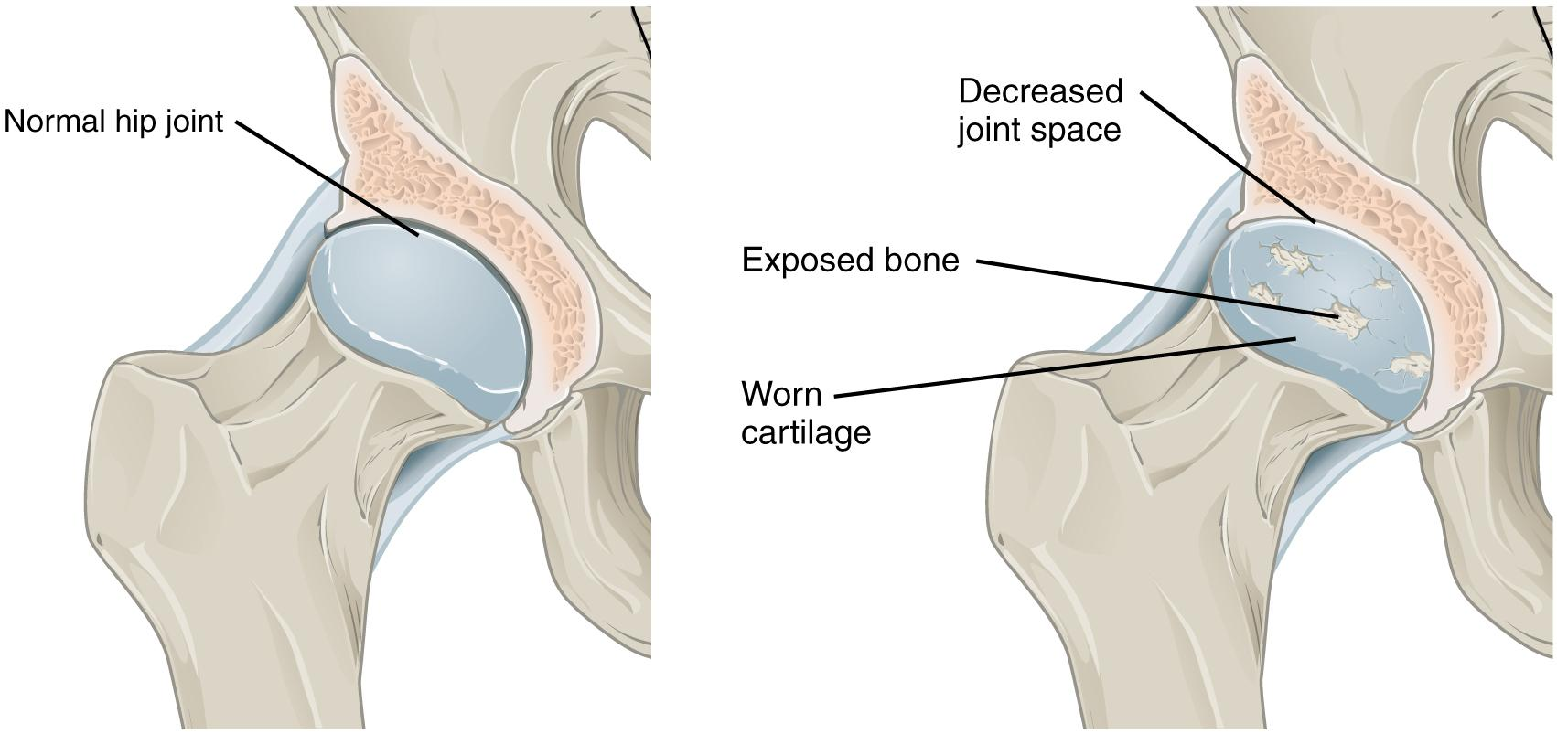
Figure 2.23 Osteoarthritis Osteoarthritis of a synovial joint results from aging or prolonged joint wear and tear. These cause erosion and loss of the articular cartilage covering the surfaces of the bones, resulting in inflammation that causes joint stiffness and pain.

In its early stages, symptoms of osteoarthritis may be reduced by mild activity that “warms up” the joint, but symptoms may worsen following exercise. In individuals with more advanced osteoarthritis, the affected joints can become more painful and therefore are difficult to use effectively, resulting in increased immobility. There is no cure for osteoarthritis, but several treatments can help alleviate pain. Treatments may include physiotherapy, lifestyle changes (weight loss and low-impact exercise), and over-the-counter or prescription medications that help to alleviate pain and inflammation. For severe cases, joint replacement surgery (arthroplasty) may be required.
Joint replacement is a very invasive procedure, so other treatments are always tried before surgery. However arthroplasty can provide relief from chronic pain and can enhance mobility within a few months following the surgery. This type of surgery involves replacing the articular surfaces of the bones with prosthesis (artificial components). For example, in hip arthroplasty, the worn or damaged parts of the hip joint, including the head and neck of the femur and the acetabulum of the pelvis, are removed and replaced with artificial joint components. The replacement head for the femur consists of a rounded ball attached to the end of a shaft that is inserted inside the diaphysis of the femur. The acetabulum of the pelvis is reshaped and a replacement socket is fitted into its place.

Key Terms

amphiarthrosis slightly mobile joint

articular capsule connective tissue structure that encloses the joint cavity of a synovial joint

articular cartilage thin layer of hyaline cartilage that covers the articulating surfaces of bones at a synovial joint

articular disc meniscus; a fibrocartilage structure found between the bones of some synovial joints; provides padding or smooths movements between the bones; strongly unites the bones together

articulation joint of the body

ball-and-socket joint synovial joint formed between the spherical end of one bone (the ball) that fits into the depression of a second bone (the socket); found at the hip and shoulder joints; functionally classified as a multiaxial joint

biaxial joint type of diarthrosis; a joint that allows for movements within two planes (two axes)

bone hard, dense connective tissue that forms the structural elements of the skeleton

bursa connective tissue sac containing lubricating fluid that prevents friction between adjacent structures, such as skin and bone, tendons and bone, or between muscles

cartilaginous joint joint at which the bones are united by hyaline cartilage (synchondrosis) or fibrocartilage (symphysis)

central canal longitudinal channel in the center of each osteon; contains blood vessels, nerves, and lymphatic vessels; also known as the Haversian canal

compact bone dense osseous tissue that can withstand compressive forces

condyloid joint synovial joint in which the shallow depression at the end of one bone receives a rounded end from a second bone or a rounded structure formed by two bones; found at the metacarpophalangeal joints of the fingers or the radiocarpal joint of the wrist; functionally classified as a biaxial joint

diaphysis tubular shaft that runs between the proximal and distal ends of a long bone

diarthrosis freely mobile joint

endochondral ossification process in which bone forms by replacing hyaline cartilage

endosteum delicate membranous lining of a bone’s medullary cavity

epiphyseal line completely ossified remnant of the epiphyseal plate

epiphyseal plate (also, growth plate) sheet of hyaline cartilage in the metaphysis of an immature bone; replaced by bone tissue as the organ grows in length

epiphysis wide section at each end of a long bone; filled with spongy bone and red marrow

extrinsic ligament ligament located outside of the articular capsule of a synovial joint

fibrous joint joint where the articulating areas of the adjacent bones are connected by fibrous connective tissue

flat bone thin and curved bone; serves as a point of attachment for muscles and protects internal organs

gomphosis type of fibrous joint in which the root of a tooth is anchored into its bony jaw socket by strong periodontal ligaments

hematopoiesis production of blood cells, which occurs in the red marrow of the bones

hinge joint synovial joint at which the convex surface of one bone articulates with the concave surface of a second bone; includes the elbow, knee, ankle, and interphalangeal joints; functionally classified as a uniaxial joint

interosseous membrane wide sheet of fibrous connective tissue that fills the gap between two parallel bones, forming a syndesmosis; found between the radius and ulna of the forearm and between the tibia and fibula of the leg

intramembranous ossification process by which bone forms directly from mesenchymal tissue

intrinsic ligament ligament that is fused to or incorporated into the wall of the articular capsule of a synovial joint

irregular bone bone of complex shape; protects internal organs from compressive forces

joint site at which two or more bones or bone and cartilage come together (articulate)

joint cavity space enclosed by the articular capsule of a synovial joint that is filled with synovial fluid and contains the articulating surfaces of the adjacent bones

ligament strong band of dense connective tissue spanning between bones

long bone cylinder-shaped bone that is longer than it is wide; functions as a lever

medullary cavity hollow region of the diaphysis; filled with yellow marrow

meniscus articular disc

modeling process, during bone growth, by which bone is resorbed on one surface of a bone and deposited on another

multiaxial joint type of diarthrosis; a joint that allows for movements within three planes (three axes)

osseous tissue bone tissue; a hard, dense connective tissue that forms the structural elements of the skeleton

ossification center cluster of osteoblasts found in the early stages of intramembranous ossification

osteoblast cell responsible for forming new bone

osteoclast cell responsible for resorbing bone

osteocyte primary cell in mature bone; responsible for maintaining the matrix

osteogenic cell undifferentiated cell with high mitotic activity; the only bone cells that divide; they differentiate and develop into osteoblasts

osteoid uncalcified bone matrix secreted by osteoblasts

osteon (also, Haversian system) basic structural unit of compact bone; made of concentric layers of calcified matrix

perichondrium membrane that covers cartilage

periosteum fibrous membrane covering the outer surface of bone and continuous with ligaments

pivot joint synovial joint at which the rounded portion of a bone rotates within a ring formed by a ligament and an articulating bone; functionally classified as uniaxial joint

plane joint synovial joint formed between the flattened articulating surfaces of adjacent bones; functionally classified as a multiaxial joint

primary ossification center region, deep in the periosteal collar, where bone development starts during endochondral ossification

proximal radioulnar joint articulation between head of radius and radial notch of ulna; uniaxial pivot joint that allows for rotation of radius during pronation/supination of forearm

remodeling process by which osteoclasts resorb old or damaged bone at the same time as and on the same surface where osteoblasts form new bone to replace that which is resorbed

red marrow connective tissue in the interior cavity of a bone where hematopoiesis takes place

saddle joint synovial joint in which the articulating ends of both bones are convex and concave in shape, such as at the first carpometacarpal joint at the base of the thumb; functionally classified as a biaxial joint

secondary ossification center region of bone development in the epiphyses

sesamoid bone small, round bone embedded in a tendon; protects the tendon from compressive forces

short bone cube-shaped bone that is approximately equal in length, width, and thickness; provides limited motion

spongy bone (also, cancellous bone) trabeculated osseous tissue that supports shifts in weight distribution

suture fibrous joint that connects the bones of the skull (except the mandible); an immobile joint (synarthrosis)

symphysis type of cartilaginous joint where the bones are joined by fibrocartilage

synarthrosis immobile or nearly immobile joint

synchondrosis type of cartilaginous joint where the bones are joined by hyaline cartilage

syndesmosis type of fibrous joint in which two separated, parallel bones are connected by an interosseous membrane

synovial fluid thick, lubricating fluid that fills the interior of a synovial joint

synovial joint joint at which the articulating surfaces of the bones are located within a joint cavity formed by an articular capsule

synovial membrane thin layer that lines the inner surface of the joint cavity at a synovial joint; produces the synovial fluid

tendon dense connective tissue structure that anchors a muscle to bone

tendon sheath connective tissue that surrounds a tendon at places where the tendon crosses a joint; contains a lubricating fluid to prevent friction and allow smooth movements of the tendon

trabeculae (singular = trabecula) spikes or sections of the lattice-like matrix in spongy bone

uniaxial joint type of diarthrosis; joint that allows for motion within only one plane (one axis)

yellow marrow connective tissue in the interior cavity of a bone where fat is stored

3 | MUSCLE TISSUE
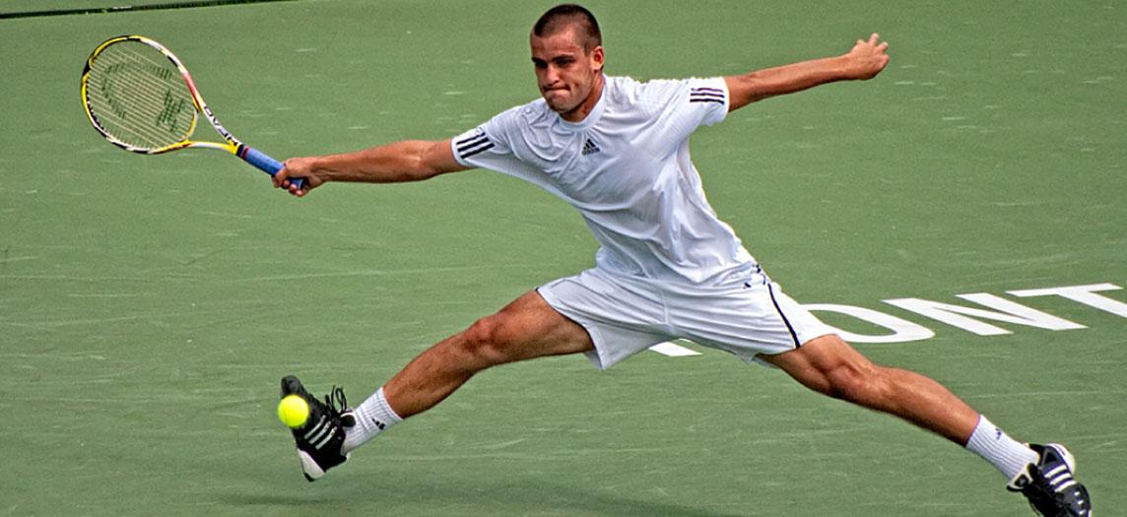
Figure 3.1 Tennis Player Athletes rely on toned skeletal muscles to supply the force required for movement. (credit: Emmanuel Huybrechts/flickr)
Chapter Objectives
After studying this chapter, you will be able to:
- Explain the organization of muscle tissue
- Describe the function and structure of skeletal muscle
- Explain how muscles work with tendons to move the body
- Describe how muscles contract and relax
- Define the process of muscle metabolism
- Explain how the nervous system controls muscle tension
- Relate the connections between exercise and muscle performance
- Explain the development and regeneration of muscle tissue

Introduction
When most people think of muscles, they think of the muscles that are visible just under the skin, particularly of the limbs. These are skeletal muscles, so-named because most of them move the skeleton. But there are two other types of muscle in the body, with distinctly different jobs. Cardiac muscle, found in the heart, is concerned with pumping blood through the circulatory system. Smooth muscle is concerned with various involuntary movements, such as having one’s hair stand on end when cold or frightened, or moving food through the digestive system. This chapter will examine the structure and function of these three types of muscles.

3.1 Overview of Muscle Tissues

Learning Objectives
By the end of this section, you will be able to:
- Describe the different types of muscle
- Explain contractibility and extensibility
Muscle is one of the four primary tissue types of the body, and the body contains three types of muscle tissue: skeletal muscle, cardiac muscle, and smooth muscle (Figure 3.2). All three muscle tissues have some properties in common; they all exhibit a quality called excitability as their plasma membranes can change their electrical states (from polarized to depolarized) and send an electrical wave called an action potential along the entire length of the membrane. While the nervous system can influence the excitability of cardiac and smooth muscle to some degree, skeletal muscle completely depends on signaling from the nervous system to work properly. On the other hand, both cardiac muscle and smooth muscle can respond to other stimuli, such as hormones and local stimuli.
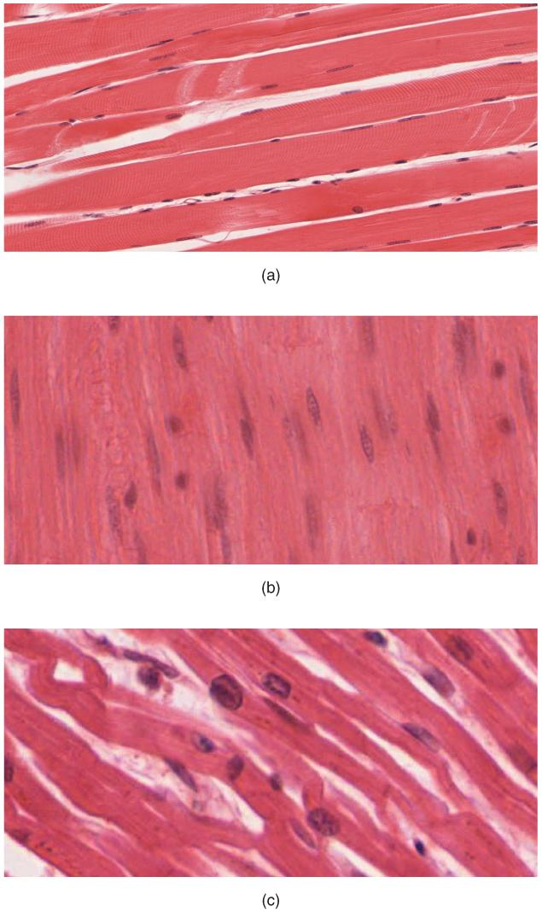
Figure 3.2 The Three Types of Muscle Tissue The body contains three types of muscle tissue: (a) skeletal muscle, (b) smooth muscle, and (c) cardiac muscle. (Micrographs provided by the Regents of University of Michigan Medical School © 2012)
Contractility allows muscle tissue to pull on its attachment points and shorten with force. A muscle can return to its original length when relaxed due to a quality of muscle tissue called elasticity. It can recoil back to its original length due to elastic fibers. Muscle tissue also has the quality of extensibility; it can stretch or extend.
Differences among the three muscle types include the microscopic organization of their contractile proteins—actin and myosin. The actin and myosin proteins are arranged very regularly in the cytoplasm of individual muscle cells (referred to as fibers) in both skeletal muscle and cardiac muscle, which creates a pattern, or stripes, called striations. The striations are visible with a light microscope under high magnification (see Figure 3.2). Skeletal muscle fibers are multinucleated structures that compose the skeletal muscle. Cardiac muscle fibers each have one to two nuclei and are physically and electrically connected to each other so that the entire heart contracts as one unit (called a syncytium).
Because the actin and myosin are not arranged in such regular fashion in smooth muscle, the cytoplasm of a smooth muscle fiber (which has only a single nucleus) has a uniform, nonstriated appearance (resulting in the name smooth muscle). However, the less organized appearance of smooth muscle should not be interpreted as less efficient. Smooth muscle in the walls of arteries is a critical component that regulates blood pressure necessary to push blood through the circulatory system.

3.2 Skeletal Muscle

Learning Objectives
By the end of this section, you will be able to:
- Describe the layers of connective tissues packaging skeletal muscle
- Explain how muscles work with tendons to move the body
- Identify areas of the skeletal muscle fibers
- Describe excitation-contraction coupling
The best-known feature of skeletal muscle is its ability to contract and cause movement.. Small, constant adjustments of the skeletal muscles are needed to hold a body upright or balanced in any position. Muscles also prevent excess movement of the bones and joints, maintaining skeletal stability and preventing skeletal structure damage or deformation. Skeletal muscles also protect internal organs (particularly abdominal and pelvic organs) by acting as an external barrier or shield to external trauma and by supporting the weight of the organs.
Skeletal muscles contribute to the maintenance of homeostasis in the body by generating heat. Muscle contraction requires energy, and when ATP is broken down, heat is produced. This heat is very noticeable during exercise, when sustained muscle movement causes body temperature to rise, and in cases of extreme cold, when shivering produces random skeletal muscle contractions to generate heat.
Each skeletal muscle is an organ that consists of various integrated tissues. These tissues include the skeletal muscle fibers, blood vessels, nerve fibers, and connective tissue. Each skeletal muscle has three layers of connective tissue (called “mysia”) that enclose it and provide structure to the muscle as a whole, and also compartmentalize the muscle fibers within the muscle (Figure 3.3). Each muscle is wrapped in a sheath of dense, irregular connective tissue called the epimysium, which allows a muscle to contract and move powerfully while maintaining its structural integrity. The epimysium also separates muscle from other tissues and organs in the area, allowing the muscle to move independently.
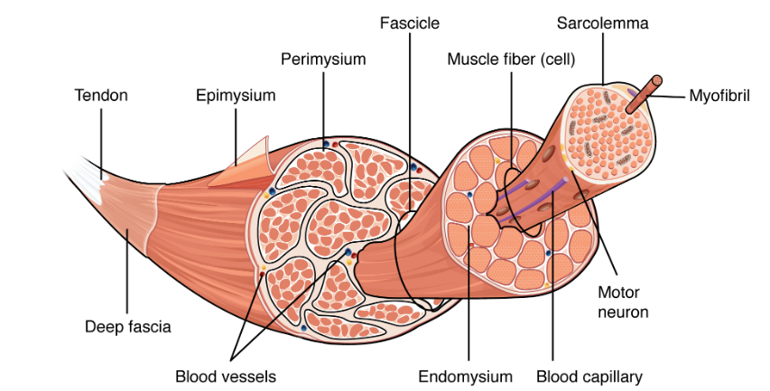
Figure 3.3 The Three Connective Tissue Layers Bundles of muscle fibers, called fascicles, are covered by the perimysium. Muscle fibers are covered by the endomysium.
Inside each skeletal muscle, muscle fibers are organized into individual bundles, each called a fascicle, by a middle layer of connective tissue called the perimysium. Inside each fascicle, each muscle fiber is encased in a thin connective tissue layer of collagen and reticular fibers called the endomysium. The endomysium contains the extracellular fluid and nutrients to support the muscle fiber.
In skeletal muscles that work with tendons to pull on bones, the collagen in the three tissue layers (the mysia) intertwines with the collagen of a tendon. At the other end of the tendon, it fuses with the periosteum coating the bone. The tension created by contraction of the muscle fibers is then transferred through the mysia, to the tendon, and then to the periosteum to pull on the bone for movement of the skeleton. In other places, the mysia may fuse with a broad, tendon-like sheet called an aponeurosis, or to fascia, the connective tissue between skin and bones. The broad sheet of connective tissue in the lower back that the latissimus dorsi muscles (the “lats”) fuse into is an example of an aponeurosis.

Skeletal Muscle Fibers
Because skeletal muscle cells are long and cylindrical, they are commonly referred to as muscle fibers. Some other terminology associated with muscle fibers is rooted in the Greek sarco, which means “flesh.” The plasma membrane of muscle fibers is called the sarcolemma, and the cytoplasm is referred to as sarcoplasm (Figure 3.4). As will soon be described, the functional unit of a skeletal muscle fiber is the sarcomere, a highly organized arrangement of the contractile myofilaments actin (thin filament) and myosin (thick filament), along with other support proteins.
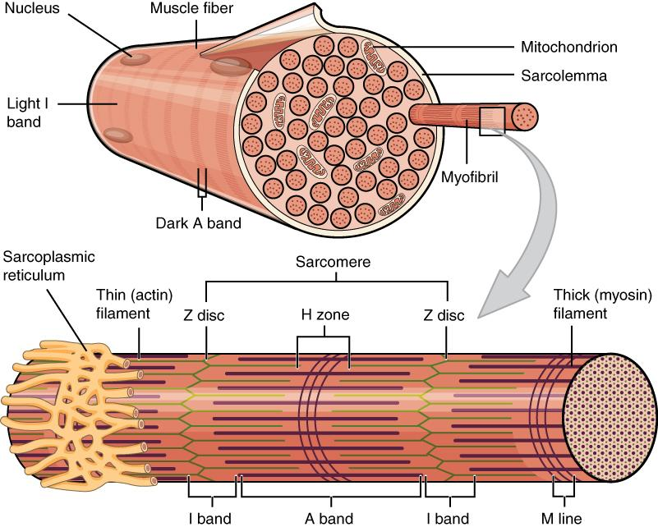
Figure 3.4 Muscle Fiber A skeletal muscle fiber is surrounded by a plasma membrane called the sarcolemma, which contains sarcoplasm, the cytoplasm of muscle cells. A muscle fiber is composed of many fibrils, which give the cell its striated appearance.

The Sarcomere
The striated appearance of skeletal muscle fibers is due to the arrangement of the myofilaments of actin and myosin in sequential order from one end of the muscle fiber to the other. Each packet of these microfilaments and their regulatory proteins, troponin and tropomyosin (along with other proteins) is called a sarcomere.
The sarcomere is the functional unit of the muscle fiber. The sarcomere itself is bundled within the myofibril that runs the entire length of the muscle fiber and attaches to the sarcolemma at its end. As myofibrils contract, the entire muscle cell contracts. Because myofibrils are only approximately 1.2 μm in diameter, hundreds to thousands (each with thousands of sarcomeres) can be found inside one muscle fiber. Each sarcomere is bordered by structures called Z-discs (also called Z-lines), to which the actin myofilaments are anchored (Figure 3.5). Because the actin form strands that are thinner than the myosin, it is called the thin filament of the sarcomere. Likewise, because the myosin strands and their multiple heads (projecting from the center of the sarcomere toward the Z-discs) have more mass and are thicker, they are called the thick filament of the sarcomere.
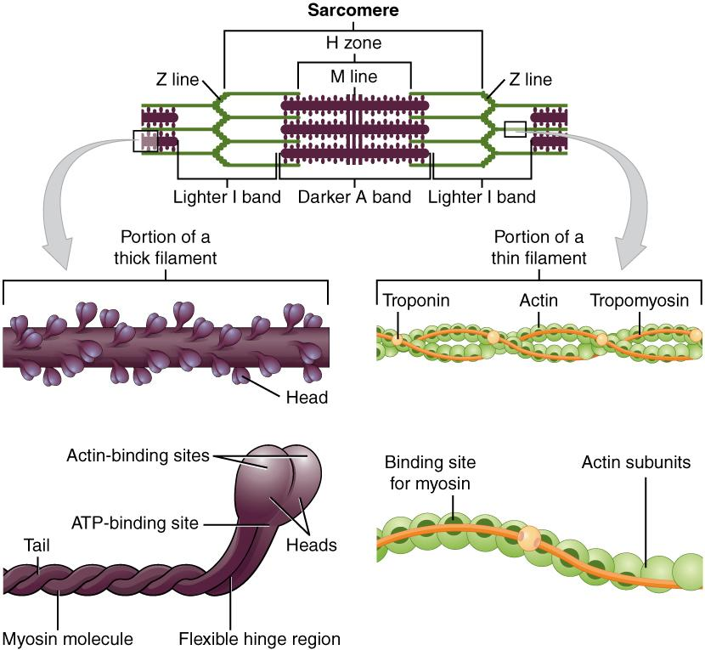
Figure 3.5 The Sarcomere The sarcomere, the region from one Z-line to the next Z-line, is the functional unit of a skeletal muscle fiber.

The Neuromuscular Junction
Another specialization of the skeletal muscle is the site where a motor neuron’s terminal meets the muscle fiber—called the neuromuscular junction (NMJ). This is where the muscle fiber first responds to signaling by the motor neuron. Every skeletal muscle fiber in every skeletal muscle is innervated by a motor neuron at the NMJ. Excitation signals from the neuron are the only way to functionally activate the fiber to contract.

Excitation-Contraction Coupling
All living cells have membrane potentials, or electrical gradients across their membranes. The inside of the membrane is usually around -60 to -90 mV, relative to the outside. This is referred to as a cell’s membrane potential. Neurons and muscle cells can use their membrane potentials to generate electrical signals. They do this by controlling the movement of charged particles, called ions, across their membranes to create electrical currents. This is achieved by opening and closing specialized proteins in the membrane called ion channels. Although the currents generated by ions moving through these channel proteins are very small, they form the basis of both neural signaling and muscle contraction.
Both neurons and skeletal muscle cells are electrically excitable, meaning that they are able to generate action potentials. An action potential is a special type of electrical signal that can travel along a cell membrane as a wave. This allows a signal to be transmitted quickly and faithfully over long distances.
Although the term excitation-contraction coupling confuses or scares some students, it comes down to this: for a skeletal muscle fiber to contract, its membrane must first be “excited”—in other words, it must be stimulated to fire an action potential. The muscle fiber action potential, which sweeps along the sarcolemma as a wave, is “coupled” to the actual contraction through the release of calcium ions (Ca⁺⁺).
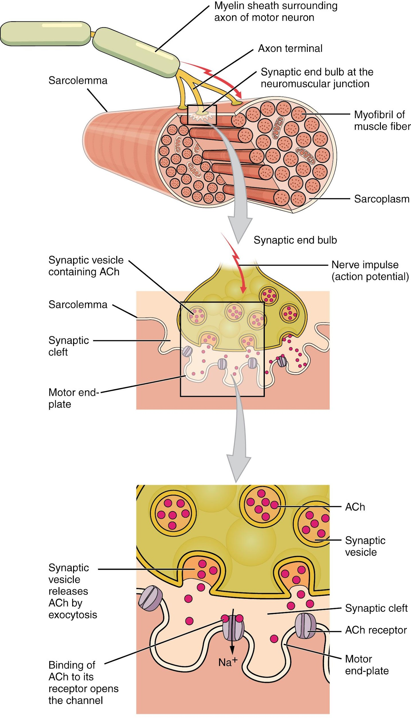
Figure 3.6 Motor End-Plate and Innervation At the NMJ, the axon terminal releases ACh. The motor end-plate is the location of the ACh-receptors in the muscle fiber sarcolemma. When ACh molecules are released, they diffuse across a minute space called the synaptic cleft and bind to the receptors.
The motor neurons that tell the skeletal muscle fibers to contract originate in the spinal cord, with a smaller number located in the brainstem for activation of skeletal muscles of the face, head, and neck. These neurons have long processes, called axons, which are specialized to transmit action potentials long distances— in this case, all the way from the spinal cord to the muscle itself (which may be up to three feet away). The axons of multiple neurons bundle together to form nerves, like wires bundled together in a cable.
Signaling begins when a neuronal action potential travels along the axon of a motor neuron, and then along the individual branches to terminate at the NMJ. At the NMJ, the axon terminal releases a chemical messenger, or neurotransmitter, called acetylcholine (ACh). The ACh molecules diffuse across a minute space called the synaptic cleft and bind to ACh receptors located within the motor end-plate of the sarcolemma on the other side of the synapse. Once ACh binds, a channel in the ACh receptor opens and positively charged ions can pass through into the muscle fiber, causing it to depolarize, meaning that the membrane potential of the muscle fiber becomes less negative (closer to zero.)
As the membrane depolarizes, another set of ion channels called voltage-gated sodium channels are triggered to open. Sodium ions enter the muscle fiber, and an action potential rapidly spreads (or “fires”) along the entire membrane to initiate excitation-contraction coupling. Things happen very quickly in the world of excitable membranes (just think about how quickly you can snap your fingers as soon as you decide to do it).
Propagation of an action potential along the sarcolemma is the excitation portion of excitation-contraction coupling. Recall that this excitation actually triggers the release of calcium ions (Ca⁺⁺). It is the arrival of Ca⁺⁺ in the sarcoplasm that initiates contraction of the muscle fiber by its contractile units, or sarcomeres. This is described next in the sliding filament model of contraction.

The Sliding Filament Model of Contraction
When signaled by a motor neuron, a skeletal muscle fiber contracts as the thin filaments are pulled and then slide past the thick filaments within the fiber’s sarcomeres. This process is known as the sliding filament model of muscle contraction (Figure 3.7).
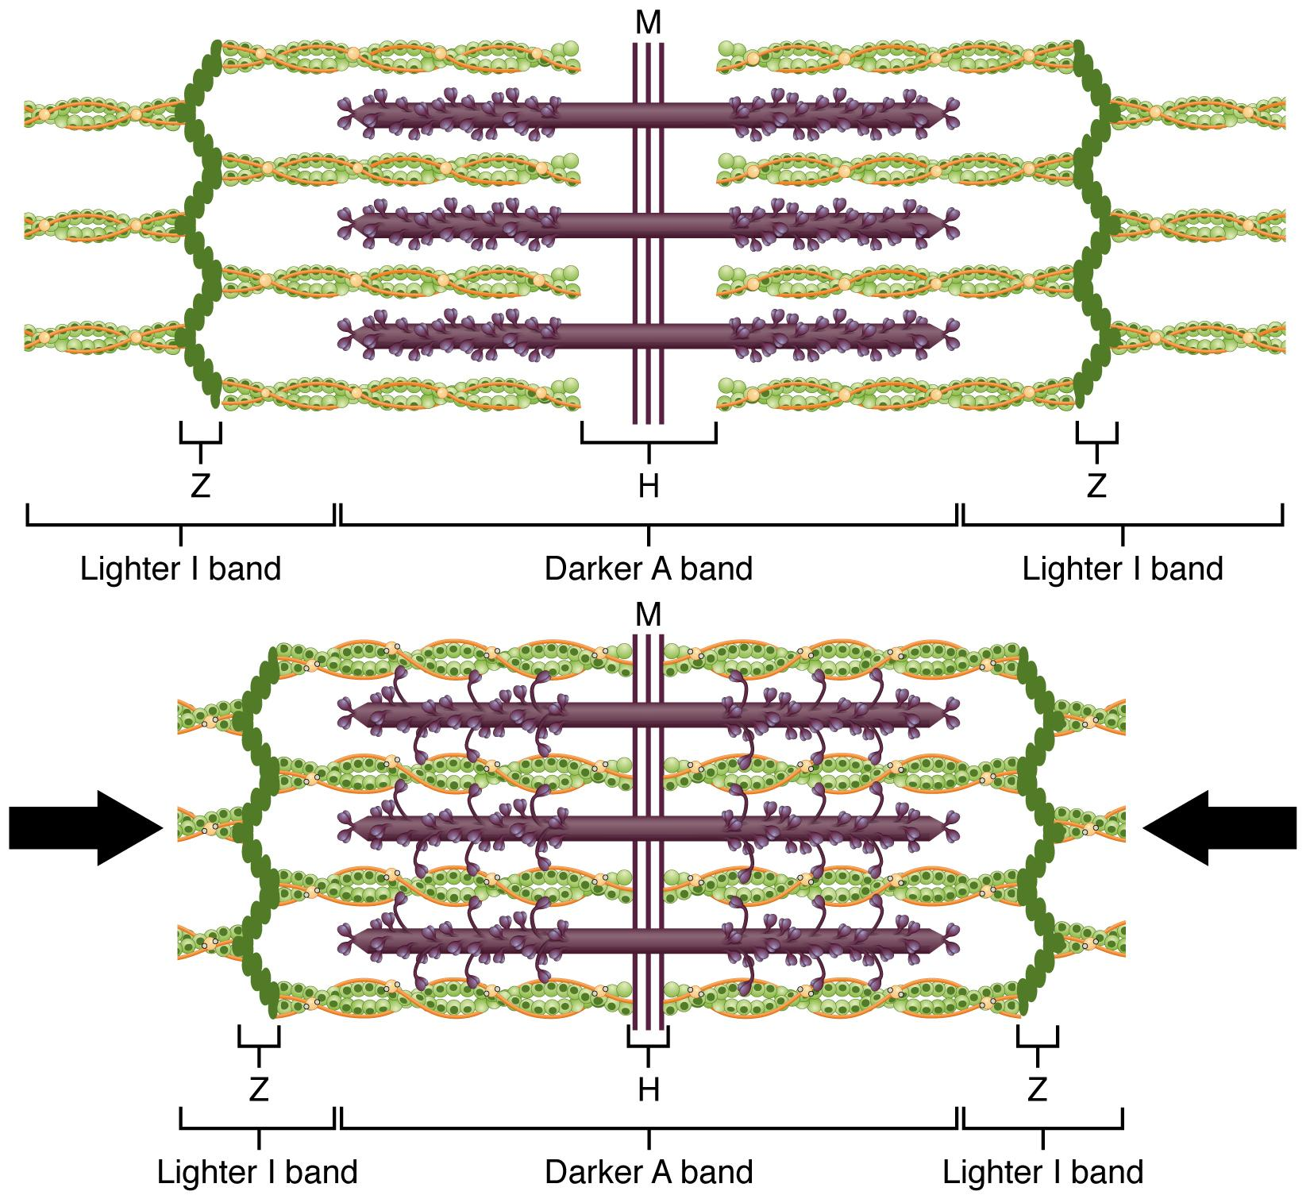
Figure 3.7 The Sliding Filament Model of Muscle Contraction When a sarcomere contracts, the Z lines move closer together, and the I band becomes smaller. The A band stays the same width. At full contraction, the thin and thick filaments overlap completely.
Tropomyosin is a protein that winds around actin filament and covers the myosin-binding sites to prevent actin from binding to myosin. Tropomyosin binds to troponin to form a troponin-tropomyosin complex. The troponin-tropomyosin complex prevents the myosin “heads” from binding to the active sites on the actin microfilaments. Troponin also has a binding site for Ca⁺⁺ ions.
To initiate muscle contraction, Ca++ binds to troponin, causing tropomyosin to slide away from the myosin-binding sites on the actin. This allows the myosin heads to bind to these exposed binding sites and form cross-bridges. The thin filaments are then pulled by the myosin heads to slide past the thick filaments toward the center of the sarcomere. But each head can only pull a very short distance before it has reached its limit and must be “re-cocked” before it can pull again, a step that requires ATP.
For thin filaments to continue to slide past thick filaments during muscle contraction, myosin heads must pull the actin at the binding sites, detach, re-cock, attach to more binding sites, pull, detach, re-cock, etc. This repeated movement is known as the cross-bridge cycle. This motion of the myosin heads is similar to the oars when an individual rows a boat: The paddle of the oars (the myosin heads) pull, are lifted from the water (detach), repositioned (re-cocked) and then immersed again to pull. Each cycle requires energy, and the action of the myosin heads in the sarcomeres repetitively pulling on the thin filaments also requires energy, which is provided by ATP.
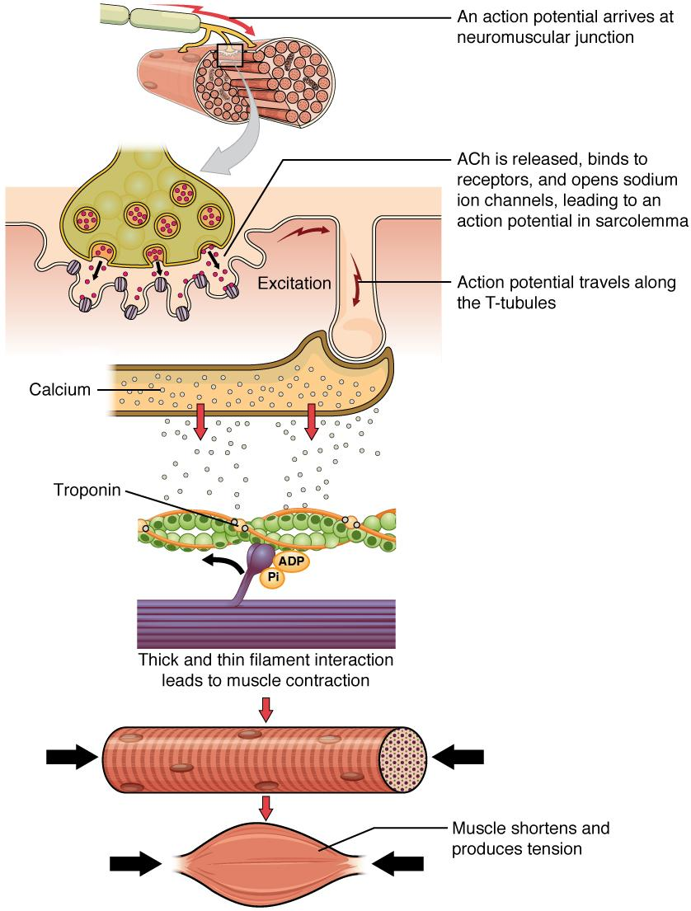
Figure 3.8 Excitation-Contraction Coupling A neural impulse is sent in the form of an action potential, which arrives at the NMJ. ACh is released across the synaptic cleft resulting in the release of Ca⁺⁺ within the sarcoplasm. The Ca⁺⁺ ions bind to troponin leading to a muscle contraction. As long as ATP is available, the muscle fiber will continue to shorten.

Relaxation of a Skeletal Muscle
Relaxing skeletal muscle fibers, and ultimately, the skeletal muscle, begins with the motor neuron, which stops releasing its chemical signal, ACh, into the synapse at the NMJ. The muscle fiber will repolarize, which stops the release of Ca⁺⁺. ATP-driven pumps will move Ca⁺⁺ out of the sarcoplasm. This results in the “reshielding” of the actin-binding sites on the thin filaments. Without the ability to form cross-bridges between the thin and thick filaments, the muscle fiber loses its tension and relaxes.

3.3 Types of Muscle Contractions

Learning Objectives
By the end of this section, you will be able to:
- Explain concentric, isotonic, and eccentric contractions
- Describe the length-tension relationship

To move an object, referred to as load, the sarcomeres in the muscle fibers of the skeletal muscle must shorten. The force generated by the contraction of the muscle (or shortening of the sarcomeres) is called muscle tension. However, muscle tension also is generated when the muscle is contracting against a load that does not move, resulting in two main types of skeletal muscle contractions: isotonic contractions and isometric contractions.
In isotonic contractions, where the tension in the muscle stays constant, a load is moved as the length of the muscle changes (shortens). There are two types of isotonic contractions: concentric and eccentric. A concentric contraction involves the muscle shortening to move a load. An example of this is the biceps brachii muscle contracting when a hand weight is brought upward with increasing muscle tension. As the biceps brachii contract, the angle of the elbow joint decreases as the forearm is brought toward the body. Here, the biceps brachii contracts as sarcomeres in its muscle fibers are shortening and cross-bridges form; the myosin heads pull the actin. An eccentric contraction occurs as the muscle tension diminishes and the muscle lengthens. In this case, the hand weight is lowered in a slow and controlled manner as the amount of cross-bridges being activated by nervous system stimulation decreases. In this case, as tension is released from the biceps brachii, the angle of the elbow joint increases. Eccentric contractions are also used for movement and balance of the body.
An isometric contraction occurs as the muscle produces tension without changing the angle of a skeletal joint. Isometric contractions involve sarcomere shortening and increasing muscle tension, but do not move a load, as the force produced cannot overcome the resistance provided by the load. For example, if one attempts to lift a hand weight that is too heavy, there will be sarcomere activation and shortening to a point, and ever-increasing muscle tension, but no change in the angle of the elbow joint. In everyday living, isometric contractions are active in maintaining posture and maintaining bone and joint stability. However, holding your head in an upright position occurs not because the muscles cannot move the head, but because the goal is to remain stationary and not produce movement. Most actions of the body are the result of a combination of isotonic and isometric contractions working together to produce a wide range of outcomes (Figure 3.9).
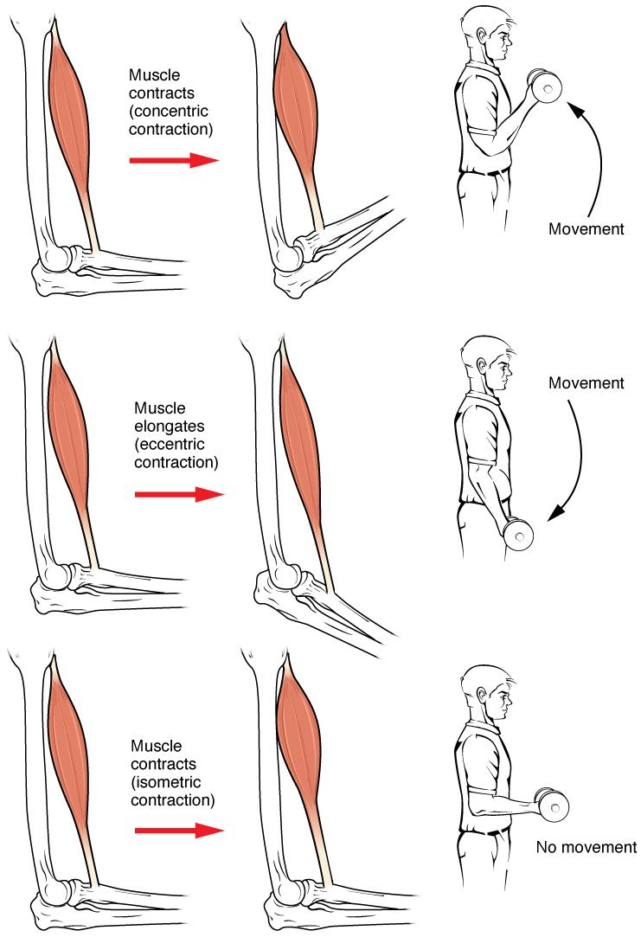

Figure 3.9 Types of Muscle Contractions During isotonic contractions, muscle length changes to move a load. During isometric contractions, muscle length does not change because the load exceeds the tension the muscle can generate.
Interactive Link
Watch this video for a practical example of the differences between isometric, concentric, and eccentric contractions and the importance of strengthening exercises of all types of contractions.

The Length-Tension Range of a Sarcomere
When a skeletal muscle fiber contracts, myosin heads attach to actin to form cross-bridges followed by the thin filaments sliding over the thick filaments as the heads pull the actin, and this results in sarcomere shortening, creating the tension of the muscle contraction. The cross-bridges can only form where thin and thick filaments already overlap, so that the length of the sarcomere has a direct influence on the force generated when the sarcomere shortens. This is called the length-tension relationship.
The ideal length of a sarcomere to produce maximal tension occurs at 80 percent to 120 percent of its resting length, with 100 percent being the state where the medial edges of the thin filaments are just at the most-medial myosin heads of the thick filaments (Figure 3.10). This length maximizes the overlap of actin-binding sites and myosin heads. If a sarcomere is stretched past this ideal length (beyond 120 percent), thick and thin filaments do not overlap sufficiently, which results in less tension produced. If a sarcomere is shortened beyond 80 percent, the zone of overlap is reduced with the thin filaments jutting beyond the last of the myosin heads and shrinks the H zone, which is normally composed of myosin tails. Eventually, there is nowhere else for the thin filaments to go and the amount of tension is diminished. If the muscle is stretched to the point where thick and thin filaments do not overlap at all, no cross-bridges can be formed, and no tension is produced in that sarcomere. This amount of stretching does not usually occur, as accessory proteins and connective tissue oppose extreme stretching.
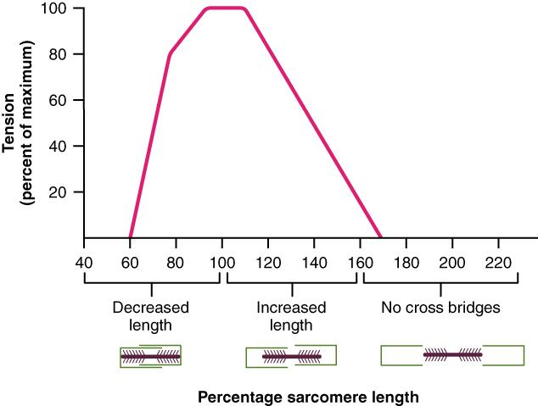
Figure 3.10 The Ideal Length of a Sarcomere Sarcomeres produce maximal tension when thick and thin filaments overlap between about 80 percent to 120 percent.

3.4 Types of Muscle Fibers

Learning Objectives
By the end of this section, you will be able to:
- Describe the types of skeletal muscle fibers
- Explain fast and slow muscle fibers
Two criteria to consider when classifying the types of muscle fibers are how fast some fibers contract relative to others, and how fibers produce ATP. Using these criteria, there are three main types of skeletal muscle fibers. Slow oxidative (SO) fibers contract relatively slowly and use aerobic respiration (oxygen and glucose) to produce ATP. Fast oxidative (FO) fibers have fast contractions and primarily use aerobic respiration, but because they may switch to anaerobic respiration (glycolysis), can fatigue more quickly than SO fibers. Lastly, fast glycolytic (FG) fibers have fast contractions and primarily use anaerobic glycolysis. The FG fibers fatigue more quickly than the others.
The primary metabolic pathway used by a muscle fiber determines whether the fiber is classified as oxidative or glycolytic. If a fiber primarily produces ATP through aerobic pathways it is oxidative. With the use of oxygen, more ATP can be produced during each metabolic cycle, making the fiber more resistant to fatigue. Glycolytic fibers primarily create ATP through anaerobic glycolysis, which produces less ATP per cycle, but does not require oxygen to do so. As a result, glycolytic fibers fatigue at a quicker rate.
The oxidative fibers contain many more mitochondria than the glycolytic fibers, because aerobic metabolism, which uses oxygen (O₂) in the metabolic pathway, occurs in the mitochondria. The SO fibers possess a large number of mitochondria and are capable of contracting for longer periods because of the large amount of ATP they can produce, but they have a relatively small diameter and do not produce a large amount of tension. SO fibers are extensively supplied with blood capillaries to supply O₂ from the red blood cells in the bloodstream. All of these features allow SO fibers to produce large quantities of ATP, which can sustain muscle activity without fatiguing for long periods of time.
The fact that SO fibers can function for long periods without fatiguing makes them useful in maintaining posture, producing isometric contractions, stabilizing bones and joints, and making small movements that happen often but do not require large amounts of energy. They do not produce high tension, and thus they are not used for powerful, fast movements that require high amounts of energy and rapid cross-bridge cycling.
FO fibers are sometimes called intermediate fibers because they possess characteristics that are intermediate between fast fibers and slow fibers. They produce ATP relatively quickly, more quickly than SO fibers, and thus can produce relatively high amounts of tension. They are oxidative because they produce ATP aerobically, possess high amounts of mitochondria, and do not fatigue quickly. FO fibers are used primarily for movements, such as walking, that require more energy than postural control but less energy than an explosive movement, such as sprinting. FO fibers are useful for this type of movement because they produce more tension than SO fibers but they are more fatigue-resistant than FG fibers.
FG fibers primarily use anaerobic glycolysis as their ATP source. They have a large diameter and possess high amounts of glycogen, which is used in glycolysis to generate ATP quickly to produce high levels of tension. Because they do not primarily use aerobic metabolism, they do not possess substantial numbers of mitochondria. FG fibers are used to produce rapid, forceful contractions to make quick, powerful movements. These fibers fatigue quickly, permitting them to only be used for short periods. Most muscles possess a mixture of each fiber type. The predominant fiber type in a muscle is determined by the primary function of the muscle.

Muscle Fiber Type Comparison
 | Slow Oxidative (SO) Fibers | Fast Oxidative (FO) Fibers | Fast Glycolytic (FG) Fibers
Metabolic Pathway | Aerobic respiration: uses oxygen to create ATP | Primarily aerobic respiration, but can switch to anaerobic glycolysis | Anaerobic glycolysis: breaks down glucose to produce ATP without requiring oxygen
Fatigability | Slowest to fatigue | Quicker to fatigue than SO fibers | Quickest to fatigue
Speed of Contraction | Relatively slow contraction | Fast contraction | Fast contraction
Amount of Tension Produced | Low | High | Highest
Table 3.1

Exercise and Muscle Performance
Most skeletal muscles in a human contain(s) all three types of muscle fibers, although in varying proportions. There are many factors that play a role in the proportion of each fiber type in any given muscle.
One important factor is how the muscle is trained.

Endurance Exercise
Slow fibers are predominantly used in endurance exercises that require little force but involve numerous repetitions. The aerobic metabolism used by slow-twitch fibers allows them to maintain contractions over long periods. Endurance training modifies these slow fibers to make them even more efficient by producing more mitochondria to enable more aerobic metabolism and more ATP production.
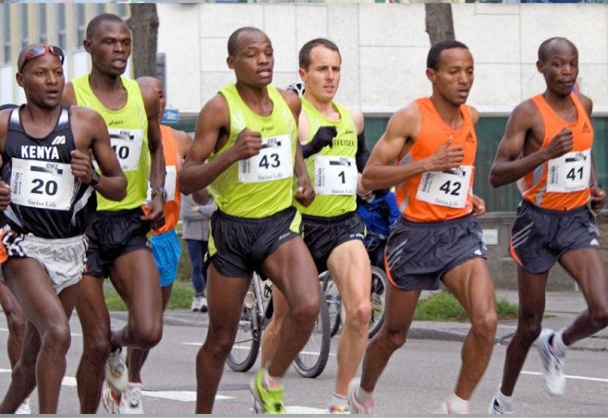
Figure 3.11 Marathoners Long-distance runners have a large number of SO fibers and relatively few FO and FG fibers. (credit: “Tseo2”/Wikimedia Commons)

Resistance Exercise
Resistance exercises, as opposed to endurance exercise, require large amounts of FG fibers to produce short, powerful movements that are not repeated over long periods. The high rates of ATP hydrolysis and cross-bridge formation in FG fibers result in powerful muscle contractions. Muscles used for power have a higher ratio of FG to SO/FO fibers, and trained athletes possess even higher levels of FG fibers in their muscles.
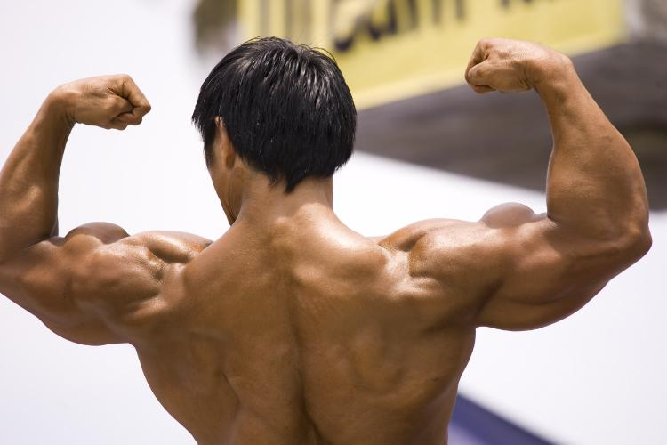
Figure 3.12 Hypertrophy Body builders have a large number of FG fibers and relatively few FO and SO fibers. (credit: Lin Mei/flickr)

Key Terms

acetylcholine (ACh) neurotransmitter that binds at a motor end-plate to trigger depolarization

actin protein that makes up most of the thin myofilaments in a sarcomere muscle fiber

action potential change in voltage of a cell membrane in response to a stimulus that results in transmission of an electrical signal; unique to neurons and muscle fibers

aerobic respiration production of ATP in the presence of oxygen

aponeurosis broad, tendon-like sheet of connective tissue that attaches a skeletal muscle to another skeletal muscle or to a bone

concentric contraction muscle contraction that shortens the muscle to move a load

contractility ability to shorten (contract) forcibly

depolarize to reduce the voltage difference between the inside and outside of a cell’s plasma membrane (the sarcolemma for a muscle fiber), making the inside less negative than at rest

eccentric contraction muscle contraction that lengthens the muscle as the tension is diminished

elasticity ability to stretch and rebound

endomysium loose, and well-hydrated connective tissue covering each muscle fiber in a skeletal muscle

epimysium outer layer of connective tissue around a skeletal muscle

excitability ability to undergo neural stimulation

excitation-contraction coupling sequence of events from motor neuron signaling to a skeletal muscle fiber to contraction of the fiber’s sarcomeres

extensibility ability to lengthen (extend)

fascicle bundle of muscle fibers within a skeletal muscle

fast glycolytic (FG) muscle fiber that primarily uses anaerobic glycolysis

fast oxidative (FO) intermediate muscle fiber that is between slow oxidative and fast glycolytic fibers

fibrosis replacement of muscle fibers by scar tissue

glycolysis anaerobic breakdown of glucose to ATP

isometric contraction muscle contraction that occurs with no change in muscle length

isotonic contraction muscle contraction that involves changes in muscle length

motor end-plate sarcolemma of muscle fiber at the neuromuscular junction, with receptors for the neurotransmitter acetylcholine

muscle tension force generated by the contraction of the muscle; tension generated during isotonic contractions and isometric contractions

myofibril long, cylindrical organelle that runs parallel within the muscle fiber and contains the sarcomeres

myosin protein that makes up most of the thick cylindrical myofilament within a sarcomere muscle fiber

neuromuscular junction (NMJ) synapse between the axon terminal of a motor neuron and the section of the membrane of a muscle fiber with receptors for the acetylcholine released by the terminal

neurotransmitter signaling chemical released by nerve terminals that bind to and activate receptors on target cells

perimysium connective tissue that bundles skeletal muscle fibers into fascicles within a skeletal muscle

power stroke action of myosin pulling actin inward (toward the M line)

sarcolemma plasma membrane of a skeletal muscle fiber

sarcomere longitudinally, repeating functional unit of skeletal muscle, with all of the contractile and associated proteins involved in contraction

sarcoplasm cytoplasm of a muscle cell

skeletal muscle striated, multinucleated muscle that requires signaling from the nervous system to trigger contraction; most skeletal muscles are referred to as voluntary muscles that move bones and produce movement

slow oxidative (SO) muscle fiber that primarily uses aerobic respiration

smooth muscle nonstriated, mononucleated muscle in the skin that is associated with hair follicles; assists in moving materials in the walls of internal organs, blood vessels, and internal passageways

synaptic cleft space between a nerve (axon) terminal and a motor end-plate

thick filament the thick myosin strands and their multiple heads projecting from the center of the sarcomere toward, but not all to way to, the Z-discs

thin filament thin strands of actin and its troponin-tropomyosin complex projecting from the Z-discs toward the center of the sarcomere

tropomyosin regulatory protein that covers myosin-binding sites to prevent actin from binding to myosin

troponin regulatory protein that binds to actin, tropomyosin, and calcium

voltage-gated sodium channels membrane proteins that open sodium channels in response to a sufficient voltage change, and initiate and transmit the action potential as Na⁺ enters through the channel

4 | THE NERVOUS SYSTEM
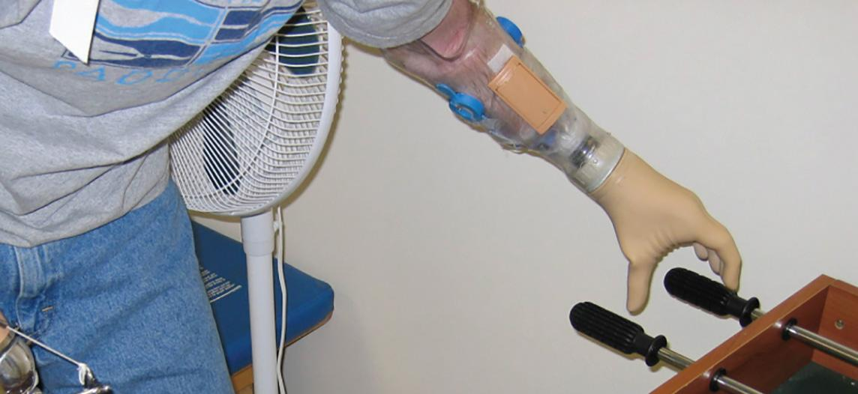
Figure 4.1 Robotic Arms Playing Foosball As the neural circuitry of the nervous system has become more fully understood and robotics more sophisticated, it is now possible to integrate technology with the body and restore abilities following traumatic events. At some point in the future, will this type of technology lead to the ability to augment our nervous systems? (credit: U.S. Army/Wikimedia Commons)
Chapter Objectives

After studying this chapter, you will be able to:
- Name the major divisions of the nervous system, both anatomical and functional
- Describe the functional and structural differences between gray matter and white matter structures
- Distinguish the major functions of the nervous system: sensation, integration, and response
- Describe the components of the membrane that establish the resting membrane potential
- Describe the changes that occur to the membrane that result in the action potential
- Explain the differences between types of graded potentials

Introduction
The nervous system is a very complex organ system. In Peter D. Kramer’s book Listening to Prozac, a pharmaceutical researcher is quoted as saying, “If the human brain were simple enough for us to understand, we would be too simple to understand it” (1994). That quote is from the early 1990s; in the two decades since, progress has continued at an amazing rate within the scientific disciplines of neuroscience. It is an interesting conundrum to consider that the complexity of the nervous system may be too complex for it (that is, for us) to completely unravel.
One easy way to begin to understand the structure of the nervous system is to start with the large divisions and work through to a more in-depth understanding. In this chapter, we will first look at an overview of the system that will allow you to begin to understand how its parts work together. The focus of the remainder of the chapter will be on the role of the nervous system in voluntary movement.

4.1 Basic Structure and Function of the Nervous System

Learning Objectives
By the end of this section, you will be able to:
- Identify the anatomical and functional divisions of the nervous system
- List the basic functions of the nervous system
The picture you have in your mind of the nervous system probably includes the brain, the nervous tissue contained within the cranium, and the spinal cord, the extension of nervous tissue within the vertebral column. That suggests it is made of two organs—and you may not even think of the spinal cord as an organ—but the nervous system is a very complex structure. Within the brain, many different and separate regions are responsible for many different and separate functions. It is as if the nervous system is composed of many organs that all look similar and can only be differentiated using tools such as the microscope or electrophysiology. In comparison, it is easy to see that the stomach is different than the esophagus or the liver, so you can imagine the digestive system as a collection of specific organs.

The Central and Peripheral Nervous Systems
The nervous system can be divided into two major regions: the central and peripheral nervous systems. The central nervous system (CNS) is the brain and spinal cord, and the peripheral nervous system (PNS) is everything else (Figure 4.2). The brain is contained within the cranial cavity of the skull, and the spinal cord is contained within the vertebral cavity of the vertebral column. It is a bit of an oversimplification to say that the CNS is what is inside these two cavities and the peripheral nervous system is outside of them, but that is one way to start to think about it. In actuality, there are some elements of the peripheral nervous system that are within the cranial or vertebral cavities. The peripheral nervous system is so named because it is on the periphery—meaning beyond the brain and spinal cord. Depending on different aspects of the nervous system, the dividing line between central and peripheral is not necessarily universal.
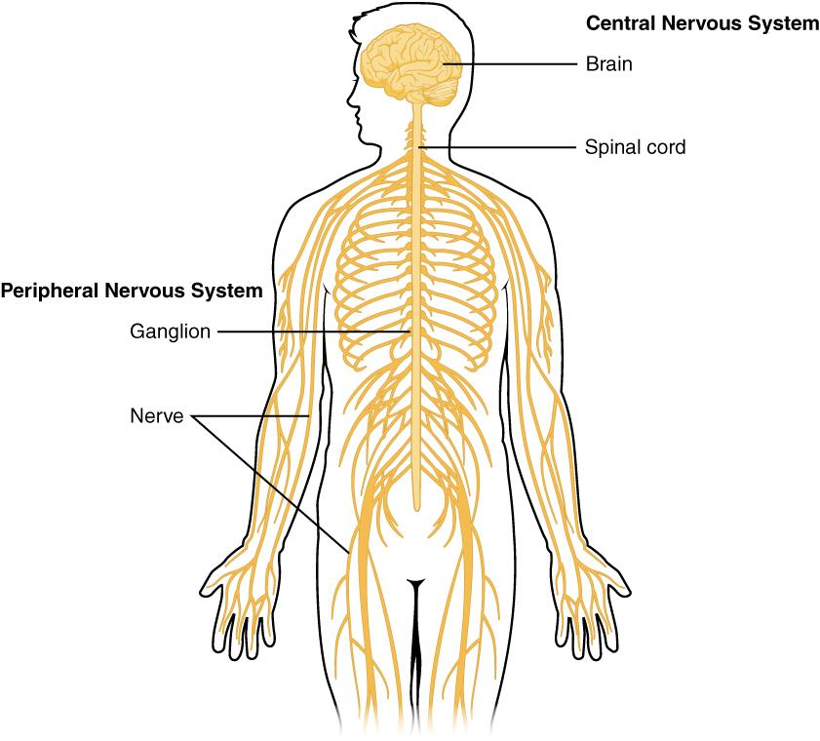
Figure 4.2 Central and Peripheral Nervous System The CNS consists of the brain and spinal cord. The PNS are the ganglion and nerves that exist outside of the brain and spinal cord.

Components of the Central Nervous System
The brain and the spinal cord are the central nervous system, and they represent the main organs of the nervous system. The spinal cord is a single structure, whereas the adult brain is described in terms of four major regions: the cerebrum, the diencephalon, the brain stem, and the cerebellum. A person’s conscious experiences are based on neural activity in the brain.

The Cerebrum
The iconic gray mantle of the human brain, which appears to make up most of the mass of the brain, is the cerebrum (Figure 4.3). The wrinkled portion is the cerebral cortex, and the rest of the structure is beneath that outer covering. There is a large separation between the two sides of the cerebrum called the longitudinal fissure. It separates the cerebrum into two distinct halves, a right and left cerebral hemisphere.
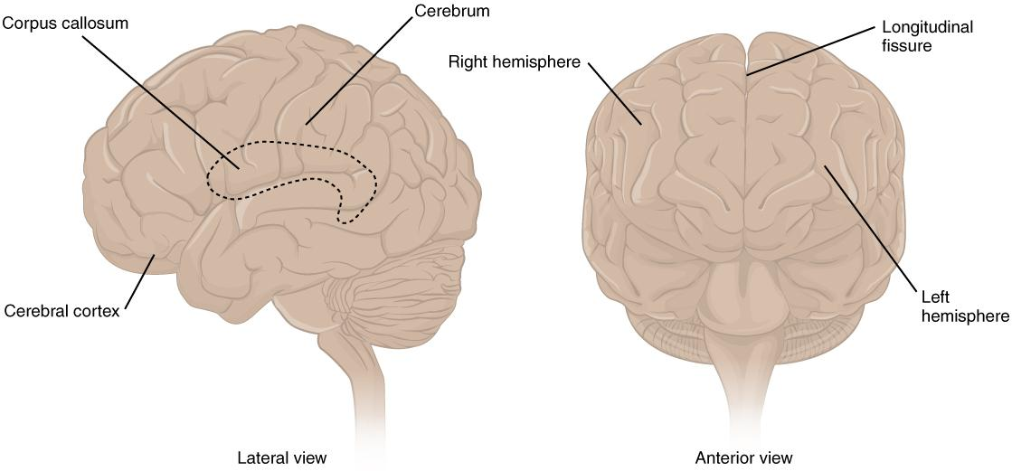
Figure 4.3 The Cerebrum The cerebrum is a large component of the CNS in humans, and the most obvious aspect of it is the folded surface called the cerebral cortex.
Many of the higher neurological functions, such as memory, emotion, and consciousness, are the result of cerebral function. The complexity of the cerebrum is different across vertebrate species. The complexity of the cerebrum separates human thinking from other mammals. The cerebrum can be divided into different regions, each with its own particular function.

The Diencephalon
The diencephalon is the one region of the adult brain that retains its name from embryologic development. The etymology of the word diencephalon translates to “through brain.” It is the connection between the cerebrum and the rest of the nervous system, with one exception. The rest of the brain, the spinal cord, and the PNS all send information to the cerebrum through the diencephalon. Output from the cerebrum passes through the diencephalon.
The diencephalon is deep beneath the cerebrum. The diencephalon can be described as any region of the brain with “thalamus” in its name. The two major regions of the diencephalon are the thalamus itself and the hypothalamus (Figure 4.4).
Thalamus: The thalamus is a collection of nuclei that relay information between the cerebral cortex and the periphery, spinal cord, or brain stem. All sensory information, except for the sense of smell, passes through the thalamus before processing by the cortex.
The cerebrum also sends information down to the thalamus, which usually communicates motor commands.
Hypothalamus: Inferior and slightly anterior to the thalamus is the hypothalamus, the other major region of the diencephalon. The hypothalamus is a collection of nuclei that are largely involved in regulating homeostasis. The hypothalamus is the executive region in charge of the autonomic nervous system and the endocrine system.
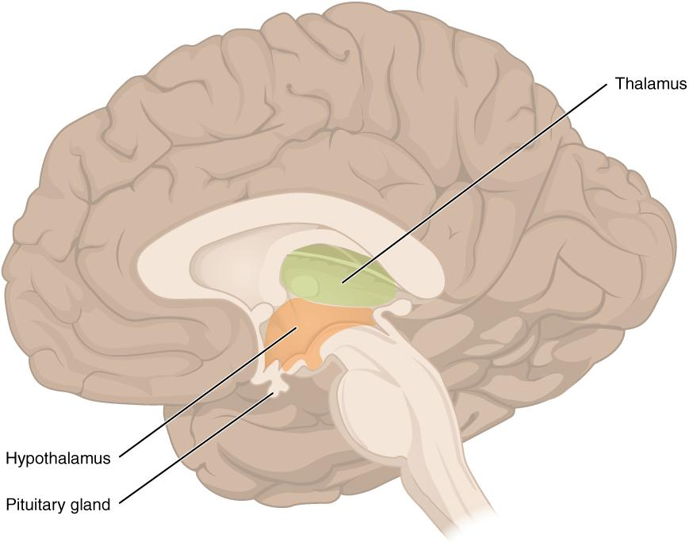
Figure 4.4 The Diencephalon The diencephalon is composed primarily of the thalamus and hypothalamus, which together define the walls of the third ventricle. The thalami are two elongated, ovoid structures on either side of the midline that make contact in the middle. The hypothalamus is inferior and anterior to the thalamus, culminating in a sharp angle to which the pituitary gland is attached.

Brain Stem
The midbrain, pons and medulla are collectively referred to as the brain stem (Figure 4.5). The structure emerges from the ventral surface of the cerebrum as a tapering cone that connects the brain to the spinal cord. The brainstem coordinates sensory representations of the visual, auditory, and somatosensory perceptual spaces. It also regulates several crucial functions, including the cardiovascular and respiratory systems and rates.

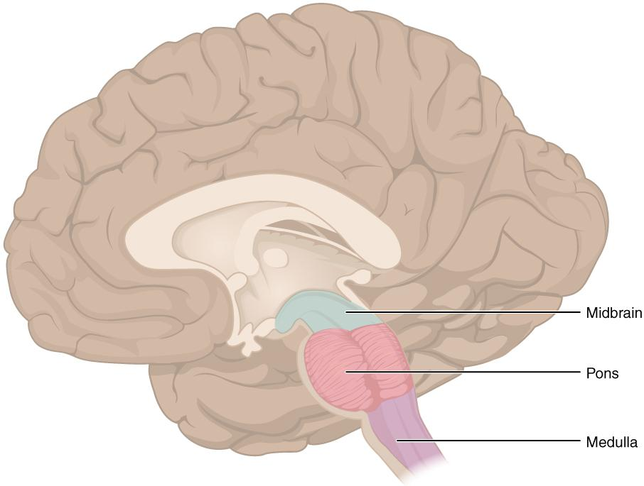
Figure 4.5 The Brain Stem The brain stem comprises three regions: the midbrain, the pons, and the medulla.

The Cerebellum
The cerebellum, as the name suggests, is the “little brain”, and looks like a miniature version of the cerebrum. The cerebellum is largely responsible for coordination of voluntary movement, balance, and posture. It does this by comparing information from the cerebrum with sensory feedback from the periphery through the spinal cord.

The Spinal Cord
The description of the CNS is concentrated on the structures of the brain, but the spinal cord is another major organ of the system.
The length of the spinal cord is divided into regions that correspond to the regions of the vertebral column. The name of a spinal cord region corresponds to the level at which spinal nerves pass through the intervertebral foramina. Immediately adjacent to the brain stem is the cervical region, followed by the thoracic, then the lumbar, and finally the sacral region. The spinal cord is not the full length of the vertebral column because the spinal cord does not grow significantly longer after the first or second year, but the skeleton continues to grow. The nerves that emerge from the spinal cord pass through the intervertebral foramina at the respective levels. As the vertebral column grows, these nerves grow with it and result in a long bundle of nerves that resembles a horse’s tail and is named the cauda equina. The sacral spinal cord is at the level of the upper lumbar vertebral bones. The spinal nerves extend from their various levels to the proper level of the vertebral column.
The spinal cord can be thought of as a “highway” that carries information between the brain and body. Similar to a highway, this information flows in two directions. The ascending tracts of the spinal cord carry sensory information from the body up to the brain. The descending tracts of the spinal cord carry motor commands from the brain out to the body.

Functional Divisions of the Nervous System
The nervous system can also be divided on the basis of its functions. There are two ways to consider how the nervous system is divided functionally. First, the nervous system can be divided based on control of the body - it can be somatic or autonomic. Secondly, the nervous system can be divided based on its basic functions - sensation, integration and response.

Controlling the Body
The nervous system can be divided into two parts mostly on the basis of a functional difference in responses. The somatic nervous system (SNS) is responsible for conscious perception and voluntary motor responses. Voluntary motor response means the contraction of skeletal muscle, but those contractions are not always voluntary in the sense that you have to want to perform them. Some somatic motor responses are reflexes, and often happen without a conscious decision to perform them. If your friend jumps out from behind a corner and yells “Boo!” you will be startled and you might scream or leap back. You didn’t decide to do that, and you may not have wanted to give your friend a reason to laugh at your expense, but it is a reflex involving skeletal muscle contractions. Other motor responses become automatic (in other words, unconscious) as a person learns motor skills (referred to as “habit learning” or “procedural memory”).
The autonomic nervous system (ANS) is responsible for involuntary control of the body, usually for the sake of homeostasis (regulation of the internal environment). Sensory input for autonomic functions can be from sensory structures tuned to external or internal environmental stimuli. The motor output extends to smooth and cardiac muscle as well as glandular tissue. The role of the autonomic system is to regulate the organ systems of the body, which usually means to control homeostasis. Sweat glands, for example, are controlled by the autonomic system. When you are hot, sweating helps cool your body down. That is a homeostatic mechanism. But when you are nervous, you might start sweating also. That is not homeostatic, it is the physiological response to an emotional state.

Basic Functions
The nervous system is involved in receiving information about the environment around us (sensation) and generating responses to that information (motor responses). The nervous system can be divided into regions that are responsible for sensation (sensory functions) and for the response (motor functions). But there is a third function that needs to be included. Sensory input needs to be integrated with other sensations, as well as with memories, emotional state, or learning (cognition). Some regions of the nervous system are termed integration or association areas. The process of integration combines sensory perceptions and higher cognitive functions such as memories, learning, and emotion to produce a response.
Sensation. The first major function of the nervous system is sensation—receiving information about the environment to gain input about what is happening outside the body (or, sometimes, within the body). The sensory functions of the nervous system register the presence of a change from homeostasis or a particular event in the environment, known as a stimulus. The senses we think of most are the “big five”: taste, smell, touch, sight, and hearing. There are actually more senses than just those, but that list represents the major senses. Those five are all senses that receive stimuli from the outside world, and of which there is conscious perception. Additional sensory stimuli might be from the internal environment (inside the body), such as the stretch of an organ wall.
Response. The nervous system produces a response on the basis of the stimuli perceived by sensory structures. An obvious response would be the movement of muscles, such as withdrawing a hand from a hot stove, but there are broader uses of the term. The nervous system can cause the contraction of all three types of muscle tissue. For example, skeletal muscle contracts to move the skeleton, cardiac muscle is influenced as heart rate increases during exercise, and smooth muscle contracts as the digestive system moves food along the digestive tract. Responses also include the neural control of glands in the body as well, such as the production and secretion of sweat to lower body temperature.
Responses can be divided into those that are voluntary or conscious (contraction of skeletal muscle) and those that are involuntary (contraction of smooth muscles, regulation of cardiac muscle, activation of glands). Voluntary responses are governed by the somatic nervous system and involuntary responses are governed by the autonomic nervous system.
Integration. Stimuli that are received by sensory structures are communicated to the nervous system where that information is processed. This is called integration. Stimuli are compared with, or integrated with, other stimuli, memories of previous stimuli, or the state of a person at a particular time. This leads to the specific response that will be generated. Seeing a baseball pitched to a batter will not automatically cause the batter to swing. The trajectory of the ball and its speed will need to be considered. Maybe the count is three balls and one strike, and the batter wants to let this pitch go by in the hope of getting a walk to first base. Or maybe the batter’s team is so far ahead, it would be fun to just swing away.

4.2 Nervous Tissue

Learning Objectives
By the end of this section, you will be able to:
- Describe the basic structure of a neuron
- Describe myelin and its role in neuronal electrical activity
Nervous tissue, present in both the CNS and PNS, contains two basic types of cells: neurons and glial cells. A glial cell is a cell that supports the neurons and their activities. The neuron is the more functionally important of the two, in terms of the communicative function of the nervous system. Neurons are electrically active and release chemical signals to target cells.

Neurons
Neurons are the cells considered to be the basis of nervous tissue. They are responsible for the electrical signals that communicate information about sensations, and that produce movements in response to those stimuli, along with inducing thought processes within the brain. An important part of the function of neurons is in their structure, or shape. The three-dimensional shape of these cells makes the immense numbers of connections within the nervous system possible.

Parts of a Neuron
Neurons are cells and therefore have a soma, or cell body. The cell body contains the nucleus and most of the major organelles. Neurons also have extensions of the cell; each extension is generally referred to as a process. There is one important process that every neuron has called an axon, which is the fiber that connects a neuron with its target. A single axon can branch repeatedly to communicate with many target cells. It is the axon that transmits the nerve impulse, which is communicated to one or more cells. Another type of process that branches off from the soma is the dendrite. Dendrites are responsible for receiving most of the input from other neurons at specialized areas of contact called synapses. The dendrites are usually highly branched processes, providing locations for other neurons to communicate with the cell body. Information flows through a neuron from the dendrites, across the cell body, and down the axon. This gives the neuron a polarity—meaning that information flows in this one direction. Figure 4.6 shows the relationship of these parts to one another.
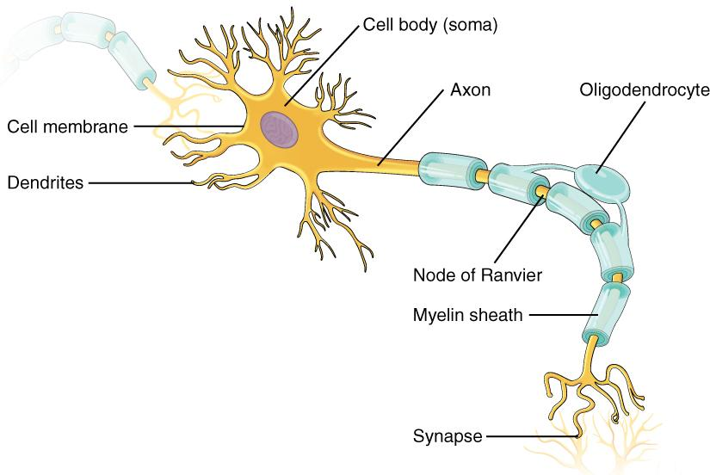
Figure 4.6 Parts of a Neuron The major parts of the neuron are labeled on a multipolar neuron from the CNS.
Where the axon emerges from the cell body, there is a special region referred to as the axon hillock. This is a tapering of the cell body toward the axon fiber. Because the axon hillock represents the beginning of the axon, it is also referred to as the initial segment.
Many axons are wrapped by an insulating substance called myelin, which is actually made from glial cells. Myelin acts as insulation much like the plastic or rubber that is used to insulate electrical wires. Myelin is a lipid-rich sheath that surrounds the axon and by doing so creates a myelin sheath that facilitates the transmission of electrical signals along the axon. The appearance of the myelin sheath can be thought of as similar to the pastry wrapped around a hot dog for “pigs in a blanket” or a similar food (Figure 4.7). A key difference between myelin and the insulation on a wire is that there are gaps in the myelin covering of an axon. Each gap is called a node of Ranvier and is important to the way that electrical signals travel down the axon. At the end of the axon is the axon terminal, where there are usually several branches extending toward the target cell, each of which ends in an enlargement called a synaptic end bulb. These bulbs are what make the connection with the target cell at the synapse.
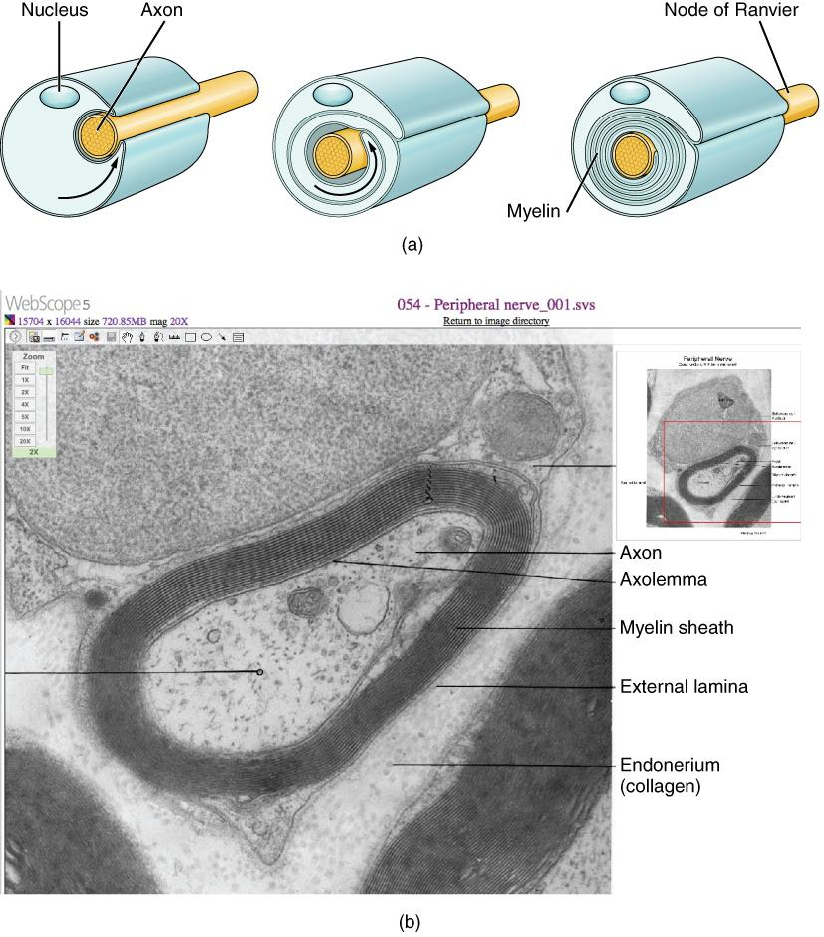

Figure 4.7 The Myelin Sheath Myelin acts as an insulator, wrapped around the axon to facilitate electrical signal transmission. Gaps exist in the myelin sheath, and these areas where there is no myelin covering on the axon are referred to as the Nodes of Ranvier.
Disorders of the…
Nervous Tissue
Several diseases can result from the demyelination of axons. The causes of these diseases are not the same; some have genetic causes, some are caused by pathogens, and others are the result of autoimmune disorders. Though the causes are varied, the results are largely similar. The myelin insulation of axons is compromised, making electrical signaling slower.
Multiple sclerosis (MS) is one such disease. It is an example of an autoimmune disease. The immune system marks the myelin as something that should not be in the body. This causes inflammation and destruction of myelin in the central nervous system. As the insulation around the axons is destroyed by the disease, scarring occurs in its place. This is where the name of the disease comes from; sclerosis means hardening of tissue, which is what a scar is. Multiple scars are found in the brain and spinal cord. The symptoms of MS include both somatic and autonomic deficits. Control of the musculature is compromised, as is control of organs such as the bladder.
Guillain-Barré (pronounced gee-YAN bah-RAY) syndrome is an example of a demyelinating disease of the peripheral nervous system. It is also the result of an autoimmune reaction, but the inflammation is in peripheral nerves. Sensory symptoms or motor deficits are common, and autonomic failures can lead to changes in the heart rhythm or a drop in blood pressure, especially when standing, which causes dizziness.

4.3 The Function of Nervous Tissue

Learning Objectives
By the end of this section, you will be able to:
- Distinguish the major functions of the nervous system: sensation, integration, and response
- List the sequence of events in a simple sensory receptor–motor response pathway
Having looked at the components of nervous tissue, and the basic anatomy of the nervous system, next comes an understanding of how nervous tissue is capable of communicating within the nervous system. Before getting to the nuts and bolts of how this works, an illustration of how the components come together will be helpful. An example is summarized in Figure 4.8.
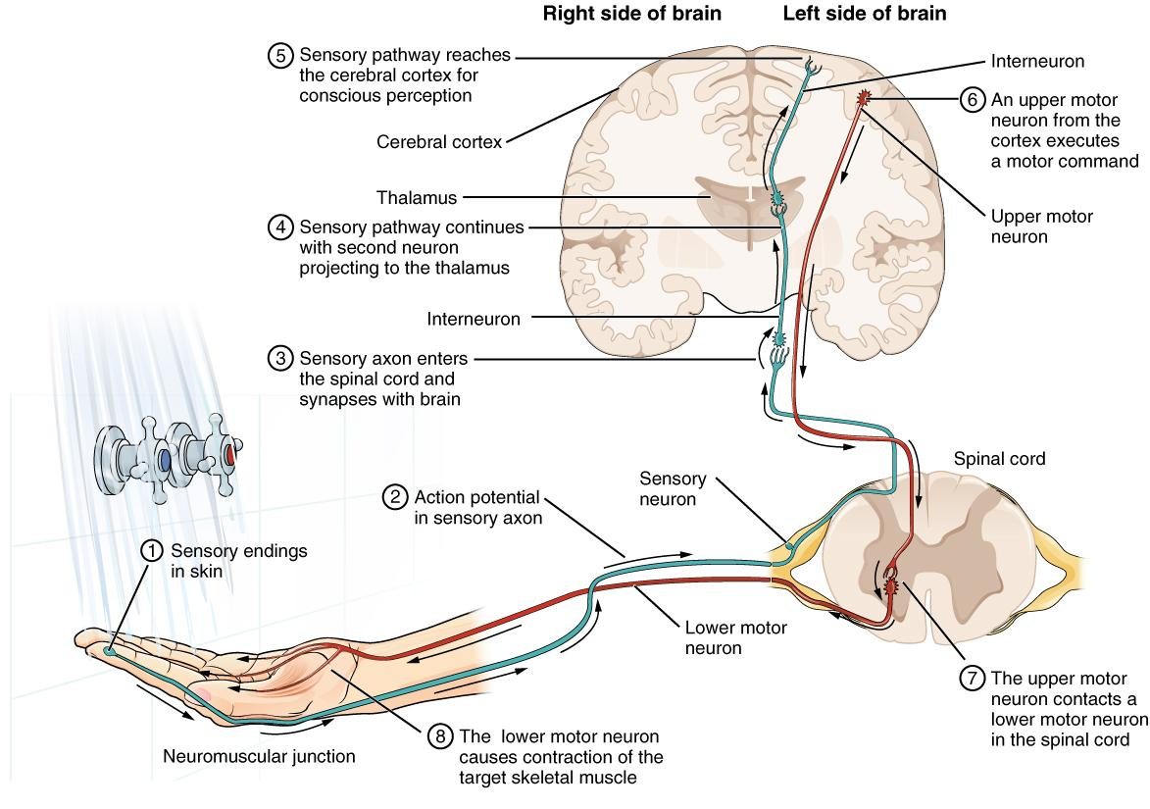
Figure 4.8 Testing the Water (1) The sensory neuron has endings in the skin that sense a stimulus such as water temperature. The strength of the signal that starts here is dependent on the strength of the stimulus. (2) The graded potential from the sensory endings, if strong enough, will initiate an action potential at the initial segment of the axon (which is immediately adjacent to the sensory endings in the skin). (3) The axon of the peripheral sensory neuron enters the spinal cord and contacts a secondary neuron. The contact is a synapse where another graded potential is caused by the release of a chemical signal from the axon terminals. (4) An action potential is initiated at the initial segment of this neuron and travels up the sensory pathway to a region of the brain called the thalamus. Another synapse passes the information along to the tertiary neuron. (5) The sensory pathway ends when the signal reaches the cerebral cortex. (6) After integration with neurons in other parts of the cerebral cortex, a motor command is sent from the motor region of the cortex. (7) The upper motor neuron sends an action potential down to the spinal cord. The target of the upper motor neuron is the dendrites of the lower motor neuron in the spinal cord. (8) The axon of the lower motor neuron emerges from the spinal cord in a nerve and connects to a muscle through a neuromuscular junction to cause contraction of the target muscle.
Imagine you are about to take a shower in the morning before going to school. You have turned on the faucet to start the water as you prepare to get in the shower. After a few minutes, you expect the water to be a temperature that will be comfortable to enter. So you put your hand out into the spray of water. What happens next depends on how your nervous system interacts with the stimulus of the water temperature and what you do in response to that stimulus.
Found in the skin of your fingers or toes is a type of sensory receptor that is sensitive to temperature, called a thermoreceptor. When you place your hand under the shower (Figure 4.9), the cell membrane of the thermoreceptors changes its electrical state (voltage). The amount of change is dependent on the strength of the stimulus (how hot the water is). This is called a graded potential. If the stimulus is strong, the voltage of the cell membrane will change enough to generate an electrical signal that will travel down the axon. The voltage at which such a signal is generated is called the threshold, and the resulting electrical signal is called an action potential. In this example, the action potential travels—a process known as propagation—along the axon from the axon hillock to the axon terminals and into the synaptic end bulbs. When this signal reaches the end bulbs, it causes the release of a signaling molecule called a neurotransmitter.
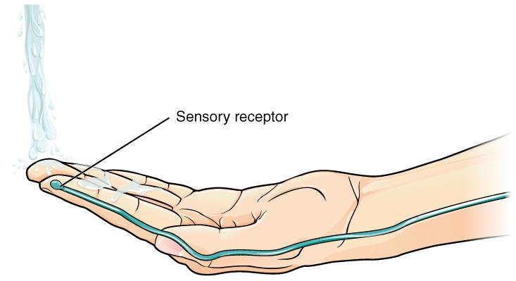
Figure 4.9 The Sensory Input Receptors in the skin sense the temperature of the water.
The neurotransmitter diffuses across the short distance of the synapse and binds to a receptor protein of the target neuron. When the molecular signal binds to the receptor, the cell membrane of the target neuron changes its electrical state and a new graded potential begins. If that graded potential is strong enough to reach threshold, the second neuron generates an action potential at its axon hillock. The target of this neuron is another neuron in the thalamus of the brain, the part of the CNS that acts as a relay for sensory information. At another synapse, neurotransmitter is released and binds to its receptor. The thalamus then sends the sensory information to the cerebral cortex where conscious perception of that water temperature begins.
Within the cerebral cortex, information is processed among many neurons, integrating the stimulus of the water temperature with other sensory stimuli, with your emotional state (you just aren't ready to wake up; the bed is calling to you), memories (perhaps of the lab notes you have to study before a quiz). Finally, a plan is developed about what to do, whether that is to turn the temperature up, turn the whole shower off and go back to bed, or step into the shower. To do any of these things, the cerebral cortex has to send a command out to your body to move muscles (Figure 4.10).
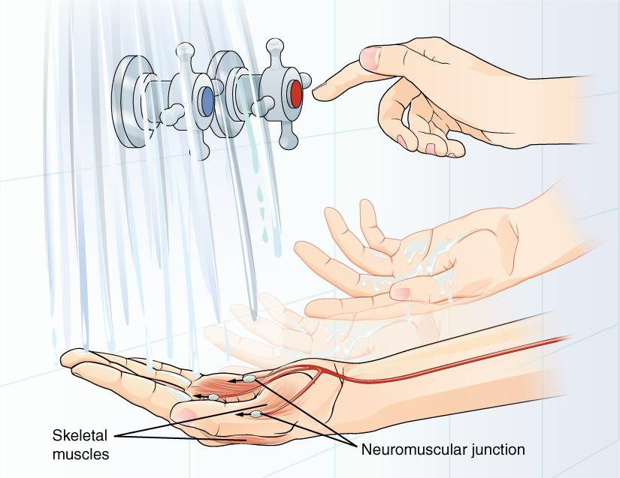
Figure 4.10 The Motor Response On the basis of the sensory input and the integration in the CNS, a motor response is formulated and executed.
A region of the cortex is specialized for sending signals down to the spinal cord for movement. The upper motor neuron is in this region which has an axon that extends all the way down the spinal cord. At the level of the spinal cord at which this axon makes a synapse, a graded potential occurs in the cell membrane of a lower motor neuron. This second motor neuron is responsible for causing muscle fibers to contract. An action potential travels along the motor neuron axon into the periphery. The axon terminates on muscle fibers at the neuromuscular junction. Acetylcholine is released at this specialized synapse, which causes the muscle action potential to begin, following a large potential known as an end plate potential. When the lower motor neuron excites the muscle fiber, it contracts. All of this occurs in a fraction of a second, but this story is the basis of how the nervous system functions.

Motor Units
Every skeletal muscle fiber must be innervated by the axon terminal of a motor neuron in order to contract. Each muscle fiber is innervated by only one motor neuron. The group of muscle fibers in a muscle innervated by a single motor neuron is called a motor unit (Figure 4.11). The size of a motor unit is variable depending on the nature of the muscle.
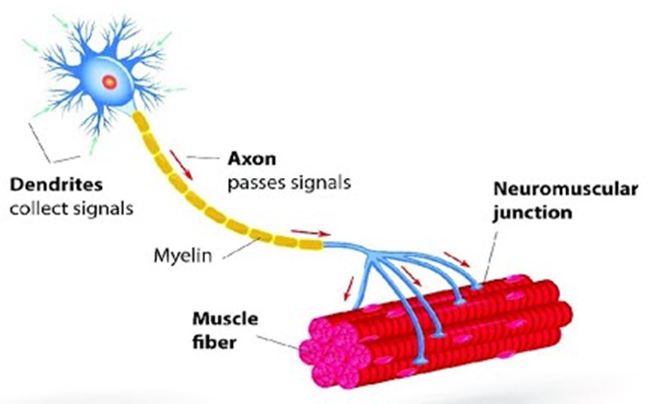
Figure 4.11 Motor Unit A motor unit includes one motor neuron and all the muscle fibers it innervates. The number of muscle fibers within a motor unit varies greatly and can be very small or quite large.
A small motor unit is an arrangement where a single motor neuron supplies a small number of muscle fibers in a muscle. Small motor units permit very fine motor control of the muscle. The best example in humans is the small motor units of the extraocular eye muscles that move the eyeballs. There are thousands of muscle fibers in each muscle, but every six or so fibers are supplied by a single motor neuron, as the axons branch to form synaptic connections at their individual NMJs. This allows for exquisite control of eye movements so that both eyes can quickly focus on the same object. Small motor units are also involved in the many fine movements of the fingers and thumb of the hand for grasping, texting, etc.
A large motor unit is an arrangement where a single motor neuron supplies a large number of muscle fibers in a muscle. Large motor units are concerned with simple, or “gross,” movements, such as powerfully extending the knee joint. The best example is the large motor units of the thigh muscles or back muscles, where a single motor neuron will supply thousands of muscle fibers in a muscle, as its axon splits into thousands of branches.
There is a wide range of motor units within many skeletal muscles, which gives the nervous system a wide range of control over the muscle. The small motor units in the muscle will have smaller, lower-threshold motor neurons that are more excitable, firing first to their skeletal muscle fibers, which also tend to be the smallest. Activation of these smaller motor units, results in a relatively small degree of contractile strength (tension) generated in the muscle. As more strength is needed, larger motor units, with bigger, higher-threshold motor neurons are enlisted to activate larger muscle fibers. This increasing activation of motor units produces an increase in muscle contraction known as recruitment. As more motor units are recruited, the muscle contraction grows progressively stronger. In some muscles, the largest motor units may generate a contractile force of 50 times more than the smallest motor units in the muscle. This allows a feather to be picked up using the biceps brachii arm muscle with minimal force, and a heavy weight to be lifted by the same muscle by recruiting the largest motor units.
When necessary, the maximal number of motor units in a muscle can be recruited simultaneously, producing the maximum force of contraction for that muscle, but this cannot last for very long because of the energy requirements to sustain the contraction. To prevent complete muscle fatigue, motor units are generally not all simultaneously active, but instead some motor units rest while others are active, which allows for longer muscle contractions. The nervous system uses recruitment as a mechanism to efficiently utilize a skeletal muscle.

4.4 The Action Potential

Learning Objectives
By the end of this section, you will be able to:
- Describe the components of the membrane that establish the resting membrane potential
- Describe the changes that occur to the membrane that result in the action potential
The functions of the nervous system—sensation, integration, and response—depend on the functions of the neurons underlying these pathways. To understand how neurons are able to communicate, it is necessary to describe the role of an excitable membrane in generating these signals. The basis of this communication is the action potential, which demonstrates how changes in the membrane can constitute a signal. Looking at the way these signals work in more variable circumstances involves a look at graded potentials, which will be covered in the next section.

Electrically Active Cell Membranes
Most cells in the body make use of charged particles, ions, to build up a charge across the cell membrane. The cell membrane is primarily responsible for regulating what can cross the membrane and what stays on only one side. Charged particles cannot pass through the cell membrane without assistance (Figure 4.12). Proteins embedded into the cell membrane make this possible. Of special interest is the carrier protein referred to as the sodium/potassium pump that moves sodium ions (Na⁺) out of a cell and potassium ions (K⁺) into a cell, thus regulating ion concentration on both sides of the cell membrane.
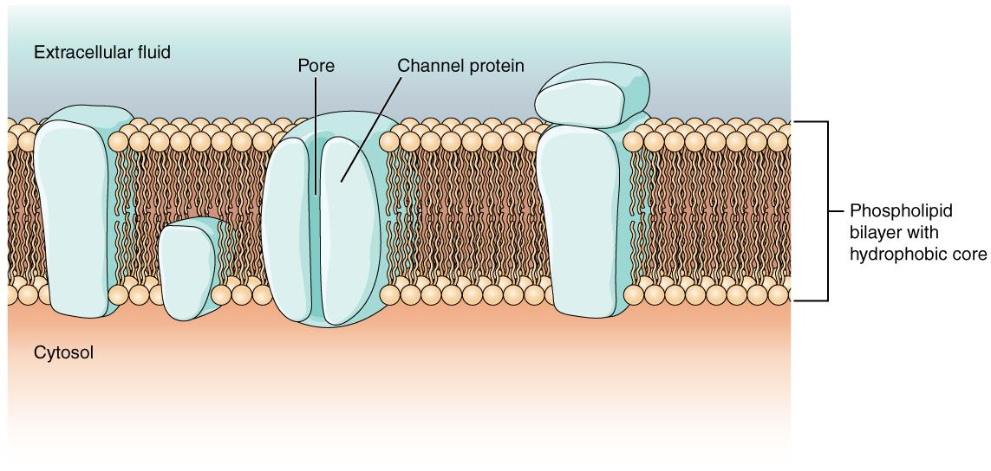
Figure 4.12 Cell Membrane and Transmembrane Proteins The cell membrane is composed of a phospholipid bilayer and has many transmembrane proteins, including different types of channel proteins that serve as ion channels.

The Membrane Potential
The electrical state of the cell membrane can have several variations. These are all variations in the membrane potential. A potential is a distribution of charge across the cell membrane, measured in millivolts (mV). The standard is to compare the inside of the cell relative to the outside, so the membrane potential is a value representing the charge on the intracellular side of the membrane based on the outside being zero, relatively speaking.
Before action potentials can be described, the resting state of the membrane must be explained. When the cell is at rest, and the protein channels are closed, ions are distributed across the membrane in a very predictable way. The concentration of Na⁺ outside the cell is 10 times greater than the concentration inside. Also, the concentration of K⁺ inside the cell is greater than outside.
With the ions distributed across the membrane at these concentrations, the difference in charge is measured at -70 mV, the value described as the resting membrane potential. The exact value measured for the resting membrane potential varies between cells, but -70 mV is most commonly used as this value.

The Action Potential
Resting membrane potential describes the steady state of the cell. Without any outside influence, it will not change. To get an electrical signal started, the membrane potential has to change.
This starts with a channel opening for Na⁺ in the membrane. Because the concentration of Na⁺ is higher outside the cell than inside the cell by a factor of 10, ions will rush into the cell that are driven largely by the concentration gradient. Because sodium is a positively charged ion, it will change the relative voltage immediately inside the cell relative to immediately outside. The resting potential is the state of the membrane at a voltage of -70 mV, so the positively charge sodium ions entering the cell will cause it to become less negative. This is known as depolarization, meaning the membrane potential moves toward zero.
The concentration gradient for Na⁺ is so strong that it will continue to enter the cell even after the membrane potential has become zero, so that the voltage immediately around the pore begins to become positive. The electrical gradient also plays a role, as negative proteins below the membrane attract the sodium ion. The membrane potential will reach +30 mV by the time sodium has entered the cell.
As the membrane potential reaches +30 mV, other voltage-gated channels are opening in the membrane. These channels are specific for the potassium ion. A concentration gradient acts on K⁺, as well. As K⁺ starts to leave the cell, taking a positive charge with it, the membrane potential begins to move back toward its resting voltage. This is called repolarization, meaning that the membrane voltage moves back toward the -70 mV value of the resting membrane potential.
Repolarization returns the membrane potential to the -70 mV value that indicates the resting potential, but it actually overshoots that value. Potassium ions reach equilibrium when the membrane voltage is below -70 mV, so a period of hyperpolarization occurs while the K⁺ channels are open. Those K⁺ channels are slightly delayed in closing, accounting for this short overshoot.
What has been described here is the action potential, which is presented as a graph of voltage over time in Figure 4.13. It is the electrical signal that nervous tissue generates for communication. The change in the membrane voltage from -70 mV at rest to +30 mV at the end of depolarization is a 100 mV change.
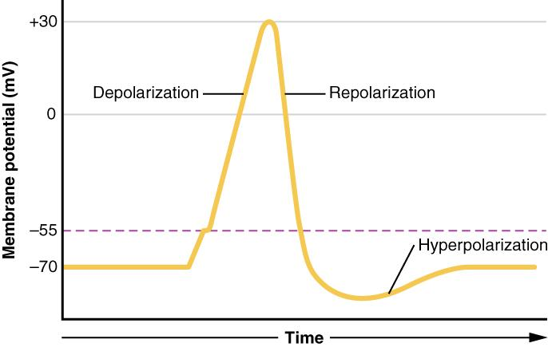
Figure 4.13 Graph of Action Potential Plotting voltage measured across the cell membrane against time, the action potential begins with depolarization, followed by repolarization, which goes past the resting potential into hyperpolarization, and finally the membrane returns to rest.
The question is, now, what initiates the action potential? The description above conveniently glosses over that point. But it is vital to understanding what is happening. The membrane potential will stay at the resting voltage until something changes. The description above just says that a Na⁺ channel opens. Now, to say “a channel opens” does not mean that one individual transmembrane protein changes. Instead, it means that one kind of channel opens. A Na⁺ channel will open when a neurotransmitter binds to it or a Na⁺ channel will open when a physical stimulus affects a sensory receptor (like pressure applied to the skin compresses a touch receptor). Whether it is a neurotransmitter binding to its receptor protein or a sensory stimulus activating a sensory receptor cell, some stimulus gets the process started. Sodium starts to enter the cell and the membrane becomes less negative.
As the sodium enters, the membrane potential becomes less negative. The amount of sodium that enters at this point is related to the size of the stimulus. This is a graded potential. When the membrane potential reaches threshold (-55 mV), more sodium channels open, and an action potential will be initiated.
Action potentials follow an All-or-Nothing law—it either happens or it does not. If the threshold is not reached, then no action potential occurs. If depolarization reaches -55 mV, then the action potential continues and runs all the way to +30 mV, at which K⁺ causes repolarization, including the hyperpolarizing overshoot. Also, those changes are the same for every action potential, which means that once the threshold is reached, the exact same thing happens. A stronger stimulus, which might depolarize the membrane well past threshold, will not make a “bigger” action potential. Action potentials are “all or none.” Either the membrane reaches the threshold and everything occurs as described above, or the membrane does not reach the threshold and nothing else happens. All action potentials peak at the same voltage (+30 mV), so one action potential is not bigger than another. Stronger stimuli will initiate multiple action potentials more quickly, but the individual signals are not bigger.
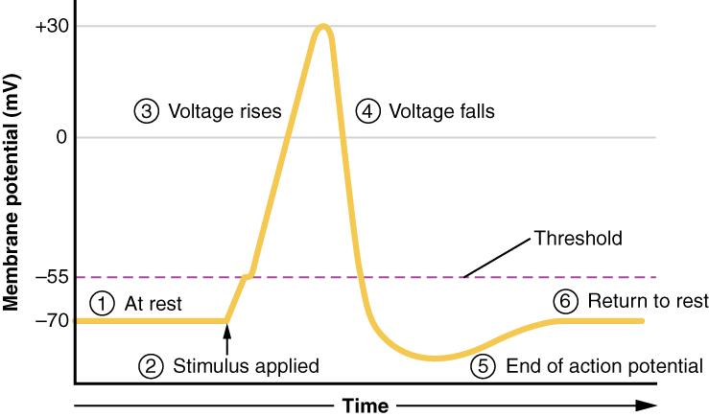
Figure 4.14 Stages of an Action Potential Plotting voltage measured across the cell membrane against time, the events of the action potential can be related to specific changes in the membrane voltage. (1) At rest, the membrane voltage is -70 mV. (2) The membrane begins to depolarize when an external stimulus is applied. (3) The membrane voltage begins a rapid rise toward +30 mV. (4) The membrane voltage starts to return to a negative value. (5) Repolarization continues past the resting membrane voltage, resulting in hyperpolarization. (6) The membrane voltage returns to the resting value shortly after hyperpolarization.
Interactive Link
Watch this video that provides an animation of the process of an action potential and the flow of ions that are responsible for the action potential.

Key Terms

action potential change in voltage of a cell membrane in response to a stimulus that results in transmission of an electrical signal; unique to neurons and muscle fibers

All-or-Nothing law a principle that if a single nerve fiber if stimulated, it will always give a maximal response and produce an electrical impulse of a single amplitude

ascending tract central nervous system fibers carrying sensory information from the spinal cord or periphery to the brain

autonomic nervous system (ANS) functional division of the nervous system that is responsible for homeostatic reflexes that coordinate control of cardiac and smooth muscle, as well as glandular tissue

axon single process of the neuron that carries an electrical signal (action potential) away from the cell body toward a target cell

axon hillock tapering of the neuron cell body that gives rise to the axon

axon terminal end of the axon, where there are usually several branches extending toward the target cell

cauda equina bundle of spinal nerve roots that descend from the lower spinal cord below the first lumbar vertebra and lie within the vertebral cavity; has the appearance of a horse's tail

central nervous system (CNS) anatomical division of the nervous system located within the cranial and vertebral cavities, namely the brain and spinal cord

cerebellum region of the adult brain connected primarily to the pons that developed from the metencephalon (along with the pons) and is largely responsible for comparing information from the cerebrum with sensory feedback from the periphery through the spinal cord

cerebral cortex outermost layer of gray matter in the brain, where conscious perception takes place

cerebral hemisphere one half of the bilaterally symmetrical cerebrum

cerebrum region of the adult brain that develops from the telencephalon and is responsible for higher neurological functions such as memory, emotion, and consciousness

dendrite one of many branchlike processes that extends from the neuron cell body and functions as a contact for incoming signals (synapses) from other neurons or sensory cells

depolarization change in a cell membrane potential from rest toward zero

descending tract central nervous system fibers carrying motor commands from the brain to the spinal cord or periphery

excitable membrane cell membrane that regulates the movement of ions so that an electrical signal can be generated

glial cell one of the various types of neural tissue cells responsible for maintenance of the tissue, and largely responsible for supporting neurons

graded potential change in the membrane potential that varies in size, depending on the size of the stimulus that elicits it

hypothalamus major region of the diencephalon that is responsible for coordinating autonomic and endocrine control of homeostasis

initial segment first part of the axon as it emerges from the axon hillock, where the electrical signals known as action potentials are generated

integration nervous system function that combines sensory perceptions and higher cognitive functions (memories, learning, emotion, etc.) to produce a response

longitudinal fissure large separation along the midline between the two cerebral hemispheres

lower motor neuron second neuron in the motor command pathway that is directly connected to the skeletal muscle

membrane potential distribution of charge across the cell membrane, based on the charges of ions

motor unit motor neuron and the group of muscle fibers it innervates

myelin lipid-rich insulating substance surrounding the axons of many neurons, allowing for faster transmission of electrical signals

neuron neural tissue cell that is primarily responsible for generating and propagating electrical signals into, within, and out of the nervous system

neurotransmitter chemical signal that is released from the synaptic end bulb of a neuron to cause a change in the target cell

node of Ranvier gap between two myelinated regions of an axon, allowing for strengthening of the electrical signal as it propagates down the axon

peripheral nervous system (PNS) anatomical division of the nervous system that is largely outside the cranial and vertebral cavities, namely all parts except the brain and spinal cord

process in cells, an extension of a cell body; in the case of neurons, this includes the axon and dendrites

propagation movement of an action potential along the length of an axon

recruitment increase in the number of motor units involved in contraction

repolarization return of the membrane potential to its normally negative voltage at the end of the action potential

response nervous system function that causes a target tissue (muscle or gland) to produce an event as a consequence to stimuli

resting membrane potential the difference in voltage measured across a cell membrane under steady-state conditions, typically -70 mV

sensation nervous system function that receives information from the environment and translates it into the electrical signals of nervous tissue

soma in neurons, that portion of the cell that contains the nucleus; the cell body, as opposed to the cell processes (axons and dendrites)

somatic nervous system (SNS) functional division of the nervous system that is concerned with conscious perception, voluntary movement, and skeletal muscle reflexes

stimulus an event in the external or internal environment that registers as activity in a sensory neuron

synapse narrow junction across which a chemical signal passes from neuron to the next, initiating a new electrical signal in the target cell

synaptic end bulb swelling at the end of an axon where neurotransmitter molecules are released onto a target cell across a synapse

thalamus region of the central nervous system that acts as a relay for sensory pathways

thermoreceptor type of sensory receptor capable of transducing temperature stimuli into neural action potentials

threshold membrane voltage at which an action potential is initiated

upper motor neuron first neuron in the motor command pathway with its cell body in the cerebral cortex that synapses on the lower motor neuron in the spinal cord

5 | THE AXIAL SKELETON
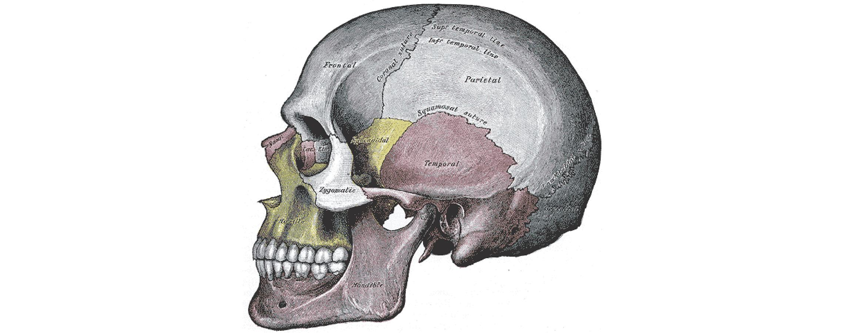
Figure 5.1 Lateral View of the Human Skull
Chapter Objectives
After studying this chapter, you will be able to:
- Describe the functions of the skeletal system and define its two major subdivisions
- Identify the bones and bony structures of the skull, the cranial suture lines, the cranial fossae, and the openings in the skull
- Discuss the vertebral column and regional variations in its bony components and curvatures
- Describe the components of the thoracic cage
- Discuss the embryonic development of the axial skeleton

Introduction
The skeletal system forms the rigid internal framework of the body. It consists of the bones, cartilages, and ligaments. Bones support the weight of the body, allow for body movements, and protect internal organs. Cartilage provides flexible strength and support for body structures such as the thoracic cage, the external ear, and the trachea and larynx. At joints of the body, cartilage can also unite adjacent bones or provide cushioning between them. Ligaments are the strong connective tissue bands that hold the bones at a moveable joint together and serve to prevent excessive movements of the joint that would result in injury. Providing movement of the skeleton are the muscles of the body, which are firmly attached to the skeleton via connective tissue structures called tendons. As muscles contract, they pull on the bones to produce movements of the body. Thus, without a skeleton, you would not be able to stand, run, or even feed yourself!
Each bone of the body serves a particular function, and therefore bones vary in size, shape, and strength based on these functions. For example, the bones of the lower back and lower limb are thick and strong to support your body weight. Similarly, the size of a bony landmark that serves as a muscle attachment site on an individual bone is related to the strength of this muscle. Muscles can apply very strong pulling forces to the bones of the skeleton. To resist these forces, bones have enlarged bony landmarks at sites where powerful muscles attach. This means that not only the size of a bone, but also its shape, is related to its function. For this reason, the identification of bony landmarks is important during your study of the skeletal system.
Bones are also dynamic organs that can modify their strength and thickness in response to changes in muscle strength or body weight. Thus, muscle attachment sites on bones will thicken if you begin a workout program that increases muscle strength. Similarly, the walls of weight-bearing bones will thicken if you gain body weight or begin pounding the pavement as part of a new running regimen. In contrast, a reduction in muscle strength or body weight will cause bones to become thinner. This may happen during a prolonged hospital stay, following limb immobilization in a cast, or going into the weightlessness of outer space. Even a change in diet, such as eating only soft food due to the loss of teeth, will result in a noticeable decrease in the size and thickness of the jaw bones.

5.1 Divisions of the Skeletal System

Learning Objectives
By the end of this section, you will be able to:
- Discuss the functions of the skeletal system
- Distinguish between the axial skeleton and appendicular skeleton
- Define the axial skeleton and its components
- Define the appendicular skeleton and its components
The skeletal system includes all of the bones, cartilages, and ligaments of the body that support and give shape to the body and body structures. The skeleton consists of the bones of the body. For adults, there are 206 bones in the skeleton. Younger individuals have higher numbers of bones because some bones fuse together during childhood and adolescence to form an adult bone. The primary functions of the skeleton are to provide a rigid, internal structure that can support the weight of the body against the force of gravity, and to provide a structure upon which muscles can act to produce movements of the body. The lower portion of the skeleton is specialized for stability during walking or running. In contrast, the upper skeleton has greater mobility and ranges of motion, features that allow you to lift and carry objects or turn your head and trunk.
In addition to providing for support and movements of the body, the skeleton has protective and storage functions. It protects the internal organs, including the brain, spinal cord, heart, lungs, and pelvic organs. The bones of the skeleton serve as the primary storage site for important minerals such as calcium and phosphate. The bone marrow found within bones stores fat and houses the blood-cell producing tissue of the body.
The skeleton is subdivided into two major divisions—the axial and appendicular.

The Axial Skeleton
The skeleton is subdivided into two major divisions—the axial and appendicular. The axial skeleton forms the vertical, central axis of the body and includes all bones of the head, neck, chest, and back (Figure 5.2). It serves to protect the brain, spinal cord, heart, and lungs. It also serves as the attachment site for muscles that move the head, neck, and back, and for muscles that act across the shoulder and hip joints to move their corresponding limbs.
The axial skeleton of the adult consists of 80 bones, including the skull, the vertebral column, and the thoracic cage. The skull is formed by 22 bones. Also associated with the head are an additional seven bones, including the hyoid bone and the ear ossicles (three small bones found in each middle ear). The vertebral column consists of 24 bones, each called a vertebra, plus the sacrum and coccyx. The thoracic cage includes the 12 pairs of ribs, and the sternum, the flattened bone of the anterior chest.
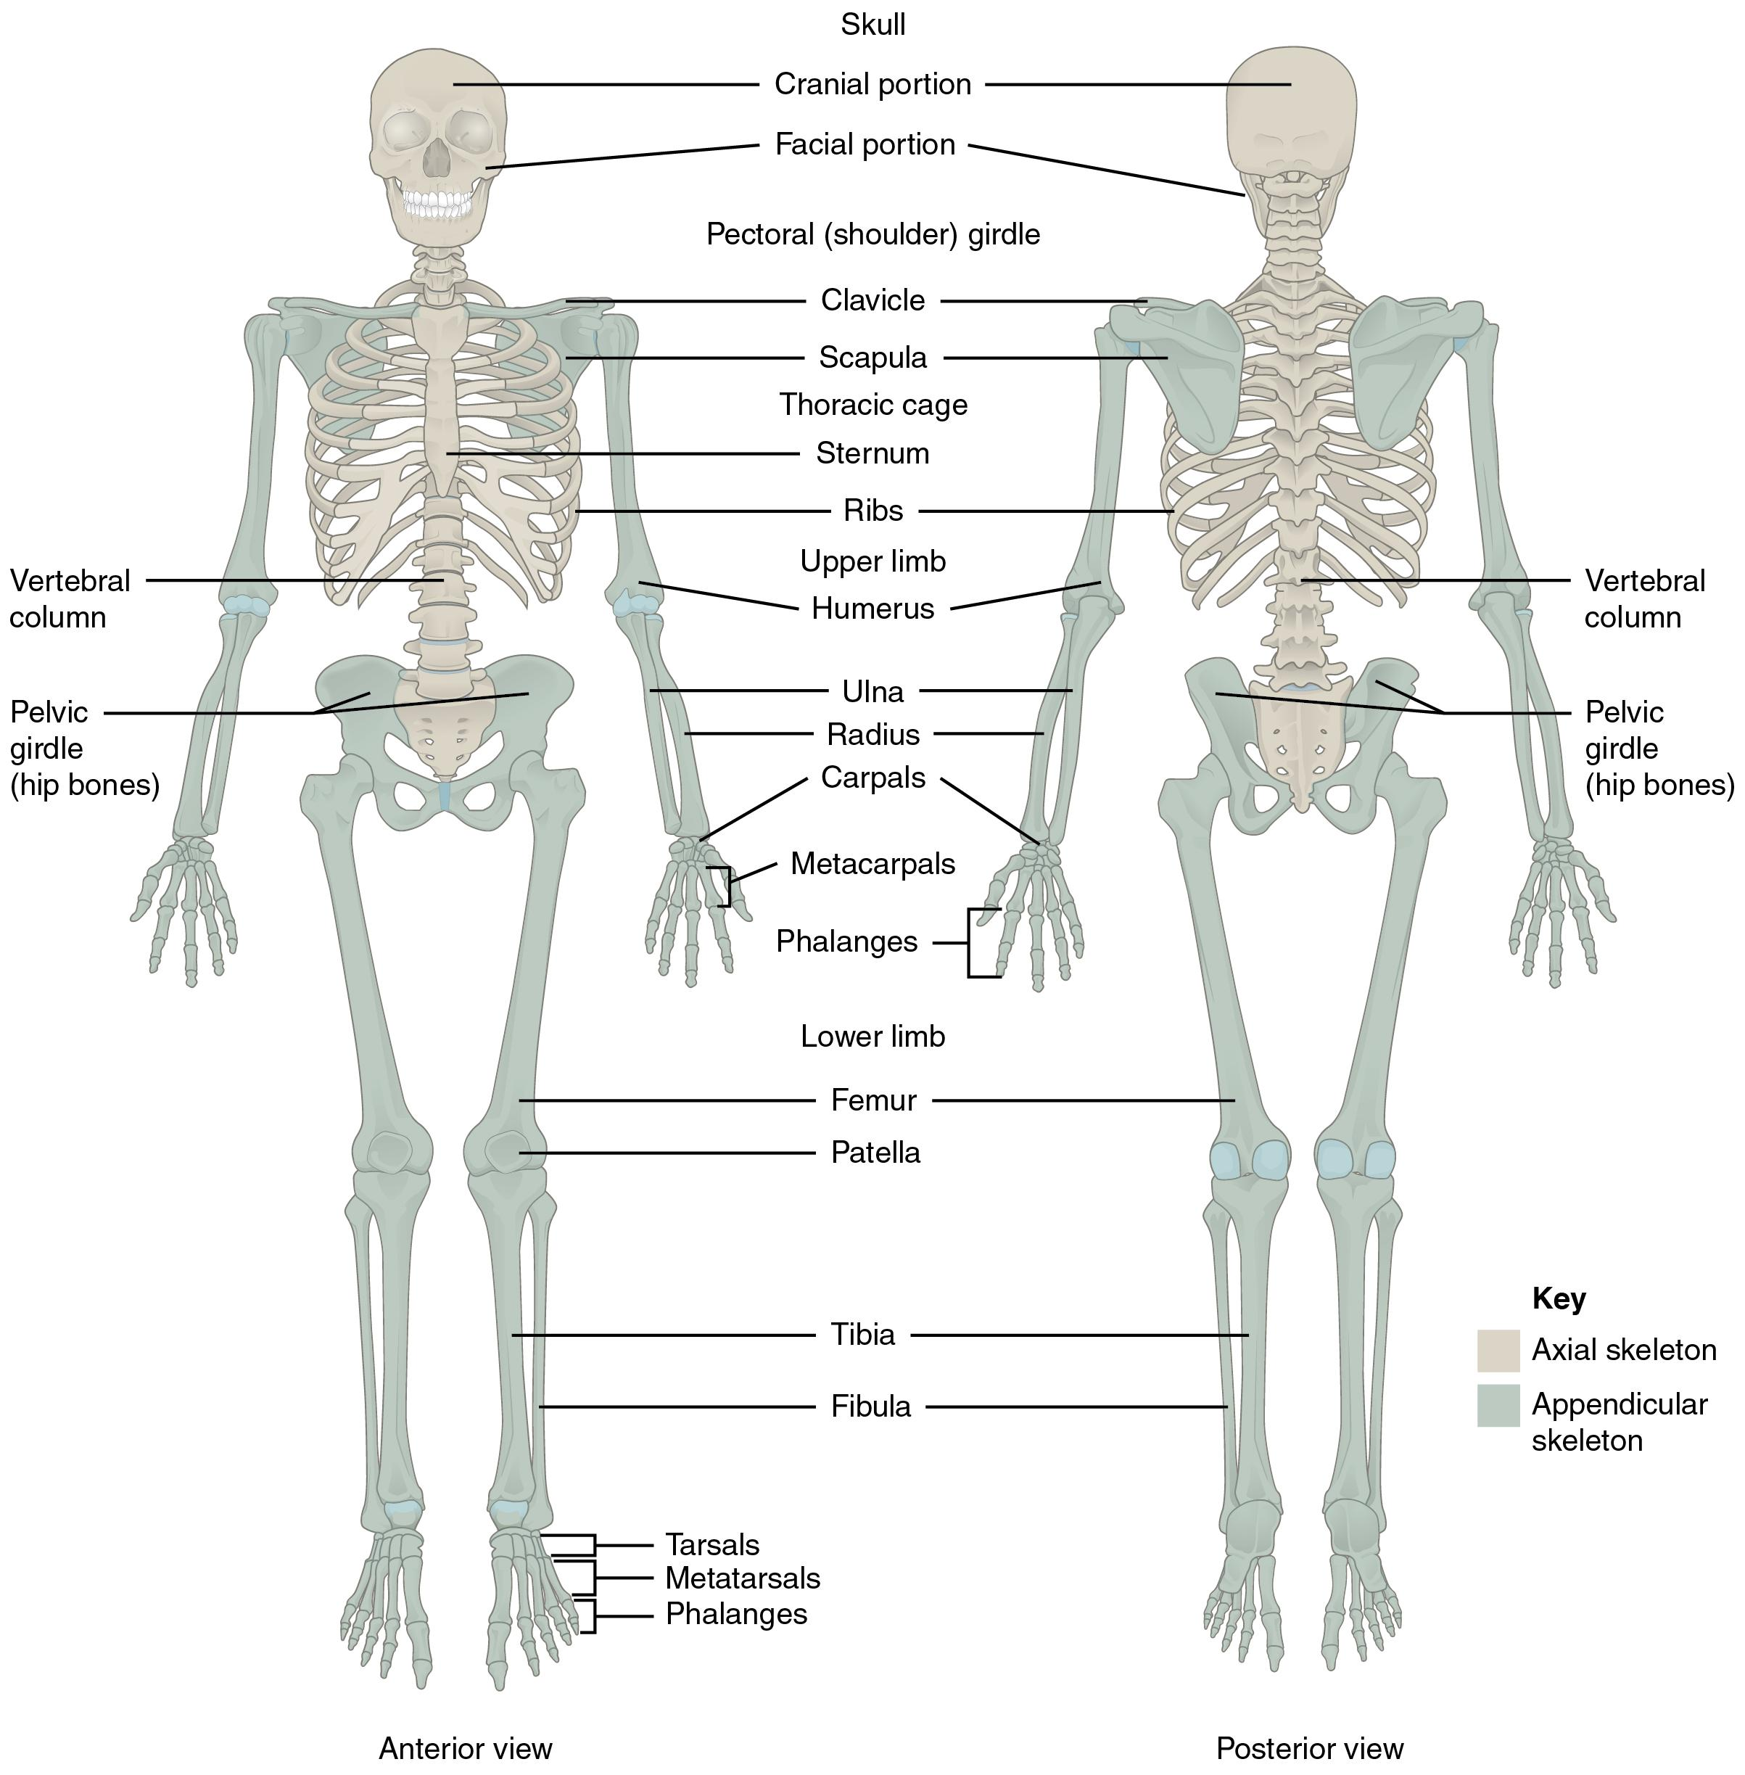
Figure 5.2 Axial and Appendicular Skeleton The axial skeleton supports the head, neck, back, and chest and thus forms the vertical axis of the body. It consists of the skull, vertebral column (including the sacrum and coccyx), and the thoracic cage, formed by the ribs and sternum. The appendicular skeleton is made up of all bones of the upper and lower limbs.

The Appendicular Skeleton
The appendicular skeleton includes all bones of the upper and lower limbs, plus the bones that attach each limb to the axial skeleton. There are 126 bones in the appendicular skeleton of an adult. The bones of the appendicular skeleton are covered in a separate chapter.

5.2 The Skull

Learning Objectives
By the end of this section, you will be able to:
- List and identify the bones of the brain case and face
- Locate the major suture lines of the skull and name the bones associated with each
- Name the bones that make up the walls of the orbit
- Identify some of the bony openings of the skull
The cranium (skull) is the skeletal structure of the head that supports the face and protects the brain. It is subdivided into the facial bones and the brain case, or cranial vault (Figure 5.3). The facial bones underlie the facial structures, form the nasal cavity, enclose the eyeballs, and support the teeth of the upper and lower jaws. The rounded brain case surrounds and protects the brain and houses the middle and inner ear structures.
In the adult, the skull consists of 22 individual bones, 21 of which are immobile and united into a single unit. The 22nd bone is the mandible (lower jaw), which is the only moveable bone of the skull.
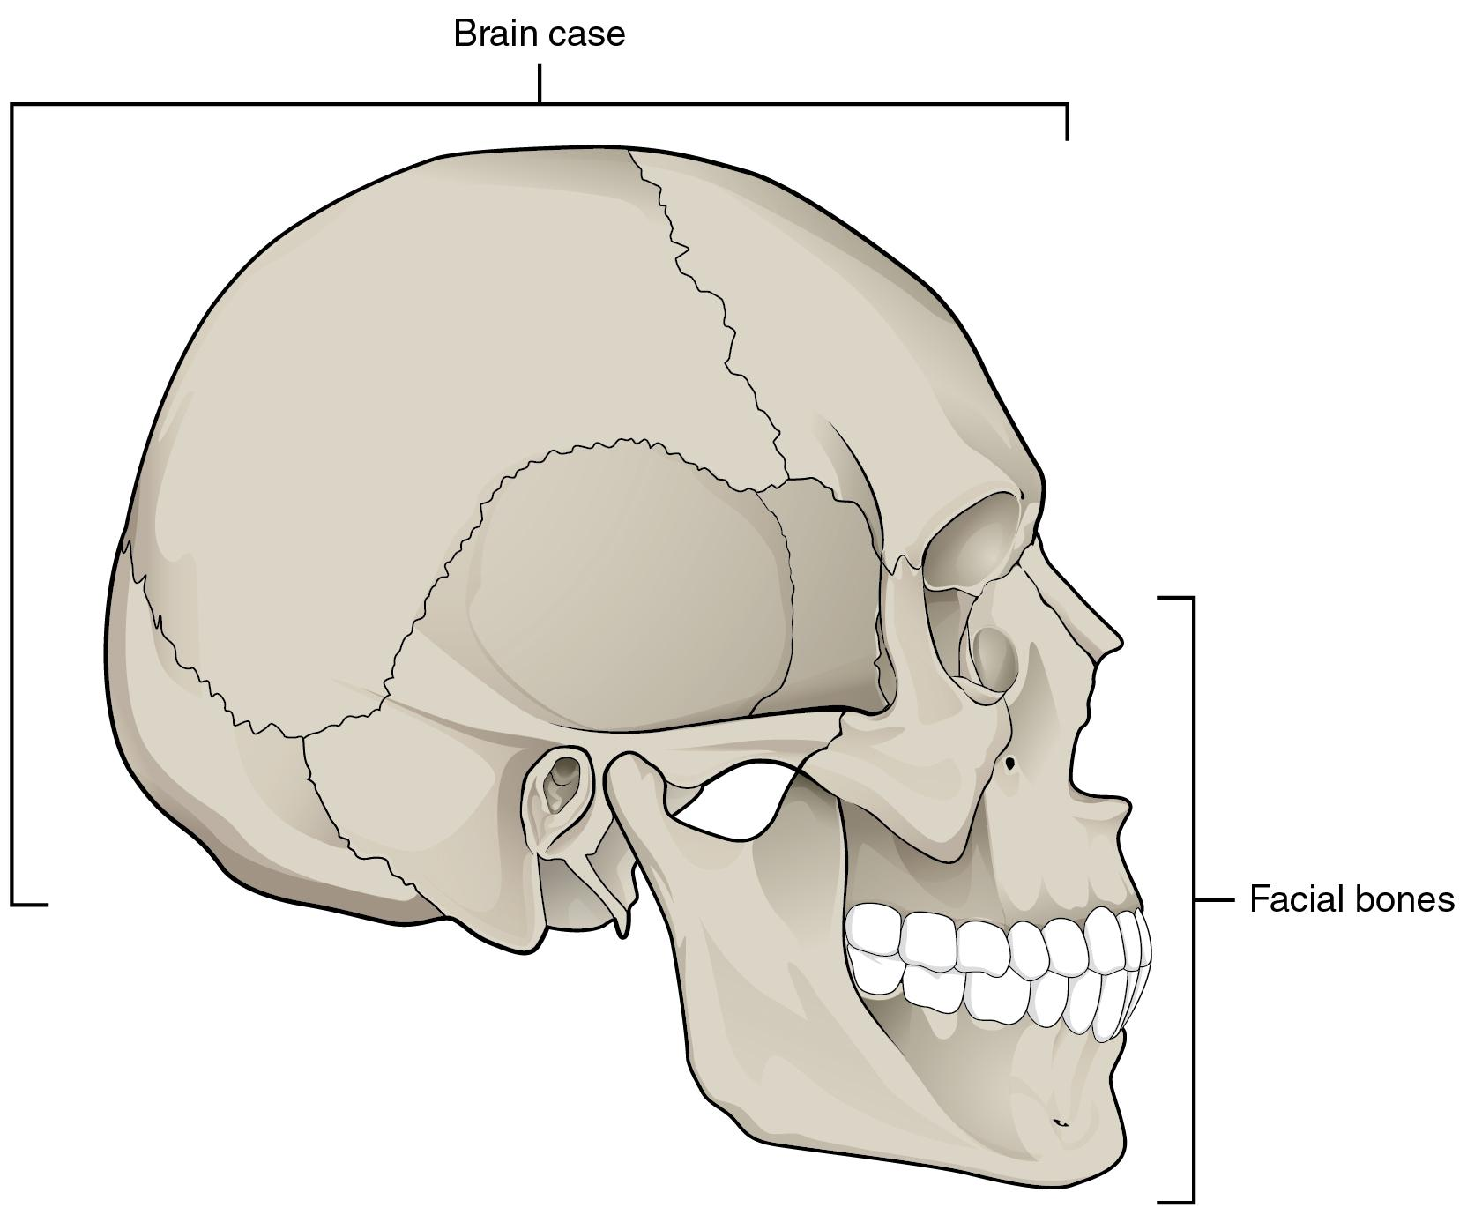
Figure 5.3 Parts of the Skull The skull consists of the rounded brain case that houses the brain and the facial bones that form the upper and lower jaws, nose, orbits, and other facial structures.
Interactive Link
Watch this video to view a rotating and exploded skull, with color-coded bones. When bone (yellow) is centrally located and joints with most of the other bones of the skull?

Anterior View of Skull
The anterior skull consists of the facial bones and provides the bony support for the eyes and structures of the face. This view of the skull is dominated by the openings of the orbits and the nasal cavity. Also seen are the upper and lower jaws, with their respective teeth (Figure 5.4).
The orbit is the bony socket that houses the eyeball and muscles that move the eyeball or open the upper eyelid.
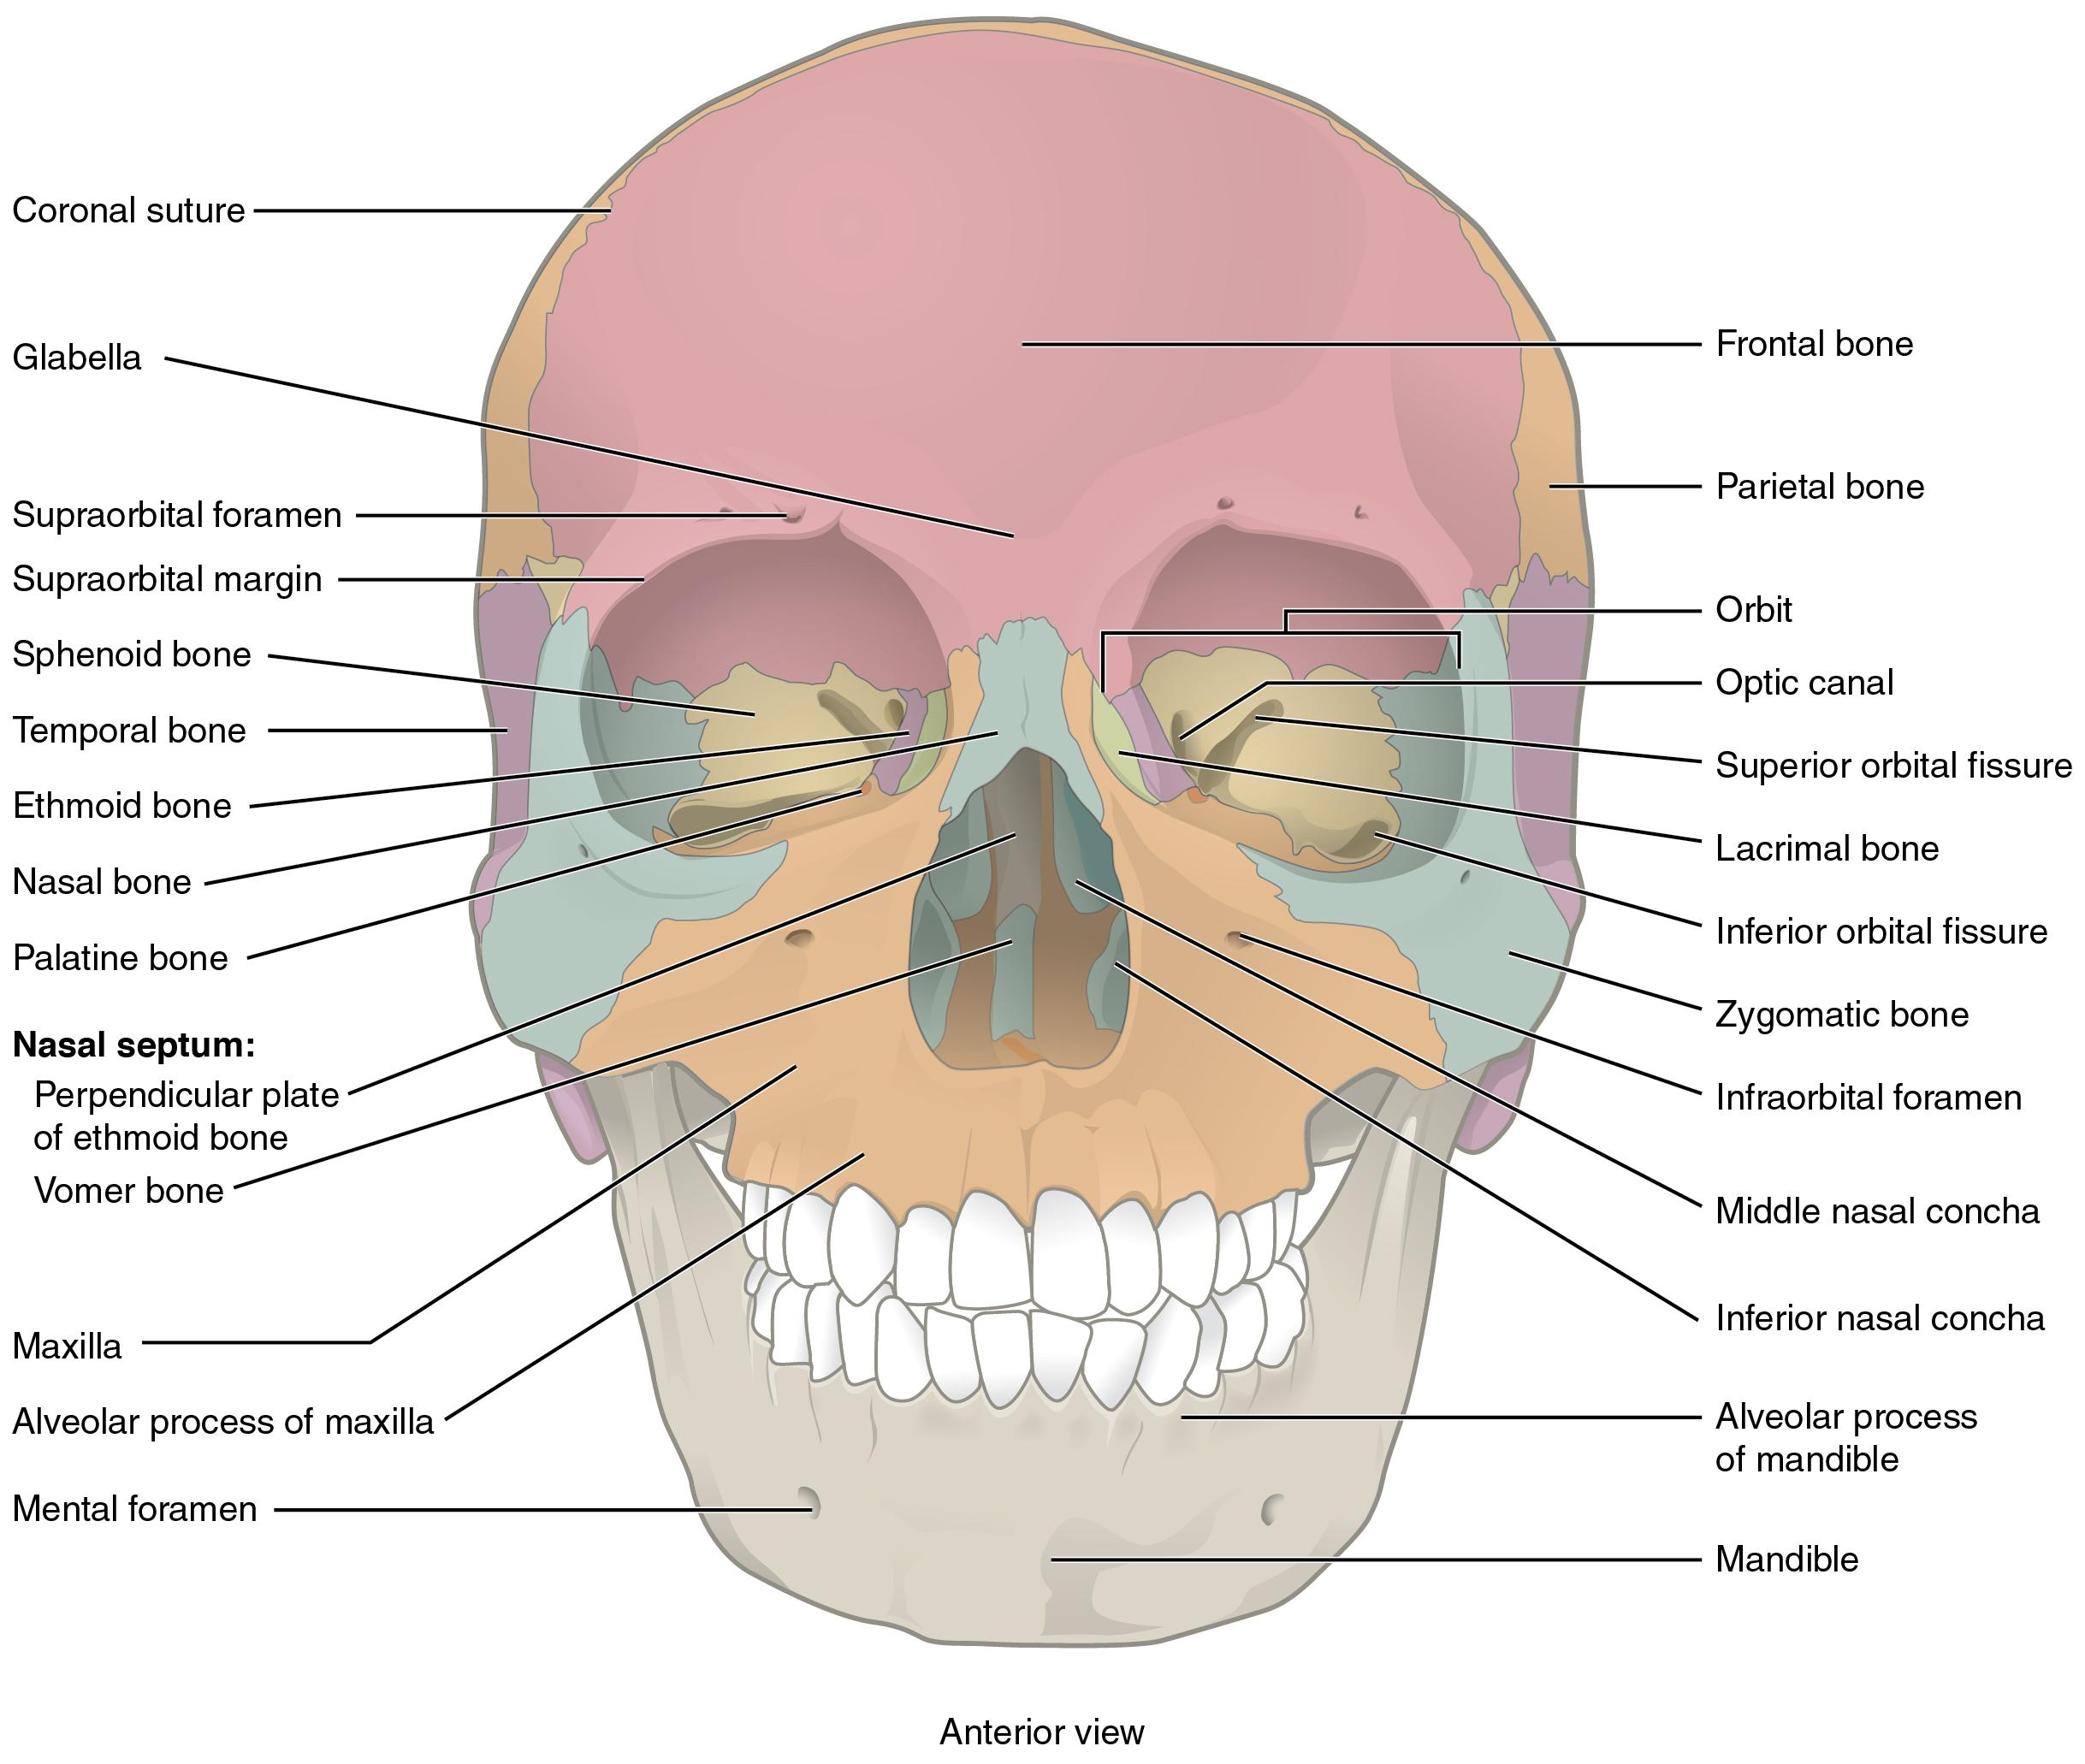
Figure 5.4 Anterior View of Skull An anterior view of the skull shows the bones that form the forehead, orbits (eye sockets), nasal cavity, nasal septum, and upper and lower jaws.
Inside the nasal area of the skull, the nasal cavity is divided into halves by the nasal septum. The upper portion of the nasal septum is formed by the perpendicular plate of the ethmoid bone and the lower portion is the vomer bone. Each side of the nasal cavity is triangular in shape, with a broad inferior space that narrows superiorly. When looking into the nasal cavity from the front of the skull, two bony plates are seen projecting from each lateral wall. The larger of these is the inferior nasal concha, an independent bone of the skull. Located above the inferior concha are the middle nasal concha and superior nasal concha, both of which are part of the ethmoid bone.

Lateral View of Skull
A view of the lateral skull is dominated by the large, rounded brain case above and the upper and lower jaws with their teeth below (Figure 5.5). Separating these areas is the bridge of bone called the zygomatic arch. The zygomatic arch is the bony arch on the side of the skull that spans from the area of the cheek to just above the ear canal. It is formed by the junction of two bony processes: the temporal process of the zygomatic bone (the cheekbone) and the zygomatic process of the temporal bone.
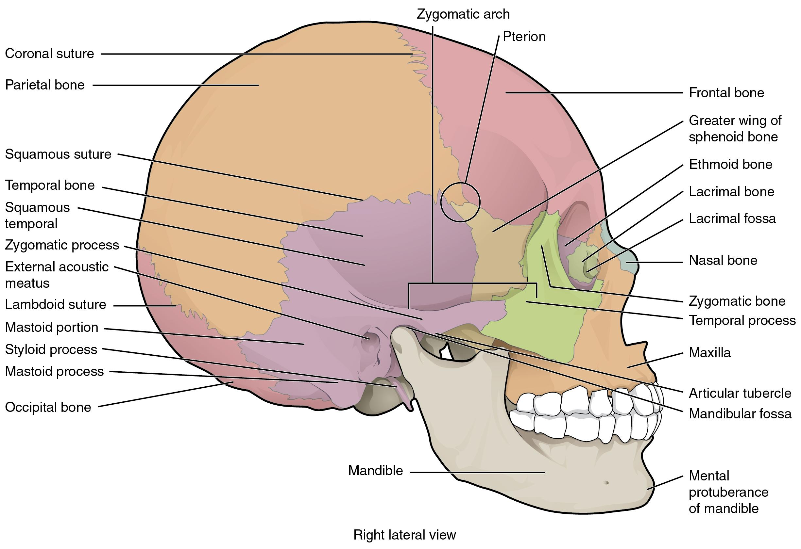
Figure 5.5 Lateral View of Skull The lateral skull shows the large rounded brain case, zygomatic arch, and the upper and lower jaws. The zygomatic arch is formed jointly by the zygomatic process of the temporal bone and the temporal process of the zygomatic bone. The shallow space above the zygomatic arch is the temporal fossa. The space inferior to the zygomatic arch and deep to the posterior mandible is the infratemporal fossa.

Bones of the Brain Case
The brain case contains and protects the brain. The interior space that is almost completely occupied by the brain is called the cranial cavity. This cavity is bounded superiorly by the rounded top of the skull, and the lateral and posterior sides of the skull. The bones that form the top and sides of the brain case are usually referred to as the “flat” bones of the skull.
The floor of the brain case is referred to as the base of the skull. This is a complex area that varies in depth and has numerous openings for the passage of cranial nerves, blood vessels, and the spinal cord. Inside the skull, the base is subdivided into three large spaces, called the anterior cranial fossa, middle cranial fossa, and posterior cranial fossa (fossa = “trench or ditch”) (Figure 5.6).
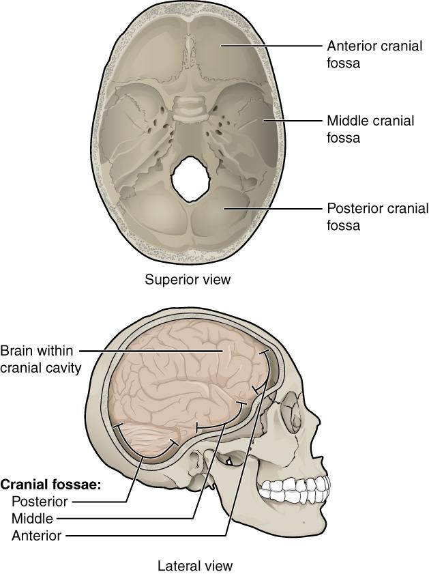
Figure 5.6 Cranial Fossae The bones of the brain case surround and protect the brain, which occupies the cranial cavity. The base of the brain case, which forms the floor of cranial cavity, is subdivided into the shallow anterior cranial fossa, the middle cranial fossa, and the deep posterior cranial fossa.
The brain case consists of eight bones. These include the paired parietal and temporal bones, plus the unpaired frontal, occipital, sphenoid, and ethmoid bones.

Parietal Bone
The parietal bone forms most of the upper lateral side of the skull (see Figure 5.5). These are paired bones, with the right and left parietal bones joining together at the top of the skull. Each parietal bone is also bounded anteriorly by the frontal bone, inferiorly by the temporal bone, and posteriorly by the occipital bone.

Temporal Bone
The temporal bone forms the lower lateral side of the skull (see Figure 5.5). Common wisdom has it that the temporal bone (temporal = “time”) is so named because this area of the head (the temple) is where hair typically first turns gray, indicating the passage of time.
Projecting inferiorly from the posterior portion of the temporal bone is a large prominence, the mastoid process, which serves as a muscle attachment site. The mastoid process can easily be felt on the side of the head just behind your earlobe.
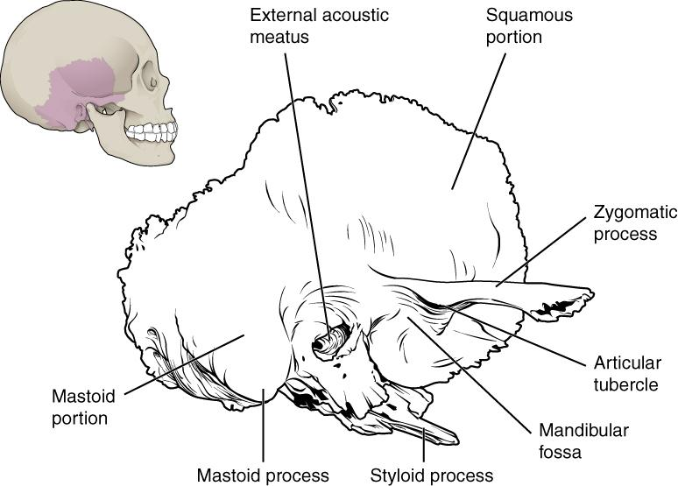
Figure 5.7 Temporal Bone A lateral view of the isolated temporal bone.
Important landmarks of the temporal bone, as shown in Figure 5.7, include the following:
- External acoustic meatus (ear canal)—This is the large opening on the lateral side of the skull that is associated with the ear.
- Mandibular fossa—This is the deep, oval-shaped depression located on the external base of the skull, just in front of the external acoustic meatus. The mandible (lower jaw) joins with the skull at this site as part of the temporomandibular joint, which allows for movements of the mandible during opening and closing of the mouth.
- Mastoid process—The mastoid process is a large prominence that serves as a muscle attachment site.

Frontal Bone
The frontal bone is the single bone that forms the forehead. The frontal bone also forms the superior portion of the orbit. The frontal bone is thickened just above each orbit, forming rounded brow ridges. These are located just behind your eyebrows and vary in size among individuals, although they are generally larger in males. Inside the cranial cavity, the frontal bone extends posteriorly. This flattened region forms both the roof of the orbit below and the floor of the anterior cranial cavity above (see Figure 5.8b).
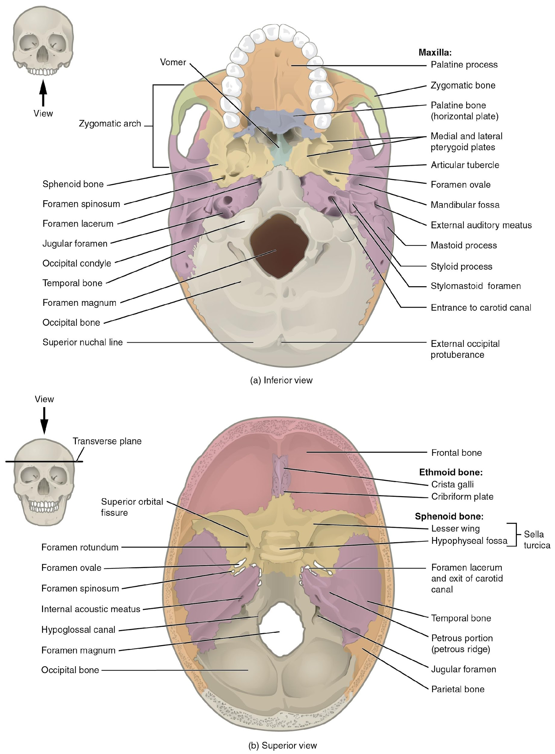
Figure 5.8 External and Internal Views of Base of Skull

Occipital Bone
The occipital bone is the single bone that forms the posterior skull and posterior base of the cranial cavity (Figure 5.9; see also Figure 5.8). On its outside surface, at the posterior midline, is a small protrusion called the external occipital protuberance, which serves as an attachment site for a ligament of the posterior neck. Lateral to either side of this bump is a superior nuchal line (nuchal = “nape” or “posterior neck”). The nuchal lines represent the most superior point at which muscles of the neck attach to the skull, with only the scalp covering the skull above these lines. On the base of the skull, the occipital bone contains the large opening of the foramen magnum, which allows for passage of the spinal cord as it exits the skull. On either side of the foramen magnum is an oval-shaped occipital condyle. These condyles form joints with the first cervical vertebra and thus support the skull on top of the vertebral column.
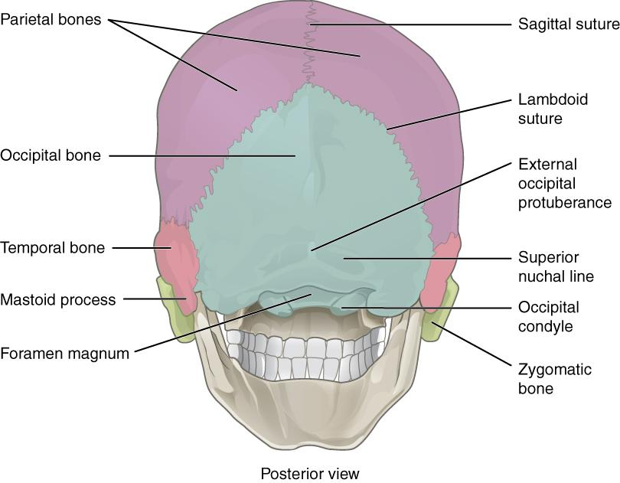
Figure 5.9 Posterior View of Skull This view of the posterior skull shows attachment sites for muscles and joints that support the skull.

Sphenoid Bone
The sphenoid bone is a single, complex bone of the central skull (Figure 5.10). It serves as a “keystone” bone, because it joins with almost every other bone of the skull. The sphenoid forms much of the base of the central skull (see Figure 5.8) and also extends laterally to contribute to the sides of the skull (see Figure 5.5). Inside the cranial cavity, the right and left lesser wings of the sphenoid bone, which resemble the wings of a flying bird, form the lip of a prominent ridge that marks the boundary between the anterior and middle cranial fossae. The sella turcica (“Turkish saddle”) is located at the midline of the middle cranial fossa. This bony region of the sphenoid bone is named for its resemblance to the horse saddles used by the Ottoman Turks, with a high back and a tall front. The rounded depression in the floor of the sella turcica houses the pea-sized pituitary (hypophyseal) gland. The greater wings of the sphenoid bone extend laterally to either side away from the sella turcica, where they form the anterior floor of the middle cranial fossa. The greater wing is best seen on the outside of the lateral skull, where it forms a rectangular area immediately anterior to the temporal bone.
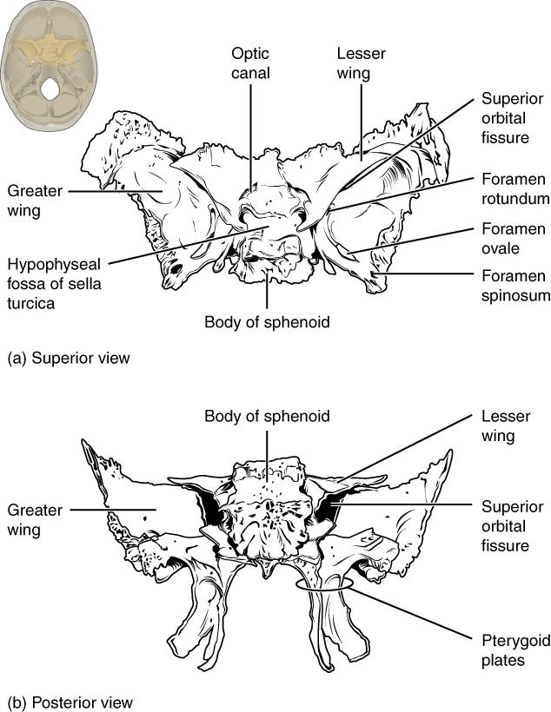
Figure 5.10 Sphenoid Bone Shown in isolation in (a) superior and (b) posterior views, the sphenoid bone is a single midline bone that forms the anterior walls and floor of the middle cranial fossa. It has a pair of lesser wings and a pair of greater wings.

Ethmoid Bone
The ethmoid bone is a single, midline bone that forms the roof and lateral walls of the upper nasal cavity, the upper portion of the nasal septum, and contributes to the medial wall of the orbit (Figure 5.11 and Figure 5.12). On the interior of the skull, the ethmoid also forms a portion of the floor of the anterior cranial cavity (see Figure 5.8b).

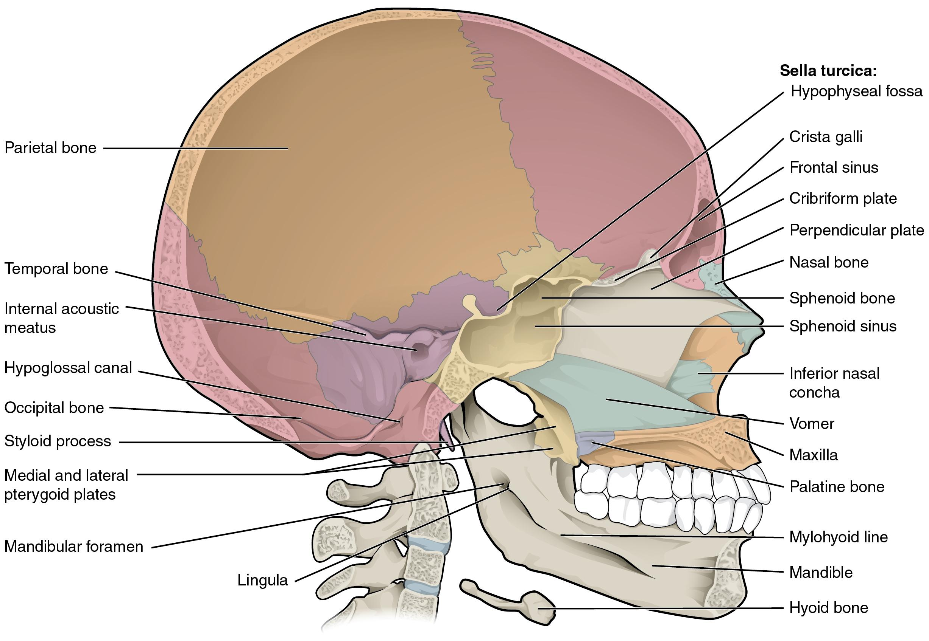
Figure 5.11 Sagittal Section of Skull This midline view of the sagittally sectioned skull shows the nasal septum.
Within the nasal cavity, the perpendicular plate of the ethmoid bone forms the upper portion of the nasal septum. The ethmoid bone also forms the lateral walls of the upper nasal cavity.
In the cranial cavity, the ethmoid bone forms a small area at the midline in the floor of the anterior cranial fossa. This region also forms the narrow roof of the underlying nasal cavity. This portion of the ethmoid bone consists of two parts, the crista galli and cribriform plates. The crista galli (“rooster’s comb or crest”) is a small upward bony projection located at the midline. It functions as an anterior attachment point for one of the covering layers of the brain. To either side of the crista galli is the cribriform plate (cribrum = “sieve”), a small, flattened area with numerous small openings termed olfactory foramina. Small nerve branches from the olfactory areas of the nasal cavity pass through these openings to enter the brain.
The lateral portions of the ethmoid bone are located between the orbit and upper nasal cavity, and thus form the lateral nasal cavity wall and a portion of the medial orbit wall. Located inside this portion of the ethmoid bone are several small, air-filled spaces that are part of the paranasal sinus system of the skull.
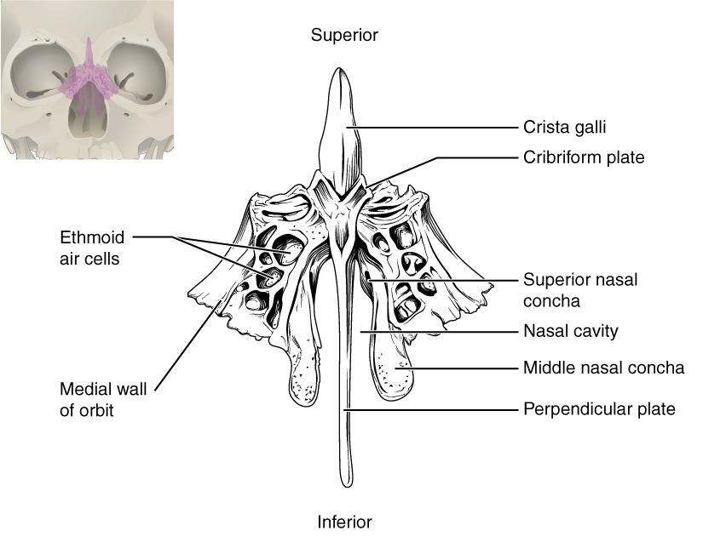
Figure 5.12 Ethmoid Bone The single ethmoid bone is located at the midline within the central skull. It has an upward projection, the crista galli, and a downward projection, the perpendicular plate, which forms the upper nasal septum. The cribriform plates form both the roof of the nasal cavity and a portion of the anterior cranial fossa floor. The lateral sides of the ethmoid bone form the lateral walls of the upper nasal cavity, part of the medial orbit wall, and give rise to the superior and middle nasal conchae. The ethmoid bone also contains the ethmoid air cells.

Sutures of the Skull
A suture is an immobile joint between adjacent bones of the skull. The narrow gap between the bones is filled with dense, fibrous connective tissue that unites the bones. The long sutures located between the bones of the brain case are not straight, but instead follow irregular, tightly twisting paths. These twisting lines serve to tightly interlock the adjacent bones, thus adding strength to the skull for brain protection.
The two suture lines seen on the top of the skull are the coronal and sagittal sutures. The coronal suture runs from side to side across the skull, within the coronal plane of section (see Figure 5.5). It joins the frontal bone to the right and left parietal bones. The sagittal suture extends posteriorly from the coronal suture, running along the midline at the top of the skull in the sagittal plane of section (see Figure 5.9). It unites the right and left parietal bones. On the posterior skull, the sagittal suture terminates by joining the lambdoid suture. The lambdoid suture extends downward and laterally to either side away from its junction with the sagittal suture. The lambdoid suture joins the occipital bone to the right and left parietal and temporal bones. This suture is named for its upside-down "V" shape, which resembles the capital letter version of the Greek letter lambda (Λ). The squamous suture is located on the lateral skull. It unites the temporal bone with the parietal bone (see Figure 5.5). At the intersection of four bones is the pterion, a small, capital-H-shaped suture line region that unites the frontal bone, parietal bone, squamous portion of the temporal bone, and greater wing of the sphenoid bone. It is the weakest part of the skull. The pterion is located approximately two finger widths above the zygomatic arch and a thumb’s width posterior to the upward portion of the zygomatic bone.

Disorders of the…
Skeletal System
Head and traumatic brain injuries are major causes of immediate death and disability, with bleeding and infections as possible additional complications. According to the Centers for Disease Control and Prevention (2010), approximately 30 percent of all injury-related deaths in the United States are caused by head injuries. THe majority of head injuries involve falls. They are most common among young children (ages 0-4 years), adolescents (15-19 years), and the elderly (over 65 years). Additional causes vary, but prominent among these are automobile and motorcycle accidents.
Strong blows to the brain-case portion of the skull can produce fractures. These may result in bleeding inside the skull with subsequent injury to the brain. THe most common is a linear skull fracture, in which fracture lines radiate from the point of impact. Other fracture types include a comminuted fracture, in which the bone is broken into several pieces at the point of impact, or a depressed fracture, in which the fractured bone is pushed inward. In a contrecoup (counterblow) fracture, the bone at the point of impact is not broken, but instead a fracture occurs on the opposite side of the skull. Fractures of the occipital bone at the base of the skull can occur in this manner.
A blow to the lateral side of the head may fracture the bones of the pterion. The pterion is an important clinical landmark because located immediately deep to it on the inside of the skull is a major branch of an artery that supplies the skull and covering layers of the brain. A strong blow to the region can fracture the bones around the pterion. If the underlying artery is damaged, bleeding can cause the formation of a hematoma (collection of blood) between the brain and interior of the skull. As blood accumulates, it will put pressure on the brain. Symptoms associated with a hematoma may not be apparent immediately following the injury, but if untreated, blood accumulation will exert increasing pressure on the brain and can result in death within a few hours.

Facial Bones of the Skull
The facial bones of the skull form the upper and lower jaws, the nose, nasal cavity and nasal septum, and the orbit. The facial bones include 14 bones, with six paired bones and two unpaired bones. The paired bones are the maxilla, palatine, zygomatic, nasal, lacrimal, and inferior nasal conchae bones. The unpaired bones are the vomer and mandible bones. Although classified with the brain-case bones, the ethmoid bone also contributes to the nasal septum and the walls of the nasal cavity and orbit.

Maxillary Bone
The maxillary bone, often referred to simply as the maxilla (plural = maxillae), is one of a pair that together form the upper jaw, much of the hard palate, the medial floor of the orbit, and the lateral base of the nose (see Figure 5.4). The hard palate is the bony plate that forms the roof of the mouth and floor of the nasal cavity, separating the oral and nasal cavities.

Palatine Bone
The palatine bone is one of a pair of irregularly shaped bones that contribute small areas to the lateral walls of the nasal cavity and the medial wall of each orbit. Thus, the palatine bones are best seen in an inferior view of the skull and hard palate (see Figure 5.8a).

Zygomatic Bone
The zygomatic bone is also known as the cheekbone. Each of the paired zygomatic bones forms much of the lateral wall of the orbit and the lateral-inferior margins of the anterior orbital opening (see Figure 5.4). The temporal process of the zygomatic bone projects posteriorly, where it forms the anterior portion of the zygomatic arch (see Figure 5.5).

Nasal Bone
The nasal bone is one of two small bones that articulate (join) with each other to form the bony base (bridge) of the nose. They also support the cartilages that form the lateral walls of the nose (see Figure 5.11). These are the bones that are damaged when the nose is broken.

Lacrimal Bone
Each lacrimal bone is a small, rectangular bone that forms the anterior, medial wall of the orbit (see Figure 5.4 and Figure 5.5).

Inferior Nasal Conchae
The right and left inferior nasal conchae form a curved bony plate that projects into the nasal cavity space from the lower lateral wall.

Vomer Bone
The unpaired vomer bone, often referred to simply as the vomer, is triangular-shaped and forms the posterior-inferior part of the nasal septum (see Figure 5.11). The vomer is best seen when looking from behind into the posterior openings of the nasal cavity (see Figure 5.8a). In this view, the vomer is seen to form the entire height of the nasal septum. A much smaller portion of the vomer can also be seen when looking into the anterior opening of the nasal cavity.

Mandible
The mandible forms the lower jaw and is the only moveable bone of the skull. At the time of birth, the mandible consists of paired right and left bones, but these fuse together during the first year to form the single U-shaped mandible of the adult skull (see Figure 5.5).

The Orbit
The orbit is the bony socket that houses the eyeball and contains the muscles that move the eyeball or open the upper eyelid. Each orbit is cone-shaped, with a narrow posterior region that widens toward the large anterior opening. To help protect the eye, the bony margins of the anterior opening are thickened and somewhat constricted. The medial walls of the two orbits are parallel to each other but each lateral wall diverges away from the midline at a 45° angle. This divergence provides greater lateral peripheral vision.
The walls of each orbit include contributions from seven skull bones (Figure 5.13). The frontal bone forms the roof and the zygomatic bone forms the lateral wall and lateral floor. The medial floor is primarily formed by the maxilla, with a small contribution from the palatine bone. The ethmoid bone and lacrimal bone make up much of the medial wall and the sphenoid bone forms the posterior orbit.
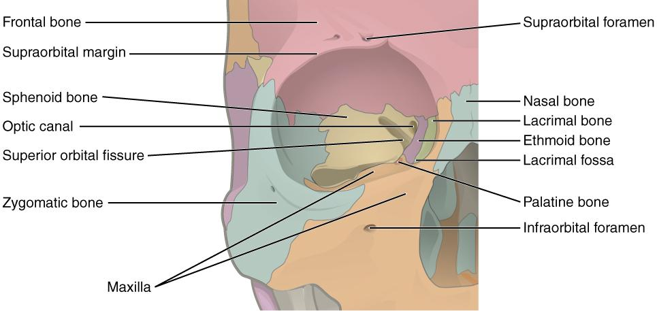
Figure 5.13 Bones of the Orbit Seven skull bones contribute to the walls of the orbit. Opening into the posterior orbit from the cranial cavity are the optic canal and superior orbital fissure.

Hyoid Bone
The hyoid bone is an independent bone that does not contact any other bone and thus is not part of the skull (Figure 5.14). It is a small U-shaped bone located in the upper neck near the level of the inferior mandible, with the tips of the “U” pointing posteriorly. The hyoid serves as the base for the tongue above, and is attached to the larynx below and the pharynx posteriorly. The hyoid is held in position by a series of small muscles that attach to it either from above or below. These muscles act to move the hyoid up/down or forward/back. Movements of the hyoid are coordinated with movements of the tongue, larynx, and pharynx during swallowing and speaking.
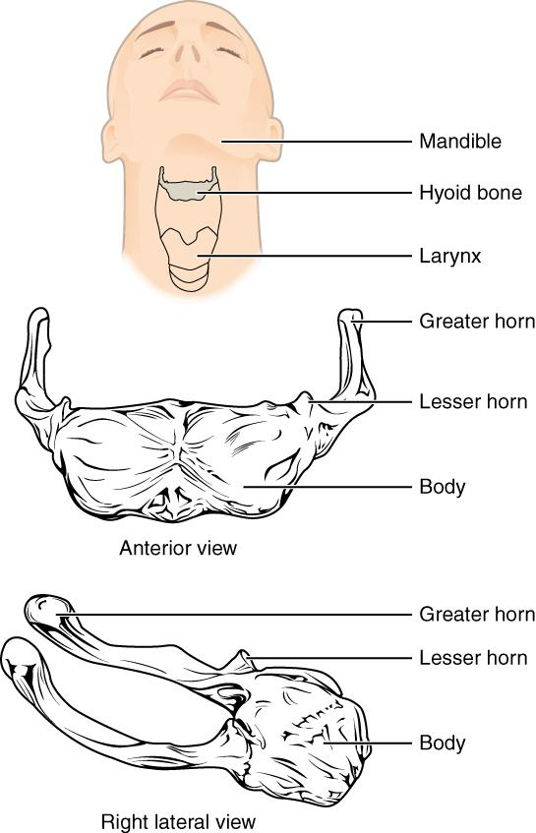
Figure 5.14 Hyoid Bone The hyoid bone is located in the upper neck and does not join with any other bone. It provides attachments for muscles that act on the tongue, larynx, and pharynx

5.3 The Vertebral Column

Learning Objectives
By the end of this section, you will be able to:
- Describe each region of the vertebral column and the number of bones in each region
- Discuss the curves of the vertebral column and how these change after birth
- Describe a typical vertebra and determine the distinguishing characteristics for vertebrae in each vertebral region and features of the sacrum and the coccyx
- Define the structure of an intervertebral disc
- Determine the location of the ligaments that provide support for the vertebral column
The vertebral column is also known as the spinal column or spine (Figure 5.15). It consists of a sequence of vertebrae (singular = vertebra), each of which is separated and united by an intervertebral disc. Together, the vertebrae and intervertebral discs form the vertebral column. It is a flexible column that supports the head, neck, and body and allows for their movements. It also protects the spinal cord, which passes down the back through openings in the vertebrae.
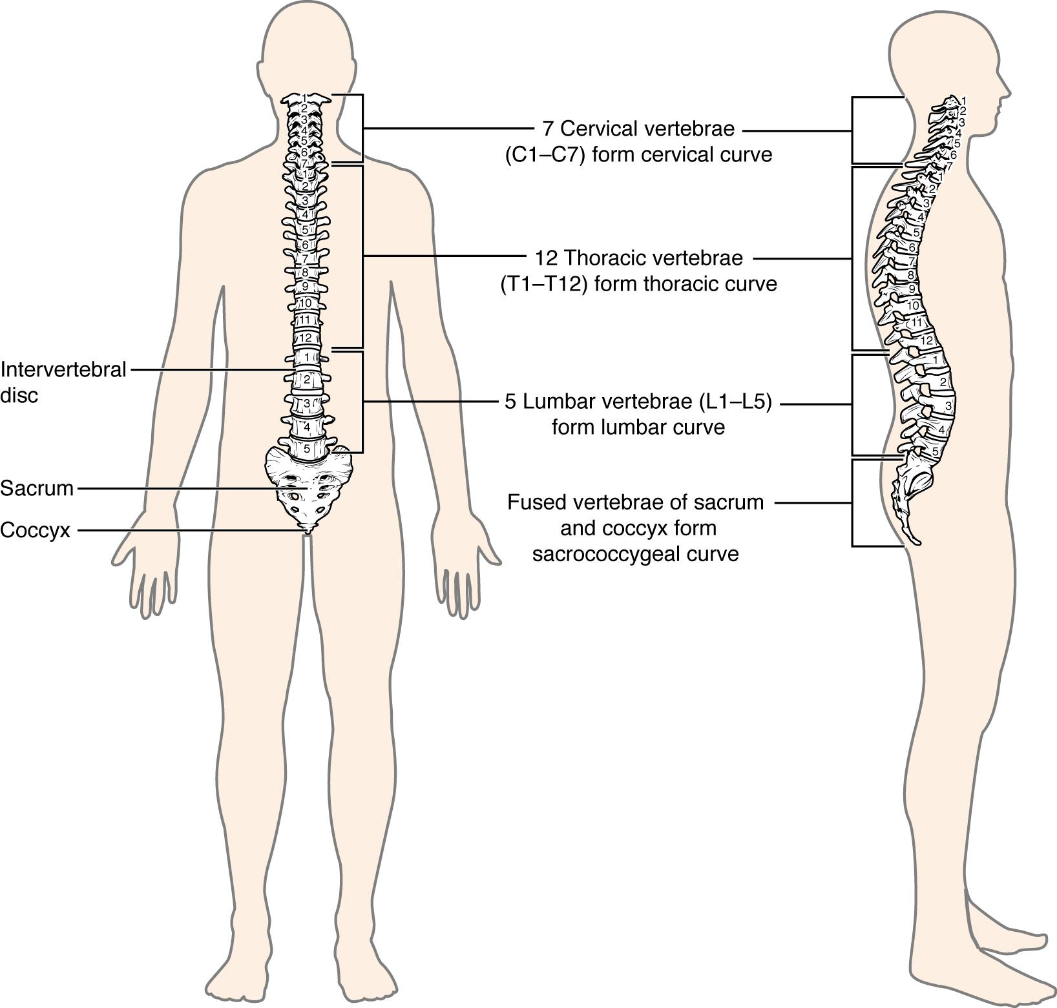
Figure 5.15 Vertebral Column The adult vertebral column consists of 24 vertebrae, plus the sacrum and coccyx. The vertebrae are divided into three regions: cervical C1–C7 vertebrae, thoracic T1–T12 vertebrae, and lumbar L1–L5 vertebrae. The vertebral column is curved, with two primary curvatures (thoracic and sacrococcygeal curves) and two secondary curvatures (cervical and lumbar curves).

Regions of the Vertebral Column
The vertebral column originally develops as a series of 33 vertebrae, but this number is eventually reduced to 24 vertebrae, plus the sacrum and coccyx. The vertebral column is subdivided into five regions, with the vertebrae in each area named for that region and numbered in descending order. In the neck, there are seven cervical vertebrae, each designated with the letter “C” followed by its number. Superiorly, the C1 vertebra articulates (forms a joint) with the occipital condyles of the skull. Inferiorly, C1 articulates with the C2 vertebra, and so on. Below these are the 12 thoracic vertebrae, designated T1–T12. The lower back contains the L1–L5 lumbar vertebrae. The single sacrum, which is also part of the pelvis, is formed by the fusion of five sacral vertebrae. Similarly, the coccyx, or tailbone, results from the fusion of four small coccygeal vertebrae. However, the sacral and coccygeal fusions do not start until age 20 and are not completed until middle age.
An interesting anatomical fact is that almost all mammals have seven cervical vertebrae, regardless of body size. This means that there are large variations in the size of cervical vertebrae, ranging from the very small cervical vertebrae of a shrew to the greatly elongated vertebrae in the neck of a giraffe. In a full-grown giraffe, each cervical vertebra is 11 inches tall.

Curvatures of the Vertebral Column
The adult vertebral column does not form a straight line, but instead has four curvatures along its length (see Figure 5.15). These curves increase the vertebral column’s strength, flexibility, and ability to absorb shock. When the load on the spine is increased, by carrying a heavy backpack for example, the curvatures increase in depth (become more curved) to accommodate the extra weight. They then spring back when the weight is removed. The four adult curvatures are classified as either primary or secondary curvatures. Primary curves are retained from the original fetal curvature, while secondary curvatures develop after birth.
During fetal development, the body is flexed anteriorly into the fetal position, giving the entire vertebral column a single curvature that is concave anteriorly. In the adult, this fetal curvature is retained in two regions of the vertebral column as the thoracic curve, which involves the thoracic vertebrae, and the sacrococcygeal curve, formed by the sacrum and coccyx. Each of these is thus called a primary curve because they are retained from the original fetal curvature of the vertebral column.
A secondary curve develops gradually after birth as the child learns to sit upright, stand, and walk. Secondary curves are concave posteriorly, opposite in direction to the original fetal curvature. The cervical curve of the neck region develops as the infant begins to hold their head upright when sitting. Later, as the child begins to stand and then to walk, the lumbar curve of the lower back develops. In adults, the lumbar curve is generally deeper in females.
Disorders associated with the curvature of the spine include kyphosis (an excessive posterior curvature of the thoracic region), lordosis (an excessive anterior curvature of the lumbar region), and scoliosis (an abnormal, lateral curvature, accompanied by twisting of the vertebral column).


Disorders of the…
Vertebral Column
Developmental anomalies, pathological changes, or obesity can enhance the normal vertebral column curves, resulting in the development of abnormal or excessive curvatures (Figure 5.16). Hyperkyphosis, also referred to as humpback or hunchback, is an excessive posterior curvature of the thoracic region. This can develop when osteoporosis causes weakening and erosion of the anterior portions of the upper thoracic vertebrae, resulting in their gradual collapse (Figure 5.17). Hyperlordosis, or swayback, is an excessive anterior curvature of the lumbar region and is most commonly associated with late pregnancy and sometimes obesity. The accumulation of body weight in the absomonly region results in an anterior shift in the line of gravity that carries the weight of the body. This causes an anterior tilt of the pelvis and a pronounced enhancement of the lumbar curve.
Scoliosis is an abnormal, lateral curvature, accompanied by twisting, or rotation, of the vertebral column. Scoliosis is the most common vertebral abnormality among girls. The cause is usually unknown, but it may result from weakness of the back muscles, differential growth rates in the right and left sides of the vertebral column, or differences in the length of the lower limbs. When present, scoliosis tends to worsen during adolescent growth spurts. Although most individuals do not require treatment, a back brace may be recommended for growing children to reduce the amount the curve increases during these growth phases. In extreme cases, surgery may be required.
Excessive vertebral curves can be identified while an individual stands in the anatomical position. Observe the vertebral profile from the side and then from behind to check for kyphosis or lordosis. Then have the person bend forward. If scoliosis is present, an individual will have difficulty in bending directly forward, and the right and left sides of the back will not be level with each other in the bent position.
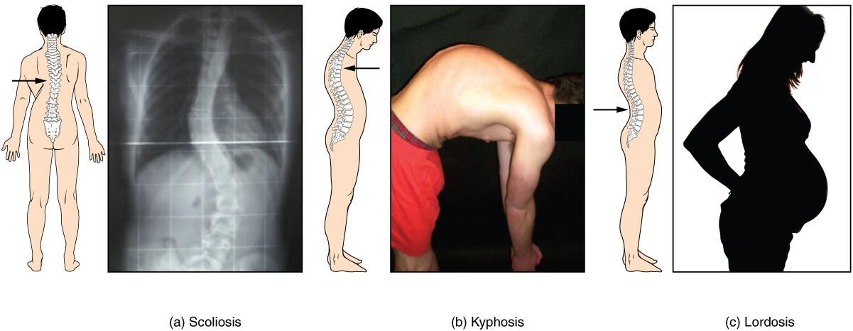
Figure 5.16 Abnormal Curvatures of the Vertebral Column (a) Scoliosis is an abnormal lateral bending of the vertebral column. (b) An excessive curvature of the upper thoracic vertebral column is called kyphosis. (c) Lordosis is an excessive curvature in the lumbar region of the vertebral column.

General Structure of a Vertebra
Within the different regions of the vertebral column, vertebrae vary in size and shape, but they all follow a similar structural pattern. A typical vertebra will consist of a body, a vertebral arch, and seven processes (Figure 5.17).
The body is the anterior portion of each vertebra and is the part that supports the body weight. Because of this, the vertebral bodies progressively increase in size and thickness going down the vertebral column. The bodies of adjacent vertebrae are separated and strongly united by an intervertebral disc.
The vertebral arch forms the posterior portion of each vertebra. The large opening between the vertebral arch and body is the vertebral foramen, which contains the spinal cord. In the intact vertebral column, the vertebral foramina of all of the vertebrae align to form the vertebral (spinal) canal, which serves as the bony protection and passageway for the spinal cord down the back. When the vertebrae are aligned together in the vertebral column, notches in the vertebral arches of adjacent vertebrae together form an intervertebral foramen, the opening through which a spinal nerve exits from the vertebral column (Figure 5.18).
Seven processes arise from the vertebral arch. Each paired transverse process projects laterally off the vertebral arch. The single spinous process (vertebral spine) projects posteriorly at the midline of the back. The vertebral spines can easily be felt as a series of bumps just under the skin down the middle of the back. The transverse and spinous processes serve as important muscle attachment sites. A superior articular process extends or faces upward, and an inferior articular process faces or projects downward on each side of a vertebrae. The paired superior articular processes of one vertebra join with the corresponding paired inferior articular processes from the next higher vertebra. These junctions form slightly moveable joints between the adjacent vertebrae. The shape and orientation of the articular processes vary in different regions of the vertebral column and play a major role in determining the type and range of motion available in each region.
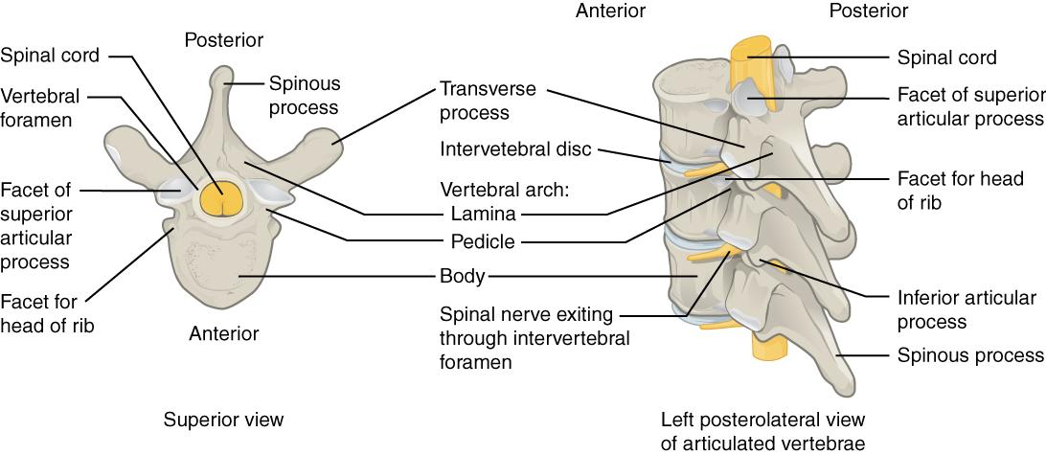
Figure 5.17 Parts of a Typical Vertebra A typical vertebra consists of a body and a vertebral arch. The arch is formed by the paired pedicles and paired laminae. Arising from the vertebral arch are the transverse, spinous, superior articular, and inferior articular processes. The vertebral foramen provides for passage of the spinal cord. Each spinal nerve exits through an intervertebral foramen, located between adjacent vertebrae. Intervertebral discs unite the bodies of adjacent vertebrae.
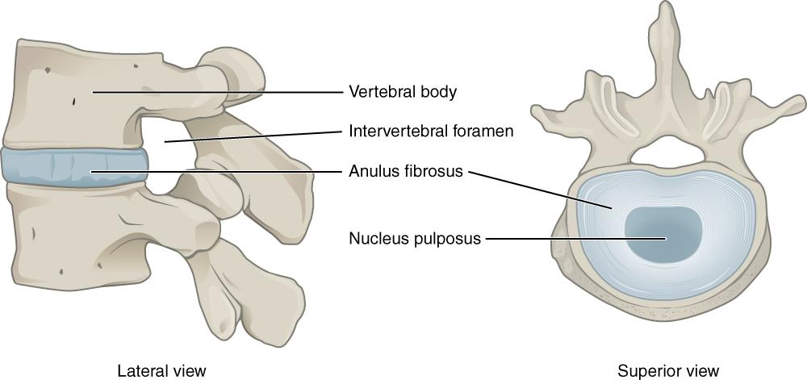
Figure 5.18 Intervertebral Disc The bodies of adjacent vertebrae are separated and united by an intervertebral disc, which provides padding and allows for movements between adjacent vertebrae. The disc consists of a fibrous outer layer called the annulus fibrosus and a gel-like center called the nucleus pulposus. The intervertebral foramen is the opening formed between adjacent vertebrae for the exit of a spinal nerve.

Regional Modifications of Vertebrae
In addition to the general characteristics of a typical vertebra described above, vertebrae also display characteristic size and structural features that vary between the different vertebral column regions. Thus, cervical vertebrae are smaller than lumbar vertebrae due to differences in the proportion of body weight that each supports. Thoracic vertebrae have sites for rib attachment, and the vertebrae that give rise to the sacrum and coccyx have fused together into single bones.

Cervical Vertebrae
Typical cervical vertebrae, such as C4 or C5, have several characteristic features that differentiate them from thoracic or lumbar vertebrae (Figure 5.19). Cervical vertebrae have a small body, reflecting the fact that they carry the least amount of body weight. Cervical vertebrae usually have a bifid (Y-shaped) spinous process. The spinous processes of the C3–C6 vertebrae are short, but the spine of C7 is much longer. You can find these vertebrae by running your finger down the midline of the posterior neck until you encounter the prominent C7 spine located at the base of the neck. The transverse processes of the cervical vertebrae are sharply curved (U-shaped) to allow for passage of the cervical spinal nerves. Each transverse process also has an opening called the transverse foramen. An important artery that supplies the brain ascends up the neck by passing through these openings. The superior and inferior articular processes of the cervical vertebrae are flattened and largely face upward or downward, respectively.
The first and second cervical vertebrae are further modified, giving each a distinctive appearance. The first cervical (C1) vertebra is also called the atlas, because this is the vertebra that supports the skull on top of the vertebral column (in Greek mythology, Atlas was the god who supported the heavens on his shoulders). The C1 vertebra does not have a body or spinous process. Instead, it is ring-shaped, consisting of an anterior arch and a posterior arch. The transverse processes of the atlas are longer and extend more laterally than do the transverse processes of any other cervical vertebrae. The superior articular processes face upward and are deeply curved for articulation with the occipital condyles on the base of the skull. The inferior articular processes are flat and face downward to join with the superior articular processes of the C2 vertebra.
The second cervical (C2) vertebra is called the axis, because it serves as the axis for rotation when turning the head toward the right or left. The axis resembles typical cervical vertebrae in most respects, but is easily distinguished by the dens (odontoid process), a bony projection that extends upward from the vertebral body. The dens joins with the inner aspect of the anterior arch of the atlas, where it is held in place by transverse ligament.
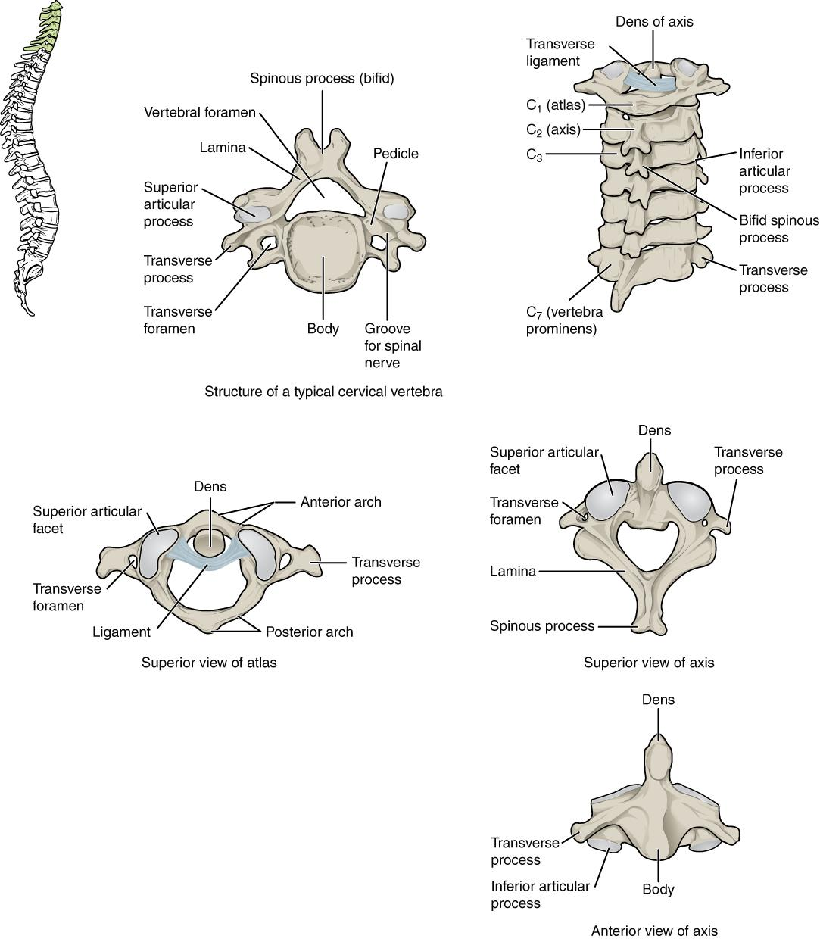
Figure 5.19 Cervical Vertebrae A typical cervical vertebra has a small body, a bifid spinous process, transverse processes that have a transverse foramen and are curved for spinal nerve passage. The atlas (C1 vertebra) does not have a body or spinous process. It consists of an anterior and a posterior arch and elongated transverse processes. The axis (C2 vertebra) has the upward projecting dens, which articulates with the anterior arch of the atlas.

Thoracic Vertebrae
The bodies of the thoracic vertebrae are larger than those of cervical vertebrae (Figure 5.20). The characteristic feature for a typical midthoracic vertebra is the spinous process, which is long and has a pronounced downward angle that causes it to overlap the next inferior vertebra. The superior articular processes of thoracic vertebrae face anteriorly and the inferior processes face posteriorly. These orientations are important determinants for the type and range of movements available to the thoracic region of the vertebral column.
Thoracic vertebrae have several additional articulation sites, each of which is called a facet, where a rib is attached. Most thoracic vertebrae have two facets located on the lateral sides of the body, each of which is called a costal facet (costal = “rib”). These are for articulation with the head (end) of a rib. An additional facet is located on the transverse process for articulation with the tubercle of a rib (Figure 5.21).
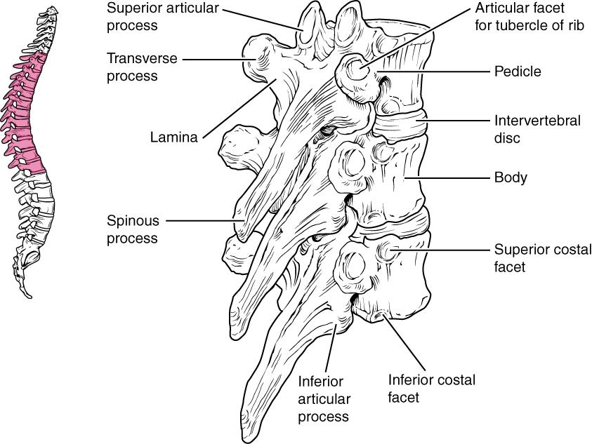
Figure 5.20 Thoracic Vertebrae A typical thoracic vertebra is distinguished by the spinous process, which is long and projects downward to overlap the next inferior vertebra. It also has articulation sites (facets) on the vertebral body and a transverse process for rib attachment.
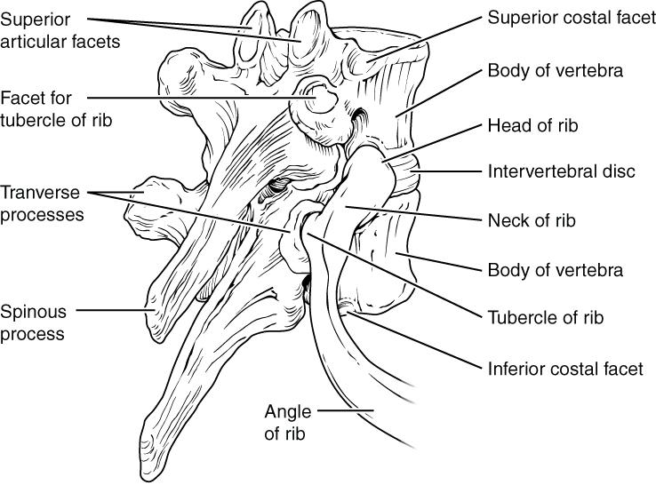
Figure 5.21 Rib Articulation in Thoracic Vertebrae Thoracic vertebrae have superior and inferior articular facets on the vertebral body for articulation with the head of a rib, and a transverse process facet for articulation with the rib tubercle.

Lumbar Vertebrae
Lumbar vertebrae carry the greatest amount of body weight and are thus characterized by the large size and thickness of the vertebral body (Figure 5.22). They have short transverse processes and a short, blunt spinous process that projects posteriorly. The articular processes are large, with the superior process facing backward and the inferior facing forward.
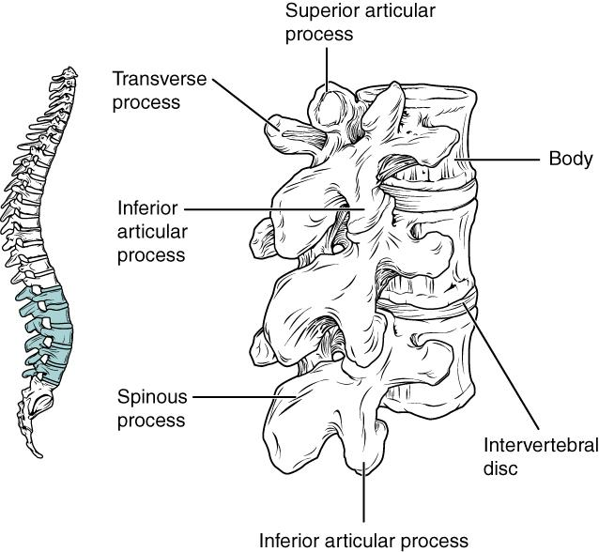
Figure 5.22 Lumbar Vertebrae Lumbar vertebrae are characterized by having a large, thick body and a short, rounded spinous process.

Sacrum and Coccyx
The sacrum is a triangular-shaped bone that is thick and wide across its superior base where it is weight bearing and then tapers down to an inferior, non-weight bearing apex (Figure 5.23). It is formed by the fusion of five sacral vertebrae, a process that does not begin until after the age of 20.
The sacral promontory is the anterior lip of the superior base of the sacrum. Lateral to this is the roughened auricular surface, which joins with the ilium portion of the hipbone to form the immobile sacroiliac joints of the pelvis. The anterior and posterior surfaces of the sacrum have a series of paired openings called sacral foramina (singular = foramen) that allow for the branches of the sacral spinal nerves to exit the sacrum. The superior articular process of the sacrum articulates with the inferior articular processes from the L5 vertebra.
The coccyx, or tailbone, is derived from the fusion of four very small coccygeal vertebrae (see Figure 5.23). It articulates with the inferior tip of the sacrum. It is not weight bearing in the standing position, but may receive some body weight when sitting.
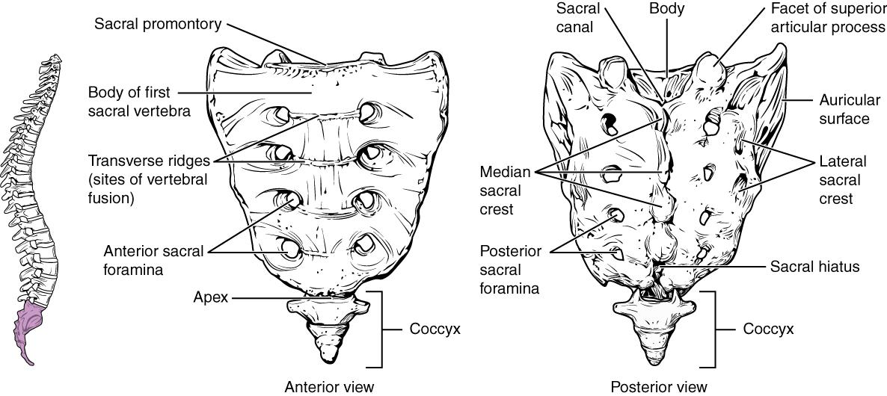
Figure 5.23 Sacrum and Coccyx The sacrum is formed from the fusion of five sacral vertebrae, whose lines of fusion are indicated by the transverse ridges. The fused spinous processes form the median sacral crest, while the lateral sacral crest arises from the fused transverse processes. The coccyx is formed by the fusion of four small coccygeal vertebrae.

Intervertebral Discs and Ligaments of the Vertebral Column
The bodies of adjacent vertebrae are strongly anchored to each other by an intervertebral disc. This structure provides padding between the bones during weight bearing, and because it can change shape, also allows for movement between the vertebrae. Although the total amount of movement available between any two adjacent vertebrae is small, when these movements are summed together along the entire length of the vertebral column, large body movements can be produced. Ligaments that extend along the length of the vertebral column also contribute to its overall support and stability.

Intervertebral Disc
An intervertebral disc is a fibrocartilaginous pad that fills the gap between adjacent vertebral bodies (see Figure 5.18). Each disc is anchored to the bodies of its adjacent vertebrae, thus strongly uniting these. The discs also provide padding between vertebrae during weight bearing. Because of this, intervertebral discs are thin in the cervical region and thickest in the lumbar region, which carries the most body weight. In total, the intervertebral discs account for approximately 25 percent of your body height between the top of the pelvis and the base of the skull. Intervertebral discs are also flexible and can change shape to allow for movements of the vertebral column.
Each intervertebral disc consists of two parts. The annulus fibrosus is the tough, fibrous outer layer of the disc. It forms a circle (annulus = “ring” or “circle”) and is firmly anchored to the outer margins of the adjacent vertebral bodies. Inside is the nucleus pulposus, consisting of a softer, more gel-like material. It has a high water content that serves to resist compression and thus is important for weight bearing. With increasing age, the water content of the nucleus pulposus gradually declines. This causes the disc to become thinner, decreasing total body height somewhat, and reduces the flexibility and range of motion of the disc, making bending more difficult.
The gel-like nature of the nucleus pulposus also allows the intervertebral disc to change shape as one vertebra rocks side to side or forward and back in relation to its neighbors during movements of the vertebral column. Thus, bending forward causes compression of the anterior portion of the disc but expansion of the posterior disc.

Ligaments of the Vertebral Column
Adjacent vertebrae are united by ligaments that run the length of the vertebral column along both its posterior and anterior aspects (Figure 5.24). These serve to resist excess forward or backward bending movements of the vertebral column, respectively.
The anterior longitudinal ligament runs down the anterior side of the entire vertebral column, uniting the vertebral bodies. It serves to resist excess backward bending of the vertebral column. Protection against this movement is particularly important in the neck, where extreme posterior bending of the head and neck can stretch or tear this ligament, resulting in a painful whiplash injury.
The supraspinous ligament is located on the posterior side of the vertebral column, where it interconnects the spinous processes of the thoracic and lumbar vertebrae. This strong ligament supports the vertebral column during forward bending motions. In the posterior neck, where the cervical spinous processes are short, the supraspinous ligament expands to become the nuchal ligament (nuchae = “nape” or “back of the neck”). The nuchal ligament is attached to the cervical spinous processes and extends upward and posteriorly to attach to the midline base of the skull, out to the external occipital protuberance. It supports the skull and prevents it from falling forward. You can easily feel this ligament by first extending your head backward and pressing down on the posterior midline of your neck. Then tilt your head forward and you will fill the nuchal ligament popping out as it tightens to limit anterior bending of the head and neck.
Additional ligaments are located inside the vertebral canal, next to the spinal cord, along the length of the vertebral column. The posterior longitudinal ligament is found anterior to the spinal cord, where it is attached to the posterior sides of the vertebral bodies. It provides important support for the vertebral column when bending forward.
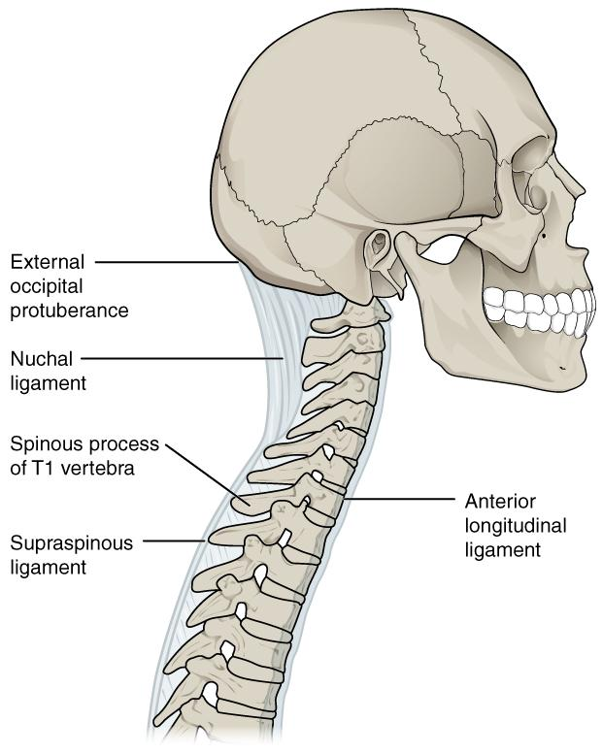
Figure 5.24 Ligaments of Vertebral Column The anterior longitudinal ligament runs the length of the vertebral column, uniting the anterior sides of the vertebral bodies. The supraspinous ligament connects the spinous processes of the thoracic and lumbar vertebrae. In the posterior neck, the supraspinous ligament enlarges to form the nuchal ligament, which attaches to the cervical spinous processes and to the base of the skull.
Interactive Link
Use this tool to identify the bones, intervertebral discs, and ligaments of the vertebral column. The thickest portions of the anterior longitudinal ligament and the supraspinous ligament are found in which regions of the vertebral column?

5.4 The Thoracic Cage

Learning Objectives
By the end of this section, you will be able to:
- Discuss the components that make up the thoracic cage
- Identify the parts of the sternum and define the sternal angle
- Discuss the parts of a rib and rib classifications
The thoracic cage (rib cage) forms the thorax (chest) portion of the body. It consists of the 12 pairs of ribs with their costal cartilages and the sternum (Figure 5.25). The ribs are anchored posteriorly to the 12 thoracic vertebrae (T1–T12). The thoracic cage protects the heart and lungs.
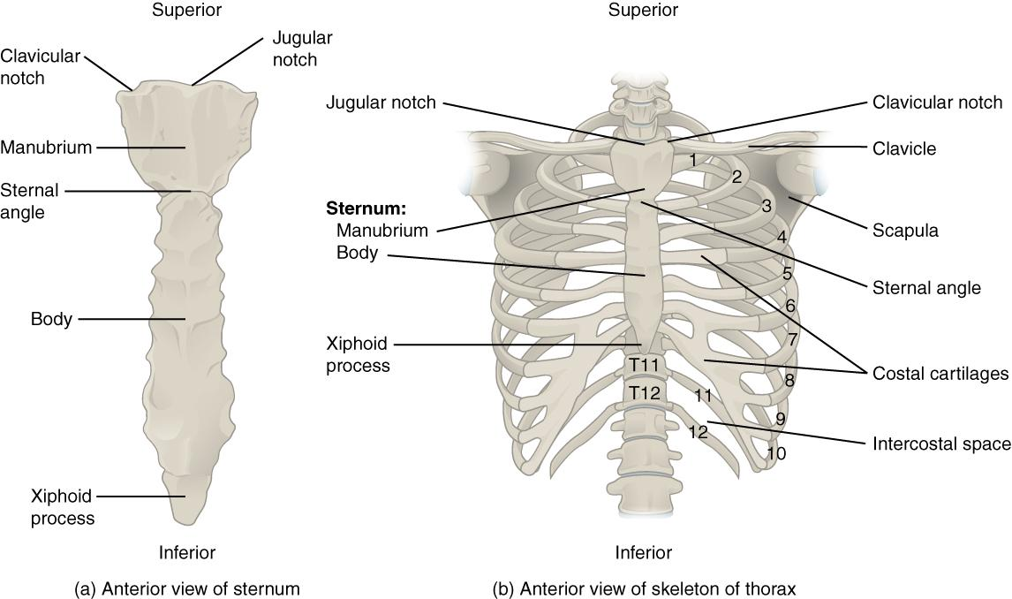
Figure 5.25 Thoracic Cage The thoracic cage is formed by the (a) sternum and (b) 12 pairs of ribs with their costal cartilages. The ribs are anchored posteriorly to the 12 thoracic vertebrae. The sternum consists of the manubrium, body, and xiphoid process. The ribs are classified as true ribs (1–7) and false ribs (8–12). The last two pairs of false ribs are also known as floating ribs (11–12).

Sternum
The sternum is the elongated bony structure that anchors the anterior thoracic cage. It consists of three parts: the manubrium, body, and xiphoid process. The manubrium is the wider, superior portion of the sternum. The top of the manubrium has a shallow, U-shaped border called the jugular (suprasternal) notch. This can be easily felt at the anterior base of the neck, between the medial ends of the clavicles. The clavicular notch is the shallow depression located on either side at the superior-lateral margins of the manubrium. This is the site of the sternoclavicular joint, between the sternum and clavicle. The first ribs also attach to the manubrium.
The elongated, central portion of the sternum is the body. The manubrium and body join together at the sternal angle, so called because the junction between these two components is not flat, but forms a slight bend. The second rib attaches to the sternum at the sternal angle. Since the first rib is hidden behind the clavicle, the second rib is the highest rib that can be identified by palpation. Thus, the sternal angle and second rib are important landmarks for the identification and counting of the lower ribs. Ribs 3–7 attach to the sternal body.
The inferior tip of the sternum is the xiphoid process. This small structure is cartilaginous early in life, but gradually becomes ossified starting during middle age.

Ribs
Each rib is a curved, flattened bone that contributes to the wall of the thorax. The ribs articulate posteriorly with the T1–T12 thoracic vertebrae, and most attach anteriorly via their costal cartilages to the sternum. There are 12 pairs of ribs. The ribs are numbered 1–12 in accordance with the thoracic vertebrae.

Parts of a Typical Rib
The posterior end of a typical rib is called the head of the rib (see Figure 5.21). This region articulates primarily with the costal facet located on the body of the same numbered thoracic vertebra and to a lesser degree, with the costal facet located on the body of the next higher vertebra. Lateral to the head is the narrowed neck of the rib. A small bump on the posterior rib surface is the tubercle of the rib, which articulates with the facet located on the transverse process of the same numbered vertebra. The remainder of the rib is the body of the rib (shaft). Just lateral to the tubercle is the angle of the rib, the point at which the rib has its greatest degree of curvature. The angles of the ribs form the most posterior extent of the thoracic cage. In the anatomical position, the angles align with the medial border of the scapula.

Rib Classifications
The bony ribs do not extend anteriorly completely around to the sternum. Instead, each rib ends in a costal cartilage. These cartilages are made of hyaline cartilage and can extend for several inches. Most ribs are then attached, either directly or indirectly, to the sternum via their costal cartilage (see Figure 5.25). The ribs are classified into three groups based on their relationship to the sternum.
Ribs 1–7 are classified as true ribs (vertebrosternal ribs). The costal cartilage from each of these ribs attaches directly to the sternum. Ribs 8–12 are called false ribs (vertebrochondral ribs). The costal cartilages from these ribs do not attach directly to the sternum. For ribs 8–10, the costal cartilages are attached to the cartilage of the next higher rib. Thus, the cartilage of rib 10 attaches to the cartilage of rib 9, rib 9 then attaches to rib 8, and rib 8 is attached to rib 7. The last two false ribs (11–12) are also called floating ribs (vertebral ribs). These are short ribs that do not attach to the sternum at all. Instead, their small costal cartilages terminate within the musculature of the lateral abdominal wall.

5.5 Embryonic Development of the Axial Skeleton

Learning Objectives
By the end of this section, you will be able to:
- Discuss the two types of embryonic bone development within the skull
- Describe the development of the vertebral column and thoracic cage
The axial skeleton begins to form during early embryonic development. However, growth, remodeling, and ossification (bone formation) continue for several decades after birth before the adult skeleton is fully formed. Knowledge of the developmental processes that give rise to the skeleton is important for understanding the abnormalities that may arise in skeletal structures.

Development of the Skull
During the third week of embryonic development, a rod-like structure called the notochord develops dorsally along the length of the embryo. The tissue overlying the notochord enlarges and forms the neural tube, which will give rise to the brain and spinal cord. By the fourth week, mesoderm tissue located on either side of the notochord thickens and separates into a repeating series of block-like tissue structures, each of which is called a somite. As the somites enlarge, each one will split into several parts. The most medial of these parts is called a sclerotome. The sclerotomes consist of an embryonic tissue called mesenchyme, which will give rise to the fibrous connective tissues, cartilages, and bones of the body.
The bones of the skull arise from mesenchyme during embryonic development in two different ways. The first mechanism produces the bones that form the top and sides of the brain case. This involves the local accumulation of mesenchymal cells at the site of the future bone. These cells then differentiate directly into bone producing cells, which form the skull bones through the process of intramembranous ossification. As the brain case bones grow in the fetal skull, they remain separated from each other by large areas of dense connective tissue, each of which is called a fontanelle (Figure 5.26). The fontanelles are the soft spots on an infant’s head. They are important during birth because these areas allow the skull to change shape as it squeezes through the birth canal. After birth, the fontanelles allow for continued growth and expansion of the skull as the brain enlarges. The largest fontanelle is located on the anterior head, at the junction of the frontal and parietal bones. The fontanelles decrease in size and disappear by age 2. However, the skull bones remained separated from each other at the sutures, which contain dense fibrous connective tissue that unites the adjacent bones. The connective tissue of the sutures allows for continued growth of the skull bones as the brain enlarges during childhood growth.
The second mechanism for bone development in the skull produces the facial bones and floor of the brain case. This also begins with the localized accumulation of mesenchymal cells. However, these cells differentiate into cartilage cells, which produce a hyaline cartilage model of the future bone. As this cartilage model grows, it is gradually converted into bone through the process of endochondral ossification. This is a slow process and the cartilage is not completely converted to bone until the skull achieves its full adult size.
At birth, the brain case and orbits of the skull are disproportionately large compared to the bones of the jaws and lower face. This reflects the relative underdevelopment of the maxilla and mandible, which lack teeth, and the small sizes of the paranasal sinuses and nasal cavity. During early childhood, the mastoid process enlarges, the two halves of the mandible and frontal bone fuse together to form single bones, and the paranasal sinuses enlarge. The jaws also expand as the teeth begin to appear. These changes all contribute to the rapid growth and enlargement of the face during childhood.
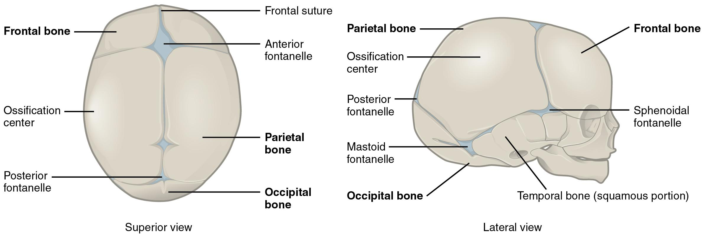
Figure 5.26 Newborn Skull The bones of the newborn skull are not fully ossified and are separated by large areas called fontanelles, which are filled with fibrous connective tissue. The fontanelles allow for continued growth of the skull after birth. At the time of birth, the facial bones are small and underdeveloped, and the mastoid process has not yet formed.

Development of the Vertebral Column and Thoracic Cage
Development of the vertebrae begins with the accumulation of mesenchyme cells from each sclerotome around the notochord. These cells differentiate into a hyaline cartilage model for each vertebra, which then grow and eventually ossify into bone through the process of endochondral ossification. As the developing vertebrae grow, the notochord largely disappears. However, small areas of notochord tissue persist between the adjacent vertebrae and this contributes to the formation of each intervertebral disc.
The ribs and sternum also develop from mesenchyme. The ribs initially develop as part of the cartilage model for each vertebra, but in the thorax region, the rib portion separates from the vertebra by the eighth week. The cartilage model of the rib then ossifies, except for the anterior portion, which remains as the costal cartilage. The sternum initially forms as paired hyaline cartilage models on either side of the anterior midline, beginning during the fifth week of development. The cartilage models of the ribs become attached to the lateral sides of the developing sternum. Eventually, the two halves of the cartilaginous sternum fuse together along the midline and then ossify into bone. The manubrium and body of the sternum are converted into bone first, with the xiphoid process remaining as cartilage until late in life.
Interactive Link
Watch this video to review the two processes that give rise to the bones of the skull and body. What are the two mechanisms by which the bones of the body are formed and which bones are formed by each mechanism?

Key Terms

angle of the mandible rounded corner located at outside margin of the body and ramus junction

angle of the rib portion of rib with greatest curvature; together, the rib angles form the most posterior extent of the thoracic cage

anterior arch anterior portion of the ring-like C1 (atlas) vertebra

anterior cranial fossa shallowest and most anterior cranial fossa of the cranial base that extends from the frontal bone to the lesser wing of the sphenoid bone

anterior longitudinal ligament ligament that runs the length of the vertebral column, uniting the anterior aspects of the vertebral bodies

annulus fibrosus tough, fibrous outer portion of an intervertebral disc, which is strongly anchored to the bodies of the adjacent vertebrae

appendicular skeleton all bones of the upper and lower limbs, plus the girdle bones that attach each limb to the axial skeleton

atlas first cervical (C1) vertebra

axial skeleton central, vertical axis of the body, including the skull, vertebral column, and thoracic cage

axis second cervical (C2) vertebra

body of the rib shaft portion of a rib

brain case portion of the skull that contains and protects the brain, consisting of the eight bones that form the cranial base and rounded upper skull

carotid canal zig-zag tunnel providing passage through the base of the skull for the internal carotid artery to the brain; begins anteromedial to the styloid process and terminates in the middle cranial cavity, near the posterior-lateral base of the sella turcica

cervical curve posteriorly concave curvature of the cervical vertebral column region; a secondary curve of the vertebral column

cervical vertebrae seven vertebrae numbered as C1–C7 that are located in the neck region of the vertebral column

clavicular notch paired notches located on the superior-lateral sides of the sternal manubrium, for articulation with the clavicle

coccyx small bone located at inferior end of the adult vertebral column that is formed by the fusion of four coccygeal vertebrae; also referred to as the “tailbone”

coronal suture joint that unites the frontal bone to the right and left parietal bones across the top of the skull

costal cartilage hyaline cartilage structure attached to the anterior end of each rib that provides for either direct or indirect attachment of most ribs to the sternum

costal facet site on the lateral sides of a thoracic vertebra for articulation with the head of a rib

cranial cavity interior space of the skull that houses the brain

cranium skull

cribriform plate small, flattened areas with numerous small openings, located to either side of the midline in the floor of the anterior cranial fossa; formed by the ethmoid bone

crista galli small upward projection located at the midline in the floor of the anterior cranial fossa; formed by the ethmoid bone

dens bony projection (odontoid process) that extends upward from the body of the C2 (axis) vertebra

ear ossicles three small bones located in the middle ear cavity that serve to transmit sound vibrations to the inner ear

ethmoid bone unpaired bone that forms the roof and upper, lateral walls of the nasal cavity, portions of the floor of the anterior cranial fossa and medial wall of orbit, and the upper portion of the nasal septum

external acoustic meatus ear canal opening located on the lateral side of the skull

external occipital protuberance small bump located at the midline on the posterior skull

facet small, flattened area on a bone for an articulation (joint) with another bone, or for muscle attachment

facial bones 14 bones that support the facial structures and form the upper and lower jaws and the hard palate

false ribs vertebrochondral ribs 8–12 whose costal cartilage either attaches indirectly to the sternum via the costal cartilage of the next higher rib or does not attach to the sternum at all

floating ribs vertebral ribs 11–12 that do not attach to the sternum or to the costal cartilage of another rib

fontanelle expanded area of fibrous connective tissue that separates the brain case bones of the skull prior to birth and during the first year after birth

foramen magnum large opening in the occipital bone of the skull through which the spinal cord emerges and the vertebral arteries enter the cranium

frontal bone unpaired bone that forms forehead, roof of orbit, and floor of anterior cranial fossa

greater wings of sphenoid bone lateral projections of the sphenoid bone that form the anterior wall of the middle cranial fossa and an area of the lateral skull

hard palate bony structure that forms the roof of the mouth and floor of the nasal cavity, formed by the maxillary bones and the palatine bones

head of the rib posterior end of a rib that articulates with the bodies of thoracic vertebrae

hyoid bone small, U-shaped bone located in upper neck that does not contact any other bone

inferior articular process bony process that extends downward from the vertebral arch of a vertebra that articulates with the superior articular process of the next lower vertebra

inferior nasal concha one of the paired bones that project from the lateral walls of the nasal cavity to form the largest and most inferior of the nasal conchae

intervertebral disc structure located between the bodies of adjacent vertebrae that strongly joins the vertebrae; provides padding, weight bearing ability, and enables vertebral column movements

intervertebral foramen opening located between adjacent vertebrae for exit of a spinal nerve

jugular (suprasternal) notch shallow notch located on superior surface of sternal manubrium

kyphosis (also, humpback or hunchback) excessive posterior curvature of the thoracic vertebral column region

lacrimal bone paired bones that contribute to the anterior-medial wall of each orbit

lambdoid suture inverted V-shaped joint that unites the occipital bone to the right and left parietal bones on the posterior skull

lesser wings of the sphenoid bone lateral extensions of the sphenoid bone that form the bony lip separating the anterior and middle cranial fossae

lordosis (also, swayback) excessive anterior curvature of the lumbar vertebral column region

lumbar curve posteriorly concave curvature of the lumbar vertebral column region; a secondary curve

lumbar vertebrae five vertebrae numbered as L1–L5 that are located in lumbar region (lower back) of the vertebral column

mandible unpaired bone that forms the lower jaw bone; the only moveable bone of the skull

manubrium expanded, superior portion of the sternum

mastoid process large bony prominence on the inferior, lateral skull, just behind the earlobe

maxillary bone (also, maxilla) paired bones that form the upper jaw and anterior portion of the hard palate

middle cranial fossa centrally located cranial fossa that extends from the lesser wings of the sphenoid bone to a portion of the temporal bone

middle nasal concha nasal concha formed by the ethmoid bone that is located between the superior and inferior conchae

nasal bone paired bones that form the base of the nose

nasal cavity opening through skull for passage of air

nasal conchae curved bony plates that project from the lateral walls of the nasal cavity; include the superior and middle nasal conchae, which are parts of the ethmoid bone, and the independent inferior nasal conchae bone

nasal septum flat, midline structure that divides the nasal cavity into halves, formed by the perpendicular plate of the ethmoid bone, vomer bone, and septal cartilage

neck of the rib narrowed region of a rib, next to the rib head

notochord rod-like structure along dorsal side of the early embryo; largely disappears during later development but does contribute to formation of the intervertebral discs

nuchal ligament expanded portion of the supraspinous ligament within the posterior neck; interconnects the spinous processes of the cervical vertebrae and attaches to the base of the skull

nucleus pulposus gel-like central region of an intervertebral disc; provides for padding, weight-bearing, and movement between adjacent vertebrae

occipital bone unpaired bone that forms the posterior portions of the brain case and base of the skull

occipital condyle paired, oval-shaped bony knobs located on the inferior skull, to either side of the foramen magnum

orbit bony socket that contains the eyeball and associated muscles

palatine bone paired bones that form the posterior quarter of the hard palate and a small area in floor of the orbit

parietal bone paired bones that form the upper, lateral sides of the skull

perpendicular plate of the ethmoid bone downward, midline extension of the ethmoid bone that forms the superior portion of the nasal septum

posterior arch posterior portion of the ring-like C1 (atlas) vertebra

posterior cranial fossa deepest and most posterior cranial fossa

posterior longitudinal ligament ligament that runs the length of the vertebral column, uniting the posterior sides of the vertebral bodies

primary curve anteriorly concave curvatures of the thoracic and sacrococcygeal regions that are retained from the original fetal curvature of the vertebral column

pterion H-shaped suture junction region that unites the frontal, parietal, temporal, and sphenoid bones on the lateral side of the skull

ribs thin, curved bones of the chest wall

sacral foramina series of paired openings for nerve exit located on both the anterior (ventral) and posterior (dorsal) aspects of the sacrum

sacral promontory anterior lip of the base (superior end) of the sacrum

sacrococcygeal curve anteriorly concave curvature formed by the sacrum and coccyx; a primary curve of the vertebral column

sacrum single bone located near the inferior end of the adult vertebral column that is formed by the fusion of five sacral vertebrae; forms the posterior portion of the pelvis

sagittal suture joint that unites the right and left parietal bones at the midline along the top of the skull

sclerotome medial portion of a somite consisting of mesenchyme tissue that will give rise to bone, cartilage, and fibrous connective tissues

scoliosis abnormal lateral curvature of the vertebral column

secondary curve posteriorly concave curvatures of the cervical and lumbar regions of the vertebral column that develop after the time of birth

sella turcica elevated area of sphenoid bone located at midline of the middle cranial fossa

skeleton bones of the body

skull bony structure that forms the head, face, and jaws, and protects the brain; consists of 22 bones

somite one of the paired, repeating blocks of tissue located on either side of the notochord in the early embryo

sphenoid bone unpaired bone that forms the central base of skull

spinous process unpaired bony process that extends posteriorly from the vertebral arch of a vertebra

squamous suture joint that unites the parietal bone to the squamous portion of the temporal bone on the lateral side of the skull

sternal angle junction line between manubrium and body of the sternum and the site for attachment of the second rib to the sternum

sternum flattened bone located at the center of the anterior chest

superior articular process bony process that extends upward from the vertebral arch of a vertebra that articulates with the inferior articular process of the next higher vertebra

superior articular process of the sacrum paired processes that extend upward from the sacrum to articulate (join) with the inferior articular processes from the L5 vertebra

superior nasal concha smallest and most superiorly located of the nasal conchae; formed by the ethmoid bone

superior nuchal line paired bony lines on the posterior skull that extend laterally from the external occipital protuberance

supraspinous ligament ligament that interconnects the spinous processes of the thoracic and lumbar vertebrae

suture junction line at which adjacent bones of the skull are united by fibrous connective tissue

temporal bone paired bones that form the lateral, inferior portions of the skull, with squamous, mastoid, and petrous portions

thoracic cage consists of 12 pairs of ribs and sternum

thoracic curve anteriorly concave curvature of the thoracic vertebral column region; a primary curve of the vertebral column

thoracic vertebrae twelve vertebrae numbered as T1–T12 that are located in the thoracic region (upper back) of the vertebral column

transverse foramen opening found only in the transverse processes of cervical vertebrae

transverse process paired bony processes that extends laterally from the vertebral arch of a vertebra

true ribs vertebrosternal ribs 1–7 that attach via their costal cartilage directly to the sternum

tubercle of the rib small bump on the posterior side of a rib for articulation with the transverse process of a thoracic vertebra

vertebra individual bone in the neck and back regions of the vertebral column

vertebral (spinal) canal bony passageway within the vertebral column for the spinal cord that is formed by the series of individual vertebral foramina

vertebral arch bony arch formed by the posterior portion of each vertebra that surrounds and protects the spinal cord

vertebral column entire sequence of bones that extend from the skull to the tailbone

vertebral foramen opening associated with each vertebra defined by the vertebral arch that provides passage for the spinal cord

vomer bone unpaired bone that forms the inferior and posterior portions of the nasal septum

xiphoid process small process that forms the inferior tip of the sternum

zygomatic arch elongated, free-standing arch on the lateral skull, formed anteriorly by the zygomatic bone and posteriorly by the temporal bone

zygomatic bone cheekbone; paired bones that contribute to the lateral orbit and anterior zygomatic arch

6 | THE APPENDICULAR SKELETON
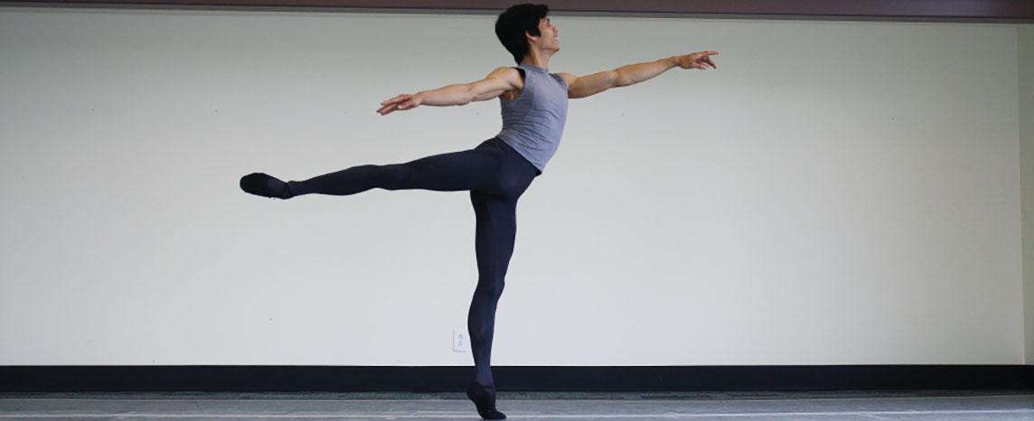
Figure 6.1 Dancer The appendicular skeleton consists of the upper and lower limb bones, the bones of the hands and feet, and the bones that anchor the limbs to the axial skeleton. (credit: Melissa Dooley/flickr)

Chapter Objectives
After studying this chapter, you will be able to:
- Discuss the bones of the pectoral and pelvic girdles, and describe how these unite the limbs with the axial skeleton
- Describe the bones of the upper limb, including the bones of the arm, forearm, wrist, and hand
- Identify features of the pelvis and explain how these differ between the adult male and female pelvis
- Describe the bones of the lower limb, including the bones of the thigh, leg, ankle, and foot
- Describe the embryonic formation and growth of the limb bones

Introduction
Your skeleton provides the internal supporting structure of the body. The adult axial skeleton consists of 80 bones that form the head and body trunk. Attached to this are the limbs, whose 126 bones constitute the appendicular skeleton. These bones are divided into two groups: the bones that are located within the limbs themselves, and the girdle bones that attach the limbs to the axial skeleton. The bones of the shoulder region form the pectoral girdle, which anchors the upper limb to the thoracic cage of the axial skeleton. The lower limb is attached to the vertebral column by the pelvic girdle.
Because of our upright stance, different functional demands are placed upon the upper and lower limbs. Thus, the bones of the lower limbs are adapted for weight-bearing support and stability, as well as for body locomotion via walking or running. In contrast, our upper limbs are not required for these functions. Instead, our upper limbs are highly mobile and can be utilized for a wide variety of activities. The large range of upper limb movements, coupled with the ability to easily manipulate objects with our hands and opposable thumbs, has allowed humans to construct the modern world in which we live.

6.1 The Pectoral Girdle

Learning Objectives
By the end of this section, you will be able to:
- Describe the bones that form the pectoral girdle
- List the functions of the pectoral girdle
The appendicular skeleton includes all of the limb bones, plus the bones that unite each limb with the axial skeleton (Figure 6.2). The bones that attach each upper limb to the axial skeleton form the pectoral girdle (shoulder girdle). This consists of two bones, the scapula and clavicle (Figure 6.3). The clavicle (collarbone) is an S-shaped bone located on the anterior side of the shoulder. It is attached on its medial end to the sternum of the thoracic cage, which is part of the axial skeleton. The lateral end of the clavicle articulates (joins) with the scapula just above the shoulder joint. You can easily palpate, or feel with your fingers, the entire length of your clavicle.
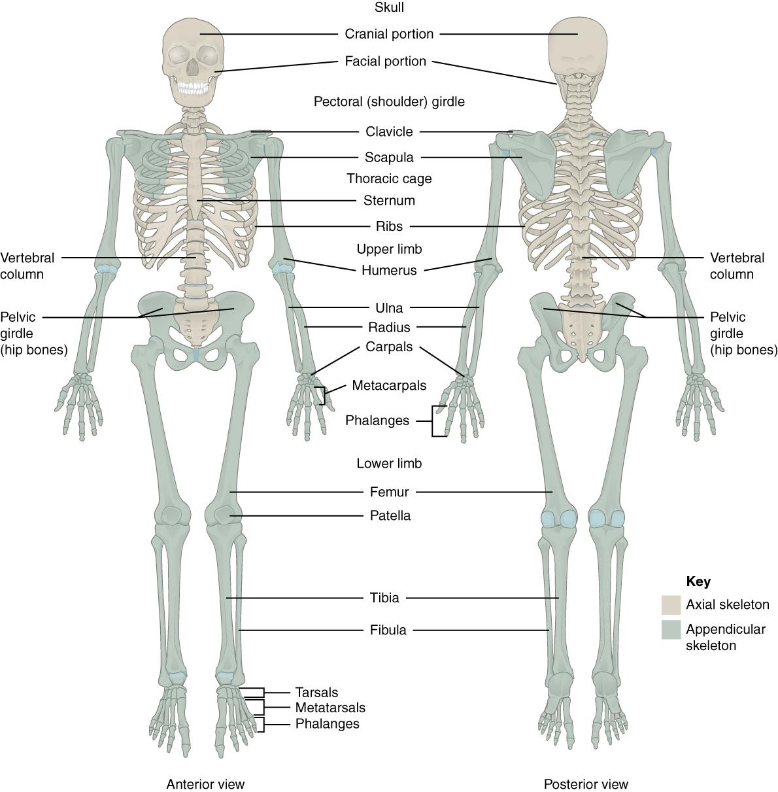
Figure 6.2 Axial and Appendicular Skeletons The axial skeleton forms the central axis of the body and consists of the skull, vertebral column, and thoracic cage. The appendicular skeleton consists of the pectoral and pelvic girdles, the limb bones, and the bones of the hands and feet.
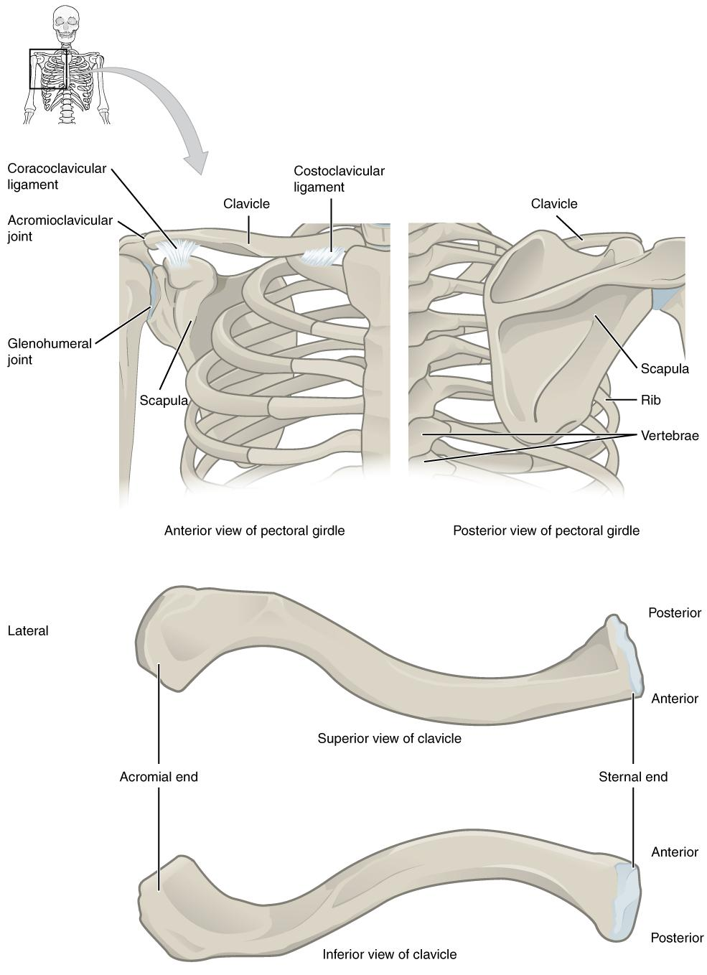
Figure 6.3 Pectoral Girdle The pectoral girdle consists of the clavicle and the scapula, which serve to attach the upper limb to the sternum of the axial skeleton.
The scapula (shoulder blade) lies on the posterior aspect of the shoulder. It is supported by the clavicle and articulates with the humerus (arm bone) to form the shoulder joint. The scapula is a flat, triangular-shaped bone with a prominent ridge running across its posterior surface. This ridge extends out laterally, where it forms the bony tip of the shoulder and joins with the lateral end of the clavicle. By following along the clavicle, you can palpate out to the bony tip of the shoulder, and from there, you can move back across your posterior shoulder to follow the ridge of the scapula. Move your shoulder around and feel how the clavicle and scapula move together as a unit. Both of these bones serve as important attachment sites for muscles that aid with movements of the shoulder and arm.
The right and left pectoral girdles are not joined to each other, allowing each to operate independently. In addition, the clavicle of each pectoral girdle is anchored to the axial skeleton by a single, highly mobile joint. This allows for the extensive mobility of the entire pectoral girdle, which in turn enhances movements of the shoulder and upper limb.

Clavicle
The clavicle is the only long bone that lies in a horizontal position in the body (see Figure 6.3). The clavicle has several important functions. First, anchored by muscles from above, it serves as a strut that extends laterally to support the scapula. This in turn holds the shoulder joint superiorly and laterally from the body trunk, allowing for maximal freedom of motion for the upper limb. The clavicle also transmits forces acting on the upper limb to the sternum and axial skeleton. Finally, it serves to protect the underlying nerves and blood vessels as they pass between the trunk of the body and the upper limb.
The clavicle has three regions: the medial end, the lateral end, and the shaft. The medial end, known as the sternal end of the clavicle, has a triangular shape and articulates with the manubrium portion of the sternum. This forms the sternoclavicular joint, which is the only bony articulation between the pectoral girdle of the upper limb and the axial skeleton. This joint allows considerable mobility, enabling the clavicle and scapula to move in upward/downward and anterior/posterior directions during shoulder movements. The sternoclavicular joint is indirectly supported by the costoclavicular ligament (costo- = “rib”), which spans the sternal end of the clavicle and the underlying first rib. The lateral or acromial end of the clavicle articulates with the acromion of the scapula, the portion of the scapula that forms the bony tip of the shoulder. There are some sex differences in the morphology of the clavicle. In women, the clavicle tends to be shorter, thinner, and less curved. In men, the clavicle is heavier and longer, and has a greater curvature and rougher surfaces where muscles attach, features that are more pronounced in manual workers.
The clavicle is the most commonly fractured bone in the body. Such breaks often occur because of the force exerted on the clavicle when a person falls onto his or her outstretched arms, or when the lateral shoulder receives a strong blow. Because the sternoclavicular joint is strong and rarely dislocated, excessive force results in the breaking of the clavicle, usually between the middle and lateral portions of the bone. If the fracture is complete, the shoulder and lateral clavicle fragment will drop due to the weight of the upper limb, causing the person to support the sagging limb with their other hand. Muscles acting across the shoulder will also pull the shoulder and lateral clavicle anteriorly and medially, causing the clavicle fragments to override. The clavicle overlies many important blood vessels and nerves for the upper limb, but fortunately, due to the anterior displacement of a broken clavicle, these structures are rarely affected when the clavicle is fractured.

Scapula
The scapula is also part of the pectoral girdle and thus plays an important role in anchoring the upper limb to the body. The scapula is located on the posterior side of the shoulder. It is surrounded by muscles on both its anterior (deep) and posterior (superficial) sides, and thus does not articulate with the ribs of the thoracic cage.
The scapula has several important landmarks (Figure 6.4). The three margins or borders of the scapula, named for their positions within the body, are the superior border of the scapula, the medial border of the scapula, and the lateral border of the scapula. The suprascapular notch is located lateral to the midpoint of the superior border. The corners of the triangular scapula, at either end of the medial border, are the superior angle of the scapula, located between the medial and superior borders, and the inferior angle of the scapula, located between the medial and lateral borders. The inferior angle is the most inferior portion of the scapula, and is particularly important because it serves as the attachment point for several powerful muscles involved in shoulder and upper limb movements. The remaining corner of the scapula, between the superior and lateral borders, is the location of the glenoid cavity (glenoid fossa). This shallow depression articulates with the humerus bone of the arm to form the glenohumeral joint (shoulder joint). The small bony bumps located immediately above and below the glenoid cavity are the supraglenoid tubercle and the infraglenoid tubercle, respectively. These provide attachments for muscles of the arm.
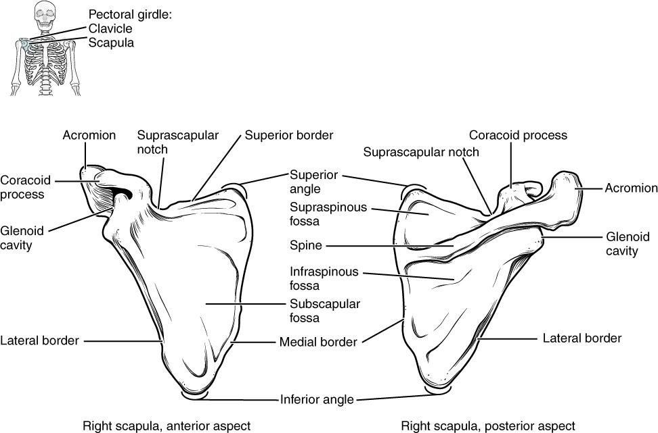
Figure 6.4 Scapula The isolated scapula is shown here from its anterior (deep) side and its posterior (superficial) side.
The scapula also has two prominent projections. Toward the lateral end of the superior border, between the suprascapular notch and glenoid cavity, is the hook-like coracoid process (coracoid = “shaped like a crow’s beak”). This process projects anteriorly and curves laterally. At the shoulder, the coracoid process is located inferior to the lateral end of the clavicle. It is anchored to the clavicle by a strong ligament, and serves as the attachment site for muscles of the anterior chest and arm. On the posterior aspect, the spine of the scapula is a long and prominent ridge that runs across its upper portion. Extending laterally from the spine is a flattened and expanded region called the acromion or acromial process. The acromion forms the bony tip of the superior shoulder region and articulates with the lateral end of the clavicle, forming the acromioclavicular joint (see Figure 6.3). Together, the clavicle, acromion, and spine of the scapula form a V-shaped bony line that provides for the attachment of neck and back muscles that act on the shoulder, as well as muscles that pass across the shoulder joint to act on the arm.
The scapula has three depressions, each of which is called a fossa (plural = fossae). Two of these are found on the posterior scapula, above and below the scapular spine. Superior to the spine is the narrow supraspinous fossa, and inferior to the spine is the broad infraspinous fossa. The anterior (deep) surface of the scapula forms the broad subscapular fossa. All of these fossae provide large surface areas for the attachment of muscles that cross the shoulder joint to act on the humerus.
The acromioclavicular joint transmits forces from the upper limb to the clavicle. The ligaments around this joint are relatively weak. A hard fall onto the elbow or outstretched hand can stretch or tear the acromioclavicular ligaments, resulting in a moderate injury to the joint. However, the primary support for the acromioclavicular joint comes from a very strong ligament called the coracoclavicular ligament (see Figure 6.3). This connective tissue band anchors the coracoid process of the scapula to the inferior surface of the acromial end of the clavicle and thus provides important indirect support for the acromioclavicular joint.
Following a strong blow to the lateral shoulder, such as when a hockey player is driven into the boards, a complete dislocation of the acromioclavicular joint can result. In this case, the acromion is thrust under the acromial end of the clavicle, resulting in ruptures of both the acromioclavicular and coracoclavicular ligaments. The scapula then separates from the clavicle, with the weight of the upper limb pulling the shoulder downward. This dislocation injury of the acromioclavicular joint is known as a “shoulder separation” and is common in contact sports such as hockey, football, or martial arts.
Interactive Link
Watch this video that reviews many of the anatomical landmarks of the pectoral girdle with a 3D model.

6.2 Bones of the Upper Limb

Learning Objectives
By the end of this section, you will be able to:
- Identify the divisions of the upper limb and describe the bones in each region
- List the bones and bony landmarks that articulate at each joint of the upper limb
The upper limb is divided into three regions. These consist of the arm, located between the shoulder and elbow joints; the forearm, which is between the elbow and wrist joints; and the hand, which is located distal to the wrist. There are 30 bones in each upper limb (see Figure 6.2). The humerus is the single bone of the upper arm, and the ulna (medially) and the radius (laterally) are the paired bones of the forearm. The base of the hand contains eight bones, each called a carpal bone, and the palm of the hand is formed by five bones, each called a metacarpal bone. The fingers and thumb contain a total of 14 bones, each of which is a phalanx bone of the hand.

Humerus
The humerus is the single bone of the upper arm region (Figure 6.5). At its proximal end is the head of the humerus. This is the large, round, smooth region that faces medially. The head articulates with the glenoid cavity of the scapula to form the glenohumeral (shoulder) joint. The margin of the smooth area of the head is the anatomical neck of the humerus. Located on the lateral side of the proximal humerus is an expanded bony area called the greater tubercle. The smaller lesser tubercle of the humerus is found on the anterior aspect of the humerus. Both the greater and lesser tubercles serve as attachment sites for muscles that act across the shoulder joint. Passing between the greater and lesser tubercles is the narrow intertubercular groove (sulcus), which is also known as the bicipital groove because it provides passage for a tendon of the biceps brachii muscle. The surgical neck is located at the base of the expanded, proximal end of the humerus, where it joins the narrow shaft of the humerus. The surgical neck is a common site of arm fractures. The deltoid tuberosity is a roughened, V-shaped region located on the lateral side in the middle of the humerus shaft. As its name indicates, it is the site of attachment for the deltoid muscle.
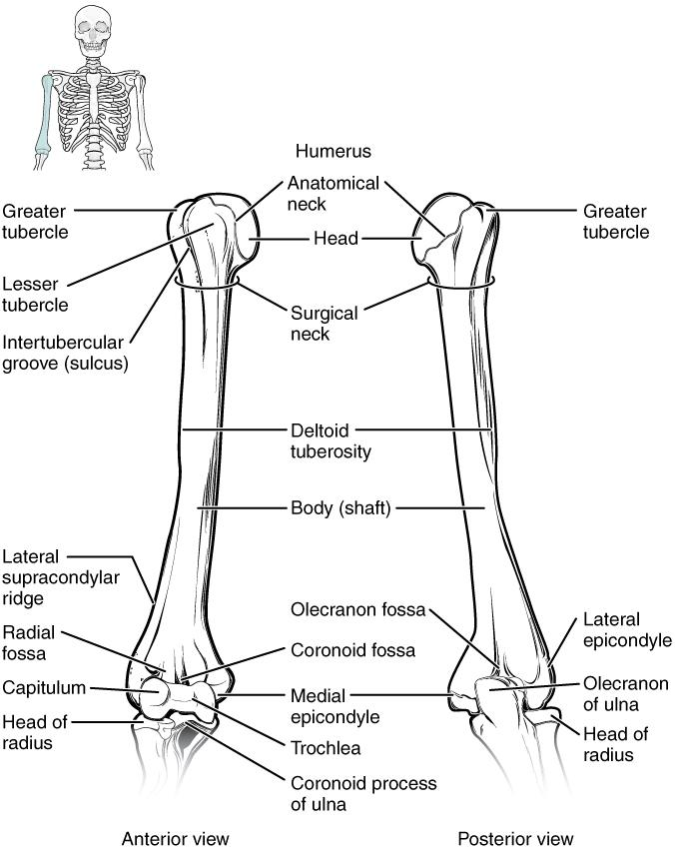
Figure 6.5 Humerus and Elbow Joint The humerus is the single bone of the upper arm region. It articulates with the radius and ulna bones of the forearm to form the elbow joint.
Distally, the humerus becomes flattened. The prominent bony projection on the medial side is the medial epicondyle of the humerus. The much smaller lateral epicondyle of the humerus is found on the lateral side of the distal humerus. The roughened ridge of bone above the lateral epicondyle is the lateral supracondylar ridge. All of these areas are attachment points for muscles that act on the forearm, wrist, and hand. The powerful grasping muscles of the anterior forearm (wrist flexor muscles) arise from the medial epicondyle, which is thus larger and more robust than the lateral epicondyle that gives rise to the weaker posterior forearm muscles (wrist extensor muscles).
The distal end of the humerus has two articulation areas, which join the ulna and radius bones of the forearm to form the elbow joint. The more medial of these areas is the trochlea, a spindle- or pulley-shaped region (trochlea = “pulley”), which articulates with the ulna bone. Immediately lateral to the trochlea is the capitulum (“small head”), a knob-like structure located on the anterior surface of the distal humerus. The capitulum articulates with the radius bone of the forearm. Just above these bony areas are two small depressions. These spaces accommodate the forearm bones when the elbow is fully bent (flexed). Superior to the trochlea is the coronoid fossa, which receives the coronoid process of the ulna, and above the capitulum is the radial fossa, which receives the head of the radius when the elbow is flexed. Similarly, the posterior humerus has the olecranon fossa, a larger depression that receives the olecranon process of the ulna when the forearm is fully extended.

Ulna
The ulna is the medial bone of the forearm. It runs parallel to the radius, which is the lateral bone of the forearm (Figure 6.6). The proximal end of the ulna resembles a crescent wrench with its large, C-shaped trochlear notch. This region articulates with the trochlea of the humerus as part of the elbow joint. The inferior margin of the trochlear notch is formed by a prominent lip of bone called the coronoid process of the ulna. Just below this on the anterior ulna is a roughened area called the ulnar tuberosity. To the lateral side and slightly inferior to the trochlear notch is a small, smooth area called the radial notch of the ulna. This area is the site of articulation between the proximal radius and the ulna, forming the proximal radioulnar joint. The posterior and superior portions of the proximal ulna make up the olecranon process, which forms the bony tip of the elbow.
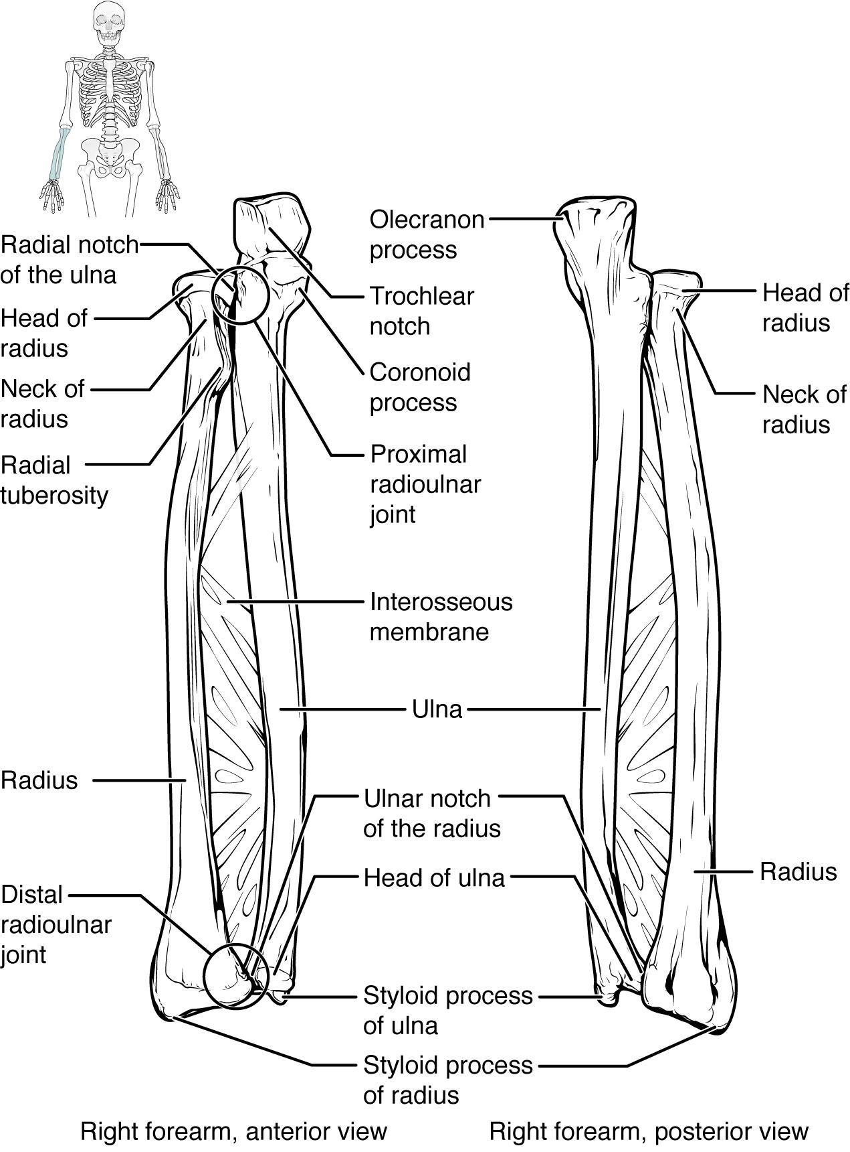
Figure 6.6 Ulna and Radius The ulna is located on the medial side of the forearm, and the radius is on the lateral side. These bones are attached to each other by an interosseous membrane.
More distal is the shaft of the ulna. The lateral side of the shaft forms a ridge called the interosseous border of the ulna. This is the line of attachment for the interosseous membrane of the forearm, a sheet of dense connective tissue that unites the ulna and radius bones. The small, rounded area that forms the distal end is the head of the ulna. Projecting from the posterior side of the ulnar head is the styloid process of the ulna, a short bony projection. This serves as an attachment point for a connective tissue structure that unites the distal ends of the ulna and radius.
In the anatomical position, with the elbow fully extended and the palms facing forward, the arm and forearm do not form a straight line. Instead, the forearm deviates laterally by 5–15 degrees from the line of the arm. This deviation is called the carrying angle. It allows the forearm and hand to swing freely or to carry an object without hitting the hip. The carrying angle is larger in females to accommodate their wider pelvis.

Radius
The radius runs parallel to the ulna, on the lateral (thumb) side of the forearm (see Figure 6.6). The head of the radius is a disc-shaped structure that forms the proximal end. The small depression on the surface of the head articulates with the capitulum of the humerus as part of the elbow joint, whereas the smooth, outer margin of the head articulates with the radial notch of the ulna at the proximal radioulnar joint. The neck of the radius is the narrowed region immediately below the expanded head. Inferior to this point on the medial side is the radial tuberosity, an oval-shaped, bony protuberance that serves as a muscle attachment point. The shaft of the radius is slightly curved and has a small ridge along its medial side. This ridge forms the interosseous border of the radius, which, like the similar border of the ulna, is the line of attachment for the interosseous membrane that unites the two forearm bones. The distal end of the radius has a smooth surface for articulation with two carpal bones to form the radiocarpal joint or wrist joint (Figure 6.7 and Figure 6.8). On the medial side of the distal radius is the ulnar notch of the radius. This shallow depression articulates with the head of the ulna, which together form the distal radioulnar joint. The lateral end of the radius has a pointed projection called the styloid process of the radius. This provides attachment for ligaments that support the lateral side of the wrist joint. Compared to the styloid process of the ulna, the styloid process of the radius projects more distally, thereby limiting the range of movement for lateral deviations of the hand at the wrist joint.

Carpal Bones
The wrist and base of the hand are formed by a series of eight small carpal bones (see Figure 6.7). The carpal bones are arranged in two rows, forming a proximal row of four carpal bones and a distal row of four carpal bones. The bones in the proximal row, running from the lateral (thumb) side to the medial side, are the scaphoid (“boat-shaped”), lunate (“moon-shaped”), triquetrum (“three-cornered”), and pisiform (“pea-shaped”) bones. The small, rounded pisiform bone articulates with the anterior surface of the triquetrum bone. The pisiform thus projects anteriorly, where it forms the bony bump that can be felt at the medial base of your hand. The distal bones (lateral to medial) are the trapezium (“table”), trapezoid (“resembles a table”), capitate (“head-shaped”), and hamate (“hooked bone”) bones. The hamate bone is characterized by a prominent bony extension on its anterior side called the hook of the hamate bone.
A helpful mnemonic for remembering the arrangement of the carpal bones is “So Long To Pinky, Here Comes The Thumb.” This mnemonic starts on the lateral side and names the proximal bones from lateral to medial (scaphoid, lunate, triquetrum, pisiform), then makes a U-turn to name the distal bones from medial to lateral (hamate, capitate, trapezoid, trapezium). Thus, it starts and finishes on the lateral side.
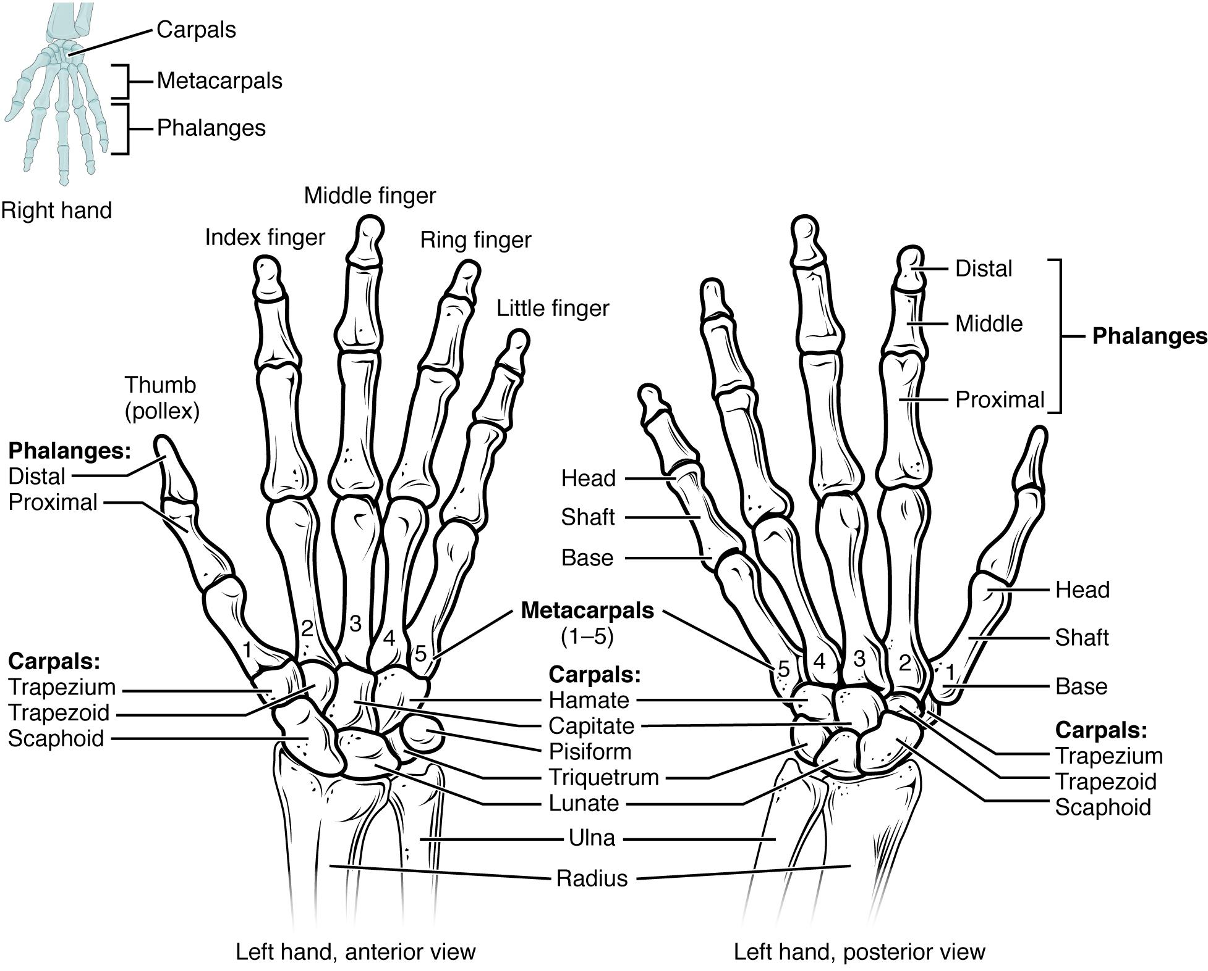
Figure 6.7 Bones of the Wrist and Hand The eight carpal bones form the base of the hand. These are arranged into proximal and distal rows of four bones each. The metacarpal bones form the palm of the hand. The thumb and fingers consist of the phalanx bones.
The carpal bones form the base of the hand. This can be seen in the radiograph (X-ray image) of the hand that shows the relationships of the hand bones to the skin creases of the hand (see Figure 6.8). Within the carpal bones, the four proximal bones are united to each other by ligaments to form a unit. Only three of these bones, the scaphoid, lunate, and triquetrum, contribute to the radiocarpal joint. The scaphoid and lunate bones articulate directly with the distal end of the radius, whereas the triquetrum bone articulates with a fibrocartilaginous pad that spans the radius and styloid process of the ulna. The distal end of the ulna thus does not directly articulate with any of the carpal bones.
The four distal carpal bones are also held together as a group by ligaments. The proximal and distal rows of carpal bones articulate with each other to form the midcarpal joint (see Figure 6.8). Together, the radiocarpal and midcarpal joints are responsible for all movements of the hand at the wrist. The distal carpal bones also articulate with the metacarpal bones of the hand.
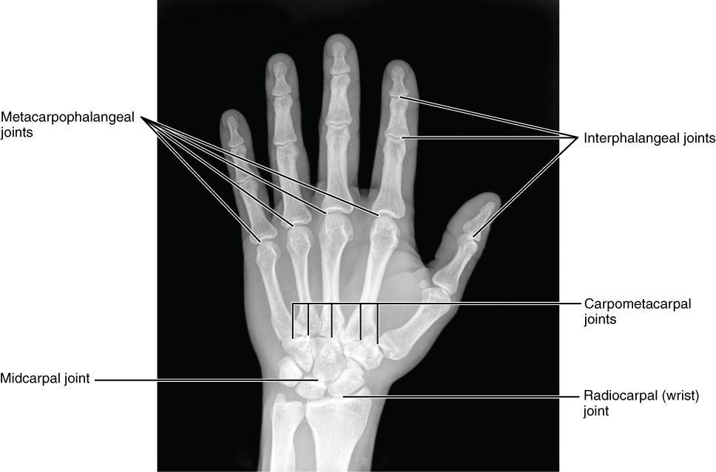
Figure 6.8 Bones of the Hand This radiograph shows the position of the bones within the hand. Note the carpal bones that form the base of the hand. (credit: modification of work by Trace Meek)
In the articulated hand, the carpal bones form a U-shaped grouping. A strong ligament called the flexor retinaculum spans the top of this U-shaped area to maintain this grouping of the carpal bones. The flexor retinaculum is attached laterally to the trapezium and scaphoid bones, and medially to the hamate and pisiform bones. Together, the carpal bones and the flexor retinaculum form a passageway called the carpal tunnel, with the carpal bones forming the walls and floor, and the flexor retinaculum forming the roof of this space (Figure 6.9). The tendons of nine muscles of the anterior forearm and an important nerve pass through this narrow tunnel to enter the hand. Overuse of the muscle tendons or wrist injury can produce inflammation and swelling within this space. This produces compression of the nerve, resulting in carpal tunnel syndrome, which is characterized by pain or numbness, and muscle weakness in those areas of the hand supplied by this nerve.
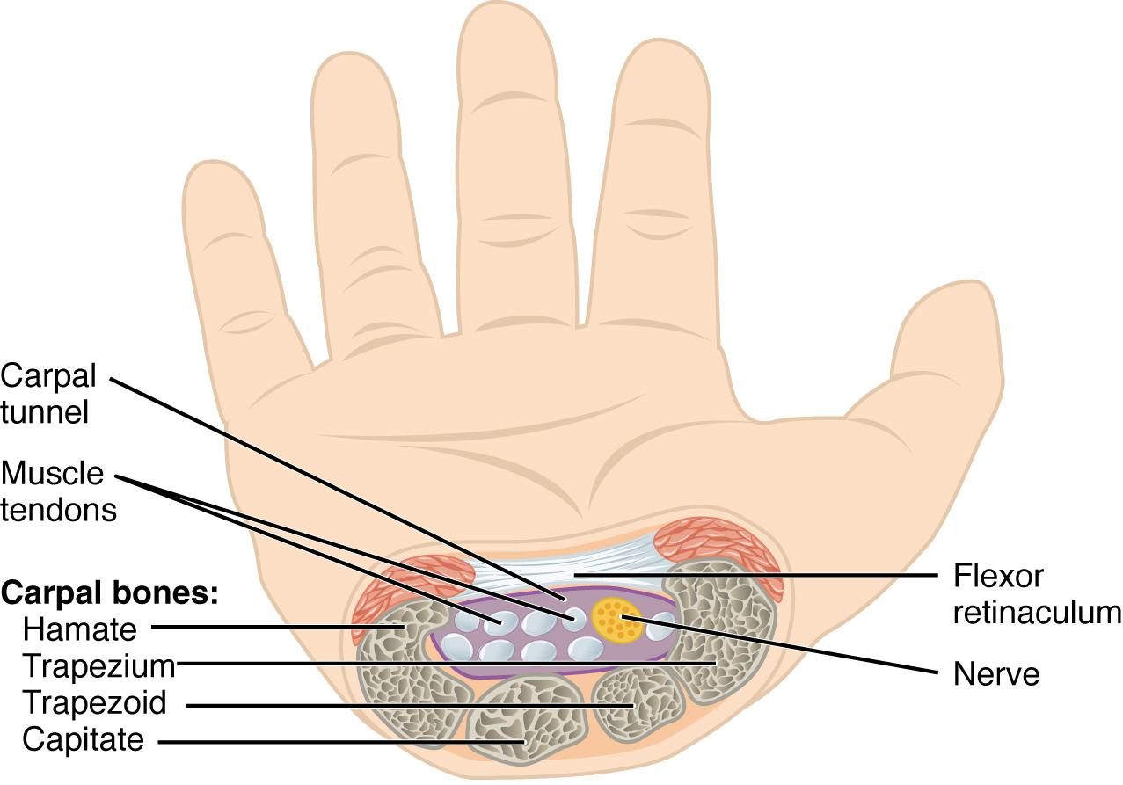
Figure 6.9 Carpal Tunnel The carpal tunnel is the passageway by which nine muscle tendons and a major nerve enter the hand from the anterior forearm. The walls and floor of the carpal tunnel are formed by the U-shaped grouping of the carpal bones, and the roof is formed by the flexor retinaculum, a strong ligament that anteriorly unites the bones.

Metacarpal Bones
The palm of the hand contains five elongated metacarpal bones. These bones lie between the carpal bones of the wrist and the bones of the fingers and thumb (see Figure 6.7). The proximal end of each metacarpal bone articulates with one of the distal carpal bones. Each of these articulations is a carpometacarpal joint (see Figure 6.8). The expanded distal end of each metacarpal bone articulates at the metacarpophalangeal joint with the proximal phalanx bone of the thumb or one of the fingers. The distal end also forms the knuckles of the hand, at the base of the fingers. The metacarpal bones are numbered 1–5, beginning at the thumb.
The first metacarpal bone, at the base of the thumb, is separated from the other metacarpal bones. This allows it a freedom of motion that is independent of the other metacarpal bones, which is very important for thumb mobility. The remaining metacarpal bones are united together to form the palm of the hand.

Phalanx Bones

The fingers and thumb contain 14 bones, each of which is called a phalanx bone (plural = phalanges), named after the ancient Greek phalanx (a rectangular block of soldiers). The thumb (pollex) is digit number 1 and has two phalanges, a proximal phalanx, and a distal phalanx bone (see Figure 6.7). Digits 2 (index finger) through 5 (little finger) have three phalanges each, called the proximal, middle, and distal phalanx bones. An interphalangeal joint is one of the articulations between adjacent phalanges of the digits (see Figure 6.8).
Disorders of the…
Appendicular System: Fractures of Upper Limb Bones
Due to our constant use of the hands and the rest of our upper limbs, an injury to any of these areas will cause a significant loss of functional ability. Many fractures result from a hard fall onto an outstretched hand. The resulting transmission of force up the limb may result in a fracture of the humerus, radius, or scaphoid bones. These injuries are especially common in elderly people whose bones are weakened due to osteoporosis.
Falls onto the hand or elbow, or direct blows to the arm can result in fractures of the humerus. These fractures typically happen at the surgical neck or through the shaft of the humerus.
In children, a fall onto the tip of the elbow frequently results in a distal humerus fracture. In these, the olecranon of the ulna is driven upward, resulting in a fracture across the distal humerus, above both epicondyles (supracondylar fracture), or a fracture between the epicondyles (intercondylar fracture). This is often described as a “broken elbow”, which accurately identifies the general location of the fracture, but doesn’t describe the boney fracture correctly.
Another frequent injury following a fall onto an outstretched hand (a “FOOSH”) is a Colles fracture (“col-lees”) of the distal radius. This involves a complete transverse fracture across the distal radius that drives the separated distal fragment of the radius posteriorly and superiorly. This injury results in a characteristic “dinner fork” bend of the forearm just above the wrist due to the posterior displacement of the hand. This is a common injury in persons over the age of 50, particularly in older women with osteoporosis. It also commonly occurs following a high-speed fall onto the hand during activities such as snowboarding or skating.
The most commonly fractured carpal bone is the scaphoid, often resulting from a fall onto the hand. Deep pain at the lateral wrist may yield an initial diagnosis of a wrist sprain, but a radiograph taken several weeks after the injury, after tissue swelling has subsided, will reveal the fracture. Due to the poor blood supply to the scaphoid bone, healing will be slow and there is the danger of bone necrosis and subsequent degenerative joint disease of the wrist.
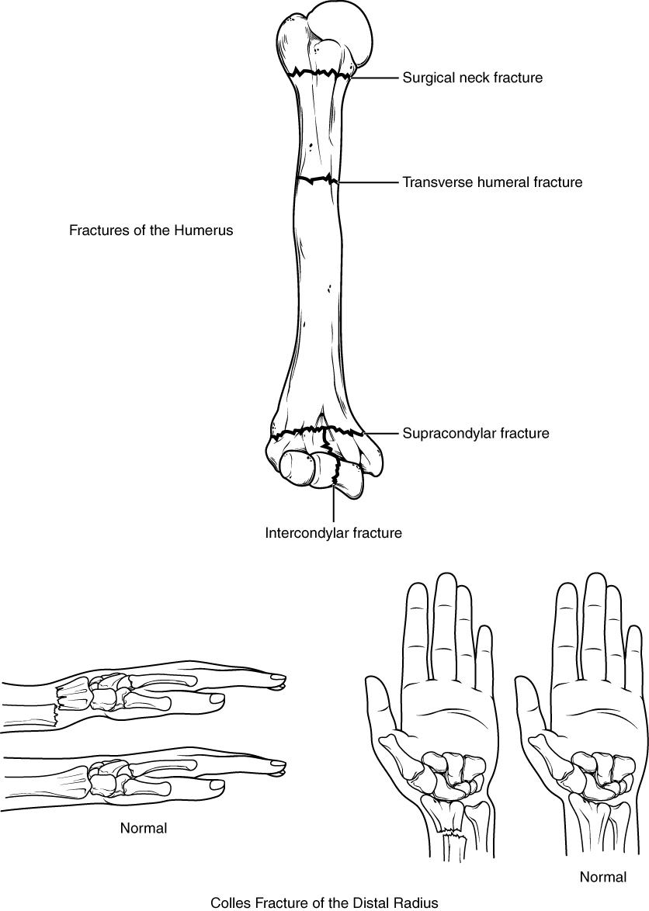
Figure 6.10 Fractures of the Humerus and Radius Falls or direct blows can result in fractures of the surgical neck or shaft of the humerus. Falls onto the elbow can fracture the distal humerus. A Colles fracture of the distal radius is the most common forearm fracture.

6.3 The Pelvic Girdle and Pelvis

Learning Objectives
By the end of this section, you will be able to:
- Define the pelvic girdle and describe the bones and ligaments of the pelvis
- Explain the three regions of the hip bone and identify their bony landmarks
- Describe the openings of the pelvis and the boundaries of the greater and lesser pelvis
The pelvic girdle (hip girdle) is formed by a single bone, the coxal bone (coxal = “hip”), which serves as the attachment point for each lower limb. Each hip bone, in turn, is firmly joined to the axial skeleton via its attachment to the sacrum of the vertebral column. The right and left hip bones also converge anteriorly to attach to each other. The bony pelvis is the entire structure formed by the two hip bones, the sacrum, and, attached inferiorly to the sacrum, the coccyx (Figure 6.11).
Unlike the bones of the pectoral girdle, which are highly mobile to enhance the range of upper limb movements, the bones of the pelvis are strongly united to each other to form a largely immobile, weight-bearing structure. This is important for stability because it enables the weight of the body to be easily transferred laterally from the vertebral column, through the pelvic girdle and hip joints, and into either lower limb whenever the other limb is not bearing weight. Thus, the immobility of the pelvis provides a strong foundation for the upper body as it rests on top of the mobile lower limbs.
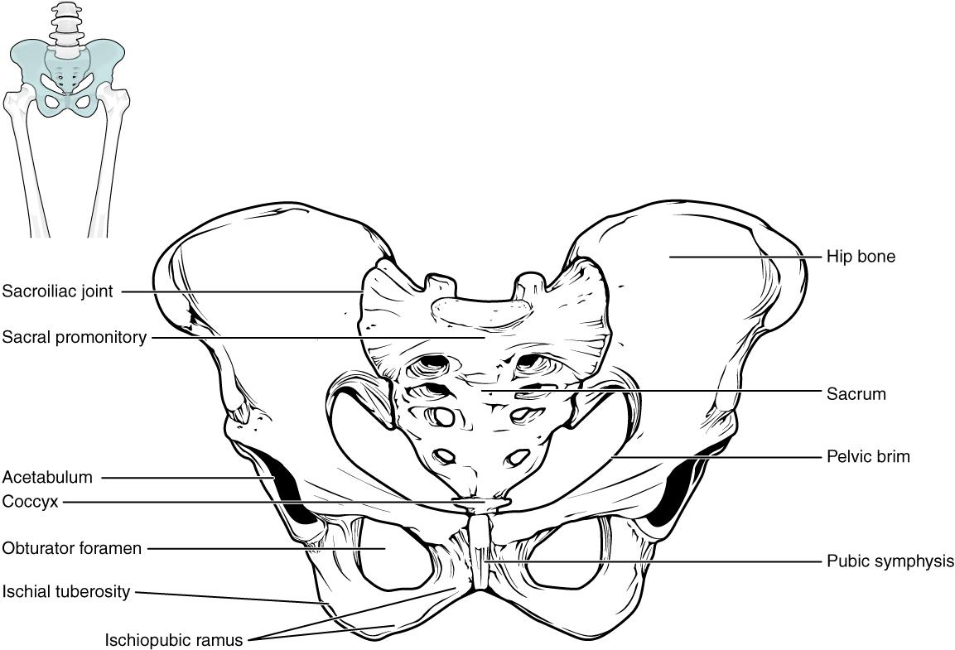
Figure 6.11 Pelvis The pelvic girdle is formed by a single hip bone. The hip bone attaches the lower limb to the axial skeleton through its articulation with the sacrum. The right and left hip bones, plus the sacrum and the coccyx, together form the pelvis.

Hip Bone
The hip bone, or coxal bone, forms the pelvic girdle portion of the pelvis. The paired hip bones are the large, curved bones that form the lateral and anterior aspects of the pelvis. Each adult hip bone is formed by three separate bones that fuse together during the late teenage years. These bony components are the ilium, ischium, and pubis (Figure 6.12). These names are retained and used to define the three regions of the adult hip bone.
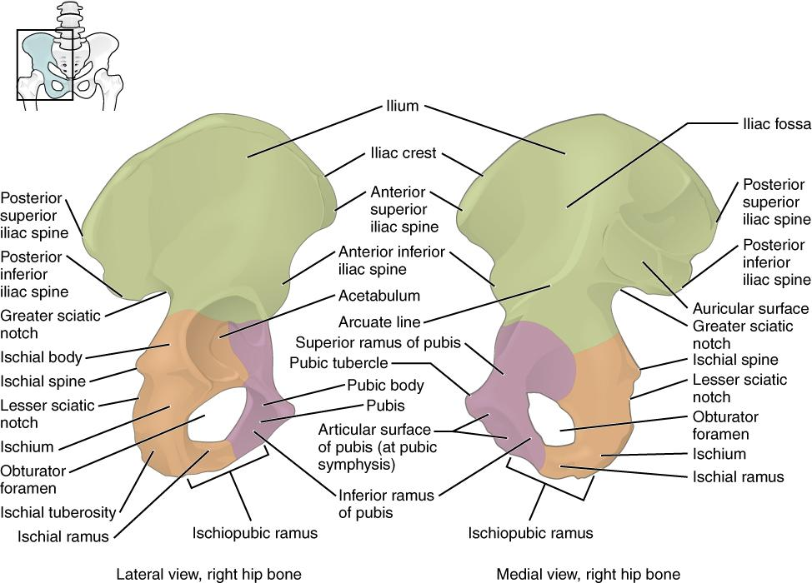
Figure 6.12 The Hip Bone The adult hip bone consists of three regions. The ilium forms the large, fan-shaped superior portion, the ischium forms the posteroinferior portion, and the pubis forms the anteromedial portion.
The ilium is the fan-like, superior region that forms the largest part of the hip bone. It is firmly united to the sacrum at the largely immobile sacroiliac joint (see Figure 6.11). The ischium forms the posteroinferior region of each hip bone. It supports the body when sitting. The pubis forms the anterior portion of the hip bone. The pubis curves medially, where it joins to the pubis of the opposite hip bone at a specialized joint called the pubic symphysis.

Ilium
When you place your hands on your waist, you can feel the arching, superior margin of the ilium along your waistline (see Figure 6.12). This curved, superior margin of the ilium is the iliac crest. The rounded, anterior termination of the iliac crest is the anterior superior iliac spine. This important bony landmark can be felt at your anterolateral hip. Inferior to the anterior superior iliac spine is a rounded protuberance called the anterior inferior iliac spine. Both of these iliac spines serve as attachment points for muscles of the thigh. Posteriorly, the iliac crest curves downward to terminate as the posterior superior iliac spine. Muscles and ligaments surround but do not cover this bony landmark, thus sometimes producing a depression seen as a “dimple” located on the lower back. More inferiorly is the posterior inferior iliac spine. This is located at the inferior end of a large, roughened area called the auricular surface of the ilium. The auricular surface articulates with the auricular surface of the sacrum to form the sacroiliac joint. Both the posterior superior and posterior inferior iliac spines serve as attachment points for the muscles and very strong ligaments that support the sacroiliac joint.
The shallow depression located on the anteromedial (internal) surface of the upper ilium is called the iliac fossa. The large, inverted U-shaped indentation located on the posterior margin of the lower ilium is called the greater sciatic notch.

Ischium
The ischium forms the posterolateral portion of the hip bone (see Figure 6.12). The large, roughened area of the inferior ischium is the ischial tuberosity. This serves as the attachment for the posterior thigh muscles and also carries the weight of the body when sitting. You can feel the ischial tuberosity if you wiggle your pelvis against the seat of a chair. Projecting superiorly and anteriorly from the ischial tuberosity is a narrow segment of bone called the ischial ramus. The slightly curved posterior margin of the ischium above the ischial tuberosity is the lesser sciatic notch. The bony projection separating the lesser sciatic notch and greater sciatic notch is the ischial spine.

Pubis
The pubis forms the anterior portion of the hip bone (see Figure 6.12). The enlarged medial portion of the pubis is the pubic body. Located superiorly on the pubic body is a small bump called the pubic tubercle. The superior pubic ramus is the segment of bone that passes laterally from the pubic body to join the ilium.
The pubic body is joined to the pubic body of the opposite hip bone by the pubic symphysis. Extending downward and laterally from the body is the inferior pubic ramus. The pubic arch is the bony structure formed by the pubic symphysis, and the bodies and inferior pubic rami of the adjacent pubic bones. The inferior pubic ramus extends downward to join the ischial ramus.

Pelvis
The pelvis consists of four bones: the right and left hip bones, the sacrum, and the coccyx (see Figure 6.11). The pelvis has several important functions. Its primary role is to support the weight of the upper body when sitting and to transfer this weight to the lower limbs when standing. It serves as an attachment point for trunk and lower limb muscles, and also protects the internal pelvic organs. When standing in the anatomical position, the pelvis is tilted anteriorly. In this position, the anterior superior iliac spines and the pubic tubercles lie in the same vertical plane, and the anterior (internal) surface of the sacrum faces forward and downward.
The three areas of each hip bone, the ilium, pubis, and ischium, converge centrally to form a deep, cup-shaped cavity called the acetabulum. This is located on the lateral side of the hip bone and is part of the hip joint. The large opening in the anteroinferior hip bone between the ischium and pubis is the obturator foramen. This space is largely filled in by a layer of connective tissue and serves for the attachment of muscles on both its internal and external surfaces.
The space enclosed by the bony pelvis is divided into two regions (Figure 6.13). The broad, superior region, defined laterally by the large, fan-like portion of the upper hip bone, is called the greater pelvis (greater pelvic cavity; false pelvis). This broad area is occupied by portions of the small and large intestines, and because it is more closely associated with the abdominal cavity, it is sometimes referred to as the false pelvis. More inferiorly, the narrow, rounded space of the lesser pelvis (lesser pelvic cavity; true pelvis) contains the bladder and other pelvic organs, and thus is also known as the true pelvis. The pelvic brim (also known as the pelvic inlet) forms the superior margin of the lesser pelvis, separating it from the greater pelvis. The pelvic brim is defined by a line formed by the upper margin of the pubic symphysis anteriorly, and the pectineal line of the pubis, the arcuate line of the ilium, and the sacral promontory (the anterior margin of the superior sacrum) posteriorly. The inferior limit of the lesser pelvic cavity is called the pelvic outlet. This large opening is defined by the inferior margin of the pubic symphysis anteriorly, and the ischiopubic ramus, the ischial tuberosity, the sacrotuberous ligament, and the inferior tip of the coccyx posteriorly. Because of the anterior tilt of the pelvis, the lesser pelvis is also angled, giving it an anterosuperior (pelvic inlet) to posteroinferior (pelvic outlet) orientation.
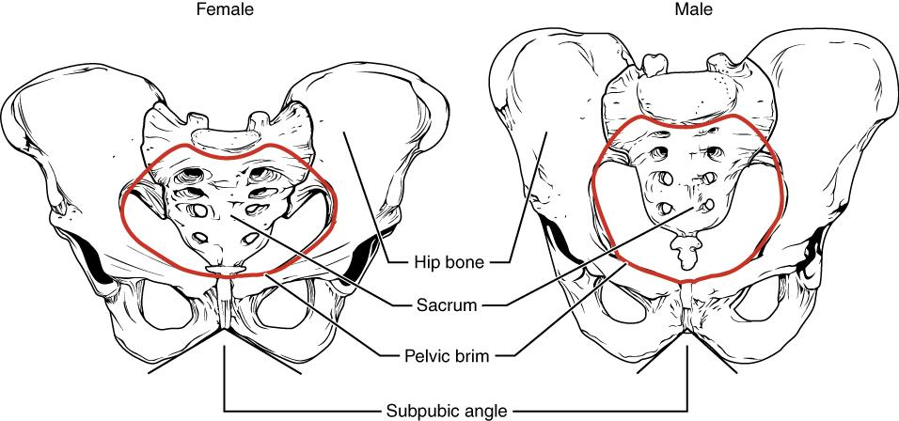
Figure 6.13 Male and Female Pelvis The female pelvis is adapted for childbirth and is broader, with a larger subpubic angle, a rounder pelvic brim, and a wider and more shallow lesser pelvic cavity than the male pelvis.

Comparison of the Female and Male Pelvis
The differences between the adult female and male pelvis relate to function and body size. In general, the bones of the male pelvis are thicker and heavier, adapted for support of the male’s heavier physical build and stronger muscles. The greater sciatic notch of the male hip bone is narrower and deeper than the broader notch of females. Because the female pelvis is adapted for childbirth, it is wider than the male pelvis, as evidenced by the distance between the anterior superior iliac spines (see Figure 6.13). The ischial tuberosities of females are also farther apart, which increases the size of the pelvic outlet. Because of this increased pelvic width, the subpubic angle is larger in females (greater than 80 degrees) than it is in males (less than 70 degrees). The female sacrum is wider, shorter, and less curved, and the sacral promontory projects less into the pelvic cavity, thus giving the female pelvic inlet (pelvic brim) a more rounded or oval shape compared to males. The lesser pelvic cavity of females is also wider and more shallow than the narrower, deeper, and tapering lesser pelvis of males. Because of the obvious differences between female and male hip bones, this is the one bone of the body that allows for the most accurate sex determination. Table 6.1 provides an overview of the general differences between the female and male pelvis.

Overview of Differences between the Female and Male Pelvis
 | Female Pelvis | Male Pelvis
Pelvic weight | Bones of the pelvis are lighter and thinner | Bones of the pelvis are thicker and heavier
Pelvic inlet shape | Pelvic inlet has a round or oval shape | Pelvic inlet is heart-shaped
Lesser pelvic cavity shape | Lesser pelvic cavity is shorter and wider | Lesser pelvic cavity is longer and narrower
Subpubic angle | Subpubic angle is greater than 80 degrees | Subpubic angle is less than 70 degrees
Pelvic outlet shape | Pelvic outlet is rounded and larger | Pelvic outlet is smaller
Table 6.1

6.4 Bones of the Lower Limb

Learning Objectives
By the end of this section, you will be able to:
- Identify the divisions of the lower limb and describe the bones of each region
- Describe the bones and bony landmarks that articulate at each joint of the lower limb
Like the upper limb, the lower limb is divided into three regions. The thigh is that portion of the lower limb located between the hip joint and knee joint. The leg is specifically the region between the knee joint and the ankle joint. Distal to the ankle is the foot. The lower limb contains 30 bones. These are the femur, patella, tibia, fibula, tarsal bones, metatarsal bones, and phalanges (see Figure 6.2). The femur is the single bone of the thigh. The patella is the kneecap and articulates with the distal femur. The tibia is the larger, weight-bearing bone located on the medial side of the leg, and the fibula is the thin bone of the lateral leg. The bones of the foot are divided into three groups. The posterior portion of the foot is formed by a group of seven bones, each of which is known as a tarsal bone, whereas the mid-foot contains five elongated bones, each of which is a metatarsal bone. The toes contain 14 small bones, each of which is a phalanx bone of the foot.

Femur
The femur, or thigh bone, is the single bone of the thigh region (Figure 6.14). It is the longest and strongest bone of the body, and accounts for approximately one-quarter of a person’s total height. The rounded, proximal end is the head of the femur, which articulates with the acetabulum of the hip bone to form the hip joint. The fovea capitis is a minor indentation on the medial side of the femoral head that serves as the site of attachment for the ligament of the head of the femur. This ligament spans the femur and acetabulum, but is weak and provides little support for the hip joint. It does, however, carry an important artery that supplies the head of the femur.
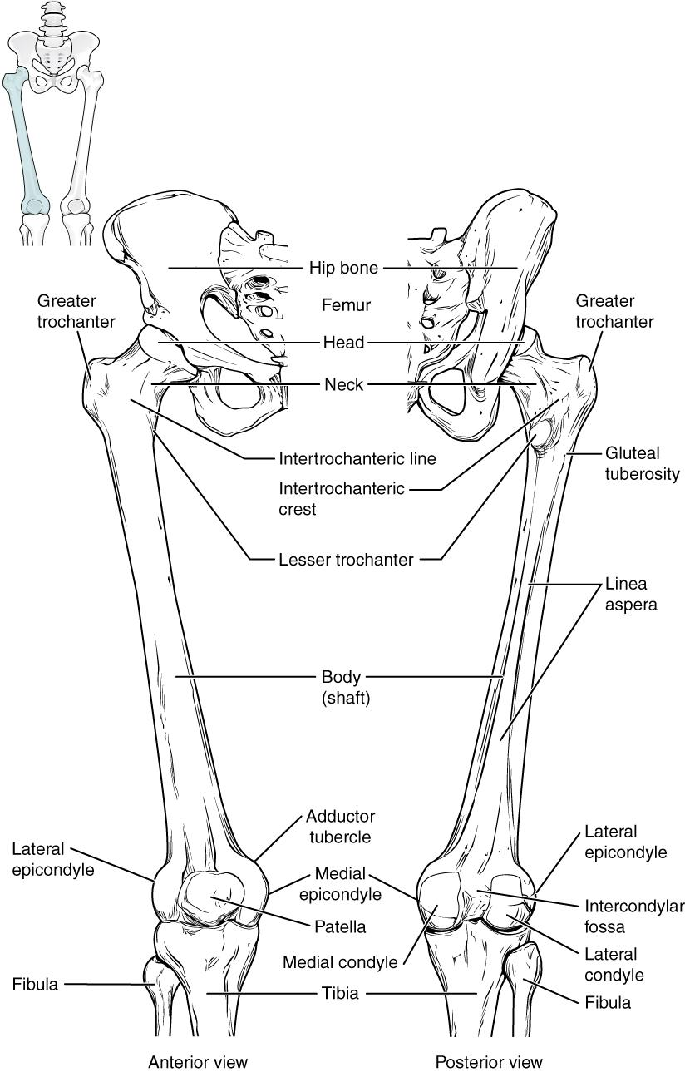
Figure 6.14 Femur and Patella The femur is the single bone of the thigh region. It articulates superiorly with the hip bone at the hip joint, and inferiorly with the tibia at the knee joint. The patella only articulates with the distal end of the femur.
The narrowed region below the head is the neck of the femur. This is a common area for fractures of the femur. The greater trochanter is the large, upward, bony projection located above the base of the neck. Multiple muscles that act across the hip joint attach to the greater trochanter, which, because of its projection from the femur, gives additional leverage to these muscles. The greater trochanter can be felt just under the skin on the lateral side of your upper thigh. The lesser trochanter is a small, bony prominence that lies on the medial aspect of the femur, just below the neck. A single, powerful muscle attaches to the lesser trochanter. Running between the greater and lesser trochanters on the anterior side of the femur is the roughened intertrochanteric line. The trochanters are also connected on the posterior side of the femur by the larger intertrochanteric crest.
The elongated shaft of the femur has a slight anterior bowing or curvature. At its proximal end, the posterior shaft has the gluteal tuberosity, a roughened area extending inferiorly from the greater trochanter. More inferiorly, the gluteal tuberosity becomes continuous with the linea aspera (“rough line”). This is the roughened ridge that passes distally along the posterior side of the mid-femur. Multiple muscles of the hip and thigh regions make long, thin attachments to the femur along the linea aspera.
The distal end of the femur has medial and lateral bony expansions. On the lateral side, the smooth portion that covers the distal and posterior aspects of the lateral expansion is the lateral condyle of the femur. The roughened area on the outer, lateral side of the condyle is the lateral epicondyle of the femur. Similarly, the smooth region of the distal and posterior medial femur is the medial condyle of the femur, and the irregular outer, medial side of this is the medial epicondyle of the femur. The lateral and medial condyles articulate with the tibia to form the knee joint. The epicondyles provide attachment for muscles and supporting ligaments of the knee. The adductor tubercle is a small bump located at the superior margin of the medial epicondyle. Posteriorly, the medial and lateral condyles are separated by a deep depression called the intercondylar fossa. Anteriorly, the smooth surfaces of the condyles join together to form a wide groove called the patellar surface, which provides for articulation with the patella bone. The combination of the medial and lateral condyles with the patellar surface gives the distal end of the femur a horseshoe (U) shape.

Patella
The patella (kneecap) is the largest sesamoid bone of the body (see Figure 6.14). A sesamoid bone is a bone that is incorporated into the tendon of a muscle where that tendon crosses a joint. The sesamoid bone articulates with the underlying bones to prevent damage to the muscle tendon due to rubbing against the bones during movements of the joint. The patella is found in the tendon of the quadriceps femoris muscle, the large muscle of the anterior thigh that passes across the anterior knee to attach to the tibia. The patella articulates with the patellar surface of the femur and thus prevents rubbing of the muscle tendon against the distal femur. The patella also lifts the tendon away from the knee joint, which increases the leverage power of the quadriceps femoris muscle as it acts across the knee. The patella does not articulate with the tibia.
Homeostatic Imbalances
Runner’s Knee
Runner’s knee, also known as patellofemoral syndrome, is the most common overuse injury among runners. It is most frequent in adolescents and young adults, and is more common in females. It often results from exercissive running, but may also occur in athletes who do a lot of knee bending, such as jumpers, skiers, cyclists, weight lifters, and soccer players. It is felt as a dull, aching pain around the front of the knee and deep to the patella. THe pain may be felt when walking or running, going up or down stairs, kneeling or squatting, or after sitting with the knee bent for an extended period.
Patellofemoral syndrome may be initiated by a variety of causes, including individual variations in the shape and movement of the patella, a direct blow to the patella, or flat feet or improper shoes that cause excessive turning in or out of the feet or leg. These factors may cause an imbalance in the muscle pull that acts on the patella, resulting in abnormal tracking of
the patella that allows it to deviate too far toward the lateral side of the patellar surface on the distal femur.
Because the hips are wider than the knee region, the femur has a diagonal orientation within the thigh, in contrast to the vertically oriented tibia of the leg (Figure 6.15). The Q-angle is a measure of how far the femur is angled laterally away from vertical. The Q-angle is normally 10-15 degrees, with females typically having a larger Q-angle due to their wider pelvis. During extension of the knee, the quadriceps femoris muscle pulls the patella both superiorly and laterally, with the lateral pull greater in women due to their large Q-angle. This makes women more vulnerable to developing patellofemoral syndrome than men.
If the pull produced by the medial and lateral sides of the quadriceps femoris muscle is not properly balanced, abnormal tracking of the patella toward the lateral side may occur. With continued use, this produces pain and could result in damage to the articulating surfaces of the patella and femur, and the possible future development of arthritis. Treatment generally involves stopping the activity that produces knee pain for a period of time, followed by a gradual resumption of activity. Proper strengthening to correct for imbalances is also important to help prevent reoccurrence
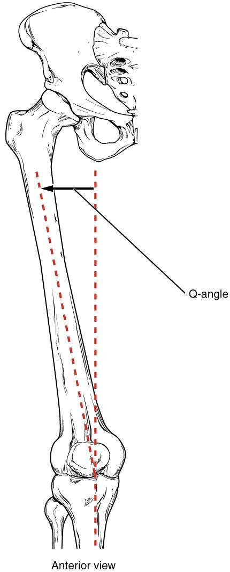
Figure 6.15 The Q-Angle The Q-angle is a measure of the amount of lateral deviation of the femur from the vertical line of the tibia. Adult females have a larger Q-angle due to their wider pelvis than adult males.

Tibia
The tibia (shin bone) is the medial bone of the leg and is larger than the fibula, with which it is paired (Figure 6.16). The tibia is the main weight-bearing bone of the lower leg and the second longest bone of the body, after the femur. The medial side of the tibia is located immediately under the skin, allowing it to be easily palpated down the entire length of the medial leg.
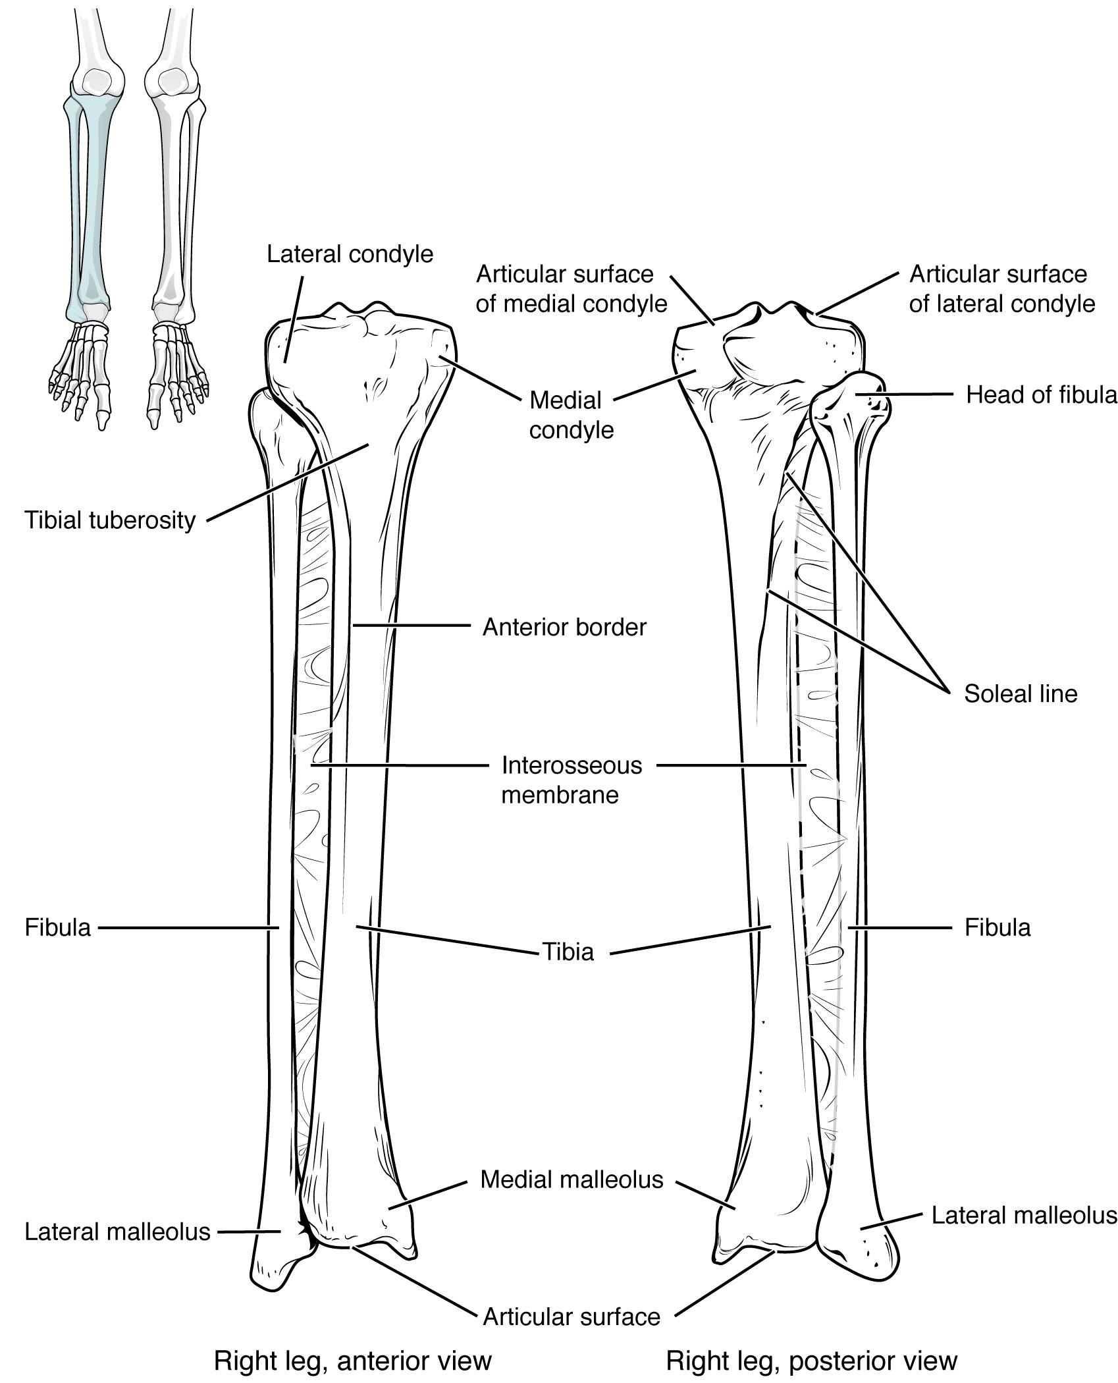
Figure 6.16 Tibia and Fibula The tibia is the larger, weight-bearing bone located on the medial side of the leg. The fibula is the slender bone of the lateral side of the leg and does not bear weight.
The proximal end of the tibia is greatly expanded. The two sides of this expansion form the medial condyle of the tibia and the lateral condyle of the tibia. The tibia does not have epicondyles. The top surface of each condyle is smooth and flattened. These areas articulate with the medial and lateral condyles of the femur to form the knee joint. Between the articulating surfaces of the tibial condyles is the intercondylar eminence, an irregular, elevated area that serves as the inferior attachment point for two supporting ligaments of the knee.
The tibial tuberosity is an elevated area on the anterior side of the tibia, near its proximal end. It is the final site of attachment for the muscle tendon associated with the patella. More inferiorly, the shaft of the tibia becomes triangular in shape.
The anterior apex of this triangle forms the anterior border of the tibia, which begins at the tibial tuberosity and runs inferiorly along the length of the tibia. Both the anterior border and the medial side of the triangular shaft are located immediately under the skin and can be easily palpated along the entire length of the tibia. A small ridge running down the lateral side of the tibial shaft is the interosseous border of the tibia. This is for the attachment of the interosseous membrane of the leg, the sheet of dense connective tissue that unites the tibia and fibula bones. Located on the posterior side of the tibia is the soleal line, a diagonally running, roughened ridge that begins below the base of the lateral condyle, and runs down and medially across the proximal third of the posterior tibia. Muscles of the posterior leg attach to this line.
The large expansion found on the medial side of the distal tibia is the medial malleolus (“little hammer”). This forms the large bony bump found on the medial side of the ankle region. Both the smooth surface on the inside of the medial malleolus and the smooth area at the distal end of the tibia articulate with the talus bone of the foot as part of the ankle joint. On the lateral side of the distal tibia is a wide groove called the fibular notch. This area articulates with the distal end of the fibula, forming the distal tibiofibular joint.

Fibula
The fibula is the slender bone located on the lateral side of the leg (see Figure 6.16). The fibula does not bear weight. It serves primarily for muscle attachments and thus is largely surrounded by muscles. Only the proximal and distal ends of the fibula can be palpated.
The head of the fibula is the small, knob-like, proximal end of the fibula. It articulates with the inferior aspect of the lateral tibial condyle, forming the proximal tibiofibular joint. The thin shaft of the fibula has the interosseous border of the fibula, a narrow ridge running down its medial side for the attachment of the interosseous membrane that spans the fibula and tibia. The distal end of the fibula forms the lateral malleolus, which forms the easily palpated bony bump on the lateral side of the ankle. The deep (medial) side of the lateral malleolus articulates with the talus bone of the foot as part of the ankle joint. The distal fibula also articulates with the fibular notch of the tibia.

Tarsal Bones
The posterior half of the foot is formed by seven tarsal bones (Figure 6.17). The most superior bone is the talus. This has a relatively square-shaped, upper surface that articulates with the tibia and fibula to form the ankle joint. Three areas of articulation form the ankle joint: The superomedial surface of the talus bone articulates with the medial malleolus of the tibia, the top of the talus articulates with the distal end of the tibia, and the lateral side of the talus articulates with the lateral malleolus of the fibula. Inferiorly, the talus articulates with the calcaneus (heel bone), the largest bone of the foot, which forms the heel. Body weight is transferred from the tibia to the talus to the calcaneus, which rests on the ground. The medial calcaneus has a prominent bony extension called the sustentaculum tali (“support for the talus”) that supports the medial side of the talus bone.
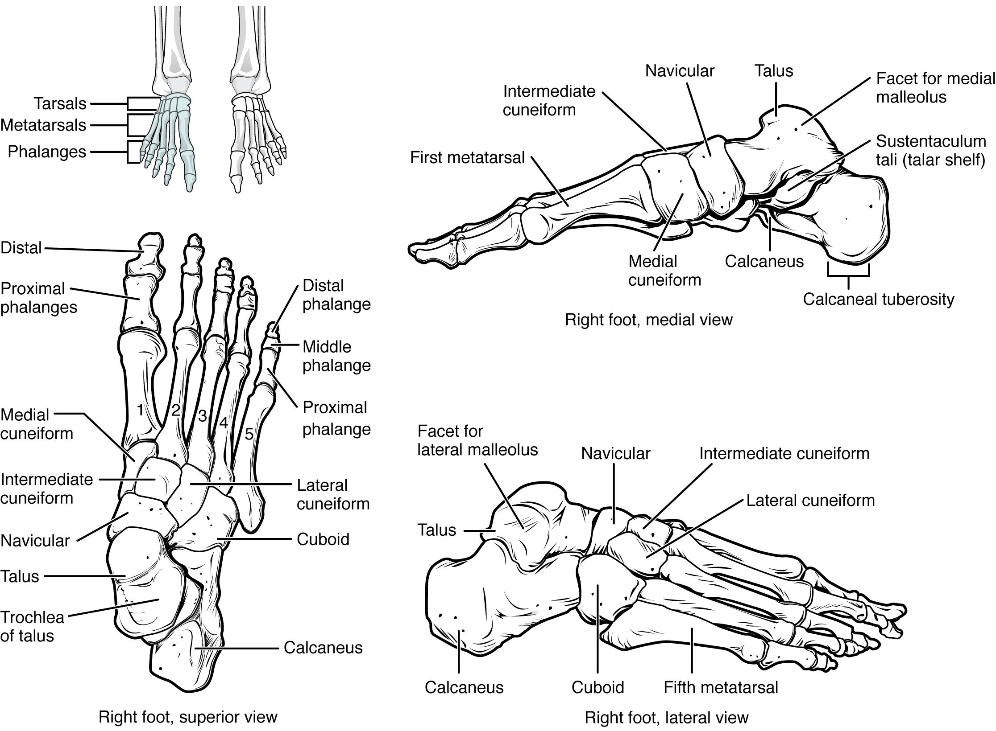
Figure 6.17 Bones of the Foot The bones of the foot are divided into three groups. The posterior foot is formed by the seven tarsal bones. The mid-foot has the five metatarsal bones. The toes contain the phalanges.

The cuboid bone articulates with the anterior end of the calcaneus bone. The cuboid has a deep groove running across its inferior surface, which provides passage for a muscle tendon. The talus bone articulates anteriorly with the navicular bone, which in turn articulates anteriorly with the three cuneiform (“wedge-shaped”) bones. These bones are the medial cuneiform, the intermediate cuneiform, and the lateral cuneiform. Each of these bones has a broad superior surface and a narrow inferior surface, which together produce the transverse (medial-lateral) curvature of the foot. The navicular and lateral cuneiform bones also articulate with the medial side of the cuboid bone.
Interactive Link
Use this tutorial to review the bones of the foot. Which tarsal bones are in the proximal, intermediate, and distal groups?

Metatarsal Bones
The anterior half of the foot is formed by the five metatarsal bones, which are located between the tarsal bones of the posterior foot and the phalanges of the toes (see Figure 6.17). These elongated bones are numbered 1–5, starting with the medial side of the foot. The first metatarsal bone is shorter and thicker than the others. The second metatarsal is the longest. The base of the metatarsal bone is the proximal end of each metatarsal bone. These articulate with the cuboid or cuneiform bones. The base of the fifth metatarsal has a large, lateral expansion that provides for muscle attachments. This expanded base of the fifth metatarsal can be felt as a bony bump at the midpoint along the lateral border of the foot. The expanded distal end of each metatarsal is the head of the metatarsal bone. Each metatarsal bone articulates with the proximal phalanx of a toe to form a metatarsophalangeal joint. The heads of the metatarsal bones also rest on the ground and form the ball (anterior end) of the foot.

Phalanges
The toes contain a total of 14 phalanx bones (phalanges), arranged in a similar manner as the phalanges of the fingers (see Figure 6.17). The toes are numbered 1–5, starting with the big toe (hallux). The big toe has two phalanx bones, the proximal and distal phalanges. The remaining toes all have proximal, middle, and distal phalanges. A joint between adjacent phalanx bones is called an interphalangeal joint.

Arches of the Foot
When the foot comes into contact with the ground during walking, running, or jumping activities, the impact of the body weight puts a tremendous amount of pressure and force on the foot. During running, the force applied to each foot as it contacts the ground can be up to 2.5 times your body weight. The bones, joints, ligaments, and muscles of the foot absorb this force, thus greatly reducing the amount of shock that is passed superiorly into the lower limb and body. The arches of the foot play an important role in this shock-absorbing ability. When weight is applied to the foot, these arches will flatten somewhat, thus absorbing energy. When the weight is removed, the arch rebounds, giving “spring” to the step. The arches also serve to distribute body weight side to side and to either end of the foot.
The foot has a transverse arch, a medial longitudinal arch, and a lateral longitudinal arch (see Figure 6.17). The transverse arch forms the medial-lateral curvature of the mid-foot. It is formed by the wedge shapes of the cuneiform bones and bases (proximal ends) of the first to fourth metatarsal bones. This arch helps to distribute body weight from side to side within the foot, thus allowing the foot to accommodate uneven terrain.
The longitudinal arches run down the length of the foot. The lateral longitudinal arch is relatively flat, whereas the medial longitudinal arch is larger (taller). The longitudinal arches are formed by the tarsal bones posteriorly and the metatarsal bones anteriorly. These arches are supported at either end, where they contact the ground. Posteriorly, this support is provided by the calcaneus bone and anteriorly by the heads (distal ends) of the metatarsal bones. The talus bone, which receives the weight of the body, is located at the top of the longitudinal arches. Body weight is then conveyed from the talus to the ground by the anterior and posterior ends of these arches. Strong ligaments unite the adjacent foot bones to prevent disruption of the arches during weight bearing. On the bottom of the foot, additional ligaments tie together the anterior and posterior ends of the arches. These ligaments have elasticity, which allows them to stretch somewhat during weight bearing, thus allowing the longitudinal arches to spread. The stretching of these ligaments stores energy within the foot, rather than passing these forces into the leg. Contraction of the foot muscles also plays an important role in this energy absorption. When the weight is removed, the elastic ligaments recoil and pull the ends of the arches closer together. This recovery of the arches releases the stored energy and improves the energy efficiency of walking.

6.5 Development of the Appendicular Skeleton

Learning Objectives
By the end of this section, you will be able to:
- Discuss the appearance of primary and secondary ossification centers

Ossification of Appendicular Bones
All of the girdle and limb bones, except for the clavicle, develop by the process of endochondral ossification. This process begins as the mesenchyme within the limb bud differentiates into hyaline cartilage to form cartilage models for future bones. By the twelfth week, a primary ossification center will have appeared in the diaphysis (shaft) region of the long bones, initiating the process that converts the cartilage model into bone. A secondary ossification center will appear in each epiphysis (expanded end) of these bones at a later time, usually after birth. The primary and secondary ossification centers are separated by the epiphyseal plate, a layer of growing hyaline cartilage. This plate is located between the diaphysis and each epiphysis. It continues to grow and is responsible for the lengthening of the bone. The epiphyseal plate is retained for many years, until the bone reaches its final, adult size, at which time the epiphyseal plate disappears and the epiphysis fuses to the diaphysis. (Seek additional content on ossification in the chapter on bone tissue.)
Small bones, such as the phalanges, will develop only one secondary ossification center and will thus have only a single epiphyseal plate. Large bones, such as the femur, will develop several secondary ossification centers, with an epiphyseal plate associated with each secondary center. Thus, ossification of the femur begins at the end of the seventh week with the appearance of the primary ossification center in the diaphysis, which rapidly expands to ossify the shaft of the bone prior to birth. Secondary ossification centers develop at later times. Ossification of the distal end of the femur, to form the condyles and epicondyles, begins shortly before birth. Secondary ossification centers also appear in the femoral head late in the first year after birth, in the greater trochanter during the fourth year, and in the lesser trochanter between the ages of 9 and 10 years. Once these areas have ossified, their fusion to the diaphysis and the disappearance of each epiphyseal plate follow a reversed sequence. Thus, the lesser trochanter is the first to fuse, doing so at the onset of puberty (around 11 years of age), followed by the greater trochanter approximately 1 year later. The femoral head fuses between the ages of 14–17 years, whereas the distal condyles of the femur are the last to fuse, between the ages of 16–19 years. Knowledge of the age at which different epiphyseal plates disappear is important when interpreting radiographs taken of children. Since the cartilage of an epiphyseal plate is less dense than bone, the plate will appear dark in a radiograph image. Thus, a normal epiphyseal plate may be mistaken for a bone fracture.
The clavicle is the one appendicular skeleton bone that does not develop via endochondral ossification. Instead, the clavicle develops through the process of intramembranous ossification. During this process, mesenchymal cells differentiate directly into bone-producing cells, which produce the clavicle directly, without first making a cartilage model. Because of this early production of bone, the clavicle is the first bone of the body to begin ossification, with ossification centers appearing during the fifth week of development. However, ossification of the clavicle is not complete until age 25.

Key Terms

acetabulum large, cup-shaped cavity located on the lateral side of the hip bone; formed by the junction of the ilium, pubis, and ischium portions of the hip bone

acromial end of the clavicle lateral end of the clavicle that articulates with the acromion of the scapula

acromial process acromion of the scapula

acromioclavicular joint articulation between the acromion of the scapula and the acromial end of the clavicle

acromion flattened bony process that extends laterally from the scapular spine to form the bony tip of the shoulder

adductor tubercle small, bony bump located on the superior aspect of the medial epicondyle of the femur

anatomical neck line on the humerus located around the outside margin of the humeral head

ankle joint joint that separates the leg and foot portions of the lower limb; formed by the articulations between the talus bone of the foot inferiorly, and the distal end of the tibia, medial malleolus of the tibia, and lateral malleolus of the fibula superiorly

anterior border of the tibia narrow, anterior margin of the tibia that extends inferiorly from the tibial tuberosity

anterior inferior iliac spine small, bony projection located on the anterior margin of the ilium, below the anterior superior iliac spine

anterior superior iliac spine rounded, anterior end of the iliac crest

arm region of the upper limb located between the shoulder and elbow joints; contains the humerus bone

auricular surface of the ilium roughened area located on the posterior, medial side of the ilium of the hip bone; articulates with the auricular surface of the sacrum to form the sacroiliac joint

base of the metatarsal bone expanded, proximal end of each metatarsal bone

bicipital groove intertubercular groove; narrow groove located between the greater and lesser tubercles of the humerus

calcaneus heel bone; posterior, inferior tarsal bone that forms the heel of the foot

capitate from the lateral side, the third of the four distal carpal bones; articulates with the scaphoid and lunate proximally, the trapezoid laterally, the hamate medially, and primarily with the third metacarpal distally

capitulum knob-like bony structure located anteriorly on the lateral, distal end of the humerus

carpal bone one of the eight small bones that form the wrist and base of the hand; these are grouped as a proximal row consisting of (from lateral to medial) the scaphoid, lunate, triquetrum, and pisiform bones, and a distal row containing (from lateral to medial) the trapezium, trapezoid, capitate, and hamate bones

carpal tunnel passageway between the anterior forearm and hand formed by the carpal bones and flexor retinaculum

carpometacarpal joint articulation between one of the carpal bones in the distal row and a metacarpal bone of the hand

clavicle collarbone; elongated bone that articulates with the manubrium of the sternum medially and the acromion of the scapula laterally

coracoclavicular ligament strong band of connective tissue that anchors the coracoid process of the scapula to the lateral clavicle; provides important indirect support for the acromioclavicular joint

coracoid process short, hook-like process that projects anteriorly and laterally from the superior margin of the scapula

coronoid fossa depression on the anterior surface of the humerus above the trochlea; this space receives the coronoid process of the ulna when the elbow is maximally flexed

coronoid process of the ulna projecting bony lip located on the anterior, proximal ulna; forms the inferior margin of the trochlear notch

costoclavicular ligament band of connective tissue that unites the medial clavicle with the first rib

coxal bone hip bone

cuboid tarsal bone that articulates posteriorly with the calcaneus bone, medially with the lateral cuneiform bone, and anteriorly with the fourth and fifth metatarsal bones

deltoid tuberosity roughened, V-shaped region located laterally on the mid-shaft of the humerus

distal radioulnar joint articulation between the head of the ulna and the ulnar notch of the radius

distal tibiofibular joint articulation between the distal fibula and the fibular notch of the tibia

elbow joint joint located between the upper arm and forearm regions of the upper limb; formed by the articulations between the trochlea of the humerus and the trochlear notch of the ulna, and the capitulum of the humerus and the head of the radius

femur thigh bone; the single bone of the thigh

fibula thin, non-weight-bearing bone found on the lateral side of the leg

fibular notch wide groove on the lateral side of the distal tibia for articulation with the fibula at the distal tibiofibular joint

flexor retinaculum strong band of connective tissue at the anterior wrist that spans the top of the U-shaped grouping of the carpal bones to form the roof of the carpal tunnel

foot portion of the lower limb located distal to the ankle joint

forearm region of the upper limb located between the elbow and wrist joints; contains the radius and ulna bones

fossa (plural = fossae) shallow depression on the surface of a bone

fovea capitis minor indentation on the head of the femur that serves as the site of attachment for the ligament to the head of the femur

glenohumeral joint shoulder joint; formed by the articulation between the glenoid cavity of the scapula and the head of the humerus

glenoid cavity (also, glenoid fossa) shallow depression located on the lateral scapula, between the superior and lateral borders

gluteal tuberosity roughened area on the posterior side of the proximal femur, extending inferiorly from the base of the greater trochanter

greater pelvis (also, greater pelvic cavity or false pelvis) broad space above the pelvic brim defined laterally by the fan-like portion of the upper ilium

greater sciatic notch large, U-shaped indentation located on the posterior margin of the ilium, superior to the ischial spine

greater trochanter large, bony expansion of the femur that projects superiorly from the base of the femoral neck

greater tubercle enlarged prominence located on the lateral side of the proximal humerus

hallux big toe; digit 1 of the foot

hamate from the lateral side, the fourth of the four distal carpal bones; articulates with the lunate and triquetrum proximally, the fourth and fifth metacarpals distally, and the capitate laterally

hand region of the upper limb distal to the wrist joint

head of the femur rounded, proximal end of the femur that articulates with the acetabulum of the hip bone to form the hip joint

head of the fibula small, knob-like, proximal end of the fibula; articulates with the inferior aspect of the lateral condyle of the tibia

head of the humerus smooth, rounded region on the medial side of the proximal humerus; articulates with the glenoid fossa of the scapula to form the glenohumeral (shoulder) joint

head of the metatarsal bone expanded, distal end of each metatarsal bone

head of the radius disc-shaped structure that forms the proximal end of the radius; articulates with the capitulum of the humerus as part of the elbow joint, and with the radial notch of the ulna as part of the proximal radioulnar joint

head of the ulna small, rounded distal end of the ulna; articulates with the ulnar notch of the distal radius, forming the distal radioulnar joint

hip joint joint located at the proximal end of the lower limb; formed by the articulation between the acetabulum of the hip bone and the head of the femur

hook of the hamate bone bony extension located on the anterior side of the hamate carpal bone

humerus single bone of the upper arm

iliac crest curved, superior margin of the ilium

iliac fossa shallow depression found on the anterior and medial surfaces of the upper ilium

ilium superior portion of the hip bone

inferior angle of the scapula inferior corner of the scapula located where the medial and lateral borders meet

inferior pubic ramus narrow segment of bone that passes inferiorly and laterally from the pubic body

infraglenoid tubercle small bump or roughened area located on the lateral border of the scapula, near the inferior margin of the glenoid cavity

infraspinous fossa broad depression located on the posterior scapula, inferior to the spine

intercondylar eminence irregular elevation on the superior end of the tibia, between the articulating surfaces of the medial and lateral condyles

intercondylar fossa deep depression on the posterior side of the distal femur that separates the medial and lateral condyles

intermediate cuneiform middle of the three cuneiform tarsal bones; articulates posteriorly with the navicular bone, medially with the medial cuneiform bone, laterally with the lateral cuneiform bone, and anteriorly with the second metatarsal bone

interosseous border of the fibula small ridge running down the medial side of the fibular shaft; for attachment of the interosseous membrane between the fibula and tibia

interosseous border of the radius narrow ridge located on the medial side of the radial shaft; for attachment of the interosseous membrane between the ulna and radius bones

interosseous border of the tibia small ridge running down the lateral side of the tibial shaft; for attachment of the interosseous membrane between the tibia and fibula

interosseous border of the ulna narrow ridge located on the lateral side of the ulnar shaft; for attachment of the interosseous membrane between the ulna and radius

interosseous membrane of the forearm sheet of dense connective tissue that unites the radius and ulna bones

interosseous membrane of the leg sheet of dense connective tissue that unites the shafts of the tibia and fibula bones

interphalangeal joint articulation between adjacent phalanx bones of the hand or foot digits

intertrochanteric crest short, prominent ridge running between the greater and lesser trochanters on the posterior side of the proximal femur

intertrochanteric line small ridge running between the greater and lesser trochanters on the anterior side of the proximal femur

intertubercular groove (sulcus) bicipital groove; narrow groove located between the greater and lesser tubercles of the humerus

ischial ramus bony extension projecting anteriorly and superiorly from the ischial tuberosity

ischial spine pointed, bony projection from the posterior margin of the ischium that separates the greater sciatic notch and lesser sciatic notch

ischial tuberosity large, roughened protuberance that forms the posteroinferior portion of the hip bone; weight-bearing region of the pelvis when sitting

ischium posteroinferior portion of the hip bone

knee joint joint that separates the thigh and leg portions of the lower limb; formed by the articulations between the medial and lateral condyles of the femur, and the medial and lateral condyles of the tibia

lateral border of the scapula diagonally oriented lateral margin of the scapula

lateral condyle of the femur smooth, articulating surface that forms the distal and posterior sides of the lateral expansion of the distal femur

lateral condyle of the tibia lateral, expanded region of the proximal tibia that includes the smooth surface that articulates with the lateral condyle of the femur as part of the knee joint

lateral cuneiform most lateral of the three cuneiform tarsal bones; articulates posteriorly with the navicular bone, medially with the intermediate cuneiform bone, laterally with the cuboid bone, and anteriorly with the third metatarsal bone

lateral epicondyle of the femur roughened area of the femur located on the lateral side of the lateral condyle

lateral epicondyle of the humerus small projection located on the lateral side of the distal humerus

lateral malleolus expanded distal end of the fibula

lateral supracondylar ridge narrow, bony ridge located along the lateral side of the distal humerus, superior to the lateral epicondyle

leg portion of the lower limb located between the knee and ankle joints

lesser pelvis (also, lesser pelvic cavity or true pelvis) narrow space located within the pelvis, defined superiorly by the pelvic brim (pelvic inlet) and inferiorly by the pelvic outlet

lesser sciatic notch shallow indentation along the posterior margin of the ischium, inferior to the ischial spine

lesser trochanter small, bony projection on the medial side of the proximal femur, at the base of the femoral neck

lesser tubercle small, bony prominence located on anterior side of the proximal humerus

ligament of the head of the femur ligament that spans the acetabulum of the hip bone and the fovea capitis of the femoral head

linea aspera longitudinally running bony ridge located in the middle third of the posterior femur

lunate from the lateral side, the second of the four proximal carpal bones; articulates with the radius proximally, the capitate and hamate distally, the scaphoid laterally, and the triquetrum medially

medial border of the scapula elongated, medial margin of the scapula

medial condyle of the femur smooth, articulating surface that forms the distal and posterior sides of the medial expansion of the distal femur

medial condyle of the tibia medial, expanded region of the proximal tibia that includes the smooth surface that articulates with the medial condyle of the femur as part of the knee joint

medial cuneiform most medial of the three cuneiform tarsal bones; articulates posteriorly with the navicular bone, laterally with the intermediate cuneiform bone, and anteriorly with the first and second metatarsal bones

medial epicondyle of the femur roughened area of the distal femur located on the medial side of the medial condyle

medial epicondyle of the humerus enlarged projection located on the medial side of the distal humerus

medial malleolus bony expansion located on the medial side of the distal tibia

metacarpal bone one of the five long bones that form the palm of the hand; numbered 1–5, starting on the lateral (thumb) side of the hand

metacarpophalangeal joint articulation between the distal end of a metacarpal bone of the hand and a proximal phalanx bone of the thumb or a finger

metatarsal bone one of the five elongated bones that forms the anterior half of the foot; numbered 1–5, starting on the medial side of the foot

metatarsophalangeal joint articulation between a metatarsal bone of the foot and the proximal phalanx bone of a toe

midcarpal joint articulation between the proximal and distal rows of the carpal bones; contributes to movements of the hand at the wrist

navicular tarsal bone that articulates posteriorly with the talus bone, laterally with the cuboid bone, and anteriorly with the medial, intermediate, and lateral cuneiform bones

neck of the femur narrowed region located inferior to the head of the femur

neck of the radius narrowed region immediately distal to the head of the radius

obturator foramen large opening located in the anterior hip bone, between the pubis and ischium regions

olecranon fossa large depression located on the posterior side of the distal humerus; this space receives the olecranon process of the ulna when the elbow is fully extended

olecranon process expanded posterior and superior portions of the proximal ulna; forms the bony tip of the elbow

patella kneecap; the largest sesamoid bone of the body; articulates with the distal femur

patellar surface smooth groove located on the anterior side of the distal femur, between the medial and lateral condyles; site of articulation for the patella

pectoral girdle shoulder girdle; the set of bones, consisting of the scapula and clavicle, which attaches each upper limb to the axial skeleton

pelvic brim pelvic inlet; the dividing line between the greater and lesser pelvic regions; formed by the superior margin of the pubic symphysis, the pectineal lines of each pubis, the arcuate lines of each ilium, and the sacral promontory

pelvic girdle hip girdle; consists of a single hip bone, which attaches a lower limb to the sacrum of the axial skeleton

pelvic inlet pelvic brim

pelvic outlet inferior opening of the lesser pelvis; formed by the inferior margin of the pubic symphysis, right and left ischiopubic rami and sacrotuberous ligaments, and the tip of the coccyx

pelvis ring of bone consisting of the right and left hip bones, the sacrum, and the coccyx

phalanx bone of the foot (plural = phalanges) one of the 14 bones that form the toes; these include the proximal and distal phalanges of the big toe, and the proximal, middle, and distal phalanx bones of toes two through five

phalanx bone of the hand (plural = phalanges) one of the 14 bones that form the thumb and fingers; these include the proximal and distal phalanges of the thumb, and the proximal, middle, and distal phalanx bones of the fingers two through five

pisiform from the lateral side, the fourth of the four proximal carpal bones; articulates with the anterior surface of the triquetrum

pollex (also, thumb) digit 1 of the hand

posterior inferior iliac spine small, bony projection located at the inferior margin of the auricular surface on the posterior ilium

posterior superior iliac spine rounded, posterior end of the iliac crest

proximal radioulnar joint articulation formed by the radial notch of the ulna and the head of the radius

proximal tibiofibular joint articulation between the head of the fibula and the inferior aspect of the lateral condyle of the tibia

pubic arch bony structure formed by the pubic symphysis, and the bodies and inferior pubic rami of the right and left pubic bones

pubic body enlarged, medial portion of the pubis region of the hip bone

pubic symphysis joint formed by the articulation between the pubic bodies of the right and left hip bones

pubic tubercle small bump located on the superior aspect of the pubic body

pubis anterior portion of the hip bone

radial fossa small depression located on the anterior humerus above the capitulum; this space receives the head of the radius when the elbow is maximally flexed

radial notch of the ulna small, smooth area on the lateral side of the proximal ulna; articulates with the head of the radius as part of the proximal radioulnar joint

radial tuberosity oval-shaped, roughened protuberance located on the medial side of the proximal radius

radiocarpal joint wrist joint, located between the forearm and hand regions of the upper limb; articulation formed proximally by the distal end of the radius and the fibrocartilaginous pad that unites the distal radius and ulna bone, and distally by the scaphoid, lunate, and triquetrum carpal bones

radius bone located on the lateral side of the forearm

sacroiliac joint joint formed by the articulation between the auricular surfaces of the sacrum and ilium

scaphoid from the lateral side, the first of the four proximal carpal bones; articulates with the radius proximally, the trapezoid, trapezium, and capitate distally, and the lunate medially

scapula shoulder blade bone located on the posterior side of the shoulder

shaft of the femur cylindrically shaped region that forms the central portion of the femur

shaft of the fibula elongated, slender portion located between the expanded ends of the fibula

shaft of the humerus narrow, elongated, central region of the humerus

shaft of the radius narrow, elongated, central region of the radius

shaft of the tibia triangular-shaped, central portion of the tibia

shaft of the ulna narrow, elongated, central region of the ulna

soleal line small, diagonally running ridge located on the posterior side of the proximal tibia

spine of the scapula prominent ridge passing mediolaterally across the upper portion of the posterior scapular surface

sternal end of the clavicle medial end of the clavicle that articulates with the manubrium of the sternum

sternoclavicular joint articulation between the manubrium of the sternum and the sternal end of the clavicle; forms the only bony attachment between the pectoral girdle of the upper limb and the axial skeleton

styloid process of the radius pointed projection located on the lateral end of the distal radius

styloid process of the ulna short, bony projection located on the medial end of the distal ulna

subscapular fossa broad depression located on the anterior (deep) surface of the scapula

superior angle of the scapula corner of the scapula between the superior and medial borders of the scapula

superior border of the scapula superior margin of the scapula

superior pubic ramus narrow segment of bone that passes laterally from the pubic body to join the ilium

supraglenoid tubercle small bump located at the superior margin of the glenoid cavity

suprascapular notch small notch located along the superior border of the scapula, medial to the coracoid process

supraspinous fossa narrow depression located on the posterior scapula, superior to the spine

surgical neck region of the humerus where the expanded, proximal end joins with the narrower shaft

sustentaculum tali bony ledge extending from the medial side of the calcaneus bone

talus tarsal bone that articulates superiorly with the tibia and fibula at the ankle joint; also articulates inferiorly with the calcaneus bone and anteriorly with the navicular bone

tarsal bone one of the seven bones that make up the posterior foot; includes the calcaneus, talus, navicular, cuboid, medial cuneiform, intermediate cuneiform, and lateral cuneiform bones

thigh portion of the lower limb located between the hip and knee joints

tibia shin bone; the large, weight-bearing bone located on the medial side of the leg

tibial tuberosity elevated area on the anterior surface of the proximal tibia

trapezium from the lateral side, the first of the four distal carpal bones; articulates with the scaphoid proximally, the first and second metacarpals distally, and the trapezoid medially

trapezoid from the lateral side, the second of the four distal carpal bones; articulates with the scaphoid proximally, the second metacarpal distally, the trapezium laterally, and the capitate medially

triquetrum from the lateral side, the third of the four proximal carpal bones; articulates with the lunate laterally, the hamate distally, and has a facet for the pisiform

trochlea pulley-shaped region located medially at the distal end of the humerus; articulates at the elbow with the trochlear notch of the ulna

trochlear notch large, C-shaped depression located on the anterior side of the proximal ulna; articulates at the elbow with the trochlea of the humerus

ulna bone located on the medial side of the forearm

ulnar notch of the radius shallow, smooth area located on the medial side of the distal radius; articulates with the head of the ulna at the distal radioulnar joint

ulnar tuberosity roughened area located on the anterior, proximal ulna inferior to the coronoid process

7 | THE MUSCULAR SYSTEM
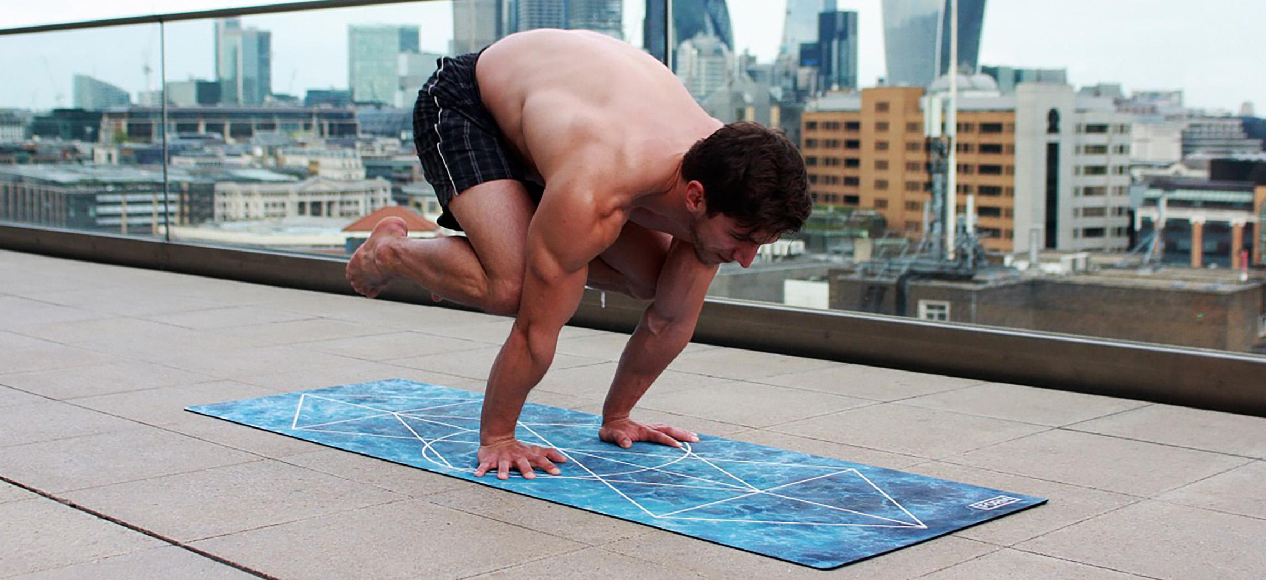
Figure 7.1 A Body in Motion The muscular system allows us to move, flex and contort our bodies. Practicing yoga, as pictured here, is a good example of the voluntary use of the muscular system. (credit: Dmitry Yanchylenko)

Chapter Objectives
After studying this chapter, you will be able to:
- Describe the actions and roles of agonists and antagonists
- Explain the structure and organization of muscle fascicles and their role in generating force
- Explain the criteria used to name skeletal muscles
- Identify the skeletal muscles and their actions on the skeleton and soft tissues of the body
- Identify the origins and insertions of skeletal muscles and the prime movements

Introduction
Think about the things that you do each day—talking, walking, sitting, standing, and running—all of these activities require movement of particular skeletal muscles. Skeletal muscles are even used during sleep. The diaphragm is a sheet of skeletal muscle that has to contract and relax for you to breathe day and night. If you recall from your study of the skeletal system and joints, body movement occurs around the joints in the body. The focus of this chapter is on skeletal muscle organization. The system to name skeletal muscles will be explained; in some cases, the muscle is named by its shape, and in other cases it is named by its location or attachments to the skeleton. If you understand the meaning of the name of the muscle, often it will help you remember its location and/or what it does. This chapter also will describe how skeletal muscles are arranged to accomplish movement, and how other muscles may assist, or be arranged on the skeleton to resist or carry out the opposite movement. The actions of the skeletal muscles will be covered in a regional manner, working from the head down to the toes.

7.1 Interactions of Skeletal Muscles, Their Fascicle Arrangement, and Their Lever Systems

Learning Objectives
By the end of this section, you will be able to:
- Compare and contrast agonist and antagonist muscles
- Describe how fascicles are arranged within a skeletal muscle
- Explain the major events of a skeletal muscle contraction within a muscle in generating force
To move the skeleton, the tension created by the contraction of the fibers in most skeletal muscles is transferred to the tendons. The tendons are strong bands of dense, regular connective tissue that connect muscles to bones. The bone connection is why this muscle tissue is called skeletal muscle.

Interactions of Skeletal Muscles in the Body
To pull on a bone, that is, to change the angle at its joint, which essentially moves the skeleton, a skeletal muscle must also be attached to a fixed part of the skeleton. The moveable end of the muscle that attaches to the bone being pulled is called the muscle’s insertion, and the end of the muscle attached to a fixed (stabilized) bone is called the origin. During elbow flexion—bending the elbow—a muscle called the biceps brachii contracts pulling its insertion on the radius toward its origin on the humerus.
Although a number of muscles may be involved in an action, the principal muscle involved is called the prime mover, or agonist. To lift a cup, the biceps brachii muscle is the prime mover of elbow flexion; however, because it can be assisted by a muscle called the brachialis, the brachialis is called a synergist in this action (Figure 7.2). A synergist can also be a fixator that holds an origin site stable for the prime mover.
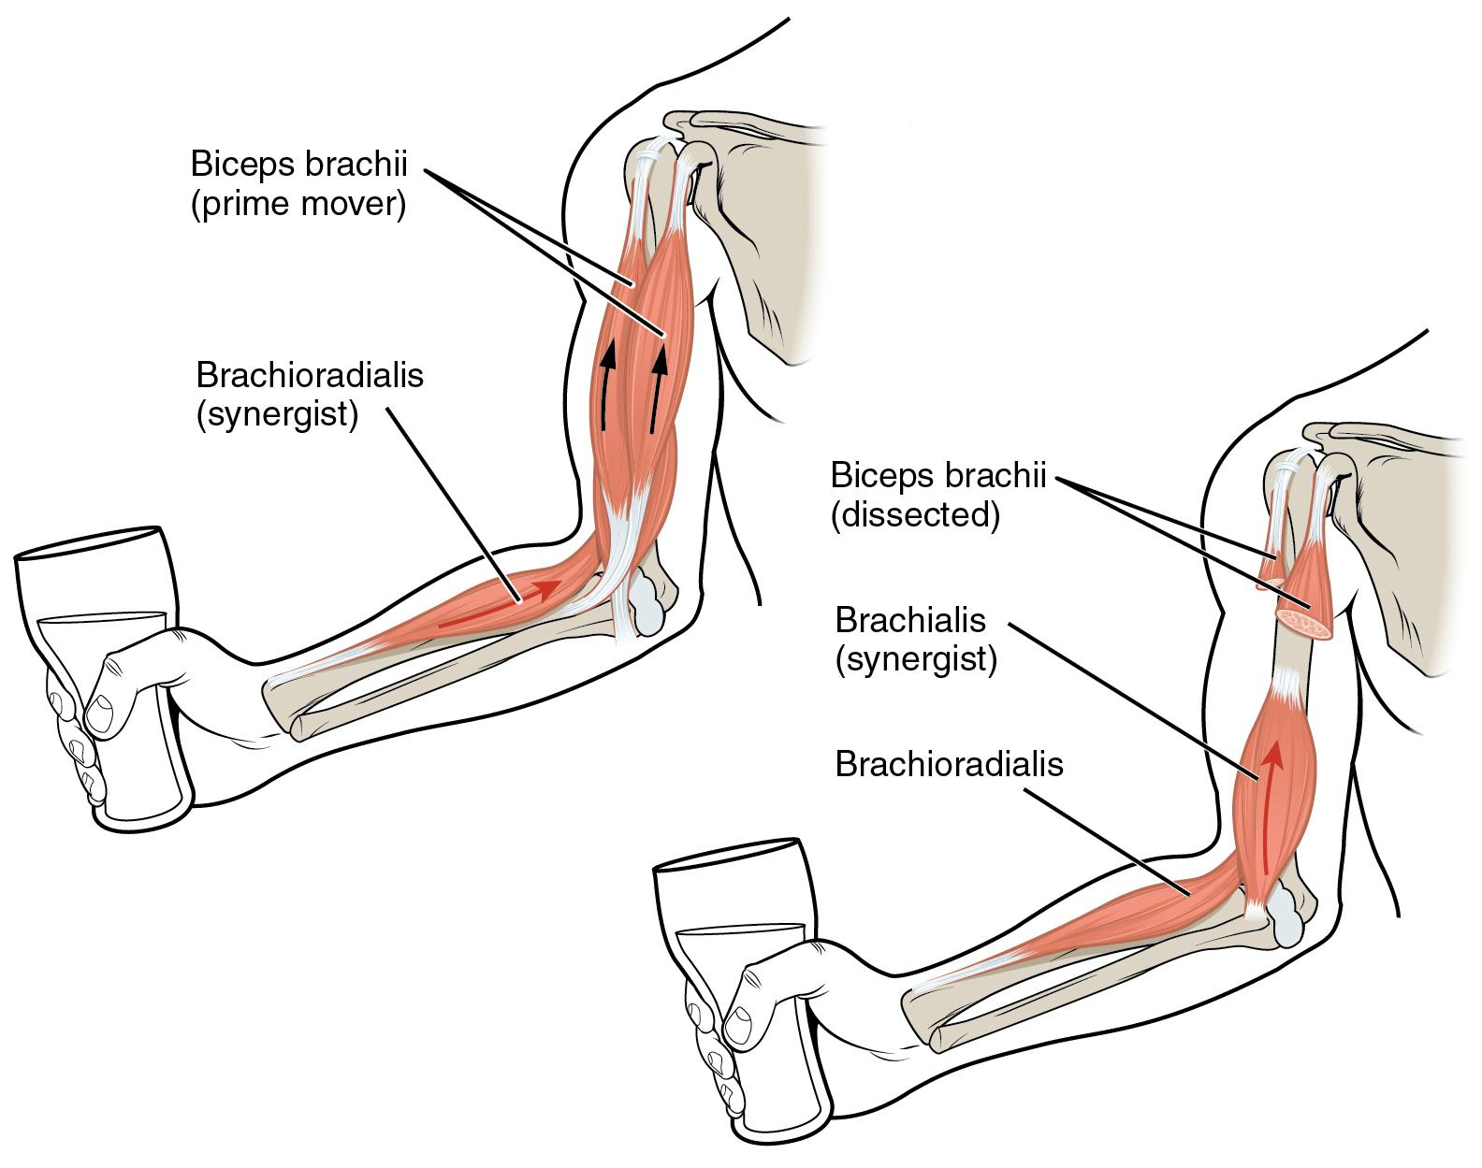
Figure 7.2 Prime Movers and Synergists The biceps brachii flex the lower arm. The brachioradialis, in the forearm, and brachialis, located deep to the biceps in the upper arm, are both synergists that aid in this motion.
A muscle with the opposite action of the prime mover is called an antagonist. Antagonists play two important roles in muscle function: (1) they maintain body or limb position, such as holding the arm out or standing erect; and (2) they control rapid movement, as in shadow boxing without landing a punch or the ability to check the motion of a limb.
For example, to extend the knee, a group of four muscles called the quadriceps femoris in the anterior compartment of the thigh are activated (and would be called the agonists of knee extension). However, to flex the knee joint, an opposite or antagonistic set of muscles called the hamstrings is activated.
As you can see, these terms would also be reversed for the opposing action. If you consider the first action as the knee bending, the hamstrings would be called the agonists and the quadriceps femoris would then be called the antagonists. See Table 7.1 for a list of some agonists and antagonists.
Agonist and Antagonist Skeletal Muscle Pairs
Agonist | Antagonist | Movement
Biceps brachii - in the anterior compartment of the arm | Triceps brachii - in the posterior compartment of the arm | The biceps brachii flexes the elbow, whereas the triceps brachii extends the elbow
Hamstrings - group of three muscles in the posterior compartment of the thigh | Quadriceps femoris - groups of four muscles in the anterior compartment of the thigh | The hamstrings flex the knee, whereas the quadriceps femoris extends the knee
Flexor digitorum superficialis and flexor digitorum profundus - in the anterior compartment of the forearm | Extensor digitorum - in the posterior compartment of the forearm | The flexor digitorum superficialis and flexor digitorum profundus flex the fingers and wrist, whereas the extensor digitorum extends the fingers and wrist
Table 7.1

Patterns of Fascicle Organization
Skeletal muscle is enclosed in connective tissue scaffolding at three levels. Each muscle fiber (cell) is covered by endomysium and the entire muscle is covered by epimysium. When a group of muscle fibers is “bundled” as a unit within the whole muscle by an additional covering of a connective tissue called perimysium, that bundled group of muscle fibers is called a fascicle. Fascicle arrangement by perimysia is correlated to the force generated by a muscle; it also affects the range of motion of the muscle. Based on the patterns of fascicle arrangement, skeletal muscles can be classified in several ways. What follows are the most common fascicle arrangements.
Parallel muscles have fascicles that are arranged in the same direction as the long axis of the muscle (Figure 7.3). The majority of skeletal muscles in the body have this type of organization. Some parallel muscles are flat sheets that expand at the ends to make broad attachments. Other parallel muscles are rotund with tendons at one or both ends. Muscles that seem to be plump have a large mass of tissue located in the middle of the muscle, between the insertion and the origin, which is known as the central body. A more common name for this muscle is belly. When a muscle contracts, the contractile fibers shorten it to an even larger bulge. For example, extend and then flex your biceps brachii muscle; the large, middle section is the belly (Figure 7.4). When a parallel muscle has a central, large belly that is spindle-shaped, meaning it tapers as it extends to its origin and insertion, it sometimes is called fusiform.
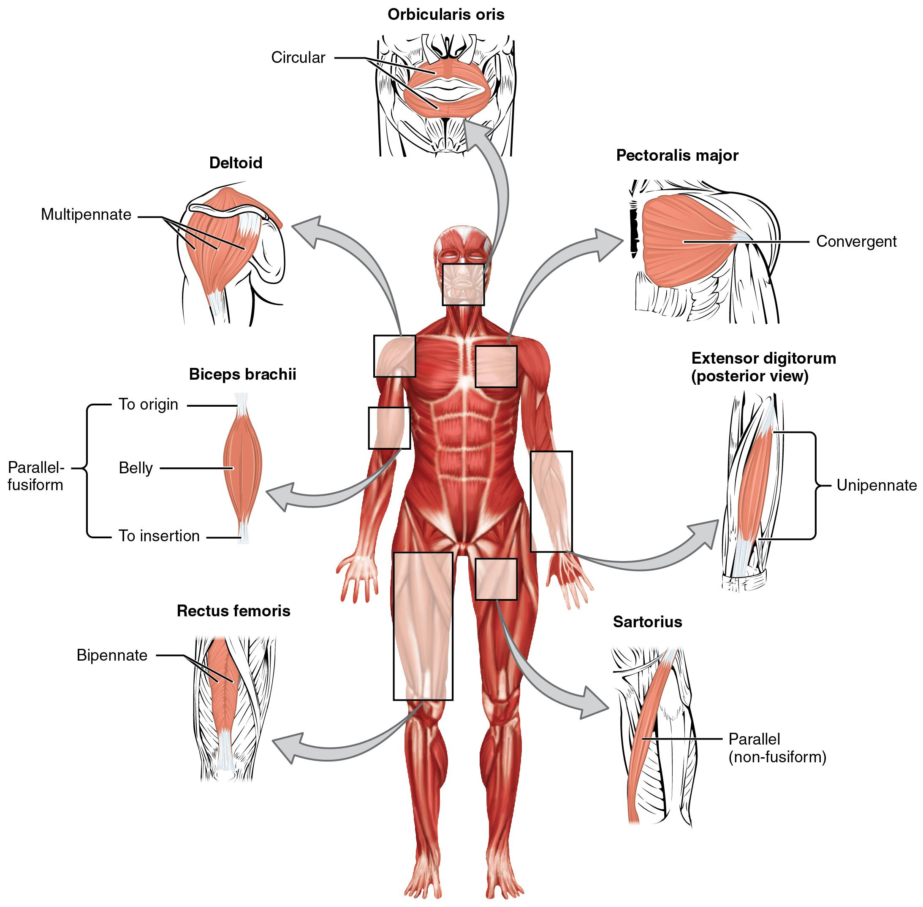
Figure 7.3 Muscle Shapes and Fiber Alignment The skeletal muscles of the body typically come in seven different general shapes.
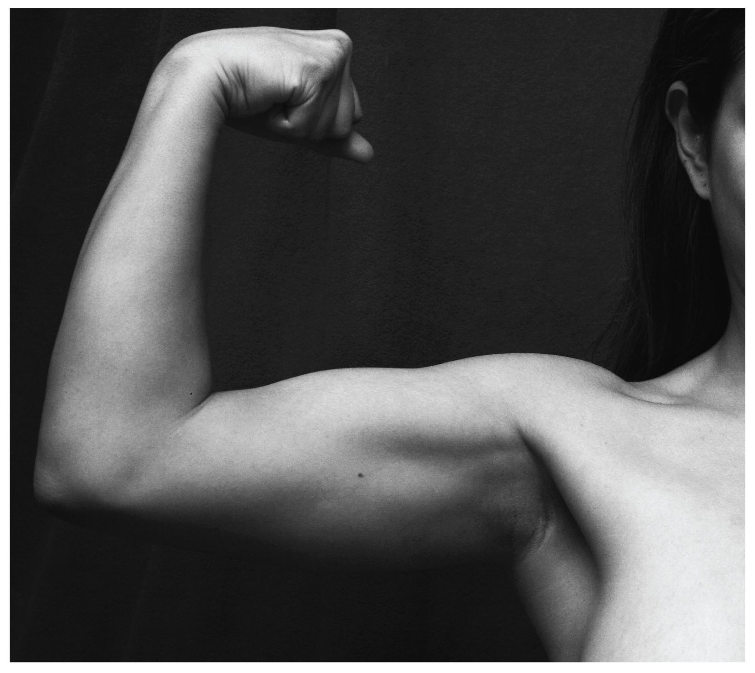
Figure 7.4 Biceps Brachii Muscle Contraction The large mass at the center of a muscle is called the belly. Tendons emerge from both ends of the belly and connect the muscle to the bones, allowing the skeleton to move. The tendons of the bicep connect to the upper arm and the forearm. (credit: Victoria Garcia)
Circular muscles are also called sphincters (see Figure 7.3). When they relax, the sphincters’ concentrically arranged bundles of muscle fibers increase the size of the opening, and when they contract, the size of the opening shrinks to the point of closure. The orbicularis oris muscle is a circular muscle that goes around the mouth. When it contracts, the oral opening becomes smaller, as when puckering the lips for whistling. Another example is the orbicularis oculi, one of which surrounds each eye. Consider, for example, the names of the two orbicularis muscles (orbicularis oris and orbicularis oculi), where part of the first name of both muscles is the same. The first part of orbicularis, orb (orb = “circular”), is a reference to a round or circular structure; it may also make one think of an orbit, such as the moon’s path around the earth. The word oris (oris = “oral”) refers to the oral cavity, or the mouth. The word oculi (ocular = “eye”) refers to the eye.
There are other muscles throughout the body named by their shape or location. The deltoid is a large, triangular-shaped muscle that covers the shoulder. It is so-named because the Greek letter delta looks like a triangle. The rectus abdominis (rector = “straight”) is the straight muscle in the anterior wall of the abdomen, while the rectus femoris is the straight muscle in the anterior compartment of the thigh.
When a muscle has a widespread expansion over a sizable area, but then the fascicles come to a single, common attachment point, the muscle is called convergent. The attachment point for a convergent muscle could be a tendon, an aponeurosis (a flat, broad tendon), or a raphe (a very slender tendon). The large muscle on the chest, the pectoralis major, is an example of a convergent muscle because it converges on the greater tubercle of the humerus via a tendon.
Pennate muscles (penna = “feathers”) blend into a tendon that runs through the central region of the muscle for its whole length, somewhat like the quill of a feather with the muscle arranged similar to the feathers. Due to this design, the muscle fibers in a pennate muscle can only pull at an angle, and as a result, contracting pennate muscles do not move their tendons very far. However, because a pennate muscle generally can hold more muscle fibers within it, it can produce relatively more tension for its size. There are three subtypes of pennate muscles.
In a unipennate muscle, the fascicles are located on one side of the tendon. The extensor digitorum of the forearm is an example of a unipennate muscle. A bipennate muscle has fascicles on both sides of the tendon. In some pennate muscles, the muscle fibers wrap around the tendon, sometimes forming individual fascicles in the process. This arrangement is referred to as multipennate. A common example is the deltoid muscle of the shoulder, which covers the shoulder but has a single tendon that inserts on the deltoid tuberosity of the humerus.
Because of fascicles, a portion of a multipennate muscle like the deltoid can be stimulated by the nervous system to change the direction of the pull. For example, when the deltoid muscle contracts, the shoulder abducts (arm moves away from midline in the sagittal plane), but when only the anterior fascicle is stimulated, the shoulder will abduct and flex (arm moves anteriorly at the shoulder joint).

The Lever System of Muscle and Bone Interactions
Skeletal muscles do not work by themselves. Muscles are arranged in pairs based on their functions. For muscles attached to the bones of the skeleton, the connection determines the force, speed, and range of movement. These characteristics depend on each other and can explain the general organization of the muscular and skeletal systems.
The skeleton and muscles act together to move the body. Have you ever used the back of a hammer to remove a nail from wood? The handle acts as a lever and the head of the hammer acts as a fulcrum, the fixed point that the force is applied to when you pull back or push down on the handle. The effort applied to this system is the pulling or pushing on the handle to remove the nail, which is the load, or “resistance” to the movement of the handle in the system. Our musculoskeletal system works in a similar manner, with bones being stiff levers and the articular endings of the bones—encased in synovial joints—acting as fulcrums. The load would be an object being lifted or any resistance to a movement (your head is a load when you are lifting it), and the effort, or applied force, comes from contracting skeletal muscle.

7.2 Naming Skeletal Muscles

Learning Objectives
By the end of this section, you will be able to:
- Describe the criteria used to name skeletal muscles
- Explain how understanding the muscle names helps describe shapes, location, and actions of various muscles
The Greeks and Romans conducted the first studies done on the human body in Western culture. The educated class of subsequent societies studied Latin and Greek, and therefore the early pioneers of anatomy continued to apply Latin and Greek terminology or roots when they named the skeletal muscles. The large number of muscles in the body and unfamiliar words can make learning the names of the muscles in the body seem daunting, but understanding the etymology can help. Etymology is the study of how the root of a particular word entered a language and how the use of the word evolved over time. Taking the time to learn the root of the words is crucial to understanding the vocabulary of anatomy and physiology. When you understand the names of muscles it will help you remember where the muscles are located and what they do (Figure 7.5, Figure 7.6, and Table 7.2). Pronunciation of words and terms will take a bit of time to master, but after you have some basic information; the correct names and pronunciations will become easier.
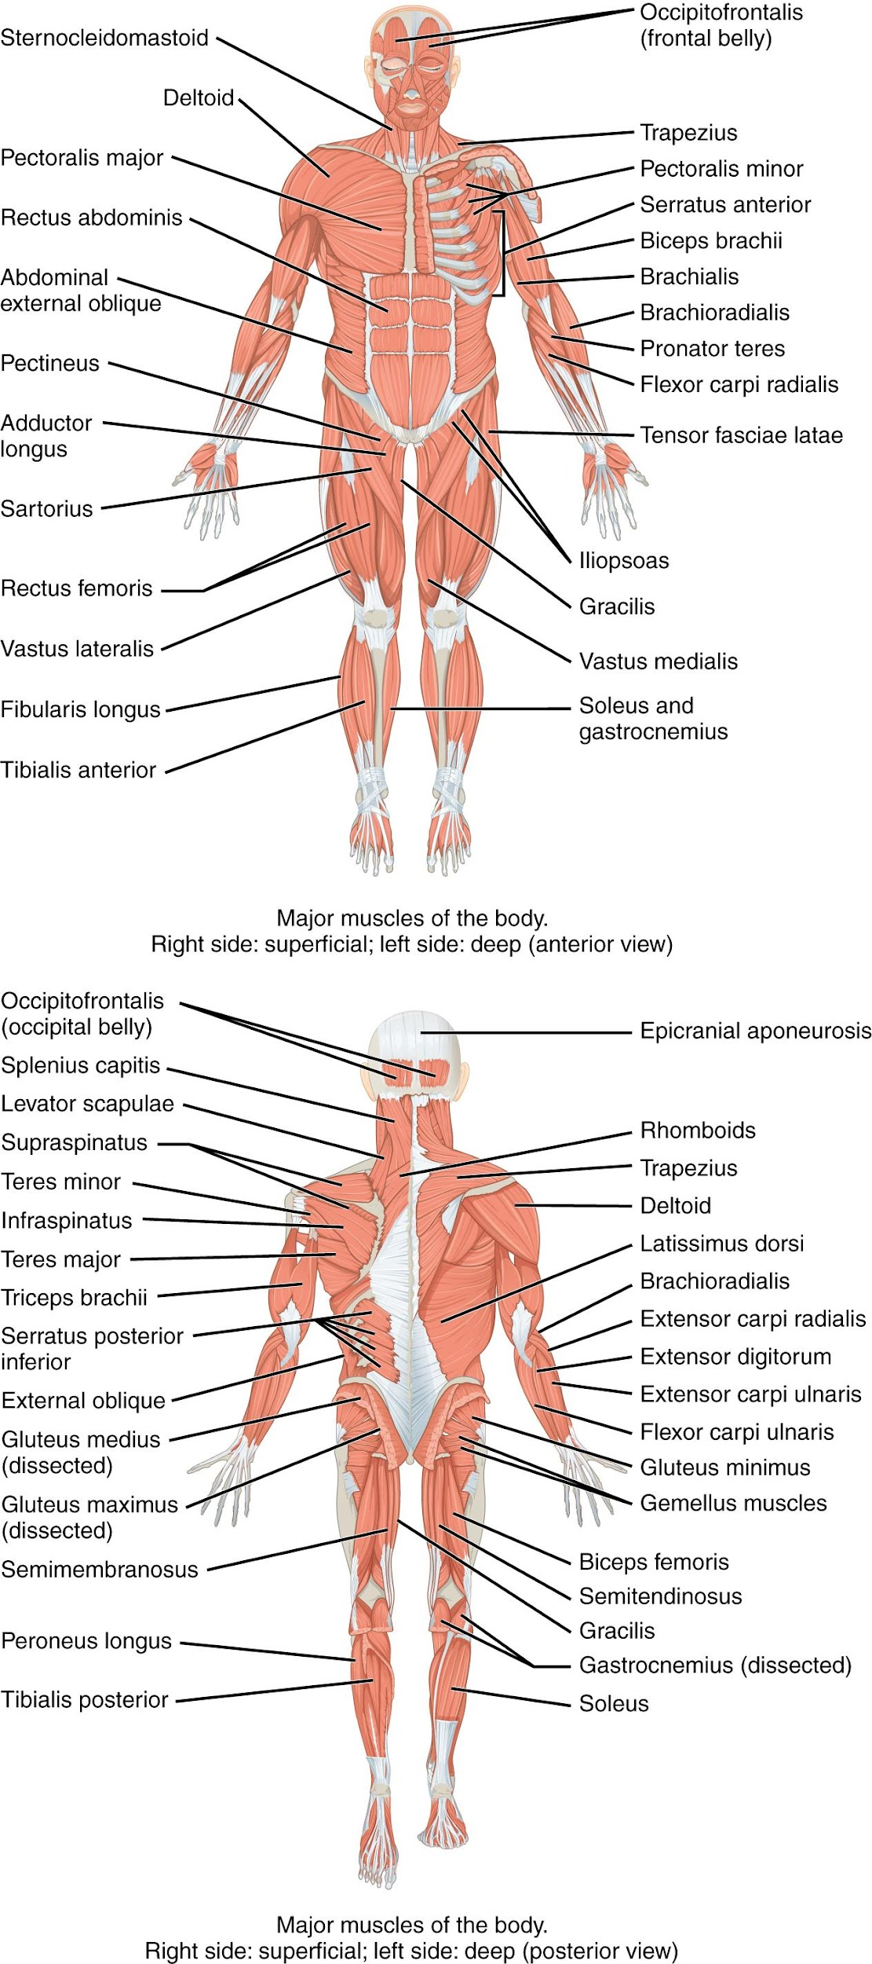
Figure 7.5 Overview of the Muscular System On the anterior and posterior views of the muscular system above, superficial muscles (those at the surface) are shown on the right side of the body while deep muscles (those underneath the superficial muscles) are shown on the left half of the body. For the legs, superficial muscles are shown in the anterior view while the posterior view shows both superficial and deep muscles.
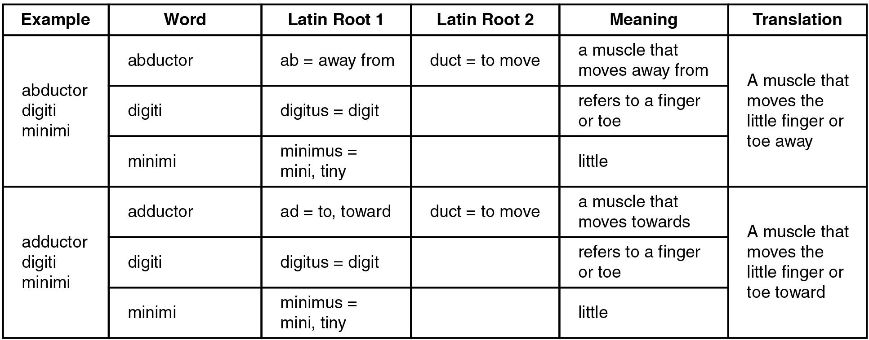
Figure 7.6 Understanding a Muscle Name from the Latin
Mnemonic Device for Latin Roots
Example | Latin/Greek Translation | Mnemonic Device
ad | to; toward | ADvance toward your goal
ab | away from | ABducted by aliens
sub | under | SUBmarines move underwater
ductor | something that moves | a conDUCTOR makes a train move
anti | against | if you are anti-social, you are against engaging in social activities
epi | on top of | N/A
longissimus | longest | “longissimus” is longer than the word long
longus | long | long
brevis | short | brief
maximus | large | the “maximum” is a lot
medius | medium | medium
minimus | tiny; little | mini
rectus | straight | to RECTify a situation is to straighten it out
multi | many | if something is MULTI coloured, it has many colours
uni | one | a UNIcorn has one horn
bi/di | two | BIcycles have two wheels
tri | three | TRIple the amount is three times the amount
quad | four | QUADruplets are four babies born in the same birth
externus | outside | EXternal
internus | inside | INternal
Table 7.2
Anatomists name the skeletal muscles according to a number of criteria, each of which describes the muscle in some way. These include naming the muscle after its shape, its size compared to other muscles in the area, its location in the body or the location of its attachments to the skeleton, how many origins it has, or its action.
The skeletal muscle’s anatomical location or its relationship to a particular bone often determines its name. For example, the frontalis muscle is located on top of the frontal bone of the skull. Similarly, the shapes of some muscles are very distinctive and the names, such as orbicularis, reflect the shape. For the buttocks, the size of the muscles influences the names: gluteus maximus (largest), gluteus medius (medium), and the gluteus minimus (smallest). Names were given to indicate length—brevis (short), longus (long)—and to identify position relative to the midline: lateralis (to the outside away from the midline), and medialis (toward the midline). The direction of the muscle fibers and fascicles are used to describe muscles relative to the midline, such as the rectus (straight) abdominis, or the oblique (at an angle) muscles of the abdomen.
Some muscle names indicate the number of muscles in a group. One example of this is the quadriceps, a group of four muscles located on the anterior (front) thigh. Other muscle names can provide information as to how many origins a particular muscle has, such as the biceps brachii. The prefix bi indicates that the muscle has two origins and tri indicates three origins.
The location of a muscle’s attachment can also appear in its name. When the name of a muscle is based on the attachments, the origin is always named first. For instance, the sternocleidomastoid muscle of the neck has a dual origin on the sternum (sterno) and clavicle (cleido), and it inserts on the mastoid process of the temporal bone. The last feature by which to name a muscle is its action. When muscles are named for the movement they produce, one can find action words in their name. Some examples are flexor (decreases the angle at the joint), extensor (increases the angle at the joint), abductor (moves the bone away from the midline), or adductor (moves the bone toward the midline).

7.3 Axial Muscles of the Head, Neck, and Back

Learning Objectives
By the end of this section, you will be able to:
- Identify the axial muscles of the face, head, and neck
- Identify the movement and function of the face, head, and neck muscles
The skeletal muscles are divided into axial (muscles of the trunk and head) and appendicular (muscles of the arms and legs) categories. This system reflects the bones of the skeleton system, which are also arranged in this manner. The axial muscles are grouped based on location, function, or both. Some of the axial muscles may seem to blur the boundaries because they cross over to the appendicular skeleton. The first grouping of the axial muscles you will review includes the muscles of the head and neck, then you will review the muscles of the vertebral column, and finally you will review the oblique and rectus muscles.

Muscles That Move the Head
The head, attached to the top of the vertebral column, is balanced, moved, and rotated by the neck muscles (Table 7.3). When these muscles act unilaterally, the head rotates. When they contract bilaterally, the head flexes or extends. The major muscle that laterally flexes and rotates the head is the sternocleidomastoid. In addition, both muscles working together are the flexors of the head. Place your fingers on both sides of the neck and turn your head to the left and to the right. You will feel the movement originate there. This muscle divides the neck into anterior and posterior triangles when viewed from the side (Figure 7.7).
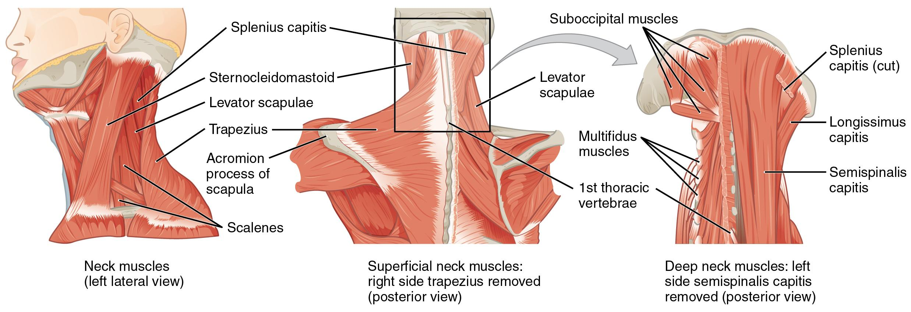
Figure 7.7 Posterior and Lateral Views of the Neck The superficial and deep muscles of the neck are responsible for moving the head, cervical vertebrae, and scapulas.

Muscles that Move the Head
Prime mover | Origin | Insertion | Movement
Sternocleidomastoid | Sternum; clavicle | Mastoid process on temporal bone | Individually - rotates head to opposite side and side flexes head to ipsilateral side  Bilaterally - cervical flexion
Splenius capitis | Spinous processes of cervical and thoracic vertebra | Mastoid process on temporal bone | Individually - laterally flexes and rotates head to ipsilateral side  Bilaterally - cervical extension
Longissimus capitis | Transverse and articular processes of cervical and thoracic vertebra | Mastoid process on temporal bone | Individually - laterally flexes and rotates head to ipsilateral side  Bilaterally - cervical extension
Scalenes | Transverse processes of C3-7 | 1st and 2nd ribs | Individually - laterally flexes head to ipsilateral side  Bilaterally - cervical flexion
Table 7.3

Muscles of the Posterior Neck and the Back
The posterior muscles of the neck are primarily concerned with head movements, like extension. The back muscles stabilize and move the vertebral column, and are grouped according to the lengths and direction of the fascicles.
The splenius muscles originate at the midline and run laterally and superiorly to their insertions. From the sides and the back of the neck, the splenius capitis inserts onto the head region, and the splenius cervicis extends onto the cervical region. These muscles can extend the head, laterally flex it, and rotate it (Figure 7.8).
The erector spinae group forms the majority of the muscle mass of the back and it is the primary extensor of the vertebral column. It controls flexion, lateral flexion, and rotation of the vertebral column, and maintains the lumbar curve. The erector spinae comprises the iliocostalis (laterally placed) group, the longissimus (intermediately placed) group, and the spinalis (medially placed) group.
The iliocostalis group includes the iliocostalis cervicis, associated with the cervical region; the iliocostalis thoracis, associated with the thoracic region; and the iliocostalis lumborum, associated with the lumbar region. The three muscles of the longissimus group are the longissimus capitis, associated with the head region; the longissimus cervicis, associated with the cervical region; and the longissimus thoracis, associated with the thoracic region. The third group, the spinalis group, comprises the spinalis capitis (head region), the spinalis cervicis (cervical region), and the spinalis thoracis (thoracic region).
The multifidus muscle of the lumbar region helps extend and laterally flex the vertebral column.
Finally, the scalene muscles work together to flex, laterally flex, and rotate the head. They also contribute to deep inhalation. The scalene muscles include the anterior scalene muscle (anterior to the middle scalene), the middle scalene muscle (the longest, intermediate between the anterior and posterior scalenes), and the posterior scalene muscle (the smallest, posterior to the middle scalene).
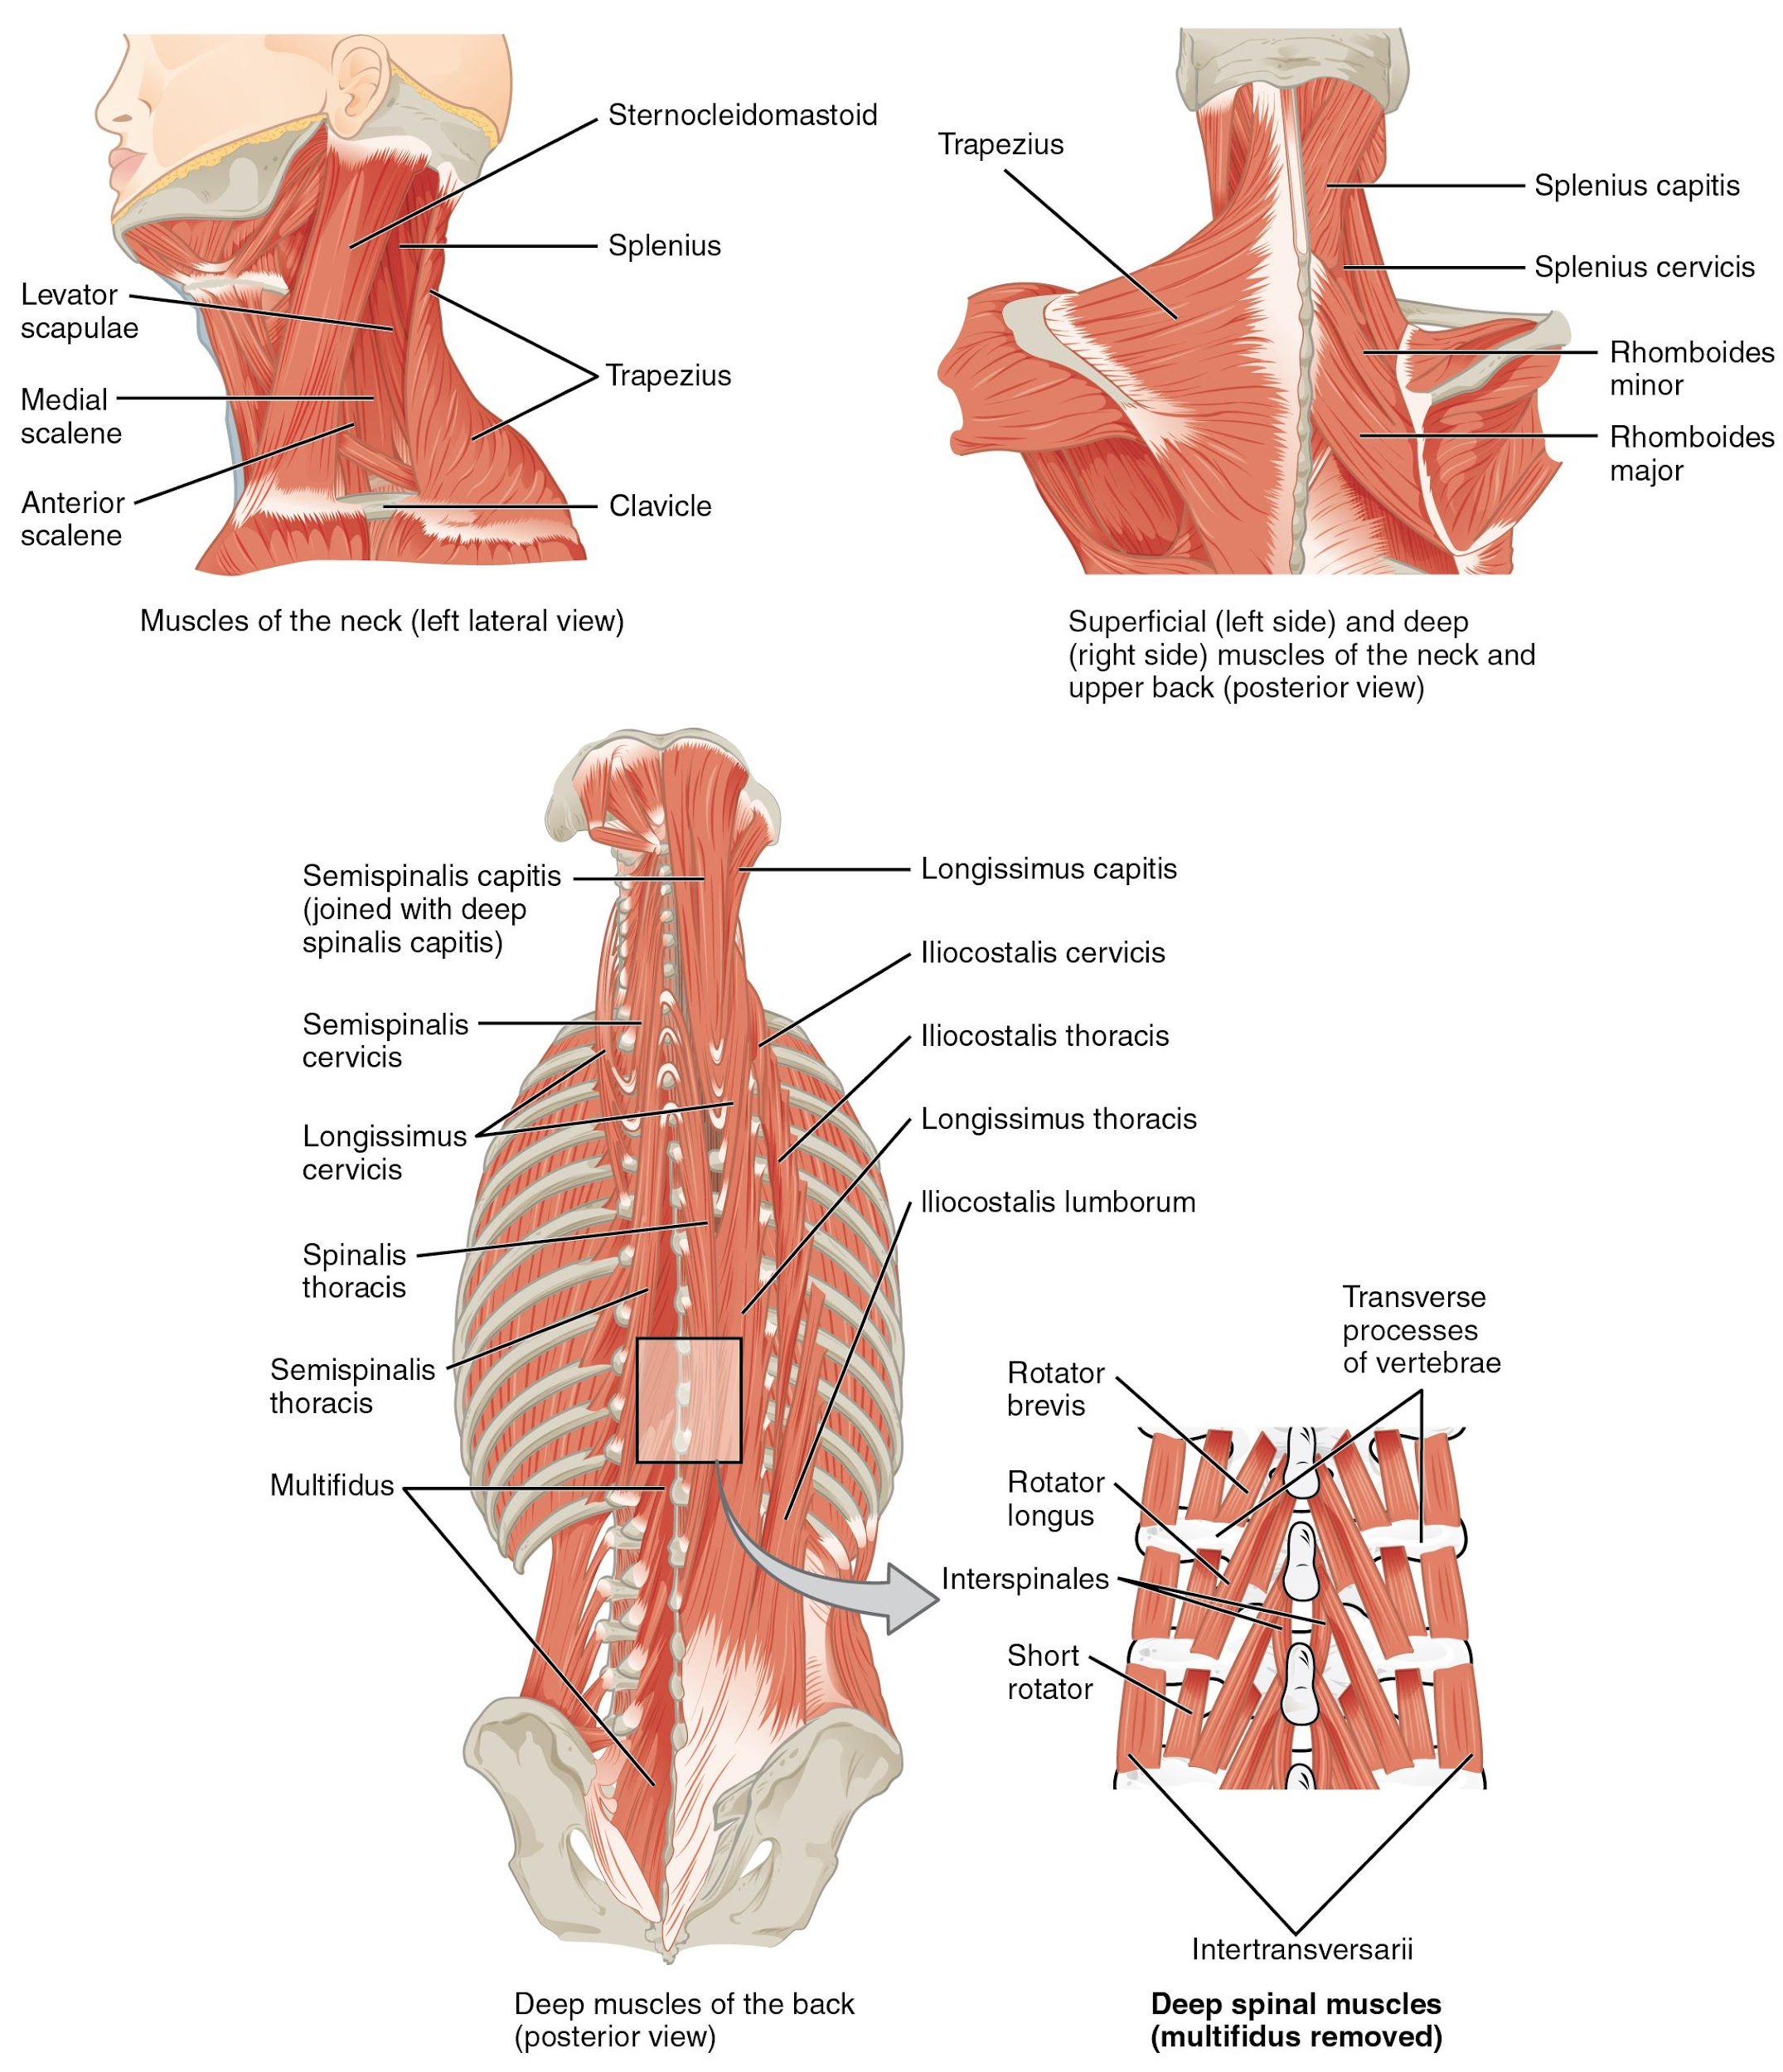
Figure 7.8 Muscles of the Neck and Back The large, complex muscles of the neck and back move the head, shoulders, and vertebral column.

7.4 Axial Muscles of the Abdominal Wall, and Thorax

Learning Objectives
By the end of this section, you will be able to:
- Identify the intrinsic skeletal muscles of the back and neck, and the skeletal muscles of the abdominal wall and thorax
- Identify the movement and function of the intrinsic skeletal muscles of the back and neck, and the skeletal muscles of the abdominal wall and thorax
It is a complex job to balance the body on two feet and walk upright. The muscles of the vertebral column, thorax, and abdominal wall extend, flex, and stabilize different parts of the body’s trunk. The deep muscles of the core of the body help maintain posture as well as carry out other functions. The brain sends out electrical impulses to these various muscle groups to control posture by alternate contraction and relaxation. This is necessary so that no single muscle group becomes fatigued too quickly. If any one group fails to function, body posture will be compromised.

Muscles of the Abdomen
There are four pairs of abdominal muscles that cover the anterior and lateral abdominal region and meet at the anterior midline. These muscles of the anterolateral abdominal wall can be divided into four groups: the external obliques, the internal obliques, the transversus abdominis, and the rectus abdominis (Table 7.4 and Figure 7.9).
Muscles of the Abdomen
Prime mover | Origin | Insertion | Movement
Rectus abdominis | Pubic crest of pubis | Ribs 5-7 and xiphoid process | Lumbar flexion  Lower thoracic flexion
External oblique | Ribs 5-7 | Iliac crest; linea alba | Contralateral spinal rotation  Ipsilateral spinal side flexion
Internal oblique | Iliac crest; thoracolumbar fascia | Linea alba | Ipsilateral spinal rotation  Ipsilateral spinal side flexion
Transversus abdominis | Iliac crest; thoracolumbar fascia; costal cartilage 7-12 | Linea alba; xiphoid process; pubic crest | Compression of abdominal wall
Quadratus lumborum | Iliac crest | Rib 12; transverse processes of L1-4 | Individually - lumbar side flexion  Bilaterally - lumbar extension
Table 7.4
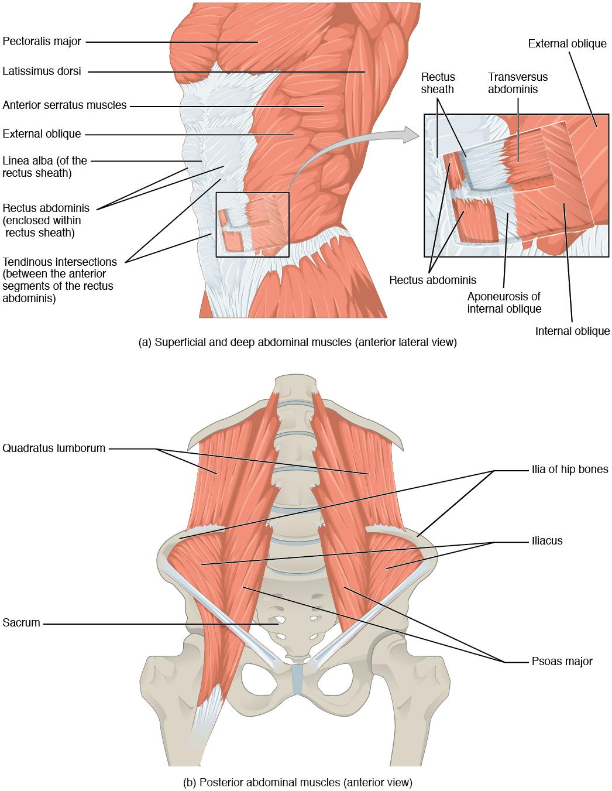
Figure 7.9 Muscles of the Abdomen (a) The anterior abdominal muscles include the medially located rectus abdominis, which is covered by a sheet of connective tissue called the rectus sheath. On the flanks of the body, medial to the rectus abdominis, the abdominal wall is composed of three layers. The external oblique muscles form the superficial layer, while the internal oblique muscles form the middle layer, and the transversus abdominis forms the deepest layer. (b) The muscles of the lower back move the lumbar spine but also assist in femur movements.
There are three flat skeletal muscles in the antero-lateral wall of the abdomen. The external oblique, closest to the surface, extend inferiorly and medially, in the direction of sliding one’s four fingers into pants pockets. Perpendicular to it is the intermediate internal oblique, extending superiorly and medially, the direction the thumbs usually go when the other fingers are in the pants pocket. The deep muscle, the transversus abdominis, is arranged transversely around the abdomen, similar to the front of a belt on a pair of pants. This arrangement of three bands of muscles in different orientations allows various movements and rotations of the trunk. The three layers of muscle also help to protect the internal abdominal organs in an area where there is no bone.
The linea alba is a white, fibrous band that is made of the bilateral rectus sheaths that join at the anterior midline of the body. These enclose the rectus abdominis muscles (a pair of long, linear muscles, commonly called the “sit-up” muscles) that originate at the pubic crest and symphysis, and extend the length of the body’s trunk. Each muscle is segmented by three transverse bands of collagen fibers called the tendinous intersections. This results in the look of “six-pack abs,” as each segment hypertrophies on individuals at the gym who do many sit-ups.
The posterior abdominal wall is formed by the lumbar vertebrae, parts of the ilia of the hip bones, psoas major and iliacus muscles, and quadratus lumborum muscle. This part of the core plays a key role in stabilizing the rest of the body and maintaining posture.

Muscles of the Thorax
The muscles of the chest serve to facilitate breathing by changing the size of the thoracic cavity (Table 7.5). When you inhale, your chest rises because the cavity expands. Alternately, when you exhale, your chest falls because the thoracic cavity decreases in size.
Muscles of the Chest
Prime mover | Origin | Insertion | Movement
External intercostals | Rib superior to each intercostal muscle | Rib inferior to each intercostal muscle | Inhalation
Internal intercostals | Rib inferior to each intercostal muscle | Rib superior to each intercostal muscle | Forced exhalation
Diaphragm | Sternum; ribs 6-12; lumbar vertebrae | Central tendon | Inhalation
Table 7.5

The Diaphragm
The change in volume of the thoracic cavity during breathing is due to the alternate contraction and relaxation of the diaphragm (Figure 7.10). It separates the thoracic and abdominal cavities, and is dome-shaped at rest. The superior surface of the diaphragm is convex, creating the elevated floor of the thoracic cavity. The inferior surface is concave, creating the curved roof of the abdominal cavity.
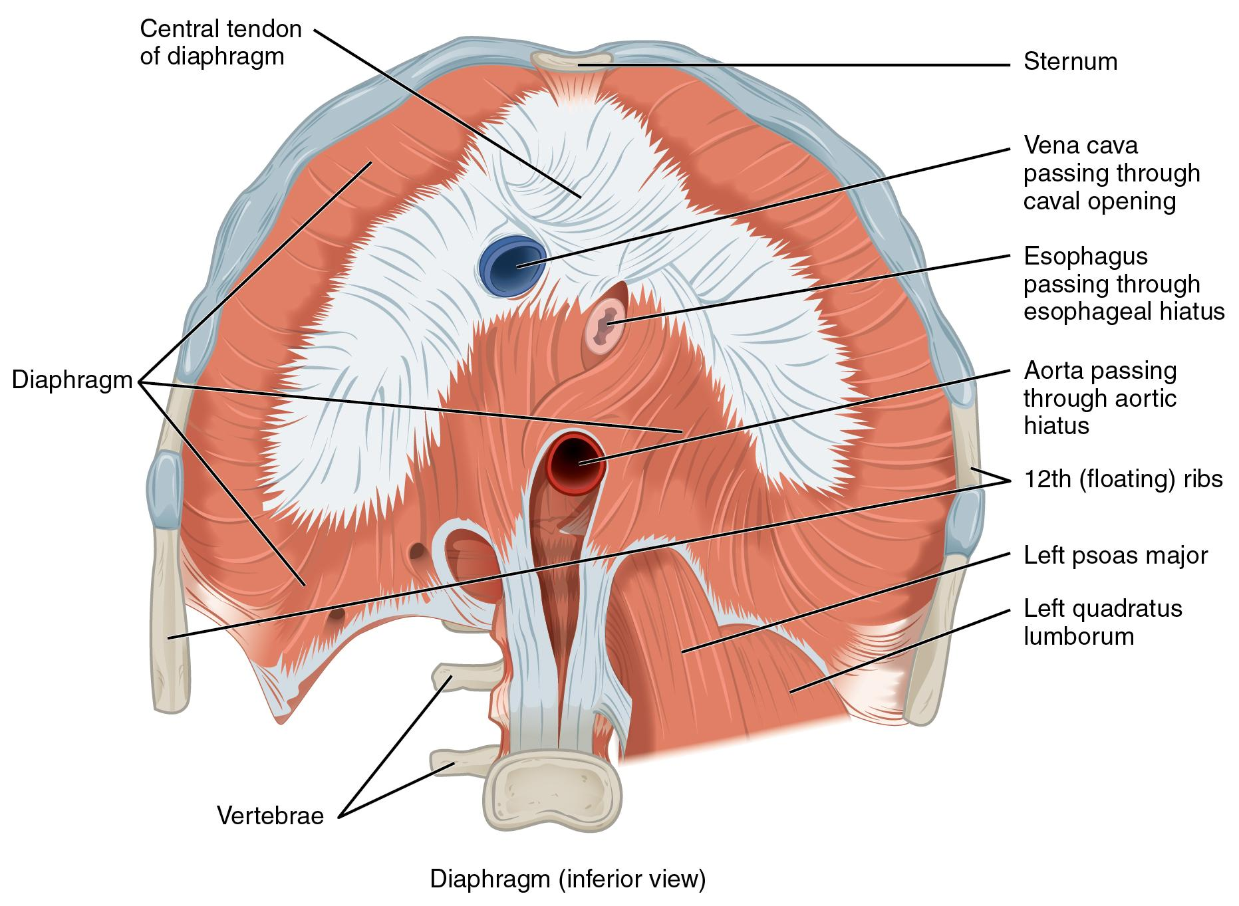
Figure 7.10 Muscles of the Diaphragm The diaphragm separates the thoracic and abdominal cavities.
Defecating, urination, and even childbirth involve cooperation between the diaphragm and abdominal muscles (this cooperation is referred to as the “Valsalva maneuver”). You hold your breath by a steady contraction of the diaphragm; this stabilizes the volume and pressure of the peritoneal cavity. When the abdominal muscles contract, the pressure cannot push the diaphragm up, so it increases pressure on the intestinal tract (defecation), urinary tract (urination), or reproductive tract (childbirth).
The inferior surface of the pericardial sac and the inferior surfaces of the pleural membranes (parietal pleura) fuse onto the central tendon of the diaphragm. To the sides of the tendon are the skeletal muscle portions of the diaphragm, which insert into the tendon while having a number of origins including the xiphoid process of the sternum anteriorly, the inferior six ribs and their cartilages laterally, and the lumbar vertebrae and 12th ribs posteriorly.
The diaphragm also includes three openings for the passage of structures between the thorax and the abdomen. The inferior vena cava passes through the caval opening, and the esophagus and attached nerves pass through the esophageal hiatus. The aorta, thoracic duct, and azygous vein pass through the aortic hiatus of the posterior diaphragm.

The Intercostal Muscles
There are three sets of muscles, called intercostal muscles, which span each of the intercostal spaces. The principal role of the intercostal muscles is to assist in breathing by changing the dimensions of the rib cage (Figure 7.11).
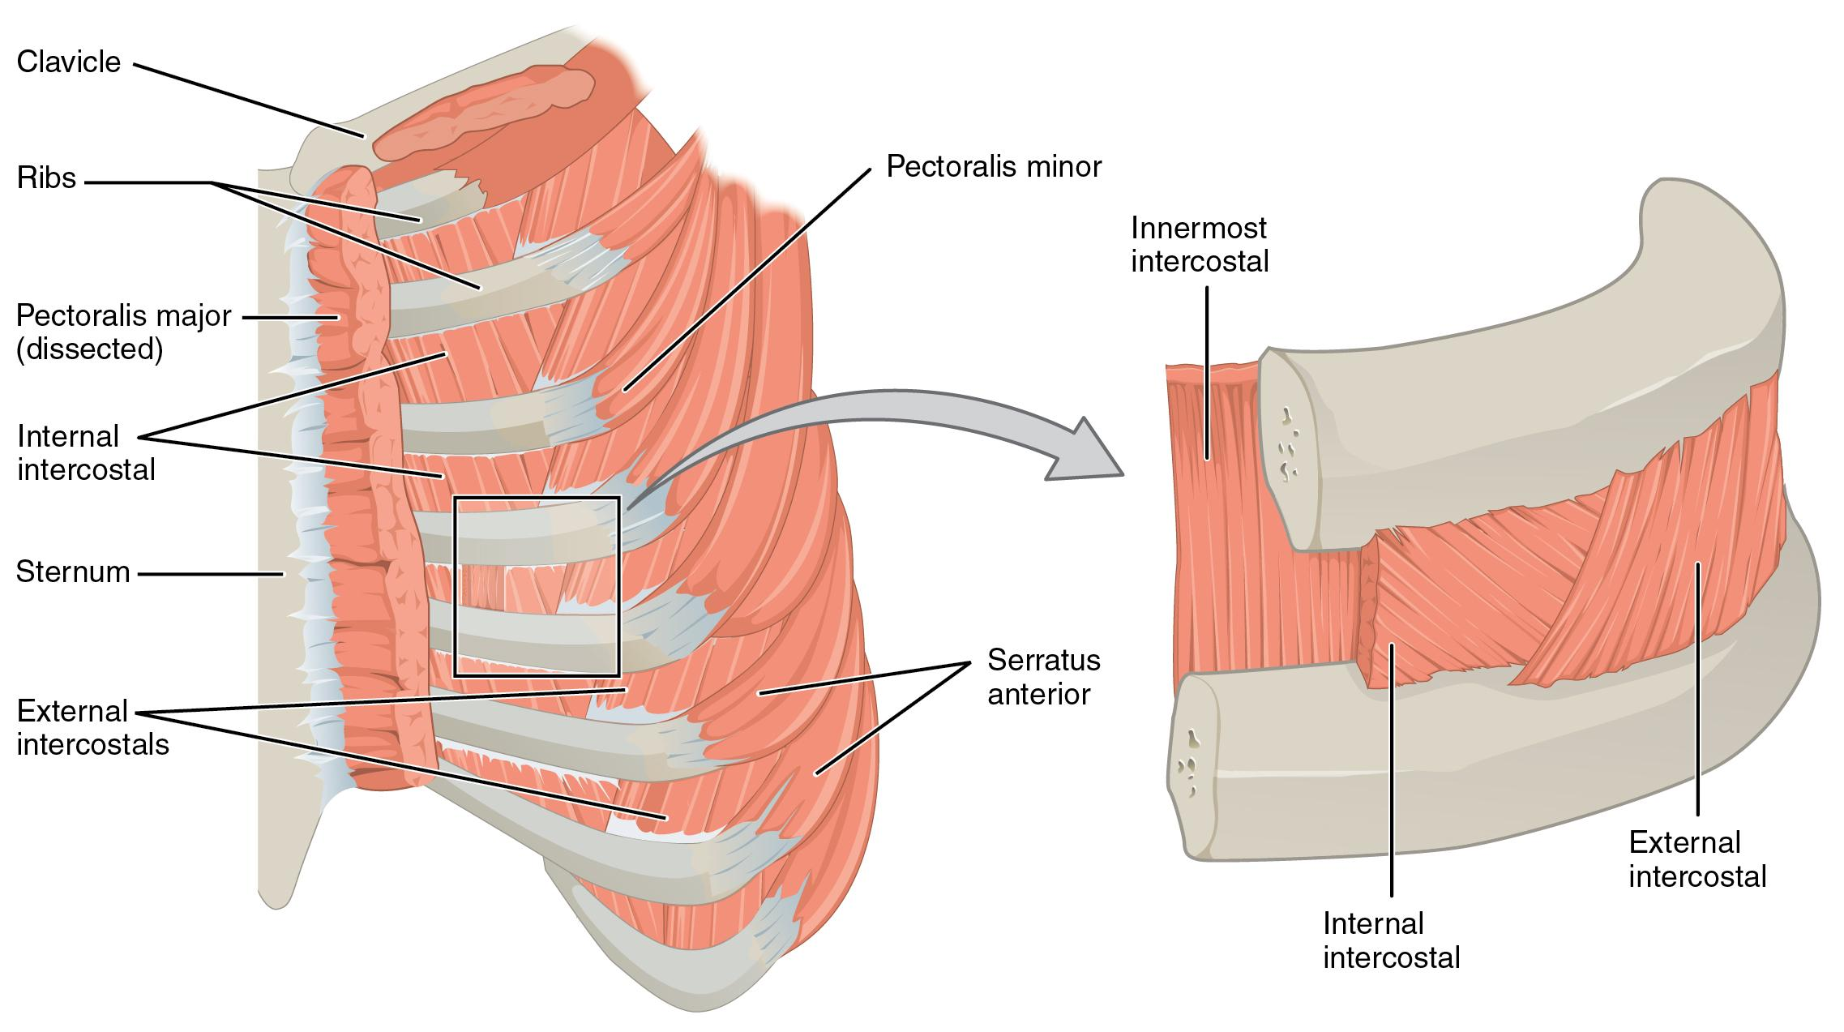
Figure 7.11 Intercostal Muscles The external intercostals are located laterally on the sides of the body. The internal intercostals are located medially near the sternum. The innermost intercostals are located deep to both the internal and external intercostals.
The 11 pairs of superficial external intercostal muscles aid in inspiration of air during breathing because when they contract, they raise the rib cage, which expands it. The 11 pairs of internal intercostal muscles, just under the externals, are used for expiration because they draw the ribs together to constrict the rib cage. The innermost intercostal muscles are the deepest, and they act as synergists for the action of the internal intercostals.

7.5 Muscles of the Pectoral Girdle and Upper Limbs

Learning Objectives
By the end of this section, you will be able to:
- Identify the muscles of the pectoral girdle and upper limbs
- Identify the movement and function of the pectoral girdle and upper limbs
Muscles of the shoulder and upper limb can be divided into four groups: muscles that stabilize and position the pectoral girdle, muscles that move the arm, muscles that move the forearm, and muscles that move the wrists, hands, and fingers. The pectoral girdle, or shoulder girdle, consists of the lateral ends of the clavicle and scapula, along with the proximal end of the humerus, and the muscles covering these three bones to stabilize the shoulder joint. The girdle creates a base from which the head of the humerus, in its ball-and-socket joint with the glenoid fossa of the scapula, can move the arm in multiple directions.

Muscles That Position the Pectoral Girdle
Muscles that position the pectoral girdle are located either on the anterior thorax or on the posterior thorax (Figure 7.12 and Table 7.6). The anterior muscles include the subclavius, pectoralis minor, and serratus anterior. The posterior muscles include the trapezius, rhomboid major, and rhomboid minor. When the rhomboids are contracted, your scapula moves medially, which can pull the shoulder and upper limb posteriorly.
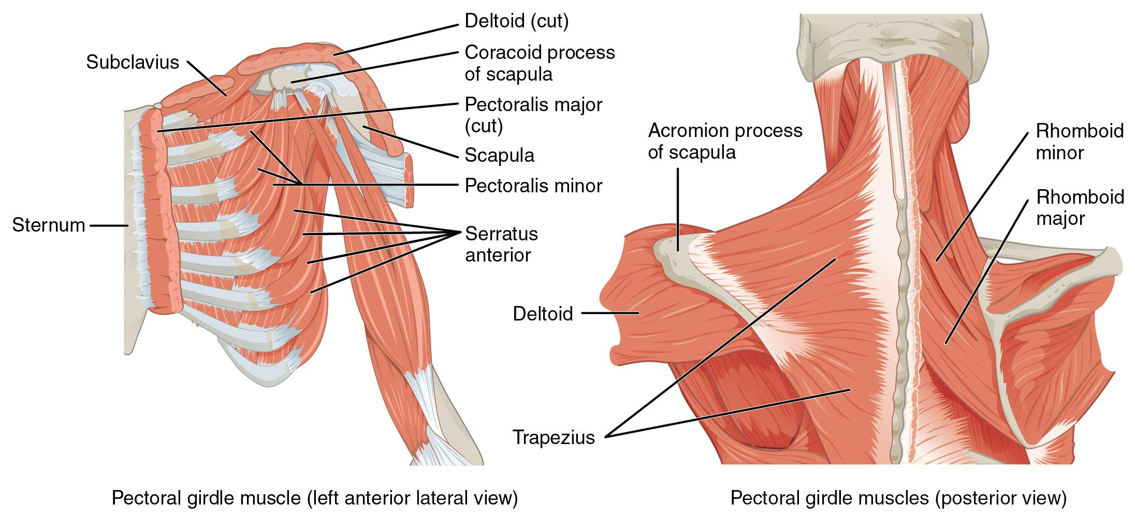
Figure 7.12 Muscles That Position the Pectoral Girdle The muscles that stabilize the pectoral girdle make it a steady base on which other muscles can move the arm. Note that the pectoralis major and deltoid, which move the humerus, are cut here to show the deeper positioning muscles.
Muscles that Position the Pectoral Girdle
Prime mover | Origin | Insertion | Movement
Subclavius | First rib | Inferior surface of clavicle | Depression of the clavicle; stabilizes the clavicle during shoulder movement
Levator scapula | Transverse processes C1-4 | Medial border of scapula | Elevation of the scapula; cervical side flexion
Pectoralis minor | Ribs 3-5 | Coracoid process of the scapula | Stabilizes the scapula against the rib cage by pulling anteriorly; assists with inhalation
Serratus anterior | Lateral aspects of ribs 1-9 | Anterior surface of lateral border of scapula | Scapular protraction
Trapezius | Occipital bone; nuchal ligament; spinous process of C7-T12 | Lateral ⅓ of clavicle; spine of scapula; acromion process | Upper fibers - scapular elevation; cervical side flexion  Middle fibers - scapular retraction  Lower fibers - scapular depression
Rhomboid major | Thoracic vertebrae T2-5 | Medial border of scapula | Scapular retraction; scapular downward rotation
Rhomboid minor | C7 and T1 | Medial border of scapula | Scapular retraction; scapular downward rotation
Table 7.6

Muscles That Move the Humerus
Similar to the muscles that position the pectoral girdle, muscles that cross the shoulder joint and move the humerus bone of the arm include both axial and scapular muscles (Figure 7.13 and Table 7.7). The two axial muscles are the pectoralis major and the latissimus dorsi. The pectoralis major is thick and fan-shaped, covering much of the superior portion of the anterior thorax. The broad, triangular latissimus dorsi is located on the inferior part of the back, where it inserts into a thick connective tissue sheath called an aponeurosis.
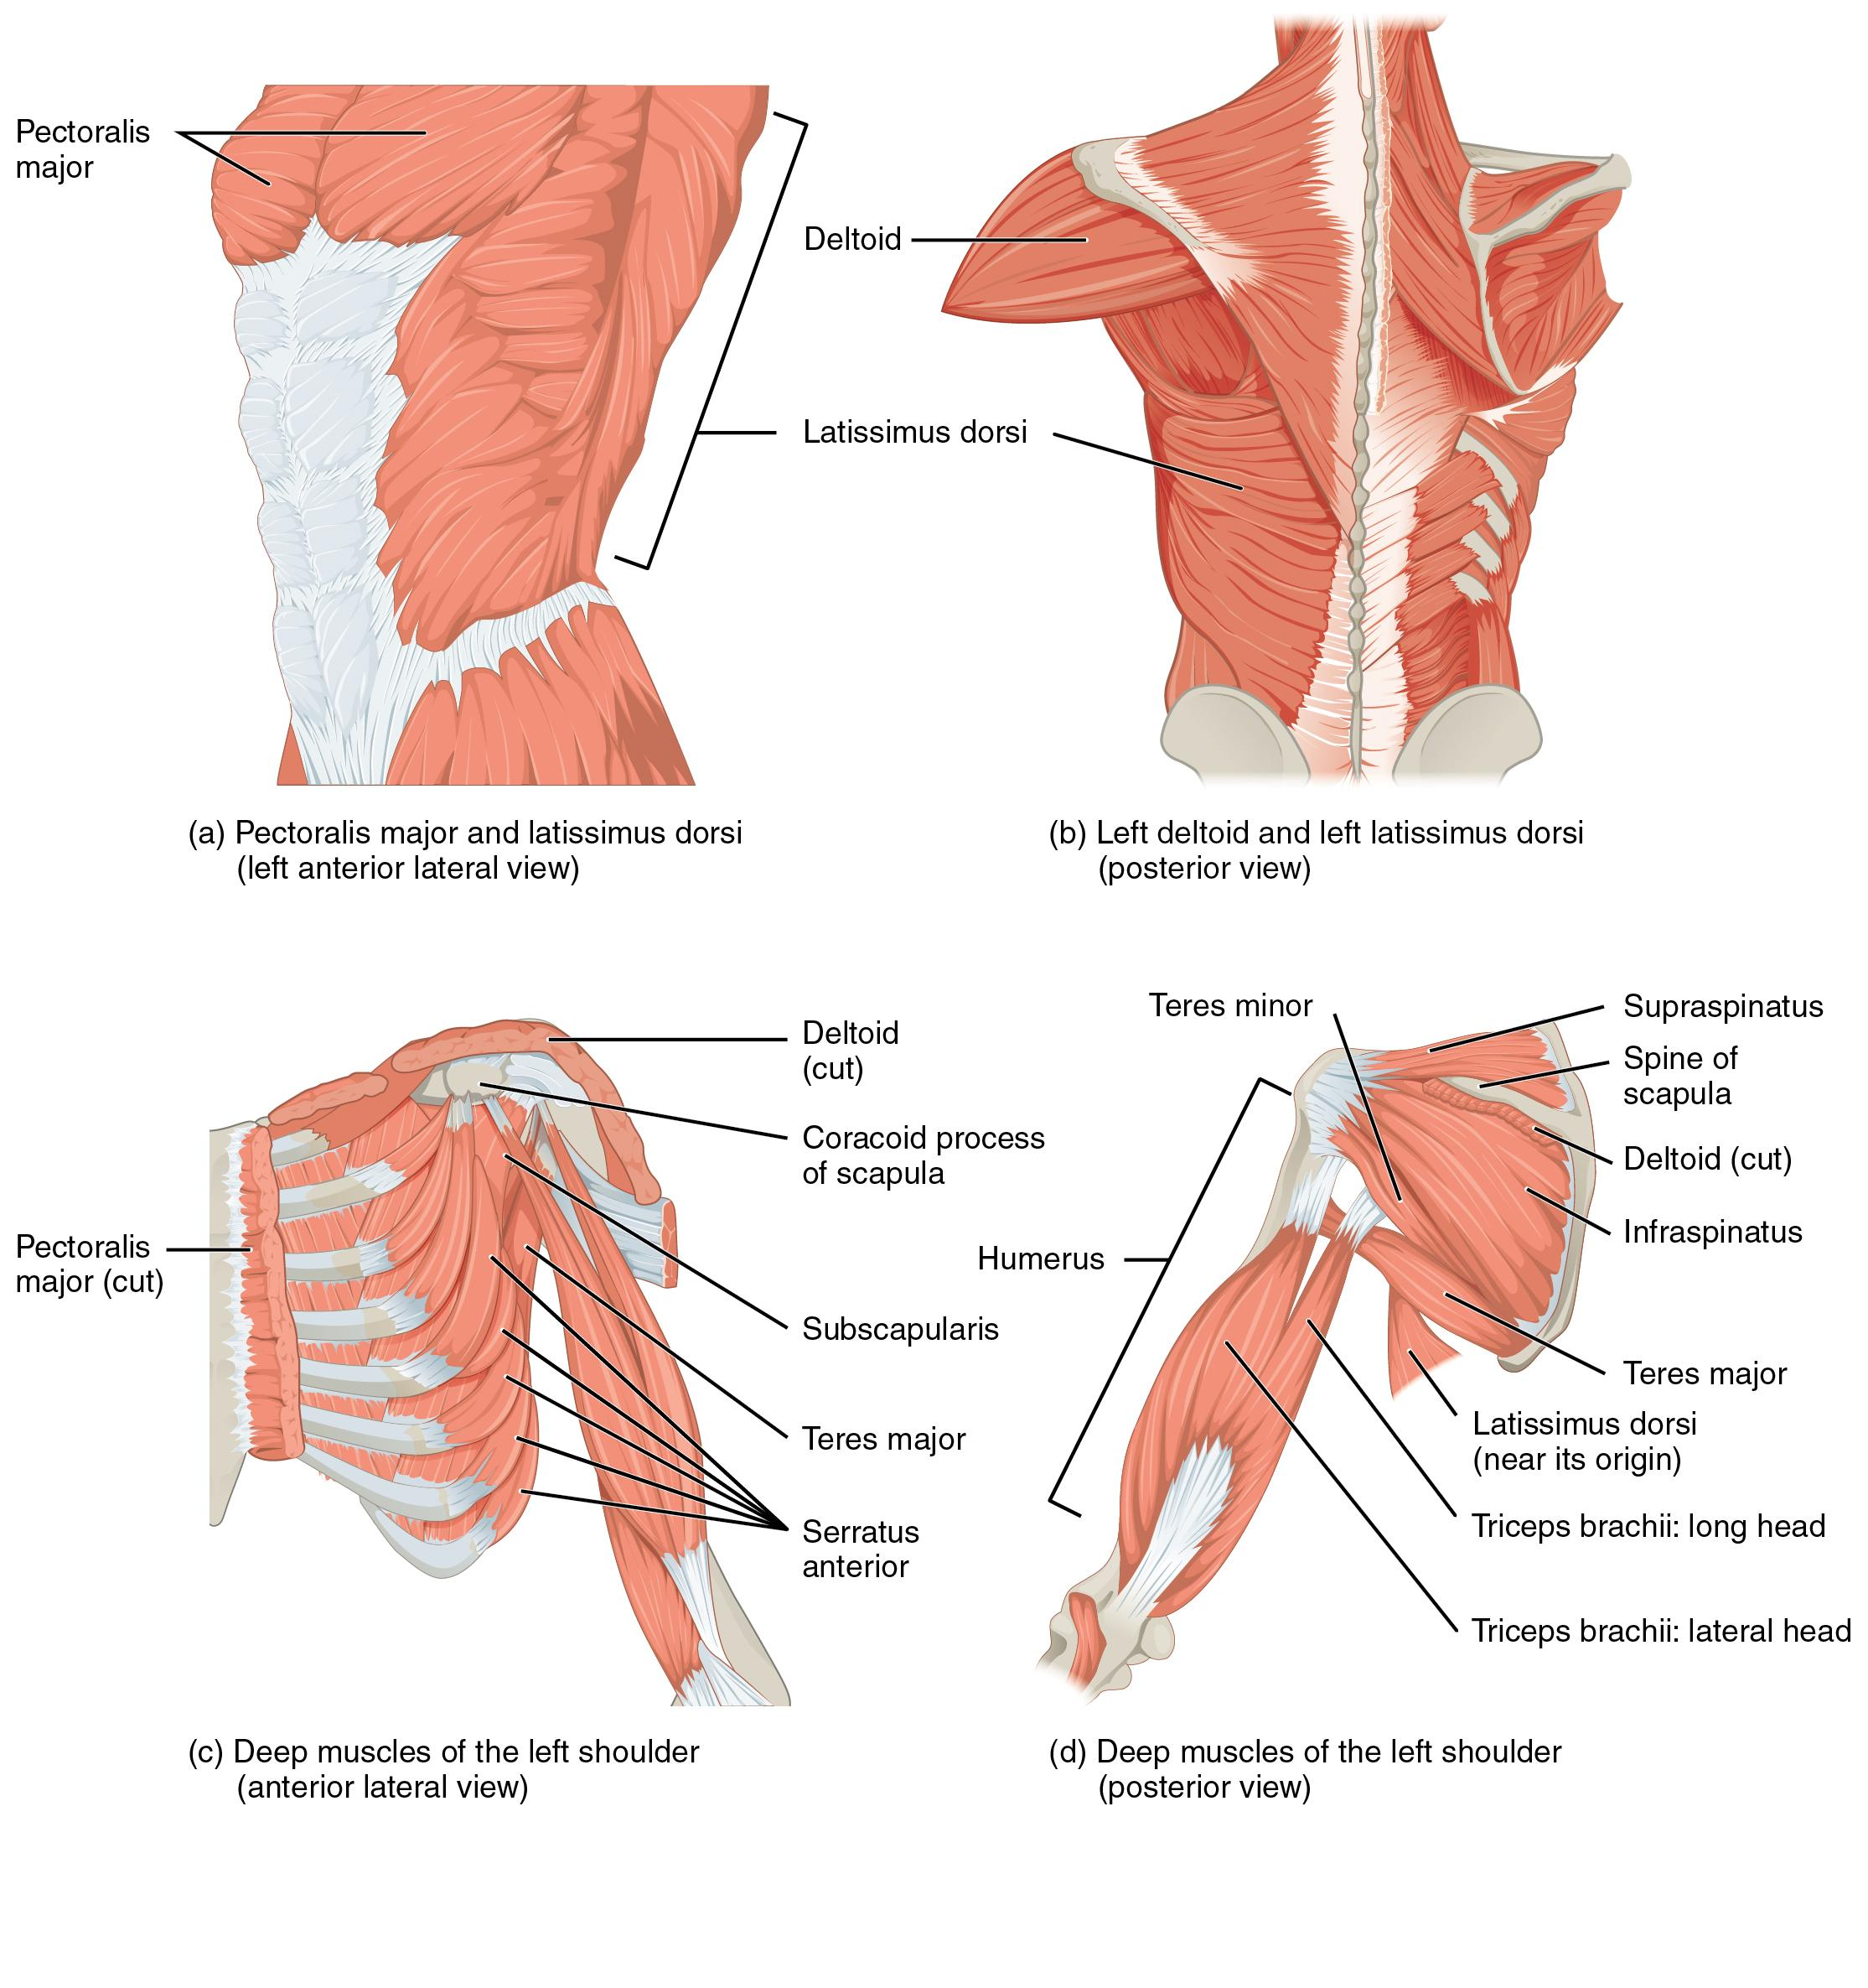
Figure 7.13 Muscles That Move the Humerus (a, c) The muscles that move the humerus anteriorly are generally located on the anterior side of the body and originate from the sternum (e.g., pectoralis major) or the anterior side of the scapula (e.g., subscapularis). (b) The muscles that move the humerus superiorly generally originate from the superior surfaces of the scapula and/or the clavicle (e.g., deltoids). The muscles that move the humerus inferiorly generally originate from middle or lower back (e.g., latissiumus dorsi). (d) The muscles that move the humerus posteriorly are generally located on the posterior side of the body and insert into the scapula (e.g., infraspinatus).
Muscles that Move the Humerus
Prime mover | Origin | Insertion | Movement
Axial muscles
Pectoralis major | Clavicle; sternum; cartilage of certain ribs (1-6/7); aponeurosis of external oblique muscle | Greater tubercle of humerus | Shoulder flexion, adduction, and medial rotation
Latissimus dorsi | T7-T12; lumbar vertebrae; ribs 9-12; iliac crest | Bicipital groove of humerus | Shoulder extension, adduction, and medial rotation  Scapular depression
Appendicular muscles
Deltoid | Lateral ⅓ of clavicle; acromion of scapula; spine of scapula | Deltoid tuberosity of humerus | Anterior fibers - shoulder flexion and medial rotation  Middle fibers - shoulder abduction  Lateral fibers - shoulder extension and lateral rotation
Subscapularis | Subscapular fossa of scapula | Lesser tubercle of humerus | Centers head of humerus in glenoid fossa  Shoulder medial rotation
Supraspinatus | Supraspinous fossa of scapula | Greater tubercle of humerus | Centers head of humerus in glenoid fossa  Shoulder lateral rotation
Infraspinatus | Infraspinous fossa of scapula | Greater tubercle of humerus | Centers head of humerus in glenoid fossa  Shoulder lateral rotation
Teres major | Inferior angle and lateral border of scapula | Bicipital groove of humerus | Shoulder extension and adduction
Teres minor | Lateral border of scapula | Greater tubercle of humerus | Centers head of humerus in glenoid fossa  Shoulder lateral rotation
Coracobrachialis | Coracoid process of scapula | Medial surface of humeral shaft | Shoulder flexion and adduction
Table 7.7
The rest of the shoulder muscles originate on the scapula. The anatomical and ligamental structure of the shoulder joint and the arrangements of the muscles covering it, allows the arm to carry out different types of movements. The deltoid, the thick muscle that creates the rounded lines of the shoulder is the major abductor of the arm, but it also facilitates flexing and medial rotation, as well as extension and lateral rotation. The subscapularis originates on the anterior scapula and medially rotates the arm. Named for their locations, the supraspinatus (superior to the spine of the scapula) and the infraspinatus (inferior to the spine of the scapula) abduct the arm, and laterally rotate the arm, respectively. The thick and flat teres major is inferior to the teres minor and extends the arm, and assists in adduction and medial rotation of it. The long teres minor laterally rotates and extends the arm. Finally, the coracobrachialis flexes and adducts the arm.
The tendons of the deep subscapularis, supraspinatus, infraspinatus, and teres minor connect the scapula to the humerus, forming the rotator cuff (musculotendinous cuff), the circle of tendons around the shoulder joint. When baseball pitchers undergo shoulder surgery it is usually on the rotator cuff, which becomes pinched and inflamed, and may tear away from the bone due to the repetitive motion of bring the arm overhead to throw a fast pitch.

Muscles That Move the Elbow and Forearm
The forearm, made of the radius and ulna bones, has four main types of action at the hinge of the elbow joint: flexion, extension, pronation, and supination. The elbow flexors include the biceps brachii, brachialis, and brachioradialis. The elbow extensor is the triceps brachii. The forearm pronators are the pronator teres and the pronator quadratus, and the supinator is the only one that supinates the forearm (turns the palm of the hand anteriorly).
The biceps brachii, brachialis, and brachioradialis flex the elbow. The two-headed biceps brachii crosses the shoulder and elbow joints to flex the elbow, also taking part in supinating the forearm at the radioulnar joints and flexing the arm at the shoulder joint. Deep to the biceps brachii, the brachialis provides additional power in flexing the elbow. Finally, the brachioradialis can flex the elbow quickly or help lift a load slowly. These muscles and their associated blood vessels and nerves form the anterior compartment of the arm (anterior flexor compartment of the arm) (Figure 7.14 and Table 7.8).
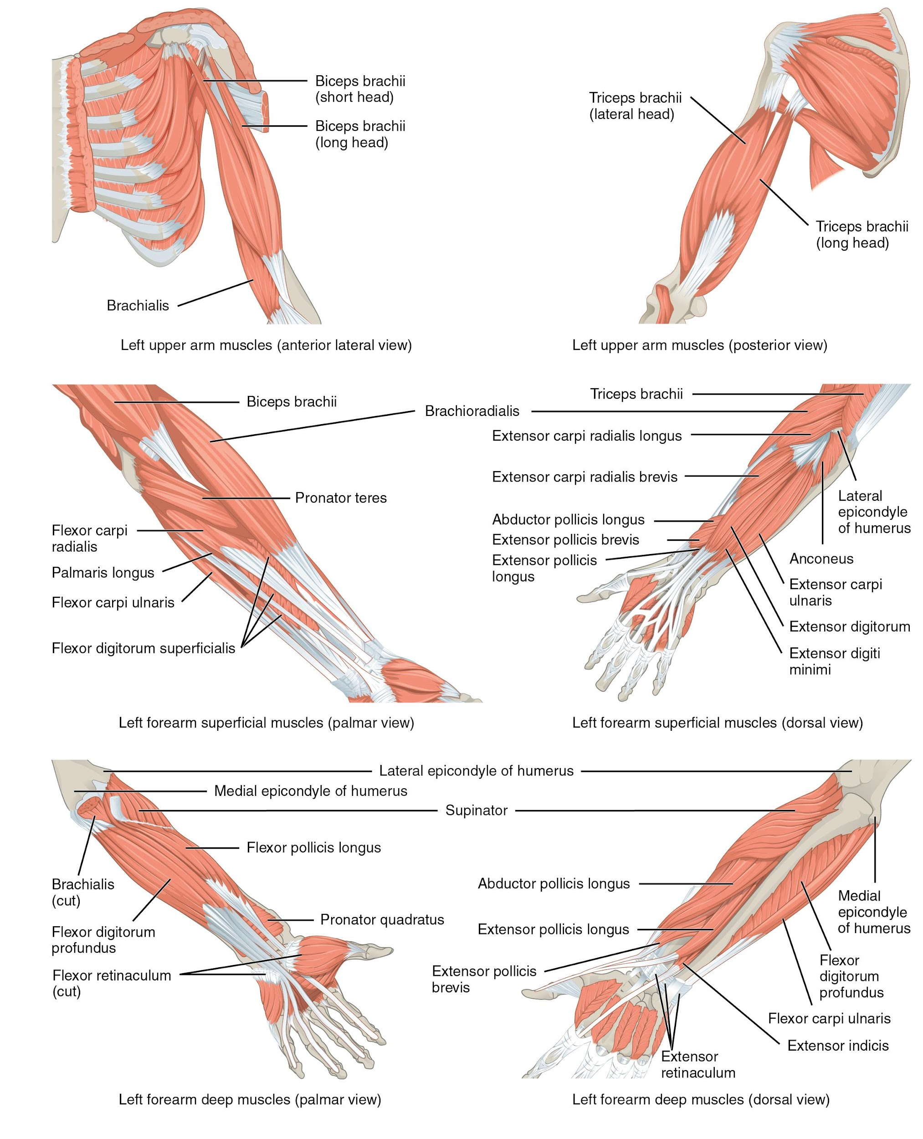
Figure 7.14 Muscles That Move the Elbow and Forearm The muscles originating in the upper arm flex and extend the elbow, and pronate, and supinate the forearm. The muscles originating in the forearm move the wrists, hands, and fingers.
Muscles that Move the Elbow and Forearm
Prime mover | Origin | Insertion | Movement
Anterior muscles (flexion)
Biceps brachii | Long head - supraglenoid tubercle of scapula  Short head - coracoid process of scapula | Radial tuberosity | Elbow flexion and supination  Shoulder flexion (long head only)
Brachialis | Anterior distal shaft of humerus | Coronoid process of ulna | Elbow flexion
Brachioradialis | Lateral distal shaft of humerus | Radial styloid process | Elbow flexion  Assists forearm supination when pronated  Assists forearm pronation when supinated
Posterior muscles (extension)
Triceps brachii | Long head - infraglenoid tubercle of scapula  Medial head - medial shaft of humerus  Lateral head - lateral shaft of humerus | Olecranon process of ulna | Elbow extension  Shoulder extension (long head only)
Anconeus | Lateral epicondyle of humerus | Lateral aspect of olecranon process of ulna | Elbow extension
Anterior muscles (pronation)
Pronator teres | Medial epicondyle of humerus; coronoid process of ulna | Lateral mid-shaft of radius | Forearm pronation
Pronator quadratus | Anterior distal shaft of ulna | Anterior distal shaft of radius | Forearm pronation
Posterior muscles (supination)
Supinator | Lateral epicondyle of humerus; proximal ulna | Lateral proximal shaft of radius | Forearm supination
Table 7.8

Muscles That Move the Wrist, Hand, and Fingers
Wrist, hand, and finger movements are facilitated by two groups of muscles. The forearm is the origin of the extrinsic muscles of the hand. The palm is the origin of the intrinsic muscles of the hand.

Muscles of the Arm That Move the Wrists, Hands, and Fingers
The muscles in the anterior compartment of the forearm (anterior flexor compartment of the forearm) originate on the humerus and insert into different parts of the hand. These make up the bulk of the forearm. From lateral to medial, the superficial anterior compartment of the forearm includes the flexor carpi radialis, palmaris longus, flexor carpi ulnaris, and flexor digitorum superficialis. The flexor digitorum superficialis flexes the hand as well as the digits at the knuckles, which allows for rapid finger movements, as in typing or playing a musical instrument (see Table 7.9 and Table 7.10). However, poor ergonomics can irritate the tendons of these muscles as they slide back and forth with the carpal tunnel of the anterior wrist and pinch the median nerve, which also travels through the tunnel, causing Carpal Tunnel Syndrome. The deep anterior compartment produces wrist and digit flexion, bending the fingers to make a fist. These are the flexor pollicis longus and the flexor digitorum profundus.
The muscles in the superficial posterior compartment of the forearm (superficial posterior extensor compartment of the forearm) originate on the humerus. These are the extensor radialis longus, extensor carpi radialis brevis, extensor digitorum, extensor digiti minimi, and the extensor carpi ulnaris.
The muscles of the deep posterior compartment of the forearm (deep posterior extensor compartment of the forearm) originate on the radius and ulna. These include the abductor pollicis longus, extensor pollicis brevis, extensor pollicis longus, and extensor indicis (see Table 7.9).
The tendons of the forearm muscles attach to the wrist and extend into the hand. Fibrous bands called retinacula sheath the tendons at the wrist. The flexor retinaculum extends over the palmar surface of the hand while the extensor retinaculum extends over the dorsal surface of the hand.
Muscles that Move the Wrist, Hand, and Forearm
Prime mover | Origin | Insertion | Movement
Superficial anterior compartment of forearm
Flexor carpi radialis | Medial epicondyle of humerus | Base of 2nd and 3rd metacarpals | Wrist flexion and abduction
Flexor carpi ulnaris | Medial epicondyle of humerus | Pisiform, hamate, base of 5th metacarpal | Wrist flexion and adduction
Flexor digitorum superficialis | Medial epicondyle of humerus; anterior shaft of radius | Middle phalanges of digits 2-5 | Wrist flexion; finger flexion digits 2-5
Palmaris longus | Medial epicondyle of humerus | Palmar aponeurosis | Wrist flexion
Deep anterior compartment of forearm
Flexor digitorum profundus | Coronoid process; anteromedial surface of ulna | Distal phalanges of digits 2-5 | Wrist flexion; finger flexion digits 2-5
Flexor pollicis longus | Anterior surface of radius | Distal phalanx of thumb | Thumb flexion
Superficial posterior compartment of forearm
Extensor carpi radialis longus | Lateral supracondylar ridge of humerus | Base of 2nd metacarpal | Wrist extension and abduction
Extensor carpi radialis brevis | Lateral epicondyle of humerus | Base of 3rd metacarpal | Wrist extension and abduction
Extensor carpi ulnaris | Lateral epicondyle of humerus | Base of 5th metacarpal | Wrist extension and adduction
Extensor digitorum | Lateral epicondyle of humerus | Extensor expansions; distal phalanges of digits 2-5 | Wrist extension; finger extension
Extensor digiti minimi | Lateral epicondyle of humerus | Extensor expansions; distal phalanx of digit 5 | Finger extension of digit 5
Deep posterior compartment of forearm
Abductor pollicis longus | Posterior surface of radius and ulna | Base of first metacarpal; trapezium | Thumb abduction and extension  Wrist abduction
Extensor pollicis longus | Posterior shaft of radius and ulna | Base of distal phalanx of thumb | Thumb extension
Extensor pollicis brevis | Posterior shaft of radius and ulna | Base of proximal phalanx of thumb | Thumb extension
Extensor indicis | Posterior surface of radius and ulna | Tendon of extensor digitorum of index finger | Finger extension of digit 2
Table 7.9

Intrinsic Muscles of the Hand
The intrinsic muscles of the hand both originate and insert within it (Figure 7.15). These muscles allow your fingers to also make precise movements for actions, such as typing or writing. These muscles are divided into three groups. The thenar muscles are on the radial aspect of the palm. The hypothenar muscles are on the medial aspect of the palm, and the intermediate muscles are midpalmar.
The thenar muscles include the abductor pollicis brevis, opponens pollicis, flexor pollicis brevis, and the adductor pollicis. These muscles form the thenar eminence, the rounded contour of the base of the thumb, and all act on the thumb. The movements of the thumb play an integral role in most precise movements of the hand.
The hypothenar muscles include the abductor digiti minimi, flexor digiti minimi brevis, and the opponens digiti minimi. These muscles form the hypothenar eminence, the rounded contour of the little finger, and as such, they all act on the little finger. Finally, the intermediate muscles act on all the fingers and include the lumbrical, the palmar interossei, and the dorsal interossei.
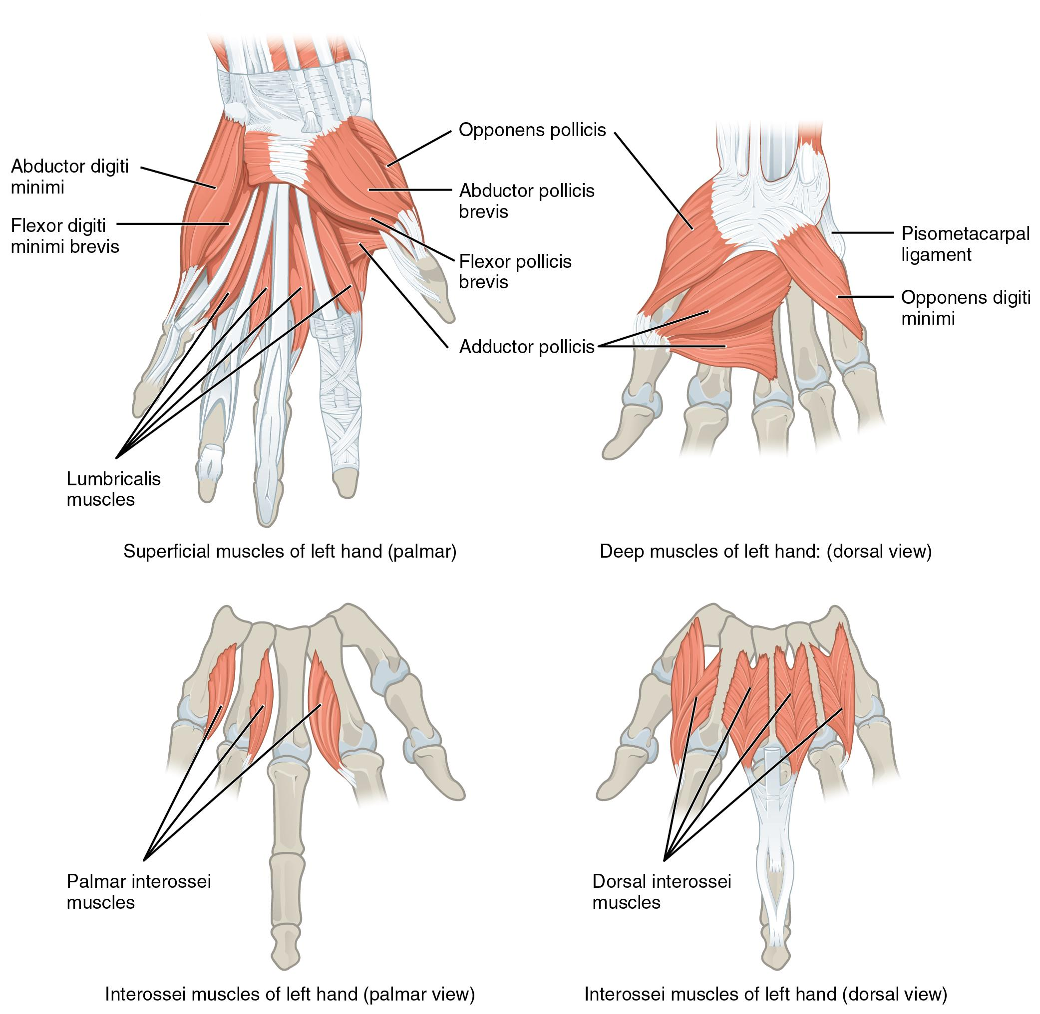
Figure 7.15 Intrinsic Muscles of the Hand The intrinsic muscles of the hand both originate and insert within the hand. These muscles provide the fine motor control of the fingers by flexing, extending, abducting, and adducting the more distal finger and thumb segments.
Intrinsic Muscles of the Hand
Prime mover | Origin | Insertion | Movement
Abductor pollicis brevis | Flexor retinaculum; nearby carpals | Lateral base of proximal phalanx of thumb | Thumb abduction
Opponens pollicis | Flexor retinaculum; trapezium | Anterior shaft of first metacarpal | Thumb opposition
Flexor pollicis brevis | Flexor retinaculum; trapezium | Base of proximal phalanx of thumb | Thumb flexion
Adductor pollicis | Capitate; bases of metacarpals 2-4 | Medial base of proximal phalanx of thumb | Thumb adduction
Abductor digiti minimi | Pisiform | Medial side of proximal phalanx of digit 5 | Abduction of digit 5
Flexor digiti minimi brevis | Hamate; flexor retinaculum | Medial side of proximal phalanx of digit 5 | Flexion of digit 5
Opponens digiti minimi | Hamate; flexor retinaculum | Medial side of 5th metacarpal | Opposition of digit 5
Lumbricals | Lateral sides of tendons in flexor digitorum profundus | Lateral edges of extensor expansion on first phalanges | Flexion at metacarpo-phalangeal joint and extension of interphalangeal joint of digits 2-5
Palmar interossei | Sides of each metacarpal that faces metacarpal 3 | Extensor expansion on first phalanx of each expect (expect digit 3) on side facing digit 3 | Adducts the fingers (except digit 3)
Dorsal interossei | Sides of metacarpals | Both sides of digit 3; for each other finger extensor expansion over first phalanx on side opposite digit 3 | Abducts the three middle fingers (digits 2-4)
Table 7.10

7.6 Appendicular Muscles of the Pelvic Girdle and Lower Limbs

Learning Objectives
By the end of this section, you will be able to:
- Identify the appendicular muscles of the pelvic girdle and lower limb
- Identify the movement and function of the pelvic girdle and lower limb
The appendicular muscles of the lower body position and stabilize the pelvic girdle, which serves as a foundation for the lower limbs. Comparatively, there is much more movement at the pectoral girdle than at the pelvic girdle. There is very little movement of the pelvic girdle because of its connection with the sacrum at the base of the axial skeleton. The pelvic girdle has less range of motion because it was designed to stabilize and support the body.

Muscles of the Thigh
What would happen if the pelvic girdle, which attaches the lower limbs to the torso, were capable of the same range of motion as the pectoral girdle? For one thing, walking would expend more energy if the heads of the femurs were not secured in the acetabula of the pelvis. The body’s center of gravity is in the area of the pelvis. If the center of gravity were not to remain fixed, standing up would be difficult as well. Therefore, what the leg muscles lack in range of motion and versatility, they make up for in size and power, facilitating the body’s stabilization, posture, and movement.
Most muscles that insert on the femur (the thigh bone) and move it, originate on the pelvic girdle. The psoas major and iliacus make up the iliopsoas muscle. Some of the largest and most powerful muscles in the body are the gluteal muscles or gluteal group. The gluteus maximus is the largest; deep to the gluteus maximus is the gluteus medius, and deep to the gluteus medius is the gluteus minimus, the smallest of the trio (Figure 7.16 and Table 7.11).
The tensor fascia latae is a thick, squarish muscle in the superior aspect of the lateral thigh. It acts as a synergist of the gluteus medius in abducting the thigh, and as a synergist of the iliopsoas in flexing the thigh. It also helps stabilize the lateral aspect of the knee by pulling on the iliotibial tract (band), making it taut. Deep to the gluteus maximus, the piriformis, obturator internus, obturator externus, superior gemellus, inferior gemellus, and quadratus femoris laterally rotate the femur at the hip. These muscles are often grouped together and referred to as the deep lateral rotator muscle group.
The pectineus, adductor longus, adductor brevis, adductor magnus, and gracilis are muscles in the medial compartment of the thigh with the gracilis originating most medially and the pectineus originating most laterally. The muscles in the medial compartment of the thigh are responsible for adducting the femur at the hip. The pectineus flexes the femur at the hip as well. The pectineus is located in the femoral triangle, which is formed at the junction between the hip and the leg and also includes the femoral nerve, the femoral artery, the femoral vein, and the deep inguinal lymph nodes. The adductor longus, adductor brevis, and adductor magnus can both medially and laterally rotate the thigh depending on the placement of the foot. The adductor longus flexes the thigh, whereas the adductor magnus extends it. The strap-like gracilis additionally flexes the leg at the knee (Table 7.12).
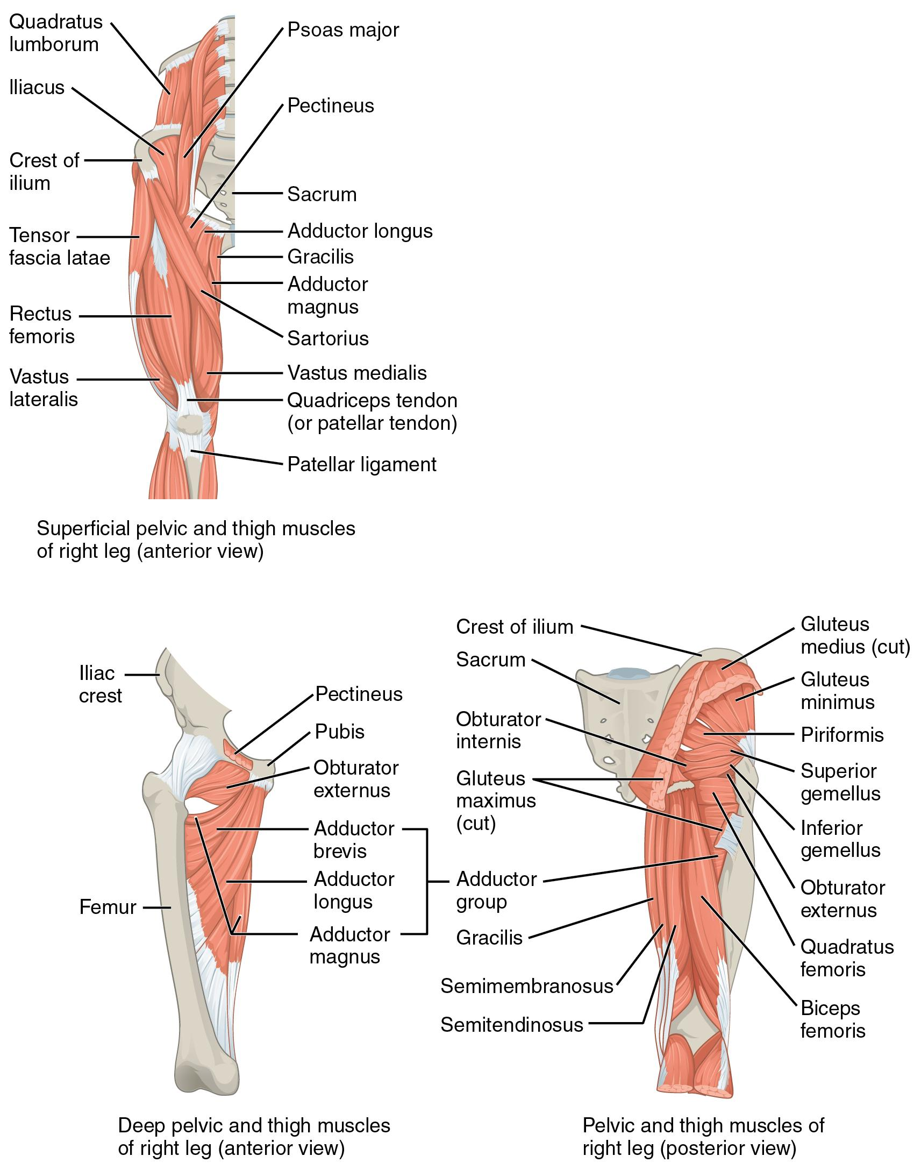
Figure 7.16 Hip and Thigh Muscles The large and powerful muscles of the hip that move the femur generally originate on the pelvic girdle and insert into the femur. The muscles that move the lower leg typically originate on the femur and insert into the bones of the knee joint.
Gluteal Region Muscles that Move the Femur
Prime mover | Origin | Insertion | Movement
Iliopsoas group
Psoas major | T12, L1-5 | Lesser trochanter of femur | Hip flexion, external rotation
Iliacus | Iliac fossa; iliac crest | Lesser trochanter of femur | Hip flexion, external rotation
Gluteal group
Gluteus maximus | Dorsal ilium; sacrum; coccyx | Gluteal tuberosity of femur; iliotibial band | Hip extension, external rotation, abduction
Gluteus medius | Iliac crest | Greater trochanter of femur | Hip abduction  Pelvic stability in weight bearing
Gluteus minimus | Ilium | Greater trochanter of femur | Hip abduction
Tensor fascia latae | Anterior superior iliac spine | Iliotibial band | Assists with hip flexion and hip abduction
Lateral rotators
Piriformis | Anterolateral surface of sacrum | Greater trochanter of femur | Hip external rotation
Obturator internus | Inner surface of obturator membrane; greater sciatic notch; margins of obturator foramen | Greater trochanter of femur | Hip external rotation
Obturator externus | Outer surface of obturator membrane; pubic and ischium; margins of obturator foramen | Trochanteric fossa of femur | Hip external rotation
Superior gemellus | Ischial spine | Greater trochanter of femur | Hip external rotation
Inferior gemellus | Ischial tuberosity | Greater trochanter of femur | Hip external rotation
Quadratus femoris | Ischial tuberosity | Trochanteric crest of femur | Hip external rotation
Adductors
Gracilis | Pubis near pubic symphysis | Tibial shaft at pes anserine | Hip adduction  Knee flexion
Adductor longus | Pubis near pubic symphysis | Linea aspera | Hip adduction
Adductor brevis | Body of pubis; inferior ramus of pubis | Linea aspera, more proximal than adductor longus | Hip adduction
Adductor magnus | Pubic ramus; ischial tuberosity | Linea aspera of femur gluteal tuberosity; adductor tubercle of femur | Hip adduction and extension
Pectineus | Pectineal line of pubis | Proximal medial shaft of femur, just inferior to lesser trochanter | Hip adduction and flexion
Table 7.11
Thigh Muscles that Move the Femur, Tibia, Fibula
Prime mover | Origin | Insertion | Movement
Anterior compartment of thigh
Rectus femoris | Anterior inferior iliac spine | Patella; tibial tuberosity | Knee extension  Hip flexion
Vastus lateralis | Greater trochanter; intertrochanteric line; linea aspera | Patella; tibial tuberosity | Knee extension
Vastus medialis | Linea aspera; intertrochanteric line | Patella; tibial tuberosity | Knee extension
Vastus intermedius | Proximal shaft of femur | Patella; tibial tuberosity | Knee extension
Sartorius | Anterior superior iliac spine | Medial aspect of proximal tibia | Hip flexion, abduction and external rotation  Knee flexion
Posterior compartment of thigh
Biceps femoris | Ischial tuberosity; linea aspera; distal femur | Head of fibula; lateral condyle of tibia | Knee flexion  Hip extension and external rotation
Semitendinosus | Ischial tuberosity | Upper medial tibial shaft | Knee flexion  Hip extension and internal rotation
Semimembranosus | Ischial tuberosity | Medial condyle of tibia | Knee flexion  Hip extension and internal rotation
Table 7.12
The muscles of the anterior compartment of the thigh flex the hip and extend the knee. This compartment contains the quadriceps femoris group, which actually comprises four muscles that extend and stabilize the knee. The rectus femoris is on the anterior aspect of the thigh, the vastus lateralis is on the lateral aspect of the anterior thigh, the vastus medialis is on the medial aspect of the anterior thigh, and the vastus intermedius is between the vastus lateralis and vastus medialis and deep to the rectus femoris. The tendon common to all four is the quadriceps tendon, which inserts into the patella and continues below it as the patellar ligament. The patellar ligament attaches to the tibial tuberosity. In addition to the quadriceps femoris, the sartorius is a band-like muscle that extends from the anterior superior iliac spine to the medial side of the proximal tibia. This versatile muscle flexes the leg at the knee and flexes, abducts, and laterally rotates the leg at the hip. This muscle allows us to sit cross-legged. It is the longest muscle in the human body.
The posterior compartment of the thigh includes muscles that flex the leg and extend the thigh. The three long muscles on the back of the knee are the hamstring group, which flexes the knee. These are the biceps femoris, semitendinosus, and semimembranosus. The tendons of these muscles form the popliteal fossa, the diamond-shaped space at the back of the knee.

Muscles That Move the Feet and Toes
Similar to the thigh muscles, the muscles of the leg are divided by deep fascia into compartments, although the leg has three: anterior, lateral, and posterior (Figure 7.17 and Table 7.13).
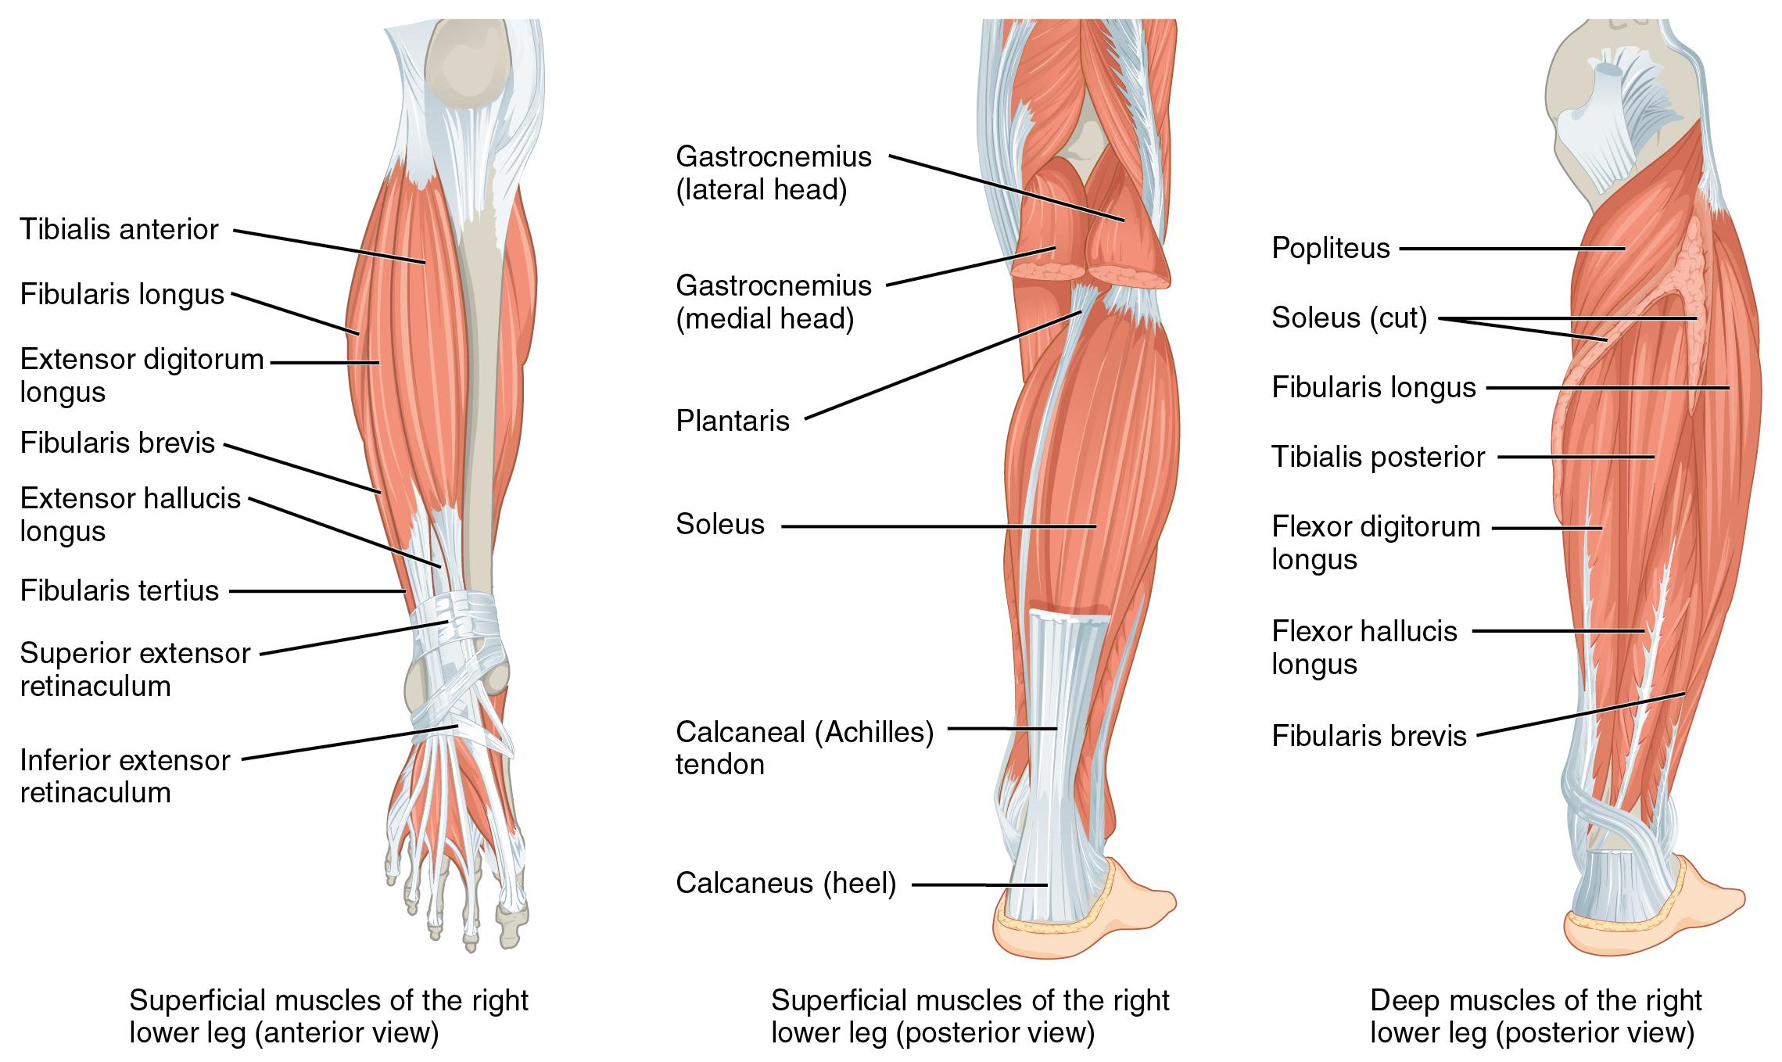
Figure 7.17 Muscles of the Lower Leg The muscles of the anterior compartment of the lower leg are generally responsible for dorsiflexion, and the muscles of the posterior compartment of the lower leg are generally responsible for plantar flexion. The lateral and medial muscles invert, evert, and rotate the foot.
Muscles that Move the Feet and Toes
Prime mover | Origin | Insertion | Movement
Anterior compartment of the leg
Tibialis anterior | Anterior shaft of tibia; interosseous membrane | First metatarsal; medial cuneiform | Ankle dorsiflexion  Foot inversion
Extensor hallucis longus | Anteromedial fibular shaft; interosseous membrane | Distal phalanx of big toe | Big toe extension  Ankle dorsiflexion
Extensor digitorum longus | Lateral condyle of tibia; interosseous membrane | Middle and distal phalanges of toes 2-5 | Toe extension toes 2-5  Ankle dorsiflexion
Lateral compartment of the leg
Fibularis longus | Upper portion of lateral fibula | First metatarsal; medial cuneiform | Ankle plantarflexion  Foot eversion
Fibularis brevis | Lateral shaft of distal fibula | Fifth metatarsal | Ankle plantarflexion  Foot eversion
Posterior compartment of the leg: superficial muscles
Gastrocnemius | Medial and lateral condyles of femur | Posterior calcaneus | Ankle plantarflexion  Knee flexion
Soleus | Posterior shaft of tibia and fibula; interosseous membrane | Posterior calcaneus | Ankle plantarflexion
Plantaris | Posterior femur above lateral condyle | Calcaneus or Achilles tendon | Ankle plantarflexion  Knee flexion
Tibialis posterior | Posterior shaft of tibia and fibula; interosseous membrane | Plantar surfaces of navicular; metatarsals 2-4 | Ankle plantarflexion  Foot inversion  Supports medial longitudinal arch
Posterior compartment of the leg: deep muscles
Popliteus | Lateral condyle of femur; lateral meniscus | Proximal medial tibia | Knee flexion  “Unlocks” the knee from full extension
Flexor digitorum longus | Posterior tibia | Distal phalanges of toes 2-5 | Toe flexion toes 2-5  Ankle plantarflexion
Flexor hallucis longus | Midshaft of fibula; interosseous membrane | Distal phalanx of big toe | Big toe flexion  Ankle plantarflexion
Table 7.13
The muscles in the anterior compartment of the leg: the tibialis anterior, a long and thick muscle on the lateral surface of the tibia, the extensor hallucis longus, deep to the tibialis anterior, and the extensor digitorum longus, lateral to the tibialis anterior. All three muscles contribute to ankle dorsiflexion - raising the front of the foot when they contract. Thick bands of connective tissue called the superior extensor retinaculum (transverse ligament of the ankle) and the inferior extensor retinaculum, hold the tendons of these muscles in place during dorsiflexion.
The lateral compartment of the leg includes two muscles: the fibularis longus (peroneus longus) and the fibularis brevis (peroneus brevis). Both of these muscles contribute to foot eversion.
The superficial muscles in the posterior compartment of the leg all insert onto the calcaneal tendon (Achilles tendon), a strong tendon that inserts into the calcaneal bone of the ankle. The muscles in this compartment are large and strong and keep humans upright. The most superficial and visible muscle of the calf is the gastrocnemius. Deep to the gastrocnemius is the wide, flat soleus. The plantaris runs obliquely between the two; some people may have two of these muscles, whereas no plantaris is observed in about seven percent of other cadaver dissections. There are four deep muscles in the posterior compartment of the leg as well: the popliteus, flexor digitorum longus, flexor hallucis longus, and tibialis posterior.
The foot also has intrinsic muscles, which originate and insert within it (similar to the intrinsic muscles of the hand). These muscles primarily provide support for the foot and its arch, and contribute to movements of the toes (Figure 7.18 and Table 7.14). The principal support for the longitudinal arch of the foot is a deep fascia called plantar aponeurosis, which runs from the calcaneus bone to the toes (inflammation of this tissue is the cause of “plantar fasciitis,” which can affect runners). The intrinsic muscles of the foot consist of two groups. The dorsal group includes only one muscle, the extensor digitorum brevis. The second group is the plantar group, which consists of four layers, starting with the most superficial.
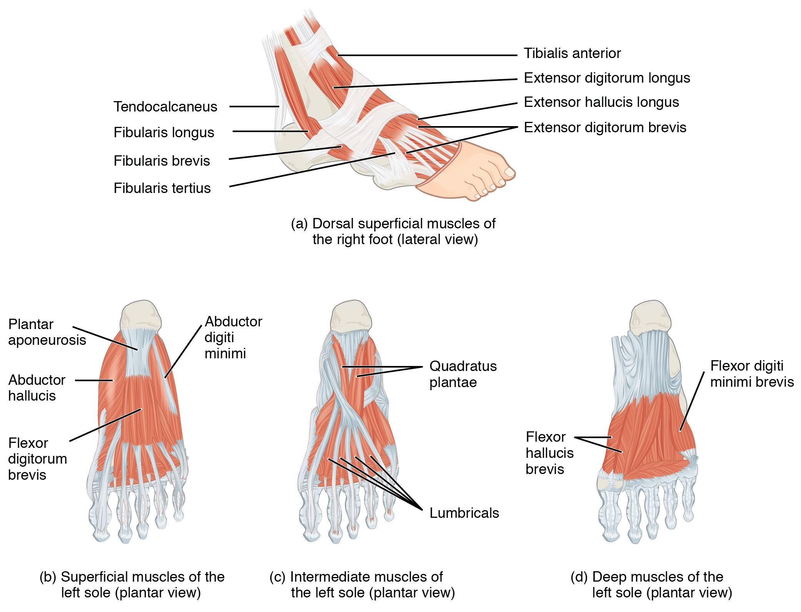
Figure 7.18 Intrinsic Muscles of the Foot The muscles along the dorsal side of the foot (a) generally extend the toes while the muscles of the plantar side of the foot (b, c, d) generally flex the toes. The plantar muscles exist in three layers, providing the foot the strength to counterbalance the weight of the body. In this diagram, these three layers are shown from a plantar view beginning with the bottom-most layer just under the plantar skin of the foot (b) and ending with the top-most layer (d) located just inferior to the foot and toe bones.
Intrinsic Muscles of the Foot
Prime mover | Origin | Insertion | Movement
Dorsal group
Extensor digitorum brevis | Calcaneus; extensor retinaculum | Extensor expansion toes 2-5 | Toe extension toes 2-5
Plantar group (layer 1)
Abductor hallucis | Calcaneal tuberosity; flexor retinaculum | Proximal phalanx of big toe | Big toe adduction and flexion
Flexor digitorum brevis | Calcaneal tuberosity | Middle phalanx of toes 2-4 | Toe flexion toes 2-4
Abductor digiti minimi | Calcaneal tuberosity | Proximal phalanx of middle toe | Toe abduction and flexion toe 5
Plantar group (layer 2)
Quadratus plantae | Medial and lateral sides of calcaneus | Tendon of flexor digitorum longus | Toe flexion toes 2-5
Lumbricals | Tendons of flexor digitorum longus | Medial side of proximal phalanx toes 2-5 | Extension at interphalangeal joint and flexion at metatarsophalangeal joint toes 2-5
Plantar group (layer 3)
Flexor hallucis brevis | Lateral cuneiform; cuboid | Base of proximal phalanx of big toe | Big toe flexion
Adductor hallucis | Bases of metatarsals 2-4 | Base of proximal phalanx of big toe | Big toe adduction and flexion
Flexor digiti minimi brevis | Base of metatarsal 5 | Base of proximal phalanx of toe 5 | Toe flexion toe 5
Plantar group (layer 4)
Dorsal interossei | Sides of metatarsals | Both sides of toe 2; for other toes the extensor expansion on side opposite of toe 2 | Toe abduction and flexion
Plantar interossei | Side of each metatarsal that faces toe 2 | Extensor expansion on side facing toe 2 | Toe abduction and flexion toes 3-5
Table 7.14

Key Terms

abduct move away from midline in the sagittal plane

abductor moves the bone away from the midline

abductor digiti minimi muscle that abducts the little finger

abductor pollicis brevis muscle that abducts the thumb

abductor pollicis longus muscle that inserts into the first metacarpal

adductor moves the bone toward the midline

adductor brevis muscle that adducts and medially rotates the thigh

adductor longus muscle that adducts, medially rotates, and flexes the thigh

adductor magnus muscle with an anterior fascicle that adducts, medially rotates and flexes the thigh, and a posterior fascicle that assists in thigh extension

adductor pollicis muscle that adducts the thumb

agonist (also, prime mover) muscle whose contraction is responsible for producing a particular motion

antagonist muscle that opposes the action of an agonist

anterior compartment of the arm (anterior flexor compartment of the arm) the biceps brachii, brachialis, brachioradialis, and their associated blood vessels and nerves

anterior compartment of the forearm (anterior flexor compartment of the forearm) deep and superficial muscles that originate on the humerus and insert into the hand

anterior compartment of the leg region that includes muscles that dorsiflex the foot

anterior compartment of the thigh region that includes muscles that flex the thigh and extend the leg

anterior scalene a muscle anterior to the middle scalene

appendicular of the arms and legs

axial of the trunk and head

belly bulky central body of a muscle

bi two

biceps brachii two-headed muscle that crosses the shoulder and elbow joints to flex the forearm while assisting in supinating it and flexing the arm at the shoulder

biceps femoris hamstring muscle

bipennate pennate muscle that has fascicles that are located on both sides of the tendon

brachialis muscle deep to the biceps brachii that provides power in flexing the forearm.

brachioradialis muscle that can flex the forearm quickly or help lift a load slowly

brevis short

calcaneal tendon (also, Achilles tendon) strong tendon that inserts into the calcaneal bone of the ankle

caval opening opening in the diaphragm that allows the inferior vena cava to pass through; foramen for the vena cava

circular (also, sphincter) fascicles that are concentrically arranged around an opening

convergent fascicles that extend over a broad area and converge on a common attachment site

coracobrachialis muscle that flexes and adducts the arm

deep anterior compartment flexor pollicis longus, flexor digitorum profundus, and their associated blood vessels and nerves

deep lateral rotator muscle group the piriformis, obturator internus, obturator externus, superior gemellus, inferior gemellus, and quadratus femoris that laterally rotate the femur at the hip

deep posterior compartment of the forearm (deep posterior extensor compartment of the forearm) the abductor pollicis longus, extensor pollicis brevis, extensor pollicis longus, extensor indicis, and their associated blood vessels and nerves

deltoid shoulder muscle that abducts the arm as well as flexes and medially rotates it, and extends and laterally rotates it

diaphragm skeletal muscle that separates the thoracic and abdominal cavities and is dome-shaped at rest

dorsal group region that includes the extensor digitorum brevis

dorsal interossei muscles that abduct and flex the three middle fingers at the metacarpophalangeal joints and extend them at the interphalangeal joints

erector spinae group large muscle mass of the back; primary extensor of the vertebral column

extensor muscle that increases the angle at the joint

extensor carpi radialis brevis muscle that extends and abducts the hand at the wrist

extensor carpi ulnaris muscle that extends and adducts the hand

extensor digiti minimi muscle that extends the little finger

extensor digitorum muscle that extends the hand at the wrist and the phalanges

extensor digitorum brevis muscle that extends the toes

extensor digitorum longus muscle that is lateral to the tibialis anterior

extensor hallucis longus muscle that is partly deep to the tibialis anterior and extensor digitorum longus

extensor indicis muscle that inserts onto the tendon of the extensor digitorum of the index finger

extensor pollicis brevis muscle that inserts onto the base of the proximal phalanx of the thumb

extensor pollicis longus muscle that inserts onto the base of the distal phalanx of the thumb

extensor radialis longus muscle that extends and abducts the hand at the wrist

extensor retinaculum band of connective tissue that extends over the dorsal surface of the hand

external intercostal superficial intercostal muscles that raise the rib cage

external oblique superficial abdominal muscle with fascicles that extend inferiorly and medially

extrinsic muscles of the hand muscles that move the wrists, hands, and fingers and originate on the arm

fascicle muscle fibers bundled by perimysium into a unit

femoral triangle region formed at the junction between the hip and the leg and includes the pectineus, femoral nerve, femoral artery, femoral vein, and deep inguinal lymph nodes

fibularis brevis (also, peroneus brevis) muscle that plantar flexes the foot at the ankle and everts it at the intertarsal joints

fibularis longus (also, peroneus longus) muscle that plantar flexes the foot at the ankle and everts it at the intertarsal joints

fixator synergist that assists an agonist by preventing or reducing movement at another joint, thereby stabilizing the origin of the agonist

flexion movement that decreases the angle of a joint

flexor muscle that decreases the angle at the joint

flexor carpi radialis muscle that flexes and abducts the hand at the wrist

flexor carpi ulnaris muscle that flexes and adducts the hand at the wrist

flexor digiti minimi brevis muscle that flexes the little finger

flexor digitorum longus muscle that flexes the four small toes

flexor digitorum profundus muscle that flexes the phalanges of the fingers and the hand at the wrist

flexor digitorum superficialis muscle that flexes the hand and the digits

flexor hallucis longus muscle that flexes the big toe

flexor pollicis brevis muscle that flexes the thumb

flexor pollicis longus muscle that flexes the distal phalanx of the thumb

flexor retinaculum band of connective tissue that extends over the palmar surface of the hand

fusiform muscle that has fascicles that are spindle-shaped to create large bellies

gastrocnemius most superficial muscle of the calf

gluteal group muscle group that extends, flexes, rotates, adducts, and abducts the femur

gluteus maximus largest of the gluteus muscles that extends the femur

gluteus medius muscle deep to the gluteus maximus that abducts the femur at the hip

gluteus minimus smallest of the gluteal muscles and deep to the gluteus medius

gracilis muscle that adducts the thigh and flexes the leg at the knee

hamstring group three long muscles on the back of the leg

hypothenar group of muscles on the medial aspect of the palm

hypothenar eminence rounded contour of muscle at the base of the little finger

iliacus muscle that, along with the psoas major, makes up the iliopsoas

iliocostalis cervicis muscle of the iliocostalis group associated with the cervical region

iliocostalis group laterally placed muscles of the erector spinae

iliocostalis lumborum muscle of the iliocostalis group associated with the lumbar region

iliocostalis thoracis muscle of the iliocostalis group associated with the thoracic region

iliopsoas muscle muscle group consisting of iliacus and psoas major muscles, that flexes the thigh at the hip, rotates it laterally, and flexes the trunk of the body onto the hip

iliotibial tract connective tissue that inserts onto the tibia

inferior extensor retinaculum cruciate ligament of the ankle

inferior gemellus muscle deep to the gluteus maximus on the lateral surface of the thigh that laterally rotates the femur at the hip

infraspinatus muscle that laterally rotates the arm

innermost intercostal the deepest intercostal muscles that draw the ribs together

insertion end of a skeletal muscle that is attached to the structure (usually a bone) that is moved when the muscle contracts

intercostal muscles muscles that span the spaces between the ribs

intermediate group of midpalmar muscles

internal intercostal muscles the intermediate intercostal muscles that draw the ribs together

internal oblique flat, intermediate abdominal muscle with fascicles that run perpendicular to those of the external oblique

intrinsic muscles of the hand muscles that move the wrists, hands, and fingers and originate in the palm

lateral compartment of the leg region that includes the fibularis (peroneus) longus and the fibularis (peroneus) brevis and their associated blood vessels and nerves

lateralis to the outside

latissimus dorsi broad, triangular axial muscle located on the inferior part of the back

linea alba white, fibrous band that runs along the midline of the trunk

longissimus capitis muscle of the longissimus group associated with the head region

longissimus cervicis muscle of the longissimus group associated with the cervical region

longissimus group intermediately placed muscles of the erector spinae

longissimus thoracis muscle of the longissimus group associated with the thoracic region

longus long

lumbrical muscle that flexes each finger at the metacarpophalangeal joints and extend each finger at the interphalangeal joints

maximus largest

medial compartment of the thigh a region that includes the adductor longus, adductor brevis, adductor magnus, pectineus, gracilis, and their associated blood vessels and nerves

medialis to the inside

medius medium

middle scalene longest scalene muscle, located between the anterior and posterior scalenes

minimus smallest

multifidus muscle of the lumbar region that helps extend and laterally flex the vertebral column

multipennate pennate muscle that has a tendon branching within it

oblique at an angle

obturator externus muscle deep to the gluteus maximus on the lateral surface of the thigh that laterally rotates the femur at the hip

obturator internus muscle deep to the gluteus maximus on the lateral surface of the thigh that laterally rotates the femur at the hip

opponens digiti minimi muscle that brings the little finger across the palm to meet the thumb

opponens pollicis muscle that moves the thumb across the palm to meet another finger

origin end of a skeletal muscle that is attached to another structure (usually a bone) in a fixed position

palmar interossei muscles that abduct and flex each finger at the metacarpophalangeal joints and extend each finger at the interphalangeal joints

palmaris longus muscle that provides weak flexion of the hand at the wrist

parallel fascicles that extend in the same direction as the long axis of the muscle

patellar ligament extension of the quadriceps tendon below the patella

pectineus muscle that abducts and flexes the femur at the hip

pectoral girdle shoulder girdle, made up of the clavicle and scapula

pectoralis major thick, fan-shaped axial muscle that covers much of the superior thorax

pectoralis minor muscle that moves the scapula and assists in inhalation

pelvic girdle hips, a foundation for the lower limb

pennate fascicles that are arranged differently based on their angles to the tendon

piriformis muscle deep to the gluteus maximus on the lateral surface of the thigh that laterally rotates the femur at the hip

plantar aponeurosis muscle that supports the longitudinal arch of the foot

plantar group four-layered group of intrinsic foot muscles

plantaris muscle that runs obliquely between the gastrocnemius and the soleus

popliteal fossa diamond-shaped space at the back of the knee

popliteus muscle that flexes the leg at the knee and creates the floor of the popliteal fossa

posterior compartment of the leg region that includes the superficial gastrocnemius, soleus, and plantaris, and the deep popliteus, flexor digitorum longus, flexor hallucis longus, and tibialis posterior

posterior compartment of the thigh region that includes muscles that flex the leg and extend the thigh

posterior scalene smallest scalene muscle, located posterior to the middle scalene

prime mover (also, agonist) principle muscle involved in an action

pronator quadratus pronator that originates on the ulna and inserts on the radius

pronator teres pronator that originates on the humerus and inserts on the radius

psoas major muscle that, along with the iliacus, makes up the iliopsoas

quadratus femoris muscle deep to the gluteus maximus on the lateral surface of the thigh that laterally rotates the femur at the hip

quadratus lumborum posterior part of the abdominal wall that helps with posture and stabilization of the body

quadriceps femoris group four muscles, that extend and stabilize the knee

quadriceps tendon tendon common to all four quadriceps muscles, inserts into the patella

rectus straight

rectus abdominis long, linear muscle that extends along the middle of the trunk

rectus femoris quadricep muscle on the anterior aspect of the thigh

rectus sheaths tissue that makes up the linea alba

retinacula fibrous bands that sheath the tendons at the wrist

rhomboid major muscle that attaches the vertebral border of the scapula to the spinous process of the thoracic vertebrae

rhomboid minor muscle that attaches the vertebral border of the scapula to the spinous process of the thoracic vertebrae

rotator cuff (also, musculotendinous cuff) the circle of tendons around the shoulder joint

sartorius band-like muscle that flexes, abducts, and laterally rotates the leg at the hip

scalene muscles flex, laterally flex, and rotate the head; contribute to deep inhalation

semimembranosus hamstring muscle

semitendinosus hamstring muscle

serratus anterior large and flat muscle that originates on the ribs and inserts onto the scapula

soleus wide, flat muscle deep to the gastrocnemius

spinalis capitis muscle of the spinalis group associated with the head region

spinalis cervicis muscle of the spinalis group associated with the cervical region

spinalis group medially placed muscles of the erector spinae

spinalis thoracis muscle of the spinalis group associated with the thoracic region

splenius posterior neck muscles; includes the splenius capitis and splenius cervicis

splenius capitis neck muscle that inserts into the head region

splenius cervicis neck muscle that inserts into the cervical region

sternocleidomastoid major muscle that laterally flexes and rotates the head

subclavius muscle that stabilizes the clavicle during movement

subscapularis muscle that originates on the anterior scapula and medially rotates the arm

superficial anterior compartment of the forearm flexor carpi radialis, palmaris longus, flexor carpi ulnaris, flexor digitorum superficialis, and their associated blood vessels and nerves

superficial posterior compartment of the forearm extensor radialis longus, extensor carpi radialis brevis, extensor digitorum, extensor digiti minimi, extensor carpi ulnaris, and their associated blood vessels and nerves

superior extensor retinaculum transverse ligament of the ankle

superior gemellus muscle deep to the gluteus maximus on the lateral surface of the thigh that laterally rotates the femur at the hip

supinator muscle that moves the palm and forearm anteriorly

supraspinatus muscle that abducts the arm

synergist muscle whose contraction helps a prime mover in an action

tendinous intersections three transverse bands of collagen fibers that divide the rectus abdominis into segments

tensor fascia lata muscle that flexes and abducts the thigh

teres major muscle that extends the arm and assists in adduction and medial rotation of it

teres minor muscle that laterally rotates and extends the arm

thenar group of muscles on the lateral aspect of the palm

thenar eminence rounded contour of muscle at the base of the thumb

tibialis anterior muscle located on the lateral surface of the tibia

tibialis posterior muscle that plantar flexes and inverts the foot

transversus abdominis deep layer of the abdomen that has fascicles arranged transversely around the abdomen

trapezius muscle that stabilizes the upper part of the back

tri three

triceps brachii three-headed muscle that extends the forearm

unipennate pennate muscle that has fascicles located on one side of the tendon

vastus intermedius quadricep muscle that is between the vastus lateralis and vastus medialis and is deep to the rectus femoris

vastus lateralis quadricep muscle on the lateral aspect of the thigh

vastus medialis quadricep muscle on the medial aspect of the thigh

8 | JOINTS OF THE BODY
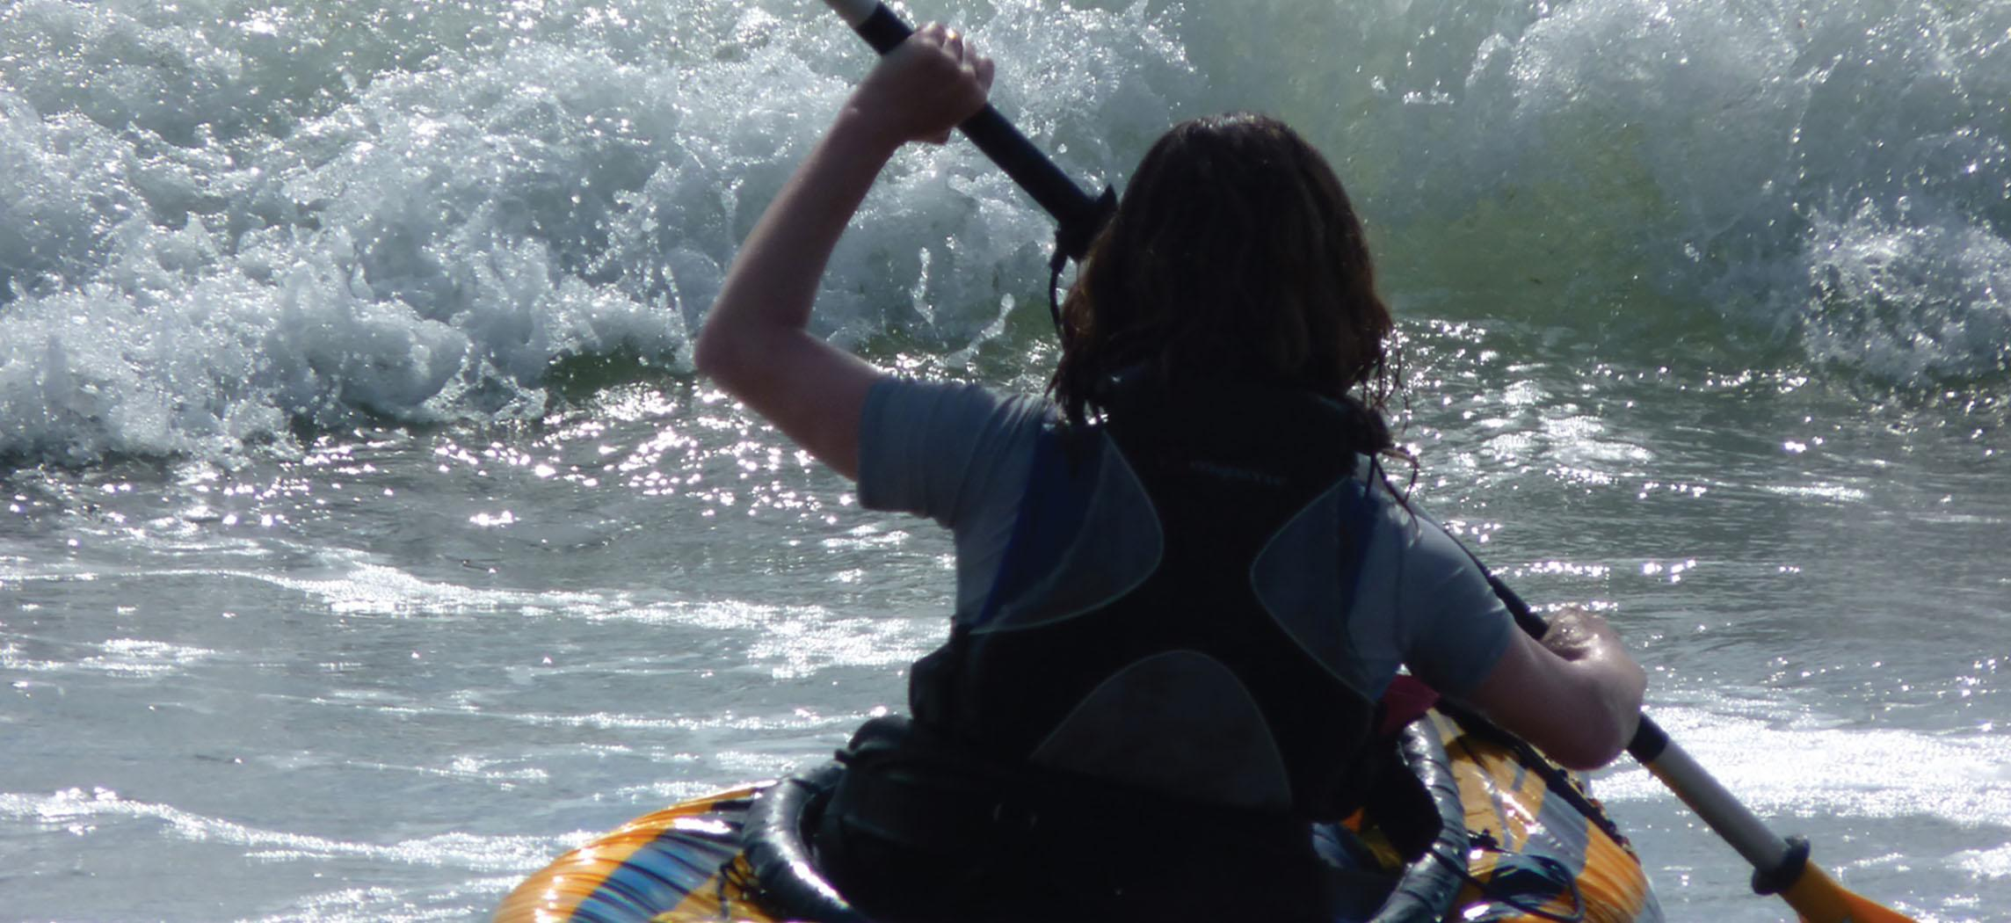
Figure 9.1 Girl Kayaking Without joints, body movements would be impossible. (credit: Graham Richardson/flickr.com)

Chapter Objectives
After studying this chapter, you will be able to:
- Review the types of movements that occur at synovial joints
- Review the classification of synovial joints
- Describe the anatomy of selected synovial joints
- Identify important bony landmarks, ligaments, and cartilaginous structures associated with selected joints

Introduction
Our body movement occurs as a result of muscles pulling on bones and creating movement at joints. Joints play an important role in the movement we are able to do. The structure and anatomy of joints also plays an important role in what types of body movements we are able to do with each joint.
Joints also have many important structures that contribute to the mobility and stability of that joint. These structures can be susceptible to injury, which can cause pain and limitations in movement.

8.1 Types of Body Movements at Synovial Joints

Learning Objectives
By the end of this section, you will be able to:
- Review the different types of body movements
- Identify the joints that allow for these motions
Synovial joints allow the body a tremendous range of movements. Each movement at a synovial joint results from the contraction or relaxation of the muscles that are attached to the bones on either side of the articulation. The type of movement that can be produced at a synovial joint is determined by its structural type. While the ball-and-socket joint gives the greatest range of movement at an individual joint, in other regions of the body, several joints may work together to produce a particular movement. Overall, each type of synovial joint is necessary to provide the body with its great flexibility and mobility. There are many types of movement that can occur at synovial joints (Table 8.1). Movement types are generally paired, with one being the opposite of the other. Body movements are always described in relation to the anatomical position of the body: upright stance, with upper limbs to the side of body and palms facing forward. Refer to Figure 8.2 as you go through this section.
Movements of the Joints
Type of Joint | Movement | Example
Pivot | Uniaxial joint that allows rotational movement | Atlantoaxial joints (C1-C2)  Proximal radioulnar joint
Hinge | Uniaxial joint that allows flexion/extension movements | Knee; elbow; ankle  Interphalangeal joints of fingers and toes
Condyloid | Biaxial joint that allows flexion/extension and abduction/adduction movements | Metacarpophalangeal (knuckle) joints of fingers  Radiocarpal joint of wrist  Metatarsophalangeal joints
Saddle | Biaxial joint that allows flexion/extension and abduction/adduction movements | First carpometacarpal joint of the thumb  Sternoclavicular joint
Plane | Multiaxial joint that allows inversion and eversion of foot, or flexion, extension and lateral flexion of the vertebral column | Intertarsal joints of foot  Superior-inferior articular process articulations between vertebrae
Ball-and-socket | Multiaxial joint that allows flexion/extension, abduction/adduction, internal/external rotation movements | Shoulder and hip joints

Table 8.1

Figure 8.2 Movements of the Body, Part 1 Synovial joints give the body many ways in which to move. (a)–(b) Flexion and extension motions are in the sagittal (anterior–posterior) plane of motion. These movements take place at the shoulder, hip, elbow, knee, wrist, metacarpophalangeal, metatarsophalangeal, and interphalangeal joints. (c)–(d) Anterior bending of the head or vertebral column is flexion, while any posterior-going movement is extension. (e) Abduction and adduction are motions of the limbs, hand, fingers, or toes in the coronal (medial–lateral) plane of movement. Moving the limb or hand laterally away from the body, or spreading the fingers or toes, is abduction. Adduction brings the limb or hand toward or across the midline of the body, or brings the fingers or toes together. Circumduction is the movement of the limb, hand, or fingers in a circular pattern, using the sequential combination of flexion, adduction, extension, and abduction motions. (f) Turning of the head side to side or twisting of the body is rotation. Medial and lateral rotation of the upper limb at the shoulder or lower limb at the hip involves turning the anterior surface of the limb toward the midline of the body (medial or internal rotation) or away from the midline (lateral or external rotation).
Figure 8.3 Movements of the Body, Part 2 (g) Supination of the forearm turns the hand to the palm forward position in which the radius and ulna are parallel, while forearm pronation turns the hand to the palm backward position in which the radius crosses over the ulna to form an "X." (h) Dorsiflexion of the foot at the ankle joint moves the top of the foot toward the leg, while plantar flexion lifts the heel and points the toes. (i) Eversion of the foot moves the bottom (sole) of the foot away from the midline of the body, while foot inversion faces the sole toward the midline. (j) Protraction of the mandible pushes the chin forward, and retraction pulls the chin back. (k) Depression of the mandible opens the mouth, while elevation closes it. (l) Opposition of the thumb brings the tip of the thumb into contact with the tip of the fingers of the same hand and reposition brings the thumb back next to the index finger.

Flexion and Extension
Flexion and extension are typically movements that take place within the sagittal plane and involve anterior or posterior movements of the neck, trunk, or limbs. For the vertebral column, flexion is an anterior (forward) bending of the neck or trunk, while extension involves a posterior-directed motion (bending backward). Lateral flexion of the vertebral column occurs in the coronal plane and is defined as the bending of the neck or trunk toward the right or left side.
In the limbs, flexion decreases the angle between the bones (bending of the joint), while extension increases the angle and straightens the joint. For the upper limb, all anterior-going motions are flexion and all posterior-going motions are extension. These include anterior-posterior movements of the arm at the shoulder, the forearm at the elbow, the hand at the wrist, and the fingers at the metacarpophalangeal and interphalangeal joints. In the lower limb, bringing the thigh forward and upward is flexion at the hip joint, while posterior-going motion of the thigh is extension. Knee flexion is the bending of the knee to bring the foot toward the posterior thigh, and extension is the straightening of the knee.
Hyperextension is the abnormal or excessive extension of a joint beyond its normal range of motion, thus resulting in injury. Similarly, hyperflexion is excessive flexion at a joint. Hyperextension injuries are common at hinge joints such as the knee or elbow.

Abduction and Adduction
Abduction and adduction motions occur within the coronal plane and involve medial-lateral motions of the limbs, fingers, toes, or thumb. Abduction moves the limb laterally away from the midline of the body, while adduction is the opposing movement that brings the limb toward the body or across the midline.

Circumduction
Circumduction is the movement of a body region in a circular manner, in which one end of the body region being moved stays relatively stationary while the other end describes a circle. It involves the sequential combination of flexion, adduction, extension, and abduction at a joint (see Figure 8.2e).

Rotation
Rotation can occur within the vertebral column, at a pivot joint, or at a ball-and-socket joint. Rotation of the neck or body is the twisting movement produced by the summation of the small rotational movements available between adjacent vertebrae.
Rotation can also occur at the ball-and-socket joints of the shoulder and hip. Here, the humerus and femur rotate around their long axis, which moves the anterior surface of the arm or thigh either toward or away from the midline of the body. Movement that brings the anterior surface of the limb toward the midline of the body is called medial (internal) rotation. Conversely, rotation of the limb so that the anterior surface moves away from the midline is lateral (external) rotation (see Figure 8.2f).

Supination and Pronation
Supination and pronation are movements of the forearm. Pronation is the motion that moves the forearm from the supinated (anatomical) position to the pronated (palm backward) position. This motion is produced by rotation of the radius at the proximal radioulnar joint, accompanied by movement of the radius at the distal radioulnar joint. The proximal radioulnar joint is a pivot joint that allows for rotation of the head of the radius. Because of the slight curvature of the shaft of the radius, this rotation causes the distal end of the radius to cross over the distal ulna at the distal radioulnar joint. This crossing over brings the radius and ulna into an X-shape position. Supination is the opposite motion, in which rotation of the radius returns the bones to their parallel positions and moves the palm to the anterior facing (supinated) position. It helps to remember that supination is the motion you use when scooping up soup with a spoon (see Figure 8.3g).

Dorsiflexion and Plantar Flexion
Dorsiflexion and plantar flexion are movements at the ankle joint, which is a hinge joint. Lifting the front of the foot, so that the top of the foot moves toward the anterior leg is dorsiflexion, while lifting the heel of the foot from the ground or pointing the toes downward is plantar flexion. These are the only movements available at the ankle joint (see Figure 8.3h).

Inversion and Eversion
Inversion and eversion are complex movements that involve the multiple plane joints among the bones of the foot. Inversion is the turning of the foot to bring the soles of the foot toward the midline, while eversion turns the bottom of the foot away from the midline. The foot has a greater range of inversion than eversion motion (see Figure 8.3i).

Protraction and Retraction
Protraction and retraction are anterior-posterior movements of the scapula or mandible. Protraction of the scapula occurs when the shoulder is moved forward, as when pushing against something or throwing a ball. Retraction is the opposite motion, with the scapula being pulled posteriorly and medially, toward the vertebral column. For the mandible, protraction occurs when the lower jaw is pushed forward, to stick out the chin, while retraction pulls the lower jaw backward. (See Figure 8.3j.)

Depression and Elevation
Depression and elevation are downward and upward movements of the scapula or mandible. The upward movement of the scapula and shoulder is elevation, while a downward movement is depression. These movements are used to shrug your shoulders. Similarly, elevation of the mandible is the upward movement of the lower jaw used to close the mouth or bite on something, and depression is the downward movement that produces opening of the mouth (see Figure 8.3k).

Upward Rotation and Downward Rotation
Upward and downward rotation are movements of the scapula and are defined by the direction of movement of the glenoid cavity. These motions involve rotation of the scapula around a point inferior to the scapular spine and are produced by combinations of muscles acting on the scapula. During upward rotation, the glenoid cavity moves upward as the medial end of the scapular spine moves downward. This is a very important motion that contributes to upper limb abduction. Without upward rotation of the scapula, the greater tubercle of the humerus would hit the acromion of the scapula, thus preventing any abduction of the arm above shoulder height. Upward rotation of the scapula is thus required for full abduction of the upper limb. Downward rotation occurs during limb adduction and involves the downward motion of the glenoid cavity with upward movement of the medial end of the scapular spine.

Opposition and Reposition
Opposition is the thumb movement that brings the tip of the thumb in contact with the tip of a finger. This movement is produced at the first carpometacarpal joint, which is a saddle joint formed between the trapezium carpal bone and the first metacarpal bone. Thumb opposition is produced by a combination of flexion and abduction of the thumb at this joint. Returning the thumb to its anatomical position next to the index finger is called reposition (see Figure 8.3l).

8.2 Anatomy of Selected Synovial Joints

Learning Objectives
By the end of this section, you will be able to:
- Describe the bones that articulate together to form selected synovial joints
- Discuss the movements available at each joint
- Describe the structures that support and prevent excess movements at each joint
Each synovial joint of the body is specialized to perform certain movements. The movements that are allowed are determined by the structural classification for each joint. For example, a multiaxial ball-and-socket joint has much more mobility than a uniaxial hinge joint. However, the ligaments and muscles that support a joint may place restrictions on the total range of motion available. Thus, the ball-and-socket joint of the shoulder has little in the way of ligament support, which gives the shoulder a very large range of motion. In contrast, movements at the hip joint are restricted by strong ligaments, which reduce its range of motion but confer stability during standing and weight bearing.
This section will examine the anatomy of selected synovial joints of the body. Anatomical names for most joints are derived from the names of the bones that articulate at that joint, although some joints, such as the elbow, hip, and knee joints are exceptions to this general naming scheme.

Articulations of the Vertebral Column
In addition to being held together by the intervertebral discs, adjacent vertebrae also articulate with each other at synovial joints formed between the superior and inferior articular processes called zygapophysial joints (facet joints). These are plane joints that provide for only limited motions between the vertebrae. The orientation of the articular processes at these joints varies in different regions of the vertebral column and serves to determine the types of motions available in each vertebral region. The cervical and lumbar regions have the greatest ranges of motions.
The articulations formed between the skull, the atlas (C1 vertebra), and the axis (C2 vertebra) differ from the articulations in other vertebral areas and play important roles in movement of the head. The atlanto-occipital joint is formed by the articulations between the superior articular processes of the atlas and the occipital condyles on the base of the skull. This articulation has a pronounced U-shaped curvature, oriented along the anterior-posterior axis. This allows the skull to rock forward and backward, producing flexion and extension of the head. This moves the head up and down, as when shaking your head “yes.”
The atlantoaxial joint, between the atlas and axis, consists of three articulations. The paired superior articular processes of the axis articulate with the inferior articular processes of the atlas. These articulating surfaces are relatively flat and oriented horizontally. The third articulation is the pivot joint formed between the dens, which projects upward from the body of the axis, and the inner aspect of the anterior arch of the atlas (Figure 8.4). A strong ligament passes posterior to the dens to hold it in position against the anterior arch. These articulations allow the atlas to rotate on top of the axis, moving the head toward the right or left, as when shaking your head “no.”
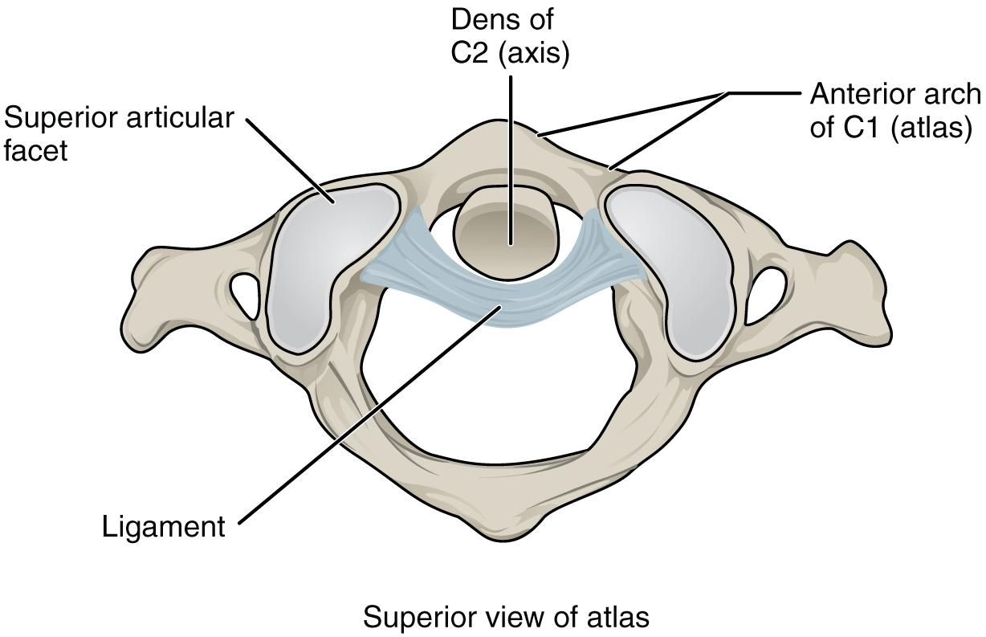
Figure 8.4 Atlantoaxial Joint The atlantoaxial joint is a pivot type of joint between the dens portion of the axis (C2 vertebra) and the anterior arch of the atlas (C1 vertebra), with the dens held in place by a ligament.

Shoulder Joint
The shoulder joint is called the glenohumeral joint. This is a ball-and-socket joint formed by the articulation between the head of the humerus and the glenoid cavity of the scapula (Figure 8.5). This joint has the largest range of motion of any joint in the body. However, this freedom of movement is due to the lack of structural support and thus the increased mobility is offset by a loss of stability.
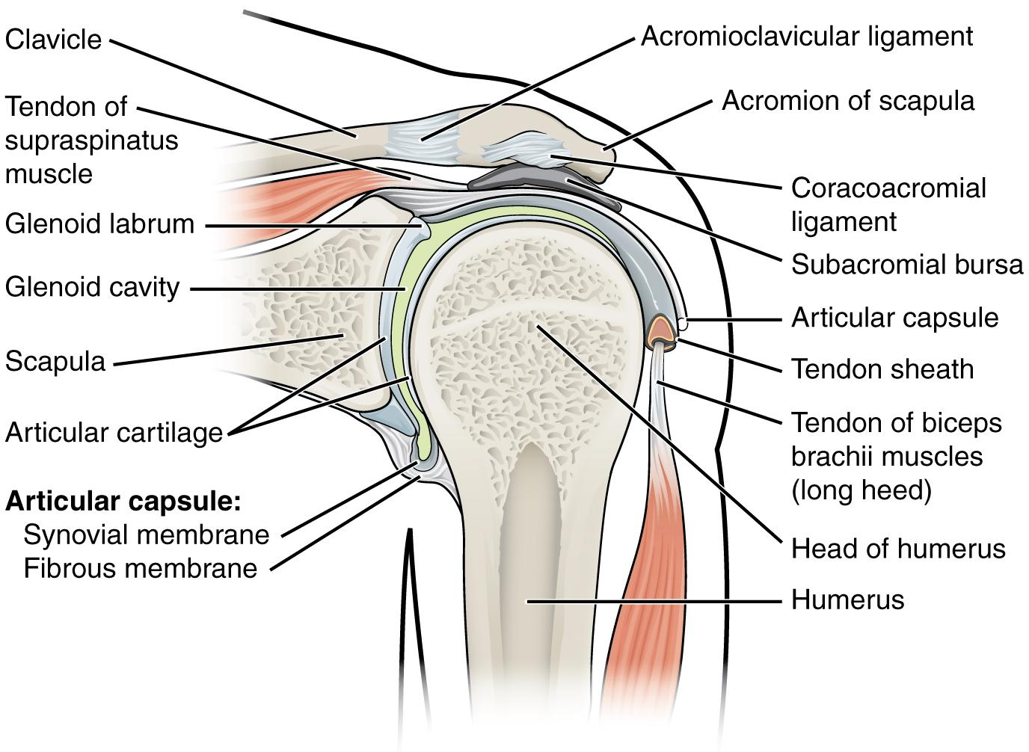
Figure 8.5 Glenohumeral Joint The glenohumeral (shoulder) joint is a ball-and-socket joint that provides the widest range of motions. It has a loose articular capsule and is supported by ligaments and the rotator cuff muscles.
The large range of motions at the shoulder joint is provided by the articulation of the large, rounded humeral head with the small and shallow glenoid cavity, which is only about one third of the size of the humeral head. The socket formed by the glenoid cavity is deepened slightly by a small lip of fibrocartilage called the glenoid labrum, which extends around the outer margin of the cavity. The articular capsule that surrounds the glenohumeral joint is relatively thin and loose to allow for large motions of the upper limb. Some structural support for the joint is provided by thickenings of the articular capsule wall that form intrinsic ligaments. These include the coracohumeral ligament, running from the coracoid process of the scapula to the anterior humerus, and three ligaments, each called a glenohumeral ligament, located on the anterior side of the articular capsule. These ligaments help to strengthen the superior and anterior capsule walls.
However, the primary support for the shoulder joint is provided by muscles crossing the joint, particularly the four rotator cuff muscles. These muscles (supraspinatus, infraspinatus, teres minor, and subscapularis) arise from the scapula and attach to the greater or lesser tubercles of the humerus. As these muscles cross the shoulder joint, their tendons encircle the head of the humerus and become fused to the walls of the articular capsule. The thickening of the capsule formed by the fusion of these four muscle tendons is called the rotator cuff. The subacromial bursa helps to prevent friction between the rotator cuff muscle tendons and the scapula as these tendons cross the glenohumeral joint. In addition to their individual actions of moving the upper limb, the rotator cuff muscles also serve to hold the head of the humerus in position within the glenoid cavity. By constantly adjusting their strength of contraction to resist forces acting on the shoulder, these muscles serve as “dynamic ligaments” and thus provide the primary structural support for the glenohumeral joint.
Injuries to the shoulder joint are common. Repetitive use of the upper limb, particularly in abduction such as during throwing, swimming, or racquet sports, may lead to acute or chronic inflammation of the bursa or muscle tendons, a tear of the glenoid labrum, or degeneration or tears of the rotator cuff. Because the humeral head is strongly supported by muscles and ligaments around its anterior, superior, and posterior aspects, most dislocations of the humerus occur in an inferior direction. This can occur when force is applied to the humerus when the upper limb is fully abducted, as when diving to catch a baseball and landing on your hand or elbow.
Interactive Link
What this video for a tutorial on the anatomy of the shoulder joint. What movements are available at the shoulder joint?

Elbow Joint
The elbow joint is a uniaxial hinge joint formed by the humeroulnar joint, the articulation between the trochlea of the humerus and the trochlear notch of the ulna. Also associated with the elbow are the humeroradial joint and the proximal radioulnar joint. All three of these joints are enclosed within a single articular capsule (Figure 8.6).
The articular capsule of the elbow is thin on its anterior and posterior aspects, but is thickened along its outside margins by strong intrinsic ligaments. These ligaments prevent side-to-side movements and hyperextension. On the medial side is the triangular ulnar collateral ligament. This arises from the medial epicondyle of the humerus and attaches to the medial side of the proximal ulna. The strongest part of this ligament is the anterior portion, which resists hyperextension of the elbow. The ulnar collateral ligament may be injured by frequent, forceful extensions of the forearm, as is seen in baseball pitchers.
The lateral side of the elbow is supported by the radial collateral ligament. This arises from the lateral epicondyle of the humerus and then blends into the lateral side of the annular ligament. The annular ligament encircles the head of the radius. This ligament supports the head of the radius as it articulates with the radial notch of the ulna at the proximal radioulnar joint. This is a pivot joint that allows for rotation of the radius during supination and pronation of the forearm.
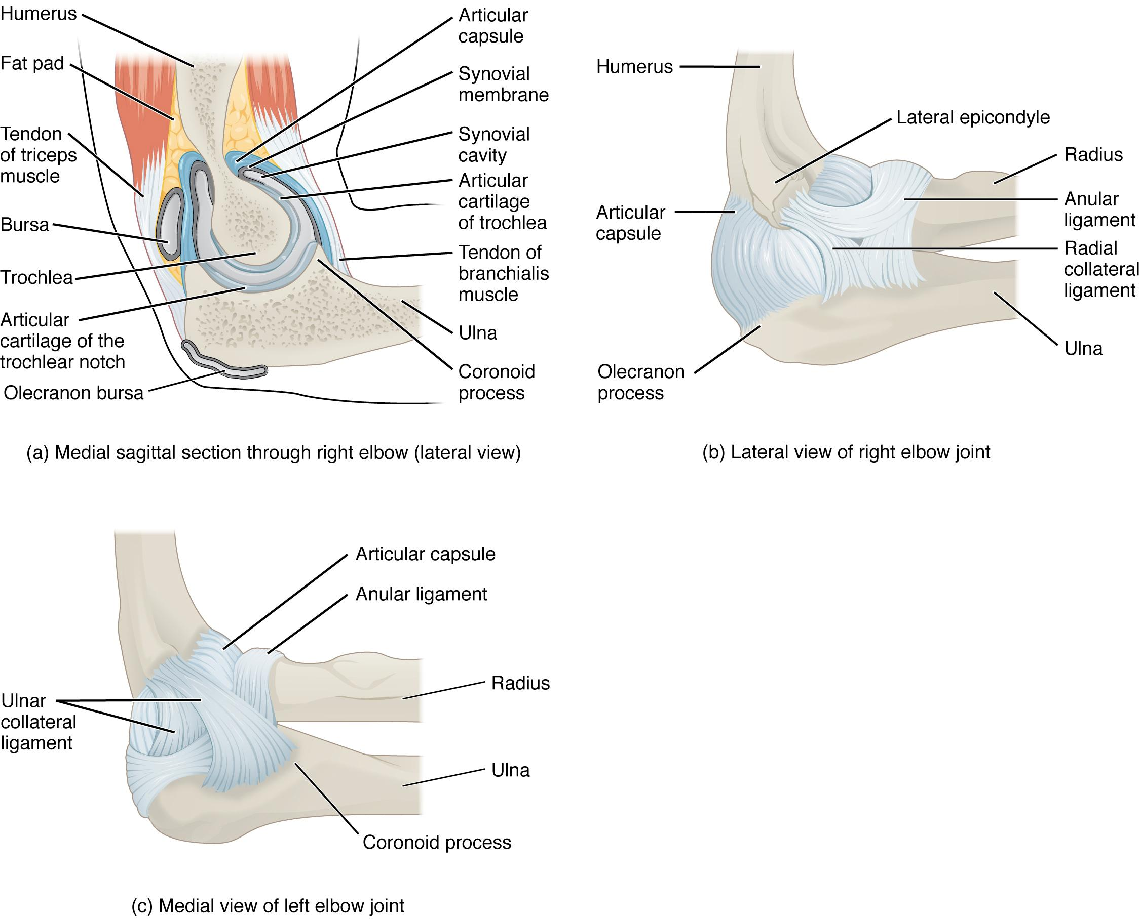
Figure 8.6 Elbow Joint (a) The elbow is a hinge joint that allows only for flexion and extension of the forearm. (b) It is supported by the ulnar and radial collateral ligaments. (c) The annular ligament supports the head of the radius at the proximal radioulnar joint, the pivot joint that allows for rotation of the radius.
Interactive Link
Watch this animation to learn more about the anatomy of the elbow joint. Which structures provide the main stability for the elbow?

Hip Joint
The hip joint is a multiaxial ball-and-socket joint between the head of the femur and the acetabulum of the hip bone (Figure 8.7). The hip carries the weight of the body and thus requires strength and stability during standing and walking. For these reasons, its range of motion is more limited than at the shoulder joint.
The acetabulum is the socket portion of the hip joint. This space is deep and has a large articulation area for the femoral head, thus giving stability and weight bearing ability to the joint. The acetabulum is further deepened by the acetabular labrum, a fibrocartilage lip attached to the outer margin of the acetabulum. The surrounding articular capsule is strong, with several thickened areas forming intrinsic ligaments. These ligaments arise from the hip bone, at the margins of the acetabulum, and attach to the femur at the base of the neck. The ligaments are the iliofemoral ligament, pubofemoral ligament, and ischiofemoral ligament, all of which spiral around the head and neck of the femur. These ligaments stabilize the hip joint and allow you to maintain an upright standing position with only minimal muscle contraction. Inside of the articular capsule, the ligament of the head of the femur (ligamentum teres) spans between the acetabulum and femoral head. This intracapsular ligament is normally slack and does not provide any significant joint support, but it does provide a pathway for an important artery that supplies the head of the femur.
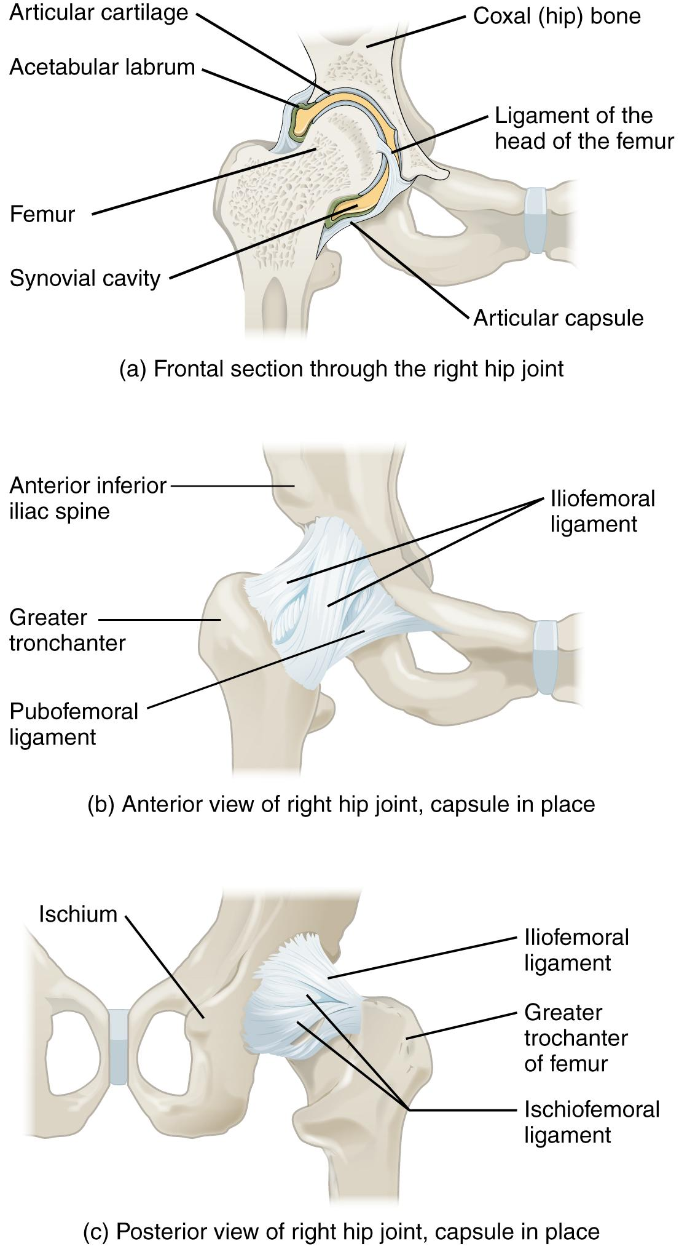

Figure 8.7 Hip Joint (a) The ball-and-socket joint of the hip is a multiaxial joint that provides both stability and a wide range of motion. (b–c) When standing, the supporting ligaments are tight, pulling the head of the femur into the acetabulum.
Interactive Link
Watch this video for a tutorial on the anatomy of the hip joint. What is a possible consequence following a fracture of the femoral neck within the capsule of the hip joint?

Knee Joint
The knee joint is the largest joint of the body (Figure 8.8). It actually consists of three articulations. The femoropatellar joint is found between the patella and the distal femur. The medial tibiofemoral joint and lateral tibiofemoral joint are located between the medial and lateral condyles of the femur and the medial and lateral condyles of the tibia. All of these articulations are enclosed within a single articular capsule. The knee functions as a hinge joint, allowing flexion and extension of the leg. The knee is well constructed for weight bearing in its extended position, but is vulnerable to injuries associated with hyperextension, twisting, or blows to the medial or lateral side of the joint, particularly while weight bearing.
At the femoropatellar joint, the patella slides vertically within a groove on the distal femur. The patella is a sesamoid bone incorporated into the tendon of the quadriceps femoris muscle, the large muscle of the anterior thigh. The patella serves to protect the quadriceps tendon from friction against the distal femur. Continuing from the patella to the anterior tibia just below the knee is the patellar ligament. Acting via the patella and patellar ligament, the quadriceps femoris is a powerful muscle that acts to extend the leg at the knee. It also serves as a “dynamic ligament” to provide very important support and stabilization for the knee joint.
The medial and lateral tibiofemoral joints are the articulations between the rounded condyles of the femur and the relatively flat condyles of the tibia. During flexion and extension motions, the condyles of the femur both roll and glide over the surfaces of the tibia. The rolling action produces flexion or extension, while the gliding action serves to maintain the femoral condyles centered over the tibial condyles, thus ensuring maximal bony, weight-bearing support for the femur in all knee positions.
Located between the articulating surfaces of the femur and tibia are two articular discs, the medial meniscus and lateral meniscus (see Figure 8.8b). Each is a C-shaped fibrocartilage structure that is thin along its inside margin and thick along the outer margin. They are attached to their tibial condyles, but do not attach to the femur. The menisci provide padding between the bones and help to fill the gap between the round femoral condyles and flattened tibial condyles.
The knee joint has multiple ligaments that provide support, particularly in the extended position (see Figure 8.8c). Outside of the articular capsule, located at the sides of the knee, are two extrinsic ligaments. The fibular collateral ligament (lateral collateral ligament) is on the lateral side and spans from the lateral epicondyle of the femur to the head of the fibula. The tibial collateral ligament (medial collateral ligament) of the medial knee runs from the medial epicondyle of the femur to the medial tibia. As it crosses the knee, the tibial collateral ligament is firmly attached on its deep side to the articular capsule and to the medial meniscus. In the fully extended knee position, both collateral ligaments are taut (tight), thus serving to stabilize and support the extended knee and preventing side-to-side or rotational motions between the femur and tibia.
The articular capsule of the posterior knee is thickened by intrinsic ligaments that help to resist knee hyperextension. Inside the knee are two ligaments, the anterior cruciate ligament and posterior cruciate ligament. These ligaments are anchored inferiorly to the tibia at the intercondylar eminence, the roughened area between the tibial condyles. The cruciate ligaments are named for whether they are attached anteriorly or posteriorly to this tibial region. Each ligament runs diagonally upward to attach to the inner aspect of a femoral condyle. The cruciate ligaments are named for the X-shape formed as they pass each other (cruciate means “cross”). The posterior cruciate ligament is the stronger ligament. It serves to support the knee when it is flexed and weight bearing, as when walking downhill. In this position, the posterior cruciate ligament prevents the femur from sliding anteriorly off the top of the tibia. The anterior cruciate ligament becomes tight when the knee is extended, and thus resists hyperextension.
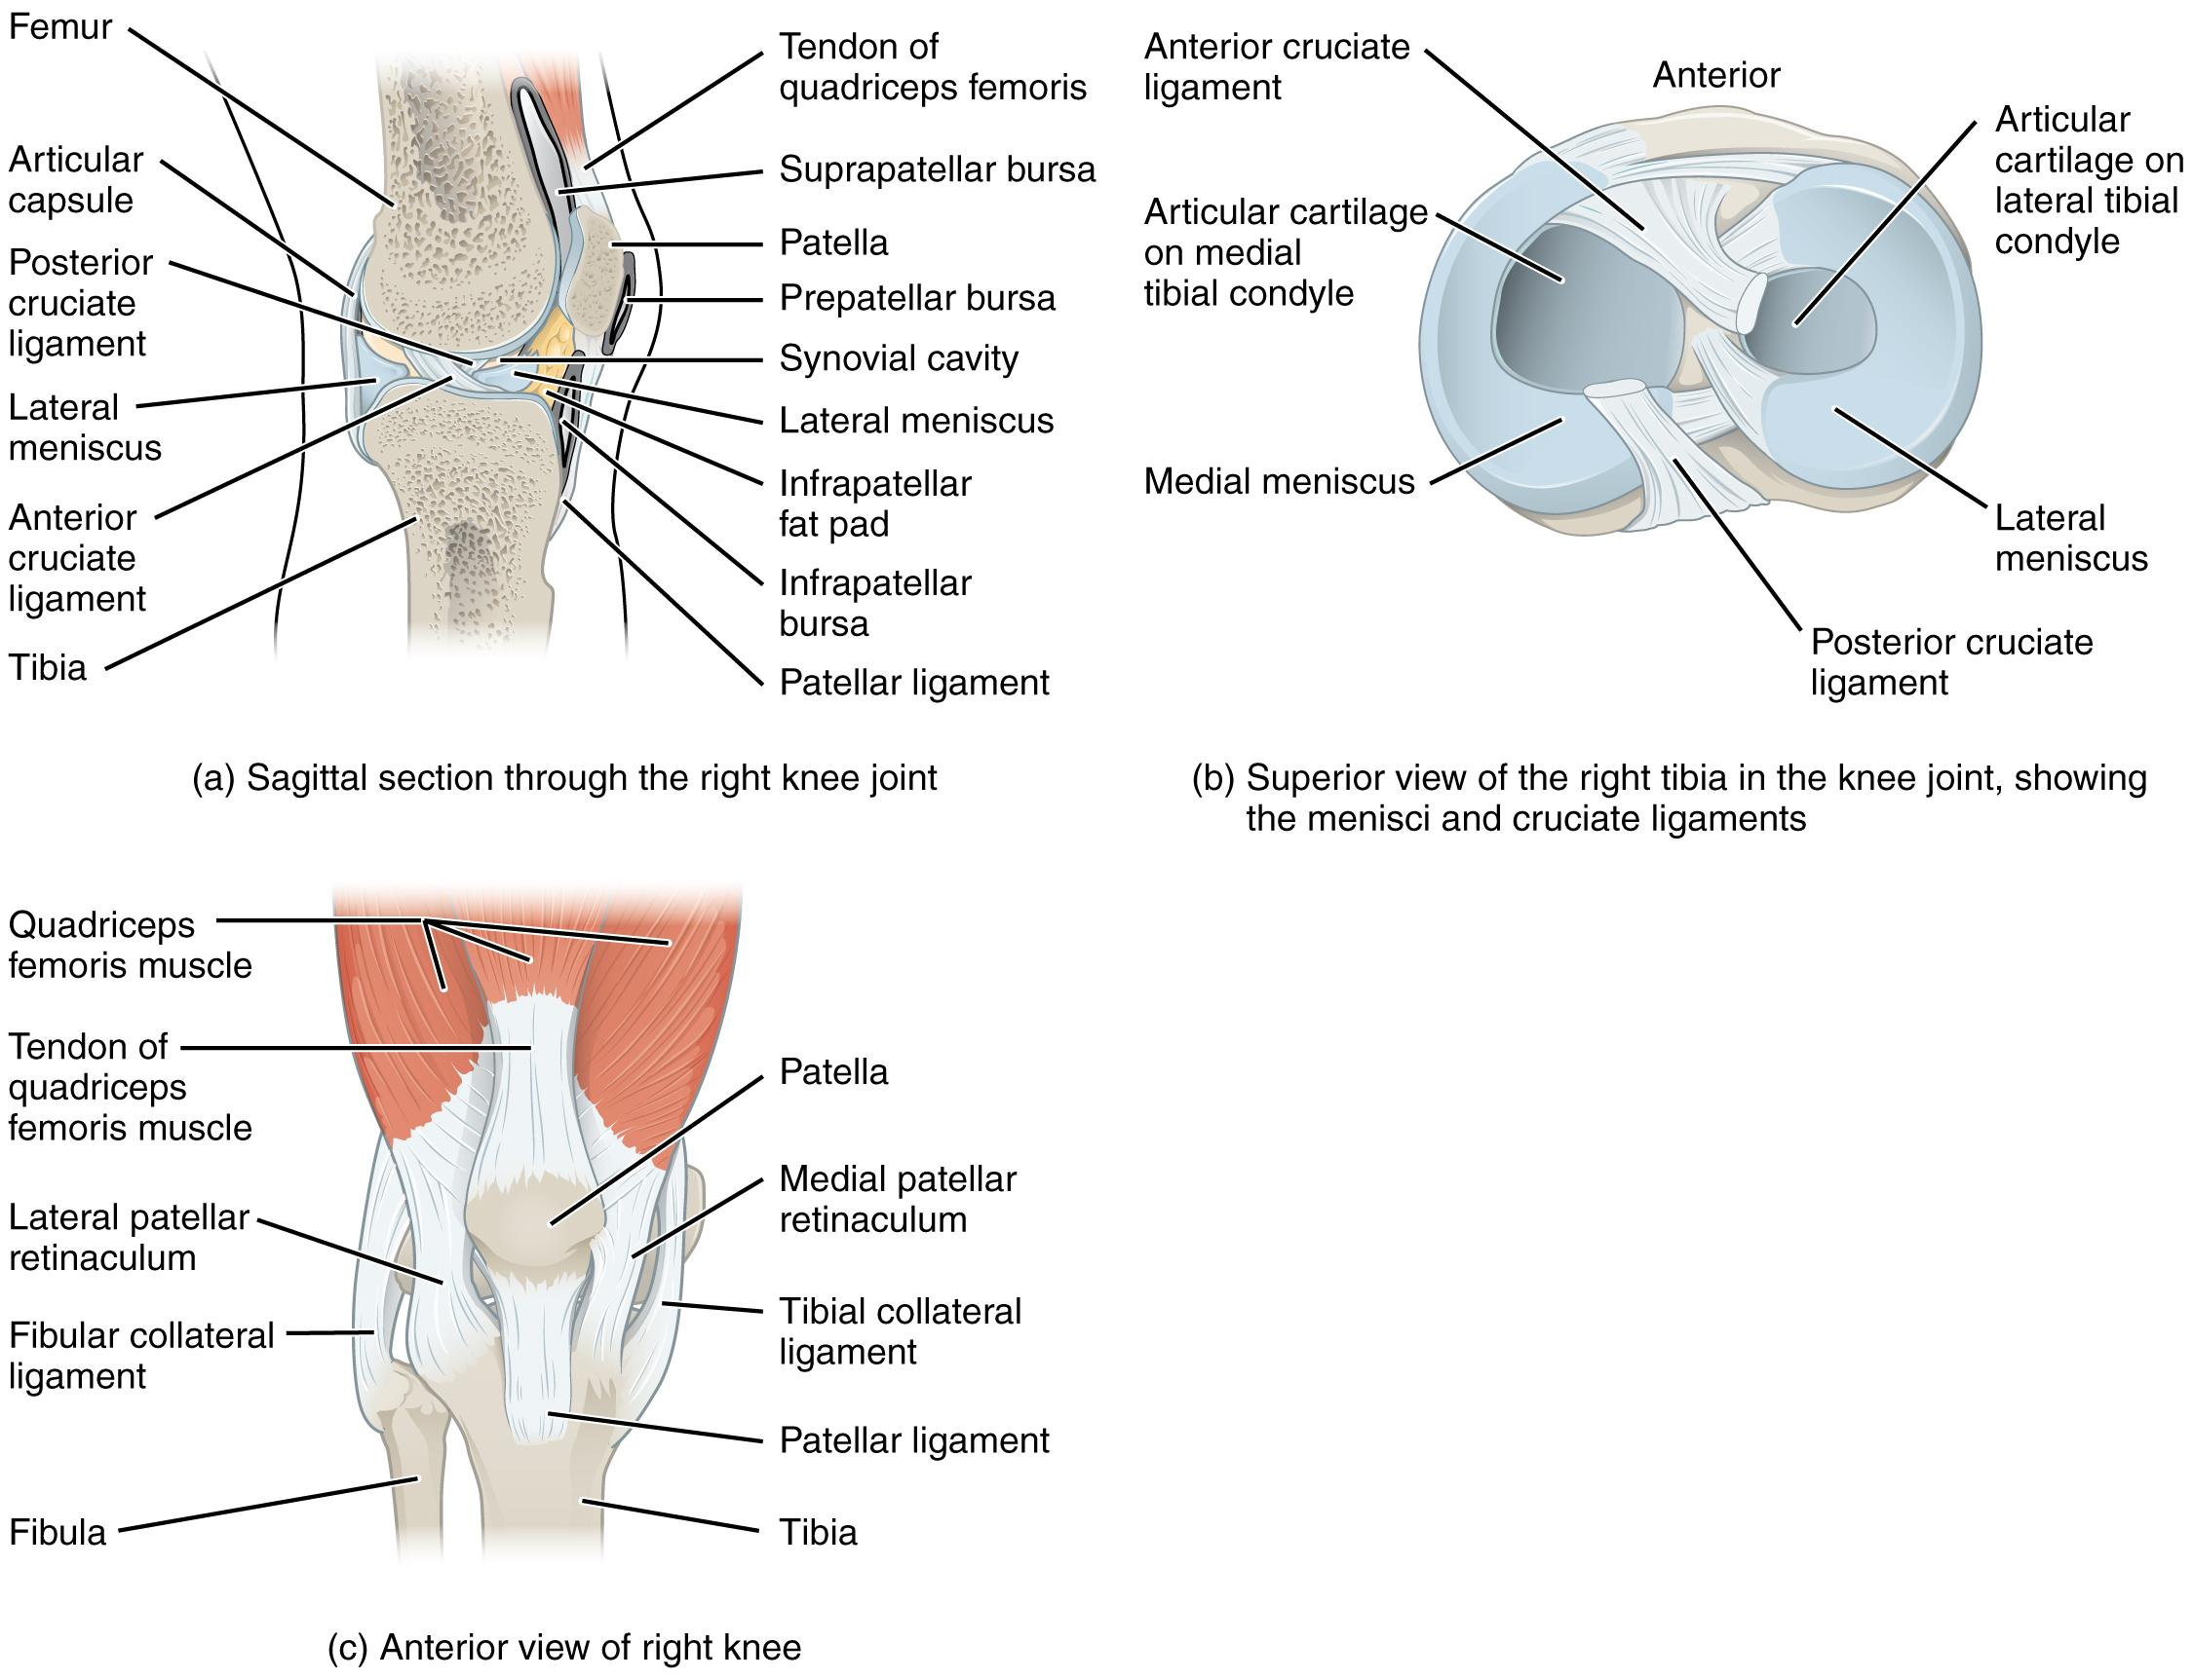

Figure 8.8 Knee Joint (a) The knee joint is the largest joint of the body. (b)–(c) It is supported by the tibial and fibular collateral ligaments located on the sides of the knee outside of the articular capsule, and the anterior and posterior cruciate ligaments found inside the capsule. The medial and lateral menisci provide padding and support between the femoral condyles and tibial condyles.
Disorders of the…
Joints
Injuries to the knee are common. Since this joint is primarily supported by muscles and ligaments, injuries to any of these structures will result in pain or knee instability. Injury to the posterior cruciate ligament (PCL) occurs when the knee is flexed and the tibia is driven posteriorly, such as falling and landing on the tibial tuberosity or hitting the tibia on the dashboard when not wearing a seatbelt during an automobile accident. More commonly, injuries occur when forces are applied to the extended knee, particularly when the foot is planted and unable to move. Anterior cruciate ligament (ACL) injuries can result with a forceful blow to the anterior knee, producing hyperextension, or when a runner makes a quick change of direction that produces both twisting and hyperextension of the knee.

A worse combination of injuries can occur with a hit to the lateral side of the extended knee (Figure 8.9). A moderate blow to the lateral knee will cause the medial side of the joint to open, resulting in stretching or damage to the medial collateral ligament (MCL). Because the medial meniscus is attached to the medial collateral ligament, a stronger blow can tear the
ligament and also damage the medial meniscus. This is one reason that the medial meniscus is 20 times more likely to be injured than the lateral meniscus. A powerful blow to the lateral knee produces a “terrible triad” injury, in which there is a sequential injury to the medial collateral ligament, medial meniscus, and anterior cruciate ligament.
Arthroscopic surgery has greatly improved the surgical treatment of knee injuries and reduced subsequent recovery times. This procedure involves a small incision and the insertion into the joint of an arthroscope, a pencil-thin instrument that allows for visualization of the joint interior. Small surgical instruments are also inserted via additional incisions. These tools allow a surgeon to remove or repair a torn meniscus or to reconstruct a ruptured cruciate ligament. The current method for anterior cruciate ligament replacement involves using a portion of the patellar ligament. Holes are drilled into the cruciate ligament attachment points on the tibia and femur, and the patellar ligament graft, with small areas of attached bone still intact at each end, is inserted into these holes. The bone-to-bone sites at each end of the graft heal rapidly and strongly, thus enabling a rapid recovery.
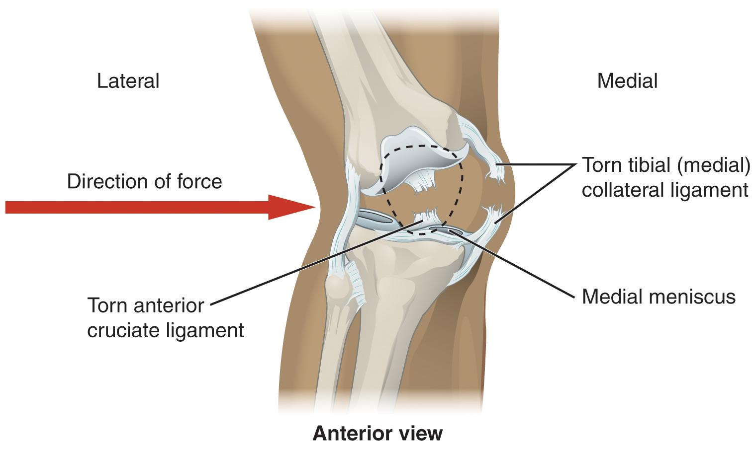
Figure 8.9 Knee Injury A strong blow to the lateral side of the extended knee will cause three injuries, in sequence: tearing of the tibial collateral ligament, damage to the medial meniscus, and rupture of the anterior cruciate ligament.

Ankle and Foot Joints
The ankle is formed by the talocrural joint (Figure 8.10). It consists of the articulations between the talus bone of the foot and the distal ends of the tibia and fibula of the leg (crural = “leg”). The superior aspect of the talus bone is square-shaped and has three areas of articulation. The top of the talus articulates with the inferior tibia. This is the portion of the ankle joint that carries the body weight between the leg and foot. The sides of the talus are firmly held in position by the articulations with the medial malleolus of the tibia and the lateral malleolus of the fibula, which prevent any side-to-side motion of the talus. The ankle is thus a uniaxial hinge joint that allows only for dorsiflexion and plantar flexion of the foot.
Additional joints between the tarsal bones of the posterior foot allow for the movements of foot inversion and eversion. Most important for these movements is the subtalar joint, located between the talus and calcaneus bones. The joints between the talus and navicular bones and the calcaneus and cuboid bones are also important contributors to these movements. All of the joints between tarsal bones are plane joints. Together, the small motions that take place at these joints all contribute to the production of inversion and eversion foot motions.
Like the hinge joints of the elbow and knee, the talocrural joint of the ankle is supported by several strong ligaments located on the sides of the joint. These ligaments extend from the medial malleolus of the tibia or lateral malleolus of the fibula and anchor to the talus and calcaneus bones. Since they are located on the sides of the ankle joint, they allow for dorsiflexion and plantar flexion of the foot. They also prevent abnormal side-to-side and twisting movements of the talus and calcaneus bones during eversion and inversion of the foot. On the medial side is the broad deltoid ligament. The deltoid ligament supports the ankle joint and also resists excessive eversion of the foot. The lateral side of the ankle has several smaller ligaments. These include the anterior talofibular ligament and the posterior talofibular ligament, both of which span between the talus bone and the lateral malleolus of the fibula, and the calcaneofibular ligament, located between the calcaneus bone and fibula. These ligaments support the ankle and also resist excess inversion of the foot.
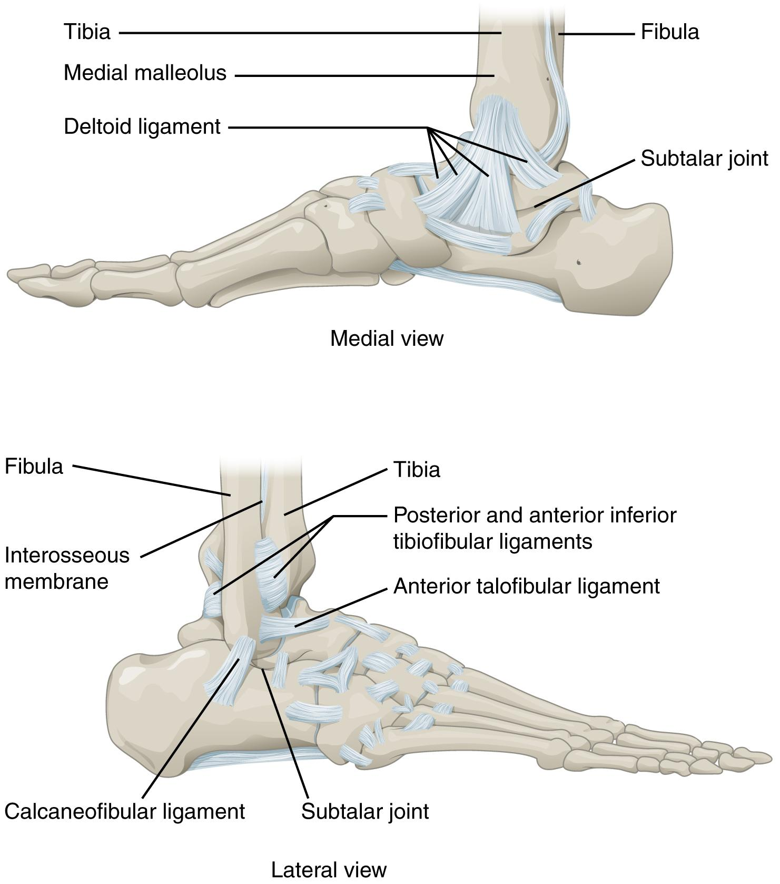
Figure 8.10 Ankle Joint The talocrural (ankle) joint is a uniaxial hinge joint that only allows for dorsiflexion or plantar flexion of the foot. Movements at the subtalar joint, between the talus and calcaneus bones, combined with motions at other intertarsal joints, enables eversion/inversion movements of the foot. Ligaments that unite the medial or lateral malleolus with the talus and calcaneus bones serve to support the talocrural joint and to resist excess eversion or inversion of the foot.
Interactive Link
Watch this video for a tutorial on the anatomy of the ankle joint. What are the three ligaments found on the lateral side of the ankle joint?


Disorders of the…
Joints
The ankle is the most frequently injured joint in the body, with the most common injury being an inversion ankle sprain. A sprain is the stretching or tearing of the supporting ligament. Excess inversion causes the talus bone to tilt laterally, thus damaging the ligaments on the lateral side of the ankle. THe anterior talofibular ligament (ATFL) is most commonly injured, followed by the calcaneofibular ligament (CFL). In severe inversion injuries, the forceful lateral movement of the talus not only ruptures the lateral ankle ligaments, but also fractures the distal fibula.
Above the ankle, the distal ends of the tibia and fibula are united by a strong syndesmosis formed by the interosseous membrane and ligaments at the distal tibiofibular joint. These connections prevent separation between the distal ends of the tibia and fibula and maintain the talus locked into position between the medial malleolus and lateral malleolus. Injuries that produce a lateral twisting of the leg on top of the planted foot can result in stretching or tearing of the tibiofibular ligaments, producing a syndesmotic ankle sprain or “high ankle sprain.”
Most ankle sprains can be treated using the PRICE technique: Protect, Rest, Ice, Compression, and Elevation. Increasing joint stability using a brace may be required for a period of time. More severe injuries involving ligament tears or bone fractures may require surgery.

Key Terms

abduction movement in the coronal plane that moves a limb laterally away from the body; spreading of the fingers

acetabular labrum lip of fibrocartilage that surrounds outer margin of the acetabulum on the hip bone

adduction movement in the coronal plane that moves a limb medially toward or across the midline of the body; bringing fingers together

annular ligament intrinsic ligament of the elbow articular capsule that surrounds and supports the head of the radius at the proximal radioulnar joint

anterior cruciate ligament intracapsular ligament of the knee; extends from anterior, superior surface of the tibia to the inner aspect of the lateral condyle of the femur; resists hyperextension of knee

anterior talofibular ligament intrinsic ligament located on the lateral side of the ankle joint, between talus bone and lateral malleolus of fibula; supports talus at the talocrural joint and resists excess inversion of the foot

atlanto-occipital joint articulation between the occipital condyles of the skull and the superior articular processes of the atlas (C1 vertebra)

atlantoaxial joint series of three articulations between the atlas (C1) vertebra and the axis (C2) vertebra, consisting of the joints between the inferior articular processes of C1 and the superior articular processes of C2, and the articulation between the dens of C2 and the anterior arch of C1

calcaneofibular ligament intrinsic ligament located on the lateral side of the ankle joint, between the calcaneus bone and lateral malleolus of the fibula; supports the talus bone at the ankle joint and resists excess inversion of the foot

circumduction circular motion of the arm, thigh, hand, thumb, or finger that is produced by the sequential combination of flexion, abduction, extension, and adduction

coracohumeral ligament intrinsic ligament of the shoulder joint; runs from the coracoid process of the scapula to the anterior humerus

deltoid ligament broad intrinsic ligament located on the medial side of the ankle joint; supports the talus at the talocrural joint and resists excess eversion of the foot

depression downward (inferior) motion of the scapula or mandible

dorsiflexion movement at the ankle that brings the top of the foot toward the anterior leg

downward rotation movement of the scapula during upper limb adduction in which the glenoid cavity of the scapula moves in a downward direction as the medial end of the scapular spine moves in an upward direction

elbow joint humeroulnar joint

elevation upward (superior) motion of the scapula or mandible

eversion foot movement involving the intertarsal joints of the foot in which the bottom of the foot is turned laterally, away from the midline

extension movement in the sagittal plane that increases the angle of a joint (straightens the joint); motion involving posterior bending of the vertebral column or returning to the upright position from a flexed position

femoropatellar joint portion of the knee joint consisting of the articulation between the distal femur and the patella

fibular collateral ligament extrinsic ligament of the knee joint that spans from the lateral epicondyle of the femur to the head of the fibula; resists hyperextension and rotation of the extended knee

flexion movement in the sagittal plane that decreases the angle of a joint (bends the joint); motion involving anterior bending of the vertebral column

glenohumeral joint shoulder joint; articulation between the glenoid cavity of the scapula and head of the humerus; multiaxial ball-and-socket joint that allows for flexion/extension, abduction/adduction, circumduction, and medial/lateral rotation of the humerus

glenohumeral ligament one of the three intrinsic ligaments of the shoulder joint that strengthen the anterior articular capsule

glenoid labrum lip of fibrocartilage located around the outside margin of the glenoid cavity of the scapula

humeroradial joint articulation between the capitulum of the humerus and head of the radius

humeroulnar joint articulation between the trochlea of humerus and the trochlear notch of the ulna; uniaxial hinge joint that allows for flexion/extension of the forearm

hyperextension excessive extension of joint, beyond the normal range of movement

hyperflexion excessive flexion of joint, beyond the normal range of movement

iliofemoral ligament intrinsic ligament spanning from the ilium of the hip bone to the femur, on the superior-anterior aspect of the hip joint

inversion foot movement involving the intertarsal joints of the foot in which the bottom of the foot is turned toward the midline

ischiofemoral ligament intrinsic ligament spanning from the ischium of the hip bone to the femur, on the posterior aspect of the hip joint

lateral (external) rotation movement of the arm at the shoulder joint or the thigh at the hip joint that moves the anterior surface of the limb away from the midline of the body

lateral flexion bending of the neck or body toward the right or left side

lateral meniscus O-shaped fibrocartilage articular disc located at the knee, between the lateral condyle of the femur and the lateral condyle of the tibia

lateral tibiofemoral joint portion of the knee consisting of the articulation between the lateral condyle of the tibia and the lateral condyle of the femur; allows for flexion/extension at the knee

ligament of the head of the femur intracapsular ligament that runs from the acetabulum of the hip bone to the head of the femur

medial (internal) rotation movement of the arm at the shoulder joint or the thigh at the hip joint that brings the anterior surface of the limb toward the midline of the body

medial meniscus C-shaped fibrocartilage articular disc located at the knee, between the medial condyle of the femur and medial condyle of the tibia

medial tibiofemoral joint portion of the knee consisting of the articulation between the medial condyle of the tibia and the medial condyle of the femur; allows for flexion/extension at the knee

meniscus articular disc

opposition thumb movement that brings the tip of the thumb in contact with the tip of a finger

patellar ligament ligament spanning from the patella to the anterior tibia; serves as the final attachment for the quadriceps femoris muscle

plantar flexion foot movement at the ankle in which the heel is lifted off of the ground

posterior cruciate ligament intracapsular ligament of the knee; extends from the posterior, superior surface of the tibia to the inner aspect of the medial condyle of the femur; prevents anterior displacement of the femur when the knee is flexed and weight bearing

posterior talofibular ligament intrinsic ligament located on the lateral side of the ankle joint, between the talus bone and lateral malleolus of the fibula; supports the talus at the talocrural joint and resists excess inversion of the foot

pronation forearm motion that moves the palm of the hand from the palm forward to the palm backward position

protraction anterior motion of the scapula or mandible

pubofemoral ligament intrinsic ligament spanning from the pubis of the hip bone to the femur, on the anterior-inferior aspect of the hip joint

radial collateral ligament intrinsic ligament on the lateral side of the elbow joint; runs from the lateral epicondyle of humerus to merge with the annular ligament

reposition movement of the thumb from opposition back to the anatomical position (next to index finger)

retraction posterior motion of the scapula or mandible

rotation movement of a bone around a central axis (atlantoaxial joint) or around its long axis (proximal radioulnar joint; shoulder or hip joint); twisting of the vertebral column resulting from the summation of small motions between adjacent vertebrae

rotator cuff strong connective tissue structure formed by the fusion of four rotator cuff muscle tendons to the articular capsule of the shoulder joint; surrounds and supports superior, anterior, lateral, and posterior sides of the humeral head

subacromial bursa bursa that protects the supraspinatus muscle tendon and superior end of the humerus from rubbing against the acromion of the scapula

subtalar joint articulation between the talus and calcaneus bones of the foot; allows motions that contribute to inversion/eversion of the foot

supination forearm motion that moves the palm of the hand from the palm backward to the palm forward position

talocrural joint ankle joint; articulation between the talus bone of the foot and medial malleolus of the tibia, distal tibia, and lateral malleolus of the fibula; a uniaxial hinge joint that allows only for dorsiflexion and plantar flexion of the foot

tibial collateral ligament extrinsic ligament of knee joint that spans from the medial epicondyle of the femur to the medial tibia; resists hyperextension and rotation of extended knee

ulnar collateral ligament intrinsic ligament on the medial side of the elbow joint; spans from the medial epicondyle of the humerus to the medial ulna

upward rotation movement of the scapula during upper limb abduction in which the glenoid cavity of the scapula moves in an upward direction as the medial end of the scapular spine moves in a downward direction

zygapophysial joints facet joints; plane joints between the superior and inferior articular processes of adjacent vertebrae that provide for only limited motions between the vertebrae

