Academic Integrity Repository

Dr. Tranum Kaur,
Department of Chemistry and Biochemistry,
University of Windsor, ON

Creative Commons License
ACADEMIC INTEGRITY REPOSITORY, OER, is adapted for the Master of Medical Biotechnology program at the University of Windsor. This work licensed under a Attribution-NonCommercial-ShareAlike (CC BY-NC-SA) 4.0 International License.

Table of Contents
What is Plagiarism? 3
Why is avoiding plagiarism important? 3
What if I am caught cheating? What are some consequences of plagiarism? 3
Different ways of avoiding plagiarism: 4
1. Quoting: 4
2. Paraphrasing: 5
3. Summarizing: 6
Citation and Reference Formats 7
1. American Psychological Association (APA) 7
2. Modern Language Association (MLA) 8
Flow chart for better citation clarity 9
Practice Exercises 10
Human Physiology Practice Quiz 10
Clinical Biochemistry Practice Quiz 13
Drugs: From Discovery to Market Practice Quiz 15
Protein Structure and Function Practice Quiz 17
Biotechnology Laboratory Practice Quiz 20
Integrative Biological Mass Spectrometry Practice Quiz 22
Structural Proteomics Practice Quiz 23
Free Radical in Chemistry and Biology Practice Quiz 25
Biotechnology Entrepreneurship Practice Quiz 27
Marketing Practice Quiz Case: 30
Leadership and Organizational Change 31
Additional Resources 33

What is Plagiarism?
Definition:
According to Student Code of Conduct at the University of Windsor, plagiarism is defined as “the act of copying, reproducing or paraphrasing portions of someone else's published or unpublished material (from any source, including the internet), without proper acknowledgement.”

Plagiarism applies to all intellectual endeavors, including the creation and presentation of music, drawings, designs, dance, photography, and other artistic and technical works. In the case of oral presentations, the use of material that is not one’s own, without proper acknowledgment or attribution, constitutes plagiarism and, hence, academic dishonesty.

More information about plagiarism and appropriate acknowledgement of sources can be found at the Office of Academic Integrity: Academic Integrity (uwindsor.ca) and from the Senate Graduate Studies Policy on Plagiarism.

Why is avoiding plagiarism important?
Students are expected to demonstrate academic integrity in all aspects of the program and become familiar with Senate Bylaws and policies. Plagiarism is considered a very serious offense, and all instances will be reported as per Senate Bylaw 31.
Plagiarism has several consequences for students, researchers, and professionals:
- Students: Consequences can include failing grades on assignments or classes, academic probation, expulsion, and even the rescinding of a degree.
- Researchers: Plagiarism can cause a loss of credibility, legal consequences, and other professional consequences.
- Professionals: In a corporate or analogous settings, professionals may be reprimanded, face disciplinary actions, and can even be terminated.
Source: https://owl.purdue.edu/owl/avoiding_plagiarism/index.html (Accessed on 5th February 2022)

What if I am caught cheating? What are some consequences of plagiarism?

At the University of Windsor, as per Senate Bylaw 31, there are several consequences that students may face because of academic dishonesty:

- acknowledgement by letter of apology/reflection,
- admonition,
- censure,
- community service,
- denial of registration,
- educational session/workshop,
- expulsion,
- mark/grade reduction,
- repeat work for assessment,
- rescinding degree, and
- suspension.

How can I avoid cheating? What are some tips to avoid plagiarism?
- Plan well in advance
- Reading and Notetaking (Tips for effective Notetaking; Strategic Notetaking)
- Using citation and references
- Consult with your instructor (e.g., for clarity and/or deadline extension as the case may be)
- Revision and proofreading
- Citation Tools (e.g., EndNote or Zotero)

NOTE: If you are not sure or need assistance about academic writing, consult with the Writing Support Desk.

Different ways of avoiding plagiarism:
Several options exist for incorporating the words and ideas of others for your work:

Quoting:
- When the words are particularly clear or expressive, you may want to quote them.
- Do not quote all the time: Save quotes for instances where the wording is especially powerful.
- Put quotation marks around the words and identify the source.
Example:
Original | Quoting
These data provide a strong rationale to explore the therapeutic use of olaparib in combination with carboplatin (CBP) and NVP-BKM120 (BKM120) in animal models, and later in clinical trials on patients with TNBC.  Source: Zhao, H., Yang, Q., Hu, Y., & Zhang, J. (2018). Antitumor effects and mechanisms of olaparib in combination with carboplatin and BKM120 on human triple‑negative breast cancer cells. Oncology reports, 40(6), 3223–3234 | Based on research conducted by Zhao H et al., “these data provide a strong rationale to explore the therapeutic use of olaparib in combination with CBP and BKM120 in animal models, and later in clinical trials on patients with TNBC”.  Source: Zhao, H., Yang, Q., Hu, Y., & Zhang, J. (2018). Antitumor effects and mechanisms of olaparib in combination with carboplatin and BKM120 on human triple‑negative breast cancer cells. Oncology reports, 40(6), 3223–3234.

Paraphrasing:
- Put the information into your own words and identify the source.
- In written papers, you will paraphrase more than you will quote.
- Avoid paraphrasing tools/websites for two reasons:
      - They are academically dishonest, and
      - They are often ineffective as their algorithms replace words with synonyms that may confuse or change the meaning of the source text, thereby undermining your credibility.
Example:
Original | Paraphrasing
These data provide a strong rationale to explore the therapeutic use of olaparib in combination with carboplatin (CBP) and NVP-BKM120 (BKM120) in animal models, and later in clinical trials on patients with TNBC.  Source: Zhao, H., Yang, Q., Hu, Y., & Zhang, J. (2018). Antitumor effects and mechanisms of olaparib in combination with carboplatin and BKM120 on human triple‑negative breast cancer cells. Oncology reports, 40(6), 3223–3234. | Olaparib in combination of CBP and BKM120 has an immense potential as a treatment option and should be further analysed in pre-clinical and clinical studies.  Source: Zhao, H., Yang, Q., Hu, Y., & Zhang, J. (2018). Antitumor effects and mechanisms of olaparib in combination with carboplatin and BKM120 on human triple‑negative breast cancer cells. Oncology reports, 40(6), 3223–3234.
Source: Avoiding Plagiarism - Choosing Whether to Quote or to Paraphrase | Academic Integrity at MIT (Accessed on 5th February 2022)

Summarizing:
- A summary is a synthesis of the key ideas of a piece of writing, restated in your own words – i.e., paraphrased.
- Take the key ideas and paraphrase them and identify the source.
Example:
Original | Summary
Triple negative breast cancer (TNBC) refers to a heterogeneous group of tumors, for which there is currently a lack of targeted therapies. Poly(ADP ribose) polymerase (PARP) inhibitors, phosphatidylinositol 3 kinase (PI3K) inhibitors and carboplatin (CBP) have demonstrated sufficient efficacy and safety for their use as individual drugs for the treatment of TNBC; however, their effects on TNBC when used as a combination have not been investigated. The primary objectives of the present study were to determine the effects of a combination of CBP, olaparib and NVP BKM120 (BKM120), and to investigate the mechanism underlying their effects on TNBC cells. The drug combination was cytotoxic to TNBC cells, both with regards to short term and long-term sensitivity, as determined using colony forming assays, and they exerted strong synergistic effects on MDA MB 231 and CAL51 cell lines. All drugs affected cell cycle progression, and western blotting and immunofluorescence indicated that the drug combination exerted its cytotoxicity via DNA damage, enhancing non homologous end joining repair and inhibiting homologous recombination repair. These data provide a strong rationale to explore the therapeutic use of olaparib in combination with CBP and BKM120 in animal models, and later in clinical trials on patients with TNBC.  Source: Zhao, H., Yang, Q., Hu, Y., & Zhang, J. (2018). Antitumor effects and mechanisms of olaparib in combination with carboplatin and BKM120 on human triple‑negative breast cancer cells. Oncology reports, 40(6), 3223–3234. | According to Zhao H et al., the combination of CBP, Olaparib and BKM 120 has a short term and long-term cytotoxic effect on TNBC cells by the process of DNA damage, inhibiting homologous repair whereas enhancing non-homologous activity. Further analysis of this combination treatment is warranted.  Source: Zhao, H., Yang, Q., Hu, Y., & Zhang, J. (2018). Antitumor effects and mechanisms of olaparib in combination with carboplatin and BKM120 on human triple‑negative breast cancer cells. Oncology reports, 40(6), 3223–3234.

Source: Summarizing | Academic Integrity at MIT (Accessed on 5th February 2022)

Citation and Reference Formats
The most common type of style used are American Psychological Association (APA) and Modern Language Association (MLA).

American Psychological Association (APA)
In Text Citation:
For intext citations, the author’s surname and year of publication is included, often but not always at the end of the sentence (see table below). When quoting directly from the source, page number is also provided. All sources cited must appear in the reference list at the end excepting personal communication.

 | Narrative Citation | Parenthetical Citation
Paraphrased Passage | According to Holmes (2022), deductive reasoning can help solve crimes. | Deductive reasoning can help solve crimes (Holmes, 2022).
Quoted Passage | Ali (2022) states that “academic integrity is a central part to one’s academic studies” (p. 1). | According to one study, “academic integrity is a central part to one’s academic studies” (Ali, 2022, p. 1).

Reference List:
The general format for referencing journal articles
Author, A. A., Author, B. B., & Author, C. C. (Year). Title of article. Title of Journal, volume number (issue number), page range. https://doi.org/xx.xxx/yyyy
The general format for referencing electronic sources/weblinks
If you are citing a web page with an individual author:
Lastname, F. M. (Year, Month Date). Title of page. Site name. URL

If the web page belongs to an organization or group rather than an individual:
Group name. (Year, Month Date). Title of page. Site name. URL

If there is no date, just use (n.d.) to indicate that. The only other major thing is, if you are citing a web page that is likely to change over time (like a wiki), include a retrieved date.
Title of page. (Year, Month Date). Site name. Retrieved Month Date, Year, from URL

The format of citation and reference changes depending on the source. Refer to APA Style Introduction // Purdue Writing Lab for more information.

Modern Language Association (MLA)
MLA style uses parenthetical citations to incorporate work done by other from different sources.
In Text Citation:
For intext citations, the author’s full published name is used for the initial narrative citation, and the page number is included where the cited material ends; for parenthetical citations and subsequent narrative citations, only the author’s surname and the page number are used (see table below). All sources cited must appear in the reference list at the end excepting personal communication.

 | Narrative Citation | Parenthetical Citation
Initial Citation | Sherlock Holmes states that deductive reasoning can help solve crimes (3). | Deductive reasoning can help solve crimes (Holmes 3).
Subsequent Citation | Holmes states that “Moriarty committed the crime” (1). | According to one study, “Moriarty committed the crime” (Holmes 1).

Reference List:
The general format for referencing articles is:
Surname, Given Name. "Title of Article." Title of Journal, Volume, Issue, Year, pages.

The general format for referencing electronic sources/weblinks
Here are some common features you should try to find before citing electronic sources in MLA style. Not every web page will provide all of the following information. However, collect as much of the following information as possible:
Author. "Title." Title of container (self contained if book), Other contributors (translators or editors), Version (edition), Number (vol. and/or no.), Publisher, Publication Date, Location (pages, paragraphs and/or URL, DOI or permalink). 2nd container’s title, other contributors, Version, Number, Publisher, Publication date, Location, Date of Access (if applicable).
The format of citation and reference changes depending on the source. Refer to MLA Style Introduction // Purdue Writing Lab, for more information.

Flow chart for better citation clarity
A visual guide from Purdue Owl is presented below in the form of a flow chart for better clarity while citing the works.
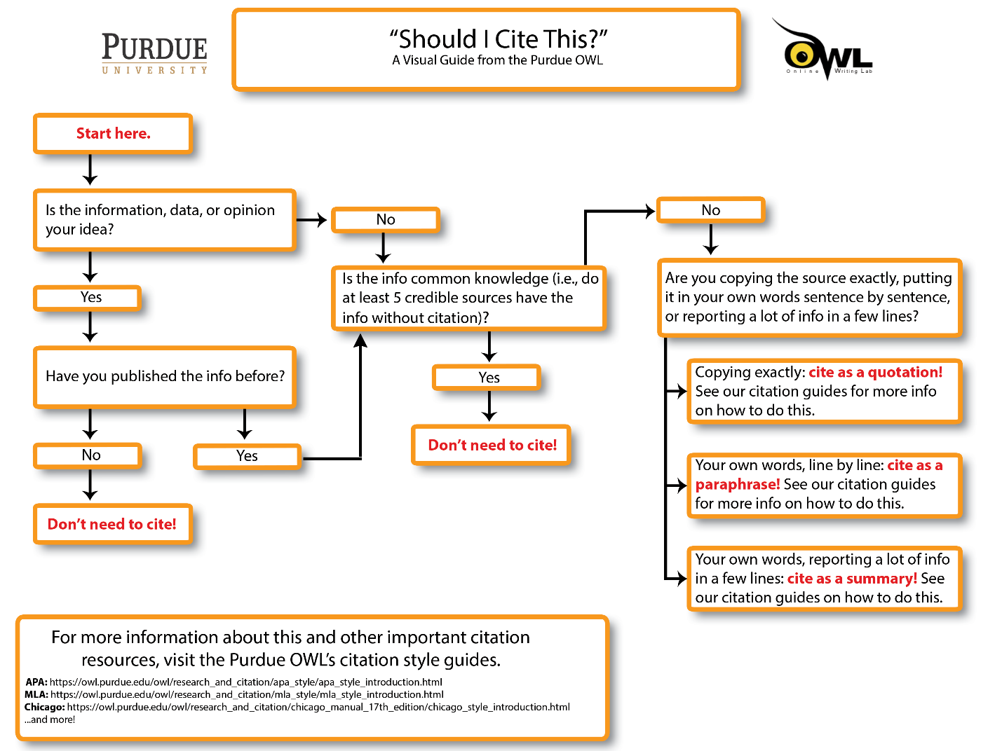
Adapted from: “Should I Cite This?” Poster. Purdue University. Reprinted From: https://owl.purdue.edu/owl/avoiding_plagiarism/should_i_cite_this_poster.html. Copyright ©2021 by The Writing Lab & The OWL at Purdue and Purdue University

Practice Exercises

Human Physiology Practice Quiz

Case:

Many factors can cause cells to undergo apoptosis. However, the discovery that shared morphological and biochemical changes occurred independently of the apoptotic triggering event led to postulate that most apoptotic pathways converge on a small number of common effectors, see, e.g. (Elmore, 2007; Galluzzi et al., 2018). The relative timing of caspase activation and mitochondrial cytochrome c release distinguishes two primary routes. In intrinsic apoptosis, cytochrome c is released from the mitochondrial intermembrane space before caspase activation, whereas in extrinsic apoptosis, an effector caspase is triggered before mitochondrial changes. The activation of intracellular sensors that detect, e.g. DNA damage, the presence of viral infections, or the lack of survival signals provided by other cells is the first stage of the intrinsic pathway. The extrinsic pathway, on the other hand, begins with a pro-death extrinsic signal that involves natural killer or CD8-positive cytotoxic T lymphocytes in the immune system (Yanumula et al., 2021; Losse, 2022).

References

Elmore, S. (2007). Apoptosis: A review of programmed cell death. Toxicologic Pathology, 35(4), 495-516. Elmore, S. (2007) Apoptosis: A review of programmed cell death. Toxicol. Pathol. 35, 495–516 https://doi.org/10.1080/01926230701320337
Galluzzi, L., Vitale, I., Aaronson, S. A., Abrams, J. M., Adam, D., Agostinis, P., Alnemri, E. S., Altucci, L., Amelio, I., Andrews, D. W., Annicchiarico-Petruzzelli, M., Antonov, A. V., Arama, E., Baehrecke, E. H., Barlev, N. A., Bazan, N. G., Bernassola, F., Bertrand, M. J. M., Bianchi, K.,… Kroemer, G. (2018). Molecular mechanisms of cell death: recommendations of the Nomenclature Committee on Cell Death 2018. Cell Death & Differentiation, 25(3), 486-541. https://doi.org/10.1038/s41418-017-0012-4
Lossi, L. (2022). The concept of intrinsic versus extrinsic apoptosis. Biochemical Journal, 479(3), 357-384. https://doi.org/10.1042/BCJ20210854
Yanumula, A., and & Cusick, J. K. (2021). ; Biochemistry, extrinsic pathway of apoptosis. In StatPearls, StatPearls Publishing. Copyright © 2021, StatPearls Publishing LLC, Treasure Island, FL

Sample1
The pathway of intrinsic apoptosis is different than that of extrinsic pathway, the former begins with intracellular specific signals like DNA damage or viral infections while the latter begins with extrinsic signal that involves natural killer or CD8-positive cytotoxic T lymphocytes in the immune system. (Elmore, 2007; Galluzzi, 2018; Lossi, 2022; Yanumula, 2021)

References
Elmore, S. (2007). Apoptosis: A review of programmed cell death. Toxicologic Pathology, 35(4), 495-516. https://doi.org/10.1080/01926230701320337
Galluzzi, L., Vitale, I., Aaronson, S. A., Abrams, J. M., Adam, D., Agostinis, P., Alnemri, E. S., Altucci, L., Amelio, I., Andrews, D. W., Annicchiarico-Petruzzelli, M., Antonov, A. V., Arama, E., Baehrecke, E. H., Barlev, N. A., Bazan, N. G., Bernassola, F., Bertrand, M. J. M., Bianchi, K.,… Kroemer, G. (2018). Molecular mechanisms of cell death: recommendations of the Nomenclature Committee on Cell Death 2018. Cell Death & Differentiation, 25(3), 486-541. https://doi.org/10.1038/s41418-017-0012-4
Lossi, L. (2022). The concept of intrinsic versus extrinsic apoptosis. Biochemical Journal, 479(3), 357-384. https://doi.org/10.1042/BCJ20210854
Yanumula, A., & Cusick, J. K. (2021). Biochemistry, extrinsic pathway of apoptosis. StatPearls Publishing.

Q1: Does Sample 1 use the source appropriately without plagiarism?

- Yes
- No

Answer: A. Yes

Feedback: Sample 1 has summarized, cited and included all references.

Sample 2
Many factors can cause cells to undergo apoptosis. The relative timing of caspase activation and mitochondrial cytochrome c release distinguishes two primary routes.

Q2: Which of the following caused plagiarism in Sample 2?

- No proper in text citation
- Copy the words directly
- Missing the complete reference
- All of the above

Answer: D. All of the Above

Feedback: To avoid plagiarism, first, there should be a proper citations and references; second, if you want to cite the words from an article without summarization, the quotation marks should be added in the beginning and end of the paragraph.
The sample is #2 CTRL+C type plagiarized

Sample 3
Apoptosis
Originally, apoptosis was described as a distinct type of cell death based on a series of ultrastructural features that occurred in a specific sequence at TEM observation (Figure 1). The sequence comprises nuclear and cytoplasmic condensation, cell fragmentation, and phagocytosis (Hacker, 2000; Kerr et al. 1972).

Figure1 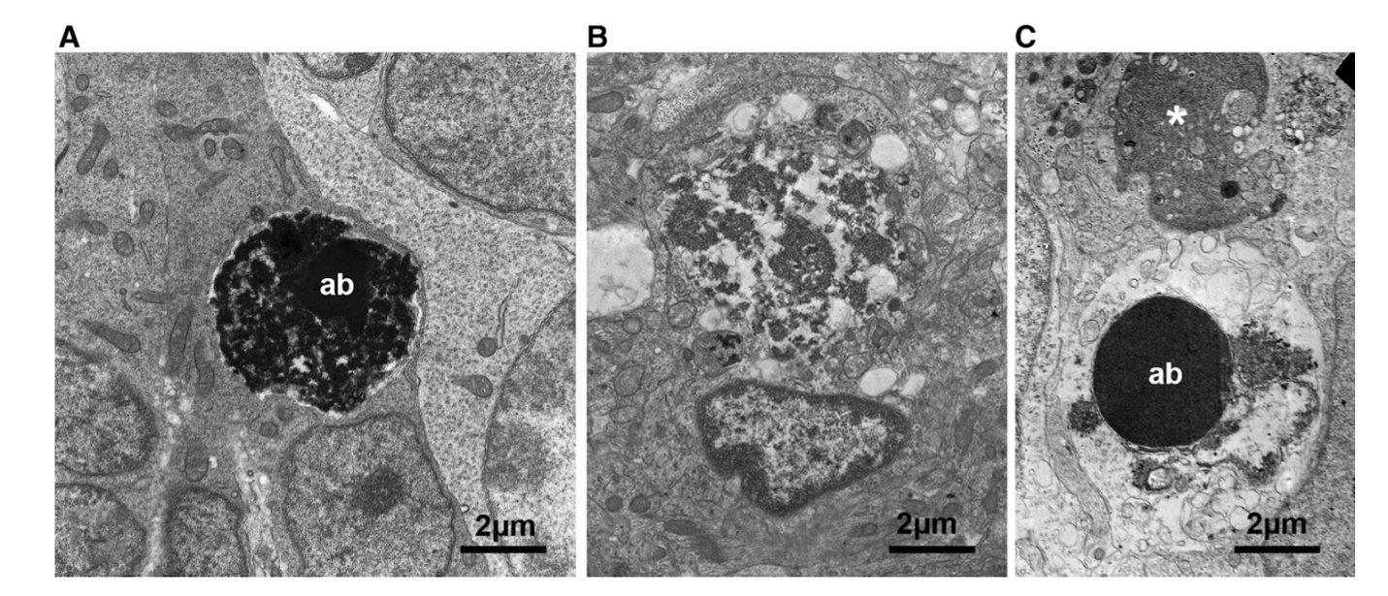
References
Häcker, G. (2000). The morphology of apoptosis. Cell and Tissue Research, 301(1), 5-17. https://doi.org/10.1007/s004410000193
Kerr, J. F., Wyllie, A. H., & Currie, A. R. (1972). Apoptosis: a basic biological phenomenon with wide ranging implications in tissue kinetics. British Journal of Cancer, 26(4), 239-257. https://doi.org/10.1038/bjc.1972.33
Lossi, L. (2022). The concept of intrinsic versus extrinsic apoptosis. Biochemical Journal, 479(3), 357-384. https://doi.org/10.1042/BCJ20210854

Q3: Which of the following is the right way to avoid plagiarism in Sample 3?
- Just the figure by itself is good
- Figure with in-text citation (i.e., Loss, 2022) and a corresponding reference entry.
- Figure with incomplete citation i.e. The concept of intrinsic versus extrinsic apoptosis. 479(3), 357-384.

Answer: B. Figure with in-text citation/source provided i.e. Lossi, L. (2022). The concept of intrinsic versus extrinsic apoptosis. Biochemical Journal, 479(3), 357-384.

Option A does not provide any reference to the source
Option C has incomplete citation and is missing author information

Feedback: For figure, a complete reference source should include author, title, journal, volume/issue, and page number. Consider including a descriptive phase or title of the figure, the magnification scale/bar, copyright issuing authority and year E.g. Copyright [Year] by the Name of Copyright Holder If reprint permission has been sought, that can also be shared e.g., Reprinted [or adapted] with permission.

Clinical Biochemistry Practice Quiz

Sample:
Watch this YouTube video and answer the below question

Source: https://www.youtube.com/watch?v=MSZuFfigzGQ

Q1: Which of the following is the best way to include this video as a part of your assignment/presentation?

- Paraphrase information from the video and provide reference
- Summarize information from the video and provide reference
- Play the video during your presentation and provide reference
- All of the above

Answer: D. All of the above

Feedback: YouTube can be a great source of information and learning. However, the information used or displayed should be cited correctly.

Q2: Which of the below options is the right method to cite this video?
- UTSWMed (2018, October 19). New blood test speeds up heart attack diagnosis [Video]. YouTube. https://www.youtube.com/watch?v=MSZuFfigzGQ
- New blood test speeds up heart attack diagnosis.
- https://www.youtube.com/watch?v=MSZuFfigzGQ

Answer:
A. UTSWMed (2018, October 19). New blood test speeds up heart attack diagnosis [Video]. YouTube. https://www.youtube.com/watch?v=MSZuFfigzGQ
New blood test speeds up heart attack diagnosis. UTSWMed. (2018). Retrieved 21 March 2022, from https://www.youtube.com/watch?v=MSZuFfigzGQ

Feedback: The following information should be included while referencing videos:
Author/Publisher name, Date/Year of publication, Video Title, Date of access and URL

Case 2:
No studies have shown that the Aspartate aminotransferase (AST): Alanine aminotransferase (ALT) ratio, either alone or in combination with other factors or models, has the necessary sensitivity or specificity to definitively differentiate between alcoholic liver disease (ALD) and NAFLD, but it acts as a useful clinical guide when considering the need for liver biopsy. It should also be noted that liver transaminases are known to worsen in response to cessation of alcohol intake (often coinciding with admission to hospital) and that ALT has also been shown to rise simply from admission to hospital, even in patients with no liver disease. (Hall et al., 2012)

Reference
Hall, P., & Cash, J. (2012). What is the real function of the liver 'function' tests? The Ulster Medical Journal, 81(1), 30–36. https://www.ncbi.nlm.nih.gov/pmc/articles/PMC3609680/

Sample:

Ratio of Aspartate aminotransferase (AST): Alanine aminotransferase (ALT) can be used for differential diagnosis of liver disease. (Hall P et al., 2012)

Q1: Does sample 1 capture the real application of the liver function test in line with academic integrity best practices?

- Yes
- No

Answer: B. No

Feedback: No, the sample has misunderstood the idea that the author wants to convey. The Aspartate aminotransferase (AST): Alanine aminotransferase (ALT) ratio cannot be used for differential diagnosis purpose because of lower sensitivity and specificity to distinguish between alcoholic liver disease (ALD) and Non-alcoholic Fatty Liver Disease (NAFLD).
The sample is #8 404 Error type plagiarized

Drugs: From Discovery to Market Practice Quiz

Case:
Depending on the research question and the data available, ligand- or structure-based target prediction methods can be applied. In ligand-based methods, potential targets can either be inferred from the most similar known ligands or through elaborated machine learning models. The latter require sufficient and well annotated data in order to train proper models. Structure-based approaches compare a query protein based on their binding sites or interaction fingerprints to a panel of protein structures or screen a query compound against these panels using a docking or pharmacophore screening engine. The former provides more quantitative information such as predicted bioactivities that can directly be associated with experimental values, whereas the latter can give additional information about the binding pose of ligands to potential targets. (Sydow et al., 2019)

Source:
Sydow, D., Burggraaff, L., Szengel, A., van Vlijmen, H. W., IJzerman, A. P., van Westen, G. J., & Volkamer, A. (2019). Advances and challenges in computational target prediction. Journal of Chemical Information and Modeling, 59(5), 1728-1742. https://doi.org/10.1021/acs.jcim.8b00832

Sample
Ligand based target prediction provides more quantitative information, such as predicted bioactivities that can directly be associated with experimental values, while structure-based target prediction gives additional information about the binding pose of ligands to potential targets.

Q1: In the above sample, what changes should be made to ensure best academic integrity practices?

- Double Quote “provides more…. experimental value”
- Double Quote “gives additional…. Potential targets”
- Add in text citation at the end of the sentence: (Sydow D et al., 2019)
- Provide complete proper reference at the end.
- All of the above

Answer: E. All of the above
Feedback: As the sample uses statements directly from the source, it should be quoted, cited appropriately and complete reference should be provided at the end.

The sample is #3 Find-Replace type plagiarized

Q2: Which one of the below options represents the correct APA format reference of the above case?

Sydow, Dominique et al. “Advances and Challenges in Computational Target Prediction.” Journal of chemical information and modeling vol. 59,5 (2019): 1728-1742. doi:10.1021/acs.jcim.8b00832

Sydow, D., Burggraaff, L., Szengel, A., van Vlijmen, H., IJzerman, A. P., van Westen, G., & Volkamer, A. (2019). Advances and challenges in computational target prediction. Journal of Chemical Information and Modeling, 59(5), 1728–1742. https://doi.org/10.1021/acs.jcim.8b00832

Sydow D, Burggraaff L, Szengel A, et al. Advances and Challenges in Computational Target Prediction. J Chem Inf Model. 2019;59(5):1728-1742. doi:10.1021/acs.jcim.8b00832

Answer: Option B.

Feedback: Option B follows the APA format for referencing.
Author, A. A., Author, B. B., & Author, C. C. (Year). Title of article. Title of Journal, volume number (issue number), pages. https://doi.org/xx.xxx/yyyy
Visit APA Style Introduction // Purdue Writing Lab for more information
Option A follows MLA format (MLA Style Introduction // Purdue Writing Lab)
Option C follows AMA format (AMA Style Introduction // Purdue Writing Lab)

Protein Structure and Function Practice Quiz

Case 1:
When the three-dimensional structures of many different protein molecules are compared, it becomes clear that, although the overall conformation of each protein is unique, two regular folding patterns are often found in parts of them. Both patterns were discovered about 50 years ago from studies of hair and silk. The first folding pattern to be discovered, called the α helix, was found in the protein α-keratin, which is abundant in skin and its derivatives—such as hair, nails, and horns (Eisenberg et al., 2003). Within a year of the discovery of the α helix, a second folded structure, called a β sheet, was found in the protein fibroin, the major constituent of silk (Lefèvre et al., 2007). These two patterns are particularly common because they result from hydrogen-bonding between the N–H and C=O groups in the polypeptide backbone, without involving the side chains of the amino acids. Thus, they can be formed by many different amino acid sequences. In each case, the protein chain adopts a regular, repeating conformation. (Alberts et al., 2002)

Reference
Alberts, B., Johnson, A., Lewis, J., Raff, M., Roberts, K., and Walter, P. (2002) Molecular biology of the cell (4th ed.). Garland Science. https://www.ncbi.nlm.nih.gov/books/NBK26830/

Sample 1:
α helix protein structure was discovered first followed by β sheet (Alberts et al., 2002; Eisenberg, 2003; Lefèvre et al., 2007). The former was found in keratin protein while the latter was found in fibroin protein. These structures can be commonly found in different proteins as they are involved in hydrogen bonds between amino acids. (Alberts et al. 2002).

Alberts, B., Johnson, A., Lewis, J., Raff, M., Roberts, K., and Walter, P. (2002) Molecular biology of the cell (4th ed.). Garland Science. https://www.ncbi.nlm.nih.gov/books/NBK26830/
Eisenberg, D. (2003). The discovery of the alpha-helix and beta-sheet, the principal structural features of proteins. Proceedings of the National Academy of Sciences of the United States of America, 100(20), 11207–11210. https://doi.org/10.1073/pnas.2034522100
Lefèvre, T., Rousseau, M. E., & Pézolet, M. (2007). Protein secondary structure and orientation in silk as revealed by Raman spectromicroscopy. Biophysical Journal, 92(8), 2885–2895. https://doi.org/10.1529/biophysj.106.100339

Q1: Does sample 1 use the in-text citations appropriately without plagiarism?

- Yes
- No

Answer: A. Yes

Feedback: Consider including multiple reference/in text citation sources providing credentials to the content material.

Case 2:

Chirality is formally defined as the geometric property of a rigid object (like a molecule or drug) of not being superimposable with its mirror image. Molecules that can be superimposed on their mirror images are achiral (not chiral). The 2 mirror images of a chiral molecule are termed enantiomers. A racemate (often called a racemic mixture) is a mixture of equal amounts of both enantiomers of a chiral drug.

Reference
McConathy, J., & Owens, M. J. (2003). Stereochemistry in drug action. Primary Care Companion to the Journal of Clinical Psychiatry, 5(2), 70–73. https://doi.org/10.4088/pcc.v05n0202

Q1: While using the sample source for defining chirality, enantiomers and racemate, which of the following should you adhere to?

- Use the definitions as they are
- Change the definition based on your understanding
- Use double quotes to define each term with correct citation and reference.
- None of the above
Answer: Option C. Use double quotes to define each term with correct citation and reference.
Feedback: When using definitions, a common practice is to use double quotes (parenthesis), to ensure the meaning of the definition remains intact.

Biotechnology Laboratory Practice Quiz

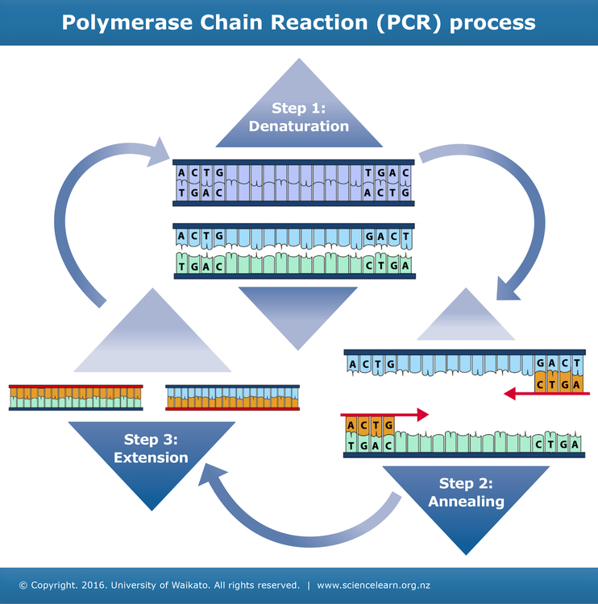

Q1: Which of the following is the correct method for citing this image?

- Weblink only: https://www.webmd.com/hepatitis/toxic-liver-disease
- Polymerase chain reaction (PCR) process. WebMD. 2022. Toxic for Your Liver: Drugs, Chemicals, and Herbs. Reprinted from: https://www.webmd.com/hepatitis/toxic-liver-disease. Copyright 2016 by University of Waikato.
- No citation required for images

Answer: Option B. Polymerase chain reaction (PCR) process. WebMD. 2022. Toxic for Your Liver: Drugs, Chemicals, and Herbs. Reprinted from: https://www.webmd.com/hepatitis/toxic-liver-disease. Copyright 2016 by University of Waikato
Feedback: Figure Citation should include:
Adapted from “Article Title,” by Initials. Last name, Year, Journal Name, Volume(Issue), p. Page number (URL or DOI). Copyright statement.

Case 2:
In one of your laboratory experiments you conducted Bradford Assay to determine the concentration of protein in your unknown sample. However, you found that the graph made from your the data was deviating from the predicted linear standard graph. As you have already conducted the experiment and have to submit your lab report along with the value of protein concentration in the unknown sample, can you alter the data for further analysis?

A. Yes. Of course, you can add certain assumed data point values, so that the graph is in the standard format
B. No. You cannot change any data obtained from the laboratory experiment
C. Yes. Just delete certain data points as this would not affect determining protein concentration in unknown sample

Answer: Option B.
Feedback: Both option A and C is the WRONG answer because altering (Option A) or missing (Option C) of data on purpose without any permission or authorization is belonged to fabrication, which also treated as the research misconduct.
Case 3
You are assigned to submit a group lab report which requires you to determine Km and Vmax values by drawing Michaelis-Menten plot and Lineweaver-Burk plot using the results obtained in the laboratory experiment specific to your group. Which of the following choices is in line with best academic integrity practices?

A. If you are not getting the right graphs/values, you can use data from other groups doing the same experiment.
B. If you are unable to determine Km and Vmax values from your graph, you can ask students from different lab section or group to share their graphs with you.
C. Change/modify the data obtained from the laboratory experiment so that your Km and Vmax values fall within the expected range.
D. Work in your assigned group to understand how to use the values to determined Km and Vmax values and ask your professor or GA if any queries persist.
Answer: D. Work in your assigned group to understand how to use the values to determined Km and Vmax values and ask your professor if any queries persist.
Feedback: Altering data or consulting with students not in your assigned group is not line with best academic integrity practices.

Integrative Biological Mass Spectrometry Practice Quiz

Case:

The discrimination of malignant melanoma from benign nevi may be difficult in some cases. For this reason, immunohistological and molecular techniques are included in the differential diagnostic toolbox for these lesions. These methods are time consuming when applied subsequently and, in some cases, no definitive diagnosis can be made. We studied both lesions by imaging mass spectrometry (IMS) in a large cohort (n = 203) to determine a different proteomic profile between cutaneous melanomas and melanocytic nevi. Statistical analysis of the IMS data revealed mass-to-charge ratio (m/z) peaks which varied significantly between the two tissue types. Our findings clearly show that discrimination of melanocytic nevi from melanoma is possible by IMS. (Casadonte et al., 2021)

Reference
Casadonte, R., Kriegsmann, M., Kriegsmann, K., Hauk, I., Meliß, R. R., Müller, C. S., & Kriegsmann, J. (2021). Imaging mass spectrometry-based proteomic analysis to differentiate melanocytic nevi and malignant melanoma. Cancers, 13(13), 3197. https://doi.org/10.3390/cancers13133197

Q1A: Which of the below samples utilizes the source case correctly without plagiarism?

- Imaging mass spectrometry can be potentially used to a differential diagnostic tool to distinguish between nevi and cutaneous melanoma (Casadonte et al., 2021)
- According to Casadonte et al., (2021), distinctive diagnosis of cutaneous melanoma from nevi can be an uncertain and lengthy process. However, use of imaging mass spectrometry has shown immense potential by determining differences in the protein profile and mass to charge ratio between the two.
- Both A and B
- Neither A nor B

Answer: C. Both A and B

Feedback: Both options A and B have utilized summarizing and paraphrasing to keep the main idea without plagiarism and with proper in text citation.

Q1B: Which one of the below options represents the correct MLA format reference of the above case?

Casadonte, Rita et al. “Imaging Mass Spectrometry-Based Proteomic Analysis to Differentiate Melanocytic Nevi and Malignant Melanoma.” Cancers vol. 13, 13 3197. 26 Jun. 2021, doi:10.3390/cancers13133197

Casadonte, R., Kriegsmann, M., Kriegsmann, K., Hauk, I., Meliß, R. R., Müller, C., & Kriegsmann, J. (2021). Imaging Mass Spectrometry-Based Proteomic Analysis to Differentiate Melanocytic Nevi and Malignant Melanoma. Cancers, 13(13), 3197. https://doi.org/10.3390/cancers13133197

Casadonte R, Kriegsmann M, Kriegsmann K, et al. Imaging Mass Spectrometry-Based Proteomic Analysis to Differentiate Melanocytic Nevi and Malignant Melanoma. Cancers (Basel). 2021;13(13):3197. Published 2021 Jun 26. doi:10.3390/cancers13133197
Answer: A.
Casadonte, Rita et al. “Imaging Mass Spectrometry-Based Proteomic Analysis to Differentiate Melanocytic Nevi and Malignant Melanoma.” Cancers vol. 13,13 3197. 26 Jun. 2021, doi:10.3390/cancers13133197

Feedback: Option A follows the MLA format for referencing.
Author last name, First name et al. “Article Title.” Journal Name, vol. Volume, no. Issue, Month Year, Page range. DOI or URL.
For more information visit MLA Style Introduction // Purdue Writing Lab
Option B follows APA format (APA Style Introduction // Purdue Writing Lab)
Option C follows AMA format (AMA Style Introduction // Purdue Writing Lab )

Structural Proteomics Practice Quiz
Case 1
Protein functions commonly rely on conformational changes within the protein. Extensive conformational changes are associated with protein folding immediately during or after their synthesis in vivo, when they fold to acquire their native conformational structure. Knowledge of the location of functionally relevant conformational changes within the protein and the magnitude and rates of conformational interconversion among various protein conformations (i.e. dynamics) are of great importance to the understanding of protein function.

Reference
Artigues, A., Nadeau, O. W., Rimmer, M. A., Villar, M. T., Du, X., Fenton, A. W., & Carlson, G. M. (2016). Protein structural analysis via mass spectrometry-based proteomics. Advances in Experimental Medicine and Biology, 919, 397–431. https://doi.org/10.1007/978-3-319-41448-5_19

Sample 1:
Specific function of proteins depends on their structure and orientation. Analysing the changes in the structure gives insights into its role. (Artigues et al 2016)
Reference
Artigues, A., Nadeau, O. W., Rimmer, M. A., Villar, M. T., Du, X., Fenton, A. W., & Carlson, G. M. (2016). Protein structural analysis via mass spectrometry-based proteomics. Advances in Experimental Medicine and Biology, 919, 397–431. https://doi.org/10.1007/978-3-319-41448-5_19

Q: Sample 1 utilises the case in accordance with best academic integrity practices

- True
- False

Answer: Option A. True

Feedback: Sample 1 uses paraphrasing and summarizing the convey the idea of the case source with intext citation and reference

Case 2:

Read the following news article and answer the below questions:

https://www.news-medical.net/news/20220127/Structural-proteomics-approaches-can-help-in-the-treatment-of-neurodegenerative-diseases.aspx

Q: While utilizing content from this news article, which reference would you use?

Henderson, E. (2022, January 27). Structural proteomics approaches can help in the treatment of neurodegenerative diseases. News: Medical Life Sciences. Retrieved April 11, 2022, from https://www.news-medical.net/news/20220127/Structural-proteomics-approaches-can-help-in-the-treatment-of-neurodegenerative-diseases.aspx

Petrotchenko, E. V., & Borchers, C. H. (2021). Protein chemistry combined with mass spectrometry for protein structure determination. Chemical Reviews, 122(8), 7488–7499. doi.org/10.1021/acs.chemrev.1c00302.
- Both A and B

Answer: Option C. Both A and B

Feedback: As the case news article utilizes Petrotchenko et al. (2021) to show how structural proteomics can help in treatment of neurodegenerative diseases, both the newsletter and article should be referenced.

Free Radical in Chemistry and Biology Practice Quiz

Case:
“Benzimidazoles and their derivatives, which have good biological activities and reactive activities, are very useful intermediates for the development of molecules on pharmaceutical or biological interest [21-24]. The proton transfer behavior of 2-substituted benzimidazole compounds has been an interesting topic for years [25-30]. Especially, the hydrogen bond of these compounds is close to the length of the low-barrier hydrogen bond (LBHB) [31,32]. Which will help to study the interrelation between the barrier and the p-electron delocalization.”

References
Peng, H., Huang, P., Yi, P., Xu, F., & Sun, L. (2018). Theoretical studies of π-electron delocalization and localization on intramolecular proton transfer in the ground state. Journal of Molecular Structure, 1154, 590-595. https://doi.org/10.1016/j.molstruc.2017.10.079

Author’s references
[21] Y. Bansal, O. Silakari, The therapeutic journey of benzimidazoles: a review, Biorg. Med. Chem. 20 (2012) 6208-6236.
[22] H. Wang, Y. Wang, C. Peng, J. Zhang, Q. Zhu, Direct intramolecular C-H ami- nation reaction cocatalyzed by copper(II) and iron(III) as part of an efficient route for the synthesis of pyrido 1,2-a benzimidazoles from N-Aryl-2- aminopyridines, J. Am. Chem. Soc. 132 (2010) 13217-13219.
[23] J. Plutnar, M. Hromadova, N. Fanelli, S. Ramesova, Z. Havlas, L. Pospisil, Elec- tron transfer mechanism of substituted benzimidazoles: dimer switching, oscillations, and search for singlet fission properties, J. Phys. Chem. C 121 (2017) 9963-9969.
[24] S. Rajasekhar, B. Maiti, M.M. Balamurali, K. Chanda, Synthesis and medicinal applications of benzimidazoles: an overview, Curr. Org. Synth. 14 (2017) 40-60.
[25] X.-F. Han, M.-M. Chen, Z.-M. Zhou, Synthesis of several new 2-substituted benzimidazoles, J. Chem. Res. (2015) 407-409.
[26] P. Ghosh, R. Subba, MgCl2 center dot 6H(2)O catalyzed highly efficient synthesis of 2-substituted-1H-benzimidazoles, Tetrahedron Lett. 56 (2015) 2691-2694.
[27] V. Kumar, D.G. Khandare, A. Chatterjee, M. Banerjee, DBSA mediated chemoselective synthesis of 2-substituted benzimidazoles in aqueous media, Tetrahedron Lett. 54 (2013) 5505-5509.
[28] F.K. Behbahani, P. Ziaei, One-pot synthesis of 2-substituted benzimidazoles catalyzed by anhydrous FePO4, Chem. Heterocycl. Compd. 48 (2012) 1011-1017.
[29] H. Shi, B. Xu, H.-J. Zhu, Electrochemical and theoretical studies of 1-Alkyl-2-substituted benzimidazoles as corrosion inhibitors for carbon steel surface in HCl medium, Chin. J. Struct. Chem. 35 (2016) 1829-1839.
[30] J. Kovvuri, B. Nagaraju, A. Kamal, A.K. Srivastava, An efficient synthesis of 2-substituted benzimidazoles via photocatalytic condensation of o-phenyl-enediamines and aldehydes, ACS Comb. Sci. 18 (2016) 644-650.
[31] P.A. Frey, S.A. Whitt, J.B. Tobin, A low-barrier hydrogen-bond in the catalytic triad of serine proteases, Science 264 (1994) 1927-1930.
[32] W.W. Cleland, M.M. Kreevoy, Low-barrier hydrogen-bonds and enzymatic catalysis, Science 264 (1994) 1887-1890.

Sample 1
The researchers (Peng, H.et al, 2018) believed that the hydrogen bond of 2-substituted benzimidazole compounds will help to study interrelation between the barrier and the p-electron delocalization because that compound is close to the length of low-barrier hydrogen bond (LBHB). [21-32]

Q1: Does this sample provide the correct formatting for in-text citation or not?
A. True
B. False

Answer: Option B. False
Feedback: In text citation should have consistent formatting. It could either be APA text-based format or numerical based formatting. But you would not mix/combine text and number in text citations.

Sample 2

The researchers (Peng, H.et al, 2018) believed that the hydrogen bond of 2-substituted benzimidazole compounds will help to study interrelation between the barrier and the p-electron delocalization because that compound is close to the length of low-barrier hydrogen bond (LBHB) (P.A. Frey et al., 1994; F.K. Behbahan et al., 2012).

Is this an example of plagiarism?
- True
- False

Answer: Option B. False
Feedback: Sample 2 is using a unique format of citation (APA style) compared to Sample 1, which is a proper way to cite.

Biotechnology Entrepreneurship Practice Quiz

Case 1:
“The realm and the role of the bioscience sector are rapidly changing, creating new opportunities for small start-ups and biotechs. In particular, as large pharmaceutical companies downsize their R&D workforce in response to pricing and regulatory pressures, they seek to invest in and/or acquire smaller companies and focus their efforts on product marketing, sales, and distribution. For example, to bolster its pipeline, Cubist acquires Trius and Optimer, smaller companies with antibiotic products, and Merck has taken over Idenix (admittedly no longer a “small” biotech company, but the model holds). For many of these large pharmaceutical companies, acquiring smaller or start-up biotechnology companies provides support for their own development efforts as their older products lose patent protection.” (Froshauer S., 2017)

Reference
Froshauer S. (2017). Careers at biotech start-ups and in entrepreneurship. Cold Spring Harbor Perspectives in Biology, 9(11), a032938. https://doi.org/10.1101/cshperspect.a032938.

Q1: Which of the following sample best utilizes summarization of the case?

- As an alternative to launching new products, bigger companies tend to acquire small companies which have shown to be more cost effective and convenient in the biotech industry. (Froshauer S. 2017)
- Merck took over Idenix to grow further in the biotech industry (Froshauer S. 2017)
- Cubist acquires Trius and Optimer as a way to increase product portfolio (Froshauer S. 2017)

Answer: Option A. As an alternative to launching new products, bigger companies tend to acquire small companies which have shown to be more cost effective and convenient in the biotech industry. (Froshauer S. 2017)

Feedback: Option A best summarizes the sample.
Option A gives a holistic view of the sample and summarizes the idea the author wants to convey, instead of giving a specific example out of context as option B and C

Case 2:
This study presumes the resource-based view of firms (Barney (1991); Kogut and Zander (1992); Conner and Prahalad (1996); Grant (1996)) and its extended literature related to academic startups (Landry et al. (2006); Knockaert et al. (2010); Rasmussen and Borch, (2010); Huynh et al. (2017); Corsi et al. (2019)) to assume that, as with entrepreneurs, startup readiness by academic researchers will increase when either the resources or their coordination will be appropriate or sufficient.

Reference
Goji, T., Hayashi, Y., & Sakata, I. (2020). Evaluating "startup readiness" for researchers: case studies of research-based startups with biopharmaceutical research topics. Heliyon, 6(6), e04160. https://doi.org/10.1016/j.heliyon.2020.e04160. Creative Commons CC-BY-NC-ND

Author References:
• Barney J. Firm resources and sustained competitive advantage. J. Manag. 1991;17(1):99–120.
• Kogut B., Zander U. Knowledge of the firm, combinative capabilities, and the replication of technology. Organ. Sci. 1992;3(3):383–397.
• Conner K.R., Prahalad C.K. A resource-based theory of the firm: knowledge versus opportunism. Organ. Sci. 1996;7(5):477–501.
• Grant R.M. Toward a knowledge-based theory of the firm. Strat. Manag. J. 1996;17(S2):109–122.
• Landry R., Amara N., Rherrad I. Why are some university researchers more likely to create spin-offs than others? Evidence from Canadian universities. Res. Pol. 2006;35(10):1599–1615.
• Knockaert M., Spithoven A., Clarysse B. The knowledge paradox explored: what is impeding the creation of ICT spin-offs? Technol. Anal. Strat. Manag. 2010;22(4):479–493.
• Rasmussen E., Borch O.J. University capabilities in facilitating entrepreneurship: a longitudinal study of spin-off ventures at mid-range universities. Res. Pol. 2010;39(5):602–612.
• Huynh T., Patton D., Arias-Aranda D., Molina-Fernández L.M. University spin-off's performance: capabilities and networks of founding teams at creation phase. J. Bus. Res. 2017;78:10–22.
• Corsi C., Prencipe A., Rodríguez-Gulías M.J., Rodeiro-Pazos D., Fernández-López S. Growth of KIBS and non-KIBS firms: evidence from university spin-offs. Serv. Ind. J. 2019;39(1):43–64.

Q1: While using the above sample in your assignment, how many of these references do you have to use?

- Only the source reference is sufficient
- Three of them
- None of them
- Multiple References

Answer: Option D. Multiple References

Feedback: More than one reference or multiple references helps support better validation of the information used.

Marketing Practice Quiz Case:

Watch the video and answer the below question

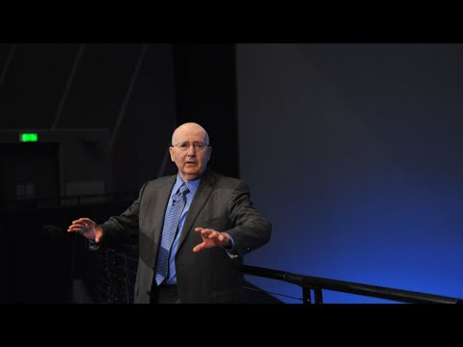

Source: London Business Forum. (2020, July 7). Philip Kotler - Marketing and Values [Video]. You Tube. https://www.youtube.com/watch?v=P-IXyLJ39eM&t=49s

Q1A: Which of the following options would you use to avoid plagiarism while maintaining best academic integrity practices?

- According to Philip Kotler we are currently in stage 5 of marketing which is called co-marketing which is not just market to customers but to involve your customers in the marketing.
- According to Philip Kotler we are currently in stage 5 of marketing which is called co-marketing which is not just market to customers but to involve your customers in the marketing. (London Business Forum, Philip Kotler - Marketing and Values 2020)
- According to Philip Kotler, “we are currently in stage 5 of marketing which is called co-marketing which is not just market to customers but to involve your customers in the marketing.” London Business Forum, Philip Kotler - Marketing and Values 2020)

Answer: Option C. According to Philip Kotler, “we are currently in stage 5 of marketing which is called co-marketing which is not just market to customers but to involve your customers in the marketing.” London Business Forum, Philip Kotler - Marketing and Values 2020)

Feedback: Option C is not plagiarized.
As the sentence uses direct words of Philip Kotler, it should be put in double quotes, cited and referenced. Option A does not provide double quotes nor citation. Option B does not use double quotes.

Q1B: Basis the video, is the sentence below plagiarized based on best academic integrity practices?

Strategy comprises three important aspects: quantifiable end goal, targeted opportunity and how you differentiate using your value-added actions and services. London Business Forum, Philip Kotler - Marketing and Values 2020)
Reference
London Business Forum. (2020, July 7). Philip Kotler - Marketing and Values [Video]. YouTube. https://www.youtube.com/watch?v=P-IXyLJ39eM&t=49s
- Yes
- No
Answer: Option B. No
Feedback: The sentence paraphrases the information with in text citation and complete reference, hence not plagiarized.

Leadership and Organizational Change
Case 1
While writing an individual case paper on organizational change using ADKAR (Awareness, Desire, Knowledge, Ability, Reinforcement) model, you realize your understanding of change models is minimal considering you have a biological sciences background. For completing this assignment, you decide to seek help from a student studying in a business school, to write the paper on your behalf, thinking he will be able to do a better job in the assignment to achieve a higher grade.
Q1: Is this behavior counted as plagiarism or not?
- A. Yes.
- B. No.
Answer: Option A. Yes

Feedback: For an individual assignment, the student is responsible to complete the assignment on his own.

Case 2
You are asked to submit a recorded group presentation on one of the change models and its application in organizational change. One of your group members does not put in the work as required in the group contract and you decide to do it for your groupmate and present the slides as well. Is this method adhering with the best academic integrity practices?

A. Yes

B. No

Answer:
B. No

Feedback: Each member of the team is equally responsible for completing the assigned work in the group presentation, especially as it is required in the group contract. Such situations should be reported to your professor or GA/TA so that appropriate actions can be taken.
Case 3:
You have been asked to write an assignment on a company of your choice that has undergone organizational change. When you do a google search you find multiple websites which provide you with ready assignments which talk about this topic. Can you take this assignment or parts of this assignment from a third-party sources and use it as your own?
- Yes
- No
Answer: B. No
Feedback: Using third party sources as your own for assignments would be considered as contract cheating. For more information on contract cheating visit: https://www.turnitin.com/blog/what-is-contract-cheating-why-does-it-matter

Additional Resources
- Writing Support Desk: Visit by appointment or drop-in hours to receive assistance or attend their Citation Workshops to learn more about the different guidelines and how to integrate sources into academic writing. Email any additional questions you may have to writingsupport@uwindsor.ca.
- Leddy Library: Visit the Library's website for avoiding plagiarism and the Library's website for writing help to learn more about avoiding plagiarism.
- Purdue OWL Citation Chart: Refer to this chart to receive a breakdown on citations and references for different sources using MLA, APA, and CMS formats
- More about understanding and preventing plagiarism here.
- To understand different types of plagiarism visit: The 5 Types of Plagiarism | Explanations & Examples; Turnitin - The Plagiarism Spectrum
- Find out about Tips for preventing plagiarism
- Student Misconduct and Bylaw 32 Petitions
- Students can also use citation and referencing tools like Cite This For Me or Citation Machine.

Note - Please check out interactive WordPress Site for enhanced engagement!

Thank You!

