Meta Quest VR application testing guide
NOTE: This application requires a Meta Quest VR headset. This document does not explain how to set up your VR equipment

- Ensure that your VR headset is in developer mode. To do this:
  - Download the Meta Quest App on your phone
  - Pair your Meta Quest App with your headset
  - In the Meta Quest app, find the setting to switch VR headset to ‘Developer mode’

- Install SideQuest on your computer (this is a Meta approved method of loading applications onto Quest)

- Download the latest Application (it is an “APK” file) located here: https://drive.google.com/drive/folders/1kloI53_kEf0syiwjNMhjllo53IVxD089

- Install APK onto your Meta Quest VR headset using SideQuest

  - Physically connect your headset to your computer via USB cable.
  - Open SideQuest on your computer.
  - In SideQuest’s top menu bar, click on the icon that looks like a folder with a downwards arrow.
  - Find and select the APK file on your computer (wherever you downloaded it / saved it).
  - SideQuest will begin loading the App onto your headset (You will get a green notification at the bottom of the screen once it's complete)
  - Disconnect headset from the computer.

- Find the application within your VR headset:
  - Put on your headset and in your main menu find your “Applications” (currently visualized as a square icon that is a grid of dots).
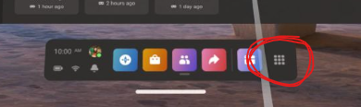
  - Then, at the top right of your screen there should be a dropdown menu. Scroll down to “Unknown Sources”.
  - Within “Unknown Sources” you should see the app you’ve sideloaded. You can select it to open it.

- Application will launch in VR headset

Need help?
If you have any technical issues or questions about the scenario, email team@propelvr.ca

