Course Design Foundations (CDF) Content Reader
Last updated: June 2, 2026

Table of Contents

Welcome to the CTSI Course Design Foundations (CDF) 8
Hello and Welcome 8
Enrol in CDF 8
About the Course Design Foundations (CDF) 8
Pause for Workbook Activities 9

1. Understanding Your Context: Introduction to Integrated Course Design 10
1.1 Introducing Module 1 10
Welcome 10
Module 1 Pages 10
1.2 The Integrated Course Design Model: Key Components 11
What is Integrated Course Design? 11
Defining Integrated Course Design Terms 12
Integrated Course Design Steps 13
1.3 Getting Started: Identifying Situational Factors 15
What is Your Teaching Context? 15
Pause for Workbook Activity: Identifying Your Situational Factors 17
1.4 Considering Course Priorities and Modalities 18
Course Priorities and Frameworks 18
Course Modalities 19
Pause for Workbook Activity: Identifying Your Course Modality 21
1.5 Module 1 References and Resources 23
Congratulations! 23
References and Resources 23

2. Creating Equitable Classrooms: Introduction to Inclusive Pedagogy 24
2.1 Introducing Module 2 24
Welcome 24
Module 2 Pages 24
2.2 How Identity Impacts Learning 26
Intersecting Identities 26
How Does Identity Impact Student Learning? 27
2.3 Context and Positionality in Inclusive Pedagogy 30
The Social Context 30
Pause for Reflection 31
Instructor and Student Positionality 32
Empowering Instructors and Students 33
2.4 The Inclusive Pedagogy Framework (IPF): Building Inclusion 34
Engaged Pedagogy 34
Inclusive Pedagogical Framework (IFP) 34
Empowerment and Collaboration 35
2.5 IPF: Who You Are: Self-Reflection/Knowing 36
Positionality and Identity 36
Pause for Reflection 36
Unlearning and Leaning into Discomfort 37
Building Inclusion: Culturally Responsive Teaching 37
2.6 IPF: How You Teach: Teaching Practices 38
Instructor Presence and Role Modelling 38
Pause for Reflection 38
Building Relationships 39
Building Inclusion: Pedagogy of Kindness 39
2.7 IPF: What You Teach: Course Design 40
Intent and Impact 40
Pause for Reflection 40
Communicating Transparency 41
Building Inclusion: Transparency in Learning and Teaching 41
2.8 Module 2 References and Resources 43
Congratulations! 43
References and Resources 43

3. Promoting Access for All Learners: Introduction to Universal Design for Learning (UDL) 46
3.1 Introducing Module 3 46
Welcome 46
Module 3 Pages 46
3.2 Learner Variability and Barriers to Learning 48
Learner Variability is the Norm 48
The Jagged Learning Profile 48
Barriers to Learning 49
Pause for Reflection: Learning Barriers in Your Teaching Context 49
3.3 The Universal Design for Learning (UDL) Framework: Building Access and Agency 51
What is UDL? 51
UDL and Academic Accommodations 52
Implementing UDL: The Plus-one Approach 53
3.4 The "Why" of Learning: Designing Multiple Means of Engagement 54
Students Ask: "Why should I care?" 54
Engagement in Practice 55
Pause for Reflection: Plus-one in Engagement 56
3.5 The "What" of Learning: Designing Multiple Means of Representation 57
Students Ask: "What are you teaching?" 57
Representation in Practice 57
Pause for Reflection: Plus-one in Representation 59
3.6 The "How" of Learning: Designing Multiple Means of Action & Expression 60
Students Ask: "How do I do this?" 60
Action & Expression in Practice 60
Pause for Reflection: Plus-one in Action & Expression 62
3.7 Module 3 References and Resources 63
Congratulations! 63
References and Resources 63

4. Developing Course Learning Outcomes 66
4.1 Introducing Module 4 66
Welcome 66
Module 4 Pages 66
4.2 Getting Started: Articulating Course Goals 68
Starting with Goals 68
Examining Categories of Learning 68
Pause for Workbook Activity: Articulating Your Course Goals 70
4.3 Defining Learning Outcomes 72
What are Learning Outcomes? 72
Developing Effective Learning Outcomes 72
Considering the Benefits and Limitations of Learning Outcomes 74
4.4 Translating Goals into Outcomes 76
Comparing Course Goals and Learning Outcomes 76
Writing Learning Outcomes 77
Translating Course Goals into Learning Outcomes 79
Pause for Workbook Activity: Translating Your Course Goals into Learning Outcomes 80
4.5 Using and Communicating Learning Outcomes 81
Aligning Your Learning Outcomes 81
Communicating and Leveraging Your Learning Outcomes 82
Pause for Workbook Activity: Identifying Opportunities to Communicate Your Learning Outcomes 84
4.6 Revisiting, Revising, and Refining Your Learning Outcomes 85
Revisiting, Revising, and Refining Iteratively 85
Revisiting Sample Learning Outcomes 85
Revising Sample Learning Outcomes 86
Refining Sample Learning Outcomes 87
Pause for Workbook Activity: Reflecting on Your Learning Outcomes 88
4.7 Reframing Learning Outcomes with Generative AI in Mind 91
Reframing Learning Outcomes for the Generative AI Era 91
Reframing Learning Outcomes with Bloom's Cognitive Taxonomy Revisited (2024) 91
Reframing Sample Learning Outcomes with Generative AI in Mind 93
Pause for Workbook Activity: Reframing Your Learning Outcomes for the Generative AI Era 94
4.8 Module 4 References and Resources 96
Congratulations! 96
References and Resources 96

5. Designing Effective Assessments 98
5.1 Introducing Module 5 98
Welcome 98
Module 5 Pages 98
5.2 Getting Started: Defining and Framing Assessment Design 100
Defining and Designing Assessment 100
Framing Assessment Design with UDL 101
Assessments and Accessibility 102
5.3 Examining Types of Assessments 104
Types of Assessments 104
Assessments in Practice 106
5.4 Promoting Academic Integrity 108
Addressing Academic Integrity in Your Course and Assessments 108
To Share: It's Okay to Ask for Help 109
5.5 Identifying Cognitive Processes in Your Assessment Design 111
Cognitive Process and Assessment Trajectory 111
Bloom's Taxonomy and Assessment Options 111
5.6 Engaging Learners in Meaningful Assessments 113
Scaffolded Assessments 113
Authentic and Powerful Assessments 115
5.7 Designing Meaningful Assessments with Generative AI in Mind 118
Effective Assessment Design Considerations with Generative AI in Mind 118
Integrating Authorized Generative AI Use in Assessments 120
Pause for Workbook Activity: Reflecting on Your Assessments 122
5.8 Adding Assessment Activities to Your Three-column Table 124
Bringing It All Together: A Sample Inclusive Assessment Framed by UDL 124
Pause for Workbook Activity: Adding Assessments to Your Three-column Table 127
5.9 Module 5 References and Resources 129
Congratulations! 129
References and Resources 129

6. Designing Activities to Support Student Learning 132
6.1 Introducing Module 6 132
Welcome 132
Module 6 Pages 132
6.2 Getting Started: Integrating and Framing Learning Activities Design 134
Integrating Learning Activities 134
Pause for Reflection: Your Learning Experiences 135
Framing Learning Activities Design with UDL 136
Shifting from Passive to Active Learning 137
6.3 Promoting Active Learning 138
What is Active Learning? 138
Six Benefits of Active Learning 139
Promoting Learning and Student Agency 141
6.4 Examining Types of Active Learning Activities 143
Revisiting Your Situational Factors 143
Exploring an Active Learning Continuum 144
Pause for Exploration: Active Learning Activities 145
Designing Active Learning Activities for Larger Groups 146
Using Technology to Enhance Active Learning Activities 148
Pause for Exploration: More Active Learning Activities 148
6.5 Integrating Generative AI Technologies and Learning Activities 150
Intentional Generative AI and Learning Activities Integration 150
Generative AI-integrated Active Learning Activities 150
Five Principles for Integrating Generative AI Technologies and Learning Activities 152
Pause for Workbook Activity: Reflecting on Your Learning Activities 153
6.6 Adding Learning Activities to Your Three-column Table 155
When to Use Active Learning 155
Learning Outcomes–Assessments–Learning Activities: Starting with the End in Mind 156
Pause for Workbook Activity: Adding Learning Activities to Your Three-column Table 157
Sequencing Your Learning Activities: Using the Castle Top Diagram 157
Pause for Workbook Activity: Sequencing Your Learning Activities 159
6.7 Module 6 References and Resources 161
Congratulations! 161
References and Resources 161

7. Putting It All Together: Building Your Course 164
7.1 Introducing Module 7 164
Welcome 164
Module 7 Pages 164
7.2 Integrating Course Components and Developing Your Course Structure 166
Extending the Three-column Table and Castle Top Diagram 166
Examining Three Hypothetical Course Structures 167
Brainstorming and Sketching Course Structure 169
Pause for Workbook Activity: Developing Your Course Structure 170
7.3 Communicating Alignment and Structure in Your Course Syllabus 171
Leveraging Your Course Syllabus 171
Communicating Course Priorities 172
Getting Started with Your Course Syllabus 173
Pause for Workbook Activity: Identifying Communication Strategies for Your Course Syllabus 174
7.4 Using Technology to Enhance Your Course Design 175
Promoting Pedagogical Flexibility 175
Building, Organizing, and Maintaining Your Course 175
Connecting, Communicating, and Collaborating with Your Students 177
Assessing Student Work and Providing Feedback 178
Designing and Fostering Accessible and Inclusive Teaching and Learning 179
Analyzing Teaching and Learning Data and Insights 180
Pause for Reflection: Plus-one in Using Technology 181
7.5 Module 7 References and Resources 183
Congratulations! 183
References and Resources 183

Beyond CDF 185
What's Next? 185
Congratulations 185
CDF Feedback Survey 185
Supports and Resources 185
Acknowledgements 187

Welcome to the CTSI Course Design Foundations (CDF)

Hello and Welcome

Watch the "Welcome to Course Design Foundations" video (02:15). Select "CC" for closed captions or download the transcript docx. We hope you enjoy your experience in the Course Design Foundations (CDF) self-paced learning program.

Enrol in CDF

CDF is a public resource available to anyone interested in course design. University of Toronto (U of T) instructors may enrol in CDF to add the program directly to their Quercus dashboard and use built-in accessibility features such as Microsoft Immersive Reader, which allows you to listen to page content, adjust text display (font, spacing, and colour), and personalize your reading experience to suit your preferences.

For technical assistance or accommodation requests related to the CDF self-paced learning program, please contact q.help@utoronto.ca.

Self-enrol in CDF

About the Course Design Foundations (CDF)

The CTSI CDF is a self-paced, asynchronous learning program for instructors who are designing a new course or redesigning an existing course. CDF offers a course design/redesign introduction for new (and new to U of T) instructors and acts as a refresher for experienced instructors.

CDF's seven modules introduce components of integrated course design, the Inclusive Pedagogy Framework (IPF), and Universal Design for Learning (UDL). Each module contains text, audio, and video content with supporting references and resources. Set aside 60 minutes per module to engage with the module materials and workbook activities.

Watch or listen to the one-minute navigation video (opens in a new tab) to learn how to navigate this self-paced learning program, hosted in Quercus. Select each triangle play icon below to review each module. Note that you can view all modules sequentially, or you can choose to visit specific modules of interest. For a list of module pages, select the "Modules" link from the Course Navigation Menu (located on the left side of the interface). Have fun with your design/redesign!

- ▶️ Module 1: Understanding Your Context: Introduction to Integrated Course Design
- ▶️ Module 2: Creating Equitable Classrooms: Introduction to Inclusive Pedagogy
- ▶️ Module 3: Promoting Access for All Learners: Introduction to Universal Design for Learning (UDL)
- ▶️ Module 4: Developing Course Learning Outcomes
- ▶️ Module 5: Designing Effective Assessments
- ▶️ Module 6: Designing Activities to Support Student Learning
- ▶️ Module 7: Putting It All Together: Building Your Course
- ▶️ Beyond CDF

Pause for Workbook Activities

Throughout the modules, you will be invited to pause for reflections and/or design activities. Download the Course Design Foundations Workbook docx and have the file ready as you progress through the modules.

Prefer an offline version of the program for reflection or future reference? Download the CDF Content Reader PDF, a consolidated and accessible copy of all module content.

1. Understanding Your Context: Introduction to Integrated Course Design

1.1 Introducing Module 1

Welcome

In this module, you will explore the integrated course design model, which aligns your learning outcomes, assessments, and learning activities and instruction. You will identify your situational factors (e.g., learning and teaching contexts, characteristics of the learners and instructor, and nature of the subject) and plan your course design accordingly.

Learning Outcomes

After completing this module, you will be able to describe how the integrated course design model affects your course design. In support of this outcome, you will be able to:

- Examine the various components of the integrated course design model;
- Identify situational factors that affect your course design; and
- Consider teaching priorities and modalities for enhancing your course design.

Module 1 Pages

This module consists of five pages accompanied by activities from the Course Design Foundations Workbook docx.

Use the "Next" and "Previous" buttons in the bottom right to progress through the module.

- 1.1 Introducing Module 1 (you are here)
- 1.2 The Integrated Course Design Model: Key Components
- 1.3 Getting Started: Identifying Situational Factors
- 1.4 Considering Course Priorities and Modalities
- 1.5 Module 1 References and Resources

1.2 The Integrated Course Design Model: Key Components

On this page:

- What is Integrated Course Design?
- Defining Integrated Course Design Terms
- Integrated Course Design Steps

What is Integrated Course Design?

"An integrated course design requires a significant investment in time, energy, and thought. But this expenditure has great potential for exerting a potent effect on student acquisition of 'significant' (rather than trivial) learning." L. Dee Fink (2003, p. 6)

Where do you start in your course design? It may feel logical to come up with a list of topics and, based on the topics, schedule some graded assessments, such as exams and papers, to measure students' knowledge of those topics. This topics-based approach to course design can have some pitfalls, namely that it "pays little or no attention to the quality and quantity of student learning" (Fink, 2013, p. 68).

L. Dee Fink's integrated course design model takes a learning-centred approach and invites instructors to design high-quality learning experiences informed by their situational factors and strengthened by the interactive relationships and connections between course components—learning outcomes, assessments, and learning activities and instruction.

Refer to the diagram below, which shows the alignment of learning outcomes, assessments, and learning activities and instruction, all informed by the course's situational factors.

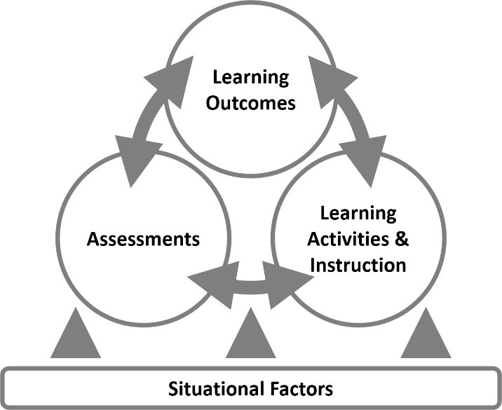

Defining Integrated Course Design Terms

Terms | Definitions
Situational factors | Situational factors are contextual elements that you should consider when designing a course. Situational factors can include items such as the nature of the subject; your learners' characteristics and experiences; your values, experiences, and perspectives; the opportunities and challenges presented by generative AI technologies; and class size, format, and modality. You will identify your situational factors on the next page.
Learning outcomes | Learning outcomes are statements that describe the knowledge or skills students should acquire by the end of a particular assignment, class, course, or program. Learning outcomes often include action verbs that concretize the statements to students. You will begin drafting your learning outcomes in module 4.
Assessments | Assessments provide evidence of various forms and levels of student learning through different assessment types (graded and non-graded). Assessments reveal areas of strength and improvement of student learning and may uncover barriers that impede learning development and progress. You will begin designing your assessments in module 5.
Learning activities and instruction | Learning activities and instruction are intentionally designed to help students demonstrate their learning and achieve learning outcomes. Learning activities may include some assessments. You will begin designing and selecting your learning activities in module 6.
Alignment | Alignment refers to the interactive relationships and connections between the learning outcomes, assessments, and learning activities—the course components. Alignment between the course components clarifies the intention and relationship between learning outcomes, assessments, and learning activities and helps instructors design learning activities that support student learning, prepare for assessments, and measure student progress and attainment of the learning outcomes. You will align your course components in modules 4, 5, and 6.

Integrated Course Design Steps

Fink (2003) outlines five steps to integrated course design, which we will examine throughout modules 1 (current module), 4, 5, 6, and 7.

In addition to Fink's five steps listed below, we will consider how to build upon and enhance our course design through key priorities and frameworks, such as the Inclusive Pedagogy Framework (module 2) and the Universal Design for Learning Framework (module 3).

- Identifying the situational factors (module 1)
- Establishing learning outcomes (module 4)
- Designing assessment procedures (module 5)
- Selecting learning activities (module 6)
- Integrating the situational factors and course components (module 7)

The Course Design Three-column Table

Throughout the modules, you will have the opportunity to align your course components—learning outcomes, assessments, and learning activities—using the three-column table located in the Course Design Foundations Workbook docx.

Learning Outcomes | Assessments | Learning Activities
To complete in module 4. Identify one learning outcome per row. | To complete in module 5. Design various assessments provide evidence of various forms and levels of student learning and demonstrate attainment of the learning outcomes. | To complete in module 6. Design learning activities that support student learning, prepare for assessments, and measure student progress and attainment of the learning outcomes.

1.3 Getting Started: Identifying Situational Factors

On this page:

- What is Your Teaching Context?
  - Specific Context
  - Broader Context
  - Nature of the Subject
  - Learner Characteristics
  - Instructor Characteristics
  - Additional Pedagogical Factors
- Pause for Workbook Activity: Identifying Your Situational Factors

What is Your Teaching Context?

Situational factors are contextual elements that you should consider when designing a course. Your situational factors will affect your course design decisions and contribute to the student learning experience.

Fink (2013) has developed a series of prompts to help instructors analyze their teaching context (pp. 76–77).

Specific Context

- How many students are enrolled in your course? When is the enrollment closing date?
- Is the course lower division, upper division, or graduate level?
- How long and frequent are the classes, tutorials, and/or labs?
- How will the course be delivered: synchronous or asynchronous, a mixture of online and in-person, or other?
- What physical and virtual spaces are assigned to this course?
- What equipment, supplies, and prerequisites are required for this course?

Broader Context

- What does society at large need and expect in terms of the education of students enrolled in this program and/or subject?
- What professional accreditation requirements, standards, and competencies affect the goals and outcomes of your course?
- What licensing examinations affect the goals and outcomes of your course?
- How does your course fit into the broader program, departmental, or divisional curriculum?
- How does your course connect to next-level courses, cognate disciplines, and broader educational pathways?
- How does the emergence of generative AI technologies impact the skills and knowledge required in your field, and how can your course address these changes?

Nature of the Subject

- Is the subject matter convergent (working toward a single correct answer) or divergent (working toward multiple, equally valid interpretations)?
- Are the topics addressed discrete and independent, or do they build on one another?
- Is the subject primarily cognitive or does it include the learning of significant physical skills as well?
- Is the field of study relatively stable, in a period of rapid change, or in a situation where competing paradigms are challenging each other?
- How does the subject connect to other courses and programs?
- How do generative AI technologies interact with or potentially transform the core concepts and practices in your subject area?

Learner Characteristics

- Are you familiar with or could you predict the life situations of your students in this course? Are they or will they be primarily full-time students, part-time working students, commuter students, and/or students with family and work responsibilities?
- What life or professional goals do students have that relate to this learning experience?
- What are the students' reasons for enrolling in this course?
- What are the students' prior experiences, knowledge, skills, and attitudes toward the subject (as far as you know)?
- What knowledge, skills and attitudes should a student leave this course with?
- What motivates these students? Are they self-starters, responsible learners, or beginning undergraduates?
- What resources or supports do your students need?
- How can you learn more about your students?

Instructor Characteristics

- What is your level of competence and confidence in this subject area?
- What are your prior experiences, knowledge, skills, and attitudes with regard to this subject area?
- What are your prior experiences, knowledge, skills and attitudes with regard to teaching?
- What are your instructional strengths, and in which areas do you need to grow?
- How much time do you have to develop this course?
- What resources or support do you need to design/redesign this course?

Additional Pedagogical Factors

- How can you create an inclusive classroom and build a community where student identities are valued and students feel they belong?
- How do you welcome learning variability in your classroom and reduce learning barriers in your course?
- What special situations or circumstances beyond the course may challenge you and your students' desire to make this a meaningful and important learning experience?
- Are there other additional situational factors, such as changes and developments in higher education, that may affect the design/redesign of your course?

Pause for Workbook Activity: Identifying Your Situational Factors

Use the prompts listed in the six categories above and jot down your situational factors in your Course Design Foundations Workbook docx.

There is no need to respond to all the prompts. Instead, aim to address two or three prompts per category.

1.4 Considering Course Priorities and Modalities

On this page:

- Course Priorities and Frameworks
- Course Modalities
- Pause for Workbook Activity: Identifying Your Course Modality

Course Priorities and Frameworks

In addition to the terms and situational factors listed on the previous pages, how can you enhance your course design?

To answer this question, we consider two frameworks that welcome student identities and learner variability.

Inclusive Pedagogy Framework

The Inclusive Pedagogy Framework (IPF) considers who you are, how you teach, and what you teach to identify strategies for building a community where student identities are valued and students feel they belong.

We will examine specific inclusive pedagogy strategies and provide pauses for reflections in module 2.

Universal Design for Learning Framework

The Universal Design for Learning (UDL) Framework reduces learning barriers by enhancing access to learning and constructing a flexible learning environment that promotes learner agency (or autonomy) through three UDL principles—designing multiple means of engagement, representation, and action & expression.

We will examine specific UDL strategies and provide pauses for reflections in module 3.

What other course priorities do you have? Are there other frameworks that can support your course priorities and enhance your course design? For example, you may want to examine Indigenous epistemologies and pedagogies as a future integration.

Course Modalities

Course modality refers to the format in which your course is offered. Is your course taking place in person, online, or a combination of both? If your course is entirely online, are activities occurring synchronously (in real-time) or asynchronously?

It is important to think about your course format (whether chosen or assigned), as this will affect your course design. Explore the range of course modalities at U of T below, which includes definitions as well as descriptions of what each course modality might look like in practice.

Note that policies regarding course modalities may vary by division. For the most up-to-date definitions and division-specific information regarding course modalities, please consult directly with your division.

In Person

Student-facing definition: "This meeting section is in person. You will be required to attend this meeting section at a specific time and location."

What might this course look like?

- In-person courses are taught in physical classrooms. Physical classrooms include spaces such as seminar rooms, lecture halls, and state-of-the-art active learning classrooms.
- The instructor(s) and the students are in the same physical location at the same time for most or all of the teaching and learning involved in the course components, usually on campus.
- Regardless of the physical space to which your class is assigned, instructors are encouraged to take advantage of in-person time for active learning activities that help students engage with the course material for deeper learning.
- While online components may be included as part of the course design, they do not constitute the majority of academic activities.

Synchronous Online

Student-facing definition: "This meeting section is online and requires online participation at a specific time for class activities. There are no in-person activities or assessments (e.g., exams)."

What might this course look like?

- Synchronous online courses take place on a web conferencing platform (such as Zoom or Microsoft Teams), which allows for screen-sharing, audio and video communication, and chats.
- You can promote student interaction through breakout groups and other activities, such as polling and chat.
- Synchronous online courses can be helpful for course content that requires real-time discussion, conversation, and collaboration.

By definition, synchronous online courses have no in-person activities or assessments. Note that with governance approval, some synchronous online courses may feature in-person assessments.

Asynchronous Online

Student-facing definition: "This meeting section is online and does not require attendance at a specific time for class activities. There are no in-person activities or assessments (e.g., exams)."

What might this course look like?

- Asynchronous online courses can feature activities such as lecture recordings ("lecturettes"), readings, individual assignment submissions, discussion posts, and collaborative group work that students complete on their own time.
- Given that there is no requirement for students to show up at a given time, asynchronous courses can be beneficial for students who may have precarious access to technology and the internet and for students who live in a different time zone.
- Activities in an asynchronous course will still require a schedule and due dates. However, a course like this would not have webinars/meetings scheduled for specific dates and times or tests/exams scheduled at specific dates and times.

By definition, asynchronous online courses have no in-person activities or assessments. Note that with governance approval, some asynchronous online courses may feature in-person assessments.

Hybrid

Student-facing definition: "This meeting section includes in-person and online activities. You will be required to attend both in-person and online activities at a specific time."

What might this course look like?

- A hybrid course is designed such that there is a mix of online and in-person interactions involving the use of technologies to facilitate multi-modality, flexibility, and student engagement.
- Normally, a course is considered hybrid if roughly one-third to two-thirds of scheduled class time is replaced by online activities.
- A hybrid course is different from a course that is offered in person and simultaneously live-streamed to enable remote participation.
- Exams or other academic assessments may require attendance at a specific physical location.

Note: The student-facing definitions of course modalities are taken from the U of T Timetable Builder. For more information, visit the Online Learning at U of T webpage.

Pause for Workbook Activity: Identifying Your Course Modality

Do you know your course modality? Jot down your responses to the following questions in your Course Design Foundations Workbook docx.

- Have you been informed which course modality you will be teaching?
  - If so, which modality will you be teaching?
  - If not, who can you ask to obtain this information? Which course modality best aligns with how you would like to teach this course?
- What are the advantages of teaching in this modality?
- What are some possible disadvantages of or considerations for teaching in this modality?
- What modifications will you make to your course design?

1.5 Module 1 References and Resources

Congratulations!

You've reached the end of Module 1: Understanding Your Context: Introduction to Integrated Course Design. Throughout the module, you had the opportunity to describe how the integrated course design model affects your course design. In this module, we have:

- Examined the various components of the integrated course design model;
- Identified situational factors that affect your course design; and
- Considered teaching priorities and modalities for enhancing your course design.

References and Resources

The list below is a compilation of module references and additional resources. These resources are provided as additional information to help you think further about the module topic. Reviewing these resources is optional. They are not intended as essential components of the module, so you are not required to review any of them before proceeding to the next module. You can review them at your own pace at a later date.

- Antoine, A., Mason, R., Mason, R., Palahicky, S., & Rodriguez de France, C. (2018). Pulling together: A guide for curriculum developers. BCcampus.
- Fink, L. D. (2003). Integrated course design [pdf] (IDEA Paper No. 42).
- Fink, L. D. (2013). Creating significant learning experiences: An integrated approach to designing college courses (Revised and Updated Ed.). Jossey-Bass.
- Wiggins, G., & McTighe, J. (1998). Understanding by design. Association for Supervision and Curriculum Development.

U of T Resources

- CTSI Online Learning at U of T
- CTSI Teaching with Generative AI: Introduction to Generative AI
- U of T Timetable Builder

2. Creating Equitable Classrooms: Introduction to Inclusive Pedagogy

2.1 Introducing Module 2

Welcome

In this module, you will explore how to create an inclusive classroom, regardless of the subject matter of your course. The module considers the impacts of identity on learning and introduces an Inclusive Pedagogy Framework (IPF) to help you consider how you can evolve your learning space and pedagogies to remove barriers and build a community where student identities are valued and students feel they belong. You will learn from research and evidence-informed practices and engage in reflective activities.

Learning Outcomes

After completing this module, you will be able to reflect on key ideas and theories related to inclusive teaching practices that will inform your course design. In support of this outcome, you will be able to:

- Engage in self-reflection and self-knowing toward creating an inclusive classroom;
- Explore a range of inclusive teaching practices (e.g., culturally responsive teaching, pedagogy of kindness, transparency in learning and teaching) that can impact student learning; and
- Adapt the inclusive pedagogy framework (who you are, how you teach, what you teach) to your course design.

Module 2 Pages

This module consists of eight pages accompanied by activities from the Course Design Foundations Workbook docx.

Use the "Next" and "Previous" buttons in the bottom right to progress through the module.

- 2.1 Introducing Module 2 (you are here)
- 2.2 How Identity Impacts Learning
- 2.3 Context and Positionality in Inclusive Pedagogy
- 2.4 The Inclusive Pedagogy Framework (IPF): Building Inclusion
- 2.5 IPF: Who You Are: Self-Reflection/Knowing
- 2.6 IPF: How You Teach: Teaching Practices
- 2.7 IPF: What You Teach: Course Design
- 2.8 Module 2 References and Resources

2.2 How Identity Impacts Learning

On this page:

- Intersecting Identities
- How Does Identity Impact Student Learning?

Intersecting Identities

"The often implicit belief that some students are deficient hinders our collective ability to make education an equalizer. It is simply not enough that our institutions accept a more diverse group if everyone doesn't play a role in ensuring the success of all students. Success takes into account feelings of inclusion and goals of equity."​ Kelly A. Hogan and Viji Sathy (2022, p. 17)

In our current times of increasing complexity, in which societal injustice and colonial legacies are being brought to the forefront and critiqued by students, there is a growing need to reflect on our teaching and learning practices to create learning experiences that foster a sense of belonging for all students. For students whose identities have been marginalized based on their race, gender, sexuality, mental health, and other intersecting identities, the classroom can be a space that reinforces feelings of exclusion.

As Hogan and Sathy (2022) outline, creating more equitable classrooms "requires naming and dismantling the systems, structures, and oppressive forces that act as barriers for some students more than others" (p. 5). Part of this process is understanding how identity impacts learning. The visual with overlapping circles represents various identities—gender, sexuality, race, ethnicity, class, ability, age, family responsibilities, citizenship, religion, faith, and geographic identity. This visual is not an exhaustive representation, and many identities are missing. Still, this visual can help us understand how identities intersect, are not static, and impact the student experience.

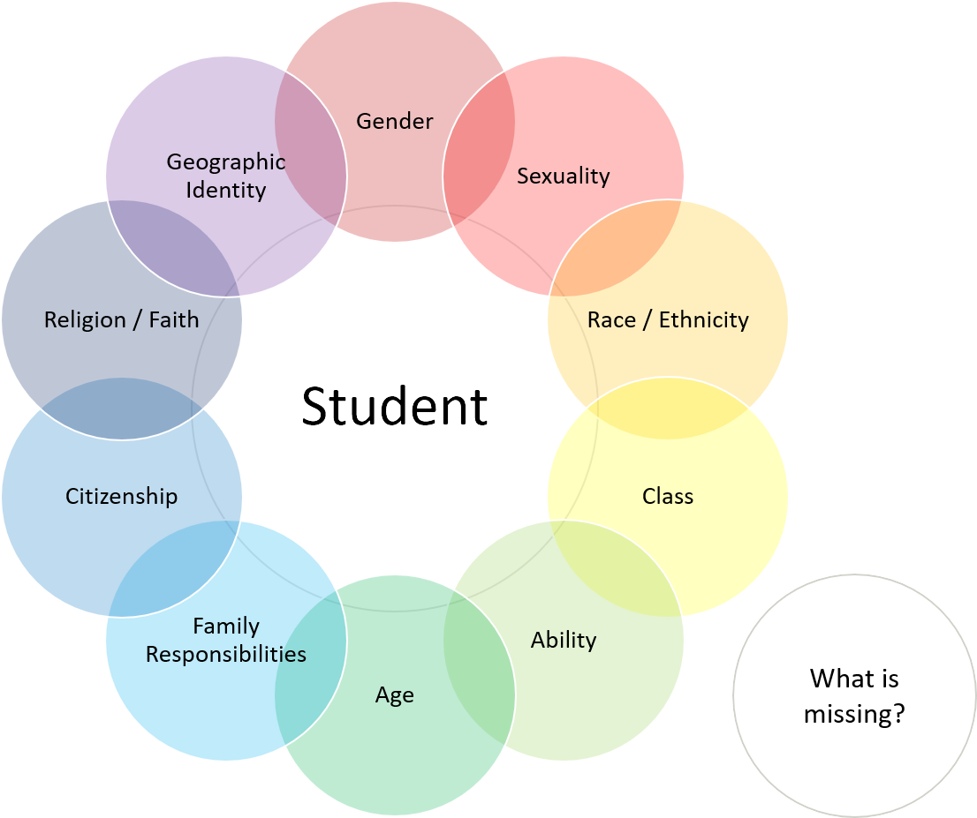

How Does Identity Impact Student Learning?

Many factors related to identity significantly impact learning. The six factors listed below negatively impact student learning. Consider how you can disrupt and alleviate the impacts of each factor in your teaching context.

Systemic Barriers

The work of Kimberlé Crenshaw (2022) outlines that our identities intersect, are not static, and can be a source of oppression and/or privilege. But the most important point to consider is how the systems we interact with create vulnerability and barriers for certain identities.

Microaggressions

Derald Wing Sue (2007) defines racial microaggressions as "brief and commonplace daily verbal, behavioral or environmental indignities, whether intentional or unintentional, that communicate hostile, derogatory, or negative racial slights and insults toward people of color" (p. 271). Microaggressions can have a significant psychological impact on students, as they can be subtle but frequent and emotionally draining.

Internalized Oppression

Oppressions occur when those in power impose, control, and/or oppress access and ideologies upon another group. Students experiencing oppression over time may begin to individually internalize the ideologies of inferiority and perpetuate oppression among members of the same group—leading to self-hatred/harm/doubt and intragroup fragmentation/violence (David, 2014).

Stereotype Threats

Claude M. Steele and Joshua Aronson (1995) define stereotype threats as "being at risk of confirming, as self-characteristic, a negative stereotype about one's group " (p. 797). In a competitive university environment, stereotype threats can significantly impact marginalized students as they navigate their identity while facing systemic barriers and microaggressions.

Feeling Like An Imposter

Feelings of self-doubt or unworthiness about whether one belongs in higher education or even deserves to be in higher education can lead to feeling like an imposter as a student navigates the journey of moving from novice to expert in their field of study. Tulshyan and Burey (2021) question whether feeling like an imposter accurately portrays what is happening. Their work asserts that what a marginalized person is feeling is a consequence of systemic barriers they have faced due to their identity, so it is not only an individual problem but a result of being in spaces that are not inclusive.

Cognitive Bandwidth

The consequence of how identity impacts learning is that it can impact a student's cognitive bandwidth. Cognitive bandwidth refers to our ability to focus, concentrate, and use our executive functioning to learn and absorb information. Research shows that factors such as marginalization based on our identity, economic insecurity, and a lack of a sense of belonging can lead to stress and reduced cognitive bandwidth (Verschelden, 2017).

2.3 Context and Positionality in Inclusive Pedagogy

On this page:

- The Social Context
- Pause for Reflection
- Instructor and Student Positionality
- Empowering Instructors and Students

The Social Context

"Anti-racist pedagogy is not about simply incorporating racial content into courses, curriculum, and discipline. It is also about how one teaches, even in courses where race is not the subject matter. It begins with the faculty's awareness and self-reflection of their social position and leads to the application of this analysis not just in their teaching, but also in their discipline, research, and departmental, university, and community work." Kyoko Kishimoto (2018, p. 540)

An important aspect of cultivating more inclusive classrooms is considering the larger social context beyond our classroom and how it informs our course, regardless of the subject matter. When we approach our understanding of inclusive classrooms through this more comprehensive stance, we know that the classroom is not a neutral space and that education is not a neutral experience for students.

The following visual shows the impact of social context on students and your course. The largest ring is the social hierarchy and systemic oppression based on racism that operates in our society. The largest ring informs the educational systems, structures, and communities, represented by a slightly smaller ring. An even smaller ring presents the impact on departmental culture and research, which impacts the student experience and learning, the smallest ring in the diagram. All the rings show the external and historical factors that ultimately impact your lesson/course, the circle at the center of the rings.

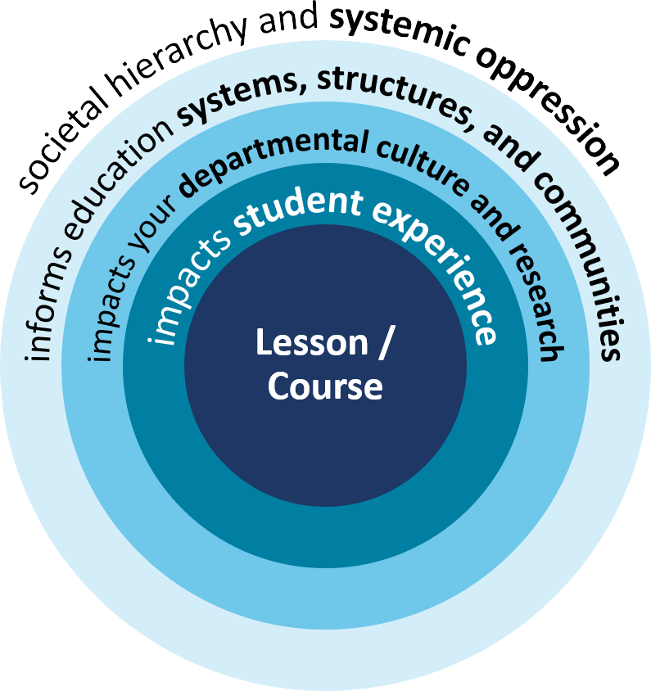

Pause for Reflection

Let's examine the implications of social context on your course. Take a moment to consider the following questions. Document your reflections in your Course Design Foundations Workbook docx.

- Whose voice and knowledge is valued in your field of study?
- Which demographics dominate your field historically and today?
- How did/does your discipline value contributions by Indigenous and racialized scholars?
- What is an accurate historical context of your discipline—have there been unethical research practices in the past?
- How does your discipline need to evolve or change to meet the current needs of our complex society?

Instructor and Student Positionality

Another important part of building a more inclusive classroom is being self-aware of your positionality as an instructor and the power you hold. How does your positionality inform your teaching and interactions with students?

Consider your students' positionality. How does student positionality inform their relationship with you and the course?

Inclusive pedagogy acts as a bridge, inviting exchanges between instructors and students. In an inclusive classroom, learning is multidirectional—students learn from one another, students learn from the instructor, and the instructor learns from students. Together, the instructor and students transform the learning environment.

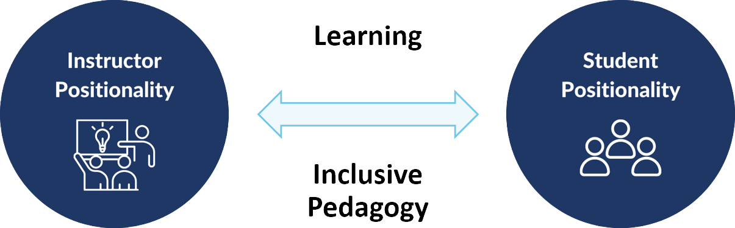

Empowering Instructors and Students

Inclusive pedagogy factors in the social context and the instructor and student positionality to cultivate a space where students can identify and situate themselves in the course, department, university, and discipline. Inclusive pedagogy empowers instructors and students to disrupt social hierarchies and historical injustices and foster an environment where everyone feels and knows they belong.

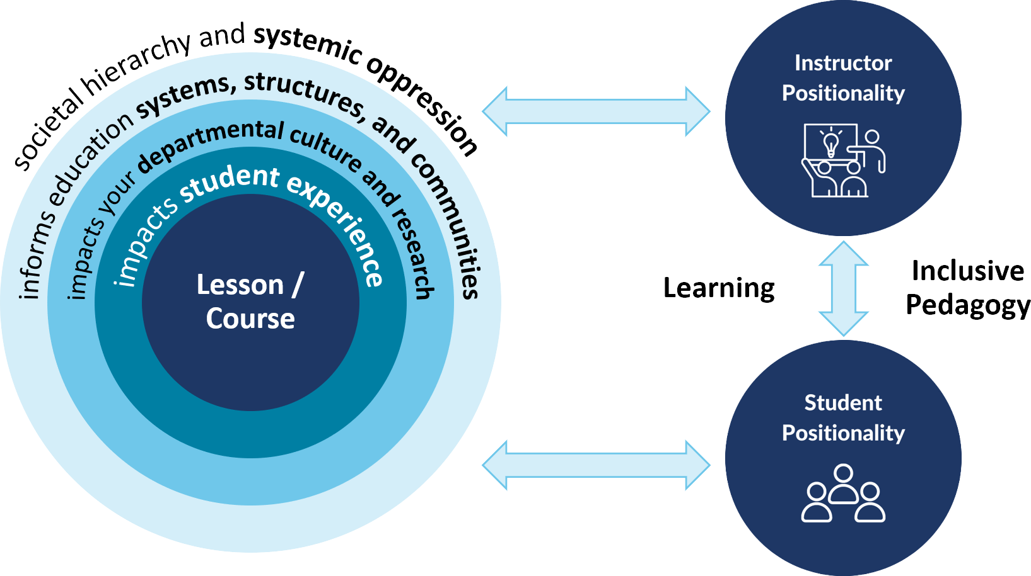

2.4 The Inclusive Pedagogy Framework (IPF): Building Inclusion

On this page:

- Engaged Pedagogy
- Inclusive Pedagogical Framework (IFP)
- Empowerment and Collaboration

Engaged Pedagogy

"The classroom remains the space of most radical possibility in the academy… When education is the practice of freedom, students are not the only ones who are asked to share, to confess. Engaged pedagogy does not seek simply to empower students. Any​ classroom that employs a holistic model of learning will also be a place where teachers grow, and are ​empowered by the process. That empowerment cannot happen if we refuse to be vulnerable while encouraging students to take risks." bell hooks (1994, p. 21)

Despite all the challenges students may face in the educational system, the difference a faculty member can make with students in their classroom is very powerful. The process of creating a more inclusive classroom can be empowering for both students and faculty.

Inclusive Pedagogical Framework (IFP)

To help you create a more inclusive classroom, we introduce the Inclusive Pedagogical Framework (IFP), which considers who you are, how you teach, and what you teach.

Who You Are

Self-Reflection/knowing: Awareness of your positionality and how your identity intersects with systemic injustice in society.

- What is your experience of power, privilege, and oppression?
- How does this translate into your teaching presence in the classroom?
- How do you respond to "HOT" (heated, offensive, tense) moments in class?

How You Teach

Teaching practices: In-class teaching experiences that contribute to furthering student learning.

- How are you integrating an awareness of how identity impacts learning into your classroom teaching?
- How can you incorporate culturally responsive teaching, pedagogy of kindness, and UDL-informed practices to create a more inclusive classroom?

What You Teach

Lesson/course design: How a course is developed, the decision-making process of choosing course material, designing assessments, and creating intentional learning outcomes that shape student learning.

- Does your intent for the course match the impact?
- Are you transparent about your intentions and expectations?

Empowerment and Collaboration

The three IFP dimensions interact and intersect to generate a holistic learning model in which instructors and students are empowered to establish and maintain an inclusive learning environment collaboratively. In the following pages, let's delve into each dimension of the IFP.

2.5 IPF: Who You Are: Self-Reflection/Knowing

On this page:

- Positionality and Identity
- Pause for Reflection
- Unlearning and Leaning into Discomfort
- Building Inclusion: Culturally Responsive Teaching

Positionality and Identity

One of the most important aspects of creating an inclusive classroom is reflecting on your positionality and identity, which will inform how and what you teach. This process can feel very personal as you explore your thoughts and beliefs, your worldview, and your taken-for-granted assumptions through a critical lens. It can almost feel like your very identity is coming into question.

In this section, we invite you to notice any resistance you may be feeling and try to approach this reflection with curiosity and openness. The intention is to learn more about your positionality and identity so you can better support the diverse students who are entering your classroom.

Pause for Reflection

We invite you to use the following prompts to reflect on your positionality and identity. Consider how your and your students' identities impact learning. Document your reflections in your Course Design Foundations Workbook docx.

- How do my positionality and identity help or hinder me at U of T?
- How do students' positionality and identity help or hinder them at U of T?
- What is my "learning edge" related to inclusive teaching?
- What gaps do I have in my learning?
- What issues about positionality and identity am I most comfortable discussing, and which do I find challenging and why?

Unlearning and Leaning into Discomfort

In addition to reflecting on your positionality and identity, consider the context of the current education system. Examine and understand the historical legacy and continuing impacts of colonization and racism on the education system. Become critically aware of the dominance of Eurocentric ideology in higher education (and likely in your discipline).

Unlearning racism is a challenging process. Lean into the discomfort that arises, notice if you are withdrawing or resisting, and reflect on what you can learn from it. Unlearning is emotional work. Identify and access community support to help you navigate the complexity of this unlearning process.

"To learn that things and life are more complex than we think is more difficult than staying in the comfort and security of the idea that there is a good or bad, a right or wrong, anti-oppression and oppression, and that we simply need to decide which side we are on. To create a dialogic communicative space, however, it is crucial that we are not preoccupied with categorizing people into good or bad, right or wrong—"us" or "them"—but rather we learn to appreciate the fluidity of being and engage with each other in the openness of "listening silence." Yuk-Lin Renita Wong (2004)

Building Inclusion: Culturally Responsive Teaching

Watch Zaretta Hammond's discussion of culturally responsive teaching video (10:34). Select "CC" for closed captions. As Hammond notes in the video: "All instruction is culturally responsive teaching. The question is, whose culture is it responding to?"

2.6 IPF: How You Teach: Teaching Practices

On this page:

- Instructor Presence and Role Modelling
- Pause for Reflection
- Building Relationships
- Building Inclusion: Pedagogy of Kindness

Instructor Presence and Role Modelling

Instructor presence and role modelling are vital in creating a classroom climate that promotes belonging. Instructor presence means "being there" with students in the learning environment, while role modelling refers to the instructor's demonstration of knowledge, skills, and attitudes.

An inclusive classroom promotes belonging for all teaching and learning community members. Maintaining such belonging requires instructors to be self-aware of difficult moments and identify strategies for addressing such situations.

Pause for Reflection

Using the following prompts, we invite you to reflect on how you demonstrate your presence and role model knowledge, skills, and attitudes in your teaching context. Consider how your presence and role modelling impact learning. Document your reflections in your Course Design Foundations Workbook docx.

- What "tone" do I set in my classroom? How do I set the "tone"?
- How do I integrate student engagement strategies into my teaching?
- How do I handle challenges or "HOT" (heated, offensive, tense) moments in the classroom?
- Who has a voice in my classroom, and whose voices are not included?
- How do I show my students a commitment to inclusive and anti-racist teaching?
- What role can the pedagogy of kindness (refer to Fiona Rawle's podcast episode below) play in my classroom?

Building Relationships

Instructor presence and role modelling set the groundwork for building relationships with students. Building relationships with your students and regarding them as partners on the learning journey can contribute to student learning. Both you and your students play a role in establishing and maintaining the learning environment.

When difficult moments arise in the learning environment, being self-aware of how identity impacts learning can relay your commitment to equity to students.

"I long, as does every human being, to be at home wherever I find myself." Maya Angelou

Building Inclusion: Pedagogy of Kindness

Listen to Fiona Rawle's discussion of the pedagogy of kindness podcast (8:49). Select "CC" for closed captions. As Rawle shares in the podcast: "We need to foster dialogue and learn about the student experience. We need to purposefully bridge the professor-student divide."

2.7 IPF: What You Teach: Course Design

On this page:

- Intent and Impact
- Pause for Reflection
- Communicating Transparency
- Building Inclusion: Transparency in Learning and Teaching

Intent and Impact

Designing a course that promotes inclusion requires intentionality so your intent for your course matches the impact on students.

Start with offering students an accurate history of your discipline and sharing a perspective beyond centring Eurocentric thought and leadership. In doing so, you demonstrate to students that they can incorporate a critical lens on the history of their discipline and strive for a more inclusive future.

Pause for Reflection

We invite you to use the following prompts to reflect on your teaching intent and learning impact. Document your reflections in your Course Design Foundations Workbook docx.

- How can I incorporate greater diversity in the course materials, readings, case studies, examples, and prompts?
- How do I offer students a more accurate and critical history of my discipline?
- Whose knowledge, voices, and/or contributions are missing?
- How do I incorporate student feedback into my course design?
- How do I incorporate UDL approaches into my course design?
- How do I teach students to learn how to learn as part of my approach to cultivating greater equity in my classroom?

Communicating Transparency

Another key element of inclusive pedagogy is clear communication of course goals, learning outcomes, and expectations. Rather than relying on prior experiences and unconfirmed assumptions to decode course components, instructors can facilitate learning by offering transparency about all aspects of the course.

Enhance your teaching and learning environment by providing opportunities for student feedback (e.g., informal mid-course feedback or ongoing check-ins) about various aspects of your course (e.g., pacing, workload, assessment instructions). Student feedback enables you to assess the impact of your teaching and whether or not your teaching strategies (e.g., culturally responsive teaching, pedagogy of kindness, UDL-informed practices) match your intent for student learning in your course.

"Transparency reduces systemic inequities." Mary-Ann Winkelmes (2022, p. 131)

Building Inclusion: Transparency in Learning and Teaching

Watch Mary-Ann Winkelmes's explanation of the Transparency Framework from the Transparency in Learning and Teaching project (TILT Higher Ed) in the following four videos (total time 02:11). Select "CC" for closed captions. Consult the TILT Higher Ed examples and resources webpage for various resources, including those listed below.

Videos: Transparency Framework for Academic Work

- Unwritten rules for college success (00:39)
- Transparency Framework 1: Purpose (00:44)
- Transparency Framework 2: Task (00:24)
- Transparency Framework 3: Criteria (00:24)

Resources: Tools for Teachers and Students

- Transparent assignment template for instructors PDF
- Checklist for designing transparent assignments for instructors PDF
- Unwritten rules: Transparent assignment framework for students PDF
- Transparent equitable learning framework for students PDF

2.8 Module 2 References and Resources

Congratulations!

You've reached the end of Module 2: Creating Equitable Classrooms: Introduction to Inclusive Pedagogy.

Throughout the module, you had the opportunity to reflect on key ideas and theories related to inclusive teaching practices that will inform your course design. A summary of key ideas we shared in this module are:

- Education is not neutral.
- Historical and current social injustice informs your course.
- As an instructor, you play a pivotal role in student learning.
- Identity impacts student learning.

In this module, we have:

- Engaged in self-reflection and self-knowing toward building an anti-oppressive pedagogy;
- Explored a range of inclusive teaching practices (e.g., culturally responsive teaching, pedagogy of kindness, transparency in learning and teaching) that can impact student learning; and
- Adapted the inclusive pedagogy framework (who you are, how you teach, what you teach) to your course design.

References and Resources

The list below is a compilation of module references and additional resources. These resources are provided as additional information to help you think further about the module topic. Reviewing these resources is optional. They are not intended as essential components of the module, so you are not required to review any of them before proceeding to the next module. You can review them at your own pace at a later date.

- Addy, T. M., Dube, D., Mitchell, K. A., & SoRelle, M. (2021). What inclusive instructors do: Principles and practices for excellence in college teaching. Stylus Publishing.
- Andrade, M. (Host). (2020, November 27). The pedagogy of kindness (No. 12) [Audio podcast episode]. In The New Normal with Maydianne Andrade. University of Toronto.
- Crenshaw, K. W. (2022). This is not a drill: The war against antiracist teaching in America. UCLA Law Review, 68, 1702–1729.
- David, E. J. R. (2014). Internalized oppression: The psychology of marginalized groups. Springer Publishing Company.
- Denial, C. (2019). A pedagogy of kindness. Hybrid Pedagogy.
- Edthena. (2021, August 23). Zaretta Hammond: Culturally responsive teaching 101 | #PLtogether [Video]. YouTube.
- Fusion Comedy. (2016, October 5). How microaggressions are like mosquito bites: Same difference [Video]. YouTube.
- Hammond, Z. (2015). Culturally responsive teaching and the brain: Promoting authentic engagement and rigor among culturally and linguistically diverse students. Corwin.
- Hogan, K. A., & Sathy, V. (2022). Inclusive teaching: Strategies for promoting equity in the college classroom. West Virginia University Press.
- hooks, b. (1994). Teaching to transgress: Education as the practice of freedom. Routledge.
- hooks, b. (2003). Teaching community: A pedagogy of hope. Routledge.
- Kishimoto, K. (2018). Anti-racist pedagogy: From faculty's self-reflection to organizing within and beyond the classroom. Race Ethnicity and Education, 21(4), 540–554.
- Kumar, R., & Refaei, B., eds. (2021). Equity and inclusion in higher education: Strategies for teaching. University of Cincinnati Press.
- Saujani, R. (2023, June 21). Reshma Saujani at Smith College's 2023 Commencement: Imposter syndrome is modern-day bicycle face [Video]. YouTube.
- Spencer, S. J., Logel, C., & Davies, P. G. (2016). Stereotype threat. Annual Review of Psychology, 67(1), 415–437.
- Steele, C. M., & Aronson, J. (1995). Stereotype threat and the intellectual test performance of African Americans. Journal of Personality and Social Psychology, 69(5), 797–811.
- Sue, D. W., et al. (2007). Racial microaggressions in everyday life: Implications for clinical practice. The American Psychologist, 62(4), 271–286.
- TILT Higher Ed. (2023). Transparency in learning and teaching.
- Tulshyan, R., & Burey, J.-A. (2021, February 11). Stop telling women they have imposter syndrome. Harvard Business Review.
- Verschelden, C. (2017). Bandwidth recovery: Helping students reclaim cognitive resources lost to poverty, racism, and social marginalization. Stylus Publishing.
- Winkelmes, M.-A. (2022). Assessment in class meetings: Transparency reduces systemic inequities. In G. W. Henning et al. (Eds.), Reframing assessment to center equity: Theories, models, and practices (pp. 131-144). Routledge.
- Wong, Y.-L. R. (2004). Knowing through discomfort: A mindfulness-based critical social work pedagogy. Critical Social Work, 5(1).

U of T Resources

- CTSI Equity, Diversity and Inclusion
- UTSC Campus Curriculum Review Resource Hub

3. Promoting Access for All Learners: Introduction to Universal Design for Learning (UDL)

3.1 Introducing Module 3

Welcome

In this module, you will examine the Universal Design for Learning (UDL), an educational framework for optimizing learning based on cognitive neuroscience, and schematize UDL approaches to your course planning.

Learning Outcomes

After completing this module, you will be able to reflect on how the UDL guidelines will inform your course design. In support of this outcome, you will be able to:

- Identify common barriers to learning in higher education;
- Examine the three UDL principles (engagement, representation, and action & expression); and
- Adapt UDL-informed practices to reduce learning barriers and welcome learner variability in your teaching context.

Module 3 Pages

This module consists of seven pages accompanied by activities from the Course Design Foundations Workbook docx.

Use the "Next" and "Previous" buttons in the bottom right to progress through the module.

- 3.1 Introducing Module 3 (you are here)
- 3.2 Learner Variability and Barriers to Learning
- 3.3 The Universal Design for Learning (UDL) Framework: Building Access and Agency
- 3.4 The "Why" of Learning: Designing Multiple Means of Engagement
- 3.5 The "What" of Learning: Designing Multiple Means of Representation
- 3.6 The "How" of Learning: Designing Multiple Means of Action & Expression
- 3.7 Module 3 References and Resources

3.2 Learner Variability and Barriers to Learning

On this page:

- Learner Variability is the Norm
- The Jagged Learning Profile
- Barriers to Learning
- Pause for Reflection: Learning Barriers in Your Teaching Context

Learner Variability is the Norm

"We now understand from scientific research that brains and even genes are highly responsive to their environments. Individual differences in our brains are not innate or fixed but developed and malleable, and context has huge impact. This is the best news yet for educators who have the opportunity to provide environments that facilitate positive growth, or learning, for all students." Anne Meyer, David H. Rose, and David Gordon

Learner variability is the norm. There is no "average" student, and there is no one path to learning. The "one-size-fits-all" design intended for everyone ends up supporting no one.

Watch Todd Rose's TEDxTalk "The Myth of Average" video (18:26). Select "CC" for closed captions. Rose introduces the jagged learning profile and invites instructors to ban the average in education and design to the edges so that we reach every student.

The Jagged Learning Profile

The jagged learning profile acknowledges the multiple dimensions of student learning. Each student has a different combination of characteristics/skills/levels in memory, language, knowledge, reading, vocabulary, curiosity, perceptual, cognitive, and interest.

Consider how the student learning experience is impacted by the student's intersecting identities (module 2) and jagged learning profile. Students may be marginalized and experience barriers to learning based on their intersecting identities and jagged learning profiles.

The Universal Design for Learning (UDL) framework offers strategies for instructors to design for learners at the edge and welcome learner variability into our learning environments.

Barriers to Learning

A UDL mindset can help instructors identify learning barriers and design to reduce learning barriers. For every course design decision you make, consider the following three questions:

- Who am I centring through my design choices?
- Who is marginalized or left out by my design choices?
- How do I welcome more learners in my design choices?

For example, an instructor might plan to record their classes and post the recordings online for students who cannot attend every in-person session. Let's consider the three questions listed above and possible responses:

- Students who cannot attend every in-person session will benefit from the class recordings.
- Students who attend in-person sessions may be concerned about their questions, discussions, and reactions being recorded.
- Consider what conversations and guidelines can be established to foster a safer space for learning and clarify expectations about participating in in-person sessions.

Barriers to learning differ based on the teaching context. When applying UDL thinking, consider your specific context to determine what intervention would support the greatest number of students.

Pause for Reflection: Learning Barriers in Your Teaching Context

In your Course Design Foundations Workbook docx, note down learning barriers in your teaching context. Consider:

- What learning barriers have you noticed in your courses?
- What learning barriers do you anticipate in your future courses?

As you proceed through the module, you will have the opportunity to identify strategies for reducing learning barriers in your teaching context.

3.3 The Universal Design for Learning (UDL) Framework: Building Access and Agency

On this page:

- What is UDL?
- UDL and Academic Accommodations
- Implementing UDL: The Plus-one Approach

What is UDL?

"UDL isn't about erasing differences to make 'one-size-fits-all' lessons and assessments. It's about recognizing barriers, naming them, highlighting them, celebrating them, and designing for them." Katie Novak

Universal Design for Learning (UDL) is a framework for welcoming learner variability in our classrooms. The philosophy of UDL is that rather than adapting a course for individual student needs—a reactive approach—educators can design a curriculum that is accessible to a wide range of learners—a proactive approach. The UDL approach reduces learning barriers by enhancing access to learning and constructing a flexible learning environment that promotes learner agency (or autonomy) through three UDL principles—designing multiple means of engagement, representation, and action & expression.

Engagement

- The "why" of learning
- Students ask: "Why should I care?"
- Big takeaway: Designing flexible options for generating and sustaining motivation

Representation

- The "what" of learning
- Students ask: "What are you teaching?"
- Big takeaway: Designing flexible ways to present what we teach and learn

Action & Expression

- The "how" of learning
- Students ask: "How do I do this?"
- Big takeaway: Designing flexible options for how we interact and express what we know

Watch Katie Billard and Biana Sorbera's "Universal Design for Learning in Higher Education" video (04:42) for some examples of designing multiple means of engagement, representation, and action & expression. Select "CC" for closed captions.

UDL Guidelines

On the following pages, we will examine each of the UDL principles and consider UDL-informed practices outlined in the UDL Guidelines. The guidelines "offer a set of concrete suggestions that can be applied to any discipline or domain to ensure that all learners can access and participate in meaningful, challenging learning opportunities" (CAST).

CAST, a nonprofit education research and development organization, created the UDL framework and guidelines. UDL Guidelines 1.0 was issued in 2008, and UDL Guidelines 3.0 was launched in July 2024.

UDL and Academic Accommodations

Designing your course using UDL principles enhances access and builds student agency in their learning. UDL proactively designs for learner variability and reduces learning barriers. Nevertheless, UDL does not eliminate the need for specific academic accommodations for students with disabilities.

UDL closes the gap between student needs and instructional design and offers a ramp to better facilitate academic accommodations for students with disabilities.

UDL | Academic Accommodations
Proactive design approach | Reactive remedial approach
Designed for many learners | Individualized and determined on a case-by-case basis
Implemented during the design phase | Implemented after the course has been designed

Implementing UDL: The Plus-one Approach

"In our book, we advocate for the idea that UDL is really just 'plus-one' thinking. For every interaction that learners have now—with the materials, yes, but also with each other, with instructors and with the wider world—provide one more way for that interaction to happen. The plus-one approach helps to take what otherwise might look like an insurmountable amount of effort and break it down into manageable, approachable chunks. It also helps people to determine where to start applying the UDL framework so they can address current challenges and pain points in their interactions." Thomas J. Tobin

Watch Thomas Tobin's summary of "UDL plus-one" video (02:19). Select "CC" for closed captions. Tobin acknowledges that UDL can entail a lot of work and recommends the plus-one approach to keep your efforts manageable.

The plus-one approach, developed by Thomas J. Tobin and Kirsten T. Behling, invites instructors to identify one more way students can interact with your course—plus-one thinking. For example, share an outline alongside a live lecture so that students have more than one way to interact with your lecture.

To get started, identify moments in the course that aren't going the way you anticipated—the "pinch points" of your course. For example, what questions do you receive repeatedly in class, via emails, and during office hours? What is another way you can present the information to enhance clarity and support student learning?

By applying the plus-one approach to the "pinch points" in your course, your course design will prioritize reducing the most significant barriers and welcoming learner variability.

In each of the following pages examining the UDL principles, you will be invited to identify a "pinch point" in your course and consider how you can add one more way (the plus-one approach) for students to access and engage with your course.

3.4 The "Why" of Learning: Designing Multiple Means of Engagement

On this page:

- Students Ask: "Why should I care?"
- Engagement in Practice
- Pause for Reflection: Plus-one in Engagement

Students Ask: "Why should I care?"

"Affect represents a crucial element to the learning process, and learners differ markedly in what sparks their motivation and enthusiasm for learning. Learners must be able to bring their authentic selves to the learning environment and find connections to what matters most in their lives. The UDL framework emphasizes the idea of learner variability, and learners' multiple and intersecting identities are an essential layer of fully recognizing the notion of learner variability. While we emphasize dimensions of identity as a part of variability in this section on Multiple Means of Engagement, the essential role identity plays in learning is woven across all three UDL principles. Further, learners' interests and sources of motivation may vary depending on the context. Some learners may be highly engaged by spontaneity and novelty while others are disengaged, even frightened, by those aspects, preferring strict routine. Some learners might like to work alone, while others prefer to work with their peers. And, these preferences might vary from week to week or even day to day. In reality, there is not one means of engagement that will be optimal for all learners in all contexts; multiple options for engagement are essential." CAST

Designing multiple means of engagement engages with the affective networks of the brain and addresses the "Why" of learning. The affective networks engage with information. Consider how you can stimulate students' interests and sustain motivation for learning in a variety of ways. Review the "Engagement in practice" section below and identify strategies that can be adapted into your teaching context.

By designing flexible options for generating and sustaining motivation, we can foster individual and collective learning that is purposeful and reflective.

Engagement in Practice

What options can you design for welcoming interests and identities, sustaining effort and persistence, and emotional capacity?

Designing Options for Welcoming Interests and Identities

- Optimize choice and autonomy
- Optimize relevance, value, and authenticity
- Nurture joy and play
- Address biases, threats, and distractions

Examples:

- Providing resources and support in the notes section of PowerPoint
- Connecting lab-based learning to real-world or professional contexts that are relevant to students' interests
- Inviting students to do a deeper dive with the course material

Designing Options for Sustaining Effort and Persistence

- Elevate the meaning and purpose of goals
- Optimize challenge and support
- Foster collaboration, interdependence, and collective learning
- Foster belonging and community
- Offer action-oriented feedback

Examples:

- Clarifying learning outcomes (module 4) and its connection/application to post-education goals
- Incorporating peer-based learning in discussion-based settings to encourage collaboration and community
- Providing action-oriented feedback that focuses on levels of effort and process

Designing Options for Emotional Capacity

- Recognize expectations, beliefs, and motivations
- Develop awareness of self and others
- Promote individual and collective reflection
- Cultivate empathy and restorative practices

Examples:

- Using pre-course surveys to learn about your students, their goals, expectations, and concerns
- Highlighting learning outcomes (module 4) and encouraging students to create their own learning goals
- Offering opportunities for students to assess their learning progress through knowledge checks, self-assessment checklists, and peer reviews

More Engagement Strategies

Watch Oakland University's Center for Excellence in Teaching and Learning's "Universal Design for Learning (Part 3): Engagement Strategies" video (05:26) for more engagement strategies that increase access and reduce barriers for all types of learners. Select "CC" for closed captions.

Pause for Reflection: Plus-one in Engagement

In your Course Design Foundations Workbook docx, note down how you are already designing multiple means of engagement to welcome learner variability. Consider:

- How are these practices reducing learning barriers?
- What is a "pinch point" in your course, and how can you add one more way (the plus-one approach) for students to access and engage with your course?

3.5 The "What" of Learning: Designing Multiple Means of Representation

On this page:

- Students Ask: "What are you teaching?"
- Representation in Practice
- Pause for Reflection: Plus-one in Representation

Students Ask: "What are you teaching?"

"Learners differ in the ways that they perceive and comprehend information that is presented to them. For example, those with sensory disabilities (e.g., blindness or deafness), learning disabilities (e.g., dyslexia), and those representing diverse or non-dominant cultures and/or languages all approach content differently. And these differing approaches must be honored and valued. Equally important is the consideration of how people, cultures, individual and collective identities, perspectives, and ways of knowing are represented within the content. Learning, and transfer of learning, occurs when multiple representations and perspectives are used, because they support learners to make connections within, as well as between, concepts. In short, there is not one means of representation that will be optimal for all learners; providing options for representation is essential." CAST

Designing multiple means of representation engages with the recognition networks of the brain and addresses the "What" of learning. The recognition networks recognize information. Consider how you can present information and course content in multiple ways so that all students can access and understand the materials. Review the "Representation in practice" section below and identify strategies that can be adapted into your teaching context.

By designing flexible ways to present what we teach and learn, we can foster individual and collective learning that is resourceful and authentic.

Representation in Practice

What options can you design for perception, language and symbols, and building knowledge?

Designing Options for Perception

- Support opportunities to customize the display of information
- Support multiple ways to perceive information
- Represent a diversity of perspectives and identities in authentic ways

Examples:

- Presenting information through text, video, audio, or graphics
- Incorporating multiple forms of media in your lecture, such as short videos, in-class learning activities, or a copy of your presentation slides
- Embedding and acknowledging different perspectives and identities in readings, examples, and discussions

Designing Options for Language and Symbols

- Clarify vocabulary, symbols, and language structures
- Support decoding of text, mathematical notation, and symbols
- Cultivate understanding and respect across languages and dialects
- Address biases in the use of language and symbols
- Illustrate through multiple media

Examples:

- Embedding hyperlinks for vocabulary and symbols and providing links to definitions and resources
- Clarifying jargon, abbreviations, and acronyms and co-constructing a course glossary

Designing Options for Building Knowledge

- Connect prior knowledge to new learning
- Highlight and explore patterns, critical features, big ideas, and relationships
- Cultivate multiple ways of knowing and making meaning
- Maximize transfer and generalization

Examples:

- Making connections between concepts by using graphic organizers or concept maps
- Offering note-taking outlines or prompts to help students organize their notes
- Fostering critical thinking by using "think aloud" to model thought processes and demonstrate your logic to students

More Representation Strategies

Watch Oakland University's Center for Excellence in Teaching and Learning's "Universal Design for Learning (Part 4): Representation Strategies" video (04:32) for more representation strategies that increase access and reduce barriers for all types of learners. Select "CC" for closed captions.

Pause for Reflection: Plus-one in Representation

In your Course Design Foundations Workbook docx, note down how you are already designing multiple means of representation to welcome learner variability. Consider:

- How are these practices reducing learning barriers?
- What is a "pinch point" in your course, and how can you add one more way (the plus-one approach) for students to access and engage with your course?

3.6 The "How" of Learning: Designing Multiple Means of Action & Expression

On this page:

- Students Ask: "How do I do this?"
- Action & Expression in Practice
- Pause for Reflection: Plus-one in Action & Expression

Students Ask: "How do I do this?"

"Learners differ in the ways they navigate a learning environment, approach the learning process, and express what they know. Therefore, it is essential to design for and honor these varying forms of action and expression. For example, all individuals, including those with disabilities, approach learning tasks very differently. Depending on the context, some may prefer to express themselves in written text but not speech, and vice versa. It should also be recognized that action and expression require a great deal of strategy, practice, and organization, and this is another area in which learners will differ. In reality, there is not one means of action and expression that will be optimal for every learner; options for action and expression are essential." CAST

Designing multiple means of representation engages with the strategic networks of the brain and addresses the "How" of learning. The strategic networks organize and express information. Consider how you can vary methods for students to express or demonstrate their learning. Review the "Representation in practice" section below and identify strategies that can be adapted into your teaching context.

By designing flexible options for how we interact and express what we know, we can foster individual and collective learning that is strategic and action-oriented.

Action & Expression in Practice

What options can you design for interaction, expression and communication, and strategy development?

Designing Options for Interaction

- Vary the honour methods for response, navigation, and movement
- Optimize access to accessible materials and assistive and accessible technologies and tools

Examples:

- Welcoming student voices and contributions through various student response systems and collaborative platforms
- Clarifying where students can access tools, resources, and supports

Designing Options for Expression and Communication

- Use multiple media for communication
- Use multiple tools for construction, composition, and creativity
- Build fluencies with graduated support for practice and performance
- Address biases related to modes of expression and communication

Examples:

- Offering various modes for communication, such as through office hours, discussion boards, Q&A sessions, or emails
- Using multiple media for formative or summative assessments (module 5), including videos, podcasts, comics, infographics, or essays

Designing Options for Strategy Development

- Set meaningful goals
- Anticipate and plan for challenges
- Organize information and resources
- Enhance capacity for monitoring progress
- Challenge exclusionary practices

Examples:

- Providing tools for organizing information and clarifying expectations, such as calendars, note-taking outlines, or rubrics
- Identifying resources and supports in anticipation of challenges

More Action & Expression Strategies

Watch Oakland University's Center for Excellence in Teaching and Learning's "Universal Design for Learning (Part 5): Action and Expression Strategies video (05:06) for more action & expression strategies that increase access and reduce barriers for all types of learners. Select "CC" for closed captions.

Pause for Reflection: Plus-one in Action & Expression

In your Course Design Foundations Workbook docx, note down how you are already designing multiple means of action & expression to welcome learner variability. Consider:

- How are these practices reducing learning barriers?
- What is a "pinch point" in your course, and how can you add one more way (the plus-one approach) for students to access and engage with your course?

3.7 Module 3 References and Resources

Congratulations!

You've reached the end of Module 3: Promoting Access for All Learners: Introduction to Universal Design for Learning (UDL). Throughout the module, you had the opportunity to reflect on how the UDL guidelines will inform your course design. In this module, we have:

- Identified common barriers to learning in higher education;
- Examined the three UDL principles (engagement, representation, and action & expression); and
- Adapted UDL-informed practices to reduce learning barriers and welcome learner variability in your teaching context.

References and Resources

The list below is a compilation of module references and additional resources. These resources are provided as additional information to help you think further about the module topic. Reviewing these resources is optional. They are not intended as essential components of the module, so you are not required to review any of them before proceeding to the next module. You can review them at your own pace at a later date.

- Battaglia, A. (2019, June 6). "Plus-One" thinking: A framework for inclusive teaching. Center for Teaching and Learning, The University of Texas at Austin.
- Benton Kearney, D. (2022). Universal design for learning (UDL) for inclusion, diversity, equity, and accessibility (IDEA). eCampusOntario.
- Black, J., & Moore, E. J. (2019). UDL navigators in higher education: A field guide. CAST Professional Publishing.
- Burgstahler, S. E. (Ed.). (2013). Universal Design in higher education: Promising practices. DO-IT, University of Washington.
- Burgstahler, S. E. (2020). Creating inclusive learning opportunities in higher education: A universal design toolkit. Harvard Education Press.
- CAST. (2024). Universal Design for Learning guidelines version 3.0.
- CAST (n.d.). UDL on campus: Universal Design for Learning in higher education.
- Centre for Teaching and Learning. (n.d.). Accessibility: Universal Design for Learning (UDL). Queen's University.
- Couros, G., & Novak, K. (2020). Innovate inside the box: Empowering learners through UDL and the innovator's mindset. Impress Books.
- Digital Promise. Learner variability project.
- Disability and Access. Creating an accessible classroom. The University of Texas at Austin.
- Disability Awareness. (2021, November 7). UDL plus-one - Thomas Tobin. [Video]. YouTube.
- Fovet, F. (Ed.). (2021). Applying Universal Design for Learning across disciplines: Case studies on implementation. IGI Global.
- Fritzgerald, A. (2020). Antiracism and universal design for learning: Building expressways to success. CAST Professional Publishing.
- Humber College. (2019, June 12). Universal Design for Learning in higher education. [Video]. YouTube.
- La, H., Dyjur, P., & Bair, H. (2018). Universal Design for Learning in higher education. Taylor Institute for Teaching and Learning, University of Calgary.
- Lieberman, M. (2018, November 28). Q&A: Making sense of Universal Design for Learning. Inside HigherEd.
- Merry, K. L. (2023). Delivering inclusive and impactful instruction: Universal Design for Learning in higher education. CAST Professional Publishing.
- Meyer, A., Rose, D., Gordon, D. (2014). Universal Design for Learning: Theory and practice. CAST Professional Publishing.
- Nelson, L. L. (2014). Design and deliver: Planning and teaching using Universal Design for Learning (2nd Ed.). Brookes Publishing.
- Novak, K. (2020). Be honest. Your vision may be out of reach. Novak Education.
- Oakland University. (2017, July 24). Universal Design for Learning (part 3): Engagement strategies. [Video]. YouTube.
- Oakland University. (2017, July 25). Universal Design for Learning (part 4): Representation strategies. [Video]. YouTube.
- Oakland University. (2017, July 25). Universal Design for Learning (part 5): Action and expression strategies. [Video]. YouTube.
- Rose, T. (2015). The end of average: How we succeed in a world that values sameness. HarperOne.
- Takacs, S., Zhang, J., Lee, H., Truong, L., & Smulders, D. (2021). A comprehensive guide to applying Universal Design for Learning. Justice Institute of British Columbia.
- TEDx Talks. (2013, June 19). The myth of average: Todd Rose at TEDxSonomaCounty. [Video]. YouTube.
- Tobin, T. J., & Behling, K. T. (2018). Reach everyone, teach everyone: Universal Design for Learning in higher education. West Virginia University Press.

U of T Resources

- CTSI Accessibility Guidelines for Teaching and Learning
- CTSI Teaching with Universal Design for Learning at U of T
- CTSI Universal Design for Learning
- CTSI Universal Design for Learning Foundations (UDLF) Self-Paced Program
- UTSC Universal Design for Learning

4. Developing Course Learning Outcomes

4.1 Introducing Module 4

Welcome

In this module, you will begin using the integrated course design framework to define and clarify what you would like students to be able to do after taking your course.

Learning Outcomes

After completing this module, you will be able to develop effective learning outcomes shaped by situational factors and course goals. In support of this outcome, you will be able to:

- Translate your course goals into learning outcomes;
- Identify where and how to use learning outcomes in your course design and teaching practice; and
- Refine your learning outcomes informed by your course's situational factors, UDL/inclusion considerations, and ongoing advancements in generative AI technologies.

Module 4 Pages

This module consists of seven pages accompanied by activities from the Course Design Foundations Workbook docx.

Use the "Next" and "Previous" buttons in the bottom right to progress through the module.

- 4.1 Introducing Module 4 (you are here)
- 4.2 Getting Started: Articulating Course Goals
- 4.3 Defining Learning Outcomes
- 4.4 Translating Goals into Outcomes
- 4.5 Using and Communicating Learning Outcomes
- 4.6 Revisiting, Revising, and Refining Your Learning Outcomes
- 4.7 Reframing Learning Outcomes with Generative AI in Mind
- 4.8 Module 4 References and Resources

4.2 Getting Started: Articulating Course Goals

On this page:

- Starting with Goals
- Examining Categories of Learning
- Pause for Workbook Activity: Articulating Your Course Goals

Starting with Goals

In the previous module, we examined the contexts and situational factors that inform and shape your course design and delivery. On this page, we invite you to consider your course goals. In other words, what do you want students to take away from your course?

Course goals establish the basis for all other decisions in the course design process. Articulating course goals is an essential step in planning your course structure and assessments. Below are sample course goals from three courses:

English

Course goal: Introduce students​ to modes of ​satiric writing ​in the ​18th century.

History of Education

Course goal: Be aware of historical assumptions behind core frameworks in educational philosophy.

Pharmacy

Course goal: Understand the biochemical basis of drug design and development.

Examining Categories of Learning

When articulating what you want students to take away from the course, it is helpful to consider the various categories of learning that can occur in the course.

There are many kinds of learning. Students may learn about various knowledge, skills, and attitudes in your course. L. Dee Fink (2013) identifies six significant learning categories: foundational knowledge, application, integration, human dimension, caring, and learning how to learn.

Examine each category of significant learning outlined by Fink below (2013, pp. 34–37).

Foundational Knowledge

Foundational knowledge provides the basic understanding necessary for other kinds of learning. Foundational knowledge refers to the understanding and remembering of information and ideas.

Application

Application learning allows other kinds of learning to become useful. Application refers to skills, thinking (critical, creative, and practical), and managing projects.

Integration

The act of making new connections gives learners a new form of power, especially intellectual power. Integration refers to connecting ideas, learning experiences, and realms of life.

Human Dimension

Human dimension learning informs students about the human significance of what they are learning. Students learn about oneself and others.

Caring

When students care about something, they then have the energy they need for learning more about it and making it part of their lives. Students develop new feelings, interests, and values. Without the energy for learning, nothing significant happens.

Learning How to Learn

Learning how to learn enables students to continue learning in the future and to do so with greater effectiveness. Learning how to learn helps students become better students, inquire about subjects, and develop into self-directed learners.

Significant learning occurs when various categories of significant learning interact, as visualized by the diagram below. The six circles of significant learning categories interact and intersect with one another to form significant learning, labelled at the center of the diagram. No one category is privileged over another. Instead, the six categories combine cognitive, social, and relation development throughout the learning experience.

A well-designed course combines various learning categories, and the course goals articulate the significant learning embedded in the course design. As you draft your course goals, consider how the six categories of significant learning work together to help your students better engage in learning that they will remember years after the course has concluded.

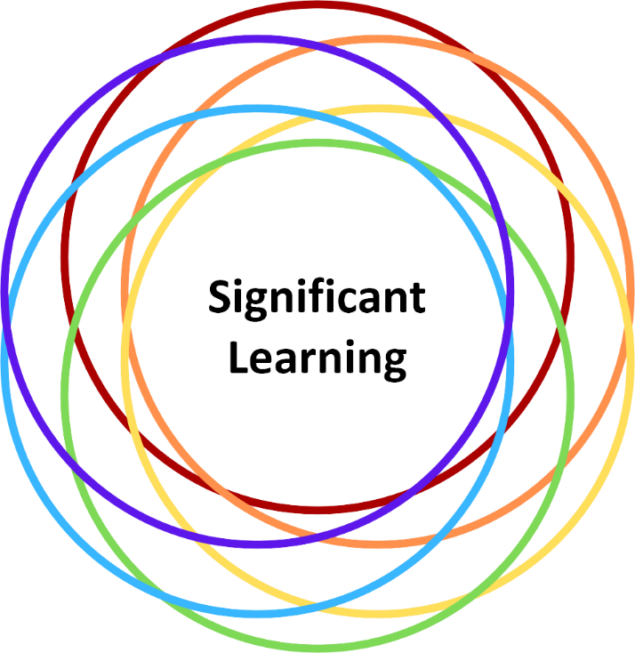

Pause for Workbook Activity: Articulating Your Course Goals

Now it's time for you to think about your own course and what you want students to take away from your course.

Open your Course Design Foundations Workbook docx and begin drafting your course goals. Remember the six categories of significant learning and consider the following prompts:

- What are the "big ideas," core concepts, or foundational knowledge students will acquire from your course?
- What skills will students develop, apply, and integrate throughout the course?
- What will students accomplish in the course?

On the next page, we will examine learning outcomes, which expand upon the course goals that you've articulated.

4.3 Defining Learning Outcomes

On this page:

- What are Learning Outcomes?
- Developing Effective Learning Outcomes
- Considering the Benefits and Limitations of Learning Outcomes

What are Learning Outcomes?

Now that you have articulated your broad course goals, it is time to consider your specific learning outcomes.

Learning outcomes are statements that describe the knowledge or skills students should acquire by the end of a particular assignment, class, course, or program. Learning outcomes emphasize the application and integration of knowledge and articulate how students will be able to employ the material, both in the context of the class and more broadly. While many course designs include a handful of learning outcomes, the number of learning outcomes in your course will depend on your teaching context and disciplinary practices.

Watch the following learning outcomes video (06:42) to learn about the role of learning outcomes and their purpose in course design. The video features faculty members across various post-secondary Ontario universities, including U of T's own Steve Joordens (Psychology). Select "CC" for closed captions.

Remember: Using learning outcomes as a foundation of the course design helps emphasize the learning context and focus on the knowledge and skills that will be most valuable to the student now and in the future.

Developing Effective Learning Outcomes

Developing effective learning outcomes is an iterative process. The exercise of developing learning outcomes offers you an opportunity to reflect on the course content in the context of its potential applications.

This module invites you to iteratively develop your learning outcomes, from articulating your course goals to reflecting on your learning outcomes. Some instructors working through this module might be approaching this task for a new course or as an initial deep dive into course design principles. For others, this module may offer additional prompts and reminders to expand their broad course goals into specific learning outcomes or revise existing learning outcomes alongside associated activities and assessments that create deep, meaningful learning experiences for students.

Effective learning outcomes feature four characteristics (presented below). Consider how you can incorporate the four characteristics to help you develop and enhance your learning outcomes.

Focus on the Learners

Effective learning outcomes focus on the learners.

- What key knowledge and skills do you want your students to leave with at the end of your course?
- How do the new knowledge and skills build upon students' prior knowledge and experiences?

Indicate How Learning Will be Assessed

Concrete and clear learning outcomes indicate how the learning will be measured and assessed.

- What opportunities do students have to apply the newly acquired knowledge and skills?
- Do students know what they must demonstrate to meet the course requirements?

Are Realistic

Effective learning outcomes are achievable within the context of the course's situational factors.

- Are the learning outcomes geared at the right level of study?
- Are the learning outcomes appropriate for the course size, modality, and duration?

Are Transferable

Effective learning outcomes should be transferable.

- How can the knowledge and skills acquired be applied to contexts beyond your course?

Example Learning Outcomes

Revisit the Course Design Foundations' learning outcomes on the home page.

- Do the learning outcomes focus on the learners (you) and indicate how learning will be assessed?
- Are the learning outcomes realistic and transferable?

Considering the Benefits and Limitations of Learning Outcomes

Learning outcomes support the design of an aligned course—offering direction for assessment decisions (module 5) and complimentary instruction (module 6)—and can also support a broader program-level overview of learning across courses and years.

Transparent learning outcomes are also beneficial to students. Learning outcomes assist in communicating expectations—removing the potential for ambiguity in the learning process—and provide a clear connection between teaching and learning.

Conversely, there are some concerns that learning outcomes can be too prescriptive, require time and resources to embed in a curriculum, and can constrain creativity, limiting the path and direction students may travel throughout their learning journey (Hussey & Smith, 2002, 2008; Clegg & Ashworth, 2004; Lassnigg, 2012; Furedi, 2013; Havnes & Prøitz, 2016).

One way to address the concerns around learning outcomes is to embed inclusive practices (module 2) and UDL-informed strategies (module 3) in the development of your learning outcomes. Proceed to the next page to translate your course goals into learning outcomes that follow UDL-informed strategies and inclusive practices.

4.4 Translating Goals into Outcomes

On this page:

- Comparing Course Goals and Learning Outcomes
- Writing Learning Outcomes
- Translating Course Goals into Learning Outcomes
- Pause for Workbook Activity: Translating Your Course Goals into Learning Outcomes

Comparing Course Goals and Learning Outcomes

Course Goals | Learning Outcomes
Are meant to be broad, overarching, and abstract—general statements of what you want your students to learn. | Have a defined purpose and structure and are specific and targeted—specific statements that describe the knowledge or skills students should acquire by the end of a particular assignment, class, course, or program.
Are designed to capture the "big ideas" of a course or class and are often focused on content. | Are measurable, realistic, and transferable. The learning outcomes make clear what students can do to demonstrate they've achieved the outcomes and are realistic in that they are achievable based on the course's situational factors. The students can apply the knowledge and skills to different contexts besides just one course.
Are "teacher-centred" in that the course goals relay what the teacher intends to cover in a course or class. | Are "student-centred," indicating to students how they will be expected to demonstrate what they have learned and how this learning will be assessed. Learning outcomes are written from the student's perspective and are characterized by the intentional use of verbs that clearly communicate to students the knowledge or skills they must develop to meet the goals of the course.

Writing Learning Outcomes

Action verbs are important elements in translating your course goals into effective learning outcomes. Action-oriented verbs concretize the learning outcomes to students.

Can't decide which verbs to use for your learning outcomes? Taxonomies of learning help determine effective verb choices, revealing various categories of learning and cognitive domain levels.

Below are some action verbs that align with two taxonomies of learning: Fink's Taxonomy of Significant Learning (2013) and Bloom's Revised Cognitive Taxonomy (2001). You will have the opportunity to examine how action-oriented verbs are incorporated into the sample learning outcomes from three courses.

Action Verbs for Fink's Taxonomy of Significant Learning (2013)

You might recall the six intersecting circles of Fink's Taxonomy of Significant Learning from an earlier page. The table lists action-oriented verbs associated with the six categories of significant learning: foundational knowledge, application, integration, human dimension, caring, and learning how to learn.

Foundational Knowledge | Application | Integration | Human Dimension | Caring | Learning How to Learn
- Compare  - Describe  - Explain  - Identify | - Analyze  - Critique  - Create  - Draw  - Interpret | - Associate  - Combine  - Differentiate  - Integrate  - Synthesize | - Advise  - Communicate  - Collaborate  - Negotiate | - Develop  - Explore  - Express  - Share | - Self-assess  - Identify needs  - Reflect

Action Verbs for Bloom's Revised Cognitive Taxonomy (2001)

Bloom's Revised Cognitive Taxonomy (2001) is by far the best-known and most widely used taxonomy of learning. The six cognitive domain levels are often presented as a pyramid: remember, understand, apply, analyze, evaluate, and create. The pyramid diagram and following table listing action-oriented verbs are adapted from the Vanderbilt University Center for Teaching. Additional action verbs are available on the CTSI Bloom's revised taxonomy page.

Remember | Understand | Apply | Analyze | Evaluate | Create
Recall facts and basic concepts  - Define  - Duplicate  - List  - Memorize  - Repeat  - State | Explain ideas or concepts  - Classify  - Describe  - Discuss  - Explain  - Identify  - Locate  - Recognize  - Report  - Select  - Translate | Use information in new situations  - Execute  - Implement  - Solve  - Use  - Demonstrate  - Interpret  - Operate  - Schedule  - Sketch | Draw connections among ideas  - Differentiate  - Organize  - Relate  - Compare  - Contrast  - Distinguish  - Examine  - Experiment  - Question  - Test | Justify a stand or decision  - Appraise  - Argue  - Defend  - Judge  - Select  - Support  - Value  - Critique  - Weigh | Produce new or original work  - Design  - Assemble  - Construct  - Conjecture  - Develop  - Formulate  - Author  - Investigate

Student learning progresses in an upward spiral through the six cognitive domain levels. When students are introduced to new concepts, they learn initially in the lower levels (remember and understand) and move up through the higher levels (apply and analyze) as they become comfortable with the material and are given more complex and challenging tasks. When a new concept is introduced, students shift back down to lower levels and build towards a higher level (evaluate and create) than before.

Learning is cumulative and builds upon prior levels of understanding. The upward spiral toward mastery and creative thinking will continue anew throughout your course.

Translating Course Goals into Learning Outcomes

Let's examine how different disciplines translate broad course goals into specific learning outcomes. Review the course goals and two iterations of the learning outcomes for each of the three courses. Identify the elements changed and the specific details provided to create effective learning outcomes.

English

Course goal: Introduce students to modes of satiric writing in the 18th century.

Learning outcome (first iteration): Students should be familiar with a number of substantive texts from the period.

Learning outcome (second iteration): Students will analyze the relationship between the language of satire and literary form through the close examination of three eighteenth-century texts.

History of Education

Course goal: Be aware of historical assumptions behind core frameworks in educational philosophy.

Learning outcome (first iteration): Students will consider the historical assumptions and contexts behind core frameworks in educational philosophy.

Learning outcome (second iteration): By analyzing case studies, students will be able to connect core philosophical frameworks to key historical events and pedagogical examples.

Pharmacy

Course goal: Understand the biochemical basis of drug design and development.

Learning outcome (first iteration): Students will increase awareness of the application of molecular graphics to drug design.

Learning outcome (second iteration): Students will apply the principles underpinning the use of molecular graphics in the design of drugs to illustrate general and specific cases.

Pause for Workbook Activity: Translating Your Course Goals into Learning Outcomes

Now it's time for you to think about your own course and what you want students to take away from your course.

It is now your turn to translate your course goals into learning outcomes using the three-column table in your Course Design Foundations Workbook docx. In the first column of the three-column table, translate each of your course goals into learning outcomes.

When drafting your learning outcomes, focus on your learners—writing from the students' perspective using action verbs—and ask yourself:

- What should the students know and be able to do with the course material? Consider Fink's six categories of significant learning.
- In what contexts will students be able to practice and show their learning, and under what conditions? Consider how realistic and transferable the learning outcomes are.
- How will students demonstrate their learning, and to what degree? Consider how learning will be measured and assessed.

Learning Outcomes | Assessments | Learning Activities
Translate your course goals into learning outcomes | To complete in module 5 | To complete in module 6

As you progress through the modules, the three-column table is a helpful tool to ensure the alignment of your learning outcomes, assessments, and learning activities and instruction.

4.5 Using and Communicating Learning Outcomes

On this page:

- Aligning Your Learning Outcomes
- Communicating and Leveraging Your Learning Outcomes
- Pause for Workbook Activity: Identifying Opportunities to Communicate Your Learning Outcomes

Aligning Your Learning Outcomes

In the last activity, you drafted learning outcomes in the first column of the three-column table. The three-column table reinforces the alignment and interconnectedness between learning outcomes, assessments, and learning activities and instruction, grounded by the course's unique situational factors.

Alignment between learning outcomes, assessments, and instructional activities clarifies the intention and relationship between the various course components. Learning outcomes play a crucial role in Fink's model of Integrated Course Design and help instructors design effective assessments to evaluate student learning and course effectiveness.

Image caption: Fink's Integrated Course Design Model (2013) showing the alignment of learning outcomes, assessments, and learning activities and instruction, all informed by the course's situational factors.

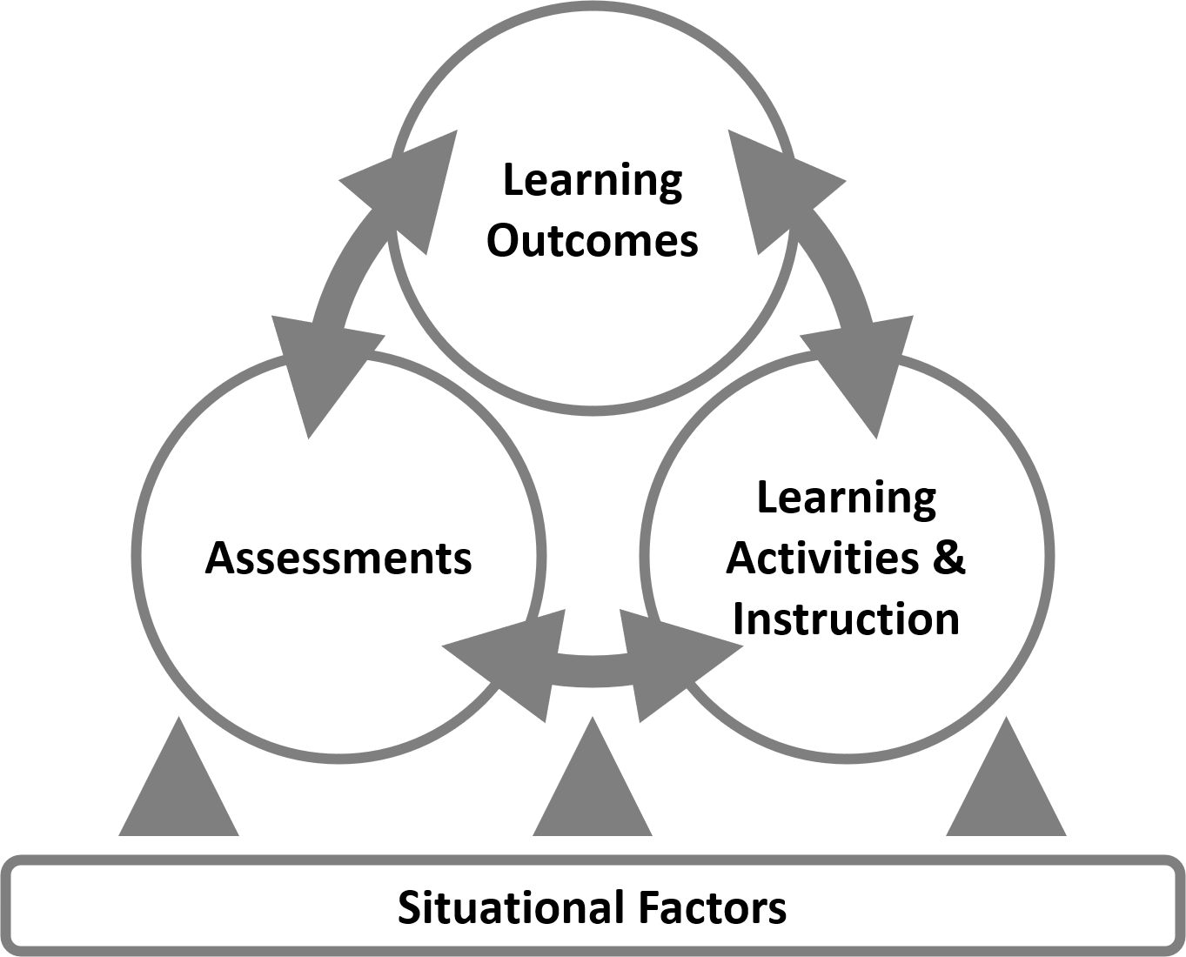

Communicating and Leveraging Your Learning Outcomes

Now that you have drafted effective and well-aligned learning outcomes, let's examine strategies for communicating and leveraging your learning outcomes.

Learning outcomes are most impactful when students know the intentionality behind your course design. Below are six opportunities for introducing and reminding students about the connections between the learning outcomes and course components (activities and assessments). The prompts invite you to incorporate UDL-informed strategies and inclusive practices when communicating and leveraging your learning outcomes.

In the Course Syllabus

- Introduce the learning outcomes in a prominent location in the syllabus
- Use the learning outcomes to set the first impression, tone, and expectations of the course
- Consider how the learning outcomes acknowledge and welcome diverse learners

Via Visual Aids

- Consider visually representing the learning outcomes using charts, diagrams, or infographics
- Offer concise, clear, and accessible visual aids to make the learning outcomes more accessible and memorable for students
- Provide instructions on how to access and read the visual aid

During Class Discussions

- Engage students in synchronous or asynchronous discussions about the learning outcomes
- Explain the purpose and significance of the learning outcomes and invite students to reflect on their relevance
- Provide space to address student questions and identify areas for clarification

In Learning Journals or Reflection Activities

- Incorporate activities where students reflect on their progress toward the learning outcomes
- Facilitate reflective discussions to check for student understanding of the learning outcomes and strategies for improvement
- Offer support and resources to facilitate learning and achieve the learning outcomes

Within Rubrics or Assessment Criteria

- Provide transparency about how student work will be evaluated in relation to the learning outcomes
- Clarify expectations within rubrics or assessment criteria by reminding students of the relevant learning outcomes
- Encourage students to self-assess their progress using the learning outcomes, rubrics, and assessment criteria

Via Feedback

- Provide ongoing feedback throughout the term that links observations and next steps to the learning outcomes
- Clarify where students have progressed in relation to the learning outcomes and where to focus their efforts
- Remind students of where the course is based on the trajectory set by the learning outcomes and offer relevant support and resources

Pause for Workbook Activity: Identifying Opportunities to Communicate Your Learning Outcomes

How have you communicated and used your learning outcomes in your courses?

In your Course Design Foundations Workbook docx, identify one additional opportunity for your students to engage with and reflect upon your learning outcomes. Consider the following prompts:

- Where can students find the learning outcomes? For example, in the syllabus document, on Quercus, within the rubrics or assignments instructions, or on the discussion board.
- How are learning outcomes presented and discussed in the course? For example, listed in the syllabus, presented as an infographic, discussed in class, analyzed in a shared document, or highlighted in the assignment description.
- When are impactful moments to revisit the learning outcomes? For example, at the beginning, middle, or end of the semester, or before an activity or assessment.

4.6 Revisiting, Revising, and Refining Your Learning Outcomes

On this page:

- Revisiting, Revising, and Refining Iteratively
- Revisiting Sample Learning Outcomes
- Revising Sample Learning Outcomes
- Refining Sample Learning Outcomes
- Pause for Workbook Activity: Reflecting on Your Learning Outcomes

Revisiting, Revising, and Refining Iteratively

In the previous pages, we examined why crafting learning outcomes for your course can be helpful and how to structure and communicate your learning outcomes effectively. However, there is more to do regarding your learning outcomes!

Drafting and writing learning outcomes is an ongoing task—an iterative process. It is helpful to adjust learning outcomes throughout the course design process and make adjustments after the course has been delivered. Revisit, revise, and refine your learning outcomes with each course iteration.

Revisiting Sample Learning Outcomes

Recall the three sample courses from the "Getting Started: Articulating Course Goals" page. Review how each course translated the course goals into learning outcomes.

What would you suggest to each instructor to refine their learning outcomes and why?

English

Course goal: Introduce students​ to modes of ​satiric writing ​in the ​18th century.

Learning outcome (first iteration): Students should be familiar with a number of substantive texts from the period.

History of Education

Course goal: Be aware of historical assumptions behind core frameworks in educational philosophy.

Learning outcome (first iteration): Students will consider the historical assumptions and contexts behind core frameworks in educational philosophy.

Pharmacy

Course goal: Understand the biochemical basis of drug design and development.

Learning outcome (first iteration): Students will increase awareness of the application of molecular graphics to drug design.

Revising Sample Learning Outcomes

Compare the first and second iterations of the learning outcomes provided below. What changes were made to refine the learning outcomes? What additional suggestions would you offer to each instructor and why?

To help you with this exercise, recall the four characteristics of effective learning outcomes:

- Focus on the learner
- Indicate how learning will be assessed
- Are realistic
- Are transferable

English

Learning outcome (first iteration): Students should be familiar with a number of substantive texts from the period.

Learning outcome (second iteration): Students will analyze the relationship between the language of satire and literary form through the close examination of three eighteenth-century texts.

History of Education

Learning outcome (first iteration): Students will consider the historical assumptions and contexts behind core frameworks in educational philosophy.

Learning outcome (second iteration): By analyzing case studies, students will be able to connect core philosophical frameworks to key historical events and pedagogical examples.

Pharmacy

Learning outcome (first iteration): Students will increase awareness of the application of molecular graphics to drug design.

Learning outcome (second iteration): Students will apply the principles underpinning the use of molecular graphics in the design of drugs to illustrate general and specific cases.

Refining Sample Learning Outcomes

Learning outcomes are designed to engage with and include all learners. When beginning your backward design process, think of the outcomes that may be achievable by the majority of students, given the requirements and context of your course, and consider all of the ways that students can show that they have mastered course concepts.

Let's revisit the learning outcomes we examined earlier on this page. How can each instructor embed UDL-informed strategies and inclusive practices in the three sample courses? What additional information would be helpful to frame the learning outcomes in the context of each sample course? What other information might you consider for your context?

English

- Where are the three eighteenth-century texts from? Who wrote these texts?
- Will the close examinations be conducted as a class, in small groups, or individually? Will the close examination be held in person or online, synchronously or asynchronously?
- How will students demonstrate their understanding, application, and integration of their analysis? Can students demonstrate their understanding, application, and integration in an analysis paper, presentation, or visualization?

History of Education

- Where and when are the case studies from? Are the case studies drawn from real-life scenarios?
- How will students analyze the case study? Will students work individually, in small groups, or as a class?
- Where are the core philosophical frameworks, historical events, and pedagogical examples based? Who is represented in these frameworks, events, and examples?
- How will students demonstrate their understanding, application, and integration of the connections? What opportunities exist for students to express their learning in text, audio, and/or visual?

Pharmacy

- What opportunities exist for structural and computational biology students to learn from computer science colleagues to better understand molecular graphics?
- What modes of illustration and visualization are available to students to demonstrate their understanding, application, and integration?
- How are illustrations and visualizations studied and used in pharmacy and related health disciplines?

Pause for Workbook Activity: Reflecting on Your Learning Outcomes

As our teaching and learning contexts change and as we develop our teaching practices, so will our learning outcomes.

Let's take a moment to open your Course Design Foundations Workbook docx and refer back to your previous work outlining your situational factors and developing your learning outcomes, paying specific attention to the effectiveness of your course learning outcomes in light of inclusive pedagogy and UDL considerations.

Critically-reflective Questions

The following questions by Michael K. Potter and Erika Kustra (2012) will help you critically reflect on your learning outcomes. We encourage you to return to these reflective questions throughout the design process—before, during, and after the semester—to assess what revisions are needed.

- If students completed your course having mastered these learning outcomes, and only these learning outcomes, would you consider the course a success?
- How would you explain your decisions if a colleague asked why you chose these learning outcomes?
- Why do the skills, concepts, attitudes, and values in these learning outcomes matter to you, your course, and your discipline? Why should they matter to students?
- What does this set of learning outcomes communicate about you as a teacher—your identity, values, concerns, theoretical affiliations, assumptions, presuppositions, etc.?
- Given the learning outcomes you've chosen, how does this course connect with other courses taught (or likely to be taught) in your department?
- How does it prepare students for the rest of their program?
- How does it build on what they would have learned before enrolling in your course?
- Which of your outcomes address likely threshold concepts* and bottlenecks?
- How would you explain your choices if a colleague said, "I think your outcomes expect too much (or too little)"?

*Contrasted with a core concept, a building block of learning, "a threshold concept can be considered as akin to a portal, opening up a new and previously inaccessible way of thinking about something. It represents a transformed way of understanding, interpreting, or viewing something without which the learner cannot progress." (Meyer & Land, 2003). For more on threshold concepts, refer to the threshold concepts guide by Sarah Kent (2016).

Additional Reflective Questions for Inclusive Pedagogy and UDL Considerations

- What do you know about your students; could most/all students reasonably understand and achieve these outcomes?
- Considering student background and variety, are the outcomes you set achievable by most/all students?
- Thinking back to the UDL guidelines, do the learning outcomes create space for learner variability (taking into consideration cognitive, social, emotional, and psychomotor variability)?
- Do the learning outcomes allow opportunities for students to share their experiences with the class?

4.7 Reframing Learning Outcomes with Generative AI in Mind

On this page:

- Reframing Learning Outcomes for the Generative AI Era
- Reframing Learning Outcomes with Bloom's Cognitive Taxonomy Revisited (2024)
- Reframing Sample Learning Outcomes with Generative AI in Mind
- Pause for Workbook Activity: Reframing Your Learning Outcomes for the Generative AI Era

Reframing Learning Outcomes for the Generative AI Era

Drafting and writing learning outcomes is an ongoing process. With each course iteration, you may wish to revisit, revise, and refine your learning outcomes by embedding UDL-informed strategies and inclusive practices. In addition, you may consider explicitly reframing your learning outcomes in light of ongoing advancements in generative AI capabilities.

Generative AI-informed reframing might involve strategically integrating generative AI tools as an explicit supplement to the learning process or deliberately emphasizing human-centred skills that generative AI technologies cannot easily replicate. By strategically reframing learning outcomes in these ways, you can create opportunities for students to develop meaningful learning experiences that prioritize critical thinking, creativity, and authentic skill development.

Reframing Learning Outcomes with Bloom's Cognitive Taxonomy Revisited (2024)

Earlier, you explored Bloom's Revised Cognitive Taxonomy (2001) as a basis for developing action-oriented verbs for the six cognitive domain levels (remember, understand, apply, analyze, evaluate, and create) to concretize the learning outcomes for students. More recently, Oregon State University developed Bloom's Cognitive Taxonomy Revisited, Version 2.0 (2024): a revised explication of Bloom's Taxonomy that instructors may use to reconsider the way that they communicate course outcomes and student learning for the generative AI era.

Since students at the University of Toronto are permitted to use generative AI as learning aids, it is valuable to reframe your course-level learning outcomes to explicitly prioritize human-centred skills, thereby mitigating potential overreliance on generative AI. Bloom's Cognitive Taxonomy Revisited, Version 2.0 can help you clarify what skills and actions you wish to emphasize and evaluate at each cognitive process. Each cognitive process invites opportunities for you to integrate or limit student use of generative AI in assessments and learning activities.

Refer to the following table for potential reframing of your learning outcomes, considering aligned course assessments and activities that either emphasize human-centred skills or integrate generative AI tools as a supplement to the learning process. Not all learning outcomes necessarily require explicit reframing in response to generative AI. By reflecting on this table, you can develop a plan to determine if and how you will implement specific changes to your course-level learning outcomes.

Cognitive Process | Human-Centred Skills | How Generative AI can Supplement Learning Processes
Remember | Recall information without technological assistance | Retrieve, organize, and synthesize factual information across timelines and definitions
Understand | Contextualize answers within emotional, moral, or ethical considerations; select relevant information; explain significance | Accurately describe a concept in different words; recognize a related example; translate
Apply | Implement, experiment, and test in the real world; apply human creativity and imagination to solutions | Apply systematic problem-solving methods and help diagnose solution errors
Analyze | Critically analyze across cognitive and affective domains with clear justification | Compare and contrast, and analyze data trends and relate findings to real-world applications
Evaluate | Metacognitively reflect on ethical implications and broader contexts | Evaluate potential strategies and develop assessment criteria
Create | Generate original solutions by integrating human experiences, social-emotional insights, and intuitive judgment | Support creative exploration by suggesting alternatives and developing tangible outcomes

Reframing Sample Learning Outcomes with Generative AI in Mind

Compare the second and third iterations of the learning outcomes provided below. What changes were made to reframe the learning outcomes so that they emphasize human-centred skills that mitigate overreliance on generative AI tools?

English

Learning outcome (second iteration): Students will analyze the relationship between the language of satire and literary form through the close examination of three eighteenth-century texts.

Learning outcome (third iteration with generative AI in mind): Students will critically analyze and interpret the relationship between satirical language and literary form, developing original interpretations through close textual examination.

History of Education

Learning outcome (second iteration): By analyzing case studies, students will be able to connect core philosophical frameworks to key historical events and pedagogical examples.

Learning outcome (third iteration with generative AI in mind): Students will synthesize core philosophical frameworks with key historical events and pedagogical examples, developing original insights through in-depth case study analysis.

Pharmacy

Learning outcome (second iteration): Students will apply the principles underpinning the use of molecular graphics in the design of drugs to illustrate general and specific cases.

Learning outcome (third iteration with generative AI in mind): Students will apply and critically evaluate the principles underpinning the use of molecular graphics principles in drug design to illustrate general and specific cases.

Pause for Workbook Activity: Reframing Your Learning Outcomes for the Generative AI Era

As generative AI technologies continue to reshape the educational landscape, it is valuable to reframe your learning outcomes with generative AI in mind.

Let's take a moment to open your Course Design Foundations Workbook docx and refer back to your draft learning outcomes. Consider the following prompts for reframing your learning outcomes for the generative AI era:

- Which cognitive process does your learning outcome align with? Consult the "Bloom's Cognitive Taxonomy Revisited" table above for reference.
- What human-centred skills does this outcome highlight or develop?
- To what extent could generative AI tools be used to support or enhance this learning outcome?
- How can you reframe this outcome to emphasize human-centred skills that generative AI technologies cannot easily replicate?

Add your reframed learning outcomes with generative AI in mind to the three-column table. Compare the changes you made and how your reframed learning outcomes address the challenges and opportunities presented by generative AI technologies.

Learning Outcomes | Assessments | Learning Activities
Draft learning outcomes (from earlier)  Reframed learning outcomes (with generative AI in mind) | To complete in module 5 | To complete in module 6

As you progress through the modules, the three-column table is a helpful tool to ensure the alignment of your learning outcomes, assessments, and learning activities and instruction.

Supporting Student GenAI Literacy

As you reframe your learning outcomes with generative AI in mind, consider how you will support students in developing the literacy and critical thinking skills needed to use these tools ethically and effectively.

U of T offers Coursework and GenAI: A Practical Guide for Students, an open educational resource designed to enhance students' literacy around generative AI. The resource includes customizable modules that instructors can flexibly adapt and integrate into their courses across disciplines. Instructors may also choose to link to an adapted version of this resource in their syllabus to support students' understanding of generative AI tools and expectations.

4.8 Module 4 References and Resources

Congratulations!

You've reached the end of Module 4: Developing Course Learning Outcomes. You are on your way to developing learning outcomes shaped by situational factors and course goals. In this module, we have:

- Translated your course goals into learning outcomes;
- Identified where and how to use learning outcomes in your course design and teaching practice; and
- Refined your learning outcomes informed by your course's situational factors, UDL/inclusion considerations, and ongoing advancements in generative AI technologies.

References and Resources

The list below is a compilation of module references and additional resources. These resources are provided as additional information to help you think further about the module topic. Reviewing these resources is optional. They are not intended as essential components of the module, so you are not required to review any of them before proceeding to the next module. You can review them at your own pace at a later date.

- Anderson, L. W., & Krathwohl, D. R. (Eds.). (2001). A taxonomy for learning, teaching, and assessing: A revision of Bloom's taxonomy of educational objectives. Longman.
- Armstrong, P. (2010). Bloom's taxonomy. Vanderbilt University.
- Bloom, B. S., et al. (1956). Taxonomy of educational objectives: The classification of educational goals. Handbook 1: Cognitive domain. D. McKay.
- Brock University. (2020, January 21). The role of learning outcomes. [Video]. YouTube.
- CAST. (2020). UDL Tips for developing learning goals.
- Center for Distributed Learning. (n.d.). Objective builder tool. University of Central Florida.
- Center for Excellence in Learning and Teaching. (n.d.). Revised Bloom's taxonomy. Iowa State University
- Centre for Teaching and Learning. (n.d.). Designing to meet course learning outcomes. Western University.
- Clegg, S., & Ashworth, P. (2004). Contested practices: Learning outcomes and disciplinary understandings. In Satterthwaite, J., Atkinson, E., & Martin, W. (Eds.), The disciplining of education: New languages of power and resistance. Trentham Books.
- Ecampus. (2024). Bloom's Taxonomy Revisited, Version 2.0. Oregon State University.
- Erikson, M. G., & Erikson, M. (2018). Learning outcomes and critical thinking: Good intentions in conflict. Studies in Higher Education, 44(12), 2293–2303.
- Fink, L. D. (2013). Creating significant learning experiences: An integrated approach to designing college courses (Revised and updated ed.). Jossey-Bass.
- Furedi, F. (2013). Learning outcomes are corrosive. CAUT/ACPPU Bulletin Online, 60(1).
- Havnes, A., & Prøitz, T. S. (2016). Why use learning outcomes in higher education? Exploring the grounds for academic resistance and reclaiming the value of unexpected learning. Educational assessment, evaluation and accountability, 28(3), 205–223.
- Hussey, T., & Smith, P. (2002). The trouble with learning outcomes. Active learning in higher education, 3(3), 220–233.
- Hussey, T., & Smith, P. (2008). Learning outcomes: A conceptual analysis. Teaching in higher education, 13(1), 107–115.
- Kent, S. (2016). Threshold concepts. University of Calgary.
- Lassnigg, L. (2012). "Lost in translation": Learning outcomes and the governance of education. Journal of education and work, 25(3), 299–330.
- Meyer, J. H. F., & Land, R. (2005). Threshold concepts and troublesome knowledge (2): Epistemological considerations and a conceptual framework for teaching and learning. Higher Education, 49(3), 373–388.
- Potter, M. K., & Kustra, E. (2012). A primer on learning outcomes and the SOLO taxonomy. University of Windsor.

U of T Resources

- CTSI Active Verbs for Bloom's Revised Taxonomy
- CTSI Developing Learning Outcomes
- CTSI Quercus Learning Outcomes
- GenAI Literacy Course Modules
- Generative Artificial Intelligence in the Classroom: FAQ's

5. Designing Effective Assessments

5.1 Introducing Module 5

Welcome

In this module, you will learn diverse ways to capture students' learning and how they have achieved the learning goals you have set for the course. You will learn from research, instructor practices, and reflective activities.

Learning Outcomes

After completing this module, you will be able to design effective assessments for your course. In support of this outcome, you will be able to:

- Apply inclusive and UDL-informed practices to your course assessment design;
- Compare the different types of assessments (diagnostic, formative, and summative) in alignment with your learning outcomes;
- Integrate strategies to promote academic integrity;
- Explore assessments that may lead to meaningful learning; and
- Draft an assessment plan that maps out multiple methods of assessment and integrates the principles of effective assessment design.

Module 5 Pages

This module consists of eight pages accompanied by activities from the Course Design Foundations Workbook docx.

Use the "Next" and "Previous" buttons in the bottom right to progress through the module.

- 5.1 Introducing Module 5 (you are here)
- 5.2 Getting Started: Defining and Framing Assessment Design
- 5.3 Examining Types of Assessments
- 5.4 Promoting Academic Integrity
- 5.5 Identifying Cognitive Processes in Your Assessment Design
- 5.6 Engaging Learners in Meaningful Assessments
- 5.7 Designing Meaningful Assessments with Generative AI in Mind
- 5.8 Adding Assessment Activities to Your Three-column Table
- 5.9 Module 5 References and Resources

5.2 Getting Started: Defining and Framing Assessment Design

On this page:

- Defining and Designing Assessment
- Framing Assessment Design with UDL
- Assessments and Accessibility

Defining and Designing Assessment

What do we mean by assessments? How do you know if students are working towards and/or achieving the course learning outcomes?

Assessments provide evidence of various forms and levels of student learning through different assessment types (graded and non-graded). Assessments reveal areas of strength and improvement of student learning and may uncover barriers that impede learning development and progress.

Assessments vs. Evaluations

Some assessments are also evaluations. Evaluations focus on whether students have achieved the learning outcomes. In other words, assessments highlight the learning progress—how much are students learning and what are they learning—while evaluations judge whether the learning has occurred.

Effective Assessment Design Considerations

In addition to highlighting student learning progress, assessments help instructors assess and improve their teaching practices (Angelo and Cross, 1988).

One way to improve teaching is through inclusive considerations. Isis Artze-Vega et al. (2023) identifies three characteristics of inclusive assessments:

Purpose

Purposeful assessments align with the learning outcomes and offer opportunities for students to incorporate feedback in subsequent assessments (i.e., scaffolded assessments) or courses. Refer to the next page for three types of assessments that can be integrated to promote learning as an iterative process.

Authenticity

Authentic assessments invite students to engage with meaningful, complex challenges and demonstrate acquired knowledge and skills in various forms (i.e., activities and artifacts) (Wiggins, 1990). Authentic assessments emphasize the applicability and value of the assessment and strive to improve engagement and motivation.

Transparency

Transparent assessments make explicit the why, how, and what of assessments. "Why" relates to purposeful assessments, which align the assessment with learning outcomes and articulate the knowledge and skills required and gained. "How" clarifies what students are asked to demonstrate and the method to achieve success. "What" refers to the criteria for success and invites self-assessment. The Transparency in Learning and Teaching (TILT) project offers resources to help instructors design assessments containing transparent, explicit expectations and instructions.

Framing Assessment Design with UDL

As you consider various strategies for implementing principles of effective assessment design and feedback, consider how the Universal Design for Learning (UDL) guidelines may frame your designs and support your teaching and learning goals.

Designing Multiple Means of:

Engagement

- Use various examples and resources to stimulate student interest and enable them to link what they are learning in your course to a broad range of lived experiences, genuine and current "wicked" problems, or real-world scenarios
- Incorporate these examples and authentic scenarios into your assessments
- Vary assessments to promote perseverance and incremental progress toward your learning outcomes

Representation

- Share content in various ways to help students prepare for assessments (e.g., readings, videos, digital resources)
- Clarify and decode text, symbols, and notation in assessment instructions and rubrics
- Use cues and prompts to promote connections between prior knowledge and new information in assessments and their alignment with learning outcomes

Action & Expression

- Invite students to show what they know through various assessments, such as written submissions, online postings, verbal contributions, multimedia and/or visual representations, etc.
- Schedule individual, paired, or small group work opportunities through independent and collaborative assessment activities
- Optimize assessment materials that interact with common assistive technologies

Assessments and Accessibility

Although UDL encompasses accessibility—along with inclusion and usability—UDL does not fully eliminate the need for all individual accommodation needs.

To address accommodation needs, the University of Toronto developed the following faculty and staff resources highlighting the various forms of academic accommodations and strategies for supporting students.

- Demystifying academic accommodations PDF
- How to support and refer students with disabilities
- Academic accommodations and essential requirements
- Note-taking guidelines

Accessibility Services at U of T

- U of T St. George Accessibility Services
- U of T Mississauga Accessibility Services
- U of T Scarborough AccessAbility Services

5.3 Examining Types of Assessments

On this page:

- Types of Assessments
- Assessments in Practice

Types of Assessments

Elizabeth F. Barkley and Claire Howell Major (2022) organize assessment types by key features, such as purpose and timing. Examine the various types of assessments below and consider what forms of assessments you already use and what other forms you would like to implement.

Assessments Based on Purpose

Diagnostic Assessments

Pre-assessment

- Identify what students know and can do (prior knowledge and skills)
- Reveal misconceptions and misunderstandings
- Show students' expectations, preferences, and assumptions

Examples:

- Welcome (pre-course, first-day) surveys
- Ungraded quizzes
- Mind maps

Formative Assessments

Assessment for and as learning

- Are learning-centred
- Are forward-looking as they build towards improvement before the next learning task
- Provide more frequent opportunities (compared to summative assessments) for learners to practice skills, consolidate learning, and monitor progress
- Focus attention on important aspects of the subject
- Are low-stakes graded or non-graded assessments, often accompanied by feedback
- Offers an instructor key insights into their teaching

Examples:

- In-class discussions
- One-minute (or three-minute) papers
- Practice quizzes
- Student Response Systems (e.g., Clickers, Polling)
- Draft proposals
- Self-assessments
- Peer reviews

Summative Assessments

Assessment of learning

- Are content-centred
- Are backward-looking in that they measure learning that has already happened
- Provide a means to demonstrate student mastery of the learning outcomes within a given unit/module of instruction of an entire course
- Help instructors evaluate students and their own instruction after teaching one or more units/modules
- Use summative information about a student's achievement to count toward their grade

Examples:

- Term papers
- Problem sets
- Portfolios
- Internships
- Demonstrations or performances
- Clinicals
- Capstone projects
- Midterms
- Final exams

Assessments Based on Timing

Pre-assessments

- Occur at the start of the course or each class
- Are equivalent to diagnostic assessments

Interim and Benchmark Assessments

- Occur periodically throughout the course to check student learning progress
- Benchmark student progress with course progress
- Are often implemented as formative assessments and can also be part of a scaffolded summative assessment

Outcomes Assessments

- Occur at the conclusion of a unit/module or course to evaluate student mastery of the learning outcomes
- Are often high-stakes and equivalent to summative assessments

Assessments in Practice

The following examples feature assessment practices taking place across and beyond campus. What design considerations are implemented? Recall the three characteristics of inclusive assessments: purpose, authenticity, and transparency.

To Read: Diagnostic Assessments

Getting ready for a new semester and want to learn about your students? Read Ashley Mowreader's "Engagement tip: Creating a first-day survey" (2023) for useful guidance on designing an ungraded survey (e.g., get to know your students, measure prior knowledge or skills, connect learning objectives to goals).

To Watch: Formative Assessments

Consider including a short writing activity in your course. Watch The K. Patricia Cross Academy's "Quick write" video (02:36). Select "CC" for closed captions. An instructor's guide is available for download via the video hyperlink. The guide offers several steps for implementing Quick Write, from clarifying your teaching purpose and learning goals to reflecting upon the activity and evaluating its effectiveness.

To Explore: Summative Assessments

Explore the U of T Assignments Across Disciplines (AAD), "a collection of peer-reviewed post-secondary assignments created by Professor Andrea Williams with contributions by U of T faculty and students" (TSpace). Many assignments in AAD can be adapted as summative assessments in your course. Consult each assignment's short description, instructor commentary, and accompanying materials.

To Listen: Inclusive Assessment Practices

Listen to the Teach.Learn.Share podcast episode "Inclusive assessment practices for healthier learning environments, with Char Lewis-Sutherland" (34:09). Lewis-Sutherland invites instructors to reflect on using assessments to focus on the learning rather than shortcomings and consider the implicit bias and assessment inequities that can be minimized through purposeful, authentic, and transparent assessment design.

Additional Assessments in Practice

Visit the following resources for more assessment practices taking place within and beyond U of T.

- Reassessing assessment: U of T faculty members reflect on their experiences creating assessments in an online teaching environment.
- UDL and assessment: A collection of resources developed by CAST addressing learner variability and assessment design.

5.4 Promoting Academic Integrity

On this page:

- Addressing Academic Integrity in Your Course and Assessments
- To Share: It's Okay to Ask for Help

Addressing Academic Integrity in Your Course and Assessments

Academic Integrity at the University of Toronto is viewed as a shared responsibility between students and instructors.

The CTSI academic integrity resource guide offers guidance on your role in educating your students about the principles of academic integrity, directing them to the appropriate resources and supports, and playing a role in preventing academic integrity cases.

Consider addressing academic integrity topics early and often in your course. Explore the following student-centred and supportive approaches to promoting academic integrity at the beginning, middle, and end of the term.

Beginning of the Term

- Introduce students to the Code of Behaviour on Academic Matters and highlight the role of students and instructors
- Clarify and be transparent about course expectations and academic integrity, especially around the use of generative artificial intelligence and plagiarism detection tool
- Have a conversation about what constitutes an academic offence, especially in your discipline​
- Use and share Smart Strategies for assessment design
- Incorporate a diagnostic or formative assessment to check student understanding of academic integrity at U of T

Throughout the Term

- Review definitions and examples of academic integrity terms such as plagiarism, paraphrasing, summarizing, editing, and proofreading for written assignments
- Incorporate ongoing discussions on responsible generative AI use in academic work, clarifying boundaries for AI as a learning aid in your course
- Invite students to seek clarification about generative AI expectations and appropriate usage
- Clarify parameters of collaborative work in assessments
- Set aside time for students to ask clarifying questions about academic integrity and assessments
- Re-share Smart Strategies and additional relevant resources such as academic success tips, library studying and learning guides, and writing advice files

End of the Term

- Reaffirm academic integrity values and practices before final assessments
- Invite student feedback on how to make academic integrity and assessment information even more purposeful, authentic, and transparent
- Connect with colleagues, librarians, and staff on identifying proactive, educational approaches to academic integrity and assessment design
- Join ongoing conversations about academic integrity and the changing landscape of higher education

To Share: It's Okay to Ask for Help

In addition to the various hyperlinks provided above, consider sharing the video series "It's Okay To Ask for Help- Academic Integrity at U of T," produced by the Innovation Hub, Division of Student Life, in partnership with the Office of the Provost. The series includes the following five short videos:

- It's Okay to Ask for Help – Academic Integrity at U of T (02:10)
- Advice from a Professor – Academic Integrity at U of T (01:15)
- Advice from a Teaching Assistant – Academic Integrity at U of T (00:56)
- Advice from a Librarian – Academic Integrity at U of T (01:00)
- Advice from a Writing Centre – Academic Integrity at U of T (01:24)
- Advice from a Learning Strategist – Academic Integrity at U of T (01:31)

Academic integrity is a shared responsibility between students and instructors at U of T. It's okay to ask for help.

5.5 Identifying Cognitive Processes in Your Assessment Design

On this page:

- Cognitive Process and Assessment Trajectory
- Bloom's Taxonomy and Assessment Options

Cognitive Process and Assessment Trajectory

Earlier in the module, we defined assessments as a tool for providing evidence of various forms and levels of student learning through different assessment types (graded and non-graded). Effective assessments are designed to help students work towards achieving the course learning outcomes. An important component in supporting student learning development and progress is identifying the cognitive process for each assessment and their position in the overall trajectory of your course assessments.

Bloom's Taxonomy and Assessment Options

One method for mapping course assessments is to connect the learning process with Bloom's revised taxonomy (2001) and the six cognitive processes: remember, understand, apply, analyze, evaluate, and create. The verbs associated with the six cognitive processes help instructors map and align assessments with learning outcomes and identify various assessments that support learning development and progress.

Consult the following table for assessment option ideas for each cognitive process. The remainder of the module will build on Bloom's Taxonomy and consider scaffolded and authentic assessments to reinforce the overall trajectory of your course assessments.

Cognitive Process | Learning Process | Associated Verbs | Assessment Options
Remember | Recall facts and basic concepts | Define, duplicate, list, repeat, state | Multiple-choice quiz, clicker question, fill-in-the-blank, true-and-false
Understand | Explain ideas or concepts | Classify, describe, discuss, report, translate, recognize | Short-answer test or quiz, one-minute (or three-minute) paper, concept map
Apply | Use information in new situations | Execute, implement, solve, use, sketch, demonstrate | Essay, research project, journal, lab report, simulation
Analyze | Draw connections among ideas | Differentiate, organize, relate, compare, contrast | Case studies, group discussion, analysis paper, critique
Evaluate | Justify a stand or decision | Appraise, argue, defend, judge, select, support, value | Student-led seminar, debate, persuasive essay, review
Create | Produce new or original work | Design, assemble, construct, formulate | Project presentation, poster, ePortfolio, business plan, capstone project, musical composition, set design

Adapted from Sneed, O. (2016, May 9). Integrating technology with Bloom's Taxonomy. Arizona State University, Teach Online.

5.6 Engaging Learners in Meaningful Assessments

On this page:

- Scaffolded Assessments
- Authentic and Powerful Assessments

This module is culminating in a focus on two approaches to designing your assessments: scaffolded and authentic. The examples on this page offer starting points as you consider opportunities to integrate diagnostic, formative, and summative assessments in your course.

Scaffolded Assessments

Assessments help instructors and students identify what and how much is learned and where strengths and areas of improvement lie. Diagnostic, formative, and summative assessments reinforce various forms of learning and can function as building blocks in alignment with learning outcomes. Such building blocks, known as scaffolding, are one strategy for engaging learners in meaningful assessment.

Scaffolded assessments break down large, complex, higher-stakes assessments into smaller, incremental, lower-stakes assessments as stages or building blocks. A scaffolded approach allows students opportunities to build towards a concept or skill before they are evaluated on the full application of the concept or skill. Scaffolded assessments help instructors improve instruction by revealing areas for clarification and opportunities for additional examples and support.

For students, scaffolded assessments provide opportunities to build toward a concept or skill, offer a clearer sense of purpose for each step of the process, and allow a more advanced application of concepts and skills through incremental stages.

For instructors, scaffolded assessments help instructors identify areas for clarification and opportunities for additional examples and support, which reduces misunderstanding (often shown in the high volume of questions and emails). More importantly, scaffolded assessments allow more complex and demanding assignments that do not overwhelm students. This approach promotes academic integrity by focusing on skills and knowledge development in engaging manageable portions.

Examples of Scaffolded Assessments

Each scaffold, or building block, can be a diagnostic, formative, or summative assessment. Such scaffolded design enables various forms of engagement, representation, and action and expression.

For example, a frequently scaffolded writing assignment might include a sequence of assignments (summary of one article, comparison of two, then analysis of three or more). Refer to additional assignment ideas from U of T writing supports. You may notice that these assignment prompts align with Bloom's Taxonomy.

The scaffolding examples below are a more detailed approach that can prepare students for a research paper and that reinforces the academic writing process, from prewriting to editing and proofreading. and invites students to engage with the learning process and develop their skills and knowledge. Note: Not all components of scaffolded assessments need to be assigned a grade. This list provides specific examples that align to Bloom's Taxonomy.

Scaffold 1: Draw a mind map (e.g., illustrations, graphics, timelines)
Scaffold 2: Draft a proposal that includes a working thesis statement
Scaffold 3: Prepare an annotated bibliography
Scaffold 4: Evaluate the sources in small peer groups
Scaffold 5: Create a paper outline
Scaffold 6: Conduct a peer review of a paper draft

Explore additional scaffolded assessments from High quality online courses:

- Biodiversity and conservation science: Capstone project
- Geography and environmental management: Group assignment

Getting Started with Scaffolded Assessments

Consider the following questions to help you get started with designing scaffolded assessments:

- What is a major (higher-stakes) assessment you wish to scaffold in your course?
- What prerequisite skills do students need to succeed in the major assessment?
- How does the major assessment align with your learning outcomes? Are the prerequisite skills built into the learning outcomes?
- What is the process for completing the major assessment? Can the process be broken down into smaller pieces to practice the prerequisite skills and support student learning trajectories?
- How can the smaller pieces (the scaffolded lower-stakes assessments) be mapped out in the course schedule?
- What resources and support are available to students for each scaffolded lower-stakes assessment?
- How will you share your rationale about the design of the scaffolded assessments with your students?

Authentic and Powerful Assessments

As mentioned earlier in the module, authentic assessments invite students to engage with meaningful, complex challenges and demonstrate acquired knowledge and skills in various forms (i.e., activities and artifacts) (Wiggins, 1990). These assessments invite students to engage in activities measuring their learning through applied, context-specific, real-world tasks and help learners transfer usable knowledge and skills and understand the "what" (representation), the "how" (action and expression), and the "why" (engagement) of their learning.

Grant P. Wiggins (1993) defines authentic assessment as "engaging and worthy problems or questions of importance, in which students must use knowledge to fashion performances effectively and creatively. The tasks are either replicas of or analogous to the kinds of problems faced by adult citizens and consumers or professionals in the field" (p. 229).

Geoff Scott (2016) uses the term "powerful assessments" to describe assessments that go beyond skills, knowledge, and competencies and encompass personal, interpersonal, and cognitive capabilities to foster work-ready-plus students. Watch CTSI's video featuring Scott addressing powerful assessments (06:57). Select "CC" for closed captions.

For students: According to Scott, powerful assessments train students to respond to real-world challenging situations and "wicked problems" and become "future-ready." Through powerful assessment, students become "sustainability literate," "inventive and creative," and become "change implementation savvy." Students are also able to understand and act on their own values, and are therefore able to contribute socially, culturally, and environmentally to their communities.

For instructors: Authentic and powerful assessments promote academic integrity because such assessments extend beyond traditional tests and exams, employing complex integration and application of knowledge and skills and engaging with cognitive processes such as applying, analyzing, evaluating, and creating (e.g., case studies, exhibitions, and presentations).

Examples of Authentic and Powerful Assessments

Authentic and powerful assessments can take the form of diagnostic, formative, or summative assessments. Explore the various forms of authentic and powerful assessments from various disciplines listed below.

- Computer science: Role-playing in paper-reading seminars (video, 47:11, UTORid login required)
- Engineering: Alumni interview assignment (video, 05:23)
- Statistics: "Explain it to me like I'm a …" (video, 05:06), Assignment Across Disciplines files
- From High quality online courses:
  - Creative expression and society: Ethical arguments in a real-world context
  - Drama: Advocating for the arts
  - Engineering: E-book project on sustainable cities for the future
  - Mathematics: Authentic assessment in mathematics

Getting Started with Authentic and Powerful Assessments

Consider the following questions to help you get started with designing authentic and powerful assessments:

- In what ways do my assessments engage learners in understanding the authenticity and relevance of the content?
- How am I providing opportunities for learners to apply new knowledge to novel situations and authentic experiences?
- How can the authentic and powerful assessment be scaffolded?
- Are there opportunities for learners to collaborate in this assessment?
- What instructions, parameters, and processes are provided for students engaging with the authentic and powerful assessment
- What resources and support are available to students for engaging with the authentic and powerful assessment?
- How will you share your rationale about the design of the authentic and powerful assessments with your students?

5.7 Designing Meaningful Assessments with Generative AI in Mind

On this page:

- Effective Assessment Design Considerations with Generative AI in Mind
- Integrating Authorized Generative AI Use in Assessments
- Pause for Workbook Activity: Reflecting on Your Assessments

Effective Assessment Design Considerations with Generative AI in Mind
Recall: Assessments highlight the learning progress—how much are students learning and what are they learning.

Ongoing advancements in generative AI technologies invite new considerations and innovative approaches for designing effective and meaningful assessments. Such assessments address learning barriers and promote meaningful learning, critical thinking, ethical reasoning, and independent problem-solving. You may consider making slight adjustments to assessments to leverage generative AI as a learning aid (as demonstrated by U of T instructors), supporting students in applying independent thinking and connecting new information to their existing knowledge base. Effective assessment design with generative AI in mind ensures the depth of learning, its ongoing relevance, and educational value.

Earlier in this module, we examined the three characteristics of inclusive assessments (Isis Artze-Vega et al., 2023): purpose, authenticity, and transparency. These three characteristics take on new significance and complexity when integrating generative AI into your assessment design. Consider how generative AI intersects with the three characteristics of inclusive assessments as you navigate the decision between incorporating generative AI into assessments as a supplement to learning or revising assessments to prevent unauthorized use.

Purpose

Purposeful assessments align with the learning outcomes and offer opportunities for students to incorporate feedback in subsequent assessments.

To incorporate generative AI as a supplement to learning:

- Outcome alignment: Design assessments that use generative AI to support specific learning outcomes, ensuring generative AI integration enhances rather than replaces critical thinking
- Skill development: Create opportunities for students to develop generative AI literacy skills alongside course-specific competencies

To prevent unauthorized use of generative AI:

- Human-centred skills: Focus assessments on evaluating skills that generative AI cannot easily replicate, such as critical analysis and creative problem-solving (refer to Bloom's Cognitive Taxonomy Revisited, Version 2.0 (2024))
- Process emphasis: Design scaffolded assessments that value the learning process, not just the final product, making unauthorized generative AI use less advantageous
  - Note: Scaffolding is also helpful as a supplement to learning

Authenticity

Authentic assessments invite students to engage with meaningful, complex challenges and demonstrate acquired knowledge and skills in various forms.

To incorporate generative AI as a supplement to learning:

- Real-world application: Incorporate generative AI tools in ways that mirror their use in professional settings relevant to the course subject
- Complex problem-solving: Use generative AI to present students with multifaceted challenges that require human judgment and creativity to solve
- AI output critique: Ask students to critically evaluate and improve upon AI-generated content, demonstrating their own expertise and understanding of the subject matter

To prevent unauthorized use of generative AI:

- Personalization: Design assignments that require students to link course concepts to personal experiences or individual reflections
- Local context: Focus assessment materials and prompts on topics local to the course and encourage students to make connections between information sources, course materials, and their own interpretations

Transparency

Transparent assessments make explicit the why, how, and what of assessments.

To incorporate generative AI as a supplement to learning:

- Clear expectations: Communicate with students how you will evaluate their capacity to evaluate AI-generated content and use it to develop their discipline-specific critical analysis skills
- Reflection on generative AI use: Include written reflections on how students used generative AI tools in their learning process, encouraging them to analyze how these tools influenced their understanding and approach to the subject matter

To prevent unauthorized use of generative AI:

- Explicit guidelines: Make clear when or if generative AI-created and assisted work is acceptable in your course, and explain the consequences if students are found using generative AI inappropriately
- Citation requirements: Share citation resources (such as University of Toronto Libraries "Citing Artificial Intelligence (AI) Generative Tools (including ChatGPT)" guide) and incorporate citation requirements for generative AI use, including the prompts used
- Reflection on learning: Integrate metacognitive components into assignments, encouraging students to contemplate their learning journey and examine their thought processes; example prompts include:
  - What led you to this conclusion?
  - How has your understanding evolved?
  - Describe the reasoning behind your approach.

Integrating Authorized Generative AI Use in Assessments

As you revise your assessments to integrate generative AI as a supplement to learning or to prevent unauthorized use of generative AI, consider the importance of fostering critical thinking, creativity, and the authentic application of knowledge that extends beyond AI-generated content.

The Artificial Intelligence Assessment Scale (AIAS)

The Artificial Intelligence Assessment Scale (AIAS) is designed to guide instructors in integrating generative AI into assessments while maintaining alignment with course learning outcomes and addressing academic integrity considerations.

Level of Generative AI Use | Description | Examples
No AI | Assess independent knowledge and skills in controlled environments. | In-class exams, supervised tasks, oral presentations, and practicums.
AI Planning | Allow generative AI use in pre-task activities, but the final work must be independent. | Research design planning, structured brainstorming, argument mapping, literature review preparation, and thesis statement refinement.
AI Collaboration | Use generative AI as a supportive tool across the assessment process. Students critically evaluate AI-generated outputs, maintain their unique voices, and transparently document generative AI contributions. | Collaborative writing, peer reviews, technical documentation, and analytical reports.
Full AI | Positions generative AI as a co-creator in achieving specific learning outcomes. Students direct generative AI tools to complete defined elements of tasks while students demonstrate their ability to guide and critically evaluate generative AI contributions. | Problem-based learning projects, case study analyses, policy evaluations, and research synthesis projects.
AI Exploration | Students and instructors collaborate to design and implement novel generative AI applications, focusing on field-specific problem-solving and advancement. | Applied research projects, creative projects, innovative solution design, and interdisciplinary investigations.

Pause for Workbook Activity: Reflecting on Your Assessments

Let's take a moment to open your Course Design Foundations Workbook docx and consider how you may integrate generative AI into your assessment at any of the AIAS levels (no AI, AI planning, AI collaboration, full AI, and AI exploration). Refer to the following questions to ensure that your assessments remain inclusive and meaningful:

- How can you create opportunities for students to develop relevant generative AI literacy skills? For example, incorporating tutorials, workshops, or activities to help students build necessary generative AI literacy skills for the assessment.
- How can you scaffold the assessment to encourage the critical use of generative AI tools? For example, implementing checkpoints throughout the process to provide timely feedback and support student progress.
- How can you design real-world tasks that require students to apply generative AI tools in conjunction with their own critical thinking and subject knowledge? For example, asking students to use generative AI tools to generate initial ideas or data, then critically analyze, refine, and apply these outputs to solve complex, course-relevant problems.

Student Support Resource: GenAI Literacy Modules

To support your students in developing the generative AI literacy skills needed for ethical, effective, and critical use of AI tools in assessments, you may wish to share the open educational resource Coursework and GenAI: A Practical Guide for Students.

This self-paced resource includes customizable modules that instructors can adapt and integrate into their courses. You may also choose to link to an adapted version of this resource in your syllabus to help clarify expectations and build student capacity for working with generative AI.

5.8 Adding Assessment Activities to Your Three-column Table

On this page:

- Bringing It All Together: A Sample Inclusive Assessment Framed by UDL
- Pause for Workbook Activity: Adding Assessments to Your Three-column Table

Bringing It All Together: A Sample Inclusive Assessment Framed by UDL

Let's explore the design and implementation of an inclusive assessment framed by the Universal Design for Learning (UDL) guidelines. The following assessment was designed by Judi Laprade, Associate Professor, Teaching Stream, Division of Anatomy.

Assignment: Create and Demonstrate a Learning Tool (Anatomy 2021)

Recall the three characteristics of inclusive assessments discussed at the beginning of this module: purpose, authenticity, and transparency. Consider the assessment information the instructor provided to support student learning.

Purpose

How does this purposeful assessment align with the learning outcome?

The "Create and demonstrate a learning tool" assignment, as applied to the organ system, addresses the following learning outcome:

- Demonstrate detailed knowledge of organ systems, including the surrounding cavity, the organ features, functions, innervation and blood supply.

For the neuroanatomy section of the course, Students can choose to address one of the following:

- Demonstrate an understanding of the external features, internal features, blood supply and functions of the brain and nervous system.
- Describe examples of spinal pathways and their functions.
- Locate the twelve sets of cranial nerves and list their main functions.

The main goal of the "Create and demonstrate a learning tool" assignment is to give students an opportunity to demonstrate or illustrate their full understanding/synthesis of an anatomical region in a creative manner.

Authenticity

How does this authentic assessment invite students to engage with meaningful, complex challenges and demonstrate acquired knowledge and skills in various forms?

For the "Create and demonstrate a learning tool" assignment, the learning tool produced by the student must:

- Be original work (no use of already developed content or professionally completed art forms, illustrations, models, animations, games, etc.);
- Be anatomically accurate (this does not mean, however, that it has to be realistic in its design, but it must assist a learner in identifying or learning features, etc. accurately);
- Incorporate a learning purpose or method so that if the learning tool were used by a student learning anatomy for the first time, it would assist their understanding or mastery of the topic (think how their learning might be guided or tested);
- Be unique, interesting, or entertaining—demonstrate outside-the-box thinking—by thinking of ways you like to learn new topics/content or concepts efficiently in a fun way and use that as inspiration;
- Clearly explain or demonstrate the learning tool—while the tool should be pretty much self-explanatory to anyone viewing or using the learning tool, the student is required to include accompanying "documentation" that provides guidance, explanation, rules, tips and hints, or explanation of the content and the user experience.

Transparency

What instructions does this assessment provide to make the expectations transparent and explicit? Students were provided the following process steps for the "Create and demonstrate a learning tool" assignment:

- Select a topic below (or come up with your own topic, with permission from the course director).
- Develop your learning tool or synopsis of the content in a creative manner (refer to ideas below).
- Submit your learning tool to Dr. Laprade via Quercus assignment submission (if your learning tool is a "paper format," please submit the entire product; if your learning tool is electronic in nature, please provide an appropriate URL/site; if your learning tool is a 3D art piece, please provide multiple images or video; if your learning tool is in video/audio format; please provide mp4 files, etc.).
- Also, submit your written explanation or video demonstration (the format is dependent on the type of creative format you use)—If you are unsure of which accompanying kind of "demonstration" is appropriate, consult with your course director (there will be assigned office hours for this conversation, please do not email).

A creative format can take the form of any of the following (if you have another creative method to use, go for it!):

- Gamified learning tool/puzzle
- Song or musical interpretation for memorizing
- Dance/physical illustration
- Artwork: drawing, painting, or illustrations; graphic novel, comic, or cartoon; sculpture in any medium
- Video (not just a '"talk"): infomercial, advertising, movie trailer
- Print: newspaper, book, pamphlet
- Other mediums: sewing, knitting, woodwork, paper mache, balloon art, etc.
- Models (refer to additional guidelines on page three of the assignment instructions if you choose a model)
- What is not considered a creative submission:
- Flashcards;
- PowerPoint files of lectures; or
- Simply reproducing your textbook/ notes or any kind of essay/document.
- Basically, your learning tool needs to have some level of learning interactivity built in!

Assignment Submissions and Feedback: Anatomy Learning Tool

Check out some of the learning tool submissions. Download the image to Zoom in on each learning tool submission. The submissions ranged from crochet and cross-stitched models, cakes, animated videos, pop-up and lift-the-flap books, music videos, and more!



Assessments help instructors assess and improve their teaching practices. The student feedback for the "Create and demonstrate a learning tool" assignment, two of which are shared below, reveals the impact of Dr. Laprade's inclusive assessment design.

- "As a student who often gets very anxious around testing, I am really excited about the create and demonstrate project."
- "I personally don't really enjoy this type of assignment so I am a little biased however it did force me to really learn the content of that joint so it was very helpful."

Pause for Workbook Activity: Adding Assessments to Your Three-column Table

Now that you have explored the characteristics of inclusive assessments framed by UDL, examined different assessment types, considered academic integrity, identified cognitive processes, and reviewed examples of scaffolded, authentic, and powerful assessments, it's time to design and capture your ideas using the three-column table in your Course Design Foundations Workbook docx.

In preparation for this activity, consider reviewing two CTSI assessment design resources:

- Ten Tips for Assignment Design PDF
- Assignment Design: The Student Perspective PDF

Revisit your three-column table and jot down your assessment design notes and considerations in the "Assessments" (middle) column.

Learning Outcomes | Assessments | Learning Activities
Completed in module 4 | To add in this module | To complete in module 6

As you progress through the modules, the three-column table is a helpful tool to ensure the alignment of your learning outcomes, assessments, and learning activities and instruction.

5.9 Module 5 References and Resources

Congratulations!

You've reached the end of Module 5: Designing Effective Assessments. You are on your way to designing effective assessments for your course. In this module, we have:

- Applied the UDL guidelines and inclusive teaching practices to your course assessment design;
- Compared the different types of assessments (diagnostic, formative, and summative) in alignment with your learning outcomes;
- Integrated strategies to promote academic integrity;
- Explored assessments that may lead to meaningful learning; and
- Drafted an assessment plan that maps out multiple methods of assessment and integrates the principles of effective assessment design.

References and Resources

The list below is a compilation of module references and additional resources. These resources are provided as additional information to help you think further about the module topic. Reviewing these resources is optional. They are not intended as essential components of the module, so you are not required to review any of them before proceeding to the next module. You can review them at your own pace at a later date.

- Al Amoush, S., & Farhat, A. (2023, December 13). The power of authentic assessment in the age of AI. Faculty Focus.
- Anderson, L. W., & Krathwohl, D. R. (Eds.). (2001). A taxonomy for learning, teaching, and assessing: A revision of Bloom's taxonomy of educational objectives. Longman.
- Angelo, T. A., & Cross, K. P. (1988). Classroom assessment techniques: A handbook for college teachers. Jossey-Bass Publishers.
- Artze-Vega, I., Darby, F., Dewsbury, B., & Imad, M. (2023). The Norton guide to equity-minded teaching. W.W. Norton and Company.
- Barkley, E. F., & Major, C. H. (2022). Engaged teaching: A Handbook for college faculty. K. Patricia Cross Academy.
- Bowen, J. A., & Watson, C. E. (2024). Teaching with AI: A practical guide to a new era of human learning. John Hopkins University Press.
- CAST. (n.d.). UDL and assessment. UDL on Campus.
- CAST. (2018). UDL guidelines (version 2.2).
- Ecampus. (2024). Bloom's Taxonomy Revisited, Version 2.0. Oregon State University.
- Echenberg, M. (2023, October 31). Inclusive assessment practices for healthier learning environments, with Char Lewis-Sutherland. Teaching for Learning @ McGill University.
- Furze, L., Perkins, M., Roe, J., & MacVaugh, J. (2024, August 28). Updating the AI assessment scale. Leon Furze.
- K. Patricia Cross Academy. (n.d.). Quick write.
- Moore, E. J. (2020, April 27). Assessments by design: Rethinking assessment for learner variability. Faculty Focus.
- Mowreader, A. (2023, July 25). Engagement tip: Create a first-day survey. Inside Higher Ed.
- Shaw, A. (2019, September 5). Scaffolding learning in the online classroom. Wiley University Services.
- Sneed, O. (2016, May 9). Integrating technology with Bloom's taxonomy. Arizona State University, Teach Online.
- Sotiriadou, P., Logan. D., Daly, A., & Guest, R. (2020). The role of authentic assessment to preserve academic integrity and promote skill development and employability. Studies in Higher Education, 23(11), 2132–2148.
- TILT Higher Ed. (n.d.). Transparency in learning and teaching.
- University of Waterloo, Queen's University, University of Toronto, & Conestoga College. (n.d.). High quality online courses: How to improve course design and delivery for your post-secondary learners.
- Wiggins, G. (1990). The case for authentic assessment. Practical Assessment, Research, and Evaluation, 2, Article 2.
- Wiggins, G. P. (1993). Assessing student performance: Exploring the purpose and limits of testing. Jossey-Bass Publishers.

U of T Resources

- Academic Integrity: Smart Strategies
- Academic Success Tips
- AccessAbility Services at U of T Scarborough
- Accessibility Services at U of T Mississauga
- Accessibility Services at U of T St. George
- Accessibility Services: Academic Accommodations and Essential Requirements
- Accessibility Services: Demystifying Academic Accommodations PDF
- Accessibility Services: How to Support and Refer Students with Disabilities
- Accessibility Services: Note-taking Guidelines
- Advice on Academic Writing
- Assignments Across Disciplines Collection
- Code of Behaviour on Academic Matters
- Course Assessment Plan Worksheet (docx) (UTORid login required)
- CTSI Academic Integrity and the Role of the Instructor
- CTSI Assignment Design: The Student Perspective PDF
- CTSI Plagiarism Detection
- CTSI Plagiarism Review - Turnitin
- CTSI Powerful Assessment with Geoff Scott Video (06:57)
- CTSI Reassessing Assessment
- CTSI Student Response Systems
- CTSI Teaching with Generative AI at U of T
- CTSI Teaching with Generative AI at U of T: U of T Teaching Examples
- CTSI Ten Tips for Assignment Design PDF
- Designing Assignments and Presenting Them to Students
- GenAI Literacy Course Modules
- Generative Artificial Intelligence in the Classroom: FAQ's
- Innovation Hub: "It's Okay to Ask for Help - Academic Integrity at U of T" Playlist
- Online Assessments Accessibility (xlsx) (UTORid login required)
- Teaching with Quercus: Assessment and Feedback
- Undergraduate Research Hub
- University of Toronto Libraries: Citing Artificial Intelligence (AI) Generative Tools (including ChatGPT)
- University of Toronto Libraries: Studying and Learning Guides

6. Designing Activities to Support Student Learning

6.1 Introducing Module 6

Welcome

In this module, you will explore active learning activities to support student learning and finalize your three-column table by adding learning activities that are aligned with your learning outcomes and assessment plans. You will be introduced to the castle top diagram for organizing in-class and out-of-class activities.

Learning Outcomes

After completing this module, you will be able to design learning activities that are aligned with your learning outcomes and assessment plans. In support of this outcome, you will be able to:

- Apply inclusive and UDL-informed practices to your design of learning activities;
- Describe how active learning activities can support student learning; and
- Explore a variety of active and collaborative learning activities that can be used in different teaching contexts.

Module 6 Pages

This module consists of six pages accompanied by activities from the Course Design Foundations Workbook docx.

Use the "Next" and "Previous" buttons in the bottom right to progress through the module.

- 6.1 Introducing Module 6 (you are here)
- 6.2 Getting Started: Integrating and Framing Learning Activities Design
- 6.3 Promoting Active Learning
- 6.4 Examining Types of Active Learning Activities
- 6.5 Integrating Generative AI Technologies and Learning Activities
- 6.6 Adding Learning Activities to Your Three-column Table
- 6.7 Module 6 References and Resources

6.2 Getting Started: Integrating and Framing Learning Activities Design

On this page:

- Integrating Learning Activities
- Pause for Reflection: Your Learning Experiences
- Framing Learning Activities Design with UDL
- Shifting from Passive to Active Learning

Integrating Learning Activities

"Students should not have to wait until graduate school to encounter the expectation that they can be contributors to the creation of knowledge and not just passive recipients of information." Patty McDonald, Richard Reeve, and Marlene Scardamalia

In the previous modules, you have identified your situational factors (module 1), developed your learning outcomes (module 4), and drafted assessment plans (module 6). Now you can begin to formulate the learning activities and instruction that interact and connect with components in your integrated course design.

What should happen during the course for students to demonstrate their learning and progress towards the learning outcomes? How do we invite students to become contributors to the creation of knowledge and active agents in their learning progress?

Pause for Reflection: Your Learning Experiences

In your Course Design Foundations Workbook docx, take a moment to reflect on your most memorable or impactful learning experiences.

- What were you learning?
- How did you learn (or not learn) the material?
- What helped you learn? What didn't help you learn?
- How did the environment support (or not support) your learning?
- How did you relate (or not relate) to the content?
- How did you engage (or not engage) with others during the learning process?

Many factors contribute to an effective (or ineffective) learning experience. As we move towards designing learning activities, it is helpful to consider how your reflections might inform your designs.

Framing Learning Activities Design with UDL

In the reflection activity above, we noted that many factors contribute to an effective learning experience. Beyond integrating and aligning learning activities with learning outcomes and assessments, learning activities can acknowledge that learner variability is the norm and there is no one path to learning (module 3). As such, effective learning activities include both a variety and a diversity of options for students to practice their learning.

As you design learning activities to enhance access and build student agency towards attaining the learning outcomes, consider how the Universal Design for Learning (UDL) guidelines may frame your designs and support your teaching and learning goals.

Designing Multiple Means of:

Engagement

- Use various diagnostic activities to learn about your students, as well as their goals, expectations, and concerns
- Schedule individual, paired, or small group collaboration opportunities to promote incremental progress toward your learning outcomes
- Embed opportunities for students to assess their learning progress through knowledge checks, self-assessment checklists, peer reviews, and formative feedback

Representation

- Present instruction through text, video, audio, or graphics in preparation for the learning activities
- Clarify, decode, and practice using text, symbols, and notation in learning activities
- Use note-taking outlines, graphic organizers, and concept maps to highlight and explore patterns, critical features, big ideas, and relationships

Action & Expression

- Vary the methods for students to interact with one another and demonstrate their learning progress
- Practice the tools and platforms used for summative assessments
- Identify resources and supports in anticipation of challenges

Shifting from Passive to Active Learning

UDL-informed practices invite students to shift from passive recipients of information to active agents of learning.

L. Dee Fink (2013) distinguishes between passive and active learning, where passive learning encompasses receiving information and ideas, often from lectures and readings, while active learning involves experiences and reflections that invite students to do, observe, and reflect on the what and how of learning individually and collaboratively.

How forgettable are lectures?

Lectures are one common method for delivering information and ideas, but how much information can students recall eight weeks after a lecture? More than 75%? Around 50%? Less than 25%?

Many students sit and take notes while listening to the lecturer talk. Even when taking notes, students are relatively passive in the learning process. As a result, traditional lecturing is pretty forgettable.

According to the "forgetting curve," the average student can recall 62% of the material just presented, 42% of the material three to four days later, and just 24% of the material eight weeks later (Menges, 1988; Nelson & Crow, 2014).

We will examine active learning strategies to support (and retain) student learning on the following pages and explore a variety of active and collaborative learning activities that may enhance your teaching context.

6.3 Promoting Active Learning

On this page:

- What is Active Learning?
- Six Benefits of Active Learning
- Promoting Learning and Student Agency

What is Active Learning?

There are many definitions and misconceptions about active learning. In an effort to build a meaningful understanding of the term, the Centre for Teaching Support & Innovation (CTSI) conducted a literature review, interviewed U of T faculty, administrators, and staff members teaching and working in active learning environments, and identified the following attributes associated with active learning.

Active learning invites learners to:

- Collect and synthesize information, practice critical thinking, and engage in problem-solving activities
- Connect classroom learning to real-world or professional contexts
- Identify, plan, and reflect upon one's learning needs and progress
- Share agency in enhancing learning between all members of the community

Fink (2013) offers a holistic model of active learning that "includes getting information and ideas as well as experiences and reflection" (pp. 118–123).

Getting Information and Ideas

- Original and primary data and sources
- Secondary data and sources
- Lectures, textbooks, and handbooks
- Videos, audio, and images
- Course site and supplementary websites

Experiencing

- Real doing, in authentic settings
- Direct observations of phenomena
- Case studies, simulations, and roleplaying
- Stories and oral histories
- In-class writing, revisions, and collaborative work
- Offsite, in the field, or virtual experiences

Reflecting

- Reflective dialogues and writing prompts about the learning process
- Individual, paired, or group writing, concept mapping, or journaling activities
- Individual, paired, or group discussions
- Self-assessments and post-assessment reflections
- Creative or alternative reflection formats, such as drawings, songs, and dances

Watch Janet Rankin's "Active Learning Overview" video (04:59). Select "CC" for closed captions. Rankin describes active learning and how she introduces this concept to students who may not have had active learning experiences prior to taking the course.

As you design active learning activities, consider how you can incorporate getting information and ideas, experiencing, and reflecting to enhance the quality of student learning.

Six Benefits of Active Learning

"Learning is enhanced and made more permanent when students reflect on the learning experience and its meaning to them… When students reflect on what they are learning, how they are learning, its value, and what else they need to know, they are more inclined to both 'own' and appreciate their learning." L. Dee Fink

Active learning activities offer numerous benefits that address common learning barriers that students face, such as disengagement, low motivation, boredom, poor information retention, and limited opportunity to connect to real-world situations and engage in "deep learning" (e.g., relational and critical thinking, etc.). Below are six benefits of active learning:

Note: The main focus of active learning is not on what's happening in the classroom visibly but on what's happening in students' brains.

Improved Engagement

Hodges (2020) describes how active learning strategies can ignite interactive engagement and constructive behaviours in the learning process. Students gradually learn to take responsibility for what they learn and develop the skills of expert learners.

Increased Motivation

Active learning has been linked to higher student motivation and serves to motivate students throughout the learning process (Machemer & Crawford, 2007).

Information Retention

Students who actively contribute to lectures retain information for longer than if they only watch or listen to the lecture. (Fry et al., 1999; McCarthy & Anderson, 2000; Lujan & DiCarlo, 2006).

Critical Thinking Skills

Smith et al. (2005) found that active student participation in lectures led to better student attitudes and improved critical thinking skills.

Deeper Learning and Relational Thinking

An increased depth of understanding can also positively impact student confidence with class materials (Cherney, 2008).

Self-Directed Learning

Justice et al. (2007) report that inquiry-based approaches in which students are provided with opportunities to think critically and reflectively help them to become self-directed learners who are better able to weigh evidence from a variety of sources, synthesize information, and communicate their ideas.

Promoting Learning and Student Agency

Active learning enhances the quality of student learning and helps students engage more, learn more, and retain more in-class and out-of-class.

In addition to the six benefits of active learning presented above, active learning offers instructors the opportunity to integrate inclusive and UDL-informed practices to reduce learning barriers and empower students.

Elli J. Theobald et al. (2020) found active learning course designs grounded in deliberate practice and a culture of inclusion reduce achievement gaps for underrepresented students (p. 6479).

Deliberate practice emphasizes:

- Extensive and highly focused efforts geared toward improving performance—meaning that students work hard on relevant tasks
- Scaffolded exercises designed to address specific deficits in understanding or skills
- Immediate feedback
- Repetition

A culture of inclusion emphasizes:

- Treating students with dignity and respect
- Communicating confidence in students' ability to meet high standards
- Demonstrating a genuine interest in students' intellectual and personal growth and success

Consider how you can incorporate deliberate practice and a culture of inclusion to promote learning and student agency in your design of active learning activities. To help with this endeavour, we will revisit situational factors and examine various types of active learning activities in diverse teaching contexts.

6.4 Examining Types of Active Learning Activities

On this page:

- Revisiting Your Situational Factors
- Exploring an Active Learning Continuum
- Pause for Exploration: Active Learning Activities
- Designing Active Learning Activities for Larger Groups
- Using Technology to Enhance Active Learning Activities
- Pause for Exploration: More Active Learning Activities

Revisiting Your Situational Factors

Recall your course's situational factors you identified in module 1. What factors, including the ones listed below, will guide your design of active learning activities? What additional factors will affect your design? How can UDL-informed practices support your design?

Factors | Considerations
Course modality | - In person  - Synchronous online  - Asynchronous online  - Hybrid
Learning environment | - Classroom furniture and equipment  - Online platform features and tools
Technical knowledge and support | - Low, medium, or high skill level  - Technical support
Activity planning and implementation | - Simple to complex level  - Less to more time
Duration of activity | - Less to more time  - Less than five or ten minutes  - Less than thirty or forty-five minutes  - The entire class, tutorial, or lab  - The entire course
Timing (sequencing) of activity | - Synchronous or asynchronous  - Before, during, or after class (i.e., in or out of class)
Level of engagement | - Simple to complex level
Type of engagement | - Student to student  - Student to content  - Student to instructor  - Student to public
Organization of collaboration | - Student to student  - Student to content  - Student to instructor  - Student to public
Privacy | - Private vs. public

Exploring an Active Learning Continuum

The Active Learning Continuum depicts a range of active learning strategies that are divided into individual and collaborative activities, with some activities falling under both categories. The various activities listed below are plotted along an axis, indicating a relationship between complexity and planning and implementation time.

- Individual activities: Quick write/minute paper, "IRA" reading response, self-assessment, and quiz/test questions
- Both individual and collaborative activities: Brainstorming, media critique, case method, problem-based learning, graphic organizers, virtual/augmented reality (VR)
- Collaborative activities: Think–pair–share, small/large group discussion, debates and constructive controversy, peer assessment, jigsaw activity, and experiential/community-engaged learning

The K. Patricia Cross Academy offers video summaries and instructor guides for many of the active learning activities identified in the Active Learning Continuum, including:

- Quick write
- "IRA" reading response
- Think–pair–share
- Jigsaw activity

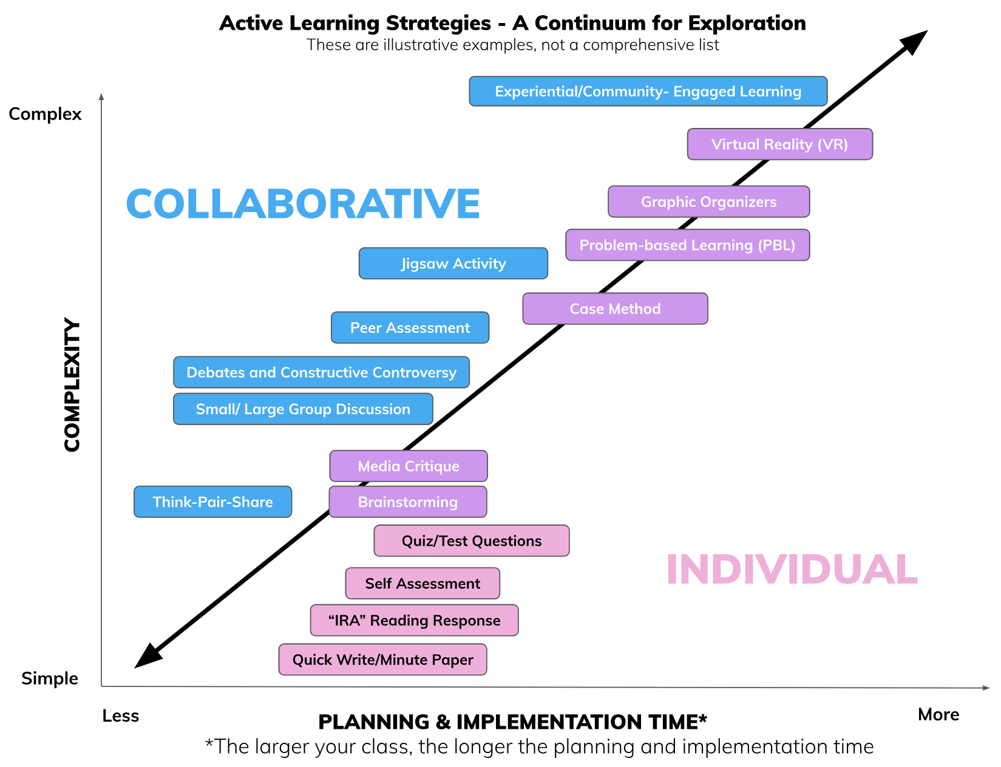

Pause for Exploration: Active Learning Activities

Knowing your teaching context and situational factors helps you determine appropriate active learning activities. Set aside some time to explore the Active Learning Continuum and select several active learning strategies to learn more about its structure and implementation.

In your Course Design Foundations Workbook docx, identify active learning activities that can be integrated and aligned with your learning outcomes and assessments. Please keep in mind the amount of time to plan and execute an activity may increase with the size of the class and the complexity of the activity.

Designing Active Learning Activities for Larger Groups

Active learning activities can be effective for larger groups of students. Below are several active learning activities that can be scaled up for larger groups of students to engage with information and ideas, experience by doing and observing, and reflect on their learning. The CTSI Active Learning at the University of Toronto webpage offers additional activity ideas and considerations.

Ticket Out the Door

Purpose: A ticket out the door is an exit ticket. The ticket provides an opportunity for students to share low-risk/stakes work with the instructors. Instructors can use the tickets to gauge student learning and measure the effectiveness of different learning activities and instruction.

Procedure:

- During class, identify a question you would like students to respond to by the end of the class.
- Near the end of class, provide students with the ticket (as an electronic form or a piece of paper) and invite students to share their responses to the question identified earlier.
- Provide students time to document their responses.
- Collect the tickets at the end of class. Students can submit the electronic form online or leave their physical tickets with you in the classroom.
- Review the tickets and share a summary and feedback with students during the next class, by email, or via announcements.

Scaling Up Tip: The ticket out the door can be adapted for large-scale classes by organizing students into small groups. Each small group can submit one ticket.

3–2–1

(Paterson & Rolheiser, 2009)

Purpose: 3–2–1 is a graphic organizer that learners use to record ideas, observations, and/or reflections related to a specific learning experience.

Procedure:

- Share your 3–2–1 graphic organizer with students. The 3–2–1 organizer can include prompts such as: Identify:
  - 3 things you just learned
  - 2 things you found interesting
  - 1 question you still have
- Invite students to reflect on the prompts and record their responses in the 3–2–1 organizer. This activity can take place after viewing a video, listening to a panel presentation or guest speaker, engaging in a service-learning activity, reflecting on a personal experience, etc.
- Consider designing opportunities for students to share their ideas with one another (e.g., using the think–pair–share technique).
- Identify trends in student responses and share a debrief summary during the next class, by email, or via announcements.

Scaling Up Tip: The 3–2–1 strategy works well with a large-scale class because it involves individual reflection. Students can respond individually in their seats or on their computers. Students can either share some of their responses in class and/or you can collect their responses as a ticket out the door.

The Fish Bowl

(Paulson & Faust, 2006)

Purpose: The fish bowl encourages students to offer feedback on course readings or class discussions. It is often more helpful and engaging to get students to provide the answers to their peers.

Procedure:

- During class, provide students with an electronic form or index cards. For this activity, students do not need to note their names on the form or index card.
- Invite students to ask a question of clarification regarding some aspect of the material or, perhaps, the application of course material to practical contexts.
- At the end of class, ask students to submit the electronic form online or deposit their index cards in a container (the "fish bowl") in the classroom.
- Select several questions and address them during the next class, by email, or via announcements.

Scaling Up Tip: The fish bowl is well suited to large-scale classes because it allows students some anonymity while providing them with an opportunity to ask questions and receive feedback.

Using Technology to Enhance Active Learning Activities

For each of the active learning activities presented above, consider how technology can be used to improve access, increase engagement, and enhance the learning experience.

For example, what tools can facilitate the ticket out the door or fish bowl activity? Microsoft Forms may be helpful in collecting tickets and questions. Microsoft Forms can display real-time responses and generate word clouds and charts summarizing the results.

How can technology facilitate opportunities for students to share their ideas with one another in the 3–2–1 activity? Microsoft 365 apps, such as Word, Excel, and PowerPoint, offer robust collaborative spaces for active learning activities.

Visit the U of T Academic Toolbox webpage and the CTSI Microsoft 365 Tools webpage to generate more ideas for your teaching contexts.

Pause for Exploration: More Active Learning Activities

Visit the CTSI Active Learning at the University of Toronto webpage for more active learning activity ideas.

In your Course Design Foundations Workbook docx, identify additional active learning activities that could be integrated into your course design and what tools can help facilitate the activities. You will have the opportunity to narrow down which active learning activities are in alignment with the learning outcomes and assessments drafted in your three-column table.

6.5 Integrating Generative AI Technologies and Learning Activities

On this page:

- Intentional Generative AI and Learning Activities Integration
- Generative AI-integrated Active Learning Activities
- Five Principles for Integrating Generative AI Technologies and Learning Activities
- Pause for Workbook Activity: Reflecting on Your Learning Activities

Intentional Generative AI and Learning Activities Integration

On the previous page, you considered how technology can improve access, increase engagement, and enhance the learning experience.

For example, while Microsoft Forms can facilitate ticket-out-the-door activity by collecting, displaying, and summarizing real-time responses, generative AI technologies can offer opportunities for knowledge retention and critical thinking. During the ticket-out-the-door activity, students can analyze AI-generated responses related to course topics. Intentional generative AI and learning activities integration offers:

- personalized practice tailored to students' needs,
- deeper reflection on the course material, and
- supports for AI literacy development.

Note: AI literacy is defined as the ability to understand, use, evaluate, and critically reflect on AI technologies and their impacts (Hibbert et al., 2024).

Generative AI-integrated Active Learning Activities

Fink's (2013) holistic model of active learning identifies three significant forms of active learning activities: getting information and ideas, experiencing, and reflecting. These activities gain new relevance when considering the integration of generative AI technologies into active learning activities. Consider the challenges and opportunities for access, engagement, and learning in the following generative AI-integrated active learning activities.

Getting Information and Ideas

- Multiple examples and explanations: Use generative AI tools to create diverse examples related to a topic, model thought processes, and offer alternative explanations. Create discussion spaces for students to critique AI-generated output, enhancing their analytical skills.
- Comparative analysis: Have students compare AI-generated explanations with textbook content, identifying strengths, limitations, and potential biases in each source.
- Multi-perspective synthesis: Invite students to use generative AI tools to generate multiple viewpoints on a topic, then synthesize these perspectives into a comprehensive understanding, emphasizing critical evaluation of AI-generated content.

Experiencing

- Role-playing with generative AI: Design activities where students assume different roles or maintain their identity while applying knowledge. Generative AI tools can serve as both a scenario creator and a responsive element in the simulation (Mollick & Mollick, 2023).
- AI-critique exercises: Have students critique AI-generated work samples or scenarios, fostering critical thinking and deepening subject understanding. For example, philosophy students might use generative AI tools to create counter-arguments for discussion preparation and then analyze the logical structure and validity of these arguments.
- Problem-solving partnerships: Develop activities in which students collaborate with generative AI tools to solve complex problems, then analyze the problem-solving process, outcomes, and the role of human judgment in refining AI-generated solutions.

Reflecting

- AI-assisted tutoring: Engage students in metacognitive reflection using generative AI tools. Design activities where students identify knowledge gaps, consider alternative perspectives, and establish connections within complex information, encouraging self-regulation and goal-directed learning. Consider using examples from the CTSI AI Virtual Tutor: Effective Prompting Strategies resource to guide students.
- Analyzing generative AI interactions: Have students reflect on their use of generative AI tools, considering how these interactions impact their learning process and outcomes. Design activities where students compare their own problem-solving approaches with AI-generated solutions, reflecting on differences and similarities.
- Generative AI-integrated peer review: Create activities in which students use generative AI tools to analyze and evaluate their ideas, then compare the AI-generated insights to their own self-assessments and reflect on the relevance and usefulness of these insights.

Five Principles for Integrating Generative AI Technologies and Learning Activities
The Durham College (DC) framework offers a structured approach (using five principles) to thoughtfully incorporate generative AI technologies into learning activities while maintaining pedagogical integrity. This framework can help you consider both the challenges and opportunities generative AI technologies may bring to your learning activities design.

- Principle 1: Intentionality: What is the purpose of using the generative AI tool, and what skills will be learned? Does using the tool support and increase access to the learning outcome of the activity?
- Principle 2: Active Engagement: Does the activity require adjustments to ensure the generative AI tool enhances the learning without substituting student learning?
- Principle 3: Responsibility of Accuracy: Is there a capacity to teach students to be critical consumers of generated information? How will you guide students to critically analyze AI-generated output?
- Principle 4: Ethical and Legal Considerations: How will students be informed about the ethical principles grounding their responsibilities around using generative AI tools? Will the data collected not perpetuate stereotypes or biases, including racism, sexism, or ageism?
- Principle 5: Reflective Practice: How will students reflect on their learning after using generative AI tools? Did the tool encourage deeper engagement with and processing of course content and new concepts?

Example Learning Activity: Think-Pair-Copilot-Share

Review the following historical text analysis learning activity and its integration of generative AI technologies using the DC framework's five principles. While some activities may be better suited for generative AI integration than others, the DC framework offers a consistent way to evaluate these opportunities.

- Principle 1: Intentionality: Use generative AI tools to help students analyze historical relationships between Indigenous peoples and resource development during the 1974 Mackenzie Valley Pipeline Inquiry.
- Principle 2: Active Engagement: Students first analyze sections of the text without generative AI. Students then read AI-generated summaries and critically discuss with a peer how they compare to the original testimony.
- Principle 3: Responsibility of Accuracy: Students identify and critique gaps in AI-generated outputs.
- Principle 4: Ethical and Legal Considerations: Students identify biases in AI-generated text interpretations.
- Principle 5: Reflective Practice: Students evaluate their ability to critically analyze historical documents with assistance from generative AI tools.

Pause for Workbook Activity: Reflecting on Your Learning Activities

As you explore the extent to which you may begin integrating generative AI use into your learning activities, consider the following questions to ensure that your activities interact and connect with components in your integrated course design.

Let's take a moment to open your Course Design Foundations Workbook docx and document your reflections.

- What should happen during the course for students to demonstrate their learning and progress towards the learning outcomes?
- How can we invite students to contribute to the creation of knowledge and be active agents in their learning progress?
- Which aspects of your learning activities should prioritize independent thinking and skill development without relying on generative AI assistance?
- How can you design discussions that encourage students to critically reflect on and share their experiences with generative AI use in the context of course content?
- In what ways can you scaffold generative AI-integrated activities to complement other coursework, enhancing student engagement and supporting deeper learning outcomes?
- What strategies will you employ to effectively communicate guidelines, expectations, and ethical considerations regarding generative AI use in learning activities?

Student Support Resource: GenAI Literacy Modules

As you design learning activities that integrate generative AI technologies, you may wish to support students in building the foundational skills needed to use these tools effectively, ethically, and critically.

U of T offers Coursework and GenAI: A Practical Guide for Students, an open educational resource designed to enhance students' literacy around generative AI. The resource includes customizable modules that instructors can flexibly adapt and integrate into their courses across disciplines. Instructors may also choose to link to an adapted version of this resource in their syllabus to support students' understanding of generative AI tools and expectations.

6.6 Adding Learning Activities to Your Three-column Table

On this page:

- When to Use Active Learning
- Learning Outcomes–Assessments–Learning Activities: Starting with the End in Mind
- Pause for Workbook Activity: Adding Learning Activities to Your Three-column Table
- Sequencing Your Learning Activities: Using the Castle Top Diagram
- Pause for Workbook Activity: Sequencing Your Learning Activities

When to Use Active Learning

Active learning activities are most meaningful and impactful when they are designed to be integrated and aligned with your learning outcomes and assessments.

Learning outcomes, assessments, and learning activities are the core components of the integrated course design (module 1) (Fink, 2003 & 2013) and backward course design (Wiggins & McTighe, 1998). Both models focus on the alignment of the three core components to support students in attaining the learning outcomes.

Learning Outcomes–Assessments–Learning Activities: Starting with the End in Mind

Like an integrated course design, backward course design invites instructors to start with the end in mind (Wiggins & McTighe, 1009, pp. 17–19):

Step 1

Identifying Desired Results (Learning Outcomes)

- What should students know, understand, and be able to do?

Step 2

Determining Acceptable Evidence (Assessments)

- How will students demonstrate what they have learned?

Step 3

Planning Learning Experiences and Instruction (Learning Activities and Instruction)

- What (active) learning activities will help students learn the knowledge and/or skills?
- What (active) learning activities will help students practice using the knowledge and/or skills?
- What feedback and resources will help students advance their knowledge and/or skills?

Pause for Workbook Activity: Adding Learning Activities to Your Three-column Table

Now that you have explored the benefits of active learning, examined different active learning activities, and considered how technology enhances activities learning activities, it's time to design and capture your ideas of learning activities that align with the learning outcomes and assessments in each row of your three-column table in your Course Design Foundations Workbook docx.

Learning Outcomes | Assessments | Learning Activities
Completed in module 4 | Completed in module 5 | To add in this module

As you develop your course design, use the three-column table as your blueprint for finalizing your learning outcomes, assessments, and learning activities and instruction.

Sequencing Your Learning Activities: Using the Castle Top Diagram

Now that you have jotted down your learning activities design notes and considerations in the "Learning Activities" (right) column in your three-column table, when will you schedule each learning activity to promote learning and student agency throughout the course?

The castle top diagram takes a holistic approach to sequencing learning activities. The diagram, developed by Fink (2013), considers what students are doing in class and outside of class and how such activities are sequenced to support student preparation for assessments and eventual attainment of the learning outcomes.

Refer to the sample castle top diagram (Fink, 2013, p. 297) to conceptualize how in-class and out-of-class activities can be sequenced to promote student learning. In the diagram, a horizontal line separates the in-class and out-class activities. Above the horizontal line are in-class activities, such as lecture, test on reading, in-class problem solving, and exam. Below the horizontal line are out-of-class activities, such as reading homework, problem-solving homework, and review. The shape and pattern created by the in-class and out-of-class activities are reminiscent of the crenellation often found along the top of castle walls, hence the name "castle top."

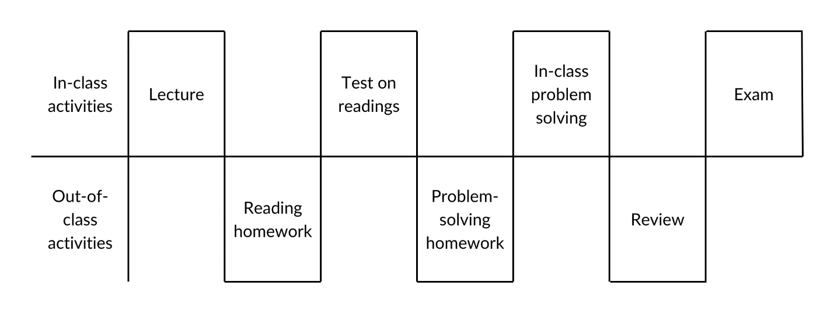

The castle top diagram reinforces the alignment between learning outcomes, assessments, and learning activities and reveals the intentional instructional strategy in planning for differentiation and integration of learning (Fink, 2013, p. 154–155).

Differentiation

Differentiation refers to the variety of types of learning activities (individual, collaborative, in-class, out-of-class, no tech, low tech, high tech) that scaffold learning and help students build their knowledge and skills toward the attainment of the learning outcome. Differentiation reinforces UDL-informed practices by:

- Fostering collaboration, interdependence, and collective learning (designing multiple means of engagement: options for sustaining effort and persistence)
- Connecting prior knowledge to new learning (designing multiple means of representation: options for building knowledge)
- Using multiple tools for construction, composition, and innovation (designing multiple means of action & expressions: options for expression and communication)
- Building fluencies with graduated support for practice (designing multiple means of action & expressions: options for expression and communication)
- Enhancing capacity for monitoring progress (designing multiple means of action & expressions: options for strategy development)

Integration

Integration refers to the interactive relationships and connections between various learning activities (differentiation) and between the course components—learning outcomes, assessments, and learning activities.

In the sample castle top diagram above, the lecture prepares students for the reading homework, which in turn prepares students for the test on readings, which demonstrates the attainment of knowledge and skills to be put to use in the problem-solving homework, that then prepares students for the collaborative in-class problem-solving exercise, which leads to the review, in preparation for the exam that provides an opportunity for students to demonstrate their learning and attainment of the learning outcome.

Pause for Workbook Activity: Sequencing Your Learning Activities

How will your course begin? Use the castle top diagram template in your Course Design Foundations Workbook docx to sequence learning activities at the start of your course. Refer to your three-column table to confirm the alignment of the learning activities with your assessments and learning outcomes.

Consider the following prompts to help you determine which learning activities can be in or out of class:

- When will students benefit most from working when you are with them (in class)? What will they be doing? How does the activity align with your learning outcome?
- When will students benefit from working on their own (out of class) without your direct input/oversight? What will they be doing? How does the activity align with your learning outcome?
- When will students benefit from working with other students (in or out of class)? Will students need real-time guidance and feedback from you (in class), or can the collaboration occur without your direct input/oversight (out of class)? What will they be doing? How does the activity align with your learning outcome?
- How does the activity incorporate getting information and ideas, experiencing, and reflecting to build fluencies with graduated support for practice and enhance student capacity for monitoring their progress? How will you support student resilience (accounting for variability in conditions) while they are preparing for and completing academic work for the course?

6.7 Module 6 References and Resources

Congratulations!

You've reached the end of Module 6: Designing Activities to Support Student Learning. Throughout the module, you had the opportunity to design learning activities that are aligned with your learning outcomes and assessment plans. In this module, we have:

- Applied inclusive and UDL-informed practices to your design of learning activities;
- Described how active learning activities can support student learning; and
- Explored a variety of active and collaborative learning activities that can be used in different teaching contexts.

References and Resources

The list below is a compilation of module references and additional resources. These resources are provided as additional information to help you think further about the module topic. Reviewing these resources is optional. They are not intended as essential components of the module, so you are not required to review any of them before proceeding to the next module. You can review them at your own pace at a later date.

- Barkley, E. F., & Major, C. H. (2022). Engaged teaching: A handbook for college faculty. The K. Patricia Cross Academy.
- Barkley, E. F., & Major, C. H. (n.d.). The K. Patricia Cross Academy.
- Centre for Teaching and Learning. (2025). DC's framework for implementing generative AI. Durham College.
- Centre for Teaching and Learning. (2025). GenAI and course (re)design: A brief guide [Google doc]. University of Alberta.
- Cherney, I. D. (2008). The effects of active learning on students' memories for course content. Active Learning in Higher Education, 9(2), 152–171.
- Fink, L. D. (2003). Integrated course design. [PDF] (IDEA Paper No. 42).
- Fink, L. D. (2013). Creating significant learning experiences: An integrated approach to designing college courses (Revised and Updated Ed.). Jossey-Bass.
- Fry, H., Ketteridge, S., & Marshall, S. (Eds.). (1999). A handbook for teaching and learning in higher education: Enhancing academic practice. Kogan Page.
- Golparian, S. (2024). Accessible Active Learning.
- Hibbert, M., Altman, E., Shippen, T., & Wright, M. (2024, June 3). A framework for AI literacy. Educause Review.
- Hodges, L. C. (2020). Student engagement in active learning classes. In Mintzes, J. J., & Walter, E. M. (Eds.), Active learning in college science: The case of evidence-based practice. Springer International Publishing.
- Justice, C., Rice, J., Warry, W., Inglis, S., Miller, S., Sammon, S. (2007). Inquiry in higher education: Reflections and directions on course design and teaching methods. Innovative Higher Education, 31(4), 201–214.
- Lujan, H. L., & DiCarlo, S. E. (2006). Too much teaching, not enough learning: What is the solution? Advances in Physiology Education, 30(1), 17–22.
- Machemer, P. L., & Crawford, P. (2007). Student perception of active learning in a large cross-disciplinary classroom. Active Learning in Higher Education, 8(1), 9–30.
- McCarthy, J. P., & Anderson, L. (2000). Active learning techniques versus traditional teaching styles: Two experiments from history and political science. Innovative Higher Education, 24(4), 279–94.
- McDonald, P., Reeve, R., & Scardamalia, M. (2000). Knowledge building, from the beginning. In Telelearning 2000, Toronto.
- Menges, R. J. (1988). Research on teaching and learning: The relevant and the redundant. Review of Higher Education, 11(3), 259–268.
- Michaelsen, L. K., Knight, A. B., & Fink, L. D. (2004). Team-based learning: A transformative use of small groups for large and small classes. Stylus.
- Mollick, E. R., & Mollick, L. (2023). Assigning AI: Seven approaches for students, with prompts. The Wharton School Research Paper.
- Nelson, L. P., & Crow, M. L. (2014). Do active-learning strategies improve students' critical thinking? Higher Education Studies, 4(2), 77–90.
- Paterson, J., & Rolheiser, C. (2009). 13 parameters: A literacy leadership toolkit. Pearson Education Canada.
- Paulson, D. R., & Faust, J. L. (2006). Active learning for the college classroom. Journal on Excellence in College Teaching, 9(2), 3–24.
- Smith, K. A., Sheppard, S. D., Johnson, D. W., Johnson, R. T. (2005). Pedagogies of engagement: Classroom-based practices. Journal of Engineering Education, 94(1), 87–101.
- Theobald, E. J., Hill, M. J., Tran, E., Agrawal, S., Arroyo, E. N., Behling, S., Chambwe, N., Cintrón, D. L., Cooper, J. D., Dunster, G., Grummer, J. A., Hennessey, K., Hsiao, J., Iranon, N., Jones II, L., Jordt, H., Keller, M., Lacey, M. E., Littlefield, C. E., Lowe, A., … Freeman, S. (2020). Active learning narrows achievement gaps for underrepresented students in undergraduate science, technology, engineering, and math. PNAS, 117(12), 6476–6483.
- Wiggins, G., & McTighe, J. (1998). Understanding by design. Association for Supervision and Curriculum Development.

U of T Resources

- ARC Academic Toolbox
- CTSI Active Learning at the University of Toronto
- CTSI Active Learning Design Foundations (ALDF) Self-Paced Learning Program
- CTSI AI Virtual Tours: Effective Prompting Strategies
- CTSI Microsoft 365 Tools
- CTSI Resilient Course Design
- CTSI Student Response Systems
- GenAI Literacy Course Modules
- Generative Artificial Intelligence in the Classroom: FAQ's

7. Putting It All Together: Building Your Course

7.1 Introducing Module 7

Welcome

In the previous modules, you have identified situational factors and drafted learning outcomes, assessments, and learning activities as part of your integrated course design. Now, you have the opportunity to put everything together and develop a course structure that sequences the learning journey. You will consider how the syllabus can be used to communicate the alignment in your design and examine Quercus and other educational technologies to enhance your course design.

Learning Outcomes

After completing this module, you will be able to design a course structure that integrates your learning outcomes, assessments, and learning activities drafted from earlier modules and incorporates technology-enhanced practices to reduce learning barriers and welcome learner variability. In support of this outcome, you will be able to:

- Develop your course structure that integrates course components from your integrated course design;
- Consider strategies for communicating alignment and structure in your course syllabus; and
- Identify educational technologies that enhance your inclusive and UDL-informed practices.

Module 7 Pages

This module consists of five pages accompanied by activities from the Course Design Foundations Workbook docx.

Use the "Next" and "Previous" buttons in the bottom right to progress through the module.

- 7.1 Introducing Module 7 (you are here)
- 7.2 Integrating Course Components and Developing Your Course Structure
- 7.3 Communicating Alignment and Structure in Your Course Syllabus
- 7.4 Using Technology to Enhance Your Course Design
- 7.5 Module 7 References and Resources

7.2 Integrating Course Components and Developing Your Course Structure

On this page:

- Extending the Three-column Table and Castle Top Diagram
- Examining Three Hypothetical Course Structures
- Brainstorming and Sketching Course Structure
- Pause for Workbook Activity: Developing Your Course Structure

Extending the Three-column Table and Castle Top Diagram

In the previous six modules, you completed the first four steps of Fink's (2003) integrated course design.

- You identified your situational factors (module 1).
- You established your learning outcomes (module 4).
- You designed assessments (module 5).
- You selected learning activities and sequenced activities for the start of your course (module 6).

In this module, we move into step 5—integrating the situational factors and course components (module 7).

Your three-column table and castle top diagram have already begun integrating and aligning your learning outcomes, assessments, and learning activities. Now, we consider how you can extend your design from your three-column table and castle top diagram to create an overall structure for your entire course.

The overall course structure clarifies the integration of the situational factors and course components and identifies the flow between and sequence of different components. Let's examine three hypothetical course structures that support students' learning journey and attainment of the learning outcomes.

Examining Three Hypothetical Course Structures

The following three hypothetical course structures are examples of possibilities that you can adapt, consider a variation on one of them, or develop an entirely different structure that makes sense for your course. The goal is to spark some ideas and offer various ways of thinking about course structure.

Modular Course Structure

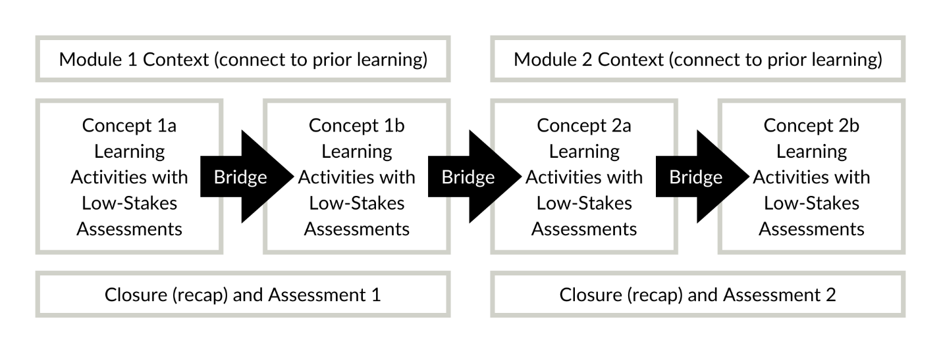

A modular course structure "chunks" content into modules. These modules are often scheduled weekly and provide a structure and rhythm that helps students progress steadily through the learning activities, assessments, and learning outcomes.

A module consists of a beginning, middle, and end. The beginning sets the context, outlines the learning outcomes, and connects to prior learning. The middle section introduces key concepts through readings, videos/audio/images, and/or demonstrations and offers various learning activities that help students progress through the content. Low-stakes assessments check for understanding before bridging into the next concept or module. A module may end with a recap and assessment as appropriate.

A modular or unit-based structure is familiar to many courses. Consider how such a structure aligns with your situational factors and learning outcomes.

Experiential Journey Course Structure

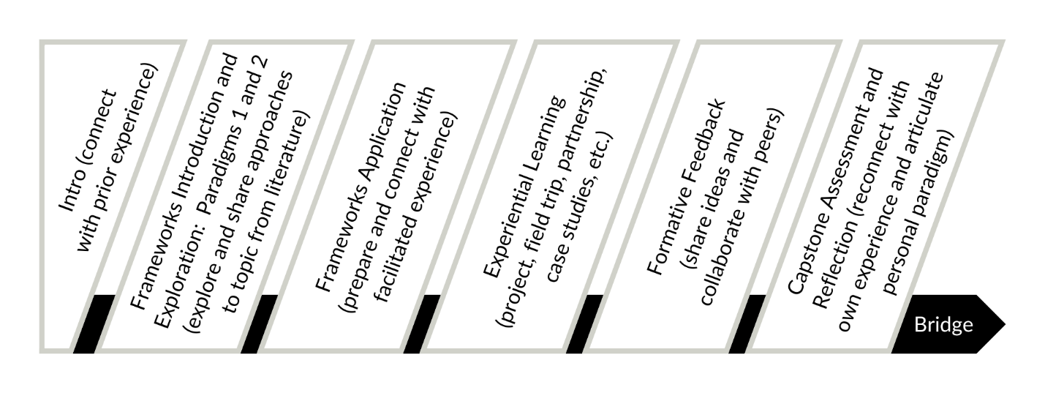

An experiential journey course structure aims to facilitate social learning, taking a constructivist approach. Students are provided with prompts that link the course content to their prior experiences, and emphasis is placed on linking learning with authentic experiences and reflective processes that culminate in a capstone assessment.

While the course content may be organized by modules, each module structure may differ as students move through a journey of discovery.

Scaffolded Project-based Course Structure

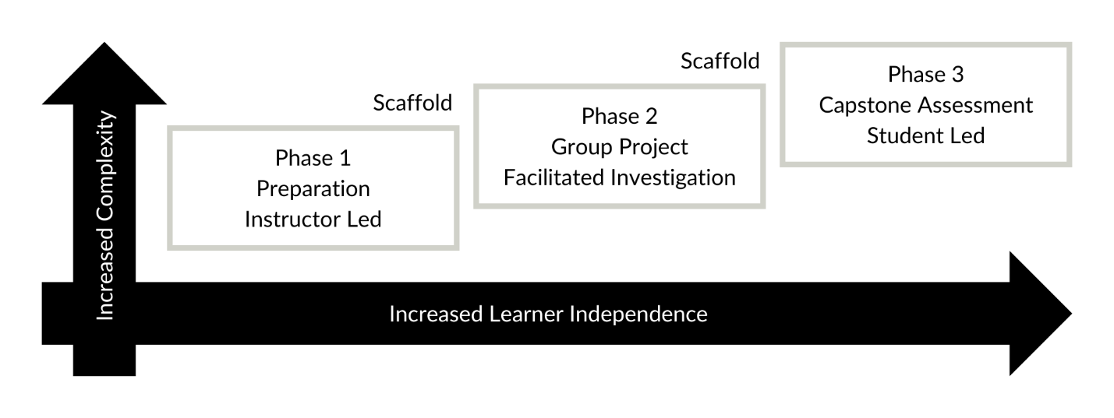

A scaffolded project-based course structure also leads to a capstone assessment but in a highly structured format with intentional scaffolding.

As students move through the course, concepts, learning activities, and assessments become increasingly complex, and there is a higher expectation for learner independence. A scaffolded project-based course structure begins with a highly facilitated preparatory phase and shifts into facilitated group activities. Group projects promote collaborative learning that can reduce stress and ensure that the knowledge and skills necessary to succeed in the capstone assessment are fostered with intention.

Brainstorming and Sketching Course Structure
Check out the following two brainstorming sketches by past Course Design Institute participants.

The first brainstorming sketch illustrates the flow between and sequence of different components. The learning outcome on the green sticky note is placed at the top left corner of the page. Below the learning outcome are alternating small yellow sticky notes representing content chunks and learning activities and large pink sticky notes outlining the assessments. Blue sticky notes at the bottom of the page note resources and materials needed to facilitate the content chunk, learning activities, and assessments.

The second brainstorming sketch is a hand-drawn concept map that shows how the two learning outcomes link to various asynchronous and synchronous learning activities that lead to various forms of assessments, such as multiple-choice questions, group debriefs, and problem-solving assignments.

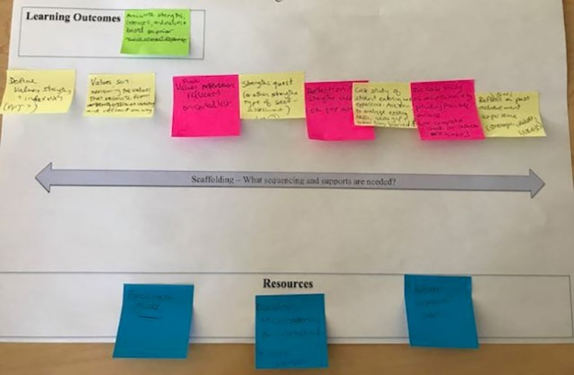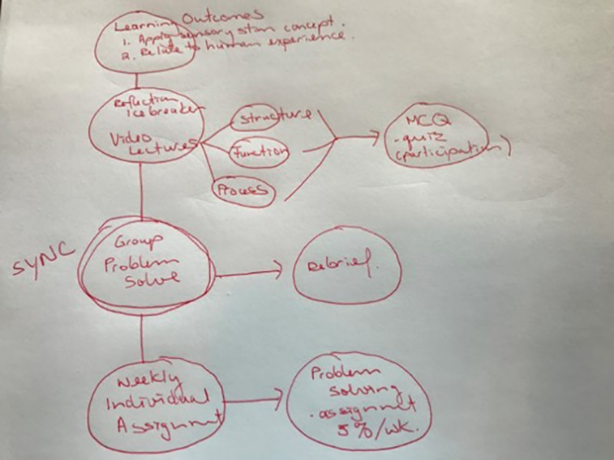

Pause for Workbook Activity: Developing Your Course Structure

What type of course structure will help you integrate your situational factor and course components throughout the term? In your Course Design Foundations Workbook docx, brainstorm and sketch your course structure. You are welcome and encouraged to experiment with different forms of brainstorming and sketching using various tools, such as such as sticky notes, chart papers, bulletin boards, PowerPoints, etc.

For now, you are just developing the overall structure and sequencing of the components. To help you ground your thinking, recall the three core course components that you aligned in your three-column table and consider when these components will occur and how they will be scaffolded and facilitated in your course structure.

- Learning outcomes: What should students know, understand, and be able to do?
- Assessments: How will students demonstrate what they have learned?
- Learning Activities and instruction: What learning activities will help students learn and practice using the knowledge and/or skills?

7.3 Communicating Alignment and Structure in Your Course Syllabus

On this page:

- Leveraging Your Course Syllabus
- Communicating Course Priorities
- Getting Started with Your Course Syllabus
- Pause for Workbook Activity: Identifying Communication Strategies for Your Course Syllabus

Leveraging Your Course Syllabus

"The syllabus can extend welcoming invitations to learning, highlighting the relevance and importance of the course." Maryellen Weimer (2020)

How can you communicate your course alignment and structure to your students? A strategy for communicating your intentional course design is through your syllabus—one of the first points of interaction between students and your course.

The syllabus is a powerful learning tool that can highlight the interactive relationships and alignment between learning outcomes, assessments, and learning activities—reinforcing the relevance and importance of every step in the learning journey. Consider the following strategies for leveraging your syllabus:

- Share the course learning outcomes
- Identify which learning outcomes each assessment addresses
- Clarify when students can expect assessment feedback to support their progress toward the learning outcomes
- State which learning activities and instruction prepare students for assessments and when such activities are scheduled
- Offer timelines and strategies for engaging in learning activities and preparing for assessments
- Highlight relevant resources and supports that promote student learning and reflection

The interactive relationships and alignments between course components can be presented graphically as a "course map" (Nilson, 2007). Consider designing options for perception (multiple means of representation) and nurturing joy and play through active, engaged learning (multiple means of engagement).

Remember, effective active learning involves sequencing getting information and ideas, experiencing, and reflecting to enhance learning.

Communicating Course Priorities

Throughout the modules, you have considered two frameworks that welcome student identities and learner variability: The Inclusive Pedagogy Framework (IPF) (module 2) and the Universal Design or Learning (UDL) Framework (module 3).

Consider the following strategies for communicating your course priorities of welcoming student identifies and learner variability in your syllabus:

- Share a bit of information about yourself (beyond your name, title, and email), such as:
  - A photograph (or a link to an introduction video)
  - How to address you (including how to pronounce your name) and your pronouns
  - Your research and/or recreational interests
  - Fun facts about you
- Draft meaningful statements that reflect your intentions, commitments, and actions, which may include:
  - A proclamation for the respect for diversity and accessibility
  - An inclusive list of relevant dimensions of diversity, especially within the context of your course
  - A land acknowledgement that signals the need for change in settler colonial societies
  - Expectations with respect to the classroom climate and behaviours, interactions, and communications
- Update your reading lists and consider the following:
  - Whose perspectives are represented in your primary texts/readings?
  - What are the identities of the authors and editors?
  - What minoritized identities are referenced in the readings, and how are they portrayed?
  - What ways of knowing are being privileged? In other words, what kinds of sources are perceived to be of the most academic value and why?

Consult the CTSI Sample Statements for Your Course Syllabi webpage for statements that may be relevant to your teaching context. Hogan & Sathy (2022, pp. 58–60) and Artze-Vega et al. (2023, pp. 78–79) provide sample diversity and inclusion statements.

Getting Started with Your Course Syllabus

For guidance on designing your course syllabus, consult CTSI's Syllabus Design Foundations (SDF) program—a self-paced resource for University of Toronto (U of T) instructors developing a new course syllabus or revising an existing one. The SDF program consists of three modules that explore key aspects of inclusive, accessible, and usable syllabus design.

- Module 1: Understanding Syllabus Design in the U of T Context
- Module 2: Embedding Inclusive Practices in Your Syllabus
- Module 3: Creating an Accessible and Usable Syllabus

The CTSI Developing a Course Syllabus webpage offers information on various syllabus elements, including:

- Essential information
- Coursework and grading
- Key dates and deadlines
- Course/department/divisional policies
- Copyright in instructional settings
- Student support and accommodation
- Options for additional information

Check with your division or home unit to identify relevant local policies and procedures that need to be considered or applied when designing your syllabus. Consult the Council of Ontario Universities' Accessible Campus website for tips on writing an accessible course syllabus.

Pause for Workbook Activity: Identifying Communication Strategies for Your Course Syllabus

In your Course Design Foundations Workbook docx, note down how you will leverage your syllabus to communicate the interactive relationships, alignment, and structure of your course components, as well as your course priorities.

Identify what else you would like to communicate about the learning journey and attainment of learning outcomes in your course.

Take a moment to reflect on your most memorable or impactful learning experiences. What information would have enhanced your learning experience? Are there opportunities to share such information in your course syllabus?

7.4 Using Technology to Enhance Your Course Design

On this page:

- Promoting Pedagogical Flexibility
- Building, Organizing, and Maintaining Your Course
- Connecting, Communicating, and Collaborating with Your Students
- Assessing Student Work and Providing Feedback
- Designing and Fostering Accessible and Inclusive Teaching and Learning
- Analyzing Teaching and Learning Data and Insights
- Pause for Reflection: Plus-one in Using Technology

Promoting Pedagogical Flexibility

Throughout the Course Design Foundations (CDF) program, you've had the opportunity to experience Quercus as a learner. In this section, we examine how Quercus and other teaching tools can improve access, increase engagement, and enhance the learning experience.

Quercus is U of T's learning management engine, based on Canvas's web-based learning management system, which facilitates instructors in building, organizing, and maintaining the course; connecting, communicating, and collaborating with students; assessing student work and providing feedback; designing and fostering accessible and inclusive teaching and learning; and analyzing teaching and learning data and insights. Quercus' built-in tools and integration of other educational technologies allow for greater pedagogical flexibility in designing options for the course community to engage with one another, for instructors to represent content, and for students to interact with and express their learning.

This page offers a brief overview of how Quercus and other educational technologies can help you enhance your course design. Refer to U of T's Academic Toolbox webpage, CTSI Educational Technology webpage, and CTSI Tool Guides for more information about each tool.

Building, Organizing, and Maintaining Your Course

Quercus facilitates building, organizing, and maintaining your course and making your course materials available to students so they can access them with ease. A well-organized course supports students in their learning journey so they can spend their time learning the materials rather than trying to find the materials. Consider how your course organization:

- Elevates the meaning and purpose of goals—by clarifying and integrating the interactive relationships and alignment between course components (designing multiple means of engagement: options for sustaining effort and persistence)
- Supports multiple ways to perceive information—by offering information in text, video, audio, and/or images (designing multiple means of representation: options for perception)
- Varies the methods for response, navigation, and movement—by sharing information in Quercus, Word, and/or other appropriate formats (designing multiple means of action & expression: options for interaction)

Check out our webinar recording (59:35, UTORid login required) about organizing your content in Quercus. Some of the tools and strategies discussed include:

Modules

Quercus Modules are "containers" of material that can include Pages, files, URLs, and links to other "activities" within Quercus (such as Discussions, Assignments, and Quizzes). Modules provide a linear sequence through various materials, and students can use the "previous" and "next" buttons to navigate. The CDF program organized its content into seven modules.

Pages

Quercus Pages are another way of organizing your course content. Imagine a page as a built-in Microsoft Word document within Quercus. You can build and edit your content (text, video, audio, and/or images) using the Rich Content Editor. Pages can be used to customize your course home page and provide quick access to important areas of Quercus, as well as additional links. Check out CTSI's Quercus Home Page Foundations self-paced program. The CDF program used pages for its home page and each page of the module content.

Course Tour

Consider creating a course tour guide to help students understand how the course is organized and can be navigated. Every instructor uses Quercus differently. Your course tour may save you hundreds of emails asking where things are! A course tour can be presented on a Page, in a document, or via a video. Watch Avi J. Cohen's discussion of his course tour video using lecture capture software (02:23). Select "CC" for closed captions.

Connecting, Communicating, and Collaborating with Your Students

Quercus and other educational technologies, such as Microsoft 365, facilitate connecting, communicating, and collaborating with your students, as well as fostering a sense of community in the learning environment. An environment that promotes connection, communication, and collaboration empowers students and helps them know they belong. Consider how your connection, communication, and collaboration strategies:

- Fosters belonging and community—by clarifying and co-creating community expectations and guidelines (designing multiple means of engagement: options for sustaining effort and persistence)
- Clarifies vocabulary, symbols, and language structures—by decoding texts and symbols (designing multiple means of representation: options for language and symbols)
- Uses multiple media for communication and tools for construction, composition, and innovation—by identifying different methods to communicate and collaborate in class and out of class (designing multiple means of action & expression: options for expression and communication)

Check out our webinar recording (51:59, UTORid login required) about connecting, communicating, and collaborating with your students. Some of the tools and strategies discussed include:

Announcements

Quercus Announcements are a way of sharing information with students. Students can receive email notifications about announcements once notifications are enabled. Announcements can help establish a course rhythm (e.g., scheduling weekly announcements) and provide timely notifications for time-sensitive information.

Discussions

Quercus has a built-in discussion tool for graded and ungraded discussions. The discussion tool can be used as an icebreaker where students introduce themselves or as a platform for sharing reading reactions, questions, and responses. Discussion can host text, video, audio, and/or images.

Microsoft 365

Microsoft 365 offers a variety of tools and applications, such as Word, Excel, and PowerPoint, that can be used for collaboration. The Microsoft 365 OneDrive integration allows students and instructors to use, create, share, and collaborate on Office 365 OneDrive files within Quercus.

Assessing Student Work and Providing Feedback

Quercus facilitates accepting electronic submissions, assessing student work, providing feedback, and assigning and calculating grades. Timely action-oriented feedback throughout the term helps students prepare for assessments and attain the learning outcomes. Consider how assessing student work and providing feedback:

- Develops awareness of self and promotes individual reflection—by offering action-oriented feedback (designing multiple means of engagement: options for emotional capacity)
- Connects prior knowledge to new learning—by designing activities and assessments that check for and practice previously- and newly-acquired knowledge and/or skills (designing multiple means of representation: options for building knowledge)
- Enhances capacity for monitoring progress—by providing clear instructions and rubrics and offering timely feedback (designing multiple means of action & expression: options for strategy development)

Check out our webinar recordings (UTORid login required), Part I (55:01) and Part II (01:04:54), about assessing student work and providing feedback. Some of the tools and strategies discussed include:

Assignments

Quercus Assignments accepts electronic submissions from students, including text entry, website URL, media recordings, and file uploads. Quercus Assignments also support group submissions if you use the Quercus Groups feature. By default, all assignment submissions are individual.

Quizzes

Quercus Quizzes administers online, graded and practice quizzes and graded and ungraded surveys. Quercus Quizzes include multiple question types such as multiple choice, true/false, fill-in-the-blank, etc. Many of these question types, not all, are automatically gradeable.

SpeedGrader

Quercus SpeedGrader allows instructors to view, comment, and grade student submissions directly within the browser. When students upload files, you can use the DocViewer within SpeedGrader to add points, highlight, text, strikeout text, draw, and area annotations. SpeedGrader also has options for providing feedback using a rubric and/or leaving text, video, or audio comments.

Designing and Fostering Accessible and Inclusive Teaching and Learning

Quercus and other educational technologies reduce learning barriers and welcome learner variability by enhancing accessibility, autonomy, and inclusion. Accessibility checkers and online meeting and learning platforms facilitate access and engagement. Consider how designing and fostering accessible and inclusive teaching and learning:

- Optimizes choice and autonomy—by offering choice for engaging with office hours or out-of-class materials (designing multiple means of engagement: options for welcoming interests and identities)
- Supports opportunities to customize the display of information—by providing video/audio alternatives when appropriate (designing multiple means of representation: options for perception)
- Optimizes access to accessible materials and assistive technologies—by checking for common accessibility issues and enabling captions and immersive readers (designing multiple means of action & expression: options for interaction)

Some tools and strategies to facilitate accessible and inclusive teaching and learning include:

Microsoft Teams and Zoom

Microsoft Teams and Zoom are video conferencing platforms with many interactive features, including video, audio, and screen sharing, breakout rooms, chat panels, virtual whiteboards, polls, captions and transcripts, and recording options. Recordings may benefit students preparing for assessments and progressing towards the learning outcomes.

Accessibility Checkers

Microsoft 365 and the Quercus Rich Content Editor include accessibility checkers that detect common accessibility issues such as headings, alt text, contrast between text and background, etc. The built-in accessibility checkers offer a starting point for creating accessible documents and facilitating access to course materials.

Microsoft Immersive Reader

Microsoft Immersive Reader is a learning tool that enhances and improves access to reading experience and comprehension. Immersive Reader can read aloud text, translate over 100 languages, and reduce "visual crowding." Use the Immersive Reader in Word and on Quercus. Listen to this page by selecting the "Immersive Reader" button at the top of the page (browsers only; not available in the mobile app).

Analyzing Teaching and Learning Data and Insights

Quercus and other educational technologies facilitate pedagogical reflections, improvements, and innovations. Teaching and learning data and insights help unpack how students are progressing through a course—what content they are engaging with, what concepts they are struggling with, and insights into how learner variability intersects with course design. Consider how analyzing teaching and learning data and insights:

- Addresses biases, threats, and distractions—by addressing learning barriers identified through student feedback and learning analytics and implementing supports (designing multiple means of engagement: options for welcoming interests and identities)
- Addresses biases in the use of language and symbols—by providing clarifications and alternatives for language and symbols flagged in student feedback and learning analytics (designing multiple means of representation: options for language and symbols)
- Challenges exclusionary practices—by reflecting upon and re-designing course components highlighted in student feedback and learning analytics (designing multiple means of action & expression: options for strategy development)

Some tools for accessing teaching and learning data and insights include:

Microsoft Forms

Microsoft Forms can be used to create surveys and polls to gather student feedback throughout the term. The built-in analytics evaluates responses, and Forms can be exported to Excel for additional analysis. Data collected via the Forms tool is safe and secure as part of the Microsoft 365 environment.

Quercus New Analytics

Quercus New Analytics provides individual and comparative data regarding student activities in the Quercus course. The information gathered can help instructors identify assessment patterns and design supports to enhance student progress toward the learning outcomes.

Pause for Reflection: Plus-one in Using Technology

In your Course Design Foundations Workbook docx, note down how you are already using technology to enhance your course. Consider:

- What technology do you use to facilitate:
  - Building, organizing, and maintaining your course?
  - Connecting, communicating, and collaborating with your students?
  - Assessing student work and providing feedback?
  - Designing and fostering accessible and inclusive teaching and learning?
  - Analyzing teaching and learning data and insights?
- How are these technology-enhanced practices reducing learning barriers?
- What is a "pinch point" in your course, and how can you use/add technology in one more way (the plus-one approach) for students to access and engage with your course?

7.5 Module 7 References and Resources

Congratulations!

You've reached the end of Module 7: Putting It All Together: Building Your Course. Throughout the module, you had the opportunity to design a course structure that integrates your learning outcomes, assessments, and learning activities and incorporates technology-enhanced practices to reduce learning barriers and welcome learner variability. In this module, we have:

- Developed your course structure that integrates course components from your integrated course design;
- Considered strategies for communicating alignment and structure in your course syllabus; and
- Identified educational technologies that enhance your inclusive and UDL-informed practices.

References and Resources

The list below is a compilation of module references and additional resources. These resources are provided as additional information to help you think further about the module topic. Reviewing these resources is optional. They are not intended as essential components of the module, so you are not required to review any of them before proceeding to the next module. You can review them at your own pace at a later date.

- Artze-Vega, I., et al. (2023). The Norton guide to equity-minded teaching. W. W. Norton & Company.
- Council of Ontario Universities. (n.d.). Writing a course syllabus. Accessible Campus.
- Fink, L. D. (2003). Integrated course design. [pdf] (IDEA Paper No. 42).
- Fink, L. D. (2013). Creating significant learning experiences: An integrated approach to designing college courses (Revised and Updated Ed.). Jossey-Bass.
- Hogan, K. A., & Sathy, V. (2022). Inclusive teaching: Strategies for promoting equity in the college classroom. West Virginia University Press.
- Instructure. (n.d.). How do I assign an assignment to a course group?. Canvas Instructor Guide.
- Instructure. (n.d.). How do I change the course home page?. Canvas Instructor Guide.
- Instructure. (n.d.). How do I use the announcements index page?. Canvas Instructor Guide.
- Instructure. (n.d.). What is Canvas?. Canvas Basics Guide.
- Nilson, L. B. (2007). The graphic syllabus and the outcomes map: Communicating your course. Jossey-Bass.
- Weimer, M. (2020, January 6). Revisiting the syllabus. The Teaching Professor.

U of T Resources

- ARC Academic Toolbox
- CTSI Creating a Course Tour Using Lecture Capture Software Video (02:23)
- CTSI Developing a Course Syllabus
- CTSI Educational Technology
- CTSI Microsoft 365 Tools
- CTSI MS Teams Meeting Video Recording
- CTSI MyMedia Hosting and Sharing
- CTSI Quercus Assignment
- CTSI Quercus Discussions
- CTSI Quercus Home Page Foundations (QHPF) Self-Paced Learning Program
- CTSI Quercus Modules and Pages
- CTSI Quercus Notifications
- CTSI Quercus Quizzes
- CTSI Quercus SpeedGrader
- CTSI Quercus Support
- CTSI Sample Statements for Your Course Syllabi
- CTSI Snagit
- CTSI Syllabus Design Foundations (SDF) Self-Paced Learning Program
- CTSI Zoom - Quercus Integration

Beyond CDF

What's Next?

Congratulations

You've completed the Course Design Foundations (CDF) self-paced learning program. Throughout CDF, you had the opportunity to reflect upon and design components of your course using the principles of integrated course design, the Inclusive Pedagogy Framework (IPF), and Universal Design for Learning (UDL).

Use your notes from the Course Design Foundations Workbook docx as your blueprint for finalizing your learning outcomes, assessments, and learning activities and instruction.

Prefer an offline version of the program? The CDF Content Reader PDF provides a single, accessible document containing all module content for future reference.

CDF Feedback Survey

Please share your feedback about your learning experience in this brief, anonymous survey. Your feedback will help us enhance the program and design future programming.

This survey will take approximately 5–7 minutes to complete. Your name and email address will not be recorded. Contact q.help@utoronto.ca for technical assistance and accommodation requests for the CDF self-paced learning program.

Start the CDF Feedback Survey

Supports and Resources

The Centre for Teaching Support & Innovation (CTSI) and U of T teaching support offices offer various services and expertise to support your teaching endeavours. Book a consultation and/or join a programming session to enhance your course design.

Explore the links below to identify the next steps for your teaching context. We look forward to connecting with you soon.

Useful Links

- CTSI Consultations
- Teaching Feedback Services
- Course Evaluations
- Educational Technology
- Resource Library
- Scholarship of Teaching and Learning (SoTL) Support
- Teaching Award Support
- Teaching with GenAI at U of T
- Teaching with UDL at U of T

Programming Series

- U of T Teaching and Learning Calendar
- CTSI Workshops and Programs
- Course Design Institute
- Peer-to-Peer (P2P) Faculty Mentoring for Teaching
- Reflecting on Your Teaching at U of T
- Self-Paced Learning Programs
- Teaching and Learning Symposium
- UDL Conversations
- UDL Express

U of T Teaching Support Offices

- Centre for Community Partnerships
- Centre for Faculty Development, Temerty Faculty of Medicine
- Centre for Teaching and Learning, UTSC
- Education Technology Office, Faculty of Applied Science & Engineering
- Institute for the Study of University Pedagogy, UTM
- Robert Gillespie Academic Skills Centre, UTM
- Teaching and Learning Office, Faculty of Arts & Science

Acknowledgements

This open-access resource under a Creative Commons Attribution-NonCommercial-ShareAlike 4.0 International (CC BY-NC-SA 4.0) License was co-developed by members from the U of T community. We would like to acknowledge the expertise and support of our U of T colleagues.

Megan Burnett, Samantha Chang, Cristina D'Amico, Justin Fletcher, Kelly Gordon, William Heikoop, Jordan Holmes, Derek Hunt, Michal Kasprzak, Clarissa Lau, Simone Laughton, Cora McCloy, Kathleen Olmstead, Sun Ooi, Elias Barboza Polcheira, Jasjit Sangha, Sarah Shujah, Shayne Train, Kyle Turner, Amy Widdifield, Derek Wilson

CDF is part of CTSI Self-Paced Learning Programs. Let us know what other programs and resources you would like to engage with in our CDF feedback survey available near the top of this page.

Thank you for completing the CDF self-paced learning program. Visit the CTSI website for resources and upcoming events. We look forward to connecting with you again soon.

