Systematic Review Steps
There is general acceptance about the main steps of a systematic review:³⁵
- Formulate a review question;
- Define inclusion and exclusion criteria;
- Locate studies through searching;
- Select studies for inclusion;
- Assess the quality of studies;
- Extract data;
- Analyse and synthesize relevant studies;
- Present and interpret the results.
The Cochrane Consumers and Communication Group created the following infographic to highlight the steps of a systematic review that authors follow.³⁶
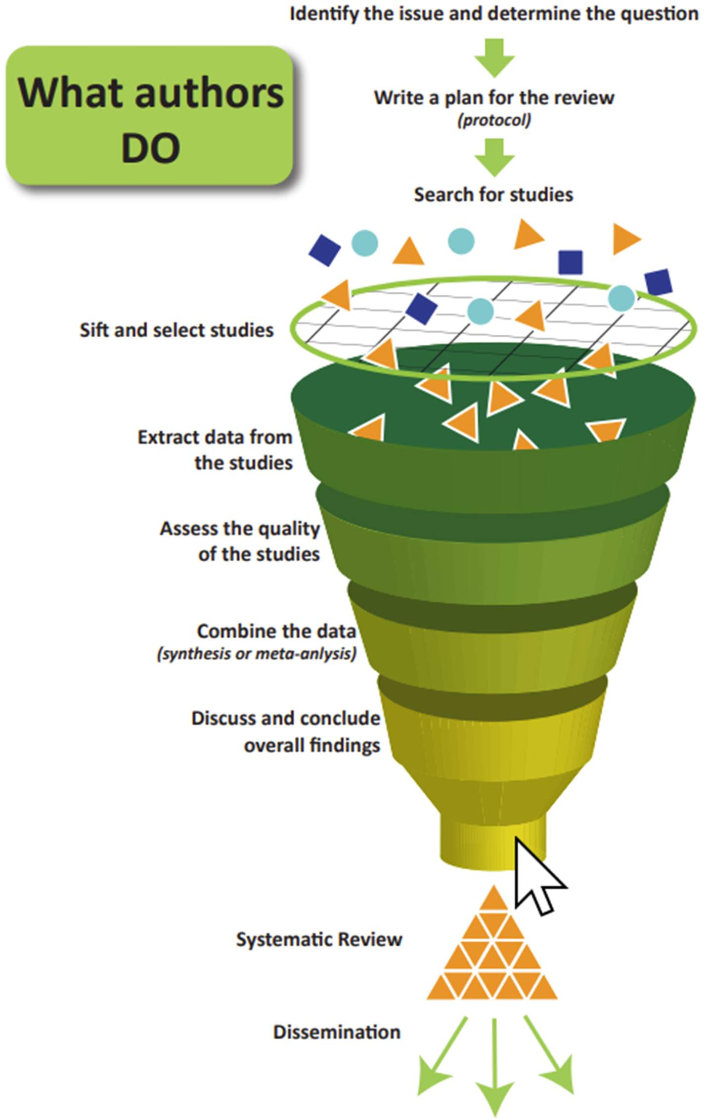
Figure 6: Infographic showing the steps of a systematic review.

Setting Your Review Up for Success
In the early stages of planning a systematic review, there are steps authors can take to help ensure they are not duplicating research efforts, that their review question is actually feasible, and that they have the resources for conducting a high-quality systematic review. Specifically, authors should determine the following before fully embarking on a systematic review:
- That there is not a recent systematic review publication or systematic review protocol addressing the same research question;
- That studies are available that would address your research question and/or inclusion criteria;
- That you have, on your review team, the expertise and resources needed to produce a high-quality systematic review;
- That you have time to do the review well.
Checking for Similar Publications and Protocols
As a first step of conducting a systematic review, you want to be confident that the same review has not been recently published or coming down the research pipeline. Duplication of efforts is a waste of time and resources and contravenes the premise of creating systematic reviews to reduce the amount of literature clinicians need to find and appraise to make informed decisions. This can be proactively managed by searching for systematic reviews that have been published and for systematic review protocols that have been registered or published.
Where to search for published systematic reviews and protocols:
- International research collaborations: e.g., search Cochrane Library or JBI EBP Database;
- Bibliographic databases: e.g., search PubMed/Ovid MEDLINE, Embase, PsycINFO, Web of Science, etc., (some databases allow you to limit to systematic review publication types which often include protocols);
- Other databases/resources: e.g., search Trip medical database, Epistemonikos, and Google Scholar for systematic review publications and protocols;
- Protocol registries and repositories.

PROSPERO is the international prospective register of systematic reviews.

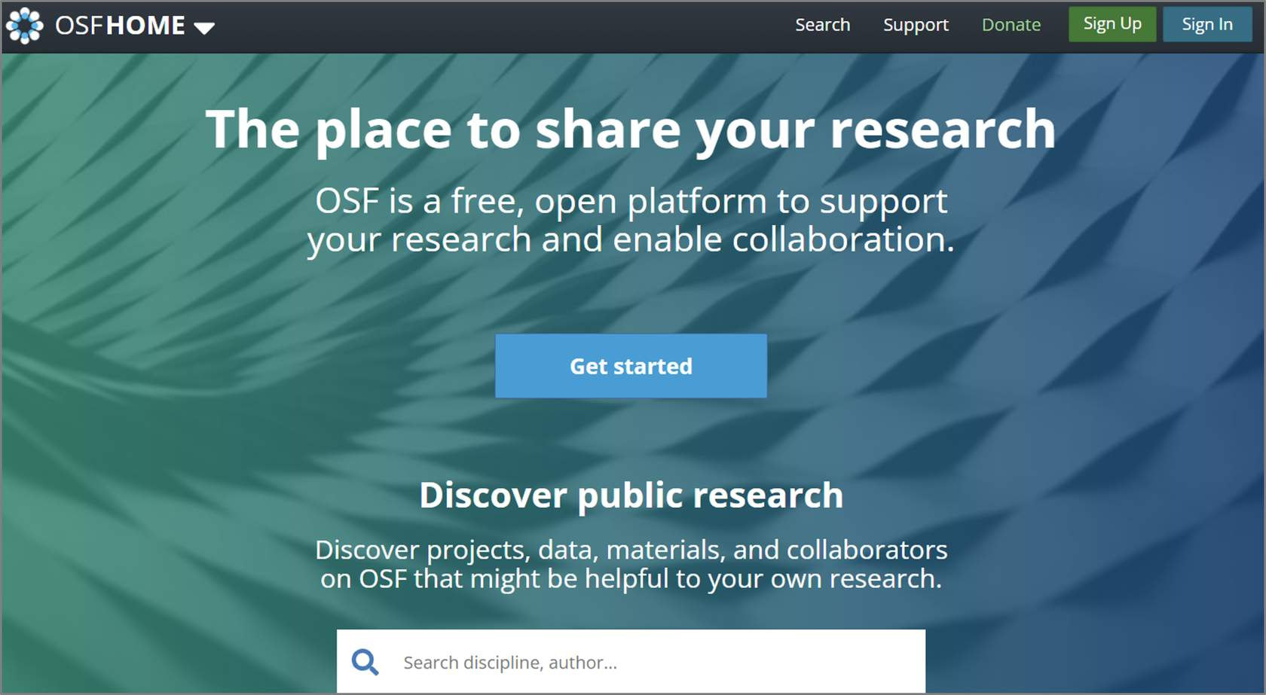
Protocols can also be found in repositories such as Open Science Framework.

Checking that Necessary Studies Exist
When developing your research question and considering the inclusion/exclusion criteria for eligible studies it’s important to be aware of the amount and type of research studies that are actually available. Making assumptions about the existence of certain research and study designs may lead to screening hundreds or thousands of literature search results only to find out there are next to no studies meeting your eligibility criteria and you need to go back to the planning stage.
A preliminary search should be conducted if:
- You are not already aware of studies, or are unsure if there will be enough studies, to answer your research question.
- You are unsure what types of study designs might address your research question (which can help refine your inclusion and exclusion criteria).
This preliminary search does not have to be comprehensive or systematic. It can be achieved using basic or advanced searching in bibliographic databases (e.g., PubMed/MEDLINE, Embase, etc.). or Google Scholar.
Considering Team Expertise and Experience
When conducting a systematic review, it is advisable to include expertise in:
- The topic area under review;
- Systematic review methodology, including statistical expertise if conducting a meta-analysis;
- Searching for studies;
- Different disciplines, as appropriate, to include perspectives that may help avoid assumptions or terminology stemming from an over-reliance on a single discipline.
While many academic and hospital libraries offer systematic review support for literature searching, a survey of libraries that support medical schools in Ontario suggests there is currently insufficient review methodology and biostatistics support available to researchers.³⁷ First-time systematic review authors are encouraged to work with experienced reviewers and to receive relevant training to help set themselves up for success.
Working as a team not only spreads the effort, but ensures that tasks such as the selection of studies for eligibility, data extraction and rating the certainty of the evidence will be performed by at least two people independently, minimizing the likelihood of errors.³⁸

Systematic Review Timeline Considerations
The length of time to conduct a systematic review will depend on a number of factors such as the scope of the topic and the amount of evidence available, and the number of and expertise of team members. One research study found that the mean length for a systematic review was 67.3 weeks.³⁹
Cochrane provides a timeline for their reviews as follows:⁴⁰
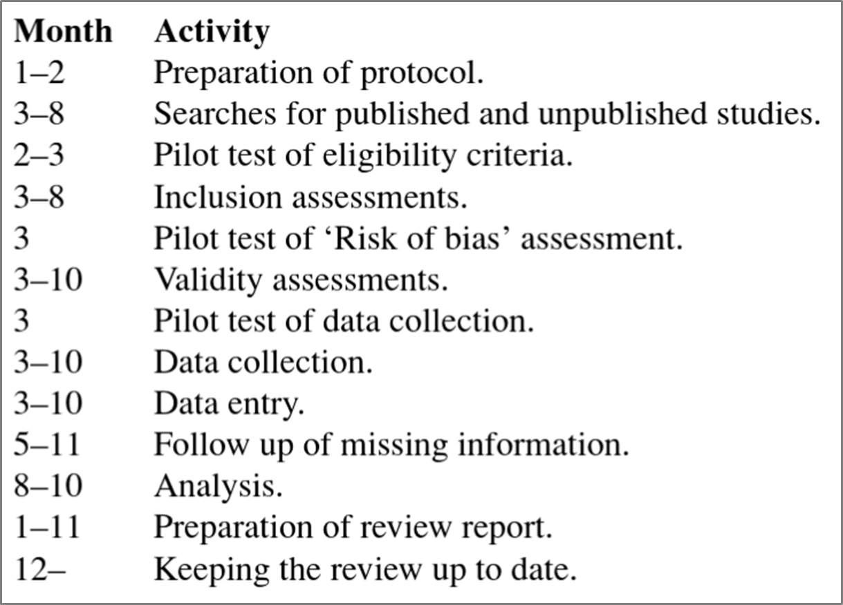
Systematic Review Resources and Guidelines
There is no shortage of manuals and guides to help you learn the ins and outs of doing a systematic review. While guidance from international research collaborations like Cochrane and JBI are the gold standard, these resources have been developed for researchers conducting and publishing Cochrane and JBI reviews and may be intimidating for new researchers or students. In such cases, student or introductory guides may be a more accessible starting point.
Guidance from International Research Collaborations
The following handbooks are freely available online:

Link: https://training.cochrane.org/handbook


Link: https://training.cochrane.org/handbook-diagnostic-test-accuracy
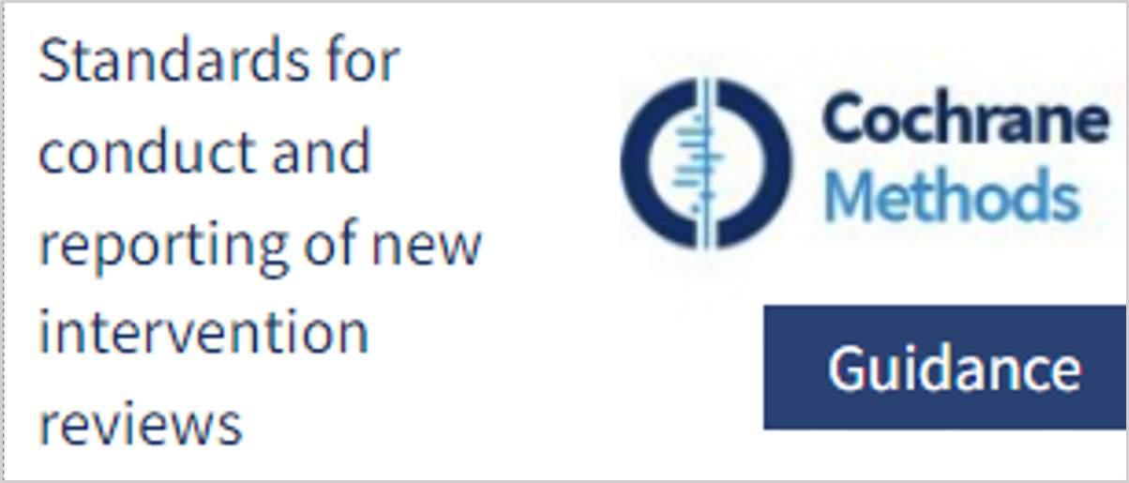
Link: https://community.cochrane.org/mecir-manual.(opens in a new tab)

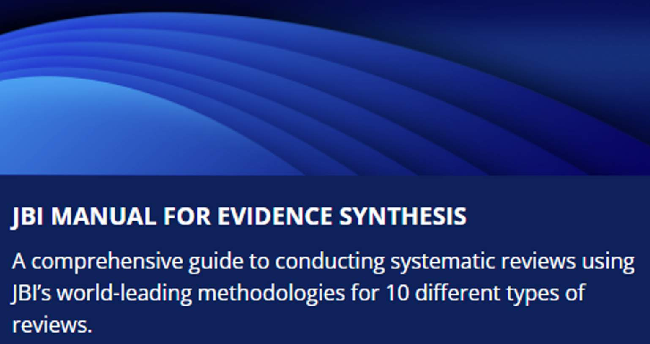
Link: https://jbi-global-wiki.refined.site/space/MANUAL

Other Guides and Resources
Check your library for access.

Link: https://study.sagepub.com/doingasystematicreview2e/student-resources/about-the-book(opens in a new tab)


Link: https://us.sagepub.com/en-us/nam/an-introduction-to-systematic-reviews/book245742


Link: https://us.sagepub.com/en-us/nam/systematic-approaches-to-a-successful-literature-review/book270933
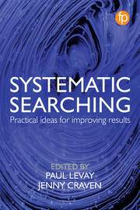
Link: https://www.routledge.com/Systematic-Searching-Practical-ideas-for-improving-results/Levay-Craven/p/book/9781783303731

Systematic Review Reporting Standards
It is crucial for systematic review authors to clearly report their methods and findings so that readers can properly appraise how well the systematic review was conducted, an essential component of evidence-based decision making. Transparent reporting can also facilitate the replication of research methods to verify the findings.
PRISMA
While international research collaborations like Cochrane and JBI provide their own detailed reporting instructions for authors, many journals endorse PRISMA (Preferred Reporting Items for Systematic Reviews and Meta-Analyses). The PRISMA 2020 Statement that was published in 2021 consists of a checklist and a flow diagram, and is intended to be accompanied by the PRISMA 2020 Explanation and Elaboration document.⁴¹⁻⁴²
PRISMA 2020 Checklist
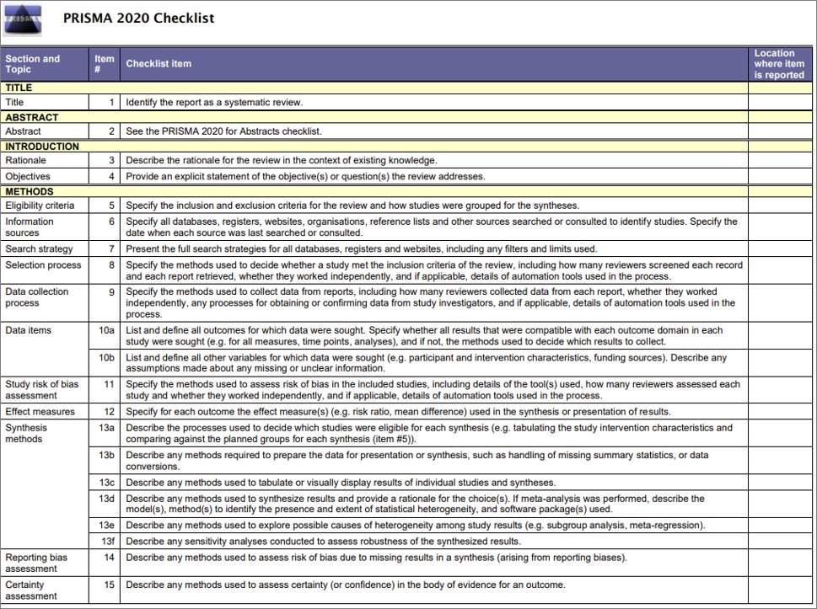
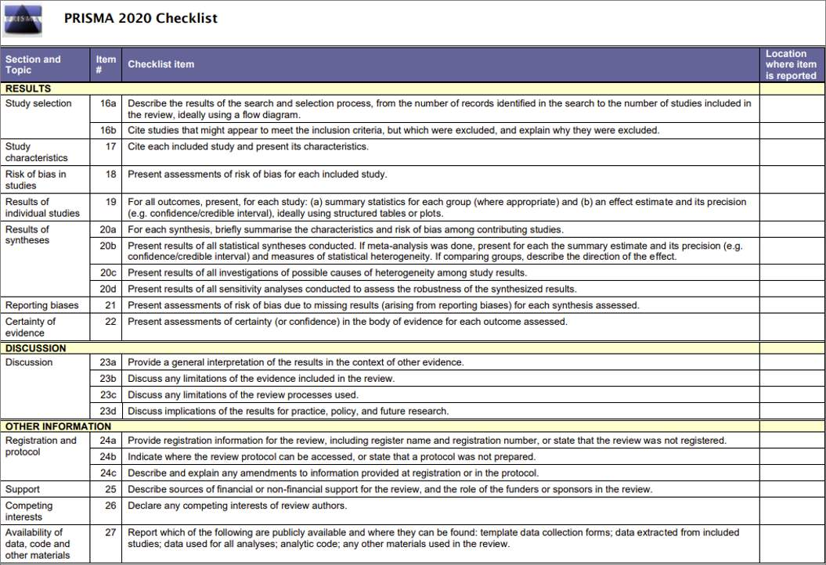
PRISMA Extensions
PRISMA also provides many extensions for reporting different aspects of a systematic review (e.g., PRISMA for Abstracts, PRISMA for Protocols, and PRISMA for Searching) in addition to extension for different review types (e.g., PRISMA for Diagnostic Test Accuracy and PRISMA for Network Meta-Analyses).

Knowledge Check
Please place the steps of conducting a systematic review into the correct order:
- Extract data (5)
- Locate studies through searching (3)
- Assess the quality of studies (6)
- Analyze and synthesize relevant studies (7)
- Formulate a review question (1)
- Define inclusion and exclusion criteria (2)
- Select studies for inclusion (4)
- Present and interpret the results (8)

You have completed Lesson 4 of 5 of Module 1: Introduction to Systematic Reviews.

