The Mass Production of Systematic Reviews
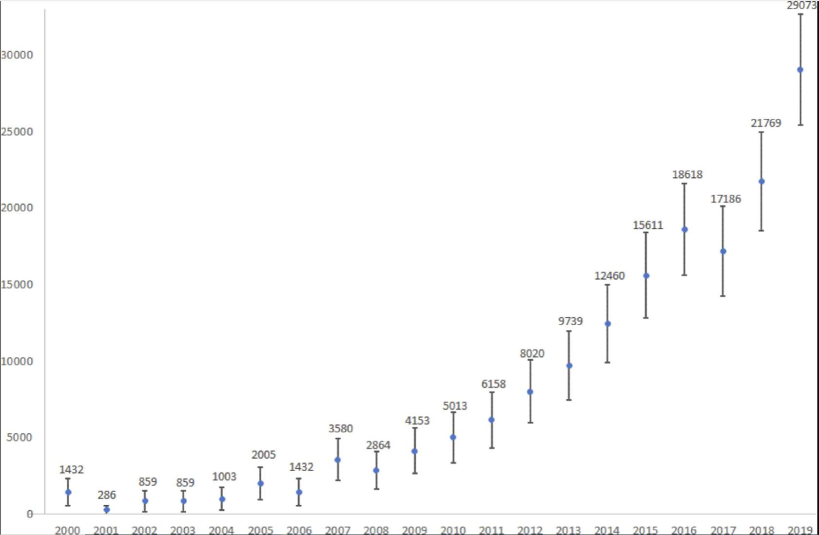
Figure 7: Estimated number of systematic reviews indexed in MEDLINE (via PubMed) per year (including 95% CI), 2000–2019.⁴³
In 2019, a total of 80 systematic reviews were published per day!⁴³
In 2021, the number had already increased to 135 per day!⁴⁴
While a steady rise of high-quality systematic reviews would be a welcome trend in any profession, the reality is that many of these systematic reviews are redundant, misleading, and conflicting,⁴⁵ which makes their use in evidence-based practice more challenging. Synthesized research evidence becomes less efficient for healthcare practitioners and policy makers than intended if they are just switching from having to collect and appraise numerous primary research studies to numerous systematic reviews.
Several factors come into play when examining why systematic review publications are on a steep incline. Please navigate through the process tabs below for more details.
Factor 1 - The ever-increasing number of studies
- The ever-increasing number of primary studies means that there is a continuously expanding body of literature to synthesize.⁴⁶
Factor 2 - Publish or Perish
- Researchers face pressures to publish (or perish) in order to advance their careers.⁴⁷ Academic institutions have been criticized for rewarding quantity over quality of research articles and contributing to the problem of unnecessary publications.
Factor 3 - New and expanding journal publications
- New biomedical journals are being created all the time, including predatory journals, which increases the number of publishing options available to authors. Additionally, some biomedical journals are steadily increasing the number of articles they publish each year.⁴⁸
Factor 4 - Student assignments and research projects
- More undergraduate and graduate students are now conducting systematic reviews as course assignments or research projects.
Factor 5 - Industry financial influence
- Favourable findings from industry-sponsored research can be used as a way to market products and increase profits.⁴⁹

Characteristics of High-Quality Systematic Reviews
High-quality systematic reviews take care to employ methods that will minimize the risk of error and bias during the research process. As mentioned earlier, international research collaborations like Cochrane and JBI are the gold standard for producing systematic reviews and many of these review teams involve methodologists/biostatisticians and librarians.

Measures that authors can take to increase the quality of a systematic review include:
- Publish or register a review protocol to increase transparency. This can help readers investigate the likelihood of outcome reporting bias;
- Employ comprehensive search strategies across multiple databases to identify all eligible studies and minimize selection bias;
- Include research evidence in the form of “grey literature” (i.e. unpublished studies) such as conference materials, preprint articles, and data from clinical trials registries, as appropriate, to reduce publication bias;
- Attempt to include non-English studies to reduce language bias;
- Consider heterogeneity (variation across individual studies) and only perform a meta-analysis of all, or some, of the studies when appropriate;
- Comply with systematic review reporting guidelines to increase reproducibility and transparency.

Impact of Suboptimal Systematic Reviews
Poor or flawed systematic review methods (whether intentional or not) lead to misleading results, bias, and research waste.
Suboptimal and low-quality systematic reviews diminish their usefulness for evidence-based practice⁴³ and can be exploited as marketing tools.⁴⁶
“Living systematic reviews” could address the redundancy of systematic review research.⁴³
Navigating through the discrepancies of redundant, misleading, and conflicting systematic reviews can even be demanding for practitioners who are well trained in evidence-based medicine and highly conversant on these methods⁴⁵

Importance of Appraising Systematic Reviews
As is the case with primary research studies, not all systematic reviews are created equal. Flawed research design and/or execution can introduce bias and lead to misleading results.
No research study should be taken at face value. Critical appraisal tools for systematic reviews specifically, include AMSTAR 2, which can help walk you through important questions about the methodology and reporting to consider before relying on the findings of any review.⁵⁰
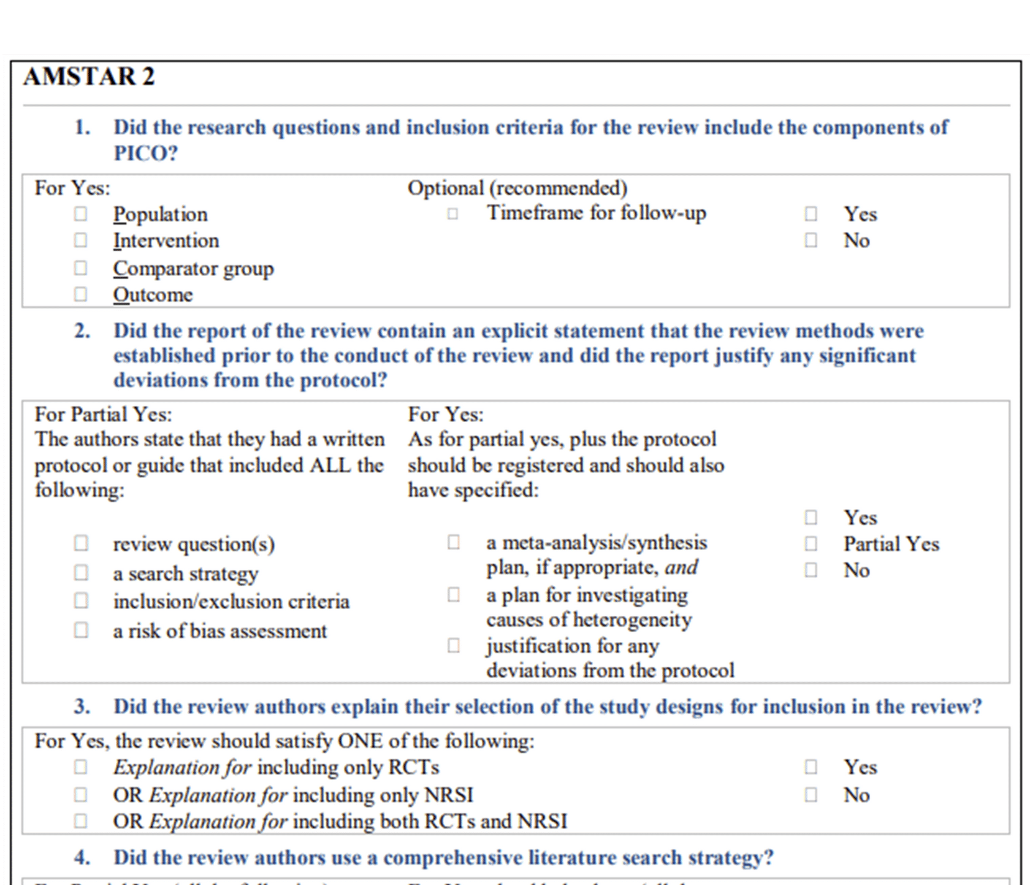
Figure 8: Extract from the AMSTAR 2 tool.

Critical Appraisal Checklists for Systematic Reviews:
- AMSTAR 2(opens in a new tab)
- CASP Systematic Review Checklist(opens in a new tab)
- JBI Checklist for Systematic Reviews(opens in a new tab)

Knowledge Check
Taking shortcuts when conducting systematic reviews is one way that bias can be introduced into the research process. Match the systematic review research shortcomings below with the most specific type of bias that may result or be indicated.
- Only searched one database
- Protocol not available
- Non-English studies not included
- Grey literature not included
- Publication bias (4)
- Language bias (3)
- Outcome reporting bias (2)
- Selection bias (1)

Congratulations! You have completed the final lesson of Module 1: Introduction to Systematic Reviews.

