Module 3: Searching for Eligible Studies
The third module in the series The Essentials of Conducting Systematic Reviews explores how and where to search for studies, how to manage search results, and how to report the search methods and results.
The author of this module is:
Sandra McKeown, Health Sciences Librarian at Queen's University.
At the end of this module, learners will be able to:
- Discuss elements of a comprehensive search strategy;
- Identify relevant sources to search;
- Describe supplemental search methods;
- Manage and export search results;
- Report the search in compliance with PRISMA-S guidelines.

Suggested citation:
McKeown S. Module 3: searching for eligible studies. In: McKeown S, Ritonja J, editors. The essentials of conducting systematic reviews [Internet]. Kingston (ON): Office of Professional Development and Educational Scholarship, Queen’s University; 2025 Jun 3. Available from: https://healthsci.queensu.ca/sites/opdes/files/modules/searching-for-eligible-studies-m3.

Lesson 1: Introduction to Systematic Review Searching
A Note About Librarian Involvement:
This module will explore considerations and strategies for developing and executing a comprehensive search approach but it is not intended to make you an expert searcher. Fortunately, comprehensive searching is a skill set that many librarians possess and may be able to help you with.

Did you know?
- Research evidence has demonstrated that librarian involvement in systematic review research can improve the quality of search methods and reporting.¹⁻⁴
- Involving a librarian in systematic review research is a best practice recommendation by international research collaborations and prominent medical journals encourage researchers to engage librarians in the review process to increase research quality and reduce research waste.⁵⁻⁹
Contact the library at your academic or healthcare institution to inquire about systematic review support, preferably in the early stages of the planning process.
Systematic Review Searching
Systematic reviews attempt to find all of the research evidence that can
answer a specific clinical question.¹⁰

In order to understand the full picture about how effective a health care intervention is, for example, all relevant studies need to be appraised and synthesized. Otherwise, selection bias and/or publication bias may present an incomplete and possibly misleading representation of the big picture, which can lead to sub-optimal care for patients, or worse.

The search approach that is necessary for systematic reviews is very different than what might constitute as an adequate search for other research projects or clinical practice.
A proper, comprehensive search is so fundamental to the rigorous systematic review methodology that it is a component of critical appraisal checklists for assessing the quality of systematic reviews.

Question 4 of the AMSTAR checklist (A MeaSurement Tool to Assess systematic Reviews):¹¹

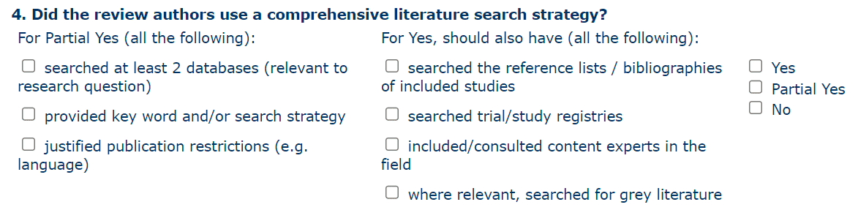

Components of a Comprehensive Search Approach:
- Including published and "unpublished" studies;
- Searching all relevant databases and information sources;
- Developing comprehensive search strategies;
- Using supplemental search methods.

Published and "Unpublished" Studies
When attempting to identify all eligible studies, many researchers naturally think to search for scholarly, peer-reviewed journal articles. In addition to studies published in journals, reviewers should consider searching for study data and study reports that are not made available by traditional commercial publishers in order to minimize bias.
Research has found that studies that report positive or significant results are more likely to be published, which can distort the findings of systematic reviews.¹²⁻¹⁴
While some researchers are hesitant to include non-peer-reviewed studies, there is limited evidence showing that published studies (particularly trials) are methodologically superior.¹⁵
Furthermore, studies included in a systematic review undergo critical appraisal (risk of bias assessments) because even published studies can be of poor quality.

Often referred to as grey literature, examples of unpublished literature containing study data or study reports include:
- Clinical trial data;
- Conference proceedings, abstracts and papers;
- Preprint articles;
- Dissertations and theses.

Knowledge Check

- Reviewers should include grey literature content in their systematic reviews because (select all that apply):
- Not all studies get published in scholarly journals
- It improves evidence-based decision making and patient care
- It's a requirement for getting your review published
- It helps minimize selection bias and publication bias

Correct answer: i, ii, & iv

Relevant Databases and Information Sources
Searching in health-related bibliographic databases is generally the most efficient way to identify references to journal articles. While many of these databases also include references for some types of grey literature, there are also information sources comprised of specific types of grey literature.
Ideally, reviewers should search all bibliographic databases and information sources that might contain relevant references for their research topic, however this may not always be possible or practical.
For example, while PubMed is made freely available for anyone to search, most bibliographic databases are made available through library subscriptions and require you to access them through your institution's library website.
At a minimum, reviewers should search two to three bibliographic databases for systematic reviews in health care, including PubMed (or Ovid MEDLINE) and Embase, if accessible. Additionally, reviewers should search relevant information sources for grey literature, many of which are freely available.
Comprehensive Search Strategies
"Searches for systematic reviews aim to be as extensive as possible in order to ensure that as many of the relevant studies as possible are included in the review. It is, however, necessary to strike a balance between striving for comprehensiveness and maintaining relevance when developing a search strategy."¹⁰
Sensitivity and Precision
Developing comprehensive search strategies in bibliographic databases is a balancing act between sensitivity/recall and precision. Recall being the ability of the search strategy to identify eligible studies, and precision being the ability of the search strategy to identify the relevant eligible studies relative to the overall number of database records that the search strategy generates.¹⁶
One study found a median precision of 1.5% and a median recall of 83% in Cochrane Reviews.¹⁶ For a review that ends up including 24 eligible studies, this would translate to screening 1600 records. This can be a helpful benchmark for developing a systematic review search, although precision has been shown to vary tremendously¹⁷ and will likely depend on the research question.
While the prospect of screening thousands of citations/abstracts retrieved from database searching might seem daunting, reviewers can usually ascertain relevance for 1-2 citation/abstracts per minute.¹⁰ In other words, "...the results of a database search can be screened at the rate of 60–120 per hour (or approximately 500–1000 over an 8-hour period), so the high yield and low precision associated with systematic review searching may not be as daunting as it might at first appear in comparison with the total time to be invested in the review."¹⁰
Supplemental Search Methods
While searching bibliographic databases can be a very effective way of identifying eligible studies, it is possible that comprehensive search strategies in databases and other information sources may not retrieve every relevant study. Furthermore, some study data or reports may not be in the bibliographic databases and grey literature sources searched. For this reason, supplemental search methods including checking reference lists and cited references, are recommended after the database search results have been screened to identify included studies.
Checking Reference Lists (Looking Back in Time):
Checking the reference lists of included studies allows you to examine if any additional eligible studies were cited by the included studies.


Checking Citing References (Looking Forward in Time):
Checking the citing references (or "cited by" references) of included studies allows you to examine if any additional eligible studies cite the included studies.
This can be accomplished by searching for a document title in Google Scholar(opens in a new tab) and then viewing the Cited by... search results. Scopus and Web of Science can also be used for this purpose.

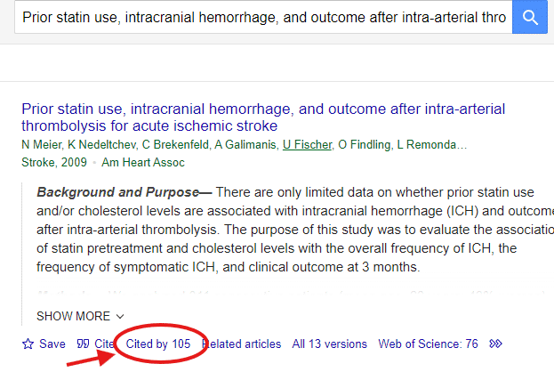

References
- Rethlefsen ML, Farrell AM, Osterhaus Trzasko LC, Brigham TJ. Librarian co-authors correlated with higher quality reported search strategies in general internal medicine systematic reviews. J Clin Epidemiol. 2015;68(6):617-626. doi:10.1016/j.jclinepi.2014.11.025(opens in a new tab).
- Meert D, Torabi N, Costella J. Impact of librarians on reporting of the literature searching component of pediatric systematic reviews. J Med Libr Assoc. 2016;104(4):267-277. https://doi.org/10.5195/jmla.2016.139(opens in a new tab).
- Koffel JB. Use of recommended search strategies in systematic reviews and the impact of librarian involvement: a cross-sectional survey of recent authors. PLoS One. 2015;10(5):e0125931. doi:10.1371/journal.pone.0125931(opens in a new tab).
- Schellinger J, Sewell K, Bloss JE, Ebron T, Forbes C. The effect of librarian involvement on the quality of systematic reviews in dental medicine. PLoS One. 2021;16(9):e0256833. doi:10.1371/journal.pone.0256833(opens in a new tab).
- Lefebvre C, Manheimer E, Glanville J. Chapter 6: Searching for studies. In: Higgins JPT, Green S. (Editors). Cochrane handbook for systematic reviews of interventions version 5.1.0. Updated March 2011. Accessed July 27, 2022. https://handbook-5-1.cochrane.org/chapter_6/6_searching_for_studies.htm(opens in a new tab).
- Aromataris E, Munn Z. Chapter 1: JBI systematic reviews. In: Aromataris E, Munn Z (Editors). In: JBI Manual for Evidence Synthesis. JBI; 2020. Accessed July 27, 2022. https://jbi-global-wiki.refined.site/space/MANUAL(opens in a new tab).
- Kugley S, Wade A, Thomas J, et al. Searching for studies: a guide to information retrieval for Campbell Systematic Reviews. Oslo: The Campbell Collaboration; 2017. Accessed July 27, 2022. doi: 10.4073/cmg.2016.1(opens in a new tab).
- Rethlefsen ML, Murad MH, Livingston EH. Engaging medical librarians to improve the quality of review articles. JAMA. 2014;312(10):999-1000. doi:10.1001/jama.2014.9263(opens in a new tab).
- Kirtley S. Increasing value and reducing waste in biomedical research: librarians are listening and are part of the answer. Lancet. 2016;387(10028):1601. doi:10.1016/S0140-6736(16)30241-0(opens in a new tab).
- Higgins JPT, Thomas J, Chandler J, Cumpston M, Li T, Page MJ, Welch VA (editors). Cochrane Handbook for Systematic Reviews of Interventions version 6.4 (updated August 2023). Cochrane, 2023. Available from www.training.cochrane.org/handbook(opens in a new tab).
- Shea BJ, Reeves BC, Wells G, Thuku M, Hamel C, Moran J, Moher D, Tugwell P, Welch V, Kristjansson E, Henry DA. AMSTAR 2: a critical appraisal tool for systematic reviews that include randomised or non-randomised studies of healthcare interventions, or both. BMJ. 2017 Sep 21;358:j4008. https://doi.org/10.1136/bmj.j4008(opens in a new tab).
- Dwan K, Gamble C, Williamson PR, Kirkham JJ, Reporting Bias Group. Systematic review of the empirical evidence of study publication bias and outcome reporting bias—an updated review. PloS one. 2013 Jul 5;8(7):e66844. https://doi.org/10.1371/journal.pone.0003081(opens in a new tab).
- Ioannidis JP, Munafo MR, Fusar-Poli P, Nosek BA, David SP. Publication and other reporting biases in cognitive sciences: detection, prevalence, and prevention. Trends in cognitive sciences. 2014 May 1;18(5):235-41. https://doi.org/10.1016/j.tics.2014.02.010(opens in a new tab).
- McAuley L, Tugwell P, Moher D. Does the inclusion of grey literature influence estimates of intervention effectiveness reported in meta-analyses?. The Lancet. 2000 Oct 7;356(9237):1228-31. https://doi.org/10.1016/s0140-6736(00)02786-0(opens in a new tab).
- Hopewell S, McDonald S, Clarke MJ, Egger M. Grey literature in meta‐analyses of randomized trials of health care interventions. Cochrane Database of Systematic Reviews. 2007(2). https://doi.org/10.1002/14651858.MR000010.pub2(opens in a new tab).
- Straube S, Heinz J, Landsvogt P, Friede T. Recall, precision, and coverage of literature searches in systematic reviews in occupational medicine: an overview of Cochrane Reviews Recall, Precision und Coverage von Literatursuchen in systematischen Reviews aus dem Bereich Arbeitsmedizin: Ein Überblick über Cochrane Reviews. GMS Medizinische Informatik, Biometrie und Epidemiologie. 2021;17(1). doi: 10.3205/mibe000216(opens in a new tab).
- Sampson M, Tetzlaff J, Urquhart C. Precision of healthcare systematic review searches in a cross‐sectional sample. Research synthesis methods. 2011 Jun;2(2):119-25. https://doi.org/10.1002/jrsm.42(opens in a new tab).

Lesson 2: Sources to Search
Health-related Bibliographic Databases
Searching in health-related bibliographic databases is generally the most efficient way to identify an initial set of relevant studies. Examples of health-related databases include PubMed/Ovid MEDLINE, Embase, and Cochrane Central Register of Controlled Trials (CENTRAL). These three databases are often considered the most important when searching for trials.¹⁸
PubMed / Ovid MEDLINE
MEDLINE(opens in a new tab) is produced by the National Library of Medicine (NLM) in the U.S. It contains more than 31 million references to biomedical journal articles dating back to 1946 and includes citations from over 5,200 scholarly journals published around the world in about 40 different languages.
MEDLINE is the primary component of PubMed(opens in a new tab), a literature database developed and maintained by the NLM National Center for Biotechnology Information.
PubMed contains more than 38 million references. In addition to MEDLINE content, PubMed also includes(opens in a new tab) citations that are being processed for MEDLINE, citations that are out-of-scope from MEDLINE journals, "ahead of print" citations that precede the article's final publication in a MEDLINE journal, and more.¹⁹
The same bibliographic records available in PubMed can also be searched via
"Ovid MEDLINE" or MEDLINE on EBSCO.
Access: PubMed is freely available. Ovid MEDLINE and MEDLINE on EBSCO require library/institution access.
Embase
Embase(opens in a new tab) is a biomedical database produced by the scientific publisher Elsevier. It contains more than 45 million references. In addition to including references from over 8,400 scholarly journals representing 95 countries, Embase also contains references for grey literature content:
- Over 5 million references for conference abstracts from over 15,000 conferences.
- Around 125,000 references to preprint articles from medRxiv and bioRxiv.
Access: Embase is a proprietary source that requires library/institution access. Embase is available on "Embase.com" and Ovid platforms, however, your library will likely only provide access to one or the other.
Cochrane CENTRAL
Cochrane CENTRAL(opens in a new tab) is a database of bibliographic reports of randomized controlled trials. It contains more than 2 million references.
Most records in Cochrane CENTRAL come from bibliographic databases (mainly PubMed and Embase.com). They also come from other published and unpublished sources, including CINAHL, ClinicalTrials.gov and the WHO's International Clinical Trials Registry Platform.
Access: Cochrane CENTRAL is a proprietary source that is included with a Cochrane Library subscription. Your library/institution may subscribe to Cochrane Library through Wiley or Ovid (EBM Reviews).
Visual Comparison of Database Platforms
PubMed
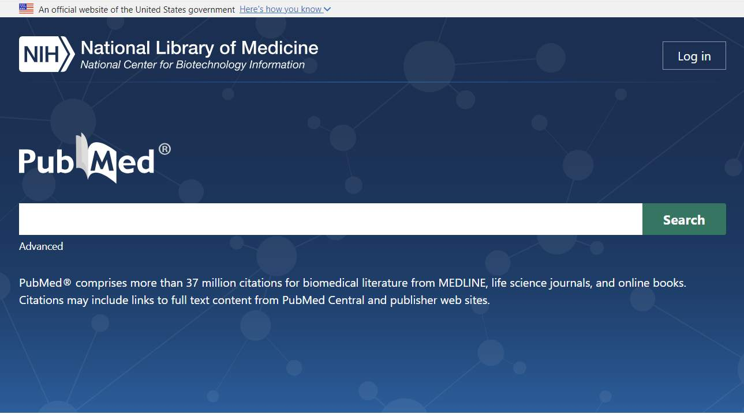
Ovid MEDLINE
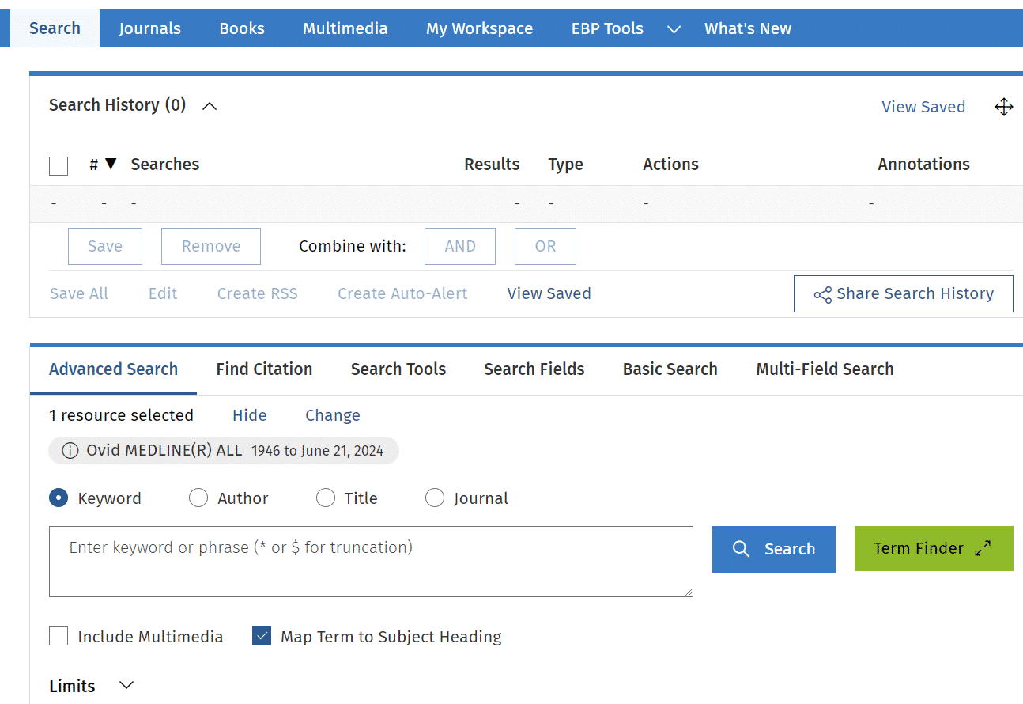
Embase.com
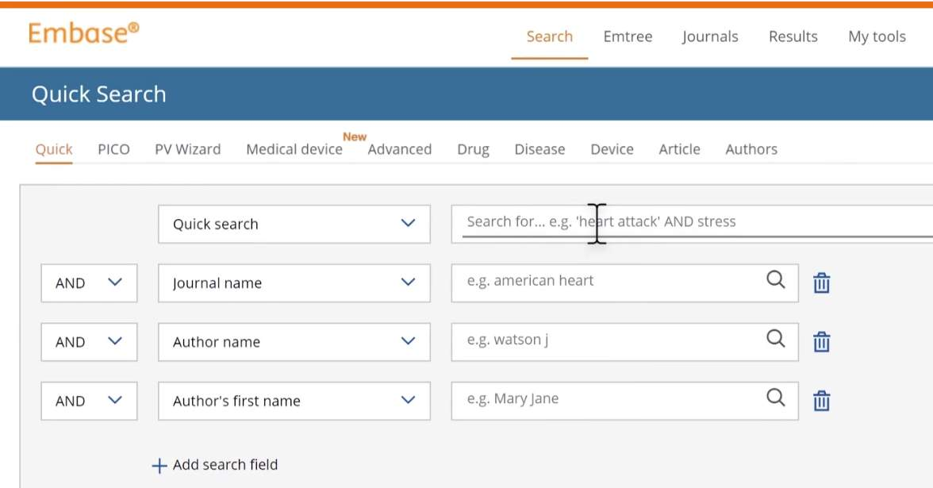

Ovid Embase
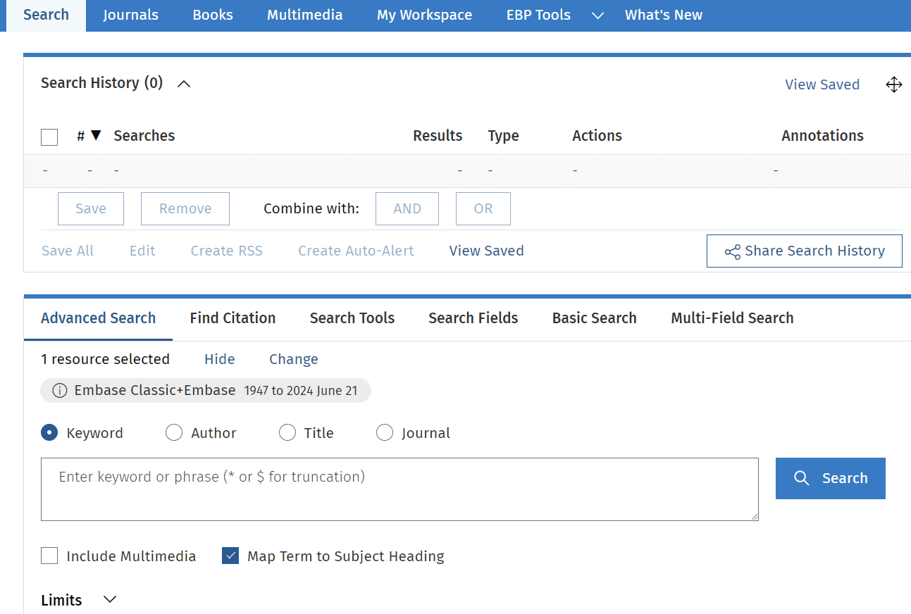

Cochrane Library (Wiley)
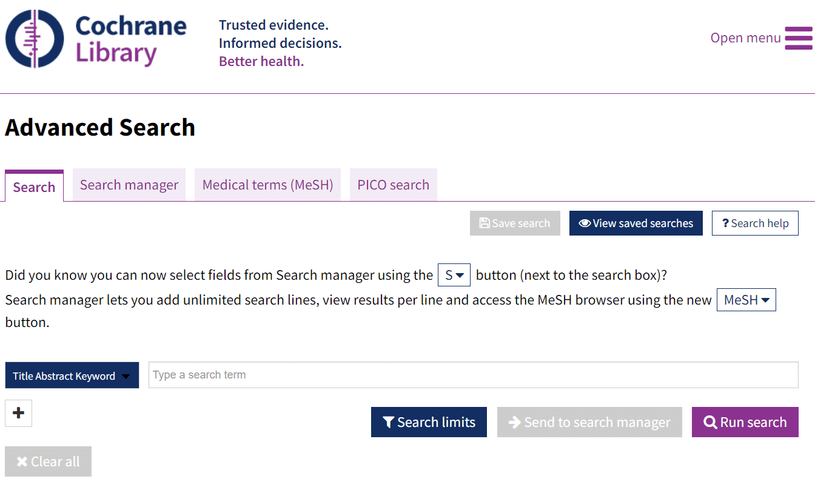
Cochrane Central Register of Controlled Trials on the Ovid interface
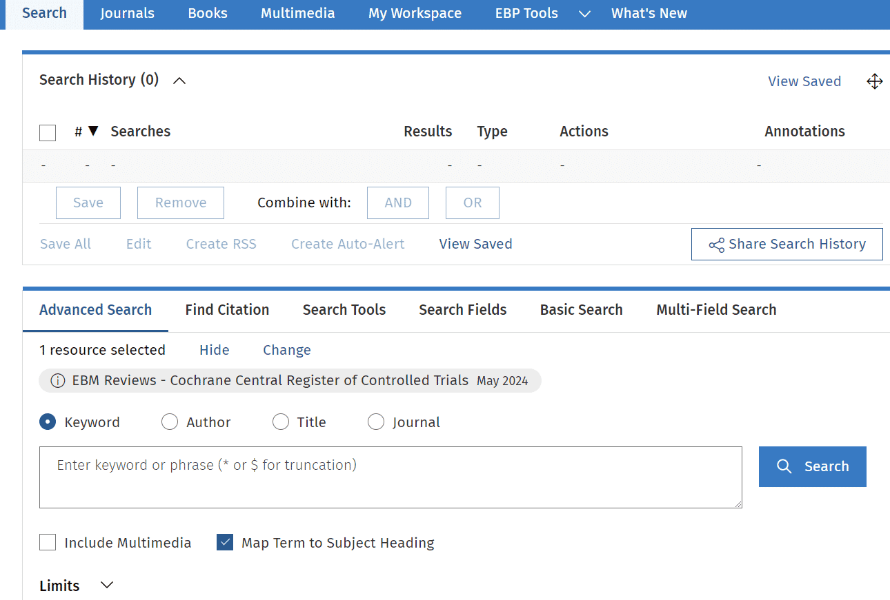

Knowledge Check
  - The main health-related databases for identifying trials are:
- Embase; Ovid; Cochrane CENTRAL
- PubMed; Ovid MEDLINE; Cochrane CENTRAL
- PubMed or Ovid MEDLINE; Embase; Cochrane CENTRAL
- PubMed; Ovid MEDLINE; Embase; Cochrane CENTRAL
Correct answer: c.

Subject-specific Bibliographic Databases
In addition to the health-related bibliographic databases above, there are also subject-specific options. These databases contain a fraction of the references that PubMed/Ovid MEDLINE and Embase have because they focus on a specific health-related subject area. Some library website's will have an option to search for databases by subject to help you identify relevant databases to search.
APA PsycInfo
APA PsycInfo(opens in a new tab) is a database covering the behavioral and social sciences produced by the American Psychological Association. It contains more than 5 million references.
In addition to including records from over 2,400 journals in 30 languages from 50 countries, APA PsycINFO also contains references for grey literature content in the form of dissertations.
Access: APA PsycInfo is a proprietary source that requires library/institution access. It is available on PsycNET, EBSCO, and Ovid platforms.
Individuals can also purchase access to APA databases through annual subscriptions or on-demand access(opens in a new tab).
AMED (Allied and Complementary Medicine Database)
AMED(opens in a new tab) is a unique bibliographic database produced by the Health Care Information Service of the British Library. It contains more than 375,000 references and covers a selection of over 600 journals in complementary medicine, palliative care, and several professions allied to medicine. Many references are not indexed by other biomedical sources.
Access: AMED is a proprietary source that requires library/institution access. It is available via Ovid and EBSCO platforms.

CINAHL (Cumulative Index in Nursing and Allied Health Literature)
CINAHL(opens in a new tab) is produced by EBSCO and covers nursing, biomedicine, alternative and complementary medicine, consumer health and 17 allied health disciplines. It contains more than 8 million references.
In addition to including records from over 6,000 journals, CINAHL also includes grey literature content in the form of nursing dissertations and selected conference proceedings.
Access: CINAHL is a proprietary source that requires library/institution access. It is available on the EBSCO platform.

Global Health
Global Health(opens in a new tab) is the leading specialist database dedicated to public health produced by CABI. It contains more than 4 million references, with research from over 100 countries in 50 languages.
Global Health includes over 7,300 journals. In addition to journal articles, it contains relevant grey literature content such as reports, conference proceedings, and theses. Around 40% of material contained in Global Health is unique to the database.
Access: Global Health is freely available to search on the CABI platform(opens in a new tab). It is also available via Ovid and EBSCO platforms to subscribing libraries/institutions.

Knowledge Check
- In addition to searching the three main health-related databases, which subject-specific database(s) would also be relevant for a systematic review investigating the effects of cranberries on urinary tract infections (select all that apply)?
  - AMED
  - APA PsycInfo
  - Global Health
Correct answer: a.
AMED (Allied and Complementary Medicine) could be a good addition here. It wouldn't hurt to include CINAHL as well, but it's possible that any relevant studies retrieved from CINAHL would have already been picked up in the main health-related databases.
Reference
EBSCO. Allied and Complementary Medicine Database (AMED). Accessed September 4, 204: https://www.ebsco.com/products/research-databases/allied-and-complementary-medicine-database-amed

Multidisciplinary Bibliographic Databases
Searching databases outside of the health sciences may be helpful if your topic is multidisciplinary. For example, if your review centers around medical education, it is possible that relevant studies could be published in education journals that are not included in health-related databases.
The main two multidisciplinary bibliographic databases are Scopus and Web of Science Core Collection. Because their content coverage is so broad, these databases contain more than twice as many references as PubMed/Ovid MEDLINE or Embase.

Scopus
Scopus(opens in a new tab) is produced by the scientific publisher Elsevier. It contains more than 100 million references from over 29,000 active serial titles.
Scopus incorporates grey literature including over 2.5 million preprint records from seven leading preprint servers as well as conference materials from serials and conference proceedings.
Access: Scopus is a proprietary source that requires library/institution access.
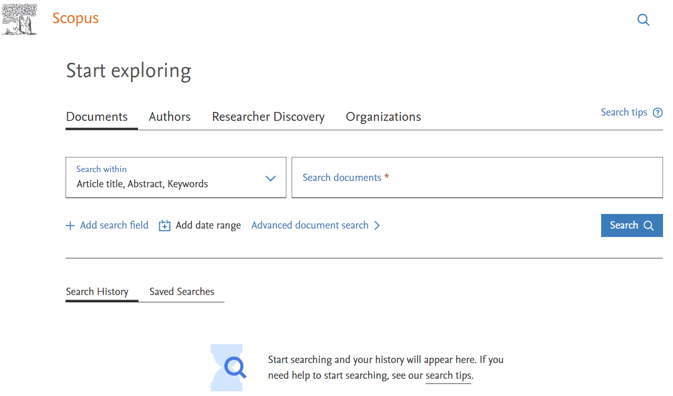

Web of Science Core Collection
Web of Science Core Collection(opens in a new tab) is owned by Clarivate. It contains more than 95 million references from over 22,000 peer-reviewed journals.
Web of Science Core Collection also contains grey literature content in the form of more than 13.5 million references from over 314,000 conferences.
Access: Web of Science is a proprietary source that requires library/institution access.
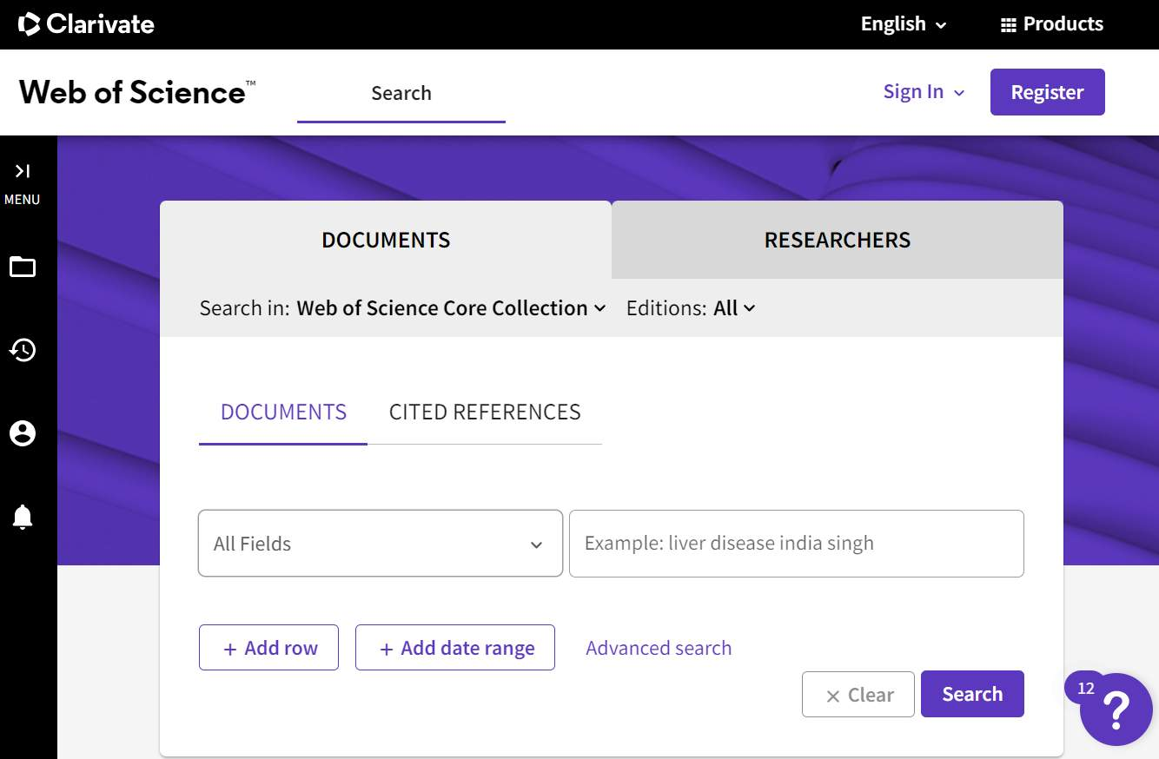

Notes on Searching Bibliographic Databases
- Database selection should be guided by the research topic and question type. For example, if your question is about diagnostic test accuracy, you would not search Cochrane CENTRAL because you are looking for accuracy studies not randomized controlled trials.
- It is common for bibliographic databases to be available on more than one search platform or interface (e.g., PubMed vs. Ovid MEDLINE). Which databases and platforms you are able to search will depend on access via your library/institution.
- There is content overlap across bibliographic databases. For example, of the more than 8,400 journals with records in Embase, only 3,365 of those journals are unique to this database. For this reason, it is best to remove duplicate references from database searching before the screening process. This will be discussed later in the module.

Grey Literature Information Sources
While grey literature document types are vast, only study data or study reports are relevant in the context of systematic review searching. Grey literature sources for studies include, for example, trial registers, conference proceedings, preprint servers, and dissertation and theses databases. Many grey literature sources are free to search.
Clinical Trial Registers
Two of the main trial registers are ClinicalTrials.gov(opens in a new tab) and the World Health Organization's International Clinical Trials Registry Platform (WHO ICTRP(opens in a new tab)), which are free to search. Wikipedia provides a list of clinical trial registers(opens in a new tab) that can help identify additional sources that may be appropriate.
Searching clinical trial registers and identifying trial data that may not be reported/published elsewhere is mandatory for authors conducting a Cochrane systematic review in order to reduce the risk of publication bias.¹⁸
Excerpt from the Cochrane Handbook for Systematic Reviews of Interventions:
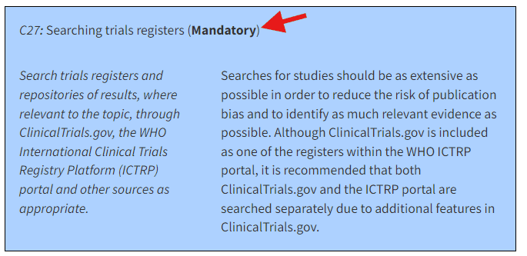
Image of MECIR Box 4.3.d: Relevant expectations for conduct of intervention reviews.¹⁸

Preprint Servers and Databases
The preprint server for the health sciences, medRxiv(opens in a new tab) (pronounced med-archive), describes preprints as "...preliminary reports of work that have not been certified by peer review."²⁰
It may be appropriate to search additional preprint servers for some review questions (for example PsyArXiv(opens in a new tab) for psychology-related topics). Preprint servers are generally free to search. Wikipedia provides a list of preprint repositories(opens in a new tab) that can help identify additional sources that may be appropriate.
Some library's may provide access to Preprint Citation Index, which allows aggregated preprint discovery from multiple preprint repositories. If you will be searching medRxiv as well as arXiv, bioRxiv, chemRxiv, or Preprints.org, check to see if your library subscribes to Preprint Citation Index(opens in a new tab) to streamline the preprint search process.

Dissertations and Theses Databases
To identify databases for finding dissertations and theses that may be available through your library, look for a link to Databases on your library's website and try searching for "dissertations" or "theses". An example of a database requiring a library subscription to search is ProQuest Dissertations & Theses Global(opens in a new tab).
Some bibliographic databases include records for dissertations, two examples are PsycInfo and CINAHL (Cumulative Index to Nursing and Allied Health).
There are also a number of free sources available for identifying dissertations and theses, including:
- EBSCO Open Dissertations(opens in a new tab)
- Networked Digital Library of Theses(opens in a new tab)
- DART-Europe E-theses Portal(opens in a new tab)

Knowledge Check
- Match the type of grey literature content to the information source:
  - WHO ICTRP
  - medRxiv
  - DART-Europe E-theses Portal
  - Preprint server
  - Dissertations & theses database
  - Trial register
Correct answers: a=iii; b=i; c=ii

References
- Lefebvre C, Glanville J, Briscoe S, Featherstone R, Littlewood A, Metzendorf M-I, Noel-Storr A, Paynter R, Rader T, Thomas J, Wieland LS. Chapter 4: Searching for and selecting studies. In: Higgins JPT, Thomas J, Chandler J, Cumpston M, Li T, Page MJ, Welch VA (editors). Cochrane Handbook for Systematic Reviews of Interventions version 6.4 (updated October 2023). Cochrane, 2023. Available from www.training.cochrane.org/handbook(opens in a new tab).
- MEDLINE, PubMed, and PMC (PubMed Central): How are they different? Last updated December 28, 2023. Accessed June 23, 2024. https://www.nlm.nih.gov/bsd/difference.html(opens in a new tab).
- Cold Spring Harbor Laboratory, Yale University, BMJ. medRxiv. Accessed September 4, 2024. https://www.medrxiv.org/(opens in a new tab).

Lesson 3: Developing Comprehensive Search Strategies
Developing Comprehensive Search Strategies
This section focuses on designing comprehensive search strategies in bibliographic databases, which offer advanced search options and sophisticated platforms to help users contend with searching millions of records. (Searching in information sources that are much smaller in scale, such as ClinicalTrials.gov or medRxiv, often requires a more simplified approach).
Bibliographic databases are comprised of a large set of database records. Each database record contains bibliographic information for a specific work of literature, presented in fields such as title, abstract, author-provided keywords, etc. Database records in some bibliographic databases are also assigned subject headings to describe the subjects covered in the work.
Database record in Ovid MEDLINE (arrows pointing to relevant search fields):
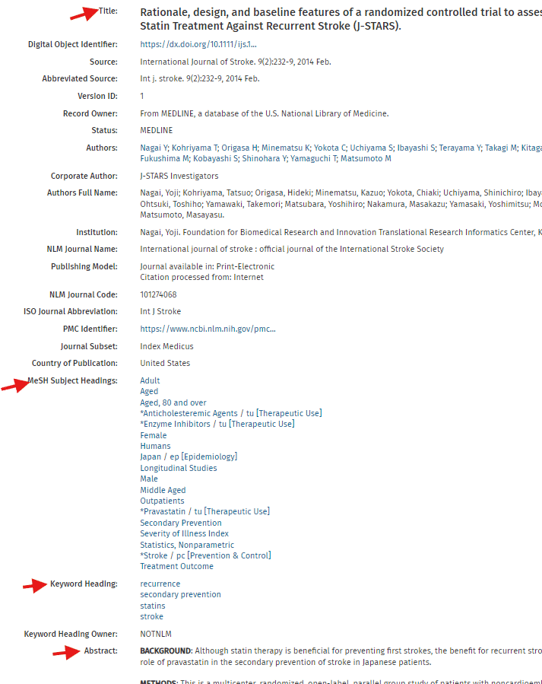

As the gold standard for conducting systematic reviews,
Cochrane recommends searching bibliographic databases
using a combination of text words and subject headings.²¹⁻²²

Text Words
Text words (also referred to as keywords) are the terms that are present in the various fields of a database record.
Highly relevant fields for conducting a text word search include title, abstract, and author-provided keywords.
Because authors can express the same concept with different words or word variations, it is essential to consider spelling variants, synonyms, acronyms, truncation, and sometimes antonyms, when conducting text word searching.
Many databases offer advanced search techniques to help you search for spelling variants and the different truncation of rootwords. Every database will have some sort of help menu available where you can check to see what options are available.
Ovid's help menu describing how to use truncation and wildcards:
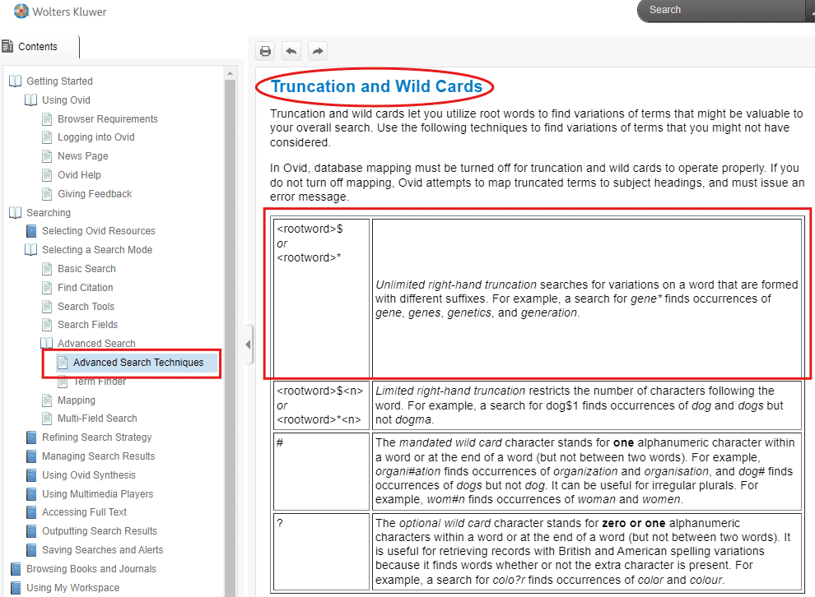

Subject Headings
Many discipline/subject-specific bibliographic databases use a controlled vocabulary, often referred to as subject headings, to index records in the database (assigned by human indexers and/or using automated methods).
Subject headings are generally database-specific. While MEDLINE uses "Medical Subject Headings" or "MeSH terms" to index database records, other bibliographic databases use different subject headings (e.g., "Emtree" terms in Embase).
"[Subject headings] are useful because they provide a complementary way of retrieving records that may use different text words to describe the same concept and because they can provide information beyond that which is contained in the words in the title and abstract." - Technical Supplement to Chapter 4: Searching for and selecting studies.²¹
For example, in MEDLINE, searching with the MeSH Hydroxymethylglutaryl-CoA Reductase Inhibitors will retrieve articles indexed with this concept, even if the authors use different words to describe this concept in their title/abstract.
MeSH "Scope Note" for Hydroxymethylglutaryl-CoA Reductase Inhibitors in Ovid MEDLINE:
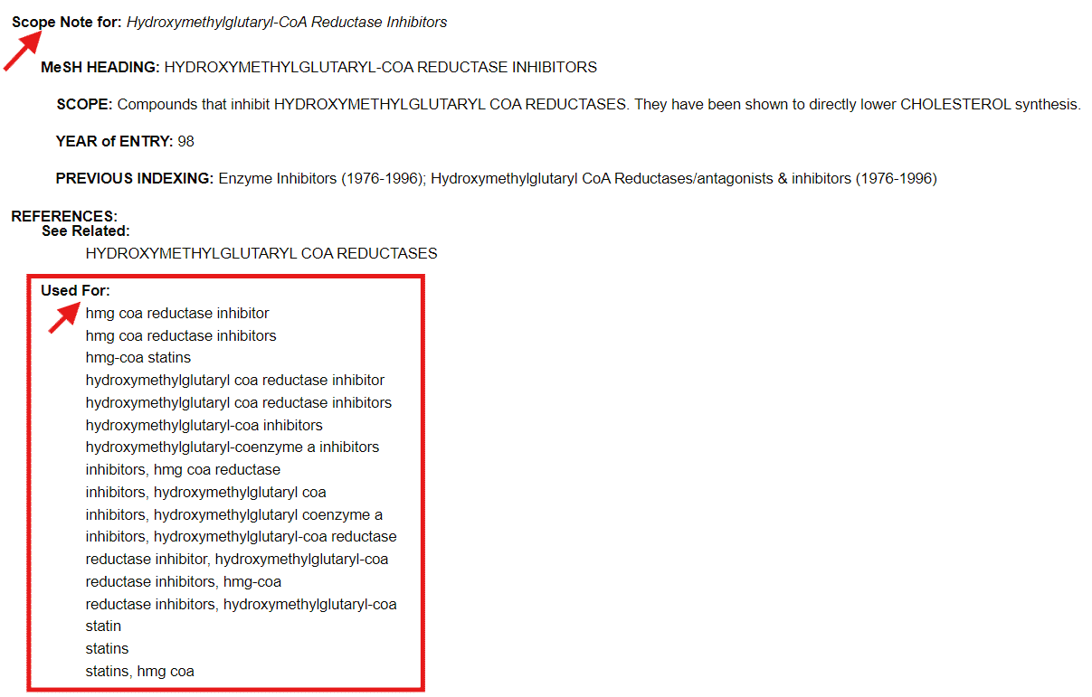
The "Used For" section shows examples of other words that authors may have used for this concept in their title, abstract, or provided keywords.
Check out review tools that help identify
relevant MeSH terms in PubMed/MEDLINE
in Module 8.
There are limitations to subject heading searching in bibliographic databases though, which is why a complementary approach with text word searching is needed.
A common misconception about searching bibliographic databases is thinking that you can search for terms that appear in the full text. However, most bibliographic databases contain just that, bibliographic information and not full text articles. Therefore, you generally cannot search within the corresponding full text when searching for records in bibliographic databases.
Identifying Your Main Concepts
Using a research question formulation framework such as PICOS (see Module 2) can help identify the main concepts of your systematic review question before beginning your search.
Whether you use a framework like PICOS or not, you will need to identify the main concepts of your review question to plan your search.
The Cochrane Handbook explains why including all of your main concepts in a search is generally unnecessary, and even undesirable at times, though:
"Although a research question may specify particular comparators or outcomes, these concepts may not be well described in the title or abstract of an article and are often not well indexed with controlled vocabulary terms. Therefore, when searching general databases, such as MEDLINE, a search strategy [for a PICO question] will typically have three sets of terms:
(i) terms to search for the health condition of interest, i.e. the population;
(ii) terms to search for the intervention(s) evaluated; and
(iii) terms to search for the types of study design to be included."²²

For example:
PICO question: "In adults with a previous history of ischemic stroke (P), how does use of statin therapy (I) compare to no use of statin therapy (C) in terms of ischemic stroke recurrence (O), as measured by randomized controlled trials and cohort studies (S)?"
Search concepts:
(i) ischemic stroke (P)
(ii) statins (I)
(iii) randomized controlled trials or cohort studies (S)
Identifying Relevant Search Terms
Text words
Relevant text words can be identified by:
- Reviewing a few eligible studies, particularly, the title, abstract, and author-provided keywords (if available).
- This step will help you understand variations in the language being used by authors to describe your search concepts (e.g., spelling variants, synonyms, acronyms, and related antonyms).
- If you aren't already aware of a few eligible studies, you can try doing a simple search in Google Scholar(opens in a new tab).
- Reviewing the scope note for relevant subject headings within bibliographic databases to identify "Used For" terms that might be helpful to include as text words.
Subject headings
Relevant subject headings can be identified by:
- Retrieving the database record for eligible studies in the bibliographic databases you will be searching and then reviewing any assigned subject headings.
- Tip: you can do a title search to determine if a bibliographic database has a record for an eligible study. If it does, view the complete database record to see any assigned subject headings.
- Exploring the subject headings available within a bibliographic database by having the database "map to" or "suggest" relevant subject headings for the words or phrases entered.
Combining Search Terms
- Use AND to combine different search concepts (e.g., P AND I).
- Use OR to capture spelling variants, synonyms, acronyms, and relevant antonyms, for each of your search concepts.
Knowledge Check
How do we properly combine the search terms displayed below:
- Stroke / Statins
- Statins / Atorvastatin / Fluvastatin
- Randomized Controlled Trials / Cohort Studies
  - OR
  - AND
Correct answers: 1=b; 2=a; 3=a.

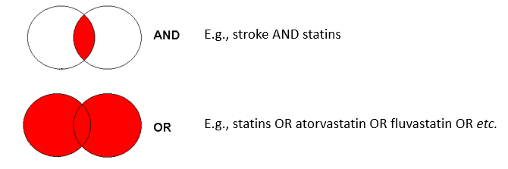
Image of combining search terms with AND/OR.

Using the PICO question above, I retrieved a known eligible study in Ovid MEDLINE by doing a title search:
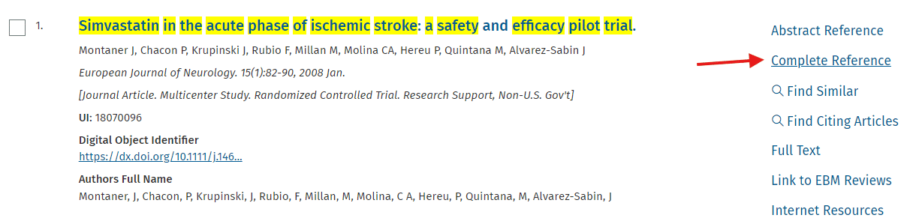
Clicking on "Complete Reference" in Ovid MEDLINE will display any subject headings assigned to this record.
Knowledge Check
1. What subject heading(s) might be relevant for searching the concept of ischemic stroke?
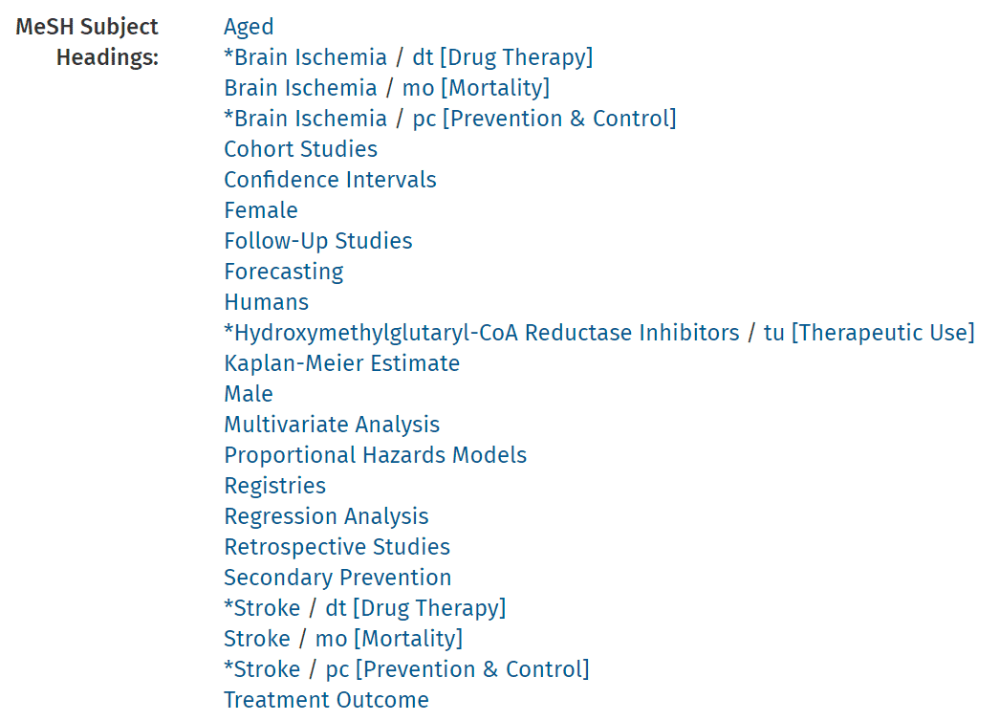
Correct responses include: Stroke, Brain Ischemia, stroke and brain ischemia, brain ischemia and stroke, stroke brain ischemia, brain ischemia stroke, brain ischemia, stroke, stroke, brain ischemia, stroke or brain ischemia, brain ischemia or stroke.
Most Cochrane Reviews about ischemic stroke use "OR" to combine subject headings for Stroke with the subject heading for Brain Ischemia to be as comprehensive as possible.
Reference
Dower A, Mulcahy M, Maharaj M, Chen H, Lim CE, Li Y, Sheridan M. Surgical decompression for malignant cerebral oedema after ischaemic stroke. Cochrane Database of Systematic Reviews 2022, Issue 11. Art. No.: CD014989. DOI: 10.1002/14651858.CD014989.pub(opens in a new tab)2. Accessed 11 September 2024.

- What subject heading(s) might be relevant for searching the concept of study design in this scenario (i.e. randomized controlled trials or cohort studies)? Separate subject headings in answer with a comma and space.

Correct responses include: cohort studies, retrospective studies, follow-up studies, retrospective studies, follow-up studies, cohort studies, follow-up studies, retrospective studies, cohort studies, cohort studies, follow-up studies, retrospective studies, follow-up studies, cohort studies, retrospective studies, retrospective studies, cohort studies, follow-up studies.
Relevant subject headings for cohort studies include Cohort Studies, Follow-Up Studies, Retrospective Studies.
Reference
BMJ Knowledge Centre. Search strategies. Accessed September 4, 2024. https://bestpractice.bmj.com/info/toolkit/learn-ebm/study-design-search-filters/

Search Filters
Search filters are a combination of search terms (e.g., subject headings and text words) designed to retrieve specific records in a bibliographic database, for example, references that use a specific study design or cover a certain topic. Search filters are database and platform specific because they incorporate database-specific subject headings and platform-specific syntax. For example, there are different filters for identifying randomized controlled trials in Ovid MEDLINE, PubMed, and Ovid Embase.
Note about search filters for study designs: It may not be necessary, or even desirable, to include a search filter for study design if the number of search results after combining your other main concepts is already fairly manageable. Keep in mind that all study design filters (even the ones developed to maximize sensitivity) and all search strategies are a compromise that may miss relevant database records.²²

Where to Find Search Filters
Cochrane's Technical Supplement to Chapter 4: Searching for and selecting studies(opens in a new tab) contains search filters for identifying randomized controlled trials in different databases and using various platforms.²¹

The ISSG Search Filter Resource(opens in a new tab) "is a collaborative venture to identify, assess and test search filters designed to retrieve research by study design or focus. The Search Filters Resource aims to provide easy access to published and unpublished search filters."²³

Publication Date Considerations
Bibliographic databases allow you to filter your database search results by publication date. It may be appropriate to limit your search results by publication date in some cases, but this should not be done arbitrarily to reduce the number of references that need to be screened. One example where it might make sense to limit by publication date, is if a drug has been on the market for decades but has only recently been approved for treating a different condition (the one you are interested in). Be prepared to provide a rationale in your manuscript if you do end up excluding studies published before a certain time period.

Language Considerations
While bibliographic databases provide the option of filtering by publication language, reviewers should keep in mind that database records for non-English references will provide an English translation for the citation and abstract. This means that reviewers can complete title/abstract screening for non-English references.
In some cases, reviewers may not end up with any non-English references that move on to full-text screening, and their review may not have language limitations. In other cases, where non-English references make it to full-text screening, reviewers can use free translation programs like Google Translate(opens in a new tab) or DeepL(opens in a new tab) to try to determine whether a study meets their eligibility criteria. Reviewers should describe any language limitations of their review in the manuscript.

Key Points
- The search process for a systematic review should be iterative:
  - After combining your search concepts you can decide if a broader or more specific approach is needed if you're retrieving too many or very few search results.
- Text word and subject heading searching will look different depending on the database and platform being used.
  - Look for a "Help" option within each database to learn more about advanced search options.
- Recall that librarian involvement in systematic review searching is a best practice recommendation!

Knowledge Check
- It is essential to consider spelling variants, synonyms, acronyms, and sometimes antonyms, when searching for your concepts.
- True
- False
Correct answer: True.
Because authors can express the same concept with different words or word variations, it is essential to consider spelling variants, synonyms, acronyms, truncation, and sometimes antonyms, when conducting text word searching.
Reference
Lefebvre C, Glanville J, Briscoe S, Featherstone R, Littlewood A, Metzendorf M-I, Noel-Storr A, Paynter R, Rader T, Thomas J, Wieland LS. Chapter 4: Searching for and selecting studies. In: Higgins JPT, Thomas J, Chandler J, Cumpston M, Li T, Page MJ, Welch VA (editors). Cochrane Handbook for Systematic Reviews of Interventions version 6.4 (updated October 2023). Cochrane, 2023. Available from www.training.cochrane.org/handbook(opens in a new tab).

- All of your main concepts (e.g. PICO elements) must be represented in your search strategy.
  - True
  - False
Correct answer: False.
The Cochrane Handbook explains why including all of your main concepts in a search is generally unnecessary, and even undesirable at times, though:
"Although a research question may specify particular comparators or outcomes, these concepts may not be well described in the title or abstract of an article and are often not well indexed with controlled vocabulary terms. Therefore, when searching general databases, such as MEDLINE, a search strategy [for a PICO question] will typically have three sets of terms:
(i) terms to search for the health condition of interest, i.e. the population;
(ii) terms to search for the intervention(s) evaluated; and
(iii) terms to search for the types of study design to be included."
Reference
Lefebvre C, Glanville J, Briscoe S, Featherstone R, Littlewood A, Metzendorf M-I, Noel-Storr A, Paynter R, Rader T, Thomas J, Wieland LS. Chapter 4: Searching for and selecting studies. In: Higgins JPT, Thomas J, Chandler J, Cumpston M, Li T, Page MJ, Welch VA (editors). Cochrane Handbook for Systematic Reviews of Interventions version 6.4 (updated October 2023). Cochrane, 2023. Available from www.training.cochrane.org/handbook(opens(opens in a new tab) in a new tab)(opens in a new tab).

- To ensure systematic reviews are based on current evidence, search results should be limited by publication date (e.g., from the year 2000 onward).
  - True
  - False
Correct answer: False.
Searches should capture as many studies as possible that meet the eligibility criteria and otherwise justify the use of any restrictions in the search strategy on publication date.

Reference
Lefebvre C, Glanville J, Briscoe S, Featherstone R, Littlewood A, Metzendorf M-I, Noel-Storr A, Paynter R, Rader T, Thomas J, Wieland LS. Chapter 4: Searching for and selecting studies. In: Higgins JPT, Thomas J, Chandler J, Cumpston M, Li T, Page MJ, Welch VA (editors). Cochrane Handbook for Systematic Reviews of Interventions version 6.4 (updated October 2023). Cochrane, 2023. Available from www.training.cochrane.org/handbook(opens in a new tab).

References
- Lefebvre C, Glanville J, Briscoe S, Featherstone R, Littlewood A, Metzendorf M-I, Noel-Storr A, Paynter R, Rader T, Thomas J, Wieland LS. Technical Supplement to Chapter 4: Searching for and selecting studies. In: Higgins JPT, Thomas J, Chandler J, Cumpston M, Li T, Page MJ, Welch VA (editors). Cochrane Handbook for Systematic Reviews of Interventions Version 6.4 (updated February 2024). Cochrane, 2024. Available from www.training.cochrane.org/handbook(opens in a new tab).
- Lefebvre C, Glanville J, Briscoe S, Featherstone R, Littlewood A, Metzendorf M-I, Noel-Storr A, Paynter R, Rader T, Thomas J, Wieland LS. Chapter 4: Searching for and selecting studies. In: Higgins JPT, Thomas J, Chandler J, Cumpston M, Li T, Page MJ, Welch VA (editors). Cochrane Handbook for Systematic Reviews of Interventions version 6.4 (updated October 2023). Cochrane, 2023. Available from www.training.cochrane.org/handbook(opens in a new tab).
- ISSG Search Filter Resource [Internet]. Glanville J, Lefebvre C, Manson P, Robinson S, Brbre I and Woods L, editors. York (UK): The InterTASC Information Specialists' Sub-Group; 2006 [updated 22 July 2024; cited 22 July 2024]. Available from https://sites.google.com/a/york.ac.uk/issg-search-filters-resource/home.

Lesson 4: Managing Search Results
Managing Search Results
Searching multiple databases and information sources means that you will likely have retrieved hundreds, if not thousands, of duplicate references (the same reference retrieved from more than one resource). For efficiency, duplicate references should be removed before screening takes place.
"Managing database overlap prior to screening the search results helps prevent researchers from screening the same references for inclusion or exclusion multiple times."²⁴ - Sandra McKeown, Health Sciences Librarian at Queen's University
Tools for Removing Duplicate References
There are a number of free and proprietary software tools that can remove duplicate references before the screening process (see Module 8). Check with your institution/library to see if you have institutional access to a systematic review tool platform (as these tools often outperform reference management software for removing duplicate references²⁵). If your institution does not subscribe to a top performing deduplication tool such as Covidence(opens in a new tab), the Deduplicator tool(opens in a new tab) (part of Systematic Review Accelerator) is freely available and comes with built-in user-mediation to increase specificity.²⁵
Exporting Search Results
Once you have conducted literature searches in the relevant databases and information sources, you can export the search results from each resource and then import them into a tool that can deduplicate references. You can export your search results in a number of different file types (e.g., RIS, XML, etc.).
You will need to know which file types are accepted by the tool you choose to import your search results to (RIS is a commonly accepted file type).
Databases will often provide an option to "Export" or "Save" search results right above where the search results are displayed.
Important! When exporting search results, make sure you export the citation and abstract! The default settings for exporting search results may not include the abstract, but abstracts are crucial for the screening process.
Example of exporting results from CENTRAL via Cochrane Library (Wiley):
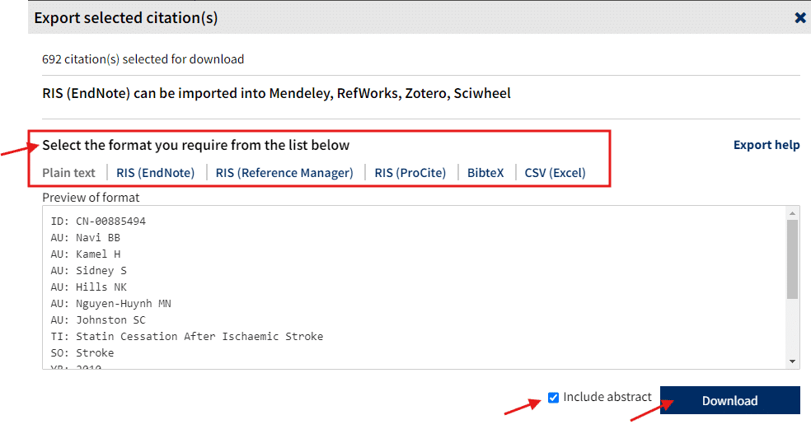
Exporting search results from information sources other than bibliographic databases can be a bit tricky (e.g., until recently, there was not an option to export search results from Clinicaltrials.gov in RIS format). In some cases, reviewers may need to do the screening right within the information source itself.
Record Limits for Exporting
Some databases will have limits on how many records can be exported at a time. Some of these limits are set by the libraries providing you with access to the databases. In the example provided below, where you can only export 1000 results from Web of Science Core Collection at a time, you would need to download multiple export files to export more than 1000 search results.
Example of exporting search results from Web of Science Core Collection:
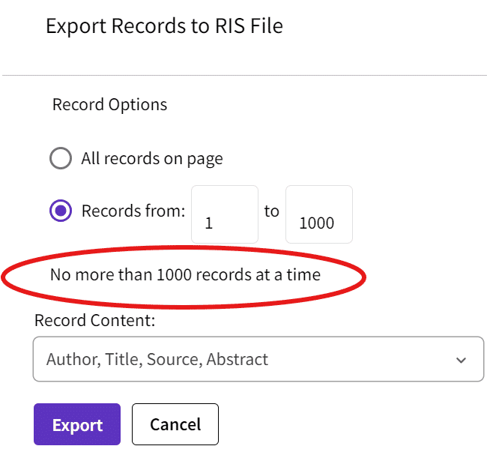
Importing Search Results to Various Tools
The export files that you download from each database or information source will show up in the downloads folder on your computer. Some people like to save these files "just in case" they might need them again. However, you can simply import the downloaded export files without saving them as well. Look for "Import"/"Import files" or similar to import your downloaded export files.
Note: Importing large files (e.g., for 1000 or more references) can take a few minutes.
Example of importing search results into Covidence:
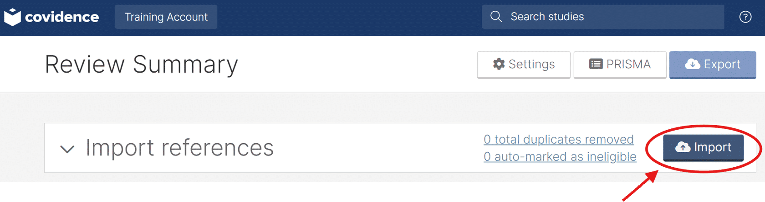
Knowledge Check
- Arrange the following steps in their proper order:
- Remove duplicate references
- Export search results from databases
- Screen references for eligible studies
- Import search results to software tool
  - Step 1
  - Step 2
  - Step 3
  - Step 4
Correct answers: a=iii; b=i; c=iv; d=ii.
References
McKeown S, Mir ZM. Considerations for conducting systematic reviews: A follow‐up study to evaluate the performance of various automated methods for reference de‐duplication. Research Synthesis Methods. 2024. https://doi.org/10.1002/jrsm.1736(opens in a new tab)
Lefebvre C, Glanville J, Briscoe S, Featherstone R, Littlewood A, Metzendorf M-I, Noel-Storr A, Paynter R, Rader T, Thomas J, Wieland LS. Technical Supplement to Chapter 4: Searching for and selecting studies. In: Higgins JPT, Thomas J, Chandler J, Cumpston M, Li T, Page MJ, Welch VA (editors). Cochrane Handbook for Systematic Reviews of Interventions Version 6.4 (updated February 2024). Cochrane, 2024. Available from www.training.cochrane.org/handbook(opens in a new tab).

References
- McKeown S, Mir ZM. Considerations for conducting systematic reviews: evaluating the performance of different methods for de-duplicating references. Systematic Reviews. 2021 Dec;10:1-8. https://doi.org/10.1186/s13643-021-01583-y(opens in a new tab).
- McKeown S, Mir ZM. Considerations for conducting systematic reviews: A follow‐up study to evaluate the performance of various automated methods for reference de‐duplication. Research Synthesis Methods. 2024. https://doi.org/10.1002/jrsm.1736(opens in a new tab).

Lesson 5: Guidelines for Reporting the Search
Reporting the Search Methods
Searches of bibliographic databases should be transparent enough that they could be reproduced.
Well reported search methods help editors, peer-reviewers, and readers
appraise the quality of systematic review methods.
PRISMA for Searching
PRISMA(opens in a new tab) stands for Preferred Reporting Items for Systematic reviews and Meta-Analyses.²⁶ There is a PRISMA extension for searching (PRISMA-Search or PRISMA-S) to improve the reporting quality of search methods.²⁷
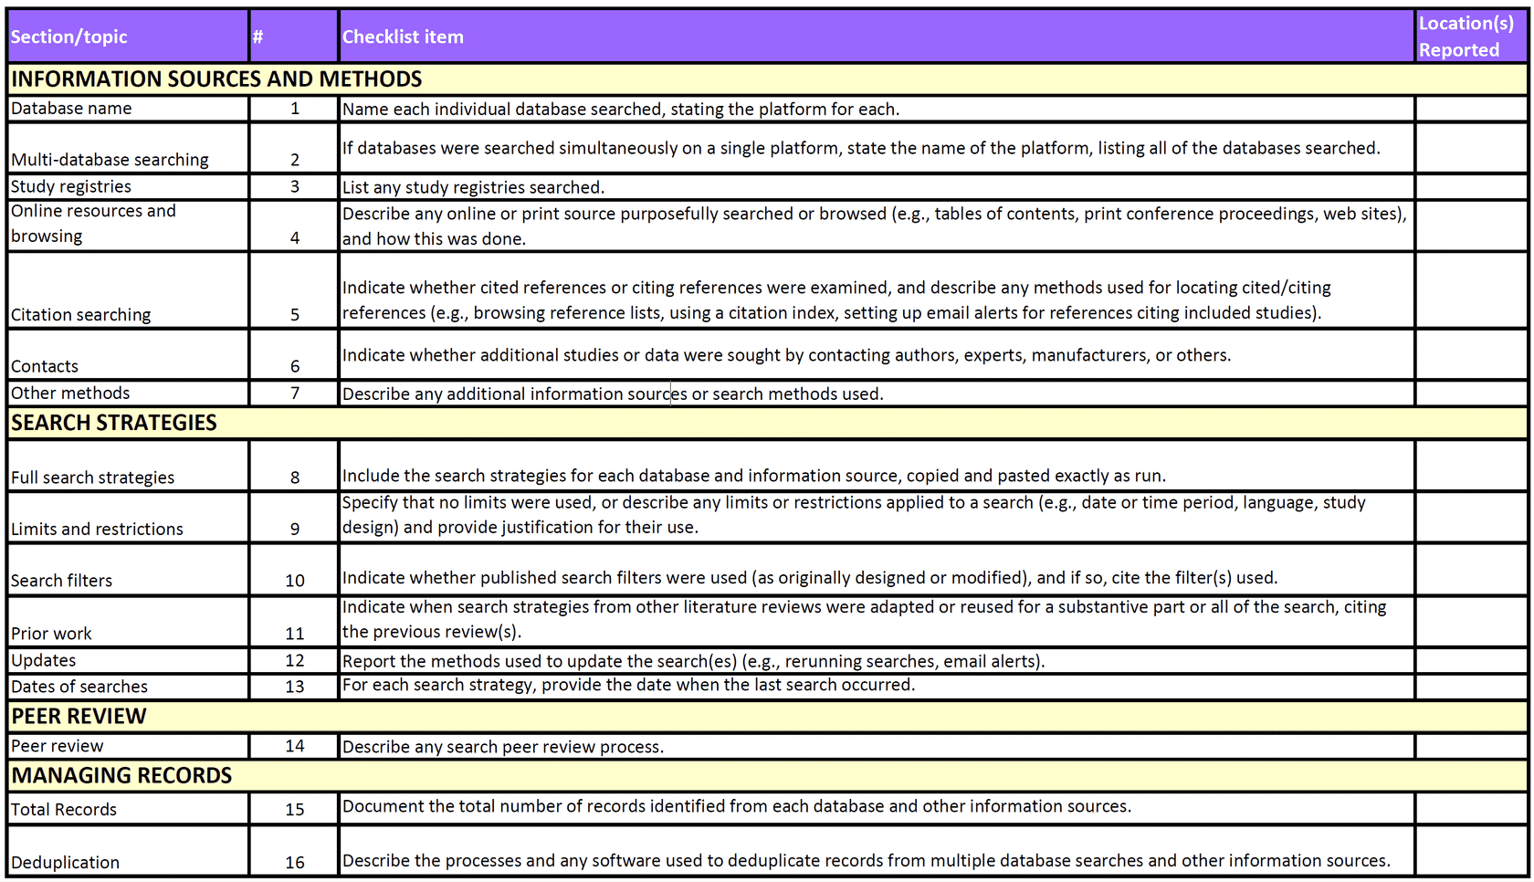
A Glossary(opens in a new tab) of terms used in the checklist is available.
Some checklist items may not be relevant and therefore
do not need to be addressed in the search methods write-up.²⁷
Other items, like Total Records (item 15) may be presented in the results section, where the PRISMA Flow Diagram is provided.
Preserving Full Search Strategies
PRISMA-S checklist #8 requires reviewers to "Include the search strategies for each database and information source, copied and pasted exactly as run."²⁷
At the time of executing a search in each database and information source, you can copy and paste your search history into a Word document or elsewhere for future reporting.
You may wish to save the search history in the databases and information sources searched so that you can run search updates at a later time. In this case, you can copy and paste the search history at a later time as well.
Saving searches in a database requires creating an account with the database provider. For example, if you search MEDLINE, Embase, or PsycINFO on the Ovid platform, you will be required to create a Ovid account before you can save searches.
Additional Options on the Ovid Platform
If using the Ovid platform for database searching, there are also a number of ways that you can share the search history with yourself and others that doesn't require creating an Ovid account.
For example, if you click on Share Search History and then select Email All Search History, you will send yourself a link that can rerun the same search at a later time, and you will receive a copy of your search history (see image below).
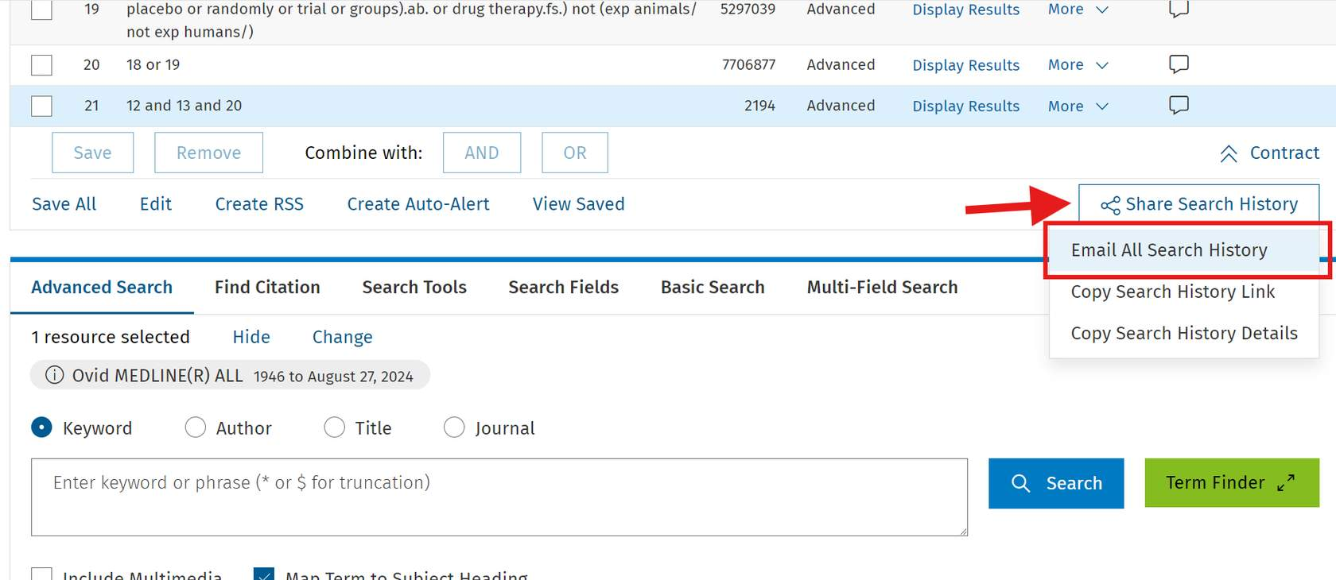
Email from Ovid with link to rerun search and search history provided:
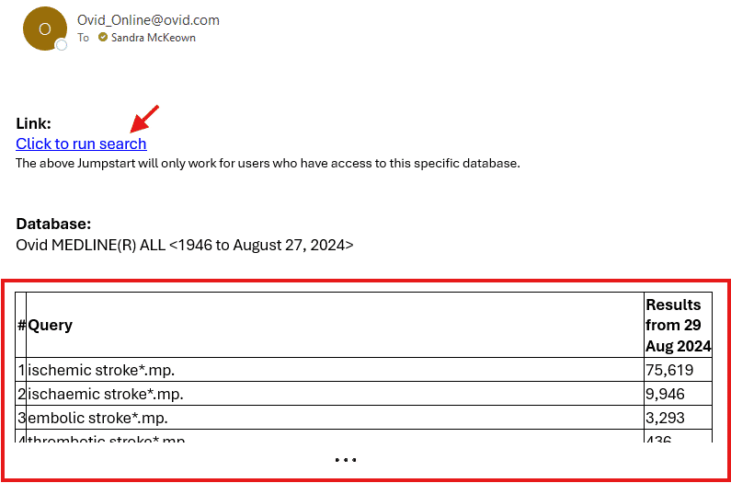

Reporting the Search Results
PRISMA Flow Diagram
The PRISMA flow diagram "depicts the flow of information through the different phases of a systematic review. It maps out the number of records identified, included and excluded, and the reasons for exclusions".²⁸
The PRISMA website(opens in a new tab) provides different editable templates(opens in a new tab) of the flow diagram that you can download depending on the type of review (new or updated) and sources used to identify studies.
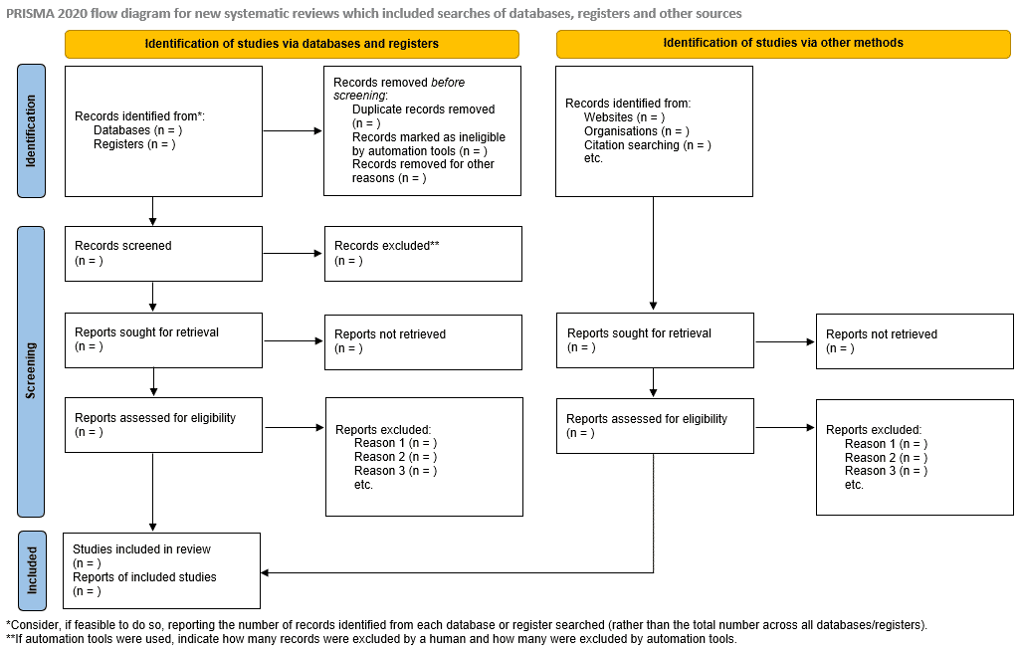

Example of Write-up for PRISMA-S Components
- Please note that the example below is fictitious.
- Relevant PRISMA-S checklist item numbers are provided for learning purposes here and would not be included in the actual write-up.
Part of methods section:
Search methods for identification of studies
A comprehensive search approach was employed to locate published studies (journal articles) and unpublished studies (grey literature) in the form of clinical trial data, conference abstracts and papers, and preprint articles. A preliminary search was conducted in Google Scholar to identify a few eligible studies, which were then analyzed to identify relevant text words and database-specific subject headings. A comprehensive search was developed in Ovid MEDLINE and peer-reviewed by Health Sciences Librarian Sandra McKeown at Queen’s University using the PRESS 2015 Guideline Evidence-Based Checklist [Item 14] (1). The final Ovid MEDLINE strategy was adapted for Embase (Ovid), Cochrane CENTRAL (Ovid), Web of Science Core Collection, and the Preprint Citation Index (Web of Science platform) [Item 1]. The Cochrane Embase RCT filter for Ovid (2023 revisions) and the Cochrane Highly Sensitive Search Strategy for identifying randomized trials in Ovid MEDLINE (sensitivity-maximizing 2023 version) were utilized [Item 10] (2-3). A topical search was conducted in Clinicaltrials.gov and the WHO International Clinical Trials Registry Platform (ICTRP) portal [Item 3]. All databases and information sources were searched from inception up until August 27, 2024, the date the search was last rerun, with no language or date restrictions applied (Appendix 1) [Items 8, 9, 12, & 13].
Duplicate references were removed in Covidence systematic review software before screening [Item 16]. For each eligible study identified in Covidence, we manually screened reference lists and reviewed citing references in Google Scholar to identify additional studies [Item 5].
Part of results section:
Figure #: PRISMA Flow Diagram
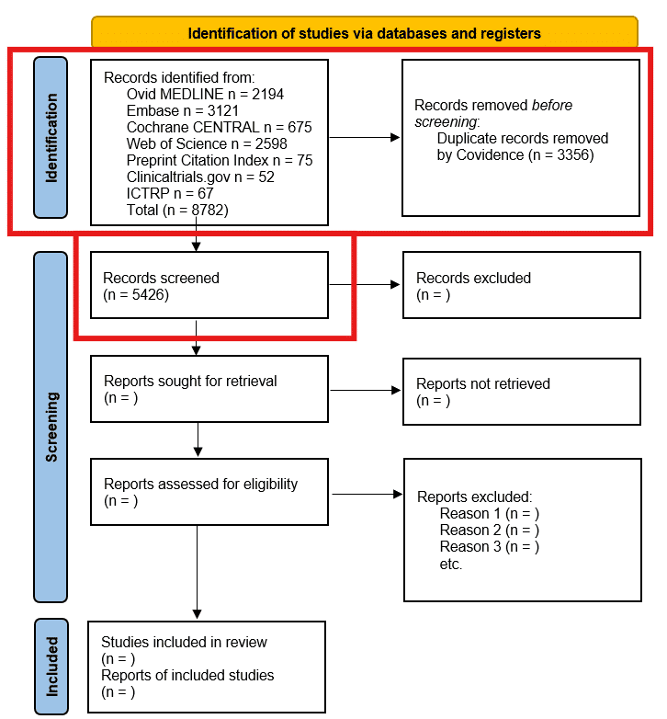
Part of supplementary files:
Appendix 1: Search strategies for each database and information source searched [Item 8]
Ovid MEDLINE(R) ALL 1946 to August 27, 2024
# Searches Results
1 ischemic stroke*.mp. 75619
2 ischaemic stroke*.mp. 9946
3 embolic stroke*.mp. 3293
4 thrombotic stroke*.mp. 436
…continued with each complete search strategy
Part of reference list:
1) McGowan J, Sampson M, Salzwedel DM, Cogo E, Foerster V, Lefebvre C. PRESS peer review of electronic search strategies: 2015 guideline statement. Journal of clinical epidemiology. 2016 Jul 1;75:40-6.
2) Lefebvre C, Glanville J, Briscoe S, Featherstone R, Littlewood A, Metzendorf M-I, Noel-Storr A, Paynter R, Rader T, Thomas J, Wieland LS. Chapter 4: Searching for and selecting studies. In: Higgins JPT, Thomas J, Chandler J, Cumpston M, Li T, Page MJ, Welch VA (editors). Cochrane Handbook for Systematic Reviews of Interventions version 6.4 (updated October 2023). Cochrane, 2023. Available from www.training.cochrane.org/handbook.
3) Glanville J. EMBASE RCT filter. 2023 Apr 30. ISSG Search Filter Resource [Internet]. Accessed July 2024: https://sites.google.com/a/york.ac.uk/issg-search-filters-resource/home/rcts/embase-rct-filter.
Knowledge Check
1. All PRISMA-S items need to be addressed in your manuscript write-up:
- True
- False
Correct answer: False.
"Not every systematic review will make use of all of the items in the Information Sources and Methods section of the checklist, depending on the research question and the methods chosen by the authors."
Reference
Rethlefsen ML, Kirtley S, Waffenschmidt S, Ayala AP, Moher D, Page MJ, Koffel JB; PRISMA-S Group. PRISMA-S: an extension to the PRISMA Statement for Reporting Literature Searches in Systematic Reviews. Syst Rev. 2021 Jan 26;10(1):39. doi: 10.1186/s13643-020-01542-z(opens in a new tab).

- All database and information source search strategies need to be included with your manuscript write-up:
- True
- False
Correct answer: True.
Item 8 of the PRISMA-S checklist: Include the search strategies for each database and information source, copied and pasted exactly as run.
Reference
Rethlefsen ML, Kirtley S, Waffenschmidt S, Ayala AP, Moher D, Page MJ, Koffel JB; PRISMA-S Group. PRISMA-S: an extension to the PRISMA Statement for Reporting Literature Searches in Systematic Reviews. Syst Rev. 2021 Jan 26;10(1):39. doi: 10.1186/s13643-020-01542-z(opens in a new tab).
References
- Page MJ, McKenzie JE, Bossuyt PM, Boutron I, Hoffmann TC, Mulrow CD, Shamseer L, Tetzlaff JM, Akl EA, Brennan SE, Chou R, Glanville J, Grimshaw JM, Hróbjartsson A, Lalu MM, Li T, Loder EW, Mayo-Wilson E, McDonald S, McGuinness LA, Stewart LA, Thomas J, Tricco AC, Welch VA, Whiting P, Moher D. The PRISMA 2020 statement: an updated guideline for reporting systematic reviews. BMJ. 2021 Mar 29;372:n71. doi: https://doi.org/10.1136/bmj.n71(opens in a new tab).
- Rethlefsen ML, Kirtley S, Waffenschmidt S, Ayala AP, Moher D, Page MJ, Koffel JB; PRISMA-S Group. PRISMA-S: an extension to the PRISMA Statement for Reporting Literature Searches in Systematic Reviews. Syst Rev. 2021 Jan 26;10(1):39. doi: 10.1186/s13643-020-01542-z(opens in a new tab).
- Page MJ, McKenzie JE, Bossuyt PM, Boutron I, Hoffmann TC, Mulrow CD, Shamseer L, Tetzlaff JM, Akl EA, Brennan SE, Chou R, Glanville J, Grimshaw JM, Hróbjartsson A, Lalu MM, Li T, Loder EW, Mayo-Wilson E, McDonald S, McGuinness LA, Stewart LA, Thomas J, Tricco AC, Welch VA, Whiting P, Moher D. PRISMA flow diagram. 2024. Accessed 5 Jul 2024 from: https://www.prisma-statement.org/prisma-2020-flow-diagram.(opens in a new tab)
Congratulations! You have completed Module 3: Searching for Eligible Studies.

