Trades Access Common Core
Line C: Tools and Equipment
Competency C-2: Describe Common Power
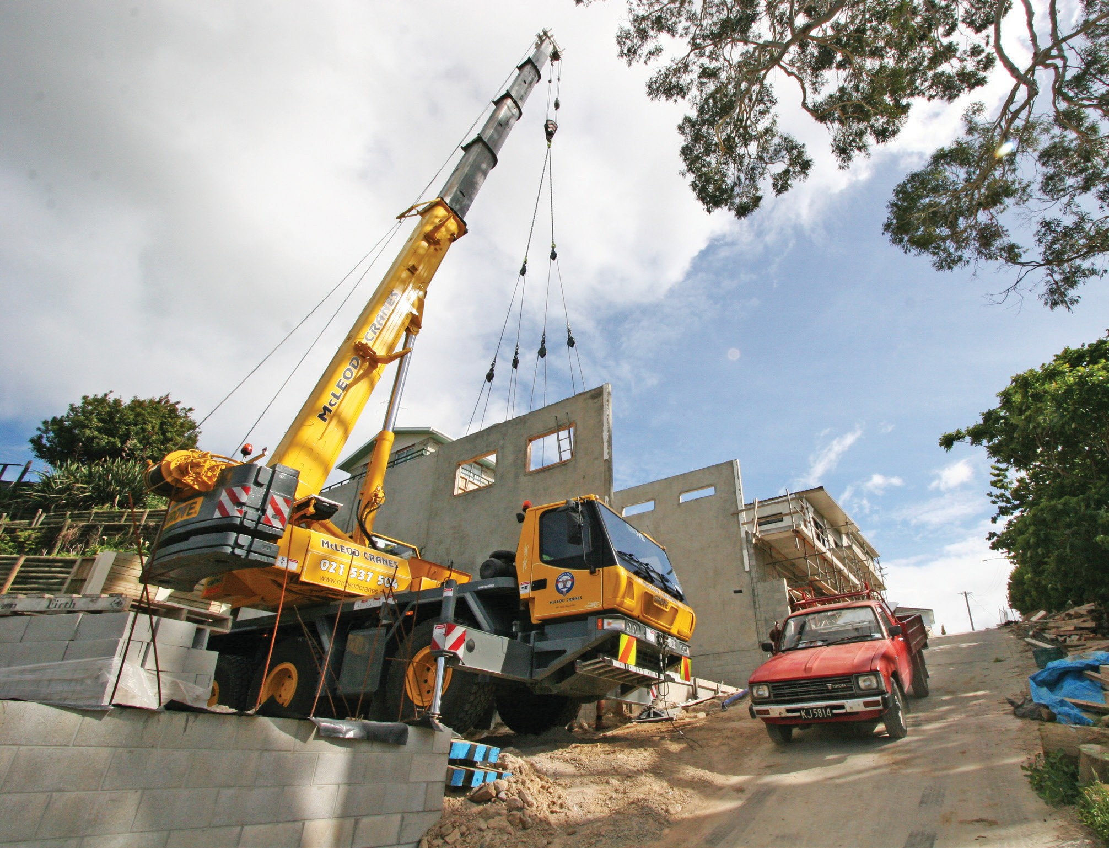Tools and Their Uses

Image to be placed here.

B.C. Open Textbook Project
OpenEd
open.bccampus.ca

Trades Access
COMMON CORE
Line C: Tools and Equipment Competency C-2: Describe Common Power Tools and
Their Uses

Acknowledgments and Copyright
To learn more about BCcampus Open Textbook project, visit http://open.bccampus.ca
© Camosun College. The Trades Access Common Core resources are licensed under the Creative Commons Attribution 4.0 Unported Licence ( http://creativecommons.org/licenses/by/4.0/ ), except where otherwise noted. Under this licence, any user of this textbook or the textbook contents herein must provide proper attribution as follows:
- If you redistribute this textbook in a digital format (including but not limited to EPUB, PDF, and HTML), then you must retain on every page the following attribution: Download for free at http:// open.bccampus.ca/find-open-textbooks/
- If you redistribute this textbook in a print format, then you must include on every physical page the following attribution: Download for free at http://open.bccampus.ca/find-open-textbooks/
- If you redistribute part of this textbook, then you must retain in every digital format page view (including but not limited to EPUB, PDF, and HTML) and on every physical printed page the following attribution: Download for free at http://open.bccampus.ca/find-open-textbooks/
- If you use this textbook as a bibliographic reference, then you should cite it as follows: BCcampus, Name of Textbook or OER. DATE. http://open.bccampus.ca/find-open-textbooks/.
For questions regarding this licensing, please contact opentext@bccampus.ca
All images copyright BC Industry Training Authority are licensed under the Creative Commons Attribution-NonCommercial-ShareAlike 4.0 licence.
http://creativecommons.org/licenses/by-nc-sa/4.0/
The issuing/publishing body is Crown Publications, Queen’s Printer, Ministry of Technology, Innovation and Citizens’ Services.
BCcampus would like to acknowledge the following individuals and organizations for their contributions in producing the Trades Access Common Core Open Textbook resources.

BCcampus
Open Education Team Hilda Anggraeni, Graphics

Camosun College
Olaf Nielsen, Chair, Trades Development and Special Projects, School of Trades and Technology Nannette Plant, Manager, Enterprise Point Operations & Special Projects, Office of the VP Strategic Development
Rod Lidstone, Instructor, Plumbing and Pipe Trades, Lead Writer/Reviewer Brian Coey, Instructor, Sheet Metal and Metal Fabrication, Writer/Reviewer Matt Zeleny, Camosun Innovates, 3D imaging

Open School BC
Monique Brewer, Director
Adrian Hill, Instructional Designer
Dennis Evans, Image Coordinator, Photographer, Graphics, Production Technician (layout) Farrah Patterson, Production Technician

Industry Training Authority of BC
The ITA works with employers, employees, industry, labour, training providers, and government to issue credentials, manage apprenticeships, set program standards, and increase opportunities in approximately 100 BC trades. Among its many functions are oversight of the development of training resources that align with program standards, outlines, and learning objectives, and authorizing permission to utilize these resources (text and images).
Erin Johnston, Director of Training Delivery Cory Williams, Manager, Industry Relations

Publishing Services, Queen’s Printer
Spencer Tickner, Director of QP Publishing Services Dwayne Gordon, Manager, Electronic Publishing
October 2015, Version 1
To order print copies of any of the Trades Access Common Core resources, please contact us:
Crown Publications, Queen’s Printer PO Box 9452 Stn Prov Govt
563 Superior St, 3rd Floor Victoria, BC V8W 9V7 Phone: 250-387-6409
Toll Free: 1-800-663-6105
Fax: 250-387-1120
crownpub@gov.bc.ca www.crownpub.bc.ca

Intellectual Property Program
Ilona Ugro, Copyright Officer, Ministry of Technology, Innovation and Citizens’ Services, Province of British Columbia

Creative Commons Attributions
Cover photo:
http://commons.wikimedia.org/wiki/File:GMK3050_All_Terrain_Crane.jpg by Scottmss under CC BY SA 3.0 https://creativecommons.org/licenses/by-sa/3.0/deed.en

Foreword
The BC Open Textbook Project began in 2012 with the goal of making post-secondary education in British Columbia more accessible by reducing student cost through the use of openly licensed textbooks. The
BC Open Textbook Project is administered by BCcampus and is funded by the British Columbia Ministry of Advanced Education.
Open textbooks are open educational resources (OER); they are instructional resources created and shared in ways so that more people have access to them. This is a different model than traditionally copyrighted materials. OER are defined as teaching, learning, and research resources that reside in the public domain or have been released under an intellectual property licence that permits their free use and repurposing by others (Hewlett Foundation). Our open textbooks are openly licensed using a Creative Commons licence, and are offered in various e-book formats free of charge, or as printed books that are available at cost. For more information about this project, please contact opentext@bccampus.ca. If you are an instructor who is using this book for a course, please let us know.

Preface
The concept of identifying and creating resources for skills that are common to many trades has a long history in the Province of British Columbia. This collection of Trades Access Common Core (TACC) resources was adapted from the 15 Trades Common Core line modules co-published by the Industry
Training and Apprenticeship Commission (ITAC) and the Centre for Curriculum Transfer and Technology (C2T2) in 2000-2002. Those modules were revisions of the original Common Core portion of the TRAC modules prepared by the Province of British Columbia Ministry of Post-Secondary Education in 1986. The TACC resources are still in use by a number of trades programs today and, with the permission from the Industry Training Authority (ITA), have been utilized in this project.
These open resources have been updated and realigned to match many of the line and competency titles found in the Province of BC’s trades apprenticeship program outlines. A review was carried out to analyze the provincial program outlines of a number of trades, with the intent of finding common entry-
level learning tasks that could be assembled into this package. This analysis provided the template for the outline used to update the existing modules. Many images found in ITA apprentice training modules were also incorporated into these resources to create books that are similar to what students will see when they continue their chosen trades training. The project team has also taken many new photographs for this project, which are available for use in other trades training resources.
The following list of lines and competencies was generated with the goal of creating an entry-level trades training resource, while still offering the flexibility for lines to be used as stand-alone books. This
flexibility—in addition to the textbook content being openly licensed—allows these resources to be used within other contexts as well. For example, instructors or institutions may incorporate these resources into foundation-level trades training programming or within an online learning management system (LMS).
Line A – Safe Work Practices
- A-1 Control Workplace Hazards
- A-2 Describe WorkSafeBC Regulations
- A-3 Handle Hazardous Materials Safely
- A-4 Describe Personal Safety Practices
- A-5 Describe Fire Safety
Line B – Employability Skills
- B-1 Apply Study and Learning Skills
- B-2 Describe Expectations and Responsibilities of Employers and Employees
- B-3 Use Interpersonal Communication Skills
- B-4 Describe the Apprenticeship System

Line C –Tools and Equipment
- C-1 Describe Common Hand Tools and Their Uses
- C-2 Describe Common Power Tools and Their Uses
- C-3 Describe Rigging and Hoisting Equipment
- C-4 Describe Ladders and Platforms
Line D – Organizational Skills
- D-1 Solve Trades Mathematical Problems
- D-2 Apply Science Concepts to Trades Applications
- D-3 Read Drawings and Specifications
- D-4 Use Codes, Regulations, and Standards
- D-5 Use Manufacturer and Supplier Documentation
- D-6 Plan Projects
Line E – Electrical Fundamentals
- E-1 Describe the Basic Principles of Electricity
- E-2 Identify Common Circuit Components and Their Symbols
- E-3 Explain Wiring Connections
- E-4 Use Multimeters
All of these textbooks are available in a variety of formats in addition to print:
- PDF—printable document with TOC and hyperlinks intact
- HTML—basic export of an HTML file and its assets, suitable for use in learning management systems
- Reflowable EPUB—format that is suitable for all screen sizes including phones
All of the self-test questions are also available from BCcampus as separate data, if instructors would like to use the questions for online quizzes or competency testing.

About This Book
In an effort to make this book a flexible resource for trainers and learners, the following features are included:
- An introduction outlining the high-level goal of the Competency, and a list of objectives reflecting the skills and knowledge a person would need to achieve to fulfill this goal.
- Discrete Learning Tasks designed to help a person achieve these objectives
- Self-tests at the end of each Learning Task, designed to informally test for understanding.
- A reminder at the end of each Competency to complete a Competency test. Individual trainers are expected to determine the requirements for this test, as required.
- Throughout the textbook, there may also be links and/or references to other resources that learners will need to access, some of which are only available online.
- Notes, cautions, and warnings are identified by special symbols. A list of those symbols is provided below.

Symbols Legend

Important: This icon highlights important information.

Poisonous: This icon is a reminder for a potentially toxic/poisonous situation.

Resources: The resource icon highlights any required or optional resources.

Flammable: This icon is a reminder for a potentially flammable situation.

Self-test: This icon reminds you to complete a self-test.

Explosive: This icon is a reminder for a possibly explosive situation.

Safety gear: The safety gear icon is an important reminder to use protective equipment.

Electric shock: This icon is a reminder for potential electric shock.

Safety Advisory
Be advised that references to the Workers’ Compensation Board of British Columbia safety regulations contained within these materials do not/may not reflect the most recent Occupational Health and Safety Regulation. The current Standards and Regulation in BC can be obtained at the following website: http:// www.worksafebc.com.
Please note that it is always the responsibility of any person using these materials to inform him/herself about the Occupational Health and Safety Regulation pertaining to his/her area of work.
BCcampus January 2015

Disclaimer
The materials in the Trades Access Common Core Open Textbook project are for use by students and instructional staff and have been compiled from sources believed to be reliable and to represent best current opinions on these subjects. These manuals are intended to serve as a starting point for good practices and may not specify all minimum legal standards. No warranty, guarantee or representation is made by BCcampus as to the accuracy or sufficiency of the information contained in these publications. These manuals are intended to provide basic guidelines for trade practices. Do not assume, therefore, that all necessary warnings and safety precautionary measures are contained in this module and that other or additional measures may not be required.

Contents

Introduction 9
Objectives 9
Resources 9
Learning Task 1: Describe tools by types of power 11
Electric tools 11
Combustion tools 12
Pneumatic tools 12
Hydraulic tools 13
Powder-actuated tools 13
Self-Test 1 14
Learning Task 2: Describe the safe use of power tools 17
Common causes of injuries 17
Safety and electric power tools 18
Care and maintenance of electric power tools 19
Grounding tools and equipment 20
Self-Test 2 21
Learning Task 3: Describe types of electric saws 25
Circular saws 25
Mitre saws 27
Cut-off saws 28
Saw blades for circular saws 29
Sabre saws 33
Reciprocating saws 34
Band saws 35
Self-Test 3 41
Learning Task 4: Describe types of power drills 47
Hand drills 47
Drill presses 52
Electromagnetic drills 54
Drill bit types 55
Safety 60
Self-Test 4 61
Learning Task 5: Describe routers, grinders, and sanders 67
Routers 67
Belt sanders 67
Orbital sanders 68
Safety and maintenance for routers and sanders 68
Straight grinders 69
Angle grinders 70
Bench grinders 71
Self-Test 5 78
Learning Task 6: Describe portable air power tools 83
Air-supply system 83
Maintenance of an air-supply system 86
Types of air tools 88
Safety with air tools 92
Self-Test 6 94
Learning Task 7: Describe powder-actuated tools 99
Tool classification 99
Powder-actuated tool operating principles 100
Powder loads 100
Fasteners 102
General use limitations 104
Safety, care, and maintenance 105
Self-Test 7 106
Answer Key 108

Introduction
Power tools play a major role in virtually every trade. You will be expected to be familiar with a wide range of portable and stationary power tools and to understand the safe operation of these tools. Proper maintenance improves the life and performance of the tool. Correct set-up and operating procedures ensure good results and prevent injury.

Objectives
When you have completed the Learning Tasks in this Competency, you should be able to:
  - list the basic safety precautions to take when you work with power tools

  - describe the use and maintenance of common power tools

Resources
You will be required to reference publications and videos online.

LEARNING TASK 1

Describe tools by types of power
A power tool is actuated by a power source and mechanism in addition to hand power. The additional power increases productivity and efficiency of work.

The most common types of power tools use electric motors, combustion engines, compressed air, and hydraulic power. Powder-actuated tools are commonly used in the construction industries.

Power tools in the early Industrial Revolution–era factories were driven by belts from overhead shafts. The prime power source was a water wheel or, much later, a steam engine. The introduction of the electric motor and electric distribution networks in the 1880s made possible the self-powered stationary and portable tools that are familiar today.

Electric tools
Electric motors are the most popular choice to power stationary and portable tools. The motor converts electrical energy into mechanical energy to generate force within the motor. While stationary electric tools are typically “hard wired,” portable electric tools may be either corded or battery powered (Figure 1).

Electric tools have advanced greatly in recent years, especially with the progress of battery technology. Almost any corded tool manufactured today is available in a cordless battery- powered design that is ighter and more powerful than ever. Cordless tools are truly portable, using a rechargeable battery cell that is composed of one of several different combinations of chemicals, including nickel-cadmium, nickel-zinc, and lithium-ion.

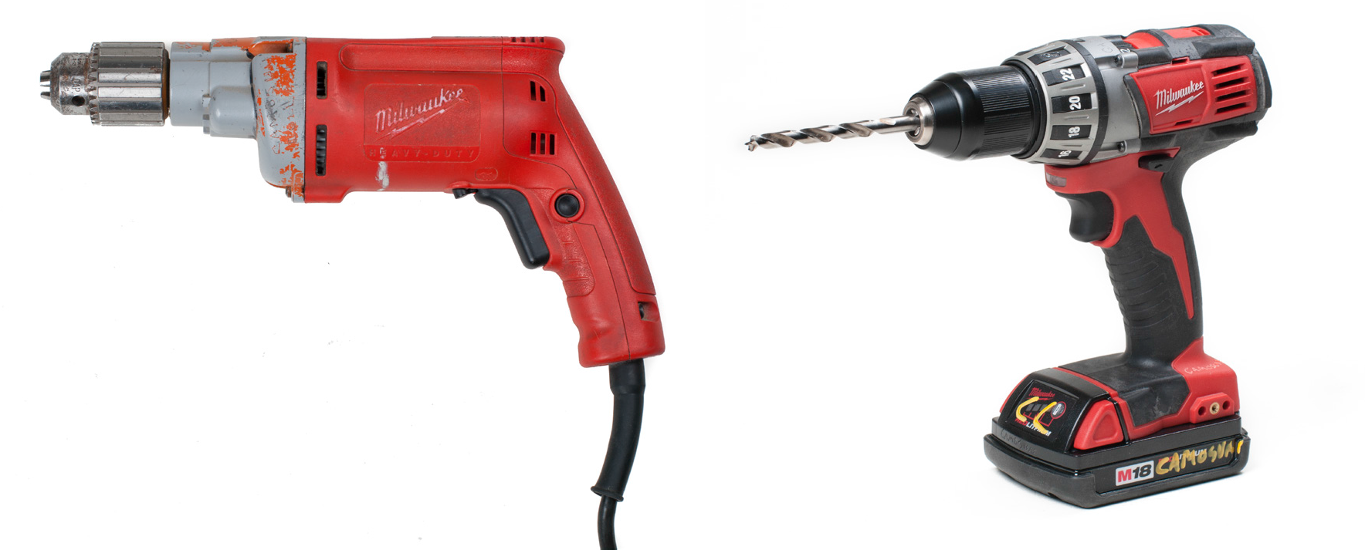
Figure 1 — Portable corded electric drill (left); Cordless drill with rechargeable battery (right)

Combustion tools
Tools that are powered by combustion engines typically use gasoline or diesel as their energy source. Many landscaping tools, such as rototillers, and some cutting devices such as chainsaws, (Figure 2) are powered in this way.

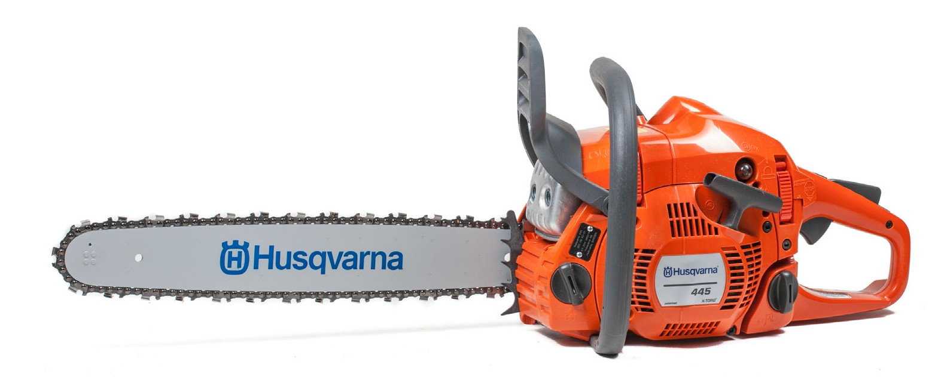
Figure 2 — Gasoline-powered chainsaw

Pneumatic tools
Pneumatic tools (Figure 3) are powered by a compressed air system. It is the primary power source for tools like nailers and paint sprayers, sheet metal power shears, and die grinders. Pneumatic tools are discussed more in Learning Task 6.

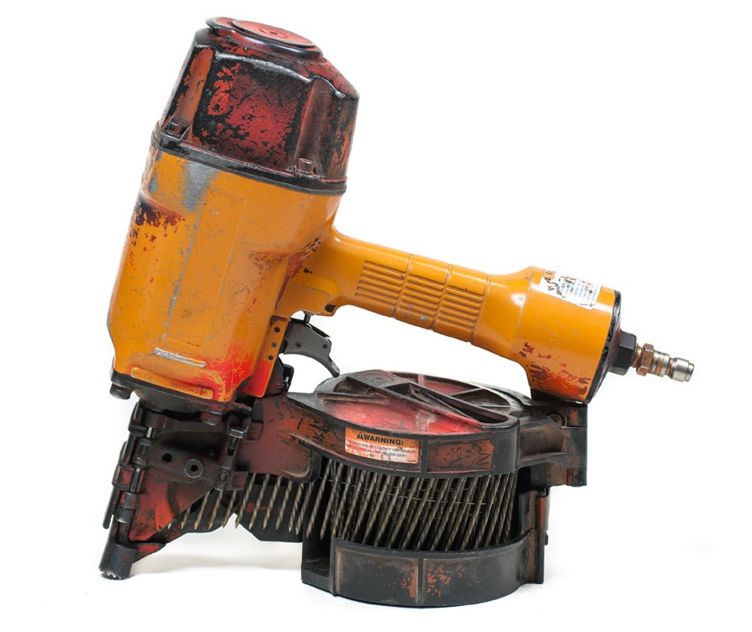
Figure 3 — Pneumatic coil nailer

Hydraulic tools
Tools that use liquid pressure as the driving force are called “hydraulic tools” (Figure 4). Hydraulic tools are popular because they offer several advantages, including increased force and reduced noise and exhaust. Examples of hydraulic power tools include jackhammers and impact rivet machines.

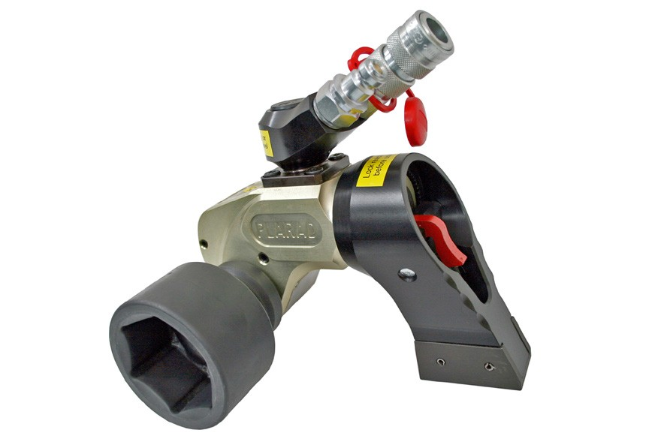
Figure 4 — Hydraulic torque wrench

Powder-actuated tools
Powder-actuated tools (Figure 5) use an explosive chemical propellant to drive fasteners similar to the process that discharges a firearm. They are a quick and efficient way to install nails and fasteners into existing concrete slabs and block walls to secure equipment and components.
Powder-actuated tools are discussed more in Learning Task 7.

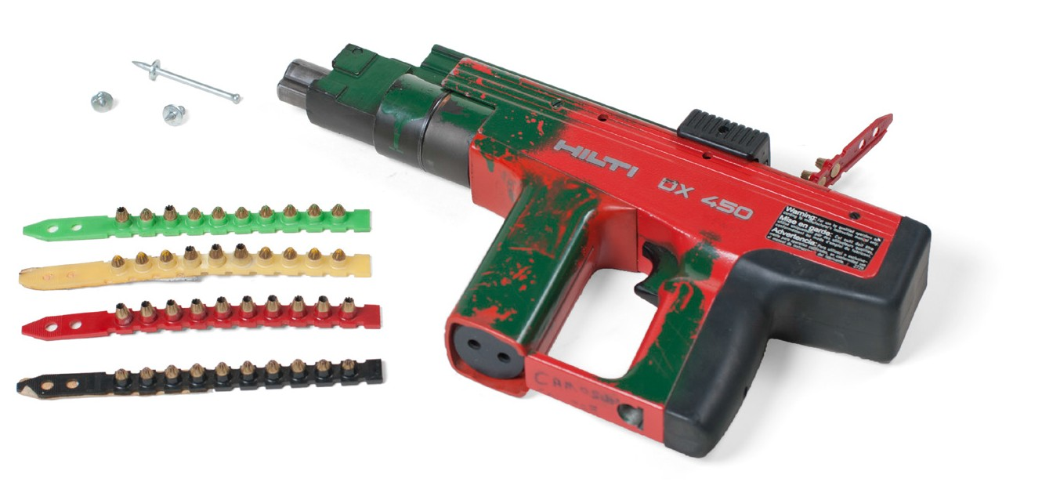
Figure 5 — Powder-actuated fastener tool

Now complete the Learning Task Self-Test.

Self-Test 1
- What is the definition of a power tool?
  - A tool that converts electrical energy into mechanical energy
  - A tool that converts hydraulic energy into mechanical energy
  - A tool that converts pneumatic energy into mechanical energy
  - All of the above

- Which of the following is an example of a combustion-powered tool?
  - Rototiller
  - Cordless drill
  - Hydraulic jackhammer
  - Air paint sprayer

- Which type of power tool converts the chemical energy found in fuel gases to electrical energy?
  - Electric power tools
  - Hydraulic power tools
  - Air power tools
  - Combustion engine power tools

- How are air tools powered?
  - Using the energy of combustion
  - Transferring energy through compressed air
  - Transferring energy through pressurized liquids
  - All of the above

- Which type of power tool uses liquid to convey energy?
  - Electric power tool
  - Hydraulic power tool
  - Powder-actuated tool
  - Air power tool

- Which power tool employs a chemical propellant to drive fasteners?
  - Electric power tool
  - Hydraulic power tool
  - Powder-actuated tool
  - Air power tool

- Portable electric power tools can be corded or battery powered.
  - True
  - False

- Combustion-powered tools typically use diesel or gasoline as their energy source.
  - True
  - False

- Air tools are found only in the painting industry.
  - True
  - False

LEARNING TASK 2

Describe the safe use of power tools
Power tools must be handled cautiously and kept in good condition, as they can pose a serious hazard to the operator and workers in the area.

Common causes of injuries
The most common power tool accident involves injuries to the fingers. This can be anything from a minor cut to losing an entire finger. Approximately half of all finger amputations in North America each year are the result of an injury involving a power tool. The most common power tool involved is one of the various types of saws.

According to WorkSafeBC, a large portion of power tool injuries occur because the power source is not removed while changing parts on the tool, with drill bits and saw blades being the most common culprits. Figure 1 shows a chuck key taped to the plug end of the power cord as a reminder to de-energize the tool. No matter how much experience you have with the power tool or how quickly you can change a part, you must de-energize the tool before changing bits or blades.

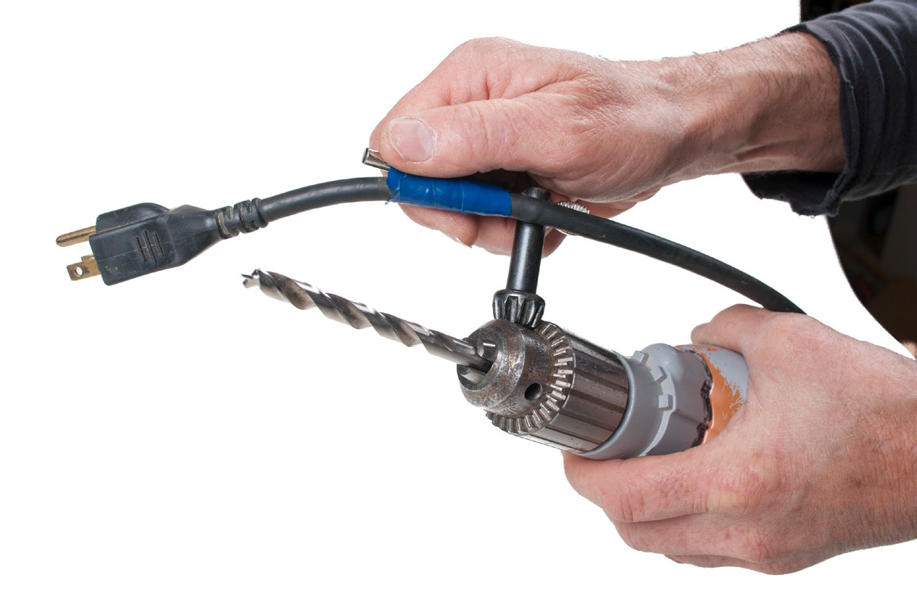
Figure 1 — De-energize tool before changing drill bit

It only takes a moment to unplug the power source. The inconvenience is worth your safety!
Cords on electric power tools are another concern. Many power tool accidents have been eliminated by switching to cordless power tools, which are safer than corded power tools because of the highly reduced risk of shock. As well, the cords on power tools often pose a tripping hazard.

If you operate any type of power tool that has a cord, make sure you properly secure it. Don’t leave the cord out in the open where you or someone else can trip on it. There is always the risk of electrocution, so make sure the cord isn’t frayed. This check is just as important for any
extension cords you may be using as well. Keep all cords out of damp areas, and make sure there is nothing in the area that can accidentally be spilled on them.

Even if you use the power tool safely and correctly and you are wearing the right safety equipment, accidents can still happen. Tripping, slipping, or falling while you have a power tool in your hand can result in an injury. Accidentally depressing a trigger switch or a moving part to create a crush point can have dangerous consequences.

To help prevent power tool accidents, make sure your work area is tidy. Ladders should be securely in place. Never work on a surface that is slippery or unstable. Don’t take risks with a power tool in your hand.

Safety and electric power tools
The following are important safety considerations when using power tools:
    - Inspect tools carefully before use. Check the condition of the cord or battery, guards, and handles.
    - Remember PPE (personal protection equipment)! Wear eye protection, hearing protection, and a dust mask when you use power saws and other power equipment that kicks up dust and particles.
    - Read the operator’s manual. Never operate power equipment until you are sure you know how to use it.
    - Keep your mind on your work.

    - Match the voltage requirement of the power source to the tool. Failure to do so will result in damage to the tool and is a fire risk.
    - For cordless tools, be sure that the batteries are the correct type for the tool and that they are properly charged. Keep a spare charged battery on hand.
    - Confirm the switch is in the off position before you connect a power tool to a power supply.
    - Ensure the equipment is properly connected to the power supply and that the circuit is grounded or the tool double insulated.
    - Never operate a power tool when there is explosive or flammable liquid and material nearby.
    - If you plan to cut into a wall, floor, or ceiling, make sure that there is another worker in the area and no live wiring or pipe behind it.

  - If an extension cord must be used, make sure that it is approved for heavy-duty work.

  - Make sure that the work is secure and will not slip under the force of the tool.

  - Make all required adjustments before you start up the tool. Be sure that the switches on the tool work properly, and confirm that trigger locks aren’t activated.
  - Know what you are going to do before you start up the tool.

  - Let the tool do the work. Feed the work to the machine, or the machine to the work carefully, at a pace suitable for both the machine and the operation.
  - Keep cutting edges of tools/bits/blades sharp and securely fastened to the tool.

  - Turn off the power when you finish the work, then wait until moving parts come to a stop before you leave the machine.
  - Always carry a tool by the handle, never by the cord. Never yank the cord to disconnect it from the receptacle.

Care and maintenance of electric power tools
  - Before storing a power tool, wipe off dust, dirt, and chips with a cloth.

  - Clean plastic parts with a soft cloth lightly dampened with soapy water. Never use solvents such as gasoline, thinner, benzine, carbon tetrachloride, or alcohol, as these substances damage and crack plastic.
  - Keep the air-cooling passages in the tool clean and free of obstructions.

  - Clean and lubricate as required.

  - Maintain the plug and cord in good condition: there must be no loose prongs on the plug and the cord must not show any signs of deterioration.
  - Keep the cord away from heat, oil, and sharp-edged surfaces.

  - Never allow the motor portion to become wet with water or oil.

  - Store tools properly and in an appropriate area and/or case. For example, drills, screw guns, and routers should have the bits removed; a circular saw must have the guard in place; sabre and reciprocating saws must have the blades removed or the blades must be adequately protected.

Never use a power tool with a deformed or cracked housing, or with a broken handle or part. Tag as broken and report it to your supervisor.

Grounding tools and equipment
All tools and equipment that are operated by electricity must be grounded or double insulated. Occupational guidelines require that when portable electrical equipment, including temporary lighting, is used outdoors or in a damp location, it must be protected by an approved ground- fault circuit interrupter (GFCI) (Figure 1).


Figure 1 — GFCI outlet

For tools that are not double insulated, you must use a three-wire cord and the proper U-ground prong on the cord. Do not use a tool with a damaged or missing U-ground prong. If the cord is damaged, you should tag it as such and remove it from service.

By properly grounding the equipment, the operator should not receive an electrical shock if the tool or equipment develops a short circuit.

Now complete the Learning Task Self-Test.

Self-Test 2
- Which part of the body is most commonly injured in accidents involving power tools?
  - Eyes
  - Face
  - Knees
  - Fingers

- What is the cause of a large portion of power tool injuries, according to WorkSafeBC?
  - Using the incorrect power supply
  - Uncontrollable speeds employed by the operator
  - Power surges causing the tool to behave erratically
  - Changing bits or blades while the power source is connected

- Which power tool is most commonly involved in workplace accidents?
  - Cordless drill
  - Power sander
  - Air drill
  - Various types of power saws

- What factors contribute to making cordless power tools safer than corded ones?
  - Most corded tools are more compact.
  - Cords provide a U-ground and a safe path to ground for any stray voltage.
  - Batteries have a higher voltage than wall outlets, and therefore use safer, lower amperages.
  - Batteries have a much lower voltage than wall outlets and therefore have a reduced shock factor.

- What is the safest course of action if it is discovered that the U-ground prong on a bench tool plug is missing?
  - Use the tool; if it runs, it works.
  - Only use the cord in a dry environment.
  - Tag the tool as “damaged” and remove from service and have the cord fixed.
  - Find another tool to use until someone takes care of the broken tool.

- What is required when portable electrical equipment is used outdoors or in a damp environment?
  - The operator must be trained in wet work.
  - The equipment must be protected by a GFCI.
  - The equipment must be protected by a tarp.
  - The operator must wear insulated rubber boots.

- What must be done to safely use an electric power tool that is not double insulated?
  - The cord must be three pronged and grounded.
  - The work must be approved by the safety officer.
  - The supply voltage must be 208 volts, three phase.
  - There is no special consideration for tools that aren’t double insulated.

- Batteries for cordless power tools are interchangeable and have the same voltage.
  - True
  - False

- Clean plastic parts with a cloth and mild soapy water, never with solvents.
  - True
  - False

- The owner’s manual for power tools is only meant for new workers.
  - True
  - False

- The power cord of a portable power tool is a convenient and safe option for hoisting tools up a ladder.
  - True
  - False

- An inoperative or damaged tool should be tagged out of service and reported to supervision.
  - True
  - False

- Ensuring that personnel, equipment, and material such as wires and pipe will not be damaged by a power tool is the responsibility of the operator.
  - True
  - False

- Power tool motors are generally considered waterproof and are protected from both water and oil.
  - True
  - False

- Corded power tools are generally considered safer than cordless as the power source is more consistent and reliable.
  - True
  - False

- Sharp blades and bits are more dangerous than dull blades and bits.
  - True
  - False

LEARNING TASK 3

Describe types of electric saws
Electric saws are valued for the speed and efficiency with which they can do certain jobs. The circular saw, for example, is well suited for cutting cleanly into thick lumber and for trimming assembled work. A reciprocating saw is a good choice for cutting wood framing in place and creating notches for pipe, conduit, or equipment. This Learning Task will look at these and other power saws you may find on a job site.

Portable saws may be double insulated or grounded. Grounded saws have a three-prong plug, one being a ground pin. Double-insulated saws have only two prongs.

Circular saws
Portable circular saws (Figure 1) are capable of making straight cuts in a variety of materials. Other names for this type of saw are “Skilsaw,”“utility saw,”“electric handsaw,” and “builder’s saw.”

The handle of the saw has a trigger switch to start the saw. The teeth of the blade point forward in the direction of rotation. The blade is protected by two guards. On top there is a ridged guard to prevent contact with the blade and capture flying debris. On the bottom there is a
spring-loaded guard that retracts under the top guard as you push the saw forward through the material being cut.
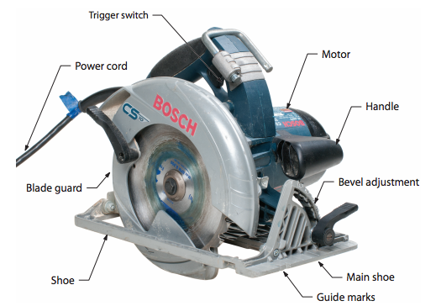

Figure 1 — Portable circular saw

The size of the saw is identified by the diameter of the blade. As a rule, the larger the diameter of the blade, the more powerful the motor of the saw and the greater the depth of the cut. The most common size is 184 mm (7¼ in.) for corded saws and 152 mm (6 in.) for a cordless types.

Portable circular saws can be used to both rip and crosscut. You can control the depth of the cut by raising or lowering the base. You can make bevel cuts by adjusting the tilt of the base.

The portable circular saw is usually guided freehand along a pencil line or chalk line, so its accuracy depends on your guiding skill as the operator.

Straight cuts can be made using the rip guide, a standard attachment with most circular saws. Even more accurate cuts can be made by securing a straightedge to the work and running the base of the saw along the straightedge during the cut.

Portable circular saws are capable of starting a cut in the middle of a workpiece. This technique is called a “pocket cut” or “plunge cut.” This feature makes the portable circular saw an ideal tool for cutting rectangular holes in the middle of a sheet of plywood, something not easy to do with a handsaw.

Safety precautions
Take the following precautions when using portable saws:
    - Ensure all guards are in place and functioning properly before using the saw.

    - Ensure the set in the teeth is sufficient to produce proper clearance for the blade.

    - Ensure that the work is well supported, as this will keep the kerf (the slot cut by the saw) open and prevent the saw blade from binding during the cut.
    - Support thin pieces near the cut. Clamp small pieces to the workbench or sawhorse.

    - Carefully inspect the blade. Never use a blade that is dull, has missing teeth, or requires setting.
    - Adjust the depth of the cut to the thickness of the stock plus 3 mm to 6 mm more.

    - Ensure the base of the saw, the guide, and all other adjustments are tightened.

    - Place the base of the saw on the stock, making sure that the blade is clear before you turn the saw on.
    - While making the cut, stand to one side of the cutting line.

Never reach under the material while it is being cut.

If the saw stalls during a cut, release the trigger, back out the saw until it is free of the material, then resume the cut.

Pay close attention to the sound of the saw. If the rpms drop, the blade may be dull or the material too hard. Allowing the rpms to drop too low puts stress on the motor and draws excessive amounts of amps, which may lead to the breaker tripping. If the saw continues to stall, turn off the power source and look at the condition of the blade and the set of the teeth.

When you come to the end of a cut, release the trigger and allow the blade to come to a standstill as you lift the saw out and away from the work. Lift the saw away from the stock as soon as you release the trigger, but do not twist the saw as you lift, as you may score the work.

Mitre saws
The power mitre saw speeds up the work of fitting and installing mouldings and trim. There are two types of mitre saws: the power mitre box saw and the slide compound mitre saw.

Power mitre box saw
The power mitre box saw is a circular saw mounted in a frame (Figure 2). The saw blade pivots horizontally from the rear of the table and locks into position for cutting angles up to 45° in either direction It is designed to cut mouldings and other small-dimensioned wood up to about 150 mm (6 in.) wide.

Sliding compound mitre saw
The sliding compound mitre saw (Figure 2) is similar to the power mitre box saw, but in addition to tilting horizontally it also tilts vertically. This allows it to cut a mitre and a bevel at the same time, called a “compound cut.” The motor and blade slide along a track, which allows it to cut much wider boards.

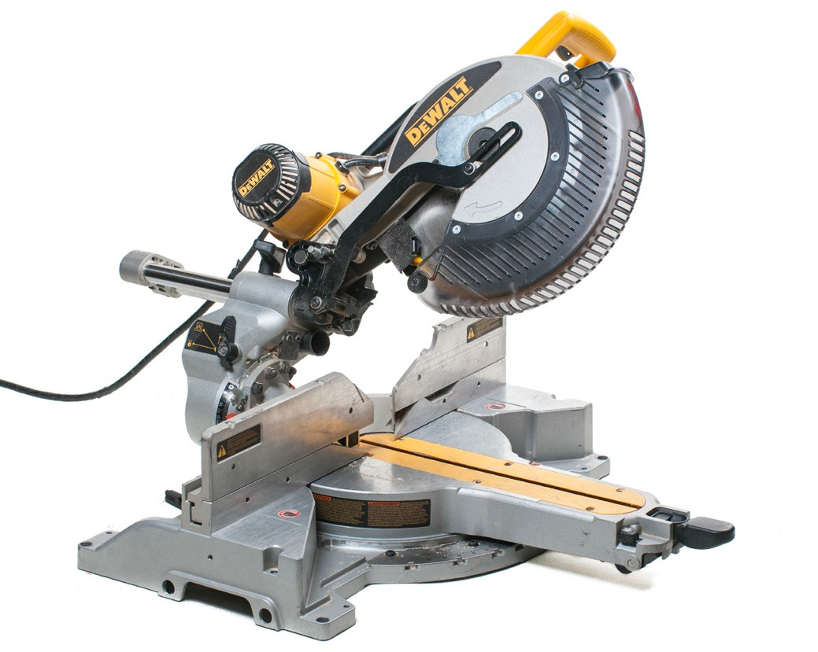
Figure 2 — Slide compound saw

Whenever you use a power saw, wear eye and ear protection and allow the saw to reach full speed before you start a cut.

When you use a mitre saw, do a trial run on waste material before you cut into good material. This gives you a chance to check the angles.

Cut-off saws
An abrasive blade cut-off saw, or chop saw (Figure 3), is used to make straight or angular cuts through metal material such as angle iron, flat bar, ready-rod, and channel iron. Power cut-off saws use a thin, abrasive, circular disk as a saw blade. The disk is made from mineral or synthetic grains that are fibre reinforced and resin bonded. Disks come in thicknesses of 2 mm to 3 mm (1/16 in. to 1/8 in.) and in diameters of 150 mm to 500 mm (6 in. to 20 in.).

The mandrel and motor of a cut-off saw are mounted on a pivoting frame. It is operated by grasping the handle fastened to the pivoting frame and pulling the rotating cut-off wheel into the workpiece. The workpiece is secured on the bed of the tool by a built-in vise or clamp. Power cut-off saws are also manufactured with special features for a variety of applications.

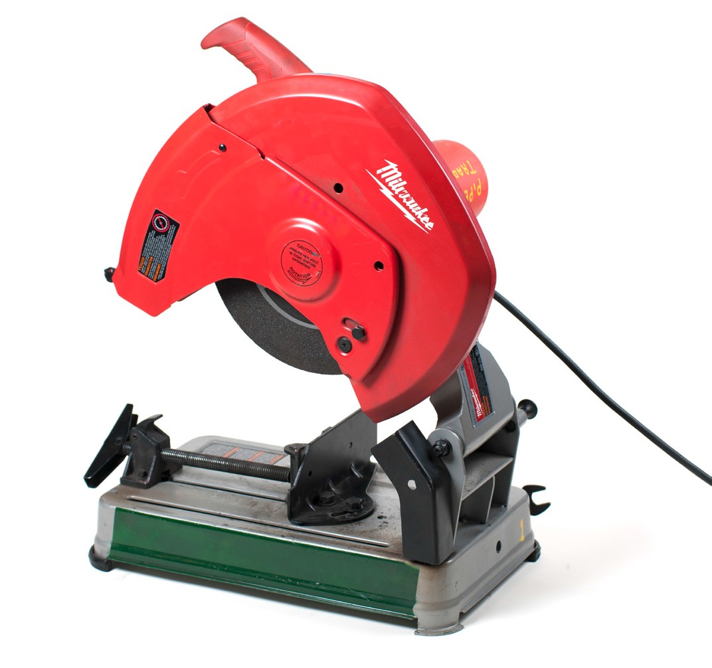
Figure 3 — Cut-off saw (or chop saw)

This saw cuts relatively quickly but produces a considerable amount of heat at the site of the cut, which may damage the workpiece. It is used to cut steel that will not suffer too much from heat buildup.

Be especially safety conscious while operating this tool. Follow these safety precautions when using a power cut-off saw:
- Make sure the blade guard is in place before operating the machine.

- Secure the workpiece in the vise or clamp; never hold the piece with your hands.

- If you are cutting long pieces, have the end supported or held by an assistant, as the piece could kick back and break the cut-off blade.
- Use a face shield, not just eye protection.

- Use leather gloves to handle the cut pieces, as they will be hot.

- Do not use excessive force when cutting, and be careful not to bump the blade onto the work, as this could break the blade.
- During the cutting operation, do not stand in line with the cut-off blade. Stand off to one side so that if the blade breaks, you will not be in line with flying pieces.

Abrasive cut-off wheels
Abrasive cut-off wheels are designed for cutting masonry products or for cutting metal. Metal- cutting wheels are available in two grades: fast cut and long life. Fast-cut wheels cut faster
but wear out sooner than long-life wheels. Most metal-cutting abrasive wheels will cut steel, stainless steel, cast iron, and aluminum.

Each abrasive cut-off wheel has a maximum speed listed in rpm. You must ensure the rated speed of the cut-off wheel is greater than the speed of the motor or the wheel could shatter.

Saw blades for circular saws
There are several designs of blades. Each blade design is intended for a specific cutting task and will last longer and perform better if used only for the intended task. Circular saws and mitre saws use various types of blades:
- rip blades
- crosscut blades
- combination blades
- metal-cutting blades
- masonry blades

Use crosscut blades for crosscutting and rip blades for ripping. Use a combination blade if the work requires you to constantly change from crosscutting to ripping.

Rip blades
Rip blades (Figure 4) are designed to cut solid lumber along the length of the stock. The teeth are filed square across their cutting edge and will cause chipping if used for crosscutting (Figure 5).

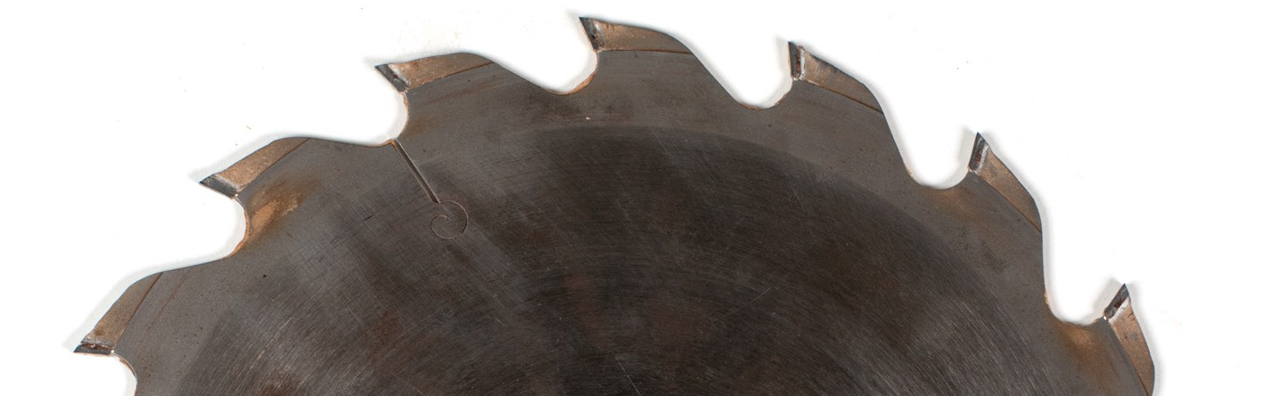
Figure 4 — Rip blade teeth

Crosscut blades
Crosscut blades (Figure 5) have teeth sharpened to a knife-like point. They will produce a smooth, chip-free cut across the grain of solid lumber, and they are ideal for cutting plywood regardless of the direction of the cut.

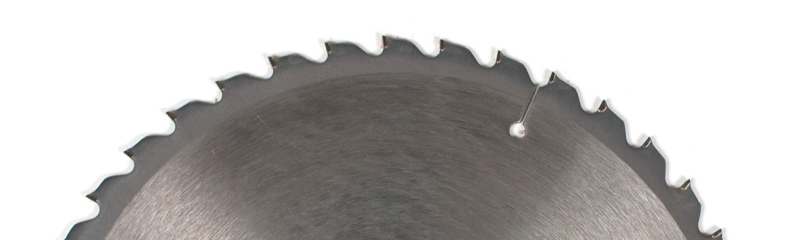
Figure 5 — Crosscut blade teeth

Combination blades
A standard combination blade (Figure 6) will provide an adequate cut with or across the grain of solid wood as well as on various plywood and panel products. However, it does none of these cuts as well as those blades specifically designed for each task.

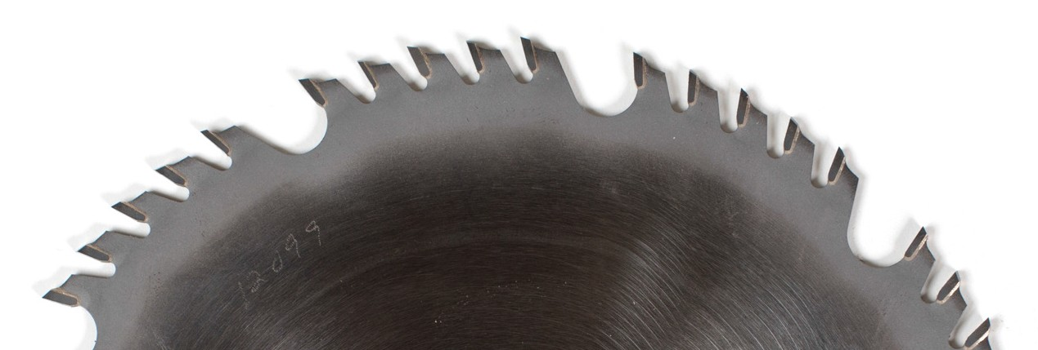
Figure 6 — Combination blade teeth

Metal-cutting blades
Non-ferrous metals can be cut with a metal-cutting circular blade (Figure 7). The blade resembles a plywood blade, but the teeth are square across the cutting edge like those of the ripsaw blade. These blades usually require lubrication to prevent the waste material from
binding to the blade. The most common type of lubricant is a wax stick, which is rubbed on the sides of the blade.

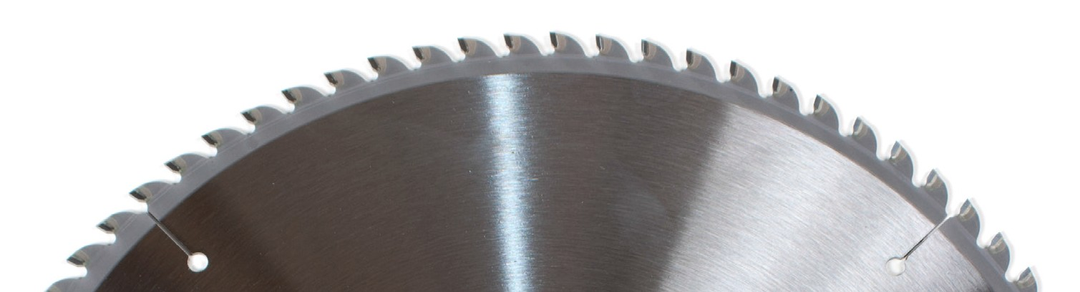
Figure 7 — Metal-cutting blade

Ferrous metals, metals containing iron and that spark when ground, can be cut with an abrasive blade (Figure 8). The blade has no teeth and simply grinds a thin cut through the metal. The abrasive blade must be matched to the hardness of the steel being cut. Otherwise, the blade will either cut very slowly or wear out very quickly.

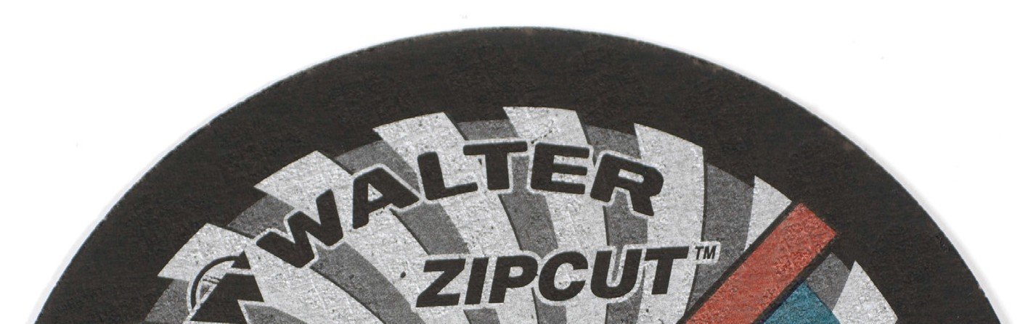
Figure 8 — Abrasive disk blade

Masonry blades
Masonry products are cut with an abrasive wheel similar to the type used for ferrous metals. Because masonry blades and ferrous-cutting blades are similar in appearance, check to make sure you have the correct type of blade.

Saw teeth characteristics
Figure 9 shows the blade teeth and the characteristics that distinguish one type from another.
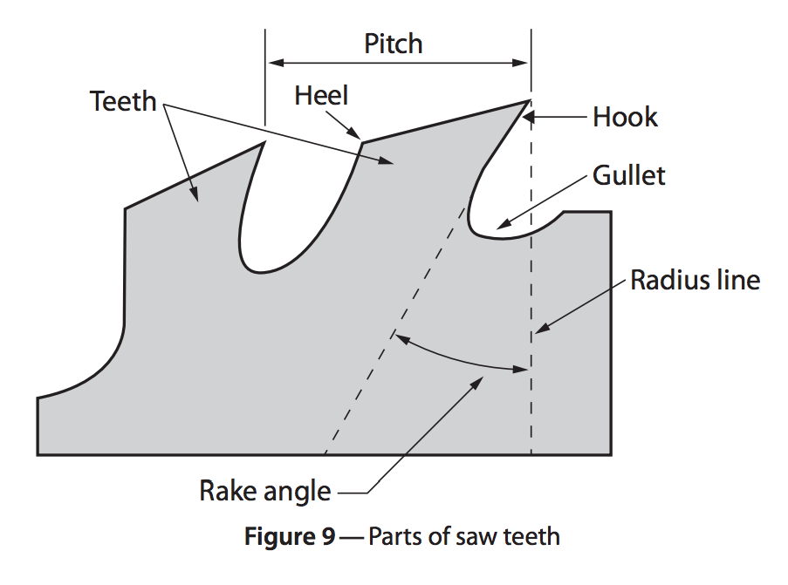

Hook or rake angle
The hook or rake angle is the angle formed between a radial line extending to the tip of the tooth and the gullet of the tooth. This angle has a lot to do with the performance of the blade. A 12° hook angle is common for combination blades. Finishing blades have less hook angle, and special blades designed for cutting two-sided melamine have a negative hook angle.

Clearance
The clearance at the back of the tooth is required to allow the cutting tip to cut cleanly and reduce heat buildup.

Gullet
The gullet is used to clear sawdust and chips out of the kerf. Ripping blades have deep gullets; crosscut blades have shallower gullets.

Carbide-tipped blades
Carbide-tipped blades remain sharp much longer than conventional steel blades. They can be used to cut wood, plastic, and composition board as well as non-ferrous metals. The carbide tips, which are extremely hard and brittle, are brazed onto a standard-sized metal disk. The carbide tips are then ground to a shape suitable for the blade’s intended use. Figure 10 shows a carbide- tipped blade with an expansion slot to prevent warping of the blade due to excessive heat.

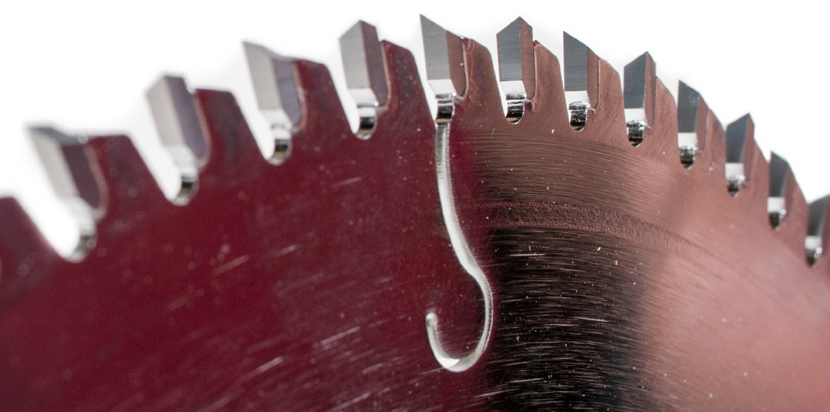
Figure 10 — Carbide-tipped blade

Carbide is so hard and brittle that it can be chipped and dulled through contact with other hard materials. As a result, all carbide-tipped blades require careful handling. You must not let the carbide come in contact with any hard surface such as the metal parts of a saw, other saw blades, or concrete and masonry.

Sabre saws
A sabre saw, or a jigsaw as it is commonly called (Figure 11), is used to make curved or irregular cuts in wood, plastics, or metal.

The blade action is a high-speed up-and-down motion, with the cutting taking place during the upstroke.

The sabre saw is designed mainly for light cutting but is capable of making cuts through materials 40 mm to 50 mm (1½ in. to 2 in.) thick.

The blade should be of a length so that when the blade is at the top end of its stroke, the lower end of the blade still is below the bottom of the stock being cut.

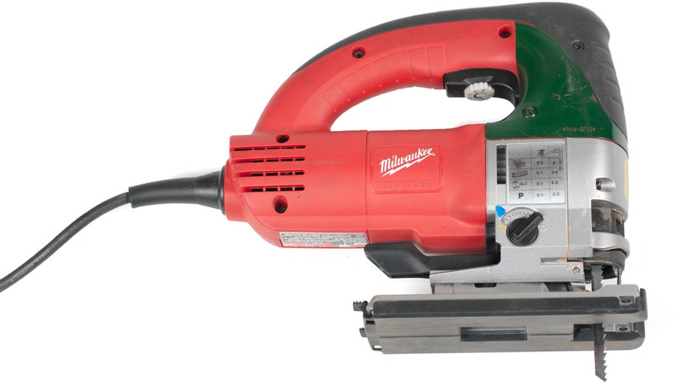
Figure 11 — Sabre saw (or jig saw)

The sabre saw is capable of starting a cut in the middle of a piece of wood. However, it is much easier and safer to drill a starter hole through the workpiece and use the hole as the start of the cut. The rapid up-and-down action of the blade may cause the workpiece to chatter, so the workpiece must be secured and the sabre saw held firmly against the work.

The most common types of sabre saw blades are shown in Figure 12. Note that there are two different end types, the straight end and the hooked end. They cannot be interchanged. The blades for plywood, particle board, and plastics have fine teeth, and the blade for cutting thicker plywood and lumber has coarse teeth. The blade for cutting thin hardboard and plywood in a scroll pattern has fine teeth and is very narrow. The blade used for cutting ferrous metals has very fine teeth set in a wavy pattern.

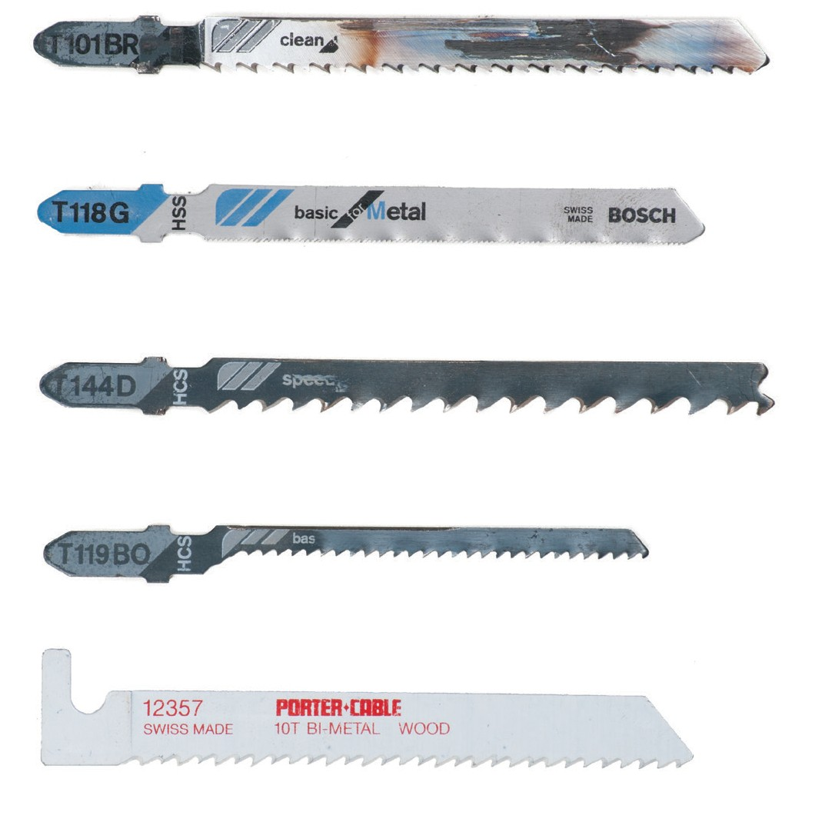
Plywood blade
Ferrous metal blade
Coarse cut wood blade
Narrow (scroll) blade
Hooked end bi-metal/wood blade
Figure 12 — Sabre saw blades

Reciprocating saws
The reciprocating saw makes cuts in any direction and can do heavier work than the sabre saw. This type of saw can be used to cut metal, wood, fibreglass, and virtually any other substance using the correct blade.

A reciprocating saw can be electric, corded (Figure 13), cordless, or air powered.

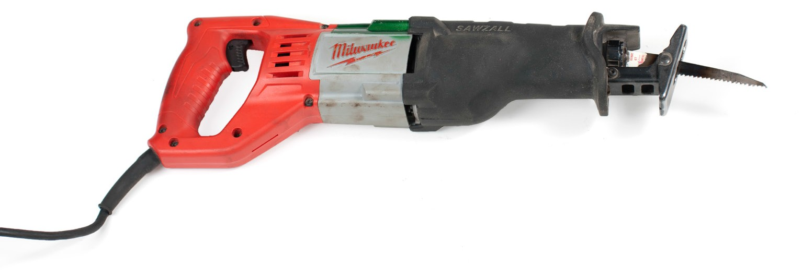
Figure 13 — Corded reciprocating saw

Reciprocating saw blades are designed in the same way as sabre saw blades. Fine teeth are generally for harder material, coarse teeth are for softer material, and thin blades are for tighter, scrolling cuts. Diamond grit blades are for cast iron, and coarse aggressive blades are for lumber and demolition.

When replacing blades, always match the blade to the intended job. Also be sure the chuck system matches.

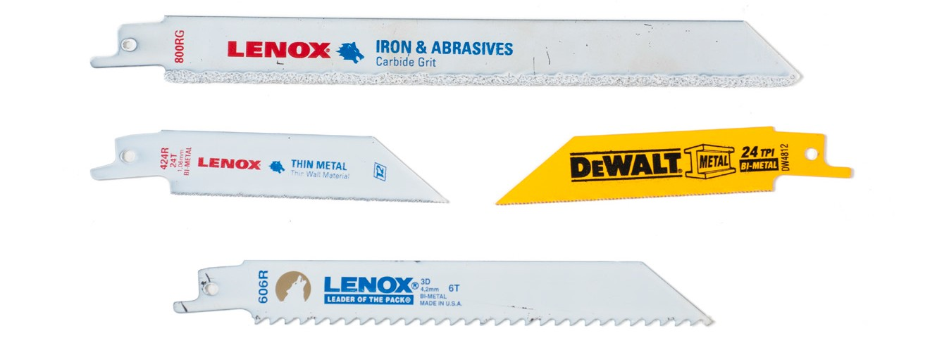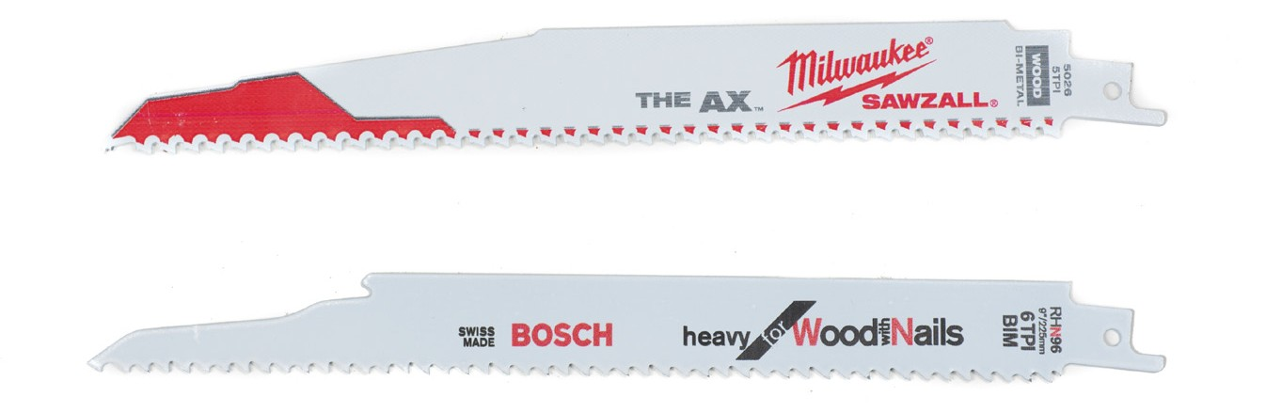
Figure 14 — Reciprocating saw blades

Band saws
Band saws (Figure 15) use a flexible band of steel with teeth along one edge, which forms an endless belt on a power-driven pulley. Band saws are capable of sawing straight, curved, or irregular cuts in a great variety of materials. They are available in a variety of models and sizes. The blade can be rigidly mounted within the saw housing and the material moved into the vertical blade.

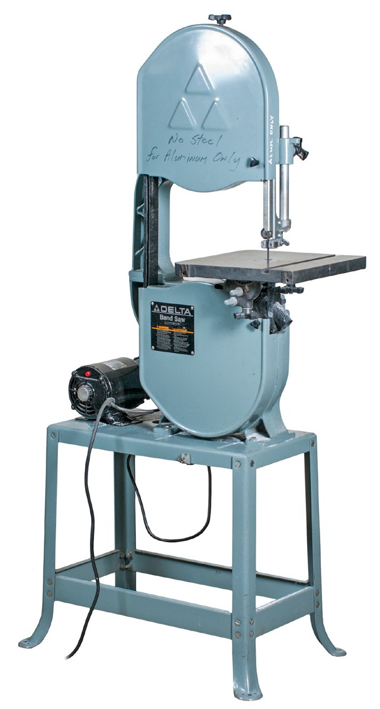
Figure 15 — Vertical bandsaw

For the horizontal type the material being cut is held by a built-in vise and the saw blade is brought down through the material. The vise can be rotated to allow a cutting angle from 45° to 90°.

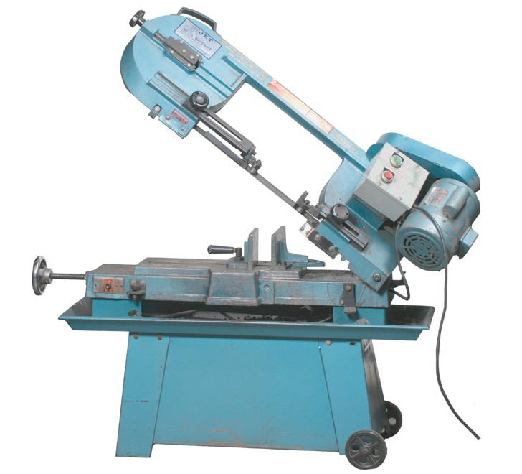
Figure 16 — Horizontal band saw

The size of the metal-cutting band saw is designated by the thickness of the stock it is able to cut. Standard sizes are 115 mm, 180 mm, and 255 mm (4 ½ in., 7 in., and 10 in.). Some larger models are capable of cutting through a pipe that is 50 cm (20 in.) in diameter.

Band saws produce an accurate cut without an excessive buildup of heat. Some saws are equipped with a mist spray cooling system that cools and lubricates the saw blade. For dry saws, the blade manufacturer may recommend applying a wax coating for cutting some metals.

The smaller models regulate the amount of cutting pressure by use of an adjustable counterweight. Larger models use a hydraulic system to regulate the feed pressure. All models are designed to shut off once the workpiece is cut. These features allow the saw to be left unattended during long cutting operations. If several smaller pieces need to be cut, they can be cut simultaneously, providing they can all be secured in the vise.

The speed of the saw blade can be reduced to prevent heat buildup during a heavy cut. Speeds may range between 21 m/min. (65 ft./min.) ans 90 m/min. (300 ft./min.).

Portable band saws
A portable hand-held band saw can be used when it is easier to move the saw to the work. They come in corded or cordless styles (Figure 17).

The saw runs and cuts on a pull motion, so you need to place the stop firmly against the objects being cut. The blade of a portable band saw can get stuck easily if the angle isn’t held steady.
Never force a portable band saw; let the saw do the cutting.

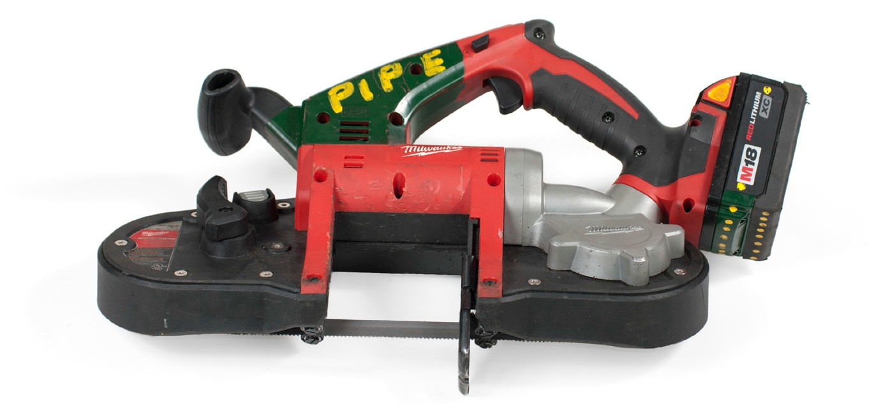
Figure 17 — Cordless portable band saw

Wear the appropriate safety equipment with all cutting machines. Protect your eyes from small particles of metal that can be sent flying during the operation. Protect your hearing from the high volumes associated with these tools.

Metal-cutting blades
Metal-cutting band saw blades (Figure 18) are defined by their grades of steel, tooth formation, tooth set, and blade width. Grades include:
  - carbon-steel blades
  - semi-high-speed steel blades
  - high-speed steel blades

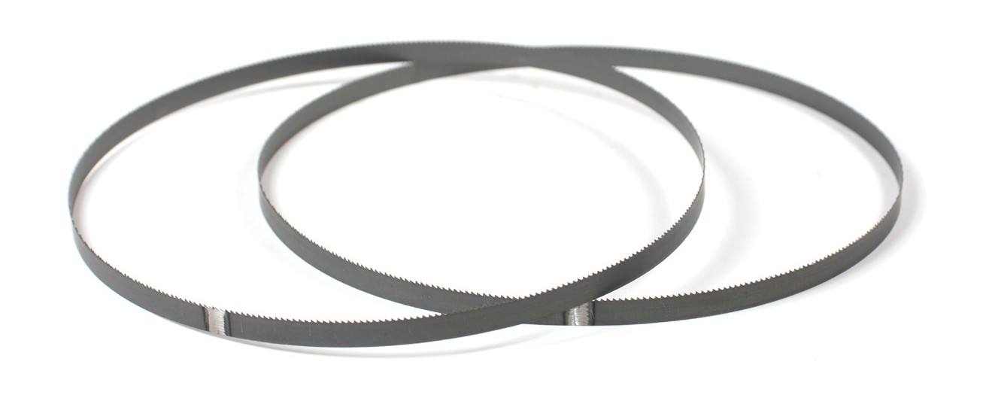
Figure 18 — Band saw blades

Tooth formations include:
  - regular
  - hook
  - skip

Carbon-steel blades
Carbon-steel blades are used for general-purpose cutting on a standard band saw. Blades made of carbon steel are inexpensive but are less durable than the other grades.

Semi-high-speed steel blades
Semi-high-speed steel blades cut 50% faster than carbon steel blades. They are harder than carbon steel but are able to withstand mechanical shocks and vibrations that would break harder, more brittle blades.

High-speed steel blades
High-speed steel blades cut better and last longer than other blades but are more expensive and more delicate than the other two grades.

Regular-tooth formation
Band saw blades with regular teeth (Figure 19) are used for straight and curved cuts in most ferrous and hard non-ferrous metals. Blades with regular teeth can be considered general- purpose blades.

Figure 19 — Regular-tooth

Hook-tooth formation
The hook-tooth blade (Figure 20) is best for fast cutting of non-ferrous metals (Figure 21). The large, rounded gullets are capable of fast chip removal, and the forward slope of the tooth requires less downward pressure to cut. Thin sections of metal should not be cut with this tooth style due to the wide spacing of the teeth.

Figure 20 — Hook-tooth

Skip-tooth formation
The skip-tooth formation (Figure 21) is very similar to the hook tooth, but it is capable of cutting ferrous metals. The wide spacing of the skip-tooth formation makes the blade suitable for fast cutting of large sections of steel.

Figure 21 — Skip-tooth

Hook- and skip-tooth types are available in 3 to 6 teeth per inch. Regular-tooth styles range from 6 to 32 teeth per inch. The number of teeth per inch affects the cutting speed of a band saw and the size of stock it is best suited to cut. Blades with a large number of teeth per inch are able to cut small, thin pieces of metal but are slow for cutting large sections. Blades with few teeth per inch cut faster but are too coarse for cutting thin sections of metal.

Tooth set
Set is defined as the left and right positioning of the teeth to provide a wider cut than the thickness of the blade. The wide cut provides clearance for the blade within the cut, preventing binding and overheating.

There are two types of tooth sets available on metal-cutting band saws: the raker set (Figure 23) and the wavy set (Figure 22).

Raker set

Wavy set
Figure 22 — Tooth set

Hook- and skip-tooth blades have raker set teeth. Regular-tooth blades with up to 24 teeth per inch come with either raker set or wavy set teeth. All regular-tooth blades with more than 24 teeth per inch have wavy set teeth.

Blade width
Band saw blades are available in widths ranging from ¼ in. to 1¼ in. The narrower blades are able to cut curves of a smaller radius than are the wider blades. Wide blades are used for straight cuts.

Now complete the Learning Task Self-Test.

Self-Test 3
- How is the size of a portable circular saw designated?
  - By the depth of its cut
  - By the length of its base
  - By the strength of its motor
  - By the diameter of its blade

- How is the depth of cut controlled on a portable circular saw?
  - By varying the cutting speed
  - By raising or lowering the base
  - By changing the size of the blade
  - By altering the speed of the motor

- How are the straightest, most accurate cuts made with a portable circular saw?
  - By eye
  - By freehand
  - Using a chalk line
  - With a straightedge

- What is the recommended way to make a bevel cut using a portable circular saw?
  - Tilting the base
  - Raising the blade
  - Tilting the lumber
  - Using a special saw blade

- What is the intended purpose of the rip guide?
  - Control the angle of the cut
  - Control the length of the stock
  - Control the squareness of the cut
  - Control the width of the stock being cut

- What is the ideal depth to set the saw when performing a straight cut?
  - Maximum depth
  - Slightly deeper than the stock
  - Equal to the thickness of the stock
  - Slightly less than the thickness of the stock

- What is the PPE required for the use of a circular saw?
  - Gloves
  - Apron
  - Dust mask
  - Eye protection

- In which direction should the circular saw teeth point if the blade is installed correctly?
  - Up
  - Down
  - Either up or down
  - To the rear of the saw

- In addition to ear protection, what PPE must be worn when cutting masonry products with a portable circular saw?
  - Hard hat
  - Dust cap
  - Dust mask
  - Leather apron

- What is a sabre saw designed to cut?
  - Curved cuts
  - Heavy timbers
  - Long, straight cuts
  - Masonry products

- What is the proper length of a sabre saw blade?
  - Half the depth of the cut
  - Stock thickness plus stroke length
  - Stock thickness minus stroke length
  - The thickness of the material being cut

- What is the safest practice to start a sabre saw cut in the middle of a workpiece?
  - Use a short blade
  - Drill a starter hole
  - Reverse the blade
  - Use a starter blade

- Why must the sabre saw be held firmly against the workpiece you are cutting?
  - To control chattering
  - To prevent bevelled cuts
  - To prevent dulling the teeth
  - To avoid the sawdust from flying

- What is the tooth pattern found on a circular saw blade designed for ripping lumber?
  - Filed straight across
  - Filed to a knife-like point
  - Brazed with alternate slopes on the back of each tooth
  - Brazed with a bevel on the face of each tooth

- What other circular saw blades are similar in appearance to those designed to cut plywood?
  - Rip blade
  - Crosscut blade
  - Chisel-tooth blade
  - Combination blade

- What two words best describe the carbide metal used for carbide-tipped saws?
  - Strong and durable
  - Forged and magnetic
  - Hard and brittle
  - Light and indestructible

- Which two materials are abrasive circular saw blades designed to cut?
  - Plastic and vinyl
  - Plastic and wood
  - Non-ferrous metals and plastic
  - Ferrous metals and masonry products

- Which feature is most important to match when purchasing replacement blades for a sabre saw?
  - The width
  - The length
  - The thickness
  - The chuck end

- What material are sabre saw blades with coarse teeth designed to cut?
  - Lumber
  - Plastic material
  - Any sort of metal
  - Thin panel products

- What feature best describes sabre saw blades used to cut ferrous metals?
  - The blade’s wavy teeth
  - A thin and narrow blade
  - The blade’s coarse teeth
  - All metal blades are short and stubby

- A metal-cutting band saw may use hydraulics to create downward pressure. What is another technique used to create downward pressure, more typically found in smaller models?
  - The use of air
  - The use of a feed screw
  - The use of a worm screw
  - The use of counterweights

- What are some band saws equipped with to prevent overheating the workpiece?
  - A mist spray
  - A blower system
  - An abrasive blade
  - High-speed blades

- What happens when a metal-cutting band saw has cut through the workpiece?
  - A beeper will sound.
  - The stock will unclamp.
  - The saw will increase in speed.
  - The saw will automatically shut off.

- What action can be taken to reduce heat buildup when using a band saw to make a heavy cut?
  - Use a well-worn blade.
  - Reduce the blade speed.
  - Increase the blade speed.
  - Apply greater downward pressure.

- Which of the band saw blades listed below is the least expensive to purchase?
  - Raker set blade
  - Carbon steel blade
  - High-speed steel blade
  - Semi-high-speed steel blade

- To cut non-ferrous metals, which one of the following blades cuts the quickest and easiest?
  - Wavy set blade
  - Skip-toothed blade
  - Hook-toothed blade
  - Regular-toothed blade

- Which blade should not be used to cut thin or narrow sections of metal?
  - Narrow blade
  - Raker set blade
  - Skip-tooth blade
  - Abrasive cut-off wheels

- Which metal-cutting band saw blade is the best choice for quickly cutting ferrous metals?
  - Skip-tooth, carbon steel blade
  - Regular-tooth, carbon steel blade
  - Skip-tooth, high-speed steel blade
  - Hook-tooth, high-speed steel blade

- What teeth spacing can be found in the skip-tooth and hook-tooth metal cutting band saw blades?
  - 1 to 3 teeth per inch
  - 3 to 6 teeth per inch
  - 6 to 24 teeth per inch
  - 6 to 32 teeth per inch

- What material is the power cut-off saw blade made of?
  - Carbide
  - Diamond grit
  - High-speed steel
  - Reinforced abrasives

- Why are long pieces of cutting material supported at both ends and clamped to the bed of a cut-off saw?
  - To achieve an off-square cut
  - To prevent stalling the motor
  - To avoid turning the end of the stock
  - To avoid the risk of breaking the blade

- Which protective equipment must be worn when using a cut-off saw?
  - Safety glasses
  - A leather apron
  - Goggles and a hard hat
  - Face shield and gloves

- What must be confirmed before safely using an abrasive cut-off wheel to cut metal?
  - That the blade is an all-purpose blade
  - That the blade is designed to cut metal
  - That the word “masonry” is on its label
  - That the blade’s direction of rotation is correct

- What is the primary safety concern to consider when choosing an abrasive disk for a cut-off saw?
  - Depth of cut
  - Ferrous rating
  - Temperature limit
  - Maximum speed rating

LEARNING TASK 4

Describe types of power drills

Hand drills
The portable electric drill is used for a variety of tasks, including drilling holes, driving screws, and stirring paint. Electric drills may be corded or cordless. Corded drills may be double insulated or three pronged.

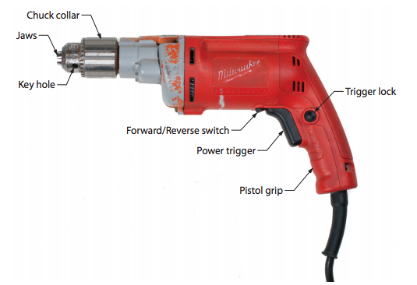
Some electric drills are manufactured with a pistol grip (Figure 1). A trigger switch is located on the pistol grip to allow for single-handed use during light-duty operations. During heavier drilling operations two hands should be used, one applying force to the back end of the drill and the other holding the handle to counteract the torque generated by the drill.

Figure 1 — Electric drill components

Drill chucks
The drill bit is secured to the portable power drill by means of a chuck. The conventional style is a three-jawed chuck that can be opened and closed by rotating the knurled outer sleeve, but final tightening is done with a special wrench known as a “chuck key” (Figure 2). The chuck key is inserted into a hole on the chuck so that the teeth on the key engage matching teeth on the chuck sleeve. Final tightening with the chuck key should be performed at two points on the three-jawed chuck to ensure a tight contact.

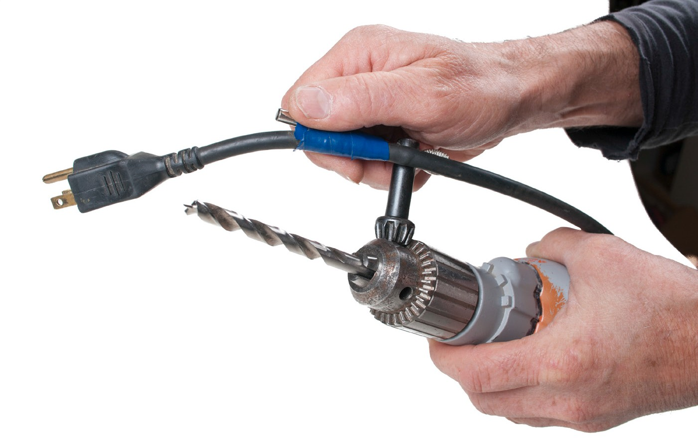
Figure 2 — Chuck key

Many jawed chucks, however, are keyless and have a knurled sleeve to permit tightening and loosening by hand force alone (Figure 3). Keyless designs offer the convenience of quicker and easier chucking and unchucking, but they have lower gripping force to hold the drill from
slipping, which is potentially more of a problem with conventional cylindrical drill bits than with hexagonal shank bits.

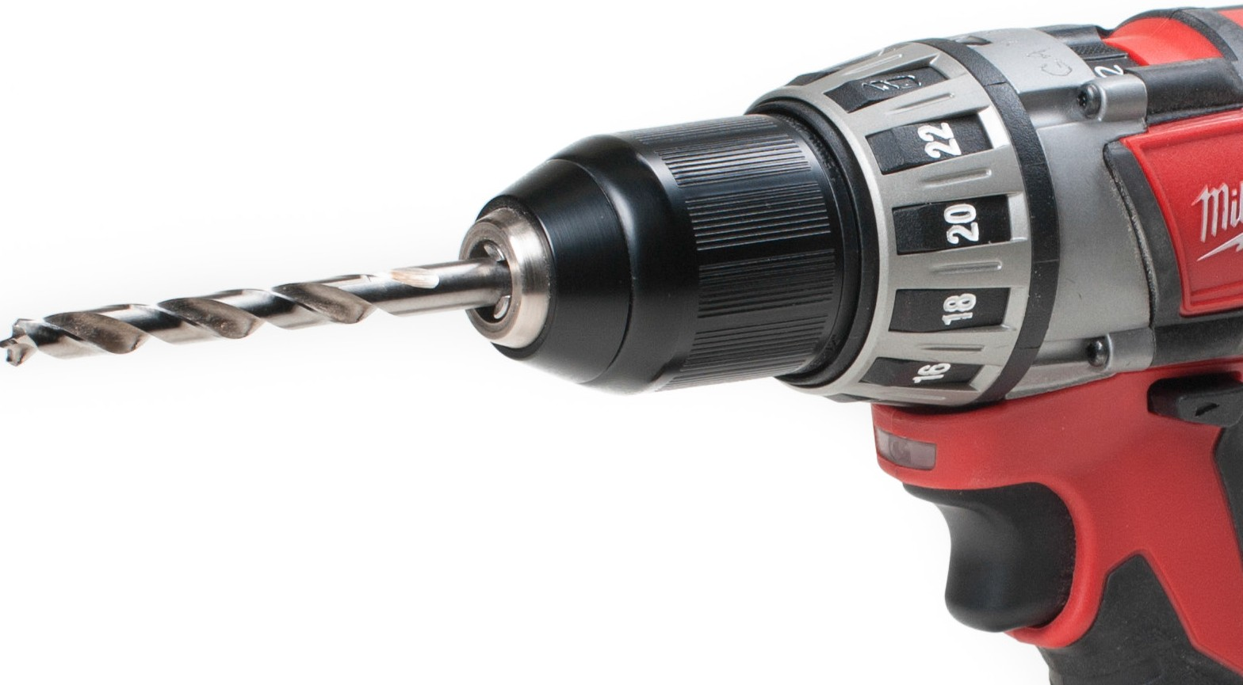
Figure 3 — Keyless chuck

Another style of chuck is the quick-release hex chuck (Figure 4), originally designed to hold screwdriver bits but that also fits many drill bits that have hex shanks with a retaining channel.

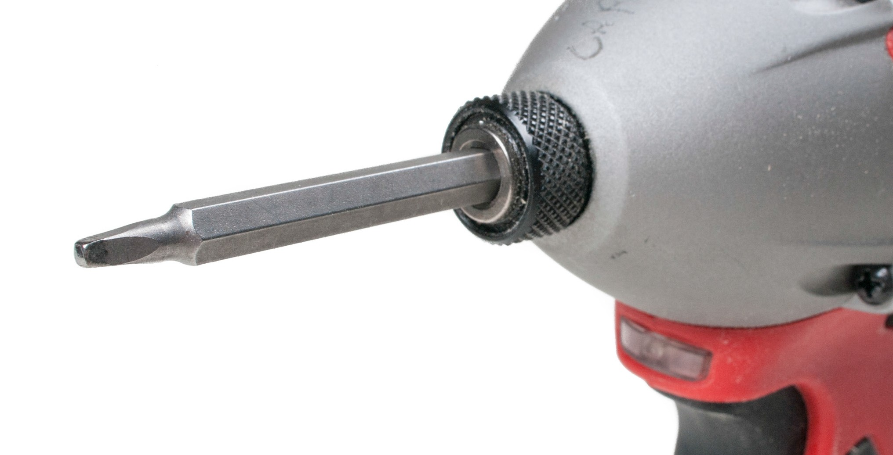
Figure 4 — Hex shank screwdriver bit

Control switches
Some portable electric drills only have an on-off switch. This type of switch limits the use of the electric drill to those operations that require a clockwise rotation of the chuck at the fixed speed at which that particular drill turns.

Other drills are manufactured with a variable speed switch. These switches provide control over the chuck speed. This control allows the electric drill to be used for a variety of tasks. Driving screws and drilling hard steel require a slow-turning drill, while other operations require higher speeds.

An additional switch found on some drills allows the motor to turn counter-clockwise as well as clockwise. When both a variable speed switch and a reversible switch are present on an electric drill, the drill can be used to remove screws as well as to drive them.

Always allow the motor on a reversible drill to come to a complete stop before switching the motor direction. Failure to do so will damage the motor.

¼ in. drills
Most ¼ in. drills are used for light-duty drilling operations. The drill will accept a maximum
¼ in. shank size. The chuck on a ¼ in. drill turns at about 1500 to 1800 rpm. Such high speeds are good for drilling small holes in soft metals but tend to burn drill bits if used for hard metals. Quick-release hex chucks are common for these drills to accommodate machine screwdriver bits and have spread from that application to be used for hex shank drill bits.

3/8 in. drills
These drills can turn at a much slower speed than a ¼ in. drill. Their average chuck speed is 750 to 900 rpm. Considerably more torque is generated, which makes the 3/8 in. drill more suitable for drilling larger holes in metal. This size drill is often equipped with a forward-reverse switch as well as a variable speed switch.

½ in. drills
These drills generate substantial torque and are usually equipped with an additional handle to provide the operator with added leverage. Some heavy-duty models have a pistol grip on one side, a removable T-handle opposite the pistol grip, and a D-handle at the back (Figure 5).

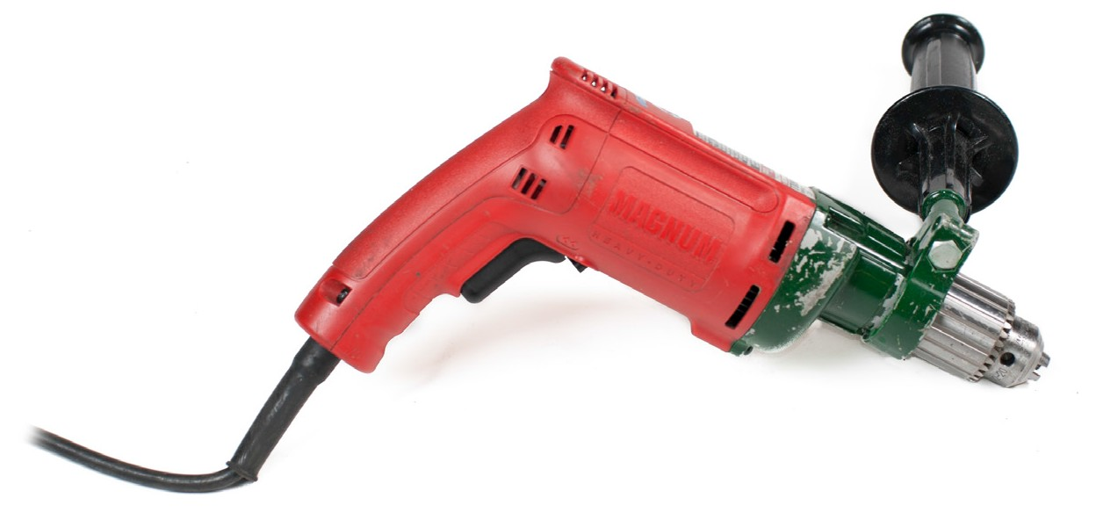
Figure 5 — ½ in. drive drill

Cordless drills
Cordless drills are common in the smaller sizes and are very useful for working in awkward spaces or in areas where a power source is not convenient. Some cordless drills have adjustable clutches so they can also serve as a power screwdriver. Most cordless drills are available with keyless chucks.

Angle drills
Angle drills have their chuck mounted at right angles to the drive motor, allowing for the motor to remain horizontal when drilling vertical holes (and vice versa). This helps to reach into confined wall and ceiling cavities to bore holes or drive screws. The multi-positional handle attachments help maintain control in close quarters.

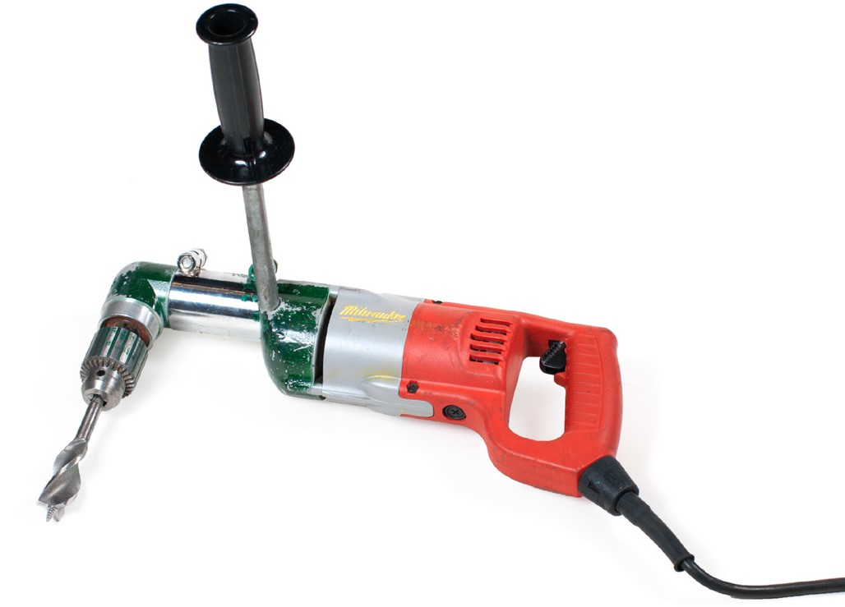
Figure 6 — Angle drill

Hammer drills
The hammer drill (Figure 7) has a pounding action as it rotates, which enables it to drill into masonry or stone. It requires special hammer drill bits that can take the pounding while pulverizing and removing the materials from the hole.

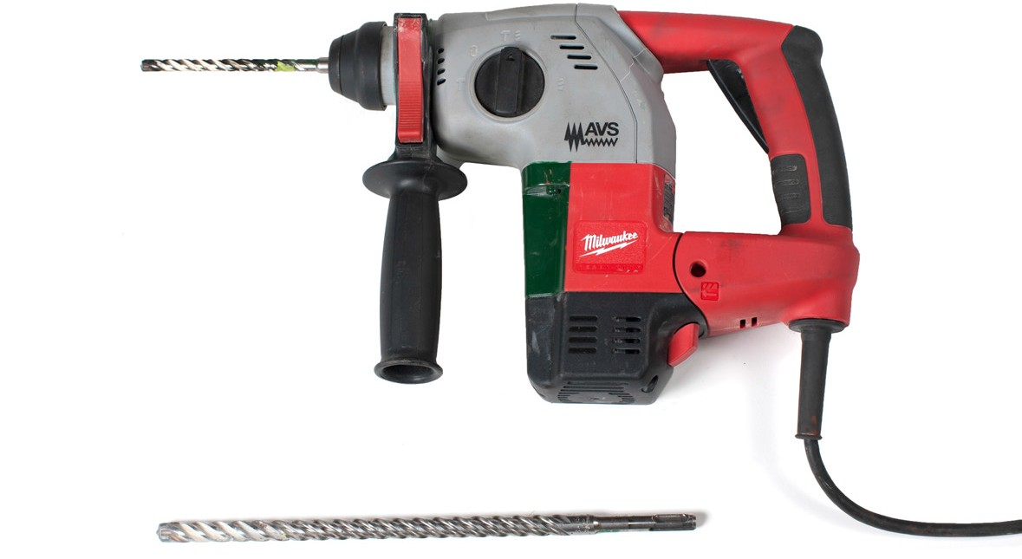
Figure 7 — Hammer drill and masonry bits

The hammer drill has a spring-loaded chuck, so that bits are simply pushed into the chuck without tightening. The drill bit is not held solidly in the chuck, but can slide back and forth like a piston. Rotational drive uses the sliding keyways (Figure 7) that open to the end of the shank, which mate with keys in the chuck. The smaller indentations that do not open to the end are grasped by the chuck to prevent the drill bit from falling out. The hammer of the drill hits the flat end of the shank. The shank must be lubricated with grease to allow it to slide in the chuck.

Hammer drill bits with this shank design are known as “SDS bits” (Figure 8). The name comes from the German stecken-drehen-sichern (insert-twist-secure).

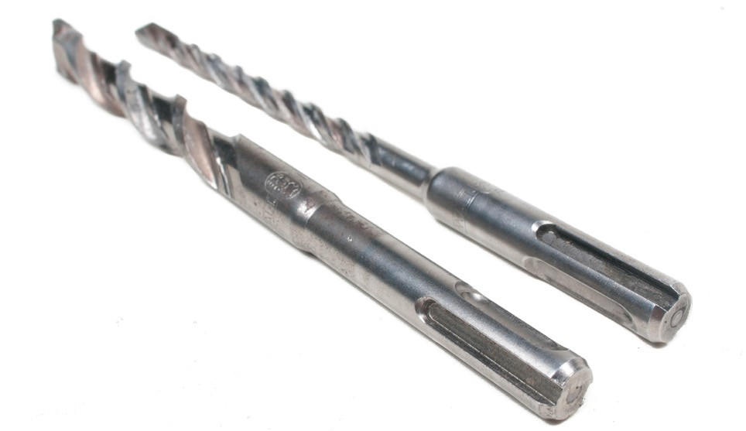
Figure 8 — SDS hammer drill bits

Drill presses
The drill press (Figure 9) is one of the most practical power tools because of its versatility and ease of operation. A drill press can be floor or bench mounted.

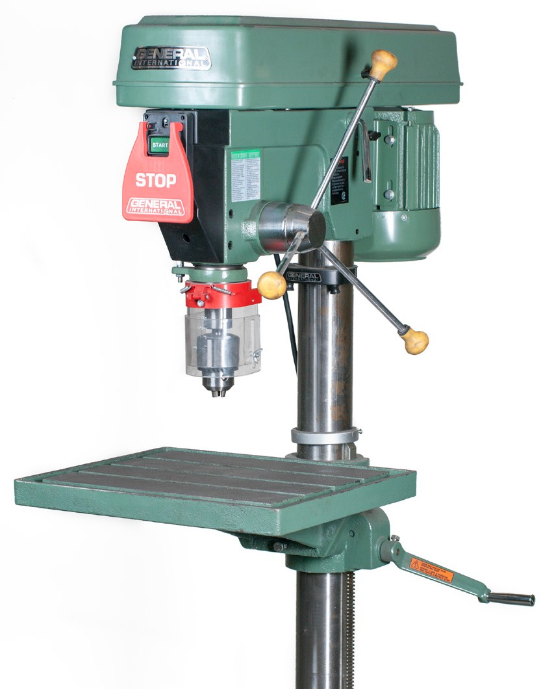
Figure 9 — Drill press

Construction
The four basic parts of the drill press are the base, column, table, and head. The head is the entire working mechanism attached to the upper end of the column. The table can be moved up and down on the column. On some models, the table can be swung to either side or tilted.

The chuck is moved downward by means of simple rack-and-pinion gearing worked by the feed lever. The feed lever is returned to its normal position by means of a coil spring. You can lock the feed and pre-set the depth to which it can travel.

Power and speed
The drill press is fitted with pulleys or gears so that different speeds can be obtained. The average drill press can obtain drill bit speeds of 680, 1250, 2400, and 4600 rpm. When the machine is used exclusively for metalwork, a larger cone pulley is used on the spindle to give lower drill bit speeds of about 470, 780, 1300, and 1950 rpm.

Drilling metal
A drill bit turning in a piece of metal exerts significant torque, which tends to cause the work to rotate. The twisting action increases when the drill bit breaks through the underside of the piece being drilled. A piece of work spinning on the end of a drill can cause serious bodily injury, break

the drill bit, or spoil the work. This hazard is avoided by clamping the work or mounting it to prevent twisting. A machine vise (Figure 10) can be used for holding smaller items. Large pieces should be secured with C-clamps.

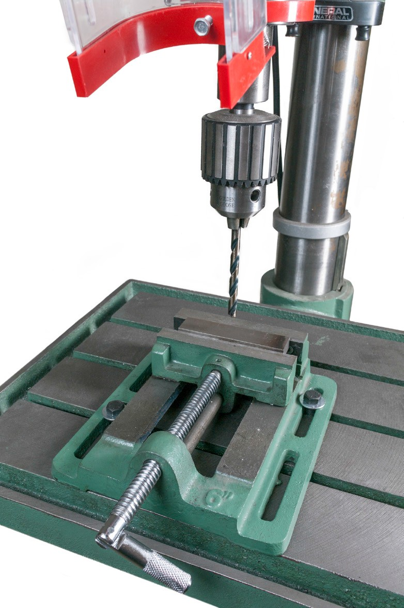
Figure 10 — Drill press machine vise

Speed and feed
The speed in any drilling operation is determined by the kind of material and the size of the hole. The smaller the drill bit, the greater the required speed in rpm. The speed should also be higher for soft materials than for hard materials.

On most drill presses, it is difficult to obtain the exact recommended speed, but you can come close by adjusting the drive belt on the step-cone pulleys. You will find instructions on adjusting the pulleys in the manufacturer’s manual; there is usually a chart in the manual giving the various speed ratios for your particular drill press.

Feed is the amount of pressure you apply to control penetration. Too much pressure will force the tool beyond its cutting capacity and can result in rough cuts and jammed or broken bits. Too light a feed, particularly with metals or other hard materials, will cause overheating of the bit and burning of the cutting edge. The best results will be obtained by matching the correct speed with a steady feed pressure that lets the bits cut easily at an even rate. A good indicator of the ideal pressure and speed is the shape of the waste metal created by the work. It should have two long, tight, continuous curl shapes.

Safe use of the drill press
As with all power tools, you must ensure the safe operation of a drill press. When performing any drill press operation, you should follow the following safety precautions:
- Use a vise or clamp to prevent the work from spinning.

- Use a face shield to protect yourself from flying chips.

- Before you start to drill, check the speed settings.

- Set speeds or adjust the work ONLY once the machine is stopped and locked out or unplugged.
- Keep away from revolving parts of a drill press to prevent your clothing from being caught.
- Allow the drill to break through the work gradually by easing up on the drilling pressure as the bit begins to break through the work.
- Always remove burrs from a drilled hole with a file or scraper, not with your hands.

- Ensure the chuck key has been removed from the drill chuck.

- Ensure the machine has stopped before attempting to grab the work. Never attempt to grab work while the drill is still in motion; stop the machine first.
- Always position the table or the vise so that the drill bit will not damage either of them as it penetrates through the work.

Electromagnetic drills
The electromagnetic drill (Figure 11) is a portable drill mounted on an electromagnetic base. When the drill is placed on a metal workpiece and the power is turned on, the magnetic base holds the drill in place.

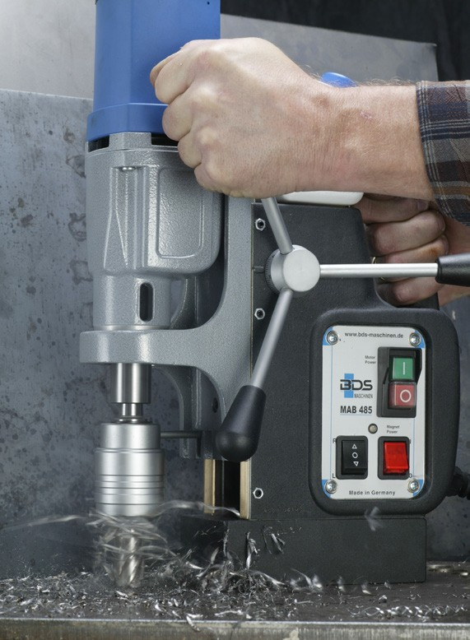
Figure 11 — Electromagnetic drills

Drill bit types
There are a wide variety of dill bits available. Which bit to choose will depend on the type of drill, material type, and size of hole you require.

Twist drills
Twist drills (Figure 12) are sometimes merely called “drill bits.” Twist drills may be made from carbon steel or high-speed steel. High-speed steel drills are harder and can drill harder metals. High-speed steel remains sharp longer than carbon steel and is able to withstand higher temperatures.

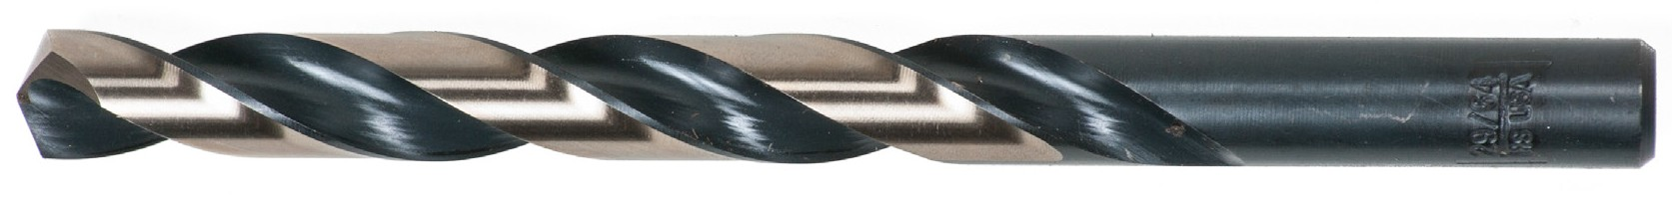
Figure 12 — Twist drill

Twist drills are available in sizes designated by one of four different systems:
- metric
- number
- letter
- fractional

Metric
Twist drills in metric sizes are usually supplied in 0.5 mm increments. Metric twist drills are commonly available in sizes from 0.5 mm to 15.5 mm in diameter.

Number
Twist drills in the number system range from 0.0135 in. to 0.228 in. in diameter. Size #80 is the smallest (just under 1/64 in. in diameter) and size #1 the biggest (just less than ¼ in. in diameter).

Letter
Letter sizes range from A to Z. Size A is equal to 0.2344 in. in diameter and size Z is equal to
0.413 in. in diameter.

Fractional
Fractional sizes start at 1/64 in. in diameter and increase in size by sixty-fourths up to 1 in. Larger bits are available in fractional sizes at varying increments of 1/32 in., 1/16 in., and 1/8 in.

By intermixing fractional, number, and letter sizes you can get up to 138 different sizes under
½ in. in diameter. Larger drills (over ½ in.) are available with reduced shank sizes so that they can be used in standard chucks.

Checking a twist drill’s sharpness
A correctly sharpened twist drill will cut mild steel with ease. Metal shavings should be produced equally by the two cutting lips of the drill. These shavings should eject from the hole in the shape of spiral coils. When the drill bit becomes dull it must be sharpened or replaced.

Twist drill bit angles
For normal use, a twist drill will have the cutting lips at 59° to the axis of the drill (Figure 13). Check the angle of the cutting lip with a drill point gauge. Both lips should be at the correct angle and equal in length.
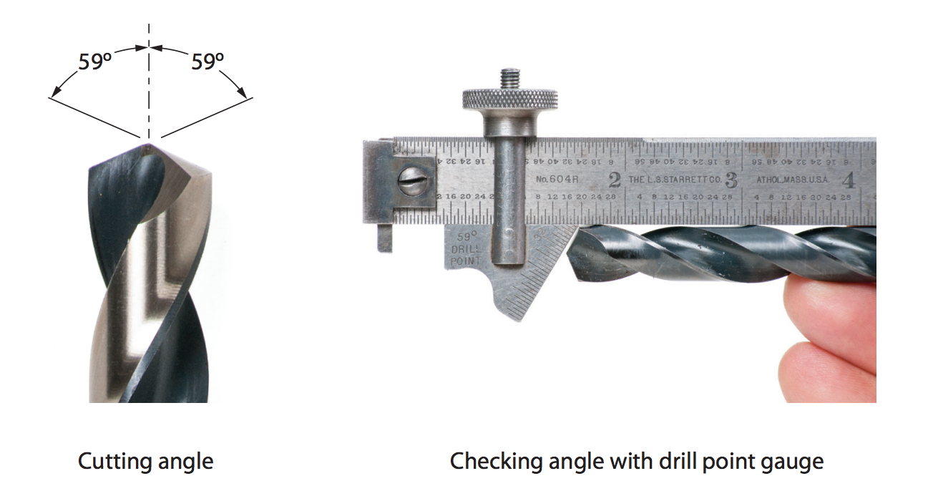
Figure 13 — Twist drill bit angle

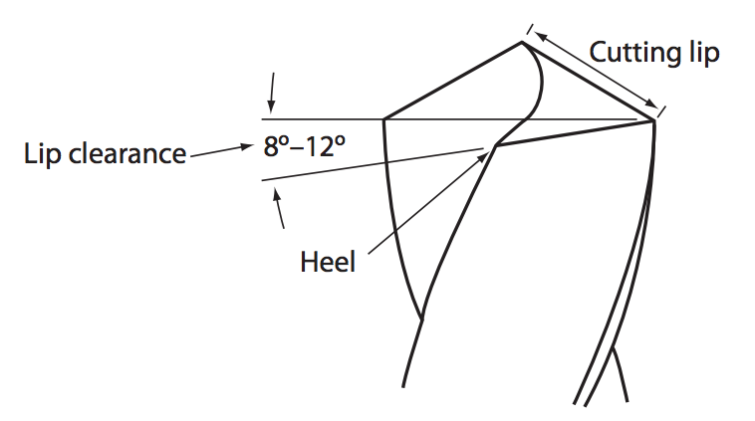
Lip clearance on a twist drill is the angular difference between the heel and an imaginary horizontal line perpendicular to the lip. On a twist drill, a lip clearance of 12° is usually considered adequate. The heel of each cutting face rises 12° from the left end to the right end (Figure 14).
Figure 14 — Lip clearance on a drill bit

Lip clearance on a drill bit (Figure 14) can be compared to the heel clearance of a wood chisel. Not enough lip clearance will result in the cutting edge being held away from the workpiece surface (Figure 15A). The chisel in Figure 15B will cut when moved in the direction of the arrow

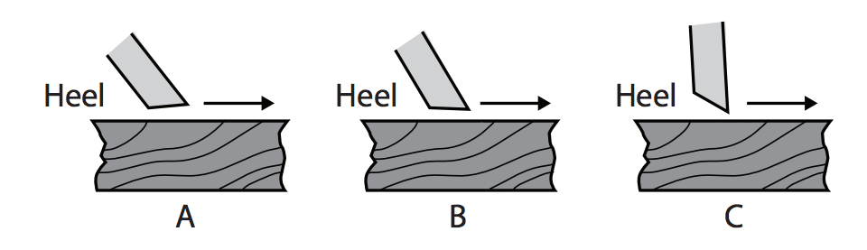
because the heel clearance allows the cutting edge to make contact with the surface of the wood. Too much lip clearance (Figure 15C) will lead to rapid dulling of the cutting edge.
Figure 15 — Lip clearance angle

Another method of measuring the lip clearance angle is to use the 12° end cut on the drill- grinding gauge. To use this gauge accurately, place it on its edge on a flat surface. Lay the twist drill behind the gauge with the point of the drill toward the 12° end of the gauge. The slope of the heel should be parallel to the 12° end of the gauge (Figure 16A). The drill should be lying with its cutting lips parallel to the flat surface and should be sighted as illustrated in Figure 16B.

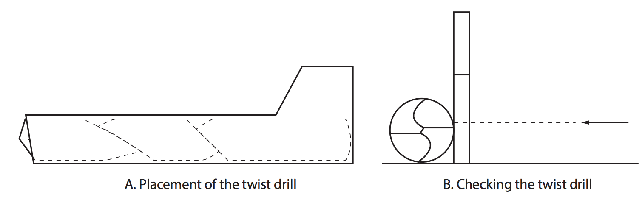

Figure 16 — Placement and checking of the twist drill

Other drill bit types
Several other drill bits are available for specialty uses.

Spade bits
The spade bit (Figure 17) is designed to drill into wood products only. Sizes of spade bits range from 9 mm to 38 mm (3/8 in. to 1½ in.) in diameter. The quality of the cut produced by the spade bit is not as good as most other bits. Therefore, its use is limited to rough work.

The spade bit shown in Figure 17 is a spur-style spade bit. This design cuts cleaner than the straight spade bit, as the spurs will cut the wood along the circumference of the hole first.

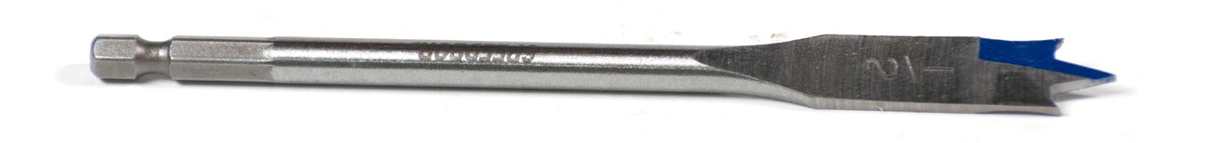
Figure 17 — Spade bit

Multi-spur bits
The multi-spur bit, or the self-feeding wood bore (Figure 18), uses the sides of the hole rather than the point of the bit to guide it while drilling. Having a very short centre point, the multi- spur bit drills virtually flat-bottomed holes.

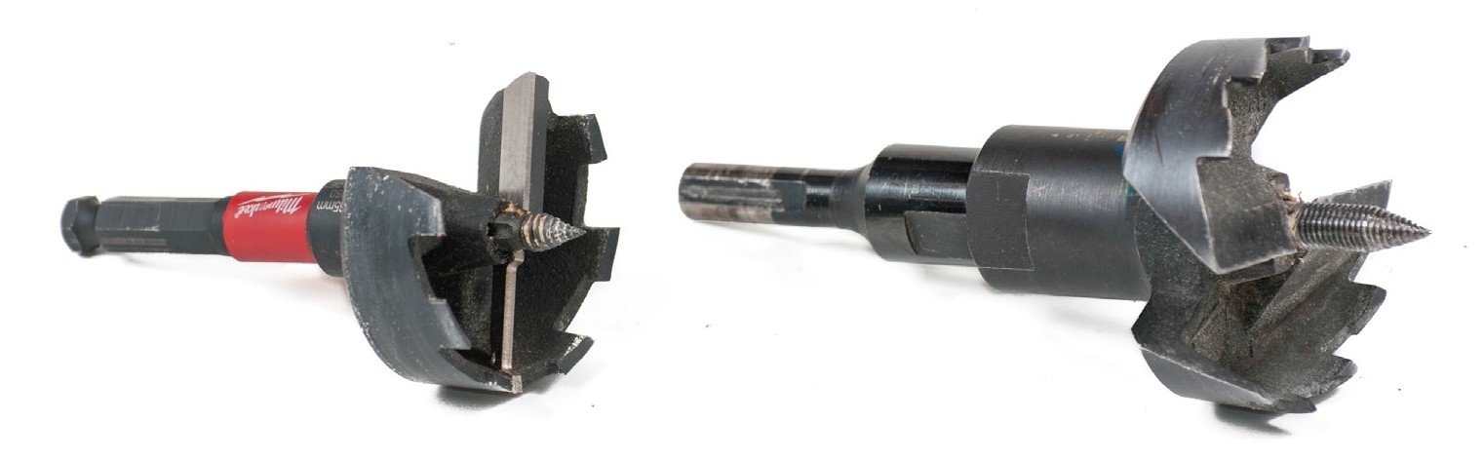
Figure 18 — Multi-spur bit

Multi-spur bits are available in sizes from 25 mm to 75 mm (1 in. to 3 in.). Their cutting action cuts clean but shallow holes.

Auger bits
The auger bit (Figure 19) drills clean, accurate, straight, and deep holes. The bit is guided by both the point of the bit and the sides of the hole. Waste from the hole is carried to the surface by the spiral flutes.

Figure 19 — Auger bit

Self-feeding bits have a threaded point to pull the bit through the material. This requires less force but the bit can be easily jammed if not held steady and straight while drilling.

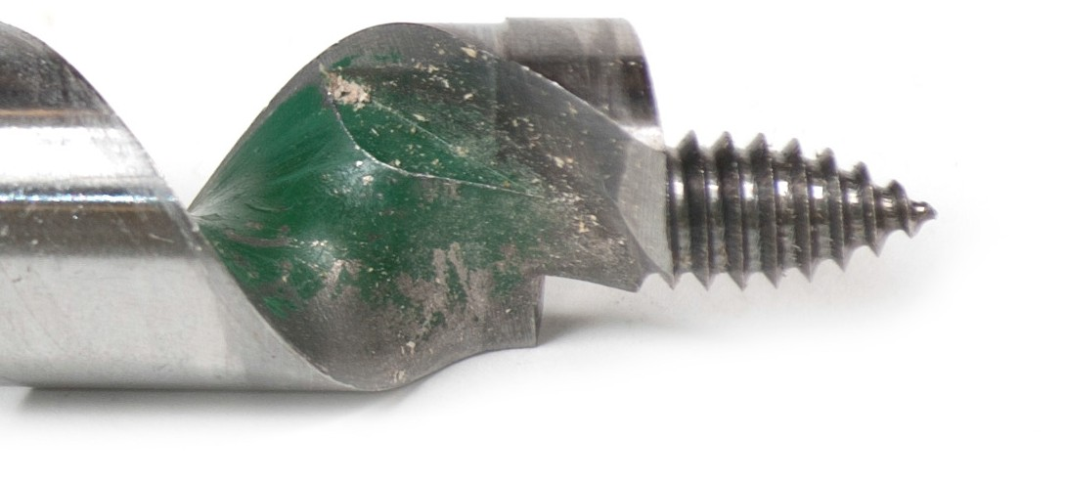
Figure 20 — Self-feeding drill point

Countersink bits
When flat-head screws are to be installed flush or below the surface of a workpiece, the countersink bit (Figure 21) will drill a broad, shallow hole to receive the head of the screw.

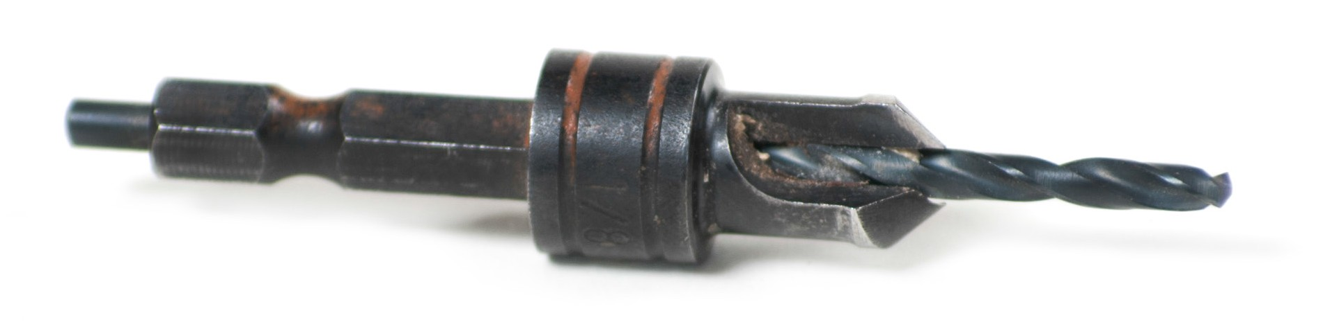
Figure 21 — Countersink bit

Carbide-tipped bits
Carbide-tipped drill bits (Figure 22) are used to drill holes in hard, abrasive materials such as concrete, stone, masonry, brick, and ceramic tile.

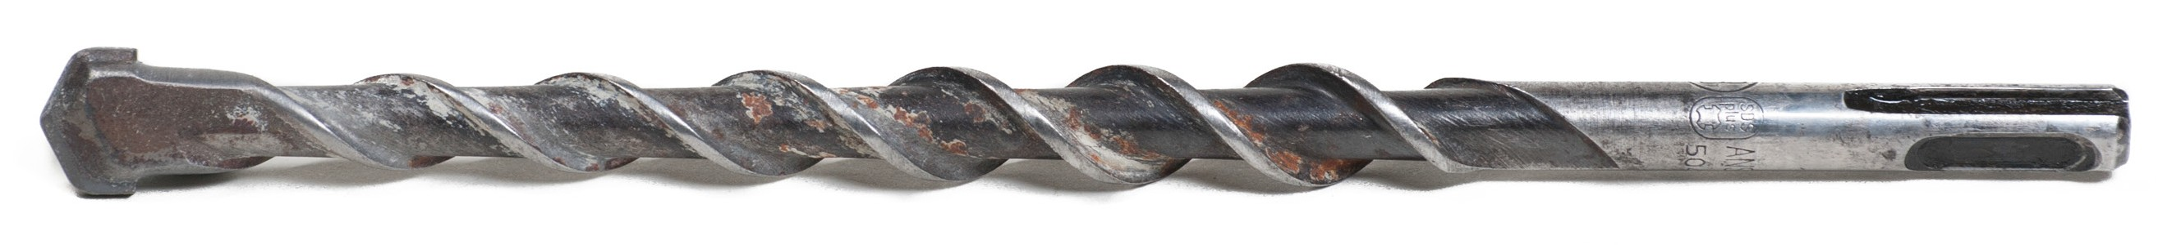
Figure 22 — Carbide-tipped bit

Drilling into these materials requires a slow-turning drill (350 to 500 rpm) to prevent the bit from overheating. Periodically adding small amounts of water can keep the heat under control.

Hole saws
The hole saw (Figure 23) is designed to cut large-diameter holes in wood, fibreglass, or sheet metal. The hole saw has a pilot bit at its centre that enters the workpiece ahead of the hole saw and serves to guide the hole saw as it enters the workpiece.

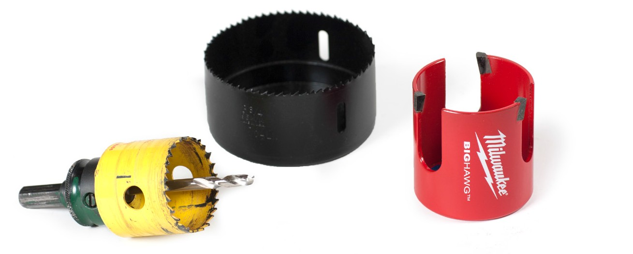
Figure 23 — Hole saw

Hole saws are available in sizes from 14 mm to 111 mm (9/16 in. to 43/8 in.) in diameter. The depth of the hole drilled is restricted by the length of the hole saw. Standard lengths are 12 mm or 28 mm (½ in. or 11/8 in.).

Bits for core drills
A core drill is specifically designed to remove a cylinder of material, much like a hole saw without the pilot bit (Figure 24). These drills use different tip types depending on whether they are being used to drill concrete, stone, metal, or other materials. The material left inside the drill bit is referred to as the “core,” and it is sometimes saved when performing mineral exploration, for example.

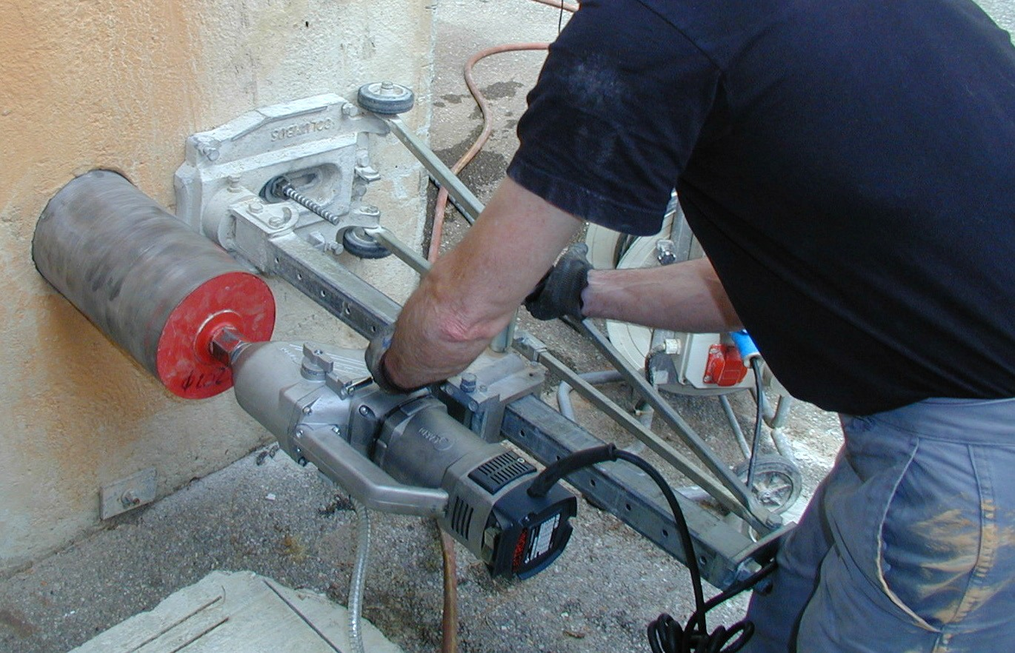
Figure 24 — Core drilling

Safety
If a drill bit jams, the forces that were being used to turn the drill bit are suddenly directed to turning the electric drill. This sudden spinning of the tool in your hands can bruise, sprain muscles, or even break bones depending on the speed and torque of the tool. The risk of jamming increases with the diameter of the drill bit.

Always wear appropriate protection when using an electric drill.

The more powerful the motor of the drill, the more force you will need to exert to stop the rotation of the drill. The faster the rotation of the drill bit, the more violent the reaction to jamming.
Because a risk of jamming always exists, you should never lock the switch in the on position.

Now complete the Learning Task Self-Test.

Self-Test 4
- What wrench is used to tighten the drill chuck to the drill bit?
  - Chuck key
  - Allen key
  - Hex wrench
  - Drill wrench

- Where would the on/off switch typically be found on a portable electric drill?
  - On the D-handle
  - On the pistol grip
  - On the left side of the drill
  - On the rear of the motor housing

- What control does a variable speed switch give the drill operator?
  - Size of the hole
  - Reduced risk of jamming
  - Speed of rotation
  - Direction of rotation

- On which of the following are the lowest fixed speeds typically found?
  - ½ in. drills
  - 3/8 in. drills
  - ¼ in. drills
  - Cordless drills

- What is the safety concern that requires the operator to wear eye protection when using a drill?
  - Toxic fumes
  - Jamming the drill
  - Hot, airborne particles
  - Overheating the work

- What is the primary safety risk if the drill switch is locked in the on position?
  - Jamming the drill
  - Breaking the drill bit
  - Overheating of the work
  - Hot, airborne particles

- What is/are the necessary feature(s) of a drill to drive and remove screws?
  - It must have a geared chuck.
  - It must have a keyless chuck.
  - It must have variable speed control.
  - It must have both variable speed and a reversing switch.

- According to the manufacturer and safe work practice, when is it safe to reverse the direction of rotation of a drill motor?
  - Only if the drill is unplugged
  - Only after full speed is reached
  - Once the switch has been opened
  - Only once the motor has stopped turning

- What is the correct term to describe the smooth round portion of the twist drill that makes contact with the chuck?
  - Body
  - Twist
  - Shank
  - Shaft

- What is the correct term to describe the spiral groove portion of the twist drill?
  - Point
  - Twist
  - Shank
  - Body

- How many systems are used to indicate the diameter or size of the twist drill?

a. | 2
b. | 3
c. | 4
d. | 5

- Choosing from metric twist drill system, what is the smallest available size?
  - 0.01 mm
  - 0.1 mm
  - 0.5 mm
  - 1.0 mm

- Choosing from the numbered twist drill system, what is the largest twist drill available?

a. | 1
b. | 60
c. | 80
d. | 100

- Choosing from the letter twist drill system, what is the smallest size available?
  - A
  - Z
  - AA
  - ZZ

- Choosing from the fractional twist drill system, what is the smallest size available? a. 1/32 in.
b. 1/64 in.
c. 1/100 in. d. 1/1000 in.
- Using a properly sharpened twist drill to drill into mild steel, what should the shavings look like?
  - They should be flaked.
  - They should be spiral coils.
  - They should resemble sawdust.
  - They should be short and curved.

- What is the ideal and safest heel clearance on a twist drill? a. 12°
b. 59°
c. 1.5 mm (1/16 in.)
d. Approximately half the length of the cutting lip

- What is the result if the lip clearance provided to a twist drill is insufficient?
  - The cutting edge will chatter.
  - The cutting edge will cut slowly.
  - The cutting edge will cut too rapidly.
  - The cutting edge will become dull quickly.

- What factors are required for both cutting lips on a twist drill to produce shavings of equal thickness?
  - The heel clearance must be correct.
  - The cutting lips must be of equal angle.
  - The cutting lips must be of equal length.
  - The cutting lips must be of equal length and angle.

- What guides a hole saw at the start of a cut?
  - A pilot bit
  - A hole saw jig
  - The kerf of the blade
  - A steady hand and an experienced operator

- What guides the multi-spur bit during drilling operations?
  - The shaft of bit
  - The tips of the bit
  - The sides of the bit
  - The centre point of the bit

- Which drill bit is best suited for drilling deep holes in wood?
  - A spur bit
  - A spade bit
  - An auger bit
  - A carbide-tipped bit

- What material is a carbide-tipped bit designed to drill?
  - Wood
  - Metal
  - Plastic
  - Concrete

- When comparing larger drill bits to smaller drill bits, which of the following best describes larger drill bits?
  - Larger bits require less torque.
  - Larger bits require slower speeds.
  - Larger bits require shorter handles.
  - Larger bits require less downward pressure.

- When using a hand drill, when should the operator ease up on feed pressure?
  - To allow the bit to cool
  - As the bit breaks through the work
  - As soon as the bit starts to cut the work
  - From the start to allow the bit to self-feed

- When should drill speed be increased?
  - When the metal is soft.
  - When the metal is ferrous.
  - When the metal is very hard.
  - When the metal is clamped to the drill press.

- What term is used to describe the entire upper unit of the drill press?
  - Head
  - Power unit
  - Working end
  - Operational unit

- Where must the operator secure the workpiece to safely prevent it from moving while being drilled on a drill press?
  - To the table
  - To the spindle
  - To the column
  - To the depth stop

LEARNING TASK 5

Describe routers, grinders, and sanders
Electric routers, grinders, and sanders are used for a variety of cutting, shaping, and smoothing tasks on materials such as wood, plastic, and metals.

Routers
With the electric router (Figure 1), a carpenter can shape the surfaces and edges of stock. This tool is used with a variety of bits, each designed for a specific purpose.

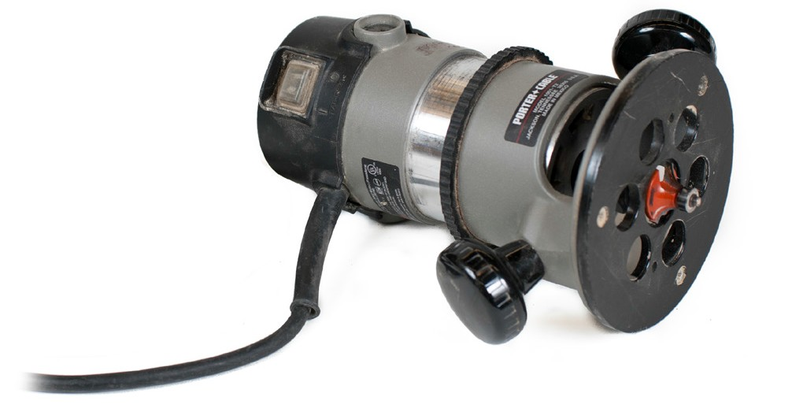
Figure 1 — Electric router

The motor on the router usually coasts for some time after the power is switched off. If coasting becomes noticeably shorter, it is an indication that something (usually the bearings) needs to be replaced.

Belt sanders
The belt sander (Figure 2) is a general utility tool that is useful for a number of sanding jobs, including chamfering, edge work, finishing, and sanding rough stock. When fitted with the proper abrasive, it can also be used for sharpening tools and removing old paint and varnish.

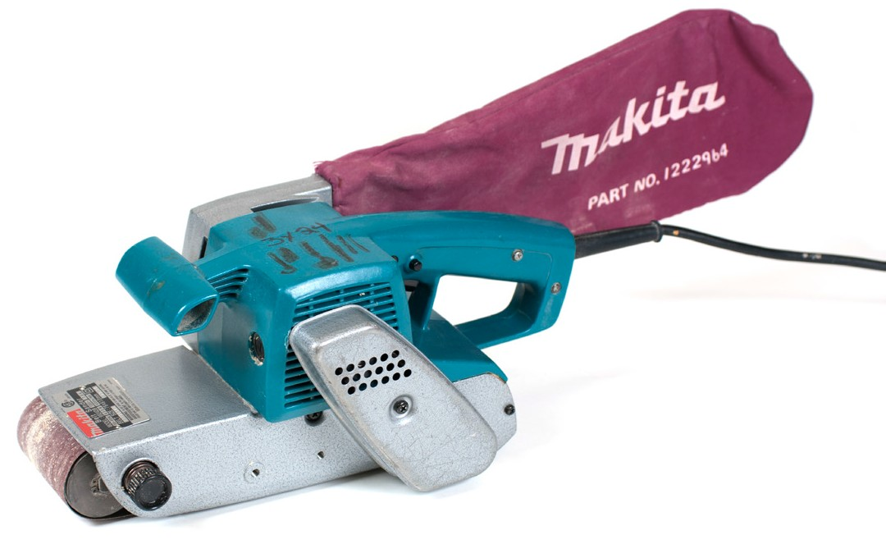
Figure 2 — Electric belt sander

Orbital sanders
The orbital (or oscillating) sander (Figure 3) removes very small amounts of stock and, accordingly, is considered a fine-finishing sander.


Figure 3 — Orbital sander

Safety and maintenance for routers and sanders
When using routers, follow these safety precautions:
    - Wear eye protection or a face shield and appropriate hearing protection.

    - Disconnect the power supply before making any adjustments or changing bits.

    - Ensure that the bit is securely mounted in the chuck and the base is tight.

    - Put the base of the router on the work, template, or guide and make sure that the bit can rotate freely before switching on the motor.
    - Secure the stock mechanically and never rely on yourself or a second person to support or hold the material, as sudden torque or kickback from the router can cause damage and injury.
    - Check the stock thoroughly for staples, nails, screws, or other foreign objects before using a router.
    - Keep all cords clear of the cutting area.

    - Always hold both hands on the router handles until the motor has stopped, and never set the router down until the exposed router bit has stopped turning.
    - Do not overreach. Always keep proper footing and balance.

    - Feed the router bit into the material at a firm, controlled speed.

When using sanders, follow these safety precautions:
- Always wear eye protection.

- Wear hearing protection that is suitable for the level and frequency of the noise you are exposed to in the shop.
- Wear respiratory protection (e.g., dust mask) where required during sanding operations, and clean up all residue.
- Always use sanders with the local exhaust ventilation turned on, or make sure that the sander has a dust collection system.
- Keep your hands away from the abrasive surface.

- Inspect the abrasive material before using the sander and replace damaged disks, inserts, or belts.

Straight grinders
The straight grinder (Figure 4) turns the grinding wheel with a drive shaft that is aligned with the motor.

Straight grinders are available in a variety of sizes and shapes. Large grinders are used for the quick removal of metals, while smaller models are used in hard-to-reach areas.

The larger models have a grinding wheel approximately 150 mm (6 in.) in diameter. A guard encloses the upper half of the wheel, which rotates at around 6000 rpm. You must hold these larger models with both hands during use.

Small straight grinders, pencil grinders, or detail grinders (Figure 4) use a small grinding stone or flapper wheel mounted on its own shaft, which is in turn held in the collet (a chuck that will accept only one size of bit) of the grinder. These grinding stones are available in a wide range of shapes and are described by their shaft diameter.

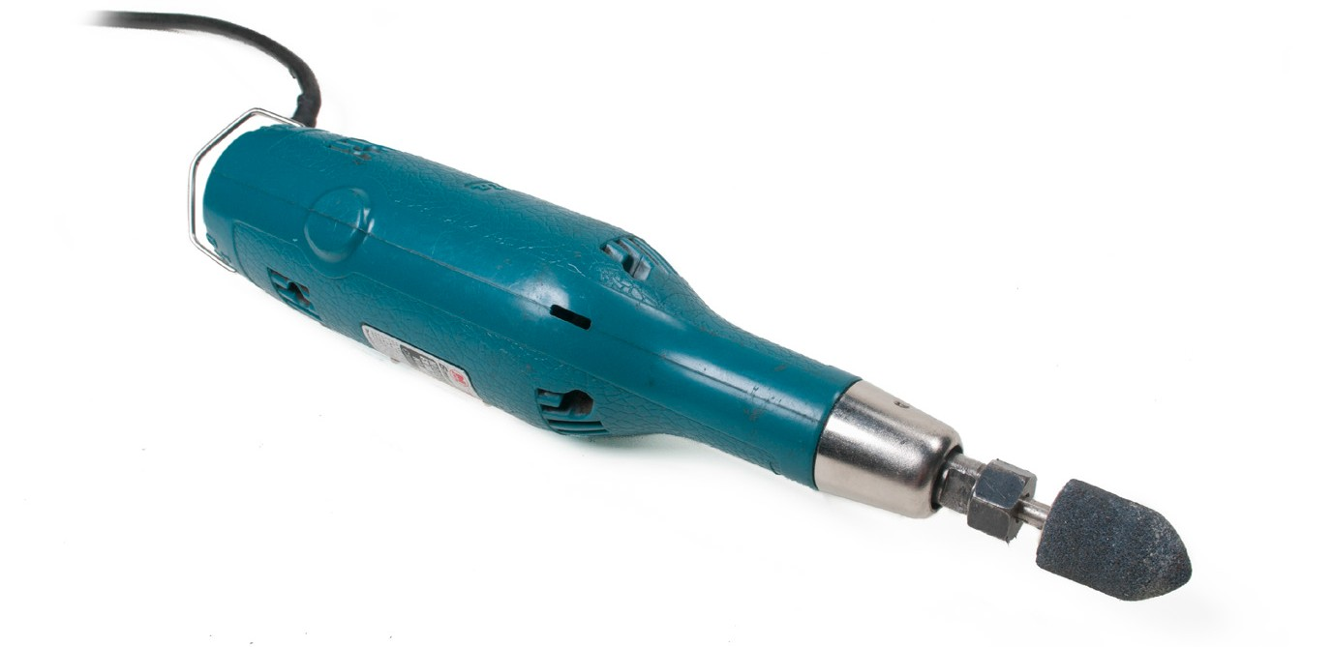
Figure 4 — Small straight grinder

Angle grinders
Angle grinders (Figure 5) have a grinding disk that rotates at 90° to the axis of the motor. Disks range in diameter from 75 mm to 225 mm (3 in. to 9 in.), and each disk type and size will have its rpm rating identified.

You must make sure the rpm rating of the disk either matches or exceeds the rpm of the grinder.

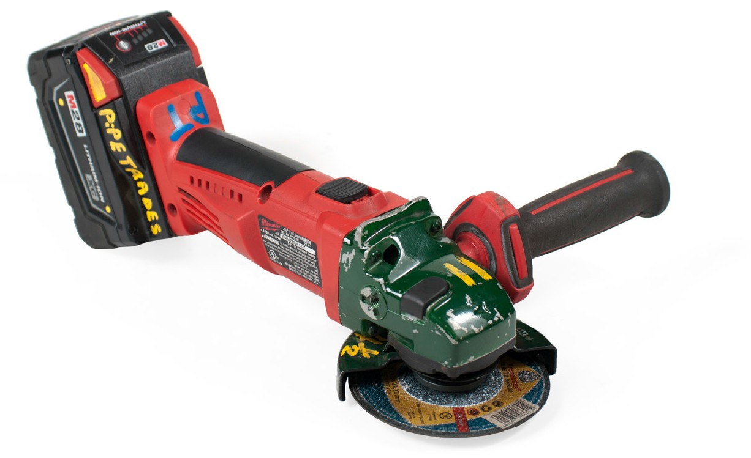
Figure 5 — Electric angle grinder

The angle grinder has a guard covering half the disk. The grinder is held to the workpiece so that only the exposed portion of the disk makes contact with the workpiece.

Disks for jobs other than grinding are available for angle grinders (Figure 6). With these disks the angle grinder becomes a very versatile tool and can be used for cutting, cleaning, shaping, and buffing . Wire wheels are also available in a variety of sizes for different applications.

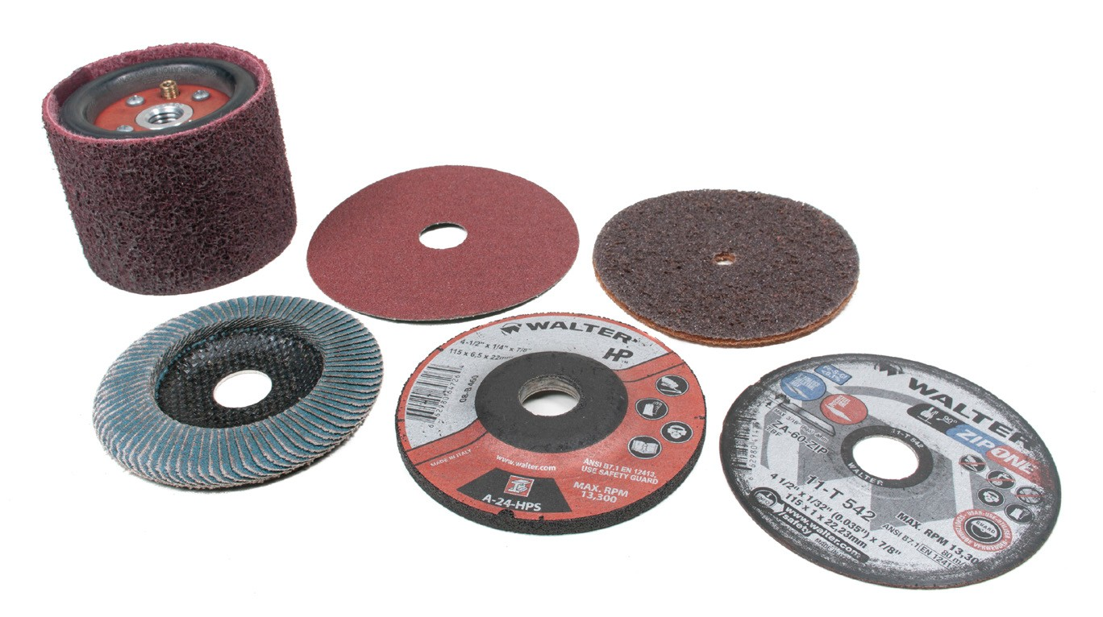
Figure 6 — Grinding wheels and disks

Safety and maintenance for angle grinders
Follow these safety and maintenance rules when using portable grinders:
- Always wear a face shield.

- Use a portable shield to prevent sparks from hitting other workers, damaging equipment nearby, or creating a fire hazard.
- Wear leather gloves and protective clothing.

- Always use hearing protection.

- Use both hands to control the grinder.

- Inspect the disk before use. Look for cracks and chips.

- Ensure that the rpm rating of the disk or wheel will not be exceeded.

- Secure the workpiece to prevent any movement during the grinding operation.

- Ensure that the wheel or disk is suitable for the type of material on which you are working.
- Ensure that the disk or wheel has not been damaged.

- Never remove the guard from a grinder and never use a grinder without a guard.

- Remove flammable materials before grinding.

- Never grind near disassembled components that could be contaminated or damaged by grit and sparks.
- Keep sparks away from glass and finished surfaces.

Bench grinders
The stationary bench grinder (Figure 7) typically consists of an electric motor with grinding or wire wheels attached to both ends of the motor shaft. The wheels are enclosed in guards that support a tool rest at the front and a spark shield. The wheels rotate so that they travel toward the operator from the top of the wheel.

Stationary grinders may be mounted on a bench or a free-standing pedestal.

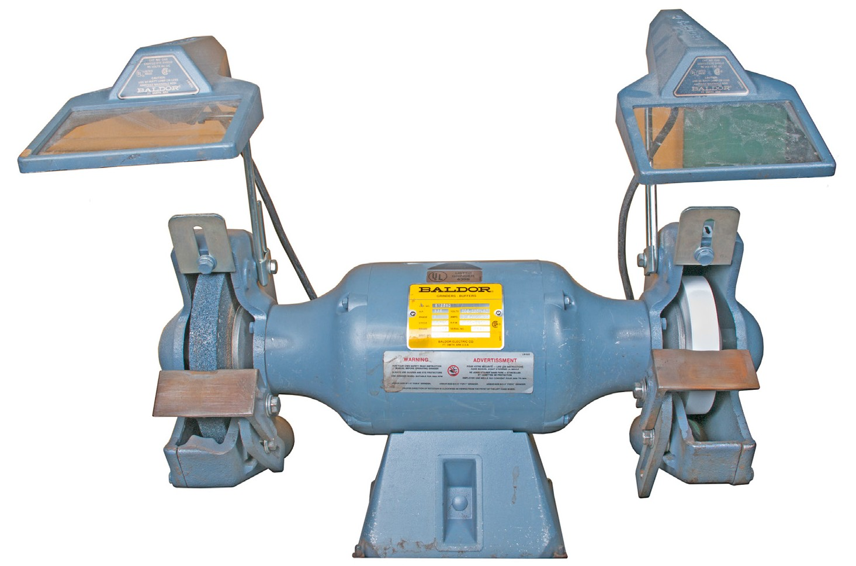
Figure 7 — Bench grinder

Tool rest
The tool rest (Figure 8) is adjustable and must be positioned no lower than the centre of the wheel. The distance between the front edge of the wheel and the tool rest must not be more than 3 mm (1/8 in.).

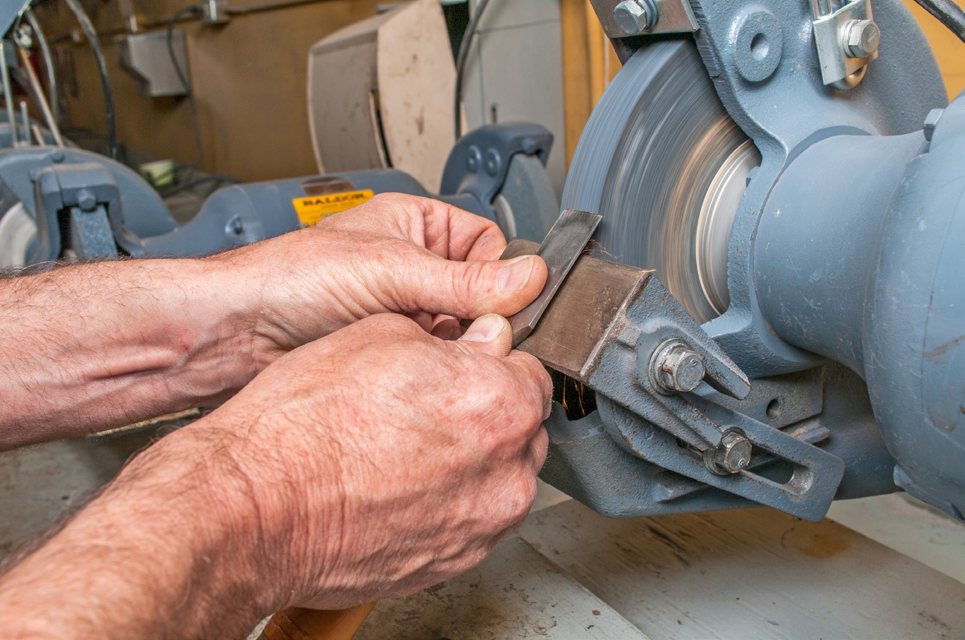
Figure 8 — Tool rest

Spark guard
Sparks are created during the grinding of ferrous metals and when using the wire wheel. To reduce the number of sparks that hit the operator, a spark guard is mounted at the upper end of the exposed portion of the wheel. The spark guard should be mounted as close as possible to the surface of the wheel. During wire wheel brushing, grit, dust, and wires may be thrown off. The spark guard reduces operator risk from flying debris.

Grinder ratings
Stationary grinders have motors with different horsepower ratings. As the horsepower increases, the grinding wheels become wider and larger in diameter. Motor speeds are reduced as the diameter of the grinding wheel becomes larger.

When replacing a wheel, make sure the new wheel has an rpm rating that either matches or exceeds the no-load speed of the motor.

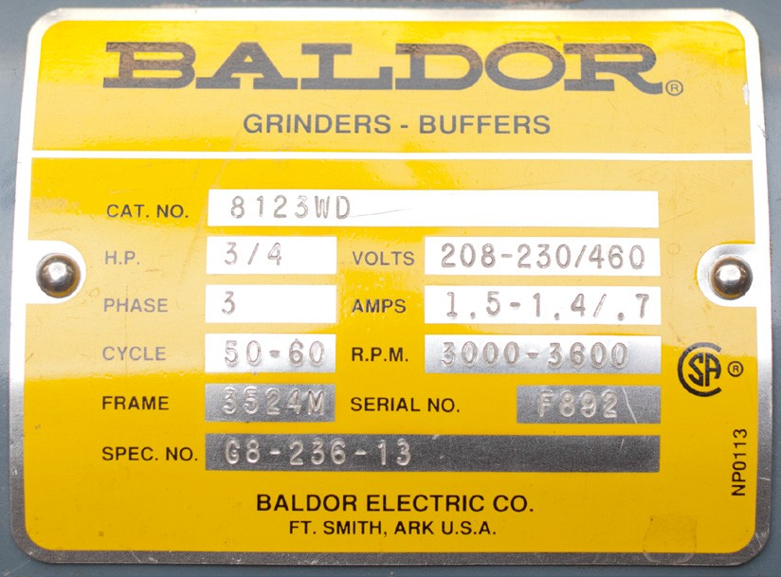
Figure 9 — Grinder rating plate and grinder wheel label

Grinder wheel markings
The standard marking system for most grinding wheels indicates:
- the operating speed (e.g. 3183 rpm)
- the wheel diameter (e.g. 180 mm)
- the wheel thickness (e.g. 13 mm)
- the hole diameter (e.g. 31.75 mm)
- the type codes

Replacing the wheel
Grinding wheels are supplied with a blotter-type paper disk on each side. The disks serve to cushion the strain caused by the flanges when the clamping nut is tightened. Avoid overtightening the flanges. Tighten just enough to avoid slippage. Once the new wheel is
mounted, stand to the side, out of the line of fire, and run the wheel at no-load for one minute. If the wheel is damaged, it is at this time that it may fall apart, so be alert.

Grinding wheels with hairline cracks are unsafe and must be discarded. To test for cracks, simply stand the wheel on edge and tap the sides with a hard object like a screwdriver handle. Cracked grinding wheels will give off a dull sound, while a good wheel will give off a ringing sound.

The wheels on stationary grinders are secured between two large clamping washers or flanges held tight by a nut on the end of the spindle (Figure 10). The nut on the left (as seen from the front) has a left-hand thread. To remove this nut requires a clockwise rotation. The nut on the other end of the grinder has a standard right-hand thread.
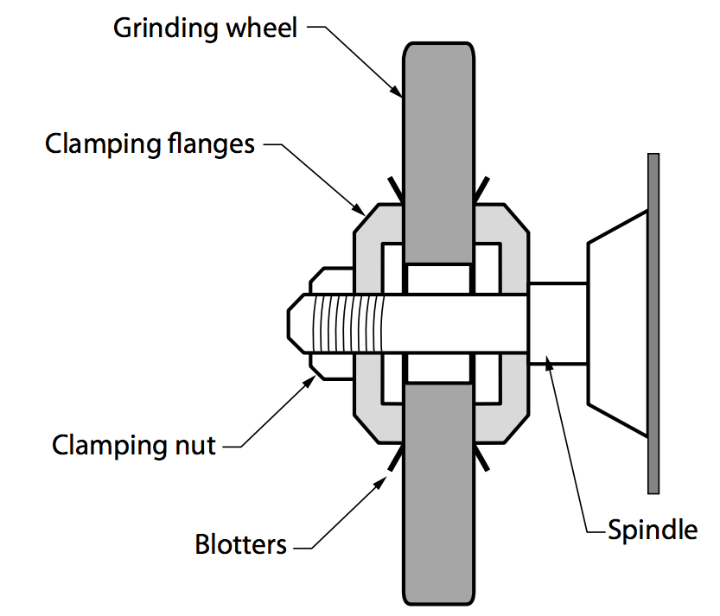

Figure 10 — Replacing a grinder wheel

Using stationary grinders
Before starting a grinder, check the condition of the grinding wheel. Place an object on the tool rest so that it just touches the face of the wheel, then turn the wheel by hand. The wheel should just contact the object at all times as it makes a full turn. If not, the wheel is out-of-round. Out- of-round wheels cause the workpiece to vibrate during grinding.

Check the condition of the face of the grinding wheel. If it shows excess signs of metal particles it will need to be cleaned. Grinding wheels with a surface embedded with metal (Figure 11) tend to generate heat rather than to grind.

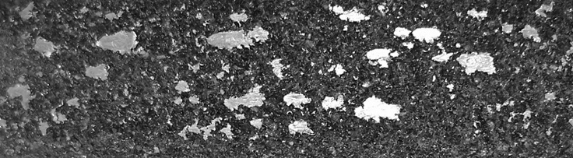
clean clogged

Figure 11 — Metal in a grinding wheel

To remedy out-of-round or dirty wheels, use a wheel dresser (Figure 12) on the face of the stone. Where the grinder design permits, the tool rest must be backed away from the grinding wheel enough to allow the dresser to hook over the front edge of the tool rest. While the grinder is running, the handle of the dresser is raised until the sectional washers touch the wheel‘s face and the dresser is moved across the width of the grinding wheel in a methodical fashion with attention to high spots. Turn off the grinder, and when the grinding wheels have stopped turning, check the entire face for metal particles or out-of-round. Repeat dressing as necessary.

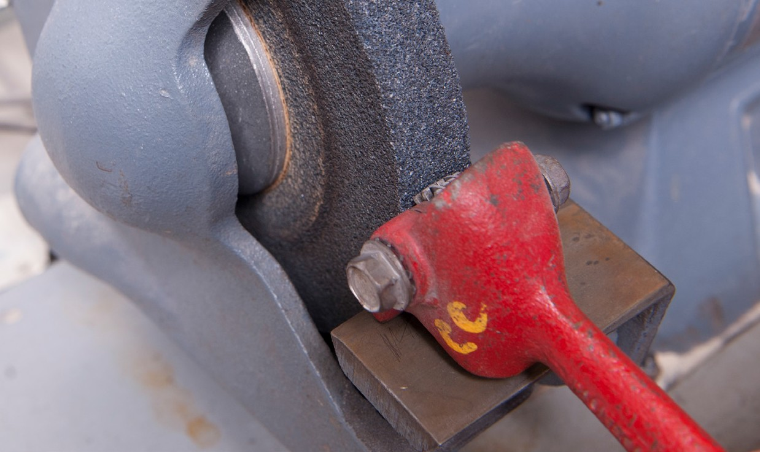
Figure 12 — Using a wheel dresser

Remember to reposition the tool rest no further than 3 mm (1/8 in.) from the wheel after dressing.

When you are using a stationary grinder you should rest the workpiece on the tool rest and apply enough pressure against the wheel so that grinding or brushing takes place. Avoid applying too much pressure, which will cause a noticeable reduction in the motor’s rotation speed.

Tools such as drill bits, screwdriver tips, and cold chisels occasionally require grinding to improve their performance. You should grip such tools close to the area being ground so that you can feel any buildup of heat. If the tool is heated to the point of showing colour (yellow, purple, or blue), the hardness of the tool will be affected. To prevent overheating, make sure the grinding wheel is clean and dip the workpiece in water frequently to cool it.

Grinding wheel characteristics
The common characteristics of grinding wheels are:
  - Type of abrasive material, aluminum oxide being most common

  - Grain size (also known as “coarseness”) is the actual size of the abrasive grains, from 8 (coarsest) to 1200 (finest)
  - Wheel grade from A (soft) to Z (hard) indicates how tightly the bond holds the abrasive grains intact while they are sharp
  - Structure (also known as “grain spacing”) indicates the density by how far apart the grains are spaced. Structures are rated from 1 (densest) to 16 (least dense/open) Figure 13 shows the difference between dense and open-grain wheels.


Dense Open
Figure 13 — Relative grain spacing on a grinding wheel

The wheel characteristics are indicated by codes on the wheel’s label. Choose a wheel compromising between the desired finish and the material removal rate. An open structure coarse grain wheel (which provides better chip clearance) is used on soft materials. Dense structure fine grain wheels are used where a smooth surface finish is required. Do not use wheels with a dense structure if the work material tends to clog the grinding wheel face.

Always select a grinding wheel having a rated rpm at least as high as the grinder spindle no- load speed.

Safety with stationary grinders
Follow these rules when using a stationary grinder:
  - Always wear a face shield.
  - Always wear leather gloves and protective clothing.
  - Always use hearing protection.
  - Use both hands to control the work.
  - Ensure that the rpm rating of the wheel will not be exceeded.
  - Ensure that the wheel is suitable for the type of material.
  - Ensure that the wheel has not been damaged

- Ensure that all guards are in place.
- Ensure that the tool rest is properly adjusted.
- Remove flammable materials from the work area.
- Have people not involved in the grinding operation leave the area.
- Never reverse a wire wheel, as the wires in the wheel will have taken a “set.”
- Secure small parts with pliers when grinding or cleansing, never with your hands.
- Always stand to one side when starting the grinder.

Now complete the Learning Task Self-Test.

Self-Test 5
- Which power tool is designed to shape the surfaces and edges of wood stock?
  - Router
  - Cold chisel
  - Bench grinder
  - Angle grinder

- Which power sander is designed to remove small amounts of stock and is considered a finishing tool?
  - Router
  - Planer
  - Belt sander
  - Orbital sander

- What is the safe procedure to use a belt sander with a torn belt?
  - Replace the torn belt with a new belt.
  - Flip the belt over to use the other side.
  - Trim the edge of the belt where it is torn.
  - Continue to use until the sander no longer removes material.

- What important step must occur before safely changing a belt on a belt sander?
  - Completing a risk assessment
  - Ensuring the power is disconnected
  - Ensuring the work stock is properly secured
  - Ensuring the on/off switch is in the off position

- Which type of grinder is designed for fine work and work that is difficult to access?
  - Disk grinder
  - Pencil grinder
  - Bench grinder
  - Straight grinder

- What is the name for a grinder with a grinding disk that rotates at 90° to the axis of the motor?
  - Angle grinder
  - Pencil grinder
  - Bench grinder
  - Straight grinder

- When is it safe to use an angle grinder with the guard removed?
  - It is never safe to do so.
  - It is safe if double eye protection is used.
  - It is safe if the grinder guard has a quick release.
  - It is safe if the guard gets in the way of the work required.

- Which part of the bench grinder protects the operator from hot, flying debris?
  - The tool rest
  - The fire blanket
  - The spark guard
  - The ground-fault interceptor

- How does horsepower of a bench grinder’s motor relate to wheel size?
  - Motor size and wheel size do not relate.
  - As motor size decreases, wheel size increases.
  - As motor size increases, wheel size increases.
  - As motor size increases, wheel size decreases.

- What is the procedure for working safely with a bench grinder wheel that is cracked?
  - Position the tool rest closer to the wheel, not less than 5 mm.
  - Replace the wheel immediately, as a cracked wheel is dangerous.
  - Use the wheel only for light duty grinding such as tool sharpening.
  - Use the dressing tool to clean the wheel and remedy out-of-round.

- What procedure is recommended for determining if a bench grinder wheel is cracked?
  - Power up the grinder to see if the wheel breaks apart.
  - Employ the tool dresser to remove excess metal particles.
  - Hold the wheel up to a light source to see light shine through the crack.
  - Lightly tap the wheel with a screwdriver handle and listen to the sound.

- What condition will be present if a bench grinder wheel is out-of-round?
  - The work will vibrate excessively.
  - The sparks will change colour.
  - The tool rest will need to be adjusted closer to the wheel.
  - The wheel will show signs of excessive amounts of metal particles.

- What important safety conditions must be met when replacing a bench grinder wheel?
  - The new wheel must be for coarse and fine work.
  - The brand name and weight must match the old wheel.
  - The rpm rating of the wheel must equal or exceed the grinder rpm.
  - The new wheel must be sharp, and the arbour hole must be dead centre of the wheel.

- At what distance should the tool rest be positioned from the wheel?
  - A minimum of 3 mm (1/8 in.)
  - A minimum of 5 mm (1/6 in.)
  - A maximum of 8 mm (1/3 in.)
  - Whichever distance feels comfortable

- Where must the tool rest be positioned in relation to the wheel?
  - Below the wheel
  - Above the wheel
  - At a 37.5° angle from the wheel
  - No lower than the centre of the wheel

- What tool should be used to remedy a bench grinder wheel that is out-of-round or dirty?
  - Tool rest
  - Wheel dresser
  - Hard object such as a screwdriver handle
  - If the wheel is out-of-round, it should be replaced.

- How should an operator of a bench grinder prevent overheating the work when sharpening or reconditioning a hand tool?
  - Dress the wheel to eliminate overheating.
  - Pay close attention to the sound of the grinding.
  - Continue grinding until the work has changed colour.
  - Frequently dip the work in water and work with a clean wheel.

- What does a change of colour in a drill bit or cold chisel indicate when sharpening with a bench grinder?
  - The hand tool is sharp enough.
  - The metal is overheated and the tool may be weakened.
  - Different colours indicate different grain spacing on the grinder wheel.
  - The grinder wheel is inappropriate for the job and needs to be replaced.

- What do the letters “rpm” stand for?
  - Rated pipe material
  - Revolutions per minute
  - Revolutions past midpoint
  - Rated and primed material

- What markings should be found on the standard marking system for most grinding wheels?
  - Operating speed, work material, and weight of wheel
  - Bench grinder speed, date of manufacturing, and contact information
  - Wheel diameter, wheel thickness, and maximum operating speed
  - Minimum operating speed, safety instructions, and manufacturer’s information

LEARNING TASK 6

Describe portable air power tools
Air power tools, or pneumatic power tools, employ the explosive energy contained in compressed air to perform work. This powerful energy is also a tremendous source of multiple potential hazards and needs to be treated carefully.

Air-supply system
Compressed air is air kept under a pressure that is greater than atmospheric pressure. In industry, compressed air is so widely used that it is often regarded as the fourth utility, after electricity, natural gas, and water. However, compressed air is more expensive than the other three utilities when evaluated on the basis of energy delivered per unit.

Compressor and receiver
Air or pneumatic tools are operated by compressed air supplied by an air compressor. This compressor (Figure 1) is pre-set to maintain a constant supply of compressed air at pressures ranging from 350 kPa (50 psi) to 1050 kPa (152 psi). A reservoir tank attached to the compressor retains a supply of compressed air to assure sufficient volume.

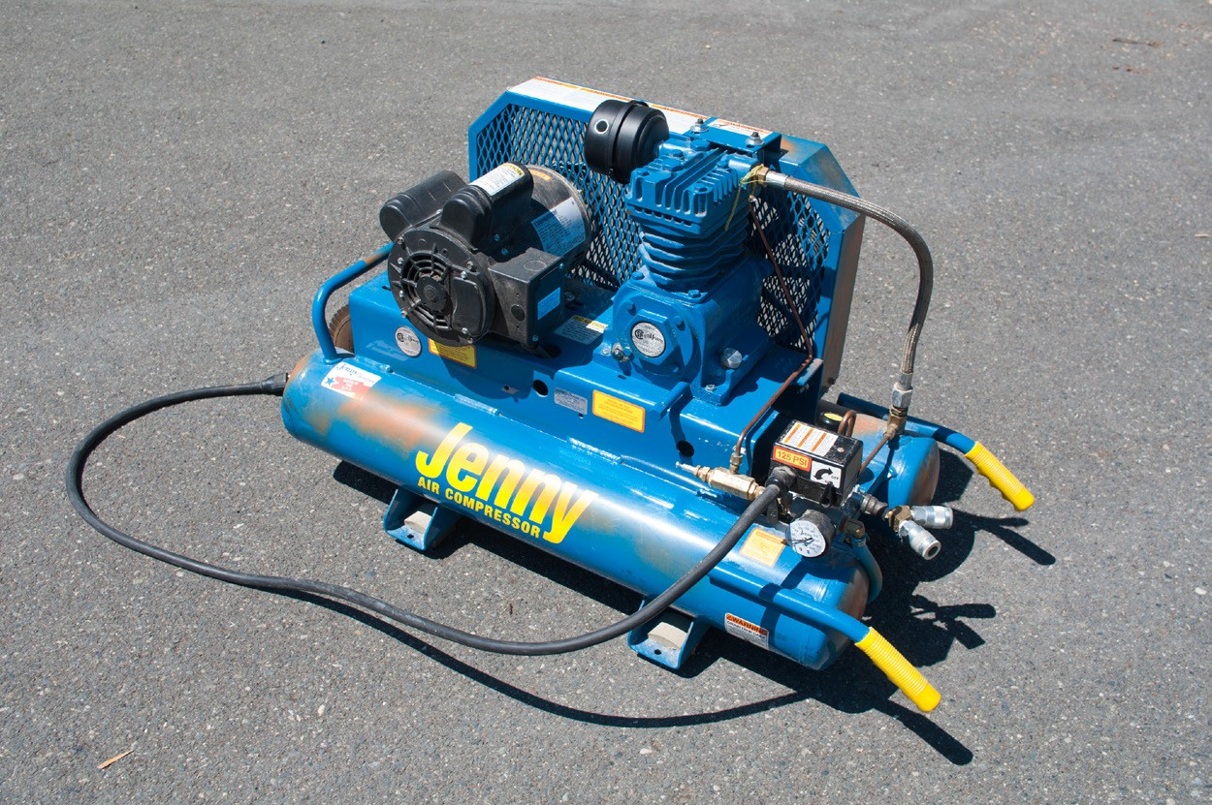
Figure 1 — Shop air compressor

All air tools require a large volume, or flow, of compressed air at a specified dynamic air pressure in order to operate efficiently. Dynamic air pressure is the pressure that is maintained while the air tool is in use. Static air pressure is the air pressure in the line when the air tool is not in use.
The static pressure is always higher than the dynamic pressure. Having the correct size of air line and hose is important in maintaining adequate dynamic air pressure.

Compressed air is usually piped to quick-connectors placed conveniently at stations around the shop. High-pressure flexible rubber air hoses are used to connect the air-operated tool to the quick-connectors. These hoses must be kept in good condition and their end connections must be tight. A broken or severed hose can suddenly whip around uncontrollably, powered by the escaping air pressure, and can cause serious injury to anyone in its path. Use a safety retaining wire or chain to prevent accidental whipping.

Never leave air hoses lying on the floor where they can become damaged or weakened by being run over by vehicles or equipment.
Components on a typical air compressor are illustrated in Figure 2. A filter captures remaining moisture and potentially damaging grit or dirt, a cut-off valve controls air flow, and a pressure regulator controls the outflow air pressure to the tool. Some systems also include a lubricator to add necessary oil to the clean, dry, compressed air.

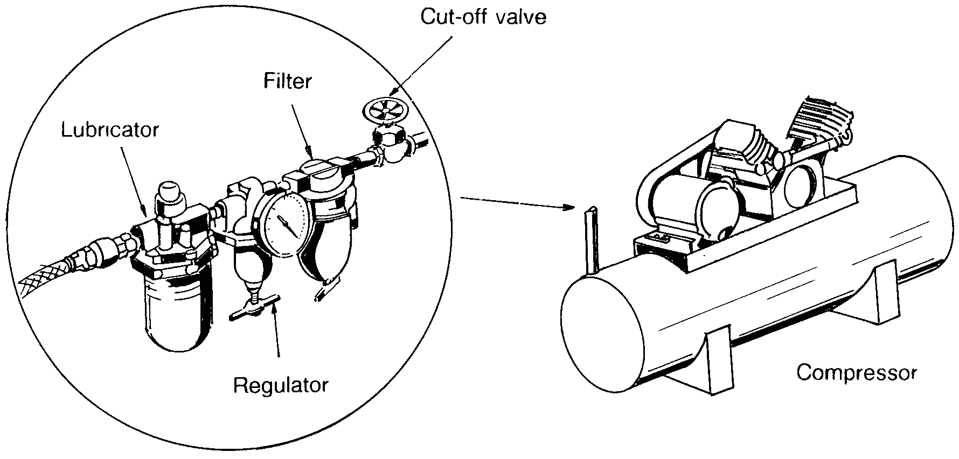
Figure 2 — Typical compressed air system

Condensation is released from the system through a drain-off valve (Figure 3).

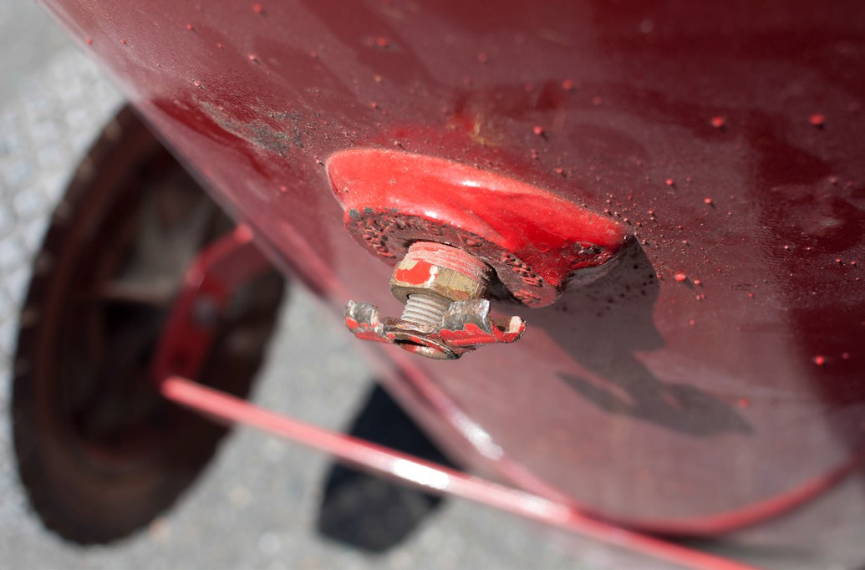
Figure 3 — Drain valve

Filters and regulators
A clean, dry air supply is very important for the safe and proper operation of an air compressor and air tools. Moisture in the air line will damage tools and interfere with performance as water tends to dilute and wash away the lubricant, which will lead to corrosion of internal parts.

During regular operation, air is expelled from the tool’s exhaust port. If the air is excessively wet, this exhaust can cause several problems, including damaging the work surface, being a nuisance to the operator, and freezing in cold weather. Excessive moisture accumulation in the compressor tank can also interfere with the proper operation of the compressor.

Most of the moisture is removed at the compressor before it can enter the system. A filter and moisture separator located at the beginning of the air line hose will remove any moisture
remaining. The trap on the water separator should be drained every day when the system is in regular use.

The regulator controls the air pressure to the tool. A gauge at the front of the regulator shows the pressure reading. Air tools are rated for capacity and performance at an operating air pressure according to manufacturer’s specifications. The pressure regulator should be pre-set to maintain this level of pressure at the tool.

Lubricator
In many tools, the compressed air must contain a lubricant to keep the moving parts operating freely. In addition, a lubricant helps keep heat levels low, flush dirt from the air stream, and create a seal between areas of high and low pressure. The tool-specific lubricator, attached between the regulator and the tool, supplies the lubricant in the form of a fine mist. The operator can control the amount of oil misted into the compressed air.

Always follow the manufacturer’s instructions because lubrication requirements can be different and require oil that is specially formulated for air tools. Other oils should not be used because they can cause sticking and sluggish performance. In addition, some lubricants may contain toxic additives, which become a serious respiratory hazard when vaporized.

Some air tools have built-in oil reservoirs for continuous lubrication. The air line lubricator mixes the air with a small amount of oil that lubricates all parts of the tool except those requiring a grease lubricant. The lubricator reservoirs are usually made from clear plastic, allowing the oil level to be checked easily.

Quick-connectors
Quick-connectors (Figure 4), also referred to as “quick-couplers,” make it easier to connect and disconnect supply hoses and tools. The internal end of the connectors is designed to shut off the air flow when the external end is disconnected, preventing an accidental discharge.

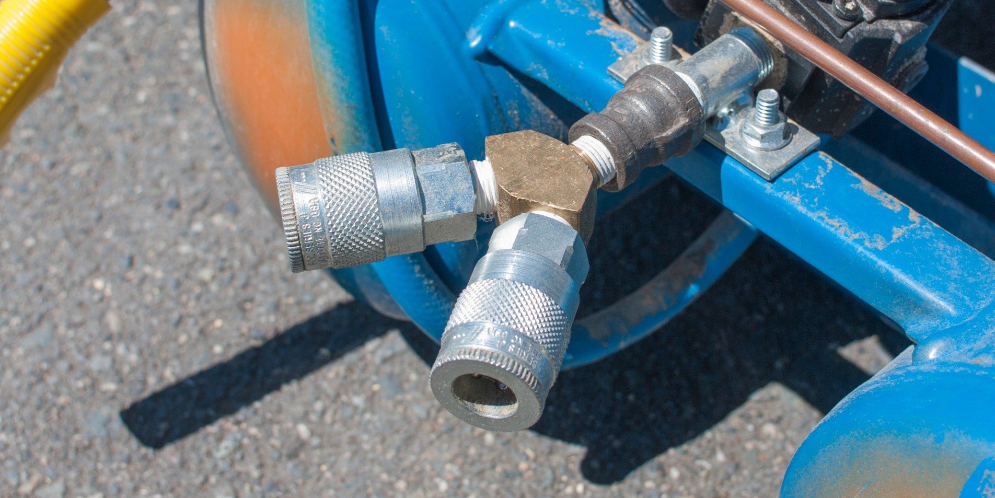
Figure 4 — Quick-connectors

Air hoses
Air hoses (Figure 5) are made of flexible rubber reinforced with braided thread or wire and coated inside to prevent air from leaking. Hoses are available in different lengths and diameters and can be coupled to reach longer distances. The most common lengths of single hose are
7.5 m and 15 m. A variety of pressure ratings and colours are also available.

Air hoses must be protected from cuts and other damage and from oil or grease. Never drive over them or use them to pull attached air tools across the ground or floor.

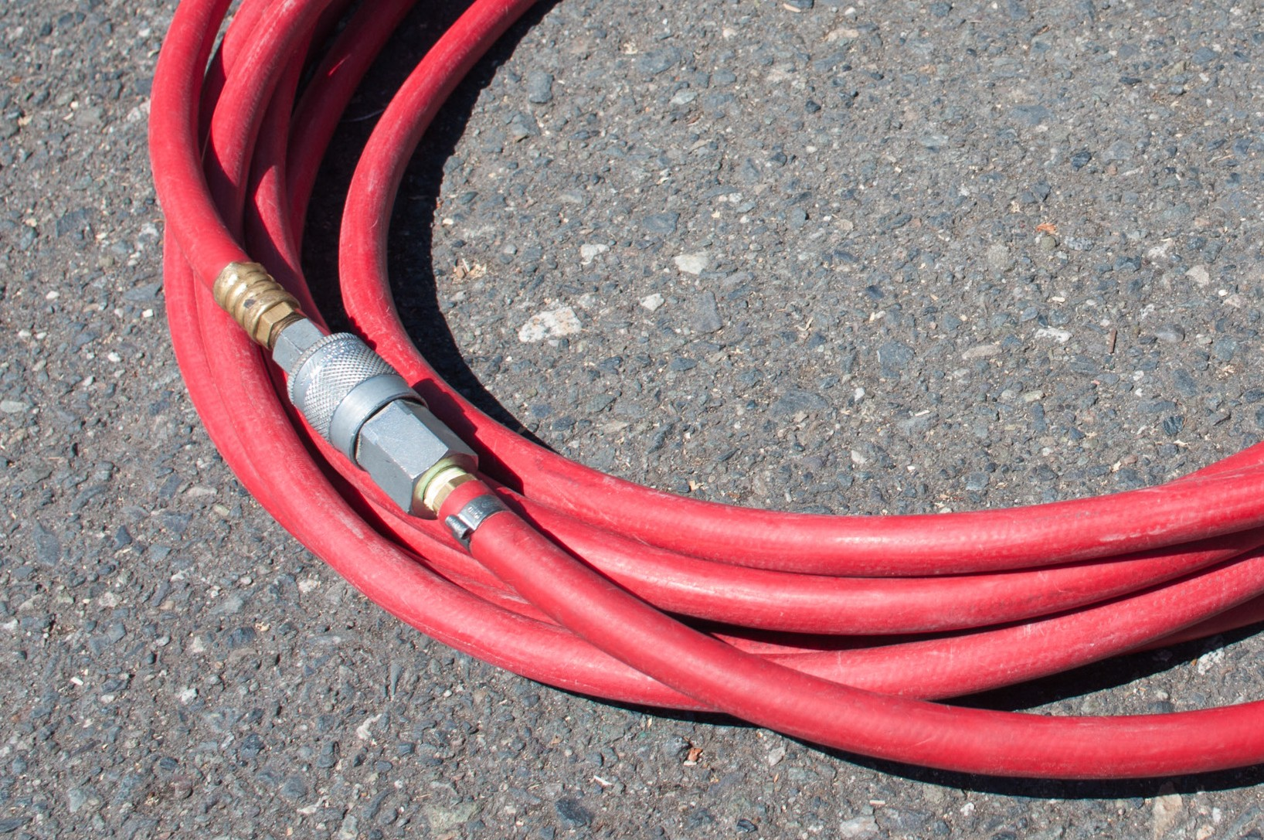
Figure 5 — Air hose with ends connected together for storing

Maintenance of an air-supply system
Regular maintenance of the compressor and air lines is important to ensure problem-free operation and to avoid equipment damage.

Compressor
Compressor trouble usually arises from overheating. Preventive maintenance includes regular lubricating, replacing defective parts, cleaning the cooling fins and air intake filter, and draining the storage tank daily to prevent the accumulation of moisture.

When compressed air begins to cool in the storage tank, droplets of water condense on the inside wall of the tank. If the water is not removed, it not only takes up space that compressed air could occupy, but it also rusts the tank or finds its way into the tools and causes trouble with operation.

To increase the life of the compressor and avoid unnecessary problems, shut the compressor off each night and open the drain to allow water to drain out. In the morning, turn the compressor on and allow it to run for a minute to remove any remaining water. Then close the valve.

Compressor maintenance and operation should include the following steps:
- Keep the compressor crankcase filled to the proper level and change the oil as recommended by the manufacturer.
- Oil the bearings on the electric motor weekly if they are not lifetime-lubricated bearings.

- Check the belt for proper tension and alignment so that the proper power transmission is achieved.
- Blow away dust from the cooling fins, including the intercooler and the aftercooler.

- At least once a week, lift the safety valve handle to make sure that it is operating properly.

- Check the flywheel for tightness on the crankshaft.

Air line and hose
Regular maintenance and operation of the air line and hose should include the following:
- Inspect air hoses periodically for fraying, kinks, loose fittings, and air leaks, and look for any dust plugging the fittings.
- Keep the hose away from dirt and moisture as much as possible and never drop a disconnected connector onto soil or dirt.
- Coil up the hose and connect the male and female quick-connectors to loop the hose.

- Before connecting a tool, blow the air line to clear it of moisture, dirt, and other foreign matter.
- Use a filter and an oiler on the air line ahead of the tool. An emulsifying oil that does not contain a detergent is commonly added to the main air supply by an automatic line oiler, but using an air oiler on the line ahead of the tool ensures that the moving parts of the tool will be adequately lubricated.
- Fill any self-contained oiler the tool might have at the start of each shift.

Types of air tools
Air-powered tools are available for a variety of tasks, including nailing, stapling, installing or removing fasteners, grinding, drilling, riveting, metal cutting, and chiselling.

Finish nailers
The finish nailer (Figure 6) drives up to 16-gauge finish nails up to 63 mm long. It is used primarily in cabinet making and interior carpentry.

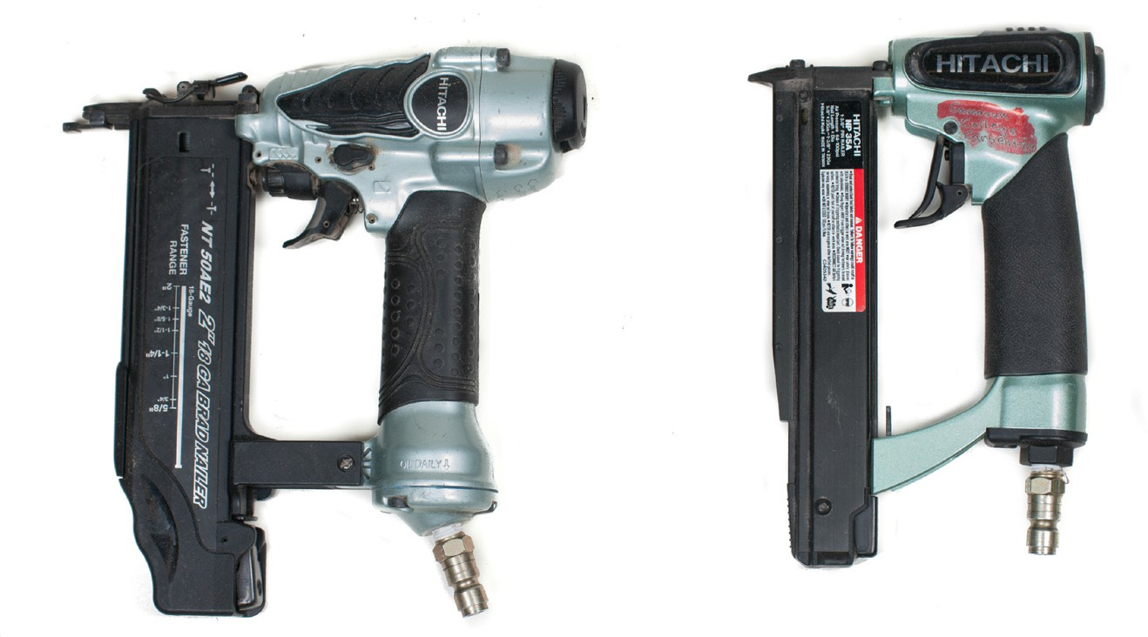
Figure 6 — Finish nailers – 18 gauge and 23 gauge

Strip nailers
The strip nailer (Figure 7) is designed for fastening framing components together and applying sheathing. Depending on the design and the application, it drives nails from 50 mm to 82 mm in length.

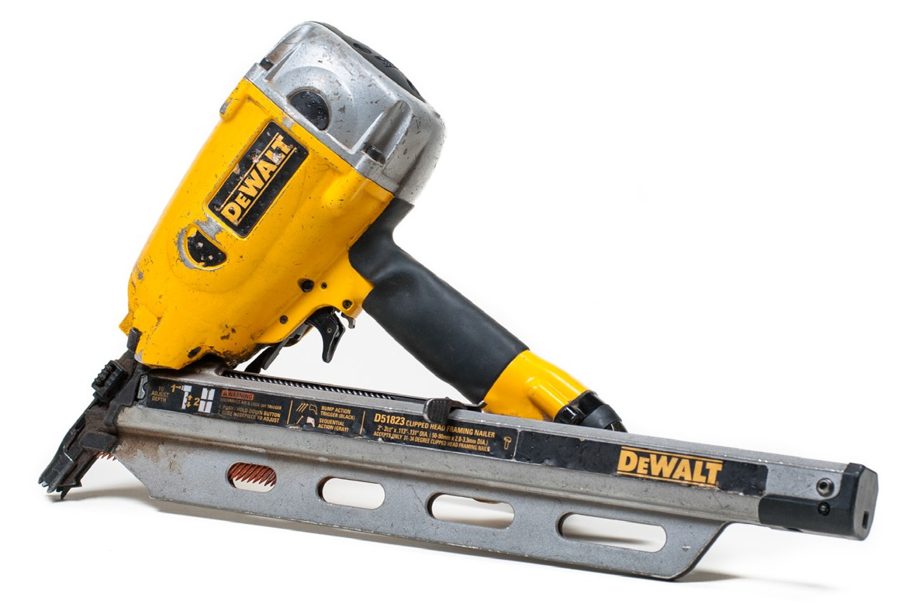
Figure 7 — Strip nailer

Staplers
The stapling machine is used primarily for floor, wall, and roof sheathing. As well as being quick and accurate, it allows the operator to fasten with one hand while positioning and holding material with the other.

There are various stapler designs, and depending on the model, there is a range of staple sizes. The stapler shown in Figure 8 places staples ranging in size from 15 mm to 50 mm.

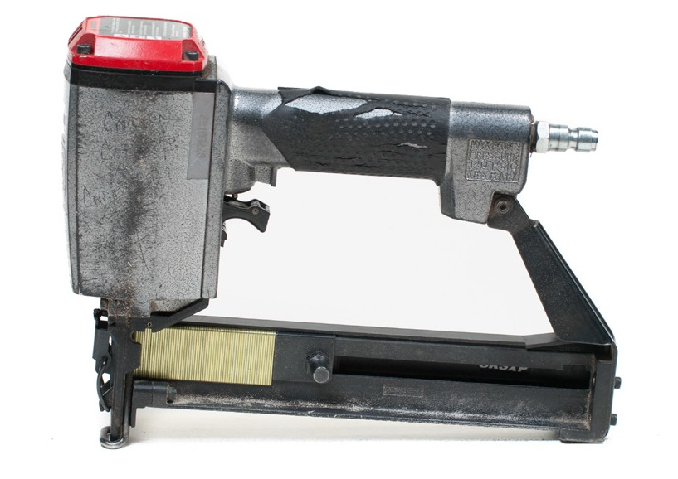
Figure 8 — Stapler

Impact wrenches
An impact wrench (Figure 9) is reversible and can be used to install or remove fasteners. There is a wide variety of sockets and attachments for this tool.

Air-powered impact wrenches are made in larger sizes than electrically operated impact tools and are used more often in heavy-duty applications. Impact wrench sizes are designated by the size of the drive on the nose of the tool, which is usually square. The most common sizes are
3/8 in., ½ in., ¾ in., and 1 in. The wrench nose is inserted into the drive end of the appropriately sized socket.

Only sockets made for impact wrenches should be used, as they are designed to absorb the tremendous forces generated. Hand tool sockets used in this application pose a hazard and could shatter.

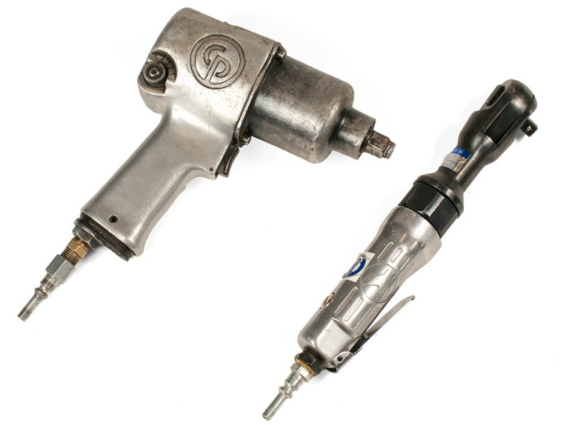
Figure 9 — Air-powered impact wrenches

Be careful when using large impact wrenches, as the torque can twist the tool out of your hands.

Torque is controlled by regulating the air flow to the motor of the wrench. Air-impact wrenches can produce very high torque values even though there is little torque reaction, and you need to exercise caution to avoid stressing the nuts and bolts. In-line air-pressure regulators are sometimes required to control torque.

Grinders
Portable air-powered grinders are used for sharpening other tools, removing burrs, bevelling corners, and grinding welding beads. Accessories for brushing, buffing, filing, and sanding can be attached to certain models, increasing their versatility.

A portable air grinder for heavy-duty use is shown in Figure 10. The grinder spindle speed is inversely proportional to grinder size, and the speed ranges from 4000 rpm on larger models to over 40 000 rpm on smaller ones. Each grinder has a throttle lever to regulate speed. Certain
models have a throttle lever stop-screw that limits throttle depression and that may be adjusted to maintain a desired maximum rpm.

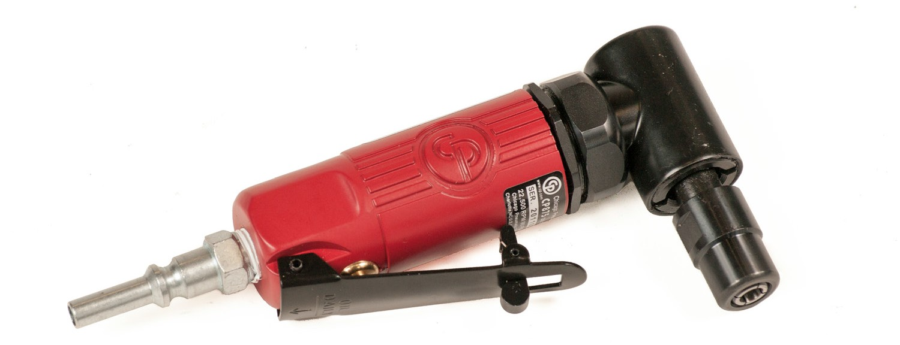
Figure 10 — Typical heavy-duty grinder

A heavy-duty air grinder that holds a depressed-centre (cup-shaped) grinder wheel may also be adapted for brushing or sanding. Two hand grips are featured for safe, controlled operation. One handle includes the air trigger or lever. This grinder is available with spindle speeds from 4500 to 7000 rpm.

A portable air grinder is more convenient to use if a 1 m (3 ft.) foot whip (leader) hose is attached directly to the tool and the air-line coupling is away from the tool. Although larger hoses are preferred for many air grinders, all hoses must have inside diameters of at least 6 mm (¼ in.). Before use, adjust the throttle lever stop-screw. The grinder speed is regulated by the distance the throttle lever is pulled or turned.

Drills and drivers
Air-powered drills are operated by the force of air moving over the blades of a rotor. This turning force is transmitted to the chuck through a series of gears. The speed of the drill is controlled through its full rpm range by the amount the air-throttle lever or trigger is depressed. Many air drills are designed with mufflers to reduce the noise of the motor.

Chucks for air drills have features similar to electric drill chucks and are made in different sizes corresponding to the drill capacity. Both keyless and key-type chucks are available. Both have three hardened steel jaws that are tightened and released by turning a threaded sleeve.

The portable air drill is often preferred to an electric drill because it is light and has infinite speed control, cannot overheat or be damaged by overloading, and can stop quickly. In addition, air drills can also be operated safely in wet areas, in conditions that would make the operation of an electric drill hazardous. Air-powered drills don’t only drill holes; with the appropriate accessory attached, they can be used for removing carbon and for honing, grinding, sanding, buffing, and brushing tires before vulcanizing.

Air screwdrivers and nut drivers look very much like air drills. The main difference is in the chuck or bit holder. The tool bit is held in place by a ball-and-spring detent, which facilitates quick changes of bits.

To further enhance the versatility of power screwdrivers, a clutch device or a friction drive can be incorporated, which runs the screw or nut to the required depth or tension.

Hammers and chisels
The air hammer is used for riveting, metal cutting, and chiselling. It uses a reciprocating piston that strikes a tool bit accessory that, in turn, strikes the workpiece.

Air hammers and chisels (Figure 11) can deliver between 1500 and 4000 blows per minute.

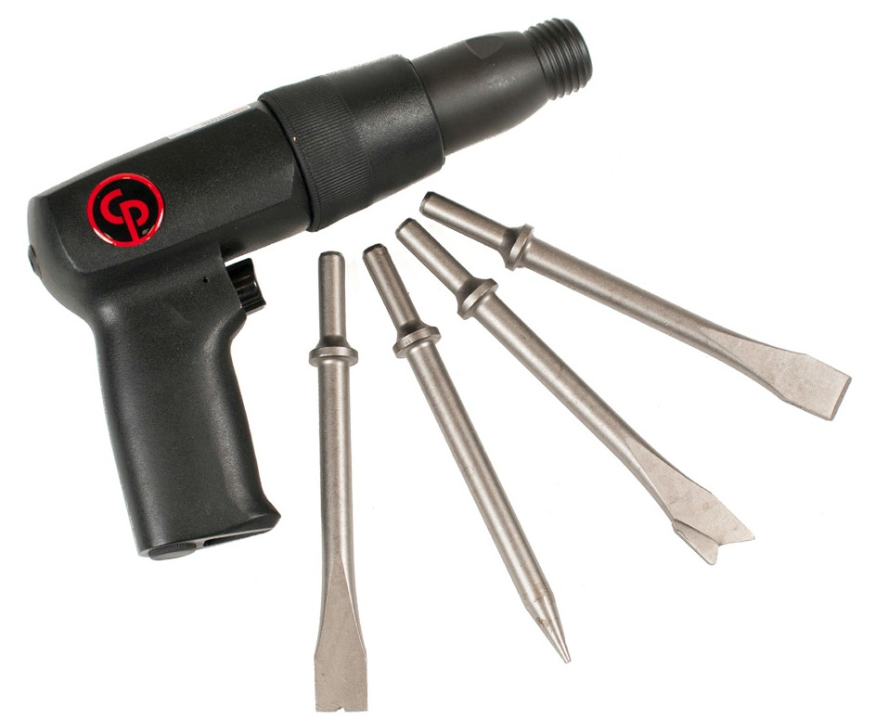
Figure 11 — Air hammer/chisel

A typical tool bit (chisel) accessory is manufactured from high-quality alloy steel and is heat- treated to withstand and deliver repeated blows from the striker piston. Many different bits are available to perform various tasks. Tool bits are retained by various methods (Figure 12).

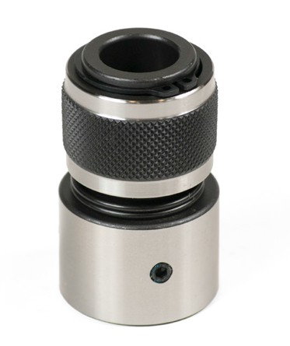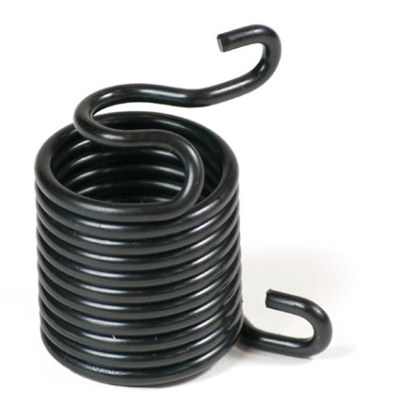
Figure 12 — Retainers for tool bits

Important safety points to remember when you are operating an air hammer are:
  - Always wear eye and hearing protection.

  - Always remove the air hose before making a tool change.

  - Never allow anyone to stand in front of the hammer or chisel during operation.

  - Always be aware of the line of fire.

Safety with air tools
The following safety rules apply to all air tools:
  - High-pressure air poses a severe hazard to the human body. Never expose yourself or your co-workers to any direct blasts of air, as they can drive particles under your skin or inject air bubbles into your bloodstream, resulting in a potentially fatal situation.
  - Never use compressed air to clean your clothing, as particles can be blown into your skin. Blowing air at your clothing could also react with some petroleum products and cause combustion.
  - Wear PPE, including eye and ear protection and steel-toed boots. Air tools are very noisy as the compressed air rushes at great speeds to expand into the atmosphere. Hearing damage can result unless proper ear protection is worn at all times by all persons in the area. Continuous vibration of certain air tools can cause nerve damage. Use heavy gloves if you are engaged in impact work.
  - Fittings often come loose from their retainers and can fly a considerable distance at high speed. When using air tools, be cautious of where you point the tool, and use lock-pin fittings when possible.
  - Never use air tools in an area where the exhaust from the tool could stir up clouds of toxic chemicals or hazardous materials such as asbestos dust. Disconnect the tool from the air supply when you load the tool or change the depth of drive adjustment.

- Disconnect the tool from the air supply to clear a jam, to change tool bits, or when you have completed the task.
- Assume that staplers or nailers are loaded. Always keep the stapler or nailer pointed in a safe direction.
- Carry the tool by the handle only. Never carry it by the air hose, and do not touch the trigger while you carry it.
- Ensure the tool is in good working order. Never operate an air tool if it is not working properly.
- Follow the manufacturer’s recommended air pressure, and check the gauge twice a day. Never use bottled air or gases to power the tool, as they could cause the tool to explode.
- Clean the tool at least daily and lubricate it as needed. Never operate a dirty tool.

- Treat the tool carefully; do not throw the tool, strike the tool housing, or use the tool as a hammer.
- Always ensure you have received proper training and read the operator’s manual before using an air tool.

Now complete the Learning Task Self-Test.

Self-Test 6
- How are air tools able to perform work?
  - Air tools harness electricity.
  - Air tools harness magnetic energy.
  - Air tools harness energy in compressed air.
  - Air tools harness energy in compressed water.

- When is it safe to use compressed air to clean work clothes?
  - It is safe if PPE is worn.
  - It is never safe to do so.
  - It is safe if work clothes are dusty.
  - It is safe if the clothes are coveralls.

- How is compressed air a hazard to the human body?
  - Compressed air contains toxins.
  - Compressed air can cause frostbite.
  - Compressed air is highly pressurized.
  - Compressed air can drive air bubbles into the body.

- What PPE is used to mitigate the strong vibrations of air impact work?
  - Leather apron
  - Eye protection
  - Heavy duty gloves
  - Hearing protection

- How often should an operator inspect and lubricate an air tool?
  - Before and after each use
  - Approximately once a week
  - When the operator notices poor performance
  - Air tools do not require lubrication or inspection.

- What is the purpose of the pressure regulator?
  - To control the speed of a tool
  - To limit air pressure to the tool
  - To expel excess air and exhaust air
  - To filter debris and moisture from compressed air

- What is an air compressor?
  - A motor that is run on pressurized air
  - A filter used to condition pressurized air
  - A machine that compresses air to perform work
  - A tool that uses pressurized air to perform work

- Which component stores compressed air to ensure sufficient volume?
  - Air storage unit
  - Reservoir tank
  - High-pressure tank
  - Compression storage tank

- What does the term “dynamic pressure” describe?
  - The range of air pressures an air tool functions in
  - The controlled manner in which air tools are used
  - The air pressure that is maintained while the air tool is in use
  - The air pressure that is in the line while the air tool is not in use

- What is the ideal condition of compressed air entering an air tool?
  - Air should be clean and dry.
  - Air should be warm and dry.
  - Air should be cold and moist.
  - Air should be moist and clean.

- Which safety component allows the operator to remove excess moisture from a compressed air line?
  - The exhaust port
  - The drain-off valve
  - The water regulator
  - The pop safety valve

- How often should the trap on the moisture separator be drained?
  - Daily
  - Weekly
  - Monthly
  - When the operator feels it is necessary

- Why is it important to remove moisture from compressed air?
  - Moisture causes the tool to short cycle.
  - Moisture increases the weight of the tool.
  - Moisture creates excessively noisy exhaust.
  - Moisture dilutes lubricant and can damage the tool.

- Which safety component captures grit and dirt from the compressed air before it enters the air hose?
  - The filter
  - The lubricator
  - The speed governor
  - The pressure regulator

- How is a compressed air hose constructed?
  - It is made with reinforced flexible rubber.
  - It is made with multi-layered polybutylene.
  - It is made with cross-connection polyethylene.
  - It is merely a water hose with a smaller diameter.

- Why must only specially designed impact sockets be used with an air impact wrench?
  - Air wrenches generate too much force for normal sockets.
  - Air wrenches use a connection system unique to air power tools.
  - Ordinary sockets are not long enough to be used with an air tool.
  - Ordinary sockets are not large enough to be used with an air tool.

- How is torque controlled in an air impact wrench?
  - By regulating the air flow to the motor
  - By throttling the trigger on the wrench
  - By choosing a specific filter for the air line
  - Torque cannot be controlled when working with air tools.

- Why is the portable air drill often preferred to the electric drill?
  - Electricity is often more expensive.
  - Air drills have better speed control.
  - Air drills do not require hoses or cords.
  - Electric drills cannot overheat or be damaged by overloading.

- What material is typically used to make air chisel tool bits?
  - High-quality cast iron
  - High-quality alloy steel
  - High-quality aluminum alloy
  - Cold-treated high-quality alloy steel

LEARNING TASK 7

Describe powder-actuated tools
Powder-actuated tools are designed to drive fastening devices into steel or concrete. Similar to a bullet, they are powered by an explosive powder charge, referred to as a “load.” The explosive powder charge creates a rapid expansion of gas that, either directly or indirectly, drives the fastener.

There are a number of different types and models of powder-actuated tools, each having specifically designed explosive charges and fasteners (Figure 1). These parts are not interchangeable.

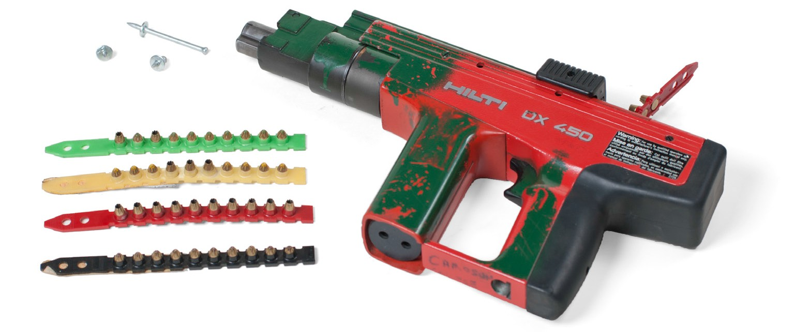

Tool classification
Figure 1 — Powder-actuated fastening system

Powder-actuated tools are classified as low, medium, or high velocity. This classification system applies to both direct- and indirect-acting tools and is based on a ballistic test. Using the strongest powder load and the lightest fastener commercially available from the manufacturer for a specific tool, the velocity of the tool is determined by measuring the average velocity of the fastener for 10 individual tests.

The velocity classifications based on ANSI A10.3 - 1995 are as follows:
- Low-velocity tool: A tool in which the average test velocity does not exceed 100 m/sec. (328 ft./sec.).
- Medium-velocity tool: A tool in which the average test velocity exceeds 100 m/sec. (328 ft./ sec.) but is less than 150 m/sec. (492 ft./sec.).
- High-velocity tool: A tool in which the average test velocity exceeds 150 m/sec. (492 ft./sec.).

WorkSafeBC requires that only low-velocity tools are to be used in all work environments unless no low-velocity tool is available on the market that is capable of performing the fastening task.

Powder-actuated tool operating principles
Powder-actuated tools available in the market operate on two different driving principles: direct-acting and indirect-acting. The basic designs of the tools are similar in that each has a breech that holds the powder load and a barrel guide mechanism to hold the fastener. While the direct-acting principle may allow fasteners to penetrate very dense concrete and thick steel base materials, safety concerns have made the indirect principle the technology of choice.

Direct-acting principle
The direct-acting tool uses the rapidly expanding gases of the powder load to drive the fastener down the barrel of the tool and into the base material (Figure 2). In a tool of this type, 100%
of the energy developed by the powder load is transferred to the fastener, resulting in a high velocity. Penetration of the fastener into the base material is controlled primarily by the density of the base material and the load level selected.
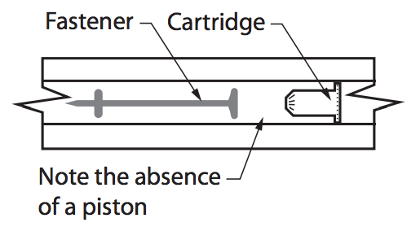

Figure 2 — High-velocity tool mechanism

Indirect-acting principle
The indirect-acting tool uses the rapidly expanding gases of the powder load to drive a captive piston housed in the barrel of the tool (Figure 3). This piston in turn drives the fastener into
the base material. In a tool of this type, most of the energy developed by the powder load is retained by the piston, allowing for better penetration control by the operator. Penetration of the fastener into the base material, therefore, is controlled by the design of the piston, the load level selected, and the density of the base material. An indirect-acting tool is classified as a low- velocity tool.

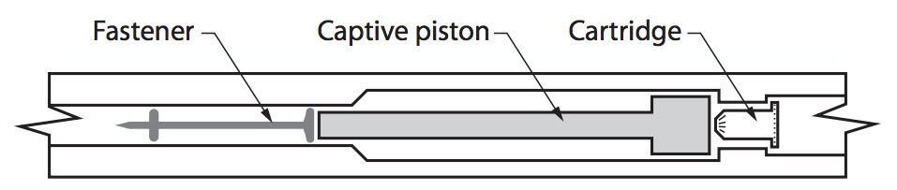
Figure 3 — Low-velocity captive piston mechanism

Powder loads
The energy source used to drive a powder-actuated fastener into the base material is a self- contained unit called a “powder load.” Specific load types are designed for each unique powder- actuated tool. Powder loads use encased chemical propellant, or gunpowder, that is housed in a crimped metal cartridge.

Powder load identification
Powder loads are available in sizes ranging from .22 to .27 calibre. The power level or strength of a cased powder load is identified using a 12-level system in which a combination of six colour codes and two case types are used. Power level 1 (grey) is the lowest, and power level 12 (purple) is the highest. Only six colour codes are used because there are not 12 easily distinguished colours available. Figure 4 shows this identification system.

Brass case (low velocity) |  |  |  | Nickel case (high velocity)
Power level | Load colour | Strength | Power level |  | Load colour | Strength
1 | Grey | Weakest  to  strongest | 7 |  | Grey | Weakest  to  strongest
2 | Brown |  | 8 |  | Brown
3 | Green |  | 9 |  | Green
4 | Yellow |  | 10 |  | Yellow
5 | Red |  | 11 |  | Red
6 | Purple |  | 12 |  | Purple
Figure 4 — Cartridge codes

Types of powder loads
Powder loads are available as single units as well as collated in groups of 10 into plastic strips or metal disks for semi-automatic tools. Consult the individual tool instructions for details on the calibre, range, and type of load. Always follow the manufacturer’s instructions for selection of load types.

Some loads have a crimped tip that keeps the powder in the casing (Figure 5). Wadded loads that have a plug in the front of the casing should never be used in tools designed for use with crimped loads such as low-velocity piston tools. The wadding material can cause the tool to clog or jam.
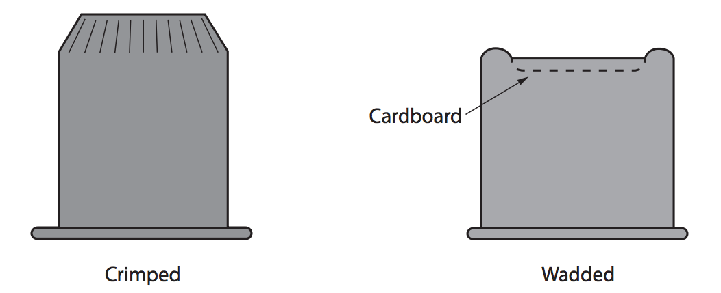

Figure 5 — Types of cartridges

Powder loads are either centre fired or rIm fired (Figure 6). These terms refer to where the firing pin contacts the cartridge.

Rim fired (HILTI TM) Centre fired
Figure 6 — Cartridge firing methods

Powder load selection
Use of the proper power level is critical to the success of a powder-actuated fastening. Before selecting the proper power level, check that the concrete is not too hard for fastening. A simple way to check this is by conducting a centre punch test by striking a fastener with a hammer to ensure that it will make a mark into the concrete.

To select the proper power level to be used with a specific fastener, always make a test firing using the lowest power level recommended for the tool being used. On tools that have a variable power control, use the lowest possible setting. If the lowest power level does not fully drive the fastener, try the next highest power level. Continue this procedure until the proper fastener penetration is obtained.

Fasteners
Several fastener types are available, including drive pins, threaded studs, and special application-specific assemblies. Only fasteners and powder loads recommended by the tool manufacturer for a particular tool, or those providing the same level of safety and performance, should be used.

Drive pins
Drive pins or nails (Figure 7) are one of the most commonly specified type of powder-actuated fastener. They are used to fasten a fixture directly to the base material in one operation for permanent applications. Pins are available in different head configurations. Each of the head configurations has a corresponding shank diameter and a variety of lengths. Some drive pins designed for use in steel have a knurled shank to provide increase-load capacities.

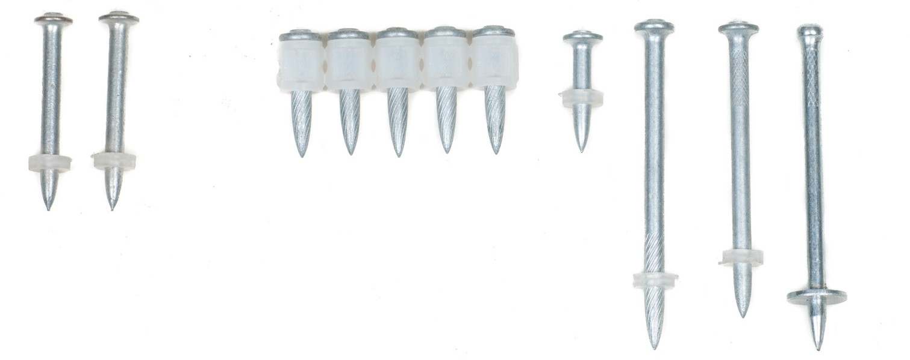
Figure 7 — Drive pins

Threaded studs
Threaded studs (Figure 8) are available with both 6 mm (¼ in.) or 9 mm (3/8 in.) thread diameter for applications where adjustment may be required. Each thread size has a corresponding shank diameter and is available in a variety of shank and thread lengths.

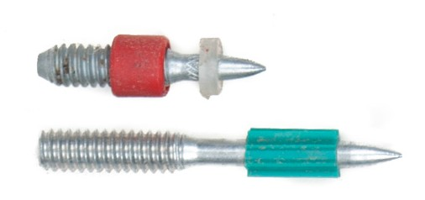
Figure 8 — Threaded studs

Fastener guidance
Both drive pin and threaded stud fasteners have pre-mounted plastic fluting or washers that hold the fastener centred in the tool guide prior to driving (Figure 9). During the driving process, the fluting or washers provide point guidance for the fastener. Generally, head guidance is provided by the diameter of the fastener head or threads. The 6 mm (¼ in.) 20-threaded studs also have a plastic cap to protect the threads of the fastener during the driving process and to provide head guidance.

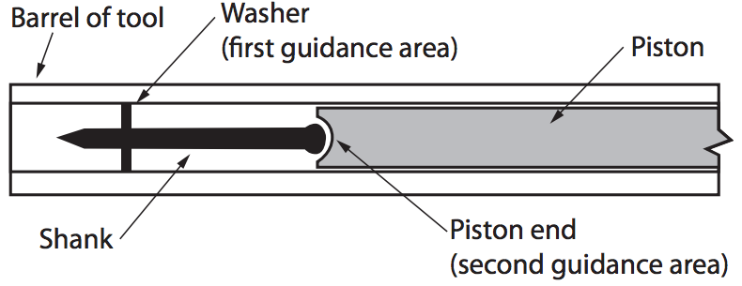

Figure 9 — Double-guidance system

Fastener assemblies
Assemblies that have pre-mounted fixtures or washers are available for a variety of special applications (Figure 10). These include special angle clips for use with acoustical ceilings, electrical conduit applications, and pins with pre-mounted washers for fastening insulation or lumber.

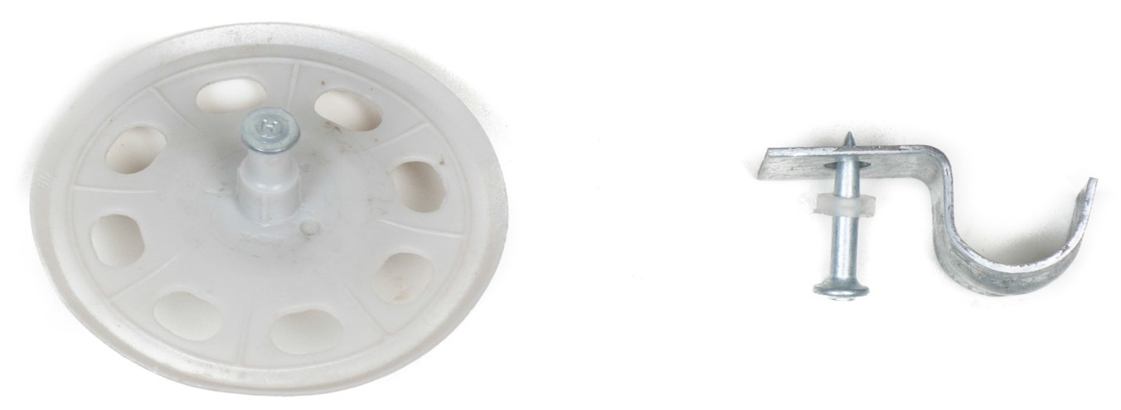
Figure 10 — Fastener assemblies

General use limitations
The following WorkSafeBC limitations as well as any manufacturer’s guidelines apply to all powder-actuated tools:
  - A powder-actuated tool fastener must not be driven into very hard or brittle materials, such as cast iron, glazed tile, hardened steel, glass block, natural rock, hollow tile, and most brick.
  - A powder-actuated tool fastener may only be driven into easily penetrated or thin materials or materials of unknown resistance if the receiving material is backed by a material that will prevent the fastener from passing completely through.
  - A powder-actuated tool fastener must not be driven into steel within 13 mm (½ in.) of an edge, or within 5 cm (2 in.) of a weld except for special applications permitted by the tool manufacturer.
  - Except for special applications recommended by the manufacturer, a powder-actuated tool fastener may not be driven into masonry materials:
▸ within 7.5 cm (3 in.) of an unsupported edge with a low-velocity tool, or
▸ within 15 cm (6 in.) of an unsupported edge with a medium- or high-velocity tool.

  - A powder-actuated tool fastener must not be driven:
▸ into concrete unless material thickness is at least three times the fastener shank penetration,
▸ into any spalled area, or
▸ through existing holes unless a specific guide means, as recommended and supplied by the tool manufacturer, is used to assure positive alignment.

Safety, care, and maintenance
The following general safety guidelines apply to all powder-actuated tools:
- Only a qualified person may handle or use a powder-actuated tool or power loads.

- The operator must have the following immediately available when using or servicing a powder actuated tool:
▸ a copy of the manufacturer‘s operating instructions for the tool,
▸ a copy of the power load and fastener charts for the tool, and
▸ any accessories or tools needed for use or field servicing of the tool, including personal protection equipment.
- A powder-actuated tool must not be used in an explosive or flammable atmosphere.

- A powder-actuated tool may only be loaded when it is being prepared for immediate use, and must be unloaded at once if work is interrupted after loading.
- A powder-actuated tool must not be pointed at any person.

- If a powder-actuated tool misfires, the operator must hold the tool firmly against the work surface for at least five seconds, then follow the manufacturer’s instructions for such occurrences, and until the cartridge has been ejected, keep the tool pointed in a direction that will not cause injury to any person.
For additional safety, WorkSafeBC requires that operating powder-actuated tools must incorporate two separate and distinct stages:
- Activating the tool, which is done by depressing the tool into the firing position

- The final firing movement, which is depressing the trigger.

All powder-actuated fastening systems must be used and serviced according to the manufacturer‘s instructions. Using fasteners and cartridges that are not approved for use by the tool manufacturer may result in jamming, misfires, and fastener failures, which are all potential safety hazards.

Make sure that the manufacturer’s name or trademark, model number, and serial number are visible on the tool. Also make sure that all guards and accessories for the particular powder- actuated tool are marked with the manufacturer‘s name or trademark.

When not in use, a powder-actuated tool must be unloaded and the tool and power loads must be securely stored and be accessible only to qualified and authorized persons. Power loads of different power levels and types must be kept in different compartments or containers.

Now complete the Learning Task Self-Test.

Self-Test 7
  - How are powder-actuated tools able to drive fasteners into concrete?
    - They employ electric energy to drive the fastener or piston.
    - They employ the rapid expansion of gas to drive the fastener or piston
    - They employ the power of pressurized air to drive the fastener or piston.
    - They employ the power of pressurized water to drive the fastener or piston.

  - What feature defines a low-velocity powder-actuated tool?
    - A tool in which the average test velocity exceeds 492 ft./sec. (150 m/sec.)
    - A tool in which the average test velocity does not exceed 492 ft./sec. (150 m/sec.)
    - A tool in which the average test velocity does not exceed 656 ft./sec. (200 m/per sec.)
    - A tool in which the average test velocity does not exceed 328 ft./sec. (100 m/sec.)

  - How does an indirect-acting powder-actuated tool drive a fastener into the base material?
    - The rapidly expanding gases act directly on the fastener.
    - The rapidly expanding gases are indirectly vented out of an exhaust port.
    - The rapidly expanding gases act directly on a piston that drives the fastener.
    - The rapidly expanding gases act indirectly on a piston that drives the fastener.

  - How is a powder load identified?
    - By colour
    - By calibre
    - By case type
    - By colour and case type

  - With the right powder load, a powder-actuated tool can drive a fastener into any base material.
    - True
    - False

  - Fastener selection is varied and can include nail-style fasteners as well as special-application fasteners such as electrical conduit clips.
    - True
    - False

  - The powder-actuated tool is safe to use on thin base material if the operator uses a backing material to prevent accidental pass-through of the base material.
    - True
    - False

  - If the correct powder load is chosen, a fastener may be driven into any masonry material.
    - True
    - False

  - Any worker may use a powder-actuated tool, as it functions in a very intuitive manner.
    - True
    - False

  - A powder-actuated tool should be stored unloaded, and loads must be stored separately.
    - True
    - False

  - A powder-actuated tool must fire only if the trigger is depressed. There must be no other action.
    - True
    - False

  - In the case of a misfire the operator must hold the tool in place for five seconds.
    - True
    - False

  - Only masonry material must be tested for suitability, as steel is consistent and predictable.
    - True
    - False

  - Only fasteners approved by the manufacturer should be used.
    - True
    - False

  - To select the proper power level to be used with a specific fastener, always perform a test firing using the highest power level recommended for the tool.
    - True
    - False

Answer Key

Self-Test 1
      - d. All of the above

      - a. Rototiller

      - d. Combustion engine power tools

      - b. Transferring energy through compressed air

      - b. Hydraulic power tool

      - c. Powder-actuated tool

      - a. True

      - a. True

      - b. False

Self-Test 2
- d. Fingers

- d. Changing bits or blades while the power source is connected

- d. Various types of power saws

- d. Batteries have a much lower voltage than wall outlets and therefore have a reduced shock factor.
- c. Tag the tool as “damaged” and remove from service and have the cord fixed.

- b. The equipment must be protected by a GFCI.

- a. The cord must be three pronged and grounded.

- b. False

- a. True

- b. False

- b. False

- a. True

- a. True

- b. False

- b. False

- b. False

Self-Test 3
- d. By the diameter of its blade

- b. By raising or lowering the base

- d. With a straightedge

- a. Tilting the base

- d. Control the width of the stock being cut

- b. Slightly deeper than the stock

- d. Eye protection

- a. Up

- c. Dust mask

- a. Curved cuts

- b. Stock thickness plus stroke length

- b. Drill a starter hole

- a. To control chattering

- a. Filled straight across

- b. Crosscut blade

- c. Hard and brittle

- d. Ferrous metals and masonry products

- d. The chuck end

- a. Lumber

- a. The blade’s wavy teeth

- d. The use of counterweights

- a. A mist spray

- d. The saw will automatically shut off.

- b. Reduce the blade speed.

- b. Carbon steel blade

- c. Hook-toothed blade

- c. Skip-tooth blade

- c. Skip-tooth, high-speed steel blade

- b. 3 to 6 teeth per inch

- d. Reinforced abrasives

- d. To avoid the risk of breaking the blade

- d. Face shield and gloves

- b. That the blade is designed to cut metal

- d. Maximum speed rating

Self-Test 4
- a. Chuck key

- b. On the pistol grip

- c. Speed of rotation

- a. ½ in. drills

- c. Hot, airborne particles

- a. Jamming the drill

- d. It must have both variable speed and a reversing switch.

- d. Only once the motor has stopped turning

- c. Shank

- d. Body

11. c. 4

12. b. 0.1 mm

13. a. 1

14. a. A

15. b. 1/64 in.

16. b. They should be spiral coils. 17. a. 12°
- b. The cutting edge will cut slowly.

- d. The cutting lips must be of equal length and angle.

- a. A pilot bit

- c. The sides of the bit

- c. An auger bit

- d. Concrete

- b. Larger bits require slower speeds.

- b. As the bit breaks through the work

- a. When the metal is soft.

- a. Head

- a. To the table

Self-Test 5
- a. Router
- d. Orbital sander
- a. Replace the torn belt with a new belt.
- b. Ensuring the power is disconnected
- b. Pencil grinder
- a. Angle grinder
- a. It is never safe to do so.
- c. The spark guard
- c. As motor size increases, wheel size increases.
- b. Replace the wheel immediately, as a cracked wheel is dangerous.
- d. Lightly tap the wheel with a screwdriver handle and listen to the sound.
- a. The work will vibrate excessively.
- c. The rpm rating of the wheel must equal or exceed the grinder rpm.
- a. A minimum of 3 mm (1/8 in.)
- d. No lower than the centre of the wheel
- b. Wheel dresser
- d. Frequently dip the work in water and work with a clean wheel.
- b. The metal is overheated and the tool may be weakened.
- b. Revolutions per minute
- c. Wheel diameter, wheel thickness, and maximum operating speed

Self-Test 6
  - c. Air tools harness energy in compressed air.

  - b. It is never safe to do so.

  - d. Compressed air can drive air bubbles into the body.

  - c. Heavy-duty gloves

  - a. Before and after each use

  - b. To limit air pressure to the tool

  - c. A machine that compresses air to perform work

  - b. Reservoir tank

  - c. The air pressure that is maintained while the air tool is in use

  - a. Air should be clean and dry.

  - b. The drain-off valve

  - a. Daily

  - d. Moisture dilutes lubricant and can damage the tool.

  - a. The filter

  - a. It is made with reinforced flexible rubber.

  - a. Air wrenches generate too much force for normal sockets.

  - a. By regulating the air flow to the motor

  - b. Air drills have better speed control.

  - b. High-quality alloy steel

Self-Test 7

1. | b. | They employ the rapid expansion of gas to drive the fastener or piston.
2. | d. | A tool in which the average test velocity does not exceed 100 m/sec.
3. | c. | The rapidly expanding gases act directly on a piston that drives the fastener.
4. | d. | By colour and case type
5. | b. | False
6. | a. | True
7. | a. | True

- b. False

- b. False

- a. True

- b. False

- a. True

- b. False

- a. True

- b. False

The British Columbia Open Textbook Project
The British Columbia Open Textbook Project is funded by the B.C. Ministry of Advanced Education, and managed by BCcampus, a publicly-funded organization that uses information technology to connect B.C. post-secondary institutions under a collaborative service delivery framework. The Open Textbook Project aims to make available
openly-licensed textbooks in the province’s high-impact subject areas. Visit open.bccampus.ca for more information.





7960003684

