"This document is attributed to Douglas S. Shafer, and Zhiyi Zhang”

About the Authors

Douglas S. Shafer

Douglas Shafer is Professor of Mathematics at the University of

North Carolina at Charlotte. In addition to his position in Charlotte

he has held visiting positions at the University of Missouri at

Columbia and Montana State University and a Senior Fulbright

Fellowship in Belgium. He teaches a range of mathematics courses

as well as introductory statistics. In addition to journal articles and

this statistics textbook, he has co-authored with V. G. Romanovski (Maribor, Sloveia) a graduate textbook in his research specialty. He earned a PhD in mathematics at the University of North Carolina at Chapel Hill.

Zhiyi Zhang

Zhiyi Zhang is Professor of Mathematics at the University of North

Carolina at Charlotte. In addition to his teaching and research duties

at the university, he consults actively to industries and governments

on a wide range of statistical issues. His research activities in statistics

have been supported by National Science Foundation, U.S.

Environmental Protection Agency, Office of Naval Research, and

National Institute of Health. He earned a PhD in statistics at Rutgers University in New Jersey.

Read License Information
Full Legal Code

Acknowledgements
We would like to thank the following colleagues whose comprehensive feedback and suggestions for improving the material helped us make a better text:

Kathy Autrey, Northwestern State University
Kiran Bhutani, The Catholic University of America
Rhonda Buckley, Texas Woman’s University
Susan Cashin, University of Wisconsin-Milwaukee
Kathryn Cerrone, The University of Akron-Summit College
Zhao Chen, Florida Gulf Coast University
Ilhan Izmirli, George Mason University, Department of Statistics
Denise Johansen, University of Cincinnati
Eric Kean, Western Washington University
Yolanda Kumar, Univeristy of Missouri-Columbia
Eileen Stock, Baylor University
Sean Thomas, Emory University
Sara Tomek, University of Alabama
Mildred Vernia, Indiana University Southeast
Gingia Wen, Texas Woman’s University
Jiang Yuan, Baylor University

We also acknowledge the valuable contribution of the publisher’s accuracy checker, Phyllis Barnidge.

Dedication
To our families and teachers.

Preface
This book is meant to be a textbook for a standard one-semester introductory statistics course for general education students. Our motivation for writing it is twofold: 1.) to provide a low-cost alternative to many existing popular textbooks on the market; and 2.) to provide a quality textbook on the subject with a focus on the core material of the course in a balanced presentation.

The high cost of textbooks has spiraled out of control in recent years. The high frequency at which new editions of popular texts appear puts a tremendous burden on students and faculty alike, as well as the natural environment. Against this background we set out to write a quality textbook with materials such as examples and exercises that age well with time and that would therefore not require frequent new editions. Our vision resonates well with the publisher’s business model which includes free digital access, reduced paper prints, and easy customization by instructors if additional material is desired.

Over time the core content of this course has developed into a well-defined body of material that is substantial for a one-semester course. The authors believe that the students in this course are best served by a focus on the core material and not by an exposure to a plethora of peripheral topics. Therefore in writing this book we have sought to present material that comprises fully a central body of knowledge that is defined according to convention, realistic expectation with respect to course duration and students’ maturity level, and our professional judgment and experience. We believe that certain topics, among them Poisson and geometric distributions and the normal approximation to the binomial distribution (particularly with a continuity correction) are distracting in nature. Other topics, such as nonparametric methods, while important, do not belong in a first course in statistics. As a result we envision a smaller and less intimidating textbook that trades some extended and unnecessary topics for a better focused presentation of the central material.

Textbooks for this course cover a wide range in terms of simplicity and complexity. Some popular textbooks emphasize the simplicity of individual concepts to the point of lacking the coherence of an overall network of concepts. Other textbooks include overly detailed conceptual and computational discussions and as a result repel students from reading them. The authors believe that a successful book must strike a balance between the two extremes, however difficult it may be. As a consequence the overarching guiding principle of our writing is to seek simplicity but to preserve the coherence of the whole body of information communicated, both conceptually and computationally. We seek to remind ourselves (and others) that we teach ideas, not just step-by-step algorithms, but ideas that can be implemented by straightforward algorithms.

In our experience most students come to an introductory course in statistics with a calculator that they are familiar with and with which their proficiency is more than adequate for the course material. If the instructor chooses to use technological aids, either calculators or statistical software such as Minitab or SPSS, for more than mere arithmetical computations but as a significant component of the course then effective instruction for their use will require more extensive written instruction than a mere paragraph or two in the text. Given the plethora of such aids available, to discuss a few of them would not provide sufficiently wide or detailed coverage and to discuss many would digress unnecessarily from the conceptual focus of the book. The overarching philosophy of this textbook is to present the core material of an introductory course in statistics for non-majors in a complete yet streamlined way. Much room has been intentionally left for instructors to apply their own instructional styles as they deem appropriate for their classes and educational goals. We believe that the whole matter of what technological aids to use, and to what extent, is precisely the type of material best left to the instructor’s discretion.

All figures with the exception of Figure 1.1 "The Grand Picture of Statistics",Figure 2.1 "Stem and Leaf Diagram", Figure 2.2 "Ordered Stem and Leaf Diagram",Figure 2.13 "The Box Plot", Figure 10.4 "Linear Correlation Coefficient ", Figure 10.5 "The Simple Linear Model Concept", and the unnumbered figure in Note 2.50 "Example 16" of Chapter 2 "Descriptive Statistics" were generated using MATLAB, copyright 2010.

Chapter 1

Introduction
In this chapter we will introduce some basic terminology and lay the groundwork for the course. We will explain in general terms what statistics and probability are and the problems that these two areas of study are designed to solve.

Basic Definitions and Concepts

LEARNING OBJECTIVE
- To learn the basic definitions used in statistics and some of its key concepts.

We begin with a simple example. There are millions of passenger automobiles in the United States. What is their average value? It is obviously impractical to attempt to solve this problem directly by assessing the value of every single car in the country, adding up all those numbers, and then dividing by however many numbers there are. Instead, the best we can do would be to estimate the average. One natural way to do so would be to randomly select some of the cars, say 200 of them, ascertain the value of each of those cars, and find the average of those 200 numbers. The set of all those millions of vehicles is called the population of interest, and the number attached to each one, its value, is a measurement. The average value is a parameter: a number that describes a characteristic of the population, in this case monetary worth. The set of 200 cars selected from the population is called a sample, and the 200 numbers, the monetary values of the cars we selected, are the sample data. The average of the data is called a statistic: a number calculated from the sample data. This example illustrates the meaning of the following definitions.

Definition
A population is any specific collection of objects of interest. A sample is any subset or subcollection of the population, including the case that the sample consists of the whole population, in which case it is termed a census.

Definition
A measurement is a number or attribute computed for each member of a population or of a sample. The measurements of sample elements are collectively called the sample data.

Definition
A parameter is a number that summarizes some aspect of the population as a whole. A statistic is a number computed from the sample data.

Continuing with our example, if the average value of the cars in our sample was $8,357, then it seems reasonable to conclude that the average value of all cars is about $8,357. In reasoning this way we have drawn an inference about the population based on information obtained from the sample. In general, statistics is a study of data: describing properties of the data, which is called descriptive statistics, and drawing conclusions about a population of interest from information extracted from a sample, which is called inferential statistics. Computing the single number $8,357 to summarize the data was an operation of descriptive statistics; using it to make a statement about the population was an operation of inferential statistics.

Definition
Statistics is a collection of methods for collecting, displaying, analyzing, and drawing conclusions from data.

Definition
Descriptive statistics is the branch of statistics that involves organizing, displaying, and describing data.

Definition
Inferential statistics is the branch of statistics that involves drawing conclusions about a population based on information contained in a sample taken from that population.

The measurement made on each element of a sample need not be numerical. Inthe case of automobiles, what is noted about each car could be its color, its make, its body type, and so on. Such data are categorical or qualitative, as opposed to numerical or quantitative data such as value or age. This is a general distinction.

Definition
Qualitative data are measurements for which there is no natural numerical scale, but which consist of attributes, labels, or other nonnumerical characteristics.

Definition
Quantitative data are numerical measurements that arise from a natural numerical scale.

Qualitative data can generate numerical sample statistics. In the automobile example, for instance, we might be interested in the proportion of all cars that are less than six years old. In our same sample of 200 cars we could note for each car whether it is less than six years old or not, which is a qualitative measurement. If 172 cars in the sample are less than six years old, which is 0.86 or 86%, then we would estimate the parameter of interest, the population proportion, to be about the same as the sample statistic, the sample proportion, that is, about 0.86.
The relationship between a population of interest and a sample drawn from that population is perhaps the most important concept in statistics, since everything else rests on it. This relationship is illustrated graphically in Figure 1.1 "The Grand Picture of Statistics". The circles in the large box represent elements of the population. In the figure there was room for only a small number of them but in actual situations, like our automobile example, they could very well number in the millions. The solid black circles represent the elements of the population that are selected at random and that together form the sample. For each element of the sample there is a measurement of interest, denoted by a lower case x (which we have indexed as x1,…,xn to tell them apart); these measurements collectively form the sample data set. From the data we may calculate various statistics. To anticipate the notation that will be used later, we might compute the sample mean x− and the sample proportion pˆ, and take them as approximations to the population mean μ (this is the lower case Greek letter mu, the traditional symbol for this parameter) and the population proportion p, respectively. The other symbols in the figure stand for other parameters and statistics that we will encounter.

Figure 1.1 The Grand Picture of Statistics
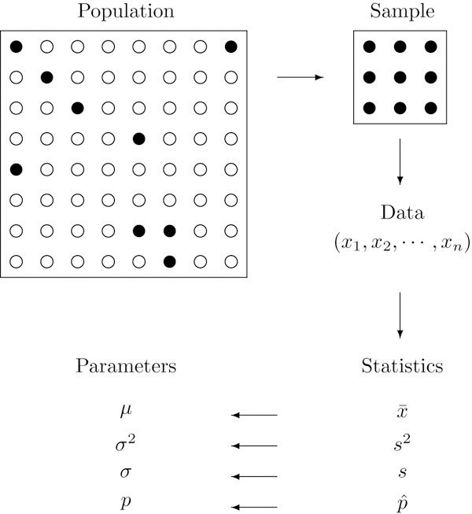

KEY TAKEAWAYS
- Statistics is a study of data: describing properties of data (descriptive statistics) and drawing conclusions about a population based on information in a sample (inferential statistics).
- The distinction between a population together with its parameters and a sample together with its statistics is a fundamental concept in inferential statistics.
- Information in a sample is used to make inferences about the population from which the sample was drawn.

EXERCISES
- Explain what is meant by the term population.
- Explain what is meant by the term sample.
- Explain how a sample differs from a population.
- Explain what is meant by the term sample data.
- Explain what a parameter is.
- Explain what a statistic is.
- Give an example of a population and two different characteristics that may be of interest.
- Describe the difference between descriptive statistics and inferential statistics. Illustrate with an example.
- Identify each of the following data sets as either a population or a sample:
  - The grade point averages (GPAs) of all students at a college.
  - The GPAs of a randomly selected group of students on a college campus.
  - The ages of the nine Supreme Court Justices of the United States on January 1, 1842.
  - The gender of every second customer who enters a movie theater.
  - The lengths of Atlantic croakers caught on a fishing trip to the beach.
- Identify the following measures as either quantitative or qualitative:
  - The 30 high-temperature readings of the last 30 days.
  - The scores of 40 students on an English test.
  - The blood types of 120 teachers in a middle school.
  - The last four digits of social security numbers of all students in a class.
  - The numbers on the jerseys of 53 football players on a team.
- Identify the following measures as either quantitative or qualitative:
  - The genders of the first 40 newborns in a hospital one year.
  - The natural hair color of 20 randomly selected fashion models.
  - The ages of 20 randomly selected fashion models.
  - The fuel economy in miles per gallon of 20 new cars purchased last month.
  - The political affiliation of 500 randomly selected voters.
- A researcher wishes to estimate the average amount spent per person by visitors to a theme park. He takes a random sample of forty visitors and obtains an average of $28 per person.
  - What is the population of interest?
  - What is the parameter of interest?
  - Based on this sample, do we know the average amount spent per person by visitors to the park? Explain fully.
- A researcher wishes to estimate the average weight of newborns in South America in the last five years. He takes a random sample of 235 newborns and obtains an average of 3.27 kilograms.
  - What is the population of interest?
  - What is the parameter of interest?
  - Based on this sample, do we know the average weight of newborns in South America? Explain fully.
- A researcher wishes to estimate the proportion of all adults who own a cell phone. He takes a random sample of 1,572 adults; 1,298 of them own a cell phone, hence 1298∕1572 ≈ .83 or about 83% own a cell phone.
  - What is the population of interest?
  - What is the parameter of interest?
  - What is the statistic involved?
  - Based on this sample, do we know the proportion of all adults who own a cell phone? Explain fully.
- A sociologist wishes to estimate the proportion of all adults in a certain region who have never married. In a random sample of 1,320 adults, 145 have never married, hence 145∕1320 ≈ .11 or about 11% have never married.
  - What is the population of interest?
  - What is the parameter of interest?
  - What is the statistic involved?
  - Based on this sample, do we know the proportion of all adults who have never married? Explain fully.
- a. What must be true of a sample if it is to give a reliable estimate of the value of a particular
population parameter?
b. What must be true of a sample if it is to give certain knowledge of the value of a particular
population parameter?

ANSWERS
- A population is the total collection of objects that are of interest in a statistical study.

- A sample, being a subset, is typically smaller than the population. In a statistical study, all elements of a sample are available for observation, which is not typically the case for a population.

- A parameter is a value describing a characteristic of a population. In a statistical study the value of a parameter is typically unknown.

- All currently registered students at a particular college form a population. Two population characteristics of interest could be the average GPA and the proportion of students over 23 years.

- a. Population.
b. Sample.
- Population.
- Sample.
- Sample.

- a. Qualitative.
b. Qualitative.
- Quantitative.
- Quantitative.
- Qualitative.

- a. All newborn babies in South America in the last five years. b. The average birth weight of all newborn babies in South America in the last five years. c. No, not exactly, but we know the approximate value of the average.

- a. All adults in the region. b. The proportion of the adults in the region who have never married. c. The proportion computed from the sample, 0.1. d. No, not exactly, but we know the approximate value of the proportion.

Overview

LEARNING OBJECTIVE
- To obtain an overview of the material in the text.

The example we have given in the first section seems fairly simple, but there are some significant problems that it illustrates. We have supposed that the 200 cars of the sample had an average value of $8,357 (a number that is precisely known), and concluded that the population has an average of about the same amount, although its precise value is still unknown. What would happen if someone were to take another sample of exactly the same size from exactly the same population? Would he get the same sample average as we did, $8,357? Almost surely not. In fact, if the investigator who took the second sample were to report precisely the same value, we would immediately become suspicious of his result. The sample average is an example of what is called a random variable: a number that varies from trial to trial of an experiment (in this case, from sample to sample), and does so in a way that cannot be predicted precisely. Random variables will be a central object of study for us, beginning in Chapter 4 "Discrete Random Variables".

Another issue that arises is that different samples have different levels of reliability. We have supposed that our sample of size 200 had an average of $8,357. If a sample of size 1,000 yielded an average value of $7,832, then we would naturally regard this latter number as likely to be a better estimate of the average value of all cars. How can this be expressed? An important idea that we will develop in Chapter 7 "Estimation" is that of the confidence interval: from the data we will construct an interval of values so that the process has a certain chance, say a 95% chance, of generating an interval that contains the actual population average. Thus instead of reporting a single estimate, $8,357, for the population mean, we would say that we are 95% certain that the true average is within $100 of our sample mean, that is, between $8,257 and $8,457, the number $100 having been computed from the sample data just like the sample mean $8,357 was. This will automatically indicate the reliability of the sample, since to obtain the same chance of containing the unknown parameter a large sample will typically produce a shorter interval than a small one will. But unless we perform a census, we can never be completely sure of the true average value of the population; the best that we can do is to make statements of probability, an important concept that we will begin to study formally in Chapter 3 "Basic Concepts of Probability".

Sampling may be done not only to estimate a population parameter, but to test a claim that is made about that parameter. Suppose a food package asserts that the amount of sugar in one serving of the product is 14 grams. A consumer group might suspect that it is more. How would they test the competing claims about the amount of sugar, 14 grams versus more than 14 grams? They might take a random sample of perhaps 20 food packages, measure the amount of sugar in one serving of each one, and average those amounts. They are not interested in the true amount of sugar in one serving in itself; their interest is simply whether the claim about the true amount is accurate. Stated another way, they are sampling not in order to estimate the average amount of sugar in one serving, but to see whether that amount, whatever it may be, is larger than 14 grams. Again because one can have certain knowledge only by taking a census, ideas of probability enter into the analysis. We will examine tests of hypotheses beginning in Chapter 8 "Testing Hypotheses".

Several times in this introduction we have used the term “random sample.” Generally the value of our data is only as good as the sample that produced it. For example, suppose we wish to estimate the proportion of all students at a large university who are females, which we denote by p. If we select 50 students at random and 27 of them are female, then a natural estimate is p≈pˆ-27/50-0.54 or 54%. How much confidence we can place in this estimate depends not only on the size of the sample, but on its quality, whether or not it is truly random, or at least truly representative of the whole population. If all 50 students in our sample were drawn from a College of Nursing, then the proportion of female students in the sample is likely higher than that of the entire campus. If all 50 students were selected from a College of Engineering Sciences, then the proportion of students in the entire student body who are females could be underestimated. In either case, the estimate would be distorted or biased. In statistical practice an unbiased sampling scheme is important but in most cases not easy to produce. For this introductory course we will assume that all samples are either random or at least representative.

KEY TAKEAWAY
- Statistics computed from samples vary randomly from sample to sample. Conclusions made about population parameters are statements of probability.

Presentation of Data

LEARNING OBJECTIVE
- To learn two ways that data will be presented in the text.

In this book we will use two formats for presenting data sets. The first is a data list, which is an explicit listing of all the individual measurements, either as a display with space between the individual measurements, or in set notation with individual measurements separated by commas.

EXAMPLE 1
The data obtained by measuring the age of 21 randomly selected students enrolled in freshman courses at a university could be presented as the data list

18 18 19 19 19 18 22 20 18 18 17
19 18 24 18 20 18 21 20 17 19

or in set notation as
{18,18,19,19,19,18,22,20,18,18,17,19,18,24,18,20,18,21,20,17,19}

A data set can also be presented by means of a data frequency table, a table in which each distinct value x is listed in the first row and its frequency f, which is the number of times the value x appears in the data set, is listed below it in the second row.

EXAMPLE 2
The data set of the previous example is represented by the data frequency table
x 17 18 19 20 21 22 24
f 2 8 5 3 1 1 1

The data frequency table is especially convenient when data sets are large and the number of distinct values is not too large.

KEY TAKEAWAY
- Data sets can be presented either by listing all the elements or by giving a table of values and frequencies.

EXERCISES

- List all the measurements for the data set represented by the following data frequency table.
x 21 22 22 24 25
f 1 5 6 4 2

- List all the measurements for the data set represented by the following data frequency table.
x 97 98 99 100 101 102 102 105
f 7 5 2 4 2 2 1 1

- Construct the data frequency table for the following data set.

22 25 22 27 24 23
26 24 22 24 26
- Construct the data frequency table for the following data set.

{1,5,2,3,5,1,4,4,4,3,2,5,1,3,2,
1,1,1,2}

ANSWERS
- {31,32,32,32,32,32,33,33,33,33,33,33,34,34,34,34,35,35}.

x 22 23 24 25 26 27
f 3 1 3 1 2 1

Chapter 2

Descriptive Statistics

As described in Chapter 1 "Introduction", statistics naturally divides into two branches, descriptive statistics and inferential statistics. Our main interest is in inferential statistics, as shown in Figure 1.1 "The Grand Picture of Statistics" in Chapter 1 "Introduction". Nevertheless, the starting point for dealing with a collection of data is to organize, display, and summarize it effectively. These are the objectives of descriptive statistics, the topic of this chapter.

2.1 Three Popular Data Displays

LEARNING OBJECTIVE
- To learn to interpret the meaning of three graphical representations of sets of data: stem and leaf diagrams, frequency histograms, and relative frequency histograms.

A well-known adage is that “a picture is worth a thousand words.” This saying proves true when it comes to presenting statistical information in a data set. There are many effective ways to present data graphically. The three graphical tools that are introduced in this section are among the most commonly used and are relevant to the subsequent presentation of the material in this book.

Stem and Leaf Diagrams
Suppose 30 students in a statistics class took a test and made the following scores:
86 80 25 77 73 76 100 90 69 93
90 83 70 73 73 70 90 83 71 95
40 58 68 69 100 78 87 97 92 74

How did the class do on the test? A quick glance at the set of 30 numbers does not immediately give a clear answer. However the data set may be reorganized and rewritten to make relevant information more visible. One way to do so is to construct a stem and leaf diagram as shown in . The numbers in the tens place, from 2 through 9, and additionally the number 10, are the “stems,” and are arranged in numerical order from top to bottom to the left of a vertical line. The number in the units place in each measurement is a “leaf,” and is placed in a row to the right of the corresponding stem, the number in the tens place of that measurement. Thus the three leaves 9, 8, and 9 in the row headed with the stem 6 correspond to the three exam scores in the 60s, 69 (in the first row of data), 68 (in the third row), and 69 (also in the third row). The display is made even more useful for some purposes by rearranging the leaves in numerical order, as shown in . Either way, with the data reorganized certain information of interest becomes apparent immediately. There are two perfect scores; three students made scores under 60; most students scored in the 70s, 80s and 90s; and the overall average is probably in the high 70s or low 80s.

igure 2.1 Stem and Leaf Diagram
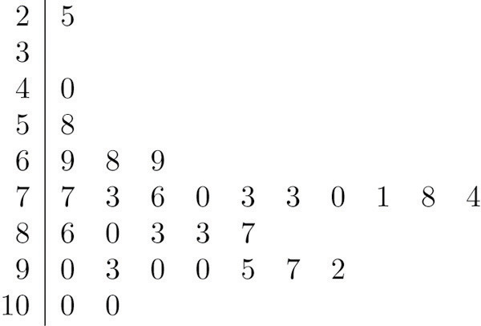
Figure 2.2 Ordered Stem and Leaf Diagram
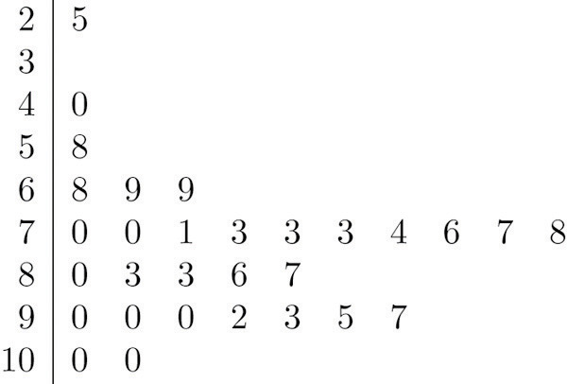

In this example the scores have a natural stem (the tens place) and leaf (the ones place). One could spread the diagram out by splitting each tens place number into lower and upper categories. For example, all the scores in the 80s may be represented on two separate stems, lower 80s and upper 80s:
8 0 3 3
8 6 7

The definitions of stems and leaves are flexible in practice. The general purpose of a stem and leaf diagram is to provide a quick display of how the data are distributed across the range of their values; some improvisation could be necessary to obtain a diagram that best meets that goal.
Note that all of the original data can be recovered from the stem and leaf diagram. This will not be true in the next two types of graphical displays.

Frequency Histograms
The stem and leaf diagram is not practical for large data sets, so we need a different, purely graphical way to represent data. A frequency histogram is such a device. We will illustrate it using the same data set from the previous subsection. For the 30 scores on the exam, it is natural to group the scores on the standard ten-point scale, and count the number of scores in each group. Thus there are two 100s, seven scores in the 90s, six in the 80s, and so on. We then construct the diagram shown in by drawing for each group, or class, a vertical bar whose length is the number of observations in that group. In our example, the bar labeled 100 is 2 units long, the bar labeled 90 is 7 units long, and so on. While the individual data values are lost, we know the number in each class. This number is called the frequency of the class, hence the name frequency histogram.
Figure 2.3 Frequency Histogram
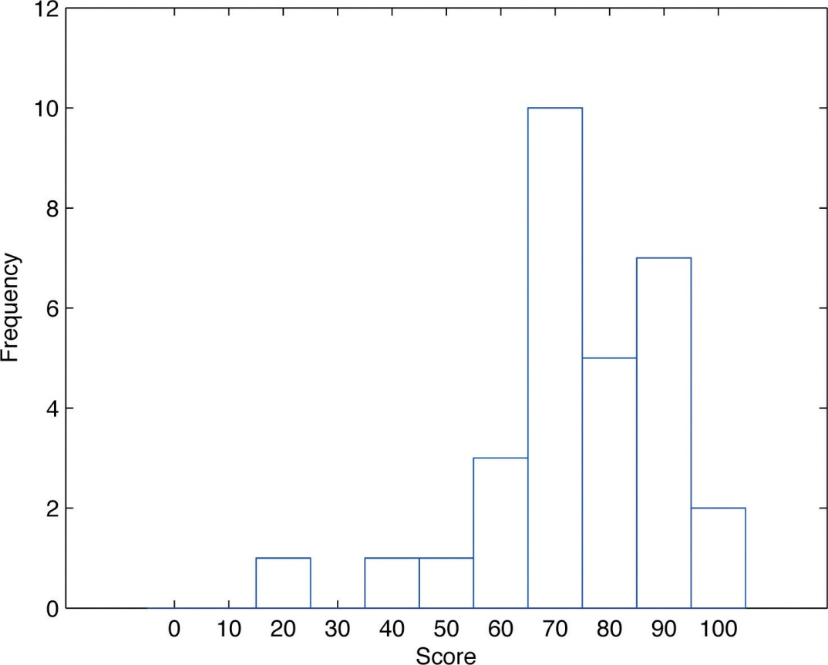
The same procedure can be applied to any collection of numerical data. Observations are grouped into several classes and the frequency (the number of observations) of each class is noted. These classes are arranged and indicated in order on the horizontal axis (called the x-axis), and for each group a vertical bar, whose length is the number of observations in that group, is drawn. The resulting display is a frequency histogram for the data. The similarity in and is apparent, particularly if you imagine turning the stem and leaf diagram on its side by rotating it a quarter turn counterclockwise.

In general, the definition of the classes in the frequency histogram is flexible. The general purpose of a frequency histogram is very much the same as that of a stem and leaf diagram, to provide a graphical display that gives a sense of data distribution across the range of values that appear. We will not discuss the process of constructing a histogram from data since in actual practice it is done automatically with statistical software or even handheld calculators.

Relative Frequency Histograms
In our example of the exam scores in a statistics class, five students scored in the 80s. The number 5 is the frequency of the group labeled “80s.” Since there are 30 students in the entire statistics class, the proportion who scored in the 80s is 5/30. The number 5/30, which could also be expressed as 0.16≈.1667, or as 16.67%, is the relative frequency of the group labeled “80s.” Every group (the 70s, the 80s, and so on) has a relative frequency. We can thus construct a diagram by drawing for each group, or class, a vertical bar whose length is the relative frequency of that group. For example, the bar for the 80s will have length 5/30 unit, not 5 units. The diagram is a relative frequency histogram for the data, and is shown in . It is exactly the same as the frequency histogram except that the vertical axis in the relative frequency histogram is not frequency but relative frequency.

Figure 2.4 Relative Frequency Histogram
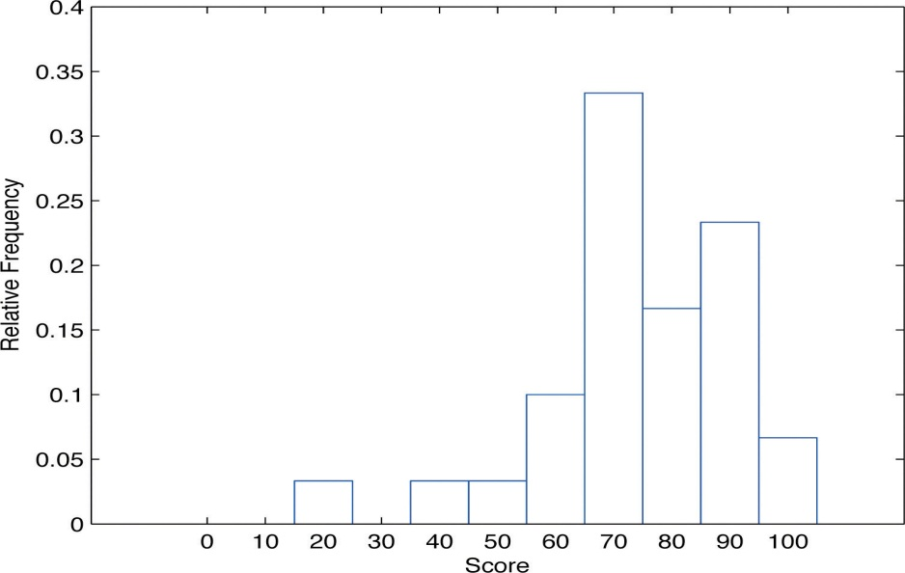
The same procedure can be applied to any collection of numerical data. Classes are selected, the relative frequency of each class is noted, the classes are arranged and indicated in order on the horizontal axis, and for each class a vertical bar, whose length is the relative frequency of the class, is drawn. The resulting display is a relative frequency histogram for the data. A key point is that now if each vertical bar has width 1 unit, then the total area of all the bars is 1 or 100%.

Although the histograms in and have the same appearance, the relative frequency histogram is more important for us, and it will be relative frequency histograms that will be used repeatedly to represent data in this text. To see why this is so, reflect on what it is that you are actually seeing in the diagrams that quickly and effectively communicates information to you about the data. It is the relative sizes of the bars. The bar labeled “70s” in either figure takes up 1/3 of the total area of all the bars, and although we may not think of this consciously, we perceive the proportion 1/3 in the figures, indicating that a third of the grades were in the 70s. The relative frequency histogram is important because the labeling on the vertical axis reflects what is important visually: the relative sizes of the bars.

When the size n of a sample is small only a few classes can be used in constructing a relative frequency histogram. Such a histogram might look something like the one in panel (a) of . If the sample size n were increased, then more classes could be used in constructing a relative frequency histogram and the vertical bars of the resulting histogram would be finer, as indicated in panel (b) of . For a very large sample the relative frequency histogram would look very fine, like the one in (c) of. If the sample size were to increase indefinitely then the corresponding relative frequency histogram would be so fine that it would look like a smooth curve, such as the one in panel (d) of .
Figure 2.5 Sample Size and Relative Frequency Histograms
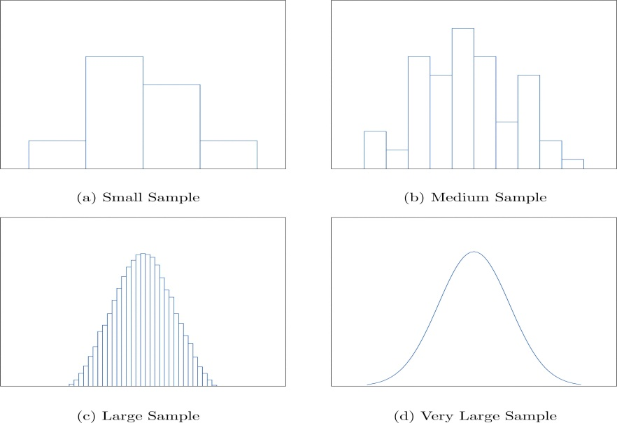
It is common in statistics to represent a population or a very large data set by a smooth curve. It is good to keep in mind that such a curve is actually just a very fine relative frequency histogram in which the exceedingly narrow vertical bars have disappeared. Because the area of each such vertical bar is the proportion of the data that lies in the interval of numbers over which that bar stands, this means that for any two numbers a and b, the proportion of the data that lies between the two numbers a and b is the area under the curve that is above the interval (a,b) in the horizontal axis. This is the area shown in . In particular the total area under the curve is 1, or 100%.
Figure 2.6 A Very Fine Relative Frequency Histogram
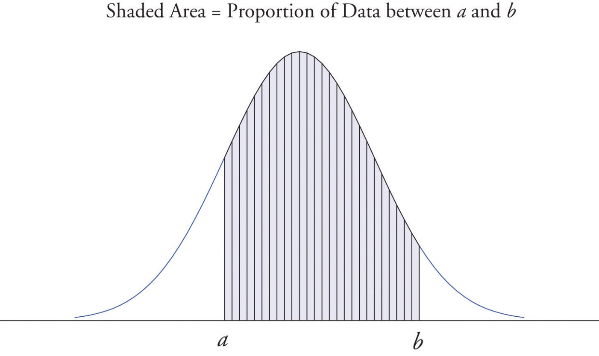

KEY TAKEAWAYS
- Graphical representations of large data sets provide a quick overview of the nature of the data.
- A population or a very large data set may be represented by a smooth curve. This curve is a very fine relative frequency histogram in which the exceedingly narrow vertical bars have been omitted.
- When a curve derived from a relative frequency histogram is used to describe a data set, the proportion of data with values between two numbers a and b is the area under the curve between a and b, as illustrated in Figure 2.6 "A Very Fine Relative Frequency Histogram".
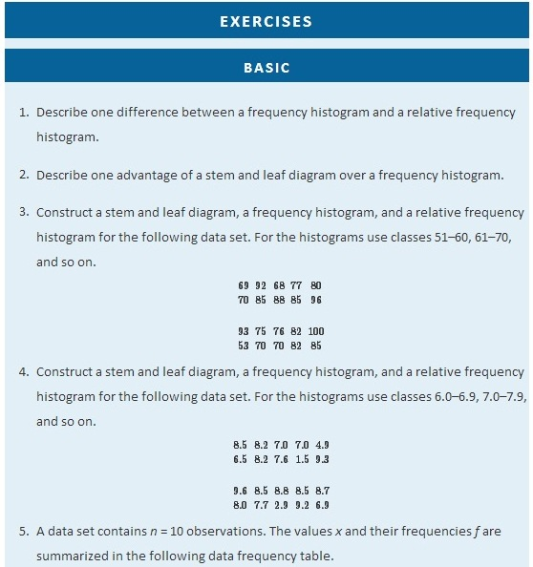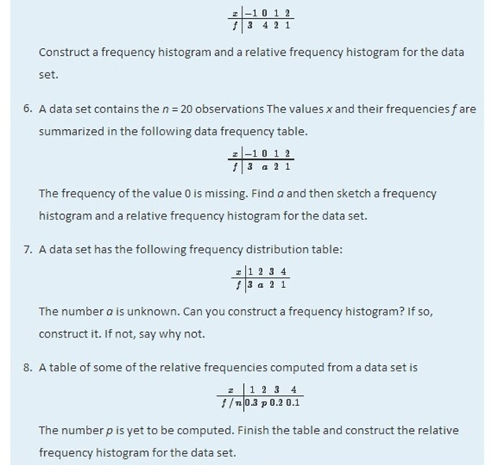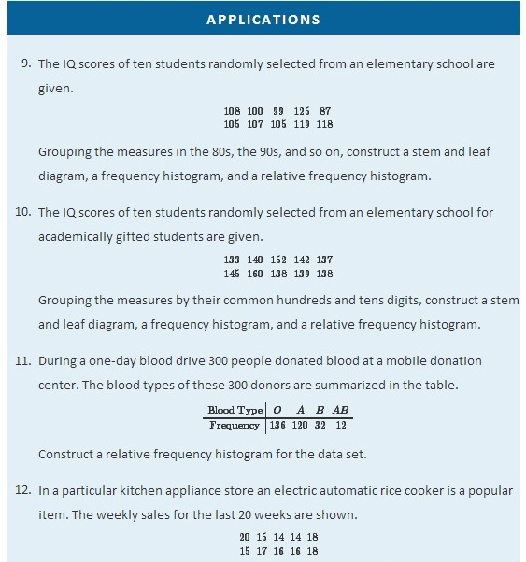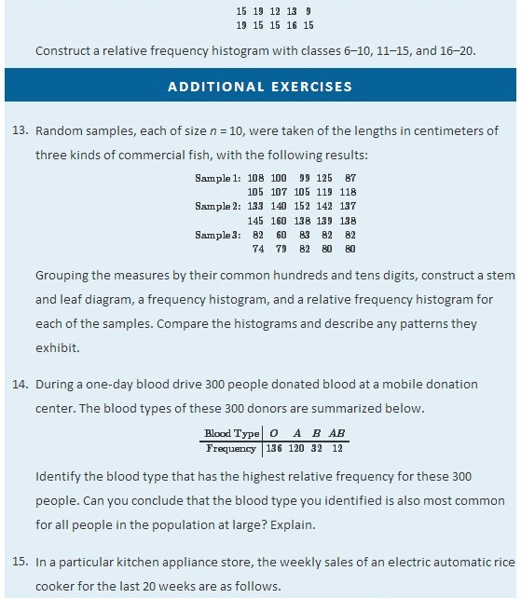
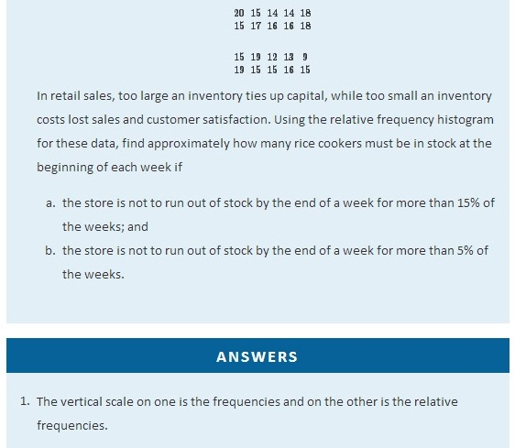
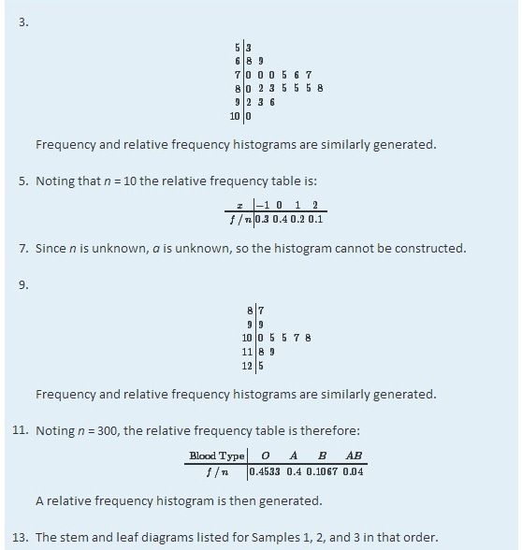
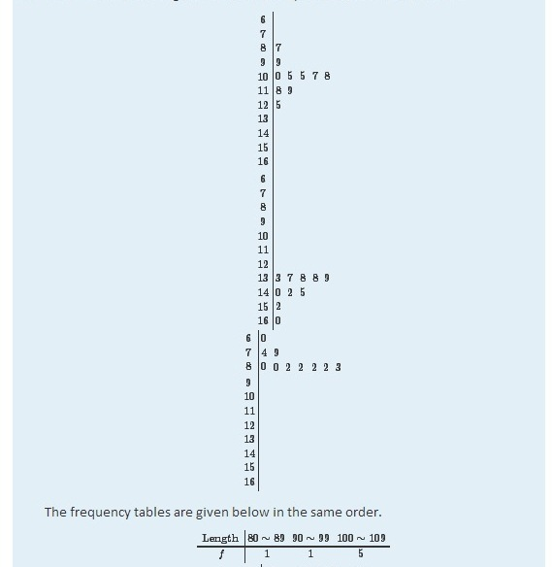
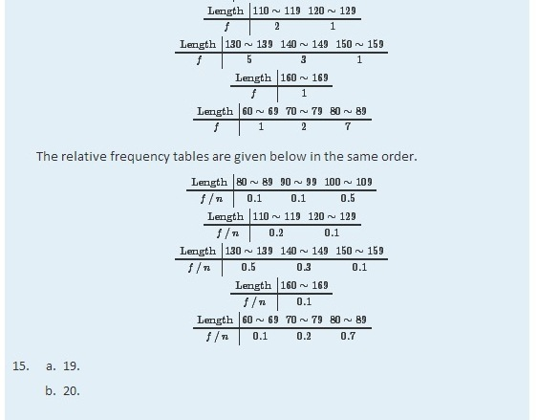

2.2 Measures of Central Location

LEARNING OBJECTIVES
- To learn the concept of the “center” of a data set.
- To learn the meaning of each of three measures of the center of a data set—the mean, the median, and the mode—and how to compute each one.

This section could be titled “three kinds of averages of a data set.” Any kind of “average” is meant to be an answer to the question “Where do the data center?” It is thus a measure of the central location of the data set. We will see that the nature of the data set, as indicated by a relative frequency histogram, will determine what constitutes a good answer. Different shapes of the histogram call for different measures of central location.

The Mean
The first measure of central location is the usual “average” that is familiar to everyone. In the formula in the following definition we introduce the standard summation notation Σ, where Σ is the capital Greek letter sigma. In general, the notation Σ followed by a second mathematical symbol means to add up all the values that the second symbol can take in the context of the problem. Here is an example to illustrate this.

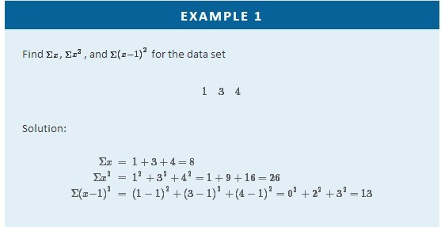
In the definition we follow the convention of using lowercase n to denote the number of measurements in a sample, which is called the sample size.
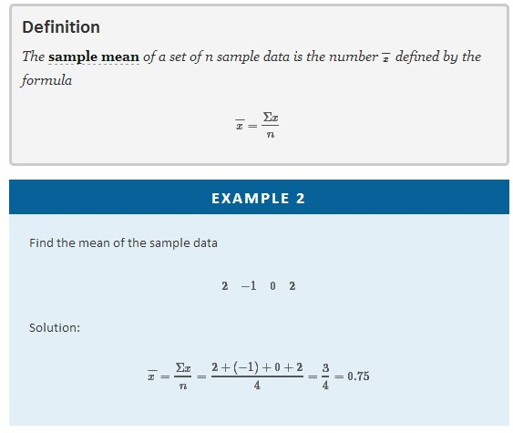
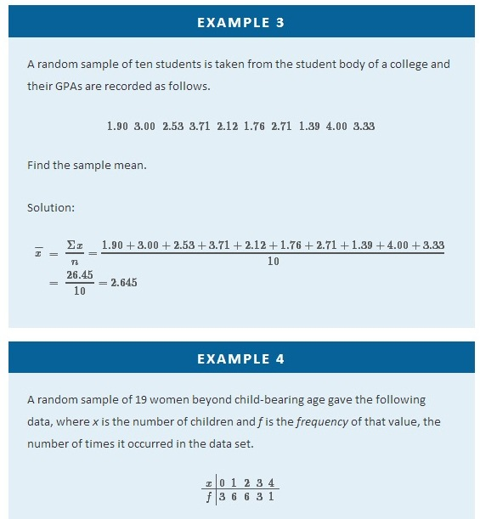
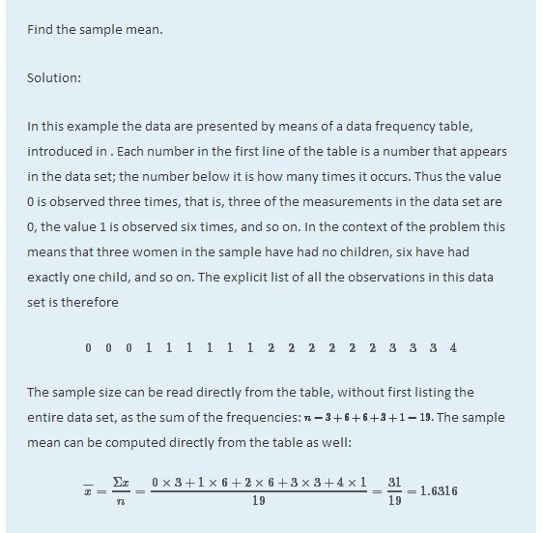
In the examples above the data sets were described as samples. Therefore the means were sample means, denoted by x̅. If the data come from a census, so that there is a measurement for every element of the population, then the mean is calculated by exactly the same process of summing all the measurements and dividing by how many of them there are, but it is now the population mean and is denoted by μ, the lower case Greek letter mu.
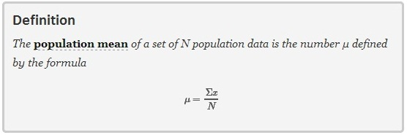
The mean of two numbers is the number that is halfway between them. For example, the average of the numbers 5 and 17 is (5 + 17) ∕ 2 = 11, which is 6 units above 5 and 6 units below 17. In this sense the average 11 is the “center” of the data set {5,17}. For larger data sets the mean can similarly be regarded as the “center” of the data.

The Median
To see why another concept of average is needed, consider the following situation. Suppose we are interested in the average yearly income of employees at a large corporation. We take a random sample of seven employees, obtaining the sample data (rounded to the nearest hundred dollars, and expressed in thousands of dollars).

24.8 22.8 24.6 192.5 25.2 18.5 23.7

The mean (rounded to one decimal place) is x̅-47.4, but the statement “the average income of employees at this corporation is $47,400” is surely misleading. It is approximately twice what six of the seven employees in the sample make and is nowhere near what any of them makes. It is easy to see what went wrong: the presence of the one executive in the sample, whose salary is so large compared to everyone else’s, caused the numerator in the formula for the sample mean to be far too large, pulling the mean far to the right of where we think that the average “ought” to be, namely around $24,000 or $25,000. The number 192.5 in our data set is called an outlier, a number that is far removed from most or all of the remaining measurements. Many times an outlier is the result of some sort of error, but not always, as is the case here. We would get a better measure of the “center” of the data if we were to arrange the data in numerical order,
18.5 22.8 23.7 24.6 24.8 25.2 192.5
then select the middle number in the list, in this case 24.6. The result is called the median of the data set, and has the property that roughly half of the measurements are larger than it is, and roughly half are smaller. In this sense it locates the center of the data. If there are an even number of measurements in the data set, then there will be two middle elements when all are lined up in order, so we take the mean of the middle two as the median. Thus we have the following definition.

Definition
The sample median x^~ of a set of sample data for which there are an odd number of measurements is the middle measurement when the data are arranged in numerical order. The sample median x^~ of a set of sample data for which there are an even number of measurements is the mean of the two middle measurements when the data are arranged in numerical order.

The population median is defined in a similar way, but we will not have occasion to refer to it again in this text.

The median is a value that divides the observations in a data set so that 50% of the data are on its left and the other 50% on its right. In accordance with , therefore, in the curve that represents the distribution of the data, a vertical line drawn at the median divides the area in two, area 0.5 (50% of the total area 1) to the left and area 0.5 (50% of the total area 1) to the right, as shown in . In our income example the median, $24,600, clearly gave a much better measure of the middle of the data set than did the mean $47,400. This is typical for situations in which the distribution is skewed. (Skewness and symmetry of distributions are discussed at the end of this subsection.)

Figure 2.7 The Median
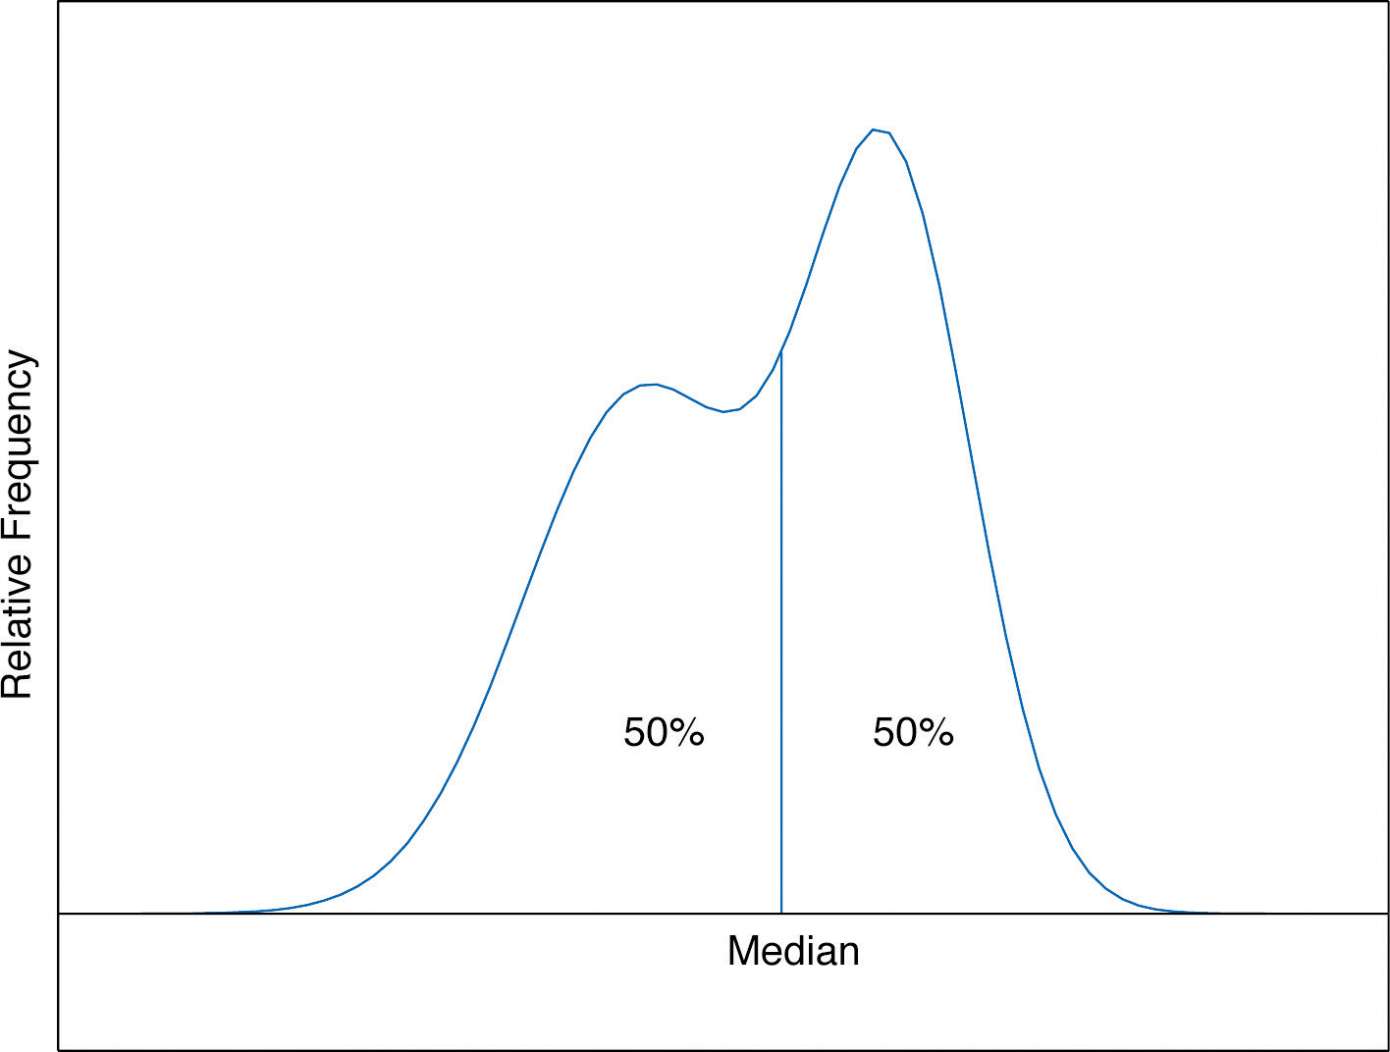
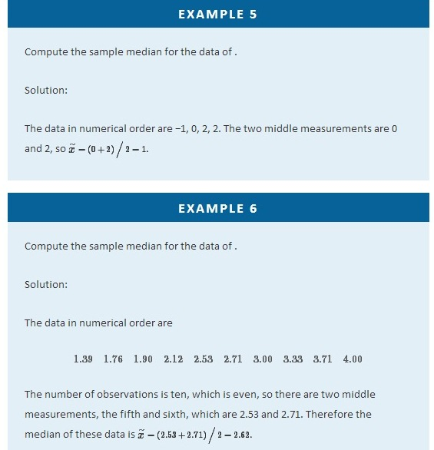
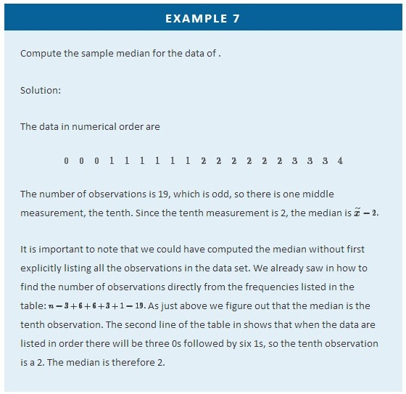
The relationship between the mean and the median for several common shapes of distributions is shown in . The distributions in panels (a) and (b) are said to be symmetric because of the symmetry that they exhibit. The distributions in the remaining two panels are said to be skewed. In each distribution we have drawn a vertical line that divides the area under the curve in half, which in accordance with is located at the median. The following facts are true in general:
- When the distribution is symmetric, as in panels (a) and (b) of , the mean and the median are equal.
- When the distribution is as shown in panel (c) of , it is said to be skewed right. The mean has been pulled to the right of the median by the long “right tail” of the distribution, the few relatively large data values.
- When the distribution is as shown in panel (d) of , it is said to be skewed left. The mean has been pulled to the left of the median by the long “left tail” of the distribution, the few relatively small data values.

Figure 2.8 Skewness of Relative Frequency Histograms
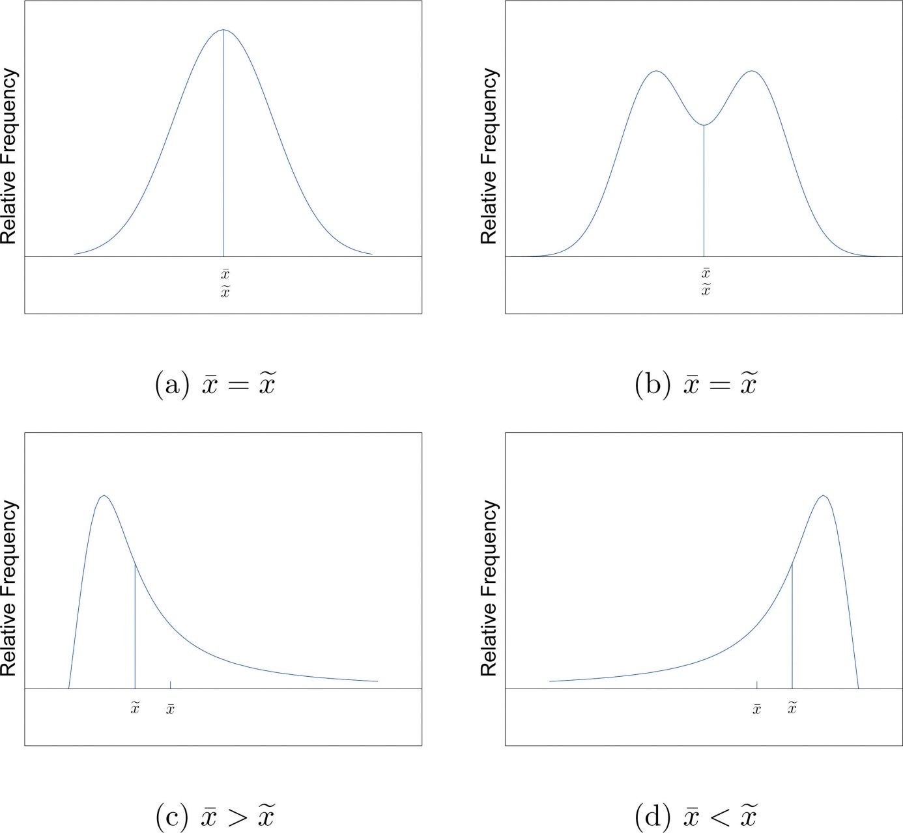

The Mode
Perhaps you have heard a statement like “The average number of automobiles owned by households in the United States is 1.37,” and have been amused at the thought of a fraction of an automobile sitting in a driveway. In such a context the following measure for central location might make more sense.

Definition
The sample mode of a set of sample data is the most frequently occurring value.

The population mode is defined in a similar way, but we will not have occasion to refer to it again in this text.

On a relative frequency histogram, the highest point of the histogram corresponds to the mode of the data set. illustrates the mode.

Figure 2.9 Mode
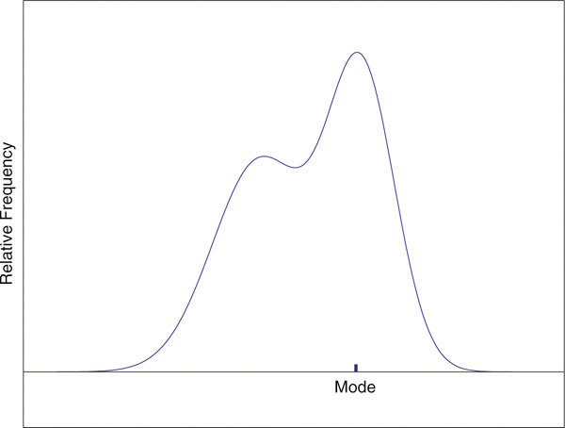

For any data set there is always exactly one mean and exactly one median. This need not be true of the mode; several different values could occur with the highest frequency, as we will see. It could even happen that every value occurs with the same frequency, in which case the concept of the mode does not make much sense.

EXAMPLE 8
Find the mode of the following data set.
−1 0 2 0
Solution:
The value 0 is most frequently observed and therefore the mode is 0.

EXAMPLE 9
Compute the sample mode for the data of .
Solution:
The two most frequently observed values in the data set are 1 and 2. Therefore mode is a set of two values: {1,2}.

The mode is a measure of central location since most real-life data sets have moreobservations near the center of the data range and fewer observations on the lower and upper ends. The value with the highest frequency is often in the middle of the data range.

KEY TAKEAWAY
The mean, the median, and the mode each answer the question “Where is the center of the data set?” The nature of the data set, as indicated by a relative frequency histogram, determines which one gives the best answer.
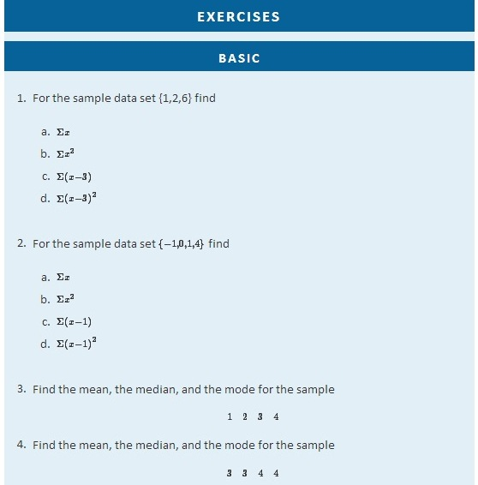

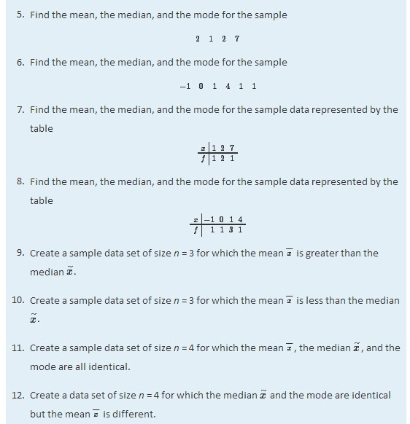
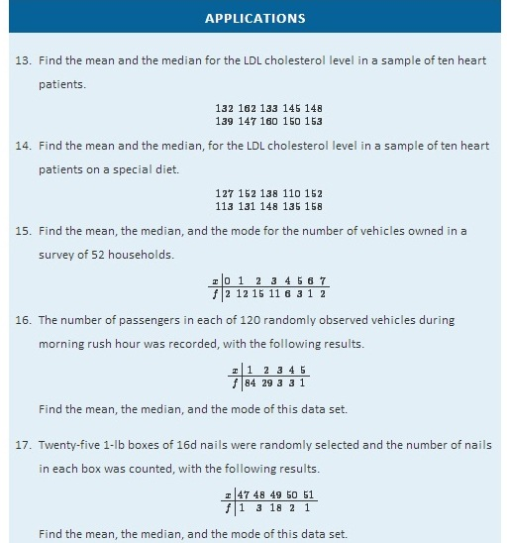
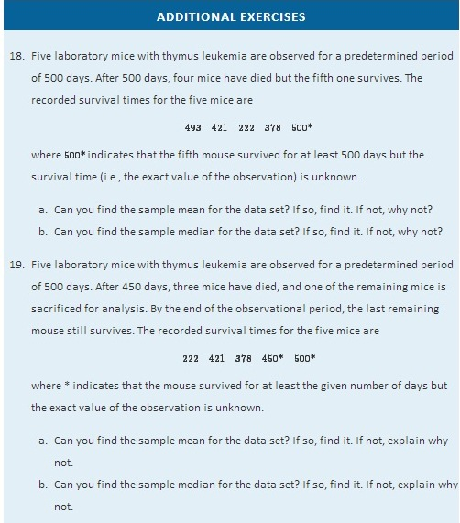
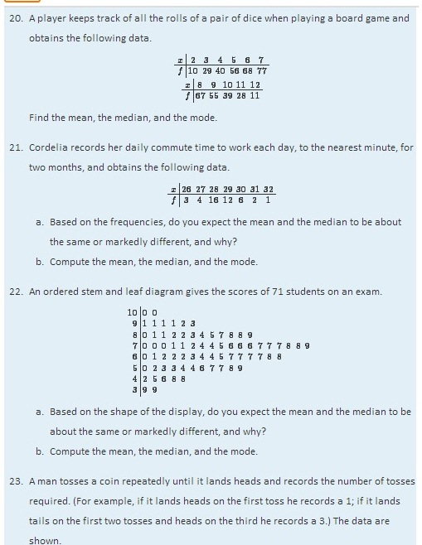
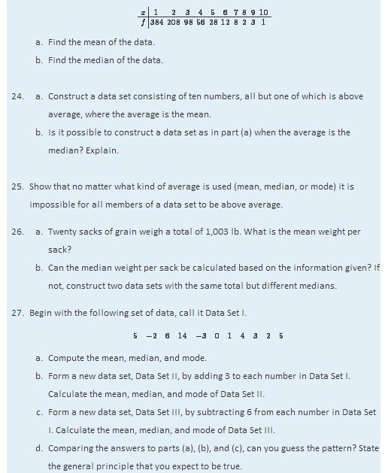

LARGE DATA SET EXERCISES
- Large Data Set 1 lists the SAT scores and GPAs of 1,000 students.
http://www.flatworldknowledge.com/sites/all/files/data1.xls
  - Compute the mean and median of the 1,000 SAT scores.
  - Compute the mean and median of the 1,000 GPAs.
- Large Data Set 1 lists the SAT scores of 1,000 students.
http://www.flatworldknowledge.com/sites/all/files/data1.xls
  - Regard the data as arising from a census of all students at a high school, in which the SAT score of every student was measured. Compute the population mean μ.
  - Regard the first 25 observations as a random sample drawn from this population. Compute the sample mean x^− and compare it to μ.
  - Regard the next 25 observations as a random sample drawn from this population. Compute the sample mean x^− and compare it to μ.
- Large Data Set 1 lists the GPAs of 1,000 students.
http://www.flatworldknowledge.com/sites/all/files/data1.xls
  - Regard the data as arising from a census of all freshman at a small college at the end of their first academic year of college study, in which the GPA of every such person was measured. Compute the population mean μ.
  - Regard the first 25 observations as a random sample drawn from this population. Compute the sample mean x^− and compare it to μ.
  - Regard the next 25 observations as a random sample drawn from this population. Compute the sample mean x^− and compare it to μ.
- Large Data Sets 7, 7A, and 7B list the survival times in days of 140 laboratory mice with thymic leukemia from onset to death.
http://www.flatworldknowledge.com/sites/all/files/data7.xls
http://www.flatworldknowledge.com/sites/all/files/data7A.xls
http://www.flatworldknowledge.com/sites/all/files/data7B.xls
  - Compute the mean and median survival time for all mice, without regard to gender.
  - Compute the mean and median survival time for the 65 male mice (separately recorded in Large Data Set 7A).
  - Compute the mean and median survival time for the 75 female mice (separately recorded in Large Data Set 7B).
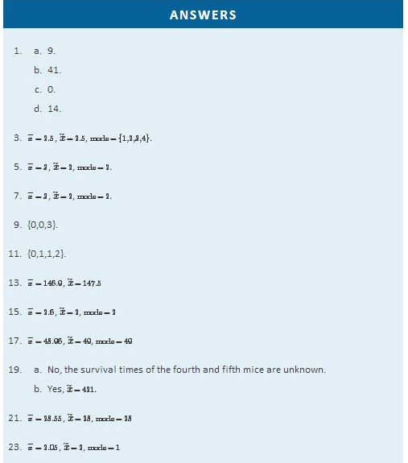
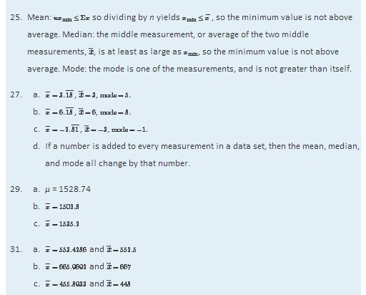

2.3 Measures of Variability

LEARNING OBJECTIVES
- To learn the concept of the variability of a data set.
- To learn how to compute three measures of the variability of a data set: the range, the variance, and the standard deviation.

Look at the two data sets in Table 2.1 "Two Data Sets" and the graphical representation of each, called a dot plot, in Figure 2.10 "Dot Plots of Data Sets".

Table 2.1 Two Data Sets
Data Set I: | 40 | 38 | 42 | 40 | 39 | 39 | 43 | 40 | 39 | 40
Data Set II: | 46 | 37 | 40 | 33 | 42 | 36 | 40 | 47 | 34 | 45
Figure 2.10 Dot Plots of Data Sets
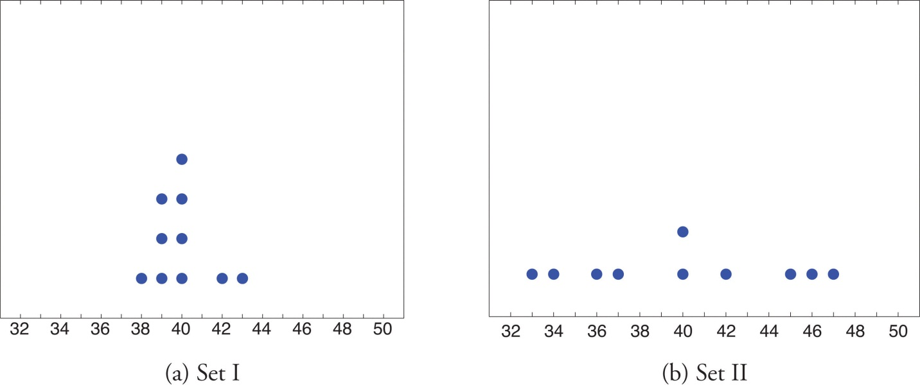
The two sets of ten measurements each center at the same value: they both have mean, median, and mode 40. Nevertheless a glance at the figure shows that they are markedly different. In Data Set I the measurements vary only slightly from the center, while for Data Set II the measurements vary greatly. Just as we have attached numbers to a data set to locate its center, we now wish to associate to each data set numbers that measure quantitatively how the data either scatter away from the center or cluster close to it. These new quantities are called measures of variability, and we will discuss three of them.

The Range
The first measure of variability that we discuss is the simplest.

Definition
The range of a data set is the number R defined by the formula
R=xmax−xmin
where xmax is the largest measurement in the data set and xmin is the smallest.

EXAMPLE 10
Find the range of each data set in Table 2.1 "Two Data Sets".
Solution:
For Data Set I the maximum is 43 and the minimum is 38, so the range is R=43−38=5.
For Data Set II the maximum is 47 and the minimum is 33, so the range is R=47−33=14.

The range is a measure of variability because it indicates the size of the interval over which the data points are distributed. A smaller range indicates less variability (less dispersion) among the data, whereas a larger range indicates the opposite.

The Variance and the Standard Deviation
The other two measures of variability that we will consider are more elaborate and also depend on whether the data set is just a sample drawn from a much larger population or is the whole population itself (that is, a census).

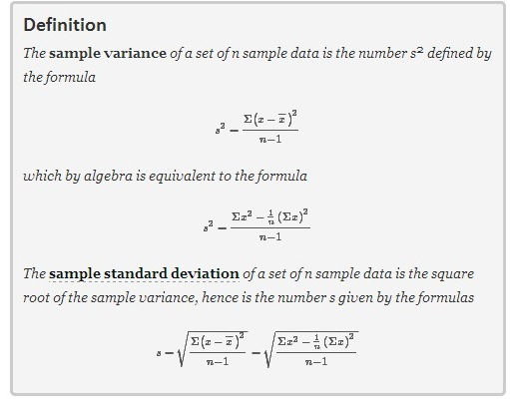

Although the first formula in each case looks less complicated than the second, the latter is easier to use in hand computations, and is called a shortcut formula.
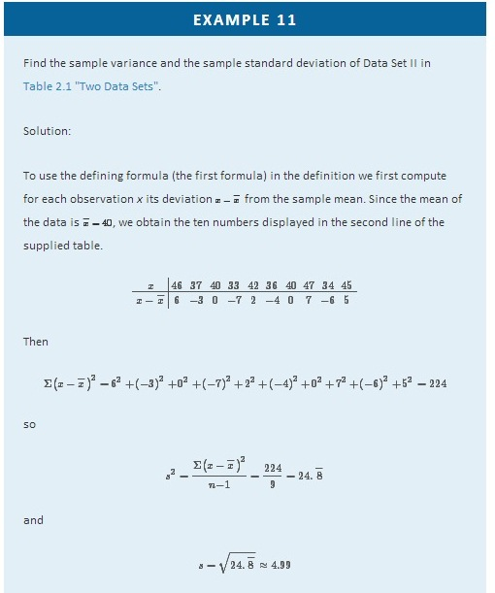
The student is encouraged to compute the ten deviations for Data Set I and verify that their squares add up to 20, so that the sample variance and standard deviation of Data Set I are the much smaller numbers s²=20/9=2.2^¯ and s=√20/9≈1.49.
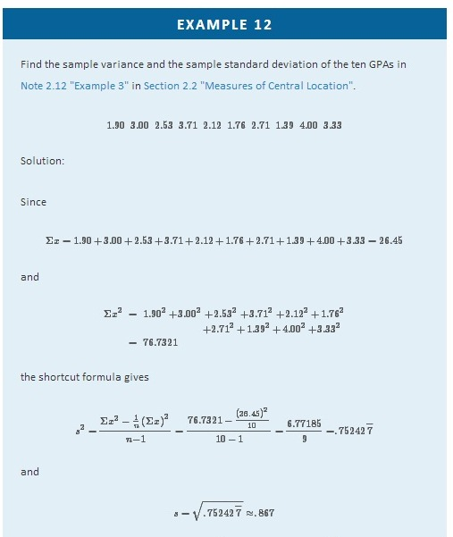
The sample variance has different units from the data. For example, if the units in the data set were inches, the new units would be inches squared, or square inches. It is thus primarily of theoretical importance and will not be considered further in this text, except in passing.
If the data set comprises the whole population, then the population standard deviation, denoted σ (the lower case Greek letter sigma), and its square, the population variance σ², are defined as follows.
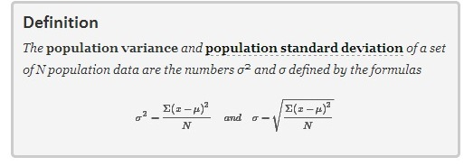
Note that the denominator in the fraction is the full number of observations, not that number reduced by one, as is the case with the sample standard deviation. Since most data sets are samples, we will always work with the sample standard deviation and variance.
Finally, in many real-life situations the most important statistical issues have to do with comparing the means and standard deviations of two data sets. Figure 2.11 "Difference between Two Data Sets" illustrates how a difference in one or both of the sample mean and the sample standard deviation are reflected in the appearance of the data set as shown by the curves derived from the relative frequency histograms built using the data.

Figure 2.11 Difference between Two Data Sets
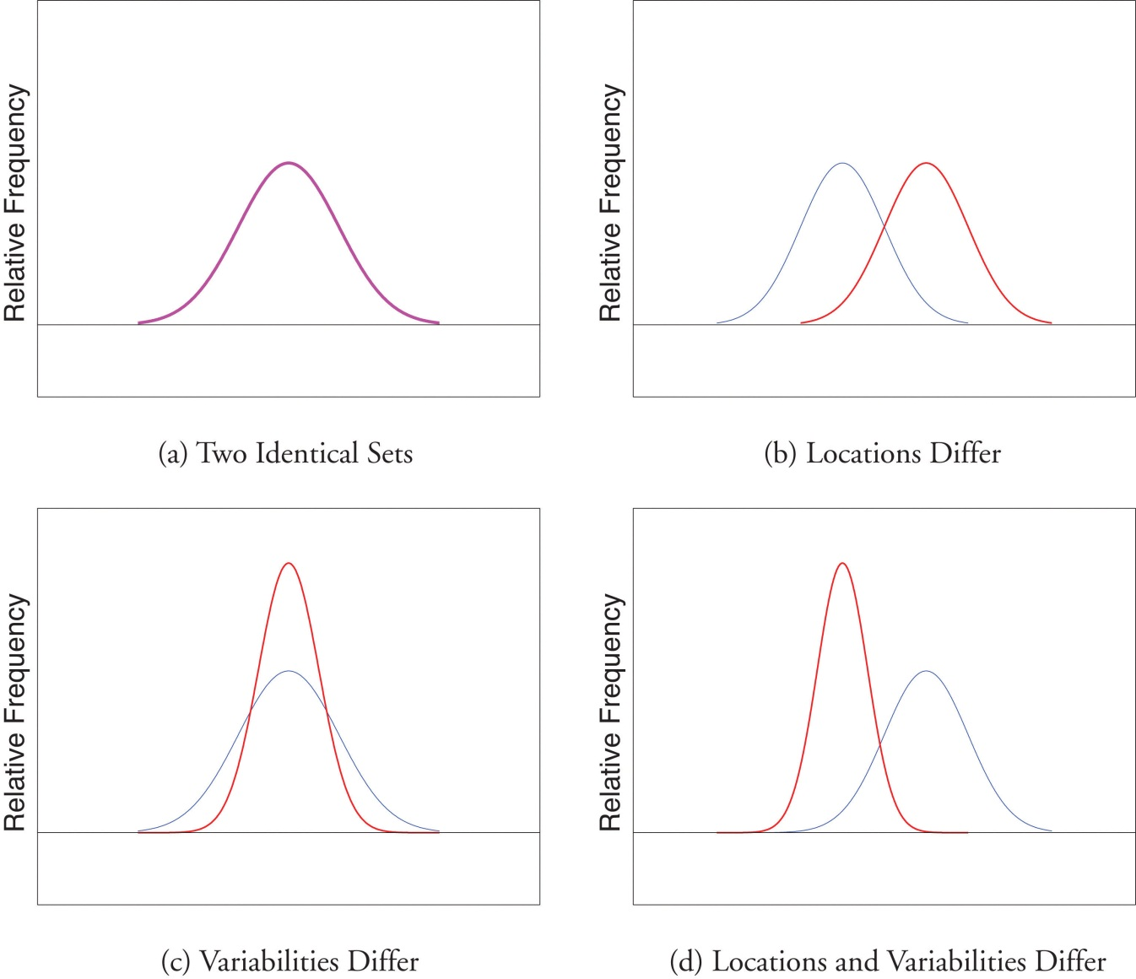

KEY TAKEAWAY
The range, the standard deviation, and the variance each give a quantitative answer to the question “How variable are the data?”
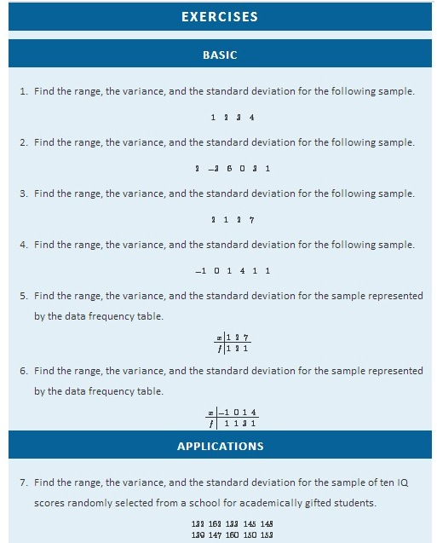
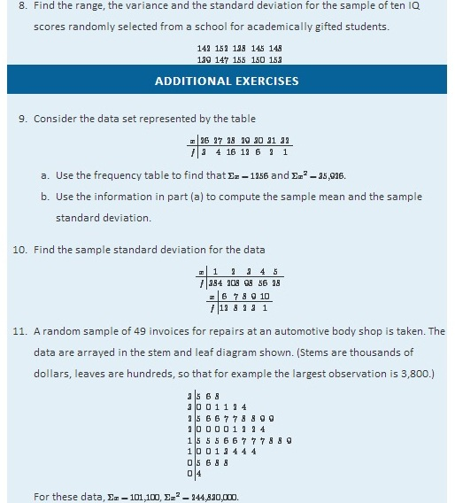
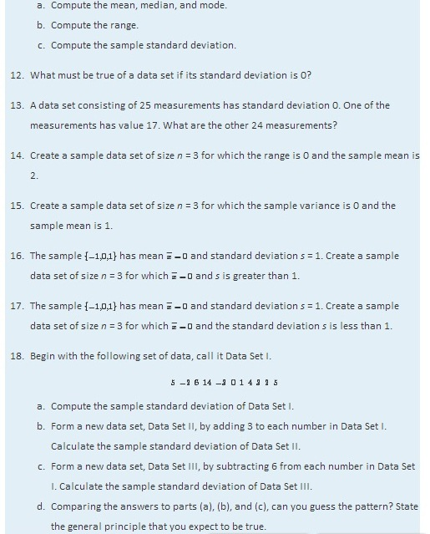

LARGE DATA SET EXERCISES

- Large Data Set 1 lists the SAT scores and GPAs of 1,000 students.
http://www.flatworldknowledge.com/sites/all/files/data1.xls
  - Compute the range and sample standard deviation of the 1,000 SAT scores.
  - Compute the range and sample standard deviation of the 1,000 GPAs.
- Large Data Set 1 lists the SAT scores of 1,000 students.
http://www.flatworldknowledge.com/sites/all/files/data1.xls
  - Regard the data as arising from a census of all students at a high school, in which the SAT score of every student was measured. Compute the population range and population standard deviation σ.
  - Regard the first 25 observations as a random sample drawn from this population. Compute the sample range and sample standard deviation s and compare them to the population range and σ.
  - Regard the next 25 observations as a random sample drawn from this population. Compute the sample range and sample standard deviation s and compare them to the population range and σ.
- Large Data Set 1 lists the GPAs of 1,000 students.
http://www.flatworldknowledge.com/sites/all/files/data1.xls
  - Regard the data as arising from a census of all freshman at a small college at the end of their first academic year of college study, in which the GPA of every such person was measured. Compute the population range and population standard deviation σ.
  - Regard the first 25 observations as a random sample drawn from this population. Compute the sample range and sample standard deviation s and compare them to the population range and σ.
  - Regard the next 25 observations as a random sample drawn from this population. Compute the sample range and sample standard deviation s and compare them to the population range and σ.
- Large Data Sets 7, 7A, and 7B list the survival times in days of 140 laboratory mice with thymic leukemia from onset to death.
http://www.flatworldknowledge.com/sites/all/files/data7.xls
http://www.flatworldknowledge.com/sites/all/files/data7A.xls
http://www.flatworldknowledge.com/sites/all/files/data7B.xls
  - Compute the range and sample standard deviation of survival time for all mice, without regard to gender.
  - Compute the range and sample standard deviation of survival time for the 65 male mice (separately recorded in Large Data Set 7A).
  - Compute the range and sample standard deviation of survival time for the 75 female mice (separately recorded in Large Data Set 7B). Do you see a difference in the results for male and female mice? Does it appear to be significant?
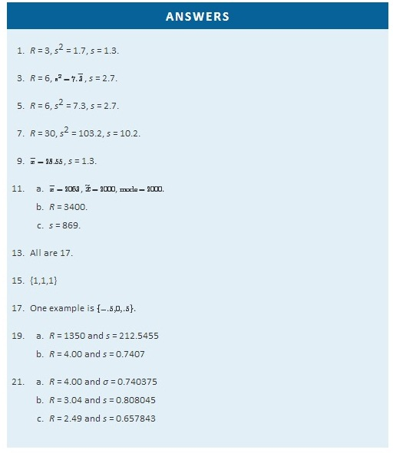

2.4 Relative Position of Data

LEARNING OBJECTIVES
- To learn the concept of the relative position of an element of a data set.
- To learn the meaning of each of two measures, the percentile rank and the z-score, of the relative position of a measurement and how to compute each one.
- To learn the meaning of the three quartiles associated to a data set and how to compute them.
- To learn the meaning of the five-number summary of a data set, how to construct the box plot associated to it, and how to interpret the box plot.
When you take an exam, what is often as important as your actual score on the exam is the way your score compares to other students’ performance. If you made a 70 but the average score (whether the mean, median, or mode) was 85, you did relatively poorly. If you made a 70 but the average score was only 55 then you did relatively well. In general, the significance of one observed value in a data set strongly depends on how that value compares to the other observed values in a data set. Therefore we wish to attach to each observed value a number that measures its relative position.

Percentiles and Quartiles
Anyone who has taken a national standardized test is familiar with the idea of being given both a score on the exam and a “percentile ranking” of that score. You may be told that your score was 625 and that it is the 85th percentile. The first number tells how you actually did on the exam; the second says that 85% of the scores on the exam were less than or equal to your score, 625.

Definition
Given an observed value x in a data set, x is the Pth percentile of the data if the percentage of the data that are less than or equal to x is P. The number P is the percentile rank of x.

EXAMPLE 13
What percentile is the value 1.39 in the data set of ten GPAs considered in Note 2.12 "Example 3" in Section 2.2 "Measures of Central Location"? What percentile is the value 3.33?
Solution:
The data written in increasing order are
1.39 1.76 1.90 2.12 2.53 2.71 3.00 3.33 3.71 4.00
The only data value that is less than or equal to 1.39 is 1.39 itself. Since 1 is 1∕10 = .10 or 10% of 10, the value 1.39 is the 10th percentile. Eight data values are less than or equal to 3.33. Since 8 is 8∕10 = .80 or 80% of 10, the value 3.33 is the 80th percentile.
The Pth percentile cuts the data set in two so that approximately P% of the data lie below it and (100−P)% of the data lie above it. In particular, the three percentiles that cut the data into fourths, as shown in Figure 2.12 "Data Division by Quartiles", are called the quartiles. The following simple computational definition of the three quartiles works well in practice.
Figure 2.12 Data Division by Quartiles
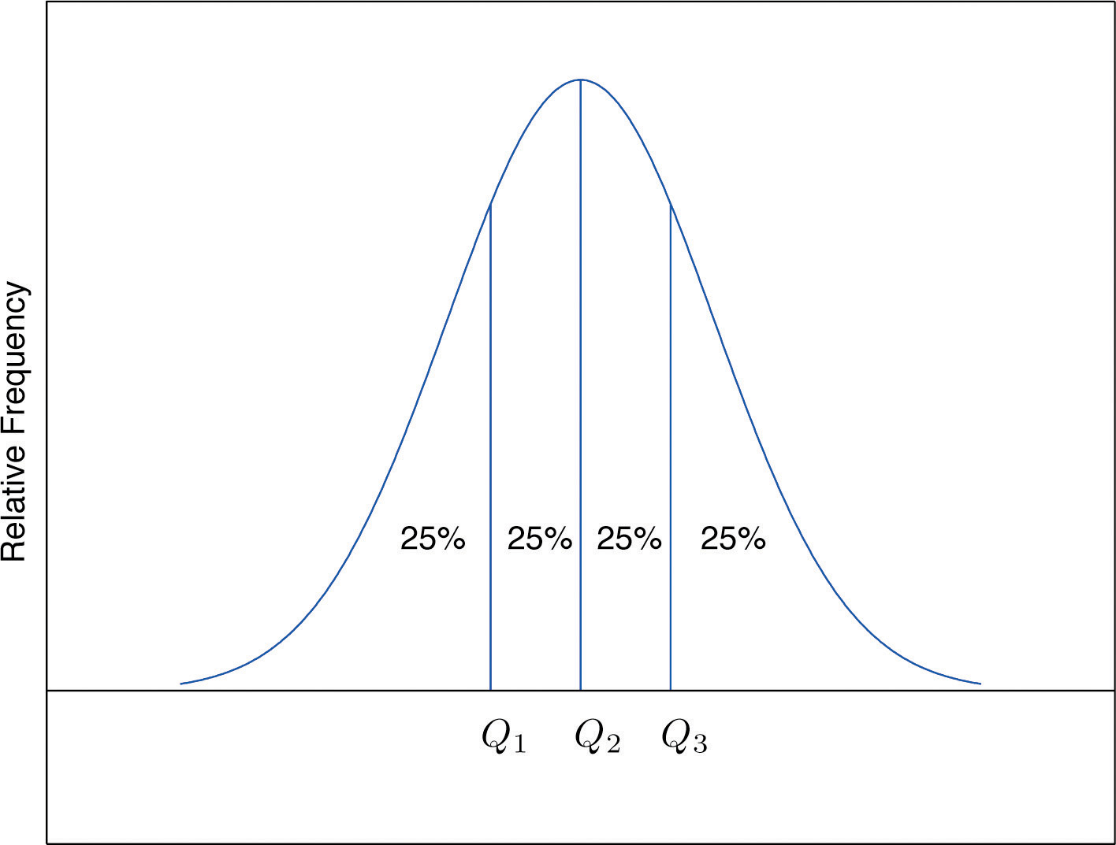

Definition
For any data set:
- The second quartile Q₂ of the data set is its median.
- Define two subsets:
    - the lower set: all observations that are strictly less than Q₂;
    - the upper set: all observations that are strictly greater than Q₂.
- The first quartile Q₁ of the data set is the median of the lower set.
- The third quartile Q₃ of the data set is the median of the upper set.

EXAMPLE 14
Find the quartiles of the data set of GPAs of Note 2.12 "Example 3" in Section 2.2 "Measures of Central Location".
Solution:
As in the previous example we first list the data in numerical order:
1.39 1.76 1.90 2.12 2.53 2.71 3.00 3.33 3.71 4.00
This data set has n = 10 observations. Since 10 is an even number, the median is the mean of the two middle observations: x˜=(2.53 + 2.71)/2=2.62. Thus the second quartile is Q₂=2.62. The lower and upper subsets are
Lower: L={1.39,1.76,1.90,2.12,2.53}
Upper: U={2.71,3.00,3.33,3.71,4.00}
Each has an odd number of elements, so the median of each is its middle observation. Thus the first quartile is Q₁=1.90, the median of L, and the third quartile is Q₃=3.33, the median of U.

EXAMPLE 15
Adjoin the observation 3.88 to the data set of the previous example and find the quartiles of the new set of data.
Solution:
As in the previous example we first list the data in numerical order:
1.39 1.76 1.90 2.12 2.53 2.71 3.00 3.33 3.71 3.88 4.00
This data set has 11 observations. The second quartile is its median, the middle value 2.71. Thus Q₂=2.71. The lower and upper subsets are now
Lower: L={1.39,1.76,1.90,2.12,2.53}
Upper: U= {3.00,3.33,3.71,3.88,4.00}
The lower set L has median the middle value 1.90, so Q₁=1.90. The upper set has median the middle value 3.71, so Q₃=3.71.
In addition to the three quartiles, the two extreme values, the minimum xmin and the maximum xmax are also useful in describing the entire data set. Together these five numbers are called the five-number summary of the data set:
{xmin, Q1, Q2, Q3, xmax}
The five-number summary is used to construct a box plot as in Figure 2.13 "The Box Plot". Each of the five numbers is represented by a vertical line segment, a box is formed using the line segments at Q1 and Q3 as its two vertical sides, and two horizontal line segments are extended from the vertical segments marking Q1 and Q3 to the adjacent extreme values. (The two horizontal line segments are referred to as “whiskers,” and the diagram is sometimes called a “box and whisker plot.”) We caution the reader that there are other types of box plots that differ somewhat from the ones we are constructing, although all are based on the three quartiles.
Figure 2.13 The Box Plot
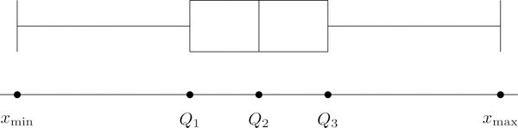
Note that the distance from Q1 to Q3 is the length of the interval over which the middle half of the data range. Thus it has the following special name.

Definition
The interquartile range (IQR) is the quantity
IQR=Q3−Q1

EXAMPLE 16
Construct a box plot and find the IQR for the data in Note 2.44 "Example 14".
Solution:
From our work in Note 2.44 "Example 14" we know that the five-number summary is
xmin=1.39 Q1=1.90 Q2=2.62 Q3=3.33 xmax=4.00
The box plot is
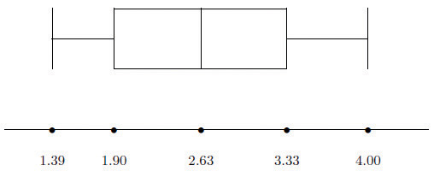
The interquartile range is IQR=3.33−1.90=1.43.

z-scores

Another way to locate a particular observation x in a data set is to compute its distance from the mean in units of standard deviation.
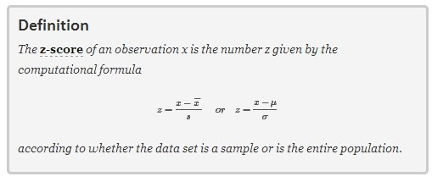

The formulas in the definition allow us to compute the z-score when x is known. If the z-score is known then x can be recovered using the corresponding inverse formulas

x=(x^−)+sz or x=μ+σz
The z-score indicates how many standard deviations an individual observation x is from the center of the data set, its mean. If z is negative then x is below average. If z is 0 then x is equal to the average. If z is positive then x is above average. See Figure 2.14.
Figure 2.14 x-Scale versus z-Score
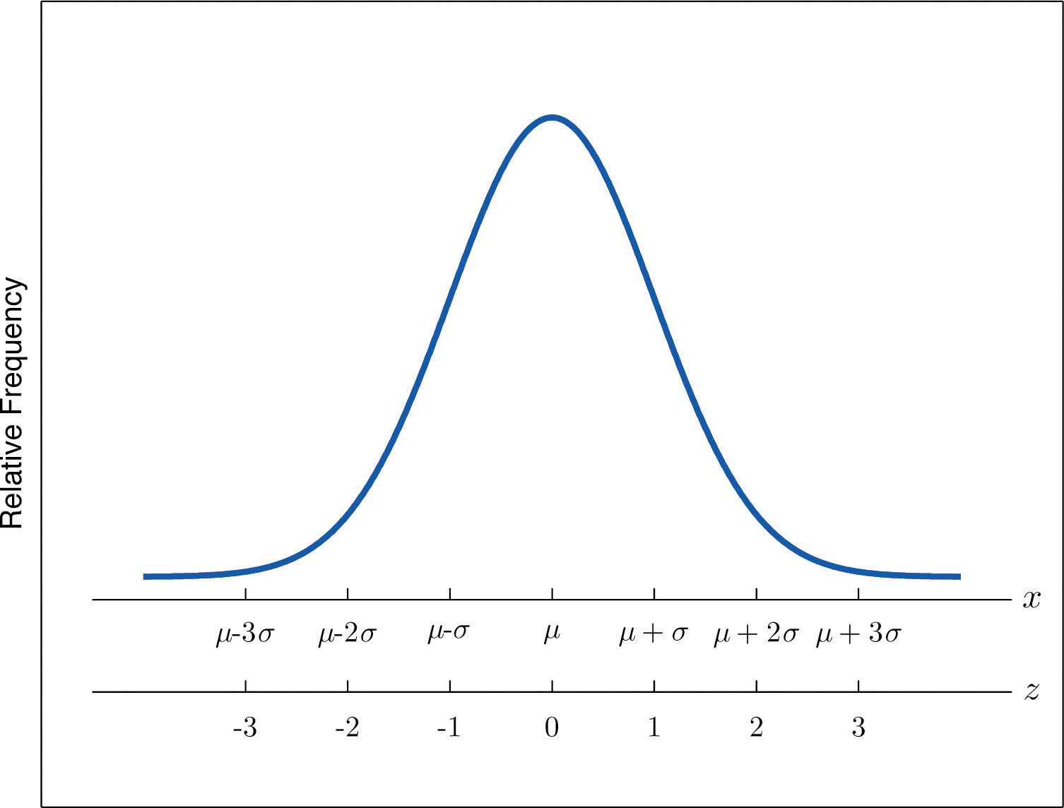
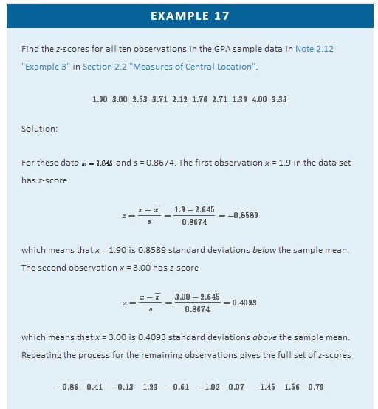

EXAMPLE 18
Suppose the mean and standard deviation of the GPAs of all currently registered students at a college are μ = 2.70 and σ = 0.50. The z-scores of the GPAs of two students, Antonio and Beatrice, are z=−0.62 and z = 1.28, respectively. What are their GPAs?
Solution:
Using the second formula right after the definition of z-scores we compute the GPAs as
Antonio: x=μ+z σ=2.70+(−0.62)(0.50)=2.39
Beatrice: x=μ+z σ=2.70+(1.28)(0.50)=3.34

KEY TAKEAWAYS
- The percentile rank and z-score of a measurement indicate its relative position with regard to the other measurements in a data set.
- The three quartiles divide a data set into fourths.
- The five-number summary and its associated box plot summarize the location and distribution of the data.
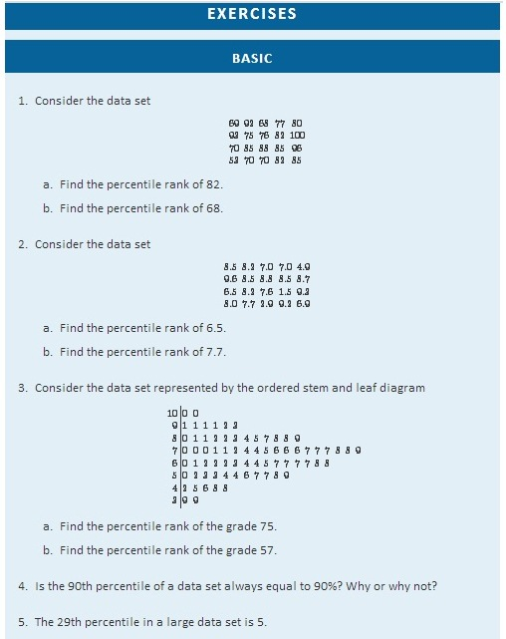
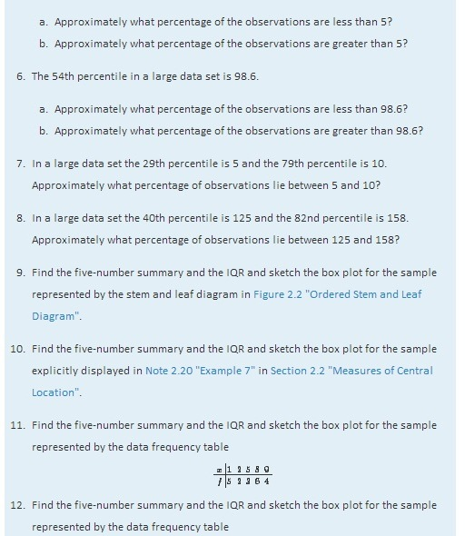
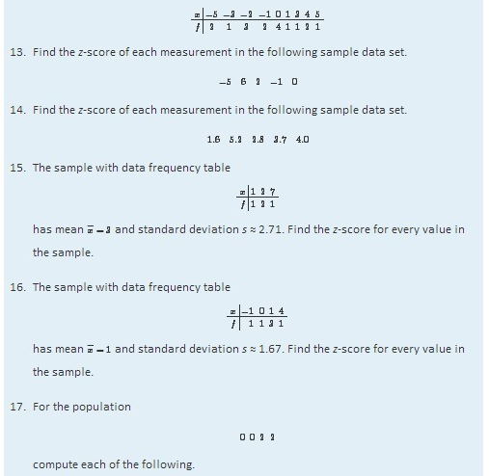
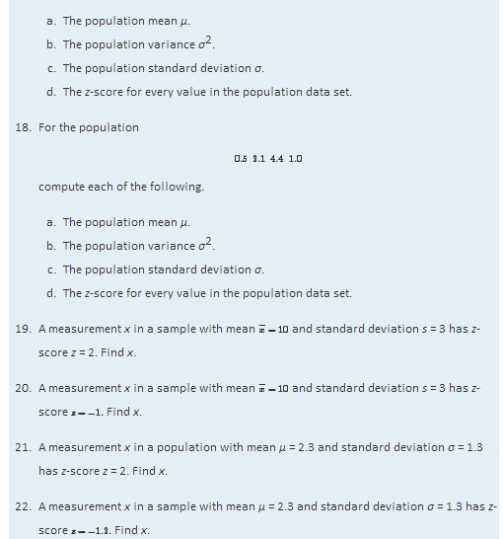
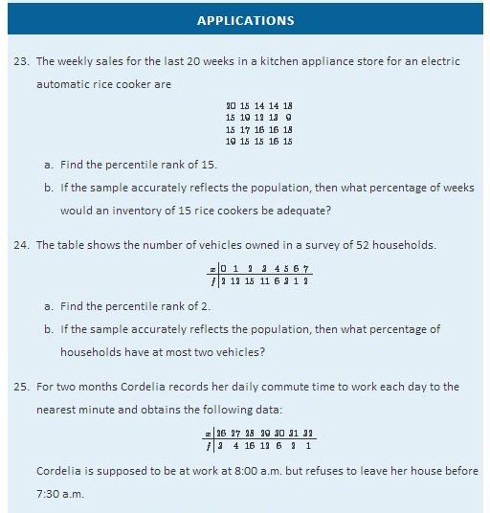
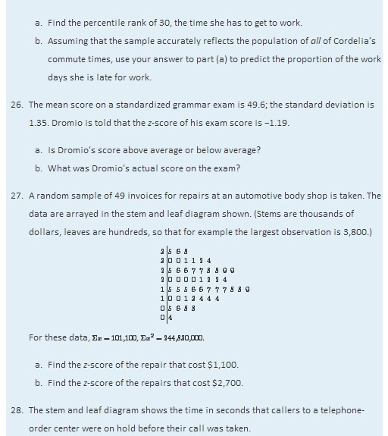
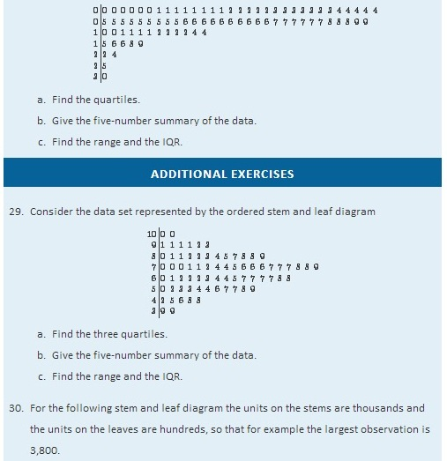
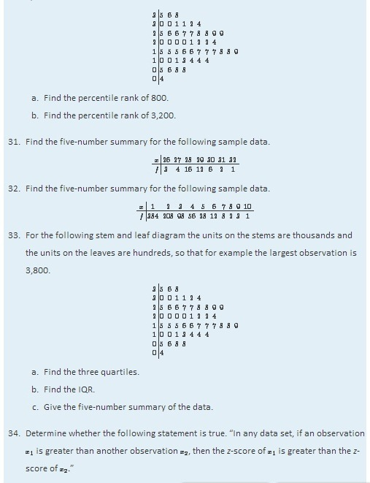
- Emilia and Ferdinand took the same freshman chemistry course, Emilia in the fall, Ferdinand in the spring. Emilia made an 83 on the common final exam that she took, on which the mean was 76 and the standard deviation 8. Ferdinand made a 79 on the common final exam that he took, which was more difficult, since the mean was 65 and the standard deviation 12. The one who has a higher z-score did relatively better. Was it Emilia or Ferdinand?
- Refer to the previous exercise. On the final exam in the same course the following semester, the mean is 68 and the standard deviation is 9. What grade on the exam matches Emilia’s performance? Ferdinand’s?
- Rosencrantz and Guildenstern are on a weight-reducing diet. Rosencrantz, who weighs 178 lb, belongs to an age and body-type group for which the mean weight is 145 lb and the standard deviation is 15 lb. Guildenstern, who weighs 204 lb, belongs to an age and body-type group for which the mean weight is 165 lb and the standard deviation is 20 lb. Assuming z-scores are good measures for comparison in this context, who is more overweight for his age and body type?

LARGE DATA SET EXERCISES
- Large Data Set 1 lists the SAT scores and GPAs of 1,000 students.
http://www.flatworldknowledge.com/sites/all/files/data1.xls
  - Compute the three quartiles and the interquartile range of the 1,000 SAT scores.
  - Compute the three quartiles and the interquartile range of the 1,000 GPAs.
- Large Data Set 10 records the scores of 72 students on a statistics exam.
http://www.flatworldknowledge.com/sites/all/files/data10.xls
  - Compute the five-number summary of the data.
  - Describe in words the performance of the class on the exam in the light of the result in part (a).
- Large Data Sets 3 and 3A list the heights of 174 customers entering a shoe store.
http://www.flatworldknowledge.com/sites/all/files/data3.xls
http://www.flatworldknowledge.com/sites/all/files/data3A.xls
  - Compute the five-number summary of the heights, without regard to gender.
  - Compute the five-number summary of the heights of the men in the sample.
  - Compute the five-number summary of the heights of the women in the sample.
- Large Data Sets 7, 7A, and 7B list the survival times in days of 140 laboratory mice with thymic leukemia from onset to death.
http://www.flatworldknowledge.com/sites/all/files/data7.xls
http://www.flatworldknowledge.com/sites/all/files/data7A.xls
http://www.flatworldknowledge.com/sites/all/files/data7B.xls
  - Compute the three quartiles and the interquartile range of the survival times for all mice, without regard to gender.
  - Compute the three quartiles and the interquartile range of the survival times for the 65 male mice (separately recorded in Large Data Set 7A).
  - Compute the three quartiles and the interquartile range of the survival times for the 75 female mice (separately recorded in Large Data Set 7B).
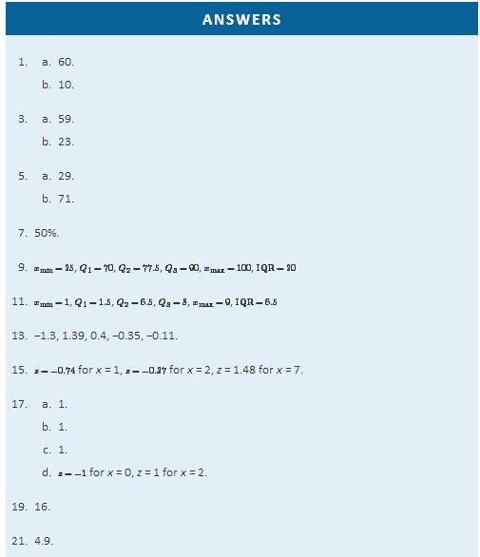
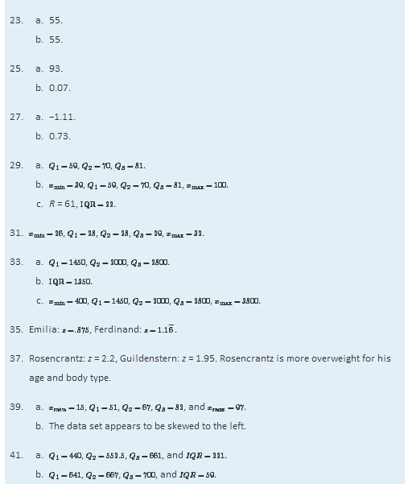

2.5 The Empirical Rule and Chebyshev’s Theorem

LEARNING OBJECTIVES
- To learn what the value of the standard deviation of a data set implies about how the data scatter away from the mean as described by the Empirical Rule and Chebyshev’s Theorem.
- To use the Empirical Rule and Chebyshev’s Theorem to draw conclusions about a data set.

You probably have a good intuitive grasp of what the average of a data set says about that data set. In this section we begin to learn what the standard deviation has to tell us about the nature of the data set.

The Empirical Rule
We start by examining a specific set of data. Table 2.2 "Heights of Men" shows the heights in inches of 100 randomly selected adult men. A relative frequency histogram for the data is shown in Figure 2.15 "Heights of Adult Men". The mean and standard deviation of the data are, rounded to two decimal places, x^−=69.92 and s = 1.70. If we go through the data and count the number of observations that are within one standard deviation of the mean, that is, that are between 69.92−1.70=68.22 and 69.92+1.70=71.62 inches, there are 69 of them. If we count the number of observations that are within two standard deviations of the mean, that is, that are between 69.92−2(1.70)=66.52 and 69.92+2(1.70)=73.32 inches, there are 95 of them. All of the measurements are within three standard deviations of the mean, that is, between 69.92−3(1.70)=64.822 and 69.92+3(1.70)=75.02 inches. These tallies are not coincidences, but are in agreement with the following result that has been found to be widely applicable.

Table 2.2 Heights of Men
68.7 | 72.3 | 71.3 | 72.5 | 70.6 | 68.2 | 70.1 | 68.4 | 68.6 | 70.6
73.7 | 70.5 | 71.0 | 70.9 | 69.3 | 69.4 | 69.7 | 69.1 | 71.5 | 68.6
70.9 | 70.0 | 70.4 | 68.9 | 69.4 | 69.4 | 69.2 | 70.7 | 70.5 | 69.9
69.8 | 69.8 | 68.6 | 69.5 | 71.6 | 66.2 | 72.4 | 70.7 | 67.7 | 69.1
68.8 | 69.3 | 68.9 | 74.8 | 68.0 | 71.2 | 68.3 | 70.2 | 71.9 | 70.4
71.9 | 72.2 | 70.0 | 68.7 | 67.9 | 71.1 | 69.0 | 70.8 | 67.3 | 71.8
70.3 | 68.8 | 67.2 | 73.0 | 70.4 | 67.8 | 70.0 | 69.5 | 70.1 | 72.0
72.2 | 67.6 | 67.0 | 70.3 | 71.2 | 65.6 | 68.1 | 70.8 | 71.4 | 70.2
70.1 | 67.5 | 71.3 | 71.5 | 71.0 | 69.1 | 69.5 | 71.1 | 66.8 | 71.8
69.6 | 72.7 | 72.8 | 69.6 | 65.9 | 68.0 | 69.7 | 68.7 | 69.8 | 69.7
Figure 2.15 Heights of Adult Men
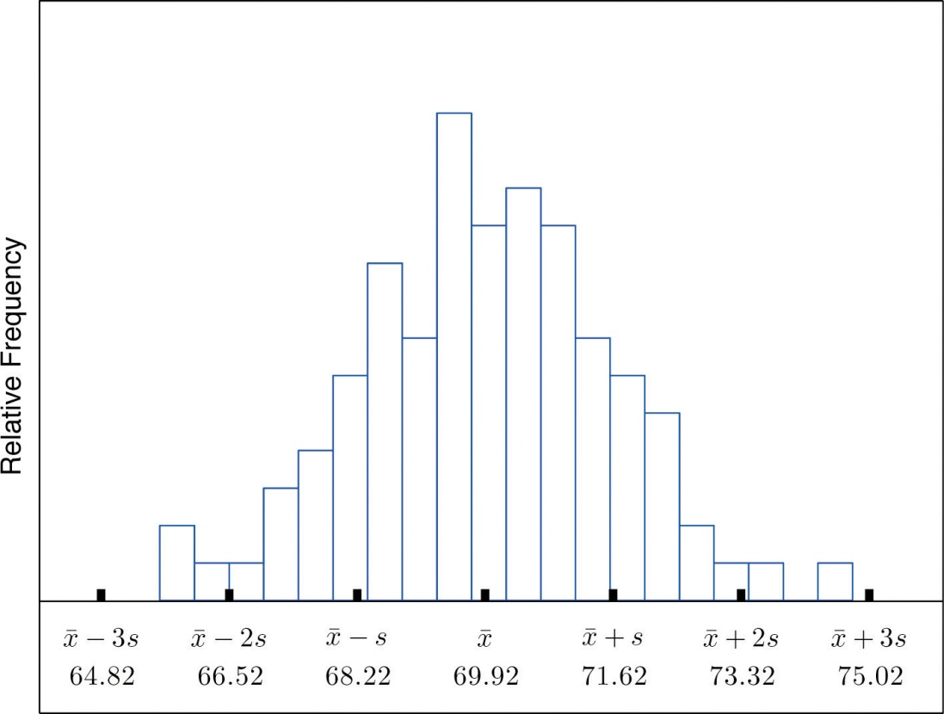

The Empirical Rule

If a data set has an approximately bell-shaped relative frequency histogram, then (see Figure 2.16 "The Empirical Rule")
- approximately 68% of the data lie within one standard deviation of the mean, that is, in the interval with endpoints x^−±s for samples and with endpoints μ±σ for populations;
- approximately 95% of the data lie within two standard deviations of the mean, that is, in the interval with endpoints x^−±2s for samples and with endpoints μ±2σ for populations; and
- approximately 99.7% of the data lies within three standard deviations of the mean, that is, in the interval with endpoints x^−±3s for samples and with endpoints μ±3σ for populations.

Figure 2.16 The Empirical Rule
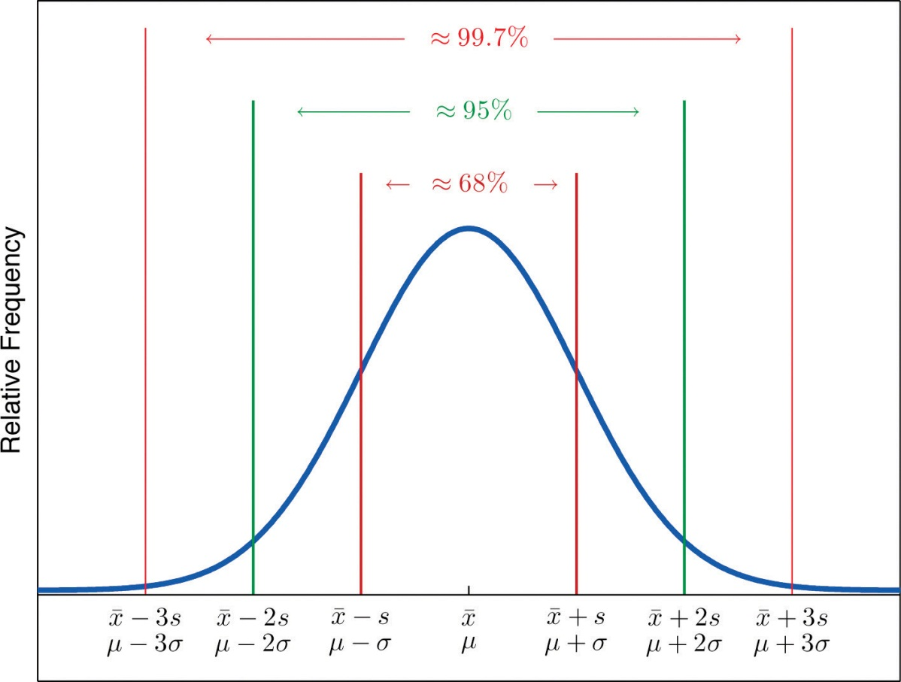

Two key points in regard to the Empirical Rule are that the data distribution must be approximately bell-shaped and that the percentages are only approximately true. The Empirical Rule does not apply to data sets with severely asymmetric distributions, and the actual percentage of observations in any of the intervals specified by the rule could be either greater or less than those given in the rule. We see this with the example of the heights of the men: the Empirical Rule suggested 68 observations between 68.22 and 71.62 inches but we counted 69.
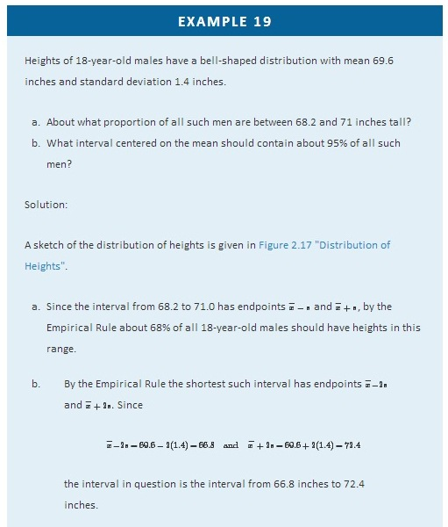

Figure 2.17Distribution of Heights
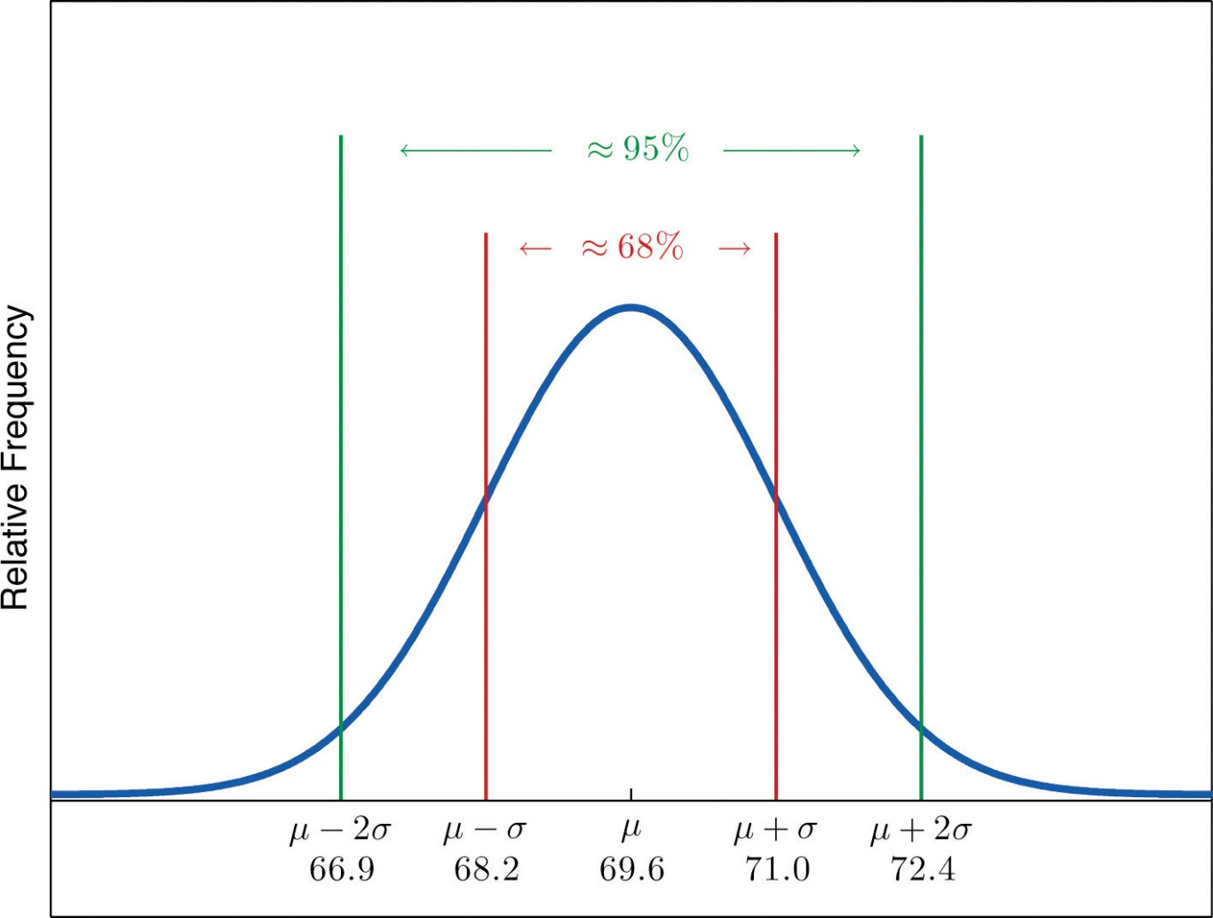

EXAMPLE 20
Scores on IQ tests have a bell-shaped distribution with mean μ = 100 and standard deviation σ = 10. Discuss what the Empirical Rule implies concerning individuals with IQ scores of 110, 120, and 130.
Solution:
A sketch of the IQ distribution is given in Figure 2.18 "Distribution of IQ Scores". The Empirical Rule states that
- approximately 68% of the IQ scores in the population lie between 90 and 110,
- approximately 95% of the IQ scores in the population lie between 80 and 120, and
- approximately 99.7% of the IQ scores in the population lie between 70 and 130.

Figure 2.18Distribution of IQ Scores
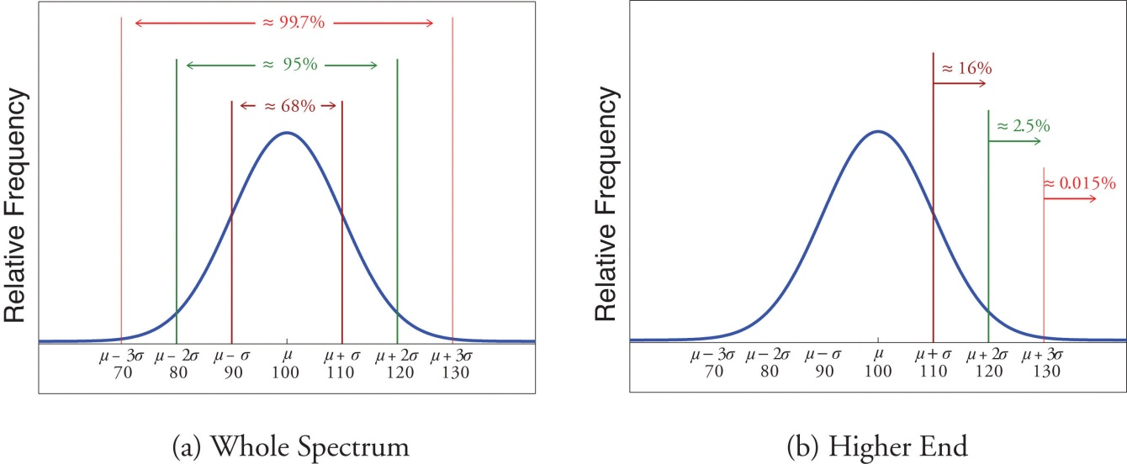
Since 68% of the IQ scores lie within the interval from 90 to 110, it must be the case that 32% lie outside that interval. By symmetry approximately half of that 32%, or 16% of all IQ scores, will lie above 110. If 16% lie above 110, then 84% lie below. We conclude that the IQ score 110 is the 84th percentile.
The same analysis applies to the score 120. Since approximately 95% of all IQ scores lie within the interval form 80 to 120, only 5% lie outside it, and half of them, or 2.5% of all scores, are above 120. The IQ score 120 is thus higher than 97.5% of all IQ scores, and is quite a high score.
By a similar argument, only 15/100 of 1% of all adults, or about one or two in every thousand, would have an IQ score above 130. This fact makes the score 130 extremely high.

Chebyshev’s Theorem

The Empirical Rule does not apply to all data sets, only to those that are bell-shaped, and even then is stated in terms of approximations. A result that applies to every data set is known as Chebyshev’s Theorem.

Chebyshev’s Theorem
For any numerical data set,
- at least 3/4 of the data lie within two standard deviations of the mean, that is, in the interval with endpoints x^−±2s for samples and with endpoints μ±2σ for populations;
- at least 8/9 of the data lie within three standard deviations of the mean, that is, in the interval with endpoints x^−±3s for samples and with endpoints μ±3σ for populations;
- at least 1−1/k² of the data lie within k standard deviations of the mean, that is, in the interval with endpoints x^−±ks for samples and with endpoints μ±kσ for populations, where k is any positive whole number that is greater than 1.

Figure 2.19 "Chebyshev’s Theorem" gives a visual illustration of Chebyshev’s Theorem.
igure 2.19 Chebyshev’s Theorem
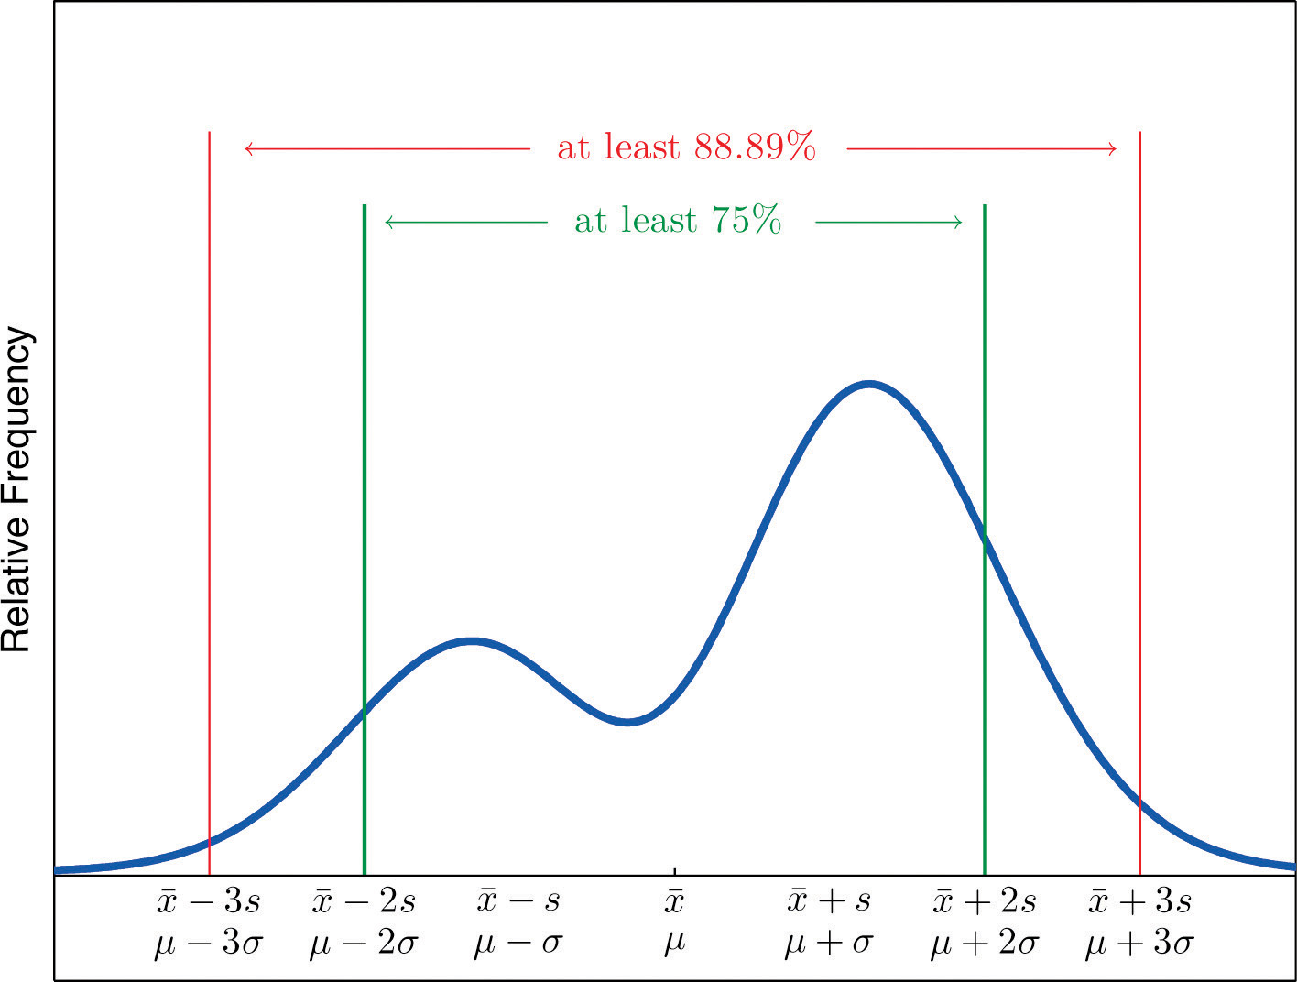

It is important to pay careful attention to the words “at least” at the beginning of each of the three parts. The theorem gives the minimum proportion of the data which must lie within a given number of standard deviations of the mean; the true proportions found within the indicated regions could be greater than what the theorem guarantees.
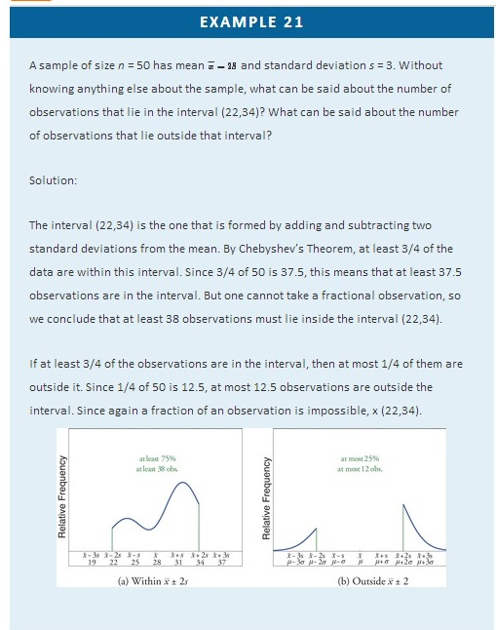

EXAMPLE 22
The number of vehicles passing through a busy intersection between 8:00 a.m. and 10:00 a.m. was observed and recorded on every weekday morning of the last year. The data set contains n = 251 numbers. The sample mean is x^−=725 and the sample standard deviation is s = 25. Identify which of the following statements must be true.
- On approximately 95% of the weekday mornings last year the number of vehicles passing through the intersection from 8:00 a.m. to 10:00 a.m. was between 675 and 775.
- On at least 75% of the weekday mornings last year the number of vehicles passing through the intersection from 8:00 a.m. to 10:00 a.m. was between 675 and 775.
- On at least 189 weekday mornings last year the number of vehicles passing through the intersection from 8:00 a.m. to 10:00 a.m. was between 675 and 775.
- On at most 25% of the weekday mornings last year the number of vehicles passing through the intersection from 8:00 a.m. to 10:00 a.m. was either less than 675 or greater than 775.
- On at most 12.5% of the weekday mornings last year the number of vehicles passing through the intersection from 8:00 a.m. to 10:00 a.m. was less than 675.
- On at most 25% of the weekday mornings last year the number of vehicles passing through the intersection from 8:00 a.m. to 10:00 a.m. was less than 675.
Solution:
- Since it is not stated that the relative frequency histogram of the data is bell-shaped, the Empirical Rule does not apply. Statement (1) is based on the Empirical Rule and therefore it might not be correct.
- Statement (2) is a direct application of part (1) of Chebyshev’s Theorem because (x^−−2s,x^−+2s)=(675,775). It must be correct.
- Statement (3) says the same thing as statement (2) because 75% of 251 is 188.25, so the minimum whole number of observations in this interval is 189. Thus statement (3) is definitely correct.
- Statement (4) says the same thing as statement (2) but in different words, and therefore is definitely correct.
- Statement (4), which is definitely correct, states that at most 25% of the time either fewer than 675 or more than 775 vehicles passed through the intersection. Statement (5) says that half of that 25% corresponds to days of light traffic. This would be correct if the relative frequency histogram of the data were known to be symmetric. But this is not stated; perhaps all of the observations outside the interval (675,775) are less than 75. Thus statement (5) might not be correct
- Statement (4) is definitely correct and statement (4) implies statement (6): even if every measurement that is outside the interval (675,775) is less than 675 (which is conceivable, since symmetry is not known to hold), even so at most 25% of all observations are less than 675. Thus statement (6) must definitely be correct.

KEY TAKEAWAYS
- The Empirical Rule is an approximation that applies only to data sets with a bell-shaped relative frequency histogram. It estimates the proportion of the measurements that lie within one, two, and three standard deviations of the mean.
- Chebyshev’s Theorem is a fact that applies to all possible data sets. It describes the minimum proportion of the measurements that lie must within one, two, or more standard deviations of the mean.

EXERCISES

BASIC
- State the Empirical Rule.
- Describe the conditions under which the Empirical Rule may be applied.
- State Chebyshev’s Theorem.
- Describe the conditions under which Chebyshev’s Theorem may be applied.
- A sample data set with a bell-shaped distribution has mean x^−=6 and standard deviation s = 2. Find the approximate proportion of observations in the data set that lie:
  - between 4 and 8;
  - between 2 and 10;
  - between 0 and 12.
- A population data set with a bell-shaped distribution has mean μ = 6 and standard deviation σ = 2. Find the approximate proportion of observations in the data set that lie:
  - between 4 and 8;
  - between 2 and 10;
  - between 0 and 12.
- A population data set with a bell-shaped distribution has mean μ = 2 and standard deviation σ = 1.1. Find the approximate proportion of observations in the data set that lie:
  - above 2;
  - above 3.1;
  - between 2 and 3.1.
- A sample data set with a bell-shaped distribution has mean x−=2 and standard deviation s = 1.1. Find the approximate proportion of observations in the data set that lie:
  - below −0.2;
  - below 3.1;
  - between −1.3 and 0.9.
- A population data set with a bell-shaped distribution and size N = 500 has mean μ = 2 and standard deviation σ = 1.1. Find the approximate number of observations in the data set that lie:
  - above 2;
  - above 3.1;
  - between 2 and 3.1.
- A sample data set with a bell-shaped distribution and size n = 128 has mean x^−=2and standard deviation s = 1.1. Find the approximate number of observations in the data set that lie:
  - below −0.2;
  - below 3.1;
  - between −1.3 and 0.9.
- A sample data set has mean x^−=6 and standard deviation s = 2. Find the minimum proportion of observations in the data set that must lie:
  - between 2 and 10;
  - between 0 and 12;
  - between 4 and 8.
- A population data set has mean μ = 2 and standard deviation σ = 1.1. Find the minimum proportion of observations in the data set that must lie:
  - between −0.2 and 4.2;
  - between −1.3 and 5.3.
- A population data set of size N = 500 has mean μ = 5.2 and standard deviation σ = 1.1. Find the minimum number of observations in the data set that must lie:
  - between 3 and 7.4;
  - between 1.9 and 8.5.
- A sample data set of size n = 128 has mean x^−=2 and standard deviation s = 2. Find the minimum number of observations in the data set that must lie:
  - between −2 and 6 (including −2 and 6);
  - between −4 and 8 (including −4 and 8).
- A sample data set of size n = 30 has mean x^−=6 and standard deviation s = 2.
  - What is the maximum proportion of observations in the data set that can lie outside the interval (2,10)?
  - What can be said about the proportion of observations in the data set that are below 2?
  - What can be said about the proportion of observations in the data set that are above 10?
  - What can be said about the number of observations in the data set that are above 10?
- A population data set has mean μ = 2 and standard deviation σ = 1.1.
  - What is the maximum proportion of observations in the data set that can lie outside the interval (−1.3,5.3)?
  - What can be said about the proportion of observations in the data set that are below −1.3?
  - What can be said about the proportion of observations in the data set that are above 5.3?

APPLICATIONS
- Scores on a final exam taken by 1,200 students have a bell-shaped distribution with mean 72 and standard deviation 9.
  - What is the median score on the exam?
  - About how many students scored between 63 and 81?
  - About how many students scored between 72 and 90?
  - About how many students scored below 54?
- Lengths of fish caught by a commercial fishing boat have a bell-shaped distribution with mean 23 inches and standard deviation 1.5 inches.
  - About what proportion of all fish caught are between 20 inches and 26 inches long?
  - About what proportion of all fish caught are between 20 inches and 23 inches long?
  - About how long is the longest fish caught (only a small fraction of a percent are longer)?
- Hockey pucks used in professional hockey games must weigh between 5.5 and 6 ounces. If the weight of pucks manufactured by a particular process is bell-shaped, has mean 5.75 ounces and standard deviation 0.125 ounce, what proportion of the pucks will be usable in professional games?
- Hockey pucks used in professional hockey games must weigh between 5.5 and 6 ounces. If the weight of pucks manufactured by a particular process is bell-shaped and has mean 5.75 ounces, how large can the standard deviation be if 99.7% of the pucks are to be usable in professional games?
- Speeds of vehicles on a section of highway have a bell-shaped distribution with mean 60 mph and standard deviation 2.5 mph.
  - If the speed limit is 55 mph, about what proportion of vehicles are speeding?
  - What is the median speed for vehicles on this highway?
  - What is the percentile rank of the speed 65 mph?
  - What speed corresponds to the 16th percentile?
- Suppose that, as in the previous exercise, speeds of vehicles on a section of highway have mean 60 mph and standard deviation 2.5 mph, but now the distribution of speeds is unknown.
  - If the speed limit is 55 mph, at least what proportion of vehicles must speeding?
  - What can be said about the proportion of vehicles going 65 mph or faster?
- An instructor announces to the class that the scores on a recent exam had a bell-shaped distribution with mean 75 and standard deviation 5.
  - What is the median score?
  - Approximately what proportion of students in the class scored between 70 and 80?
  - Approximately what proportion of students in the class scored above 85?
  - What is the percentile rank of the score 85?
- The GPAs of all currently registered students at a large university have a bell-shaped distribution with mean 2.7 and standard deviation 0.6. Students with a GPA below 1.5 are placed on academic probation. Approximately what percentage of currently registered students at the university are on academic probation?
- Thirty-six students took an exam on which the average was 80 and the standard deviation was 6. A rumor says that five students had scores 61 or below. Can the rumor be true? Why or why not?
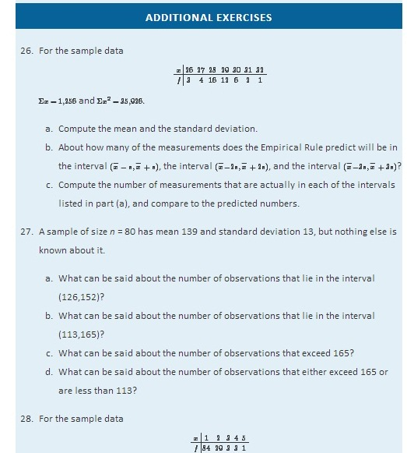
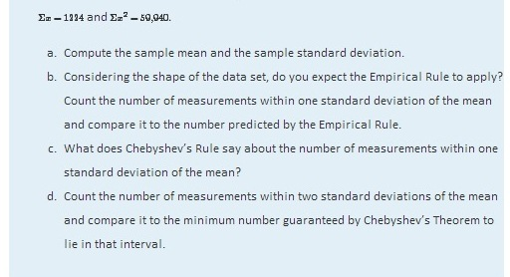
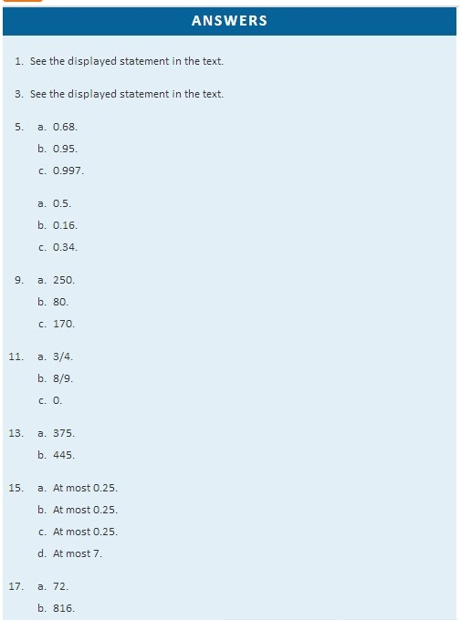
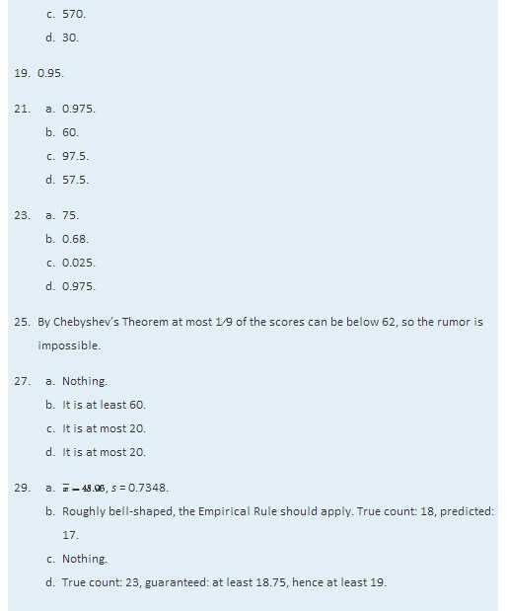

Chapter 3

Basic Concepts of Probability

Suppose a polling organization questions 1,200 voters in order to estimate the proportion of all voters who favor a particular bond issue. We would expect the proportion of the 1,200 voters in the survey who are in favor to be close to the proportion of all voters who are in favor, but this need not be true. There is a degree of randomness associated with the survey result. If the survey result is highly likely to be close to the true proportion, then we have confidence in the survey result. If it is not particularly likely to be close to the population proportion, then we would perhaps not take the survey result too seriously. The likelihood that the survey proportion is close to the population proportion determines our confidence in the survey result. For that reason, we would like to be able to compute that likelihood. The task of computing it belongs to the realm of probability, which we study in this chapter.

3.1 Sample Spaces, Events, and Their Probabilities

LEARNING OBJECTIVES
- To learn the concept of the sample space associated with a random experiment.
- To learn the concept of an event associated with a random experiment.
- To learn the concept of the probability of an event.

Sample Spaces and Events

Rolling an ordinary six-sided die is a familiar example of a random experiment, an action for which all possible outcomes can be listed, but for which the actual outcome on any given trial of the experiment cannot be predicted with certainty. In such a situation we wish to assign to each outcome, such as rolling a two, a number, called the probability of the outcome, that indicates how likely it is that the outcome will occur. Similarly, we would like to assign a probability to any event, or collection of outcomes, such as rolling an even number, which indicates how likely it is that the event will occur if the experiment is performed. This section provides a framework for discussing probability problems, using the terms just mentioned.

Definition
A random experiment is a mechanism that produces a definite outcome that cannot be predicted with certainty. The sample space associated with a random experiment is the set of all possible outcomes. An event is a subset of the sample space.

Definition
An event E is said to occur on a particular trial of the experiment if the outcome observed is an element of the set E.

EXAMPLE 1
Construct a sample space for the experiment that consists of tossing a single coin.
Solution:
The outcomes could be labeled h for heads and t for tails. Then the sample space is the set S={h,t}.

EXAMPLE 2
Construct a sample space for the experiment that consists of rolling a single die. Find the events that correspond to the phrases “an even number is rolled” and “a number greater than two is rolled.”
Solution:
The outcomes could be labeled according to the number of dots on the top face of the die. Then the sample space is the set S={1,2,3,4,5,6}.
The outcomes that are even are 2, 4, and 6, so the event that corresponds to the phrase “an even number is rolled” is the set {2,4,6}, which it is natural to denote by the letter E. We write E={2,4,6}.
Similarly the event that corresponds to the phrase “a number greater than two is rolled” is the set T={3,4,5,6}, which we have denoted T.
A graphical representation of a sample space and events is a Venn diagram, as shown in Figure 3.1 "Venn Diagrams for Two Sample Spaces" for Note 3.6 "Example 1" and Note 3.7 "Example 2". In general the sample space S is represented by a rectangle, outcomes by points within the rectangle, and events by ovals that enclose the outcomes that compose them.
ure 3.1 Venn Diagrams for Two Sample Spaces

EXAMPLE 3
A random experiment consists of tossing two coins.
- Construct a sample space for the situation that the coins are indistinguishable, such as two brand new pennies.
- Construct a sample space for the situation that the coins are distinguishable, such as one a penny and the other a nickel.
Solution:
- After the coins are tossed one sees either two heads, which could be labeled 2h, two tails, which could be labeled 2t, or coins that differ, which could be labeled d. Thus a sample space is S={2h,2t,d}.
- Since we can tell the coins apart, there are now two ways for the coins to differ: the penny heads and the nickel tails, or the penny tails and the nickel heads. We can label each outcome as a pair of letters, the first of which indicates how the penny landed and the second of which indicates how the nickel landed. A sample space is then S′={hh,ht,th,tt}.

A device that can be helpful in identifying all possible outcomes of a random experiment, particularly one that can be viewed as proceeding in stages, is what is called a tree diagram. It is described in the following example.

EXAMPLE 4
Construct a sample space that describes all three-child families according to the genders of the children with respect to birth order.
Solution:
Two of the outcomes are “two boys then a girl,” which we might denote bbg, and “a girl then two boys,” which we would denote gbb. Clearly there are many outcomes, and when we try to list all of them it could be difficult to be sure that we have found them all unless we proceed systematically. The tree diagram shown inFigure 3.2 "Tree Diagram For Three-Child Families", gives a systematic approach.
Figure 3.2Tree Diagram For Three-Child Families
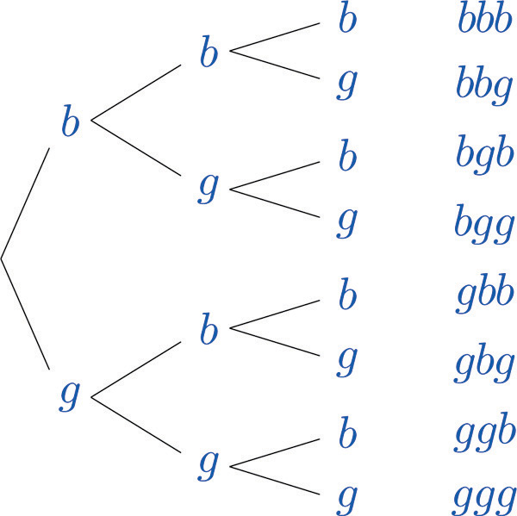
The diagram was constructed as follows. There are two possibilities for the first child, boy or girl, so we draw two line segments coming out of a starting point, one ending in a b for “boy” and the other ending in a g for “girl.” For each of these two possibilities for the first child there are two possibilities for the second child, “boy” or “girl,” so from each of the b and g we draw two line segments, one segment ending in a b and one in a g. For each of the four ending points now in the diagram there are two possibilities for the third child, so we repeat the process once more.

The line segments are called branches of the tree. The right ending point of each branch is called a node. The nodes on the extreme right are the final nodes; to each one there corresponds an outcome, as shown in the figure.
From the tree it is easy to read off the eight outcomes of the experiment, so the sample space is, reading from the top to the bottom of the final nodes in the tree,
S={bbb,bbg,bgb,bgg,gbb,gbg,ggb,ggg}

Probability

Definition
The probability of an outcome e in a sample space S is a number p between 0 and 1 that measures the likelihood that e will occur on a single trial of the corresponding random experiment. The value p = 0 corresponds to the outcome e being impossible and the value p = 1 corresponds to the outcome e being certain.

Definition
The probability of an event A is the sum of the probabilities of the individual outcomes of which it is composed. It is denoted P(A).
The following formula expresses the content of the definition of the probability of an event:

If an event E is E={e₁,e₂,…,e_{k}}, then
P(E)=P(e₁)+P(e₂)+ ⋅ ⋅ ⋅ +P(e_{k})
Figure 3.3 "Sample Spaces and Probability" graphically illustrates the definitions.
Figure 3.3 Sample Spaces and Probability
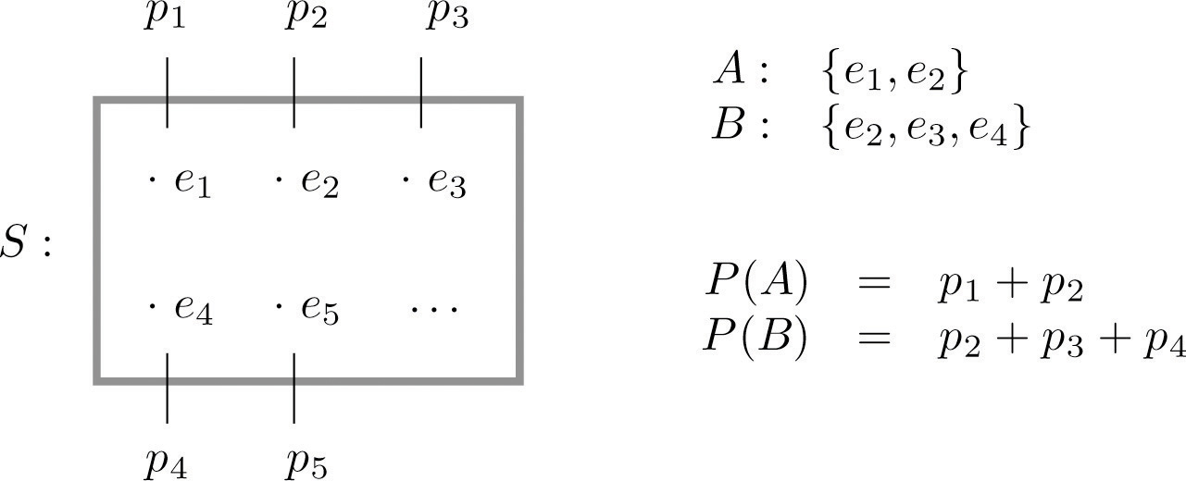
Since the whole sample space S is an event that is certain to occur, the sum of the probabilities of all the outcomes must be the number 1.
In ordinary language probabilities are frequently expressed as percentages. For example, we would say that there is a 70% chance of rain tomorrow, meaning that the probability of rain is 0.70. We will use this practice here, but in all the computational formulas that follow we will use the form 0.70 and not 70%.

EXAMPLE 5
A coin is called “balanced” or “fair” if each side is equally likely to land up. Assign a probability to each outcome in the sample space for the experiment that consists of tossing a single fair coin.
Solution:
With the outcomes labeled h for heads and t for tails, the sample space is the set S={h,t}. Since the outcomes have the same probabilities, which must add up to 1, each outcome is assigned probability 1/2.

EXAMPLE 6
A die is called “balanced” or “fair” if each side is equally likely to land on top. Assign a probability to each outcome in the sample space for the experiment that consists of tossing a single fair die. Find the probabilities of the events E: “an even number is rolled” and T: “a number greater than two is rolled.”
Solution:
With outcomes labeled according to the number of dots on the top face of the die, the sample space is the set S={1,2,3,4,5,6}. Since there are six equally likely outcomes, which must add up to 1, each is assigned probability 1/6.

EXAMPLE 7
Two fair coins are tossed. Find the probability that the coins match, i.e., either both land heads or both land tails.
Solution:
In Note 3.8 "Example 3" we constructed the sample space S={2h,2t,d} for the situation in which the coins are identical and the sample space S′={hh,ht,th,tt}for the situation in which the two coins can be told apart.
The theory of probability does not tell us how to assign probabilities to the outcomes, only what to do with them once they are assigned. Specifically, using sample space S, matching coins is the event M={2h,2t}, which has probability P(2h)+P(2t). Using sample space S′, matching coins is the event M′={hh,tt}, which has probability P(hh)+P(tt). In the physical world it should make no difference whether the coins are identical or not, and so we would like to assign probabilities to the outcomes so that the numbers P(M) and P(M′) are the same and best match what we observe when actual physical experiments are performed with coins that seem to be fair. Actual experience suggests that the outcomes in S′ are equally likely, so we assign to each probability 1∕4, and then
P(M′)=P(hh)+P(tt)=1/4+1/4=1/2
Similarly, from experience appropriate choices for the outcomes in S are:
P(2h)=1/4 P(2t)=1/4 P(d)=1/2
which give the same final answer
P(M)=P(2h)+P(2t)=1/4+1/4=1/2
The previous three examples illustrate how probabilities can be computed simply by counting when the sample space consists of a finite number of equally likely outcomes. In some situations the individual outcomes of any sample space that represents the experiment are unavoidably unequally likely, in which case probabilities cannot be computed merely by counting, but the computational formula given in the definition of the probability of an event must be used.

EXAMPLE 8
The breakdown of the student body in a local high school according to race and ethnicity is 51% white, 27% black, 11% Hispanic, 6% Asian, and 5% for all others. A student is randomly selected from this high school. (To select “randomly” means that every student has the same chance of being selected.) Find the probabilities of the following events:
- B: the student is black,
- M: the student is minority (that is, not white),
- N: the student is not black.
Solution:
The experiment is the action of randomly selecting a student from the student population of the high school. An obvious sample space is S={w,b,h,a,o}. Since 51% of the students are white and all students have the same chance of being selected, P(w)=0.51, and similarly for the other outcomes. This information is summarized in the following table:
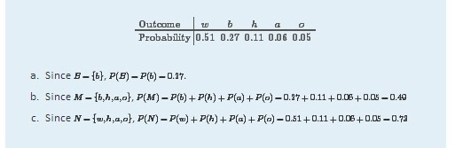

EXAMPLE 9
The student body in the high school considered in Note 3.18 "Example 8" may be broken down into ten categories as follows: 25% white male, 26% white female, 12% black male, 15% black female, 6% Hispanic male, 5% Hispanic female, 3% Asian male, 3% Asian female, 1% male of other minorities combined, and 4% female of other minorities combined. A student is randomly selected from this high school. Find the probabilities of the following events:
- B: the student is black,
- MF: the student is minority female,
- FN: the student is female and is not black.
Solution:
Now the sample space is S={wm,bm,hm,am,om,wf,bf,hf,af,of}. The information given in the example can be summarized in the following table, called a two-way contingency table:
Gender | Race / Ethnicity
 | White | Black | Hispanic | Asian | Others
Male | 0.25 | 0.12 | 0.06 | 0.03 | 0.01
Female | 0.26 | 0.15 | 0.05 | 0.03 | 0.04
- Since B={bm,bf}, P(B)=P(bm)+P(bf)=0.12+0.15=0.27.
- Since MF={bf,hf,af,of},
P(M)=P(bf)+P(hf)+P(af)+P(of)=0.15+0.05+0.03+0.04=0.27
- Since FN={wf,hf,af,of},
P(FN)=P(wf)+P(hf)+P(af)+P(of)=0.26+0.05+0.03+0.04=0.38

KEY TAKEAWAYS
- The sample space of a random experiment is the collection of all possible outcomes.
- An event associated with a random experiment is a subset of the sample space.
- The probability of any outcome is a number between 0 and 1. The probabilities of all the outcomes add up to 1.
- The probability of any event A is the sum of the probabilities of the outcomes in A.

EXERCISES

BASIC
- A box contains 10 white and 10 black marbles. Construct a sample space for the experiment of randomly drawing out, with replacement, two marbles in succession and noting the color each time. (To draw “with replacement” means that the first marble is put back before the second marble is drawn.)

- A box contains 16 white and 16 black marbles. Construct a sample space for the experiment of randomly drawing out, with replacement, three marbles in succession and noting the color each time. (To draw “with replacement” means that each marble is put back before the next marble is drawn.)

- A box contains 8 red, 8 yellow, and 8 green marbles. Construct a sample space for the experiment of randomly drawing out, with replacement, two marbles in succession and noting the color each time.

- A box contains 6 red, 6 yellow, and 6 green marbles. Construct a sample space for the experiment of randomly drawing out, with replacement, three marbles in succession and noting the color each time.

- In the situation of Exercise 1, list the outcomes that comprise each of the following events.
    - At least one marble of each color is drawn.
    - No white marble is drawn.
- In the situation of Exercise 2, list the outcomes that comprise each of the following events.
    - At least one marble of each color is drawn.
    - No white marble is drawn.
    - More black than white marbles are drawn.
- In the situation of Exercise 3, list the outcomes that comprise each of the following events.
    - No yellow marble is drawn.
    - The two marbles drawn have the same color.
    - At least one marble of each color is drawn.
- In the situation of Exercise 4, list the outcomes that comprise each of the following events.
  - No yellow marble is drawn.
  - The three marbles drawn have the same color.
  - At least one marble of each color is drawn.
- Assuming that each outcome is equally likely, find the probability of each event in Exercise 5.
- Assuming that each outcome is equally likely, find the probability of each event in Exercise 6.
- Assuming that each outcome is equally likely, find the probability of each event in Exercise 7.
- Assuming that each outcome is equally likely, find the probability of each event in Exercise 8.

- A sample space is S={a,b,c,d,e}. Identify two events as U={a,b,d} and V={b,c,d}.Suppose P(a) and P(b) are each 0.2 and P(c) and P(d) are each 0.1.
  - Determine what P(e) must be.
  - Find P(U).
  - Find P(V).
- A sample space is S={u,v,w,x}. Identify two events as A={v,w} and B={u,w,x}.Suppose P(u)=0.22, P(w)=0.36, and P(x)=0.27.
  - Determine what P(v) must be.
  - Find P(A).
  - Find P(B).

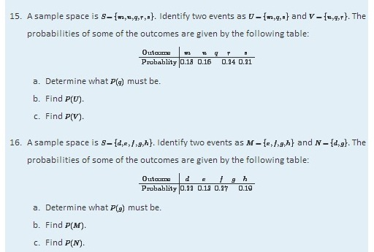

APPLICATIONS
- The sample space that describes all three-child families according to the genders of the children with respect to birth order was constructed in Note 3.9 "Example 4". Identify the outcomes that comprise each of the following events in the experiment of selecting a three-child family at random.
  - At least one child is a girl.
  - At most one child is a girl.
  - All of the children are girls.
  - Exactly two of the children are girls.
  - The first born is a girl.
- The sample space that describes three tosses of a coin is the same as the one constructed in Note 3.9 "Example 4" with “boy” replaced by “heads” and “girl” replaced by “tails.” Identify the outcomes that comprise each of the following events in the experiment of tossing a coin three times.
  - The coin lands heads more often than tails.
  - The coin lands heads the same number of times as it lands tails.
  - The coin lands heads at least twice.
  - The coin lands heads on the last toss.
- Assuming that the outcomes are equally likely, find the probability of each event in Exercise 17.
- Assuming that the outcomes are equally likely, find the probability of each event in Exercise 18.

ADDITIONAL EXERCISES
- The following two-way contingency table gives the breakdown of the population in a particular locale according to age and tobacco usage:
Age | Tobacco Use
 | Smoker | Non-smoker
Under 30 | 0.05 | 0.20
Over 30 | 0.20 | 0.55
A person is selected at random. Find the probability of each of the following events.
  - The person is a smoker.
  - The person is under 30.
  - The person is a smoker who is under 30.

- The following two-way contingency table gives the breakdown of the population in a particular locale according to party affiliation (A, B, C, or None) and opinion on a bond issue:
Affiliation | Opinion
 | Favors | Opposes | Undecided
A | 0.12 | 0.09 | 0.07
B | 0.16 | 0.12 | 0.14
C | 0.04 | 0.03 | 0.06
None | 0.08 | 0.06 | 0.03
A person is selected at random. Find the probability of each of the following events.
  - The person is affiliated with party B.
  - The person is affiliated with some party.
  - The person is in favor of the bond issue.
  - The person has no party affiliation and is undecided about the bond issue.

- The following two-way contingency table gives the breakdown of the population of married or previously married women beyond child-bearing age in a particular locale according to age at first marriage and number of children:
Age | Number of Children
 | 0 | 1 or 2 | 3 or More
Under 20 | 0.02 | 0.14 | 0.08
20–29 | 0.07 | 0.37 | 0.11
30 and above | 0.10 | 0.10 | 0.01
A woman is selected at random. Find the probability of each of the following events.

  - The woman was in her twenties at her first marriage.
  - The woman was 20 or older at her first marriage.
  - The woman had no children.
  - The woman was in her twenties at her first marriage and had at least three children.

- The following two-way contingency table gives the breakdown of the population of adults in a particular locale according to highest level of education and whether or not the individual regularly takes dietary supplements:
Education | Use of Supplements
 | Takes | Does Not Take
No High School Diploma | 0.04 | 0.06
High School Diploma | 0.06 | 0.44
Undergraduate Degree | 0.09 | 0.28
Graduate Degree | 0.01 | 0.02
An adult is selected at random. Find the probability of each of the following events.

  - The person has a high school diploma and takes dietary supplements regularly.
  - The person has an undergraduate degree and takes dietary supplements regularly.
  - The person takes dietary supplements regularly.
  - The person does not take dietary supplements regularly.

LARGE DATA SET EXERCISES
- Large Data Sets 4 and 4A record the results of 500 tosses of a coin. Find the relative frequency of each outcome 1, 2, 3, 4, 5, and 6. Does the coin appear to be “balanced” or “fair”?
http://www.flatworldknowledge.com/sites/all/files/data4.xls
http://www.flatworldknowledge.com/sites/all/files/data4A.xls
- Large Data Sets 6, 6A, and 6B record results of a random survey of 200 voters in each of two regions, in which they were asked to express whether they prefer Candidate Afor a U.S. Senate seat or prefer some other candidate.
  - Find the probability that a randomly selected voter among these 400 prefers Candidate A.
  - Find the probability that a randomly selected voter among the 200 who live in Region 1 prefers Candidate A (separately recorded in Large Data Set 6A).
  - Find the probability that a randomly selected voter among the 200 who live in Region 2 prefers Candidate A (separately recorded in Large Data Set 6B).
http://www.flatworldknowledge.com/sites/all/files/data6.xls
http://www.flatworldknowledge.com/sites/all/files/data6A.xls
http://www.flatworldknowledge.com/sites/all/files/data6B.xls
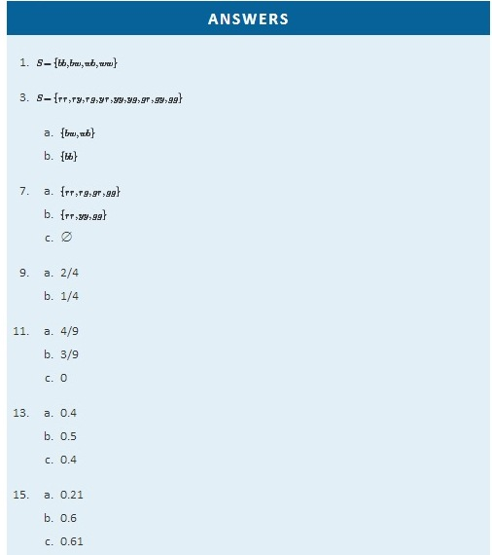
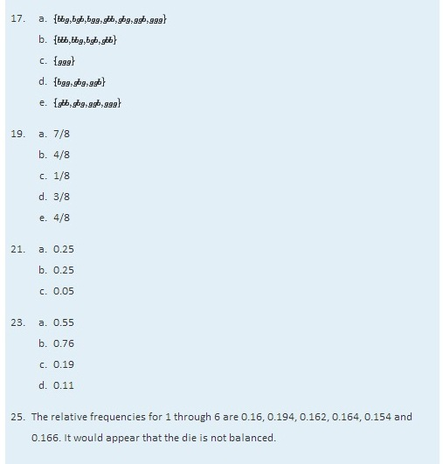

3.2 Complements, Intersections, and Unions

LEARNING OBJECTIVES
- To learn how some events are naturally expressible in terms of other events.
- To learn how to use special formulas for the probability of an event that is expressed in terms of one or more other events.
Some events can be naturally expressed in terms of other, sometimes simpler, events.

Complements

Definition
The complement of an event A in a sample space S, denoted A^{c}, is the collection of all outcomes in S that are not elements of the set A. It corresponds to negating any description in words of the event A.

EXAMPLE 10
Two events connected with the experiment of rolling a single die are E: “the number rolled is even” and T: “the number rolled is greater than two.” Find the complement of each.
Solution:
In the sample space S={1,2,3,4,5,6} the corresponding sets of outcomes are E={2,4,6} and T={3,4,5,6}. The complements are E^{c}={1,3,5} and T^{c}={1,2}.
In words the complements are described by “the number rolled is not even” and “the number rolled is not greater than two.” Of course easier descriptions would be “the number rolled is odd” and “the number rolled is less than three.”
If there is a 60% chance of rain tomorrow, what is the probability of fair weather? The obvious answer, 40%, is an instance of the following general rule.

Probability Rule for Complements

P(A^{c})=1−P(A)
This formula is particularly useful when finding the probability of an event

EXAMPLE 11
Find the probability that at least one heads will appear in five tosses of a fair coin.
Solution:
Identify outcomes by lists of five hs and ts, such as tthtt and hhttt. Although it is tedious to list them all, it is not difficult to count them. Think of using a tree diagram to do so. There are two choices for the first toss. For each of these there are two choices for the second toss, hence 2×2=4 outcomes for two tosses. For each of these four outcomes, there are two possibilities for the third toss, hence 4×2=8 outcomes for three tosses. Similarly, there are 8×2=16 outcomes for four tosses and finally 16×2=32 outcomes for five tosses.

Let O denote the event “at least one heads.” There are many ways to obtain at least one heads, but only one way to fail to do so: all tails. Thus although it is difficult to list all the outcomes that form O, it is easy to write O^{c}={ttttt}. Since there are 32 equally likely outcomes, each has probability 1/32, so P(O^{c})=1/32, hence P(O)=1−1/32≈0.97 or about a 97% chance.

Intersection of Events

Definition
The intersection of events A and B, denoted A ∩ B, is the collection of all outcomes that are elements of both of the sets A and B. It corresponds to combining descriptions of the two events using the word “and.”

To say that the event A ∩ B occurred means that on a particular trial of the experiment both A and B occurred. A visual representation of the intersection of events A and B in a sample space S is given in Figure 3.4 "The Intersection of Events ". The intersection corresponds to the shaded lens-shaped region that lies within both ovals.

Figure 3.4 The Intersection of Events Aand B
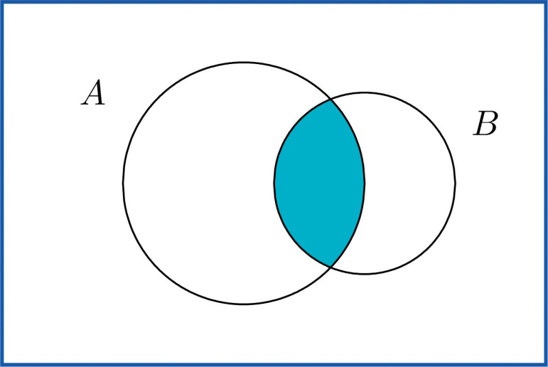

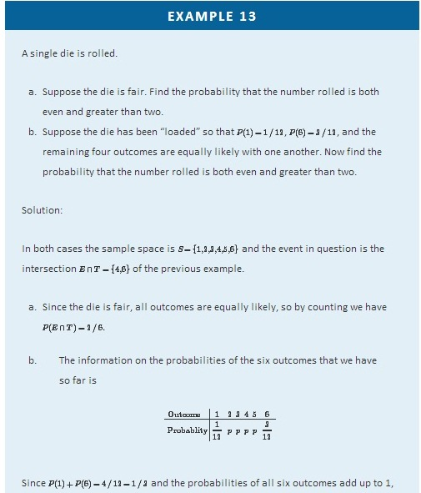
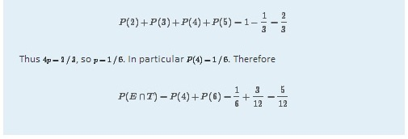

Definition
Events A and B are mutually exclusive if they have no elements in common.

For A and B to have no outcomes in common means precisely that it is impossible for both A and B to occur on a single trial of the random experiment. This gives the following rule.

Probability Rule for Mutually Exclusive Events
Events A and B are mutually exclusive if and only if

P(A∩B)=0

Any event A and its complement A^{c} are mutually exclusive, but A and B can be mutually exclusive without being complements.

EXAMPLE 14
In the experiment of rolling a single die, find three choices for an event A so that the events A and E: “the number rolled is even” are mutually exclusive.
Solution:
Since E={2,4,6} and we want A to have no elements in common with E, any event that does not contain any even number will do. Three choices are {1,3,5} (the complement E^{c}, the odds), {1,3}, and {5}.

Union of Events

Definition
The union of events A and B, denoted A ∪ B, is the collection of all outcomes that are elements of one or the other of the sets A and B, or of both of them. It corresponds to combining descriptions of the two events using the word “or.”

To say that the event A ∪ B occurred means that on a particular trial of the experiment either A or B occurred (or both did). A visual representation of the union of events A and B in a sample space S is given in Figure 3.5 "The Union of Events ". The union corresponds to the shaded region.

Figure 3.5 The Union of Events A and B
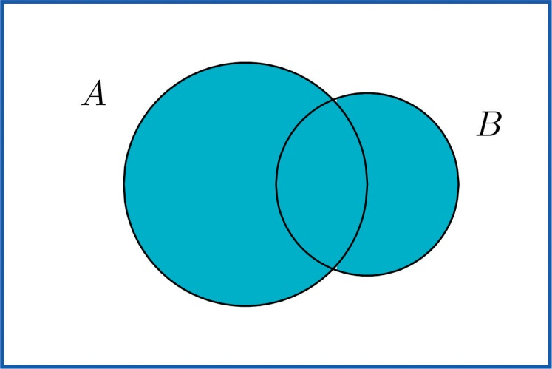

EXAMPLE 15
In the experiment of rolling a single die, find the union of the events E: “the number rolled is even” and T: “the number rolled is greater than two.”
Solution:
Since the outcomes that are in either E={2,4,6} or T={3,4,5,6} (or both) are 2, 3, 4, 5, and 6, E∪T={2,3,4,5,6}. Note that an outcome such as 4 that is in both sets is still listed only once (although strictly speaking it is not incorrect to list it twice).
In words the union is described by “the number rolled is even or is greater than two.” Every number between one and six except the number one is either even or is greater than two, corresponding to E ∪ T given above.

EXAMPLE 16
A two-child family is selected at random. Let B denote the event that at least one child is a boy, let D denote the event that the genders of the two children differ, and let M denote the event that the genders of the two children match. Find B ∪ D and B ∪ M.
Solution:
A sample space for this experiment is S={bb,bg,gb,gg}, where the first letter denotes the gender of the firstborn child and the second letter denotes the gender of the second child. The events B, D, and M are
B={bb,bg,gb} D={bg,gb} M={bb,gg}
Each outcome in D is already in B, so the outcomes that are in at least one or the other of the sets B and D is just the set B itself: B∪D={bb,bg,gb}=B.
Every outcome in the whole sample space S is in at least one or the other of the sets B and M, so B ∪ M={bb,bg,gb,gg}=S.

The following Additive Rule of Probability is a useful formula for calculating the probability of A∪B.

Additive Rule of Probability

P(A ∪ B)=P(A)+P(B)−P(A ∩ B)

The next example, in which we compute the probability of a union both by counting and by using the formula, shows why the last term in the formula is needed.
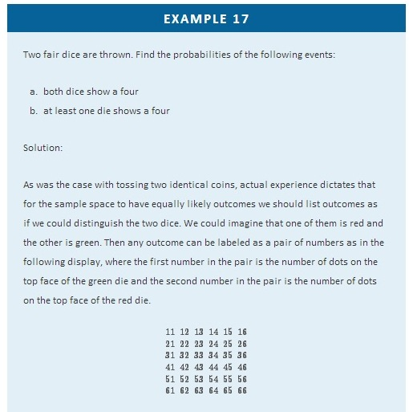
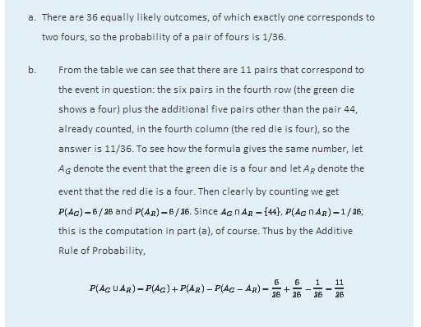

EXAMPLE 18
A tutoring service specializes in preparing adults for high school equivalence tests. Among all the students seeking help from the service, 63% need help in mathematics, 34% need help in English, and 27% need help in both mathematics and English. What is the percentage of students who need help in either mathematics or English?
Solution:

Imagine selecting a student at random, that is, in such a way that every student has the same chance of being selected. Let M denote the event “the student needs help in mathematics” and let E denote the event “the student needs help in English.” The information given is that P(M)=0.63, P(E)=0.34, and P(M∩E)=0.27.The Additive Rule of Probability gives

P(M ∪ E)=P(M)+P(E)−P(M ∩ E)=0.63+0.34−0.27=0.70
Note how the naïve reasoning that if 63% need help in mathematics and 34% need help in English then 63 plus 34 or 97% need help in one or the other gives a number that is too large. The percentage that need help in both subjects must be subtracted off, else the people needing help in both are counted twice, once for needing help in mathematics and once again for needing help in English. The simple sum of the probabilities would work if the events in question were mutually exclusive, for then P(A ∩ B) is zero, and makes no difference.
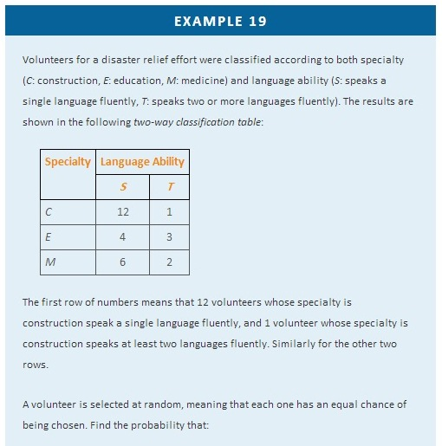
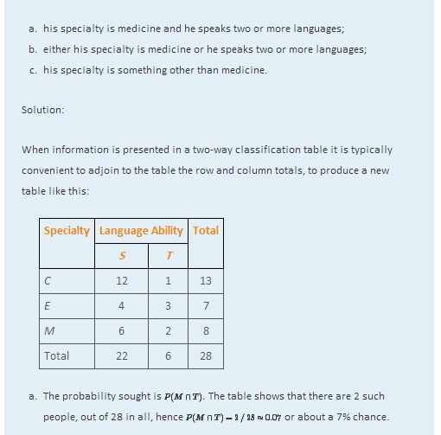
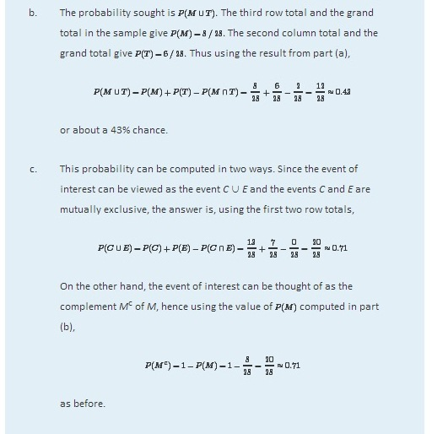

KEY TAKEAWAY
- The probability of an event that is a complement or union of events of known probability can be computed using formulas.
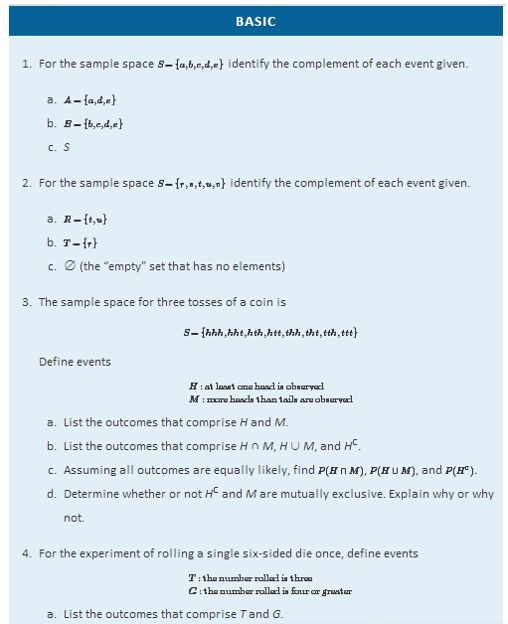
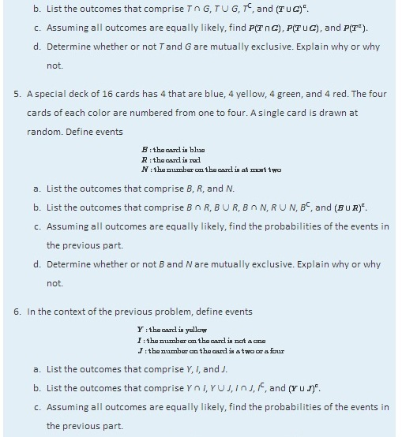
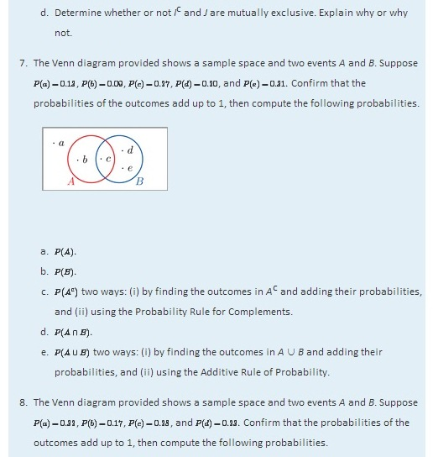
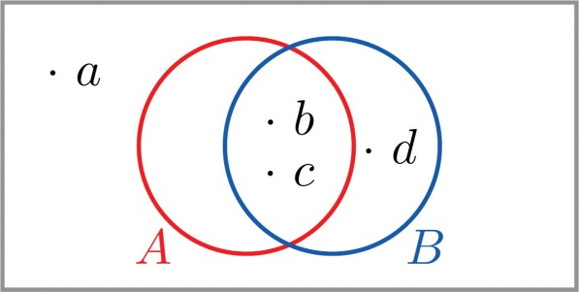
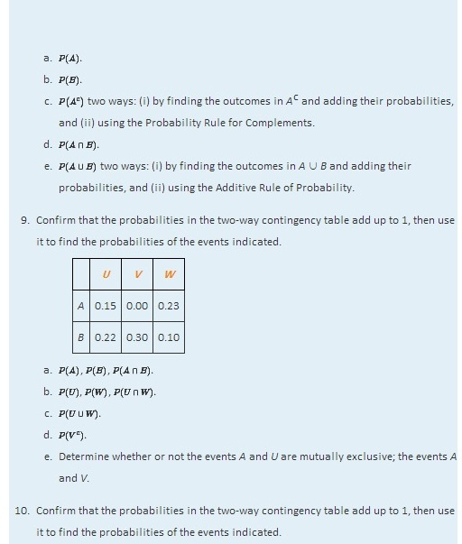

 | R | S | T
M | 0.09 | 0.25 | 0.19
N | 0.31 | 0.16 | 0.00
- P(R), P(S), P(R∩S).
- P(M), P(N), P(M∩N).
- P(R∪S).
- P(R^{c}).
- Determine whether or not the events N and S are mutually exclusive; the events N and T.

APPLICATIONS
- Make a statement in ordinary English that describes the complement of each event (do not simply insert the word “not”).

  - In the roll of a die: “five or more.”
  - In a roll of a die: “an even number.”
  - In two tosses of a coin: “at least one heads.”
  - In the random selection of a college student: “Not a freshman.”

- Make a statement in ordinary English that describes the complement of each event (do not simply insert the word “not”).
  - In the roll of a die: “two or less.”
  - In the roll of a die: “one, three, or four.”
  - In two tosses of a coin: “at most one heads.”
  - In the random selection of a college student: “Neither a freshman nor a senior.”

- The sample space that describes all three-child families according to the genders of the children with respect to birth order is
S={bbb,bbg,bgb,bgg,gbb,gbg,ggb,ggg}.
For each of the following events in the experiment of selecting a three-child family at random, state the complement of the event in the simplest possible terms, then find the outcomes that comprise the event and its complement.

- At least one child is a girl.
- At most one child is a girl.
- All of the children are girls.
- Exactly two of the children are girls.
- The first born is a girl.

- The sample space that describes the two-way classification of citizens according to gender and opinion on a political issue is
S={mf,ma,mn,ff,fa,fn},
where the first letter denotes gender (m: male, f: female) and the second opinion (f: for, a: against, n: neutral). For each of the following events in the experiment of selecting a citizen at random, state the complement of the event in the simplest possible terms, then find the outcomes that comprise the event and its complement.
  - The person is male.
  - The person is not in favor.
  - The person is either male or in favor.
  - The person is female and neutral.

- A tourist who speaks English and German but no other language visits a region of Slovenia. If 35% of the residents speak English, 15% speak German, and 3% speak both English and German, what is the probability that the tourist will be able to talk with a randomly encountered resident of the region?

- In a certain country 43% of all automobiles have airbags, 27% have anti-lock brakes, and 13% have both. What is the probability that a randomly selected vehicle will have both airbags and anti-lock brakes?
- A manufacturer examines its records over the last year on a component part received from outside suppliers. The breakdown on source (supplier A, supplier B) and quality (H: high, U: usable, D: defective) is shown in the two-way contingency table.
 | H | U | D
A | 0.6937 | 0.0049 | 0.0014
B | 0.2982 | 0.0009 | 0.0009
The record of a part is selected at random. Find the probability of each of the following events.
- The part was defective.
- The part was either of high quality or was at least usable, in two ways: (i) by adding numbers in the table, and (ii) using the answer to (a) and the Probability Rule for Complements.
- The part was defective and came from supplier B.
- The part was defective or came from supplier B, in two ways: by finding the cells in the table that correspond to this event and adding their probabilities, and (ii) using the Additive Rule of Probability.

18. Individuals with a particular medical condition were classified according to the presence (T) or absence (N) of a potential toxin in their blood and the onset of the condition (E: early, M: midrange, L: late). The breakdown according to this classification is shown in the two-way contingency table.
 | E | M | L
T | 0.012 | 0.124 | 0.013
N | 0.170 | 0.638 | 0.043
One of these individuals is selected at random. Find the probability of each of the following events.
  - The person experienced early onset of the condition.
  - The onset of the condition was either midrange or late, in two ways: (i) by adding numbers in the table, and (ii) using the answer to (a) and the Probability Rule for Complements.
  - The toxin is present in the person’s blood.
  - The person experienced early onset of the condition and the toxin is present in the person’s blood.
  - The person experienced early onset of the condition or the toxin is present in the person’s blood, in two ways: (i) by finding the cells in the table that correspond to this event and adding their probabilities, and (ii) using the Additive Rule of Probability.
- The breakdown of the students enrolled in a university course by class (F: freshman, So: sophomore, J: junior, Se: senior) and academic major (S: science, mathematics, or engineering, L: liberal arts, O: other) is shown in the two-way classification table.
Major | Class
 | F | So | J | Se
S | 92 | 42 | 20 | 13
L | 368 | 167 | 80 | 53
O | 460 | 209 | 100 | 67
A student enrolled in the course is selected at random. Adjoin the row and column totals to the table and use the expanded table to find the probability of each of the following events.
  - The student is a freshman.
  - The student is a liberal arts major.
  - The student is a freshman liberal arts major.
  - The student is either a freshman or a liberal arts major.
  - The student is not a liberal arts major.
- The table relates the response to a fund-raising appeal by a college to its alumni to the number of years since graduation.
Response | Years Since Graduation
 | 0–5 | 6–20 | 21–35 | Over 35
Positive | 120 | 440 | 210 | 90
None | 1380 | 3560 | 3290 | 910
An alumnus is selected at random. Adjoin the row and column totals to the table and use the expanded table to find the probability of each of the following events.
  - The alumnus responded.
  - The alumnus did not respond.
  - The alumnus graduated at least 21 years ago.
  - The alumnus graduated at least 21 years ago and responded.

ADDITIONAL EXERCISES
- The sample space for tossing three coins is
S={hhh,hht,hth,htt,thh,tht,tth,ttt}
  - List the outcomes that correspond to the statement “All the coins are heads.”
  - List the outcomes that correspond to the statement “Not all the coins are heads.”
  - List the outcomes that correspond to the statement “All the coins are not heads.”
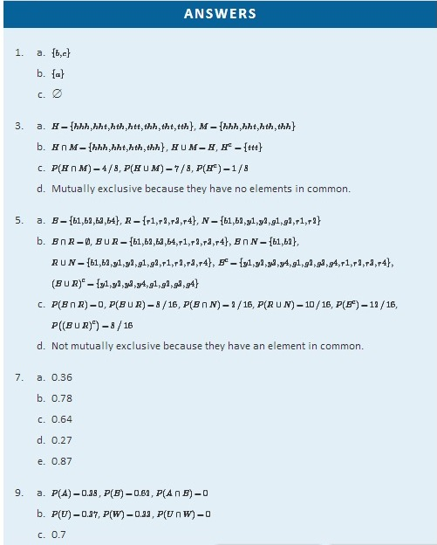
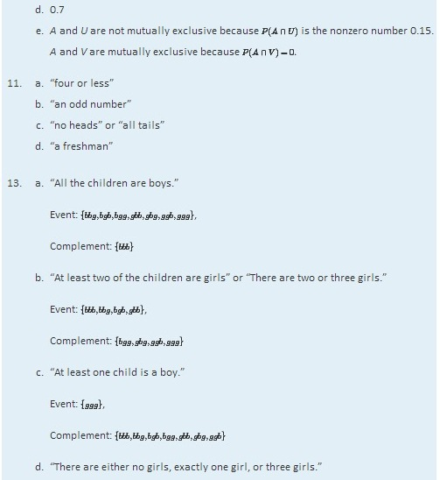
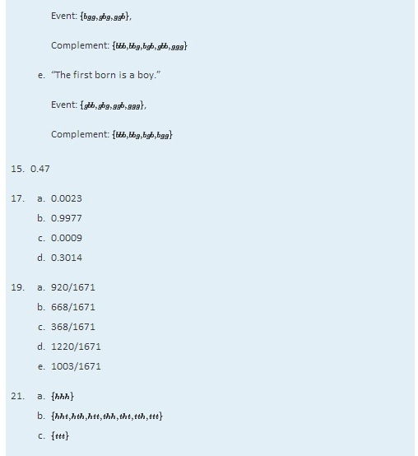

3.3 Conditional Probability and Independent Events

LEARNING OBJECTIVES
- To learn the concept of a conditional probability and how to compute it.
- To learn the concept of independence of events, and how to apply it.

Conditional Probability
Suppose a fair die has been rolled and you are asked to give the probability that it was a five. There are six equally likely outcomes, so your answer is 1/6. But suppose that before you give your answer you are given the extra information that the number rolled was odd. Since there are only three odd numbers that are possible, one of which is five, you would certainly revise your estimate of the likelihood that a five was rolled from 1/6 to 1/3. In general, the revised probability that an event A has occurred, taking into account the additional information that another event B has definitely occurred on this trial of the experiment, is called the conditional probability of A given B and is denoted by P(A|B). The reasoning employed in this example can be generalized to yield the computational formula in the following definition.

Definition
The conditional probability of A given B, denoted P(A|B), is the probability that event A has occurred in a trial of a random experiment for which it is known that event B has definitely occurred. It may be computed by means of the following formula:

Rule for Conditional Probability

P(A|B)=P(A∩B)/P(B)

EXAMPLE 20
A fair die is rolled.
- Find the probability that the number rolled is a five, given that it is odd.
- Find the probability that the number rolled is odd, given that it is a five.
Solution:
The sample space for this experiment is the set S={1,2,3,4,5,6} consisting of six equally likely outcomes. Let F denote the event “a five is rolled” and let O denote the event “an odd number is rolled,” so that

F={5} and O={1,3,5}

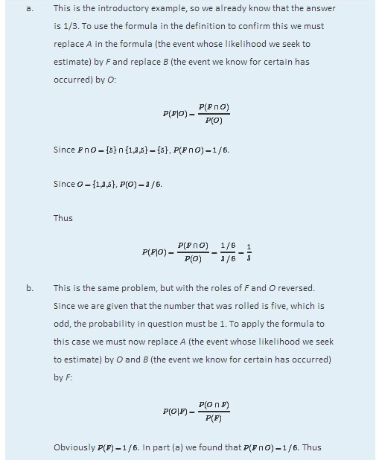
Just as we did not need the computational formula in this example, we do not need it when the information is presented in a two-way classification table, as in the next example.

EXAMPLE 21
In a sample of 902 individuals under 40 who were or had previously been married, each person was classified according to gender and age at first marriage. The results are summarized in the following two-way classification table, where the meaning of the labels is:

- M: male
- F: female
- E: a teenager when first married
- W: in one’s twenties when first married
- H: in one’s thirties when first married
 | E | W | H | Total
M | 43 | 293 | 114 | 450
F | 82 | 299 | 71 | 452
Total | 125 | 592 | 185 | 902
The numbers in the first row mean that 43 people in the sample were men who were first married in their teens, 293 were men who were first married in their twenties, 114 men who were first married in their thirties, and a total of 450 people in the sample were men. Similarly for the numbers in the second row. The numbers in the last row mean that, irrespective of gender, 125 people in the sample were married in their teens, 592 in their twenties, 185 in their thirties, and that there were 902 people in the sample in all. Suppose that the proportions in the sample accurately reflect those in the population of all individuals in the population who are under 40 and who are or have previously been married. Suppose such a person is selected at random.

- Find the probability that the individual selected was a teenager at first marriage.
- Find the probability that the individual selected was a teenager at first marriage, given that the person is male.

Solution:

It is natural to let E also denote the event that the person selected was a teenager at first marriage and to let M denote the event that the person selected is male.

- According to the table the proportion of individuals in the sample who were in their teens at their first marriage is 125/902. This is the relative frequency of such people in the population, hence P(E)=125/902≈0.139 or about 14%.
Since it is known that the person selected is male, all the females may be removed from consideration, so that only the row in the table corresponding to men in the sample applies:
 | E | W | H | Total
M | 43 | 293 | 114 | 450
The proportion of males in the sample who were in their teens at their first marriage is 43/450. This is the relative frequency of such people in the population of males, hence P(E|M)=43/450≈0.096 or about 10%.

In the next example, the computational formula in the definition must be used.

EXAMPLE 22
Suppose that in an adult population the proportion of people who are both overweight and suffer hypertension is 0.09; the proportion of people who are not overweight but suffer hypertension is 0.11; the proportion of people who are overweight but do not suffer hypertension is 0.02; and the proportion of people who are neither overweight nor suffer hypertension is 0.78. An adult is randomly selected from this population.

- Find the probability that the person selected suffers hypertension given that he is overweight.
- Find the probability that the selected person suffers hypertension given that he is not overweight.
- Compare the two probabilities just found to give an answer to the question as to whether overweight people tend to suffer from hypertension.
Solution:

Let H denote the event “the person selected suffers hypertension.” Let O denote the event “the person selected is overweight.” The probability information given in the problem may be organized into the following contingency table:

 | O | O^{c}
H | 0.09 | 0.11
H^{c} | 0.02 | 0.78
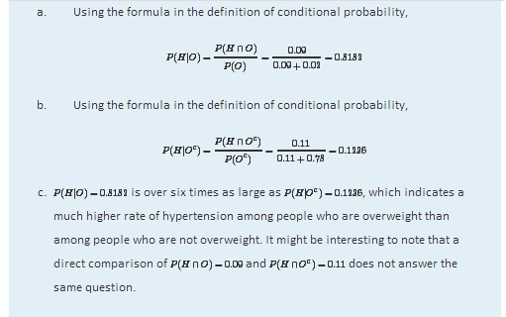

Independent Events

Although typically we expect the conditional probability P(A|B) to be different from the probability P(A) of A, it does not have to be different from P(A). When P(A|B)=P(A), the occurrence of B has no effect on the likelihood of A. Whether or not the event A has occurred is independent of the event B.

Using algebra it can be shown that the equality P(A|B)=P(A) holds if and only if the equality P(A ∩ B)=P(A)⋅P(B) holds, which in turn is true if and only if P(B|A)=P(B). This is the basis for the following definition.

Definition
Events A and B are independent if

P(A∩B)=P(A)⋅P(B)
If A and B are not independent then they are dependent.
The formula in the definition has two practical but exactly opposite uses:

- In a situation in which we can compute all three probabilities P(A), P(B), and P(A∩B), it is used to check whether or not the events A and B are independent:
  - If P(A∩B)=P(A)⋅P(B), then A and B are independent.
  - If P(A∩B)≠P(A)⋅P(B), then A and B are not independent.

- In a situation in which each of P(A) and P(B) can be computed and it is known that A and B are independent, then we can compute P(A∩B) by multiplying together P(A) and P(B): P(A∩B)=P(A)⋅P(B).

EXAMPLE 23
A single fair die is rolled. Let A={3} and B={1,3,5}. Are A and B independent?
Solution:
In this example we can compute all three probabilities P(A)=1/6, P(B)=1/2, and P(A ∩ B)=P({3})=1/6. Since the product P(A)⋅P(B)=(1/6)(1/2)=1/12 is not the same number as P( A ∩ B)=1/6, the events A and B are not independent.

EXAMPLE 24
The two-way classification of married or previously married adults under 40 according to gender and age at first marriage in Note 3.48 "Example 21" produced the table
 | E | W | H | Total
M | 43 | 293 | 114 | 450
F | 82 | 299 | 71 | 452
Total | 125 | 592 | 185 | 902

Determine whether or not the events F: “female” and E: “was a teenager at first marriage” are independent.
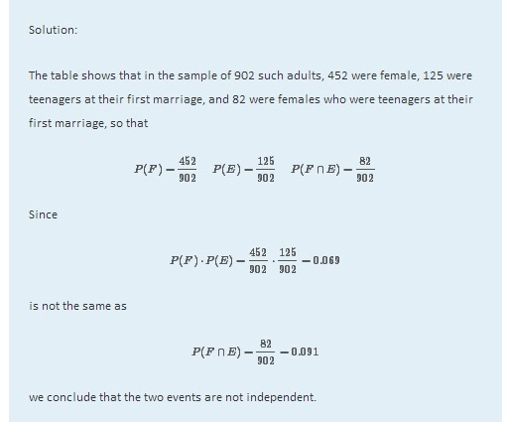

EXAMPLE 25
Many diagnostic tests for detecting diseases do not test for the disease directly but for a chemical or biological product of the disease, hence are not perfectly reliable. The sensitivity of a test is the probability that the test will be positive when administered to a person who has the disease. The higher the sensitivity, the greater the detection rate and the lower the false negative rate.
Suppose the sensitivity of a diagnostic procedure to test whether a person has a particular disease is 92%. A person who actually has the disease is tested for it using this procedure by two independent laboratories.

- What is the probability that both test results will be positive?
- What is the probability that at least one of the two test results will be positive?

Solution:
- Let A₁ denote the event “the test by the first laboratory is positive” and let A₂ denote the event “the test by the second laboratory is positive.” Since A₁ and A₂ are independent,

P(A₁ ∩ A₂)=P(A₁)⋅P(A₂)=0.92×0.92=0.8464
- Using the Additive Rule for Probability and the probability just computed,
P(A₁ ∪ A₂)=P(A₁)+P(A₂)−P(A₁ ∩ A₂)=0.92+0.92−0.8464=0.9936

EXAMPLE 26
The specificity of a diagnostic test for a disease is the probability that the test will be negative when administered to a person who does not have the disease. The higher the specificity, the lower the false positive rate.
Suppose the specificity of a diagnostic procedure to test whether a person has a particular disease is 89%.

- A person who does not have the disease is tested for it using this procedure. What is the probability that the test result will be positive?
- A person who does not have the disease is tested for it by two independent laboratories using this procedure. What is the probability that both test results will be positive?
Solution:

- Let B denote the event “the test result is positive.” The complement of B is that the test result is negative, and has probability the specificity of the test, 0.89. Thus
P(B)=1−P(B^{c})=1−0.89=0.11.
- Let B₁ denote the event “the test by the first laboratory is positive” and let B₂ denote the event “the test by the second laboratory is positive.” Since B₁ and B₂ are independent, by part (a) of the example
P(B1 ∩ B2)=P(B₁)⋅P(B₂)=0.11×0.11=0.0121.
The concept of independence applies to any number of events. For example, three events A, B, and C are independent if P(A ∩ B∩ C)=P(A)⋅P(B)⋅P(C). Note carefully that, as is the case with just two events, this is not a formula that is always valid, but holds precisely when the events in question are independent.
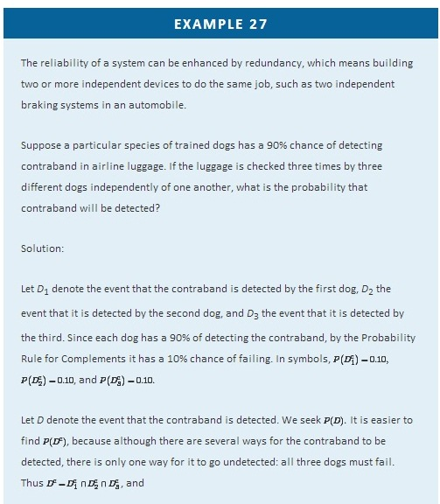
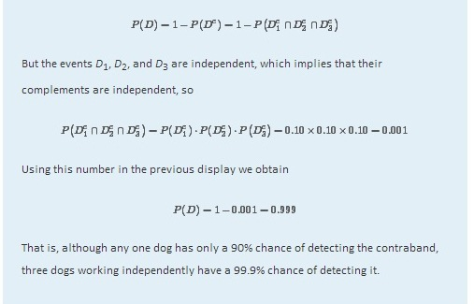

Probabilities on Tree Diagrams
Some probability problems are made much simpler when approached using a tree diagram. The next example illustrates how to place probabilities on a tree diagram and use it to solve a problem.

EXAMPLE 28
A jar contains 10 marbles, 7 black and 3 white. Two marbles are drawn without replacement, which means that the first one is not put back before the second one is drawn.

- What is the probability that both marbles are black?
- What is the probability that exactly one marble is black?
- What is the probability that at least one marble is black?
Solution:

A tree diagram for the situation of drawing one marble after the other without replacement is shown in Figure 3.6 "Tree Diagram for Drawing Two Marbles". The circle and rectangle will be explained later, and should be ignored for now.

Figure 3.6Tree Diagram for Drawing Two Marbles
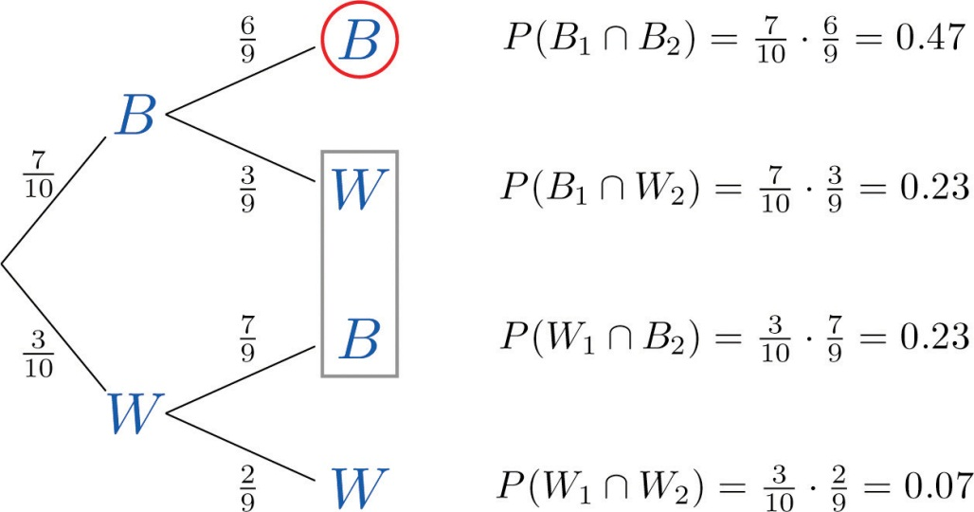
The numbers on the two leftmost branches are the probabilities of getting either a black marble, 7 out of 10, or a white marble, 3 out of 10, on the first draw. The number on each remaining branch is the probability of the event corresponding to the node on the right end of the branch occurring, given that the event corresponding to the node on the left end of the branch has occurred. Thus for the top branch, connecting the two Bs, it is P(B2|B1), where B₁ denotes the event “the first marble drawn is black” and B₂ denotes the event “the second marble drawn is black.” Since after drawing a black marble out there are 9 marbles left, of which 6 are black, this probability is 6/9.
The number to the right of each final node is computed as shown, using the principle that if the formula in the Conditional Rule for Probability is multiplied by P(B), then the result is

P(B ∩ A)=P(B)⋅P(A|B)
- The event “both marbles are black” is B₁ ∩ B₂ and corresponds to the top right node in the tree, which has been circled. Thus as indicated there, it is 0.47.

- The event “exactly one marble is black” corresponds to the two nodes of the tree enclosed by the rectangle. The events that correspond to these two nodes are mutually exclusive: black followed by white is incompatible with white followed by black. Thus in accordance with the Additive Rule for Probability we merely add the two probabilities next to these nodes, since what would be subtracted from the sum is zero. Thus the probability of drawing exactly one black marble in two tries is 0.23+0.23=0.46.
The event “at least one marble is black” corresponds to the three nodes of the tree enclosed by either the circle or the rectangle. The events that correspond to these nodes are mutually exclusive, so as in part (b) we merely add the probabilities next to these nodes. Thus the probability of drawing at least one black marble in two tries is 0.47+0.23+0.23=0.93.

Of course, this answer could have been found more easily using the Probability Law for Complements, simply subtracting the probability of the complementary event, “two white marbles are drawn,” from 1 to obtain 1−0.07=0.93.

As this example shows, finding the probability for each branch is fairly straightforward, since we compute it knowing everything that has happened in the sequence of steps so far. Two principles that are true in general emerge from this example:

Probabilities on Tree Diagrams

- The probability of the event corresponding to any node on a tree is the product of the numbers on the unique path of branches that leads to that node from the start.
- If an event corresponds to several final nodes, then its probability is obtained by adding the numbers next to those nodes.

KEY TAKEAWAYS
- A conditional probability is the probability that an event has occurred, taking into account additional information about the result of the experiment.
- A conditional probability can always be computed using the formula in the definition. Sometimes it can be computed by discarding part of the sample space.
- Two events A and B are independent if the probability P(A ∩ B) of their intersection A ∩ B is equal to the product P(A)⋅P(B) of their individual probabilities.
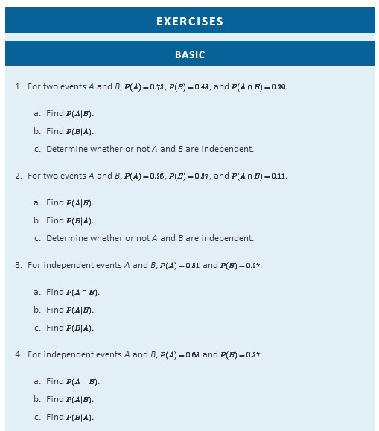
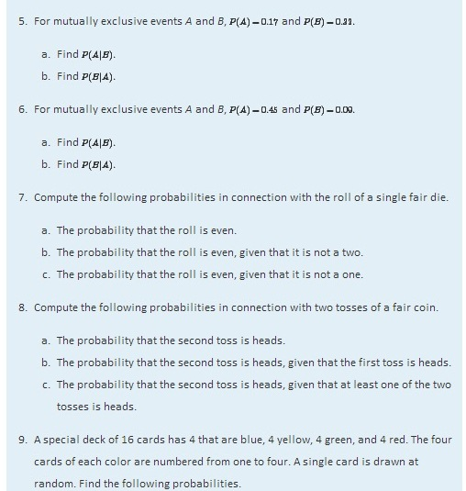
  - The probability that the card drawn is red.
  - The probability that the card is red, given that it is not green.
  - The probability that the card is red, given that it is neither red nor yellow.
  - The probability that the card is red, given that it is not a four.

- A special deck of 16 cards has 4 that are blue, 4 yellow, 4 green, and 4 red. The four cards of each color are numbered from one to four. A single card is drawn at random. Find the following probabilities.
  - The probability that the card drawn is a two or a four.
  - The probability that the card is a two or a four, given that it is not a one.
  - The probability that the card is a two or a four, given that it is either a two or a three.
  - The probability that the card is a two or a four, given that it is red or green.

- A random experiment gave rise to the two-way contingency table shown. Use it to compute the probabilities indicated.
 | R | S
A | 0.12 | 0.18
B | 0.28 | 0.42
  - P(A), P(R), P(A ∩ R).
  - Based on the answer to (a), determine whether or not the events A and R are independent.
  - Based on the answer to (b), determine whether or not P(A|R) can be predicted without any computation. If so, make the prediction. In any case, compute P(A|R)using the Rule for Conditional Probability.
- A random experiment gave rise to the two-way contingency table shown. Use it to compute the probabilities indicated.
 | R | S
A | 0.13 | 0.07
B | 0.61 | 0.19
  - P(A), P(R), P(A ∩ R).
  - Based on the answer to (a), determine whether or not the events A and R are independent.
  - Based on the answer to (b), determine whether or not P(A|R) can be predicted without any computation. If so, make the prediction. In any case, compute P(A|R)using the Rule for Conditional Probability.
- Suppose for events A and B in a random experiment P(A)=0.70 and P(B)=0.30.Compute the indicated probability, or explain why there is not enough information to do so.
  - P(A ∩ B).
  - P(A ∩ B), with the extra information that A and B are independent.
  - P(A ∩ B), with the extra information that A and B are mutually exclusive.
- Suppose for events A and B connected to some random experiment, P(A)=0.50 and P(B)=0.50. Compute the indicated probability, or explain why there is not enough information to do so.
  - P(A ∩ B).
  - P(A ∩ B), with the extra information that A and B are independent.
  - P(A ∩ B), with the extra information that A and B are mutually exclusive.
- Suppose for events A, B, and C connected to some random experiment, A, B, and C are independent and P(A)=0.88, P(B)=0.65, and P(C)=0.44. Compute the indicated probability, or explain why there is not enough information to do so.
  - P(A ∩B ∩ C)
  - P(A^{c} ∩ B ^{c}∩ C^{c})
- Suppose for events A, B, and C connected to some random experiment, A, B, and C are independent and P(A)=0.95, P(B)=0.73, and P(C)=0.62. Compute the indicated probability, or explain why there is not enough information to do so.
  - P(A ∩ B ∩ C)
  - P(A^{c} ∩ B^{c} ∩ C^{c})

APPLICATIONS
- The sample space that describes all three-child families according to the genders of the children with respect to birth order is
S={bbb,bbg,bgb,bgg,gbb,gbg,ggb,ggg}
In the experiment of selecting a three-child family at random, compute each of the following probabilities, assuming all outcomes are equally likely.
  - The probability that the family has at least two boys.
  - The probability that the family has at least two boys, given that not all of the children are girls.
  - The probability that at least one child is a boy.
  - The probability that at least one child is a boy, given that the first born is a girl.
- The following two-way contingency table gives the breakdown of the population in a particular locale according to age and number of vehicular moving violations in the past three years:
Age | Violations
 | 0 | 1 | 2+
Under 21 | 0.04 | 0.06 | 0.02
21–40 | 0.25 | 0.16 | 0.01
41–60 | 0.23 | 0.10 | 0.02
60+ | 0.08 | 0.03 | 0.00
A person is selected at random. Find the following probabilities.
  - The person is under 21.
  - The person has had at least two violations in the past three years.
  - The person has had at least two violations in the past three years, given that he is under 21.
  - The person is under 21, given that he has had at least two violations in the past three years.
  - Determine whether the events “the person is under 21” and “the person has had at least two violations in the past three years” are independent or not.
- The following two-way contingency table gives the breakdown of the population in a particular locale according to party affiliation (A, B, C, or None) and opinion on a bond issue:

Affiliation | Opinion
 | Favors | Opposes | Undecided
A | 0.12 | 0.09 | 0.07
B | 0.16 | 0.12 | 0.14
C | 0.04 | 0.03 | 0.06
None | 0.08 | 0.06 | 0.03
A person is selected at random. Find each of the following probabilities.
  - The person is in favor of the bond issue.
  - The person is in favor of the bond issue, given that he is affiliated with party A.
  - The person is in favor of the bond issue, given that he is affiliated with party B.
- The following two-way contingency table gives the breakdown of the population of patrons at a grocery store according to the number of items purchased and whether or not the patron made an impulse purchase at the checkout counter:
Number of Items | Impulse Purchase
 | Made | Not Made
Few | 0.01 | 0.19
Many | 0.04 | 0.76
A patron is selected at random. Find each of the following probabilities.
  - The patron made an impulse purchase.
  - The patron made an impulse purchase, given that the total number of items purchased was many.
  - Determine whether or not the events “few purchases” and “made an impulse purchase at the checkout counter” are independent.
- The following two-way contingency table gives the breakdown of the population of adults in a particular locale according to employment type and level of life insurance:
Employment Type | Level of Insurance
 | Low | Medium | High
Unskilled | 0.07 | 0.19 | 0.00
Semi-skilled | 0.04 | 0.28 | 0.08
Skilled | 0.03 | 0.18 | 0.05
Professional | 0.01 | 0.05 | 0.02
An adult is selected at random. Find each of the following probabilities.
  - The person has a high level of life insurance.
  - The person has a high level of life insurance, given that he does not have a professional position.
  - The person has a high level of life insurance, given that he has a professional position.
  - Determine whether or not the events “has a high level of life insurance” and “has a professional position” are independent.

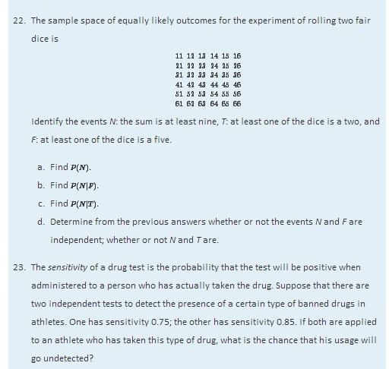
- A man has two lights in his well house to keep the pipes from freezing in winter. He checks the lights daily. Each light has probability 0.002 of burning out before it is checked the next day (independently of the other light).

  - If the lights are wired in parallel one will continue to shine even if the other burns out. In this situation, compute the probability that at least one light will continue to shine for the full 24 hours. Note the greatly increased reliability of the system of two bulbs over that of a single bulb.
  - If the lights are wired in series neither one will continue to shine even if only one of them burns out. In this situation, compute the probability that at least one light will continue to shine for the full 24 hours. Note the slightly decreased reliability of the system of two bulbs over that of a single bulb.
- An accountant has observed that 5% of all copies of a particular two-part form have an error in Part I, and 2% have an error in Part II. If the errors occur independently, find the probability that a randomly selected form will be error-free.

- A box contains 20 screws which are identical in size, but 12 of which are zinc coated and 8 of which are not. Two screws are selected at random, without replacement.

  - Find the probability that both are zinc coated.
  - Find the probability that at least one is zinc coated.

ADDITIONAL EXERCISES
- Events A and B are mutually exclusive. Find P(A|B).
- The city council of a particular city is composed of five members of party A, four members of party B, and three independents. Two council members are randomly selected to form an investigative committee.
  - Find the probability that both are from party A.
  - Find the probability that at least one is an independent.
  - Find the probability that the two have different party affiliations (that is, not both A, not both B, and not both independent).

- A basketball player makes 60% of the free throws that he attempts, except that if he has just tried and missed a free throw then his chances of making a second one go down to only 30%. Suppose he has just been awarded two free throws.
  - Find the probability that he makes both.
  - Find the probability that he makes at least one. (A tree diagram could help.)

- An economist wishes to ascertain the proportion p of the population of individual taxpayers who have purposely submitted fraudulent information on an income tax return. To truly guarantee anonymity of the taxpayers in a random survey, taxpayers questioned are given the following instructions.
    - Flip a coin.
    - If the coin lands heads, answer “Yes” to the question “Have you ever submitted fraudulent information on a tax return?” even if you have not.
    - If the coin lands tails, give a truthful “Yes” or “No” answer to the question “Have you ever submitted fraudulent information on a tax return?”

The questioner is not told how the coin landed, so he does not know if a “Yes” answer is the truth or is given only because of the coin toss.
  - Using the Probability Rule for Complements and the independence of the coin toss and the taxpayers’ status fill in the empty cells in the two-way contingency table shown. Assume that the coin is fair. Each cell except the two in the bottom row will contain the unknown proportion (or probability) p.

Status | Coin |  | Probability
 | H | T
Fraud |  |  | p
No fraud
Probability |  |  | 1
  - The only information that the economist sees are the entries in the following table:

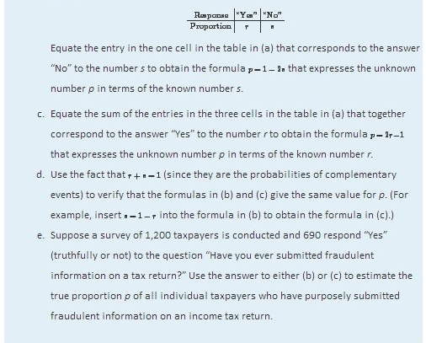
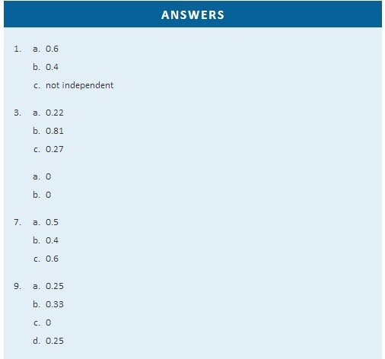
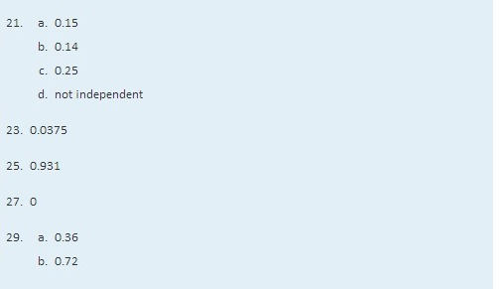

Chapter 4

Discrete Random Variables

It is often the case that a number is naturally associated to the outcome of a random experiment: the number of boys in a three-child family, the number of defective light bulbs in a case of 100 bulbs, the length of time until the next customer arrives at the drive-through window at a bank. Such a number varies from trial to trial of the corresponding experiment, and does so in a way that cannot be predicted with certainty; hence, it is called a random variable. In this chapter and the next we study such variables.

4.1 Random Variables

LEARNING OBJECTIVES
- To learn the concept of a random variable.
- To learn the distinction between discrete and continuous random variables.

Definition
A random variable is a numerical quantity that is generated by a random experiment.
We will denote random variables by capital letters, such as X or Z, and the actual values that they can take by lowercase letters, such as x and z.

Table 4.1 "Four Random Variables" gives four examples of random variables. In the second example, the three dots indicates that every counting number is a possible value for X. Although it is highly unlikely, for example, that it would take 50 tosses of the coin to observe heads for the first time, nevertheless it is conceivable, hence the number 50 is a possible value. The set of possible values is infinite, but is still at least countable, in the sense that all possible values can be listed one after another. In the last two examples, by way of contrast, the possible values cannot be individually listed, but take up a whole interval of numbers. In the fourth example, since the light bulb could conceivably continue to shine indefinitely, there is no natural greatest value for its lifetime, so we simply place the symbol ∞ for infinity as the right endpoint of the interval of possible values.

Table 4.1 Four Random Variables
Experiment | Number X | Possible Values of X
Roll two fair dice | Sum of the number of dots on the top faces | 2, 3, 4, 5, 6, 7, 8, 9, 10, 11, 12
Flip a fair coin repeatedly | Number of tosses until the coin lands heads | 1, 2, 3,4, …
Measure the voltage at an electrical outlet | Voltage measured | 118 ≤ x ≤ 122
Operate a light bulb until it burns out | Time until the bulb burns out | 0 ≤ x < ∞

Definition
A random variable is called discrete if it has either a finite or a countable number of possible values. A random variable is called continuous if its possible values contain a whole interval of numbers.

The examples in the table are typical in that discrete random variables typically arise from a counting process, whereas continuous random variables typically arise from a measurement.

KEY TAKEAWAYS
- A random variable is a number generated by a random experiment.
- A random variable is called discrete if its possible values form a finite or countable set.
- A random variable is called continuous if its possible values contain a whole interval of numbers.

EXERCISES

BASIC
- Classify each random variable as either discrete or continuous.
  - The number of arrivals at an emergency room between midnight and 6:00 a.m.
  - The weight of a box of cereal labeled “18 ounces.”
  - The duration of the next outgoing telephone call from a business office.
  - The number of kernels of popcorn in a 1-pound container.
  - The number of applicants for a job.
- Classify each random variable as either discrete or continuous.
  - The time between customers entering a checkout lane at a retail store.
  - The weight of refuse on a truck arriving at a landfill.
  - The number of passengers in a passenger vehicle on a highway at rush hour.
  - The number of clerical errors on a medical chart.
  - The number of accident-free days in one month at a factory.
- Classify each random variable as either discrete or continuous.
  - The number of boys in a randomly selected three-child family.
  - The temperature of a cup of coffee served at a restaurant.
  - The number of no-shows for every 100 reservations made with a commercial airline.
  - The number of vehicles owned by a randomly selected household.
  - The average amount spent on electricity each July by a randomly selected household in a certain state.
- Classify each random variable as either discrete or continuous.
  - The number of patrons arriving at a restaurant between 5:00 p.m. and 6:00 p.m.
  - The number of new cases of influenza in a particular county in a coming month.
  - The air pressure of a tire on an automobile.
  - The amount of rain recorded at an airport one day.
  - The number of students who actually register for classes at a university next semester.
- Identify the set of possible values for each random variable. (Make a reasonable estimate based on experience, where necessary.)
  - The number of heads in two tosses of a coin.
  - The average weight of newborn babies born in a particular county one month.
  - The amount of liquid in a 12-ounce can of soft drink.
  - The number of games in the next World Series (best of up to seven games).
  - The number of coins that match when three coins are tossed at once.
- Identify the set of possible values for each random variable. (Make a reasonable estimate based on experience, where necessary.)
- The number of hearts in a five-card hand drawn from a deck of 52 cards that contains 13 hearts in all.
- The number of pitches made by a starting pitcher in a major league baseball game.
- The number of breakdowns of city buses in a large city in one week.
- The distance a rental car rented on a daily rate is driven each day.
- The amount of rainfall at an airport next month.

ANSWERS
- a. discrete
  - continuous
  - continuous
  - discrete
  - discrete

  - discrete
  - continuous
  - discrete
  - discrete
  - continuous

  - {0.1.2}
  - an interval (a,b) (answers vary)
  - an interval (a,b) (answers vary)
  - {4,5,6,7}
  - {2,3}

4.2 Probability Distributions for Discrete Random Variables

LEARNING OBJECTIVES
- To learn the concept of the probability distribution of a discrete random variable.
- To learn the concepts of the mean, variance, and standard deviation of a discrete random variable, and how to compute them.

Probability Distributions
Associated to each possible value x of a discrete random variable X is the probability P(x) that X will take the value x in one trial of the experiment.

Definition
The probability distribution of a discrete random variable X is a list of each possible value of X together with the probability that X takes that value in one trial of the experiment.

The probabilities in the probability distribution of a random variable X must satisfy the following two conditions:
- Each probability P(x) must be between 0 and 1: 0≤P(x)≤1.
- The sum of all the probabilities is 1: ΣP(x)=1.
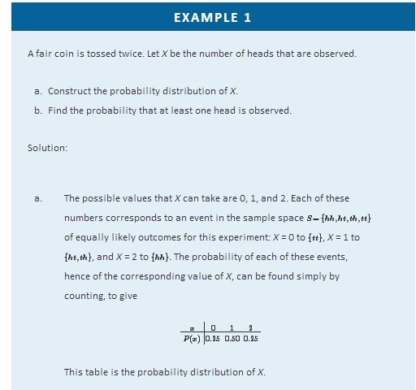
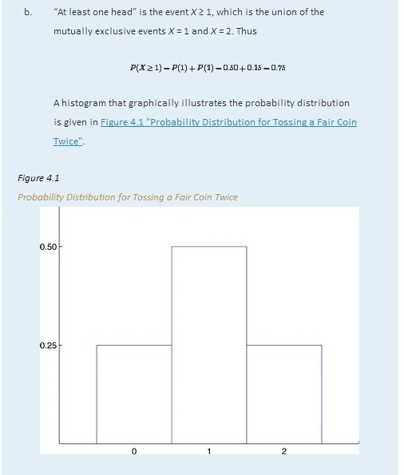
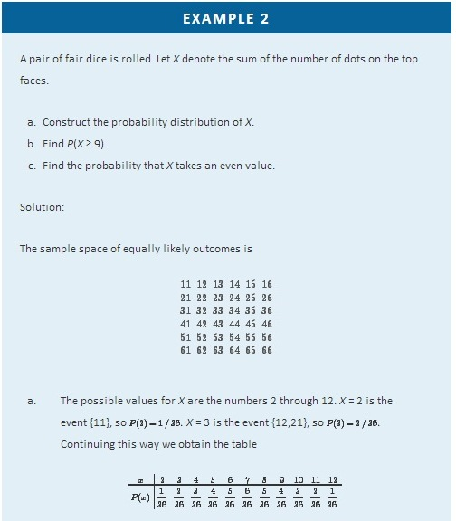
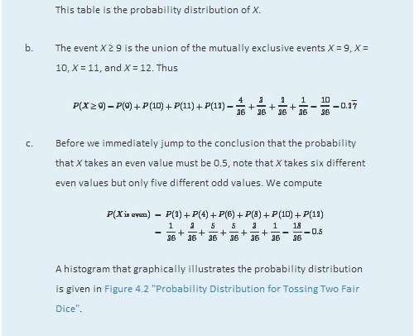
Figure 4.2Probability Distribution for Tossing Two Fair Dice
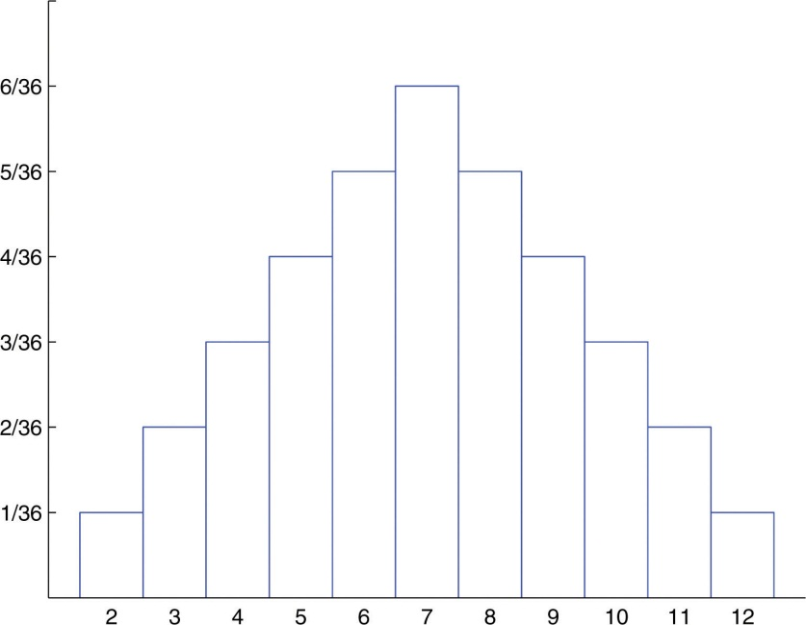

The Mean and Standard Deviation of a Discrete Random Variable

Definition
The mean (also called the expected value) of a discrete random variable X is the number
μ=E(X)=Σx P(x)
The mean of a random variable may be interpreted as the average of the values assumed by the random variable in repeated trials of the experiment.
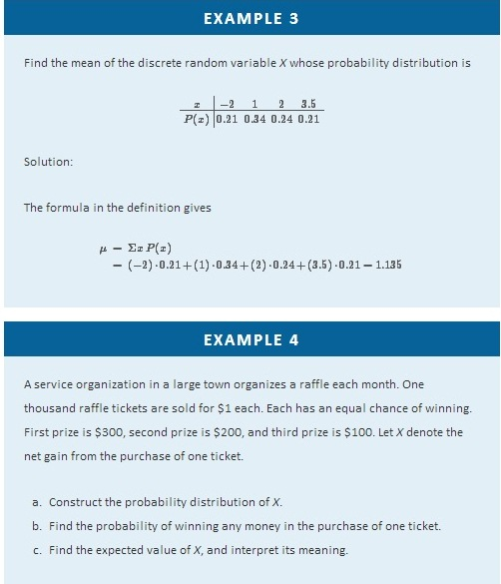
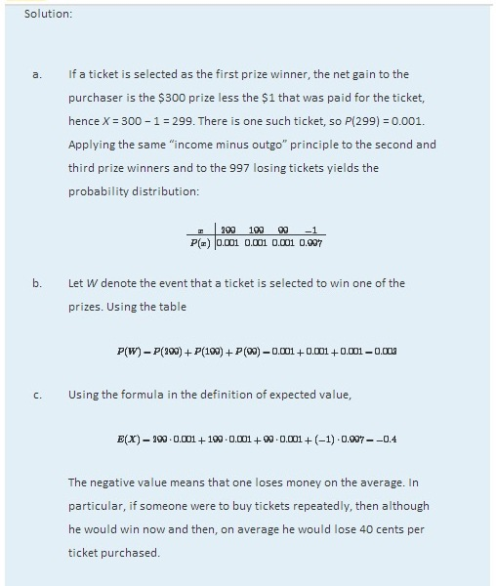

The concept of expected value is also basic to the insurance industry, as the following simplified example illustrates.

EXAMPLE 5
A life insurance company will sell a $200,000 one-year term life insurance policy to an individual in a particular risk group for a premium of $195. Find the expected value to the company of a single policy if a person in this risk group has a 99.97% chance of surviving one year.
Solution:

Let X denote the net gain to the company from the sale of one such policy. There are two possibilities: the insured person lives the whole year or the insured person dies before the year is up. Applying the “income minus outgo” principle, in the former case the value of X is 195 − 0; in the latter case it is 195−200,000=−199,805. Since the probability in the first case is 0.9997 and in the second case is 1−0.9997=0.0003, the probability distribution for X is:
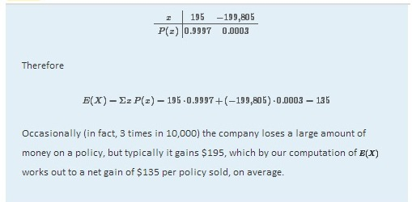
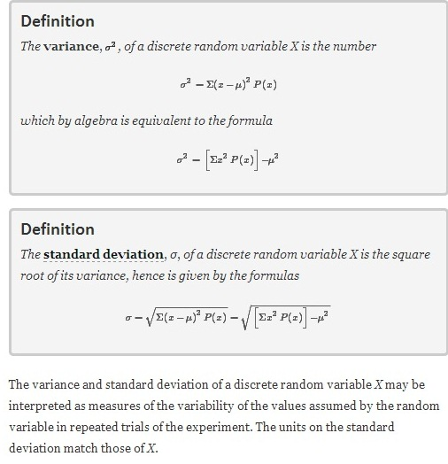
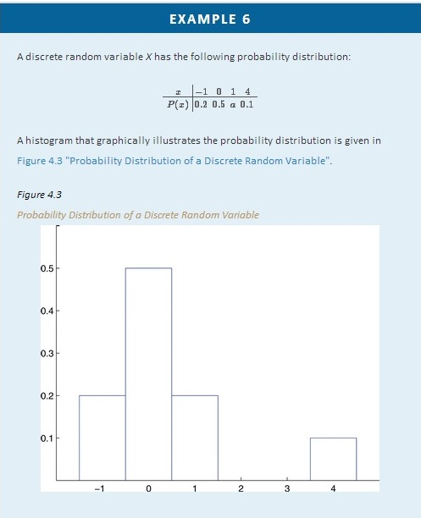

Compute each of the following quantities.
- a.
- P(0).
- P(X > 0).
- P(X ≥ 0).
- P(X≤−2).
- The mean μ of X.
- The variance σ2 of X.
- The standard deviation σ of X.
Solution:
- Since all probabilities must add up to 1, a=1−(0.2+0.5+0.1)=0.2.
- Directly from the table, P(0)=0.5.
- From the table, P(X>0)=P(1)+P(4)=0.2+0.1=0.3.
- From the table, P(X≥0)=P(0)+P(1)+P(4)=0.5+0.2+0.1=0.8.
- Since none of the numbers listed as possible values for X is less than or equal to −2, the event X ≤ −2 is impossible, so P(X ≤ −2) = 0.
- Using the formula in the definition of μ,
μ=Σx P(x)=(−1)⋅0.2+0⋅0.5+1⋅0.2+4⋅0.1=0.4
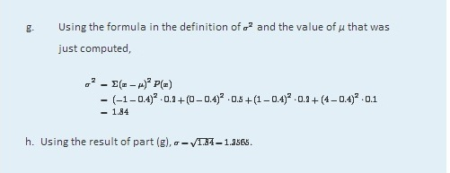

KEY TAKEAWAYS
- The probability distribution of a discrete random variable X is a listing of each possible value x taken by X along with the probability P(x) that X takes that value in one trial of the experiment.
- The mean μ of a discrete random variable X is a number that indicates the average value of X over numerous trials of the experiment. It is computed using the formula μ=Σx P(x).
- The variance σ2 and standard deviation σ of a discrete random variable X are numbers that indicate the variability of X over numerous trials of the experiment. They may be computed using the formula σ²=[Σx² P(x) ]−μ², taking the square root to obtain σ.
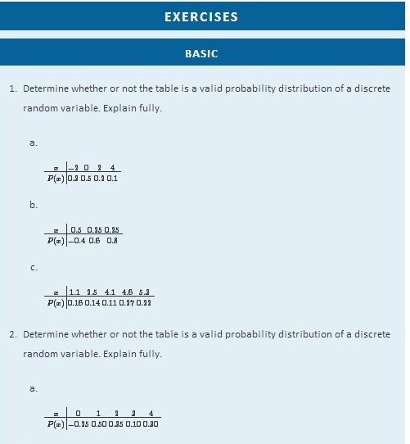
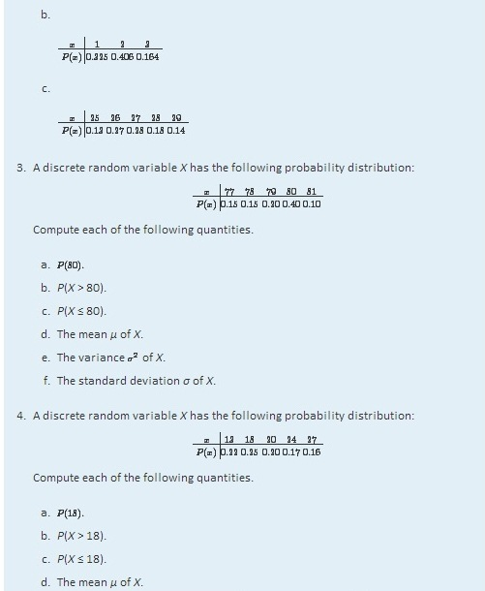
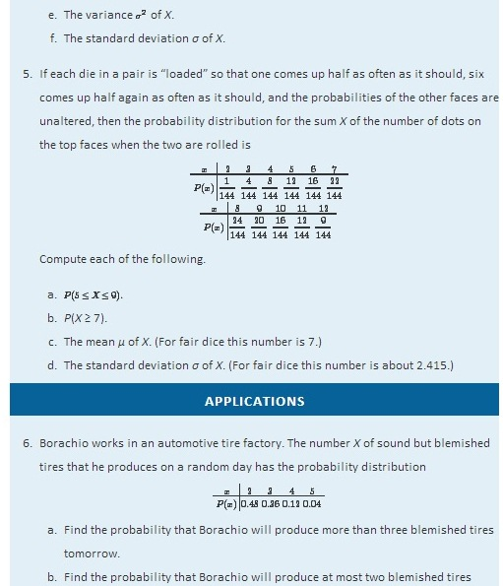
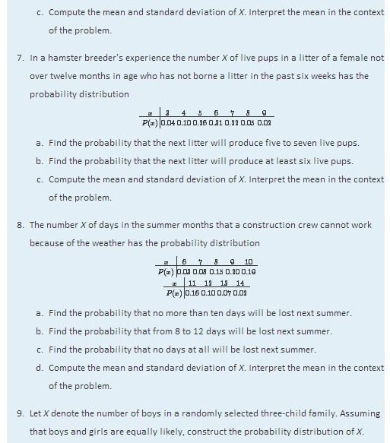
- Let X denote the number of times a fair coin lands heads in three tosses. Construct the probability distribution of X.
- Five thousand lottery tickets are sold for $1 each. One ticket will win $1,000, two tickets will win $500 each, and ten tickets will win $100 each. Let X denote the net gain from the purchase of a randomly selected ticket.
  - Construct the probability distribution of X.
  - Compute the expected value E(X) of X. Interpret its meaning.
  - Compute the standard deviation σ of X.
- Seven thousand lottery tickets are sold for $5 each. One ticket will win $2,000, two tickets will win $750 each, and five tickets will win $100 each. Let X denote the net gain from the purchase of a randomly selected ticket.
  - Construct the probability distribution of X.
  - Compute the expected value E(X) of X. Interpret its meaning.
  - Compute the standard deviation σ of X.
- An insurance company will sell a $90,000 one-year term life insurance policy to an individual in a particular risk group for a premium of $478. Find the expected value to the company of a single policy if a person in this risk group has a 99.62% chance of surviving one year.

- An insurance company will sell a $10,000 one-year term life insurance policy to an individual in a particular risk group for a premium of $368. Find the expected value to the company of a single policy if a person in this risk group has a 97.25% chance of surviving one year.

- An insurance company estimates that the probability that an individual in a particular risk group will survive one year is 0.9825. Such a person wishes to buy a $150,000 one-year term life insurance policy. Let C denote how much the insurance company charges such a person for such a policy.
  - Construct the probability distribution of X. (Two entries in the table will containC.)
  - Compute the expected value E(X) of X.
  - Determine the value C must have in order for the company to break even on all such policies (that is, to average a net gain of zero per policy on such policies).
  - Determine the value C must have in order for the company to average a net gain of $250 per policy on all such policies.
- An insurance company estimates that the probability that an individual in a particular risk group will survive one year is 0.99. Such a person wishes to buy a $75,000 one-year term life insurance policy. Let C denote how much the insurance company charges such a person for such a policy.
  - Construct the probability distribution of X. (Two entries in the table will containC.)
  - Compute the expected value E(X) of X.
  - Determine the value C must have in order for the company to break even on all such policies (that is, to average a net gain of zero per policy on such policies).
  - Determine the value C must have in order for the company to average a net gain of $150 per policy on all such policies.
- A roulette wheel has 38 slots. Thirty-six slots are numbered from 1 to 36; half of them are red and half are black. The remaining two slots are numbered 0 and 00 and are green. In a $1 bet on red, the bettor pays $1 to play. If the ball lands in a red slot, he receives back the dollar he bet plus an additional dollar. If the ball does not land on red he loses his dollar. Let X denote the net gain to the bettor on one play of the game.
  - Construct the probability distribution of X.
  - Compute the expected value E(X) of X, and interpret its meaning in the context of the problem.
  - Compute the standard deviation of X.
- A roulette wheel has 38 slots. Thirty-six slots are numbered from 1 to 36; the remaining two slots are numbered 0 and 00. Suppose the “number” 00 is considered not to be even, but the number 0 is still even. In a $1 bet on even, the bettor pays $1 to play. If the ball lands in an even numbered slot, he receives back the dollar he bet plus an additional dollar. If the ball does not land on an even numbered slot, he loses his dollar. Let X denote the net gain to the bettor on one play of the game.
  - Construct the probability distribution of X.
  - Compute the expected value E(X) of X, and explain why this game is not offered in a casino (where 0 is not considered even).
  - Compute the standard deviation of X.
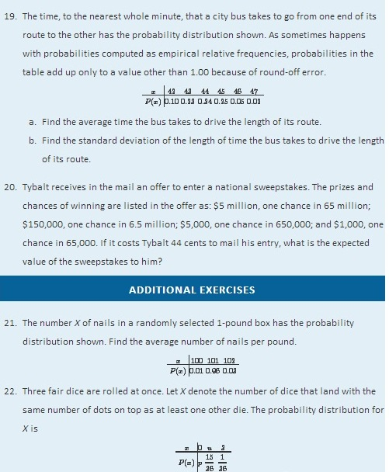

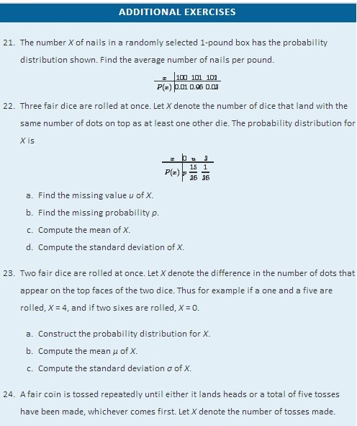
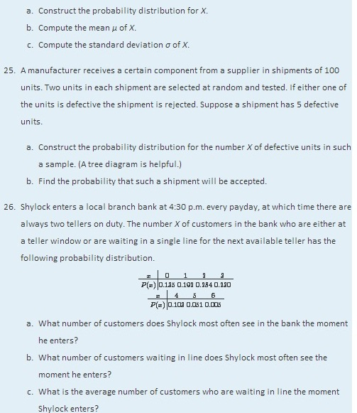
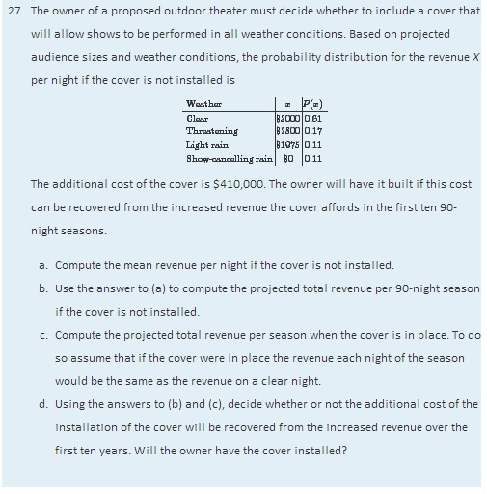
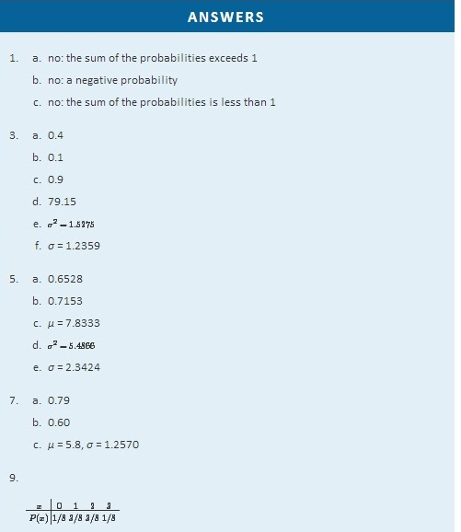
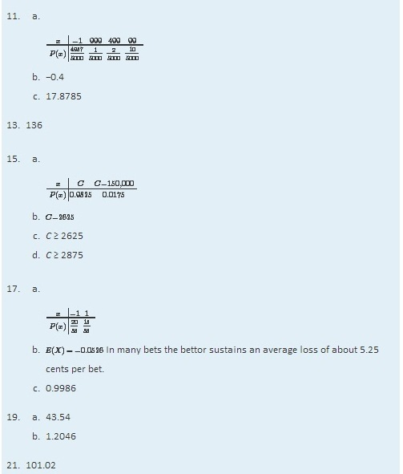
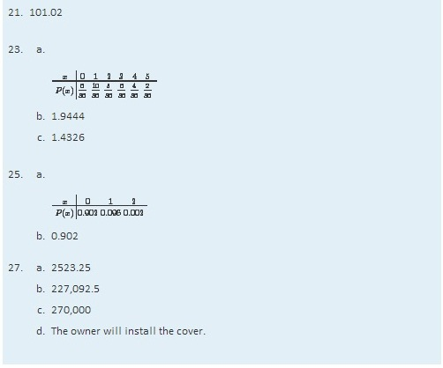

4.3 The Binomial Distribution

LEARNING OBJECTIVES
- To learn the concept of a binomial random variable.
- To learn how to recognize a random variable as being a binomial random variable.

The experiment of tossing a fair coin three times and the experiment of observing the genders according to birth order of the children in a randomly selected three-child family are completely different, but the random variables that count the number of heads in the coin toss and the number of boys in the family (assuming the two genders are equally likely) are the same random variable, the one with probability distribution

A histogram that graphically illustrates this probability distribution is given inFigure 4.4 "Probability Distribution for Three Coins and Three Children". What is common to the two experiments is that we perform three identical and independent trials of the same action, each trial has only two outcomes (heads or tails, boy or girl), and the probability of success is the same number, 0.5, on every trial. The random variable that is generated is called the binomial random variable with parameters n = 3 and p = 0.5. This is just one case of a general situation.
Figure 4.4 Probability Distribution for Three Coins and Three Children
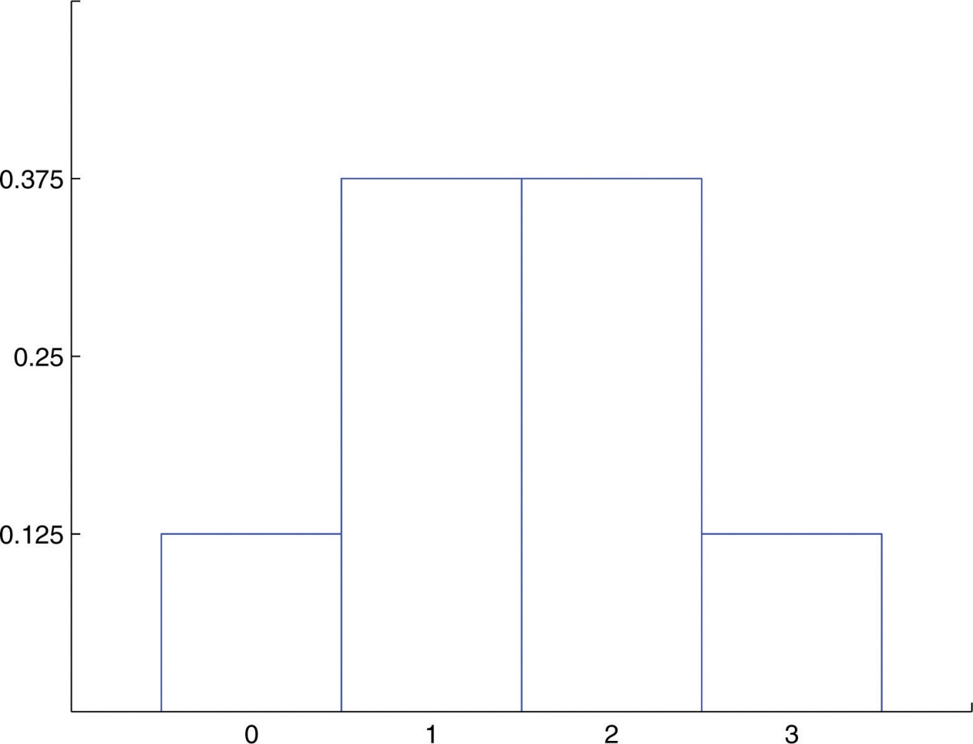

Definition

Suppose a random experiment has the following characteristics.
- There are n identical and independent trials of a common procedure.
- There are exactly two possible outcomes for each trial, one termed “success” and the other “failure.”
- The probability of success on any one trial is the same number p.
Then the discrete random variable X that counts the number of successes in the n trials is the binomial random variable with parameters nand p. We also say that X has a binomial distribution with parameters n and p.

The following four examples illustrate the definition. Note how in every case “success” is the outcome that is counted, not the outcome that we prefer or think is better in some sense.
- A random sample of 125 students is selected from a large college in which the proportion of students who are females is 57%. Suppose X denotes the number of female students in the sample. In this situation there are n = 125 identical and independent trials of a common procedure, selecting a student at random; there are exactly two possible outcomes for each trial, “success” (what we are counting, that the student be female) and “failure;” and finally the probability of success on any one trial is the same number p= 0.57. X is a binomial random variable with parameters n = 125 and p = 0.57.
- A multiple-choice test has 15 questions, each of which has five choices. An unprepared student taking the test answers each of the questions completely randomly by choosing an arbitrary answer from the five provided. Suppose X denotes the number of answers that the student gets right. X is a binomial random variable with parameters n = 15 and p=1/5=0.20.
- In a survey of 1,000 registered voters each voter is asked if he intends to vote for a candidate Titania Queen in the upcoming election. Suppose X denotes the number of voters in the survey who intend to vote for Titania Queen. X is a binomial random variable with n = 1000 and p equal to the true proportion of voters (surveyed or not) who intend to vote for Titania Queen.
- An experimental medication was given to 30 patients with a certain medical condition. Suppose X denotes the number of patients who develop severe side effects. X is a binomial random variable with n = 30 and p equal to the true probability that a patient with the underlying condition will experience severe side effects if given that medication.

Probability Formula for a Binomial Random Variable

Often the most difficult aspect of working a problem that involves the binomial random variable is recognizing that the random variable in question has a binomial distribution. Once that is known, probabilities can be computed using the following formula.
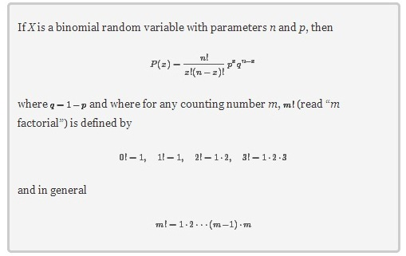
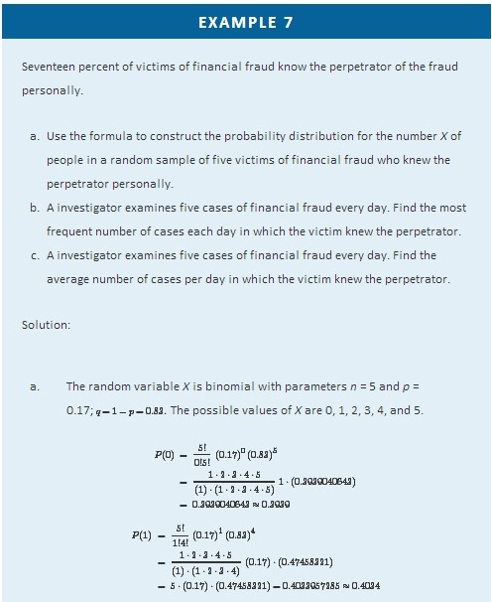
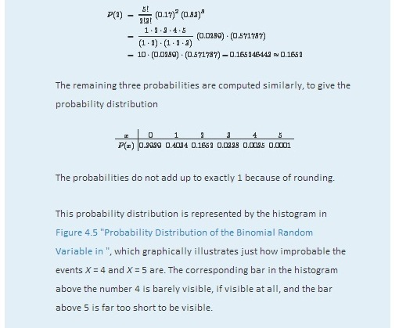
Figure 4.5Probability Distribution of the Binomial Random Variable in Note 4.29 "Example 7"
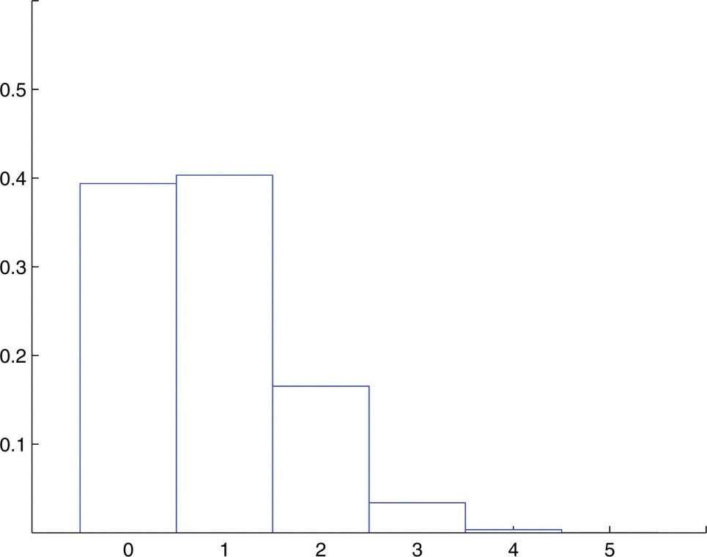
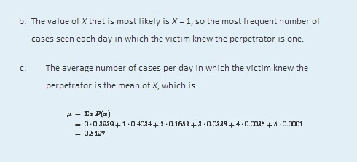

Special Formulas for the Mean and Standard Deviation of a Binomial Random Variable
Since a binomial random variable is a discrete random variable, the formulas for its mean, variance, and standard deviation given in the previous section apply to it, as we just saw in Note 4.29 "Example 7" in the case of the mean. However, for the binomial random variable there are much simpler formulas.
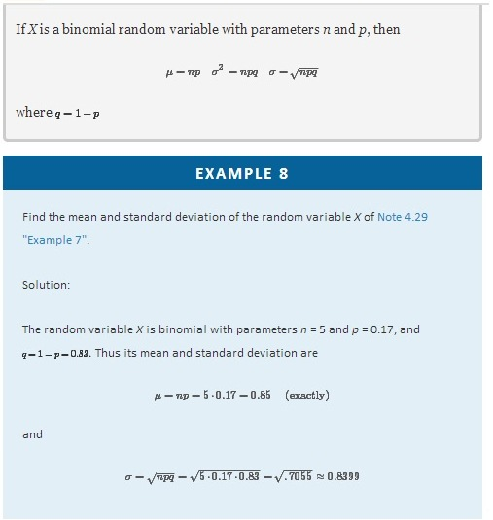

The Cumulative Probability Distribution of a Binomial Random Variable

In order to allow a broader range of more realistic problems Chapter 12 "Appendix" contains probability tables for binomial random variables for various choices of the parameters n and p. These tables are not the probability distributions that we have seen so far, but are cumulative probability distributions. In the place of the probability P(x) the table contains the probability

P(X≤x)=P(0)+P(1)+ ⋅ ⋅ ⋅ +P(x)
This is illustrated in Figure 4.6 "Cumulative Probabilities". The probability entered in the table corresponds to the area of the shaded region. The reason for providing a cumulative table is that in practical problems that involve a binomial random variable typically the probability that is sought is of the form P(X≤x) or P(X≥x). The cumulative table is much easier to use for computing P(X≤x) since all the individual probabilities have already been computed and added. The one table suffices for both P(X≤x) or P(X≥x) and can be used to readily obtain probabilities of the form P(x), too, because of the following formulas. The first is just the Probability Rule for Complements.
Figure 4.6 Cumulative Probabilities
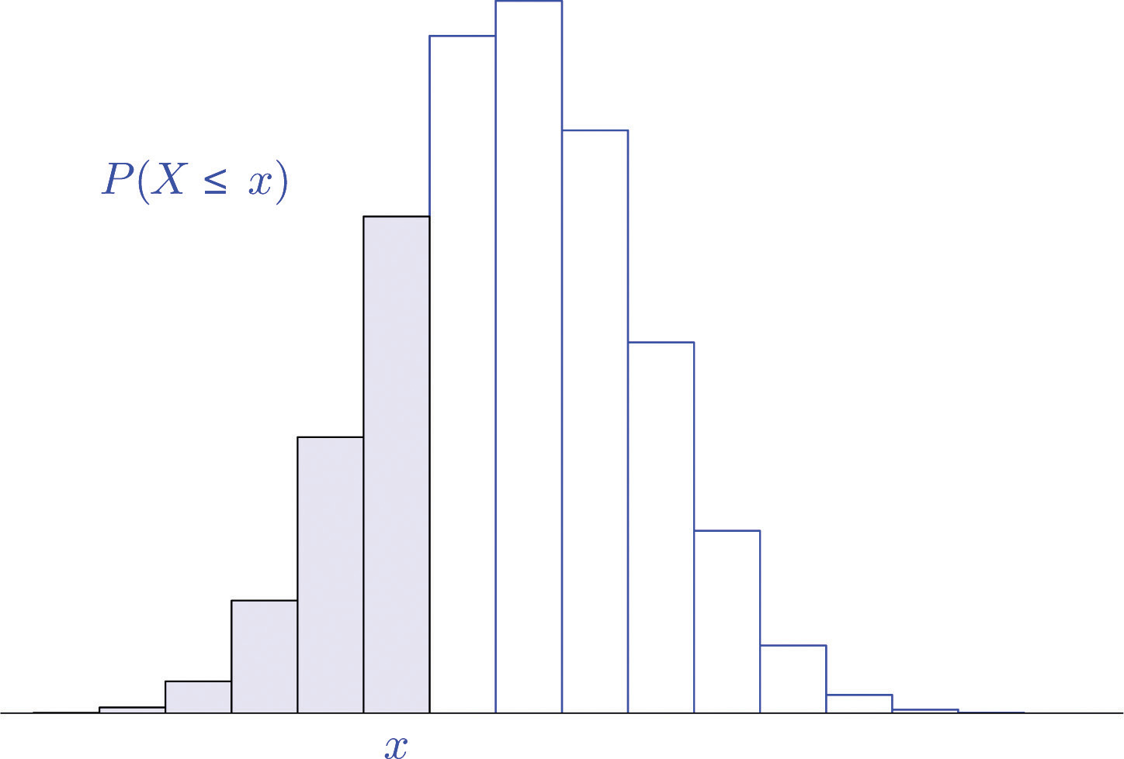
If X is a discrete random variable, then

P(X≥x)=1−P(X≤x−1) and P(x)=P(X≤x)−P(X≤x−1)
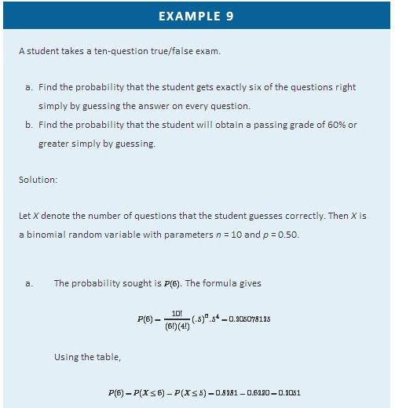

  - The student must guess correctly on at least 60% of the questions, which is 0.60⋅10=6 questions. The probability sought is not P(6) (an easy mistake to make), but
P(X≥6)=P(6)+P(7)+P(8)+P(9)+P(10)
Instead of computing each of these five numbers using the formula and adding them we can use the table to obtain
P(X≥6)=1−P(X≤5)=1−0.6230=0.3770
which is much less work and of sufficient accuracy for the situation at hand.

EXAMPLE 10
An appliance repairman services five washing machines on site each day. One-third of the service calls require installation of a particular part.
- The repairman has only one such part on his truck today. Find the probability that the one part will be enough today, that is, that at most one washing machine he services will require installation of this particular part.
- Find the minimum number of such parts he should take with him each day in order that the probability that he have enough for the day's service calls is at least 95%.
Solution:
Let X denote the number of service calls today on which the part is required. ThenX is a binomial random variable with parameters n = 5 and p=1/3=0.3^−.
- Note that the probability in question is not P(1), but rather P(X ≤ 1). Using the cumulative distribution table in Chapter 12 "Appendix",
P(X≤1)=0.4609
- The answer is the smallest number x such that the table entry P(X≤x) is at least 0.9500. Since P(X≤2)=0.7901 is less than 0.95, two parts are not enough. Since P(X≤3)=0.9547 is as large as 0.95, three parts will suffice at least 95% of the time. Thus the minimum needed is three.

KEY TAKEAWAYS
- The discrete random variable X that counts the number of successes in n identical, independent trials of a procedure that always results in either of two outcomes, “success” or “failure,” and in which the probability of success on each trial is the same number p, is called the binomial random variable with parameters n and p.
- There is a formula for the probability that the binomial random variable with parameters n and p will take a particular value x.
- There are special formulas for the mean, variance, and standard deviation of the binomial random variable with parameters n and p that are much simpler than the general formulas that apply to all discrete random variables.
- Cumulative probability distribution tables, when available, facilitate computation of probabilities encountered in typical practical situations.

BASIC
- Determine whether or not the random variable X is a binomial random variable. If so, give the values of n and p. If not, explain why not.
  - X is the number of dots on the top face of fair die that is rolled.
  - X is the number of hearts in a five-card hand drawn (without replacement) from a well-shuffled ordinary deck.
  - X is the number of defective parts in a sample of ten randomly selected parts coming from a manufacturing process in which 0.02% of all parts are defective.
  - X is the number of times the number of dots on the top face of a fair die is even in six rolls of the die.
  - X is the number of dice that show an even number of dots on the top face when six dice are rolled at once.
- Determine whether or not the random variable X is a binomial random variable. If so, give the values of n and p. If not, explain why not.
  - X is the number of black marbles in a sample of 5 marbles drawn randomly and without replacement from a box that contains 25 white marbles and 15 black marbles.
  - X is the number of black marbles in a sample of 5 marbles drawn randomly and with replacement from a box that contains 25 white marbles and 15 black marbles.
  - X is the number of voters in favor of proposed law in a sample 1,200 randomly selected voters drawn from the entire electorate of a country in which 35% of the voters favor the law.
  - X is the number of fish of a particular species, among the next ten landed by a commercial fishing boat, that are more than 13 inches in length, when 17% of all such fish exceed 13 inches in length.
  - X is the number of coins that match at least one other coin when four coins are tossed at once.
- X is a binomial random variable with parameters n = 12 and p = 0.82. Compute the probability indicated.
  - P(11)
  - P(9)
  - P(0)
  - P(13)
- X is a binomial random variable with parameters n = 16 and p = 0.74. Compute the probability indicated.
  - P(14)
  - P(4)
  - P(0)
  - P(20)
- X is a binomial random variable with parameters n = 5, p = 0.5. Use the tables inChapter 12 "Appendix" to compute the probability indicated.
  - P(X ≤ 3)
  - P(X ≥ 3)
  - P(3)
  - P(0)
  - P(5)
- X is a binomial random variable with parameters n = 5, p=0.3^−. Use the table inChapter 12 "Appendix" to compute the probability indicated.
  - P(X ≤ 2)
  - P(X ≥ 2)
  - P(2)
  - P(0)
  - P(5)
- X is a binomial random variable with the parameters shown. Use the tables inChapter 12 "Appendix" to compute the probability indicated.
  - n = 10, p = 0.25, P(X ≤ 6)
  - n = 10, p = 0.75, P(X ≤ 6)
  - n = 15, p = 0.75, P(X ≤ 6)
  - n = 15, p = 0.75, P(12)
  - n = 15, p=0.6−, P(10≤X≤12)
- X is a binomial random variable with the parameters shown. Use the tables in Chapter 12 "Appendix" to compute the probability indicated.
  - n = 5, p = 0.05, P(X ≤ 1)
  - n = 5, p = 0.5, P(X ≤ 1)
  - n = 10, p = 0.75, P(X ≤ 5)
  - n = 10, p = 0.75, P(12)
  - n = 10, p=0.6−, P(5≤X≤8)

- X is a binomial random variable with the parameters shown. Use the special formulas to compute its mean μ and standard deviation σ.
  - n = 8, p = 0.43
  - n = 47, p = 0.82
  - n = 1200, p = 0.44
  - n = 2100, p = 0.62
- X is a binomial random variable with the parameters shown. Use the special formulas to compute its mean μ and standard deviation σ.
  - n = 14, p = 0.55
  - n = 83, p = 0.05
  - n = 957, p = 0.35
  - n = 1750, p = 0.79

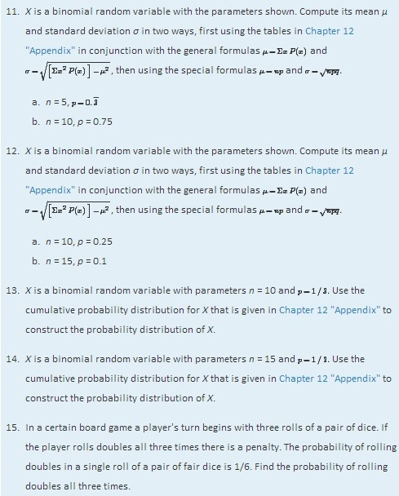
- A coin is bent so that the probability that it lands heads up is 2/3. The coin is tossed ten times.
  - Find the probability that it lands heads up at most five times.
  - Find the probability that it lands heads up more times than it lands tails up.

APPLICATIONS
- An English-speaking tourist visits a country in which 30% of the population speaks English. He needs to ask someone directions.
  - Find the probability that the first person he encounters will be able to speak English.
  - The tourist sees four local people standing at a bus stop. Find the probability that at least one of them will be able to speak English.
- The probability that an egg in a retail package is cracked or broken is 0.025.
  - Find the probability that a carton of one dozen eggs contains no eggs that are either cracked or broken.
  - Find the probability that a carton of one dozen eggs has (i) at least one that is either cracked or broken; (ii) at least two that are cracked or broken.
  - Find the average number of cracked or broken eggs in one dozen cartons.
- An appliance store sells 20 refrigerators each week. Ten percent of all purchasers of a refrigerator buy an extended warranty. Let X denote the number of the next 20 purchasers who do so.
  - Verify that X satisfies the conditions for a binomial random variable, and find n and p.
  - Find the probability that X is zero.
  - Find the probability that X is two, three, or four.
  - Find the probability that X is at least five.
- Adverse growing conditions have caused 5% of grapefruit grown in a certain region to be of inferior quality. Grapefruit are sold by the dozen.
  - Find the average number of inferior quality grapefruit per box of a dozen.
  - A box that contains two or more grapefruit of inferior quality will cause a strong adverse customer reaction. Find the probability that a box of one dozen grapefruit will contain two or more grapefruit of inferior quality.
- The probability that a 7-ounce skein of a discount worsted weight knitting yarn contains a knot is 0.25. Goneril buys ten skeins to crochet an afghan.
  - Find the probability that (i) none of the ten skeins will contain a knot; (ii) at most one will.
  - Find the expected number of skeins that contain knots.
  - Find the most likely number of skeins that contain knots.
- One-third of all patients who undergo a non-invasive but unpleasant medical test require a sedative. A laboratory performs 20 such tests daily. Let X denote the number of patients on any given day who require a sedative.
  - Verify that X satisfies the conditions for a binomial random variable, and find n and p.
  - Find the probability that on any given day between five and nine patients will require a sedative (include five and nine).
  - Find the average number of patients each day who require a sedative.
  - Using the cumulative probability distribution for X in Chapter 12 "Appendix", find the minimum number x min of doses of the sedative that should be on hand at the start of the day so that there is a 99% chance that the laboratory will not run out.
- About 2% of alumni give money upon receiving a solicitation from the college or university from which they graduated. Find the average number monetary gifts a college can expect from every 2,000 solicitations it sends.
- Of all college students who are eligible to give blood, about 18% do so on a regular basis. Each month a local blood bank sends an appeal to give blood to 250 randomly selected students. Find the average number of appeals in such mailings that are made to students who already give blood.
- About 12% of all individuals write with their left hands. A class of 130 students meets in a classroom with 130 individual desks, exactly 14 of which are constructed for people who write with their left hands. Find the probability that exactly 14 of the students enrolled in the class write with their left hands.
- A travelling salesman makes a sale on 65% of his calls on regular customers. He makes four sales calls each day.
  - Construct the probability distribution of X, the number of sales made each day.
  - Find the probability that, on a randomly selected day, the salesman will make a sale.
  - Assuming that the salesman makes 20 sales calls per week, find the mean and standard deviation of the number of sales made per week.
- A corporation has advertised heavily to try to insure that over half the adult population recognizes the brand name of its products. In a random sample of 20 adults, 14 recognized its brand name. What is the probability that 14 or more people in such a sample would recognize its brand name if the actual proportion p of all adults who recognize the brand name were only 0.50?

ADDITIONAL EXERCISES
- When dropped on a hard surface a thumbtack lands with its sharp point touching the surface with probability 2/3; it lands with its sharp point directed up into the air with probability 1/3. The tack is dropped and its landing position observed 15 times.
  - Find the probability that it lands with its point in the air at least 7 times.
  - If the experiment of dropping the tack 15 times is done repeatedly, what is the average number of times it lands with its point in the air?
- A professional proofreader has a 98% chance of detecting an error in a piece of written work (other than misspellings, double words, and similar errors that are machine detected). A work contains four errors.
  - Find the probability that the proofreader will miss at least one of them.
  - Show that two such proofreaders working independently have a 99.96% chance of detecting an error in a piece of written work.
  - Find the probability that two such proofreaders working independently will miss at least one error in a work that contains four errors.
- A multiple choice exam has 20 questions; there are four choices for each question.
  - A student guesses the answer to every question. Find the chance that he guesses correctly between four and seven times.
  - Find the minimum score the instructor can set so that the probability that a student will pass just by guessing is 20% or less.
- In spite of the requirement that all dogs boarded in a kennel be inoculated, the chance that a healthy dog boarded in a clean, well-ventilated kennel will develop kennel cough from a carrier is 0.008.
  - If a carrier (not known to be such, of course) is boarded with three other dogs, what is the probability that at least one of the three healthy dogs will develop kennel cough?
  - If a carrier is boarded with four other dogs, what is the probability that at least one of the four healthy dogs will develop kennel cough?
  - The pattern evident from parts (a) and (b) is that if K+1 dogs are boarded together, one a carrier and K healthy dogs, then the probability that at least one of the healthy dogs will develop kennel cough is P(X≥1)=1−(0.992)^{K}, where X is the binomial random variable that counts the number of healthy dogs that develop the condition. Experiment with different values of K in this formula to find the maximum number K+1 of dogs that a kennel owner can board together so that if one of the dogs has the condition, the chance that another dog will be infected is less than 0.05.
- Investigators need to determine which of 600 adults have a medical condition that affects 2% of the adult population. A blood sample is taken from each of the individuals.
  - Show that the expected number of diseased individuals in the group of 600 is 12 individuals.
  - Instead of testing all 600 blood samples to find the expected 12 diseased individuals, investigators group the samples into 60 groups of 10 each, mix a little of the blood from each of the 10 samples in each group, and test each of the 60 mixtures. Show that the probability that any such mixture will contain the blood of at least one diseased person, hence test positive, is about 0.18.
  - Based on the result in (b), show that the expected number of mixtures that test positive is about 11. (Supposing that indeed 11 of the 60 mixtures test positive, then we know that none of the 490 persons whose blood was in the remaining 49 samples that tested negative has the disease. We have eliminated 490 persons from our search while performing only 60 tests.)
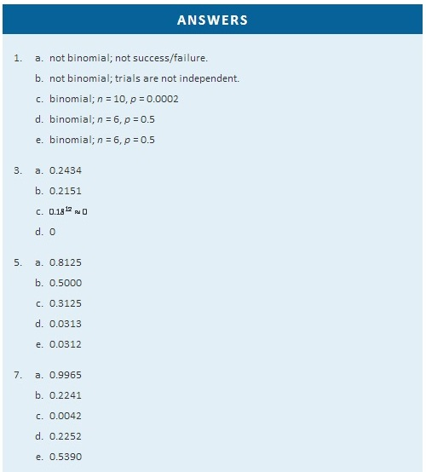
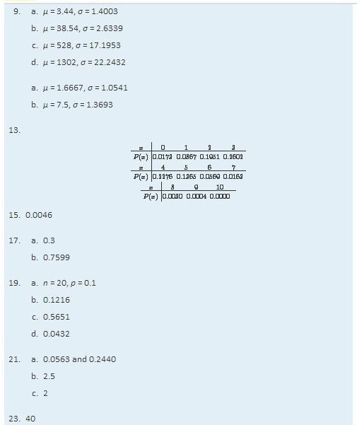

Chapter 5

Continuous Random Variables

As discussed in Section 4.1 "Random Variables" in Chapter 4 "Discrete Random Variables", a random variable is called continuous if its set of possible values contains a whole interval of decimal numbers. In this chapter we investigate such random variables.

5.1 Continuous Random Variables

LEARNING OBJECTIVES
- To learn the concept of the probability distribution of a continuous random variable, and how it is used to compute probabilities.
- To learn basic facts about the family of normally distributed random variables.

The Probability Distribution of a Continuous Random Variable
For a discrete random variable X the probability that X assumes one of its possible values on a single trial of the experiment makes good sense. This is not the case for a continuous random variable. For example, suppose X denotes the length of time a commuter just arriving at a bus stop has to wait for the next bus. If buses run every 30 minutes without fail, then the set of possible values of X is the interval denoted [0,30], the set of all decimal numbers between 0 and 30. But although the number 7.211916 is a possible value of X, there is little or no meaning to the concept of the probability that the commuter will wait precisely 7.211916 minutes for the next bus. If anything the probability should be zero, since if we could meaningfully measure the waiting time to the nearest millionth of a minute it is practically inconceivable that we would ever get exactly 7.211916 minutes. More meaningful questions are those of the form: What is the probability that the commuter's waiting time is less than 10 minutes, or is between 5 and 10 minutes? In other words, with continuous random variables one is concerned not with the event that the variable assumes a single particular value, but with the event that the random variable assumes a value in a particular interval.

Definition

The probability distribution of a continuous random variable X is an assignment of probabilities to intervals of decimal numbers using a function f(x), called a density function, in the following way: the probability that X assumes a value in the interval [a,b] is equal to the area of the region that is bounded above by the graph of the equation y=f(x),bounded below by the x-axis, and bounded on the left and right by the vertical lines through a and b, as illustrated in Figure 5.1 "Probability Given as Area of a Region under a Curve".
Figure 5.1Probability Given as Area of a Region under a Curve
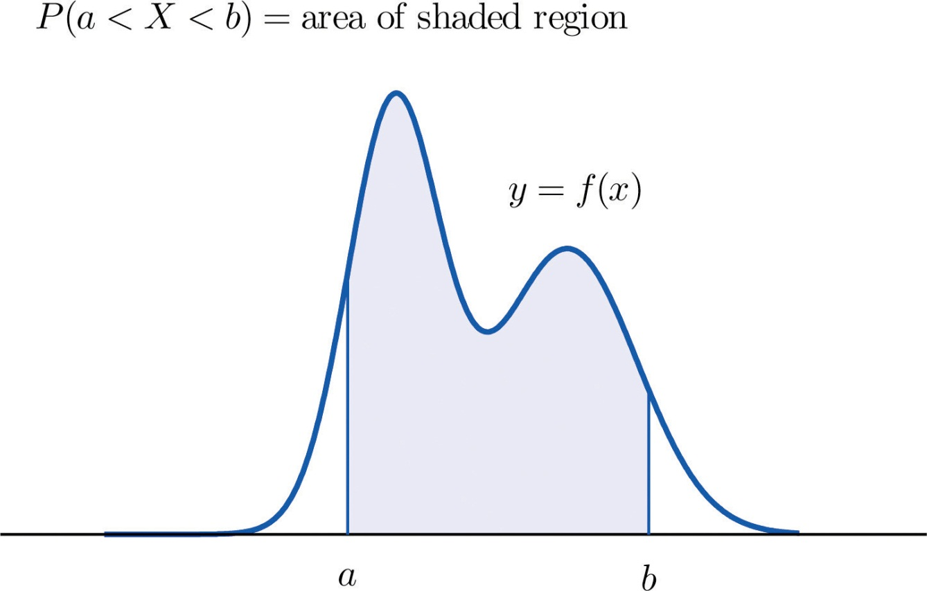
This definition can be understood as a natural outgrowth of the discussion inSection 2.1.3 "Relative Frequency Histograms" in Chapter 2 "Descriptive Statistics". There we saw that if we have in view a population (or a very large sample) and make measurements with greater and greater precision, then as the bars in the relative frequency histogram become exceedingly fine their vertical sides merge and disappear, and what is left is just the curve formed by their tops, as shown in Figure 2.5 "Sample Size and Relative Frequency Histograms" in Chapter 2 "Descriptive Statistics". Moreover the total area under the curve is 1, and the proportion of the population with measurements between two numbersa and b is the area under the curve and between a and b, as shown in Figure 2.6 "A Very Fine Relative Frequency Histogram" in Chapter 2 "Descriptive Statistics". If we think of X as a measurement to infinite precision arising from the selection of any one member of the population at random, then P(a<X<b)is simply the proportion of the population with measurements between a and b, the curve in the relative frequency histogram is the density function for X, and we arrive at the definition just above.

Every density function f(x) must satisfy the following two conditions:

- For all numbers x, f(x)≥0, so that the graph of y=f(x) never drops below the x-axis.
- The area of the region under the graph of y=f(x) and above the x-axis is 1.
Because the area of a line segment is 0, the definition of the probability distribution of a continuous random variable implies that for any particular decimal number, say a, the probability that X assumes the exact value a is 0. This property implies that whether or not the endpoints of an interval are included makes no difference concerning the probability of the interval.
For any continuous random variable X:

P(a≤X≤b)=P(a<X≤b)=P(a≤X<b)=P(a<X<b)

EXAMPLE 1
A random variable X has the uniform distribution on the interval [0,1]: the density function is f(x)=1 if x is between 0 and 1 and f(x)=0 for all other values of x, as shown in Figure 5.2 "Uniform Distribution on ".
Figure 5.2Uniform Distribution on [0,1]
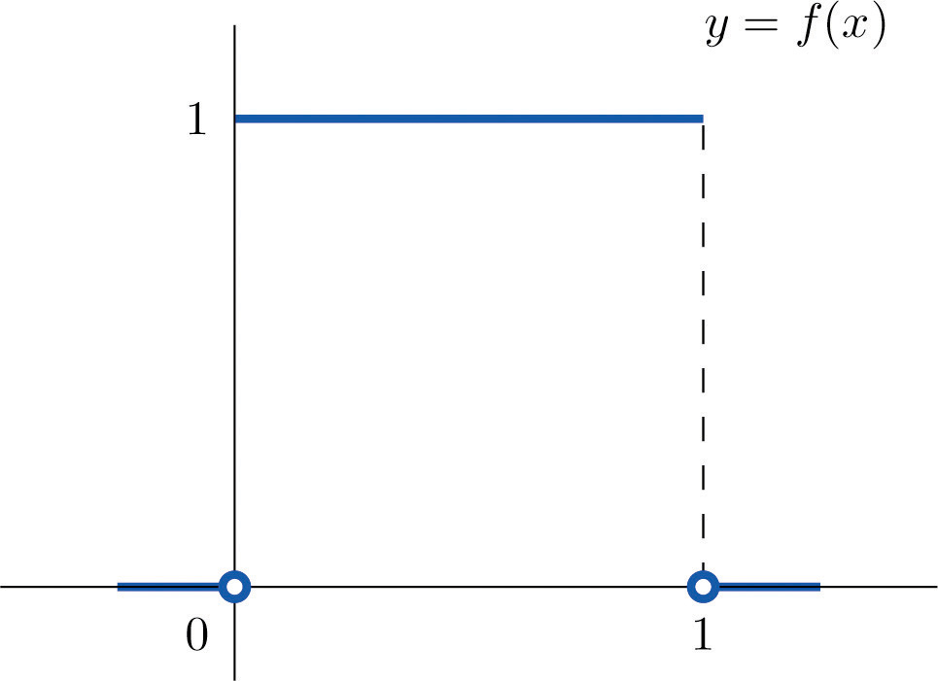
- Find P(X > 0.75), the probability that X assumes a value greater than 0.75.
- Find P(X ≤ 0.2), the probability that X assumes a value less than or equal to 0.2.
- Find P(0.4 < X < 0.7), the probability that X assumes a value between 0.4 and 0.7.
Solution:
- P(X > 0.75) is the area of the rectangle of height 1 and base length 1−0.75=0.25, hence is base×height=(0.25)⋅(1)=0.25. See Figure 5.3 "Probabilities from the Uniform Distribution on "(a).
- P(X ≤ 0.2) is the area of the rectangle of height 1 and base length 0.2−0=0.2, hence is base×height=(0.2)⋅(1)=0.2. See Figure 5.3 "Probabilities from the Uniform Distribution on "(b).
- P(0.4 < X < 0.7) is the area of the rectangle of height 1 and length 0.7−0.4=0.3, hence is base×height=(0.3)⋅(1)=0.3. See Figure 5.3 "Probabilities from the Uniform Distribution on "(c).
Figure 5.3Probabilities from the Uniform Distribution on [0,1]
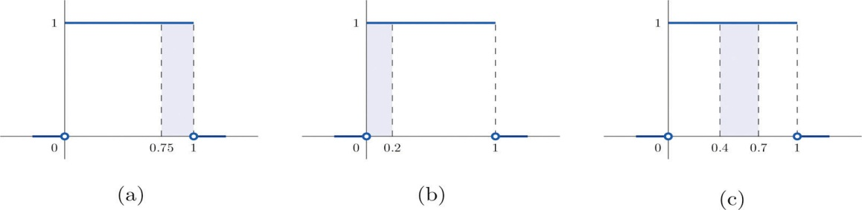

EXAMPLE 2
A man arrives at a bus stop at a random time (that is, with no regard for the scheduled service) to catch the next bus. Buses run every 30 minutes without fail, hence the next bus will come any time during the next 30 minutes with evenly distributed probability (a uniform distribution). Find the probability that a bus will come within the next 10 minutes.
Solution:
The graph of the density function is a horizontal line above the interval from 0 to 30 and is the x-axis everywhere else. Since the total area under the curve must be 1, the height of the horizontal line is 1/30. See Figure 5.4 "Probability of Waiting At Most 10 Minutes for a Bus". The probability sought is P(0≤X≤10). By definition, this probability is the area of the rectangular region bounded above by the horizontal line f(x)=1/30, bounded below by the x-axis, bounded on the left by the vertical line at 0 (the y-axis), and bounded on the right by the vertical line at 10. This is the shaded region in Figure 5.4 "Probability of Waiting At Most 10 Minutes for a Bus". Its area is the base of the rectangle times its height, 10⋅(1/30)=1/3. Thus P(0≤X≤10)=1/3.

Figure 5.4Probability of Waiting At Most 10 Minutes for a Bus
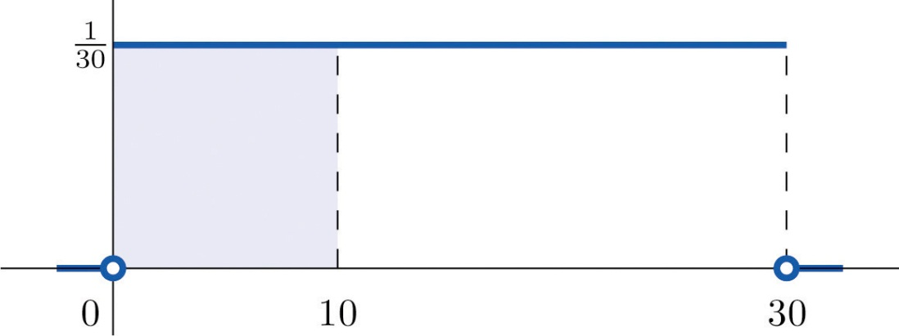
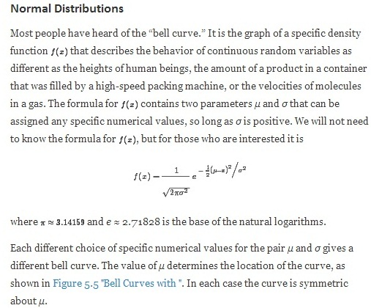

Figure 5.5 Bell Curves with σ = 0.25 and Different Values of μ
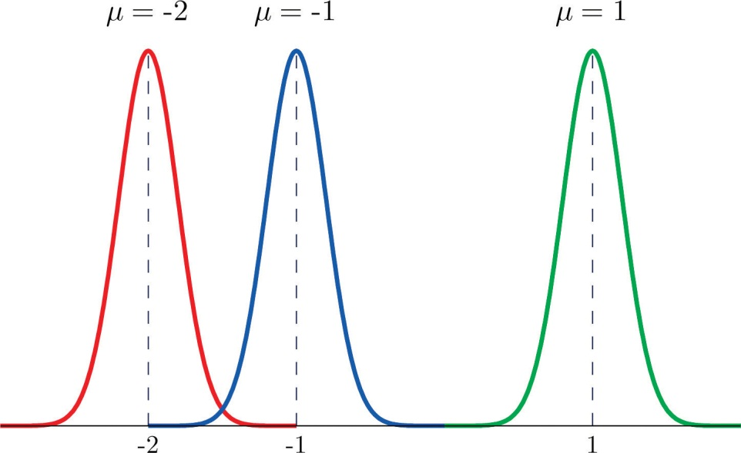
The value of σ determines whether the bell curve is tall and thin or short and squat, subject always to the condition that the total area under the curve be equal to 1. This is shown in Figure 5.6 "Bell Curves with ", where we have arbitrarily chosen to center the curves at μ = 6.
Figure 5.6 Bell Curves with μ = 6 and Different Values of σ
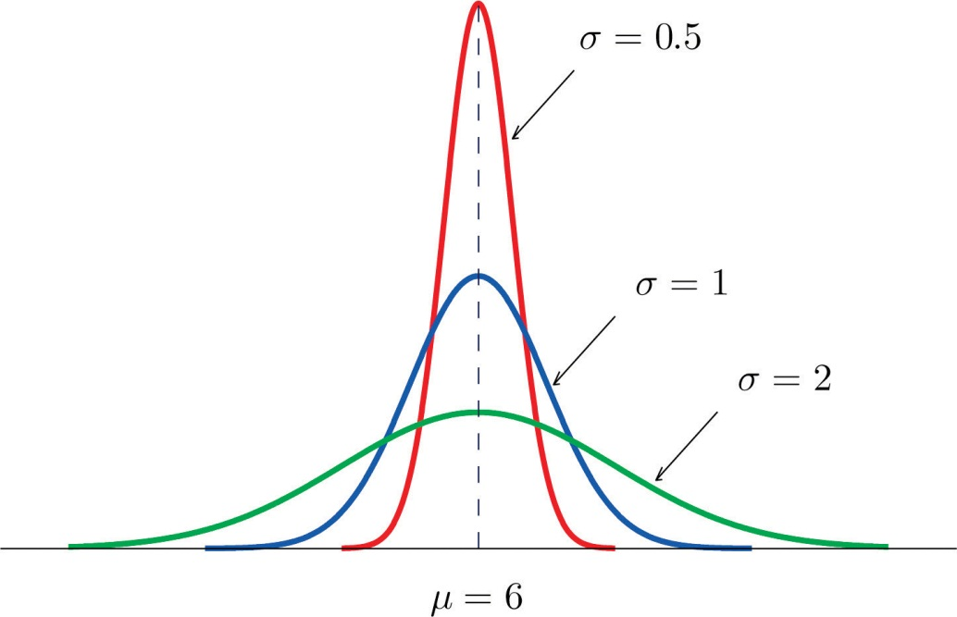

Definition
The probability distribution corresponding to the density function for the bell curve with parameters μ and σ is called the normal distribution with mean μ and standard deviation σ.

Definition
A continuous random variable whose probabilities are described by the normal distribution with mean μ and standard deviation σ is called a normally distributed random variable, or a normal random variable for short, with mean μ and standard deviation σ.

Figure 5.7 "Density Function for a Normally Distributed Random Variable with Mean " shows the density function that determines the normal distribution with mean μ and standard deviation σ. We repeat an important fact about this curve:

The density curve for the normal distribution is symmetric about the mean.

Figure 5.7 Density Function for a Normally Distributed Random Variable with Mean μ and Standard Deviation σ
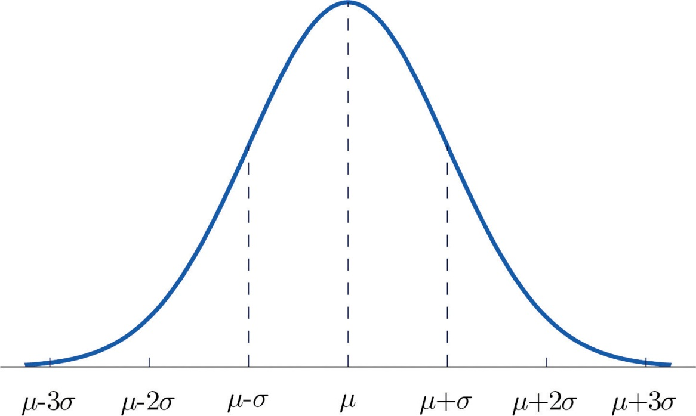

EXAMPLE 3
Heights of 25-year-old men in a certain region have mean 69.75 inches and standard deviation 2.59 inches. These heights are approximately normally distributed. Thus the height X of a randomly selected 25-year-old man is a normal random variable with mean μ = 69.75 and standard deviation σ = 2.59. Sketch a qualitatively accurate graph of the density function for X. Find the probability that a randomly selected 25-year-old man is more than 69.75 inches tall.
Solution:
The distribution of heights looks like the bell curve in Figure 5.8 "Density Function for Heights of 25-Year-Old Men". The important point is that it is centered at its mean, 69.75, and is symmetric about the mean.

Figure 5.8Density Function for Heights of 25-Year-Old Men
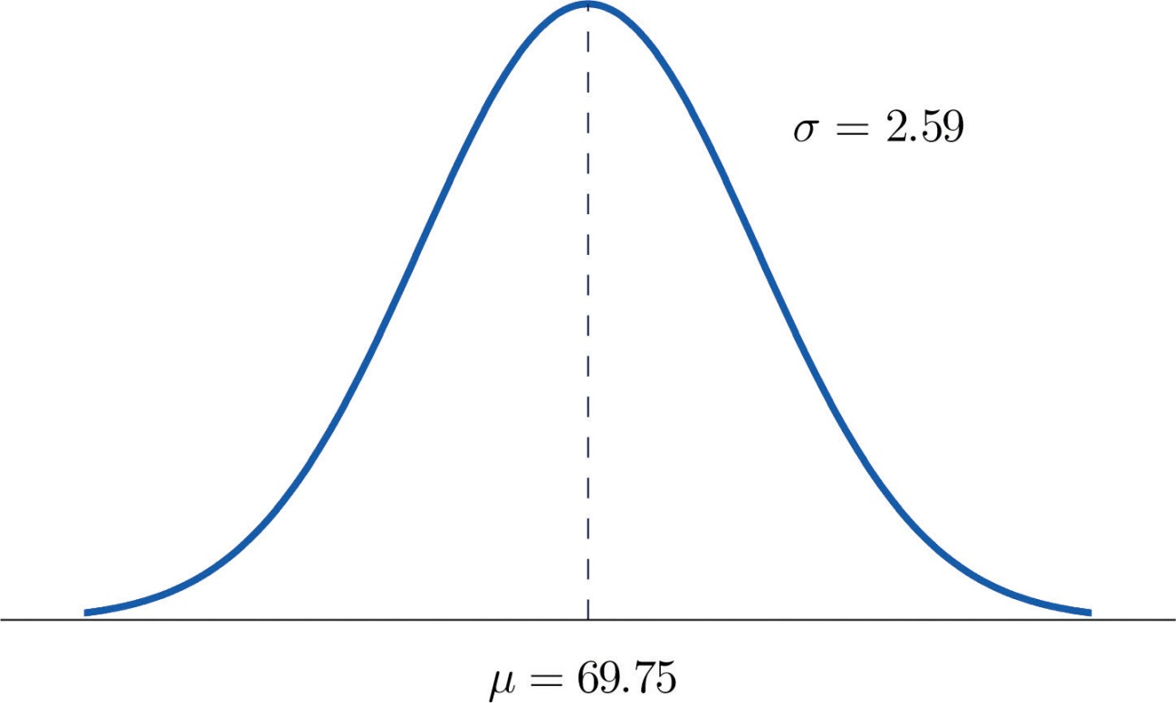
Since the total area under the curve is 1, by symmetry the area to the right of 69.75 is half the total, or 0.5. But this area is precisely the probability P(X > 69.75), the probability that a randomly selected 25-year-old man is more than 69.75 inches tall.
We will learn how to compute other probabilities in the next two sections.

KEY TAKEAWAYS
- For a continuous random variable X the only probabilities that are computed are those of X taking a value in a specified interval.
- The probability that X take a value in a particular interval is the same whether or not the endpoints of the interval are included.
- The probability P(a<X<b), that X take a value in the interval from a to b, is the area of the region between the vertical lines through a and b, above the x-axis, and below the graph of a function f(x) called the density function.
- A normally distributed random variable is one whose density function is a bell curve.
- Every bell curve is symmetric about its mean and lies everywhere above the x-axis, which it approaches asymptotically (arbitrarily closely without touching).

EXERCISES

BASIC
- A continuous random variable X has a uniform distribution on the interval [5,12].Sketch the graph of its density function.
- A continuous random variable X has a uniform distribution on the interval [−3,3].Sketch the graph of its density function.
- A continuous random variable X has a normal distribution with mean 100 and standard deviation 10. Sketch a qualitatively accurate graph of its density function.
- A continuous random variable X has a normal distribution with mean 73 and standard deviation 2.5. Sketch a qualitatively accurate graph of its density function.
- A continuous random variable X has a normal distribution with mean 73. The probability that X takes a value greater than 80 is 0.212. Use this information and the symmetry of the density function to find the probability that X takes a value less than 66. Sketch the density curve with relevant regions shaded to illustrate the computation.
- A continuous random variable X has a normal distribution with mean 169. The probability that X takes a value greater than 180 is 0.17. Use this information and the symmetry of the density function to find the probability that X takes a value less than 158. Sketch the density curve with relevant regions shaded to illustrate the computation.
- A continuous random variable X has a normal distribution with mean 50.5. The probability that X takes a value less than 54 is 0.76. Use this information and the symmetry of the density function to find the probability that X takes a value greater than 47. Sketch the density curve with relevant regions shaded to illustrate the computation.
- A continuous random variable X has a normal distribution with mean 12.25. The probability that X takes a value less than 13 is 0.82. Use this information and the symmetry of the density function to find the probability that X takes a value greater than 11.50. Sketch the density curve with relevant regions shaded to illustrate the computation.
- The figure provided shows the density curves of three normally distributed random variables X_{A}, X_{B}, and X_{C}. Their standard deviations (in no particular order) are 15, 7, and 20. Use the figure to identify the values of the means μA, μB, and μC and standard deviations σA, σB, and σC of the three random variables.

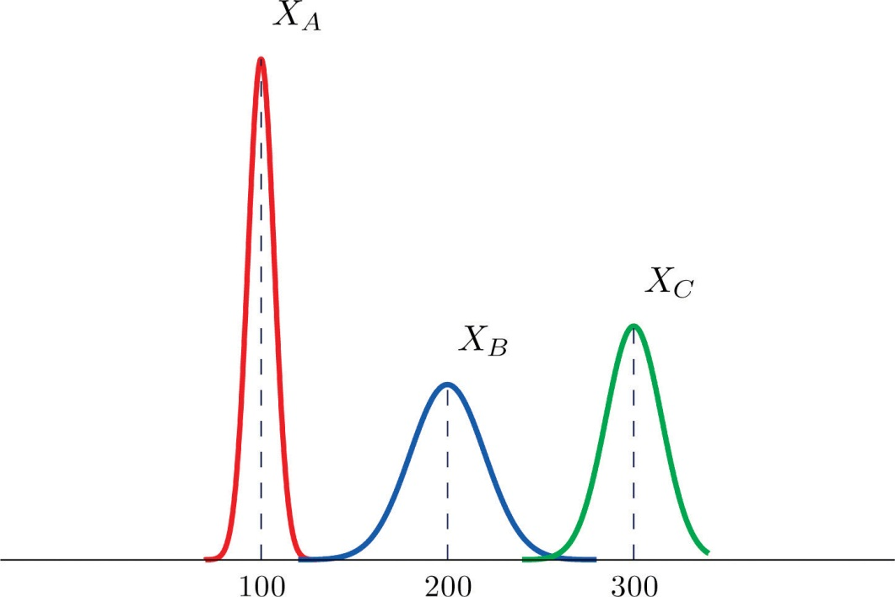

- The figure provided shows the density curves of three normally distributed random variables X_{A}, X_{B}, and X_{C}. Their standard deviations (in no particular order) are 20, 5, and 10. Use the figure to identify the values of the means μA, μB, and μC and standard deviations σA, σB, and σC of the three random variables.

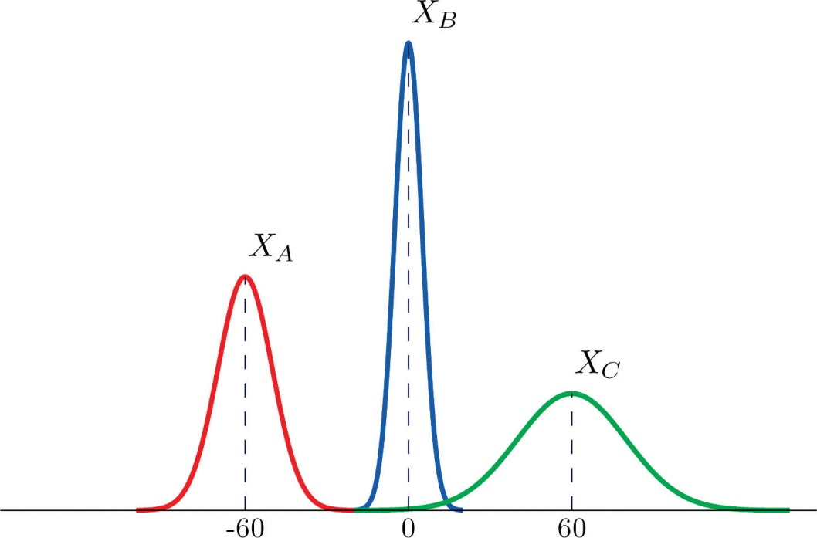

APPLICATIONS
- Dogberry's alarm clock is battery operated. The battery could fail with equal probability at any time of the day or night. Every day Dogberry sets his alarm for 6:30 a.m. and goes to bed at 10:00 p.m. Find the probability that when the clock battery finally dies, it will do so at the most inconvenient time, between 10:00 p.m. and 6:30 a.m.
- Buses running a bus line near Desdemona's house run every 15 minutes. Without paying attention to the schedule she walks to the nearest stop to take the bus to town. Find the probability that she waits more than 10 minutes.
- The amount X of orange juice in a randomly selected half-gallon container varies according to a normal distribution with mean 64 ounces and standard deviation 0.25 ounce.
  - Sketch the graph of the density function for X.
  - What proportion of all containers contain less than a half gallon (64 ounces)? Explain.
  - What is the median amount of orange juice in such containers? Explain.
- The weight X of grass seed in bags marked 50 lb varies according to a normal distribution with mean 50 lb and standard deviation 1 ounce (0.0625 lb).
  - Sketch the graph of the density function for X.
  - What proportion of all bags weigh less than 50 pounds? Explain.
  - What is the median weight of such bags? Explain.
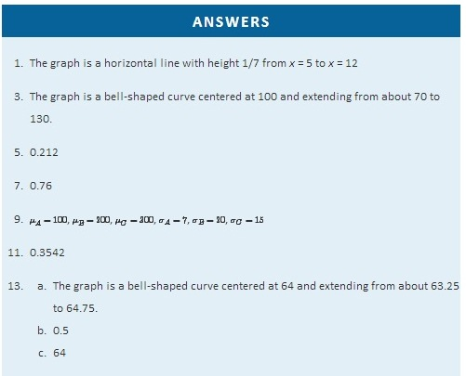

5.2 The Standard Normal Distribution

LEARNING OBJECTIVES
- To learn what a standard normal random variable is.
- To learn how to use Figure 12.2 "Cumulative Normal Probability" to compute probabilities related to a standard normal random variable.

Definition
A standard normal random variable is a normally distributed random variable with mean μ = 0 and standard deviation σ = 1. It will always be denoted by the letter Z.

The density function for a standard normal random variable is shown in Figure 5.9 "Density Curve for a Standard Normal Random Variable".
Figure 5.9 Density Curve for a Standard Normal Random Variable
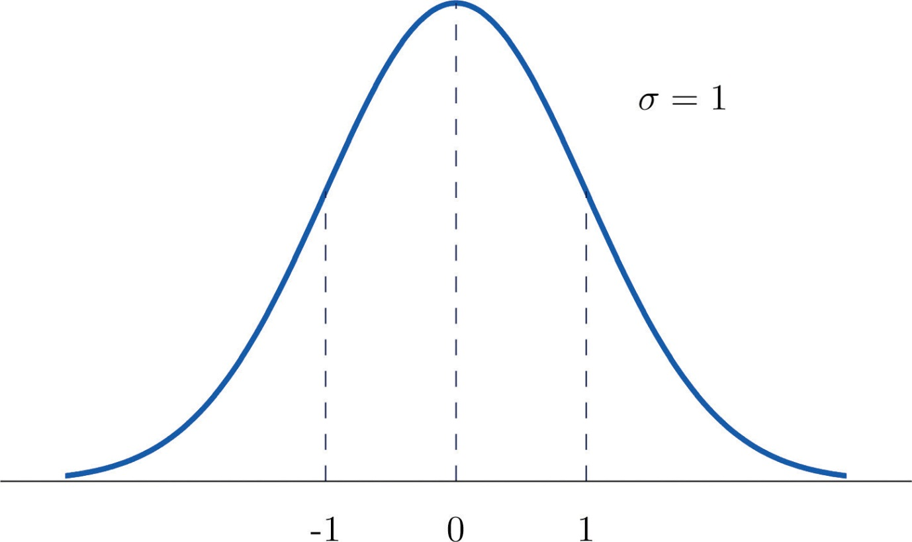
To compute probabilities for Z we will not work with its density function directly but instead read probabilities out of Figure 12.2 "Cumulative Normal Probability" in Chapter 12 "Appendix". The tables are tables of cumulative probabilities; their entries are probabilities of the form P(Z<z). The use of the tables will be explained by the following series of examples.

EXAMPLE 4
Find the probabilities indicated, where as always Z denotes a standard normal random variable.
- P(Z < 1.48).
- P(Z< −0.25).
Solution:
- Figure 5.10 "Computing Probabilities Using the Cumulative Table" shows how this probability is read directly from the table without any computation required. The digits in the ones and tenths places of 1.48, namely 1.4, are used to select the appropriate row of the table; the hundredths part of 1.48, namely 0.08, is used to select the appropriate column of the table. The four decimal place number in the interior of the table that lies in the intersection of the row and column selected, 0.9306, is the probability sought: P(Z<1.48)=0.9306.
Figure 5.10Computing Probabilities Using the Cumulative Table
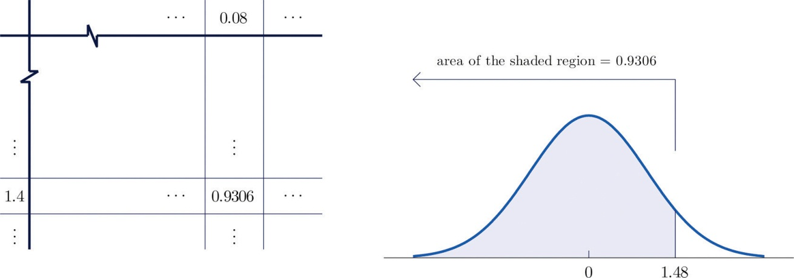
- The minus sign in −0.25 makes no difference in the procedure; the table is used in exactly the same way as in part (a): the probability sought is the number that is in the intersection of the row with heading −0.2 and the column with heading 0.05, the number 0.4013. Thus P(Z < −0.25) = 0.4013.

EXAMPLE 5
Find the probabilities indicated.
- P(Z > 1.60).
- P(Z > −1.02).
Solution:
- Because the events Z > 1.60 and Z ≤ 1.60 are complements, the Probability Rule for Complements implies that
P(Z>1.60)=1−P(Z≤1.60)
Since inclusion of the endpoint makes no difference for the continuous random variable Z, P(Z≤1.60)=P(Z<1.60), which we know how to find from the table. The number in the row with heading 1.6 and in the column with heading 0.00 is 0.9452. Thus P(Z<1.60)=0.9452 so

P(Z>1.60)=1−P(Z≤1.60)=1−0.9452=0.0548
Figure 5.11 "Computing a Probability for a Right Half-Line"illustrates the ideas geometrically. Since the total area under the curve is 1 and the area of the region to the left of 1.60 is (from the table) 0.9452, the area of the region to the right of 1.60 must be 1−0.9452=0.0548.

Figure 5.11Computing a Probability for a Right Half-Line
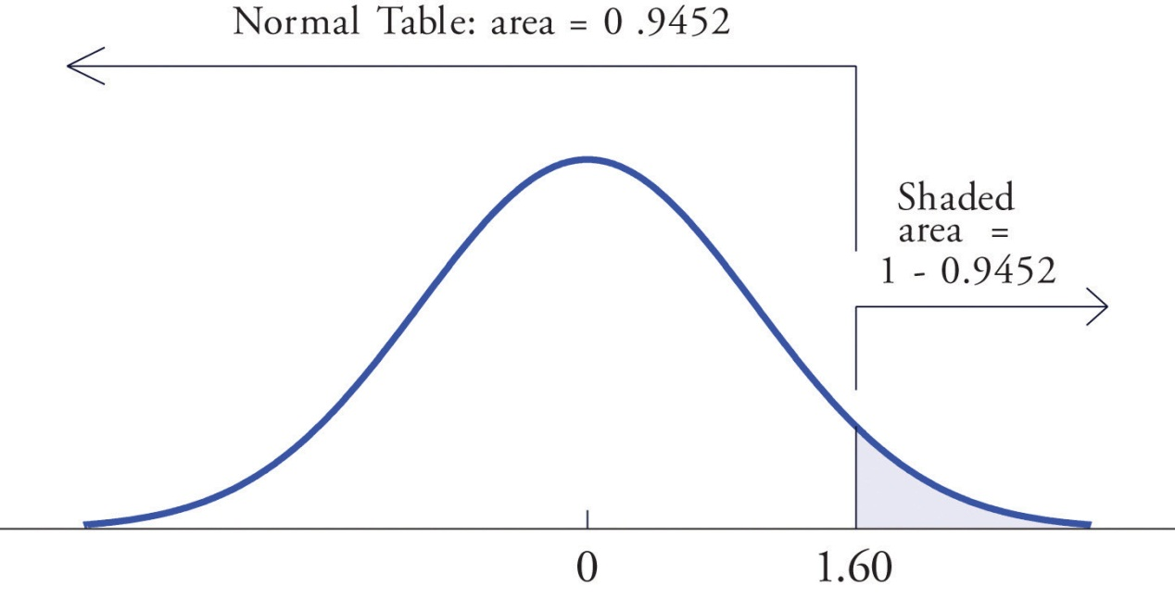
- The minus sign in −1.02 makes no difference in the procedure; the table is used in exactly the same way as in part (a). The number in the intersection of the row with heading −1.0 and the column with heading 0.02 is 0.1539. This means that P(Z<−1.02)=P(Z≤−1.02)=0.1539, hence

P(Z>−1.02)=1−P(Z≤−1.02)=1−0.1539=0.8461

Figure 5.12 Computing a Probability for an Interval of Finite Length
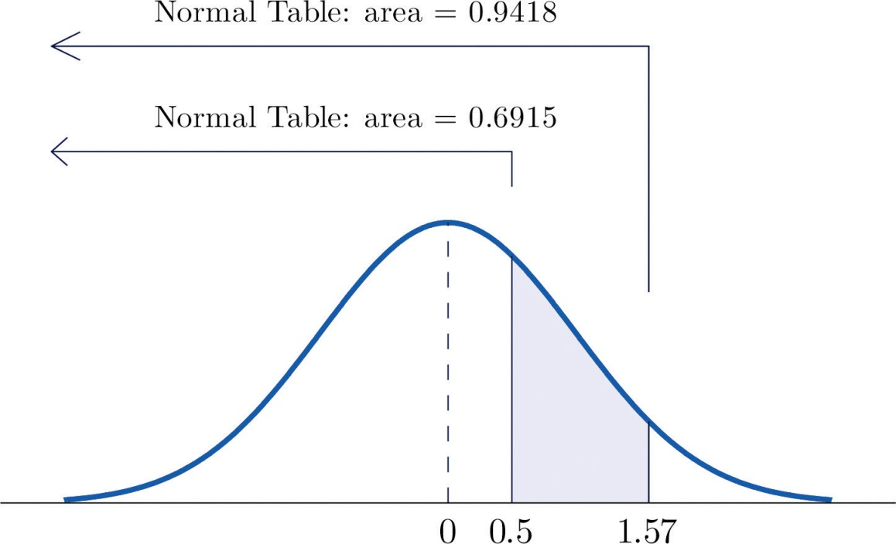
- The procedure for finding the probability that Z takes a value in a finite interval whose endpoints have opposite signs is exactly the same procedure used in part (a), and is illustrated in Figure 5.13 "Computing a Probability for an Interval of Finite Length". In symbols the computation is

P(−2.55<Z<0.09)==P(Z<0.09)−P(Z<−2.55)
=0.5359−0.0054=0.5305

Figure 5.13 Computing a Probability for an Interval of Finite Length
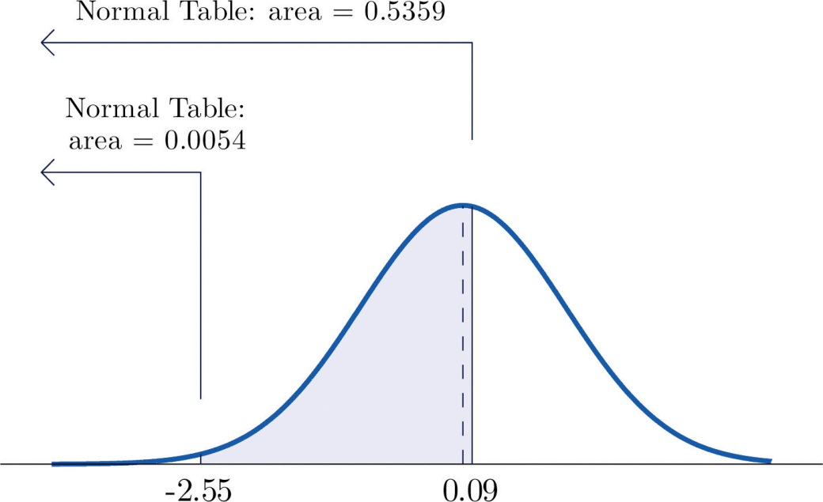
The next example shows what to do if the value of Z that we want to look up in the table is not present there.

EXAMPLE 7
Find the probabilities indicated.
- P(1.13<Z<4.16).
- P(−5.22<Z<2.15).
Solution:
- We attempt to compute the probability exactly as in Note 5.20 "Example 6" by looking up the numbers 1.13 and 4.16 in the table. We obtain the value 0.8708 for the area of the region under the density curve to left of 1.13 without any problem, but when we go to look up the number 4.16 in the table, it is not there. We can see from the last row of numbers in the table that the area to the left of 4.16 must be so close to 1 that to four decimal places it rounds to 1.0000. Therefore
P(1.13<Z<4.16)=1.0000−0.8708=0.1292
- Similarly, here we can read directly from the table that the area under the density curve and to the left of 2.15 is 0.9842, but −5.22 is too far to the left on the number line to be in the table. We can see from the first line of the table that the area to the left of −5.22 must be so close to 0 that to four decimal places it rounds to 0.0000. Therefore
P(−5.22<Z<2.15)=0.9842−0.0000=0.9842
The final example of this section explains the origin of the proportions given in the Empirical Rule.

EXAMPLE 8
Find the probabilities indicated.
- P(−1<Z<1).
- P(−2<Z<2).
- P(−3<Z<3).
Solution:
- Using the table as was done in Note 5.20 "Example 6"(b) we obtain

P(−1<Z<1)=0.8413−0.1587=0.6826
Since Z has mean 0 and standard deviation 1, for Z to take a value between −1 and 1 means that Z takes a value that is within one standard deviation of the mean. Our computation shows that the probability that this happens is about 0.68, the proportion given by the Empirical Rule for histograms that are mound shaped and symmetrical, like the bell curve.
- Using the table in the same way,

P(−2<Z<2)=0.9772−0.0228=0.9544
This corresponds to the proportion 0.95 for data within two standard deviations of the mean.
- Similarly,

P(−3<Z<3)=0.9987−0.0013=0.9974
which corresponds to the proportion 0.997 for data within three standard deviations of the mean.

KEY TAKEAWAYS
- A standard normal random variable Z is a normally distributed random variable with mean μ = 0 and standard deviation σ = 1.
- Probabilities for a standard normal random variable are computed usingFigure 12.2 "Cumulative Normal Probability".
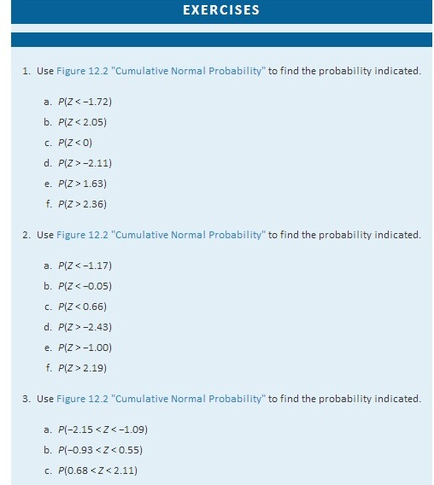

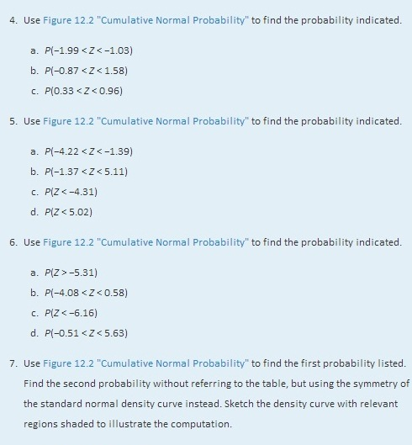
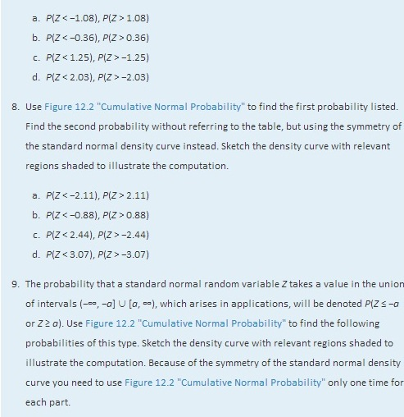
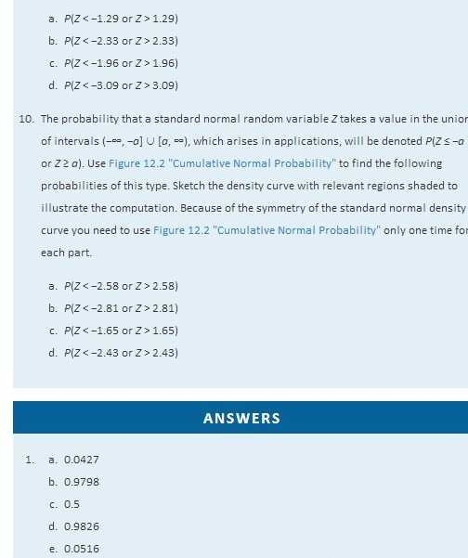
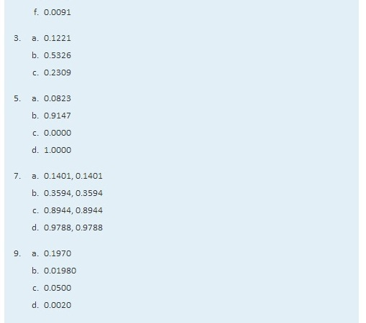

5.3 Probability Computations for General Normal Random Variables

LEARNING OBJECTIVE
- To learn how to compute probabilities related to any normal random variable.

If X is any normally distributed normal random variable then Figure 12.2 "Cumulative Normal Probability" can also be used to compute a probability of the form P(a<X<b) by means of the following equality.
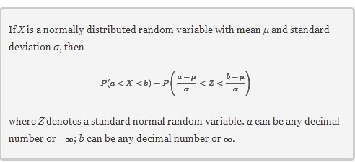
The new endpoints (a−μ)/σ and (b−μ)/σ are the z-scores of a and b as defined in Section 2.4.2 in Chapter 2 "Descriptive Statistics".

Figure 5.14 "Probability for an Interval of Finite Length" illustrates the meaning of the equality geometrically: the two shaded regions, one under the density curve for X and the other under the density curve for Z, have the same area. Instead of drawing both bell curves, though, we will always draw a single generic bell-shaped curve with both an x-axis and a z-axis below it.

Figure 5.14 Probability for an Interval of Finite Length
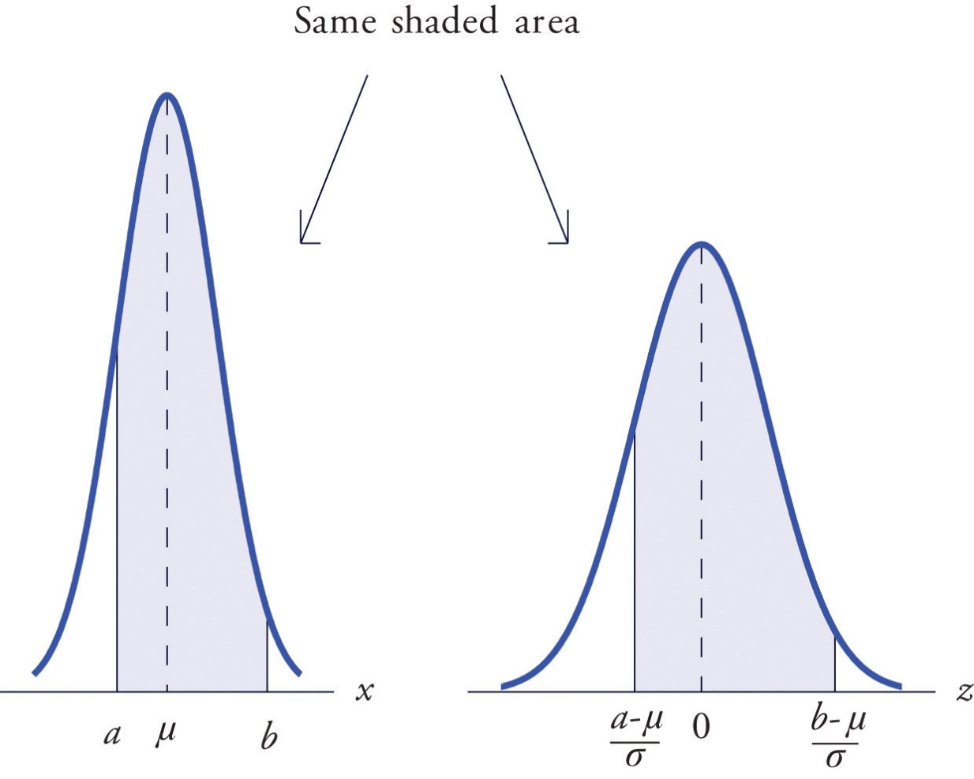

EXAMPLE 9
Let X be a normal random variable with mean μ = 10 and standard deviation σ = 2.5. Compute the following probabilities.
- P(X < 14).
- P(8<X<14).
Solution:
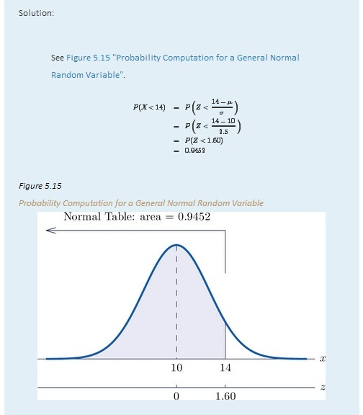
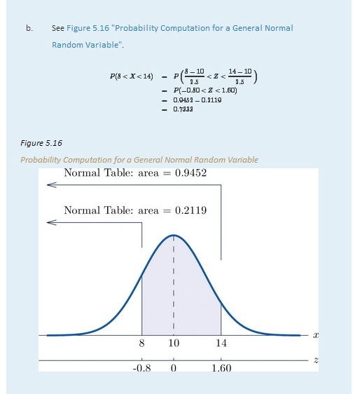

EXAMPLE 10
The lifetimes of the tread of a certain automobile tire are normally distributed with mean 37,500 miles and standard deviation 4,500 miles. Find the probability that the tread life of a randomly selected tire will be between 30,000 and 40,000 miles.
Solution:
Let X denote the tread life of a randomly selected tire. To make the numbers easier to work with we will choose thousands of miles as the units. Thus μ = 37.5, σ = 4.5, and the problem is to compute P(30<X<40). Figure 5.17 "Probability Computation for Tire Tread Wear" illustrates the following computation:
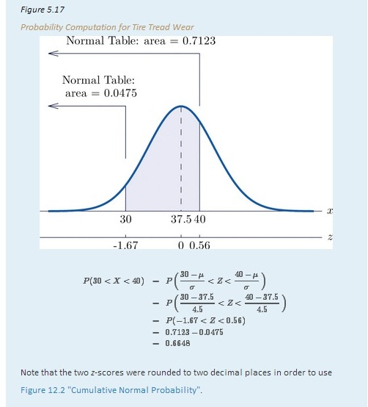

EXAMPLE 11
Scores on a standardized college entrance examination (CEE) are normally distributed with mean 510 and standard deviation 60. A selective university considers for admission only applicants with CEE scores over 650. Find percentage of all individuals who took the CEE who meet the university's CEE requirement for consideration for admission.

Solution:

Let X denote the score made on the CEE by a randomly selected individual. Then Xis normally distributed with mean 510 and standard deviation 60. The probability that X lie in a particular interval is the same as the proportion of all exam scores that lie in that interval. Thus the solution to the problem is P(X > 650), expressed as a percentage. Figure 5.18 "Probability Computation for Exam Scores" illustrates the following computation:
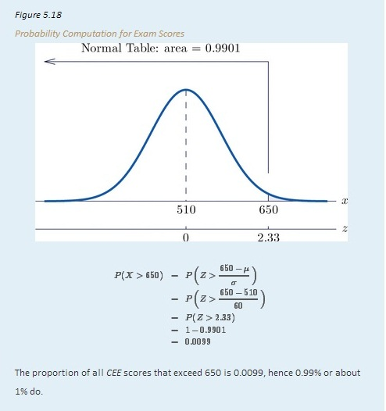

KEY TAKEAWAY
- Probabilities for a general normal random variable are computed usingFigure 12.2 "Cumulative Normal Probability" after converting x-values to z-scores.

EXERCISES

BASIC
- X is a normally distributed random variable with mean 57 and standard deviation 6. Find the probability indicated.
  - P(X < 59.5)
  - P(X < 46.2)
  - P(X > 52.2)
  - P(X > 70)
- X is a normally distributed random variable with mean −25 and standard deviation 4. Find the probability indicated.
  - P(X < −27.2)
  - P(X < −14.8)
  - P(X > −33.1)
  - P(X > −16.5)
- X is a normally distributed random variable with mean 112 and standard deviation 15. Find the probability indicated.
  - P(100<X<125)
  - P(91<X<107)
  - P(118<X<160)
- X is a normally distributed random variable with mean 72 and standard deviation 22. Find the probability indicated.
  - P(78<X<127)
  - P(60<X<90)
  - P(49<X<71)
- X is a normally distributed random variable with mean 500 and standard deviation 25. Find the probability indicated.
  - P(X < 400)
  - P(466<X<625)
- X is a normally distributed random variable with mean 0 and standard deviation 0.75. Find the probability indicated.
  - P(−4.02 < X < 3.82)
  - P(X > 4.11)
- X is a normally distributed random variable with mean 15 and standard deviation 1. Use Figure 12.2 "Cumulative Normal Probability" to find the first probability listed. Find the second probability using the symmetry of the density curve. Sketch the density curve with relevant regions shaded to illustrate the computation.
  - P(X < 12), P(X > 18)
  - P(X < 14), P(X > 16)
  - P(X < 11.25), P(X > 18.75)
  - P(X < 12.67), P(X > 17.33)
- X is a normally distributed random variable with mean 100 and standard deviation 10. Use Figure 12.2 "Cumulative Normal Probability" to find the first probability listed. Find the second probability using the symmetry of the density curve. Sketch the density curve with relevant regions shaded to illustrate the computation.
  - P(X < 80), P(X > 120)
  - P(X < 75), P(X > 125)
  - P(X < 84.55), P(X > 115.45)
  - P(X < 77.42), P(X > 122.58)
- X is a normally distributed random variable with mean 67 and standard deviation 13. The probability that X takes a value in the union of intervals (−∞,67−a] ∪ [67+a,∞) will be denoted P(X≤67−a or X≥67+a). Use Figure 12.2 "Cumulative Normal Probability" to find the following probabilities of this type. Sketch the density curve with relevant regions shaded to illustrate the computation. Because of the symmetry of the density curve you need to use Figure 12.2 "Cumulative Normal Probability" only one time for each part.
  - P(X<57 or X>77)
  - P(X<47 or X>87)
  - P(X<49 or X>85)
  - P(X<37 or X>97)
- X is a normally distributed random variable with mean 288 and standard deviation 6. The probability that X takes a value in the union of intervals (−∞,288−a] ∪ [288+a,∞) will be denoted P(X≤288−a or X≥288+a). Use Figure 12.2 "Cumulative Normal Probability" to find the following probabilities of this type. Sketch the density curve with relevant regions shaded to illustrate the computation. Because of the symmetry of the density curve you need to use Figure 12.2 "Cumulative Normal Probability" only one time for each part.
  - P(X<278 or X>298)
  - P(X<268 or X>308)
  - P(X<273 or X>303)
  - P(X<280 or X>296)

APPLICATIONS
- The amount X of beverage in a can labeled 12 ounces is normally distributed with mean 12.1 ounces and standard deviation 0.05 ounce. A can is selected at random.
  - Find the probability that the can contains at least 12 ounces.
  - Find the probability that the can contains between 11.9 and 12.1 ounces.
- The length of gestation for swine is normally distributed with mean 114 days and standard deviation 0.75 day. Find the probability that a litter will be born within one day of the mean of 114.
- The systolic blood pressure X of adults in a region is normally distributed with mean 112 mm Hg and standard deviation 15 mm Hg. A person is considered “prehypertensive” if his systolic blood pressure is between 120 and 130 mm Hg. Find the probability that the blood pressure of a randomly selected person is prehypertensive.
- Heights X of adult women are normally distributed with mean 63.7 inches and standard deviation 2.71 inches. Romeo, who is 69.25 inches tall, wishes to date only women who are shorter than he but within 4 inches of his height. Find the probability that the next woman he meets will have such a height.
- Heights X of adult men are normally distributed with mean 69.1 inches and standard deviation 2.92 inches. Juliet, who is 63.25 inches tall, wishes to date only men who are taller than she but within 6 inches of her height. Find the probability that the next man she meets will have such a height.
- A regulation hockey puck must weigh between 5.5 and 6 ounces. The weights X of pucks made by a particular process are normally distributed with mean 5.75 ounces and standard deviation 0.11 ounce. Find the probability that a puck made by this process will meet the weight standard.
- A regulation golf ball may not weigh more than 1.620 ounces. The weights X of golf balls made by a particular process are normally distributed with mean 1.361 ounces and standard deviation 0.09 ounce. Find the probability that a golf ball made by this process will meet the weight standard.
- The length of time that the battery in Hippolyta's cell phone will hold enough charge to operate acceptably is normally distributed with mean 25.6 hours and standard deviation 0.32 hour. Hippolyta forgot to charge her phone yesterday, so that at the moment she first wishes to use it today it has been 26 hours 18 minutes since the phone was last fully charged. Find the probability that the phone will operate properly.
- The amount of non-mortgage debt per household for households in a particular income bracket in one part of the country is normally distributed with mean $28,350 and standard deviation $3,425. Find the probability that a randomly selected such household has between $20,000 and $30,000 in non-mortgage debt.
- Birth weights of full-term babies in a certain region are normally distributed with mean 7.125 lb and standard deviation 1.290 lb. Find the probability that a randomly selected newborn will weigh less than 5.5 lb, the historic definition of prematurity.
- The distance from the seat back to the front of the knees of seated adult males is normally distributed with mean 23.8 inches and standard deviation 1.22 inches. The distance from the seat back to the back of the next seat forward in all seats on aircraft flown by a budget airline is 26 inches. Find the proportion of adult men flying with this airline whose knees will touch the back of the seat in front of them.
- The distance from the seat to the top of the head of seated adult males is normally distributed with mean 36.5 inches and standard deviation 1.39 inches. The distance from the seat to the roof of a particular make and model car is 40.5 inches. Find the proportion of adult men who when sitting in this car will have at least one inch of headroom (distance from the top of the head to the roof).

ADDITIONAL EXERCISES
- The useful life of a particular make and type of automotive tire is normally distributed with mean 57,500 miles and standard deviation 950 miles.
  - Find the probability that such a tire will have a useful life of between 57,000 and 58,000 miles.
  - Hamlet buys four such tires. Assuming that their lifetimes are independent, find the probability that all four will last between 57,000 and 58,000 miles. (If so, the best tire will have no more than 1,000 miles left on it when the first tire fails.) Hint: There is a binomial random variable here, whose value of p comes from part (a).
- A machine produces large fasteners whose length must be within 0.5 inch of 22 inches. The lengths are normally distributed with mean 22.0 inches and standard deviation 0.17 inch.
  - Find the probability that a randomly selected fastener produced by the machine will have an acceptable length.
  - The machine produces 20 fasteners per hour. The length of each one is inspected. Assuming lengths of fasteners are independent, find the probability that all 20 will have acceptable length. Hint: There is a binomial random variable here, whose value of p comes from part (a).
- The lengths of time taken by students on an algebra proficiency exam (if not forced to stop before completing it) are normally distributed with mean 28 minutes and standard deviation 1.5 minutes.
  - Find the proportion of students who will finish the exam if a 30-minute time limit is set.
  - Six students are taking the exam today. Find the probability that all six will finish the exam within the 30-minute limit, assuming that times taken by students are independent. Hint: There is a binomial random variable here, whose value of p comes from part (a).
- Heights of adult men between 18 and 34 years of age are normally distributed with mean 69.1 inches and standard deviation 2.92 inches. One requirement for enlistment in the military is that men must stand between 60 and 80 inches tall.
  - Find the probability that a randomly elected man meets the height requirement for military service.
  - Twenty-three men independently contact a recruiter this week. Find the probability that all of them meet the height requirement. Hint: There is a binomial random variable here, whose value of p comes from part (a).
- A regulation hockey puck must weigh between 5.5 and 6 ounces. In an alternative manufacturing process the mean weight of pucks produced is 5.75 ounce. The weights of pucks have a normal distribution whose standard deviation can be decreased by increasingly stringent (and expensive) controls on the manufacturing process. Find the maximum allowable standard deviation so that at most 0.005 of all pucks will fail to meet the weight standard. (Hint: The distribution is symmetric and is centered at the middle of the interval of acceptable weights.)
- The amount of gasoline X delivered by a metered pump when it registers 5 gallons is a normally distributed random variable. The standard deviation σ of X measures the precision of the pump; the smaller σ is the smaller the variation from delivery to delivery. A typical standard for pumps is that when they show that 5 gallons of fuel has been delivered the actual amount must be between 4.97 and 5.03 gallons (which corresponds to being off by at most about half a cup). Supposing that the mean of X is 5, find the largest that σ can be so that P(4.97 < X < 5.03) is 1.0000 to four decimal places when computed using Figure 12.2 "Cumulative Normal Probability", which means that the pump is sufficiently accurate. (Hint: The z-score of 5.03 will be the smallest value of Z so that Figure 12.2 "Cumulative Normal Probability" gives P(Z<z)=1.0000.)

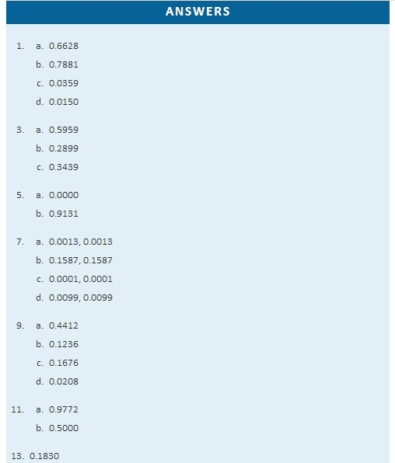

5.4 Areas of Tails of Distributions

LEARNING OBJECTIVE
- To learn how to find, for a normal random variable X and an area a, the value x* of X so that P(X<x*)=a or that P(X>x*)=a, whichever is required.

Definition
The left tail of a density curve y=f(x) of a continuous random variable Xcut off by a value x* of X is the region under the curve that is to the left of x*, as shown by the shading in Figure 5.19 "Right and Left Tails of a Distribution"(a). The right tail cut off by x* is defined similarly, as indicated by the shading in Figure 5.19 "Right and Left Tails of a Distribution"(b).
Figure 5.19Right and Left Tails of a Distribution
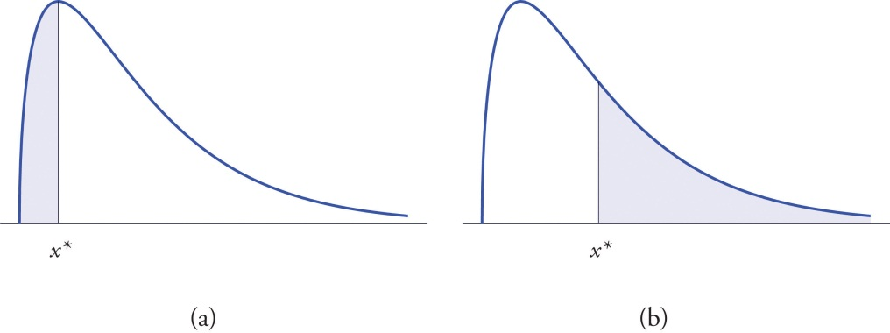

The probabilities tabulated in Figure 12.2 "Cumulative Normal Probability" are areas of left tails in the standard normal distribution.

Tails of the Standard Normal Distribution
At times it is important to be able to solve the kind of problem illustrated by Figure 5.20. We have a certain specific area in mind, in this case the area 0.0125 of the shaded region in the figure, and we want to find the value z* of Z that produces it. This is exactly the reverse of the kind of problems encountered so far. Instead of knowing a value z* of Z and finding a corresponding area, we know the area and want to find z*. In the case at hand, in the terminology of the definition just above, we wish to find the value z* that cuts off a left tail of area 0.0125 in the standard normal distribution.

The idea for solving such a problem is fairly simple, although sometimes its implementation can be a bit complicated. In a nutshell, one reads the cumulative probability table for Z in reverse, looking up the relevant area in the interior of the table and reading off the value of Z from the margins.
Figure 5.20 Z Value that Produces a Known Area
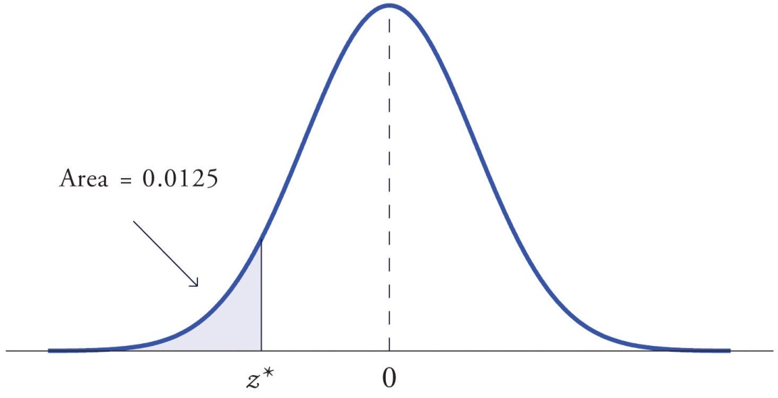

EXAMPLE 12
Find the value z* of Z as determined by Figure 5.20: the value z* that cuts off a left tail of area 0.0125 in the standard normal distribution. In symbols, find the number z* such that P(Z<z*)=0.0125.
Solution:

The number that is known, 0.0125, is the area of a left tail, and as already mentioned the probabilities tabulated in Figure 12.2 "Cumulative Normal Probability" are areas of left tails. Thus to solve this problem we need only search in the interior of Figure 12.2 "Cumulative Normal Probability" for the number 0.0125. It lies in the row with the heading −2.2 and in the column with the heading 0.04. This means that P(Z < −2.24) = 0.0125, hence z*=−2.24.

EXAMPLE 13
Find the value z* of Z as determined by Figure 5.21: the value z* that cuts off a right tail of area 0.0250 in the standard normal distribution. In symbols, find the number z* such that P(Z>z*)=0.0250.
Fiigure 5.21Z Value that Produces a Known Area
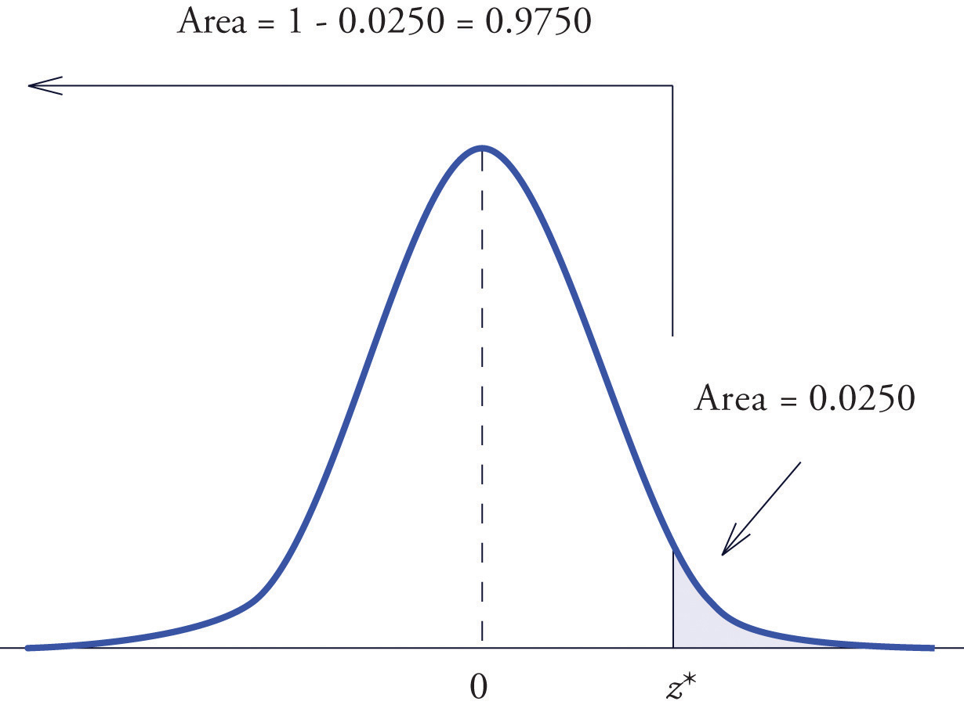
Solution:

The important distinction between this example and the previous one is that here it is the area of a right tail that is known. In order to be able to use Figure 12.2 "Cumulative Normal Probability" we must first find that area of the left tail cut off by the unknown number z*. Since the total area under the density curve is 1, that area is 1−0.0250=0.9750. This is the number we look for in the interior of Figure 12.2 "Cumulative Normal Probability". It lies in the row with the heading 1.9 and in the column with the heading 0.06. Therefore z*=1.96.

Definition
The value of the standard normal random variable Z that cuts off a right tail of area c is denoted z_{c}. By symmetry, value of Z that cuts off a left tail of area c is −zc. See Figure 5.22 "The Numbers ".
Figure 5.22The Numbers z_{c} and −zc
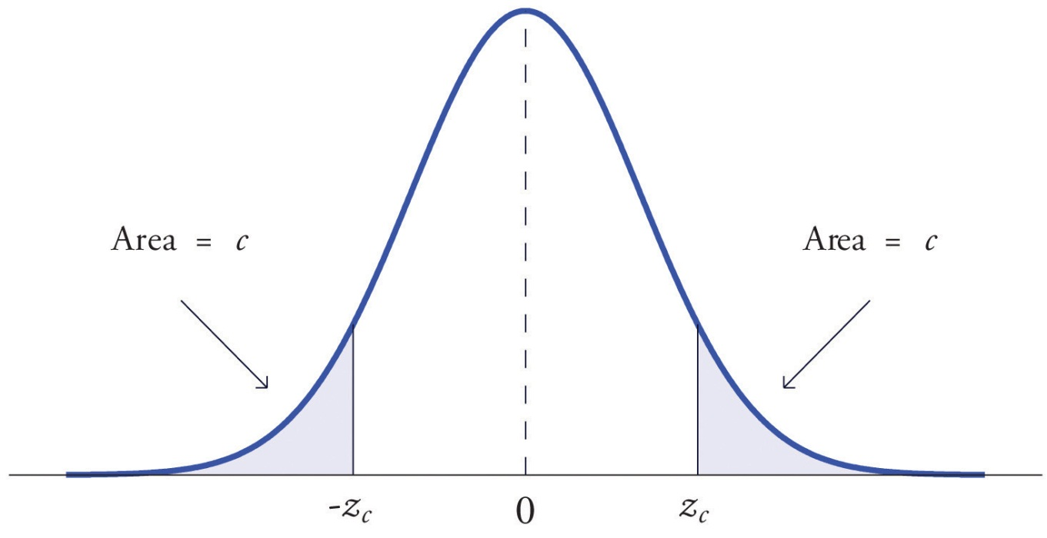

EXAMPLE 14
Find z.01 and −z.01, the values of Z that cut off right and left tails of area 0.01 in the standard normal distribution.

Solution:

Since −z.01 cuts off a left tail of area 0.01 and Figure 12.2 "Cumulative Normal Probability" is a table of left tails, we look for the number 0.0100 in the interior of the table. It is not there, but falls between the two numbers 0.0102 and 0.0099 in the row with heading −2.3. The number 0.0099 is closer to 0.0100 than 0.0102 is, so for the hundredths place in −z.01 we use the heading of the column that contains 0.0099, namely, 0.03, and write −z.₀₁≈−2.33.
The answer to the second half of the problem is automatic: since −z.₀₁=−2.33, we conclude immediately that z.₀₁=2.33.
We could just as well have solved this problem by looking for z.01 first, and it is instructive to rework the problem this way. To begin with, we must first subtract 0.01 from 1 to find the area 1−0.0100=0.9900 of the left tail cut off by the unknown number z.01. See Figure 5.23 "Computation of the Number ". Then we search for the area 0.9900 in Figure 12.2 "Cumulative Normal Probability". It is not there, but falls between the numbers 0.9898 and 0.9901 in the row with heading 2.3. Since 0.9901 is closer to 0.9900 than 0.9898 is, we use the column heading above it, 0.03, to obtain the approximation z.01≈2.33. Then finally −z.01≈−2.33.
Figure 5.23Computation of the Number z.01
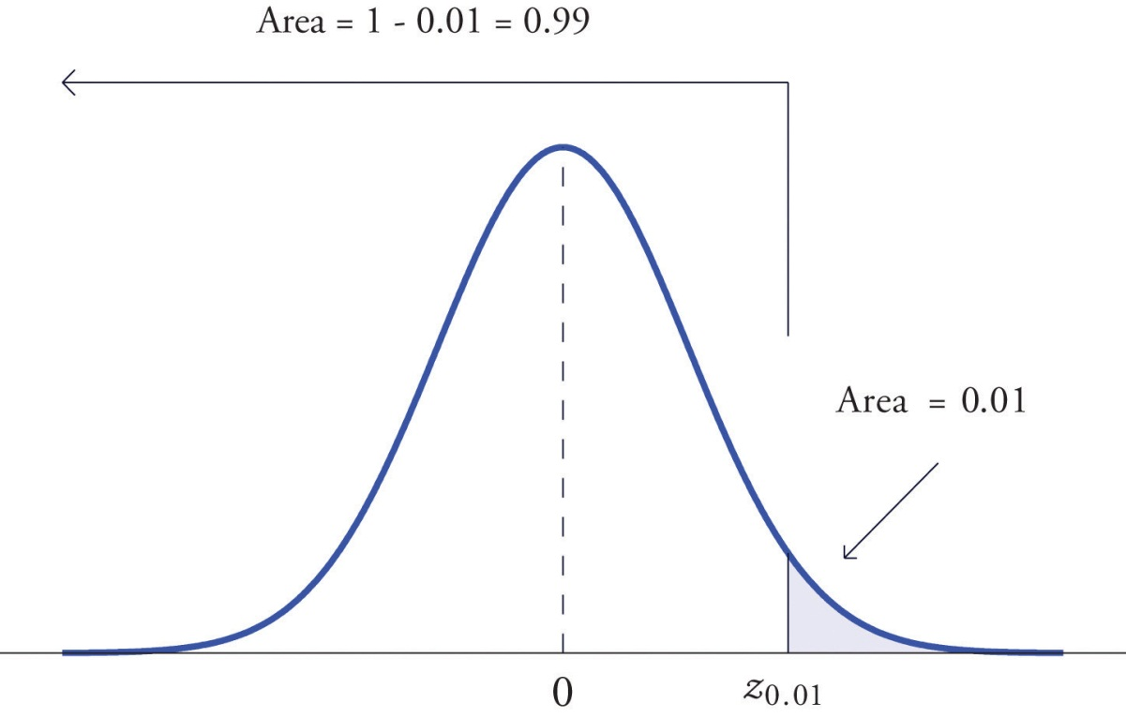

Tails of General Normal Distributions

The problem of finding the value x* of a general normally distributed random variable X that cuts off a tail of a specified area also arises. This problem may be solved in two steps.

Suppose X is a normally distributed random variable with mean μ and standard deviation σ. To find the value x* of X that cuts off a left or right tail of area c in the distribution of X:

- find the value z* of Z that cuts off a left or right tail of area c in the standard normal distribution;
- z* is the z-score of x*; compute x* using the destandardization formula

x*=μ+z*σ

EXAMPLE 15
Find x* such that P(X<x*)=0.9332, where X is a normal random variable with mean μ = 10 and standard deviation σ = 2.5.

Solution:

All the ideas for the solution are illustrated in Figure 5.24 "Tail of a Normally Distributed Random Variable". Since 0.9332 is the area of a left tail, we can find z* simply by looking for 0.9332 in the interior of Figure 12.2 "Cumulative Normal Probability". It is in the row and column with headings 1.5 and 0.00, hence z*=1.50. Thus x* is 1.50 standard deviations above the mean, so

x*=μ+z*σ=10+1.50⋅2.5=13.75.
Figure 5.24Tail of a Normally Distributed Random Variable
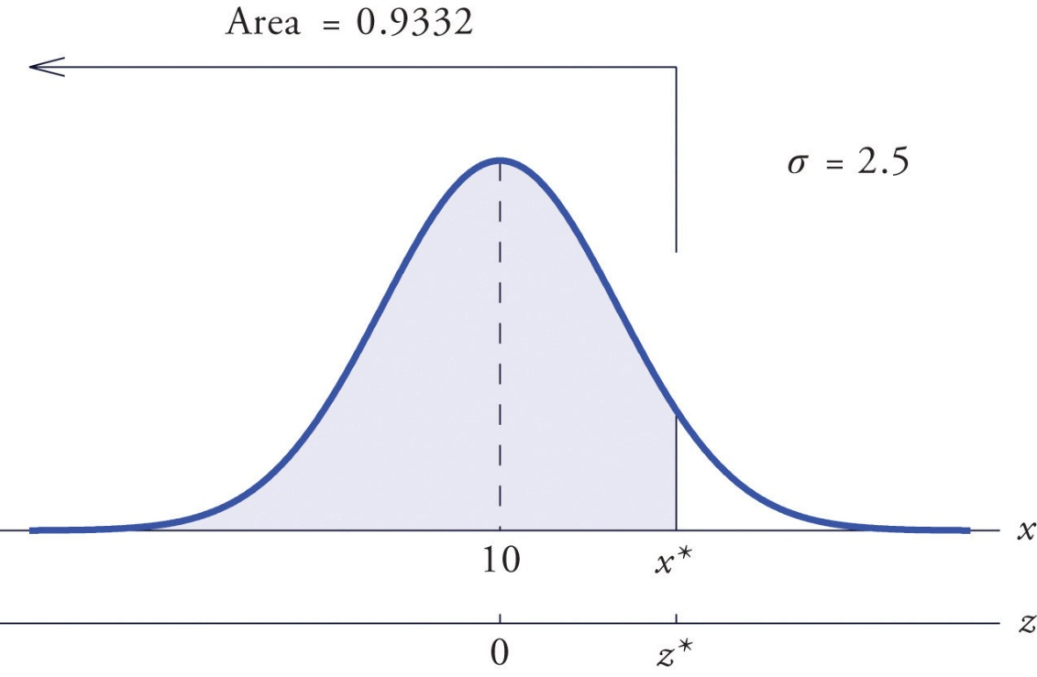

EXAMPLE 16
Find x* such that P(X>x*)=0.65, where X is a normal random variable with meanμ = 175 and standard deviation σ = 12.

Solution:

The situation is illustrated in Figure 5.25 "Tail of a Normally Distributed Random Variable". Since 0.65 is the area of a right tail, we first subtract it from 1 to obtain 1−0.65=0.35, the area of the complementary left tail. We find z* by looking for 0.3500 in the interior of Figure 12.2 "Cumulative Normal Probability". It is not present, but lies between table entries 0.3520 and 0.3483. The entry 0.3483 with row and column headings −0.3 and 0.09 is closer to 0.3500 than the other entry is, so z*≈−0.39. Thus x* is 0.39 standard deviations below the mean, so

x*=μ+z*σ=175+(−0.39)⋅12=170.32
Figure 5.25Tail of a Normally Distributed Random Variable
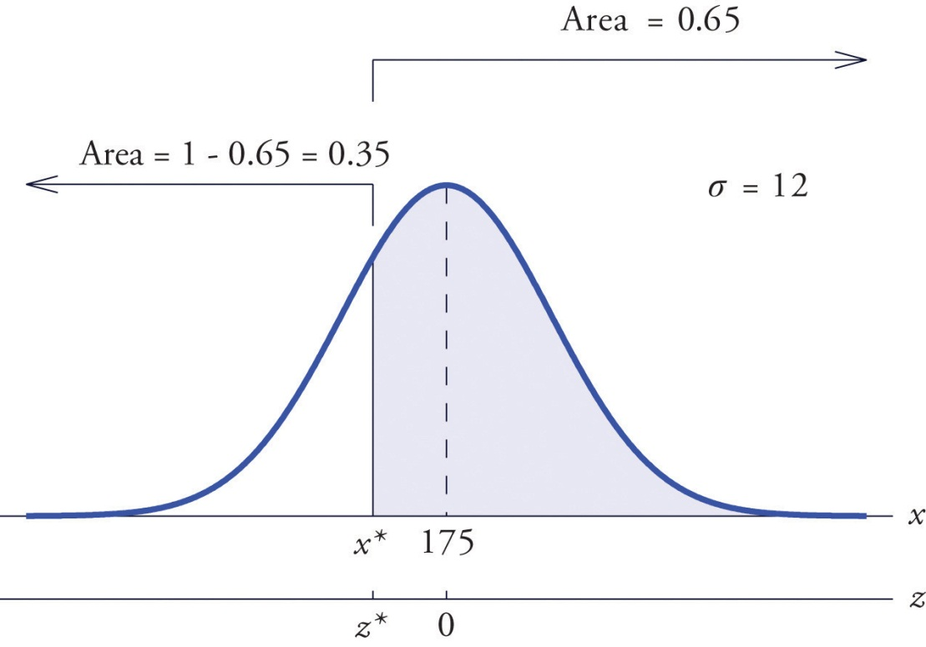

EXAMPLE 17
Scores on a standardized college entrance examination (CEE) are normally distributed with mean 510 and standard deviation 60. A selective university decides to give serious consideration for admission to applicants whose CEE scores are in the top 5% of all CEE scores. Find the minimum score that meets this criterion for serious consideration for admission.
Solution:

Let X denote the score made on the CEE by a randomly selected individual. Then Xis normally distributed with mean 510 and standard deviation 60. The probability that X lie in a particular interval is the same as the proportion of all exam scores that lie in that interval. Thus the minimum score that is in the top 5% of all CEE is the score x* that cuts off a right tail in the distribution of X of area 0.05 (5% expressed as a proportion). See Figure 5.26 "Tail of a Normally Distributed Random Variable".
Figure 5.26Tail of a Normally Distributed Random Variable
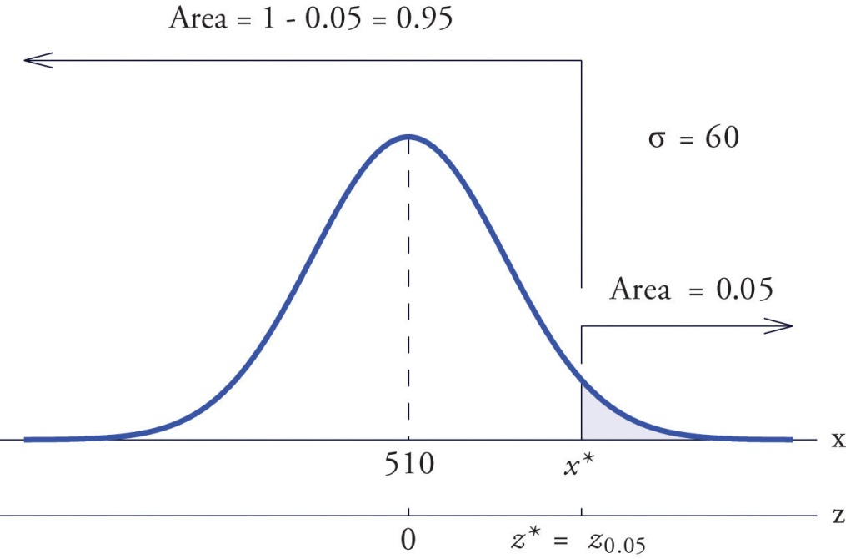
Since 0.0500 is the area of a right tail, we first subtract it from 1 to obtain 1−0.0500=0.9500, the area of the complementary left tail. We find z*=z.05 by looking for 0.9500 in the interior of Figure 12.2 "Cumulative Normal Probability". It is not present, and lies exactly half-way between the two nearest entries that are, 0.9495 and 0.9505. In the case of a tie like this, we will always average the values of Z corresponding to the two table entries, obtaining here the value z*=1.645. Using this value, we conclude that x* is 1.645 standard deviations above the mean, so

x*=μ+z*σ=510+1.645⋅60=608.7

EXAMPLE 18
All boys at a military school must run a fixed course as fast as they can as part of a physical examination. Finishing times are normally distributed with mean 29 minutes and standard deviation 2 minutes. The middle 75% of all finishing times are classified as “average.” Find the range of times that are average finishing times by this definition.
Solution:

Let X denote the finish time of a randomly selected boy. Then X is normally distributed with mean 29 and standard deviation 2. The probability that X lie in a particular interval is the same as the proportion of all finish times that lie in that interval. Thus the situation is as shown in Figure 5.27 "Distribution of Times to Run a Course". Because the area in the middle corresponding to “average” times is 0.75, the areas of the two tails add up to 1 − 0.75 = 0.25 in all. By the symmetry of the density curve each tail must have half of this total, or area 0.125 each. Thus the fastest time that is “average” has z-score −z.125, which by Figure 12.2 "Cumulative Normal Probability" is −1.15, and the slowest time that is “average” has z-score z.125=1.15. The fastest and slowest times that are still considered average are
x fast=μ+(−z.125)σ=29+(−1.15)⋅2=26.7
and
x slow=μ+z.125σ=29+(1.15)⋅2=31.3
Figure 5.27Distribution of Times to Run a Course
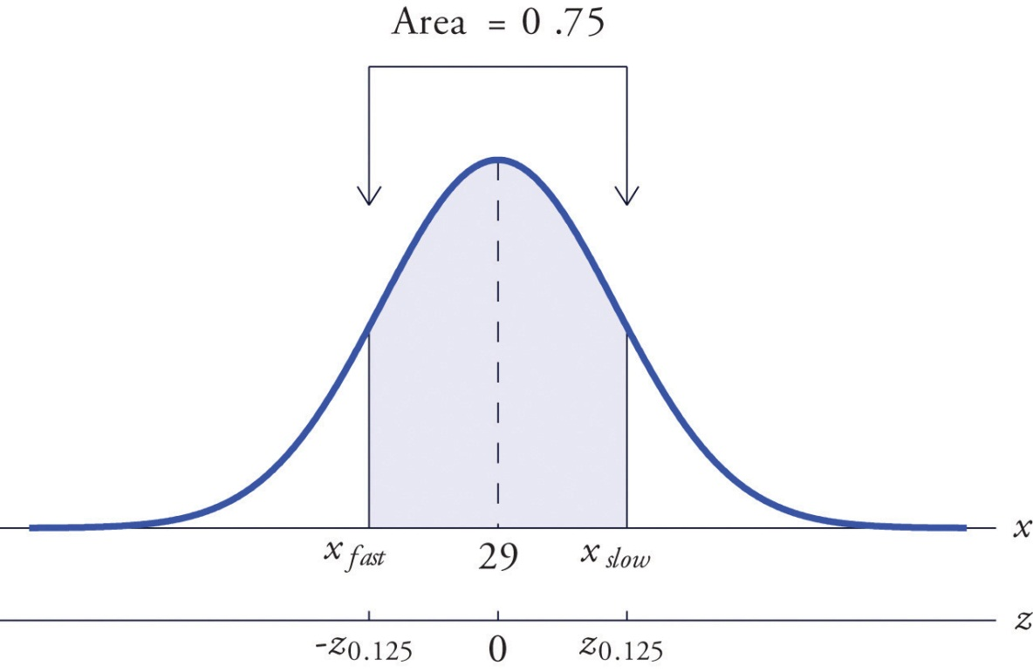
A boy has an average finishing time if he runs the course with a time between 26.7 and 31.3 minutes, or equivalently between 26 minutes 42 seconds and 31 minutes 18 seconds.

KEY TAKEAWAYS
- The problem of finding the number z* so that the probability P(Z<z*) is a specified value c is solved by looking for the number c in the interior of Figure 12.2 "Cumulative Normal Probability" and reading z* from the margins.
- The problem of finding the number z* so that the probability P(Z>z*) is a specified value c is solved by looking for the complementary probability 1−cin the interior of Figure 12.2 "Cumulative Normal Probability" and reading z*from the margins.
- For a normal random variable X with mean μ and standard deviation σ, the problem of finding the number x* so that P(X<x*) is a specified value c (or so that P(X>x*) is a specified value c) is solved in two steps: (1) solve the corresponding problem for Z with the same value of c, thereby obtaining the z-score, z*, of x*; (2) find x* using x*=μ+z*⋅σ.
- The value of Z that cuts off a right tail of area c in the standard normal distribution is denoted z_{c}.
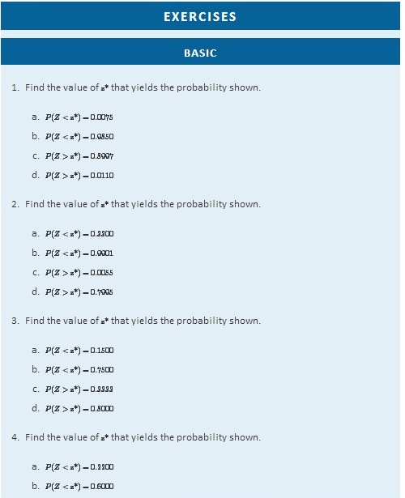
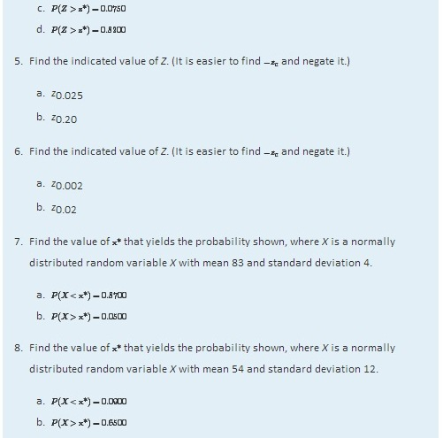
- X is a normally distributed random variable X with mean 15 and standard deviation 0.25. Find the values x_{L} and x_{R} of X that are symmetrically located with respect to the mean of X and satisfy P(x_{L} < X < x_{R}) = 0.80. (Hint. First solve the corresponding problem for Z.)
- X is a normally distributed random variable X with mean 28 and standard deviation 3.7. Find the values x_{L} and x_{R} of X that are symmetrically located with respect to the mean of X and satisfy P(x_{L} < X < x_{R}) = 0.65. (Hint. First solve the corresponding problem for Z.)

APPLICATIONS
- Scores on a national exam are normally distributed with mean 382 and standard deviation 26.
  - Find the score that is the 50th percentile.
  - Find the score that is the 90th percentile.
- Heights of women are normally distributed with mean 63.7 inches and standard deviation 2.47 inches.
  - Find the height that is the 10th percentile.
  - Find the height that is the 80th percentile.
- The monthly amount of water used per household in a small community is normally distributed with mean 7,069 gallons and standard deviation 58 gallons. Find the three quartiles for the amount of water used.
- The quantity of gasoline purchased in a single sale at a chain of filling stations in a certain region is normally distributed with mean 11.6 gallons and standard deviation 2.78 gallons. Find the three quartiles for the quantity of gasoline purchased in a single sale.
- Scores on the common final exam given in a large enrollment multiple section course were normally distributed with mean 69.35 and standard deviation 12.93. The department has the rule that in order to receive an A in the course his score must be in the top 10% of all exam scores. Find the minimum exam score that meets this requirement.
- The average finishing time among all high school boys in a particular track event in a certain state is 5 minutes 17 seconds. Times are normally distributed with standard deviation 12 seconds.
  - The qualifying time in this event for participation in the state meet is to be set so that only the fastest 5% of all runners qualify. Find the qualifying time. (Hint: Convert seconds to minutes.)
  - In the western region of the state the times of all boys running in this event are normally distributed with standard deviation 12 seconds, but with mean 5 minutes 22 seconds. Find the proportion of boys from this region who qualify to run in this event in the state meet.
- Tests of a new tire developed by a tire manufacturer led to an estimated mean tread life of 67,350 miles and standard deviation of 1,120 miles. The manufacturer will advertise the lifetime of the tire (for example, a “50,000 mile tire”) using the largest value for which it is expected that 98% of the tires will last at least that long. Assuming tire life is normally distributed, find that advertised value.
- Tests of a new light led to an estimated mean life of 1,321 hours and standard deviation of 106 hours. The manufacturer will advertise the lifetime of the bulb using the largest value for which it is expected that 90% of the bulbs will last at least that long. Assuming bulb life is normally distributed, find that advertised value.
- The weights X of eggs produced at a particular farm are normally distributed with mean 1.72 ounces and standard deviation 0.12 ounce. Eggs whose weights lie in the middle 75% of the distribution of weights of all eggs are classified as “medium.” Find the maximum and minimum weights of such eggs. (These weights are endpoints of an interval that is symmetric about the mean and in which the weights of 75% of the eggs produced at this farm lie.)
- The lengths X of hardwood flooring strips are normally distributed with mean 28.9 inches and standard deviation 6.12 inches. Strips whose lengths lie in the middle 80% of the distribution of lengths of all strips are classified as “average-length strips.” Find the maximum and minimum lengths of such strips. (These lengths are endpoints of an interval that is symmetric about the mean and in which the lengths of 80% of the hardwood strips lie.)
- All students in a large enrollment multiple section course take common in-class exams and a common final, and submit common homework assignments. Course grades are assigned based on students' final overall scores, which are approximately normally distributed. The department assigns a C to students whose scores constitute the middle 2/3 of all scores. If scores this semester had mean 72.5 and standard deviation 6.14, find the interval of scores that will be assigned a C.
- Researchers wish to investigate the overall health of individuals with abnormally high or low levels of glucose in the blood stream. Suppose glucose levels are normally distributed with mean 96 and standard deviation 8.5 mg/d ℓ, and that “normal” is defined as the middle 90% of the population. Find the interval of normal glucose levels, that is, the interval centered at 96 that contains 90% of all glucose levels in the population.

ADDITIONAL EXERCISES
- A machine for filling 2-liter bottles of soft drink delivers an amount to each bottle that varies from bottle to bottle according to a normal distribution with standard deviation 0.002 liter and mean whatever amount the machine is set to deliver.
  - If the machine is set to deliver 2 liters (so the mean amount delivered is 2 liters) what proportion of the bottles will contain at least 2 liters of soft drink?
  - Find the minimum setting of the mean amount delivered by the machine so that at least 99% of all bottles will contain at least 2 liters.
- A nursery has observed that the mean number of days it must darken the environment of a species poinsettia plant daily in order to have it ready for market is 71 days. Suppose the lengths of such periods of darkening are normally distributed with standard deviation 2 days. Find the number of days in advance of the projected delivery dates of the plants to market that the nursery must begin the daily darkening process in order that at least 95% of the plants will be ready on time. (Poinsettias are so long-lived that once ready for market the plant remains salable indefinitely.)
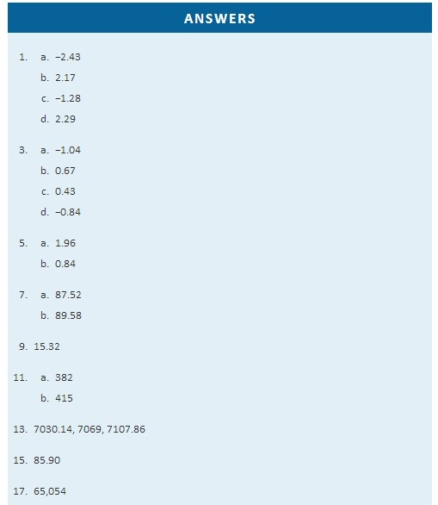

Chapter 6

Sampling Distributions
A statistic, such as the sample mean or the sample standard deviation, is a number computed from a sample. Since a sample is random, every statistic is a random variable: it varies from sample to sample in a way that cannot be predicted with certainty. As a random variable it has a mean, a standard deviation, and a probability distribution. The probability distribution of a statistic is called itssampling distribution. Typically sample statistics are not ends in themselves, but are computed in order to estimate the corresponding population parameters, as illustrated in the grand picture of statistics presented in Figure 1.1 "The Grand Picture of Statistics" in Chapter 1 "Introduction".

This chapter introduces the concepts of the mean, the standard deviation, and the sampling distribution of a sample statistic, with an emphasis on the sample mean x^−.

6.1 The Mean and Standard Deviation of the Sample Mean

LEARNING OBJECTIVES
- To become familiar with the concept of the probability distribution of the sample mean.
- To understand the meaning of the formulas for the mean and standard deviation of the sample mean.

Suppose we wish to estimate the mean μ of a population. In actual practice we would typically take just one sample. Imagine however that we take sample after sample, all of the same size n, and compute the sample mean x^− of each one. We will likely get a different value of x^− each time. The sample mean x^− is a random variable: it varies from sample to sample in a way that cannot be predicted with certainty. We will write X^−− when the sample mean is thought of as a random variable, and write x^− for the values that it takes. The random variable X^−− has a mean, denoted μX^−−, and a standard deviation, denoted σX^−−. Here is an example with such a small population and small sample size that we can actually write down every single sample.

EXAMPLE 1
A rowing team consists of four rowers who weigh 152, 156, 160, and 164 pounds. Find all possible random samples with replacement of size two and compute the sample mean for each one. Use them to find the probability distribution, the mean, and the standard deviation of the sample mean X^−−.

Solution

The following table shows all possible samples with replacement of size two, along with the mean of each:
Sample | Mean |  | Sample | Mean |  | Sample | Mean |  | Sample | Mean
152, 152 | 152 |  | 156, 152 | 154 |  | 160, 152 | 156 |  | 164, 152 | 158
152, 156 | 154 |  | 156, 156 | 156 |  | 160, 156 | 158 |  | 164, 156 | 160
152, 160 | 156 |  | 156, 160 | 158 |  | 160, 160 | 160 |  | 164, 160 | 162
152, 164 | 158 |  | 156, 164 | 160 |  | 160, 164 | 162 |  | 164, 164 | 164
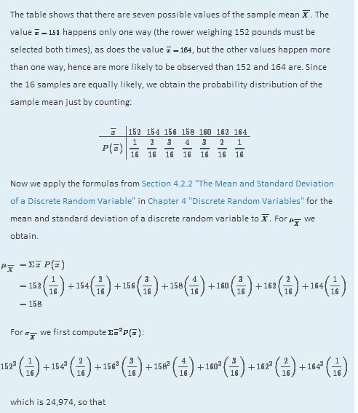
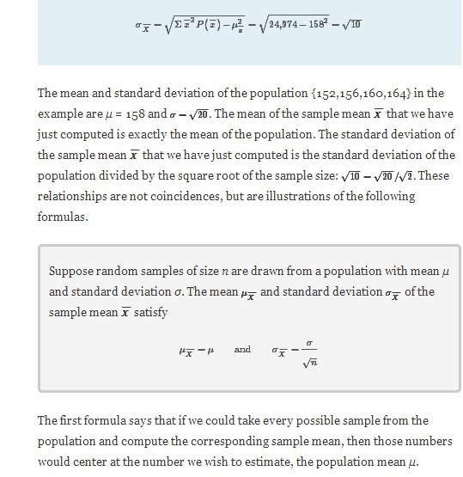

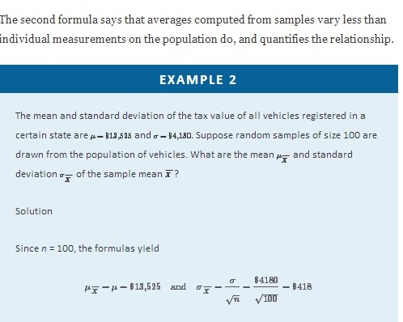

KEY TAKEAWAYS
- The sample mean is a random variable; as such it is written X−−, and x− stands for individual values it takes.
- As a random variable the sample mean has a probability distribution, a mean μ_{X−−}, and a standard deviation σ_{X−−}.
- There are formulas that relate the mean and standard deviation of the sample mean to the mean and standard deviation of the population from which the sample is drawn.

EXERCISES
- Random samples of size 225 are drawn from a population with mean 100 and standard deviation 20. Find the mean and standard deviation of the sample mean.
- Random samples of size 64 are drawn from a population with mean 32 and standard deviation 5. Find the mean and standard deviation of the sample mean.
- A population has mean 75 and standard deviation 12.
  - Random samples of size 121 are taken. Find the mean and standard deviation of the sample mean.
  - How would the answers to part (a) change if the size of the samples were 400 instead of 121?
- A population has mean 5.75 and standard deviation 1.02.
  - Random samples of size 81 are taken. Find the mean and standard deviation of the sample mean.
  - How would the answers to part (a) change if the size of the samples were 25 instead of 81?
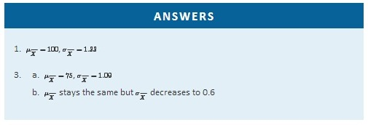

6.2 The Sampling Distribution of the Sample Mean

LEARNING OBJECTIVES
- To learn what the sampling distribution of X^−− is when the sample size is large.
- To learn what the sampling distribution of X^−− is when the population is normal.

The Central Limit Theorem
In Note 6.5 "Example 1" in Section 6.1 "The Mean and Standard Deviation of the Sample Mean" we constructed the probability distribution of the sample mean for samples of size two drawn from the population of four rowers. The probability distribution is:
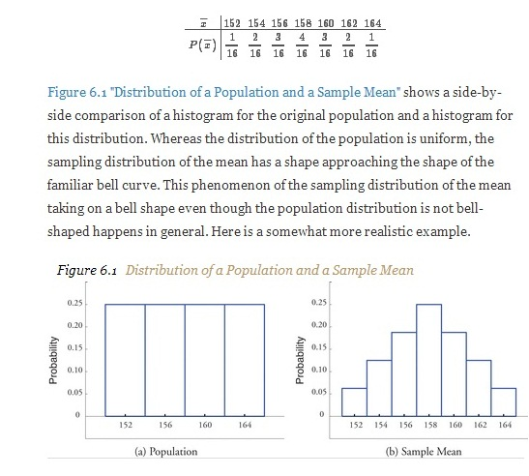
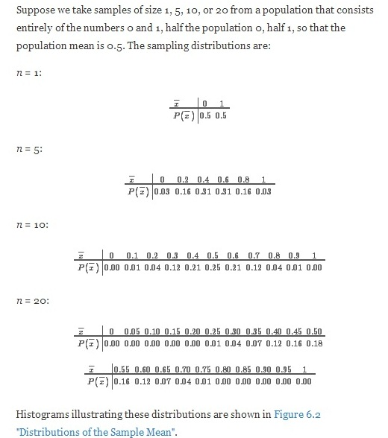

Histograms illustrating these distributions are shown in Figure 6.2 "Distributions of the Sample Mean".

Figure 6.2 Distributions of the Sample Mean
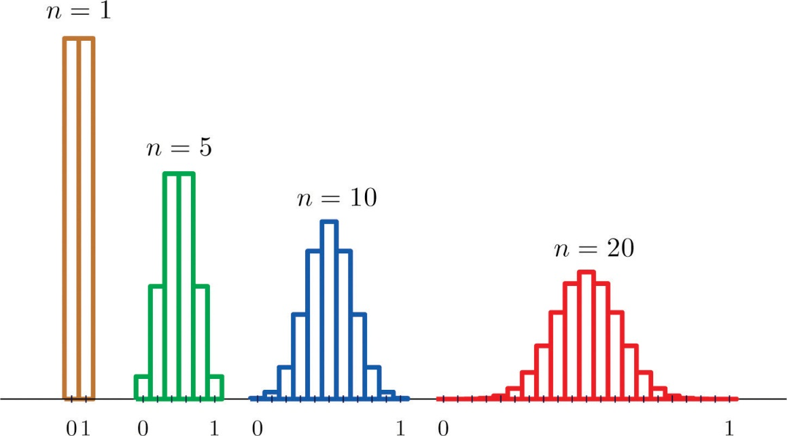
As n increases the sampling distribution of X^−− evolves in an interesting way: the probabilities on the lower and the upper ends shrink and the probabilities in the middle become larger in relation to them. If we were to continue to increase nthen the shape of the sampling distribution would become smoother and more bell-shaped.

What we are seeing in these examples does not depend on the particular population distributions involved. In general, one may start with any distribution and the sampling distribution of the sample mean will increasingly resemble the bell-shaped normal curve as the sample size increases. This is the content of the Central Limit Theorem.
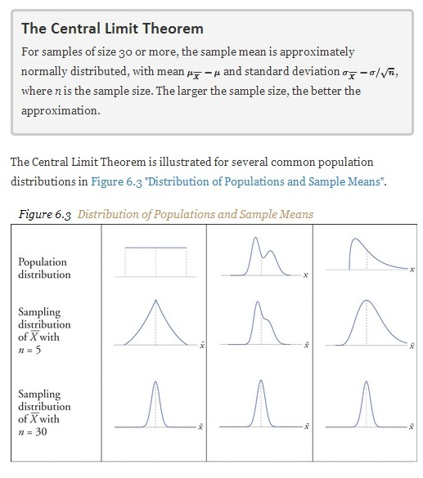
The dashed vertical lines in the figures locate the population mean. Regardless of the distribution of the population, as the sample size is increased the shape of the sampling distribution of the sample mean becomes increasingly bell-shaped, centered on the population mean. Typically by the time the sample size is 30 the distribution of the sample mean is practically the same as a normal distribution.

The importance of the Central Limit Theorem is that it allows us to make probability statements about the sample mean, specifically in relation to its value in comparison to the population mean, as we will see in the examples. But to use the result properly we must first realize that there are two separate random variables (and therefore two probability distributions) at play:

- X, the measurement of a single element selected at random from the population; the distribution of X is the distribution of the population, with mean the population mean μ and standard deviation the population standard deviation σ;
- X−−, the mean of the measurements in a sample of size n; the distribution of X−−is its sampling distribution, with mean μX−−=μ and standard deviation σX−−=σ/n√.
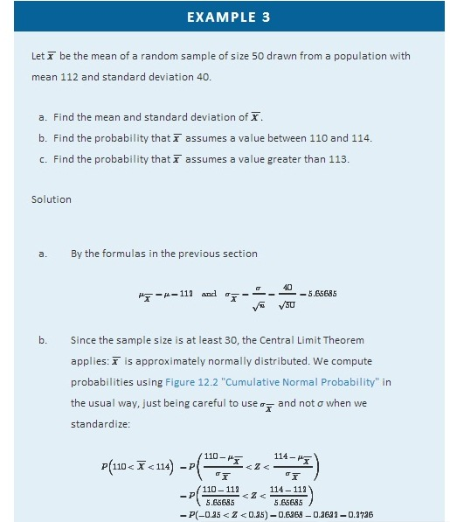
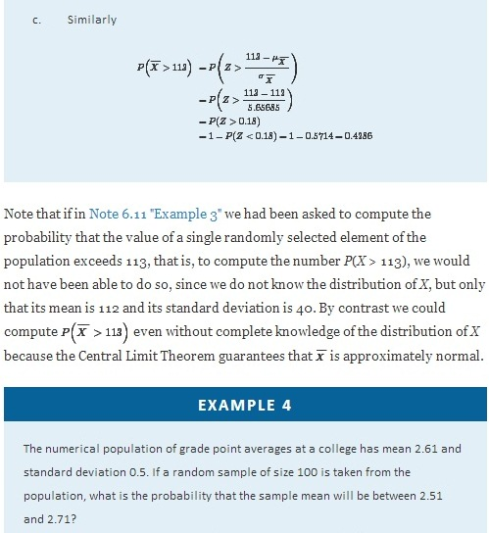
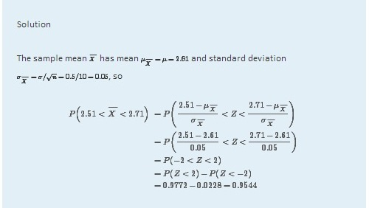

Normally Distributed Populations
The Central Limit Theorem says that no matter what the distribution of the population is, as long as the sample is “large,” meaning of size 30 or more, the sample mean is approximately normally distributed. If the population is normal to begin with then the sample mean also has a normal distribution, regardless of the sample size.

For samples of any size drawn from a normally distributed population, the sample mean is normally distributed, with mean μX^−−=μ and standard deviation σX−−=σ/√n, where n is the sample size.

The effect of increasing the sample size is shown in Figure 6.4 "Distribution of Sample Means for a Normal Population".

Figure 6.4 Distribution of Sample Means for a Normal Population
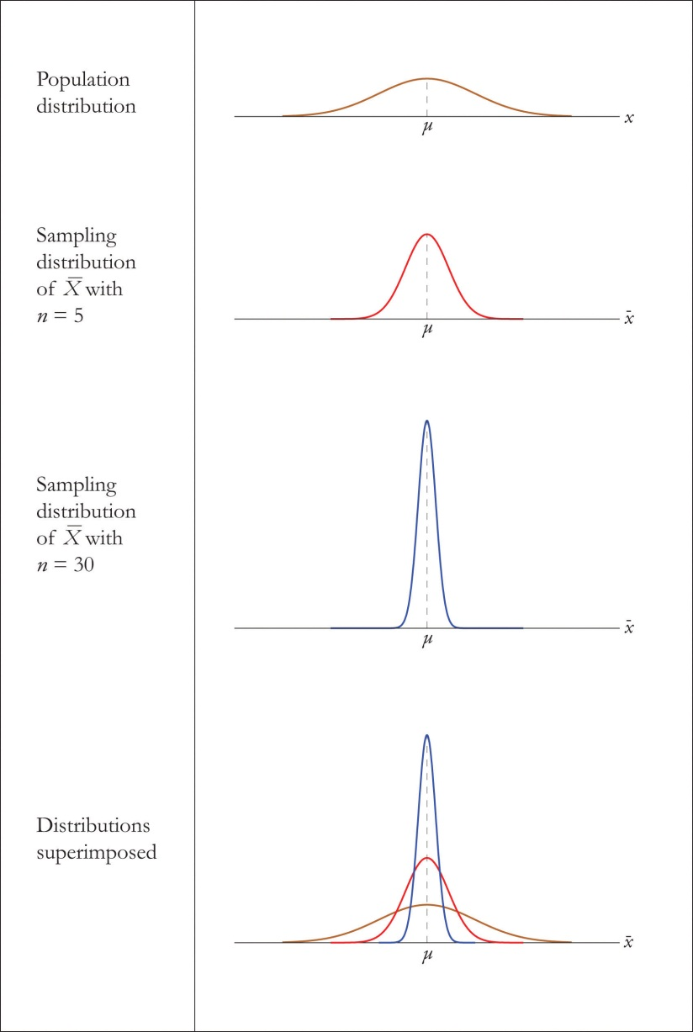

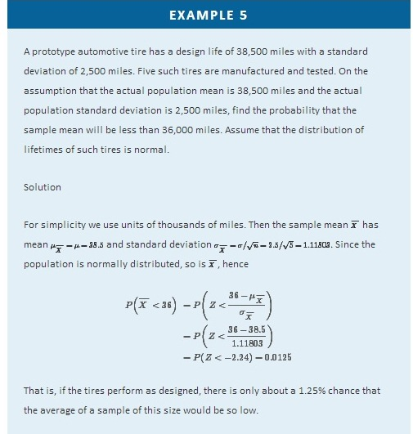
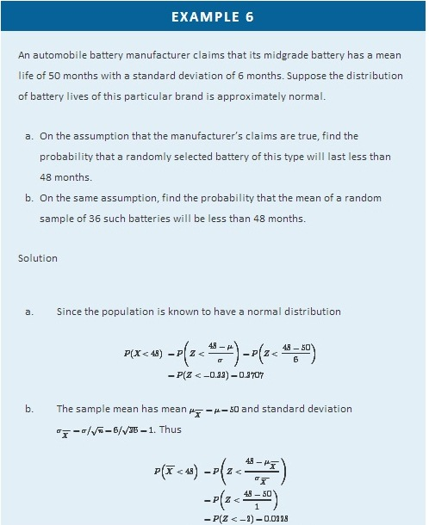

KEY TAKEAWAYS
- When the sample size is at least 30 the sample mean is normally distributed.
- When the population is normal the sample mean is normally distributed regardless of the sample size.

EXERCISES

BASIC
- A population has mean 128 and standard deviation 22.
  - Find the mean and standard deviation of X−− for samples of size 36.
  - Find the probability that the mean of a sample of size 36 will be within 10 units of the population mean, that is, between 118 and 138.
- A population has mean 1,542 and standard deviation 246.
  - Find the mean and standard deviation of X−− for samples of size 100.
  - Find the probability that the mean of a sample of size 100 will be within 100 units of the population mean, that is, between 1,442 and 1,642.
- A population has mean 73.5 and standard deviation 2.5.
  - Find the mean and standard deviation of X−− for samples of size 30.
  - Find the probability that the mean of a sample of size 30 will be less than 72.
- A population has mean 48.4 and standard deviation 6.3.
  - Find the mean and standard deviation of X−− for samples of size 64.
  - Find the probability that the mean of a sample of size 64 will be less than 46.7.
- A normally distributed population has mean 25.6 and standard deviation 3.3.
  - Find the probability that a single randomly selected element X of the population exceeds 30.
  - Find the mean and standard deviation of X−− for samples of size 9.
  - Find the probability that the mean of a sample of size 9 drawn from this population exceeds 30.
- A normally distributed population has mean 57.7 and standard deviation 12.1.
  - Find the probability that a single randomly selected element X of the population is less than 45.
  - Find the mean and standard deviation of X−− for samples of size 16.
  - Find the probability that the mean of a sample of size 16 drawn from this population is less than 45.
- A population has mean 557 and standard deviation 35.
  - Find the mean and standard deviation of X−− for samples of size 50.
  - Find the probability that the mean of a sample of size 50 will be more than 570.
- A population has mean 16 and standard deviation 1.7.
  - Find the mean and standard deviation of X−− for samples of size 80.
  - Find the probability that the mean of a sample of size 80 will be more than 16.4.
- A normally distributed population has mean 1,214 and standard deviation 122.
  - Find the probability that a single randomly selected element X of the population is between 1,100 and 1,300.
  - Find the mean and standard deviation of X−− for samples of size 25.
  - Find the probability that the mean of a sample of size 25 drawn from this population is between 1,100 and 1,300.
- A normally distributed population has mean 57,800 and standard deviation 750.
  - Find the probability that a single randomly selected element X of the population is between 57,000 and 58,000.
  - Find the mean and standard deviation of X−− for samples of size 100.
  - Find the probability that the mean of a sample of size 100 drawn from this population is between 57,000 and 58,000.
- A population has mean 72 and standard deviation 6.
  - Find the mean and standard deviation of X−− for samples of size 45.
  - Find the probability that the mean of a sample of size 45 will differ from the population mean 72 by at least 2 units, that is, is either less than 70 or more than 74. (Hint: One way to solve the problem is to first find the probability of the complementary event.)
- A population has mean 12 and standard deviation 1.5.
  - Find the mean and standard deviation of X−− for samples of size 90.
  - Find the probability that the mean of a sample of size 90 will differ from the population mean 12 by at least 0.3 unit, that is, is either less than 11.7 or more than 12.3. (Hint: One way to solve the problem is to first find the probability of the complementary event.)

APPLICATIONS
- Suppose the mean number of days to germination of a variety of seed is 22, with standard deviation 2.3 days. Find the probability that the mean germination time of a sample of 160 seeds will be within 0.5 day of the population mean.
- Suppose the mean length of time that a caller is placed on hold when telephoning a customer service center is 23.8 seconds, with standard deviation 4.6 seconds. Find the probability that the mean length of time on hold in a sample of 1,200 calls will be within 0.5 second of the population mean.
- Suppose the mean amount of cholesterol in eggs labeled “large” is 186 milligrams, with standard deviation 7 milligrams. Find the probability that the mean amount of cholesterol in a sample of 144 eggs will be within 2 milligrams of the population mean.
- Suppose that in one region of the country the mean amount of credit card debt per household in households having credit card debt is $15,250, with standard deviation $7,125. Find the probability that the mean amount of credit card debt in a sample of 1,600 such households will be within $300 of the population mean.
- Suppose speeds of vehicles on a particular stretch of roadway are normally distributed with mean 36.6 mph and standard deviation 1.7 mph.
  - Find the probability that the speed X of a randomly selected vehicle is between 35 and 40 mph.
  - Find the probability that the mean speed X−− of 20 randomly selected vehicles is between 35 and 40 mph.
- Many sharks enter a state of tonic immobility when inverted. Suppose that in a particular species of sharks the time a shark remains in a state of tonic immobility when inverted is normally distributed with mean 11.2 minutes and standard deviation 1.1 minutes.
  - If a biologist induces a state of tonic immobility in such a shark in order to study it, find the probability that the shark will remain in this state for between 10 and 13 minutes.
  - When a biologist wishes to estimate the mean time that such sharks stay immobile by inducing tonic immobility in each of a sample of 12 sharks, find the probability that mean time of immobility in the sample will be between 10 and 13 minutes.
- Suppose the mean cost across the country of a 30-day supply of a generic drug is $46.58, with standard deviation $4.84. Find the probability that the mean of a sample of 100 prices of 30-day supplies of this drug will be between $45 and $50.
- Suppose the mean length of time between submission of a state tax return requesting a refund and the issuance of the refund is 47 days, with standard deviation 6 days. Find the probability that in a sample of 50 returns requesting a refund, the mean such time will be more than 50 days.
- Scores on a common final exam in a large enrollment, multiple-section freshman course are normally distributed with mean 72.7 and standard deviation 13.1.
  - Find the probability that the score X on a randomly selected exam paper is between 70 and 80.
  - Find the probability that the mean score X−− of 38 randomly selected exam papers is between 70 and 80.
- Suppose the mean weight of school children’s bookbags is 17.4 pounds, with standard deviation 2.2 pounds. Find the probability that the mean weight of a sample of 30 bookbags will exceed 17 pounds.
- Suppose that in a certain region of the country the mean duration of first marriages that end in divorce is 7.8 years, standard deviation 1.2 years. Find the probability that in a sample of 75 divorces, the mean age of the marriages is at most 8 years.
- Borachio eats at the same fast food restaurant every day. Suppose the time Xbetween the moment Borachio enters the restaurant and the moment he is served his food is normally distributed with mean 4.2 minutes and standard deviation 1.3 minutes.
  - Find the probability that when he enters the restaurant today it will be at least 5 minutes until he is served.
  - Find the probability that average time until he is served in eight randomly selected visits to the restaurant will be at least 5 minutes.

ADDITIONAL EXERCISES
- A high-speed packing machine can be set to deliver between 11 and 13 ounces of a liquid. For any delivery setting in this range the amount delivered is normally distributed with mean some amount μ and with standard deviation 0.08 ounce. To calibrate the machine it is set to deliver a particular amount, many containers are filled, and 25 containers are randomly selected and the amount they contain is measured. Find the probability that the sample mean will be within 0.05 ounce of the actual mean amount being delivered to all containers.
- A tire manufacturer states that a certain type of tire has a mean lifetime of 60,000 miles. Suppose lifetimes are normally distributed with standard deviation σ= 3,500miles.
  - Find the probability that if you buy one such tire, it will last only 57,000 or fewer miles. If you had this experience, is it particularly strong evidence that the tire is not as good as claimed?
  - A consumer group buys five such tires and tests them. Find the probability that average lifetime of the five tires will be 57,000 miles or less. If the mean is so low, is that particularly strong evidence that the tire is not as good as claimed?

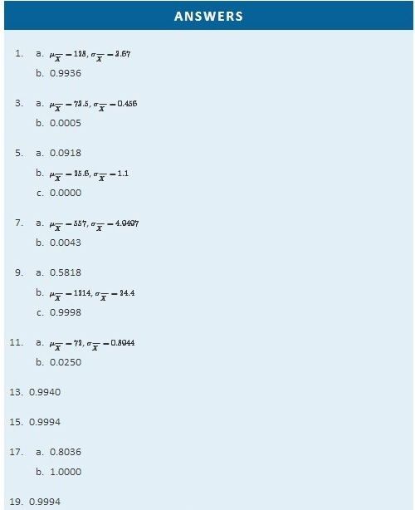

6.3 The Sample Proportion

LEARNING OBJECTIVES
- To recognize that the sample proportion Pˆ is a random variable.
- To understand the meaning of the formulas for the mean and standard deviation of the sample proportion.
- To learn what the sampling distribution of Pˆ is when the sample size is large.
Often sampling is done in order to estimate the proportion of a population that has a specific characteristic, such as the proportion of all items coming off an assembly line that are defective or the proportion of all people entering a retail store who make a purchase before leaving. The population proportion is denoted p and the sample proportion is denoted pˆ. Thus if in reality 43% of people entering a store make a purchase before leaving, p = 0.43; if in a sample of 200 people entering the store, 78 make a purchase, pˆ=78/200=0.39.

The sample proportion is a random variable: it varies from sample to sample in a way that cannot be predicted with certainty. Viewed as a random variable it will be written Pˆ. It has a mean μ_{Pˆ} and a standard deviation σ_{Pˆ}. Here are formulas for their values.
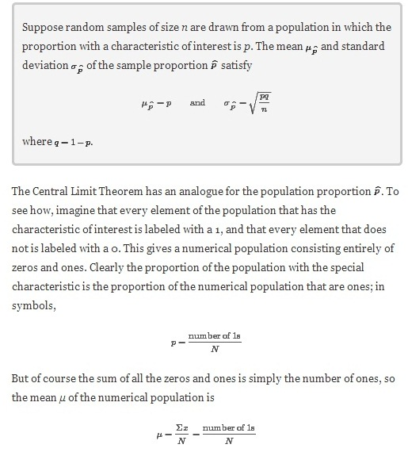
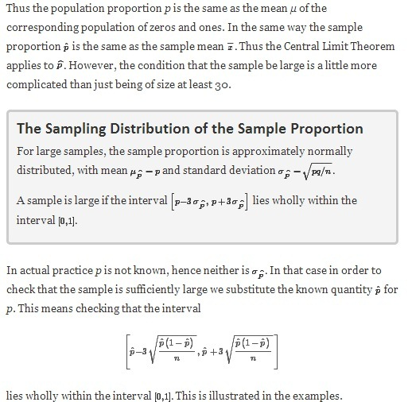

Figure 6.5 "Distribution of Sample Proportions" shows that when p = 0.1 a sample of size 15 is too small but a sample of size 100 is acceptable. Figure 6.6 "Distribution of Sample Proportions for " shows that when p = 0.5 a sample of size 15 is acceptable.

Figure 6.5 Distribution of Sample Proportions
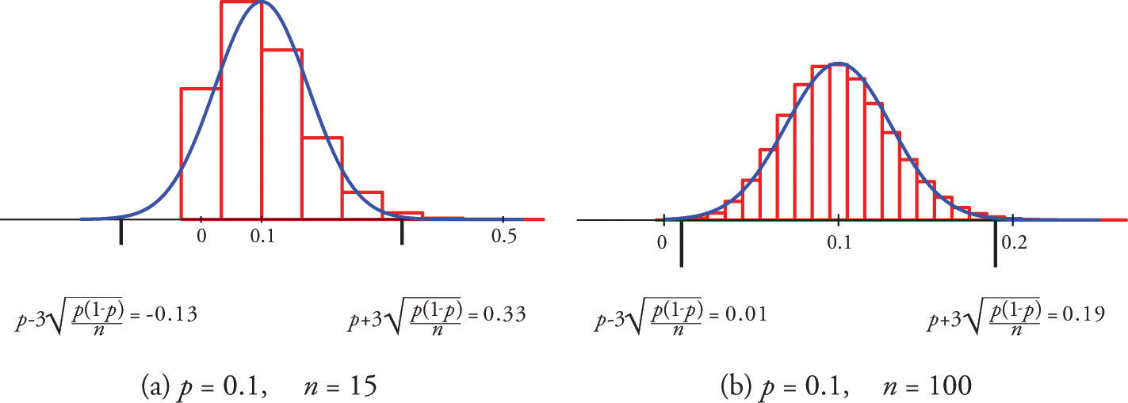

Figure 6.6 Distribution of Sample Proportions for p = 0.5 and n = 15
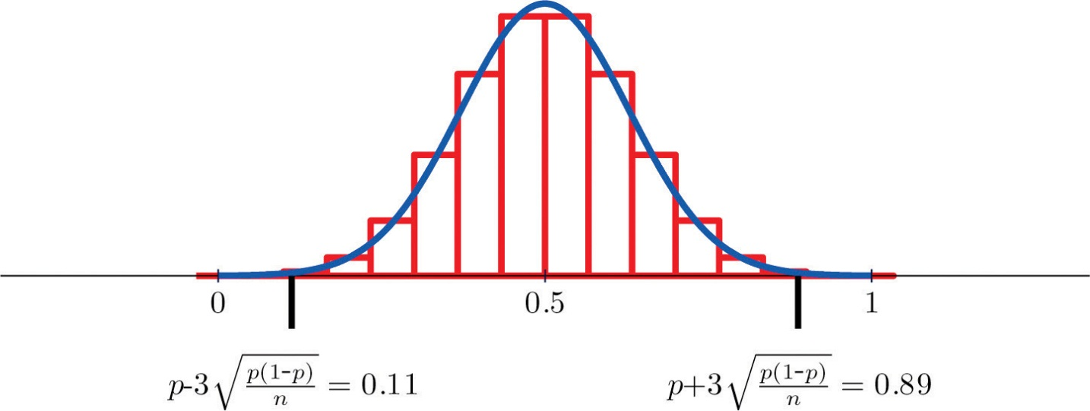
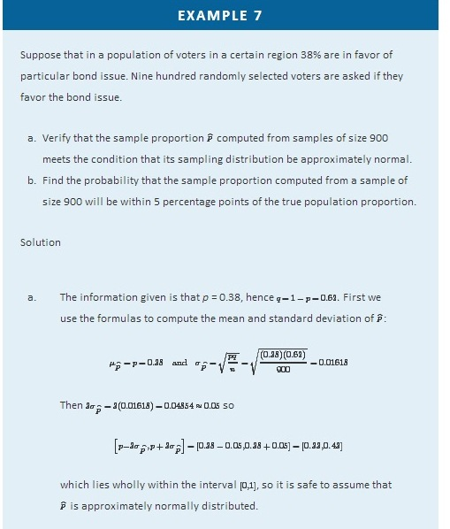
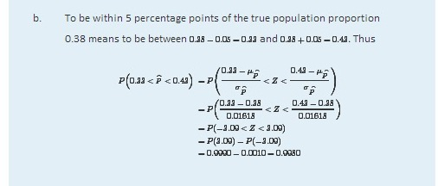

EXAMPLE 8
An online retailer claims that 90% of all orders are shipped within 12 hours of being received. A consumer group placed 121 orders of different sizes and at different times of day; 102 orders were shipped within 12 hours.
  - Compute the sample proportion of items shipped within 12 hours.
  - Confirm that the sample is large enough to assume that the sample proportion is normally distributed. Use p = 0.90, corresponding to the assumption that the retailer’s claim is valid.
  - Assuming the retailer’s claim is true, find the probability that a sample of size 121 would produce a sample proportion so low as was observed in this sample.
  - Based on the answer to part (c), draw a conclusion about the retailer’s claim.
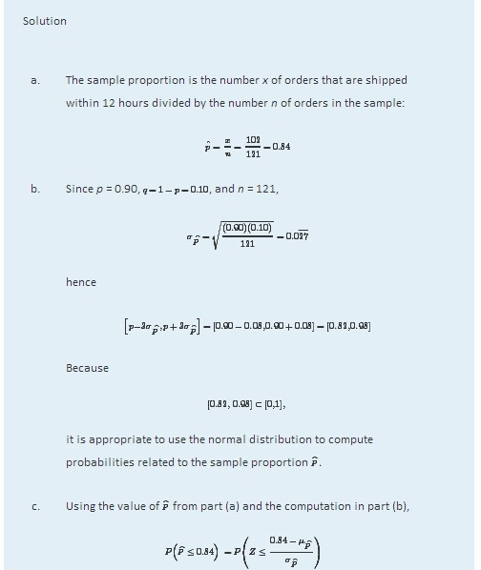
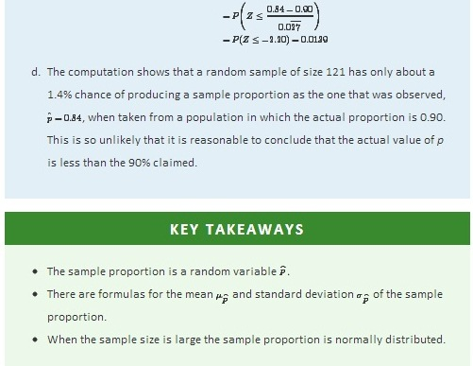
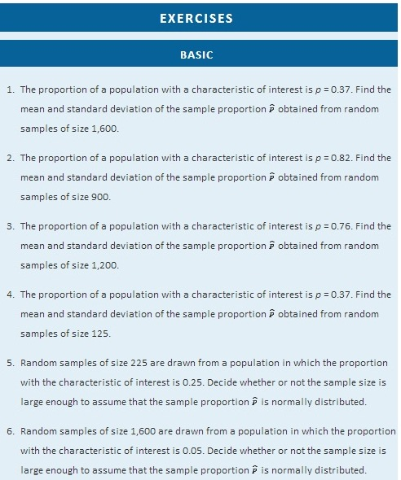
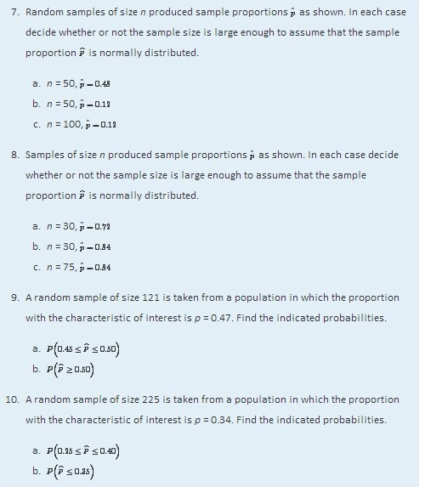
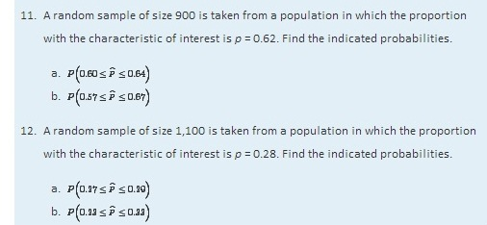

APPLICATIONS
- Suppose that 8% of all males suffer some form of color blindness. Find the probability that in a random sample of 250 men at least 10% will suffer some form of color blindness. First verify that the sample is sufficiently large to use the normal distribution.
- Suppose that 29% of all residents of a community favor annexation by a nearby municipality. Find the probability that in a random sample of 50 residents at least 35% will favor annexation. First verify that the sample is sufficiently large to use the normal distribution.
- Suppose that 2% of all cell phone connections by a certain provider are dropped. Find the probability that in a random sample of 1,500 calls at most 40 will be dropped. First verify that the sample is sufficiently large to use the normal distribution.
- Suppose that in 20% of all traffic accidents involving an injury, driver distraction in some form (for example, changing a radio station or texting) is a factor. Find the probability that in a random sample of 275 such accidents between 15% and 25% involve driver distraction in some form. First verify that the sample is sufficiently large to use the normal distribution.
- An airline claims that 72% of all its flights to a certain region arrive on time. In a random sample of 30 recent arrivals, 19 were on time. You may assume that the normal distribution applies.
  - Compute the sample proportion.
  - Assuming the airline’s claim is true, find the probability of a sample of size 30 producing a sample proportion so low as was observed in this sample.
- A humane society reports that 19% of all pet dogs were adopted from an animal shelter. Assuming the truth of this assertion, find the probability that in a random sample of 80 pet dogs, between 15% and 20% were adopted from a shelter. You may assume that the normal distribution applies.
- In one study it was found that 86% of all homes have a functional smoke detector. Suppose this proportion is valid for all homes. Find the probability that in a random sample of 600 homes, between 80% and 90% will have a functional smoke detector. You may assume that the normal distribution applies.
- A state insurance commission estimates that 13% of all motorists in its state are uninsured. Suppose this proportion is valid. Find the probability that in a random sample of 50 motorists, at least 5 will be uninsured. You may assume that the normal distribution applies.
- An outside financial auditor has observed that about 4% of all documents he examines contain an error of some sort. Assuming this proportion to be accurate, find the probability that a random sample of 700 documents will contain at least 30 with some sort of error. You may assume that the normal distribution applies.
- Suppose 7% of all households have no home telephone but depend completely on cell phones. Find the probability that in a random sample of 450 households, between 25 and 35 will have no home telephone. You may assume that the normal distribution applies.

ADDITIONAL EXERCISES
- Some countries allow individual packages of prepackaged goods to weigh less than what is stated on the package, subject to certain conditions, such as the average of all packages being the stated weight or greater. Suppose that one requirement is that at most 4% of all packages marked 500 grams can weigh less than 490 grams. Assuming that a product actually meets this requirement, find the probability that in a random sample of 150 such packages the proportion weighing less than 490 grams is at least 3%. You may assume that the normal distribution applies.
- An economist wishes to investigate whether people are keeping cars longer now than in the past. He knows that five years ago, 38% of all passenger vehicles in operation were at least ten years old. He commissions a study in which 325 automobiles are randomly sampled. Of them, 132 are ten years old or older.
  - Find the sample proportion.
  - Find the probability that, when a sample of size 325 is drawn from a population in which the true proportion is 0.38, the sample proportion will be as large as the value you computed in part (a). You may assume that the normal distribution applies.
  - Give an interpretation of the result in part (b). Is there strong evidence that people are keeping their cars longer than was the case five years ago?
- A state public health department wishes to investigate the effectiveness of a campaign against smoking. Historically 22% of all adults in the state regularly smoked cigars or cigarettes. In a survey commissioned by the public health department, 279 of 1,500 randomly selected adults stated that they smoke regularly.
  - Find the sample proportion.
  - Find the probability that, when a sample of size 1,500 is drawn from a population in which the true proportion is 0.22, the sample proportion will be no larger than the value you computed in part (a). You may assume that the normal distribution applies.
  - Give an interpretation of the result in part (b). How strong is the evidence that the campaign to reduce smoking has been effective?
- In an effort to reduce the population of unwanted cats and dogs, a group of veterinarians set up a low-cost spay/neuter clinic. At the inception of the clinic a survey of pet owners indicated that 78% of all pet dogs and cats in the community were spayed or neutered. After the low-cost clinic had been in operation for three years, that figure had risen to 86%.
  - What information is missing that you would need to compute the probability that a sample drawn from a population in which the proportion is 78% (corresponding to the assumption that the low-cost clinic had had no effect) is as high as 86%?
  - Knowing that the size of the original sample three years ago was 150 and that the size of the recent sample was 125, compute the probability mentioned in part (a). You may assume that the normal distribution applies.
  - Give an interpretation of the result in part (b). How strong is the evidence that the presence of the low-cost clinic has increased the proportion of pet dogs and cats that have been spayed or neutered?
- An ordinary die is “fair” or “balanced” if each face has an equal chance of landing on top when the die is rolled. Thus the proportion of times a three is observed in a large number of tosses is expected to be close to 1/6 or 0.16−. Suppose a die is rolled 240 times and shows three on top 36 times, for a sample proportion of 0.15.
- Find the probability that a fair die would produce a proportion of 0.15 or less. You may assume that the normal distribution applies.
- Give an interpretation of the result in part (b). How strong is the evidence that the die is not fair?
- Suppose the sample proportion 0.15 came from rolling the die 2,400 times instead of only 240 times. Rework part (a) under these circumstances.
- Give an interpretation of the result in part (c). How strong is the evidence that the die is not fair?

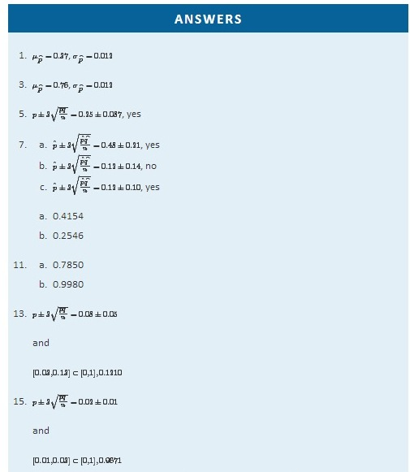
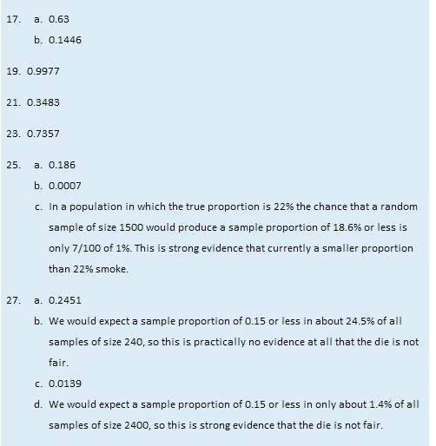

Chapter 7

Estimation
If we wish to estimate the mean μ of a population for which a census is impractical, say the average height of all 18-year-old men in the country, a reasonable strategy is to take a sample, compute its mean x−, and estimate the unknown number μ by the known number x−. For example, if the average height of 100 randomly selected men aged 18 is 70.6 inches, then we would say that the average height of all 18-year-old men is (at least approximately) 70.6 inches.

Estimating a population parameter by a single number like this is called point estimation; in the case at hand the statistic x^− is a point estimate of the parameter μ. The terminology arises because a single number corresponds to a single point on the number line.

A problem with a point estimate is that it gives no indication of how reliable the estimate is. In contrast, in this chapter we learn about interval estimation. In brief, in the case of estimating a population mean μ we use a formula to compute from the data a number E, called the margin of error of the estimate, and form the interval [x^−−E,x−+E]. We do this in such a way that a certain proportion, say 95%, of all the intervals constructed from sample data by means of this formula contain the unknown parameter μ. Such an interval is called a 95% confidence interval for μ.

Continuing with the example of the average height of 18-year-old men, suppose that the sample of 100 men mentioned above for which x^−=70.6 inches also had sample standard deviation s = 1.7 inches. It then turns out that E = 0.33 and we would state that we are 95% confident that the average height of all 18-year-old men is in the interval formed by 70.6±0.33 inches, that is, the average is between 70.27 and 70.93 inches. If the sample statistics had come from a smaller sample, say a sample of 50 men, the lower reliability would show up in the 95% confidence interval being longer, hence less precise in its estimate. In this example the 95% confidence interval for the same sample statistics but with n = 50 is 70.6±0.47 inches, or from 70.13 to 71.07 inches.

7.1 Large Sample Estimation of a Population Mean

LEARNING OBJECTIVES
- To become familiar with the concept of an interval estimate of the population mean.
- To understand how to apply formulas for a confidence interval for a population mean.
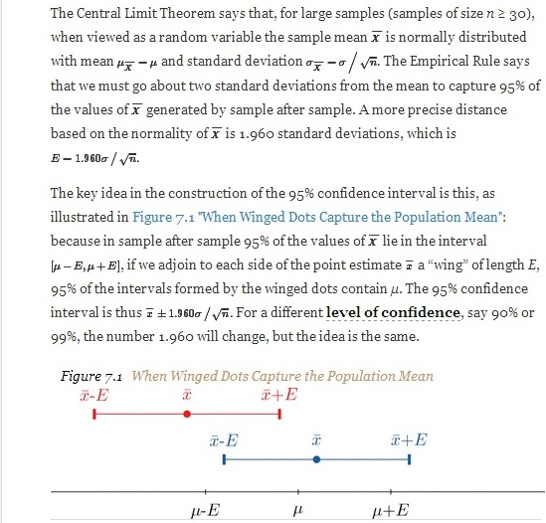
Figure 7.2 "Computer Simulation of 40 95% Confidence Intervals for a Mean"shows the intervals generated by a computer simulation of drawing 40 samples from a normally distributed population and constructing the 95% confidence interval for each one. We expect that about (0.05)(40)=2 of the intervals so constructed would fail to contain the population mean μ, and in this simulation two of the intervals, shown in red, do.

Figure 7.2 Computer Simulation of 40 95% Confidence Intervals for a Mean
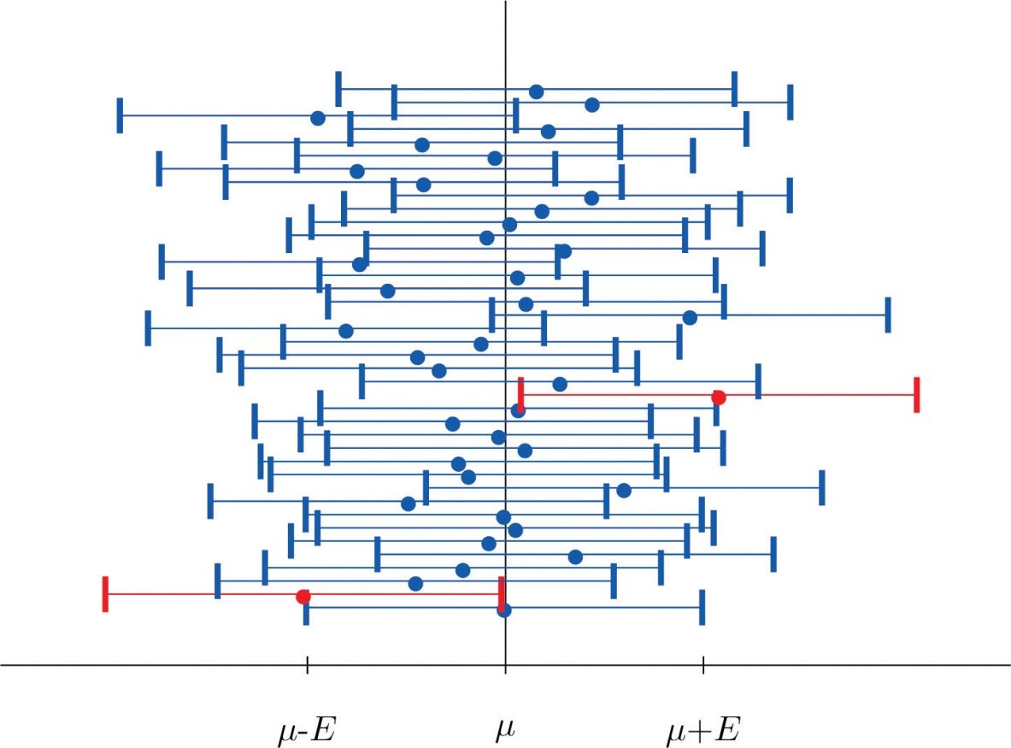
It is standard practice to identify the level of confidence in terms of the area α in the two tails of the distribution of X^−− when the middle part specified by the level of confidence is taken out. This is shown in Figure 7.3, drawn for the general situation, and in Figure 7.4, drawn for 95% confidence. Remember from Section 5.4.1 "Tails of the Standard Normal Distribution" in Chapter 5 "Continuous Random Variables" that the z-value that cuts off a right tail of area c is denotedz_{c}. Thus the number 1.960 in the example is z.025, which is zα/2 for α=1−0.95=0.05.
Figure 7.3
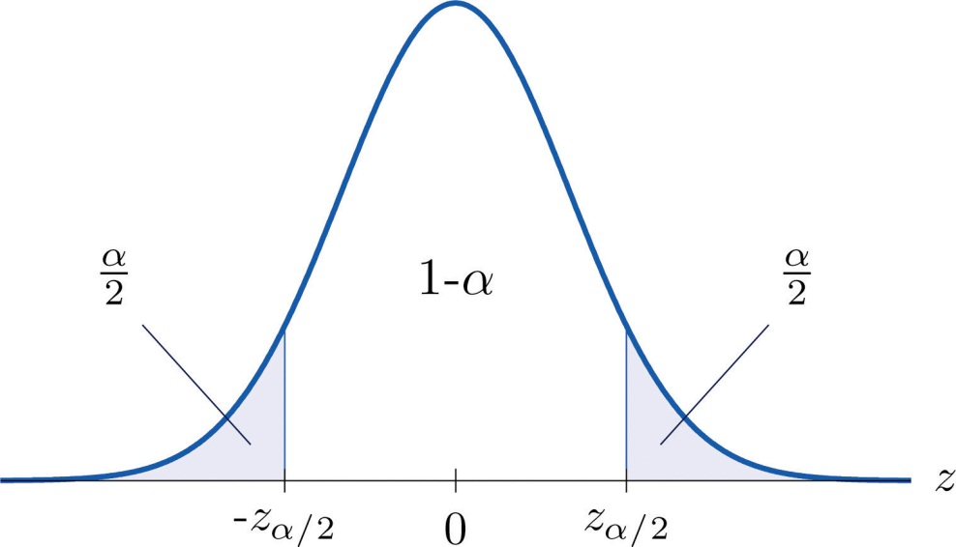
100(1−α) α/2.
Figure 7.4
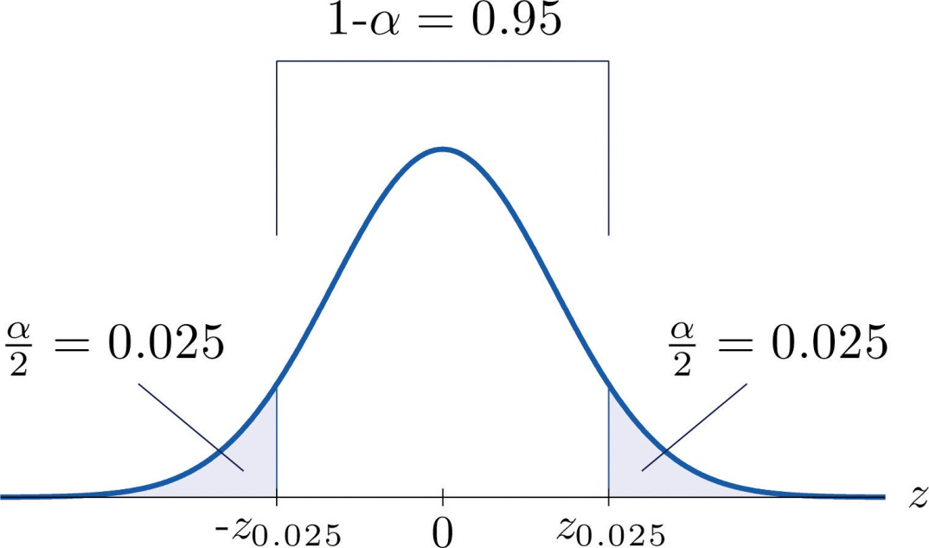
α/2=0.025.
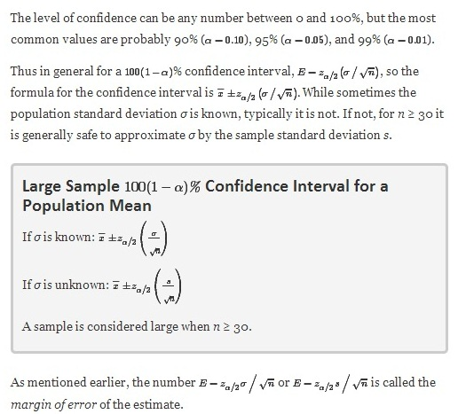

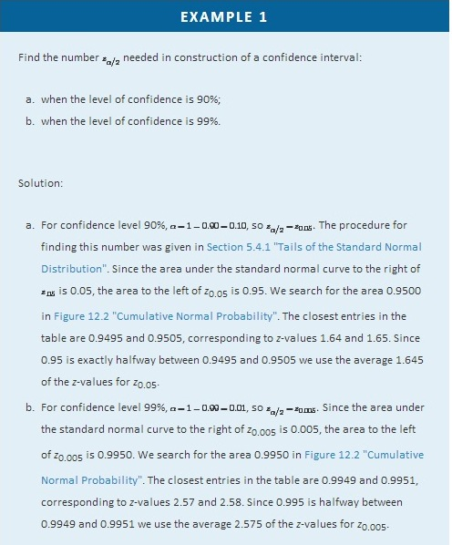

EXAMPLE 2
Use Figure 12.3 "Critical Values of " to find the number zα/2 needed in construction of a confidence interval:
- when the level of confidence is 90%;
- when the level of confidence is 99%.
Solution:
- In the next section we will learn about a continuous random variable that has a probability distribution called the Student t-distribution. Figure 12.3 "Critical Values of " gives the value t_{c} that cuts off a right tail of area c for different values of c. The last line of that table, the one whose heading is the symbol ∞ for infinity and [z], gives the corresponding z-value z_{c} that cuts off a right tail of the same area c. In particular, z_{0.05} is the number in that row and in the column with the heading t_{0.05}. We read off directly that z0.05=1.645.
- In Figure 12.3 "Critical Values of " z_{0.005} is the number in the last row and in the column headed t_{0.005}, namely 2.576.

Figure 12.3 "Critical Values of " can be used to find z_{c} only for those values of cfor which there is a column with the heading t_{c} appearing in the table; otherwise we must use Figure 12.2 "Cumulative Normal Probability" in reverse. But when it can be done it is both faster and more accurate to use the last line of Figure 12.3 "Critical Values of " to find z_{c} than it is to do so using Figure 12.2 "Cumulative Normal Probability" in reverse.

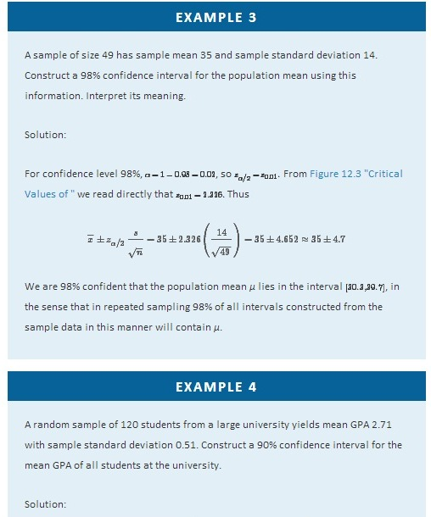
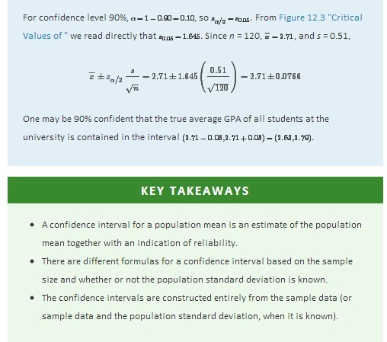

EXERCISES

BASIC
- A random sample is drawn from a population of known standard deviation 11.3. Construct a 90% confidence interval for the population mean based on the information given (not all of the information given need be used).
  - n = 36, x−=105.2, s = 11.2
  - n = 100, x−=105.2, s = 11.2
- A random sample is drawn from a population of known standard deviation 22.1. Construct a 95% confidence interval for the population mean based on the information given (not all of the information given need be used).
  - n = 121, x−=82.4, s = 21.9
  - n = 81, x−=82.4, s = 21.9
- A random sample is drawn from a population of unknown standard deviation. Construct a 99% confidence interval for the population mean based on the information given.
  - n = 49, x−=17.1, s = 2.1
  - n = 169, x−=17.1, s = 2.1
- A random sample is drawn from a population of unknown standard deviation. Construct a 98% confidence interval for the population mean based on the information given.
  - n = 225, x−=92.0, s = 8.4
  - n = 64, x−=92.0, s = 8.4
- A random sample of size 144 is drawn from a population whose distribution, mean, and standard deviation are all unknown. The summary statistics are x−=58.2 and s = 2.6.
  - Construct an 80% confidence interval for the population mean μ.
  - Construct a 90% confidence interval for the population mean μ.
  - Comment on why one interval is longer than the other.
- A random sample of size 256 is drawn from a population whose distribution, mean, and standard deviation are all unknown. The summary statistics are x−=1011 and s = 34.
  - Construct a 90% confidence interval for the population mean μ.
  - Construct a 99% confidence interval for the population mean μ.
  - Comment on why one interval is longer than the other.

APPLICATIONS
- A government agency was charged by the legislature with estimating the length of time it takes citizens to fill out various forms. Two hundred randomly selected adults were timed as they filled out a particular form. The times required had mean 12.8 minutes with standard deviation 1.7 minutes. Construct a 90% confidence interval for the mean time taken for all adults to fill out this form.
- Four hundred randomly selected working adults in a certain state, including those who worked at home, were asked the distance from their home to their workplace. The average distance was 8.84 miles with standard deviation 2.70 miles. Construct a 99% confidence interval for the mean distance from home to work for all residents of this state.
- On every passenger vehicle that it tests an automotive magazine measures, at true speed 55 mph, the difference between the true speed of the vehicle and the speed indicated by the speedometer. For 36 vehicles tested the mean difference was −1.2 mph with standard deviation 0.2 mph. Construct a 90% confidence interval for the mean difference between true speed and indicated speed for all vehicles.
- A corporation monitors time spent by office workers browsing the web on their computers instead of working. In a sample of computer records of 50 workers, the average amount of time spent browsing in an eight-hour work day was 27.8 minutes with standard deviation 8.2 minutes. Construct a 99.5% confidence interval for the mean time spent by all office workers in browsing the web in an eight-hour day.
- A sample of 250 workers aged 16 and older produced an average length of time with the current employer (“job tenure”) of 4.4 years with standard deviation 3.8 years. Construct a 99.9% confidence interval for the mean job tenure of all workers aged 16 or older.
- The amount of a particular biochemical substance related to bone breakdown was measured in 30 healthy women. The sample mean and standard deviation were 3.3 nanograms per milliliter (ng/mL) and 1.4 ng/mL. Construct an 80% confidence interval for the mean level of this substance in all healthy women.
- A corporation that owns apartment complexes wishes to estimate the average length of time residents remain in the same apartment before moving out. A sample of 150 rental contracts gave a mean length of occupancy of 3.7 years with standard deviation 1.2 years. Construct a 95% confidence interval for the mean length of occupancy of apartments owned by this corporation.
- The designer of a garbage truck that lifts roll-out containers must estimate the mean weight the truck will lift at each collection point. A random sample of 325 containers of garbage on current collection routes yielded x−=75.3 lb, s = 12.8 lb. Construct a 99.8% confidence interval for the mean weight the trucks must lift each time.
- In order to estimate the mean amount of damage sustained by vehicles when a deer is struck, an insurance company examined the records of 50 such occurrences, and obtained a sample mean of $2,785 with sample standard deviation $221. Construct a 95% confidence interval for the mean amount of damage in all such accidents.
- In order to estimate the mean FICO credit score of its members, a credit union samples the scores of 95 members, and obtains a sample mean of 738.2 with sample standard deviation 64.2. Construct a 99% confidence interval for the mean FICO score of all of its members.
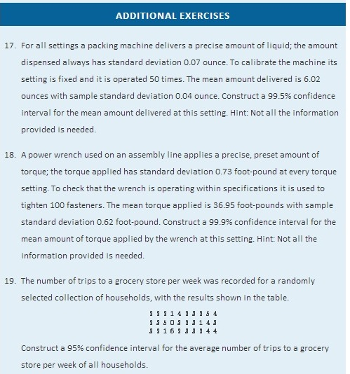
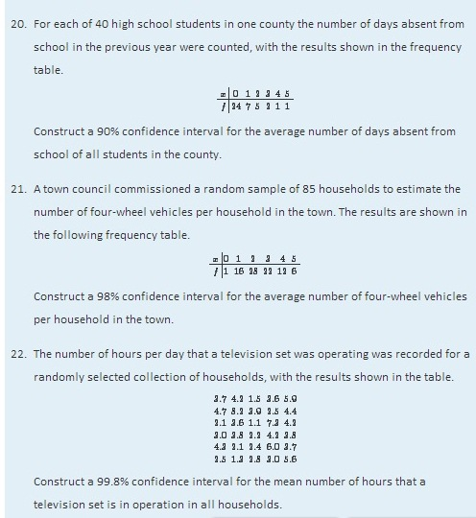

LARGE DATA SET EXERCISES
- Large Data Set 1 records the SAT scores of 1,000 students. Regarding it as a random sample of all high school students, use it to construct a 99% confidence interval for the mean SAT score of all students.
http://www.flatworldknowledge.com/sites/all/files/data1.xls
- Large Data Set 1 records the GPAs of 1,000 college students. Regarding it as a random sample of all college students, use it to construct a 95% confidence interval for the mean GPA of all students.
http://www.flatworldknowledge.com/sites/all/files/data1.xls
- Large Data Set 1 lists the SAT scores of 1,000 students.
http://www.flatworldknowledge.com/sites/all/files/data1.xls
  - Regard the data as arising from a census of all students at a high school, in which the SAT score of every student was measured. Compute the population mean μ.
  - Regard the first 36 students as a random sample and use it to construct a 99% confidence for the mean μ of all 1,000 SAT scores. Does it actually capture the mean μ?
- Large Data Set 1 lists the GPAs of 1,000 students.
http://www.flatworldknowledge.com/sites/all/files/data1.xls
- Regard the data as arising from a census of all freshman at a small college at the end of their first academic year of college study, in which the GPA of every such person was measured. Compute the population mean μ.
- Regard the first 36 students as a random sample and use it to construct a 95% confidence for the mean μ of all 1,000 GPAs. Does it actually capture the meanμ?
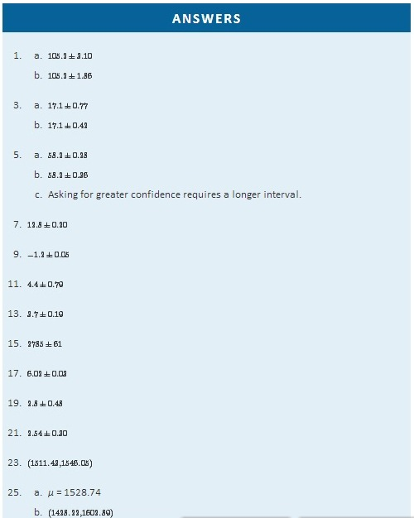

7.2 Small Sample Estimation of a Population Mean

LEARNING OBJECTIVES
- To become familiar with Student’s t-distribution.
- To understand how to apply additional formulas for a confidence interval for a population mean.
The confidence interval formulas in the previous section are based on the Central Limit Theorem, the statement that for large samples X^−− is normally distributed with mean μ and standard deviation σ/√n. When the population mean μ is estimated with a small sample (n < 30), the Central Limit Theorem does not apply. In order to proceed we assume that the numerical population from which the sample is taken has a normal distribution to begin with. If this condition is satisfied then when the population standard deviation σ is known the old formula x^−±zα/2(σ/√n) can still be used to construct a 100(1−α)% confidence interval for μ.

If the population standard deviation is unknown and the sample size n is small then when we substitute the sample standard deviation s for σ the normal approximation is no longer valid. The solution is to use a different distribution, called Student’s t-distribution with n−1 degrees of freedom. Student’s t-distribution is very much like the standard normal distribution in that it is centered at 0 and has the same qualitative bell shape, but it has heavier tails than the standard normal distribution does, as indicated by Figure 7.5 "Student’s ", in which the curve (in brown) that meets the dashed vertical line at the lowest point is the t-distribution with two degrees of freedom, the next curve (in blue) is the t-distribution with five degrees of freedom, and the thin curve (in red) is the standard normal distribution. As also indicated by the figure, as the sample size n increases, Student’s t-distribution ever more closely resembles the standard normal distribution. Although there is a different t-distribution for every value of n, once the sample size is 30 or more it is typically acceptable to use the standard normal distribution instead, as we will always do in this text.
Figure 7.5 Student’s t-Distribution
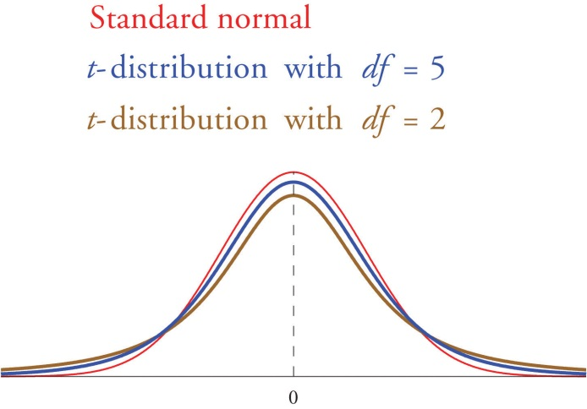
Just as the symbol z_{c} stands for the value that cuts off a right tail of area c in the standard normal distribution, so the symbol t_{c} stands for the value that cuts off a right tail of area c in the standard normal distribution. This gives us the following confidence interval formulas.
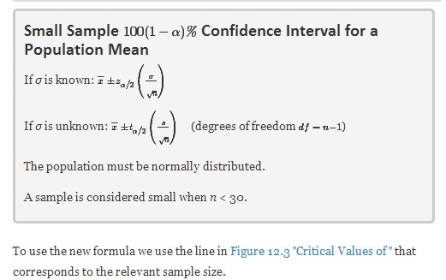
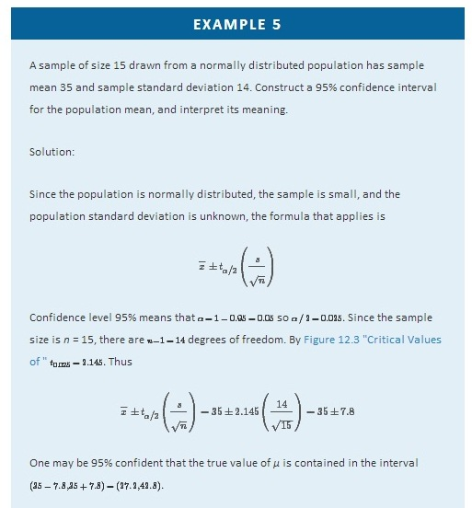
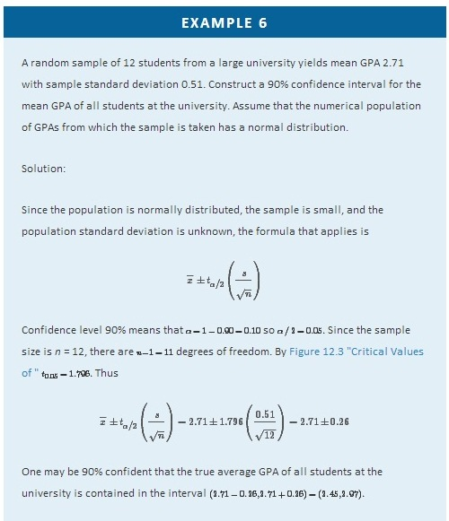

Compare Note 7.9 "Example 4" in Section 7.1 "Large Sample Estimation of a Population Mean" and Note 7.16 "Example 6". The summary statistics in the two samples are the same, but the 90% confidence interval for the average GPA of all students at the university in Note 7.9 "Example 4" in Section 7.1 "Large Sample Estimation of a Population Mean", (2.63,2.79), is shorter than the 90% confidence interval (2.45,2.97), in Note 7.16 "Example 6". This is partly because in Note 7.9 "Example 4" the sample size is larger; there is more information pertaining to the true value of μ in the large data set than in the small one.

KEY TAKEAWAYS
- In selecting the correct formula for construction of a confidence interval for a population mean ask two questions: is the population standard deviation σ known or unknown, and is the sample large or small?
- We can construct confidence intervals with small samples only if the population is normal.
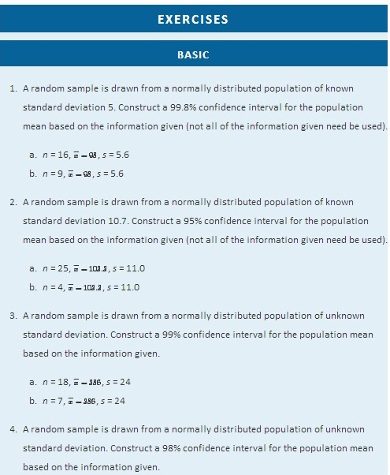
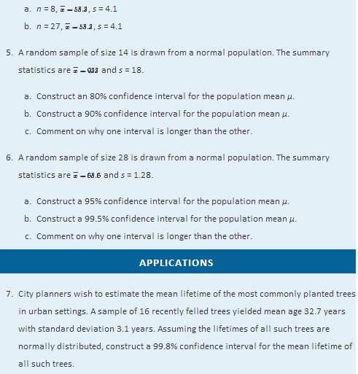
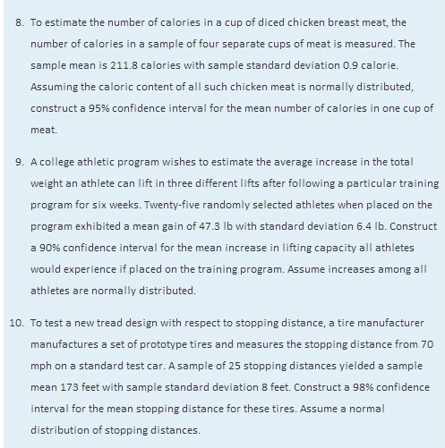
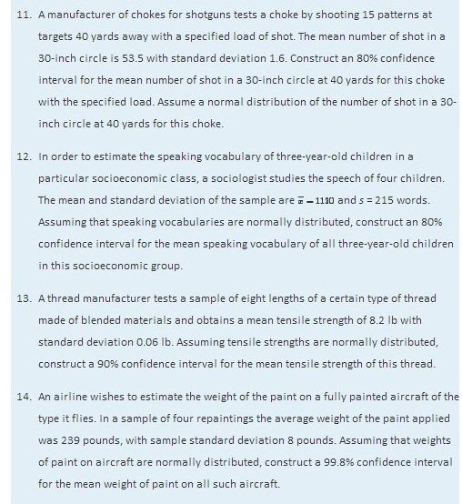
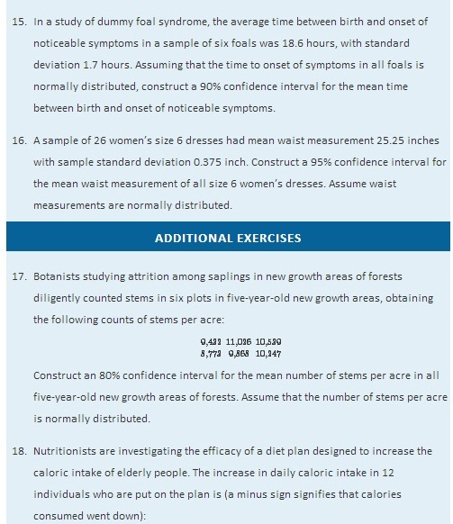
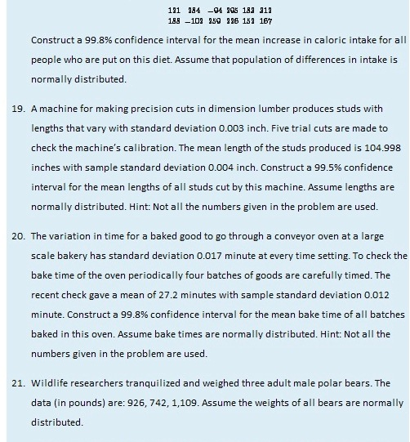
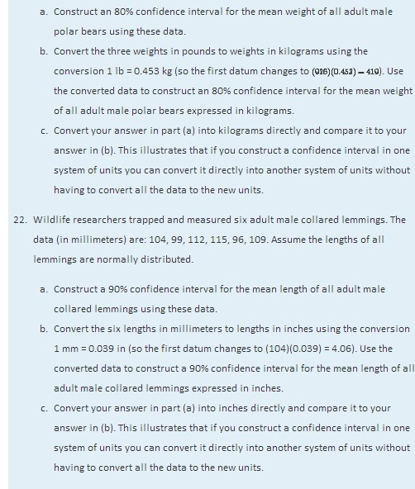
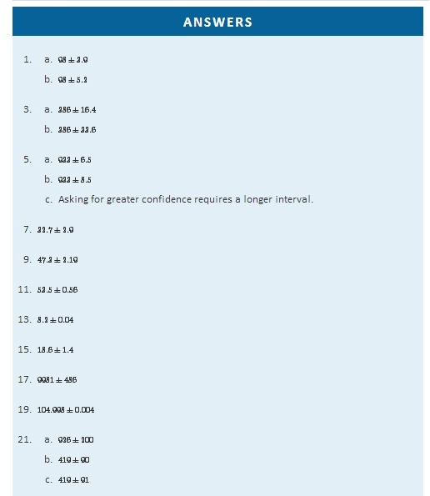

7.3 Large Sample Estimation of a Population Proportion

LEARNING OBJECTIVE
- To understand how to apply the formula for a confidence interval for a population proportion.
Since from Section 6.3 "The Sample Proportion" in Chapter 6 "Sampling Distributions" we know the mean, standard deviation, and sampling distribution of the sample proportion pˆ, the ideas of the previous two sections can be applied to produce a confidence interval for a population proportion. Here is the formula.
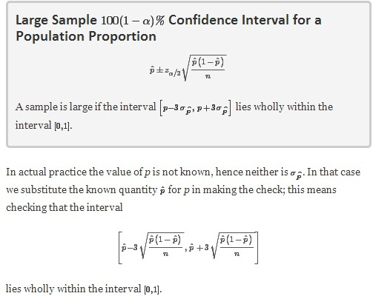
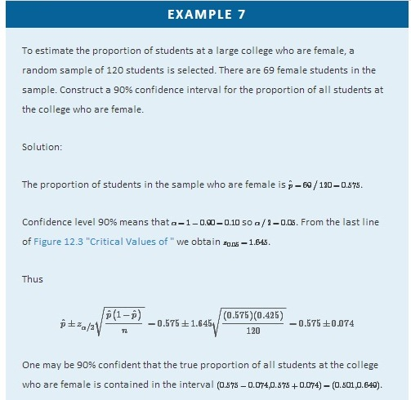

KEY TAKEAWAYS
- We have a single formula for a confidence interval for a population proportion, which is valid when the sample is large.
- The condition that a sample be large is not that its size n be at least 30, but that the density function fit inside the interval [0,1].
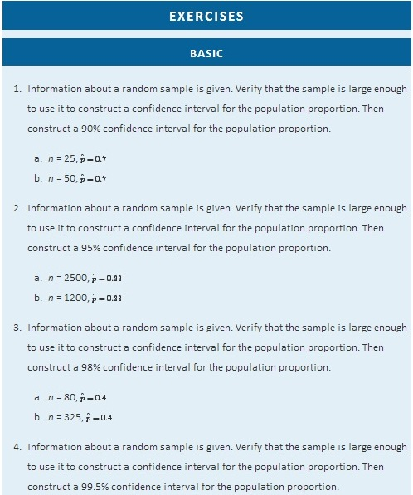
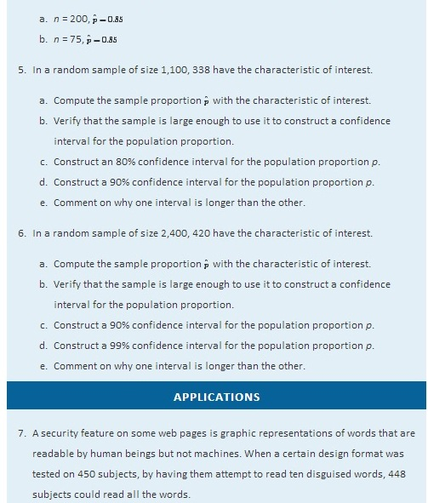
  - Give a point estimate of the proportion p of all people who could read words disguised in this way.
  - Show that the sample is not sufficiently large to construct a confidence interval for the proportion of all people who could read words disguised in this way.
- In a random sample of 900 adults, 42 defined themselves as vegetarians.
  - Give a point estimate of the proportion of all adults who would define themselves as vegetarians.
  - Verify that the sample is sufficiently large to use it to construct a confidence interval for that proportion.
  - Construct an 80% confidence interval for the proportion of all adults who would define themselves as vegetarians.
- In a random sample of 250 employed people, 61 said that they bring work home with them at least occasionally.
  - Give a point estimate of the proportion of all employed people who bring work home with them at least occasionally.
  - Construct a 99% confidence interval for that proportion.
- In a random sample of 1,250 household moves, 822 were moves to a location within the same county as the original residence.
  - Give a point estimate of the proportion of all household moves that are to a location within the same county as the original residence.
  - Construct a 98% confidence interval for that proportion.
- In a random sample of 12,447 hip replacement or revision surgery procedures nationwide, 162 patients developed a surgical site infection.
  - Give a point estimate of the proportion of all patients undergoing a hip surgery procedure who develop a surgical site infection.
  - Verify that the sample is sufficiently large to use it to construct a confidence interval for that proportion.
  - Construct a 95% confidence interval for the proportion of all patients undergoing a hip surgery procedure who develop a surgical site infection.
- In a certain region prepackaged products labeled 500 g must contain on average at least 500 grams of the product, and at least 90% of all packages must weigh at least 490 grams. In a random sample of 300 packages, 288 weighed at least 490 grams.
  - Give a point estimate of the proportion of all packages that weigh at least 490 grams.
  - Verify that the sample is sufficiently large to use it to construct a confidence interval for that proportion.
  - Construct a 99.8% confidence interval for the proportion of all packages that weigh at least 490 grams.
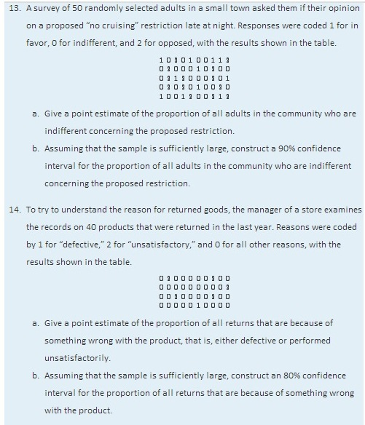
- In order to estimate the proportion of entering students who graduate within six years, the administration at a state university examined the records of 600 randomly selected students who entered the university six years ago, and found that 312 had graduated.
  - Give a point estimate of the six-year graduation rate, the proportion of entering students who graduate within six years.
  - Assuming that the sample is sufficiently large, construct a 98% confidence interval for the six-year graduation rate.
- In a random sample of 2,300 mortgages taken out in a certain region last year, 187 were adjustable-rate mortgages.
  - Give a point estimate of the proportion of all mortgages taken out in this region last year that were adjustable-rate mortgages.
  - Assuming that the sample is sufficiently large, construct a 99.9% confidence interval for the proportion of all mortgages taken out in this region last year that were adjustable-rate mortgages.
- In a research study in cattle breeding, 159 of 273 cows in several herds that were in estrus were detected by means of an intensive once a day, one-hour observation of the herds in early morning.
  - Give a point estimate of the proportion of all cattle in estrus who are detected by this method.
  - Assuming that the sample is sufficiently large, construct a 90% confidence interval for the proportion of all cattle in estrus who are detected by this method.
- A survey of 21,250 households concerning telephone service gave the results shown in the table.
 | Landline | No Landline
Cell phone | 12,474 | 5,844
No cell phone | 2,529 | 403
- Give a point estimate for the proportion of all households in which there is a cell phone but no landline.
- Assuming the sample is sufficiently large, construct a 99.9% confidence interval for the proportion of all households in which there is a cell phone but no landline.
- Give a point estimate for the proportion of all households in which there is no telephone service of either kind.
- Assuming the sample is sufficiently large, construct a 99.9% confidence interval for the proportion of all all households in which there is no telephone service of either kind.

ADDITIONAL EXERCISES
- In a random sample of 900 adults, 42 defined themselves as vegetarians. Of these 42, 29 were women.
  - Give a point estimate of the proportion of all self-described vegetarians who are women.
  - Verify that the sample is sufficiently large to use it to construct a confidence interval for that proportion.
  - Construct a 90% confidence interval for the proportion of all all self-described vegetarians who are women.
- A random sample of 185 college soccer players who had suffered injuries that resulted in loss of playing time was made with the results shown in the table. Injuries are classified according to severity of the injury and the condition under which it was sustained.

 | Minor | Moderate | Serious
Practice | 48 | 20 | 6
Game | 62 | 32 | 17
  - Give a point estimate for the proportion p of all injuries to college soccer players that are sustained in practice.
  - Construct a 95% confidence interval for the proportion p of all injuries to college soccer players that are sustained in practice.
  - Give a point estimate for the proportion p of all injuries to college soccer players that are either moderate or serious.
- The body mass index (BMI) was measured in 1,200 randomly selected adults, with the results shown in the table.
 | BMI
 | Under 18.5 | 18.5–25 | Over 25
Men | 36 | 165 | 315
Women | 75 | 274 | 335
- Give a point estimate for the proportion of all men whose BMI is over 25.
- Assuming the sample is sufficiently large, construct a 99% confidence interval for the proportion of all men whose BMI is over 25.
- Give a point estimate for the proportion of all adults, regardless of gender, whose BMI is over 25.
- Assuming the sample is sufficiently large, construct a 99% confidence interval for the proportion of all adults, regardless of gender, whose BMI is over 25.

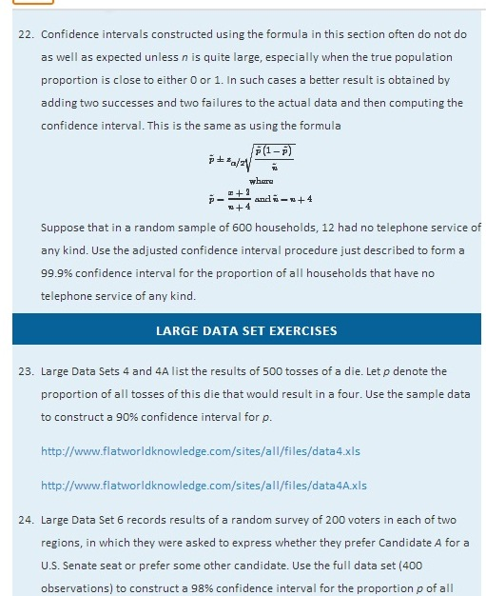

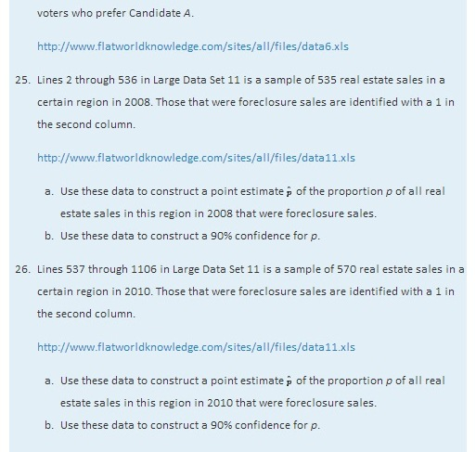
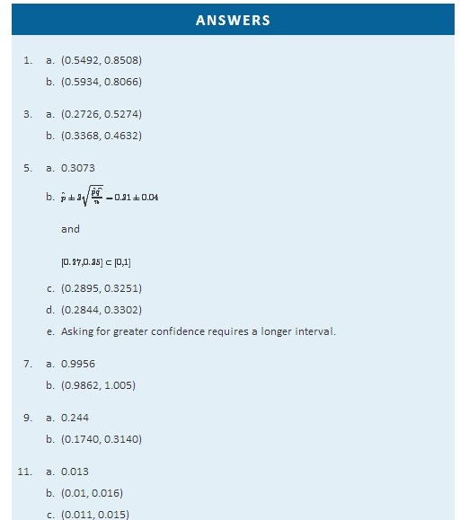
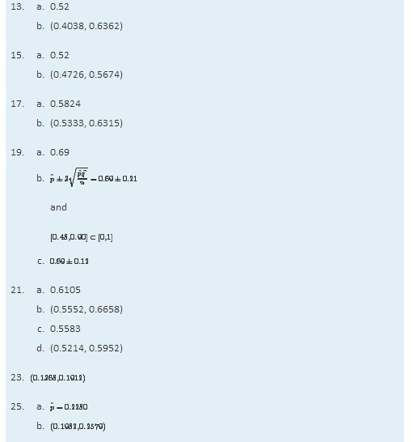

7.4 Sample Size Considerations

LEARNING OBJECTIVE
- To learn how to apply formulas for estimating the size sample that will be needed in order to construct a confidence interval for a population mean or proportion that meets given criteria.

Sampling is typically done with a set of clear objectives in mind. For example, an economist might wish to estimate the mean yearly income of workers in a particular industry at 90% confidence and to within $500. Since sampling costs time, effort, and money, it would be useful to be able to estimate the smallest size sample that is likely to meet these criteria.
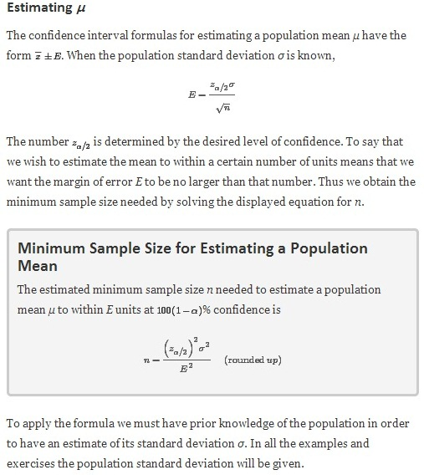
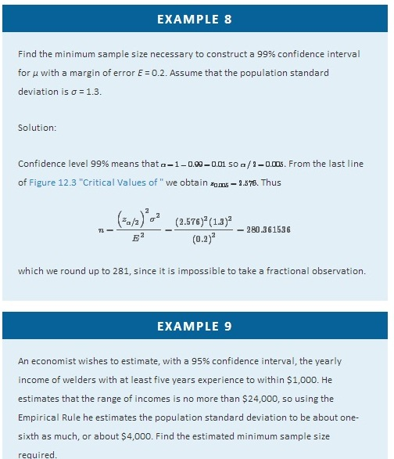
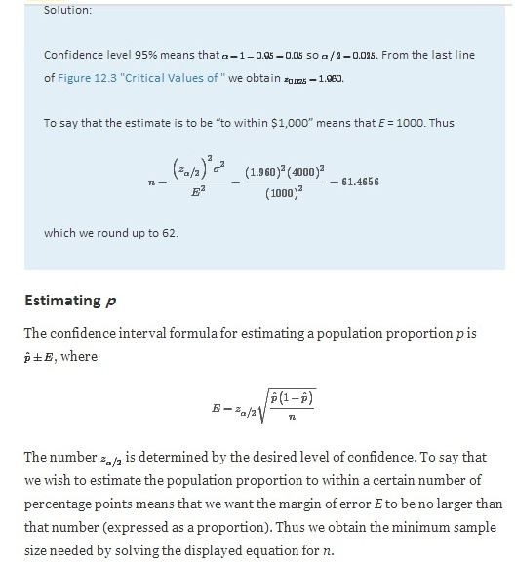
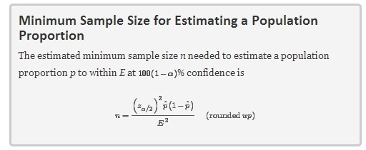
There is a dilemma here: the formula for estimating how large a sample to take contains the number pˆ, which we know only after we have taken the sample. There are two ways out of this dilemma. Typically the researcher will have some idea as to the value of the population proportion p, hence of what the sample proportion pˆ is likely to be. For example, if last month 37% of all voters thought that state taxes are too high, then it is likely that the proportion with that opinion this month will not be dramatically different, and we would use the value 0.37 for pˆ in the formula.
The second approach to resolving the dilemma is simply to replace pˆ in the formula by 0.5. This is because if pˆ is large then 1−pˆ is small, and vice versa, which limits their product to a maximum value of 0.25, which occurs when pˆ=0.5. This is called the most conservative estimate, since it gives the largest possible estimate of n.
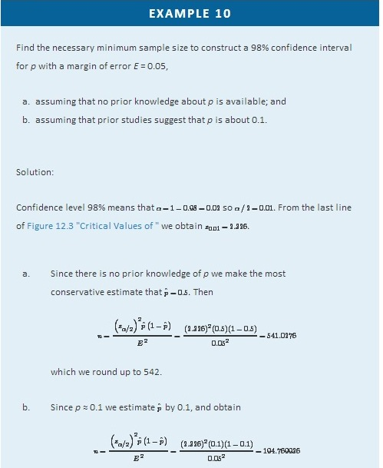

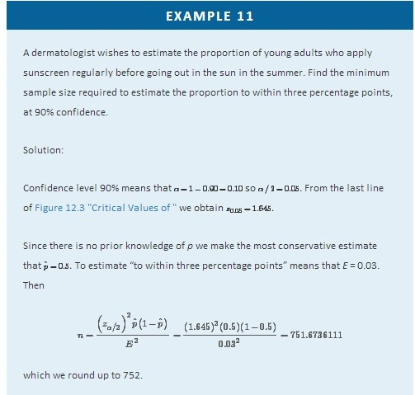

KEY TAKEAWAYS
- If the population standard deviation σ is known or can be estimated, then the minimum sample size needed to obtain a confidence interval for the population mean with a given maximum error of the estimate and a given level of confidence can be estimated.
- The minimum sample size needed to obtain a confidence interval for a population proportion with a given maximum error of the estimate and a given level of confidence can always be estimated. If there is prior knowledge of the population proportion p then the estimate can be sharpened.

EXERCISES

BASIC
- Estimate the minimum sample size needed to form a confidence interval for the mean of a population having the standard deviation shown, meeting the criteria given.
  - σ = 30, 95% confidence, E = 10
  - σ = 30, 99% confidence, E = 10
  - σ = 30, 95% confidence, E = 5
- Estimate the minimum sample size needed to form a confidence interval for the mean of a population having the standard deviation shown, meeting the criteria given.
  - σ = 4, 95% confidence, E = 1
  - σ = 4, 99% confidence, E = 1
  - σ = 4, 95% confidence, E = 0.5
- Estimate the minimum sample size needed to form a confidence interval for the proportion of a population that has a particular characteristic, meeting the criteria given.
  - p ≈ 0.37, 80% confidence, E = 0.05
  - p ≈ 0.37, 90% confidence, E = 0.05
  - p ≈ 0.37, 80% confidence, E = 0.01
- Estimate the minimum sample size needed to form a confidence interval for the proportion of a population that has a particular characteristic, meeting the criteria given.
  - p ≈ 0.81, 95% confidence, E = 0.02
  - p ≈ 0.81, 99% confidence, E = 0.02
  - p ≈ 0.81, 95% confidence, E = 0.01
- Estimate the minimum sample size needed to form a confidence interval for the proportion of a population that has a particular characteristic, meeting the criteria given.
  - 80% confidence, E = 0.05
  - 90% confidence, E = 0.05
  - 80% confidence, E = 0.01
- Estimate the minimum sample size needed to form a confidence interval for the proportion of a population that has a particular characteristic, meeting the criteria given.
  - 95% confidence, E = 0.02
  - 99% confidence, E = 0.02
  - 95% confidence, E = 0.01

APPLICATIONS
- A software engineer wishes to estimate, to within 5 seconds, the mean time that a new application takes to start up, with 95% confidence. Estimate the minimum size sample required if the standard deviation of start up times for similar software is 12 seconds.
- A real estate agent wishes to estimate, to within $2.50, the mean retail cost per square foot of newly built homes, with 80% confidence. He estimates the standard deviation of such costs at $5.00. Estimate the minimum size sample required.
- An economist wishes to estimate, to within 2 minutes, the mean time that employed persons spend commuting each day, with 95% confidence. On the assumption that the standard deviation of commuting times is 8 minutes, estimate the minimum size sample required.
- A motor club wishes to estimate, to within 1 cent, the mean price of 1 gallon of regular gasoline in a certain region, with 98% confidence. Historically the variability of prices is measured by σ=$0.03. Estimate the minimum size sample required.
- A bank wishes to estimate, to within $25, the mean average monthly balance in its checking accounts, with 99.8% confidence. Assuming σ=$250, estimate the minimum size sample required.
- A retailer wishes to estimate, to within 15 seconds, the mean duration of telephone orders taken at its call center, with 99.5% confidence. In the past the standard deviation of call length has been about 1.25 minutes. Estimate the minimum size sample required. (Be careful to express all the information in the same units.)
- The administration at a college wishes to estimate, to within two percentage points, the proportion of all its entering freshmen who graduate within four years, with 90% confidence. Estimate the minimum size sample required.
- A chain of automotive repair stores wishes to estimate, to within five percentage points, the proportion of all passenger vehicles in operation that are at least five years old, with 98% confidence. Estimate the minimum size sample required.
- An internet service provider wishes to estimate, to within one percentage point, the current proportion of all email that is spam, with 99.9% confidence. Last year the proportion that was spam was 71%. Estimate the minimum size sample required.
- An agronomist wishes to estimate, to within one percentage point, the proportion of a new variety of seed that will germinate when planted, with 95% confidence. A typical germination rate is 97%. Estimate the minimum size sample required.
- A charitable organization wishes to estimate, to within half a percentage point, the proportion of all telephone solicitations to its donors that result in a gift, with 90% confidence. Estimate the minimum sample size required, using the information that in the past the response rate has been about 30%.
- A government agency wishes to estimate the proportion of drivers aged 16–24 who have been involved in a traffic accident in the last year. It wishes to make the estimate to within one percentage point and at 90% confidence. Find the minimum sample size required, using the information that several years ago the proportion was 0.12.

ADDITIONAL EXERCISES
- An economist wishes to estimate, to within six months, the mean time between sales of existing homes, with 95% confidence. Estimate the minimum size sample required. In his experience virtually all houses are re-sold within 40 months, so using the Empirical Rule he will estimate σ by one-sixth the range, or 40/6=6.7.
- A wildlife manager wishes to estimate the mean length of fish in a large lake, to within one inch, with 80% confidence. Estimate the minimum size sample required. In his experience virtually no fish caught in the lake is over 23 inches long, so using the Empirical Rule he will estimate σ by one-sixth the range, or 23/6=3.8.
- You wish to estimate the current mean birth weight of all newborns in a certain region, to within 1 ounce (1/16 pound) and with 95% confidence. A sample will cost $400 plus $1.50 for every newborn weighed. You believe the standard deviations of weight to be no more than 1.25 pounds. You have $2,500 to spend on the study.
  - Can you afford the sample required?
  - If not, what are your options?
- You wish to estimate a population proportion to within three percentage points, at 95% confidence. A sample will cost $500 plus 50 cents for every sample element measured. You have $1,000 to spend on the study.
  - Can you afford the sample required?
  - If not, what are your options?
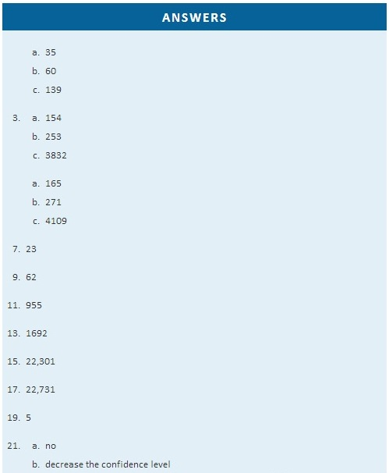

Chapter 8

Testing Hypotheses

A manufacturer of emergency equipment asserts that a respirator that it makes delivers pure air for 75 minutes on average. A government regulatory agency is charged with testing such claims, in this case to verify that the average time is not less than 75 minutes. To do so it would select a random sample of respirators, compute the mean time that they deliver pure air, and compare that mean to the asserted time 75 minutes.

In the sampling that we have studied so far the goal has been to estimate a population parameter. But the sampling done by the government agency has a somewhat different objective, not so much to estimate the population mean μ as totest an assertion—or a hypothesis—about it, namely, whether it is as large as 75 or not. The agency is not necessarily interested in the actual value of μ, just whether it is as claimed. Their sampling is done to perform a test of hypotheses, the subject of this chapter.

8.1 The Elements of Hypothesis Testing

LEARNING OBJECTIVES
- To understand the logical framework of tests of hypotheses.
- To learn basic terminology connected with hypothesis testing.
- To learn fundamental facts about hypothesis testing.

Types of Hypotheses

A hypothesis about the value of a population parameter is an assertion about its value. As in the introductory example we will be concerned with testing the truth of two competing hypotheses, only one of which can be true.

Definition
The null hypothesis, denoted H₀, is the statement about the population parameter that is assumed to be true unless there is convincing evidence to the contrary.
The alternative hypothesis, denoted H_{a}, is a statement about the population parameter that is contradictory to the null hypothesis, and is accepted as true only if there is convincing evidence in favor of it.

Definition
Hypothesis testing is a statistical procedure in which a choice is made between a null hypothesis and an alternative hypothesis based on information in a sample.
The end result of a hypotheses testing procedure is a choice of one of the following two possible conclusions:

- Reject H₀ (and therefore accept H_{a}), or
- Fail to reject H₀ (and therefore fail to accept H_{a}).

The null hypothesis typically represents the status quo, or what has historically been true. In the example of the respirators, we would believe the claim of the manufacturer unless there is reason not to do so, so the null hypotheses is H₀:μ=75. The alternative hypothesis in the example is the contradictory statement H_{a}:μ<75. The null hypothesis will always be an assertion containing an equals sign, but depending on the situation the alternative hypothesis can have any one of three forms: with the symbol “<,” as in the example just discussed, with the symbol “>,” or with the symbol “≠” The following two examples illustrate the latter two cases.

EXAMPLE 1
A publisher of college textbooks claims that the average price of all hardbound college textbooks is $127.50. A student group believes that the actual mean is higher and wishes to test their belief. State the relevant null and alternative hypotheses.
Solution:

The default option is to accept the publisher’s claim unless there is compelling evidence to the contrary. Thus the null hypothesis is H₀:μ=127.50. Since the student group thinks that the average textbook price is greater than the publisher’s figure, the alternative hypothesis in this situation is H_{a}:μ>127.50.

EXAMPLE 2
The recipe for a bakery item is designed to result in a product that contains 8 grams of fat per serving. The quality control department samples the product periodically to insure that the production process is working as designed. State the relevant null and alternative hypotheses.
Solution:

The default option is to assume that the product contains the amount of fat it was formulated to contain unless there is compelling evidence to the contrary. Thus the null hypothesis is H₀:μ=8.0. Since to contain either more fat than desired or to contain less fat than desired are both an indication of a faulty production process, the alternative hypothesis in this situation is that the mean is different from 8.0, so H_{a}:μ≠8.0.
In Note 8.8 "Example 1", the textbook example, it might seem more natural that the publisher’s claim be that the average price is at most $127.50, not exactly $127.50. If the claim were made this way, then the null hypothesis would be H₀:μ≤127.50, and the value $127.50 given in the example would be the one that is least favorable to the publisher’s claim, the null hypothesis. It is always true that if the null hypothesis is retained for its least favorable value, then it is retained for every other value.
Thus in order to make the null and alternative hypotheses easy for the student to distinguish, in every example and problem in this text we will always present one of the two competing claims about the value of a parameter with an equality. The claim expressed with an equality is the null hypothesis. This is the same as always stating the null hypothesis in the least favorable light. So in the introductory example about the respirators, we stated the manufacturer’s claim as “the average is 75 minutes” instead of the perhaps more natural “the average is at least 75 minutes,” essentially reducing the presentation of the null hypothesis to its worst case.

The first step in hypothesis testing is to identify the null and alternative hypotheses.

The Logic of Hypothesis Testing
Although we will study hypothesis testing in situations other than for a single population mean (for example, for a population proportion instead of a mean or in comparing the means of two different populations), in this section the discussion will always be given in terms of a single population mean μ.
The null hypothesis always has the form H₀:μ=μ₀ for a specific number μ₀ (in the respirator example μ₀=75, in the textbook example μ₀=127.50, and in the baked goods example μ₀=8.0). Since the null hypothesis is accepted unless there is strong evidence to the contrary, the test procedure is based on the initial assumption that H₀ is true. This point is so important that we will repeat it in a display:

The test procedure is based on the initial assumption that H₀ is true.

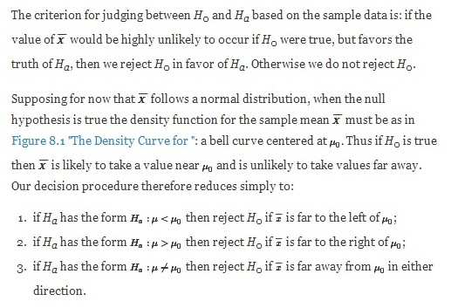
Figure 8.1 The Density Curve for X−− if H₀ Is True
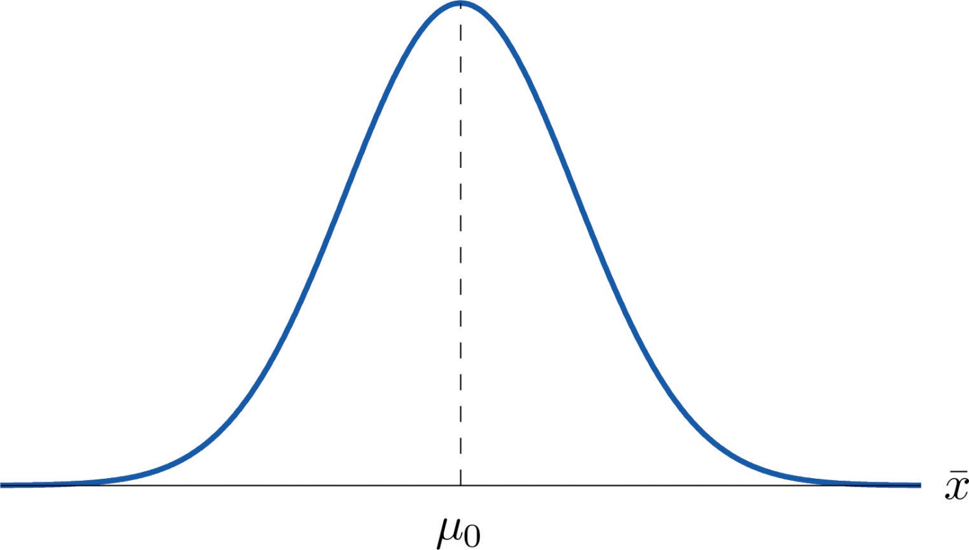
Think of the respirator example, for which the null hypothesis is H0:μ=75, the claim that the average time air is delivered for all respirators is 75 minutes. If the sample mean is 75 or greater then we certainly would not reject H₀ (since there is no issue with an emergency respirator delivering air even longer than claimed).

If the sample mean is slightly less than 75 then we would logically attribute the difference to
sampling error and also not reject H₀ either.

Values of the sample mean that are smaller and smaller are less and less likely to come from a population for which the population mean is 75. Thus if the sample mean is far less than 75, say around 60 minutes or less, then we would certainly reject H₀, because we know that it is highly unlikely that the average of a sample would be so low if the population mean were 75. This is the rare event criterionfor rejection: what we actually observed (X^−−<60) would be so rare an event if μ= 75 were true that we regard it as much more likely that the alternative hypothesis μ < 75 holds.

In summary, to decide between H₀ and H_{a} in this example we would select a “rejection region” of values sufficiently far to the left of 75, based on the rare event criterion, and reject H₀ if the sample mean X−− lies in the rejection region, but not reject H₀ if it does not.

The Rejection Region

Each different form of the alternative hypothesis H_{a} has its own kind of rejection region:

- if (as in the respirator example) H_{a} has the form H_{a}:μ<μ₀, we reject H₀ if x−is far to the left of μ0, that is, to the left of some number C, so the rejection region has the form of an interval (−∞,C];
- if (as in the textbook example) H_{a} has the form H_{a}:μ>μ₀, we reject H₀ if x−is far to the right of μ0, that is, to the right of some number C, so the rejection region has the form of an interval [C,∞);
- if (as in the baked good example) H_{a} has the form H_{a}:μ≠μ₀, we reject H₀ if x− is far away from μ0 in either direction, that is, either to the left of some number C or to the right of some other number C′, so the rejection region has the form of the union of two intervals (−∞,C]∪[C′,∞).
The key issue in our line of reasoning is the question of how to determine the number C or numbers C and C′, called the critical value or critical values of the statistic, that determine the rejection region.

The key issue in our line of reasoning is the question of how to determine the number C or numbers C and C′, called the critical value or critical values of the statistic, that determine the rejection region.

Definition
The critical value or critical values of a test of hypotheses are the number or numbers that determine the rejection region.

Suppose the rejection region is a single interval, so we need to select a single number C. Here is the procedure for doing so. We select a small probability, denoted α, say 1%, which we take as our definition of “rare event:” an event is “rare” if its probability of occurrence is less than α. (In all the examples and problems in this text the value of α will be given already.) The probability that X^−− takes a value in an interval is the area under its density curve and above that interval, so as shown in Figure 8.2 (drawn under the assumption that H₀ is true, so that the curve centers at μ₀) the critical value C is the value of X^−− that cuts off a tail area α in the probability density curve of X^−−. When the rejection region is in two pieces, that is, composed of two intervals, the total area above both of them must be α, so the area above each one is α/2, as also shown in Figure 8.2.

Figure 8.2
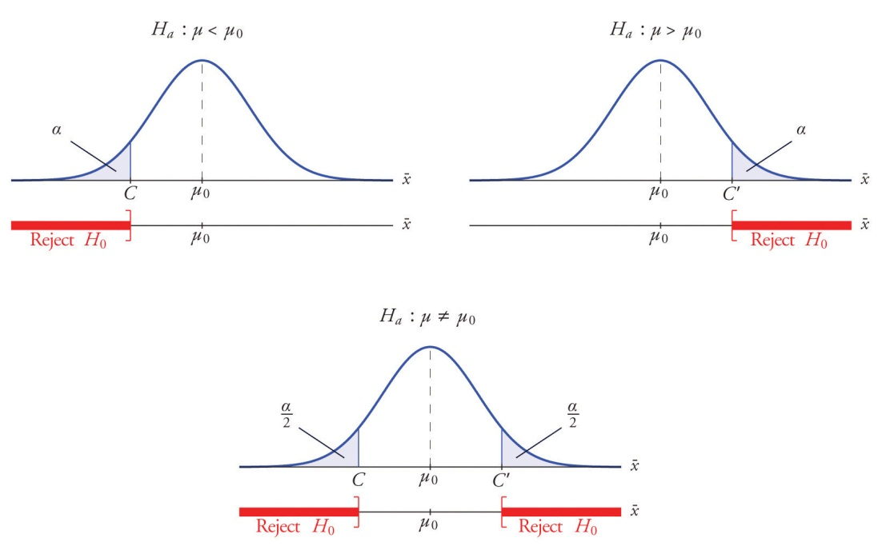
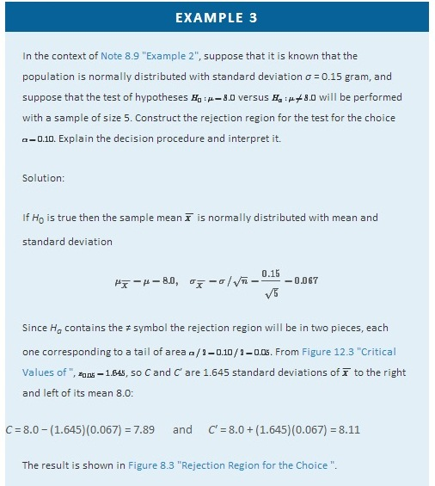
Figure 8.3Rejection Region for the Choice α=0.10
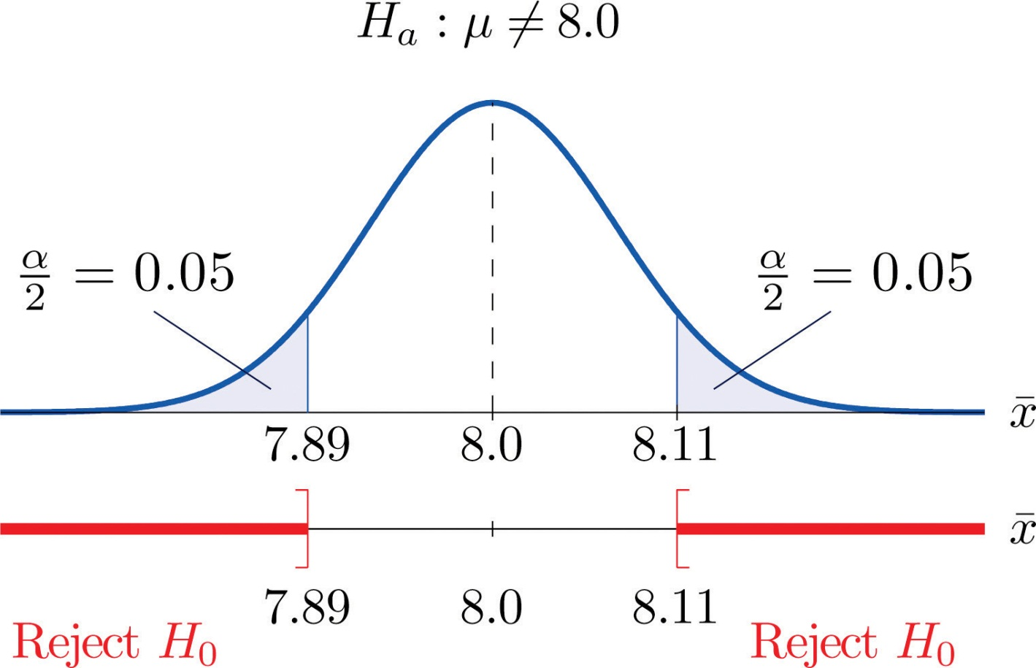
The decision procedure is: take a sample of size 5 and compute the sample mean x−. If x− is either 7.89 grams or less or 8.11 grams or more then reject the hypothesis that the average amount of fat in all servings of the product is 8.0 grams in favor of the alternative that it is different from 8.0 grams. Otherwise do not reject the hypothesis that the average amount is 8.0 grams.
The reasoning is that if the true average amount of fat per serving were 8.0 grams then there would be less than a 10% chance that a sample of size 5 would produce a mean of either 7.89 grams or less or 8.11 grams or more. Hence if that happened it would be more likely that the value 8.0 is incorrect (always assuming that the population standard deviation is 0.15 gram).

Because the rejection regions are computed based on areas in tails of distributions, as shown in Figure 8.2, hypothesis tests are classified according to the form of the alternative hypothesis in the following way.

Definition
If H_{a} has the form μ≠μ₀ the test is called a two-tailed test.
If H_{a} has the form μ<μ₀ the test is called a left-tailed test.
If H_{a} has the form μ>μ₀ the test is called a right-tailed test.
Each of the last two forms is also called a one-tailed test.

Two Types of Errors
The format of the testing procedure in general terms is to take a sample and use the information it contains to come to a decision about the two hypotheses. As stated before our decision will always be either
- reject the null hypothesis H₀ in favor of the alternative H_{a} presented, or
- do not reject the null hypothesis H₀ in favor of the alternative H_{a} presented.

There are four possible outcomes of hypothesis testing procedure, as shown in the following table:

 |  | True State of Nature
 |  | H₀ is true | H₀ is false
Our Decision | Do not reject H₀ | Correct decision | Type II error
 | Reject H₀ | Type I error | Correct decision

As the table shows, there are two ways to be right and two ways to be wrong. Typically to reject H₀ when it is actually true is a more serious error than to fail to reject it when it is false, so the former error is labeled “Type I” and the latter error “Type II.”

Definition
In a test of hypotheses, a Type I error is the decision to reject H₀ when it is in fact true. A Type II error is the decision not to reject H₀ when it is in fact not true.

Unless we perform a census we do not have certain knowledge, so we do not know whether our decision matches the true state of nature or if we have made an error. We reject H₀ if what we observe would be a “rare” event if H₀ were true. But rare events are not impossible: they occur with probability α. Thus when H₀ is true, a rare event will be observed in the proportion α of repeated similar tests, and H₀ will be erroneously rejected in those tests. Thus α is the probability that in following the testing procedure to decide between H₀ and H_{a} we will make a Type I error.

Definition
The number α that is used to determine the rejection region is called the level of significance of the test. It is the probability that the test procedure will result in a Type I error.

The probability of making a Type II error is too complicated to discuss in a beginning text, so we will say no more about it than this: for a fixed sample size, choosing α smaller in order to reduce the chance of making a Type I error has the effect of increasing the chance of making a Type II error. The only way to simultaneously reduce the chances of making either kind of error is to increase the sample size.

Standardizing the Test Statistic

Hypotheses testing will be considered in a number of contexts, and great unification as well as simplification results when the relevant sample statistic is standardized by subtracting its mean from it and then dividing by its standard deviation. The resulting statistic is called a standardized test statistic. In every situation treated in this and the following two chapters the standardized test statistic will have either the standard normal distribution or Student’s t-distribution.

Definition
A standardized test statistic for a hypothesis test is the statistic that is formed by subtracting from the statistic of interest its mean and dividing by its standard deviation.

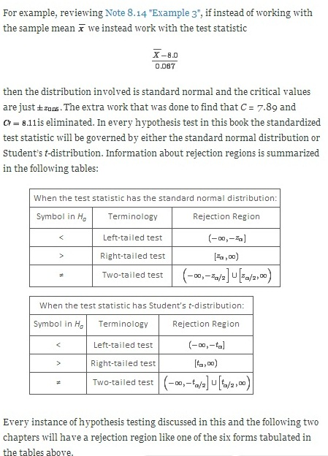

Every instance of hypothesis testing discussed in this and the following two chapters will have a rejection region like one of the six forms tabulated in the tables above.

No matter what the context a test of hypotheses can always be performed by applying the following systematic procedure, which will be illustrated in the examples in the succeeding sections.

Systematic Hypothesis Testing Procedure: Critical Value Approach
- Identify the null and alternative hypotheses.
- Identify the relevant test statistic and its distribution.
- Compute from the data the value of the test statistic.
- Construct the rejection region.
- Compare the value computed in Step 3 to the rejection region constructed in Step 4 and make a decision. Formulate the decision in the context of the problem, if applicable.

The procedure that we have outlined in this section is called the “Critical Value Approach” to hypothesis testing to distinguish it from an alternative but equivalent approach that will be introduced at the end of Section 8.3 "The Observed Significance of a Test".

KEY TAKEAWAYS
- A test of hypotheses is a statistical process for deciding between two competing assertions about a population parameter.
- The testing procedure is formalized in a five-step procedure.

EXERCISES
- State the null and alternative hypotheses for each of the following situations. (That is, identify the correct number μ₀ and write H₀:μ=μ₀ and the appropriate analogous expression for H_{a}.)
  - The average July temperature in a region historically has been 74.5°F. Perhaps it is higher now.
  - The average weight of a female airline passenger with luggage was 145 pounds ten years ago. The FAA believes it to be higher now.
  - The average stipend for doctoral students in a particular discipline at a state university is $14,756. The department chairman believes that the national average is higher.
  - The average room rate in hotels in a certain region is $82.53. A travel agent believes that the average in a particular resort area is different.
  - The average farm size in a predominately rural state was 69.4 acres. The secretary of agriculture of that state asserts that it is less today.
- State the null and alternative hypotheses for each of the following situations. (That is, identify the correct number μ₀ and write H₀:μ=μ₀ and the appropriate analogous expression for H_{a}.)
  - The average time workers spent commuting to work in Verona five years ago was 38.2 minutes. The Verona Chamber of Commerce asserts that the average is less now.
  - The mean salary for all men in a certain profession is $58,291. A special interest group thinks that the mean salary for women in the same profession is different.
  - The accepted figure for the caffeine content of an 8-ounce cup of coffee is 133 mg. A dietitian believes that the average for coffee served in a local restaurants is higher.
  - The average yield per acre for all types of corn in a recent year was 161.9 bushels. An economist believes that the average yield per acre is different this year.
  - An industry association asserts that the average age of all self-described fly fishermen is 42.8 years. A sociologist suspects that it is higher.
- Describe the two types of errors that can be made in a test of hypotheses.
- Under what circumstance is a test of hypotheses certain to yield a correct decision?
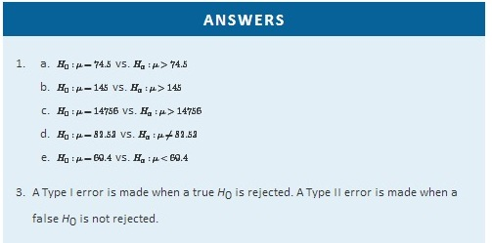

8.2 Large Sample Tests for a Population Mean

LEARNING OBJECTIVES
- To learn how to apply the five-step test procedure for a test of hypotheses concerning a population mean when the sample size is large.
- To learn how to interpret the result of a test of hypotheses in the context of the original narrated situation.
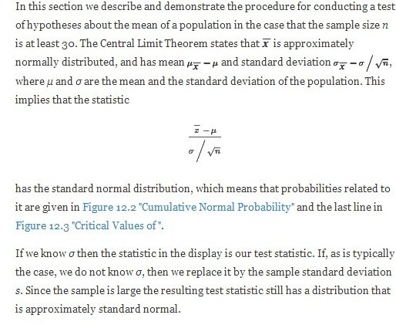

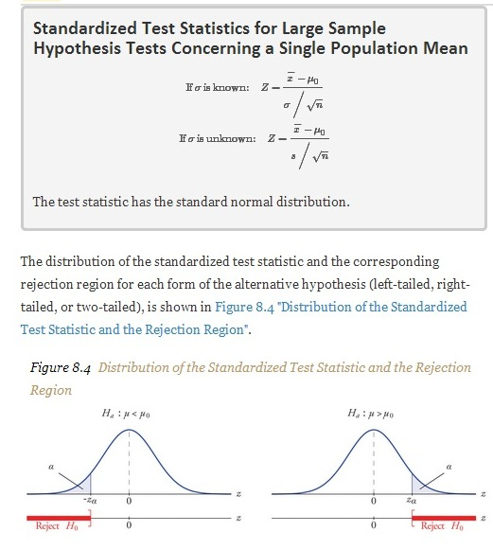

EXAMPLE 4
It is hoped that a newly developed pain reliever will more quickly produce perceptible reduction in pain to patients after minor surgeries than a standard pain reliever. The standard pain reliever is known to bring relief in an average of 3.5 minutes with standard deviation 2.1 minutes. To test whether the new pain reliever works more quickly than the standard one, 50 patients with minor surgeries were given the new pain reliever and their times to relief were recorded. The experiment yielded sample mean x^−=3.1 minutes and sample standard deviation s = 1.5 minutes. Is there sufficient evidence in the sample to indicate, at the 5% level of significance, that the newly developed pain reliever does deliver perceptible relief more quickly?
Solution:

We perform the test of hypotheses using the five-step procedure given at the end of Section 8.1 "The Elements of Hypothesis Testing".

- Step 1. The natural assumption is that the new drug is no better than the old one, but must be proved to be better. Thus if μ denotes the average time until all patients who are given the new drug experience pain relief, the hypothesis test is
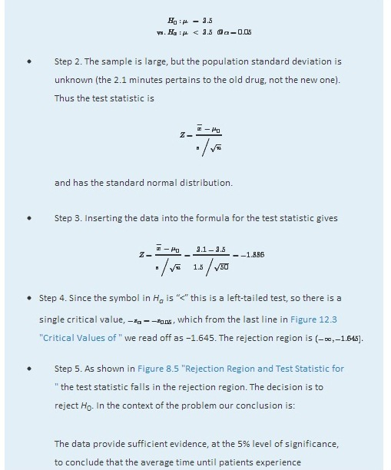

perceptible relief from pain using the new pain reliever is smaller than the average time for the standard pain reliever.
Figure 8.5Rejection Region and Test Statistic forNote 8.27 "Example 4"
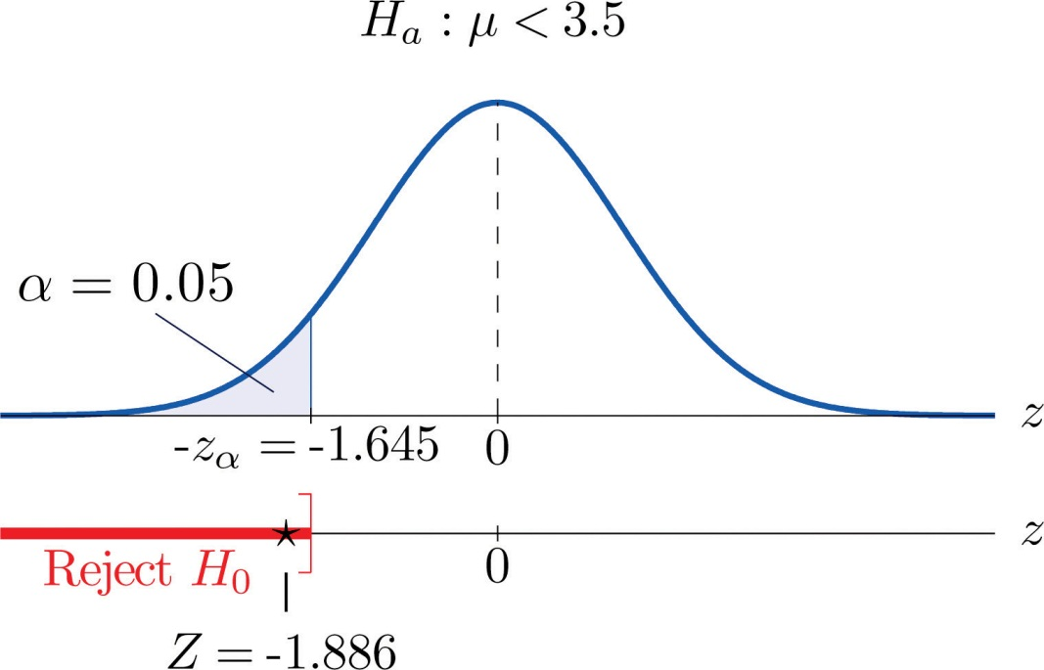

EXAMPLE 5
A cosmetics company fills its best-selling 8-ounce jars of facial cream by an automatic dispensing machine. The machine is set to dispense a mean of 8.1 ounces per jar. Uncontrollable factors in the process can shift the mean away from 8.1 and cause either underfill or overfill, both of which are undesirable. In such a case the dispensing machine is stopped and recalibrated. Regardless of the mean amount dispensed, the standard deviation of the amount dispensed always has value 0.22 ounce. A quality control engineer routinely selects 30 jars from the assembly line to check the amounts filled. On one occasion, the sample mean is x−=8.2 ounces and the sample standard deviation is s = 0.25 ounce. Determine if there is sufficient evidence in the sample to indicate, at the 1% level of significance, that the machine should be recalibrated.
Solution:
- Step 1. The natural assumption is that the machine is working properly. Thus if μ denotes the mean amount of facial cream being dispensed, the hypothesis test is
H0:μ = 8.1
vs. Ha:μ=≠8.1 @ α=0.01
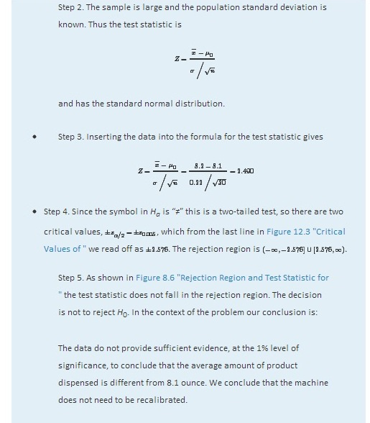
Figure 8.6Rejection Region and Test Statistic forNote 8.28 "Example 5"
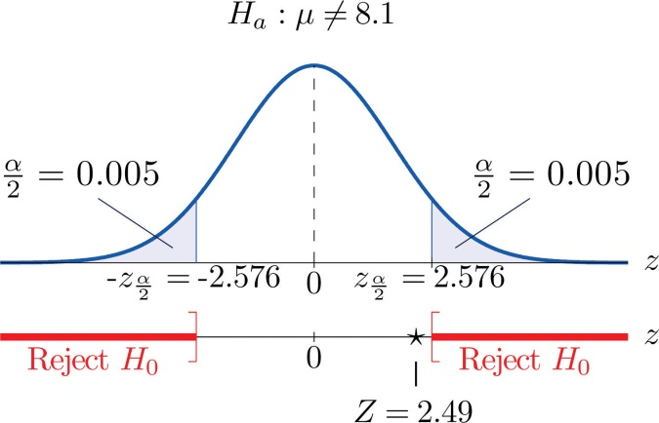

KEY TAKEAWAYS
- There are two formulas for the test statistic in testing hypotheses about a population mean with large samples. Both test statistics follow the standard normal distribution.
- The population standard deviation is used if it is known, otherwise the sample standard deviation is used.
- The same five-step procedure is used with either test statistic.

EXERCISES

BASIC
- Find the rejection region (for the standardized test statistic) for each hypothesis test.
  - H0:μ=27 vs. Ha:μ<27 @ α=0.05.
  - H0:μ=52 vs. Ha:μ≠52 @ α=0.05.
  - H0:μ=−105 vs. Ha:μ>−105 @ α=0.10.
  - H0:μ=78.8 vs. Ha:μ≠78.8 @ α=0.10.
- Find the rejection region (for the standardized test statistic) for each hypothesis test.
  - H0:μ=17 vs. Ha:μ<17 @ α=0.01.
  - H0:μ=880 vs. Ha:μ≠880 @ α=0.01.
  - H0:μ=−12 vs. Ha:μ>−12 @ α=0.05.
  - H0:μ=21.1 vs. Ha:μ≠21.1@ α=0.05.
- Find the rejection region (for the standardized test statistic) for each hypothesis test. Identify the test as left-tailed, right-tailed, or two-tailed.
  - H0:μ=141 vs. Ha:μ<141 @ α=0.20.
  - H0:μ=−54 vs. Ha:μ<−54 @ α=0.05.
  - H0:μ=98.6 vs. Ha:μ≠98.6 @ α=0.05.
  - H0:μ=3.8 vs. Ha:μ>3.8 @ α=0.001.
- Find the rejection region (for the standardized test statistic) for each hypothesis test. Identify the test as left-tailed, right-tailed, or two-tailed.
  - H0:μ=−62 vs. Ha:μ≠−62 @ α=0.005.
  - H0:μ=73 vs. Ha:μ>73 @ α=0.001.
  - H0:μ=1124 vs. Ha:μ<1124 @ α=0.001.
  - H0:μ=0.12 vs. Ha:μ≠0.12 @ α=0.001.
- Compute the value of the test statistic for the indicated test, based on the information given.
  - Testing H0:μ=72.2 vs. Ha:μ>72.2, σ unknown, n = 55, x−=75.1, s = 9.25
  - Testing H0:μ=58 vs. Ha:μ>58, σ = 1.22, n = 40, x−=58.5, s = 1.29
  - Testing H0:μ=−19.5 vs. Ha:μ<−19.5, σ unknown, n = 30, x−=−23.2, s = 9.55
  - Testing H0:μ=805 vs. Ha:μ≠805, σ = 37.5, n = 75, x−=818, s = 36.2
- Compute the value of the test statistic for the indicated test, based on the information given.
  - Testing H0:μ=342 vs. Ha:μ<342, σ = 11.2, n = 40, x−=339, s = 10.3
  - Testing H0:μ=105 vs. Ha:μ>105, σ = 5.3, n = 80, x−=107, s = 5.1
  - Testing H0:μ=−13.5 vs. Ha:μ≠−13.5, σ unknown, n = 32, x−=−13.8, s = 1.5
  - Testing H0:μ=28 vs. Ha:μ≠28, σ unknown, n = 68, x−=27.8, s = 1.3
- Perform the indicated test of hypotheses, based on the information given.
  - Test H0:μ=212 vs. Ha:μ<212 @ α=0.10, σ unknown, n = 36, x−=211.2, s = 2.2
  - Test H0:μ=−18 vs. Ha:μ>−18 @ α=0.05, σ = 3.3, n = 44, x−=−17.2, s = 3.1
  - Test H0:μ=24 vs. Ha:μ≠24 @ α=0.02, σ unknown, n = 50, x−=22.8, s = 1.9
- Perform the indicated test of hypotheses, based on the information given.
  - Test H0:μ=105 vs. Ha:μ>105 @ α=0.05, σ unknown, n = 30, x−=108, s = 7.2
  - Test H0:μ=21.6 vs. Ha:μ<21.6 @ α=0.01, σ unknown, n = 78, x−=20.5, s = 3.9
  - Test H0:μ=−375 vs. Ha:μ≠−375 @ α=0.01, σ = 18.5, n = 31, x−=−388, s = 18.0

APPLICATIONS
- In the past the average length of an outgoing telephone call from a business office has been 143 seconds. A manager wishes to check whether that average has decreased after the introduction of policy changes. A sample of 100 telephone calls produced a mean of 133 seconds, with a standard deviation of 35 seconds. Perform the relevant test at the 1% level of significance.
- The government of an impoverished country reports the mean age at death among those who have survived to adulthood as 66.2 years. A relief agency examines 30 randomly selected deaths and obtains a mean of 62.3 years with standard deviation 8.1 years. Test whether the agency’s data support the alternative hypothesis, at the 1% level of significance, that the population mean is less than 66.2.
- The average household size in a certain region several years ago was 3.14 persons. A sociologist wishes to test, at the 5% level of significance, whether it is different now. Perform the test using the information collected by the sociologist: in a random sample of 75 households, the average size was 2.98 persons, with sample standard deviation 0.82 person.
- The recommended daily calorie intake for teenage girls is 2,200 calories/day. A nutritionist at a state university believes the average daily caloric intake of girls in that state to be lower. Test that hypothesis, at the 5% level of significance, against the null hypothesis that the population average is 2,200 calories/day using the following sample data: n = 36, x−= 2,150, s = 203.
- An automobile manufacturer recommends oil change intervals of 3,000 miles. To compare actual intervals to the recommendation, the company randomly samples records of 50 oil changes at service facilities and obtains sample mean 3,752 miles with sample standard deviation 638 miles. Determine whether the data provide sufficient evidence, at the 5% level of significance, that the population mean interval between oil changes exceeds 3,000 miles.
- A medical laboratory claims that the mean turn-around time for performance of a battery of tests on blood samples is 1.88 business days. The manager of a large medical practice believes that the actual mean is larger. A random sample of 45 blood samples yielded mean 2.09 and sample standard deviation 0.13 day. Perform the relevant test at the 10% level of significance, using these data.
- A grocery store chain has as one standard of service that the mean time customers wait in line to begin checking out not exceed 2 minutes. To verify the performance of a store the company measures the waiting time in 30 instances, obtaining mean time 2.17 minutes with standard deviation 0.46 minute. Use these data to test the null hypothesis that the mean waiting time is 2 minutes versus the alternative that it exceeds 2 minutes, at the 10% level of significance.
- A magazine publisher tells potential advertisers that the mean household income of its regular readership is $61,500. An advertising agency wishes to test this claim against the alternative that the mean is smaller. A sample of 40 randomly selected regular readers yields mean income $59,800 with standard deviation $5,850. Perform the relevant test at the 1% level of significance.
- Authors of a computer algebra system wish to compare the speed of a new computational algorithm to the currently implemented algorithm. They apply the new algorithm to 50 standard problems; it averages 8.16 seconds with standard deviation 0.17 second. The current algorithm averages 8.21 seconds on such problems. Test, at the 1% level of significance, the alternative hypothesis that the new algorithm has a lower average time than the current algorithm.
- A random sample of the starting salaries of 35 randomly selected graduates with bachelor’s degrees last year gave sample mean and standard deviation $41,202 and $7,621, respectively. Test whether the data provide sufficient evidence, at the 5% level of significance, to conclude that the mean starting salary of all graduates last year is less than the mean of all graduates two years before, $43,589.

ADDITIONAL EXERCISES
- The mean household income in a region served by a chain of clothing stores is $48,750. In a sample of 40 customers taken at various stores the mean income of the customers was $51,505 with standard deviation $6,852.
  - Test at the 10% level of significance the null hypothesis that the mean household income of customers of the chain is $48,750 against that alternative that it is different from $48,750.
  - The sample mean is greater than $48,750, suggesting that the actual mean of people who patronize this store is greater than $48,750. Perform this test, also at the 10% level of significance. (The computation of the test statistic done in part (a) still applies here.)
- The labor charge for repairs at an automobile service center are based on a standard time specified for each type of repair. The time specified for replacement of universal joint in a drive shaft is one hour. The manager reviews a sample of 30 such repairs. The average of the actual repair times is 0.86 hour with standard deviation 0.32 hour.
  - Test at the 1% level of significance the null hypothesis that the actual mean time for this repair differs from one hour.
  - The sample mean is less than one hour, suggesting that the mean actual time for this repair is less than one hour. Perform this test, also at the 1% level of significance. (The computation of the test statistic done in part (a) still applies here.)

LARGE DATA SET EXERCISES
- Large Data Set 1 records the SAT scores of 1,000 students. Regarding it as a random sample of all high school students, use it to test the hypothesis that the population mean exceeds 1,510, at the 1% level of significance. (The null hypothesis is that μ = 1510.)
http://www.flatworldknowledge.com/sites/all/files/data1.xls
- Large Data Set 1 records the GPAs of 1,000 college students. Regarding it as a random sample of all college students, use it to test the hypothesis that the population mean is less than 2.50, at the 10% level of significance. (The null hypothesis is that μ = 2.50.)
http://www.flatworldknowledge.com/sites/all/files/data1.xls
- Large Data Set 1 lists the SAT scores of 1,000 students.
http://www.flatworldknowledge.com/sites/all/files/data1.xls
  - Regard the data as arising from a census of all students at a high school, in which the SAT score of every student was measured. Compute the population mean μ.
  - Regard the first 50 students in the data set as a random sample drawn from the population of part (a) and use it to test the hypothesis that the population mean exceeds 1,510, at the 10% level of significance. (The null hypothesis is that μ = 1510.)
  - Is your conclusion in part (b) in agreement with the true state of nature (which by part (a) you know), or is your decision in error? If your decision is in error, is it a Type I error or a Type II error?
- Large Data Set 1 lists the GPAs of 1,000 students.
http://www.flatworldknowledge.com/sites/all/files/data1.xls
  - Regard the data as arising from a census of all freshman at a small college at the end of their first academic year of college study, in which the GPA of every such person was measured. Compute the population mean μ.
  - Regard the first 50 students in the data set as a random sample drawn from the population of part (a) and use it to test the hypothesis that the population mean is less than 2.50, at the 10% level of significance. (The null hypothesis is that μ= 2.50.)
  - Is your conclusion in part (b) in agreement with the true state of nature (which by part (a) you know), or is your decision in error? If your decision is in error, is it a Type I error or a Type II error?

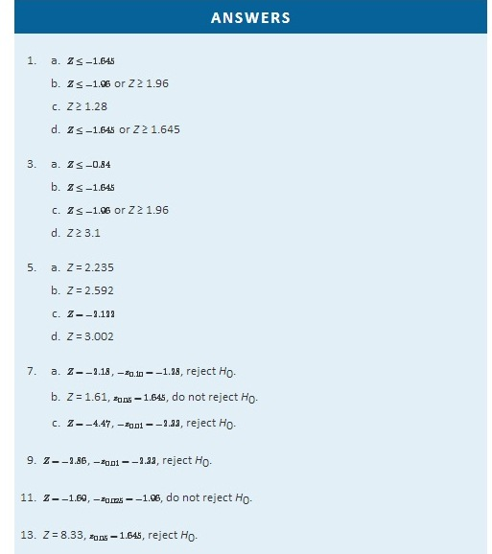
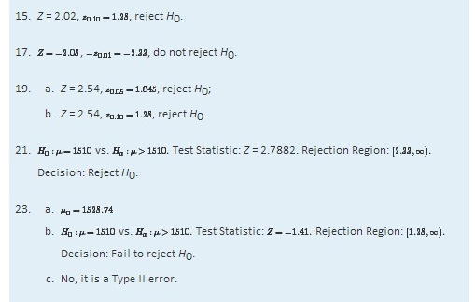

8.3 The Observed Significance of a Test

LEARNING OBJECTIVES
- To learn what the observed significance of a test is.
- To learn how to compute the observed significance of a test.
- To learn how to apply the p-value approach to hypothesis testing.

The Observed Significance
The conceptual basis of our testing procedure is that we reject H₀ only if the data that we obtained would constitute a rare event if H₀ were actually true. The level of significance α specifies what is meant by “rare.” The observed significance of the test is a measure of how rare the value of the test statistic that we have just observed would be if the null hypothesis were true. That is, the observed significance of the test just performed is the probability that, if the test were repeated with a new sample, the result of the new test would be at least as contrary to H₀ and in support of H_{a} as what was observed in the original test.

Definition
The observed significance or p-value of a specific test of hypotheses is the probability, on the supposition that H₀ is true, of obtaining a result at least as contrary to H₀ and in favor of H_{a} as the result actually observed in the sample data.

Think back to Note 8.27 "Example 4" in Section 8.2 "Large Sample Tests for a Population Mean" concerning the effectiveness of a new pain reliever. This was a left-tailed test in which the value of the test statistic was −1.886. To be as contrary to H₀ and in support of H_{a} as the result Z=−1.886 actually observed means to obtain a value of the test statistic in the interval (−∞,−1.886]. Rounding −1.886 to −1.89, we can read directly from Figure 12.2 "Cumulative Normal Probability" that P(Z≤−1.89)=0.0294. Thus the p-value or observed significance of the test in Note 8.27 "Example 4" is 0.0294 or about 3%. Under repeated sampling from this population, if H₀ were true then only about 3% of all samples of size 50 would give a result as contrary to H₀ and in favor of H_{a} as the sample we observed. Note that the probability 0.0294 is the area of the left tail cut off by the test statistic in this left-tailed test.

Analogous reasoning applies to a right-tailed or a two-tailed test, except that in the case of a two-tailed test being as far from 0 as the observed value of the test statistic but on the opposite side of 0 is just as contrary to H₀ as being the same distance away and on the same side of 0, hence the corresponding tail area is doubled.

Computational Definition of the Observed Significance of a Test of Hypotheses
The observed significance of a test of hypotheses is the area of the tail of the distribution cut off by the test statistic (times two in the case of a two-tailed test).

EXAMPLE 6
Compute the observed significance of the test performed in Note 8.28 "Example 5"in Section 8.2 "Large Sample Tests for a Population Mean".
Solution:

The value of the test statistic was z = 2.490, which by Figure 12.2 "Cumulative Normal Probability" cuts off a tail of area 0.0064, as shown in Figure 8.7 "Area of the Tail for ". Since the test was two-tailed, the observed significance is 2×0.0064=0.0128.

Figure 8.7Area of the Tail forNote 8.34 "Example 6"
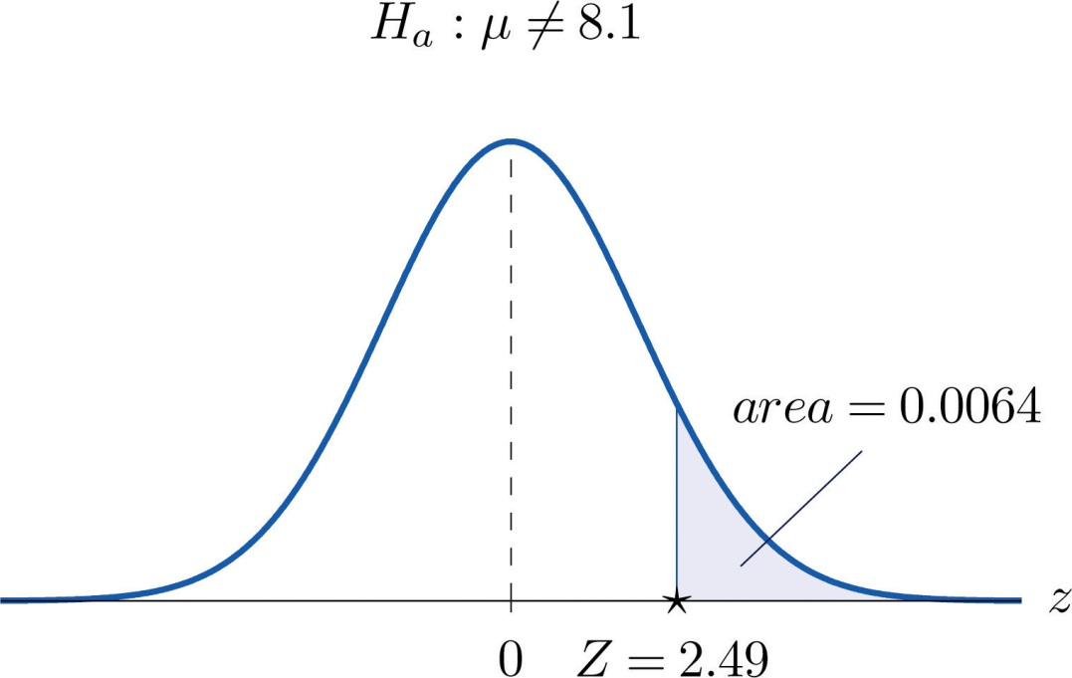

The p-value Approach to Hypothesis Testing
In Note 8.27 "Example 4" in Section 8.2 "Large Sample Tests for a Population Mean" the test was performed at the 5% level of significance: the definition of “rare” event was probability α=0.05 or less. We saw above that the observed significance of the test was p = 0.0294 or about 3%. Since p=0.0294<0.05=α (or 3% is less than 5%), the decision turned out to be to reject: what was observed was sufficiently unlikely to qualify as an event so rare as to be regarded as (practically) incompatible with H₀.

In Note 8.28 "Example 5" in Section 8.2 "Large Sample Tests for a Population Mean" the test was performed at the 1% level of significance: the definition of “rare” event was probability α=0.01 or less. The observed significance of the test was computed in Note 8.34 "Example 6" as p = 0.0128 or about 1.3%. Since p=0.0128>0.01=α (or 1.3% is greater than 1%), the decision turned out to be not to reject. The event observed was unlikely, but not sufficiently unlikely to lead to rejection of the null hypothesis.

The reasoning just presented is the basis for a slightly different but equivalent formulation of the hypothesis testing process. The first three steps are the same as before, but instead of using α to compute critical values and construct a rejection region, one computes the p-value p of the test and compares it to α, rejecting H₀ if p≤α and not rejecting if p>α.

Systematic Hypothesis Testing Procedure: p-Value Approach
- Identify the null and alternative hypotheses.
- Identify the relevant test statistic and its distribution.
- Compute from the data the value of the test statistic.
- Compute the p-value of the test.
- Compare the value computed in Step 4 to significance level α and make a decision: reject H₀ if p≤α and do not reject H₀ if p>α. Formulate the decision in the context of the problem, if applicable.
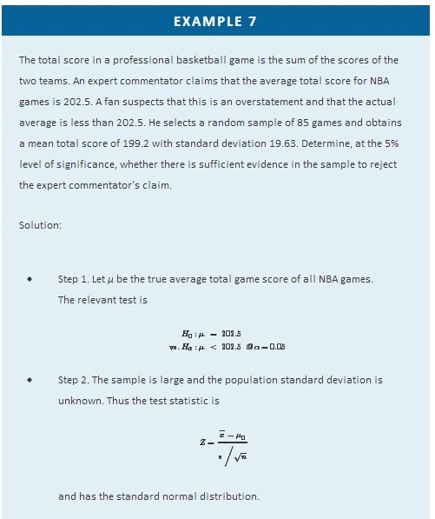
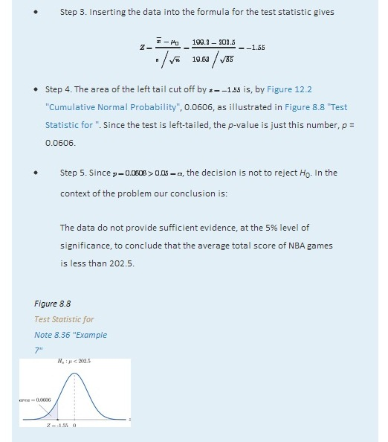

EXAMPLE 8
Mr. Prospero has been teaching Algebra II from a particular textbook at Remote Isle High School for many years. Over the years students in his Algebra II classes have consistently scored an average of 67 on the end of course exam (EOC). This year Mr. Prospero used a new textbook in the hope that the average score on the EOC test would be higher. The average EOC test score of the 64 students who took Algebra II from Mr. Prospero this year had mean 69.4 and sample standard deviation 6.1. Determine whether these data provide sufficient evidence, at the 1% level of significance, to conclude that the average EOC test score is higher with the new textbook.
Solution:

- Step 1. Let μ be the true average score on the EOC exam of all Mr. Prospero’s students who take the Algebra II course with the new textbook. The natural statement that would be assumed true unless there were strong evidence to the contrary is that the new book is about the same as the old one. The alternative, which it takes evidence to establish, is that the new book is better, which corresponds to a higher value of μ. Thus the relevant test is

H0:μ = 67
vs. Ha:μ >67 @ α=0.01
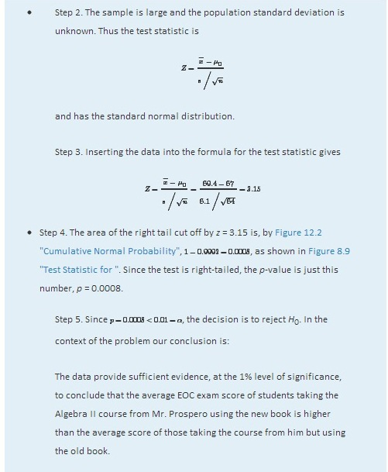
Figure 8.9Test Statistic forNote 8.37 "Example 8"
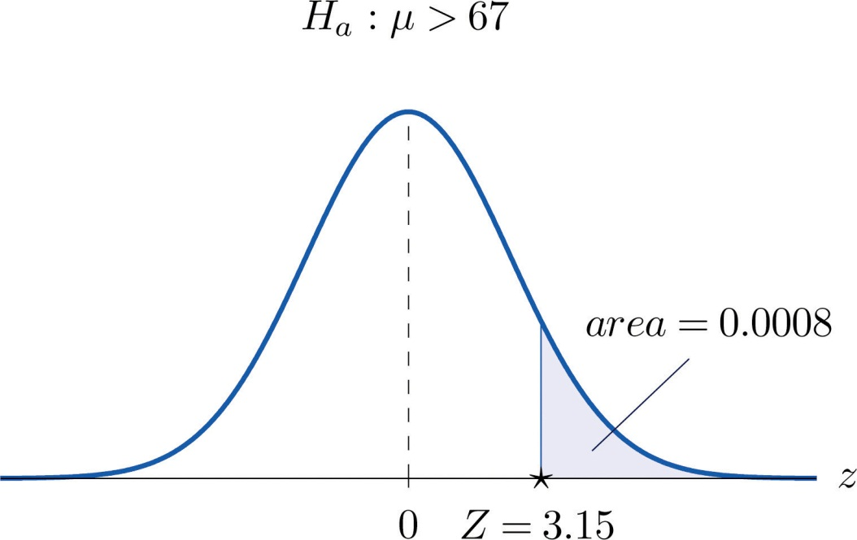
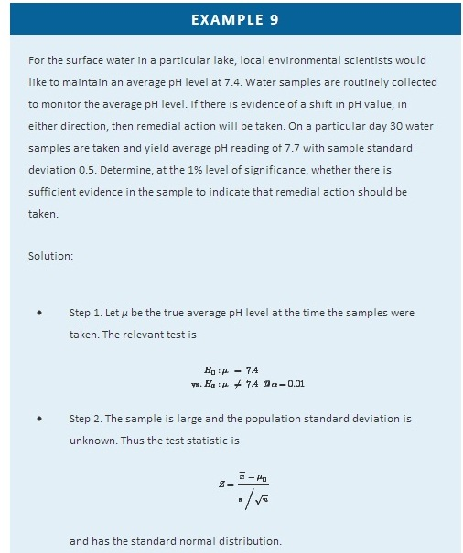
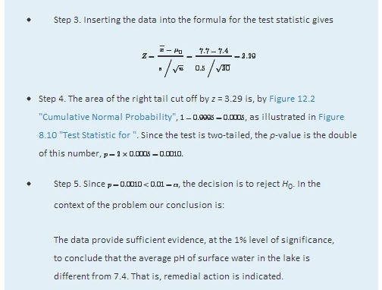
Figure 8.10Test Statistic forNote 8.38 "Example 9"
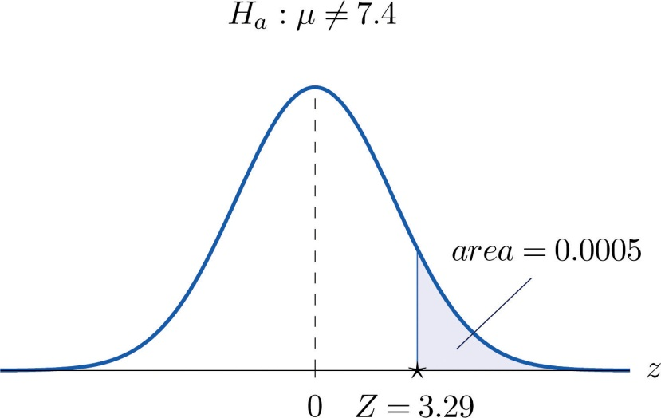

KEY TAKEAWAYS
- The observed significance or p-value of a test is a measure of how inconsistent the sample result is with H₀ and in favor of H_{a}.
- The p-value approach to hypothesis testing means that one merely compares the p-value to α instead of constructing a rejection region.
- There is a systematic five-step procedure for the p-value approach to hypothesis testing.

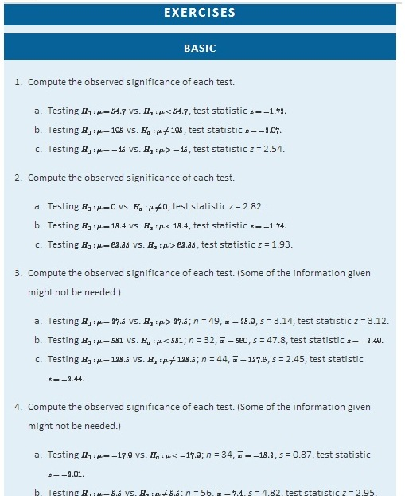
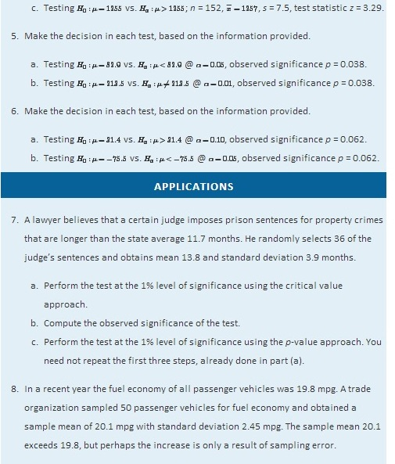
  - Perform the relevant test of hypotheses at the 20% level of significance using the critical value approach.
  - Compute the observed significance of the test.
  - Perform the test at the 20% level of significance using the p-value approach. You need not repeat the first three steps, already done in part (a).
- The mean score on a 25-point placement exam in mathematics used for the past two years at a large state university is 14.3. The placement coordinator wishes to test whether the mean score on a revised version of the exam differs from 14.3. She gives the revised exam to 30 entering freshmen early in the summer; the mean score is 14.6 with standard deviation 2.4.
  - Perform the test at the 10% level of significance using the critical value approach.
  - Compute the observed significance of the test.
  - Perform the test at the 10% level of significance using the p-value approach. You need not repeat the first three steps, already done in part (a).
- The mean increase in word family vocabulary among students in a one-year foreign language course is 576 word families. In order to estimate the effect of a new type of class scheduling, an instructor monitors the progress of 60 students; the sample mean increase in word family vocabulary of these students is 542 word families with sample standard deviation 18 word families.
  - Test at the 5% level of significance whether the mean increase with the new class scheduling is different from 576 word families, using the critical value approach.
  - Compute the observed significance of the test.
  - Perform the test at the 5% level of significance using the p-value approach. You need not repeat the first three steps, already done in part (a).
- The mean yield for hard red winter wheat in a certain state is 44.8 bu/acre. In a pilot program a modified growing scheme was introduced on 35 independent plots. The result was a sample mean yield of 45.4 bu/acre with sample standard deviation 1.6 bu/acre, an apparent increase in yield.
  - Test at the 5% level of significance whether the mean yield under the new scheme is greater than 44.8 bu/acre, using the critical value approach.
  - Compute the observed significance of the test.
  - Perform the test at the 5% level of significance using the p-value approach. You need not repeat the first three steps, already done in part (a).
- The average amount of time that visitors spent looking at a retail company’s old home page on the world wide web was 23.6 seconds. The company commissions a new home page. On its first day in place the mean time spent at the new page by 7,628 visitors was 23.5 seconds with standard deviation 5.1 seconds.
  - Test at the 5% level of significance whether the mean visit time for the new page is less than the former mean of 23.6 seconds, using the critical value approach.
  - Compute the observed significance of the test.
  - Perform the test at the 5% level of significance using the p-value approach. You need not repeat the first three steps, already done in part (a).
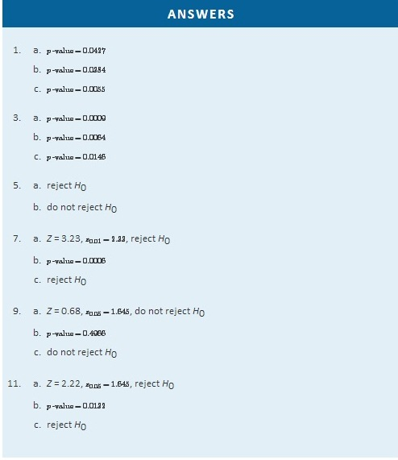

8.4 Small Sample Tests for a Population Mean

LEARNING OBJECTIVE
- To learn how to apply the five-step test procedure for test of hypotheses concerning a population mean when the sample size is small.

In the previous section hypotheses testing for population means was described in the case of large samples. The statistical validity of the tests was insured by the Central Limit Theorem, with essentially no assumptions on the distribution of the population. When sample sizes are small, as is often the case in practice, the Central Limit Theorem does not apply. One must then impose stricter assumptions on the population to give statistical validity to the test procedure. One common assumption is that the population from which the sample is taken has a normal probability distribution to begin with. Under such circumstances, if the population standard deviation is known, then the test statistic (x−−μ0)/(σ/√n) still has the standard normal distribution, as in the previous two sections. If σ is unknown and is approximated by the sample standard deviation s, then the resulting test statistic (x−−μ0)/(s/√n) follows Student’s t-distribution with n−1 degrees of freedom.
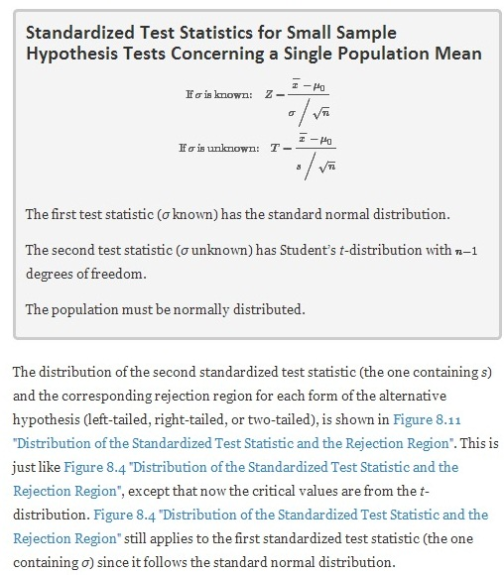
Figure 8.11 Distribution of the Standardized Test Statistic and the Rejection Region
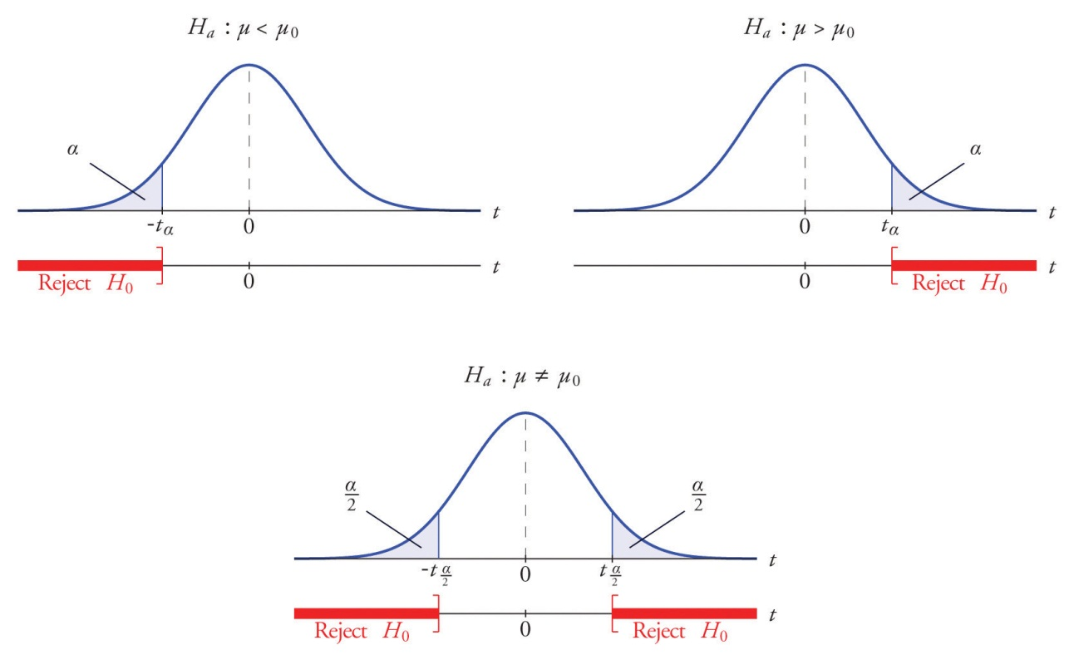

The p-value of a test of hypotheses for which the test statistic has Student’s t-distribution can be computed using statistical software, but it is impractical to do so using tables, since that would require 30 tables analogous to Figure 12.2 "Cumulative Normal Probability", one for each degree of freedom from 1 to 30.Figure 12.3 "Critical Values of " can be used to approximate the p-value of such a test, and this is typically adequate for making a decision using the p-value approach to hypothesis testing, although not always. For this reason the tests in the two examples in this section will be made following the critical value approach to hypothesis testing summarized at the end of Section 8.1 "The Elements of Hypothesis Testing", but after each one we will show how the p-value approach could have been used.

EXAMPLE 10
The price of a popular tennis racket at a national chain store is $179. Portia bought five of the same racket at an online auction site for the following prices:
155 179 175 175 161
Assuming that the auction prices of rackets are normally distributed, determine whether there is sufficient evidence in the sample, at the 5% level of significance, to conclude that the average price of the racket is less than $179 if purchased at an online auction.
Solution:

- Step 1. The assertion for which evidence must be provided is that the average online price μ is less than the average price in retail stores, so the hypothesis test is
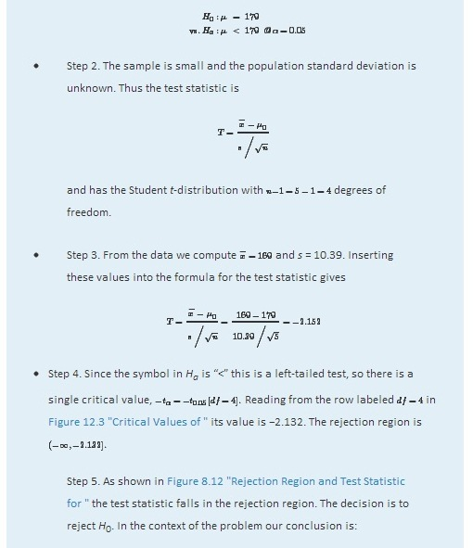
(−∞,−2.132].
- Step 5. As shown in Figure 8.12 "Rejection Region and Test Statistic for " the test statistic falls in the rejection region. The decision is to reject H₀. In the context of the problem our conclusion is:
The data provide sufficient evidence, at the 5% level of significance, to conclude that the average price of such rackets purchased at online auctions is less than $179.
Figure 8.12Rejection Region and Test Statistic forNote 8.42 "Example 10"
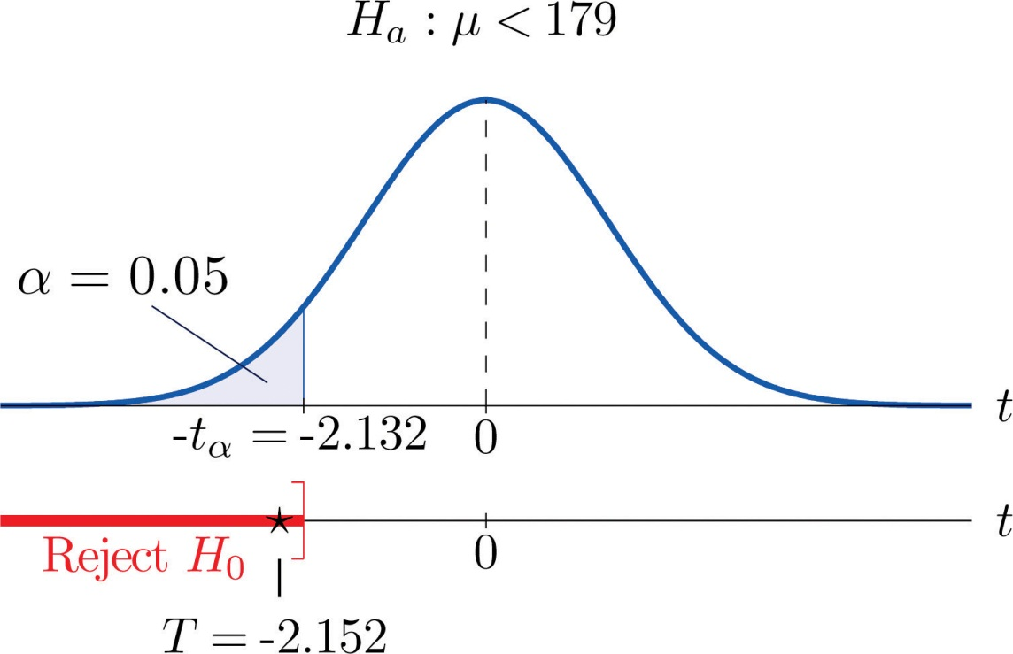

To perform the test in Note 8.42 "Example 10" using the p-value approach, look in the row in Figure 12.3 "Critical Values of " with the heading df=4 and search for the two t-values that bracket the unsigned value 2.152 of the test statistic. They are 2.132 and 2.776, in the columns with headings t_{0.050} and t_{0.025}. They cut off right tails of area 0.050 and 0.025, so because 2.152 is between them it must cut off a tail of area between 0.050 and 0.025. By symmetry −2.152 cuts off a left tail of area between 0.050 and 0.025, hence the p-value corresponding to t=−2.152 is between 0.025 and 0.05. Although its precise value is unknown, it must be less than α=0.05, so the decision is to reject H₀.

EXAMPLE 11
A small component in an electronic device has two small holes where another tiny part is fitted. In the manufacturing process the average distance between the two holes must be tightly controlled at 0.02 mm, else many units would be defective and wasted. Many times throughout the day quality control engineers take a small sample of the components from the production line, measure the distance between the two holes, and make adjustments if needed. Suppose at one time four units are taken and the distances are measured as
0.021 0.019 0.023 0.020
Determine, at the 1% level of significance, if there is sufficient evidence in the sample to conclude that an adjustment is needed. Assume the distances of interest are normally distributed.
Solution:
- Step 1. The assumption is that the process is under control unless there is strong evidence to the contrary. Since a deviation of the average distance to either side is undesirable, the relevant test is
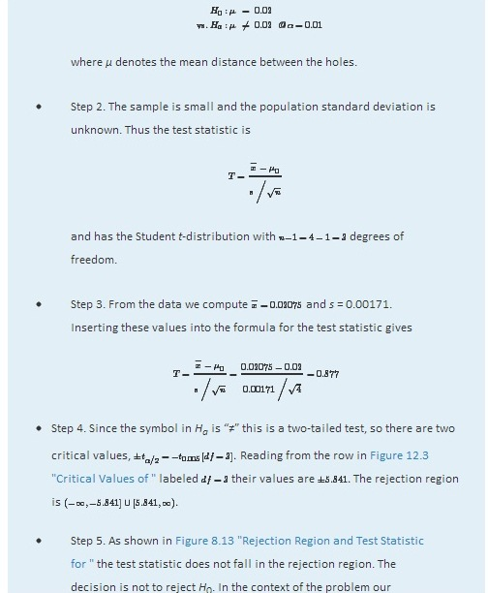
conclusion is:
The data do not provide sufficient evidence, at the 1% level of significance, to conclude that the mean distance between the holes in the component differs from 0.02 mm.

Figure 8.13Rejection Region and Test Statistic forNote 8.43 "Example 11"
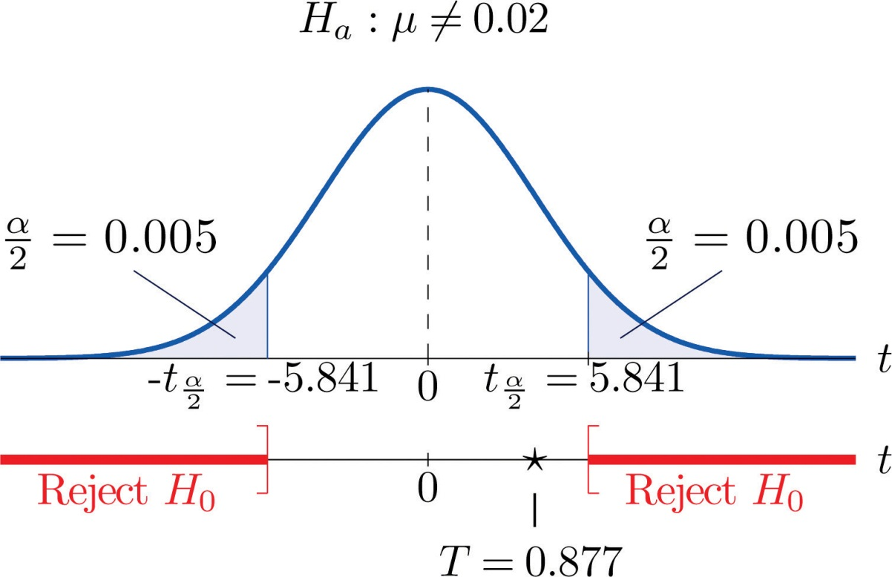

To perform the test in Note 8.43 "Example 11" using the p-value approach, look in the row in Figure 12.3 "Critical Values of " with the heading df=3 and search for the two t-values that bracket the value 0.877 of the test statistic. Actually 0.877 is smaller than the smallest number in the row, which is 0.978, in the column with heading t_{0.200}. The value 0.978 cuts off a right tail of area 0.200, so because 0.877 is to its left it must cut off a tail of area greater than 0.200. Thus the p-value, which is the double of the area cut off (since the test is two-tailed), is greater than 0.400. Although its precise value is unknown, it must be greater than α=0.01, so the decision is not to reject H₀.

KEY TAKEAWAYS
- There are two formulas for the test statistic in testing hypotheses about a population mean with small samples. One test statistic follows the standard normal distribution, the other Student’s t-distribution.
- The population standard deviation is used if it is known, otherwise the sample standard deviation is used.
- Either five-step procedure, critical value or p-value approach, is used with either test statistic.
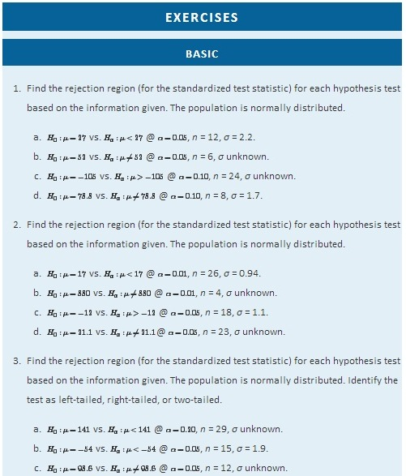
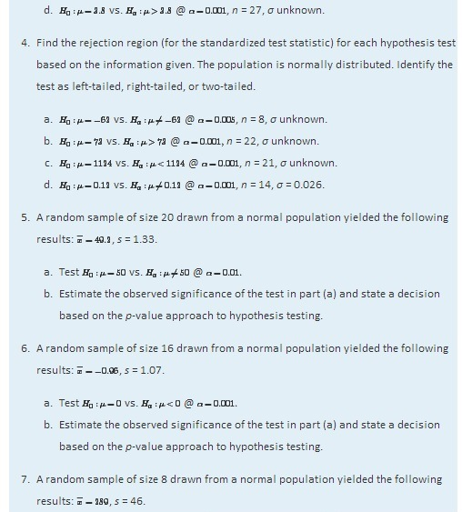
- Test H0:μ=250 vs. Ha:μ>250 @ α=0.05.
- Estimate the observed significance of the test in part (a) and state a decision based on the p-value approach to hypothesis testing.

- A random sample of size 12 drawn from a normal population yielded the following results: x−=86.2, s = 0.63.
  - Test H0:μ=85.5 vs. Ha:μ≠85.5 @ α=0.01.
  - Estimate the observed significance of the test in part (a) and state a decision based on the p-value approach to hypothesis testing.

APPLICATIONS
- Researchers wish to test the efficacy of a program intended to reduce the length of labor in childbirth. The accepted mean labor time in the birth of a first child is 15.3 hours. The mean length of the labors of 13 first-time mothers in a pilot program was 8.8 hours with standard deviation 3.1 hours. Assuming a normal distribution of times of labor, test at the 10% level of significance test whether the mean labor time for all women following this program is less than 15.3 hours.

- A dairy farm uses the somatic cell count (SCC) report on the milk it provides to a processor as one way to monitor the health of its herd. The mean SCC from five samples of raw milk was 250,000 cells per milliliter with standard deviation 37,500 cell/ml. Test whether these data provide sufficient evidence, at the 10% level of significance, to conclude that the mean SCC of all milk produced at the dairy exceeds that in the previous report, 210,250 cell/ml. Assume a normal distribution of SCC.

- Six coins of the same type are discovered at an archaeological site. If their weights on average are significantly different from 5.25 grams then it can be assumed that their provenance is not the site itself. The coins are weighed and have mean 4.73 g with sample standard deviation 0.18 g. Perform the relevant test at the 0.1% (1/10th of 1%) level of significance, assuming a normal distribution of weights of all such coins.

- An economist wishes to determine whether people are driving less than in the past. In one region of the country the number of miles driven per household per year in the past was 18.59 thousand miles. A sample of 15 households produced a sample mean of 16.23 thousand miles for the last year, with sample standard deviation 4.06 thousand miles. Assuming a normal distribution of household driving distances per year, perform the relevant test at the 5% level of significance.

- The recommended daily allowance of iron for females aged 19–50 is 18 mg/day. A careful measurement of the daily iron intake of 15 women yielded a mean daily intake of 16.2 mg with sample standard deviation 4.7 mg.

  - Assuming that daily iron intake in women is normally distributed, perform the test that the actual mean daily intake for all women is different from 18 mg/day, at the 10% level of significance.
  - The sample mean is less than 18, suggesting that the actual population mean is less than 18 mg/day. Perform this test, also at the 10% level of significance. (The computation of the test statistic done in part (a) still applies here.)
- The target temperature for a hot beverage the moment it is dispensed from a vending machine is 170°F. A sample of ten randomly selected servings from a new machine undergoing a pre-shipment inspection gave mean temperature 173°F with sample standard deviation 6.3°F.
  - Assuming that temperature is normally distributed, perform the test that the mean temperature of dispensed beverages is different from 170°F, at the 10% level of significance.
  - The sample mean is greater than 170, suggesting that the actual population mean is greater than 170°F. Perform this test, also at the 10% level of significance. (The computation of the test statistic done in part (a) still applies here.)
- The average number of days to complete recovery from a particular type of knee operation is 123.7 days. From his experience a physician suspects that use of a topical pain medication might be lengthening the recovery time. He randomly selects the records of seven knee surgery patients who used the topical medication. The times to total recovery were:
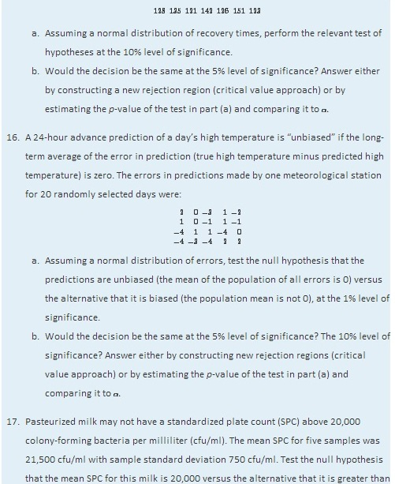

20,000, at the 10% level of significance. Assume that the SPC follows a normal distribution.
- One water quality standard for water that is discharged into a particular type of stream or pond is that the average daily water temperature be at most 18°C. Six samples taken throughout the day gave the data:
16.8 21.5 19.1 12.8 18.0 20.7
The sample mean x^−=18.15 exceeds 18, but perhaps this is only sampling error. Determine whether the data provide sufficient evidence, at the 10% level of significance, to conclude that the mean temperature for the entire day exceeds 18°C.

ADDITIONAL EXERCISES
- A calculator has a built-in algorithm for generating a random number according to the standard normal distribution. Twenty-five numbers thus generated have mean 0.15 and sample standard deviation 0.94. Test the null hypothesis that the mean of all numbers so generated is 0 versus the alternative that it is different from 0, at the 20% level of significance. Assume that the numbers do follow a normal distribution.
- At every setting a high-speed packing machine delivers a product in amounts that vary from container to container with a normal distribution of standard deviation 0.12 ounce. To compare the amount delivered at the current setting to the desired amount 64.1 ounce, a quality inspector randomly selects five containers and measures the contents of each, obtaining sample mean 63.9 ounces and sample standard deviation 0.10 ounce. Test whether the data provide sufficient evidence, at the 5% level of significance, to conclude that the mean of all containers at the current setting is less than 64.1 ounces.
- A manufacturing company receives a shipment of 1,000 bolts of nominal shear strength 4,350 lb. A quality control inspector selects five bolts at random and measures the shear strength of each. The data are:
4,320 4,290 4,360 4,350 4,320
  - Assuming a normal distribution of shear strengths, test the null hypothesis that the mean shear strength of all bolts in the shipment is 4,350 lb versus the alternative that it is less than 4,350 lb, at the 10% level of significance.
  - Estimate the p-value (observed significance) of the test of part (a).
  - Compare the p-value found in part (b) to α=0.10 and make a decision based on the p-value approach. Explain fully.
- A literary historian examines a newly discovered document possibly written by Oberon Theseus. The mean average sentence length of the surviving undisputed works of Oberon Theseus is 48.72 words. The historian counts words in sentences between five successive 101 periods in the document in question to obtain a mean average sentence length of 39.46 words with standard deviation 7.45 words. (Thus the sample size is five.)
  - Determine if these data provide sufficient evidence, at the 1% level of significance, to conclude that the mean average sentence length in the document is less than 48.72.
  - Estimate the p-value of the test.
  - Based on the answers to parts (a) and (b), state whether or not it is likely that the document was written by Oberon Theseus.
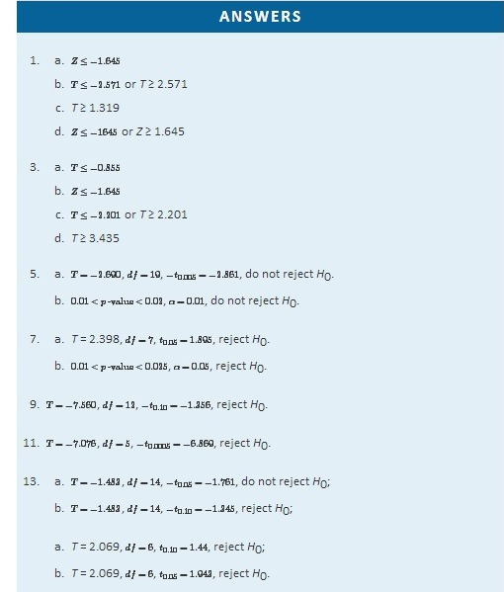
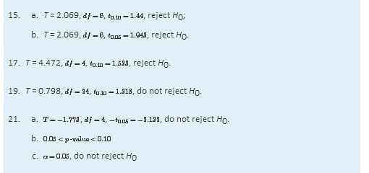

8.5 Large Sample Tests for a Population Proportion

LEARNING OBJECTIVES
- To learn how to apply the five-step critical value test procedure for test of hypotheses concerning a population proportion.
- To learn how to apply the five-step p-value test procedure for test of hypotheses concerning a population proportion.
Both the critical value approach and the p-value approach can be applied to test hypotheses about a population proportion p. The null hypothesis will have the form H0:p=p₀ for some specific number p₀ between 0 and 1. The alternative hypothesis will be one of the three inequalities p<p₀, p>p₀, or p≠p₀ for the same number p₀ that appears in the null hypothesis.
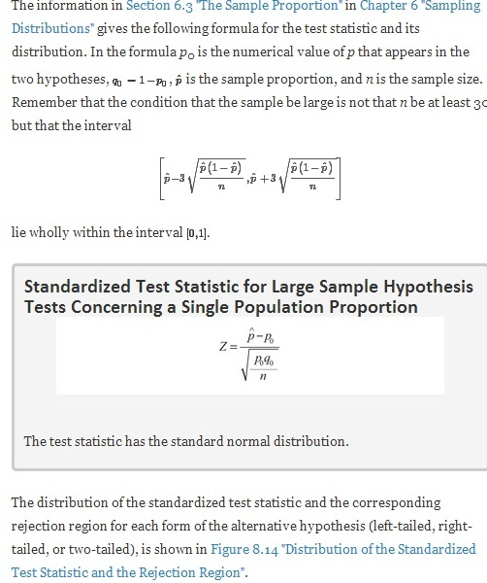

Figure 8.14 Distribution of the Standardized Test Statistic and the Rejection Region
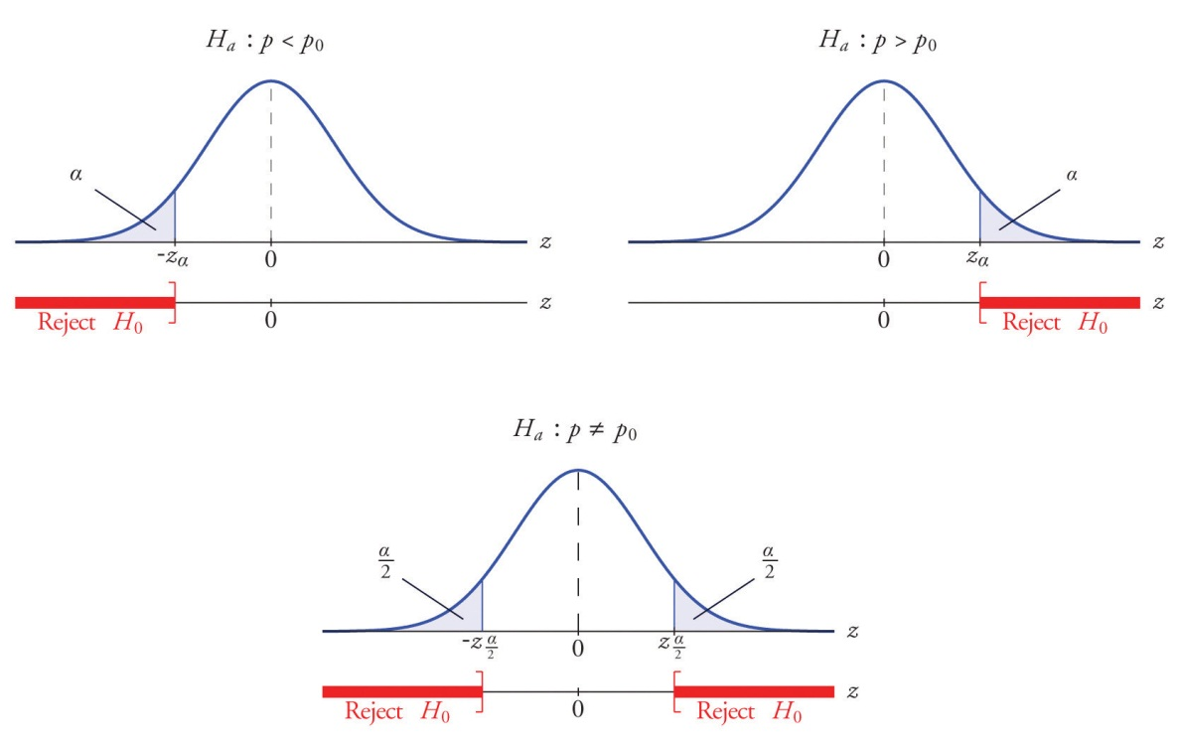
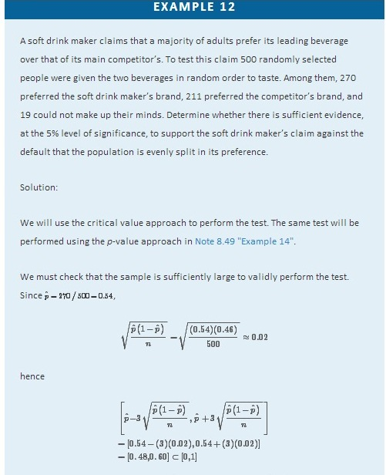
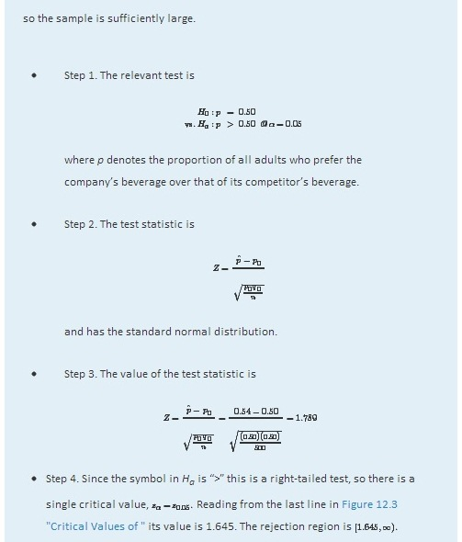
- Step 5. As shown in Figure 8.15 "Rejection Region and Test Statistic for " the test statistic falls in the rejection region. The decision is to reject H₀. In the context of the problem our conclusion is:
The data provide sufficient evidence, at the 5% level of significance, to conclude that a majority of adults prefer the company’s beverage to that of their competitor’s.

Figure 8.15Rejection Region and Test Statistic forNote 8.47 "Example 12"
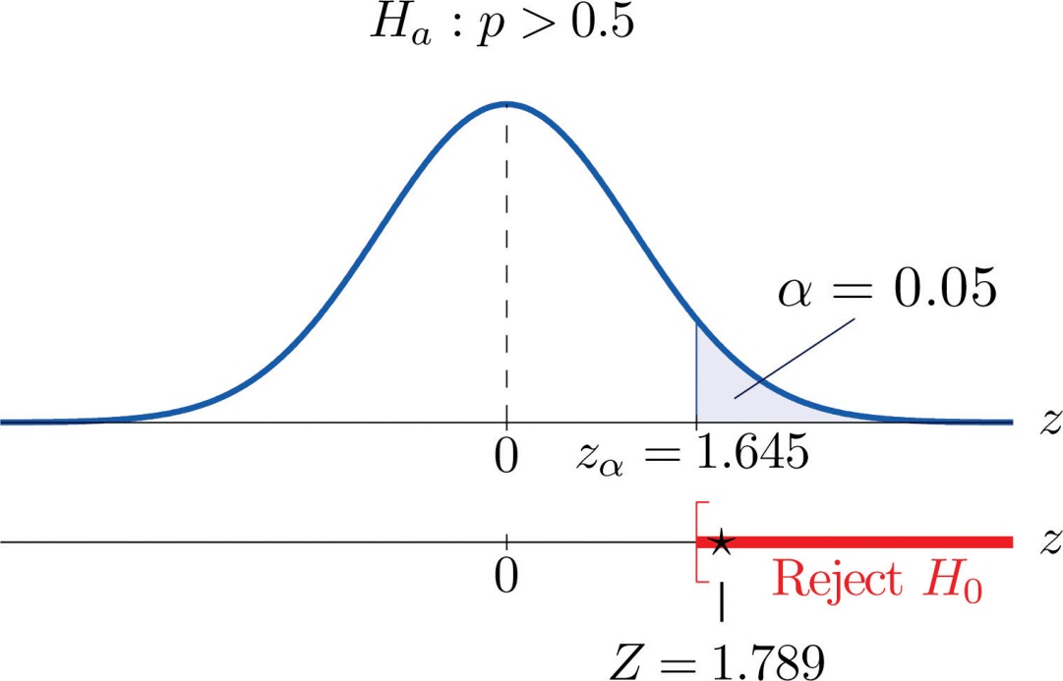
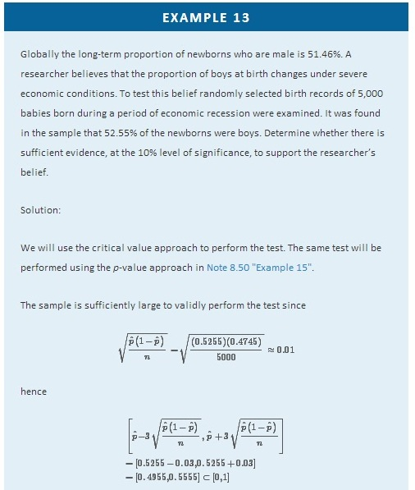
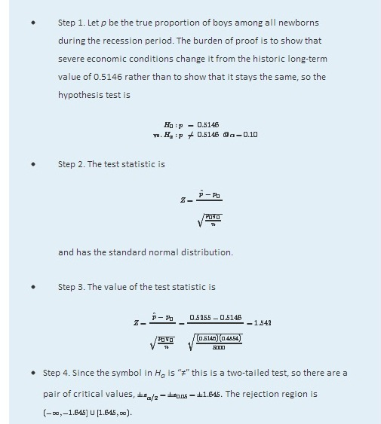
- Step 5. As shown in Figure 8.16 "Rejection Region and Test Statistic for " the test statistic does not fall in the rejection region. The decision is not to reject H₀. In the context of the problem our conclusion is:
The data do not provide sufficient evidence, at the 10% level of significance, to conclude that the proportion of newborns who are male differs from the historic proportion in times of economic recession.

Figure 8.16Rejection Region and Test Statistic forNote 8.48 "Example 13"
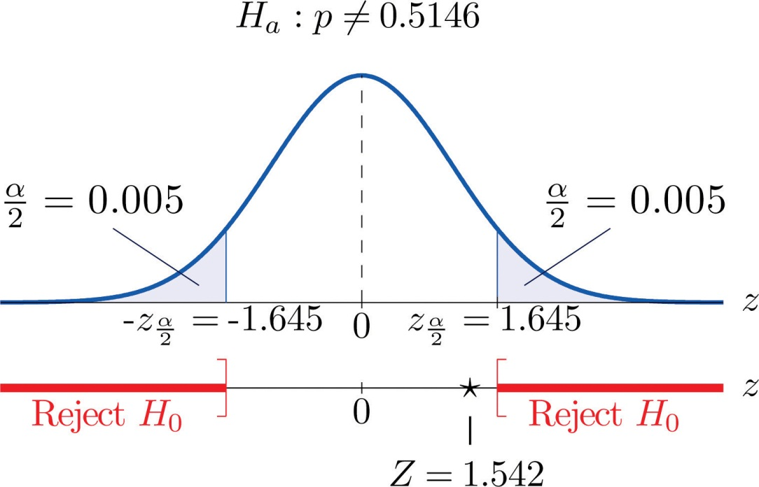

EXAMPLE 14
Perform the test of Note 8.47 "Example 12" using the p-value approach.
Solution:
We already know that the sample size is sufficiently large to validly perform the test.
- Steps 1–3 of the five-step procedure described in Section 8.3.2 "The " have already been done in Note 8.47 "Example 12" so we will not repeat them here, but only say that we know that the test is right-tailed and that value of the test statistic is Z = 1.789.
- Step 4. Since the test is right-tailed the p-value is the area under the standard normal curve cut off by the observed test statistic, z = 1.789, as illustrated inFigure 8.17. By Figure 12.2 "Cumulative Normal Probability" that area and therefore the p-value is 1−0.9633=0.0367.
- Step 5. Since the p-value is less than α=0.05 the decision is to reject H₀.

Figure 8.17P-Value for Note 8.49 "Example 14"
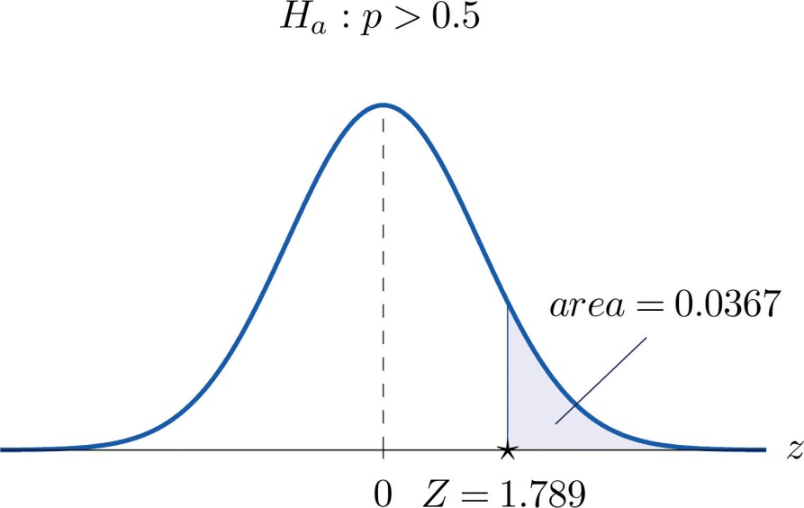

EXAMPLE 15
Perform the test of Note 8.48 "Example 13" using the p-value approach.
Solution:
We already know that the sample size is sufficiently large to validly perform the test.

- Steps 1–3 of the five-step procedure described in Section 8.3.2 "The " have already been done in Note 8.48 "Example 13". They tell us that the test is two-tailed and that value of the test statistic is Z = 1.542.
- Step 4. Since the test is two-tailed the p-value is the double of the area under the standard normal curve cut off by the observed test statistic, z = 1.542. ByFigure 12.2 "Cumulative Normal Probability" that area is 1−0.9382=0.0618, as illustrated in Figure 8.18, hence the p-value is 2×0.0618=0.1236.
- Step 5. Since the p-value is greater than α=0.10 the decision is not to rejectH₀.

Figure 8.18P-Value for Note 8.50 "Example 15"
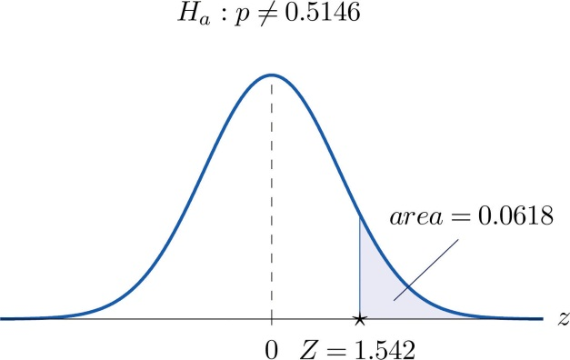

KEY TAKEAWAYS
- There is one formula for the test statistic in testing hypotheses about a population proportion. The test statistic follows the standard normal distribution.
- Either five-step procedure, critical value or p-value approach, can be used.

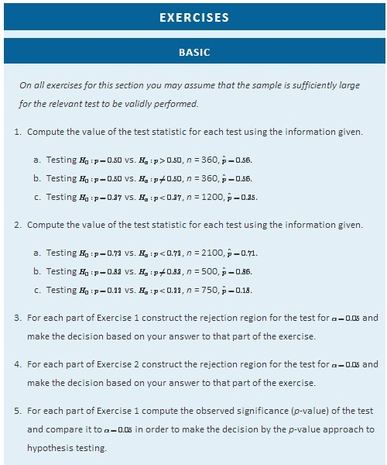
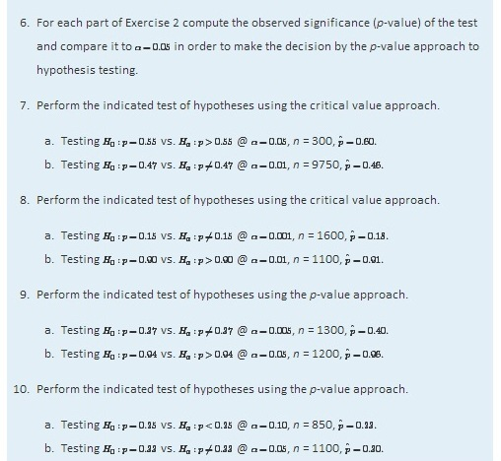

APPLICATIONS
- Five years ago 3.9% of children in a certain region lived with someone other than a parent. A sociologist wishes to test whether the current proportion is different. Perform the relevant test at the 5% level of significance using the following data: in a random sample of 2,759 children, 119 lived with someone other than a parent.
- The government of a particular country reports its literacy rate as 52%. A nongovernmental organization believes it to be less. The organization takes a random sample of 600 inhabitants and obtains a literacy rate of 42%. Perform the relevant test at the 0.5% (one-half of 1%) level of significance.
- Two years ago 72% of household in a certain county regularly participated in recycling household waste. The county government wishes to investigate whether that proportion has increased after an intensive campaign promoting recycling. In a survey of 900 households, 674 regularly participate in recycling. Perform the relevant test at the 10% level of significance.
- Prior to a special advertising campaign, 23% of all adults recognized a particular company’s logo. At the close of the campaign the marketing department commissioned a survey in which 311 of 1,200 randomly selected adults recognized the logo. Determine, at the 1% level of significance, whether the data provide sufficient evidence to conclude that more than 23% of all adults now recognize the company’s logo.
- A report five years ago stated that 35.5% of all state-owned bridges in a particular state were “deficient.” An advocacy group took a random sample of 100 state-owned bridges in the state and found 33 to be currently rated as being “deficient.” Test whether the current proportion of bridges in such condition is 35.5% versus the alternative that it is different from 35.5%, at the 10% level of significance.
- In the previous year the proportion of deposits in checking accounts at a certain bank that were made electronically was 45%. The bank wishes to determine if the proportion is higher this year. It examined 20,000 deposit records and found that 9,217 were electronic. Determine, at the 1% level of significance, whether the data provide sufficient evidence to conclude that more than 45% of all deposits to checking accounts are now being made electronically.
- According to the Federal Poverty Measure 12% of the U.S. population lives in poverty. The governor of a certain state believes that the proportion there is lower. In a sample of size 1,550, 163 were impoverished according to the federal measure.
  - Test whether the true proportion of the state’s population that is impoverished is less than 12%, at the 5% level of significance.
    - Compute the observed significance of the test.
- An insurance company states that it settles 85% of all life insurance claims within 30 days. A consumer group asks the state insurance commission to investigate. In a sample of 250 life insurance claims, 203 were settled within 30 days.
  - Test whether the true proportion of all life insurance claims made to this company that are settled within 30 days is less than 85%, at the 5% level of significance.
  - Compute the observed significance of the test.
- A special interest group asserts that 90% of all smokers began smoking before age 18. In a sample of 850 smokers, 687 began smoking before age 18.
  - Test whether the true proportion of all smokers who began smoking before age 18 is less than 90%, at the 1% level of significance.
  - Compute the observed significance of the test.
- In the past, 68% of a garage’s business was with former patrons. The owner of the garage samples 200 repair invoices and finds that for only 114 of them the patron was a repeat customer.
  - Test whether the true proportion of all current business that is with repeat customers is less than 68%, at the 1% level of significance.
  - Compute the observed significance of the test.

ADDITIONAL EXERCISES
- A rule of thumb is that for working individuals one-quarter of household income should be spent on housing. A financial advisor believes that the average proportion of income spent on housing is more than 0.25. In a sample of 30 households, the mean proportion of household income spent on housing was 0.285 with a standard deviation of 0.063. Perform the relevant test of hypotheses at the 1% level of significance. Hint: This exercise could have been presented in an earlier section.
- Ice cream is legally required to contain at least 10% milk fat by weight. The manufacturer of an economy ice cream wishes to be close to the legal limit, hence produces its ice cream with a target proportion of 0.106 milk fat. A sample of five containers yielded a mean proportion of 0.094 milk fat with standard deviation 0.002. Test the null hypothesis that the mean proportion of milk fat in all containers is 0.106 against the alternative that it is less than 0.106, at the 10% level of significance. Assume that the proportion of milk fat in containers is normally distributed. Hint: This exercise could have been presented in an earlier section.

LARGE DATA SET EXERCISES
- Large Data Sets 4 and 4A list the results of 500 tosses of a die. Let p denote the proportion of all tosses of this die that would result in a five. Use the sample data to test the hypothesis that p is different from 1/6, at the 20% level of significance.

http://www.flatworldknowledge.com/sites/all/files/data4.xls
http://www.flatworldknowledge.com/sites/all/files/data4A.xls

- Large Data Set 6 records results of a random survey of 200 voters in each of two regions, in which they were asked to express whether they prefer Candidate A for a U.S. Senate seat or prefer some other candidate. Use the full data set (400 observations) to test the hypothesis that the proportion p of all voters who prefer Candidate A exceeds 0.35. Test at the 10% level of significance.

http://www.flatworldknowledge.com/sites/all/files/data6.xls

- Lines 2 through 536 in Large Data Set 11 is a sample of 535 real estate sales in a certain region in 2008. Those that were foreclosure sales are identified with a 1 in the second column. Use these data to test, at the 10% level of significance, the hypothesis that the proportion p of all real estate sales in this region in 2008 that were foreclosure sales was less than 25%. (The null hypothesis is H0:p=0.25.)

http://www.flatworldknowledge.com/sites/all/files/data11.xls

- Lines 537 through 1106 in Large Data Set 11 is a sample of 570 real estate sales in a certain region in 2010. Those that were foreclosure sales are identified with a 1 in the second column. Use these data to test, at the 5% level of significance, the hypothesis that the proportion p of all real estate sales in this region in 2010 that were foreclosure sales was greater than 23%. (The null hypothesis is H0:p=0.23.)

http://www.flatworldknowledge.com/sites/all/files/data11.xls
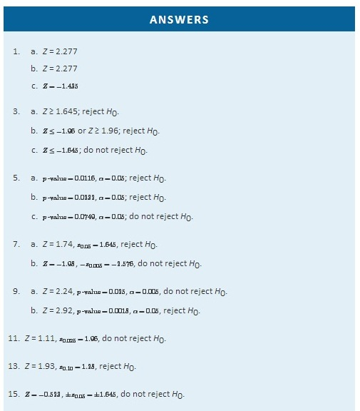
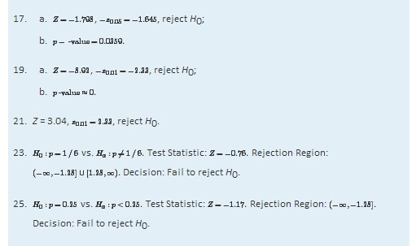

Chapter 9

Two-Sample Problems

The previous two chapters treated the questions of estimating and making inferences about a parameter of a single population. In this chapter we consider a comparison of parameters that belong to two different populations. For example, we might wish to compare the average income of all adults in one region of the country with the average income of those in another region, or we might wish to compare the proportion of all men who are vegetarians with the proportion of all women who are vegetarians.

We will study construction of confidence intervals and tests of hypotheses in four situations, depending on the parameter of interest, the sizes of the samples drawn from each of the populations, and the method of sampling. We also examine sample size considerations.

9.1 Comparison of Two Population Means: Large, Independent Samples

LEARNING OBJECTIVES
- To understand the logical framework for estimating the difference between the means of two distinct populations and performing tests of hypotheses concerning those means.
- To learn how to construct a confidence interval for the difference in the means of two distinct populations using large, independent samples.
- To learn how to perform a test of hypotheses concerning the difference between the means of two distinct populations using large, independent samples.
Suppose we wish to compare the means of two distinct populations. Figure 9.1 "Independent Sampling from Two Populations" illustrates the conceptual framework of our investigation in this and the next section. Each population has a mean and a standard deviation. We arbitrarily label one population as Population 1 and the other as Population 2, and subscript the parameters with the numbers 1 and 2 to tell them apart. We draw a random sample from Population 1 and label the sample statistics it yields with the subscript 1. Without reference to the first sample we draw a sample from Population 2 and label its sample statistics with the subscript 2.
Figure 9.1 Independent Sampling from Two Populations
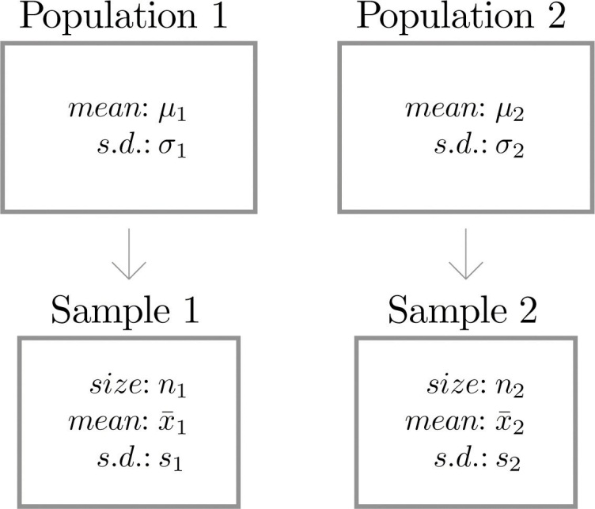

Definition
Samples from two distinct populations are independent if each one is drawn without reference to the other, and has no connection with the other.
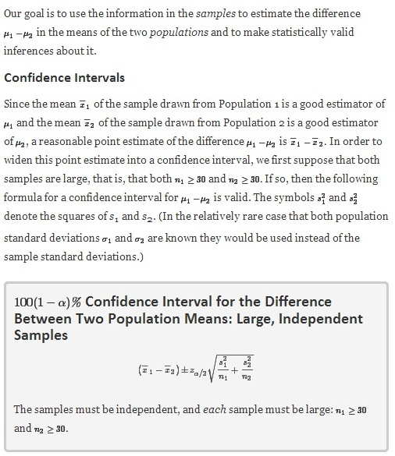

EXAMPLE 1
To compare customer satisfaction levels of two competing cable television companies, 174 customers of Company 1 and 355 customers of Company 2 were randomly selected and were asked to rate their cable companies on a five-point scale, with 1 being least satisfied and 5 most satisfied. The survey results are summarized in the following table:
Company 1 | Company 2
n1=174 | n2=355
x−1=3.51 | x−2=3.24
s1=0.51 | s2=0.52

Construct a point estimate and a 99% confidence interval for μ1−μ2, the difference in average satisfaction levels of customers of the two companies as measured on this five-point scale.
Solution:

The point estimate of μ₁−μ₂ is

x^−1 − x^−2=3.51−3.24=0.27.
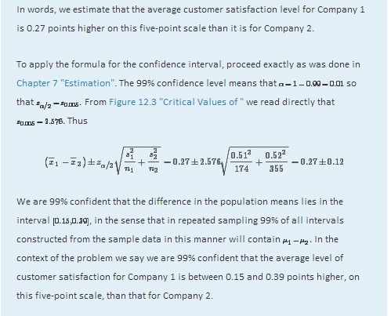

Hypothesis Testing

Hypotheses concerning the relative sizes of the means of two populations are tested using the same critical value and p-value procedures that were used in the case of a single population. All that is needed is to know how to express the null and alternative hypotheses and to know the formula for the standardized test statistic and the distribution that it follows.

The null and alternative hypotheses will always be expressed in terms of the difference of the two population means. Thus the null hypothesis will always be written

H₀:μ₁−μ₂=D₀
where D₀ is a number that is deduced from the statement of the situation. As was the case with a single population the alternative hypothesis can take one of the three forms, with the same terminology:

Form of Ha | Terminology
Ha:μ1−μ2<D0 | Left-tailed
Ha:μ1−μ2>D0 | Right-tailed
Ha:μ1−μ2≠D0 | Two-tailed

As long as the samples are independent and both are large the following formula for the standardized test statistic is valid, and it has the standard normal distribution. (In the relatively rare case that both population standard deviations σ₁ and σ₂ are known they would be used instead of the sample standard deviations.)
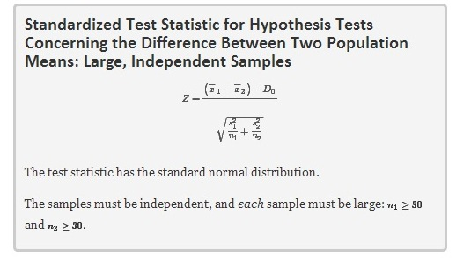
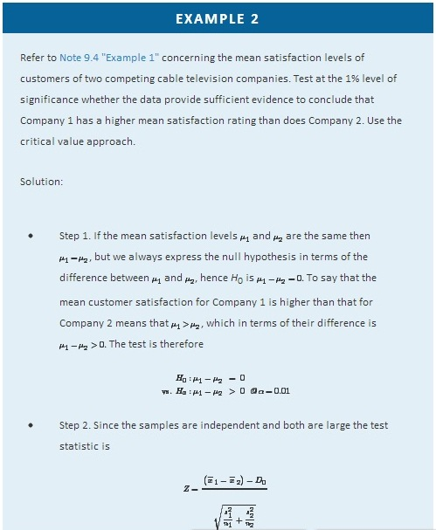
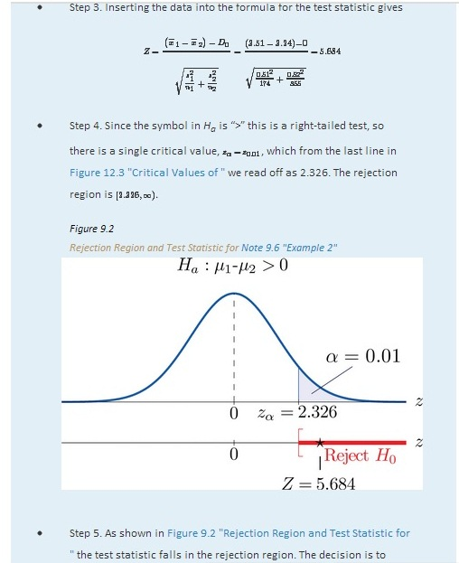
reject H₀. In the context of the problem our conclusion is:

The data provide sufficient evidence, at the 1% level of significance, to conclude that the mean customer satisfaction for Company 1 is higher than that for Company 2.

EXAMPLE 3
Perform the test of Note 9.6 "Example 2" using the p-value approach.
Solution:

The first three steps are identical to those in Note 9.6 "Example 2".

- Step 4. The observed significance or p-value of the test is the area of the right tail of the standard normal distribution that is cut off by the test statistic Z = 5.684. The number 5.684 is too large to appear in Figure 12.2 "Cumulative Normal Probability", which means that the area of the left tail that it cuts off is 1.0000 to four decimal places. The area that we seek, the area of the righttail, is therefore 1−1.0000=0.0000 to four decimal places. See Figure 9.3. That is, p -value=0.0000 to four decimal places. (The actual value is approximately 0.000 000 007.)
Figure 9.3P-Value for Note 9.7 "Example 3"
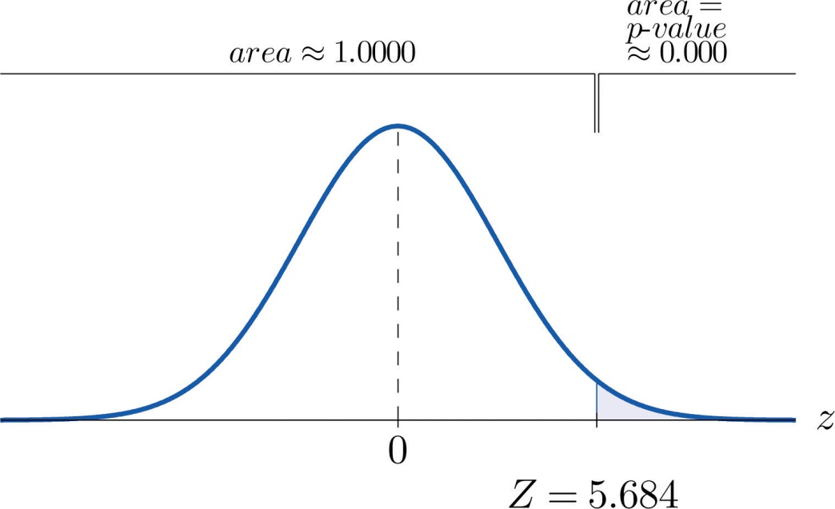
- Step 5. Since 0.0000 < 0.01, p -value<α so the decision is to reject the null hypothesis:

The data provide sufficient evidence, at the 1% level of significance, to conclude that the mean customer satisfaction for Company 1 is higher than that for Company 2.

KEY TAKEAWAYS
- A point estimate for the difference in two population means is simply the difference in the corresponding sample means.
- In the context of estimating or testing hypotheses concerning two population means, “large” samples means that both samples are large.
- A confidence interval for the difference in two population means is computed using a formula in the same fashion as was done for a single population mean.
- The same five-step procedure used to test hypotheses concerning a single population mean is used to test hypotheses concerning the difference between two population means. The only difference is in the formula for the standardized test statistic.
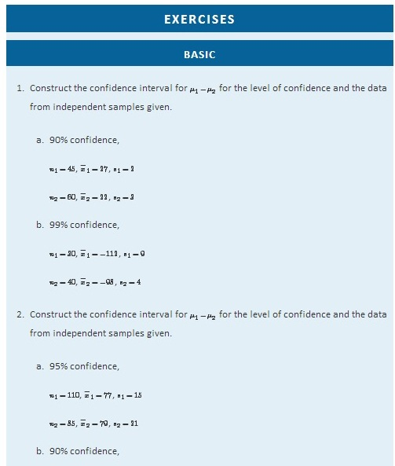
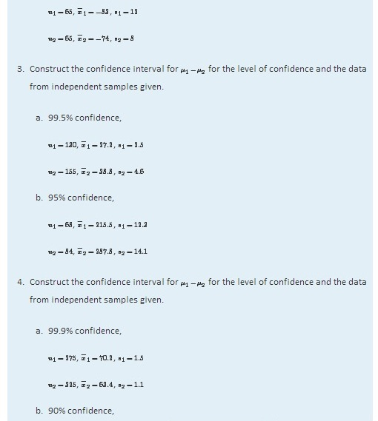
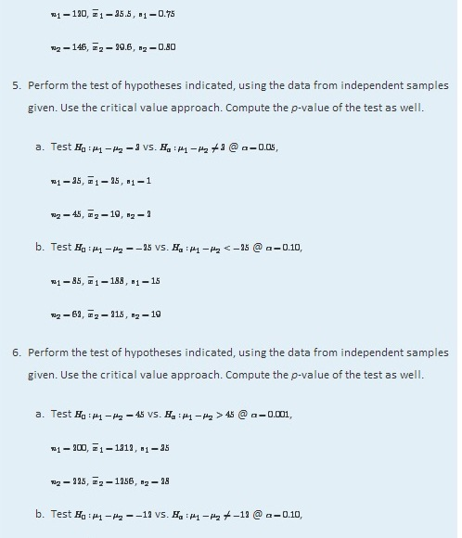
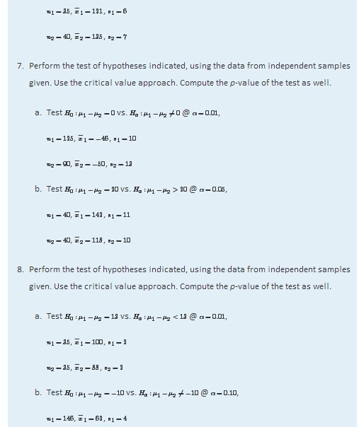
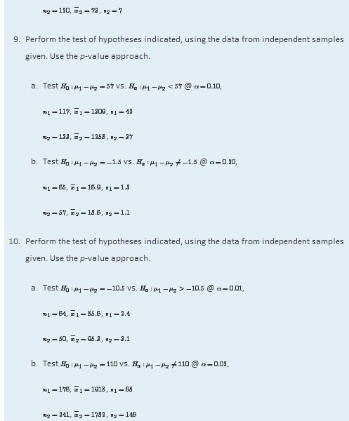
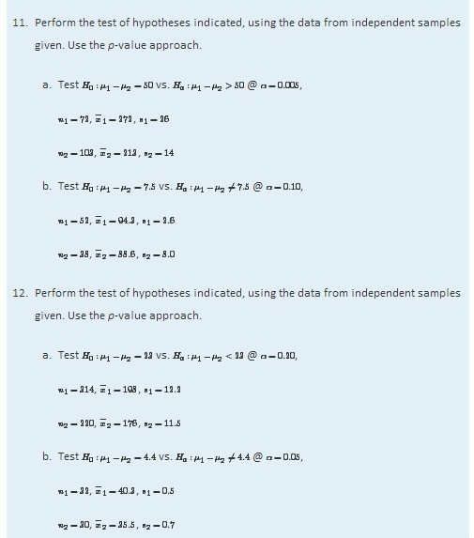

APPLICATIONS
- In order to investigate the relationship between mean job tenure in years among workers who have a bachelor’s degree or higher and those who do not, random samples of each type of worker were taken, with the following results.

 | n | x− | s
Bachelor’s degree or higher | 155 | 5.2 | 1.3
No degree | 210 | 5.0 | 1.5
  - Construct the 99% confidence interval for the difference in the population means based on these data.
  - Test, at the 1% level of significance, the claim that mean job tenure among those with higher education is greater than among those without, against the default that there is no difference in the means.
  - Compute the observed significance of the test.
- Records of 40 used passenger cars and 40 used pickup trucks (none used commercially) were randomly selected to investigate whether there was any difference in the mean time in years that they were kept by the original owner before being sold. For cars the mean was 5.3 years with standard deviation 2.2 years. For pickup trucks the mean was 7.1 years with standard deviation 3.0 years.
  - Construct the 95% confidence interval for the difference in the means based on these data.
  - Test the hypothesis that there is a difference in the means against the null hypothesis that there is no difference. Use the 1% level of significance.
  - Compute the observed significance of the test in part (b).
- In previous years the average number of patients per hour at a hospital emergency room on weekends exceeded the average on weekdays by 6.3 visits per hour. A hospital administrator believes that the current weekend mean exceeds the weekday mean by fewer than 6.3 hours.
  - Construct the 99% confidence interval for the difference in the population means based on the following data, derived from a study in which 30 weekend and 30 weekday one-hour periods were randomly selected and the number of new patients in each recorded.
 | n | x− | s
Weekends | 30 | 13.8 | 3.1
Weekdays | 30 | 8.6 | 2.7
  - Test at the 5% level of significance whether the current weekend mean exceeds the weekday mean by fewer than 6.3 patients per hour.
  - Compute the observed significance of the test.
- A sociologist surveys 50 randomly selected citizens in each of two countries to compare the mean number of hours of volunteer work done by adults in each. Among the 50 inhabitants of Lilliput, the mean hours of volunteer work per year was 52, with standard deviation 11.8. Among the 50 inhabitants of Blefuscu, the mean number of hours of volunteer work per year was 37, with standard deviation 7.2.
  - Construct the 99% confidence interval for the difference in mean number of hours volunteered by all residents of Lilliput and the mean number of hours volunteered by all residents of Blefuscu.
  - Test, at the 1% level of significance, the claim that the mean number of hours volunteered by all residents of Lilliput is more than ten hours greater than the mean number of hours volunteered by all residents of Blefuscu.
  - Compute the observed significance of the test in part (b).
- A university administrator asserted that upperclassmen spend more time studying than underclassmen.
  - Test this claim against the default that the average number of hours of study per week by the two groups is the same, using the following information based on random samples from each group of students. Test at the 1% level of significance.
 | n | x− | s
Upperclassmen | 35 | 15.6 | 2.9
Underclassmen | 35 | 12.3 | 4.1
  - Compute the observed significance of the test.
- An kinesiologist claims that the resting heart rate of men aged 18 to 25 who exercise regularly is more than five beats per minute less than that of men who do not exercise regularly. Men in each category were selected at random and their resting heart rates were measured, with the results shown.
 | n | x− | s
Regular exercise | 40 | 63 | 1.0
No regular exercise | 30 | 71 | 1.2
  - Perform the relevant test of hypotheses at the 1% level of significance.
  - Compute the observed significance of the test.
- Children in two elementary school classrooms were given two versions of the same test, but with the order of questions arranged from easier to more difficult in Version A and in reverse order in Version B. Randomly selected students from each class were given Version A and the rest Version B. The results are shown in the table.
 | n | x− | s
Version A | 31 | 83 | 4.6
Version B | 32 | 78 | 4.3
  - Construct the 90% confidence interval for the difference in the means of the populations of all children taking Version A of such a test and of all children taking Version B of such a test.
  - Test at the 1% level of significance the hypothesis that the A version of the test is easier than the B version (even though the questions are the same).
  - Compute the observed significance of the test.
- The Municipal Transit Authority wants to know if, on weekdays, more passengers ride the northbound blue line train towards the city center that departs at 8:15 a.m. or the one that departs at 8:30 a.m. The following sample statistics are assembled by the Transit Authority.
 | n | x− | s
8:15 a.m. train | 30 | 323 | 41
8:30 a.m. train | 45 | 356 | 45
  - Construct the 90% confidence interval for the difference in the mean number of daily travellers on the 8:15 train and the mean number of daily travellers on the 8:30 train.
  - Test at the 5% level of significance whether the data provide sufficient evidence to conclude that more passengers ride the 8:30 train.
  - Compute the observed significance of the test.
- In comparing the academic performance of college students who are affiliated with fraternities and those male students who are unaffiliated, a random sample of students was drawn from each of the two populations on a university campus. Summary statistics on the student GPAs are given below.
 | n | x− | s
Fraternity | 645 | 2.90 | 0.47
Unaffiliated | 450 | 2.88 | 0.42
- Test, at the 5% level of significance, whether the data provide sufficient evidence to conclude that there is a difference in average GPA between the population of fraternity students and the population of unaffiliated male students on this university campus.
- In comparing the academic performance of college students who are affiliated with sororities and those female students who are unaffiliated, a random sample of students was drawn from each of the two populations on a university campus. Summary statistics on the student GPAs are given below.
 | n | x− | s
Sorority | 330 | 3.18 | 0.37
Unaffiliated | 550 | 3.12 | 0.41
- Test, at the 5% level of significance, whether the data provide sufficient evidence to conclude that there is a difference in average GPA between the population of sorority students and the population of unaffiliated female students on this university campus.
- The owner of a professional football team believes that the league has become more offense oriented since five years ago. To check his belief, 32 randomly selected games from one year’s schedule were compared to 32 randomly selected games from the schedule five years later. Since more offense produces more points per game, the owner analyzed the following information on points per game (ppg).
 | n | x− | s
ppg previously | 32 | 20.62 | 4.17
ppg recently | 32 | 22.05 | 4.01
- Test, at the 10% level of significance, whether the data on points per game provide sufficient evidence to conclude that the game has become more offense oriented.
- The owner of a professional football team believes that the league has become more offense oriented since five years ago. To check his belief, 32 randomly selected games from one year’s schedule were compared to 32 randomly selected games from the schedule five years later. Since more offense produces more offensive yards per game, the owner analyzed the following information on offensive yards per game (oypg).
 | n | x− | s
oypg previously | 32 | 316 | 40
oypg recently | 32 | 336 | 35
- Test, at the 10% level of significance, whether the data on offensive yards per game provide sufficient evidence to conclude that the game has become more offense oriented.

LARGE DATA SET EXERCISES
- Large Data Sets 1A and 1B list the SAT scores for 1,000 randomly selected students. Denote the population of all male students as Population 1 and the population of all female students as Population 2.

http://www.flatworldknowledge.com/sites/all/files/data1A.xls
http://www.flatworldknowledge.com/sites/all/files/data1B.xls

  - Restricting attention to just the males, find n₁, x−1, and s₁. Restricting attention to just the females, find n₂, x−2, and s₂.
  - Let μ1 denote the mean SAT score for all males and μ2 the mean SAT score for all females. Use the results of part (a) to construct a 90% confidence interval for the difference μ1−μ2.
  - Test, at the 5% level of significance, the hypothesis that the mean SAT scores among males exceeds that of females.
- Large Data Sets 1A and 1B list the GPAs for 1,000 randomly selected students. Denote the population of all male students as Population 1 and the population of all female students as Population 2.

http://www.flatworldknowledge.com/sites/all/files/data1A.xls
http://www.flatworldknowledge.com/sites/all/files/data1B.xls

  - Restricting attention to just the males, find n₁, x−1, and s₁. Restricting attention to just the females, find n₂, x−2, and s₂.
  - Let μ1 denote the mean GPA for all males and μ2 the mean GPA for all females. Use the results of part (a) to construct a 95% confidence interval for the difference μ1−μ2.
  - Test, at the 10% level of significance, the hypothesis that the mean GPAs among males and females differ.
- Large Data Sets 7A and 7B list the survival times for 65 male and 75 female laboratory mice with thymic leukemia. Denote the population of all such male mice as Population 1 and the population of all such female mice as Population 2.

http://www.flatworldknowledge.com/sites/all/files/data7A.xls
http://www.flatworldknowledge.com/sites/all/files/data7B.xls

  - Restricting attention to just the males, find n₁, x−1, and s₁. Restricting attention to just the females, find n₂, x−2, and s₂.
  - Let μ1 denote the mean survival for all males and μ2 the mean survival time for all females. Use the results of part (a) to construct a 99% confidence interval for the difference μ1−μ2.
  - Test, at the 1% level of significance, the hypothesis that the mean survival time for males exceeds that for females by more than 182 days (half a year).
  - Compute the observed significance of the test in part (c).
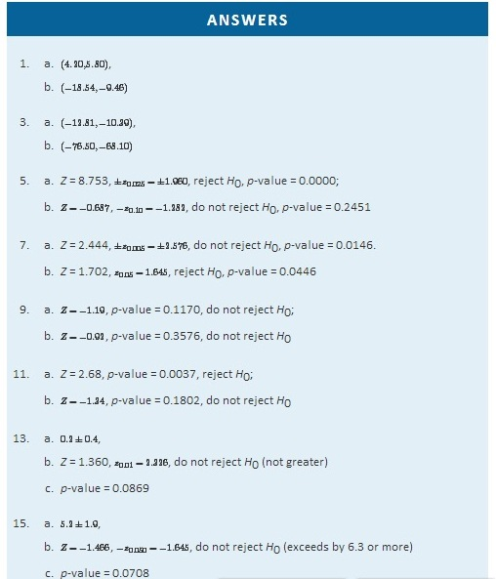
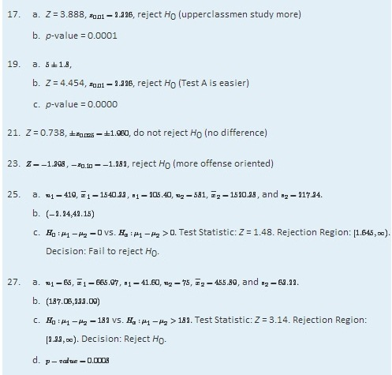

9.2 Comparison of Two Population Means: Small, Independent Samples

LEARNING OBJECTIVES
- To learn how to construct a confidence interval for the difference in the means of two distinct populations using small, independent samples.
- To learn how to perform a test of hypotheses concerning the difference between the means of two distinct populations using small, independent samples.
When one or the other of the sample sizes is small, as is often the case in practice, the Central Limit Theorem does not apply. We must then impose conditions on the population to give statistical validity to the test procedure. We will assume that both populations from which the samples are taken have a normal probability distribution and that their standard deviations are equal.

Confidence Intervals
When the two populations are normally distributed and have equal standard deviations, the following formula for a confidence interval for μ₁−μ₂ is valid.
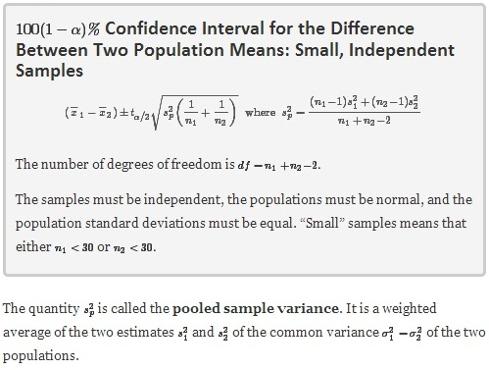

EXAMPLE 4
A software company markets a new computer game with two experimental packaging designs. Design 1 is sent to 11 stores; their average sales the first month is 52 units with sample standard deviation 12 units. Design 2 is sent to 6 stores; their average sales the first month is 46 units with sample standard deviation 10 units. Construct a point estimate and a 95% confidence interval for the difference in average monthly sales between the two package designs.

Solution:
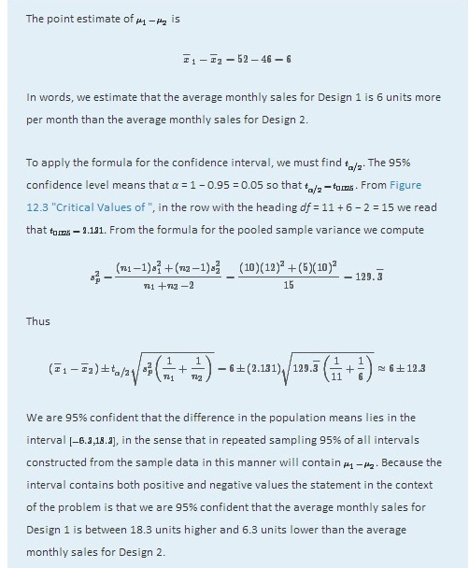
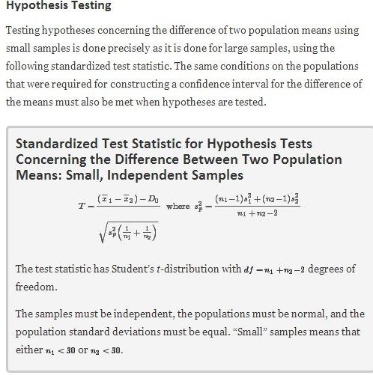
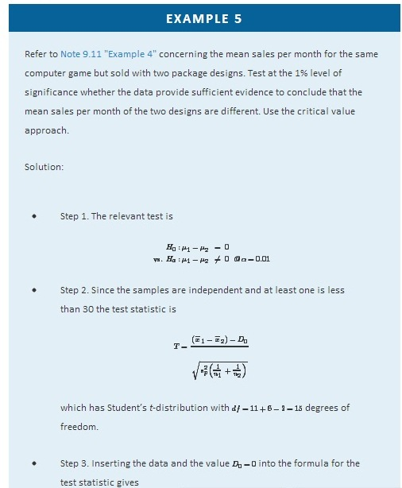
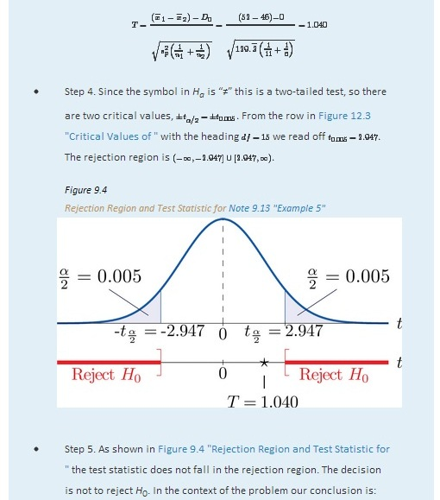
The data do not provide sufficient evidence, at the 1% level of significance, to conclude that the mean sales per month of the two designs are different.

EXAMPLE 6
Perform the test of Note 9.13 "Example 5" using the p-value approach.
Solution:

The first three steps are identical to those in Note 9.13 "Example 5".
- Step 4. Because the test is two-tailed the observed significance or p-value of the test is the double of the area of the right tail of Student’st-distribution, with 15 degrees of freedom, that is cut off by the test statistic T = 1.040. We can only approximate this number. Looking in the row of Figure 12.3 "Critical Values of " headed df=15, the number 1.040 is between the numbers 0.866 and 1.341, corresponding tot_{0.200} and t_{0.100}.

The area cut off by t = 0.866 is 0.200 and the area cut off by t = 1.341 is 0.100. Since 1.040 is between 0.866 and 1.341 the area it cuts off is between 0.200 and 0.100. Thus the p-value (since the area must be doubled) is between 0.400 and 0.200.

- Step 5. Since p>0.200>0.01, p>α, so the decision is not to reject the null hypothesis:

The data do not provide sufficient evidence, at the 1% level of significance, to conclude that the mean sales per month of the two designs are different.

KEY TAKEAWAYS
- In the context of estimating or testing hypotheses concerning two population means, “small” samples means that at least one sample is small. In particular, even if one sample is of size 30 or more, if the other is of size less than 30 the formulas of this section must be used.
- A confidence interval for the difference in two population means is computed using a formula in the same fashion as was done for a single population mean.
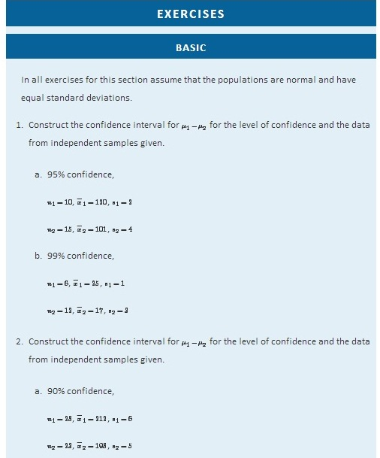
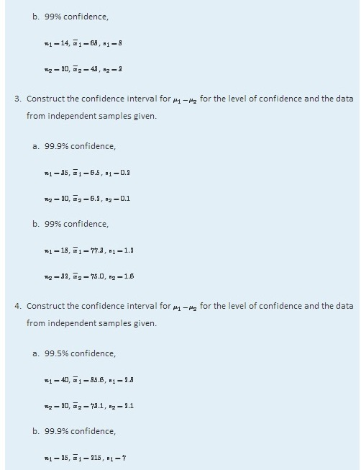
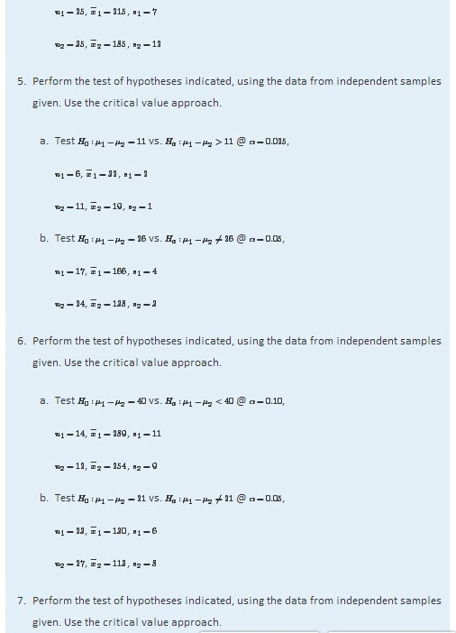
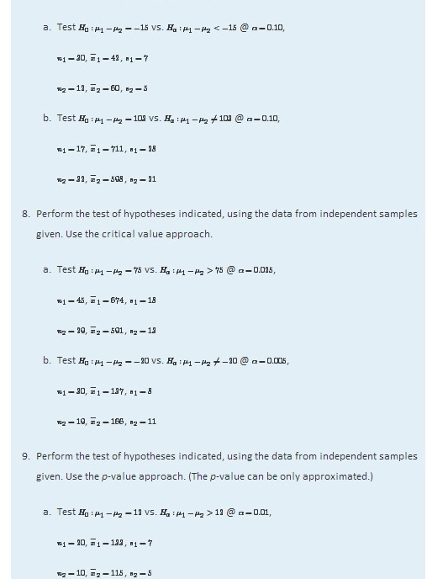
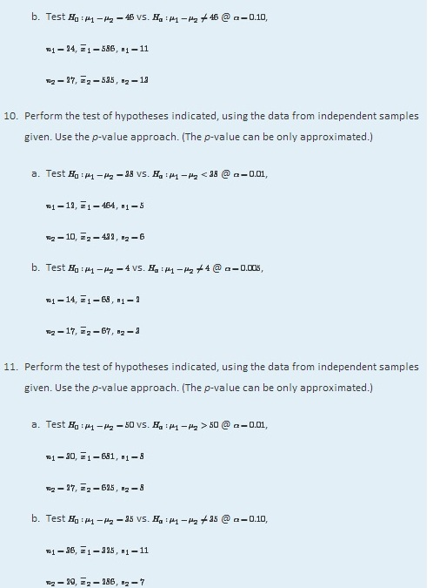
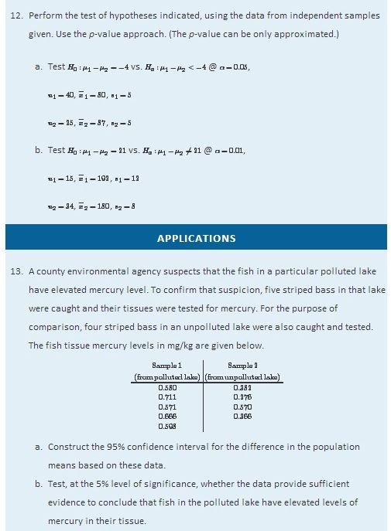
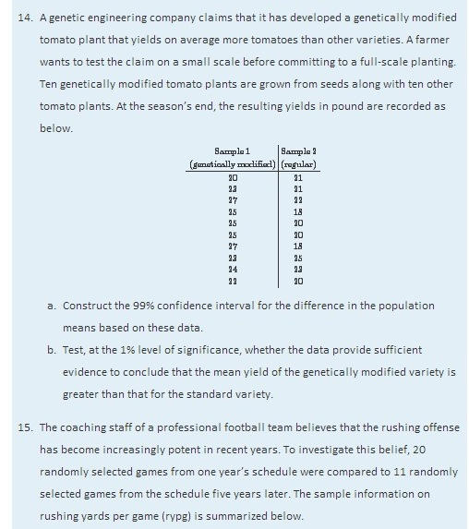
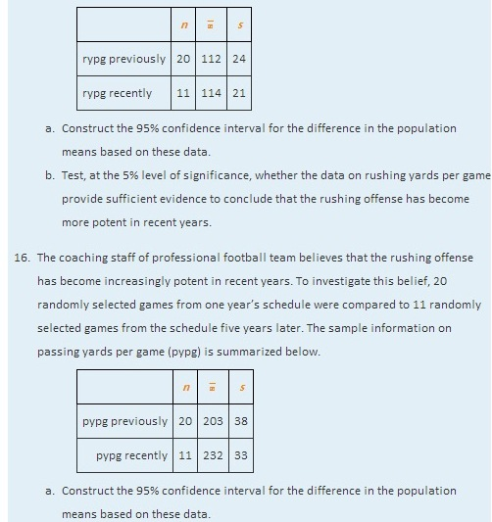
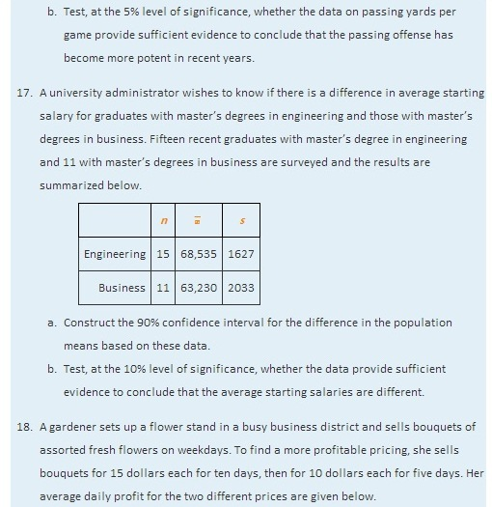
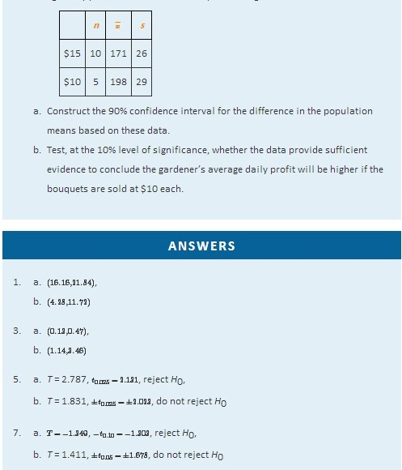
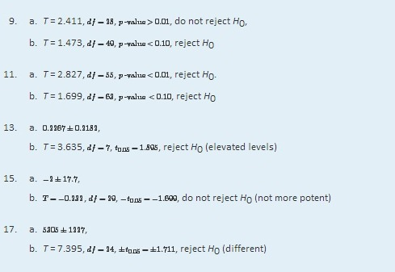

9.3 Comparison of Two Population Means: Paired Samples

LEARNING OBJECTIVES
- To learn the distinction between independent samples and paired samples.
- To learn how to construct a confidence interval for the difference in the means of two distinct populations using paired samples.
- To learn how to perform a test of hypotheses concerning the difference in the means of two distinct populations using paired samples.
Suppose chemical engineers wish to compare the fuel economy obtained by two different formulations of gasoline. Since fuel economy varies widely from car to car, if the mean fuel economy of two independent samples of vehicles run on the two types of fuel were compared, even if one formulation were better than the other the large variability from vehicle to vehicle might make any difference arising from difference in fuel difficult to detect. Just imagine one random sample having many more large vehicles than the other. Instead of independent random samples, it would make more sense to select pairs of cars of the same make and model and driven under similar circumstances, and compare the fuel economy of the two cars in each pair. Thus the data would look something like Table 9.1 "Fuel Economy of Pairs of Vehicles", where the first car in each pair is operated on one formulation of the fuel (call it Type 1 gasoline) and the second car is operated on the second (call it Type 2 gasoline).
Table 9.1 Fuel Economy of Pairs of Vehicles
Make and Model | Car 1 | Car 2
Buick LaCrosse | 17.0 | 17.0
Dodge Viper | 13.2 | 12.9
Honda CR-Z | 35.3 | 35.4
Hummer H 3 | 13.6 | 13.2
Lexus RX | 32.7 | 32.5
Mazda CX-9 | 18.4 | 18.1
Saab 9-3 | 22.5 | 22.5
Toyota Corolla | 26.8 | 26.7
Volvo XC 90 | 15.1 | 15.0
The first column of numbers form a sample from Population 1, the population of all cars operated on Type 1 gasoline; the second column of numbers form a sample from Population 2, the population of all cars operated on Type 2 gasoline. It would be incorrect to analyze the data using the formulas from the previous section, however, since the samples were not drawn independently. What is correct is to compute the difference in the numbers in each pair (subtracting in the same order each time) to obtain the third column of numbers as shown in Table 9.2 "Fuel Economy of Pairs of Vehicles" and treat the differences as the data. At this point, the new sample of differences d1=0.0,…,d9=0.1 in the third column of Table 9.2 "Fuel Economy of Pairs of Vehicles" may be considered as a random sample of size n = 9 selected from a population with mean μd=μ1−μ2. This approach essentially transforms the paired two-sample problem into a one-sample problem as discussed in the previous two chapters.
Table 9.2 Fuel Economy of Pairs of Vehicles
Make and Model | Car 1 | Car 2 | Difference
Buick LaCrosse | 17.0 | 17.0 | 0.0
Dodge Viper | 13.2 | 12.9 | 0.3
Honda CR-Z | 35.3 | 35.4 | −0.1
Hummer H 3 | 13.6 | 13.2 | 0.4
Lexus RX | 32.7 | 32.5 | 0.2
Mazda CX-9 | 18.4 | 18.1 | 0.3
Saab 9-3 | 22.5 | 22.5 | 0.0
Toyota Corolla | 26.8 | 26.7 | 0.1
Volvo XC 90 | 15.1 | 15.0 | 0.1
Note carefully that although it does not matter what order the subtraction is done, it must be done in the same order for all pairs. This is why there are both positive and negative quantities in the third column of numbers in Table 9.2 "Fuel Economy of Pairs of Vehicles".

Confidence Intervals
When the population of differences is normally distributed the following formula for a confidence interval for μ_{d}=μ₁−μ₂ is valid.
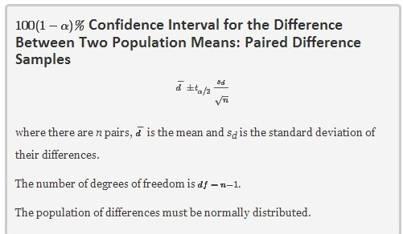

EXAMPLE 7
Using the data in Table 9.1 "Fuel Economy of Pairs of Vehicles" construct a point estimate and a 95% confidence interval for the difference in average fuel economy between cars operated on Type 1 gasoline and cars operated on Type 2 gasoline.

Solution:

We have referred to the data in Table 9.1 "Fuel Economy of Pairs of Vehicles"because that is the way that the data are typically presented, but we emphasize that with paired sampling one immediately computes the differences, as given inTable 9.2 "Fuel Economy of Pairs of Vehicles", and uses the differences as the data.
The mean and standard deviation of the differences are
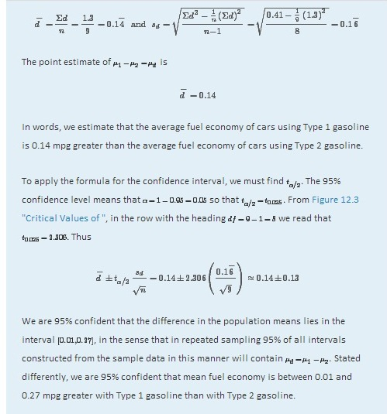

Hypothesis Testing
Testing hypotheses concerning the difference of two population means using paired difference samples is done precisely as it is done for independent samples, although now the null and alternative hypotheses are expressed in terms of μ_{d} instead of μ₁−μ₂. Thus the null hypothesis will always be written
H₀:μ_{d}=D₀
The three forms of the alternative hypothesis, with the terminology for each case, are:
Form of Ha | Terminology
Ha:μd<D0 | Left-tailed
Ha:μd>D0 | Right-tailed
Ha:μd≠D0 | Two-tailed

The same conditions on the population of differences that was required for constructing a confidence interval for the difference of the means must also be met when hypotheses are tested. Here is the standardized test statistic that is used in the test.
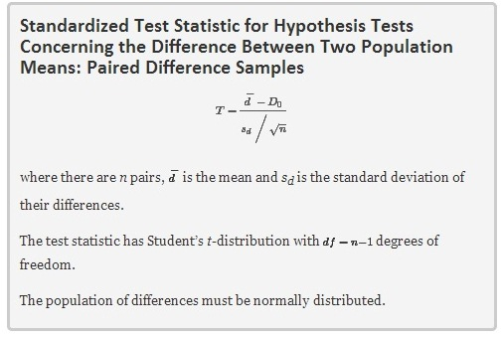

EXAMPLE 8
Using the data of Table 9.2 "Fuel Economy of Pairs of Vehicles" test the hypothesis that mean fuel economy for Type 1 gasoline is greater than that for Type 2 gasoline against the null hypothesis that the two formulations of gasoline yield the same mean fuel economy. Test at the 5% level of significance using the critical value approach.
Solution:
The only part of the table that we use is the third column, the differences.
- Step 1. Since the differences were computed in the order Type 1 mpg− Type 2 mpg, better fuel economy with Type 1 fuel corresponds to μ_{d}=μ₁−μ₂>0. Thus the test is

H₀:μ_{d} = 0
vs. H_{a}:μ_{d}>0 @ α=0.05
(If the differences had been computed in the opposite order then the alternative hypotheses would have been H_{a}:μ_{d}<0.)
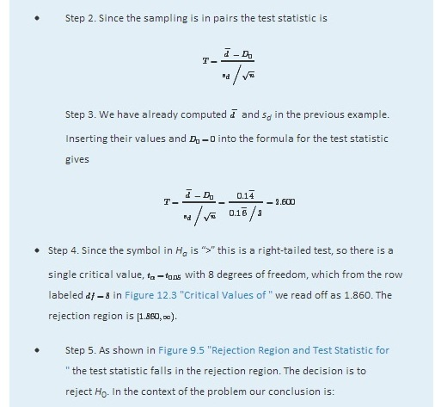
Figure 9.5Rejection Region and Test Statistic for Note 9.20 "Example 8"
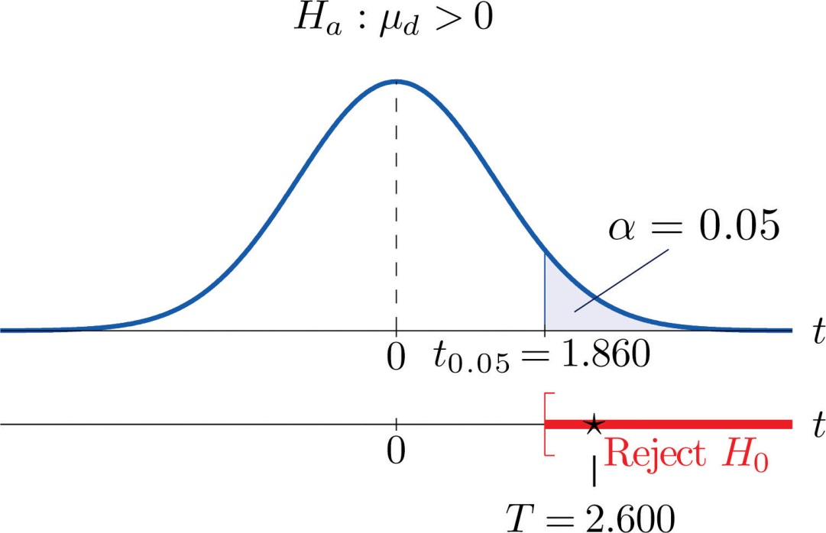

The data provide sufficient evidence, at the 5% level of significance, to conclude that the mean fuel economy provided by Type 1 gasoline is greater than that for Type 2 gasoline.

EXAMPLE 9
Perform the test of Note 9.20 "Example 8" using the p-value approach.
Solution:

The first three steps are identical to those in Note 9.20 "Example 8".
- Step 4. Because the test is one-tailed the observed significance or p-value of the test is just the area of the right tail of Student’s t-distribution, with 8 degrees of freedom, that is cut off by the test statistic T = 2.600. We can only approximate this number. Looking in the row of Figure 12.3 "Critical Values of " headed df=8, the number 2.600 is between the numbers 2.306 and 2.896, corresponding tot_{0.025} and t_{0.010}.

The area cut off by t = 2.306 is 0.025 and the area cut off by t = 2.896 is 0.010. Since 2.600 is between 2.306 and 2.896 the area it cuts off is between 0.025 and 0.010. Thus the p-value is between 0.025 and 0.010. In particular it is less than 0.025. See Figure 9.6.

Figure 9.6P-Value for Note 9.21 "Example 9"
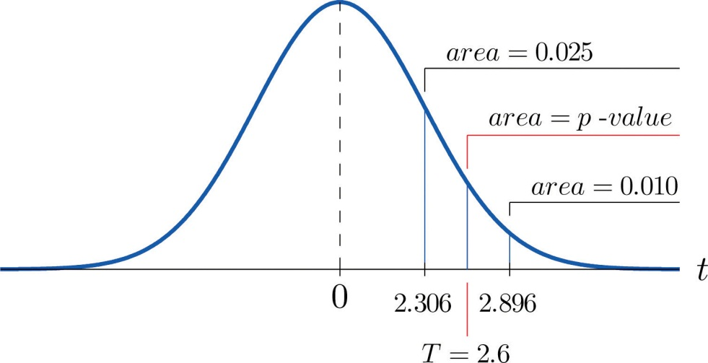

- Step 5. Since 0.025 < 0.05, p<α so the decision is to reject the null hypothesis:

The data provide sufficient evidence, at the 5% level of significance, to conclude that the mean fuel economy provided by Type 1 gasoline is greater than that for Type 2 gasoline.

The paired two-sample experiment is a very powerful study design. It bypasses many unwanted sources of “statistical noise” that might otherwise influence the outcome of the experiment, and focuses on the possible difference that might arise from the one factor of interest.
If the sample is large (meaning that n ≥ 30) then in the formula for the confidence interval we may replace t_{α/2} by z_{α/2}. For hypothesis testing when the number of pairs is at least 30, we may use the same statistic as for small samples for hypothesis testing, except now it follows a standard normal distribution, so we use the last line of Figure 12.3 "Critical Values of " to compute critical values, and p-values can be computed exactly with Figure 12.2 "Cumulative Normal Probability", not merely estimated using Figure 12.3 "Critical Values of ".

KEY TAKEAWAYS
- When the data are collected in pairs, the differences computed for each pair are the data that are used in the formulas.
- A confidence interval for the difference in two population means using paired sampling is computed using a formula in the same fashion as was done for a single population mean.

- The same five-step procedure used to test hypotheses concerning a single population mean is used to test hypotheses concerning the difference between two population means using pair sampling. The only difference is in the formula for the standardized test statistic.
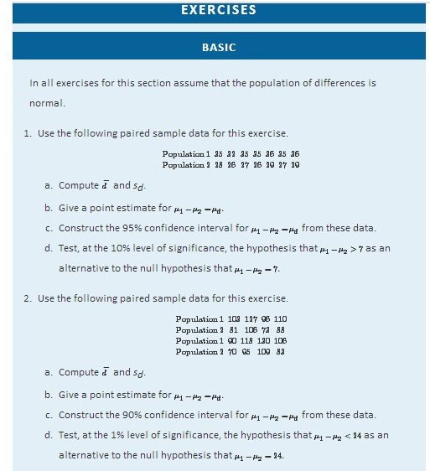
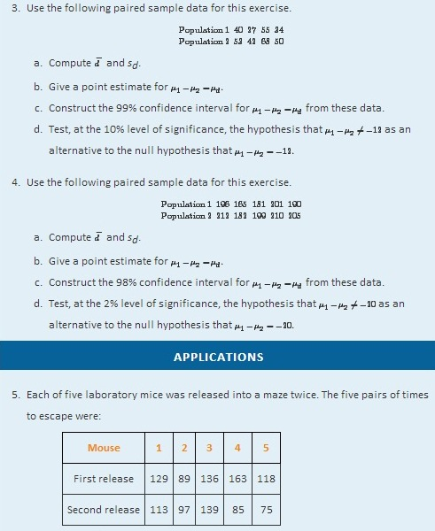
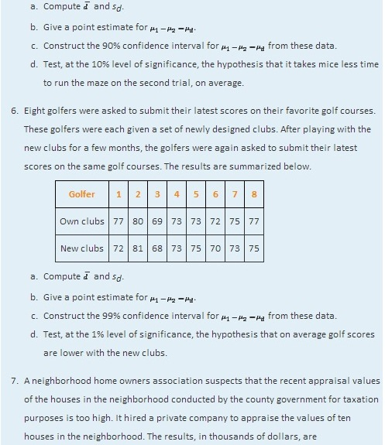

House | County Government | Private Company
1 | 217 | 219
2 | 350 | 338
3 | 296 | 291
4 | 237 | 237
5 | 237 | 235
6 | 272 | 269
7 | 257 | 239
8 | 277 | 275
9 | 312 | 320
10 | 335 | 335
  - Give a point estimate for the difference between the mean private appraisal of all such homes and the government appraisal of all such homes.
  - Construct the 99% confidence interval based on these data for the difference.
  - Test, at the 1% level of significance, the hypothesis that appraised values by the county government of all such houses is greater than the appraised values by the private appraisal company.
- In order to cut costs a wine producer is considering using duo or 1 + 1 corks in place of full natural wood corks, but is concerned that it could affect buyers’s perception of the quality of the wine. The wine producer shipped eight pairs of bottles of its best young wines to eight wine experts. Each pair includes one bottle with a natural wood cork and one with a duo cork. The experts are asked to rate the wines on a one to ten scale, higher numbers corresponding to higher quality. The results are:
Wine Expert | Duo Cork | Wood Cork
1 | 8.5 | 8.5
2 | 8.0 | 8.5
3 | 6.5 | 8.0
4 | 7.5 | 8.5
5 | 8.0 | 7.5
6 | 8.0 | 8.0
7 | 9.0 | 9.0
8 | 7.0 | 7.5
  - Give a point estimate for the difference between the mean ratings of the wine when bottled are sealed with different kinds of corks.
  - Construct the 90% confidence interval based on these data for the difference.
  - Test, at the 10% level of significance, the hypothesis that on the average duo corks decrease the rating of the wine.
- Engineers at a tire manufacturing corporation wish to test a new tire material for increased durability. To test the tires under realistic road conditions, new front tires are mounted on each of 11 company cars, one tire made with a production material and the other with the experimental material. After a fixed period the 11 pairs were measured for wear. The amount of wear for each tire (in mm) is shown in the table:
Car | Production | Experimental
1 | 5.1 | 5.0
2 | 6.5 | 6.5
3 | 3.6 | 3.1
4 | 3.5 | 3.7
5 | 5.7 | 4.5
6 | 5.0 | 4.1
7 | 6.4 | 5.3
8 | 4.7 | 2.6
9 | 3.2 | 3.0
10 | 3.5 | 3.5
11 | 6.4 | 5.1
  - Give a point estimate for the difference in mean wear.
  - Construct the 99% confidence interval for the difference based on these data.
  - Test, at the 1% level of significance, the hypothesis that the mean wear with the experimental material is less than that for the production material.
- A marriage counselor administered a test designed to measure overall contentment to 30 randomly selected married couples. The scores for each couple are given below. A higher number corresponds to greater contentment or happiness.
Couple | Husband | Wife
1 | 47 | 44
2 | 44 | 46
3 | 49 | 44
4 | 53 | 44
5 | 42 | 43
6 | 45 | 45
7 | 48 | 47
8 | 45 | 44
9 | 52 | 44
10 | 47 | 42
11 | 40 | 34
12 | 45 | 42
13 | 40 | 43
14 | 46 | 41
15 | 47 | 45
16 | 46 | 45
17 | 46 | 41
18 | 46 | 41
19 | 44 | 45
20 | 45 | 43
21 | 48 | 38
22 | 42 | 46
23 | 50 | 44
24 | 46 | 51
25 | 43 | 45
26 | 50 | 40
27 | 46 | 46
28 | 42 | 41
29 | 51 | 41
30 | 46 | 47
  - Test, at the 1% level of significance, the hypothesis that on average men and women are not equally happy in marriage.
  - Test, at the 1% level of significance, the hypothesis that on average men are happier than women in marriage.

LARGE DATA SET EXERCISES
- Large Data Set 5 lists the scores for 25 randomly selected students on practice SAT reading tests before and after taking a two-week SAT preparation course. Denote the population of all students who have taken the course as Population 1 and the population of all students who have not taken the course as Population 2.
http://www.flatworldknowledge.com/sites/all/files/data5.xls

  - Compute the 25 differences in the order after− before, their mean d−, and their sample standard deviation s_{d}.
  - Give a point estimate for μd=μ1−μ2, the difference in the mean score of all students who have taken the course and the mean score of all who have not.
  - Construct a 98% confidence interval for μd.
  - Test, at the 1% level of significance, the hypothesis that the mean SAT score increases by at least ten points by taking the two-week preparation course.

- Large Data Set 12 lists the scores on one round for 75 randomly selected members at a golf course, first using their own original clubs, then two months later after using new clubs with an experimental design. Denote the population of all golfers using their own original clubs as Population 1 and the population of all golfers using the new style clubs as Population 2.
http://www.flatworldknowledge.com/sites/all/files/data12.xls

  - Compute the 75 differences in the order original clubs− new clubs, their mean d−, and their sample standard deviation s_{d}.
  - Give a point estimate for μd=μ1−μ2, the difference in the mean score of all golfers using their original clubs and the mean score of all golfers using the new kind of clubs.
  - Construct a 90% confidence interval for μd.
  - Test, at the 1% level of significance, the hypothesis that the mean golf score decreases by at least one stroke by using the new kind of clubs.
- Consider the previous problem again. Since the data set is so large, it is reasonable to use the standard normal distribution instead of Student’s t-distribution with 74 degrees of freedom.
  - Construct a 90% confidence interval for μd using the standard normal distribution, meaning that the formula is d−±zα/2sdn−−√. (The computations done in part (a) of the previous problem still apply and need not be redone.) How does the result obtained here compare to the result obtained in part (c) of the previous problem?
  - Test, at the 1% level of significance, the hypothesis that the mean golf score decreases by at least one stroke by using the new kind of clubs, using the standard normal distribution. (All the work done in part (d) of the previous problem applies, except the critical value is now zα instead of tα (or the p-value can be computed exactly instead of only approximated, if you used the p-value approach).) How does the result obtained here compare to the result obtained in part (c) of the previous problem?
  - Construct the 99% confidence intervals for μd using both the t- and z-distributions. How much difference is there in the results now?
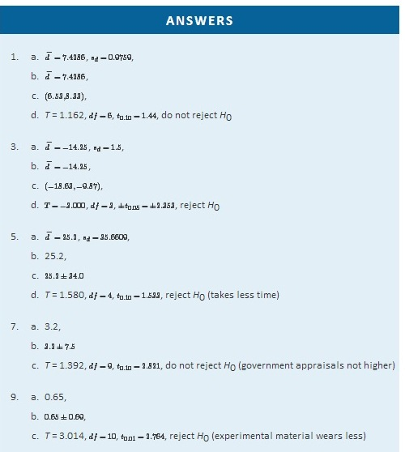
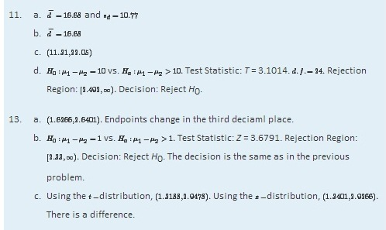

9.4 Comparison of Two Population Proportions

LEARNING OBJECTIVES
- To learn how to construct a confidence interval for the difference in the proportions of two distinct populations that have a particular characteristic of interest.
- To learn how to perform a test of hypotheses concerning the difference in the proportions of two distinct populations that have a particular characteristic of interest.
Suppose we wish to compare the proportions of two populations that have a specific characteristic, such as the proportion of men who are left-handed compared to the proportion of women who are left-handed. Figure 9.7 "Independent Sampling from Two Populations In Order to Compare Proportions" illustrates the conceptual framework of our investigation. Each population is divided into two groups, the group of elements that have the characteristic of interest (for example, being left-handed) and the group of elements that do not. We arbitrarily label one population as Population 1 and the other as Population 2, and subscript the proportion of each population that possesses the characteristic with the number 1 or 2 to tell them apart. We draw a random sample from Population 1 and label the sample statistic it yields with the subscript 1. Without reference to the first sample we draw a sample from Population 2 and label its sample statistic with the subscript 2.
Figure 9.7 Independent Sampling from Two Populations In Order to Compare Proportions
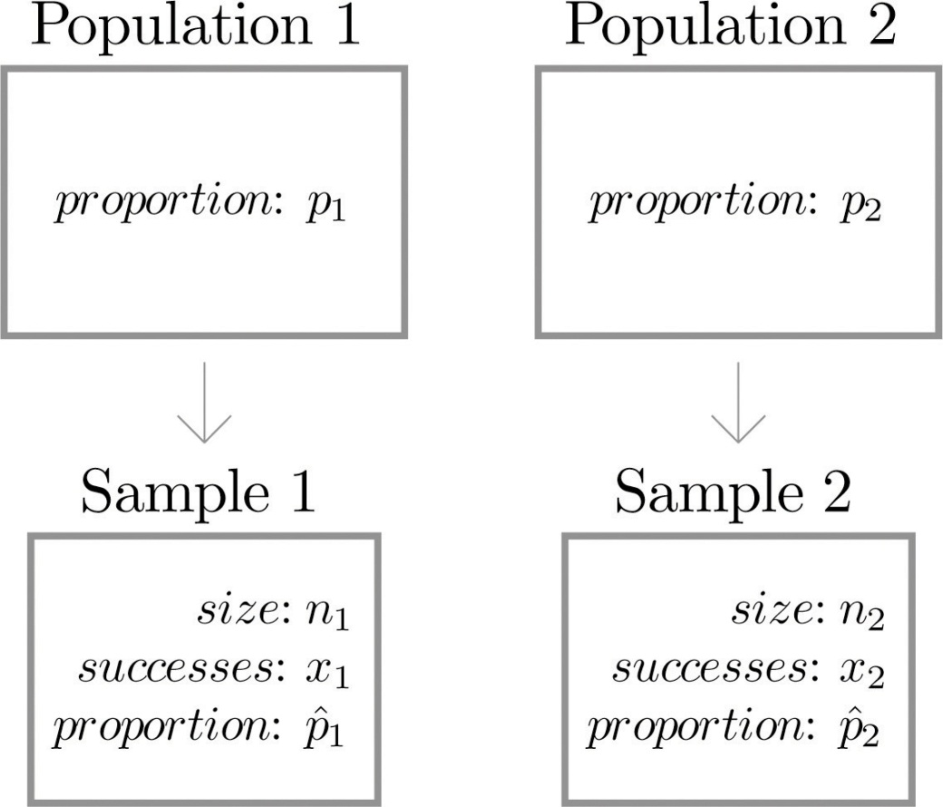
Our goal is to use the information in the samples to estimate the difference p1−p2 in the two population proportions and to make statistically valid inferences about it.

Confidence Intervals
Since the sample proportion pˆ1 computed using the sample drawn from Population 1 is a good estimator of population proportion p₁ of Population 1 and the sample proportion pˆ2 computed using the sample drawn from Population 2 is a good estimator of population proportion p₂ of Population 2, a reasonable point estimate of the difference p₁−p₂ is pˆ₁−pˆ₂. In order to widen this point estimate into a confidence interval we suppose that both samples are large, as described in Section 7.3 "Large Sample Estimation of a Population Proportion" in Chapter 7 "Estimation" and repeated below. If so, then the following formula for a confidence interval for p₁−p₂ is valid.

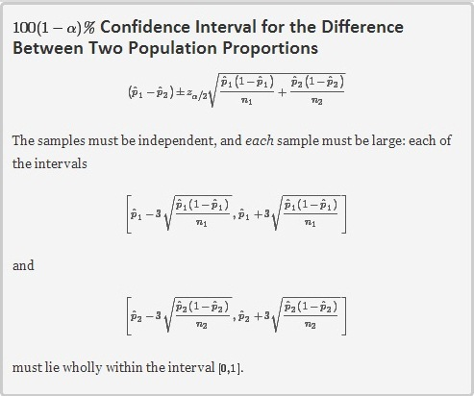
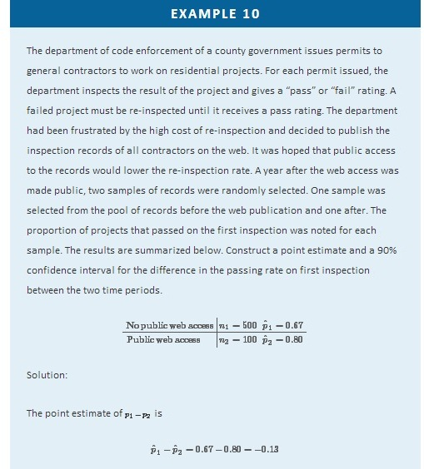
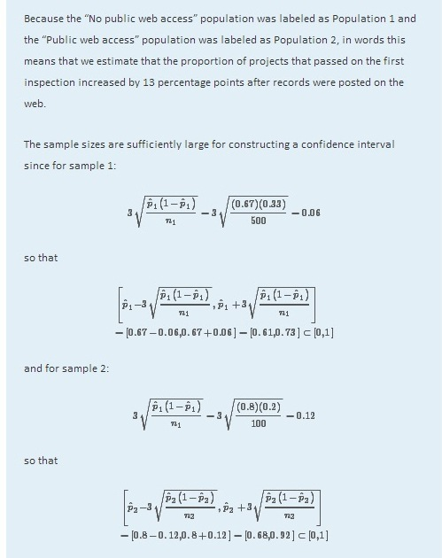
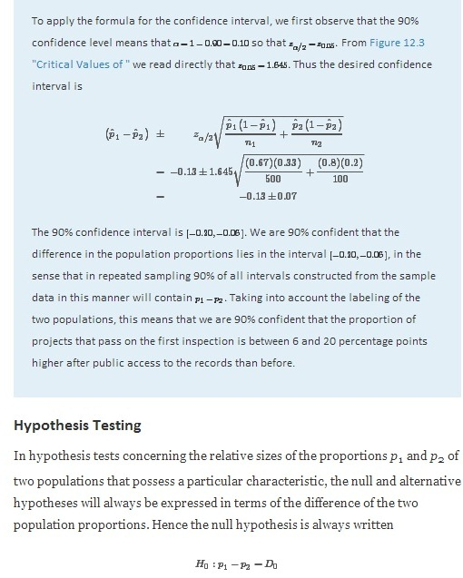
The three forms of the alternative hypothesis, with the terminology for each case, are:
Form of Ha | Terminology
Ha:p1−p2<D0 | Left-tailed
Ha:p1−p2>D0 | Right-tailed
Ha:p1−p2≠D0 | Two-tailed
As long as the samples are independent and both are large the following formula for the standardized test statistic is valid, and it has the standard normal distribution.
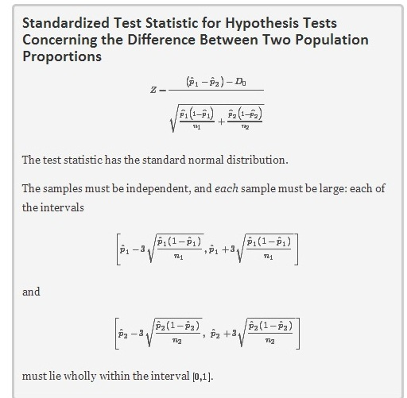

EXAMPLE 11
Using the data of Note 9.25 "Example 10", test whether there is sufficient evidence to conclude that public web access to the inspection records has increased the proportion of projects that passed on the first inspection by more than 5 percentage points. Use the critical value approach at the 10% level of significance.
Solution:
- Step 1. Taking into account the labeling of the populations an increase in passing rate at the first inspection by more than 5 percentage points after public access on the web may be expressed as p2>p1+0.05, which by algebra is the same as p1−p2<−0.05. This is the alternative hypothesis. Since the null hypothesis is always expressed as an equality, with the same number on the right as is in the alternative hypothesis, the test is
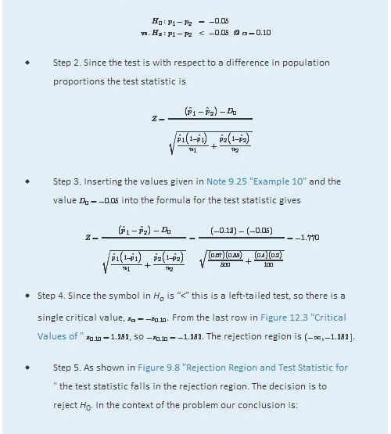
- The data provide sufficient evidence, at the 10% level of significance, to conclude that the rate of passing on the first inspection has increased by more than 5 percentage points since records were publicly posted on the web.

Figure 9.8Rejection Region and Test Statistic for Note 9.27 "Example 11"
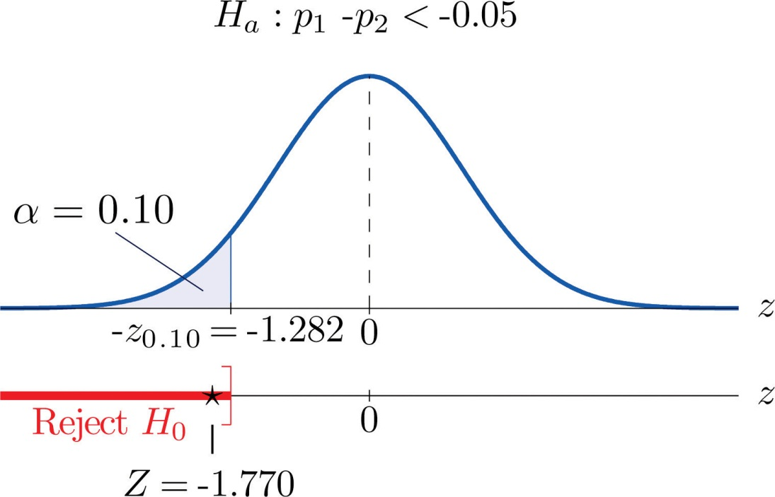

EXAMPLE 12
Perform the test of Note 9.27 "Example 11" using the p-value approach.
Solution:
The first three steps are identical to those in Note 9.27 "Example 11".
- Step 4. Because the test is left-tailed the observed significance or p-value of the test is just the area of the left tail of the standard normal distribution that is cut off by the test statistic Z=−1.770. From Figure 12.2 "Cumulative Normal Probability" the area of the left tail determined by −1.77 is 0.0384. The p-value is 0.0384.
- Step 5. Since the p-value 0.0384 is less than α=0.10, the decision is to reject the null hypothesis: The data provide sufficient evidence, at the 10% level of significance, to conclude that the rate of passing on the first inspection has increased by more than 5 percentage points since records were publicly posted on the web.
Finally a common misuse of the formulas given in this section must be mentioned. Suppose a large pre-election survey of potential voters is conducted. Each person surveyed is asked to express a preference between, say, Candidate A and Candidate B. (Perhaps “no preference” or “other” are also choices, but that is not important.) In such a survey, estimators pˆ_{A} and pˆ_{B} of p_{A} and p_{B} can be calculated. It is important to realize, however, that these two estimators were not calculated from two independent samples. While pˆ_{A}−pˆ_{B} may be a reasonable estimator of p_{A}−p_{B}, the formulas for confidence intervals and for the standardized test statistic given in this section are not valid for data obtained in this manner.

KEY TAKEAWAYS
- A confidence interval for the difference in two population proportions is computed using a formula in the same fashion as was done for a single population mean.
- The same five-step procedure used to test hypotheses concerning a single population proportion is used to test hypotheses concerning the difference between two population proportions. The only difference is in the formula for the standardized test statistic.
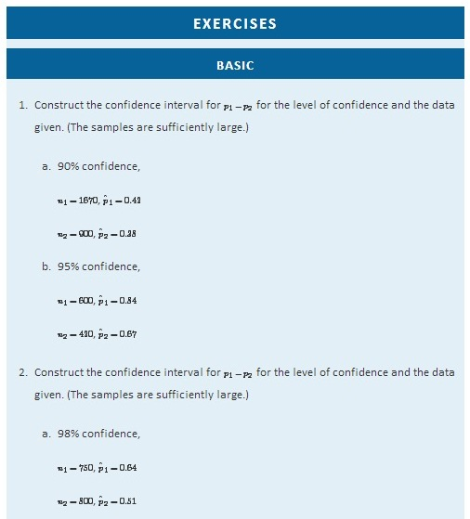

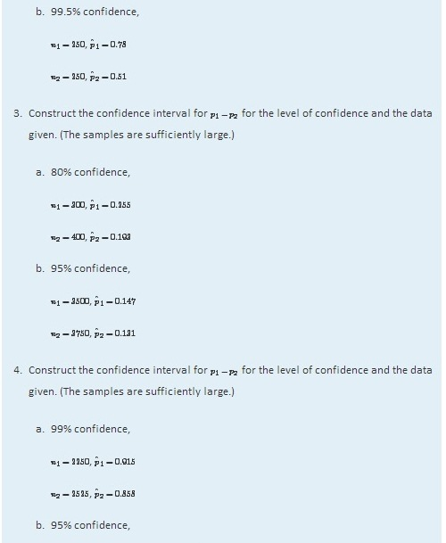
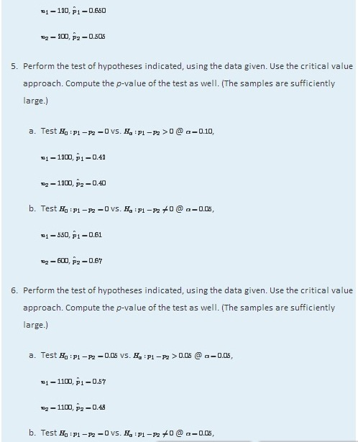
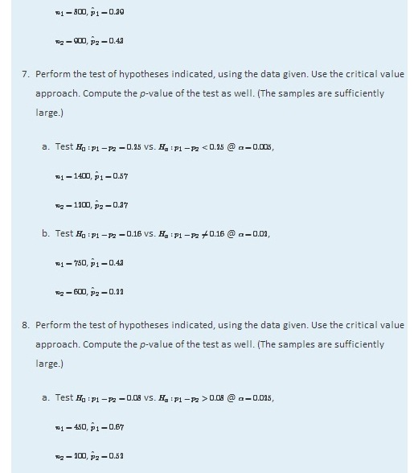
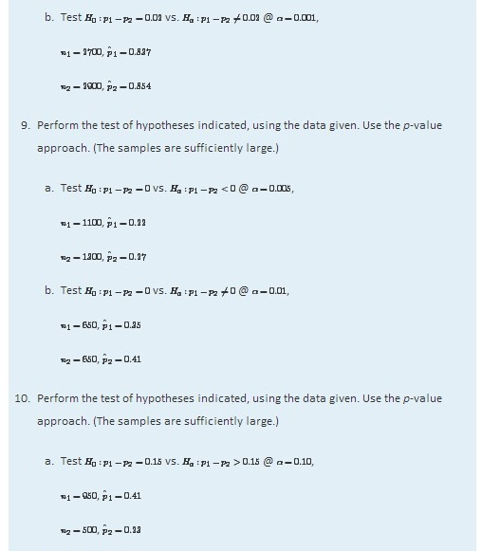
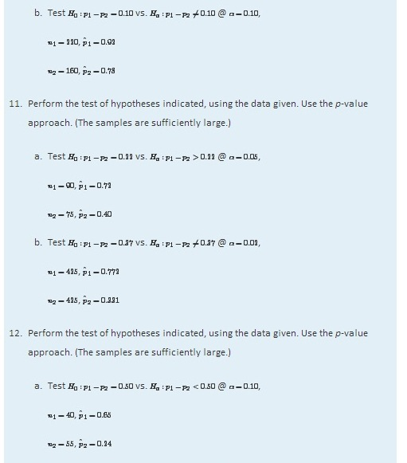
  - Test H0:p1−p2=0.30 vs. Ha:p1−p2≠0.30 @ α=0.10,
n1=7500, pˆ1=0.664
n2=1000, pˆ2=0.319

APPLICATIONS
In all the remaining exercsises the samples are sufficiently large (so this need not be checked).
- Voters in a particular city who identify themselves with one or the other of two political parties were randomly selected and asked if they favor a proposal to allow citizens with proper license to carry a concealed handgun in city parks. The results are:
 | Party A | Party B
Sample size, n | 150 | 200
Number in favor, x | 90 | 140
  - Give a point estimate for the difference in the proportion of all members of Party A and all members of Party B who favor the proposal.
  - Construct the 95% confidence interval for the difference, based on these data.
  - Test, at the 5% level of significance, the hypothesis that the proportion of all members of Party A who favor the proposal is less than the proportion of all members of Party B who do.
  - Compute the p-value of the test.
- To investigate a possible relation between gender and handedness, a random sample of 320 adults was taken, with the following results:
 | Men | Women
Sample size, n | 168 | 152
Number of left-handed, x | 24 | 9
  - Give a point estimate for the difference in the proportion of all men who are left-handed and the proportion of all women who are left-handed.
  - Construct the 95% confidence interval for the difference, based on these data.
  - Test, at the 5% level of significance, the hypothesis that the proportion of men who are left-handed is greater than the proportion of women who are.
  - Compute the p-value of the test.
- A local school board member randomly sampled private and public high school teachers in his district to compare the proportions of National Board Certified (NBC) teachers in the faculty. The results were:
 | Private Schools | Public Schools
Sample size, n | 80 | 520
Proportion of NBC teachers, pˆ | 0.175 | 0.150
  - Give a point estimate for the difference in the proportion of all teachers in area public schools and the proportion of all teachers in private schools who are National Board Certified.
  - Construct the 90% confidence interval for the difference, based on these data.
  - Test, at the 10% level of significance, the hypothesis that the proportion of all public school teachers who are National Board Certified is less than the proportion of private school teachers who are.
  - Compute the p-value of the test.
- In professional basketball games, the fans of the home team always try to distract free throw shooters on the visiting team. To investigate whether this tactic is actually effective, the free throw statistics of a professional basketball player with a high free throw percentage were examined. During the entire last season, this player had 656 free throws, 420 in home games and 236 in away games. The results are summarized below.
 | Home | Away
Sample size, n | 420 | 236
Free throw percent, pˆ | 81.5% | 78.8%
  - Give a point estimate for the difference in the proportion of free throws made at home and away.
  - Construct the 90% confidence interval for the difference, based on these data.
  - \Test, at the 10% level of significance, the hypothesis that there exists a home advantage in free throws.
  - Compute the p-value of the test.
- Randomly selected middle-aged people in both China and the United States were asked if they believed that adults have an obligation to financially support their aged parents. The results are summarized below.
 | China | USA
Sample size, n | 1300 | 150
Number of yes, x | 1170 | 110
Test, at the 1% level of significance, whether the data provide sufficient evidence to conclude that there exists a cultural difference in attitude regarding this question.
- A manufacturer of walk-behind push mowers receives refurbished small engines from two new suppliers, A and B. It is not uncommon that some of the refurbished engines need to be lightly serviced before they can be fitted into mowers. The mower manufacturer recently received 100 engines from each supplier. In the shipment from A, 13 needed further service. In the shipment from B, 10 needed further service. Test, at the 10% level of significance, whether the data provide sufficient evidence to conclude that there exists a difference in the proportions of engines from the two suppliers needing service.

LARGE DATA SET EXERCISES
- Large Data Sets 6A and 6B record results of a random survey of 200 voters in each of two regions, in which they were asked to express whether they prefer Candidate Afor a U.S. Senate seat or prefer some other candidate. Let the population of all voters in region 1 be denoted Population 1 and the population of all voters in region 2 be denoted Population 2. Let p₁ be the proportion of voters in Population 1 who prefer Candidate A, and p₂ the proportion in Population 2 who do.

http://www.flatworldknowledge.com/sites/all/files/data6A.xls
http://www.flatworldknowledge.com/sites/all/files/data6B.xls
  - Find the relevant sample proportions pˆ1 and pˆ2.
  - Construct a point estimate for p1−p2.
  - Construct a 95% confidence interval for p1−p2.
  - Test, at the 5% level of significance, the hypothesis that the same proportion of voters in the two regions favor Candidate A, against the alternative that a larger proportion in Population 2 do.
- Large Data Set 11 records the results of samples of real estate sales in a certain region in the year 2008 (lines 2 through 536) and in the year 2010 (lines 537 through 1106). Foreclosure sales are identified with a 1 in the second column. Let all real estate sales in the region in 2008 be Population 1 and all real estate sales in the region in 2010 be Population 2.

http://www.flatworldknowledge.com/sites/all/files/data11.xls
  - Use the sample data to construct point estimates pˆ1 and pˆ2 of the proportionsp₁ and p₂ of all real estate sales in this region in 2008 and 2010 that were foreclosure sales. Construct a point estimate of p1−p2.
  - Use the sample data to construct a 90% confidence for p1−p2.
  - Test, at the 10% level of significance, the hypothesis that the proportion of real estate sales in the region in 2010 that were foreclosure sales was greater than the proportion of real estate sales in the region in 2008 that were foreclosure sales. (The default is that the proportions were the same.)
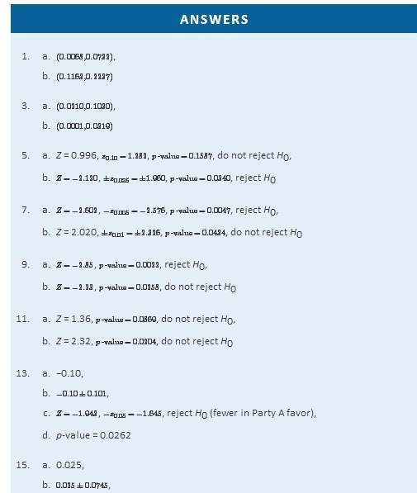
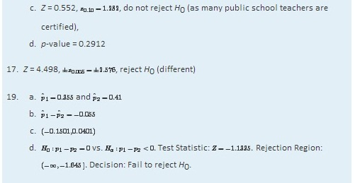

9.5 Sample Size Considerations

LEARNING OBJECTIVE
- To learn how to apply formulas for estimating the size samples that will be needed in order to construct a confidence interval for the difference in two population means or proportions that meets given criteria.
As was pointed out at the beginning of Section 7.4 "Sample Size Considerations"in Chapter 7 "Estimation", sampling is typically done with definite objectives in mind. For example, a physician might wish to estimate the difference in the average amount of sleep gotten by patients suffering a certain condition with the average amount of sleep got by healthy adults, at 90% confidence and to within half an hour. Since sampling costs time, effort, and money, it would be useful to be able to estimate the smallest size samples that are likely to meet these criteria.
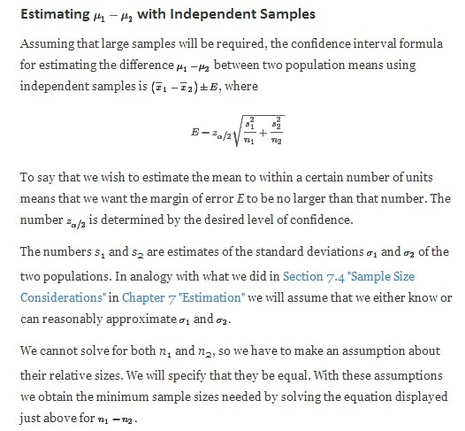
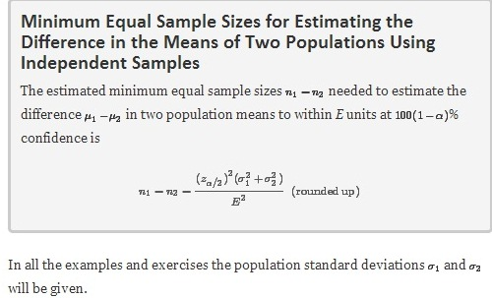
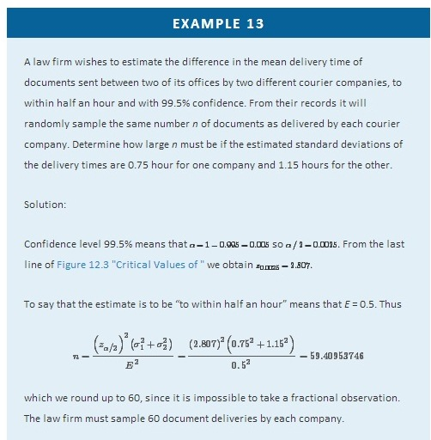
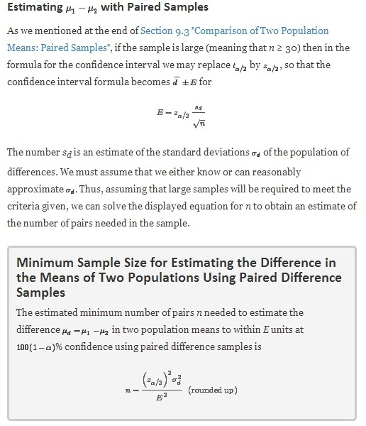
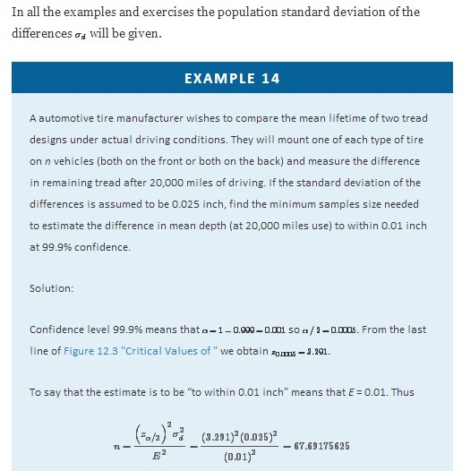
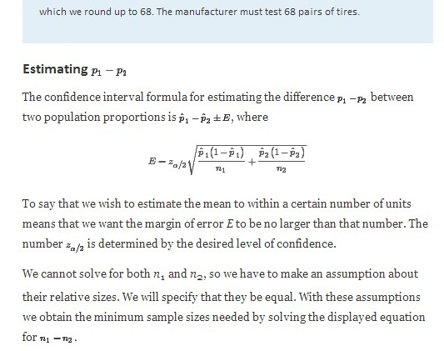
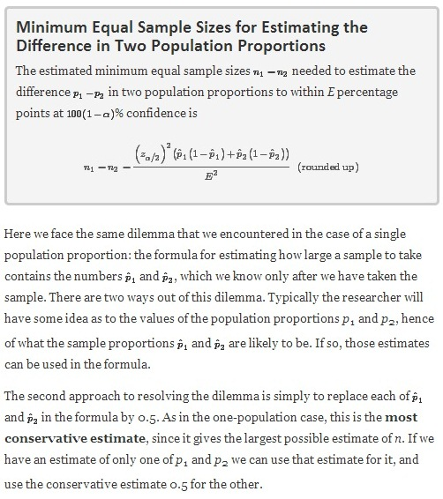
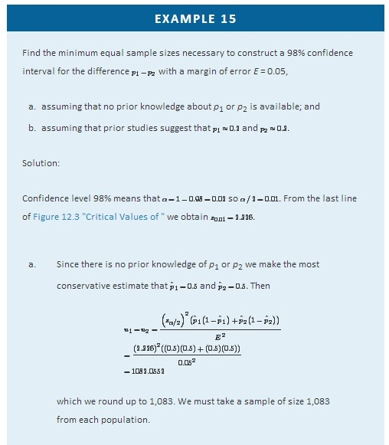
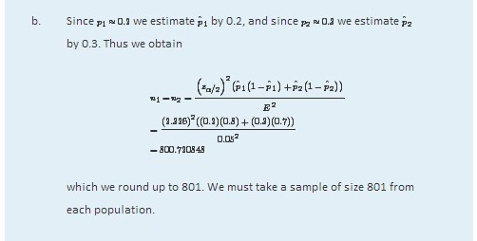

KEY TAKEAWAYS
- If the population standard deviations σ1 and σ2 are known or can be estimated, then the minimum equal sizes of independent samples needed to obtain a confidence interval for the difference μ₁−μ₂ in two population means with a given maximum error of the estimate E and a given level of confidence can be estimated.
- If the standard deviation σd of the population of differences in pairs drawn from two populations is known or can be estimated, then the minimum number of sample pairs needed under paired difference sampling to obtain a confidence interval for the difference μ_{d}=μ₁−μ₂ in two population means with a given maximum error of the estimate E and a given level of confidence can be estimated.
- The minimum equal sample sizes needed to obtain a confidence interval for the difference in two population proportions with a given maximum error of the estimate and a given level of confidence can always be estimated. If there is prior knowledge of the population proportions p₁ and p₂ then the estimate can be sharpened.

EXERCISES

BASIC
- Estimate the common sample size n of equally sized independent samples needed to estimate μ1−μ2 as specified when the population standard deviations are as shown.
  - 90% confidence, to within 3 units, σ1=10 and σ2=7
  - 99% confidence, to within 4 units, σ1=6.8 and σ2=9.3
  - 95% confidence, to within 5 units, σ1=22.6 and σ2=31.8
- Estimate the common sample size n of equally sized independent samples needed to estimate μ1−μ2 as specified when the population standard deviations are as shown.
  - 80% confidence, to within 2 units, σ1=14 and σ2=23
  - 90% confidence, to within 0.3 units, σ1=1.3 and σ2=0.8
  - 99% confidence, to within 11 units, σ1=42 and σ2=37
- Estimate the number n of pairs that must be sampled in order to estimate μd=μ1−μ2as specified when the standard deviation s_{d} of the population of differences is as shown.
  - 80% confidence, to within 6 units, σd=26.5
  - 95% confidence, to within 4 units, σd=12
  - 90% confidence, to within 5.2 units, σd=11.3
- Estimate the number n of pairs that must be sampled in order to estimate μd=μ1−μ2as specified when the standard deviation s_{d} of the population of differences is as shown.
  - 90% confidence, to within 20 units, σd=75.5
  - 95% confidence, to within 11 units, σd=31.4
  - 99% confidence, to within 1.8 units, σd=4
- Estimate the minimum equal sample sizes n1=n2 necessary in order to estimate p1−p2 as specified.
  - 80% confidence, to within 0.05 (five percentage points)
    - when no prior knowledge of p₁ or p₂ is available
    - when prior studies indicate that p1≈0.20 and p2≈0.65
  - 90% confidence, to within 0.02 (two percentage points)
    - when no prior knowledge of p₁ or p₂ is available
    - when prior studies indicate that p1≈0.75 and p2≈0.63
  - 95% confidence, to within 0.10 (ten percentage points)
    - when no prior knowledge of p₁ or p₂ is available
    - when prior studies indicate that p1≈0.11 and p2≈0.37
- Estimate the minimum equal sample sizes n1=n2 necessary in order to estimate p1−p2 as specified.
- 80% confidence, to within 0.02 (two percentage points)
    - when no prior knowledge of p₁ or p₂ is available
    - when prior studies indicate that p1≈0.78 and p2≈0.65
- 90% confidence, to within 0.05 (two percentage points)
    - when no prior knowledge of p₁ or p₂ is available
    - when prior studies indicate that p1≈0.12 and p2≈0.24
- 95% confidence, to within 0.10 (ten percentage points)
  - when no prior knowledge of p₁ or p₂ is available
  - when prior studies indicate that p1≈0.14 and p2≈0.21

APPLICATIONS
- An educational researcher wishes to estimate the difference in average scores of elementary school children on two versions of a 100-point standardized test, at 99% confidence and to within two points. Estimate the minimum equal sample sizes necessary if it is known that the standard deviation of scores on different versions of such tests is 4.9.
- A university administrator wishes to estimate the difference in mean grade point averages among all men affiliated with fraternities and all unaffiliated men, with 95% confidence and to within 0.15. It is known from prior studies that the standard deviations of grade point averages in the two groups have common value 0.4. Estimate the minimum equal sample sizes necessary to meet these criteria.
- An automotive tire manufacturer wishes to estimate the difference in mean wear of tires manufactured with an experimental material and ordinary production tire, with 90% confidence and to within 0.5 mm. To eliminate extraneous factors arising from different driving conditions the tires will be tested in pairs on the same vehicles. It is known from prior studies that the standard deviations of the differences of wear of tires constructed with the two kinds of materials is 1.75 mm. Estimate the minimum number of pairs in the sample necessary to meet these criteria.
- To assess to the relative happiness of men and women in their marriages, a marriage counselor plans to administer a test measuring happiness in marriage ton randomly selected married couples, record the their test scores, find the differences, and then draw inferences on the possible difference. Let μ1 and μ2 be the true average levels of happiness in marriage for men and women respectively as measured by this test. Suppose it is desired to find a 90% confidence interval for estimating μd=μ1−μ2 to within two test points. Suppose further that, from prior studies, it is known that the standard deviation of the differences in test scores is σd≈10. What is the minimum number of married couples that must be included in this study?
- A journalist plans to interview an equal number of members of two political parties to compare the proportions in each party who favor a proposal to allow citizens with a proper license to carry a concealed handgun in public parks. Let p₁ and p₂ be the true proportions of members of the two parties who are in favor of the proposal. Suppose it is desired to find a 95% confidence interval for estimating p1−p2 to within 0.05. Estimate the minimum equal number of members of each party that must be sampled to meet these criteria.
- A member of the state board of education wants to compare the proportions of National Board Certified (NBC) teachers in private high schools and in public high schools in the state. His study plan calls for an equal number of private school teachers and public school teachers to be included in the study. Let p₁ and p₂ be these proportions. Suppose it is desired to find a 99% confidence interval that estimates p1−p2 to within 0.05.
  - Supposing that both proportions are known, from a prior study, to be approximately 0.15, compute the minimum common sample size needed.
  - Compute the minimum common sample size needed on the supposition that nothing is known about the values of p₁ and p₂.

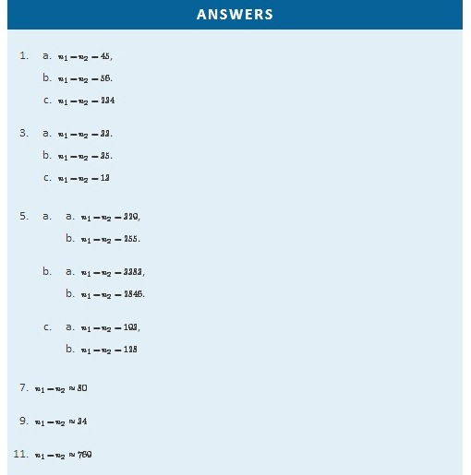

Chapter 10

Correlation and Regression

Our interest in this chapter is in situations in which we can associate to each element of a population or sample two measurements x and y, particularly in the case that it is of interest to use the value of x to predict the value of y. For example, the population could be the air in automobile garages, x could be the electrical current produced by an electrochemical reaction taking place in a carbon monoxide meter, and y the concentration of carbon monoxide in the air. In this chapter we will learn statistical methods for analyzing the relationship between variables x and y in this context.
A list of all the formulas that appear anywhere in this chapter are collected in the last section for ease of reference.

10.1 Linear Relationships Between Variables

LEARNING OBJECTIVE
- To learn what it means for two variables to exhibit a relationship that is close to linear but which contains an element of randomness.

The following table gives examples of the kinds of pairs of variables which could be of interest from a statistical point of view.
x | y
Predictor or independent variable | Response or dependent variable
Temperature in degrees Celsius | Temperature in degrees Fahrenheit
Area of a house (sq.ft.) | Value of the house
Age of a particular make and model car | Resale value of the car
Amount spent by a business on advertising in a year | Revenue received that year
Height of a 25-year-old man | Weight of the man
The first line in the table is different from all the rest because in that case and no other the relationship between the variables is deterministic: once the value of x is known the value of y is completely determined. In fact there is a formula for y in terms of x: y=95x+32. Choosing several values for x and computing the corresponding value for y for each one using the formula gives the table
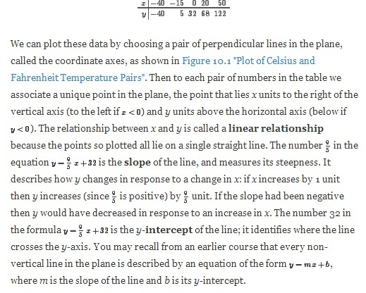
Figure 10.1 Plot of Celsius and Fahrenheit Temperature Pairs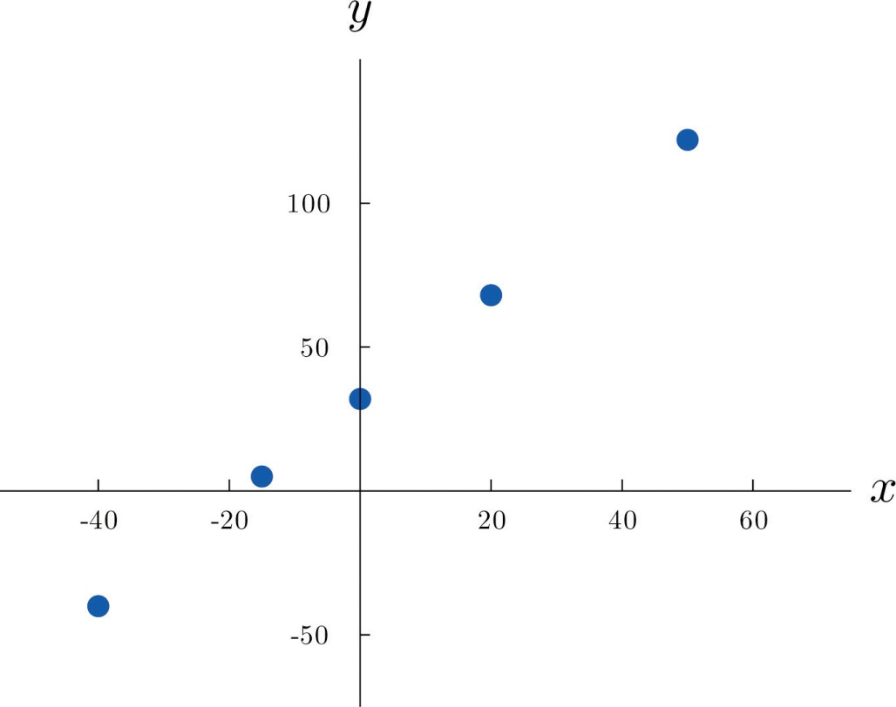
The relationship between x and y in the temperature example is deterministic because once the value of x is known, the value of y is completely determined. In contrast, all the other relationships listed in the table above have an element of randomness in them. Consider the relationship described in the last line of the table, the height x of a man aged 25 and his weight y. If we were to randomly select several 25-year-old men and measure the height and weight of each one, we might obtain a collection of (x,y) pairs something like this:

(68,151) (69,146) (70,157) (70,164) (71,171) (72,160)
(72,163)(72,180)(73,170)(73,175)(74,178)(75,188)
A plot of these data is shown in Figure 10.2 "Plot of Height and Weight Pairs". Such a plot is called a scatter diagram or scatter plot. Looking at the plot it is evident that there exists a linear relationship between height x and weight y, but not a perfect one. The points appear to be following a line, but not exactly. There is an element of randomness present.
Figure 10.2 Plot of Height and Weight Pairs
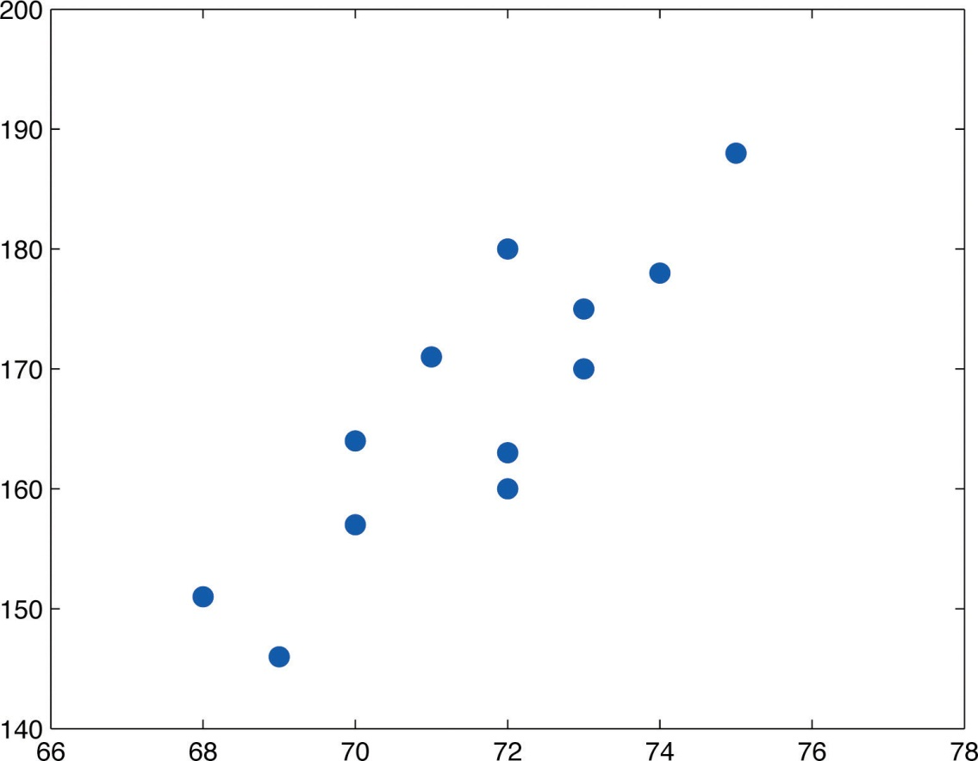

In this chapter we will analyze situations in which variables x and y exhibit such a linear relationship with randomness. The level of randomness will vary from situation to situation. In the introductory example connecting an electric current and the level of carbon monoxide in air, the relationship is almost perfect. In other situations, such as the height and weights of individuals, the connection between the two variables involves a high degree of randomness. In the next section we will see how to quantify the strength of the linear relationship between two variables.

KEY TAKEAWAYS
- Two variables x and y have a deterministic linear relationship if points plotted from (x,y) pairs lie exactly along a single straight line.
- In practice it is common for two variables to exhibit a relationship that is close to linear but which contains an element, possibly large, of randomness.

EXERCISES

BASIC
- A line has equation y=0.5x+2.
  - Pick five distinct x-values, use the equation to compute the corresponding y-values, and plot the five points obtained.
  - Give the value of the slope of the line; give the value of the y-intercept.
- A line has equation y=x−0.5.
  - Pick five distinct x-values, use the equation to compute the corresponding y-values, and plot the five points obtained.
  - Give the value of the slope of the line; give the value of the y-intercept.
- A line has equation y=−2x+4.
  - Pick five distinct x-values, use the equation to compute the corresponding y-values, and plot the five points obtained.
  - Give the value of the slope of the line; give the value of the y-intercept.
- A line has equation y=−1.5x+1.
  - Pick five distinct x-values, use the equation to compute the corresponding y-values, and plot the five points obtained.
  - Give the value of the slope of the line; give the value of the y-intercept.
- Based on the information given about a line, determine how y will change (increase, decrease, or stay the same) when x is increased, and explain. In some cases it might be impossible to tell from the information given.
  - The slope is positive.
  - The y-intercept is positive.
  - The slope is zero.
- Based on the information given about a line, determine how y will change (increase, decrease, or stay the same) when x is increased, and explain. In some cases it might be impossible to tell from the information given.
  - The y-intercept is negative.
  - The y-intercept is zero.
  - The slope is negative.
- A data set consists of eight (x,y) pairs of numbers:
(0,12)(2,15)(4,16)(5,14)(8,22)(13,24)(15,28)(20,30)
  - Plot the data in a scatter diagram.
  - Based on the plot, explain whether the relationship between x and y appears to be deterministic or to involve randomness.
  - Based on the plot, explain whether the relationship between x and y appears to be linear or not linear.
- A data set consists of ten (x,y) pairs of numbers:
(3,20)(5,13)(6,9)(8,4)(11,0)(12,0)(14,1)(17,6)(18,9)(20,16)
  - Plot the data in a scatter diagram.
  - Based on the plot, explain whether the relationship between x and y appears to be deterministic or to involve randomness.
  - Based on the plot, explain whether the relationship between x and y appears to be linear or not linear.
- A data set consists of nine (x,y) pairs of numbers:
(8,16)(9,9)(10,4)(11,1)(12,0)(13,1)(14,4)(15,9)(16,16)
  - Plot the data in a scatter diagram.
  - Based on the plot, explain whether the relationship between x and y appears to be deterministic or to involve randomness.
  - Based on the plot, explain whether the relationship between x and y appears to be linear or not linear.
- A data set consists of five (x,y) pairs of numbers:
(0,1) (2,5) (3,7) (5,11) (8,17)
  - Plot the data in a scatter diagram.
  - Based on the plot, explain whether the relationship between x and y appears to be deterministic or to involve randomness.
  - Based on the plot, explain whether the relationship between x and y appears to be linear or not linear.

APPLICATIONS
- At 60°F a particular blend of automotive gasoline weights 6.17 lb/gal. The weight yof gasoline on a tank truck that is loaded with x gallons of gasoline is given by the linear equation
y=6.17x
  - Explain whether the relationship between the weight y and the amount x of gasoline is deterministic or contains an element of randomness.
  - Predict the weight of gasoline on a tank truck that has just been loaded with 6,750 gallons of gasoline.
- The rate for renting a motor scooter for one day at a beach resort area is $25 plus 30 cents for each mile the scooter is driven. The total cost y in dollars for renting a scooter and driving it x miles is
y=0.30x+25
  - Explain whether the relationship between the cost y of renting the scooter for a day and the distance x that the scooter is driven that day is deterministic or contains an element of randomness.
  - A person intends to rent a scooter one day for a trip to an attraction 17 miles away. Assuming that the total distance the scooter is driven is 34 miles, predict the cost of the rental.
- The pricing schedule for labor on a service call by an elevator repair company is $150 plus $50 per hour on site.
  - Write down the linear equation that relates the labor cost y to the number of hours x that the repairman is on site.
  - Calculate the labor cost for a service call that lasts 2.5 hours.
- The cost of a telephone call made through a leased line service is 2.5 cents per minute.
  - Write down the linear equation that relates the cost y (in cents) of a call to its length x.
  - Calculate the cost of a call that lasts 23 minutes.

LARGE DATA SET EXERCISES
- Large Data Set 1 lists the SAT scores and GPAs of 1,000 students. Plot the scatter diagram with SAT score as the independent variable (x) and GPA as the dependent variable (y). Comment on the appearance and strength of any linear trend.
http://www.flatworldknowledge.com/sites/all/files/data1.xls
- Large Data Set 12 lists the golf scores on one round of golf for 75 golfers first using their own original clubs, then using clubs of a new, experimental design (after two months of familiarization with the new clubs). Plot the scatter diagram with golf score using the original clubs as the independent variable (x) and golf score using the new clubs as the dependent variable (y). Comment on the appearance and strength of any linear trend.
http://www.flatworldknowledge.com/sites/all/files/data12.xls
- Large Data Set 13 records the number of bidders and sales price of a particular type of antique grandfather clock at 60 auctions. Plot the scatter diagram with the number of bidders at the auction as the independent variable (x) and the sales price as the dependent variable (y). Comment on the appearance and strength of any linear trend.
http://www.flatworldknowledge.com/sites/all/files/data13.xls

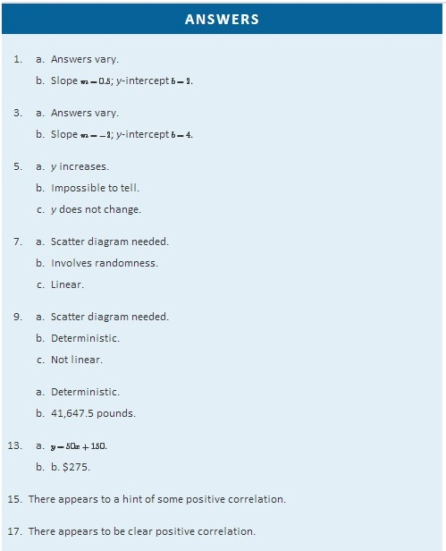

10.2 The Linear Correlation Coefficient

LEARNING OBJECTIVE
- To learn what the linear correlation coefficient is, how to compute it, and what it tells us about the relationship between two variables x and y.

Figure 10.3 "Linear Relationships of Varying Strengths" illustrates linear relationships between two variables x and y of varying strengths. It is visually apparent that in the situation in panel (a), x could serve as a useful predictor of y, it would be less useful in the situation illustrated in panel (b), and in the situation of panel (c) the linear relationship is so weak as to be practically nonexistent. The linear correlation coefficient is a number computed directly from the data that measures the strength of the linear relationship between the two variables x and y.
Figure 10.3 Linear Relationships of Varying Strengths
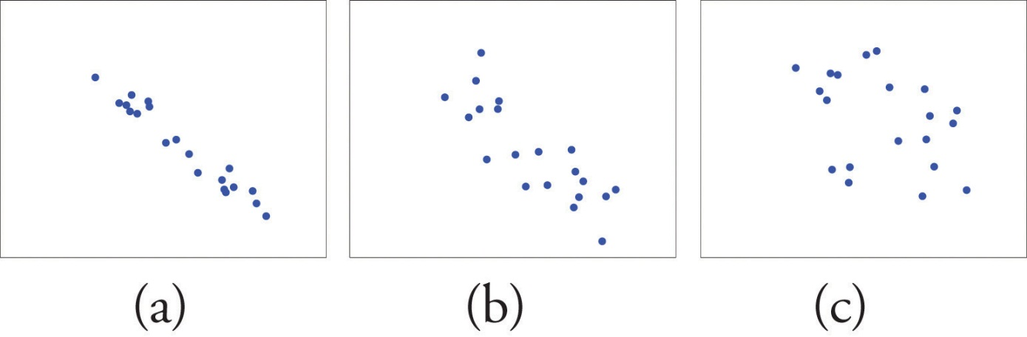
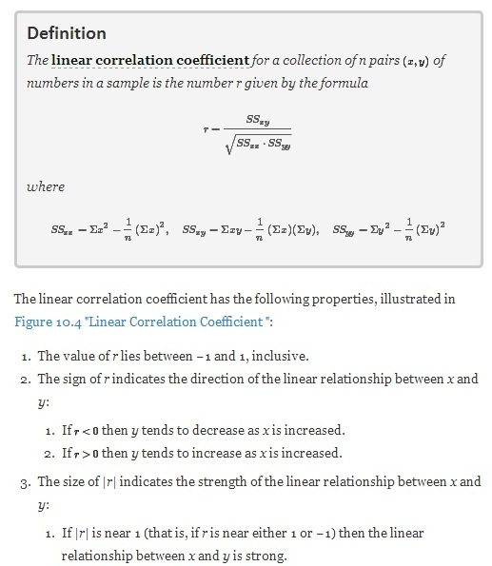
- If |r| is near 0 (that is, if r is near 0 and of either sign) then the linear relationship between x and y is weak.

Figure 10.4 Linear Correlation Coefficient R
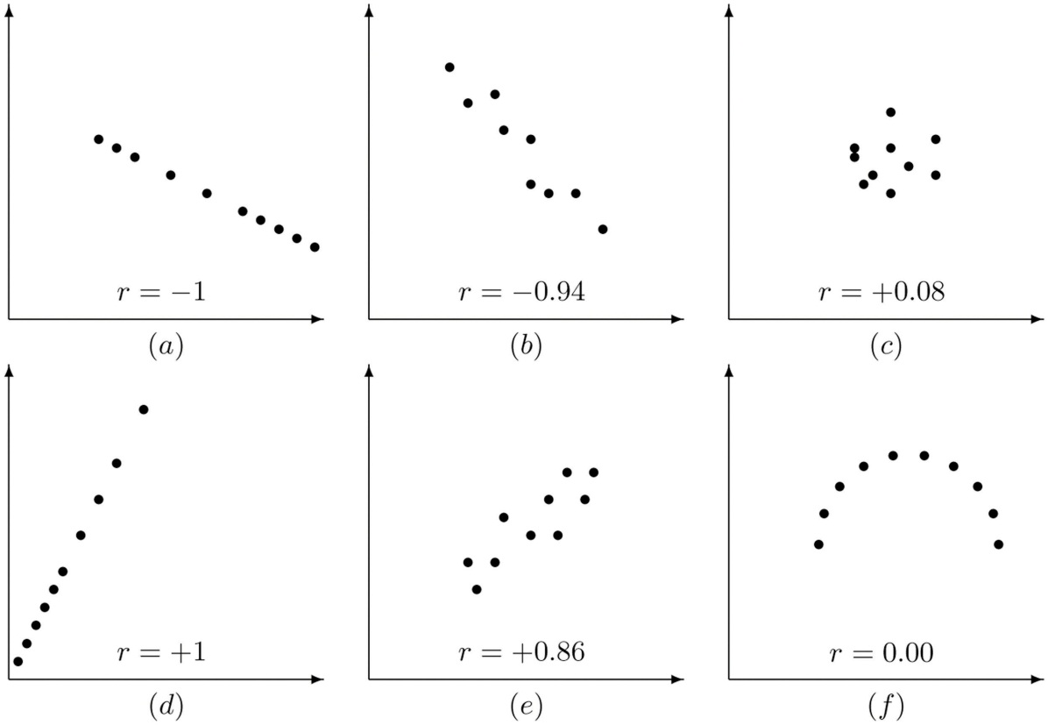
Pay particular attention to panel (f) in Figure 10.4 "Linear Correlation Coefficient ". It shows a perfectly deterministic relationship between x and y, but r=0 because the relationship is not linear. (In this particular case the points lie on the top half of a circle.)

EXAMPLE 1
Compute the linear correlation coefficient for the height and weight pairs plotted in Figure 10.2 "Plot of Height and Weight Pairs".
Solution:

Even for small data sets like this one computations are too long to do completely by hand. In actual practice the data are entered into a calculator or computer and a statistics program is used. In order to clarify the meaning of the formulas we will display the data and related quantities in tabular form. For each (x,y)pair we compute three numbers: x², xy, and y², as shown in the table provided. In the last line of the table we have the sum of the numbers in each column. Using them we compute:

 | x | y | x² | xy | y²
 | 68 | 151 | 4624 | 10268 | 22801
 | 69 | 146 | 4761 | 10074 | 21316
 | 70 | 157 | 4900 | 10990 | 24649
 | 70 | 164 | 4900 | 11480 | 26896
 | 71 | 171 | 5041 | 12141 | 29241
 | 72 | 160 | 5184 | 11520 | 25600
 | 72 | 163 | 5184 | 11736 | 26569
 | 72 | 180 | 5184 | 12960 | 32400
 | 73 | 170 | 5329 | 12410 | 28900
 | 73 | 175 | 5329 | 12775 | 30625
 | 74 | 178 | 5476 | 13172 | 31684
 | 75 | 188 | 5625 | 14100 | 35344
Σ | 859 | 2003 | 61537 | 143626 | 336025
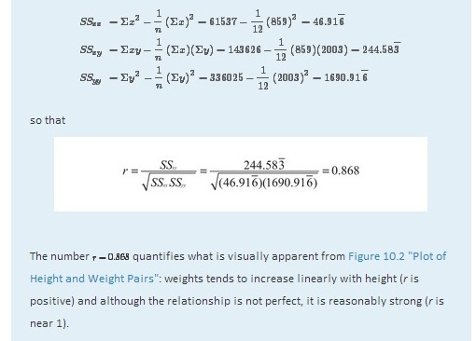

KEY TAKEAWAYS
- The linear correlation coefficient measures the strength and direction of the linear relationship between two variables x and y.
- The sign of the linear correlation coefficient indicates the direction of the linear relationship between x and y.
- When r is near 1 or −1 the linear relationship is strong; when it is near 0 the linear relationship is weak.

EXERCISES

BASIC
With the exception of the exercises at the end of Section 10.3 "Modelling Linear Relationships with Randomness Present", the first Basic exercise in each of the following sections through Section 10.7 "Estimation and Prediction" uses the data from the first exercise here, the second Basic exercise uses the data from the second exercise here, and so on, and similarly for the Application exercises. Save your computations done on these exercises so that you do not need to repeat them later.
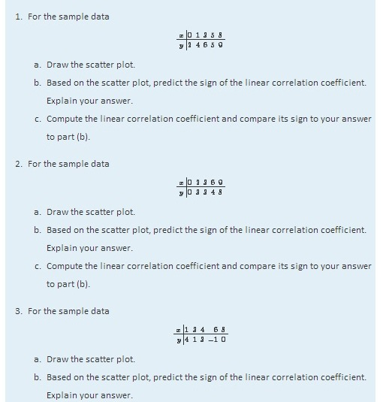
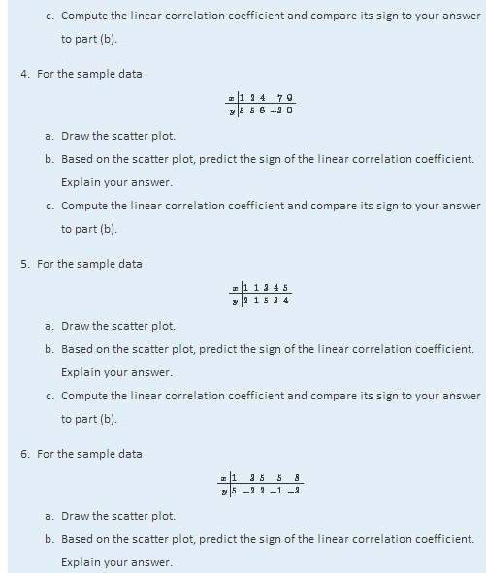
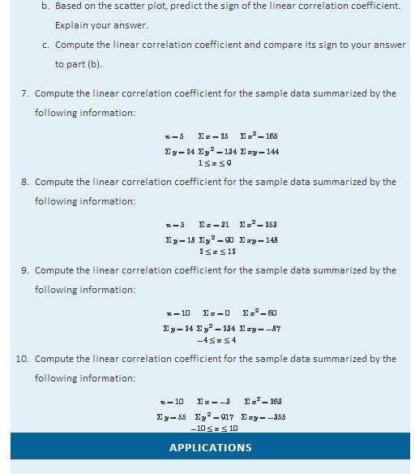
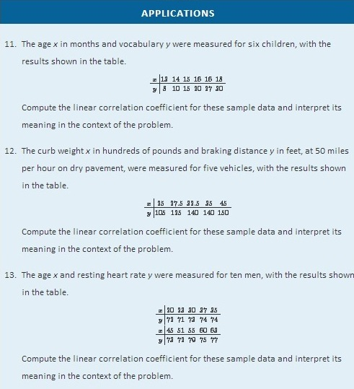
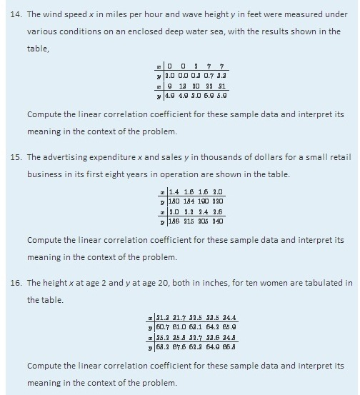
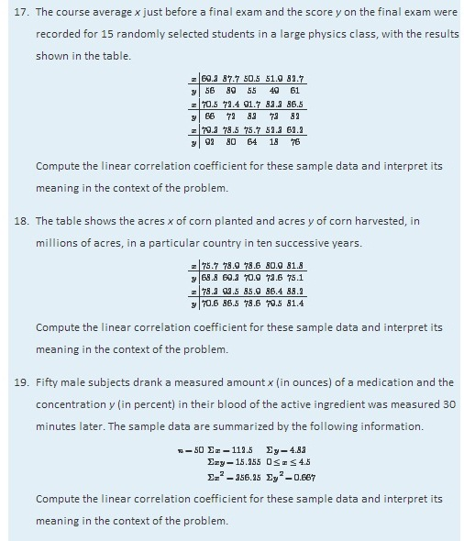
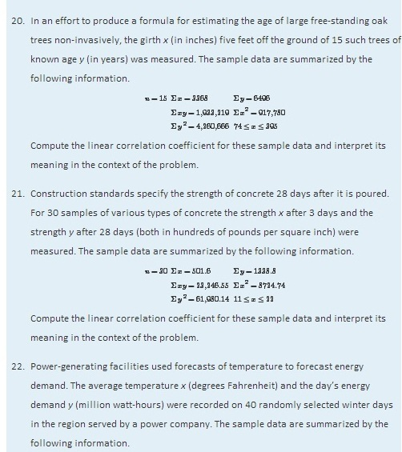
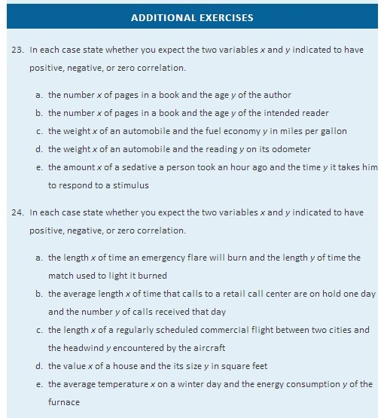
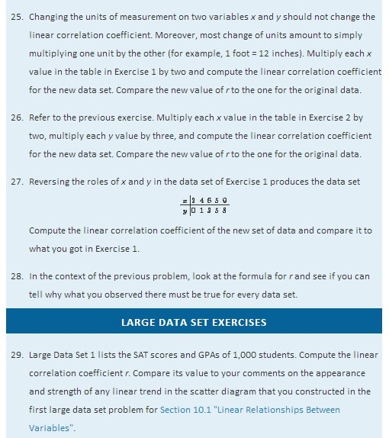
http://www.flatworldknowledge.com/sites/all/files/data1.xls

- Large Data Set 12 lists the golf scores on one round of golf for 75 golfers first using their own original clubs, then using clubs of a new, experimental design (after two months of familiarization with the new clubs). Compute the linear correlation coefficient r. Compare its value to your comments on the appearance and strength of any linear trend in the scatter diagram that you constructed in the second large data set problem for Section 10.1 "Linear Relationships Between Variables".
http://www.flatworldknowledge.com/sites/all/files/data12.xls

- Large Data Set 13 records the number of bidders and sales price of a particular type of antique grandfather clock at 60 auctions. Compute the linear correlation coefficient r. Compare its value to your comments on the appearance and strength of any linear trend in the scatter diagram that you constructed in the third large data set problem for Section 10.1 "Linear Relationships Between Variables".
http://www.flatworldknowledge.com/sites/all/files/data13.xls
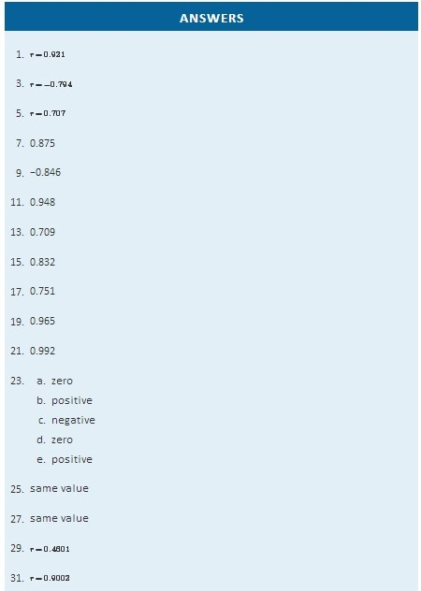

10.3 Modelling Linear Relationships with Randomness Present

LEARNING OBJECTIVE
- To learn the framework in which the statistical analysis of the linear relationship between two variables x and y will be done.

In this chapter we are dealing with a population for which we can associate to each element two measurements, x and y. We are interested in situations in which the value of x can be used to draw conclusions about the value of y, such as predicting the resale value y of a residential house based on its size x. Since the relationship between x and y is not deterministic, statistical procedures must be applied. For any statistical procedures, given in this book or elsewhere, the associated formulas are valid only under specific assumptions. The set of assumptions in simple linear regression are a mathematical description of the relationship between x and y. Such a set of assumptions is known as a model.

For each fixed value of x a sub-population of the full population is determined, such as the collection of all houses with 2,100 square feet of living space. For each element of that sub-population there is a measurement y, such as the value of any 2,100-square-foot house. Let E(y) denote the mean of all the y-values for each particular value of x. E(y) can change from x-value to x-value, such as the mean value of all 2,100-square-foot houses, the (different) mean value for all 2,500-square foot-houses, and so on.
Our first assumption is that the relationship between x and the mean of they-values in the sub-population determined by x is linear. This means that there exist numbers β1 and β0 such that

E(y)=β1x+β0
This linear relationship is the reason for the word “linear” in “simple linear regression” below. (The word “simple” means that y depends on only one other variable and not two or more.)
Our next assumption is that for each value of x the y-values scatter about the mean E(y) according to a normal distribution centered at E(y) and with a standard deviation σ that is the same for every value of x. This is the same as saying that there exists a normally distributed random variable ε with mean 0 and standard deviation σ so that the relationship between x and y in the whole population is
y=β1x+β0+ε
Our last assumption is that the random deviations associated with different observations are independent.
In summary, the model is:

Simple Linear Regression Model
For each point (x,y) in data set the y-value is an independent observation of
y=β1x+β0+ε
where β1 and β0 are fixed parameters and ε is a normally distributed random variable with mean 0 and an unknown standard deviation σ.
The line with equation y=β1x+β0 is called the population regression line.
Figure 10.5 "The Simple Linear Model Concept" illustrates the model. The symbols N(μ,σ2) denote a normal distribution with mean μ and variance σ2, hence standard deviation σ.
Figure 10.5 The Simple Linear Model Concept
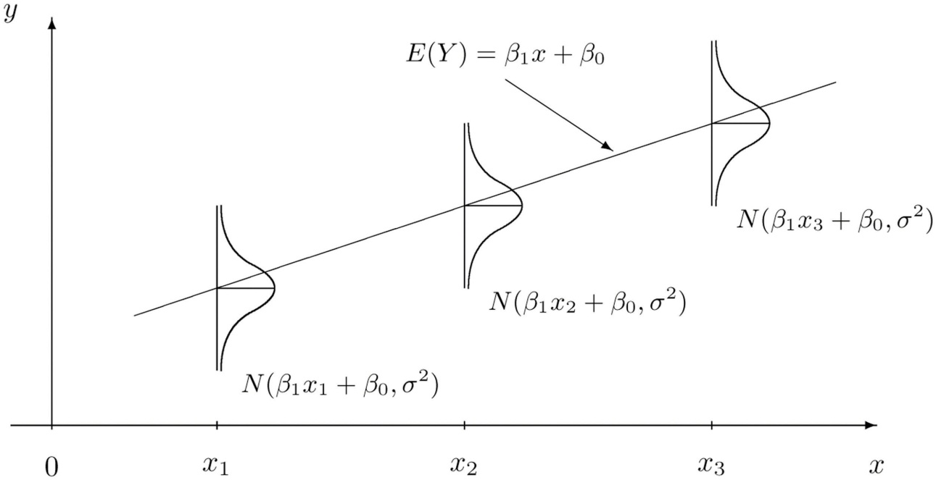
It is conceptually important to view the model as a sum of two parts:

y=β1x+β0+ε
- Deterministic Part. The first part β1x+β0 is the equation that describes the trend in y as x increases. The line that we seem to see when we look at the scatter diagram is an approximation of the line y=β1x+β0. There is nothing random in this part, and therefore it is called the deterministic part of the model.
- Random Part. The second part ε is a random variable, often called the error term or the noise. This part explains why the actual observed values of y are not exactly on but fluctuate near a line. Information about this term is important since only when one knows how much noise there is in the data can one know how trustworthy the detected trend is.
There are three parameters in this model: β0, β1, and σ. Each has an important interpretation, particularly β1 and σ. The slope parameter β1represents the expected change in y brought about by a unit increase in x. The standard deviation σ represents the magnitude of the noise in the data.

There are procedures for checking the validity of the three assumptions, but for us it will be sufficient to visually verify the linear trend in the data. If the data set is large then the points in the scatter diagram will form a band about an apparent straight line. The normality of ε with a constant standard deviation corresponds graphically to the band being of roughly constant width, and with most points concentrated near the middle of the band.

Fortunately, the three assumptions do not need to hold exactly in order for the procedures and analysis developed in this chapter to be useful.

KEY TAKEAWAY
- Statistical procedures are valid only when certain assumptions are valid. The assumptions underlying the analyses done in this chapter are graphically summarized in Figure 10.5 "The Simple Linear Model Concept".

EXERCISES
- State the three assumptions that are the basis for the Simple Linear Regression Model.
- The Simple Linear Regression Model is summarized by the equation
y=β1x+β0+ε
Identify the deterministic part and the random part.
- Is the number β1 in the equation y=β1x+β0 a statistic or a population parameter? Explain.
- Is the number σ in the Simple Linear Regression Model a statistic or a population parameter? Explain.
- Describe what to look for in a scatter diagram in order to check that the assumptions of the Simple Linear Regression Model are true.
- True or false: the assumptions of the Simple Linear Regression Model must hold exactly in order for the procedures and analysis developed in this chapter to be useful.

ANSWERS

  - The mean of y is linearly related to x.
  - For each given x, y is a normal random variable with mean β1x+β0 and standard deviation σ.
  - All the observations of y in the sample are independent.
- β1 is a population parameter.
- A linear trend.

10.4 The Least Squares Regression Line

LEARNING OBJECTIVES
- To learn how to measure how well a straight line fits a collection of data.
- To learn how to construct the least squares regression line, the straight line that best fits a collection of data.
- To learn the meaning of the slope of the least squares regression line.
- To learn how to use the least squares regression line to estimate the response variable y in terms of the predictor variable x.

Goodness of Fit of a Straight Line to Data
Once the scatter diagram of the data has been drawn and the model assumptions described in the previous sections at least visually verified (and perhaps the correlation coefficient r computed to quantitatively verify the linear trend), the next step in the analysis is to find the straight line that best fits the data. We will explain how to measure how well a straight line fits a collection of points by examining how well the line y=12x−1 fits the data set
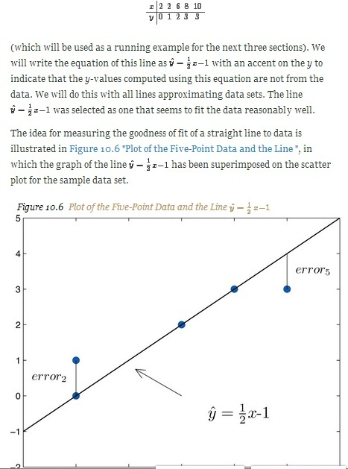
To each point in the data set there is associated an “error,” the positive or negative vertical distance from the point to the line: positive if the point is above the line and negative if it is below the line. The error can be computed as the actual y-value of the point minus the y-value yˆ that is “predicted” by inserting the x-value of the data point into the formula for the line:

error at data point (x,y)=(true y)−(predicted y)=y−yˆ
The computation of the error for each of the five points in the data set is shown in Table 10.1 "The Errors in Fitting Data with a Straight Line".
Table 10.1 The Errors in Fitting Data with a Straight Line
 | x | y | yˆ=12x−1 | y−yˆ | (y−yˆ)2
 | 2 | 0 | 0 | 0 | 0
 | 2 | 1 | 0 | 1 | 1
 | 6 | 2 | 2 | 0 | 0
 | 8 | 3 | 3 | 0 | 0
 | 10 | 3 | 4 | −1 | 1
Σ | - | - | - | 0 | 2
A first thought for a measure of the goodness of fit of the line to the data would be simply to add the errors at every point, but the example shows that this cannot work well in general. The line does not fit the data perfectly (no line can), yet because of cancellation of positive and negative errors the sum of the errors (the fourth column of numbers) is zero. Instead goodness of fit is measured by the sum of the squares of the errors. Squaring eliminates the minus signs, so no cancellation can occur. For the data and line in Figure 10.6 "Plot of the Five-Point Data and the Line " the sum of the squared errors (the last column of numbers) is 2. This number measures the goodness of fit of the line to the data.

Definition
The goodness of fit of a line yˆ=mx+b to a set of n pairs (x,y) of numbers in a sample is the sum of the squared errors
Σ(y−yˆ⁾²
(n terms in the sum, one for each data pair).

The Least Squares Regression Line
Given any collection of pairs of numbers (except when all the x-values are the same) and the corresponding scatter diagram, there always exists exactly one straight line that fits the data better than any other, in the sense of minimizing the sum of the squared errors. It is called the least squares regression line. Moreover there are formulas for its slope and y-intercept.
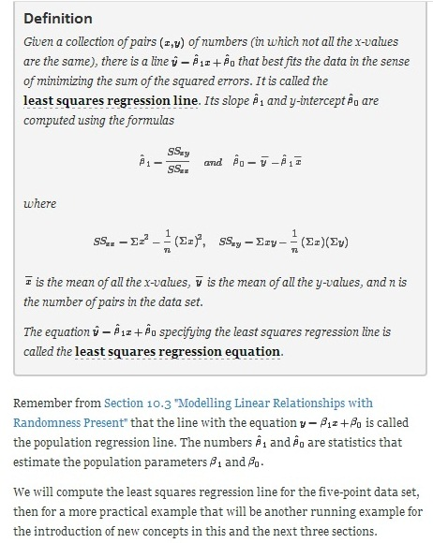
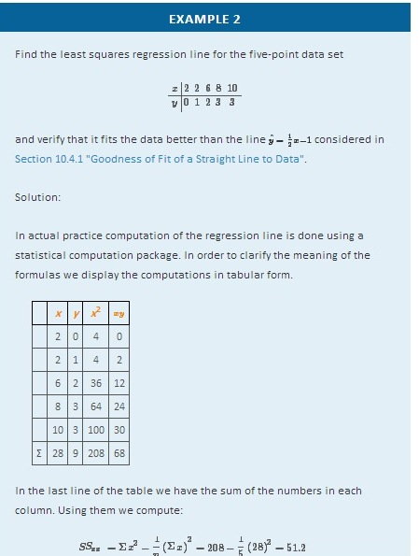
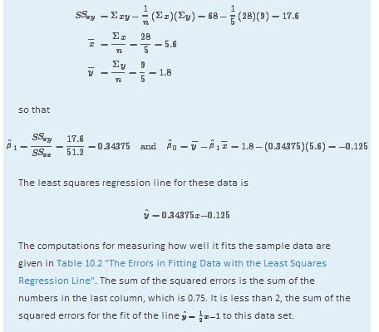
TABLE 10.2 THE ERRORS IN FITTING DATA WITH THE LEAST SQUARES REGRESSION LINE
x | y | yˆ=0.34375x−0.125 | y−yˆ | (y−yˆ)2
2 | 0 | 0.5625 | −0.5625 | 0.31640625
2 | 1 | 0.5625 | 0.4375 | 0.19140625
6 | 2 | 1.9375 | 0.0625 | 0.00390625
8 | 3 | 2.6250 | 0.3750 | 0.14062500
10 | 3 | 3.3125 | −0.3125 | 0.09765625

EXAMPLE 3
Table 10.3 "Data on Age and Value of Used Automobiles of a Specific Make and Model" shows the age in years and the retail value in thousands of dollars of a random sample of ten automobiles of the same make and model.
- Construct the scatter diagram.
- Compute the linear correlation coefficient r. Interpret its value in the context of the problem.
- Compute the least squares regression line. Plot it on the scatter diagram.
- Interpret the meaning of the slope of the least squares regression line in the context of the problem.
- Suppose a four-year-old automobile of this make and model is selected at random. Use the regression equation to predict its retail value.
- Suppose a 20-year-old automobile of this make and model is selected at random. Use the regression equation to predict its retail value. Interpret the result.
- Comment on the validity of using the regression equation to predict the price of a brand new automobile of this make and model.
TABLE 10.3 DATA ON AGE AND VALUE OF USED AUTOMOBILES OF A SPECIFIC MAKE AND MODEL
x | 2 | 3 | 3 | 3 | 4 | 4 | 5 | 5 | 5 | 6
y | 28.7 | 24.8 | 26.0 | 30.5 | 23.8 | 24.6 | 23.8 | 20.4 | 21.6 | 22.1

Solution:

- The scatter diagram is shown in Figure 10.7 "Scatter Diagram for Age and Value of Used Automobiles".
Figure 10.7Scatter Diagram for Age and Value of Used Automobiles
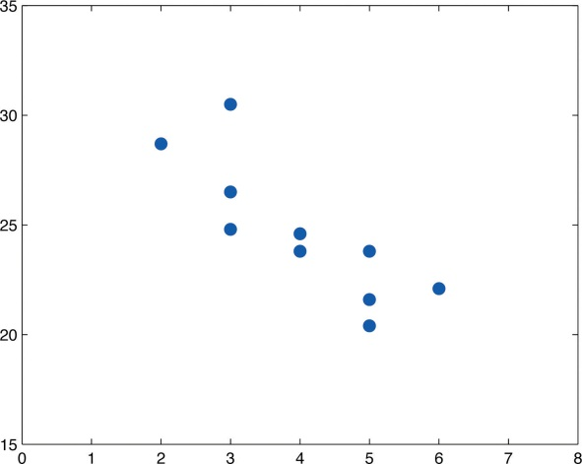
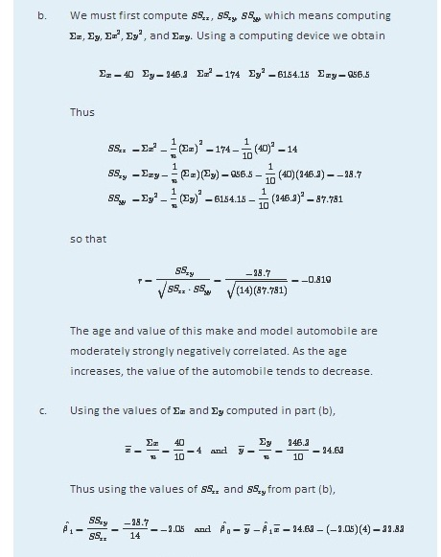
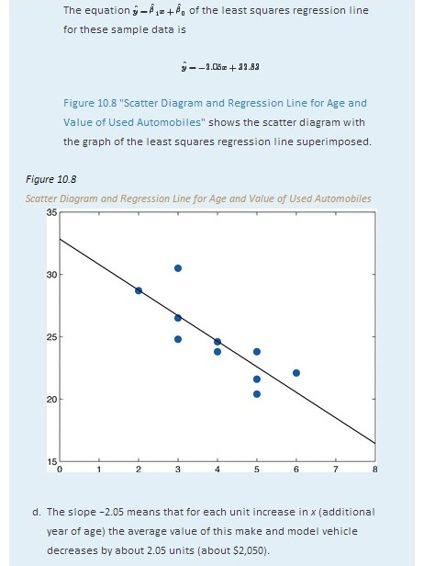
- Since we know nothing about the automobile other than its age, we assume that it is of about average value and use the average value of all four-year-old vehicles of this make and model as our estimate. The average value is simply the value of yˆ obtained when the number 4 is inserted for x in the least squares regression equation:

yˆ=−2.05(4)+32.83=24.63
which corresponds to $24,630.
- Now we insert x=20 into the least squares regression equation, to obtain

yˆ=−2.05(20)+32.83=−8.17
which corresponds to −$8,170. Something is wrong here, since a negative makes no sense. The error arose from applying the regression equation to a value of x not in the range of x-values in the original data, from two to six years.

Applying the regression equation yˆ=βˆ1x+βˆ0 to a value of x outside the range of x-values in the data set is called extrapolation. It is an invalid use of the regression equation and should be avoided.
- The price of a brand new vehicle of this make and model is the value of the automobile at age 0. If the value x=0 is inserted into the regression equation the result is always βˆ0, the y-intercept, in this case 32.83, which corresponds to $32,830. But this is a case of extrapolation, just as part (f) was, hence this result is invalid, although not obviously so. In the context of the problem, since automobiles tend to lose value much more quickly immediately after they are purchased than they do after they are several years old, the number $32,830 is probably an underestimate of the price of a new automobile of this make and model.
For emphasis we highlight the points raised by parts (f) and (g) of the example.

Definition
The process of using the least squares regression equation to estimate the value of y at a value of x that does not lie in the range of the x-values in the data set that was used to form the regression line is called extrapolation. It is an invalid use of the regression equation that can lead to errors, hence should be avoided.

The Sum of the Squared Errors SSE
In general, in order to measure the goodness of fit of a line to a set of data, we must compute the predicted y-value yˆ at every point in the data set, compute each error, square it, and then add up all the squares. In the case of the least squares regression line, however, the line that best fits the data, the sum of the squared errors can be computed directly from the data using the following formula.
The sum of the squared errors for the least squares regression line is denoted by SSE. It can be computed using the formula
SSE=SSyy−βˆ1Ssxy

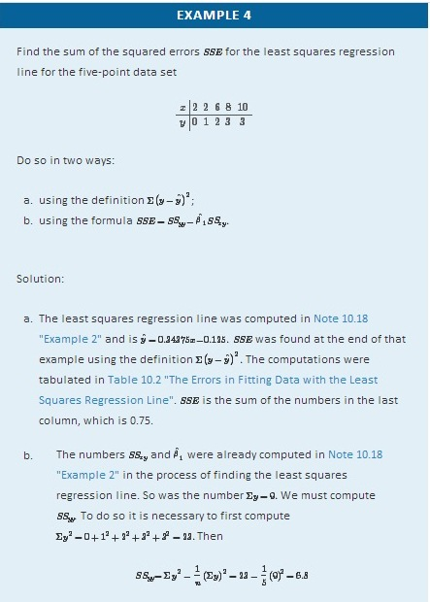
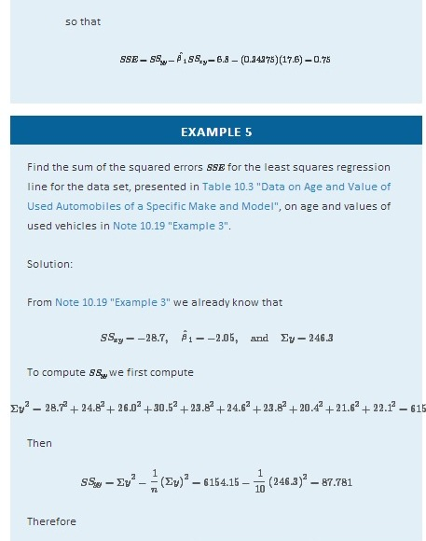
SSE=SSyy−βˆ1SSxy=87.781−(−2.05)(−28.7)=28.946

KEY TAKEAWAYS
- How well a straight line fits a data set is measured by the sum of the squared errors.
- The least squares regression line is the line that best fits the data. Its slope and y-intercept are computed from the data using formulas.
- The slope βˆ1 of the least squares regression line estimates the size and direction of the mean change in the dependent variable y when the independent variable x is increased by one unit.
- The sum of the squared errors SSE of the least squares regression line can be computed using a formula, without having to compute all the individual errors.

EXERCISES

BASIC
For the Basic and Application exercises in this section use the computations that were done for the exercises with the same number inSection 10.2 "The Linear Correlation Coefficient".
- Compute the least squares regression line for the data in Exercise 1 ofSection 10.2 "The Linear Correlation Coefficient".
- Compute the least squares regression line for the data in Exercise 2 ofSection 10.2 "The Linear Correlation Coefficient".
- Compute the least squares regression line for the data in Exercise 3 ofSection 10.2 "The Linear Correlation Coefficient".
- Compute the least squares regression line for the data in Exercise 4 ofSection 10.2 "The Linear Correlation Coefficient".
- For the data in Exercise 5 of Section 10.2 "The Linear Correlation Coefficient"
  - Compute the least squares regression line.
  - Compute the sum of the squared errors SSE using the definition Σ(y−yˆ)2.
  - Compute the sum of the squared errors SSE using the formula SSE=SSyy−βˆ1SSxy.
- For the data in Exercise 6 of Section 10.2 "The Linear Correlation Coefficient"
  - Compute the least squares regression line.
  - Compute the sum of the squared errors SSE using the definition Σ(y−yˆ)2.
  - Compute the sum of the squared errors SSE using the formula SSE=SSyy−βˆ1SSxy.
- Compute the least squares regression line for the data in Exercise 7 ofSection 10.2 "The Linear Correlation Coefficient".
- Compute the least squares regression line for the data in Exercise 8 ofSection 10.2 "The Linear Correlation Coefficient".
- For the data in Exercise 9 of Section 10.2 "The Linear Correlation Coefficient"
  - Compute the least squares regression line.
  - Can you compute the sum of the squared errors SSE using the definitionΣ(y−yˆ)2? Explain.
  - Compute the sum of the squared errors SSE using the formula SSE=SSyy−βˆ1SSxy.
- For the data in Exercise 10 of Section 10.2 "The Linear Correlation Coefficient"
  - Compute the least squares regression line.
  - Can you compute the sum of the squared errors SSE using the definition Σ(y−yˆ)2? Explain.
  - Compute the sum of the squared errors SSE using the formula SSE=SSyy−βˆ1SSxy.

APPLICATIONS
- For the data in Exercise 11 of Section 10.2 "The Linear Correlation Coefficient"
  - Compute the least squares regression line.
  - On average, how many new words does a child from 13 to 18 months old learn each month? Explain.
  - Estimate the average vocabulary of all 16-month-old children.
- For the data in Exercise 12 of Section 10.2 "The Linear Correlation Coefficient"
  - Compute the least squares regression line.
  - On average, how many additional feet are added to the braking distance for each additional 100 pounds of weight? Explain.
  - Estimate the average braking distance of all cars weighing 3,000 pounds.
- For the data in Exercise 13 of Section 10.2 "The Linear Correlation Coefficient"
  - Compute the least squares regression line.
  - Estimate the average resting heart rate of all 40-year-old men.
  - Estimate the average resting heart rate of all newborn baby boys. Comment on the validity of the estimate.
- For the data in Exercise 14 of Section 10.2 "The Linear Correlation Coefficient"
  - Compute the least squares regression line.
  - Estimate the average wave height when the wind is blowing at 10 miles per hour.
  - Estimate the average wave height when there is no wind blowing. Comment on the validity of the estimate.
- For the data in Exercise 15 of Section 10.2 "The Linear Correlation Coefficient"
  - Compute the least squares regression line.
  - On average, for each additional thousand dollars spent on advertising, how does revenue change? Explain.
  - Estimate the revenue if $2,500 is spent on advertising next year.
- For the data in Exercise 16 of Section 10.2 "The Linear Correlation Coefficient"
  - Compute the least squares regression line.
  - On average, for each additional inch of height of two-year-old girl, what is the change in the adult height? Explain.
  - Predict the adult height of a two-year-old girl who is 33 inches tall.
- For the data in Exercise 17 of Section 10.2 "The Linear Correlation Coefficient"
  - Compute the least squares regression line.
  - Compute SSE using the formula SSE=SSyy−βˆ1SSxy.
  - Estimate the average final exam score of all students whose course average just before the exam is 85.
- For the data in Exercise 18 of Section 10.2 "The Linear Correlation Coefficient"
  - Compute the least squares regression line.
  - Compute SSE using the formula SSE=SSyy−βˆ1SSxy.
  - Estimate the number of acres that would be harvested if 90 million acres of corn were planted.
- For the data in Exercise 19 of Section 10.2 "The Linear Correlation Coefficient"
  - Compute the least squares regression line.
  - Interpret the value of the slope of the least squares regression line in the context of the problem.
  - Estimate the average concentration of the active ingredient in the blood in men after consuming 1 ounce of the medication.
- For the data in Exercise 20 of Section 10.2 "The Linear Correlation Coefficient"
  - Compute the least squares regression line.
  - Interpret the value of the slope of the least squares regression line in the context of the problem.
  - Estimate the age of an oak tree whose girth five feet off the ground is 92 inches.
- For the data in Exercise 21 of Section 10.2 "The Linear Correlation Coefficient"
  - Compute the least squares regression line.
  - The 28-day strength of concrete used on a certain job must be at least 3,200 psi. If the 3-day strength is 1,300 psi, would we anticipate that the concrete will be sufficiently strong on the 28th day? Explain fully.
- For the data in Exercise 22 of Section 10.2 "The Linear Correlation Coefficient"
  - Compute the least squares regression line.
  - If the power facility is called upon to provide more than 95 million watt-hours tomorrow then energy will have to be purchased from elsewhere at a premium. The forecast is for an average temperature of 42 degrees. Should the company plan on purchasing power at a premium?
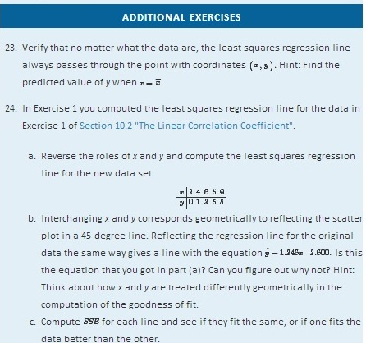

LARGE DATA SET EXERCISES
- Large Data Set 1 lists the SAT scores and GPAs of 1,000 students.
http://www.flatworldknowledge.com/sites/all/files/data1.xls

  - Compute the least squares regression line with SAT score as the independent variable (x) and GPA as the dependent variable (y).
  - Interpret the meaning of the slope βˆ1 of regression line in the context of problem.
  - Compute SSE, the measure of the goodness of fit of the regression line to the sample data.
  - Estimate the GPA of a student whose SAT score is 1350.
- Large Data Set 12 lists the golf scores on one round of golf for 75 golfers first using their own original clubs, then using clubs of a new, experimental design (after two months of familiarization with the new clubs).
http://www.flatworldknowledge.com/sites/all/files/data12.xls

  - Compute the least squares regression line with scores using the original clubs as the independent variable (x) and scores using the new clubs as the dependent variable (y).
  - Interpret the meaning of the slope βˆ1 of regression line in the context of problem.
  - Compute SSE, the measure of the goodness of fit of the regression line to the sample data.
  - Estimate the score with the new clubs of a golfer whose score with the old clubs is 73.
- Large Data Set 13 records the number of bidders and sales price of a particular type of antique grandfather clock at 60 auctions.
http://www.flatworldknowledge.com/sites/all/files/data13.xls

  - Compute the least squares regression line with the number of bidders present at the auction as the independent variable (x) and sales price as the dependent variable (y).
  - Interpret the meaning of the slope βˆ1 of regression line in the context of problem.
  - Compute SSE, the measure of the goodness of fit of the regression line to the sample data.
  - Estimate the sales price of a clock at an auction at which the number of bidders is seven.
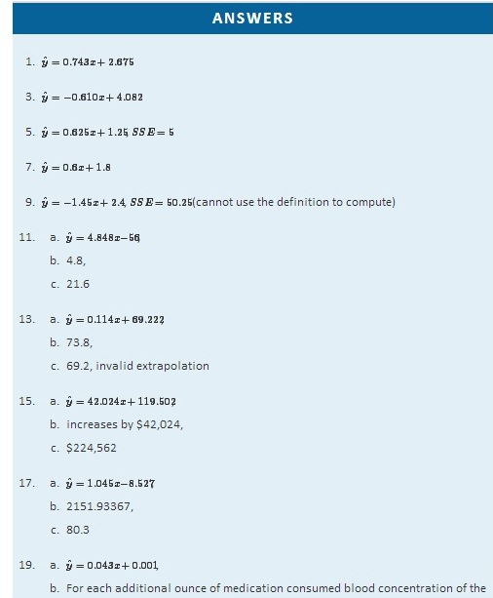
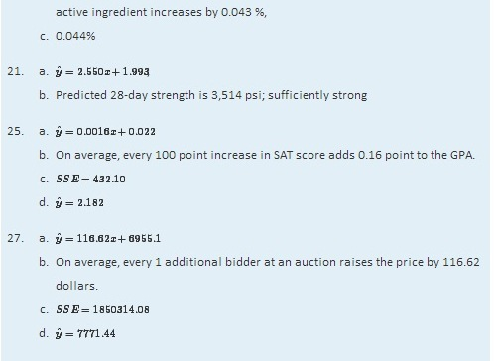

10.5 Statistical Inferences About β₁

LEARNING OBJECTIVES
- To learn how to construct a confidence interval for β1, the slope of the population regression line.
- To learn how to test hypotheses regarding β1.
The parameter β1, the slope of the population regression line, is of primary importance in regression analysis because it gives the true rate of change in the mean E(y) in response to a unit increase in the predictor variable x. For every unit increase in x the mean of the response variable y changes by β1 units, increasing if β1>0 and decreasing if β1<0. We wish to construct confidence intervals for β1 and test hypotheses about it.

Confidence Intervals for β₁
The slope βˆ1 of the least squares regression line is a point estimate of β1. A confidence interval for β1 is given by the following formula.
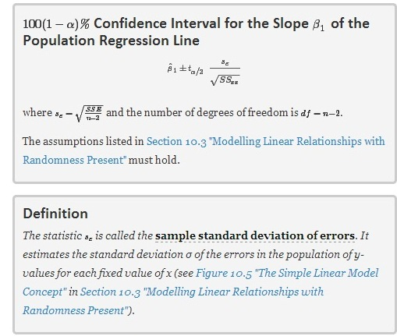
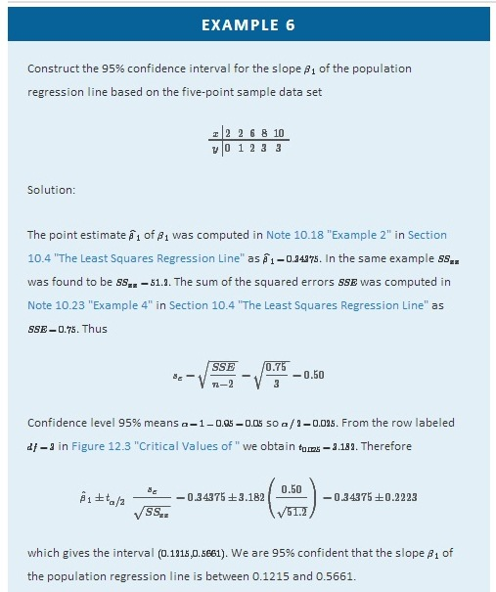
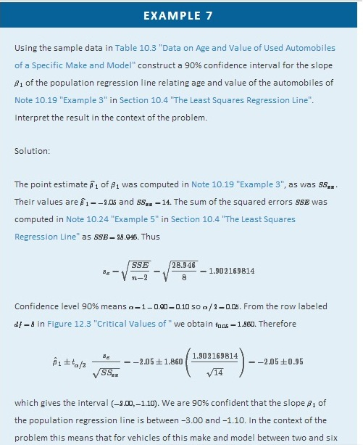
years old we are 90% confident that for each additional year of age the average value of such a vehicle decreases by between $1,100 and $3,000.

Testing Hypotheses About β₁
Hypotheses regarding β1 can be tested using the same five-step procedures, either the critical value approach or the p-value approach, that were introduced in Section 8.1 "The Elements of Hypothesis Testing" and Section 8.3 "The Observed Significance of a Test" of Chapter 8 "Testing Hypotheses". The null hypothesis always has the form H0:β1=B0 where B₀ is a number determined from the statement of the problem. The three forms of the alternative hypothesis, with the terminology for each case, are:
Form of H_{a} | Terminology
Ha:β1<B0 | Left-tailed
Ha:β1>B0 | Right-tailed
Ha:β1≠B0 | Two-tailed
The value zero for B₀ is of particular importance since in that case the null hypothesis is H0:β1=0, which corresponds to the situation in which x is not useful for predicting y. For if β1=0 then the population regression line is horizontal, so the mean E(y) is the same for every value of x and we are just as well off in ignoring x completely and approximating y by its average value. Given two variables x and y, the burden of proof is that x is useful for predicting y, not that it is not. Thus the phrase “test whether x is useful for prediction of y,” or words to that effect, means to perform the test

H0:β1=0 vs. Ha:β1≠0
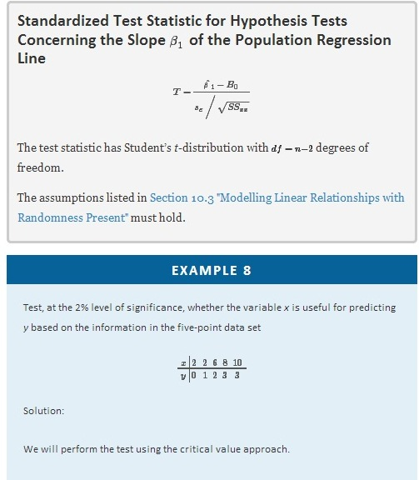
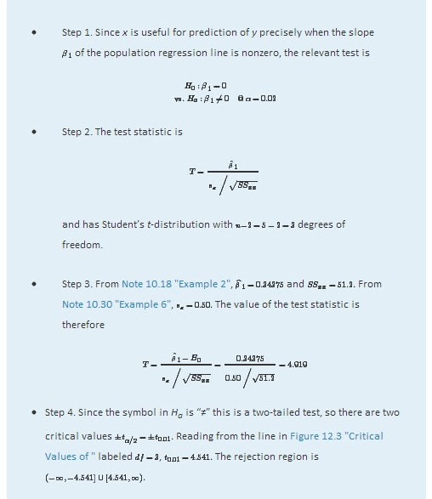
- Step 5. As shown in Figure 10.9 "Rejection Region and Test Statistic for " the test statistic falls in the rejection region. The decision is to reject H₀. In the context of the problem our conclusion is:
The data provide sufficient evidence, at the 2% level of significance, to conclude that the slope of the population regression line is nonzero, so that x is useful as a predictor of y.

Figure 10.9Rejection Region and Test Statistic for Note 10.33 "Example 8"
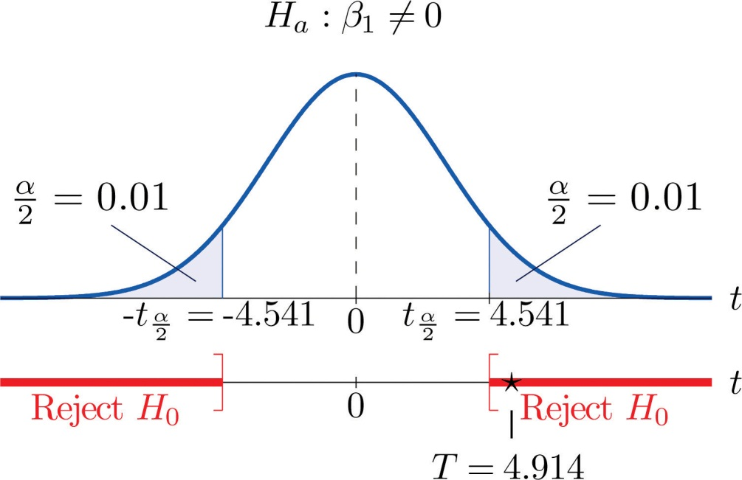

EXAMPLE 9
A car salesman claims that automobiles between two and six years old of the make and model discussed in Note 10.19 "Example 3" in Section 10.4 "The Least Squares Regression Line" lose more than $1,100 in value each year. Test this claim at the 5% level of significance.
Solution:
We will perform the test using the critical value approach.
- Step 1. In terms of the variables x and y, the salesman’s claim is that if x is increased by 1 unit (one additional year in age), then y decreases by more than 1.1 units (more than $1,100). Thus his assertion is that the slope of the population regression line is negative, and that it is more negative than −1.1. In symbols, β1<−1.1.Since it contains an inequality, this has to be the alternative hypotheses. The null hypothesis has to be an equality and have the same number on the right hand side, so the relevant test is
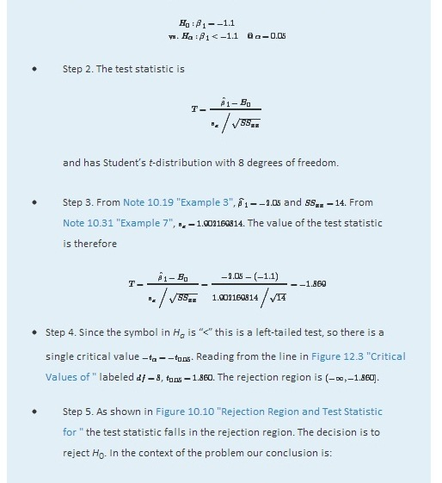
The data provide sufficient evidence, at the 5% level of significance, to conclude that vehicles of this make and model and in this age range lose more than $1,100 per year in value, on average.

Figure 10.10Rejection Region and Test Statistic forNote 10.34 "Example 9"
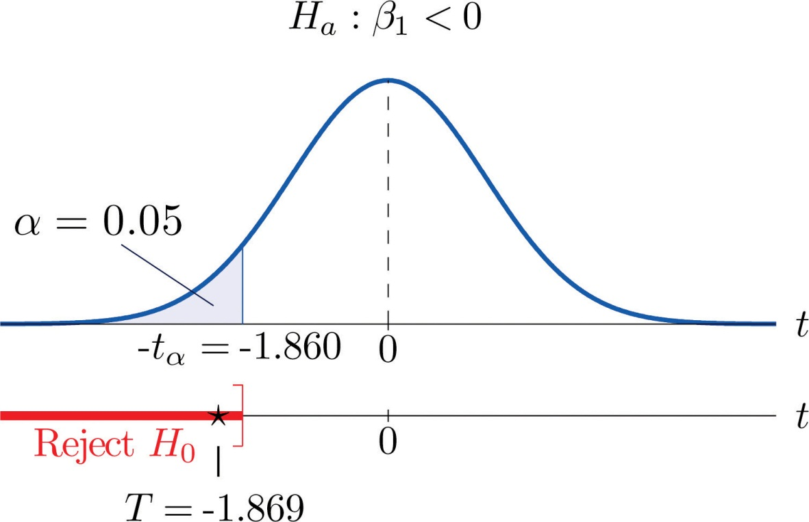

KEY TAKEAWAYS
- The parameter β1, the slope of the population regression line, is of primary interest because it describes the average change in y with respect to unit increase in x.
- The statistic βˆ1, the slope of the least squares regression line, is a point estimate of β1. Confidence intervals for β1 can be computed using a formula.
- Hypotheses regarding β1 are tested using the same five-step procedures introduced in Chapter 8 "Testing Hypotheses".

EXERCISES

BASIC
For the Basic and Application exercises in this section use the computations that were done for the exercises with the same number in Section 10.2 "The Linear Correlation Coefficient" and Section 10.4 "The Least Squares Regression Line".
- Construct the 95% confidence interval for the slope β1 of the population regression line based on the sample data set of Exercise 1 of Section 10.2 "The Linear Correlation Coefficient".
- Construct the 90% confidence interval for the slope β1 of the population regression line based on the sample data set of Exercise 2 of Section 10.2 "The Linear Correlation Coefficient".
- Construct the 90% confidence interval for the slope β1 of the population regression line based on the sample data set of Exercise 3 of Section 10.2 "The Linear Correlation Coefficient".
- Construct the 99% confidence interval for the slope β1 of the population regression Exercise 4 of Section 10.2 "The Linear Correlation Coefficient".
- For the data in Exercise 5 of Section 10.2 "The Linear Correlation Coefficient" test, at the 10% level of significance, whether x is useful for predicting y (that is, whether β1≠0).
- For the data in Exercise 6 of Section 10.2 "The Linear Correlation Coefficient" test, at the 5% level of significance, whether x is useful for predicting y (that is, whether β1≠0).
- Construct the 90% confidence interval for the slope β1 of the population regression line based on the sample data set of Exercise 7 of Section 10.2 "The Linear Correlation Coefficient".
- Construct the 95% confidence interval for the slope β1 of the population regression line based on the sample data set of Exercise 8 of Section 10.2 "The Linear Correlation Coefficient".
- For the data in Exercise 9 of Section 10.2 "The Linear Correlation Coefficient" test, at the 1% level of significance, whether x is useful for predicting y (that is, whether β1≠0).
- For the data in Exercise 10 of Section 10.2 "The Linear Correlation Coefficient" test, at the 1% level of significance, whether x is useful for predicting y (that is, whether β1≠0).

APPLICATIONS
- For the data in Exercise 11 of Section 10.2 "The Linear Correlation Coefficient"construct a 90% confidence interval for the mean number of new words acquired per month by children between 13 and 18 months of age.
- For the data in Exercise 12 of Section 10.2 "The Linear Correlation Coefficient"construct a 90% confidence interval for the mean increased braking distance for each additional 100 pounds of vehicle weight.
- For the data in Exercise 13 of Section 10.2 "The Linear Correlation Coefficient" test, at the 10% level of significance, whether age is useful for predicting resting heart rate.
- For the data in Exercise 14 of Section 10.2 "The Linear Correlation Coefficient" test, at the 10% level of significance, whether wind speed is useful for predicting wave height.
- For the situation described in Exercise 15 of Section 10.2 "The Linear Correlation Coefficient"
  - Construct the 95% confidence interval for the mean increase in revenue per additional thousand dollars spent on advertising.
  - An advertising agency tells the business owner that for every additional thousand dollars spent on advertising, revenue will increase by over $25,000. Test this claim (which is the alternative hypothesis) at the 5% level of significance.
  - Perform the test of part (b) at the 10% level of significance.
  - Based on the results in (b) and (c), how believable is the ad agency’s claim? (This is a subjective judgement.)
- For the situation described in Exercise 16 of Section 10.2 "The Linear Correlation Coefficient"
  - Construct the 90% confidence interval for the mean increase in height per additional inch of length at age two.
  - It is claimed that for girls each additional inch of length at age two means more than an additional inch of height at maturity. Test this claim (which is the alternative hypothesis) at the 10% level of significance.
- For the data in Exercise 17 of Section 10.2 "The Linear Correlation Coefficient" test, at the 10% level of significance, whether course average before the final exam is useful for predicting the final exam grade.
- For the situation described in Exercise 18 of Section 10.2 "The Linear Correlation Coefficient", an agronomist claims that each additional million acres planted results in more than 750,000 additional acres harvested. Test this claim at the 1% level of significance.
- For the data in Exercise 19 of Section 10.2 "The Linear Correlation Coefficient" test, at the 1/10th of 1% level of significance, whether, ignoring all other facts such as age and body mass, the amount of the medication consumed is a useful predictor of blood concentration of the active ingredient.
- For the data in Exercise 20 of Section 10.2 "The Linear Correlation Coefficient" test, at the 1% level of significance, whether for each additional inch of girth the age of the tree increases by at least two and one-half years.
- For the data in Exercise 21 of Section 10.2 "The Linear Correlation Coefficient"
  - Construct the 95% confidence interval for the mean increase in strength at 28 days for each additional hundred psi increase in strength at 3 days.
  - Test, at the 1/10th of 1% level of significance, whether the 3-day strength is useful for predicting 28-day strength.
- For the situation described in Exercise 22 of Section 10.2 "The Linear Correlation Coefficient"
  - Construct the 99% confidence interval for the mean decrease in energy demand for each one-degree drop in temperature.
  - An engineer with the power company believes that for each one-degree increase in temperature, daily energy demand will decrease by more than 3.6 million watt-hours. Test this claim at the 1% level of significance.

LARGE DATA SET EXERCISES
- Large Data Set 1 lists the SAT scores and GPAs of 1,000 students.
http://www.flatworldknowledge.com/sites/all/files/data1.xls
  - Compute the 90% confidence interval for the slope β1 of the population regression line with SAT score as the independent variable (x) and GPA as the dependent variable (y).
  - Test, at the 10% level of significance, the hypothesis that the slope of the population regression line is greater than 0.001, against the null hypothesis that it is exactly 0.001.
- Large Data Set 12 lists the golf scores on one round of golf for 75 golfers first using their own original clubs, then using clubs of a new, experimental design (after two months of familiarization with the new clubs).
http://www.flatworldknowledge.com/sites/all/files/data12.xls
  - Compute the 95% confidence interval for the slope β1 of the population regression line with scores using the original clubs as the independent variable (x) and scores using the new clubs as the dependent variable (y).
  - Test, at the 10% level of significance, the hypothesis that the slope of the population regression line is different from 1, against the null hypothesis that it is exactly 1.
- Large Data Set 13 records the number of bidders and sales price of a particular type of antique grandfather clock at 60 auctions.
http://www.flatworldknowledge.com/sites/all/files/data13.xls

  - Compute the 95% confidence interval for the slope β1 of the population regression line with the number of bidders present at the auction as the independent variable (x) and sales price as the dependent variable (y).
  - Test, at the 10% level of significance, the hypothesis that the average sales price increases by more than $90 for each additional bidder at an auction, against the default that it increases by exactly $90.
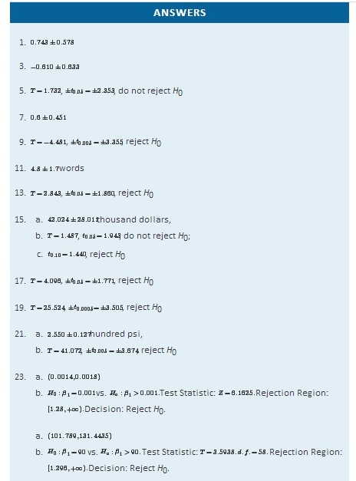
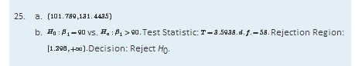

0.6 The Coefficient of Determination

LEARNING OBJECTIVE
- To learn what the coefficient of determination is, how to compute it, and what it tells us about the relationship between two variables xand y.

If the scatter diagram of a set of (x,y) pairs shows neither an upward or downward trend, then the horizontal line yˆ=y− fits it well, as illustrated in Figure 10.11. The lack of any upward or downward trend means that when an element of the population is selected at random, knowing the value of the measurement x for that element is not helpful in predicting the value of the measurement y.
Figure 10.11
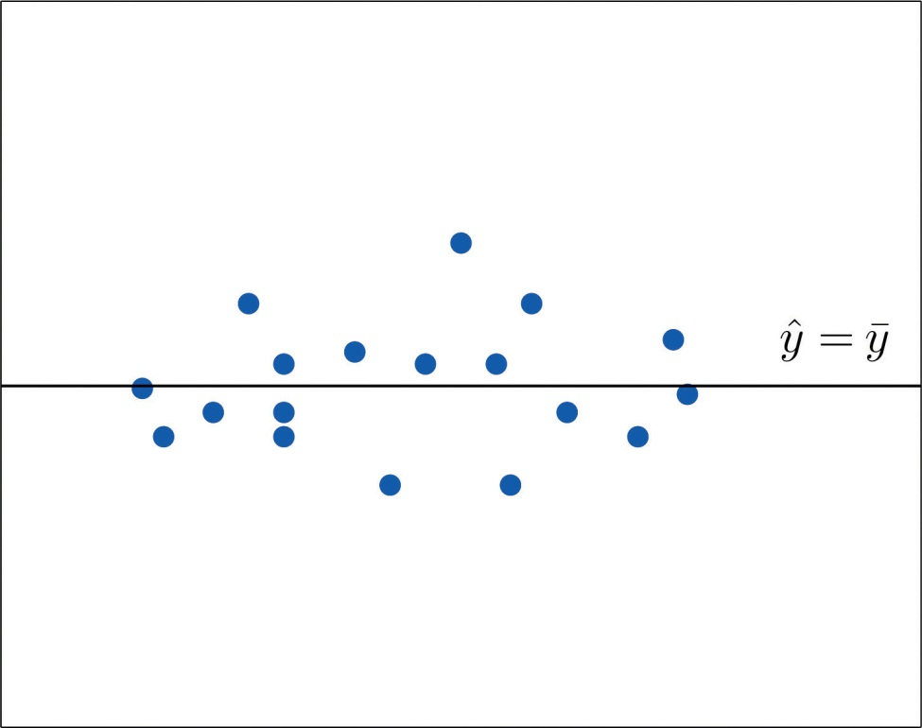
yˆ=y−
If the scatter diagram shows a linear trend upward or downward then it is useful to compute the least squares regression line yˆ=βˆ1x+βˆ0 and use it in predicting y. Figure 10.12 "Same Scatter Diagram with Two Approximating Lines" illustrates this. In each panel we have plotted the height and weight data of Section 10.1 "Linear Relationships Between Variables". This is the same scatter plot as Figure 10.2 "Plot of Height and Weight Pairs", with the average value line yˆ=y− superimposed on it in the left panel and the least squares regression line imposed on it in the right panel. The errors are indicated graphically by the vertical line segments.
Figure 10.12 Same Scatter Diagram with Two Approximating Lines
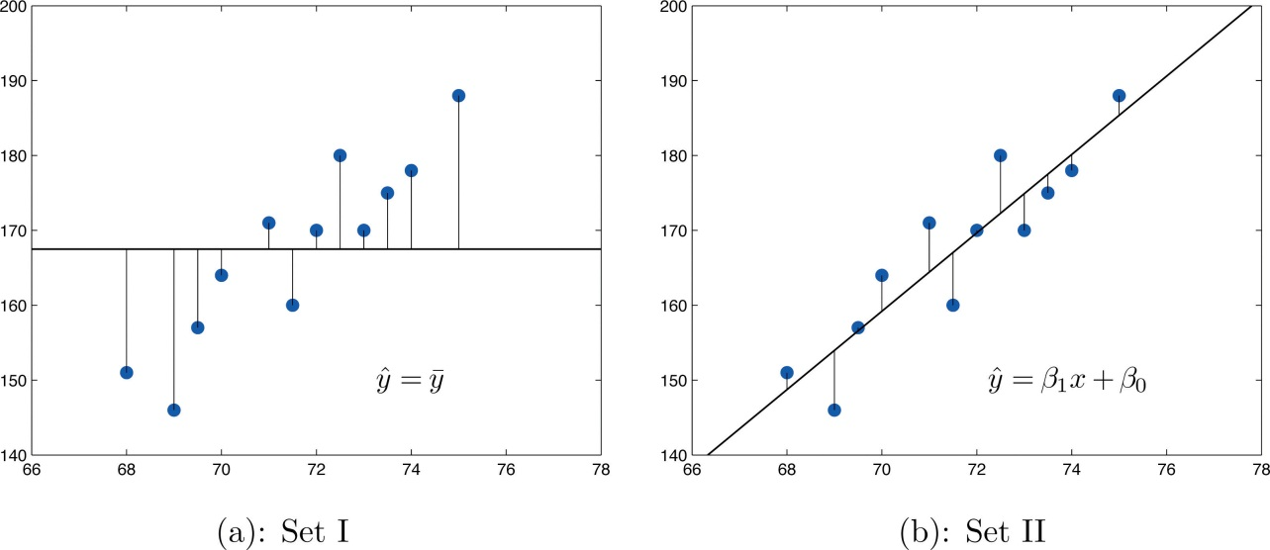
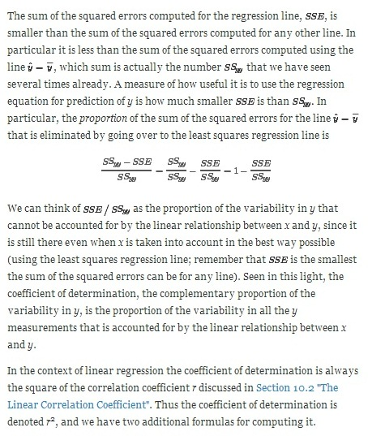

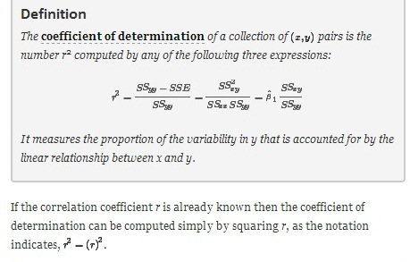
EXAMPLE 10
The value of used vehicles of the make and model discussed in Note 10.19 "Example 3" in Section 10.4 "The Least Squares Regression Line"varies widely. The most expensive automobile in the sample in Table 10.3 "Data on Age and Value of Used Automobiles of a Specific Make and Model" has value $30,500, which is nearly half again as much as the least expensive one, which is worth $20,400. Find the proportion of the variability in value that is accounted for by the linear relationship between age and value.
Solution:

The proportion of the variability in value y that is accounted for by the linear relationship between it and age x is given by the coefficient of determination, r². Since the correlation coefficient r was already computed in Note 10.19 "Example 3" as r=−0.819, r2=(−0.819)2=0.671.About 67% of the variability in the value of this vehicle can be explained by its age.

EXAMPLE 11
Use each of the three formulas for the coefficient of determination to compute its value for the example of ages and values of vehicles.
Solution:

In Note 10.19 "Example 3" in Section 10.4 "The Least Squares Regression Line" we computed the exact values
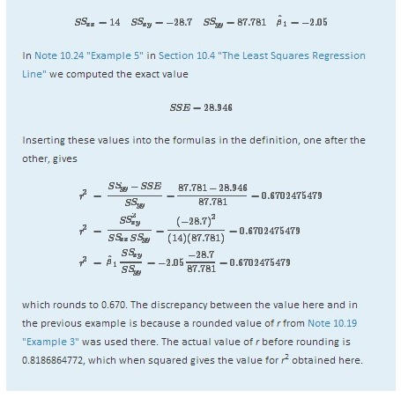

The coefficient of determination r² can always be computed by squaring the correlation coefficient r if it is known. Any one of the defining formulas can also be used. Typically one would make the choice based on which quantities have already been computed. What should be avoided is trying to compute rby taking the square root of r², if it is already known, since it is easy to make a sign error this way. To see what can go wrong, suppose r2=0.64. Taking the square root of a positive number with any calculating device will always return a positive result. The square root of 0.64 is 0.8. However, the actual value of r might be the negative number −0.8.

KEY TAKEAWAYS
- The coefficient of determination r² estimates the proportion of the variability in the variable y that is explained by the linear relationship between y and the variable x.
- There are several formulas for computing r². The choice of which one to use can be based on which quantities have already been computed so far.

EXERCISES

BASIC
For the Basic and Application exercises in this section use the computations that were done for the exercises with the same number inSection 10.2 "The Linear Correlation Coefficient", Section 10.4 "The Least Squares Regression Line", and Section 10.5 "Statistical Inferences About ".
- For the sample data set of Exercise 1 of Section 10.2 "The Linear Correlation Coefficient" find the coefficient of determination using the formula r2=βˆ1SSxy/SSyy. Confirm your answer by squaring r as computed in that exercise.
- For the sample data set of Exercise 2 of Section 10.2 "The Linear Correlation Coefficient" find the coefficient of determination using the formula r2=βˆ1SSxy/SSyy. Confirm your answer by squaring r as computed in that exercise.
- For the sample data set of Exercise 3 of Section 10.2 "The Linear Correlation Coefficient" find the coefficient of determination using the formula r2=βˆ1SSxy/SSyy. Confirm your answer by squaring r as computed in that exercise.
- For the sample data set of Exercise 4 of Section 10.2 "The Linear Correlation Coefficient" find the coefficient of determination using the formula r2=βˆ1SSxy/SSyy. Confirm your answer by squaring r as computed in that exercise.
- For the sample data set of Exercise 5 of Section 10.2 "The Linear Correlation Coefficient" find the coefficient of determination using the formula r2=βˆ1SSxy/SSyy. Confirm your answer by squaring r as computed in that exercise.
- For the sample data set of Exercise 6 of Section 10.2 "The Linear Correlation Coefficient" find the coefficient of determination using the formula r2=βˆ1SSxy/SSyy. Confirm your answer by squaring r as computed in that exercise.
- For the sample data set of Exercise 7 of Section 10.2 "The Linear Correlation Coefficient" find the coefficient of determination using the formula r2=(SSyy−SSE)/SSyy. Confirm your answer by squaring r as computed in that exercise.
- For the sample data set of Exercise 8 of Section 10.2 "The Linear Correlation Coefficient" find the coefficient of determination using the formula r2=(SSyy−SSE)/SSyy. Confirm your answer by squaring r as computed in that exercise.
- For the sample data set of Exercise 9 of Section 10.2 "The Linear Correlation Coefficient" find the coefficient of determination using the formula r2=(SSyy−SSE)/SSyy. Confirm your answer by squaring r as computed in that exercise.
- For the sample data set of Exercise 9 of Section 10.2 "The Linear Correlation Coefficient" find the coefficient of determination using the formula r2=(SSyy−SSE)/SSyy. Confirm your answer by squaring r as computed in that exercise.

APPLICATIONS
- For the data in Exercise 11 of Section 10.2 "The Linear Correlation Coefficient" compute the coefficient of determination and interpret its value in the context of age and vocabulary.
- For the data in Exercise 12 of Section 10.2 "The Linear Correlation Coefficient" compute the coefficient of determination and interpret its value in the context of vehicle weight and braking distance.
- For the data in Exercise 13 of Section 10.2 "The Linear Correlation Coefficient" compute the coefficient of determination and interpret its value in the context of age and resting heart rate. In the age range of the data, does age seem to be a very important factor with regard to heart rate?
- For the data in Exercise 14 of Section 10.2 "The Linear Correlation Coefficient" compute the coefficient of determination and interpret its value in the context of wind speed and wave height. Does wind speed seem to be a very important factor with regard to wave height?
- For the data in Exercise 15 of Section 10.2 "The Linear Correlation Coefficient" find the proportion of the variability in revenue that is explained by level of advertising.
- For the data in Exercise 16 of Section 10.2 "The Linear Correlation Coefficient" find the proportion of the variability in adult height that is explained by the variation in length at age two.
- For the data in Exercise 17 of Section 10.2 "The Linear Correlation Coefficient" compute the coefficient of determination and interpret its value in the context of course average before the final exam and score on the final exam.
- For the data in Exercise 18 of Section 10.2 "The Linear Correlation Coefficient" compute the coefficient of determination and interpret its value in the context of acres planted and acres harvested.
- For the data in Exercise 19 of Section 10.2 "The Linear Correlation Coefficient" compute the coefficient of determination and interpret its value in the context of the amount of the medication consumed and blood concentration of the active ingredient.
- For the data in Exercise 20 of Section 10.2 "The Linear Correlation Coefficient" compute the coefficient of determination and interpret its value in the context of tree size and age.
- For the data in Exercise 21 of Section 10.2 "The Linear Correlation Coefficient" find the proportion of the variability in 28-day strength of concrete that is accounted for by variation in 3-day strength.
- For the data in Exercise 22 of Section 10.2 "The Linear Correlation Coefficient" find the proportion of the variability in energy demand that is accounted for by variation in average temperature.

LARGE DATA SET EXERCISES
- Large Data Set 1 lists the SAT scores and GPAs of 1,000 students. Compute the coefficient of determination and interpret its value in the context of SAT scores and GPAs.
http://www.flatworldknowledge.com/sites/all/files/data1.xls
- Large Data Set 12 lists the golf scores on one round of golf for 75 golfers first using their own original clubs, then using clubs of a new, experimental design (after two months of familiarization with the new clubs). Compute the coefficient of determination and interpret its value in the context of golf scores with the two kinds of golf clubs.
http://www.flatworldknowledge.com/sites/all/files/data12.xls
- Large Data Set 13 records the number of bidders and sales price of a particular type of antique grandfather clock at 60 auctions. Compute the coefficient of determination and interpret its value in the context of the number of bidders at an auction and the price of this type of antique grandfather clock.
http://www.flatworldknowledge.com/sites/all/files/data13.xls

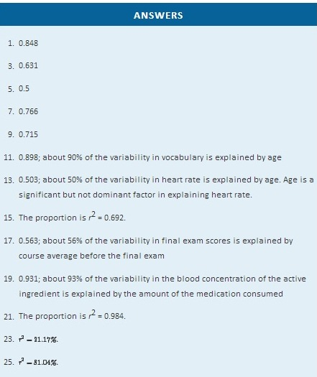
10.7 Estimation and Prediction

LEARNING OBJECTIVES
- To learn the distinction between estimation and prediction.
- To learn the distinction between a confidence interval and a prediction interval.
- To learn how to implement formulas for computing confidence intervals and prediction intervals.

Consider the following pairs of problems, in the context of Note 10.19 "Example 3" in Section 10.4 "The Least Squares Regression Line", the automobile age and value example.

    - Estimate the average value of all four-year-old automobiles of this make and model.
    - Construct a 95% confidence interval for the average value of all four-year-old automobiles of this make and model.

    - Shylock intends to buy a four-year-old automobile of this make and model next week. Predict the value of the first such automobile that he encounters.
    - Construct a 95% confidence interval for the value of the first such automobile that he encounters.

The method of solution and answer to the first question in each pair, (1a) and (2a), are the same. When we set x equal to 4 in the least squares regression equation yˆ=−2.05x+32.83 that was computed in part (c) of Note 10.19 "Example 3" in Section 10.4 "The Least Squares Regression Line", the number returned,
yˆ=−2.05(4)+32.83=24.63
which corresponds to value $24,630, is an estimate of precisely the number sought in question (1a): the mean E(y) of all y values when x = 4. Since nothing is known about the first four-year-old automobile of this make and model that Shylock will encounter, our best guess as to its value is the mean value E(y) of all such automobiles, the number 24.63 or $24,630, computed in the same way.

The answers to the second part of each question differ. In question (1b) we are trying to estimate a population parameter: the mean of the all the y-values in the sub-population picked out by the value x = 4, that is, the average value of all four-year-old automobiles. In question (2b), however, we are not trying to capture a fixed parameter, but the value of the random variable y in one trial of an experiment: examine the first four-year-old car Shylock encounters. In the first case we seek to construct a confidence interval in the same sense that we have done before. In the second case the situation is different, and the interval constructed has a different name, prediction interval. In the second case we are trying to “predict” where a the value of a random variable will take its value.
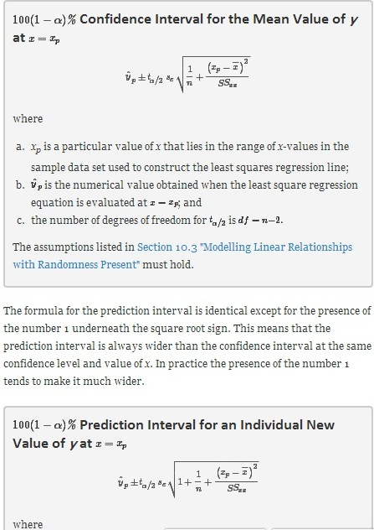
- x_{p} is a particular value of x that lies in the range of x-values in the data set used to construct the least squares regression line;
- yˆp is the numerical value obtained when the least square regression equation is evaluated at x=xp; and
- the number of degrees of freedom for tα/2 is df=n−2.
The assumptions listed in Section 10.3 "Modelling Linear Relationships with Randomness Present" must hold.

EXAMPLE 12
Using the sample data of Note 10.19 "Example 3" in Section 10.4 "The Least Squares Regression Line", recorded in Table 10.3 "Data on Age and Value of Used Automobiles of a Specific Make and Model", construct a 95% confidence interval for the average value of all three-and-one-half-year-old automobiles of this make and model.
Solution:

Solving this problem is merely a matter of finding the values of yˆp, α and tα/2, sε, x−, and SSxx and inserting them into the confidence interval formula given just above. Most of these quantities are already known. From Note 10.19 "Example 3" in Section 10.4 "The Least Squares Regression Line", SSxx=14 and x−=4. From Note 10.31 "Example 7" inSection 10.5 "Statistical Inferences About ", sε=1.902169814.

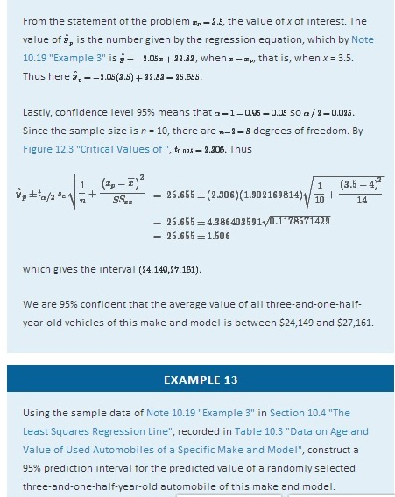

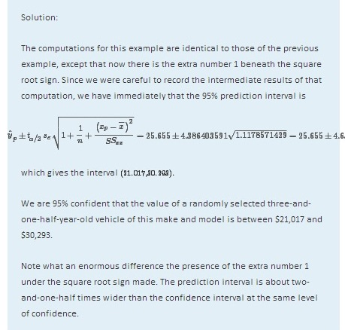

KEY TAKEAWAYS
- A confidence interval is used to estimate the mean value of y in the sub-population determined by the condition that x have some specific value x_{p}.
- The prediction interval is used to predict the value that the random variable y will take when x has some specific value x_{p}.

EXERCISES

BASIC
For the Basic and Application exercises in this section use the computations that were done for the exercises with the same number in previous sections.
- For the sample data set of Exercise 1 of Section 10.2 "The Linear Correlation Coefficient"
  - Give a point estimate for the mean value of y in the sub-population determined by the condition x = 4.
  - Construct the 90% confidence interval for that mean value.
- For the sample data set of Exercise 2 of Section 10.2 "The Linear Correlation Coefficient"
  - Give a point estimate for the mean value of y in the sub-population determined by the condition x = 4.
  - Construct the 90% confidence interval for that mean value.
- For the sample data set of Exercise 3 of Section 10.2 "The Linear Correlation Coefficient"
  - Give a point estimate for the mean value of y in the sub-population determined by the condition x = 7.
  - Construct the 95% confidence interval for that mean value.
- For the sample data set of Exercise 4 of Section 10.2 "The Linear Correlation Coefficient"
  - Give a point estimate for the mean value of y in the sub-population determined by the condition x = 2.
  - Construct the 80% confidence interval for that mean value.
- For the sample data set of Exercise 5 of Section 10.2 "The Linear Correlation Coefficient"
  - Give a point estimate for the mean value of y in the sub-population determined by the condition x = 1.
  - Construct the 80% confidence interval for that mean value.
- For the sample data set of Exercise 6 of Section 10.2 "The Linear Correlation Coefficient"
  - Give a point estimate for the mean value of y in the sub-population determined by the condition x = 5.
  - Construct the 95% confidence interval for that mean value.
- For the sample data set of Exercise 7 of Section 10.2 "The Linear Correlation Coefficient"
  - Give a point estimate for the mean value of y in the sub-population determined by the condition x = 6.
  - Construct the 99% confidence interval for that mean value.
  - Is it valid to make the same estimates for x = 12? Explain.
- For the sample data set of Exercise 8 of Section 10.2 "The Linear Correlation Coefficient"
  - Give a point estimate for the mean value of y in the sub-population determined by the condition x = 12.
  - Construct the 80% confidence interval for that mean value.
  - Is it valid to make the same estimates for x = 0? Explain.
- For the sample data set of Exercise 9 of Section 10.2 "The Linear Correlation Coefficient"
  - Give a point estimate for the mean value of y in the sub-population determined by the condition x = 0.
  - Construct the 90% confidence interval for that mean value.
  - Is it valid to make the same estimates for x=−1? Explain.
- For the sample data set of Exercise 9 of Section 10.2 "The Linear Correlation Coefficient"
  - Give a point estimate for the mean value of y in the sub-population determined by the condition x = 8.
  - Construct the 95% confidence interval for that mean value.
  - Is it valid to make the same estimates for x = 0? Explain.

APPLICATIONS
- For the data in Exercise 11 of Section 10.2 "The Linear Correlation Coefficient"
  - Give a point estimate for the average number of words in the vocabulary of 18-month-old children.
  - Construct the 95% confidence interval for that mean value.
  - Is it valid to make the same estimates for two-year-olds? Explain.
- For the data in Exercise 12 of Section 10.2 "The Linear Correlation Coefficient"
  - Give a point estimate for the average braking distance of automobiles that weigh 3,250 pounds.
  - Construct the 80% confidence interval for that mean value.
  - Is it valid to make the same estimates for 5,000-pound automobiles? Explain.
- For the data in Exercise 13 of Section 10.2 "The Linear Correlation Coefficient"
  - Give a point estimate for the resting heart rate of a man who is 35 years old.
  - One of the men in the sample is 35 years old, but his resting heart rate is not what you computed in part (a). Explain why this is not a contradiction.
  - Construct the 90% confidence interval for the mean resting heart rate of all 35-year-old men.
- For the data in Exercise 14 of Section 10.2 "The Linear Correlation Coefficient"
  - Give a point estimate for the wave height when the wind speed is 13 miles per hour.
  - One of the wind speeds in the sample is 13 miles per hour, but the height of waves that day is not what you computed in part (a). Explain why this is not a contradiction.
  - Construct the 90% confidence interval for the mean wave height on days when the wind speed is 13 miles per hour.
- For the data in Exercise 15 of Section 10.2 "The Linear Correlation Coefficient"
  - The business owner intends to spend $2,500 on advertising next year. Give an estimate of next year’s revenue based on this fact.
  - Construct the 90% prediction interval for next year’s revenue, based on the intent to spend $2,500 on advertising.
- For the data in Exercise 16 of Section 10.2 "The Linear Correlation Coefficient"
  - A two-year-old girl is 32.3 inches long. Predict her adult height.
  - Construct the 95% prediction interval for the girl’s adult height.
- For the data in Exercise 17 of Section 10.2 "The Linear Correlation Coefficient"
  - Lodovico has a 78.6 average in his physics class just before the final. Give a point estimate of what his final exam grade will be.
  - Explain whether an interval estimate for this problem is a confidence interval or a prediction interval.
  - Based on your answer to (b), construct an interval estimate for Lodovico’s final exam grade at the 90% level of confidence.
- For the data in Exercise 18 of Section 10.2 "The Linear Correlation Coefficient"
  - This year 86.2 million acres of corn were planted. Give a point estimate of the number of acres that will be harvested this year.
  - Explain whether an interval estimate for this problem is a confidence interval or a prediction interval.
  - Based on your answer to (b), construct an interval estimate for the number of acres that will be harvested this year, at the 99% level of confidence.
- For the data in Exercise 19 of Section 10.2 "The Linear Correlation Coefficient"
  - Give a point estimate for the blood concentration of the active ingredient of this medication in a man who has consumed 1.5 ounces of the medication just recently.
  - Gratiano just consumed 1.5 ounces of this medication 30 minutes ago. Construct a 95% prediction interval for the concentration of the active ingredient in his blood right now.
- For the data in Exercise 20 of Section 10.2 "The Linear Correlation Coefficient"
  - You measure the girth of a free-standing oak tree five feet off the ground and obtain the value 127 inches. How old do you estimate the tree to be?
  - Construct a 90% prediction interval for the age of this tree.
- For the data in Exercise 21 of Section 10.2 "The Linear Correlation Coefficient"
  - A test cylinder of concrete three days old fails at 1,750 psi. Predict what the 28-day strength of the concrete will be.
  - Construct a 99% prediction interval for the 28-day strength of this concrete.
  - Based on your answer to (b), what would be the minimum 28-day strength you could expect this concrete to exhibit?
- For the data in Exercise 22 of Section 10.2 "The Linear Correlation Coefficient"
  - Tomorrow’s average temperature is forecast to be 53 degrees. Estimate the energy demand tomorrow.
  - Construct a 99% prediction interval for the energy demand tomorrow.
  - Based on your answer to (b), what would be the minimum demand you could expect?

LARGE DATA SET EXERCISES
- Large Data Set 1 lists the SAT scores and GPAs of 1,000 students.
http://www.flatworldknowledge.com/sites/all/files/data1.xls

  - Give a point estimate of the mean GPA of all students who score 1350 on the SAT.
  - Construct a 90% confidence interval for the mean GPA of all students who score 1350 on the SAT.
- Large Data Set 12 lists the golf scores on one round of golf for 75 golfers first using their own original clubs, then using clubs of a new, experimental design (after two months of familiarization with the new clubs).
http://www.flatworldknowledge.com/sites/all/files/data12.xls

  - Thurio averages 72 strokes per round with his own clubs. Give a point estimate for his score on one round if he switches to the new clubs.
  - Explain whether an interval estimate for this problem is a confidence interval or a prediction interval.
  - Based on your answer to (b), construct an interval estimate for Thurio’s score on one round if he switches to the new clubs, at 90% confidence.
- Large Data Set 13 records the number of bidders and sales price of a particular type of antique grandfather clock at 60 auctions.
http://www.flatworldknowledge.com/sites/all/files/data13.xls

  - There are seven likely bidders at the Verona auction today. Give a point estimate for the price of such a clock at today’s auction.
  - Explain whether an interval estimate for this problem is a confidence interval or a prediction interval.
  - Based on your answer to (b), construct an interval estimate for the likely sale price of such a clock at today’s sale, at 95% confidence.
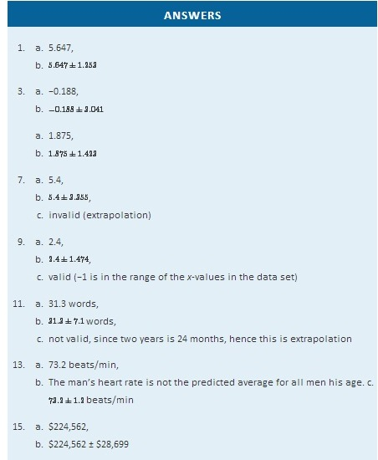
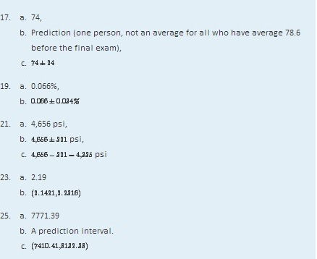

10.8 A Complete Example

LEARNING OBJECTIVE
- To see a complete linear correlation and regression analysis, in a practical setting, as a cohesive whole.

In the preceding sections numerous concepts were introduced and illustrated, but the analysis was broken into disjoint pieces by sections. In this section we will go through a complete example of the use of correlation and regression analysis of data from start to finish, touching on all the topics of this chapter in sequence.

In general educators are convinced that, all other factors being equal, class attendance has a significant bearing on course performance. To investigate the relationship between attendance and performance, an education researcher selects for study a multiple section introductory statistics course at a large university. Instructors in the course agree to keep an accurate record of attendance throughout one semester. At the end of the semester 26 students are selected a random. For each student in the sample two measurements are taken: x, the number of days the student was absent, andy, the student’s score on the common final exam in the course. The data are summarized in Table 10.4 "Absence and Score Data".

Table 10.4 Absence and Score Data
Absences | Score | Absences | Score
x | y | x | y
2 | 76 | 4 | 41
7 | 29 | 5 | 63
2 | 96 | 4 | 88
7 | 63 | 0 | 98
2 | 79 | 1 | 99
7 | 71 | 0 | 89
0 | 88 | 1 | 96
0 | 92 | 3 | 90
6 | 55 | 1 | 90
6 | 70 | 3 | 68
2 | 80 | 1 | 84
2 | 75 | 3 | 80
1 | 63 | 1 | 78
A scatter plot of the data is given in Figure 10.13 "Plot of the Absence and Exam Score Pairs". There is a downward trend in the plot which indicates that on average students with more absences tend to do worse on the final examination.
Figure 10.13 Plot of the Absence and Exam Score Pairs
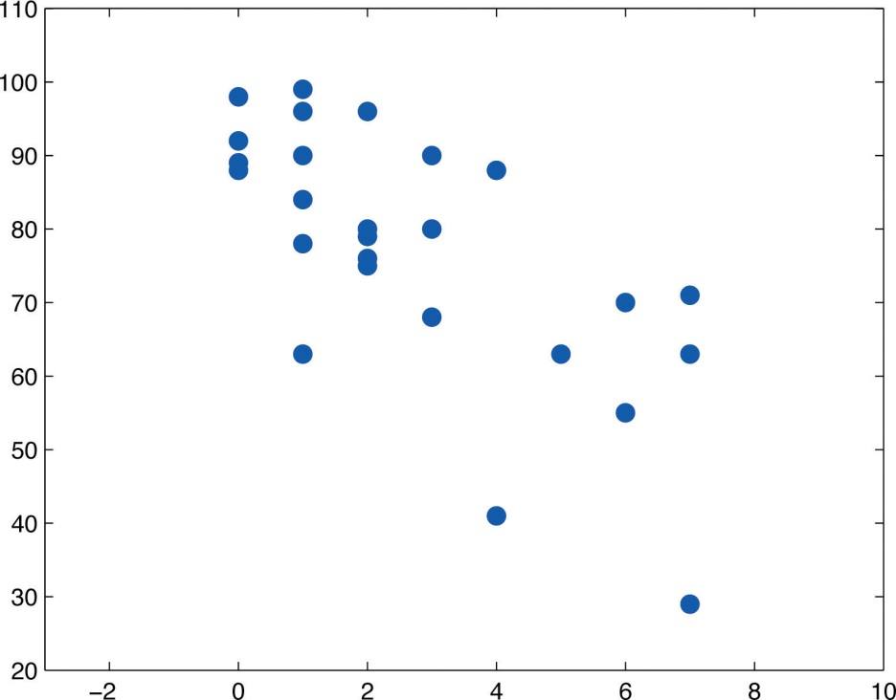
The trend observed in Figure 10.13 "Plot of the Absence and Exam Score Pairs" as well as the fairly constant width of the apparent band of points in the plot makes it reasonable to assume a relationship between x and y of the form
y=β1x+β0+ε
where β1 and β0 are unknown parameters and ε is a normal random variable with mean zero and unknown standard deviation σ. Note carefully that this model is being proposed for the population of all students taking this course, not just those taking it this semester, and certainly not just those in the sample. The numbers β1, β0, and σ are parameters relating to this large population.
First we perform preliminary computations that will be needed later. The data are processed in Table 10.5 "Processed Absence and Score Data".
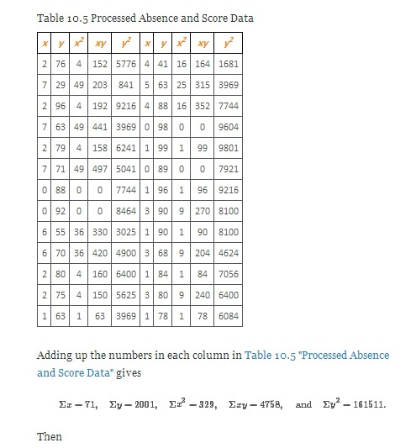
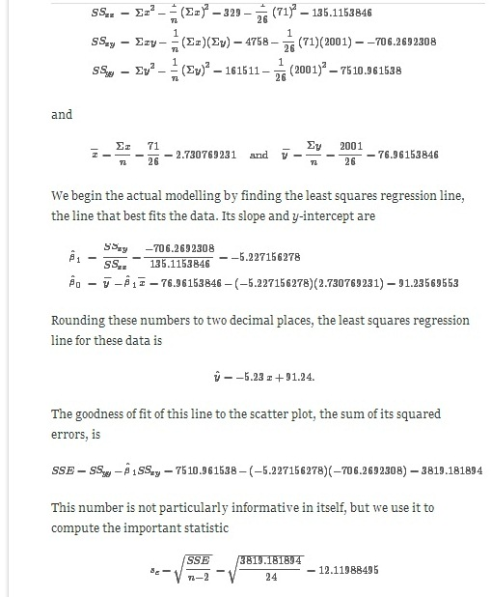
The statistic sε estimates the standard deviation σ of the normal random variable ε in the model. Its meaning is that among all students with the same number of absences, the standard deviation of their scores on the final exam is about 12.1 points. Such a large value on a 100-point exam means that the final exam scores of each sub-population of students, based on the number of absences, are highly variable.

The size and sign of the slope βˆ1=−5.23 indicate that, for every class missed, students tend to score about 5.23 fewer points lower on the final exam on average. Similarly for every two classes missed students tend to score on average 2×5.23=10.46 fewer points on the final exam, or about a letter grade worse on average.

Since 0 is in the range of x-values in the data set, the y-intercept also has meaning in this problem. It is an estimate of the average grade on the final exam of all students who have perfect attendance. The predicted average of such students is βˆ0=91.24.

Before we use the regression equation further, or perform other analyses, it would be a good idea to examine the utility of the linear regression model. We can do this in two ways: 1) by computing the correlation coefficient r to see how strongly the number of absences x and the score y on the final exam are correlated, and 2) by testing the null hypothesis H0:β1=0 (the slope of the population regression line is zero, so x is not a good predictor of y) against the natural alternative Ha:β1<0 (the slope of the population regression line is negative, so final exam scores y go down as absences x go up).
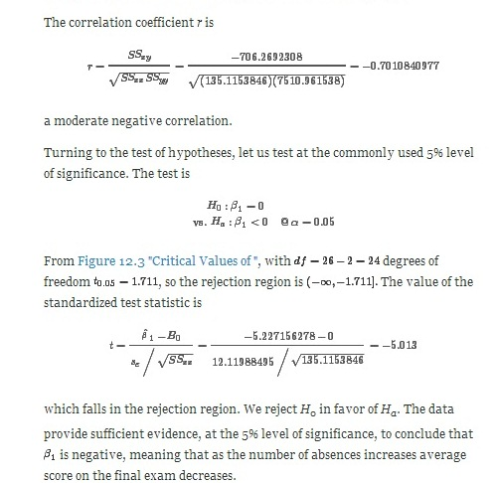

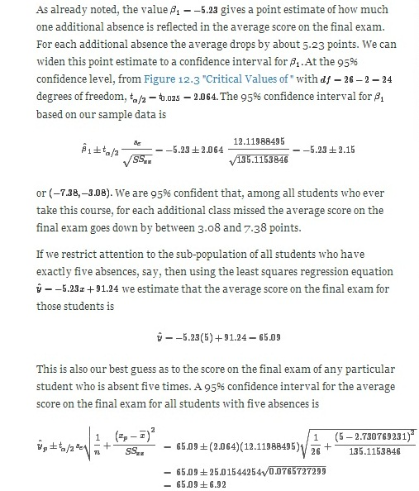
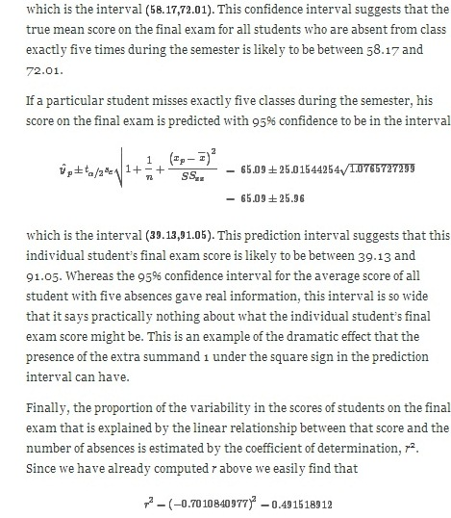
or about 49%. Thus although there is a significant correlation between attendance and performance on the final exam, and we can estimate with fair accuracy the average score of students who miss a certain number of classes, nevertheless less than half the total variation of the exam scores in the sample is explained by the number of absences. This should not come as a surprise, since there are many factors besides attendance that bear on student performance on exams.

KEY TAKEAWAY
- It is a good idea to attend class.

EXERCISES
The exercises in this section are unrelated to those in previous sections.
- The data give the amount x of silicofluoride in the water (mg/L) and the amount y of lead in the bloodstream (μg/dL) of ten children in various communities with and without municipal water. Perform a complete analysis of the data, in analogy with the discussion in this section (that is, make a scatter plot, do preliminary computations, find the least squares regression line, find SSE, sε, and r, and so on). In the hypothesis test use as the alternative hypothesis β1>0, and test at the 5% level of significance. Use confidence level 95% for the confidence interval for β1. Construct 95% confidence and predictions intervals at xp=2 at the end.
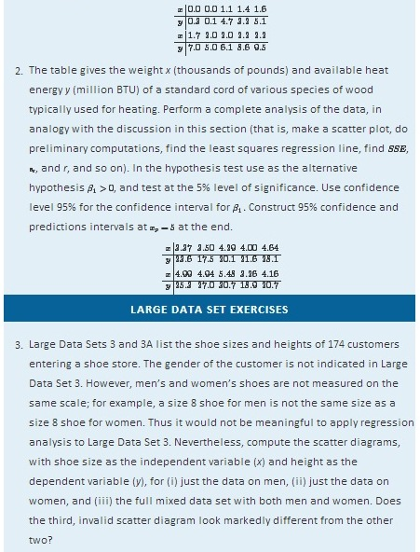
http://www.flatworldknowledge.com/sites/all/files/data3.xls
http://www.flatworldknowledge.com/sites/all/files/data3A.xls
- Separate out from Large Data Set 3A just the data on men and do a complete analysis, with shoe size as the independent variable (x) and height as the dependent variable (y). Use α=0.05 and xp=10 whenever appropriate.
http://www.flatworldknowledge.com/sites/all/files/data3A.xls

- Separate out from Large Data Set 3A just the data on women and do a complete analysis, with shoe size as the independent variable (x) and height as the dependent variable (y). Use α=0.05 and xp=10 whenever appropriate.
http://www.flatworldknowledge.com/sites/all/files/data3A.xls
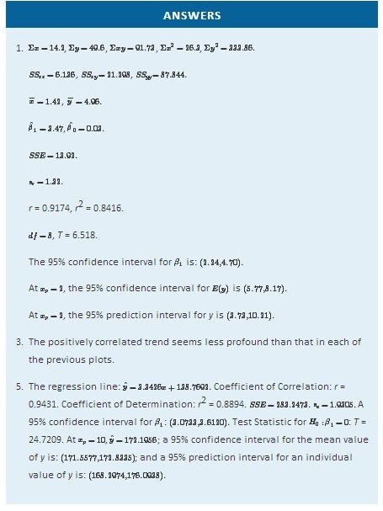
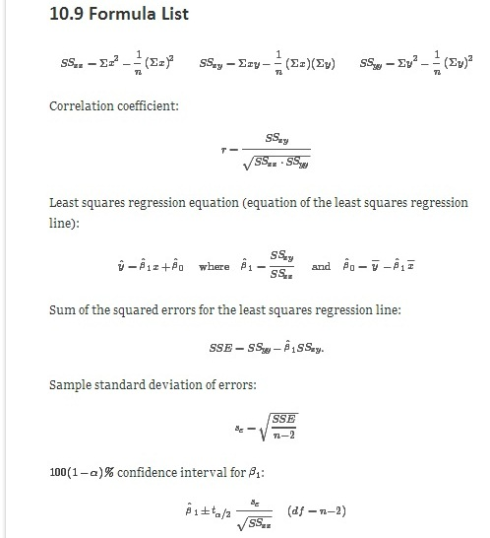
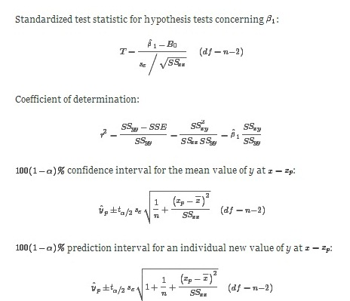

Chapter 11

Chi-Square Tests and F-Tests

In previous chapters you saw how to test hypotheses concerning population means and population proportions. The idea of testing hypotheses can be extended to many other situations that involve different parameters and use different test statistics. Whereas the standardized test statistics that appeared in earlier chapters followed either a normal or Student t-distribution, in this chapter the tests will involve two other very common and useful distributions, the chi-square and the F-distributions. The chi-square distribution arises in tests of hypotheses concerning the independence of two random variables and concerning whether a discrete random variable follows a specified distribution. The F-distribution arises in tests of hypotheses concerning whether or not two population variances are equal and concerning whether or not three or more population means are equal.

11.1 Chi-Square Tests for Independence

LEARNING OBJECTIVES
- To understand what chi-square distributions are.
- To understand how to use a chi-square test to judge whether two factors are independent.

Chi-Square Distributions
As you know, there is a whole family of t-distributions, each one specified by a parameter called the degrees of freedom, denoted df. Similarly, all the chi-square distributions form a family, and each of its members is also specified by a parameter df, the number of degrees of freedom. Chi is a Greek letter denoted by the symbol χ and chi-square is often denoted by χ2. Figure 11.1 "Many " shows several chi-square distributions for different degrees of freedom. A chi-square random variable is a random variable that assumes only positive values and follows a chi-square distribution.
Figure 11.1 Many χ2 Distributions
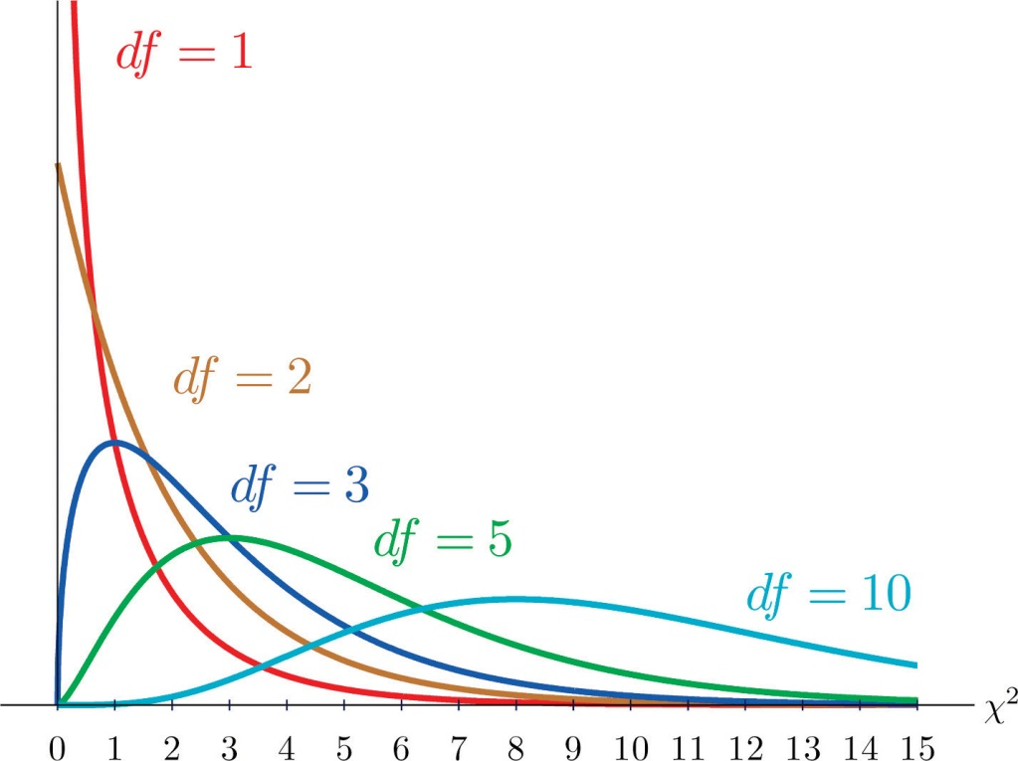

Definition
The value of the chi-square random variable χ2 with df=k that cuts off a right tail of area c is denoted χ2c and is called a critical value. See Figure 11.2.

Figure 11.2χ2c Illustrated
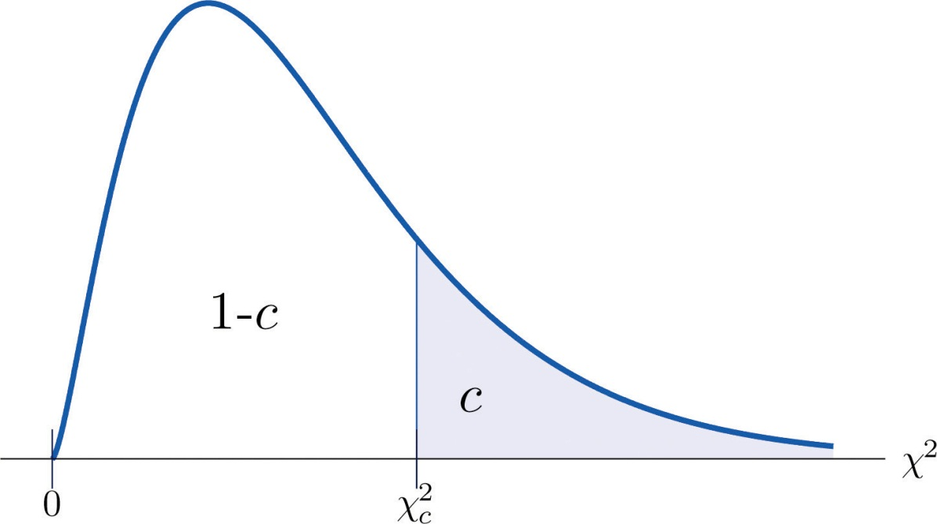
Figure 12.4 "Critical Values of Chi-Square Distributions" gives values of χ2cfor various values of c and under several chi-square distributions with various degrees of freedom.

Tests for Independence

Hypotheses tests encountered earlier in the book had to do with how the numerical values of two population parameters compared. In this subsection we will investigate hypotheses that have to do with whether or not two random variables take their values independently, or whether the value of one has a relation to the value of the other. Thus the hypotheses will be expressed in words, not mathematical symbols. We build the discussion around the following example.

There is a theory that the gender of a baby in the womb is related to the baby’s heart rate: baby girls tend to have higher heart rates. Suppose we wish to test this theory. We examine the heart rate records of 40 babies taken during their mothers’ last prenatal checkups before delivery, and to each of these 40 randomly selected records we compute the values of two random measures: 1) gender and 2) heart rate. In this context these two random measures are often called factors. Since the burden of proof is that heart rate and gender are related, not that they are unrelated, the problem of testing the theory on baby gender and heart rate can be formulated as a test of the following hypotheses:

H_{O}: Baby gender and baby heart rate are independent
vs. Ha: Baby gender and baby heart rate are not independent
The factor gender has two natural categories or levels: boy and girl. We divide the second factor, heart rate, into two levels, low and high, by choosing some heart rate, say 145 beats per minute, as the cutoff between them. A heart rate below 145 beats per minute will be considered low and 145 and above considered high. The 40 records give rise to a 2 × 2contingency table. By adjoining row totals, column totals, and a grand total we obtain the table shown as Table 11.1 "Baby Gender and Heart Rate". The four entries in boldface type are counts of observations from the sample of n= 40. There were 11 girls with low heart rate, 17 boys with low heart rate, and so on. They form the core of the expanded table.

Table 11.1 Baby Gender and Heart Rate
 |  | Heart Rate
 |  | Low | High | Row Total
Gender | Girl | 11 | 7 | 18
 | Boy | 17 | 5 | 22
Column Total |  | 28 | 12 | Total = 40

In analogy with the fact that the probability of independent events is the product of the probabilities of each event, if heart rate and gender were independent then we would expect the number in each core cell to be close to the product of the row total R and column total C of the row and column containing it, divided by the sample size n. Denoting such an expected number of observations E, these four expected values are:

- 1st row and 1st column: E=(R×C)/n=18×28/40=12.6
- 1st row and 2nd column: E=(R×C)/n=18×12/40=5.4
- 2nd row and 1st column: E=(R×C)/n=22×28/40=15.4
- 2nd row and 2nd column: E=(R×C)/n=22×12/40=6.6

We update Table 11.1 "Baby Gender and Heart Rate" by placing each expected value in its corresponding core cell, right under the observed value in the cell. This gives the updated table Table 11.2 "Updated Baby Gender and Heart Rate".

Table 11.2 Updated Baby Gender and Heart Rate
 |  | Heart Rate
 |  | Low | High | Row Total
Gender | Girl | O=11E=12.6 | O=7E=5.4 | R = 18
 | Boy | O=17E=15.4 | O=5E=6.6 | R = 22
Column Total |  | C = 28 | C = 12 | n = 40

A measure of how much the data deviate from what we would expect to see if the factors really were independent is the sum of the squares of the difference of the numbers in each core cell, or, standardizing by dividing each square by the expected number in the cell, the sum Σ(O−E)^{2/}E. We would reject the null hypothesis that the factors are independent only if this number is large, so the test is right-tailed. In this example the random variable Σ(O−E)²/E has the chi-square distribution with one degree of freedom. If we had decided at the outset to test at the 10% level of significance, the critical value defining the rejection region would be, reading from Figure 12.4 "Critical Values of Chi-Square Distributions", χ2α=χ20.10=2.706, so that the rejection region would be the interval [2.706,∞). When we compute the value of the standardized test statistic we obtain
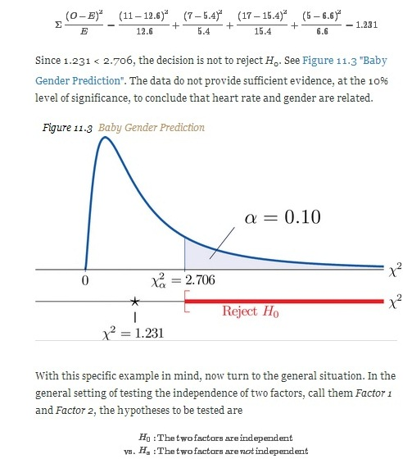
As in the example each factor is divided into a number of categories or levels. These could arise naturally, as in the boy-girl division of gender, or somewhat arbitrarily, as in the high-low division of heart rate. Suppose Factor 1 has I levels and Factor 2 has J levels. Then the information from a random sample gives rise to a general I × J contingency table, which with row totals, column totals, and a grand total would appear as shown in Table 11.3 "General Contingency Table". Each cell may be labeled by a pair of indices (i,j). Oij stands for the observed count of observations in the cell in row i and column j, R_{i} for the ith row total and C_{j} for the jth column total. To simplify the notation we will drop the indices so Table 11.3 "General Contingency Table" becomes Table 11.4 "Simplified General Contingency Table". Nevertheless it is important to keep in mind that the Os, the Rs and the Cs, though denoted by the same symbols, are in fact different numbers.
Table 11.3 General Contingency Table
 |  | Factor 2 Levels
 |  | 1 | ⋅ ⋅ ⋅ | j | ⋅ ⋅ ⋅ | J | Row Total
Factor 1 Levels | 1 | O₁₁ | ⋅ ⋅ ⋅ | O1j | ⋅ ⋅ ⋅ | O1J | R₁
 | ⋮ | ⋮ | ⋮ | ⋮ | ⋮ | ⋮ | ⋮
 | i | Oi1 | ⋅ ⋅ ⋅ | Oij | ⋅ ⋅ ⋅ | OiJ | R_{i}
 | ⋮ | ⋮ | ⋮ | ⋮ | ⋮ | ⋮ | ⋮
 | I | OI1 | ⋅ ⋅ ⋅ | OIj | ⋅ ⋅ ⋅ | OIJ | R_{I}
Column Total |  | C₁ | ⋅ ⋅ ⋅ | C_{j} | ⋅ ⋅ ⋅ | C_{J} | n
Table 11.4 Simplified General Contingency Table
 |  | Factor 2 Levels
 |  | 1 | ⋅ ⋅ ⋅ | j | ⋅ ⋅ ⋅ | J | Row Total
Factor 1 Levels | 1 | O | ⋅ ⋅ ⋅ | O | ⋅ ⋅ ⋅ | O | R
 | ⋮ | ⋮ | ⋮ | ⋮ | ⋮ | ⋮ | ⋮
 | i | O | ⋅ ⋅ ⋅ | O | ⋅ ⋅ ⋅ | O | R
 | ⋮ | ⋮ | ⋮ | ⋮ | ⋮ | ⋮ | ⋮
 | I | O | ⋅ ⋅ ⋅ | O | ⋅ ⋅ ⋅ | O | R
Column Total |  | C | ⋅ ⋅ ⋅ | C | ⋅ ⋅ ⋅ | C | n
As in the example, for each core cell in the table we compute what would be the expected number E of observations if the two factors were independent. E is computed for each core cell (each cell with an O in it) of Table 11.4 "Simplified General Contingency Table" by the rule applied in the example:
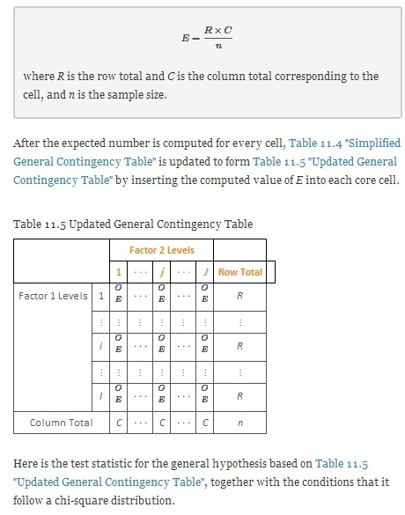
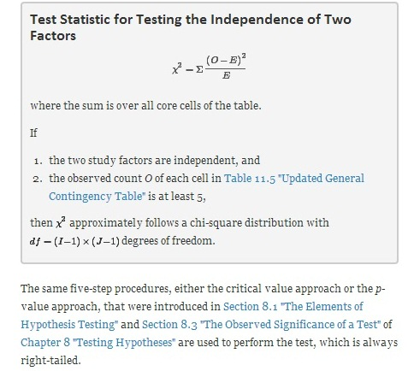

EXAMPLE 1
A researcher wishes to investigate whether students’ scores on a college entrance examination (CEE) have any indicative power for future college performance as measured by GPA. In other words, he wishes to investigate whether the factors CEE and GPA are independent or not. He randomly selects n = 100 students in a college and notes each student’s score on the entrance examination and his grade point average at the end of the sophomore year. He divides entrance exam scores into two levels and grade point averages into three levels. Sorting the data according to these divisions, he forms the contingency table shown as Table 11.6 "CEE versus GPA Contingency Table", in which the row and column totals have already been computed.

TABLE 11.6 CEE VERSUS GPA CONTINGENCY TABLE
 |  | GPA
 |  | <2.7 | 2.7 to 3.2 | >3.2 | Row Total
CEE | <1800 | 35 | 12 | 5 | 52
 | ≥1800 | 6 | 24 | 18 | 48
Column Total |  | 41 | 36 | 23 | Total=100
Test, at the 1% level of significance, whether these data provide sufficient evidence to conclude that CEE scores indicate future performance levels of incoming college freshmen as measured by GPA.
Solution:
We perform the test using the critical value approach, following the usual five-step method outlined at the end of Section 8.1 "The Elements of Hypothesis Testing" in Chapter 8 "Testing Hypotheses".
- Step 1. The hypotheses are
H0: CEE and GPA are independent factors
vs. Ha: CEE and GPA are not independent factors
- Step 2. The distribution is chi-square.
- Step 3. To compute the value of the test statistic we must first computed the expected number for each of the six core cells (the ones whose entries are boldface):
  - 1st row and 1st column: E=(R×C)/n=41×52/100=21.32
  - 1st row and 2nd column: E=(R×C)/n=36×52/100=18.72
  - 1st row and 3rd column: E=(R×C)/n=23×52/100=11.96
  - 2nd row and 1st column: E=(R×C)/n=41×48/100=19.68
  - 2nd row and 2nd column: E=(R×C)/n=36×48/100=17.28
  - 2nd row and 3rd column: E=(R×C)/n=23×48/100=11.04
Table 11.6 "CEE versus GPA Contingency Table" is updated toTable 11.7 "Updated CEE versus GPA Contingency Table".
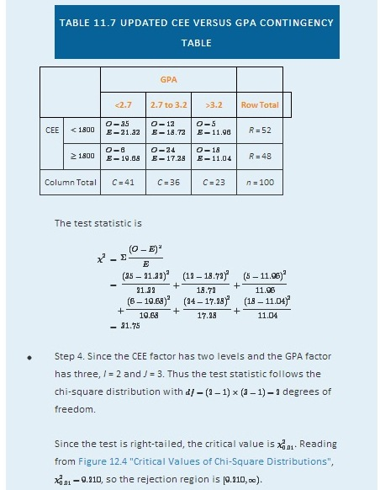
- Step 5. Since 31.75 > 9.21 the decision is to reject the null hypothesis. See Figure 11.4. The data provide sufficient evidence, at the 1% level of significance, to conclude that CEE score and GPA are not independent: the entrance exam score has predictive power.

Figure 11.4Note 11.9 "Example 1"
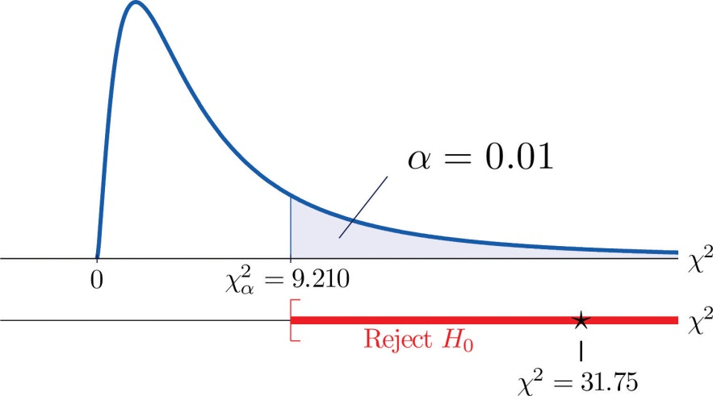

KEY TAKEAWAYS
- Critical values of a chi-square distribution with degrees of freedom df are found in Figure 12.4 "Critical Values of Chi-Square Distributions".
- A chi-square test can be used to evaluate the hypothesis that two random variables or factors are independent.
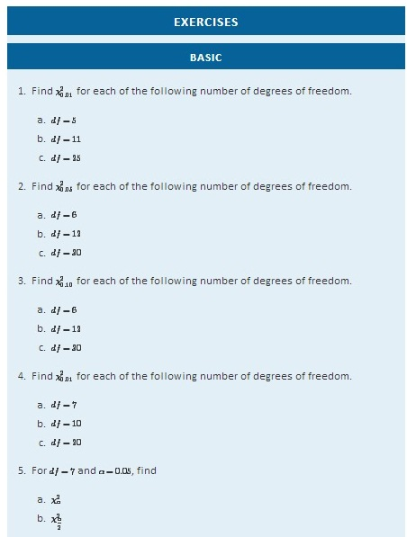
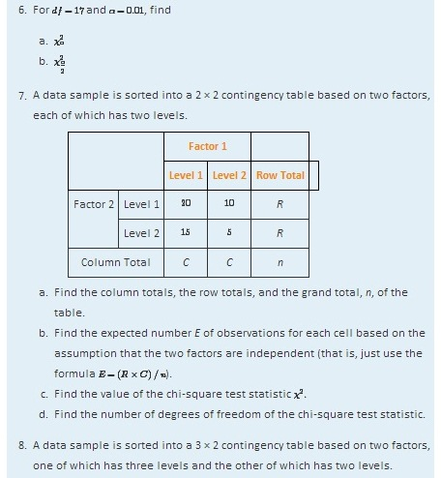
 |  | Factor 1
 |  | Level 1 | Level 2 | Row Total
Factor 2 | Level 1 | 20 | 10 | R
 | Level 2 | 15 | 5 | R
 | Level 3 | 10 | 20 | R
Column Total |  | C | C | n
- Find the column totals, the row totals, and the grand total, n, of the table.
- Find the expected number E of observations for each cell based on the assumption that the two factors are independent (that is, just use the formula E=(R×C)/n).
- Find the value of the chi-square test statistic χ2.
- Find the number of degrees of freedom of the chi-square test statistic.

APPLICATIONS
- A child psychologist believes that children perform better on tests when they are given perceived freedom of choice. To test this belief, the psychologist carried out an experiment in which 200 third graders were randomly assigned to two groups, A and B. Each child was given the same simple logic test. However in group B, each child was given the freedom to choose a text booklet from many with various drawings on the covers. The performance of each child was rated as Very Good, Good, and Fair. The results are summarized in the table provided. Test, at the 5% level of significance, whether there is sufficient evidence in the data to support the psychologist’s belief.
 |  | Group
 |  | A | B
Performance | Very Good | 32 | 29
 | Good | 55 | 61
 | Fair | 10 | 13
- In regard to wine tasting competitions, many experts claim that the first glass of wine served sets a reference taste and that a different reference wine may alter the relative ranking of the other wines in competition. To test this claim, three wines, A, B and C, were served at a wine tasting event. Each person was served a single glass of each wine, but in different orders for different guests. At the close, each person was asked to name the best of the three. One hundred seventy-two people were at the event and their top picks are given in the table provided. Test, at the 1% level of significance, whether there is sufficient evidence in the data to support the claim that wine experts’ preference is dependent on the first served wine.
 |  | Top Pick
 |  | A | B | C
First Glass | A | 12 | 31 | 27
 | B | 15 | 40 | 21
 | C | 10 | 9 | 7
- Is being left-handed hereditary? To answer this question, 250 adults are randomly selected and their handedness and their parents’ handedness are noted. The results are summarized in the table provided. Test, at the 1% level of significance, whether there is sufficient evidence in the data to conclude that there is a hereditary element in handedness.
 |  | Number of Parents Left-Handed
 |  | 0 | 1 | 2
Handedness | Left | 8 | 10 | 12
 | Right | 178 | 21 | 21
- Some geneticists claim that the genes that determine left-handedness also govern development of the language centers of the brain. If this claim is true, then it would be reasonable to expect that left-handed people tend to have stronger language abilities. A study designed to text this claim randomly selected 807 students who took the Graduate Record Examination (GRE). Their scores on the language portion of the examination were classified into three categories: low, average, and high, and their handedness was also noted. The results are given in the table provided. Test, at the 5% level of significance, whether there is sufficient evidence in the data to conclude that left-handed people tend to have stronger language abilities.
 |  | GRE English Scores
 |  | Low | Average | High
Handedness | Left | 18 | 40 | 22
 | Right | 201 | 360 | 166
- It is generally believed that children brought up in stable families tend to do well in school. To verify such a belief, a social scientist examined 290 randomly selected students’ records in a public high school and noted each student’s family structure and academic status four years after entering high school. The data were then sorted into a 2 × 3 contingency table with two factors. Factor 1 has two levels: graduated and did not graduate. Factor 2 has three levels: no parent, one parent, and two parents. The results are given in the table provided. Test, at the 1% level of significance, whether there is sufficient evidence in the data to conclude that family structure matters in school performance of the students.
 |  | Academic Status
 |  | Graduated | Did Not Graduate
Family | No parent | 18 | 31
 | One parent | 101 | 44
 | Two parents | 70 | 26
- A large middle school administrator wishes to use celebrity influence to encourage students to make healthier choices in the school cafeteria. The cafeteria is situated at the center of an open space. Everyday at lunch time students get their lunch and a drink in three separate lines leading to three separate serving stations. As an experiment, the school administrator displayed a poster of a popular teen pop star drinking milk at each of the three areas where drinks are provided, except the milk in the poster is different at each location: one shows white milk, one shows strawberry-flavored pink milk, and one shows chocolate milk. After the first day of the experiment the administrator noted the students’ milk choices separately for the three lines. The data are given in the table provided. Test, at the 1% level of significance, whether there is sufficient evidence in the data to conclude that the posters had some impact on the students’ drink choices.
 | Student Choice
 | Regular | Strawberry | Chocolate
Poster Choice
Regular | 38 | 28 | 40
Strawberry | 18 | 51 | 24
Chocolate | 32 | 32 | 53

LARGE DATA SET EXERCISE
- Large Data Set 8 records the result of a survey of 300 randomly selected adults who go to movie theaters regularly. For each person the gender and preferred type of movie were recorded. Test, at the 5% level of significance, whether there is sufficient evidence in the data to conclude that the factors “gender” and “preferred type of movie” are dependent.

http://www.flatworldknowledge.com/sites/all/files/data8.xls
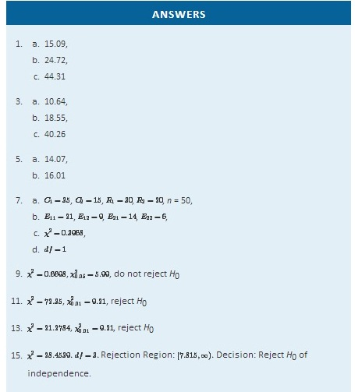

11.2 Chi-Square One-Sample Goodness-of-Fit Tests

LEARNING OBJECTIVE
- To understand how to use a chi-square test to judge whether a sample fits a particular population well.

Suppose we wish to determine if an ordinary-looking six-sided die is fair, or balanced, meaning that every face has probability 1/6 of landing on top when the die is tossed. We could toss the die dozens, maybe hundreds, of times and compare the actual number of times each face landed on top to the expected number, which would be 1/6 of the total number of tosses. We wouldn’t expect each number to be exactly 1/6 of the total, but it should be close. To be specific, suppose the die is tossed n = 60 times with the results summarized in Table 11.8 "Die Contingency Table". For ease of reference we add a column of expected frequencies, which in this simple example is simply a column of 10s. The result is shown as Table 11.9 "Updated Die Contingency Table". In analogy with the previous section we call this an “updated” table. A measure of how much the data deviate from what we would expect to see if the die really were fair is the sum of the squares of the differences between the observed frequency O and the expected frequency Ein each row, or, standardizing by dividing each square by the expected number, the sum Σ(O−E)2/E. If we formulate the investigation as a test of hypotheses, the test is
H0: The die is fair
vs. Ha: The die is not fair
Table 11.8 Die Contingency Table
Die Value | Assumed Distribution | Observed Frequency
1 | 1/6 | 9
2 | 1/6 | 15
3 | 1/6 | 9
4 | 1/6 | 8
5 | 1/6 | 6
6 | 1/6 | 13

Table 11.9 Updated Die Contingency Table
Die Value | Assumed Distribution | Observed Freq. | Expected Freq.
1 | 1/6 | 9 | 10
2 | 1/6 | 15 | 10
3 | 1/6 | 9 | 10
4 | 1/6 | 8 | 10
5 | 1/6 | 6 | 10
6 | 1/6 | 13 | 10

We would reject the null hypothesis that the die is fair only if the number Σ(O−E)2/E is large, so the test is right-tailed. In this example the random variable Σ(O−E)2/E has the chi-square distribution with five degrees of freedom. If we had decided at the outset to test at the 10% level of significance, the critical value defining the rejection region would be, reading from Figure 12.4 "Critical Values of Chi-Square Distributions", χ2α=χ20.10=9.236, so that the rejection region would be the interval [9.236,∞). When we compute the value of the standardized test statistic using the numbers in the last two columns of Table 11.9 "Updated Die Contingency Table", we obtain
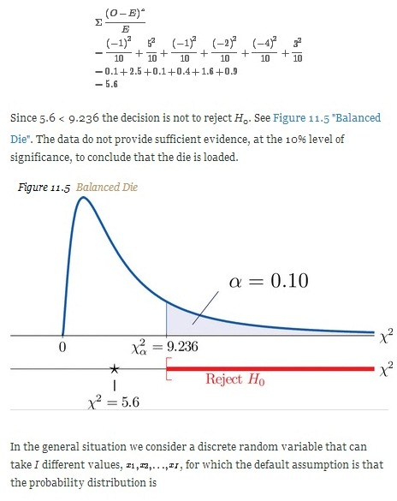
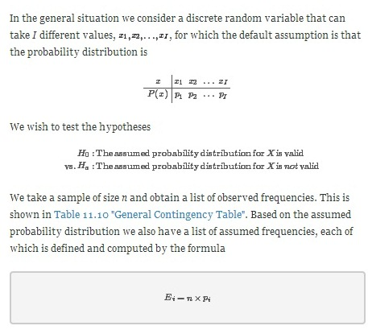
Table 11.10 General Contingency Table
Factor Levels | Assumed Distribution | Observed Frequency
1 | p₁ | O₁
2 | p₂ | O₂
⋮ | ⋮ | ⋮
I | p_{I} | O_{I}

Table 11.10 "General Contingency Table" is updated to Table 11.11 "Updated General Contingency Table" by adding the expected frequency for each value of X. To simplify the notation we drop indices for the observed and expected frequencies and represent Table 11.11 "Updated General Contingency Table" by Table 11.12 "Simplified Updated General Contingency Table".
Table 11.11 Updated General Contingency Table
Factor Levels | Assumed Distribution | Observed Freq. | Expected Freq.
1 | p₁ | O₁ | E₁
2 | p₂ | O₂ | E₂
⋮ | ⋮ | ⋮ | ⋮
I | p_{I} | O_{I} | E_{I}
Table 11.12 Simplified Updated General Contingency Table
Factor Levels | Assumed Distribution | Observed Freq. | Expected Freq.
1 | p₁ | O | E
2 | p₂ | O | E
⋮ | ⋮ | ⋮ | ⋮
I | p_{I} | O | E

Here is the test statistic for the general hypothesis based on Table 11.12 "Simplified Updated General Contingency Table", together with the conditions that it follow a chi-square distribution.
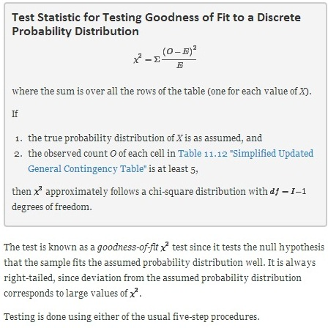

EXAMPLE 2
Table 11.13 "Ethnic Groups in the Census Year" shows the distribution of various ethnic groups in the population of a particular state based on a decennial U.S. census. Five years later a random sample of 2,500 residents of the state was taken, with the results given in Table 11.14 "Sample Data Five Years After the Census Year" (along with the probability distribution from the census year). Test, at the 1% level of significance, whether there is sufficient evidence in the sample to conclude that the distribution of ethnic groups in this state five years after the census had changed from that in the census year.
TABLE 11.13 ETHNIC GROUPS IN THE CENSUS YEAR
Ethnicity | White | Black | Amer.-Indian | Hispanic | Asian | Others
Proportion | 0.743 | 0.216 | 0.012 | 0.012 | 0.008 | 0.009
TABLE 11.14 SAMPLE DATA FIVE YEARS AFTER THE CENSUS YEAR
Ethnicity | Assumed Distribution | Observed Frequency
White | 0.743 | 1732
Black | 0.216 | 538
American-Indian | 0.012 | 32
Hispanic | 0.012 | 42
Asian | 0.008 | 133
Others | 0.009 | 23
Solution:
We test using the critical value approach.
- Step 1. The hypotheses of interest in this case can be expressed as
H0:The distribution of ethnic groups has not changed
vs. Ha: The distribution of ethnic groups has changed
- Step 2. The distribution is chi-square.
Step 3. To compute the value of the test statistic we must first compute the expected number for each row of Table 11.14 "Sample Data Five Years After the Census Year". Since n = 2500, using the formula Ei=n×pi and the values of p_{i} from either Table 11.13 "Ethnic Groups in the Census Year" or Table 11.14 "Sample Data Five Years After the Census Year",
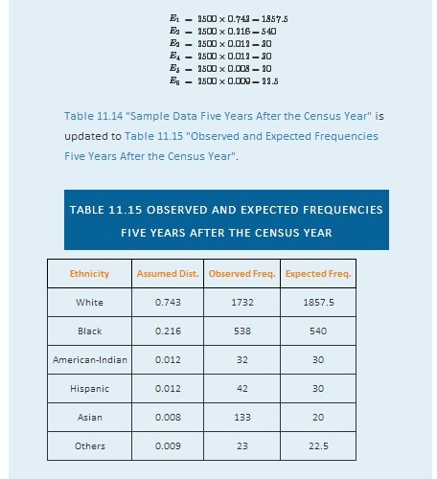
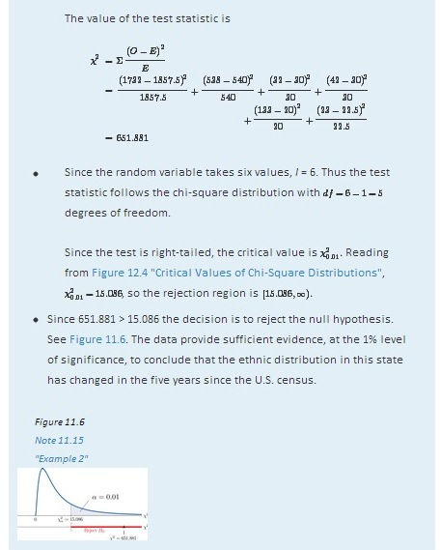

KEY TAKEAWAY
- The chi-square goodness-of-fit test can be used to evaluate the hypothesis that a sample is taken from a population with an assumed specific probability distribution.

EXERCISES

BASIC
- A data sample is sorted into five categories with an assumed probability distribution.
Factor Levels | Assumed Distribution | Observed Frequency
1 | p1=0.1 | 10
2 | p2=0.4 | 35
3 | p3=0.4 | 45
4 | p4=0.1 | 10
  - Find the size n of the sample.
  - Find the expected number E of observations for each level, if the sampled population has a probability distribution as assumed (that is, just use the formula Ei=n×pi).
  - Find the chi-square test statistic χ2.
  - Find the number of degrees of freedom of the chi-square test statistic.
- A data sample is sorted into five categories with an assumed probability distribution.
Factor Levels | Assumed Distribution | Observed Frequency
1 | p1=0.3 | 23
2 | p2=0.3 | 30
3 | p3=0.2 | 19
4 | p4=0.1 | 8
5 | p5=0.1 | 10
  - Find the size n of the sample.
  - Find the expected number E of observations for each level, if the sampled population has a probability distribution as assumed (that is, just use the formula Ei=n×pi).
  - Find the chi-square test statistic χ2.
  - Find the number of degrees of freedom of the chi-square test statistic.

APPLICATIONS
- Retailers of collectible postage stamps often buy their stamps in large quantities by weight at auctions. The prices the retailers are willing to pay depend on how old the postage stamps are. Many collectible postage stamps at auctions are described by the proportions of stamps issued at various periods in the past. Generally the older the stamps the higher the value. At one particular auction, a lot of collectible stamps is advertised to have the age distribution given in the table provided. A retail buyer took a sample of 73 stamps from the lot and sorted them by age. The results are given in the table provided. Test, at the 5% level of significance, whether there is sufficient evidence in the data to conclude that the age distribution of the lot is different from what was claimed by the seller.
Year | Claimed Distribution | Observed Frequency
Before 1940 | 0.10 | 6
1940 to 1959 | 0.25 | 15
1960 to 1979 | 0.45 | 30
After 1979 | 0.20 | 22
- The litter size of Bengal tigers is typically two or three cubs, but it can vary between one and four. Based on long-term observations, the litter size of Bengal tigers in the wild has the distribution given in the table provided. A zoologist believes that Bengal tigers in captivity tend to have different (possibly smaller) litter sizes from those in the wild. To verify this belief, the zoologist searched all data sources and found 316 litter size records of Bengal tigers in captivity. The results are given in the table provided. Test, at the 5% level of significance, whether there is sufficient evidence in the data to conclude that the distribution of litter sizes in captivity differs from that in the wild.
Litter Size | Wild Litter Distribution | Observed Frequency
1 | 0.11 | 41
2 | 0.69 | 243
3 | 0.18 | 27
4 | 0.02 | 5
- An online shoe retailer sells men’s shoes in sizes 8 to 13. In the past orders for the different shoe sizes have followed the distribution given in the table provided. The management believes that recent marketing efforts may have expanded their customer base and, as a result, there may be a shift in the size distribution for future orders. To have a better understanding of its future sales, the shoe seller examined 1,040 sales records of recent orders and noted the sizes of the shoes ordered. The results are given in the table provided. Test, at the 1% level of significance, whether there is sufficient evidence in the data to conclude that the shoe size distribution of future sales will differ from the historic one.
Shoe Size | Past Size Distribution | Recent Size Frequency
8.0 | 0.03 | 25
8.5 | 0.06 | 43
9.0 | 0.09 | 88
9.5 | 0.19 | 221
10.0 | 0.23 | 272
10.5 | 0.14 | 150
11.0 | 0.10 | 107
11.5 | 0.06 | 51
12.0 | 0.05 | 37
12.5 | 0.03 | 35
13.0 | 0.02 | 11
- An online shoe retailer sells women’s shoes in sizes 5 to 10. In the past orders for the different shoe sizes have followed the distribution given in the table provided. The management believes that recent marketing efforts may have expanded their customer base and, as a result, there may be a shift in the size distribution for future orders. To have a better understanding of its future sales, the shoe seller examined 1,174 sales records of recent orders and noted the sizes of the shoes ordered. The results are given in the table provided. Test, at the 1% level of significance, whether there is sufficient evidence in the data to conclude that the shoe size distribution of future sales will differ from the historic one.
Shoe Size | Past Size Distribution | Recent Size Frequency
5.0 | 0.02 | 20
5.5 | 0.03 | 23
6.0 | 0.07 | 88
6.5 | 0.08 | 90
7.0 | 0.20 | 222
7.5 | 0.20 | 258
8.0 | 0.15 | 177
8.5 | 0.11 | 121
9.0 | 0.08 | 91
9.5 | 0.04 | 53
10.0 | 0.02 | 31
- A chess opening is a sequence of moves at the beginning of a chess game. There are many well-studied named openings in chess literature. French Defense is one of the most popular openings for black, although it is considered a relatively weak opening since it gives black probability 0.344 of winning, probability 0.405 of losing, and probability 0.251 of drawing. A chess master believes that he has discovered a new variation of French Defense that may alter the probability distribution of the outcome of the game. In his many Internet chess games in the last two years, he was able to apply the new variation in 77 games. The wins, losses, and draws in the 77 games are given in the table provided. Test, at the 5% level of significance, whether there is sufficient evidence in the data to conclude that the newly discovered variation of French Defense alters the probability distribution of the result of the game.
Result for Black | Probability Distribution | New Variation Wins
Win | 0.344 | 31
Loss | 0.405 | 25
Draw | 0.251 | 21
- The Department of Parks and Wildlife stocks a large lake with fish every six years. It is determined that a healthy diversity of fish in the lake should consist of 10% largemouth bass, 15% smallmouth bass, 10% striped bass, 10% trout, and 20% catfish. Therefore each time the lake is stocked, the fish population in the lake is restored to maintain that particular distribution. Every three years, the department conducts a study to see whether the distribution of the fish in the lake has shifted away from the target proportions. In one particular year, a research group from the department observed a sample of 292 fish from the lake with the results given in the table provided. Test, at the 5% level of significance, whether there is sufficient evidence in the data to conclude that the fish population distribution has shifted since the last stocking.
Fish | Target Distribution | Fish in Sample
Largemouth Bass | 0.10 | 14
Smallmouth Bass | 0.15 | 49
Striped Bass | 0.10 | 21
Trout | 0.10 | 22
Catfish | 0.20 | 75
Other | 0.35 | 111

LARGE DATA SET EXERCISE
- Large Data Set 4 records the result of 500 tosses of six-sided die. Test, at the 10% level of significance, whether there is sufficient evidence in the data to conclude that the die is not “fair” (or “balanced”), that is, that the probability distribution differs from probability 1/6 for each of the six faces on the die.

http://www.flatworldknowledge.com/sites/all/files/data4.xls
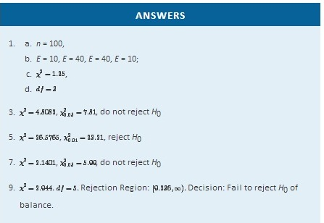

11.3 F-tests for Equality of Two Variances

LEARNING OBJECTIVES
- To understand what F-distributions are.
- To understand how to use an F-test to judge whether two population variances are equal.

F-Distributions
Another important and useful family of distributions in statistics is the family of F-distributions. Each member of the F-distribution family is specified by a pair of parameters called degrees of freedom and denoted df1and df2. Figure 11.7 "Many " shows several F-distributions for different pairs of degrees of freedom. An F random variable is a random variable that assumes only positive values and follows an F-distribution.
Figure 11.7 Many F-Distributions
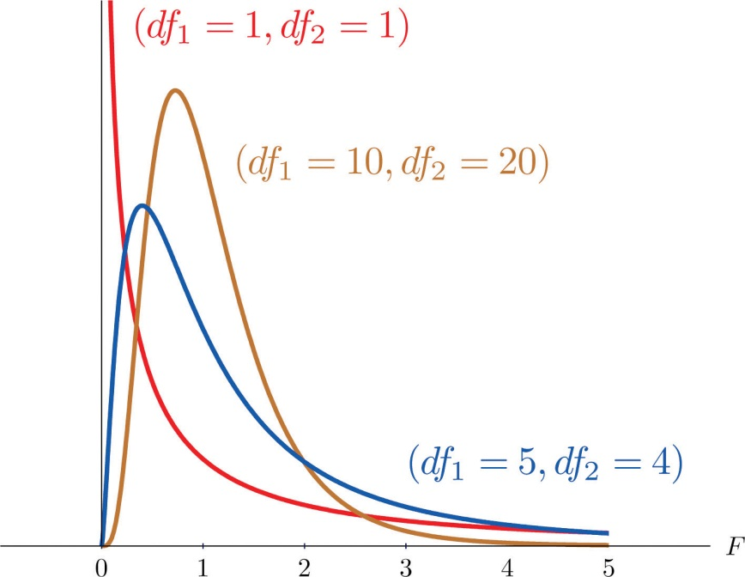
The parameter df1 is often referred to as the numerator degrees of freedom and the parameter df2 as the denominator degrees of freedom. It is important to keep in mind that they are not interchangeable. For example, the F-distribution with degrees of freedom df1=3 and df2=8 is a different distribution from the F-distribution with degrees of freedom df1=8 and df2=3.

Definition
The value of the F random variable F with degrees of freedom df1 and df2that cuts off a right tail of area c is denoted F_{c} and is called a critical value. See Figure 11.8.
Figure 11.8F_{c} Illustrated
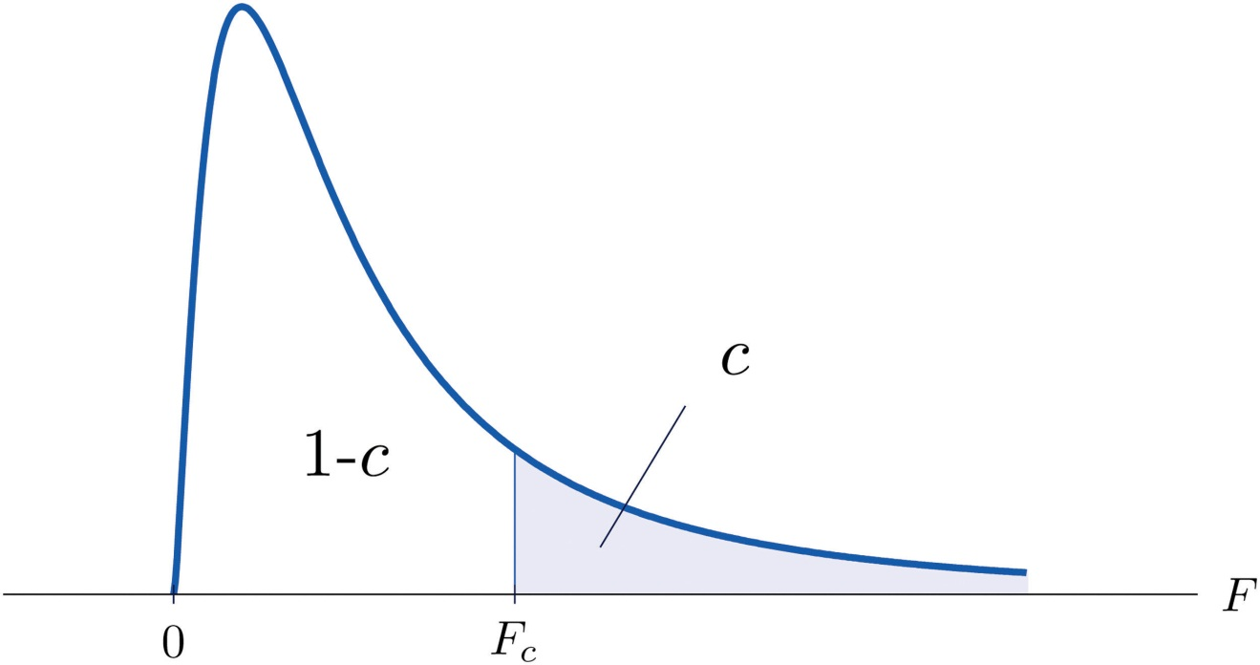
Tables containing the values of F_{c} are given in Chapter 11 "Chi-Square Tests and ". Each of the tables is for a fixed collection of values of c, either 0.900, 0.950, 0.975, 0.990, and 0.995 (yielding what are called “lower” critical values), or 0.005, 0.010, 0.025, 0.050, and 0.100 (yielding what are called “upper” critical values). In each table critical values are given for various pairs (df1,df2). We illustrate the use of the tables with several examples.

EXAMPLE 3
Suppose F is an F random variable with degrees of freedom df1=5 anddf2=4. Use the tables to find
- F_{0.10}
- F_{0.95}
Solution:

- The column headings of all the tables contain df1=5. Look for the table for which 0.10 is one of the entries on the extreme left (a table of upper critical values) and that has a row heading df2=4 in the left margin of the table. A portion of the relevant table is provided. The entry in the intersection of the column with heading df1=5 and the row with the headings 0.10 and df2=4, which is shaded in the table provided, is the answer, F0.10=4.05.
F Tail Area | df1 | 1 | 2 | · · · | 5 | · · ·
 | df2
⋮ | ⋮ | ⋮ | ⋮ | ⋮ | ⋮ | ⋮
0.005 | 4 | · · · | · · · | · · · | 22.5 | · · ·
0.01 | 4 | · · · | · · · | · · · | 15.5 | · · ·
0.025 | 4 | · · · | · · · | · · · | 9.36 | · · ·
0.05 | 4 | · · · | · · · | · · · | 6.26 | · · ·
0.10 | 4 | · · · | · · · | · · · | 4.05 | · · ·
⋮ | ⋮ | ⋮ | ⋮ | ⋮ | ⋮ | ⋮

- Look for the table for which 0.95 is one of the entries on the extreme left (a table of lower critical values) and that has a row heading df2=4 in the left margin of the table. A portion of the relevant table is provided. The entry in the intersection of the column with heading df1=5 and the row with the headings 0.95 and df2=4, which is shaded in the table provided, is the answer, F0.95=0.19.
F Tail Area | df1 | 1 | 2 | · · · | 5 | · · ·
 | df2
⋮ | ⋮ | ⋮ | ⋮ | ⋮ | ⋮ | ⋮
0.90 | 4 | · · · | · · · | · · · | 0.28 | · · ·
0.95 | 4 | · · · | · · · | · · · | 0.19 | · · ·
0.975 | 4 | · · · | · · · | · · · | 0.14 | · · ·
0.99 | 4 | · · · | · · · | · · · | 0.09 | · · ·
0.995 | 4 | · · · | · · · | · · · | 0.06 | · · ·
⋮ | ⋮ | ⋮ | ⋮ | ⋮ | ⋮ | ⋮

EXAMPLE 4
Suppose F is an F random variable with degrees of freedom df1=2 anddf2=20. Let α=0.05. Use the tables to find
- Fα
- Fα∕2
- F1−α
- F1−α∕2
Solution:

- The column headings of all the tables contain df1=2. Look for the table for which α=0.05 is one of the entries on the extreme left (a table of upper critical values) and that has a row heading df2=20 in the left margin of the table. A portion of the relevant table is provided. The shaded entry, in the intersection of the column with heading df1=2 and the row with the headings 0.05 and df2=20 is the answer, F0.05=3.49.
F Tail Area | df1 | 1 | 2 | · · ·
 | df2
⋮ | ⋮ | ⋮ | ⋮ | ⋮
0.005 | 20 | · · · | 6.99 | · · ·
0.01 | 20 | · · · | 5.85 | · · ·
0.025 | 20 | · · · | 4.46 | · · ·
0.05 | 20 | · · · | 3.49 | · · ·
0.10 | 20 | · · · | 2.59 | · · ·
⋮ | ⋮ | ⋮ | ⋮ | ⋮
- Look for the table for which α∕2=0.025 is one of the entries on the extreme left (a table of upper critical values) and that has a row heading df2=20 in the left margin of the table. A portion of the relevant table is provided. The shaded entry, in the intersection of the column with heading df1=2 and the row with the headings 0.025 and df2=20 is the answer, F0.025=4.46.

F Tail Area | df1 | 1 | 2 | · · ·
 | df2
⋮ | ⋮ | ⋮ | ⋮ | ⋮
0.005 | 20 | · · · | 6.99 | · · ·
0.01 | 20 | · · · | 5.85 | · · ·
0.025 | 20 | · · · | 4.46 | · · ·
0.05 | 20 | · · · | 3.49 | · · ·
0.10 | 20 | · · · | 2.59 | · · ·
⋮ | ⋮ | ⋮ | ⋮ | ⋮
  - Look for the table for which 1−α=0.95 is one of the entries on the extreme left (a table of lower critical values) and that has a row heading df2=20 in the left margin of the table. A portion of the relevant table is provided. The shaded entry, in the intersection of the column with heading df1=2 and the row with the headings 0.95 and df2=20 is the answer, F0.95=0.05.
F Tail Area | df1 | 1 | 2 | · · ·
 | df2
⋮ | ⋮ | ⋮ | ⋮ | ⋮
0.90 | 20 | · · · | 0.11 | · · ·
0.95 | 20 | · · · | 0.05 | · · ·
0.975 | 20 | · · · | 0.03 | · · ·
0.99 | 20 | · · · | 0.01 | · · ·
0.995 | 20 | · · · | 0.01 | · · ·
⋮ | ⋮ | ⋮ | ⋮ | ⋮
- Look for the table for which 1−α∕2=0.975 is one of the entries on the extreme left (a table of lower critical values) and that has a row heading df2=20 in the left margin of the table. A portion of the relevant table is provided. The shaded entry, in the intersection of the column with heading df1=2 and the row with the headings 0.975 and df2=20 is the answer,F0.975=0.03.
F Tail Area | df1 | 1 | 2 | · · ·
 | df2
⋮ | ⋮ | ⋮ | ⋮ | ⋮
0.90 | 20 | · · · | 0.11 | · · ·
0.95 | 20 | · · · | 0.05 | · · ·
0.975 | 20 | · · · | 0.03 | · · ·
0.99 | 20 | · · · | 0.01 | · · ·
0.995 | 20 | · · · | 0.01 | · · ·
⋮ | ⋮ | ⋮ | ⋮ | ⋮

A fact that sometimes allows us to find a critical value from a table that we could not read otherwise is:

If Fu(r,s) denotes the value of the F-distribution with degrees of freedom df1=r and df2=s that cuts off a right tail of area u, then

Fc(k,ℓ)=1F1−c(ℓ,k)

EXAMPLE 5
Use the tables to find
- F_{0.01} for an F random variable with df1=13 and df2=8
- F_{0.975} for an F random variable with df1=40 and df2=10
Solution:
- There is no table with df1=13, but there is one with df1=8.Thus we use the fact that

F0.01(13,8)=1F0.99(8,13)

Using the relevant table we find that F0.99(8,13)=0.18, henceF0.01(13,8)=0.18−1=5.556.
- There is no table with df1=40, but there is one with df1=10.Thus we use the fact that

F0.975(40,10)=1F0.025(10,40)

Using the relevant table we find that F0.025(10,40)=3.31, henceF0.975(40,10)=3.31−1=0.302.

F-Tests for Equality of Two Variances
In Chapter 9 "Two-Sample Problems" we saw how to test hypotheses about the difference between two population means μ1 and μ2. In some practical situations the difference between the population standard deviations σ1 andσ2 is also of interest. Standard deviation measures the variability of a random variable. For example, if the random variable measures the size of a machined part in a manufacturing process, the size of standard deviation is one indicator of product quality. A smaller standard deviation among items produced in the manufacturing process is desirable since it indicates consistency in product quality.

For theoretical reasons it is easier to compare the squares of the population standard deviations, the population variances σ12 and σ22. This is not a problem, since σ1=σ2 precisely when σ12=σ22, σ1<σ2 precisely whenσ12<σ22, and σ1>σ2 precisely when σ12>σ22.

The null hypothesis always has the form H0:σ12=σ22. The three forms of the alternative hypothesis, with the terminology for each case, are:
Form of H_{a} | Terminology
Ha:σ12>σ22 | Right-tailed
Ha:σ12<σ22 | Left-tailed
Ha:σ12≠σ22 | Two-tailed

Just as when we test hypotheses concerning two population means, we take a random sample from each population, of sizes n₁ and n₂, and compute the sample standard deviations s₁ and s₂. In this context the samples are always independent. The populations themselves must be normally distributed.

Test Statistic for Hypothesis Tests Concerning theDifference Between Two Population Variances
F=s12s22
If the two populations are normally distributed and if H0:σ12=σ22 is true then under independent sampling F approximately follows an F-distribution with degrees of freedom df1=n1−1 and df2=n2−1.

A test based on the test statistic F is called an F-test.

A most important point is that while the rejection region for a right-tailed test is exactly as in every other situation that we have encountered, because of the asymmetry in the F-distribution the critical value for a left-tailed test and the lower critical value for a two-tailed test have the special forms shown in the following table:

Terminology | Alternative Hypothesis | Rejection Region
Right-tailed | Ha:σ12>σ22 | F≥Fα
Left-tailed | Ha:σ12<σ22 | F≤F1−α
Two-tailed | Ha:σ12≠σ22 | F≤F1−α∕2 or F≥Fα∕2
Figure 11.9 "Rejection Regions: (a) Right-Tailed; (b) Left-Tailed; (c) Two-Tailed" illustrates these rejection regions.

Figure 11.9 Rejection Regions: (a) Right-Tailed; (b) Left-Tailed; (c) Two-Tailed
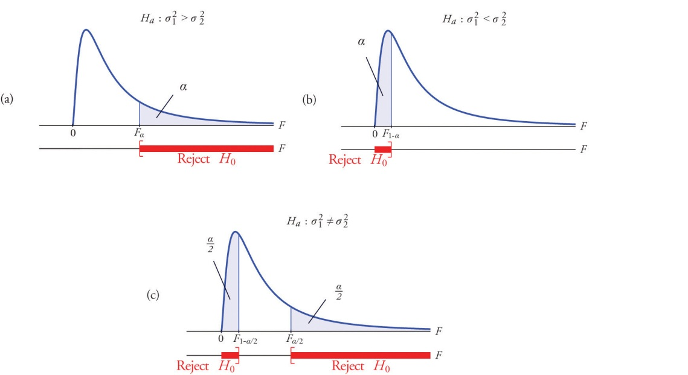

The test is performed using the usual five-step procedure described at the end of Section 8.1 "The Elements of Hypothesis Testing" in Chapter 8 "Testing Hypotheses".

EXAMPLE 6
One of the quality measures of blood glucose meter strips is the consistency of the test results on the same sample of blood. The consistency is measured by the variance of the readings in repeated testing. Suppose two types of strips, A and B, are compared for their respective consistencies. We arbitrarily label the population of Type Astrips Population 1 and the population of Type B strips Population 2. Suppose 15 Type A strips were tested with blood drops from a well-shaken vial and 20 Type B strips were tested with the blood from the same vial. The results are summarized in Table 11.16 "Two Types of Test Strips". Assume the glucose readings using Type A strips follow a normal distribution with variance σ21 and those using Type B strips follow a normal distribution with variance with σ22. Test, at the 10% level of significance, whether the data provide sufficient evidence to conclude that the consistencies of the two types of strips are different.
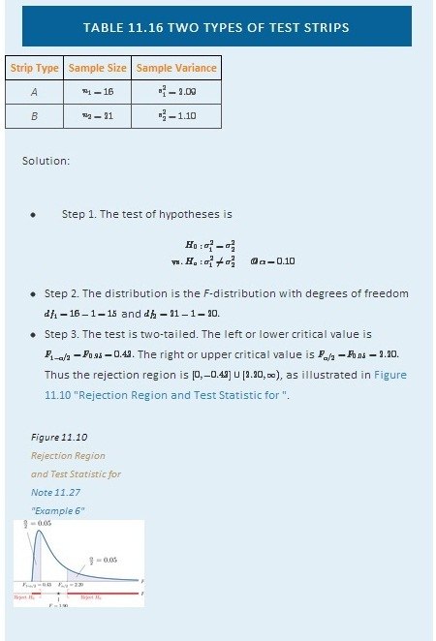
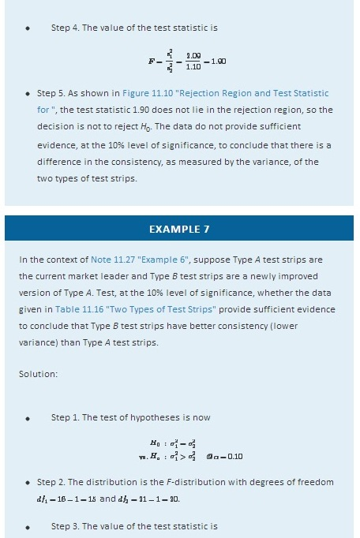
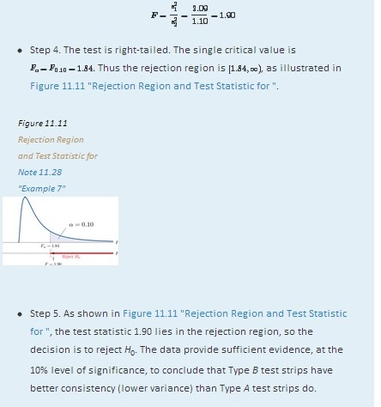

KEY TAKEAWAYS
- Critical values of an F-distribution with degrees of freedom df1 and df2 are found in tables in Chapter 12 "Appendix".
- An F-test can be used to evaluate the hypothesis of two identical normal population variances.
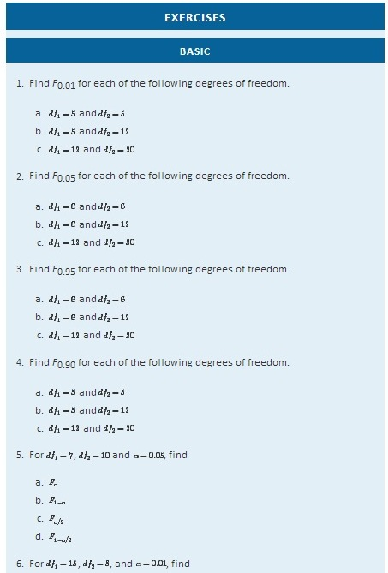
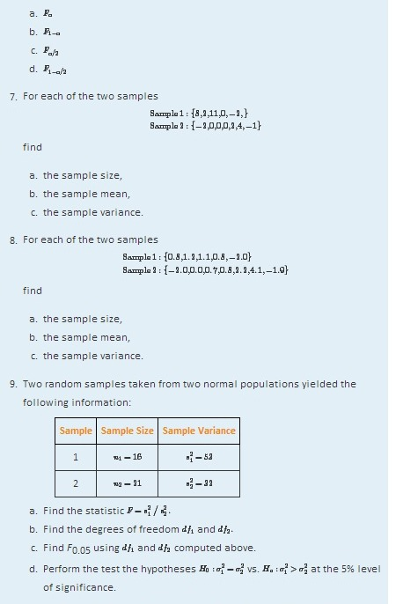
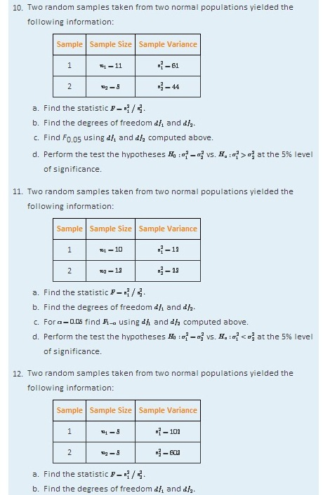
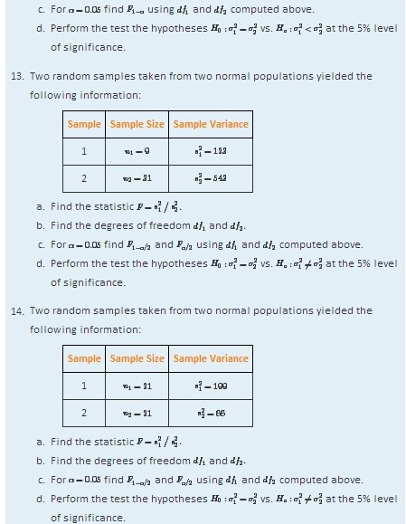

APPLICATIONS
- Japanese sturgeon is a subspecies of the sturgeon family indigenous to Japan and the Northwest Pacific. In a particular fish hatchery newly hatched baby Japanese sturgeon are kept in tanks for several weeks before being transferred to larger ponds. Dissolved oxygen in tank water is very tightly monitored by an electronic system and rigorously maintained at a target level of 6.5 milligrams per liter (mg/l). The fish hatchery looks to upgrade their water monitoring systems for tighter control of dissolved oxygen. A new system is evaluated against the old one currently being used in terms of the variance in measured dissolved oxygen. Thirty-one water samples from a tank operated with the new system were collected and 16 water samples from a tank operated with the old system were collected, all during the course of a day. The samples yield the following information:
New Sample 1 :n1=31s21=0.0121
Old Sample 2: n2=16 s22=0.0319
Test, at the 10% level of significance, whether the data provide sufficient evidence to conclude that the new system will provide a tighter control of dissolved oxygen in the tanks.
- The risk of investing in a stock is measured by the volatility, or the variance, in changes in the price of that stock. Mutual funds are baskets of stocks and offer generally lower risk to investors. Different mutual funds have different focuses and offer different levels of risk. Hippolyta is deciding between two mutual funds, A and B, with similar expected returns. To make a final decision, she examined the annual returns of the two funds during the last ten years and obtained the following information:
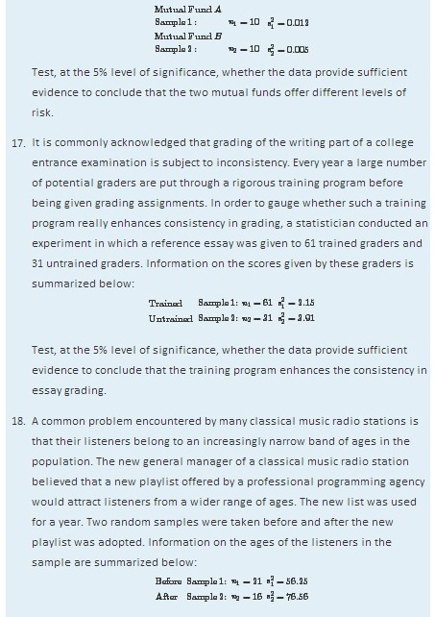

Test, at the 10% level of significance, whether the data provide sufficient evidence to conclude that the new playlist has expanded the range of listener ages.
- A laptop computer maker uses battery packs supplied by two companies, Aand B. While both brands have the same average battery life between charges (LBC), the computer maker seems to receive more complaints about shorter LBC than expected for battery packs supplied by company B. The computer maker suspects that this could be caused by higher variance in LBC for Brand B. To check that, ten new battery packs from each brand are selected, installed on the same models of laptops, and the laptops are allowed to run until the battery packs are completely discharged. The following are the observed LBCs in hours.
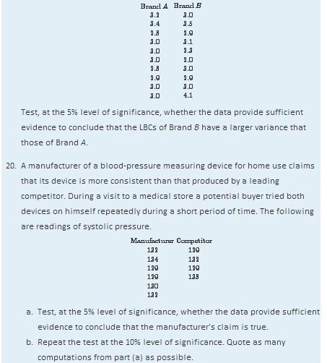

LARGE DATA SET EXERCISES
- Large Data Sets 1A and 1B record SAT scores for 419 male and 581 female students. Test, at the 1% level of significance, whether the data provide sufficient evidence to conclude that the variances of scores of male and female students differ.
http://www.flatworldknowledge.com/sites/all/files/data1A.xls
http://www.flatworldknowledge.com/sites/all/files/data1B.xls

- Large Data Sets 7, 7A, and 7B record the survival times of 140 laboratory mice with thymic leukemia. Test, at the 10% level of significance, whether the data provide sufficient evidence to conclude that the variances of survival times of male mice and female mice differ.

http://www.flatworldknowledge.com/sites/all/files/data7.xls
http://www.flatworldknowledge.com/sites/all/files/data7A.xls
http://www.flatworldknowledge.com/sites/all/files/data7B.xls
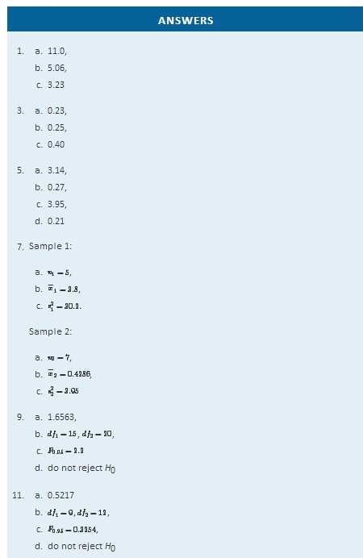
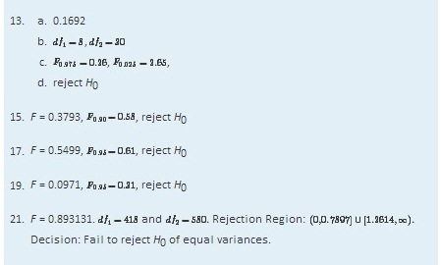

11.4 F-Tests in One-Way ANOVA

LEARNING OBJECTIVE
- To understand how to use an F-test to judge whether several population means are all equal.

In Chapter 9 "Two-Sample Problems" we saw how to compare two population means μ1 and μ2. In this section we will learn to compare three or more population means at the same time, which is often of interest in practical applications. For example, an administrator at a university may be interested in knowing whether student grade point averages are the same for different majors. In another example, an oncologist may be interested in knowing whether patients with the same type of cancer have the same average survival times under several different competing cancer treatments.

In general, suppose there are K normal populations with possibly different means, μ1,μ2,…,μK, but all with the same variance σ2. The study question is whether all the K population means are the same. We formulate this question as the test of hypotheses
H0: μ1=μ2= ⋅ ⋅ ⋅ =μK
vs. Ha: not all K population means are equal
To perform the test K independent random samples are taken from the Knormal populations. The K sample means, the K sample variances, and the Ksample sizes are summarized in the table:
Population | Sample Size | Sample Mean | Sample Variance
1 | n1 | x−1 | s21
2 | n2 | x−2 | s22
⋮ | ⋮ | ⋮ | ⋮
K | nK | x−K | s2K
Define the following quantities:
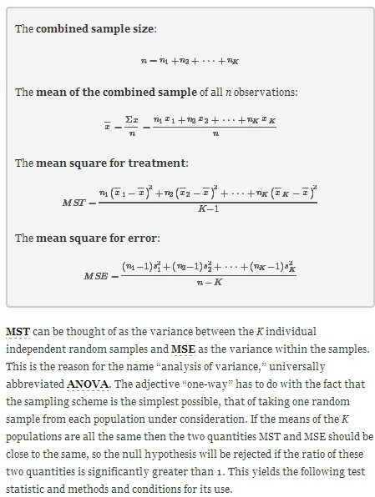
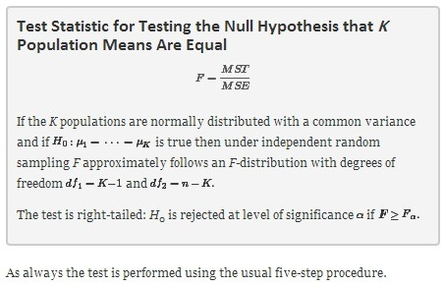

EXAMPLE 8
The average of grade point averages (GPAs) of college courses in a specific major is a measure of difficulty of the major. An educator wishes to conduct a study to find out whether the difficulty levels of different majors are the same. For such a study, a random sample of major grade point averages (GPA) of 11 graduating seniors at a large university is selected for each of the four majors mathematics, English, education, and biology. The data are given in Table 11.17 "Difficulty Levels of College Majors". Test, at the 5% level of significance, whether the data contain sufficient evidence to conclude that there are differences among the average major GPAs of these four majors.
TABLE 11.17 DIFFICULTY LEVELS OF COLLEGE MAJORS
Mathematics | English | Education | Biology
2.59 | 3.64 | 4.00 | 2.78
3.13 | 3.19 | 3.59 | 3.51
2.97 | 3.15 | 2.80 | 2.65
2.50 | 3.78 | 2.39 | 3.16
2.53 | 3.03 | 3.47 | 2.94
3.29 | 2.61 | 3.59 | 2.32
2.53 | 3.20 | 3.74 | 2.58
3.17 | 3.30 | 3.77 | 3.21
2.70 | 3.54 | 3.13 | 3.23
3.88 | 3.25 | 3.00 | 3.57
2.64 | 4.00 | 3.47 | 3.22
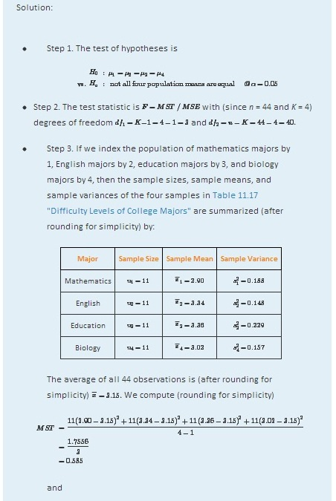
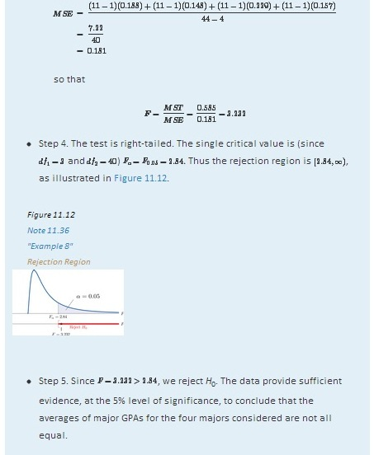

EXAMPLE 9
A research laboratory developed two treatments which are believed to have the potential of prolonging the survival times of patients with an acute form of thymic leukemia. To evaluate the potential treatment effects 33 laboratory mice with thymic leukemia were randomly divided into three groups. One group received Treatment 1, one received Treatment 2, and the third was observed as a control group. The survival times of these mice are given in Table 11.18 "Mice Survival Times in Days". Test, at the 1% level of significance, whether these data provide sufficient evidence to confirm the belief that at least one of the two treatments affects the average survival time of mice with thymic leukemia.
TABLE 11.18 MICE SURVIVAL TIMES IN DAYS
Treatment 1 |  | Treatment 2 | Control
71 | 75 | 77 | 81
72 | 73 | 67 | 79
75 | 72 | 79 | 73
80 | 65 | 78 | 71
60 | 63 | 81 | 75
65 | 69 | 72 | 84
63 | 64 | 71 | 77
78 | 71 | 84 | 67
 |  | 91
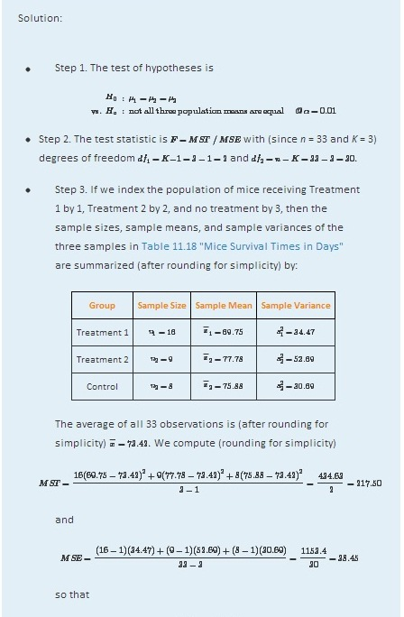
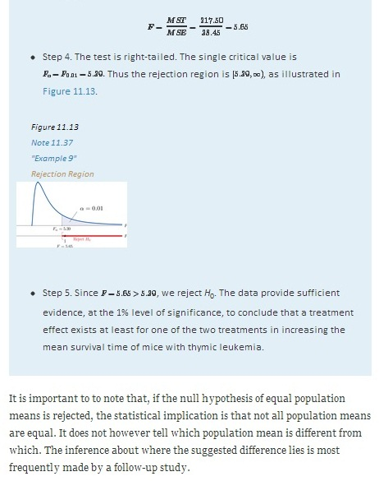

KEY TAKEAWAY
- An F-test can be used to evaluate the hypothesis that the means of several normal populations, all with the same standard deviation, are identical.

EXERCISES

BASIC
- The following three random samples are taken from three normal populations with respective means μ1, μ2, and μ3, and the same variance σ2.
Sample 1 | Sample 2 | Sample 3
2 | 3 | 0
2 | 5 | 1
3 | 7 | 2
5 |  | 1
3
  - Find the combined sample size n.
  - Find the combined sample mean x−.
  - Find the sample mean for each of the three samples.
  - Find the sample variance for each of the three samples.
  - Find MST.
  - Find MSE.
  - Find F=MST/MSE.
- The following three random samples are taken from three normal populations with respective means μ1, μ2, and μ3, and a same variance σ2.
Sample 1 | Sample 2 | Sample 3
0.0 | 1.3 | 0.2
0.1 | 1.5 | 0.2
0.2 | 1.7 | 0.3
0.1 |  | 0.5
 |  | 0.0
  - Find the combined sample size n.
  - Find the combined sample mean x−.
  - Find the sample mean for each of the three samples.
  - Find the sample variance for each of the three samples.
  - Find MST.
  - Find MSE.
  - Find F=MST/MSE.
- Refer to Exercise 1.
  - Find the number of populations under consideration K.
  - Find the degrees of freedom df1=K−1 and df2=n−K.
  - For α=0.05, find Fα with the degrees of freedom computed above.
  - At α=0.05, test hypotheses

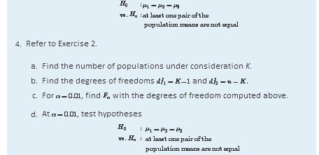

APPLICATIONS
- The Mozart effect refers to a boost of average performance on tests for elementary school students if the students listen to Mozart’s chamber music for a period of time immediately before the test. In order to attempt to test whether the Mozart effect actually exists, an elementary school teacher conducted an experiment by dividing her third-grade class of 15 students into three groups of 5. The first group was given an end-of-grade test without music; the second group listened to Mozart’s chamber music for 10 minutes; and the third groups listened to Mozart’s chamber music for 20 minutes before the test. The scores of the 15 students are given below:
Group 1 | Group 2 | Group 3
80 | 79 | 73
63 | 73 | 82
74 | 74 | 79
71 | 77 | 82
70 | 81 | 84
Using the ANOVA F-test at α=0.10, is there sufficient evidence in the data to suggest that the Mozart effect exists?
- The Mozart effect refers to a boost of average performance on tests for elementary school students if the students listen to Mozart’s chamber music for a period of time immediately before the test. Many educators believe that such an effect is not necessarily due to Mozart’s music per se but rather a relaxation period before the test. To support this belief, an elementary school teacher conducted an experiment by dividing her third-grade class of 15 students into three groups of 5. Students in the first group were asked to give themselves a self-administered facial massage; students in the second group listened to Mozart’s chamber music for 15 minutes; students in the third group listened to Schubert’s chamber music for 15 minutes before the test. The scores of the 15 students are given below:
Group 1 | Group 2 | Group 3
79 | 82 | 80
81 | 84 | 81
80 | 86 | 71
89 | 91 | 90
86 | 82 | 86
Test, using the ANOVA F-test at the 10% level of significance, whether the data provide sufficient evidence to conclude that any of the three relaxation method does better than the others.
- Precision weighing devices are sensitive to environmental conditions. Temperature and humidity in a laboratory room where such a device is installed are tightly controlled to ensure high precision in weighing. A newly designed weighing device is claimed to be more robust against small variations of temperature and humidity. To verify such a claim, a laboratory tests the new device under four settings of temperature-humidity conditions. First, two levels of high and low temperature and two levels ofhigh and low humidity are identified. Let T stand for temperature and H for humidity. The four experimental settings are defined and noted as (T, H): (high, high), (high, low), (low, high), and (low, low). A pre-calibrated standard weight of 1 kg was weighed by the new device four times in each setting. The results in terms of error (in micrograms mcg) are given below:
(high, high) | (high, low) | (low, high) | (low, low)
−1.50 | 11.47 | −14.29 | 5.54
−6.73 | 9.28 | −18.11 | 10.34
11.69 | 5.58 | −11.16 | 15.23
−5.72 | 10.80 | −10.41 | −5.69
Test, using the ANOVA F-test at the 1% level of significance, whether the data provide sufficient evidence to conclude that the mean weight readings by the newly designed device vary among the four settings.
- To investigate the real cost of owning different makes and models of new automobiles, a consumer protection agency followed 16 owners of new vehicles of four popular makes and models, call them TC, HA, NA, and FT, and kept a record of each of the owner’s real cost in dollars for the first five years. The five-year costs of the 16 car owners are given below:
TC | HA | NA | FT
8423 | 7776 | 8907 | 10333
7889 | 7211 | 9077 | 9217
8665 | 6870 | 8732 | 10540
 | 7129 | 9747
 | 7359 | 8677
Test, using the ANOVA F-test at the 5% level of significance, whether the data provide sufficient evidence to conclude that there are differences among the mean real costs of ownership for these four models.
- Helping people to lose weight has become a huge industry in the United States, with annual revenue in the hundreds of billion dollars. Recently each of the three market-leading weight reducing programs claimed to be the most effective. A consumer research company recruited 33 people who wished to lose weight and sent them to the three leading programs. After six months their weight losses were recorded. The results are summarized below:
Statistic | Prog. 1 | Prog. 2 | Prog. 3
Sample Mean | x−1=10.65 | x−2=8.90 | x−3=9.33
Sample Variance | s21=27.20 | s22=16.86 | s23=32.40
Sample Size | n1=11 | n2=11 | n3=11
The mean weight loss of the combined sample of all 33 people was x−=9.63.Test, using the ANOVA F-test at the 5% level of significance, whether the data provide sufficient evidence to conclude that some program is more effective than the others.
- A leading pharmaceutical company in the disposable contact lenses market has always taken for granted that the sales of certain peripheral products such as contact lens solutions would automatically go with the established brands. The long-standing culture in the company has been that lens solutions would not make a significant difference in user experience. Recent market research surveys, however, suggest otherwise. To gain a better understanding of the effects of contact lens solutions on user experience, the company conducted a comparative study in which 63 contact lens users were randomly divided into three groups, each of which received one of three top selling lens solutions on the market, including one of the company’s own. After using the assigned solution for two weeks, each participant was asked to rate the solution on the scale of 1 to 5 for satisfaction, with 5 being the highest level of satisfaction. The results of the study are summarized below:
Statistics | Sol. 1 | Sol. 2 | Sol. 3
Sample Mean | x−1=3.28 | x−2=3.96 | x−3=4.10
Sample Variance | s21=0.15 | s22=0.32 | s23=0.36
Sample Size | n1=18 | n2=23 | n3=22
The mean satisfaction level of the combined sample of all 63 participants was x−=3.81. Test, using the ANOVA F-test at the 5% level of significance, whether the data provide sufficient evidence to conclude that not all three average satisfaction levels are the same.

LARGE DATA SET EXERCISE
- Large Data Set 9 records the costs of materials (textbook, solution manual, laboratory fees, and so on) in each of ten different courses in each of three different subjects, chemistry, computer science, and mathematics. Test, at the 1% level of significance, whether the data provide sufficient evidence to conclude that the mean costs in the three disciplines are not all the same.

http://www.flatworldknowledge.com/sites/all/files/data9.xls
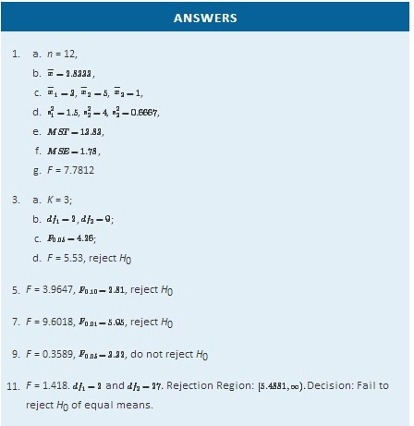

Chapter 12

Appendix
Figure 12.1 Cumulative Binomial Probability
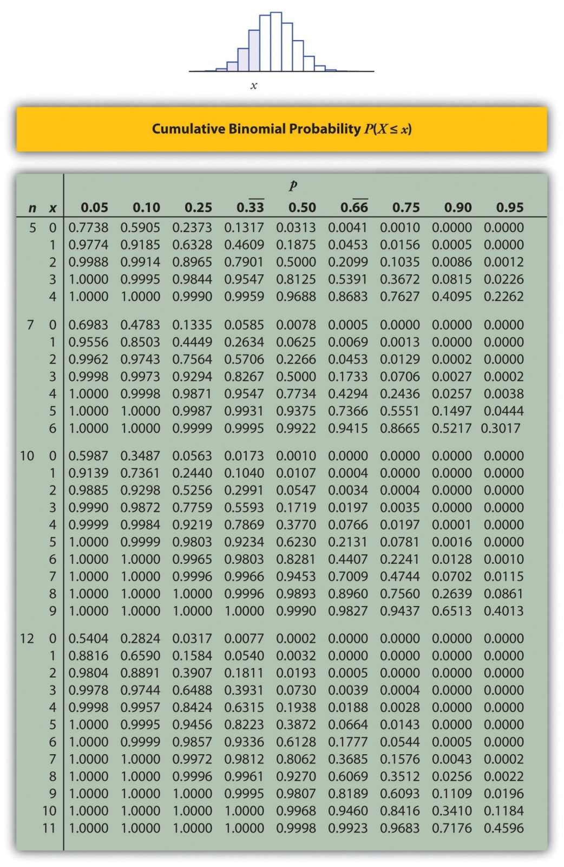
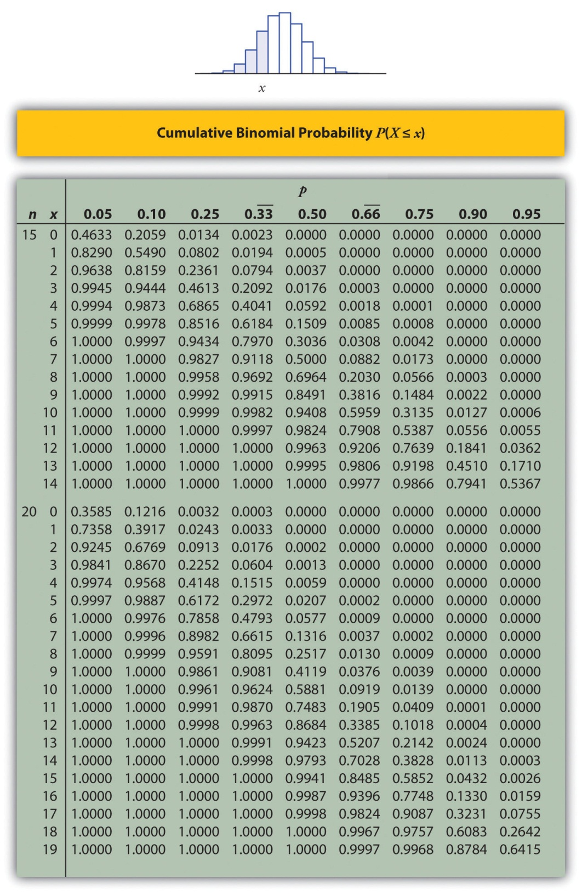

Figure 12.2 Cumulative Normal Probability
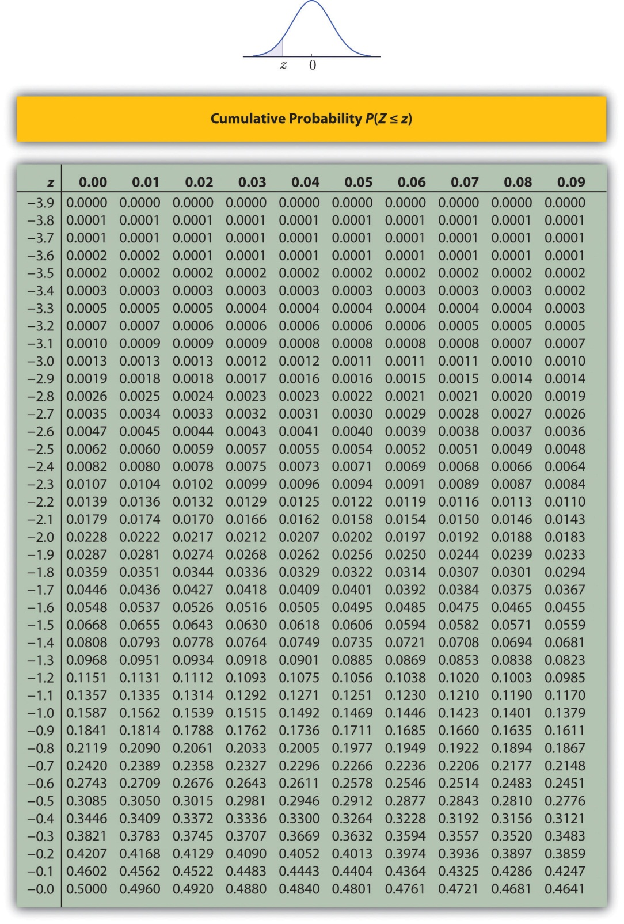
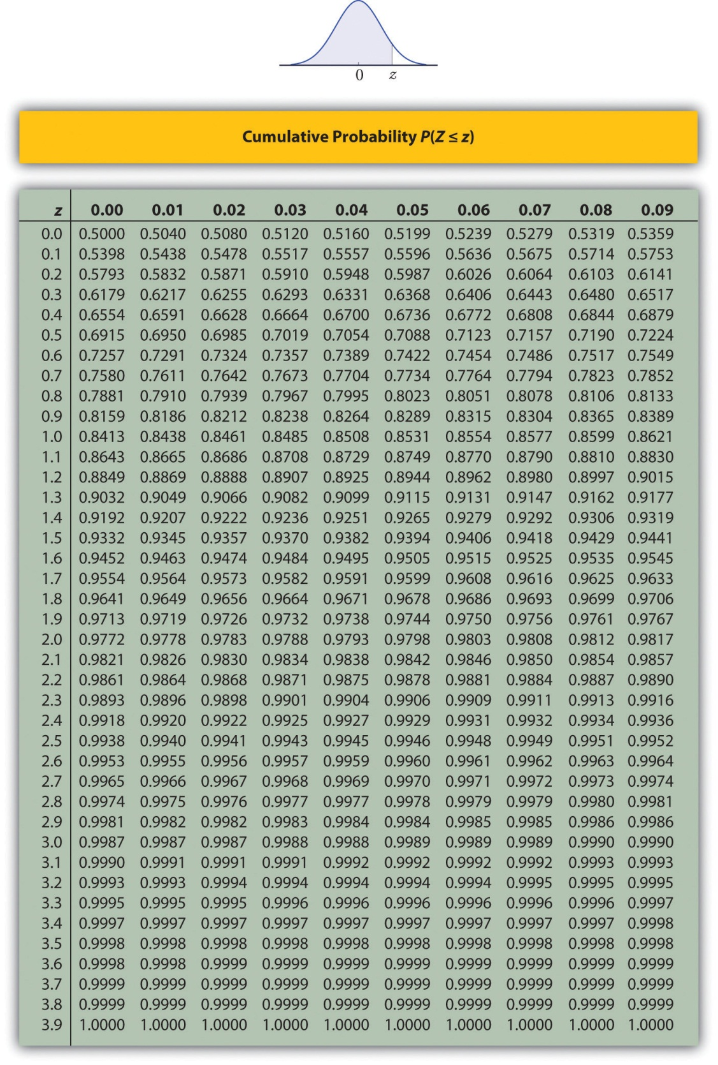

Figure 12.3 Critical Values of t
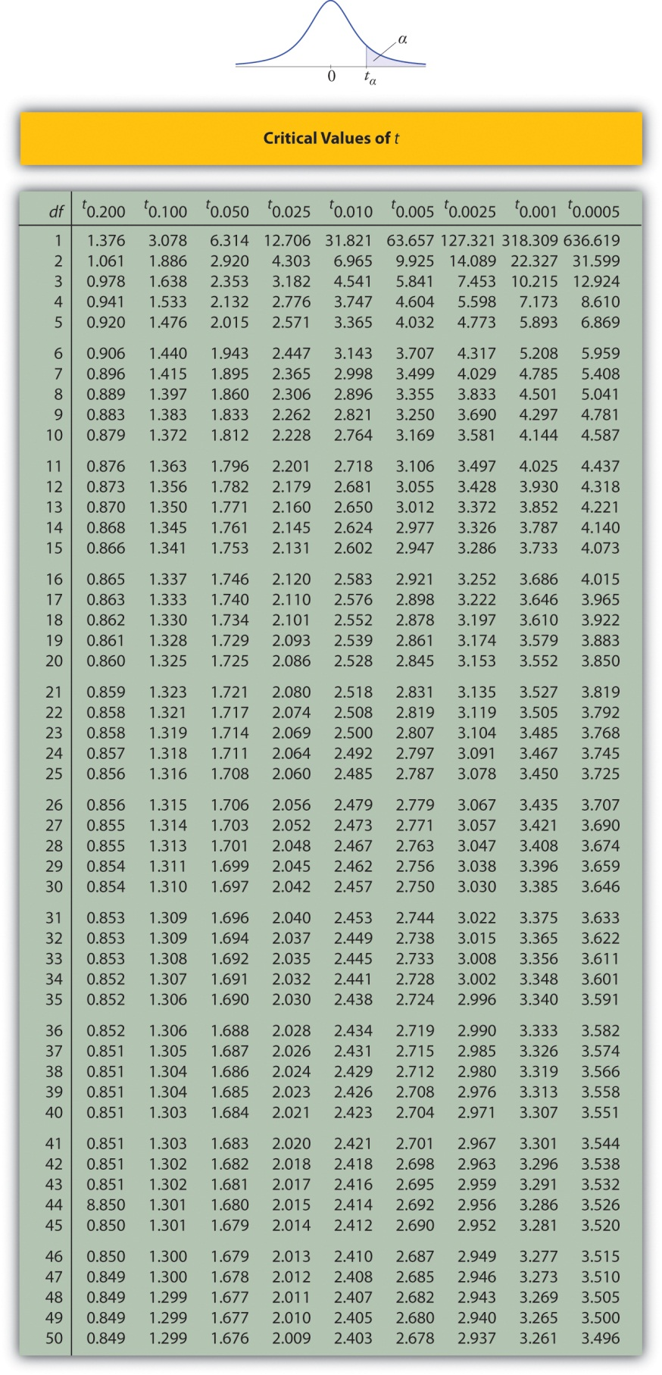
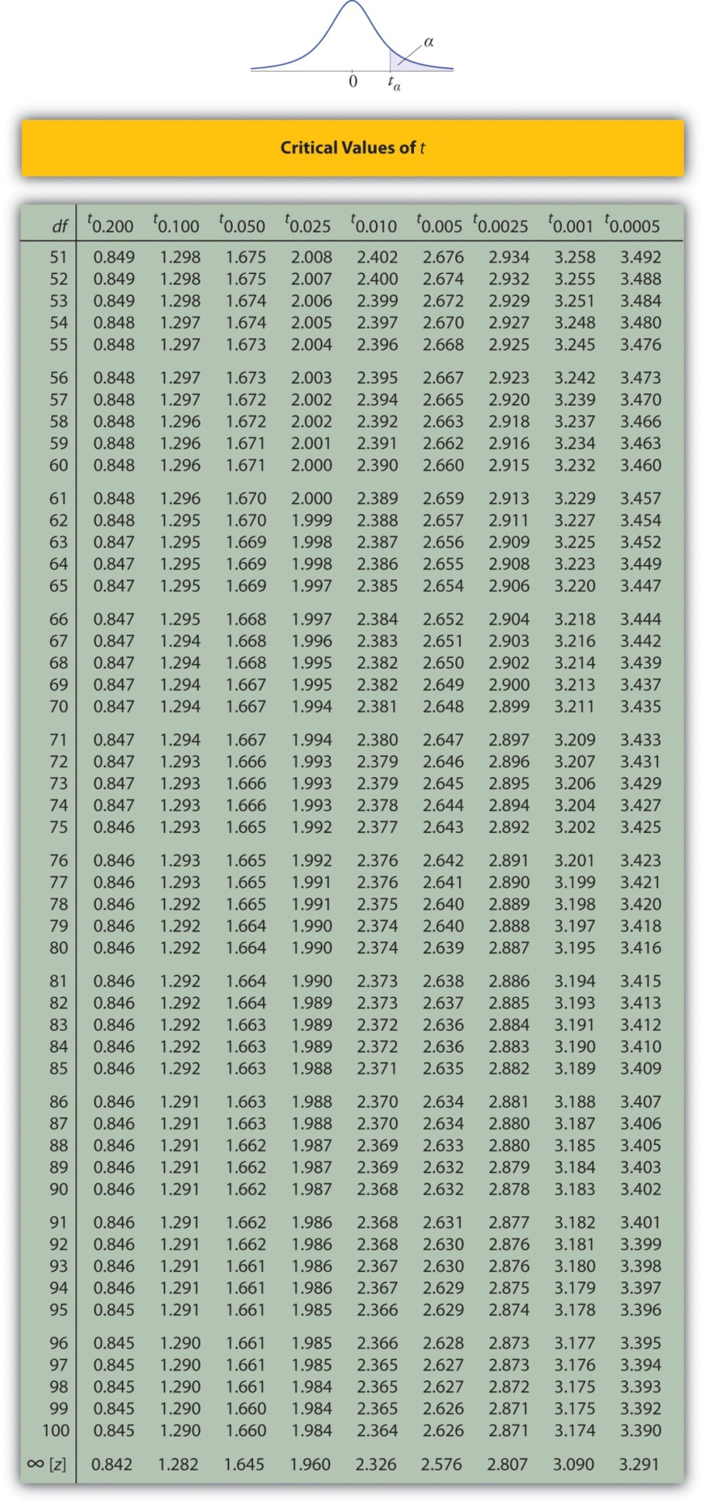
Figure 12.4 Critical Values of Chi-Square Distributions
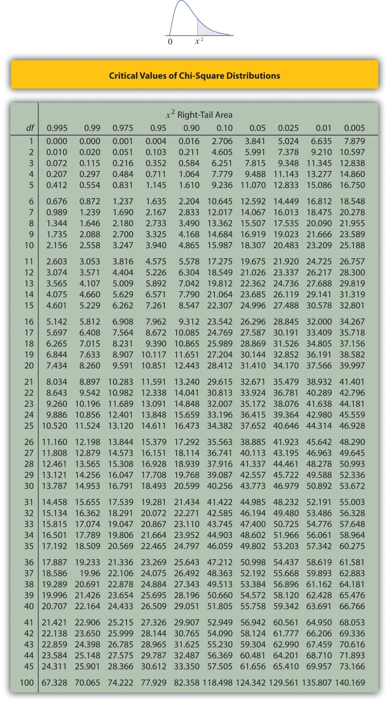

Figure 12.5 Upper Critical Values of F-Distributions
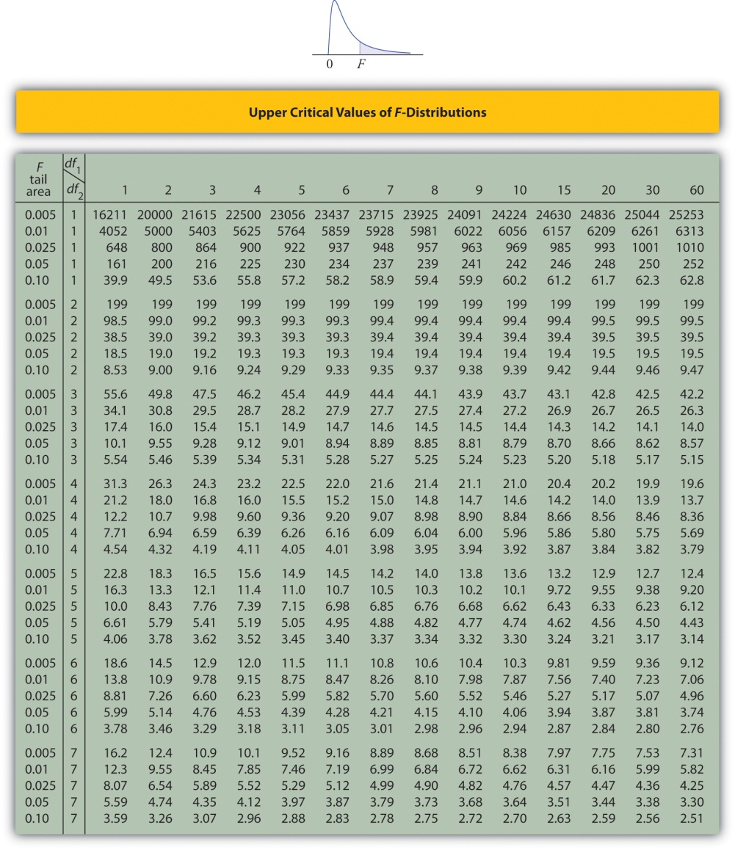
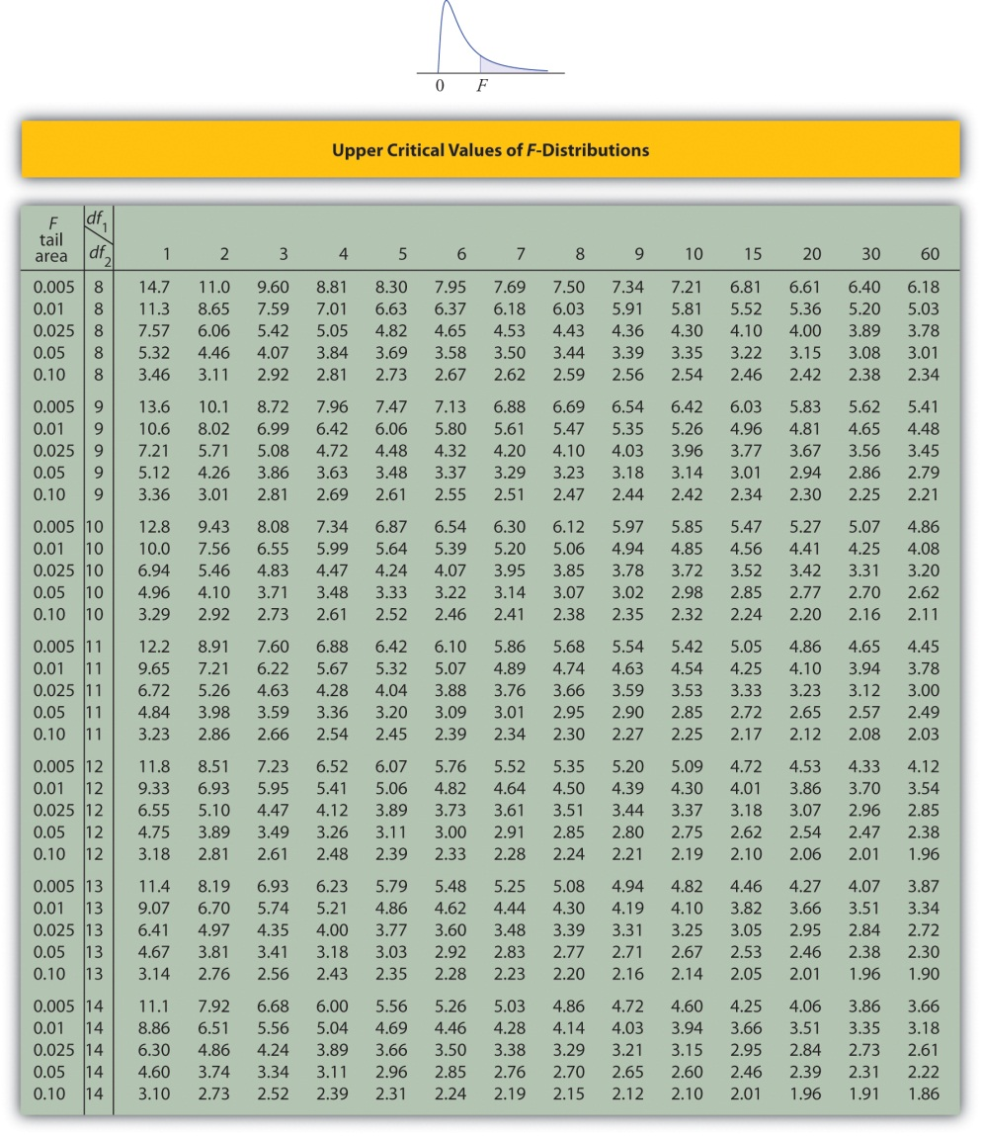
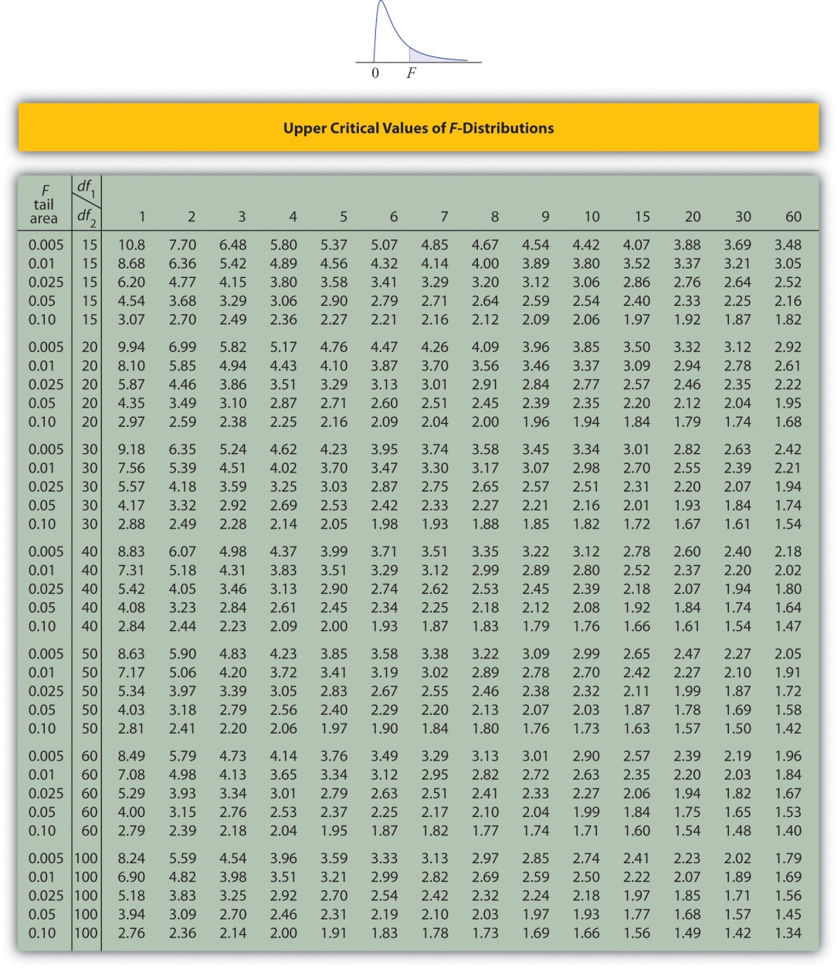

Figure 12.6 Lower Critical Values of F-Distributions
