Trades Access Common Core
Line C: Tools and Equipment
Competency C-1: Describe Common Hand
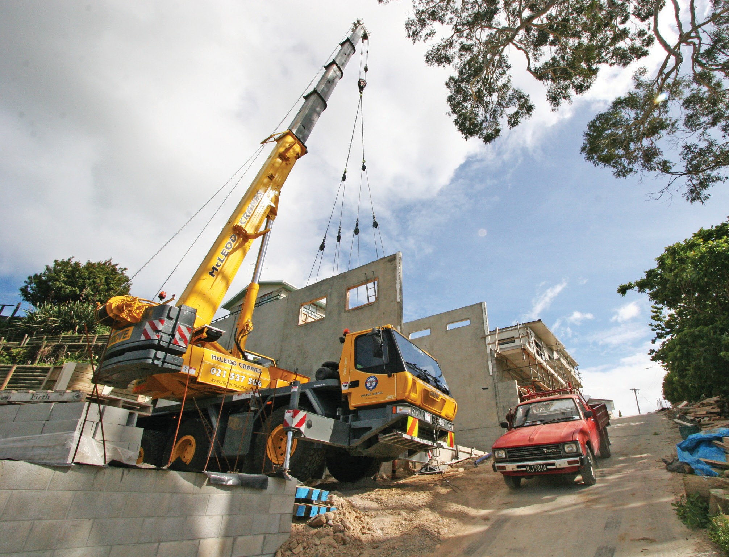Tools and Their Uses

Image to be placed here.

B.C. Open Textbook Project
OpenEd
open.bccampus.ca

Trades Access
COMMON CORE
Line C: Tools and Equipment Competency C-1: Describe Common Hand Tools
and Their Uses

Acknowledgments and Copyright
To learn more about BCcampus Open Textbook project, visit http://open.bccampus.ca
© Camosun College. The Trades Access Common Core resources are licensed under the Creative Commons Attribution 4.0 Unported Licence ( http://creativecommons.org/licenses/by/4.0/ ), except where otherwise noted. Under this licence, any user of this textbook or the textbook contents herein must provide proper attribution as follows:
- If you redistribute this textbook in a digital format (including but not limited to EPUB, PDF, and HTML), then you must retain on every page the following attribution: Download for free at http:// open.bccampus.ca/find-open-textbooks/
- If you redistribute this textbook in a print format, then you must include on every physical page the following attribution: Download for free at http://open.bccampus.ca/find-open-textbooks/
- If you redistribute part of this textbook, then you must retain in every digital format page view (including but not limited to EPUB, PDF, and HTML) and on every physical printed page the following attribution: Download for free at http://open.bccampus.ca/find-open-textbooks/
- If you use this textbook as a bibliographic reference, then you should cite it as follows: BCcampus, Name of Textbook or OER. DATE. http://open.bccampus.ca/find-open-textbooks/.
For questions regarding this licensing, please contact opentext@bccampus.ca
All images copyright BC Industry Training Authority are licensed under the Creative Commons Attribution-NonCommercial-ShareAlike 4.0 licence.
http://creativecommons.org/licenses/by-nc-sa/4.0/
The issuing/publishing body is Crown Publications, Queen’s Printer, Ministry of Technology, Innovation and Citizens’ Services.
BCcampus would like to acknowledge the following individuals and organizations for their contributions in producing the Trades Access Common Core Open Textbook resources.

BCcampus
Open Education Team Hilda Anggraeni, Graphics

Camosun College
Olaf Nielsen, Chair, Trades Development and Special Projects, School of Trades and Technology Nannette Plant, Manager, Enterprise Point Operations & Special Projects, Office of the VP Strategic Development
Rod Lidstone, Instructor, Plumbing and Pipe Trades, Lead Writer/Reviewer Brian Coey, Instructor, Sheet Metal and Metal Fabrication, Writer/Reviewer Matt Zeleny, Camosun Innovates, 3D imaging

Open School BC
Monique Brewer, Director
Adrian Hill, Instructional Designer
Dennis Evans, Image Coordinator, Photographer, Graphics, Production Technician (layout) Farrah Patterson, Production Technician

Industry Training Authority of BC
The ITA works with employers, employees, industry, labour, training providers, and government to issue credentials, manage apprenticeships, set program standards, and increase opportunities in approximately 100 BC trades. Among its many functions are oversight of the development of training resources that align with program standards, outlines, and learning objectives, and authorizing permission to utilize these resources (text and images).
Erin Johnston, Director of Training Delivery Cory Williams, Manager, Industry Relations

Publishing Services, Queen’s Printer
Spencer Tickner, Director of QP Publishing Services Dwayne Gordon, Manager, Electronic Publishing
October 2015, Version 1
To order print copies of any of the Trades Access Common Core resources, please contact us:
Crown Publications, Queen’s Printer PO Box 9452 Stn Prov Govt
563 Superior St, 3rd Floor Victoria, BC V8W 9V7 Phone: 250-387-6409
Toll Free: 1-800-663-6105
Fax: 250-387-1120
crownpub@gov.bc.ca www.crownpub.bc.ca

Intellectual Property Program
Ilona Ugro, Copyright Officer, Ministry of Technology, Innovation and Citizens’ Services, Province of British Columbia

Creative Commons Attributions
Cover photo:
http://commons.wikimedia.org/wiki/File:GMK3050_All_Terrain_Crane.jpg by Scottmss under CC BY SA 3.0 https://creativecommons.org/licenses/by-sa/3.0/deed.en

Foreword
The BC Open Textbook Project began in 2012 with the goal of making post-secondary education in British Columbia more accessible by reducing student cost through the use of openly licensed textbooks. The
BC Open Textbook Project is administered by BCcampus and is funded by the British Columbia Ministry of Advanced Education.
Open textbooks are open educational resources (OER); they are instructional resources created and shared in ways so that more people have access to them. This is a different model than traditionally copyrighted materials. OER are defined as teaching, learning, and research resources that reside in the public domain or have been released under an intellectual property licence that permits their free use and repurposing by others (Hewlett Foundation). Our open textbooks are openly licensed using a Creative Commons licence, and are offered in various e-book formats free of charge, or as printed books that are available at cost. For more information about this project, please contact opentext@bccampus.ca. If you are an instructor who is using this book for a course, please let us know.

Preface
The concept of identifying and creating resources for skills that are common to many trades has a long history in the Province of British Columbia. This collection of Trades Access Common Core (TACC) resources was adapted from the 15 Trades Common Core line modules co-published by the Industry
Training and Apprenticeship Commission (ITAC) and the Centre for Curriculum Transfer and Technology (C2T2) in 2000-2002. Those modules were revisions of the original Common Core portion of the TRAC modules prepared by the Province of British Columbia Ministry of Post-Secondary Education in 1986. The TACC resources are still in use by a number of trades programs today and, with the permission from the Industry Training Authority (ITA), have been utilized in this project.
These open resources have been updated and realigned to match many of the line and competency titles found in the Province of BC’s trades apprenticeship program outlines. A review was carried out to analyze the provincial program outlines of a number of trades, with the intent of finding common entry-
level learning tasks that could be assembled into this package. This analysis provided the template for the outline used to update the existing modules. Many images found in ITA apprentice training modules were also incorporated into these resources to create books that are similar to what students will see when they continue their chosen trades training. The project team has also taken many new photographs for this project, which are available for use in other trades training resources.
The following list of lines and competencies was generated with the goal of creating an entry-level trades training resource, while still offering the flexibility for lines to be used as stand-alone books. This
flexibility—in addition to the textbook content being openly licensed—allows these resources to be used within other contexts as well. For example, instructors or institutions may incorporate these resources into foundation-level trades training programming or within an online learning management system (LMS).
Line A – Safe Work Practices
- A-1 Control Workplace Hazards
- A-2 Describe WorkSafeBC Regulations
- A-3 Handle Hazardous Materials Safely
- A-4 Describe Personal Safety Practices
- A-5 Describe Fire Safety
Line B – Employability Skills
- B-1 Apply Study and Learning Skills
- B-2 Describe Expectations and Responsibilities of Employers and Employees
- B-3 Use Interpersonal Communication Skills
- B-4 Describe the Apprenticeship System

Line C –Tools and Equipment
- C-1 Describe Common Hand Tools and Their Uses
- C-2 Describe Common Power Tools and Their Uses
- C-3 Describe Rigging and Hoisting Equipment
- C-4 Describe Ladders and Platforms
Line D – Organizational Skills
- D-1 Solve Trades Mathematical Problems
- D-2 Apply Science Concepts to Trades Applications
- D-3 Read Drawings and Specifications
- D-4 Use Codes, Regulations, and Standards
- D-5 Use Manufacturer and Supplier Documentation
- D-6 Plan Projects
Line E – Electrical Fundamentals
- E-1 Describe the Basic Principles of Electricity
- E-2 Identify Common Circuit Components and Their Symbols
- E-3 Explain Wiring Connections
- E-4 Use Multimeters
All of these textbooks are available in a variety of formats in addition to print:
- PDF—printable document with TOC and hyperlinks intact
- HTML—basic export of an HTML file and its assets, suitable for use in learning management systems
- Reflowable EPUB—format that is suitable for all screen sizes including phones
All of the self-test questions are also available from BCcampus as separate data, if instructors would like to use the questions for online quizzes or competency testing.

About This Book
In an effort to make this book a flexible resource for trainers and learners, the following features are included:
- An introduction outlining the high-level goal of the Competency, and a list of objectives reflecting the skills and knowledge a person would need to achieve to fulfill this goal.
- Discrete Learning Tasks designed to help a person achieve these objectives
- Self-tests at the end of each Learning Task, designed to informally test for understanding.
- A reminder at the end of each Competency to complete a Competency test. Individual trainers are expected to determine the requirements for this test, as required.
- Throughout the textbook, there may also be links and/or references to other resources that learners will need to access, some of which are only available online.
- Notes, cautions, and warnings are identified by special symbols. A list of those symbols is provided below.

Symbols Legend

Important: This icon highlights important information.

Poisonous: This icon is a reminder for a potentially toxic/poisonous situation.

Resources: The resource icon highlights any required or optional resources.

Flammable: This icon is a reminder for a potentially flammable situation.

Self-test: This icon reminds you to complete a self-test.

Explosive: This icon is a reminder for a possibly explosive situation.

Safety gear: The safety gear icon is an important reminder to use protective equipment.

Electric shock: This icon is a reminder for potential electric shock.

Safety Advisory
Be advised that references to the Workers’ Compensation Board of British Columbia safety regulations contained within these materials do not/may not reflect the most recent Occupational Health and Safety Regulation. The current Standards and Regulation in BC can be obtained at the following website: http:// www.worksafebc.com.
Please note that it is always the responsibility of any person using these materials to inform him/herself about the Occupational Health and Safety Regulation pertaining to his/her area of work.
BCcampus January 2015

Disclaimer
The materials in the Trades Access Common Core Open Textbook project are for use by students and instructional staff and have been compiled from sources believed to be reliable and to represent best current opinions on these subjects. These manuals are intended to serve as a starting point for good practices and may not specify all minimum legal standards. No warranty, guarantee or representation is made by BCcampus as to the accuracy or sufficiency of the information contained in these publications. These manuals are intended to provide basic guidelines for trade practices. Do not assume, therefore, that all necessary warnings and safety precautionary measures are contained in this module and that other or additional measures may not be required.

Contents

Introduction 9
Objectives 9
Resources 9
Learning Task 1: Identify cutting tools and their uses 11
Handsaws 11
Files 16
Hand metal shears 20
Wood chisels 20
Cold chisels 24
Utility knives 26
Self-Test 1 27
Learning Task 2: Describe measuring, marking, and squaring tools and their uses 33
Systems of measurement 33
Measuring devices 34
Squaring tools 43
Layout and marking tools 46
Self-Test 2 53
Learning Task 3: Describe bracing and securing tools and their uses 57
Vises 57
Clamps 60
Self-Test 3 65
Learning Task 4: Identify hammers, punches, nail pullers, and wrecking bars and their uses..67 Hammers 67
Using a hammer 71
Bars 72
Punches 74
Self-Test 4 76
Learning Task 5: Identify levelling tools and their uses 79
Hand level 79
Torpedo level 80
Line level 80
Plumb bob 81
Laser levels 82
Line lasers 83
Self-Test 5 84
Learning Task 6: Identify wrenches and pliers and their uses 85
Wrenches 85
Pliers 93
Self-Test 6 98
Learning Task 7: Identify screwdrivers and their uses 101
Parts of a screwdriver 101
Types of screwdrivers 101
Tip types 103
Screwdriver sockets and bits 106
Care and maintenance of screwdrivers 107
Self-Test 7 108
Learning Task 8: Describe specialty hand tools 111
Staplers 111
Tubing cutters 111
Torque wrenches 112
Pullers 112
Wire brushes 114
Shovels 114
Hand-operated grease guns 115
Caulking guns 115
Taps and dies 116
Specialty measuring devices 116
Self-Test 8 122
Answer Key 123

Introduction
Hand tools are used in almost every trade, but many of them have particular applications in a specific trade. It is likely you have used some of these tools already at work, at school, or at
home, but this may be the first time you have had the chance to study some of the tools’ designs and applications in detail.

Objectives
When you have completed the Learning Tasks in this Competency, you should be able to:
  - recognize and identify common hand tools and their proper uses

  - describe the care and maintenance of common hand tools

Resources
You will be required to reference publications and videos available online.

LEARNING TASK 1

Identify cutting tools and their uses

Handsaws
There are many types of saws for cutting materials by hand. The most common are the:
  - crosscut
  - rip
  - back
  - mitre box
  - pull
  - compass
  - keyhole
  - drywall
  - hacksaw

The parts of a handsaw are shown in Figure 1. The number of points, which is usually shown on the saw, indicates the number of points per 25 mm (or per inch) of cutting edge.

Saws are made in different shapes and lengths, and Figures 1 and 2 show two common designs. In Figure 1, the back of the saw is skewed, which means that it has a slight curve toward the toe to increase its flexibility. The straight-back saw (Figure 2) is much stiffer and not as balanced in the hand as the skewback. It is useful for laying out straight lines.

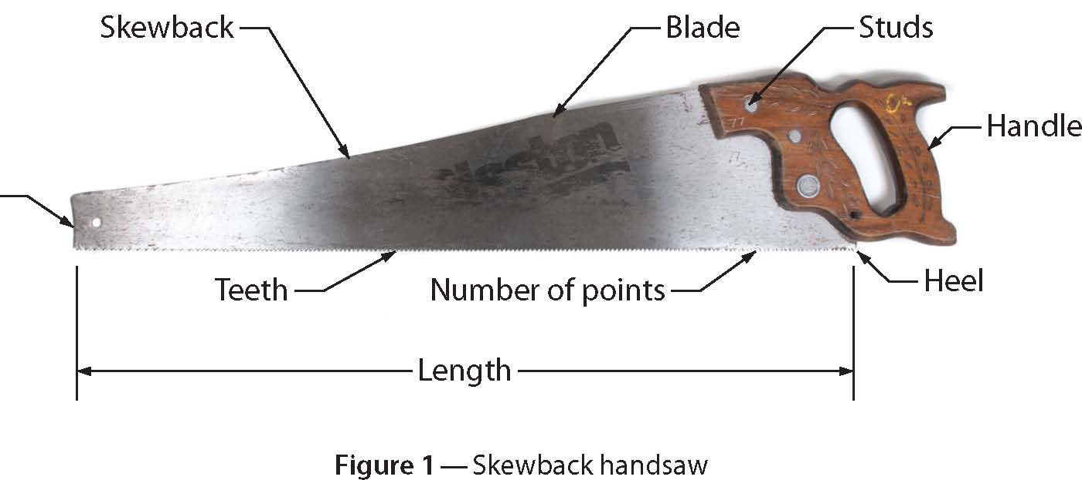
Toe

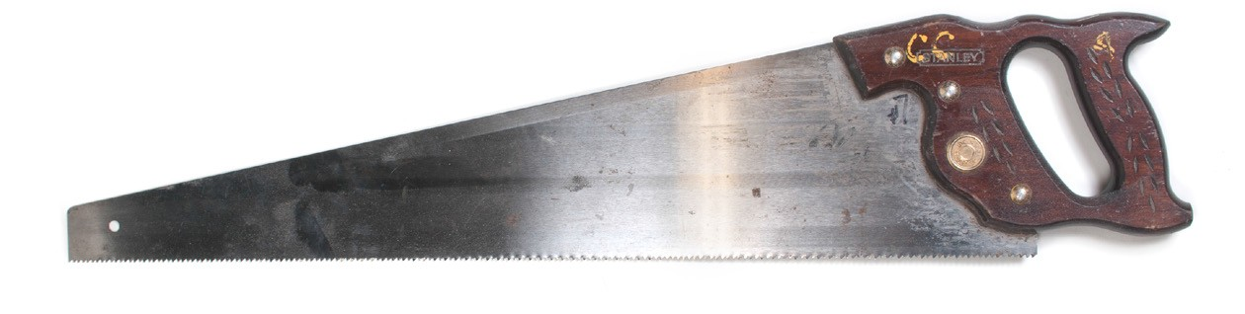
Figure 2 — Straight-back handsaw

The blade of the handsaw is made of spring steel, tempered to provide a longer-lasting edge on the teeth. In the past, the teeth were individually filed and set (angled), but now they are stamped by machines.

The face of the blade is ground and polished. The smooth surface reduces friction between the saw and the wood. A handsaw of good quality has a taper-ground blade, where the back of the blade is thinner than the tooth edge. With this design, less set is required.

The teeth of the saw are set or angled alternately in opposite directions to provide clearance on each side of the saw blade as it cuts. The width of the cut is called the “kerf,” and it creates the clearance. The set of the saw is just as important as the sharpness of the teeth, because without the set it would be difficult to push the saw through wood. Figure 3 shows examples of crosscut
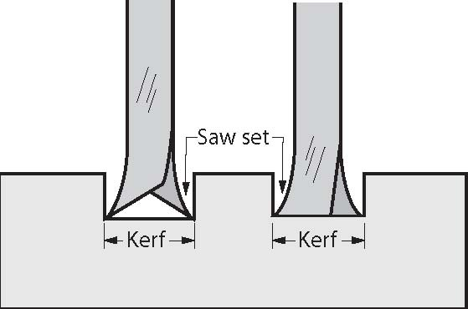
and ripsaw kerfs.

Crosscut Ripsaw
Figure 3 — Crosscut and ripsaw kerfs

Handsaws are generally specified by the shape of the teeth (i.e., crosscut or rip), the length of the blade, and the number of points per 25 mm (or per inch). The number of points is usually stamped on the heel or printed with the manufacturer’s label on the side of the saw. Figure 4 shows a diagram of 7 points and 6 teeth in 25 mm (1 in.). The number of teeth is always one less than the number of points.

1" or 25 mm
7 points – 6 teeth

Figure 4 — Number of points and teeth per 25 mm (or per inch)

Crosscut saw and rip handsaws
The tool most people think of as the handsaw is either a crosscut saw or a ripsaw. The crosscut saw is designed to cut across the grain of wood, and the ripsaw is designed to cut with the grain.

These saws vary in length from 500 mm to 700 mm. The points also vary from 6 to 14 per 25 mm (inch). The crosscut saw used for framing is normally 700 mm long and has 8 to 10 points per
25 mm (inch), whereas a framing ripsaw is commonly 6 to 8 points per 25 mm (inch). Saws used for finishing work have finer teeth.

The teeth of a crosscut saw are shaped like knives (Figure 2) to give a scoring action for cutting across the grain of wood. Most of the cutting is done on the forward stroke (or push) of the saw.

The ripsaw is designed to cut with the grain of wood. Its teeth are shaped like tiny chisels (Figure 3). The portable circular power saw has made the use of the ripsaw virtually obsolete.

Backsaw
The backsaw (Figure 5), also called the “tenon saw,” is designed for precise bench work. It has a thin blade and a metal reinforcing strip along the back edge, which restricts the depth of the cut. It is about 350 mm long and has crosscut teeth (10 to 14 points per 25 mm).

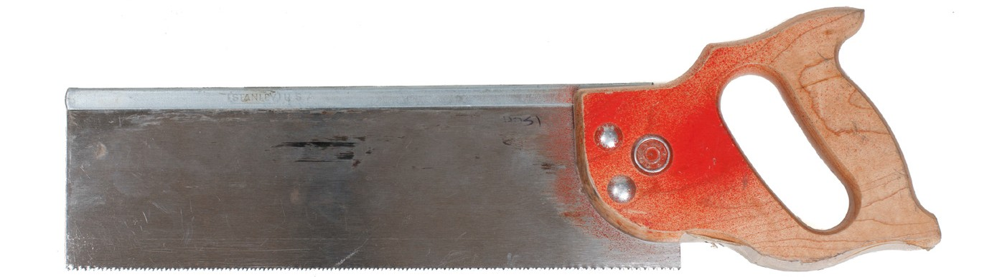
Figure 5 — Backsaw (or tenon saw)

Mitre saw
The mitre saw is longer than the backsaw (up to 700 mm long), but it has the same number of points per 25 mm. It is usually used in a mitre box, which can be a simple three- sided box that is open at the top and the ends (Figure 6). The box allows the boards being cut to be slid into it then held in place. The board can then be cut at an angle using the slots that are cut in the walls of the box as guides.
Typically the slots in the mitre box are cut at 45° and 90°. A

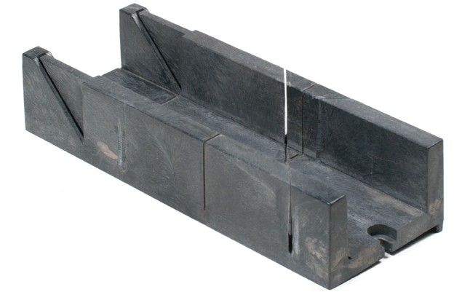
Figure 6 — Mitre box

more elaborate type of mitre box has a metal frame (Figure 6B), which can be set for any angle from 45° 90°. The mitre saw and box are useful for cutting mitres for mouldings and trim.

Pull saw
Pull-type wood handsaws (Figures 7 and 8) have been around for centuries in many older cultures, but were introduced in the West only in the last few decades. They also come in different tooth styles like rip and crosscut.

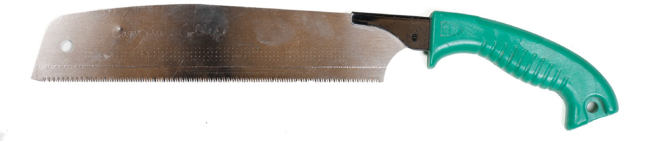
Figure 7 — Pull saw

Pull saws can be made of much thinner material than saws designed to cut on the forward push stroke, as they don’t have to resist the tendency to buckle. This can be useful when getting into tight spots to make flush cuts (Figure 8).

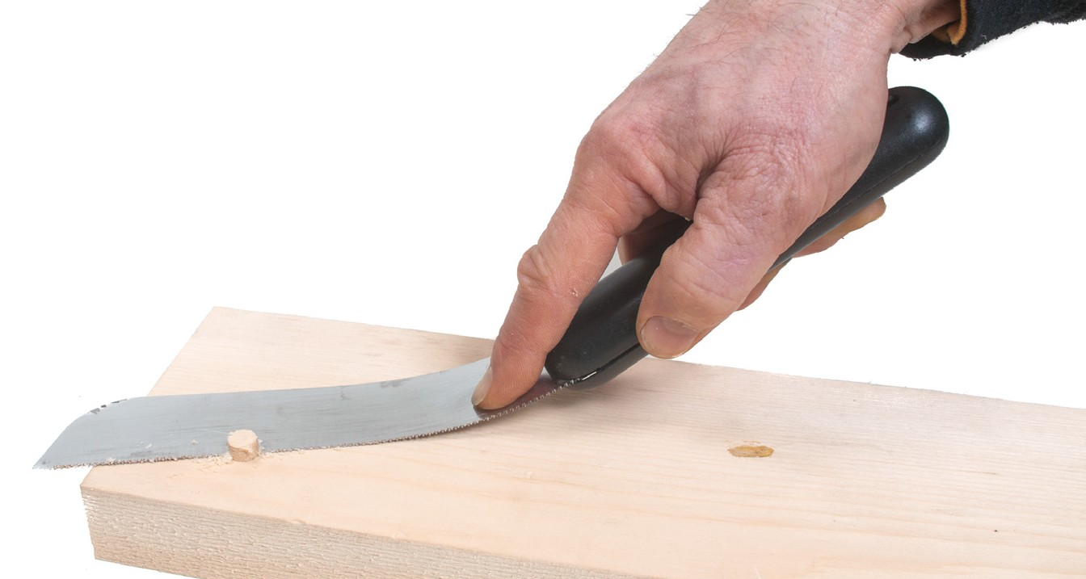
Figure 8 — Flush cut

Compass and keyhole saws
Compass and keyhole saws have narrow, tapered blades, but as shown in Figure 9, the blade of the compass saw is slightly wider.

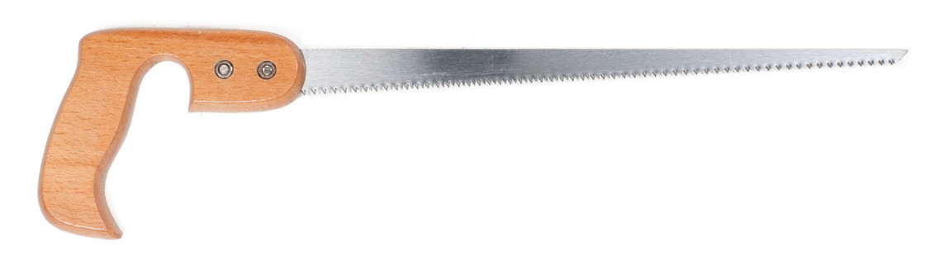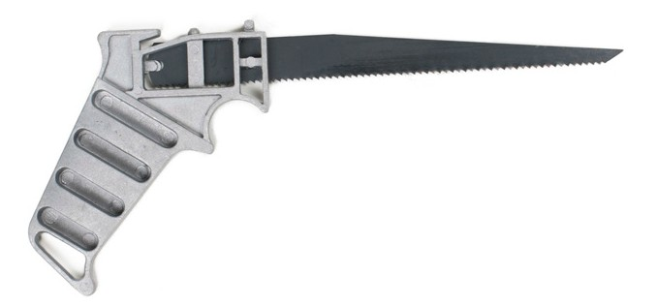
Figure 9 — Left: Compass saw; Right: Keyhole saw

The section of blade to use depends on the curve to be cut. The wide part of the blade is used for large curves and the narrow part for small cut-outs. Because the blade is so narrow, care must be taken not to cause it to buckle. The blade on these saws varies from 250 mm to 350 mm (10 in. to 14 in.) in length and the teeth are filed in the same manner as the teeth on a crosscut saw.

Drywall saw
A drywall saw (Figure 10) has a tapered blade like a keyhole saw, but it is much thicker, allowing for push-style plunge cuts into the drywall.

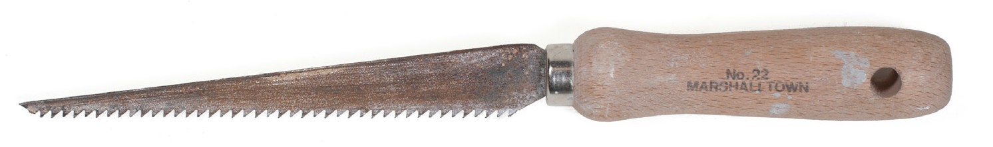
Figure 10 — Drywall saw

Hacksaw
The hacksaw (Figure 11) consists of a metal frame, a handle, and a narrow saw blade. The adjustable type accommodates different lengths of blades, from 205 mm to 410 mm (8 in. to 16 in.). The non-adjustable type holds only one length of blade. A hacksaw has a protective pistol grip handle in case the blade breaks or your hand slips.

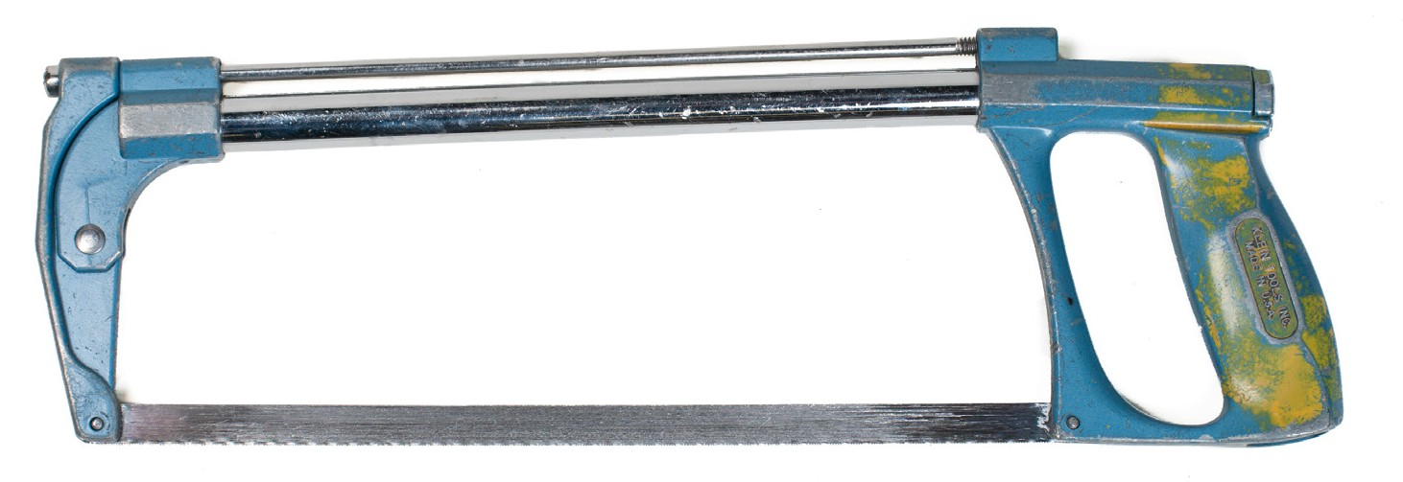
Figure 11 — Non-adjustable 250 mm (10 in.) hacksaw

Hacksaw blades
Hacksaw blades are made of flexible hard-tempered steel. The pitch (number of teeth per inch) may be 14, 18, 24, or 32. The part number stamped on each blade is a code number indicating the blade length and number of teeth per inch (TPI). For example, code number 1218 identifies a blade 12 in. long, with 18 teeth per inch (Figure 12), while code number 1032 identifies a 10 in. blade with 32 teeth per inch.

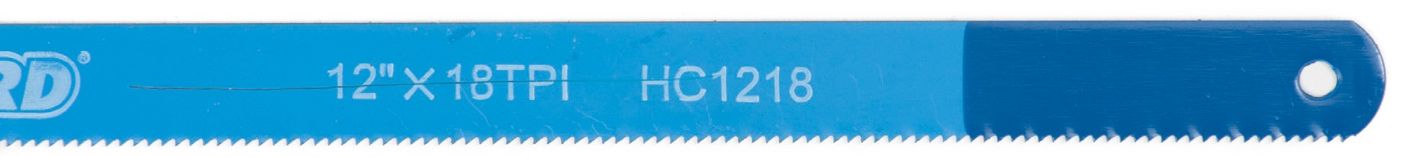
Figure 12 — Hacksaw blade

Soft materials, such as aluminum, brass, soft steel, and copper, require a 14-pitch blade. Hard materials, like a drill rod, and thin materials, like sheet aluminum or thin wall tubing, require a 32-pitch saw blade.

As the blade wears and the points of the teeth become dull, they straighten slightly and the cut made by the blade becomes narrower. A dull blade has a tendency to stick in the material being cut and breaks easily.

When using a hacksaw, be sure the blade is placed on the pins with the arrow on the blade pointing forward, away from the handle. If the arrow is not visible, ensure that the teeth of the blade face forward, as all cutting is done on the forward stroke. When cutting thin material be sure to select a blade with a pitch that has teeth small enough so that at least two teeth of the blade are in contact with the material being cut.

To avoid ruining a hacksaw blade, always test the material to be cut by running the edge of a file along the area you are going to cut. If the material cannot be filed, it cannot be cut with a hacksaw.

Care and maintenance of handsaws
Handsaws should be handled with care to keep the sharp teeth protected. Hang up your saws when you are not using them or put them in your tool box with a blade protector over the teeth. Saws should be kept dry and clean. A light coat of oil will help protect against rust in most environments. If your handsaw blade becomes rusty, clean the rust off with fine emery paper and wax both surfaces of the blade or replace the blade.

Files
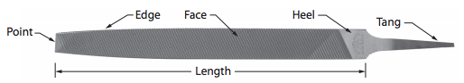
There are many different kinds, sizes, and cuts of files available. The size is determined by the length from the point to the heel, not including the tang. Teeth are cut into the faces and sometimes the edges of the file (Figure 13).

Figure 13 — Parts of a file

All files are classified by shape and by cutting face.

File shapes
The most common cross-sectional shapes of files are flat, round, half-round, and triangular (Figure 14). The flat file has teeth on both edges and is used for general-purpose filing. The round file (also known as the rat-tail file) has teeth covering the full circumference. This file is

used primarily for enlarging circular openings or filing curved surfaces. The half-round file has one flat side and teeth on all surfaces. The triangular file (also called the “three-square file”) is used to clean out corners of a square shape or to file at odd angles. All faces have teeth, and the corners between the faces are left sharp.

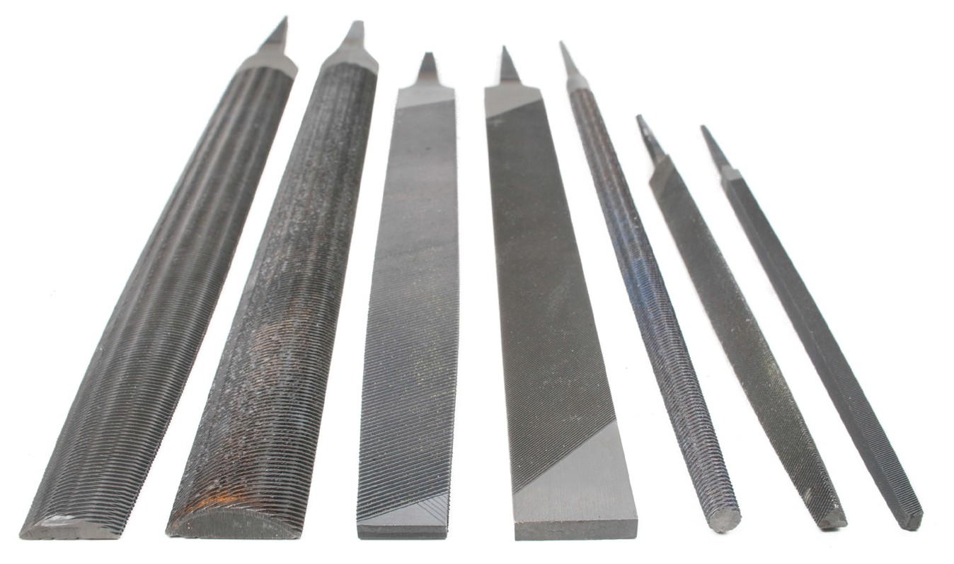
Figure 14 — Shapes of files
All of these file shapes are further described according to their contours. A couple of common examples are:
- blunt or hand-style files, which have edges that are parallel from end to end and also have a constant width
- tapered files, which have a reduction in cross-section from the heel to the point, and may taper in width, thickness, or both

Cutting faces
The three types of cutting faces are single-cut, double-cut, and curved tooth (Figure 15), which refers to the actual design of the cutting edges on the file face. The single-cut file has one set of teeth running across the face of the file. The double-cut file has two sets of teeth crossing each other. The curved tooth file has its teeth arranged in curved contours across the file face.

Single-cut Double-cut Curved tooth
Figure 15 — File faces

The single-cut file is used when a smooth finish is desired. The double-cut file is used for rough, fast metal cutting or where large amounts of material must be removed. The curved tooth file is used to file soft metals such as lead or aluminum. It removes material very quickly and produces a smooth surface after each filing stroke.

For both single- and double-cut files, the second classification identifies the grade of the file teeth. The only difference between grades is the spacing between the teeth. The coarser grade files have more space between the teeth than finer grade files. There are six grades of files, listed here in order from coarsest to finest:
  - rough cut
  - coarse cut
  - bastard cut
  - second cut
  - smooth cut
  - dead-smooth cut

Note that the spacing is in relation to the overall size of the file. For example, a large file has more space between the teeth and larger teeth than a small file, even though both may be the same grade type. Therefore, the size of the file and the grade of its cut must be taken into account against the amount of stock to be removed and the fineness of finish that is required. Figure 16 shows examples of some grades of single-cut files.

Rough cut Bastard cut Smooth cut
Figure 16 — Single-cut file grades

Rasps
Rasps are very coarse files used to rough-shape wooden objects. They have large, pyramid- shaped cutting teeth (Figure 17). Most flat rasps have very coarse teeth on one side and finer teeth on the other. Rasps are also available as round, half-round, triangle, and square.

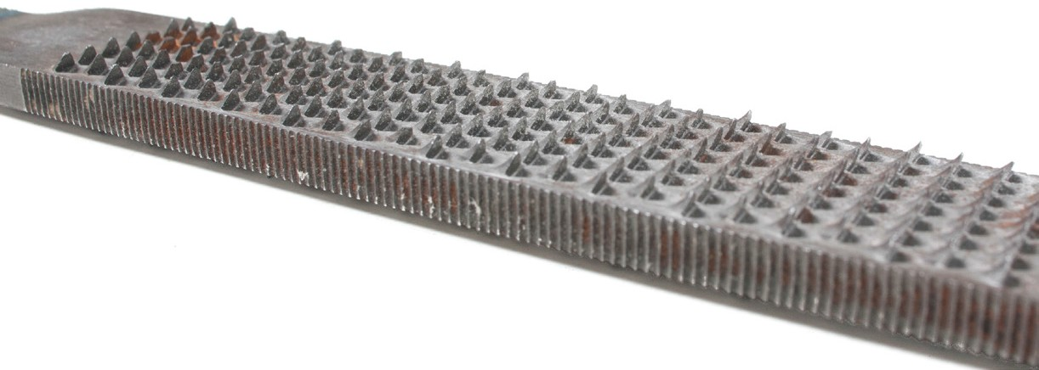
Figure 17 — Wood rasp

File handles
Always select a handle that will correctly fit the file. The tang of a file is usually pointed. If you meet an obstruction while filing and the file stops suddenly, your hand could be punctured. The work can be done more accurately and more quickly if you use a good file handle with a strong ferrule or metal collar (Figure 18).

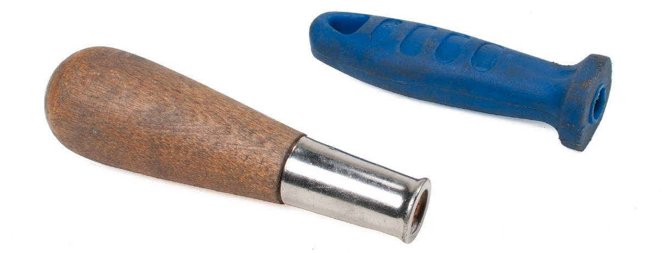
Figure 18 — File handles

Care and maintenance of files
Before starting any filing operation, the file should be coated with chalk. The chalk acts as a dry lubricant to prevent metal cuttings from becoming pinned or trapped in the teeth of the file.
Metal particles trapped in the teeth of a file not only reduce the file’s ability to remove metal from the workpiece, but may also damage the surface of the workpiece. As soon as you notice a buildup of particles on your file, brush them off with a file card, which has wire bristles on one side and fibre bristles on the other (Figure 19).

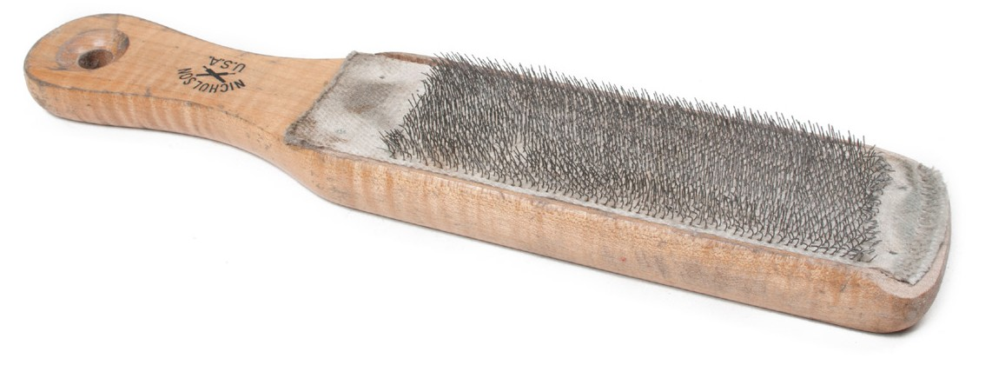
Figure 19 — File card

Begin cleaning the file with the fibre bristles. If necessary, remove any particles still left in the teeth with the wire bristles.

After filing soft metals such as aluminum, copper, or lead, filings will remain stuck between the teeth even after using the file card. If this happens, you should use a sharp, pointed piece of hard wood or soft iron to pick the remaining filings from between the teeth. Never use a piece of hardened steel, as this will cause damage to the teeth.

Files should be kept separated from each other and from other tools to prevent damage to the file teeth. A simple method for safely storing files is to fold a piece of cardboard into an accordion shape, with each fold just wide enough to entirely cover the file blade. Place a file in

each fold of the cardboard and fold the accordion together. Use a heavy elastic band or a strip of old inner tube to secure the folds of cardboard (Figure 20).

Once your files have been securely wrapped, always store them in a dry place. Rust will adversely affect the cutting edge of file teeth.

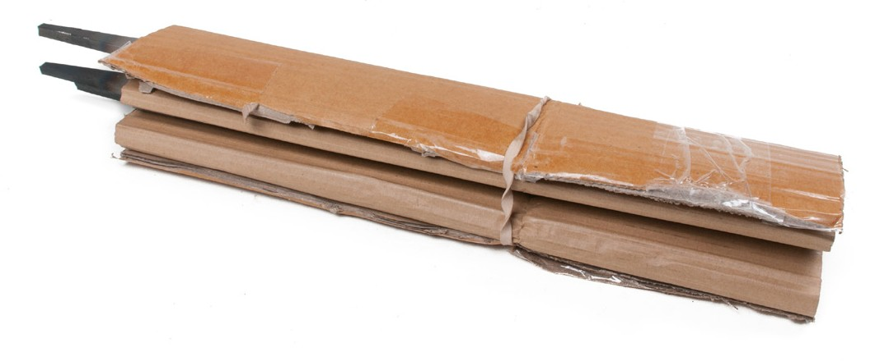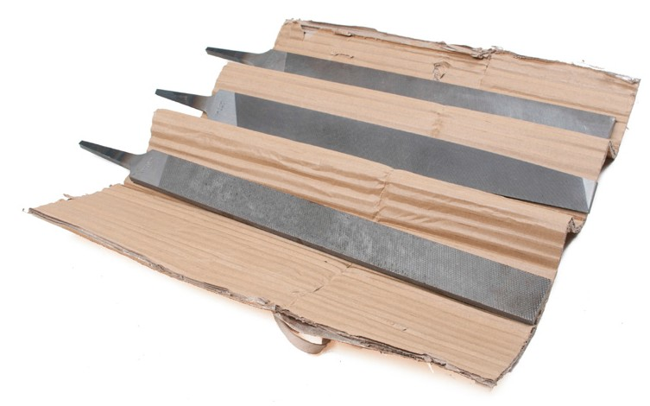
Figure 20 — Storing files

Hand metal shears
Hand shears (Figure 21) are also called tin snips, metal masters, or aviation snips. They will generally cut sheet metal up to 1.5 mm (1/16 in.) thick. The construction of hand shears varies greatly; some are made to cut straight only, while others are made to cut left or right curves.

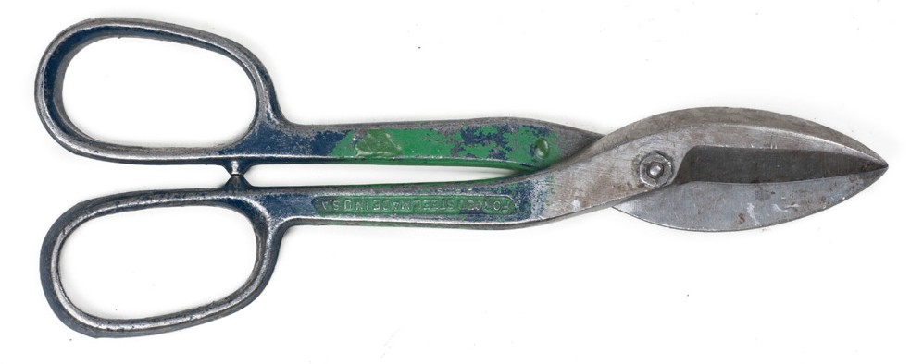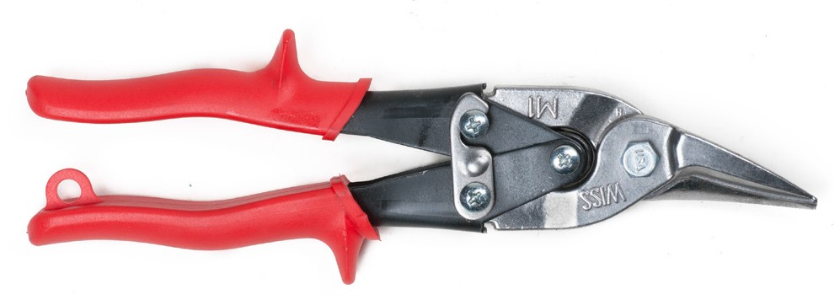
Figure 21 — Hand shears

Wood chisels
Wood chisels vary in shape, size, and the way the handle is held. All chisels hold an edge because they are made of tempered steel. Wood chisels have a cutting edge angle between 20° and 30°.

Chisels are classified according to length, width, and thickness of the blade. They are also classified according to purpose, type, blade shape, and method of holding a handle.

Blade type
The edge of the blade can be either bevelled or straight (Figure 22). The chisel with the bevelled edge is used more often, partly because it fits into hard-to-reach places. The straight-edge blade is heavier and better suited for mortise work.

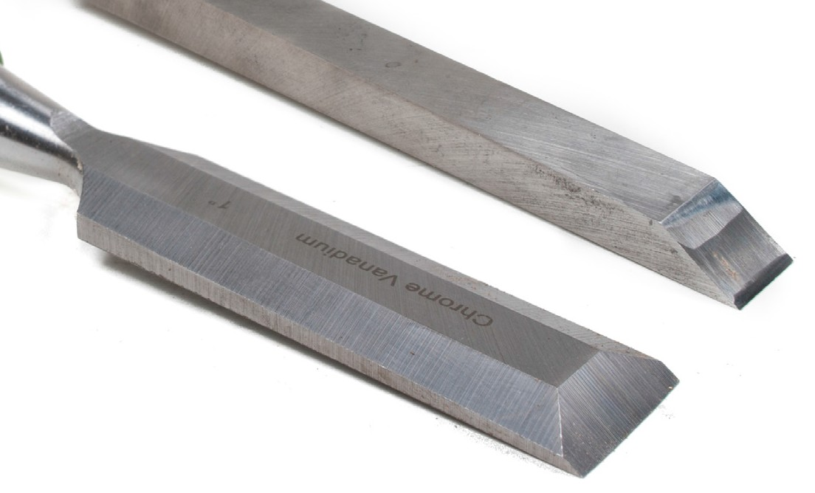
Figure 22 — Bevelled and straight-edge wood chisels

Types of chisel handles
Wood chisels are classified as tang, socket, solid, or moulded. The tang chisel has a long point that fits into the centre of the handle. The socket chisel has a socket at one end to hold a handle (Figure 23).

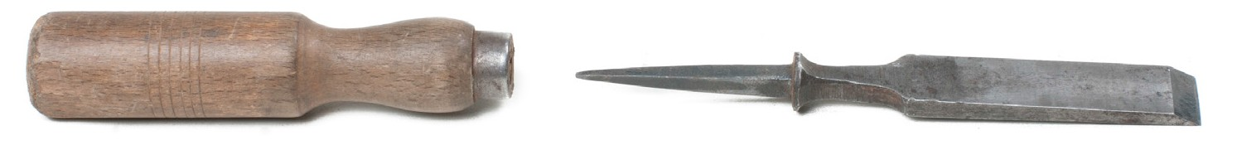
Tang

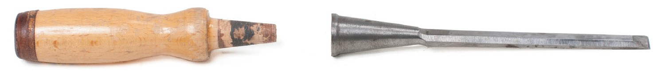
Socket

Figure 23 — Tang (top) and socket (bottom) chisels

Either part or all of the tang is incorporated into the handle of moulded chisels (Figure 24).

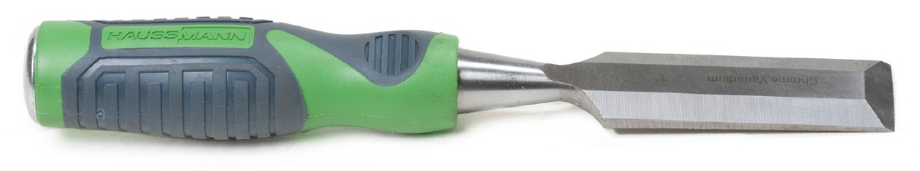
Figure 24 — Moulded chisel

Types of wood chisels
The chisels that carpenters use are:
  - finishing chisels
  - framing chisels
  - gouges

Their differences lie in the thickness and the length of the blade.

Finishing chisels
There are three types of finishing chisels:
  - paring
  - pocket
  - butt

Paring chisel
Designed for light paring work, the blade of the paring chisel is lighter and thinner than the blade of other chisels. The length of the blade varies from 150 mm to 200 mm (6 in. to 8 in.); the width, from 3 mm to 38 mm (1/8 in. to 11/2 in.). The paring chisel should NOT be struck with a mallet or a hammer.

Pocket chisel
The pocket chisel has a blade length of 75 mm to 125 mm (3 in. to 5 in.). The width of the blade is from 3 mm to 50 mm (1/8 in. to 2 in.). The blade of the pocket chisel is heavier than that of the paring chisel.

Butt chisel
The butt chisel (Figure 25) has a shorter blade than the pocket or firmer chisel. It is meant for cutting the shallow notches in wood to allow a hinge to sit flush with the surface of a door jamb. These door hinges are called “butt hinges” and the notches are known as “butt gains”—thus, the name “butt chisel.” The width of the chisel varies from 25 mm to 50 mm (1 in. to 2 in.); the length of the blade is 65 mm (21/2 in.) or less.

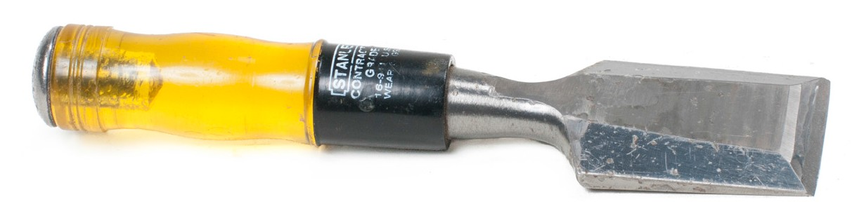
Figure 25 — Butt chisel

Framing chisels
Framing chisels include the firmer chisel and the framing chisel.

Firmer chisel
The firmer chisel is designed for medium-duty work and is normally driven with a mallet. It has a blade length of 150 mm to 200 mm (6 in. to 8 in.) and a width of 3 mm to 50 mm (1/8 in. to 2 in.). The blade is thicker than that of the pocket chisel.

Framing chisel
The framing chisel is made so that it can be driven with a steel hammer. The steel continues from the blade to the end of the handle, and the handle is moulded on each side of the steel. The framing chisel is the heaviest of the chisels. It varies in width from 20 mm to 50 mm (3/4 in. to 2 in.) and in blade length from 150 to 200 mm (6 in. to 8 in.).

Gouges
A gouge is a curved chisel that is used to cut shapes in wood. It is made in three different blade curvatures: flat sweep, medium sweep, and regular sweep. The blade width varies from 3 mm (1/8 in.) up to 50 mm (2 in.). The bevel is ground on the inside or the outside of the blade, and so the gouge is known as either an “inside gouge” or an “outside gouge.” The shank of the gouge is straight or bent as shown in Figure 26.

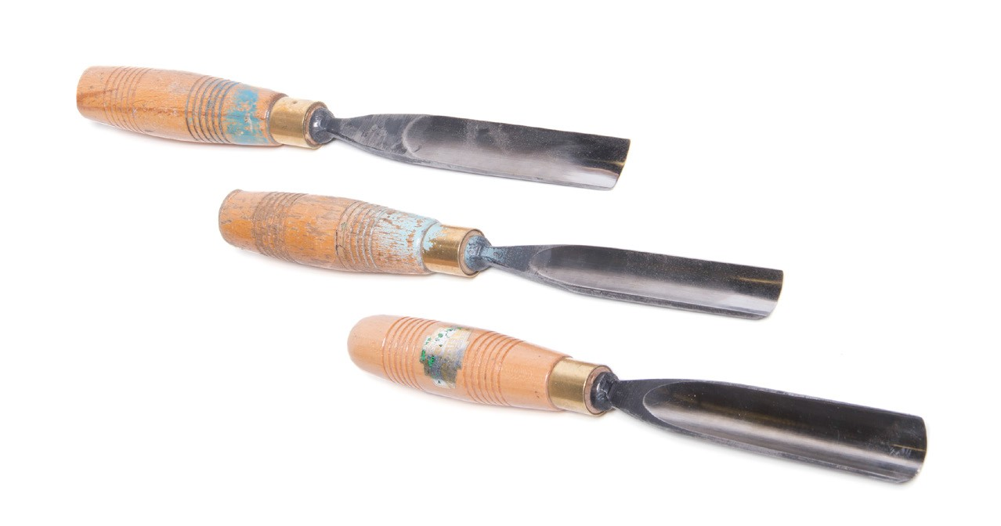
Figure 26 — Gouges

Care and maintenance of wood chisels
Follow these rules to maintain your chisels:
- Keep them sharp for better cuts.
- Keep the cutting edge of chisels protected at all times.
- Do not allow other tools to hit the chisels.
- Keep the handles in good condition and replace if necessary.
- To protect the cutting edges at all times, keep your chisels in a pouch when you carry them in your tool box (Figure 27), and make a special rack for holding chisels in the shop.

  - When you lay chisels on the workbench, place them with the bevel edge downward.
  - Many chisels come with plastic blade guards; use them (Figure 27).

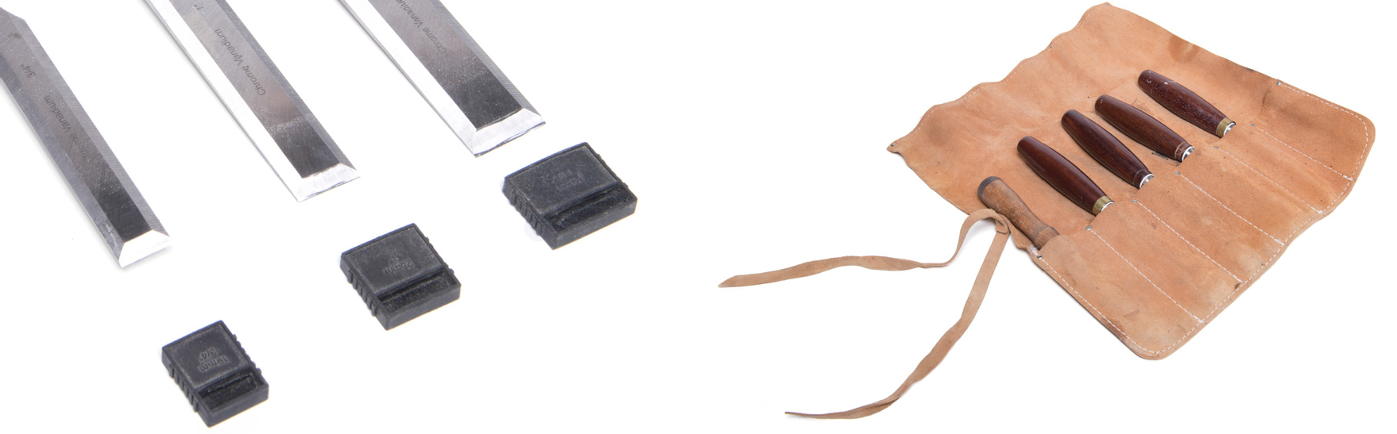
Figure 27 — Chisel protection

Cold chisels
Cold chisels are heavy bladed tools that can be used for cutting and forming metal stock. A cold chisel is forged from square, rectangular, hexagonal, or octagonal high-carbon steel stock. The steel is machined, then hardened and tempered. The body and head are softer than the cutting edge so that they can withstand a striking force without chipping. The upper end of a chisel has a slight taper (chamfer) to compensate for the mushrooming caused by repeated hammer blows.

Types of cold chisels
Different types of cold chisels (Figure 28) are used for different applications. These include:

  - side
  - cape
  - diamond point
    - round nose
    - half round
    - flat

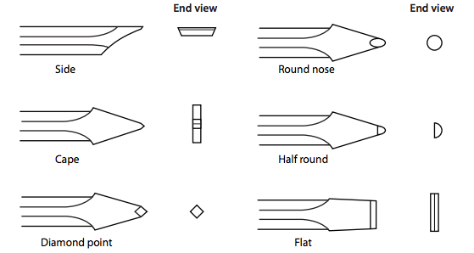

Figure 28 — Chisel types

The flat cold chisel (Figure 29) is used for most general cutting and chipping work. The cutting edge is bevelled (tapered) from both sides toward the centre. Normally, the angle of the bevel should be between 60° and 70°. The angle should be reduced for soft metals and increased for very hard metals.

The flat cold chisel has a cutting edge available in various widths.

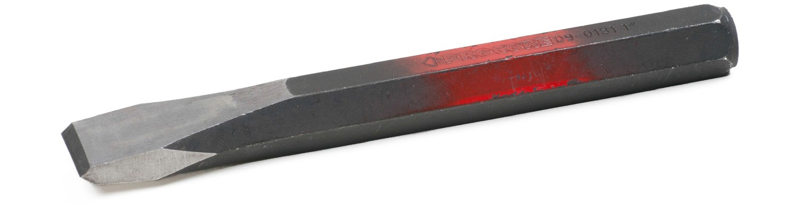
Figure 29 — Flat cold chisel

Always use a chisel large enough to do the required job. A large hammer is used with a large chisel. When using a flat chisel for chipping off metal, control the depth of the cut by raising or lowering the angle at which you hold the chisel.

Always wear appropriate protection when using a chisel.

Care and maintainance of cold chisels
The head of a chisel will mushroom with prolonged use and the cutting edge will become nicked and dull (Figure 30). When the cutting edge or the head of a chisel becomes worn or damaged, it must be dressed (cleaned up or repaired) before it can be used safely.

Tempered portion 38 mm (1½")

Undamaged chisel

Damaged chisel
Figure 30 — Maintaining cold chisels

The chisel must be returned to its original shape. All cracks and spalls (chipped areas) must be removed. If a chisel has been damaged and redressed many times, it loses many of its original qualities and becomes unsafe.

Redressing can be done with a hand file, but it is often done with a bench grinder using a medium- or fine-grit grinding wheel to keep the grinding temperature low. If the grinding temperature is not controlled, the hardness can be lost, making it easy to fracture the chisel when it is used. Chisels are heat tempered approximately 6 cm (11/2 in.) from the cutting edge. The grinding of the chisel should be kept within this area. The wheel rotation should always be away from the cutting edge, toward the body of the tool. This positioning of the tool directs heat away from the cutting edge.

Never use any power grinder unless you have been properly trained.

Utility knives
Utility knives are used for a variety of purposes, including cutting roofing felt, shingles, vinyl flooring, gypsum board, and insulation.

The utility knife has a replaceable razor-like blade. It has a handle about 150 mm (6 in.) long, made of cast iron or plastic, to hold the blade (Figure 31).

Many knives have multiple blade-locking positions. The safest models have a retractable blade, where the blade can be pulled into the handle when not in use.

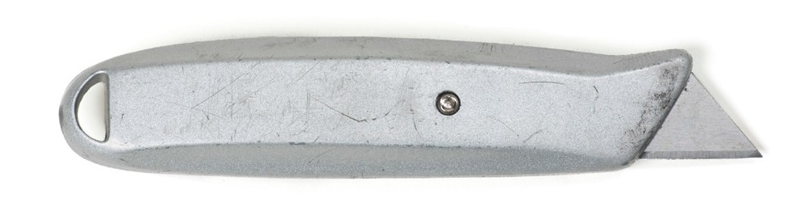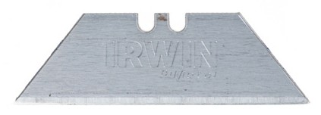
Utility knife

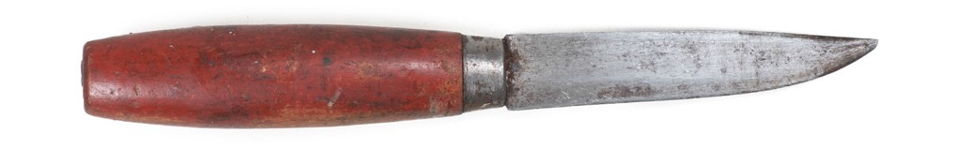
Pocket knife

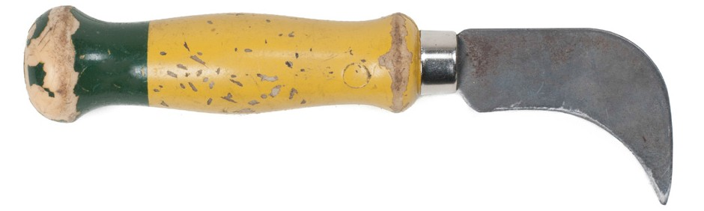
Tile knife

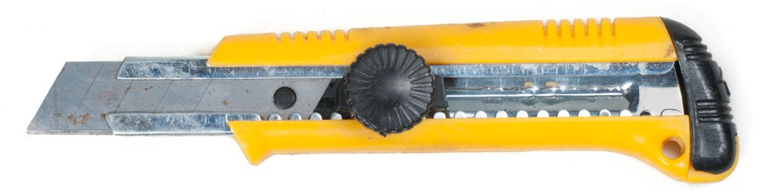
Retractable utility knife Figure 31 — Utility knives

Now complete the Learning Task Self-Test.

Self-Test 1
- Name the parts of the handsaw shown in Figure 1.
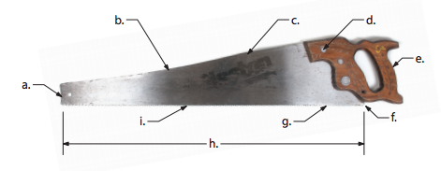

Figure 1

a. _____________ b. _____________ c. _____________ d. _____________ e. _____________
f. _____________ g. _____________ h. _____________ i. _____________

- What term is used to describe the clearance a saw blade has when it cuts wood?
  - Set
  - Slop
  - Slack
  - Shape

- What term is used to describe the slot of material that is removed by a saw?
  - Kerf
  - Loof
  - Swift
  - Tooth

- What can cause a handsaw to buckle when cutting into wood?
  - Saw too long
  - Blade too wide
  - Too little pressure
  - Too much pressure

- What is a backsaw also known as?
  - Ripsaw
  - Bucksaw
  - Spine saw
  - Tenon saw

- What features are shared by the backsaw and the mitre saw?
  - Tapered nose
  - Rip blade profile
  - Metal reinforcing strip
  - Straight handle pattern

- Identify the saws in Figure 2.

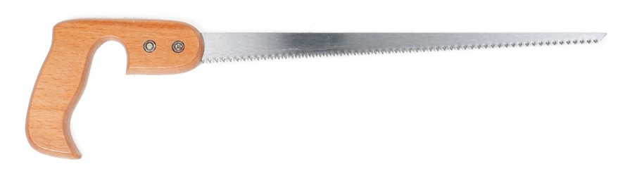 | 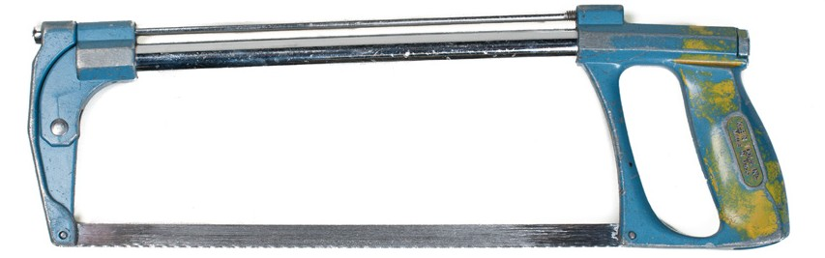
a. | c.
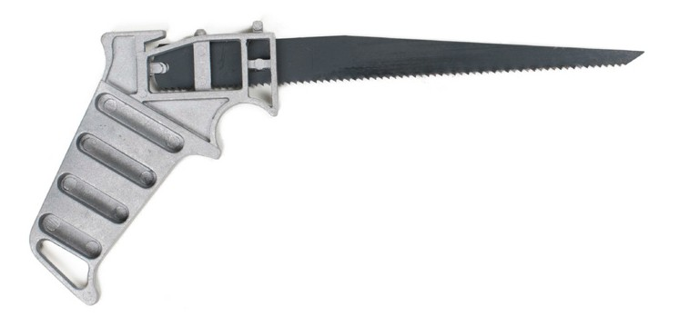 | 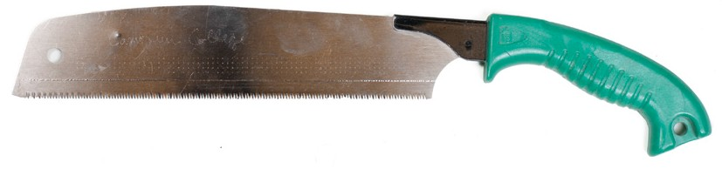
b. | d.
Figure 2

- To cut wood fibres, what are the teeth of the crosscut saw shaped like?
  - Pegs
  - Hooks
  - Knives
  - Chisels

- What do the numbers “1218” printed on a hacksaw blade indicate?
  - 18 in. long and 12 teeth per inch
  - 8 in. long and 121 teeth per inch
  - 12 in. long and 18 teeth per inch
  - the date of manufacture: 12th month 18th day

- Hacksaw blades should have the teeth facing forward so that all cutting is done on the forward stroke.
  - True
  - False

- What type of file is best for rough, fast cutting of metal?
  - Nail
  - Cabinet
  - Single-cut
  - Double-cut

- Where is the length of a file correctly measured from?
  - End to end
  - Heel to tang
  - Point to heel
  - Edge to edge

- Which file is used to obtain a smooth cut?
  - Rasp
  - Flat face
  - Single-cut
  - Double-cut

- What is used to clean files that are clogged with waste material?
  - A pick file
  - A file card
  - A file comb
  - Soapstone

- When sharpening a chisel, what effect will overheating cause?
  - Melting
  - Strengthening
  - Loss of temper
  - Dulling of the edge

- Identify the two blade types shown in Figure 3.

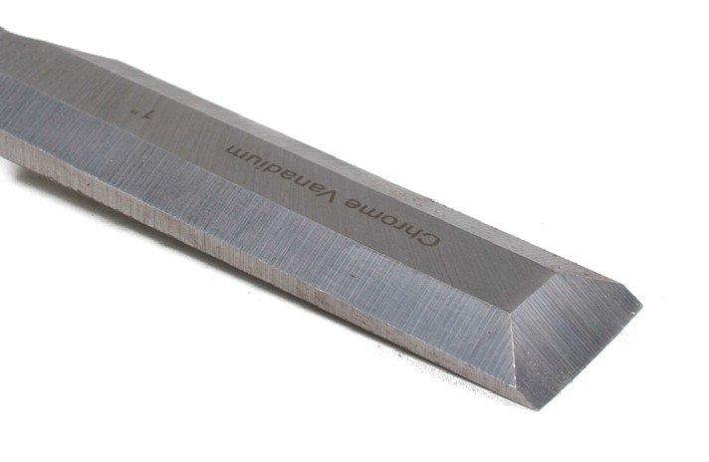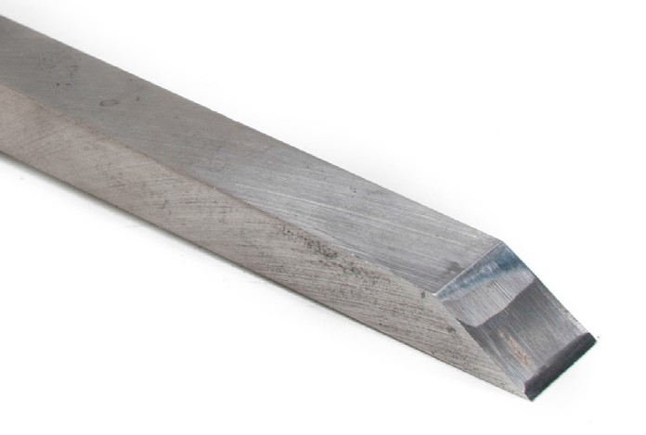
  - b.

Figure 3

- Which chisel should not be struck by a mallet?
  - Paring
  - Firmer
  - Framing
  - Mortise

- The bevelled cutting edge of a flat cold chisel is ground to what angle? a. 50°–60°
b. 60°–70°
c. 70°–90°
d. 90°–100°

- What should be done when the head of a chisel becomes mushroomed?
  - Tape the edge.
  - Grind the edge clean.
  - Use it for light work only.
  - Paint it red as a warning.

- When manufactured, what part of a chisel is actually hardened and tempered?
  - It is tempered throughout.
  - It is tempered at the striking end.
  - It is tempered at the cutting end only.
  - It is tempered at the cutting and striking ends.

LEARNING TASK 2

Describe measuring, marking, and squaring tools and their uses

Systems of measurement
You may be required to use both the metric and the imperial measuring systems.

Imperial
Feet (abbreviated as “ft.” or with the symbol ' ) are divided into 12 equal parts called “inches” (in. or "). Inches are divided into equal parts called fractions. These fractions can be as large as
halves, but greater accuracy is achieved by dividing these parts of an inch into quarters, eighths, sixteenths, or thirty-seconds (Figure 1).

1
1
Quarters Eighths

1
1

Sixteenths
Thirty-seconds
Figure 1 — Divisions of an inch

Some imperial tape measures are graduated at thirty-seconds of an inch for the first 6 in. or 12 in., then at sixteenths for the balance of the tape (Figure 2). Whenever a degree of accuracy
greater than one thirty-second of an inch is required, you must measure by thousandths or ten- thousandths of an inch.

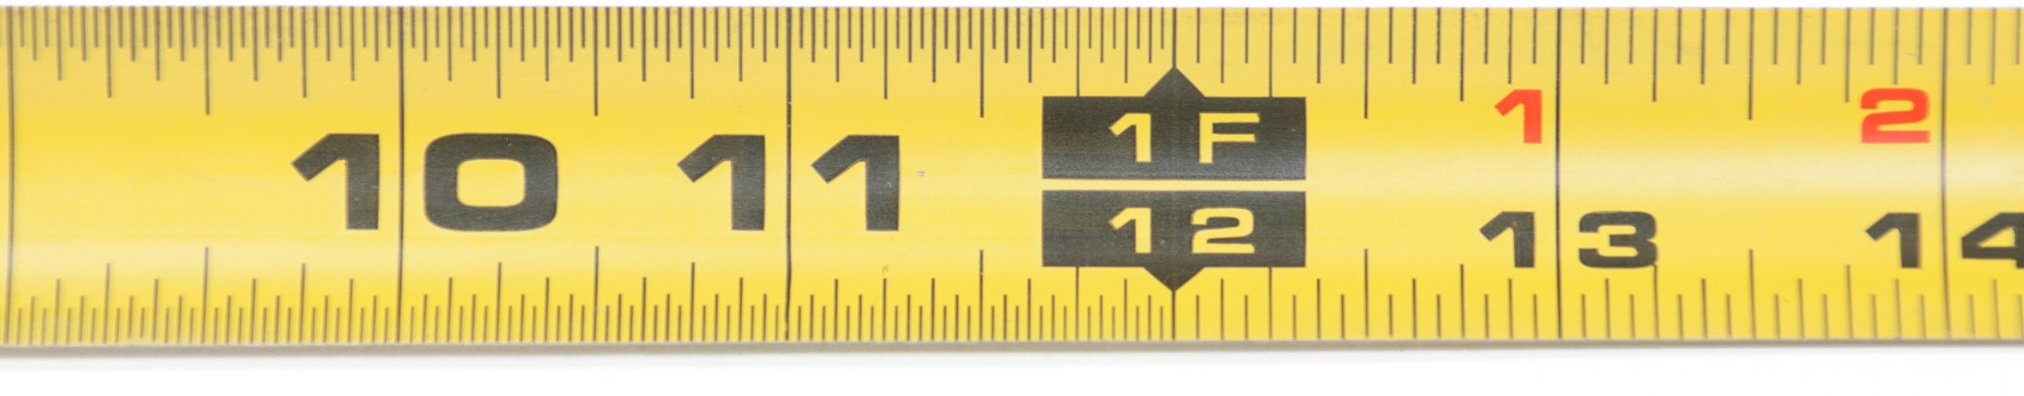
Figure 2 — An imperial tape with divisions of 1/32 and 1/16 of an inch

Watch this video to help you understand the markings on an imperial tape measure. http://youtu.be/btp6vN3Xy0E

Metric
The base unit in metric measurement is the metre. The metre is divided into 100 centimetres (cm) or 1000 millimetres (mm) (Figure 3). A millimetre is one-tenth of a centimetre. Millimetres are the most common unit of metric measurement.

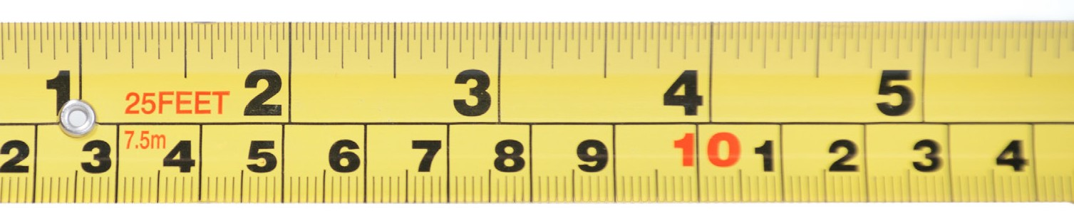
Figure 3 — Tape measure with imperial on the top and metric on the bottom marked in 10 mm units

Measuring devices
There are a wide range of measuring instruments used for checking clearances and tolerances. These include:
    - measuring tapes
    - steel rules
    - calipers
    - micrometers
    - caliper rules
    - gauges
    - squares

Measuring tapes
Tapes (Figure 4) are used to measure large layouts. The steel tape is spring loaded to retract into its carrying case when released. Metric tapes are marked in 1 mm graduations. Some imperial tapes are graduated at thirty-seconds of an inch for the first 6 in. or 12 in., then at sixteenths for the balance of the tape.

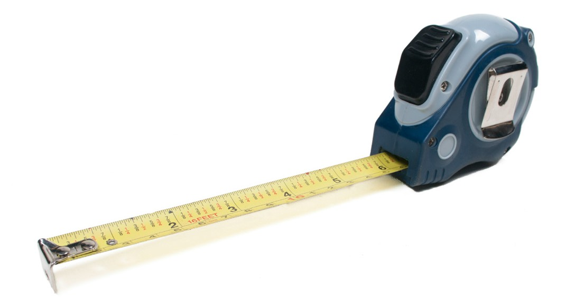
Figure 4 — Measuring tape

Watch this video to help you understand the layout of a combined imperial and metric tape measure. http://youtu.be/PW8Y8M_THnM

Most tapes have a lock to hold them in the extended position, but the return speed should be controlled. If it snaps back too fast, the hook end of the tape could be damaged.

To allow accurate inside and outside measurements, the hook at the start of the tape slides in and out a distance equal to the thickness of the hook. It is supposed to be loose so that it can move slightly. Most have a measurement stamped on the case. This measurement—say, 51 mm (2 in.) or 76 mm (3 in.)—is the length of the case and must be added to the reading when you take an inside measurement.

The steel tape (Figure 5) is made of flexible spring steel and housed in a case with a crank-type handle for rewinding. Usually it is 30 to 50 m (100 ft. to 165 ft.) long, which is much longer than a pocket tape.

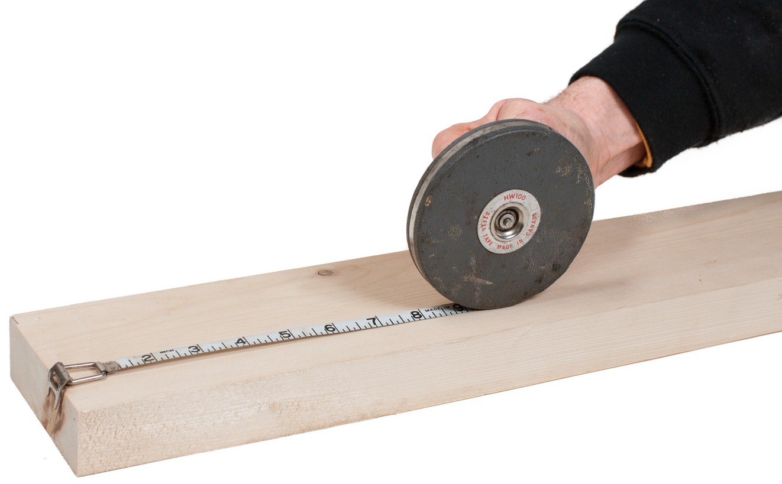
Figure 5 — Steel tape

At the end of the steel tape is a combined ring and hook (Figure 6). When taking measurements, the hook is placed over the end of the object or, if that is not possible, a nail is inserted to hold the ring. It is important when placing the nail that the very end of the ring is at the start of the measurement.

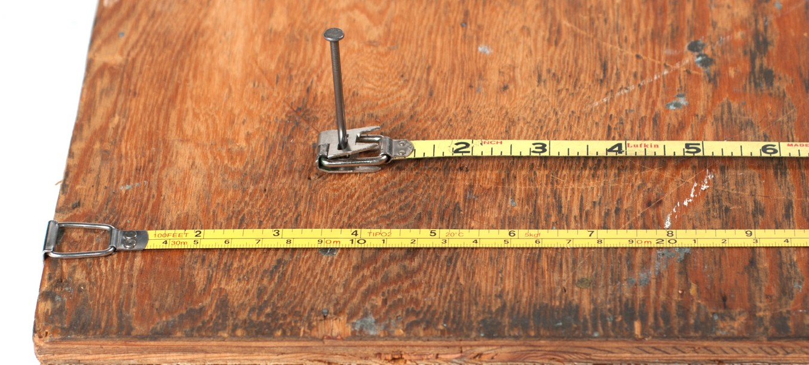
Figure 6 — Hooks and rings at end of steel tapes

When you pull the tape out of its case, it is important to pull it as shown in Figure 7. Rewind the tape in the same direction. Winding the wrong way will stretch one side of the tape, causing the tape to curl up when it is pulled from its case.

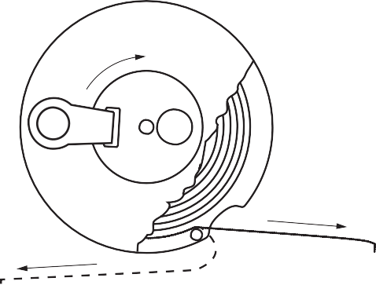
Right way
Wrong way
Figure 7 — Right way and wrong way to extend and rewind steel tape

The winding handle of the steel tape is released by pushing a button on the opposite side of the case. If the tape seems to stick during rewinding, tap the case slightly on the side. If it continues to stick, pull out the tape fully and rewind it. When working in wet conditions the tape should be wipe dry while rewinding.

Another style of long tape measure is the vinyl-coated fibreglass type (Figure 8). These are very durable and waterproof.

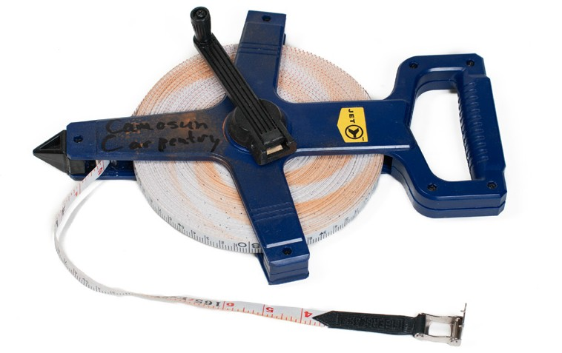
Figure 8 — Vinyl-coated fibreglass tape

Steel rule
Steel rules are usually 15 cm or 30 cm (6 in. or 12 in.) in length (Figure 9). They are used as straight edges and for any measurements shorter than the length of the rule.

Figure 9 — Ruler divisions

A longer style of steel rule is the bench rule, which is made from highly polished steel and is for use at the work bench. The standard length ranges from 450 mm (18 in.) to 600 mm (24 in.). It is about 50 mm (2 in.) wide and graduated in millimetres, or in inches and fractions of 1/32 in.

Calipers
There are several styles of calipers (Figure 10). They can be used to compare measurements of two or more items or to transfer a measurement to a steel rule or tape.

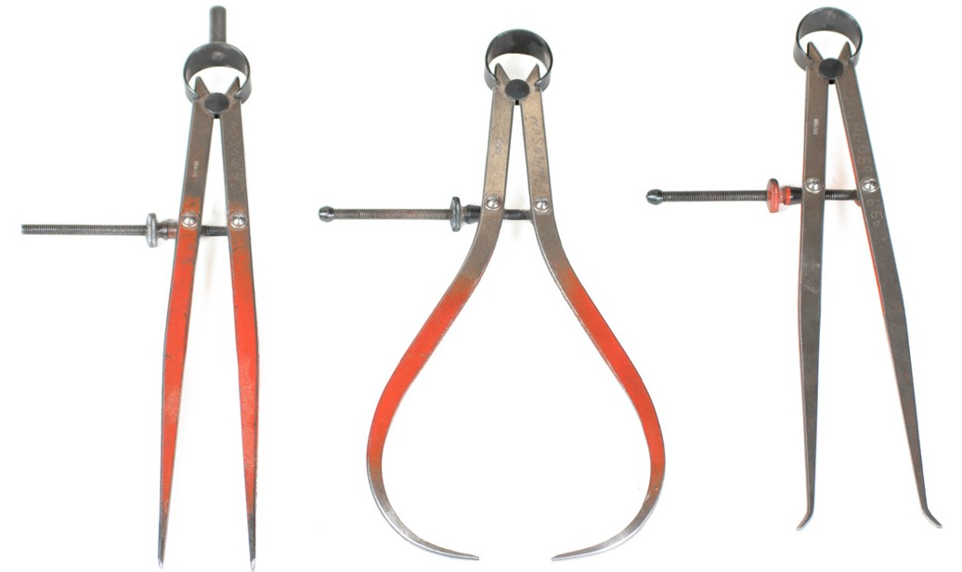
Figure 10 — Left to right: Dividers, Outside calipers, Inside calipers

Inside calipers are used to compare inside measurements such as the diameters of holes or the space between two faces. Outside calipers are used for checking the diameter of cylindrical objects such as spindles, axles, and shafts. Dividers are only used for layout. They are never used to compare the inside measurement of one object to the outside measurement of another object.

Micrometer
An outside micrometer (Figure 11) has a rounded frame to fit around the object to be measured. The anvil is a smooth, fixed contact face that you place against the object to be measured.
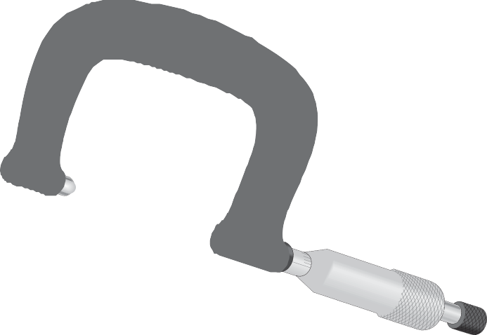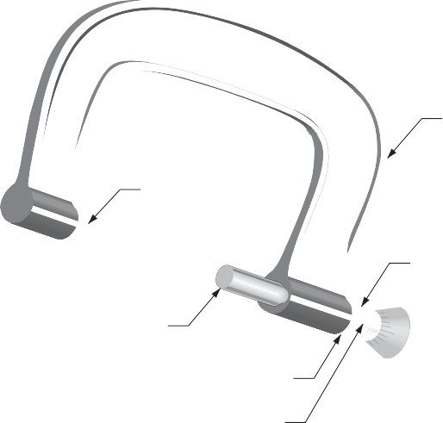

Frame

Anvil

Sleeve, barrel, or hub

Spindle

Lock nut Zero line

Thimble
Ratchet stop

Figure 11 — Outside micrometer

The sleeve (also called a “hub” or “barrel”) is fixed to the frame and does not move. The major and minor scale measurements are on the central line of the sleeve. These numbers are usually scribed into the metal of the sleeve. A line scribed under the numbers is called the zero line or datum line.

On imperial outside micrometers (Figure 12), the sleeve major scale graduations mark tenths of an inch. The numbers 1 and 2 on this scale correspond to 0.100 in. and 0.200 in. respectively.
The sleeve minor scale is represented by lines only, between the numbers. The minor scale graduations mark 0.025 in., and therefore there are three lines, creating four spaces, between each major scale line and number. The minor scale graduations equal 0.025 in., 0.050 in., and 0.075 in.

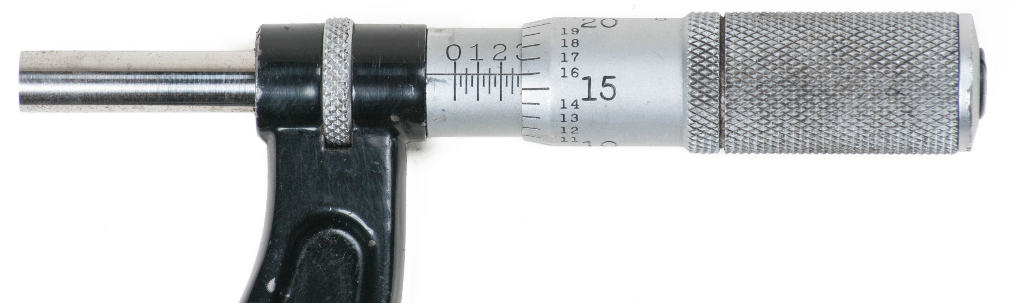
Figure 12 — Imperial micrometer reading 0.291 in.

The thimble on the micrometer rotates. Threads inside the thimble are connected to threads on the spindle, so rotating the thimble moves the spindle back and forth. Around the circumference of the thimble are the thimble graduations. The thimble graduations are marked by lines and numbers scribed onto the thimble. These numbers mark thousandths of an inch. The numbers 15 and 16 on this scale correspond to 0.015 in. and 0.016 in. respectively. The thimble is tapered at the upper end so that the lines on the thimble and the zero line on the sleeve meet on the same plane.

The ratchet stop or friction device is used to rotate the spindle when you are making very fine measurements. The ratchet stop limits the spindle pressure on the part being measured to a finite amount. The ratchet stop begins to slip when too much pressure is applied, indicated by a clicking sound. It is advisable to count the number of ratchet clicks and use the same number of clicks each time a measurement is taken.

A lock nut or clamping ring is used to lock the spindle at the desired setting. This allows the part being measured to be removed without accidentally changing the measurement.

A metric outside micrometer is shown in Figure 13. The sleeve major scale graduations are marked in millimetres, and the sleeve minor gradations are also spaced 1 mm apart, but these are offset for the upper scale by half a line to indicate 0.5 mm increments relative to the upper scale. The combination of the two-sleeve scale reading (Figure 13) would indicate 31.5 mm.
There are 50 thimble graduations marked in hundredths of a millimetre. The thimble shown is

less than 0.44 mm. The addition of these two numbers gives a measurement of 31.5 + 0.44 =
  - mm.

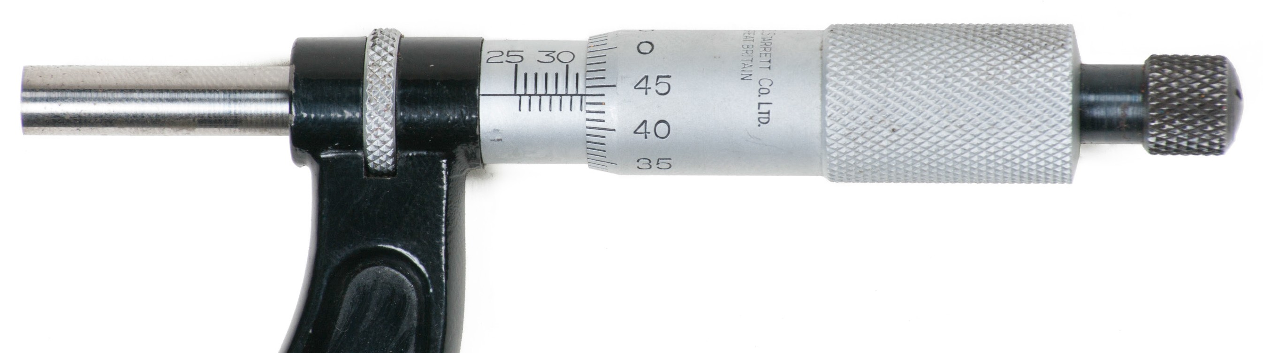
Figure 13 — Metric micrometer reading 31.94 mm

Caliper rule
Caliper rules can be used to take accurate inside and outside measurements of small objects or holes and slots (Figure 14).

Instead of using an adjustable screw like the micrometer, caliper rules have a sliding scale. On some models there are graduations on both sides of the instrument, one side for inside measurement and the other for outside measurement. On other models, both inside and outside graduations are on the same side.

Some models are available with both imperial and metric scales. Some have a dial indicator for greater accuracy, and most are designed with a sliding bar to measure depth. Digital calipers display the measurement on a liquid crystal display.

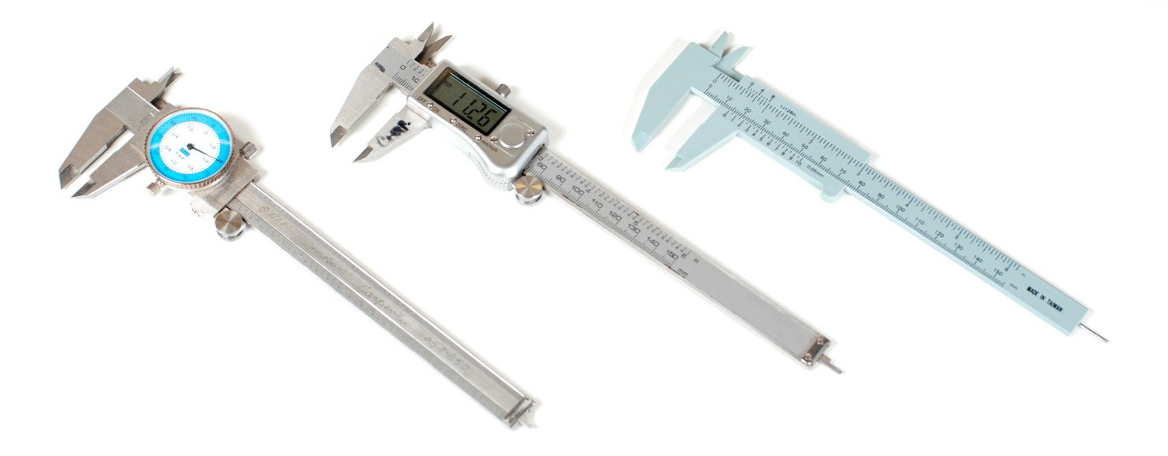
Figure 14 — Caliper rules

Vernier caliper
Precision vernier-style caliper rules (Figure 15) are capable of measuring accurately to two- hundredths of a millimetre (0.02 mm) or one-thousandth of an inch (0.001 in.)

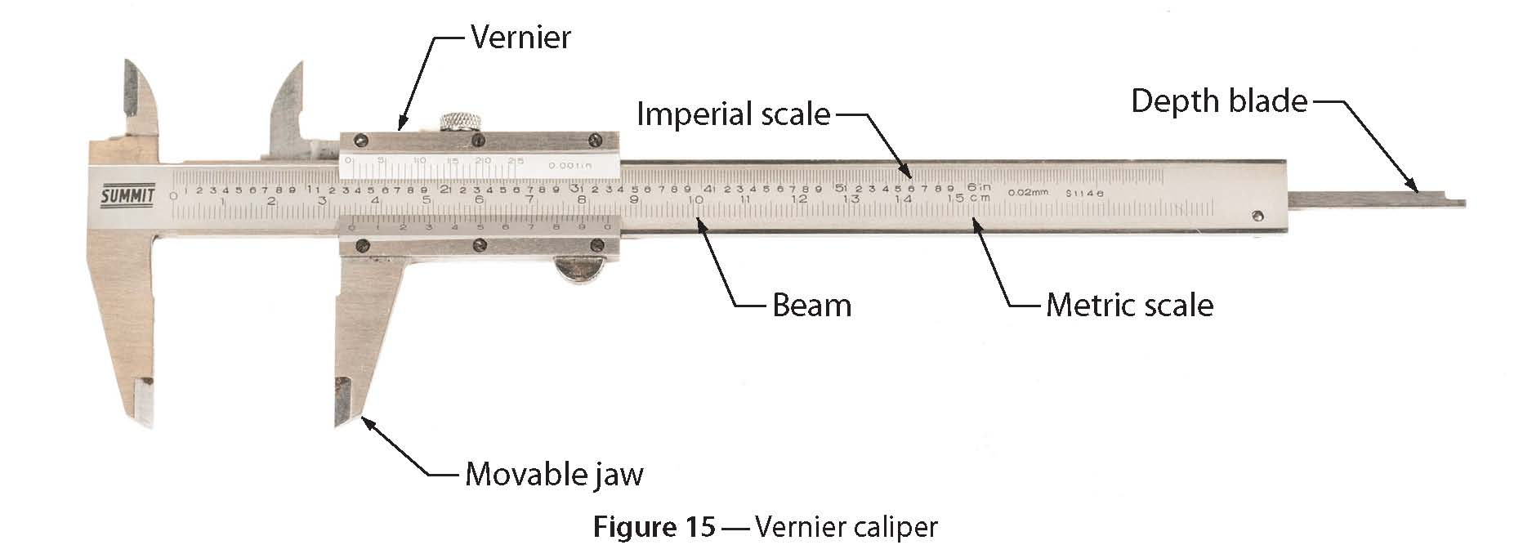

The vernier caliper consists of an L-shaped frame with a fixed jaw as one of the legs of the frame. It has the following parts:
    - outside jaws: used to take external measures of objects
    - inside jaws: used to take internal measures of objects
    - depth probe: used to measure the depth of objects
    - main scale (cm)
    - main scale (in.)
    - vernier (cm)
    - vernier (in.)
    - retainer: used to block movable part

Go to this link to watch a demonstration using the vernier-style caliper_rule. http://commons.wikimedia.org/wiki/File:Using_the_caliper_new.gif#mediaviewer/File:Using_the_caliper_new.gif

Gauges
Gauges are used in the trades for measuring the size, amount, or contents of something.

Drill-point gauge
The drill-point gauge (Figure 16) is specifically designed to check drill-point angle and lip length. The gauge consists of a 150 mm (6 in.) hook rule in combination with a sliding head. The head can be adjusted to any position along the rule and locked with a thumb nut. The head is bevelled to 59°, the correct drill-point angle for mild steel.

The head is also graduated in 1/32 in. increments along the 59° angle in order to measure the lengths of the cutting lips. For a drill to operate effectively, both cutting lips must be the same length. The hook rule is graduated in eighths, sixteenths, thirty-seconds, and sixty-fourths.

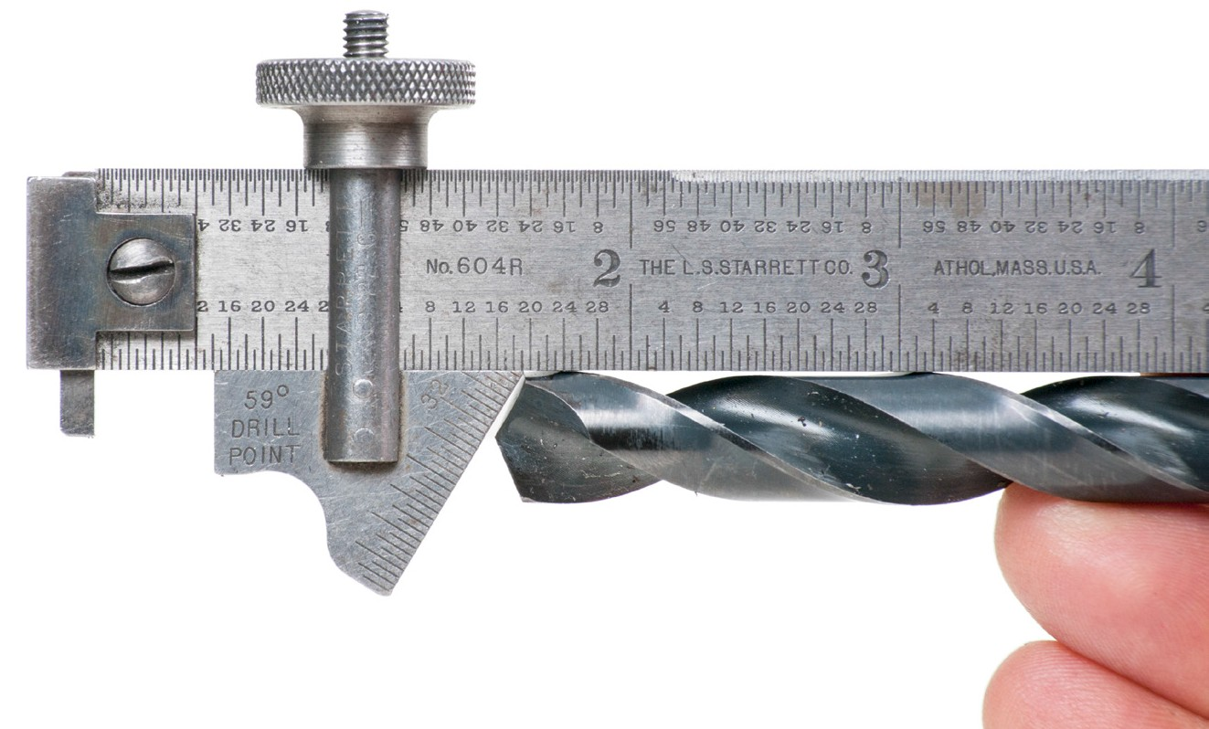
Figure 16 — Drill-point gauge

Thread gauge
A thread gauge or screw pitch gauge (Figure 17) is used to determine the pitch of various thread forms on bolts, screws, studs, or any threaded component.

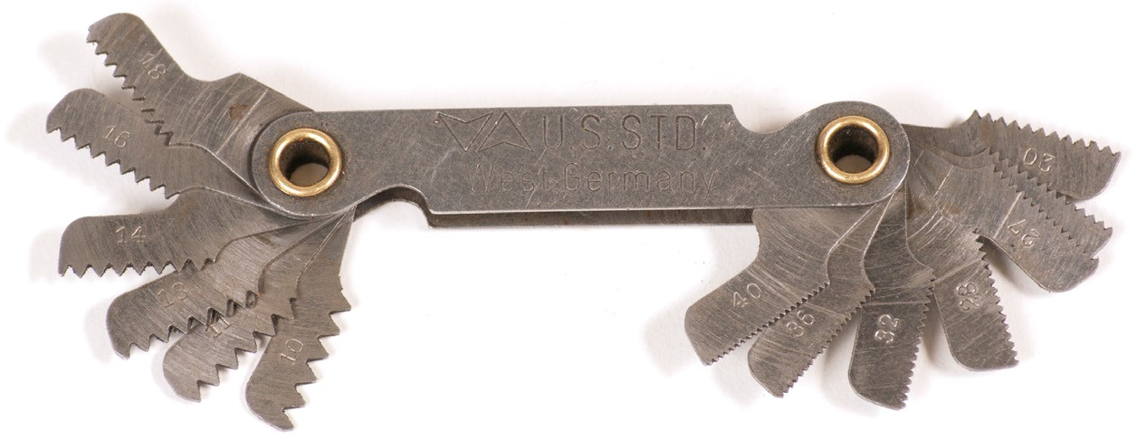
Figure 17 — Thread gauge

Screw threads are spiral grooves of uniform shape and size formed on the inside of a hole or on the outside of a rod or pipe. Some types of thread taper to form a tight seal while others don’t. These threads are measured as the number of threads per inch on imperial fasteners and as a direct measurement of pitch on metric fasteners.

The pitch of a screw thread is the distance from a point on one thread to the same or corresponding point on the next thread (Figure 18). Expressed in threads per inch, the pitch is equal to 1 divided by the number of threads per inch. For example, a screw with 10 threads per inch has a pitch of 1/10 in. (1 divided by 10).

In the metric system the pitch is expressed in a direct measurement of the pitch in millimetres, such as 1.0 mm, 1.25 mm, or 1.75 mm.
Thread pitch

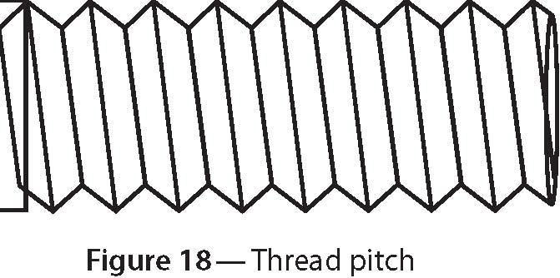

With a thread or screw pitch gauge you can find pitch without using direct measurement or calculation.

These instruments are made up of a number of thin blades, each having V-shaped teeth cut along one edge that match a standard thread shape. Each blade also has a number on it to indicate the number of teeth per inch or the pitch in millimetres.

To find the pitch of a screw thread, try to fit the appropriate gauge blade to the threads of the fastener being measured. Read the number on the gauge blade that matches your sample. The gauge blade must be held parallel to the fastener to get a correct reading.

Feeler gauge
A feeler gauge is made up of a series of steel plates or blades that have a progression of very precisely calibrated thicknesses. These blades are often joined at one end with a pin or rivet and fold back like a fan into a handle (Figure 19). Each blade is marked with its thickness. A feeler gauge is used to measure or set very small gaps, normally under 1 mm. When the blades are folded back into the handle, the thin, delicate blades are protected. The thickest possible blade that can be inserted into a gap or crack shows its width.

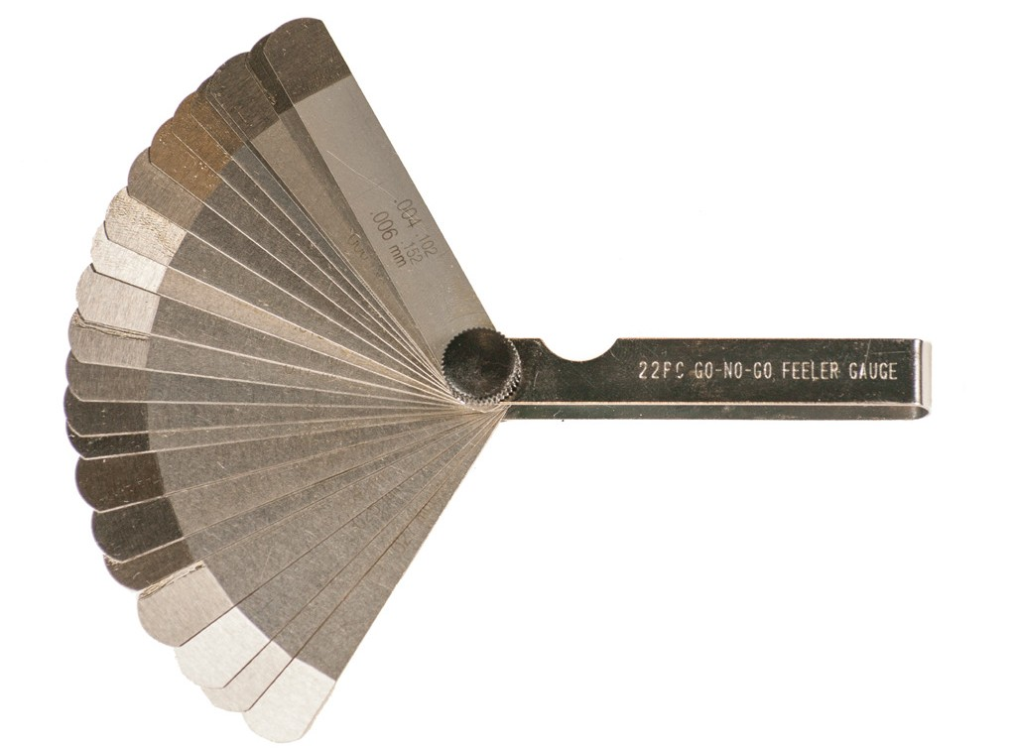
Figure 19 — Feeler gauge

Wire gauge
A wire gauge consists of a circular or oval plate having notches of different widths around its edge to receive wire and sheet metals of different thicknesses (Figure 20). Each notch is stamped with a number indicating the wire gauge size.
The circular wire gauges are the most popular, and are generally 95 mm (33/4 in.) in diameter, with 36 notches. Many have the decimal equivalents of the sizes stamped on the back.

Squaring tools

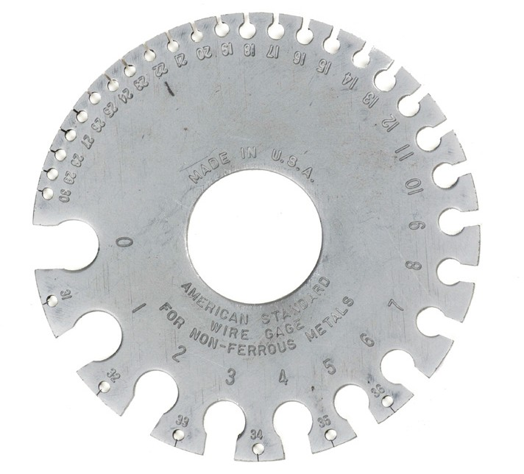
Figure 20 — Wire gauge

The main purpose of squaring tools is to ensure that components are perpendicular, or at right angles to each other. In addition, most squaring tools serve as measurement rulers.

Combination square
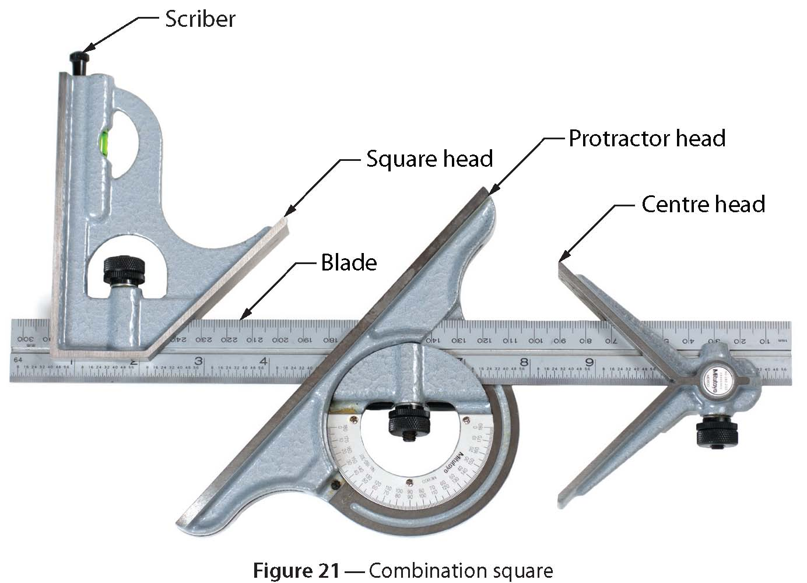
A combination square (Figure 21) has a tempered steel blade with four engraved scales. There are three interchangeable heads that slide in a central groove on the blade. The three heads are the square head, the protractor head, and the centre head. They can be adjusted to any position along the blade, or they can be easily removed to allow the blade to be used as a rule.

The centre head has two equal arms that enable you to find the centre of large or small round stock. The protractor head has a revolving turret with direct-reading double graduations from 0° to 180° in opposite directions. This permits you to read angles either above or below the blade. A square head (Figure 22) has a 90° square face and a 45° mitred face. Some square heads

also have a spirit level and a scriber. The square head with steel blade is the most popular combination and can be purchased separately without the protractor head and centre head. The square head and steel blade are often also referred to as a “combination square” (Figure 22).
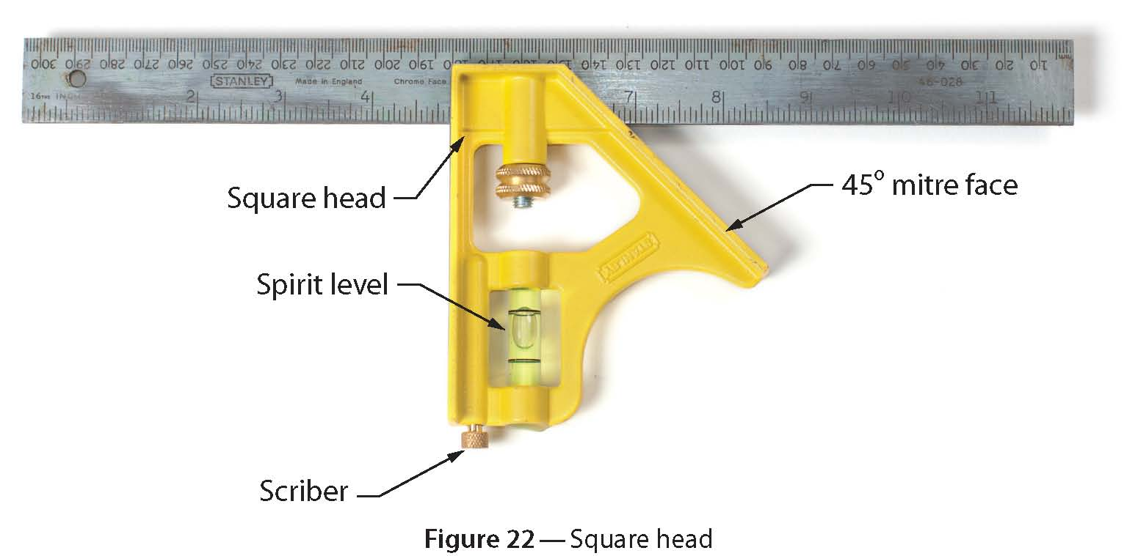

Combination squares have many practical applications, including squaring work, transferring measurements, laying out work, levelling surfaces, determining plumb, establishing centres, and laying out and checking angles. They can also be used as depth gauges for measuring recesses.

Steel squares
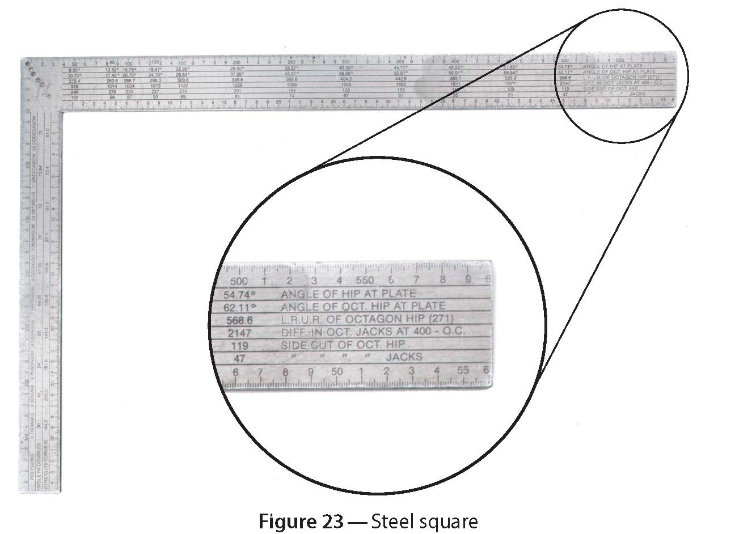
Steel squares (Figure 23) measure 600 mm (24 in.) on their long side (body) and 400 mm (16 in.) on their short side (tongue). The body is 50 mm (2 in.) wide and the tongue is 38 mm (11/2 in.) wide. To mark a layout line at 90° to the edge of a board, hook the long side over the edge of the board and mark the face of the board along the short edge of the square.

Steel squares are commonly referred to as “framing squares.” Various angles can be laid out with a framing square. For example, a 45° angle can be accurately laid out if you place the framing square so that the edge of a board intersects the sides of the square at an equal measurement along each side of the square (Figure 24). The framing square can also serve as a bench rule.
Both imperial and metric framing squares are available.

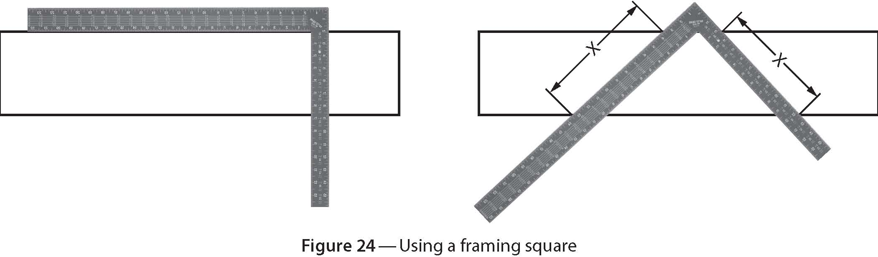

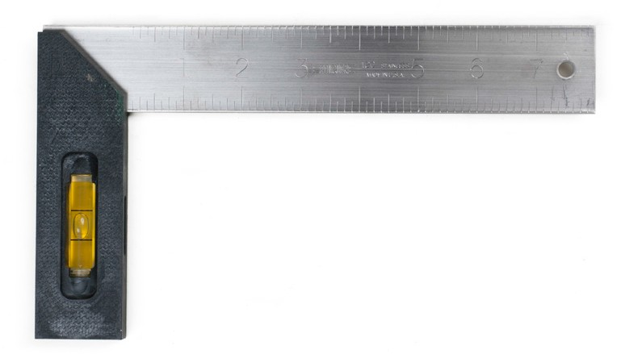Framing squares also have a table of numbers on the face of the square called a “rafter table,” used for calculating rafter lengths, cuts of different angles, and lengths and angles of braces.

Try square
The try square (Figure 25) consists of a short steel blade and a fixed wood or plastic handle. The blade, which is about 150 mm (6 in.) to 200 mm long (8 in.), is set at 90° to the handle. Some try squares have the top end of the handle set at 45°.

The try square is used mainly for bench work that

Figure 25 — Try square

involves laying out and checking the accuracy of joints and planed wood.

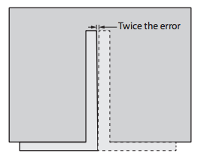
To test the accuracy of any square, use a piece of material with a straight edge. Mark a line at 90° to the straight edge. Then turn the square over, set it up on the straight edge again, and check that the square lines up with the previously drawn line (Figure 26).

Figure 26 — Checking a square

Sliding T bevel
The sliding T bevel has a solid wood or metal handle and a thin steel blade with a slot. The blade can be set to any angle and locked into place (Figure 27).

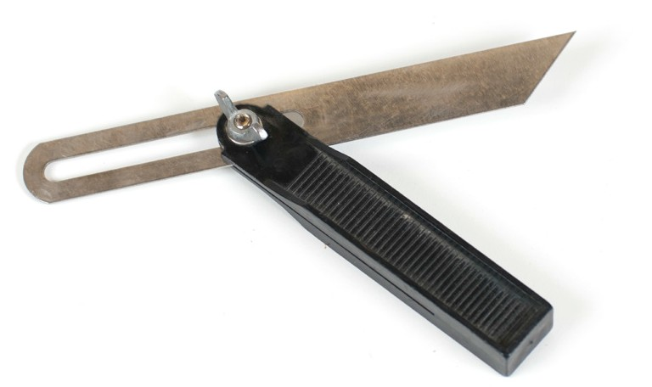
Figure 27 — Sliding T bevel

The sliding T bevel is used for transferring angles in a layout. Be careful not to jar or drop the bevel while using it. If you are in doubt about the angle, recheck before proceeding with the work. Figure 28 shows three ways to set the sliding T bevel.

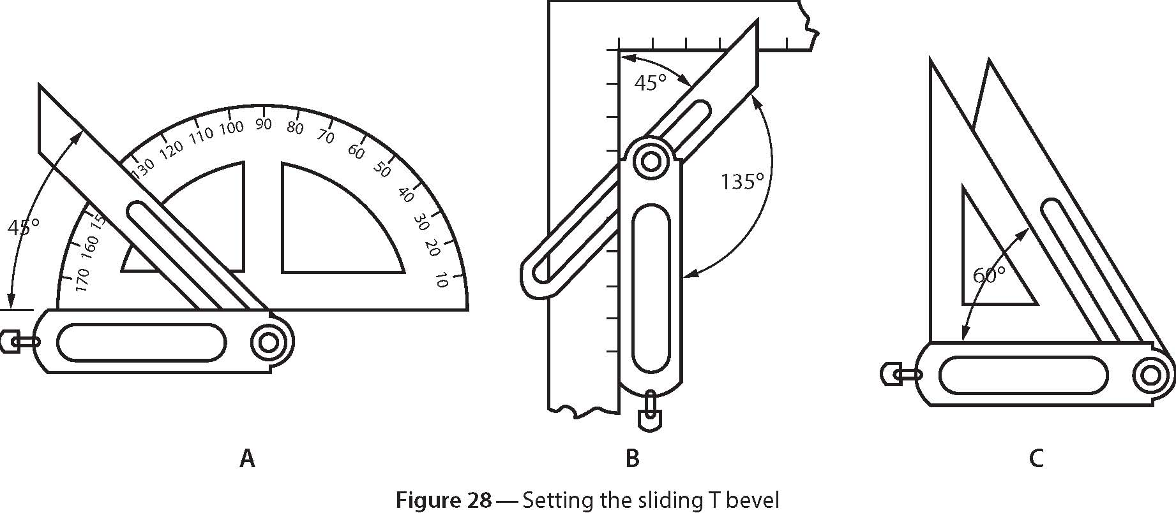

Layout and marking tools
Layout tools are used to mark linear measurements, parallel lines, angles, circles, arches, and irregular contours. The marks should be sharp and clear. If they are rubbed over, blurred, or hard to see, costly errors can easily occur. Materials can be cut too long or too short, or located incorrectly. There are many tools that are used for marking work.

Chalk lines
Chalk lines (Figure 29) are strings that are embedded with a chalk powder. The chalk line is used to lay out a straight line between two points. The line is stretched tightly between the two points on a surface. The line is then raised above the surface at its centre and then allowed to snap back. Coloured or white chalk can be used.

The chalk line is fitted around a reel housed in a case. The powdered chalk is put into the case by sliding open the access panel, or by removing a cap on the top face of the case. A metal ring attached to the end of the line can be hooked over the end of a board or panel, or onto a nail inserted for the purpose.

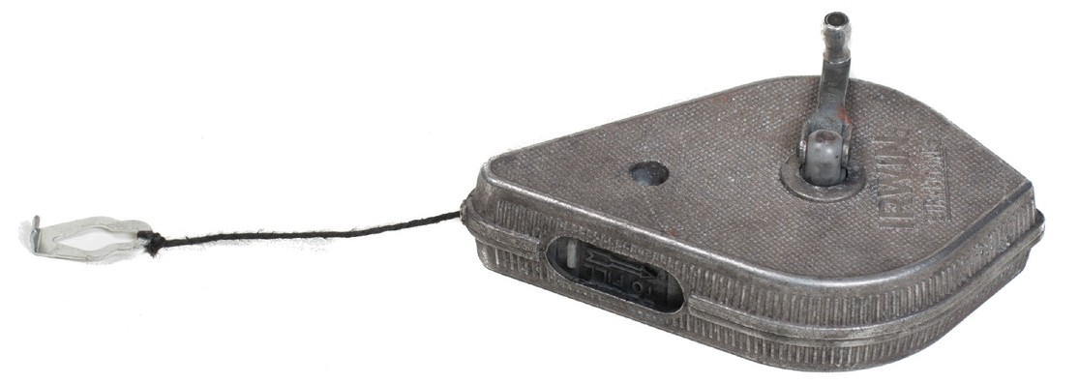
Figure 29 — Chalk line

The following are pointers on the care of a chalk line:
- When the chalk line begins to fade, add more chalk powder to the case.

- Too much chalk in the case leaves a fuzzy line.

- Do not make chalk lines on wet wood or in the rain because if the chalk becomes wet, the powder on the line will turn into a paste, and the line cannot be used until it has dried.

Scriber
The scriber (Figure 30) is a marking tool made with a hardened, tempered steel scriber point that will mark mild steel and other relatively soft metals. Scribers are precision tools and should not be used for any other purpose.

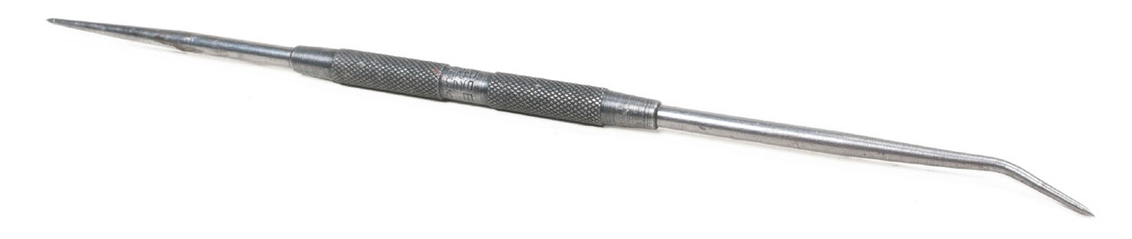
Figure 30 — Scriber

Centre punch
The centre punch (Figure 31) has a tapered bit with a broad, sharp point. It is used primarily for punching an indentation in a piece of metal as a guide for starting a drill bit. The indentation in the material will prevent the tip of the drill from slipping out of position, thus making it easier to start drilling. Centre punches are ground to an included angle of 90°, making them durable but difficult to position precisely on a smooth surface.

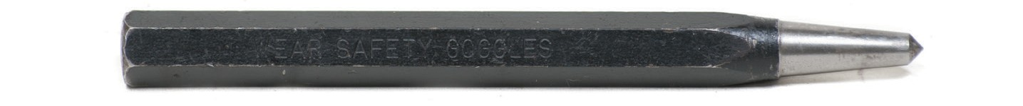
90º tip
Figure 31 — Centre punch

Prick punch
The prick punch is used initially to make a small indentation at the intersection of two layout lines (Figure 32). A centre punch can then be used to enlarge the indentation to the shape and size appropriate for a twist drill.

The point of a prick punch is ground to an included angle of 30°. This gives the punch a very thin point, making it easy to see where you are placing the point on a workpiece. This thin point is fragile and easily damaged.

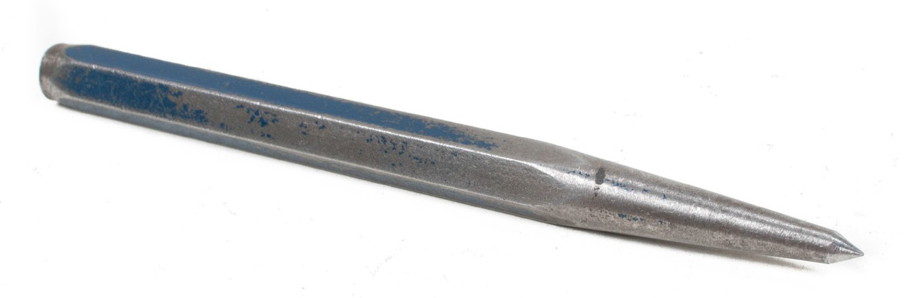
Figure 32 — Prick punch

Straightedge
The straightedge (Figure 33) is used to draw a line between two points. When clamped to a piece of work, it can serve as a fence for a circular handsaw. The accuracy of the straightedge should be checked regularly by sighting along the edge with your eye or by putting two edges together to see if they fit true.

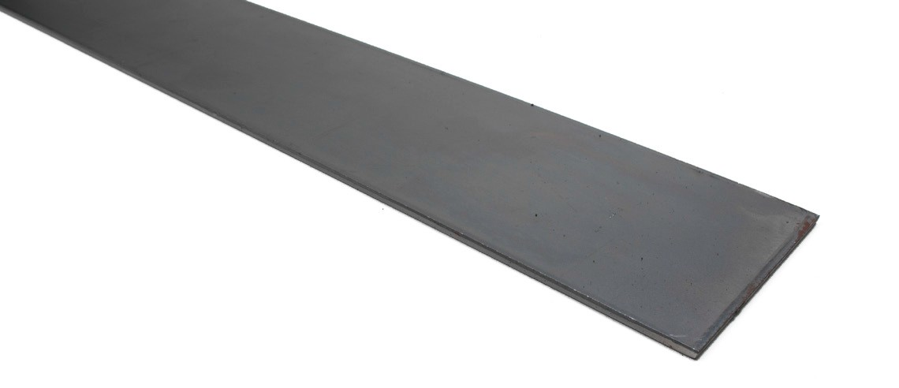
Figure 33 — Straightedge

Other instruments, such as a framing square, can be used as a straightedge. Regardless of the instrument used, the straightedge should always be long enough to connect two points.

Marking gauge
With a marking gauge (Figure 34), you can mark lines parallel to the edge of stock. The gauge consists of a beam marked in millimetres (or in inches and fractions of an inch). It also has a pin or wheel for marking the zero location. A movable head on the beam is held in place with a thumbscrew.

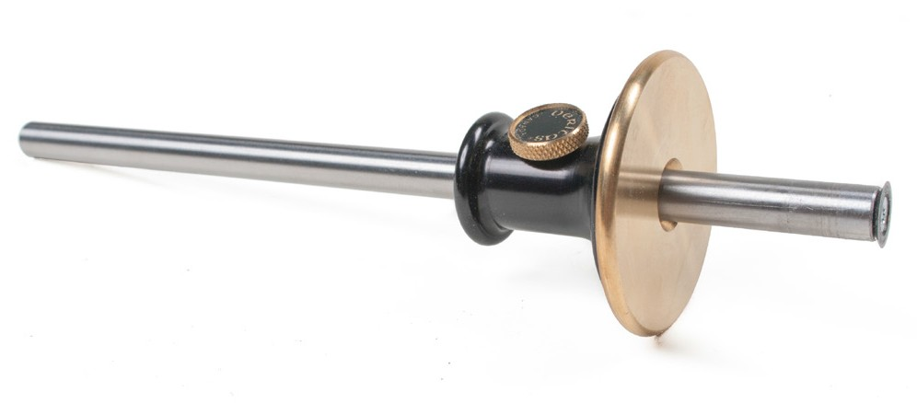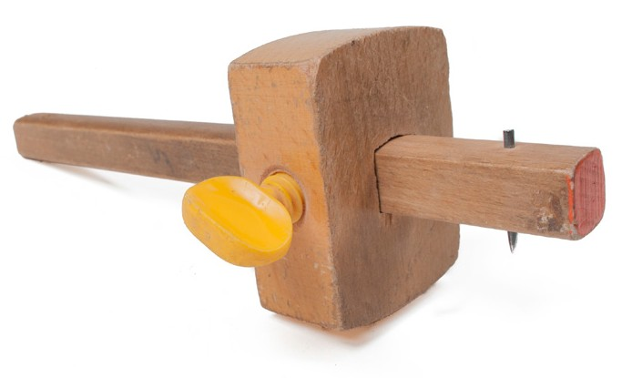
Figure 34 — Marking gauges

The marking gauge is usually used at a shop workbench for marking boards that have to be cut to width or planed. When setting the marking gauge, check it with a tape measure for accurate layout, or make a test mark with the gauge and check it with the tape measure.

The procedure for using the gauge is as follows:
- Hold the beam of the marking gauge at right angles to the edge of the work to be marked, and the head tight to the edge.
- Tilt the beam back so that it is flat on the work and the pin or wheel just touches the surface.

- Applying very light pressure on the gauge, drag it to leave a line on the wood. Be careful that the pin or wheel does not follow the grain of the wood and leave an incorrect mark.

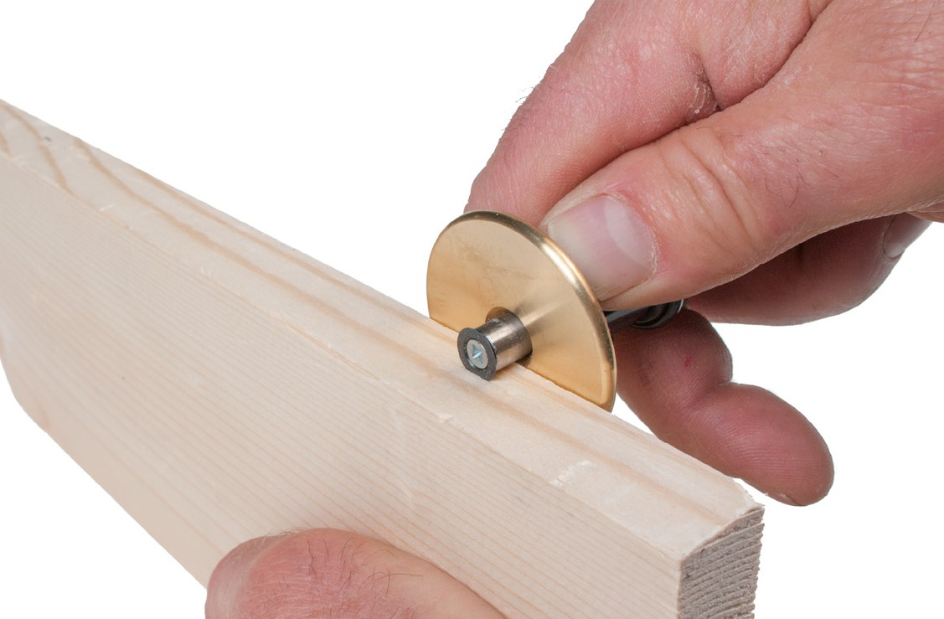
Figure 35 — Using a marking gauge

Circle layout and scribing
There are several tools used for circle layout and scribing:
  - pencil compass
  - scriber
  - trammel points

Pencil compass
Made of pressed steel with a sharp point on one side and a place to hold a pencil on the other, the pencil compass (Figure 36) is used to mark circles or arcs up to about 150 mm (6 in.) in diameter.

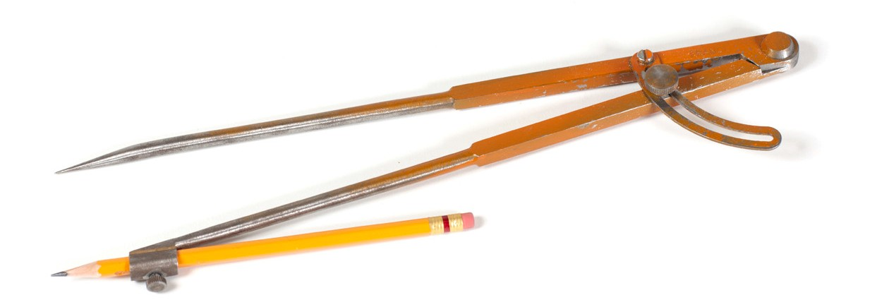
Figure 36 — Compass

Scriber
A scriber, also called an “angle divider,” is similar to a pencil compass, but it has two sharp points instead of a marker holder (Figure 37). Scribers can be used for marking circles or arcs onto metal. They can also be used to measure, transfer, or mark distances.

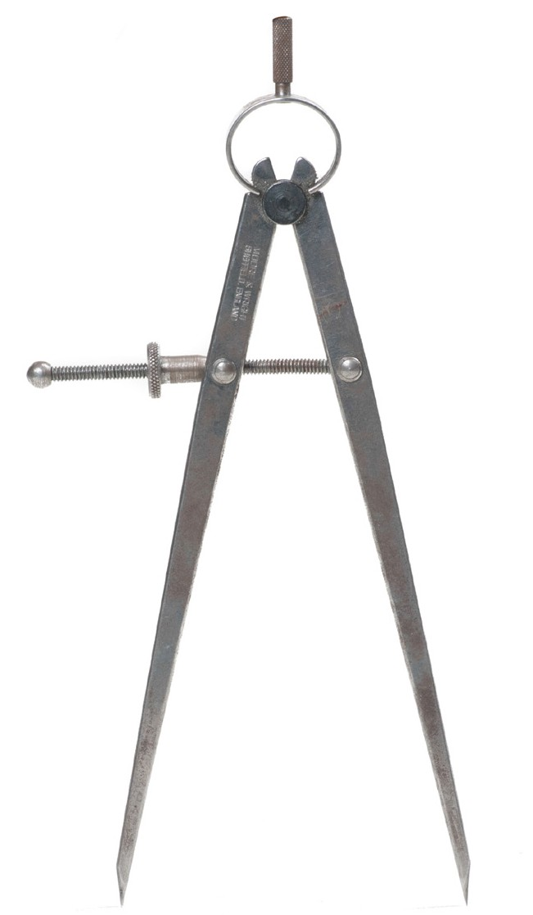
Figure 37 — Scriber (divider)

Both the compass and scriber can also be used for marking out irregular shapes, such as panelling around a crown moulding or mantel (Figure 38).

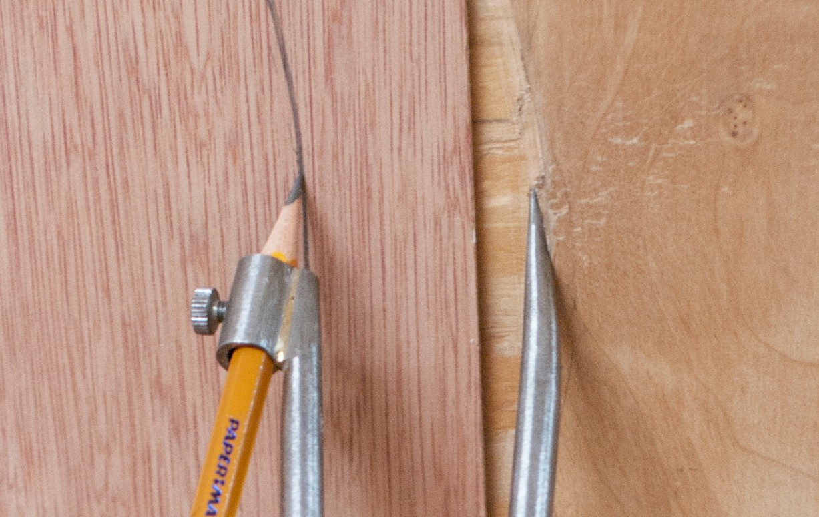
Figure 38 — Scribing an irregular line

It is important to hold the scriber points level with each other when scribing a plumb surface, and to hold the points plumb when scribing a level surface.

Trammel points
Trammel points, also called a “beam compass,” are metal points that can be attached to a long metal or wooden beam (Figure 39). They are used to scribe a circle or an arc. One of the points can hold a pencil to make the mark.

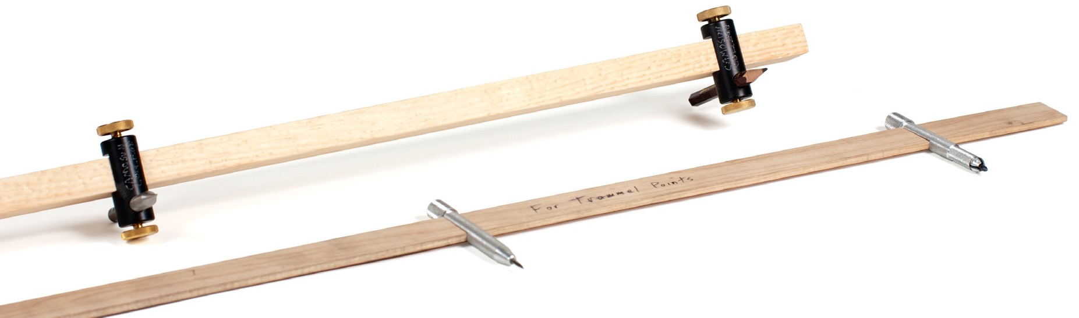
Figure 39 — Trammel points

The radius of the circle is limited only by the length of the beam. Before scribing a circle or arc, make a mark and check the measurement of the radius from the centre point to the start of the layout.

Other marking tools
There are many other tools used to mark materials for layout. One of the most common is the carpenter’s pencil (Figure 40), which is flat and wide rather than circular like regular pencils. This design allows for more accurate marking on wood, next to other objects, and along the side of a square, because when a carpenter’s pencil is sharpened, the lead is shaped to be long and narrow.

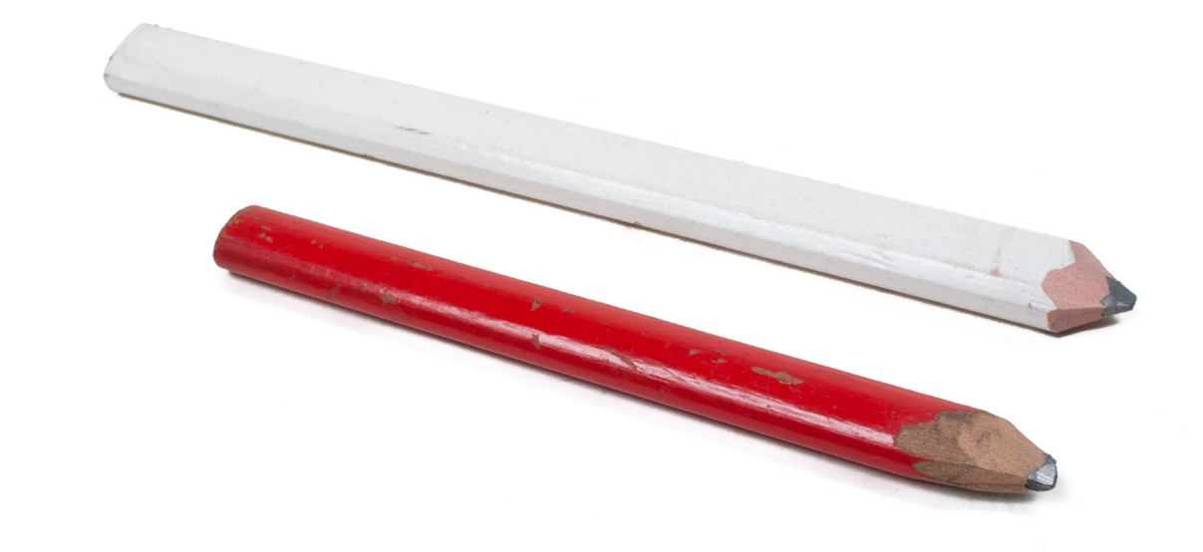
Figure 40 — Carpenter’s pencils

There are also many specialty markers made of substances that give the desired results for marking various materials. One type of specialized marking device used for working with metal is soapstone. Soapstone is a brittle, chalk-like substance favoured as a marker because it is resistant to heat and because it makes visible marks that aren’t permanent. Due to its brittleness, soapstone is often used in special holders (Figure 41).

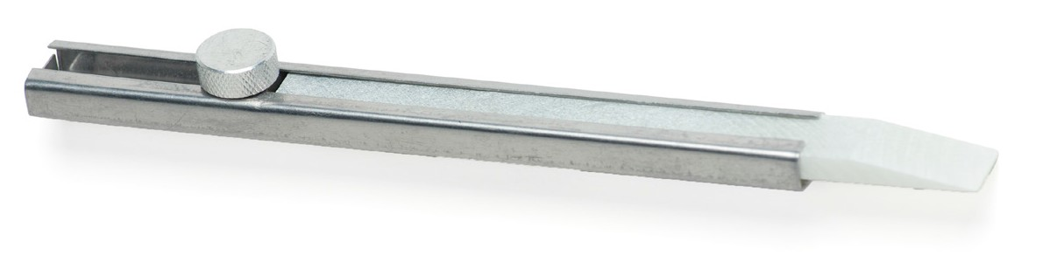
Figure 41 — Soapstone and holder

Straight lines are laid out with a straightedge and pencil (or knife), a chalk line, or a layout (string or wire) line. They can also be laid out with the aid of an optical level.

Now complete the Learning Task Self-Test.

Self-Test 2
- What part of the combination square contains a spirit level?
  - Fixed head
  - Bevel head
  - Square head
  - Protractor head

- What angle is the bevel on a drill-point gauge? a. 49°
b. 59°
c. 69°
d. 79°

- What are the smallest graduations on a metric pocket tape?
  - Metres
  - Decimetres
  - Millimetres
  - Centimetres

- What tool should be used to measure the internal bore of a cylinder?
  - A drill gauge
  - Inside calipers
  - A feeler gauge
  - Outside calipers

- What is a scriber intended for?
  - Chipping slag from welds
  - Cleaning threads on bolts
  - Lining up holes in plate steel
  - Scratching lines on soft metals

- Which dimension in Figure 1 correctly indicates thread pitch?
B
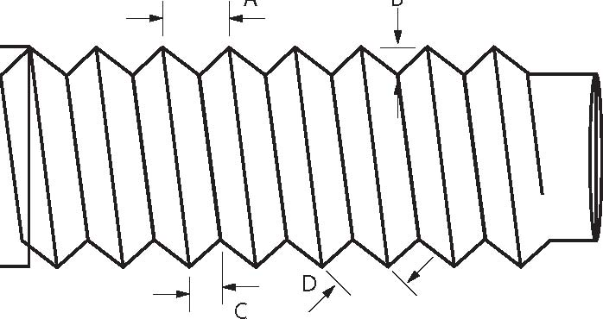
A

  - A
  - B
  - C
  - D

- In Figure 2, which is the correct way to wind up a steel tape?
  - A
  - B

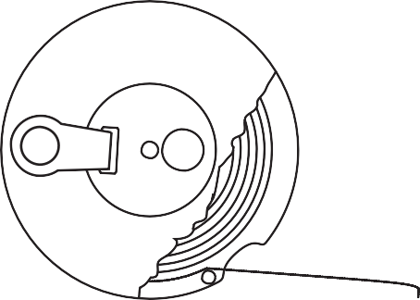
A B

Figure 2

- Which of the following tools would best be used to lay out a circle?
  - Chalk line
  - Compass
  - Try square
  - Micrometer

- What type of square has a sliding head that can be used to lay out 90° and 45° angles?
  - Try square
  - Framing square
  - Carpenter’s square
  - Combination square

- What is the smallest dimension that can be accurately be measured with a Vernier caliper?
  - 2.0 mm
  - 0.2 mm
  - 0.02 mm d. 0.002 mm

LEARNING TASK 3

Describe bracing and securing tools and their uses

Vises
The standard metal or bench vise (Figure 1) is available in many sizes and variations. A good- quality vise is a very rugged piece of equipment. Vises hold material at a bench while work such as assembly, disassembly, welding, or filing is being performed.

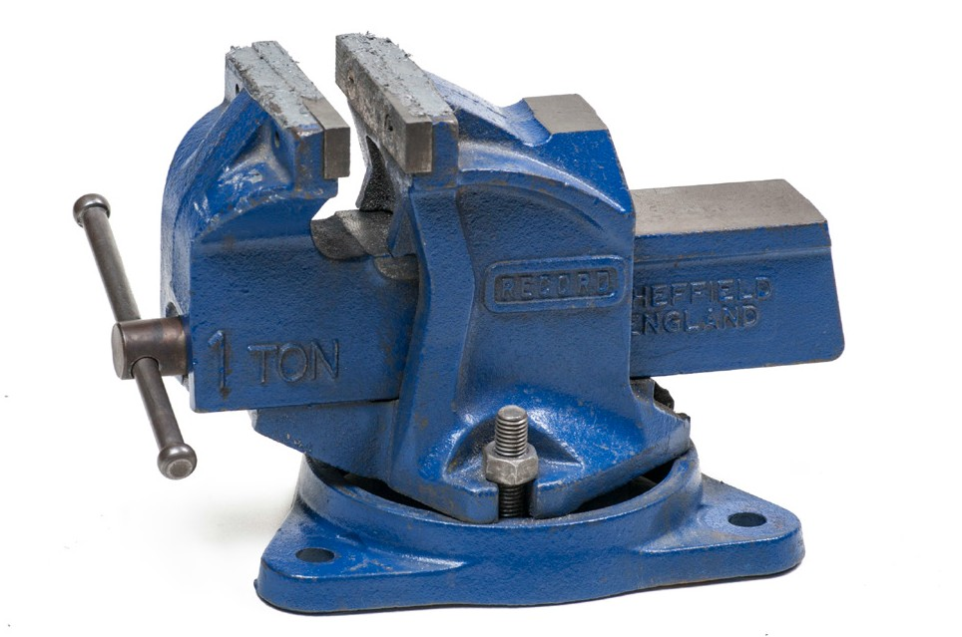
Figure 1 — Bench vise

The size of a vise is usually measured by jaw width, but the maximum jaw opening should also be measured and considered when sizing a vise. Most good vises are available with a variety of jaw widths. The jaws may be replaceable.

To use a vise, simply rotate the handle to the desired opening. Place the workpiece in the vise and tighten it just enough to hold it in place. If the part being held is soft or brittle, it may be broken or compressed by too much pressure.

Soft vise jaw-caps (Figure 2) are available to protect the workpiece. They come in pairs and slip over the jaw facings. The tabs are bent around the front and back jaws to hold them in place.

Know the type of material being clamped in the vise. Be sure the jaw facings are the type that will not damage the material. If jaw-caps are not available, use two strips of aluminum, copper, brass, or wood to protect the material.

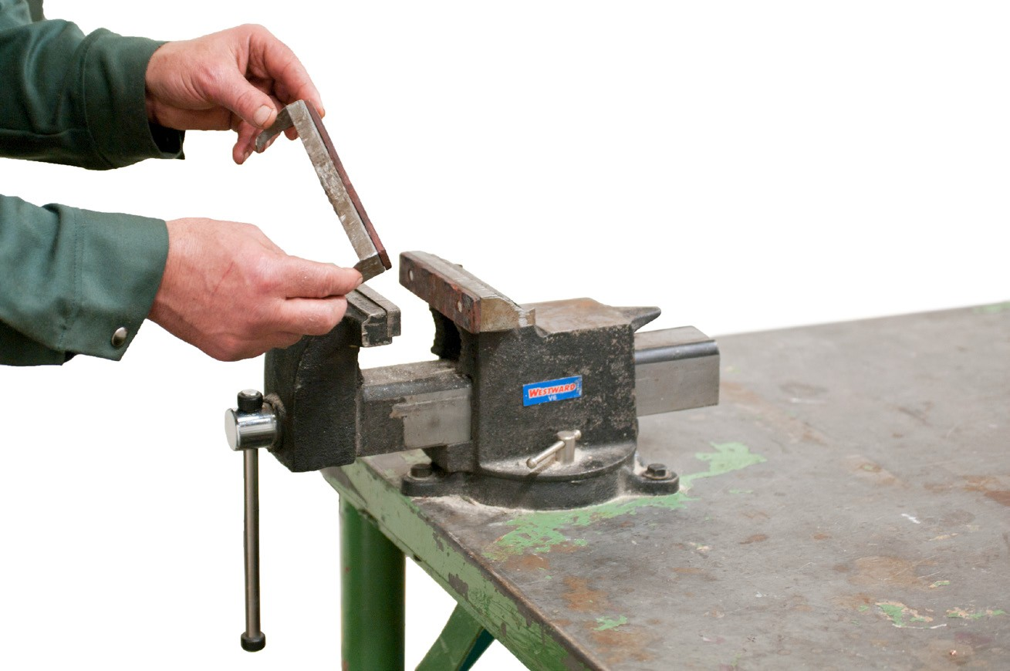
Figure 2 — Soft jaw-caps

For a hard or tough workpiece that is to be hammered or chiselled, you must ensure that the vise is tight enough to prevent the workpiece from slipping. You should also place the
workpiece in a position that allows you to hammer or chisel toward the stationary jaw (Figure 3).

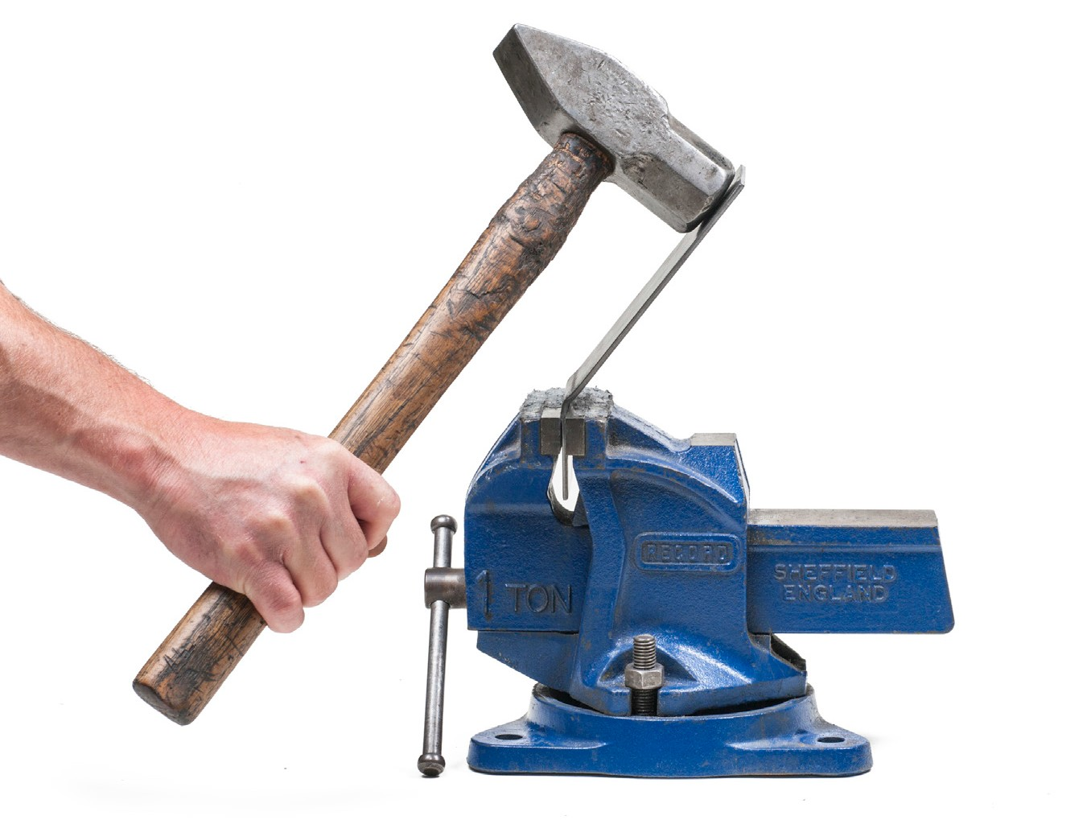
Figure 3 — Hammer toward the stationary jaw

Never hammer on the vise unless there is an anvil built on the vise for that purpose. Remove the screw periodically for cleaning and lubrication. When the jaw facings wear out or lose their
gripping power, replace them. Never overtighten the vise handle by using an extension bar over the handle ends or by hammering on the handle.

Machine vise
This type of vise (Figure 4) is used to hold a workpiece for a machining operation. For example, a machine vise is used to hold a workpiece for drilling with a drill press. The vise is designed to be bolted to the drill press table.

Machine vise jaws are replaceable. The jaw face is usually smooth to prevent the workpiece from becoming marred. The jaws may also have vertical and horizontal machined grooves to provide a gripping surface for round or irregularly shaped objects.

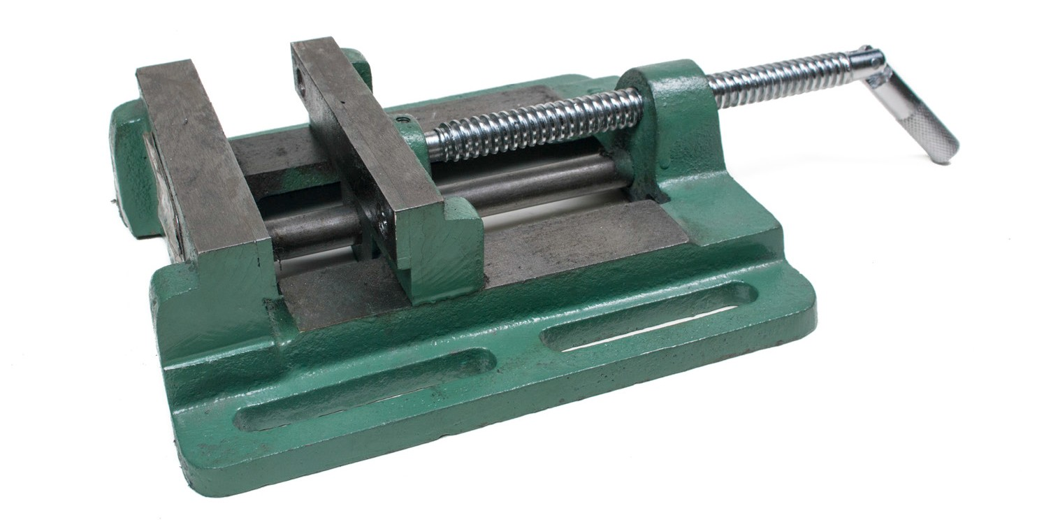
Figure 4 — Machine vise

Wood vises
Wood vises (Figure 5) are used to hold a piece of wood while it is being worked on. By using a vise you can use both hands on the tool, increasing your speed, accuracy, and control.

The wood vise has two flat metal jaws that are opened or closed by the action of a screw thread. Wood pads are usually attached to the inner faces of the jaws to prevent marring the workpiece held in the vise.

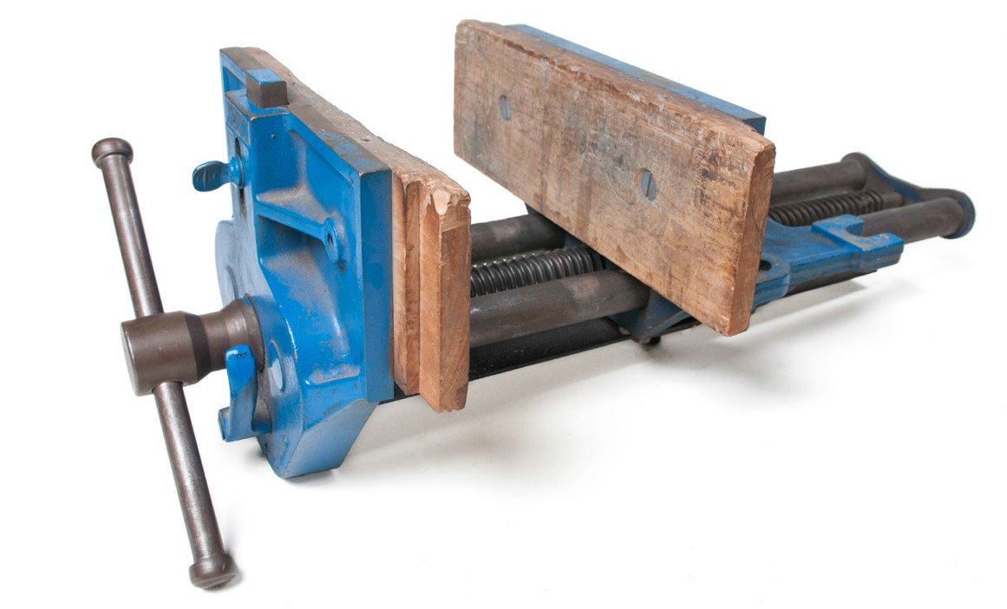
Figure 5 — Wood vise

A wood vise is bolted to the front of a workbench to add to its stability. The vise has a small sliding lever near the handle that releases the screw thread and allows for rapid opening or closing of the vise.

Pipe vises
Pipe vises are holding devices that are used while cutting, reaming, and threading pipe. Some are attached to portable stands for use at the job site; others are designed to be mounted on a workbench only. Yoke-style and chain-style vises are common types of pipe vises (Figure 6).

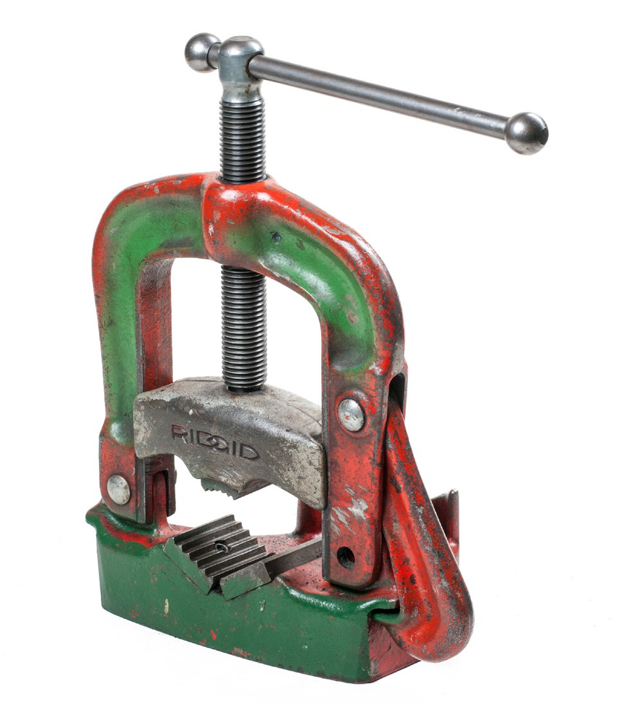
Figure 6 — Bench-mounted yoke-style pipe vise

Clamps
Clamps hold the components of a joint in position while an adhesive cures. There are various kinds, each designed for a specific application. These include:
    - C-clamp
    - bar clamp
    - deep-throat clamp
    - pipe clamp
    - spring clamp
    - band clamp
    - hand-screw clamp

C-clamps
C-clamps (Figure 7) are available in many different sizes (the width they will open to) and throat depths (the distance they can reach over a piece of stock). Sizes range from 25 mm to 120 cm (1 in. to 24 in.).

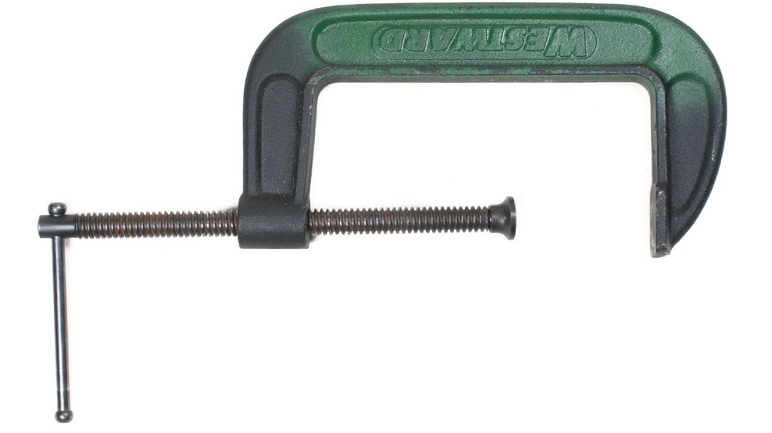
Figure 7 — C-clamp

- clamps are used to clamp a workpiece to a drill press table when the item is oddly shaped or too large to fit into a vise. They are also often used to hold a workpiece during welding or soldering operations. When welding you must be careful to protect the screws of the clamp from weld spatter.

It is also important that C-clamps not be overtightened, as this can damage both the clamp and the work.

Bar clamp
The bar clamp is also called the “cabinet clamp.” One type is made of wood; another, of steel. The steel clamp is the more common; it is used for edge-to-edge gluing, for clamping large surfaces, and for assembling large cabinets and furniture. Common lengths are from 610 mm (24 in.) to 3050 mm (120 in.).

Deep-throat clamp
The deep-throat clamp (Figure 8) is the same as the bar clamp except that the jaws are longer to allow a deep reach into the work.

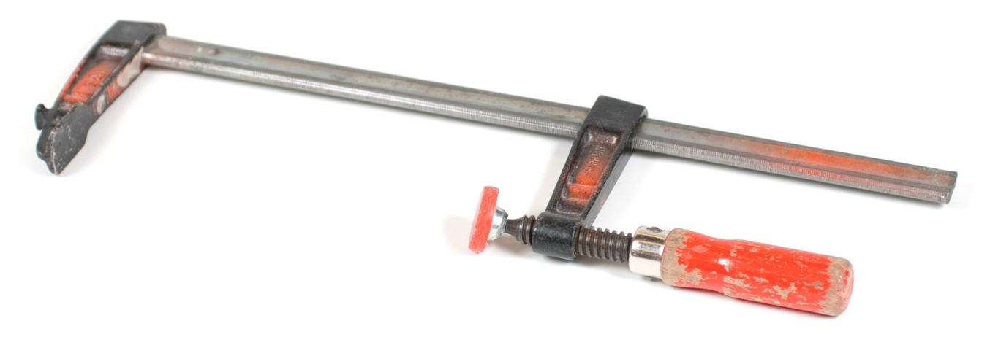
Figure 8 — Deep-throat clamp

Pipe clamp
The pipe clamp (Figure 9) is similar in design to the bar clamp, but it uses a length of steel pipe rather than a steel bar. One end of the pipe is threaded to hold a stationary head with a tightening screw and clamp. There is also a movable clamp with sets of spring-loaded disks
,used to bind the movable clamp on the pipe when pressure is applied, thus preventing it from sliding out of position. The head and clamps are sold separately from the steel pipe. This way, the clamping capacity of the pipe clamp is limited only by the length of pipe used.

Figure 9 — Pipe clamp

Spring clamp
Available in several sizes, the spring clamp ( Figure 10) provides moderate pressure (Figure 82). It is installed and removed quickly, but it is limited to an opening only 38 mm (11/2 in.) wide. It is operated by squeezing the handles to open the jaws. A large spring holds the jaws shut.

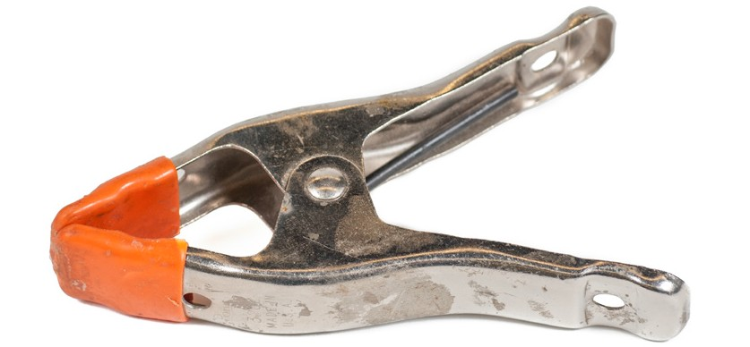
Figure 10 — Spring clamp

Band clamp
The band clamp (Figure 11) is also referred to as the “web clamp” and “strap clamp.” It consists of a band or web of canvas or nylon and a metal clamp. It is ideal for clamping round and irregularly
shaped objects and for sections of furniture. With this device, there is no damage to a wood finish.

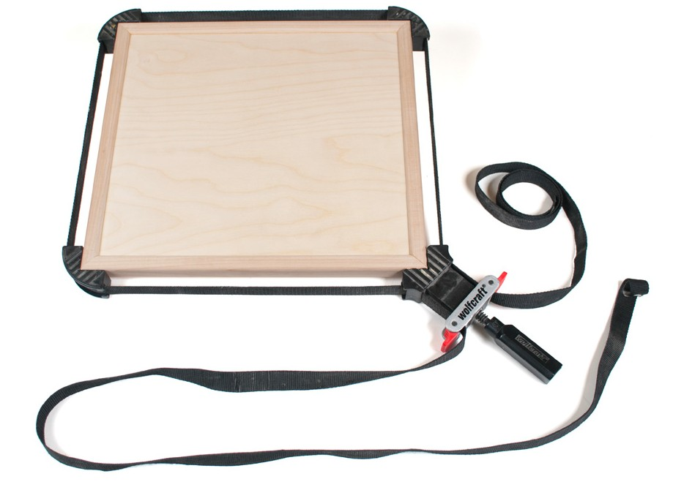
Figure 11 — Band clamp

Hand-screw clamp
Also called the “Jorgensen clamp,” the hand-screw clamp (Figure 12) is a versatile device. It applies a firm, even pressure on wood and other materials. It can also be adjusted to apply pressure at different angles to fit tapered and bevelled surfaces. This clamp is made in several sizes, typically ranging from 100 mm (4 in.) to 400 mm (16 in.).

Adjustments are made by holding a handle in each hand and cranking clockwise or counter- clockwise to open or close the jaws. Each handle can also be adjusted to change the jaws from their normal parallel position.

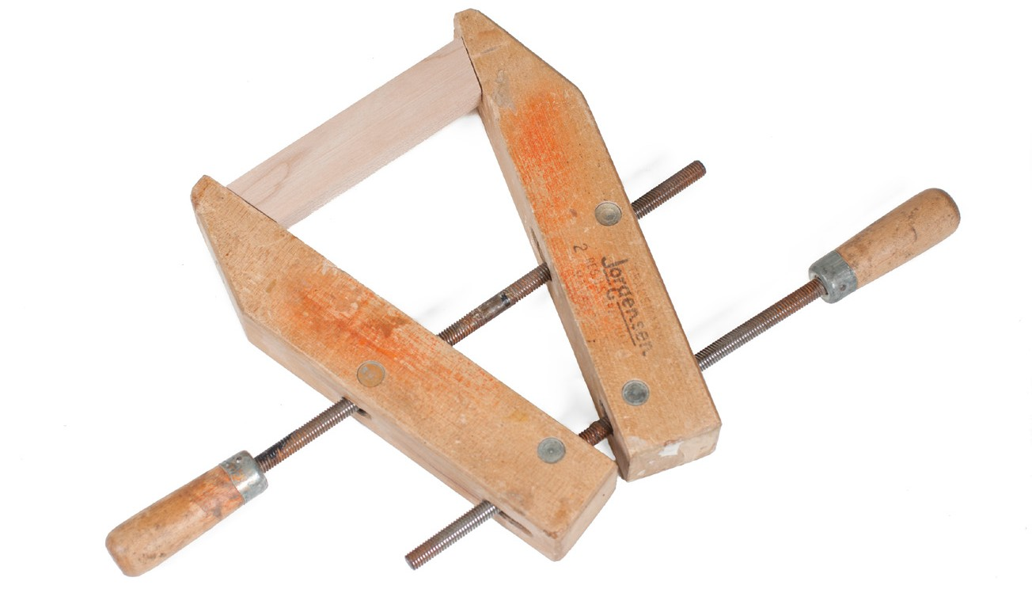
Figure 12 — Hand-screw clamp

Care and maintenance of clamps
Clamps, like other tools, must be well maintained to give effective, trouble-free service. Observe these basic rules to help keep clamps in good condition:
  - Do not allow clamps to become rusty. When rust spots appear, clean them off with solvent and wet-dry abrasive paper, then clean off the residue with solvent.
  - Never let clamps come in contact with water.

  - Always remove any lumps of glue that may have gathered on a clamp (use a scraper for the job). As a precaution, before you use clamps, check the jaws or other clamping areas (such as the belt on the band clamp) for hardened glue. Hard lumps of glue impede clamping pressure and can mar a wood surface as well as injure you.
  - Keep screw threads lightly lubricated with a dry lubricant, such as Teflon

  - If a bar or pipe clamp becomes bent, straighten it carefully without causing a kink. Badly bent clamps should be replaced.
  - Clean the notches in any type of clamp with a sliding jaw so that the jaw will hold properly for the next job.

    - Store clamps in a safe, dry place. Clamps left lying about are subject to damage and are also a tripping hazard.
    - Store bar and pipe clamps horizontally on a rack. Most of the other types should be hung from hooks.
    - A mobile rack for clamps is handy for work areas where clamping is often done. Most clamps are heavy and the mobile rack makes it easier to move them about.

Now complete the Learning Task Self-Test.

Self-Test 3
- What is an advantage of using C-clamps?
  - They are useful for small, tight areas.
  - They are quick opening and quick closing.
  - They exert only a limited amount of pressure.
  - They never require the use of protective padding.

- What is an advantage of using hand-screw clamps?
  - They are quick opening and quick closing.
  - They are best when used on round objects.
  - They can apply pressure using different angles.
  - They always require the use of protective wood strips or padding.

- Identify the clamps illustrated in Figure 1.

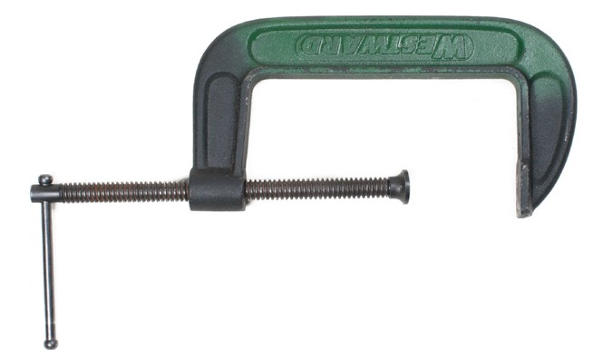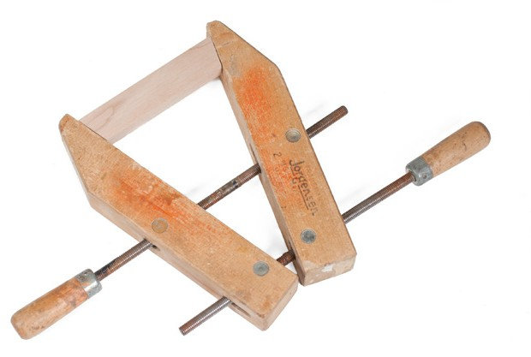
  - b.

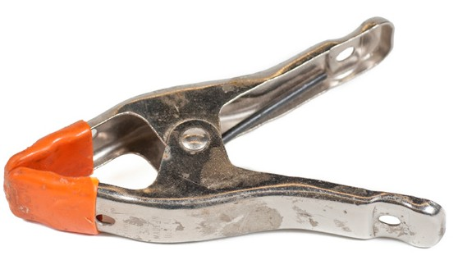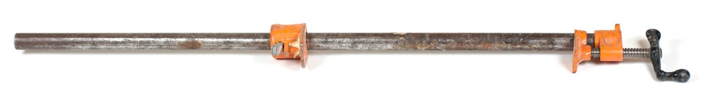
c. d.

Figure 1

- Which clamp is the quickest and easiest to use but is limited in the amount of pressure it can apply?
  - C-clamp
  - Band clamp
  - Hand-screw clamp
  - Spring clamp

- Which clamp is best suited for clamping irregularly shaped objects?
  - C-clamp
  - Band clamp
  - Hand-screw clamp
  - Spring clamp

- Which of these clamping tools is attached to a work bench?
  - C-clamp
  - Bar clamp
  - Wood vise
  - Hand-screw clamp

- What can be done to protect the workpiece when using a bench vise?
  - Use a set of soft jaw caps.
  - Grip your workpiece by the corners.
  - Grip it as tightly as possible to prevent movement.
  - Grip it very lightly to prevent damage to the piece.

- How is the size of a vise determined?
  - The width of the vise jaws
  - The length of the vise handle
  - The overall weight of the vise
  - The height of the jaws above the bench surface

- When hammering on a workpiece in a vise, in which direction should you apply force?
  - Toward the movable jaw
  - Down toward the bench
  - From the side of the vise
  - Toward the stationary jaw

- When precision drilling on a drill press, how should the machine vise be secured?
  - Held firmly with one hand
  - Held firmly with both hands
  - Held firmly by a second person
  - Bolted firmly to the drill press table

LEARNING TASK 4

Identify hammers, punches, nail pullers, and wrecking bars and their uses

Hammers
Hammering tools are used for striking and forming material, driving fasteners, and hitting objects such as punches and pins.

The head of a hammer is made of drop-forged steel, which is heat treated to make it strong and long-lasting. A hammer with a cast head is not suitable for carpentry; it is too brittle. The head of the hammer should be securely fastened to the handle. A head that is loose should be retightened with metal wedges.

Hammers come in different weights. Light hammers, which weigh 370 g (13 oz.), are used for finishing. Heavy hammers, up to 900 g (32 oz.) in weight, are used for framing. The average framing hammer weighs between 570 g and 680 g (20 oz. and 24 oz.).

Parts of a hammer
The hammer has two main parts: the head and the handle. The head is made up of the following (Figure 1):
- face
- poll
- neck
- cheek
- claw
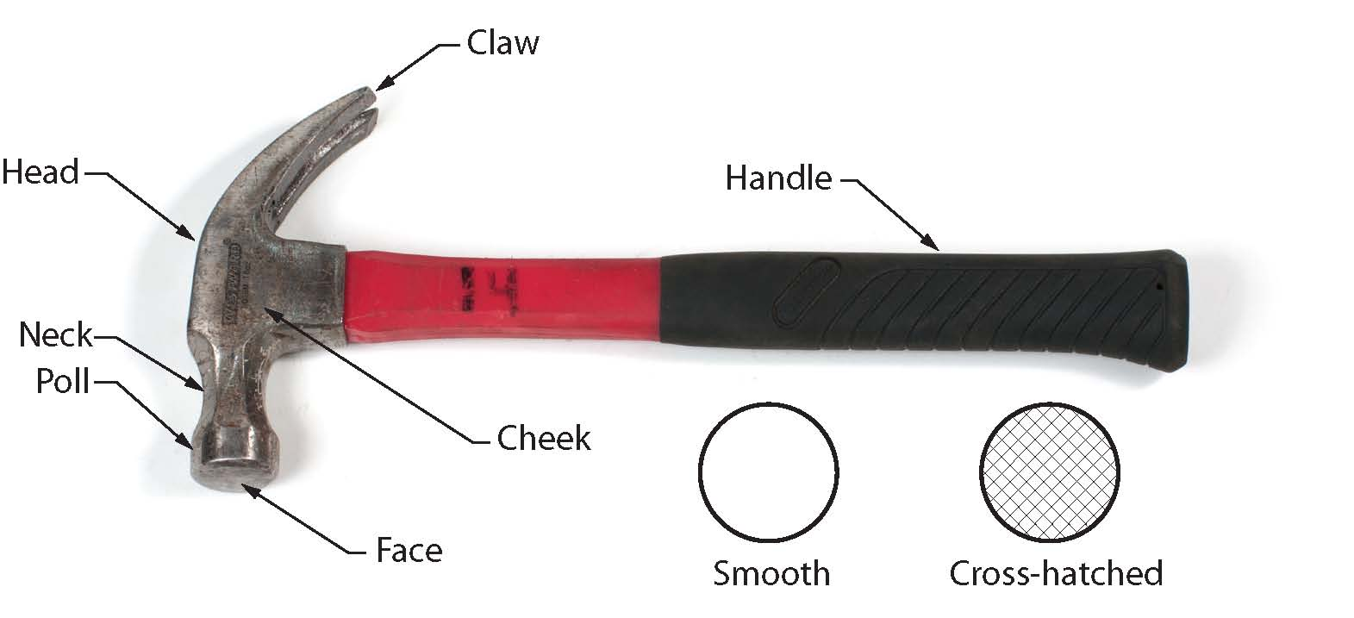

Figure 1 — Parts of a hammer

The face of the hammer is slightly curved and can be either smooth or cross-hatched. The cross- hatched hammer (also called the “cross-checkered hammer”) is usually used for framing, as the hatch marks tend to keep the head from slipping off the nail. The cross-hatched hammer is not used for finishing because of the mark it leaves.

If the face of the hammer becomes too smooth, it should be treated with a file to produce an even surface that is slightly rounded. The edge of the file is lightly tapped over the entire face of the hammer. This will leave small indentations that improve the grip on nail heads.

Hammer handles are made of wood, fibreglass, or metal. A wood handle, usually fashioned from hickory, absorbs shock better than a metal handle. A metal or steel handle is either hollow or solid and extends to include the hammer head. The end of the handle has either a rubber or leather grip. The advantage of a metal handle is that it almost never breaks; but, as mentioned, it is not a good shock absorber. A fibreglass handle is a compromise between the wood and steel types. It stands up to wear better than wood and has a superior shock-absorbing quality.

Never use a hammer with a loose head or a damaged handle. Injury or death can result if the head flies off or if the handle breaks.
The most important feature of a hammer is its balance. A hammer should feel comfortable in the hand—not heavy in its head. The distribution of weight between the head and the handle, along with the length of the handle, determines the hammer’s balance.

The angle of the face of the hammer head to the handle is also important. There should be enough room around the handle for your knuckles when the face of the head is flush with the working surface (Figure 2). The face-to-handle angle of some hammers is too great, with the result that only part of the face makes contact with a wood surface. This type of hammer tends to leave horseshoe-shaped marks (“donkey tracks”) on the wood.

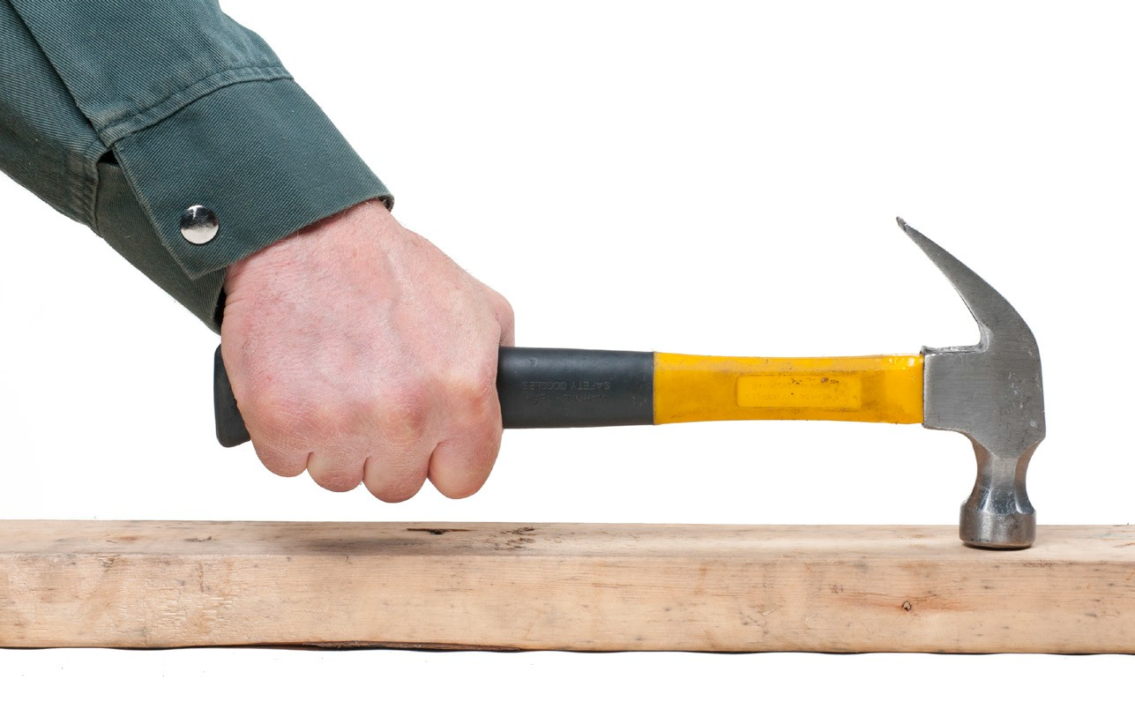
Figure 2 — When using a hammer, your knuckles must have clearance

Claw hammers
Hammers also come in two claw styles (Figure 3). The straight (ripping) claw is used most often for ripping apart members. The curved claw is more suitable for pulling nails.

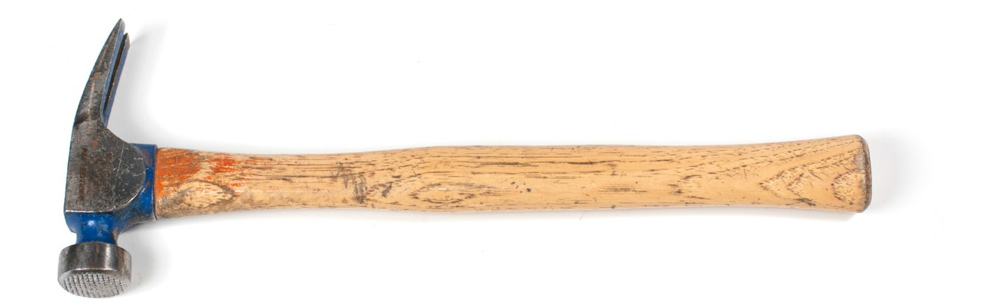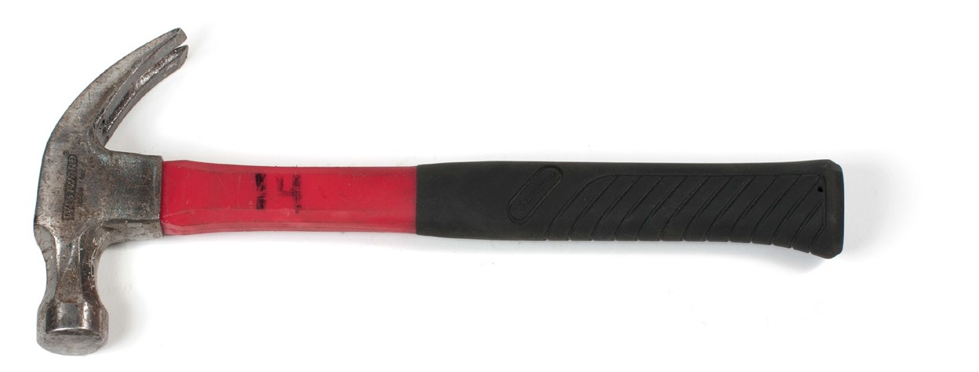
Figure 3 — Different claw hammers

Ball-peen hammers
The heads of steel-face hammers, such as ball-peen hammers, are made from high-grade alloy steel, drop forged and then heat treated to a suitable degree of hardness. The ball-peen hammer (Figure 4) generally has a slightly rounded (convex) striking surface or face. The end opposite the face is a full half sphere and is called a peen.

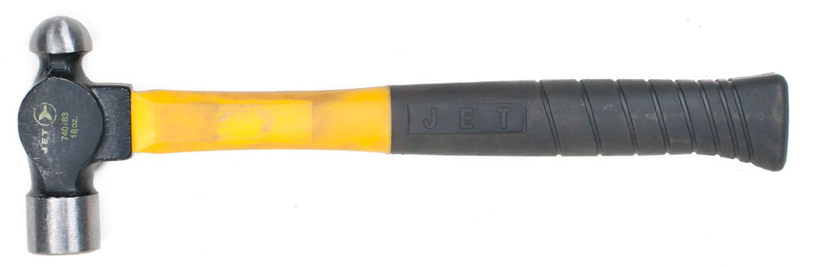
Figure 4 — Ball-peen hammer

The size specification for a ball-peen hammer is determined by the weight of the head. Ball-peen hammers weigh from 5.6 g to 1.35 kg (2 oz. to 3 lb.).

The ball-peen hammer can be used to set soft rivets or to strike chisels and punches. Small ball- peen hammers can be used to cut gaskets.

Sledge hammers
Sledge hammers (Figure 5) are used for heavy work requiring extreme force. They have longer handles than regular hammers and very large rectangular heads. They weigh 2.2 kg to 9 kg (5 lb. to 20 lb.). Sledge hammers are also available for special applications, with soft heads or specially shaped heads. The handle length varies with the weight of the head.

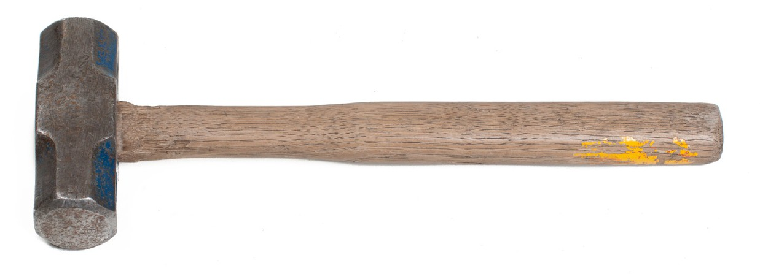
Figure 5 — Sledge hammer

Soft-face hammers
Soft-face hammers (Figure 6) have a surface that yields when it strikes an object. Soft-face hammers are preferred when machined surfaces and precision parts are involved or when marring a finish is undesirable. When you work with parts that may be damaged by a metal hammer, the plastic-tip hammer and the composition plastic hammer are good alternatives. You can also protect these parts by placing a piece of wood or brass over the surface before striking it with a hammer.

A plastic-tip hammer has a soft-face head and usually weighs 225 g to 850 g (1/2 lb. to 2 lb.). Head diameters range from 18 mm to 32 mm (3/4 in. to 11/4 in.). Replaceable plastic tips are usually available in different degrees of hardness.

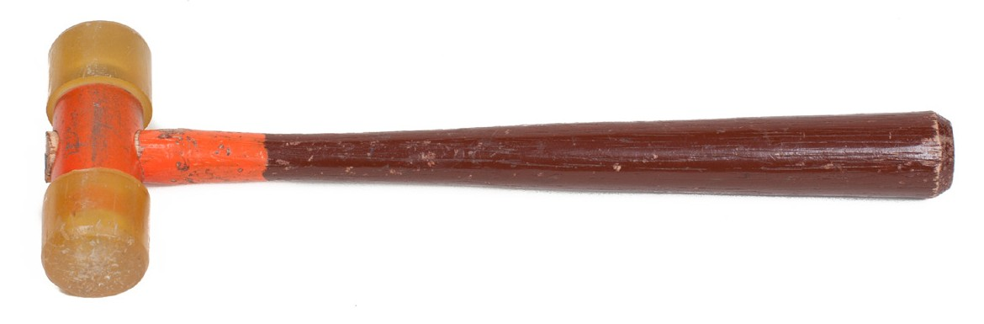
Figure 6 — Soft-face hammer

Another type of soft-face hammer has a specially compounded composition plastic tip rather than a clear plastic tip. Replaceable tips consisting of extra-tough nylon are also available. This style of hammer usually is furnished with a fibreglass handle with a rubber hand grip.

Brass-headed hammers also have relatively soft faces. They weigh between 450 g and 850 g (1 lb. and 2 lb.). A brass-headed hammer can be used for driving gears or shafts or for tapping shaft-mounted rocker arms off a shaft.

A rubber mallet has a high-grade rubber head moulded onto the handle (Figure 7). The handle may have ridges and grooves to retain the head. Rubber mallet heads are all about the same size but weights vary from 450 g to 850 g (1 lb. to 2 lb.).

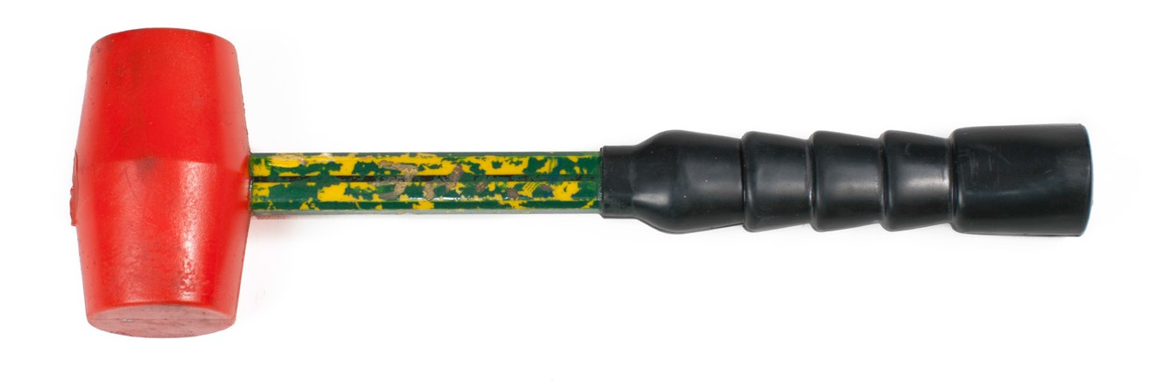
Figure 7 — Rubber mallet

A rubber mallet should be used when it is important not to scratch or dent a nearby surface. However, this type of hammer should not be used on sharp or hardened work. Rubber mallets are used for replacing hub caps and wheel covers.

Chipping hammers
Chipping hammers are a regular part of the welder’s set of tools (Figure 8). They are used after every weld deposit to chip the slag from the weld. The heads of chipping hammers are made of forged alloy steel that has been hardened and drawn for maximum toughness.

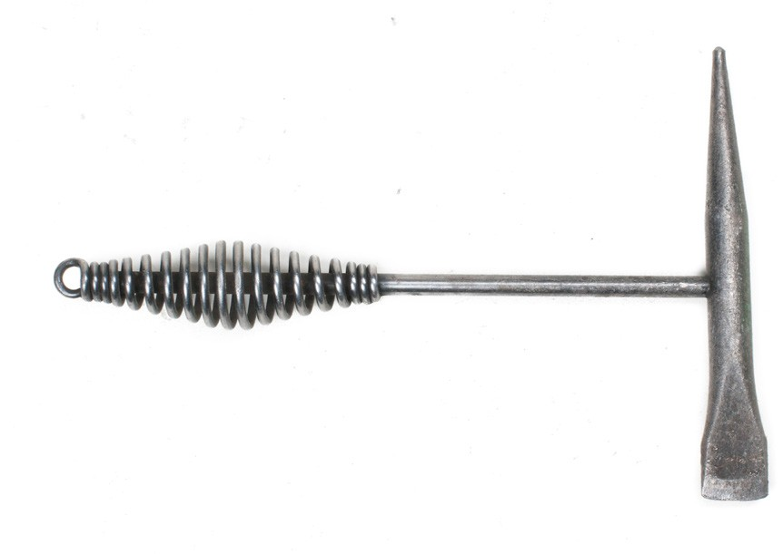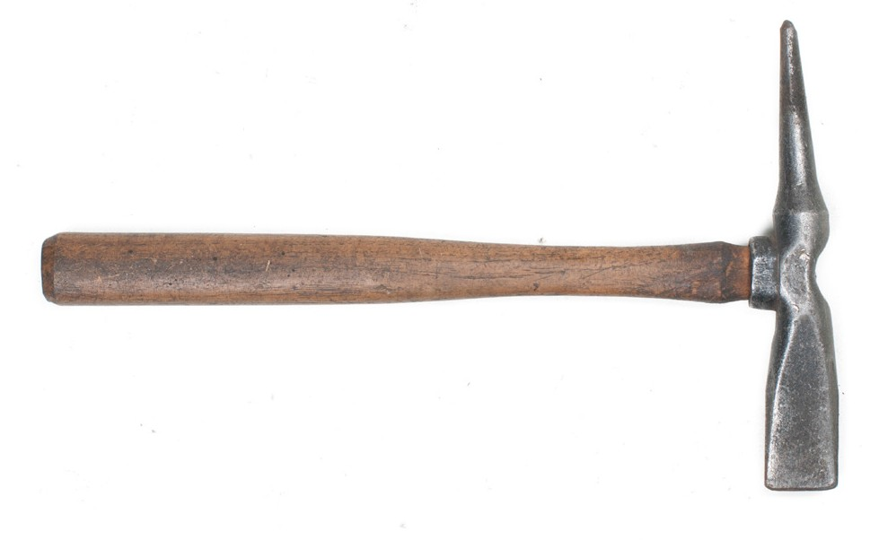
Figure 8 — Chipping hammers

Using a hammer
To strike a heavy blow with the least effort, grip the hammer firmly, but not rigidly, near the end of the handle. Gripping the handle nearer the head reduces the force of the blow.
Always strike the object with the centre of the face of the hammer to keep the face edge from chipping, as the blow is distributed over a larger area (Figure 9). All hammering should be started with light blows, followed by heavy blows if necessary.

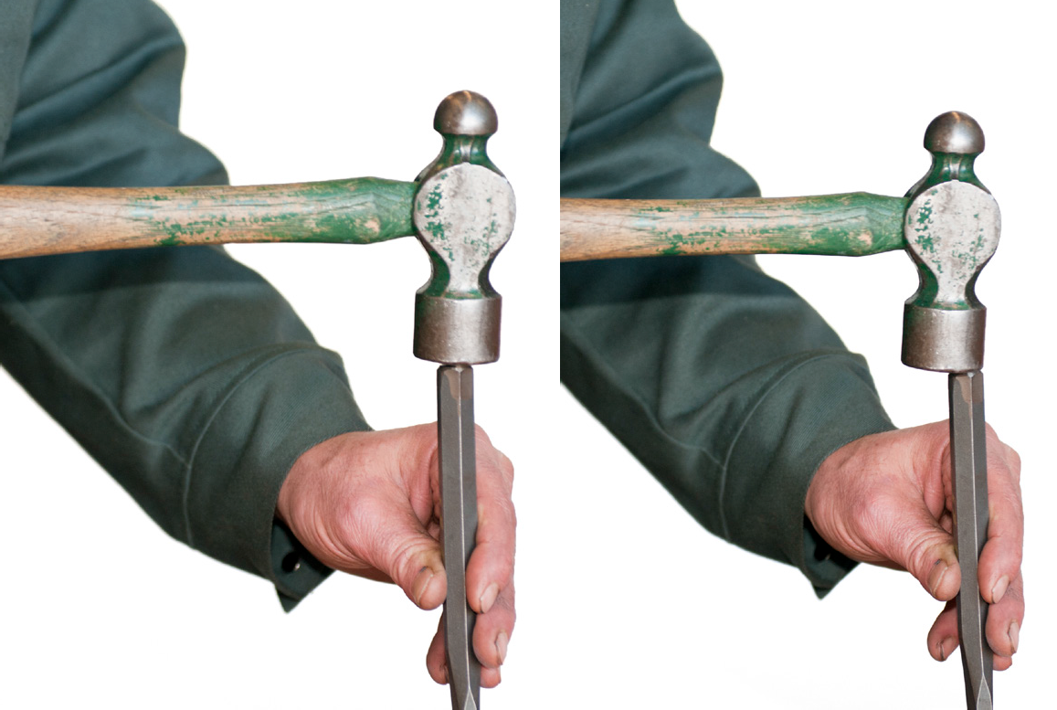
Figure 9 — Correct and incorrect use of a hammer

Always wear appropriate protection when using a hammer.

Care and maintainance of hammers
You should observe these basic rules for maintaining hammers:
  - Keep your hammer clean at all times, as a greasy or dirty hammer can be dangerous.

  - Never use a hammer with a damaged head or broken handle.

  - Always use a hammer of the correct size and weight for the job.

  - Never strike an object with the side of a hammer.

Bars
Bars of various sizes and types are used in construction, usually for demolishing structures. They include the wrecking bar (also called the gooseneck), the crowbar (also called the pry bar or the long bar), the wonder bar, and the nail puller (also called the nail claw, cat’s paw, or carpenter’s pincers).

Wrecking bar (gooseneck)
The wrecking bar, or gooseneck (Figure 10), is 300 mm (12 in.) to 915 mm (36 in.) long, with the average length being about 750 mm (30 in.). It is made of heavy octagon-shaped steel with one end flattened and the other formed into a hook and claw for pulling nails. This bar is used for demolition, stripping concrete formwork, and work that involves prying.

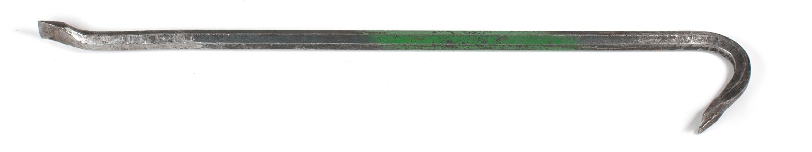
Figure 10 — Wrecking bar (or gooseneck)

Crowbar (pry bar or long bar)
The crowbar (also called the “pry bar” and “long bar”) is made in several point styles (Figure 11).
It is 1200 mm (48 in.) to 1725 mm (68 in.) long, weighs about 15 kg (30 lb.) and measures about 40 mm (11/2 in.) at the widest point. These bars are used for heavy work such as stripping concrete forms, digging soil or lifting heavy objects by their edge.

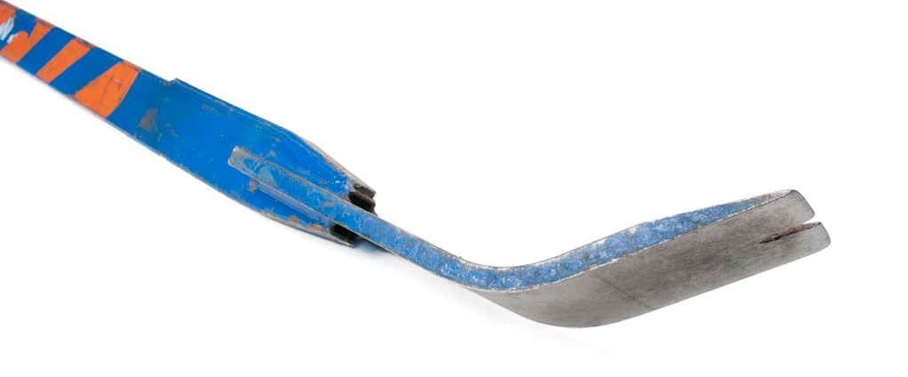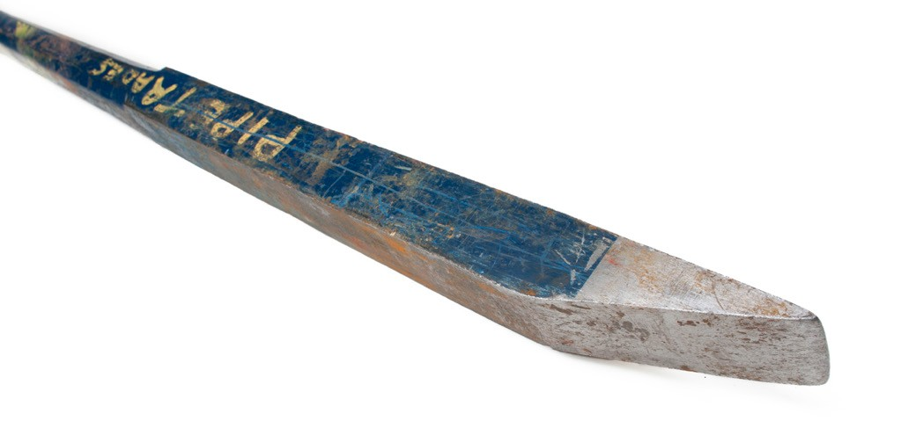
Figure 11 — Two types of crowbar

Wonder bar
The wonder bar (Figure 12) is about 400 mm (16 in.) long, and is made from flat metal. It is used for light-duty prying and stripping work. There is a claw on either end, one bent to 90°, the other bent to form a slight kink for prying.

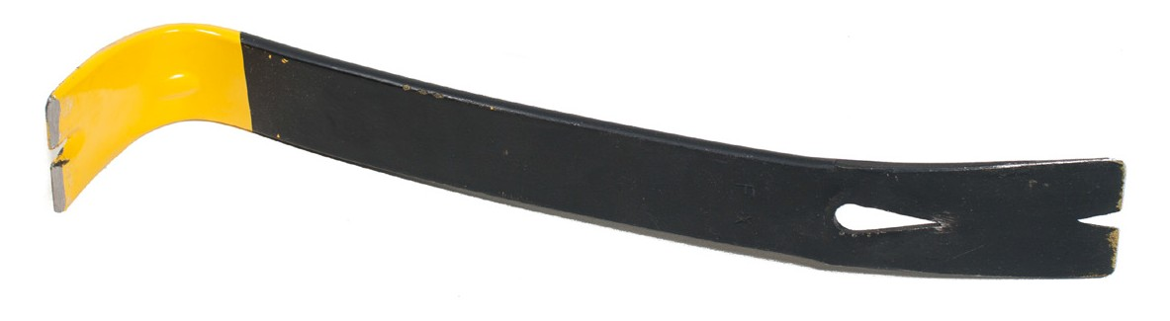
Figure 12 — Wonder bar

Nail puller
The nail puller (Figure 13) is a short bar, 250 mm (6 in.) to 350 mm long (14 in.). It is also known as “carpenter’s pincers,” a “nail claw,” and a “cat’s paw.” At one end there is a nail claw; at the other, a chisel point that is slightly bent for prying.

This bar is very useful for framing work when nails have to be pulled from lumber. The small claw is driven under the head of the nail and, depending on the length, the nail is completely pulled or just partly pulled. A wrecking bar is used to finish pulling larger nails.

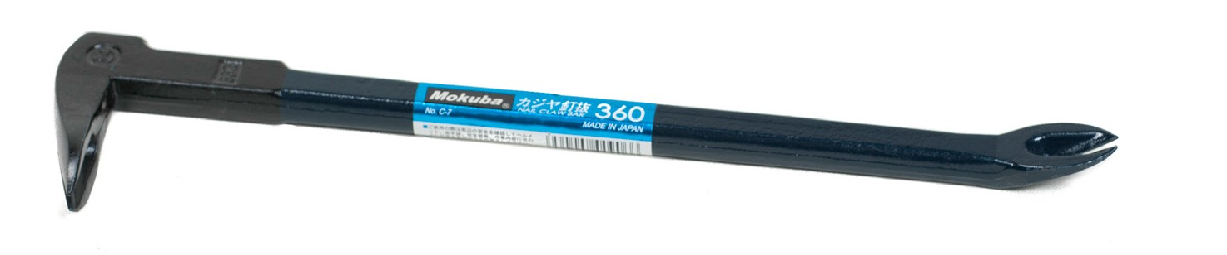
Figure 13 — Nail puller

Punches
Punches are made of hardened and tempered steel. They are used to transfer the impact force of a hammer onto a small area for indenting metal, driving pins, or aligning holes.

Starter punch
A starter punch (Figure 14) is a tapered punch sized according to its length, from 15 cm to 36 cm (6 in. to 14 in.). One of the main uses for a starter punch is to start driving rivets, pins, or bolts out from a hole in a component. The starter punch is more rigid than other punches and will start an object moving without causing it to swell.

These punches are also used as an aid in aligning bolt holes prior to inserting a fastener. The tapered end of a starter punch is placed into the semi-aligned bolt holes of two separate components and then driven into the hole. As it is driven in, the taper forces the two components into alignment, allowing for easy insertion of the fastener.

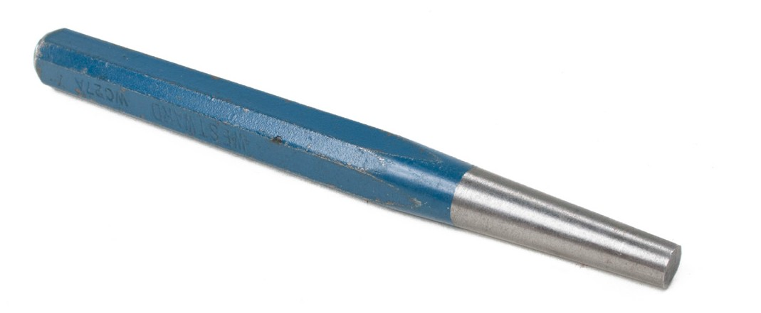
Figure 14 — Tapered starter punch

Pin punch
The pin punch (Figure 15) is necessary because the taper on the starter punch will not allow it to completely follow the object through the hole during removal. Pin punches are sized by
shaft diameter. Large pin punches are called “drift punches” and are used for applications where considerable force is required.

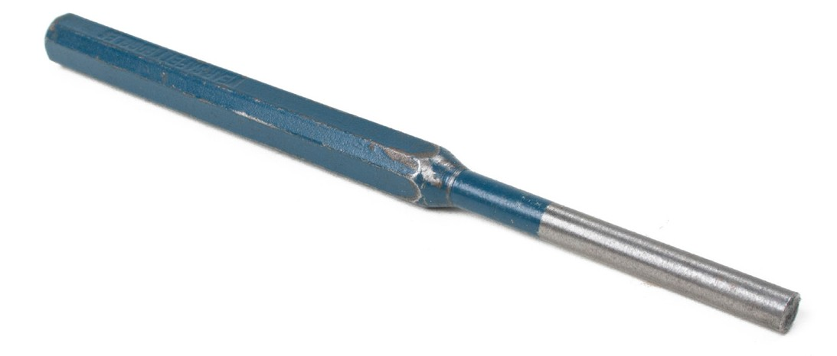
Figure 15 — Pin punch

Other types of punches include:
- centre punch
- aligning punch
- brass drift punch
- soft punches
- mild steel punches
- nail sets

Always wear appropriate protection when using punches or drifts.

Care and maintainance of punches
The head of a punch will mushroom with prolonged use and the tip will become damaged. Maintenance for punches is the same as for chisels.

Now complete the Learning Task Self-Test.

Self-Test 4
- Which type of hammer is used to pull nails?
  - Sledge
  - Ball-peen
  - Curved claw
  - Straight claw

- What is a preferred characteristic for a quality hammer?
  - It has a short handle.
  - It has an extra-long handle.
  - It should feel well balanced.
  - It should feel heavy in the head.

- Which hammer is best used when driving stakes or drift pins?
  - Sledge
  - Ball-peen
  - Curved claw
  - Straight claw

- What type of hammer is best used to set rivets or drive a punch?
  - Sledge
  - Ball-peen
  - Curved claw
  - Straight claw

- What is the head of a quality ball-peen hammer made from?
  - Cast alloy iron
  - Cast alloy steel
  - Forged stainless steel
  - Drop-forged alloy steel

- How is the size of a ball-peen hammer determined?
  - Length of the head
  - Weight of the head
  - Length of the handle
  - Weight of the entire hammer

- What type of hammer is a brass-headed hammer considered to be?
  - Framing hammer
  - Riveting hammer
  - Soft-face hammer
  - Lightweight hammer

- What must be done with a cracked hammer handle?
  - Soak it in water.
  - Use for light duties only.
  - Tape it to prevent splinters.
  - Replace it with a new handle.

- What type of bar is best used for framing work when nails have to be pulled from lumber?
  - Crowbar
  - Nail claw
  - Wonder bar
  - Wrecking bar

- What type of bar is also known as a “gooseneck”?
  - Crowbar
  - Nail claw
  - Wonder bar
  - Wrecking bar

- What type of short, flat bar is best used for light prying and stripping work?
  - Crowbar
  - Nail claw
  - Wonder bar
  - Wrecking bar

- What type of long, heavy bar would have a wedge point for digging soil or stripping concrete forms?
  - Crowbar
  - Nail claw
  - Wonder bar
  - Wrecking bar

LEARNING TASK 5

Identify levelling tools and their uses
Levelling and plumbing tools include the hand level, torpedo level, line level, plumb bob, laser level, and line laser. It is important that all levels be kept accurate. In a well-constructed project, every member is properly located, every horizontal member is level, and every vertical member is plumb.

Hand level
The hand level that many tradespeople use is about 600 mm (24 in.) long, but there are
1200 mm (48 in.) and 1800 mm (72 in.) types available as well. Modern models are made from aluminum (Figure 1). Older types were made of wood.

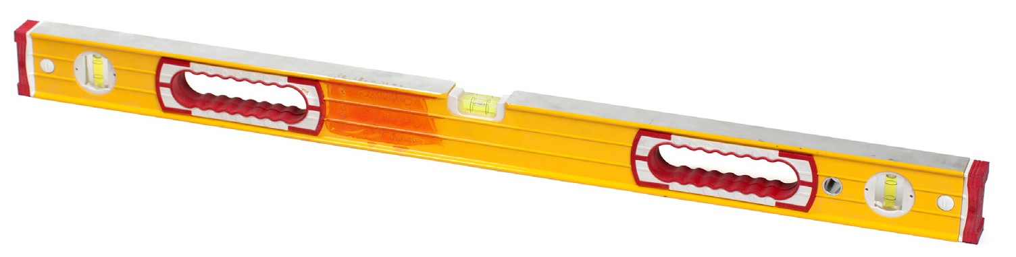
Figure 1 — Aluminum hand level

The spirit level (Figure 2) has a glass vial filled with alcohol containing a small air bubble that indicates level and plumb. Alcohol, also known as “spirits,” is used so that it won’t freeze.

When the curved vials are used the level requires two vials at each of three locations on the level to enable the user to use either edge of the level. Barrel-shaped vials are wider in the middle and are curved on both sides, so only three vials are needed on these types of levels.

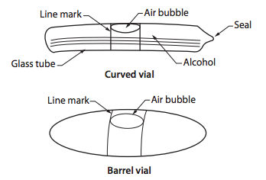
Figure 2 — Spirit level vials

Digital levels (Figure 3) are also available that can quickly display degrees, ratio, percent, or inch- per-foot slopes.

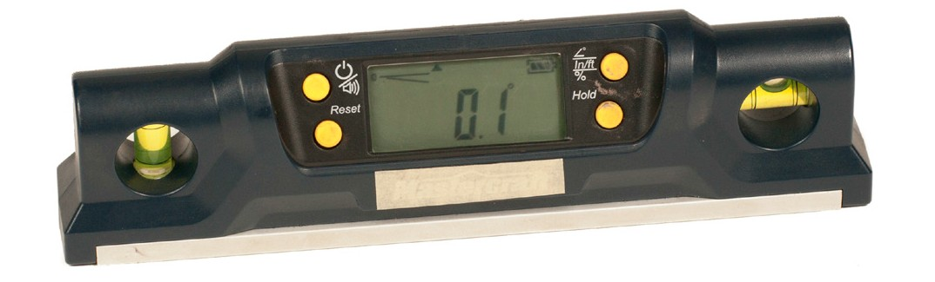
Figure 3 — Digital hand level

Hand levels should be checked regularly to see if they are true (straight) and accurate. To check the hand level for straightness, sight along the edge or place the level on a flat surface, such as the top of a table saw, to see if it is in full contact with the surface. Then turn the level over and check again.

When using the hand level, take care not to drop it or bang it, as doing so can put the bubbles out of position and make readings inaccurate. Make a habit of hanging up the level when not in use.

Torpedo level
The torpedo level (Figure 4) is a small aluminum or plastic level 200 mm (8 in.) to 300 mm
(12 in.) long. It has a bubble for level, a bubble for plumb, and a bubble for 45°. It is mostly used by plumbers, but in the carpentry trade it is handy for checking spaces that are too small to accommodate a long level.

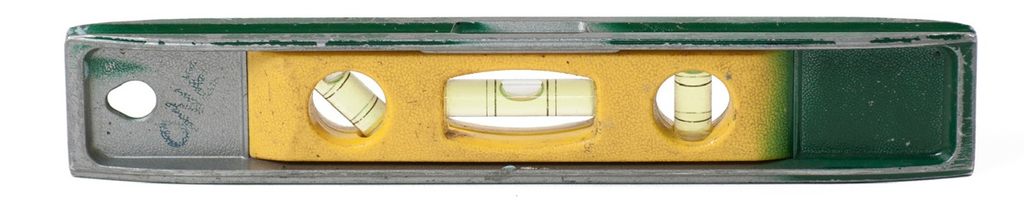
Figure 4 — Torpedo level

Line level
The line level (Figure 5) is a very short level with hooks at each end to attach to a string line. The line should be as tight as possible and the level placed near the centre of the line. One end of the line should be attached at the height desired, and the other raised or lowered until the bubble is centred. The line level is good for approximations only, such as for excavations, fence posts, or building lines.

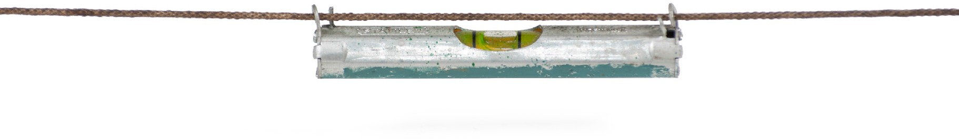
Figure 5 — Line level

Plumb bob
The plumb bob (Figure 6) has a pointed weight attached to a string and uses the force of gravity to make the line hang
vertical, or plumb. Most plumb bobs are made of steel or brass and have a small threaded point that can be replaced if it becomes damaged. Plumb bobs vary in size from 250 g (1/2 lb.) to 500 g (1 lb.).

Nothing should be allowed to touch a plumb bob line when it is suspended. The string should be attached through the centre hole of the bob and tied with the knot underneath.

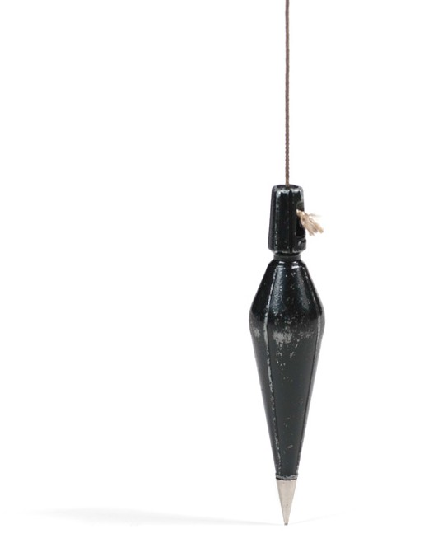
Figure 6 — Plumb bob

The plumb bob is useful for plumbing walls, posts, concrete forms, and other vertical objects. The line is attached to a nail, which is placed at the top of a member (Figure 7). The distance from the line to the member is measured, and the member is adjusted until the measurement between the line and the member is the same at the bottom and the top.

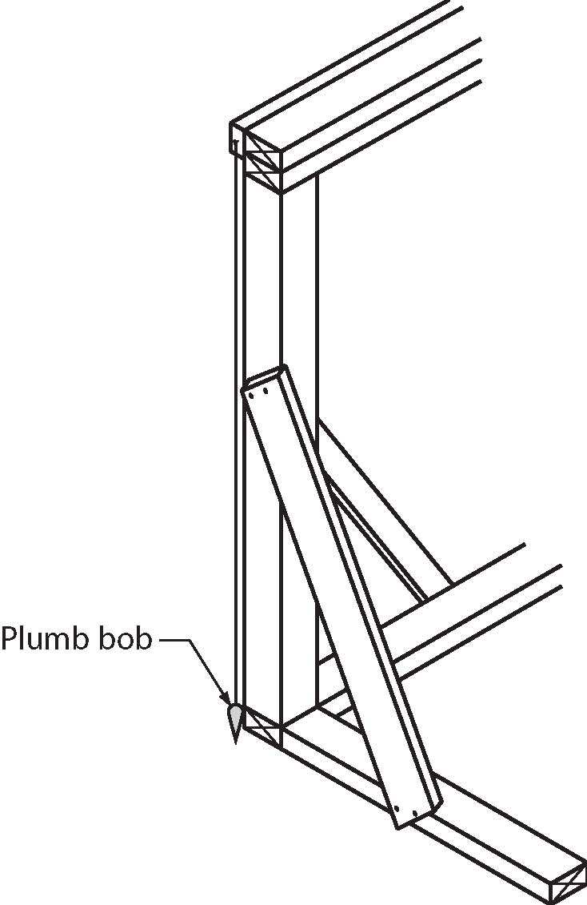

Figure 7 — Plumbing a member

The plumb bob can also be used to show the point on the ground or floor directly below an object where you may have to lay out a hole or anchor. Be aware that the plumb bob may not be hanging true if it is outdoors in a wind.

Laser levels
Laser levels (Figure 8) use a mixture of helium and neon gases to emit a very narrow beam of light that does not grow larger as it moves away from the source. Laser beams used in these levels can be either red or green.

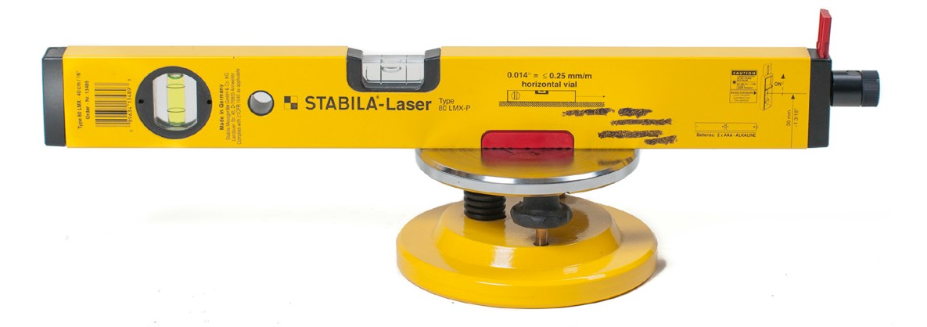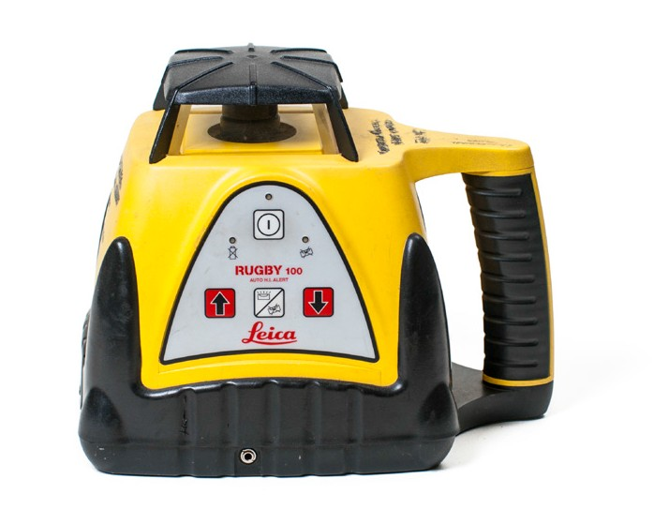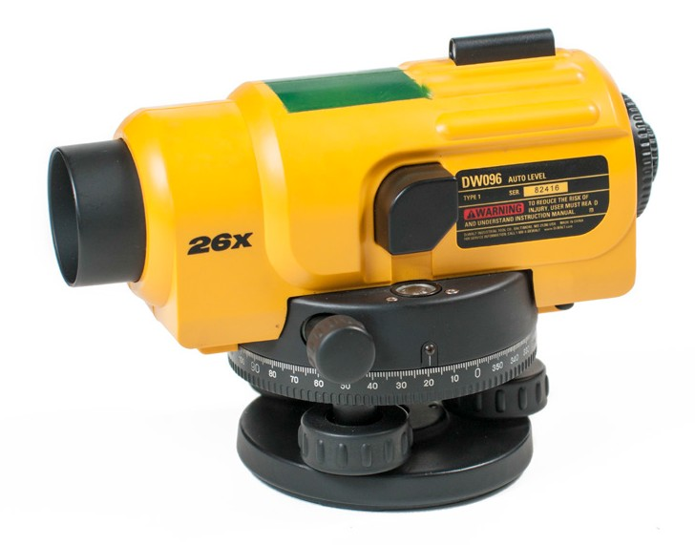
Figure 8 — Laser levels

Do not look directly into a laser beam! Looking directly at the beam may harm your eyes. A quick flash of the beam is not a problem, but avoid prolonged contact with your eyes. Use manufacturer-supplied safety glasses to help you see the beam on the surface in bright light conditions.

The instruments can be supported in several ways. The most usual supports are tripods of various heights. One person can operate a laser levelling instrument. When the instrument is set up and running, a level reference plane is created that can be detected with the sensor or receiver.

The sensors or receivers operate on batteries and have a narrow window through which the beam can be detected. When the beam is sensed, the detector shows a small coloured light or emits a sound. Sensors or detectors can be attached to the levelling rod (Figure 9) or can be used by themselves to locate instrument height on walls, forms, or other objects.

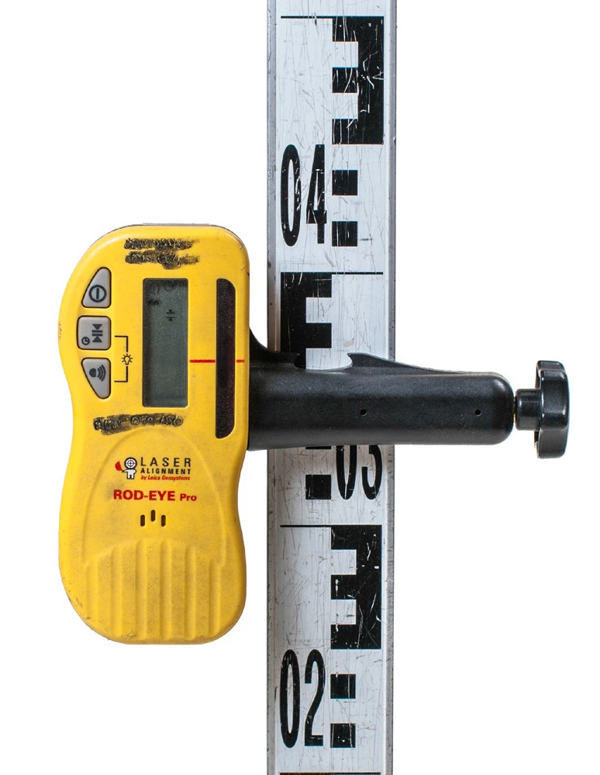
Figure 9 — Laser receiver

Line lasers
Line lasers are another type of laser level that can be used to lay out straight lines and points. There are a variety available, from single-line, straight point versions to five-way models (Figure 10). Some types are also self-levelling. These tools can be used for many of the applications of chalk lines, plumb bobs, and string lines.

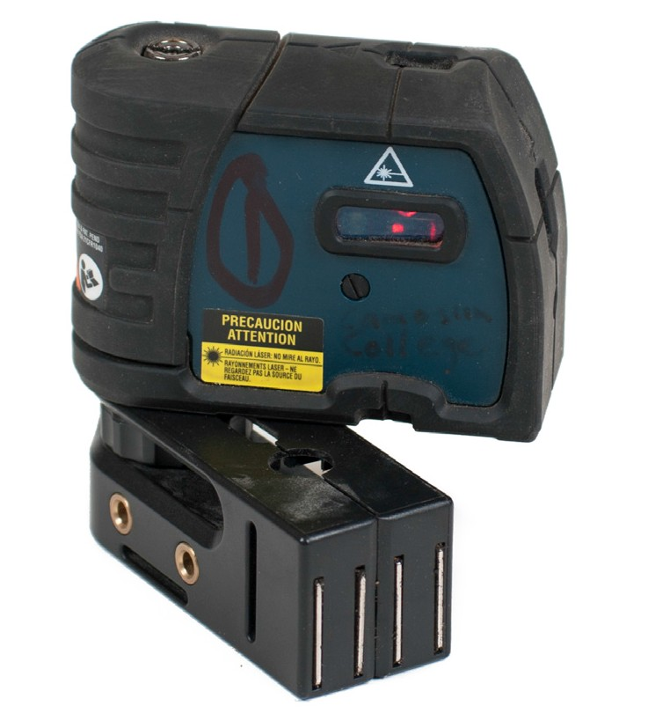
Figure 10 — Five-way laser level

Now complete the Learning Task Self-Test.

Self-Test 5
    - How should a hand level be stored when not in use?
      - Hang it up.
      - Place it in water.
      - Lay it on its edge.
      - Stack it on its end.

    - What can a plumb bob establish?
      - Level lines
      - Vertical lines
      - Diagonal lines
      - Horizontal lines

    - What must be avoided when using a laser level?
      - Mounting it on a tripod
      - Placing it on a level surface
      - Looking directly at the laser
      - Using the instrument by yourself

    - Three-vial hand levels used curved vials.
      - True
      - False

    - A line level is the best option for very accurate layouts.
      - True
      - False

    - What is the usual method of supporting a laser level?
      - Bench
      - Tripod
      - String line
      - Saw horse

    - How many vials does a torpedo level have?

a. | 2
b. | 3
c. | 4
d. | 6

LEARNING TASK 6

Identify wrenches and pliers and their uses

Wrenches
A wrench is a tool that is used to grip and turn a fastener or fitting. You will need a variety of wrenches that come in both standard and metric measurements. When selecting a wrench, you must first know the size of the nut or bolt head and then find a corresponding wrench. Usually, but not always, each end of the wrench is a different size and is stamped accordingly.

Wrenches are available with straight or offset heads. Different styles include:
- open-end wrench
- box-end wrench
- combination wrench
- ratchet wrench
- tubing nut (flare nut) wrench
- adjustable wrench
- pipe wrench
- spud wrench
- hexagon key (Allen wrench)
- slug wrench
- chain and strap wrenches
- socket wrench

Open-end wrench
An open-end wrench (Figure 1) has an open head on each end. It is designed to fit both square- headed (four corners) and hex-headed (six corners) nuts and bolts. Even though it has the advantage of being easy to position, this style of wrench can wear down corners on the nut or bolt head because it makes contact only at two points.

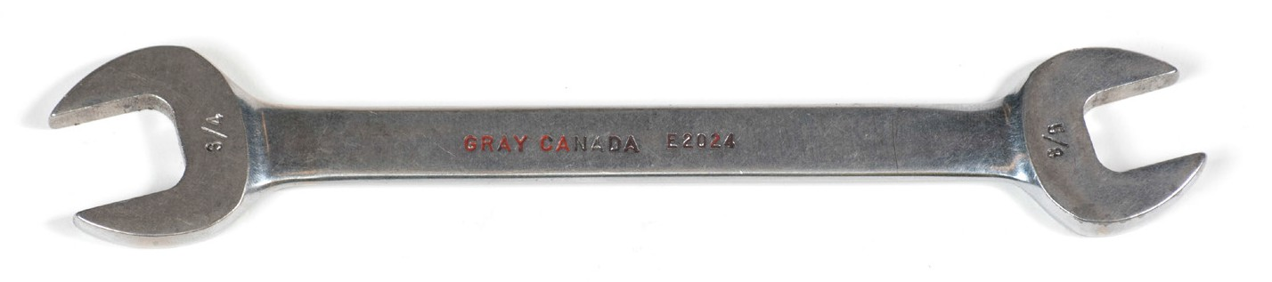
Figure 1 — Open-end wrench

While the open-end wrench may not provide as good a grip as a box-end wrench (see below), it can be used in situations where you cannot reach all the faces of the nut or bolt head.

Box-end wrench
The box-end wrench (Figure 2) is an excellent tool for tightening and loosening nuts and bolts. Unlike the open-end wrench, the box-end wrench is made to grip the nut or bolt head on all sides. This prevents slipping and allows greater leverage.

The wrench must be slipped over the top of the nut or bolt head. The points around the inner circumference of the opening securely grip the bolt head or nut. These wrenches are available in either a 6- or 12-point design. The 6-point wrench provides a more secure grip.

The two ends of the box-end wrench are usually different sizes. For example, a wrench with a 5/8 in. opening on one end and an 11/16 in. opening at the other end would be referred to as a
5/8 in. × 11/16 in. wrench. A metric wrench would have sizes such as 10 mm × 12 mm. The size of the wrench does not refer to the bolt diameter but rather to the distance across the flat of the nut
or bolt head. Like the open-end wrench, the box-end wrench usually has the sizes stamped near the corresponding head.

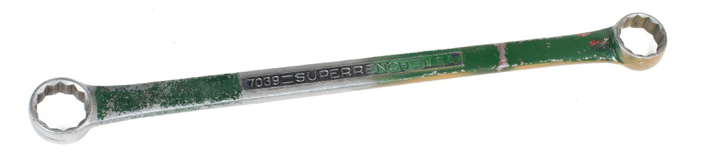
Figure 2 — Box-end wrench

Combination wrench
The combination wrench (Figure 3) is an open-end wrench and a box-end wrench combined into one tool. All the features of open-end and box-end wrenches apply also to a combination wrench. The combination wrench is available with 6- or 12-point box-end heads and in a wide selection of sizes and lengths.

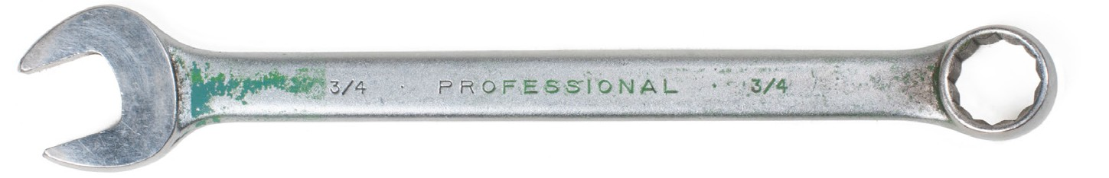
Figure 3 — Combination wrench

Ratchet wrench
A ratchet wrench (Figure 4) is similar to a combination wrench with an added ratchet feature built into the box end. This is useful in tight places where it is impossible to reposition the wrench after each turn. Instead, you just move the handle back and forth once the box end is positioned over the fastener. It is not recommended for heavy applications.

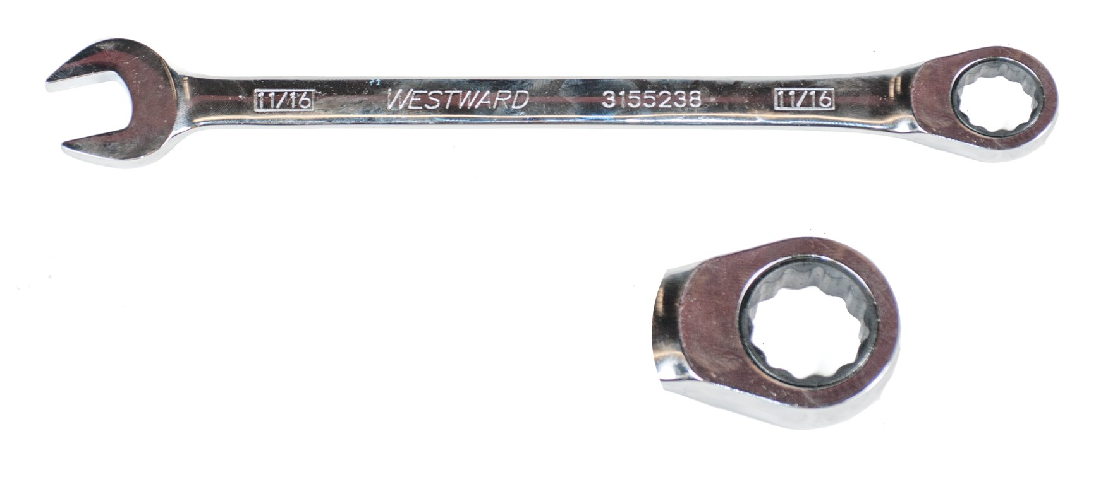
Figure 4 — Ratchet wrench

Tubing nut (flare nut) wrench
The tubing nut or flare nut wrench (Figure 5) is specially designed to provide a secure grip on line fittings. These wrenches have a slot through which the line or tube can be passed to allow a grip that is almost equal to a box-end wrench. This grip prevents wearing of the fitting hex nut corners during removal or installation, as might occur with an open-end wrench.

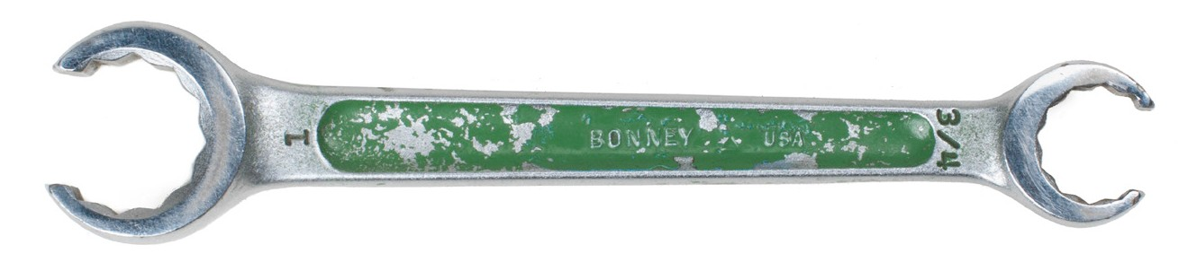
Figure 5 — Tubing nut (flare nut) wrench

These wrenches are available in both imperial and metric, in a variety of sizes, and in both 6- and 12-point design.

Adjustable wrench
The opening of this wrench (Figure 6) can be adjusted to suit the nut or bolt being turned. The adjustable jaw is moved by a knurled nut. The size of all adjustable wrenches is designated
by the wrench length, which varies from 100 mm (4 in.) to 600 mm (24 in.) For example, the 100 mm (4 in.) wrench has a 12 mm (1/2 in.) jaw capacity while the 600 mm (12 in.) wrench has a 33 mm (15/16 in.) capacity.

Adjustable wrenches are useful but should never be used as a substitute for an open-end or box-end wrench. Adjustable wrenches can be pulled in either direction for light loads but
develop their greatest strength when pressure is applied to the side of the wrench with the fixed jaw. Always be sure the wrench is adjusted as tightly as possible against the nut or bolt head before attempting to turn it.

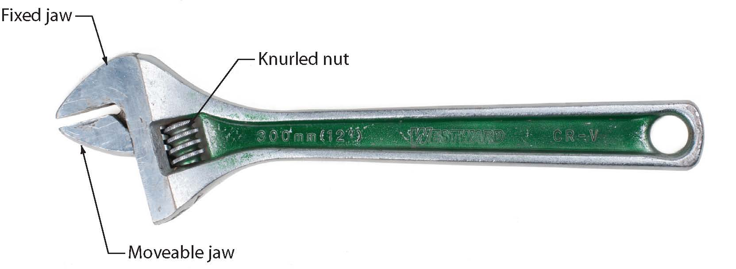

Figure F Figure 6 — Adjustable wrench

Pipe wrench
A pipe wrench (Figure 7) is used for turning pipe and other round objects. Because the sharp jaw teeth of the pipe wrench will dig in and mar the surface, a pipe wrench should not be used to turn bolts or nuts unless they are already damaged or their corners have been damaged.

Before using a pipe wrench, remove any grease or dirt from both the part to be turned and the pipe wrench jaws. Adjust the movable jaw so that the work is gripped near the centre of the jaws. Pull carefully until the wrench has a good bite on the work, then exert the force necessary to turn or tighten the work. Pipe wrenches should never be used on hardened surfaces since the jaw teeth may be dulled or chipped.

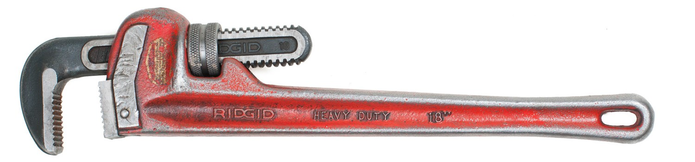
Figure 7 — Pipe wrench

Spud wrench
The spud wrench (Figure 8) has smooth, flat, narrow jaws that are ideal for use on square or rectangular stock such as flat-edged fittings or chrome-plated pipe fittings, as they won’t mar the surface like a pipe wrench.

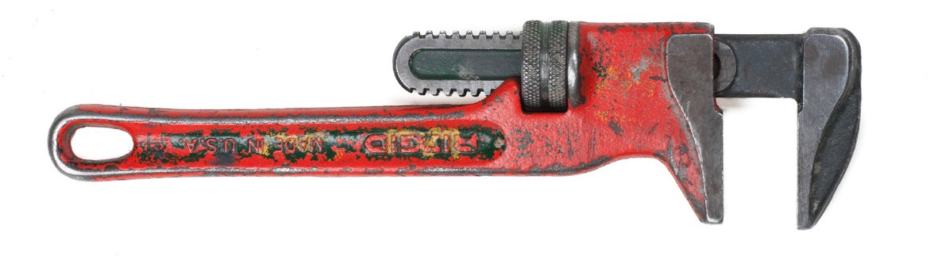
Figure 8 — Spud wrench

Hexagon wrench (Allen key)
The hexagon wrench or Allen key is an L-shaped bar of tool steel shaped in a hexagon (Figure 9). It is made to fit the hexagon hole in Allen screws. Hex wrenches are classified by the size of the hexagonal stock measured across the hex flats. They come in either imperial or
metric measurements, with the size usually stamped on the wrench. They are also available as a socket wrench.

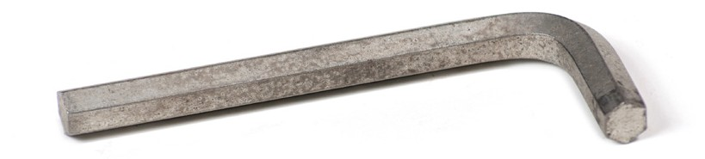
Figure 9 — Hex key (Allen wrench)

Clean out all dirt or foreign particles from the recessed opening in the screw to ensure total engagement of the tool. For breaking the fastener loose or for final tightening, engage the short end of the wrench in the screw and pull on the long arm of the wrench for leverage. After loosening the screw, engage the long end of the wrench in the screw and spin the tool for quick removal.

To start set screws, place them on the long arm of the wrench and then hold the arm perpendicular to the threaded hole while turning the screw. A set screw often needs only to be loosened one or two turns to free the part it secures. It is usually not completely removed.

Slug (striking) wrench
A slug wrench (Figure 10) is a specialized thick, short, stocky wrench with a block at the end of the handle. It is specifically designed for striking with a hammer, enabling you to impart great force.

Used commonly with large fasteners, slug wrenches also provide shock and high force used to release large and/or stuck nuts and bolts. They are also used when there is not enough space for a large wrench.

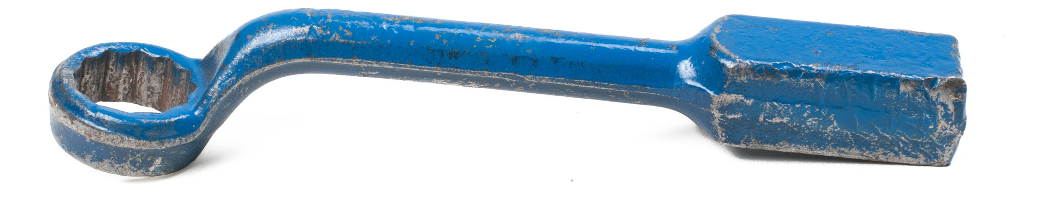
Figure 10 — Slug wrench

Chain and strap wrenches
Chain and strap wrenches (Figure 11) are used to remove large objects, such as a spin-on filter, or to turn pipe and other cylindrical objects. This style of wrench consists of a handle and either a long strap or a chain attached at one end of the wrench handle. The strap or chain is wrapped around the object and the loose end is attached to the handle. When the handle is pulled or pushed, the strap or chain tightens and grips the object. Chain wrenches will damage surfaces.

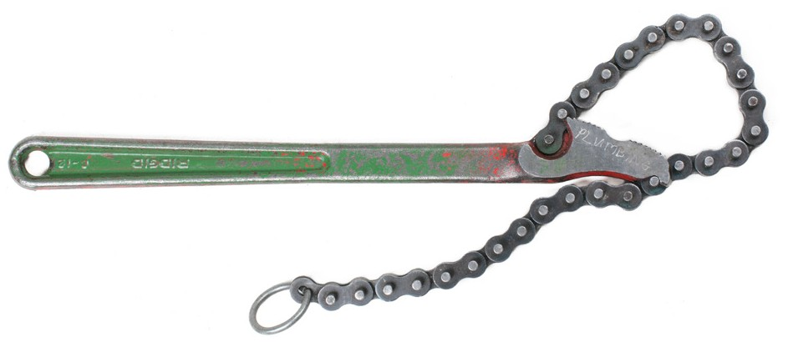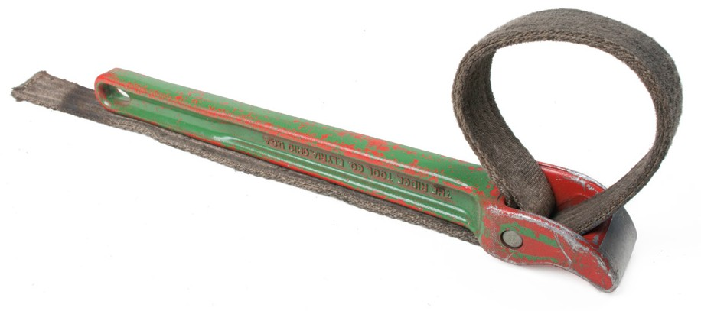
Figure 11 — Chain wrench (left); and strap wrench (right)

Socket wrench
Socket wrenches are designed to be used for turning fasteners that cannot be easily accessed with a standard wrench. A basic socket wrench is made up of a handle and several barrel- shaped sockets.

Each socket has a square hole on one end that fits directly into the drive lug on the socket wrench handle (Figure 12). The square drives range in size from 1/4 in. to 2 in. The most common sizes range from 1/4 in. through to 3/4 in. The drive size is denominated in inches; this is an international standard and no metric counterpart exists for imperial socket sizes.

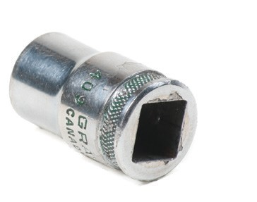½" drive
¼" drive
⁄ " drive

¾" drive

Figure 12 — Square drives

The other end of the socket looks like a box-end wrench and has 6, 8, or 12 points (Figure 13). With the socket firmly attached to the wrench handle, the socket is placed over the nut or bolt head and the handle is moved to loosen or tighten the fastener. The 6- and 12-point sockets are most common. The 6-point socket is stronger and will do less damage to the fastener than a
- point socket.

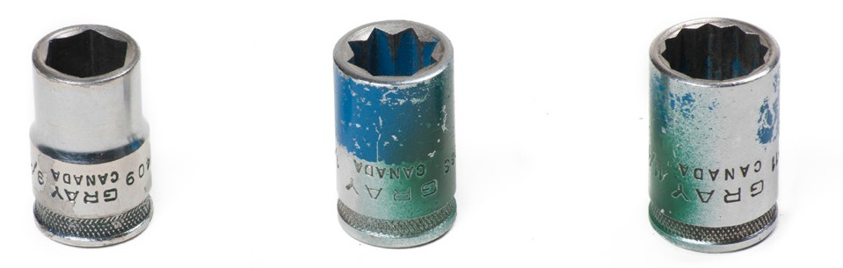

6-point 8-point 12-point
Figure 13 — Socket points

The universal flex or swivel socket permits the socket to be used at various angles by the swivelling action of the socket head. The deep socket allows you to loosen a nut on a stud or bolt that has a large number of threads showing, when standard sockets would not be long enough to reach the nut (Figure 14).

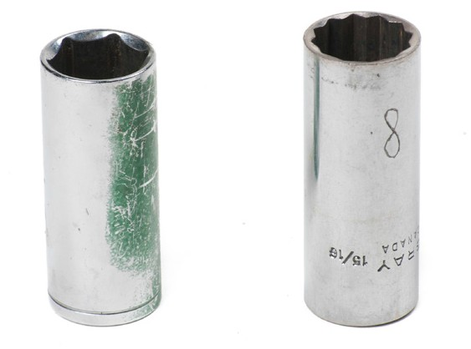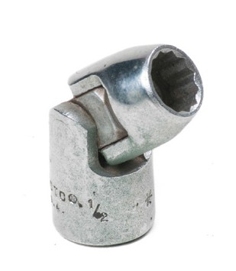
Figure 14 — Deep sockets and swivel socket

Socket sizes are marked on the outside of the socket and indicate the head size of the fastener that they will fit. Other special sockets include those designed for removing and replacing oil pressure- and temperature-sensing units, and spark plugs, and sockets designed for use with impact wrenches. Impact sockets have stronger construction and are not chrome plated, since the chrome would crack and flake off. The thick walls and heavy construction allow them to take the shock of the impact.

Regular sockets should never be used with an impact tool.
Some socket handles (Figure 15) have a small, half-exposed ball bearing centred on one side of the square drive. When the socket is fully pushed onto the socket handle, a machined groove or mating hole aligns with the recessed ball bearing to assist in retaining the socket.

Other types of holding devices include the pin and spring for larger sockets to provide secure control over the socket and extension. The ball is in the drive handle and the pin is used to push the ball in and release the socket. Additional accessories for socket wrenches can include:
  - driver handles
  - speed handles
  - adapters
  - extensions
  - sliding T-bar
  - flex (hinged) handles
  - ratchet handle

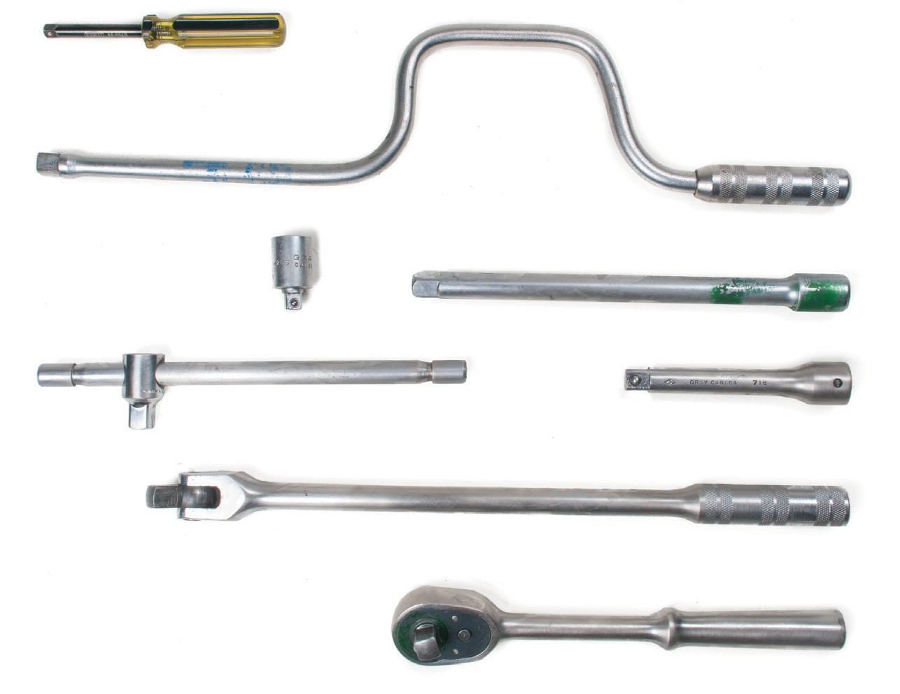
Plastic driver handle
Speed handle
Drive adapter

Sliding T-bar
Extension bar
Hinged handle
Ratchet handle
Figure 15 — Socket handles

Care and maintainance of wrenches
Keep your wrenches clean. Working with greasy, dirty tools can be dangerous, as your hands can slip, causing injury. The dirt can also damage the component on which you are working. Adjustable wrenches and pipe wrenches should be cleaned and lightly oiled periodically.

Follow these general use and care guidelines:
  - Make sure the wrench is the correct size for the job. Loose-fitting wrenches can damage both the workpiece and the jaws of the wrench.
  - Do not abuse the wrench by driving it on with a hammer or by adding leverage with a piece of pipe.
  - Do not use any wrench as a hammer and do not use socket handles for any purpose other than driving sockets.

- Do not use a socket wrench as a bushing or seal driver or for any other purpose.

- Check socket wrenches for chipping and cracking or other damage. Do not use them if they are damaged.
Hexagon key or Allen wrenches can be reconditioned if the end of the key becomes worn and slips in the socket head screw. Grind the end back to a point where the hexagon shape is true. Be careful that you keep the tool cool during the grinding operation to avoid affecting the hardened metal.

Pliers
Pliers assist a tradesperson in many tasks. Pliers are used for holding, gripping, cutting, and crimping. They are forged from hardened steel and machined to close tolerances. Some have honed cutting edges and are polished.

Pliers are classified by their type and by their overall length, which can vary from 100 mm (4 in.) to 500 mm (20 in.). Common types of pliers include:
- combination slip-joint
- interlocking slip-joint
- needle nose and round nose
- diagonal or side-cutting
- locking
- lineman
- snap-ring
- specialized application pliers

Combination slip-joint pliers
The combination slip-joint pliers (Figure 16) are the most common general-purpose pliers. They can be adjusted to two sizes by means of a sliding pivot that allows the jaws to open widely for gripping larger items. The jaws have sharp, hardened cross teeth to grip the object on which you are working.

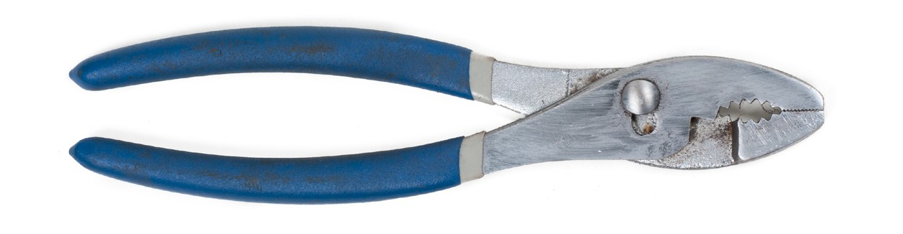
Figure 16 — Combination slip-joint pliers

Never use pliers for turning nuts or bolts, as the sharp teeth will round off the corners and badly mar the nut or bolt.

Interlocking slip-joint pliers
Interlocking slip-joint pliers (Figure 17) are a variation of the combination slip-joint pliers. These pliers are very useful for gripping large or hard-to-get-at objects. They can be opened to a number of positions while the jaws remain parallel to each other. Because of the large bite available, the handles are made longer to provide greater leverage.

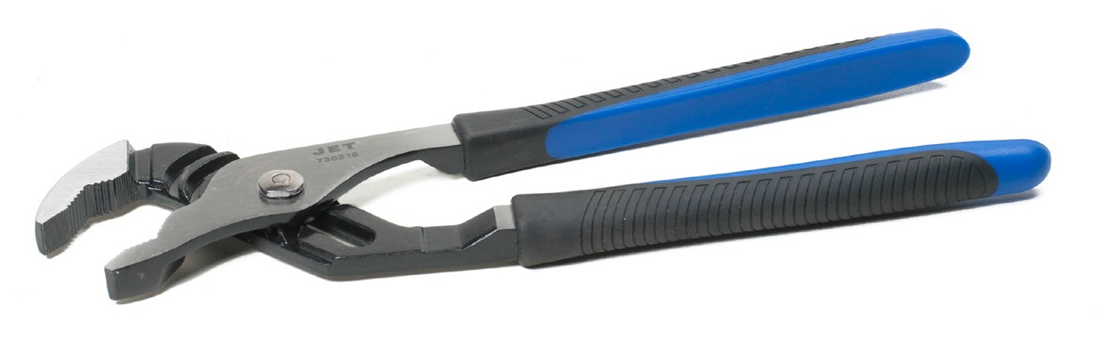
Figure 17 — Interlocking slip-joint pliers

Needle-nose and round-nose pliers
These pliers (Figure 18) come in a variety of sizes and styles, some incorporating a cutting surface. Many needle-nose pliers are useful in bending wire into curves or circles.

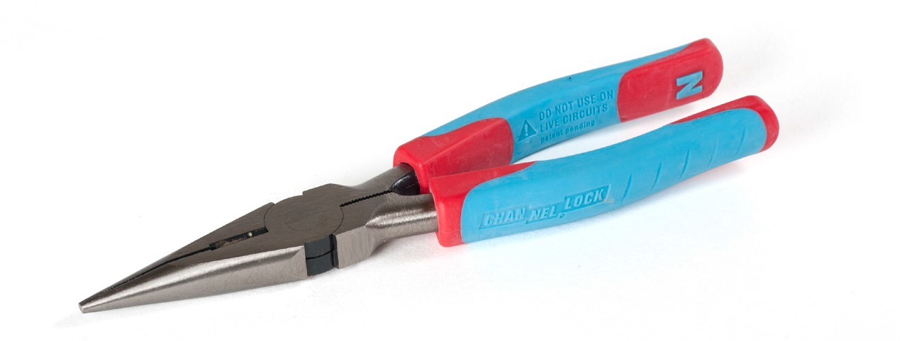
Figure 18 — Needle-nose pliers

Diagonal or side-cutting pliers
Diagonal or side-cutting pliers (Figure 19) are made with a diagonally cut head or face and a hard steel cutting edge to cut wire or other metal objects close to the surface. Diagonal cutters are especially useful for removing cotter pins and for trimming cotter pins to the desired length after installation.

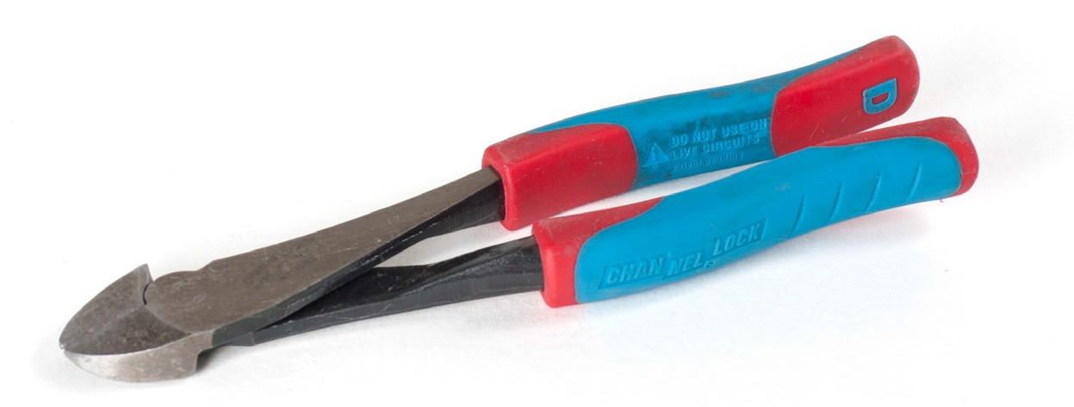
Figure 19 — Diagonal or side-cutting pliers

Locking pliers
Locking pliers, also referred to by the trade name Vise-Grip, are useful for holding parts together. They have a built-in spring mechanism that can be locked into position and released by pulling or squeezing a release lever. Locking pliers come in several sizes and styles and are available with either straight, cutting, or curved jaws (Figure 20).

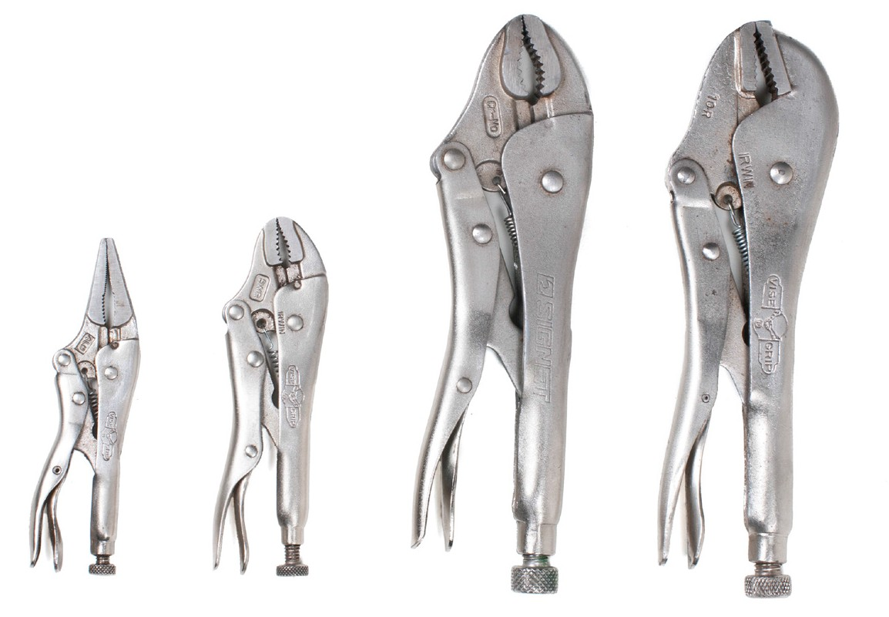
Figure 20 — Locking (or Vise-Grip) pliers

Lineman pliers
Lineman pliers (Figure 21) are designed for working with electrical wiring. They have large square jaws with a cutting edge. The handles are insulated.

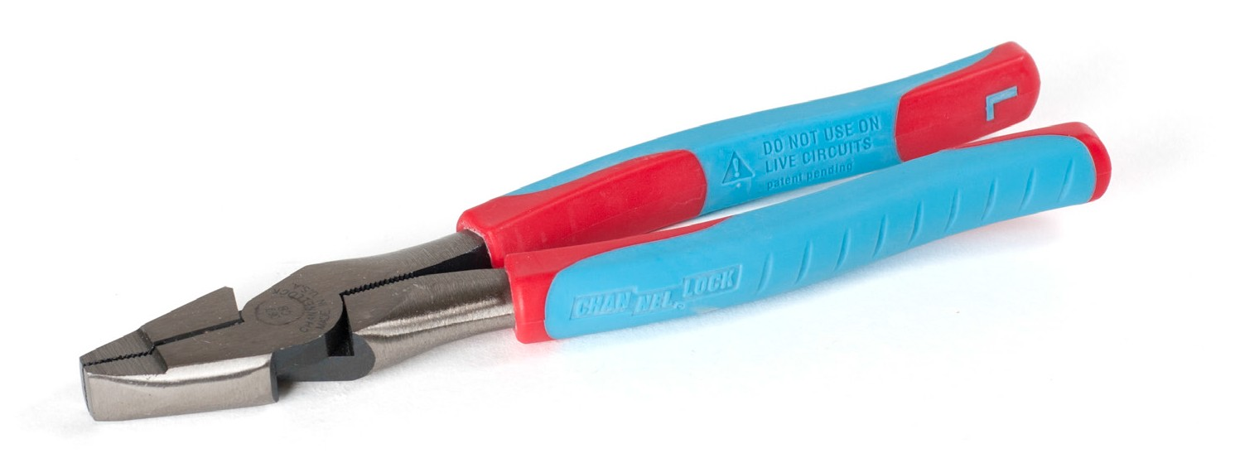
Figure 21 — Lineman pliers

Snap-ring pliers
Snap-ring pliers (Figure 22) can be used to remove square-ended external snap-rings. This type of pliers often has a feature that permits the jaws to stay parallel throughout their operating range. The jaw surfaces are usually serrated to prevent slipping.

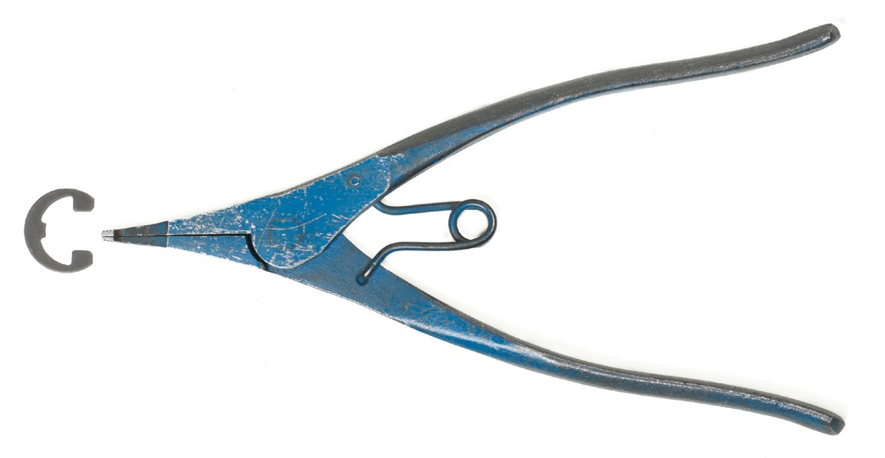
Figure 22 — Snap-ring pliers

Another type of snap-ring pliers is used with a specially designed retaining ring (circlip) that has small holes at both ends to accommodate the pliers. These rings are designed for internal or external applications. The pliers are also designed with expanding or contracting tips of different sizes.

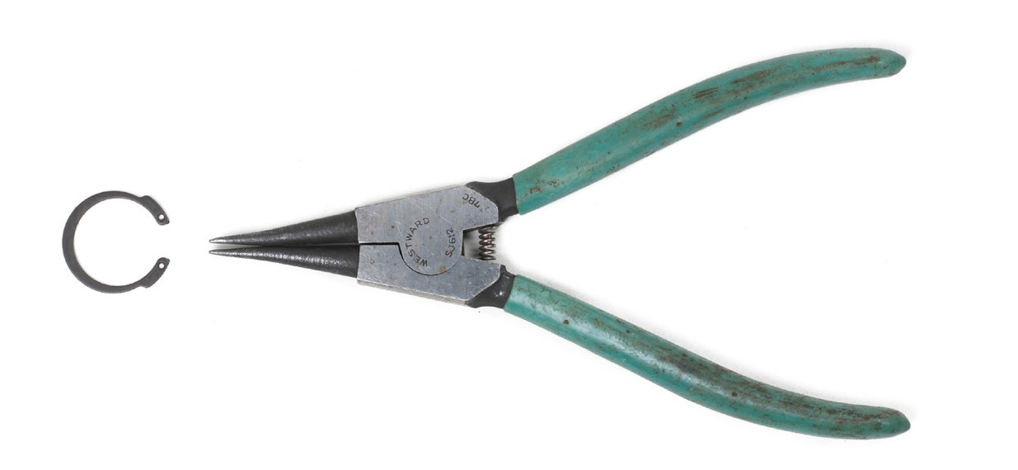
Figure 23 — Snap-ring pliers with internal circlip

Specialized pliers
There are many different types of pliers designed for special applications. Specialized pliers include:
  - battery terminal pliers to spread battery terminals
  - right-angle pliers
  - ignition pliers
  - horseshoe lock-ring pliers
  - combination wire strippers/crimpers

Care and maintainance of pliers
When using pliers, follow these general use and care guidelines:
- Pliers are not made to withstand any pressure in excess of normal hand squeezing.
- Never attempt to cut large screws or bolts with a pair of cutting pliers.
- Never put excessive side pressure on needle-nose pliers.
- Never expose pliers to a direct flame.
- Do not use pliers on nut or bolt heads.
- Cut at right angles.
- Use the right tool for the job.

Now complete the Learning Task Self-Test.

Self-Test 6
- What type of wrench is used to tighten Allen screws?
  - Hex wrench
  - Socket wrench
  - 12-point wrench
  - Adjustable wrench

- What type of wrench has a box end at one end and an open end at the other?
  - Open-box wrench
  - Double-duty wrench
  - Combination wrench
  - Double-ended wrench

- How is the size of an adjustable wrench determined?
  - By its jaw length
  - By its total weight
  - By its overall length
  - By the size of its jaw opening

- How should wrenches be maintained?
  - Greased daily
  - Wiped clean daily
  - Varnished occasionally
  - Soaked in solvent after each use

- How can an hex wrench be reconditioned if worn?
  - Bend it into shape.
  - It must be discarded.
  - Hammer the end flat.
  - Grind the worn end off slowly.

- Which wrench provides the best grip on a fastener?
  - Box-end wrench
  - Spud wrench
  - Open-end wrench
  - Adjustable wrench

- What tool should be avoided when tightening nuts or bolts?
  - Socket wrench
  - Slip-joint pliers
  - Adjustable wrench
  - Open-end wrench

- What tool is especially useful for removing cotter pins and for trimming cotter pins to the desired length after installation?
  - Locking pliers
  - Side-cutting pliers
  - Needle-nose pliers
  - Interlocking slip-joint pliers

- What type of pliers can be opened to a number of positions while the jaws remain parallel to each other?
  - Locking pliers
  - Side-cutting pliers
  - Needle-nose pliers
  - Interlocking slip-joint pliers

- What type of pliers have a built-in spring mechanism that allows them to be locked into position?
  - Locking pliers
  - Side-cutting pliers
  - Needle-nose pliers
  - Interlocking slip-joint pliers

LEARNING TASK 7

Identify screwdrivers and their uses
Screwdrivers are available in a variety of lengths and sizes. The length of a screwdriver is measured from the tip to where the handle joins the shank. Lengths range from 38 mm to 60 cm (11/2 in. to 12 in.) or more, with the shorter lengths known as “stubbies.”

Parts of a screwdriver
The parts of a screwdriver are the head, handle, ferrule, shank, and tip (Figure 1). The size of a screwdriver is indicated by the length of the shank.

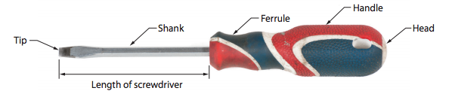
Figure 1 — Parts of a screwdriver

Types of screwdrivers
Screwdriver types include:
- cabinet tip
- round shank
- square shank
- ratchet
- stubby and offset
- multiple bit

Cabinet-tip screwdriver
The cabinet-tip screwdriver has a long shank length—150 mm (6 in.) to 200 mm (8 in.)—that is straight on both sides. Regular screwdrivers have a swaged end just above the tip; the
cabinet-tip screwdriver does not have this feature (Figure 2). It is designed for attaching cabinet hardware when a screwdriver with a swaged portion would be in the way of the hardware.

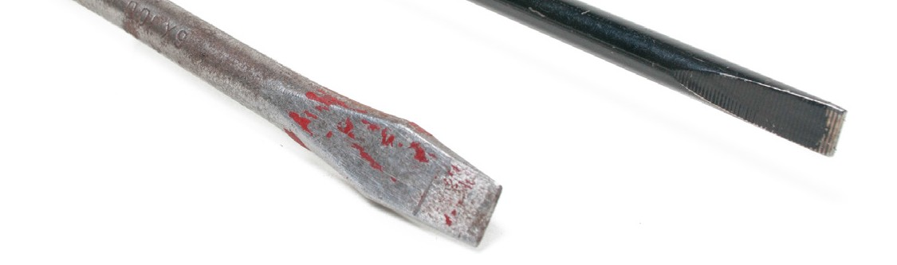
Figure 2 — Regular swaged-ended screw-driver (left); Cabinet-tip straight-ended screwdriver (right)

Square-shank screwdriver
The square-shank screwdriver (Figure 3) is useful for driving large screws because a wrench can be used on the square shank for extra leverage.

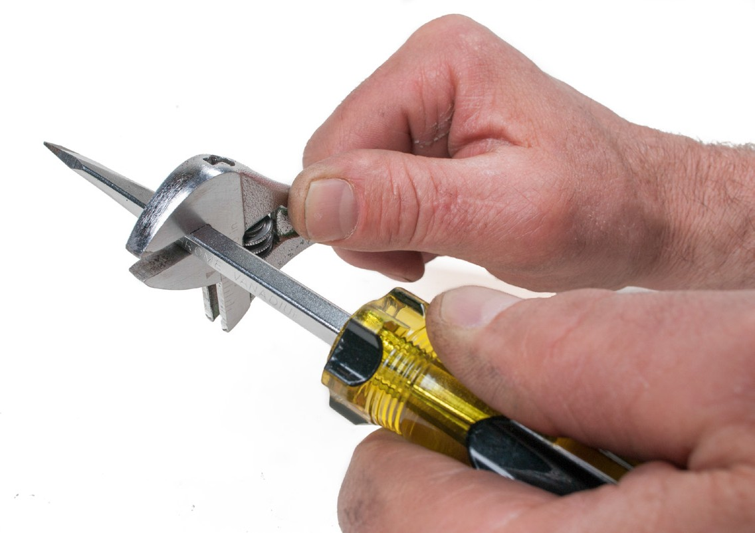
Figure 3 — Square-shank screwdriver

Ratchet screwdriver
The ratchet screwdriver has different tips for fitting into slot, Robertson, and Phillips screws. To speed up a job, the ratchet on the ferrule of the driver can be set to turn or remove a screw. It can also be set to a locked position to permit the driver to be operated as an ordinary screwdriver.

Stubby and offset screwdrivers
The stubby screwdriver (Figure 5) is available in all sizes of slot, Robertson, and Phillips tips. The shank and handle are very short—70 mm (23/4 in.) to 85 mm (31/4 in.) long—which is why it is called “stubby.” Stubby screwdrivers are used only when space will not permit use of longer screwdrivers.

Another design that allows the operator to reach into tight spaces is the offset screwdriver (Figure 4). One offset design is Z-shaped, with the tips at a right angle to the shank.

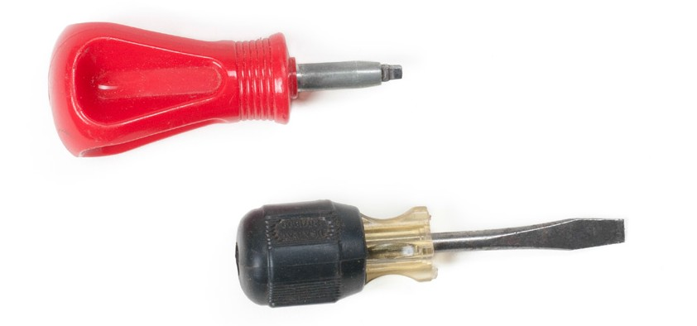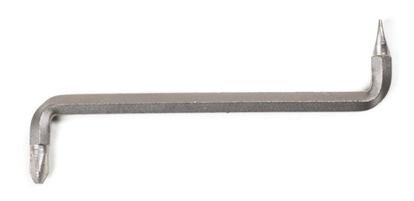
Figure 4 — Stubby and offset screwdrivers

Multiple-bit screwdrivers
Multiple-bit screwdrivers are designed to accept different types of tips, enabling a single screwdriver to potentially turn any type of screw. These multi-bit screwdrivers may include storage for extra bits in the handle (Figure 5).

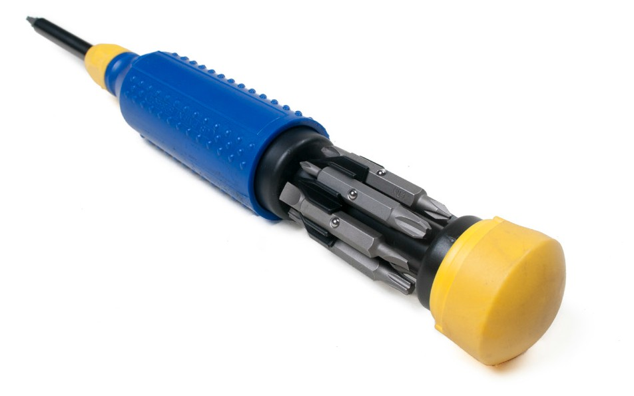
Figure 5 — Multi-bit screwdriver

Tip types
Some common screwdriver tip types include:
- slot
- Phillips
- clutch
- Torx
- hex (Allen)
- Robertson

Slot tip
The slot tip screwdriver is the most commonly used type of screwdriver, and sometimes it is referred to as the “conventional screwdriver.” It comes in many lengths and tip sizes. When you select a screwdriver for slot screws, make sure that the tip is as wide as the diameter of the screw head and that it is as thick as the slot size. Figure 6 shows the correct fit for slot screwdrivers.
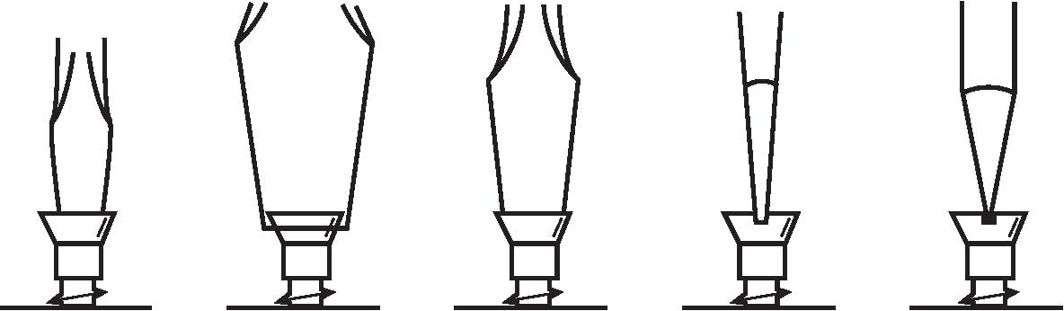

Too small Too large Good fit Good fit Too narrow
Figure 6 — Correct and incorrect fits for slot screwdrivers

If the tip of the screwdriver becomes worn and rounded, it should be reshaped by filing or grinding. Figure 7 shows correctly and incorrectly ground tips.

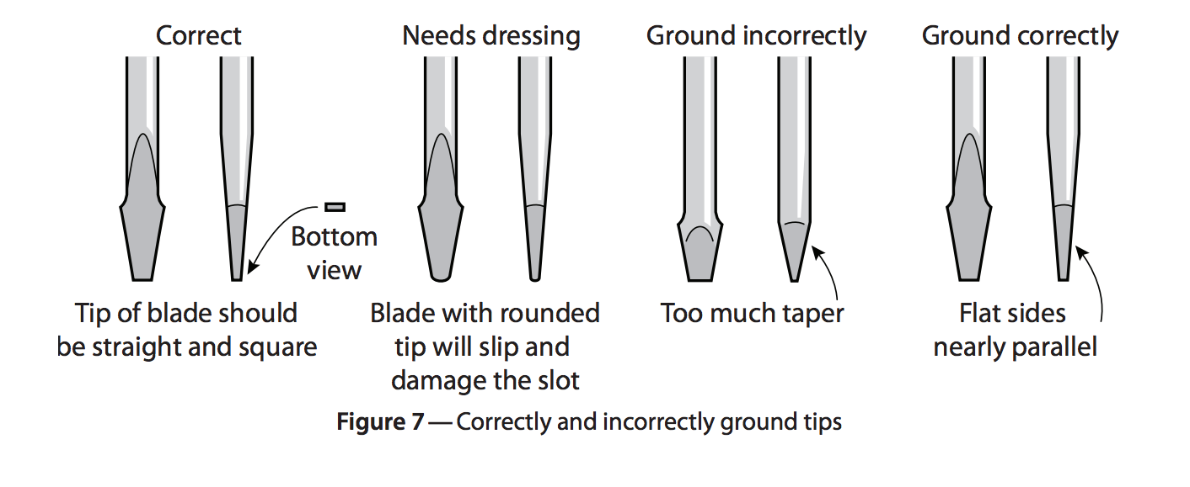

Phillips tip
The Phillips screwdriver (Figure 8) has a cross tip for fastening screws, and the screws have a cross recess for accepting the driver.

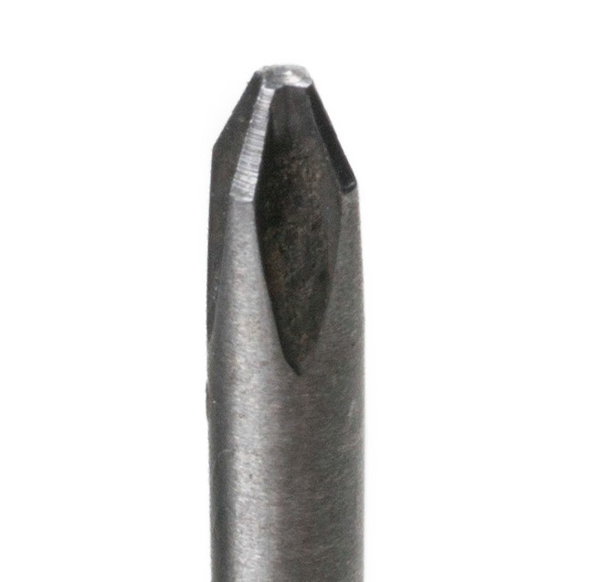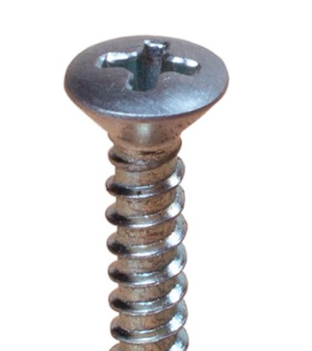
Figure 8 — Phillips screwdriver tip and screw

The Phillips screwdriver is available in the following sizes from smallest to largest: No. 00, No. 0, No. 1, No. 2, No. 3, and No. 4. The Phillips screw is often selected for finish hardware.

Torx and clutch tips
The tip of the Torx screwdriver is extremely strong and hard, and especially designed for power tools. It is available in the following sizes: T7, T8, T9, Tl0, T15, T20, T25, T27, T30, and T40. Figure 9 shows the Torx and clutch screwdriver tips.

Never use an Allen wrench on a Torx screw. The head of the Torx screw may appear to fit an Allen wrench, but you will find that as soon as force is applied, the corners of both the wrench and screw will be damaged.

The clutch screwdriver and screw are used in the automotive and manufacturing industries. The driver tip must exactly match the size of the head. The head of the screw is held firmly by the driver tip. If a slot or Phillips screwdriver is used with it, the screw might slip out.

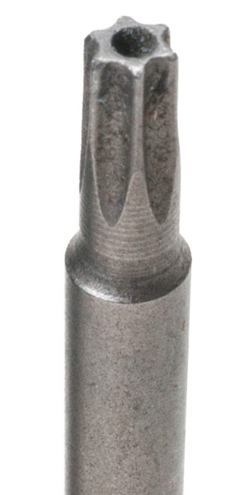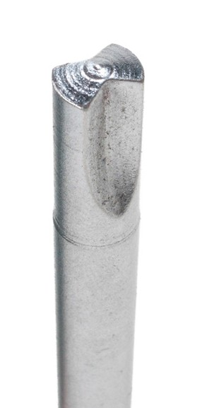
Torx Clutch
Figure 9 — Torx and clutch driver tips

Hex (Allen) tip
Similar to a hex wrench, hex (or Allen) screwdrivers are used to drive smaller size hex screws that don’t require the same leverage available when using a hex wrench. Hex tips are often available for the multiple-bit screwdrivers.

Robertson tip
The square tip of the Robertson screwdriver fits into the hole of the Robertson screw (Figure 10).

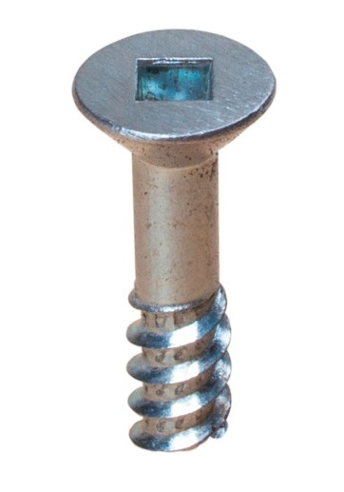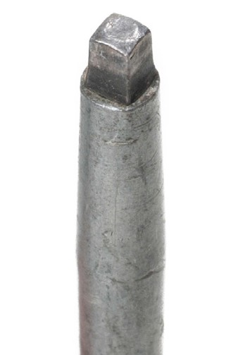
Figure 10 — Robertson screwdriver tip and screw

Robertson screwdrivers follow a sizing system that matches the colour of the handles to the tip size and screw sizes (Figure 11). The size is indicated on the handle. The smallest tip size is No. 00; the largest is No. 3.

Colour | Tip size | Screw sizes
Orange | No. 00 | #1 & #2
Yellow | No. 0 | #3 & #4
Green | No. 1 | #5, #6, #7
Red | No. 2 | #8, #9, #10
Black | No. 3 | #12 and larger
Figure 11 — Robertson screw and driver classifications

The advantage of the Robertson screwdriver is that its end can hold a screw without a clip or magnet. This leaves the operator free to position an object with one hand and fasten it with the other.

Screwdriver sockets and bits
Screwdriver sockets (Figure 12) are also available to provide a more positive drive for loosening and tightening screws. Some screw tip fasteners may need to be torqued in place; screwdriver sockets provide a means of attaching a torque wrench.

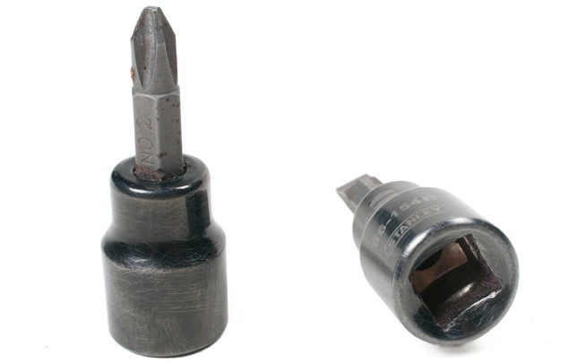
Figure 12 — Screwdriver sockets

Bits similar to those used in a multiple-bit screwdriver are also available for use in electric drills (Figure 13).

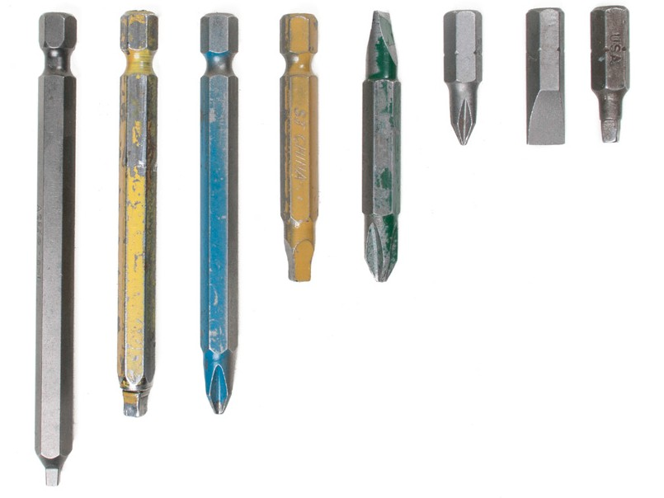
Figure 13 — Screwdriver bits

Care and maintenance of screwdrivers
Screwdrivers should be kept clean and free of grease, oil, and dirt. The handle should be intact and well secured, and the tip should not be worn. The tip of a slot screwdriver can be filed to shape, but other types must be replaced.

Screwdrivers should never be used as prying tools, punches, scrapers, can openers, or chisels. These misuses will make the screwdriver useless for driving a screw.

Now complete the Learning Task Self-Test.

Self-Test 7
    - What type of screwdriver is used for turning screws that have a single slot?
      - Torx screwdriver
      - Phillips screwdriver
      - Flat-blade screwdriver
      - Robertson screwdriver

    - In what sizes are Phillips screwdrivers available? a. 1, 2, 3, and 4
b. 0, 00, 001, and 002
c. 3/32 in., 1/8 in., 3/16 in., and 1/4 in.
d. A, B, C, and D

    - What type of screw head is illustrated in Figure 1?
      - Star head
      - Torx head
      - Phillips head
      - Robertson head

    - What determines the size of a screwdriver?
      - Width of the tip
      - Length of the shank
      - Overall length of the driver
      - Size of the screw the driver fits

    - Name the parts of the screwdriver shown in Figure 2.
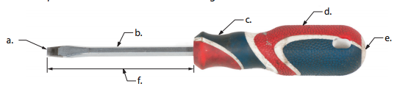

Figure 1

Figure 2

    - In Figure 3, which illustrations of slot screwdriver tips and screws in Figure 3 show a correct fit?

      - b. c. d. e.
Figure 3

- Correct: ________
- Incorrect: ________

    - Which screwdriver has the tips at right angles to the shank?
      - Offset screwdriver
      - Stubby screwdriver
      - Ratchet screwdriver
      - Cabinet-tip screwdriver

    - Identify the screwdriver tips shown in Figure 4.

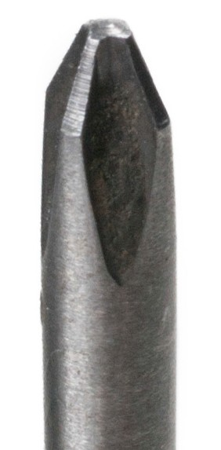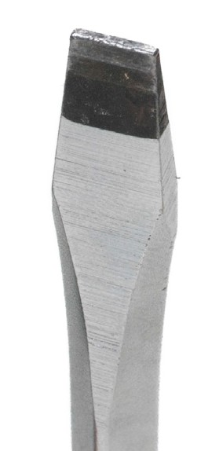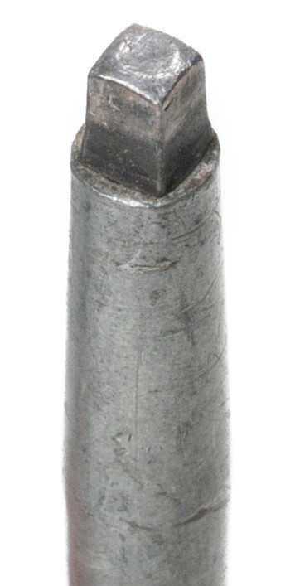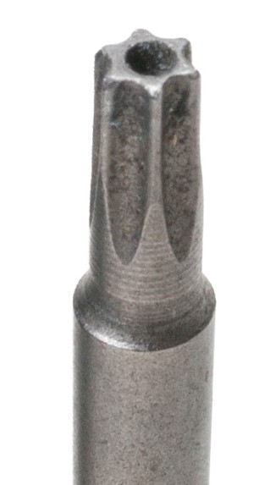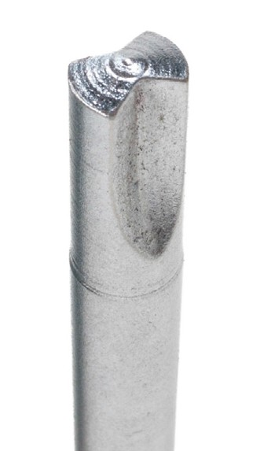
a. b. c. d. e.

Figure 4

LEARNING TASK 8

Describe specialty hand tools
There are many tools that are designed for specific applications. The best sources of information for identifying tools are manufacturers’ catalogues, which are available from suppliers or online.

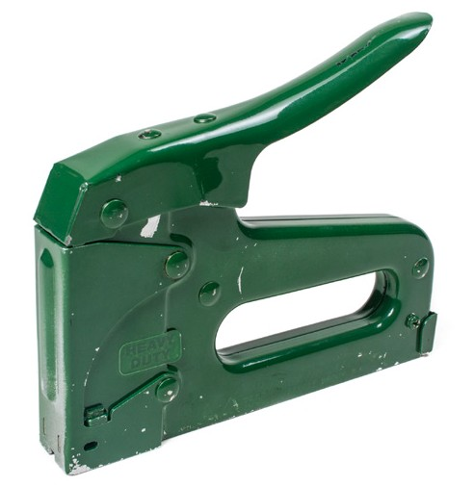Staplers
A stapler (Figure 1) is a special tool designed to insert wire metal fasteners into wood and other products that can be penetrated relatively easily. Staplers may be mechanical, electric, or pneumatic. Staplers are available in different sizes and usually have a minimum and maximum size of staple that they can apply.

Tubing cutters
Figure 1 — Stapler

The tubing cutter (Figure 2) is used to make clean, square cuts on copper, brass, aluminum, and thin-walled conduit. These lightweight cutters commonly have a foldaway reamer attached to them, with a small square hole in it to operate the valve stem of a B-size acetylene tank. Other tubing cutters have a slide-out deburring tool with a small blade that spins as it is rotated in the tube.

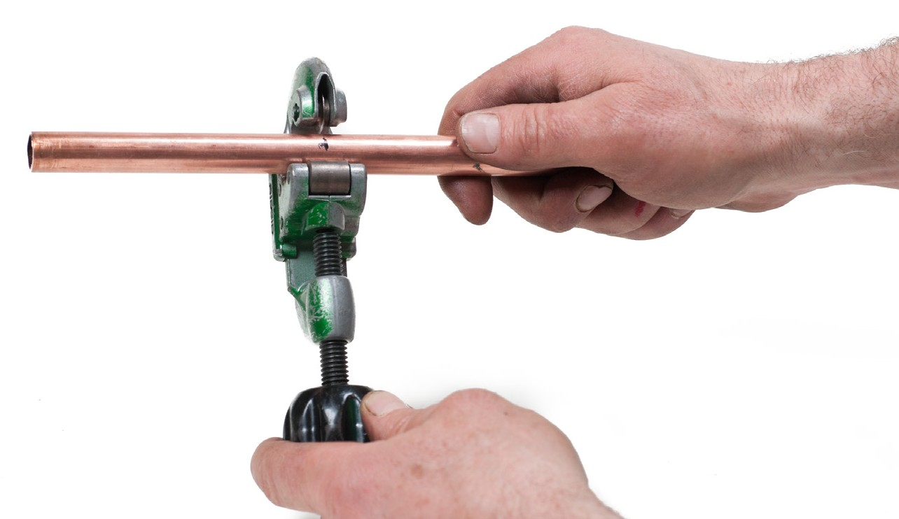
Figure 2 — Tubing cutter

Torque wrenches
Torque is the amount of twisting action at a given point. Without some way of measuring torque, it is impossible to tighten a series of bolts, nuts, or screws to an exact predetermined tension.

Torquing of bolts, nuts, and screws is a very critical operation. Applying too little torque will cause leaks. Applying too much torque will also cause leaks but will also cause distortion and major damage to expensive parts. Torque wrenches (Figure 3) are designed to measure the amount of torque being applied.

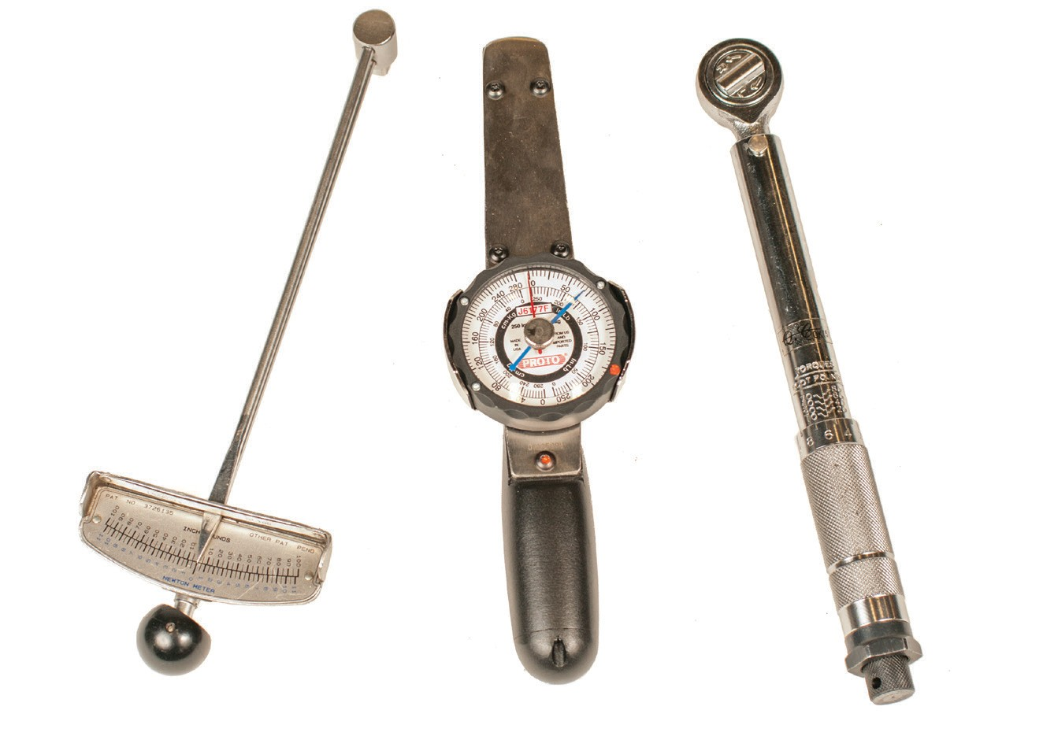
Deflecting-beam type
Dial-indicating type
Audible-click type
Figure 3 — Torque wrenches

The audible-click type and the dial-indicating type are preferable to the deflecting-beam type. The audible-click torque wrench can be used where it is difficult to read a dial or scale while performing the tightening sequences.

Some torque wrenches have a ratchet drive. Torque wrench square drives vary from 1/4 in. up to 1 in. in size (these measurements are a de facto international standard with no metric
equivalents) for standard uses and in larger sizes for heavy industrial applications. Some ratchet drivers operate in both directions, while others operate only in a right-hand rotation.

Pullers
Gear and bearing pullers (Figure 4) are designed for hundreds of applications. Their main purpose is to remove a component from a shaft (such as a gear, pulley, or bearing) or to remove a shaft from inside a hole.

Gear pullers come in a range of sizes and shapes, all designed for particular applications. They consist of three main parts:
- jaws
- cross arm
- centre-forcing screw

There are normally two or three jaws on a puller. The jaws are designed to work either externally around a pulley, or internally. The forcing screw is a long-fine-threaded screw that is applied
to the centre of the shaft. When the forcing screw is turned, it applies many tonnes of force through the component you are removing.

The cross arm attaches the jaws to the forcing screw. There may be two, three, or four arms.

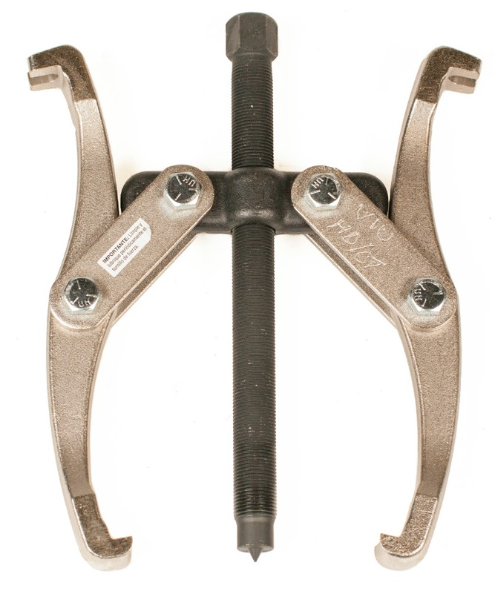
Figure 4 — Gear puller

Puller safety
Pullers (especially hydraulic pullers) can exert a tremendous amount of force, often up to 100 metric tonnes (imperial: 110 tons). Careful attention must be given to the correct choice of puller and to the safe use of that puller.

Place a shaft protector over the end of shaft before installing a puller. When the puller is installed, be sure the set-up is rigid and the puller is square with the work. Apply force gradually. The component should give a little at a time. Do not try to speed the removal by using an impact wrench on the screw. If you have applied maximum force and the part does not move, use a larger capacity puller.

Always wear safety glasses.

Tools that are in contact with hard metal surfaces and subject to high loads should be regularly inspected. Pullers receive a great deal of abuse when used under some circumstances. The points or hooks on the jaws may become rounded and worn and require replacement or repair. The pressure screw threads should be lightly oiled and clean and free of burrs. The screw end should have a clean point so that it will seat properly into the recess on the adapter plates. Jaw pins should be kept in good condition and properly maintained.

Wire brushes
Wire brushes (Figure 5) are used to remove scale, rust, dirt, loose slag, and spatter from metal surfaces. The metal of the brush should match the base metal; for example, a stainless steel brush should be used on stainless steel and a steel brush on mild steel.

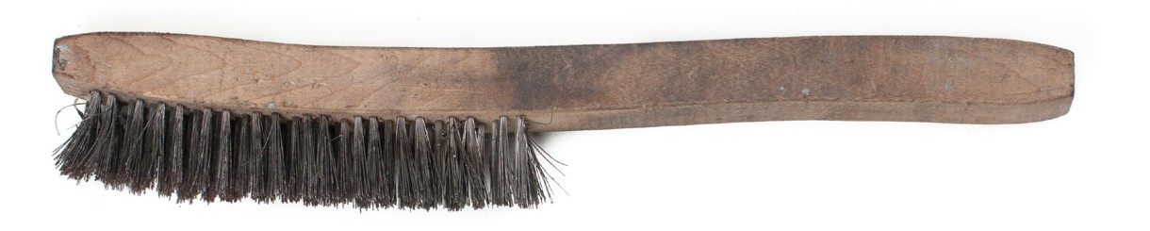
Figure 5 — Wire brushes

Take care that the sparks from welding or cutting do not fall onto the brushes as the bristles will melt together in lumps and make the brush useless. Wire brushes should be stored so that their bristles will not be bent or damaged by the weight of other tools.

Shovels
Shovels are used by many different trades. There are three basic shapes of shovel blades: round, square, and spade. Use a round-bladed shovel to dig holes or remove large amounts of soil. Use a square-bladed shovel to move gravel or clean up debris. Use a flat-ended spade to move large amounts of soil or dig trenches that need smooth, straight sides.

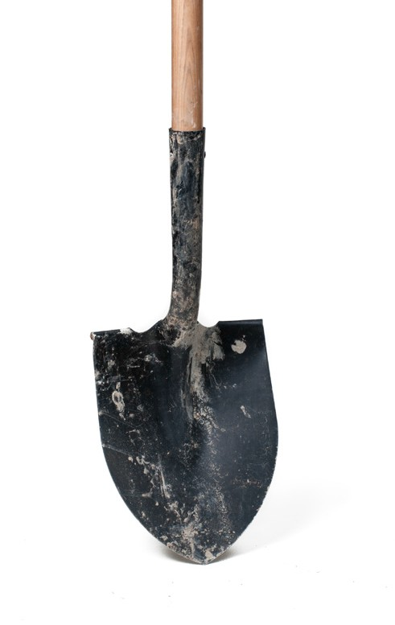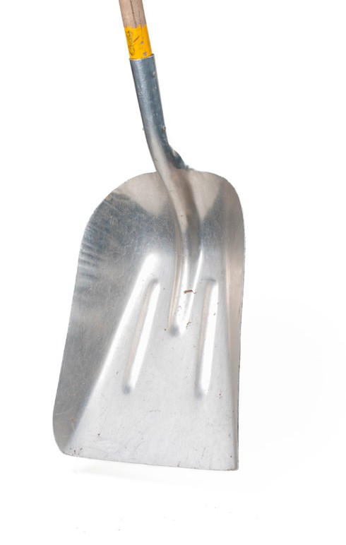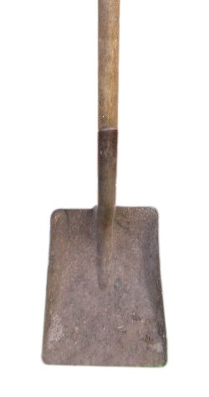
Figure 6 — Shovels

Hand-operated grease guns
There are many different styles of grease guns for different applications (Figure 7). These hand guns are capable of pumping grease at pressures of up to 10 000 psi into grease fittings on components requiring lubrication. They can be equipped with different styles of ends, from straight, fixed extensions to flexible extensions.

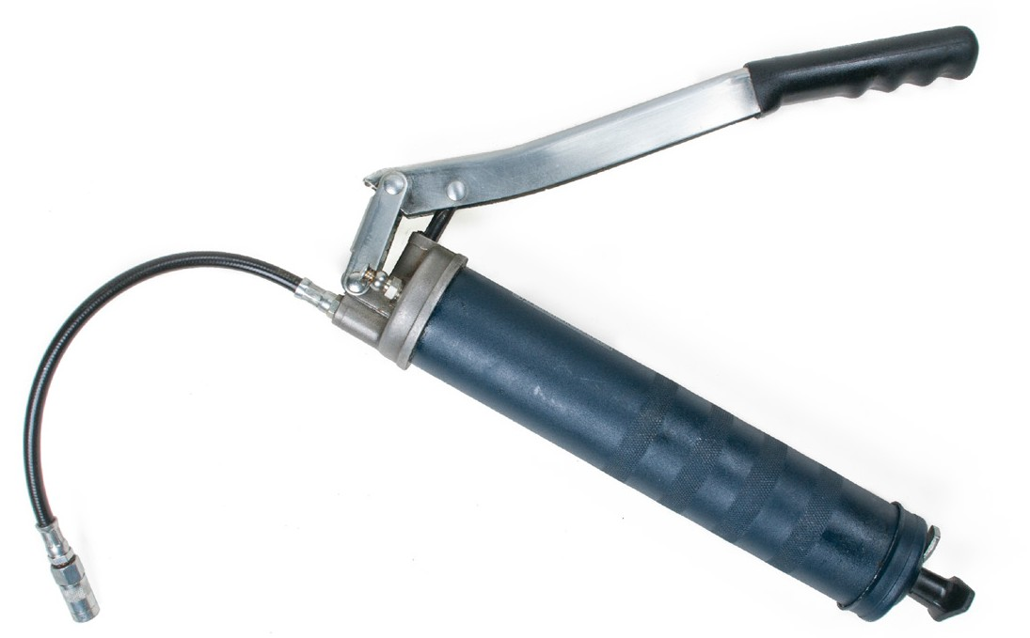
Figure 7 — Grease gun

Caulking guns
Caulking guns (Figure 8) are used to apply different types of materials, including glue, silicone, sealers, putty, and special compounds. They are often used for applying sealants in bathrooms, around fittings, and between windows and frames. They are normally available in two different types: ratchet and smooth.

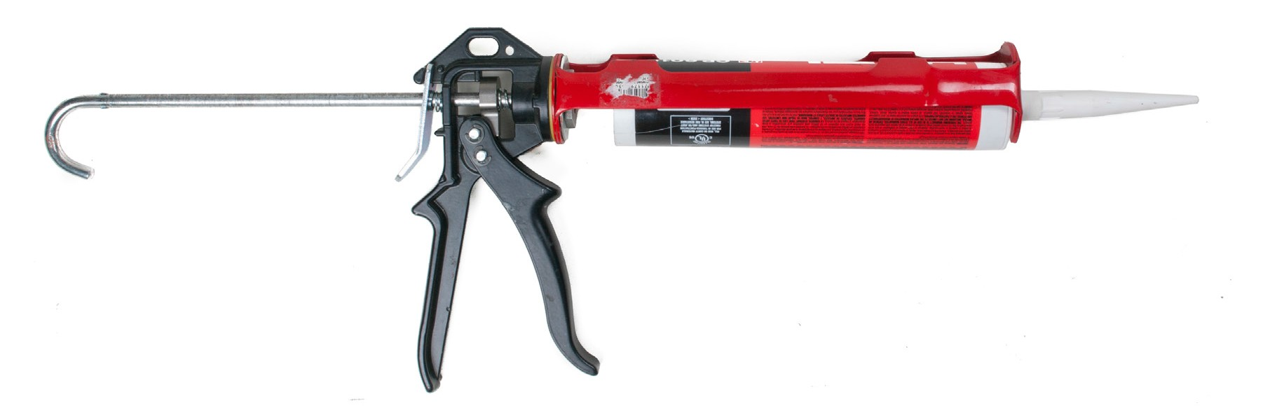
Figure 8 — Caulking gun

Pulling the trigger of the ratchet gun causes the plunger inside the housing of the gun to advance in a forward motion, extruding the material “click by click.” Smooth rod guns also operate by pulling the trigger, exerting pressure on the recoil plates or friction plates and causing them to grip the push rod.

Taps and dies
Threads are cut on screws, bolts, nuts, studs, and inside holes to allow components to be attached and assembled. Taps cut threads inside holes or nuts, whereas dies cut threads onto the outside of bolts, screws, or studs (Figure 9).

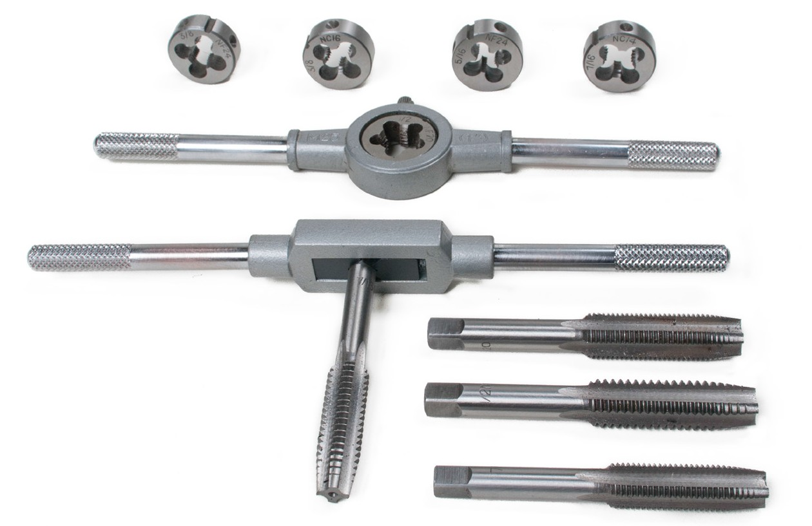
Figure 9 — Taps and dies

Die nuts, also known as “rethreading dies,” are made for cleaning up damaged threads
(Figure 10). They have no split for resizing and are made from a hexagonal bar so that a wrench or shifter spanner can be used to turn them. Die nuts cannot be used to cut new threads.

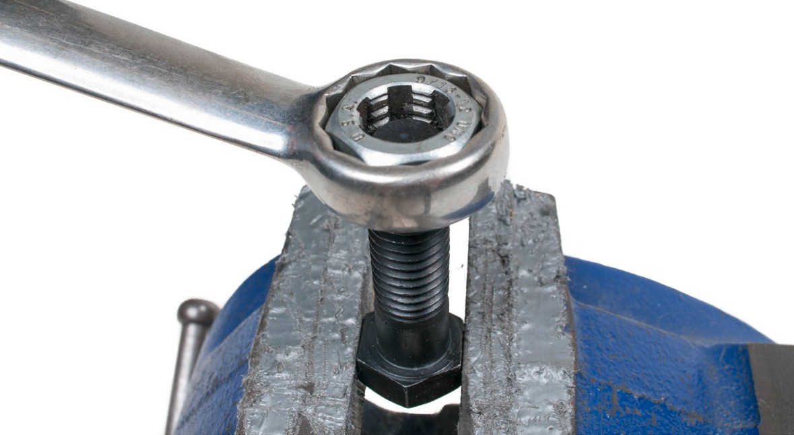
Figure 10 — Using a die nut

Specialty measuring devices
Many operations require specialized precision measuring instruments. For example, liquids and gases can have a wide range of working pressures that may need to be accurately monitored.

Pressure-measuring instruments
There are many different applications throughout the trades where gas or liquid pressure or vacuum need to be measured, recorded, and adjusted. Pressure gauges can be installed on special instruments or permanently installed on equipment being used. They come in different units of measure as well as ranges (Figure 11).

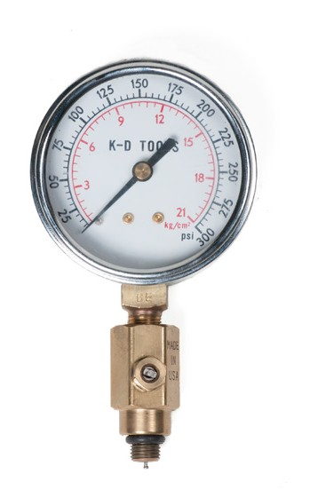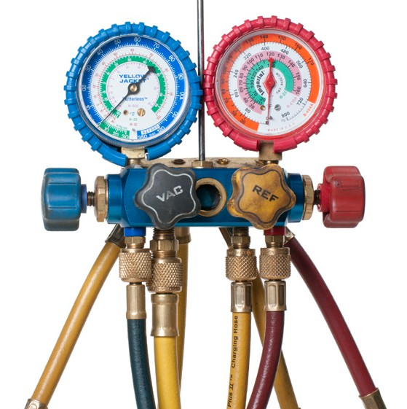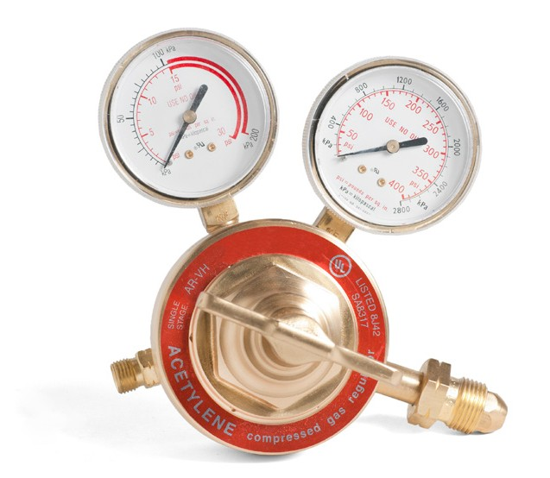

Pressure gauge Refrigeration gauge manifold
Compressed acetylene gauge

Figure 11 — Pressure Measuring instruments

Bourdon tube pressure gauges
Bourdon tube pressure gauges operate based on the principle that a flattened tube tends to change to a circular shape when pressurized internally. Although this change in cross-section may be hardly noticeable, the strain of the material of the tube is magnified by forming the tube into a C shape, so the entire tube tends to straighten out or uncoil as it is pressurized (Figure 12).

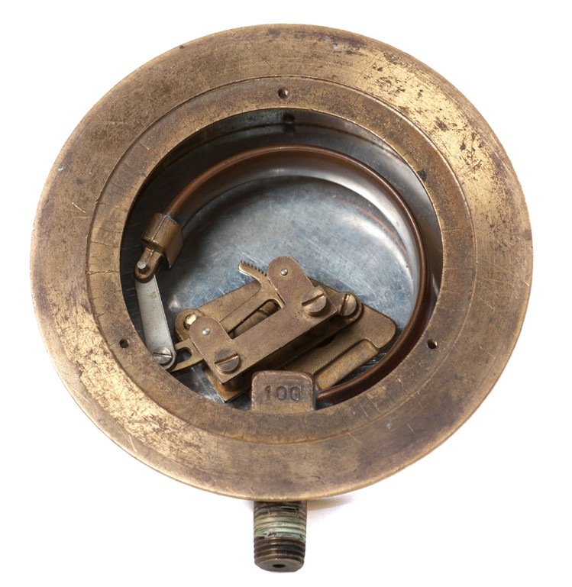
Figure 12 — Mechanical side of a pressure gauge showing the Bourdon tube

Bourdon tubes measure gauge pressure relative to ambient atmospheric pressure, as opposed to absolute pressure. When a vacuum is sensed, it is indicated with a reverse dial motion. In Figure 12, the transparent cover face of the gauge has been removed and the mechanism removed from the case.

A duplex pressure gauge is a combination vacuum and pressure gauge used for automotive diagnosis. The left side of the face, used for measuring manifold vacuum, is calibrated in kPa on its inner scale and inches of mercury on its outer scale. The right portion of the face is used to measure fuel pump pressure and is calibrated in kPa on its inner scale and pounds per square inch (psi) on its outer scale.

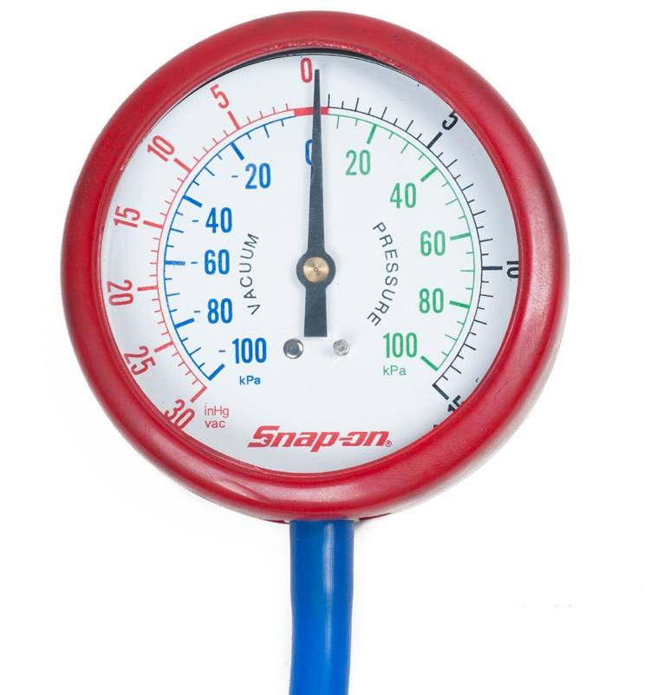
Figure 13 — Duplex pressure gauge

When the measured pressure is rapidly pulsing, such as when the gauge is near a reciprocating pump, an orifice restriction in the connecting pipe is frequently used to avoid unnecessary wear on the gears and provide an average reading. When the whole gauge is subject to mechanical vibration, the entire case including the pointer and indicator card can be filled with an oil or glycerin (Figure 14).

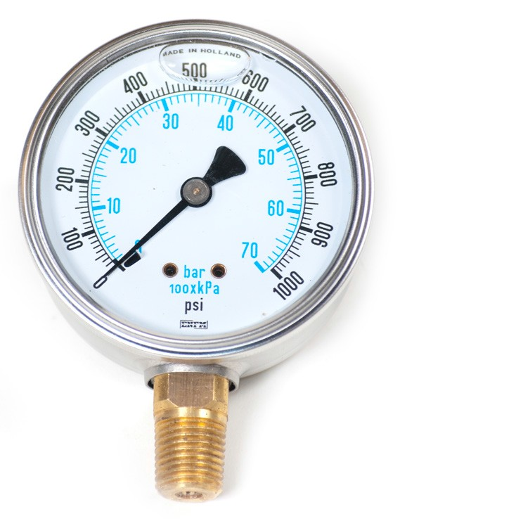
Figure 14 — Oil-filled gauge

Temperature-measuring instruments
There are many different applications throughout the trades where temperature will need to be measured, recorded, and adjusted. Temperature gauges can be installed on special instruments or permanently installed on equipment being used. They come in many types and sizes for various uses (Figure 15).

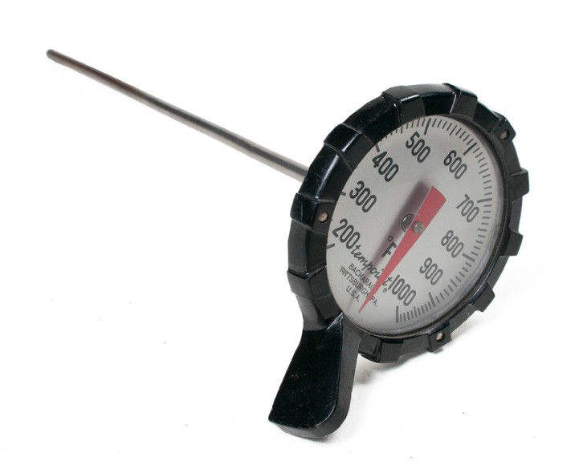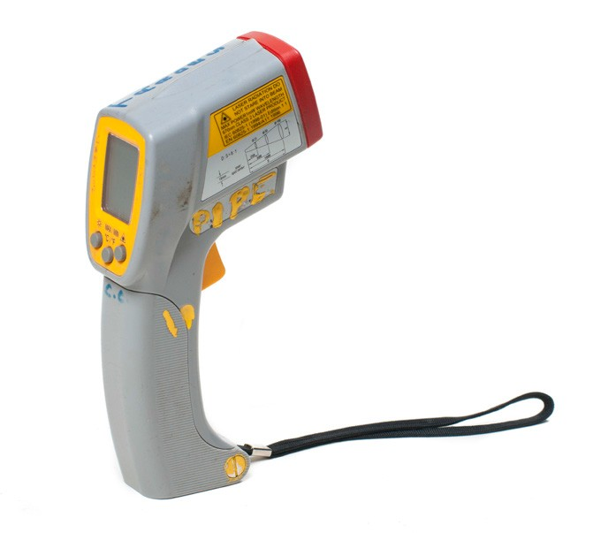

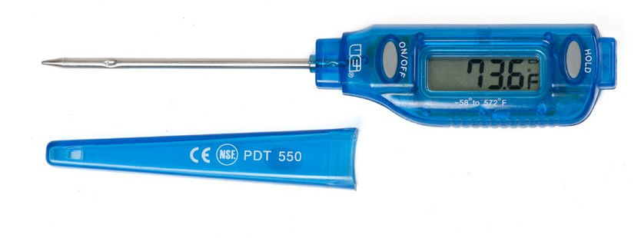Analog temperature probe

Pocket temperature probe
Infrared temperature indicator

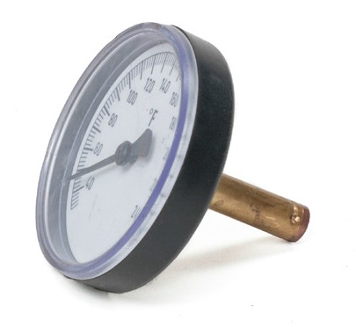
Fitting-mounted temperature gauge

Figure 15 — Temperature-measuring instruments

Electrical-measuring instruments
Whether you choose to work in an electrical trade, a mechanical trade, or one of the construction trades, you will probably use a variety of electrical-measuring instruments (Figure 16).

Later in the course you will study more thoroughly the types of meters for measuring voltage, current, and resistance and their proper use and maintenance. At this point we will just identify a few of the different meters and their applications.

Multimeter
A multimeter is a portable instrument that essentially combines the features of an ammeter, a voltmeter, and an ohmmeter within a single case. A multimeter has two main advantages: it is a single instrument so it is easier to carry than three separate instruments, and it is less expensive to buy than several separate instruments.

Multimeters are available as either analog or digital types. An analog multimeter is often referred to as a “VOM”—the abbreviation for “volt-ohm-milliammeter.” A digital multimeter is often called by its abbreviation—DMM.

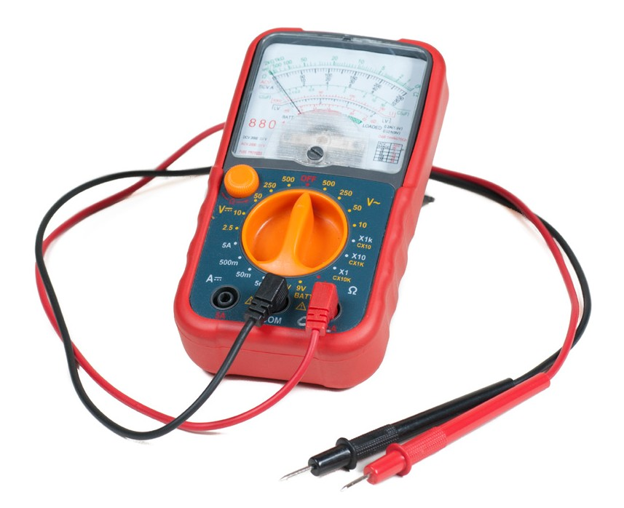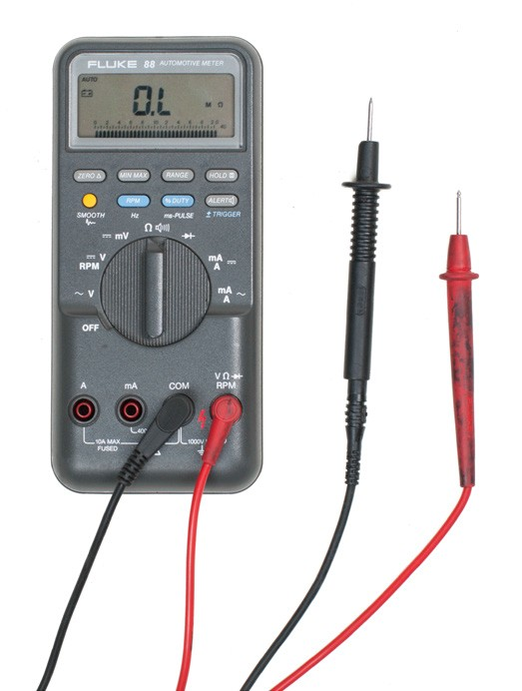
Analog volt-ohm-milliammeter (VOM) Digital multimeter (DMM)

Figure 16 — Multimeters

Current clamp (current probe)
A current clamp or current probe is an electrical device having two jaws that open to allow clamping around an electrical conductor. This allows properties of the electric current in the conductor to be measured without having to make physical contact with it or to disconnect it for insertion through the probe.

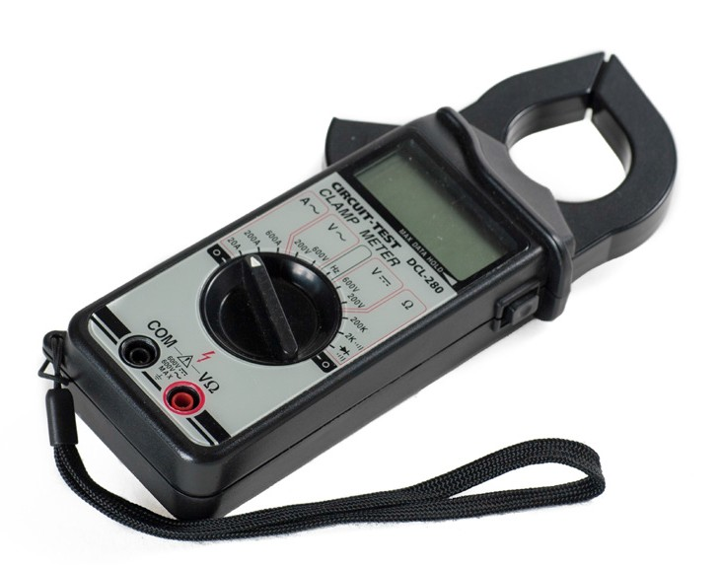
Figure 17 — Current clamp

AC voltage detector
An AC voltage detector is a device that uses electric fields to see if there is electric energy in a desired circuit or wiring system. This is a safe way to test for an energized circuit, as there is no requirement to go into the system and expose the wiring to check the system.

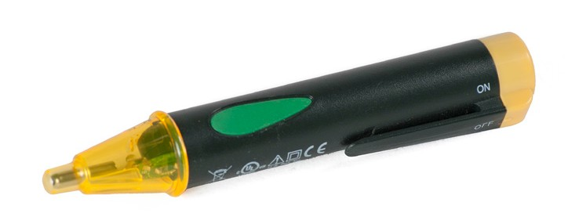
Figure 18 — AC voltage detector

The AC voltage detector can fit in your pocket, as it is small and compact, about the size of a bulky pen. Using an AC voltage detector is a clean and easy way to actually see if the circuit has electrical current.

Now complete the Learning Task Self-Test.

Self-Test 8
- Why is a torque wrench used?
  - To loosen stubborn fittings
  - To apply a specified twisting force
  - To prevent a bolt or cap screw from breaking
  - To get maximum torque on a bolt or cap screw

- What is equipped with most sets of tubing cutters?
  - Level
  - Scriber
  - Reamer
  - Spare wheel

- What is not a main part of a puller?
  - Jaws
  - Reamer
  - Cross arm
  - Centre-forcing screw

- Which is not a basic shape of shovel blade?
  - Spade
  - Round
  - Square
  - Diamond

- What pressure is a grease gun capable of achieving?
  - 500 psi
  - 1000 psi
  - 5000 psi
  - 10 000 psi

Answer Key

Self-Test 1
- a. Toe
- Skewback
- Blade
- Studs
- Handle
- Heel
- Number of points
- Length
- Teeth

- a. Set

- a. Kerf

- d. Too much pressure

- d. Tenon saw

- c. Metal reinforcing strip

- a. Compass saw

- Keyhole saw
- Hacksaw
- Pull saw

- c. Knives

- c. 12 in. long and 18 teeth per inch

- a. True

- d. Double-cut

- c. Point to heel

- c. Single-cut

- b. A file card

- c. Loss of temper

- a. Bevel edge

- Straight edge

- a. Paring 18. a. 60º–70º
- b. Grind the edge clean.

- c. It is tempered at the cutting end only.

Self-Test 2
1. c. Square head 2. b. 59º
- c. Millimetres

- b. Inside calipers

- d. Scratching lines on soft metals

- a. A

- a. A

- b. Compass

- d. Combination square 10. c. 0.02 mm

Self-Test 3
- b. They are useful for small tight areas.

- c. They can apply pressure using different angles.

- a. C-clamp
  - Hand-screw clamp
  - Spring clamp
  - Pipe-style clamp
- d. Spring clamp

- b. Band clamp

- c. Wood vise

- a. Use a set of soft jaw caps.

- a. The width of the vise jaws

- d. Toward the stationary jaw

- d. Bolted firmly to the drill press table

Self-Test 4
- c. Curved claw

- c. It should feel well balanced.

- a. Sledge

- b. Ball-peen

- d. Drop-forged alloy steel

- b. Weight of the head

- c. Soft-face hammer

- d. Replace it with a new handle.

- b. Nail claw

- d. Wrecking bar

- c. Wonder bar

- a. Crowbar

Self-Test 5
1. | a. | Hang it up.
2. | b. | Vertical lines
3. | c. | Looking directly at the laser
4. | b. | False
5. | b. | False
6. | b. | Tripod
7. | b. | 3
Self-Test 6
1. | a. | Hex wrench
2. | c. | Combination wrench
3. | c. | By its overall length
4. | b. | Wiped clean daily
5. | d. | Grind the worn end off slowly.
6. | a. | Box-end wrench

  - b. Slip-joint pliers

  - b. Side-cutting pliers

  - d. Interlocking slip-joint pliers

  - a. Locking pliers

Self-Test 7

1. | c. | Flat-blade screwdriver
2. | a. | 1, 2, 3, and 4
3. | b. | Torx head
4. | b. | Length of the blade
5. | a.  b.  c.  d.  e.  f. | Tip Shank Ferrule Handle Head  Length of screwdriver
6. Correct: c, d Incorrect: a, b, e

7. | a. | Offset screwdriver
8. | a. | Phillips
 | b. | Slot
 | c. | Robertson
 | d. | Torx
 | e. | Clutch drive
Self-Test 8
1. | b. | To apply a specified twisting force
2. | c. | Reamer
3. | b. | Reamer
4. | d. | Diamond
5. | d. | 10 000 psi

The British Columbia Open Textbook Project
The British Columbia Open Textbook Project is funded by the B.C. Ministry of Advanced Education, and managed by BCcampus, a publicly-funded organization that uses information technology to connect B.C. post-secondary institutions under a collaborative service delivery framework. The Open Textbook Project aims to make available
openly-licensed textbooks in the province’s high-impact subject areas. Visit open.bccampus.ca for more information.

7960003683

