Trades Access Common Core
Line B: Employability Skills
Competency B-1: Apply Study
and Learning Skills

Image to be placed here.

B.C. Open Textbook Project
OpenEd
open.bccampus.ca

Trades Access
COMMON CORE
Line B: Employability Skills
Competency B-1: Apply Study and Learning Skills

Acknowledgments and Copyright
To learn more about BCcampus Open Textbook project, visit http://open.bccampus.ca
© Camosun College. The Trades Access Common Core resources are licensed under the Creative Commons Attribution 4.0 Unported Licence ( http://creativecommons.org/licenses/by/4.0/ ), except where otherwise noted. Under this licence, any user of this textbook or the textbook contents herein must provide proper attribution as follows:
- If you redistribute this textbook in a digital format (including but not limited to EPUB, PDF, and HTML), then you must retain on every page the following attribution: Download for free at http://open.bccampus.ca/find-open-textbooks/.
- If you redistribute this textbook in a print format, then you must include on every physical page the following attribution: Download for free at http://open.bccampus.ca/find-open-textbooks/.
- If you redistribute part of this textbook, then you must retain in every digital format page view (including but not limited to EPUB, PDF, and HTML) and on every physical printed page the following attribution: Download for free at http://open.bccampus.ca/find-open-textbooks/.
- If you use this textbook as a bibliographic reference, then you should cite it as follows: BCcampus, Name of Textbook or OER. DATE. http://open.bccampus.ca/find-open-textbooks/.
For questions regarding this licensing, please contact opentext@bccampus.ca.
All images copyright BC Industry Training Authority are licensed under the Creative Commons Attribution-NonCommercial-ShareAlike 4.0 licence.
http://creativecommons.org/licenses/by-nc-sa/4.0/
The issuing/publishing body is Crown Publications, Queen’s Printer, Ministry of Technology, Innovation and Citizens’ Services.
BCcampus would like to acknowledge the following individuals and organizations for their contributions in producing the Trades Access Common Core Open Textbook resources.

BCcampus
Open Education Team Hilda Anggraeni, Graphics

Camosun College
Olaf Nielsen, Chair, Trades Development and Special Projects, School of Trades and Technology Nannette Plant, Manager, Enterprise Point Operations & Special Projects, Office of the VP Strategic Development
Rod Lidstone, Instructor, Plumbing and Pipe Trades, Lead Writer/Reviewer Brian Coey, Instructor, Sheet Metal and Metal Fabrication, Writer/Reviewer Zack (Richard) Zajchowski, Writer/Reviewer”
Matt Zeleny, Camosun Innovates, 3D imaging

Open School BC
Monique Brewer, Director
Adrian Hill, Instructional Designer
Dennis Evans, Image Coordinator, Photographer, Graphics, Production Technician (layout) Farrah Patterson, Production Technician

Industry Training Authority of BC
The ITA works with employers, employees, industry, labour, training providers, and government to issue credentials, manage apprenticeships, set program standards, and increase opportunities in approximately 100 BC trades. Among its many functions are oversight of the development of training resources that align with program standards, outlines, and learning objectives, and authorizing permission to utilize these resources (text and images).
Erin Johnston, Director of Training Delivery Cory Williams, Manager, Industry Relations

Publishing Services, Queen’s Printer
Spencer Tickner, Director of QP Publishing Services Dwayne Gordon, Manager, Electronic Publishing
October 2015, Version 1
To order print copies of any of the Trades Access Common Core resources, please contact us:
Crown Publications, Queen’s Printer PO Box 9452 Stn Prov Govt
563 Superior St, 3rd Floor Victoria, BC V8W 9V7 Phone: 250-387-6409
Toll Free: 1-800-663-6105
Fax: 250-387-1120
crownpub@gov.bc.ca www.crownpub.bc.ca

Intellectual Property Program
Ilona Ugro, Copyright Officer, Ministry of Technology, Innovation and Citizens’ Services, Province of British Columbia

Creative Commons Attributions
Portions of the material included in the Line B resources were originally published in Open School BC’s Communications 11 and Communications 12 courses, and is licensed under the Creative Commons
Attribution-NonCommercial ShareAlike 4.0 licence. http://creativecommons.org/licenses/by-nc-sa/4.0/
Cover photo: (https://commons.wikimedia.org/wiki/File:Experiential_Learning_facilities_at_les_Roches_Marbella.jpg) by CookiesBrownie under CC BY SA 3.0 (https://creativecommons.org/licenses/by-sa/3.0/deed.en)
Portions of the material included in the Line B resources were originally published in Open School BC’s Communications 11 and Communications 12 courses, and is licensed under the Creative Commons
Attribution-NonCommercial ShareAlike 4.0 licence. http://creativecommons.org/licenses/by-nc-sa/4.0/
Figure attributions for Competency B-1, Learning Task 1 include:
Figure 1 Developing effective study skills is beneficial to lifelong learning (https://flic.kr/p/73D8C6] by jimmiehomeschoolmom) (https://www.flickr.com/photos/jimmiehomeschoolmom/) under CC BY 2.0 (https://creativecommons.org/licenses/by/2.0/)
Figure 2 Poor study environments can increase distractions and lessen retention of information. (https://flic.kr/p/49Fy3M) by Ben Babcock (https://www.flickr.com/photos/tachyondecay/) under CC BY 2.0 [https://creativecommons.org/licenses/by/2.0/)
Figure 3 Good study environments can increase concentration and retention of information. (https://flic.kr/p/5sR4tX) by San Jose Library (https://www.flickr.com/photos/sanjoselibrary/) under CC BY 2.0 (https:// creativecommons.org/licenses/by/2.0/)

Figure 4 Group studying is beneficial and can improve communication skills. (https://flic.kr/p/ni3Aga) by www.audio-luci-store.it (https://www.flickr.com/photos/audiolucistore/) under CC BY 2.0 (https://creativecommons.org/licenses/by/2.0/)
Figure 5 Apprentice training (https://commons.wikimedia.org/wiki/File:Experiential_Learning_facilities_at_les_Roches_Marbella.jpg) by CookiesBrownie under CC BY SA 3.0 (https://creativecommons.org/licenses/by-sa/3.0/deed.en)
Figure attributions for Competency B-1, Learning Task 3 include:
Figure 1 Concept map (https://commons.wikimedia.org/wiki/File:Conceptmap.png) by Vicwood 40 under CC BY SA 3.0 (https://creativecommons.org/licenses/by-sa/3.0/deed.en)
Figure 2 Quick sketch (https://commons.wikimedia.org/wiki/File:Slider_Track_Design_Sketch.jpg) by Chong Tiam Lin under CC BY SA 4.0 (https://creativecommons.org/licenses/by-sa/4.0/)
Figure 4 Concept combination table (https://commons.wikimedia.org/wiki/File:High_School_ Engineering_Figure_4.8.png) by CK-12 Foundation (http://www.ck12.org/) under CC BY SA 3.0 (https://creativecommons.org/licenses/by-sa/3.0/us/)
Figure attributions for Competency B-1, Learning Task 4 include:
Figure 1 How the Eagle Landed — the Grumman Construction Log:
(https://flic.kr/p/cAtxiU) by Steve Jurveston (https://www.flickr.com/photos/jurvetson/) under CC BY 2.0 (https://creativecommons.org/licenses/by/2.0/)
Figure attributions for Competency B-1, Learning Task 5 include:
Figure 1 The World Wide Web has revolutionized the ways in which people research information. (https://pixabay.com/p-24984/?no_redirect) by Pixabay (http://www.pixabay.com) under CC0 (https://creativecommons.org/publicdomain/zero/1.0/deed.en)
Figure attributions for Competency B-1, Learning Task 6 include:
Figure 1 Students writing exam (https://commons.wikimedia.org/wiki/File:Test_(student_assessment).jpeg) by KF under Public Domain.
Figure 2 Sailors take their advancement exams
(https://commons.wikimedia.org/wiki/File:Flickr_-_Official_U.S._Navy_Imagery_-_Sailors_take_their_ advancement_exams..jpg) By US Navy (https://www.flickr.com/people/56594044@N06) under Public Domain.

Foreword
The BC Open Textbook Project began in 2012 with the goal of making post-secondary education in British Columbia more accessible by reducing student cost through the use of openly licensed textbooks. The BC Open Textbook Project is administered by BCcampus and is funded by the British Columbia Ministry of Advanced Education.
Open textbooks are open educational resources (OER); they are instructional resources created and shared in ways so that more people have access to them. This is a different model than traditionally copyrighted materials. OER are definedas teaching, learning, and research resources that reside in the public domain or have been released under an intellectual property licence that permits their free use and repurposing by others (Hewlett Foundation). Our open textbooks are openly licensed using a Creative Commons licence, and are offered in various e-book formats free of charge, or as printed books that are available at cost. For more information about this project, please contact opentext@bccampus.ca. If you are an instructor who is using this book for a course, please let us know.

Preface
The concept of identifying and creating resources for skills that are common to many trades has a long history in the Province of British Columbia. This collection of Trades Access Common Core (TACC) resources was adapted from the 15 Trades Common Core line modules co-published by the Industry Training and Apprenticeship Commission (ITAC) and the Centre for Curriculum Transfer and Technology (C2T2) in 2000-2002. Those modules were revisions of the original Common Core portion of the TRAC modules prepared by the Province of British Columbia Ministry of Post-Secondary Education in 1986. The TACC resources are still in use by a number of trades programs today and, with the permission from the Industry Training Authority (ITA), have been utilized in this project.
These open resources have been updated and realigned to match many of the line and competency titles found in the Province of BC’s trades apprenticeship program outlines. A review was carried out to analyze the provincial program outlines of a number of trades, with the intent of finding common entry-level learning tasks that could be assembled into this package. This analysis provided the template for the outline used to update the existing modules. Many images found in ITA apprentice training modules were also incorporated into these resources to create books that are similar to what students will see when they continue their chosen trades training. The project team has also taken many new photographs for this project, which are available for use in other trades training resources.
The following list of lines and competencies was generated with the goal of creating an entry-level trades training resource, while still offering the flexibility for lines to be used as stand-alone books. This flexibility—in addition to the textbook content being openly licensed—allows these resources to be used within other contexts as well. For example, instructors or institutions may incorporate these resources into foundation-level trades training programming or within an online learning management system (LMS).
Line A – Safe Work Practices
- A-1 Control Workplace Hazards
- A-2 Describe WorkSafeBC Regulations
- A-3 Handle Hazardous Materials Safely
- A-4 Describe Personal Safety Practices
- A-5 Describe Fire Safety
Line B – Employability Skills
- B-1 Apply Study and Learning Skills
- B-2 Describe Expectations and Responsibilities of Employers and Employees
- B-3 Use Interpersonal Communication Skills
- B-4 Describe the Apprenticeship System

Line C –Tools and Equipment
  - C-1 Describe Common Hand Tools and Their Uses
  - C-2 Describe Common Power Tools and Their Uses
  - C-3 Describe Rigging and Hoisting Equipment
  - C-4 Describe Ladders and Platforms
Line D – Organizational Skills
  - D-1 Solve Trades Mathematical Problems
  - D-2 Apply Science Concepts to Trades Applications
  - D-3 Read Drawings and Specifications
  - D-4 Use Codes, Regulations, and Standards
  - D-5 Use Manufacturer and Supplier Documentation
  - D-6 Plan Projects
Line E – Electrical Fundamentals
  - E-1 Describe the Basic Principles of Electricity
  - E-2 Identify Common Circuit Components and Their Symbols
  - E-3 Explain Wiring Connections
  - E-4 Use Multimeters
All of these textbooks are available in a variety of formats in addition to print:
  - PDF—printable document with TOC and hyperlinks intact
  - HTML—basic export of an HTML file and its assets, suitable for use in learning management systems
  - Reflowable EPUB—format that is suitable for all screen sizes including phones
All of the self-test questions are also available from BCcampus as separate data, if instructors would like to use the questions for online quizzes or competency testing.

About This Book
In an effort to make this book a flexible resource for trainers and learners, the following features are included:
  - An introduction outlining the high-level goal of the Competency, and a list of objectives reflecting the skills and knowledge a person would need to achieve to fulfill this goal.
  - Discrete Learning Tasks designed to help a person achieve these objectives
  - Self-tests at the end of each Learning Task, designed to informally test for understanding.
  - A reminder at the end of each Competency to complete a Competency test. Individual trainers are expected to determine the requirements for this test, as required.
  - Throughout the textbook, there may also be links and/or references to other resources that learners will need to access, some of which are only available online.
  - Notes, cautions, and warnings are identified by special symbols. A list of those symbols is provided below.

Symbols Legend

Important: This icon highlights important information.

Poisonous: This icon is a reminder for a potentially toxic/poisonous situation.

Resources: The resource icon highlights any required or optional resources.

Flammable: This icon is a reminder for a potentially flammable situation.

Self-test: This icon reminds you to complete a self-test.

Explosive: This icon is a reminder for a possibly explosive situation.

Safety gear: The safety gear icon is an important reminder to use protective equipment.

Electric shock: This icon is a reminder for potential electric shock.

Safety Advisory
Be advised that references to the Workers’ Compensation Board of British Columbia safety regulations contained within these materials do not/may not reflect the most recent Occupational Health and Safety Regulation. The current Standards and Regulation in BC can be obtained at the following website: http://www.worksafebc.com.
Please note that it is always the responsibility of any person using these materials to inform him/herself about the Occupational Health and Safety Regulation pertaining to his/her area of work.
BCcampus January 2015

Disclaimer
The materials in the Trades Access Common Core Open Textbook project are for use by students and instructional staff and have been compiled from sources believed to be reliable and to represent best current opinions on these subjects. These manuals are intended to serve as a starting point for good practices and may not specify all minimum legal standards. No warranty, guarantee or representation is made by BCcampus as to the accuracy or sufficiency of the information contained in these publications. These manuals are intended to provide basic guidelines for trade practices. Do not assume, therefore, that all necessary warnings and safety precautionary measures are contained in this module and that other or additional measures may not be required.

Contents
Introduction 9
Objectives 9
Resources 9
Learning Task 1: Use effective study habits 11
Preparing to become an effective learner 11
Studying environment 13
Effective time management 14
Studying with others 16
Problem solving 17
Study skills and lifelong learning 22
Learning Task 2: Describe effective listening techniques 27
Active listening 27
Self-Test 2 29
Learning Task 3: Describe techniques for effective reading 31
Self-Test 3 36
Learning Task 4: Describe effective note-taking techniques 37
Before the lesson 37
During the lesson 38
After the lesson 38
Self-Test 4 40
Learning Task 5: Describe ways to research information 41
Self-Test 5 44
Learning Task 6: Describe effective techniques for taking and preparing for tests 45
Self-Test 6 49
Summary 50
References 50
Appendix 50
Answer Key 51

Introduction
Every learner has different abilities, backgrounds, and life experiences. Some individuals will be entering a trades program directly from high school as part of a dual-credit program or youth initiative and have limited experience outside of the classroom. Others may have been out of the formal education system for a number of years, but bring valuable years of work experience into the classroom. Regardless of where you are starting from, integral to your success in post- secondary education is developing effective study and learning skills.

For some of you, learning about study skills may be new. You may have never acquired the skills needed to be an effective learner, or you may have forgotten them after many years out of the formal education system. For others, this may be a review and it may provide you with an opportunity to reflect on your current study practices to determine if there is room to improve or adopt new study strategies.

Time spent on these Learning Tasks will increase the effectiveness of time spent on all other Learning Tasks in your training program. In addition, the techniques that you choose to adopt and the effective study routine that you develop will benefit you in lifelong learning, be it formal or informal, at school, on the job, or for your own personal interest.

Objectives
When you have completed the Learning Tasks in this Competency, you should be able to:
- use effective study habits

- use effective listening techniques

- use effective note-taking techniques

- use techniques for reading textbooks effectively

- use ways to research material

- use effective techniques for preparing for and taking notes

Resources
You will be required to reference publications and videos available online.

LEARNING TASK 1

Use effective study habits
Understanding how you learn is important for developing effective study skills. Your past learning experiences and study habits are the starting point for your new learning experience. Effective study habits can be learned, and through repetition they will become part of your daily routine, both in your current studies and for lifelong learning.

Figure 1 — Developing effective study skills is beneficial to lifelong learning.

A typical apprenticeship program will consist of approximately 30 hours of class time each week for a period of six to eight consecutive weeks. Foundation or entry-level pre-apprenticeship programs, in which the training provider provides practical shop-based training as well as theory, can be up to several months in length, split between the classroom learning theory and hands-on experience in the shop. For individuals who have been employed full time in the workforce, this schedule may appear to leave a lot of free time. However, for each hour of class time, you will be expected to spend at least an additional hour reading, completing assignments and projects, studying for tests, and preparing for the next day’s class. If you have not developed effective study habits, you may need to dedicate even more time to these activities.

Your program of study can also be taught or delivered in a variety of modes, from cohort-based, in which everyone in the class moves in lockstep from one topic to the next, to self-directed, where everyone is working on their own. A number of trades programs also offer some form of online or computer-based learning component. Understanding how your program will be delivered will play a role in determining the most effective ways in which you will study.

Preparing to become an effective learner
A learner is an individual who acquires knowledge or skills through experience or study, or by being taught. The following are some of the steps that you can take to prepare yourself to become an effective learner.

- Make learning your first priority. This requires a conscious effort on your part to look at all of the activities that you are engaged in and assess whether you can continue to participate in all of them and attend school full time for the duration of your program. Attendance is mandatory in trades programs. You may need to decide whether you need to cut back on other commitments outside your program of study or try and schedule these activities prior to starting your program or upon completion.
- Develop and maintain a strong support network. Your decision to study can have a significant effect on relationships with your family and friends. Their support and understanding of your studies and the commitments you will need to make will play a role in your success. Discuss your program of study and schedule with your family and friends so that you can maintain a supportive environment. Reduced work during your studies can also have financial implications for you and your family, and planning ahead and discussing potential consequences can reduce stress and conflict. You may also be required to move to another city to complete your studies, which can present a host of challenges for you and your relationships if you don’t discuss the situation ahead of time.
The individuals you will meet in your studies can also be an important source of support, as you will be sharing the same learning experience and they will understand your workload and the associated pressures. The relationships you form during your studies can greatly enhance your learning and may lead to long-lasting friendships. As fellow students you may share information about classes, assignments, and problems. You may form study groups in order to stay motivated and on top of your workload. You may also be able to share strengths with one another and exchange informal tutoring in areas where you need additional assistance.

If you have a documented disability and are eligible for services and educational accommodations, you will need to be proactive. Establishing the support services you will need at the training institution should be a high priority. It is very important to get in touch with the unit responsible for assisting you as soon as possible. You may have paperwork to complete and, depending on the type of disability, it can take a few weeks up to several months to make sure all of the services and supports required are available. Once your file is opened, the support person or team of people assigned to your file will work with you and your instructors to make sure the necessary accommodations are put in place.

- Organize your time and prioritize your activities. While life still continues on during your studies, your ability to effectively organize the time you have will play a role in your success. Family responsibilities or part-time work may still need to be built into your schedule and other activities prioritized throughout your studies.
- Set realistic goals and celebrate your accomplishments. Daily readings and assignments can quickly pile up. Make sure you develop a realistic study plan and maintain it. Once you’ve met a goal, celebrate (within reason) and then move on to the next milestone. A celebration may be as simple as going for a run after you’ve completed your planned study session or going out with family or classmates after successively completing an exam.

- Be an active learner by engaging in activities such as reading, writing, discussion, and problem solving. These activities promote the analysis, synthesis, and evaluation of the content. Use the opportunities provided by your instructor in the classroom and in the shop to work independently or in groups to resolve problems and apply your readings to real-life situations.
- Develop an awareness of how you learn best. The prevailing theory of how we learn is through metacognition, which is the understanding and awareness of our own mental, or cognitive, processes. In general, individuals will use the strategies that have been successful for them in the past to remember information, develop their opinions, and solve problems. Past learning experiences can help to shape the way that you will take on this new learning experience. Positive experiences and good study habits can motivate a student to be more successful. Likewise, negative educational experiences and a lack of study skills in the past can create additional hurdles for a learner that must be worked through in order to meet their learning objectives. Your ability to recognize the strategies that work best for you, as well as being able to adopt and/or adapt strategies as required, will help you to be a more effective learner.

Watch the video Metacognition: Learning about Learning.
https://youtu.be/E8klKdhNop8
Developing a plan of action for both your study skills and time management prior to commencing your program can go a long way toward reducing stress. There are many different resources available to you to help you improve your study skills. These range from in-person or online classes to books to informational videos available on the Internet. Once you start your program, be sure to find out the additional resources available through your school to help you, such as study skill sessions or tutorials.

Studying environment
A proper studying environment plays a critical role in the effectiveness of your studying. This involves a space where you can block out distractions and concentrate on your reading and homework. From past learning experiences you may already know what environment works for you: perhaps an empty classroom after hours, the library, or your kitchen table at home. If your study environment is at home, it is important to choose a place and time where you are not fighting off frequent interruptions.

Ergonomics are also important. Make sure that the desk or table you use is at a comfortable height and large enough to accommodate your study materials. The chair you use should support your whole body, especially your lower back. Your feet should be able to rest flat on the floor and your arms should be in a comfortable position. If your studying environment is uncomfortable, you will be distracted.

Lighting in your studying environment is key. Make sure that the space in which you study is bright enough and without direct or reflected glare. In a space where lighting is too bright or too dim you will tire quickly. Also make sure that your studying space is adequately heated. A space that is too cold or too hot can lead to distraction or fatigue.

Prior to starting to study, make sure that you have all the materials you require in your study environment. Time spent looking for books, binders, or writing instruments later on can break your concentration and affect your comprehension. Likewise, remove any items from your studying space that may distract you, such as your cell phone.

Dedicate a set time period to study in this space each day when you are most alert. Let others know that you will be unavailable during this period, and don’t forget to take periodic breaks.

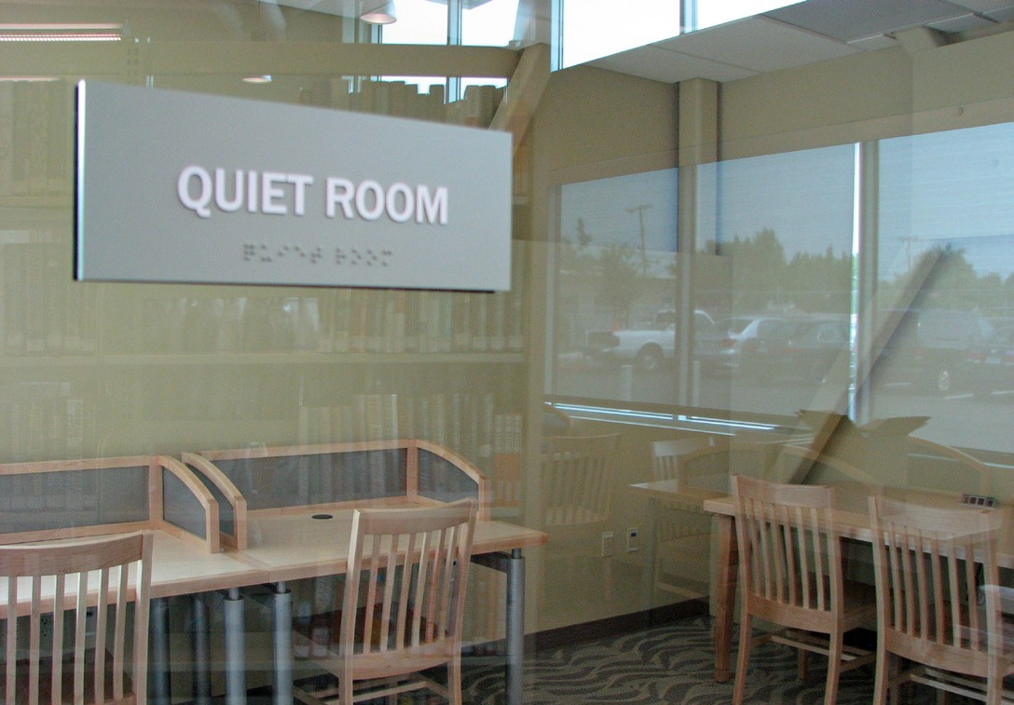
Figure 2 — Good study environments can increase concentration and retention of information.

Make sure that you have planned out the objective of your study session prior to sitting down in your study space so that you will stay on course and accomplish what you have set out to do.

Effective time management
Your ability to manage time efficiently is integral to your success. Individuals who have trouble managing their time usually find that it takes much longer to do things than they expect and are often late because of this. The first step to effective time management is to look at how you make use of your time. Do you currently make use of a calendar, schedule, or smart phone application to keep track of your time and commitments? If not, you may want to keep track of your schedule for a few weeks before you begin your studies. This will provide you with a good example of how you use your time.

Once you’ve done so, look at the schedule you created and reflect on how you’ve spent your time. Are there any noticeable patterns, for example the time you wake up or the time you set aside to read or do a specific activity? Are there periods of time that you can identify when you’ve wasted or lost track of how it was used? Could you have made better use of that time?

Prior to starting your studies, create a new schedule and identify key activities and the required time commitments. Key items in any schedule include:
- Sleep. Most individuals require at least eight hours of sleep per night to allow their brain to function normally and their memory to retain information effectively.
- Meals. Ensure that you build in time to sit down for three meals a day. Eating on the run should be an exception, not the norm.

Time at school.

- Travel time. Ensure you build in sufficient time to get to and from school without undue stress. If you are travelling using public transportation, you may be able to use this additional time to read or look at notes. However, this should not be your principal study period, as there are too many distractions.
- Study periods. Study periods should also include breaks or down time that does not include stimulating activities such as video games or television. Instead, participate in activities that will help you concentrate when you get back to studying, such as exercise. Also, remember to rehydrate with water.
- Exercise. This contributes to a decrease in physical stress and an increase in your ability to sit still, focus, and absorb and retain information. Exercise also contributes to sleeping more deeply.
- Other commitments. Make distinctions between activities that are mandatory and those that are optional. Doing so will help you to set priorities and ensure that you do not overextend yourself.
Once you have received your class schedule, make sure to build the dates of quizzes, exams, study reviews, and assignments into your calendar of activities as soon as they are received, and plan the additional study sessions you may need to prepare for these activities. You may wish to add these important dates to the calendar in your smart phone as well as put up a visual reminder in your study space using a calendar or list and posting it on your wall/bulletin board or in a common area of your home where you and your family can see it.

Remember that your schedule is not carved in stone. Make sure to review and revise it frequently to add additional commitments and make adjustments as required.

If you do decide to keep multiple schedules, for example a phone app and a paper schedule in your study space, make sure you regularly update them (this may include syncing devices) so there is no confusion about upcoming commitments and so any potential conflicts can be discussed with family members and/or friends and resolved ahead of time.

Watch the video My 3-Tier Planning System for Getting Stuff Done - College Info Geek. https://youtu.be/8nkCt3OF6-8

Benefits of planned studying
Similar to muscle memory, the repetition of regularly scheduled study sessions builds habits and prepares you for the challenges that you will encounter in your studies. A student who is organized and prepared experiences less anxiety and stress related to examinations and tests and can perform better. The time you save by being prepared can be used to relax or take part in activities with friends and family.

A student who does not hold regularly scheduled study sessions often operates in a crisis-mode, cramming from one assignment or exam to the next. Studying for a long period of time at the last minute reduces efficiency and a student’s ability to understand and retain information. Cramming leads to increased stress and anxiety for most students. It can also have adverse effects on your relationships with other students if you are working on team assignments or in study groups.

Watch the video Study Skills for People Who Hate to Study.
https://youtu.be/ZLVtIUj2_VE

Studying with others
Studying with others is an example of active learning. Working together, you can share what you have all learned, which enhances and reinforces each other’s knowledge. Group studying can also help to build camaraderie, confidence, and a positive attitude, and it can enhance your communication skills. Students tend to talk freely with their peers and may be less inhibited in asking for help than in a classroom setting with an instructor.

Figure 3 — Group studying is beneficial and can improve communication skills.

In choosing your study partners, make sure that the common focus is learning and not socializing. Mixing studying with social activities doesn’t benefit anyone and often puts you further behind than if you had used that time to study alone. Learn to draw boundaries between activities you do as friends and those you do as study partners.

Remember that studying with others does not replace your individual study time. Your ability to solve problems with a study partner does not guarantee that you will have the same ability to do so on your own in the exam. Group studying can never replace the individual studying you must do in order to confidently complete work on your own.

Problem solving
Problem solving is central to trades training, whether it be solving a math problem or finding a solution to a problem on the shop floor or job site. The problems you will solve on a daily basis test how well you can apply the concepts of the trade you are studying and also help to prepare you for tests and exams.

Every trade requires some numerical problem solving, and so it is important that you have the basic math skills needed for your particular trade. If your basic math skills are a bit weak or “rusty,” then start identifying now those resources that can help you. Here are a few very useful resources:
- Math help centres. Most trades training institutions have a math learning centre that can help you when you are stuck on a problem. Get to know where it is and when it is open.
- Fellow students. Some students in your class will have strong math skills and are often willing to help you with a problem or two. If you need more help than that, you might consider paying that student or a qualified tutor.
- Online resources. A number of online math help resources are available on the Internet.

Probably the best-known site for learning math concepts is the Khan Academy.
https://www.khanacademy.org/math
Check out this and other sites so that you have them ready when you need them.

Successful problem solving in the trades involves more than just good basic math skills. You need to understand and be able to apply the problem-solving concepts being taught. Many students find this quite challenging. Listed below are some of the common behaviours that get students into difficulty with problem-solving concepts. As you read through this list, ask yourself if you have experienced any of these behaviours:
  - not really understanding a problem presented in class and then not doing anything to get help
  - memorizing formulas or solved examples without understanding

  - leaving problem-solving studying to the last minute

  - assuming you can do the problems on a test just because the solved examples shown in the class or text “make sense”

Successful problem solvers use more effective study strategies to handle the challenges of problem-solving content. The four subsections below discuss study strategies that will help you become—or continue to be—a successful problem solver.

Make your problem study time effective
Follow these steps for effective problem solving:
    - Develop a few useful help sources (instructor, fellow students, online sites, etc.).

    - If you don’t understand something, get help quickly! Ask in class or get help soon after.

    - Start working on your problems early, and if you are stuck, get help.

    - Make sure you have solved enough test-like problems on your own rather than memorizing someone else’s solutions.
    - Don’t spend more than 15 minutes really stuck on a problem. After 15 minutes, get help or change topics (this is easy to do only if you don’t leave studying to the last minute).

Find and learn the key conceptual information first
Problem-solving concepts are actually fairly simple. They have a very small amount of carefully organized chunks of crucial information, and to be successful you need to know these chunks of information very well. That is why the formula-memorizing method of studying does not work well. Formula memorizers do not really know and understand this crucial conceptual information; instead they just try to memorize a long list of formulas and solutions. So instead of formula memorizing, your first task when you study a new concept is to find and organize these chunks of crucial information in a concept summary. The chunks of crucial information typically follow this pattern:
- the name or title of the specific concept

- the key formula for that concept (the variations of this key formula can be derived and thus do not need to be learned – see below)
- definitions and units of each new term in that concept

- additional important information like special values, when the concept does NOT work, sign conventions (whether a number is positive or negative), etc.
- a simple example or explanation of what the concept does (in your own words if possible)

- the signposts (words, units, diagrams, etc.) that you would look for in a particular problem that applies this concept
This pattern of chunks can be written down in a very brief summary for each new concept you encounter. The first four chunks of conceptual information are those you really must learn— and probably should write down—for each new concept. Without that knowledge you will not be able to successfully solve problems involving the concepts you have been taught. The last

two chunks may not need to be written down, but make sure you can answer them easily for each new concept. Being able to come up with your own simple example or explanation and identifying the signposts of a concept is a good test of your understanding of a new concept.

Try to write each concept summary fairly quickly. You can always come back and revise if needed. There are two main advantages to using concept summaries: they give you identifiable chunks of conceptual information to look for as you study, and they provide very efficient review tools for preparing for a test or a final exam.

Here is an example of a brief concept summary for density:

Title of concept | Density
Key allowable formula(s): | D = M/V (see how to derive variations on this key formula below*)
Definition of each new symbol and its units: | D is density of an object measured in grams/millilitre or grams/cubic centimetre  M is mass in grams, or g  V is volume in cubic centimetres, or cc
Additional important info: | - D of water is 1.0 g/cc  - Other units can be used, e.g., D of water is 1000 kg/m3
Simple examples or explanations: | Density is how heavy something is for one unit of its volume. A jerry can of gasoline is noticeably lighter than a jerry can of water because the D of gasoline is only 0.77 g/cc compared to 1.0 g/cc for water
Signposts: | Think about using the density formula when a problem mentions: density, or mass and volume

*How to derive variations of the key formula:
The other variations of the key density formula are: M = D × V and V = M/D
These variations do not need to be memorized because they can be quite easily derived by using one of these two methods:

Algebraic method:
  - Set up the key equation as two fractions: D/1 = M/V
  - Cross multiply to get M = D × V

Triangle method*:
    - Draw a pyramid-like triangle with these lines.

M
D
V
    - Enter the variables D, M, and V so that the triangle resembles the shape of the equation as shown.
    - You can now derive each of the variations of the key density formula visually:
▸ You can see that V = M/D on the triangle because M is “over” D.
▸ You can see that D = M/V on the triangle because M is “over” V.
▸ And M = D × V because the top of the triangle is equal to the multiplication of D and V.

*Note that the triangle method can only be used on key equations that involve multiplication or division and only three variables.

Solve problems by following steps
Consider this problem:
A specialized gold-coloured casting has a mass of 425 grams. By using Archimedes’ water displacement method, the volume of the casting was found to be 48.0 cm3. Given the following densities, identify the metal.

Gold: 19.3 g/mL
Copper: 8.86 g/mL
Bronze: 9.87 g/mL

Here are a few important steps you can use to better solve problems like this one:
- Read the problem carefully twice. One common reason students get answers wrong in tests is because they fail to read the question correctly.
- Identify the concepts needed. As you read through the problem there may appear to be a lot of confusing information. Do not get overwhelmed. Instead, try to notice the signposts that will help you identify which new concept is involved. For instance, the problem above mentions mass, volume, and density, so it must involve the density concept.

Organize the knowns and unknown information.
  - Once you have identified the relevant concept, use the key formula as a way to organize the given known and unknown information. Sometimes a diagram can help you see the information in the problem more clearly. In the example above you would use the symbols from the key density formula to organize the relevant given information:
M = 425 g
V = 48.0 cm3
D = ? (Notice that you need to find the density here, so the given densities are simply a guide to your answer. Those densities are not relevant information until you find the actual density.)

  - Make sure the units are consistent with the key formula. In this example, cm3 is the same as mL.
- Apply the variation of the key formula needed. For this problem that would be the key density equation itself:
D = M/V

so in this case:
D = 425 g/48.0 cm3

and thus:
D = 8.85 g/cm3 (note that cm3 are the same as mL)

By comparison with the given densities, the casting must be made of bronze!

- Check your answer. Does it seem reasonable? Did you check your calculations? Also check that the units of the answer are correct for that variable.
- Split harder problems into parts. Occasionally in harder problems there may be two different concepts involved or the same concept may be used twice. In such cases, split the problem into two smaller problems that apply one concept at a time.

Prepare for tests by doing a variety of problems
On a test you will face problems from each of the concepts you have learned. You may then find it quite challenging to decide which specific concept applies to which specific problem. This “sorting of problems” is a very common difficult faced by many students writing problem-solving tests. Here are some study strategies you can use to prepare effectively for problem-solving tests:
  - List all the headings or classes of problems that will likely be on the exam/test.

  - Solve a few typical exam-like problems from each concept. If you find yourself forgetting how to do a particular kind of problem, go back to its concept summary and make sure

you know the information well. Also go step by step through the problem.

    - Solve some different typical exam questions in mixed-up order (e.g., practice questions from different topics chosen randomly).

Study skills and lifelong learning
In a recent study of employers in the Province of British Columbia, “Nearly 70 per cent of surveyed employers said that skills requirements in their workplaces had increased over the past decade, and the same proportion said that they expect further increases in the next five to ten years” (Stuckey & Munro, 11).

Lifelong learning or continuous study is one of the nine essential skills recognized by the Government of Canada for success in the workplace. It is the process of continuing to learn throughout your career and lifespan. Employers value employees who are capable, self-directed learners, and rapid advances in digital technology and its use in the workplace mean that jobs are continually evolving. Your ability to learn new information on your own and acquire new skills is integral to staying current in your profession and meeting employer expectations.

Figure 4 — Apprentice training

As an apprentice, you will be required to return to a training institution for a number of years to complete all levels of your program. As an employee, you may also be required to take on additional certifications and acquire new information and skills sets in order to work on a job site. The study skills you have developed and continue to enhance throughout your life will greatly assist you with your lifelong learning objectives.

Watch the video Lifelong Learning. https://youtu.be/kDsWJaFg1HY

Now complete the Learning Task Self-Test.

Self-Test 1

- Every person learns in the same way.
  - True
  - False

- Your abilities, background, and life experiences play a role in how you learn.
  - True
  - False

- Effective study skills are not essential to success in postsecondary education and lifelong learning.
  - True
  - False

- Effective study habits are learned, and through repetition they can become part of your daily routine.
  - True
  - False

- For each hour of time spent in class, how many minutes is it suggested that you spend studying?

a. | 30
b. | 45
c. | 60
d. | 90

- Why is it important to understand how your program will be delivered?
  - It’s not important.
  - It determines how your assignments will be submitted.
  - It determines how much time you will need to spend on campus.
  - It helps you to determine the most effective ways in which to study.

- Once you decide to enter a trades program, why is it important to make learning a priority?
  - It proves a commitment to your future career goals.
  - It ensures that you are committed to being successful in your program.
  - It prompts you to reprioritize your activities while in school to ensure that you dedicate enough time to studying.
  - All of the above

- Who is responsible for making accommodations for a learner with a documented disability?
  - It is everyone’s responsibility to look after all accommodations.
  - It is the school’s responsibility to look after all accommodations.
  - It is the instructor’s responsibility to look after all accommodations.
  - It is the learner’s responsibility to be proactive and get touch with the unit responsible for student support services and ensure that necessary documentation is completed to start the process.

- What is metacognition?
  - A study skill
  - A learning strategy
  - A way of knowing how and what we do best
  - The understanding and awareness of your own cognitive (mental) processes and how you learn

- Why is it important to develop a plan for study skills and time management prior to commencing your studies?
  - To reduces stress
  - To provide you with a course of action to follow that saves time
  - To ensure you build in enough time to go out with friends on weekends
  - All of the above

- Which of the following best describes a good studying environment?
  - Good lighting and ventilation
  - A proper desk or table and chair
  - Sufficient space for you to spread out all of your study materials
  - Blocking out distractions, allowing you to concentrate on reading and homework
  - All of the above

- Good lighting and adequate heating/ventilation will improve your studying.
  - True
  - False

- What is the best way to keep track of assignments and tests?
  - Ask friends to remind you.
  - Put up a list on your locker door.
  - Highlight the dates in your notebook.
  - Use a smart phone application, calendar, agenda, or schedule.

- What do individuals who have trouble managing their time require so that they are most likely to succeed?
  - More assistance from other people
  - Less time to complete their studying
  - More time to complete their studying
  - The same amount of time to complete their studying

- Students with poor study skills often work in “crisis mode.”
  - True
  - False

- Studying with others is an example of active learning.
  - True
  - False

- What is the result of studying for a long period of time at the last minute?
  - It reduces efficiency and increases stress and anxiety.
  - It reduces the ability to understand and retain information.
  - All of the above
  - None of the above

- What is considered a desirable characteristic of a good study partner?
  - Being focussed on learning
  - Being just like you and easy to talk to
  - Being someone you can hang out with before and after class
  - Being a really good student who aces all of the exams and assignments

- Problem solving is central to trades training.
  - True
  - False

- Not all trades require numerical problem solving.
  - True
  - False

- What is the best way to get help with problem solving?
  - Try and resolve all issues on your own before asking for help.
  - Ask for help as soon as you run into difficulty, and make use of the resources available to you (e.g., help centres, fellow students, and online resources).
  - All of the above
  - None of the above

- As long as you can memorize formulas and get the right answers to math problems, it really doesn’t matter if you understand the concept.
  - True
  - False

- Memorizing all formulas is crucial to problem solving.
  - True
  - False

- Which of the following best describes “continuous study”?
  - It is needed for all individuals working in the trades.
  - It is an essential skill and highly valued by employers.
  - All of the above
  - None of the above

LEARNING TASK 2

Describe effective listening techniques
Listening is critical to learning and an important part of the communication process. In a training institution, some of the course material may be delivered through lectures, audio recordings, and verbal instructions. Even with practical demonstrations and instructional videos, much of the content is delivered through the spoken word. If you are not fully involved in listening, you will miss some important information and can easily be distracted. On a job site, effective listening can be critical in ensuring the safety of you and your co-workers and ensuring that a job is completed accurately and on time.

Active listening
Active listening is a way of listening and responding to another person so that the message is fully understood. The following sections describe several techniques that you can use to demonstrate active listening. The techniques you use will vary depending on the situation. For example, active listening during a lecture will require different techniques than active listening regarding a personnel matter at the job.

Concentrate
Eliminate distractions. Shut off shop equipment, radios, or other competing sounds. Try to put personal problems aside. Limit engagement in other activities such as texting or working on other assignments.

If you are having difficulty concentrating, use techniques to keep your mind from wandering. This may include taking very brief notes or jotting down questions you might want to ask at the appropriate time.

Empathize
Put yourself inside the speaker’s thoughts and feelings in order to better understand what they are saying to you. Suspend your own judgment and position until you clearly understand the other’s perspective.

Listen for feelings
Try to “listen between the lines” to understand the attitudes, needs, and motives behind the words. Changes in volume and tone, as well as non-verbal clues such as facial expressions and gestures, can help you determine how the speaker is feeling.

Connect
Use “listener-friendly” body language: make eye contact with the speaker or focus on the audio or visual presentation at hand.

Try to connect the information you are hearing with what you may have previously learned or already know.

Pay attention to any visuals that may accompany the audio: for example, an instructor writing on a board or asking you to look at a visual in your textbook or online while they continue reading.

Validate
Even if you don’t agree with what the speaker is saying, it is important that they know they have been heard and that you understand what they have said. Use nods and “uh-huhs” and respectful comments that show you have heard what was said.

Paraphrase
When the speaker has finished talking, repeat in your own words what they said so they know they have been understood.

Clarify
Ask questions to get more information, especially if you’re not clear on what was said. It is important to take your cues from the presenter on when is the best time to ask questions. While some instructors may ask you to interrupt and ask questions at any time, others may ask you to hold questions until the appropriate time.

Participate
Participate in discussions and respond to questions.

Now complete the Learning Task Self-Test.

Self-Test 2
- Listening is not part of the communication process.
  - True
  - False

- Active listening is a way of listening and responding to another person so that the message is fully understood.
  - True
  - False

- Which of the following is not required for active listening?
  - Asking questions if you need more clarity
  - Concentrating exclusively on what is being said
  - Concentration, empathy, reading between the lines, and appropriate body language
  - Validating what is being said and paraphrasing in your own words what you understood

LEARNING TASK 3

Describe techniques for effective reading
Reading textbooks and learning materials cover to cover may not be the best use of your limited time. Understanding how to read effectively will not only save you time, but will also provide you with a valuable strategy that you can use throughout your life.

The first step is preparing to read. Try to read earlier in the day when you are not tired, in a quiet place with minimal interruptions. Set goals for what you are going to accomplish during the session. If you have a lot to read, you may want to break down your sessions into 30- to 40-minute intervals with a break in between. Breaks are important because:
  - Your retention of information actually decreases if you study for long periods of time without any breaks.
  - Humans retain more information from the beginning and end of a study session. By taking a break during your study session, you will also retain more information from before and after the break.
  - Breaks can restore your energy level and allow you to be more focussed when you return to your studies.
One strategy for effective reading is through a process called “survey, skim, and scan”:

Survey to find out if the information is usable:
  - Read the title and subtitle.

  - Turn to the table of contents and read through the headings.

  - Flip through the material and look at the graphics, pictures, and other non-text content.

  - Look at the style of the text (how is it written, whether there are references), its source (by whom it is written), and the date of publication.
Skim to find out how the information is organized:
  - Read titles and headings.

  - Read the first sentence of some of the paragraphs.

Scan to find specific information:
  - Using the survey and skim techniques, quickly scan the pertinent sections of documents to locate the information you need.
  - Read the information you need more thoroughly.

In cases where you are required to have an in-depth knowledge of a topic, the following strategies can be effective:
    - Focus on the topics that are more important. Read the section more than once.

    - Look up words that you are unfamiliar with.

    - Underline words and phrases that are important.

    - Take notes in your own words to summarize the important information. Remember that notes can be taken in many different formats, including diagrams, tables, and mind maps.
There are a lot of different strategies you can use to keep track of the important information as you read. For example, you can use a mnemonic device, which is a small phrase or rhyme made up to help you remember information, or a made-up word that employs the first letter of each word you need to remember. For example, the mathematical order of operations can be remembered by:
Please Excuse My Dear Aunt Sally
(parentheses, exponents, multiplication, division, addition, subtraction)

or

BOMDAS
(brackets, operations, multiplication, division, addition, subtraction)

Some other effective strategies are:
    - Use sticky note papers or flags to mark key information.

    - Mark up key sections in your own book with a highlighter or underline sections and write in the margins.
    - Sketch a mind map or concept map to visually represent information.

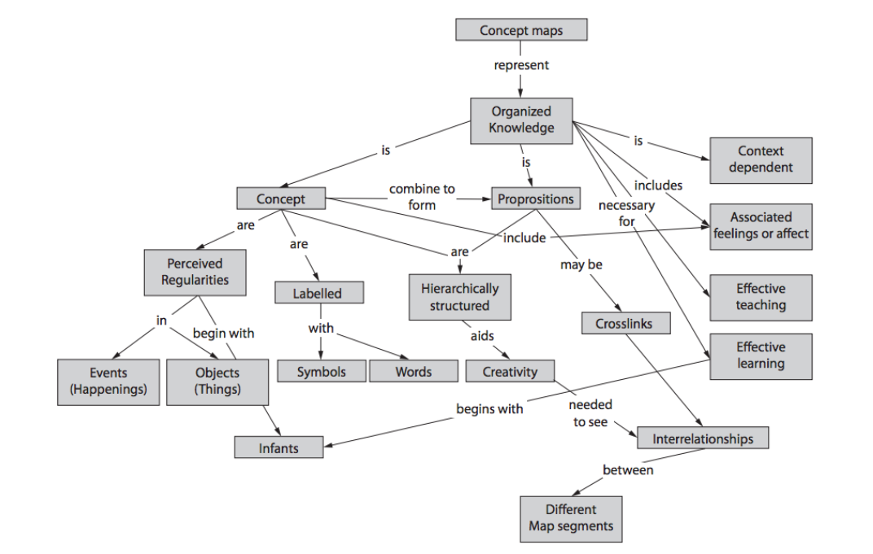
Figure 1 — Concept map

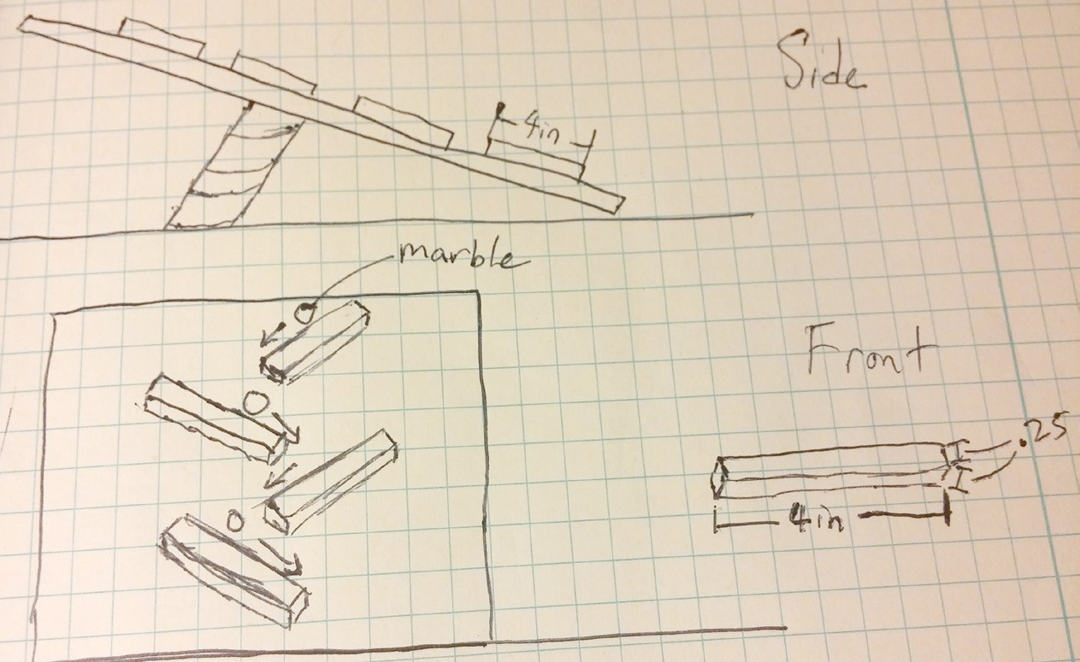
Figure 2 — Quick sketch

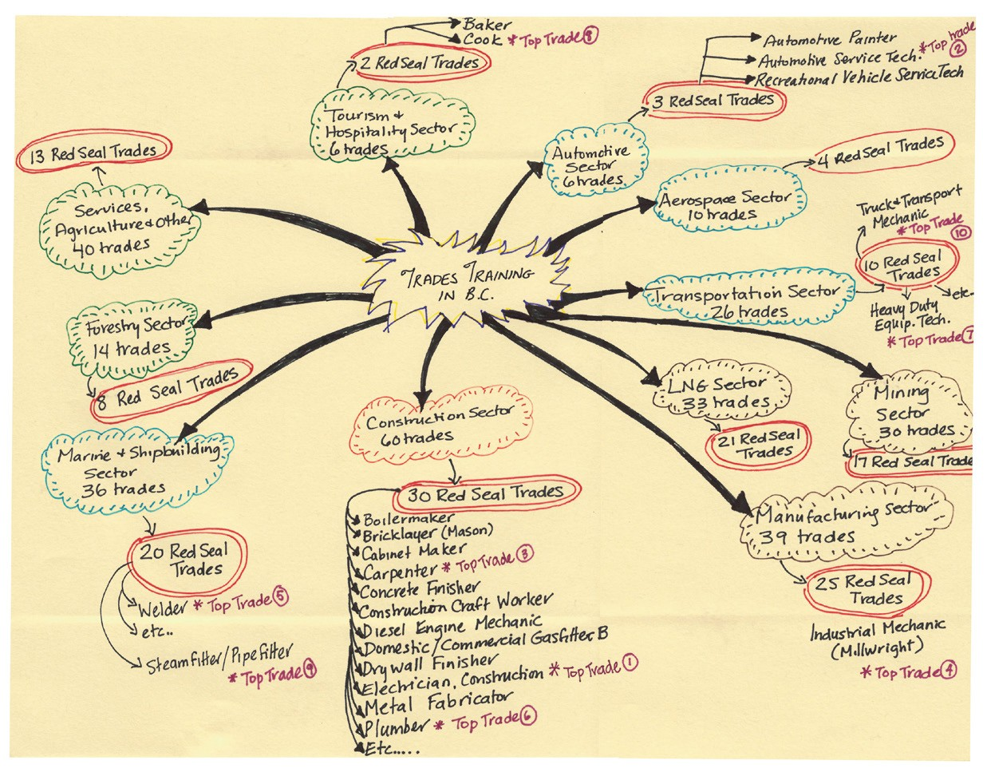
Figure 3 — Free-hand mind map

    - Create a diagram of concepts and terminology.

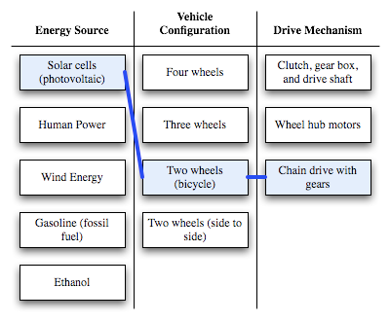
Figure 4 — Concept combination table

    - Use a chart or table if this helps you order the information for later recall.

    - Take quick aural notes using a tape recorder or application on your smart phone.

Once you’ve gone through your readings, take the time to reflect on what you’ve read. Do you understand the concepts and the reasons for learning this information? Are there any issues that are unclear? If so, make notes so that you can ask for clarification later in class or skim over the material again to see if you can find the answers on your own.

The following video may help you:

5 Active Reading Strategies for Textbook Assignments.
https://youtu.be/JL0pqJeE4_w

Now complete the Learning Task Self-Test.

Self-Test 3
- Purchasing your books ahead of time and reading from cover to cover is an effective reading strategy for trades training.
  - True
  - False

- What is the best time of day to read?
  - Whenever you can fit in the time
  - In between classes (breaks and lunch hours)
  - At night when everyone is sleeping and your home is quiet
  - Early in the day when you are not tired and have minimal interruptions

- Which of the following strategies is best if you have a lot to read?
  - Read in intervals of one to two hours with breaks in between.
  - Set aside a few hours and complete the reading all at once.
  - Read in intervals of 30 to 40 minutes with breaks in between.
  - Divide the reading with a study partner and then share your notes with each other.

- Why is it important to include breaks in your study session?
  - You may get hungry, thirsty, or require a trip to the washroom.
  - You retain more information at the beginning and the end of a study session. This will mean that you’ll also retain more information from before and after the break.
  - None of the above
  - All of the above

- Learning strategies help you organize the information you are reading and can include notes, tables, diagrams, mind maps, and mnemonics.
  - True
  - False

LEARNING TASK 4

Describe effective note-taking techniques
Effective note taking is a useful study tool that can help you synthesize the information you need to know. Good note taking improves both your concentration and comprehension. Notes that are incomplete or illegible often cause more frustration and can provide you with the wrong information.

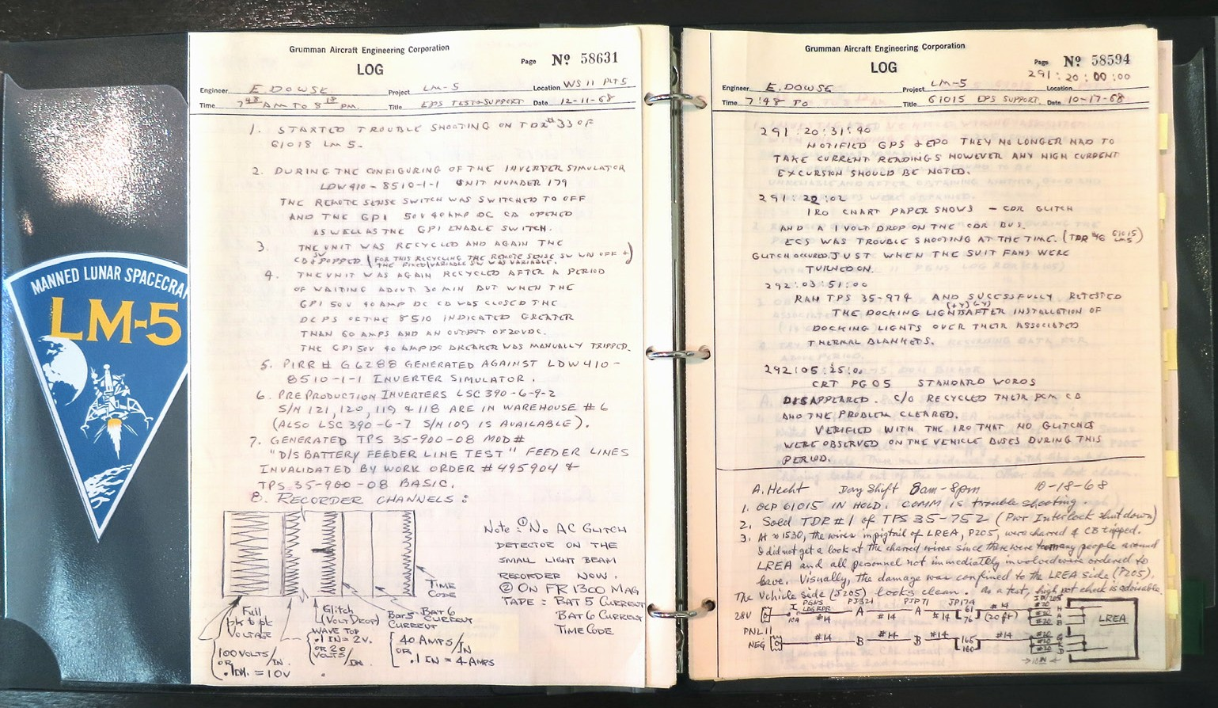
Figure 1 — Handwritten notes from Grumman engineers, as they pushed to complete Lunar Module LM-5 in 1968.
The notes are well organized for clear comprehension.

How you take notes will depend on your personal preferences. Regardless of the format in which you take your notes, there are some steps that you can take to help you before coming to class, during class, and after class.

Before the lesson
Most instructors and/or course outlines provide students with a list of materials that should be studied prior to the next day’s class. Before each class, take some time to read, review, and reflect on the subject matter.

As part of your homework, take the opportunity to jot down notes on the chapter you are reading or skimming through. Use the following techniques for effective note taking:
- Organize your writing materials, including paper and writing utensils (e.g., pencil, eraser, pen, highlighter). Prior to starting your notes, make sure that you title your note page appropriately so that you will know what it is referencing at a later date (e.g., title of the chapter/book and corresponding page numbers). Also remember to title any subsequent pages or staple the pages together to ensure that the notes do not become separated.

- Stick to keywords and information that is important and will assist your memory.

- Write your notes in your own words so that you can comprehend them afterwards.

- If you keep a separate list of keywords or formulas, make sure to update these additional lists with any information from your new notes.
- Use the techniques that work best for you. For example, some learners find that highlighting or underscoring relevant sections in their text or writing in the margins of their books is a useful step prior to making their notes. Some individuals will make a draft set of notes and then refine them in a follow-up version of notes.
- Use drawings and other non-linear note formats such as drawings, tables, charts, and mind maps if they help you remember concepts and how information is interconnected.

During the lesson
The following are helpful techniques that you can use in class:
- Take down the main points of the lesson in your own words. Do not try to take down notes verbatim or you will quickly be left behind.
- If a concept is already in the notes you prepared prior to class, only take down new information.
- Underline or highlight any information that your instructor indicates is important to remember. This information will most likely come up in quizzes, assignments, or exams.
- If your instructor is introducing information by topic, use separate subheadings in your notes to help you differentiate between topics.
- If you miss something or cannot understand it, ask questions. If this isn’t feasible, go over the issue with your instructor after class, or go over your notes with a classmate to obtain the missing information.
- If your instructor is going over an upcoming assignment or lesson, follow along as they review the upcoming assignment, and add additional notes as required.

After the lesson
The following are techniques that you can use after class or while studying:
- As soon as possible after the lesson, review and edit your notes. This may include rewriting your notes and merging them with the notes you took before the lesson. If anything is unclear, consult another reference. This may include reviewing the relevant section of the text or comparing notes with another student.
- Some individuals find it helpful to use the left-hand side of their page to jot down explanations, pointers, and ideas and use the right-hand side for notes. This is a personal preference; however, regardless of how you take down notes, devise a system that works for you and allows you to easily go back to your notes to locate information for further study and review.

- Complete any self-quizzes that may be in your textbook, handed out by your instructor, or available online. If nothing is available, create your own self-quizzes to review the important information in your notes. This will allow you to test your knowledge and the areas in which you are weak and may require more study.

Now complete the Learning Task Self-Test.

Self-Test 4
  - How are notes most effectively used?
    - Before class to prepare for the day’s lesson
    - After class to prepare for quizzes and exams
    - All of the above
    - None of the above

LEARNING TASK 5

Describe ways to research information
Understanding how to research information may be a part of both your educational program as well as your job, not to mention a vital life skill. Being able to efficiently locate information on specific subjects, products, techniques, and other general information can be a great time saver and ensure that the information you locate is of value.

Figure 1 — The World Wide Web has revolutionized the ways in which people research information.

The following are just a few tips on how to research information effectively:
- Know your research topic or the information you are looking for. What are the keywords or phrases associated with your topic? Having a good understanding of what you are looking for will determine the success you have in locating the correct information. Is the topic very general or specific? In general, the more specific your topic, the more complex your search will be. For example, a broad search would be to find some general information on car recalls. A more complex search would be to find information on car recalls in 2015 for a specific manufacturer, including the types of recall, models of cars, and total number of cars affected.
- Know the resources available to you. If you are studying on campus, get to know your library or learning commons. Check out their website and the resources available to you on line and in person. In many cases, librarians have prepared study and research guides for students by discipline. General tours and information sessions are often available at the start of the term and a session may also be included as part of your program.
Once you’ve narrowed down the topic or identified the information you need to find, you have a number of different resources available to help you gather the information required. These resources may include:
  - books, magazines, newspapers, encyclopedias, dictionaries
  - scholarly and trade publications

    - supplier documentation
    - directories, handbooks, manuals
    - almanacs
    - atlases and gazetteers
    - research reports
    - government information
    - statistics, maps, pictures, photos, images
    - expert opinions
    - interviews

The information you need may be available in a school or public library, on the Internet, or through personal contacts.

Depending on the information you require, you may have to access information in a number of different forms of media. For example, historical information may be available only on microfilm or microfiche. Other information may be on VHC, DVDs, CDs, slides, CD-ROMs, proprietary software/databases, or the Internet.

Conduct your search. Most searches today are conducted using online search engines and databases. Examples of free search engines include Google, Google Scholar, Bing, and Ask. Some search engines are proprietary and are accessible only through subscription by a library, such as Business Source Complete and Academic Search. There are also a number of private companies that provide access to information for a fee. It is important to keep in mind that many of these proprietary search engines and databases are available to students free of charge through your college library. Always check with your library to see if you can get the information you need for free before purchasing it. Again, your librarian can help you.

There is no specific search engine associated with trades programs. However, understanding your topic will help you find the appropriate search engines you can go to as well as credible websites. For example, if you are asked to research how a specific product is installed, the best site will be the manufacturer’s website where all the information is listed, including the warranties for the installation of their products.

Look for synonyms to broaden your search or additional criteria to narrow your search.
If you can’t find the information you need based on the keywords you’ve chosen, look for synonyms (alternate words with a similar meaning) to help you locate the material you need. Likewise, if your search yields too much information, you’ll need to narrow it by adding additional keywords or criteria.
For example, if you look for a video on trades students and study skills, you will probably not find videos on that specific subject. However, if you open up your search to college students and study skills, you will find many videos that you can review and choose from based on their relevance to trades students. Likewise, if you are looking for information on a famous garden and the search yields too much information, you may want to add additional search criteria such as information from the past five years and only in English.

- Learn how to use search operators and Boolean logic to define your search. Know how to use the words “and,” “or,” and “not” when doing a search. These words can either expand or reduce your search significantly. For example, a search on “joinery and Canada” will pull up all information with these two terms. A search on “joinery not Canada” will exclude any information that includes the term “joinery” but not “Canada.” The use of quotation marks around a term isolates your search to the search phrase; for example, “Hockey Night in Canada.”
There are many videos and articles available on the Internet that help you understand how to use search operators and Boolean logic. The following are just a few:

Watch the video How do I search Google effectively? Part I: Boolean Operators & Phrase Searching. https://youtu.be/Yj2YAg1ZRmg
Watch the video Boolean Operators. https://youtu.be/xsSZps3NH-M

Now complete the Learning Task Self-Test.

Self-Test 5
- What criteria should be used to decide the best approach for researching information?
  - Whether the information is available on the Web
  - The amount of time you have available to do the research
  - How well you understand the topic and the information you need to provide
  - Whether you have assistance through using online resources and proprietary databases

- When researching a topic online, how can a search be broadened to receive more accurate results?
  - Looking at related topics
  - Looking for antonyms for the keyword(s)
  - Looking for synonyms for the keyword(s)
  - Looking up the general books on the subject in a library and going to the library to survey the texts

- What are three important search operators that will expand or reduce the size of your online search?
  - Or, and, no
  - And, or, not
  - Nor, including, or.
  - And, including, excluding

LEARNING TASK 6

Describe effective techniques for taking and preparing for tests

Preparing to take exams and tests starts with planning. Be sure you have the answers to the following questions for every quiz, test, and exam you have to take, and note the information down in your schedule and notes:
  - When is the quiz, test, or exam, where will it be held, and how long will it be?

  - How much is it worth in your final mark?

  - What topics will be covered?

  - What format will it be (e.g., multiple choice, short answer)?

  - Will there be any pre-exam review or study sessions (if so when and where)?

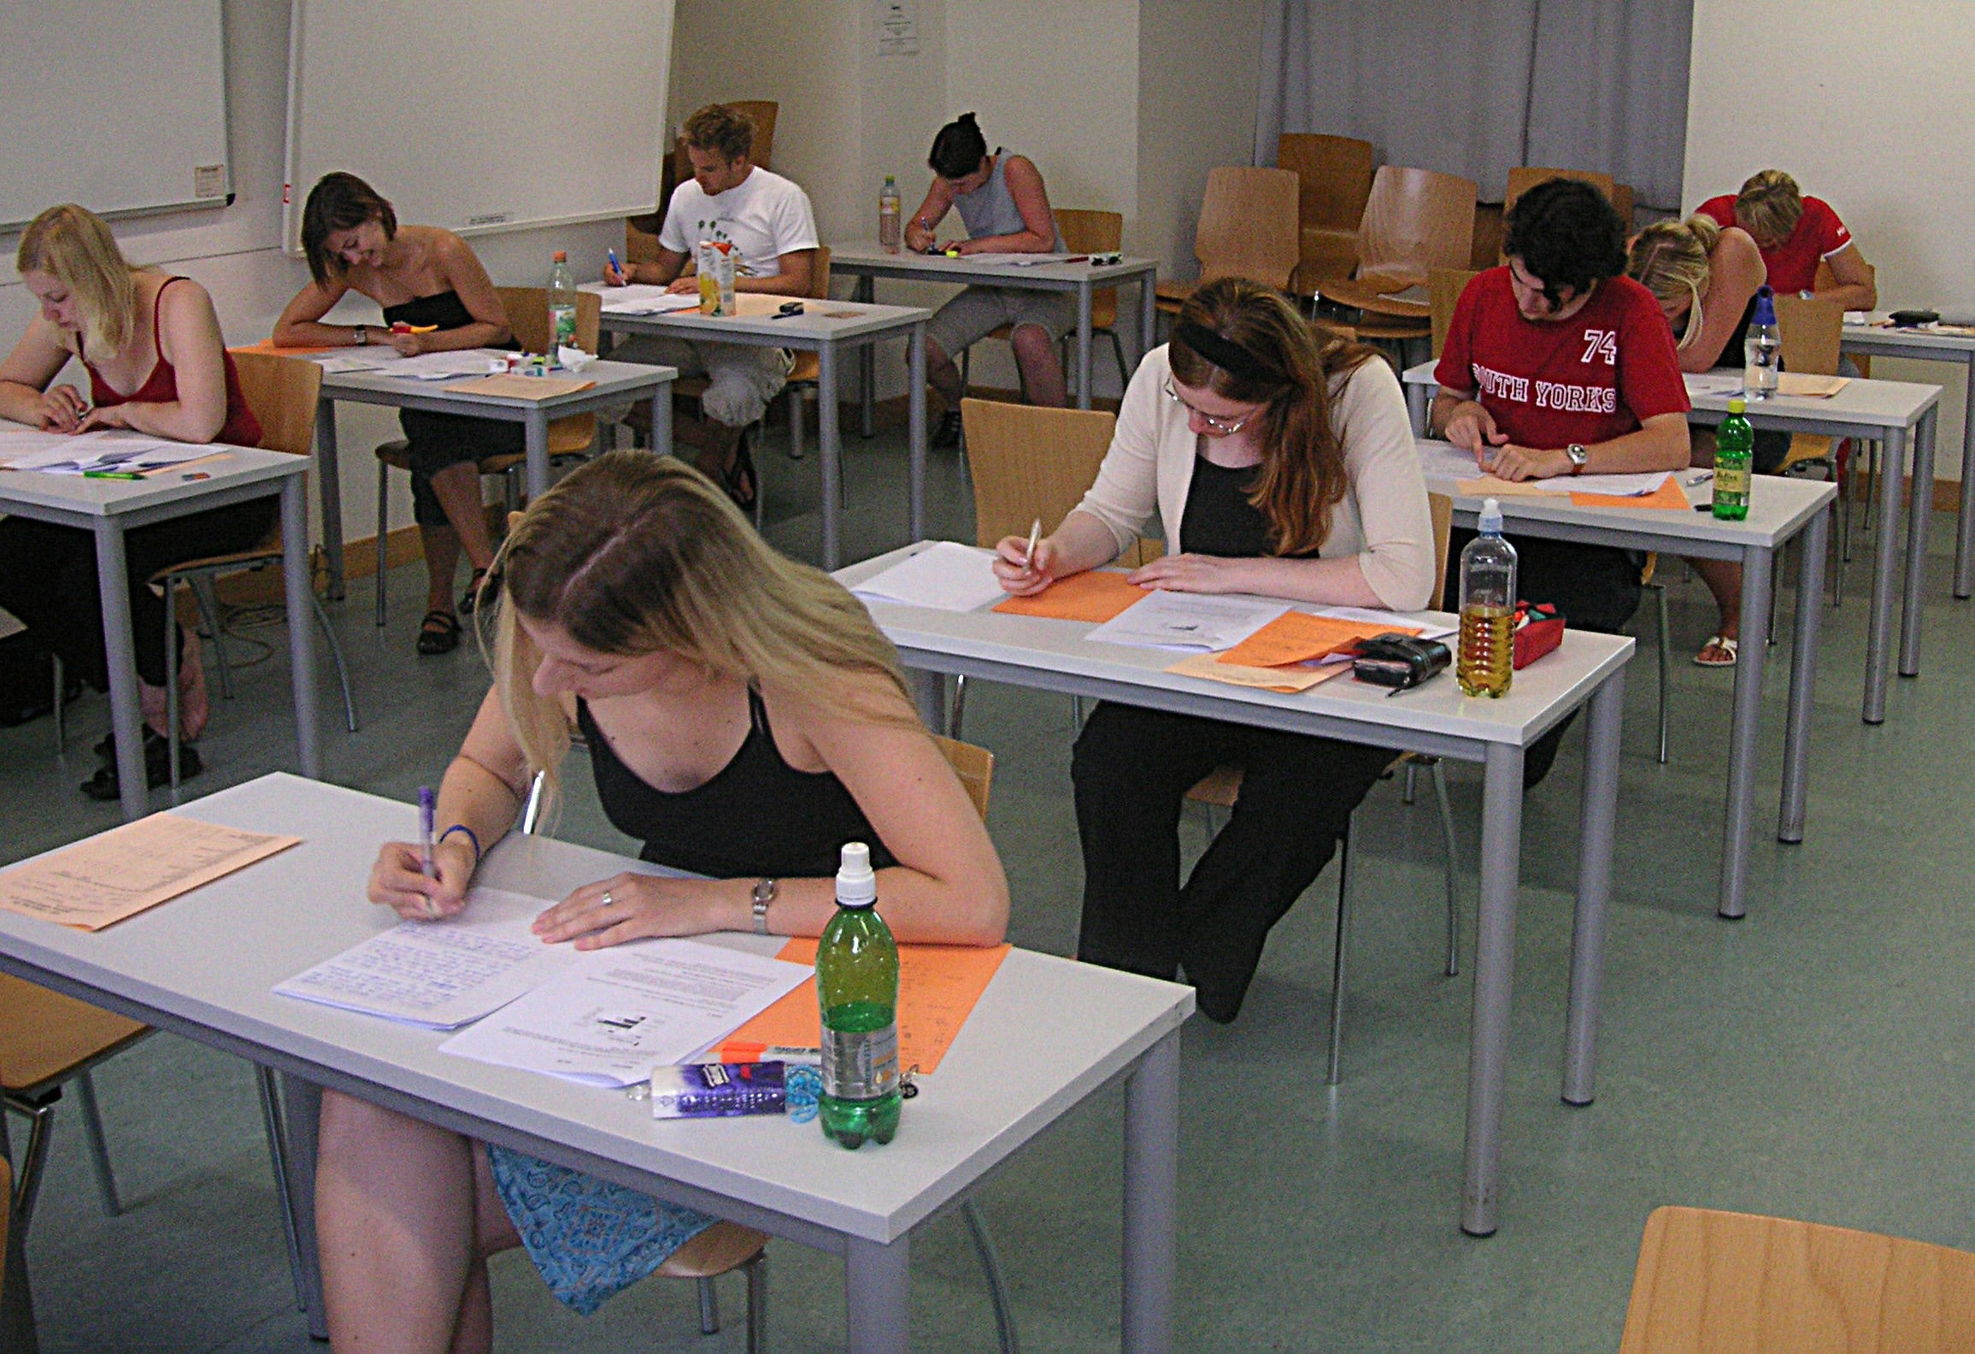

Figure 1 — Students writing exam

Having answers to the above questions will let you plan for each test appropriately and make sure that you budget sufficient study time for each. For example, a quiz worth 1% will require significantly less study time than a final exam worth 50% of your overall mark.

Here are some other strategies for effective planning for test preparation and writing:
  - Pay special attention to the information provided by the instructor. This information may

be given orally (which means you will need to transcribe the information in note form), or may be printed on handouts. If you are not sure about something, make sure to ask your instructor for clarification.
    - If there are any review or student sessions, make sure that you attend. If you are unable to attend, be proactive and get copies of any notes or handouts from your instructor or a classmate.
    - Study for the exam based on the exam format. For example, if you know that your exam will consist of problem-solving and multiple-choice questions, build these two types of questions into your studying. You should be able to find many examples of these kinds of problems in your textbooks, homework assignments, or previous tests and quizzes. Redo any related multiple-choice assignments you might have received in class or create your own tests to challenge your knowledge.
    - For larger tests or exams, plan out your study time over several days or weeks. Don’t procrastinate or try to cram your studying into the last minute.
    - Get a good night’s sleep before the exam. Set out all the materials, supplies, and identification you need to take to the exam the night before the exam. For example, make sure you’ve got ample sharpened pencils and erasers. If you are allowed to bring in one page of formulas and information, make sure that is well organized and legible.
    - Eat properly before the exam. It’s hard to focus if you are hungry, particularly if you didn’t have a good night’s sleep.
    - The day of the quiz, test, or exam, leave home earlier than usual, use the washroom, and try to show up at least 10 to 15 minutes before the exam starts.
    - Leave any items not allowed in the exam room in your locker, car, or the location identified by your instructor or the exam invigilator. If you have a cell phone, turn it off.
    - Show up to the exam relaxed and with a positive attitude. (Often this comes from knowing that you’ve put in the necessary study time.)
    - If you have a choice where to sit, choose a comfortable location and set up your desk so that you are ready to start. Check if there is a clock at the front of the classroom so you can keep track of time.
    - Listen carefully to the instructions at the start of the exam.

    - If you feel yourself becoming nervous, use strategies to help you relax, such as taking deep breaths or changing your position in your seat.
    - Keep your eyes on your own exam.

    - Pace yourself. Don’t worry if other students finish earlier than you do and leave the exam room before you are finished.

  - Make one final check before handing in the exam to ensure that all personal information required has been completed.
There are many helpful study videos available online. The following are just a few:

Watch the video Exam Tips: How to Study for Finals – College Info Geek.
https://youtu.be/qWUUP5p0Auo

Watch the video 10 Ways to Avoid Making Stupid Mistakes on Exams – College Info Geek. https://youtu.be/OY6Z8gNKp-w

Tips for multiple-choice tests
The majority of your tests and exams in trades will be in multiple-choice format. The following are just a few tips to help you when completing multiple-choice exams:
  - Read any exam instructions carefully before you begin to answer questions.

  - Fill in the paper exam sheet or computerized test according to the instructions.

  - Read over each question slowly and carefully and know exactly what is being asked. You may want to read the question a second time before proceeding.
  - If a question is long, break it into separate parts so it is easier to understand.

  - Look for any tricks or wording meant to throw you off the correct answer. For example, watch out for negatives in a question, such as “Which is not the correct answer?”
  - Try to come up with the answer in your head before reading all the choices.

  - Even if you think you know the answer, read all the choices to make sure you select the correct one.
  - Often your first choice is your best choice. Don’t second guess yourself and change answers repeatedly.
  - Complete all of the questions you know the answers to first. Then return to the questions that you don’t know.
  - If you don’t know the correct answer, go through each choice and eliminate the ones that you know are wrong. Through the process of elimination, you may come up with the correct answer or reduce the number of choices in order to make an educated guess.
  - Answer every question. An educated guess is better than no answer at all.

  - If you have time left over at the end of the exam, review the test to make sure you’ve answered all questions.

    - If your exam requires you to use formulas that you have memorized, you may want to jot them down on a piece of paper at the start of the exam. This way you can easily retrieve the formulas when you need them for specific questions.
    - If you have time, review your answers a final time. Provided you’ve understood the question the first time you read through it, you should be making very few corrections at this stage.
    - Check that your name and any other information required on the exam are completed before handing it in.

Test anxiety
Most students have some anxiety or stress before taking a test or final exam. One of the ways in which you can reduce test anxiety significantly is to be prepared. The more effective studying and preparation you do ahead of time, the greater the likelihood you’ll be able to keep your anxiety level down. Try to keep a positive attitude throughout your studies and in the exam. A negative attitude can be self-defeating and greatly increase your level of anxiety.

Figure 2 — Test anxiety is one of the greatest obstacles to succeeding on exams.

If you have a major problem with text anxiety, it can affect your health and performance. You may want to find out more about the services available at your institution to help you deal with this issue. Be proactive, and don’t wait until the last minute to ask for help.

Now complete the Learning Task Self-Test.

Self-Test 6
- Preparing to take exams and tests starts with planning.
  - True
  - False

- What is the best source for information on an exam?
  - Your instructor
  - Your friends or students who have taken the program in the past
  - All of the above
  - None of the above

- How many times is it recommended that you read over a question before attempting to answer it?
  - Once
  - At least twice
  - As many times as you need to before moving on to the next question
  - Three times, and if you don’t understand it, then move on to the next question

- How can stress or anxiety be decreased before taking a test?
  - Having a negative attitude
  - Cramming at the last minute
  - Leaving the outcome up to fate
  - Being prepared and getting a good night’s sleep

Summary
In this Competency we have provided you with the information necessary to understand how to apply study and learning skills. We have looked at effective study habits, including the importance of time management, problem solving, and lifelong learning. We have described effective listening techniques and their importance in the classroom and on the job site. We have introduced you to strategies for effective reading and for keeping track of the important information, and have looked at effective note-taking techniques and strategies for researching information. Finally, we have looked at techniques for preparing for and taking tests.

Now that you have completed this Competency, you understand that every individual is different and that it is up to you to develop a self-awareness of how you learn best so that you can determine the strategies to use for studying and learning. Once you have developed these skills, they will benefit you not only in your trades program but also in lifelong learning.

References
Stuckey, James, and Daniel Munro. (2014). Skills for success: Developing skills for a Prosperous B.C. Ottawa, ON: The Conference Board of Canada.

Appendix

Study Guides
http://www.studygs.net/

College Info Geek – Videos on studying and habits and stuff
http://www.youtube.com/user/electrickeye91/videos

McMaster University Full Frontal Learning
http://maclife.mcmaster.ca/academicskills/online_resources.cfm

Answer Key

Self-Test 1
- b. False

- a. True

- b. False

- a. True

- c. 60

- d. It helps you to determine the most effective ways in which to study.

- d. All of the above

- d. It is the learner’s responsibility to be proactive and get touch with the unit responsible for student support services and ensure that necessary documentation is completed to start the process.
- d. The understanding and awareness of your own cognitive (mental) processes and how you learn
- d. All of the above

- d. All of the above

- a True

- d. Use a smart phone application, calendar, agenda, or schedule.

- c. More time to complete their studying

- a. True

- a. True

- c. All of the above

- a. Being focussed on learning

- a. True

- b. False

- b. Ask for help as soon as you run into difficulty, and make use of the resources available to you (e.g., help centres, fellow students, and online resources).

- b. False

- b. False

- c. All of the above

Self-Test 2
1. | b. | False
2. | a. | True
3. | b. | Concentrating exclusively on what is being said
Self-Test 3
1. | b. | False
2. | d. | Early in the day when you are not tired and have minimal interruptions
3. | c. | Read in intervals of 30 to 40 minutes with breaks in between
4. | b. | You retain more information at the beginning and the end of a study session. This will
 |  | mean that you’ll also retain more information from before and after the break.
5. | a. | True

Self-Test 4
  - c. All of the above

Self-Test 5

1. | c. | How well you understand the topic and the information you need to provide
2. | c. | Looking for synonyms for the keyword(s)
3. | b. | And, or, not
Self-Test 6
1. | a. | True
2. | b. | Your instructor
3. | b. | At least twice
4. | d. | Being prepared and getting a good night’s sleep

The British Columbia Open Textbook Project
The British Columbia Open Textbook Project is funded by the B.C. Ministry of Advanced Education, and managed by BCcampus, a publicly-funded organization that uses information technology to connect B.C. post-secondary institutions under a collaborative service delivery framework. The Open Textbook Project aims to make available openly-licensed textbooks in the province’s high-impact subject areas. Visit open.bccampus.ca for more information.

7960003679

