Phys 117 Learning Evaluation

- Performance on the Force Concept Inventory

The Force Concept Inventory (FCI) is a validated conceptual test instrument, developed in the 1990s to assess students' understanding of the most basic concepts in Newtonian physics using everyday language and common-sense distractors.

The instrument is available from : https://www.physport.org/assessments/assessment.cfm?A=FCI

We administered the assessment on paper during week 2 of the course, and then again in week 8 of the course, as a pre-, post-instruction measure of conceptual gain as a direct result of instruction. The pre-/post histograms are as follows:

Pre-instruction

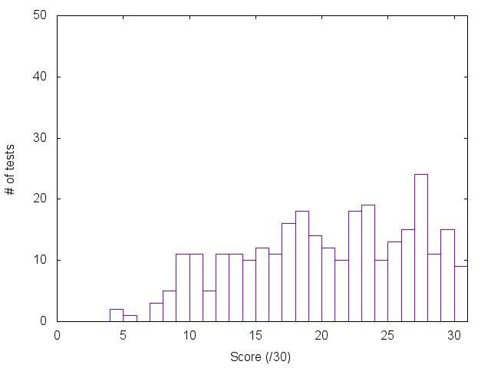

Post-instruction

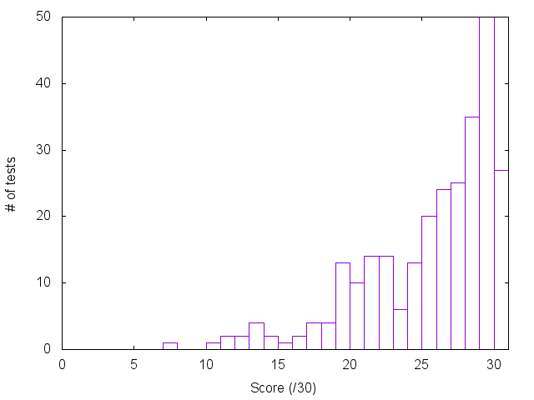

Improvement is often measured in terms of normalized gain <g>, averaged over all students form whom matched (ie pre and post) data is available for. It is defined as
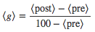

<g> for this cohort was calculated to be 0.52. (Mean score on the pre-test was 19.8/30, rising to 25.1/30 on the post test score). There is extensive research literature on normalized gains and student learning (see the PhysPort resources linked previously). It is generally accepted that classes focusing on interactive engagement strategies to support student learning can achieve gains greater than 0.3 and sometimes as high as 0.6.

- Metacognitive ability of students (measured through proxy of ability to predict one’s own score on an assessment).

An additional question was added to the FCI instrument, which asked students to predict the score that they thought they would get on the test they had just completed.

This ability to accurately (or otherwise) predict one’s own performance was taken as a proxy for students metacognitive sophistication: how well were they able to judge what they did and did not understand. The results from the pre-instruction FCI test in week 2 of the course are shown below:

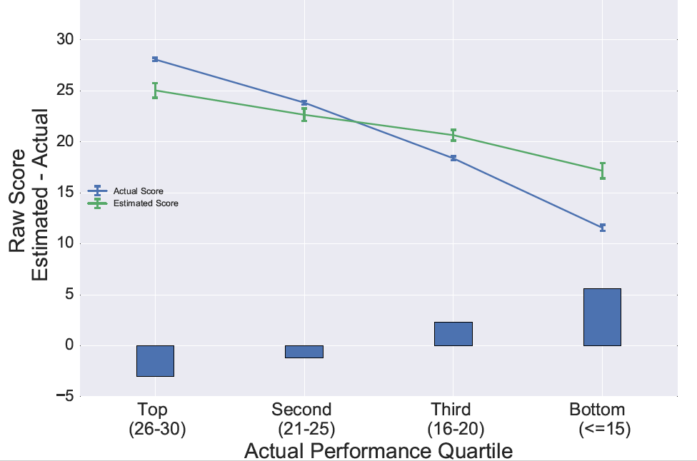

Students are split into quartiles based on their performance on the FCI instrument. What we find is the more able students in the class tend to underestimate their own ability, whereas the weaker students (particularly the bottom quartile) tend to overestimate their own ability. This is replication of the well known cognitive bias known as the Dunning-Kruger effect.

Our motivation for doing this was to see if the instructional approach, particularly with a deliberate focus through resources and instruction on metacognitive development (“thinking about your learning”) was able to improve this picture. Six weeks later, the students took the FCI assessment again, and the results from asking them to predict their scores on this assessment are shown below.

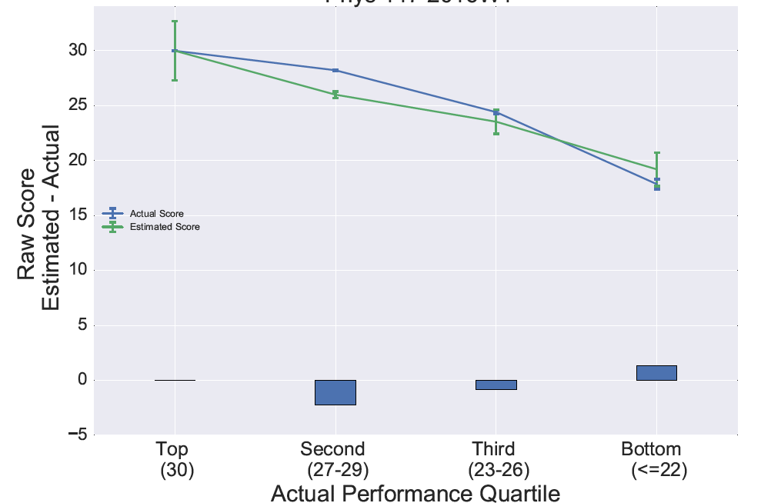

We see some improvement, particularly in the bottom quartile (these are not necessarily exactly the same group of students as in the bottom quartile of the pre-test). The average overestimation of performance for students in this group dropped from approximately 15% (pre-test) to 7% (post-test).

Further analysis sought to investigate if there was a gender dependence on these findings. Students in each quartile group were split into M and F subgroups.

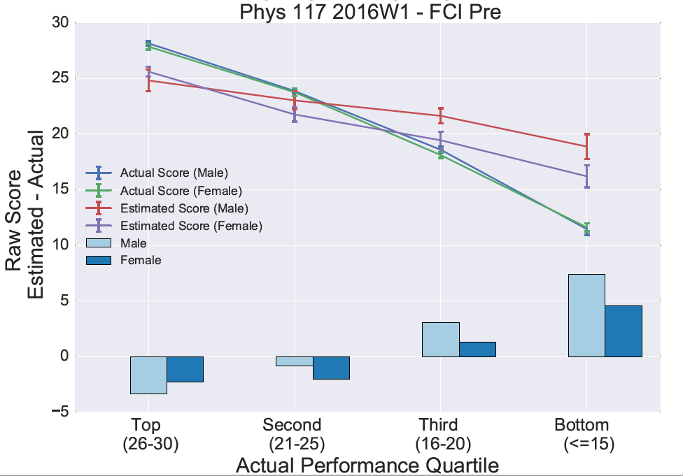

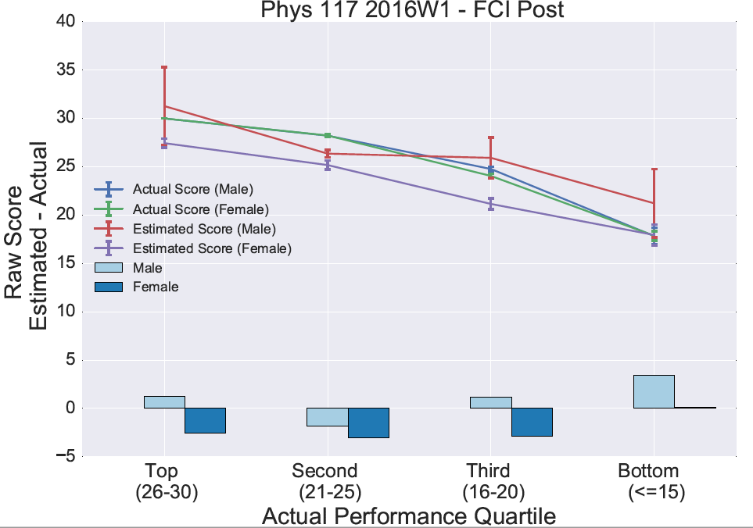
There are several things to note comparing these two plots, most natebly the striking difference between the lowest quartiles pre and post. We are still assessing what the implications of this might be for course design and delivery in the future, but it looks as if Dunning & Kruger’s original statement that the lowest performers on a task are both ‘unskilled and unaware of it’ applies particularly to male students in this quartile.

- Student-reported topic difficulty map

As part of the strategy to support students in preparing for their examination, we offered three revision classes, each of which would look at the key concepts and problems from a single week of material.

We polled students to ascertain which weeks material we should focus our attention on. This, therefore, provides a student-generated difficulty map of topics and materials to focus on, as well as valuable feedback to the course team as to where to devote more time in future iterations of the course.

