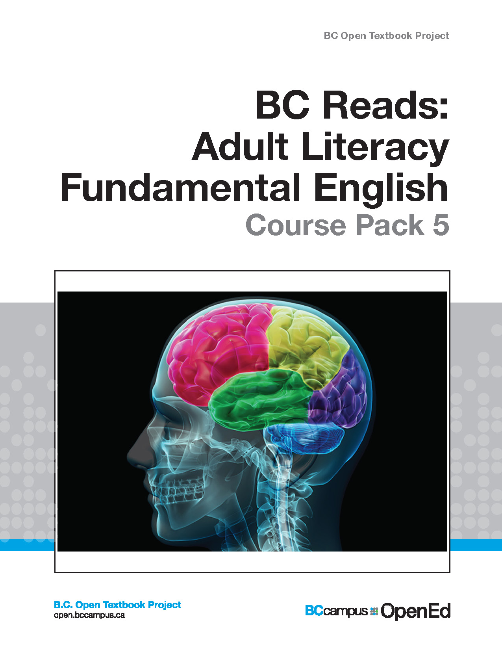

BC Reads: Adult Literacy Fundamental English - Course Pack 5

BC Reads: Adult Literacy Fundamental English - Course Pack 5

BC Reads: Adult Literacy Fundamental English - Course Pack 5

Shantel Ivits

Unless otherwise noted within this book, this book is released under a Creative Commons Attribution 4.0 International License also known as a CC-BY license. This means you are free to copy, redistribute, modify or adapt this book. Under this license, anyone who redistributes or modifies this textbook, in whole or in part, can do so for free providing they properly attribute the book.
Additionally, if you redistribute this textbook, in whole or in part, in either a print or digital format, then you must retain on every physical and/or electronic page the following attribution:
http://open.bccampus.ca
For questions regarding this license, please contact opentext@bccampus.ca. To learn more about the B.C. Open Textbook project, visit http://open.bccampus.ca .
Cover image: Brain lobes (https://www.flickr.com/photos/125992663@N02/14599057004) by Allan Ajifo (https://www.flickr.com/photos/125992663@N02/) is used under a CC-BY 2.0 license (https://creativecommons.org/licenses/by/2.0/).
BC Reads: Adult Literacy Fundamental English - Course Pack 5 by Shantel Ivits is licensed under a Creative Commons Attribution 4.0 International License, except where otherwise noted.

Contents
- About the Book
- Acknowledgments
- Notes to the Instructor
- The Most Amazing Structure on Earth
- The Many Faces of Genius
- The Many Pathways to Knowledge
- Boost Your Brainpower
- Memory Magic
- Put to the Test
- The Sixth Sense: Intuition
- The Big Five: Personality
- Secrets of a Happy Brain
- Appendix 1: Graphic Organizers
- Appendix 2: Writing Assessment Checklists
- Appendix 3: Level 5 Scope and Sequence
- Bibliography
- About the Author

1

About the Book
BC Reads: Adult Literacy Fundamental English – Course Pack 5 was created by Shantel Ivits. This creation is a part of the B.C. Open Textbook project.
The B.C. Open Textbook project began in 2012 with the goal of making post-secondary education in British Columbia more accessible by reducing student cost through the use of openly licensed textbooks. The B.C. Open Textbook project is administered by BCcampus and funded by the British Columbia Ministry of Advanced Education.
Open textbooks are open educational resources (OER); they are instructional resources created and shared in ways so that more people have access to them. This is a different model than traditionally copyrighted materials. OER are defined as teaching, learning, and research resources that reside in the public domain or have been released under an intellectual property license that permits their free use and re-purposing by others (Hewlett Foundation).
Our open textbooks are openly licensed using a Creative Commons license, and are offered in various e-book formats free of charge, or as printed books that are available at cost.
For more information about this project, please contact opentext@bccampus.ca.
If you are an instructor who is using this book for a course, please let us know.

2

Acknowledgments
These books were developed on the unceded territories of the Musqueam, Squamish, and Tsleil-Waututh Nations. Huy tseep q’u! Chen kw’enmántumiyap! Kw’as hoy!
I feel very fortunate to have had the opportunity to work on this project alongside a dedicated team of basic education instructors from across British Columbia. This series was shepherded by Leanne Caillier-Smith (College of the Rockies) and benefited enormously from the insight and encouragement of Julia Dodge (University of the Fraser Valley), Chandra McCann (Okanagan College), Jan Weiten (Vancouver Community College), and Melinda Worfolk (College of New Caledonia). The above five mentioned are representatives of the BC Adult Literacy Articulation Committee and were the advisory committee members for this project. It has been a pleasure to scaffold my own learning among such brilliant and passionate educators.
Huge thanks to Lauri Aesoph of BCcampus for introducing me to the exciting open textbook movement and managing all aspects of the publication of these books — from layout and image selection to copyediting and print –so adeptly.
I am incredibly lucky to work with and have the support of the Basic Education Department at Vancouver Community College: Rita Acton, Cynthia Bluman, Andrew Candela, Lynn Horvat, Alayna Kruger, Jo Lemay, Edie Mackenzie, Rene Merkel, Tara Mollel, Leah Rasmussen, Linda Rider, Mary Thompson-Boyd, Jan Weiten, our Program Assistant, Nadia Kawas, and our Dean, David Wells. I am also deeply grateful to the basic education students at Vancouver Community College for all that you teach me about dreams, resilience, and perseverance.
A special thank you to my partner, Marria, for always lending my words an eager ear, and for keeping the world around me turning even though my head was perpetually stuck in these books.

3

Notes to the Instructor
Having an uneasy relationship with one’s brain is probably a common human experience. Who hasn’t struggled to learn something new, forgotten an important detail, or wished away a personality quirk? I’ve dealt with this struggle, and I’ve seen it in my basic education students.
My objective with this course pack is twofold. I strive to celebrate human brains in all their diversity. I also aim to explore brain-based tools for empowering ourselves to reach our goals.
This theme-based, integrated skills course pack is designed to meet the learning outcomes for Adult Literacy Fundamental English Level 5, as outlined in the ABE in BC 2014/2015 Articulation Handbook. This is roughly equivalent to grades 6 to 7.5 in the K-12 system.
The curriculum in this course pack is based on the readings found in BC Reads: Adult Literacy Fundamental English – Reader 5. The reader includes nine level-appropriate, high-interest readings of 500 to 800 words each. Convenient links to the readings are embedded in each chapter of this course pack.
Each chapter of the course pack contains:
- Pre-reading questions that can be used for individual reflection, journaling, or class discussion
- Vocabulary-building exercises
- Comprehension questions
- Spelling lists and exercises
- Grammar lessons and exercises
- Writing tasks
For detailed information, please refer to the Level 5 Scope and Sequence document, also available in printable form in Appendix 3.
This course pack makes use of a number of graphic organizers to help students organize their thoughts in a visual way. You can download the complete set of organizers in Appendix 1. Students can also download and print them as needed, through the links embedded throughout the course pack.
In Appendix 2, you will find checklists to score the writing tasks assigned at the end of each chapter.
You may wish to use this program online, or you may wish to print it for your students by downloading it as a PDF. This program was designed to suit both options. Font size and line spacing can be adjusted in the online view, and have been enhanced for the print and PDF versions for easier reading. (In addition, both epub and mobi files are offered for students with e-readers and Kindles.) This course pack has been reviewed by subject experts from colleges and universities.
I hope these pages help learners to appreciate their unique brains and discover strategies for a lifetime of learning.
-Shantel Ivits

1

The Most Amazing Structure on Earth

Learning Goals
In this chapter, you will learn to:
- Use pre-reading strategies
- Use visualization to check your understanding while you read
- Build your vocabulary
- Understand the main ideas, sequence, and details of a text
- Spell words with the suffix -ture
- Use periods, question marks, and exclamation marks correctly
- Identify the subject in a simple sentence
- Understand the TOWER method of writing
- Organize a paragraph
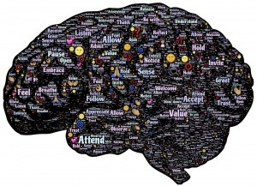
Human brain

Get Ready to Read
Readers use titles, pictures, and their own knowledge to predict what will be in a text. A good place to begin is to figure out the topic. The topic of a text is the person or thing that the text is written about. To find the topic, start by looking at the title of the text. Usually, the topic is in the title, but this strategy doesn’t always work. The title The Most Amazing Structure on Earth doesn’t tell us exactly what the most amazing structure on Earth is. Another way to find the topic is to look for words that get repeated, especially in the first sentence of each paragraph.

Think about these questions or discuss them with a partner.
- Look quickly at the first reading. What do you think the “most amazing structure on Earth” is, according to the text?
- Without looking at the text, try to answer this question: Do scientists say there were always humans on Earth? What does science say about how we got here?
- In your opinion, what can a human brain do that makes it so special?
- What do you think is smarter: your brain or the best computer in the world? Why?

Reading Strategy
Readers check their understanding of a text while they read. In this book, you will practice strategies for checking whether you are really thinking about the words on a page. One strategy is to stop after each paragraph and ask yourself: Can I picture what the text is describing, like a movie playing in my mind? If you can’t picture it, then go back and try to visualize as you re-read the paragraph. If you like to draw, you can even doodle the pictures you see in your mind in the space beside the paragraph.
Try this strategy as you read The Most Amazing Structure on Earth.

Visualizing text

Vocabulary

Find these words in the text. Use the context to choose the best meaning.
complex | structure | wormlike | creature | nerves | capable
process | supercomputer | million | billion | trillion
1. A large and very fast computer is called a ______________________________.
2. ______________________________ carry messages between your brain and your body.
3. ______________________________ means able to do something.
4. An animal of any type could be called a ______________________________.
5. ______________________________ describes something that has many parts that go together in complicated ways.
6. A long, thin animal with a soft body and no arms or legs could be described as __________________________.
7. A ______________________________ is something that is built by putting parts together.
8. The number 1,000,000 is called one ______________________________.
9. The number 1,000,000,000 is called one ______________________________.
10. The number 1,000,000,000,000 is called one ______________________________.
11. ______________________________ means to take in something like information and use it.
Check your work with the Answer Key at the end of this chapter.

Check Your Understanding
The main idea of a text is the point the writer is making about the topic. A text is usually written for one main purpose:
Purpose | Example
To describe something | What do your grandfather’s chocolate chip cookies taste like?
To explain how to do something | How do you send an email?
To tell a story | What’s the story about why some people call this land Turtle Island?
To compare different things | Do you prefer skiing or snowboarding?
To explain the advantages or disadvantages of something | What are the disadvantages of credit cards?
To summarize something | What does the TV program guide say this show is about?
We can figure out the main idea of a text by looking for the point of each paragraph.

1. The text has four paragraphs. Find the paragraph that matches each of the main ideas below.
a. Scientists don’t know everything about the brain, but what they have learned so far can help us in daily life.
b. The cerebral cortex, which has four parts, is the part of our brain that makes us so smart.
c. The brain has cells called neurons that are faster than any computer. Neurons send and receive information throughout the body, allowing us to think, remember, feel, and move.
d. A creature slowly developed into a human over millions of years.

2. Put these events in the correct sequence. Sequence refers to the order that things happen in.
a. The creature grew a spinal cord.
b. The creature became a fish.
c. The creature became a human.
d. The creature was like a worm.
e. The creature became a monkey.
f. The creature grew arms and legs.
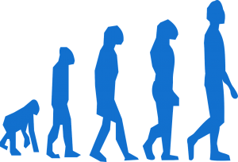
Human evolution

3. Are these details true or false?
a. The smartest part of our brain is its surface.
b. The front lobe of our brain processes images from the eyes.
c. The cerebral cortex has six parts.
d. Adults have about the same number of neurons as when they were babies, but now there are more connections between the neurons.
e. Computers are smarter than mice.

4. Fill in the blanks.
a. Our brains took about ____________________ million years to develop.
b. The four parts of the cerebral cortex are called ____________________.
c. The world’s best supercomputer is only about as fast as a ____________________ brain.
d. ____________________ is a word for a type of brain cell.
e. Information from the brain to the body travels along the ____________________.
Check your work with the Answer Key at the end of this chapter.

5. In your opinion, is the human brain the most amazing structure on Earth? Why or why not?
Ask your instructor to check your work.

Spelling

A suffix is the end part of a word. Study these words ending in -ture. Arrange a date to be tested on your ability to spell these words.

One way to learn to spell a new word is to break it into syllables. Try it. Remember that -ture is its own syllable.
1. structure = ____________________________________________
2. creature = _____________________________________________
3. mixture = _____________________________________________
4. nature = _____________________________________________
5. future = _____________________________________________
6. culture = _____________________________________________
7. signature = _____________________________________________
8. adventure = ____________________________________________
9. departure = _____________________________________________
10. furniture = _____________________________________________
Check your work with the Answer Key at the end of this chapter.

End Punctuation
Punctuation refers to the marks we use in sentences to make our meaning clear. Punctuation marks that come at the end of sentences are called end punctuation.

Grammar Rule
There are three kinds of end punctuation:
- The period.
The period is used at the end of a statement.
Example: People used to think of the brain as useless stuffing.
- The exclamation point!
The exclamation point is used at the end of a word, phrase, or statement to express strong feeling, like happiness, anger, or surprise.
Example: Your brain is so complex that it took about 700 million years to develop!
- The question mark?
The question mark is used at the end of any sentence that asks a question. Questions often begin with “who,” “what,” “where,” “when,” “why,” or “how.”
Example: What do you think is more powerful: your brain or a supercomputer?

Fill in all the periods, exclamation marks, and question marks needed in these sentences.
1. How big is your brain It is about the same size as your two fists pushed together
2. Wow You could fit 30,000 neurons on the head of a pin
3. Did you know the brain contains enough energy to power a light bulb
4. The outer part of the brain is a yellowish-grey colour
5. One neuron can have up to 10,000 connections Who knew
6. No way An American chicken named Mike survived for 18 months after his head was cut off and a small part of his brain was left behind
7. Our noses can detect between 4,000 and 10,000 smells
8. We spend one-third of our lives asleep That’s a lot of sleep
Check your work with the Answer Key at the end of this chapter.

Simple Sentences: Identifying the Subject
One way to improve your writing is to use a variety of sentences. In this book, you will learn to write three sentence types: simple sentences, compound sentences, and complex sentences. A simple sentence is a complete sentence if it has:
- a subject
- a verb
- a complete thought

Grammar Rule
The subject of a sentence is the person or thing doing the action.
- The subject can be a person:
Example: Marie Curie won two Nobel Prizes.
- The subject can be a place:
Example: The Empress Hotel serves 500,000 cups of tea every year.
- The subject can be a thing:
Example: The skull protects the brain.

Look at these simple sentences. Underline the subjects.
1. You sleep for about 30% of your life.
2. Monks train their minds to focus on one thing for long periods of time.
3. Bill Reid created brilliant art.
4. The College of New Caledonia opened in 1969.
5. Denmark provides free a college and university education to the people who live there.
6. Lucknow, India, is home to the biggest school in the world.
7. Chess gives your brain a good workout.
8. The spinal cord acts like an information highway between the brain and the rest of the body.
Check your work with the Answer Key at the end of this chapter.

Writing
During your time as a student, you will likely be asked to write many kinds of paragraphs. In this book, you will learn how to write paragraphs that describe things, explain how to do things, tell a story, or give an opinion. No matter what kind of writing task you are working on, there is a strategy you can use to stay on track. It’s called TOWER. The letters in TOWER stand for Think, Organize, Write, Edit, and Rewrite.

Eiffel Tower

Writing Task
The sentences below make up an opinion paragraph, but their order is mixed up. Decide what order the ideas belong in. Then rewrite the sentences to create a well-organized paragraph.
• Second, it can hold a huge amount of information.
• A signal in your brain can travel at speeds of 241 km/hour.
• First, it’s extremely fast.
• In conclusion, while Earth is full of wonders, these facts prove that nothing can compete with the human brain.
• The brain can hold about 1,000 times more information than Apple’s best desktop computer.
• The human brain is the most amazing structure on Earth.
• Third, it is capable of a wide variety of skills.
• What other structure on Earth is capable of scientific discovery, intense emotions, ethical decision-making, planning for the future, creating art, and inventing all kinds of tools for making life easier?
Check your work with the Answer Key at the end of this chapter.

Attributions
Human brain
Image by johnhain is in the public domain.
Visualizing text
Image by geralt is in the public domain.
Human evolution
Image by ClkerFreeVectorImages is in the public domain.
Eiffel Tower
Image by Gaertringen is in the public domain.

2

The Many Faces of Genius

Learning Goals
In this chapter, you will learn to:
- Use pre-reading strategies
- Explain main ideas in your own words to check your understanding while you read
- Build your vocabulary
- Understand the main ideas and details of a text
- Draw conclusions
- Spell words with silent consonants: wr, kn, gh, and mb
- Use colons correctly
- Identify the verb in a simple sentence
- Write an opinion paragraph
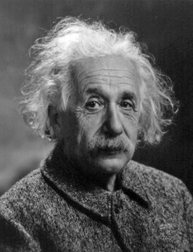
Albert Einstein

Get Ready to Read
Readers think about their own experiences with a topic before they read a text. They ask questions like, “What does this make me think of?” or “What do I already know about this topic?” Think about the questions below or discuss them with a partner.
- Who or what does the word “genius” make you think of?
- Who is the smartest person you know? What makes her or him smart?
- Agree or disagree with this statement: Being smart means being good at reading, writing, and math.
- Look quickly at the the reader for The Many Faces of Genius. What do you think the topic of this text will be?

Reading Strategy
Readers check their understanding of a text while they read. One strategy is to stop after each paragraph and try to retell the main idea in your own words.
Try this strategy as you read The Many Faces of Genius.

Vocabulary

Find these words in the text. Use the context to choose the best meaning.
measure | genius | Nobel Prize | adapt
visualize | compose | show business | cope
1. The __________________________ is a prize awarded to people who do important work in literature, medicine, and science, or for world peace.
2. A __________________________ is a very smart person.
3. The business that makes movies, TV shows, and plays is called __________________________.
4. __________________________ means to change your behaviour so it is easier to live in a particular situation.
5. __________________________ means to create a piece of music or writing.
6. __________________________ means to deal with problems and try to come up with solutions.
7. To __________________________ is to find the size, amount, or value of something.
8. __________________________ means to form a mental picture of something.
Check your work with the Answer Key at the end of this chapter.

Check Your Understanding

The text has four paragraphs. Find the paragraphs that match each of the main ideas below.
1. It is difficult to define intelligence.
2. There are different ways to be smart.
3. Intelligent people don’t always do well in school. There are many examples of geniuses who struggled in school.
4. You can find out about your strengths by taking a quiz on the Internet.

Are these details true or false?
5. People who are logic smart are good at reading maps.
6. People who are people smart are good at understanding how others are feeling.
7. People who are word smart are good at explaining things.
8. People who are body smart know their strengths and weaknesses.
9. People who are self smart tend to make good personal decisions.

Answer these questions using a complete sentence. The answers are not in the text. You must draw conclusions based on what you have read.
10. What kind of intelligence do you think Albert Einstein was strongest in?
11. What kind of intelligence do you think Winston Churchill was strongest in?
12. What kind of intelligence do you think Whoopi Goldberg is strongest in?
13. What kind of intelligence do you think you are strongest in?
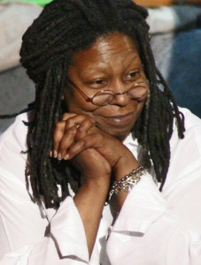
Whoopi Goldberg
Check your work with the Answer Key at the end of this chapter.

Spelling
A consonant is any letter that is not a vowel. Some words have silent consonants. This means that you do not pronounce them. Common silent consonant patterns include wr, gh, kn, and mb. Arrange a date to be tested on your ability to spell these words.

One way to learn to spell a new word is to look for the tricky parts. Silent consonants can be tricky. Cross out the silent consonants in these words.
1. bomb
2. wrist
3. ghost
4. plumber
5. know
6. wrong
7. knee
8. writer
9. thumb
10. knife
Check your work with the Answer Key at the end of this chapter.

Colons

Grammar Rule
- Colons can be used before a list. For example,
Whoopi Goldberg has won every major award in show business: the Oscar, Emmy, Tony, and Grammy.
The colon in this sentence shows that “Oscar, Emmy, Tony, and Grammy” is the list of major awards in show business that Whoopi Goldberg has won.
- Colons can be used before a definition. For example,
Picture smart: able to visualize, read maps, and draw
The colon in this example shows that the phrase “Picture smart” is defined as “able to visualize, read maps, and draw.”

Insert colons in these sentences.
1. People have five senses vision, hearing, smell, taste, and touch.
2. The tongue can only taste five things sweet, sour, salty, bitter, and savoury.
3. I.Q. tests measure many things general knowledge, math, reasoning, memory, puzzle-solving, reading, and analyzing shapes.
4. I.Q. tests have many problems they are unfair to people from different cultural backgrounds, they don’t measure all the ways a person can be smart, and some people don’t do well on tests because they get nervous.
5. Leonardo da Vinci came up with many ideas for inventions a parachute, a glider, a bicycle, a life jacket, and many kinds of weapons.
6. The smartest animals tend to be the ones with a backbone apes, dolphins, dogs, and crows.
7. Neuroscientist a person who studies how the brain is structured and how it works.
8. Psychologist a person who studies human behaviour and the mind.
Check your work with the Answer Key at the end of this chapter.

Simple Sentences: Identifying the Verb
In the last chapter, you learned that a complete simple sentence needs a subject, a verb, and a complete thought. You studied the different kinds of subjects: people, places, and things. In this chapter, you will study verbs.

Grammar Rule
- A verb is often an action word. The action verbs in the sentences below are underlined.
Tom Longboat ran faster than anyone.
Albert Einstein wrote an exam.
- Some verbs can be tricky to identify because they don’t seem like actions. For example, be and have are verbs. These verbs have many different forms. Forms of be include is, are, was, were, and will be. Forms of have include has, had, and will have.
Who has my Tanya Tagaq CD?
Is this your card?
- Some verbs are two, three, or four words long. These verbs have a main verb and some helping verbs. Words like can, could, should, may, might, will, would, and must are helping verbs.
A CEO in Seattle has lowered his own salary.
This way, he can pay all the workers in his company a minimum of $70,000.
The workers at his company had been making $48,000 per year.
The CEO had been making $1,000,000 per year.
Now he will make $70,000 per year, too.

Underline the verbs in these sentences.
1. Butterflies fly over 4,000 kilometres from Canada to Mexico every fall.
2. I ate six hot dogs in two minutes.
3. Marilyn Bell swam across Lake Ontario.
4. The sun will burn out in about 5 billion years.
5. People will live on Mars one day.
6. It will rain tomorrow.
7. My grandma has 23 grandchildren.
8. Where are my pants?
9. The longest town name in the world is Llanfairpwllgwyngyllgogerychwyrndrobwllllantysiliogogogoch.
10. You should drive a riding lawnmower up and down on a hill, not sideways.
11. Tourists can stay in an ice hotel near Quebec City.
12. A big earthquake may hit British Columbia sometime soon.
Check your work with the Answer Key at the end of this chapter.

Writing
An opinion paragraph shares what you think or feel about something. It should:
- Start with a topic sentence that says your opinion
- Include details, such as facts and examples, that prove your opinion
- End with a concluding sentence that reminds the reader of your opinion
- Use linking words like: first, second, third, for example, in addition, also, as a result, for this reason

Below is an example of an opinion paragraph. Organize the information from this paragraph on the Back Up Your Opinion worksheet. Remember that an opinion statement often contains the word “should” or “must.” An opinion can be backed up with facts and examples to convince others to agree.

Check your work with the Answer Key at the end of this chapter.

Writing Task
Imagine that the government of British Columbia has announced a new award: The Smartest Person in the Province Award. You have decided to write a paragraph to suggest the government give the award to the smartest person you know. Remember that there are many ways of being smart! Follow the TOWER method to write your paragraph.
- Think of the names of some people you know who might deserve the award. Choose one person. Brainstorm all the reasons you think they deserve to win.
- Organize your best ideas on a Back Up Your Opinion worksheet.
- Write a first draft of your opinion paragraph.
- Edit your paragraph, with the help of your instructor and The Many Faces of Genius opinion checklist.
- Rewrite your paragraph. You may wish to type it on a computer. Finally, hand it in to your instructor.
Ask your instructor for a copy of the worksheet and checklist, or print copies from the links above. For printable versions, see Appendix 1 and Appendix 2.

Gold medal award

Attributions
Albert Einstein
Image by skeeze is in the public domain.
Whoopi Goldberg
Whoopi Golberg by Daniel Langer is used under a CC BY SA 2.0 license.
Adult education
Image by ClkerFreeVectorImages is in the public domain.
Gold medal award
Image by ClkerFreeVectorImages is in the public domain.

3

The Many Pathways to Knowledge

Learning Goals
In this chapter, you will learn to:
- Use pre-reading strategies
- Use the five W questions to check your understanding while you read
- Build your vocabulary
- Understand the main ideas, details, and sequence of a text
- Spell common homonyms
- Use apostrophes in contractions
- Identify and correct sentence fragments
- Write a how-to paragraph

Get Ready to Read

Think about the questions below or discuss them with a partner.
- Think of a time when you struggled to learn something new. What helped you to cope?
- Are some people born smart or do they become that way through practice?
- What do you already know about learning disabilities?
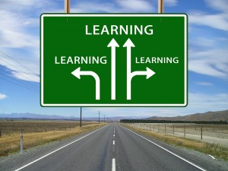
Learning

Reading Strategy
Readers check their understanding of a text while they read. One strategy is to stop a few times in the text to ask yourself: Can I answer any of the five W questions: who, what, where, when, or why? If you are able to answer at least three of these questions, then you are thinking about what you are reading.
Try this strategy as you read The Many Pathways to Knowledge.

Vocabulary

Find these words in the text. Use the context to choose the best meaning.
decade | factors | affect | learning disability | dread
exercise | peer | clumsiness | pace | approach
1. A condition that makes learning difficult is called a ___________________________.
2. ___________________________ means moving in a way where you might drop or break things.
3. A ___________________________ is one of the things that cause something to happen.
4. ___________________________ refers to activity that is done to be healthier.
5. Another word for 10 years is a ___________________________.
6. ___________________________ is the speed at which something happens.
7. ___________________________ means to act on or cause a change in someone or something.
8. ___________________________ means to fear that something will happen.
9. A person in the same age group or social group can be called a ___________________________.
10. An ___________________________ is a way of dealing with something.
Check your work with the Answer Key at the end of this chapter.

Check your Understanding

1. Read the sentences below. Which group of sentences best describes the main idea of the text?
a. Barbara Arrowsmith-Young taught herself to tell time, do math, understand grammar, and be less clumsy.
b. Geniuses aren’t born being great at something. They become geniuses through practice. People with learning disabilities can also be great at the thing they struggle with. They just learn in a different way and at a different pace.

2. Re-read the second paragraph. What is the main idea?

3. Put these events in the correct sequence.
a. After lots of practice, Barbara was able to do the things her brain was “unable” to do.
b. Barbara’s teachers said she had a learning disability.
c. Barbara made exercises to teach her brain to do the things it couldn’t.
d. Barbara struggled to learn many of the things taught in elementary school.
e. Barbara started a school to help others who learn in different ways.
f. As an adult, Barbara learned that people can change the structure of their brain through experience and exercise.

4. Try to think of the best word to complete each sentence.
a. Geniuses usually practiced their skill ___________________ hours a week for over a decade.
b. We will have a hard time learning if we do not get enough ______________________ food to eat.
c. Barbara’s teachers said she had a learning ______________________.
d. Barbara heard that people can change their brains through _________________ and ___________________.
e. She created exercises to teach herself to tell ________________________.
f. Afterward, she could also understand the rules of _____________________ and ____________________________.
g. We can change the ________________________ of our brains through practice.
Check your work with the Answer Key at the end of this chapter.

Spelling
Homonyms are two words that sound the same but have different meanings. Study these homonyms. Arrange a date to be tested on your ability to spell these words. One way to learn to spell words is to use memorable sentences. If you can remember which spelling goes with which homonym in these sentences, you can use the information to help you spell the homonyms correctly in other sentences.

Do these sentences use the correct homonym? If not, change them.
1. I wonder what the whether will be like today.
2. Can you put this box down over there?
3. It’s too late at night to practice playing my bagpipes.
4. All the unions decided that they’re going on strike.
5. My shirt is missing most of it’s buttons.
6. Does this medicine have any side affects?
7. The big flood in the town did not effect my house.
8. My parents are selling me their old car.
9. I don’t know weather I should drive in this snow.
Check your work with the Answer Key at the end of this chapter.

Apostrophes in Contractions

Grammar Rule
An apostrophe is used in place of the missing letter or letters in a contraction.
- We often think people are either born smart or they aren’t.
Aren’t = are not
- Intelligence is not something we either have or we don’t have.
Don’t = do not
- People who thought they couldn’t learn have found out they can.
Couldn’t = could not

Change the underlined words into contractions. Use apostrophes as needed.
1. We do not tend to remember our dreams unless we wake up during them.
2. It is easiest to learn a second language between the ages of 13 and 20 years old.
3. You will likely find that the best way to break a bad habit is to replace it with a new one.
4. Studies show that you should not stay up late cramming for a test because sleep is key to learning.
5. You would never be able to learn without neurons.
6. When a baby is 24 months old, she will know that the person in the mirror is herself.
7. A child who does not hear any words or language before 12 years old will not learn to speak.
8. Alan Turing was a computer scientist. In the 1950s, he came up with the Turing Test, a way to tell if a computer is intelligent. To do the test, you sit someone at a screen that is connected either to a computer or another person in a different room. The person chats and asks questions to discover whether they are talking to a computer or a person. If they cannot tell the difference, and it is a computer they are talking to, the computer can be called “intelligent.” Some people say that a computer passed the test for the first time in 2014.

Alan Turing
Check your work with the Answer Key at the end of this chapter.

Sentence Fragments
A complete sentence needs three things: a subject, a verb, and a complete thought. If a sentence is missing one of these, it is called a sentence fragment.

Grammar Rule
Sentence fragments are a common mistake in people’s writing.
- This sentence is missing a subject: Is the smallest country in the world.
Fixed: Vatican City is the smallest country in the world.
- This sentence is missing a verb: Mount Etna Europe’s tallest active volcano.
Fixed: Mount Etna is Europe’s tallest active volcano.
- This sentence is missing a complete thought: Average drivers spend two weeks of their life.
Fixed: Average drivers spend two weeks of their life waiting for traffic lights to change.

Are these complete sentences or fragments?
1. A boy.
2. Typed the English alphabet on an iPad.
3. In less than six seconds.
4. Astronauts say space has a unique smell.
5. Hit by lightning.
6. Barbie’s full name is Barbara Millicent Roberts.
7. Daniel Radcliffe wore 160 pairs of glasses while filming the Harry Potter movies.
8. An artist from Chicago.
9. Made a statue of Madonna using 180 pounds of ham.

What is missing from these sentence fragments — a subject, verb, or complete thought?
10. Is on Facebook.
11. The average Facebook user has.
12. Dyed his sheep bright orange to prevent theft.
13. Is 5 feet 11 inches.
14. A calf in Virginia.
15. Erin Finnegan and Noah Fulmor.
16. Was born with a five-foot long tail.
17. One in every seven people on Earth.
18. The average height of the Dutch.
19. 190 friends.
20. Over 70 species of mushrooms.
21. A British farmer.
22. Glow in the dark.
23. Became the first couple to get married in outer space.

24. Each sentence fragment above can be matched to another sentence fragment above to make a complete sentence. Find the fragments that go together to make a complete sentence. Use them to write a complete sentence.
Check your work with the Answer Key at the end of this chapter.

Writing
How-to paragraphs give directions. For example, this kind of paragraph might explain how to plant a tree, how to make a campfire, or how to send an email.
A how-to paragraph should:
- Begin with a topic sentence that says what task you are explaining
- Break the task down into small steps
- Explain each step clearly
- List the steps in the order the reader should do them
- Use linking words like first, then, next, after that, and finally

Below is an example of a how-to paragraph. Underline the topic sentence, the linking words, and the concluding sentence.
How to Trim a Dragon’s Toenails
People are often afraid to clip the toenails of a dragon, but it’s really not that hard. First, gather all the things you will need: nighttime tea, a tea cup, hedge trimmers, a bumpy rock, and some nail polish. Then, make the dragon a warm cup of nighttime tea. After the dragon drinks the tea, he will fall asleep. Next, pick up the hedge trimmers and carefully cut the top two inches of each toenail. After that, rub the rock back and forth over the edge of each toenail until it is nice and smooth. You may also wish to apply a coat of nail polish. Most dragons prefer red nail polish, but some dragons prefer purple. Finally, run away as fast as you can. The dragon will wake up soon, and you don’t want to be there when he does. Follow these steps and the dragon’s toenails will look fabulous!
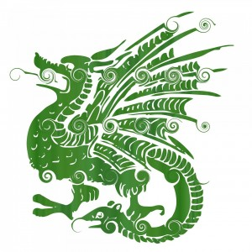
Green dragon
Check your work with the Answer Key at the end of this chapter.

Writing Task
Think about a challenge you have faced in your life, especially one you managed well. The challenge might be something practical, like changing a tire. The challenge may be something complex, like moving to a new country or coping with a divorce. Write a how-to paragraph to help someone who is facing the same challenge you faced.
Follow the TOWER method to write your paragraph. First, think of some challenges that you handled well. Choose one that you feel good writing about. Next, use the How To paragraph planner to brainstorm and organize your ideas. Then, write a first draft. Remember to include a topic sentence, linking words to smoothly connect each step, and a concluding sentence. Edit the paragraph with the help of your instructor and The Many Pathways to Knowledge paragraph planner checklist. After that, rewrite the paragraph. You may wish to type it on a computer. Finally, hand it in to your instructor.
Ask your instructor for copies of the paragraph planners, or print copies from the links above. For printable versions, see Appendix 1 and Appendix 2.
Did you notice that the above paragraph looks a lot like a how-to paragraph?

Attributions
Learning
Image by geralt is in the public domain.
Alan Turing
Allan Turing, Bletchley Park by Beyond My Ken is used under a CC BY SA 3.0 license.
Green dragon
Image by PublicDomainPictures is in the public domain.

4

Boost Your Brainpower

Learning Goals
In this chapter, you will learn to:
- Use pre-reading strategies
- Figure out unknown words while you read
- Build your vocabulary
- Understand the main ideas and details of a text
- Spell words with the suffixes -tion and -sion
- Use commas in a series
- Write compound sentences
- Write a descriptive paragraph

Get Ready to Read

Think about the questions below or discuss them with a partner.
- What things affect how well you learn?
- How do you deal with stress?
- How do you motivate yourself to try your best in school?
- What would your perfect classroom physically look like?

Reading

Reading Strategy
Readers check their understanding of a text while they read. When you struggle to figure out a word, don’t just skip it. Try this strategy instead. When you see a word you do not know, underline it. Go back and read the words before it. Then read the words after it. Now think of a word that would make sense in the spot that you underlined. Does it sound right? Does it make sense?
Try this strategy as you read Boost Your Brainpower.

Vocabulary

Find these words in the text. Use the context to choose the best meaning.
calories | concentration | oxygen | priorities | fluid
motivate | distraction | vision | fuel
1. _______________________ is something found in the air that is needed for life.
2. A _______________________ is something that makes it difficult to think or pay attention.
3. The ability to pay attention to one thing is called _______________________.
4. If you have _______________________, you have the ability to see.
5. _______________________ are used to measure the energy in food that gets released into the body.
6. _______________________ are the things that are most important and should be done first.
7. To _______________________ someone is to make them eager to work.
8. A liquid, or something that can flow like water, can be called a _______________________.
9. _______________________ is used to give power to something.
Check your work with the Answer Key at the end of this chapter.

Check Your Understanding

Match each detail to the main idea.
Main Idea | Details

Resting
Check your work with the Answer Key at the end of this chapter.

Spelling

A suffix is the end part of a word. Study these words ending in -tion and -sion. Arrange a date to be tested on your ability to spell these words.

One way to figure out how to spell a new word is to write down some possible spellings and see what looks right. Fill in the blanks with t or s based on what looks right.
1. deci____ion
2. emo____ion
3. pas____ion
4. instruc____ion
5. solu____ion
6. mis____ion
7. conclu____ion
8. educa____ion
9. televi____ion
10. addi____ion
Check your work with the Answer Key at the end of this chapter.

Commas in a Series

Grammar Rule
Commas can be used to separate items in a list. Look at how the comma is used in these sentences:
- Research suggests that some foods might be especially good for memory and concentration. Examples include: egg yolk, whole grains, nuts, fish, dark leafy green vegetables, beans, strawberries, and blueberries.
- Using a day planner will help you plan ahead, set priorities, be on time, and meet deadlines.
- Going for a walk, a run, or a bike ride really helps get oxygen to your brain.
- Reward yourself by doing something you enjoy like watching a TV show, talking to a friend on the phone, eating a treat, or taking a rest.
- Most brains have five senses: vision, hearing, smell, touch, and taste.
Notice that the comma does not go before the first word in the list. Also notice that the word “and” or “or” appears before the last item in the list. The comma goes before “and” or “or” but not after.

Add commas to the sentences below.
1. The brain needs food oxygen and water.
2. To help your brain remember the names of the Great Lakes, think of the word HOMES: Huron Ontario Michigan Erie and Superior.
3. People began performing brain surgery 7,000 years ago. Ancient Egyptians Romans Greeks Chinese Indians and Incas all performed brain surgery.
4. Emotions are an important part of survival: Fear tells you to run away from danger anger tells you to fight for your life and love creates a need for connection.
5. The brain has many chemicals that affect our feelings. Dopamine causes us to feel pleasure excitement pain and nausea.
6. Serotonin plays a role in feelings of happiness sleepiness and fullness.
7. Endorphins play a role in relaxation and reducing pain.
8. Noradrenaline can cause us to feel alert excited or anxious.
9. Oxytocin is the chemical that gets released in our brain when we fall in love.
Ask your instructor to help you pronounce the big words above. Check your work with the Answer Key at the end of this chapter.

Compound Sentences
A compound sentence is made by joining two complete sentences using a comma and one of these joining words: for, and, nor, but, or, yet, or so. To remember these joining words, think of the word FANBOYS.
For | Use to explain | , for
And | Use to add information | , and
Nor | Use to list items that are not options | , nor
But | Use to show contrast | , but
Or | Use to list options | , or
Yet | Use to add surprising information | , yet
So | Use to show cause and effect | , so

Combine the two complete sentences into one compound sentence. Replace the period with a comma and one of the FANBOYS (for, and, nor, but, or, yet, so).
1. The most commonly written word in the English language is “the.” The most commonly spoken word in the English language is “I.”
2. Today, it would be rude to wipe your dirty hands on a tablecloth. The original purpose of the tablecloth was for wiping your hands after eating!
3. Honey tastes delicious. It is the only natural food that doesn’t spoil.
4. You can see both the Atlantic and Pacific Oceans from the top of Mount Irazu on a clear day. The top of the mountain is usually very cloudy.
5. The ad for the first Ski-Dog snowmobile accidentally called it a Ski-Doo. The company changed the snowmobile’s name to match the ad.
Check your work with the Answer Key at the end of this chapter.

Writing
A descriptive paragraph helps your reader visualize the person, place, or thing that you are describing.
A descriptive paragraph should:
- Begin with a topic sentence that says what you are describing
- End with a concluding sentence that reminds the reader of the topic
- Appeal to the senses: sight, smell, touch, taste, and sound

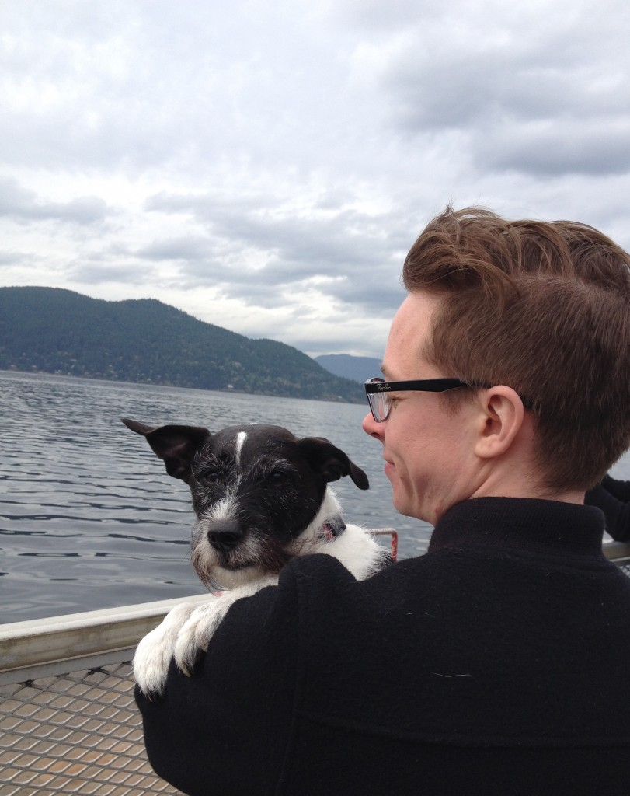
Author with Huckleberry

Identify the details in the descriptive paragraph above that appeal to these senses:
1. Sight:
2. Smell:
3. Touch:
4. Sound:
Check your work with the Answer Key at the end of this chapter.

Writing Task
Write a descriptive paragraph about your perfect classroom. Follow the TOWER method.
- Think about all the things that help you learn. Now imagine what a classroom would physically look like if it was perfectly set up to help you learn. Be creative. Write down all your ideas. Choose the ones you want to use. Think of some descriptive details that appeal to the senses.
- Organize your ideas. Decide what order you will include them in.
- Write your first draft. Include a topic sentence, your descriptive details, and a concluding sentence. Use linking words to show how the ideas are related. Linking words that are helpful for describing a place include:
- Edit your paragraph with the help of your instructor and the Boost Your Brainpower description checklist.
- Rewrite your paragraph. You may wish to type it on a computer. Finally, hand it in to your instructor.
Ask your instructor for a copy of the checklist, or print one from the link above. For a printable version, see Appendix 2.

Attributions
Reading
Image by JanDix is in the public domain.
Resting
Image by Prinz-Peter is in the public domain.

5

Memory Magic

Learning Goals
In this chapter, you will learn to:
- Use pre-reading strategies
- Ask questions to check your understanding while you read
- Build your vocabulary
- Understand the main ideas, details, and sequence of a text
- Add suffixes to words that end in silent e
- Use commas after transition words
- Identify and correct run-on sentences
- Write a narrative paragraph

Playing cards

Get Ready to Read

Think about the questions below or discuss them with a partner.
- Do you have a good memory? How do you know?
- What do you do to remember information?
- Describe a time when you really wanted to remember something but couldn’t.

Think about the title Memory Magic. Which of these words do you think will be in the text?
- attention
- circus
- senses
- focus
- hurricane
- short-term
- long-term
- bullfrog
- chunk
- visualization
- vampire

Reading Strategy
Readers check their understanding of a text while they read. One strategy is to ask questions while you read, and then look for the answers. What do you wonder when you read the sentence below?
Dave Farrow is a Canadian recorded in the Guinness Book of World Records for Greatest Memory.
You might wonder, “What did he do to set this record?” Continue reading with this question in mind. Asking questions and looking for answers helps keep your brain thinking while you read.
Try this strategy as you read Memory Magic.

Vocabulary

Find these words in the text. Use the context to choose the best meaning.
dyslexia | memorize | constantly | indigo
partner | recall | violet
1. ___________________ is a condition that makes it hard for a person to read, write, and spell.
2. ___________________ is a deep blue colour.
3. ___________________ is a deep purple colour.
4. A person someone is romantically involved with, runs a business with, or does an activity with is called their ___________________.
5. ___________________ means happening all the time or very often over a period of time.
6. To ___________________ is to learn something so well that you can remember it perfectly.
7. ___________________ means to remember something.
Check your work with the Answer Key at the end of this chapter.

Check Your Understanding
1. What’s the main idea of paragraph four?
2. What’s the main idea of paragraph five?
3. What’s the main idea of paragraph six?

4. How does the brain remember information? Put these steps in order.
a. The information goes into your short-term memory.
b. You think about the information over and over.
c. Your brain takes in information through your senses.
d. The information goes into your long-term memory.
e. Your brain pays attention to the information.

Something is incorrect in each of these sentences. Cross out the incorrect words. Add the correct words.
5. Your long-term memory only holds information for a few seconds.
6. Your short-term memory can hold about 15 things at a time.
7. Dave recommends breaking big tasks into smaller tasks, working hard for short periods of time, and taking short breaks to help your mind remember.
8. Roy G. Biv stands for red, orange, yellow, green, brown, indigo, and violet.
9. The text suggests that you memorize an address or vocabulary words in chunks.
Check your work with the Answer Key at the end of this chapter.

Spelling
If a word ends with silent e, drop the e before an ending that starts with a vowel.
become + ing = becoming
choose + ing = choosing
amaze + ing = amazing
share + ed = shared
Keep the silent e before an ending that starts with a consonant.
late + ly = lately
safe + ty = safety
use + ful = useful
sincere + ly = sincerely
These words break the rules:
argue + ment = argument
true + ly = truly

Arrange a date to be tested on your ability to spell these words.

Practice the pattern. Spell each word correctly after adding the suffix to the word.
1. write + ing
2. come + ing
3. care + ful
4. wise + ly
5. change + ing
6. use + less
7. surprise + ing
8. hope + ful
9. safe + ly
10. make + ing
11. excite + ment
12. have + ing
13. drive + ing
Check your work with the Answer Key at the end of this chapter.

Commas with Transition Words

Grammar Rule
Commas can set off transition words from the rest of a sentence. Here are some common transition words:
To add information | First, second, third, next, then, finally
To give an example | For example, for instance, in fact
To summarize | In conclusion
Here is an example from the text you read:
First, create a picture in your mind for each stage (I can see a worm, a fish, a monkey, a human). Then, think of a path you regularly walk along. For example, I often walk from the sidewalk, into my house, and into the kitchen. Finally, imagine each picture in a place along your path.

Fill in the commas in the paragraph below.
Are humans smarter than other animals? Well there are a lot of things that only humans can do. First we can survive in all sorts of environments. In fact we can survive in extreme environments like the desert, the Arctic, and outer space. Second we can write down information, so that it can easily be shared with lots of people. Third we can make art, stories, poetry, and music. Finally we can invent really complicated things. For example we can build airplanes and computers. In conclusion humans may be the smartest animal in the world.
Check your work with the Answer Key at the end of this chapter.

Run-On Sentences

Grammar Rule
When two sentences are combined without a comma or one of the FANBOYS (for, and, nor, but, or, yet, so), the result is a run-on sentence. Run-on sentences are a common sentence writing error.
- Run-on: Memory champions need to hold lots of information in their short-term memory at one time, they use different tricks.
What’s wrong: It’s missing one of the FANBOYS.
Fixed: Memory champions need to hold lots of information in their short-term memory at one time, so they use different tricks.
- Run-on: The words Roy G. Biv can help you remember the colours of the rainbow for each word stands for the first letter of a colour.
What’s wrong: It’s missing a comma.
Fixed: The words Roy G. Biv can help you remember the colours of the rainbow, for each word stands for the first letter of a colour.
- Run-on: Short-term memory can only hold about seven things at one time organizing information in chunks allows you to remember more.
What’s wrong: It’s missing a comma and one of the FANBOYS.
Fixed: Short-term memory can only hold about seven things at one time, but organizing information in chunks allows you to remember more.
The examples above showed you how to turn a run-on sentence into a compound sentence. You can also fix a run-on sentence by turning it into two simple sentences. Instead of a comma and one of the FANBOYS, you just use a period. Below are some examples:
- Memory champions need to hold lots of information in their short-term memory at one time. They use different tricks.
- The words Roy G. Biv can help you remember the colours of the rainbow. Each word stands for the first letter of a colour.
- Short-term memory can only hold about seven things at one time. Organizing information in chunks allows you to remember more.

Turn each run-on sentence into a compound sentence.
1. People say this diamond is cursed for all its owners have suffered illness or death.
2. Tim Horton was a hockey player in the NHL he is better known for his donut shops.
3. There are over 1,000 kinds of bees all over Canada some can even be found in the Arctic.
4. My phone isn’t charged I need to plug it in.
5. We could fly to Calgary or we could get there by bus.

Turn each run-on sentence above into two simple sentences.
Check your work with the Answer Key at the end of this chapter.

Writing
A narrative paragraph tells a story. It should:
- Have a beginning, middle, and end
- Include details about:
  - Who is in your story
  - What happened
  - Where it happened
  - Why it happened
  - How it happened

- Tell the events in the order they happened
- Use linking words to connect your sentences: first, then, next, finally
Below is an example of a narrative paragraph.
The Bus Ride Home
The bus ride home from school usually started out well enough. First, the bus would happily rumble from pothole to pothole down the winding country roads. On a hot summer day, all the windows would be down, blowing the children’s hair wildly in all directions. The kids all seemed to talk at once in their outdoor voices. There was only one thing that could quiet them down. The bus would turn around a big bend as we neared my house. Next, the sweet and sour stink of pig manure would pour through the windows. The excited chatter turned into groans of disgust. Then the bus would screech to a standstill at the end of my laneway, as though the smell was so thick the bus couldn’t bear to carry on. Finally, my brother and I would have to stand up and walk past the rows of eyes scowling at us from above shirt collars that had been yanked up over offended noses. The two of us would walk down our long dirt laneway in silence. Only one thought brought me comfort in that moment: the smell of pig manure was nothing compared to the smell of chicken manure that awaited that bus farther down the road.

School bus

Writing Task
Smells have the power to bring back strong memories. The part of our brain in charge of memory is very close to the part of our brain that processes smell. Tell a story about a smell that really stands out in your memory. Follow the TOWER method:
- Think of all the memories involving smell that come to mind. Choose the one that you think will make the best story. Think of who the story involved, what happened, where it happened, and why it happened.
- Organize the details into a beginning, middle, and end.
- Write your first draft. Include a topic sentence, the details, linking words, and a concluding sentence.
- Edit your paragraph, with the help of your instructor and the Memory Magic story checklist.
- Rewrite your paragraph. You may wish to type it on a computer. Finally, hand it in to your instructor.
Ask your instructor for a copy of the checklist, or print one from the link above. For a printable version, see Appendix 2.

Attributions
Playing cards
Image by gepharts3d is in the public domain.
School bus
Image by richoz is in the public domain.

6

Put to the Test

Learning Goals
In this chapter, you will learn to:
- Use pre-reading strategies
- Describe the tone of a text
- Build your vocabulary
- Understand the main ideas, details, and sequence of a text
- Make inferences
- Spell words with the prefixes pre- and ex-
- Use punctuation marks in direct quotations
- Write complex sentences
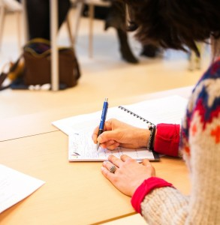
Writing

Get Ready to Read

Think about the questions below or discuss them with a partner.
- Agree or disagree: Tests should be banned from schools.
- What tips would you give to a friend who is about to take a test?

Think about the title Put to the Test. Which of these words do you think will be in the text?
fridge | luck
underwear | tuba
eyelid | section
time | marathon
instructions | reading
Paris | writing

Reading Strategy
Readers check their understanding of a text while they read. One strategy is to think about tone. Tone refers to the attitude of the writer. For example, a writer’s attitude can be playful, serious, happy, sad, supportive, or hurtful.
Try this strategy as you read Put to the Test. How would you describe the tone of this text? Why?

Vocabulary

Find these words in the text. Use the context to choose the best meaning.
independent | plenty | enough | comprehension
temples | backup plan | marathon
1. A running race that lasts a long time is called a ___________________________.
2. ___________________________ means the ability to understand.
3. ___________________________ means doing something without help.
4. ___________________________ means equal to what is needed.
5. ___________________________ means lots of something; a number of something that is enough.
6. Something that can be done if the first plan doesn’t work is called a ___________________________.
7. The small flat areas on the sides of your forehead are called ___________________________.
Check your work with the Answer Key at the end of this chapter.

Check Your Understanding

1. Re-read paragraph three. What is the main idea of this paragraph?

2. Put these events in order.
a. Put your name on it.
b. Do your best on every question.
c. Make sure you answered every question and used correct grammar and spelling.
d. Take care of your basic needs.
e. Look over the whole test to see how many marks each section is worth.
f. Read the instructions and questions carefully.
g. Study the types of questions often found on reading and writing tests.

Runner

Answer these questions in complete sentences.
3. What sections in a test should you spend the most time on?
4. How is writing a test like running a marathon? How is it different?
5. What is positive self-talk?
6. The text strongly recommends doing two things that students often forget to do. What are the two things?

Make an inference to answer these questions. An inference is an educated guess.
7. Why do you think positive self-talk works?
8. Why do you think students often skip pre-reading and pre-writing exercises?
Check your work with the Answer Key at the end of this chapter.

Spelling
Study these words. The prefix pre– means “before.” The prefix ex– means “out of” or “from.” Arrange a date to be tested on your ability to spell these words.

One way to learn to spell new words is to look at one closely, cover it up, try to spell it, and then check it. Try this strategy below.
1. prepare _____________________________________________
2. preview _____________________________________________
3. prepaid _____________________________________________
4. preheat _____________________________________________
5. prefer _____________________________________________
6. example _____________________________________________
7. express _____________________________________________
8. excuse _____________________________________________
9. exercise _____________________________________________

Direct Quotations
Quotation marks are used to show that the words inside them are the exact words that someone said, thought, or wrote.
Below is an example from the text:
Some runners use positive self-talk when they are struggling. They tell themselves things like, “I feel good about myself and my abilities. I am not going to worry. I will do the best that I can.”
Notice that a comma follows the word right before the quotation. The end punctuation goes inside the last quotation mark.

Fill in the missing quotation marks, commas, and end punctuation in the sentences below.
1. A parrot named Alex was the first animal to ask a human a question about himself. Alex asked What colour am I
2. When Alex got bored of working with his trainer, he would say Wanna go back!
3. The night before Alex died, he spoke his last words to his trainer. He said Be good. Good night. I love you
4. Koko is a gorilla who can speak a form of American Sign Language. She knows about 1,000 signs and has the ability to create logical words for things she doesn’t know the name of. For example, for ring she said finger bracelet and for mask she said eye hat
5. There was a seal named Hoover who lived in an aquarium. Hoover said How are ya to some visitors. To other visitors he said Get outta here!
6. An elephant named Batyr learned 20 different phrases. He could say Batyr is good He could also say Batyr is hungry
Check your work with the Answer Key at the end of this chapter.

Complex Sentences

Grammar Rule
- You have learned that a compound sentence is made by joining two complete sentences. On the other hand, a complex sentence is made by joining one complete sentence with a sentence fragment. Together, they make one complete sentence.
- You can put the two parts in whatever order you prefer. Below are two correct complex sentences:
  - Before you hand in your test, you should review your answers. or
  - You should review your answers before you hand in your test.

- Both sentences are made of a sentence fragment (“Before you hand in your test”) and a complete sentence (“You should review your answers”).
- If you put the fragment first, follow it with a comma. If you put the fragment last, do not use a comma.
- Fragments often begin with one of these words:
after | although | as | because
before | even if | even though | if
in order to | since | so that | unless
until | when | while

Read each complex sentence below. Insert commas as needed. Remember that not all complex sentences need a comma.
1. If you want breakfast in bed you should sleep in the kitchen.
2. To escape a black hole you must go faster than the speed of light.
3. After a spider web has collected dust it becomes a cobweb.
4. The Ski-Doo cost $900 when it first came out in the 1950s.
5. Until 1920 people in British Columbia drove their cars on the left side of the road.
Check your work with the Answer Key at the end of this chapter.

Look at the sentence fragments below. Use your own ideas and the rules you have learned to turn them into complex sentences.
1. If you want to wake someone up really quickly.
2. When riding on the bus.
3. When I was five years old.
4. Until the day I die.
5. Before you buy a lottery ticket.

Look at the complete sentences below. Use the word in brackets and your own ideas to turn them into complex sentences.
1. I love long car rides. (unless)
2. A dog can be a person’s best friend. (although)
3. I was about to pay the bill. (when)
4. I filled the birdfeeder with seeds. (before)
5. The seal watched me from the water. (while)
Ask your instructor to check your work.

Writing

Writing Task
Life tests us in many ways. There are school tests, drivers’ tests, and job interviews. Then, there are situations that test our patience, our love, our loyalty, and our beliefs. What words of wisdom and encouragement have helped you make it through life’s tests? Fill in the Inspiring Words worksheet. Use quotation marks correctly.
Ask your instructor for a copy of the worksheet, or print one from the link above. For a printable version, see Appendix 1.

Attributions
Writing
Image by aafjevandehulsbeek is in the public domain.
Runner
Image by tpsdave is in the public domain.

7

The Sixth Sense: Intuition

Learning Goals
In this chapter, you will learn to:
- Use pre-reading strategies
- Make predictions to check your understanding of a text
- Build your vocabulary
- Understand the main ideas, details, and sequence of a text
- Draw conclusions about characters’ emotions
- Add suffixes to 1-1-1 words
- Use commas in place names and dates
- Edit for subject-verb agreement
- Write a narrative paragraph

Glass ball

Get Ready to Read

Think about the questions below or discuss them with a partner.
- Describe a time when you had a gut feeling that was either right or wrong.
- Do you think people should trust their gut feelings?
- Do you think some people can predict the future?

Reading Strategy
Readers check their understanding of a text while they read. One strategy is to make predictions while you read. For example, read the first paragraph of The Sixth Sense: Intuition.
A fire broke out in the kitchen of a house in Chicago, Illinois. A team of firefighters kicked down the door of the house. They stood in the living room as they sprayed water at the fire in the kitchen. Strangely, the fire would not go out. One of the firefighters had a feeling that something was very wrong. “Get out, now!” he ordered. The team ran out of the house. Moments later, the floor they had been standing on in the living room collapsed.
Predict why the floor collapsed. Predict how the firefighter knew to get his team out of the house. Then read on to see if your predictions were correct. This strategy helps you actively think about what you are reading, to build a deeper understanding.
Use this strategy as you read The Sixth Sense: Intuition.

Vocabulary

Find these words in the text. Use the context to choose the best meaning.
order | collapse | unusually | reputation | shortcut | inferior
reason | valued | spiritual | bias | accurate
1. A quicker and easier way to get someplace or do something is called a _____________________.
2. A tendency to unfairly think of some things are better than others is called a _________________.
3. _____________________ means to break apart or fall down suddenly.
4. Something is _____________________ if it is free from mistakes or errors.
5. _____________________ means in a way that is not normal.
6. _____________________ means less in quality or importance.
7. _____________________ describes things related to the human soul.
8. _____________________ is the power of the mind to think and understand in a logical way.
9. A _____________________ is the way people think about something or someone.
10. Something that is _____________________ is thought of as important.
11. _____________________ means to tell someone to do something.
Check your work with the Answer Key at the end of this chapter.

Check Your Understanding

1. Which of these sentences summarizes the main idea?
a. Firefighters use intuition to decide if a situation is safe.
b. Intuition is not as useful as reason when making decisions.
c. Intuition is a useful ability of the human brain that we should use in balance with reason.

Answer these questions using complete sentences.
2. What is intuition?
3. What is the main idea of paragraph six?
4. What is the main idea of paragraph seven?
5. How did the firefighter explain why he knew to get out of the burning house?
6. How did the researcher explain why the firefighter knew to get out of the burning house?
7. Find three synonyms for intuition used in the text.
8. What did scientists think of as better than intuition?
9. What different ways of knowing in First Nations cultures are mentioned in the text?
10. How do you think the firefighter felt when he saw the floor of the house collapse?
Check your work with the Answer Key at the end of this chapter.
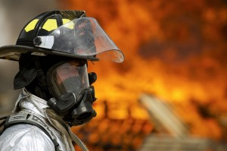
Firefighter

Spelling
A 1-1-1 word is a word that has one syllable, one vowel, and ends with one consonant. Always double the consonant before adding a suffix to a 1-1-1 word.
Examples of 1-1-1 Words
run | running
stop | stopping
trip | tripping
drop | dropping
clap | clapping

Study these words. Arrange a date to be tested on your ability to spell these words.
1. getting
2. putting
3. planned
4. sunny
5. hunter
6. loaded
7. sharpest
8. baggage
9. shipping
10. leader

1. One way to learn new words is to look for patterns. Which of these words are 1-1-1 words and which are not? Make two lists. Try not to look at the list above.
lead | sharp | put | load | get
ship | bag | sun | plan | hunt
1-1-1 Words | Not 1-1-1 Words

Spell each word correctly after adding the suffix. Try not to look at the spelling list.
2. lead + er = ________________________
3. sharp + est = ________________________
4. put + ing = ________________________
5. load + ed = ________________________
6. get + ing = ________________________
7. ship + ing = ________________________
8. bag + age = ________________________
9. sun + y = ________________________
10. plan + ed = ________________________
11. hunt + er = ________________________
Check your work with the Answer Key at the end of this chapter.

Commas with Place Names and Dates

Grammar Rule
- Use a comma between the name of a city and the name of a province or state.
Example: A fire broke out in the kitchen of a one-storey house in Chicago, Illinois.
- Use a comma between the name of a province and the name of a country.
Example: Over 4 million people live in British Columbia, Canada.
- Use a comma between the day and the year in a date.
Example: The fire broke out on March 6, 1998.

Fill in the commas in the sentences below.
1. There is a place called Intuition Peak in South Shetland Islands Antarctica.
2. Carl Jung was born on July 26 1875. During his life, he developed a theory that we are all born with memories from our ancestors.
3. Jung died on June 6 1961. He died in Zurich Switzerland. Since then, his idea has been proven wrong.
4. Sigmund Freud was born on May 6 1856. He spent most of his life in Vienna Austria. He studied the human mind. He thought he could help people with their mental problems by studying their dreams.
5. Freud died on September 23 1939. He died in London England.
Check your work with the Answer Key at the end of this chapter.
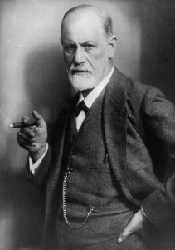
Sigmund Freud

Subject-Verb Agreement
You have learned that subject refers to the people, places, or things that do the action in a sentence. In this lesson, you’ll study how verbs must agree with their subjects.
There is a popular blog on the Internet called “I Can Has Cheezburger?” The blog is full of pictures of cats using grammar in ways that might make your instructor cringe. The cats tend to use verbs that do not agree with their subjects. For example, this cat says, “I are serious cat” instead of “I am a serious cat.”

Serious cat
Unless you are writing for this blog, use the verbs “be” and “have” correctly. Here’s a quick review:

Grammar Rule
Be (Simple Present) |  |  | Be (Simple Past)
I | am |  | I | was
You | are |  | You | were
He/She/It | is |  | He/She/It | was
We | are |  | We | were
They | are |  | They | were

Have (Simple Present)
I | have
You | have
She/He/It | has
We | have
They | have

Choose the verb that agrees with each subject.
1. These words have/has no rhymes: diamond, skeleton, silver, and month.
2. A butterfly have/has the ability to taste with its feet.
3. Elephants is/are the only land animals that can’t jump.
4. Mohammed is/are the most common name in the world.
5. Station wagons was/were replaced by mini-vans and SUVs.
6. The umbrella was/were invented in Africa as a way to protect people from the sun.
Check your work with the Answer Key at the end of this chapter.

Baby elephant

Grammar Rule
- Sometimes there are words between the subject and the verb. These words often trick people into using the wrong verb form.
  - People in Japan has the highest life expectancy in the world.
  - People in Japan have the highest life expectancy in the world.

Underline the subject in each sentence. Choose the verb that agrees with the subject.
7. Couples who marry in January, February, and March have/has the highest divorce rates.
8. The cherry trees on my street is/are so beautiful.
9. The eyes of a chameleon is/are able to move in two different directions at the same time.
10. The kitten with the big green eyes was/were the cutest.
11. The cookies on the kitchen counter wasn’t/weren’t actually for you.
Check your work with the Answer Key at the end of this chapter.

Writing

Writing Task
Choose one of the writing tasks below:
1. People often report having feelings or dreams that predict or warn them about a future event. For example, the firefighter in the text you read knew he needed to get his team out of the house, even though he didn’t know why. Moments later, the floor they were standing on collapsed. Have you ever had a gut feeling like this? Write a paragraph telling the story of what happened.
2. There’s an old saying that goes, “You can’t believe everything you think.” Tell the story of a time when you thought something was true, but it turned out to be completely wrong.
Follow the TOWER method:
- Think of experiences you have had that fit the writing task you have chosen. Decide which one will make the best story. Think about who was involved, what happened, where it happened, and why it happened.
- Organize your ideas into a beginning, middle, and end.
- Write a first draft. Include a topic sentence, details, linking words, and a concluding sentence.
- Edit your work, with the help on your instructor and The Sixth Sense: Intuition story checklist.
- Rewrite your paragraph. You may wish to type it on a computer. Finally, hand it in to your instructor.
Ask your instructor for a copy of the checklist, or print one from the link above. For a printable version, see Appendix 2.

Attributions
Glass ball
Image by FeeLoona is in the public domain.
Firefighter
Image by skeeze is in the public domain.
Sigmund Freud
Image by skeeze is in the public domain.
Serious cat
Serious cat by brownpau is used under a CC BY 2.0 license.
Baby elephant
Image by designerpoint is in the public domain.

8

The Big Five: Personality

Learning Goals
In this chapter, you will learn to:
- Use pre-reading strategies
- Set a purpose for reading
- Build your vocabulary
- Understand the main ideas and details of a text
- Draw conclusions
- Spell words with the suffix -ous
- Use commas with appositives
- Edit for shifting verb tense
- Write a descriptive paragraph

Personality

Get Ready to Read

Think about the questions below or discuss them with a partner.
- How do others see you?
- How do you see yourself?
- What do you like about your personality?
- If you could change one thing about your personality, what would it be?

Reading Strategy
Readers use texts for many different purposes. We read stories for enjoyment. We read the news to find out what is happening in the world. We read cookbooks to follow a recipe. We read instructions to find out how to put together or use something new. Before you read, think about your purpose for reading. It is easier to use a text when we know why we are using it. The next text you will read is called The Big Five: Personality. Below are some examples of purposes for reading this text:
- To find out more about your personality. As you read, you might ask yourself, “What words in this text describe my personality?”
- To learn what “the big five” are. As you read, you might circle the words that make up “the big five.”
- To find the vocabulary words and figure out what they mean.
- To enjoy yourself.
You may wish to re-read a text a few times, with a different purpose each time. This is a way to get as much information, enjoyment, and reading practice from a text as possible.
Try setting a purpose for reading The Big Five: Personality.

Vocabulary

Find these words in the text. Use the context to choose the best meaning.
upbringing | bossy | fussy | curious | unpredictable
practical | closed-minded | stubborn | genes
1. Someone who is _____________________ is able to deal with daily life in a way that makes sense.
2. Someone who is _____________________ is hard to please.
3. Someone who is _____________________ is not behaving as expected.
4. Someone who is _____________________ is not willing to listen to different ideas or opinions.
5. Someone who is _____________________ refuses to change their ideas or stop doing something.
6. Someone who is _____________________ tends to tell others what to do.
7. A _____________________ is the part of a cell that controls how a living thing looks and grows.
8. _____________________ refers to the way a child is raised.
9. Someone who is _____________________ wants to know about things.
Check your work with the Answer Key at the end of this chapter.

Check Your Understanding

Answer these questions in complete sentences.
1. What are the five factors researchers use to describe personality.
2. What is the advantage of being an introvert?
3. What is the advantage of being less agreeable?
4. What is the disadvantage of being open?
5. What is the disadvantage of being conscientious?
6. What is the advantage of being less sensitive?
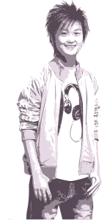
Teenager

Antonyms are words that have an opposite meaning. Find an antonym in the text for the words below.
7. open
8. extrovert
9. stubborn

Read the descriptions of each person below. Match the personality trait to each person.
open | conscientious | agreeable | introverted | sensitive
10. Lee always does her homework and is never late for school. She writes everything in black pen because she thinks blue looks too messy.
11. Tim loves his partner so much he could burst. He wrote a poem to express his feelings, but was so worried his partner would hate it that he tore it up.
12. On most Friday nights, you’ll find Juan in his pajamas reading a book. If the phone rings, he looks to see who’s calling. He won’t answer it unless it’s his best friend.
13. Sam likes to skateboard, fly kites, play the keyboard, and go bowling. He might join a soccer team next summer.
14. Frieda always greets the people she sees on the street. Once a week, she mows her neighbour’s lawn. Today, she lent her favourite book to a guy she met on the bus. She’s pretty sure she’ll get it back.
Check your work with the Answer Key at the end of this chapter.

Spelling
Study these words ending in –ous. The suffix –ous means “full of.” Arrange a date to be tested on your ability to spell these words.

One way to figure out how to spell a word is to sound out each syllable. Break up these words into their syllables.
1. various = ______ ______ ______
2. serious = ______ ______ ______
3. previous = ______ ______ ______
4. obvious = ______ ______ ______
5. curious = ______ ______ ______
6. famous = fa ______
7. nervous = ______ ______
8. generous = ______ er ______
9. dangerous = ______ ger ______
10. enormous = ______ nor ______
Check your work with the Answer Key at the end of this chapter.

Commas with Appositives

Grammar Rule
Extra information in a sentence is called an appositive. If you delete the appositive, you will still have a complete sentence.
Use a comma before and after the appositive.
Sentence | Sentence with extra information
Dave is easy-going. | Dave, my teacher, is easy-going.
My dog loves adventure. | My dog, a Jack Russell named Huck, loves adventure.
This book is interesting. | The Giver
If the appositive comes at the end of the sentence, only use a comma before the appositive.
Sentence | Sentence with extra information
This is my friend. | This is my friend, Raven.
Canada comes from the Mohawk word “kanata.” | Canada comes from the Mohawk word “kanata,” which means “village.”
She goes to Vancouver Community College. | She goes to Vancouver Community College, the biggest and oldest college in British Columbia.

Fill in the commas in the sentences below.
1. Many animals such as starfish and jellyfish survive without a brain.
2. Aristotle the world’s first great scientist thought that the brain’s only job was to keep the body from getting too hot.
3. A doctor in the 1790s Franz Joseph Gall believed he could figure out a person’s personality by studying the bumps on their head.
4. The corpus callosum which allows both sides of the brain to talk to each other is bigger in most musicians.
5. According to a popular personality test which is known as the Myers-Briggs Type Indicator there are 16 personality types.
6. The Rubik’s Cube which tests a person’s ability to visualize is the world’s best-selling toy.
7. Sign language which is based on the use of sight uses the same parts of the brain as language that is based on the use of sound.
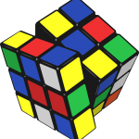
Rubik’s Cube
Check your work with the Answer Key at the end of this chapter.

Shifting Verb Tense
You have learned about some of the common errors to avoid in your paragraph writing: fragments, run-ons, and subject-verb problems. The final error explored in this book is the shifting verb tense.
When you write a paragraph, choose a verb tense and stick to it unless you have a good reason not to.

Look at the paragraph below. Does it begin in past, present, or future tense? What verb tense does it shift to for no reason? Rewrite the paragraph in one consistent verb tense.
Five Ways of Dealing with Conflict
Check your work with the Answer Key at the end of this chapter.

Writing

Writing Task
There are many personality tests that help people figure out what job would be a good match for them. Choose a job, such as doctor, parent, social worker, or server. Describe the kind of personality someone needs to succeed in this job.
Follow the TOWER method:
- Think about what jobs you might like to write about. Choose one. Brainstorm some of the qualities a person needs to be successful in this job. Try to use interesting vocabulary words.
- Organize your ideas. What details will you include? What order will you put them in?
- Write your first draft. Include a topic sentence, details, linking words, and a concluding sentence.
- Edit your paragraph, with the help of your instructor and The Big Five: Personality description checklist.
- Rewrite a final copy of your paragraph. You may wish to type it on a computer. Finally, hand it in to your instructor.
Ask your instructor for a copy of the checklist, or print one from the link above. For a printable version, see Appendix 2.

Attributions
Personality
Image by RyanMcGuire is in the public domain.
Teenager
Image by OpenClipartVectors is in the public domain.
Rubik’s cube
Image by OpenClipartVectors is in the public domain.
Turtle
Image by wjgomes is in the public domain.

9

Secrets of a Happy Brain

Learning Goals
In this chapter, you will learn to:
- Use pre-reading strategies
- Build your vocabulary
- Understand the main ideas and details of a text
- Spell words using the “i before e” rule
- Use apostrophes to show possession
- Write a personal letter

Happy

Get Ready to Read

Think about the question below or discuss it with a partner.
- What do you need to be happy?

Predict which of these things researchers say bring happiness:
- money
- friends
- fame
- power
- good looks
- exercise
- being kind
- being good at something

Reading Strategy
In this book, you have learned about many strategies for checking your understanding of a text while you read:
- Check if you can visualize what’s being described
- Check if you can retell the main idea in your own words
- Check if you can answer any of the five W’s: who, what, where, when, or why
- Check if you can figure out unknown words by using the words around them
- Ask questions as you read and see whether the text gives the answers
- Think about the tone of the text
- Make predictions and read on to check them
- Read with a purpose in mind
Choose one of these strategies to use as you read Secrets of a Happy Brain.

Vocabulary

Find these words in the text. Use the context to choose the best meaning.
positive | negative | immediate | ancestor | shelter
circumstances | psychologist | empathy | effective | meditation
1. A building that covers and protects people or things is called a _______________________.
2. A person who was in someone’s family in past times is called an _______________________.
3. A scientist who studies and treats the mind is called a ___________________.
4. _______________________ means good or useful.
5. _______________________ means happening or done without delay.
6. _______________________ means harmful or bad.
7. Something is _______________________ if it produces the result that is wanted.
8. _______________________ is the ability to understand someone’s feelings.
9. _______________________ is the act of spending time in quiet thought.
10. _______________________ are the conditions in which someone lives.
Check your work with the Answer Key at the end of this chapter.

Check Your Understanding
1. What is the main idea of this text?
2. What are the seven habits that make people happier?

Fill in the blanks for the sentences below.
3. When it comes to happiness, the quality of our friendships is more important than the ____________________ of friends we have.
4. Some research has shown that ____________________ can be as effective as medication in treating depression.
5. ____________________ is when we are so interested in an activity that we lose track of time.
6. ____________________ is a synonym for grateful.
7. Going to a place of worship or praying are two ways of practicing ____________________.
Check your work with the Answer Key at the end of this chapter.

Buddhist monk

Spelling
The i before e spelling rule says: use i before e except after c. Arrange a date with your instructor to be tested on your ability to spell these words:

One way to learn to spell new words is learn a rule and then remember which words break the rule. Sort the words into two lists. Which words follow the rule? Which words break the rule?
Rule Followers | Rule Breakers

Apostrophes in Possessive Nouns

Grammar Rule
- Use an apostrophe and s to write the possessive form of a singular noun.
The tree’s largest branch broke off in the wind.
- Use only an apostrophe to write the possessive form of a plural noun that ends in s.
The twins’ hobbies include chess and ping-pong.
- Use an apostrophe and s to write the possessive form of a plural noun that does not end in s.
The women’s bathroom is down the hall.

Fill in the apostrophes in the sentences below.
1. Some research suggests that the worlds happiest country is Denmark.
2. The part of the brain that allows you to speak is named after Pierre Paul Broca. It is called Brocas area.
3. As soon as a baby is born, it can tell the difference between its mothers voice and all other sounds.
4. Old peoples brains are usually smaller and lighter than young adults brains, but they still make new cells and work well.
5. Einsteins brain was smaller than average.
6. Taxi drivers in London spend up to four years studying all the streets and buildings in order to get their license. The taxi drivers hippocampus, the part of their brain used for remembering, is bigger than it is in most peoples brains.
Check your work with the Answer Key at the end of this chapter.

Writing

Writing Task
Being grateful is linked to being happy. Write a thank you letter to someone who has made a positive difference in your life. Let them know what they did and how it helped you.
Follow the TOWER method:
- Think about some of the people who have made your life better. Choose the one person you would most like to write about. Think of some examples of how they made a difference in your life.
- Organize your ideas. Which details will you include? Which ones will you leave out? What order will you write them in?
- Write a first draft. Follow the format for writing personal letters shown below. Common greetings include: Dear, To, or Hi. Common closings include: From, Sincerely, or Love.
- Edit your work, with the help of an instructor and the Secrets of a Happy Brain personal letter checklist.
- Rewrite your letter. You may wish to type it on a computer. Finally, hand it in to your instructor. You may also wish to give it to the person you wrote to!
Ask your instructor for a copy of the checklist, or print one from the link above. For a printable version, see Appendix 2.
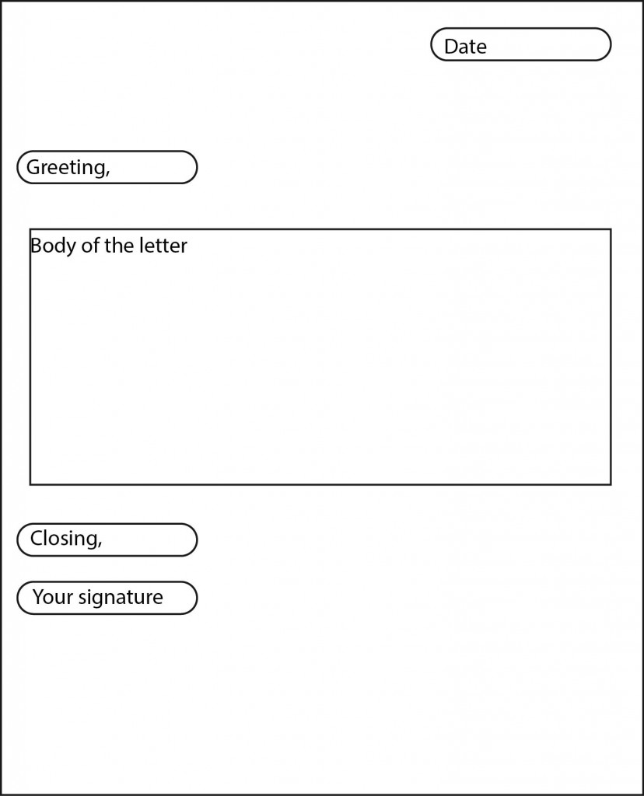
Personal letter

Attributions
Happy
Image by tpsdave is in the public domain.
Buddhist monk
Image by sciencefreak is in the public domain.

1

Appendix 1: Graphic Organizers
Below is a list of the graphic organizers and forms used in this book. These are convenient for students and instructors using the web version of this book.
- Back Up Your Opinion – worksheet
- How To – paragraph planner
- Inspiring Words worksheet – using quotation marks
- My Writing Assignments
Print-friendly versions of these same graphic organizers and forms are also provided on the following pages.

2

Appendix 2: Writing Assessment Checklists
Click on the links below for checklists that assess learners’ writing progress. Print-friendly versions of these same checklists are also provided on the following pages.
Checklist: The Many Faces of Genius
Checklist: The Many Pathways to Knowledge
Checklist: Boost Your Brainpower
Checklist: Memory Magic
Checklist: The Sixth Sense: Intuition
Checklist: The Big Five: Personality
Checklist: Secrets of a Happy Brain
Note: No checklist is necessary for The Most Amazing Structure on Earth as learners can check the Answer Key to see if they have put the sentences into the correct order. Likewise, no checklist is needed for Put to the Test. Simply check to make sure learners have used quotation marks correctly. You may also wish to give feedback on grammar.

3

Appendix 3: Level 5 Scope and Sequence
For detailed information on the contents of each chapter in this course pack, please refer to the Level 5 Scope and Sequence document. A print-friendly version is also provided on the following pages

4

Bibliography
Alexander, R. (Ed.). (2013). Ripley’s believe it or not! Special edition 2014. Orlando: FL: Ripley.
Beck, J. (21 October 2013). How to build a happier brain. Retrieved from: http://www.theatlantic.com/health/archive/2013/10/how-to-build-a-happier-brain/280752/
Davis, B., Sumara, D., & Luce-Kapler, R. (2000). Engaging minds: Changing teaching in complex times. 2nd ed. New York: Routledge.
Holford, K. (2012). 100 creative writing activities to promote positive thinking. Milton Keynes, UK: Speechmark.
Kluger, J. (Ed.). (2009). Your brain: A user’s guide. New York: TIME.
Loma Linda University School of Medicine. (n.d.). Test anxiety tips. Retrieved from: http://www.llu.edu/medicine/medical-student-education/resources/test-anxiety-tips.page
Morhan, N. (2007). Know your brain: Feed it, test it, stretch it. Boston, MA: Walker.
North Vancouver School District. (2004). Reading 44: Intermediate. North Vancouver, BC: Leo Marshall Curriculum Centre.
Public Broadcasting Service. (2009). This Emotional Life. Retrieved from: http://www.pbs.org/thisemotionallife/topic/happiness/what-happiness
Pursuit of Happiness, The. (2015). Positive psychology and the science of happiness. Retrieved from: http://www.pursuit-of-happiness.org/science-of-happiness/
Romanek, T. (2004). Aha! The most interesting book you’ll ever read about intelligence. Toronto: Kids Can.
Salon, H. (2015). Dave Farrow: Mind over Memory. Retrieved from: http://www.cbn.com/700club/guests/bios/dave_farrow012909.aspx
Simpson, K. (2009). The human brain: Inside your body’s control room. Washington, D.C.: National Geographic.
Toegel, G. & Barsoux, J. (March 20, 2012). How to become a better leader. MIT Sloan Management Review. Retrieved from: http://sloanreview.mit.edu/article/how-to-become-a-better-leader/
VIA Institute, The. (2014). The VIA Institute on Character Classification of Strengths. Retrieved from https://www.viacharacter.org/www/Portals/0/Character%20Strengths%20Infographic.jpg
Walker, R., Woodward, J., Brown, S. & Morgan, B. (2012). Human body: A visual encyclopedia. New York: DK.
Watson, W., Beebe, L., Traison, N., Dixon, A., & Mathieson, S. Adult basic education intermediate grammar: Unit 1. Victoria, BC: Ministry of Advanced Education, Training & Technology.
Watson, W., Beebe, L., Traison, N., Dixon, A., & Mathieson, S. Adult basic education intermediate grammar: Unit 2. Victoria, BC: Ministry of Advanced Education, Training & Technology.
Watson, W., Beebe, L., Traison, N., Dixon, A., & Mathieson, S. Adult basic education intermediate grammar: Unit 3. Victoria, BC: Ministry of Advanced Education, Training & Technology.
Watson, W., Beebe, L., Traison, N., Dixon, A., & Mathieson, S. Adult basic education intermediate grammar: Unit 4. Victoria, BC: Ministry of Advanced Education, Training & Technology.
Watson, W., Beebe, L., Traison, N., Dixon, A., & Mathieson, S. Adult basic education intermediate grammar: Unit 5. Victoria, BC: Ministry of Advanced Education, Training & Technology.
Wilson, B. A. (1996). Wilson reading system instructor manual. Oxford, MA: Wilson Language Training.
Winston, R. (2010). What goes on inside my head? New York: DK.
Woodward, J. (2009). How to be a genius. New York: DK.

5

About the Author

Shantel Ivits is an instructor in the Basic Education Department at Vancouver Community College, on the unceded territories of the Musqueam, Squamish, and Tsleil-Waututh Nations.
Shantel has designed curricula for the National Film Board of Canada, the British Columbia Teachers’ Federation, and many community-based projects.
Over the past decade, they have taught in literacy programs, university bridging programs, an ESL academy, and K-12 public schools.
They hold a Bachelor of Arts in English Literature from Trent University, as well as a Bachelor of Education and a Master of Arts in Educational Studies from the University of British Columbia.
Shantel identifies as a queer and trans person with white settler privilege. Their goal as an educator is to help people build their capacity to reach their goals and create more socially just communities.
Shantel also enjoys raising awareness that “they” can be used as a singular pronoun!

