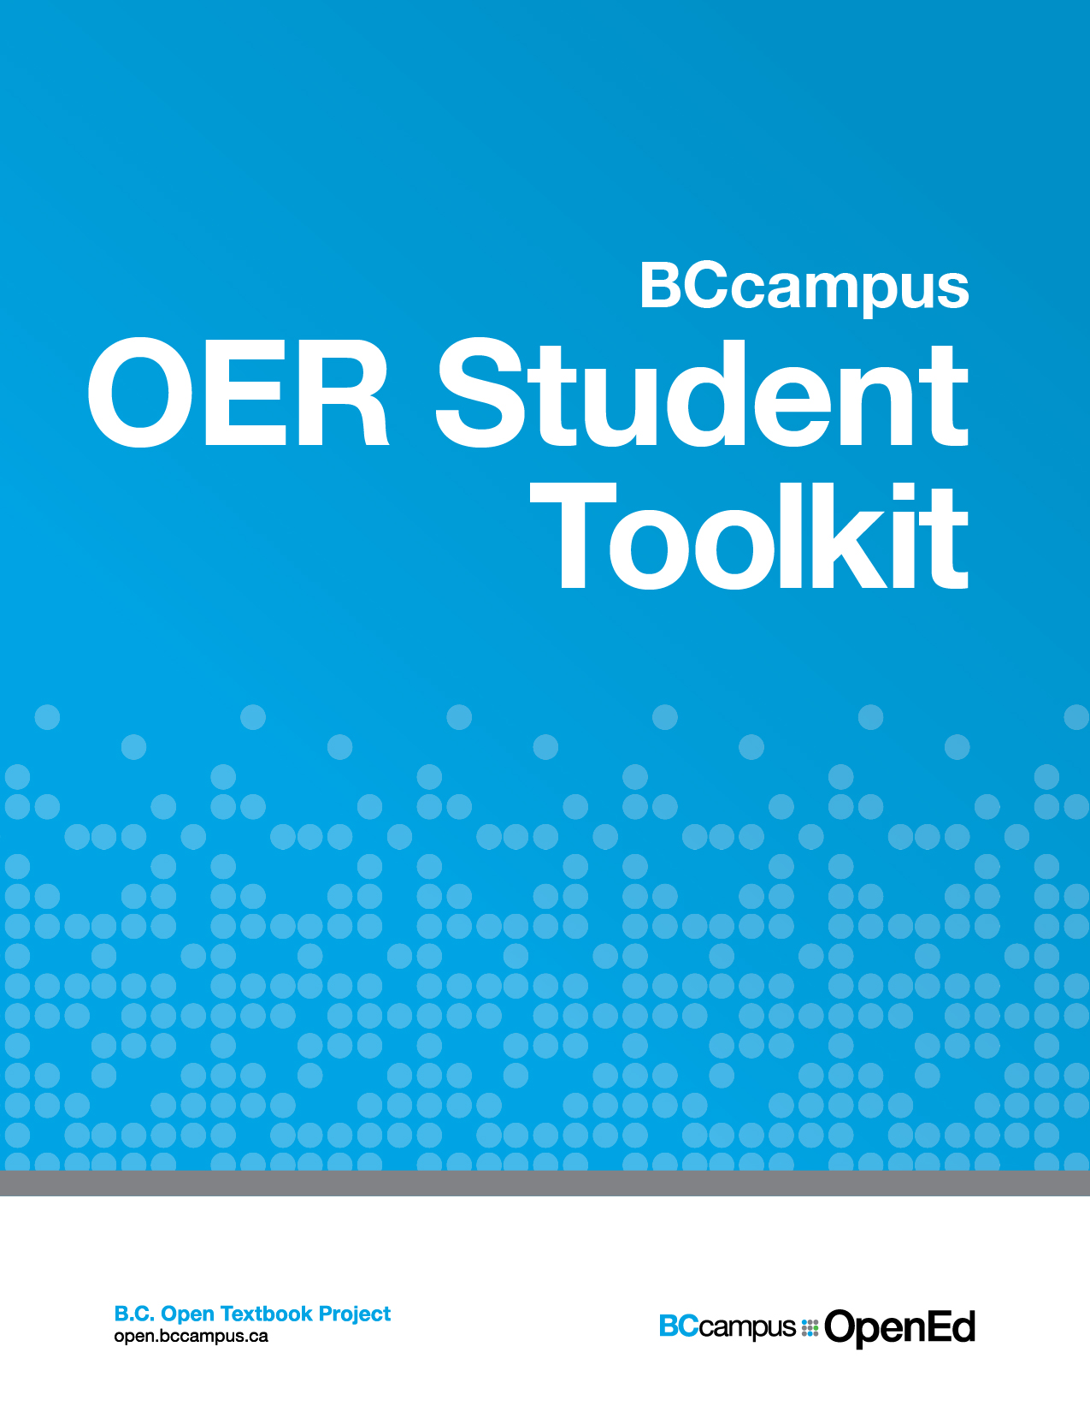

BCcampus OER Student Toolkit

BCcampus OER Student Toolkit

An Advocacy Guide for Student Leaders

Daniel Munro, Jenna Omassi, and Brady Yano

BCcampus

This document has been prepared by Daniel Munro, Jenna Omassi and Brady Yano. Content found within the document was inspired by Making Textbooks Affordable, Student Government Toolkit published by the Student Government Resource Center as well as the Open Educational Resources (OER) Guide for Students in Post-Secondary and Higher Education published by the Commonwealth of Learning.
Unless otherwise noted, this book is released under a Creative Commons Attribution 4.0 Unported License also known as a CC-BY license. This means you are free to copy, redistribute, modify or adapt this book. Under this license, anyone who redistributes or modifies this textbook, in whole or in part, can do so for free providing they properly attribute the book as follows:
by Daniel Munro, Jenna Omassi, and Brady Yano used under a
international license.
Additionally, if you redistribute this textbook, in whole or in part, in either a print or digital format, then you must retain on every physical and/or electronic page the following attribution:

If you use this textbook as a bibliographic reference, then you can cite the book as follows:

For questions regarding this licensing, please contact opentext@bccampus.ca. To learn more about BCcampus Open Textbook project, visit http://open.bccampus.ca
BCcampus OER Student Toolkit by BCcampus is licensed under a Creative Commons Attribution 4.0 International License, except where otherwise noted.

Contents
- Introduction
- Open Creation: In Progress
- Step One: What Are OER, Why Are They Important, and What are the Barriers to Adoption?
What Are OER, Why Are They Important, and What are the Barriers to Adoption?
- Step Two: What Already Exists On Your Campus?
- Step Three: How To Advocate On Your Campus
- Appendix A: Resources
Resources
- Appendix B: OER Repositories
OER Repositories
- Appendix C: #textbookbroke Information
#Textbookbroke Information

Introduction
The high cost of educational resources and textbooks create a serious obstacle to the accessibility and affordability of a post-secondary education. Traditional educational resources also present barriers to innovation in pedagogy and curriculum design. Fortunately, Open Educational Resources (OER) are a viable solution to both these problems, since they can be accessed for free online or printed at a fraction of the cost of a traditional textbook. They can also be edited to better fit the curricular or pedagogical goals of an instructor.
In British Columbia, OER have been funded by institutions such as the provincial government, a number of universities and colleges, and other organizations. Though there has been quite a concerted effort within the open community to promote the creation of open resources, widespread uptake at post-secondary institutions has not followed.
Student support and advocacy for OER is important to:
- ensure that OER gain or continue to build momentum on campuses,
- bring together community members, and
- push for the adoption and creation of resources.
This toolkit provides information on how interested student societies/associations as well as individual students can successfully advocate for greater OER adoption on campus. Primarily designed to serve post-secondary students in Canada working to support open education, we hope this toolkit will be useful to students from any country.
Greater OER adoption results in:
- an increase in the amount of student dollars saved,
- pedagogical benefits in the classroom, and
- benefits to society more broadly.
This toolkit explains the benefits of OER and provides guidance on how students can help promote OER adoption.

Open Creation: In Progress
This toolkit is currently in the open creation stage. Below is a list of the tasks left to complete.
- Review for completeness
- Add screenshots and images
- Add Style Guide
- Copy edit
- Review and complete Book Info page
- Export all file types
Last updated: October 14, 2016
All file types last exported: October 11, 2016

Chapter 1

Step One: What Are OER, Why Are They Important, and What are the Barriers to Adoption?

Step One

What Are OER, Why Are They Important, and What are the Barriers to Adoption?

What are OER?
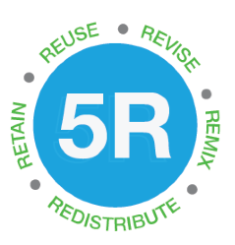
Open Education Resources (OER) can be any type of educational material: their scale varies from something as small as a class handout or image to something as large as a textbook or online course. While traditional course resources come with restrictive copyright laws, OER use open copyright licenses like Creative Commons. Depending on the creator’s desires, these licenses allow for different degrees of openness, and may restrict or preclude users from engaging in one or more of the 5Rs.
According to David Wiley’s definition of openness, OER are “licensed in a manner that provides users with free and perpetual permission to engage in the 5R activities:
- Retain – the right to make, own, and control copies of the content (e.g., download, duplicate, store, and manage)
- Reuse – the right to use the content in a wide range of ways (e.g., in a class, in a study group, on a website, in a video)
- Revise – the right to adapt, adjust, modify, or alter the content itself (e.g., translate the content into another language)
- Remix – the right to combine the original or revised content with other material to create something new (e.g., incorporate the content into a mashup)
- Redistribute – the right to share copies of the original content, your revisions, or your remixes with others (e.g., give a copy of the content to a friend)”

Why are OER important? Cost Savings.
For students already struggling to afford rising tuition and housing costs, the additional expense of textbooks can be a hurdle to accessing higher education. In a study conducted by Florida Virtual Campus in 2012, 65% of respondents indicated that they did not purchase textbooks at one point in their schooling due to cost. The same survey also indicated that 35% of students reduced their semesterly course load due to textbook cost and that 23% of students regularly forego purchasing textbooks due to cost alone. According to a Consumer Study conducted by NBC in 2015, from January 1977 to June 2015 textbook prices within the United States have risen 1,041%; this amount has risen over three times the rate of U.S. inflation.
While there are many short-term measures that students can use to save money on textbooks, such as buying or borrowing used materials, rental programs, or using e-textbooks and library reserves, none of these options are as innovative as OER. Open educational resources, like open textbooks, can decrease the cost of education because they are either free or low cost. Lower costs will result in students being less dependent on student loans and may even result in higher program completion rates. Greater open textbook adoption will therefore result in a more affordable, more accessible post-secondary education.
Because their license allows OER to be retained and reused, OER can also be accessed repeatedly throughout one’s degree, unlike online textbooks (or e-books) and course materials that require expensive access codes that expire when a course is finished. OER can therefore be used to enhance future projects or assignments or serve as supplementary reading later in one’s degree or post-graduation, promoting low-cost, lifelong learning that is not confined to the span of a course.
OER cost savings in action:
- BCcampus Open Textbook Project saved students over $350,000 in its first two years
- Introductory Physics students at the University of British Columbia saved $90,000 in one year
- In its first year, the UC Davis ChemWiki replaced traditional textbooks to save students $500,000 across four US campuses

Why are OER important? Pedagogical Benefits.
The many cost saving benefits of OER are matched by the equally important pedagogical benefits of open education.
One of the main teaching benefits is that, since open materials are fully revisable and remixable, they can be customized to fit the way an instructor wants to teach a course. When using static traditional resources that cannot be easily edited or combined due to copyright restrictions, instructors may be forced to teach their courses in a way that conforms to available resources, rather than teach the course in their ideal way. Using OER allows the freedom to revise material by removing irrelevant content or adding one’s own content, as well as the flexibility to combine parts of resources together, thereby ensuring materials are contextualized to a specific course.
Because anyone, including students, can be involved in the creation, revision, and distribution of OER, instructors can also use these resources to engage in “open pedagogy,” assignments that leverage OER to create more meaningful learning experiences. Traditionally, students work hard on assignments that will be handed in to their instructor, graded, and then never seen again. Instead, instructors might, for example, ask students to edit OER for redistribution, or have students openly license their own work for use by future students, thereby allowing their work to be shared with a more meaningful audience. This positions students as active participants in scholarly knowledge-sharing.
Open pedagogy in action:
- University of British Columbia students created and contributed to Wikipedia articles on Latin American literature and reached audiences in the hundreds of thousands
- Students at NC State University created instructional chemistry videos for other students, resulting in better lab performance than students instructed by TAs

Why are OER important? Knowledge Creation and Dissemination.
OER also provide benefits to members of communities beyond college and university campuses, allowing for knowledge creation and sharing outside the bounds of the traditional class and campus settings. It can be difficult for those outside of scholarly communities to access and participate in learning materials or research, and the creation of openly licensed research and teaching materials helps break down such barriers. This allows broader access to information and research, and broader participation in scholarship, helping universities to spread their core missions to society as a whole.
Open knowledge in action:
- A UBC video game law course invited members of the outside community to join in course discussions through an open course website
- Open data sets from governments, universities, businesses, and other organizations allow anyone to access and analyze information traditionally restricted to professional researchers

What are the Main Barriers to Adopting OER?
Research has shown there are many barriers to faculty and instructors adopting open educational resources. These include a mixture of true barriers and barriers caused by faculty perceptions of OER and open pedagogy. Students should keep the following list of barriers in mind when starting their own advocacy for OER; suggestions in Steps Two and Three of this toolkit attempt to address them.
- Not available or difficult to find. Faculty who are new to OER perceive knowing where to find relevant course materials, as well as the time involved in finding them, as barriers to adoption. It is thus important that institutions provide staff and library support for the adoption process, as well as incentives for faculty to spend extra time adopting OER.
- Perception of quality. Faculty are used to using traditionally published resources, and may be hesitant to adopt OER when they don’t know if they can trust their quality. However, those who have used OER often report their quality as equal to or better than traditional resources. The pedagogical benefits that come with the flexibility of OER should be emphasized in messaging to faculty, as these can contribute to improved perception.
- Traditional textbook package. Traditional textbooks often come with not just a book, but also with ancillary resources like online homework platforms or banks of exam questions. Faculty will be more likely to adopt OER if, in doing so, they can adopt both a textbook and a package of related materials.
- Institutional culture. Faculty may be reluctant to adopt OER if they perceive that they are alone in doing so, or that they are acting against the culture of their institution. Student advocacy should target not just faculty, but also university administrations who set strategic priorities and make decisions about what initiatives to fund. Showing broad support from the student body can also help to shift institutional culture.
- Not an individual decision. Often, the choice of which textbook to use in large courses is made by departments, not individual faculty members. This makes it more difficult for faculty to choose to adopt OER, because of competing interests and values of instructors. Working with faculty champions to speak to those instructors who may be reluctant to adopt OER can be successful to ensure widespread support. This can be effective in leveraging the support of instructors who are willing to do the work behind adoption.
For a more in-depth look at these issues:
- this blog post summarizes barriers from a faculty member’s perspective, and
- this research report from BCcampus studies many of these barriers, and includes links to many similar studies describing these barriers in detail.

Chapter 2

Step Two: What Already Exists On Your Campus?

How to start
When starting any new initiative as a student society, it is important to recognize that there are likely already faculty, staff, or librarians on your campus who care about an issue as much as you. This is also an issue that provides incentives and benefits to all groups on campus. Before starting to work on an OER campaign in isolation, an indispensable first step is to conduct a scan of the advocates and initiatives that already exist at your institution. This could include:
- Faculty who engage in open educational practices in their courses;
- Staff at teaching and learning centres who offer resources and professional development for faculty who wish to adopt open educational practices;
- Librarians who encourage faculty to adopt open resources in place of traditional ones;
- Administrators who are interested in making open education part of your university’s strategic goals.
If you already know of one or more such people, approach them and ask about the work they are doing, and ask them to connect you with other advocates. If you don’t know where to start, you might try reaching out to the broader OER network beyond your institution, as they likely have connections with advocates in your community. Regional organizations that have open education as part of their mandate (e.g. BCcampus, Campus Manitoba) can be a good place to start.
Once you have conducted this scan, some things to reflect on include:
- What is some work already being done that could use an extra boost? You may find that many advocates have ideas for things they want to start, but they need an extra boost that can come from students expressing their passion about an issue. Talk to these advocates to encourage them to get started implementing their ideas, and offer to help in any ways you can.
- Who needs to be brought together that is working alone? Students, especially student leaders, have access to people in all areas of the university, who may be working in silos. You may find that people in all areas have similar interests but are not working as closely together as they could, and one key role students can play is bringing all of these advocates together.
- After you consider the above, where are the remaining gaps? Once you have determined how you can augment and build upon existing work and ideas, you can look for the remaining gaps that you can fill by starting new projects and initiatives. The next section contains some ideas for that.

Chapter 3

Step Three: How To Advocate On Your Campus

For Student Societies and Student Leaders

Student-Facing Advocacy
#textbookbroke
One of the best ways to mobilize student voices in support of open education is to appeal to the fact that students spend too much money on textbooks each term. You can demonstrate wide student support and inform students about the high cost of textbooks through a campaign like #textbookbroke, a social media campaign that can be adapted to any institution.
This campaign involves asking students to take a photo showing how much they spent on their textbooks, then posting the photo on social media along with the hashtag #textbookbroke (or a variation of this hashtag, like #textbookbrokeBC). The photo could be taken as the student leaves their campus bookstore, or an image of their bookstore receipt could be posted online along with the hashtag.

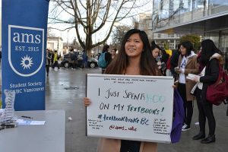
Image from UBC AMS #textbookbrokeBC campaign. See more at http://wiki.ubc.ca/Category:Open_AMS
The campaign raises awareness of the existence of open textbooks and OER, and starts the conversation surrounding the costs of educational resources and how they are used in the classroom. More information about the #textbookbroke campaign can be found in Appendix C of this toolkit.
Engage students in programming during events like Open Education Week.
Many universities hold OER-themed programming, like panel discussions or workshops, during Open Education Week or similar annual events. These are opportunities to involve students in programming that is normally only appealing to faculty and staff, ensuring that student opinions are heard. You might try to get students involved in event planning processes, ensure students participate in panels or presentations, or advertise events to your study body. This allows information to be shared with students that are involved, and student-centric messaging to be shared with those on your campus involved in OER promotion.
Ensure that your own resources and information is openly licensed and share with other student groups and societies.
It is great to talk the talk, but make sure to walk the walk as well. The open education community is very supportive, and we can only be successful if we work together and make our resources open. You can use open licenses for resources your student society creates and adapts, to ensure that you are supporting other student groups and societies in starting their own OER initiatives. An easy way to do this is using the Creative Commons Choose a License feature. Make sure to look for existing resources you could adapt before creating your own.

Faculty-Facing Advocacy
Make faculty-facing advocacy a priority.
Instructors and faculty members are the ones who choose the educational resources they will be using in the classroom, so advocacy directed at faculty may be the best means for change. Having a good understanding of the pedagogical benefits of open and how to adopt and create OERs makes students able to provide instructors with the right information to support them in adopting OER and open practices.
Create opportunities for faculty engagement and professional development.
Many faculty have either never heard of OER or, even if they have, don’t know how to start using it in their courses. University teaching and learning centres and libraries often offer regular professional development workshops or events centered around themes related to improving teaching. Student leaders can encourage more content related to open education to be injected into these, and can join in their delivery to talk about what is important from the student perspective.
Encourage your institution to offer grants to faculty willing to redesign courses with OER.
Providing monetary support for faculty members willing to adopt OER as their primary course materials can incentivize greater adoption, and also shows that faculty thinking about adoption have institutional support behind them. For example, at Simon Fraser University (SFU) the Vice-President Academic Office made available a number of OER Grants valued at $5,000 which aim to support the adoption of OER in SFU courses. These are restricted to covering the costs of support for the faculty member through research assistants, persons with specific expertise, support for data collection and analysis, and travel for the dissemination of findings. Institutions should ensure that the focus includes both resources like textbooks but also ancillary materials that instructors often find as part of publishers’ packages.
Advocate for your library to make OER easily accessible in their catalogue.
Faculty are more likely to trust resources if their quality is assured by librarian approval. If your library can make resources like open textbooks available to find in their online, searchable databases, faculty will be more likely to adopt them. The UBC Library, for example, has an online research guide about open education, which includes a page about finding open textbooks in the UBC collections.
Encourage creation and adoption of OER through faculty promotion and tenure processes.
Investigate the processes for faculty promotion and tenure at your institution, and determine who is responsible for setting guidelines. Ask them to consider the use of open educational practices as one (among many) of the ways faculty can demonstrate commitments to quality teaching during the promotion and tenure process. Showing that you have faculty members who support this may help, and you might consider garnering this support by connecting with your institution’s union or association of faculty.

For Students more Broadly
There are many low-barrier ways that individual students can get involved in the open education movement, and student societies can encourage these activities within their student body.
Talk to your professors or instructors about open educational resources.
The final say about what resources will be used in a course usually lies with faculty, to whom students have unique, direct access. Some ways of doing this include:
- Show faculty students care about this issue by sharing your thoughts on high textbook costs or showing them you appreciate it when they use cheap or free alternatives. One easy way to do this is through anonymous midterm or end of term course evaluations that take place at many institutions.
- Tell faculty about open education that you think may be interested. If you know of any examples of OER that would be useful in a course you have taken, tell the instructor about it. You can also refer them to resources or OER repositories (see below), or share stories of other faculty adopting OER at your institution.
Create open content yourself.
Students can choose to publish their own work under an open license as well:
- See this open publishing guide developed by SPARC’s Right to Research Coalition for some suggestions and guidelines.
- Students can use platforms like flickr to upload photos and images they have created under open licenses, including content they may have created as part of their courses.
- Many institutions also have local opportunities for students to publish their work, often in student-led, open access journals. Students can seek out these opportunities, and student leaders can help promote them widely.
Pass this resource on to your student society.
As a member of your institution’s scholarly community you can have a lot of influence over the way in which you create content and experience teaching and learning. However, you can have much more support by working with the student society that represents you to advocate for OER, and by doing so you can ensure that it is a priority for more students. This resource is meant for you as a student, and for groups and societies, so make sure to pass it along, or adopt it for your own context.

1

Appendix A: Resources

Appendix A

Resources
http://www.opencontent.org/ has various resources and articles that serve as a good introduction to OER and their benefits.
University of British Columbia Alma Mater Society’s OER website, which includes graphics other student societies can reuse and adapt: www.ams.ubc.ca/OER.
Learn more about how open licensing works at www.creativecommons.org.
Learn more about the BC Open Textbook Projects at open.bccampus.ca

2

Appendix B: OER Repositories

Appendix B

OER Repositories
Since the field is constantly growing, this list provides a small sample of the open resources and repositories that are currently available.
BCcampus: The goal of this project is to make higher education more accessible by reducing student costs through the use of openly licensed textbooks. They provide over 130 textbooks across various subject areas.
https://open.bccampus.ca/find-open-textbooks
MERLOT II: MERLOT is a curated collection of OER and open resources.
www.merlot.org
OER Commons: OER Commons is a dynamic digital library and network.
www.oercommons.org
Open Culture: Open Culture offers a collection of 200 textbooks covering various subject areas.
www.openculture.com/free_textbooks
OpenStax College: OpenStax College offers students free textbooks that meet scope and sequence requirements for most courses. They are peer-reviewed texts written by professional content developers.
https://openstaxcollege.org/books
Open Textbook Library: Open Textbook Library is a collection of free, peer-reviewed and openly-licensed textbooks for university students developed by the University of Minnesota
https://open.umn.edu/opentextbooks

3

Appendix C: #textbookbroke Information

Appendix C

#Textbookbroke Information
The #textbookbroke campaign began in the United States as a way to showcase the high prices of textbooks and engage in conversations with college and university communities surrounding affordability. This campaign’s goal is to spread awareness surrounding open textbooks and OER more generally, as well as ensure that students are talking about the price of educational materials, and thinking critically about the resources that they are assigned.

Campaign Steps:
- Identify goals of bringing #textbookbroke to your campus.
- Look at materials and plans that already exist.
- Reach out to your university campus and bookstore to see if they would like to work with you.
- Tie the campaign into your broader advocacy efforts.

#textbookbrokeBC
As a result of the success of the #textbookbroke campaign, the Alma Mater Society of UBC Vancouver (AMS), the Simon Fraser Student Society (SFSS), and the Student Union of the Okanagan at UBC Okanagan (SUO), ran a #textbookbrokeBC campaign in September 2015 and January 2016. The goal of the campaign was similar to the goal of the U.S. campaign: to engage students in conversations surrounding the cost of educational resources and make them aware of alternatives, such as Open Textbooks and OER.

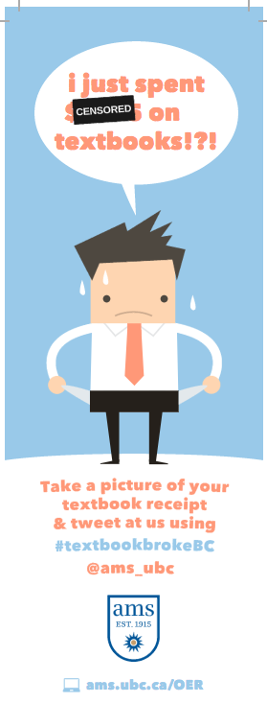
TextbookbrokeBC Bookmark by AMS UBC is licensed CC BY 4.0.
The open community is just that: open. The aim is to ensure that openness is a practice that is used in not only the promotion of OER, but in their adoption and creation as well. In that spirit, the #textbookbrokeBC materials have been offered openly by the AMS of UBC Vancouver at www.ams.ubc.ca/OER.

An open creation is an original work that is progress, but publicly viewable and openly licensed.

