**ADULT LITERACY FUNDAMENTAL MATHEMATICS**

**Book Four**

December 2014



**ABE**

###### ADULT BASIC

**EDUCATION**

**Adult Literacy Fundamental Mathematics**

## Book 4

Prepared by Liz Girard

Based on the work of Leslie Tenta (1993) and Marjorie E. Enns (1983) Steve Ballantyne, Lynne Cannon, James Hooten, Kate Nonesuch (1994)

**Canadian Cataloguing in Publication Data**

**Downloading Information:**

<http://urls.bccampus.ca/abefundmath4>

ISBN 978-0-7726-6302-3

Adult Literacy Fundamental Mathematics Book 1

ISBN 978-0-7726-6303-0

Adult Literacy Fundamental Mathematics Book 2

ISBN 978-0-7726-6304-7

Adult Literacy Fundamental Mathematics Book 3

ISBN 978-0-7726-6305-4

Adult Literacy Fundamental Mathematics Book 4

ISBN 978-0-7726-6306-1

Adult Literacy Fundamental Mathematics Book 5

ISBN 978-0-7726-6307-8

Adult Literacy Fundamental Mathematics Book 6

ISBN 978-0-7726-6347-4

Adult Literacy Fundamental Mathematics, Instructor‘s Manual and Test Bank

Copyright © 2010 Province of British Columbia Ministry of Advanced Education and Labour Market Development

Unless otherwise noted, this book is released under a [Creative Commons Attribution 4.0 Unported License](http://creativecommons.org/licenses/by/4.0/) also known as a CC-BY license. This means you are free to copy, redistribute, modify, or adapt this book. Under this license, anyone who redistributes or modifies this textbook, in whole or in part, can do so for free providing they properly attribute the book as follows:

[Adult Literacy Fundamental Mathematics: Book 4](https://open.bccampus.ca/find-open-textbooks/?uuid=f2ccf504-86e6-4ebc-9d39-63eaf9695d72&contributor=&keyword=&subject=Academic/Basic%20Upgrading) by Wendy Tagami and Liz Girard is used under a [CC-BY 4.0](http://creativecommons.org/licenses/by/4.0/) international license.

For questions regarding this licensing, please contact opentext@bccampus.ca. To learn more about BCcampus Open Textbook project, visit <http://open.bccampus.ca>

**Acknowledgments**

**Curriculum Writers:**

Liz Girard, North Island College Wendy Tagami, Selkirk College

**Advisory Committee members:**

Jill Auchinachie, Camosun College

Leanne Caillier-Smith, College of the Rockies Mercedes de la Nuez, Northwest Community College Barbara Stirsky, University of the Fraser Valley

Jan Weiten, Vancouver Community College

**The Deans and Directors of Developmental Education:**

Stephanie Jewell, Vancouver Community College Vivian Hermansen, North Island College

Lyle Olsen, Selkirk College Allison Alder, Selkirk College

The Adult Literacy Fundamental Working Group Cheryl Porter, North Island College

Stephen & Jennifer Marks, Layout editors

**Table of Contents – Book 4**

**Unit 1: Working with Decimals**

**Topic A: Part of the Whole Thing** **2**

Decimal Fractions 5

Common Fractions 7

Fractions as a Percent 8

Real Life Examples 9

What is a Decimal Fraction? 13

**Topic B: Reading & Writing Decimals** **15**

Writing Decimals 32

Dollars and Cents 36

Topic B: Self-Test 44

**Topic C:** **Comparing decimals** **52**

Topic C: Self-Test 55

Estimating and Rounding Decimals 57

**Topic D: Rounding Whole Numbers** **58**

Review: Rounding to the Nearest Ten 59

Review: Rounding to the Nearest Hundred 61

Review: Rounding to the Nearest Thousand 63

Rounding Decimals to Whole Numbers 65

Rounding Decimals to the Nearest Tenth 68

Rounding Decimals to the Nearest Hundredth 71

Rounding Decimals to the Nearest Thousandth 74

Topic D: Self-Test 79

i

**Unit 1 Review** **81**

###### Unit 2: Adding & Subtracting Decimals

**Topic A: Adding Decimals** **90**

Problem Solving Steps 100

Topic A: Self-Test 109

**Topic B: Subtracting Decimals** **112**

Subtracting a Decimal from a Whole Number 116

Problems Using Subtraction of Decimals 119

Topic B: Self-Test 124

**Topic C: Bookkeeping** **126**

Keeping a Bank Book Record 129

Cheque Writing 133

**Unit 2 Review** **139**

###### Unit 3: Multiplying Decimals

**Topic A: Multiplying Decimals** **146**

Prefixing Zeros 153

Multiplying by 10, 100, 1 000, 10 000 157

Problems Using Multiplication of Decimals 162

Topic A: Self-Test 175

**Unit 3 Review** **177**

###### Unit 4: Dividing Decimals

**Topic A: Dividing Decimals** **182**

Dividing by Decimal Divisors 186

What about Remainders? 193

Dividing by 10, 100, 1 000, 10 000, etc 198

Problems Using Division of Decimals 201

Topic A: Self-Test 210

**Unit 4 Review** **213**

###### Unit 5: Using Decimals in Real Life

**Topic A: Unit Pricing** **220**

Rounding to the Nearest Tenth of a Cent 228

**Topic B: Decimal Problems** **230**

Topic B: Self-Test 245

**Unit 5 Review** **248**

###### Unit 6: Measurement

**Topic A: Why Metric?** **252**

A Review of Measurement Units 253

Rules of Style 258

**Topic B: The Prefixes** **260**

A Chart of the SI Prefixes 261

Topic B: Measuring 266

Measuring Mass 271

Measuring Capacity (Volume) 273

**Topic C: Conversion within the Metric System** **277**

Why Do We Need to Convert Measurements? 282

Topic C: Self-Test 289

Weights and Measures 291

**Unit 6 Review** **293**

**Glossary** **317**

**To the Learner:**

***Welcome to Fundamental Mathematics Book Four.***

Adult Math Learners

You have the skills you need to be a strong student in this class. Your instructor knows this because you have passed the Fundamental Math Level Three class, or you have been assessed into this level.

Adult math learners have many skills. They have a lot of life experience. They also use math in their everyday lives. This means that adult math learners may already know some of what is being taught in this book. Use what you already know with confidence!

Grades Record

You have also been given a sheet to write down your grades. After each test, you can write in the mark. This way you can keep track of your grades as you go through the course. This is a good idea to use in all your courses. You can find this grade sheet on page xi.

How to Use this Book This textbook has:

* A **Table of Contents** listing the units, the major topics and subtopics.
* A **Glossary** giving definitions for mathematical vocabulary used in the course.
* A **grades record** to keep track of your marks.

1. The **textbook** has many exercises; some are quite short, but others have a great number of questions. **You do not have to do every single question!**

Do as many questions as **you** feel are necessary for you to be confident in your skill. It is best to do **all** the word problems.



If you leave out some questions, try doing every second or every third question. Always do some questions from the end of each exercise because the questions usually get harder at the end. You might use the skipped questions for review before a test.

 If you are working on a difficult skill or concept, do half the exercise one day and finish the exercise the next day. That is a much better way to learn.

1. **Self-tests** at the end of most topics have an **Aim** at the top. If you do not meet the aim, talk to your instructor, find what is causing the trouble, and do some more review before you go on.
2. A **Review and Extra Practice** section is at the end of each unit. If there is an area of the unit that you need extra practice in, you can use this. Or, if you want, you can use the section for more review.
3. A **Practice Test** is available for each unit. You may:
   * Write the practice test after you have studied the unit as a practice for the end-of-chapter test, OR
   * You might want to write it before you start the unit to find what you already know and which areas you need to work on.
4. **Unit tests** are written after each unit. Again, you must reach the **Aim** before you begin the next unit. If you do not reach the aim, the instructor will assist you in finding and practising the difficult areas. When you are ready, you can write a B test to show that you have mastered the skills.
5. A **Final Test** is to be written when you have finished the book. This final test will assess your skills from the whole book. You have mastered the skills in each unit and then kept using many of them throughout the course. The test reviews all those skills.

**Math Anxiety**

Math anxiety, or the fear of math, is something many people experience. It is a learned habit and can be unlearned. Math anxiety can happen for a few different reasons:

 Feeling anxious when writing tests

 Negative experiences in a past math class  Embarrassment in a past math class

 Social pressures and expectations to not like math or not do well in math  The want to get everything right

 Negative self-message (―I don‘t know how to do it‖, or ―I hate math‖)

Everyone can learn math. There is no special talent people are born with that make them better at math. There are some people who are better at math than others, but even those people had to learn math to be good at it.

**Do you suffer from math anxiety?**

Read the list below and put a check mark beside the ones you feel when thinking about or doing math.

|  |  |
| --- | --- |
|  | Are your palms moist? |
|  | Is your stomach fluttering? |
|  | Do you feel like you can‘t think clearly? |
|  | Do you feel like you would rather do anything else than learn math? |
|  | Are you breathing faster than normal? |
|  | Is your heart pounding? |
|  | Do you feel cold? |
|  | Do you feel sweaty? |

If you answered yes to two or more of these items, you may have math anxiety.

If you have math anxiety, a first step to understanding it is to look at where it all started.

In the space below, make a list of your experiences with learning math. Think back to the first math experiences you had and write about them. Think about the time in school from the younger grades to the higher grades when learning math and write about the experiences and feelings you had from that time. Write about now and how you are feeling about learning math. Beside each experience, write if it was a positive or negative.

Look at the examples below to give you an idea:

|  |  |
| --- | --- |
| Positive or negative? | Math experience |
| Negative | *My teacher in elementary school lined the whole class up in a row and made us play a multiplication game. When it was my turn, I had to know the multiplication problem that came to me. I didn’t know the answer so I was trying to figure it out on my fingers before my turn came up. I got the answer right, but I was so nervous that I would be made fun of because I didn’t know the answer off the top of my head. I still don’t know my times tables.* |
| Positive | *In high school, I could use a calculator to figure out the simple multiplication problems, and then I could figure out the tougher problems without worrying about knowing my times tables.* |
| Negative | *Now that I am upgrading my math, I feel nervous every time I even think about opening the book. I want to get all the answers right, and I know that I won’t be able to. I really need everything to be right so that I know that I am getting it.* |

|  |  |
| --- | --- |
| Positive or negative? | Math experience |
|  |  |
|  |  |
|  |  |
|  |  |
|  |  |
|  |  |
|  |  |

Once you have made a list of experiences, go over the stories with your instructor, or by yourself and try to find some common themes.

 Can you see when you felt anxiety?

 Can you see why you are now anxious about math?

 Is there any experience you could use now to help you feel calmer about math?

Hopefully by examining the beginnings of the anxiety, you can feel more in control of it.

##### How to Deal with Math Anxiety

**Anyone** can feel math anxiety. It will slow down your learning. The key to dealing with math anxiety is to be the ―boss‖ of your anxiety.

One way to be the ―boss‖ is to relax. Try this breathing exercise:

Start by breathing in slowly to the count of four. It may help to close your eyes and count.

Now hold your breath for four counts and then let your breath out slowly to the count of four. The counting is silent and should follow this pattern: ―breathe in, two, three four; hold, two, three, four; breathe out, two, three, four; wait, two, three four.‖

With practice, the number of counts can be increased. This is an easy and good way to relax. Now try this exercise quietly and repeat it five times slowly.

Each time you feel anxious about learning, use the breathing exercise to help calm yourself. Ask yourself if what you tried worked. Do you feel calmer?

Remember learning to deal with your math anxiety may take some time. It took you a long time to learn ―math anxiety‖, so it will take some time to overcome it.

Each text in the fundamental math courses give another tip for how to deal with math anxiety. Look for them!

**Grades Record Book 4**

|  |  |  |  |  |  |
| --- | --- | --- | --- | --- | --- |
| **Unit** | **Practice Test** | **Date of Test A** | **Test A** | **Date of Test B** | **Test B** |
| ***Example*** | ***√*** | ***Sept. 4, 2011*** | 25  33 | ***Sept. 7, 2011*** | 28  33 |
| 1 |  |  |  |  |  |
| 2 |  |  |  |  |  |
| 3 |  |  |  |  |  |
| 4 |  |  |  |  |  |
| **Final Test** |  |  |  |  |  |

# Unit 1

### Working with Decimals

##### Topic A: Part of the Whole Thing

This is the beginning of an adventure with numbers that represent **part of the whole thing**. These numbers can be shown in a few different ways:

|  |  |
| --- | --- |
| Fraction name | Example |
| **Decimal fraction** | 0.50 |
| **Common fraction** | or |
| **Percent fraction** | 50% |

When we talk about fractions in any of the three ways listed above, we are talking about numbers in relation to the whole thing. The whole thing is a word we use to describe one thing.

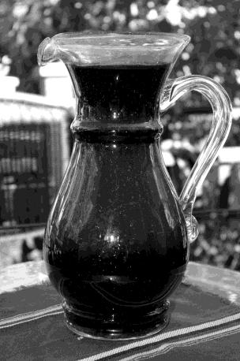



An example would be

one jug of juice.

That is one whole thing.

Once someone starts taking some juice, less than the whole thing remains.

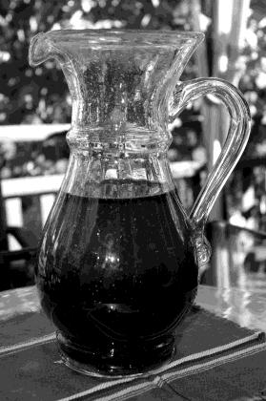



Someone had half the juice. The remaining amount can be

written as 0.5 or or 50%.

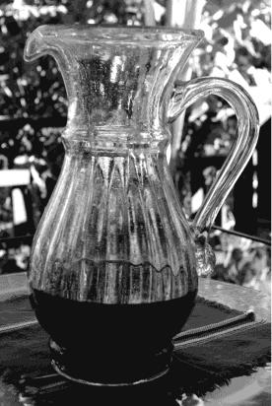



Almost all the juice has been taken. Now there is only 0.25 of the juice

left (or or 25%).

 



Now there are two full

jugs of juice.

This shows *two* whole things.

A fraction does not tell us much unless we know what the fraction is part of—we need to know the whole thing! If someone says to you,

"Sure, let's go, I still have !" you instantly need to know, "One-half of what?"

This could be of a tank of gas, it could be of a paycheque, it could be of a vacation, it could be of an hour, or of...

Fractions have meaning only when we understand the whole thing.

##### Decimal Fractions

**Decimal fractions** are one way to consider **parts of the whole thing**—and the whole thing is one. You use decimal fractions every time you think about money! The dollars are written as whole numbers; the cents are written as a decimal fraction of a dollar.

A decimal fraction has a decimal point (**.**) that separates the whole number from the fraction. We use our **knowledge of place value** to understand how many parts the whole thing is divided into. Our number system is called a ***decimal system*** because it is based on the number **ten** ("deci" is the Latin word for ten). So in decimal fractions the whole thing is divided into **tenths**; the tenths are divided by ten to make **hundredths**; the hundredths are divided by ten to make **thousandths** and so on.

Decimal fractions are often used in our daily lives, especially in money and measurement.

$12.24

3.5 kilometres to drive to the store

2.6 metres of material

1.8 kilograms of roast beef

You will be working with decimal fractions in the first two units of this book.



**Whole Wheat Flour**

**2.5 kg 5.5 lb**

**Adult** – regular strength CAPLETS **24 pkg.**

**$ 2.29**

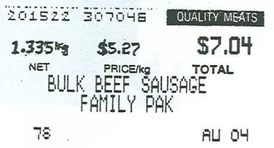

##### Common Fractions

**Common Fractions** are a second way we will work with **parts of the whole thing**. They are written with two numbers, one above the other, with a line in between. The line may be straight — or on an angle **/.**

or ¾

The **denominator** is the bottom number. The denominator tells **how many equal parts there are in the whole thing.**

Numerator 3

4



Denominator

The **numerator** is the top number in a common fraction. The numerator tells **how many of the equal parts are actually being described or talked about.**

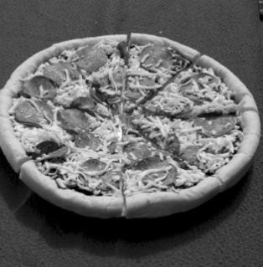This pizza has been **cut into eight pieces**, all the same size (equal).

The denominator to use while talking about **this** pizza is **8**. The numerator will be the exact number of pieces of the pizza that are being described.

This is **1 pizza**, and that is the **whole thing**. If someone ate all 8 pieces or 8/8 (eight-eighths) that person ate **1** pizza. Eating three of the pieces would be 3/8 of the pizza.

Fundamental Mathematics book 5 explains more about common fractions.

##### Fractions as a Percent

A third and useful way to think about **parts of the whole thing** is as a percent. Percent fractions are written with a number and a percent sign.

50%

99%

In percent fractions the denominator is **always** understood to be **100**. That makes the arithmetic much easier and helps us to understand the **size** or **proportion** of the fraction. For example, if you got on a test this week, and on one last week, it is hard to get a

sense of how you are doing. But if you know you got 70% last week and 76% this week, it is easier to see your improvement.

In percent fractions, the **whole thing is 100%**. 100% equals 1.

**Statistics** and general information are often reported in percent fractions. You will learn to work with fractions as a percent in Fundamental Mathematics book 6. We hope you enjoy the challenge.

**LANDFILL CONTENTS**

8%

8%

38%

12%

34%

metal 5 - 8 %

glass 5 - 8 %

plastics 8 - 12 %

organics 34 %

fibres 38 %



**Security G.I.C. Plus**

**Minimum return …… 2 %**

**Maximum return …… 9 %**

**Comox Valley Regional District - 2010**

***LESS THAN 10% OF OUR LANDFILL IS REAL GARBAGE!***

##### Real Life Examples

The idea of fractions may be very comfortable to most of us because our minds are used to dealing with **parts** in our everyday life. Look at the pictures and use a **fraction** to answer the questions.

one quarter = 0.25 = one third = 0.333. . . =

one half = 0.5 = two thirds = 0.666. . . =

three quarters = 0.75 =

How much gas is left? (See page 5 for possible answers.)

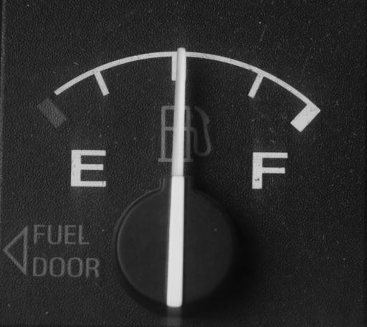 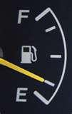

a) of a tank b) of a tank

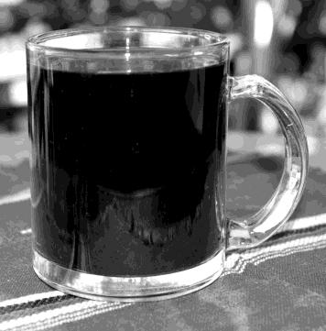

This full cup of coffee is the **whole thing**. It is **1** cup of coffee.

**Do you want more coffee?**

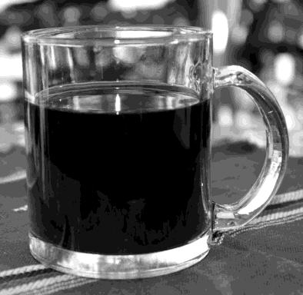 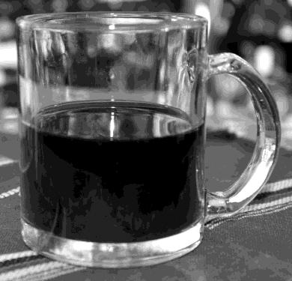

c) No thanks, I still have of a cup. d) Sure, I only have of a cup left.

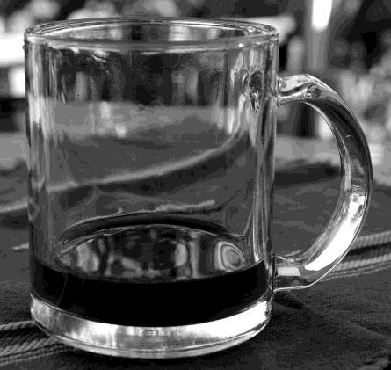

1. Yes please, I'm down to of a cup.

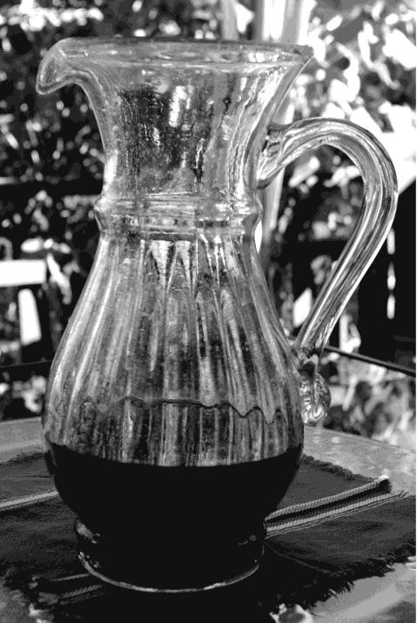

**Do we need more juice?**

1. Yes, there is just of the juice left.

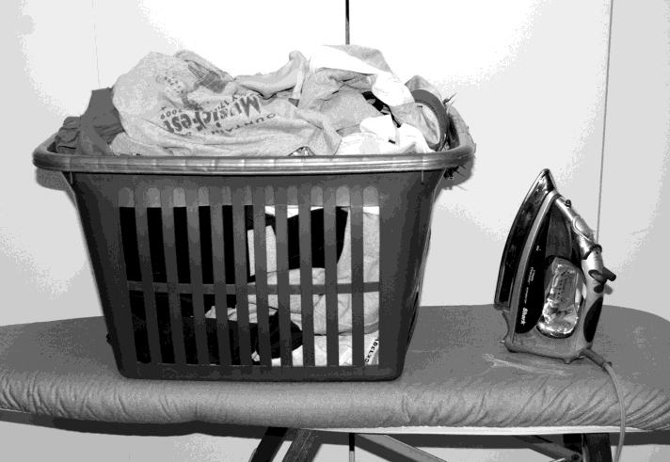Here is a familiar sight—a full basket of clothes to be ironed!

This full basket is the

**whole thing**.

It is **1** basket of ironing.

Things are looking up!

**Answers to Photo Questions:** Answers may differ because the fraction is approximate.

Ask your instructor to check any different answers.

g) done left to do **or** 0.75 done, with 0.25 left to do

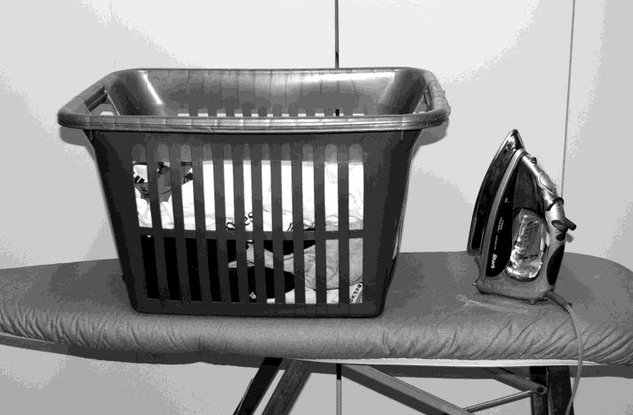

1. of the ironing has been done. There is only about of the ironing left to do.

|  |  |  |  |  |
| --- | --- | --- | --- | --- |
| a) | **or or** 0.5 | b) | **or** 0.25 | c) **or** 0.75 |
| d) | **or** 0.5 | e) | **or** 0.25 | f) **or** 0.333 |

##### What is a Decimal Fraction?

As you know, fractions describe **part** of **the whole thing**—a fraction is smaller than **1**. And as you also know, **1** (the whole thing) can be many things. For example, it can be:

one dollar one city one school

one paycheque one year

one second

one loaf of bread one population one ferry ride...

So a decimal might represent part of a year, part of the population of Canada, part of a second or part of anything you want.

**Decimal fractions are different from common fractions in several ways:**

**A decimal point,** separates whole numbers from the fraction. A decimal fraction starts with a decimal point.

**0.1** ( is ) **0.34** ( is ) **0.5** ( is )

In a decimal fraction, the **denominator** is **not written**. Remember that the denominator in a common fraction is the bottom number and tells how many equal parts there are in the whole thing.

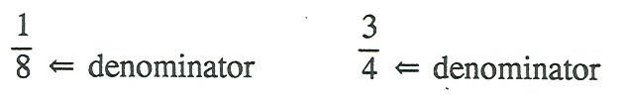

But in a decimal fraction the denominator is **understood**. We tell the size of the denominator by looking at how many numerals are placed **after** the decimal point.

Decimal fraction denominators are always **ten or ten multiplied by tens**. ***Decimal*** means "based on the number ten".

0.4

has a denominator of 10

0.44

has a denominator of 100

0.444

has a denominator of 1 000

0.4444

has a denominator of 10 000

0.44444

has a denominator of 100 000

0.444444 has a denominator of 1 000 000

A whole number and a decimal can be written together. This is called a **mixed decimal**.

4.35 100.47 $12.39

**Every whole number has a decimal point after it**, even though we usually do not bother to write the decimal point unless a decimal follows the whole number. We can also put zeros to the right of the decimal point of any whole number without changing its value. Get used to thinking of a decimal point after every whole number!

|  |  |  |  |  |
| --- | --- | --- | --- | --- |
| 3 | = | 3**.** | = | 3**.0000000** |
| 275 | = | 275**.** | = | 275**.0** |
| 100 | = | 100**.** | = | 100**.0000000000** |
| $8 | = | $8**.** | = | $8**.00** |

**Decimal or Decimal Fraction?**

In math, we use the word **decimal** to mean **decimal fraction.** In the rest of this book,  you will see the word **decimal,** and it will mean **decimal fraction.**

##### Topic B: Reading & Writing Decimals

**Remember the Place Value Chart of whole numbers?**

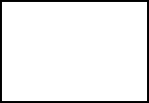

Decimal point

|  |  |  |  |  |  |  |
| --- | --- | --- | --- | --- | --- | --- |
| Thousands | | | Ones | | |  |
| Hundred thousands | Ten thousands | One thousands | hundreds | tens | ones |  |
|  |  |  | **3** | **5** | **2** |  |
|  |  |  |  |  |  |  |
|  |  |  |  |  |  |  |
|  |  |  |  |  |  |  |
|  |  |  |  |  |  |  |
|  |  |  |  |  |  |  |

352 is the first number on the chart:

* The three is in the hundreds spot
* The five is in the tens spot
* The 2 is in the ones spot

Place the following numbers on the place value chart:

o 4 984

o 836 466

o 70 834

Check with your instructor to see if you have placed the numbers in the chart correctly.

Have you ever wondered what goes to the right of the decimal in a place value chart? That is where the decimals go!

Here is a place value chart for decimals:

|  |  |  |  |  |  |  |  |  |
| --- | --- | --- | --- | --- | --- | --- | --- | --- |
| Hundreds | tens | ones |  | tenths | hundredths | thousandths | Ten thousandths | Hundred thousandths |
|  |  | 3 |  | 4 | 5 | 3 |  |  |
|  |  | 0 |  | 9 | 6 |  |  |  |
|  |  |  |  |  |  |  |  |  |

See the words in to the right of the decimal point? They look different than the usual whole number words you are used to. These are all the names for the decimal places. You will see them in the next lesson.

**The first number is 3.453**

It is said as three and four hundred fifty-three thousandths or three point four five three 3 is in the ones spot

4 is in the ten*ths* spot

5 is in the hundred*ths* spot 3 is in the thousand*ths* spot

**The second number is 0.96**

It is said as zero and ninety six hundredths or as zero point nine six.

0 is in the ones spot

9 is in the tenths spot

6 is in the hundredths spot

Common fractions with a denominator of 10 are written as a decimal with **one place to the right of the decimal point**. This is the **tenths place**.

We often shorten the way we say "places to the right of the decimal point" to **"decimal places"**. So we can say that **tenths** have **one decimal place**.



= 0.6 = six tenths

= 0.3 = three tenths

(An easy way to remember is that there is one zero in the denominator and so there is one decimal place taken up).

**Exercise One** Write each common fraction as a decimal and in words.

a) = 0**.**4 = four tenths

b) = 0.1 = one tenth

c) = =

d) = =

e) = =

f) = =

g) = =

h) = =

i) = =

j) Now enter each common fraction in the place value chart on the next page. The first one is done for you. Please show this to your instructor once you are finished to make sure you are on the right track.



**Answers to Exercise One**

|  |  |  |  |  |  |  |  |  |
| --- | --- | --- | --- | --- | --- | --- | --- | --- |
| hundreds | tens | ones |  | tenths | hundredths | thousandths | Ten thousandths | Hundred thousandths |
|  |  | 0 |  | 4 |  |  |  |  |
|  |  |  |  |  |  |  |  |  |
|  |  |  |  |  |  |  |  |  |
|  |  |  |  |  |  |  |  |  |
|  |  |  |  |  |  |  |  |  |
|  |  |  |  |  |  |  |  |  |
|  |  |  |  |  |  |  |  |  |
|  |  |  |  |  |  |  |  |  |
|  |  |  |  |  |  |  |  |  |

|  |  |  |  |
| --- | --- | --- | --- |
| a) 0**.**4, four tenths | b) 0.1, one tenth | c) 0.2, two tenths | d) 0.9, nine tenths |
| e) 0.7, seven tenths | f) 0.5, five tenths | g) 0.8, eight tenths | h) 0.6, six tenths |
| i) 0.3, three tenths |  |  |  |

**Decimals with one digit** to the right of the decimal point have an **unwritten denominator of ten.** These decimals show the whole thing is thought about in 10 equal parts. Each part is called a **tenth**.

When we write decimals, a zero is usually placed to the left of the decimal point to show there is no whole number. This zero keeps the decimal point from being "lost" or not noticed.

**.2 should be written as 0.2**

**Exercise Two** Write each decimal as a common fraction and in words.

1. 0.3 = = *three tenths*
2. 0.4 = = *four tenths*

c) 0.8 = =

d) 0.7 = =

e) 0.1 = =

f) 0.6 = =

g) 0.2 = =

h) 0.9 = =

**Answers to Exercise Two**

a) , three tenths b) , four tenths

c) , eight tenths

d) , seven tenths

e) , one tenth

f) , six tenths

g) , two tenths

h) , nine tenths

**Decimals with two digits** to the right of the decimal point have an **unwritten denominator of one hundred**. These decimals show that the whole is thought about in 100 equal parts.

Each part is called a **hundredth**.

**Exercise Three** Write each decimal as a common fraction and in words.

1. 0.34 *thirty-four hundredths*



1. 0.71 *seventy-one hundredths*



c) 0.06

d) 0.56

e) 0.33

f) 0.40

g) 0.75

h) 0.09

i) 0.16

j) 0.08

k) Now place the above decimal numbers in the place value chart on the next page. The first two are done for you. Then ask your instructor to correct it.

|  |  |  |  |  |  |  |  |  |
| --- | --- | --- | --- | --- | --- | --- | --- | --- |
| Hundreds | tens | ones |  | tenths | hundredths | thousandths | Ten thousandths | Hundred thousandths |
|  |  | 0 |  | 3 | 4 |  |  |  |
|  |  | 0 |  | 7 | 1 |  |  |  |
|  |  |  |  |  |  |  |  |  |
|  |  |  |  |  |  |  |  |  |
|  |  |  |  |  |  |  |  |  |
|  |  |  |  |  |  |  |  |  |
|  |  |  |  |  |  |  |  |  |
|  |  |  |  |  |  |  |  |  |
|  |  |  |  |  |  |  |  |  |
|  |  |  |  |  |  |  |  |  |

**Answers to Exercise Three**

a) thirty-four hundredths b)

seventy-one hundredths

c)

six hundredths

d)

fifty-six hundredths

e)

thirty-three hundredths

f)

forty hundredths

g)

seventy-five hundredths h)

nine hundredths

i)

sixteen hundredths

j)

eight hundredths

Common fractions with a **denominator of one hundred** are written as decimals with **two decimal places**.

= 0.23



= 0.99



= 0.04

The **0** must be used after the decimal point in 0.**0**4 to hold the tenths place so the denominator will be understood as hundredths.

This is called **prefixing zeros**. (see that there are two zeros in the denominator, so there must be two decimal places taken up.)

**Exercise Four** Write these common fractions as decimals. a) *0.34* b) *0.70*



c) d)



e) f)



g) h)



 j)



**Answers to Exercise Four**

a) 0.34

b) 0.70 c) 0.85 d) 0.11 e) 0.21 f) 0.05 g) 0.06 h) 0.45 i) 0.50 j) 0.01

Decimals with three digits to the right of the decimal point (**three decimal places**) have an unwritten denominator of one thousand. Each part is one **thousandth**. Look carefully at how thousandths are written. Watch for the zero that may be needed to hold the tenth decimal place or the hundredth decimal place.

0.472 = four hundred seventy-two thousandths =



0.085 = eighty-five thousandths =



0.003 = three thousandths =

(see that there are three zeros in the denominator, so there must be three decimal places taken up.)

**Exercise Five** Write each decimal as a common fraction and in words.

When there is no whole number to the left of the decimal point, do not use "and". Practise saying them aloud.

1. 0.006 *six thousandths*
2. 0.142 *one hundred forty-two thousandths*



c) 0.238

d) 0.562

e) 0.600

f) 0.203

g) 0.025

h) 0.042

i) 0.070

**Answers to Exercise Five**

a)

, six thousandths

b)

, one hundred forty-two thousandths

c)

, two hundred thirty-eight thousandths

d)

, five hundred sixty-two thousandths

e)

, six hundred thousandths

f)

, two hundred three thousandths

g)

, twenty-five thousandths

h)

, forty-two thousandths

i)

, seventy thousandths

**Exercise Six** Write each common fraction as a decimal. Write the decimals

in the place value chart, then show it to your instructor.

a) *0.736* b) *0.084*



1.  d)



e) f)



g) h)



i) j)



k) l)



|  |  |  |  |  |  |  |  |  |
| --- | --- | --- | --- | --- | --- | --- | --- | --- |
| hundreds | tens | ones |  | tenths | hundredths | thousandths | Ten thousandths | Hundred thousandths |
|  |  | 0 |  | 7 | 3 | 6 |  |  |
|  |  | 0 |  | 0 | 8 | 4 |  |  |
|  |  |  |  |  |  |  |  |  |
|  |  |  |  |  |  |  |  |  |
|  |  |  |  |  |  |  |  |  |
|  |  |  |  |  |  |  |  |  |
|  |  |  |  |  |  |  |  |  |
|  |  |  |  |  |  |  |  |  |
|  |  |  |  |  |  |  |  |  |
|  |  |  |  |  |  |  |  |  |
|  |  |  |  |  |  |  |  |  |
|  |  |  |  |  |  |  |  |  |

**Answers to Exercise Six**

|  |  |  |  |  |  |
| --- | --- | --- | --- | --- | --- |
| a) 0.736 | b) 0.084 | c) 0.210 | d) 0.006 | e) 0.106 | f) 0.116 |
| g) 0.003 | h) 0.400 | i) 0.020 | j) 0.027 | k) 0.592 | l) 0.962 |

Decimals with **four decimal places** have an unwritten denominator of **ten-thousand**. The whole thing is being thought of as having ten thousand parts. Each part is one **ten- thousandth**.

0.1458 = = one thousand four hundred fifty-eight **ten-thousandths**



0.0581 = = five hundred eighty-one **ten-thousandths**



(see that there are four zeros in the denominator, so there must be four decimal places taken up.)

**Exercise Seven** Write each decimal as a common fraction and in words.

Practise saying these aloud to someone else; they can be real tongue-twisters!

1. 0.2489 *two thousand four hundred eighty-nine ten-thousandths*



1. 0.1111 *one thousand one hundred eleven ten-thousandths*



c) 0.0236

d) 0.4015

e) 0.2306

f) 0.0003

g) 0.4501

h) 0.0024

i) 0.9001

j) 0.0298

**Answers to Exercise Seven**

a)

, two thousand four hundred eighty-nine ten-thousandths

b)

, one thousand one hundred eleven ten-thousandths

c)

, two hundred thirty-six ten-thousandths

d)

, four thousand fifteen ten-thousandths

e)

, two thousand three hundred six ten-thousandths

f)

, three ten-thousandths

4501

g) 10000 , four thousand five hundred one ten-thousandths

h)

, twenty-four ten-thousandths

i)

, nine thousand one ten-thousandths

j)

, two hundred ninety-eight ten-thousandths

**Exercise Eight** Write these common fractions as decimals, and then place the

numbers from a) to f) in the place value chart. Please have you your instructor check your place value chart once you have completed it.

a) *0****.****1489* b) *0.0002*



1. d)



e) f)



g) h)



i) j)



|  |  |  |  |  |  |  |  |  |
| --- | --- | --- | --- | --- | --- | --- | --- | --- |
| hundreds | tens | ones |  | tenths | hundredths | thousandths | Ten thousandths | Hundred thousandths |
|  |  | 0 |  | 1 | 4 | 8 | 9 |  |
|  |  | 0 |  |  |  |  |  |  |
|  |  |  |  |  |  |  |  |  |
|  |  |  |  |  |  |  |  |  |
|  |  |  |  |  |  |  |  |  |
|  |  |  |  |  |  |  |  |  |
|  |  |  |  |  |  |  |  |  |
|  |  |  |  |  |  |  |  |  |
|  |  |  |  |  |  |  |  |  |
|  |  |  |  |  |  |  |  |  |

**Answers to Exercise Eight**

|  |  |  |  |  |  |
| --- | --- | --- | --- | --- | --- |
| a) 0.1489 | b) 0.0002 | c) 0.0386 | d) 0.9137 | e) 0.0004 | f) 0.0916 |
| g) 0.0290 | h) 0.0111 | i) 0.5003 | j) 0.0075 |  |  |

 **Mixed decimals** are a whole number and a decimal written together.

4.3 = 4 = four **and** three tenths

27.27 = 27 = twenty-seven **and** twenty-seven hundredths

8.104 = 8 = eight **and** one hundred four thousandths

Digits to the left of the decimal point are whole numbers. Digits to the right of the decimal point are fractions.

The decimal point is read "**and**".

Look at the above mixed decimals in the place value chart:

|  |  |  |  |  |  |  |  |  |
| --- | --- | --- | --- | --- | --- | --- | --- | --- |
| hundreds | tens | ones |  | tenths | hundredths | thousandths | Ten thousandths | Hundred thousandths |
|  |  | 4 |  | 3 |  |  |  |  |
|  | 2 | 7 |  | 2 | 7 |  |  |  |
|  |  | 8 |  | 1 | 0 | 4 |  |  |

##### Writing Decimals

1. Read the number. Does the word "**and**" show that this is a mixed decimal? If it does, the

**whole number** is **before** the word "**and**".

1. If it is a mixed decimal, write the whole number with the decimal point after it. If there is no whole number, write a **0** with the decimal point after it.
2. Decide how many decimal places you need. Look and listen for the "**ths**" ending.

Ten**ths** need one decimal place.

Hundred**ths** need two decimal places.

Thousand**ths** need three decimal places.

Ten-thousand**ths** need four decimal places.

1. It may help if you draw a little line for each decimal place that you need. The word with "**ths**" is the understood denominator.

tenths hundredths thousandths

ten-thousandths

1. Write the decimal so the last digit is on the last little line and fill any remaining lines with zeros. For example:

|  |  |  |
| --- | --- | --- |
| seven hundredths | **.** 7 | 0**.**0 7 |
| eight thousandths | **.** 8 | 0**.**0 0 8 |
| twenty-six thousandths | **.** 2 6 | 0**.**0 2 6 |
| four hundred six thousandths | **.**4 0 6 | 0**.**4 0 6 |

**CHECK what you have written. Does it say what you want?**

**Exercise Nine** Write each as a common fraction and as a decimal.

|  |  |  |  |
| --- | --- | --- | --- |
| a) sixty-eight thousandths |  |  | *0****.****068* |
| b) five tenths |  |  | *0****.****5* |
| c) fifty-six thousandths |  |  |  |
| d) ninety-nine hundredths |  |  |  |
| e) four hundred twenty-seven ten-thousandths |  |  |  |
| 1. four thousandths 2. six hundredths 3. one thousand three hundred two ten-thousandths 4. four hundred thirty-three thousandths |  |  |  |
| 1. thirty-seven hundredths 2. five thousandths 3. six hundred five thousandths 4. nine tenths |  |  |  |
| n) nine thousand nine hundred fifty ten-thousandths |  |  |  |

|  |  |  |  |  |
| --- | --- | --- | --- | --- |
| f) | , 0.004 | g) | , 0.06 | h) |
| k) | , 0.005 | l) | , 0.605 | m) |

**Exercise Ten** Write each number as a decimal (or mixed decimal).

**Answers to Exercise Nine**

a) , 0.068 b) , 0.5

c)

, 0.056

d) , 0.99

e)

, 0.0427

, 0.1302 i)

, 0.433

j) , 0.37

, 0.9

n)

, 0.9950

* 1. eighteen and six tenths *18.6 _______*
  2. six and forty-two hundredths *6.42 _______*
  3. seventy-one ten-thousandths
  4. one hundred and sixty-seven hundredths
  5. five hundred twenty-seven and twelve hundredths
  6. one and five tenths
  7. two hundred six and four thousand three hundred twenty-one

ten thousandths

* 1. nineteen and seven hundredths
  2. two hundred sixty-five thousandths
  3. thirty-six and nine thousandths
  4. one hundred twenty and ninety-nine thousandths
  5. four thousand two hundred one and forty-seven hundredths

|  |  |  |  |  |  |
| --- | --- | --- | --- | --- | --- |
| **Answers to Exercise Ten** | | | | | |
| a) 18.6 | b) 6.42 | c) 0.0071 | d) 100.67 | e) 527.12 | f) 1.5 |
| g) 206.4321 | h) 19.07 | i) 0.265 | j) 36.009 | k) 120.099 | l) 4201.47 |

Often, people read decimals and mixed decimals in the following way:

4.25 as "four point two five" instead of "four and twenty-five hundredths"

0.009 as "point zero zero nine" instead of nine thousandths

It is important to read and understand decimals using their place values before you start taking shortcuts in the way you read them.

##### Dollars and Cents

As you have noticed, the cents part of our money is written as a decimal with two decimal places. $1.00 = 1 dollar

What do we call of a dollar? Right! One cent.

$2.33 = two dollars **and** thirty-three **cents**

$427.05 = four hundred twenty-seven dollars **and** five **cents**

$0.62 = sixty two **cents**

$0.03 = three **cents**

**Exercise Eleven** Write the amount of money in words.

a) $212.63 *two hundred twelve dollars and sixty-three cents*

b) $47.01

c) $9.28

d) $82.50

e) $100.05

Write with numerals, using $.

1. twenty-seven dollars and six cents *$27.06*
2. one hundred sixty-two dollars
3. thirteen dollars and sixty cents
4. one thousand dollars and seventy-seven cents
5. sixty-nine cents
6. seven cents
7. five hundred dollars and ninety cents

**Answers to Exercise Eleven**

1. two hundred twelve dollars and sixty-three cents
2. forty-seven dollars and one cent
3. nine dollars and twenty-eight cents
4. eighty-two dollars and fifty cents
5. one hundred dollars and five cents

f) $27.06 g) $162.00 h) $13.60 i) $1000.77

j) $0.69 k) $0.07 l) $500.90

Let's leave math for a minute and look at some **Latin**!

Latin is the language formerly used in the Roman Empire. The Latin language provides the base (the root) for many English words. Other European languages also have a Latin base for many words.

**CENTUM** is a **Latin** word which means

1. a **hundred** or a hundred fold (hundred times)
2. a **hundredth** part of Look at these words:

**centi**pede - wormlike creatures with a hundred legs

**cent**ury - a hundred years

**cent**ennial - a hundredth anniversary **centi**grade - having a hundred degrees **cent** - one hundredth of a dollar **centi**meter - one hundredth of a meter

You might enjoy looking in the dictionary at the many words starting with "cent".

So when we talk about $12.25 as twelve dollars and twenty-five **cents** we are using the Latin word for "one hundredths". We could also write our money like this, which we do on cheques:

$14.75 = $14 (looks funny!)

$12.25 = $12

$403.10 = $403

We have another way of writing money. We often write money that is **less than one dollar** using a **cent sign** which is a **c** for cent with a line through it **¢**. We can also use the **¢** method for amounts more than a dollar, but this is not very common unless you want to count all the pennies, nickels, and dimes in your piggy bank!

$0.05 = 5¢ $0.33 = 33¢

$0.10 = 10¢ $0.25 = 25¢

$0.99 = 99¢ $1.08 = 108¢

**Exercise Twelve** Rewrite these using the other common way of writing

money. Remember to use the ¢ or $ as needed.

|  |  |  |  |  |  |
| --- | --- | --- | --- | --- | --- |
| a)  c) | $0.75 =  $0.01 = | *75¢* | b) 83¢  d) 47¢ | =  = | *$0.83* |
| e) | $0.04 = |  | f) 3¢ | = |  |
| g) | $0.40 = |  | h) 101¢ | = |  |

|  |  |  |  |  |  |
| --- | --- | --- | --- | --- | --- |
| i) | $0.29 = |  | j) 50¢ | = |  |
| k) | $0.80 = |  | l) 99¢ | = |  |
| m) | $1.00 = |  | n) 175¢ | = |  |
| o) | $1.10 = |  | p) 18¢ | = |  |
| q) | $1.25 = |  | r) 200¢ | = |  |
| s) | $2.20 = |  | t) 167¢ | = |  |

|  |  |  |  |  |  |  |  |
| --- | --- | --- | --- | --- | --- | --- | --- |
| **Answers to Exercise Twelve** | | | | | | | |
| a) 75¢ | b) $0.83 | c) 1¢ | d) | $0.47 | e) 4¢ | f) $0.03 | g) 40¢ |
| h) $1.01 | i) 29¢ | j) $0.50 | k) | 80¢ | l) $0.99 | m) 100¢ | n) $1.75 |
| o) 110¢ | p) $0.18 | q) 125¢ | r) | $2.00 | s) 220¢ | t) $1.67 |  |

Important Information!

Do we need to use a decimal point with the cent sign?

**No.**

A decimal point would indicate a **fraction or part of one cent**.

If a sign said "ice cream cones **.**50¢", you would only pay fifty hundredths of a cent (= one half of a cent) for an ice cream cone. That would be two cones for 1¢ —good deal!

Pay attention to the way amounts of money are written. We will work with this in other units.

**Exercise Thirteen** Correct the following ways of writing money. a) .50¢ = 50¢

b) .99¢ =

c) .20¢ =

d) ¢0.40 =

**Answers to Exercise Thirteen**

b) 99¢

c) 20¢

d) 40¢

**Exercise Fourteen** A Review: Complete the chart so that each question has



the amount written as a decimal, a common fraction, and in words. The first two are done.

|  |  |  |  |
| --- | --- | --- | --- |
|  | **Decimal** | **Fraction** | **In words** |
| a) | .048 |  |  |
| b) | 0.7 |  | seven tenths |
| c) |  |  | four hundredths |
| d) | 0.006 |  |  |
| e) |  | 16 |  |
| f) |  |  | twelve and fifteen hundredths |
| g) | 463.03 |  |  |
| h) |  | 213 |  |
| i) |  |  | seventy-five and twenty-eight thousandths |
| j) | 1833.018 |  |  |
| k) |  | 12 |  |
| l) |  |  | nine tenths |

**Answers to Exercise Fourteen**



|  |  |  |  |
| --- | --- | --- | --- |
|  | **Decimal** | **Fraction** | **In words** |
| a) | .048 |  | forty-eight thousandths |
| b) | 0.7 |  | seven tenths |
| c) | 0.04 |  | four hundredths |
| d) | 0.006 |  | six thousandths |
| e) | 16.002 | 16 | sixteen and two thousandths |
| f) | 12.15 | 12 | twelve and fifteen hundredths |
| g) | 463.03 | 463 | four hundred sixty-three and three hundredths |
| h) | 213.025 | 213 | two hundred thirteen and twenty-five thousandths |
| i) | 75.028 | 75 | seventy-five and twenty-eight thousandths |
| j) | 1833.018 | 1833 | one thousand eight hundred thirty-three and eighteen thousandths |
| k) | 12.0418 | 12 | twelve and four hundred eighteen ten-thousandths |
| l) | 0.9 |  | nine tenths |

**Topic B: Self-Test Mark /43 Aim 36/40**

1. **Write as decimals. 10 marks**
   1.  b)

|  |  |  |  |  |
| --- | --- | --- | --- | --- |
| b) |  | d) |  |  |
| e) 3 |  | f) |  |  |
| g) 6 |  | h) | 4 |  |
| i) 6 |  | j) | 93 |  |

1. **Change these decimals to common fractions. 10 marks**

a) 0.5 b) 0.04

c) 0.37 d) 0.010

e) 3.0918 f) 3.025

g) 0.164 h) 2.1498

i) 0.110 j) 6.08

1. **Write as common fractions and as decimals. 20 marks**
   1. one hundredth
   2. forty-seven hundredths
   3. two hundred seventy-one thousandths
   4. forty-one thousandths
   5. one hundred twenty ten-thousandths
   6. four and four tenths
   7. two hundred sixty and fourteen ten-thousandths
   8. seven and two hundred eleven thousandths
   9. forty and six hundredths
   10. five dollars and sixty-three cents
2. **Write the amount of money with numerals, using a $ sign. 3 marks**
   1. Five dollars and sixty cents $5.60
   2. Seventy two cents $0.72
   3. Fifty six cents
   4. Six cents
   5. One hundred twenty four cents

**Answers to Topic B Self-Test**

**Part A**

a) , 0.01

b) , 0.47

c) , 0.271

d)

, 0.041

e)

, 0.0120

f) 4 , 4.4

g) 260

, 260.0014

h) 7

, 7.211

i) 40 , 40.06

j) 5 , $5.63

**Part D**

c) $0.56

d) $0.06

e) $1.24

|  |  |  |  |  |  |  |
| --- | --- | --- | --- | --- | --- | --- |
| a) 0.3  g) 6.3 | b) 0.24  h) 4.011 | c) 0.036  i) 6.250 | d) 0.0206  j) 93.0047 | e) | 3.123 | f) 0.02 |
| **Part B**  a) | b) | c) | d) | e) | 3 | f) 3 |
| g) | h) 2 | i) | j) 6 |  |  |  |
| **Part C** |  |  |  |  |  |  |

##### Topic C: Comparing Decimals

More about Zeros...

**Here is a quick review:**

 A whole number can have a decimal point and as many zeros as you care to write after it without changing its value.

47 = 47.0 = 47.000 = 47.0000000000000000

 Zeros are used to hold a place when we write whole numbers. in 1**00**, the 0's hold the tens place and the ones place

in 1 2**0**6, the 0 holds the tens place

 In decimals, any zero to the right of the decimal point and to the left of another digit is important because the zero is holding a place and giving the decimal the correct value.

in 4**.**3**0**6, the 0 holds the hundredths place

in 17**.000**2, the 0's hold the tenth, hundredth and thousandth places.

 A zero is usually placed to the left of the decimal point if there is no whole number.

**0**.5 **0**.937

**Which zeros are not needed?**

Zeros at the **beginning**, or far left, of **whole numbers** are **not needed**. **0000**4 = 4 **00**100 = 100

Zeros at the **end**, or far right, of **decimal** are **not needed**. 3.21**0** = 3.21 34.062**000** = 34.062

Zeros **on the outside edges of mixed decimals** do **not change the value of the number** and are not necessary.

**00**28.971**0** = 28.971

**00**100.003**000** = 100.003

890.407 = **00**890.407**0000000**

**Exercise One** Cross out the zeros that are not needed.

a) 70.0390/ b) 0/ 0.2906 c) 06.30

d) 087.50 e) 60.0205 f) 4 020.0020

g) 400.080 h) 340.600 i) 03.5830

j) 9.0

m) 04.803

k) 0.002030

n) 4 000.060

l) 50.300

o) 002.002

**Answers to Exercise One**

a) 709.0390/

f) 4 020.0020/ k) 0.002030/

b) 0/ 0.2906

g) 400.080/ l) 50.30/ 0/

c) 0/ 6.30/

h) 340.60/ 0/ m) 0/ 4.803

d) 0/ 87.50/

i) 0/ 3.5830/ n) 4 000.060/

e) 60.0205

j) 9. 0/

o) 0/ 0/ 2.002

Zeros at the **end** of a **decimal do not change the value**.

6. = 6.0 = 6.00

And zeros at the **beginning** of a **whole number do not change the value**.

8 = 08 = 00008

But zeros **between** a decimal point and a digit **do** change the value.

Example:

405 is very different than 45 and: 0.05 = five hundredths

0.5 = five tenths These are also very different.

Apples and Oranges!

You have probably heard the old saying: "You cannot compare apples to oranges!" And it's true, it **is** tough to compare things that do not have much in common.

So before we compare decimals, we give the decimals something in common—the **same number of decimal places** which gives them a **common** understood **denominator**.

Before comparing decimals, **put zeros at the end** or cross out any unnecessary zeros so the decimals have a common (same) number of decimal places. If you write the decimals that you are comparing right underneath each other your eye will often tell you which is the larger amount or if the amounts are equal.

**Example:** Compare 0.43 and 0.4 Which is larger?

1. 0.43 has two decimal places; it is forty-three hundredths.
2. 0.4 has one decimal place; it is four tenths.
3. Add a zero to 0.4 to make it 0.4**0**; now we read it as forty hundredths. (which is the same as 4 tenths)

Now, which is larger? 0.40 (

0.43 (

40

100 )

43

100 )

5. You can easily see that 0.43 is the larger amount.

**Review of Greater Than > and Less Than <**

An easy way to remember these signs is to think that the big (wide) end of the sign is closer to the bigger (greater) number, and the small end of the sign is closer to the smaller number.

0.43 is larger than 0.40 0.43 > 0.40

0.52 is smaller than 0.60 0.52 < 0.60

**Exercise Two** Which is greater? Draw a box around the bigger decimal

**Answers to Exercise Two**

fraction in each pair and write a greater than > or a less than < sign to make a true statement.

|  |  |
| --- | --- |
| **a) 0.6 <** **0.65** | **b) 14 > 1.4** |
| c) 0.17 0.02 | d) 0.009 0.09 |
| e) 0.148 0.2 | f) 0.999 1 |
| g) 0.23 0.215 | h) 0.51 0.159 |
| i) 0.8 0.008 | j) 0.11 0.101 |
| k) 0.03 0.0352 | l) 0.07 0.063 |
| m) 630.3 630.03 | n) 0.80 0.6989 |

|  |  |  |  |  |  |  |  |  |
| --- | --- | --- | --- | --- | --- | --- | --- | --- |
| a) < | b) > | c) > | d) < | e) < | f) < | g) > | h) > | i) > |
| j) > | k) < | l) > | m) > | n) > |  |  |  |  |

##### Comparing decimals

You can compare decimals using a number line. A number line organizes what you are thinking about on paper – or on a ruler. You can plot your decimals on the number line and then be able to see which number is larger. Take a look:

First try to put the following numbers in order without looking at the number line below: 2.347 2.3 2.37 2.33 2.39 2.341 2.41

Then, look at the number line and see if you ordered your numbers correctly. The number line has a jagged edge which means it does not start at zero. It starts in the middle of a ruler.

Using a number line can help you see your work and think about it at the same time.

2.3 2.33 2.341 2.347 2.37 2.39 2.41

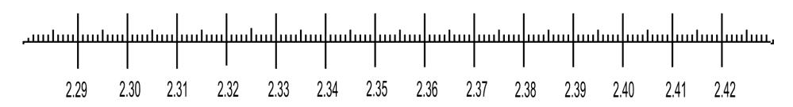

Try plotting the following decimals on the number line below:

4.59 4.32 4.7 5.23 4.47 4.3 4.17

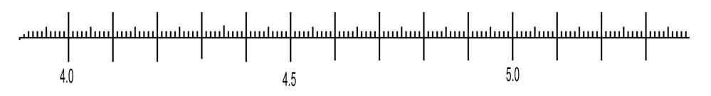

And now, plot these numbers on an empty number line.

(You need to fill in the numbers yourself. Plot 7.3 on the first large vertical line on the left) 7.35 7.3 8.2 7.53 7.98 8.34 7.9 7.5



This is one way to organize and order decimals, please use it if the system is helpful for you.

|  |  |  |  |  |  |  |  |
| --- | --- | --- | --- | --- | --- | --- | --- |
| **Answers:**  4.17 | 4.3 | 4.32 | 4.47 | 4.59 | 4.7 | 5.23 | 7.3 |
| 7.35 | 7.5 | 7.53 | 7.9 | 7.98 | 8.2 | 8.34 |  |

**Exercise Three** Draw a box around the smallest decimal fraction in each

group.

|  |  |
| --- | --- |
| a) 0.3, 0.03 , 0.23 | b) 0.04 , 0.14, 0.41 |
| c) 0.016, 0.2, 0.216 | d) 0.62, 0.6103, 0.5 |
| e) 2.202, 2.21, 2.200 | f) 9.678, 8.866, 9.9 |
| g) 0.041, 0.04, 0.4 | h) 100.1, 100.13, 100.01 |
| i) 2.71, 2.072, 2.007l | j) 0.38, 0.4, 0.401 |

|  |  |  |  |  |  |
| --- | --- | --- | --- | --- | --- |
| **Answers to Exercise Three** | | | | | |
| a) 0.03  g) 0.04 | b) 0.04  h) 100.01 | c) 0.016  i) 2.0071 | d) 0.5  j) 0.38 | e) 2.200 | f) 8.866 |

**Exercise Four** State if each pair of decimal fractions is equal = or not

equal ≠ by putting the correct sign between them.

a) 0.8 **=** 0.80 b) 0.25 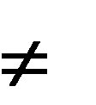 0.205

c) 5.503 5.330 d) 9.3200 9.32

e) 0.02 0.20 f) 3.309 3.90

g) 0.75 0.750 h) 23.3 2.33

i) 0.040 0.40 j) 0.8010 0.801

k) 0.027 0.270 l) 50.91 50.091

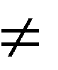

**Answers to Exercise Four**

a) = b) c)

h) i) j) =

d) =

k)

e)

l)

f)

g) =

|  |  |  |  |
| --- | --- | --- | --- |
| **Topic C: Self-Test** | **Mark** | **/20** | **Aim 17/20** |
| **A. Cross out the unnecessary zeros.**  a) 0401.02 b) 1 000.001 |  |  | **4 marks** |
| c) 68.3020 d) 050.200 |  |  |  |
| **B. Draw a box around the larger amount in each pair.** |  |  | **8 marks** |
| a) 0.8 or 0.08 b) 0.004 or 0.04 |  | | |
| c) 0.125 or 0.21 d) 2.100 or 2.12 |
| e) 0.006 or 0.6 f) 33.006 or 33.06 |
| g) 0.88 or 0.879 h) 4.01 or 5.01 |

**C. Put the correct sign between the decimals. Choose = or > or < 8 marks**

a) 2.3 23 b) 0.2 0.003

c) 4.7 4.700 d) 0.25 0.250

2.12

5.01

|  |  |
| --- | --- |
| e) 0.2081 0.2108 | f) 18.34 19.43 |
| g) 042.9002 042.9 | h) 0.4092 0.411 |



**Answers to Topic F Self-Test**

**Part A**

a) 0/ 401.02

b) 1 000.001

c) 68.3020/

d) 0/ 50.20/ 0/

**Part B**

a) 0.8

f) 33.06

b) 0.04

g) 0.88

c) 0.21

h) 5.01

d) 2.12

e) 0.6

**Part C**

a) < b) >

c) =

d) =

e) <

f) <

g) >

h) <

##### Estimating and Rounding Decimals

If a pair of jeans cost $49.98, what amount would you say if someone asks what you paid for them? You would probably say, "They cost around $50."

We often round cents to dollars as we go about our lives. You may already have an idea of how to do this. For example, answer these questions.

About how much do your groceries cost each month? About how much does it cost to fill a small car's gas tank?

Look at your answers. The amount for groceries may be quite large. When you estimated your answer, how did you round the amount?

For example, if your real monthly grocery bill was $481.73 you might have said

$482 or perhaps $480. Perhaps you even have estimated to the nearest hundred dollars and said, "About $500 a month for groceries." All those estimates would be correct.

Of course, the estimates you wrote down will be different because the amount you spend on groceries is different.

The amount for a tank of gas is less than a month's groceries. How did you estimate? For example, a small car may take $33.75 of gas.

If you estimated to the nearest dollar, you would say, "About $34."

If you estimated to the nearest ten dollars, you would say, "About $30." If you rounded to the nearest dollar you would say ―34 dollars‖.

We round a number in different ways depending on several things:  the **size** of the number we are rounding

 what we are going to do with the number after we have rounded it off our own convenience

##### Topic D: Rounding Whole Numbers

**1)** Carefully review the **place value for whole numbers**

|  |  |  |  |  |  |  |
| --- | --- | --- | --- | --- | --- | --- |
| Thousands | | | Ones | | |  |
| Hundred thousands | Ten thousands | One thousands | hundreds | tens | ones |  |
|  |  |  | **3** | **5** | **2** |  |
|  |  |  |  |  |  |  |

2) Write down the method you use to round whole numbers.

1. Find another student who is working on the same topic, and compare notes. Tell your partner what your method is and let him/her tell you his/her method.
2. If you have trouble explaining to yourself or your partner how to round whole numbers, ask your instructor for assistance and work through Exercises One, Two, and Three.

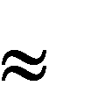Rounding numbers gives an approximate amount; it is not an accurate figure. Use a different form of the equal sign which means **approximately equal**. This sign is

##### Review: Rounding to the Nearest Ten



EXAMPLE

23

289

Underline the tens digit

23

289

look at the digit (to the

right) in the ones place (you can put an arrow above it to help you find it later)

20

290

if the ones digit is **less than 5**, the tens

digit does not change and the ones digit is written as a zero

if the ones digit is **5 or more**,

write the ones digit as zero and

increase the tens digit by one

Example:



2 3 Rounding 23 to the nearest ten is 20 because the ones digit is less than 5.



2 8 7 Rounding 287 to the nearest ten is 290 because the ones digit is 5 or more.

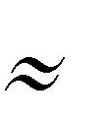**Exercise One** Round each of the following to the nearest ten. a) 46 *50* 111 7 116

b) 71 *70* 89 96 4

c) 385 *390* 108 73 17

d) 14 25 399 123

e) 361 8 49 148

f) 77 l65 128 35

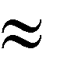

**Answers to Exercise One**

d) 10

30

400

120

|  |  |  |  |
| --- | --- | --- | --- |
| a) 50 | 110 | 10 | 120 |
| b) 70 | 90 | 100 | 0 |
| c) 390 | 110 | 70 | 20 |

|  |  |  |  |
| --- | --- | --- | --- |
| e) 360 | 10 | 50 | 150 |
| f) 80 | 170 | 130 | 40 |

##### Review: Rounding to the Nearest Hundred

underline the hundreds

digit

look at the digit following

in the tens place (you can put an arrow above it to help you find it later)

If the tens digit is **less than**

**5**, the hundreds digit does not change and the tens and ones digits are written as zeros

If the tens digit is **5 or**

**more**, write the tens and ones digits as zeros and add another hundred; that is, increase the hundreds digit by one.



EXAMPLE

728

793

728

793

700

800

Example:



7 2 8 to the nearest hundred is 700 because the tens digit is less than 5. 5 7 6 to the nearest hundred is 600 because the tens digit is 5 or more.

**Exercise Two** Round these numerals to the nearest hundred.



|  |  |  |  |
| --- | --- | --- | --- |
| a) **3**30 *300* | 908 | 2 795 | 1 260 |
| b) **7**42 *700* | 127 | 302 | 945 |
| c) **8**65 *900* | 275 | 590 | 1 240 |
| d) 214 | 4 450 | 98 | 996 |
| e) 348 | 720 | 497 | 1 075 |
| f) 480 | 95 | 1 742 | 80 |
| g) 250 | 333 | 1 899 | 1 355 |

|  |  |  |  |  |  |  |  |
| --- | --- | --- | --- | --- | --- | --- | --- |
| **Answers to Exercise Two** | | | | | | | |
| a) 300 | 900 | 2 800 | 1 300 | e) 300 | 700 | 500 | 1 100 |
| b) 700 | 100 | 300 | 900 | f) 500 | 100 | 1 700 | 100 |
| c) 900 | 300 | 600 | 1 200 | g) 300 | 300 | 1 900 | 1 400 |
| d) 200 | 4 500 | 100 | 1 000 |  |  |  |  |

##### Review: Rounding to the Nearest Thousand

If the hundreds digit is **5 or more**, write the hundreds, tens and ones digits as zeros and add another thousand; that is, increase the thousands digit by one

underline the

thousands digit

look at the hundreds digit that

follows it (you can put an arrow above it to help you find it later)

If the hundreds digit is **less than**

**5**, the thousands digit does not change and the hundreds , tens and ones digits are written as zeros



EXAMPLE

3496

3996

3496

3996

3000

4000

Example:



4 4 9 6 rounds to 4 000 because the hundreds digit is less than 5.



13 5 0 1 rounds to 14 000 because the hundreds digit is 5 or more.

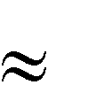**Exercise Three** Round these numerals to the nearest thousand.

|  |  |  |  |  |  |  |
| --- | --- | --- | --- | --- | --- | --- |
| a) | 1 760 | 2 000 | 6 250 |  | 850 |  |
| b) | 320 | 0 | 5 544 |  | 1 234 |  |
| c) | 4 925 | 5 000 | 6 199 |  | 9 883 |  |
| d) | 1 045 |  | 7 856 |  | 500 |  |
| e) | 1 780 |  | 495 |  | 9 300 |  |
| f) | 2 450 |  | 8 075 |  | 31 900 |  |
| g) | 700 |  | 2 449 |  | 5 555 |  |
| h) | 8 914 |  | 85 455 |  | 6 475 |  |
| i) | 927 |  | 2 050 |  | 11 250 |  |
| j) | 1 723 |  | 5 500 |  | 25 902 |  |

|  |  |  |  |  |  |  |
| --- | --- | --- | --- | --- | --- | --- |
| **Answers to Exercise Three** | | | | | | |
| a) 2 000 | 6 000 | 1 000 | f) | 2 000 | 8 000 | 32 000 |
| b) 0 | 6 000 | 1 000 | g) | 1 000 | 2 000 | 6 000 |
| c) 5 000 | 6 000 | 10 000 | h) | 9 000 | 85 000 | 6 000 |
| d) 1 000 | 8 000 | 1 000 | i) | 1 000 | 2 000 | 11 000 |
| e) 2 000 | 0 | 9 000 | j) | 2 000 | 6 000 | 26 000 |

##### Rounding Decimals to Whole Numbers

Decimals are **part of the whole thing**. As we discussed at the beginning of this topic, sometimes the **whole thing** might be all we need. So we **round** the decimal to a whole number. The **whole number** is **written with no numbers after the decimal dot**. Rounding to whole numbers means rounding off to the **ones** place. When rounding to the whole number:

consider the "whole

number" as the ones place

underline the digit

in the ones place

look at the digit (to the right) in the

first decimal place - the tenths (you can put an arrow above it to help you find it later)

if the tenths digit **is less than**

**5**, then write only the whole number as it is, with no decimals at all

if the tenths digit is **five or**

**more**, then add one to the whole number and write the number with no decimals



EXAMPLE

37.392

37.792

37.392

37.792

37

38

**Example A:** Round to a whole number.

42.123 42.123 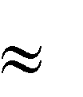42

**Example B:** Round 960.802 to the nearest whole number.

960.802 960.802 961

**Example C:** Round 39.5 to the nearest whole number (ones).



39.5 39.52 40





**Zeros again -** You know that zeros at the **end** of a decimal do **not change** the value of the amount and can be added as you like.

**But,** when a decimal has been rounded, **drop any zeros after the place where you have rounded**. The reason? The 0 in a decimal place implies an accurate amount for that place when in fact you have estimated the amount.

39.52 40.0 is **not** correct, just write 39.52 40

960.802 961.000 is **not** correct, just write 960.802 961

**Exercise Four** Round each of the following to the nearest whole number.

|  |  |  |  |  |  |  |
| --- | --- | --- | --- | --- | --- | --- |
| a) | 11.3 | 11 | 2.679 |  | 403.8 |  |
| b) | 7.6 | 8 | 65.91 |  | 22.2 |  |
| c) | 3.76 | 4 | 9.2 |  | 1.7 |  |
| d) | 2.4 |  | 9.9 |  | 1.4 |  |
| e) | 0.6 |  | 2.63 |  | 5.09 |  |
| f) | 19.8 |  | 2.1 |  | 0.7 |  |
| g) | 74.2 |  | 3.61 |  | 12.3 |  |
| h) | 6.4 |  | 48.5 |  | 9.492 |  |
| i) | 34.5 |  | 17.82 |  | 2.45 |  |

|  |  |  |  |  |  |
| --- | --- | --- | --- | --- | --- |
| j) 1.792 |  | 2.01 |  | 5.55 |  |
| k) 1.17 |  | 17.2 |  | 3.72 |  |
| l) 4.16 |  | 25.08 |  | 8.703 |  |
| m) 10.3 |  | 9.9 |  | 8.15 |  |

|  |  |  |  |  |  |  |
| --- | --- | --- | --- | --- | --- | --- |
| a) 11 | 3 | 404 | h) | 6 | 49 | 9 |
| b) 8 | 66 | 22 | i) | 35 | 18 | 2 |
| c) 4 | 9 | 2 | j) | 2 | 2 | 6 |
| d) 2 | 10 | 1 | k) | 1 | 17 | 4 |
| e) 1 | 3 | 5 | l) | 4 | 25 | 9 |
| f) 20 | 2 | 1 | m) | 10 | 10 | 8 |
| g) 74 | 4 | 12 |  |  |  |  |

If these exercises on rounding are becoming tiresome, please do not despair—there **is** a



**Answers to Exercise Four**

purpose. When you do operations (+ - with decimals, you will often end up with

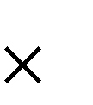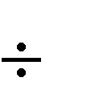

)

answers in the ten-thousandths place when you really only need the accuracy of a tenth or a hundredth place decimal. If you do decimal operations on a calculator you may end up with 6 decimal places (millionths)—not too practical if you are working with money and only want two decimal places! You will know how to round the answer to the decimal place you need for that question or situation.

##### Rounding Decimals to the Nearest Tenth

Underline the tenths

place digit

look at the digit (to the right)

in the hundredths place (you can put an arrow above it to help you find it later)

if the hundredths digit is

**less than 5**, the tenths digit does not change and the hundredths digit (and all other decimals numbers after the hundredths) are not written at all

if the hundredths digit is **5**

**or more**, increase the tenths digit by one and write no more decimals in the hundredths spot or after



EXAMPLE

13.432

13.476

13.432

13.476

13.4

13.5

**Example A:** Round to the nearest tenth.



0.263 0.2 6 3  0.3

**Example B:** Round to the nearest tenth.



234.0399 234.0 3 99 234.0

Keep the 0 because you have accurately rounded off to that zero. It is called a ***significant figure***.

**Exercise Five** Round each of the following to the nearest tenth.

|  |  |  |  |  |  |
| --- | --- | --- | --- | --- | --- |
| a) 4.23 | 4.2 | 5.18 | . | 8.54 |  |
| b) 16.09 | 16.1 | 3.52 |  | 4.14 |  |
| c) 6.24 | 6.2 | 1.76 |  | 1.74 |  |
| d) 7.19 |  | 2.15 |  | 1.44 |  |
| e) 3.172 |  | 9.99 |  | 5.09 |  |
| f) 4.111 |  | 6.046 |  | 0.71 |  |
| g) 3.63 |  | 9.45 |  | 12.36 |  |
| h) 202.305 |  | 2.66 |  | 9.492 |  |
| i) 7.388 |  | 5.249 |  | 2.45 |  |
| j) 7.452 |  | 10.78 |  | 5.55 |  |
| k) 3.96 |  | 43.94 |  | 3.72 |  |
| l) 0.726 |  | 4.072 |  | 8.703 |  |
| m) 0.051 |  | 3.274 |  | 8.15 |  |
| n) 6.148 |  | 0.082 |  | 4.378 |  |
| o) 7.642 |  | 3.501 |  | 5.647 |  |

|  |  |  |  |  |  |  |
| --- | --- | --- | --- | --- | --- | --- |
| **Answers to Exercise Five** | | | | | | |
| a) 4.2 | 5.2 | 8.5 | i) | 7.4 | 5.2 | 2.5 |
| b) 16.1 | 3.5 | 4.1 | j) | 7.5 | 10.8 | 5.6 |
| c) 6.2 | 1.8 | 1.7 | k) | 4.0 | 43.9 | 3.7 |
| d) 7.2 | 2.2 | 1.4 | l) | 0.7 | 4.1 | 8.7 |
| e) 3.2 | 10.0 | 5.1 | m) | 0.1 | 3.3 | 8.2 |
| f) 4.1 | 6.0 | 0.7 | n) | 6.1 | 0.1 | 4.4 |
| g) 3.6 | 9.5 | 12.4 | o) | 7.6 | 3.5 | 5.6 |
| h) 202.3 | 2.7 | 9.5 |  |  |  |  |



##### Rounding Decimals to the Nearest Hundredth

Rounding decimals to the nearest hundredth is similar to rounding to the nearest tenth.

Underline the hundredths place digit

look at the digit (to the right) in the thousandths place (you can put an arrow above it to help you find it later)

if the thousandths digit is **less than 5**, the hundredths digit does not change and the thousandths digit (and all other decimals numbers after the hundredths) are not written at all

if the thousandths digit is **5 or more**, increase the hundredths digit by one and write no more decimals in the thousandths spot or after



EXAMPLE

35.4524

35.4567

35.4524

35.4567

35.45

35.46

**Example A:** Round to the nearest hundredth.

47.9873 47.9873  47.99

**Example B:** Round to the nearest hundredth. Watch this one! 23.99609 23.99609 24.00

Keep these zeros because you have accurately rounded off to them. These zeros are significant.

**Exercise Six** Round to the nearest hundredth.

|  |  |  |  |  |  |
| --- | --- | --- | --- | --- | --- |
| a) | 128.409 | 128.41 | b) | 0.909 |  |
| c) | 98.024 |  | d) | 3.001 |  |
| e) | 10.6659 |  | f) | 4.798 |  |
| g) | 76.3333 |  | h) | 0.229 |  |
| i) | 100.999 |  | j) | 0.756 |  |
| k) | 0.098 |  | l) | 4.796 |  |

|  |  |  |  |  |  |  |  |  |  |  |  |  |
| --- | --- | --- | --- | --- | --- | --- | --- | --- | --- | --- | --- | --- |
| **Answers to Exercise Six** |  |  |  |  |  |  |  |  |  |  |  |  |
| a) 128.41 b) | 0.91 |  | c) 98.02 |  | d) | 3.00 |  | e) | 10.67 | f) | 4. | 80 |
| g) 76.33 h) | 0. 23 | i) | 101.00 | j) | 0.76 |  | k) | 0.1 |  | l) | 4.8 | 0 |

**More Dollars and Cents**

A cent is what fraction of a dollar?

Yes, a cent is th of a dollar.

You may be asked to round amounts of money to the nearest cent. What you are actually doing is rounding to the nearest hundredth of a dollar.

$3.28 6 $3.29 $14.92 3  $14.92

one cent = one hundredth of a dollar

**Exercise Seven** Round to the nearest cent.



**Answers to Exercise Seven**

a) $42.008 *$ 42.01* b) $ 0.233 *$ 0.23*

c) $25.255 d) $10.141

e) $0.706 f) $100.999

g) $13.8234 h) $50.5029

i) $0.9834 j) $2.8977

|  |  |  |  |  |  |  |  |  |  |
| --- | --- | --- | --- | --- | --- | --- | --- | --- | --- |
| a) | $42.01 | b) | $0.23 | c) | $25.26 | d) | $10.14 | e) | $0.71 |
| f) | $101.00 | g) | $13.82 | h) | $50.50 | i) | $0.98 | j) | $2.90 |

##### Rounding Decimals to the Nearest Thousandth

Which is the thousandths place?

**Example A:** Round to the nearest thousandth (1000th).

2.0486



2.048 6 2.049

**Example B:** Round to the nearest thousandth (1000th).

29.4324



29.432 4 29.432

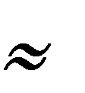**Exercise Eight** A Review: Round the following numbers as called for at the left of the chart.

|  |  |  |  |  |  |
| --- | --- | --- | --- | --- | --- |
| a) Tenth | 2.34 | 3.75 | 1.028 | 2.749 | 0.072 |
| ***2.3*** |
| b) Thousandth | 0.1234 | 1.8032 | 7.0052 | 2.80719 | 0.00049 |
| ***0.123*** |
| c) Whole number | 21.2 | 2.7 | 12.05 | 6.49 | 0.8 |
| ***21*** |
| d) Hundred | 275 | 490 | 1 260 | 4 720 | 1 050 |
| e) Hundredth | 1.732 | 2.466 | 3.074 | 80.27 | 0.005 |
| f) Ten | 68 | 32 | 824 | 675 | 104 |
| g) Thousandth | 0.7286 | 0.5027 | 1.2345 | 0.0075 | 7.9999 |

 Use rounded numbers to estimate answers in daily situations, in math problem solving, and to get an idea of the answer before you figure something out on a calculator.

Numbers that are rounded off make calculations simpler.



**Answers to Exercise Eight**

|  |  |  |  |  |  |
| --- | --- | --- | --- | --- | --- |
| a) Tenth | 2.34  ***2.3*** | 3.75  *3.8* | 1.028  *1.0* | 2.749  *2.7* | 0.072  *0.1* |
| b) Thousandth | 0.1234  ***0.123*** | 1.8032  *1.803* | 7.0052  *7.005* | 2.80719  *2.807* | 0.00049  *0.000* |
| c) Whole number | 21.2  ***21*** | 2.7  *3* | 12.05  *12* | 6.49  *6* | 0.8  *1* |
| d) Hundred | 275  *300* | 490  *500* | 1 260  *1 300* | 4 720  *4 700* | 1 050  *1 100* |
| e) Hundredth | 1.732  *1.73* | 2.466  *2.47* | 3.074  *3.07* | 80.27  *80.27* | 0.005  *0.01* |
| f) Ten | 68  *70* | 32  *30* | 824  *820* | 675  *680* | 104  *100* |
| g) Thousandth | 0.7286  *0.729* | 0.5027  *0.503* | 1.2345  *1.235* | 0.0075  *0.008* | 7.9999  *8.000* |

**Exercise Nine** Round the numbers to estimate the answer. Draw a box

around the estimate that is the best answer.

|  |  |  |
| --- | --- | --- |
| a) | **Question** 47 52  ***Estimation*** *50 50 = 2 500* | 240 2 500 250 2 600 |
| b) | **Question** 3.2 4.875  ***Estimation*** *3 5 = 15* | 6 8 15 17 |
| c) | **Question** 4 149 20 | 2 000 200 20 230 |
| d) | **Question** 2 895 + 2895 | 600 6 000 4 000 5 000 |
| e) | **Question** 118 + 289 | 300 350 400 5000 |
| f) | **Question** 91 79 | 720 800 8 000 80 000 |
| g) | **Question** 347 50 | 7 70 700 8 |
| h) | **Question** 4 892 - 3 012 | 1 500 1 000 2 000 3 500 |
| i) | **Question** 29.75 3.02 | 6 8 10 20 |
| j) | **Question** 12.82 + 9.04 | 21 23 22 20 |
| k) | Mr. Jones drives an average of 285 km per week. **Estimate** how many kilometres he drives in one year (52 weeks). | He drives approximately kilometres in one year. |
|  |  |  |

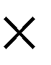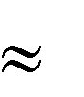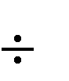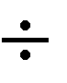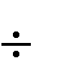

**Answers to Exercise Nine**

|  |  |  |  |  |  |  |  |
| --- | --- | --- | --- | --- | --- | --- | --- |
| a) | **Question** 47 52  ***Estimation*** *50 50 = 2 500* | 240 2 500 250 2 600 | | | | | |
| b) | **Question** 3.2 4.875  ***Estimation*** *3 5 = 15* | 6 8 15 17 | | | | | |
| c) | **Question** 4 149 20  *Estimation 4 000 20 =* | 2 000 | | 200 | 20 230 | | |
|  | | | | | |
| d) | **Question** 2 895 + 2895  *Estimation 3 000 + 3 000 =* | 600 | 6 000 | | | 4 000 5 000 | |
|  | | | | | |
| e) | **Question** 118 + 289  *Estimation 100 + 300 =* | 300 350 400 5000 | | | | | |
| f) | **Question** 91 79  *Estimation 100 80 =* | 720 800 8 000 7 200 | | | | | |
| g) | **Question** 347 50  *Estimation 350 50 =* | 7 70 700 8 | | | | | |
| h) | **Question** 4 892 - 3 012  *Estimation 5 000 – 3 000 =* | 1 500 1 000 | | | | 2 000 | 3 500 |
|  | | | | | |
| i) | **Question** 29.75 3.02  *Estimation 30 3 =* | 6 8 10 20 | | | | | |
| j) | **Question** 12.82 + 9.04  *Estimation 13 + 9 =* | 21 23 22 20 | | | | | |
| k) | **Estimation:** 300 50 =  15 000 | He drives approximately  15 000 kilometres in one year. | | | | | |

**Topic D: Self-Test Mark /17 Aim 14/17**

1. **Round to the nearest hundred. 3 marks**

a) 749 b) 691 c) 1 101

1. **Round to the nearest whole number. 3 marks**

a) 0.831 b) 6.24 c) 79.98

1. **Round to the nearest tenth. 3 marks**

a) 8.29 b) 6.533 c) 93.018

1. **Round to the nearest hundredth. 3 marks**

a) 34.792 b) 6.459 c) 8.899

1. **Round to the nearest thousandth. 3 marks**

a) 5.4392 b) 0.8208 c) 21.4925

1. **Estimate the answer. 2 marks**



**Answers to Topic H Self-Test**

**Part A**

**Part F**

Estimation – 7 hours $8 = $56

Mary baby-sat for her twin nephews for 6.75 hours on Saturday. She is paid $8.40 an hour. Estimate her earnings by first rounding the numbers in the problem to whole numbers.

Show how you worked out the estimate.

|  |  |  |  |  |
| --- | --- | --- | --- | --- |
| a) 700  **Part B** | b) 700 | | c) 1 100 | |
| a) 1 b) 6 | c) 80 | |  | |
| **Part C**  a) 8.3 | b) | 6.5 | c) | 93.0 |
| **Part D**  a) 34.79 | b) | 6.46 | c) | 8.90 |
| **Part E**  a) 5.439 | b) | 0.821 | c) | 21.493 |

##### Unit 1 Review

This section is for extra practice and review. If you are unsure about how to do something, look back at the lesson on that skill.

Reading and writing decimals:

1) Write as decimals:

a) =

b) =



c) =



d) =

e) =



f) 3 =

g) 4 =



h) 5 = i) 38 = j) 78 =



1. **Write these decimals as common fractions:**

|  |  |  |
| --- | --- | --- |
| a) 0.7 = | f) | 3.078 = |
| b) 0.06 = | g) | 47.397 = |
| c) 0.49 = | h) | 2.173 = |
| d) 0.02 = | i) | 0.63 = |
| e) 0.473 = | j) | 6.07 = |

1. **Write as common fractions and as decimals:**

|  |  |  |  |
| --- | --- | --- | --- |
| a) Three tenths |  | | |
| b) Fifty nine hundredths |  |  |  |
| c) Three hundred and sixty one thousandths |  |  |  |
| d) Fifty one thousandths |  |  |  |
| e) Four hundred thirty one ten thousandths |  |  |  |
| f) Seven and seven tenths |  |  |  |

|  |  |  |  |
| --- | --- | --- | --- |
| g) | Nine hundred seventy and eighty nine hundredths |  |  |
| h) | Nine and four hundred twelve thousandths |  |  |
| i) | Six hundredths |  |  |

1. **Write the amount of money with numerals, using a $ sign:**
   1. Seven dollars and seventy eight cents
   2. Eighty eight cents
   3. Five hundred dollars and five cents
   4. Seven dollars
   5. Three hundred twenty four cents
   6. Eight cents
   7. Ninety nine dollars and ninety cents
   8. Five thousand three hundred twenty two dollars
   9. Eighty nine cents
2. **Complete the chart. The first two are done for you as examples.**



|  |  |  |  |
| --- | --- | --- | --- |
|  | **Decimal** | **Fraction** | **In words** |
| a) | 0.005 |  | Five thousandths |
| b) | 0.07 |  | Seven hundredths |
| c) |  |  |  |
| d) |  | 7 |  |
| e) |  |  | Fourteen and seven thousandths |
| f) | 647.8 |  |  |
| g) |  | 103 |  |
| h) | 75.13 |  |  |
| i) |  |  | Forty two and three tenths |
| j) | 0.789 |  |  |
| k) |  |  | Ten and five hundred sixty seven thousandths |

**Comparing decimals:**

1. **Cross out the zeros that are not needed:**

a) 0.5060

b) 07.0307

c) 900.380

d) 05.200

e) 01000.03010

f) 700.030

g) 03.70

h) 6.03

1. **Compare the decimals and then put the correct sign between the decimals (<, >, =):**

a) 4.3 43 f) 3.5 3.05

b) 78.9 7.89 g) 042.9003 042.9

c) 8.03 8.031 h) 17.34 13.34

d) 0.35 0.350 i) 4.01 5.01

e) 0.2 0.289

Rounding decimals:

1. **Round the following decimals:**
   1. To the nearest tenth:

i. 3.84

ii. 4.75

iii. 89.034

iv. 0.09

v. 3.97

c) To the nearest thousandth: i. 0.1376

ii. 78.4788

iii. 1.8044 iv. 2.7499 v. 0.00057

b) To the nearest hundredth: i. 2.754

ii. 4.3856

iii. 5.9754 iv. 1.8032 v. 37.439

d) To the nearest whole number: i. 0.39

ii. 78.78

iii. 4.44 iv. 80.745 v. 901.399



|  |  |  |  |  |  |  |  |  |
| --- | --- | --- | --- | --- | --- | --- | --- | --- |
|  | **Answers to Review** | | |  | |  |  |  |
|  | **1)** | | |  | |  |  |  |
|  | a) 0.4 b) 0.25 | | | c) 0.37 d) 0.03 | | e) 0.0207 | f) 3.787 |  |
|  | g) 4.11 h) 5.012 | | | i) 38.12 j) 78.0043 | |  |  |  |
|  | **2)** | | |  | |  |  |  |
|  | a) b) | | | c) d) | | e) | f) 3 |  |
|  | g) 47 h) 2 | | | i) j) 6 | |  |  |  |
|  | **3)** | | |  | |  |  |  |
|  | a) 0.3 | | | b) 0.59 | | c) 300 | 300.061 |  |
|  | d) 0.051 | | | e) 0.0431 | | f) 7 7.7 |  |  |
|  | g) 970 970.89 | | | h) 9 9.412 | | i) 0.06 |  |  |
|  | **4)** | | |  | |  |  |  |
|  | a) $7.78 b) $0.88 | | | c) $500.05 d) $7.00 | | e) $3.24 | f)$0.08 |  |
|  | g) $99.90 h) $5 322.00 | | | i) $0.89 | |  |  |  |
|  | **5)** | | |  | |  |  |  |
|  |  | **Decimal** | **Fraction** | | **In words** | | |  |
| a) | 0.0005 |  | | Five thousandths | | |
| b) | 0.07 |  | | Seven hundredths | | |
| c) | 0.086 |  | | Eighty six thousandths | | |
| d) | 7.11 | 7 | | Seven and eleven hundredths | | |
| e) | 14.017 | 14 | | Fourteen and seven thousandths | | |
| f) | 647.8 | 647 | | Six hundred forty seven and eight tenths | | |
| g) | 103.062 | 103 | | One hundred three and sixty two thousandths | | |
| h) | 75.13 | 73 | | Seventy five and thirteen Hundredths | | |
| i) | 42.3 | 42 | | Forty two and three tenths | | |
| j) | 0.789 |  | | Seven hundred eighty nine hundredths | | |
| k) | 10.567 | 10 | | Ten and five hundred sixty seven thousandths | | |

**6)**

a) 0.506~~0~~

b) ~~0~~7.0307

c) 900.38~~0~~

d) ~~0~~5.2~~00~~

e) ~~0~~1000.0301~~0~~

f) 700.03~~0~~

g) ~~0~~3.7~~0~~

h) 6.03

**7)**

|  |  |  |  |  |  |  |  |
| --- | --- | --- | --- | --- | --- | --- | --- |
| a) < b)  g) > h) | | >  > | c)  i) | <  < | d) = | e) < | f) > |
| **8)**  a) i. 3.8 | ii. 4.8 | | iii. 89.0 | | | iv. 0.1 | v. 4.0 |
| b) i. 2.75 | ii. 4.39 | | iii. 5.98 | | | iv. 1.80 | v. 37.44 |
| c) i. 0.138 | ii. 78.479 | | iii. 1.804 | | | iv. 2.750 | v. 0.001 |
| d) i. 0 | ii. 79 | | iii. 4 | | | iv. 81 | v. 901 |

**Test time!**

Please see your instructor to get your practice test.

When you are confident, you can write your unit 1 test.

**Congratulations!**

**Unit 2**

Adding and Subtracting Decimals

**Topic A: Adding Decimals**

**Review place value** in whole numbers and in decimal fractions. Here is a place value chart for decimals:

|  |  |  |  |  |  |  |  |  |
| --- | --- | --- | --- | --- | --- | --- | --- | --- |
| Whole numbers | | | Decimal point | Decimals | | | | |
| hundreds | tens | ones |  | ten*ths* | hundred*ths* | thousand*ths* | Ten thousand*ths* | Hundred thousand*ths* |
|  |  | 3 |  | 4 | 5 | 3 |  |  |
|  |  | 0 |  | 9 | 6 |  |  |  |
|  |  |  |  |  |  |  |  |  |
|  |  |  |  |  |  |  |  |  |

**Vocabulary Review -** Use the example below and the glossary to help you write the definitions.

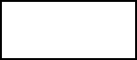

addend

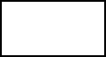

sum

3 + 5 = 8

addends:

**sum:**

To add decimals you must be very careful to add together the digits with the same place value.

Add thousandths to thousandths. Add hundredths to hundredths. Add tenths to tenths.

**Here are some techniques to help you organize your decimal addition.**

Write the addends underneath each other so the decimal points are in a straight column.

0.43 + 0.2 + 0.804 + 0.1 = 0.43

0.2

0.804

+ 0.1

Put zeros at the end of the decimal fractions so that all fractions have the same number of decimal places.

0.430

0.200

0.804

+ 0.100

It may help you to put the decimal point in the answer line before you do the addition.

0.300

0.602

+ 0.290

When adding mixed decimals, be sure to keep the whole number places lined up as well. As you know, ones add to ones, tens to tens, hundreds to hundreds and so on. Put a decimal point after any whole numbers.

62.1 + 14.58 + 6**.** + 7.311 + 6.23 = 62.100

14.580

6.000

7.311

+ 6.230

.

Add each column, starting with the decimal place farthest to the right. If the total of a column is ten or more, carry the ten number to the next column as you are used to doing with whole numbers.

|  |  |
| --- | --- |
| 1 1 | 2 1 1 |
| 0.470 | 0.620 |
| 0.298 | 0.281 |
| 0.100 | 0.900 |
| + 5.600 | +0.549 |
| 6.468 | 2.350 |

**Exercise One** Rewrite each question in columns and add.

a) 0.24 + 0.73 + 0.51 = b) 0.821 + 0.14 + 0.019 =

*1 1*

*0.24 0.821*

*0.73 0.140*

*+ 0.51 + 0.019*

*1.48 0.980*

c) 0.17 + 0.85 + 0.03 = d) 0.72 + 0.3 + 0.54 =

e) 0.084 + 0.291 + 0.652 = f) 0.195 + 0.982 + 0.605 =

g) 0.232 + 0.8 + 0.715 = h) 0.153 + 0.229 + 0.521 =

i) 0.625 + 0.845 + 0.33 = j) 0.442 + 0.782 + 0.254 =

|  |  |  |  |
| --- | --- | --- | --- |
| a) 1.48 | b) 0.980 | c) 1.05 | d) 1.56 |
| e) 1.027 | f) 1.782 | g) 1.747 | h) 0.903 |
| i) 1.8 | j) 1.478 |  |  |

**Exercise Two** Rewrite in columns and add.

**Answers to Exercise One**

a) 1.003 + 141.2 + 0.47 = b) 5.6 + 3.59 + 1 829 =

|  |  |
| --- | --- |
| 1.003 | 5.60 |
| 141.200 | 3.59 |
| + 0.470 | + 1 829.00 |
| 142.673 | 1838.19 |

c) 4.6 + 2.59 + 1 629 = d) 0.391 + 80 + 4.63 =

e) 0.001 + 0.150 + 0.12 = f) 6.341 + 0.02 + 1.6 =

g) 0.9764 + 147 + 67.31 = h) 53.261 + 3.59 + 0.0068 =

**Answers to Exercise Two**

i) 16.34 + 211.684 + 75.0697 = j) 321.6 + 485.791 + 0.001 =

k) 64.1 + 18 + 49.003 = l) 47.91 + 5.3 + 0.00163 =

m) 0.22 + 46.84 + 95.6 = n) 0.042 + 0.018 + 19.1 =

|  |  |  |  |
| --- | --- | --- | --- |
| a) 142.673 | b) 1838.19 | c) 1636.19 | d) 85.021 |
| e) 0.271 | f) 7.961 | g) 215.2864 | h) 56.8578 |
| i) 303.0937 | j) 807.392 | k) 131.103 | l) 53.21163 |
| m) 142.66 | n) 19.16 |  |  |

**Exercise Three** Remember that perimeter is the measurement around the

outside edge of an object. To find perimeter, you add the lengths of all the sides together.

Find the perimeter of the **squares** described in each question. The measure of one side has been given. Draw a picture of each square to help visualize the question.

a) *s* = 75.3 m b) *s* = 12.4 mm P = S + S + S + S P =

P = 75.3 + 75.3 + 75.3 + 75.3 m P =



75.3 m

75.3 m

75.3 m

75.3 m

c) *s* = 100.73 km d) *s* = 50.2 cm P =

e) *s* = 130.07 m f) *s* = 1 000.82 km

g) *s* = 16.5 m h) *s* = 3.25 m

**Answers to Exercise Three**

|  |  |  |  |
| --- | --- | --- | --- |
| a) 301.2 m | b) 49.6 mm | c) 402.92 km | d) 200.8 cm |
| e) 520.28 m | f) 4003.28 km | g) 66 m | h) 13 m |

**Exercise Four** Find the perimeter of the rectangles described below.

You may wish to draw and label a sketch for the ones with no pictures.

a) b)



7.5 m

3.1 m



10.45 cm

5.3 cm

P =side + side + side + side

P = P = side + side + side + side

P =

c) 4.3 m d)

4.3 m



3.8 cm



3.7 m



5.7 cm

e)



f)

7.5 m

1.5 m



2.1 cm

7.5 cm

**Answers to Exercise Four**

|  |  |  |
| --- | --- | --- |
| g) *l* = 10.3 cm | h) *l* = 100.03 km | i) *l* = 15.5 mm |
| *w* = 6.6 cm | *w* = 70.96 km | *w* = 10.5 mm |



10.3 cm



6.6 cm

|  |  |  |
| --- | --- | --- |
| j) *l* = 9.75 cm | k) *l* = 40.47 km | l) *l* = 19.6 cm |
| *w* = 3.5 cm | *w* = 10.4 km | *w* = 2.8 cm |

|  |  |  |  |
| --- | --- | --- | --- |
| a) 21.2 m | b) 31.5 cm | c) 16 m | d) 19 cm |
| e) 19.2 cm | f) 18 m | g) 33.8 cm | h) 341.98 km |
| i) 52 mm | j) 26.5 cm | k) 101.74 km | l) 44.8 cm |

**Exercise Five** Find the perimeter of the polygons described below. Be

sure the measurements are in the same unit value. Use a formula for each calculation, the formula work is started in the first two for you.

a) b)

7.5 km



7.5 km

6.5 km

9.5 km



80.3 m

80.3 m

80.3 m

80.3 m

80.3 m

80 .3m

P = Side + Side + Side

P = 6.5 km + 7.5 km + 9.5 km P =

P = P = Side + Side + Side + Side + Side + Side

P = P = + + + + + P =

P =

c) d)



7.2 cm

4.85 cm

5 cm



12.03 km



3.89km

P = P =

Units can be anything from centimetres, to litres to ice cubes to plain old ―units‖.

e) 12 units f)

8 m

7 m



7 m

8.2 m

9.4m

8.5m



7 units

7 units

6 units



10 m

g) h)

**Answers to Exercise Five**



1.45 km

8.94 km



30.3 m

|  |  |  |  |
| --- | --- | --- | --- |
| a) 23.5 km | b) 481.8 m | c) 17.05 cm | d) 31.84 km |
| e) 32 units | f) 43.1 m | g) 20.78 km | h) 121.2 m |

##### Problem Solving Steps

Word problems describe a real-life situation that involves numbers. Often the most difficult part of working with numbers is knowing **what** we should do, then it is easy to know **how** to do it.

It is sort of like dancing. You may know **how** to jive, rhumba, cha cha, waltz, polka, etc., but when the music plays, the question is "**What** dance is it?" So you listen to the music until you find a dance that fits.

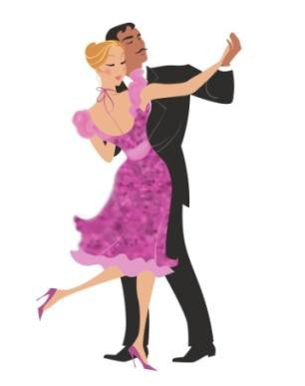



Okay, how do you "listen to" a math problem? Use these steps:

**Step 1 READ** the problem carefully. Decide what you have to find out.

What is the **QUESTION**? Draw a picture to help you see the problem described.

**Step 2** What does the problem tell you? What **INFORMATION** is **NECESSARY** to solve the problem? Often you are given extra numbers and information that are not needed.

Circle

the information you need.

Write out the information you need with the picture you drew.

**Step 3** Decide what **ARITHMETIC OPERATION** to use. Do you add, subtract, multiply, or divide? Does the problem have two parts?

**Key words** often point to the operation needed. Drawing a diagram or sketch is often helpful.

Write an equation (a number sentence).

**Step 4 ESTIMATE** the answer to the problem.

 Round the numbers so you can work with them quickly.

 Use the operation you chose in Step 3 and come to a quick answer.

Does this estimated answer make sense? Does it answer the question in the problem? **THINK** carefully before you do Step 5.

**Step 5 SOLVE** the problem using the **actual** numbers.

 Check your arithmetic.

 Compare to your estimate.

 Think again about the problem. Does your solution make sense?

 State **what** the numbers are counting (the units) when you write the answer. The answer could be 3 dozen eggs, 3 kilometres, or 3 people.

**Some common metric units and their abbreviations**

|  |  |  |  |
| --- | --- | --- | --- |
| kilometre | km | kilogram | kg |
| metre | m | gram | g |
| centimetre | cm | litre | L |

**Example A:**

The nutrition information on a box of cereal says that a regular serving contains 2.8 g of protein, 0.2 g of fat, 25 g of carbohydrate, and 1.9 g of "other nutrients". Give the total number of grams in a regular serving.

**Step 1 QUESTION?**

How many grams in a regular serving?

Draw a picture:



Protein



fat



carbohydrate



Other

**Step 2 NECESSARY INFORMATION**

A regular serving contains 2.8 g protein, 0.2 g fat, 25 g carbohydrate, and 1.9 g "other nutrients".

Add to your Picture:



Protein

2.8 g



Fat

0.2 g



Carbohydrate 25 g



Other

1.9 g

**Step 3 OPERATION**

Problem lists four different amounts and asks you to find one total. "Total" points to adding.

Add the operation



Fat

0.2 g



Carbohydrate

+25 g



+Other

1.9 g

You need to youPrrotein +

2.8 g

Picture:

Then, write an equation:

2.8 + 0.2 + 25 + 1.9 = total number of grams

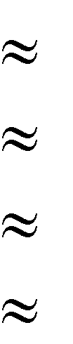**Step 4 ESTIMATE**

2.8 g 3 g

0.2 g 0 g

25 g 25 g

1.9 g + 2 g 30 g

Does this answer make sense?

**Step 5 SOLVE**

1

2.8 g 0.2 25.0

+ 1.9

29.9 g

A regular serving of cereal is 29.9 grams.

Check arithmetic Compare to estimate

Makes sense?

Some **key words** that point to **addition** include:

**sum plus**

**total total amount**

**altogether combined**

**complete entire**

**in all added to**

**increased by**

**Exercise Six** Use your skills in adding decimal fractions to do the following problems. Underline key words in the problems that will help you to recognize addition problems.

*Remember to first draw a picture!*

1. A road construction crew finished surfacing 5.7 km of highway one week and 4.4 km the next week. How many kilometres did they complete in that two weeks? (a picture is drawn for you here)

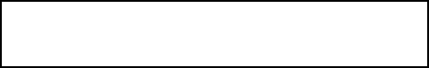

5.7 km

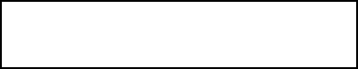

4.4 km

+

Estimation: *6 km + 4 km = 10 km*

Actual Solution:

*5.7 km*

*+ 4.4 km*

*10.1 km*

*The road crew completed 10.1 km of road surfacing in two weeks.*

1. When Ted bought his used car, the odometer showed 12 686.4 km. In one year he drove it 13 294.8 km. What did the odometer read then? (draw your own picture now)

Estimation:

Actual Solution:

1. Joanne phoned to ask her partner to pick up some groceries on his way home. He said, "I only have $20. Will that be enough?" Joanne wanted him to buy milk ($4.86), bread ($1.45), a bag of apples on sale for $3.99 and laundry detergent ($8.57). Does he have enough money?

Estimation:

Actual Solution:

1. A recipe for spaghetti sauce uses 1.25 kg of ground beef, 2.4 kg of fresh tomatoes, 1 kg of onions, 0.75 kg of celery, 0.5 kg of green pepper and lots of garlic and herbs. What is the total weight of the ingredients, not counting the garlic and herbs?

Estimation:

Actual Solution:

1. This month your power bill has increased $24.67, your phone bill has an extra $13.43 and your cable bill is up $2.24—great month! What is the combined extra cost that you are paying this month?

Estimation:

Actual Solution:

1. One side of a square Deluxe Scrabble board measures 38.7 cm. What is the perimeter of the board?

Estimation:

Actual Solution:

1. The campground security officer walks around the outside of the campground four times every evening. The campground is 800.75 m square. How far does the officer walk in these patrols each night?

**Note:** *800.75 m square* is a common way of saying ―a square with sides that each measure

800.75 m.‖ Estimation:

Actual Solution:



**Answers to Exercise Six**

1. Estimation: *6 km + 4 km 10 km*

Actual Solution: 5*.7 km + 4.4 km = 10.1 km*

*The road crew completed 10.1 km of road surfacing in two weeks*.

1. Estimation: 13 000 km + 13 000 km = 26 000 km Actual Solution: 12 686.4 km + 13 294.8 km = 25 981.2 km The odometer read 25 981.2 km.

c) Estimation: $5 + $1 + $4 + $9 = $19

Actual Solution: $4.86 + $1.45 + $3.99 + $8.57 = $18.87

The groceries will cost $18.87, so he will have enough money.

d) Estimation: 1 kg + 2 kg + 1 kg + 1 kg + 1 kg = 6 kg

Actual Solution: 1.25 kg + 2.4 kg + 1 kg + 0.75 kg + 0.5 kg = 5.9 kg The total weight of the ingredients is 5.9 kg.

e) Estimation: $25 + $13 + $2 = $40

Actual Solution: $24.67 + $13.43 + $2.24 = $40.34 The extra cost you are paying is $40.34.

1. Estimation: 40 cm + 40 cm + 40 cm + 40 cm = 160 cm Actual Solution: 38.7 cm X 4 = 154.8 cm

The perimeter of the Scrabble board is 154.8 cm

1. Estimation: 801 m X 4 X 4 = 12 816 m Actual Solution: 800.75 X 4 X 4 = 12 812 m

The campground security officer walks 12 812 m each night on her patrol.

|  |  |  |  |  |
| --- | --- | --- | --- | --- |
| **Topic A: Self-Test** | **Mark** | **/10** | **Aim** | **8/10** |
| **A. Find the sum.** |  |  | **6 marks** |  |

a) 3.67 b) 5.27 + 2.4 + 8 + 6.93 + 10.27 =

12.55

8.19

+ 5.67

c) 0.183 d) 8.173 + 4.68 + 1.275 + 7.331 =

19.76

8.029

+ 3.38

e) 4.648 f) 2.72 + 0.6 + 110 + 17.223 =

1.92

1.275

+ 86.9

**B. Problems 4 marks**

1. Gwen has to mail her Christmas gifts to her family as they do not live near her. A box for Vancouver weighed 3.7 kg, the gift to her sister's family in Campbell River was 2.145 kg, the one to Prince George was 1.06 kg and the parcel to Toronto was 4 kg. What was the combined weight of Gwen's parcels?

Estimation:

Actual Solution:

1. George purchased new running shoes for his three kids. The six year old's shoes at $15.85 were a bargain. The nine year old got a pair of runners for $39.30, but the teen-aged daughter **had** to have the fancy pair that cost $89.95. How much did George spend on the three pairs of running shoes, before taxes?

Estimation:

Actual Solution:

**Answers to Topic A Self-Test**

Part A

a) 30.08

e) 94.743

Part B

b) 32.87

f) 130.543

c) 31.352

d) 21.459

a) Estimation: 4 kg + 2 kg +1 kg + 4 kg = 11 kg

Actual Solution: 3.7 kg + 2.145 kg + 1.06 kg + 4 kg = 10.905 kg The combined weight of the parcels was 10.905 kg.

b) Estimation: $15 + $40 + $90 = $145

Actual Solution: $15.85 + $39.30 + $89.95 = $145.10 George spent $145.10 on the three pairs of running shoes.

##### Topic B: Subtracting Decimals

To subtract decimals **you must subtract each digit from the digit of the same place value**.

Subtract thousandths from thousandths. Subtract hundredths from hundredths. Subtract tenths from tenths.

The same techniques that you used in adding decimals are helpful when you subtract decimals.

1. Write the number that you are starting with. Put the amount you are subtracting underneath so the decimal points are in a straight column.

0.468 - 0.3 = 0.468

- 0.3

1. Put zeros at the end of the decimals so that all the decimals in the question have the same number of decimal places.

0.468 - 0.3 = 0.468

- 0.3**00**

1. Use the subtracting skills that you know from working with whole numbers.

**Example:**





1) *Rewrite the problem:*

2.536

- 0.590

2) 2.536

- 0.590

6

1. *now you will need to borrow:*

4 1

2.~~5~~36

- 0.590

46

1. *And borrow again*

1 14 1

~~2.5~~36

- 0.590

.946

1. *and then finish the problem*

1 14 1

~~2.5~~36

- 0.590

1.946

**Vocabulary Review -** Write the definition.

8 – 5 = 3



difference

**Difference:**

**Exercise One** Subtract to find the differences.

|  |  |  |
| --- | --- | --- |
| a) 2.75  -0.68 | b) 9.64  - 7.15 | c) 3.85  - 1.75 |
| *2.07* | *2.49* |  |

|  |  |  |
| --- | --- | --- |
| d) 1.17 | e) 27.3 | f) 0.732 |
| - 0.92 | - 18.9 | - 0.651 |

|  |  |  |
| --- | --- | --- |
| g) 0.803 | h) 7.17 | i) 9.00 |
| - 0.411 | - 2.08 | - 1.75 |

|  |  |  |
| --- | --- | --- |
| j) 0.362 | k) 6.85 | l) 18.5 |
| - 0.177 | - 1.28 | - 7.9 |

|  |  |  |
| --- | --- | --- |
| m) 6.273 | n) 12.35 | o) 6.152 |
| - 0.192 | -8.47 | - 4.071 |

|  |  |  |
| --- | --- | --- |
| p) 98.6 | q) 5.276 | r) 5.251 |
| - 45.8 | - 3.298 | - 2.738 |

**Answers to Exercise One**

|  |  |  |  |
| --- | --- | --- | --- |
| a) 2.07 | b) 2.49 | c) 2.10 | d) 0.25 |
| e) 8.4 | f) 0.081 | g) 0.392 | h) 5.09 |
| i) 7.25 | j) 0.185 | k) 5.57 | l) 10.6 |
| m) 6.081 | n) 3.88 | o) 2.081 | p) 52.8 |
| q) 1.978 | r) 2.513 |  |  |

##### Subtracting a Decimal from a Whole Number

Follow these steps to subtract a decimal from a whole number:  Put a **decimal point after** the **whole number**.

16 - 0.4 = 16**.** - 0.4

 **Put zeros after the decimal point** as needed.

16 - 0.4 = 16.**0**

- 0.4

.

 Do the subtraction as usual. See that you will need to borrow right away.

**Example A:** 32 - 0.12 = 32.00

- 0.12

 Rename the 2 in the ones place as 1 and 10 tenths.

1 10

3~~2.0~~0

- 0.12

 Now rename the 10 tenths as 9 tenths and 10 hundredths. You are ready to subtract.

9

1 1**0**10

3~~2.00~~

- 0.12

31.88

**Example B:** $14 - $3.49

$14.00

- 3.49

9

310 10

$1~~4.00~~

- 3.49

$10.51

**Exercise Two** Rewrite each question in columns and find the difference. a) 6 - 3.42 = b) 14 - 9.23 =

*5 1*0 *10*

~~6~~*~~.~~*~~00~~ 14.00

- 3.42 - 9.23

*2.58*

c) 11 - 3.821 = d) 2 - 1.98 =

e) 7 - 6.815 = f) 212 - 3.006 =

g) 22 - 13.51 = h) 7 - 3.976 =

|  |  |  |  |
| --- | --- | --- | --- |
| a) 2.58 | b) 4.77 | c) 7.179 | d) 0.02 |
| e) 0.185 | f) 208.994 | g) 8.49 | h) 3.024 |

If you had problems with this, go over your subtraction method with your instructor  before you continue.

**Answers to Exercise Two**

**Exercise Three** Rewrite each question in columns and find the difference. a) 163.682 - 41.5 = b) 361.008 - 4.595 =

*163.682*

*- 41.500*

*122.182*

c) $60 - $44.28 = d) $4.00 - $0.44 =

e) $260.06 - $3 = f) 193 - 37.06 =

g) 89.0309 - 6.3 = h) $56.59 - $4.17 =

i) $100 - $13.75 = j) 519.3 - 68.009 =

**Answers to Exercise Three**

|  |  |  |  |
| --- | --- | --- | --- |
| a) 122.182 | b) 356.413 | c) $15.72 | d) $3.56 |
| e) $257.06 | f) 155.94 | g) 82.7309 | h) $52.42 |
| i) $86.25 | j) 451.291 |  |  |

##### Problems Using Subtraction of Decimals

**Key words** which point to **subtraction** include:

**difference balance**

**minus amount left**

**subtracted from decreased by**

**reduced by taken away less**

Questions may ask you to compare or find the difference between two amounts. Look for such words as **how much greater (or larger, taller, more)**, **how much less (or smaller, shorter)**. **What are the savings? Subtract to find the answer.**

**Exercise Four** Use your skills in subtracting decimals to do the following

problems. Underline key words in the problems that will help you to recognize subtraction problems. Try to draw pictures to help yourself see the problem in real life.

1. Brad is 1.8 m tall. He just did the best high jump of his life, clearing 1.89 m. How much less is his own height than the height he jumped?

Estimation:

Actual Solution:

1. 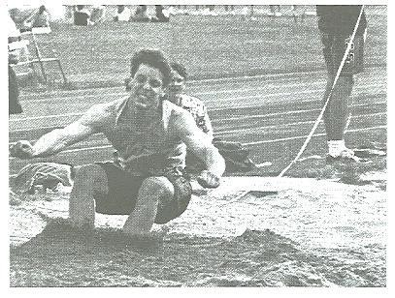Jonathan's best track and field event is long jump. He leapt 6.16 m. His dad used to long jump in high school and jumped 5.52 m. How much farther did Jonathan jump than his dad?

Estimation (to tenths):

Actual Solution:

1. Joe had a bank balance of $438. He wrote a cheque for $56.59 to pay for a phone bill. What is the balance in his bank account now?

Estimation:

Actual Solution:

1. A plumber needs to replace 11.5 m of pipe in a home. She has 6.5 m in her truck. How much more pipe does she need?

Estimation:

Actual Solution:

1. One store advertises coffee for $3.19 a kilogram. Another store sells coffee at $2.99 per kilogram. What is the saving if the coffee is bought at the second store?

Estimation:

Actual Solution:

1. George's car averages 6.3 kilometres per litre of gasoline. Bill's car averages 5.55 km/L gasoline. How much better is George's car than Bill's in its use of gasoline?

Estimation (to tenths):

Actual Solution:

1. Lee is going to install base boards in the recreation room he has built in his basement. The room is 5.8 metres square. The baseboard material is expensive, so he will be sure to deduct 1 m for each of the two doorways. How much baseboard material does he need to buy?

Estimation (to tenths):

Actual Solution:



**Answers to Exercise Four**

1. Estimation: 1.9 m – 1.8 0.1 m Actual Solution: 1.89 – 1.8 = 0.09 m

Brad‘s height is 0.09 m less than the height he jumped.

1. Estimation: 6.2 – 5.5 0.7 m Actual Solution: 6.16 – 5.52 = 0.64 m

Jonathan jumped 0.64 m farther than his dad.

c) Estimation: $440 - $60 $380

Actual Solution: $438 - $56.59 = $381.41 Joe‘s bank balance is now $381.41.

d) Estimation: 12 m – 7 m 5 m Actual Solution: 11.5 m – 6.5 m = 5 m The plumber needs 5 m more of pipe.

e) Estimation: $3.20 - $3.00 $0.20 Actual Solution: $3.19 - $2.99 = $0.20

The savings will be $0.20 if the coffee is bought at the second store.

1. Estimation: 6.3 – 5.6 0.7 km/L Actual Solution: 6.3 – 5.55 = 0.75 km/L

George‘s car is 0.75 km/L better than Bill‘s car.

1. Estimation: 6 m X 4 = 24 m 24 m – 2 m (doors) = 22 m

Actual Solution: 5.8 m X 4 = 23.2 m

23.2 m – 2 m (doors) = 21.2 m

Lee will need to buy 21.2 m worth of base board material.

**Topic B: Self-Test Mark /10 Aim 8/10**

1. **Subtract 6 marks**

a) 72.04 b) 19.6 - 6.254 =

- 13.98

c) 88.402 d) 1 100 - 248.91 =

- 16.51

e) 11.21 f) $140 - $102.73 =

- 3.875

1. **Problems 4 marks**
2. Gail spent $273.24 on her shopping trip. She had taken $300 with her. How much of her money is left?

Estimation:

Actual Solution:

1. To connect the new phone in her bedroom Marian needs 4.25 m of wire. The wire that she found in the workshop is 3.9 m in length. How much more wire does Marian need?

Estimation (to tenths):

Actual Solution:



**Answers to Topic B Self-Test**

**Part A**

a) 58.06

e) 7.335

b) 13.346

f) $37.27

c) 71.892

d) 851.09

**Part B**

a) Estimation: $300 – $275 $25

Actual Solution: $300 - $273.24 = $26.76 Gail had $26.76 left after her shopping trip.

b) Estimation: 4.3 m – 4.0 m = 0.3 m

Actual Solution: 4.25 m – 3.9 m = 0.35 m Marian needs 0.35 m more of wire.

##### Topic C: Bookkeeping

One everyday use of adding and subtracting decimals is the bookkeeping that we all must do with our money. Some examples follow:

Balancing a cheque book Keeping track of payments

Figuring out how much money to take on a trip Stretching a pay cheque over two weeks Organizing the household budget

Deciding how much lunch money the children need List some other examples of bookkeeping that you do:

The bookkeeping that most of us do is straightforward:

Add on money received or deposited to our accounts. Subtract money spent or paid out.

The result of the addition or subtraction is the **balance**.

Methods of Payment

There are many different methods of paying for purchases. Some of the most common methods are:

Cash Debit card Credit card Cheque

Online payment (ex: paypal, RBS WorldPay)

There are benefits to each method of payment. Each person chooses to do what works best for his or her own style and comfort. Here is a list of some of the benefits and drawbacks of each method of payment.

1. **Cash**

Advantages:

It is quick and easy to pull money out of your wallet You can see how much money you have left

It is impossible to overspend

It is a great method to use if you do not have a bank account

Disadvantages:

It is easier to loose

You may need to continue to visit the bank to get money out You might run out of cash while trying to pay at the till

1. **Debit card**

Advantages:

It is quick at the till

You cannot spend more than you have in your bank account It is safe

Disadvantages:

There is often a service fee with using the card to pay for shopping You cannot always use it for on-line shopping

1. **Credit card**

Advantages:



You only have to pay the company money once a month It is quick at the till

It is easy to keep track of what you have spent because the credit card company sends you a monthly statement

 You can use a credit card for on-line shopping

Disadvantages:

 It is really easy to overspend your budget because you do not have to pay any money up front

There are often service charges once a year that are expensive

You can get into debt with a credit card and it may be really hard to get out of that debt

1. **Cheque**

Advantages:

It can be convenient when you want to mail someone money It is safe

The check book helps you keep a written record of your bank balance

Disadvantages:

 Some stores do not accept cheques, or several pieces of identification are needed, usually a driver's licence and a credit card.

Most banks and credit unions have a small service charge for each cheque that you write. If your account is **overdrawn** your cheque will be **N.S.F.** (**N**ot **S**ufficient **F**unds) for which you are charged extra by the store **and** the bank. To avoid this, keep **careful, up- to-date records** so you always know your balance.

1. **Online Payment:**

Advantages:

It allows you to shop online securely

You can pay directly online with money from your bank account or your credit card You can easily send money to friends or family

Disadvantages:

 You may not have rights that regular banks give you when you use an online payment company.

The company is not local, and so any problems may be hard to resolve. There are fees charged to have an online payment account.

No matter what method of payment you choose to use, it is very helpful to keep track of your money. You can use a record book to mark in when you spent money and when you were paid money. This will help with budgeting and planning.

##### Keeping a Bank Book Record

Bank books have a space for record keeping similar to this:

|  |  |  |  |  |  |  |  |  |  |
| --- | --- | --- | --- | --- | --- | --- | --- | --- | --- |
| DATE | CHEQUE NO. | CHEQUES ISSUED TO  OR DESCRIPTION OF DEBIT OR DEPOSIT | DEBIT OR  CHEQUE AMOUNT | | ✓ | DEPOSIT AMOUNT | | BALANCE | |
|  |  | **BALANCE FORWARD** |  |  |  |  |  |  |  |
|  |  |  |  |  |  |  |  |  |  |
|  |  |  |  |  |  |  |  |  |  |

One line is given for each **transaction** that you do. The transactions are usually recorded in chronological order, which is the order by the date or time. The columns are described:

* **Date -** The date of the transaction. The examples given use this method: March 29 is the 29th day of the 3rd month. Write it as 29/3.
* **Cheque No. -** Write the number that is usually found on the top right corner of your cheque. This is **NOT** your account number.
* **Cheque Issued to or Description of Debit or Deposit -** Details of who your cheques were written to, of what you used your debit card for, if you withdrew cash, or made a deposit.
* **Amount of Cheque or Debit -** Write the exact amount of the cheque, debit, or cash withdrawal. **Subtract** this amount from the balance. Note that a dotted line is often drawn for you to separate the dollars from the cents. You may put the decimal on the line if you wish.
* **Amount of Deposit - Add** this amount to your balance.
* Use the column with the tick mark (✓) when you compare your debit card/cheque book record to the statement from the bank.
* **Balance Forward -** The balance from the previous page in the record book.
* **Balance -** The amount in your bank account after each transaction.

**Exercise One** Look carefully at this sample debit card/cheque book

record and answer the questions that follow.

|  |  |  |  |  |  |  |  |  |  |
| --- | --- | --- | --- | --- | --- | --- | --- | --- | --- |
| DATE | CHEQUE NO. | CHEQUES ISSUED TO  OR DESCRIPTION OF DEBIT OR DEPOSIT | DEBIT OR  CHEQUE AMOUNT | | ✓ | DEPOSIT AMOUNT | | BALANCE | |
|  |  | **BALANCE FORWARD** |  |  |  |  |  | *121* | *16* |
| *29/3* | *-* | *Pay deposit* |  |  |  | *675* | *62* | *796* | *78* |
| *30/3* | *161* | *Finance Co. (car loan)* | *175* | *40* |  |  |  | *621* | *38* |
| *30/3* | *162* | *B.C. Hydro (Feb-Mar)* | *50* | *27* |  |  |  | *571* | *11* |
| *5/4* |  | *$ for birthday gift* |  |  |  | *25* | *00* | *596* | *11* |
| *8/4* | *163* | *Telus* | *19* | *80* |  |  |  | *576* | *31* |
| *9/4* |  | *Grocery Mart* | *128* | *54* |  |  |  | *447* | *77* |
| *9/4* |  | *Cash* | *30* | *00* |  |  |  | *417* | *77* |
|  |  |  |  |  |  |  |  |  |  |
|  |  |  |  |  |  |  |  |  |  |

1. Name the month when the cheque to Telus was written:
2. What is the amount of the debit to the Grocery Mart?
3. How much was the pay deposit?
4. What was the balance after the B.C. Hydro transaction?
5. How much was the balance forward?
6. How many deposits were made?
7. What is the total amount of the deposits?

**Exercise Two** Complete the debit card/check book record using the

information below.

|  |  |  |  |  |  |  |  |  |  |
| --- | --- | --- | --- | --- | --- | --- | --- | --- | --- |
| DATE | CHEQUE NO. | CHEQUES ISSUED TO  OR DESCRIPTION OF DEBIT OR DEPOSIT | DEBIT OR  CHEQUE AMOUNT | | ✓ | DEPOSIT AMOUNT | | BALANCE | |
|  |  | **BALANCE FORWARD** |  |  |  |  |  |  |  |
|  |  |  |  |  |  |  |  |  |  |
|  |  |  |  |  |  |  |  |  |  |
|  |  |  |  |  |  |  |  |  |  |
|  |  |  |  |  |  |  |  |  |  |
|  |  |  |  |  |  |  |  |  |  |
|  |  |  |  |  |  |  |  |  |  |
|  |  |  |  |  |  |  |  |  |  |
|  |  |  |  |  |  |  |  |  |  |
|  |  |  |  |  |  |  |  |  |  |
|  |  |  |  |  |  |  |  |  |  |
|  |  |  |  |  |  |  |  |  |  |
|  |  |  |  |  |  |  |  |  |  |

|  |  |  |
| --- | --- | --- |
| April 23 | Balance forward | $210.83 |
| April 25 | Cash withdrawal | $45.00 |
| April 28 | Debit to Grocery Mart | $99.95 |
| April 30 | Pay deposit | $843.29 |
| May 1 | Cheque #48 to Mark Jones for rent | $420.00 |
| May 3 | Cheque #49 to children's school | $25.00 |
|  | (for sports) |  |
| May 6 | Debit to Self-Serve gas | $18.27 |
| May 8 | Cash withdrawal | $110.00 |
| May 10 | Cheque #50 to Acme Finance Co. | $150.00 |
|  | (car payment) |  |
| May 12 | Deposit Child Care Tax Refund | $66.48 |
| May 13 | Debit to Grocery Mart | $183.00 |
| May 15 | Pay deposit | $792.18 |

**Answers to Exercise Two**

|  |  |  |  |  |  |  |  |  |  |
| --- | --- | --- | --- | --- | --- | --- | --- | --- | --- |
| DATE | CHEQUE NO. | CHEQUES ISSUED TO OR DESCRIPTION OF DEBIT OR DEPOSIT | DEBIT OR CHEQUE AMOUNT | | ✓ | DEPOSIT AMOUNT | | BALANCE | |
|  |  | **BALANCE FORWARD** |  |  |  |  |  | 210 | 83 |
| 25/4 |  | Cash Withdrawal | 45 | 00 |  |  |  | 165 | 83 |
| 28/4 |  | Grocery Mart | 99 | 95 |  |  |  | 65 | 88 |
| 30/4 |  | Pay Deposit |  |  |  | 843 | 29 | 909 | 17 |
| 1/5 | 48 | Rent | 420 | 00 |  |  |  | 489 | 17 |
| 3/5 | 49 | Children‘s School (sports) | 25 | 00 |  |  |  | 464 | 17 |
| 6/5 |  | Self-Serve Gas | 18 | 27 |  |  |  | 445 | 90 |
| 8/5 |  | Cash Withdrawal | 110 | 00 |  |  |  | 335 | 90 |
| 10/5 | 50 | Acme Finance Co. (car payment) | 150 | 00 |  |  |  | 185 | 90 |
| 12/5 |  | Child Care Tax Refund |  |  |  | 66 | 48 | 252 | 38 |
| 13/5 |  | Grocery Mart | 183 | 00 |  |  |  | 69 | 38 |
| 15/5 |  | Pay Deposit |  |  |  | 792 | 18 | 861 | 56 |
|  |  |  |  |  |  |  |  |  |  |

##### Cheque Writing

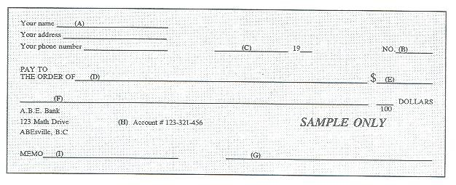

* 1. When you have a chequing account, you have cheques printed with your name, address and phone number, usually in the top left corner.
  2. The cheques are numbered in sequence (in order) to help you keep track of the cheques that you write.
  3. Be sure to include the year. A cheque is **stale-dated** after a certain amount of time and can **no longer be cashed**—**it is not negotiable**. The length of time before a cheque is stale-dated depends on the bank and ranges from three months to one year. Always look at the date when you receive a cheque, too.
  4. Use the whole line for "Pay to the order of". If the name of the person or company you write the cheque to does not use all the space, draw a line through the rest of the space. This prevents anyone from changing what you have written.
  5. Write the amount of the cheque in numbers: $22.98
  6. Write, in words, the dollars to be paid. Write the cents as a fraction over 100. Be sure to fill unused parts of the space with a straight line.

$22.98 becomes twenty-two Dollars.

* 1. When you open a bank account, the bank will ask you for a sample signature for their files. Sign exactly as you plan to sign your cheques. Then be sure you always sign your cheques in this way. It is very embarrassing to have your bank refuse to cash your cheque because the signature is wrong.
  2. Your bank account number and codes used at the bank will be printed on your cheque blanks.
  3. A place for details—useful if you want the cheque as a receipt, too. You might list the invoice number for the bill you are paying, for example.

As soon as you write a cheque, be sure to enter it in your debit card/cheque-book record.

Practice cheques or any cheques you do not want cashed should have **VOID** or

 **SAMPLE ONLY** written on them.

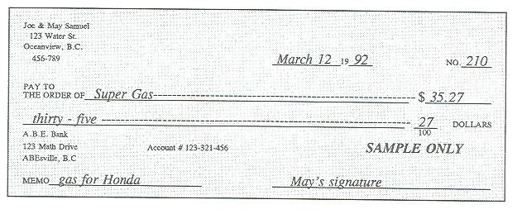

**Exercise Three** Write cheques #48, 49, and 50 from Exercise Two. Use

any name and signature you want. Ask your instructor to check your cheques.

Your name

Your address

Your phone number

20

No.

PAY TO

THE ORDER OF $

DOLLARS 100

ABE Bank

123 Any Street Account # 456-789-0 Our Town, BC

***SAMPLE ONLY***

MEMO

Your name

Your address

Your phone number

20

No.

PAY TO

THE ORDER OF $

DOLLARS 100

ABE Bank

123 Any Street Account # 456-789-0 Our Town, BC

***SAMPLE ONLY***

MEMO

Your name

Your address

Your phone number

20

No.

PAY TO

THE ORDER OF $

DOLLARS 100

ABE Bank

123 Any Street Account # 456-789-0 Our Town, BC

***SAMPLE ONLY***

MEMO

A debit card/cheque-book record is a simple accounts book or **ledger**. A ledger is a convenient way to record **expenditures** (money spent) and **income**. Many types of ledger books are available at stationery stores. You might like to look at some of these ledgers and talk to your instructor about their use.

**Exercise Four** A Review. Complete a debit card/cheque record using this

information. Arrange the information in chronological order. That means put the information with the earliest date first, then the next date, and so on.

The balance forward is $312.07

**Withdrawals:**

|  |  |  |  |
| --- | --- | --- | --- |
| 1/5 | #122 | Mortgage payment | $375.00 |
| 06/5 | #123 | Cable | $32.17 |
| 23/4 |  | Mike the Mechanic | $45.82 |
| 18/4 | #121 | B.C. Hydro (Feb & Mar) | $62.53 |
| 2/3 |  | Cash withdrawal | $75.00 |
| 2/3 |  | debit charge | $1.50 |
| 4/5 |  | Grocery Mart | $111.95 |

**Deposits:**

|  |  |  |
| --- | --- | --- |
| 30/4 | Pay | $596.27 |
| 15/4 | Separation cheque | $200.00 |
| 20/4 | Child Care Tax Refund | $33.64 |

|  |  |  |  |  |  |  |  |  |  |
| --- | --- | --- | --- | --- | --- | --- | --- | --- | --- |
| DATE | CHEQUE NO. | CHEQUES ISSUED TO  OR DESCRIPTION OF DEBIT OR DEPOSIT | DEBIT OR CHEQUE  AMOUNT | | ✓ | DEPOSIT AMOUNT | | BALANCE | |
|  |  | **BALANCE FORWARD** |  |  |  |  |  |  |  |
|  |  |  |  |  |  |  |  |  |  |
|  |  |  |  |  |  |  |  |  |  |
|  |  |  |  |  |  |  |  |  |  |
|  |  |  |  |  |  |  |  |  |  |
|  |  |  |  |  |  |  |  |  |  |
|  |  |  |  |  |  |  |  |  |  |
|  |  |  |  |  |  |  |  |  |  |
|  |  |  |  |  |  |  |  |  |  |
|  |  |  |  |  |  |  |  |  |  |
|  |  |  |  |  |  |  |  |  |  |
|  |  |  |  |  |  |  |  |  |  |

1. Use the cheque blank to write out cheque # 121 from part A. Use any name and address you want. Ask your instructor to check.

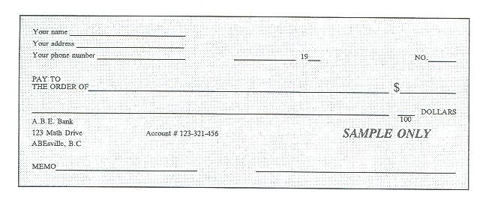

**Answers to Exercise Four**

A.

|  |  |  |  |  |  |  |  |  |  |
| --- | --- | --- | --- | --- | --- | --- | --- | --- | --- |
| DATE | CHEQUE NO. | DEBIT OR CHEQUE DESCRIPTION OR DESCRIPTION OF DEPOSIT | CHEQUE AMOUNT | |  | DEPOSIT AMOUNT | | BALANCE | |
|  |  | **BALANCE FORWARD** |  |  |  |  |  | 312 | 07 |
| 2/3 |  | Cash Withdrawal | 75 | 00 |  |  |  | 237 | 07 |
| 2/3 |  | Debit charge | 1 | 50 |  |  |  | 235 | 57 |
| 15/4 |  | Separation Cheque |  |  |  | 200 | 00 | 435 | 57 |
| 18/4 | 121 | BC Hydro (Feb & Mar) | 62 | 53 |  |  |  | 373 | 04 |
| 20/4 |  | Child Care Tax Refund |  |  |  | 33 | 64 | 406 | 68 |
| 23/4 |  | Sears (fix shocks) | 45 | 82 |  |  |  | 360 | 86 |
| 30/4 |  | Pay |  |  |  | 596 | 27 | 957 | 13 |
| 1/5 | 122 | Mortgage Payment | 375 | 00 |  |  |  | 582 | 13 |
| 4/5 |  | Grocery Mart | 111 | 95 |  |  |  | 470 | 18 |
| 6/5 | 123 | Cable Vision | 32 | 17 |  |  |  | 438 | 01 |

B.

Your name John Smith

Your address 123 – Fourth Street, Anywhere, BC Your phone number 250-123-4567

April 18 20 06

No. 121

PAY TO

THE ORDER OF BC Hydro $ 62.53

----------Sixty-Two------------------------------------------------------------------------------- 53 DOLLARS

100

ABE Bank

123 Any Street Our Town, BC

Account # 456-789-0

***SAMPLE ONLY***

MEMO Feb. & Mar Payment

John Smith

##### Unit 2 Review

* 1. Find the Sum:

a. 4.87 + 3.91 + 0.33 + 5.68 = b. 14.3 + 17.89 + 0.36 + 18.01 =

c. 0.187 + 28.27 + 8.039 + 4.44 = d. 5.739 + 7.812 + 9.101 + 3.334 =

e. 5.38 +4.7102 + 24.003 +0.78 = f. 2.78 + 1.86 + 120 + 18.13=

g. 3.912 + 46 + 72.04 + 19.19 =

* 1. Solve the following word problems:
     1. Paolo spent $4.53 on butter, $10.97 on a big bag of flour and $3.50 on eggs. How much did he spend?
     2. A pilot is measuring the weight of the freight and passengers on her next flight. The freight is 800.25 kg and the passengers weigh an approximate 452.5 kg. How much weight is being added to the flight?
     3. Find the perimeter of this long house: 30.7 m long and 12.6 wide.
  2. Find the difference:

a. 82.07 – 14.86 = b. 89.506 – 16.039 =

c. 51.31 – 50.99 = d. 17.21 – 3.861 =

e. 19.7 – 8.274 = f. 1239 – 74.97 =

g. $72.53 - $51.30 = h. $7 - $0.31 =

* 1. Solve the following word problems:
     1. Babies often lose a bit of weight in their first few days alive. They then usually go on to grow quite quickly. When Oliver was first born, he weighed 3.36 kg. when he was two days old, he weighed 3.19 kg, how much weight had he lost?
     2. George is paid $478.12 four times a month. Each month he must pay his bills. He has to pay BC Hydro $52.73, Telus $68.22 and the landlord $575.00. How much money does George have left over for his other expenses each month?
     3. Jules is installing trim around a doorway. The perimeter of the door is 5.78 m. Jules does not want to buy trim for the base of the doorway. If the base of the doorway measures 0.85 m, how much trim should he purchase?
  2. Reading a bank book statement:

Look at the following statement and answer the questions below:

|  |  |  |  |
| --- | --- | --- | --- |
| **Date** | **Withdrawal amount**  **/description** | **Deposit amount**  **/description** | **Balance** |
| April 20/10 | Deposit – gift | 200.00 | 759.58 |
| April 21/10 | 74.53 | Dentist visit |  |
| April 29/10 | Deposit – child care tax refund | 89.70 |  |
| May 01/10 | Direct deposit – payroll | 609.74 |  |
| May 01/10 | 650.00 | Rent |  |
| May 08/10 | 52.46 | Debit – gas station |  |
| May 08/10 | 1.75 | Debit charge |  |
| May 10/10 | 73.02 | Debit – grocery |  |
| May 10/10 | 1.89 | Debit Charge |  |
| May 12/10 | 60.00 | Cash withdrawal |  |

* + 1. Complete the balance column
    2. How much was the payroll direct deposit?
    3. What amount is the child care tax?
    4. When was the cash withdrawal made?
    5. How much was the gift of money?
    6. Why is there a debit charge for the gas station and grocery store purchase? (this answer is not in the book, if you don‘t know the answer, ask a friend, or your instructor)

**Answers to Review**

4.

a) 0.17 kg or 170 g

b) $1 216.53

c) 4.93 m

|  |  |  |  |  |
| --- | --- | --- | --- | --- |
| 1.  a) 14.79  f) 142.77 | b) 50.56  g) 141.142 | c) 40.936 | d) 25.986 | e) 34.8732 |
| 2.  a) $19.00 | b) 1252.75 kg | c) 86.6 m |  |  |
| 3.  a) 67.21 | b) 73.467 | c) 0.32 | d) 13.349 | e) 11.426 f) 1164.03 |
| g) $21.23 | h) $6.69 |  |  |  |

|  |  |
| --- | --- |
| 5.  a. | 685.05 |
|  | 774.75 |
|  | 1384.49 |
|  | 734.49 |
|  | 682.03 |
|  | 680.28 |
|  | 607.26 |
|  | 605.37 |
|  | 545.37 |
| b. | $609.74 |
| c. | $89.70 |
| d. | May 12, 2010 |
| e. | $200.00 |
| f. | Because banks charge people for using their debit cards at places other than the bank. |

**Test time!**

Please see your instructor to get your practice test.

When you are confident, you can write your unit 2 test.

**Congratulations!**

**Unit 3**

Multiplying Decimals

**Topic A: Multiplying Decimals**

Multiplying decimals uses the same method that you learned for multiplying whole numbers. Review multiplication of whole numbers.

**Vocabulary Review –** Review the diagram below and try to write in the three explanations of the mathematical terms. You may refer to the glossary, if you wish. For right now it is mostly important to remember what factor means.

3 X 7 = 21



factors



product

Product:

**Factors:**

**Multiplying Decimals:**

Multiplying decimals follows almost the same steps as multiplying whole numbers. On the next few pages you will be shown two methods of how to multiply decimals together.

Where do you place the decimal point?

**Method One:**

One method is to **estimate the product using whole numbers. Example A:** 4.3 5.7 4 6 = 24

The **answer** will be **around 24** which is two whole number places. It will **not** be **2.4** and it will **not** be **240**.

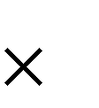When you actually multiply 4.3 5.7 (as if the decimals were not there) the numerals in the product are **2451**. Your estimate tells you the decimal point will be after 24, so 4.3 5.7 = 24.51

5.7

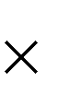 4.3 171

2280

24.51

**Example B:** 23.24 3.9 23 4 = 92

The answer will be **around 92**. It will **not** be **9.2** and it will **not** be **920**.

When you actually multiply 23.24 3.9 the numerals in the product are **90636**. Your estimate tells you the whole number will be two whole number places, so

23.24 3.9 = 90.636

23.24

 3.9 20916

69720

90.636

If the whole numbers in the question are large, you can round to the nearest ten or hundred and be able to tell where to put the decimal point. This is a **quick estimate**.

**Example C:** 383.298 213.87 400 200 = 80 000

The answer will be **around 80 000**. It will **not** be **8 000 or 800 000**. When you actually multiply 383.298 by 213.87 the numerals in the product are **8197594326**. Your estimate tells you the whole number will go up to the ten-thousands place, which is five whole number places, so

383.298 213.87 = 81975.94326 **Whew!**

383.298

 213.87 81975.94326

**Exercise One** All the multiplying has been done already. Your task is to

put the decimal point in the product by doing a whole number estimate of the question.

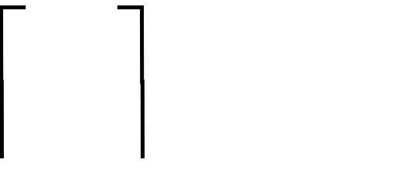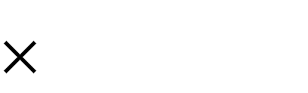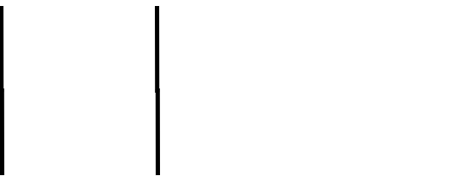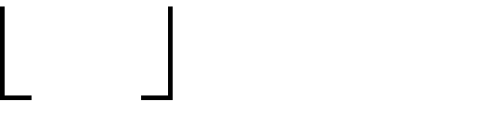

3

4 12

a) 2.8

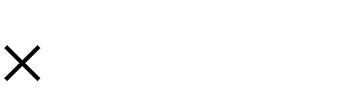 4.3 84

1120

12.04

b) 56.9

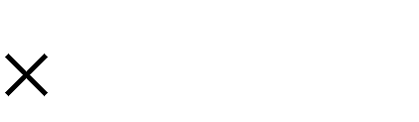 12.3 1707

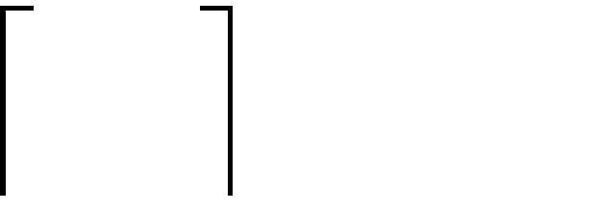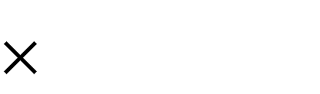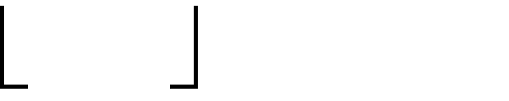

60

10 600

11380

56900

699.87

c) 7.3 d) 28.7

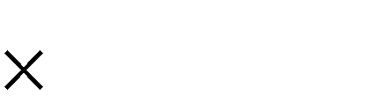

19.6

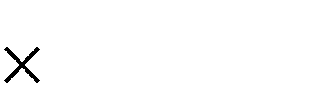

64.97

14308 1864639

e) 428.6 f) 5.6

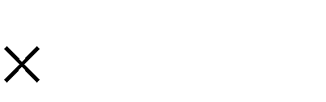

4.9

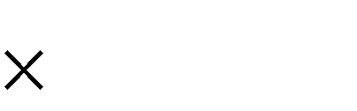

0.9

210014 504

g) 73.2 h) 1.8



1.6



1.3

11712 234

i) 38.4 j) 16.437



29.25

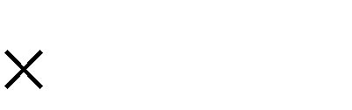

8.973

1123200 147489201

k) 48.29 l) 91.2

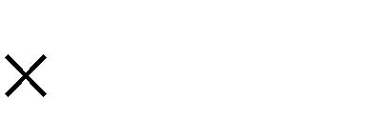

55.6



1.5

2684924 13680



|  |  |  |  |
| --- | --- | --- | --- |
| a) 12.04 | b) 699.87 | c) 143.08 | d) 1864.639 |
| e) 2100.14 | f) 5.04 | g) 117.12 | h) 2.34 |
| i) 1123.200 | j) 147.489201 | k) 2684.924 | l) 136.80 |

Method Two:

**Answers to Exercise One**

Another way of locating the decimal point in the product is to **look** at the **decimal places** in the decimals you are multiplying.

**Example A:** 43.**23** *2 decimal places*

19.**6** *1 decimal place*

Then add the number of decimal places you counted above (2+1 = 3) This is the number of decimal places you will have in your answer.

|  |  |  |
| --- | --- | --- |
|  | 43.23 | *2 decimal places* |
| 19.6 | + *1 decimal place* |
| 847**.**3 0 8 | *3 decimal places* |
| **Example B:** | 0.35 | *2 decimal places* |
|  | 0.47 | *+ 2 decimal places* |
|  | 0.1 6 4 5 | *4 decimal places* |
| **Example C:** | 13.452 | *3 decimal places* |
|  | 30 | *+ 0 decimal places* |
|  | 403.5 6 0 | *3 decimal places* |

**Exercise Two** Again, the multiplying has been done. Use the method of

multiplying the understood denominators to put the decimal point in the product.

|  |  |  |  |
| --- | --- | --- | --- |
| a) 9.2  0.3 | 1 decimal place  + 1 decimal place | b) 0.27  1.8 | 2 decimal places  + 1 decimal place |
| 2.76 | 2 decimal places | *0.486* | *3 decimal places* |

|  |  |  |
| --- | --- | --- |
| c) 6.8  0.4 | d) 2.4  0.13 | e) 240  0.05 |
| 272 | 0312 | 1200 |

|  |  |  |
| --- | --- | --- |
| f) 0.72  2.8 | g) 0.66  0.25 | h) 0.8  2.6 |
| 2016 | 01650 | 208 |

|  |  |  |
| --- | --- | --- |
| i) 0.91  6.2 | j) 0.29  1.2 | k) 0.87  0.19 |
| 5642 | 0348 | 01653 |

|  |  |  |
| --- | --- | --- |
| l) 1.08  0.2 | m) 2.65  1.5 | n) 6.2  0.18 |
| 0216 | 3975 | 1116 |

|  |  |  |
| --- | --- | --- |
| o) 7.3  3.8 | p) 4.24  0.07 | q) 0.042  60 |
| 2774 | 02968 | 2520 |



**Answers to Exercise Three**

|  |  |  |  |
| --- | --- | --- | --- |
| a) 2.76 | b) 0.486 | c) 2.72 | d) 0.312 |
| e) 12.00 | f) 2.016 | g) 0.1650 | h) 2.08 |
| i) 5.642 | j) 0.348 | k) 0.1653 | l) 0.216 |
| m) 3.975 | n) 1.116 | o) 27.74 | p) 0.2968 |
| q) 2.520 |  |  |  |

**Exercise Three** If you had trouble with the first two exercises, then get

**Answers to Exercise Two**

help from your instructor. Here is extra practice if you want or need it.

|  |  |  |  |
| --- | --- | --- | --- |
| a) 41  0.061 | 0 decimal places  + 3 decimal places | b) 7.8  0.5 | 1 decimal place  + 1 decimal place |
| 2.501 | 3 decimal places total | 3.90 | 2 decimal places total |

|  |  |  |
| --- | --- | --- |
| c) 59.275  0.08 | d) 7.18  23.46 | e) 0.84  2.1 |
| 474200 | 1684428 | 1764 |

|  |  |  |
| --- | --- | --- |
| f) 5.3  21 | g) 2.8  1.5 | h) 0.32  2.5 |
| 1113 | 420 | 0800 |

|  |  |  |
| --- | --- | --- |
| i) 18.6  0.3 | j) 100  0.35 | k) 0.72  3.4 |
| 558 | 3500 | 2448 |

|  |  |  |  |
| --- | --- | --- | --- |
| a) 2.501 | b) 3.90 | c) 4.74200 | d) 168.4428 |
| e) 1.764 | f) 111.3 | g) 4.20 | h) 0.800 |
| i) 5.58 | j) 35.00 | k) 2.448 |  |

**Exercise Four** Multiply to find the product. Remember to put the decimal

**Answers to Exercise Four**

point in the correct place; you know two methods!

|  |  |  |
| --- | --- | --- |
| a) 13.8  3.9 | b) 0.076  24 | c) 2.05  1.7 |
| *1242* |  |  |
| *4140* |  |  |
| *53****.****82* |  |  |

|  |  |  |
| --- | --- | --- |
| d) 0.95 | e) 0.168 | f) 84.3 |
| 0.76 | 2.1 | 1.2 |

|  |  |  |
| --- | --- | --- |
| g) 0.429 | h) 0.063 | i) 96 |
| 7.5 | 100 | 0.2 |

|  |  |  |
| --- | --- | --- |
| j) 1.79 | k) 2.5 | l) 40.1 |
| 0.33 | 26 | 0.9 |

|  |  |  |  |
| --- | --- | --- | --- |
| a) 53.82 | b) 1.824 | c) 3.485 | d) 0.722 |
| e) 0.3528 | f) 101.16 | g) 3.2175 | h) 6.300 |
| i) 19.2 | j) 0.5907 | k) 65.0 | l) 36.09 |

##### Prefixing Zeros

Remember this skill?

1000

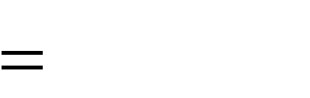

23

0.**0**23

100

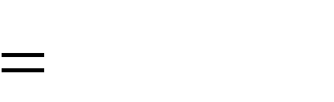

7

0.**0**7

1000



8

0.**00**8

10000

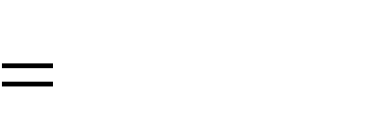

19

0.**00**19

When changing from a fraction to a decimal: If you do not have enough digits to fill all the places, zeros are put between the decimal point and the digits from the fraction—this is called **prefixing zeros**.

How does this apply to multiplying decimals? Look at the examples.

**Example A:**

1.

0.07 *2 decimal places*

X 0.5 *1 decimal places*

35 *3 decimal places*

*Uh oh! There are not enough places to make the decimals fit in!*

2.

0.07

0.5

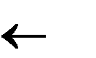**00**35 A*dd in zeros before (prefix the zeros!) your product.*

**3 2 1 count** *It is completely within the rules of math to do that.*

3.

0.07

0.5

**0.0**35 *Then put in the decimal in the place in the correct*

**3 2 1 count** *place.*

|  |  |  |
| --- | --- | --- |
| **Example B:** | 0.25 | *2 decimal places* |
|  | 0.03  **.**_ _ 7 5 | *+2 decimal places*  *4 decimal places in product* |
|  | **4 3 2 1** | **count** |

**Example C:** Look carefully at this one - it is tricky!

0.05 *2 decimal places*

0.8 *1 decimal place*

**.** 4 0 *3 decimal places in product*

**3 2 1 count**

Because the last digit, the zero, is the result of multiplying 8 5, you **must count it**

when working out the decimal places to put in the decimal point. The product is forty thousandths:

40

= 0.04

which can now also be written as four hundredths:

4

= 0.04

Note that if you had **not counted** that zero, you would have written 0.004 which is four thousandths and **not correct**.

**Exercise Five** Find the products. Be certain to place all decimal points

correctly.

|  |  |  |
| --- | --- | --- |
| a) 0.35  0.13 | b) 1.8  0.05 | c) 300  0.04 |
| *105* |  |  |
| *350* |  |  |
| *0.0455* |  |  |

|  |  |  |
| --- | --- | --- |
| d) 0.16 | e) 2.3 | f) 88 |
| 0.16 | 0.016 | 1.1 |

|  |  |  |
| --- | --- | --- |
| g) 1.3 | h) 500 | i) 0.603 |
| 0.027 | 0.073 | 0.4 |

|  |  |  |
| --- | --- | --- |
| j) 0.036 | k) 9.26 | l) 0.635 |
| 0.03 | 1.3 | 0.8 |

|  |  |  |
| --- | --- | --- |
| m) 38.2 | n) 0.025 | o) 3.5 |
| 1.9 | 0.25 | 0.018 |



**Answers to Exercise Five**

|  |  |  |
| --- | --- | --- |
| p) 3.14 | q) 2.86 | r) 3.721 |
| 0.006 | 3.9 | 25 |

|  |  |  |
| --- | --- | --- |
| s) 0.043 | t) 0.013 | u) 0.201 |
| 3.3 | 1.4 | 2.1 |

|  |  |  |  |
| --- | --- | --- | --- |
| a) 0.0455 | b) 0.09 | c) 12.00 | d) 0.0256 |
| e) 0.0368 | f) 96.8 | g) 0.0351 | h) 36.500 |
| i) 0.2412 | j) 0.00108 | k) 12.038 | l) 0.508 |
| m) 72.58 | n) 0.00625 | o) 0.063 | p) 0.01884 |
| q) 11.154 | r) 93.025 | s) 0.1419 | t) 0.0182 |
| u) 0.4221 |  |  |  |

##### Multiplying by 10, 100, 1 000, 10 000 ...

There is a pattern that you can see when we multiply by a decimal number by 10, 100, 1 000, 10 000, and so on. Look at the following example and try to find the pattern:

45.9264 X 10 = 459.264

45.9264 X 100 = 4592.64

45.9264 X 1 000 = 45926.4

45.9264 X 10 000 = 459264

Do you see a pattern?

When **multiplying** by 10, 100, 1 000, 10 000, etc., count the zeros in the 10, 100, 1 000, etc. and move the decimal point that same number of places to the right.

**Exercise Six** Try these questions.

When you **multiply by ten**, **move** the **decimal point one place to the right**. Remember that every whole number can have a decimal point at the right.

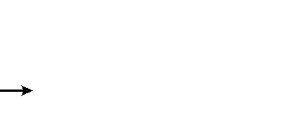*.37x10=*.3.7 = 3.7

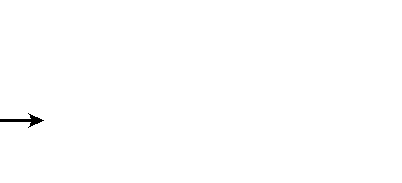*13x10 =*13. . = 130.

a) 2.2 10 = b) $27.00 10 =

c) 6.67 10 = d) 1.47 10 =

e) 12 10 = f) 2 10 =

|  |  |  |  |
| --- | --- | --- | --- |
| a) 22 | b) $270.00 | c) 66.7 | d) 14.7 |
| e) 120 | f) 20 |  |  |

Now do these:

**Answers to Exercise Six:**

When you **multiply** by 100, **move** the decimal point **two** places to the right. Note that zeros may be needed at the **end** of the numeral

4.2 100 = 4.2  **. =** 42**0.**

6 100 = 6.   **. =** 6**00.**

g) 5.67 100 = h) 87 100 =

i) 92.737 100 = j) 0.3 100 =

k) 2.1 100 = l) $25.00 100 =

**Answers to Exercise Six:**

g) 567

k) 210

h) 8 700

l) $2 500.00

i) 9 273.7

j) 30

And do these questions:

To **multiply by 1000 move** the **decimal point three places to the right**.

4.2 1000 = 4.2   **. =** 42**00.**

m) 6.721 1000 = n) 1.56 1000 =

o) 6.7 1000 = p) $2 1000 =

q) 0.7246 1000 = r) 2.1 1000 =

**Answers to Exercise Six:**

m) 6 721

q) 724.6

n) 1 560

r) 2 100

o) 6 700

p) 2 000

**Exercise Seven** Write the products using the short method you now know. a) 0.4 10 = b) 1.6 10 =

c) 0.27 10 = d) $1.47 10 =

e) 10 0.926 = f) 10 77.6 =

g) 10 0.09 = h) 10 0.047 =

i) 0.62 100 = j) 3.56 100 =

k) 0.119 100 = l) 5.6 100 =

m) 100 2.03 = n) 100 0.55 =

o) 100 0.345 = p) 100 14.4 =

q) 1.934 1000 = r) $.36 1000 =

s) 28.9 100 = t) 0.892 1000 =

u) 1000 7.654 = v) 1000 0.068 =

w) 1000 5.4 = x) 1000 32.36 =

|  |  |  |  |
| --- | --- | --- | --- |
| a) 4 | b) 16 | c) 2.7 | d) $14.70 |
| e) 9.26 | f) 776 | g) 0.9 | h) 0.47 |
| i) 62 | j) 356 | k) 11.9 | l) 560 |
| m) 203 | n) 55 | o) 34.5 | p) 1 440 |
| q) 1 934 | r) $360.00 | s) 2 890 | t) 892 |
| u) 7 654 | v) 68 | w) 5 400 | x) 32 360 |

**Exercise Eight** The area of an object is: the measurement of the amount

**Answers to Exercise Seven**

of space the object surface covers. Area is described in square units.

Find the **area** of the **rectangles** described below. The measures of the length(*l*) and width

(*w*) have been given. You should draw and label a sketch for each.

|  |  |  |
| --- | --- | --- |
| a) *l =* 10.5 cm | b) *l* = 100.04 km | c) *l* = 15.5 mm |
| *w* = 6.6 cm | *w* = 70.2 km | *w* = 10.5 mm |



10.5cm

6.6 cm

A = ***l w***

A = 10.5 X 6.6 cm A =

|  |  |  |
| --- | --- | --- |
| d) *l* = 9.75 cm | e) *l* = 40.43 km | f) *l* = 19.6 cm |
| *w* = 3.5 cm | *w* = 10.9 km | *w* = 2.8 cm |

**Answers to Exercise Eight**

a) 69.3 cm2

e) 440.687 km2

b) 7022.808 km2

f) 54.88 cm2

c) 162.75 mm2

d) 34.125 cm2

**Exercise Nine** Find the area of each square described in the questions

below. Even though this is a simple square, it is still good practice to draw the picture.

a) A square, if *s* = 5 cm b) A square, if *s* = 12.5 km



5 cm

c) A square, if *s* = 45.3 mm d) A square, if *s* = 100.9 m

e) A square, if *s* = 1.4 km f) A square, if *s* = 25.4 cm

**Answers to Exercise Nine**

a) 25 cm2

e) 1.96 km2

b) 156.25 km2

f) 645.16 cm2

c) 2 052.09 mm2

d) 10 180.81 m2

##### Problems Using Multiplication of Decimals

Multiplication problems usually give information about one thing and ask you to find a total amount for several of the same things. Look for this pattern in the following problems. Also look for key words.

**Key words** which point to **multiplication** include:

**product**

**altogether**

**total**

**of**

Multiplication by a decimal or fraction often uses the word "**of**" in word problems. ―**Of”** means multiply **if “of” has a decimal or fraction right before it and is followed by a number** or a word which stands for a number. For example,

She spends 0.25 **of** her salary on rent. Her salary is $1445 a month. How much is her rent? (The word "salary" stands for the number $1445.)

0.25 $1445 = $361.25

She spends $361.25 on rent every month.

Remember to always draw a picture to help yourself visualize how to solve the problem.

**Exercise Ten** Solve these problems. Do an estimation first.

1. One package of juice costs $11.73 How much will five packages cost?

Estimation:

Actual Solution:

1. It takes George 0.75 hours to reupholster a vinyl chair. A restaurant wants him to reupholster 35 chairs. How many hours of labour will George charge the restaurant for this job?

Estimation:

Actual Solution:

1. The new carpet for the bedroom was on sale for $21.80 per square metre (m2). The amount of carpet needed was 18.5 m2. Find the total cost of the carpet, before taxes.

Estimation:

Actual Solution:

1. Your 4X4 truck averages 7.75 kilometres per litre of gas. How far could your truck travel with 52 L of gas?

Estimation:

Actual Solution:

1. The distance between Jackie's home and her work place is 6.6 km. She walks **to and from** work five days a week. What is the total distance Jackie walks per week on these trips back and forth to work?

Estimation:

Actual Solution:

1. The four young men who run on the 4 00 metre relay team have an average time for the 100



1

m of 11.4 seconds each. How long should it take them to run the relay race if they each run 100 m, one after the other?

Estimation:

Actual Solution:

1. The express bus on the Caribou route averages 75.5 kilometres per hour (km/h). How far does it travel on the non-stop overnight run that lasts 6.25 hours?

Estimation:

Actual Solution:

1. Each roof truss for the new house uses 25.2 m of lumber. The house needs 21 trusses. How much lumber will be used to build all these trusses?

Estimation:

Actual Solution:

1. Mary makes fantastic pickles every fall. Her recipe calls for 4.25 kg of cucumbers. This year she is going to make 3.5 times her usual recipe and give these pickles as gifts at Christmas. How many kilograms of cucumbers does she need?

Estimation:

Actual Solution:

1. On statutory holidays, union workers who work are paid double time and a half. This is 2.5 times their regular pay.
   1. The employees at the smelter earn $17.37 per hour. How much are they paid per hour if they work on a statutory holiday?
   2. Jesse worked a 7.5 hour shift at the smelter on Labour Day last year. What were his

**gross** (before deductions) earnings for that day?

1. Phil is going to fence his large 50.5 m square vegetable garden to keep the deer out. The fence will be made with four strands of barbed wire. How much barbed wire should Phil buy?

The fence will look like this:

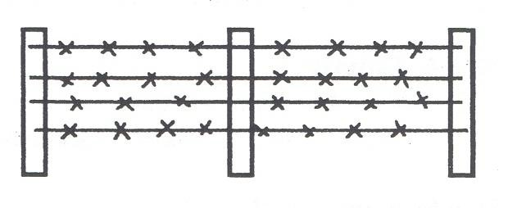

1. Janice plans to sew lace on the edge of a tablecloth that is 132.5 cm in width and 218.8 cm long. How much lace does she need? Give your answer in centimetres and also in metres.
2. One physical education teacher starts each class by having everyone jog around the school 4 times. The school is rectangular (shaped like a rectangle) and 160 m long and 95 m wide.

About how far do the students jog each class?

**Note:** *160 m long and 95 m wide* may be written as ―160 m by 95 m.‖

1. How many metres of baseboard are needed for a rectangular room 4.5 m by 3.2 m? There are two doorways, each measuring one meter in width. Be sure to deduct the amount needed for the doorways.
2. Calculate the total amount of weather-stripping needed to go around the following windows in a house.

3 windows each measuring 76.2 cm by 122 cm

2 windows each measuring 152 cm by 135 cm

1. The Nelsons are going to replace the fascia board (the trim at the edge of a roof) with new pressure-treated cedar board. Their flat roof is 14.4 m by 12.3 m. How much fascia board is needed?
2. Chung Cha wants to put a pool into her back yard. The pool she wants is 20.5 m by 6.4 m. Her back yard measures 464.5 m2. Will the pool she wants fit in her back yard?
3. The carpet for Frank‘s living room is $24.95 for one square metre. He must also buy underlay at $5/m2 and pay $4.50/m2 for the carpet layer‘s labour. The living room is square with a 5.5 m length per side. What is the total cost of the installed carpet (all taxes are included in the prices already)?
4. The directions on a carpet shampoo say one bottle will clean 50 m2 of carpet. Joyce wants to clean the wall-to-wall carpet in three rooms. One room is 6 m by 4.5 m, the bedroom is 3 m by 4 m, and the hall is 1.2 m by 5 m. How many bottles of carpet shampoo should she buy? (Calculate the area of each of the rooms and then find the total area to be cleaned.)
5. Diane bought a souvenir poster in Sweden. The souvenir poster is 0.5 metres square. Diane wants to put non-glare glass over the poster and was told the glass costs $12 per m2. How much will the glass cost for Diane‘s poster?



**Answers to Exercise Ten**

a) Estimation: $12 5 $60 Actual Solution: $11.73 5 = $58.65

Five packages of juice will cost $58.65

35 35 hours

j) i) $17.37 2.5 = $43.425 per hour

Actual Solution: 0.75 35 = 26.25 hours

It will take George 26.25 hours to reupholster the chairs.

20 $400

k) Estimation: 50 + 50 + 50 + 50 = 200 m

200 m X 4 = 800 m

202 m

4 = 808 m

d) Estimation: 8 km 50 L

Actual Solution: 7.75 km

400 km

52 L = 403 km

The truck could travel 403 km.

Estimation: 7 km 10 (to and from)

70 km

Actual Solution: 6.6 km 10 = 66 km

Jackie walks 66 km each week.

f) Estimation: 4 11 seconds 44 seconds Actual Solution: 4 11.4 seconds = 45.6 seconds

It should take them 45.6 seconds to run the relay race.

g) Estimation: 80 km 6 hours 480 km

Actual Solution: 75.5 6.25 hours = 471.875 km The bus will travel 471.875 km.

h) Estimation: 25 m 20 500 m

Actual Solution: 25.2 m 21 = 529.2 m

There will be 529.2 m of lumber used for the trusses.

i) Estimation: 4 kg 4 16 kg

Actual Solution: 4.25 kg

3.5 = 14.875 kg

Mary will need 14.875 kg of cucumbers.

b) Estimation: 1

ii) $43.425

7.5 hours = $325.69

Jesse earned $325.69 on Labour Day.

c) Estimation: $20

Actual Solution: $21.80 18.5 = $403.30

The total cost of the carpet, before taxes, is $403.30.

Actual Solution: 50.5m

4 = 202m

Phil should buy 808 m of barbed wire.

l) Estimation: 130cm + 130cm + 220cm + 220cm

700 cm or 7 m

Actual Solution: 132.5cm + 132.5cm + 218.8cm 218.8 cm = 702.6 cm or 7.026 m

Janice needs 702.6cm or 7.026 m of lace.

m) Estimation: (150m + 150m + 100m + 100m) X 4

2000 m

Actual Solution: (160 m + 160 m + 95 m + 95 m) X 4

2040 m

The students jog 2040 m each class.

n) Estimation: 5m + 5m + 3m + 3m = 16 m

16 m – 2m = 14 m

Actual Solution: 4.5 m + 4.5 m + 3.2 m + 3.2 m

15.4 m

15.4 m – 2 m = 13.4 m

13.4 m of baseboard are needed for the room.

o) Estimation: 80cm + 80cm + 120cm + 120cm 400 cm

400 cm 3 = 1200 cm

150cm + 150cm + 140cm + 140cm = 580 cm 580cm 2 = 1160 cm

1160 cm + 1200 cm = 2360 cm or 23.6 m



o) Actual Solution: 76.2cm + 76.2cm + 122cm +

122cm = 396.4 cm

396.4 cm

3 = 1189.2 cm

152cm + 152cm + 135cm + 135cm = 574 cm

574cm

2 = 1148 cm

1148 cm + 1189.2 cm = 2337.2 cm or 23.372 m

The total amount of weather stripping is 23.37 m.

p) Estimation: 14m + 14m + 12m + 12 m = 52 m Actual Solution: 14.4 m + 14.4 m + 12.3 m + 12. 3m

= 53.4m

53.4 m of fasica board will be needed.

Actual Solution: same as estimate.

1. Estimation: 6 m 5 m = 30 m2 3 m 4 m = 12 m2

1 m 5m = 5 m2

30 m2 + 12 m2 + 5m2 = 47 m2

Joyce should buy just one bottle of carpet cleaner. Actual Solution: 6 m 4.5 m = 27 m2

3 m 4 m = 12 m2

1.2 m 5m = 6 m2

27 m2 + 12 m2 + 6m2 = 45 m2

Joyce should buy just one bottle of carpet cleaner.

1. Estimation: 0.5 m 0.5 m = 0.25 m2

q) Estimation: 20 m

pool will fit.

6 m = 120 m2 So, yes, the

0.25 m2 $12/m2 = $3.00

Diane‘s glass will cost $3.00

Actual Solution: 20.5 m

6.4 m = 131.2 m2

Yes, her pool will fit in her back yard.

r) Estimation: 5m 5 m = 25 m2

$25 + $5 + $5 = $35

$35 25 m2 n= $875

Actual Solution: 5.5m 5.5 m = 30.25 m2

$24.95 + $5.00 + $4.50 = $34.45

$34.45 30.25 m2 n= $1042.11

The cost will be $1042.11 for the carpet

**Topic A: Self-Test Mark /10 Aim 8/10**

1. **Find the product. 6 marks**

|  |  |  |
| --- | --- | --- |
| a) 66 | b) 7.25 | c) 8.2 |
| 0.7 | 12 | 0.4 |

|  |  |  |
| --- | --- | --- |
| d) 6.5 | e) 19.5 | f) 0.025 |
| 0.6 | 0.07 | 0.12 |

1. **Problems 4 marks**
2. Maria bought 3.4 m of lace at $2.89 a metre. What was the cost of the lace before taxes? (Round to the nearest cent.)

Estimation: Actual Solution:

1. Alan averages 90.5 km an hour on his motorcycle. How far will he go in 2.5 hours, travelling his average speed?

Estimation: Actual Solution:

Answers to Topic A Self-Test Part A

a) 46.2

e) 1.365

b) 87.0

f) 0.003

c) 3.28

d) 3.9

**Part B**

a) Estimation: 3 x 3 = $9.00 Actual solution: 9.826 ~ $9.83

b) Estimation: 90 x 3 = 270km or 91 x 3 = 273 km

Actual Solution: 226.25 km

##### Unit 3 Review

1. Put the decimals in the correct place for the answer:

|  |  |  |
| --- | --- | --- |
| a) 66  0.9 | b) 7.25  1.2 | c) 101  0.4 |
| 594 | 8700 | 404 |

d) 19.5

3.47 67665

1. Find the product:

|  |  |  |
| --- | --- | --- |
| a) 0.78 | b) 3.42 | c) 3.469 |
| 1.4 | 0.1 | 4.63 |

d) 7.94

4.02

1. Multiply by 10, 100, or 1 000:

a. 0.53 10 = f. 3.7834 100 =

b. 7.89 10 = g. 46.3214 100 =

c. 0.472 10 = h. 42.42 100 =

d. 100.3 10 = i. 4.3247 1 000 =

e. 1.476 100 = j. 0.4113 1 000 =

k. 10.321 1 000 = l. 4.89 1 000 =

1. Solve the following word problems:
   1. Mark could bike at about 11.4 km an hour, how much distance did he cover in a 7.5 hour bike ride?

b. i) If Johnny spent 3.25 hours cleaning the learning center twice a week, how many hours did he work each week?

ii) If Johnny got paid $7.85 an hour, how much did he get paid each week?

**Answer Key to Review Section:**

c. Joe and Kat‘s rectangular family tent measures 3.4 m by 2.9 m. How much area does the floor of the tent cover?

|  |  |  |  |
| --- | --- | --- | --- |
| 1) |  | d) | 1 003 |
| a) | 59.4 | e) | 147.6 |
| b) | 8.7 | f) | 378.34 |
| c) | 40.4 | g) | 4 632.14 |
| d) | 67.665 | h) | 4 242 |
|  |  | i) | 4 324.7 |
| 2) |  | j) | 411.3 |
| a) | 1.092 | k) | 10 321 |
| b) | 0.342 | l) | 4 890 |
| c) | 16.06147 |  |  |
| d) | 31.9188 | 4) |  |
|  |  | a) | 85.5km |
| 3) |  | b) i) | 6.5 hours |
| a) | 5.3 | ii) | $51.03 |
| b) | 78.9 | c) | 9.86m2 |
| c) | 4.72 |  |  |

**Test time!**

Please see your instructor to get your practice test.

When you are confident, you can write your unit 3 test.

**Congratulations!**

**Unit 4**

**Dividing Decimals**

**Topic A: Dividing Decimals**

Dividing decimals uses the same method that you learned for dividing whole numbers.

**Vocabulary Review -** Write the definitions.

Divisor:

Dividend:

Quotient:

quotient

divisor

dividend

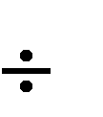**dividend divisor = quotient**

Be very sure that you hold the places in the quotient with a zero if there is no other digit

⇩

1**0**4

9 936

9↓↓

03↓

0↓

36

36

0

**Where do you place the decimal point?**

**Estimation** is one method of locating the decimal point. **Estimate the quotient using rounded whole numbers**.

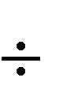**Example A:** 18.6 6 18 6 = 3

So you know the answer will be **around 3** which is one whole number place. It will **not** be

* 1. and it will not be 30.

When you actually **divide** 18.6 by 6, the numerals in the quotient are 32 and your estimate of 3 tells you the decimal point will be after the 3.

18.6 3 = 3.2

**Example B:** 137.84 18 140 20 = 7

The answer will be **around 7**. It will **not** be 0.7 or 70 or 700.

The numerals in the quotient when you actually divide 137.84 by 18 are 766. You know from your estimate that the answer is approximately 7, which is one whole number place.

137.84 18 = 7.66

To **check** the accuracy of your **division**, **multiply the quotient by the divisor**.

Dividend divisor = quotient Quotient divisor = dividend

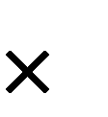

The product will equal the dividend if your arithmetic is correct.

23.72 8 = 2.965 2.965

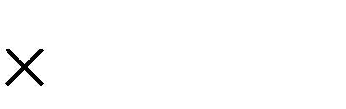

8

23.720

**Exercise One** The division has been done. Your task is to put the

decimal point in the quotient by doing a whole number estimate of the question.

*10* .8



2 21.6

*1*.3

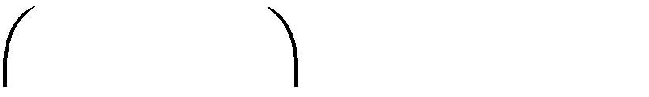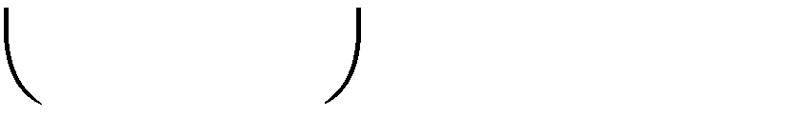

*10*

*2 20*

b)

8 10.4

*2 4 3*

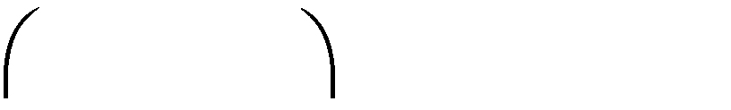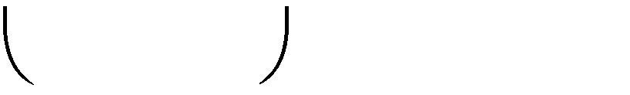

*1*

*8 10*

c)

*6 14.16*

*8 2*



*7 57.4*

*4 3 4*



*4 173.6*

*3 4 5*



*5 17.25*

*3 1 2*



*6 18.72*

248



2 4.96

276



3 8.28

*8 6 4*



*7 60.48*

*18 2*



*6 10.92*

*3 3 6 9*



*2 6.738*

*7 8*



*3 23.4*

*9 3 6*



*7 65.52*

*3 9 3*



*2 7.86*

*18*



*37 66.6*

*2 4 3*



*18 43.74*

*4 3*



*21 90.3*

**Answers to Exercise One**

|  |  |  |  |
| --- | --- | --- | --- |
| a) 10.8 | b) 1.3 | c) 2.43 | d) 8.2 |
| e) 43.4 | f) 3.45 | g) 3.12 | h) 2.48 |
| i) 2.76 | j) 8.64 | k) 1.82 | l) 3.369 |
| m) 7.8 | n) 9.36 | o) 3.93 | p) 1.8 |
| q) 2.43 | r) 4.3 |  |  |

**Have you found the shortcut?**

**If the divisor is a whole number**, place the decimal point in the quotient this way:

Put the decimal point in the quotient right above the decimal point in the dividend and then divide as you would whole numbers. It might be helpful to make a dotted line through the decimal points to keep the whole numbers and the fractions separated and in straight columns.

**Example A:** 18.45 9 = ◻

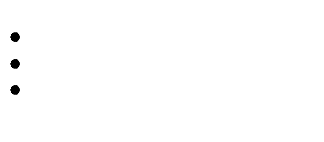

18.45

9

2.05 9 18.45



8

0 4

0

1

45

45

0

**Example B:** 420.75 25 = ◻

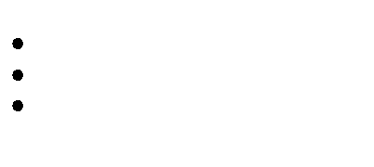

25 420.75

16.83 25 420.75



25

170

150

20 7

20 0

75

75

0

**Exercise Two** Find the quotients. Check the answer by multiplying the

a) 60

|  |  |  |  |
| --- | --- | --- | --- |
| 14.40 | check | 0.24 | b) 4 2 23. 5 2 |
| 12 0 |  | 60 |  |
| 2 40 |  | 14.40 |  |
| 2 40 |  |  |  |
| 0 |  |  |  |

0.24

quotient by the divisor.

 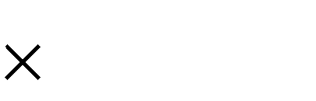

c) 33 d) 14

7. 26

17 2. 2

e) 91 f) 25

263.9

2 0 7 .5

g) 86 h) 75

9. 46

11. 7 00

i) 57 j) 63

9 6. 9

17 6. 4

|  |  |  |  |
| --- | --- | --- | --- |
| a) 0.24 | b) 0.56 | c) 0.22 | d) 12.3 |
| e) 2.9 | f) 8.3 | g) 0.11 | h) 0.156 |
| i) 1.7 | j) 2.8 |  |  |

**Dividing by Decimal Divisors**

**Answers to Exercise Two**

A **decimal divisor must be changed to a whole number** before you can work with it. The method you will learn uses the following facts:

 Multiplying by 10, 100 or 1 000 etc. moves the decimal point as many places to the right as there are zeros in the 10, 100, 1 000.

 When the divisor and dividend are **both multiplied by the same number**, the quotient is not changed.

Your instructor will give you more information about **why** this method works if you wish to know.

**If the divisor is a decimal**, do this:

 Set the question up for long division. (This may already be done.)

1**.**255 0**.**05 = ◻

*0*.*05*

*1*.*255*

 Move the decimal point in the divisor as many places to the right as needed to make a whole number.

0.0 5 . 1.255

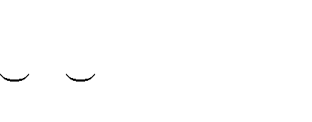

1 2

(moved decimal point 2 places which is like multiplying by 100)

 Now move the decimal point in the dividend the **same number of places to the right** (like multiplying by 100).

. .

0.0 5 1.2 5 5

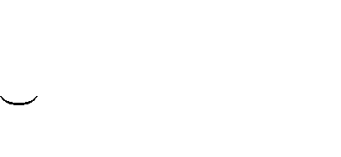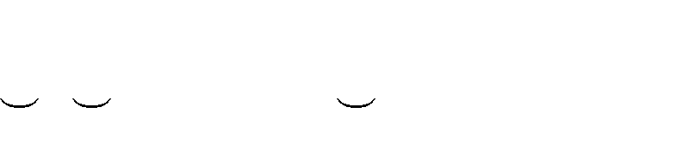

1 2 1 2

 Put the decimal point in the quotient directly above the new place in the dividend and divide.

25.1

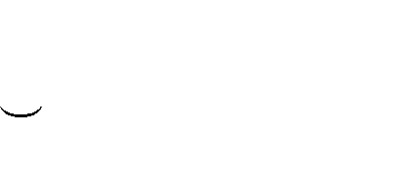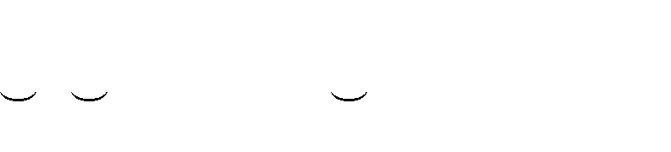

. .

0.0 5 1.2 5 5

1 2 1 2

1**.**255 0**.**05 = 25**.**1

Zeros may have to be put at the end of the dividend when you move the decimal point.

48**.**6 0**.**24 = ◻

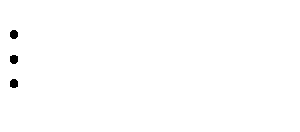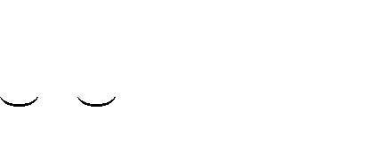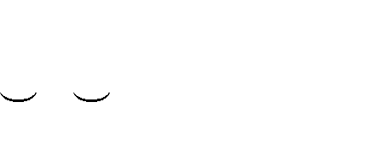

0.2 4 . 48.6 0 .

1 2

1 2

Remember that if the dividend is a whole number, first put a decimal to the right of it, and

**then move the decimal as needed** to match what you did to the divisor. You will need to add zeros to hold the places.

36 1**.**8 = ◻

*1.8 36*.

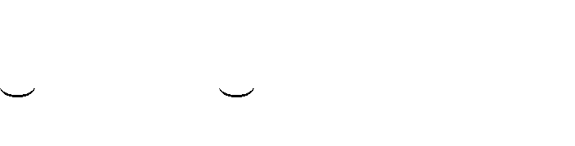

1.8 . 36.0 .

1

1

**Exercise Three** Find the quotients**.** a) 1.3 2.73 b) 2.1

0. 651

c) 3.4 d) 6.6

3.808

19.14

e) 5.5 f) 4.8

26 4

17 6.16

g) 0.0 4 h) 0. 67

15. 2

6.16 4

**Answers to Exercise Three**

a) 2.1 b) 0.31

e) 48 f) 36.7

c) 1.12

g) 380

d) 2.9

h) 9.2

If you are having any difficulty with this exercise, ask your instructor for help before you go any further.

**Exercise Four Now try these:**

a) 0.5 b) 1.7

0. 2635

15. 4 7

c) 0.0 4 d) 0. 6 2 43

10.8

e) 0. 0 03 f) 0.33

4 2.12

0.1452

g) 4.9 h) 0. 9

30.87

12. 33

|  |  |  |  |
| --- | --- | --- | --- |
| a) 0.527 | b) 9.1 | c) 270 | d) 405 |
| e) 14 040 | f) 0.44 | g) 6.3 | h) 13.7 |

**Exercise Five** Set the question up for long division and find the quotient.

**Answers to Exercise Four**

Check your answers by multiplying quotient divisor. Product should equal dividend.

a) 0.2448 0.008 = b) 2.3412 0.6 =

.

30 6

0.008. 0.244.8



24

30.6

04 0.2448

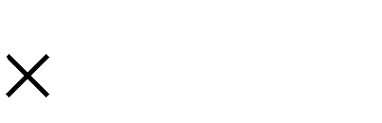

0.008

0 

4 8

4 8

c) 25.6 0.008 = d) 2.176 3.4 =

e) 378 0.9 = f) 0.946 0.022 =

g) 205 4.1 = h) 2.1122 59 =

i) 125 0.005 = j) 604.8 0.007 =

|  |  |  |  |  |
| --- | --- | --- | --- | --- |
| **Answers to Exercise Five** |  | | | |
| a) 30.6 | b) 3.902 | c) 3 200 | d) 0.64 | e) 420 |
| f) 43 | g) 50 | h) 0.0358 | i) 25 000 | j) 86 400 |

**What about Remainders?**

The questions that you have been practising all work out evenly. But, as you know, the world is seldom perfect and division questions seldom "come out even"! For everyday uses of mathematics, answers to the hundredths or thousandths decimal places are accurate enough.

This is what you do if the division problem does not work out evenly:

 Do the long division until you have worked out three or four decimal places in your quotient. Add zeros to the decimal in the dividend as necessary.

**Example A:** 12**.**5 7 = ◻ **Example B:** 422 1**.**7 = ◻

 1.7857 7 12.5**000**

24 8.2352

1.7. 422.**0**.**0000**

7 34

5 5 82

4 9 68

60 14 0

56 13 6

4 0 4 0

3 5 3 4

50 60

49 51

1 90

85

50

34

16

 **Round the quotient to the nearest tenth**, **hundredth**, or **thousandth** as you are asked or as you need for your own use. Review **Rounding** if you need to.

 **In this course, round to the nearest thousandth unless you are asked otherwise**.

In Example A, the quotient 1.7857 will round this way:

|  |  |
| --- | --- |
| to the nearest thousandth | 1.786 |
| to the nearest hundredth | 1.79 |
| to the nearest tenth | 1.8 |

In Example B, the quotient 248.2352 will round this way:

|  |  |
| --- | --- |
| to the nearest thousandth | 248.235 |
| to the nearest hundredth | 248.24 |
| to the nearest tenth | 248.2 |

 When you are planning to round the quotient, do the long division only to one decimal place past where you will round. It is not necessary to divide any further.

* If rounding the quotient to the nearest tenths, divide to the hundredths place (2 decimal places).
* If rounding the quotient to the nearest hundredths, divide to the thousandths place (3 decimal places).
* If rounding the quotient to the nearest thousandths, divide to the ten-thousandths place (4 decimal places).

 Always round money to the nearest cent.

$47.26 3 = ◻

 $15.753 3 $47.26**0**

3

17

15

2 2

2 1

16

15

10

$15.753 $15.75

 Sometimes numbers **repeat** when you divide.

100 3 = ◻

.

33 333

.

3 100 **000**

9

10

9

1 0

9

1 0

9

10

This will go on forever—**to infinity**.

To show that the 3 keeps repeating as a decimal fraction, put a **·** (dot) or a ¯ (bar) above the repeating decimal digit.



33.3 or 33.3

Sometimes a **group of digits** will repeat. Put a bar above the repeating decimal digits. For example 2.341341341341

2.341

**Exercise Six** Use long division to find the quotient. Round the quotient to the nearest tenth.

a) 13.71 3 = b) 71.13 12 =

c) 6.17 7 = d) 2.61 5 =

e) 7.359 1.3 = f) 15.68 2.2 =

g) 4.93 6 = h) 59 8 =

**Answers to Exercise Six**

a) 4.6 b) 5.9

e) 5.7 f) 7.1

c) 0.9

g) 0.8

d) 0.5

h) 7.4

**Exercise Seven** Divide and round the quotient to the nearest hundredth. a) 41.874 5 = b) 22.76 7 =

c) 98.9 0.3 = d) 52.48 6 =

e) 43.893 1.1 = f) 1.9525 0.6 =

g) 0.4474 0.7 = h) 10.48 1.5 =

**Answers to Exercise Seven**

|  |  |  |  |
| --- | --- | --- | --- |
| a) 8.37 | b) 3.25 | c) 329.67 | d) 8.75 |
| e) 39.90 | f) 3.25 | g) 0.64 | h) 6.99 |

**Dividing by 10, 100, 1 000, 10 000, etc.**

Multiplication and division are opposite operations. **Multiplying** by ten, hundred, etc. **moves** the **decimal point** the same number of decimal places **to the right** as there are zeros in the 10, 100, 1000, etc. Moving a decimal point to the right gives a larger number.

So **dividing** by ten, hundred, etc. **must move the decimal point to the left**. Remember that moving a decimal point to the left gives a smaller number. Study the examples.

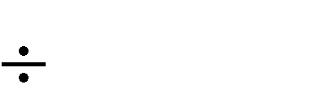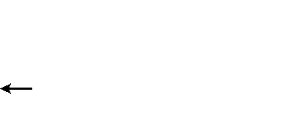

10 = .4.6 = 0.46

4.6

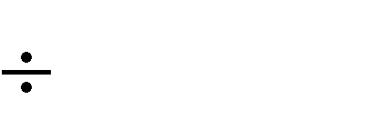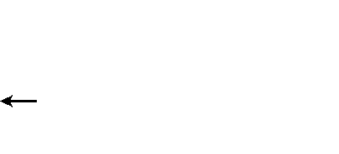

10 = 2.9.6 = 2.96

29.6

27.4

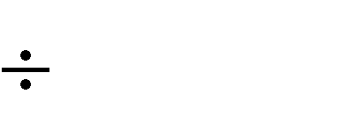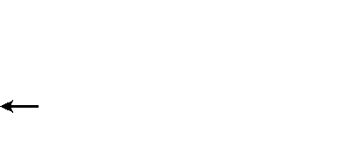

100 = .27.4 = 0.27

185.4

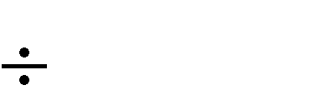

100 = 1

325

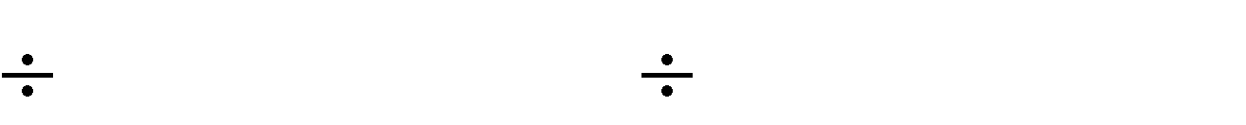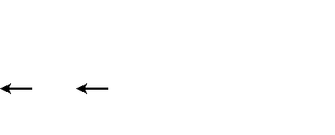

1000 = 325. 1000 = .325. = 0.32

2567.3

4

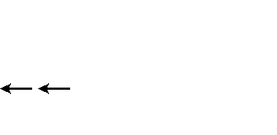

.85.4 = 1.854

5

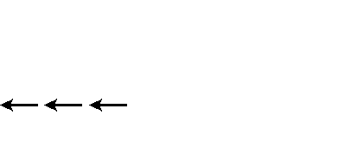2.567.3 = 2.5673

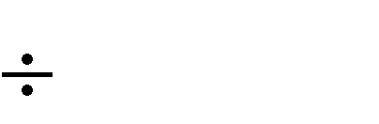

1000 =

To **divide** by a 10, 100, 1 000, 10 000, etc., **move** the **decimal point** the same number of **places to the left** as there are zeros in the divisor.

You may need to prefix zeros. Look at these examples:

0.3

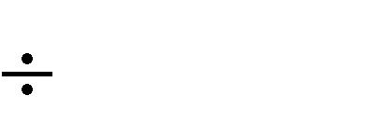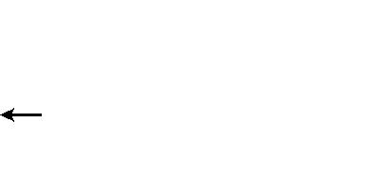

10 = .0.3 = 0.03

1.75 100 = .

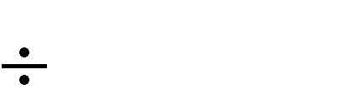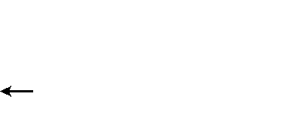

1.75 = 0.0175

0.5 . 05



1000 =

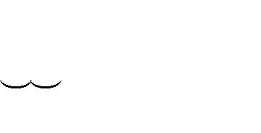

.5 = 0.00

**Exercise Eight** Write the quotient. Use the short method you have just

learned.

a) 7 10 = b) 14 100 =

c) 6.5 10 = d) 74.35 10 =

e) 43.2 100 = f) 147.6 100 =

g) 183.75 1 000 = h) 2 374.5 1000 =

i) 0.63 10 = j) 7.46 100 =

k) 0.035 10 = l) 366 100 =

m) 42.16 1000 = n) 0.03 10 =

o) 923.5 100 = p) 3 980 1000 =

q) 0.3 10 = r) 0.47 100 =

s) 28.1 1000 = t) 6.9 100 =

u) 0.1 1000 = v) 100.1 10 =

w) 16.2 100 = x) 5 692.1 10 =

y) 0.025 100 = z) 3.31 10 =

**Answers to Exercise Eight**

|  |  |  |  |
| --- | --- | --- | --- |
| a) 0.7  e) 0.432  i) 0.063 | b) 0.14  f) 1.476  j) 0.0746 | c) 0.65  g) 0.18375  k) 0.0035 | d) 7.435  h) 2.3745  l) 3.66 |
| m) 0.04216 | n) 0.003 | o) 9.235 | p) 3.980 |
| q) 0.03 | r) 0.0047 | s) 0.0281 | t) 0.069 |
| u) 0.0001 | v) 10.01 | w) 0.162 | x) 569.21 |
| y) 0.00025 | z) 0.331 |  |  |

##### Problems Using Division of Decimals

**Division** problems usually **give information about several of the same things** and ask you to

**find** the **amount for one thing**.

**Key words** which point to **division** include

**separated split**

**cut shared**

**What is cost per...? unit price**

**What is distance per...? average (speed, cost, weight, time)**

**Exercise Nine** Solve these division problems. Look carefully for the

pattern of the problems and underline any key words which point to division. Do an estimation before you find the actual solution.

1. Joanne's little car has a 44.5 L tank. She can drive 525 km on a tank of gas. What is the average distance she can travel per litre of gas? (The answer will be kilometres per litre, so you must divide the kilometres by the litres.)

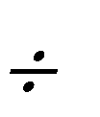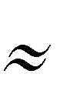Estimation: *520 km 40 L 13 km/L*

Actual Solution: *525 km 44.5 L = 11.798 km/L*

*Joanne's car travels an average of 11.798 kilometres per litre of gas.*

1. Weight lifters still talk about pounds, but try this question using the equivalent weight in kilograms.

Al bench-presses 136.36 kilograms when he works out at the gym. The bar already weighs

20.45 kg, so he only needs to put 115.91 kg of weights onto the bar before he lifts it. If each weight is also 20.45 kg, how many weights must he put on the bar? Round your answer to the nearest whole number.

Estimation: Actual Solution:

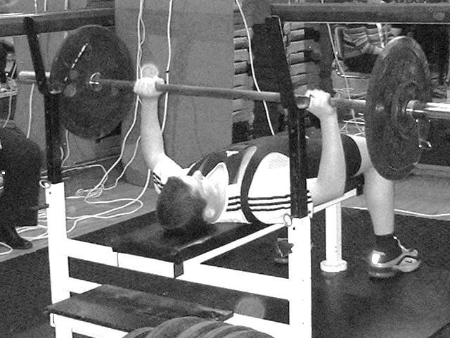

1. Sam earns $9.68 an hour at his part-time job. His paycheque last week was $174.24 before deductions. How many hours did Sam work for that paycheque?

Estimation:

Actual Solution:

1. If you can solve 30 math questions in 1.5 hours, how long does it take you to solve one of those math questions?

(Hint: You want the average time per question. The answer will be less than one hour, so it may be easier to work out the problem using minutes. Change hours to minutes by multiplying the hours by 60 minutes.

[1.5 hours 60 minutes = number of minutes] Estimation:

Actual Solution:

1. Three communities are hosting a feast to celebrate the coming of spring. The cost will be

$8 978.45. How much will each community pay?

Estimation:

Actual Solution:

1. Joe‘s snowmobile travelled 121.626 km in 3.5 hours. What was his average speed (kilometres per hour) on his trip?

Estimation:

Actual Solution:

1. The class decided to go out every month for a birthday lunch, and whoever had a birthday that month would not have to pay. This month there were three birthdays, so the bill had to be split among only 13 people. The bill was $156.80 including taxes and tip. How much did each person pay?

Estimation:

Actual Solution:

1. Dennis likes to cycle 30 km daily so he can stay in shape. He plans to use a cycle path around a local park. The park is rectangular and measures 3.1 km in width and 4.4 km in length. How many times should Dennis ride around this park each day?

Estimation:

Actual Solution:

1. One bundle of prefinished decorative wood covers 2.5 m2 of wall. Frank wants to put this wood on the end wall in his remodeled living room. The wall is 5.5 m long and 2.5 m high. How many bundles of wood will Frank need? (Calculate the area of the wall first.)

Estimation:

Actual Solution:

1. Roofing material is often sold by the *square*. This term used to refer to the shingles needed to cover 100 square feet. In metric measure, a *square* will cover approximately 9.5 m2. How many squares of cedar shakes (shingles) do you need for a roof which is 12.2 m by 11.5 m on the front side of the house and 12.2 m by 10 m on the back side of the house? Answer to the nearest square of shakes.

Estimation:

Actual Solution:

1. Marlene is helping her daughter to cut rectangular cards to label her science project. They have a piece of bright orange cardboard that is 1.2 m long and 80 cm wide. Each card is going to be 10 cm by 5 cm in size. How many cards can they cut from this piece of cardboard?

This problem has several steps:

* 1. rename one of the measurements to the same measure as the other (cm will be most practical).
  2. find the area of the cardboard and also the area of a card.
  3. **then** you are ready to answer the question in the problem.

Estimation:

Actual Solution:



**Answers to Exercise Nine**

a) Estimation: 520 km 40 L 13 km/L Actual Solution: 525 km 44.5 L = 11.798 km/L

Joanne‘s car travels an average of 11.798 kilometres per litre of gas.

b) Estimation: 120 kg 20 kg 6 weights

Actual Solution: 115.91 kg 20.45 kg = 5.7 weights Al must put on 6 more weights.

c) Estimation: $170 $10 17 hours

Actual Solution: $174.24 $9.68 = 18 hours

Sam worked 18 hours.

d) Estimation: 90 minutes 30 questions 3 minutes

Actual Solution: 90 minutes 30 questions = 3 minutes

It takes you 3 minutes to solve one math question.

e) Estimation: $9 000.00 3

$3 000.00

Actual Solution: $8 978.45 3 = $2 992.82

Each community will pay $2 992.82

f) Estimation: 120 km 4 hours 30 km/hr

Actual Solution: 121.626 km 3.5 hours = 34.75 km/hr

The average speed was 34.75kilometres per hour.

g) Estimation: $150 15 $10

Actual Solution: $156.80 13 = $12.06

Each person paid $12.06.



1. Estimation: 5km + 5km + 3km + 3km = 16 km 30 km 16 km 2 times around the park

Actual Solution: 4.4km + 4.4km + 3.1km + 3.1km = 15 km 30 km 15 km = 2

Dennis should cycle 2 times around the park.

1. Estimation: 6 m 3 m = 18 m2 18m2 3 m2 6 bundles

Actual Solution: 5.5 m 2.5 m = 13.75 m2

13.75 m2 2.5 m2 = 5.5

Frank will need 5.5 bundles of wood; he will probably have to buy 6.

1. Estimation: 12 m 11m = 132 m2 12 m 10m = 120 m2

132 m2 + 120 m2 = 252 m2

252 m2 10 m2 25.2 squares or cedar shakes Actual Solution: 12.2 m 11.5m = 140.3 m2 12.2 m 10m = 122 m2

140.3 m2 + 122 m2 = 262.3 m2

262.3 m2 9.5 m2 = 27.6

You will need 28 squares of cedar shakes.

k) Estimation: 100cm 100 cm = 10000 cm2 10 cm 5 cm = 50 cm2

10000 cm2 50 cm2 200

Actual Solution: 120cm 80 cm = 9600 cm2 10 cm 5 cm = 50 cm2

9600 cm2 50 cm2 = 192

Marlene and her daughter can make 192 cards.

**Topic A: Self-Test Mark /18 Aim 15/18**

1. **Find the quotients. 4 marks**

a) 4 b) 5

17 . 6

29.3

c) 0. 3 d) 0. 07

39 6

1. 666

1. **Divide and round the quotient to 4 marks**
2. the nearest tenth

*2.3*

*10 .4*

1. the nearest hundredth *0.12*

*0 .47 39*

1. **Find the quotients. 6 marks**

a) 51 10 = b) 47.2 10 =

c) 81.81 100 = d) 1.93 100 =

e) 62.811 1 000 = f) 0.5 10 =

1. **Problems 4 marks**
2. A train travelled 252.5 km in 4.25 hours. What was its average speed in kilometres per hour?

Estimation:

Actual Solution:

1. The new shirts for the slow-pitch team were $181.30 in total. How much should the manager charge each of the fourteen team members for a shirt?

Estimation:

Actual Solution:



**Answers to Topic A Self-Test**

**Part A**

a) 4.4 b) 5.86

c) 1320

d) 23.8

**Part B**

a) 4.5

b) 3.95

**Part C**

a) 5.1

e) 0.062811

b) 4.72

f) 0.05

c) 0.8181

d) 0.0193

**Part D**

a) Estimation: 250 km Actual Solution: 252.5 km

5 hours

50 km/hr

4.25 hours = 59.411764 km/hr

The average speed is 59.41 kilometres per hour.

b) Estimation: $180 15 $12

Actual Solution: $181.30 14 = $12.95

The manager should charge each team member $12.95.

##### Unit 4 Review

* 1. Write the decimal in the correct place in the quotient:

864



243



43



*7* 60.48

18 43.74

21 90.3

205



1683



024



9 *18.*45

25 420.75

60 14.4

* 1. Find the quotients:

34 179.146



81 517.59



75 6947.25



57 30.21

* + 1. 25

75 61.5

* 1. Find the quotients:

158.75



3.4 23.46

2.112



6.7 23.45



2.1 0.1134



1.005 0.25929

e) 0.33

f)

0.72 2.58768

* 1. Find the quotient, round the quotient to the nearest hundredth:

a) 14.71 3.1 =

b) 81.13 12 =

c) 4.93 6 =

d) 17.92 12.36 =

e) 15.68 2.2 =

f) 2.61 5.1 =

* 1. Divide, round your answer to the nearest tenth:

a) 98.9 1.3 =

b) 1.742 3.2 =

c) 0.64 3 =

d) 10.48 3.2 =

e) 43.893 2.2 =

f) 2.61 5.2 =

* 1. Divide by 10, 100 or 1000. Make sure you use the shortcut!

a) 53.4 10 =

b) 10 000 1000 =

c) 3 427 013 1000 =

d) 2 100 =

e) 124.32 100 =

f) 62.911 100 =

g) 0.34 100 =

h) 1.22 100 =

i) 479.99 1000 =

j) 3 411.2 1000 =

k) 12.12 1000 =

l) 4.2 1000 =

* 1. Solve the following word problems:
     1. Len pays $35.89 each month to pay off his interest free loan of $304.73. How many months will it take to pay off the loan?
     2. Lola paid $47.71 for her fill up of gas in her car. The cost of gas that day was

$1.02 per litre. How much gas did she buy?

* + 1. The Lee family children want to adopt a dog from the BC SPCA. The four children will split the cost of the dog evenly.

The costs of buying a dog are:

|  |  |
| --- | --- |
| $395.46 | Adoption cost |
| $159.30 | vet care |
| $67.49 | immunizations |
| $38.99 | first month of food |
| $278.34 | extra gear a dog needs (collars, leash, toys, crate, and a bed) |
| $30.00 | Licence fee |

What will each child pay?

* + 1. Oliver and Dougal are making homemade valentines cards for the kids at their daycare. They have a piece of pink cardboard that is 43.5 cm long and 62.4 cm wide. Each card is going to be 7.5 cm by 10 cm in size. How many cards can they cut out of this piece of cardboard.



**Answers to Review**

**7)**

1. $8.49 months (so really 9 months)
2. 46.77 litres c) $242.40 each

d) 2 714.4 cm2 75 cm2 = 36.192, so, the boys can make 36 cards in total.

|  |  |  |  |  |  |
| --- | --- | --- | --- | --- | --- |
| **1)**  a) 8.64 | b) 2.43 | c) 4.3 | d) 2.05 | e) 16.83 | f) 0.24 |
| **2)** |  |  |  |  |  |
| a) 5.269 | b) 6.39 | c) 92.63 | d) 0.53 | e) 6.35 | f) 0.82 |
| **3)** |  |  |  |  |  |
| a) 6.9 | b) 3.5 | c) 0.054 | d) 0.258 | e) 6.4 | f) 3.594 |
| **4)**  a) 4.75 | b) 6.76 | c) 0.82 | d) 1.45 | e) 7.13 | f) 0.51 |
| **5)** |  |  |  |  |  |
| a) 76.1 | b) 0.5 | c) 0.2 | d) 3.3 | e) 20 | f) 0.5 |
| **6)** |  |  |  |  |  |
| a) 5.34 | b) 10 | c) 3427.013 | d) 0.02 | e) 1.2432 | f) 0.62911 |
| g) 0.0034 | h) 0.0122 | i) 0.47999 | j) 3.4112 | k) 0.01212 | l) 0.0042 |

**Test time!**

Please see your instructor to get your practice test.

When you are confident, you can write your unit 4 test.

**Congratulations!**

**Unit 5**

Using Decimals in Real Life

**Topic A: Unit Pricing**

This next skill you learn will help you practice some math skills you have already learned:

Dividing Rounding



Working with money Comparing numbers

Have you stood in front of a store shelf trying to decide on the "best buy"? Often the packages are different sizes so it is difficult to compare the prices. Many stores now help by putting the **unit prices** on the shelf below their products, but you may need to figure the unit price out yourself.

The unit price is the price for one measure or one unit of a product.

 The unit price for 6 kilograms (kg) of tomatoes will be the **price per one kilogram (price/kg)**.

 You may wish to compare the cost of soft drinks sold in 750 millilitre (mL) bottles, 500 mL cans and 2 litre (which is 2000 mL) bottles. The unit price will be **price per one millilitre (price/mL)**.

 Socks are often sold in bundles of several pairs. How do you decide on the best buy if the same socks are on sale in bundles of 6 pairs, bundles of 8 pairs and bundles of 4 pairs? You figure out the unit price which would be the **price per one pair of socks (price/pair)**.

To calculate the unit price, do this:



**Total Price Number of Units = Unit Price**

To compare unit prices you need to **compare the same unit measure to the same unit measure**.

Compare kilograms to kilograms Compare litres to litres

Compare pairs of slippers to pairs of slippers Compare grams to grams

...and so on!

**Example:**

A 12 gram bag of potato chips costs $1.08 while an 8 g bag sells for $0.80

Which is the better buy? We will compare the price per gram for the 12 g bag with the price per gram for the 8 g bag. The bag with the lower price per gram is the better buy.

**Step 1** Be sure that the **prices** are **written the same way**; that is, all using the $ (dollars) style or all using the ¢ (cents) style. Be sure that the **units** for all items are the **same**.

**Step 2** Work out the unit price for each size bag by dividing the total price by the contents (the number of grams). **Be careful to include the money sign and units**.

$1.08 12g = $ 0.09/g $0.80 8g = $ 0.10/g

**Step 3** Compare the unit price to decide which size bag is the better value. The 12 g bag is the better buy.

 Of course the item with the best unit price may not be the best buy for you. You may only have enough money to buy a small quantity, or you may not want to have a large quantity of something. This is a helpful skill to know for if you need to use it.

**Exercise One** Calculate the unit price of these items which are of equal

**Answers to Exercise One**

quality and then √ the better buy. (Divide price by number of units.)

|  |  |  |  |  |  |
| --- | --- | --- | --- | --- | --- |
| **Item** | **Unit to Compare** | **Total Price** | **Number of Units** | **Unit Price** | **√** |
| Socks-4 pair $2.80 | *pairs* | *$2.80* | *4* | *$0.70/pr* |  |
| Socks-6 pair $4.08 | *pairs* | *$4.08* | *6* | *$0.68/pr* | √ |
| Toilet paper-8 rolls $2.56 |  |  |  |  |  |
| Toilet paper-6 rolls $1.86 |  |  |  |  |  |
| Laundry Soap-3 Litres $5.94 |  |  |  |  |  |
| Laundry Soap-5 Litres $9.80 |  |  |  |  |  |
| A dozen eggs $2.79 |  |  |  |  |  |
| A dozen and a half eggs $4.09 |  |  |  |  |  |

|  |  |  |  |  |  |
| --- | --- | --- | --- | --- | --- |
| Item | Unit to Compare | Total Price | Number of Units | Unit Price | √ |
| Socks-4 pair $2.80 | *pairs* | *$2.80* | *4* | *$0.70/pr* |  |
| Socks-6 pair $4.08 | *pairs* | *$4.08* | *6* | *$0.68/pr* | √ |
| Toilet paper-8 rolls $2.56 | *rolls* | *$2.56* | *8* | *$0.32/roll* |  |
| Toilet paper-6 rolls $1.86 | *rolls* | *$1.86* | *6* | *$0.31/roll* | √ |
| Laundry Soap-3 Litres $5.94 | *litres* | *$5.94* | *3* | *$1.98/L* |  |
| Laundry Soap-5 Litres $9.80 | *litres* | *$9.80* | *5* | *$1.96/L* | √ |
| A dozen eggs $2.79 | *Eggs* | *$2.79* | *12* | *$0.2325/egg* |  |
| A dozen and a half eggs $4.09 | *eggs* | *$4.09* | *18* | *$0.227/egg* | √ |

**Now look at this example:**

The drugstore is advertising one brand of toothpaste at $1.39 per 100 mL tube and an equal brand at 99¢ per 75 mL tube. Which is the better buy?

**Step 1** Check that the units are the same. You will compare millilitres to millilitres. Rewrite 99¢ as $0.99

**Step 2** Work out the unit price for each tube by dividing total price by the contents (number of mL).

$1.39 100 mL = $0.0139/mL

$0.99 75 mL = $0.0132/mL

**Step 3** Decide which tube is cheaper per unit price. Even though the results look strange for money, you are still able to tell that

$0.0132/mL is less than $0.0139/ml. The 75 mL tube is the better buy.

This is a good time to review **Dollars and Cents** and **Rounding**.

Remember:

**Abbreviations**

kilogram kg

gram g

1 kilogram = 1000 grams litre L

1 litre =1000 millilitres millilitre mL package pkg

**Exercise Two** Round to the nearest cent.

**Answers to Exercise Two**

a) $2.438 b) $0.099

c) 84.8¢ d) $6.409

e) 0.9¢ f) 13.2¢

g) $0.051 h) 28.6¢

i) 10.9¢ j) $0.252

k) $12.479 l) 1.4¢

|  |  |  |  |
| --- | --- | --- | --- |
| a) $2.44 | b) $0.10 | c) 85¢ | d) $6.41 |
| e) 1¢ | f) 13¢ | g) $0.05 | h) 29¢ |
| i) 11¢ | j) $0.25 | k) $12.48 | l) 1¢ |

**Exercise Three** Decide which item in each group is the "best buy" by

figuring out the unit price. Round the unit price to the nearest cent and √ the best buy.

|  |  |  |  |  |  |
| --- | --- | --- | --- | --- | --- |
|  | **Item** | **Amount** | **Price** | **Unit price** | **Best Buy** |
| a) | Frozen waffles  *(See calculations below)* | 200 g | $4.99 | *$0.024/g*  *$0.02/g* | _ |
| Frozen waffles | 1 kg (1000g) | $11.99 | *$0.011/g*  *$0.01/g* | √ |

0.024

200 4.990

4 000

990

800

90

*$11.99 1000 g = $0.0011/g $0.01/g*

|  |  |  |  |  |  |
| --- | --- | --- | --- | --- | --- |
| a) | **Item** | **Amount** | **Price** | **Unit price** | **Best Buy** |
| b) | Box of laundry soap | 5 kg | $9.99 |  |  |
| Box of laundry soap | 8 kg | $16.99 |  |  |
| c) | Granola bars | 170 g | $ 4.49 |  |  |
| Granola bars | 300 g | $3.98 |  |  |
| d) | Garbage bags | 20 bags | $2.29 |  |  |
| Garbage bags | 45 bags | $3.98 |  |  |

|  |  |  |  |  |  |
| --- | --- | --- | --- | --- | --- |
| e) | Rice | 1.4 kg | $3.69 |  |  |
| Rice | 2 kg | $5.39 |  |  |
| f) | Knee hi stockings | 2 pair | 99¢ |  |  |
| Knee hi stockings | 5 pair | $2.58 |  |  |
| g) | Orange juice | 5 L | $ 4.99 |  |  |
|  | Orange juice | 2 one litre cartons | $ 1.69 |  |  |
| h) | Bleach | 3.6 L | $1.89 |  |  |
| Bleach | 5 L | $2.49 |  |  |
| i) | Socks | 10 pair | $ 5.99 |  |  |
| Socks | 2 pair | $ 2.29 |  |  |
| j) | Cat food | 1.5 kg bag | 2 bags for $6.99 |  |  |
| Cat food | 0.4 kg bag | $1.25 |  |  |
| k) | 10-W-30 Motor oil | case of 12 1 L cans | $14.60 |  |  |
| 10-W-30 Motor oil | 1 L can | 3 cans for $3.49 |  |  |

**Answers to Exercise Three**

|  |  |  |  |  |  |
| --- | --- | --- | --- | --- | --- |
|  | **Item** | **Amount** | **Price** | **Unit price** | **Best Buy** |
| b) | Box of laundry soap | 5 kg | $9.99 | $2.00/kg | √ |
| Box of laundry soap | 8 kg | $16.99 | $2.12/kg |  |
| c) | Granola bars | 170 g | $ 4.49 | $0.03/g |  |
| Granola bars | 300 g | $3.98 | $0.01/g | √ |
| d) | Garbage bags | 20 bags | $2.29 | $0.11/bag |  |
| Garbage bags | 45 bags | $3.98 | $0.09/bag | √ |
| e) | Rice | 1.4 kg | $3.69 | $2.64/kg | √ |
| Rice | 2 kg | $5.39 | $2.70/kg |  |
| f) | Knee hi stockings | 2 pair | 99¢ | $0.50/pr | √ |
| Knee hi stockings | 5 pair | $2.58 | $0.52/pr |  |
| g) | Orange juice | 5 L | $ 4.99 | $1.00/L |  |
| Orange juice | 2 one litre cartons | $ 1.69 | $0.85/L | √ |
| h) | Bleach | 3.6 L | $1.89 | $0.53/L |  |
| Bleach | 5 L | $2.49 | $0.50/L | √ |
| i) | Socks | 10 pair | $ 5.99 | $0.60/pr | √ |
| Socks | 2 pair | $ 2.29 | $1.15/pr |  |
| j) | Cat food | 1.5 kg bag | 2 bags for  $6.99 | $2.33/kg | √ |
| Cat food | 0.4 kg bag | $1.25 | $3.13/kg |  |
| k) | 10-W-30 Motor oil | case of 12, one L cans | $14.60 | $1.22/L |  |
| 10-W-30 Motor oil | 1 L can | 3 cans for  $3.49 | $1.16/L | √ |

##### Rounding to the Nearest Tenth of a Cent

We do not have a coin that equals one tenth of a cent, but this amount of money is often used to calculate prices and can be significant for large amounts. The unit price information on store shelves also may include tenths of a cent. One other place where you see tenths of a cent is at the gas station—gasoline is priced at cents per litre and is usually written like this, without the $ or ¢:

**99.9 L** (99.9¢/L) or **0.999 L** ($0.999/L)

Gas Pricing Now, Past and the Future

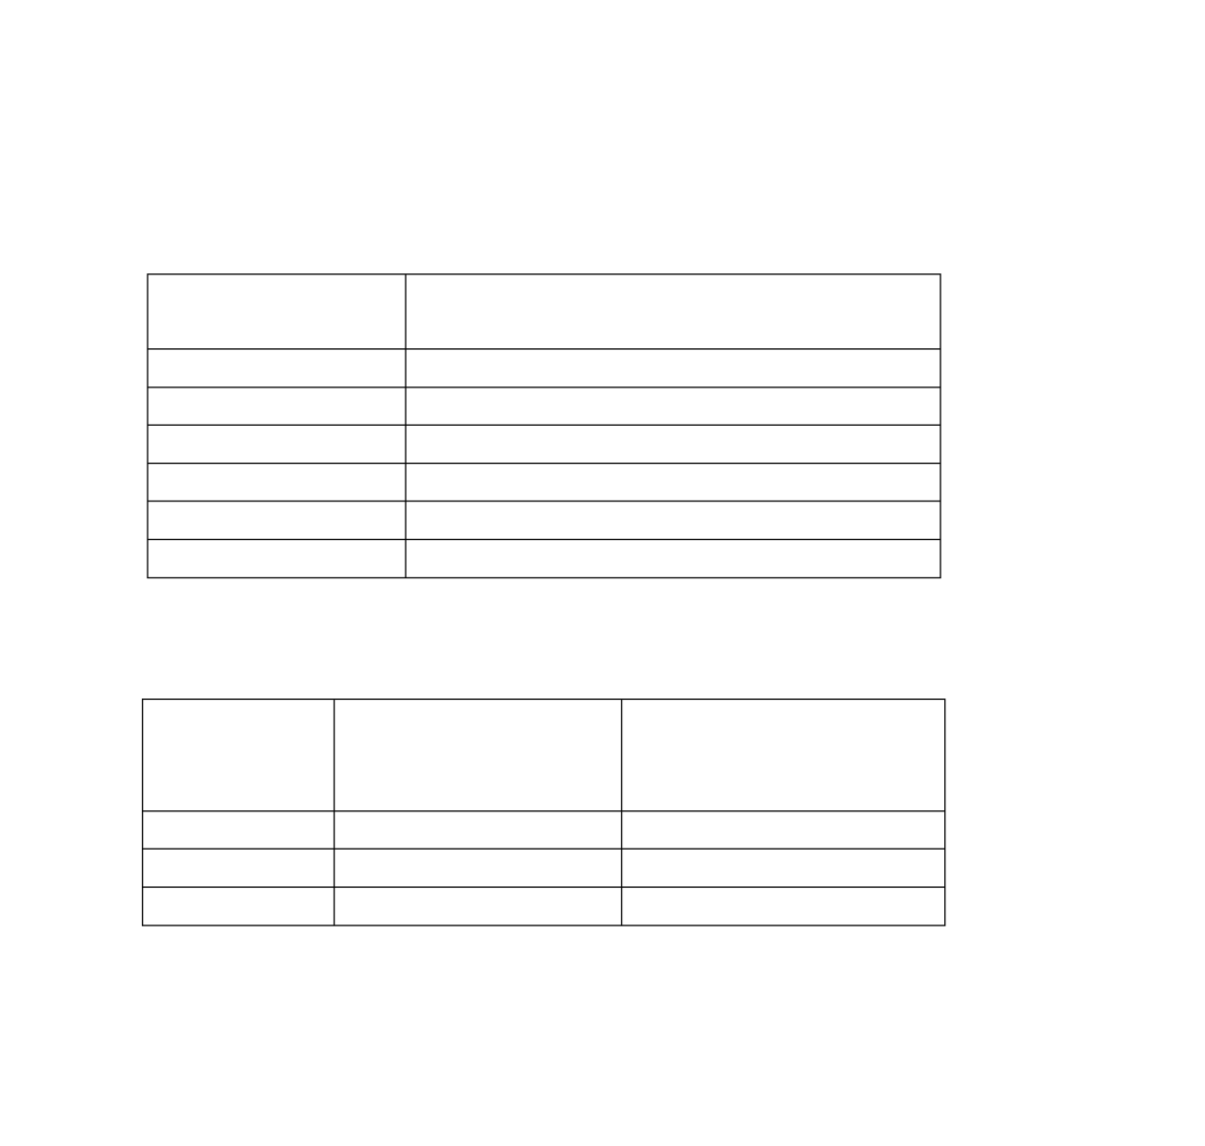

Gas prices have risen and fallen thousands of times in the past. On the gas station signs, the cost is listed as cents per litre (¢/L). In early 2010, the cost of gas was about 103.4

¢/L. This could also be written as $1.034/L. In the past it was unthinkable to have the gas price be so high that we would need to talk about dollars per litre. Before the 1970‘s gas prices were more stable. Here are a few pump prices from the past 20 years to compare:

Average Costs of Regular Gas in Canada in the Past 20 Years.

|  |  |
| --- | --- |
| Y**ear** | **Average Cost of Regular Gas in**  **Canada in ¢/L** |
| 1987 | 50.1 |
| 1990 | 58.5 |
| 1995 | 54.1 |
| 2000 | 71.6 |
| 2005 | 92.3 |
| 2009 | 94.5 |

(from M.J. Ervin & Associates, <http://www.mjervin.com/>)

Some Interesting Highest Average Prices in Canada (!!)

|  |  |  |
| --- | --- | --- |
| **Date** | **Location** | **Price (for regular**  **gas)**  **In ¢/L** |
| June 2009 | Yellowknife | 122.0 |
| June 2009 | Vancouver | 113.3 |
| June 2009 | Fort St. John | 112.7 |

(from M.J. Ervin & Associates, <http://www.mjervin.com/>)

Can you imagine what the future of gas prices will look like? How will the sellers show the prices on their signs in a few years from now? Do you think it will it be ¢/L or $/L?

**Topic A: Self-Test Aim: Good Shopping!**

Sit down with this week's grocery sale fliers and **comparison shop**. Work out the unit price for at least 5 items that are advertised by more than one store. Decide on the "best buy".

You may prefer to go to a store and copy down the prices and sizes of different brands of an item that you use. Decide which size in what brand is the best buy. Do this for five items. If the store has the unit price labels on the shelves, the hard work has already been done!

If you are not satisfied with your skill in unit pricing, ask your instructor for assistance.

##### Topic B: Decimal Problems

Spend a few minutes **reviewing the key words** that will help you identify addition, subtraction, multiplication and division problems. Read over some of the problems that you have done in each topic to **remind yourself of the patterns** to expect for different operations. Carefully review the **five steps** to use when solving problems (Unit Two, Topic A).

Step 1 **Read**, **find** the **question**.

Step 2 Get the **necessary information** from the problem. Draw pictures to help do this.

Step 3 **Decide** on the **arithmetic operation**.

Step 4 **Estimate** the answer, using rounded numbers. Step 5 **Solve** the problem, using the **actual numbers**.

1. The total weight of an A.T.V. is 293.937 kg. If a hunter, who weighs 62.142 kg carried an extra 68.39 kg, how much would her entire A.T.V. weigh when loaded?

Estimation:

Actual Solution:

1. The Courtenay town shuttle bus drives a route that is 12.73 km. It drives this route 30 times

a day. How many kilometres does the bus drive in one day?

Estimation:

Actual Solution:

1. John's take-home pay is $952.52 every two weeks. If $221.21 has been deducted (taken off) for income tax, $24.57 for employment insurance, and $22.70 for the Canada Pension Plan, what is his **gross** pay? (Gross pay is what he earns **before deductions)**.

Estimation:

Actual Solution:

1. Which is the best buy? Find the unit price for each item, rounded to the nearest cent, and √ the best buy.

|  |  |  |  |  |  |
| --- | --- | --- | --- | --- | --- |
|  | **Item** | **Amount** | **Price** | **Unit price** | **Best Buy** |
| i) | Flour | 10 kg bag | $8.89 |  |  |
| ii) | Flour | 4 kg bag | $3.79 |  |  |
| iii) | Flour | 2.5 kg bag | $2.69 |  |  |

1. Mary bought a TV set. She made a down payment of $75.00 and then made monthly payments of $56.19 for eight months. How much did she pay for the TV set altogether?

Estimation:

Actual Solution:

1. The total number of employee hours to be paid on the weekly payroll for the Dryer Company was 19 600 hours. The average rate of pay was $9.575 per hour. How much money was paid out in the payroll that week?

Estimation:

Actual Solution:

1. Bill and his wife were on a week-end trip. They spent $68.25 for gas, $74.96 for motels,

$124.80 for meals and liquor, $29.50 for the show, and $24.98 for a gift for his parents who were baby-sitting. How much did they spend?

Estimation:

Actual Solution:

1. Mr. Swift bought a 7.5 kg turkey for $18.91 just before Thanksgiving. What was the cost of the turkey per kg?

Estimation:

Actual Solution:

1. Joe's truck holds 94.5 L of gasoline. If he can drive 896 km on that much gasoline, calculate the km/L of gasoline for his truck. Answer to the nearest hundredth of a litre.

Estimation:

Actual Solution:

1. Calculate the total cost of having new carpet in the family room which will need 24 square metres (m2) to cover the floor. Here are the costs for one square metre: (Note that this is a two-

step problem.)

carpet $19.95/m2

underlay $ 4.50/m2

taxes $ 3.83/m2 labour charges $ 4.75/m2

Estimations:

Actual Solutions:

1. When he bought his new cell phone, Lou paid $150 in cash and said he would pay the rest at the end of the month. How much did he have left to pay on his $319.95 cell phone?

Estimation:

Actual Solution:

1. Sarah figures that it takes 0.75m of material to create a crest for a button blanket. How many crests can she make with 8.75 m of material?

Estimation:

Actual Solution:

1. Andy bought a shirt for $29.95 and a tie for $13.50. The HST was $5.21.
   1. How much did he spend? Estimation:

Actual Solution:

* 1. How much change did he get from his fifty dollar bill? Estimation:

Actual Solution:

1. In a recent 48-game season, the Campbell River Storm won 0.625 of their hockey games. How many games did they win? And how many games did they lose? Be sure that your games won and the games lost add up to 48 games when you are finished.

Estimations:

Actual Solutions:

1. Ann got tired of packing her lunch every day so now she always buys the $6.25 lunch from the catering service in the factory where she works. How much did she spend on lunches in the 22 days she worked in October?

Estimation:

Actual Solution:

1. Jim's online bank statement showed a balance of $183.65 before he used his debit card to pay

$24.62 at the grocery store and $14.89 at the pharmacy. What is his new bank balance?

Estimation:

Actual Solution:

1. If Diane takes a job paying $28 606.60 a year, what will her monthly salary (before deductions) be? (1 year = 12 months)

Estimation:

Actual Solution:

1. Carl's total **annual** union dues are $235.75 If he pays the same amount each month toward his union dues, what does he pay monthly?

Estimation:

Actual Solution:

1. What will Lynne pay for 12.8 litres (L) of gasoline at 99.9¢/L for her new sports car? Round your answer to the nearest cent.

Estimation:

Actual Solution:

1. Joan earns $86.25 for working 7.5 hours. What is her hourly rate of pay?

Estimation:

Actual Solution:

1. Samantha's height and weight have both changed since she was sixteen. Her old height and weight were 160.02 cm and 56.82 kg. Her present height and weight are 165.1 cm and 58.18 kg. Find the increases in her height and weight.

Estimation:

Actual Solution:

1. A car stereo can be purchased for $199.99 cash. If you wish to buy it "on time" you must pay

$50.00 a down payment and make monthly payments of $27.50 for six months.

* 1. How much do you pay if you buy "on time"?
  2. How much do you save if you pay cash?

**Answers to Unit 2 – Topic B**



1. Estimation: 300kg + 60 kg + 70 kg kg 430 kg

Actual Solution: 293.937 kg + 62.142 kg + 68.39 kg = 424.469 kg The ATV weighed 424.469 kg when loaded.

1. Estimation: 12 km 30 km 360 km per day Actual Solution: 12.73 km 30 km = 381.9 km The bus drives 381.9 km a day.

c) Estimation: $950 + $220 + $25 + $25 $1220

Actual Solution: $952.52 + $221.21 + $24.57 + $22.70 = $1221.00 John‘s gross pay is $1221.00.

d)

|  |  |  |  |  |  |
| --- | --- | --- | --- | --- | --- |
|  | **Item** | **Amount** | **Price** | **Unit price** | **Best Buy** |
| i) | Flour | 10 kg bag | $8.89 | $0.89 | ✓ |
| ii) | Flour | 4 kg bag | $3.79 | $0.95 |  |
| iii) | Flour | 2.5 kg bag | $2.69 | $1.08 |  |

e) Estimation: $60 8 + $75 $555

Actual Solution: $56.19 8 + $75.00 = $524.52 Mary paid $524.52 for the TV set.

f) Estimation: 20 000 hours $10.00 $200 000

Actual Solution: 19 600 hours $9.575 = $187 670

Dryer Company paid out $187 670 for the payroll that week.

g) Estimation: $70 + $75 + $125 + $30 + 25 $325

Actual Solution: $68.25 + $74.96 + $124.80 + $29.50 + $24.98 = $322.49 Bill and his wife spent $322.49 on their weekend trip.

1. Estimation: $20 8 kg $2.50 Actual Solution: $18.91 7.5 kg = $2.52

The cost of the turkey was $2.52 per kilogram.

1. Estimation: 900 km 90 L 10 km/L Actual solution: 896 km 94.5 L = 9.48 km/L Joe‘s truck uses 9.48 kilometres per litre.



j) Estimations: $20 + $5 + $5+ $5 $35

$35 25 m2 $875

Actual Solutions: $19.95 + $4.50 + $3.83 + $4.75 = $33.03

$33.03 24 m2 = $792.72

The cost to have the new carpet is $792.72.

k) Estimation: $320 - $150 $170 Actual Solution: $319.95 - $150 = $169.95

Lou will have $169.95 left to pay at the end of the month.

l) Estimation: 9 m 1 m 9 m Actual Solution: 8.75 m 0.75 = 11.6 Sarah can make 11 crests.

m) i) Estimation: $30 + $14 + $5 $49

Actual Solution: $29.95 + $13.50 + $5.21 = $48.66 Andy spent $48.66

ii) Estimation: $50 - $49 $1 Actual Solution: $50 - $48.66 = $1.34 Andy got $1.34 change from his $50.

n) Estimations: 50 0.50 25 games won

50 0.50 25 games lost

Actual Solutions: 48 0.625 =30 games won

48 0.375 =18 games lost

o) Estimation: 20 $6 $120 Actual Solution: 22 $6.25 = $137.50

Ann spent $137.50 on lunches in October.

p) Estimation: $180 - $20 - $10 $150

Actual Solution: $183.65 - $24.62 - $14.89 = $144.14 Jim‘s new cheque book balance is $144.14.

q) Estimation: $30 000 10 $3 000

Actual Solution: $28 606.60 12 = $2 383.88 Diane‘s monthly salary will be $2 383.88.



r) Estimation: $250 10 $25

Actual Solution: $235.75 12 = $19.65 Carl‘s will pay $19.65 monthly.

s) Estimation: 13 L $1.00 $13.00

Actual Solution: 12.8 L 99.9¢ = 1278.7¢ or $12.79 Lynne will pay $12.79 for gasoline.

1. Estimation: $90 8 hours $11.25 Actual Solution: $86.25 7.5 hours = $11.50 Joan‘s hourly rate of pay is $11.50.
2. Estimation: 165 cm – 160 cm 5 cm 58 kg – 57 kg = 1 kg

Actual Solution: 165.1 cm – 160.02 cm = 5.08 cm 58.18 kg – 56.82 kg = 1.36 kg

Samantha‘s height has changed by 5.08 cm and her weight has changed by 1.36 kg.

v) i) $27.50 6 = $165

$165 + 50 = $215 If you pay ―on time‖ you will pay $215.

1. $215 - $199.99 = $15.01 If you pay cash, you will save $15.01.

**Topic B: Self-Test Mark /10 Aim 8/10**

1. A machinist has to bore (drill) a hole through 2.6 cm of steel. He has drilled 1.25 cm. How much farther must he drill?

Estimation:

Actual Solution:

1. Cliff bought 15.5 kilograms of chicken feed for $0.98/kg. That feed will last his chickens for 12 days. How many kilograms of this chicken feed do his chickens eat every day?

Estimation:

Actual Solution:

1. Mrs. Williams bought 6.5 m of fabric to make two dresses. The fabric was on sale for $8.95 a metre and as part of the sale the store was paying all the taxes. How much did she pay?

Estimation:

Actual Solution:

1. The bus boys (table clearers) at the local restaurant only work while the dining room is busy, so they have to record their hours. Last week Jason worked 4.5 hours on Monday, 3.25 hours on Tuesday, 5.75 hours on Wednesday, none on Thursday or Friday, but 8.8 hours on Saturday. Find the total of the hours that Jason worked clearing dishes at the restaurant last week.

Estimation:

Actual Solution:

1. Karla gets $12.75 per hour when she works overtime. Yesterday she worked 3.25 hours overtime. How much money did she make for that time?

Estimation:

Actual Solution:



**Answers to Topic B Self-Test**

a) Estimation: 3 cm – 1 cm 2 cm

Actual Solution: 2.6 cm – 1.25 cm = 1.35 cm He has to drill 1.35 cm farther.

b) Estimation: 16 kg

Actual Solution: 15.5 kg

10 days

1.6 kg

12 days = 1.292 kg

Cliff‘s chickens eat 1.292 kg of chicken feed every day.

c) Estimation: 5 m $10 $50

Actual Solution: 6.5 m $8.95 = $58.18 Mrs. Williams paid $58.18 for the fabric.

d) Estimation: 5 + 3 + 6 + 9 23 hours

Actual Solution: 4.5 + 3.25 + 5.75 + 8.8 = 22.3 hours Jason worked 22.3 hours last week.

e) Estimation: $13 3 hours $39

Actual Solution: $12.75 3.25 hours = $41.44 Karla made $41.44 for that time.

##### Unit 5 Review

Use the skills you learned in this unit to figure out the best buy:

|  |  |  |  |  |  |
| --- | --- | --- | --- | --- | --- |
|  | **Item** | **Amount** | **Price** | **Unit price** | **Best Buy** |
| a) | Dish soap | 740 ml | $3.40 |  |  |
| Dish soap | 4.3 L | $16.10 |  |  |
| b) | Apples | Bag of 7 | $ 4.99 |  |  |
| Apples | 1 | $0.75 |  |  |
| c) | Lined paper | 500 sheets | $4.49 |  |  |
| Lined paper | 50 sheets | $1.99 |  |  |

|  |  |  |  |  |  |
| --- | --- | --- | --- | --- | --- |
| d) | Dog food | 1 can | $2.59 |  |  |
| Dog food | 12 pack | $27.97 |  |  |
| e) | Bread | 3 pack | $8.99 |  |  |
| Bread | 1 loaf | $2.49 |  |  |
| f) | Can of soup | Case of 9 | $ 10.99 |  |  |
| Can of soup | 3 for the price of 2 | $ 2.50 |  |  |
| g) | Light bulbs | Pack of 4 | $1.89 |  |  |
| h) | Light bulbs | Econo pack of 12 | $5.97 |  |  |

**Answers to Review:**

|  |  |  |  |  |  |
| --- | --- | --- | --- | --- | --- |
|  | **Item** | **Amount** | **Price** | **Unit price** | **Best Buy** |
| a) | Dish soap | 740 ml | $3.40 | 4.59/L |  |
| Dish soap | 4.3 L | $16.10 | 3.74/L | ✓ |
| b) | Apples | Bag of 7 | $ 4.99 | 0.71 each | ✓ |
| Apples | 1 | $0.75 | 0.75 each |  |
| c) | Lined paper | 500 sheets | $4.49 | $00.00898  /sheet | ✓ |
| Lined paper | 50 sheets | $1.99 | $0.0398  /sheet |  |
| d) | Dog food | 1 can | $2.59 | $2.59/can |  |
| Dog food | 12 pack | $27.97 | $2.33/can | ✓ |
| e) | Bread | 3 pack | $8.99 | $3.00/loaf |  |
| Bread | 1 loaf | $2.49 | $2.49/loaf | ✓ |
| f) | Can of soup | Case of 9 | $ 10.99 | $1.22/can |  |
| Can of soup | 3 for the  price of 2 | $ 2.50 | $0.83/can | ✓ |
| g) | Light bulbs | Pack of 4 | $1.89 | $0.47/bulb | ✓ |
| Light bulbs | Econo pack of 12 | $5.97 | $0.50/bulb |  |

**Test time!**

Please see your instructor to get your practice test.

When you are confident, you can write your unit 5 test.

**Congratulations!**

**Unit 6**

Measurement

**Topic A: Why Metric?**

This unit will help you explore the system of metric measurement.

First, why metric?

 Over 98% of the world‘s population uses the metric system of measurement or is in the process of converting to it.

 The *International System of Units* (**SI**) was established in 1960 as a result of a long series of international discussions. The **SI** sets the standards for the modern metric system. Because of **SI**, the use of the metric system provides exact measurements which have the same meaning worldwide.

 The metric system is patterned after the decimal number system – which means that the metric system focuses on **10**. The calculations within the metric system are done with factors such as 10, 100, 1000. **Many such calculations can be done by simply moving the decimal point.**

 The metric system uses the same prefixes with all the units. Once you understand the prefixes and the units, your knowledge can be applied to all the metric measures used in science, technology, and everyday life.

 The **SI** provides certain rules of style. Some of these are listed for your reference on the next two pages. Read them over now and then look back at them often as you work with metric measurement.

The end of this unit will look at how metric measurement (metres, litres, grams, etc) and imperial measurement (inches, feet, cups, ounces, pounds, etc) compare to each other.

##### A Review of Measurement Units

**The metre:**

The metre is the base unit used to measure **length, height,** and **distance**.

**Here are some ways we use length, height and distance measurement in our everyday lives:**

* 1. I drove 58 km from Vernon to Salmon Arm.
  2. It is 1 755 km from Dease Lake to Vancouver.
  3. The height of a newborn baby is 50 cm.
  4. An average adult male is about 1.8 m tall.
  5. A standard doorway is 2 m high.
  6. A brand new pencil is about 18 cm long.
  7. The base of a pencil is about 8 mm in length.

**The gram**

The gram is the unit for measuring **mass.** (We use the words mass and weight in the same way.)

**Here are some ways we use the measurement of mass in our everyday lives:**

1. 1 paper clip is 1 g.
2. 1 000 paper clips is 1 kg, or 1000 g.
3. A medium sized raisin is about 1 g.
4. A block of butter (known as 1 pound in the imperial system) is 453.5 g.
5. An adult woman can weigh about 63 kg.
6. A baby might weight about 3.5 kg when born.
7. A semi – trailer transport truck weighs about 425 000 kg.

**The litre**

Litres are the everyday unit that we use to measure volume or capacity.

*Volume* or *capacity* tells how much a container can hold. For example, the volume of the classroom would be represented by the amount of air in the room. The capacity of a container would be the amount of liquid it could hold. We use **litres** to measure liquids and gases such as air.

**Here are some ways we use volume measurement in our everyday lives:**

1. A big plastic milk jug is 4 L.
2. A juice box that goes in a child‘s lunch is 250 ml.
3. There is 355 ml of pop in a regular pop can.
4. Gas tanks can hold about 50 L of gasoline.
5. The average person has about 3.8 L of blood in his or her body.

**Degree Celsius oC**

**Degrees Celsius** is the common unit for measuring temperature. The symbol is **oC**.

The Celsius temperature scale was determined by  setting the freezing point of water at **0oC**

 setting the boiling point of water at **100 oC**

 dividing the interval between freezing and boiling of water into **100 equal parts known as degrees Celsius**

(The name is from the 18th century Swedish scientist, Anders Celsius.)

Temperatures colder than the freezing point of water are ―below zero‖ or ―below freezing‖ and are indicated with a minus sign in front of the number.

five and a half degrees below freezing is written **-5.5 oC**

forty degrees below zero is written **-40 oC**

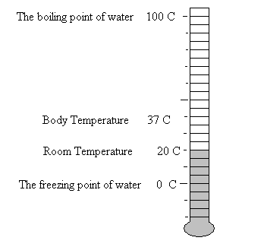

**Exercise One** Read the temperatures on the thermometers pictured on

the page.

a) b)

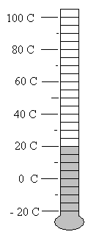 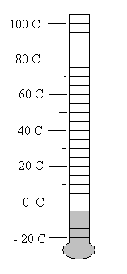

c) d)

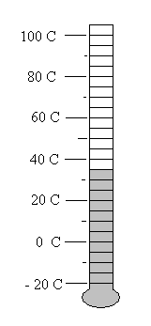 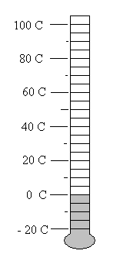

e) f)

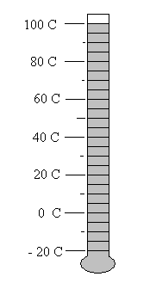 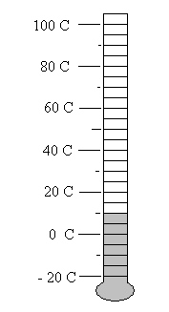

**Answers to Exercise One**

a) 20°C

b) - 5°C

c) 35°C

d) 0°C

e) 100°C

f) 10°C

**Body Temperatures**

1. oC normal
2. oC feverish, you might consider calling a doctor 39 oC very feverish

40 oC dangerously high body temperature (equal to 104 oF)

**Air Temperatures**

40 oC too hot – sit down in the shade and relax! 30 oC very warm summer‘s day

20 oC pleasant temperature for outdoor activities 10 oC quite cool, you need a coat

0 oC water is freezing

-10 oC brisk winter‘s day

-20 oC cold, watch for frostbite

-30 oC very cold

-40 oC extremely cold!!!

**Exercise Two** Keep track of the morning temperatures each day for a

week. Put a thermometer outside your window and fill in the following chart. This is a great activity to do with your kids. The purpose of this activity is to get familiar with reading a thermometer, which is practicing a scientific measurement.

|  |  |  |  |  |  |  |  |
| --- | --- | --- | --- | --- | --- | --- | --- |
| **Day of week** | **Sunday** | **Monday** | **Tuesday** | **Wednesday** | **Thursday** | **Friday** | **Saturday** |
| Temperature in °C |  |  |  |  |  |  |  |

##### Rules of Style

**Names of Units**

 The name of a unit starts with a lower case (small) letter except at the beginning of a sentence and except for degrees Celsius.

gram metre litre second

 Use only one prefix at a time with a base unit. Do not use a hyphen (-) between the prefix and the base unit.

kilogram centimetre millilitre

**Symbols**

 With numerals, use the symbols for the metric units, not the full name.

For example, 67 km, **not** 67 kilometres

2.1 L, **not** 2.1 litres

 Write the full name of the unit and prefix if no numeral is used.

For example, milk is measured in litres.

 Do not use a period after the symbols. A period is only used if the symbol is at the end of a sentence.

For example, Matt drove 457 **km** yesterday.

Yesterday, Matt drove 457 **km.**

 Do not use an ―s‖ with the symbols to mean more than one unit.

For example, four kilograms is written **4 kg** (no ―s‖ and no period)

 Do not start a sentence with a symbol; write out the full name at the beginning of a sentence.

 If a unit is squared, an *exponent* is used. For example, five square metres is written as

**5 m2**.

**Numerals**

 Leave a space between the last digit of the numeral and the symbol.

For example, 45 km 2.5 L

An exception is degrees Celsius, which is written as 27oC with no space.

Use decimal fractions with metric units, not common fractions.

For example, 10.75 km, **not** 10 3 km

4

 If a number is greater than ten, the preferred **SI** form is to use numerals, not the written-out number name.

For example, 15 L, **not** fifteen litres

 **If** the number name is written out, write the full name of the metric unit also.

For example, two kilometres, twenty-five metres

##### Topic B: The Prefixes

The metric system uses base units, some of which you have just studied. It would not be practical to use only the base units because sometimes the unit would be far too large and other times it would be too small.

 If your weight was written in grams, it might be 60 000 g – that sounds massive!  The distance from Vancouver to Montreal is approximately 4 800 000 m.

 To measure a sewing seam or to select a wrench using only metres would mean using decimal amounts such as 0.007 m for a wrench and 0.015 m for the seam allowance on a dress.

These measures would all be correct but inconvenient to use. They would be easier to understand as:



Your weight is 60 kg.

The distance from Vancouver to Montreal is approximately 4800 km A 7 mm wrench and 1.5 cm for a seam allowance.

The metric prefixes are similar to the place values in our number system. The prefix in front of a base unit tells **how many** of the base unit.

For example, the prefix **kilo** means **1000**, so

a **kilo**metre is 1000 metres a **kilo**gram is 1000 grams a **kilo**litre is 1000 litres



Each prefix can be combined with almost any unit. You will need to memorize the most common prefixes, their symbol and their meaning.

On the next page is a chart of most of the prefixes used in **SI**. In our everyday life and studies we use only a few of these prefixes. However, it is interesting to look

 at the pattern of the prefixes and compare their pattern to the place value that you

know so well. The ones to memorize are written in **bold** type and marked with an *.

##### A Chart of the SI Prefixes

|  |  |  |
| --- | --- | --- |
| **Prefix** | **Symbol** | **Number of Base Units** |
| terra | T | 1 000 000 000 000 |
| giga | G | 1 000 000 000 |
| mega | M | 1 000 000 |
| **kilo\*** | **k** | **1 000** |
| **hecto\*** | **h** | **100** |
| **deca\*** | **da** | **10** |
| no prefix | base unit | **1** |
| **deci\*** | **d** | **0.1** |
| **centi\*** | **c** | **0.01** |
| **milli\*** | **m** | **0.001** |
| micro |  | 0.000 001 |
| nano | n | 0.000 000 001 |
| pico | p | 0.000 000 000 001 |

**Exercise Three** Use the Prefix Chart to answer these questions.

1. Give the meaning and symbol for *deca*. *Deca means ten base units. da*
2. Give the meaning and symbol for *hecto.*
3. Give the meaning and symbol for *kilo*.
4. Write the symbols for these units: metre , gram , litre
5. Look at the prefixes *deci*, *centi, milli,* (and also *micro, nano, pico*). These prefixes tell you that the measurement is **less than the base unit**; they give a fraction of the base unit.
   1. deci means *one tenth of the unit*
   2. centi means
   3. milli means

As a memory helper, notice that these three units which give a fraction of the base unit, all end with the letter **i**. You already know that *centi* is the Latin word for ―one hundredth‖ and that one cent is one hundredth of a dollar.

1. Prefixes have been combined with base units in this exercise. Write the meaning and the symbol. The first two questions are done as examples.
   1. centimetre *one hundredth of a metre cm*
   2. decagram *ten grams dag*
   3. kilogram
   4. hectometre
   5. millilitre
   6. decimetre
   7. centigram
   8. kilometre
   9. hectolitre
   10. decametre

**Answers to Exercise Three**

a)

c)

e)

deca means ten base units. **da**

kilo means 1000 base units. **k**

1. deci means one tenth of the unit
2. centi means one-hundredth of the unit
3. milli means one thousandth of the unit

b)

d)

hecto means 100 base units. **h**

metre **m**

gram **g**

litre **L**

f) i) one hundredth of a metre **cm**

iii) thousand grams **kg**

v) one-thousandth of a litre **mL**

vii) one-hundredth of a gram **cg**

ix) hundred litres **hL**

ii) ten grams **dag**

iv) hundred metres **hm**

vi) one-tenth of a metre **dm**

viii) thousand metres **km**

x) ten metres **dam**

**Exercise Four** Complete the chart. The first three are done for you.

|  |  |  |  |
| --- | --- | --- | --- |
| **Symbol** | **Word Name** | **Meaning** | **Measures** |
| kL | *kilolitre* | *one thousand litres* | *capacity* |
| hm | *hectometer* | *one hundred metres* | *distance (length)* |
| dg | *decigram* | *one tenth of a gram* | *mass* |
| mm |  |  |  |
| daL |  |  |  |
| kg |  |  |  |
| m |  |  |  |
| mL |  |  |  |
| dag |  |  |  |
| cL |  |  |  |
| cm |  |  |  |
| hL |  |  |  |
| hg |  |  |  |
| L |  |  |  |
| dam |  |  |  |
| mg |  |  |  |
| dL |  |  |  |
| g |  |  |  |
| km |  |  |  |
| cg |  |  |  |
| dm |  |  |  |

**Answers to Exercise Four**

|  |  |  |  |
| --- | --- | --- | --- |
| **Symbol** | **Word Name** | **Meaning** | **Measures** |
| kL | *kilolitre* | *one thousand litres* | *capacity* |
| hm | *hectometer* | *one hundred metres* | *distance (length)* |
| dg | *decigram* | *one tenth of a gram* | *mass* |
| mm | millimetre | one-thousandth of a metre | distance |
| daL | decalitre | ten litres | capacity or volume |
| kg | kilogram | thousand grams | mass |
| m | metre | one metre | distance |
| mL | millilitre | one-thousandth of a litre | capacity |
| dag | decagram | ten grams | mass |
| cL | centilitre | one-hundredth of a litre | capacity |
| cm | centimetre | one-hundredth of a metre | distance |
| hL | hectoliter | hundred litres | capacity |
| hg | hectogram | hundred grams | mass |
| L | litre | one litre | capacity |
| dam | decametre | ten metres | distance |
| mg | milligram | one-thousandth of a gram | mass |
| dL | decilitre | one-tenth of a litre | capacity |
| g | gram | one gram | mass |
| km | kilometre | thousand metres | distance |
| cg | centigram | one-hundredth of a gram | mass |
| dm | decimetre | one-tenth of a metre | distance |

##### Topic B: Measuring

The metre is the base unit for this purpose. In Topic C, all the prefixes were combined with the base unit *metre*. But for everyday purposes, we use only kilo, centi and milli with metre.

|  |  |
| --- | --- |
| **Use…** | **To Measure** |
| **kilometres** | long distances, such as road distances, length of rivers, to measure car speed per hour, highway signs |
| **metres** | medium lengths, such as room size, track and field events, size of building lots, rope, extension cords, fabric, carpeting |
| **centimetres** | common, smaller things such as a person‘s height, waist measurement, size of furniture, length of pants, width of wax paper, shoelaces, skis |
| **millimeters** | very small things such as postage stamps, size of precise tools, length of screws and nails, fine sewing measurements, thickness of plywood and glass |

**Exercise Five** Get a metre stick or tape measure. If you have problems, your

instructor will assist you in reading the measuring tool that you use and will check your work.

1. Find the centimetre markings on the metre stick or tape measure. Remember that one centimetre is one hundredth of a metre, so there are 100 centimetres in each metre.
2. Using the centimetre markings, measure the following:
   1. your desk or table top, in both directions
   2. the distance from the floor to your desk top (its height)
   3. the cover of this book
   4. the covers of two different-sized books
   5. the thickness of a fat dictionary
   6. the height of your chair seat from the floor
   7. the length of your foot
   8. the length of your hand from your wrist to your fingertips
   9. your hand span; that is, how far you can stretch from the tip of your thumb to the tip of your little finger.

Your hand span is a **handy** measurement to know because you can use it as a  measuring tool to make quick measurements of smaller objects. Knowing the

length of your pace is useful for quick measurements of room size, etc.

1. You will need a flexible tape measure for these measurements to be taken in centimetres. These are personal measurements which you may keep private if you wish.
   1. your height
   2. your waist
   3. your chest
   4. your hips
   5. around your head
   6. around your neck
   7. your pant length, usually done on the inside seam

**Exercise Six** The answers to questions a) and c) are listed below; your

instructor will check your other measurements and assist you as needed.

1. Look carefully at the measuring tool you have been using. Find the millimeter markings **if** they have been written on the tape or stick. You may have to look at a shorter ruler to find the millimeters marked.
   1. A millimeter is one thousandth of a metre.
   2. millimeters equal one metre.
   3. millimeters equal one centimetre.
2. Now measure these items in your classroom, first in centimetres and then in millimeters:
   1. the length of a pen
   2. the length of a pencil
   3. the length of an eraser
   4. the length of a paperclip
   5. the length of your thumb
   6. the distance across a dime
   7. the distance across a quarter
   8. the height of a quarter when it is laying flat on the table – you will probably just use millimeters for this one!
   9. the length of two different pieces of chalk
   10. the length of your longest fingernail
   11. the width of the fingernail on your small finger
3. Measure the longest (or widest) part of each picture in cm and in mm.

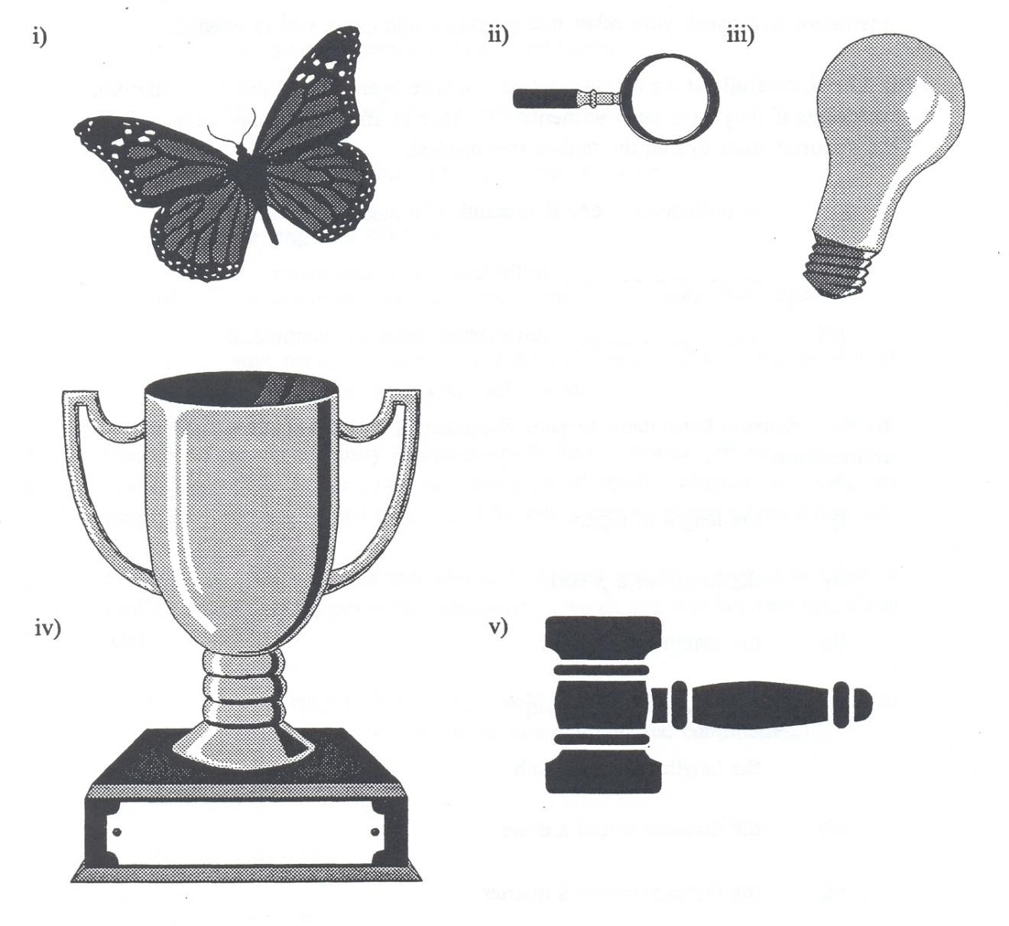

* 1. cm ii) cm iii) cm iv) cm v) cm

i) mm ii) mm iii) mm iv) mm v) mm

|  |  |  |
| --- | --- | --- |
| **Answers to Exercise Six** | | |
| a) i)  ii) iii) | A millimetre is one thousandth of a metre.  1000 millimetres equal one metre. 10 millimetres equal one centimetre. |  |
| c) i) | 4.5 cm 45 mm (wing tip to wing tip) | ii) 3.1 cm 31 mm |
| iii) v) | 4.1 cm 41 mm 5 cm 50 mm | iv) 7.8 cm 78 mm |

**Exercise Seven** Make the following measurements. Choose the most

convenient unit (metres, centimetres, or millimetres) for each question. Draw a sketch of the shapes. Record your results carefully because you will use them at the end of the Unit Two.

1. Measure the length and width of your classroom.
2. Measure the length and width of the desk or table top that you use.
3. **Estimate** the length and width of the hallway outside your classroom. Make this estimate by counting the number of **paces** you must take. Your instructor will demonstrate how to do this if you are not sure of the method.
4. Measure the length and width of the top of a rectangular eraser. Find one that is not round.

##### Measuring Mass

Mass measures the weight of something. The unit for mass to which prefixes are attached is the gram – a very small mass. We use the kilogram (1000 g) for many everyday purposes. In fact, **SI** uses the kilogram as the official base unit because it is the most used, most practical amount. Let‘s look at the use of the common measurements for mass.

|  |  |
| --- | --- |
| **Use…** | **To Measure** |
| **tonne (t)** | Very large amounts such as trucks and farm crops; loads on trucks, trains, and ships; coal; factory production |
| **kilogram** | Common amounts such as our body mass, meat and vegetables, packaged foods, packaged household supplies |
| **gram** | Small amounts of mass such as breakfast cereals, light packaged food, newborn babies, ingredients in some recipes. The amount of certain nutrients that we should eat. Bulk and delicatessen foods may be priced per 100 g. |
| **milligram** | Extremely small amounts of mass such as in medicines (―3 mg of pain-reliever in every tablet!‖); the vitamins and minerals in foods (check the nutrient information on a package); the recommended dose of daily vitamins |

The **tonne**, symbol **t**, has not been mentioned before. Notice that the name does not use a prefix or a base unit. Say ―tun‖ for *tonne.*

1 tonne = 1 000 kg

1 tonne = 1 000 000 g (Can you imagine the mass of one million raisins?)

**Exercise Eight** Use a scale marked in kilograms at a supermarket for

b) to e).

1. Find your own mass in kg.
2. Find the mass of a large turkey.
3. Find the mass of 4 L of milk.
4. Find the mass of 12 carrots.
5. Find the mass of any vegetables and fruit you buy in the next week.

##### Measuring Capacity (Volume)

The base unit for capacity is the litre. Capacity measures how much fluid a container will hold. The fluid might be liquids such as milk, water, and blood or it might be a gas such as air or oxygen. The litre and the millilitre are the everyday measurements for capacity.

|  |  |
| --- | --- |
| **Use…** | **To Measure** |
| **litre** | Common amounts of liquids such as milk, gasoline, paint, household cleaners, bottled drinks (pop, juice, etc.), large cans of food; car engines may be described by the litres of air displaced in the cylinders (for example, a 1.5 L engine in a small car). The capacities of buckets, cookware and ice cream are given in litres. |
| **millilitre** | Liquids in containers less than one litre such as food, soft drinks, and wine. Spices and flavouring for cooking (one teaspoon 5 mL). Measuring cups are often 250 mL or 500 mL. |

Look at your home and around the grocery store to find items measured in litres and items measured in millimetres. Look at measuring spoons to help you get a feeling for small amounts measured in millilitres.

**Exercise Nine** Write the measurement (prefix and unit) which would be

most practical to measure these objects in real life. Answer every part of each question.

a)

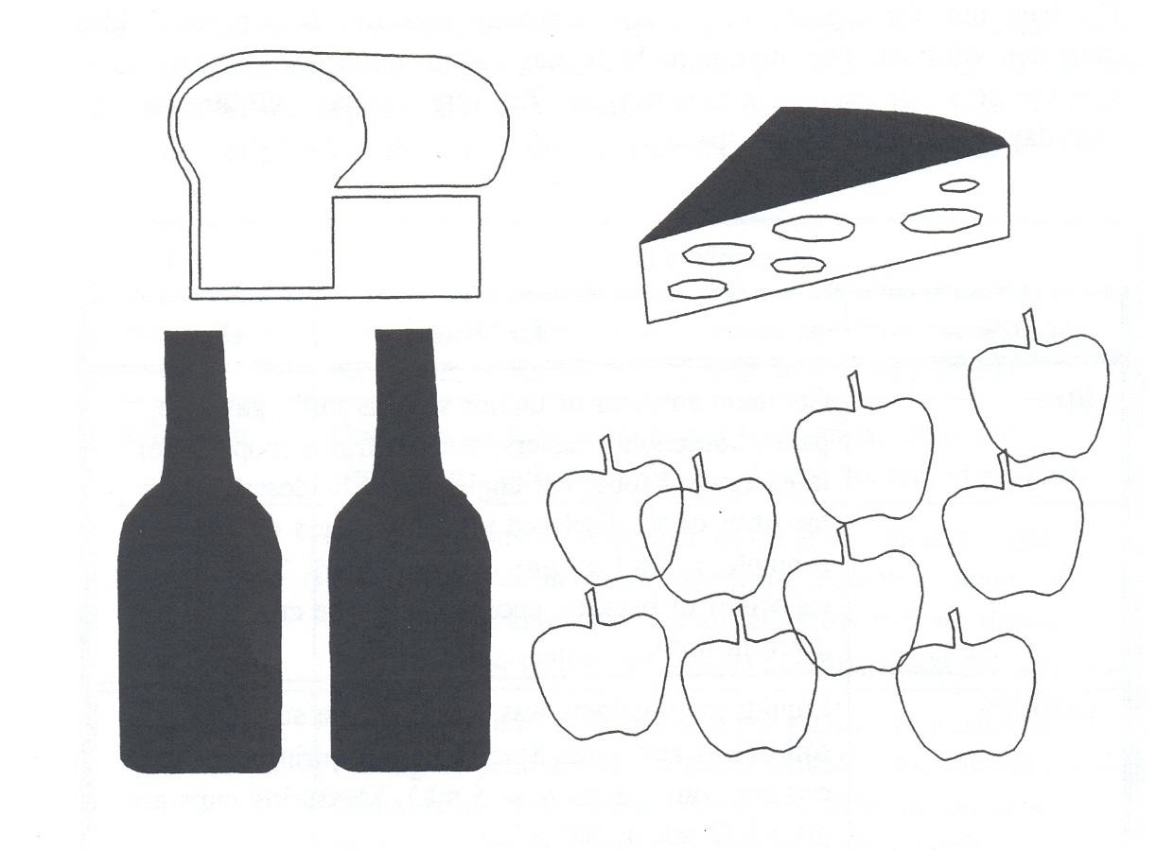

|  |  |  |
| --- | --- | --- |
| a) Example: |  | |
| i) bread | mass *grams (g)* | length *centimeters (cm)* |
| ii) apples | mass | distance around |
| iii) wine | mass | height capacity |
| iv) cheese | mass | height |

b)

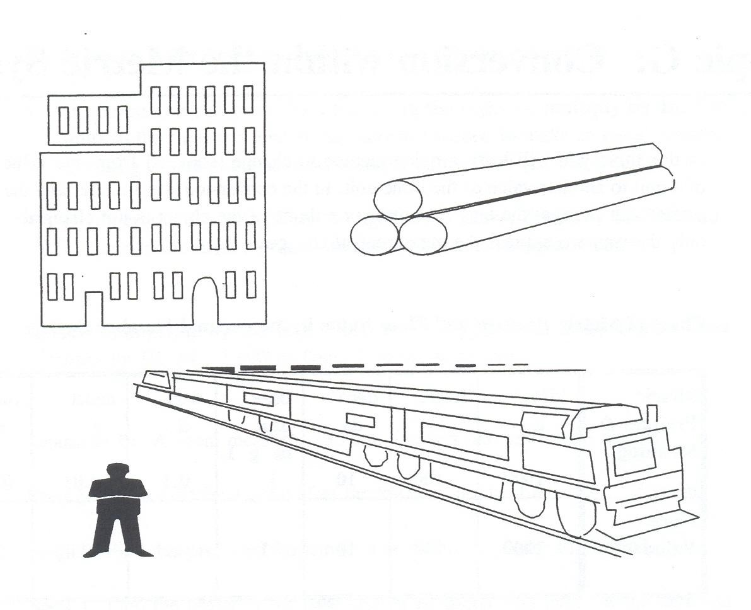

|  |  |  |  |
| --- | --- | --- | --- |
| b)  i) | person | mass | height lung capacity |
| ii) | building | height | width |
| iii) | train | length | mass |

distance the train travels per hour

iv) logs length mass

distance across the cut end of one log

**Answers to Exercise Nine**

a) i) bread: grams, centimetres

iii) wine: kilogram, centimetre, litre

ii) apples: kilograms, centimetres

iv) cheese: kilograms, cm or mm

b) i) person: kilograms, centimetres, litres

iii) train: metres, tonnes, kilometres

ii) building: metres, metres

iv) logs: metres, kg or tonnes, cm

##### Topic C: Conversion within the Metric System

In this topic you will learn a quick method to change (convert) between different units with the same base. In the conversion, the number and the prefix both change; the length or mass or volume of the object is **not** changed – only the way we express the measurement changes.

 Are you a visual learner? If you are, then ask your instructor to show you the next skill. It will save you a lot of frustration. You may learn this skill much faster with a real life

example.

**Chart of Metric Prefixes and Place Value in the Decimal Number System**

|  |  |  |  |  |  |  |  |
| --- | --- | --- | --- | --- | --- | --- | --- |
| **Metric Prefixes** | **kilo** | **hecto** | **deca** | **base unit** | **deci** | **centi** | **milli** |
| Mass | kg | hg | dag | g | dg | cg | mg |
| Volume | kL | hL | daL | L | dL | cL | mL |
| Length | km | hm | dam | m | dm | cm | mm |
| **Place Value** | **1000** | **100** | **10** | **1** | **0.1** | **0.01** | **0.001** |

**Converting within the Metric System using the Chart Example A:** A cigar weighs 12 g. Convert this amount to mg.

**Step 1** If there is no decimal point in the amount, place a **.** after the amount.

12 g = 12**.** g

**Step 2** Locate the prefix of the known amount. If no prefix is given, find the base unit (gram in the example) in the centre of the chart.

**Step 3** Find the prefix that you are changing to (**milli**gram in this example). It is to the right of the gram. Count the number of bars ( | ) between gram and milli. You **cross three bars** to **move three places to the right.**

**Step 4 Move the decimal point** the **same number of places** in the **same direction** as you moved on the chart. Add zeros as needed.

12**.** g = 12 000**.** mg The cigar is 12 000 mg.

On the chart, every time you cross over a bar ( | ), the factor is **10**.

 If you cross a bar going from the left **to the right , multiply by 10.** The units to the right are smaller, so more are needed to make an equal amount. Crossing 3 bars is the same as multiplying by 1000 (10 10 10).

 If you cross a bar going from the right **to the left , divide by 10.** The units to the left are larger, so less are needed to make an equal amount.

 Review Multiplying by 10, 100, 1 000.

**Example B:** The length of a room measures 450 cm. Convert this amount to metres. **Step 1** Place a decimal point after the known amount if needed. 450**.** cm **Step 2** Find the **prefix** of the known amount on the chart. Find **centi**.

**Step 3** Find the prefix or the base unit (if no prefix was used) of the unit you are changing to. Is it left or right of centi? Count the bars between cm and metre. You cross two bars to move **two places to the left.** That is the same as dividing by 100.

**Step 4 Move the decimal point** the **same number of places** in the **same direction** as you moved on the chart. Add zeros as needed.

450**.** cm = 4**.**50 m 450 cm = 4.5 m

**Example C:** The container holds 45.5 dL. Write this amount in daL.

**Step 1 and 2** A decimal point is already in the amount. Find **deci** on the chart.

**Step 3** Find **deca** on the chart. Count the number of bars you cross going from deci to deca – 2 bars to move 2 places to the left. (divide by 100)

**Step 4** Move the decimal point 2 places to the left.

45**.**5 dL = **0.**455 daL (less than 1 daL)

**Exercise Ten** Complete the metric conversions. Some units are not

common, but the practice in conversion is useful.

* + 1. From memory, put the metric prefixes on the chart according to their place value. Check that your chart is correct before you use it.

| | | base units | | |

b) 42 cm = m 8 241 m = km

c) 23 mm = m 2.86 m = cm

d) 358 mm = cm 5 hm = m

e) 0.87 m = mm 0.5 kg = g

1. 33 kg = cg 500 mL = L
2. 197 cm = m 4.5 kg = dag
3. 28 m = km 890 dL = kL
4. 8 L = mL 85 km = m
5. 100 mm = m 78 mm = cm
6. 45 cm = mm 3 hL = mL
7. Add 45 cm and 92 cm. Express the sum in metres.

*45 cm + 92 cm = 137 cm 137 cm = 1.37 m*

1. Add 245 m, 689 m, and 124 m. Express the sum in kilometres.
2. Multiply 250 mL by 6. Express the product in litres.

**Answers to Exercise Ten**

a) kilo | hecto | deca | BASE UNIT | deci | centi | milli

|  |  |  |  |  |
| --- | --- | --- | --- | --- |
| b) 0.42 m | 8.241 km | c) | 0.023 m | 286 cm |
| d) 35.8 cm | 500 m | e) | 870 mm | 500 g |
| f) 3 300 000 cg | 0.5 L | g) | 1.97 m | 450 dag |
| h) 0.028 km | 0.089 kL | i) | 8 000 mL | 85 000 m |
| j) 0.1 m | 7.8 cm | k) | 450 mm | 300 000 mL |
| m) 1.058 km |  | n) | 1.5 L |  |

##### Why Do We Need to Convert Measurements?

The skill of converting within the metric system is very useful.

 Before we can work with measurements we must **be sure the measurements are all in the same unit value.** For example, subtract litres from litres, multiply metres by metres, add milligram to milligrams.

 Measurements are usually written with small whole numbers. This is the *simple form* of the measurement. For example,

instead of 4 587 g, write 4.587 kg

instead of 52 000 mL, write 52 L instead of 0.0065 m, write 6.5 mm

**Before** doing any calculations with measurements, convert them as needed so that the unit values are the same.

**Example A:** 50 g – 275 mg = ?

Convert 50 g to mg 50 g = 50 000 mg

Subtract 50 000 mg

- 275 mg

49 725 mg which is 49.725 g

**OR**

Convert 275 mg to g 275 mg = 0.275 g

Subtract (add a decimal and zeros to make subtraction easier)

50.000 g

- 0.275 g

49.725 g

**Example B:** The bottom of the square dance skirt measures 2.6 m around. The lace trim is packaged in 75 cm lengths. How many packages of lace will Jill need to trim the buy?

First, convert the measurements to the same values.

2.6 m = 260 cm

This is a division problem. How many groups of 75 cm are in 260 cm? 260 cm 75 cm = 3.47 times

She will need to buy 4 packages because she needs more than 3 packages and cannot buy a part of a package.

**NOTE:** When dividing you are finding out how many times something goes into  something else, so you DO NOT use units in the answer.

**Exercise Eleven** Convert as needed to solve these problems.

1. Complete the chart from memory for your use. Check that it is correct.

| | | base units | | |

1. Harold is making frames for six of his favourite photos from his last hiking trip. Each photo needs 85 cm of framing wood. How many centimetres of wood does Harold need? The wood is sold by the metre so how many metres should Harold buy?
2. The new refrigerator is 175 cm high. The directions say that 10 cm must be left above the refrigerator for air circulation. The height of the space for the refrigerator is 1.9 m. Will the refrigerator fit?
3. The nutrition information on the cereal box says each serving contains 2.5 g of protein, 1.2 g of fat, 24.4 g of carbohydrate, 240 mg of sodium, and 97 mg of potassium. What is the total weight of one serving of cereal?
4. The stairway is 89 cm wide. How much must be trimmed from the side of the carpet runner that is 1 m wide?
5. Miah is calculating how much wine to buy for the banquet. She needs to fill glasses for the after-dinner *toasts* to the guests. How many 250 mL glasses will she be able to fill from a 4 L bottle of wine?
6. Jasmine bought snacks in the bulk food section for the class party. When her items were weighed, she had 430 g of taco chips, 621 g of peanuts, 356 g of cheesies, and 1.2 kilograms of fresh vegetables. How many kilograms of snacks, including the vegetables, did she buy?
7. Aarav is 1.67 m tall. His wife Chandani is 145 cm tall. How much taller is Aarav than his wife?

|  |  |  |  |
| --- | --- | --- | --- |
| **Answers to Exercise Eleven**  a) kilo | hecto | deca | BASE UNIT | deci | centi | milli | | | |
| b) 5.1 m  f) 16 glasses | c) Yes, with 5 cm to spare  g) 2.607 kg | d) 28.437 g  h) 22 cm taller | e) 11 cm |

Write one unit for a measurement.

For example, use

2.75 m **not** 2 m, 75 cm

60.5 kg **not** 60 kg, 500 g

4.25 L **not** 4 L, 250 mL

When there is a mixed measurement such as shown in the examples, do this:

 convert the amount with the smaller unit value to the larger unit value (it will often be a decimal)

 add the amounts together

**Example A:** 16 cm, 4 mm

4 mm = 0.4 cm

16 cm + 0.4 cm = 16.4 cm

**Example B:** 1 km, 350 m

350 m = 0.350 km

1 km + 0.35 km = 1.35 km

**Exercise Twelve** Write these measurements using only one unit. a) 5 L, 750 mL = b) 8 m, 45 cm =

c) 3 kg, 150 g = d) 60 cm, 4 mm =

e) 1 m, 5 cm = f) 1 km, 75 m =

g) 5 m, 7 dm = h) 89 km, 5 hm =

i) 6 m, 345 cm = j) 125 g, 590 mg =

|  |  |  |  |  |
| --- | --- | --- | --- | --- |
| **Answers to Exercise Twelve** | | | | |
| a) 5.75 L | b) 8.45 m | c) 3.15 kg | d) 60.4 cm | e) 1.05 m |
| f) 1.075 km | g) 5.7 m | h) 89.5 km | i) 9.45 m | j) 125.59 g |

**Exercise Thirteen** Here is more conversion practice; perhaps do half the

questions now and save the rest for review.

a) | | | base units | | |

b) 3.2 km = m c) 8.7 hm = m

d) 0.006 m = mm e) 45.5 cm = m

f) 1.64 kg = g g) 45.5 L = kL

h) 155 g = hg i) 0.086 cm = mm

j) 2 m + 16 cm = m k) 4 mm = cm

l) 1 L + 50 mL = L m) 5 000 000 m = km

1. 89 m = km o) 78 dg = mg

p) 457 m = hm q) 12.5 kg = dag

**Watch for different units!** Use the simplest form for the answer.

|  |  |  |  |
| --- | --- | --- | --- |
| r) 674 mm | s) 589 km | t) 5.5 g | u) 45 mL |
| + 86 cm | - 975 m | - 40 dg | + 16 cL |

v) 9954 mL – 8.9 L = w) 128 hm + 4 km =

|  |  |  |  |  |  |  |  |
| --- | --- | --- | --- | --- | --- | --- | --- |
| b) 3 200 m | c) 870 m | d) | 6 mm | e) | 0.455 m | f) | 1 640 g |
| g) 0.0455 kL | h) 1.55 hg | i) | 0.86 mm | j) | 2.16 m | k) | 0.4 cm |
| l) 1.05 L | m) 5 000 km | n) | 0.089 km | o) | 7 800 mg | p) | 4.57 hm |
| q) 1 250 dag v) 1.054 L | r) 153.4 cm (1.534 m)  w) 16.8 km | s) | 588.025 km | t) | 1.5 g (15 dg) | u) | 205 mL  (20.5 cL) |

***Heads up on a new little twist for you!***

**Answers to Exercise Thirteen**

a) kilo | hecto | deca | BASE UNIT | deci | centi | milli

When you are dividing two items of the same units, the units ‗cancel‘ themselves out. This means that your answer will not have a unit written in after the number.

Follow this example:

* 1. 5000 g  40 g = 125 (no units written!)

b) 880 cm 11 mm = 8 800 mm 11 mm = 800 (no units!)

**Exercise Fourteen**

a) 6 000g 250 g = b) 7 800 km 5 km =

c) 3.38 m 13 cm = d) 110 kL 80 L =

e) 6 km 300 m = f) 660 cm 11 mm =

**Answers to Exercise Fourteen**

a) 24

b) 1560

c) 26

d) 1375

e) 20

f) 600

**Topic C: Self-Test Mark /28 Aim 23/28**

1. **Give the measurement (unit with prefix as needed) that would be most practical to measure these items. 11 Marks**
   1. a child‘s height b) the grain shipment to Russia

c) a big bag of flour d) a jug of cream

e) the distance from Ottawa to Toronto f) the temperature of the room

g) a box of oranges h) a box of crispy potato chips

i) the distance from your seat to the door j) a can of house paint

k) the flavouring to put in the cake batter

1. **Complete the metric conversions. 10 Marks**

|  |  |  |  |
| --- | --- | --- | --- |
| a) | 8 m = cm | b) | 6 L = mL |
| c) | 5.2 hm = km | d) | 8 dL = daL |
| e) | 4.2 kg = g | f) | 26 mg = g |
| g) | 242 dag = kg | h) | 45.2 cm = mm |
| i) | 28 mm = cm | j) | 94 mg = dg |

1. **Calculate. Express the answer in simplest form.** Watch the prefixes! **7 marks**

a) 8.2 L – 48 mL = b) 526 m – 0.5 km =

c) 42 mg + 2 dg = d) 67 km + 13 hm =

e) 0.8 m 20 cm = f) 108 g 54 mg =

g) You need a strip of metal that is 97 cm in length. The piece of metal that you found in the workshop is 1.3 m. How much must be cut off the end to give you a 97 cm strip?

**Answers to Topic C Self-Test**

**A)**

a) cm

e) km

i) m

b) tonne

f)

j)

oC

L

c)

g)

k)

kg

kg mL

d) mL

h) g

|  |  |  |  |  |  |  |  |  |
| --- | --- | --- | --- | --- | --- | --- | --- | --- |
| **B)**  a) 800 cm f) 0.026 g | b)  g) | 6 000 mL  2.42 kg | c)  h) | 0.52 km 452 mm | d)  i) | 0.08 daL  2.8 cm | e)  j) | 4 200 g  0.94 dg |
| **C)**  a) 8.152 L |  | b) 0.026 km |  | c) 2.42 dg | d) | 68.3 km |  |  |
| e) 4  g) 33 cm |  | f) 2 000 |  |  |  |  |  |  |

##### Weights and Measures

Originally, people would measure things compared to their body parts.

 In French, the word for **inch** is *pouce*, which means thumb. So, really, an inch came from the measurement of a thumb.

 We still use the **foot** for measurement. It came from the measurement of an average person‘s foot.

 If you have ever heard anyone talking about horses, you may have heard about a horse being a certain number of ‗**hands**‘ tall. But, measuring things with your own body is not practical because we are all different shapes.

The original system of using body parts to talk about measurements was replaced in England by **the Imperial System**. This became a popular set of measurements that many countries followed. It made trading goods easier, because people were using the same units of measure. But, this imperial system has problems. If you have ever tried to divide a foot into 5 equal parts, you will know that it is not easily done. (A foot is 12 inches, which is not easily divided into 5 equal parts). This problem is found with almost all measurements in the imperial system.

Then, the **International System** (also known as **Metric**) was created to make it even easier for people to work with measurements. It is made on a **Base Ten System**. The Base Ten System is another name for the decimal number system that we use every day. Because we already use the Base Ten System as our decimal system, which many cultures around the world use, it is easy to measure things and divide them up or add them together.

Here are some of the measurements that you may see in the Imperial System and the International System (Metric):

|  |  |  |
| --- | --- | --- |
|  | **Imperial System:** | **International System (Metric)** |
| **Length** | Inch, foot, yard, mile | Millimetre, centimetre, metre, kilometre |
| **Mass** | Ounce, pound, ton | Milligram, gram, kilogram |
| **Volume** | Fluid ounce, cup, pint, quart, gallon | Millilitre, litre, kilolitre |

Here are some conversions between the two systems:

|  |  |  |
| --- | --- | --- |
|  | **Imperial System:** | **International System (Metric)** |
| **Length** | 1 inch | 2.54 cm |
| 1 foot | 0.30 m |
| 1 mile | 1.61 km |
| 1.09 yards or 3.28 feet | 1 m |
| 0.62 miles | 1 km |
| **Mass** | 1 ounce | 28.35 g |
| 1 pound | 0.45 kg |
| 0.04 ounces | 1 g |
| 2.20 pounds | 1 kg |
| **Volume** | 1 fluid ounce | 29.57 ml |
| 1 quart | 0.95 L |
| 1 gallon | 3.79 L |
| 0.03 fluid ounces | 1 ml |
| 1.06 quarts | 1 L |

This is information you may find useful. It is not necessary to learn or memorize any of the above numbers.

##### Unit 6 Review

1. Complete these metric conversions:

a) 5 m = cm q) 37.63g = kg

b) 3.3 dam = mm r) 400.3 kg = hg

c) 53 mm = dm s) 333 mg = g

d) 1 km = m t) 0.34 g = mg

e) 38 cm = dam u) 17 L = mL

f) 47.39 m = hm v) 3.9 kL = dL

g) 3.734 km = mm w) 3 hL = mL

h) 47.32 m = dm x) 500 mL = L

i) 15 dam = hm y) 28 mL = dL

j) 0.53 cm mm z) 19.7 cL = L

1. 7 cg = mg aa) 5 hL = kL
2. 218 dag = g bb) 500 L = daL

m) 31.4 hg = dg cc) 38.943 L = kL

n) 3.843 kg = g dd) 4.329 dL = mL

1. 47.1 cg = mg
2. 42 mg = g
3. Write these measurements using only the larger unit.
   1. 6 L and 650 mL = g) 55 mL and 1 L =
   2. 8 g and 45 cg = h) 60 cm and 4 mm =
   3. 1 kg and 45 g = i) 1 m and 50 cm =
   4. 9 km and 35013 cm = j) 5 km and 7 hm =
   5. 5 m and 8 dm =
   6. 6 g and 345 cg =
4. Solve the following word problems:
   1. Bamboo is a fast growing plant. It can grow 2 cm per hour. In 5 weeks, a bamboo reaches adult height of 18 m. If Frank planted a bamboo seedling that was 7 cm high, how much did it grow to reach 18m?
   2. The sediment at the bottom of a creek is usually 17 cm thick. Recent winter flooding washed 22 mm of the sediment away. How thick is it now?
   3. A logging company needs to cut a 70 m long tree into 20 equal pieces before loading it onto

a truck for shipping. How long will each piece be?

* 1. An elevator has a weight limit of 1 500 kg. The maximum capacity the elevator is 20 people. What is the average weight of each passenger?
  2. One box of hot chocolate mix weighs 0.478 kg, but 37 grams of this weight is the packaging. What it the actual weight of the hot chocolate mix?
  3. Cousin Jim used to drink 1.33L of milk each day as a teenager. How much milk did he drink each week?
  4. Julie‘s car has a 50.4 L gas tank. She just bought 48.7 L of gas, how much did she have left in the tank before she filled up?
  5. Deepa drank 368 mL of tea from her two litre teapot. How much tea is left in the pot?

**Answers to Review**

1)

3)

1. It grew 17.93 m.
2. The sediment is now 14.8 cm.
3. The log will be cut into 3.5 m pieces.
4. The average weight of each passenger can be 75 kg each.
5. The actual weight of the mix is 0.441kg or 441g.
6. He would drink 9.31 L or milk each week.
7. Julie had 1.7 L of gas left in her tank before she filled up.
8. Deepa has 1.632 L of tea left in her pot.

|  |  |  |  |  |  |
| --- | --- | --- | --- | --- | --- |
| a)  b)  c) | 500 cm  33 000 mm  0.53 dm | k) 70 mg  l) 2 180 g  m) 31 400 dg |  |  | v) 39 000 dL  w) 300 000 mL  x) 0.5 L |
| d) | 1 000 m | n) 3 843 g |  |  | y) 0.28 dL |
| e) | 0.038 dam | o) 471 mg |  |  | z) 0.197 L |
| f) | 0.4739 hm | p) 0.042 g |  |  | aa) 0.5 kL |
| g) | 3 734 000 | q) 0.03763 kg |  |  | bb) 50 daL |
|  | mm | r) 4 003 hg |  |  | cc) 0.038943 kL |
| h) | 473.2 dm | s) 0.333 g |  |  | dd) 432.9 mL |
| i) | 1.5 hm | t) 340 mg |  |  |  |
| j) | 5.3 mm | u) 17 000mL |  |  |  |
| 2)  a)  b) | 6.65 L  8.45 cg |  | f)  g) | 9.45 g  1.055 L |  |
| c) | 1.045 kg |  | h) | 60.4 cm |  |
| d) | 9.35013 km |  | i) | 1.5 m |  |
| e) | 5.8 m |  | j) | 5.7 km |  |

**Test time!**

Please see your instructor to get your practice test.

When you are confident, you can write your unit 6 test.

**Final Test Time too!**

This is the last unit of your course, so, now is the time to write the final test too!

See your instructor for the practice final, and when you are confident,

you can write the final.

**Congratulations!**

**Book Four Final Review**

**You will now practice all the skills you learned in Book 4**. You can use this as a review for your final test.

**If you can’t remember how to do a question**, go back to the lesson on this topic to refresh your memory. The unit and topic for where each question came from is listed next to the question.

Example: **1B** means Unit 1, Topic B

**1-B**

1. **Write as decimals**
   1. Fifty-seven hundredths
   2. Six hundred ninety-five thousandths
   3. Eight tenths
   4. Three and two hundred six thousandths

e)



f)



1. 9



1. 36
2. **Write as common fractions and in words**

*Example: 0.4 four tenths*

|  |  |  |
| --- | --- | --- |
| a) 0.7 |  |  |
| b) 7.3 |  |  |

|  |  |  |
| --- | --- | --- |
| c) 0.41 |  |  |
| d) 6.938 |  |  |
| e) 5.011 |  |  |
| f) 42.104 |  |  |
| g) 0.3821 |  |  |
| h) 23.0501 |  |  |

**Write the amount of money with numerals, using a $ 3.**

|  |  |  |
| --- | --- | --- |
| i) | seven dollars and twenty-four cents |  |
| j) | eighty-one cents |  |
| k) | four cents |  |
| l) | two hundred thirty-three cents |  |
| **1-C** |  |  |

**Cross our any extra zeros that are not needed**

**4.**

a) 314.6090 b) 0.0710

c) 00.59 d) 087.070

1. **Show which number is larger by using < or >**

a) 0.736 0.763 b) 0.006 0.06

c) 0.141 0.114 d) 6.972 6.0972

1. **Show if each pair of decimals is equal (=) or not equal ( )**

a) 1.51 1.051 b) 0.87 0.870

c) 2.43 22.43 d) 0.952 0.925

1. **Round each of the following to the nearest whole number**

a) 8.17 b) 32.453 c) 0.6

1. **Round each of the following to the nearest tenth**

a) 1.559 b) 0.919 c) 0.145

1. **Round each of the following to the nearest hundredth**

a) 72.013 b) 0.779 c) 0.4685

1. **Round each of the following to the nearest thousandth**

a) 0.2795 b) 8.2039 c) 0.0108

**2-A**

1. **Find the sum**

a) 34.972 b) 28.53 + 8.927 + 13.554 + 691 =

17.08

6.3

+ 76.504

c) 100.456 d) 34.53 + 56.236 + 99.002 + 241.4 =

36.29

298.214

+ 42.942

**2-B**

1. **Find the difference**

a) 83.026 b) 79 – 25.086 =

- 41.893

c) 172.257 – 69.088 = d) 93.08 – 25.49 =

1. **Solve the following word problems**
2. Sylvia bikes 2 times a week. On Monday she biked 25.8 km, and then on Friday, she biked 34.5 km. How far did she bike in total?
3. Find the monthly costs of owning and operating a truck. Monthly truck payment: $156.73

Monthly insurance cost: $89.03 Average gasoline bill per month: $ 208.35

1. The average height of people in Denmark is 1.83 m. The average height of people in Canada is 1.79 m. How much greater is the average height in Denmark than the average height in Canada?
2. A pair of eyeglasses cost a total of $346.98. The frames of the glasses are $234.56. How much do the lenses cost?
3. Joseph bought three books at the college books store. They cost $35.06, $14.92 and

$50.73. He paid with 6 $20 bills. How much did he get back in change?

1. Find the perimeter.



1.67 m

1.67 m

1. Find the perimeter.



0.97

1.34 cm

2.56 cm

**2-C**

1. **Complete a bank record using this information**

Arrange the information in **chronological** order. That means put the information with the earliest date first, then the next date, and so on.

The balance forward is $621.95.

**Debit Card withdrawals and Cheques (cheques will have cheque number):**

|  |  |  |  |
| --- | --- | --- | --- |
| 3/9 |  | Pharmacy | $28.81 |
| 4/9 | #207 | ABE Aquatic Centre | $101.00 |
| 16/9 |  | Car Payment | $291.00 |
| 2/9 |  | Sally‘s Clothing Store | $132.55 |
| 23/9 | #208 | Rogers Cable Vision | $74.32 |
| 8/9 |  | Cash | $150.00 |

**Deposits:**

31/9 Pay Deposit $997.26

15/9 Pay Deposit $948.74

|  |  |  |  |  |  |  |  |  |  |
| --- | --- | --- | --- | --- | --- | --- | --- | --- | --- |
| DATE | CHEQUE NO. | DEBIT OR CHEQUE DESCRIPTION OR DESCRIPTION OF DEPOSIT | CHEQUE/DEBIT AMOUNT | |  | DEPOSIT AMOUNT | | BALANCE | |
|  |  | **BALANCE FORWARD** |  |  |  |  |  |  |  |
|  |  |  |  |  |  |  |  |  |  |
|  |  |  |  |  |  |  |  |  |  |
|  |  |  |  |  |  |  |  |  |  |
|  |  |  |  |  |  |  |  |  |  |
|  |  |  |  |  |  |  |  |  |  |
|  |  |  |  |  |  |  |  |  |  |
|  |  |  |  |  |  |  |  |  |  |
|  |  |  |  |  |  |  |  |  |  |
|  |  |  |  |  |  |  |  |  |  |

1. **Use this blank cheque to write out cheque #208 from question #13. Use any name and address you wish.**

Your name

Your address

Your phone number

20

No.

PAY TO

THE ORDER OF $

DOLLARS 100

ABE Bank

123 Any Street Our Town, BC

Account # 456-789-0

***SAMPLE ONLY***

MEMO

**3-C**

1. **Find the product**

|  |  |  |
| --- | --- | --- |
| a) 3.56 | b) 23.51 | c) 0.7059 |
| 48 | 0.8 | 4.6 |

|  |  |  |
| --- | --- | --- |
| d) 435.92 | e) 45.02 | f) 2.583 |
| 1.4 | 2.14 | 36 |

1. **Find the area of the following rectangles**

|  |  |  |
| --- | --- | --- |
| a) *l* = 4.15 cm | b) *l* = 4.67 m | c) *l* = 4.18 m |
| *w* = 36.72 cm | *w* = 5.9 m | *w* = 19.2 m |

1. **Solve the following problems**
   1. Shiv worked 40.5 hours last week. His hourly wage is $22.19. How much is his pay before taxes?
   2. If 3 460 people visited the fair each week, how many people came to the fair for the whole 4.5 weeks it was open?
   3. A math textbook costs $12.87 (including the HST). If 14 students in the class each buy a book, how much money did the bookstore get?
   4. A plot of land measures 30.48 m by 45.72 m. Calculate the area of the land, rounded to two decimal places.
   5. A pool is 25.8 m by 22.5m. Measure its **perimeter and area**.

**4-A**

1. **Solve the following division questions**

a) 7.83 6 = b) 4 9.48

c) 504  0.08 = d) 40.3 94.302

e) 33.2543 2.9 = f) 3.8 32.034

1. **Solve the following word problems**
   1. Lucy walked 12.75 km over 5 days. How far did she walk each day?
   2. An order was placed for 125 custom-made beeswax candles. Erin can make 2.5 candles in an hour. How many hours will it take Erin to make 125 candles?
   3. A patient is to take 48.75 ml of medicine per day in 3 equally divided doses. How much medicine is to be taken in each dose?
   4. Examine the following rain fall chart:

|  |  |
| --- | --- |
| **Date** | **Amount of rain in mm** |
| January 10 | 15.5 mm |
| January 14 | 2.4 mm |
| January 19 | 10.73 mm |
| January 24 | 1.9 mm |
| January 29 | 13.05 mm |

* + 1. How much did it rain in total in January?
    2. If all the rain in January was spread out evenly between each of the 31 days of the month, how much rain fell each day? Round your answer to two decimal places.
  1. Find: i) area ii) perimeter.

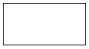

3.78 m



1.35 m

* 1. Find: i) area ii) perimeter.

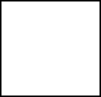

square

45.65 cm

**5-A**

1. **Unit Pricing Question**
   1. Marissa wants to buy some juice. She can‘t decide between apple juice and orange juice. Calculate what the unit price is on each of these two brands, to the nearest cent, to decide which of these is the better buy.

Apple Juice is 5 L for $8.79 Orange Juice is 4 L for $7.29

* 1. Are the socks cheaper if they are bought as 5 pairs of socks in a package for $12.87, or 1 pair of socks for $2.99?

**6-A & B**

1. **Fill in the following chart**

|  |  |  |  |
| --- | --- | --- | --- |
| **UNIT** | **SYMBOL** | **MEASURES** | **EXAMPLES** |
| **METRES** |  |  |  |
| **LITRES** |  |  |  |
| **GRAMS** |  |  |  |
| **SECONDS** |  |  |  |

1. **Prefixes have been combined with base units in this question. Write the meaning and the symbol. The first one is done for you.**

|  |  |  |  |  |
| --- | --- | --- | --- | --- |
| a) centimeter | = | one hundredth of a metre | = | cm |
| b) hectogram | = |  | = |  |
| c) decimeter | = |  | = |  |
| d) milligram | = |  | = |  |
| e) decameter | = |  | = |  |
| f) kilometer | = |  | = |  |

1. **Put the metric prefixes on the chart according to their place value**

/ / / base unit / /

**6-C**

1. **Convert the following**

|  |  |  |
| --- | --- | --- |
| 1. 45 daL 2. 57 g 3. 101 cm |  | L  cg mm |
| d) 49 mL |  | hL |
| e) 255 mm |  | m |
| f) 5 km |  | dm |
| g) 0.75 kg |  | g |

1. **Write the measurements using only one unit**

a) 4 km, 29 m =

b) 17 L, 95 cL =

1. **Answer using only one unit.**
   1. 391 cg b) 783 daL

+ 138 mg - 68 mL

c) 5 km d) 6 075 cm 75 mm =

+ 99 m

1. **Answer the following word problems**
2. How much fencing is needed to enclose a square field 45.6 m on each side?
3. Find the perimeter of the top of a square cd case if the length of one side is 17.78 cm.
4. A metal strip is being installed around three work benches that are 3.46 metres long and 1.2 metres wide. How much metal stripping is needed?
5. If the stripping in question d) costs $6.67 per metre, find the total cost of the stripping.
6. Gerald is framing a picture. The frame measures 50.8 cm by 34.5 cm. Find out how many square cm of glass he needs to buy.
7. A curtain measures 1.8 metres by 2.1 metres. Find out how many square meters of material is needed for making four more curtains the same size.



**Answers to Book 4 Final Review**

**1.**

a) 0.57 b) 0.695 c) 0.8 d) 3.206 e) 0.3142

f) 0.024 g) 9.12 h) 36.005

**2.**

a) , seven tenths b) 7 , seven and three tenths c) , forty one hundredths

d) 6 , six and nine hundred thirty eight thousandths e) 5 , five and eleven thousandths

1. 42 , forty two and one hundred four thousandths
2. , three thousand eight hundred twenty one ten thousandths
3. 23 , twenty three and five hundred one ten thousandths

**3.**

a) $7.24 b) $0.81 c) $0.04 d) $2.33

**4.**

a) 314.609 b) 0.071 c) 0.59 d) 87.07

**5.**

a) < b) < c) > d) >

**6.**

a) b) = c) d)

|  |  |  |  |
| --- | --- | --- | --- |
| **7.**  a) 8 | b) 32 | c) 1 |  |
| **8.**  a) 1. 6 | b) 0.9 | c) 0.1 |
| **9.**  a) 72.01 | b) 0.78 | c) 0.47 |
| **10.**  a) 0.28 | b) 8.204 | c) 0.011 |
| **11.**  a) 134.856 | b) 742.011 | c) 477.902 | d) 431.168 |
| **12.**  a) 41.133 | b) 53.914 | c) 103.169 | d) 67.59 |
| **13.**  a) 60.3 km | b) $454.11 | c) 0.04 m | d) $112.42 |
| e) $19.29 | f) 6.68m | g) 4.87cm |  |

|  |  |  |  |  |  |  |  |  |  |  |  |  |  |
| --- | --- | --- | --- | --- | --- | --- | --- | --- | --- | --- | --- | --- | --- |
|  | | | | | | | | | | | | | |
|  | |  |  | DEBIT OR CHEQUE | |  | |  | |  | |  | |
| DATE | CHEQUE NO. | DESCRIPTION OR DESCRIPTION OF | | CHEQUE/DEBIT AMOUNT | |  | | DEPOSIT AMOUNT | | BALANCE | |
|  |  | DEPOSIT | |  | |  | |  | |  | |
|  |  | **BALANCE FORWARD** | |  |  |  | |  |  | $621 | 95 |
| 2/9 |  | Sally‘s Clothing Store | | 132 | 55 |  | |  |  | 489 | 40 |
| 3/9 |  | Pharmacy | | 28 | 81 |  | |  |  | 460 | 59 |
| 4/9 | 207 | ABE Aquatic Centre | | 101 | 00 |  | |  |  | 359 | 59 |
| 8/9 |  | Cash | | 150 | 00 |  | |  |  | 209 | 59 |
| 15/9 |  | Pay Deposit | |  |  |  | | 948 | 74 | 1158 | 33 |
| 16/9 |  | Car Payment | | 291 | 00 |  | |  |  | 867 | 33 |
| 23/9 | 208 | Roger‘s Cable Vision | | 74 | 32 |  | |  |  | 793 | 01 |
| 31/9 |  | Pay deposit | |  |  |  | | 997 | 26 | 1790 | 27 |
| **14.** | | | | | | | | | | | | | |
|  | Your name Joy Blackburn Your address 222 College Dr  Your phone number (250) 444-444 September 23, 2014 No. 208  PAY TO  THE ORDER OF Rogers Cable Vision $ 74.32  Seventy Four--------------------------------------------------------------------------------------------------------  32 DOLLARS  100  ABE Bank  123 Any Street Account # 456-789-0 ***SAMPLE ONLY***  Our Town, BC  MEMO *Payment*  *J. Blackburn* | | | | | | | | | | | | |
| **15.** | | |  | |  | | |  |  | | |  | |
| a) 170.88 | | | b) 18.808 | | c) 3.24714 | | |  | d) 610.288 | | |  | |
| e) 96.3428 | | | f) 92.988 | |  | | |  |  | | |  | |
| **16.** | | |  | |  | | |  |  | | |  | |
| a) 152.388 cm2 | | | b) 27.553 m2 | | c) 80.256 m2 | | |  |  | | |  | |
| **17.** | | |  | |  | | |  |  | | |  | |
| a) $898.70 | | | b) 15 570 people | | c) $180.18 | | |  | d) 1393.55 m2 | | |  | |
| e) 580.5 m2 | | |  | |  | | |  |  | | |  | |
| **18.** | | |  | |  | | |  |  | | |  | |
| a) 1.305 | | | b) 2.37 | | c) 6300 | | |  | d) 2.34 | | |  | |
| e) 11.467 | | | f) 8.43 | |  | | |  |  | | |  | |

|  |  |  |
| --- | --- | --- |
| **19.**  a) 2.55 km each day | b) 50 hours | c) 16.25 ml per day |
| d) i) 43.58 mm  f) i) 2083.923 cm2 | ii) 1.41 mm e) i) 5.103 m2  ii) 182.6 cm | ii) 10.26 m |

**20.**

1. Apple juice is the better buy at $1.76/L (orange juice is $1.82/L)
2. The pack of 5 pairs of socks are cheaper at $2.57/pair

**21.**

|  |  |  |  |
| --- | --- | --- | --- |
| **UNIT** | **SYMBOL** | **MEASURES** | **EXAMPLES** |
| **METRES** | m | Length | Running race, height |
| **LITRES** | L | Volume | Milk, juice |
| **GRAMS** | g | Weight/ mass | Medication, baby‘s weight |
| **SECONDS** | s | Time | Time left on a test |

**22.**

a) one hundredth of a metre = cm b) one hundred grams = hg

c) one tenth of a metre = dm d) one thousandth of a gram = mg

e) ten metres = dam f) one thousand metres = km

**23.** Kilo / hecto / deca / **base unit** / deci / centi / mili

|  |  |  |
| --- | --- | --- |
| **24.**  a) 450 L | b) 5700 cg | c) 1010 mm d) 0.00049 hL |
| e) 0.255m | f) 50 000 dm | g) 750 g |
| **25.**  a) 4029 m | b) 1795 cL |  |
| **26.** |  |  |

a) 4048 mg or 404.8 cg b) 7 829 932 mL or 782.9932 daL

c) 5099 m or 5.099 km d) 810

**27.**

a) 182.4 m b) 71.12 cm c) 27.96 m d) $186.49 e) 1752.6 cm2 f) 15.12 m2

##### Glossary

**Addends** The numbers to be added together in an addition question. In 3 + 5 = 8, the addends are 3 and 5.

**axis** Any straight line used for measuring or as a reference.

**balance** Balance has many meanings. In money matters, the balance is the amount left. It might be the amount left in a bank account (bank balance) or it might be the amount you still must pay on a bill (balance owing).

**cancelled cheque** A cheque that has been cashed. The cheque is stamped, or cancelled, so it is no longer negotiable.

**circumference** The distance around a circle; the perimeter of a circle.

**commission** Salespeople may be paid a percentage of the money made in sales. The commission is part or all of their earnings.

**common fractions** eg, , ,



**cross multiply** In a proportion, multiply the numerator of the first fraction times the denominator of the second fraction. Then multiply the denominator of the first fraction times the numerator of the second fraction. In a true proportion, the products of the cross multiplication are equal.

**denominator** The bottom number in a common fraction; tells into how many equal parts the whole thing has been divided.

**diameter** The distance across a circle through its centre.

**difference** The result of a subtraction question, the answer. Subtraction gives the difference between two numbers.

**digit** Any of the ten numerals (0 to 9) are digits. This term comes from our ten fingers which are called digits. The numerals came to be called "digits" from the practice of counting on the fingers!

**discount** An amount taken off the regular cost. If something is bought "at a discount" it is bought at less than the regular price.

**divide** To separate into equal parts.

**dividend** The number or quantity to be divided; what you start with before you divide.

**divisor** The number of groups or the quantity into which a number (the dividend) is to be separated.

**equal =** The same as

**equation** A mathematical statement that two quantities are equal. An equation may use numerals with a letter to stand for an unknown quantity. 6 + Y = 9

**equivalent** Equal in value; equivalent numbers (whole or fractions) can be used interchangeably; that is, they can be used instead of each other.

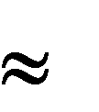**estimate** Make an approximate answer. Use the sign to mean approximately equal.

**factors** The numbers or quantities that are multiplied together to form a given product.

5 2 = 10, so 5 and 2 are factors of 10.

**factors** The numbers or quantities that are multiplied together to form a given product.

5 2 = 10, so 5 and 2 are factors of 10.

**fraction** Part of the whole; a quantity less than one unit.

**horizontal** In a flat position, eg. we are horizontal when we lie in a bed. A horizontal line goes across the page.

**improper fraction** A common fraction with a value equal to or more than one.

**infinite** Without end, without limit.

**invert** To turn upside down.

**like fractions** With the same denominators.

**lowest terms** When the terms of a common fraction or ratio do not have a common factor (except 1), the fraction or ratio is in lowest terms (also called simplest form).

**minuend** The first number in a subtraction question.

**mixed decimal** A whole number and a decimal fraction. 1.75

**mixed number** A whole number and a common fraction. 1 3

4

**multiple** If a certain number is multiplied by another number, the product is a multiple of the numbers. Think of the multiplication tables. For example, 2, 4, 6, 8, 10, 12, 14. . .are multiples

of 2.

**multiplicand** The number to be multiplied.

**multiplier** The number you multiply by.

**negotiable** Something which can be cashed, that is, exchanged or traded as money.

**numbers** Numbers represent the amount, the place in a sequence; *number* is the idea of quantity or order.

**numerals** The digits 1,2,3,4,5,6,7,8,9,0 are also called numerals. These ten digits are combined to make infinite numerals. Digits are like letters, numerals are like words, and numbers are the meaning.

**numerator** The top number in a common fraction; the numerator tells how many parts of the whole thing are being considered.

**overdrawn** If the value of the cheques or money taken from a bank account is higher than the amount of money in the account, then the account is overdrawn. The account is "in the hole" or "in the red" are expressions sometimes used.

**parallel** Two objects or lines side by side, never crossing and always the same distance from each other. Railway tracks are parallel, the lines on writing paper are parallel.

**percent %** For every one hundred.

**perimeter** The distance around the outside of a shape.

**place value** We understand numbers by the way the digits (numerals) are arranged in relationship to each other and to the decimal point. Each position has a certain value. Our number system is a **decimal system**. The place value is based on **ten.**

**prime number** A number that can only be divided evenly by itself and 1.

**product** The result of a multiplying question, the answer.

**proper fraction** A common fraction with a value less than one.

**proportion** Generally, proportion is a way of comparing a part of something to the whole thing. Eg. his feet are small in proportion to his height. In mathematics, proportion is used to describe two or more ratios that are equivalent to each other.

**quotient** The result of a division question; the quotient tells how many times one number is contained in the other.

**radius** The distance from the centre of a circle to the outside of the circle.

**ratio** The relationship between two or more quantities. Eg. the ratio of men to women in the armed forces is 10 to 3 (10:3)

**reciprocal** A number, when multiplied by its reciprocal, equals 1. To find the reciprocal of a common fraction, invert it. = 1



**reduce** Write a common fraction in lowest terms. Divide both terms by same factor.

**remainder** The amount left when a divisor does not divide evenly into the dividend. The remainder must be less than the divisor.

**remainder** The amount left when a divisor does not divide evenly into the dividend. The remainder must be less than the divisor.

**sign** In mathematics, a symbol that tells what operation is to be performed or what the relationship is between the numbers.

**+** plus, means to add

**-** minus, means to subtract  multiplied by, "times"  divided by, division

**=** equal, the same quantity as 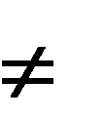 not equal

 approximately equal

**<** less than

**>** greater than

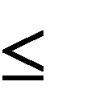 less than or equal to 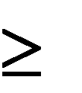 greater than or equal to

**simplify** See *reduce*.

**subtrahend** The amount that is taken away in a subtraction question.

**sum** The result of an addition question, the answer to an addition question.

**symbol** A written or printed mark, letter, abbreviation etc. that stands for something else.

**term** A definite period of time, such as a school term or the term of a loan.

**total** The amount altogether.

**transaction** One piece of business. A transaction often involves money. When you pay a bill, take money from the bank or write a cheque, you have made a transaction.

**unit** Any fixed quantity, amount, distance or measure that is used as a standard. In mathematics, always identify the unit with which you are working. Eg. 3 km, 4 cups, 12 people,

$76, 70 books, 545 g

**unit price** The price for a set amount. Eg. price per litre, price per gram.

**unlike fractions** Fractions which have different denominators.

**vertical** In an up and down position, eg. we are vertical when we are standing up. On a page, a vertical line is shown from the top to the bottom of the page.