An OER Toolkit for Trades Instructors |
Adopting an Open Education Resource & Integrating it into a Trades Course
Snapshot of the OER Adoption Process Outlined in this Toolkit
Preamble | Name your Motivation. What is motivating you to incorporate an Open Education Resource (OER) into your teaching and learning practice? Integrating Open Education Resources requires time and consideration, so identifying the benefits is helpful: for example, reduced textbook costs for your students, and/or opportunity to customize a textbook for your course, and/or a chance to work more efficiently by using ancillary resources like a bank of quiz questions or demonstration videos.
Phase 1 | Take stock. How do you currently deliver your course (in the classroom, online, or a combination of the two)? What are your current course resources? (textbook(s), video(s), quiz banks, PowerPoints etc.). Making a list will help you to identify gaps and to understand the difference between a ‘must have’ and ‘nice-to-have’ OER resource. For example, you may decide that your priority is to find an OER quiz bank so you can move away from paper-based assessment.
Phase 2 | Make a plan. Integrating OER into a course can be as simple as adding some quiz questions, or as complicated as transitioning your course to an online format supported by OER resources. Decide what you want to do, and by when.
Making a plan includes asking the right questions. Where do I go in my institution to find the support/resources I need (for example, instructional designers, educational technologists, disability advisors, copyright experts, other instructors who have experience developing online courses and adopting OERs)? Making a plan also includes identifying online sites and resources that will be helpful (for example, websites that focus on, and host, open resources).
Phase 3 | Adopt and Evaluate. Integrate the OERs you have identified as being helpful into your course and keep track of how this worked for you and your students.

Getting to Know Open Education Resources (OERs) 3
Brief Introduction to Open Education Resources 3
Quick Start: Know the Jargon 3
Term 3
Definition 3
Using an Open Textbook and a Learning Management System in Trades Courses: A (Possible) Case Study 5
Phase 1: Moira Reviews Her Course 5
Moira’s Course 5
Moira’s Review 6
Phase 2: Moira Plans Her Course Revisions 8
Moira’s Questions 9
Moira’s Planning Notes & Recommendations for Colleagues 9
Phase 3: Moira Implements Her Plan 15
How Moira Adopted an Open Textbook, Began to Use an LMS, and Created a More Accessible Course Experience for Her Students 15
PHASE 3 - Implementation of Planned Course Revisions: 1st Month 16
PHASE 3 - Implementation of Planned Course Revisions: 2nd Month 19
PHASE 3 - Implementation of Planned Course Revisions: 3rd Month 22
A Sample Module From Moira’s Newly Blended Course 28
Appendix A: Index of External Resources Recommended in this Guide 33
Open Textbooks in BC 33
Open Educational Resources 33
Acknowledgments 34
Project Owners and 34
Partner institutions/Faculty contributors 34
Instructional Design/Needs Assessment/Toolkit Development 34

Getting to Know Open Education Resources (OERs)

Brief Introduction to Open Education Resources
At the heart of the open movement lie two central ideas:
- Publicly-funded knowledge and knowledge products should be made freely available to the public.
- Coordinated peer production is a powerful way to create quality products for education.
Open Educational Resources (OERs) are typically developed by publically-funded educators, who contribute their creations into the public domain using an open license. The nature of these open materials means that anyone can legally and freely copy, use, adapt and re-share them. OERs range from textbooks to curricula, syllabi, lecture notes, assignments, tests, projects, audio, video and animation.
The research shows that OERs not only reduce student debt, they also (when used appropriately in a course) improve student learning.

Quick Start: Know the Jargon
Term | Definition
Blended learning  (“Flipped classroom”) | Blended learning is a combination of both face-to-face and online instruction. For example, a student alternates studying in class, with studying independently using Internet-based resources and spaces.
Face-to-face | Face-to-face instructional typically occurs in a classroom and that is bound by time, space, and place.
LMS  (Learning Management System) | An LMS is a software application for the administration, documentation, tracking, reporting and delivery of educational courses or training programs.
Copyright | Copyright means the sole right to produce or reproduce a work or a substantial part of it in any form.
Fair dealing / Fair use | Fair dealing is a user right contained in the Copyright Act (Canada). Fair dealing allows one to copy from a copyrighted work, without the copyright owner's permission, if the copy is research, private study, education, parody, satire, criticism, review or news reporting; and, the dealing (use) is fair.
OER  (Open Educational Resource) | Open Educational Resources are “teaching, learning, and research resources that reside in the public domain or have been released under an intellectual property license that permits their free use and repurposing by others.  An OER gives instructors and students the legal permission to engage in the “5Rs”. An OER is:  - Free to retain – you can make, own and control copies of the content. E.g. download, duplicate, store and manage.  - Free to reuse – you can use the content in a wide range of ways. E.g. in a class, on a website.  - Free to revise – you can adapt, modify or alter the content itself.  - Free to remix – you can combine the original or revised content with other material to create something new  - Free to redistribute – you can share copies of the original content, your revisions or your remixes with others.  OER include full courses, course materials, modules, textbooks, streaming videos, tests, software, and any other tools, materials, or techniques used to support access to knowledge.”
Open license | This is the “intellectual property license that permits their free use and repurposing by others” that defines a resource as “open”.  For example, all new open textbooks added to the BC Open Textbook collection are released under a Creative Commons CC-BY 4.0 International license. With this open license, you are free to:  - Share — copy and redistribute the material in any medium or format  - Adapt — remix, transform, and build upon the material  for any purpose, even commercial.
Public domain | The state of belonging or being available to the public as a whole, and therefore not subject to copyright.

Using an Open Textbook and a Learning Management System in Trades Courses:
A (Possible) Case Study

Phase 1: Moira Reviews Her Course

Moira’s Course
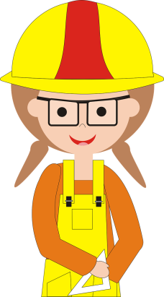  Moira  Image: CC0 Public Domain | Meet Moira.  Moira is an instructor in a Trades program at a college in B.C. Since she started working at the college, she has taught all of her courses face-to-face, both in a classroom and on the shop floor. Over the years, Moira has designed and taught her classes around a framework that includes the following:  - Course pack.  Each term, Moira photocopies dozens of articles and excerpts from assorted textbooks and works with the college’s printing services to assemble the readings into a course pack for her students. Moira’s students are responsible for purchasing a copy of this course pack at the college bookstore at the beginning of term. Moira assigns readings from the course pack each week with the expectation students will have completed them before the week’s lecture and gained some grounding in the topic well before they spend hands-on time in the shop.  - In-class lectures & discussions.  Moira uses the 6 hours of in-class time she has with her students each day to expand on that week’s topic and to supplement any areas not addressed in enough detail – or covered at all – by the readings in the course pack. She creates PowerPoint presentations to use in her lectures; her PowerPoint slides are full of Trades images and photos Moira finds online and downloads to use in her course to help illustrate Trades practices for her students. Sometimes other Trades instructors come to class to demonstrate to students how the course theory is applied in practice.  - In-class “self-assessment” quizzes.  Moira also uses some in-class time to give her students quizzes (paper handouts) and she marks these quizzes that same day. These quizzes are not part of the students’ formal grade in the course but Moira does require that students achieve a score of 70% or more; the quizzes are intended to give students an opportunity to confirm their comprehension of the theory and their readiness to apply the theory in the shop.
In summary: Moira’s students acquire their course theory during class lectures and from the course pack. They then go on to have hands-on time in the shop to apply the theory they learned in class and from the course pack readings.

Moira’s Review
Recently, Moira has been reviewing her course. She has developed a list of recurring issues she wants to address through some course revisions:
- Course pack:
Moira has a few significant concerns about her course pack of photocopied readings.
  - Several students have told Moira that they chose not to buy the course pack. Some explained that their decision was based on their own budget restraints, while others gave her a variety of reasons why they have difficulty using it (e.g. font size is too small, or the quality of the photocopies is too poor to read, or the course pack is heavy and too cumbersome to be easily portable to bring to-and-from campus).
  - After attending a workshop at her college, Moira is now also concerned that she may have been unintentionally violating copyright laws by creating copies of some articles and textbook chapters and republishing them without permission in the course pack.
  - There have been times when Moira has felt like she is constantly photocopying readings and working with the college’s printing services to prepare yet another version of the course pack. This is a time-consuming task and Moira is frustrated that after all the time she spends on it, the course pack still isn’t the resource her students really need.
- In-class lectures and demonstrations:
Moira also has a couple of concerns with the in-class lecture time she has with her students.
  - The in-class, practical demonstrations give students a chance to see how the concepts they learn in class are applied in the shop. However, there is no way for students to review demonstrations again, and if students miss a class, they miss the demonstration altogether.
  - After what she learned at the copyright workshop, Moira also has concerns about all of the images and photos she has downloaded. She does not want to inadvertently infringe on copyright and she has not kept track of the source sites she collected them from.
- Quizzes (& Grade Management):
Moira does not feel that her current practice of giving students the “self-assessment” quizzes via paper-handouts in class is sustainable for her or even particularly helpful for her students.
  - Moira is concerned that between tracking which student is ready to move on to the hands-on time in the shop and scheduling time for students to re-take a quiz in order to achieve the passing score, she is wasting opportunities to spend meaningful contact time with her students. Similarly, Moira worries that in her rush to mark the quizzes and help get students into the shop more quickly, she is missing opportunities to give the students more meaningful feedback and specific guidance on course concepts they may be struggling with.
  - Further to these concerns, since many of her students have acknowledged they don’t have the course pack, Moira realizes that many of her students must also be completing the self-assessment quizzes without having read the foundational materials. Moira is concerned that they are missing out on learning opportunities and are just trying to achieve the minimum score they need in order to get into the shop.

Phase 2: Moira Plans Her Course Revisions
After discussing these concerns with some of her teaching colleagues, Moira feels encouraged to make some significant revisions to her face-to-face course. However, she does not have a lot of time to spare on these revisions; not only will she teach this course again in 3 months but Moira is currently teaching another course and will not have release time to complete her course revisions.
Moira’s goal now is to shift the theory part of her course into a blended delivery format; she will deliver part of the course online and part of it in the classroom. She plans to use her college’s LMS to post readings, her own lecture notes, and videos of practical demonstrations. She believes this will give her students more flexibility in when and where they can review course materials. Moira also hopes that this shift will leave more time in-class for discussions about challenging concepts and preparation for the hands-on time in the shop.
In addition, Moira intends to move all of her self-assessment quizzes into the LMS. Her students will still need to achieve at least 70% to pass the quizzes, but she understands that in the LMS, she can set up the quizzes so students can have more than one attempt to achieve that grade. And she has learned that it’s possible to set these quizzes up so students can receive feedback on their answers as soon as they submit – feedback that could include references back to specific content and readings students should review and can also find in the context of the course site.
Moira has given a lot of thought to the course pack she has been using, especially since hearing from students about the barriers it presents to some of them. Since she will now be using the LMS to support her course, Moira hopes to be able to provide all the instructional materials for the course – including all of the course readings - in a digital format and give her students more flexibility in how they access their content. In her earlier discussions with colleagues about where to begin looking for digital readings and images that she could post to an LMS site, Moira was excited to learn about OERs and the B.C. Open Textbook collection of free textbooks and she began to explore the available titles in the collection. Not only did she discover the collection includes many textbooks geared towards Trades subjects, but she was pleased that she could adopt as much or as little of a textbook as she needed without any concerns about copyright infringement or financial cost to her students.
While Moira is excited to begin implementing her plans for course revisions, she is quickly realizing that she is going to need some help adopting an open textbook and setting up her course site in the LMS. She has created a list of questions and has begun to collect answers from some other Trades instructors with more blended-learning experience. In the process, she is also creating her own list of recommendations for other instructors who may be looking to try something similar.

Moira’s Questions | Moira’s Planning Notes & Recommendations for Colleagues
- Where do I find help at my institution for moving my course into a blended delivery format? | Colleagues at [my college] have recommended that I connect with an instructional designer for advice about moving from a face-to-face to a blended, partially-online format. At [my college], instructional design support is provided through our Teaching & Learning Centre.  Speaking of colleagues, I would like to ask a couple of colleagues who have prior experience with any of this process if it’s alright for me to ask for their advice and recommendations when I have questions along the way.
- How much time will it take for me to convert my course into a blended format?  Do I have enough time to make the revisions I want to make? | I know that 3 months of working “off the side of my desk” does not leave me with a lot of time to complete significant course revisions like this and I understand that I may not have enough time to do everything on my list.  I’m dividing my list of priorities into two categories: “must have” by the next time I teach this course and “nice to have” (but may have to wait until I can work on the course again). I will create a 3-month project implementation plan to complete my “must-have” items and will work on any remaining “nice to haves” in the time remaining or at a future date if I run out of time now.  “MUST HAVE”  - Move to a blended format:  - Learn how to use the LMS at my college so that I can post course content, videos and OERS (including the textbook) for my students to access whenever they need to. I have not used an LMS before, so what I am able to do this time around will heavily depend on how much training I need and how much time I have for that training.  - Learn what types of support my students will need in a blended course using the LMS and an open textbook, and what resources are available to support them.  - Textbook:  - Find an Open Textbook to replace the course-pack.  - Learn how to adopt and use an Open Textbook.  “NICE TO HAVE”  - Video Demonstrations:  Find video-based versions of the practical demonstrations my students get in-class. (Ideally, I would like to create some of my own, but I know this is out of scope in my 3-month window).  - Quizzes:  I really want to move my in-class quizzes online but I understand that building quiz questions in an LMS might be out of scope for me this time. I plan to at least learn how to do create quizzes in the LMS now but may not be finished this revision in 3 months. (I may have to administer quizzes through paper hand-outs in class for one more term.)  - Copyright-clear images:  I would like to be sure that I can upload Trades-related images and photos I find to my course LMS site, which really requires me to look for open-licensed images to replace all of the copyrighted images I currently use in my course materials. I suspect I will not have enough time to find open-licensed alternatives to all of the copyrighted images I already have, so this will be a longer-term undertaking. I will not upload any images to my new LMS course site unless I am sure they are openly-licensed.
- What LMS does my institution use?  Where do I find help at my institution for learning how to use the LMS?  (Does this support include help around incorporating selected OERs into my LMS course site?) | I started by talking to some of my colleagues who have experience teaching their courses in a blended format.  - I have learned that at [my college], the Teaching & Learning Centre provides support for instructors who are teaching online and using the college’s LMS.  - I have also learned that the LMS [my college] uses is D2L.
- Where do I find help for adopting OERs?  (e.g. Open textbooks, open images, ancillary resources) | These are a few “getting started”-type resources I’ve found helpful with the more specific questions I have about OERs:  - “What does it mean to ‘license something as open’? How do I know what I can do with an open education resource?”  This page provides a quick summary of the 6 levels open licenses, as defined by the Creative Commons organization. This page will be a handy resource to have open when I am searching for OERs and wanted to confirm that a resource was open, or to look up the permissions attached to a particular license: https://open.bccampus.ca/open-textbook-101/demystifying-open-licenses/  - “Are there criteria – in addition to quality of content – I should include in my review of OERs I find?”  There are a number of criteria to consider when choosing any type of educational resource. This resource, presented in a checklist format, gives clear guidelines for assessing OERs in particular:  https://open.bccampus.ca/files/2014/07/Faculty-Guide-22-Apr-15.pdf  I have been looking into what colleagues consider to be the essential criteria of OERs and “accessibility” is one of the key criteria everyone lists. The BC Open Textbook Accessibility Toolkit connects web-content accessibility standards to the requirements placed on contributors to the textbook collection. (This is very much a “how-to” type of Toolkit, so I can also refer to it when I create content for my LMS-course site and want to ensure my content is also accessible.):  https://opentextbc.ca/accessibilitytoolkit/  - “What are the steps I should follow when I’m ready to adopt an OER for my course?”  The BC Open Textbook Adoption Guide provides greater detail than the first 2 resources, which makes it especially useful to have open when you’re ready to begin: https://opentextbc.ca/adoptopentextbook/
- Where do I actually find an Open Textbook and then how do I create a copy for my students?  Where can I find open images that I can be sure I am allowed to post online for my students? | These are the resources I would recommend my colleagues use to work through the next steps in an open textbook adoption process:  - For me, the best place to start my search for an alternative textbook is in the BC Open Textbook collection:  https://open.bccampus.ca/find-open-textbooks/  - I am also finding the “Using an Open Textbook for Your Course” section in the BC Open Textbook Adoption Guide helpful when it comes to finding answers to my questions about distributing the textbook to my students: https://opentextbc.ca/adoptopentextbook/chapter/using-an-open-textbook-for-your-course/  I would definitely recommend that any colleagues who are searching for open-license images use this web service called Creative Commons Search:  - While I still needed to confirm that the images I found actually had a CC license, this service will really help me to focus my search for open-licensed images and photos to replace the ones I have been using in my PowerPoint lectures with : https://search.creativecommons.org/
- How do I prepare my students for the online portion of my blended course? | I’ve spoken to an instructional designer and also some of my colleagues about things I can do to prepare my students for the online part of the course. Based on their recommendations, I am planning to:  - Make sure the course description in the college calendar tells students that the course requires they have computer & internet access. I want them to know this before they register so that they can be prepared for the technical requirements and also for the expectation that they will be completing course work outside of our face-to-face class time.  - Familiarize my students with the LMS course site by going through it with them during our first face-to-face class. My colleagues who have more experience using the LMS to teach their Trades courses have told me that this task is critical and the investment of time at the outset will help avoid stress and wasted time later. Based on their strong recommendations, I am planning to dedicate a full, in-class day to getting my students up-to-speed with the LMS.  - Create a section on the homepage of my course site with helpful resource links such as online tutorials about using our LMS and some of the college services my students should know about, including where they go for technical or academic support.
- Where do students get technical support at my institution for the online portion of my course? | Colleagues have told me to expect that some students will find it challenging at first to use the LMS, and that even those students who have a lot of confidence with technology may need technical assistance on occasion.  I have investigated at our college where students can get technical assistance when they are on campus, and I’ve also looked into what technical support they can get when they working in the LMS off-campus. At my college, most students on campus use the Helpdesk run by our IT Services. However, for specific assistance with the LMS, the Helpdesk often redirects students to the Teaching & Learning Centre – since they are the unit that supports the LMS.  Based on the recommendations I’ve collected from my colleagues and also from the instructional designer I’m working with, I am planning to:  - Include in the “helpful resource links” section of my LMS course site the phone number, email address and hours of operation for the college’s Teaching & Learning Centre support and also for our Helpdesk support.
- Where do students with a learning disability get support (if they need it) at my institution? | In my discussions with colleagues and my instructional designer, I have learned there is a strong possibility that some students in my course may have some type of a learning disability.  I have learned that at my college, students who have a disability can connect with our “Disability Resource Centre” if they need some form of assistance or accommodation in support of their needs.  I have also learned that some students who have a learning disability are reluctant to tell their instructor due to fears of being stigmatized. I’m concerned that there might be students in my course who, due to some form of learning disability, experience challenges with the LMS or the Open Textbook and don’t tell me about this.  Based on what I have learned so far, I am planning to:  - Connect with the Disability Resource Centre at my college for their advice about what information I can and should provide to my students about what help is available and how they should seek help if they need it.  - Include in the “helpful resource links” section of my LMS course site the phone number, email address and hours of operation for the college’s Disability Resource Centre.

Phase 3: Moira Implements Her Plan

How Moira Adopted an Open Textbook, Began to Use an LMS, and Created a More Accessible Course Experience for Her Students
Guided by the information she collected during the planning stage, Moira moved forward with her course revisions. With only 3 months before she had to deliver the course again, this is what Moira was able to do to address the key issues she noted in Phase 1 of this guide:
- Adopted an Open Textbook for her Trades course and the ancillary resources available alongside it (videos and question bank);
- Revised her course to be delivered in a blended format – partially online in her institution’s LMS and partially face-to-face in the classroom.
- Located online videos of hands-on demonstrations of Trades practices; confirmed that these were licensed under Creative Commons open licenses.
- Learned enough about her institution’s LMS to set up weekly modules, make the OERs (textbook, videos, quiz questions) she adopted available to her students, and begin to create online quizzes.
Note: in Moira’s “Implementation of Planned Revisions” which are described next:
OT = task associated with Open Textbook and/or OER goal;
LMS = task associated with goal of moving into blended format with a Learning Management System

PHASE 3 - Implementation of Planned Course Revisions: 1st Month
Moira’s Tasks  (Weeks 1-4) | “Must Have” Goal this Task Supports | Supports Moira Used
- Connected with 2 colleagues in the Trades school who were willing to share suggestions and recommendations based on their own prior experience with similar course revisions and moving into the LMS. | LMS | Informal “buddy” or mentor system with more experienced “blended delivery” colleagues in Moira’s program.
- Met with an instructional designer at the college. | LMS; OT | Instructional Designer  Specific to Moira’s college; locate the teaching & learning services at your institution for suggestions.
- Booked hands-on training sessions to learn how to use the LMS to:  - Organize her course site to support her intentions and usability for her students;  - Organize all of her course files to support her own work with the site and make her ongoing maintenance of the site efficient and manageable;  - Upload OER files (textbook chapters, images), as well as own PowerPoint and Word documents;  - Create new content pages;  - Create and deliver quizzes. | LMS | LMS Training & workshops  Specific to Moira’s college; locate the teaching & learning services at your institution for suggestions.
- Reviewed the “Common Core” section of the “Trades” collection in the BC Open Textbook library | OT | Common Core section of Open Textbook “Trades” collection:  https://open.bccampus.ca/find-open-textbooks/?subject=Common Core
- Searched this collection for anything that covered “tools and equipment”.  - Found: 4 sections in the “Line C: Tools & Equipment” series;  - Identified “Line C: Tools and Equipment Competency C-4: Describe Ladders and Work Platforms” as first textbook to use. | OT | From the BC Open Textbook Collection:  Line C: Tools and Equipment Competency C-4: Describe Ladders and Work Platforms
- Read through the textbook and information about the ancillary resources associated with the textbook.  [Note: The ancillary resources available with the open textbook Moira adopted included demonstration videos AND a question bank to use for online “self tests”. Moira is free to use all or some of the resources as she likes, and can create new videos and new questions to add to the question bank as her time permits.] | OT | Open Textbook plus ancillary resources: videos, question library.
- Downloaded all textbook files + specific ancillary-resource files formatted for Moira’s LMS (D2L) | OT; LMS | Saved to a folder on her own computer at this point.
- Filled out and submitted the BC Open Textbook Adoption Form | OT | BC Open Textbook Adoption Form: https://open.bccampus.ca/about-2/adoption-form/  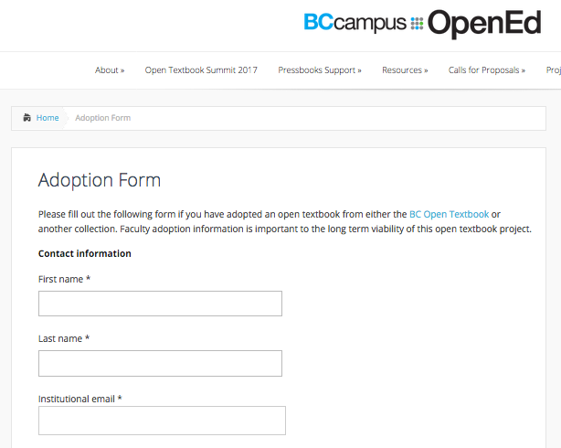
Moira’s recommendation at this point in the project:
Check-in with “buddy system” and instructional designer: “How am I doing so far?”

PHASE 3 - Implementation of Planned Course Revisions: 2nd Month
Moira’s Tasks  (Weeks 5-8) | “Must Have” Goal this Task Supports | Supports Moira Used
- BEFORE STARTING TO USE THE LMS:  Using only Microsoft Word, Moira developed a framework or outline of how she would organize information in her LMS site. She wanted to have a clear plan of her online course components in place BEFORE she started working in the LMS.  Moira knew that she wanted her LMS site to support a weekly lesson structure, provide quick access to student services information, and give her students access to all of the course materials they needed in order to prepare for classes and to review before taking quizzes and moving into the shop.  Using only the technology of Word, Moira decided she would organize her weekly lessons (or “Modules”) and she identified the common components she planned to include in each Module:  - Time commitment: a heads-up to students about how much time they should plan to spend on the online component that week;  - Learning Objectives;  - Readings (including from the Open Textbook);  - Content (including notes from PowerPoints, images, demonstration videos,  - Activities (including self-assessment activities to test readiness to move onto having hands-on time in the shop) | LMS | For this task, Moira used:  - MS Word  - The help of an instructional designer  [Specific to Moira’s college; locate the teaching & learning services at your institution for suggestions]  - Suggestions from her informal “buddy” system of 2 colleagues with prior experience.  Moira’s mock-up in Word of Module structure  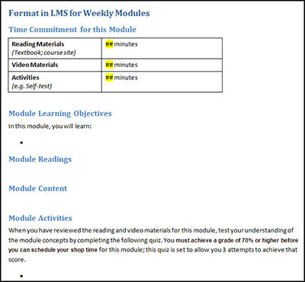
- Implemented planned framework in the LMS:  Referring to the course site plan she had previously outlined in a Word document, Moira created the structural framework (i.e. Module outlines) for her course in the LMS. | LMS | D2L (The LMS at Moira’s institution)  Moira’s mock-up in LMS of Module structure  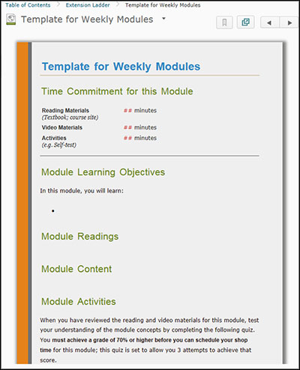
- Uploaded all of the Open Textbook files (textbook chapters + the ancillary video and quiz resources) to the LMS site. | OT; LMS | - D2L (The LMS at Moira’s institution)  - From the BC Open Textbook Collection:  Line C: Tools and Equipment Competency C-4: Describe Ladders and Work Platforms
- Connected with direct supervisor (Program Chair) to confirm necessary updates to the course description in the institution’s course calendar.  Course description modified to include notifications to prospective students so that they would know:  - The course required computer and internet access.  - Students should expect to access all course materials online.  - Students should expect to complete some of the required course activities online. | LMS | Program Chair  [Specific to Moira’s college & her program; locate your supervisor for suggestions.]
- Connected with the college’s “Disability Resource Centre” for their recommendations about what information Moira should provide to her students about help that is available for students with a disability and how they locate help when and if they need it. | LMS; OT | Disability Resource Centre / Accessibility Services  Specific to Moira’s college; locate the accessibility or disability-support services at your institution for suggestions.
Moira’s recommendation at this point in the project:
Check-in with “buddy system” and instructional designer: “How am I doing so far?”

PHASE 3 - Implementation of Planned Course Revisions: 3rd Month
Moira’s Tasks  (Weeks 9-12) | “Must Have” Goal this Task Supports | Supports Moira Used
- BUILT OUT THE ONLINE COURSE MODULES:  Moira fleshed out the framework she had created in the LMS during Weeks 5-8. She worked through each Module page she had created, and inserted information into each of the sections she had outlined.  - Time commitment  In each Module, Moira included an estimate of how much time students would need to spend working through that week’s online materials and activities.  - Learning Objectives  - Readings  Moira listed the Module’s required readings from the Open Textbook here. She linked the list item directly to the textbook file(s) she had uploaded to the LMS during Weeks 5-8.  For some modules, Moira also had additional readings and web-based resources she wanted her students to read. She listed and linked to those readings here as well.  - Content  Moira used this section in her weekly Modules to add any of her own additional notes (e.g. some of the notes she used to share with her students in her PowerPoint lectures.)  She left spaces to insert demonstration videos into this section.  - Activities  Moira used this section to list any self-assessment quizzes associated with the Module. In the long-term, her plan is to convert all of her paper-based quizzes into automated quizzes in the LMS. At this point in the revisions, she was not sure if she would have time to convert ALL of them, but she still wanted her students to know that a quiz in some format is associated with the Module. | LMS | - LMS site (D2L at Moira’s college)  - Online Tutorials about using the LMS. [Specific to Moira’s college; locate the teaching & learning services at your institution for suggestions.]  See screenshots of a sample Module from Moira’s course site.
- Followed accessibility standards for web content while setting up online content.  Based on the recommendations and advice Moira had collected through consultations with an instructional designer, her “buddy system” and with her college’s Disability Resource Centre, Moira understands that if she follows some web accessibility guidelines, she can do a lot to make the content on her course LMS site accessible to all of her students, including students with a disability. | LMS | - BC Open Textbook Accessibility Toolkit:  https://opentextbc.ca/accessibilitytoolkit/
- Created a “Helpful Resources” section on the homepage of the course site.  This section includes short descriptions and links to critical support services that were identified during the Planning stage,:  - Technical support (with the LMS):  Phone number, email address and hours of operation  - Disability/Accessibility Services:  Phone numbers, email addresses and hours of operation | LMS | - “Course Homepage” of LMS site  - Technical Support services & Disability Support services [Specific to Moira’s college; locate the teaching & learning services and the disability/accessibility support services at your institution for suggestions.]
- Set up a Gradebook in the LMS to more easily track student progress through self-assessment quizzes.  During her LMS training, Moira realized that even if she did not have time to create online quizzes to replace the paper-based self-assessments she currently uses, she could at least take advantage of the Gradebook tool to keep track of her students’ progress and opportunities to move on to hands-on time in the shop. Moira was very keen to replace her own paper-based method of tracking this information, and setting up the Gradebook was something she was going to do when she created online quizzes anyway. | LMS (but was also a  “Nice to have”) | - LMS site (D2L at Moira’s college)  - The help of an instructional designer  [Specific to Moira’s college; locate the teaching & learning services at your institution for suggestions]
- Added selected demonstration videos to the course content.  Moira selected several of the available demonstration videos (ancillary resources to the open textbook) and inserted them into the appropriate Modules. | “Nice to have” | Ancillary open-education resources: Videos
- Quizzes (An “in progress” task for Moira at this time)  Moira was happy to find that a sizeable question bank was one of the ancillary resources available with the open textbook she adopted. However, with only 3 months to work on her revisions, she ran out of time to review all of the questions and convert all of her self-assessment “quizzes” into an online format.  At this point, Moira has set up just a couple of quizzes in her site. Her current plan is to evaluate how her students approach the two online quizzes she has created, and whether or not giving them:  - more flexibility in when they can complete them,  - immediate feedback on their responses, and  - multiple attempts to do well,  helps her students to become better prepared for their hands-on time in the shop.  Moira will also administer quizzes through paper hand-outs in class and continue to create more of the LMS-based self-assessment quizzes whenever she has time. | “Nice to have” | Ancillary open-education resources: Question bank
- Open-licensed images and photos (An “out-of-scope” task for Moira at this time)  As she expected, Moira did not have enough time to search out openly-licensed images to replace the images she had been using (whose copyright permissions were not known to Moira).  Moira’s long-term goal is to search for more images online and download only those images that are openly-licensed. In the meantime, Moira has decided not upload any of her current images to the LMS course site unless she is certain she has copyright-clearance to do so. | “Nice to have” | Creative Commons, “About the Licenses”  https://creativecommons.org/licenses/  Creative Commons Search  https://search.creativecommons.org/  NOTE from the CC Search service: “CC has no control over the results that are returned. Do not assume that the results displayed in this search portal are under a CC license. You should always verify that the work is actually under a CC license by following the link…If you are in doubt you should contact the copyright holder directly, or try to contact the site where you found the content.”
Moira’s recommendation at this point in the project:
Check-in with “buddy system” and instructional designer: “How am I doing now?”
- Moira has set aside most of first face-to-face class to give students a hands-on orientation to the LMS course site and the open textbook. | LMS; OT | For this task, Moira used:  - Suggestions from her Informal “buddy” system of 2 colleagues with prior experience.  - LMS site (D2L at Moira’s college)  - Online Tutorials about using the LMS. [Specific to Moira’s college; locate the teaching & learning services at your institution for suggestions]
And (FINALLY):
Moira highly recommends you take a moment at this point to celebrate all your efforts!
(You can resume planning for the next phase of your course revisions soon enough.)
.

A Sample Module From Moira’s Newly Blended Course
The following pages include screen-shots of the first module Moira built in her LMS course site.
“Extension Ladders”
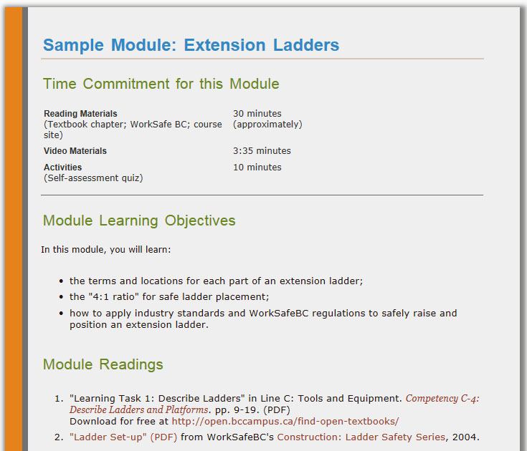
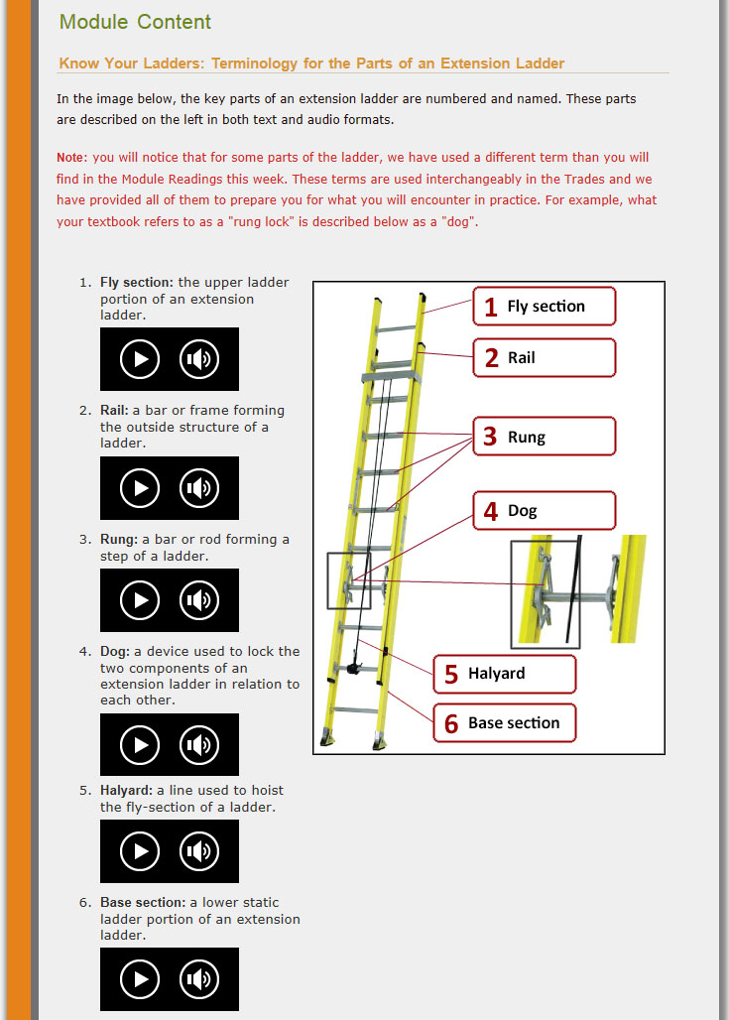
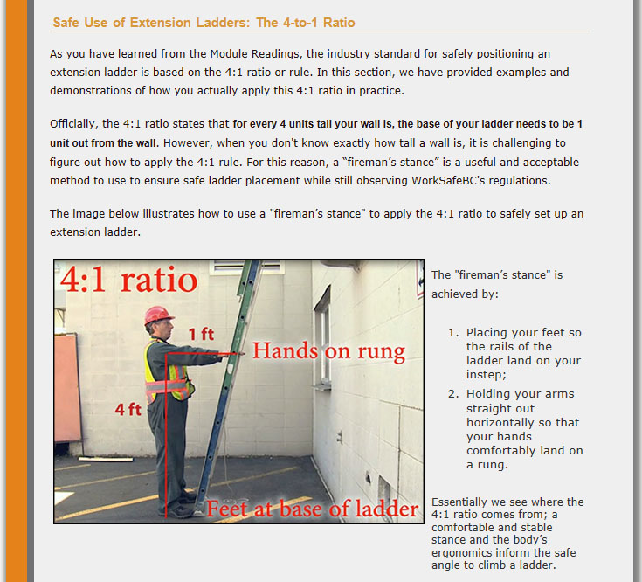
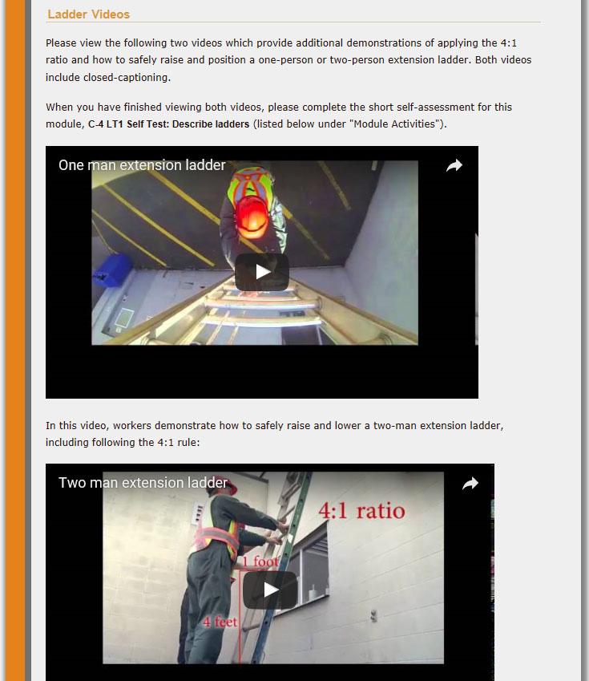
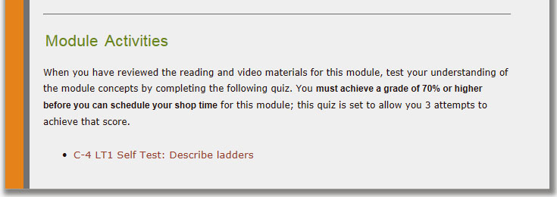

Appendix A: Index of External Resources Recommended in this Guide

Open Textbooks in BC
BCcampus Open Ed “Open Licenses
https://open.bccampus.ca/open-textbook-101/demystifying-open-licenses/
BCcampus Open Ed “Faculty Guide for Evaluating Open Resources”
https://open.bccampus.ca/files/2014/07/Faculty-Guide-22-Apr-15.pdf
BC Open Textbook Adoption Guide
https://opentextbc.ca/adoptopentextbook/
BCcampus Open Ed – Find Open Textbook
https://open.bccampus.ca/find-open-textbooks/
BC Open Textbook Adoption Guide -- “Using an Open Textbook for Your Course”
https://opentextbc.ca/adoptopentextbook/chapter/using-an-open-textbook-for-your-course/
BC Open Textbook Accessibility Toolkit
https://opentextbc.ca/accessibilitytoolkit/

Open Educational Resources
Creative Commons, “About the Licenses”
https://creativecommons.org/licenses/
Creative Commons Search
https://search.creativecommons.org/
Jhangiani, R.S., Pitt, R., Hendricks, C., Key, J., Lalonde, C., (2016) Exploring Faculty Use of Open Education Resources. BCcampus Research Report.
Jhangiani R. & Biswas-Diener R. 2017. Open: The Philosophy and Practices that are Revolutionizing Education and Science. London: Ubiquity Press. DOI: https://doi.org/10.5334/bbc
Lumen Learning, “What’s OER?”
http://lumenlearning.com/about/whats-oer/
Online learning and distance education resources moderated by Tony Bates https://www.tonybates.ca/tag/open-textbooks/
Tuomi, Ilkka. 2013. Open Educational Resources and the Transformation of Education. European Journal of Education, Vol. 48, No. 1, 2013.
William & Flora Hewlett Foundation, “Open Educational Resources OER Defined” http://www.hewlett.org/strategy/open-educational-resources/#overview

Acknowledgments

Project Sponsor
BCcampus

Project Owners
Rod Lidstone, Josh Stull, Sarah-Jayne Roe (Camosun College)

Partner institutions/Faculty contributors
With much thanks to the faculty from Trades programs at the following BC post-secondary institutions for contributing input through a needs-assessment survey and follow-up interviews:
- Camosun College
- Kwantlen Polytechnic University
- University of the Fraser Valley

Instructional Design/Needs Assessment/Toolkit Development
Sue Doner & Susan Chandler (Camosun College)

Source: http://lumenlearning.com/about/whats-oer/
Source: http://www.hewlett.org/strategy/open-educational-resources/#overview
Examples of popular LMSs currently in use at BC post-secondary institutions include: D2L, Moodle, Sakai, Blackboard.

