Trades Access Common Core

**Line D: Organizational Skills**

**Competency D-3: Read Drawings and**

**Speciﬁcations**

Image to be placed here.

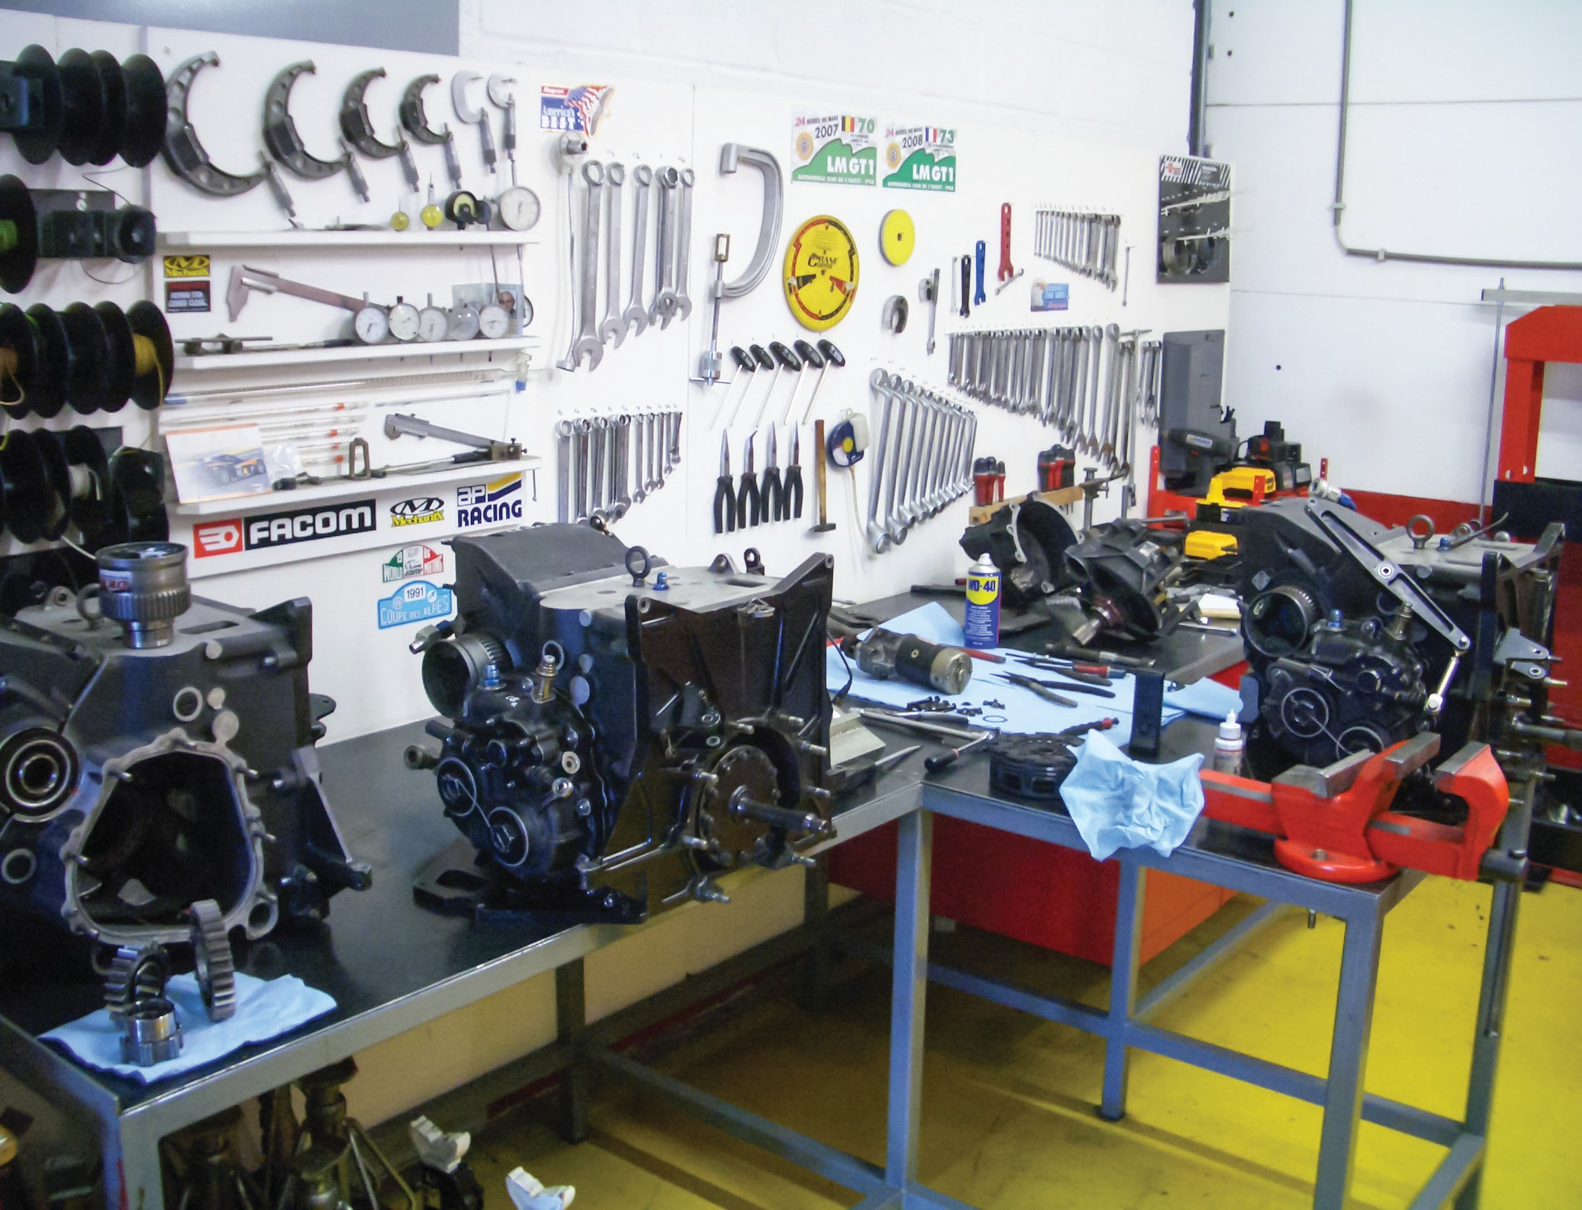

**B.C. Open Textbook Project**



OpenEd

open.bccampus.ca

**Trades Access**

COMMON CORE

Line D: Organizational Skills Competency D-3: Read Drawings and Specifications

**Acknowledgments and Copyright**

To learn more about BCcampus Open Textbook project, visit [http://open.bccampus.ca](http://open.bccampus.ca/)

© Camosun College. The Trades Access Common Core resources are licensed under the Creative Commons Attribution 4.0 Unported Licence ( <http://creativecommons.org/licenses/by/4.0/>), except where otherwise noted. Under this licence, any user of this textbook or the textbook contents herein must provide proper attribution as follows:

* If you redistribute this textbook in a digital format (including but not limited to EPUB, PDF, and HTML), then you must retain on every page the following attribution: Download for free at [http://](http://open.bccampus.ca/find-open-textbooks/)  [open.bccampus.ca/find-open-textbooks/](http://open.bccampus.ca/find-open-textbooks/)
* If you redistribute this textbook in a print format, then you must include on every physical page the following attribution: Download for free at <http://open.bccampus.ca/find-open-textbooks/>
* If you redistribute part of this textbook, then you must retain in every digital format page view (including but not limited to EPUB, PDF, and HTML) and on every physical printed page the following attribution: Download for free at <http://open.bccampus.ca/find-open-textbooks/>
* If you use this textbook as a bibliographic reference, then you should cite it as follows: BCcampus, Name of Textbook or OER. DATE. <http://open.bccampus.ca/find-open-textbooks/>.

For questions regarding this licensing, please contact [opentext@bccampus.ca](mailto:opentext@bccampus.ca)

All images copyright BC Industry Training Authority are licensed under the Creative Commons Attribution-NonCommercial-ShareAlike 4.0 licence.

<http://creativecommons.org/licenses/by-nc-sa/4.0/>

The issuing/publishing body is Crown Publications, Queen’s Printer, Ministry of Technology, Innovation and Citizens’ Services.

BCcampus would like to acknowledge the following individuals and organizations for their contributions in producing the Trades Access Common Core Open Textbook resources.

**BCcampus**

Open Education Team Hilda Anggraeni, Graphics

**Camosun College**

Olaf Nielsen, Chair, Trades Development and Special Projects, School of Trades and Technology Nannette Plant, Manager, Enterprise Point Operations & Special Projects, Office of the VP Strategic Development

Rod Lidstone, Instructor, Plumbing and Pipe Trades, Lead Writer/Reviewer Brian Coey, Instructor, Sheet Metal and Metal Fabrication, Writer/Reviewer Matt Zeleny, Camosun Innovates, 3D imaging

**Open School BC**

Monique Brewer, Director

Adrian Hill, Instructional Designer

Dennis Evans, Image Coordinator, Photographer, Graphics, Production Technician (layout) Farrah Patterson, Production Technician

**Industry Training Authority of BC**

The ITA works with employers, employees, industry, labour, training providers, and government to issue credentials, manage apprenticeships, set program standards, and increase opportunities in approximately 100 BC trades. Among its many functions are oversight of the development of training resources that align with program standards, outlines, and learning objectives, and authorizing permission to utilize these resources (text and images).

Erin Johnston, Director of Training Delivery Cory Williams, Manager, Industry Relations

**Publishing Services, Queen’s Printer**

Spencer Tickner, Director of QP Publishing Services Dwayne Gordon, Manager, Electronic Publishing

October 2015, Version 1

To order print copies of any of the Trades Access Common Core resources, please contact us:

Crown Publications, Queen’s Printer PO Box 9452 Stn Prov Govt

563 Superior St, 3rd Floor Victoria, BC V8W 9V7 Phone: 250-387-6409

Toll Free: 1-800-663-6105

Fax: 250-387-1120

[crownpub@gov.bc.ca](mailto:crownpub@gov.bc.ca)  [www.crownpub.bc.ca](http://www.crownpub.bc.ca/)

**Intellectual Property Program**

Ilona Ugro, Copyright Officer, Ministry of Technology, Innovation and Citizens’ Services, Province of British Columbia

**Creative Commons Attributions**

**Cover photo:**

(https://commons.wikimedia.org/wiki/File:DKR_Atelier.jpg) by DKR under CC BY SA 3.0 (<https://creativecommons.org/licenses/by-sa/3.0/deed.en>)

**Foreword**

The BC Open Textbook Project began in 2012 with the goal of making post-secondary education in British Columbia more accessible by reducing student cost through the use of openly licensed textbooks. The

BC Open Textbook Project is administered by BCcampus and is funded by the British Columbia Ministry of Advanced Education.

Open textbooks are open educational resources (OER); they are instructional resources created and shared in ways so that more people have access to them. This is a different model than traditionally copyrighted materials. OER are defined as teaching, learning, and research resources that reside in the public domain or have been released under an intellectual property licence that permits their free use and repurposing by others (Hewlett Foundation). Our open textbooks are openly licensed using a Creative Commons licence, and are offered in various e-book formats free of charge, or as printed books that are available at cost. For more information about this project, please contact [opentext@bccampus.ca.](mailto:opentext@bccampus.ca) If you are an instructor who is using this book for a course, please let us know.

**Preface**

The concept of identifying and creating resources for skills that are common to many trades has a long history in the Province of British Columbia. This collection of Trades Access Common Core (TACC) resources was adapted from the 15 Trades Common Core line modules co-published by the Industry

Training and Apprenticeship Commission (ITAC) and the Centre for Curriculum Transfer and Technology (C2T2) in 2000-2002. Those modules were revisions of the original Common Core portion of the TRAC modules prepared by the Province of British Columbia Ministry of Post-Secondary Education in 1986. The TACC resources are still in use by a number of trades programs today and, with the permission from the Industry Training Authority (ITA), have been utilized in this project.

These open resources have been updated and realigned to match many of the line and competency titles found in the Province of BC’s trades apprenticeship program outlines. A review was carried out to analyze the provincial program outlines of a number of trades, with the intent of finding common entry-

level learning tasks that could be assembled into this package. This analysis provided the template for the outline used to update the existing modules. Many images found in ITA apprentice training modules were also incorporated into these resources to create books that are similar to what students will see when they continue their chosen trades training. The project team has also taken many new photographs for this project, which are available for use in other trades training resources.

The following list of lines and competencies was generated with the goal of creating an entry-level trades training resource, while still offering the flexibility for lines to be used as stand-alone books. This

flexibility—in addition to the textbook content being openly licensed—allows these resources to be used within other contexts as well. For example, instructors or institutions may incorporate these resources into foundation-level trades training programming or within an online learning management system (LMS).

**Line A – Safe Work Practices**

* A-1 Control Workplace Hazards
* A-2 Describe WorkSafeBC Regulations
* A-3 Handle Hazardous Materials Safely
* A-4 Describe Personal Safety Practices
* A-5 Describe Fire Safety

**Line B – Employability Skills**

* B-1 Apply Study and Learning Skills
* B-2 Describe Expectations and Responsibilities of Employers and Employees
* B-3 Use Interpersonal Communication Skills
* B-4 Describe the Apprenticeship System

**Line C –Tools and Equipment**

* C-1 Describe Common Hand Tools and Their Uses
* C-2 Describe Common Power Tools and Their Uses
* C-3 Describe Rigging and Hoisting Equipment
* C-4 Describe Ladders and Platforms

**Line D – Organizational Skills**

* D-1 Solve Trades Mathematical Problems
* D-2 Apply Science Concepts to Trades Applications
* D-3 Read Drawings and Specifications
* D-4 Use Codes, Regulations, and Standards
* D-5 Use Manufacturer and Supplier Documentation
* D-6 Plan Projects

**Line E – Electrical Fundamentals**

* E-1 Describe the Basic Principles of Electricity
* E-2 Identify Common Circuit Components and Their Symbols
* E-3 Explain Wiring Connections
* E-4 Use Multimeters

All of these textbooks are available in a variety of formats in addition to print:

* PDF—printable document with TOC and hyperlinks intact
* HTML—basic export of an HTML file and its assets, suitable for use in learning management systems
* Reflowable EPUB—format that is suitable for all screen sizes including phones

All of the self-test questions are also available from BCcampus as separate data, if instructors would like to use the questions for online quizzes or competency testing.

**About This Book**

In an effort to make this book a flexible resource for trainers and learners, the following features are included:

* An introduction outlining the high-level goal of the Competency, and a list of objectives reflecting the skills and knowledge a person would need to achieve to fulfill this goal.
* Discrete Learning Tasks designed to help a person achieve these objectives
* Self-tests at the end of each Learning Task, designed to informally test for understanding.
* A reminder at the end of each Competency to complete a Competency test. Individual trainers are expected to determine the requirements for this test, as required.
* Throughout the textbook, there may also be links and/or references to other resources that learners will need to access, some of which are only available online.
* Notes, cautions, and warnings are identified by special symbols. A list of those symbols is provided below.

**Symbols Legend**

**Important:** This icon highlights important information.

**Poisonous:** This icon is a reminder for a potentially toxic/poisonous situation.

**Resources:** The resource icon highlights any required or optional resources.

**Flammable:** This icon is a reminder for a potentially flammable situation.

**Self-test:** This icon reminds you to complete a self-test.

**Explosive:** This icon is a reminder for a possibly explosive situation.

**Safety gear:** The safety gear icon is an important reminder to use protective equipment.

**Electric shock:** This icon is a reminder for potential electric shock.

**Safety Advisory**

Be advised that references to the Workers’ Compensation Board of British Columbia safety regulations contained within these materials do not/may not reflect the most recent Occupational Health and Safety Regulation. The current Standards and Regulation in BC can be obtained at the following website: [http://](http://www.worksafebc.com/)  [www.worksafebc.com](http://www.worksafebc.com/).

Please note that it is always the responsibility of any person using these materials to inform him/herself about the Occupational Health and Safety Regulation pertaining to his/her area of work.

BCcampus January 2015

**Disclaimer**

The materials in the Trades Access Common Core Open Textbook project are for use by students and instructional staff and have been compiled from sources believed to be reliable and to represent best current opinions on these subjects. These manuals are intended to serve as a starting point for good practices and may not specify all minimum legal standards. No warranty, guarantee or representation is made by BCcampus as to the accuracy or sufficiency of the information contained in these publications. These manuals are intended to provide basic guidelines for trade practices. Do not assume, therefore, that all necessary warnings and safety precautionary measures are contained in this module and that other or additional measures may not be required.

# Contents

Introduction 8

Objectives 8

Resources 8

Learning Task 1: Describe the drafting tools and materials used in drawing plans 9

Tools 9

Drafting materials 18

Computer drafting printing 20

Self-Test 1 21

Learning Task 2: Describe lines, lettering, and dimensioning in drawings 25

Line styles and types 25

Standard lettering 32

Principles of dimensioning 34

Self-Test 2 42

Learning Task 3: Use scale rulers to determine actual dimensions from drawings 45

Architect’s (imperial) scales 46

Metric scales 48

Obtain dimensions from drawings 50

Self-Test 3 53

Learning Task 4: Describe drawing projections 57

Types of views used in drawings 57

Self-Test 4 65

Learning Task 5: Interpret mechanical drawings 69

Basic layout of a drawing 69

Specifications 71

Self-Test 5 73

Learning Task 6: Creating drawings and sketches 75

Sketching technique 75

Make isometric sketches of simple rectangular objects 79

Sketching figures with non-isometric lines 84

Practical Competency 1: Make orthographic sketches 86

Practical Competency 2: Make an orthographic three-view, fully dimensioned sketch

of a simple object 90

Practical Competency 3: Make isometric sketches 92

Answer Key 94

### Introduction

Some of the most important documents used in the workplace are the technical drawings, diagrams, and schematics that specify how fabrication and construction tasks will be carried out, or describe the composition and assembly of equipment. One of the essential skills for anyone involved in a trade is the ability to correctly interpret drawings. If you are in a construction or fabrication industry, you will need to be able to examine a drawing, take information from it, and visualize the finished product. If you are in a service or maintenance industry, you will need to interpret exploded drawings in order to properly repair or assemble equipment.

### Objectives

You will be able to read, interpret, and make simple drawing and sketches. You will learn about the standard practices used in producing engineering drawings (drafting). You will work with imperial and metric scales and practise obtaining dimensions from drawings.

When you have completed the Learning Tasks in this Competency, you should be able to:

* + Name and describe the uses of drafting tools commonly used by trades people
  + Recognize and identify basic terms, components, symbols, and lines used in drawings
  + Describe different types of drawing projections
  + Use scale rulers
  + Obtain dimensions from drawings
  + Draw simple sketches
  + Make simple drawings using drafting tools and standard practices

### Resources

You will be required to reference publications and videos available online.

LEARNING TASK 1

**Describe the drafting tools and materials used in drawing plans**

Traditionally, drafters sat at drafting boards and used pencils, pens, compasses, protractors, triangles, and other drafting devices to prepare a drawing manually. Today, however, most professional drafters use computer-aided drafting (CAD) systems to prepare drawings. Although drafters use CAD extensively, it is only a tool. Drafters and tradespersons still need knowledge of traditional drafting tools and techniques.

### Tools

Drafting tools are needed to lay out the different shapes and lines used to create drawings and sketches. A basic knowledge of the available tools and how to use them will assist you in your drawing.

##### Drafting board or table

The drafting board is an essential tool. Paper will be attached and kept straight and still, so the surface of the drafting board must be smooth and true, with no warps or twists. The surfaces of most drafting boards are covered with vinyl because it is smooth and even.

The drafting board or table should have two parallel outside working edges made of either hardwood or steel.

Most drafting table tops can be set at different heights from the floor and at any angle from vertical to horizontal. Other drafting tables may not have the same adjustments and may be limited to being raised only from horizontal to a low slope.

To reduce back strain, use an adjustable drafting stool when working at a drafting table. Tables or boards should be a minimum of 1.2 m (4') in width and 0.9 m (3') in height.

##### T-square

The fixed head T-square is used for most work. It should be made of durable materials and have a transparent edge on the blade. To do accurate work, the blade must be perfectly square and straight; this should be checked regularly.

The T-square is used to draw horizontal lines and to align other drawing instruments. If you are right-handed, you hold it tight against the left edge of the drawing board and move it up

and down as required. When you make close adjustments, your fingers should be on top of the square and you should use your thumb to control the T-square’s movement (Figure 1).

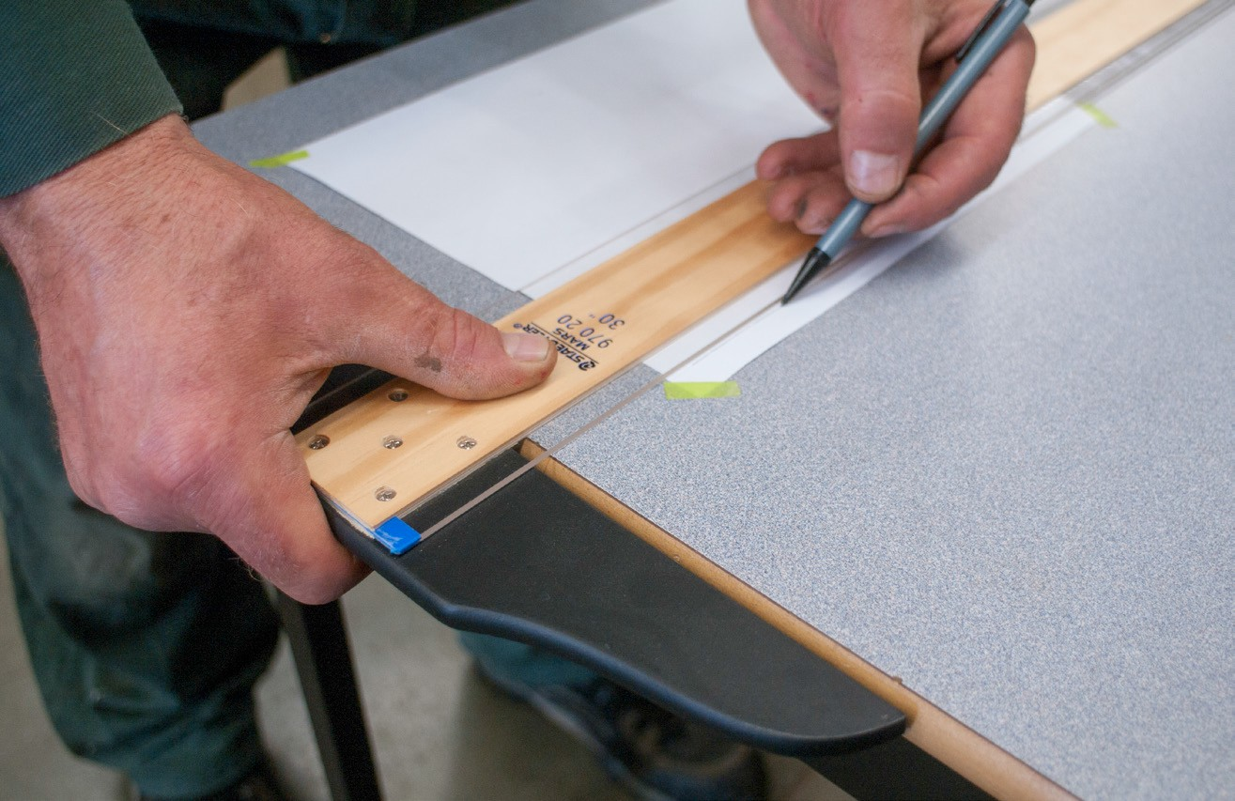

**Figure 1 —** Using a T-square

When drawing horizontal lines, incline your pencil in the direction you are drawing the line. Hold the pencil point as close as possible to the blade. Roll the pencil between your fingers to prevent the point from becoming flat on one side.

##### Triangle

A triangle (set-square) is made of a clear plastic. Some triangles have rabbeted edges (Figure 2), so that when you draw lines, the corner of the edge is set away from the paper to help prevent smudges and ink blotches.

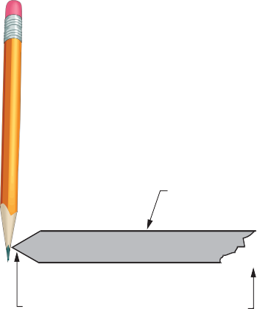

Triangle

Rabbeted edge

Paper

**Figure 2 —** Rabbeted edge

Triangles are available in 45°-90°-45° or 30°-60°-90° combinations. For most work, triangles should be about 200 mm to 250 mm (8" to 10") long. Triangles should be stored flat to prevent warping, and not stored underneath other objects to prevent any pressure from causing them to deform.

Check a triangle for accuracy by drawing a perpendicular line, then reversing the triangle and drawing another perpendicular line (Figure 3).

Twice the error

**Figure 3 —** Testing a triangle

Triangles are used to draw vertical lines and other lines at set angles. Rest the triangle on the T-square blade and slide it along the blade to the desired location. Draw the full length of the

vertical line in one pass if possible. Hold the blades of the T-square and the triangle together to prevent any movement when you are drawing, and hold the pencil point as close as possible to the triangle. You can also draw 15° and 75° angles by using both a 45°-90°-45° and a 30°-60°-90° in combination. Figure 4 shows how triangles are placed to draw angles that are every multiple of 15°.

90º

75º

60º

45º

30º

15º

0º

**Figure 4 —** Drawing angles with one or two triangles

##### Protractor

A protractor (Figure 5) is an instrument used to measure angles. It is typically made of transparent plastic or glass. Protractors can be used for checking and transferring angles to and from a drawing sheet.

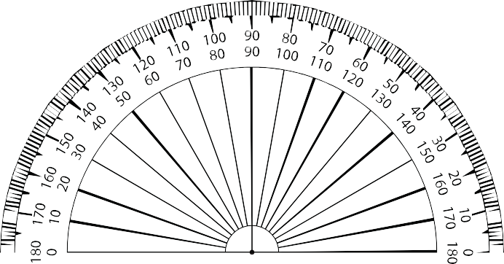

**Figure 5 —** Protractor

##### Drafting machine

A drafting machine (Figure 6) is a device that is mounted to the drawing board. The drafting machine replaces the T-square and triangles, as it has rulers with angles that can be precisely adjusted with a controlling mechanism. A drafting machine allows easy drawing of parallel lines over the paper. The adjustable angle between the rulers allows the lines to be drawn in a variety of accurate angles. Rulers may also be used as a support for separate special rulers and letter templates. The rulers are replaceable and can be replaced with scale rulers.

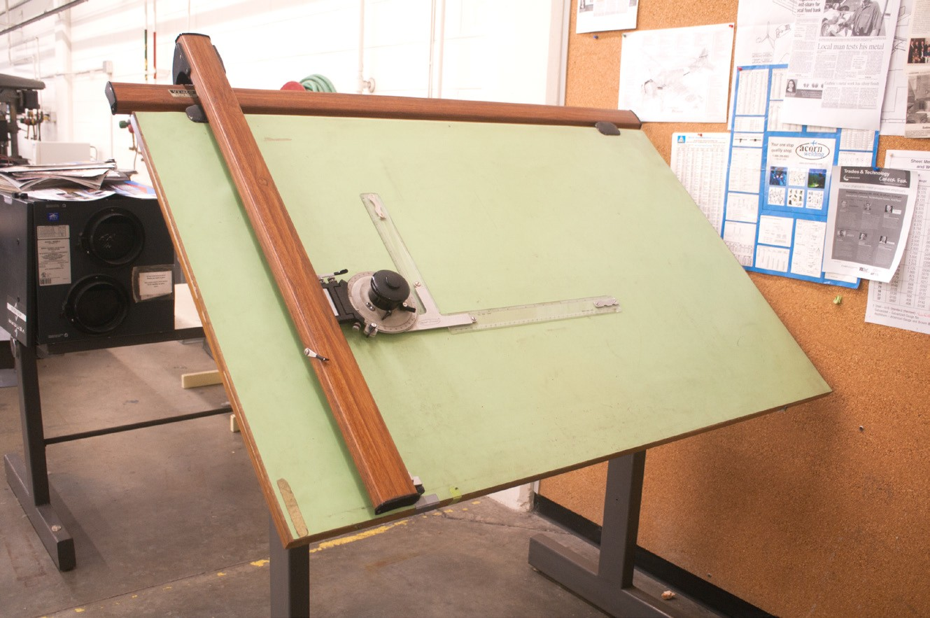

**Figure 6 —** Drafting machine

##### Drawing pencils

Both wood and mechanical pencils are used for drafting (Figure 7).

Manufacturers grade drawing pencils using numbers and letters. These range from 6B (very soft and black) to 9H (the hardest). From 6B the pencils progress through 5B, 4B, 3B, 2B, B, and HB, and then to F, the medium grade. After that they move to the harder graphite: H, 2H, 3H, 4H, 5H, 6H, 7H, 8H, and finally 9H. The softer grades are used for sketching and rendering drawings. The harder grades are used for instrument drawings.

Mechanical pencils do not require sharpening and are made to hold leads (they are actually made of graphite) that are bought separately. Thin-lead mechanical pencils, with leads as small as 0.5 mm, are available in different grades of lead. Most draftspersons use four or five different mechanical pencils with a different lead in each. The pencils come in different colours so it is easy to keep track of which lead is in each.

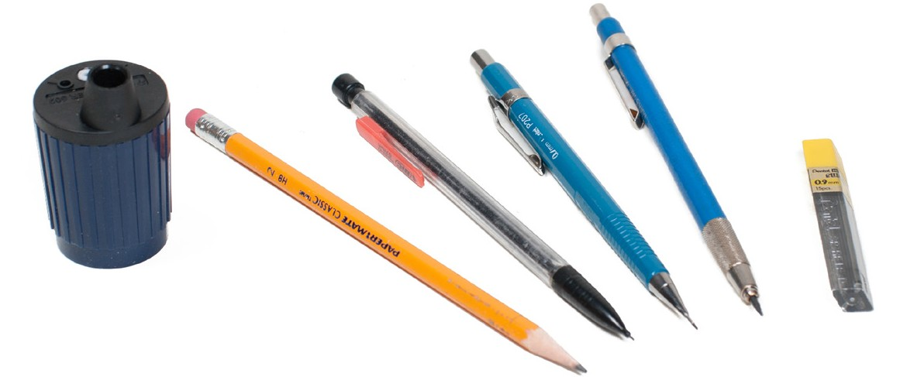

**Figure 7 —** Wood and mechanical pencils

##### Erasers and erasing shields

The best eraser to use on drawings is either a soft pink eraser that has bevelled ends, or the white plastic eraser. Electric rotary erasers are also available. They permit easy erasure of small errors without erasing adjacent lines.

A metal erasing shield helps to confine erasures to the desired area. Erasing shields are made from very thin stainless steel and have holes of various shapes to accommodate the sections to be erased. Figure 8 shows two erasers and an erasing shield.

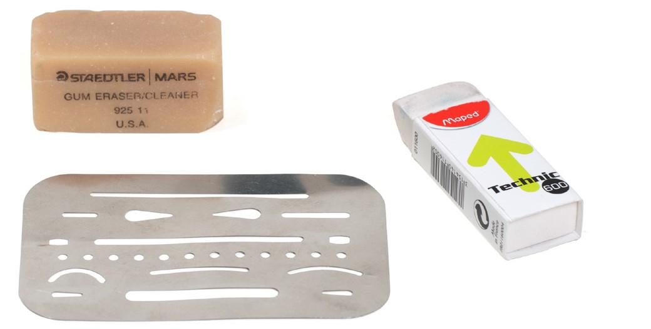

**Figure 8 —** Erasers and erasing shield

##### Templates

Templates (Figure 9) are available for many different trades. Templates incorporate cut-outs of symbols and fixtures that are commonly used in that trade. These cut-outs make it easy to trace shapes onto drawing paper.

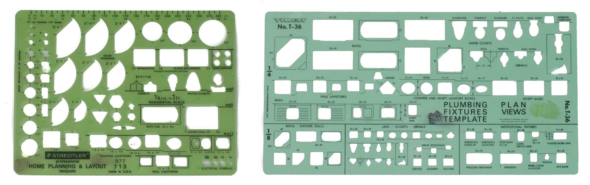

**Figure 9 —** Templates

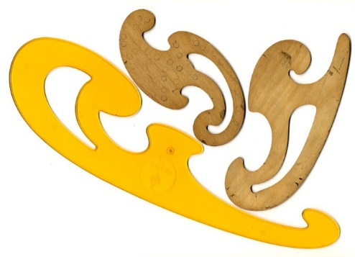

##### French curves and splines

A French curve (Figure 10) is a plastic template designed to help you draw curves. The French curve contains many different curves, but each one is represented over a very short distance only. One radius of curve blends

into another radius. It takes a lot of practice to use French curves effectively.

**Figure 10 —** French curve

A spline or flexible curve (Figure 11) can be used instead of a French curve to draw most curves. A spline is a plastic or rubber rod that is reinforced with metal. To use a spline, bend it to the shape of the curve you need. The design of the spline lets you hold a pencil against an edge and draw an accurate line without smudging. A spline cannot be used to draw curves that have a very short radius because the spline will not bend tightly.

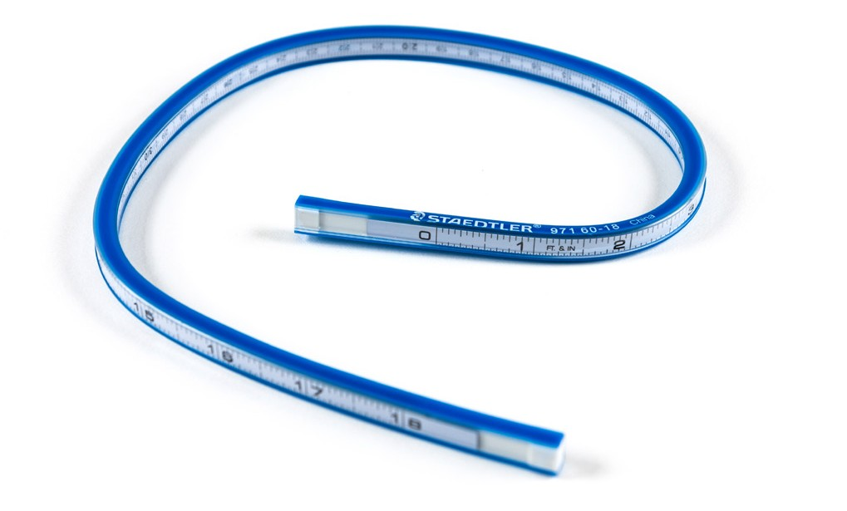

**Figure 11 —** Spline

##### Compass

A compass can be used for drawing circles, bisecting lines, or dividing angles. For very large circles you can use a beam compass. The four types of compasses are shown in Figure 12. Most compasses can be fitted with leads, pens, or points.

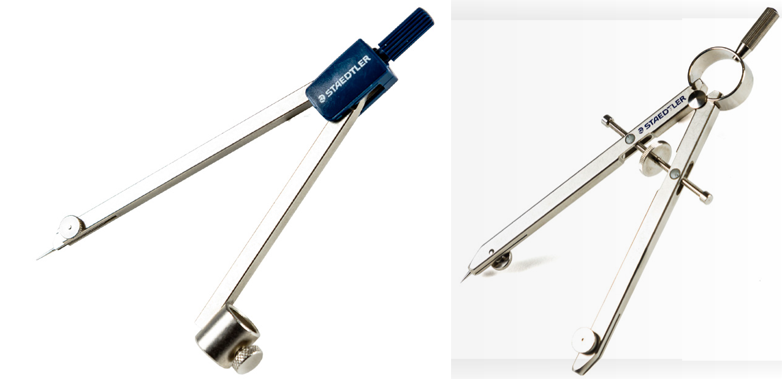

**Friction compass Bow compass**

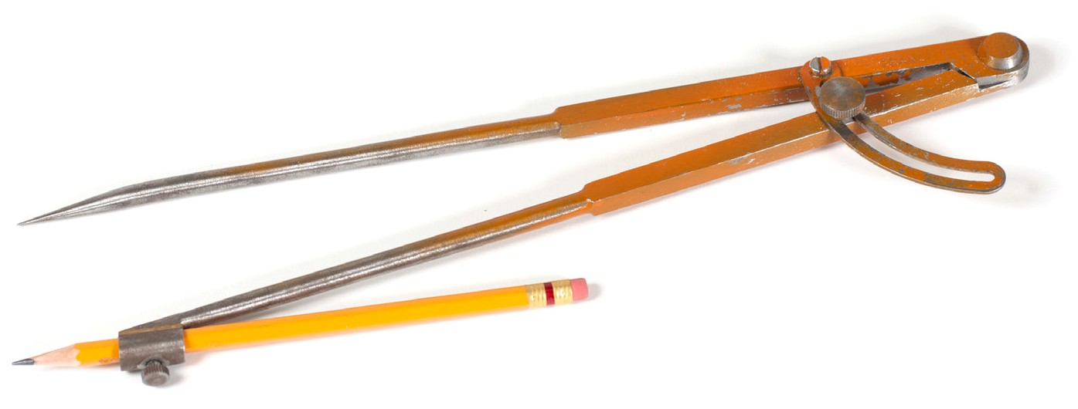

**Wing compass**

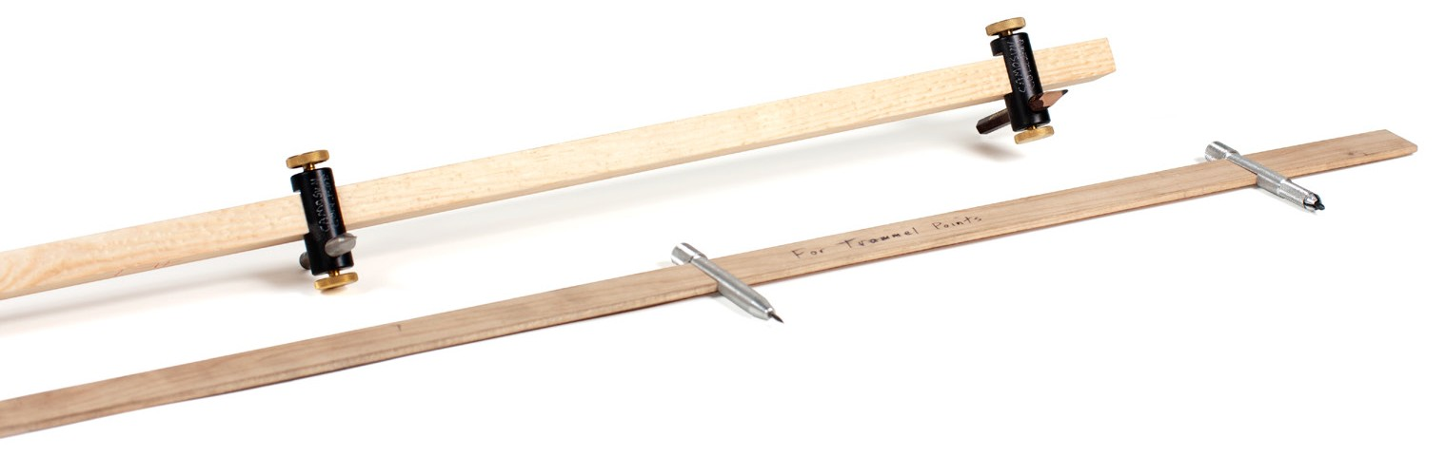

**Beam compass**

**Figure 12 —** Four types of compasses

When using the compass, tilt it in the direction of the line, as shown in Figure 13.

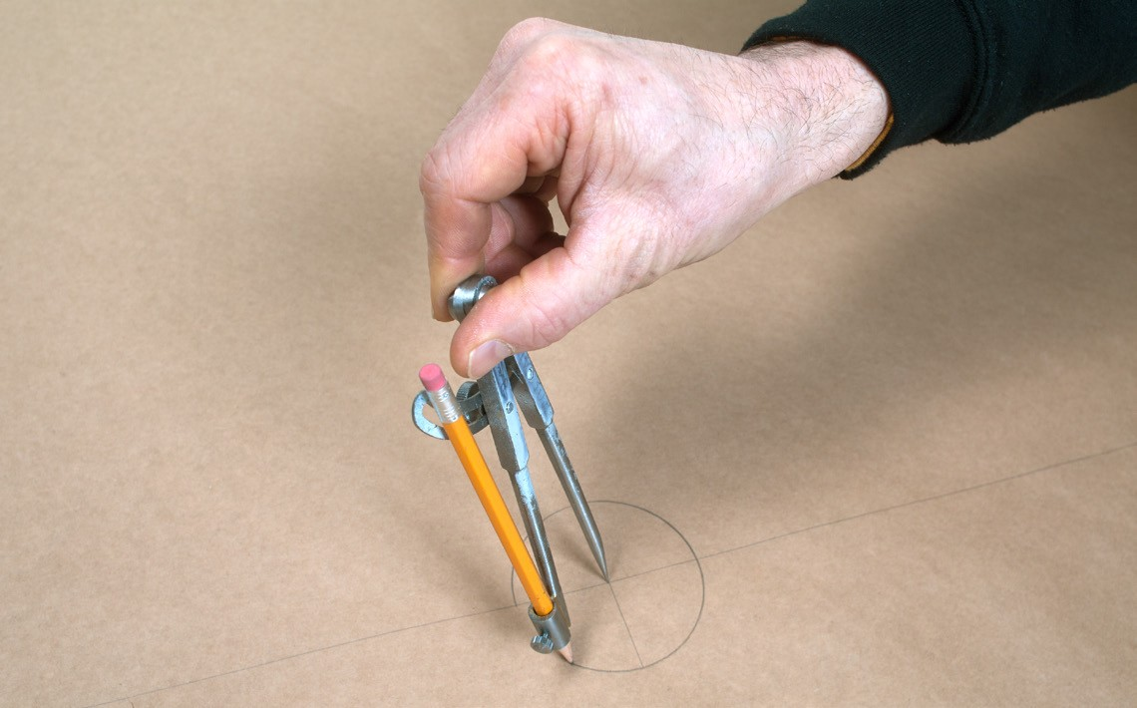

**Figure 13 —** Drawing a circle with a compass

##### Dividers

Dividers (Figure 14) are used for transferring dimensions from a drawing to a measuring device such as a ruler or scale. They are also used when scribing directly on material like metal.

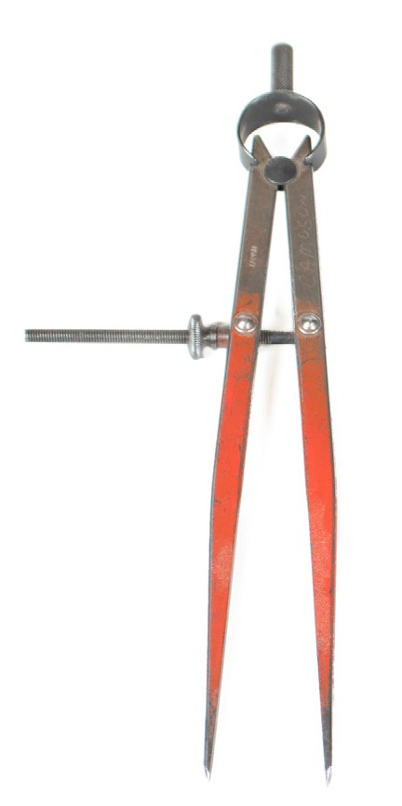

**Figure 14 —** Dividers

##### Dusting cloth or brush

It is very important to keep your drawings and drafting surface clean. When equipment gets dirty from the lead pencils, you should clean it regularly so that it does not smudge your drawings. Any soft, clean cloth is suitable. You may want to wash your board occasionally with a spray cleaner.

Use a brush like the one in Figure 15 to clean your table prior to placing paper down and to sweep away any debris as you are drawing. If you use your hand to brush, you could leave marks on the paper. After sharpening a pencil, wipe off any dust that is clinging to the point of the pencil to prevent smudging.

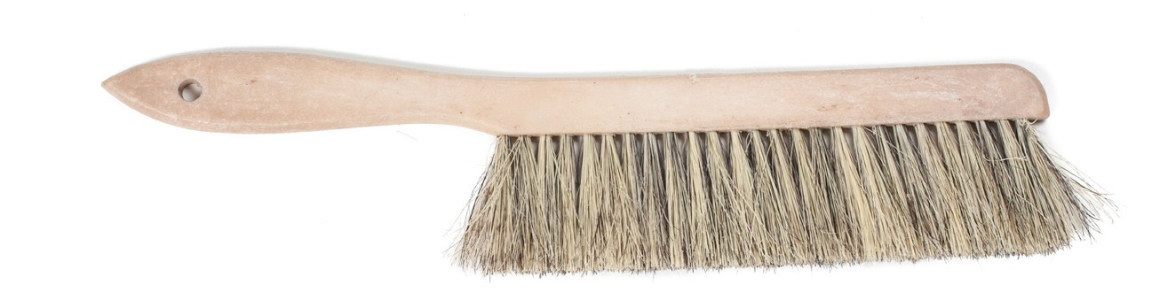

**Figure 15 —** Dusting brush

##### Scale rulers

Scale rulers let you draw diagrams at a reduced scale. They also let you obtain dimensions from a scaled drawing. Scale rulers come in a variety of types to meet the requirements of many different kinds of work. Most scale rulers have three edges and six different scales. The scales are read from either end of the rule. A typical combination of metric scales is 1:20, 1:50, 1:100, 1:25, 1:75, and 1:125.

Because of the decimal basis of metric measurements, metric scale rulers are both applicable and easy to use at any scale. Figure 16 shows the two scales from both ends of the same side.

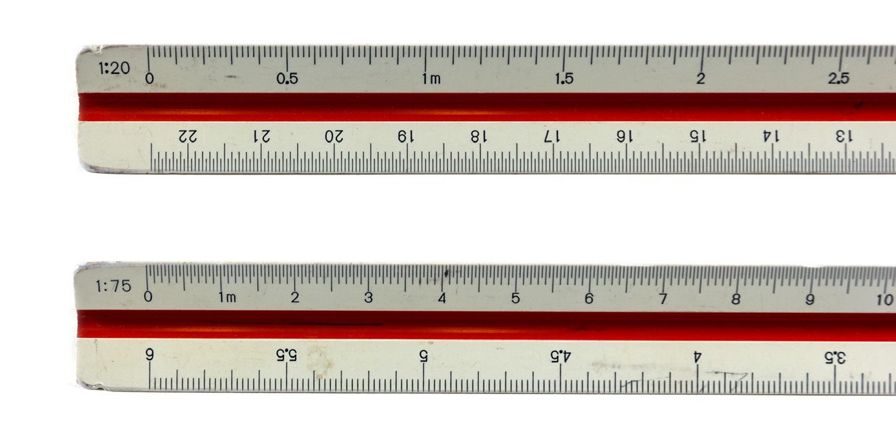

**Figure 16 —** Metric scale ruler

Imperial scale rulers may be an architect’s ruler, a mechanical engineer’s ruler, or a civil engineer’s ruler (Figure 17). The architect’s scale ruler is the most common, and is in inches and fractions of inches. A mechanical engineer’s scale ruler comes in inches and decimals of inches. A civil engineer’s scale ruler comes in feet and decimals of feet.

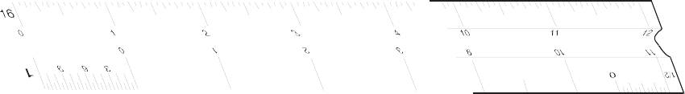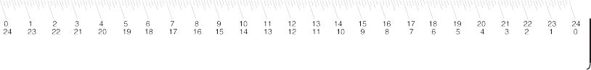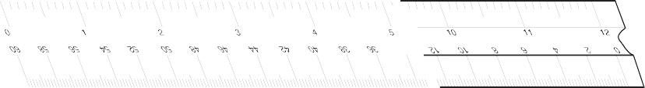

**Figure 17 —** Imperia scale rulers

### Drafting materials

The most common support for drawing is paper. Even though the original creative surface has changed from the drafting table to the computer screen, on the work site drawings are still primarily in printed form.

##### Drawing paper

There is a wide variety of drawing paper available in many sizes and of different qualities.

Good quality drawing paper is acid-free and will not turn yellow with age. Light-coloured drawing papers are available in pale yellow or buff, but these should be used only when it is not necessary to make copies.

##### Tracing paper

Tracing paper, which is transparent, can be used to make copies of drawings. It is thin enough to allow the light of photocopy machines to shine through the unmarked areas, and only the lines and figures will block the light. Materials used for tracing include tracing paper, vellum, tracing cloth, glass cloth, and polyester film with a matte finish.

###### Standard paper sizes

Paper sizes typically comply with one of two different standards: ISO (world standard) or ANSI/ ASME Y14 (American).

The standard ISO series of paper sizes is as follows: A0 841 mm × 1189 mm

A1 594 mm × 841 mm

A2 420 mm × 594 mm

A3 297 mm × 420 mm

A4 210 mm × 297 mm

A5 148 mm × 210 mm

The standard ANSI/ASME series of paper sizes is as Follows:

E 34 inch × 44 inch

D 22 inch × 34 inch

C 17 inch × 22 inch

B 11 inch × 17 inch

A 8.5 inch × 11 inch

The 81/2" × 11" standard letter paper corresponds to 216 mm × 279 mm. You can buy precut sheets that have a border and a preprinted title block in the lower right-hand corner. These are available in many standard sizes.

If the paper you use does not have a border and title block, you will have to draw them in. The left-hand border should be wider than the right-hand border and should be at least 50 mm wide to allow room for the prints to be bound. Figure 18 shows a title block with suitable dimensions added.

37 mm

|  |  |  |  |  |  |  |  |  |
| --- | --- | --- | --- | --- | --- | --- | --- | --- |
|  | | | | TITLE | | | | |
| Revisions | | | |
| No. | Date | Drn. by | Appr. by | CLIENT | | | | |
| 1 |  |  |  |
| 2 |  |  |  |
| 3 |  |  |  |
| SCALE | DRN. BY | APPR. BY | DATE | DRNG. NO. |
| 4 |  |  |  |

7 mm

16 mm

10 mm

35 mm 23 mm 22 mm 22 mm 34 mm

**Figure 18 —** Dimensions for title block

(Not to scale)

###### Paper rolls

Many grades of paper rolls are available in different widths that can be cut to any length required.

###### Drafting or masking tape

Use drafting or masking tape to hold the paper on the drafting surface. The tape should be attached at the corners to hold the sheet firmly stretched with no wrinkles. Only short pieces of tape are required.

### Computer drafting printing

Computer drafting programs are used effectively for all manner of drafting and have virtually replaced manual drafting. Small size computer-generated drawings can be printed on normal computer printers. However, larger drawings require a plotter. Older plotters used pencils, pens, or felt pens, but the new plotters are laser-based or jet printers and are capable of multiple colours. They are made to print all the sizes of drawings. Plotters also print well on vellum and some other non-paper media.

Now complete the Learning Task Self-Test.

#### Self-Test 1

1. What are most drafting tables covered with?
   1. Vinyl
   2. Wood
   3. Metal
   4. Plastic wrap
2. Drafting tables are adjustable in height and angle to the floor.
   1. True
   2. False
3. What are T-squares used for?
   1. Drawing angled lines
   2. Drawing vertical lines
   3. Setting paper on a table
   4. Drawing horizontal lines
4. Why might a set square have rabbeted edges?
   1. To help you prevent smudges
   2. To help keep your pencil sharp
   3. To help keep your pencil aligned
   4. To allow you to draw straight lines
5. Checking a triangle should be done periodically.
   1. True
   2. False
6. What is a set square used for?
   1. Drawing circles
   2. Drawing curved lines
   3. Drawing vertical and angled lines
   4. Drawing horizontal and angled lines
7. When using a 45°-90°-45° and a 30°-60°-90° triangle, angles can be drawn every 10°.
   1. True
   2. False
8. What is a protractor used for?
   1. Measuring lines
   2. Measuring angles
   3. Drawing angled lines
   4. Drawing straight lines
9. What kind of line is drawn to check a triangle?
   1. Straight
   2. Parallel
   3. Oblique
   4. Perpendicular
10. What is a compass used for?
    1. Drawing angled lines
    2. Drawing straight lines
    3. Drawing arcs and circles
    4. Drawing irregular curves
11. What is an erasing shield used for?
    1. To erase mistakes
    2. To hold the eraser
    3. To erase in a desired area
    4. To prevent the need for erasing
12. A spline is a plastic or rubber rod reinforced with metal used for drawing curves.
    1. True
    2. False
13. What is the tool called a *divider* used for?
    1. Drawing circles
    2. Drawing a diameter
    3. Scribing arcs on metal
    4. Drawing arcs and curves
14. What is the purpose of a scale ruler?
    1. To draw straight lines
    2. To enlarge the scale of a drawing
    3. To create drawings at a reduced scale
    4. To convert between imperial and metric measures

LEARNING TASK 2

**Describe lines, lettering, and dimensioning in drawings**

The purpose of engineering drawings is to convey objective facts, whereas artistic drawings convey emotion or artistic sensitivity in some way.

Engineering drawings and sketches need to display simplicity and uniformity, and they must be executed with speed. Engineering drawing has evolved into a language that uses an extensive set of conventions to convey information very precisely, with very little ambiguity.

Standardization is also very important, as it aids internationalization; that is, people from different countries who speak different languages can read the same engineering drawing and interpret it the same way. To that end, drawings should be as free of notes and abbreviations as possible so that the meaning is conveyed graphically.

### Line styles and types

Standard lines have been developed so that every drawing or sketch conveys the same meaning to everyone. In order to convey that meaning, the lines used in technical drawings have both a definite pattern and a definite thickness. Some lines are complete and others are broken. Some lines are thick and others are thin. A visible line, for example, is used to show the edges (or “outline”) of an object and to make it stand out for easy reading. This line is made thick and dark. On the other hand, a centre line, which locates the precise centre of a hole or shaft, is drawn thin and made with long and short dashes. This makes it easily distinguishable from the visible line.

When you draw, use a fairly sharp pencil of the correct grade and try to maintain an even, consistent pressure to make it easier for you to produce acceptable lines (Figure 1). Study the line thicknesses (or “line weights”) shown in Figure 2 and practise making them.

Technical Sketching

9H 8H 7H 6H 5H 4H 3H 2H H F HB B 2B 3B 4B 5B 6B 7B 8B 9B

Hardness Blackness

**Figure 1 —** Lead grade and usage

In computer drafting, the line shape remains the same, but line thickness may not vary as it does in manually created drawings. Some lines, such as centre lines, may not cross in the same manner as in a manual drawing. For most computer drafting, line thickness is not important.

|  |  |  |  |  |
| --- | --- | --- | --- | --- |
| **Type** | **Weight** |  | **Line** | **Description** |
| Object line Margin line | Heavy |  |  | Solid line to show visible shape, edges, and outlines. |
| Hidden body line | Medium |  |  | Broken line of long and short dashes to show hidden object lines not visible to the eye. |
| Phantom line | Light |  |  | Broken line of short dashes to show alternate positions or movement of a part. |
| Section line | Light |  | Steel Copper/Brass    Lead Cast iron/ General purpose | Unbroken lines arranged in a pattern, usually straight and at a 45º diagonal. |
| Projection line | Light |  |  | Unbroken lines that extend away from the object or feature for emphasis. |
| Centre line | Light |  |  | Broken line of long and short dashes to show the centre of an object. |
| Extension line/ Dimension line | Light |  | 25 mm | Extension lines are small lines that extend outward from an object or feature. Dimension lines span between the extension lines with arrowheads and a given dimension. |
| Leader line | Light |  | Label | Unbroken line usually drawn at an angle often with a “dogleg” and an arrowhead. A dot is used in place of an arrowhead where a surface is referenced.  Usually accompanied by a label. |
| Cutting plane line | Heavy |  | A A | Broken line of one long and two short dashes to show an imaginary cross-section. The arrowheads show the direction from where the cross-section is viewed. A corresponding image will show the view of A. |
| Break lines for wood and metal | Heavy |  |  | Unbroken freehand or straight zig-zag lines to abbre- viate longer spans of wood or metal. |
| Break lines for piping | Heavy |  |  | Curled lines to abbreviate a longer span of pipe. |

**Figure 2 —** Weights of lines

To properly read and interpret drawings, you must know the meaning of each line and understand how each is used to construct a drawing. The ten most common are often referred to as the “alphabet of lines.” Let’s look at an explanation and example of each type.

##### Object lines

Object lines (Figure 3) are the most common lines used in drawings. These thick, solid lines show the visible edges, corners, and surfaces of a part. Object lines stand out on the drawing and clearly define the outline and features of the object.



Object line

**Figure 3 —** Object lines

##### Hidden lines

Hidden lines (Figure 4) are used to show edges and surfaces that are not visible in a view. These lines are drawn as thin, evenly spaced dashes. A surface or edge that is shown in one view with an object line will be shown in another view with a hidden line.

**Figure 4 —** Hidden lines

##### Centre lines

Centre lines (Figure 5) are used in drawings for several different applications. The meaning of a centre line is normally determined by how it is used. Centre lines are thin, alternating long

and short dashes that are generally used to show hole centres and centre positions of rounded features, such as arcs and radii. Arcs are sections of a circle, and radii are rounded corners or edges of a part. Centre lines can also show the symmetry of an object.

*r*

**Figure 5 —** Centre lines

##### Dimension and extension lines

Dimension and extension lines (Figure 6) are thin, solid lines that show the direction, length, and limits of the dimensions of a part. Dimension lines are drawn with an arrowhead at both ends.

Extension lines are drawn close to, but never touching, the edges or surface they limit. They should be perpendicular, or at right angles, to the dimension line. The length of extension lines is generally suited to the number of dimensions they limit.

Dimension line Extension line

Dimension

End marks



62

Object line

**Figure 6 —** Dimension and extension lines

##### Leader lines

Leader lines (Figure 7) show information such as dimensional notes, material specifications, and process notes. These lines are normally drawn as thin, solid lines with an arrowhead at one end. They are bent or angled at the start, but should always end horizontal at the notation. When leader lines reference a surface, a dot is used instead of an arrowhead.

Leader line (thin and solid)

Flat bar 3 mm thick

R 20

ø8 2 holes

Copper plate this surface

**Figure 7 —** Leader lines

Note that the symbol ø is used to indicate a diameter rather than the abbreviation “DIA.” The number that immediately follows this symbol is the diameter of the hole, followed by the number of holes that must be drilled to that dimension.

##### Phantom lines

Like centre lines, phantom lines (Figure 8) are used for several purposes in blueprints. Phantom lines are used to show alternate positions for moving parts and the positions of related or adjacent parts, and to eliminate repeated details. Phantom lines are drawn as thin, alternating long dashes separated by two short dashes.

Existing column

New girder

**Figure 8 —** Phantom lines

##### Cutting plane lines

Cutting plane lines (Figure 9) show the location and path of imaginary cuts made through parts to show internal details. In most cases, sectional views (or views that show complicated internal details of a part) are indicated by using a cutting plane line. These lines are thick, alternating long lines separated by two short dashes. The arrowheads at each end show the viewing direction of the related sectional view. The two main types of cutting plane lines are the straight and the offset.

Cutting plane line (thick with one long then two short dashes)

**A A B B**



Section A–A Section B–B

**Figure 9 —** Cutting plane lines

##### Section lines

Section lines, also known as sectional lining, (Figure 10) indicate the surfaces in a sectional view as they would appear if the part were actually cut along the cutting plane line. These are solid lines that are normally drawn at 45 degree angles. Different symbols are used to represent different types of materials.

Section lines (thin and solid)



Section B–B

**Figure 10 —** Section lines combined with cutting plane lines

##### Break lines

Break lines are drawn to show that a part has been shortened to reduce its size on the drawing. The two variations of break lines common to blueprints are the long break line and the short break line (Figure 11). Long break lines are thin solid lines that have zigzags to indicate a break. Short break lines are thick, wavy solid lines that are drawn freehand. When either of these break lines is used to shorten an object, you can assume that the section removed from the part is identical to the portions shown on either side of the break.

(thin and long with a zigzag)

(thick and short, wavy freehand)

**Figure 11 —** Break line

### Standard lettering

The letters and numbers on a drawing or sketch are as important as the lines. Scribbled, smudged, or badly written letters and numbers can become impossible to read. This may lead to time-consuming and costly errors. Lettering is necessary to describe:

* + - the name or title of a drawing
    - when it was made
    - the scale
    - who sketched it
    - the dimensions
    - the special notations that describe the size
    - the materials to be used
    - the construction methods

The American Standard Vertical letters (Figure 12) have become the most accepted style of lettering used in the production of manual drafting. This lettering is a Gothic sans serif script, formed by a series of short strokes.

Font styles and sizes may vary in computer drafting. Note that all letters are written as capital (upper case) letters. Practise these characters, concentrating on forming the correct shape.

Remember that letters and numbers must be black so that they will stand out and be easy to read. Lettering and figures should have the same weight and darkness as hidden lines.

Title and drawing sizes = 6 mm (¼")

# A B C D E F G H I J K L M N O P Q R S T U V W X Y Z 0 1 2 3 4 5 6 7 8 9

Dimension and notation sizes = 3 mm (1/8") A B C D E F G H I J K L M N O P Q R S T U V W

X Y Z 0 1 2 3 4 5 6 7 8 9

**Figure 12 —** Standard lettering

##### Abbreviations

Abbreviations are commonly used to help simplify a drawing and conserve space. Although many fields share common abbreviation conventions, there are also field- or trades-specific conventions that you will see as you become more specialized. Here is a common list of abbreviations that are used on drawings. Each trade will have specific abbreviations from this list, and therefore a set of drawings will usually include an abbreviation key.

AB anchor bolt

ABT about AUX auxiliary BC bolt circle

BBE bevel both ends BCD bolt circle diameter BOE bevel one end

BE both ends

BL baseline

BM bench mark

Btm bottom

BP base plate

B/P blueprint

BLD blind

C/C centre to centre COL column

CPLG coupling

CS carbon steel C/W complete with CYL cylinder

DIA diameter DIAG diagonal DIM dimension DWG drawing EA each

EL elevation

EXT external

F/F face to face

FF flat face

FLG flange

FW fillet weld

Ga gauge Galv galvanized HVY heavy

HH hex head

HR hot rolled

HT heat treatment

HLS holes

HSS hollow structural steel ID inside diameter

IN inches

INT internal

ISO International Standards Org. KP kick plate

LH left hand

LAT lateral

LR long radius

LG long

MB machine bolt MS mild steel MIN minimum MAX maximum MAT’L material MISC miscellaneous

NC national course NF national fine

NO number MOM nominal NTS not to scale

NPS nominal pipe size NPT national pipe thread O/C on centre

OA overall

OD outside diameter OR outside radius OPP opposite

PAT pattern

PBE plain both ends POE plain one end

PSI pounds per square inch PROJ project

RD running dimension R or Rad radius

RND round

REF reference REQ’D required REV revision

RF raised face

RH right hand SCH schedule

SI International System of Units SPECS specifications

SQ square

SM seam

SMLS seamless

S/S seam to seam SO slip on

SEC section

STD standard

SS stainless steel SYM symmetrical T top

T&B top and bottom

T&C threaded and coupled THD threaded

TBE threaded both ends TOE threaded one end THK thick

TOL tolerance

TOC top of concrete TOS top of steel TYP typical

U/N unless noted VERT vertical

WD working drawing WP working point WT weight

W/O without

XH extra heavy

XS extra strong

Figure 13 shows a simple drawing. Notice that the dimensions are given between arrows that point to extension lines. By using this method, the dimensions do not get in the way of the drawing. One extension line can be used for several dimensions. Notice also that the titles require larger letter sizes than those used for dimensions and notations. It is important that the title and sketch number stand out, as shown in Figure 13. When you begin lettering, you may wish to use very light lettering guide lines to ensure uniformity in lettering size and alignment.



|  |  |  |
| --- | --- | --- |
| Dimensions and notations 3 mm (1⁄8")  1-25/32" 1-25/32"  1-1/16"  1-5/8"  1"  2" 2"  17/32"  3-5/16"  Title and drawing sizes 6 mm (¼") | | |
| **DN** | **REDUCING TEE**  **SLIP × SLIP × SLIP** | **DWG** |
| **DATE:** |  |

**Figure 13 —** Standard lettering sizes

### Principles of dimensioning

A good sketch of an object is one that you can use as a blueprint to manufacture the object. Your sketch must show all the necessary dimensions of the part, locate any features it may have (such as holes and slots), give information on the material it is to be made from, and if necessary, stipulate the processes to be used in the manufacture of the object.

Three principles of dimensioning must be followed:

1. Do not leave any size, shape, or material in doubt.
2. To avoid confusion and the possibility of error, no dimension should be repeated twice on any sketch or drawing.
3. Dimensions and notations must be placed on the sketch where they can be clearly and easily read.

Consider Figure 14 and note whether these three dimensioning principles have been followed.

NOTES:

|  |  |
| --- | --- |
| 1350 |  |
|  | 60 |

* 1. All leg and rail joints to be dowelled and glued
  2. Leg top joints to be dowelled and glued

0

80

80

200

500

600

80

**Figure 14 —** Shop table

Although the dimensions and notations are clear and easy to read in Figure 14, the following points should be made:

* Leg and rail sizes have not been shown.
* The thickness of the top has not been given.
* The material has not been given as a notation.
* The 600 dimension has been repeated.
* The type of finish to be used has not been given.
* Note 2 is redundant.

The sketch of the shop table is far from complete, and the table could not be made without a lot of guesswork. Figure 15, on the other hand, shows a completed sketch that, along with the necessary notes and dimension information, can be readily used for construction purposes.

Ø15 4 holes

R15

35 45

R15

75

90 Ø30

R20

240 REF

75

20 40

60

45º

75

110 REF

R15

**Figure 15 —** Dimensioning

##### Rules of dimensioning

For most objects, there are three types of dimensions:

* + size dimensions
  + location dimensions
  + notation dimensions

Figure 16 illustrates the difference between size and location dimensions. (S = size dimension and L = location dimension).

Ø20 2 holes

L

S

L

L

L

S

S

**Figure 16 —** Shim plate

Size dimensions are necessary so that the material size of the object can be determined. Location dimensions are necessary so that parts, holes, or other features can be positioned in or on the object. Notation dimensions describe the part, hole, or other feature with a short note such as the “ø20 2 holes” notation (see Figure 16). Keep these points in mind:

* Keep all dimension lines at least 10 mm (3/8") clear of object lines wherever possible.
* Try to group related dimensions rather than scattering them.
* Try to keep dimensions off the views themselves.
* Separate one line of dimensions from another line of dimensions or from a notation by a space of at least 10 mm (3/8").
* Leave a space of approximately 3 mm (1/8") between the object outline and the beginning of any extension line.
* Keep arrowheads slim and neat.
* Never dimension to a hidden line.
* Draw leader lines at an angle when intersecting object lines to avoid confusing them with extension lines.

Figure 17 illustrates good placement of dimensions and notations. Note the placement of extension lines and the use of centre lines to locate features such as holes. Also, note the shape and size of arrowheads.

Overall or larger dimensions should be farther from the drawing than smaller dimensions

Arrowhead ratio should be approx. 3:1

S

S - Ø hole

L

L

S

Allow the extension

line to go past the L

dimension line by approx. 2 mm

S-Rad

Leave approx. 3 mm between object line and

extension line

S = size dimensions and notations L = location dimensions

**Figure 17 —** Extension line usage

##### Dimensioning systems

Two systems are used for dimensioning drawings. They are the aligned and the *unidirectional* systems. Figure 18 shows examples of both systems. As you can see, the aligned system requires that you turn the drawing on its side, whereas the unidirectional system may be read from the normal reading position. For most drawings, the unidirectional system is preferred, as it is easier to read; however, architectural drawings still use the aligned system.

40

40

100

100

Aligned dimensions Unidirectional dimensions

**Figure 18 —** Dimensioning systems

##### Systems of measurement

You may be required to sketch or read drawings constructed with either metric (SI) or imperial dimensions. You may also encounter drawings that are dual dimensioned and contain both systems of measurement on the same drawing.

###### SI system of measurement

The SI system of measurement has become the official standard in Canada. It is common practice on shop drawings to express all metric dimensions in millimetres. Figure 19 shows a detail drawing for a connector arm using metric measurements. All metric drawings should contain a note specifying that all dimensions are in millimetres.

Ø30 drill

Ø20

90

200

R30

Notes:

1. All dimensions are in mm
2. Materials - 6 × 60 mild steel plate

**Figure 19 —** Connector arm – metric measurement

###### Imperial system of measurement

An imperial drawing may use the decimal-inch system, the fractional-inch system, or feet and inches.

* In the decimal-inch system, very accurate dimensions for items such as machine parts are expressed as decimals of an inch, such as 0.005". In words this reads as five one- thousandths of an inch.
* In the fraction-inch system, dimensions for things such as steel and lumber sizes are expressed as inches and fractions of an inch from as small as 1/64" (Figure 20). Most drawings that are dimensioned in the imperial system will use the fraction-inch system.
  1. /2" R

1-1/2" Ø drill

3/8" Ø

3-5/8"

7-7/8"

Notes:

* + 1. All dimensions are in inches
    2. Materials - 5/16 × 3 mild steel plate

**Figure 20 —** Connector arm – imperial measurement

In the feet-inch system (Figure 21), the dimensions of large structures such as machine frames and buildings are expressed in feet and inches, such as 2'-6" (two feet, six inches).

3'-0" × 6'-8" Solid r door

4'-0" × 3'-8" DH window

2'-10"

4'-0"

5'-0"

12'-6"

3'-4"

10'-3"

**Figure 21 —** Fuel storage shed

##### Dimensioning orthographic sketches

The following are rules and procedures for dimensioning single- and multi-view sketches:

* Place dimensions on views that show parts of features as solid outlines. Avoid dimensioning hidden lines wherever possible.
* Try to keep dimensions between views. Leave adequate room between views when you begin your sketch.
* Keep the smallest dimensions nearest to the object outline.
* Diameters in metric measurement should be denoted on a sketch using the symbol ø (e.g., ø20 – 2 holes). A radius should be denoted using the letter R (e.g., R 25).
* Diameters in imperial measurements may be denoted on a sketch by the symbol ø or the abbreviation DIA (e.g., 3" ø DRILL or 41/2" DIA). A radius may be denoted using the letter R or the abbreviation RAD (e.g., 3" R or 61/2" RAD).
* Arrows carrying notations should always point toward the centre of circular objects.
* Arrows should always point toward a circle centre when dimensioning a diameter and away from the centre when dimensioning a radius.

Now complete the Learning Task Self-Test.

**Self-Test 2**

1. Which line in a drawing should be the darkest and thickest?
   1. Centre line
   2. Hidden line
   3. Object line
   4. Dimension line
2. This line in a drawing is a broken line of alternating short and long dashes.
   1. Centre line
   2. Hidden line
   3. Phantom line
   4. Compression line
3. What is the name of a line in a drawing that shows a hidden feature?
   1. Buried line
   2. Missing line
   3. Hidden line
   4. Concealed line
4. A break line shows where part of an object in a drawing has been removed.
   1. True
   2. False
5. A drawing should have all dimensions shown in every view.
   1. True
   2. False
6. Which line is used to shows notes or specifications in a drawing?
   1. Leader line
   2. Object line
   3. Extension line
   4. Phantom line
7. How are alternate positions of moving parts shown in a drawing?
   1. With a break line
   2. With a hidden line
   3. With an object line
   4. With a phantom line
8. What does a sectional view in a drawing normally show?
   1. Outside of a part
   2. Inside dimensions
   3. Internal holes and slots
   4. Internal features of a part
9. What do the arrows that locate a sectional view in a drawing indicate?
   1. Side the part is cut on
   2. Internal holes and slots
   3. Direction of the standard view
   4. Direction of observation when the section is drawn
10. In the drawing below, indicate whether the dimensions shown by letters D2 and D4 are size dimensions, no dimensions, location dimensions, or notation dimensions.
    1. Size dimensions
    2. No dimensions
    3. Notation dimensions
    4. Location dimensions

D1

D2

|  |  |  |  |  |
| --- | --- | --- | --- | --- |
|  |  | | |  |
|  |  | | |  |
| D5 DOOR SIZE | | | |
| D6 WINDOW SIZE | | |  |
|  |  |  |  |  |

D3

D4

LEARNING TASK 3

**Use scale rulers to determine actual dimensions from drawings**

Scale drawings are accurate and convenient visual representations made and used by engineers, architects, and people in the construction trades. The accuracy is achieved because the drawing is proportional to the real thing. The convenience comes from the size of the drawing. It is large enough to provide the desired detail but small enough to be handy.

The flexibility to draw proportionally in different sizes is provided by scales. For the purposes of representation, we will only be concerned with reduction scales. Reduction scales make the drawing smaller than the object. The kinds of rulers we will be discussing for making scaled drawings are the architect’s scale and the metric scale, both shown in Figure 1.

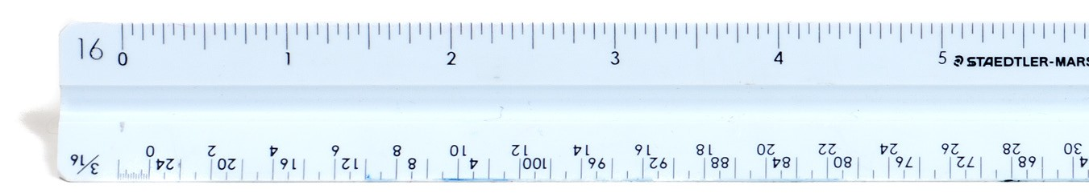

**Architect's scale ruler**

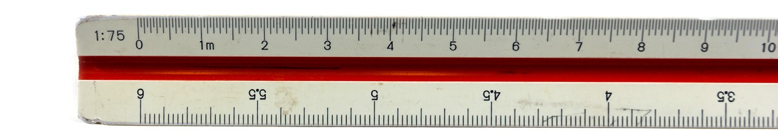

**Metric scale ruler**

**Figure 1 —** Architect’s and metric rulers

The scale of the drawing is always written on the drawing, unless the drawing is not drawn to scale. In the latter case, this will be indicated by the “not to scale” abbreviation (NTS). The scale is the ratio of the size of the drawing to the object. For drawings smaller than the object, the ratio is that of a smaller distance to a larger one.

The architect’s scales use ratios of inches to a foot. The most common architect’s scale used is

1/4 inch to the foot, written on drawings as:

Scale 1/4" = 1'-0"

This means that a line 1/ long on the drawing represents an object that is one foot long. At the same scale, a line 11/2" long represents an object 6' long, because 11/2" contains 6 quarter-inches.

Metric scale ratios use the same units in both ratio terms, resulting in an expression of how many times smaller than the object the drawing is. For example, the standard metric scale ratio that corresponds approximately to 1/4" = 1'-0" is written on drawings as "Scale 1:50."

This means that the object is 50 times as large as the drawing, so that 50 mm on the object is represented by 1 mm on the drawing. For another example, 30 mm on the drawing represents 50 × 30 mm = 1500 mm (or 1.5 metres) on the object.

Figure 2 lists the scale ratios used for building plans and construction drawings in both metric and the approximate equivalent architectural scale ratios.

|  |  |  |  |  |
| --- | --- | --- | --- | --- |
| **Type of Drawing** | **Common Metric Ratios** | **Imperial Equivalents and Ratios** | | **Use** |
| Site plan | 1:500  1:200 | 1" = 40'-0"  1/16" =1'-0" | 1:480  1:192 | * To locate the building, services and reference points on the site |
| Sketch plans | 1:200 | 1/16" =1'-0" | 1:192 | * To show the overall design of the building * To indicate the juxtaposition of the rooms and locate the positions of piping systems and components |
| General locations | 1:100 | 1/8" =1'-0" | 1:96 |
| Drawings | 1:50 | ¼’’ =1'-0" | 1:48 |
| Construction details | 1:20  1:10  1:5  1:1 | ½’’ =1'-0"  1" = 1'-0"  3" =1'-0"  Full size | 1:24  1:12  1:4  1:1 | * To show the detail of system components and assemblies |

**Figure 2 —** Preferred scales for building drawings

### Architect’s (imperial) scales

Traditional architectural measurements of length are written very precisely in feet and inches using the appropriate symbols for feet and inches separated by a dash (e.g., 4'-3 1/2" and 7'-0"). This is the way that all imperial measurements are written on construction drawings.

Listed below are the scales found on the architect’s triangular scale ruler.

1. 3/32" =1'-0"

2. 3/16" =1'-0"

3. 1/8" = 1'-0"

4. 1/4" = 1'-0"

5. ¾" =1'-0"

6. 3/8" = 1'-0"

7. 1" =1'-0"

8. 1/2" = 1'-0"

9. 11/2" = 1'-0"

10. 3" = 1'-0"

1. 1" = 1" (full size—use the scale labelled 16)

Figure 3 shows one face of an architect’s imperial triangular scale ruler. There are two edges on each face and each edge contains two scales that run in opposite directions. At each end of an edge, a number or fraction indicates the distance in inches that represents one foot. The top edge is in eighths of an inch from left to right, and in quarters of an inch from right to left. Note that the 1/8" scale from 0 to the right end represents 95 feet, and the 1/4" scale from 0 to the left end represents 47 feet.

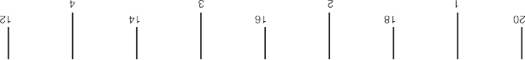

**Figure 3 —** One face of an architect’s ruler (NTS)

At each end, between the zero and the number indicating scale, the length representing one foot is subdivided into 6, 12, 24, or more parts to indicate inches and, in some scales, fractions of an inch. For example, each of the six marks on the 1/8" scale represents two inches, while each mark equals a quarter of an inch on the 1" reduction scale and one inch on the 1/4" scale.

Now look at the 1/2" scale in Figure 4. The subdivided unit is divided into inches and fractions of an inch. Reading left from the zero, notice the figures 3, 6, and 9, which represent measurements of 3", 6", and 9". From the zero to the first long mark represents 1". Between the zero and the one- inch mark there are four spaces, each of which represent one-quarter of an inch.



**Figure 4 —** Units in an architect’s scale ruler (NTS)

Piping drawings usually use a 1/8" scale for larger buildings, a 1/4" scale for smaller buildings and houses, and a 1/2" scale for details. Each drawing will state in the title box the scale that is used. Sometimes when special details are given, the scale is placed directly under the detail.

To draw or measure a length to scale, first find the edge of the ruler containing the scale. One end of the length will rest exactly on one of the foot marks of the scale, and the other end should rest either on the zero marker or somewhere on the inch subdivision of the scale. The length can then be marked and drawn or read off from a drawing.

Figures 5 and 6 demonstrate this manner of reading dimensions from four of the ratios on the architect’s scale.

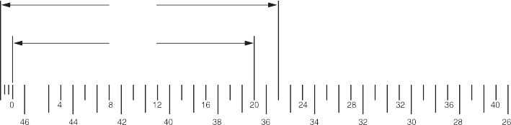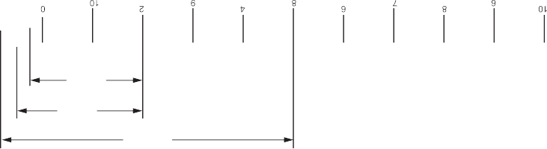

22' 6"

20' 0"

2' 3"

2' 6"

8' 10"

**Figure 5 —** Reading dimensions using an architect’s ruler (NTS)

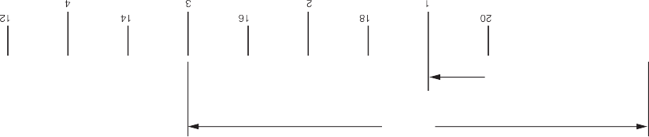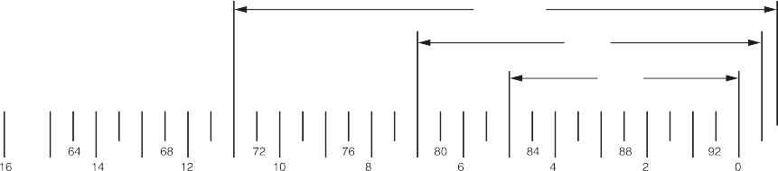

11' 10"

7' 6"

5' 0"

1' 3"

3' 10"

**Figure 6 —** Reading dimensions using an architect’s ruler (NTS)

**Architectural units have feet divided into inches, whereas engineering units divide feet into tenths and hundredths. Engineers’ scales are not used to make piping drawings.**

### Metric scales

A triangular metric scale is similar to the architectural scale in that it has six edges, but it has only one scale ratio per edge. The ratio is marked at the left end of the scale. For example, the scale of 1:50 means that 1 mm on the drawing represents 50 mm on the object. This means that the object is 50 times larger than the drawing of it. An object 450 mm long would be represented by a line 9 mm long (450 mm/50).

Figure 7 shows one of the three sides of a metric scale. The scale labelled 1:50 is read from left to right, from 0 to 15 m. The 1:5 scale (on the bottom) can also be read from left to right (0 to 600 mm) by turning the scale around.

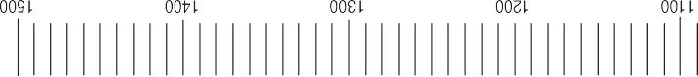

**Figure 7 —** One side of a metric ruler

If the ratio is 1:1, it means that 1 mm on the drawing represents 1 mm. In other words, the object in the drawing is being drawn to its actual size.

**The ratios most often used in drawings are 1:100 for larger buildings, 1:50 for smaller buildings, and 1:20 for details.**

You will notice that all the edges on a metric scale are marked with spaces that are 1 mm apart, similar to a metric tape measure. The difference is that each edge is marked off or labelled according to a different ratio, so that proportionate lengths are read directly from the scale. This eliminates the need to calculate dimensions.

Figure 8 shows common metric scales for comparison. Notice that all the scales shown are labelled in metres and that 0.5 m = 500 mm. All the scales in Figure 8 are marked at the scaled position of 250 mm.

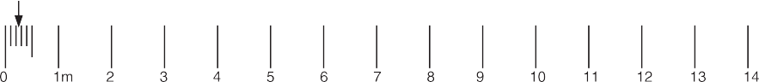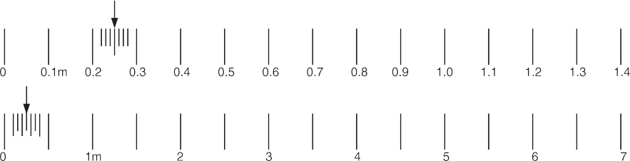



**Figure 8 —** Metric scales marked at 250 mm

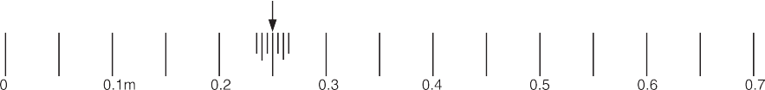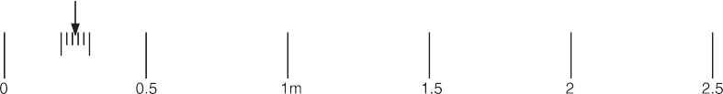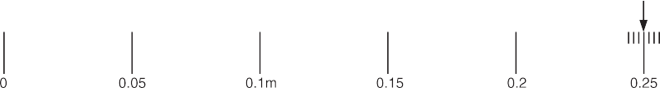

**The length of an object represented on a drawing in a metric scale is found by measuring the drawn object with a metric ruler of the proper scale. You can also measure the drawing with any metric tape measure and multiply that by the scale ratio.**

### Obtain dimensions from drawings

The best way to get exact dimensions from drawings is to use the explicit dimensions (in millimeters or in feet and inches) written between the dimension lines. Any measurements that you need should be somewhere on the drawings. Drawings normally only give each dimension once. If there are a number of parallel lengths, only one will have a measurement. To find the dimension you need, you may need to refer to other views or you may have to add or subtract other dimensions.

Measuring lines on a drawing to determine the measurement is not an accurate way to

extract dimensions. This is because the drawing is only a representation and may not be exact. Photocopies of drawings may not be to the scale of the original.

The scale of the drawing and your accuracy in measuring will lead to inaccuracies. For example, if the scale of a drawing is 1/8" = 1'-0", an error of 1/32" in measuring the plan amounts to 3"

of error in the object measured. Detail drawings permit more exactness because they are proportionately larger. Details, however, often require more exactness and usually contain any needed dimensions.

When accuracy is not required and approximate dimensions are adequate, measuring plans is a quick method of taking off material for estimating the cost of a job. In such cases, 10% is usually added for cut-off and waste allowance.

**Measuring plans is not accurate enough for measuring materials for cutting and installation purposes.**

If you use the scale of the drawing, it will be simple to read off the measurements. However, in the field you will often need approximate measurements and the only measuring tool at hand will be a measuring tape.

A steel pocket tape measure has a movable hook on the end that allows accurate measuring both when butted against a surface or when hooked on the end of an object (Figure 9). The end of the flexible tape itself is shortened to allow for the hook.

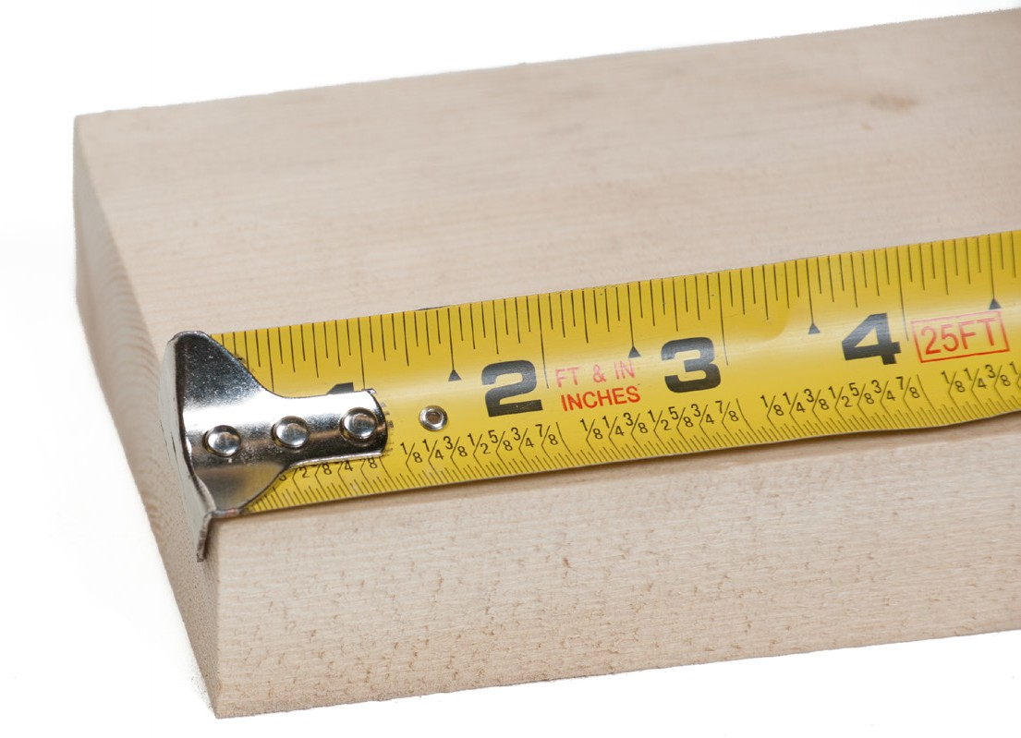

**Figure 9 —** Tape measure with movable hook

To avoid any error and in order to place the tape flat on the drawing, use a convenient unit mark, such as 100 mm, as the starting point for measuring, as in Figure 10.

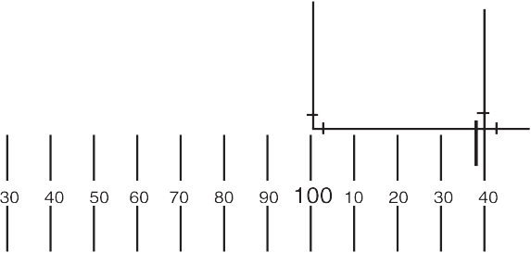

**Figure 10 —** Measuring metric drawings

The distance between the dimension lines is 40 mm. Since the scale is 1:50, the centre to centre length is:

40 mm × 50 = 2000 mm

If the scale had been 1:100, the length would be 40 mm × 100 = 4000 mm.

Follow the same procedure to determine approximate lengths from imperial scale drawings. An imperial tape measure is used in the same way to find a length on the drawing in inches. As an example, suppose the length is 71/2". To find the length represented, use the scale of the drawing.

In every case, if you divide the length on the drawing by the scale fraction or number, you will be calculating the length in feet. Since dividing by a fraction is the same as multiplying by its reciprocal, you multiply the drawn length in inches by:

4 when the scale is 1/4" = 1'-0" 8 when the scale is 1/8" = 1'-0" 2 when the scale is 1/2" = 1'-0"

**The reciprocals of all standard scales used by architects are shown in Figure 11.**

|  |  |  |  |  |  |  |  |  |  |  |
| --- | --- | --- | --- | --- | --- | --- | --- | --- | --- | --- |
| **Scale** | 3/32 | 1/8 | 3/16 | 1/4 | 3/8 | 1/2 | ¾ | 1 | 1 1/2 (3/2) | 3 |
| **Reciprocal** | 32/3 | 8 | 16/3 | 4 | 8/3 | 2 | 4/3 | 1 | 2/3 | 1/3 |

**Figure 11 —** Reciprocals of standard scales

The 71/2" length on a drawing scaled 1/4" = 1'-0" would represent 7 1/2" × 4 = 30'.

On a scale of 3/8" = 1'-0", the same 7 1/2" drawing length would represent 71/2" × 8/3 = 20'.

**Figure 12 —** Reading lengths of piping runs

Figure 12 is part of a piping run drawn to the scale of 1/8"= 1' -0". The total length of the run is 41/4" × w8 = 34".

Now complete the Learning Task Self-Test.

#### Self-Test 3

1. Scale rulers are available in both imperial and metric.
   1. True
   2. False
2. Which scale ruler would be most likely to have a 1/4" to 1' scale on it?
   1. Metric scale ruler
   2. Architect’s scale ruler
   3. Civil engineer’s scale ruler
   4. Mechanical engineer’s scale ruler
3. How many scale ratios per edge do metric scale rulers have?

|  |  |
| --- | --- |
| a. | 1 |
| b. | 2 |
| c. | 3 |
| d. | 4 |

1. What is the best way to get exact dimensions from a drawing?
   1. Measure using a tape measure.
   2. Exact dimensions aren’t important.
   3. Scale it with your combination square.
   4. Use the dimension written between the dimension lines.
2. If a line measures 41/2 ", what is the equivalent in ¼"=1' scale?
   1. 9"

b. 18'

c. 9'

d. 18"

1. If a line measures 6 3/8", what is the equivalent in 1/8" = 1' scale? a. 27"

b. 48'

c. 4'3"

d. 51'

1. What is the measurement of the line below?

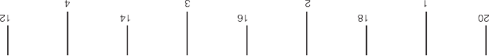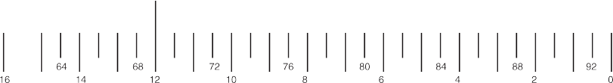

a. 68'

b. 6'3"

c. 80'

d. 12'6"

1. What is the measurement of the line below?

20

22

24

26

28

0

4

3

2

1

a. 1'3"

9

6

3

0

b. 1'6"

c. 27'3"

d. 27'6"

1. What is the measurement of the line below?

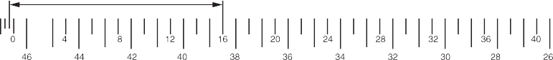

a. 16'2"

b. 16'4"

c. 16'6"

d. 16'9"

1. What is the measurement of the line below?

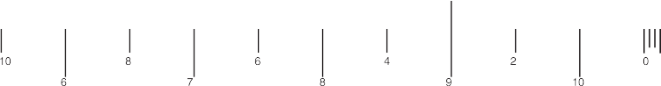

a. 3'4"

b. 3'7"

c. 9'4"

d. 13'7"

1. What is the measurement of the line below?

1:100

10

9

8

7

6

5

4

3

2

1 m

* 1. 35 mm

6

5.5

5

4.5

4

3.5

* 1. 3.5 m
  2. 35 m
  3. 350 m

1. What is the measurement of the line below?

1:20

0

0.5

1 m

1.5

2

2.5

22

21

20

19

18

17

16

15

14

13

a. 0.19 m

1. 1.9 m
2. 19 m
3. 190 m
4. What is the measurement of the piping run below in 1/2"=1' scale?

a. 8'6"

b. 10'6"

c. 17'

d. 34'

LEARNING TASK 4

**Describe drawing projections**

Architectural drawings are made according to a set of conventions, which include particular views (floor plan, section, etc.), sheet sizes, units of measurement and scales, annotation, and cross-referencing.

### Types of views used in drawings

The two main types of views (or “projections”) used in drawings are:

* pictorial
* orthographic

##### Pictorial views

Pictorial views show a 3-D view of how something should look when completed. There are three types of pictorial views:

* perspective
* isometric
* oblique

###### Perspective view

A perspective view presents a building or an object just as it would look to you. A perspective view has a *vanishing point*; that is, lines that move away from you come together in the distance. For example, in Figure 1, we see a road and line of telephone poles. Even though the poles get smaller in their actual measurement, we recognize them as being the same size but more distant.

**Figure 1 —** Perspective view

###### Isometric view

An isometric view is a three-dimensional view. The plumb lines are vertical. The horizontal lines are set at 30 degree angles from a line parallel to the bottom of the page. Isometric views have no vanishing point, so the objects do not appear as they would in a perspective view.

Lengths are exact on isometric drawings only when the item is parallel to one of the axes of the drawing. Figure 2 shows an isometric view of a simple object, as well as the lines that represent the three dimensions.

30º

30º

**Figure 2 —** An isometric view

###### Oblique view

An oblique view is similar to an isometric view, except that the face or front view is drawn to exact scale and the oblique lines are extended at a 30 degree to 45 degree angle to create a three-dimensional representation (Figure 3).

45º

**Figure 3 —** Oblique view of the object in Figure 2

##### Multi-view (orthographic) drawings

Pictorial drawings are excellent for presenting easy-to-visualize pictures to the viewer, but there are some problems. The main problem is that these drawings cannot be accurately drawn to scale. Also, they cannot accurately duplicate exact shapes and angles. As this information can be essential, another form of drawing is used, one that has several names, including *orthographic projection*, *third angle projection*, *multi-view projection*, and *working drawing*. Each projection is a view that shows only one face of an object, such as the front, side, top, or back. These views are not pictorial.

To interpret or read these drawings you must first understand how the views in a multi- view drawing are developed and how each view relates to the other views. The best way to

understand the principle of orthographic views is to suspend the object you wish to draw inside an imaginary glass box. If you were to look at the object through each side of the box and draw onto the glass the view of the object you see through the glass, you would end up with a sketch similar to that shown in Figure 4.

The view through each side of the glass box shows only the end view of one side of the object. All lines are straight and parallel because the original object has sides that are straight and parallel. Each view represents what you see when you look directly at the object.

**Figure 4 —** Multi-view through a glass box

If you were to open up the glass box, as shown in Figure 5, each view would be in the correct position for a true orthographic drawing. Each view is given a name that reflects its position in relation to the other views.

Top-side view

Front-side view

Rear-side view

Bottom-side view

Left-side view

Right-side view

**Figure 5 —** Box opened to produce orthographic views

When the imaginary glass box is flattened as shown in Figure 6, you can see that each view is in line with the adjacent view. Then the edges of the box are removed and you have a six-view

orthographic drawing of the original object (Figure 7). These six views are called the six principal orthographic views. This view alignment is important and is always consistent in orthographic projection. You will seldom need to show views of all six sides of an object; usually it is sufficient to show just two or three. You should remember the names of these six views and understand how they are obtained in case you ever need to show an object that cannot be truly represented in two or three views.

|  |  |  |  |
| --- | --- | --- | --- |
|  | | Top (plan) view |  |
| Back view | Left view (elevation) | Front-side view (elevation) | Right view (elevation) |
|  | | Bottom view |  |

**Figure 6 —** Drawing with the glass box flattened out

Top (plan) view

Back view

Left view (elevation)

Front-side view

(elevation)

Right view (elevation)

Bottom view

**Figure 7 —** Orthographic views of the object in Figure 2

Unless the object is very complex, only the front, top, and right-side views are necessary. If the object has a uniform thickness, only one or two views are necessary. You should not show more views than are necessary. The front, left, back, and right views are also referred to as elevations.

###### Floor plan

A floor plan (or floor drawing) is an orthographic plan view (or top view) looking down on the various floor levels. Floor plans are one of the most important drawings for construction, as they provide the most information about the building. Floor plans identify rooms by name or number. They give the:

* room dimensions
* overall dimensions
* doorways
* windows
* plumbing fixtures
* equipment
* location of structural members and walls

Figure 8 shows the floor plan for the main floor of a house.

F

Up

Down

R

Bedroom #2

Dining area

Bath

Living room

Master bedroom

**Figure 8 —** Main floor plan of a house

###### Elevation drawings

An elevation drawing (called an elevation) is a view of any vertical surface and is taken from the floor plans (Figure 9). Normally, elevation drawings include the front, back, and side

orthographic projections of the buildings. The elevation drawings show what the exterior of the building will look like when it is finished. The drawings show the finished grade line, the finish materials, and the door and the window locations. Elevation drawings may also show interior walls that have special features, such as fireplaces or kitchen cabinets.



3

1

Roof slope

600

Siding or optional finish

Flashing

Flashing

Approx. finish grade

**Figure 9 —** Left elevation of house in Figure 8

###### Section plan

Section drawings (called sections) provide detailed drawings of the cross-section of a building or wall unit (Figure 10). The scale of these drawings is large (about 1:20), which allows different structural members to be drawn so that the construction details are seen clearly.

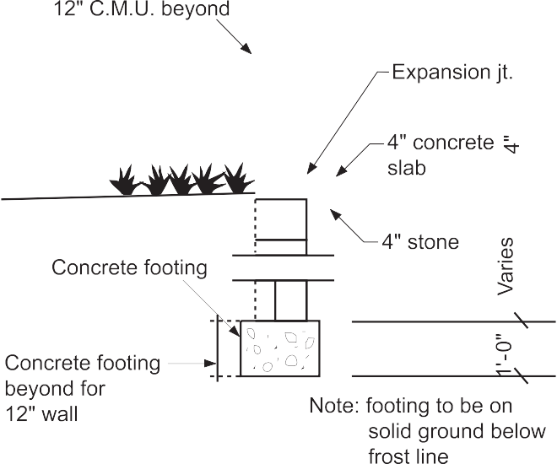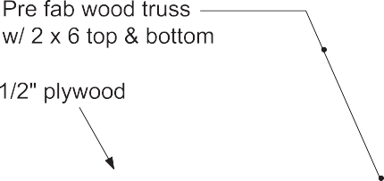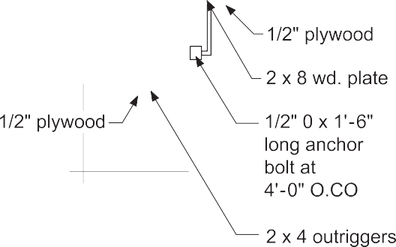

**Figure 10 —** Section A-A

Sectional views give information about wall construction and exterior and interior wall finish. To avoid any confusion, the precise location or cut of a sectional view is given in another drawing, such as detail drawing or a floor plan. For example, the reference in the lower left-hand corner of Figure 11 shows the location of the section in Figure 10. The line drawn through the wall indicates the point and span of the cut and the arrows indicate the direction of view.



This cross-section

is shown as “A-A” in Figure 10

**Figure 11 —** Section A-A

###### Measurements on orthographic drawings

To get all of the measurements required, you will need to refer to more than one view. For example, you cannot take elevation measurements from a plan view.

Now complete the Learning Task Self-Test.

**Self-Test 4**

1. A perspective drawing is one form of which type of view?
   1. Oblique
   2. Pictorial
   3. Isometric
   4. Orthographic
2. At what angle should isometric drawings have horizontal lines drawn? a. 15°

b. 30°

c. 45°

d. 60°

1. What do perspective drawings always have?
   1. Scale
   2. Dimensions
   3. Hidden lines
   4. Vanishing points
2. At what angles should oblique drawings have lines drawn? a. 0°–15°

b. 15°–30°

c. 30°–45°

d. 45°–60°

1. Orthographic projection drawings are three-dimensional drawings.
   1. True
   2. False
2. What is a common name for a top view in an orthographic drawing?
   1. Plan view
   2. Down view
   3. Ceiling view
   4. Elevation view

|  |  |  |
| --- | --- | --- |
|  |  | |
|  | | |
|  |  |  |

1. In orthographic projection, how many views are most commonly shown?

|  |  |
| --- | --- |
| a. | 1 |
| b. | 2 |
| c. | 3 |
| d. | 4 |

1. In the diagrams below, match letters A to L with numbers 1 to 12.

A

B

C

D

E

F

G

H

I

J

K

L

|  |  |  |  |
| --- | --- | --- | --- |
| 1 | 2 | 3 | 4 |
| 5 | 6 | 7 | 8 |
| 9 | 10 | 11 | 12 |

1. What is a top view called in a construction drawing?
   1. Plan view
   2. Floor plan
   3. Floor detail
   4. Building plan
2. What are drawings called that show door and window locations, and other exterior finishes of a building?
   1. Wall drawings
   2. Front drawings
   3. Exterior drawings
   4. Elevation drawings

LEARNING TASK 5

**Interpret mechanical drawings**

Interpreting drawings requires the ability to visualize and the ability to interpret what is being drawn and written. The drawing should be studied carefully before beginning any work. The reader should attempt to visualize what is being shown on the drawing and how it will be built. Mistakes can be made when the tradesperson does not take the time to become fully familiar with the drawing.

### Basic layout of a drawing

The layout of most drawings is similar in that the drawing format has some standard features or components. A typical drawing format will include some or all of these features:

* title block
* bill of materials or material list
* area where the job specifications are listed
* general notes
* reference drawing list
* revision chart

These drawing components are common for some types of drawings; however, other components may be used to show the necessary information for the complete design.

Each of the listed drawing components serves a specific purpose and contains information about the job and its specifications (Figure 1).

Detailed view of object

View of object

View of object

General notes

Bill of materials

Title block

Reference drawings

Specifications

Revision chart

**Figure 1 —** Drawing format

The following information is a guideline to use each time a new drawing is observed.

##### Title block

The title block is located in the lower right corner of the drawing and is separated from the main drawing. The contents of the title block will vary from company to company and often differ from drawing to drawing by the same company. As a standard feature, a company will have its name and logo in the title block along with other standard company information, plus particular information such as the customer’s name.

The following information can be located in the title block; however, note that not all of the items listed below are necessarily included:

* + job title
  + name of the item to be fabricated or installed
  + name of the customer
  + name of the designing engineer or firm
  + name or initial of draftsperson and checker
  + date drawn
  + drawing number
  + contract number or job number
  + number of revisions, if any, for the drawings
  + scale of the drawing

##### Bill of materials

The bill of materials is usually located in the upper right corner of the drawings, above the title block. As with the title block, the bill of materials is separated from the rest of the drawing and is essentially a table with partitioned rows and columns showing:

* + item number or mark number
  + quantity
  + material description
  + material grade
  + material weight
  + remarks

##### Revision chart

The revision chart is often located to the left of the title block and is bordered off from the rest of the drawing. The revision chart, like the bill of materials, is divided into rows and columns. These columns identify the revision number and give a general description of the revision, who checked the revision, and the date of the revision. It is important to make sure that you are working from the latest revision, as it is not uncommon for changes to be made from the original drawing.

##### Drawing specifications

The specifications section of a drawing is used to list all the design information of the item being built or installed. This section is often located to the left of the revision chart. If drawing space is a problem, it may be located elsewhere. A common location is the area below the bill of materials. (The contents of specifications are covered in more detail later.)

##### Drawing notes

Drawings will often contain two types of notes: general and specific. The general and specific notes should not be confused with the information found in the bill of materials, title block, revision chart, or the drawing specifications.

The general notes are usually located in the upper left corner of the drawing. A general note is information about the fabrication that refers to similar items or procedures throughout the drawing. Specific notes can be found anywhere on the drawing as needed and are most often written with a leader line pointing to the relevant part or area.

##### Reference drawings

A job requiring more than one drawing is called a *drawing set*, and it contains two or more drawings. It is a common practice to have a list of all of the drawings that make up the drawing set. This listing is referred to as the *reference drawings* for the project.

Often work being shown on one drawing requires you to look at or reference other drawings in the set. There is no specific area where the reference drawings are listed; however, two

common locations are near the bottom of the print on the far left-hand side, and just below the bill of materials.

### Specifications

Specifications in North America form part of the contract documents that accompany and govern the construction of a building. Specifications are written descriptions of the materials and procedures that must be used in constructing a building or system.

These specifications translate working drawings into words to ensure that systems will be neither overdesigned nor underdesigned. They tell the contractor exactly which materials must be used.

Aside from serving as a manual on how to do the job, the book of specifications has another function: it is a legal document outlining each contractor’s obligations. These obligations may include the need to provide fire insurance, to pay for municipal inspections, or to complete the job by a certain deadline.

Specifications are divided into 50 divisions of construction information as defined by the Construction Specifications Institute’s (CSI’s) MasterFormat. Before 2004, MasterFormat consisted of 16 divisions. MasterFormat is the most widely used standard for organizing specifications

and other written information for commercial and institutional building projects in the United States and Canada. It provides a master list of divisions, and section numbers and titles within each division, to follow in organizing information about a facility’s construction requirements and associated activities. Standardizing the presentation of such information improves communication among all parties involved in construction projects.

**For more information about the 50 CSI divisions, go to:**

[**http://en.wikipedia.org/wiki/MasterFormat**](http://en.wikipedia.org/wiki/MasterFormat)

Now complete the Learning Task Self-Test.

#### Self-Test 5

1. Where is the scale of a drawing found?
   1. In the revisions
   2. In the title block
   3. In the specifications
   4. In the bill of materials
2. The specifications of a drawing serve as a legal contract for the job.
   1. True
   2. False
3. Where on a drawing would information on material grade be found?
   1. In the title block
   2. In the specifications
   3. In the revision chart
   4. In the bill of materials
4. Specifications are a written description of a construction project.
   1. True
   2. False
5. What should the title block on a drawing always include?
   1. Title
   2. Date
   3. Name of the draftsperson
   4. All of the above

LEARNING TASK 6

**Creating drawings and sketches**

Freehand sketching is a very useful skill that can be mastered with practice and by following a few guidelines. The ability to interpret drawings is complemented by the ability to sketch

information from a drawing to take to your work location. Sketching is also a valuable tool when no drawing is available and you need to communicate job information to someone else.

For freehand sketching, you require a pad of graph paper (8 1/2" × 11" sheets with a 5 mm or 1/4" grid), a sharp HB pencil, and an eraser. Do not begin any sketch with a dull pencil.

### Sketching technique

Sketching provides a quick and simple way to express ideas and to communicate the shape and general size of an object.

##### Sketching parallel lines

Start by drawing lines that are parallel to the edges of the paper, such as a border line and title block. Use your finger as a guide when you draw along the grid line on the sketch pad (Figure 1). If you let the end of your little finger run down the edge of the paper pad as you draw, this will steady your hand and make it easier to get a straight line.

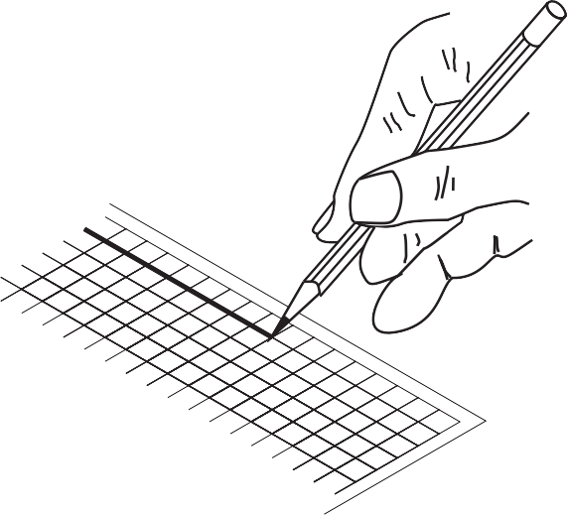

**Figure 1 —** Sketching a parallel vertical line

##### Sketching non-parallel lines

When you are sketching lines that are not parallel to the sides of the paper, turn the paper around so that the line you wish to draw is either straight up and down in front of you or straight across the sheet of paper.

It is much easier to draw lines this way, rather than at an angle across the sheet. Let the side of your little finger rest on the paper as you draw. This will help you steady your hand (Figure 2).

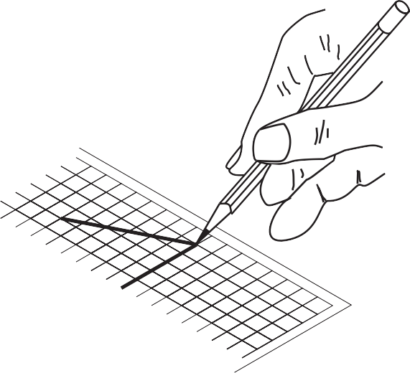

**Figure 2 —** Sketching a horizontal line

##### Sketching a rectangle

Locate the corners of the rectangle first. Then place your paper in a comfortable position for sketching and sketch downward for vertical lines and left to right for horizontal lines. Use the grid lines as a guide to maintain lines parallel and at 90 degrees to each other (Figure 3).

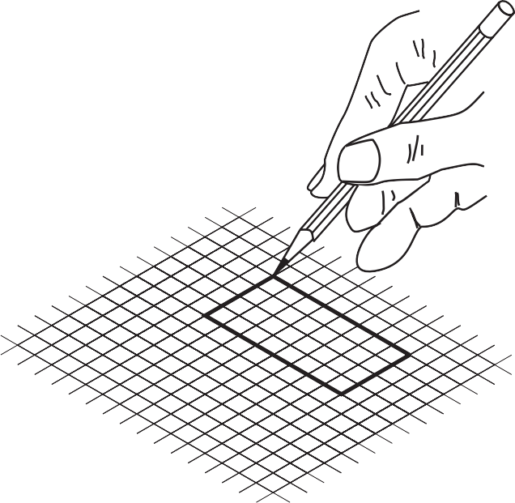

**Figure 3 —** Sketching a rectangle

##### Sketching a circle

First, locate the centre of the circle (Figure 4), and then very lightly box in the size of the circle (using the diameter as a guide), as in the top right. Sketch in the circle, one quarter at a time, as shown in the bottom row, left to right. You may find it necessary at first to add light points along the projected circumference to help guide you through each quarter. Remember to move your sketch pad so that you can maintain a comfortable sketching position.

**Figure 4 —** Sketching a circle

##### Sketching to approximate scale

In Figure 5, the full-size square is on the left. The centre square is half size, and the right square is quarter size. Note that centre and right squares are the same shape as the left square, only smaller.

Full size Half size Quarter size

**Figure 5 —** Sketching to scale

When you are sketching freehand, your sketches should reflect the true shapes of objects as much as possible. If you use grid paper, it is not difficult to sketch to an approximate scale. Assume that the object in Figure 6 is shown full size. As it is necessary to show all orthographic

views on the same sheet of paper, the views must be scaled. Figure 7 shows the views at approximately one-half the original size.

**Figure 6 —** Full-size isometric object

|  |  |  |  |  |  |  |  |  |  |  |  |  |  |  |  |  |  |  |
| --- | --- | --- | --- | --- | --- | --- | --- | --- | --- | --- | --- | --- | --- | --- | --- | --- | --- | --- |
|  |  |  |  |  |  |  |  |  |  |  |  |  |  |  |  |  |  |  |
|  |  |  |  |  |  |  |  |  |  |  |  |  |  |  |  |  |  |  |
|  |  |  |  |  |  |  |  |  |  |  |  |  |  |  |  |  |  |  |
|  |  |  |  |  |  |  |  |  |  |  |  |  |  |  |  |  |  |  |
|  |  |  |  |  |  |  |  |  |  |  |  |  |  |  |  |  |  |  |
|  |  |  |  |  |  |  |  |  |  |  |  |  |  |  |  |  |  |  |
|  |  |  |  |  |  |  |  |  |  |  |  |  |  |  |  |  |  |  |
|  |  |  |  |  |  |  |  |  |  |  |  |  |  |  |  |  |  |  |
|  |  |  |  |  |  |  |  |  |  |  |  |  |  |  |  |  |  |  |
|  |  |  |  |  |  |  |  |  |  |  |  |  |  |  |  |  |  |  |
|  |  |  |  |  |  |  |  |  |  |  |  |  |  |  |  |  |  |  |
|  |  |  |  |  |  |  |  |  |  |  |  |  |  |  |  |  |  |  |
|  |  |  |  |  |  |  |  |  |  |  |  |  |  |  |  |  |  |  |

**Figure 7 —** Scale orthographic projections

### Make isometric sketches of simple rectangular objects

Isometric sketches are useful because they are easy to draw and clearly represent an object or system. This clarity comes from using directional lines to represent the three dimensions of length, width, and height, much like a picture.

##### Construction methods

The following steps explain how to draw an isometric cube. The three dimensions of length, width, and height are drawn along the isometric axes shown in Figure 8. The lengths of objects running parallel to these axes can be drawn to scale. Lines at other angles will not be to scale.

Height

Width

Length

**Figure 8 —** Isometric axes

Draw a small star-shaped axis on the bottom corner of your grid paper. The sloping axes should be drawn at a 30° degree angle from the horizontal grid line. The vertical axis of the star indicates height (H) or depth (D), and the two sloping axes indicate the length (L) and the width (W) of the rectangle. The vertical axis can be used as a guide when making lines on your drawing. Notice we have labelled the points on the star in Figure 9. These labels can change depending on the view that you may want when drawing a stationary object. The bottom two horizontal points indicate the view that is being drawn. In this case we would be creating a front-right view.

Top or plan

Left Back

30º 30º

Front Right

Bottom

**Figure 9 —** Step 1: Isometric guide for front-right view

Sketch the top of the block by drawing two lines, one parallel to L and one parallel to W (Figure 10).

L

W

D

**Figure 10 —** Step 2: Isometric view of top surface of a rectangular block

Sketch two lines, one parallel to L and one parallel to D as shown in Figure 11.

L

W

D

**Figure 11 —** Step 3: Lines parallel to L and D

Sketch two lines, one parallel to W and one parallel to D, to complete the outline of the rectangular block as shown in Figure 12. Begin with light construction lines so that you can make any necessary adjustments before darkening them. The finished isometric sketch is shown in Figure 13.

L

W

D

**Figure 12 —** Step 4: Completed outline of rectangular block

Top

Front

Right

**Figure 13 —** Completed isometric sketch

##### Sketching irregular shapes with isometric lines

Not all rectangular objects are as simple as the block you have just sketched. Sometimes the shapes are irregular and have cut-out sections or some sides longer than others. All rectangular objects can be fitted into a box having the maximum length (L), width (W), and depth (D). Begin by sketching a light outline of a basic box that is the size of the object to be drawn.

As an example, consider the object shown in the three-view orthographic sketch in Figure 14. To produce an isometric sketch of this object, you need to find the maximum L, W, and D for the containing box (Figure 14). In this case:

L = 5 grid spaces W = 3 grid spaces D = 3 grid spaces

Top

|  |  |  |  |  |  |  |  |  |
| --- | --- | --- | --- | --- | --- | --- | --- | --- |
|  |  |  |  |  | W = 3 | | | |
|  |  |  |  |  |
|  |  |  |  |  |
| L = 5 | | | | | H = 3 |  | | |
|  |  | | | |  |  |  |
|  |  |  |  |  |  |  |  |
|  |  |  |  |  |  |  |  |

Side

**Figure 14 —** Orthographic views

Front

Sketch a light outline of the basic rectangular box to the required size, as shown in Figure 15.

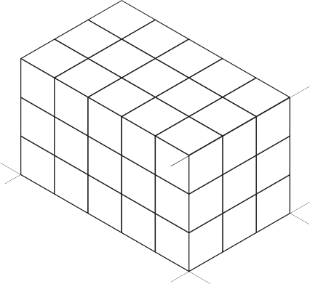Top

D = 3 units

Front

L = 5 units

Side

W = 3 units

**Figure 15 —** Basic outline

The front view shows the outline most clearly. Place this view on the front surface of the isometric box. Use the dimension given in the front view of Figure 14 and mark the number of units indicated along the axes L and D (Figure 16).

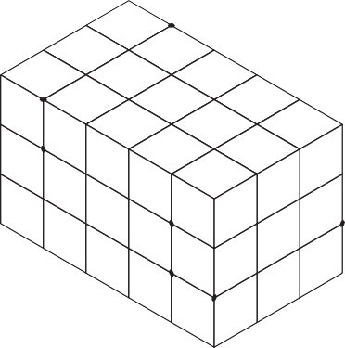

**Figure 16 —** Location of marks on axes

Lightly sketch lines parallel to the L and D axes from the marked points on the front surface (Figure 17). The step outline is drawn more heavily to emphasize the profile of the object, once you are sure your sketch is correct.

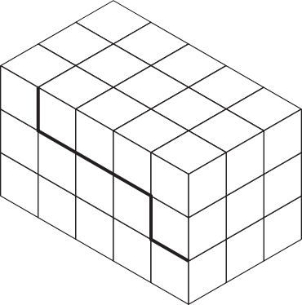

**Figure 17 —** Location of main features

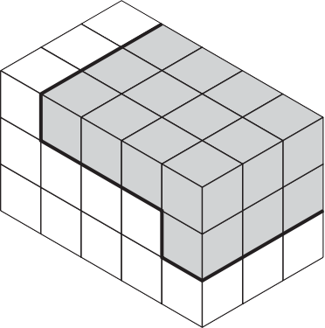

1

2

3

4

5

7

6

**Figure 18 —** Location of outer surfaces

Sketch in a series of lines parallel to the axes (L, W, and D) from the corners numbered 1 to 7 (Figure 18). These lines establish the stepped outline as shown in Figure 19.

When you are sure your isometric sketch is correct, erase all unnecessary construction lines and darken the object lines. Your completed sketch of the rectangular object should be similar to that in Figure 20.

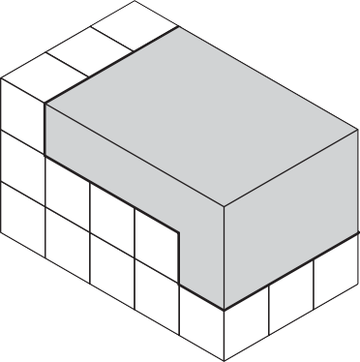

1

2

3

4

5

7

6

**Figure 19 —** Internal features

**Figure 20 —** Completed sketch

### Sketching figures with non-isometric lines

Figure 21 shows an object that is basically rectangular but has one face machined at an angle. You can easily construct an isometric sketch of the basic rectangular block. To show the machined face, it is necessary to plot the appropriate points of intersection and join those points to produce the correct angle.

W = 4 units

|  |  |  |  |  |  |
| --- | --- | --- | --- | --- | --- |
|  | | | |  |  |
|  |  |
|  |  |
|  |  |
| L = 6 units | | | | | |
|  | | | |  |  |
|  |  |  |  |  |  |
|  |  |  |  |  |  |

D = 3 units

**Figure 21 —** Rectangle with face machined at an angle

Sketch a light outline of the basic rectangular block, using the size measurements given in Figure 21. Mark the number of units indicated along the length (L) and the depth (D), as shown in Figure 22.

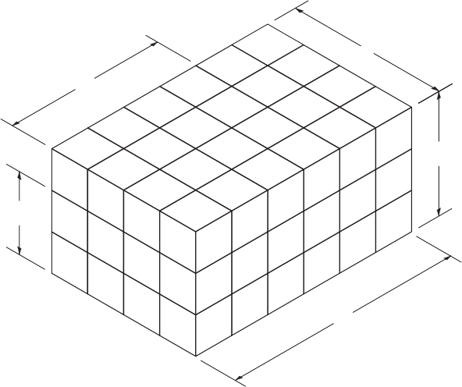Lightly sketch lines parallel to the original block outlines from the marked points on the front and side surfaces, as shown in Figure 23.

4

4

3

**Figure 22 —** Rectangle with units marked along L and D

6

2

3

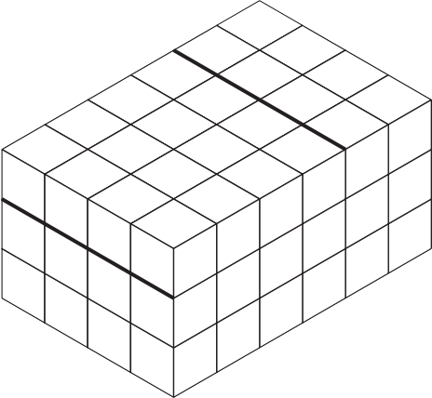

1

2

4

**Figure 23 —** Lines sketched parallel to original block outline

Join the two points on the front face and the two ends of the lines you have just sketched across the object (Figure 24). Once you are sure your sketch is correct, erase the light lines that originally outlined the block and darken the outline of the completed block as shown in Figure 25.

3

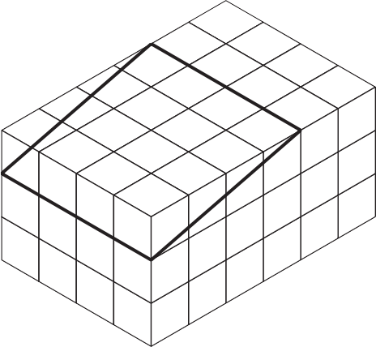

1

2

4

**Figure 24 —** Front face

**Figure 25 —** Completed block

PRACTICAL COMPETENCY 1

**Make orthographic sketches**

Use sketching techniques to produce orthographic sketches of the following figures. For the purposes of these exercises, do not be concerned with dimensions. Concentrate on producing good, dark outlines, good circular shapes, and correctly drawn hidden and centre lines.

* + 1. Sketch one orthographic view of the object shown pictorially in Figure 1. Remember that the holes in the gasket are circular (not elliptical as they appear in the three-dimensional sketch shown). Add a title block with the following:

Title: Gasket

Sk. No.: D-1/031

Sk. by: (your name) Date: (today’s date)

**Figure 1 —** Gasket

|  |  |  |  |  |  |  |  |  |  |  |  |  |  |  |  |  |  |  |
| --- | --- | --- | --- | --- | --- | --- | --- | --- | --- | --- | --- | --- | --- | --- | --- | --- | --- | --- |
|  |  |  |  |  |  |  |  |  |  |  |  |  |  |  |  |  |  |  |
|  |  |  |  |  |  |  |  |  |  |  |  |  |  |  |  |  |  |  |
|  |  |  |  |  |  |  |  |  |  |  |  |  |  |  |  |  |  |  |
|  |  |  |  |  |  |  |  |  |  |  |  |  |  |  |  |  |  |  |
|  |  |  |  |  |  |  |  |  |  |  |  |  |  |  |  |  |  |  |
|  |  |  |  |  |  |  |  |  |  |  |  |  |  |  |  |  |  |  |
|  |  |  |  |  |  |  |  |  |  |  |  |  |  |  |  |  |  |  |
|  |  |  |  |  |  |  |  |  |  |  |  |  |  |  |  |  |  |  |
|  |  |  |  |  |  |  |  |  |  |  |  |  |  |  |  |  |  |  |
|  |  |  |  |  |  |  |  |  |  |  |  |  |  |  |  |  |  |  |
|  |  |  |  |  |  |  |  |  |  |  |  |  |  |  |  |  |  |  |
|  |  |  |  |  |  |  |  |  |  |  |  |  |  |  |  |  |  |  |
|  |  |  |  |  |  |  |  |  |  |  |  |  |  |  |  |  |  |  |
|  |  |  |  |  |  |  |  |  |  |  |  |  |  |  |  |  |  |  |
|  |  |  |  |  |  |  |  |  |  |  |  |  |  |  |  |  |  |  |
|  |  |  |  |  |  |  |  |  |  |  |  |  |  |  |  |  |  |  |
|  |  |  |  |  |  |  |  |  |  |  |  |  |  |  |  |  |  |  |
|  |  |  |  |  |  |  |  |  |  |  |  |  |  |  |  |  |  |  |
|  |  |  |  |  |  |  |  |  |  |  |  |  |  |  |  |  |  |  |

* + 1. Sketch two orthographic views (front view and top view), in the approximate scale of the object shown pictorially in Figure 2. Remember to place the views correctly and make sure that all hidden lines are clearly shown. Add a title block with the following:

Title: Stop piece Sk. No.: D-1/032

Sk. by: (your name) Date: (today’s date)

**Figure 2 —** Stop piece

|  |  |  |  |  |  |  |  |  |  |  |  |  |  |  |  |  |  |  |
| --- | --- | --- | --- | --- | --- | --- | --- | --- | --- | --- | --- | --- | --- | --- | --- | --- | --- | --- |
|  |  |  |  |  |  |  |  |  |  |  |  |  |  |  |  |  |  |  |
|  |  |  |  |  |  |  |  |  |  |  |  |  |  |  |  |  |  |  |
|  |  |  |  |  |  |  |  |  |  |  |  |  |  |  |  |  |  |  |
|  |  |  |  |  |  |  |  |  |  |  |  |  |  |  |  |  |  |  |
|  |  |  |  |  |  |  |  |  |  |  |  |  |  |  |  |  |  |  |
|  |  |  |  |  |  |  |  |  |  |  |  |  |  |  |  |  |  |  |
|  |  |  |  |  |  |  |  |  |  |  |  |  |  |  |  |  |  |  |
|  |  |  |  |  |  |  |  |  |  |  |  |  |  |  |  |  |  |  |
|  |  |  |  |  |  |  |  |  |  |  |  |  |  |  |  |  |  |  |
|  |  |  |  |  |  |  |  |  |  |  |  |  |  |  |  |  |  |  |
|  |  |  |  |  |  |  |  |  |  |  |  |  |  |  |  |  |  |  |
|  |  |  |  |  |  |  |  |  |  |  |  |  |  |  |  |  |  |  |
|  |  |  |  |  |  |  |  |  |  |  |  |  |  |  |  |  |  |  |
|  |  |  |  |  |  |  |  |  |  |  |  |  |  |  |  |  |  |  |
|  |  |  |  |  |  |  |  |  |  |  |  |  |  |  |  |  |  |  |
|  |  |  |  |  |  |  |  |  |  |  |  |  |  |  |  |  |  |  |
|  |  |  |  |  |  |  |  |  |  |  |  |  |  |  |  |  |  |  |
|  |  |  |  |  |  |  |  |  |  |  |  |  |  |  |  |  |  |  |
|  |  |  |  |  |  |  |  |  |  |  |  |  |  |  |  |  |  |  |

20

PRACTICAL COMPETENCY 2

**Make an orthographic three-view, fully dimensioned sketch of a simple object**

Sketch the necessary views of the object shown in the pictorial drawing below and dimension fully. Sketch to approximate scale to suit your sheet size.

20

Ø 10 mm DRILL THRU

20

50

100

60

20

70

50

Add a title block with the following:

Title: Clamp Bracket Sk. No.: D1/PC3

Sk. by: (your name) Date: (today’s date)

|  |  |  |  |  |  |  |  |  |  |  |  |  |  |  |  |  |  |  |
| --- | --- | --- | --- | --- | --- | --- | --- | --- | --- | --- | --- | --- | --- | --- | --- | --- | --- | --- |
|  |  |  |  |  |  |  |  |  |  |  |  |  |  |  |  |  |  |  |
|  |  |  |  |  |  |  |  |  |  |  |  |  |  |  |  |  |  |  |
|  |  |  |  |  |  |  |  |  |  |  |  |  |  |  |  |  |  |  |
|  |  |  |  |  |  |  |  |  |  |  |  |  |  |  |  |  |  |  |
|  |  |  |  |  |  |  |  |  |  |  |  |  |  |  |  |  |  |  |
|  |  |  |  |  |  |  |  |  |  |  |  |  |  |  |  |  |  |  |
|  |  |  |  |  |  |  |  |  |  |  |  |  |  |  |  |  |  |  |
|  |  |  |  |  |  |  |  |  |  |  |  |  |  |  |  |  |  |  |
|  |  |  |  |  |  |  |  |  |  |  |  |  |  |  |  |  |  |  |
|  |  |  |  |  |  |  |  |  |  |  |  |  |  |  |  |  |  |  |
|  |  |  |  |  |  |  |  |  |  |  |  |  |  |  |  |  |  |  |
|  |  |  |  |  |  |  |  |  |  |  |  |  |  |  |  |  |  |  |
|  |  |  |  |  |  |  |  |  |  |  |  |  |  |  |  |  |  |  |
|  |  |  |  |  |  |  |  |  |  |  |  |  |  |  |  |  |  |  |
|  |  |  |  |  |  |  |  |  |  |  |  |  |  |  |  |  |  |  |
|  |  |  |  |  |  |  |  |  |  |  |  |  |  |  |  |  |  |  |
|  |  |  |  |  |  |  |  |  |  |  |  |  |  |  |  |  |  |  |
|  |  |  |  |  |  |  |  |  |  |  |  |  |  |  |  |  |  |  |
|  |  |  |  |  |  |  |  |  |  |  |  |  |  |  |  |  |  |  |

PRACTICAL COMPETENCY 3

**Make isometric sketches**

Given the orthographic sketches shown of the two objects in 1 and 2, make isometric sketches of each object to the same scale as the object shown. Borders and title blocks are not necessary for these sketches.

1.

|  |  |  |  |  |  |
| --- | --- | --- | --- | --- | --- |
|  |  |  |  |  |  |
|  |  |  |  |  |  |
|  |  |  |  |  |  |
|  |  |  |  |  |  |

|  |  |  |  |  |  |
| --- | --- | --- | --- | --- | --- |
|  |  |  | | | |
|  |  |
|  |  |
|  |  | |  |  |  |

2.

|  |  |  |  |
| --- | --- | --- | --- |
|  |  |  |  |
|  |  |  |  |
|  |  |  |  |
|  |  |  |  |

|  |  |  |  |
| --- | --- | --- | --- |
|  |  | |  |
|  |  |  |  |
|  |  |  |  |
|  |  |  |  |

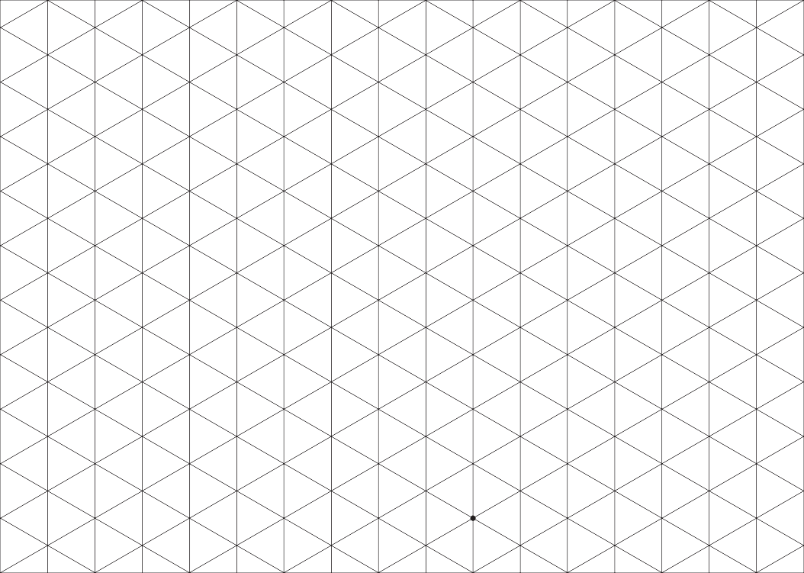

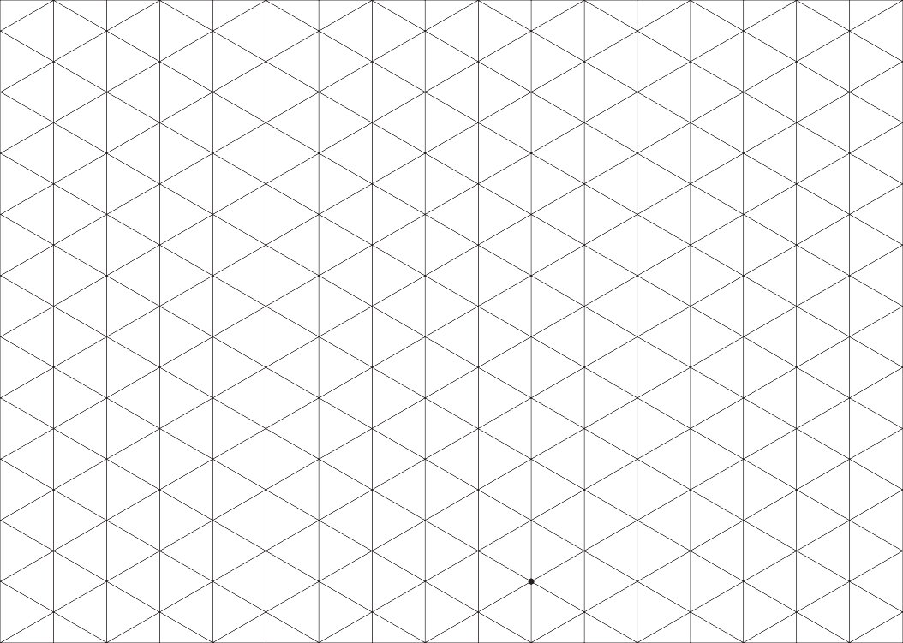

#### Answer Key

###### Self-Test 1

1. a. Vinyl
2. a. True
3. d. Drawing horizontal lines
4. a. To help you prevent smudges
5. a. True
6. c. Drawing vertical and angled lines
7. b. False
8. b. Measuring angles
9. d. Perpendicular
10. c. Drawing arcs and circles
11. c. To erase in a desired area
12. a. True
13. c. Scribing arcs on metal
14. c. To create drawings at a reduced scale

###### Self-Test 2

1. c. Object line
2. a. Centre line
3. c. Hidden line
4. a. True
5. b. False
6. a. Leader line
7. d. With a phantom line
8. d. Internal features of a part
9. d. Direction of observation when the section is drawn
10. a. Size dimensions

###### Self-Test 3

1. a. True
2. b. Architect’s scale ruler 3. a. 1

4. d. Use the dimension written between the dimension lines. 5. b. 18'

6. d. 51'

7. d. 12'6"

8. a. 1'3"

9. a. 16'2"

10. a. 3'4"

11. b. 3.5 m

12. b. 1.9 m

13. a. 8'6"

###### Self-Test 4

1. b. Pictorial 2. b. 30°

3. d. Vanishing points 4. c. 30°–45°

1. b. False
2. a. Plan view

7. c. 3

8. A. 10

* 1. 11
  2. 5
  3. 6
  4. 1
  5. 12
  6. 7
  7. 2
  8. 8
  9. 4
  10. 9
  11. 3

1. b. Floor plan
2. d. Elevation drawings

###### Self-Test 5

|  |  |  |
| --- | --- | --- |
| 1. | b. | In the title block |
| 2. | a. | True |
| 3. | d. | In the bill of materials |
| 4. | a. | True |
| 5. | d. | All of the above |

**The British Columbia Open Textbook Project**

The British Columbia Open Textbook Project is funded by the B.C. Ministry of Advanced Education, and managed by BCcampus, a publicly-funded organization that uses information technology to connect B.C. post-secondary institutions under a collaborative service delivery framework. The Open Textbook Project aims to make available

openly-licensed textbooks in the province’s high-impact subject areas. Visit open.bccampus.ca for more information.



7960003689

