Trades Access Common Core

**Line E: Electrical Fundamentals**

**Competency E-1: Describe the Basic**

**Principles of Electricity**

Image to be placed here.

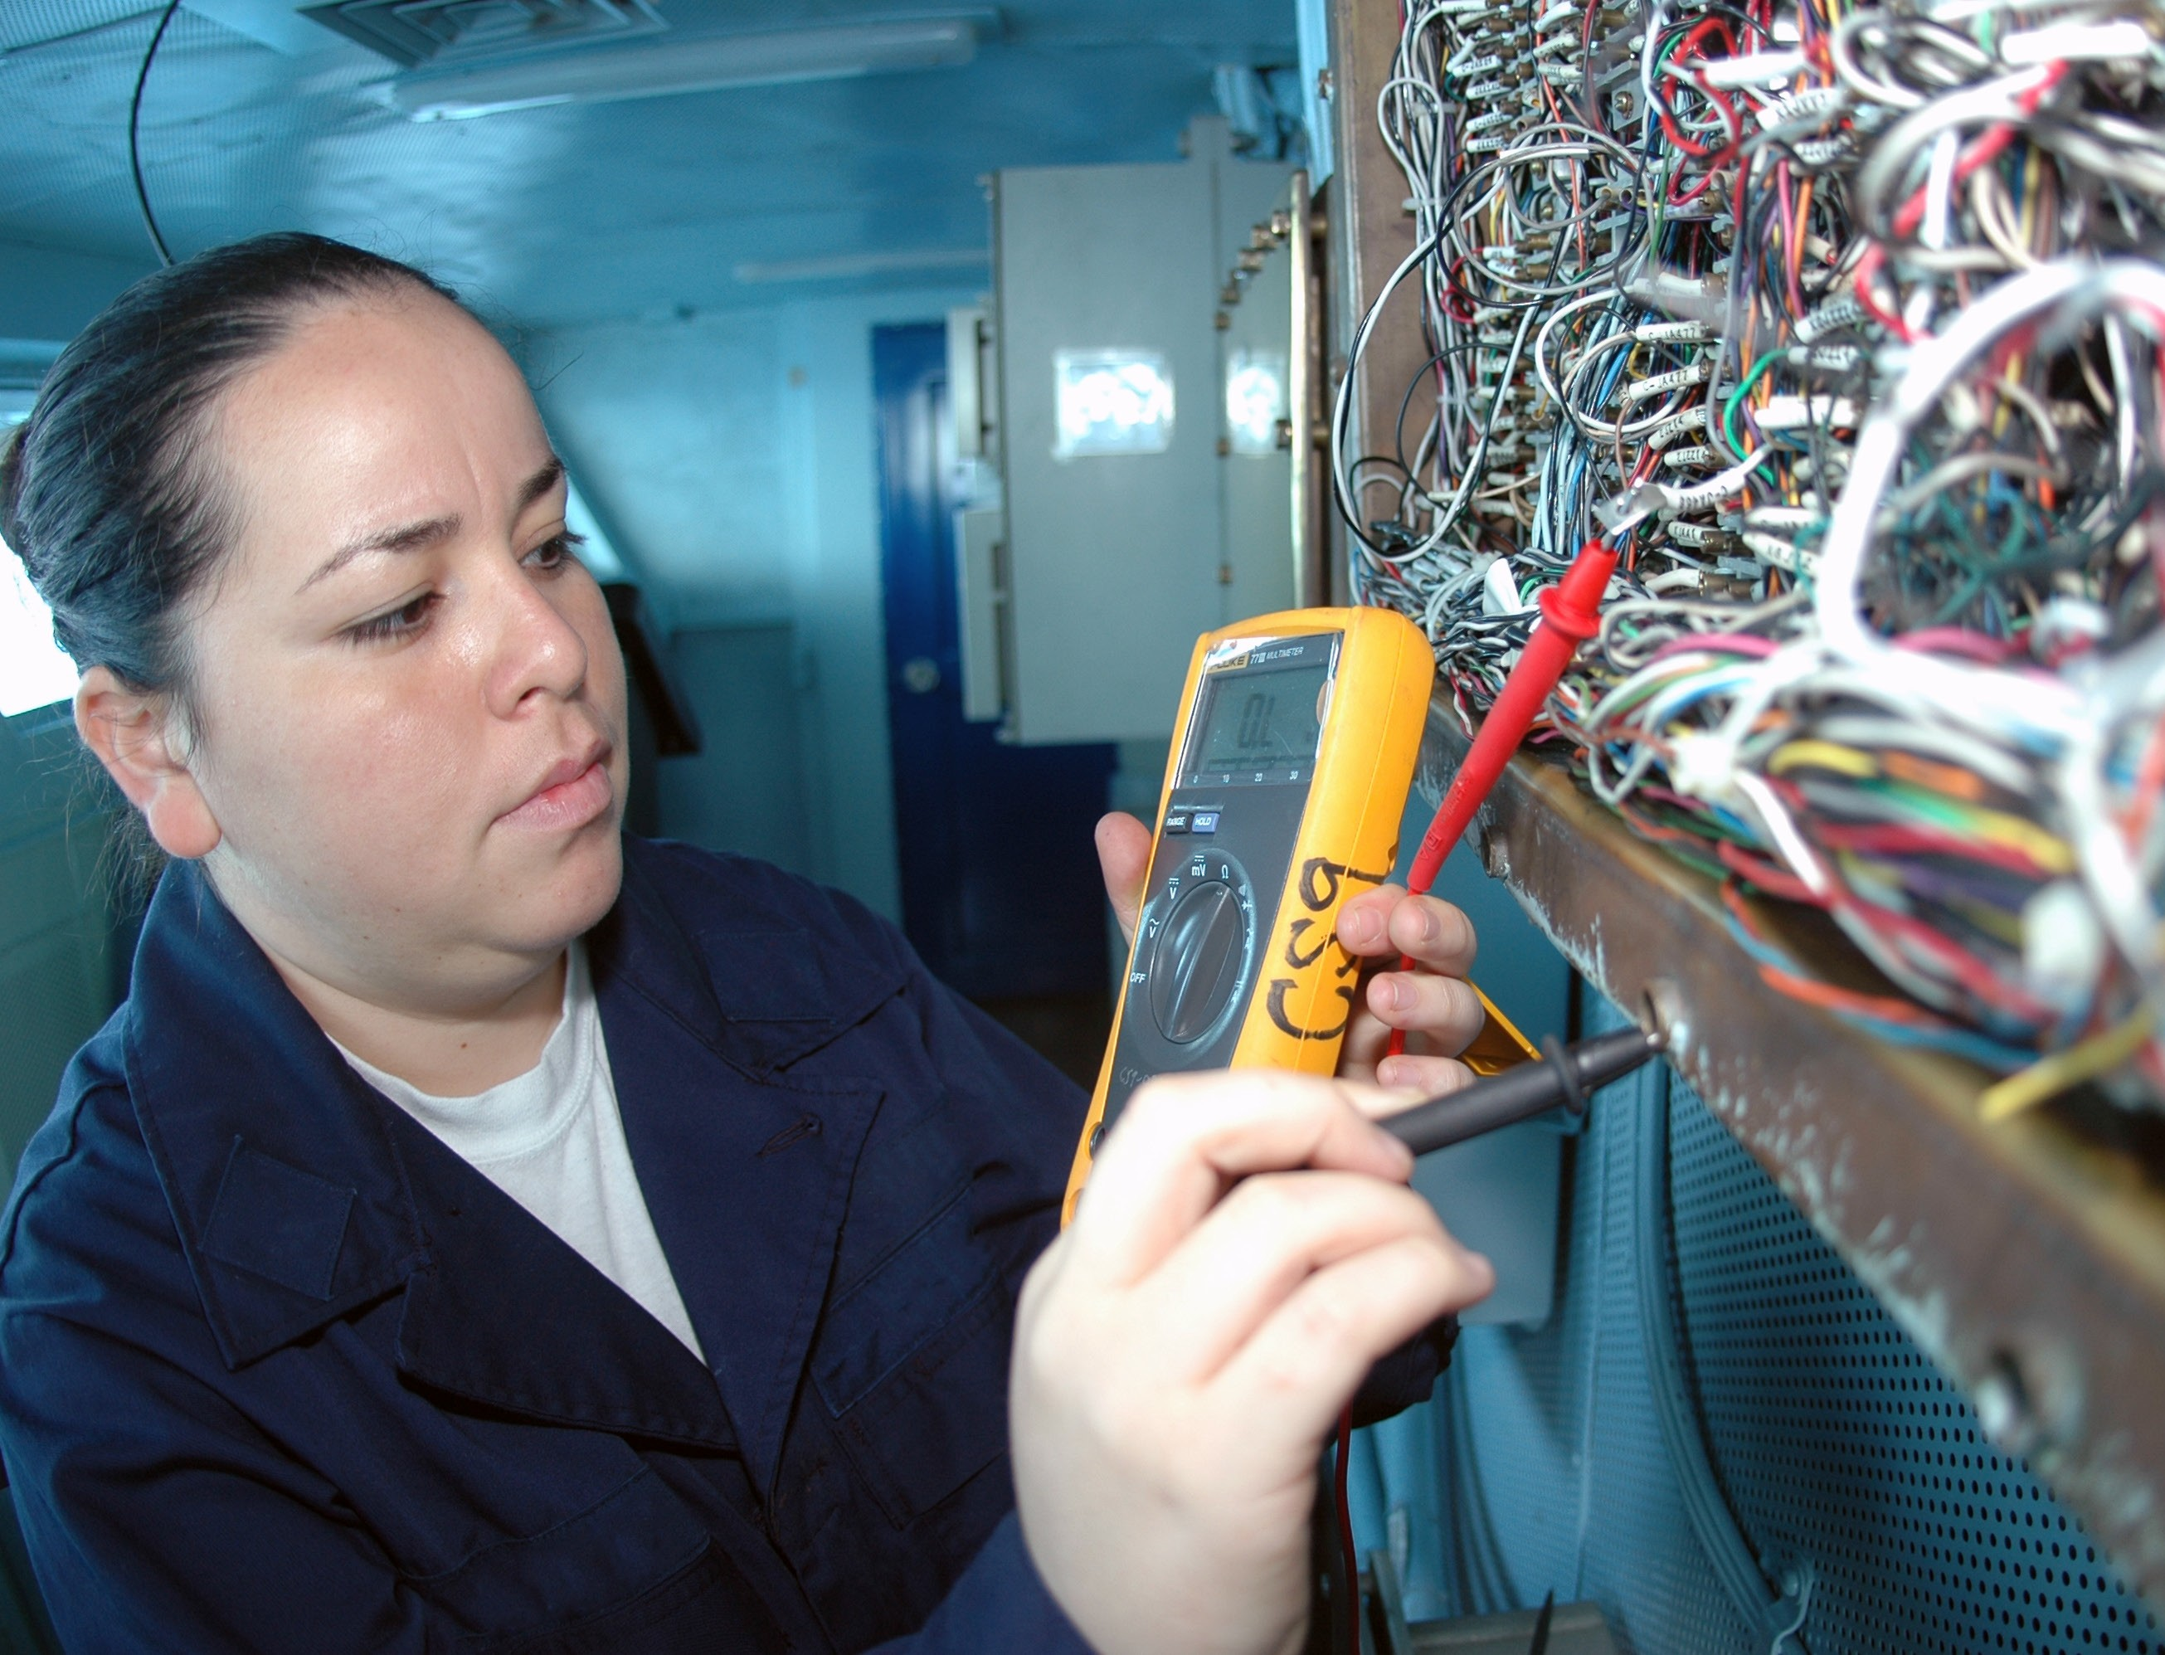

**B.C. Open Textbook Project**



OpenEd

open.bccampus.ca

**Trades Access**

COMMON CORE

Line E: Electrical Fundamentals Competency E-1: Describe the Basic Principles of

Electricity

##### Acknowledgments and Copyright

To learn more about BCcampus Open Textbook project, visit [http://open.bccampus.ca](http://open.bccampus.ca/)

© Camosun College. The Trades Access Common Core resources are licensed under the Creative Commons Attribution 4.0 Unported Licence ( <http://creativecommons.org/licenses/by/4.0/>), except where otherwise noted. Under this licence, any user of this textbook or the textbook contents herein must provide proper attribution as follows:

* If you redistribute this textbook in a digital format (including but not limited to EPUB, PDF, and HTML), then you must retain on every page the following attribution: Download for free at [http://](http://open.bccampus.ca/find-open-textbooks/)  [open.bccampus.ca/find-open-textbooks/](http://open.bccampus.ca/find-open-textbooks/)
* If you redistribute this textbook in a print format, then you must include on every physical page the following attribution: Download for free at <http://open.bccampus.ca/find-open-textbooks/>
* If you redistribute part of this textbook, then you must retain in every digital format page view (including but not limited to EPUB, PDF, and HTML) and on every physical printed page the following attribution: Download for free at <http://open.bccampus.ca/find-open-textbooks/>
* If you use this textbook as a bibliographic reference, then you should cite it as follows: BCcampus, Name of Textbook or OER. DATE. <http://open.bccampus.ca/find-open-textbooks/>.

For questions regarding this licensing, please contact [opentext@bccampus.ca](mailto:opentext@bccampus.ca)

All images copyright BC Industry Training Authority are licensed under the Creative Commons Attribution-NonCommercial-ShareAlike 4.0 licence.

<http://creativecommons.org/licenses/by-nc-sa/4.0/>

The issuing/publishing body is Crown Publications, Queen’s Printer, Ministry of Technology, Innovation and Citizens’ Services.

BCcampus would like to acknowledge the following individuals and organizations for their contributions in producing the Trades Access Common Core Open Textbook resources.

BCcampus

Open Education Team Hilda Anggraeni, Graphics

Camosun College

Olaf Nielsen, Chair, Trades Development and Special Projects, School of Trades and Technology Nannette Plant, Manager, Enterprise Point Operations & Special Projects, Office of the VP Strategic Development

Rod Lidstone, Instructor, Plumbing and Pipe Trades, Lead Writer/Reviewer Brian Coey, Instructor, Sheet Metal and Metal Fabrication, Writer/Reviewer Matt Zeleny, Camosun Innovates, 3D imaging

Open School BC

Monique Brewer, Director

Adrian Hill, Instructional Designer

Dennis Evans, Image Coordinator, Photographer, Graphics, Production Technician (layout) Farrah Patterson, Production Technician

Industry Training Authority of BC

The ITA works with employers, employees, industry, labour, training providers, and government to issue credentials, manage apprenticeships, set program standards, and increase opportunities in approximately 100 BC trades. Among its many functions are oversight of the development of training resources that align with program standards, outlines, and learning objectives, and authorizing permission to utilize these resources (text and images).

Erin Johnston, Director of Training Delivery Cory Williams, Manager, Industry Relations

Publishing Services, Queen’s Printer

Spencer Tickner, Director of QP Publishing Services Dwayne Gordon, Manager, Electronic Publishing

October 2015, Version 1

To order print copies of any of the Trades Access Common Core resources, please contact us:

Crown Publications, Queen’s Printer PO Box 9452 Stn Prov Govt

563 Superior St, 3rd Floor Victoria, BC V8W 9V7 Phone: 250-387-6409

Toll Free: 1-800-663-6105

Fax: 250-387-1120

[crownpub@gov.bc.ca](mailto:crownpub@gov.bc.ca)  [www.crownpub.bc.ca](http://www.crownpub.bc.ca/)

Intellectual Property Program

Ilona Ugro, Copyright Officer, Ministry of Technology, Innovation and Citizens’ Services, Province of British Columbia

##### Creative Commons Attributions

**Cover photo:**

US Navy 091004-N-8960W-014 Interior Communications Electrician 3rd Class Karla Martinez inspects wiring aboard the aircraft carrier USS Nimitz (CVN 68): U.S. Navy photo by Mass Communication Specialist Seaman Apprentice Robert Winn

(https://commons.wikimedia.org/wiki/File:US_Navy_091004-N-8960W-014_Interior_Communications_ Electrician_3rd_Class_Karla_Martinez_inspects_wiring_aboard_the_aircraft_carrier_USS_Nimitz_ (CVN_68).jpg) under Public Domain

##### Foreword

The BC Open Textbook Project began in 2012 with the goal of making post-secondary education in British Columbia more accessible by reducing student cost through the use of openly licensed textbooks. The

BC Open Textbook Project is administered by BCcampus and is funded by the British Columbia Ministry of Advanced Education.

Open textbooks are open educational resources (OER); they are instructional resources created and shared in ways so that more people have access to them. This is a different model than traditionally copyrighted materials. OER are defined as teaching, learning, and research resources that reside in the public domain or have been released under an intellectual property licence that permits their free use and repurposing by others (Hewlett Foundation). Our open textbooks are openly licensed using a Creative Commons licence, and are offered in various e-book formats free of charge, or as printed books that are available at cost. For more information about this project, please contact [opentext@bccampus.ca.](mailto:opentext@bccampus.ca) If you are an instructor who is using this book for a course, please let us know.

##### Preface

The concept of identifying and creating resources for skills that are common to many trades has a long history in the Province of British Columbia. This collection of Trades Access Common Core (TACC) resources was adapted from the 15 Trades Common Core line modules co-published by the Industry

Training and Apprenticeship Commission (ITAC) and the Centre for Curriculum Transfer and Technology (C2T2) in 2000-2002. Those modules were revisions of the original Common Core portion of the TRAC modules prepared by the Province of British Columbia Ministry of Post-Secondary Education in 1986. The TACC resources are still in use by a number of trades programs today and, with the permission from the Industry Training Authority (ITA), have been utilized in this project.

These open resources have been updated and realigned to match many of the line and competency titles found in the Province of BC’s trades apprenticeship program outlines. A review was carried out to analyze the provincial program outlines of a number of trades, with the intent of finding common entry-

level learning tasks that could be assembled into this package. This analysis provided the template for the outline used to update the existing modules. Many images found in ITA apprentice training modules were also incorporated into these resources to create books that are similar to what students will see when they continue their chosen trades training. The project team has also taken many new photographs for this project, which are available for use in other trades training resources.

The following list of lines and competencies was generated with the goal of creating an entry-level trades training resource, while still offering the flexibility for lines to be used as stand-alone books. This

flexibility—in addition to the textbook content being openly licensed—allows these resources to be used within other contexts as well. For example, instructors or institutions may incorporate these resources into foundation-level trades training programming or within an online learning management system (LMS).

**Line A – Safe Work Practices**

* A-1 Control Workplace Hazards
* A-2 Describe WorkSafeBC Regulations
* A-3 Handle Hazardous Materials Safely
* A-4 Describe Personal Safety Practices
* A-5 Describe Fire Safety

**Line B – Employability Skills**

* B-1 Apply Study and Learning Skills
* B-2 Describe Expectations and Responsibilities of Employers and Employees
* B-3 Use Interpersonal Communication Skills
* B-4 Describe the Apprenticeship System

**Line C –Tools and Equipment**

* C-1 Describe Common Hand Tools and Their Uses
* C-2 Describe Common Power Tools and Their Uses
* C-3 Describe Rigging and Hoisting Equipment
* C-4 Describe Ladders and Platforms

**Line D – Organizational Skills**

* D-1 Solve Trades Mathematical Problems
* D-2 Apply Science Concepts to Trades Applications
* D-3 Read Drawings and Specifications
* D-4 Use Codes, Regulations, and Standards
* D-5 Use Manufacturer and Supplier Documentation
* D-6 Plan Projects

**Line E – Electrical Fundamentals**

* E-1 Describe the Basic Principles of Electricity
* E-2 Identify Common Circuit Components and Their Symbols
* E-3 Explain Wiring Connections
* E-4 Use Multimeters

All of these textbooks are available in a variety of formats in addition to print:

* PDF—printable document with TOC and hyperlinks intact
* HTML—basic export of an HTML file and its assets, suitable for use in learning management systems
* Reflowable EPUB—format that is suitable for all screen sizes including phones

All of the self-test questions are also available from BCcampus as separate data, if instructors would like to use the questions for online quizzes or competency testing.

About This Book

In an effort to make this book a flexible resource for trainers and learners, the following features are included:

* An introduction outlining the high-level goal of the Competency, and a list of objectives reflecting the skills and knowledge a person would need to achieve to fulfill this goal.
* Discrete Learning Tasks designed to help a person achieve these objectives
* Self-tests at the end of each Learning Task, designed to informally test for understanding.
* A reminder at the end of each Competency to complete a Competency test. Individual trainers are expected to determine the requirements for this test, as required.
* Throughout the textbook, there may also be links and/or references to other resources that learners will need to access, some of which are only available online.
* Notes, cautions, and warnings are identified by special symbols. A list of those symbols is provided below.

##### Symbols Legend

**Important:** This icon highlights important information.

**Poisonous:** This icon is a reminder for a potentially toxic/poisonous situation.

**Resources:** The resource icon highlights any required or optional resources.

**Flammable:** This icon is a reminder for a potentially flammable situation.

**Self-test:** This icon reminds you to complete a self-test.

**Explosive:** This icon is a reminder for a possibly explosive situation.

**Safety gear:** The safety gear icon is an important reminder to use protective equipment.

**Electric shock:** This icon is a reminder for potential electric shock.

Safety Advisory

Be advised that references to the Workers’ Compensation Board of British Columbia safety regulations contained within these materials do not/may not reflect the most recent Occupational Health and Safety Regulation. The current Standards and Regulation in BC can be obtained at the following website: [http://](http://www.worksafebc.com/)  [www.worksafebc.com](http://www.worksafebc.com/).

Please note that it is always the responsibility of any person using these materials to inform him/herself about the Occupational Health and Safety Regulation pertaining to his/her area of work.

BCcampus January 2015

Disclaimer

The materials in the Trades Access Common Core Open Textbook project are for use by students and instructional staff and have been compiled from sources believed to be reliable and to represent best current opinions on these subjects. These manuals are intended to serve as a starting point for good practices and may not specify all minimum legal standards. No warranty, guarantee or representation is made by BCcampus as to the accuracy or sufficiency of the information contained in these publications. These manuals are intended to provide basic guidelines for trade practices. Do not assume, therefore, that all necessary warnings and safety precautionary measures are contained in this module and that other or additional measures may not be required.

Contents

Introduction 8

Objectives 8

Learning Task 1: Explain fundamentals of electricity 9

Basic principles 9

Electrical circuits and units of measurement 15

Self-Test 1 21

Learning Task 2: Describe basic circuit concepts 25

Basic electrical circuits 25

Series circuits 26

Parallel circuits 28

Series-parallel circuits 32

Polarity and direction of current flow 33

Self-Test 2 34

Learning Task 3: Describe electromagnetism 37

Magnetic fields 37

Electricity and magnetism 41

Self-Test 3 46

Answer Key 47

## Introduction

You will use electricity daily. Vehicles and machinery are started and often operated by electricity. Electric tools make the performance of your job easier and more efficient. However, to use electricity safely and effectively, it is important to understand electricity’s terminology and principles.

## Objectives

When you have completed the Learning Tasks in this Competency, you will be able to:

* + describe the composition of matter and the structure of the atom
  + describe the principles of electricity and the theory of current flow
  + describe basic types of electrical circuits and their characteristics
  + describe electromagnetism

LEARNING TASK 1

**Explain fundamentals of electricity**

Over the centuries scientists have discovered that electricity is predictable and measurable. Being familiar with the fundamentals of electricity will help you to understand how and why electrical circuits work.

## Basic principles

Electricity is a form of energy. To understand electricity, it is important that you first understand the structure of matter. Anything that occupies space and has weight is called *matter*. All liquids, gases, and solids are examples of matter in different forms. Matter is made of smaller units called *atoms*. Atoms can be grouped together in compounds to form *molecules*.

#### Atomic theory

Atoms are the most basic part of matter and differ in atomic structure from each other. The structure of the atom can be described in much the same way as the solar system. Instead of the Sun at the centre, there is a nucleus. This nucleus is made of two basic particles: protons and neutrons.

Neutrons make up the mass (or weight equivalency) of the atom, have no electrical charge, and are considered to be neutral. Protons are particles that have a positive (+) electrical charge and cannot be separated from the nucleus. Surrounding the nucleus in orbits are electrons. These are tiny particles with a negative (–) electrical charge. Figure 1 shows a model of a carbon atom.

Valence orbit

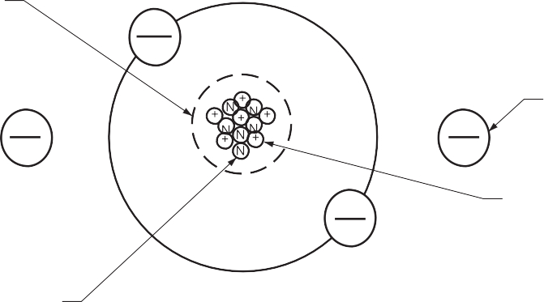

Nucleus

Electron

Proton

Neutron

**Figure 1 —** Carbon atom

Atoms are identified by the way that the electrons are arranged in orbits around the nucleus. For example, a hydrogen atom (Figure 2) has one electron in orbit around the nucleus. This means that there is one proton in the nucleus to balance the one electron in orbit. The atom is electrically neutral and its atomic number is 1.

Copper is a more complex atom than hydrogen and has 29 electrons in orbits around it and 29 protons in the nucleus to electrically balance the atom (Figure 2).

**H**

**Cu**

**Figure 2 —** Hydrogen and copper atoms

Electrons stay in different shells (orbits) about the nucleus. The number of electrons in the outer orbit determines whether the matter will be an insulator, conductor, or semiconductor.

Electrons in the inner orbits are known as *bound electrons* since they cannot easily leave their orbits. Electrons in the outer orbit (called the *valence shell*) are called *free electrons* since they will sometimes overlap with other atomic orbits near them and can be pushed or pulled out of their orbits. The behaviour of electrical circuits is dependent on the behaviour of these valence electrons.

The first rule of electricity is:

*Like charges repel and unlike charges attract.*

Two positively charged particles tend to repel each other (as would two negatively charged particles), while a negative particle and a positive particle would be attracted to each other (Figure 3).

Centrifugal force



Electrical attraction

Electrical attraction

Centrifugal force

**Figure 3 —** Electrical attraction

Any energy added to the electrons in the valence orbit is distributed equally among all those electrons. This means that less energy is required to remove an electron from its orbit if it is the only electron in the orbit. More energy is required if there are other electrons in the same orbit. The more electrons there are in the valence orbit, the more energy is required to free an electron.

**Conductors**

Conductors are elements that have atoms with electrons that are easily freed. Atoms that have one to three valence electrons are good conductors and can transmit electron motion easily. The ability of these conductors to easily pass current can be determined by four basic factors:

* material
* cross-sectional area
* length
* temperature

Material

Most metals are good conductors while most non-metallic elements are not good conductors. Silver is the best conductor. The most common conductor materials are copper and aluminum.

Cross-sectional area

A conductor with a large cross-sectional area will carry a larger current than one with a small cross-sectional area. This is why wire is available in different sizes or gauges. A high gauge number indicates a small cross-sectional area of wire. For example, 18 gauge wire is smaller than 10 gauge wire.

Length

A long conductor has a greater resistance to current flow than a short conductor. That is why there are limits to the effective length of a conductor for a given gauge.

Temperature

As the temperature of a conductor increases, the resistance will also increase, reducing conductivity.

###### Insulators

Insulators are materials with few free electrons; they have a valence shell of five to eight electrons. As the amount of resistance in a material increases, it will conduct less current and can be used as an insulator. Inert gases, such as helium, are examples of elements with high valence- count shells. Common insulators are often compounds, such as glass, plastic, and rubber.

###### Semiconductors

Semiconductors are those elements that are neither good conductors nor good insulators. They are the elements with exactly four valence electrons. Examples are carbon, silicon, and germanium. As mentioned with insulators, some elements when combined into compounds can be either conductors or insulators, depending on how they are combined. For example, germanium and silicon can have other elements mixed with them (such as arsenic) and will conduct electricity when they are properly controlled. This type of compound is used in transistors and diodes that are used in integrated and solid state circuits.

#### Static electricity and electric current

Static electricity and electric current are two separate phenomena. They both involve electric charge, and they may occur simultaneously in the same object. *Static electricity* refers to the electric charge of an object and the related electrostatic discharge when two objects are brought together that are not at equilibrium. An electrostatic discharge creates a change in the charge of each of the two objects. In contrast, *electric current* is the flow of electric charge through an object, which produces no net loss or gain of electric charge.

###### Electric charge

A body can possess a positive charge, a negative charge, or no charge at all. If it possesses no charge at all, it is said to be *neutral*. The type of charge a body has depends on the numbers of electrons compared to stable protons the body has.

Note that an electron has a mass that is a fraction of that of a proton. Also, the protons are very firmly bound to the nucleus. Therefore, it is the electrons, not the protons, that are added or removed. There are three ways in which a body can get an electric charge: by friction or contact, by conduction, and by induction.

###### Electric current

Free electrons are the basis of electric current. Free electrons can move between atoms. If this electron drift can be organized to move in one direction, it will produce an electron flow or electric current.

When an electron leaves an atom, it creates an electrical imbalance. If a copper atom has 29 electrons and 29 protons, it has no charge. If one electron is pulled out of the valence shell, there will be 28 electrons and 29 protons.

If there are more protons than electrons, the atom will have a net positive charge of +1 (29 protons – 28 electrons). This atom is now called a *positive ion* since it is no longer balanced. An ion is an atom or molecule with a positive (+) or negative (–) net electric charge, due to the loss or gain of one or more electrons.

The electron that is left attaches itself to a neighbouring copper atom and produces a net charge in that atom of –1. The positive ion will then attract another electron because it has a positive charge and opposite charges attract.

This continuous electron motion can be produced by providing an electrical push or force. The push or force that creates this flow of electrons is known as *electromotive force* (EMF). This force is also known by the more common name of *voltage*. You can measure the amount of force exerted by using an instrument called a *voltmeter*.

When voltage is applied to a group of atoms and electron movement begins, that movement is called *induced flow* or *amperage*. You can measure the amount of induced flow or current flow with an instrument called an *ammeter*. Resistance to electron movement can be measured with a test instrument called an *ohmmeter*.

If you line up billiard balls next to each other and strike the first one, the billiard balls transmit the motion through each other, and the ball on the end will move (Figure 4). This is how the motions of the free electrons act in a wire.

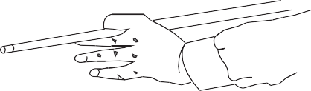

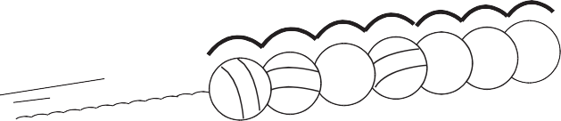

**Figure 4 —** Transmission of impulse

#### Sources of electrical force

You have just learned that if there is a surplus of electrons at one end of a conductor and a deficiency at the other end, a current flows in the conductor. There are devices that create this difference in charge so that a current will flow. These devices are referred to as *sources* of electromotive force. These sources include:

* + chemical
  + electromagnetic induction
  + friction
  + heat
  + pressure
  + light

###### Chemical

A battery is a source of electrical force due to the chemical reaction that takes place between plates and an electrolyte. This reaction causes a buildup of positive ions on one plate and negative ions on the other plate. This electrical difference between the plates is also known as *potential difference*.

###### Electromagnetic induction

Electric force can be generated by using a magnetic field. This is the method by which most of the electrical energy we use is produced. An example is an alternator or generator.

###### Friction

Friction can cause free electrons to move from one body to another and be stored there temporarily. When you walk across a carpet, electrons are transferred to the atoms in your body and you return them to other atoms when you touch a metallic object.

###### Heat

If two unlike metals are placed together and heated, they will produce electrical force. An example is the thermocouple in a furnace.

###### Pressure

Certain crystals will produce electricity if they are squeezed under extreme pressure. An example is a barbecue starter (also called *piezoelectric generator*).

###### Light

Some crystals and semiconductors will produce electrical force when they are exposed to light. An example is the photocell in a calculator.

All six of these sources of EMF achieve the same thing. They separate charge by:

* imparting energy to the electrons
* pushing them against an electrostatic field
* causing a surplus of electrons (negative charge) at one terminal of the source and a deficiency of electrons (positive charge) at the other terminal

In a sense, the process can be likened to compressing a spring. The energy stored in the compressed spring can be used later to do useful work. The same is true of the separated charges: they store energy that can be used to do useful work.

Electrical energy always comes from some other form of energy. The source of EMF is simply the device that makes the conversion from some other form of energy to electrical energy.

## Electrical circuits and units of measurement

The term *circuit* refers to a circular journey or loop. In the case of an electrical circuit, it is the closed path or loop travelled by the electrons. The movement or flow of electrons (current) is predictable and measurable, depending on a number of variables within the circuit.

#### Polarity

Electrical polarity (positive and negative) is present in every electrical circuit. Electrons flow from the negative pole to the positive pole. In a direct current (DC) circuit, one pole is always negative, the other pole is always positive, and the electrons flow in one direction only. In an alternating current (AC) circuit, the two poles alternate between negative and positive, and the direction of the electron flow reverses.

#### Circuit components

A closed circuit provides a complete path for the flow of electrons through conductors. Included in this circuit there must be a resistance (or load), which will do the work and some form of control.

For a circuit to be operational it must contain some basic components (Figure 5). These include:

* power source
* conductors
* controls
* load
* protection

###### Power source

In equipment, the power source is the battery when the engine is off and the generator when the engine is running. In most buildings, it is the power supplied by the local service provider.

###### Conductors

Conductors are wires or cables wrapped in insulation that carry the current in the circuit. A common ground circuit conductor could be the frame or body of the equipment or the frame on a vehicle.

###### Controls

Switches are used to turn the current on and off or to regulate the flow of electricity. Switches can be operated mechanically by vacuum, pressure, or electricity.

###### Load

The load converts electrical energy to work, such as with electric motors, bulbs, heater coils, or horns.

###### Protection

Fuses, circuit breakers, or fusible links must be used to prevent damage to the source, load, and conductors.

Wire (conductor)

Fuse (protection)

+ _

Switch (control)

Electric motor

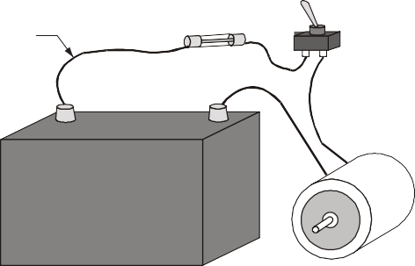

(load)

Motor

Fuse

Switch

Wire

+

_

Battery (source of electricity)

Battery

**Pictorial diagram Schematic diagram**

**Figure 5 —** Basic circuit

In order for electricity to flow, a circuit must fulfill two basic requirements:

1. The circuit must be closed. This means that the switch must be closed, the circuit protection device must be in good condition, the load must be in working order, and the conductors must be intact. Any break in the system will prevent operation.
2. A voltage source, such as a battery, must be available. The battery must be fully charged and capable of supplying electrical power.

#### Electrical units

To move electrons through a conductor, energy is required in the form of potential energy difference. This potential difference acts like a pushing force or pressure moving the electrons through the circuit. When you say that a battery has 12 volts, you are really saying that it has an electrical pressure of 12 volts. Pressure in an electrical system is also known as potential *difference* or *electromotive force*. This is measured in volts (V), which are named after the Italian physicist and chemist Alessandro Volta.

Current flow in a conductor indicates the volume of electrons in motion past a single point. The rate of electron flow is measured in amperes (A), named after the French physicist and mathematician André Ampère.

Just as friction opposes motion around you, there is an electrical quantity that opposes or resists the flow of electric current. This amount of resistance in an electrical circuit relative to the movement of electrons is measured in ohms (Ω), named after the German physicist Georg Simon Ohm.

###### Ohm’s law

One volt of electrical pressure will push one ampere of electric current through one ohm of resistance. This means that the current in a circuit is directly proportional to the voltage and inversely proportional to the resistance.

This relationship is known as *Ohm’s law* and can be written in the form of an equation: E = I × R, where:

Volts (V) is represented by “E” for electromotive force. Amperes (A) is represented by “I” for intensity of current. Ohms (Ω) is represented by “R” for resistance.

This formula can be changed to find any missing value. For instance, if you know resistance and voltage but need the value of the current, then the formula would read:

I = E / R

If you know the voltage and the current but need to find the resistance, then the formula would read:

R = E / I

The easiest way to do this is to place the formula in a circle (Figure 6). Then, to find the formula you need, just cover up the missing element.

I = amperes (current) R = ohms (resistance)

E

I

R

VOLTS

AMPS OHMS

E = volts (electromotive force)

E

I

R

E

I

R

E

I

R

R = E

I

E = I × R

**Figure 6 —** Ohm’s law circuit aid

I = E

R

**Measuring electricity**

The system used to indicate electrical quantities is as follows:

* + milli, meaning times one one-thousandth or 0.001 (1/1000), symbol m
  + micro, meaning times one one-millionth or 0.000 001 (1/1 000 000), symbol μ Quantities larger than 1:
  + kilo, meaning times 1000, symbol K
  + mega, meaning times 1 000 000, symbol M Examine the following comparisons of quantities:

• 15 mA = 0.015 A

• 500 mA = 0.5 A

• 650 mV = 0.65 V

• 50 μA = 0.000 05 A

• 700 μV = 0.000 7 V

Try to solve the following questions with calculations using Ohm’s law.

1. If a circuit has a current flow of 3 A and a pressure of 12 V, what is the resistance? The formula is R = E ÷ I.

Therefore R = 12 V ÷ 3 A. The result is R = 4 Ω.

1. If resistance in a circuit is 10 Ω and the pressure is 12 V, what is the current flow? The formula is I = E ÷ R

Therefore I = 12 V ÷ 10Ω. The result is I = 1.2 A.

1. If a circuit has a current flow of 2 amps and the resistance is 20 ohms, what is the pressure in volts?

The formula is E = I × R. Therefore E = 2 A × 20 Ω. The result is E = 40 V.

#### Power

When work is done on an object, the object receives energy. So power (P) can be defined as the rate of doing work, or as the rate of energy transfer.

The power level that a load performs at (for example, a heater fan motor) is measured in watts (W), named after James Watt, the Scottish engineer. This is the measure of a load’s ability to convert electrical energy to another form of energy, or the rate of energy transfer. Electrical power is calculated by using the formula

watts = volts x amps

or

P = E × I.

This formula can be changed to find any missing value. For instance, if you know power and voltage but need the value of the current, then the formula would read

I = P / E.

If you know the power and the current but need to find the voltage, then the formula would read E = P / I.

The easiest way to do this is to place the formula in a circle (Figure 7). Then, to find the formula you need, just cover up the missing element.

P = power in watts E = voltage in volts I = current in amps

P

E

I

WATTS

VOLTS AMPS

P

E

I

P

E

I

P

E

I

I =P E

P = E × I

**Figure 7 —** Power circuit aid

E =P

I

Try to solve the following questions for power, using Ohm’s law calculations.

* 1. How many amps will flow through a 96 W headlight bulb in a 12 V system? The formula is I = P ÷ E.

Therefore I = 96 W ÷ 12 V. The result is I = 8 A.

This could be an important consideration in selecting the correct circuit protection device. A fuse with a rating of more than 8 A would have to be chosen in this situation.

* 1. How much power will a soldering gun produce if it uses 6 A in a 120 V electrical system? The formula is P = E × I.

Therefore P = 120 V × 6 A. The result is P = 720 W.

Soldering guns are rated in watts. The higher the wattage rating of the gun, the more heat it will produce.

Now complete the Learning Task Self-Test.

**Self-Test 1**

1. What are the tiny particles that matter is made of called?
   1. Compounds
   2. Atoms
   3. Ions
   4. Protons and neutrons
2. What are elements called that have atoms with electrons that are easily freed?
   1. Ions
   2. Conductors
   3. Insulators
   4. Elements
3. Which of the following best describes copper?
   1. Conductor
   2. Insulator
   3. Semiconductor
   4. Valence electron
4. Why are insulators useful?
   1. They transport an electrical charge.
   2. They do not transport an electrical charge.
   3. They readily release valence electrons.
   4. They will ionize easily when subjected to voltage.
5. In what units is current measured?
   1. Volts
   2. Amperes
   3. Ohms
   4. EMF
6. A source of electromotive force can be from a chemical reaction.
   1. True
   2. False
7. In a DC circuit the poles alternate from positive to negative.
   1. True
   2. False
8. What is the device called that is used to turn a circuit on and off?
   1. A control
   2. A conductor
   3. A load
   4. A protector
9. Which of the following best describes an electric motor?
   1. A control
   2. A load
   3. A fuse
   4. A conductor

Use Ohm’s law for the following questions. E = I × R, where:

* Volts (V) is represented by “E” for electromotive force.
* Amperes (A) is represented by “I” for intensity of current.
* Ohms (Ω) is represented by “R” for resistance.

1. If resistance in a circuit is 6 Ω and the pressure is 24 V, what is the current flow?
   1. 2 A
   2. 4 A
   3. 6 A
   4. 8 A
2. If a circuit had a current flow of 8 A and the resistance is 20 Ω, what is the pressure in volts?
   1. 120 V
   2. 160 V
   3. 2.5 V
   4. 25 V
3. If a circuit has a current flow of 5 A and a pressure of 120 V, what is the resistance? a. 24 Ω

b. 12 Ω

1. 6 Ω
2. 3 Ω

Use the power formula for the following questions. watts = volts × amps or P = E × I

1. How much power will a heater produce if it uses 15 A in a 120 V electrical system? a. 1800 W

b. 1500 W

c. 900 W d. 1200 W

1. How many amps will flow through a 60 W headlight bulb in a 24 V system?
   1. 6 A
   2. 2.5 A
   3. 25 A
   4. 8 A
2. Use Ohm’s law to complete the following chart.

|  |  |  |
| --- | --- | --- |
| **voltage** | **current** | **resistance** |
|  | 500 mA | 240 |
| 12 |  | 1000 |
| 12 | 8 A |  |
| 5 |  | 20 000 |
| 120 | 10 |  |
|  | 0.15 A | 80 |
| 3 | 0.0002 A |  |

1. Use the power formula to complete the following chart.

|  |  |  |
| --- | --- | --- |
| **power** | **voltage** | **current** |
| 1500 W |  | 12.5 A |
| 40 W | 12 V |  |
|  | 12 V | 300 mA |
| 200 W |  | 10 A |
| 96 W | 12 V |  |
|  | 12 V | 40 A |

LEARNING TASK 2

**Describe basic circuit concepts**

You must understand how basic circuits function to properly diagnose and repair electrical problems. Now that you understand a simple circuit and how the basic components are connected, you can assemble more complex circuits and observe their characteristics.

## Basic electrical circuits

A circuit must provide a complete path for current flow from the power source. The current must flow through a control device into an electrical load and back to the power source through a wire or through a vehicle chassis.

In equipment, wire is normally used only on the insulated side of the circuit, since the return circuit is the chassis. Some components may require a ground wire from the component to the frame This type of circuit is called the *single wire system* (Figure 1).

Chassis

Switch

Power source

Load

**Figure 1 —** Single wire circuit

Some systems use two wires. For instance, the power source (battery) uses a ground wire that consists of a heavy multi-strand conductor (Figure 2).

Switch

Power source

Load

**Figure 2 —** Two wire circuit

There are three types of basic electrical circuits:

* series circuits
* parallel circuits
* series-parallel (combination) circuits

## Series circuits

The electrical term *in series* refers to a circuit in which two or more components are connected one after another in order that the current can only flow through one path. The switch that controls the circuit is always in series with the loads. If more than one switch is used, both must be closed for the circuit to function. Circuit protectors (such as fuses) will also be in series. If any one of the components in a series circuit opens, the circuit will not function (Figure 3).

Switch

Power source

Load

Load

**Figure 3 —** Series circuit

A series circuit must follow these rules:

1. Total circuit resistance is equal to the sum of each individual resistance. Written as a formula: RT = R1 + R2 + R3 + ....

Where RT is total resistance and R1, R2, R3 ... equal each resistance.

1. If more loads are added in a series circuit, the total resistance will continue to increase.
2. Current flow is the same throughout the circuit.

Example

Build a circuit with a 12 V battery, a switch, and three resistors (Figure 4). The resistors will have values of 2 Ω, 4 Ω, and 6 Ω, representing three loads in the circuit.

Switch

R1 = 2 ohms

Power source 12 volts

R2 = 4 ohms

R3 = 6 ohms

**Figure 4 —** Series circuit

Perform the following calculations:

1. Total resistance or RT will equal the sum of the individual resistances.

RT = R1 + R2 + R3

RT = 2 Ω + 4 Ω + 6 Ω RT = 12 Ω

1. Now apply Ohm’s law and calculate the current flow in the circuit. I = E ÷ R

I = 12 V ÷ 12 Ω I = 1 A

1. Current flow is the same throughout the circuit. By using Ohm’s law you can determine how much voltage will be used by each of the loads.

The 2 ohm resistor will require: E = I × R

E = 1 A × 2 Ω E = 2 V

The 4 ohm resistor will require: E = I × R

E = 1 A × 4 Ω E = 4 V

The 6 ohm resistor will require: E = I × R

E = 1 A × 6 Ω E = 6 V

Add the individual voltages together and you will notice that they equal the original source voltage of 12 V.

ET = 2 V + 4 V + 6 V ET = 12 V

The voltage that is used up in the circuit by the load is called *voltage drop*. This voltage drop is valuable in diagnosis as a measure of the resistance of a circuit. Some voltage may be lost in a circuit because of poor connections. If the voltage drop in connections (caused by high resistance) becomes too great, the load may not function properly or may not even work.

## Parallel circuits

The parallel circuit (Figure 5) has completely different characteristics. In a parallel circuit, two or more loads are connected side by side and are controlled by one or more switches. The different loads can each have their own switch, but the major difference is that each of the loads has access to the same amount of voltage and can operate independently of the others. There is more than one path through which the current can flow.

Switch

Power source

Load

Load Load

**Figure 5 —** Parallel circuit

If one of the loads fails, the others will continue to operate. This is very important in a circuit such as headlights and parking lights, where failure of one bulb does not cause the entire circuit to fail.

Parallel circuits have the following operating rules:

* 1. Total resistance in a parallel circuit is always less than the smallest resistor in the circuit.
  2. Total current flow is equal to the sum of the current flow through each load.

This may seem surprising after you observed the operation of a series circuit, but this is one of the advantages of a parallel circuit. Since each load operates independently, each load will get full voltage and use whatever current it requires. The current can be calculated using the assumed voltage method.

Example

If you have a circuit with 2 Ω, 4 Ω, and 6 Ω, just pick any convenient voltage. In this case, 12 V would probably work well.

Perform the following calculations:

1. Use Ohm’s law determine the current flow through each of the individual loads. Remember that the formula states that I = E ÷ R.

for the first resistor I = 12 V ÷ 2 Ω I = 6 A

for the second resistor I = 12 V ÷ 4 Ω

I = 3 A

for the third resistor I = 12 V ÷ 6 Ω

I = 2 A

1. They will each use as much current as they require to operate because each load gets all the voltage. According to the rules of parallel circuits, the total current flow in the circuit is equal to the sum of the individual current flows.

IT = 6 A + 3 A + 2 A IT = 11 A

1. Therefore, the total resistance (RT) of the circuit according to Ohm’s law, R = E ÷ I. R = 12 V ÷ 11 V

R = 1.09 Ω

In this example, the total resistance in the circuit is very low and the total current flow is very high. This is useful to provide bright lights and individual light operation in circuits such as those found in head light systems. In addition to head lights, examples of this circuitry include marker lights as well as front and rear parking lights. All of these are turned on by one switch but operate independently.

**Solving for unknown values**

Ohm’s law can be applied to each part of a parallel circuit as well as to the entire circuit. Figure 6 represents resistors of 40 ohms, 10 ohms, and 240 ohms connected in parallel to a 120 volt supply. The arrows in the drawing represent the direction of the electron flow.

E

= 120 V

T

R

= 40 Ω

1

R

= 10 Ω

2

R

= 240 Ω

3

-

+

**Figure 6 —**

Parallel circuit

Since each resistor or load acts as an independent circuit, each resistor receives the entire voltage of the supply.

The voltage across each path in a parallel circuit is equal to the total voltage of the circuit, so: ET = E1 = E2 = E3 …

Using the formula above you can now find the current in each path. Since the voltages across each component in a parallel circuit equal the total voltage, using Ohm’s law:

I = E1 = 120 = 3 amps

1

R1 40

I = E2 = 120 =12 amps

2

R2 10

I = E3 = 120 = 0.5 amp

3

R3 240

The total current in a parallel circuit is equal to the sum of the currents in the individual paths: IT = I1 + I2 + I3 …

The total current in the circuit shown in Figure 6 is equal to: IT = 3 + 12 + 0.5 = 15.5 amps

#### Calculating resistance in a parallel circuit

Total resistance in a parallel circuit can be found using any of four different methods.

###### Method 1

If the total circuit voltage and total circuit current are known, the total resistance can be found using Ohm’s law. For the circuit shown in Figure 6:

R = ET = 120 = 7.7 ohms

T

IT 15.5

The total resistance in a parallel circuit will always be less than the value of the smallest resistance in that circuit. Use this rule of thumb as a quick check when calculating parallel circuits. In this example, 7.7 ohms is smaller than 10 ohms, the smallest resistance in the circuit.

###### Method 2

If only the resistance values of a parallel circuit are known, the total resistance of the parallel circuit can be found using this formula:

RT =

1

1 + 1 + 1 ...

R1 R2 R3

In the circuit shown in Figure 6:

R= 1

T

= 7.7 ohms

1 + 1 + 1

40 10

240

R= 1

T

6 + 24

+ 1

240

R = 1

240

240

T 31

240

R = 240

T 31

RT = 7.7 ohms

This formula can be solved mathematically using fractions or by using the reciprocal function of your calculator. If you are having trouble using this formula, contact your instructor for assistance.

###### Method 3

If the resistance values of each of the paths are known and are the **same** value, the total resistance of the circuit can be found by dividing the value of one resistor by the number of resistors (Figure 7).

R=

value of one resistor

number of resistors

R=

36

4

R = 9 Ω

T

T

T

R

= 36 Ω

2

R

= 36 Ω

1

R

= 36 Ω

3

R

= 36 Ω

4

**Figure 7 —**

Parallel circuit with four resistors

###### Method 4

You can solve for the total resistance of any two resistors (Figure 8) using the product-sum method:

×

R=

R

R

R +R



R=

60

17

R = 3.5 Ω

T

2

1

2

1

T

T

R

= 5 Ω

1

R

= 12 Ω

2

**Figure 8 —**

Parallel circuit with two resistors

T

## Series-parallel circuits

The series-parallel circuit combines the two previously described types of circuits into one operating system with some distinct advantages. By introducing a load or resistor in series with a parallel circuit, the current flow through the circuit can be controlled (Figure 9).

Switch 1 ohm

Power source = 12 V

2 ohms 4 ohms

**Figure 9 —** Series-parallel circuit

To calculate the missing factors in this circuit you must first determine total resistance in the parallel circuit. Since there are only two resistors, you can calculate total resistance by using the formula:

R = 2Ω× 4Ω

T 2Ω+4 Ω

R = 8Ω

T 6Ω

RT = 1.3Ω

Add this resistance to the remaining 1 ohm (since they are in series) to get total resistance:

RT = 1.3Ω+1 Ω RT = 2.3Ω

Using Ohm’s law you can calculate total current flow.

I = E ÷ R

I = 12 V ÷ 2.3 Ω I = 5.15 mA

## Polarity and direction of current flow

Earlier you learned about the term *polarity,* referring to the charge at one point with respect to another. When working with electrical circuits, we often refer to the polarity between different points in the circuit. Understanding polarity is important for connecting the leads of polarity- dependent devices such as some meters and motors. Polarity is also important for determining the direction of current flow. In Figure 10 the current leaves the source at the negative terminal, travels around the circuit in a clockwise direction, and re-enters the source at the positive terminal.

– +

–

–

+

+

+ –

**Figure 10 —** Polarity

It is important to notice that current flows through loads from negative to positive, and current flows through sources from positive to negative. A more precise way of stating this is that outside the source, current flows from negative to positive, but inside the source current flows from positive to negative.

Now complete the Learning Task Self-Test.

### Self-Test 2

* 1. What takes the place of a ground return wire in a single wire system?
     1. Fuse
     2. Case ground
     3. Circuit breaker
     4. Chassis
  2. How many paths does a series circuit have for current flow?

|  |  |
| --- | --- |
| a. | 1 |
| b. | 2 |
| c. | 3 |
| d. | 4 |

* 1. What is a circuit called that has more than one path for current flow?
     1. Series circuit
     2. Complex circuit
     3. Compound circuit
     4. Parallel circuit
  2. What must the total voltage drop in a circuit be equal to?
     1. The source voltage
     2. The first voltage drop
     3. Half the source voltage
     4. Twice the source voltage
  3. A 12 V circuit with a 4 ohm resistor will have a current of 6 A.
     1. True
     2. False
  4. A 120 V circuit with a current of 10 A will have a load with what resistance? a. 12 Ω

b. 24 Ω

c. 6 Ω

d. 10 Ω

* 1. If one load fails in a parallel circuit, all other loads will fail.
     1. True
     2. False
  2. What is the total resistance in a series circuit with four resistors rated at 2 Ω each?
     1. 2 Ω
     2. 4 Ω
     3. 6 Ω
     4. 8 Ω
  3. A 120 V parallel circuit has three resistors: 20 Ω, 12 Ω, and 24 Ω. What is the current?
     1. 6 A
     2. 18 A
     3. 21 A
     4. 24 A
  4. What is the total resistance for a 120 V circuit with three resistors of 20 Ω, 12 Ω, and 24 Ω in parallel?
     1. 6 Ω
     2. 8 Ω

c. 12 Ω

d. 24 Ω

LEARNING TASK 3

**Describe electromagnetism**

A magnet attracts ferrous metals and some alloys. Magnets can take three forms:

* natural
* artificial
* electric

Natural magnets (known as *magnetite*) are very weak. Artificial magnets are made from magnetic materials (such as iron, nickel, and cobalt) and are given a strong magnetic force during construction. These are permanent magnets and have some limited use. Electromagnets can be easily turned on and off and are in common use because they are not permanent. They are called *temporary magnets*.

## Magnetic fields

If a magnet is suspended in the air, it will always turn and align with the north and south poles of Earth. The two ends, called the *magnetic poles*, are where the force is strongest.

A magnetic field of force is set up between the two poles. You can think of it as invisible lines of force travelling from one pole to the other. The magnetic lines (flux lines) are continuous and always form loops. These invisible lines can be seen if you sprinkle iron filings on a piece of paper placed over a bar magnet (Figure 1).

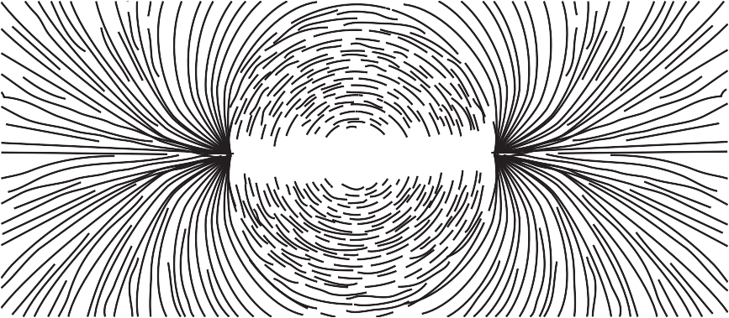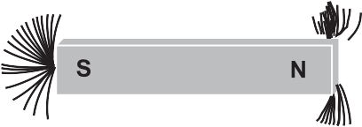

**Figure 1 —** Magnetic lines of force

#### Characteristics of magnetic lines of force

Magnets have some specific rules governing their operation.

###### Magnetic lines of force possess direction

These lines are continuous and extend from the north pole to the south pole of the magnet (Figure 2).

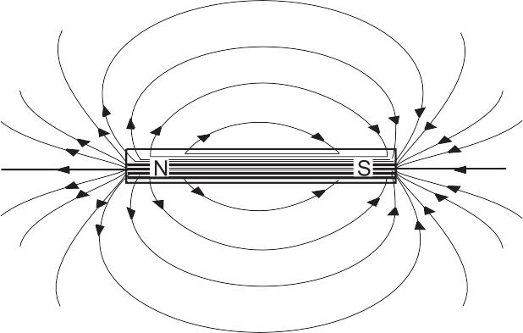

**Figure 2 —** Flux line direction

###### Magnetic lines of force always form complete loops

The lines do not begin and end at the poles but rather pass through the magnet to form complete loops. If you were to cut a magnet in half, you could observe the magnetic field between the two pieces of the magnet (Figure 3)

**Figure 3 —** Magnetic loops

###### Magnetic lines of force always form tight loops

This rule explains the idea of attraction. The flux lines attempt to pull in as close to the magnet as possible, just like rubber bands. They also try to concentrate at each pole. If you place two unlike poles together, they try to become one big magnet and shorten the lines of force (Figure 4).

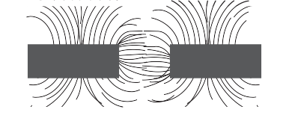

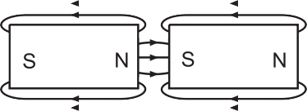

**Figure 4 —** Magnetic attraction

###### Magnetic lines of force repel each other

If magnetic lines of force act like rubber bands, why don’t they collapse into the centre? The reason is that they repel each other. Look back at Figure 3; notice that the lines tend to diverge as they move away from the poles, rather than converge or even remain parallel. This results from their mutual repulsion.

###### Magnetic lines of force never cross, but must always form individual loops

The mutual repulsion of each magnetic line accounts for this effect. This explains why like poles repel each other. If the lines cannot cross each other, then they must exert a force against each other. If you could see the lines of force, they would look like the diagram in Figure 5.

**Figure 5 —** Repulsion

###### Magnetic lines of force can pass more easily through material that can be magnetized

The magnetic lines of force will distort to include a piece of iron in the field. This will have the effect of turning the iron into a temporary magnet. Then the opposite poles of the two magnets will attract each other and try to shorten the flux lines. This accounts for the attraction of unmagnetized ferromagnetic objects (Figure 6).

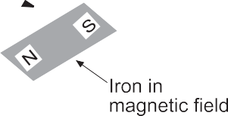

**Figure 6 —** Iron easily magnetized

###### There is no insulation against magnetic lines of force

All magnetic field lines must terminate on the opposite pole, which means there is no way to stop them. Nature must find a way to return the magnetic field lines back to an opposite pole. However, magnetic fields can be rerouted around objects. This is a form of magnetic shielding. By surrounding an object with a material that can “conduct” magnetic flux better than the materials around it, the magnetic field will tend to flow along this material and avoid the objects inside. This allows the field lines to terminate on the opposite poles, but just gives them a different route to follow (Figure 7).

Shielded instrument

N

S

Soft iron screen

**Figure 7 —** Magnetic shielding

###### Alignment of the atoms

If you took a permanent magnet and cut it in half, you would have two permanent magnets, each with a north and south pole. If you continued cutting each in half, you would have more magnets. This suggests that if you could cut right down to the atom it would also be a perfect permanent magnet.

This theory can be extended to non-magnetic material as well. Each of the atoms is a magnet, but they are all pointing in different directions. If you can get enough atoms pointing in the same direction, you will have a magnet. All you have to do is expose the piece of metal to flux lines and the atoms will align.

These atoms tend to form in groups called *domains*. When the domain becomes large enough, the entire piece of metal becomes the domain and exerts force. When all of the atoms become aligned, the piece has become saturated and cannot get any stronger.

## Electricity and magnetism

There is a direct relationship between electricity and magnetism. If there is current flow in a conductor there will be lines of force created around the conductor. If you could look at the magnetic field formed around a current-carrying conductor, it would look like Figure 8.

Compass

– +

**Figure 8 —** Electromagnetic field

Note that the lines of force circle the conductor in rings and have direction. The direction of the lines of force depends on the direction of electron flow. If you know the direction of electron flow, you can determine the direction of the lines of force by using your left hand.

The “left hand rule” says that if you hold the conductor in your left hand with your thumb pointing in the direction of the current flow, your fingers will curl in the direction of the lines of force.

#### Interaction of fields

Magnetic fields around a current-carrying conductor act in the same way as the fields around a permanent magnet. In Figure 9, two conductors have been moved close together. The current is going in opposite directions, as indicated by the symbol in the end of the conductor. An X indicates electron flow in; a dot indicates electron flow out. The magnetic lines of force try to push the two conductors apart because they are in opposite directions. The arrows indicate the direction of the magnetic force.

Current out Current in

**Figure 9 —** Opposite currents repel

If one of the conductors has the current reversed, then the magnetic lines of force travel in the same directions. When this occurs the lines of force try to contract and pull tight, just as they did with a permanent magnet. The resulting force will try to pull the two conductors together (Figure 10).

Current out Current in

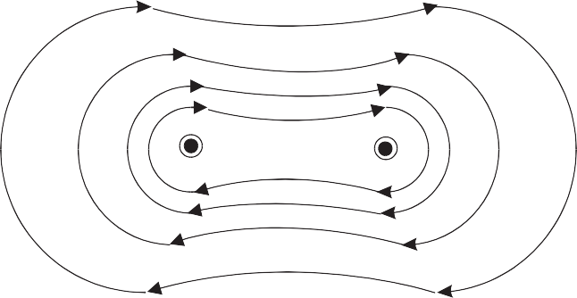

**Figure 10 —** Like currents attract

#### Conductors in loops

If a conductor carrying a current is formed into a loop, the magnetic field will be arranged differently. It will form looped lines of force with a north pole on one side of the loop and a south pole on the other. The magnetic flux lines add to each other and produce a much denser magnetic field in the centre of the coil (Figure 11).

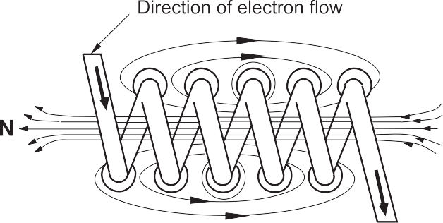

**Figure 11 —** Flux in a loop

#### Electromagnets

If a piece of soft iron is placed in the coil and a current is passed through the coil in one direction, the magnetic field of the coil causes the domains to align in the iron. This causes poles to form in the iron and creates an electromagnet, as shown in Figure 12.

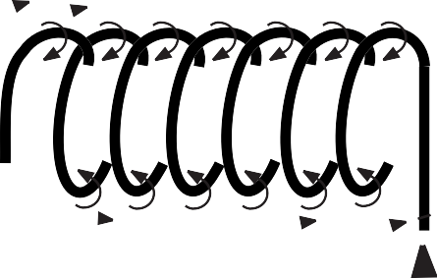

**Figure 12 —** Electromagnet

The strength of the electromagnet varies with the number of loops formed, the strength of the electric current, and the type of core in the winding. Because the iron core has a low magnetic retention, the magnetic field collapses when the current stops flowing. The iron core is no longer magnetized and will release whatever it was being used to hold or pull inward.

###### Electric motors and generators

Electromagnets are probably most commonly used in motors and generators. We have seen that magnetism can be caused by electricity. Electric motors use the force of electromagnets to produce rotation. On the other hand, electricity can be produced by magnetism. When a conductor is moved through a magnetic field or a magnet is moved passed a conductor, the movement will induce a voltage in the conductor. Most electricity is generated in this way.

To generate a voltage, three elements must be combined (Figure 13):

* + - 1. a conductor
      2. a magnetic field
      3. movement by either the conductor or the magnetic field

Field poles

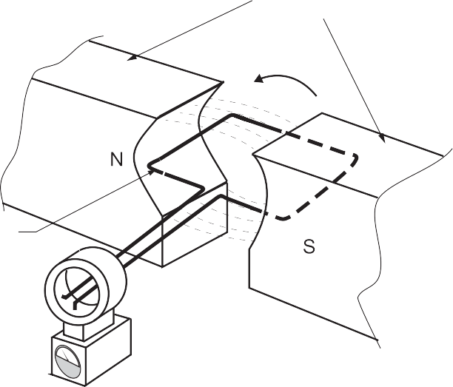

Rotation

Armature

**Figure 13 —** Simple generator

The amount of voltage produced will depend on the strength of the magnetic field and the speed at which the conductor or the field moves. A conductor that moves through a magnetic field quickly will generate a higher voltage than one that moves more slowly.

A conductor that moves through a strong magnetic field will generate a higher voltage than one moved through a weak magnetic field.

#### Alternating current

Electric current that flows in one direction for a split second then changes direction in another split second is called *alternating current* (AC). In an alternating voltage, the polarity reverses direction periodically. The spinning mechanical motion of an electric generator produces AC voltage and current.

###### AC wave form and hertz

*Hertz* is the unit used to describe the frequency of AC direction change. Figure 14 is a graphic illustration using a curved line with arrows to indicate a change of direction in AC electron flow. Starting at point A, the current flows in one direction, and then at 120 volts it changes direction, drops to 0 volts, and continues to 120 volts, where it changes direction again back to point B at 0 volts.

A

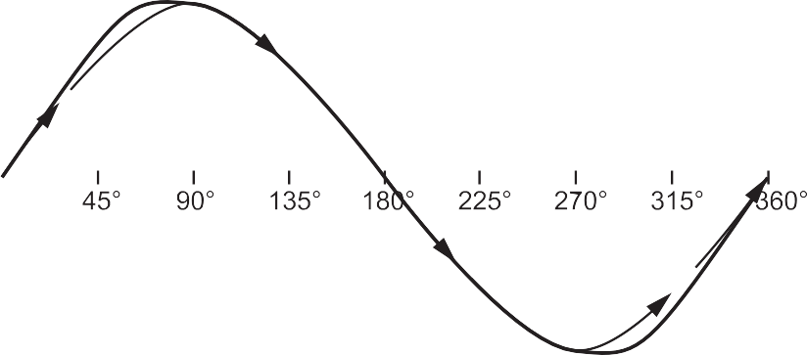

B

**Figure 14 —** AC sine wave

If it takes one second to complete the cycle from A to B, we would say the frequency is 1 hertz. Household utility AC current is supplied to the customer at 60 hertz, meaning 60 cycles per second.

###### Single-phase power supply

*Single-phase* electric power refers to the distribution of alternating current electric power using a system in which all the voltages of the supply vary in unison. Single-phase distribution is used when loads are mostly lighting and heating, and with a few large electric motors. Single-phase power comprises two independent voltages that are carried on two separate conductors.

The two hot lines are called *Line 1* and *Line 2*. They are typically found in residential and small commercial applications.

###### Three-phase AC power supply

Three-phase electrical power refers to a type of electrical power distribution in which three or more energized electrical conductors are carrying alternating currents. Examples of three-phase power systems are industrial applications and power transmission. Three-phase power supply

is used to power large motors and other heavy loads. A three-phase system is generally more economical than equivalent single-phase or two-phase systems at the same voltage.

Three-phase power comprises three independent voltages that are carried on three separate conductors. The three hot lines are called *Line 1*, *Line 2*, and *Line 3*. Three-phase power is typically found in commercial and industrial buildings.

Now complete the Learning Task Self-Test.

**Self-Test 3**

1. There are three types of magnets: natural, artificial, and electric.
   1. True
   2. False
2. Natural magnets have the strongest force.
   1. True
   2. False
3. If the south poles of two magnets are brought together, what they will do?
   1. Conduct
   2. Relate
   3. Saturate
   4. Repel
4. Changing which of the following will also change the strength of an electromagnet?
   1. Direction of current flow
   2. Size of wires
   3. The length of the core
   4. Amount of current flow
5. What is the core of an electromagnet usually made from?
   1. Air
   2. Soft iron
   3. Aluminum
   4. Copper
6. What two elements must be combined with a conductor to generate a voltage?
   1. Magnetic field and a current
   2. Current and movement
   3. Coil and a magnet
   4. Magnetic field and movement
7. Magnetic lines of force never cross.
   1. True
   2. False

### Answer Key

###### Self-Test 1

1. b. Atoms
2. b. Conductors
3. a. Conductor
4. b. They do not transport an electrical charge.
5. b. Amperes
6. a. True
7. b. False
8. a. A control
9. d. A load
10. b. 4 A 11. b. 160 V 12. a.24 Ω

13. a. 1800 W

14. b. 2.5 A

15.

|  |  |  |
| --- | --- | --- |
| **voltage** | **current** | **resistance** |
| **120** | 500 mA | 240 |
| 12 | **0.012 A** | 1000 |
| 12 | 8 A | **1.5** |
| 5 | **0.00025 A** | 20 000 |
| 120 | 10 | **12** |
| **12** | 0.15 A | 80 |
| 3 | 0.0002 A | **15 000** |

16.

|  |  |  |
| --- | --- | --- |
| **power** | **voltage** | **current** |
| 1500 W | **120 V** | 12.5 A |
| 40 W | 12 V | **4 A** |
| **3.6 W** | 12 V | 300 mA |
| 200 W | **20 V** | 10 A |
| 96 W | 12 V | **8 A** |
| **480 W** | 12 V | 40 A |

###### Self-Test 2

* 1. d. Chassis 2. a. 1

1. d. Parallel circuit
2. a. The source voltage
3. b. False 6. a. 12 Ω

7. b. False 8. d. 8 Ω 9. c. 21 A 10. a. 6 Ω

###### Self-Test 3

|  |  |  |
| --- | --- | --- |
| 1. | a. | True |
| 2. | b. | False |
| 3. | d. | Repel |
| 4. | d. | Amount of current flow |
| 5. | b. | Soft iron |
| 6. | d. | Magnetic field and movement |
| 7. | a. | True |

**The British Columbia Open Textbook Project**

The British Columbia Open Textbook Project is funded by the B.C. Ministry of Advanced Education, and managed by BCcampus, a publicly-funded organization that uses information technology to connect B.C. post-secondary institutions under a collaborative service delivery framework. The Open Textbook Project aims to make available

openly-licensed textbooks in the province’s high-impact subject areas. Visit open.bccampus.ca for more information.



7960003693

