Writing for

Success

Tara Horkoff

Writing for Success by Tara Horkoff is a derivative textbook based on Writing for Success by Scott McLean (http://open.bccampus.ca/find-open-textbooks/?uuid=be97a141-078a-46e4-a66b-e287b2b25c98) which was released under a CC-BY-NC-SA license. This derivative version is released under the same CC-BY-NC-SA license (https://creativecommons.org/licenses/by-nc-sa/3.0).

Preface
Writing is often a challenge. If you were ever challenged to express yourself via the written word, this book is for you.
Writing for Success is a text that provides instruction in steps; builds writing, reading, and critical thinking; and combines a comprehensive grammar review with an introduction to paragraph writing and composition.
Each chapter allows students to demonstrate mastery of the principles of quality writing. With its incremental approach, this book can address a range of writing levels and abilities, helping each student prepare for the next writing or post-secondary course. Constant reinforcement is provided through examples and exercises, and the text involves students in the learning process through reading, problem solving, practising, listening, and experiencing the writing process.
Each chapter also has integrated examples that unify the discussion and form a common, easy-to-understand basis for discussion and exploration. This will put students at ease and allow for greater absorption of the material.
Tips for effective writing are included in every chapter, as well. Thought-provoking scenarios provide challenges and opportunities for collaboration and interaction, which are especially helpful for working with groups of students. Clear exercises teach sentence and paragraph writing skills that are helpful for writing common English composition and research essays.
In short, Writing for Success provides a range of discussion, examples, and exercises, from writing development to mastery of the academic essay, that serve both student and instructor.

Read License Information
Full Legal Code

Features
- Exercises are integrated in each segment. Each concept is immediately reinforced as soon as it is introduced to keep students on track.
- Exercises are designed to facilitate interaction and collaboration. This allows for peer-to-peer engagement, development of interpersonal skills, and promotion of critical thinking skills.
- Exercises that involve self-editing and collaborative writing are featured. This feature develops and promotes student interest in the knowledge areas and content.
- Clear internal summaries and effective displays of information are included. This contributes to ease of access to information and increases students’ ability to locate desired content.
- Rule explanations are simplified with clear, relevant, and theme-based examples. This feature provides context that will facilitate learning and increase knowledge retention.
- There is an obvious structure to the chapter and segment level. This allows for easy adaptation to existing and changing course needs or assessment outcomes. The first eleven chapters will also include an opportunity for students to make connections between their experiences as learners and the material by composing journals.

Table of Contents

Chapter 1: Introduction to Academic Writing

Chapter 2: Working with Words: Which Word Is Right?
Chapter 3: Putting Ideas into Your Own Words and Paragraphs
Chapter 4: What Are You Writing, to Whom, and How?
Chapter 5: Putting the Pieces Together with a Thesis
Chapter 6: Working toward the End Product: Composing a Draft
Chapter 7: Sources: Choosing the Right Ones
Chapter 8: Being Critical
Chapter 9: Citations and Referencing
Chapter 10: Persuasion
Chapter 11: Developing a Convincing Argument
Chapter 12: Final Revisions and Peer Review
Appendix: Readings: Examples of Essays

Chapter 1

Introduction to Academic Writing

1.1 Post-Secondary Reading and Writing

LEARNING OBJECTIVES
- Understand the expectations for reading and writing assignments in post-secondary (university, college, institute) courses
- Understand and apply general strategies to complete post-secondary-level reading assignments efficiently and effectively
- Recognize specific types of writing assignments frequently included in post-secondary courses
- Understand and apply general strategies for managing post-secondary-level writing assignments
- Determine specific reading and writing strategies that work best for you individually
In a post-secondary environment, academic expectations change from what you may have experienced in high school. The quantity of work you are expected to do is increased. When instructors expect you to read pages upon pages or study hours and hours for one particular course, managing your workload can be challenging. This chapter includes strategies for studying efficiently and managing your time.
The quality of the work you do also changes. It is not enough to understand course material and summarize it on an exam. You will also be expected to seriously engage with new ideas by reflecting on them, analyzing them, critiquing them, making connections, drawing conclusions, or finding new ways of thinking about a given subject. Educationally, you are moving into deeper waters. A good introductory writing course will help you swim.
Table 1.1: High School versus Post-Secondary Assignments summarizes some of the other major differences between high school and university assignments.

Table 1.1 High School versus Post-Secondary Assignments
High School | Post-Secondary
Reading assignments are moderately long. Teachers may set aside some class time for reading and reviewing the material in depth. | Some reading assignments may be very long. You will be expected to come to class with a basic understanding of the material.
Teachers often provide study guides and other aids to help you prepare for exams. | Reviewing for exams is primarily your responsibility.
Your grade is determined by your performance on a wide variety of assessments, including minor and major assignments. Not all assessments are writing based. | Your grade may depend on just a few major assessments. Most assessments are writing based.
Writing assignments include personal writing and creative writing in addition to expository writing. | Outside of creative writing courses, most writing assignments are expository.
The structure and format of writing assignments is generally stable over the high school years. | Depending on the course, you may be asked to master new forms of writing and follow standards within a particular professional field.
Teachers often go out of their way to identify and try to help students who are performing poorly on exams, missing classes, not turning in assignments, or just struggling with the course. Often teachers will give students many “second chances.” | Although teachers want their students to succeed, they may not always realize when students are struggling. They also expect you to be proactive and take steps to help yourself. “Second chances” are less common.
This chapter covers the types of reading and writing assignments you will encounter as a post-secondary student. You will also learn a variety of strategies for mastering these new challenges—and becoming a more confident student and writer.
Throughout this chapter, you will follow a first-year student named Crystal. After several years of working as a saleswoman in a department store, Crystal has decided to pursue a degree in elementary education and become a teacher. She is continuing to work part time, and occasionally she finds it challenging to balance the demands of work, school, and caring for her four-year-old son. As you read about Crystal, think about how you can use her experience to get the most out of your own experience.

Setting Goals
By planning carefully and following through on her daily and weekly goals, Crystal was able to fulfill one of her goals for the semester. Although her exam scores were not as high as she had hoped, her consistently strong performance on writing assignments tipped her grade from a B+ to an A−. She was pleased to have earned a high grade in one of the required courses for her major. She was also glad to have gotten the most out of an introductory course that would help her become an effective teacher.
How does Crystal’s experience relate to your own post-secondary educational experience?
To do well in the post-secondary environment, it is important to stay focused on how your day-to-day actions determine your long-term success. You may not have defined your career goals or chosen a major yet. Even so, you surely have some overarching goals for what you want out of your studies to expand your career options, to increase your earning power, or just to learn something new. In time, you will define your long-term goals more explicitly. Doing solid, steady work, day by day and week by week, will help you meet those goals.

Discussion 1
With your group, discuss the following issues and questions:
  - Introduce yourself: Who are you? Why are you taking the course? Where are you living now?
  - How do you feel about writing in general? (You will not be judged on this.)
  - Identify one long-term goal you would like to have achieved by the time you complete your diploma or degree. For instance, you might want a particular job in your field.
  - Identify one semester goal that will help you fulfill the long-term goal you just set.
  - Review Table 1.1, High School versus Post-Secondary Assignments and answer the following questions:
- In what ways do you think post-secondary education will be rewarding for you as a learner?
- What aspects of post-secondary education do you expect to find most challenging?
- What changes do you think you might have to make in your life to ensure your success in a post-secondary learning environment?

Reading Strategies
Your post-secondary courses will sharpen both your reading and your writing skills. Most of your writing assignments—from brief response papers to in-depth research projects—will depend on your understanding of course reading assignments or related readings you do on your own. And it is difficult, if not impossible, to write effectively about a text that you have not understood. Even when you do understand the reading, it can be hard to write about it if you do not feel personally engaged with the ideas discussed.
This section discusses strategies you can use to get the most out of your reading assignments. These strategies fall into three broad categories:
- Planning strategies to help you manage your reading assignments
- Comprehension strategies to help you understand the material
- Active reading strategies to take your understanding to a higher and deeper level

Planning Your Reading
Have you ever stayed up all night cramming just before an exam? Or found yourself skimming a detailed memo from your boss five minutes before a crucial meeting? The first step in handling your reading successfully is planning. This involves both managing your time and setting a clear purpose for your reading.

Managing Your Reading Time
You will learn more detailed strategies for time management in Section 1.2: Developing Study Skills, but for now, focus on setting aside enough time for reading and breaking your assignments into manageable chunks. For example, if you are assigned a 70-page chapter to read for next week’s class, try not to wait until the night before to get started. Give yourself at least a few days and tackle one section at a time.
Your method for breaking up the assignment will depend on the type of reading. If the text is very dense and packed with unfamiliar terms and concepts, you may need to read no more than 5 or 10 pages in one sitting so that you can truly understand and process the information. With more user-friendly texts, you will be able to handle longer sections—20 to 40 pages, for instance. And if you have a highly engaging reading assignment, such as a novel you cannot put down, you may be able to read lengthy passages in one sitting.
As the semester progresses, you will develop a better sense of how much time you need to allow for the reading assignments in different subjects. It also makes sense to preview each assignment well in advance to assess its difficulty level and to determine how much reading time to set aside.

Tip
Instructors at the post-secondary level often set aside reserve readings for a particular course. These consist of articles, book chapters, or other texts that are not part of the primary course textbook. Copies of reserve readings are available through the university library, in print, or more often, online. When you are assigned a reserve reading, download it ahead of time (and let your instructor know if you have trouble accessing it). Skim through it to get a rough idea of how much time you will need to read the assignment in full.

Setting a Purpose
The other key component of planning is setting a purpose. Knowing what you want to get out of a reading assignment helps you determine how to approach it and how much time to spend on it. It also helps you stay focused during those occasional moments when it is late, you are tired, and when relaxing in front of the television sounds far more appealing than curling up with a stack of journal articles.
Sometimes your purpose is simple. You might just need to understand the reading material well enough to discuss it intelligently in class the next day. However, your purpose will often go beyond that. For instance, you might also read to compare two texts, to formulate a personal response to a text, or to gather ideas for future research. Here are some questions to ask to help determine your purpose:
- How did my instructor frame the assignment? Often instructors will tell you what they expect you to get out of the reading. For example:
  - Read Chapter 2 and come to class prepared to discuss current theories related to conducting risk assessments.
  - Read these two articles and compare Smith’s and Jones’s perspectives on the Charter of Rights and Freedoms (1982).
  - Read Chapter 5 and think about how you could apply these guidelines to the first stages of onsite patient assessment.
- How deeply do I need to understand the reading? If you are majoring in emergency management and you are assigned to read Chapter 1, “Introduction to Emergency Management,” it is safe to assume the chapter presents fundamental concepts that you will be expected to master. However, for some reading assignments, you may be expected to form a general understanding but not necessarily master the content. Again, pay attention to how your instructor presents the assignment.
- How does this assignment relate to other course readings or to concepts discussed in class? Your instructor may make some of these connections explicitly, but if not, try to draw connections on your own. (Needless to say, it helps to take detailed notes both when in class and when you read.)
- How might I use this text again in the future? If you are assigned to read about a topic that has always interested you, your reading assignment might help you develop ideas for a future research paper. Some reading assignments provide valuable tips or summaries worth bookmarking for future reference. Think about what you can take from the reading that will stay with you.

Improving Your Comprehension
You have blocked out time for your reading assignments and set a purpose for reading. Now comes the challenge: making sure you actually understand all the information you are expected to process. Some of your reading assignments will be fairly straightforward. Others, however, will be longer or more complex, so you will need a plan for how to handle them.
For any expository writing—that is, nonfiction, informational writing—your first comprehension goal is to identify the main points and relate any details to those main points. Because post-secondary-level texts can be challenging, you will also need to monitor your reading comprehension. That is, you will need to stop periodically and assess how well you understand what you are reading. Finally, you can improve comprehension by taking time to determine which strategies work best for you and putting those strategies into practice.

Identifying the Main Points
In your courses, you will be reading a wide variety of materials, including the following:
- Textbooks: These usually include summaries, glossaries, comprehension questions, and other study aids.
- Nonfiction trade books: These are less likely to include the study features found in textbooks.
- Popular magazines, newspapers, or web articles: These are usually written for a general audience.
- Scholarly books and journal articles: These are written for an audience of specialists in a given field.
Regardless of what type of expository text you are assigned to read, your primary comprehension goal is to identify the main point: the most important idea that the writer wants to communicate and often states early on. Finding the main point gives you a framework to organize the details presented in the reading and relate the reading to concepts you have learned in class or through other reading assignments. After identifying the main point, you will find the supporting points, details, facts, and explanations that develop and clarify the main point.
Some texts make that task relatively easy. Textbooks, for instance, include the aforementioned features as well as headings and subheadings intended to make it easier for students to identify core concepts. Graphic features such as sidebars, diagrams, and charts help students understand complex information and distinguish between essential and inessential points. When you are assigned to read from a textbook, be sure to use available comprehension aids to help you identify the main points.
Trade books and popular articles may not be written specifically for an educational purpose; nevertheless, they also include features that can help you identify the main ideas.
- Trade books: Many trade books include an introduction that presents the writer’s main ideas and purpose for writing. Reading chapter titles (and any subtitles within the chapter) will help you get a broad sense of what is covered. It also helps to read the beginning and ending paragraphs of a chapter closely. These paragraphs often sum up the main ideas presented.
- Popular articles: Reading the headings and introductory paragraphs carefully is crucial. In magazine articles, these features (along with the closing paragraphs) present the main concepts. Hard news articles in newspapers present the gist of the news story in the lead paragraph, while subsequent paragraphs present increasingly general details.
At the far end of the reading difficulty scale are scholarly books and journal articles. Because these texts are aimed at a specialized, highly educated audience, the authors presume their readers are already familiar with the topic. The language and writing style is sophisticated and sometimes dense.
When you read scholarly books and journal articles, try to apply the same strategies discussed earlier for other types of text. The introduction usually presents the writer’s thesis—the idea or hypothesis the writer is trying to prove. Headings and subheadings can help you understand how the writer has organized support for the thesis. Additionally, academic journal articles often include a summary at the beginning, called an abstract, and electronic databases include summaries of articles too.

Monitoring Your Comprehension
Finding the main idea and paying attention to text features as you read helps you figure out what you should know. Just as important, however, is being able to figure out what you do not know and developing a strategy to deal with it.
Textbooks often include comprehension questions in the margins or at the end of a section or chapter. As you read, stop occasionally to answer these questions on paper or in your head. Use them to identify sections you may need to reread, read more carefully, or ask your instructor about later.
Even when a text does not have built-in comprehension features, you can actively monitor your own comprehension. Try these strategies, adapting them as needed to suit different kinds of texts:
- Summarize: At the end of each section, pause to summarize the main points in a few sentences. If you have trouble doing so, revisit that section. (You will learn more about this in Chapter 3: Putting Ideas into Your Own Words and Paragraphs.)
- Ask and answer questions: When you begin reading a section, try to identify two to three questions you should be able to answer after you finish it. Write down your questions and use them to test yourself on the reading. If you cannot answer a question, try to determine why. Is the answer buried in that section of reading but just not coming across to you? Or do you expect to find the answer in another part of the reading?
- Do not read in a vacuum: Look for opportunities to discuss the reading with your classmates. Many instructors set up online discussion forums or blogs specifically for that purpose. Participating in these discussions can help you determine whether your understanding of the main points is the same as your peers’.
These discussions can also serve as a reality check. If everyone in the class struggled with the reading, it may be exceptionally challenging. If it was easy for everyone but you, you may need to see your instructor for help.
As a working mother, Crystal found that the best time to get her reading done was in the evening, after she had put her four-year-old to bed. However, she occasionally had trouble concentrating at the end of a long day. She found that by actively working to summarize the reading and asking and answering questions, she focused better and retained more of what she read. She also found that evenings were a good time to check the class discussion forums that a few of her instructors had created.

Self-Practice Exercise 1.1
Choose any text that that you have been assigned to read for one of your courses. In your notes, complete the following tasks:
- Summarize the main points of the text in two to three sentences.
- Write down two to three questions about the text that you can bring up during class discussion.

Tip
Students are often reluctant to seek help. They feel like doing so marks them as slow, weak, or demanding. The truth is, every learner occasionally struggles. If you are sincerely trying to keep up with the course reading but feel like you are in over your head, seek help. Speak up in class, schedule a meeting with your instructor, or visit your university learning centre for assistance.
Deal with the problem as early in the semester as you can. Instructors respect students who are proactive about their own learning. Most instructors will work hard to help students who make the effort to help themselves.

Taking It to the Next Level: Active Reading
Now that you have acquainted (or reacquainted) yourself with useful planning and comprehension strategies, your reading assignments may feel more manageable. You know what you need to do to get your reading done and make sure you grasp the main points. However, the most successful students in are not only competent readers but active, engaged readers.
There are two common strategies for active reading:
- Applying the four reading stages
- SQ3R
Both will help you look at a text in depth and help prepare you for when you have to study to use the information on an exam. You should try them both and decide which works better for you.

Four Reading Stages
Everyone reads and retains (or not) information in different ways. However, applying the following four stages of reading whenever you pick up material will not only help you understand what you are reading, but will also increase the changes of your actually remembering what you have read. While it may seem that this strategy of four reading stages takes a lot of time, it will become more natural for you as you continue applying it. Also, using these four stages will actually save you time because you will already have retained a lot, if not all, of the content, so when it is time to study for your exam, you will find that you already know the material.
Effective academic reading and study seeks not only to gain an understanding of the facts, opinions, and beliefs presented in a text, but also of the biases, assumptions, and perspectives underlying the discussion. The aim is to analyze, interpret, and evaluate the text, and then to draw logical inferences and conclusions.
The four reading strategies you will need to sharpen in order to get through your material are:
- Survey reading
- Close reading
- Inquiry reading
- Critical reading
These four strategies all stress “reading as thinking.” You will need to read actively to comprehend and remember what you are reading, for both your own and your instructor’s purposes. In order to do that, you need to think about the relevance of ideas to one another and about their usefulness to you personally, professionally, and academically.
Again, this differs from our usual daily reading activities, where interest often determines what we choose to read rather than utility. What happens when we are really not interested in what we are reading or seeing? Our eyes move down the page and our minds are elsewhere. We may read anywhere from one paragraph to several pages and suddenly realize we do not have the foggiest idea what we have just read. Clearly focusing our reading purpose on surveying, reading closely, being inquisitive, and reading critically, means we are reading for specific results: we read faster, know what we want, and read to get it.

Survey reading
Surveying quickly (2 to 10 minutes if it is a long chapter) allows you to see the overall picture or gist of what the text is sharing with you. Some of the benefits of surveying are listed below:
- It increases reading rate and attention because you have a road map: a mental picture of the beginning, middle, and end of this journey.
- In helps you create a mental map, allowing you to organize your travel by highlighting key topics and getting impressions of relevance, which in turn helps in the business or remembering.
- It aids in budgeting study time because you know the length and difficulty of the material. Usually you read study material to find out what is there in order to go back later and learn it. With surveying you accomplish the same in one-tenth the time.
- It improves concentration because you know what is ahead and how what you are reading fits into the total picture.

Technique for survey reading
For a text or chapter, look at introductions, summaries, chapter headings, bold print, and graphics to piece together the main theme and its development.

Practical uses
Magazines, journals, books, chapters, sections of dense material, anything that allows for an overview

Close reading
Close reading allows you to concentrate and make decisions now about what is relevant and what is not. Its main purpose is to help ensure that you understand what you are reading and to help you store information in a logical and organized way, so when you need to recall the information, it is easier for you to do so. It is a necessary and critical strategy for academic reading for the following reasons:
- You read as if you were going to be tested on it immediately upon completion. You read to remember at least 75 to 80 percent of the information.
- You clearly identify main concepts, key details, and their relationships with one another. Close reading allows you to summarize effectively what you read.
- Your ability to answer essay questions improves because the concepts are more organized and understood rather than merely memorized.
- You become more confident because your understanding improves which, in turn, increases your enjoyment.

Technique for close reading
Survey for overall structure; read, annotating main theme, key points, and essential detail; summarize the important ideas and their development.

Practical uses
Any reading that requires 80 percent comprehension and retention of main points and supporting detail

Inquiry reading
Inquiry reading tends to be what we do with material we are naturally interested in. We usually do not notice we are doing this because we enjoy learning and thinking about it. Discovery reading is another term that describes this type of reading. Some of its benefits to the study process include:
- Increased focus: By asking interpretative questions, determining relevance, and searching for your answers, you are involved and less likely to be bored or distracted.
- Retention: Memory of the material is improved because of increased involvement.
- Stimulation of creativity: This involvement will raise new questions for you and inspire further research.
- Matching instructor expectations: Instructors are usually seeking deeper understanding as well as basic memory of concepts.

Technique for inquiry reading
Increase the volume and depth in questions while reading informational, interpretative, analytical, synthesizing, and evaluating kinds of questions.

Practical uses
Any material that requires both thorough comprehension and needs or inspires examination

Critical reading
Critical reading is necessary in order to determine the salience (or key points) of the concepts presented, their relevance, and the accuracy of arguments. When you read critically, you become even more deeply involved with the material, which will allow you to make better judgments about what is the more important information.
People often read reactively to material—especially debate, controversy, and politics. When readers react, they bring a wealth of personal experience and opinion to the concept to which they are reacting. But critical reading requires thinking—as you would expect—critically about the material. Critical thinking relies on reason, evidence, and open mindedness and recognizes the biases, assumptions, and motives of both the writer and the reader.
Learning to read critically offers these advantages:
- By substantiating arguments and interpreting, analyzing, and evaluating those supporting the concept moves mere reaction into critical reading and deepens your understanding.
- By analyzing relationships between the material read and other readings or experience, you can make connections.
- By making connections, you will increase your concentration and confidence in being able to discuss and evaluate what you read.

Technique for critical reading
Understand and analyze the material in terms of writer's purpose and results, relevance to readers, and value to the field at large.

Practical uses
Any material that requires evaluation
Your memory of facts and concepts will be enhanced by surveying and close reading. Interpretation, relevance, application, and evaluation of presented facts and concepts require deeper questioning and involvement. Inquiry and critical reading are more applicable at these stages. We will be discussing this in the next section: SQ3R.

Using the SQ3R Strategy
Another strategy you can use to become a more active, engaged reader is SQ3R, which is a step-by-step process to follow before, during, and after reading. You could use SQ3R for a variety of reading purposes:
- Getting main concepts only
- Flushing out key details
- Organizing concepts
- Writing a coherent summary of significant points and their development
This is not a new or unfamiliar process; SQ3R is only a new name. It describes surveying various resources (e.g., papers, journals, other relevant sources) for whatever project we are working on; generating questions to shape our understanding of the topic; reading the material; marking, reciting, or, in some way, logging what is critical to our task; and reviewing on what we have read.
You may already use some variation of SQ3R. In essence, the process works like this:
- Survey the text in advance.
- Form questions before you start reading.
- Read the text.
- Recite and/or record important points during and after reading.
- Review and reflect on the text after you read.
Each of these elements is discussed below.

Survey
Before you read, first survey or preview the text. As noted earlier, reading introductory paragraphs and headings can help you begin to figure out the author’s main point and identify what important topics will be covered. However, surveying does not stop there. Flip through the text and look for any pictures, charts or graphs, the table of contents, index, and glossary. Scan the preface and introduction to each chapter Skim a few paragraphs. Preview any boldfaced or italicized vocabulary terms. This will help you form a first impression of the material and determine the appropriateness of the material.
The final stage of surveying occurs once you have identified which chapters are relevant. Quickly look at any headings as well as the introduction and conclusion to the chapter to confirm the relevance of the information.
Sometimes, this survey step alone may be enough because you may need only a general familiarization with the material. This is also when you will discover whether or not you want to look at the book more deeply.

Question
If you keep the question of why you are reading the material in mind, it will help you focus because you will be actively engaged in the information you are consuming. Also, if there are any visual aids, you will want to examine what they are showing as they probably represent important ideas.
Next, start brainstorming questions about the text. What do you expect to learn from the reading? You may find that some questions come to mind immediately based on your initial survey or based on previous readings and class discussions. If not, try using headings and subheadings in the text to formulate questions. For instance, if one heading in your textbook is Conditional Sentence and another is Conditional Release, you might ask yourself these questions:
- What are the major differences between these two concepts?
- Where does each appear in the sentencing process?
Although some of your questions may be simple factual questions, try to come up with a few that are more open ended. Asking in-depth questions will help you stay more engaged as you read. Once you have your questions in mind, you can move to the next step of actively reading to see if you can come up with an answer.

Read
The next step is simple: read. As you read, notice whether your first impressions of the text were correct. Are the author’s main points and overall approach about the same as what you predicted—or does the text contain a few surprises? Also, look for answers to your earlier questions and begin forming new ones. Continue to revise your impressions and questions as you read.

Recite
While you are reading, pause occasionally to recite or record important points. It is best to do this at the end of each section or when there is an obvious shift in the writer’s train of thought. Put the book aside for a moment and recite aloud the main points of the section or any important answers you found there. You might also record ideas by jotting down a few brief notes in addition to, or instead of, reciting aloud. Either way, the physical act of articulating information makes you more likely to remember it.
After you have finished reading, set the book aside and briefly answer your initial question by making notes or highlighting/underlining. Try to use your own words as much as possible, but if you find an important quote, you can identify it as well. If there are any diagrams, makes notes from memory on what information they are giving. Then look back at the diagrams to make sure you were accurate.
Repeat this questioning, reading, and reciting process for the rest of the chapter. As you work your way through, occasionally pause and really think about what you have read; it is easy to work through a section or chapter and realize that you have not actually absorbed any of the material.

Review and reflect
Once you have looked at the whole chapter, try to put each section into the context of the bigger picture. Ask yourself if you have really answered each question you set out with and if you have been accurate in your answers. To make sure that you really remember the information, review your notes again after about one week and then again three or four weeks later. Also, if the textbook includes review questions or your instructor has provided a study guide, use these tools to guide your review. You will want to record information in a more detailed format than you used during reading, such as in an outline or a list.
As you review the material, reflect on what you learned. Did anything surprise you, upset you, or make you think? Did you find yourself strongly agreeing or disagreeing with any points in the text? What topics would you like to explore further? Jot down your reflections in your notes. (Instructors sometimes require students to write brief response papers or maintain a reading journal. Use these assignments to help you reflect on what you read.)

Tip
As you go through your future readings, practise this method considering these points:
- From memory, jot down the key ideas discussed in the section you just read. If you need it, use a separate piece of paper. Look back through the text and check your memory with what you jotted down. How did you do?
- Choose one section from the chapter and write a summary from memory of what you learned from that section.
- Now review that section. Identity what corresponds and what you omitted. How are you doing? When you read that section, did you consciously intend to remember it?
Although this process may seem time-consuming, you will find that it will actually save time. Because you have a question in mind while reading, you have more of a purpose while looking for the important information. The notes you take will also be more organized and concise because you are focused, and this will save you time when it comes to writing essays. Also, since you have reviewed throughout the process, you will not need to spend as much time reviewing for exams because it is already stored in your memory.

self-practice exercise 1.2
Choose another text that that you have been assigned to read for a class. Use the SQ3R process to complete the reading. (Keep in mind that you may need to spread the reading over more than one session, especially if the text is long.)
Be sure to complete all the steps involved. Then, reflect on how helpful you found this process. On a scale of 1 to 10, how useful did you find it? How does it compare with other study techniques you have used?

Using Other Active Reading Strategies
The SQ3R process encompasses a number of valuable active reading strategies: previewing a text, making predictions, asking and answering questions, and summarizing. You can use the following additional strategies to further deepen your understanding of what you read.
- Connect what you read to what you already know. Look for ways the reading supports, extends, or challenges concepts you have learned elsewhere.
- Relate the reading to your own life. What statements, people, or situations relate to your personal experiences?
- Visualize. For both fiction and nonfiction texts, try to picture what is described. Visualizing is especially helpful when you are reading a narrative text, such as a novel or a historical account, or when you read expository text that describes a process, such as how to perform cardiopulmonary resuscitation (CPR).
- Pay attention to graphics as well as text. Photographs, diagrams, flow charts, tables, and other graphics can help make abstract ideas more concrete and understandable.
- Understand the text in context. Understanding context means thinking about who wrote the text, when and where it was written, the author’s purpose for writing it, and what assumptions or agendas influenced the author’s ideas. For instance, two writers might both address the subject of health care reform, but if one article is an opinion piece and one is a news story, the context is different.
- Plan to talk or write about what you read. Jot down a few questions or comments in your notebook so you can bring them up in class. (This also gives you a source of topic ideas for papers and presentations later in the semester.) Discuss the reading on a class discussion board or blog about it.
As Crystal began her first semester of elementary education courses, she occasionally felt lost in a sea of new terms and theories about teaching and child development. She found that it helped to relate the reading to her personal observations of her son and other kids she knew.

Writing at Work
Many courses require students to participate in interactive online components, such as a discussion forum, a page on a social networking site, or a class blog. These tools are a great way to reinforce learning. Do not be afraid to be the student who starts the discussion.
Remember that when you interact with other students and teachers online, you need to project a mature, professional image. You may be able to use an informal, conversational tone, but complaining about the workload, using off-colour language, or “flaming” other participants is inappropriate.
Active reading can benefit you in ways that go beyond just earning good grades. By practising these strategies, you will find yourself more interested in your courses and better able to relate your academic work to the rest of your life. Being an interested, engaged student also helps you form lasting connections with your instructors and with other students that can be personally and professionally valuable. In short, it helps you get the most out of your education.

Common Writing Assignments
Writing assignments at the post-secondary level serve a different purpose than the typical writing assignments you completed in high school. In high school, teachers generally focus on teaching you to write in a variety of modes and formats, including personal writing, expository writing, research papers, creative writing, and writing short answers and essays for exams. Over time, these assignments help you build a foundation of writing skills.
Now, however, your instructors will expect you to already have that foundation. Your composition courses will focus on writing for its own sake, helping you make the transition to higher-level writing assignments. However, in most of your other courses, writing assignments serve a different purpose. In those courses, you may use writing as one tool among many for learning how to think about a particular academic discipline.
Additionally, certain assignments teach you how to meet the expectations for professional writing in a given field. Depending on the class, you might be asked to write a lab report, a case study, a literary analysis, a business plan, or an account of a personal interview. You will need to learn and follow the standard conventions for those types of written products.
Finally, personal and creative writing assignments are less common at the post-secondary level than in high school. College and university courses emphasize expository writing—writing that explains or informs. Often expository writing assignments will incorporate outside research, too. Some classes will also require persuasive writing assignments in which you state and support your position on an issue. Your instructors will hold you to a higher standard when it comes to supporting your ideas with reasons and evidence.
Table 1.2: Common Types of Writing Assignments lists some of the most common types assignments you will encounter at the post-secondary level. It includes minor, less formal assignments as well as major ones. Which specific assignments you will be given will depend on the courses you take and the learning objectives developed by your instructors.

Table 1.2 Common Types of Writing Assignments
Assignment Type | Description | Example
Personal response paper | Expresses and explains your response to a reading assignment, a provocative quote, or a specific issue; may be very brief (sometimes a page or less) or more in depth | For a labour management course, students watch and write about videos of ineffective management/staff interactions.
Summary | Restates the main points of a longer passage objectively and in your own words | For a psychology course, students write a one-page summary of an article about a man suffering from short-term memory loss.
Persuasive/  position paper | States and defends your position on an issue (often a controversial issue) | For a criminal justice course, students state their positions on capital punishment using research to support their argument.
Problem-solution paper | Presents a problem, explains its causes, and proposes and explains a solution | For an emergency management course, a student presents a plan for implementing a crisis communications strategy.
Critique/  literary analysis | States a thesis about a particular literary work and develops the thesis with evidence from the work and, sometimes, from additional sources | For a literature course, a student analyzes a short story by Ian Rankin and how it relates to the field of criminology OR compares multiple works by analyzing commonalities and differences.
Research/  literature review | Sums up available research findings on a particular topic | For a course in criminology, a student reviews the past 20 years of research on whether violence in television and movies is correlated with violent behaviour.
Case study or case analysis | Investigates a particular person, group, or event in depth for the purpose of drawing a larger conclusion from the analysis | For a health science course, a student writes a case study demonstrating the successful treatment of a patient experiencing congestive heart failure.
Laboratory report | Presents a laboratory experiment, including the hypothesis, methods of data collection, results, and conclusions | For a psychology course, a group of students presents the results of an experiment in which they explored whether sleep deprivation produced memory deficits in lab rats.
Research journal | Records a student’s ideas and findings during the course of a long-term research project | For a capstone project, a student maintains a journal throughout a semester-long research project within the local fire department.
Research paper | Presents a thesis and supports it with original research and/or other researchers’ findings on the topic; can take several different formats depending on the subject area | For a criminology course, a student chooses a topic/thesis on de-escalation techniques and conducts background research on existing evidence then creates his or her own research tool to measure the effectiveness of such techniques.

Writing at Work
Part of managing your education is communicating well with others at your institution. For instance, you might need to email your instructor to request an office appointment or explain why you will need to miss a class. You might need to contact administrators with questions about your tuition or financial aid. Later, you might ask instructors to write recommendations on your behalf.
Treat these documents as professional communications. Address the recipient politely; state your question, problem, or request clearly; and use a formal, respectful tone. Doing so helps you make a positive impression and get a quicker response.

KEY TAKEAWAYS
- Post-secondary-level reading and writing assignments differ from high school assignments, not only in quantity but also in quality.
- Managing reading assignments successfully requires you to plan and manage your time, set a purpose for reading, practise effective comprehension strategies, and use active reading strategies to deepen your understanding of the text.
- Post-secondary writing assignments place greater emphasis on learning to think critically about a particular discipline and less emphasis on personal and creative writing.

1.2 Developing Study Skills

LEARNING OBJECTIVES
- Use strategies for managing time effectively
- Understand and apply strategies for taking notes efficiently
- Determine the specific time management, study, and note taking strategies that work best for you individually

By now you have a general idea of what to expect from your courses. You have probably received course syllabi, started on your first few assignments, and begun applying the strategies you learned about in Section 1.1 Post-Secondary Reading and Writing.
At the beginning of the semester, your workload is relatively light. This is the perfect time to brush up on your study skills and establish good habits. When the demands on your time and energy become more intense, you will have a system in place for handling them.
This section covers specific strategies for managing your time effectively. You will also learn about different note-taking systems that you can use to organize and record information efficiently.
As you work through this section, remember that every student is different. The strategies presented here are tried-and-true techniques that work well for many people. However, you may need to adapt them to develop a system that works well for you personally. If your friend swears by her smartphone, but you hate having to carry extra electronic gadgets around, then using a smartphone will not be the best organizational strategy for you.
Read with an open mind, and consider what techniques have been effective (or ineffective) for you in the past. Which habits from your high school years or your work life could help you succeed now? Which habits might get in your way? What changes might you need to make?

Understanding Yourself as a Learner
To succeed in your post-secondary education—or any situation where you must master new concepts and skills—it helps to know what makes you tick. For decades, educational researchers and organizational psychologists have examined how people take in and assimilate new information, how some people learn differently than others, and what conditions make students and workers most productive. Here are just a few questions to think about:
- What is your learning style? For the purposes of this chapter, learning style refers to the way you prefer to take in new information, by seeing, by listening, or through some other channel. (For more information, see the section on learning styles.)
- What times of day are you most productive? If your energy peaks early, you might benefit from blocking out early morning time for studying or writing. If you are a night owl, set aside a few evenings a week for schoolwork.
- How much clutter can you handle in your workspace? Some people work fine at a messy desk and know exactly where to find what they need in their stack of papers; however, most people benefit from maintaining a neat, organized space.
- How well do you juggle potential distractions in your environment? If you can study at home without being tempted to turn on the television, check your email, fix yourself a snack, and so on, you may make home your workspace. However, if you need a less distracting environment to stay focused, you may be able to find one on campus or in your community.
- Does a little background noise help or hinder your productivity? Some people work better when listening to background music or the low hum of conversation in a coffee shop. Others need total silence.
- When you work with a partner or group, do you stay on task? A study partner or group can sometimes be invaluable. However, working this way takes extra planning and effort, so be sure to use the time productively. If you find that group study sessions turn into social occasions, you may study better on your own.
- How do you manage stress? Accept that at certain points in the semester, you will feel stressed out. In your day-to-day routine, make time for activities that help you reduce stress, such as exercising, spending time with friends, or just scheduling downtime to relax.

Learning Styles
Most people have one channel that works best for them when it comes to taking in new information. Knowing yours can help you develop strategies for studying, time management, and note taking that work especially well for you.
To begin identifying your learning style, think about how you would go about the process of assembling a piece of furniture. Which of these options sounds most like you?
- You would carefully look over the diagrams in the assembly manual first so you could picture each step in the process.
- You would silently read the directions through, step by step, and then look at the diagrams afterward.
- You would read the directions aloud under your breath. Having someone explain the steps to you would also help.
- You would start putting the pieces together and figure out the process through trial and error, consulting the directions as you worked.
Now read the following explanations of each option in the list above. Again, think about whether each description sounds like you.
- If you chose 1., you may be a visual learner. You understand ideas best when they are presented in a visual format, such as a flow chart, a diagram, or text with clear headings and many photos or illustrations.
- If you chose 2., you may be a verbal learner. You understand ideas best through reading and writing about them and taking detailed notes.
- If you chose 3., you may be an auditory learner. You understand ideas best through listening. You learn well from spoken lectures or books on tape.
- If you chose 4., you may be a kinesthetic learner. You learn best through doing and prefer hands-on activities. In long lectures, fidgeting may help you focus.
Your learning style does not completely define you as a student. Auditory learners can comprehend a flow chart, and kinesthetic learners can sit still long enough to read a book. However, if you do have one dominant learning style, you can work with it to get the most out of your classes and study time. Table 1.3: Learning Style Strategies lists some tips for maximizing your learning style.
Table 1.3 Learning Style Strategies
Learning Style | Strategies
Visual | - When possible, represent concepts visually—in charts, diagrams, or sketches.  - Use a visual format for taking notes on reading assignments or lectures.  - Use different coloured highlighters or pens to colour code information as you read.  - Use visual organizers, such as maps and flow charts, to help you plan writing assignments.  - Use coloured pens, highlighters, or the review feature of your word processing program to revise and edit writing.
Verbal | - Use the instructional features in course texts—summaries, chapter review questions, glossaries, and so on—to aid your studying.  - Take notes on your reading assignments.  - Rewrite or condense reading notes and lecture notes to study.  - Summarize important ideas in your own words.  - Use informal writing techniques, such as brainstorming, freewriting, blogging, or posting on a class discussion forum to generate ideas for writing assignments.  - Reread and take notes on your writing to help you revise and edit.
Auditory | - Ask your instructor’s permission to tape record lectures to supplement your notes.  - Read parts of your textbook or notes aloud when you study.  - If possible, obtain an audiobook version of important course texts. Make use of supplemental audio materials, such as CDs or DVDs.  - Talk through your ideas with other students when studying or when preparing for a writing assignment.  - Read your writing aloud to help you draft, revise, and edit.
Kinesthetic | - When you read or study, use techniques that will keep your hands in motion, such as highlighting or taking notes.  - Use tactile study aids, such as flash cards or study guides you design yourself.  - Use self-stick notes to record ideas for writing. These notes can be physically reorganized easily to help you determine how to shape your paper.  - Use a physical activity, such as running or swimming, to help you break through writing blocks.  - Take breaks during studying to stand, stretch, or move around.

Tip
The material presented here about learning styles is just the tip of the iceberg. There are numerous other variations in how people learn. Some people like to act on information right away while others reflect on it first. Some people excel at mastering details and understanding concrete, tried-and-true ideas while others enjoy exploring abstract theories and innovative, even impractical, ideas. For more information about how you learn, visit your school’s academic resource centre.

Time Management
In university or college, you have increased freedom to structure your time as you please. With that freedom comes increased responsibility. High school teachers often take it upon themselves to track down students who miss class or forget assignments. Your instructors now, however, expect you to take full responsibility for managing yourself and getting your work done on time.

Getting Started: Short- and Long-Term Planning
At the beginning of the semester, establish a weekly routine for when you will study and write. A general guideline is that for every hour spent in class, you should expect to spend another two to three hours on reading, writing, and studying for tests. Therefore, if you are taking a biology course that meets three times a week for an hour at a time, you can expect to spend six to nine hours per week on it outside of class. You will need to budget time for each class just like an employer schedules shifts at work, and you must make that study time a priority.
That may sound like a lot when taking several classes, but if you plan your time carefully, it is manageable. A typical full-time schedule of 15 credit hours translates into 30 to 45 hours per week spent on schoolwork outside of class. All in all, a full-time student would spend about as much time on school each week as an employee spends on work. Balancing school and a job can be more challenging, but still doable.
In addition to setting aside regular work periods, you will need to plan ahead to handle more intense demands, such as studying for exams and writing major papers. At the beginning of the semester, go through your course syllabi and mark all major due dates and exam dates on a calendar. Use a format that you check regularly, such as your smartphone or the calendar feature in your email. (In Section 1.3 Becoming a Successful Writer, you will learn strategies for planning major writing assignments so you can complete them on time.)

Tip
The two- to three-hour rule may sound intimidating. However, keep in mind that this is only a rule of thumb. Realistically, some courses will be more challenging than others, and the demands will ebb and flow throughout the semester. You may have trouble-free weeks and stressful weeks. When you schedule your classes, try to balance introductory-level classes with more advanced classes so that your work load stays manageable.
Crystal knew that to balance a job, classes, and a family, it was crucial for her to get organized. For the month of September, she drew up a week-by-week calendar that listed not only her own class and work schedules but also the days her son attended preschool and the days her husband had off from work. She and her husband discussed how to share their day-to-day household responsibilities so she would be able to get her schoolwork done. Crystal also made a note to talk to her supervisor at work about reducing her hours during finals week in December.

Self-Practice Exercise 1.3
Now that you have learned some time management basics, it is time to apply those skills. For this exercise, you will develop a weekly schedule and a semester calendar.
- Working with your class schedule, map out a week-long schedule of study time. Try to apply the two to three-hour rule. Be sure to include any other nonnegotiable responsibilities, such as a job or child care duties.
- Use your course syllabi to record exam dates and due dates for major assignments in a calendar (paper or electronic). Use a star, highlighting, or other special marking to set off any days or weeks that look especially demanding.

Staying Consistent: Time Management Dos and Do Nots
Setting up a schedule is easy. Sticking with it, however, may be challenging. A schedule that looked great on paper may prove to be unrealistic. Sometimes, despite students’ best intentions, they end up procrastinating or pulling all-nighters to finish a paper or study for an exam.
Keep in mind, however, that your weekly schedule and semester calendar are time management tools. Like any tool, their effectiveness depends on the user: you. If you leave a tool sitting in the box unused (e.g., you set up your schedule and then forget about it), it will not help you complete the task. And if, for some reason, a particular tool or strategy is not getting the job done, you need to figure out why and maybe try using something else.
With that in mind, read the list of time management dos and don’ts. Keep this list handy as a reference you can use throughout the semester to troubleshoot if you feel like your schoolwork is getting off track.

Do:
- Do set aside time to review your schedule and calendar regularly and update or adjust them as needed.
- Do be realistic when you schedule study time. Do not plan to write your paper on Friday night when everyone else is out socializing. When Friday comes, you might end up abandoning your plans and hanging out with your friends instead.
- Do be honest with yourself about where your time goes. Do not fritter away your study time on distractions like email and social networking sites.
- Do accept that occasionally your work may get a little off track. No one is perfect.
- Do accept that sometimes you may not have time for all the fun things you would like to do.
- Do recognize times when you feel overextended. Sometimes you may just need to get through an especially demanding week. However, if you feel exhausted and overworked all the time, you may need to scale back on some of your commitments.
- Do make a plan for handling high-stress periods, such as final exam week. Try to reduce your other commitments during those periods—for instance, by scheduling time off from your job. Build in some time for relaxing activities, too.

Do Not:
- Do not procrastinate on challenging assignments. Instead, break them into smaller, manageable tasks that can be accomplished one at a time.
- Do not fall into the trap of “all or nothing” thinking. (e.g. “There is no way I can fit in a three-hour study session today, so I will just wait until the weekend.”) Extended periods of free time are hard to come by, so find ways to use small blocks of time productively. For instance, if you have a free half hour between classes, use it to preview a chapter or brainstorm ideas for an essay.
- Do not let things slide and then promise yourself, “I will do better next week.” When next week comes, the accumulated undone tasks will seem even more intimidating, and you will find it harder to get them done.
- Do not rely on caffeine and sugar to compensate for lack of sleep. These stimulants may temporarily perk you up, but your brain functions best when you are rested.

Self-practice EXERCISE 1.4
The key to managing your time effectively is consistency. Completing the following tasks will help you stay on track throughout the semester.
- Establish regular times to “check in” with yourself to identify and prioritize tasks and plan how to accomplish them. Many people find it is best to set aside a few minutes for this each day and to take some time to plan at the beginning of each week.
- For the next two weeks, focus on consistently using whatever time management system you have set up. Check in with yourself daily and weekly, stick to your schedule, and take note of anything that interferes. At the end of the two weeks, review your schedule and determine whether you need to adjust it.
- Review the list of dos and don’ts.
  - Identify at least two habits from the dos list that you could use to improve your time management skills.
  - Identify the habit from the don’ts list that you are most likely to slip into as the semester gets busier. What could you do to combat this habit?

Writing at Work
If you are part of the workforce, you have probably established strategies for accomplishing job-related tasks efficiently. How could you adapt these strategies to help you be a successful student? For instance, you might sync your school and work schedules on an electronic calendar. Instead of checking in with your boss about upcoming work deadlines, establish a buddy system where you check in with a friend about school projects. Give school the same priority you give to work.

Note-Taking Methods
One final valuable tool to have in your arsenal as a student is a good note-taking system. Just the act of converting a spoken lecture to notes helps you organize and retain information, and of course, good notes also help you review important concepts later. Although taking good notes is an essential study skill, many students have never received guidance on note taking.

Marking, note making, or note taking is a matter of personal preference in terms of style. The most important thing is to do something. Again we stress that reading is like a dialogue with an author. The author wrote this material. Pretend you are actually talking to the author.
- Do not let an idea pass without noting it.
- Do not let an ambiguity go by without questioning it.
- Do not let a term slip away if context does not help you understand it; look it up!
- Engage and you will both understand and remember.

Tip
Put small checks in pencil where you would normally underline. When you finish a section, look back and see what you really need to mark. (If you check over 50 percent of the page, you probably are marking to go back and learn later versus thinking about what is really important to learn now!)
Use consistent symbols to visually help you identify what is happening on the page:
- Circle central themes or write at the beginning of the section if it is not directly stated.
- [Bracket] main points.
- Underline key words or phrases for significant details.
- Put numbers 1, 2, 3 for items listed.
- Put square brackets or highlights for key terms when the definition follows.
- Use stars (*), question marks (?), or diagrams in the margins to show relevance.
- Use key word outlines in the margins for highlighting.
- Write questions in the margin that test your memory of what is written right there.
- Use blank spaces indicating the number of ideas to be remembered, forcing you to test yourself versus just rereading.
The following sections discuss different strategies you can use to take notes efficiently. No matter which system you choose, keep these general note-taking guidelines in mind.

General Note-Taking Guidelines
- Before class, quickly review your notes from the previous class and the assigned reading. Fixing key terms and concepts in your mind will help you stay focused and pick out the important points during the lecture.
- Come prepared with paper, pens, highlighters, textbooks, and any important handouts.
- Come to class with a positive attitude and a readiness to learn. During class, make a point of concentrating. Ask questions if you need to. Be an active participant.
- During class, capture important ideas as concisely as you can. Use words or phrases instead of full sentences, and abbreviate when possible.
- Visually organize your notes into main topics, subtopics, and supporting points, and show the relationships between ideas. Leave space if necessary so you can add more details under important topics or subtopics.
- Record the following:
- Ideas that the instructor repeats frequently or points out as key ideas
- Ideas the instructor lists on a whiteboard or transparency
- Details, facts, explanations, and lists that develop main points
- Definitions of key terms
- Review your notes regularly throughout the semester, not just before exams.

Organizing Ideas in Your Notes
A good note-taking system needs to help you differentiate among major points, related subtopics, and supporting details. It visually represents the connections between ideas. Finally, to be effective, your note-taking system must allow you to record and organize information fairly quickly. Although some students like to create detailed, formal outlines or concept maps when they read, these may not be good strategies for class notes because spoken lectures may not allow time for to create them.
Instead, focus on recording content simply and quickly to create organized, legible notes. Try one of the following techniques.

Modified Outline Format
A modified outline format uses indented spacing to show the hierarchy of ideas without including roman numerals, lettering, and so forth. Just use a dash or bullet to signify each new point unless your instructor specifically presents a numbered list of items.
The first example shows Crystal’s notes from a developmental psychology class about an important theorist in this field. Notice how the line for the main topic is all the way to the left. Subtopics are indented, and supporting details are indented one level further. Crystal also used abbreviations for terms like development and example.
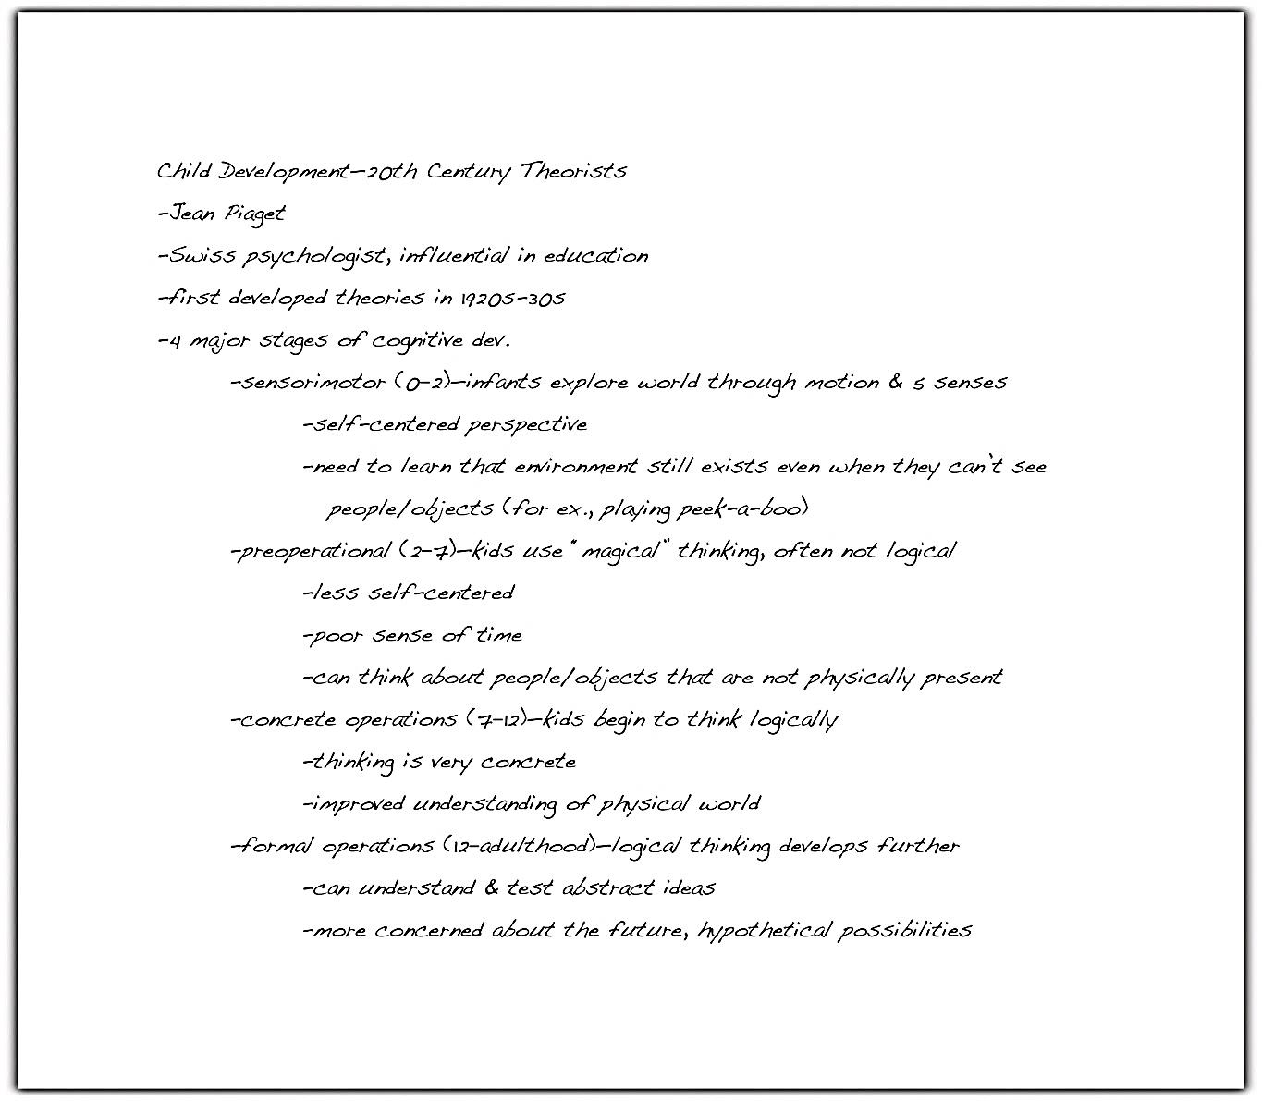

Mind Mapping/Clustering
If you are a visual learner, you may prefer to use a more graphic format for notes, such as a mind map. The next example shows how Crystal’s lecture notes could be set up differently. Although the format is different, the content and organization are the same.

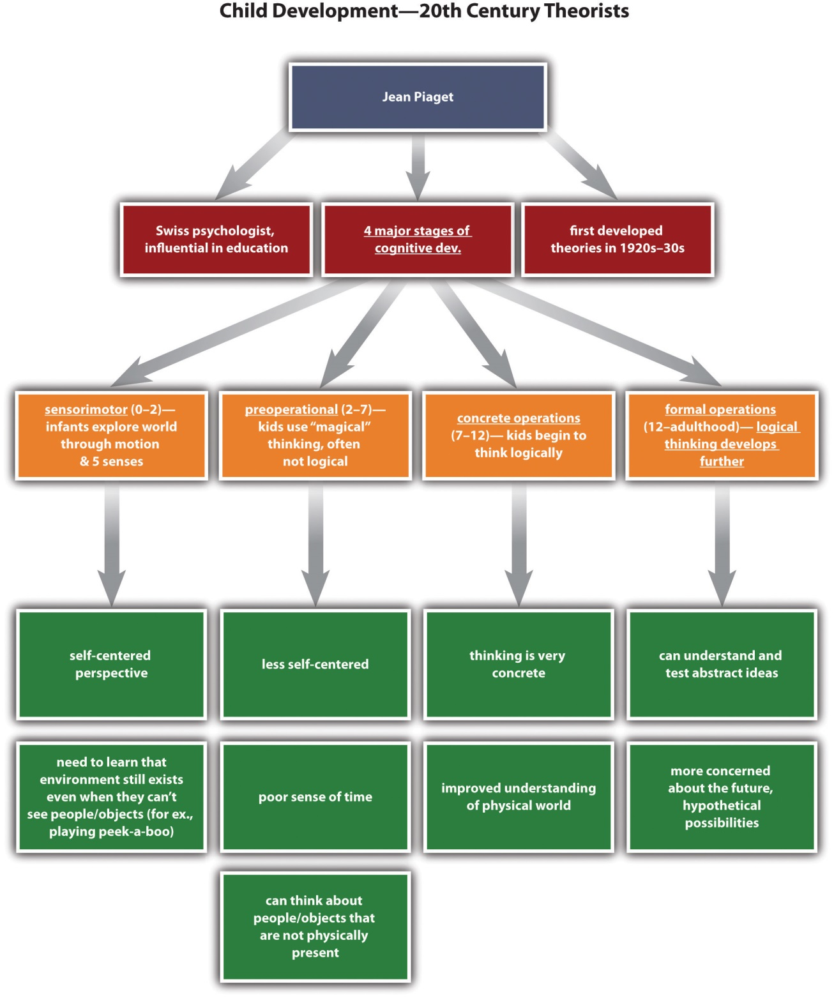

Charting
If the content of a lecture falls into a predictable, well organized pattern, you might choose to use a chart or table to record your notes. This system works best when you already know, either before class or at the beginning of class, which categories you should include. The next figure shows how this system might be used.
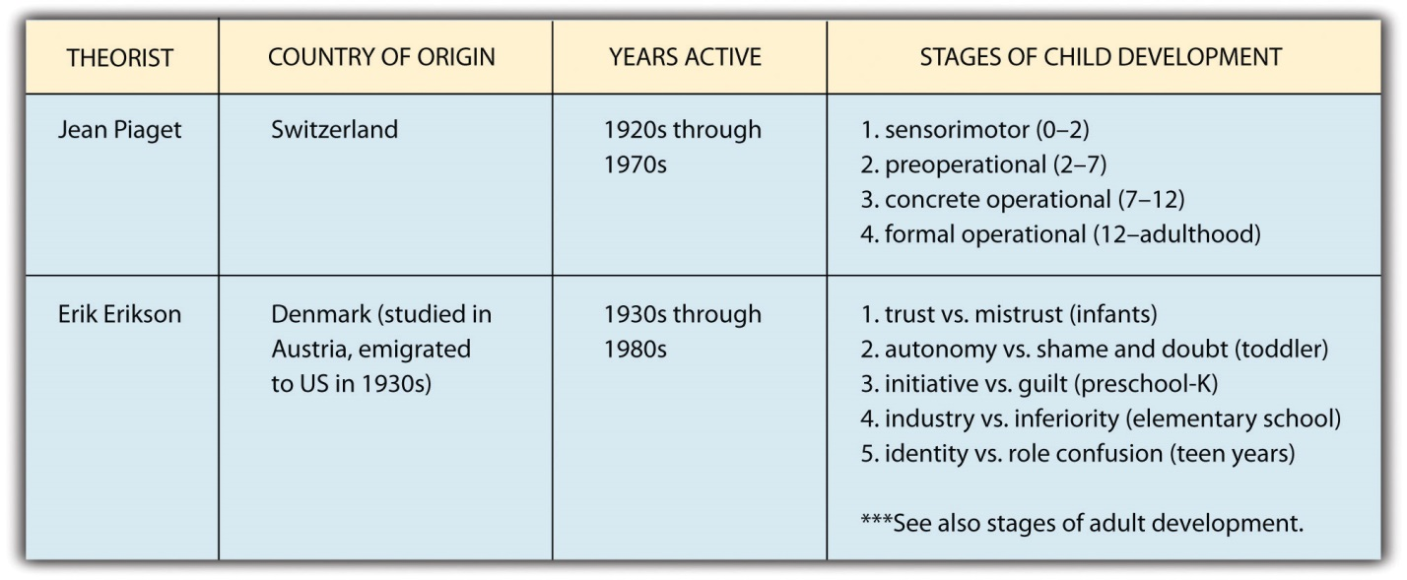
The Cornell Note-Taking System
In addition to the general techniques already described, you might find it useful to practise a specific strategy known as the Cornell note-taking system. This popular format makes it easy not only to organize information clearly but also to note key terms and summarize content.
To use the Cornell system, begin by setting up the page with these components:
- The course name and lecture date at the top of the page
- A narrow column (about two inches) at the left side of the page
- A wide column (about five to six inches) on the right side of the page
- A space of a few lines marked off at the bottom of the page
During the lecture, you record notes in the wide column. You can do so using the traditional modified outline format or a more visual format if you prefer.
Then, as soon as possible after the lecture, review your notes and identify key terms. Jot these down in the narrow left-hand column. You can use this column as a study aid by covering the notes on the right-hand side, reviewing the key terms, and trying to recall as much as you can about them so that you can mentally restate the main points of the lecture. Uncover the notes on the right to check your understanding. Finally, use the space at the bottom of the page to summarize each page of notes in a few sentences.
The next figure shows how Crystal’s notes would look using the Cornell system.
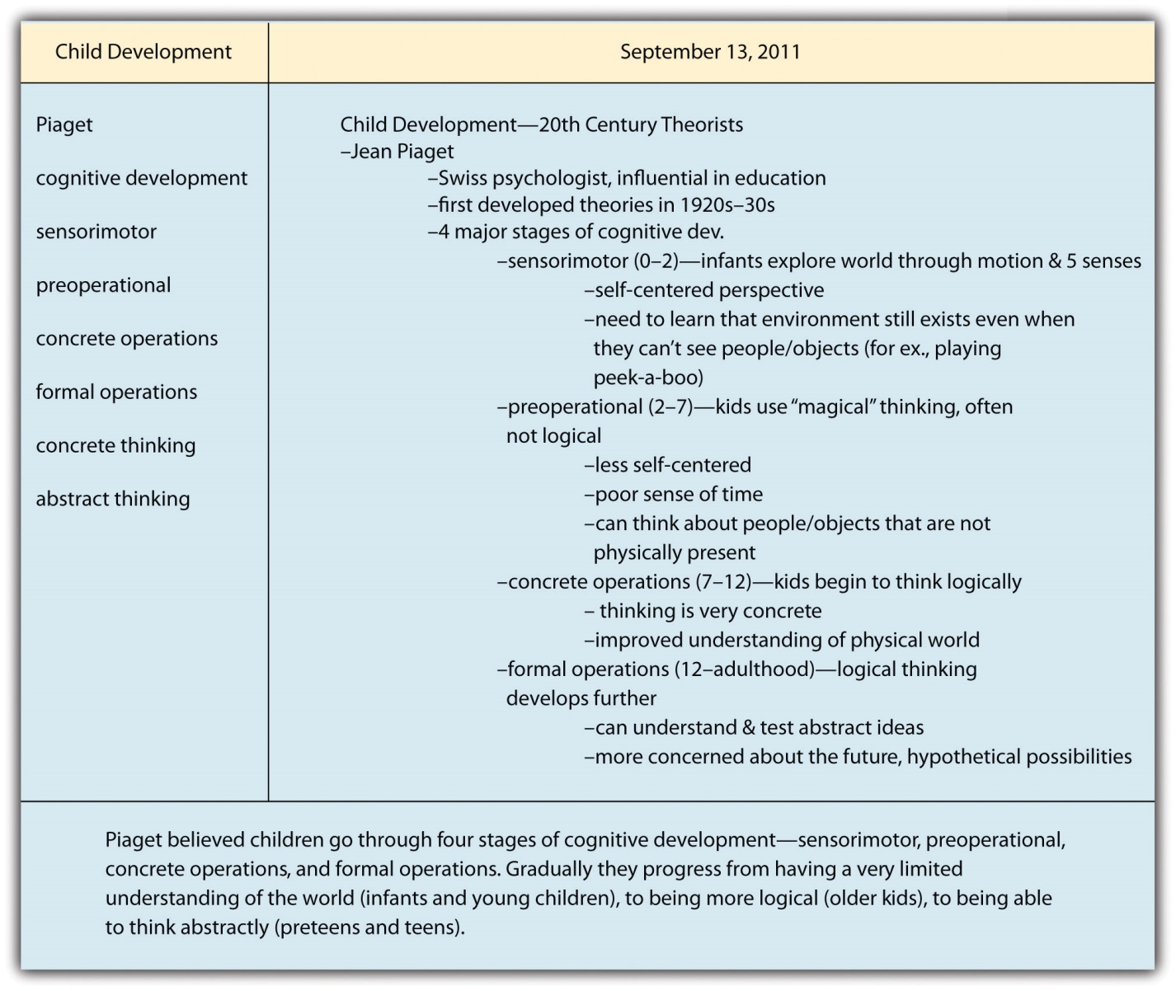

Writing at Work
Often, at school or in the workplace, a speaker will provide you with pre-generated notes summarizing electronic presentation slides. You may be tempted not to take notes at all because much of the content is already summarized for you. However, it is a good idea to jot down at least a few notes. Doing so keeps you focused during the presentation, allows you to record details you might otherwise forget, and gives you the opportunity to jot down questions or reflections to personalize the content.

Self-PRACTICE EXERCISE 1.5
Over the next few weeks, establish a note-taking system that works for you.
- If you are not already doing so, try using one of the aforementioned techniques. (Remember that the Cornell system can be combined with other note-taking formats.)
- It can take some trial and error to find a note-taking system that works for you. If you find that you are struggling to keep up with lectures, consider whether you need to switch to a different format or be more careful about distinguishing key concepts from unimportant details.
- If you find that you are having trouble taking notes effectively, set up an appointment with your school’s academic resource centre.

KEY TAKEAWAYS
- Understanding your individual learning style and preferences can help you identify the study and time management strategies that will work best for you.
- To manage your time effectively, it is important to look both at the short term (daily and weekly schedules) and the long term (major semester deadlines).
- To manage your time effectively, be consistent about maintaining your schedule. If your schedule is not working for you, make adjustments.
- A good note-taking system must differentiate among major points, related subtopics, and supporting details, and it must allow you to record and organize information fairly quickly. Choose the format that is most effective for you.

1.3 Becoming a Successful Writer

LEARNING OBJECTIVES
- Identify strategies for successful writing
- Demonstrate comprehensive writing skills
- Identify writing strategies for use in future classes
In the preceding sections, you learned what you can expect from your courses and identified strategies you can use to manage your work and to succeed. This section covers more about how to handle the demands placed on you as a writer at the post-secondary world. The general techniques you will learn will help ensure your success on any writing task, whether you complete an exam in an hour or an in-depth research project over several weeks.

Putting It All Together: Strategies for Success
Writing well is difficult. Even people who write for a living sometimes struggle to get their thoughts on the page. Even people who generally enjoy writing have days when they would rather be doing anything else. For people who do not like writing or do not think of themselves as good writers, writing assignments can be stressful or even intimidating. And of course, you cannot get through post-secondary courses without having to write—sometimes a lot, and often at a higher level than you are used to.
No magic formula will make writing quick and easy. However, you can use strategies and resources to manage writing assignments more easily. This section presents a broad overview of these strategies and resources. The remaining chapters of this book provide more detailed, comprehensive instruction to help you succeed at a variety of assignments.

Using the Writing Process
To complete a writing project successfully, good writers use some variation of the following process.

The Writing Process
- Prewriting. The writer generates ideas to write about and begins developing these ideas.
- Outlining a structure of ideas. The writer determines the overall organizational structure of the writing and creates an outline to organize ideas. Usually this step involves some additional fleshing out of the ideas generated in the first step.
- Writing a rough draft. The writer uses the work completed in prewriting to develop a first draft. The draft covers the ideas the writer brainstormed and follows the organizational plan that was laid out in the first step.
- Revising. The writer revisits the draft to review and, if necessary, reshape its content. This stage involves moderate and sometimes major changes: adding or deleting a paragraph, phrasing the main point differently, expanding on an important idea, reorganizing content, and so forth.
- Editing. The writer reviews the draft to make additional changes. Editing involves making changes to improve style and adherence to standard writing conventions—for instance, replacing a vague word with a more precise one or fixing errors in grammar and spelling. Once this stage is complete, the work is a finished piece and ready to share with others.
Chances are you have already used this process as a writer. You may also have used it for other types of creative projects, such as developing a sketch into a finished painting or composing a song. The steps listed above apply broadly to any project that involves creative thinking. You come up with ideas (often vague at first), you work to give them some structure, you make a first attempt, you figure out what needs improving, and then you refine it until you are satisfied.
Most people have used this creative process in one way or another, but many people have misconceptions about how to use it to write. Here are a few of the most common misconceptions students have about the writing process:
- “I do not have to waste time on prewriting if I understand the assignment.” Even if the task is straightforward and you feel ready to start writing, take some time to develop ideas before you plunge into your draft. Freewriting—writing about the topic without stopping for a set period of time—is one prewriting technique you might try in that situation.
- “It is important to complete a formal, numbered outline for every writing assignment.” For some assignments, such as lengthy research papers, proceeding without a formal outline can be very difficult. However, for other assignments, a structured set of notes or a detailed graphic organizer may suffice. The important thing is to have a solid plan for organizing ideas and details.
- “My draft will be better if I write it when I am feeling inspired.” By all means, take advantage of those moments of inspiration. However, understand that sometimes you will have to write when you are not in the mood. Sit down and start your draft even if you do not feel like it. If necessary, force yourself to write for just one hour. By the end of the hour, you may be far more engaged and motivated to continue. If not, at least you will have accomplished part of the task.
- “My instructor will tell me everything I need to revise.” If your instructor chooses to review drafts, the feedback can help you improve. However, it is still your job, not your instructor’s, to transform the draft to a final, polished piece. That task will be much easier if you give your best effort to the draft before submitting it. During revision, do not just go through and implement your instructor’s corrections. Take time to determine what you can change to make the work the best it can be.
- “I am a good writer, so I do not need to revise or edit.” Even talented writers still need to revise and edit their work. At the very least, doing so will help you catch an embarrassing typo or two. Revising and editing are the steps that make good writers into great writers.

Tip
The writing process also applies to timed writing tasks, such as essay exams. Before you begin writing, read the question thoroughly and think about the main points to include in your response. Use scrap paper to sketch out a very brief outline. Keep an eye on the clock as you write your response so you will have time to review it and make any needed changes before turning in your exam.

Managing Your Time
In Section 1.2: Developing Study Skills, you learned general time management skills. By combining those skills with what you have learned about the writing process, you can make any writing assignment easier to manage.
When your instructor gives you a writing assignment, write the due date on your calendar. Then work backward from the due date to set aside blocks of time when you will work on the assignment. Always plan at least two sessions of writing time per assignment, so that you are not trying to move from step 1 to step 5 in one evening. Trying to work that fast is stressful, and it does not yield great results. You will plan better, think better, and write better if you space out the steps.
Ideally, you should set aside at least three separate blocks of time to work on a writing assignment: one for prewriting and outlining, one for drafting, and one for revising and editing. Sometimes those steps may be compressed into just a few days. If you have a couple of weeks to work on a paper, space out the five steps over multiple sessions. Long-term projects, such as research papers, require more time for each step.

Tip
In certain situations you may not be able to allow time between the different steps of the writing process. For instance, you may be asked to write in class or complete a brief response paper overnight. If the time available is very limited, apply a modified version of the writing process (as you would do for an essay exam). It is still important to give the assignment thought and effort. However, these types of assignments are less formal, and instructors may not expect them to be as polished as formal papers. When in doubt, ask the instructor about expectations, resources that will be available during the writing exam, and if he or she has any tips to prepare you to effectively demonstrate your writing skills.
Each Monday in Crystal’s Foundations of Education class, the instructor distributed copies of a current news article on education and assigned students to write a one-and-a-half to two-page response that was due the following Monday. Together, these weekly assignments counted for 20 percent of the course grade. Although each response took just a few hours to complete, Crystal found that she learned more from the reading and got better grades on her writing if she spread the work out in the following way:

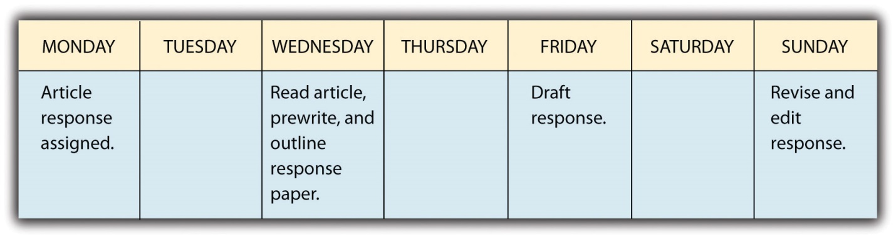

self-practice EXERCISE 1.6
In this exercise, make connections between short- and long-term goals.
- Review the long- and short-term goals you set for yourself for the discussion at the beginning of the module. Brainstorm a list of stepping stones that will help you meet that goal, such as “doing well on my midterm and final exams” or “talking to Professor Gibson about doing an internship.” Write down everything you can think of that would help you meet that semester goal.
- Review your list. Choose two to three items, and for each item identify at least one concrete action you can take to accomplish it. These actions may be recurring (meeting with a study group each week) or one time only (calling the professor in charge of internships).
- Identify one action from Step 3 that you can do today. Then do it.

Using Available Resources
One reason students sometimes find post-secondary courses overwhelming is that they do not know about, or are reluctant to use, the resources available to them. There is help available; your student fees help pay for resources that can help in many ways, such as a health centre or tutoring service. If you need help, consider asking for help from any of the following:
- Your instructor: If you are making an honest effort but still struggling with a particular course, set a time to meet with your instructor and discuss what you can do to improve. He or she may be able to shed light on a confusing concept or give you strategies to catch up.
- Your academic counsellor. Many institutions assign students an academic counsellor who can help you choose courses and ensure that you fulfill degree and major requirements.
- The academic resource centre: These centres offer a variety of services, which may range from general coaching in study skills to tutoring for specific courses. Find out what is offered at your school and use the services that you need.
- The writing centre: These centres employ tutors to help you manage your writing assignments. They will not write or edit your paper for you, but they can help you through the stages of the writing process. (In some schools, the writing centre is part of the academic resource centre.)
- The career resource centre: Visit the career resource centre for guidance in choosing a career path, developing a resumé, and finding and applying for jobs.
- Counselling services: Many schools offer psychological counselling for free or for a low fee. Use these services if you need help coping with a difficult personal situation or managing depression, anxiety, or other problems.
Students sometimes neglect to use available resources due to limited time, unwillingness to admit there is a problem, or embarrassment about needing to ask for help. Unfortunately, ignoring a problem usually makes it harder to cope with later on. Waiting until the end of the semester may also mean fewer resources are available, since many other students are also seeking last minute help.

self-practice EXERCISE 1.7
Identify at least one resource you think could be helpful to you and that you would like to investigate further. Schedule a time to visit this resource within the next week or two so you can use it throughout the semester.

Summary
You now have a solid foundation of skills and strategies you can use to succeed in university or college. The remainder of this book will provide you with guidance on specific aspects of writing, ranging from grammar and style conventions to how to write a research paper.
For any writing assignment, use these strategies:
- Plan ahead. Divide the work into smaller, manageable tasks, and set aside time to accomplish each task in turn.
- Make sure you understand the assignment requirements. If necessary, clarify the requirements with your instructor. Think carefully about the purpose of the writing, the intended audience, the topics you will need to address, and any specific requirements of the writing form.
- Complete each step of the writing process. With practice, using this process will come automatically to you.
- Use the resources available to you. Remember that most schools have specific services to help students with their writing.

KEY TAKEAWAYS
- Following the steps of the writing process helps students complete any writing assignment more successfully.
- To manage writing assignments, it is best to work backward from the due date, allotting appropriate time to complete each step of the writing process.
- Setting concrete long- and short-term goals helps students stay focused and motivated.
- A variety of resources are available to help students with writing and with other aspects of post-secondary life.

Journal entry #1
Write a paragraph or two responding to the following.
Consider the material covered this week and identify what type of learner you are and what this means for you when reading, note taking, studying, writing, and managing your time.
Remember as mentioned in the Assessment Descriptions in your syllabus:
- You will be expected to respond to the questions by reflecting on and discussing your experiences with the week’s material.
- When writing your journals, you should focus on free writing—writing without (overly) considering formal writing structures—but remember that it will be read by the instructor, who needs to be able to understand your ideas.
- Your instructor will be able to see if you have completed this entry by the end of the week but will not read all of the journals until week 6.

Chapter 2

Working with Words: Which Word Is Right?

2.1 Commonly Confused Words

LEARNING OBJECTIVES
- Identify commonly confused words
- Use strategies to avoid commonly confused words
Just as a mason uses bricks to build sturdy homes, writers use words to build successful documents. Consider the construction of a building. Builders need to use tough, reliable materials to build a solid and structurally sound skyscraper. From the foundation to the roof and every floor in between, every part is necessary. Writers need to use strong, meaningful words from the first sentence to the last and in every sentence in between.
You already know many words that you use every day as part of your writing and speaking vocabulary. You probably also know that certain words fit better in certain situations. Letters, emails, and even quickly jotted grocery lists require the proper selection of vocabulary. Imagine you are writing a grocery list to purchase the ingredients for a recipe but accidentally write down cilantro when the recipe calls for parsley. Even though cilantro and parsley look remarkably alike, each produces a very different effect in food. This seemingly small error could radically alter the flavour of your dish!
Having a solid everyday vocabulary will help you while writing, but learning new words and avoiding common word errors will make a real impression on your readers. Experienced writers know that deliberate, careful word selection and usage can lead to more polished, more meaningful work. This chapter covers word choice and vocabulary-building strategies that will improve your writing.

Commonly Confused Words
Some words in English cause trouble for speakers and writers because they share a similar pronunciation, meaning, or spelling with another word. These words are called commonly confused words. For example, read aloud the following sentences containing the commonly confused words new and knew:
I liked her new sweater.
I knew she would wear that sweater today.
These words may sound alike when spoken, but they carry entirely different usages and meanings. New is an adjective that describes the sweater, and knew is the past tense of the verb to know. To read more about adjectives, verbs, and other parts of speech see Section 3.1: Sentence Writing.

Recognizing Commonly Confused Words
New and knew are just two of the words that can be confusing because of their similarities. Familiarize yourself with the following list of commonly confused words. Recognizing these words in your own writing and in other pieces of writing can help you choose the correct word to avoid confusing the reader and, ultimately, being incorrect in your writing.

Commonly Confused Words
A, An, And
- A (article). Used before a word that begins with a consonant.
a key, a mouse, a screen
- An (article). Used before a word that begins with a vowel.
an airplane, an ocean, an igloo
- And (conjunction). Connects two or more words together.
peanut butter and jelly, pen and pencil, jump and shout
Accept, Except
- Accept (verb). Means to take or agree to something offered.
They accepted our proposal for the conference.
- Except (conjunction). Means only or but.
We could fly there except the tickets cost too much.
Affect, Effect
- Affect (verb). Means to create a change.
Hurricane winds affect the amount of rainfall.
- Effect (noun). Means an outcome or result.
The heavy rains will have an effect on the crop growth.

Are, Our
- Are (verb). A conjugated form of the verb to be.
My cousins are all tall and blonde.
- Our (pronoun). Indicates possession, usually follows the pronoun we.
We will bring our cameras to take pictures.
By, Buy
- By (preposition). Means next to.
My glasses are by the bed.
- Buy (verb). Means to purchase.
I will buy new glasses after the doctor’s appointment.
Its, It’s
- Its (pronoun). A form of it that shows possession.
The butterfly flapped its wings.
- It’s (contraction). Joins the words it and is.
It’s the most beautiful butterfly I have ever seen.
Know, No
- Know (verb). Means to understand or possess knowledge.
I know the male peacock sports the brilliant feathers.
- No. Used to make a negative.
I have no time to visit the zoo this weekend.
Loose, Lose
- Loose (adjective). Describes something that is not tight or is detached.
Without a belt, her pants are loose on her waist.
- Lose (verb). Means to forget, to give up, or to fail to earn something.
She will lose even more weight after finishing the marathon training.
Of, Have
- Of (preposition). Means from or about.
I studied maps of the city to know where to rent a new apartment.
- Have (verb). Means to possess something.
I have many friends to help me move.
- Have (linking verb). Used to connect verbs.
I should have helped her with that heavy box.
Quite, Quiet, Quit
- Quite (adverb). Means really or truly.
My work will require quite a lot of concentration.
- Quiet (adjective). Means not loud.
I need a quiet room to complete the assignments.
- Quit (verb). Means to stop or to end.
I will quit when I am hungry for dinner.
Right, Write
- Right (adjective). Means proper or correct.
When bowling, she practises the right form.
- Right (adjective). Also means the opposite of left.
The ball curved to the right and hit the last pin.
- Write (verb). Means to communicate on paper.
After the team members bowl, I will write down their scores.
Set, Sit
- Set (verb). Means to put an item down.
She set the mug on the saucer.
- Set (noun). Means a group of similar objects.
All the mugs and saucers belonged in a set.
- Sit (verb). Means to lower oneself down on a chair or another place.
I’ll sit on the sofa while she brews the tea.
Suppose, Supposed
- Suppose (verb). Means to think or to consider.
I suppose I will bake the bread, because no one else has the recipe.
- Suppose (verb). Means to suggest.
Suppose we all split the cost of the dinner.
- Supposed (verb). The past tense form of the verb suppose, meaning required or allowed.
She was supposed to create the menu.
Than, Then
- Than (conjunction). Used to connect two or more items when comparing.
Registered nurses require less schooling than doctors.
- Then (adverb). Means next or at a specific time.
Doctors first complete medical school and then obtain a residency.
Their, They’re, There
- Their (pronoun). A form of they that shows possession.
The dog walker feeds their dogs everyday at two o’clock.
- They’re (contraction). Joins the words they and are.
They’re the sweetest dogs in the neighbourhood.
- There (adverb). Indicates a particular place.
The dogs’ bowls are over there, next to the pantry.
- There (pronoun). Indicates the presence of something
There are more treats if the dogs behave.
To, Two, Too
- To (preposition). Indicates movement.
Let’s go to the circus.
- To. A word that completes an infinitive verb.
to play, to ride, to watch.
- Two. The number after one. It describes how many.
Two clowns squirted the elephants with water.
- Too (adverb). Means also or very.
The tents were too loud, and we left.
Use, Used
- Use (verb). Means to apply for some purpose.
We use a weed whacker to trim the hedges.
- Used. The past tense form of the verb to use
He used the lawnmower last night before it rained.
- Used to. Indicates something done in the past but not in the present
He used to hire a team to landscape, but now he landscapes alone.
Who’s, Whose
- Who’s (contraction). Joins the words who and either is or has.
Who’s the new student? Who’s met him?
- Whose (pronoun). A form of who that shows possession.
Whose schedule allows them to take the new student on a campus tour?
Your, You’re
- Your (pronoun). A form of you that shows possession.
Your book bag is unzipped.
- You’re (contraction). Joins the words you and are.
You’re the girl with the unzipped book bag.
The English language contains so many words; no one can say for certain how many words exist. In fact, many words in English are borrowed from other languages. Many words have multiple meanings and forms, further expanding the immeasurable number of English words. Although the list of commonly confused words serves as a helpful guide, even these words may have more meanings than shown here. When in doubt, consult an expert: the dictionary!

Self-Practice EXERCISE 2.1
Complete the following sentences by selecting the correct word.
- My little cousin turns ________(to, too, two) years old tomorrow.
- The next-door neighbour’s dog is ________(quite, quiet, quit) loud. He barks constantly throughout the night.
- ________(Your, You’re) mother called this morning to talk about the party.
- I would rather eat a slice of chocolate cake ________(than, then) eat a chocolate muffin.
- Before the meeting, he drank a cup of coffee and ________(than, then) brushed his teeth.
- Do you have any ________(loose, lose) change to pay the parking meter?
- Father must ________(have, of) left his briefcase at the office.
- Before playing ice hockey, I was ________(suppose, supposed) to read the contract, but I only skimmed it and signed my name quickly, which may ________(affect, effect) my understanding of the rules.
- Tonight she will ________(set, sit) down and ________(right, write) a cover letter to accompany her resumé and job application.
- It must be fall, because the leaves ________(are, our) changing, and ________(it’s, its) getting darker earlier.

Strategies to Avoid Commonly Confused Words
When writing, you need to choose the correct word according to its spelling and meaning in the context. Not only does selecting the correct word improve your vocabulary and your writing, but it also makes a good impression on your readers. It also helps reduce confusion and improve clarity. The following strategies can help you avoid misusing confusing words.
- Use a dictionary. Keep a dictionary at your desk while you write. Look up words when you are uncertain of their meanings or spellings. Many dictionaries are also available online, and the Internet’s easy access will not slow you down. Check out your cell phone or smartphone to see if a dictionary app is available.
- Keep a list of words you commonly confuse. Be aware of the words that often confuse you. When you notice a pattern of confusing words, keep a list nearby, and consult the list as you write. Check the list again before you submit an assignment to your instructor.
- Study the list of commonly confused words. You may not yet know which words confuse you, but before you sit down to write, study the words on the list. Prepare your mind for working with words by reviewing the commonly confused words identified in this chapter.

Tip
Commonly confused words appear in many locations, not just at work or at school. Be on the lookout for misused words wherever you find yourself throughout the day. Make a mental note of the error and remember its correction for your own pieces of writing.

Writing at Work
All employers value effective communication. From an application to an interview to the first month on the job, employers pay attention to your vocabulary. You do not need a large vocabulary to succeed, but you do need to be able to express yourself clearly and avoid commonly misused words.
When giving an important presentation on the effect of inflation on profit margins, you must know the difference between effect and affect and choose the correct word. When writing an email to confirm deliveries, you must know if the shipment will arrive in to days, too days, or two days. Confusion may arise if you choose the wrong word.
Consistently using the proper words will improve your communication and make a positive impression on your boss and colleagues.

Self-Practice EXERCISE 2.2
The following paragraph contains 11 errors. Find each misused word and correct it by adding the proper word.
The original United States Declaration of Independence sets in a case at the Rotunda for the Charters of Freedom as part of the National Archives in Washington, DC. Since 1952, over one million visitors each year of passed through the Rotunda too snap a photograph to capture they’re experience. Although signs state, “No Flash Photography,” forgetful tourists leave the flash on, an a bright light flickers for just a millisecond. This millisecond of light may not seem like enough to effect the precious document, but supposed how much light could be generated when all those milliseconds are added up. According to the National Archives administrators, its enough to significantly damage the historic document. So, now, the signs display quit a different message: “No Photography.” Visitors continue to travel to see the Declaration that began are country, but know longer can personal pictures serve as mementos. The administrators’ compromise, they say, is a visit to the gift shop for a preprinted photograph.
Collaboration: Please share with a classmate and compare your answers.

KEY TAKEAWAYS
- In order to write accurately, it is important for writers to be aware of commonly confused words.
- Although commonly confused words may look alike or sound alike, their meanings are very different.
- Consulting the dictionary is one way to make sure you are using the correct word in your writing. You may also keep a list of commonly confused words nearby when you write, or study the chart in this section.
- Choosing the proper words leaves a positive impression on your readers.

Writing Application
Review the latest assignment you completed for school or for work. Does it contain any commonly confused words? Circle each example and use the circled words to begin your own checklist of commonly confused words. Continue to add to your checklist each time you complete an assignment and find a misused word.

2.2 Spelling

LEARNING OBJECTIVES
- Identify common spelling rules
- Identify commonly misused homonyms
- Identify commonly misspelled words
One essential aspect of good writing is accurate spelling. With computer spell checkers at your disposal, spelling may seem simple, but these programs fail to catch every error. Spell checkers identify some errors, but writers still have to consider the flagged words and suggested replacements. Writers are still responsible for the errors that remain.
For example, if the spell checker highlights a word that is misspelled and gives you a list of alternative words, you may choose a word that you never intended even though it is spelled correctly. This can change the meaning of your sentence. It can also confuse readers, making them lose interest. Computer spell checkers are useful editing tools, but they can never replace human knowledge of spelling rules, homonyms, and commonly misspelled words.

Common Spelling Rules
The best way to master new words is to understand the key spelling rules. Keep in mind, however, that some spelling rules carry exceptions. A spell checker may catch these exceptions, but knowing them yourself will prepare you to spell accurately on the first try. You may want to try memorizing each rule and its exception like you would memorize a rhyme or lyrics to a song.
Write i before e except after c, or when pronounced ay like “neighbour” or “weigh.”
- achieve, niece, alien
- receive, deceive

When words end in a consonant plus y, drop the y and add an i before adding another ending.
- happy + er = happier
- cry + ed = cried

When words end in a vowel plus y, keep the y and add the ending.
- delay + ed = delayed
Memorize the following exceptions to this rule: day, lay, say, pay = daily, laid, said, paid

When adding an ending that begins with a vowel, such as -able, -ence, -ing, or -ity, drop the last e in a word.
- write + ing = writing
- pure + ity = purity

When adding an ending that begins with a consonant, such as -less, -ment, or -ly, keep the last e in a word.
- hope + less = hopeless
- advertise + ment = advertisement

For many words ending in a consonant and an o, add -s when using the plural form.
- photo + s = photos
- soprano + s = sopranos
Add -es to words that end in s, ch, sh, and x.
- church + es = churches
- fax + es = faxes

Self-Practice EXERCISE 2.3
Identify and correct the nine misspelled words in the following paragraph.
Sherman J. Alexie Jr. was born in October 1966. He is a Spokane/Coeur d’Alene Indian and an American writer, poet, and filmmaker. Alexie was born with hydrocephalus, or water on the brain. This condition led doctors to predict that he would likly suffer long-term brain damage and possibly mental retardation. Although Alexie survived with no mental disabilitys, he did suffer other serious side effects from his condition that plagud him throughout his childhood. Amazingly, Alexie learned to read by the age of three, and by age five he had read novels such as John Steinbeck’s The Grapes of Wrath. Raised on an Indian reservation, Alexie often felt aleinated from his peers due to his avid love for reading and also from the long-term effects of his illness, which often kept him from socializeing with his peers on the reservation. The reading skills he displaid at such a young age foreshadowed what he would later become. Today Alexie is a prolific and successful writer with several story anthologeis to his credit, noteably The Lone Ranger and Tonto Fistfight in Heaven and The Toughest Indian in the World. Most of his fiction is about contemporary Native Americans who are influenced by pop culture and powwows and everything in between. His work is sometimes funny but always thoughtful and full of richness and depth. Alexie also writes poetry, novels, and screenplays. His latest collection of storys is called War Dances, which came out in 2009.
Collaboration: Please share with a classmate and compare your answers.

Tip
Use these eight tips to improve your spelling skills:
- Read the words in your assignment carefully, and avoid skimming over the page. Focusing on your written assignment word by word will help you pay close attention to each word’s spelling. Skimming quickly, you may overlook misspelled words.
- Use mnemonic devices to remember the correct spelling of words. Mnemonic devices, or memory techniques and learning aids, include inventive sayings or practices that help you remember. For example, the saying “It is important to be a beautiful person inside and out” may help you remember that beautiful begins with “be a.” The practice of pronouncing the word Wednesday Wed-nes-day may help you remember how to spell the word correctly.
- Use a dictionary. Many professional writers rely on the dictionary—either in print or online. If you find it difficult to use a regular dictionary, ask your instructor to help you find a “poor speller’s dictionary.”
- Use your computer’s spell checker. The spell checker will not solve all your spelling problems, but it is a useful tool. See the introduction to this section for cautions about spell checkers.
- Keep a list of frequently misspelled words. You will often misspell the same words again and again, but do not let this discourage you. All writers struggle with the spellings of certain words; they become aware of their spelling weaknesses and work to improve. Be aware of which words you commonly misspell, and you can add them to a list to learn to spell them correctly.
- Look over corrected papers for misspelled words. Add these words to your list and practise writing each word four to five times. Writing teachers will especially notice which words you frequently misspell, and it will help you excel in your classes if they see your spelling improve.
- Test yourself with flash cards. Sometimes the old-fashioned methods are best, and for spelling, this tried-and-true technique has worked for many students. You can work with a peer or alone.
- Review the common spelling rules explained in this chapter. Take the necessary time to master the material; you may return to the rules in this chapter again and again, as needed.

Tip
Remember to focus on spelling during the editing and revising step of the writing process. Start with the big ideas such as organizing your piece of writing and developing effective paragraphs, and then work your way down toward the smaller—but equally important—details like spelling and punctuation.

Homonyms
Homonyms are words that sound like one another but have different meanings.

Commonly Misused Homonyms
Lead, Led
- Lead (noun). A type of metal used in pipes and batteries.
The lead pipes in my homes are old and need to be replaced.
- Led (verb). The past tense of the verb lead.
After the garden, she led the patrons through the museum.
Lessen, Lesson
- Lessen (verb). To reduce in number, size, or degree.
My dentist gave me medicine to lessen the pain of my aching tooth.
- Lesson (noun). A reading or exercise to be studied by a student.
Today’s lesson was about mortgage interest rates.
Passed, Past
- Passed (verb). To go away or move.
He passed the slower cars on the road using the left lane.
- Past (noun). Having existed or taken place in a period before the present.
The argument happened in the past, so there is no use in dwelling on it.
Patience, Patients
- Patience (noun). The capacity of being patient (waiting for a period of time or enduring pains and trials calmly).
The novice teacher’s patience with the unruly class was astounding.
- Patients (plural noun). Individuals under medical care.
The patients were tired of eating the hospital food, and they could not wait for a home-cooked meal.
Peace, Piece
- Peace (noun). A state of tranquility or quiet.
For once, there was peace between the argumentative brothers.
- Piece (noun). A part of a whole.
I would like a large piece of cake, thank you.

Principle, Principal
- Principle (noun). A fundamental concept that is accepted as true.
The principle of human equality is an important foundation for all nations.
- Principal (noun). The original amount of debt on which interest is calculated.
The payment plan allows me to pay back only the principal amount, not any compounded interest.
- Principal (noun). A person who is the main authority of a school.
The principal held a conference for both parents and teachers.
Sees, Seas, Seize
- Sees (verb). To perceive with the eye.
He sees a whale through his binoculars.
- Seas (plural noun). The plural of sea, a great body of salt water.
The tidal fluctuation of the oceans and seas are influenced by the moon.
- Seize (verb). To possess or take by force.
The king plans to seize all the peasants’ land.
Threw, Through
- Threw (verb). The past tense of throw.
She threw the football with perfect form.
- Through (preposition). A word that indicates movement.
She walked through the door and out of his life.
Where, Wear, Ware
- Where (adverb). The place in which something happens.
Where is the restaurant?
- Wear (verb). To carry or have on the body.
I will wear my hiking shoes when go on a climb tomorrow morning.
- Ware (noun). Articles of merchandise or manufacture (usually, wares).
When I return from shopping, I will show you my wares.
Which, Witch
- Which (pronoun). Replaces one out of a group.
Which apartment is yours?
- Witch (noun). A person who practises sorcery or who has supernatural powers.
She thinks she is a witch, but she does not seem to have any powers.

Self-Practice EXERCISE 2.4
Complete the following sentences by selecting the correct homonym.
- Do you agree with the underlying ________(principle, principal) that ensures copyrights are protected in the digital age?
- I like to ________(where, wear, ware) unique clothing from thrift stores that do not have company logos on them.
- Marjorie felt like she was being ________(led, lead) on a wild goose chase, and she did not like it one bit.
- Serina described ________(witch, which) house was hers, but now that I am here, they all look the same.
- Seeing his friend without a lunch, Miguel gave her a ________(peace, piece) of his apple.
- Do you think that it is healthy for mother to talk about the ________(passed, past) all the time?
- Eating healthier foods will ________(lessen, lesson) the risk of heart disease.
- I know it sounds clichéd, but my father had the ________(patients, patience) of a saint.
- Daniela ________(sees, seas, seize) possibilities in the bleakest situations, and that it is why she is successful.
- Everyone goes ________(through, threw) hardships in life regardless of who they are.
Collaboration: Please share with a classmate and compare your answers.

Commonly Misspelled Words
Table 2.1: Commonly Misspelled Words provides a list of commonly misspelled words. You probably use these words every day in either speaking or writing. Each word has a segment in bold type that indicates the problem area of the word that is often spelled incorrectly. Refer to this list as needed before, during, and after you write.

Tip
Use these two techniques to help you master these troublesome words:
- Copy each word a few times and underline the problem area.
- Copy the words onto flash cards and have a friend test you.
Table 2.1 Commonly Misspelled Words
across | address | answer | argument | athlete | beginning | behaviour | calendar
career | conscience | crowded | definite | describe | desperate | different | disappoint
disapprove | eighth | embarrass | environment | exaggerate | familiar | finally | government
grammar | height | illegal | immediate | important | integration | intelligent | interest
interfere | jewellery | judgment | knowledge | maintain | mathematics | meant | necessary
nervous | occasion | opinion | optimist | particular | perform | personnel | possess
possible | prefer | prejudice | privilege | probably | psychology | pursue | reference
rhythm | ridiculous | separate | speech | similar | since | strength | success
surprise | taught | temperature | thorough | thought | tired | until | weight
written | writing

Self-Practice EXERCISE 2.5
Identify and correct the 10 commonly misspelled words in the following passage.
Brooklyn is one of the five boroughs that make up New York City. It is located on the eastern shore of Long Island directly accross the East River from the island of Manhattan. Its beginings stretch back to the 16th century when it was founded by the Dutch who originally called it “Breuckelen.” Immedietely after the Dutch settled Brooklyn, it came under British rule. However, neither the Dutch nor the British were Brooklyn’s first inhabitants. When European settlers first arrived, Brooklyn was largely inhabited by the Lenapi, a collective name for several organized bands of Native American people who settled a large area of land that extended from upstate New York through the entire state of New Jersey. They are sometimes referred to as the Delaware Indians. Over time, the Lenapi succumbed to European diseases or conflicts between European settlers or other Native American enemies. Finalley, they were pushed out of Brooklyn completely by the British.
In 1776, Brooklyn was the site of the first importent battle of the American Revolution known as the Battle of Brooklyn. The colonists lost this battle, which was led by George Washington, but over the next two years they would win the war, kicking the British out of the colonies once and for all.
By the end of the 19th century, Brooklyn grew to be a city in its own right. The completion of the Brooklyn Bridge was an ocasion for celebration; transportation and commerce between Brooklyn and Manhattan now became much easier. Eventually, in 1898, Brooklyn lost its seperate identity as an independent city and became one of five boroughs of New York City. However, in some people’s opinien, the intagration into New York City should have never happened; they though Brooklyn should have remained an independant city.
Collaboration: Please share with a classmate and compare your answers.

Writing at Work
In today’s job market, writing emails has become a means by which many people find employment. Emails to prospective employers require thoughtful word choice, accurate spelling, and perfect punctuation. Employers’ inboxes are inundated with countless emails daily. If even the subject line of an email contains a spelling error, it will likely be overlooked and someone else’s email will take priority.
The best thing to do after you proofread an email to an employer and run the spell checker is to have an additional set of eyes go over it with you; one of your teachers may be able to read the email and give you suggestions for improvement. Most colleges and universities have writing centres, which may also be able to assist you.

KEY TAKEAWAYS
- Accurate, error-free spelling enhances your credibility with the reader.
- Mastering the rules of spelling may help you become a better speller.
- Knowing the commonly misused homonyms may prevent spelling errors.
- Studying the list of commonly misspelled words in this chapter, or studying a list of your own, is one way to improve your spelling skills.

Writing Application
What is your definition of a successful person? Is it based on a person’s profession or character? Perhaps success means a combination of both. In one paragraph, describe in detail what you think makes a person successful. When you are finished, proofread your work for spelling errors. Exchange papers with a partner and read each other’s work. See if you catch any spelling errors that your partner missed.

2.3 Word Choice

LEARNING OBJECTIVES
- Identify the reasons why using a dictionary and thesaurus is important when writing
- Identify how to use proper connotations
- Identify how to avoid using slang, clichés, and overly general words in your writing
Effective writing involves making conscious word choices. When you prepare to sit down to write your first draft, you likely have already completed some freewriting exercises, chosen your topic, developed your thesis statement, written an outline, and even selected your sources. When it is time to write your first draft, start to consider which words to use to best convey your ideas to the reader.
Some writers are picky about word choice as they start drafting. They may practise some specific strategies, such as using a dictionary and thesaurus, using words and phrases with proper connotations, and avoiding slang, clichés, and overly general words.
Once you understand these tricks of the trade, you can move ahead confidently in writing your assignment. Remember, the skill and accuracy of your word choice is a major factor in developing your writing style. Precise selection of your words will help you be more clearly understood—in both writing and speaking.

Using a Dictionary and Thesaurus
Even professional writers need help with the meanings, spellings, pronunciations, and uses of particular words. In fact, they rely on dictionaries to help them write better. No one knows every word in the English language and their multiple uses and meanings, so all writers, from novices to professionals, can benefit from the use of dictionaries.
Most dictionaries provide the following information:
- Spelling: How the word and its different forms are spelled
- Pronunciation: How to say the word
- Part of speech: The function of the word
- Definition: The meaning of the word
- Synonyms: Words that have similar meanings
- Etymology: The history of the word
Look at the following sample dictionary entry and see which of the preceding information you can identify:
myth, mith, n. [Gr. mythos, a word, a fable, a legend.] A fable or legend embodying the convictions of a people as to their gods or other divine beings, their own beginnings and early history and the heroes connected with it, or the origin of the world; any invented story; something or someone having no existence in fact.—myth • ic, myth • i • cal
Like a dictionary, a thesaurus is another indispensable writing tool. A thesaurus gives you a list of synonyms—words that have the same (or close to the same) meaning as another word. It also lists antonyms—words with the opposite meaning of the word. A thesaurus will help you when you are looking for the perfect word with just the right meaning to convey your ideas. It will also help you learn more words and use the ones you already know more correctly. Look at the following thesaurus entry:
precocious adj, She’s such a precocious little girl!: uncommonly smart, mature, advanced, smart, bright, brilliant, gifted, quick, clever, apt.
Ant. slow, backward, stupid.

Using Proper Connotations
A denotation is the dictionary definition of a word. A connotation, on the other hand, is the emotional or cultural meaning attached to a word. The connotation of a word can be positive, negative, or neutral. Keep in mind the connotative meaning when choosing a word. Look at the examples below:
Scrawny
- Denotation: Exceptionally thin and slight or meagre in body or size.
- Word used in a sentence: Although he was a premature baby and a scrawny child, Martin has developed into a strong man.
- Connotation: (Negative) In this sentence the word scrawny may have a negative connotation in the readers’ minds. They might find it to mean a weakness or a personal flaw; however, the word fits into the sentence appropriately.
Skinny
- Denotation: Lacking sufficient flesh, very thin.
- Word used in a sentence: Skinny jeans have become very fashionable in the past couple of years.
- Connotation: (Positive) Based on cultural and personal impressions of what it means to be skinny, the reader may have positive connotations of the word skinny.
Lean
- Denotation: Lacking or deficient in flesh; containing little or no fat.
- Word used in a sentence: My brother has a lean figure, whereas I have a more muscular build.
- Connotation: (Neutral) In this sentence, lean has a neutral connotation. It does not call to mind an overly skinny person like the word scrawny, nor does imply the positive cultural impressions of the word skinny. It is merely a neutral descriptive word.
Notice that all the words have a very similar denotation; however, the connotations of each word differ.

Self-Practice-EXERCISE 2.6
In each of the following list items, you will find words with similar denotations. Identify the words’ connotations as positive, negative, or neutral by writing the word in the appropriate box. Use the table below.
- curious, nosy, interested
- lazy, relaxed, slow
- courageous, foolhardy, assured
- new, newfangled, modern
- mansion, shack, residence
- spinster, unmarried woman, career woman
- giggle, laugh, cackle
- boring, routine, prosaic
- noted, notorious, famous
- assertive, confident, pushy

 | Positive | Negative | Neutral

Avoiding Slang
Slang describes informal words that are considered nonstandard English. Slang often changes with passing fads and may be used by or familiar to only a specific group of people. Most people use slang when they speak and in personal correspondence, such as emails, text messages, and instant messages.
Slang is appropriate between friends in an informal context but should be avoided in formal academic writing.

Writing at Work
Frequent exposure to media and popular culture has desensitized many of us to slang. In certain situations, using slang at work may not be problematic, but keep in mind that words can have a powerful effect. Slang in professional emails or during meetings may convey the wrong message or even mistakenly offend someone.

Self-Practice EXERCISE 2.7
Edit the following paragraph by replacing the slang words and phrases with more formal language. Rewrite the paragraph on your own sheet of paper.
I felt like such an airhead when I got up to give my speech. As I walked toward the podium, I banged my knee on a chair. Man, I felt like such a klutz. On top of that, I kept saying “like” and “um,” and I could not stop fidgeting. I was so stressed out about being up there. I feel like I’ve been practising this speech 24/7, and I still bombed. It was 10 minutes of me going off about how we sometimes have to do things we don’t enjoy doing. Wow, did I ever prove my point. My speech was so bad I’m surprised that people didn’t boo. My teacher said not to sweat it, though. Everyone gets nervous his or her first time speaking in public, and she said, with time, I would become a whiz at this speech giving stuff. I wonder if I have the guts to do it again.
Collaboration: Please share with a classmate and compare your answers.

Avoiding Clichés
Clichés are descriptive expressions that have lost their effectiveness because they are overused. Writing that uses clichés often suffers from a lack of originality and insight. Avoiding clichés in formal writing will help you write in original and fresh ways.
- Clichéd: Whenever my brother and I get into an argument, he always says something that makes my blood boil.
- Plain: Whenever my brother and I get into an argument, he always says something that makes me really angry.
- Original: Whenever my brother and I get into an argument, he always says something that makes me want to go to the gym and punch the bag for a few hours.

Tip
Think about all the cliché phrases that you hear in popular music or in everyday conversation. What would happen if these clichés were transformed into something unique?

Self-Practice EXERCISE 2.8
On your own sheet of paper, revise the following sentences by replacing the clichés with fresh, original descriptions.
- She is writing a memoir in which she will air her family’s dirty laundry.
- Fran had an axe to grind with Benny, and she planned to confront him that night at the party.
- Mr. Muller was at his wit’s end with the rowdy class of seventh graders.
- The bottom line is that Greg was fired because he missed too many days of work.
- Sometimes it is hard to make ends meet with just one paycheque.
- My brain is fried from pulling an all-nighter.
- Maria left the dishes in the sink all week to give Jeff a taste of his own medicine.
- While they were at the carnival, Janice exclaimed, “Time sure does fly when you are having fun!”
- Jeremy became tongue-tied after the interviewer asked him where he saw himself in five years.
- Jordan was dressed to the nines that night.

Avoiding Overly General Words
Specific words and images make your writing more interesting to read. Whenever possible, avoid overly general words in your writing; instead, try to replace general language with particular nouns, verbs, and modifiers that convey details and that bring yours words to life. Add words that provide colour, texture, sound, and even smell to your writing.
- General: My new puppy is cute.
- Specific: My new puppy is a ball of white fuzz with the biggest black eyes I have ever seen.
- General: My teacher told us that plagiarism is bad.
- Specific: My teacher, Ms. Atwater, created a presentation detailing exactly how plagiarism is illegal and unethical.

Self-practice EXERCISE 2.9
Revise the following sentences by replacing the overly general words with more precise and attractive language. Write the new sentences on your own sheet of paper.
- Reilly got into her car and drove off.
- I would like to travel to outer space because it would be amazing.
- Jane came home after a bad day at the office.
- I thought Milo’s essay was fascinating.
- The dog walked up the street.
- The coal miners were tired after a long day.
- The tropical fish are pretty.
- I sweat a lot after running.
- The goalie blocked the shot.
- I enjoyed my Mexican meal.

KEY TAKEAWAYS
- Using a dictionary and thesaurus as you write will improve your writing by improving your word choice.
- Connotations of words may be positive, neutral, or negative.
- Slang, clichés, and overly general words should be avoided in academic writing.

Writing Application
Review a piece of writing that you have completed for school. Circle any sentences with slang, clichés, or overly general words and rewrite them using stronger language.

2.4 Angle of Vision

LEARNING OBJECTIVES
- Identify how different wording can change angles of vision and impact on readers
- Apply techniques to demonstrate different angles of vision and create objective writing
On occasion, you will be asked to write an emotionally expressive or sensory piece—something like your journal entries. However, during your academic studies, your instructors will ask you to write essays that are fact based and academic in tone. This means you will only be able to show your opinions by the choice of ideas you discuss and how you present your evidence. Your instructors will expect you to compose emotion-free papers, which means you have to choose your words carefully. When you write pieces full of emotion without facts, the reader is less likely to trust your argument. Imagine that you feel very strongly on an issue but do not use facts to support your argument. What if the reader disagrees with you? Since you have not provided factual supporting evidence, the reader will not be convinced of your point of view.
In this section, we will explore the impact of emotional writing and the impact on the reader; we will also explore word choices and their possible connotations. To begin, look at the two passages in Self-Practice Exercise 2.10 showing different angles of vision or points of view.

self-practice EXERCISE 2.10
This exercise will show you how simple changes in word choice and a writer using a lot of personal opinion will impact the reader. Look at the two passages below then answer the questions.
Passage 1
What a glorious day! The beautiful sun is shining down on those basking, hoping to absorb its wonderful rays. The surf is playfully nudging the young children who are frolicking in the waves. A group of smiling young people laugh joyously as they plan an exciting game of volleyball. As I watch their rousing game, I enjoy the feel of the warm sand playing between my toes. I love summer at the beach!
Passage 2
It is way too hot! The sun is beating down on all those foolish enough to think it is healthy to get a suntan. They will be sorry when they burn. I keep seeing unsupervised children getting knocked down by the strong waves, and their negligent parents are nowhere to be seen. Nearby, some rowdy teenagers keep laughing obnoxiously every time one in their group misses the volleyball; they are really terrible volleyball players. I would like to move from where I am sitting, but the sand is scorching hot and will burn my feet. I wish I had stayed home!
Questions
- What are the differences in the physical setting that these passages are describing? Are they in different locations or happening at different times of day? Are there different people involved?
- What evidence beyond sensory perceptions and personal opinion do the writers provide?
- Which one are you more likely to agree with? Why? Is this because it matches your personal opinion of the beach or because it is combined with supporting facts?

It is clear that the two authors like or appreciate conditions and experiences differently. In Passage 1, the writer likes warm weather and does not mind noise, but in Passage 2, the writer would probably prefer to be at home in air conditioning. Ultimately, the passage that you connect with more is probably based on how you personally feel about going to the beach. Because the passages are based solely on opinion, there is nothing in them to convince the reader that other perspectives or angles of vision are valid. This is why you need to use facts to back up your ideas when writing (and of course include citations, which are discussed in Chapter 9: Citations and Referencing). However, before we look at objective, fact-based writing, your first assignment will give you an opportunity to practise choosing your words to show differing perspectives; it will also help you to see how changing words can completely change the effect of the writing.

Assignment 1: angles of vision (2.5%)

Choose a place where you can sit and observe for 15 to-20 minutes. Then write a focused description of the scene that will enable the reader to see what you see. You will actually have to write two descriptions of the same scene. One will be of the scene from a positive or favourable perspective; the other needs to convey a negative or unfavourable impression.
Both descriptions must contain only factual details and must describe exactly the same scene from the same location at the same time. This means that you cannot just change the facts like making the weather cloudy instead of sunny; your descriptive words need to do the work for you. Length: combined total of 300 to 400 words.
You can start with either the positive or negative paragraph, but remember, you do not want to just substitute antonyms, or opposite words, when writing from the opposite angle. You want to step back from the scene, so to speak, and visualize how aspects of what you are experiencing or witnessing would appear to someone who did not feel the same way you do.
You need to submit this assignment to your instructor for marking. (2.5%)
Assignment 1 shows you that changing your wording even slightly can completely change the impact or effect. This exercise also showed you an example of subjective writing—something that is writer centred often based on the writer’s sensory perceptions or emotions.
We have also talked about how the reader’s angle of vision may differ from the writer’s, and since there are no facts to give the reader a solid and believable perspective, the reader could be unconvinced. Now, we will look at an objective, or quantifiable, factual/scientific, example of the same type of passage.

self-practice EXERCISE 2.11
This exercise will show you how simple changes in word choice and a writer using a lot of personal opinion will impact the reader. Look at the two passages below then answer the questions.
Objective passage
On the morning of Saturday, June 10, I decided to visit the beach. The sky was clear with no clouds visible in the sky. I arrived at the beach at about 12:30, and it was already quite warm. I had to drive with the windows open, and it read 25°C on the car’s temperature display. Just before getting out of the car, I remembered to grab my 30 SPF sunscreen because I got burned so badly last year, and I do not want to experience that blistering again this year. In front of me, there were five children who were about six years old playing in the foot-high waves; it looked like their parents were sitting watching them carefully from about four metres away probably just in case the waves got too high and they needed to dash to their children quickly. I chose a spot 10 metres to the right away from a group of young people, maybe 16 years old, playing volleyball, close enough to watch them having fun but far away enough to not get hit by any stray balls. These teenagers must have been playing just for fun because it seemed like someone missed every second ball, and the entire group started laughing when they did. Thankfully I wore my sandals, so I could feel the warmth of the sand between my toes but protect my feet in case the sand got too hot.
Questions
- How is this passage different from the subjective examples in Self-Practice Exercise 2.10
- What evidence beyond sensory perceptions and personal opinion does the writer provide?
- Is the passage more positive or negative? Does it discuss both good and bad things? What is different about how the different perspectives are presented?
In the passage above, the writer has presented both positive and negative situations, but the language she used is neutral and without judgment. The writer has linked bad past experiences and put a positive spin on them or was able to see possible negatives but also present solutions. She also provided enough detail (measurements, temperatures, distances, etc.) to present a more complete description, so the reader could visualize where everyone was situated in the scene, how hot it was, how high the waves were. Essentially, the writer presented a complete, unemotional, and objective perspective that is supported by quantifiable evidence.

2.5 Reading Comprehension Techniques

LEARNING OBJECTIVES
- Recognize patterns and identify key words to differentiate between main and supporting ideas
- Apply pattern identification words to reinforce understanding of main ideas
- Make inferences from implied information

In the last chapter, we looked at ways to approach reading to help you understand, process, analyze, synthesize, and, ultimately, remember information better. In this chapter, we will take this a step further by developing your skills in how to understand the material you read by helping you to distinguish the main ideas in a passage from the more specific supporting details. One way to do this is to recognize patterns, which will help you organize your thinking in systematic ways that parallel the presentation in the source. Key terms for such patterns are:
- Main/controlling ideas (located in topic sentences)
- Key details (located within paragraphs)
- Patterns (form the structure of the paragraph or section)
- Inferences (are not usually written and must be concluded by the reader)
Many people read to remember everything and do not distinguish between key concepts, key supporting details, positions relative to these concepts, and inferences that can be drawn. Creating a road map with these highlights helps you both to understand and to remember what you read. This section includes a few exercises to practise identifying the main and supporting ideas in passages representing the different patterns.

Reading for Main Ideas and Details
Creating or identifying main ideas is like creating a skeleton that holds all the rest of the information together—creating a body. Key facts are like muscles. The point of view and its implications are like the blood that gives life to the body. Some main ideas are directly stated; others are implied, and you must infer a statement yourself. When you read, you can identify the main idea of a paragraph, section, chapter, or book by asking yourself the following questions:
- What is the topic or subject matter? What/who is this about?
- What am I supposed to understand about this? (This is the idea about the topic.)
- Are there any sentences that help clarify what I am supposed to understand about the topic? (Often the first or last sentence will state the main idea.)
- How do I know for sure? All the important information in the paragraph is covered by the main idea sentence. Does it help me to understand what is being said about the topic?

self-practice EXERCISE 2.12
Read the three passages below and identify the main idea in each. With the first two examples, the controlling idea is directly stated. Identify the main idea in both (expressed in the topic sentence).
In the third passage, the main idea in the third passage is implied: choose the statement from the list given that best represents the entire paragraph and then explain why the other three statements do not work.
Passage 1: Identify the main idea in this paragraph.
When we think about it, is there really something that we can call “the public”? The population of communities is really made up of a set of publics. The needs and interests of a population are uniform on only the broadest matters, such as health and the security of the person and his or her property. Beyond those very broad areas of policy, needs and interests differ, sometimes very markedly, and sometimes in ways that cause conflict between competing interests. It is highly unlikely that diverse needs or interests of all groups or individuals can all be satisfied at the same time. Thus, industrial firms that produce hazardous wastes may need sites to dispose of such undesirable by-products. Such firms can be thought of as one “public.” and it is apparent that their need will conflict with the interests of another public—the people who live near the proposed disposal site.
Main idea:
__________________________________________________________________
Passage 2: Identify the main idea in this paragraph.
Marketing research is a major component or subsystem within a marketing information system. It is used in a very wide variety of marketing situations. Typically, in a marketing research study the problem to be solved is first identified. Then a researcher decides whether to use secondary or primary sources of information. To gather primary data, the researcher may use the survey, observation, or experimental method. Normally, primary data are gathered by sampling. Then the data are analyzed, and a written report is prepared.
Main idea:
__________________________________________________________________
Passage 3: Identify the implied main point in this paragraph.
According to psychiatrist Richard Moscotti, the ability to work well is one key to a balanced life. He feels both underworking and overworking are to be avoided. A second key is the ability to love, which requires a certain amount of openness. The ability to be loved is the third key to a balanced life. This is difficult for those who feel unworthy of love. The last key is the ability to play, which involves knowing how to relax.
Main idea:
- The first key to a balanced life, according to Moscotti, is the ability to work well.
- According to Moscotti, some people having trouble receiving love.
- The final key to a balanced life, according to Moscotti, is the ability to play.
- According to Moscotti, there are four keys to a balanced life.
State why the other three answers are not the unstated main idea.
Reasons:
- _____________________________________________________________
- _____________________________________________________________
- _____________________________________________________________
Here are the answers:
Passage 1 main idea: The population of communities is really made up of a set of publics.
Passage 2 main Idea: Marketing research is a major component or subsystem within a marketing information system.
Passage 3 main idea (implied): According to psychiatrist Richard Moscotti, the ability to work well is one key to a balanced life (main elements: psychiatrist, R.M., four keys, balanced life).
D is the answer: The unstated main idea is that, according to Moscotti, there are four keys to a balanced life..
A: Too detailed to be the main idea; it expresses just one key
B: A detail of the third key
C: Too detailed to be the main idea; it is only one of four keys

Examples taken from: Langan, J. & Kay, G. (1989). Ten Steps to Building College Reading Skills. Marlton, NJ: Townsend Press.
How did you do? Were you able to identify which were the more general statements from the supporting details? Most of the time, the topic sentence (= the controlling/main idea) is at or near the beginning of the paragraph, but sometimes it is not. Always remember that when identifying the topic sentence, all of the other ideas in that paragraph need to be an example or detail relating to that main point. If one of the ideas does not fit, either you have chosen a statement or idea that is too specific (or the writer did not create a strong topic sentence in the paragraph). When we look at creating paragraphs and topic sentences in the next chapter, you will learn what creates a strong topic sentence, and this will help you with identifying them in the future.

Reading for Patterns
Depending on the writer’s purpose and the information being shared, there are four general groupings by which information is organized:
- Definitions, details, and illustrations
- Time sequences, process descriptions, experiment/instructions, and simple listing
- Comparison and contrast
- Cause and effect

Reading for Key Details
Some details are more important than others in explaining, supporting, or developing the main idea. Others are further illustrations of details.
Table 2.2: Key Words for Identifying Idea Patterns shows key words you can use to help you identify patterns with ideas in relation to the four groupings listed above. Whichever words from whichever group are used, they will help the reader follow the logical organization of the material.

Table 2.2 Key Words for Identifying Idea Patterns
Purpose | Key Words
Definitions, details, and Illustrations  Usually when you see these, a definition or concept preceded it. | - for example  - for instance  - as an illustration  - to illustrate | - such as  - to be specific  - specifically  - including one
Time sequence, process description, experiment/instructions, simple listing  Some of these can be used to both show sequence in time and ideas. | Time order | Additive listing
 | - first, second, third, etc.  - then, since, next, before, after, as soon as, now, until, later, while, during, when, finally | - also, another, and, in addition, moreover, next, first of all, first, second, furthermore, last of all, finally
Compare and contrast | Compare | Contrast
 | - similarly  - similar to  - just as with  - in comparison  - likewise  - like  - liken  - both  - compared to  - in the same way  - in a similar fashion | - on the other hand  - conversely  - rather  - on the contrary  - but  - however  - alternatively  - differ  - instead of  - in contrast to  - despite  - nevertheless
Cause and effect | - thus  - because  - because of  - causes  - as a result  - results in  - result | - affects  - therefore  - since  - leads to  - brings about  - consequently

Table 2.2: Key Words for Identifying Idea Patterns categorizes key words that can help you identify main and supporting ideas when you are reading. You will also need to apply these throughout the rest of the chapters when developing sentences, paragraphs, and essays. In Chapter 12: Final Revisions and Peer Review, we will look at the punctuation that you need to use with these words.
The next exercises will give you opportunities to practise identifying the main and key ideas in paragraphs.

self-practice EXERCISE 2.13
Survey, read, and identify the main points and key details in this paragraph.
Eidetic imagery is the technical term for what most people know as photographic memory. People with eidetic imagery can recall every detail of a memory as clearly as if they were looking at a photograph. People often wish they had this ability, but it can lead to trouble. For example, a law student with eidetic imagery was accused of cheating on an examination because his test paper contained exactly the words in his textbook. To prove his innocence, he studied an unfamiliar passage for five minutes and then wrote down more than 400 words from it without making a mistake.
Here are the answers:
Main term: eidetic imagery
Definition: photographic memory
Details: can recall every detail of a memory as clearly as if they were looking at a paragraph
Example: a law student with eidetic imagery was accused of cheating on an examination because his test paper contained exactly the words in his textbook.
Example taken from: Langan, J. & Kay, G. (1989). Ten Steps to Building College Reading Skills. Marlton, NJ: Townsend Press.

self-practice EXERCISE 2.14
Highlight the several effects caused by the condition described.
Suffering from debilitating guilt causes many self-defeating behaviours in adulthood. We see adults submitting to the outrageous demands of partners or employers. We see individuals who appear to be constantly angry and then, almost immediately, guilty. We see adults who have felt lifelong depression. The rage felt when shamed in childhood and when suffering from debilitating shame in adulthood is turned against the self because of the dependency on the other for survival. When we are rejected in adulthood by a mate or lover, the feelings we experience are anger at being rejected. Furthermore, if we suffer from debilitating shame, we have not been able to gain autonomy. We continue to feel dependent upon attachment figures. It is from them, from their feelings, attitudes and opinions of us, that we feel worthwhile. To be angry at someone depended upon for survival causes us enormous guilt. Anger is redirected on the vulnerable self. We become trapped in a circular bind of shame, anger, anxiety, guilt, and depression
Here are the answers:
- childhood shame
- rage
- anger turned against self out of guilt
- dependence on others opinions of us for worth
- rejection or outrageous demands from partners or employers
- anger
- guilt
- anger turned against self, resulting in depression

Example taken from: Middleton-Moz, J. (1990). Shame & Guilt: Masters of Disguise. Deerfield Beach, FL: Health Communications Inc., p.62.

Reading for Implications/Inferences: Tracing a Theme to its Conclusion
The methods of recognizing patterns discussed above are concrete and easy to identify. Inferences, on the other hand, are more subtle. When a writer implies something, he or she is giving hints but does not state the point directly. Think about a time, for example, when you had people visiting you at home; it was late, and you wanted them to leave. Did you ask them directly, “Hey, can you leave now”? Probably not, but you may have hinted that you had to wake up early in the morning, or you may have subtly yawned. Hopefully, those people picked up on your cues and inferred it was time to leave: meaning they put the pieces together to arrive at the conclusion you wanted them to leave, yet you did not say it directly.
When a writer does this, the reader may not actually pick up on the hints or maybe even interpret them differently. Sometimes readers make inferences that are based more on their own preferences and experience than on the information provided. This also means that two readers may interpret the same information differently because of differing individual experiences that led them to arrive at their conclusions. For you as a writer, you need to remember that it is your responsibility to give the readers everything they need in order for them to arrive at the conclusions you want them to make. If you are not direct, readers may be left confused or not catch your point.
There are also times that you as a reader will need to read passages requiring you to make inferences. The next exercises will help you to practise reading for inference. Remember, if your answers are different than the ones given, it means you interpreted the information differently and may have missed the author’s point. In these passages, you can also use a process of elimination and ask yourself statement best completes the passage.

self-practice EXERCISE 2.15
Read each passage and choose the answer that best completes the thought of the passage. Think about why the other answers would not be a correct conclusion to the passage.
Check your answers against the key at the bottom of the exercise. If you missed an answer, look back and try to figure out why. What clues did you focus on? What did you miss?
- To a manufacturer, the wages paid to employees are a large portion of production expenses. The fact that wages also determine the buying power of the consumer is sometimes overlooked. In times of overproduction, the manufacturer tries to lower operating costs by decreasing the number of employees. This reduces expenditures of money in wages, but it also:
- maintains the status quo
- increases population
- raises costs
- reduces consumption

- Totally new cities that will be built in the future may be better planned than the large cities that already exist. Old cities were not properly planned for the great growth in population and industry that they have had, and many are in the process of tearing down and rebuilding large sections. This process is helping to improve some old cities—both large and small ones—but it does not give them the choice of complete city designing that will be available to:
- richer cities
- larger cities
- foreign cities
- new cities

- The director of this company believes that there is a growing awareness by management that business corporations are, and should be, guided by policies that are designed to satisfy human needs as well as material needs, and that there is nothing inconsistent between this and the making of:
- educational opportunities for workers
- good and satisfying profits
- political enemies in some quarters
- better opportunities for workers

- Knowledge and pleasure are inextricably interlocked. It is impossible for us to learn what we do not enjoy, and we cannot enjoy that which does not impart:
- a lesson
- a novelty
- a practical use
- strong emotion

- Oratory is to be best estimated on different principles from those that are applied to other productions. Truth is the object of philosophy and history. The merit of poetry is in its truth even though the truth is understood only through the imagination, which is aroused by poetry. The object of oratory is not truth but persuasion. A speaker who exhausts the whole philosophy of a question, who displays every grace of style, yet produces no effect on an audience, may be a great essayist, a great politician, a great master of composition, but:
- essentially a persuader
- not a poet
- essentially an orator
- not an orator

Here are the answers:
1. D
2. D
3. B
4. A
5. D

Exercises taken from: Science Research Associates. (1978). Reading for Comprehension Exercises. SRA Achievement Series. Chicago: Science Research Associates.

Check back if you missed any of the answers in this self-exercise. In which instances did you read into the passages your ideas when selecting an answer versus what is stated in the passage?
In the next chapter, we will practise taking these main ideas and supporting ideas and put them into our own words, or paraphrase, to compose summaries which are very useful not only for remembering and studying information before tests but also for looking at sources and incorporating the information in them into your essays—essentially providing backing evidence to make your arguments more convincing.

Journal entry #2
Write a paragraph or two responding to the following.
- What did you notice about your writing style? Do you write more subjectively or objectively? Did you find that you struggled with one perspective or angle of vision over the other? What do you think you need to work on in regards to this?
- Which, if any, of the spelling and word choice issues do think you will have to focus on throughout the semester and in your writing in general?
- Reflect on the goals you set in Chapter 1. Is there anything you would like to add or already feel more confident with doing?
Remember as mentioned in the Assessment Descriptions in your syllabus:
- You will be expected to respond to the questions by reflecting on and discussing your experiences with the week’s material.
- When writing your journals, you should focus on freewriting—writing without (overly) considering formal writing structures—but you want to remember that it will be read by the instructor, who needs to be able to understand your ideas.
- Your instructor will be able to see if you have completed this entry by the end of the week but will not read all of the journals until week 6.

Chapter 3

Putting Ideas into Your Own Words and Paragraphs

3.1 Sentence Writing

LEARNING OBJECTIVES
- Identify the components of a basic sentence
- Identify the four most serious writing errors
Before we work more on piecing ideas together to form summaries and paragraphs, we need to look at fundamental sentence construction. Imagine you are reading a book for school. You need to find important details that you can use for an assignment. However, when you begin to read, you notice that the book has very little punctuation. The sentences fail to form complete paragraphs and instead form one block of text without clear organization. Most likely, this book would frustrate and confuse you. Without clear and concise sentences, it is difficult to find the information you need.
For both students and professionals, clear communication is important. Whether you are typing an email or writing a report or essay, it is your responsibility as the writer to present your thoughts and ideas clearly and precisely. Writing in complete sentences is one way to ensure that you communicate well. This section covers how to recognize and write basic sentence structures and how to avoid some common writing errors.

Components of a Sentence
Clearly written, complete sentences require key information: a subject, a verb and a complete idea. A sentence needs to make sense on its own. Sometimes, complete sentences are also called independent clauses. A clause is a group of words that may make up a sentence. An independent clause is a group of words that may stand alone as a complete, grammatically correct thought. The following sentences show independent clauses.
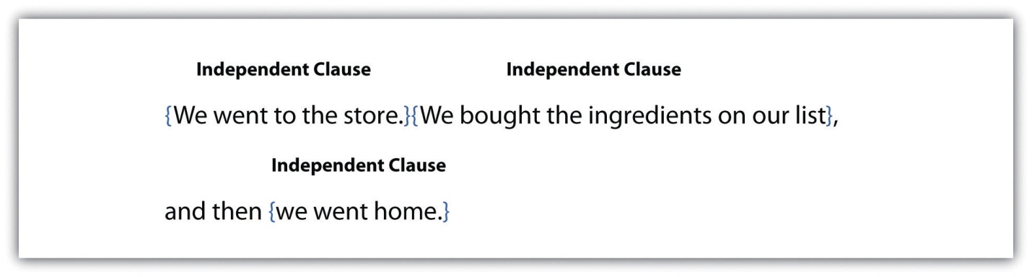
All complete sentences have at least one independent clause. You can identify an independent clause by reading it on its own and looking for the subject and the verb.

Subjects
When you read a sentence, you may first look for the subject or what the sentence is about. The subject usually appears at the beginning of a sentence as a noun or a pronoun. A noun is a word that identifies a person, place, thing, or idea. A pronoun is a word that replaces a noun. Common pronouns are I, he, she, it, you, they, and we. In the following sentences, the subject is underlined once.
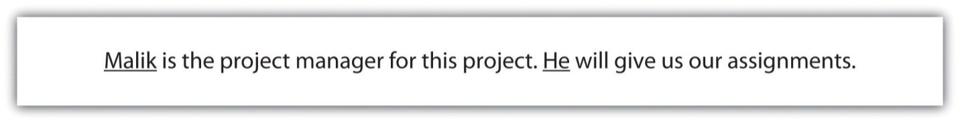
In these sentences, the subject is a person: Malik. The pronoun He replaces and refers back to Malik.
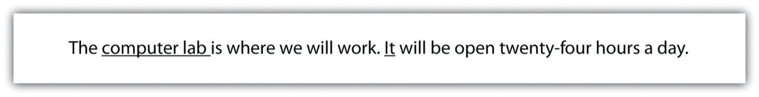
In the first sentence, the subject is a place: computer lab. In the second sentence, the pronoun It substitutes for computer lab as the subject.
In the first sentence, the subject is a thing: project. In the second sentence, the pronoun It stands in for the project.

Tip
In this chapter, please refer to the following grammar key:
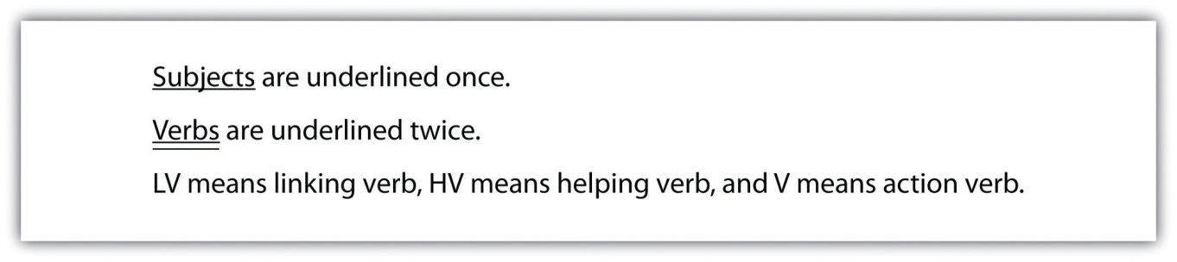

Compound Subjects
A sentence may have more than one person, place, or thing as the subject. These subjects are called compound subjects. Compound subjects are useful when you want to discuss several subjects at once.
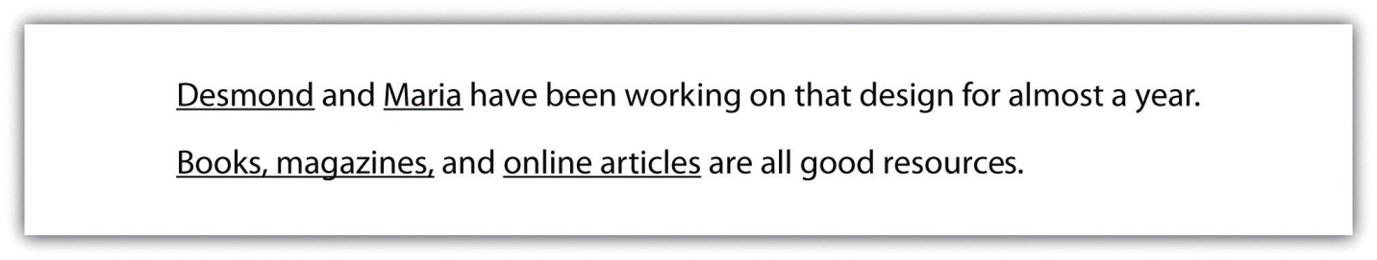

Prepositional Phrases
You will often read a sentence that has more than one noun or pronoun in it. You may encounter a group of words that includes a preposition with a noun or a pronoun. Prepositions connect a noun, pronoun, or verb to another word that describes or modifies that noun, pronoun, or verb. Common prepositions include in, on, under, near, by, with, and about. A group of words that begin with a preposition is called a prepositional phrase. A prepositional phrase begins with a preposition and modifies or describes a word. It cannot act as the subject of a sentence. The following circled phrases are examples of prepositional phrases.
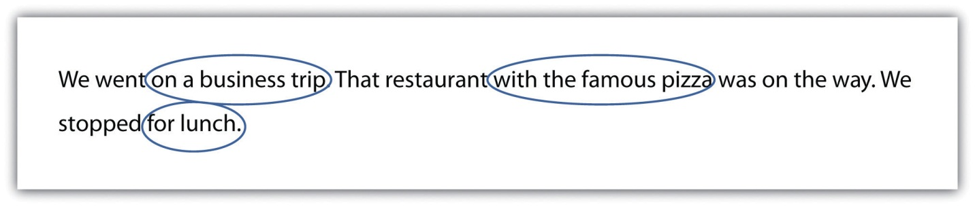

Self-Practice EXERCISE 3.1
Read the following sentences. Underline the subjects and circle the prepositional phrases.
- The gym is open until nine o’clock tonight.
- We went to the store to get some ice.
- The student with the most extra credit will win a homework pass.
- Maya and Tia found an abandoned cat by the side of the road.
- The driver of that pickup truck skidded on the ice.
- Anita won the race with time to spare.
- The people who work for that company were surprised about the merger.
- Working in haste means that you are more likely to make mistakes.
- The soundtrack has over 60 songs in languages from around the world.
- His latest invention does not work, but it has inspired the rest of us.

Verbs
Once you locate the subject of a sentence, you can move on to the next part of a complete sentence: the verb. A verb is often an action word that shows what the subject is doing. A verb can also link the subject to a describing word. There are three types of verbs that you can use in a sentence: action verbs, linking verbs, or helping verbs.

Action Verbs
A verb that connects the subject to an action is called an action verb. An action verb answers the question what is the subject doing? In the following sentences, the words underlined twice are action verbs.

Linking Verbs
A verb can often connect the subject of the sentence to a describing word. This type of verb is called a linking verb because it links the subject to a describing word. In the following sentences, the words underlined twice are linking verbs.
If you have trouble telling the difference between action verbs and linking verbs, remember:
- An action verb shows that the subject is doing something.
- A linking verb simply connects the subject to another word that describes or modifies the subject.
A few verbs can be used as either action verbs or linking verbs.
Although both sentences use the same verb, the two sentences have completely different meanings. In the first sentence, the verb describes the boy’s action. In the second sentence, the verb describes the boy’s appearance.

Helping Verbs
A third type of verb you may use as you write is a helping verb. Helping verbs are verbs that are used with the main verb to describe a mood or tense. Helping verbs are usually a form of be, do, or have. The word can is also used as a helping verb.
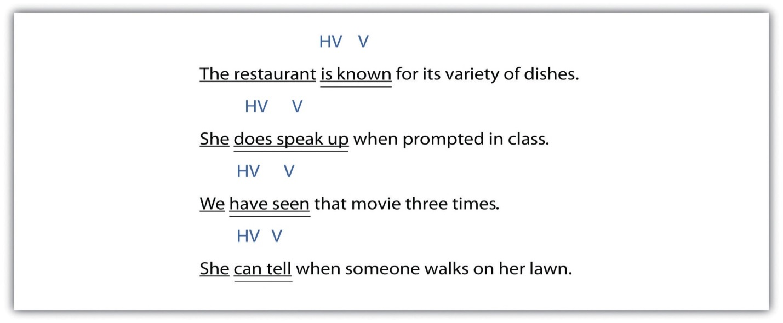

Tip
Whenever you write or edit sentences, keep the subject and verb in mind. As you write, ask yourself these questions to keep yourself on track:
Subject: Who or what is the sentence about?
Verb: Which word shows an action or links the subject to a description?

self-Practice EXERCISE 3.2
Underline the verb(s) in each of the sentences below twice. Name the type of verb(s) used in the sentence in the space provided (LV, HV, or V).
- The cat sounds ready to come back inside. ________
- We have not eaten dinner yet. ________
- It took four people to move the broken down car. ________
- The book was filled with notes from class. ________
- We walked from room to room, inspecting for damages. ________
- Harold was expecting a package in the mail. ________
- The clothes still felt damp even though they had been through the dryer twice. ________
- The teacher who runs the studio is often praised for his restoration work on old masterpieces. ________

Sentence Structure (Including Fragments)
Now that you know what makes a complete sentence—a subject and a verb—you can use other parts of speech to build on this basic structure. Good writers use a variety of sentence structures to make their work more interesting. This section covers different sentence structures that you can use to make longer, more complex sentences.

Sentence Patterns
Six basic subject-verb patterns can enhance your writing. A sample sentence is provided for each pattern. As you read each sentence, take note of where each part of the sentence falls. Notice that some sentence patterns use action verbs and others use linking verbs.

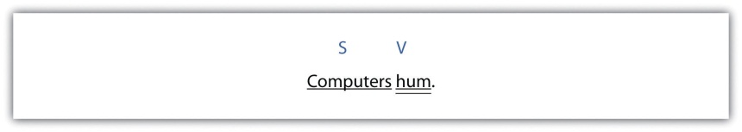
Subject → Verb
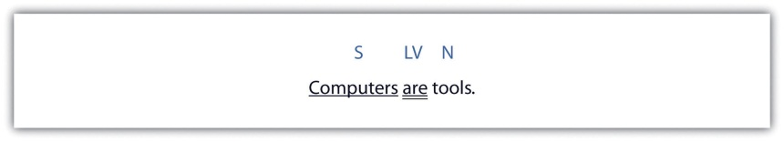

Subject → Linking Verb → Noun
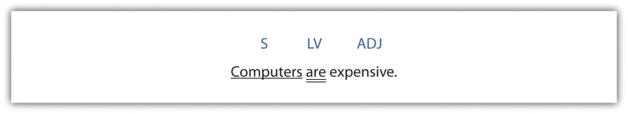

Subject → Linking Verb → Adjective

Subject → Verb → Adverb

Subject → Verb → Direct Object
When you write a sentence with a direct object (DO), make sure that the DO receives the action of the verb.

Subject → Verb → Indirect Object → Direct Object
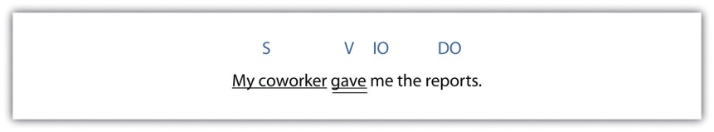
In this sentence structure, an indirect object explains to whom or to what the action is being done. The indirect object is a noun or pronoun, and it comes before the direct object in a sentence.

self-practice EXERCISE 3.3
Use what you have learned so far to bring variety in your writing. Use the following lines or your own sheet of paper to write six sentences that practise each basic sentence pattern. When you have finished, label each part of the sentence (S, V, LV, N, Adj, Adv, DO, IO).
- ________________________________________________________________
- ________________________________________________________________
- ________________________________________________________________
- ________________________________________________________________
- ________________________________________________________________
- ________________________________________________________________
Collaboration: Find an article in a newspaper, a magazine, or online that interests you. Then, identify one example of each part of a sentence (S, V, LV, N, Adj, Adv, DO, IO).

Fragments
The sentences you have encountered so far have been independent clauses. As you look more closely at your past writing assignments, you may notice that some of your sentences are not complete. A sentence that is missing a subject or a verb is called a fragment. A fragment may include a description or may express part of an idea, but it does not express a complete thought.
Fragment: Children helping in the kitchen.
Complete sentence: Children helping in the kitchen often make a mess.
You can easily fix a fragment by adding the missing subject or verb. In the example, the sentence was missing a verb. Adding often make a mess creates an S-V-N sentence structure. Figure 3.1 illustrates how you can edit a fragment to become a complete sentence.

Figure 3.1 Editing Fragments That Are Missing a Subject or a Verb
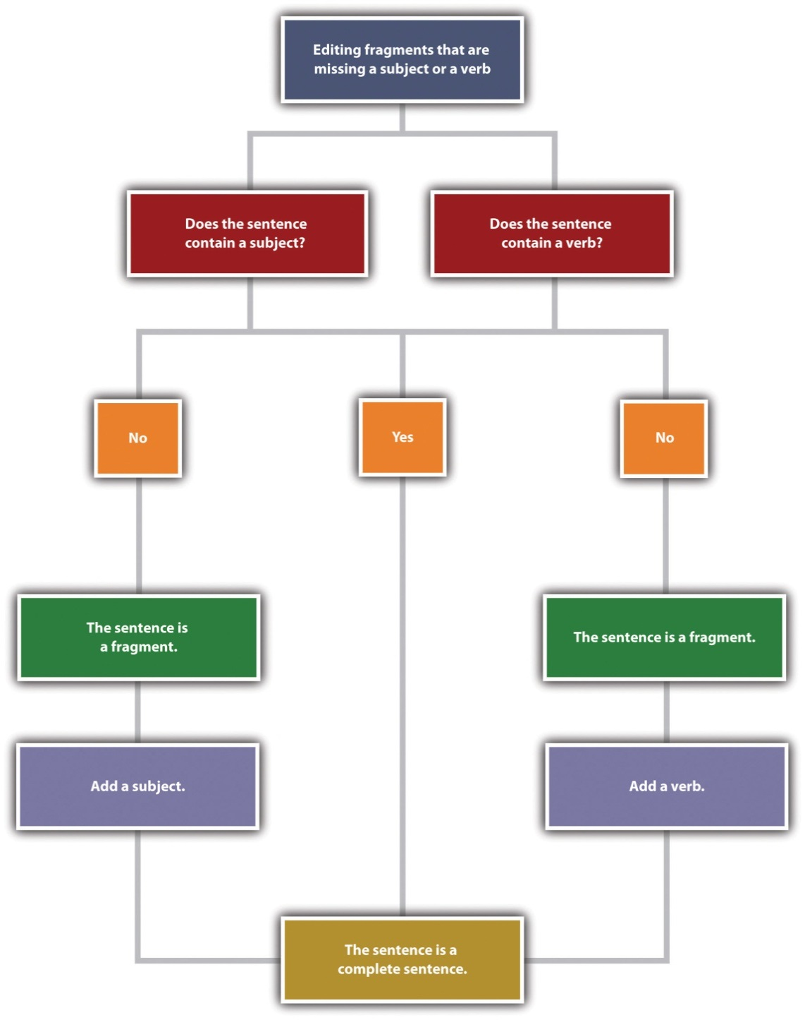
See whether you can identify what is missing in the following fragments.
Fragment: Told her about the broken vase.
Complete sentence: I told her about the broken vase.
Fragment: The store down on Main Street.
Complete sentence: The store down on Main Street sells music.

Common Sentence Errors
Fragments often occur because of some common errors, such as starting a sentence with a preposition, a dependent word, an infinitive, or a gerund. If you use the six basic sentence patterns when you write, you should be able to avoid these errors and thus avoid writing fragments.
When you see a preposition, check to see that it is part of a sentence containing a subject and a verb. If it is not connected to a complete sentence, it is a fragment, and you will need to fix this type of fragment by combining it with another sentence. You can add the prepositional phrase to the end of the sentence. If you add it to the beginning of the other sentence, insert a comma after the prepositional phrase. Look at the examples. Figure 3.2 illustrates how you can edit a fragment that begins with a preposition.
Example A:
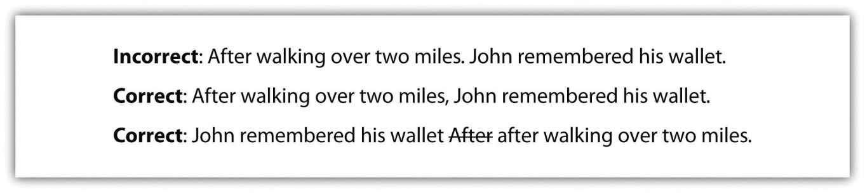
Example B:
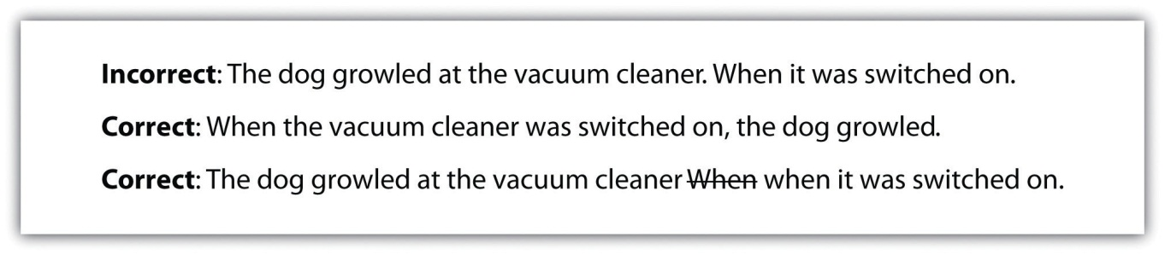

Figure 3.2 Editing Fragments That Begin with a Preposition
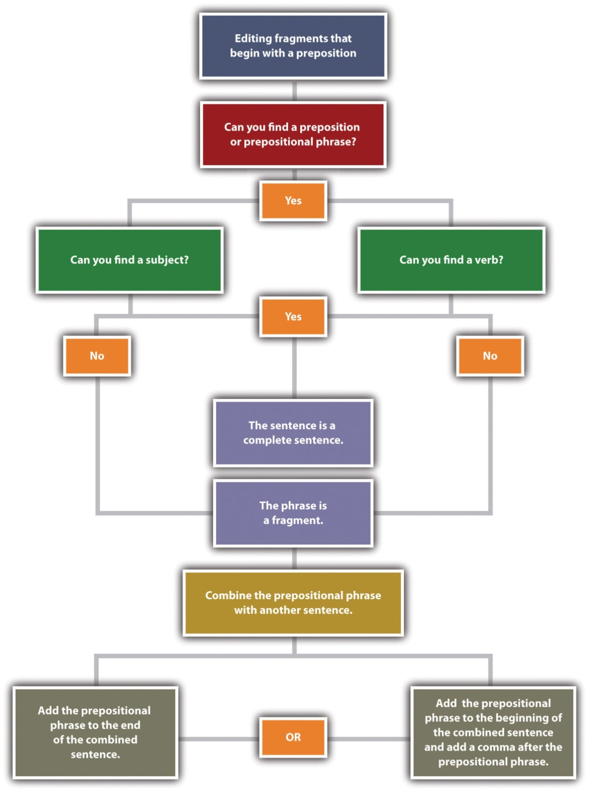
Clauses that start with a dependent word—such as since, because, without, or unless—are similar to prepositional phrases. Like prepositional phrases, these clauses can be fragments if they are not connected to an independent clause containing a subject and a verb. To fix the problem, you can add such a fragment to the beginning or end of a sentence. If the fragment is added at the beginning of a sentence, add a comma after it before the independent clause.
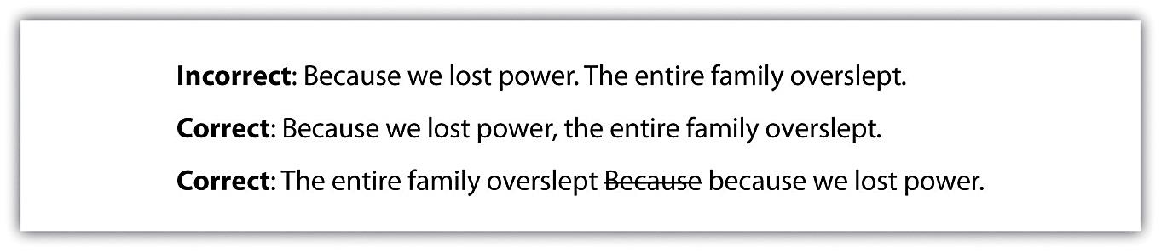
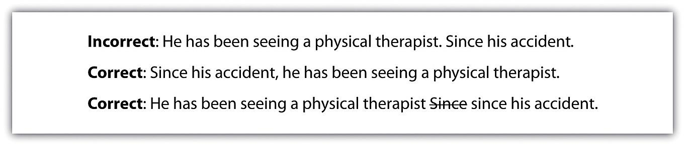
When you encounter a word ending in -ing in a sentence, identify whether it is being used as a verb in the sentence. You may also look for a helping verb. If the word is not used as a verb or if no helping verb is used with the -ing verb form, the verb is being used as a noun. An -ing verb form used as a noun is called a gerund.
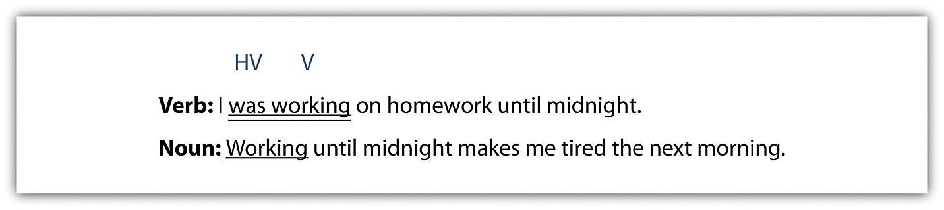
Once you know whether the -ing word is acting as a noun or a verb, look at the rest of the sentence. Does the entire sentence make sense on its own? If not, what you are looking at is a fragment. You will need to either add the parts of speech that are missing or combine the fragment with a nearby sentence. Figure 3.3 illustrates how to edit fragments that begin with a gerund.
Figure 3.3 Editing Fragments That Begin with Gerunds
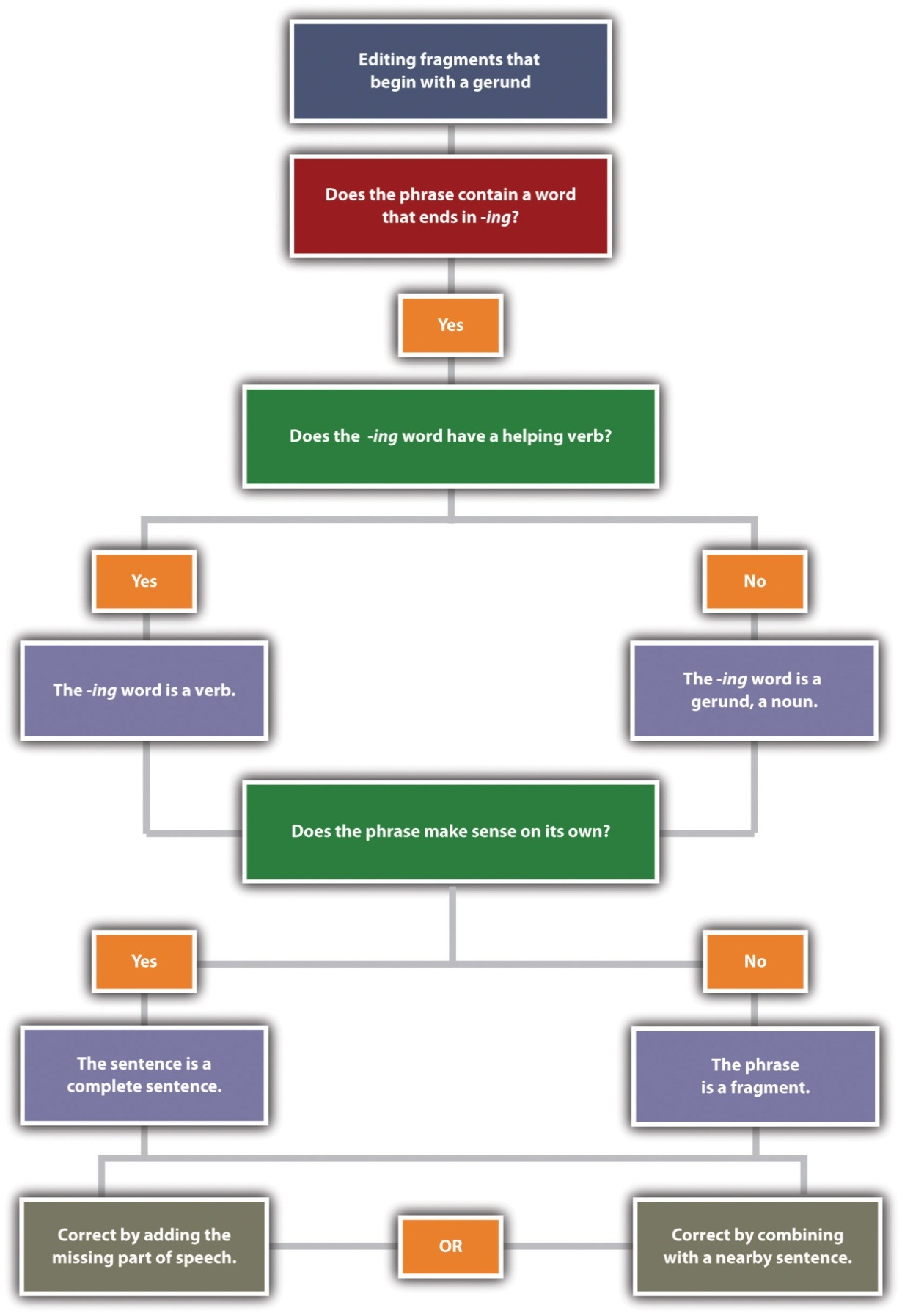
Incorrect: Taking deep breaths. Saul prepared for his presentation.
Correct: Taking deep breaths, Saul prepared for his presentation.
Correct: Saul prepared for his presentation. He was taking deep breaths.

Incorrect: Congratulating the entire team. Sarah raised her glass to toast their success.
Correct: She was congratulating the entire team. Sarah raised her glass to toast their success.
Correct: Congratulating the entire team, Sarah raised her glass to toast their success.
Another error in sentence construction is a fragment that begins with an infinitive. An infinitive is a verb paired with the word to; for example, to run, to write, or to reach. Although infinitives are verbs, they can be used as nouns, adjectives, or adverbs. You can correct a fragment that begins with an infinitive by either combining it with another sentence or adding the parts of speech that are missing.
Incorrect: We needed to make 300 more paper cranes. To reach the one thousand mark.
Correct: We needed to make 300 more paper cranes to reach the one thousand mark.
Correct: We needed to make 300 more paper cranes. We wanted to reach the one thousand mark.

Self-practice EXERCISE 3.4
Copy the following sentences onto your own sheet of paper and circle the fragments. Then combine the fragment with the independent clause to create a complete sentence.
- Working without taking a break. We try to get as much work done as we can in an hour.
- I needed to bring work home. In order to meet the deadline.
- Unless the ground thaws before spring break. We won’t be planting any tulips this year.
- Turning the lights off after he was done in the kitchen. Robert tries to conserve energy whenever possible.
- You’ll find what you need if you look. On the shelf next to the potted plant.
- To find the perfect apartment. Deidre scoured the classifieds each day.

3.2 Summarizing

LEARNING OBJECTIVES
- Explain and apply the criteria for making a summary
- Identify and avoid the challenges of creating summaries
In Chapter 2: Working with Words, you practised identifying main and supporting ideas, which is necessary for your understanding and for creating a summary of the information you have read; once you have identified what you think the important ideas are, you can transfer that information into a new paragraph, putting the original source’s ideas into your own words or what is called paraphrasing.
In this section and in other places throughout this book, you will meet Jorge, who has been assigned a paper on low-carbohydrate papers. You will follow Jorge on the steps to creating his paper, starting with his summary.

What Is Summary?
When you summarize, you are filtering and condensing the most necessary points from a source, like a book, article, or website.
When summarizing material from a source, you zero in on the main points and restate them concisely in your own words. This technique is appropriate when only the major ideas are relevant to your paper or when you need to simplify complex information into a few key points for your readers. To create a summary, consider the following points:
- Review the source material as you summarize it.
- Identify the main idea and restate it as concisely as you can—preferably in one sentence. Depending on your purpose, you may also add another sentence or two condensing any important details or examples.
- Check your summary to make sure it is accurate and complete.
- Make a careful record of where you found the information because you will need to include the reference and citation if you choose to use the information in an essay. It is much easier to do this when you are creating the summary and taking notes than having to go back and hunt for the information later. Guessing where you think you got it from is not good enough.

Summaries and Abstracts
When you read many journal articles, you will notice there is an abstract before the article starts: this is a summary of the article’s contents. Be careful when you are summarizing an article to not depend too much on the abstract as it is already a condensed version of the content. The author of the abstract identified the main points from his or her perception; these may not match your own purpose or your own idea of what is important. What may also happen if you try to summarize the abstract is you will probably end up replacing some words with synonyms and not changing the overall ideas into your own words because the ideas are already summarized, and it is difficult to make them more generalized (we will discuss this more in Section 3.3: Paraphrasing). You have to read the entire source or section of the source and determine for yourself what the key and supporting ideas are.

Tip
A summary or abstract of a reading passage is one-tenth to one-quarter the length of the original passage, written in your own words. The criteria for a summary are that it:
- Is similar to an outline but in complete sentences and can stand as an independent piece of writing
- Includes only the main points and key details
- Is valuable because it is the surest way to measure your understanding
- Helps you remember because you must attend carefully to what you read, organize your thoughts, and write them out to make it meaningful to you (This is absolutely necessary when you cannot mark a book because it belongs to someone else.)
- Challenges you to be concise in your writing while providing balanced coverage of the main points
- Challenges you to paraphrase or use your own words and avoid using too many quotations
- Is important to remain objective because you are giving the author’s views not your own.
In his draft, Jorge summarized research materials that presented scientists’ findings about low-carbohydrate diets. Read the following passage from a trade magazine article and Jorge’s summary of the article.

Article: Assessing the Efficacy of Low-Carbohydrate Diets
Adrienne Howell, Ph.D. (2010)
Over the past few years, a number of clinical studies have explored whether high-protein, low-carbohydrate diets are more effective for weight loss than other frequently recommended diet plans, such as diets that drastically curtail fat intake (Pritikin) or that emphasize consuming lean meats, grains, vegetables, and a moderate amount of unsaturated fats (the Mediterranean diet). A 2009 study found that obese teenagers who followed a low-carbohydrate diet lost an average of 15.6 kilograms over a six-month period, whereas teenagers following a low-fat diet or a Mediterranean diet lost an average of 11.1 kilograms and 9.3 kilograms respectively. Two 2010 studies that measured weight loss for obese adults following these same three diet plans found similar results. Over three months, subjects on the low-carbohydrate diet plan lost anywhere from four to six kilograms more than subjects who followed other diet plans.

Summary
In three recent studies, researchers compared outcomes for obese subjects who followed either a low-carbohydrate diet, a low-fat diet, or a Mediterranean diet and found that subjects following a low-carbohydrate diet lost more weight in the same time (Howell, 2010).

Tip
A summary restates ideas in your own words, but for specialized or clinical terms, you may need to use terms that appear in the original source. For instance, Jorge used the term obese in his summary because related words such as heavy or overweight have a different clinical meaning.

Summary Paragraphs
A summary shrinks a large amount of information into only the essentials. You probably summarize events, books, and movies daily. Think about the last movie you saw or the last novel you read. Chances are, at some point in a casual conversation with a friend, co-worker, or classmate, you compressed all the action of a two-hour film or a 200-page book into a brief description of the major plot movements. You probably described the main points in just a few sentences, using your own vocabulary and manner of speaking.
Similarly, a summary paragraph condenses a long piece of writing into a smaller paragraph by extracting only the vital information. A summary uses only the writer’s own words. Like the summary’s purpose in daily conversation, the purpose of an academic summary paragraph is to maintain all the essential information from a longer document. Although shorter than the original piece of writing, a summary should still communicate all the key points and key support. In other words, summary paragraphs should be succinct and to the point.
The following is another example of a report on the use of alcohol by adolescents with an example of a student summary of that information.

A summary of the report should present all the main points and supporting details in brief. Read the following summary of the report written by a student:
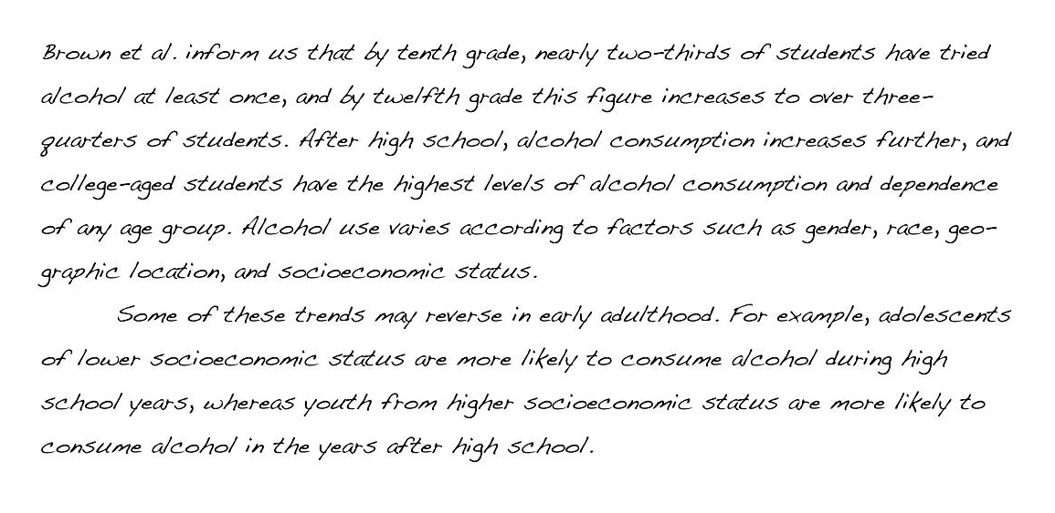
Notice how the summary retains the key points made by the writers of the original report but omits most of the statistical data. Summaries do not need to contain all the specific facts and figures in the original document; they provide only an overview of the essential information.

Tip
To write a summary:
- Survey the passage, anticipating main points and checking them.
- Read carefully, locating all controlling ideas, identifying key details, and deciding which are necessary to remember and which are not.
- Write a paragraph in whole sentences that relate/explain only the controlling ideas and supporting details; be economical and use no more words than necessary.
- Differentiate between your ideas and the original author’s by using phrases such as “According to Marshall (2014), ....” or “ Marshall (2014) argues that ....

Self-practice EXERCISE 3.5
- Read the following passage and use a note-taking method to identify the main points.
- Compose a sentence summarizing the paragraph’s main points.

Several factors about the environment influence our behaviour. First, temperature can influence us greatly. We seem to feel best when the temperature is in the high teens to low 20s. If it is too hot or cold, we have trouble concentrating. Lighting also influences how we function. A dark lecture hall may interfere with the lecture, or a bright nightclub might spoil romantic conversation. Finally, our behaviour is affected by colour. Some colours make us feel a peaceful while others are exciting. If you wanted a quiet room in which to study, for example, you would not paint it bright orange or red.
Collaboration: Please share with a classmate and compare your answers.
Here are possible answers:
Key points:
Environmental factors influence behaviour:
- Temperature: extremes make focus difficult
- Lighting: inappropriate lighting is disorientating
- Colour: colour affects relaxation
Summary sentence:
Three environmental influences that impact human behaviour include temperature, as extreme fluctuations make it difficult to focus; lighting, which can affect our ability to engage with different environments; and colour, which affects our mood.
Passage taken from: Ueland, B. (2006). Becoming a Master Student. Boston, MA : Houghton Mifflin College Div., p. 121.

Self-practice EXERCISE 3.6
- Read the passage.
- Highlight or underline necessary information (hint: there are five important ideas).
- Write your summary.
Most people drink orange juice and eat oranges because they are said to be rich in vitamin C. There are also other foods that are rich in vitamin C. It is found in citrus fruits and vegetables such as broccoli, spinach, cabbage, cauliflower, and carrots.
Vitamin C is important to our health. Do you really know how essential this nutrient is to our health and well-being? Our body needs to heal itself. Vitamin C can repair and prevent damage to the cells in our body and heal wounds. It also keeps our teeth and gums healthy. That is not all. It protects our body from infections such as colds and flu and also helps us to get better faster when we have these infections. That is why a lot of people drink orange juice and take vitamin C tablets every day. This wonderful vitamin is also good for our heart. It protects the linings of the arteries, which are the blood vessels that carry oxygenated blood. In other words, it offers protection against heart disease.
If we do not get enough vitamin C, which means we are not eating enough food that contains this vitamin, it can lead to serious diseases. Lack of vitamin C can lead to scurvy, which causes swollen gums, cheeks, fingers, hands, toes, and feet. In serious conditions, it can lead to bleeding from wounds, loss of teeth, and opening up of wounds. Therefore, make sure you have enough vitamin C in your diet.
_________________________________________________________________________________________________________________________________________________________________________________________________________________________________________________________________________________________________________________________________________________________________________________________________________________________________________________________________________________
_____________________________________________________________________________________________
Collaboration: Please share with a classmate and compare your answers.

Exercise taken from: http://www.scribd.com/doc/98238709/Form-Three-Summary-Writing-Exercise

3.3 Paraphrasing

LEARNING OBJECTIVES
- Identify how summarizing and paraphrasing work together
- Apply paraphrasing techniques of changing words and sentence structures

When you quote a source, you are taking the words directly from the passage: these are the original author’s words. Quotes can be useful (see Chapter 9: Citations and Referencing), but in order to show you understand what you have read, you should paraphrase. Paraphrasing is putting information into your words; it is an important skill to develop because when you do it, you are not only showing you understand what you have read, but you are also processing and adapting that information to your writing purpose.
When you paraphrase, you are using the technique of putting a condensed version of someone else’s ideas (summary) into your own words.
It is very important to remember when you are paraphrasing is you still need to include citations because although the words are yours, the ideas belong to the original authors, and you must give that person credit for the ideas (again, we will look at this more in Chapter 9: Citations and Referencing).

Tip
If you prefer rewriting, try not to copy but use your own paraphrasing of the material. If a concept is difficult, put it in your own terms with a concrete example so you understand it. Try to put it in the vocabulary of the course.

Paraphrasing Sources
When you paraphrase material from a source, restate the information from an entire sentence or passage in your own words, using your own original sentence structure. A paraphrased source differs from a summarized source in that you focus on restating the ideas, not condensing them. Again, it is important to check your paraphrase against the source material to make sure it is both accurate and original. Inexperienced writers sometimes use the thesaurus method of paraphrasing; that is, they simply rewrite the source material, replacing most of the words with synonyms. This constitutes a misuse of sources. A true paraphrase restates ideas using the writer’s (your) own language and style.
In his draft, Jorge frequently paraphrased details from sources. At times, he needed to rewrite a sentence more than once to ensure he was paraphrasing ideas correctly. Below is a passage with examples of how he paraphrased and adapted the information to create his own paragraph. Read the passage from a website. Then read Jorge’s initial attempt at paraphrasing it, followed by the final version of his paraphrase.

Source
According to Heinz (2009), dieters nearly always get great results soon after they begin following a low-carbohydrate diet, but these results tend to taper off after the first few months, particularly because many dieters find it difficult to follow a low-carbohydrate diet plan consistently.

Jorge’s Original Summary
People usually see encouraging outcomes shortly after they go on a low-carbohydrate diet, but their progress slows down after a short while, especially because most discover that it is a challenge to adhere to the diet strictly (Heinz, 2009).
After reviewing the paraphrased sentence, Jorge realized he was following the original source too closely. He did not want to quote the full passage verbatim, so he again attempted to restate the idea in his own style.

Jorge’s Revised Summary
Because it is hard for dieters to stick to a low-carbohydrate eating plan, the initial success of these diets is short lived (Heinz, 2009).

self-practice EXERCISE 3.7
On a sheet of paper, paraphrase each of the following passages.
- “The twenties were the years when drinking was against the law, and the law was a bad joke because everyone knew of a local bar where liquor could be had. They were the years when organized crime ruled the cities, and the police seemed powerless to do anything against it. Classical music was forgotten while jazz spread throughout the land, and men like Bix Beiderbecke, Louis Armstrong, and Count Basie became the heroes of the young. The flapper was born in the twenties, and with her bobbed hair and short skirts, she symbolized, perhaps more than anyone or anything else, America's break with the past.” From Kathleen Yancey, English 102 Supplemental Guide (1989): 25.
- “While the Sears Tower is arguably the greatest achievement in skyscraper engineering so far, it’s unlikely that architects and engineers have abandoned the quest for the world’s tallest building. The question is: Just how high can a building go? Structural engineer William LeMessurier has designed a skyscraper nearly one half mile high, twice as tall as the Sears Tower. And architect Robert Sobel claims that existing technology could produce a 500-story building.” From Ron Bachman, “Reaching for the Sky.” Dial (May 1990): 15.
Collaboration: Please share with a classmate and compare your answers.
Here are possible answers:
- During the twenties, lawlessness and social nonconformity prevailed. In cities, organized crime flourished without police interference, and, in spite of nationwide prohibition of liquor sales, anyone who wished to buy a drink knew where to get one. Musicians like Louis Armstrong become favourites, particularly among young people, as many turned away from highly respectable classical music to jazz. One of the best examples of the anti-traditional trend was the proliferation of young “flappers,” women who rebelled against custom by cutting off their hair and shortening their skirts (Yancey, 1989, p. 25).
- The Sears Tower is a world marvel, and it is unknown how much higher skyscrapers of the future will rise. However, the design of one twice as tall as the Sears Tower is already on the boards, and an architect, Robert Sobel, thinks we currently have sufficient know how to build a skyscraper with over 500 storeys (Bachman, 1990, p. 15).
Exercise taken from: https://owl.english.purdue.edu/exercises/28/12/33/

self-practice EXERCISE 3.8
On a sheet of paper, follow these steps to practise paraphrasing.
- Choose an important idea or detail from your notes.
- Without looking at the original source, restate the idea in your own words.
- Check your paraphrase against the original text in the source. Make sure both your language and your sentence structure are original.
- Revise your paraphrase if necessary.

Assignment 2: summary practice (5%)

Read the following article and compose a summary of 100 to 150 words. Determine what the key points are and paraphrase accordingly. Make sure all the points you choose are important to the understanding and overall meaning of the essay.
Remember:
- You want to use objective language that accurately represents the original author’s angle of vision: do not provide analysis or discussion
- You should not simply substitute words
- You should change up the sentence structure
- The end result needs to capture all the main points but also be in your own words.
You need to submit this assignment to your instructor for marking. (5%)

ARTICLE: ASSIGNMENT 2

Heroin as One of the Most Lethal Drugs
Among prohibited narcotic substances, heroin has been classified as one of the most addictive and detrimental. In a recent research study run by the Institute of Narcotic Examination in Rollesque, Nevada, heroin ranked 2.89 out of 3 on a dependence rating scale (Perez, 2012). This result was also confirmed by scores of research held in London by the Academy of Pharmaceutical Studies (Perez, 2012). An opiate processed from morphine, heroin is delineated as a lethal drug. The common form of heroin sold in streets looks like a white or brown gummy substance with a high consistency of tar.
Heroin is injected into the human body through a hypothermic needle directly in a muscle or a particular blood vein. It can also be smoked like cigarettes. There is the possibility of it being successfully mixed with drugs or snorted as cocaine. Street heroin is often mixed with other substances like sugar, starch, quinine, poisons or even powder milk to dilute the effect. Short and long term effects of heroin use have different levels of withdrawal, reinforcements, tolerance, dependency and intoxication. Heroin reduces pain and mimics the traits of endorphins, which causes the human brain to experience pleasure (Hollow, 2011). The central neural system becomes supersaturated with endorphin like substances, and when the effect of heroin ends, individuals begin to feel the need for a new injection to prolong pleasure (Hollow, 2011).
The degree of heroin addictiveness can be measured by the severe withdrawal symptoms which it induces in individuals. Among the most common symptoms, one can enlist the following: a warm flush feeling in the skin, an ill mood and depression, vomiting, itching, nausea, and heavy pain in joints. The cardiac functions and the neural system functions slow down, though it often depends on the individual’s genetic type, amount of the drug taken, and the purity of the substance (Hollow, 2011).
Heroin addiction causes numerous side effects to the physical body. Blood vein structure collapses, and a risk of receiving a heart infection, liver disease, or abscesses dramatically increases. Long term addiction to the drug takes the form of a chronic, relapsing disease. Long term use of heroin prompts users to gradually increase doses. Once a user is in the chronic stage, this implies such symptoms as restlessness, bone and muscle pain, insomnia, and intense withdrawal stages lasting for 24 to 48 hours after heroin has been taken (Lichter, 2012).
The treatment of heroin addiction includes a thorough detoxification program, which helps to minimize the severity of withdrawal symptoms. The use of medications for treatment along with therapy helps individuals cope. Methadone programs, buprenorphine, together with behavioral therapies aid to recover from addiction (Perez, 2012). These aspects are important, as both behavioral and pharmacological interventions can effectively normalize addiction levels, brain functions and social behavior. These methods are used in a varied combination to cure the withdrawal, tolerance, dependence and intoxication elements to minimize the addictive qualities of heroin.
References:
Hollow, M. (2011). Heroin: The Ultimate Drug. Chicago: Running Hill Books.
Lichter, M. (2012). The Dark Hole of Heroin. Boston: Sidetrack Books.
Perez, G. (2012). Studies of Heroin. New York: Gold Beard Press.

Essay taken and adapted from: http://academichelp.net/samples/essays/expository/heroin-lethal-drug.html
3.4 Effective Means for Writing a Paragraph

LEARNING OBJECTIVES
- Identify characteristics of a good topic sentence
- Identify the three parts of a developed paragraph
- Apply knowledge of topic sentences and parts of a developed paragraph in an assignment
This section addresses paragraph composition. In the next chapter, we will look at identifying common assignment purposes and how to select appropriate content for a particular audience, but here we will look at what actually makes up a paragraph. Composing an effective paragraph requires a method similar to building a house. You may have the finest content, or materials, but if you do not arrange them in the correct order, then the final product will not hold together very well.
Imagine reading one long block of text, with each idea blurring into the next. Even if you are reading a thrilling novel or an interesting news article, you will likely very quickly lose interest in what the author. During the writing process, it is helpful to position yourself as a reader. Ask yourself whether you can focus easily on each point you make. One technique that effective writers use is to begin a fresh paragraph for each new idea they introduce.
Paragraphs separate ideas into logical, manageable chunks. One paragraph focuses on only one main idea and presents coherent sentences to support that one point. Because all the sentences in one paragraph support the same point, a paragraph may stand on its own. To create longer assignments and to discuss more than one point, writers group together paragraphs.
A strong paragraph contains three distinct components:
- Topic sentence. The topic sentence is the main idea of the paragraph.
- Body. The body is composed of the supporting sentences that develop the main point.
- Conclusion. The conclusion is the final sentence that summarizes the main point.
The foundation of a good paragraph is the topic sentence, which expresses the main idea of the paragraph. The topic sentence relates to the thesis, or main point, of the essay and guides the reader by signposting what the paragraph is about. All the sentences in the rest of the paragraph should relate to the topic sentence.
This section covers the major components of a paragraph and examines how to develop an effective topic sentence.
Paragraph Length
How long should a paragraph be?
One answer to this important question may be “long enough”—long enough for you to address your points and explain your main idea. To grab attention or to present succinct supporting ideas, a paragraph can be fairly short and consist of two to three sentences. A paragraph in a complex essay about some abstract point in philosophy or archaeology can be two-thirds of a page or more in length. As long as the writer maintains close focus on the topic and does not ramble, a long paragraph is acceptable. In general, try to keep the paragraphs longer than one sentence but shorter than two-thirds of a page of double spaced text, or roughly 75 to 200 words in length.

Tip
Journalistic style often calls for brief two- or three-sentence paragraphs because of how people read the news, both online and in print. Blogs and other online information sources often adopt this paragraphing style, too. Readers often skim the first paragraphs of a great many articles before settling on the handful of stories they want to read in detail.
You may find that a particular paragraph you write may be longer than one that will hold your audience’s interest. In such cases, you should divide the paragraph into two or more shorter paragraphs, adding a topic statement or some kind of transitional word or phrase at the start of the new paragraph. Transition words or phrases show the connection between the two ideas.
In all cases, however, be guided by what your instructor wants and expects to find in your draft. Many instructors will expect you to develop a mature style as you progress through the semester’s assignments.

Developing a Topic Sentence
Pick up any newspaper or magazine and read the first sentence of an article. Are you fairly confident that you know what the rest of the article is about? If so, you have likely read the topic sentence. An effective topic sentence combines a main idea with the writer’s personal attitude or opinion. It serves to orient the reader and provides an indication of what will follow in the rest of the paragraph. Read the following example.
Creating a national set of standards for math and English education will improve student learning in many provinces.
This topic sentence declares a favourable position for standardizing math and English education. After reading this sentence, a reader might reasonably expect the writer to provide supporting details and facts as to why standardizing math and English education might improve student learning in many provinces. If the purpose of the essay is actually to evaluate education in only one particular province or to discuss math or English education specifically, then the topic sentence is misleading.

Tip
When writing a draft of an essay, allow a friend or colleague to read the opening line of your first paragraph. Ask your reader to predict what your paper will be about. If he or she is unable to guess your topic accurately, you should consider revising your topic sentence so that it clearly defines your purpose in writing.

Main Idea versus Controlling Idea
Topic sentences contain both a main idea (the subject, or topic that the writer is discussing) and a controlling idea (the writer’s specific stance on that subject). Just as a thesis statement includes an idea that controls a document’s focus, a topic sentence must also contain a controlling idea to direct the paragraph. Different writers may use the same main idea but can steer their paragraph in a number of different directions according to their stance on the subject. Read the following examples.
- Marijuana is a destructive influence on teens and causes long-term brain damage.
- The anti-nausea properties in marijuana are a lifeline for many cancer patients.
- Legalizing marijuana would create a higher demand for Class A and Class B drugs.
Although the main idea—marijuana—is the same in all three topic sentences, the controlling idea differs depending on the writer’s viewpoint.

self-practice EXERCISE 3.9
Circle the main idea and underline the controlling idea in each of the following topic sentences.
- Exercising three times a week is the only way to maintain good physical health.
- Sexism and racism are still rampant in today’s workplace.
- Raising the legal driving age to 21 would decrease road traffic accidents.
- Owning a business is the only way to achieve financial success.
- Dog owners should be prohibited from taking their pets on public beaches.

Characteristics of a Good Topic Sentence
Five characteristics define a good topic sentence:
- A good topic sentence provides an accurate indication of what will follow in the rest of the paragraph.
Weak example. People rarely give firefighters the credit they deserve for such a physically and emotionally demanding job. (The paragraph is about a specific incident that involved firefighters; therefore, this topic sentence is too general.)
Stronger example. During the October riots, Unit 3B went beyond the call of duty. (This topic sentence is more specific and indicates that the paragraph will contain information about a particular incident involving Unit 3B.)
- A good topic sentence contains both a topic and a controlling idea or opinion.
Weak example. In this paper, I am going to discuss the rising suicide rate among young professionals. (This topic sentence provides a main idea, but it does not present a controlling idea or thesis.)
Stronger example. The rising suicide rate among young professionals is a cause for immediate concern. (This topic sentence presents the writer’s opinion on the subject of rising suicide rates among young professionals.)
- A good topic sentence is clear and easy to follow.
Weak example. In general, writing an essay, thesis, or other academic or nonacademic document is considerably easier and of much higher quality if you first construct an outline, of which there are many different types. (This topic sentence includes a main idea and a controlling thesis, but both are buried beneath the confusing sentence structure and unnecessary vocabulary. These obstacles make it difficult for the reader to follow.)
Stronger example. Most forms of writing can be improved by first creating an outline. (This topic sentence cuts out unnecessary verbiage and simplifies the previous statement, making it easier for the reader to follow.)
- A good topic sentence does not include supporting details.
Weak example. Salaries should be capped in baseball for many reasons, most importantly so we don’t allow the same team to win year after year. (This topic sentence includes a supporting detail that should be included later in the paragraph to back up the main point.)
Stronger example. Introducing a salary cap would improve the game of baseball for many reasons. (This topic sentence omits the additional supporting detail so that it can be expanded upon later in the paragraph.)
- A good topic sentence engages the reader by using interesting vocabulary.
Weak example. The military deserves better equipment. (This topic sentence includes a main idea and a controlling thesis, but the language is bland and unexciting.)
Stronger example. The appalling lack of resources provided to the military is outrageous and requires our immediate attention. (This topic sentence reiterates the same idea and controlling thesis, but adjectives such as appalling and immediate better engage the reader. These words also indicate the writer’s tone.)

self-practice EXERCISE 3.10
Choose the most effective topic sentence from the following sentence pairs.
- a. This paper will discuss the likelihood of the Liberals winning the next election.
b. To boost their chances of winning the next election, the Liberals need to listen to public opinion.
- a. The unrealistic demands of union workers are crippling the economy for three main reasons.
b. Union workers are crippling the economy because companies are unable to remain competitive as a result of added financial pressure.
- a. Authors are losing money as a result of technological advances.
b. The introduction of new technology will devastate the literary world.
- a. Rap music is produced by untalented individuals with oversized egos.
b. This essay will consider whether talent is required in the rap music industry.

self-practice EXERCISE 3.11
Using the tips on developing effective topic sentences in this section, create a topic sentence on each of the following subjects. Remember to include a controlling idea as well as a main idea.
- An endangered species
_____________________________________________________________________________________________
- The cost of fuel
_____________________________________________________________________________________________
- The legal drinking age
_____________________________________________________________________________________________
- A controversial film or novel
_____________________________________________________________________________________________
Collaboration: Please share with a classmate and compare your answers.

Writing at Work
When creating a workplace document, use the “top down” approach—keep the topic sentence at the beginning of each paragraph so that readers immediately understand the gist of the message. This method saves busy colleagues precious time and effort trying to figure out the main points and relevant details.
Headings are another helpful tool. In a text-heavy document, break up each paragraph with individual headings. These serve as useful navigation aids, enabling colleagues to skim through the document and locate paragraphs that are relevant to them.

Developing Paragraphs That Use Topic Sentences, Supporting Ideas, and Transitions Effectively
Learning how to develop a good topic sentence is the first step toward writing a solid paragraph. Once you have composed your topic sentence, you have a guideline for the rest of the paragraph. To complete the paragraph, a writer must support the topic sentence with additional information and summarize the main point with a concluding sentence.
This section identifies the three major structural parts of a paragraph and covers how to develop a paragraph using transitional words and phrases.

Identifying Parts of a Paragraph
An effective paragraph contains three main parts: a topic sentence, the body, and the concluding sentence. A topic sentence is often the first sentence of a paragraph. The body of the paragraph usually follows, containing supporting details. Supporting sentences help explain, prove, or enhance the topic sentence. The concluding sentence is the last sentence in the paragraph. It reminds the reader of the main point by restating it in different words. Figure 3.4 provides a template you can use for organizing your paragraphs.
Figure 3.4 Paragraph Structure Graphic Organizer
Read the following paragraph. The topic sentence is underlined for you.
After reading the new TV guide this week, I had just one thought—why are we still being bombarded with reality shows? This season, the plague of reality television continues to darken our airwaves. Along with the return of viewer favourites, we are to be cursed with yet another mindless creation. Prisoner follows the daily lives of eight suburban housewives who have chosen to be put in jail for the purposes of this fake psychological experiment. A preview for the first episode shows the usual tears and tantrums associated with reality television. I dread to think what producers will come up with next season, but if any of them are reading this blog—stop it! We’ve had enough reality television to last us a lifetime!
The first sentence of this paragraph is the topic sentence. It tells the reader that the paragraph will be about reality television shows, and it expresses the writer’s distaste for these shows through the use of the word bombarded.
Each of the following sentences in the paragraph supports the topic sentence by providing further information about a specific reality television show. The final sentence is the concluding sentence. It reiterates the main point that viewers are bored with reality television shows by using different words from the topic sentence.
Paragraphs that begin with the topic sentence move from the general to the specific. They open with a general statement about a subject (reality shows) and then discuss specific examples (the reality show Prisoner). Most academic essays contain the topic sentence at the beginning of the first paragraph.
Now take a look at another paragraph. The topic sentence is underlined for you.
Last year, a cat travelled 200 kilometres to reach its family, who had moved to another city and had left their pet behind. Even though the cat had never been to the new home, it cat was able to track down its former owners. A dog in my neighbourhood can predict when its master is about to have a seizure. It makes sure that he does not hurt himself during an epileptic fit. Compared to many animals, our own senses are almost dull.
The last sentence of this paragraph is the topic sentence. It draws on specific examples (a cat that tracked down its owners and a dog that can predict seizures) and then makes a general statement that draws a conclusion from these examples (animals’ senses are better than humans’). In this case, the supporting sentences are placed before the topic sentence and the concluding sentence is the same as the topic sentence.
This technique is frequently used in persuasive writing. The writer produces detailed examples as evidence to back up his or her point, preparing the reader to accept the concluding topic sentence as the truth.
Sometimes, the topic sentence appears in the middle of a paragraph. Read the following example. The topic sentence is underlined for you.
For many years, I suffered from severe anxiety every time I took an exam. Hours before the exam, my heart would begin pounding, my legs would shake, and sometimes I would become physically unable to move. Last year, I was referred to a specialist and finally found a way to control my anxiety—breathing exercises. It seems so simple, but by doing just a few breathing exercises a couple of hours before an exam, I gradually got my anxiety under control. The exercises help slow my heart rate and make me feel less anxious. Better yet, they require no pills, no equipment, and very little time. It is amazing how just breathing correctly has helped me learn to manage my anxiety symptoms.
In this paragraph, the underlined sentence is the topic sentence. It expresses the main idea—that breathing exercises can help control anxiety. The preceding sentences enable the writer to build up to his main point (breathing exercises can help control anxiety) by using a personal anecdote (how the writer used to suffer from anxiety). The supporting sentences then expand on how breathing exercises help the writer by providing additional information. The last sentence is the concluding sentence and restates how breathing can help manage anxiety.
Placing a topic sentence in the middle of a paragraph is often used in creative writing. If you notice that you have used a topic sentence in the middle of a paragraph in an academic essay, read through the paragraph carefully to make sure that it contains only one major topic.

Implied Topic Sentences
Some well-organized paragraphs do not contain a topic sentence at all. Instead of being directly stated, the main idea is implied in the content of the paragraph. Read the following example:
Heaving herself up the stairs, Luella had to pause for breath several times. She let out a wheeze as she sat down heavily in the wooden rocking chair. Tao approached her cautiously, as if she might crumble at the slightest touch. He studied her face, like parchment; stretched across the bones so finely he could almost see right through the skin to the decaying muscle underneath. Luella smiled a toothless grin.
Although no single sentence in this paragraph states the main idea, the entire paragraph focuses on one concept—that Luella is extremely old. The topic sentence is thus implied rather than stated. This technique is often used in descriptive or narrative writing. Implied topic sentences work well if the writer has a firm idea of what he or she intends to say in the paragraph and sticks to it. However, a paragraph loses its effectiveness if an implied topic sentence is too subtle or the writer loses focus.

Tip
Avoid using implied topic sentences in an informational document. Readers often lose patience if they are unable to quickly grasp what the writer is trying to say. The clearest and most efficient way to communicate in an informational document is to position the topic sentence at the beginning of the paragraph.

self-practice EXERCISE 3.12
Identify the topic sentence, supporting sentences, and concluding sentence in the following paragraph.
The desert provides a harsh environment in which few mammals are able to adapt. Of these hardy creatures, the kangaroo rat is possibly the most fascinating. Able to live in some of the most arid parts of the southwest, the kangaroo rat neither sweats nor pants to keep cool. Its specialized kidneys enable it to survive on a minuscule amount of water. Unlike other desert creatures, the kangaroo rat does not store water in its body but instead is able to convert the dry seeds it eats into moisture. Its ability to adapt to such a hostile environment makes the kangaroo rat a truly amazing creature.
Collaboration: Please share with a classmate and compare your answers.

Supporting Sentences
If you think of a paragraph as a hamburger, the supporting sentences are the meat inside the bun. They make up the body of the paragraph by explaining, proving, or enhancing the controlling idea in the topic sentence. Most paragraphs contain three to six supporting sentences depending on the audience and purpose for writing. A supporting sentence usually offers one of the following:
- Reason
Sentence: The refusal of the baby boom generation to retire is contributing to the current lack of available jobs.
- Fact
Sentence: Many families now rely on older relatives to support them financially.
- Statistic
Sentence: Nearly 10 percent of adults are currently unemployed in the United States.
- Quotation
Sentence: “We will not allow this situation to continue,” stated Senator Johns.
- Example
Sentence: Last year, Bill was asked to retire at the age of 55.
The type of supporting sentence you choose will depend on what you are writing and why you are writing. For example, if you are attempting to persuade your audience to take a particular position, you should rely on facts, statistics, and concrete examples, rather than personal opinions. Read the following example:
There are numerous advantages to owning a hybrid car. (Topic sentence)
First, they get 20 percent to 35 percent more kilometres to the litre than a fuel-efficient gas-powered vehicle. (Supporting sentence 1: statistic)
Second, they produce very few emissions during low-speed city driving. (Supporting sentence 2: fact)
Because they do not require as much gas, hybrid cars reduce dependency on fossil fuels, which helps lower prices at the pump. (Supporting sentence 3: reason)
Alex bought a hybrid car two years ago and has been extremely impressed with its performance. (Supporting sentence 4: example)
“It’s the cheapest car I’ve ever had,” she said. “The running costs are far lower than previous gas-powered vehicles I’ve owned.” (Supporting sentence 5: quotation)
Given the low running costs and environmental benefits of owning a hybrid car, it is likely that many more people will follow Alex’s example in the near future. (Concluding sentence)

To find information for your supporting sentences, you might consider using one of the following sources:
- Reference book
- Academic journal/article
- Newspaper/magazine
- Textbook
- Encyclopedia
- Biography/autobiography
- Dictionary
- Interview
- Map
- Website
- Previous experience
- Personal research

Tip
When searching for information on the Internet, remember that some websites are more reliable than others. Websites ending in .gov or .edu are generally more reliable than websites ending in .com or .org. Wikis and blogs are not reliable sources of information because they are subject to inaccuracies and are usually very subjective and biased.

Concluding Sentences
An effective concluding sentence draws together all the ideas you have raised in your paragraph. It reminds readers of the main point—the topic sentence—without restating it in exactly the same words. Using the hamburger example, the top bun (the topic sentence) and the bottom bun (the concluding sentence) are very similar. They frame the “meat” or body of the paragraph. Compare the topic sentence and concluding sentence from the previous example:
Topic sentence: There are numerous advantages to owning a hybrid car.
Concluding sentence: Given the low running costs and environmental benefits of owning a hybrid car, it is likely that many more people will follow Alex’s example in the near future.
Notice the use of the synonyms advantages and benefits. The concluding sentence reiterates the idea that owning a hybrid is advantageous without using the exact same words. It also summarizes two examples of the advantages covered in the supporting sentences: low running costs and environmental benefits.
You should avoid introducing any new ideas into your concluding sentence. A conclusion is intended to provide the reader with a sense of completion. Introducing a subject that is not covered in the paragraph will confuse the reader and weaken your writing.
A concluding sentence may do any of the following:
- Restate the main idea.
Example: Childhood obesity is a growing problem in North America.
- Summarize the key points in the paragraph.
Example: A lack of healthy choices, poor parenting, and an addiction to video games are among the many factors contributing to childhood obesity.
- Draw a conclusion based on the information in the paragraph.
Example: These statistics indicate that unless we take action, childhood obesity rates will continue to rise.
- Make a prediction, suggestion, or recommendation about the information in the paragraph.
Example: Based on this research, more than 60 percent of children in North American will be morbidly obese by the year 2030 unless we take evasive action.
- Offer an additional observation about the controlling idea.
Example: Childhood obesity is an entirely preventable tragedy.

self-practice EXERCISE 3.13
On your own paper, write one example of each type of concluding sentence based on a topic of your choice.

Transitions
A strong paragraph moves seamlessly from the topic sentence into the supporting sentences and on to the concluding sentence. To help organize a paragraph and ensure that ideas logically connect to one another, writers use transitional words and phrases. A transition is a connecting word that describes a relationship between ideas. Take another look at the earlier example:
There are numerous advantages to owning a hybrid car. First, they get 20 percent to 35 percent more kilometres to the litre than a fuel-efficient gas-powered vehicle. Second, they produce very few emissions during low speed city driving. Because they require less gas, hybrid cars reduce dependency on fossil fuels, which helps lower prices at the pump. Alex bought a hybrid car two years ago and has been extremely impressed with its performance. “It’s the cheapest car I’ve ever had,” she said. “The running costs are far lower than previous gas-powered vehicles I’ve owned.” Given the low running costs and environmental benefits of owning a hybrid car, it is likely that many more people will follow Alex’s example in the near future.
Each of the underlined words is a transition word. Words such as first and second are transition words that show sequence or clarify order. They help organize the writer’s ideas by showing that he or she has another point to make in support of the topic sentence. Other transition words that show order include third, also, and furthermore.
The transition word because is a transition word of consequence that continues a line of thought. It indicates that the writer will provide an explanation of a result. In this sentence, the writer explains why hybrid cars will reduce dependency on fossil fuels (because they require less gas). Other transition words of consequence include as a result, so that, since, or for this reason.
To include a summarizing transition in her concluding sentence, the writer could rewrite the final sentence as follows:
In conclusion, given the low running costs and environmental benefits of owning a hybrid car, it is likely that many more people will follow Alex’s example in the near future.
Table 3.1: Transitional Words and Phrases to Connect Sentences provides some useful transition words to connect supporting sentences and concluding sentences. (In other chapters of this book, you will be exposed to more transitional words and phrases for other purposes.)
Table 3.1 Transitional Words and Phrases to Connect Sentences
For Supporting Sentences
above all | but | for instance | in particular | moreover | subsequently
also | conversely | furthermore | later on | nevertheless | therefore
aside from | correspondingly | however | likewise | on one hand | to begin with
at the same time | for example | in addition | meanwhile | on the contrary
For Concluding Sentences
after all | all things considered | in brief | in summary | on the whole | to sum up
all in all | finally | in conclusion | on balance | thus

self-practice EXERCISE 3.14
On a sheet of paper, write a paragraph on a topic of your choice. Be sure to include a topic sentence, supporting sentences, and a concluding sentence and to use transitional words and phrases to link your ideas together.
Collaboration: Please share with a classmate and compare your answers.

Writing at Work
Transitional words and phrases are useful tools to incorporate into workplace documents. They guide the reader through the document, clarifying relationships between sentences and paragraphs so that the reader understands why they have been written in that particular order.
For example, when writing an instructional memo, it may be helpful to consider the following transitional words and phrases: before you begin, first, next, then, finally, after you have completed. Using these transitions as a template to write your memo will provide readers with clear, logical instructions about a particular process and the order in which steps are supposed to be completed.

KEY TAKEAWAYS
- A good paragraph contains three distinct components: a topic sentence, body, and concluding sentence.
- The topic sentence expresses the main idea of the paragraph combined with the writer’s attitude or opinion about the topic.
- Good topic sentences contain both a main idea and a controlling idea, are clear and easy to follow, use engaging vocabulary, and provide an accurate indication of what will follow in the rest of the paragraph.
- Topic sentences may be placed at the beginning, middle, or end of a paragraph. In most academic essays, the topic sentence is placed at the beginning of a paragraph.
- Supporting sentences help explain, prove, or enhance the topic sentence by offering facts, reasons, statistics, quotations, or examples.
- Concluding sentences summarize the key points in a paragraph and reiterate the main idea without repeating it word for word.
- Transitional words and phrases help organize ideas in a paragraph and show how these ideas relate to one another.

Supplemental exercises
- Select one of the following topics or choose a topic of your choice:
- Drilling for oil in Alberta
- Health care reform
- Introducing a four day work week
- Bringing pets to work
- Charging airline passengers to use the in-flight bathroom
Create a topic sentence based on the topic you chose, remembering to include both a main idea and a controlling idea. Next, write an alternative topic sentence using the same main idea but a different controlling idea.
Collaboration: Please share with a classmate and compare your answers.
- Group activity. Working in a group of four or five, assign each group member the task of collecting one document each. These documents might include magazine or newspaper articles, workplace documents, academic essays, chapters from a reference book, film or book reviews, or any other type of writing. As a group, read through each document and discuss the author’s purpose for writing. Use the information you have learned in this chapter to decide whether the main purpose is to summarize, analyze, synthesize, or evaluate. Write a brief report on the purpose of each document, using supporting evidence from the text.
- Group activity. Working in a small group, select a workplace document or academic essay that has a clear thesis. Examine each paragraph and identify the topic sentence, supporting sentences, and concluding sentence. Then, choose one particular paragraph and discuss the following questions:
- Is the topic sentence clearly identifiable or is it implied?
- Do all the supporting sentences relate to the topic sentence?
- Does the writer use effective transitions to link his or her ideas?
- Does the concluding sentence accurately summarize the main point of the paragraph?
As a group, identify the weakest areas of the paragraph and rewrite them. Focus on the relationship between the topic sentence, supporting sentences, and concluding sentence. Use transitions to illustrate the connection between each sentence in the paragraph.
- Peer activity. Using the information you have learned in this chapter, write a paragraph about a current event. Underline the topic sentence in your paragraph. Now, rewrite the paragraph, placing the topic sentence in a different part of the paragraph. Read the two paragraphs aloud to a peer and have him or her identify the topic sentence. Discuss which paragraph is more effective and why.
Collaboration: Please share with a classmate, compare your answers, and discuss the contrasting results.

Journal entry #3
Write a paragraph or two responding to the following.
- Reflecting on what you read about sentence structure in this chapter, think about your writing tendencies. Which of the common sentences errors apply to your writing? How do you plan to address these?
- What challenges did you face when summarizing and paraphrasing? What will you try to focus on doing or not doing in the future when writing summaries?
- Reflect on the goals you set previously. Is there anything you would like to add or already feel more confident with doing?
Remember as mentioned in the Assessment Descriptions in your syllabus:
- You will be expected to respond to the questions by reflecting on and discussing your experiences with the week’s material.
- When writing your journals, you should focus on freewriting—writing without (overly) considering formal writing structures—but you want to remember that it will be read by the instructor, who needs to be able to understand your ideas.
- Your instructor will be able to see if you have completed this entry by the end of the week but will not read all of the journals until week 6.

