Chapter 4

What Are You Writing, to Whom, and How?

4.1 Expository Essays

LEARNING OBJECTIVES
- Understand the function and use of expository essays
- Identify eight types of expository essays
- Apply expository essay structure

What Is an Expository Essay?
An expository essay is one that explains a writer’s ideas by defining, explaining, informing, or elaborating on points to allow the reader to clearly understand the concept.
Many of your future academic workplace writing assignments will be expository–explaining your ideas or the significance of a concept or action. An expository essay allows the writer the opportunity to explain his or her ideas about a topic and to provide clarity for the reader by using:
- Facts
- Explanations
- Details
- Definitions
It may also include the writer outlining steps of a procedure in a way that is straightforward for the reader to follow. It is purely informative and often contains elements of summary.
Imagine you need to verbally explain a concept to your classmates, maybe a behavioural theory. What are the key elements on which you would focus? How would you organize the information? You could explain who came up with the theory, the specific area of study to which it is related, its purpose, and the significant details to explain the theory. Telling these four elements to your classmates would give them a complete, yet summarized, picture of the theory, so they could apply the theory in future discussions.
Although you did this verbally, you were still fulfilling the elements of an expository essay by providing definition, details, explanations, and maybe even facts if you have a really good memory. This is the same process that you would use when you write an expository essay. You may actually be doing this all the time; for example, when you are giving someone directions to a place or explaining how to cook something. In the following sections of the chapter, you will practise doing this more in different expository written forms.

The Structure of an Expository Essay
Sections versus Paragraphs
Before looking at the general structure of an expository essay, you first need to know that in your post-secondary education, you should not consider your essay as writing being constructed with five paragraphs as you might have been used to in high school. You should instead think of your essay in terms of sections (there may be five), and each section may have multiple paragraphs.
To understand further why you need to think beyond the five-paragraph essay, imagine you have been asked to submit a six-page paper (approximately 1,500 words). You already know that each paragraph should be roughly 75 to 200 words long. If you divide the required word count by five paragraphs (1,500 ÷ by 5), you end with 300 words per paragraph, way above the number you should have in a paragraph. If your paragraphs are too long, they likely have too many ideas and your reader may become confused. Your paragraphs should be two-third of a page at most, and never longer than a page.
Instead, if you think of your essays being divided into sections (with possibly more than one paragraph per section), your writing will likely be more organized and allow your reader to follow your presentation of ideas without creating too much distance between your paragraph’s supporting points and its topic sentence.
As you will see in Section 4.5: Classification, some essay forms may require even more than five paragraphs or sections because of how many points are necessary to address. . For the rest of this chapter, the term paragraph will also imply section.
Sections of an Expository Essay
An expository essay, regardless of its purpose, should have at least five sections, which are:
- Introduction
- First body section/paragraph
- Second body section/paragraph
- Third body section/paragraph
- Conclusion.
The introduction should state the topic of your paper: your thesis statement as well as brief signposts of what information the rest of the paper will include. That is, you only want to mention the content of the body paragraphs; you do not want to go in to a lot of detail and repeat what will be in the rest of the essay.
The first body section or paragraph should focus on one of your main points and provide evidence to support that point. There should be two to three supporting points: reasons, facts, statistics, quotations, examples, or a mix of these. Both the second and third body sections should follow the same pattern. Providing three body sections with one point each that supports the thesis should provide the reader with enough detail to be convinced of your argument or fully understand the concept you are explaining. However, remember that some sections will require more explanation, and you may need to separate this information into multiple paragraphs.
You can order your sections in the most logical way to explain your ideas. For example, if you are describing a process, you may use chronological order to show the definite time order in which the steps need to happen. You will learn about the different ways to organize your body paragraphs in the next chapter.
The concluding paragraph, or conclusion, can be a little tricky to compose because you need to make sure you give a concise summary of the body paragraphs, but you must be careful not to simply repeat what you have already written. Look back at the main idea of each section/paragraph, and try to summarize the point using words different from those you have already used. Do not include any new points in your concluding paragraph.

Consider Your Audience: How Much Do They Know?
Later in this chapter, you will work on determining and adapting to your audience when writing, but with an expository essay, since you are defining or informing your audience on a certain topic, you need to evaluate how much your audience knows about that topic (aside from having general common knowledge). You want to make sure you are giving thorough, comprehensive, and clear explanations on the topic. Never assume the reader knows everything about your topic (even if it is covered in the reader’s field of study). For example, even though some of your instructors may teach criminology, they may have specialized in different areas from the one about which you are writing; they most likely have a strong understanding of the concepts but may not recall all the small details on the topic. If your instructor specialized in crime mapping and data analysis for example, he or she may not have a strong recollection of specific criminological theories related to other areas of study. Providing enough background information without being too detailed is a fine balance, but you always want to ensure you have no gaps in the information, so your reader will not have to guess your intention. Again, we will practise this more in Section 4.9: Purpose, Audience, Tone, and Content.

What Comes Next?
In the next eight sections (4.2 through 4.9), we will look at different expository modes, or rhetorical modes, you will often be assigned. These are:
- Narratives
- Illustration
- Description
- Classification
- Process analysis
- Definition
- Compare and contrast
- Cause and effect
Rhetorical modes refers simply to the ways to communicate effectively through language. As you read about these modes, keep in mind that the rhetorical mode a writer chooses depends on his or her purpose for writing. Sometimes writers incorporate a variety of modes in any one essay. In this chapter, we also emphasize the rhetorical modes as a set of tools that will allow you greater flexibility and effectiveness in communicating with your audience and expressing your ideas.
In a few weeks, you will need to submit your first essay–an expository sample–and you will be given the choice of topic: one from each of the modes. Think about which types of expository essays are easier and which are more challenging for you. As mentioned, as you progress through your studies, you will be exposed to each of these types. You may want to explore a mode you find more challenging than the others in order to ensure you have a full grasp on developing each type. However, it is up to you. As you work through the sections, think about possible topics you may like to cover in your expository essay and start brainstorming as you work through the self-practice exercises.
After we explore each of the individual modes in the eight sections that follow, we will look at outlining and drafting; it is at this point you will want to fine tune and narrow the topic you will write about, so you can focus on that when doing the exercises.

4.2 Narration

LEARNING OBJECTIVES
- Determine the purpose and structure of narrative writing
- Understand how to write a narrative essay

The Purpose of Narrative Writing
Narration means the art of storytelling, and the purpose of narrative writing is to tell stories. Anytime you tell a story to a friend or family member about an event or incident in your day, you engage in a form of narration.
A narrative can be factual or fictional. A factual story is one that is based on, and tries to be faithful to, actual events as they unfolded. A fictional story is made up, or imagined; the writer of a fictional story can create characters and events as he or she sees fit. Biographies and memoirs are examples of factual stories; novels and short stories are examples of fictional stories.

Tip
Because the line between fact and fiction can often blur, it is helpful to understand what your purpose is from the beginning. Is it important that you recount history, either your own or someone else’s? Or does your interest lie in reshaping the world in your own image—either how you would like to see it or how you imagine it could be? Your answers will go a long way in shaping the stories you tell.
Ultimately, whether the story is fact or fiction, narrative writing tries to relay a series of events in an emotionally engaging way. You want your audience to be moved by your story, which could mean through humour, sympathy, fear, anger, and so on. The more clearly you tell your story, the more emotionally engaged your audience is likely to be.

self-practice EXERCISE 4.1
On a sheet of paper, start brainstorming ideas for writing a narrative. First, decide whether you want to write a factual or fictional story. Then, freewrite for five minutes. Be sure to use all five minutes and keep writing the entire time. Do not stop and think about what to write.
The following are some topics to consider to help you get going:
- Childhood
- School
- Adventure
- Work
- Love
- Family
- Friends
- Vacation
- Nature
- Space
Take your free writing and start crafting it chronologically into a rough plot summary. Be sure to use the time transition words and phrases listed in Table 4.1: Transition Words and Phrases for Expressing Time to sequence the events.
Collaboration: Please share with a classmate and compare your rough plot summaries. What feedback or other ideas can you suggest to your partner?

The Structure of a Narrative Essay
Major narrative events are most often conveyed in chronological order, the order in which events unfold from first to last. Stories typically have a beginning, a middle, and an end, and these events are typically organized by time. Using transitional words and phrases help to keep the reader oriented in the sequencing of a story. Some of these phrases are listed in Table 4.1: Transition Words and Phrases for Expressing Time.
Table 4.1 Transitional Words and Phrases for Expressing Time
after/afterward | as soon as | at last | before
currently | during | eventually | meanwhile
next | now | since | soon
finally | later | still | then
until | when/whenever | while | first, second, third
The following are the basic components of a narrative:
- Plot. The events as they unfold in sequence.
- Character. The people who inhabit the story and move it forward. Typically, there are minor characters and main characters. The minor characters generally play supporting roles to the main character, or the protagonist.
- Conflict. The primary problem or obstacle that unfolds in the plot that the protagonist must solve or overcome by the end of the narrative. The way in which the protagonist resolves the conflict of the plot results in the theme of the narrative.
- Theme. The ultimate message the narrative is trying to express; it can be either explicit or implicit.

Writing at Work
When interviewing candidates for jobs, employers often ask about conflicts or problems a potential employee has had to overcome. They are asking for a compelling personal narrative. To prepare for this question in a job interview, write out a scenario using the narrative mode. This will allow you to troubleshoot rough spots as well as better understand your own personal history. It will make both your story your presentation of it better.

Writing a Narrative Essay
When writing a narrative essay, start by asking yourself if you want to write a factual or fictional story. Then freewrite about topics that are of general interest to you. You will learn more about freewriting in Chapter 5: Putting the Pieces Together with a Thesis.
Once you have a general idea of what you will be writing about, sketch out the major events of the story that will compose your plot. Typically, these events will be revealed chronologically and climax at a central conflict that must be resolved by the end of the story. The use of strong details is crucial as you describe the events and characters in your narrative. You want the reader to emotionally engage with the world that you create in writing.

Tip
To create strong details, keep the human senses in mind. You want your reader to be immersed in the world that you create, so focus on details related to sight, sound, smell, taste, and touch as you describe people, places, and events in your narrative.
As always, it is important to start with a strong introduction to hook your reader into wanting to read more. Try opening the essay with an interesting event that helps to get the story going. Finally, your conclusion should help resolve the central conflict of the story and impress upon your reader the ultimate theme of the piece. See Appendix: Readings: Examples of Essays to read a sample narrative essay.

KEY TAKEAWAYS
- Narration is the art of storytelling.
- Narratives can be either factual or fictional. In either case, narratives should emotionally engage the reader.
- Most narratives are composed of major events sequenced in chronological order.
- Time transitional words and phrases are used to orient the reader in the sequence of a narrative.
- The four basic components to all narratives are plot, character, conflict, and theme.
- The use of sensory details is crucial to emotionally engaging the reader.
- A strong introduction is important to hook the reader. A strong conclusion should add resolution to the conflict and evoke the narrative’s theme.

4.3 Illustration

LEARNING OBJECTIVES
- Determine the purpose and structure of the illustration essay
- Understand how to write an illustration essay

The Purpose of Illustration in Writing
To illustrate means to show or demonstrate something clearly. An effective illustration essay clearly demonstrates and supports a point through the use of evidence.
As you learned in Chapter 3: Putting Ideas into Your Own Words and Paragraphs, the controlling idea of an essay is called a thesis. A writer can use different types of evidence to support his or her thesis. Using scientific studies, experts in a particular field, statistics, historical events, current events, analogies, and personal anecdotes are all ways in which a writer can illustrate a thesis. Ultimately, you want the evidence to help the reader “see” your point, as one would see a good illustration in a magazine or on a website. The stronger your evidence is, the more clearly the reader will consider your point.
Using evidence effectively can be challenging, though. The evidence you choose will usually depend on your subject and who your reader is (your audience). When writing an illustration essay, keep in mind the following:
- Use evidence that is appropriate to your topic as well as to your audience.
- Assess how much evidence you need to adequately explain your point depending on the complexity of the subject and the knowledge your audience has of the subject.
For example, if you were writing about a new kind of communication software and your audience was a group of English major undergrads, you might want to use an analogy or a personal story to illustrate how the software worked. You might also choose to add a few more pieces of evidence to make sure the audience understands your point. However, if you were writing about the same subject and your audience was information technology (IT) specialists, you would likely use more technical evidence because they would be familiar with the subject. Keeping in mind your subject in relation to your audience will increase your chances of effectively illustrating your point.

Tip
You never want to insult your readers’ intelligence by over explaining concepts they may already be familiar with, but it may be necessary to clearly articulate your point. When in doubt, add an extra example to illustrate your idea.

The Structure of an Illustration Essay
The controlling idea, or thesis, belongs at the beginning of the essay. Evidence is then presented in the essay’s body sections/paragraphs to support the thesis. You can start supporting your main point with your strongest evidence first, or you can start with evidence of lesser importance and have the essay build to increasingly stronger evidence. You will learn about this type of organization—order of importance—in Chapter 5: Putting the Pieces Together with a Thesis.
The time transition words listed in Table 4.1: Transition Words and Phrases for Expressing Time are also helpful in ordering the presentation of evidence. Words like first, second, third, currently, next, and finally all help orient the reader and sequence evidence clearly. Because an illustration essay uses so many examples, it is also helpful to have a list of words and phrases to present each piece of evidence; see Table 4.2: Phrases of Illustration.
Table 4.2 Phrases of Illustration
case in point | for example
for instance | in particular
in this case | one example  another example
specifically | to illustrate

Tip
Vary the phrases of illustration you use. Do not rely on just one. Variety in choice of words and phrasing is critical when trying to keep readers engaged in your writing and your ideas.

Writing at Work
In the workplace, it is often helpful to keep the phrases of illustration in mind and incorporate them whenever you can. Whether you are writing directives that colleagues will have to follow or requesting a new product or service from another company, making a conscious effort to incorporate a phrase of illustration will force you to provide examples of what you mean.

Writing an Illustration Essay
First, choose a topic you are interested in. Then create an interesting introduction to engage the reader. The main point, or thesis, should be stated at the end of the introduction. Gather evidence that is appropriate to both your subject and your audience. You can order the evidence in terms of importance, either from least important to most important or from most important to least important. Be sure to fully explain all your examples using strong, clear supporting details. See Appendix: Readings: Examples of Essays to read a sample illustration essay.

self-practice EXERCISE 4.2
On a sheet of paper, form a rough thesis based on one of the following topics. Then support that thesis with three pieces of evidence. Make sure to use a different phrase of illustration to introduce each piece of evidence you choose.
- Cooking
- Baseball
- Work hours
- Exercise
- Traffic
Collaboration: Please share with a classmate and compare your answers. Discuss which topic you like the best or would like to learn more about. Indicate which thesis statement you perceive as the most effective.

KEY TAKEAWAYS
- An illustration essay clearly explains a main point using evidence.
- When choosing evidence, always gauge whether the evidence is appropriate for the subject as well as the audience.
- Organize the evidence in terms of importance, either from least important to most important or from most important to least important.
- Use time transitions to order evidence.
- Use phrases of illustration to call out examples.

4.4 Description

LEARNING OBJECTIVES
- Determine the purpose and structure of the description essay
- Understand how to write a description essay

The Purpose of Description in Writing
Writers use description in writing to make sure that their audience is fully immersed in the words on the page. This requires a concerted effort by the writer to describe his or her world through sensory details.
As mentioned earlier in this chapter, sensory details are descriptions that appeal to our sense of sight, sound, smell, taste, and touch. Your descriptions should try to focus on the five senses because everyone relies on these senses to experience the world. The use of sensory details, then, provides you the greatest possibility of relating to your audience and thus engaging them in your writing, making descriptive writing important not only during your education but also during everyday situations.

Tip
Avoid empty descriptors if possible. Empty descriptors are adjectives that can mean different things to different people. Good, beautiful, terrific, and nice are examples. The use of such words in descriptions can lead to misreads and confusion. A good day, for instance, can mean many different things depending on the reader’s age, personality, or tastes.

Writing at Work
Whether you are presenting a new product or service to a client, training new employees, or brainstorming ideas with colleagues, the use of clear, evocative detail is crucial. Make an effort to use details that express your thoughts in a way that will register with others. Sharp, concise details are always impressive.

The Structure of a Description Essay
Description essays typically describe a person, a place, or an object using sensory details. The structure of a descriptive essay is more flexible than some of the other rhetorical modes. The introduction of a description essay should set up the tone and point of the essay. The thesis should convey the writer’s overall impression of the person, place, or object described in the body sections or paragraphs.
The organization of the essay may best follow spatial order, an arrangement of ideas according to physical characteristics or appearance. Depending on what the writer describes, the organization could move from top to bottom, left to right, near to far, warm to cold, frightening to inviting, and so on. For example, if the subject is a client’s kitchen in the midst of renovation, you might start at one side of the room and move slowly across to the other end, describing appliances, cabinetry, and so on. Or you might choose to start with older remnants of the kitchen and progress to the new installations. Maybe start with the floor and move up toward the ceiling.

Writing a Description Essay
Choosing a subject is the first step in writing a description essay. Once you have chosen the person, place, or object you want to describe, your challenge is to write an effective thesis statement to guide your essay. The remainder of your essay describes your subject in a way that best expresses your thesis. Remember, you should have a strong sense of how you will organize your essay. Choose a strategy and stick to it.
Every part of your essay should use vivid sensory details. The more you can appeal to your readers’ senses, the more they will be engaged in your essay. See Appendix: Readings: Examples of Essays to read a sample description essay.

self-practice EXERCISE 4.3
On a sheet of paper, choose an item below, then decide on an organizing strategy (e.g., spatially, based on sensory perceptions). Create a rough outline of possible supporting points.
- Train station
- Your office
- Your car
- A coffee shop
- Lobby of a movie theater
- Mystery option*
*Choose an object to describe but do not explicitly tell what it is. Describe it, but preserve the mystery.

KEY TAKEAWAYS
- Description essays should describe something vividly to the reader using strong sensory details.
- Sensory details appeal to the five human senses: sight, sound, smell, taste, and touch.
- A description essay should start with the writer’s main impression of a person, a place, or an object.
- Use spatial order to organize your descriptive writing.

4.5 Classification

LEARNING OBJECTIVES
- Determine the purpose and structure of the classification essay
- Understand how to write a classification essay

The Purpose of Classification in Writing
The purpose of classification is to break down broad subjects into smaller, more manageable, more specific parts. We classify things in our daily lives all the time, often without thinking about it. Cell phones, for example, have now become part of a broad category. They can be classified as feature phones, media phones, and smartphones. Smaller categories, and the way in which these categories are created, help us make sense of the world. Keep both of these elements in mind when writing a classification essay.

Tip
Choose topics that you know well when writing classification essays. The more you know about a topic, the more you can break it into smaller, more interesting parts. Adding interest and insight will enhance your classification essays.

The Structure of a Classification Essay
The classification essay opens with an introductory paragraph that introduces the broader topic. The thesis should then explain how that topic is divided into subgroups and why. Take the following introductory paragraph, for example:
When people think of British Columbia, they often think of only Vancouver. However, British Columbia is actually a diverse province with a full range of activities to do, sights to see, and cultures to explore. In order to better understand the diversity of the province of British Columbia, it is helpful to break it into seven separate regions: the Lower Mainland, Vancouver Island, the North and Central Coast, Northern British Columbia, Canyons and the Cariboo, the Thompson-Okanagan, and the Kootenays.
The underlined thesis in this example explains not only the category and subcategories but also the rationale for breaking it into those categories. In this classification essay, the writer hopes to show readers a different way of considering the province.
Each body paragraph of a classification essay is dedicated to fully illustrating each of the subcategories. In the previous example, then, each of the seven regions of British Columbia would have its own paragraph.
The conclusion should bring all the categories and subcategories together again to show the reader the big picture. In the previous example, the conclusion might explain how the various sights and activities of each region of British Columbia add to its diversity and complexity.

Tip
To avoid settling for an overly simplistic classification, make sure you break down any given topic at least three different ways. This will help you think “outside the box” and perhaps even learn something entirely new about a subject.

self-practice EXERCISE 4.4
On a sheet of paper, break the following categories into smaller classifications.
- Vehicles
- Colleges and universities
- Beverages
- Fashion
Choose one of the classifications and write a brief paragraph explaining why you chose to organize each main category in the way that you did.

Writing a Classification Essay
Start with an engaging opening that will adequately introduce the general topic that you will be dividing into smaller subcategories. Your thesis should come near the end of your introduction. It should include the topic, your subtopics, and the reason you are choosing to break down the topic in the way that you are. Use the following classification thesis equation:
topic + subtopics + rationale for the subtopics = thesis.
The organizing strategy of a classification essay is dictated by the initial topic and the subsequent subtopics. Each body paragraph is dedicated to fully illustrating each of the subtopics. In a way, coming up with a strong topic pays double rewards in a classification essay. Not only do you have a good topic, but you also have a solid organizational structure within which to write.
Be sure you use strong details and explanations for each subcategory paragraph that help explain and support your thesis. Also, be sure to give examples to illustrate your points. Finally, write a conclusion that links all the subgroups together again. The conclusion should successfully wrap up your essay by connecting it to your topic initially discussed in the introduction. See Appendix: Readings: Examples of Essays to read a sample classification essay.

KEY TAKEAWAYS
- The purpose of classification is to break a subject into smaller, more manageable, more specific parts.
- Smaller subcategories and the way in which they are created help us make sense of the world.
- A classification essay is organized by its subcategories.

4.6 Process Analysis

LEARNING OBJECTIVES
- Determine the purpose and structure of the process analysis essay
- Understand how to write a process analysis essay

The Purpose of Process Analysis in Writing
The purpose of a process analysis essay is to explain how to do something or how something works. In either case, the formula for a process analysis essay is the same. The process is articulated into clear, definitive steps.
Almost everything we do involves following a step-by-step process. From riding a bike as children to learning various jobs as adults, we initially need instructions to effectively execute the task. Likewise, we have likely had to instruct others, so we know how important good directions are—and how frustrating it is when they are poorly put together.

Writing at Work
The next time you have to explain a process to someone at work, be mindful of how clearly you articulate each step. Strong communication skills are critical for workplace satisfaction and advancement. Effective process analysis plays a critical role in developing that skill set.

The Structure of a Process Analysis Essay
The process analysis essay opens with a discussion of the process and a thesis statement that states the goal of the process. The organization of a process analysis essay is typically chronological. That is, the steps of the process are conveyed in the order in which they usually occur. Body paragraphs will be constructed based on these steps. If a particular step is complicated and needs a lot of explaining, then it will likely take up a paragraph on its own. But if a series of simple steps is easier to understand, then the steps can be grouped into a single paragraph.
The time transitional phrases provided earlier are also helpful in organizing process analysis essays (see Table 4.1: Transitional Words and Phrases for Expressing Time and Table 4.2: Phrases of Illustration). Words such as first, second, third, next, and finally are helpful cues to orient reader and organize the content of essay.

Tip
Always have someone else read your process analysis to make sure it makes sense. When a writer becomes very close to a subject, it is difficult to determine how clearly an idea is coming across. Having a friend or co-worker read it over will help identify any confusing spots.

self-practice EXERCISE 4.5
On a separate sheet of paper, make a bulleted list of all the steps that you feel would be required to clearly illustrate one of the following processes:
- Tying a shoelace
- Parallel parking
- Planning a successful first date
- Being an effective communicator
Start creating a rough outline of the possible information to include in each of your steps. Consider that you will construct paragraphs based on the complexity of each step. For complicated steps, dedicate an entire paragraph. If less complicated steps fall in succession, group them into a single paragraph.

Writing a Process Analysis Essay
Choose a topic that is interesting, is relatively complex, and can be explained in a series of steps. As with other rhetorical writing modes, you should choose something you know well so that you can more easily describe the finer details about each step in the process. Your thesis statement should come at the end of your introduction, and it should state the final outcome of the process you are describing.
Body paragraphs are composed of the steps in the process. Each step should be expressed using strong details and clear examples. Use time transitional phrases to help organize steps in the process and to orient readers. The conclusion should thoroughly describe the result of the process described in the body paragraphs. See Appendix: Readings: Examples of Essays to read an example of a process analysis essay.

KEY TAKEAWAYS
- A process analysis essay explains how to do something, how something works, or both.
- The process analysis essay opens with a discussion of the process and a thesis statement that states the outcome of the process.
- The organization of a process analysis essay typically follows a chronological sequence.
- Time transitional phrases are particularly helpful in process analysis essays to organize steps and orient reader.

4.7 Definition

LEARNING OBJECTIVES
- Determine the purpose and structure of the definition essay
- Understand how to write a definition essay

The Purpose of Definition in Writing
The purpose of a definition essay may seem self-explanatory: to simply define something. But defining terms in writing is often more complicated than just consulting a dictionary. In fact, the way we define terms can have far-reaching consequences for individuals as well as groups.
Take, for example, a word like alcoholism. The way in which one defines alcoholism depends on its legal, moral, and medical contexts. Lawyers may define alcoholism in terms of laws governing drinking alcohol; parents may define alcoholism in terms of morality; and doctors may define alcoholism in terms of symptoms and diagnostic criteria. Think also of terms that people tend to debate in our broader culture. How we define words, such as marriage and climate change, has enormous impact on policy decisions and even on daily decisions. Think about conversations couples may have in which words like commitment, respect, or love need clarification.
Defining terms within a relationship, or any other context, can at first be difficult, but once a definition is established between two people or in a group of people, it is easier to have productive dialogues. Definitions, then, establish the way in which people communicate ideas. They set parameters for a given discourse, which is why they are so important.

Tip
When writing definition essays, avoid terms that are too simple, that lack complexity. Think in terms of concepts, such as heroism, immigration, or loyalty, rather than physical objects. Definitions of concepts, rather than objects, are often fluid and contentious, making for a more effective definition essay.

Writing at Work
Definitions play a critical role in all workplace environments. Take the term sexual harassment, for example. Sexual harassment is broadly defined on the federal level, but individual companies may have additional criteria that define it further for a particular work setting. Knowing how your workplace defines and treats all sexual harassment allegations is important. Think, too, about how your company defines lateness, productivity, or contributions.

The Structure of a Definition Essay
The definition essay opens with a general discussion of the term to be defined. You then state as your thesis your definition of the term.
The rest of the essay should explain the rationale for your definition. Remember that a dictionary’s definition is limiting, and you should not rely strictly on the dictionary entry. Instead, consider the context in which you are using the word. Context identifies the circumstances, conditions, or setting in which something exists or occurs. Often words take on different meanings depending on the context in which they are used. For example, the ideal leader in a battlefield setting could likely be very different than a leader in an elementary school setting. If context is missing from the essay, the essay may be too short or the main points could be confusing or misunderstood.
The remainder of the essay should explain different aspects of the term’s definition. For example, if you were defining a good leader in an elementary classroom setting, you might define the person according to personality traits: patience, consistency, and flexibility. Each attribute would be explained in its own paragraph.

Tip
For definition essays, try to think of concepts that you have a personal stake in. You are more likely to write a more engaging definition essay if you are writing about an idea that has personal value and importance.

Writing at Work
It is a good idea to occasionally assess your role in the workplace. You can do this through the process of definition. Identify your role at work by defining not only the routine tasks but also those grey areas where your responsibilities might overlap with those of others. Coming up with a clear definition of roles and responsibilities can add value to your resumé and even increase productivity in the workplace.

self-practice EXERCISE 4.6
- On a sheet of paper, write about a time in your own life in which the definition of a word, or the lack of a definition, caused an argument. Your term could be something as simple as the category of an all-star in sports or how to define a good movie. Or it could be something with higher stakes and wider impact, such as a political argument. Explain how the conversation began, how the argument hinged on the definition of the word, and how the incident was finally resolved.
- Make a rough outline of how you would organize your points.
- Collaboration: Please share with a classmate and compare your responses.

Writing a Definition Essay
Choose a topic that will be complex enough to be discussed at length. Choosing a word or phrase of personal relevance often leads to a more interesting and engaging essay.
After you have chosen your word or phrase, start your essay with an introduction that establishes the relevance of the term in the chosen specific context. Your thesis comes at the end of the introduction, and it should clearly state your definition of the term in the specific context. Establishing a functional context from the beginning will orient readers and minimize misunderstandings.
The body paragraphs should each be dedicated to explaining a different facet of your definition. Make sure to use clear examples and strong details to illustrate your points. Your concluding paragraph should pull together all the different elements of your definition to ultimately reinforce your thesis. See Appendix: Readings: Examples of Essays to read a sample definition essay.

KEY TAKEAWAYS
- Definitions establish the way in which people communicate ideas. They set parameters for a given discourse.
- Context affects the meaning and usage of words.
- The thesis of a definition essay should clearly state the writer’s definition of the term in the specific context.
- Body paragraphs should explain the various facets of the definition stated in the thesis.
- The conclusion should pull all the elements of the definition together at the end and reinforce the thesis.

4.8 Comparison and Contrast

LEARNING OBJECTIVES
- Determine the purpose and structure of comparison and contrast in writing
- Explain organizational methods used when comparing and contrasting
- Understand how to write a compare and contrast essay

The Purpose of Comparison and Contrast in Writing
Comparison in writing discusses elements that are similar, while contrast in writing discusses elements that are different. A compare and contrast essay, then, analyzes two subjects by comparing them, contrasting them, or doing both.
The key to a good compare and contrast essay is to choose two or more subjects that connect in a meaningful way. The purpose of conducting the comparison or contrast is not to state the obvious but rather to illuminate subtle differences or unexpected similarities. For example, if you wanted to focus on contrasting two subjects you would not pick apples and oranges; rather, you might choose to contrast two types of oranges or two types of apples to highlight subtle differences: Red Delicious apples are sweet, while Granny Smiths are tart and acidic. Drawing distinctions between elements in a similar category will increase the audience’s understanding of that category, which is the purpose of the compare and contrast essay.
Similarly, to focus on comparison, choose two subjects that seem at first to be unrelated. For a comparison essay, you likely would not choose two different types of apples as in the example above because they share so many of the same properties already. Rather, you might try to compare apples and oranges. The more divergent the two subjects initially seem, the more interesting a comparison essay will be.

Writing at Work
Comparing and contrasting is also an evaluative tool. In order to make accurate evaluations about a given topic, you must first know the critical points of similarity and difference. Comparing and contrasting is a primary tool for many workplace assessments. You have likely compared and contrasted yourself to other colleagues. Employee advancements, pay raises, hiring, and firing are typically conducted using comparison and contrast. Comparison and contrast could be used to evaluate companies, departments, or individuals.

self-practice EXERCISE 4.7
- Brainstorm an essay that leans toward contrast. Choose one of the following three categories. Pick two examples from each. Then come up with one similarity and three differences between the examples.
- Romantic comedies
- Internet search engines
- Cell phones
- Brainstorm an essay that leans toward comparison. Choose one of the following three items. Then come up with one difference and three similarities.
- Department stores and discount retail stores
- Fast-food chains and fine-dining restaurants
- Dogs and cats
- Create an outline for each of the items you chose. Use the point-by-point organizing strategy for one of them, and use the subject organizing strategy for the other.
- Collaboration: Please share with a classmate and compare your responses.

The Structure of a Comparison and Contrast Essay
The compare and contrast essay starts with a thesis that clearly states the two subjects being compared, contrasted, or both, and the reason for doing so. The thesis could lean more toward either comparing or contrasting, or balance both. Remember, the point of comparing and contrasting is to provide useful knowledge to the reader. Take the following thesis as an example that leans more toward contrasting.
Thesis statement: Organic vegetables may cost more than those that are conventionally grown, but when put to the test, they are definitely worth every extra penny.
Here the thesis sets up the two subjects to be compared and contrasted (organic versus conventionally grown vegetables), and it makes a claim about the results that might prove useful to the reader.
You may organize compare and contrast essays in one of the following two ways:
- According to the subjects themselves, discussing one then the other
- According to individual points, discussing each subject in relation to each point
See Figure 4.1: Planning a Comparison and Contrast Essay, which illustrates the ways to organize the organic versus conventional vegetables thesis.
Figure 4.1 Planning a Comparison and Contrast Essay
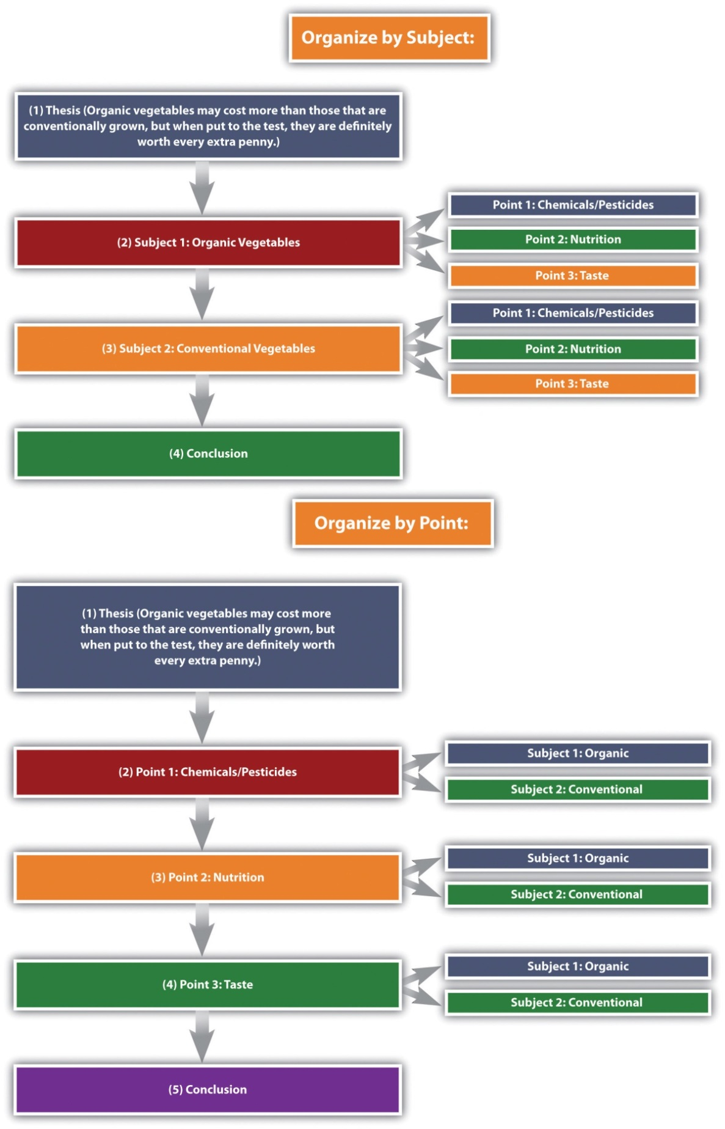
The organizational structure you choose depends on the nature of the topic, your purpose, and your audience.
Given that compare and contrast essays analyze the relationship between two subjects, it is helpful to have some phrases on hand that will cue the reader to such analysis. See Table 4.3: Phrases of Comparison and Contrast for examples.
Table 4.3 Phrases of Comparison and Contrast
Comparison | Contrast
one similarity | one difference
another similarity | another difference
both | conversely
like | in contrast
likewise | unlike
similarly | while
in a similar fashion | whereas

Writing a Comparison and Contrast Essay
First choose whether you want to compare seemingly disparate subjects, contrast seemingly similar subjects, or compare and contrast subjects. Once you have decided on a topic, introduce it with an engaging opening paragraph. Your thesis should come at the end of the introduction, and it should establish the subjects you will compare, contrast, or both, as well as state what can be learned from doing so.
The body of the essay can be organized in one of two ways: by subject or by individual points. The organizing strategy that you choose will depend on, as always, your audience and your purpose. You may also consider your particular approach to the subjects as well as the nature of the subjects themselves; some subjects might better lend themselves to one structure or the other. Be sure to use comparison and contrast phrases to cue the reader to the ways in which you are analyzing the relationship between the subjects.
After you finish analyzing the subjects, write a conclusion that summarizes the main points of the essay and reinforces your thesis. See Appendix: Readings: Examples of Essays to read a sample compare and contrast essay.

Writing at Work
Many business presentations are conducted using comparison and contrast. The organizing strategies—by subject or individual points—could also be used for organizing a presentation. Keep this in mind as a way of organizing your content the next time you or a colleague has to present something at work.

KEY TAKEAWAYS
- A compare and contrast essay analyzes two subjects by either comparing them, contrasting them, or both.
- The purpose of writing a comparison or contrast essay is not to state the obvious but rather to illuminate subtle differences or unexpected similarities between two subjects.
- The thesis should clearly state the subjects that are to be compared, contrasted, or both, and it should state what is to be learned from doing so.
- There are two main organizing strategies for compare and contrast essays.
  - Organize by the subjects themselves, one then the other.
  - Organize by individual points, in which you discuss each subject in relation to each point.
- Use phrases of comparison or phrases of contrast to signal to readers how exactly the two subjects are being analyzed.

4.9 Cause and Effect

LEARNING OBJECTIVES
- Determine the purpose and structure of cause and effect in writing
- Understand how to write a cause and effect essay

The Purpose of Cause and Effect in Writing
It is often considered human nature to ask “why?” and “how?” We may want to know how our child got sick so we can better prevent it from happening in the future, or why our colleague received a pay raise because we want one as well. We want to know how much money we will save over the long term if we buy a hybrid car. These examples identify only a few of the relationships we think about in our lives, but each shows the importance of understanding cause and effect.
A cause is something that produces an event or condition; an effect is what results from an event or condition. The purpose of the cause and effect essay is to determine how various phenomena relate in terms of origins and results. Sometimes the connection between cause and effect is clear, but often determining the exact relationship between the two is very difficult. For example, the following effects of a cold may be easily identifiable: a sore throat, runny nose, and a cough. But determining the cause of the sickness can be far more difficult. A number of causes are possible, and to complicate matters, these possible causes could have combined to cause the sickness. That is, more than one cause may be responsible for any given effect. Therefore, cause and effect discussions are often complicated and frequently lead to debates and arguments.

Tip
Use the complex nature of cause and effect to your advantage. Often it is not necessary, or even possible, to find the exact cause of an event or to name the exact effect. So, when formulating a thesis, you can claim one of a number of causes or effects to be the primary, or main, cause or effect. As soon as you claim that one cause or one effect is more crucial than the others, you have developed a thesis.

The Structure of a Cause and Effect Essay
The cause and effect essay opens with a general introduction to the topic, which then leads to a thesis that states the main cause, main effect, or various causes and effects of a condition or event.
The cause and effect essay can be organized in one of the following two primary ways:
- Start with the cause and then talk about the effects.
- Start with the effect and then talk about the causes.
For example, if your essay is on childhood obesity, you could start by talking about the effect of childhood obesity and then discuss the cause, or you could start the same essay by talking about the cause of childhood obesity and then move to the effect. Regardless of which structure you choose, be sure to explain each element of the essay completely. Explaining complex relationships requires the full use of evidence, such as scientific studies, expert testimony, statistics, and anecdotes.
Because cause and effect essays determine how phenomena are linked, they make frequent use of words and phrases that denote such linkage. See Table 4.4: Phrases of Causation for examples of such terms.
Table 4.4 Phrases of Causation
as a result | because | consequently | due to | hence | since | therefore | thus
The conclusion should wrap up the discussion and reinforce the thesis, leaving the reader with a clear understanding of the relationship that was analyzed.

Tip
Be careful of resorting to empty speculation. In writing, speculation amounts to unsubstantiated guessing. Writers are particularly prone to this trap in cause and effect arguments due to the complex nature of finding links between phenomena. Be sure to have clear evidence to support the claims that you make.

self-practice EXERCISE 4.8
Freewrite for five minutes on one of the following broad topics below. Focus on a narrower issue about that topic and its effects.
- Health and nutrition
- Sports
- Media
- Politics
- History

Writing a Cause and Effect Essay
Choose an event or condition that you think has an interesting cause and effect relationship. Introduce your topic in an engaging way. End your introduction with a thesis that states the main cause, the main effect, or both.
Organize your essay by starting with either the cause then effect structure, or the effect then cause structure. Within each section, you should clearly explain and support the causes and effects using a full range of evidence. If you are writing about multiple causes or multiple effects, you may choose to sequence either in order of importance. In other words, order the causes from least to most important (or vice versa), or order the effects from least important to most important (or vice versa).
Use the phrases of causation when trying to forge connections between various events or conditions. This will help organize your ideas and orient the reader. End your essay with a conclusion that summarizes your main points and reinforces your thesis. See Appendix: Readings: Examples of Essays to read a sample cause and effect essay.

KEY TAKEAWAYS
- The purpose of the cause and effect essay is to determine how various phenomena are related.
- The thesis states what the writer sees as the main cause, main effect, or various causes and effects of a condition or event.
- The cause and effect essay can be organized in one of these two primary ways:
  - Start with the cause and then talk about the effect.
  - Start with the effect and then talk about the cause.
- Strong evidence is particularly important in the cause and effect essay due to the complexity of determining connections between phenomena.
- Phrases of causation are helpful to signal links between various elements in the essay.

Essay 1: Expository essay (15%)

In week 7, you will need to submit an expository essay on one of the following topics. Consider these topics as you work through the rest of this chapter and the next. You will need to choose one topic from one of the rhetorical modes below and write a 750- to 900-word essay. You will need to produce a logically organized essay with a thesis statement, well developed and logically organized paragraphs (with topic sentences), and an introduction and conclusion. You will need to support your ideas using one to three sources and include an APA reference list and citations as outlined in the JIBC APA Style Guide. You need to also demonstrate appropriate use of grammar and correct spelling. Remember, your essay should not just be a story; it should demonstrate logical organization and idea development.
- Narrative: Choose one of the topics below and relate your ideas in a clearly organized narrative essay.
- Your first day of post-secondary school
- A moment of success or failure
- An experience that helped you mature
- Illustration: Choose one of the topics below and relate your ideas in a clearly organized illustration essay.
- The media and the framing of crime
- Child obesity
- The effect of violent video games on behaviour
- Description: Choose one of the topics below and relate your ideas in a clearly organized description essay.
- How to reduce weight
- How to remain relevant in your workplace
- How to get a good night’s sleep
- Classification: Choose one of the topics below and relate your ideas in a clearly organized classification essay.
- Ways of boring people
- Methods of studying for a final exam
- Extreme weather
- Process analysis: Choose one of the topics below and relate your ideas in a clearly organized process analysis essay.
- How to complain effectively
- How to apply the Heimlich manoeuvre, or other lifesaving technique
- How a particular accident occurred
- Definition: Choose one of the topics below and relate your ideas in a clearly organized definition essay.
- Right to privacy
- Integrity
- Heroism
- Compare and contrast: Choose one of the topics below and relate your ideas in a clearly organized compare and contrast essay.
- Two ways of losing weight: one healthy, one dangerous
- Two ways to break a bad habit
- An active and a passive student
- Cause and effect: Choose one of the topics below and relate your ideas in a clearly organized cause and effect essay.
- Plagiarism and cheating in school. Give its effects.
- Bullying. Give its effects.
- A personal, unreasonable fear or irritation. Give its causes.
You need to submit this assignment to your instructor for marking. (15%)

4.9 Purpose, Audience, Tone, and Content

LEARNING OBJECTIVES
- Identify the four common academic purposes
- Identify audience, tone, and content
- Apply purpose, audience, tone, and content to a specific assignment
We have examined different types or modes of composing expository essays. As each essay has a different purpose, we now need to look further at how to construct paragraphs according to the purpose, audience, and tone of writing. It is important keep the big picture thesis in mind when writing, and to question whether the information supports that thesis. As well, while thinking of how each supporting idea links back to that thesis, it is necessary to consider the purpose of the paragraphs. Should a paragraph be summary, analysis, synthesis, or evaluation to best support the thesis and essay mode? How will that purpose affect paragraph construction?
Three elements shape the content of each paragraph:
- Purpose: The reason the writer composes the paragraph.
- Tone: The attitude the writer conveys about the paragraph’s subject.
- Audience: The individual or group whom the writer intends to address.
Figure 4.2: Purpose, Audience, Tone, and Content Triangle illustrates this concept.
Figure 4.2 Purpose, Audience, Tone, and Content Triangle
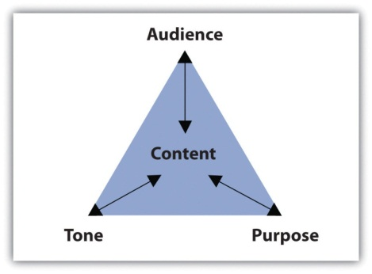
The assignment’s purpose, audience, and tone dictate what the paragraph covers and how it will support one main point. This section covers how purpose, audience, and tone affect reading and writing paragraphs.

Identifying Common Academic Purposes
The purpose is simply the reason you are writing a particular document. Basically, the purpose of a piece of writing answers the question “why?” For example, why write a play? To entertain a packed theatre. Why write instructions to the babysitter? To inform him or her of your schedule and rules. Why write a letter to your Member of Parliament? To persuade him or her to address your community’s needs.
In academic settings, the reasons for writing fulfill four main purposes: to summarize, to analyze, to synthesize, and to evaluate. You will encounter these four purposes not only as you read for your classes but also as you read for work or pleasure. Because reading and writing work together, your writing skills will improve as you read.
Eventually, your instructors will ask you to complete assignments specifically designed to meet one of the four purposes. As you will see, the purpose for writing will guide you through each part of the paper, helping you make decisions about content and style. For now, identifying these purposes by reading paragraphs will prepare you to write individual paragraphs and to build longer assignments.

Summary Paragraphs
We have already seen a sample of a summary paragraph in Section 3.2: Summarizing. Take a look back at the summary paragraph in that section to refresh your memory on what this type of paragraph should contain.

Analysis Paragraphs
An analysis separates complex materials into their different parts and studies how the parts relate to one another. The analysis of simple table salt, for example, would require a deconstruction of its parts—the elements sodium (Na) and chloride (Cl). Then, scientists would study how the two elements interact to create the compound NaCl, or sodium chloride, which is also called simple table salt.
Analysis is not limited to the sciences, of course. An analysis paragraph in academic writing fulfills the same purpose. Instead of deconstructing chemical compounds, academic analysis paragraphs typically deconstruct documents. An analysis takes apart a primary source (an essay, a book, an article, etc.) point by point. It communicates the main points of the document by examining individual points and identifying how they relate to one another.
Take a look at a student’s analysis of the journal report.
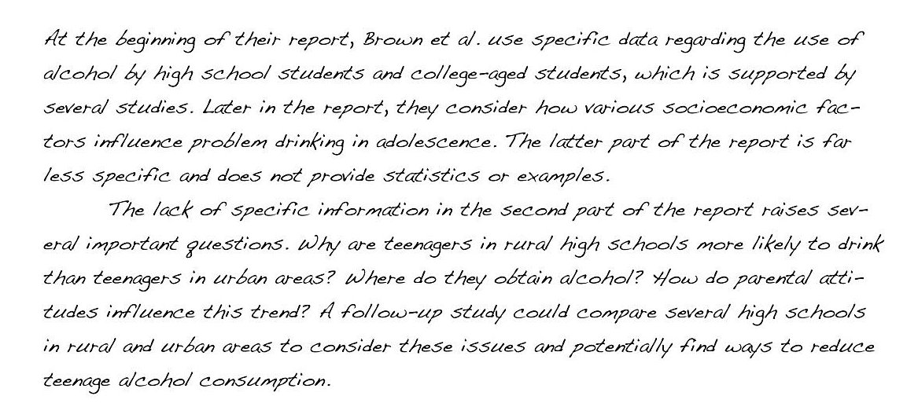
Notice how the analysis does not simply repeat information from the original report, but considers how the points within the report relate to one another. By doing this, the student uncovers a discrepancy between the points that are backed up by statistics and those that require additional information. Analyzing a document involves a close examination of each of the individual parts and how they work together.

Synthesis Paragraphs
A synthesis combines two or more items to create an entirely new item. Consider the electronic musical instrument aptly named the synthesizer. It looks like a simple keyboard but displays a dashboard of switches, buttons, and levers. With the flip of a few switches, a musician may combine the distinct sounds of a piano, a flute, or a guitar—or any other combination of instruments—to create a new sound. The purpose of the synthesizer is to blend together the notes from individual instruments to form new, unique notes.
The purpose of an academic synthesis is to blend individual documents into a new document. An academic synthesis paragraph considers the main points from one or more pieces of writing and links the main points together to create a new point, one not replicated in either document.
Take a look at a student’s synthesis of several sources about underage drinking.
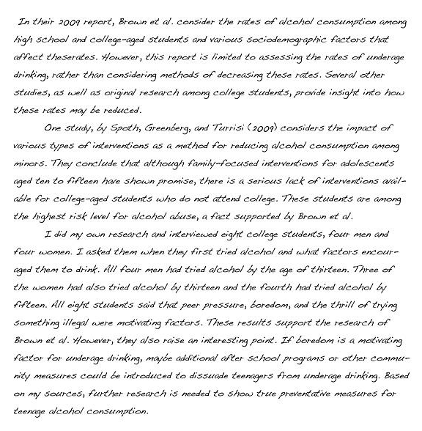
Notice how the synthesis paragraphs consider each source and use information from each to create a new thesis. A good synthesis does not repeat information; the writer uses a variety of sources to create a new idea.

Evaluation Paragraphs
An evaluation judges the value of something and determines its worth. Evaluations in everyday experiences are often not only dictated by set standards but are also influenced by opinion and prior knowledge. For example, at work, a supervisor may complete an employee evaluation by judging his subordinate’s performance based on the company’s goals. If the company focuses on improving communication, the supervisor will rate the employee’s customer service according to a standard scale. However, the evaluation still depends on the supervisor’s opinion and prior experience with the employee. The purpose of the evaluation is to determine how well the employee performs on the job.
An academic evaluation communicates your opinion, and its justifications, about a document or a topic of discussion. Evaluations are influenced by your reading of the document, your prior knowledge, and your prior experience with the topic or issue. Because an evaluation incorporates your point of view and the reasons for your point of view, it typically requires more critical thinking and a combination of summary, analysis, and synthesis skills. Thus evaluation paragraphs often follow summary, analysis, and synthesis paragraphs. Read a student’s evaluation paragraph.
Notice how the paragraph incorporates the student’s personal judgment within the evaluation. Evaluating a document requires prior knowledge that is often based on additional research.

Tip
When reviewing directions for assignments, look for the verbs summarize, analyze, synthesize, or evaluate. Instructors often use these words to clearly indicate the assignment’s purpose. These words will cue you on how to complete the assignment because you will know its exact purpose.

Self-practice EXERCISE 4.9
Read the following paragraphs about four films and then identify the purpose of each paragraph.
- This film could easily have been cut down to less than two hours. By the final scene, I noticed that most of my fellow moviegoers were snoozing in their seats and were barely paying attention to what was happening on screen. Although the director sticks diligently to the book, he tries too hard to cram in all the action, which is just too ambitious for such a detail-oriented story. If you want my advice, read the book and give the movie a miss.
- During the opening scene, we learn that the character Laura is adopted and that she has spent the past three years desperately trying to track down her real parents. Having exhausted all the usual options—adoption agencies, online searches, family trees, and so on—she is on the verge of giving up when she meets a stranger on a bus. The chance encounter leads to a complicated chain of events that ultimately result in Laura getting her lifelong wish. But is it really what she wants? Throughout the rest of the film, Laura discovers that sometimes the past is best left where it belongs.
- To create the feeling of being gripped in a vise, the director, May Lee, uses a variety of elements to gradually increase the tension. The creepy, haunting melody that subtly enhances the earlier scenes becomes ever more insistent, rising to a disturbing crescendo toward the end of the movie. The desperation of the actors, combined with the claustrophobic atmosphere and tight camera angles create a realistic firestorm, from which there is little hope of escape. Walking out of the theatre at the end feels like staggering out of a Roman dungeon.
- The scene in which Campbell and his fellow prisoners assist the guards in shutting down the riot immediately strikes the viewer as unrealistic. Based on the recent reports on prison riots in both Detroit and California, it seems highly unlikely that a posse of hardened criminals would intentionally help their captors at the risk of inciting future revenge from other inmates. Instead, both news reports and psychological studies indicate that prisoners who do not actively participate in a riot will go back to their cells and avoid conflict altogether. Examples of this lack of attention to detail occur throughout the film, making it almost unbearable to watch.
Collaboration: Share with a classmate and compare your answers.

Writing at Work
Thinking about the purpose of writing a report in the workplace can help focus and structure the document. A summary should provide colleagues with a factual overview of your findings without going into too much detail. In contrast, an evaluation should include your personal opinion, along with supporting evidence, research, or examples to back it up. Listen for words such as summarize, analyze, synthesize, or evaluate when your boss asks you to complete a report to help determine a purpose for writing.

Self-practice EXERCISE 4.10
Consider the expository essay you will soon have to write. Identify the most effective academic purpose for the assignment.
My assignment: ____________________________________________
My purpose: _____________________________________________

Identifying the Audience
Imagine you must give a presentation to a group of executives in an office. Weeks before the big day, you spend time creating and rehearsing the presentation. You must make important, careful decisions not only about the content but also about your delivery. Will the presentation require technology to project figures and charts? Should the presentation define important words, or will the executives already know the terms? Should you wear your suit and dress shirt? The answers to these questions will help you develop an appropriate relationship with your audience, making them more receptive to your message.
Now imagine you must explain the same business concepts from your presentation to a group of high school students. Those important questions you previously answered may now require different answers. The figures and charts may be too sophisticated, and the terms will certainly require definitions. You may even reconsider your outfit and sport a more casual look. Because the audience has shifted, your presentation and delivery will shift as well to create a new relationship with the new audience.
In these two situations, the audience—the individuals who will watch and listen to the presentation—plays a role in the development of presentation. As you prepare the presentation, you visualize the audience to anticipate their expectations and reactions. What you imagine affects the information you choose to present and how you will present it. Then, during the presentation, you meet the audience in person and discover immediately how well you perform.
Although the audience for writing assignments—your readers—may not appear in person, they play an equally vital role. Even in everyday writing activities, you identify your readers’ characteristics, interests, and expectations before making decisions about what you write. In fact, thinking about audience has become so common that you may not even detect the audience driven decisions.
For example, you update your status on a social networking site with the awareness of who will digitally follow the post. If you want to brag about a good grade, you may write the post to please family members. If you want to describe a funny moment, you may write with your friends’ sense of humour in mind. Even at work, you send emails with an awareness of an unintended receiver who could intercept the message.
In other words, being aware of “invisible” readers is a skill you most likely already possess and one you rely on every day. Consider the following paragraphs. Which one would the author send to her parents? Which one would she send to her best friend?
Example A
Last Saturday, I volunteered at a local hospital. The visit was fun and rewarding. I even learned how to do cardiopulmonary resuscitation, or CPR. Unfortunately, I think caught a cold from one of the patients. This week, I will rest in bed and drink plenty of clear fluids. I hope I am well by next Saturday to volunteer again.
Example B
OMG! You won’t believe this! My advisor forced me to do my community service hours at this hospital all weekend! We learned CPR but we did it on dummies, not even real peeps. And some kid sneezed on me and got me sick! I was so bored and sniffling all weekend; I hope I don’t have to go back next week. I def do NOT want to miss the basketball tournament!
Most likely, you matched each paragraph to its intended audience with little hesitation. Because each paragraph reveals the author’s relationship with her intended readers, you can identify the audience fairly quickly. When writing your own paragraphs, you must engage with your audience to build an appropriate relationship given your subject. Imagining your readers during each stage of the writing process will help you make decisions about your writing. Ultimately, the people you visualize will affect what and how you write.

Tip
While giving a speech, you may articulate an inspiring or critical message, but if you left your hair a mess and laced up mismatched shoes, your audience would not take you seriously. They may be too distracted by your appearance to listen to your words.
Similarly, grammar and sentence structure serve as the appearance of a piece of writing. Polishing your work using correct grammar will impress your readers and allow them to focus on what you have to say.
Because focusing on audience will enhance your writing, your process, and your finished product, you must consider the specific traits of your audience members. Use your imagination to anticipate the readers’ demographics, education, prior knowledge, and expectations.
- Demographics: These measure important data about a group of people, such as their age range, ethnicity, religious beliefs, or gender. Certain topics and assignments will require you to consider these factors as they relate to your audience. For other topics and assignments, these measurements may not influence your writing. Regardless, it is important to consider demographics when you begin to think about your purpose for writing.
- Education: Education considers the audience’s level of schooling. If audience members have earned a doctorate degree, for example, you may need to elevate your style and use more formal language. Or, if audience members are still in college, you could write in a more relaxed style. An audience member’s major or emphasis may also dictate your writing.
- Prior knowledge: Prior knowledge is what the audience already knows about your topic. If your readers have studied certain topics, they may already know some terms and concepts related to the topic. You may decide whether to define terms and explain concepts based on your audience’s prior knowledge. Although you cannot peer inside the brains of your readers to discover their knowledge, you can make reasonable assumptions. For instance, a nursing major would presumably know more about health-related topics than a business major would.
- Expectations: These indicate what readers will look for while reading your assignment. Readers may expect consistencies in the assignment’s appearance, such as correct grammar and traditional formatting like double-spaced lines and a legible font. Readers may also have content-based expectations given the assignment’s purpose and organization. In an essay titled “The Economics of Enlightenment: The Effects of Rising Tuition,” for example, audience members may expect to read about the economic repercussions of post-secondary tuition costs.

Self-practice EXERCISE 4.11
On a sheet of paper, generate a list of characteristics under each category for each audience. This list will help you later when you read about tone and content.
- Your classmates
  - Demographics ____________________________________________
  - Education ____________________________________________
  - Prior knowledge ____________________________________________
  - Expectations ____________________________________________
- Your instructor
  - Demographics ____________________________________________
  - Education ____________________________________________
  - Prior knowledge ____________________________________________
  - Expectations ____________________________________________
- The head of your academic department
  - Demographics ____________________________________________
  - Education ____________________________________________
  - Prior knowledge ____________________________________________
  - Expectations ____________________________________________
Now think about your next writing assignment. Identify the purpose (you may use the same purpose listed in Self-Practice Exercise 4.10 and then identify the audience. Create a list of characteristics under each category.
My assignment: ____________________________________________
My purpose: ____________________________________________
My audience: ____________________________________________
  - Demographics ____________________________________________
  - Education ____________________________________________
  - Prior knowledge ____________________________________________
  - Expectations ____________________________________________
Collaboration: please share with a classmate and compare your answers.
Keep in mind that as your topic shifts in the writing process, your audience may also shift. Also, remember that decisions about style depend on audience, purpose, and content. Identifying your audience’s demographics, education, prior knowledge, and expectations will affect how you write, but purpose and content play an equally important role. The next subsection covers how to select an appropriate tone to match the audience and purpose.

Selecting an Appropriate Tone
Tone identifies a speaker’s attitude toward a subject or another person. You may pick up a person’s tone of voice fairly easily in conversation. A friend who tells you about her weekend may speak excitedly about a fun skiing trip. An instructor who means business may speak in a low, slow voice to emphasize her serious mood. Or, a co-worker who needs to let off some steam after a long meeting may crack a sarcastic joke.
Just as speakers transmit emotion through voice, writers can transmit through writing a range of attitudes, from excited and humorous to somber and critical. These emotions create connections among the audience, the author, and the subject, ultimately building a relationship between the audience and the text. To stimulate these connections, writers intimate their attitudes and feelings with useful devices, such as sentence structure, word choice, punctuation, and formal or informal language. Keep in mind that the writer’s attitude should always appropriately match the audience and the purpose.
Read the following paragraph and consider the writer’s tone. How would you describe the writer’s attitude toward wildlife conservation?
Many species of plants and animals are disappearing right before our eyes. If we do not act fast, it might be too late to save them. Human activities, including pollution, deforestation, hunting, and overpopulation, are devastating the natural environment. Without our help, many species will not survive long enough for our children to see them in the wild. Take the tiger, for example. Today, tigers occupy just 7 percent of their historical range, and many local populations are already extinct. Hunted for their beautiful pelt and other body parts, the tiger population has plummeted from 100,000 in 1920 to just a few thousand (Smith, 2013). Contact your local wildlife conservation society today to find out how you can stop this terrible destruction.

SElf-practice EXERCISE 4.12
Think about the assignment and purpose you selected in Self-Practice Exercise 4.10 and the audience you selected in Self-Practice Exercise 4.11. Now, identify the tone you would use in the assignment.
My assignment: ____________________________________________
My purpose: ____________________________________________
My audience: ____________________________________________
My tone: ____________________________________________

Choosing Appropriate, Interesting Content
Content refers to all the written substance in a document. After selecting an audience and a purpose, you must choose what information will make it to the page. Content may consist of examples, statistics, facts, anecdotes, testimonies, and observations, but no matter the type, the information must be appropriate and interesting for the audience and purpose. An essay written for grade 3 students that summarizes the legislative process, for example, would have to contain succinct and simple content.
Content is also shaped by tone. When the tone matches the content, the audience will be more engaged, and you will build a stronger relationship with your readers. Consider that audience of grade 3 students. You would choose simple content that the audience will easily understand, and you would express that content through an enthusiastic tone. The same considerations apply to all audiences and purposes.

self-practice EXERCISE 4.13
Using the assignment, purpose, audience, and tone from Self-Practice Exercise 4.12, generate a list of content ideas. Remember that content consists of examples, statistics, facts, anecdotes, testimonies, and observations.
My assignment: ____________________________________________
My purpose: ____________________________________________
My audience: ____________________________________________
My tone: ____________________________________________
My content ideas: ____________________________________________
In the next two chapters, you will complete more exercises to further develop your expository essays.

KEY TAKEAWAYS
- Paragraphs separate ideas into logical, manageable chunks of information.
- The content of each paragraph and document is shaped by purpose, audience, and tone.
- The four common academic purposes are to summarize, to analyze, to synthesize, and to evaluate.
- Identifying the audience’s demographics, education, prior knowledge, and expectations will affect how and what you write.
- Devices such as sentence structure, word choice, punctuation, and formal or informal language communicate tone and create a relationship between the writer and his or her audience.
- Content may consist of examples, statistics, facts, anecdotes, testimonies, and observations. All content must be appropriate and interesting for the audience, purpose and tone.

Journal entry #4
Write a paragraph or two responding to the following.
- Thinking back to each of the expository essay modes you learned this week, which did you find easier and which did you find more difficult? Why?
- What challenges did you face when assessing your purpose, audience, and tone? How do you think you can address these challenges?
- Reflect on the goals you set previously. Is there anything you would like to add or already feel more confident with doing?
Remember as mentioned in the Assessment Descriptions in your syllabus:
- You will be expected to respond to the questions by reflecting on and discussing your experiences with the week’s material.
- When writing your journals, you should focus on freewriting—writing without (overly) considering formal writing structures—but you want to remember that it will be read by the instructor, who needs to be able to understand your ideas.
- Your instructor will be able to see if you have completed this entry by the end of the week but will not read all of the journals until week 6.

Chapter 5

Putting the Pieces Together with a Thesis Statement

5.1 Apply Prewriting Models

LEARNING OBJECTIVE
- Use prewriting strategies to choose a topic and narrow the focus
If you think that a blank sheet of paper or a blinking cursor on the computer screen is a scary sight, you are not alone. Many writers, students, and employees find that beginning to write can be intimidating. When faced with a blank page, however, experienced writers remind themselves that writing, like other everyday activities, is a process. Every process, from writing to cooking to bike riding to learning to use a new cell phone will get significantly easier with practice.
Just as you need a recipe, ingredients, and proper tools to cook a delicious meal, you also need a plan, resources, and adequate time to create a good written composition. In other words, writing is a process that requires steps and strategies to accomplish your goals.
These are the five steps in the writing process:
- Prewriting
- Outlining the structure of ideas
- Writing a rough draft
- Revising
- Editing
Effective writing can be simply described as good ideas that are expressed well and arranged in the proper order. This chapter will give you the chance to work on all these important aspects of writing. Although many more prewriting strategies exist, this chapter covers six: using experience and observations, freewriting, asking questions, brainstorming, mapping, and searching the Internet. Using the strategies in this chapter can help you overcome the fear of the blank page and confidently begin the writing process.

Prewriting
Prewriting is the stage of the writing process during which you transfer your abstract thoughts into more concrete ideas in ink on paper (or in type on a computer screen). Although prewriting techniques can be helpful in all stages of the writing process, the following four strategies are best used when initially deciding on a topic:
- Using experience and observations
- Reading
- Freewriting
- Asking questions
At this stage in the writing process, it is okay if you choose a general topic. Later you will learn more prewriting strategies that will narrow the focus of the topic.

Choosing a Topic
In addition to understanding that writing is a process, writers also understand that choosing a good general topic for an assignment is an essential step. Sometimes your instructor will give you an idea to begin an assignment, and other times your instructor will ask you to come up with a topic on your own. A good topic not only covers what an assignment will be about but also fits the assignment’s purpose and its audience.
In this chapter, you will follow a writer named Mariah as she prepares a piece of writing. You will also be planning one of your own. The first important step is for you to tell yourself why you are writing (to inform, to explain, or some other purpose) and for whom you are writing. Write your purpose and your audience on your own sheet of paper, and keep the paper close by as you read and complete exercises in this chapter.
My purpose: ____________________________________________
My audience: ____________________________________________

Using Experience and Observations
When selecting a topic, you may want to consider something that interests you or something based on your own life and personal experiences. Even everyday observations can lead to interesting topics. After writers think about their experiences and observations, they often take notes on paper to better develop their thoughts. These notes help writers discover what they have to say about their topic.

Tip
Have you seen an attention-grabbing story on your local news channel? Many current issues appear on television, in magazines, and on the Internet. These can all provide inspiration for your writing.

Reading
Reading plays a vital role in all the stages of the writing process, but it first figures in the development of ideas and topics. Different kinds of documents can help you choose a topic and also develop that topic. For example, a magazine advertising the latest research on the threat of global warming may catch your eye in the supermarket. The cover may interest you, and you may consider global warming as a topic. Or maybe a novel’s courtroom drama sparks your curiosity of a particular lawsuit or legal controversy.
After you choose a topic, critical reading is essential to the development of a topic. While reading almost any document, you evaluate the author’s point of view by thinking about the main idea and the support. When you judge the author’s argument, you discover more about not only the author’s opinion but also your own. If this step already seems daunting, remember that even the best writers need to use prewriting strategies to generate ideas.

Tip
The steps in the writing process may seem time consuming at first, but following these steps will save you time in the future. The more you plan in the beginning by reading and using prewriting strategies, the less time you may spend writing and editing later because your ideas will develop more swiftly.
Prewriting strategies depend on your critical reading skills. Reading prewriting exercises (and outlines and drafts later in the writing process) will further develop your topic and ideas. As you continue to follow the writing process, you will see how Mariah uses critical reading skills to assess her own prewriting exercises.

Freewriting
Freewriting is an exercise in which you write freely about any topic for a set amount of time (usually three to five minutes). During the time limit, you may jot down any thoughts that come to mind. Try not to worry about grammar, spelling, or punctuation. Instead, write as quickly as you can without stopping. If you get stuck, just copy the same word or phrase over and over until you come up with a new thought.
Writing often comes easier when you have a personal connection with the topic you have chosen. Remember, to generate ideas in your freewriting, you may also think about readings that you have enjoyed or that have challenged your thinking. Doing this may lead your thoughts in interesting directions.
Quickly recording your thoughts on paper will help you discover what you have to say about a topic. When writing quickly, try not to doubt or question your ideas. Allow yourself to write freely and unselfconsciously. Once you start writing with few limitations, you may find you have more to say than you first realized. Your flow of thoughts can lead you to discover even more ideas about the topic. Freewriting may even lead you to discover another topic that excites you even more.
Look at Mariah’s example. The instructor allowed the members of the class to choose their own topics, and Mariah thought about her experiences as a communications major. She used this freewriting exercise to help her generate more concrete ideas from her own experience.

Tip
Some prewriting strategies can be used together. For example, you could use experience and observations to come up with a topic related to your course studies. Then you could use freewriting to describe your topic in more detail and figure out what you have to say about it.
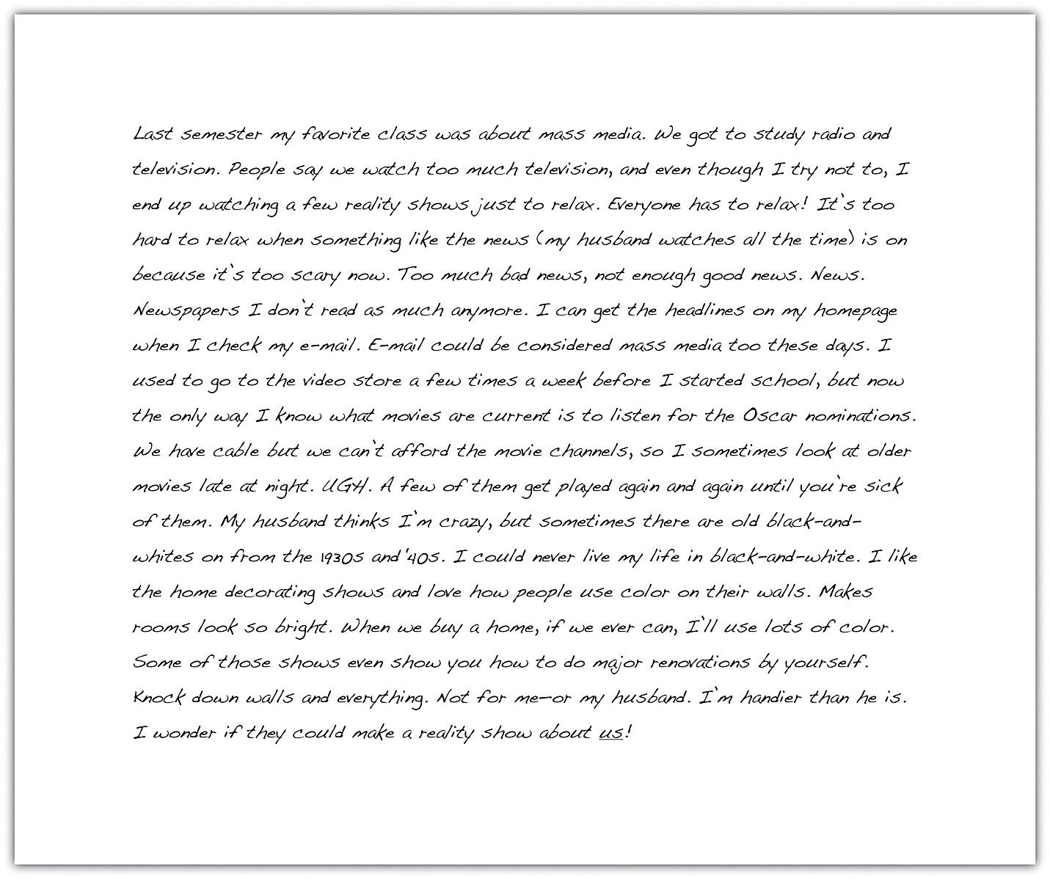

self-practice EXERCISE 5.1
Take another look at the possible topics for your expository essay assignment then freewrite about that topic. Write without stopping for five minutes. After you finish, read over what you wrote. How well do you think you will be able to develop this topic?
Possible expository essay questions:
- Narrative: Choose one of the topics below and relate your ideas in a clearly organized narrative essay.
- Your first day of post-secondary school
- A moment of success or failure
- An experience that helped you mature
- Illustration: Choose one of the topics below and relate your ideas in a clearly organized illustration essay.
- The media and the framing of crime
- Child obesity
- The effect of violent video games on behaviour
- Description: Choose one of the topics below and relate your ideas in a clearly organized description essay.
- How to reduce weight
- How to remain relevant in your workplace
- How to get a good night’s sleep
- Classification: Choose one of the topics below and relate your ideas in a clearly organized classification essay.
- Ways of boring people
- Methods of studying for a final exam
- Extreme weather
- Process analysis: Choose one of the topics below and relate your ideas in a clearly organized process analysis essay.
- How to complain effectively
- How to apply the Heimlich manoeuvre or other lifesaving technique
- How a particular accident occurred
- Definition: Choose one of the topics below and relate your ideas in a clearly organized definition essay.
- Right to privacy
- Integrity
- Heroism
- Compare and contrast: Choose one of the topics below and relate your ideas in a clearly organized compare and contrast essay.
- Two ways of losing weight: one healthy, one dangerous
- Two ways to break a bad habit
- An active and a passive student
- Cause and effect: Choose one of the topics below and relate your ideas in a clearly organized cause and effect essay.
- Plagiarism and cheating in school. Give its effects.
- Bullying. Give its effects.
- A personal, unreasonable fear or irritation. Give its causes.

Asking Questions
Who? What? Where? When? Why? How? In everyday situations, you pose these kinds of questions to get information. Who will be my partner for the project? When is the next meeting? Why is my car making that odd noise?
You seek the answers to these questions to gain knowledge, to better understand your daily experiences, and to plan for the future. Asking these types of questions will also help you with the writing process. As you choose your topic, answering these questions can help you revisit the ideas you already have and generate new ways to think about your topic. You may also discover aspects of the topic that are unfamiliar to you and that you would like to learn more about. All these idea-gathering techniques will help you plan for future work on your assignment.
When Mariah reread her freewriting notes, she found she had rambled and her thoughts were disjointed. She realized that the topic that interested her most was the one she started with: the media. She then decided to explore that topic by asking herself questions about it. Her purpose was to refine media into a topic she felt comfortable writing about. To see how asking questions can help you choose a topic, take a look at the following chart in Figure 5.1: Asking Questions that Mariah completed to record her questions and answers. She asked herself the questions that reporters and journalists use to gather information for their stories. The questions are often called the 5WH questions, after their initial letters.

Figure 5.1 Asking Questions
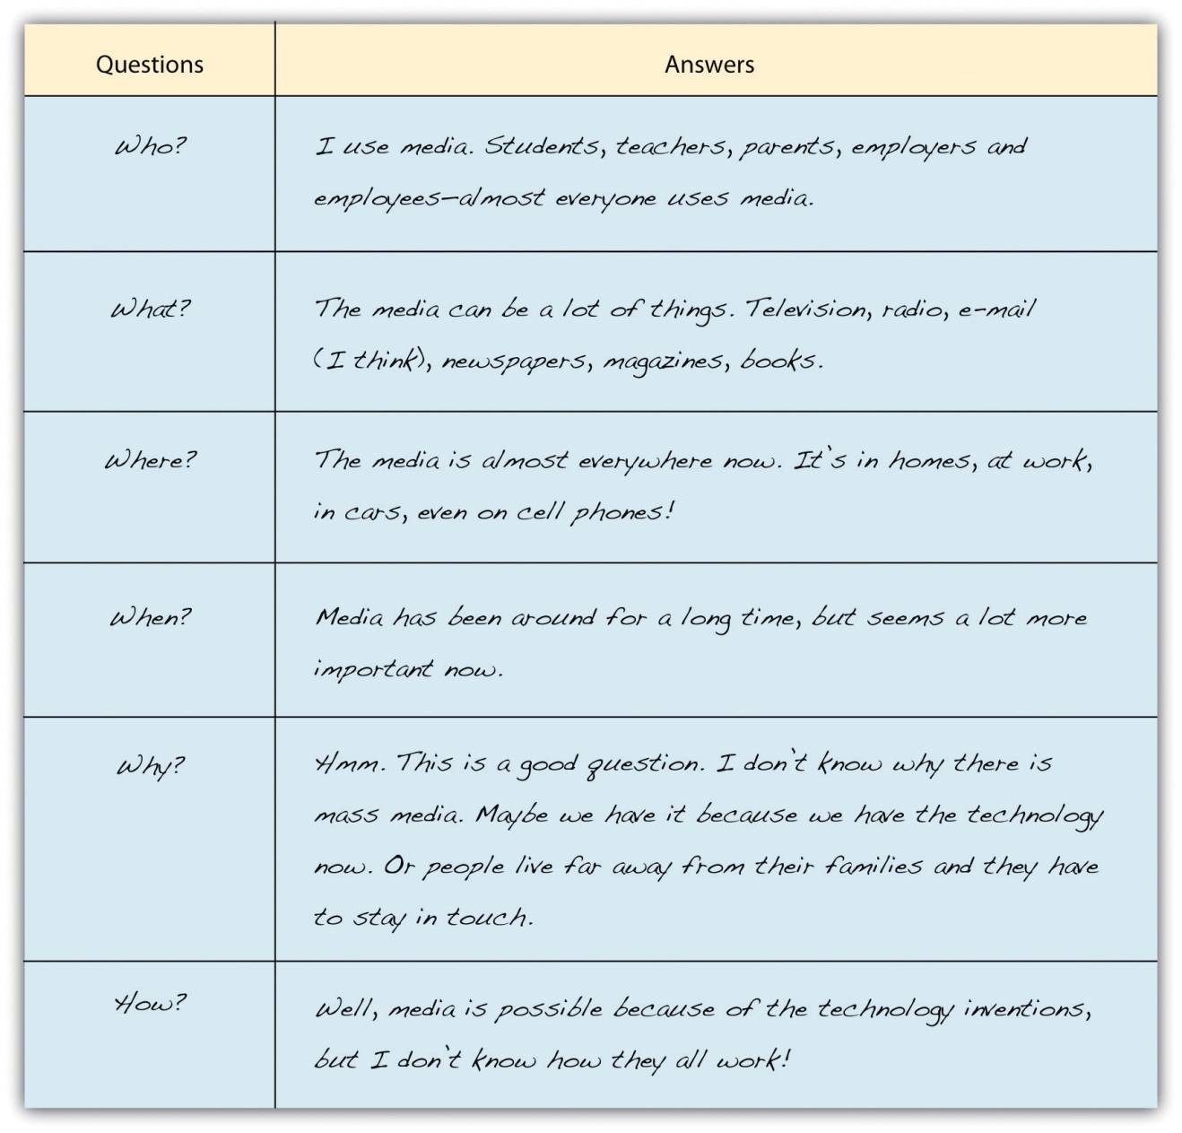

Tip
Prewriting is very purpose driven; it does not follow a set of hard and fast rules. The purpose of prewriting is to find and explore ideas so that you will be prepared to write. A prewriting technique like asking questions can help you both find a topic and explore it. The key to effective prewriting is to use the techniques that work best for your thinking process. Freewriting may not seem to fit your thinking process, but keep an open mind. It may work better than you think. Perhaps brainstorming a list of topics might better fit your personal style. Mariah found freewriting and asking questions to be fruitful strategies to use. In your own prewriting, use the 5WH questions in any way that benefits your planning.

self-practice EXERCISE 5.2
Using the prewriting you completed in Self-Practice Exercise 5.1, read each question and use your own paper to answer the 5WH questions. As with Mariah when she explored her writing topic for more detail, it is okay if you do not know all the answers. If you do not know an answer, use your own opinion to speculate, or guess. You may also use factual information from books or articles you previously read on your topic. Later in the chapter, you will read about additional ways (like searching the Internet) to answer your questions and explore your guesses.
5WH Questions
- Who?
_____________________________________________________
- What?
_____________________________________________________
- Where?
_____________________________________________________
- When?
_____________________________________________________
- Why?
_____________________________________________________
- How?
_____________________________________________________
Now that you have completed some of the prewriting exercises, you may feel less anxious about starting a paper from scratch. With some ideas down on paper (or saved on a computer), writers are often more comfortable continuing the writing process. After identifying a good general topic, you, too, are ready to continue the process.

Tip
You may find that you need to adjust your topic as you move through the writing stages (and as you complete the exercises in this chapter). If the topic you have chosen is not working, you can repeat the prewriting activities until you find a better one.

More Prewriting Techniques: Narrowing the Focus
The prewriting techniques of freewriting and asking questions helped Mariah think more about her topic. The following additional prewriting strategies would help her (and you) narrow the focus of the topic:
- Brainstorming
- Idea mapping
- Searching the Internet
Narrowing the focus means breaking up the topic into subtopics, or more specific points. Generating a lot of subtopics helps in selecting the ones that fit the assignment and appeal to the writer and the audience.
After rereading her syllabus, Mariah realized her general topic, mass media, was too broad for her class’s short paper requirement. Three pages would not be enough to cover all the concerns in mass media today. Mariah also realized that although her readers are other communications majors who are interested in the topic, they may want to read a paper about a particular issue in mass media.

Brainstorming
Brainstorming is similar to list making. You can make a list on your own or in a group with your classmates. Start with a blank sheet of paper (or a blank computer document) and write your general topic across the top. Underneath your topic, make a list of more specific ideas. Think of your general topic as a broad category and the list items as things that fit into that category. Often you will find that one item can lead to the next, creating a flow of ideas that can help you narrow your focus to a more specific paper topic.
The following is Mariah’s brainstorming list:
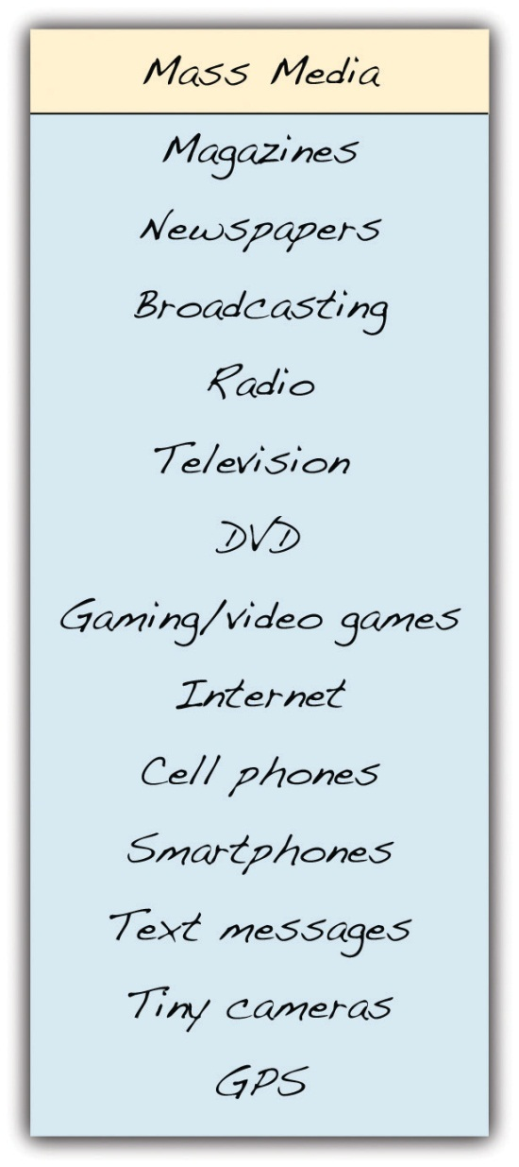
From this list, Mariah could narrow her focus to a particular technology under the broad category of mass media.

Writing at Work
Imagine you have to write an email to your current boss explaining your prior work experience, but you do not know where to start. Before you begin the email, you can use the brainstorming technique to generate a list of employers, duties, and responsibilities that fall under the general topic of work experience.

Idea Mapping
Idea mapping allows you to visualize your ideas on paper using circles, lines, and arrows. This technique is also known as clustering because ideas are broken down and clustered, or grouped together. Many writers like this method because the shapes show how the ideas relate or connect, and writers can find a focused topic from the connections mapped. Using idea mapping, you might discover interesting connections between topics that you had not thought of before.
To create an idea map, start with your general topic in a circle in the centre of a blank sheet of paper. Then write specific ideas around it and use lines or arrows to connect them together. Add and cluster as many ideas as you can think of.
Mariah tried idea mapping in addition to brainstorming. Figure 5.2: Idea Map shows what she created.
Figure 5.2 Idea Map
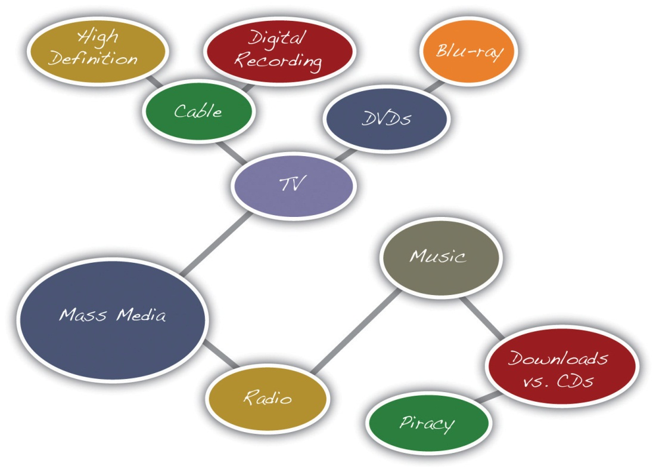
Notice Mariah’s largest circle contains her general topic: mass media. Then, the general topic branches into two subtopics written in two smaller circles: television and radio. The subtopic television branches into even more specific topics: cable and DVDs. From there, Mariah drew more circles and wrote more specific ideas: high definition and digital recording from cable and Blu-ray from DVDs. The radio topic led Mariah to draw connections between music, downloads versus CDs, and, finally, piracy.
From this idea map, Mariah saw she could consider narrowing the focus of her mass media topic to the more specific topic of music piracy.

Searching the Internet
Using search engines on the Internet is a good way to see what kinds of websites are available on your topic. Writers use search engines not only to understand more about the topic’s specific issues but also to get better acquainted with their audience.

Tip
Look back at the chart you completed in Self-Practice Exercise 5.2. Did you guess at any of the answers? Searching the Internet may help you find answers to your questions and confirm your guesses. Be choosy about the websites you use. Make sure they are reliable sources for the kind of information you seek.
When you search the Internet, type some key words from your broad topic or words from your narrowed focus into your browser’s search engine (many good general and specialized search engines are available for you to try). Then look over the results for relevant and interesting articles.
Results from an Internet search show writers the following information:
- Who is talking about the topic
- How the topic is being discussed
- What specific points are currently being discussed about the topic

Tip
If the search engine results are not what you are looking for, revise your key words and search again. Some search engines also offer suggestions for related searches that may give you better results.
Mariah typed the words music piracy from her idea map into the search engine Google (see Figure 5.3 Useful Search Engine Results).
Figure 5.3 Useful Search Engine Results
Note: Not all the results online search engines return will be useful or reliable. Carefully consider the reliability of an online source before selecting a topic based on it. Remember that factual information can be verified in other sources, both online and in print. If you have doubts about any information you find, either do not use it or identify it as potentially unreliable.
The results from Mariah’s search included websites from university publications, personal blogs, online news sources, and a lot of legal cases sponsored by the recording industry. Reading legal jargon made Mariah uncomfortable with the results, so she decided to look further. Reviewing her map, she realized that she was more interested in consumer aspects of mass media, so she refocused her search to media technology and the sometimes confusing array of expensive products that fill electronics stores. Now, Mariah considers a topic on the products that have fed the mass media boom in everyday lives.

self-practice EXERCISE 5.3
In Self-Practice Exercise 5.2, you chose a possible topic and explored it by answering questions about it using the 5WH questions. However, this topic may still be too broad. Choose and complete one of the prewriting strategies to narrow the focus. Use brainstorming, idea mapping, or searching the Internet.
Collaboration: Please share with a classmate and compare your answers. Share what you found and what interests you about the possible topic(s).
Prewriting strategies are a vital first step in the writing process. First they help you first choose a broad topic, and then they help you narrow the focus of the topic to a more specific idea. Use Checklist 5.1: Topic Checklist to help you with this step.
Checklist 5.1 Developing a Good Topic
Using this checklist can help you decide if your narrowed topic is a good topic for your assignment.
- Am I interested in this topic?
- Would my audience be interested?
- Do I have prior knowledge or experience with this topic? If so, would I be comfortable exploring this topic and sharing my experiences?
- Do I want to learn more about this topic?
- Is this topic specific?
- Does it fit the length of the assignment?
An effective topic ensures that you are ready for the next step. With your narrowed focus in mind, answer the bulleted questions in the checklist for developing a good topic. If you can answer “yes” to all the questions, write your topic on the line below. If you answer “no” to any of the questions, think about another topic or adjust the one you have and try the prewriting strategies again.
My narrowed topic: ____________________________________________

KEY TAKEAWAYS
- All writers rely on steps and strategies to begin the writing process.
- The steps in the writing process are prewriting, outlining, writing a rough draft, revising, and editing.
- Prewriting is the transfer of ideas from abstract thoughts into words, phrases, and sentences on paper.
- A good topic interests the writer, appeals to the audience, and fits the purpose of the assignment.
- Writers often choose a general topic first and then narrow the focus to a more specific topic.

5.2 Developing a Strong, Clear Thesis Statement

LEARNING OBJECTIVES
- Develop a strong, clear thesis statement with the proper elements
- Revise your thesis statement

Have you ever known someone who was not very good at telling stories? You probably had trouble following the train of thought as the storyteller jumped from point to point, either being too brief in places that needed further explanation or providing too many details on a meaningless element. Maybe the person told the end of the story first, then moved to the beginning and later added details to the middle. The ideas were probably scattered, and the story did not flow very well. When the story was over, you probably had many questions.
Just as a personal anecdote can be a disorganized mess, an essay can fall into the same trap of being out of order and confusing. That is why writers need a thesis statement to provide a specific focus for their essay and to organize what they are about to discuss in the body.
Just like a topic sentence summarizes a single paragraph, the thesis statement summarizes an entire essay. It tells the reader the point you want to make in your essay, while the essay itself supports that point. It is like a signpost that signals the essay’s destination. You should form your thesis before you begin to organize an essay, but you may find that it needs revision as the essay develops.

Elements of a Thesis Statement
For every essay you write, you must focus on a central idea. This idea stems from a topic you have chosen or been assigned or from a question your teacher has asked. It is not enough merely to discuss a general topic or simply answer a question with a yes or no. You have to form a specific opinion, and then articulate that into a controlling idea—the main idea upon which you build your thesis.
Remember that a thesis is not the topic itself, but rather your interpretation of the question or subject. For whatever topic your instructor gives you, you must ask yourself, “What do I want to say about it?” Asking and then answering this question is vital to forming a thesis that is precise, forceful, and confident.
A thesis is one sentence long and appears toward the end of your introduction. It is specific and focuses on one to three points of a single idea—points that are able to be demonstrated in the body. It forecasts the content of the essay and suggests how you will organize your information. Remember that a thesis statement does not summarize an issue but rather dissects it.

A Strong Thesis Statement
A strong thesis statement contains the following qualities:
- Specificity: A thesis statement must concentrate on a specific area of a general topic. As you may recall, the creation of a thesis statement begins when you choose a broad subject and then narrow down its parts until you pinpoint a specific aspect of that topic. For example, health care is a broad topic, but a proper thesis statement would focus on a specific area of that topic, such as options for individuals without health care coverage.
- Precision: A strong thesis statement must be precise enough to allow for a coherent argument and to remain focused on the topic. If the specific topic is options for individuals without health care coverage, then your precise thesis statement must make an exact claim about it, such as that limited options exist for those who are uninsured by their employers. You must further pinpoint what you are going to discuss regarding these limited effects, such as whom they affect and what the cause is.
- Arguability: A thesis statement must present a relevant and specific argument. A factual statement often is not considered arguable. Be sure your thesis statement contains a point of view that can be supported with evidence.
- Demonstrability: For any claim you make in your thesis, you must be able to provide reasons and examples for your opinion. You can rely on personal observations in order to do this, or you can consult outside sources to demonstrate that what you assert is valid. A worthy argument is backed by examples and details.
- Forcefulness/Assertiveness: A thesis statement that is forceful shows readers that you are, in fact, making an argument. The tone is assertive and takes a stance that others might oppose.
- Confidence: In addition to using force in your thesis statement, you must also use confidence in your claim. Phrases such as I feel or I believe actually weaken the readers’ sense of your confidence because these phrases imply that you are the only person who feels the way you do. In other words, your stance has insufficient backing. Taking an authoritative stance on the matter persuades your readers to have faith in your argument and open their minds to what you have to say.

Tip
Even in a personal essay that allows the use of first person, your thesis should not contain phrases such as in my opinion or I believe. These statements reduce your credibility and weaken your argument. Your opinion is more convincing when you use a firm attitude.

Self-practice EXERCISE 5.4
On a sheet of paper, write a thesis statement for each of the following topics. Remember to make each statement specific, precise, demonstrable, forceful and confident.
Topics
- Texting while driving
- The legal drinking age in different provinces of Canada
- Steroid use among professional athletes
- Abortion
- Racism

Examples of Appropriate Thesis Statements
Each of the following thesis statements meets several of the qualities discussed above: specificity, precision, arguability, demonstrability, forcefulness/assertiveness, and confidence.
- The societal and personal struggles of Floyd in the play Where the Blood Mixes, by Kevin Loring, symbolize the challenge of First Nations people of Canada who lived through segregation and placement into residential schools.
- Closing all American borders for a period of five years is one solution that will tackle illegal immigration.
- Shakespeare’s use of dramatic irony in Romeo and Juliet spoils the outcome for the audience and weakens the plot.
- J. D. Salinger’s character in Catcher in the Rye, Holden Caulfield, is a confused rebel who voices his disgust with phonies, yet in an effort to protect himself, he acts like a phony on many occasions.
- Compared to an absolute divorce, no-fault divorce is less expensive, promotes fairer settlements, and reflects a more realistic view of the causes for marital breakdown.
- Exposing children from an early age to the dangers of drug abuse is a sure method of preventing future drug addicts.
- In today’s crumbling job market, a high school diploma is not significant enough education to land a stable, lucrative job.

Tip
You can find thesis statements in many places, such as in the news; in the opinions of friends, co-workers or teachers; and even in songs you hear on the radio. Become aware of thesis statements in everyday life by paying attention to people’s opinions and their reasons for those opinions. Pay attention to your own everyday thesis statements as well, as these can become material for future essays.
Now that you have read about the contents of a good thesis statement and have seen examples, take a look four pitfalls to avoid when composing your own thesis.
- A thesis is weak when it is simply a declaration of your subject or a description of what you will discuss in your essay. Weak thesis statement: My paper will explain why imagination is more important than knowledge.
- A thesis is weak when it makes an unreasonable or outrageous claim or insults the opposing side. Weak thesis statement: Religious radicals across the country are trying to legislate their puritanical beliefs by banning required high school books.
- A thesis is weak when it contains an obvious fact or something that no one can disagree with or provides a dead end. Weak thesis statement: Advertising companies use sex to sell their products.
- A thesis is weak when the statement is too broad. Weak thesis statement: The life of Pierre Trudeau was long and accomplished.

Self-practice EXERCISE 5.5
Read the following thesis statements. On a piece of paper, identify each as weak or strong. For those that are weak, list the reasons why. Then revise the weak statements so that they conform to the requirements of a strong thesis.
- The subject of this paper is my experience with ferrets as pets.
- The government must expand its funding for research on renewable energy resources in order to prepare for the impending end of oil.
- Edgar Allan Poe was a poet who lived in Baltimore during the 19th century.
- In this essay, I will give you a lot of reasons why marijuana should not be legalized in British Columbia.
- Because many children’s toys have potential safety hazards that could lead to injury, it is clear that not all children’s toys are safe.
- My experience with young children has taught me that I want to be a disciplinary parent because I believe that a child without discipline can be a parent’s worst nightmare.
Collaboration: Please share with a classmate and compare your answers.

Writing at Work
Often in your career, you will need to ask your boss for something through an email. Just as a thesis statement organizes an essay, it can also organize your email request. While your email will be shorter than an essay, using a thesis statement in your first paragraph quickly lets your boss know what you are asking for, why it is necessary, and what the benefits are. In short body paragraphs, you can provide the essential information needed to expand upon your request.

Writing a Thesis Statement
One legitimate question readers always ask about a piece of writing is “What is the big idea?” (You may even ask this question when you are the reader, critically reading an assignment or another document.) Every nonfiction writing task—from the short essay to the 10-page term paper to the lengthy senior thesis—needs a big idea, or a controlling idea, as the “spine” for the work. The controlling idea is the main idea that you want to present and develop.

Tip
For a longer piece of writing, the main idea should be broader than the main idea for a shorter piece of writing. Be sure to frame a main idea that is appropriate for the length of the assignment. Ask yourself how many pages it will take to explain and explore the main idea in detail? Be reasonable with your estimate. Then expand or trim it to fit the required length.
The big idea, or controlling idea, you want to present in an essay is expressed in your thesis statement. Remember that a thesis statement is often one sentence long, and it states your point of view. The thesis statement is not the topic of the piece of writing but rather what you have to say about that topic and what is important to tell readers.
Look at Table 5.1: Topics and Thesis Statements for a comparison of topics and thesis statements.
Table 5.1 Topics and Thesis Statements: A Comparison
Topic | Thesis Statement
Music piracy | The recording industry fears that so-called music piracy will diminish profits and destroy markets, but it cannot be more wrong.
The number of consumer choices available in media gear | Everyone wants the newest and the best digital technology, but the choices are extensive, and the specifications are often confusing.
E-books and online newspapers increasing their share of the market | E-books and online newspapers will bring an end to print media as we know it.
Online education and the new media | Someday, students and teachers will send avatars to their online classrooms.
The first thesis statement you write will be a preliminary thesis statement, or a working thesis statement. You will need it when you begin to outline your assignment as a way to organize it. As you continue to develop the arrangement, you can limit your working thesis statement if it is too broad or expand it if it proves too narrow for what you want to say.

Self-practice exercise 5.6
Using the topic you selected in Self-Practice Exercise 5.3, develop a working thesis statement that states your controlling idea for the piece of writing you are doing. On a sheet of paper, write your working thesis statement.
Collaboration: Please share with a classmate and compare your answers.

Tip
You will make several attempts before you devise a working thesis statement that you think is effective. Each draft of the thesis statement will bring you closer to the wording that expresses your meaning exactly.

Revising a Thesis Statement
Your thesis will probably change as you write, so you will need to modify it to reflect exactly what you have discussed in your essay. Remember, you begin with a working thesis statement, an indefinite statement that you make about your topic early in the writing process for the purpose of planning and guiding your writing.
Working thesis statements often become stronger as you gather information and form new opinions and reasons for those opinions. Revision helps you strengthen your thesis so that it matches what you have expressed in the body of the paper.

Tip
The best way to revise your thesis statement is to ask questions about it and then examine the answers to those questions. By challenging your own ideas and forming definite reasons for those ideas, you grow closer to a more precise point of view, which you can then incorporate into your thesis statement.
You can cut down on irrelevant aspects and revise your thesis by taking the following steps:
- Pinpoint and replace all nonspecific words, such as people, everything, society, or life, with more precise words in order to reduce any vagueness.
- Working thesis: Young people have to work hard to succeed in life.
- Revised thesis: Recent college graduates must have discipline and persistence in order to find and maintain a stable job in which they can use and be appreciated for their talents.
The revised thesis makes a more specific statement about success and what it means to work hard. The original includes too broad a range of people and does not define exactly what success entails. By replacing the general words like people and work hard, the writer can better focus his or her research and gain more direction in his or her writing.
- Clarify ideas that need explanation by asking yourself questions that narrow your thesis.
- Working thesis: The welfare system is a joke.
- Revised thesis: The welfare system keeps a socioeconomic class from gaining employment by alluring members of that class with unearned income, instead of programs to improve their education and skill sets.
Joke means many things to many people. Readers bring all sorts of backgrounds and perspectives to the reading process and would need clarification for a word so vague. This expression may also be too informal for the selected audience. By asking questions, the writer can devise a more precise and appropriate explanation for joke. The writer should ask questions similar to the 5WH questions. By incorporating the answers to these questions into a thesis statement, the writer more accurately defines his or her stance, which will better guide the writing of the essay.
- Replace any linking verbs with action verbs. Linking verbs gives information about the subject, such as a condition or relationship (is, appear, smell, sound), but they do not show any action. The most common linking verb is any forms of the verb to be, a verb that simply states that a situation exists.
- Working thesis: British Columbian schoolteachers are not paid enough.
- Revised thesis: The legislature of British Columbia cannot afford to pay its educators, resulting in job cuts and resignations in a district that sorely needs highly qualified and dedicated teachers.
The linking verb in this working thesis statement is the word are. Linking verbs often make thesis statements weak because they do not express action. Reading the original thesis statement above, readers might wonder why teachers are not paid enough, but the statement does not compel them to ask many more questions. The writer should ask him- or herself questions in order to replace the linking verb with an action verb, thus forming a stronger thesis statement, one that takes a more definitive stance on the issue. For example, the writer could ask:
    - Who is not paying the teachers enough?
    - What is considered “enough”?
    - What is the problem?
    - What are the results
4. Omit any general claims that are hard to support.
- Working thesis: Today’s teenage girls are too sexualized.
- Revised thesis: Teenage girls who are captivated by the sexual images on MTV are conditioned to believe that a woman’s worth depends on her sensuality, a feeling that harms their self-esteem and behaviour.
It is true that some young women in today’s society are more sexualized than in the past, but that is not true for all girls. Many girls have strict parents, dress appropriately, and do not engage in sexual activity while in middle school and high school. The writer of this thesis should ask the following questions:
    - Which teenage girls?
    - What constitutes “too” sexualized?
    - Why are they behaving that way?
    - Where does this behaviour show up?
    - What are the repercussions?

self-practice EXERCISE 5.7
In Section 5.1, you determined your purpose for writing and your audience. You then completed a freewriting exercise on one of the topics presented to you. Using that topic, you then narrowed it down by answering the 5WH questions. After you answered these questions, you chose one of the three methods of prewriting and gathered possible supporting points for your working thesis statement.
Now, on a sheet of paper, write your working thesis statement. Identify any weaknesses in this sentence and revise the statement to reflect the elements of a strong thesis statement. Make sure it is specific, precise, arguable, demonstrable, forceful, and confident.
Collaboration: Please share with a classmate and compare your answers.

Writing at Work
In your career you may have to write a project proposal that focuses on a particular problem in your company, such as reinforcing the tardiness policy. The proposal would aim to fix the problem; using a thesis statement would clearly state the boundaries of the problem and the goals of the project. After writing the proposal, you may find that the thesis needs revising to reflect exactly what is expressed in the body. The techniques from this chapter would apply to revising that thesis.

KEY TAKEAWAYS
- Proper essays require a thesis statement to provide a specific focus and suggest how the essay will be organized.
- A thesis statement is your interpretation of the subject, not the topic itself.
- A strong thesis is specific, precise, forceful, confident, and is able to be demonstrated.
- A strong thesis challenges readers with a point of view that can be debated and supported with evidence.
- A weak thesis is simply a declaration of your topic or contains an obvious fact that cannot be argued.
- Depending on your topic, it may or may not be appropriate to use first person point of view.
- Revise your thesis by ensuring all words are specific, all ideas are exact, and all verbs express action.

5.3 Outlining

LEARNING OBJECTIVES
- Identify the steps in constructing an outline
- Construct a topic outline and a sentence outline
Your prewriting activities and readings have helped you gather information for your assignment. The more you sort through the pieces of information you found, the more you will begin to see the connections between them. Patterns and gaps may begin to stand out. But only when you start to organize your ideas will you be able to translate your raw insights into a form that will communicate meaning to your audience.

Tip
Longer papers require more reading and planning than shorter papers do. Most writers discover that the more they know about a topic, the more they can write about it with intelligence and interest.

Organizing Ideas
When you write, you need to organize your ideas in an order that makes sense. The writing you complete in all your courses exposes how analytically and critically your mind works. In some courses, the only direct contact you may have with your instructor is through the assignments you write for the course. You can make a good impression by spending time ordering your ideas.
Order refers to your choice of what to present first, second, third, and so on in your writing. The order you pick closely relates to your purpose for writing that particular assignment. For example, when telling a story, it may be important to first describe the background for the action. Or you may need to first describe a 3-D movie projector or a television studio to help readers visualize the setting and scene. You may want to group your supporting ideas effectively to convince readers that your point of view on an issue is well reasoned and worthy of belief.
In longer pieces of writing, you may organize different parts in different ways so that your purpose stands out clearly and all parts of the essay work together to consistently develop your main point.

Methods of Organizing Writing
The three common methods of organizing writing are chronological order, spatial order, and order of importance, which you learned about in Chapter 4: What Are You Writing, to Whom, and How? You need to keep these methods of organization in mind as you plan how to arrange the information you have gathered in an outline. An outline is a written plan that serves as a skeleton for the paragraphs you write. Later, when you draft paragraphs in the next stage of the writing process, you will add support to create “flesh” and “muscle” for your assignment.
When you write, your goal is not only to complete an assignment but also to write for a specific purpose—perhaps to inform, to explain, to persuade, or a combination of these purposes. Your purpose for writing should always be in the back of your mind, because it will help you decide which pieces of information belong together and how you will order them. In other words, choose the order that will most effectively fit your purpose and support your main point.
Table 5.2: Order versus Purpose shows the connection between order and purpose.
Table 5.2 Order versus Purpose
Order | Purpose
Chronological Order | To explain the history of an event or a topic
 | To tell a story or relate an experience
 | To explain how to do or make something
 | To explain the steps in a process
Spatial Order | To help readers visualize something as you want them to see it
 | To create a main impression using the senses (sight, touch, taste, smell, and sound)
Order of Importance | To persuade or convince
 | To rank items by their importance, benefit, or significance

Writing an Outline
For an essay question on a test or a brief oral presentation in class, all you may need to prepare is a short, informal outline in which you jot down key ideas in the order you will present them. This kind of outline reminds you to stay focused in a stressful situation and to include all the good ideas that help you explain or prove your point. For a longer assignment, like an essay or a research paper, many instructors will require you to submit a formal outline before writing a major paper as a way of making sure you are on the right track and are working in an organized manner. The expectation is you will build your paper based on the framework created by the outline.
When creating outlines, writers generally go through three stages: a scratch outline, an informal or topic outline, and a formal or sentence outline. The scratch outline is basically generated by taking what you have come up with in your freewriting process and organizing the information into a structure that is easy for you to understand and follow (for example, a mind map or hierarchical outline). An informal outline goes a step further and adds topic sentences, a thesis, and some preliminary information you have found through research. A formal outline is a detailed guide that shows how all your supporting ideas relate to each other. It helps you distinguish between ideas that are of equal importance and ones that are of lesser importance. If your instructor asks you to submit an outline for approval, you will want to hand in one that is more formal and structured. The more information you provide for your instructor, the better he or she will be able to see the direction in which you plan to go for your discussion and give you better feedback.

Tip
Instructors may also require you to submit an outline with your final draft to check the direction and logic of the assignment. If you are required to submit an outline with the final draft of a paper, remember to revise it to reflect any changes you made while writing the paper.
There are two types of formal outlines: the topic outline and the sentence outline. You format both types of formal outlines in the same way.
- Place your introduction and thesis statement at the beginning, under Roman numeral I.
- Use Roman numerals (II, III, IV, V, etc.) to identify main points that develop the thesis statement.
- Use capital letters (A, B, C, D, etc.) to divide your main points into parts.
- Use Arabic numerals (1, 2, 3, 4, 5, etc.) if you need to subdivide any As, Bs, or Cs into smaller parts.
- End with the final Roman numeral expressing your idea for your conclusion.
Here is what the skeleton of a traditional formal outline looks like. The indention helps clarify how the ideas are related.
- Introduction
Thesis statement
- Main point 1 → becomes the topic sentence of body paragraph 1
  - Supporting detail → becomes a support sentence of body paragraph 1
- Subpoint
- Subpoint
  - Supporting detail
- Subpoint
- Subpoint
  - Supporting detail
- Subpoint
- Subpoint
- Main point 2 → becomes the topic sentence of body paragraph 2 [same use of subpoints as with Main point 1]
  - Supporting detail
  - Supporting detail
  - Supporting detail
- Main point 3 → becomes the topic sentence of body paragraph 3[same use of subpoints as with Main points 1&2]
  - Supporting detail
  - Supporting detail
  - Supporting detail
- Conclusion

Tip
In an outline, any supporting detail can be developed with subpoints. For simplicity, the model shows subpoints only under the first main point.

Tip
Formal outlines are often quite rigid in their organization. As many instructors will specify, you cannot subdivide one point if it is only one part. For example, for every Roman numeral I, there needs to be an A. For every A, there must be a B. For every Arabic numeral 1, there must be a 2. See for yourself on the sample outlines that follow.

Constructing Informal or Topic Outlines
An informal topic outline is the same as a sentence outline except you use words or phrases instead of complete sentences. Words and phrases keep the outline short and easier to comprehend. All the headings, however, must be written in parallel structure.
Here is the informal topic outline that Mariah constructed for the essay she is developing. Her purpose is to inform, and her audience is a general audience of her fellow college students. Notice how Mariah begins with her thesis statement. She then arranges her main points and supporting details in outline form using short phrases in parallel grammatical structure.
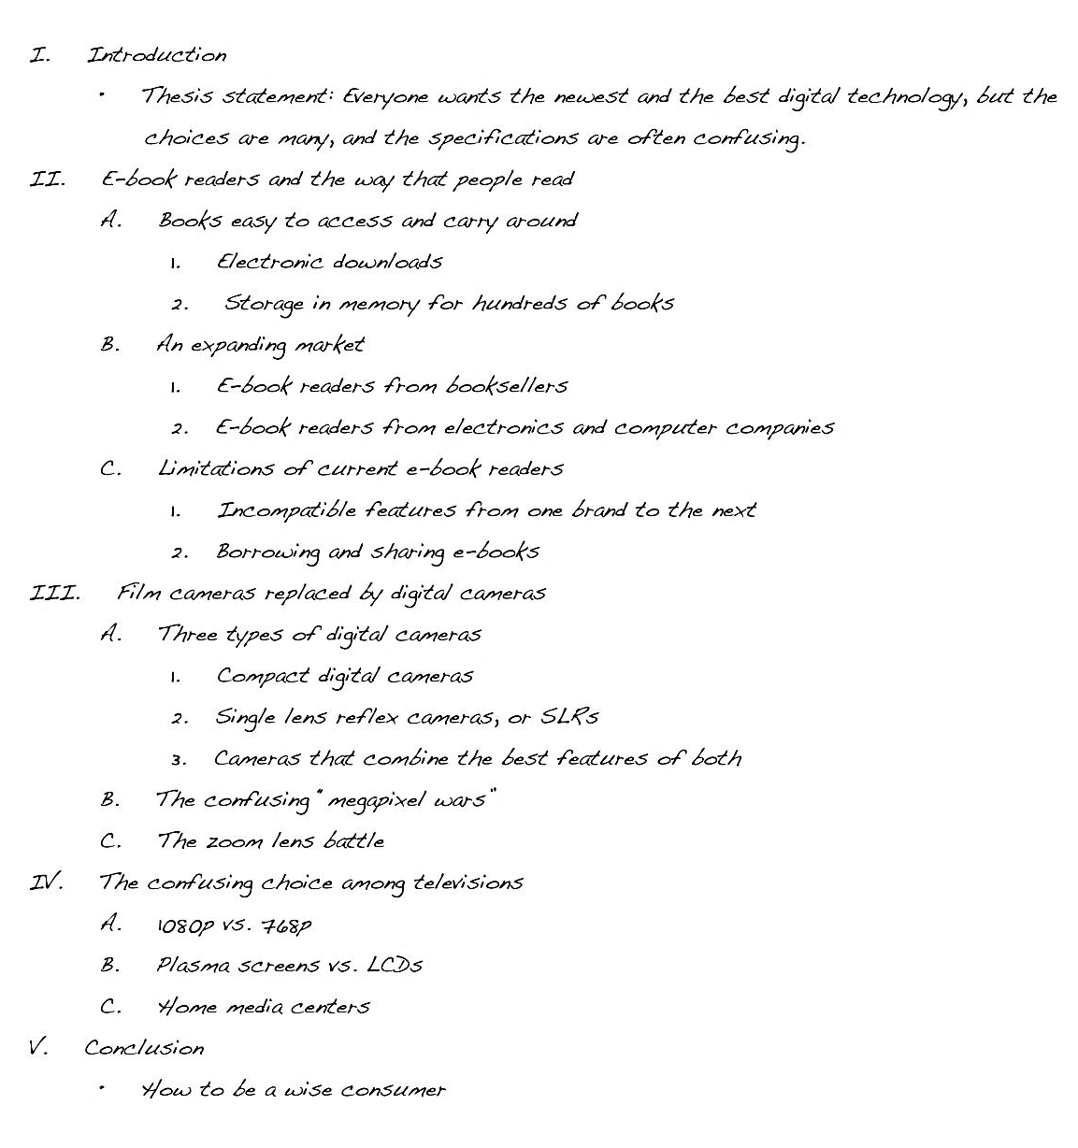

Checklist 5.2 Writing an Effective Topic Outline
This checklist can help you write an effective topic outline for your assignment. It will also help you discover where you may need to do additional reading or prewriting.
- Do I have a controlling idea that guides the development of the entire piece of writing?
- Do I have three or more main points that I want to make in this piece of writing? Does each main point connect to my controlling idea?
- Is my outline in the best order—chronological order, spatial order, or order of importance—for me to present my main points? Will this order help me get my main point across?
- Do I have supporting details that will help me inform, explain, or prove my main points?
- Do I need to add more support? If so, where?
- Do I need to make any adjustments in my working thesis statement before I consider it the final version?

Writing at Work
Word processing programs generally have an automatic numbering feature that can be used to prepare outlines. This feature automatically sets indents and lets you use the tab key to arrange information just as you would in an outline. Although in business this style might be acceptable, in college or university your instructor might have different requirements. Teach yourself how to customize the levels of outline numbering in your word processing program to fit your instructor’s preferences.

self-practice EXERCISE 5.8
Using the working thesis statement you wrote in Self-Practice Exercise 5.3 and the reading you did in Section 5.1: Apply Prewriting Models, construct a topic outline for your essay. Be sure to observe correct outline form, including correct indentions and the use of Roman and Arabic numerals and capital letters.
Collaboration: Please share with a classmate and compare your outline. Point out areas of interest from your classmate’s outline and what you would like to learn more about.

self-practice EXERCISE 5.9
Refer to the previous exercise and select three of your most compelling reasons to support the thesis statement. Remember that the points you choose must be specific and relevant to the thesis. The statements you choose will be your primary support points, and you will later incorporate them into the topic sentences for the body paragraphs.
Collaboration: Please share with a classmate and compare your answers.

Constructing Formal or Sentence Outlines
A sentence outline is the same as a topic outline except you use complete sentences instead of words or phrases. Complete sentences create clarity and can advance you one step closer to a draft in the writing process.
Here is the formal sentence outline that Mariah constructed for the essay she is developing.
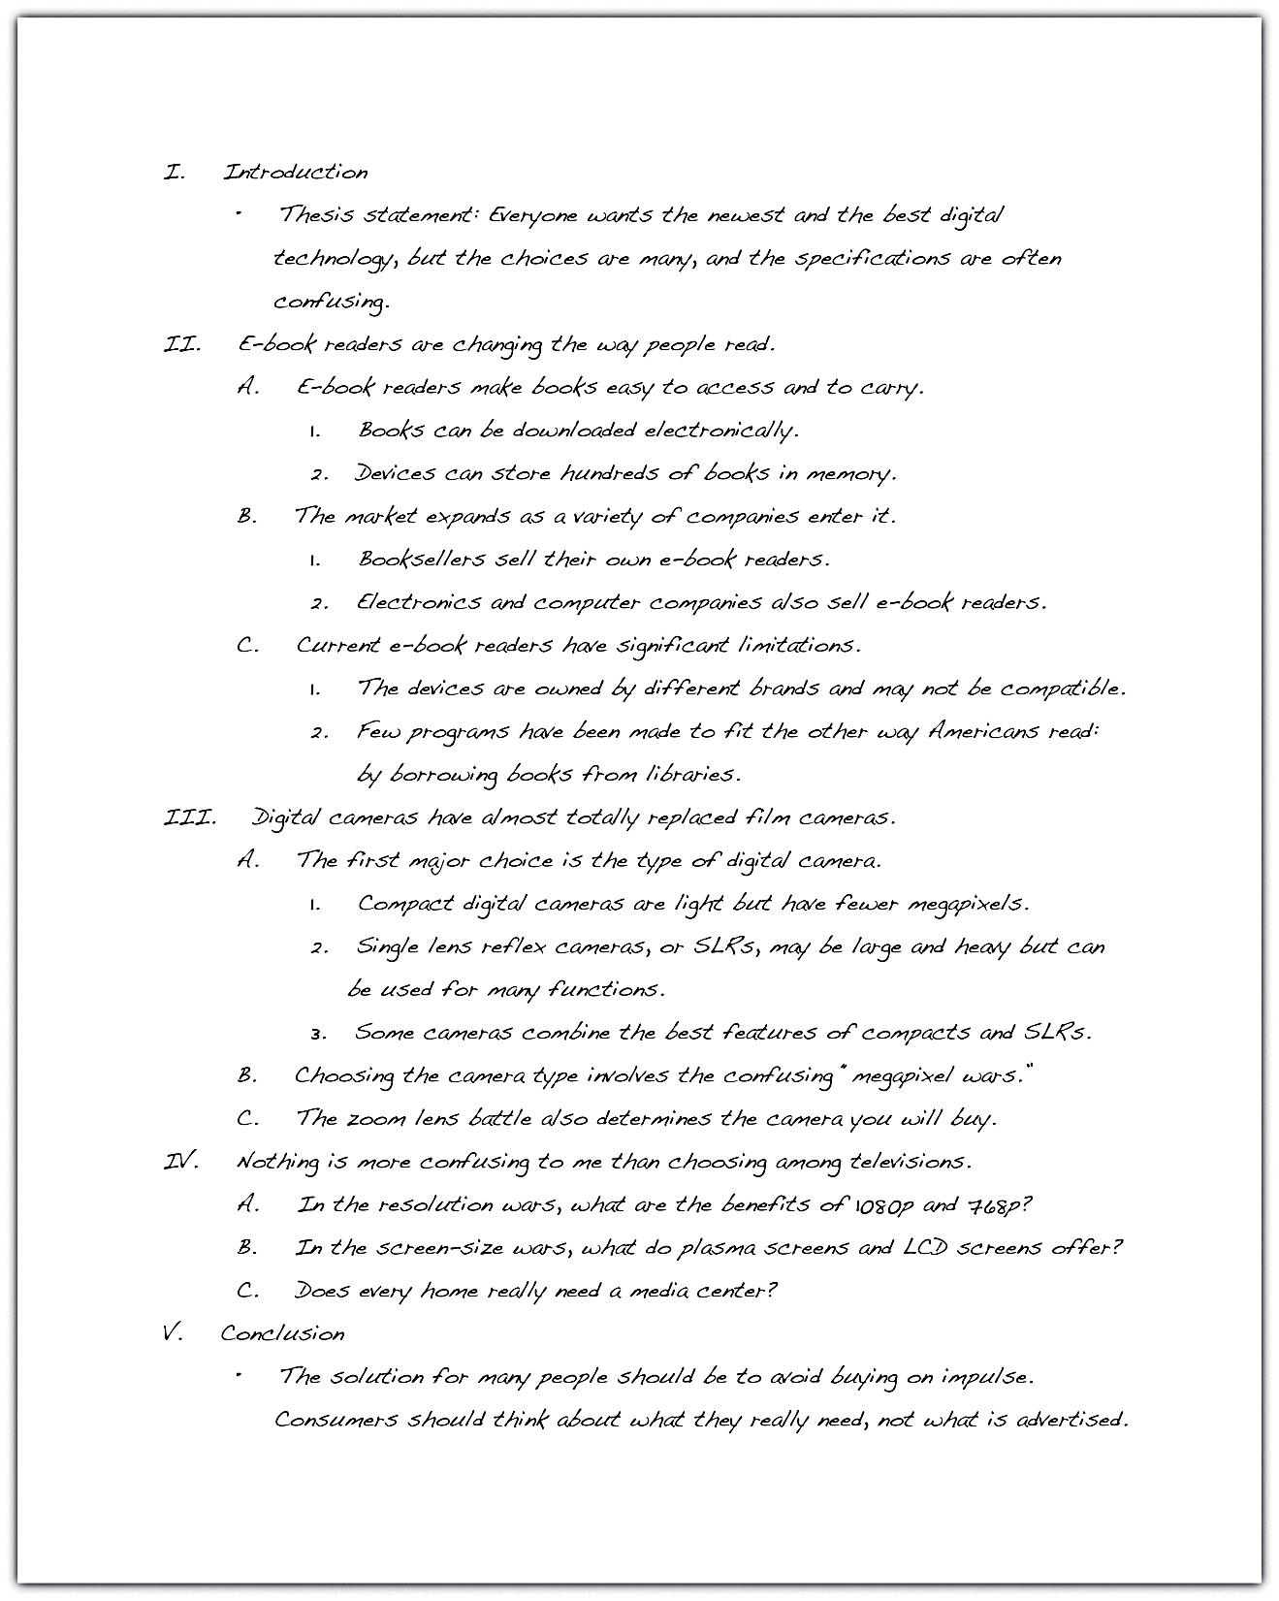

Tip
The information compiled under each Roman numeral will become a paragraph in your final paper. Mariah’s outline follows the standard five-paragraph essay arrangement, but longer essays will require more paragraphs and thus more Roman numerals. If you think that a paragraph might become too long, add an additional paragraph to your outline, renumbering the main points appropriately.

Tip
As you are building on your previously created outlines, avoid saving over the previous version; instead, save the revised outline under a new file name. This way you will still have a copy of the original and any earlier versions in case you want to look back at them.

Writing at Work
PowerPoint presentations, used both in schools and in the workplace, are organized in a way very similar to formal outlines. PowerPoint presentations often contain information in the form of talking points that the presenter develops with more details and examples than are contained on the PowerPoint slide.

self-practice EXERCISE 5.10
Expand the topic outline you prepared in Self-Practice Exercise 5.7 to make it a sentence outline. In this outline, be sure to include multiple supporting points for your main topic even if your topic outline does not contain them. Be sure to observe correct outline form, including correct indentions and the use of Roman and Arabic numerals and capital letters.

KEY TAKEAWAYS
- Writers must put their ideas in order so the assignment makes sense. The most common orders are chronological order, spatial order, and order of importance.
- After gathering and evaluating the information you found for your essay, the next step is to write a working, or preliminary, thesis statement.
- The working thesis statement expresses the main idea you want to develop in the entire piece of writing. It can be modified as you continue the writing process.
- Effective writers prepare a formal outline to organize their main ideas and supporting details in the order they will be presented.
- A topic outline uses words and phrases to express the ideas.
- A sentence outline uses complete sentences to express the ideas.
- The writer’s thesis statement begins the outline, and the outline ends with suggestions for the concluding paragraph.

5.4 Organizing Your Writing

LEARNING OBJECTIVES
- Understand how and why organizational techniques help writers and readers stay focussed
- Assess how and when to use chronological order to organize an essay
- Recognize how and when to use order of importance to organize an essay
- Determine how and when to use spatial order to organize an essay
The method of organization you choose for your essay is just as important as its content. Without a clear organizational pattern, your reader could become confused and lose interest. The way you structure your essay helps your readers draw connections between the body and the thesis, and the structure also keeps you focused as you plan and write the essay. Choosing your organizational pattern before you outline ensures that each body paragraph works to support and develop your thesis.
This section covers three ways to organize body paragraphs:
- Chronological order
- Order of importance
- Spatial order
When you begin to draft your essay, your ideas may seem to flow from your mind in a seemingly random manner. Your readers, who bring to the table different backgrounds, viewpoints, and ideas, need you to clearly organize these ideas in order to help process and accept them.
A solid organizational pattern gives your ideas a path that you can follow as you develop your draft. Knowing how you will organize your paragraphs allows you to better express and analyze your thoughts. Planning the structure of your essay before you choose supporting evidence helps you conduct more effective and targeted research.

Chronological Order
In Chapter 4: What Are You Writing, to Whom, and How?, you learned that chronological arrangement has the following purposes:
- To explain the history of an event or a topic
- To tell a story or relate an experience
- To explain how to do or to make something
- To explain the steps in a process.
Chronological order is mostly used in expository writing, which is a form of writing that narrates, describes, informs, or explains a process. When using chronological order, arrange the events in the order that they actually happened, or will happen if you are giving instructions. This method requires you to use words such as first, second, then, after that, later, and finally. These transitional words guide you and your reader through the paper as you expand your thesis.
For example, if you are writing an essay about the history of the airline industry, you would begin with its conception and detail the essential timeline events up until present day. You would follow the chain of events using words such as first, then, next, and so on.

Writing at Work
At some point in your career you may have to file a complaint with your human resources department. Using chronological order is a useful tool in describing the events that led up to your filing the grievance. You would logically lay out the events in the order that they occurred using the key transitional words. The more logical your complaint, the more likely you will be well received and helped.
Keep in mind that chronological order is most appropriate for the following purposes:
- Writing essays containing heavy research
- Writing essays with the aim of listing, explaining, or narrating
- Writing essays that analyze literary works such as poems, plays, or books

Tip
When using chronological order, your introduction should indicate the information you will cover and in what order, and establish the relevance of the information. Your body paragraphs should then provide clear divisions or steps in chronology. You can divide your paragraphs by time (such as decades, wars, or other historical events) or by the same structure of the work you are examining (such as a line-by-line explication of a poem).

self-practice EXERCISE 5.11
On a sheet of paper, write a paragraph that describes a process you are familiar with and can do well. Assume that your reader is unfamiliar with the procedure. Remember to use the chronological key words, such as first, second, then, and finally.

Order of Importance
Recall from Chapter 4: What Are You Writing, to Whom, and How? that order of importance is best used for the following purposes:
- Persuading and convincing
- Ranking items by their importance, benefit, or significance
- Illustrating a situation, problem, or solution
Most essays move from the least to the most important point, and the paragraphs are arranged in an effort to build the essay’s strength. Sometimes, however, it is necessary to begin with your most important supporting point, such as in an essay that contains a thesis that is highly debatable. When writing a persuasive essay, it is best to begin with the most important point because it immediately captivates your readers and compels them to continue reading.
For example, if you were supporting your thesis that homework is detrimental to the education of high school students, you would want to present your most convincing argument first, and then move on to the less important points for your case.
Some key transitional words you should use with this method of organization are most importantly, almost as importantly, just as importantly, and finally.

Writing at Work
During your career, you may be required to work on a team that devises a strategy for a specific goal of your company, such as increasing profits. When planning your strategy you should organize your steps in order of importance. This demonstrates the ability to prioritize and plan. Using the order of importance technique also shows that you can create a resolution with logical steps for accomplishing a common goal.

self-practice EXERCISE 5.12
On a sheet of paper, write a paragraph that discusses a passion of yours. Your passion could be music, a particular sport, filmmaking, and so on. Your paragraph should be built on the reasons why you feel so strongly. Briefly discuss your reasons in the order of least to greatest importance.

Spatial Order
As stated in Chapter 4: What Are You Writing, to Whom, and How?, spatial order is best used for the following purposes:
- Helping readers visualize something as you want them to see it
- Evoking a scene using the senses (sight, touch, taste, smell, and sound)
- Writing a descriptive essay
Spatial order means that you explain or describe objects as they are arranged around you in your space, for example in a bedroom. As the writer, you create a picture for your reader, whose perspective is the viewpoint from which you describe what is around you.
The view must move in an orderly, logical progression, giving the reader clear directional signals to follow from place to place. The key to using this method is to choose a specific starting point and then guide the reader to follow your eye as it moves in an orderly trajectory from your starting point.
Pay attention to the following student’s description of her bedroom and how she guides the reader through the viewing process, foot by foot.
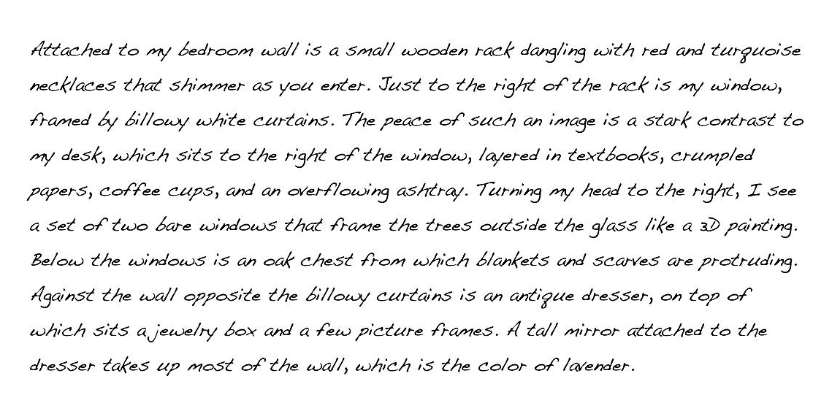
The paragraph incorporates two objectives you have learned in this chapter: using an implied topic sentence and applying spatial order. Often in a descriptive essay, the two work together.
The following are possible transitional words and phrases to include when using spatial order:
- Just to the left or just to the right | - Behind
- Between | - On the left or on the right
- Across from | - A little further down
- To the south, to the east, and so on | - A few yards away
- Turning left or turning right

self-practice EXERCISE 5.13
On a sheet of paper, write a paragraph using spatial order that describes your commute to work, school, or another location you visit often.
Collaboration: Please share with a classmate and compare your answers.

self-practice EXERCISE 5.14
Look back at your outline from Self-Practice Exercise 5.9. Please share your formal sentence outline with a classmate and together evaluate whether you have organized your points chronologically, by order of importance, or spatially. Discuss if you have organized your paragraphs in the most appropriate and logical way.
In the next chapter, you will build on this formal sentence outline to create a draft and develop your ideas further. Do not worry; you are not expected to have a completed paper at this point. You will be expanding on your sentences to form paragraphs and complete, well-developed ideas.

KEY TAKEAWAYS
- The way you organize your body paragraphs ensures you and your readers stay focused on and draw connections to your thesis statement.
- A strong organizational pattern allows you to articulate, analyze, and clarify your thoughts.
- Planning the organizational structure for your essay before you begin to search for supporting evidence helps you conduct more effective and directed research.
- Chronological order is most commonly used in expository writing. It is useful for explaining the history of your subject, for telling a story, or for explaining a process.
- Order of importance is most appropriate in a persuasion paper as well as for essays in which you rank things, people, or events by their significance.
- Spatial order describes things as they are arranged in space and is best for helping readers visualize something as you want them to see it; it creates a dominant impression.

supplemental EXERCISES
- On a separate sheet of paper, choose one of the examples of a proper thesis statement from this chapter (one that interests you) and form three supporting points for that statement. After you have formed your three points, write a topic sentence for each body paragraph. Make sure that your topic sentences can be backed up with examples and details.
- Group activity. Choose one of the topics from Self-Practice Exercise 5.4 and form a yes/no question about that topic. Then, take a survey of the people in your class to find out how they feel about the subject. Using the majority vote, ask those people to write on slips of paper the reasons for their opinion. Using the data you collect, form a thesis statement based on your classmates’ perspectives on the topic and their reasons.
- On a separate sheet of a paper, write an introduction for an essay based on the thesis statement from the group activity using the techniques for introductory paragraphs that you learned in this chapter.
- Start a journal in which you record “spoken” thesis statements. Start listening closely to the opinions expressed by your teachers, classmates, friends, and family members. Ask them to provide at least three reasons for their opinion and record them in the journal. Use this as material for future essays.
- Open a magazine and read a lengthy article. See if you can pinpoint the thesis statement as well as the topic sentence for each paragraph and its supporting details.

Journal entry #5
Write two to three paragraphs responding to the following.
- Think back to times when you had to write a paper and perhaps struggled to get started. What did you learn this week that you will apply in future assignments to get the ideas flowing?
- Reflect on all of the content you have learned so far. What did you find challenging but are now more confident with? What, if anything, still confuses you or you know you need to practice more? How have your study skills, time management, and overall writing improved over the past month?
Remember as mentioned in the Assessment Descriptions in your syllabus:
- You will be expected to respond to the questions by reflecting on and discussing your experiences with the week’s material.
- When writing your journals, you should focus on freewriting—writing without (overly) considering formal writing structures—but remember that it will be read by the instructor, who needs to be able to understand your ideas.
- Your instructor will be able to see if you have completed this entry by the end of the week but will not read all of the journals until next week.

Chapter 6

Working toward the End Product: Composing a Draft

Once you have completed your formal sentence outline, you will need to expand on that framework to create your expository essay. As much as you may be wanting to just get your ideas down and submit your paper, in order to make sure you are submitting a well-developed and strong essay, you need to make sure you are providing strong supporting ideas, developing paragraphs so they will fit together logically to best convince your reader, creating a strong introduction and conclusion, and revising your paper to catch issues you may have missed or not been aware of when writing.

In this chapter, we will look at putting the pieces together to form a complete, revised, and supported expository essay, which you will need to submit next week.

6.1 Writing Body Paragraphs

LEARNING OBJECTIVES
- Select primary support related to your thesis
- Support your topic sentences
If your thesis gives the reader a road map to your essay, then body paragraphs should closely follow that map. The reader should be able to predict what follows your introductory paragraph by simply reading the thesis statement.
The body paragraphs present the evidence you have gathered to confirm your thesis. Before you begin to support your thesis in the body, you must find information from a variety of sources that support and give credit to what you are trying to prove.

Select Primary Support for Your Thesis
Without primary support, your argument is not likely to be convincing. Primary support can be described as the major points you choose to expand on your thesis. It is the most important information you select to argue for your point of view. Each point you choose will be incorporated into the topic sentence for each body paragraph you write. Your primary supporting points are further supported by supporting details within the paragraphs.

Tip
Remember that a worthy argument is backed by examples. In order to construct a valid argument, good writers conduct a lot of background research and take careful notes. They also talk to people knowledgeable about a topic in order to understand its implications before writing about it.

Identify the Characteristics of Good Primary Support
In order to fulfill the requirements of good primary support, the information you choose must meet the following standards:
- Be specific. The main points you make about your thesis and the examples you use to expand on those points need to be specific. Use specific examples to provide the evidence and to build upon your general ideas. These types of examples give your reader something narrow to focus on, and if used properly, they leave little doubt about your claim. General examples, while they convey the necessary information, are not nearly as compelling or useful in writing because they are too obvious and typical.
- Be relevant to the thesis. Primary support is considered strong when it relates directly to the thesis. Primary support should show, explain, or prove your main argument without delving into irrelevant details. When faced with a lot of information that could be used to prove your thesis, you may think you need to include it all in your body paragraphs. But effective writers resist the temptation to lose focus. Choose your examples wisely by making sure they directly connect to your thesis.
- Be detailed. Remember that your thesis, while specific, should not be very detailed. The body paragraphs are where you develop the discussion that a thorough essay requires. Using detailed support shows readers that you have considered all the facts and chosen only the most precise details to enhance your point of view.

Prewrite to Identify Primary Supporting Points for a Thesis Statement
Recall that when you prewrite you essentially make a list of examples or reasons why you support your stance. Stemming from each point, you further provide details to support those reasons. After prewriting, you are then able to look back at the information and choose the most compelling pieces you will use in your body paragraphs.

Select the Most Effective Primary Supporting Points for a Thesis Statement
After you have prewritten about your working thesis statement, you may have generated a lot of information, which may be edited out later. Remember that your primary support must be relevant to your thesis. Remind yourself of your main argument, and delete any ideas that do not directly relate to it. Omitting unrelated ideas ensures that you will use only the most convincing information in your body paragraphs. Choose at least three of the most compelling points. These will serve as the topic sentences for your body paragraphs.
When you support your thesis, you are revealing evidence. Evidence includes anything that can help support your stance. The following are the kinds of evidence you will encounter as you conduct your research:
- Facts: Facts are the best kind of evidence to use because they often cannot be disputed. They can support your stance by providing background information on or a solid foundation for your point of view. However, some facts may still need explanation. For example, the sentence “The most populated province in Canada is Ontario” is a pure fact, but it may require some explanation to make it relevant to your specific argument.
- Judgments: Judgments are conclusions drawn from the given facts. Judgments are more credible than opinions because they are founded upon careful reasoning and examination of a topic.
- Testimony: Testimony consists of direct quotations from either an eyewitness or an expert witness. An eyewitness is someone who has direct experience with a subject; the witness adds authenticity to an argument based on facts. An expert witness is a person who has extensive experience with a topic. This person studies the facts and provides commentary based on either facts or judgments, or both. An expert witness adds authority and credibility to an argument.
- Personal observation: Personal observation is similar to testimony, but personal observation consists of your testimony. It reflects what you know to be true because you have experiences and have formed either opinions or judgments about them. For instance, if you are one of five children and your thesis states that being part of a large family is beneficial to a child’s social development, you could use your own experience to support your thesis.

Writing at Work
In any job where you devise a plan, you will need to support the steps that you lay out. This is an area in which you would incorporate primary support into your writing. Choosing only the most specific and relevant information to expand upon the steps will ensure that your plan appears well thought out and precise.

Tip
You can consult a vast pool of resources to gather support for your stance. Citing relevant information from reliable sources ensures that your reader will take you seriously and consider your assertions. Use any of the following sources for your essay: newspapers or news organization websites, magazines, encyclopedias, and scholarly journals, which are periodicals that address topics in a specialized field.

Choose Supporting Topic Sentences
Each body paragraph contains a topic sentence that states one aspect of your thesis and then expands upon it. Like the thesis statement, each topic sentence should be specific and supported by concrete details, facts, or explanations.
Each body paragraph should comprise the following elements.
topic sentence + supporting details (examples, reasons, or arguments)
As you read in Chapter 5: Putting Your Ideas into Your Own Words and Paragraphs, topic sentences indicate the location and main points of the basic arguments of your essay. These sentences are vital to writing your body paragraphs because they always refer back to and support your thesis statement. Topic sentences are linked to the ideas you have introduced in your thesis, thus reminding readers what your essay is about. A paragraph without a clearly identified topic sentence may be unclear and scattered, just like an essay without a thesis statement.

Tip
Unless your teacher instructs otherwise, you should include at least three body paragraphs in your essay. A five-paragraph/section essay, including the introduction and conclusion, is commonly the standard for exams and essay assignments.
Consider the following the thesis statement:
The following topic sentence is a primary support point for the thesis. The topic sentence states exactly what the controlling idea of the paragraph is. Later, you will see the writer immediately provide support for the sentence.

self-practice EXERCISE 6.1
In Self-Practice Exercise 5.9, you chose three of your most convincing points to support the thesis statement you wrote. Now we are going to build onto the formal sentence outline you constructed in Self-Practice Exercise 5.14. Take each point and incorporate it into a topic sentence for each body paragraph.
Supporting point 1: ____________________________________________
Topic sentence: _______________________________________________________________________________
Supporting point 2: ____________________________________________
Topic sentence: _______________________________________________________________________________
Supporting point 3: ____________________________________________
Topic sentence: _______________________________________________________________________________
Collaboration: Please share with a classmate and compare your answers.

Draft Supporting Detail Sentences for Each Primary Support Sentence
After deciding which primary support points you will use as your topic sentences, you must add details to clarify and demonstrate each of those points. These supporting details provide examples, facts, or evidence that support the topic sentence.
The writer drafts possible supporting detail sentences for each primary support sentence based on the thesis statement:
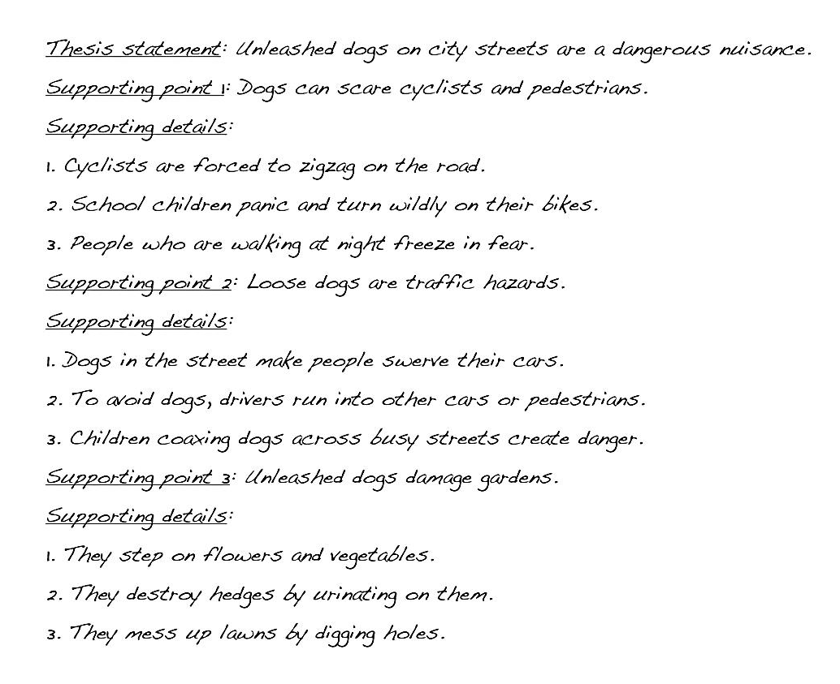
The following paragraph contains supporting detail sentences for the primary support sentence (the topic sentence), which is underlined.
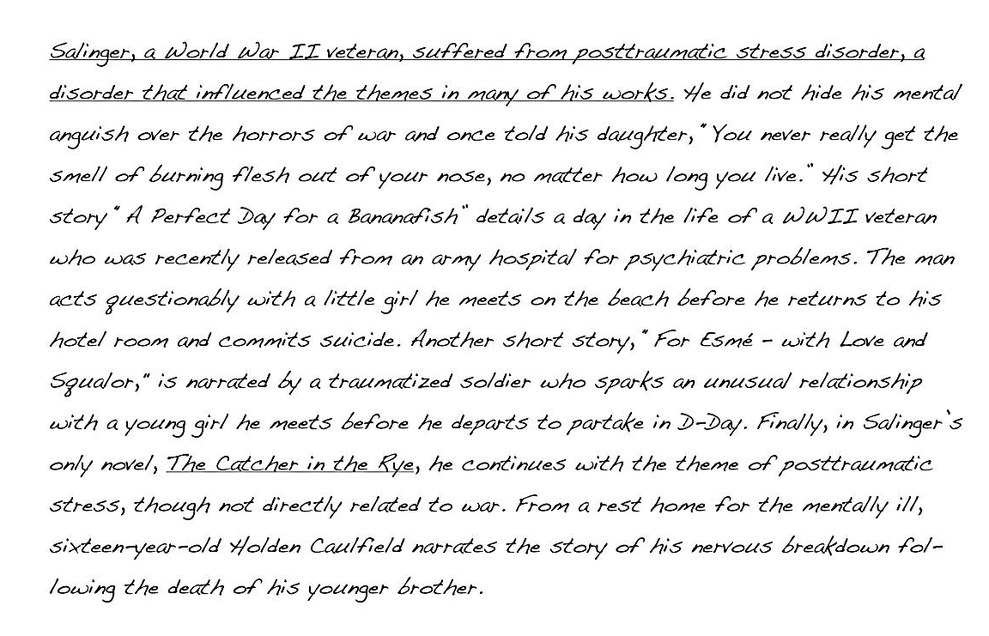

Self-practice EXERCISE 6.2
Using the three topic sentences you composed for the thesis statement in Self-Practice Exercise 6.1, draft at least three supporting details for each point.
Thesis statement: _____________________________________________________________________________
Primary supporting point 1: _____________________________________________________________________
Supporting details: ____________________________________________________________________________
Primary supporting point 2: _____________________________________________________________________
Supporting details: ____________________________________________________________________________
Primary supporting point 3: _____________________________________________________________________
Supporting details: ____________________________________________________________________________

Tip
You have the option of writing your topic sentences in one of three ways. You can state it at the beginning of the body paragraph, or at the end of the paragraph, or you do not have to write it at all. One that is not written at all is called an implied topic sentence. An implied topic sentence lets readers form the main idea for themselves. For beginning writers, it is best to not use implied topic sentences because it makes it harder to focus your writing. Your instructor may also want to clearly identify the sentences that support your thesis.

Tip
Print out the first draft of your essay and use a highlighter to mark your topic sentences in the body paragraphs. Make sure they are clearly stated and accurately present your paragraphs, as well as accurately reflect your thesis. If your topic sentence contains information that does not exist in the rest of the paragraph, rewrite it to more accurately match the rest of the paragraph.

KEY TAKEAWAYS
- Your body paragraphs should closely follow the path set forth by your thesis statement.
- Strong body paragraphs contain evidence that supports your thesis.
- Primary support comprises the most important points you use to support your thesis.
- Strong primary support is specific, detailed, and relevant to the thesis.
- Prewriting helps you determine your most compelling primary support.
- Evidence includes facts, judgments, testimony, and personal observation.
- Reliable sources may include newspapers, magazines, academic journals, books, encyclopedias, and firsthand testimony.
- A topic sentence presents one point of your thesis statement while the information in the rest of the paragraph supports that point.
- A body paragraph comprises a topic sentence plus supporting details.

6.2 Writing Introductory and Concluding Paragraphs

LEARNING OBJECTIVES
- Recognize the importance of strong introductory and concluding paragraphs
- Learn to engage the reader immediately with the introductory paragraph
- Practise concluding your essays in a more memorable way
Picture your introduction as a storefront window: you have a certain amount of space to attract your customers (readers) to your goods (subject) and bring them inside your store (discussion). Once you have enticed them with something intriguing, you then point them in a specific direction and try to make the sale (convince them to accept your thesis).
Your introduction is an invitation to your readers to consider what you have to say and then to follow your train of thought as you expand upon your thesis statement.
An introduction serves the following purposes:
- Establishes your voice and tone, or your attitude, toward the subject
- Introduces the general topic of the essay
- States the thesis that will be supported in the body paragraphs
- Provides signposts of what you will discuss in your essay
First impressions are crucial and can leave lasting effects in your reader’s mind, which is why the introduction is so important to your essay. If your introductory paragraph is dull or disjointed, your reader probably will not have much interest in continuing with the essay.

Attracting Interest in Your Introductory Paragraph
Your introduction should begin with an engaging statement devised to provoke your readers’ interest. In the next few sentences, introduce them to your topic by stating general facts or ideas about the subject. As you move deeper into your introduction, you gradually narrow the focus, moving closer to your thesis. Moving smoothly and logically from your introductory remarks to your thesis statement can be achieved using a funnel technique, as illustrated in Figure 6.1: Funnel Technique.
Figure 6.1 Funnel Technique
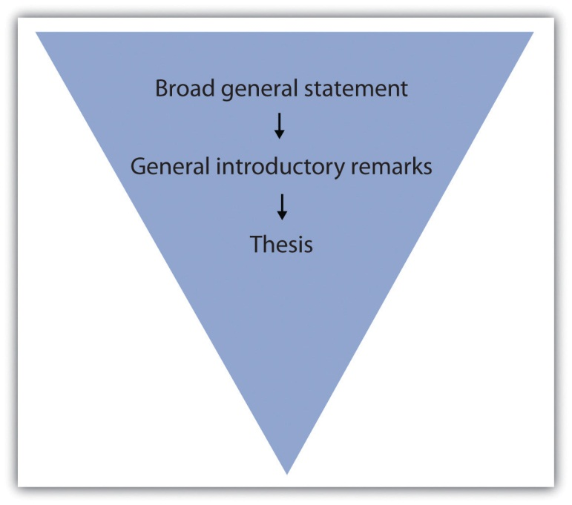

self-practice EXERCISE 6.3
On a sheet of paper, jot down a few general remarks that you can make about the topic for which you formed a thesis in Self-Practice Exercise 5.7.
Immediately capturing your readers’ interest increases the chances of having them read what you are about to discuss. You can garner curiosity for your essay in a number of ways. Try to get your readers personally involved by doing any of the following:
- Appealing to their emotions
- Using logic
- Beginning with a provocative question or opinion
- Opening with a startling statistic or surprising fact
- Raising a question or series of questions
- Presenting an explanation or rationalization for your essay
- Opening with a relevant quotation or incident
- Opening with a striking image
- Including a personal anecdote

Tip
Remember that your diction, or word choice, while always important, is most crucial in your introductory paragraph. Boring diction could extinguish any desire a person might have to read through your discussion. Choose words that create images or express action.
In Chapter 5: Putting the Pieces Together with a Thesis Statement, you followed Mariah as she moved through the writing process. In this chapter, Mariah writes her introduction and conclusion for the same essay. Mariah incorporates some of the introductory elements into her introductory paragraph, which she previously outlined. Her thesis statement is underlined.
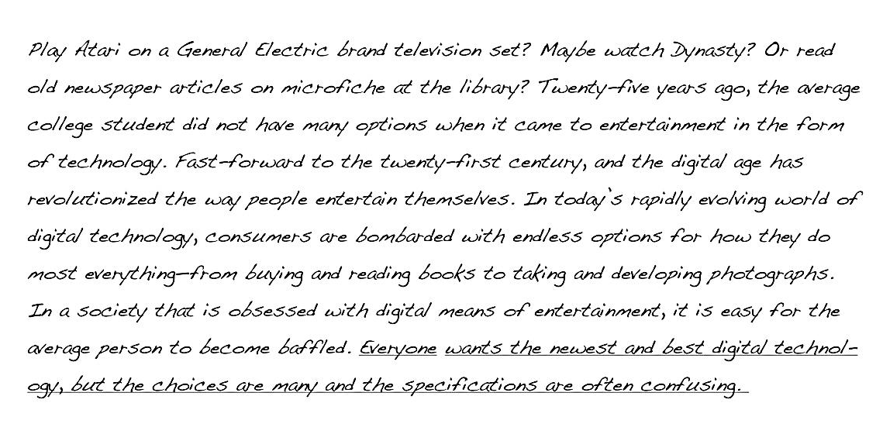

Tip
If you have trouble coming up with a provocative statement for your opening, it is a good idea to use a relevant, attention-grabbing quote about your topic. Use a search engine to find statements made by historical or significant figures about your subject.

Writing at Work
In your job field, you may be required to write a speech for an event, such as an awards banquet or a dedication ceremony. The introduction of a speech is similar to an essay because you have a limited amount of space to attract your audience’s attention. Using the same techniques, such as a provocative quote or an interesting statistic, is an effective way to engage your listeners. Using the funnel approach also introduces your audience to your topic and then presents your main idea in a logical manner.

Self-practice EXERCISE 6.4
Reread each sentence in Mariah’s introductory paragraph. Indicate which techniques she used and comment on how each sentence is designed to attract her readers’ interest.

Writing a Conclusion
It is not unusual to want to rush when you approach your conclusion, and even experienced writers may fade by the time they get to the end. But what good writers remember is that it is vital to put just as much attention into the conclusion as the rest of the essay. After all, a hasty ending can undermine an otherwise strong essay.
A conclusion that does not correspond to the rest of your essay, has loose ends, or is unorganized can unsettle your readers and raise doubts about the entire essay. However, if you have worked hard to write the introduction and body, your conclusion can often be the most logical part to compose.

The Anatomy of a Strong Conclusion
Keep in mind that the ideas in your conclusion must conform to the rest of your essay. In order to tie these components together, restate your thesis at the beginning of your conclusion. This helps you assemble, in an orderly fashion, all the information you have explained in the body. Repeating your thesis reminds your readers of the major arguments you have been trying to prove and also indicates that your essay is drawing to a close. A strong conclusion also reviews your main points and emphasizes the importance of the topic.
The construction of the conclusion is similar to the introduction, in which you make general introductory statements and then present your thesis. The difference is that in the conclusion you first paraphrase, or state in different words, your thesis and then follow up with general concluding remarks. These sentences should progressively broaden the focus of your thesis and manoeuvre your readers out of the essay.
Many writers like to end their essays with a final emphatic statement. This strong closing statement will cause your readers to continue thinking about the implications of your essay; it will make your conclusion, and thus your essay, more memorable. Another powerful technique is to challenge your readers to make a change in either their thoughts or their actions. Challenging your readers to see the subject through new eyes is a powerful way to ease yourself and your readers out of the essay.

Tip
When closing your essay, do not expressly state that you are drawing to a close. Relying on statements such as in conclusion, it is clear that, as you can see, or in summation is unnecessary and can be considered trite.

Tip
Avoid doing any of the following in your conclusion:
- Introducing new material
- Contradicting your thesis
- Changing your thesis
- Using apologies or disclaimers
Introducing new material in your conclusion has an unsettling effect on your reader. When you raise new points, you make your reader want more information, which you could not possibly provide in the limited space of your final paragraph.
Contradicting or changing your thesis statement causes your readers to think that you do not actually have a conviction about your topic. After all, you have spent several paragraphs adhering to a singular point of view. When you change sides or open up your point of view in the conclusion, your reader becomes less inclined to believe your original argument.
By apologizing for your opinion or stating that you know it is tough to digest, you are in fact admitting that even you know what you have discussed is irrelevant or unconvincing. You do not want your readers to feel this way. Effective writers stand by their thesis statement and do not stray from it.

Self-practice EXERCISE 6.5
On a sheet of a paper, restate your thesis from Self-Practice Exercise 5.7 and then make some general concluding remarks. Next, compose a final emphatic statement. Finally, incorporate what you have written into a strong conclusion paragraph for your essay.
Collaboration: Please share with a classmate and compare your answers
Mariah incorporates some of these pointers into her conclusion. She has paraphrased her thesis statement in the first sentence.
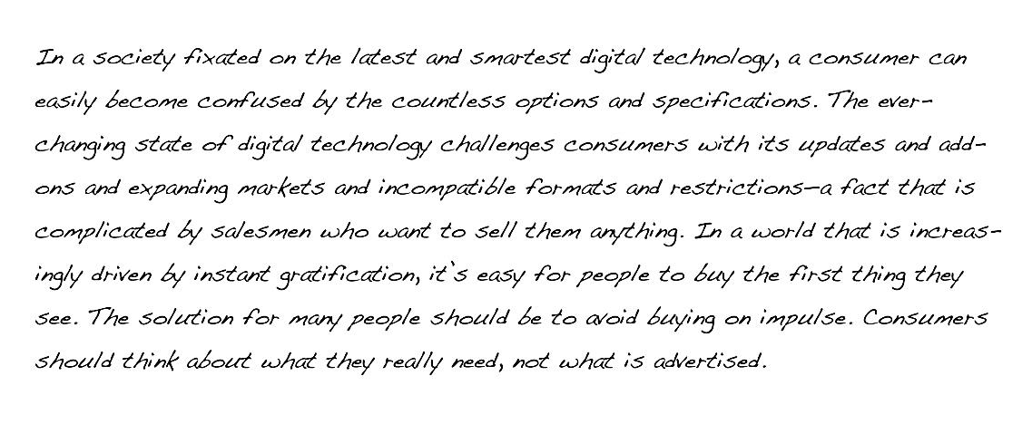

Tip
Make sure your essay is balanced by not having an excessively long or short introduction or conclusion. Check that they match each other in length as closely as possible, and try to mirror the formula you used in each. Parallelism strengthens the message of your essay.

Writing at Work
On the job you will sometimes give oral presentations based on research you have conducted. A concluding statement to an oral report contains the same elements as a written conclusion. You should wrap up your presentation by restating the purpose, reviewing the main points, and emphasizing the importance of the material you presented. A strong conclusion will leave a lasting impression on your audience.

KEY TAKEAWAYS
- A strong opening captures your readers’ interest and introduces them to your topic before you present your thesis statement.
- An introduction should restate your thesis, review your main points, and emphasize the importance of the topic.
- The funnel technique to writing the introduction begins with generalities and gradually narrows your focus until you present your thesis.
- A good introduction engages people’s emotions or logic, questions or explains the subject, or provides a striking image or quotation.
- Carefully chosen diction in both the introduction and conclusion prevents any confusing or boring ideas.
- A conclusion that does not connect to the rest of the essay can diminish the effect of your paper.
- The conclusion should remain true to your thesis statement. It is best to avoid changing your tone or your main idea and avoid introducing any new material.
- Closing with a final emphatic statement provides closure for your readers and makes your essay more memorable.

6.3 Drafting

LEARNING OBJECTIVES
- Identify drafting strategies that improve writing
- Use drafting strategies to prepare the first draft of an essay
Drafting is the stage of the writing process in which you develop a complete first version of a piece of writing.
Even professional writers admit that an empty page scares them because they feel they need to come up with something fresh and original every time they open a blank document on their computers. Because you have completed the first two steps in the writing process, you have already recovered from empty-page syndrome. You have hours of prewriting and planning already done. You know what will go on that blank page: what you wrote in your outline.

Getting Started: Strategies for Drafting
Your objective for this portion is to draft the body paragraphs of a standard five-paragraph essay. A five-paragraph essay contains an introduction, three body paragraphs, and a conclusion. If you are more comfortable starting on paper than on the computer, you can begin that way and then later type it before you revise. You can also use a voice recorder to get yourself started, dictating a paragraph or two to get you thinking. In this lesson, Mariah does all her work on the computer, but you may use pen and paper or the computer to write a rough draft.

Making the Writing Process Work for You
What makes the writing process so beneficial to writers is that it encourages alternatives to standard practices while motivating you to develop your best ideas. For instance, the following approaches, done alone or in combination with others, may improve your writing and help you move forward in the writing process:
- Begin writing with the part you know the most about. You can start with the third paragraph in your outline if ideas come easily to mind. You can start with the second paragraph or the first paragraph, too. Although paragraphs may vary in length, keep in mind that short paragraphs may contain insufficient support. Readers may also think the writing is abrupt. Long paragraphs may be wordy and may lose your reader’s interest. As a guideline, try to write paragraphs longer than one sentence but shorter than the length of an entire double-spaced page.
- Write one paragraph at a time and then stop. As long as you complete the assignment on time, you may choose how many paragraphs you complete in one sitting. Pace yourself. On the other hand, try not to procrastinate. Writers should always meet their deadlines.
- Take short breaks to refresh your mind. This tip might be most useful if you are writing a multi-page report or essay. Still, if you are impatient or cannot concentrate, take a break to let your mind rest. But do not let breaks extend too long. If you spend too much time away from your essay, you may have trouble starting again. You may forget key points or lose momentum. Try setting an alarm to limit your break, and when the time is up, return to your desk to write.
- Be reasonable with your goals. If you decide to limit your breaks to 10 minutes, try to stick to that goal. If you told yourself that you need more facts, then commit to finding them. Holding yourself to your own goals will create successful writing assignments.
- Keep your audience and purpose in mind as you write. These aspects of writing are just as important when you are writing a single paragraph for your essay as when you are considering the direction of the entire essay.
Of all of these considerations, keeping your purpose and your audience at the front of your mind is the most important to writing success. If your purpose is to persuade, for example, you will present your facts and details in the most logical and convincing way you can.
Your purpose will guide your mind as you compose your sentences. Your audience will guide word choice. Are you writing for experts, for a general audience, for other students, or for people who know very little about your topic? Keep asking yourself what your readers, with their background and experience, need to be told in order to understand your ideas. How can you best express your ideas so they are totally clear and your communication is effective?

Tip
You may want to identify your purpose and audience on an index card that you clip to your paper (or keep next to your computer). On that card, you may want to write notes to yourself—perhaps about what that audience might not know or what it needs to know—so that you will be sure to address those issues when you write. It may be a good idea to also state exactly what you want to explain to that audience, or to inform them of, or to persuade them about.

Writing at Work
Many of the documents you produce at work target a particular audience for a particular purpose. You may find that it is highly advantageous to know as much as you can about your target audience and to prepare your message to reach that audience, even if the audience is a co-worker or your boss. Menu language is a common example. Descriptions like “organic romaine” and “free-range chicken” are intended to appeal to a certain type of customer though perhaps not to the same customer who craves a thick steak. Similarly, mail-order companies research the demographics of the people who buy their merchandise. Successful vendors customize product descriptions in catalogues to appeal to their buyers’ tastes. For example, the product descriptions in a skateboarder catalogue will differ from the descriptions in a clothing catalogue for mature adults.

Setting Goals for Your First Draft
A draft is a complete version of a piece of writing, but it is not the final version. The step in the writing process after drafting, as you may remember, is revising. During revising, you will have the opportunity to make changes to your first draft before you put the finishing touches on it during the editing and proofreading stages. A first draft gives you a working version that you can later improve.

self-practice EXERCISE 6.6
Using the topic for the essay that you outlined in Section 5.3: Outlining, describe your purpose and your audience as specifically as you can. Use your own sheet of paper to record your responses. Then keep these responses near you during future stages of the writing process.
My purpose: ______________________________________________________________________________________
______________________________________________________________________________________
______________________________________________________________________________________
My audience: ______________________________________________________________________________________
______________________________________________________________________________________
______________________________________________________________________________________

Writing at Work
Workplace writing in certain environments is done by teams of writers who collaborate on the planning, writing, and revising of documents, such as long reports, technical manuals, and the results of scientific research. Collaborators do not need to be in the same room, the same building, or even the same city. Many collaborations are conducted over the Internet.
In a perfect collaboration, each contributor has the right to add, edit, and delete text. Strong communication skills, in addition to strong writing skills, are important in this kind of writing situation because disagreements over style, content, process, emphasis, and other issues may arise.
The collaborative software, or document management systems, that groups use to work on common projects is sometimes called groupware or work group support systems.
The reviewing tool on some word processing programs also gives you access to a collaborative tool that many smaller work groups use when they exchange documents. You can also use it to leave comments to yourself.

Tip
If you invest some time now to investigate how the reviewing tool in your word processor works, you will be able to use it with confidence during the revision stage of the writing process. Then, when you start to revise, set your reviewing tool to track any changes you make, so you will be able to tinker with text and commit to only those final changes you want to keep.

Discovering the Basic Elements of a First Draft
If you have been using the information in this chapter step by step to help you develop an assignment, you already have both a formal topic outline and a formal sentence outline to direct your writing. Knowing what a first draft looks like will help you make the creative leap from the outline to the first draft. A first draft should include the following elements:
- An introduction that piques the audience’s interest, tells what the essay is about, and motivates readers to keep reading
- A thesis statement that presents the main point, or controlling idea, of the entire piece of writing
- A topic sentence in each paragraph that states the main idea of the paragraph and implies how that main idea connects to the thesis statement
- Supporting sentences in each paragraph that develop or explain the topic sentence. These can be specific facts, examples, anecdotes, or other details that elaborate on the topic sentence
- A conclusion that reinforces the thesis statement and leaves the audience with a feeling of completion.
These elements follow the standard five-paragraph essay format, which you probably first encountered in high school. In Section 4.1: Expository Essays, you read that you should consider these as sections instead of just paragraphs because you will, at times, have to write a paper that needs to have more than five paragraphs because some ideas need more development or support. For now, however, Mariah focuses on writing the three body paragraphs from her outline.

The Role of Topic Sentences
Topic sentences make the structure of a text and the writer’s basic arguments easy to locate and comprehend. In post-secondary writing, using a topic sentence in each paragraph of the essay is the standard rule. However, the topic sentence does not always have to be the first sentence in your paragraph even if it the first item in your formal outline.

Tip
When you begin to draft your paragraphs, you should follow your outline fairly closely. After all, you spent valuable time developing those ideas. However, as you begin to express your ideas in complete sentences, it might strike you that the topic sentence might work better at the end of the paragraph or in the middle. Try it. Writing a draft, by its nature, is a good time for experimentation.
The topic sentence can be the first, middle, or final sentence in a paragraph. The assignment’s audience and purpose will often determine where a topic sentence belongs. When the purpose of the assignment is to persuade, for example, the topic sentence should be the first sentence in a paragraph. In a persuasive essay, the writer’s point of view should be clearly expressed at the beginning of each paragraph.
Choosing where to position the topic sentence depends not only on your audience and purpose but also on the essay’s arrangement, or order. When you organize information according to order of importance, the topic sentence may be the final sentence in a paragraph. All the supporting sentences build up to the topic sentence. Chronological order may also position the topic sentence as the final sentence because the controlling idea of the paragraph may make the most sense at the end of a sequence.
When you organize information according to spatial order, a topic sentence may appear as the middle sentence in a paragraph. An essay arranged by spatial order often contains paragraphs that begin with descriptions. A reader may first need a visual in mind before understanding the development of the paragraph. When the topic sentence is in the middle, it unites the details that come before it with the ones that come after it.

Tip
As you read critically throughout the writing process, keep topic sentences in mind. You may discover topic sentences that are not always located at the beginning of a paragraph. For example, fiction writers customarily use topic ideas, either expressed or implied, to move readers through their text. In nonfiction writing, such as the kind you read in popular magazines, topic sentences are often used when the author thinks it is appropriate (based on the audience and the purpose, of course). A single topic sentence might even control the development of a number of paragraphs.
Developing topic sentences and thinking about their placement in a paragraph will prepare you to write the rest of the paragraph.

Paragraphs
The paragraph is the main structural component of an essay as well as other forms of writing. Each paragraph of an essay adds another related main idea to support the writer’s thesis, or controlling idea. Each related main idea is supported and developed with facts, examples, and other details that explain it. By exploring and refining one main idea at a time, writers build a strong case for their thesis.

Starting Your First Draft
Now we are finally ready to look over Mariah’s shoulder as she begins to write her essay about digital technology and the confusing choices that consumers face. As she does, you should have in front of you your outline, with its thesis statement and topic sentences, and the notes you wrote earlier in this lesson on your purpose and audience. Reviewing these will put both you, like Mariah, in the proper mindset to start.
The following is Mariah’s thesis statement.
Here are the notes that Mariah wrote to herself to characterize her purpose and audience.
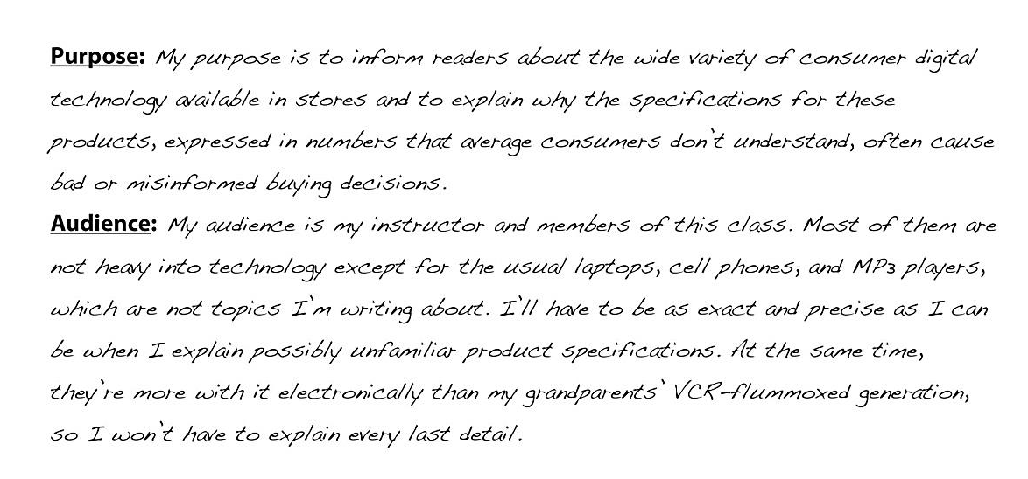
Mariah chose to begin by writing a quick introduction based on her thesis statement. She knew that she would want to improve her introduction significantly when she revised. Right now, she just wanted to give herself a starting point.

Tip
Remember Mariah’s other options. She could have started directly with any of the body paragraphs.
You learned more about writing attention-getting introductions and effective conclusions in Section 6.2: Writing Introductory and Concluding Paragraphs.
With her thesis statement and her purpose and audience notes in front of her, Mariah then looked at her sentence outline. She chose to use that outline because it includes the topic sentences. The following is the portion of her outline for the first body paragraph. The Roman numeral II identifies the topic sentence for the paragraph, capital letters indicate supporting details, and Arabic numerals label subpoints.
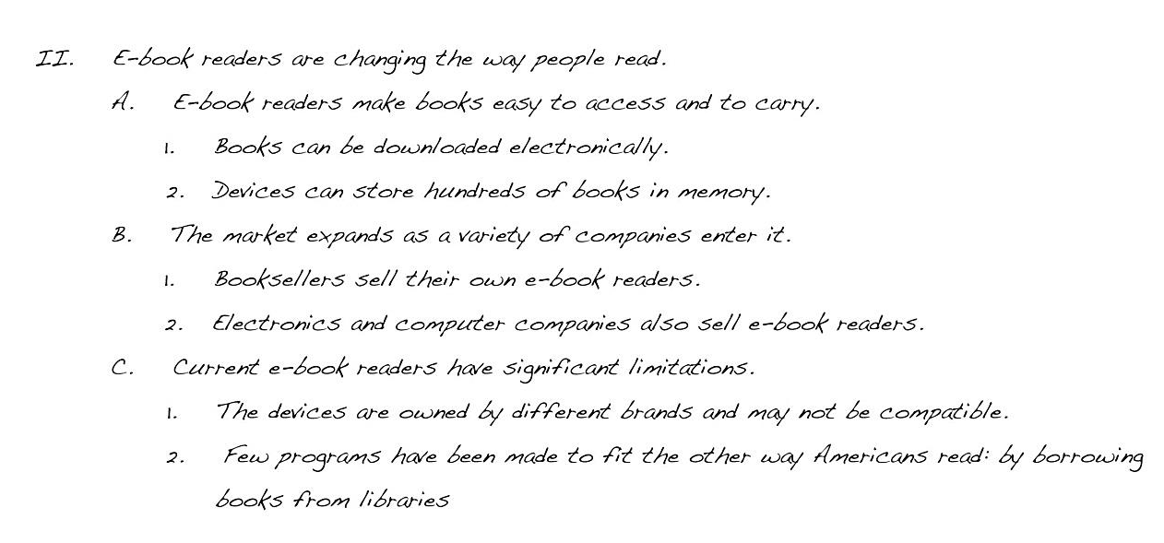
Mariah then began to expand the ideas in her outline into a paragraph. Notice how the outline helped her guarantee that all her sentences in the body of the paragraph develop the topic sentence.
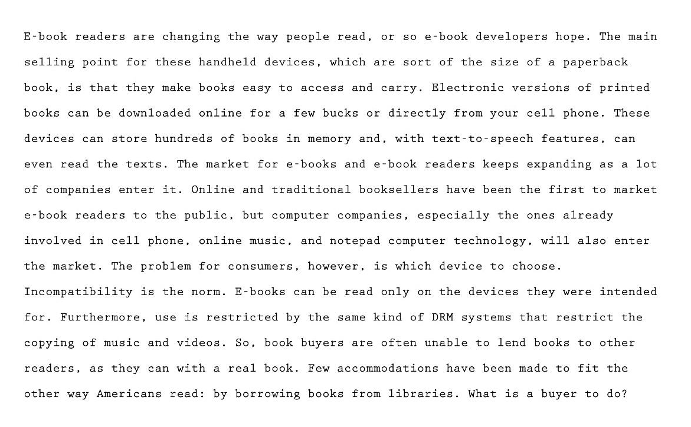

Tip
If you write your first draft on the computer, consider creating a new file folder for each course with a set of subfolders inside the course folders for each assignment you are given. Label the folders clearly with the course names, and label each assignment folder and word processing document with a title that you will easily recognize. The assignment name is a good choice for the document. Then use that subfolder to store all the drafts you create. When you start each new draft, do not just write over the last one. Instead, save the draft with a new tag after the title—draft 1, draft 2, and so on—so that you will have a complete history of drafts in case your instructor wishes you to submit them.
In your documents, observe any formatting requirements—for margins, headers, placement of page numbers, and other layout matters—that your instructor requires.

self-practice EXERCISE 6.7
Study how Mariah made the transition from her sentence outline to her first draft. First, copy her outline onto your own sheet of paper. Leave a few spaces between each part of the outline. Then copy sentences from Mariah’s paragraph to align each sentence with its corresponding entry in her outline.

Continuing the First Draft
Mariah continued writing her essay, moving to the second and third body paragraphs. She had supporting details but no numbered subpoints in her outline, so she had to consult her prewriting notes for specific information to include.

Tip
If you decide to take a break between finishing your first body paragraph and starting the next one, do not start writing immediately when you return to your work. Put yourself back in context and in the mood by rereading what you have already written. This is what Mariah did. If she had stopped writing in the middle of writing the paragraph, she could have jotted down some quick notes to herself about what she would write next.
Preceding each body paragraph that Mariah wrote is the appropriate section of her sentence outline. Notice how she expanded Roman numeral III from her outline into a first draft of the second body paragraph. As you read, ask yourself how closely she stayed on purpose and how well she paid attention to the needs of her audience.
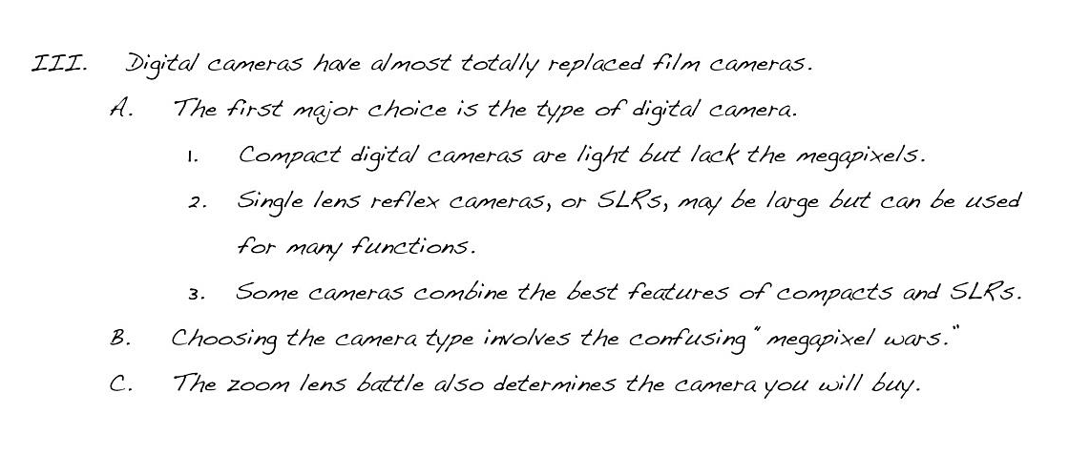
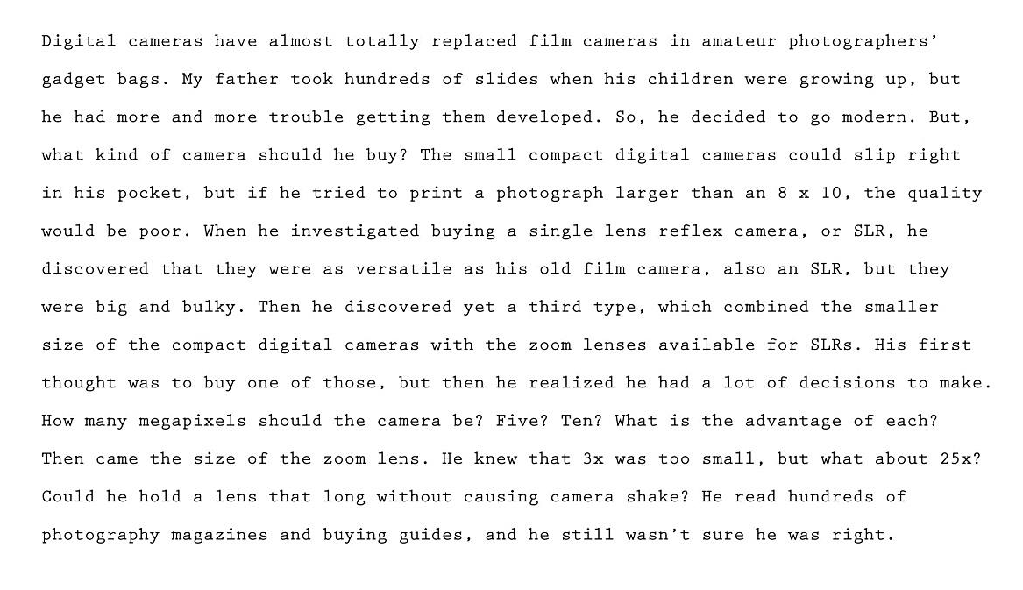
Mariah then began her third and final body paragraph using Roman numeral IV from her outline.
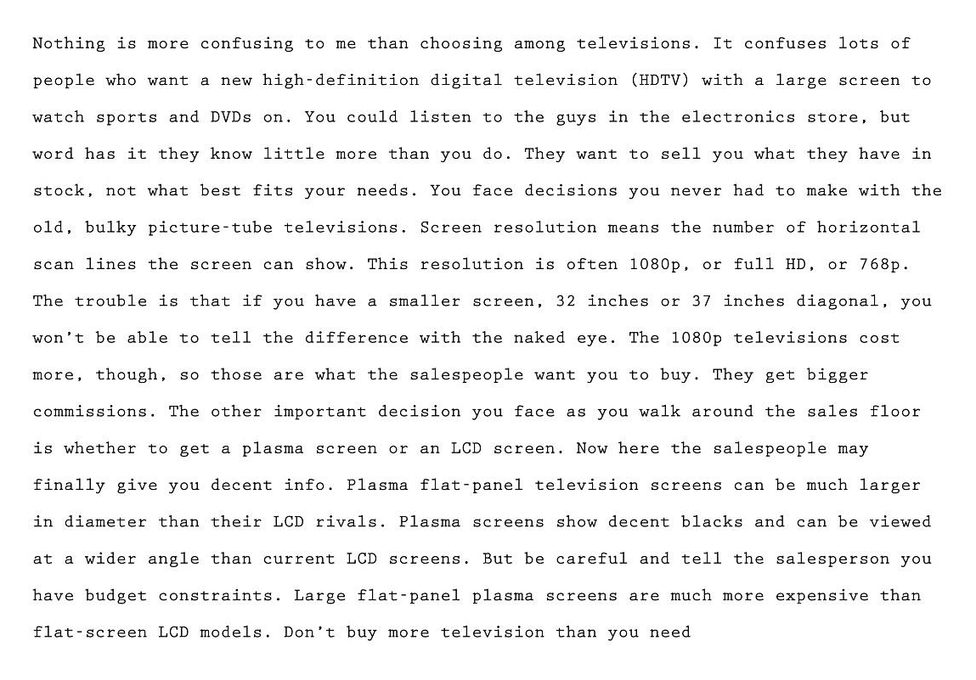

Self-practice EXERCISE 6.8
Reread body paragraphs two and three of the essay that Mariah is writing. Then answer the questions on below your own sheet of paper.
- In body paragraph two, Mariah decided to develop her paragraph as a nonfiction narrative. Do you agree with her decision? Explain. How else could she have chosen to develop the paragraph? Why is that better?
- Compare the writing styles of paragraphs two and three. What evidence do you have that Mariah was getting tired or running out of steam? What advice would you give her? Why?
- Choose one of these two body paragraphs. Write a version of your own that you think better fits Mariah’s audience and purpose.

Writing a Title
A writer’s best choice for a title is one that alludes to the main point of the entire essay. Like the headline in a newspaper or the big, bold title in a magazine, an essay’s title gives the audience a first peek at the content. If readers like the title, they are likely to keep reading.
Following her outline carefully, Mariah crafted each paragraph of her essay. Moving step by step in the writing process, Mariah finished the draft and even included a brief concluding paragraph. She then decided, as the final touch for her writing session, to add an engaging title.

Writing Your Own First Draft
Now you may begin your own first draft. Follow the suggestions and the guidelines presented in this section. Follow the steps below and work through the process just as Mariah did to develop her essay.
Also, your expository essay will be due next week, so focus on the first draft by the end of this week then take the next week to look it over. In Chapter 12, you will learn more about final revisions and peer review, so for your later papers, you will be expected to complete a more thorough revision; for the expository essay, you will be expected to work through your first draft, and once you are finished that, you will need to do a basic revision and editing, looking for errors with spelling, homonyms, sentence construction—all of the grammar content we have covered so far. For now, work through the following steps:
- Ensure your supporting ideas actually support your thesis.
- Revise your thesis as required (make sure it still addresses the initial topic you have chosen).
- Compose your paragraphs/sections following your formal sentence outline—one section at a time–then double check you have included all information from your outline in your paragraph/section.
- Check that your topic sentences support your thesis.
- Make sure the information in your paragraphs support your topic sentences.
- Insert transitional words (if you have not done so already when composing your draft) into paragraphs AND to link paragraphs.
- When writing, be conscious of your tone and how it relates to your audience.
- Be careful when considering which words to use.
- Create an introduction that engages the reader.
- Create a conclusion that leaves your reader convinced and is memorable.
- Make sure all of your sentences are complete.
- Proofread for spelling mistakes (remember to not depend too much on spelling and grammar checkers).
- Try to compile a references section using the JIBC APA Reference Guide; you will practise this later in this course, but for now refer to the guide to see how to compose a complete reference page, and be sure to include all of the sources you used.
- Include citations within your essay to show where and when you have taken information from an external source. Again, follow the JIBC APA Reference Guide. You will learn more about this is a few weeks, but refer to the guide to see how to format your citations. You need to include a citation after each piece of information taken from a source, and you may use the same citation multiple times in a row. (Try and get into the practice of doing this now because you will be expected to have these in all future papers to avoid plagiarism.)
- Create a title page with interesting title, your name, your course name and number, your instructor’s name, the date the paper is due.

KEY TAKEAWAYS
- Make the writing process work for you. Use any and all of the strategies that help you move forward in the writing process.
- Always be aware of your purpose for writing and the needs of your audience. Cater to those needs in every sensible way.
- Remember to include all the key structural parts of an essay: a thesis statement that is part of your introductory paragraph, three or more body paragraphs as described in your outline, and a concluding paragraph. Then add an engaging title to draw in readers.
- Write paragraphs of an appropriate length for your writing assignment. Paragraphs at this level of writing can be a page long, as long as they cover the main topics in your outline.
- Use your topic outline or your sentence outline to guide the development of your paragraphs and the elaboration of your ideas. Each main idea, indicated by a Roman numeral in your outline, becomes the topic of a new paragraph. Develop it with the supporting details and the subpoints of those details that you included in your outline.
- Generally speaking, write your introduction and conclusion last, after you have fleshed out the body paragraphs.

6.4 The Writing Process: End-of-Chapter Exercises

LEARNING OBJECTIVES
- Use the skills you have learned in the chapter
- Work collaboratively with other students
- Work with a variety of academic and on the job, real-world examples

Supplemental EXERCISES
- In this chapter, you have thought and read about the topic of mass media. Starting with the title “The Future of Information: How It Will Be Created, Transmitted, and Consumed,” narrow the focus of the topic until it is suitable for a two- to three-page paper. Then narrow your topic with the help of brainstorming, idea mapping, and searching the Internet until you select a final topic to explore. Keep a journal or diary in which you record and comment on everything you did to choose a final topic. Then record what you will do next to explore the idea and create a thesis statement.
- Write a thesis statement and a formal sentence outline for an essay about the writing process. Include separate paragraphs for prewriting, drafting, and revising and editing. Your audience will be a general audience of educated adults who are unfamiliar with how writing is taught at the post-secondary level. Your purpose is to explain the stages of the writing process so that readers will understand its benefits.
Collaboration: Please share with a classmate and compare your answers.
- Pieces of writing in a variety of real-life and work-related situations would benefit from revising and editing. Consider the following list of real-life and work-related pieces of writing: emails, greeting card messages, junk mail, late night television commercials, social networking pages, local newspapers, bulletin board postings, and public notices. Find and submit at least two examples of writing that needs revision. Explain what changes you would make. Replace any recognizable names with pseudonyms.
- Group activity. At work, an employer might someday ask you to contribute to the research base for an essay such as the one Mariah wrote or the one you wrote while working through this chapter. Choosing either her topic or your own, compile a list of at least five sources. Then, working in a group of four students, bring in printouts or PDF files of Internet sources or paper copies of non-Internet sources for the other group members to examine. In a group report, rate the reliability of each other’s sources.
- Group activity. Working in a peer review group of four, go to Section 6.3: Drafting and reread the draft of the first two body paragraphs of Mariah’s essay, “Digital Technology: The Newest and the Best at What Price?” Review those two paragraphs and suggest and agree on changes to improve unity and coherence, eliminate unneeded words, and refine word choice. Your purpose is to help Mariah produce two effective paragraphs for a formal post-secondary-level essay about her topic.

Journal entry #6
Write a paragraph or two responding to the following.
- How do you feel about beginning your expository essay draft? Which, if any, of the steps do you find intimidating? OR Which steps do you find straightforward?
- You were given a few tips about making the writing process for you? Which of these did you try?
- How did breaking the writing process down into smaller stages work for you? What effect did this process have on the end result? What would have been different if you had just tackled your paper in one sitting?
Remember as mentioned in the Assessment Descriptions in your syllabus:
- You will be expected to respond to the questions by reflecting on and discussing your experiences with the week’s material.
- When writing your journals, you should focus on free writing—writing without (overly) considering formal writing structures—but you want to remember that it will be read by the instructor, who needs to be able to understand your ideas.
Your instructor will begin reading your Journal Package 1 this week. (2.5%)

