Chapter 7

Sources: Choosing the Right Ones

Before now, we have looked at using expository essay forms as ways to construct essays. In this chapter, we will begin to l0ok at being more critical: not only with the sources we choose but also in how we compose our ideas. Also, this chapter will help you finalize the selection of your article for your critique. In the next chapter, you will have the opportunity to expand on the examples given and apply your own information and ideas to develop your critical essay. Before we begin that, we need to further examine how important it is to choose correct sources as supporting evidence for ideas. You will also explore different resources available to you where you can search to find supporting evidence because you cannot always rely on basic Internet searches to help you find the best support available.
You have already explored different topics you find interesting when coming up with a topic for your expository essay, and while the content of this chapter is relevant to conducting any type of research, consider the connection to finding a suitable academic article for your critique. You may have already come across an academic journal article you would like to be the basis for your critique. If you have, you still should apply the material in this chapter as you may discover an article you would prefer to use. Also, you will need to apply the information in section 7.1: Choosing a Source to confirm whether the source you have chosen is appropriate. If you have not found an article yet or discover the one you chose does not fit the parameters, the content below will help you find one that is both interesting and fits the parameters for your next essay.

7.1 Choosing a Source

LEARNING OBJECTIVES
- Identify and apply the criteria for finding an academic journal article to critique
- Identify key terminology on your topic to guide your article search
In the next chapter, you will learn more about the details of what makes a critique and how to write one. For a description of the critique requirements, refer to the Assessment Descriptions as part of the course overview in your syllabus.

How Choosing a Source for a Critique is Different
Most essays focus on a topic–one you have narrowed down–and require a number of sources to back up the points or ideas. A critique, on the other hand, focuses on one source of information. Soon you will learn more about critiquing, but at this stage, it is important to know this is the key difference between a critique and a research paper because it will have an impact your choice of base and supplemental sources. However, you first need to choose a topic that you will then narrow in your search for an appropriate academic article to critique.
Simply stated, then, a critique is typically a discussion centred around one primary source. However, just as with any other essay, you may need to bring in supplemental sources to support the ideas you present in your discussion. While your next assignment stems around the one source you choose, you will need to look for other sources on the same topic in case you need them for background or supporting information or to even present opposing points of view.
For the critique you are required to write for your next assignment, the original source you will base your critical response on needs to meet the criteria outlined in Table 7.1: Source Selection Criteria.
Table 7.1 Source Selection Criteria
It should: | It should NOT:
- Be on a topic interesting to you. It is better if it is something you react to strongly (positively or negatively) because it is easier to generate ideas of what to critique when you have more of an emotional response. | - Be on a topic on which you have no opinion or background information.
- Be from an academic source/journal–even though you may use an academic database to find your article, you may come across non-academic sources. | - Be from a website because this makes it difficult for citations and referencing.  - Be from a newspaper (print or online) because these are often biased.
- Contain language that is relatively straightforward–some challenging vocabulary would be all right because you can critique this. | - Have a lot of challenging vocabulary forcing you to constantly refer to a dictionary–you may get bogged down in doing that and miss the main points the author is presenting.
- Be 5 to 10 pages in length, giving you enough content to choose a few points to discuss in depth. | - Be closer to 3 or as high as 20 pages–this will either provide you with too little content, and you will be stuck for ideas, or it will give you too much and you will only cover the points superficially.

self-practice EXERCISE 7.1
Take a few minutes to brainstorm ideas on a topic you find interesting. This may be the same one you used for your expository essay, or it may be another one entirely. Try to come up with preliminary ideas and different key words or specific areas within that topic. Once you have brainstormed, write the key words below for easy reference. You will later use these key words when you are conducting your article search.
Key words:
Table 7.1 gives you an idea of the technical criteria you need to meet when choosing a source for your next assignment. The next section will help you ensure you find a credible source, and one that meets the requirement to use an appropriate academic source.

7.2 Strategies for Gathering Reliable Information

LEARNING OBJECTIVES
- Distinguish between primary and secondary sources
- Identify strategies for locating relevant print and electronic resources efficiently
- Identify instances when it is appropriate to use human sources, such as interviews or eyewitness testimony
- Identify criteria for evaluating research resources
- Understand why many electronic resources are not reliable
Now that you have chosen your topic, you are ready to begin the research. This phase can be both exciting and challenging. As you read this section, you will learn ways to locate sources efficiently, so you have enough time to read the sources, take notes, and think about how to use the information.
Of course, the technological advances of the past few decades—particularly the rise of online media—mean that, as a 21st century student, you have countless sources of information available at your fingertips. However, how can you tell whether a source is reliable? This section will discuss strategies for evaluating sources critically so that you can be a media savvy researcher.

Locating Useful Resources
When you chose a topic and determined your research questions, you conducted preliminary research to stimulate your thinking. Your proposal included some general ideas for how to go about your research—for instance, interviewing an expert in the field or analyzing the content of popular magazines. You may even have identified a few potential sources. Now it is time to conduct a more focused, systematic search for informative primary and secondary sources.

Using Primary and Secondary Sources
Writers classify research resources in two categories: primary sources and secondary sources. Primary sources are direct, firsthand sources of information or data. For example, if you were writing a paper about freedom of religion, the text of the Canadian Charter of Rights and Freedoms would be a primary source.
Other primary sources include the following:
- Research articles
- Literary texts
- Historical documents such as diaries or letters
- Autobiographies or other personal accounts
Secondary sources discuss, interpret, analyze, consolidate, or otherwise rework information from primary sources. In researching a paper about freedom of religion, you might read articles about legal cases that involved freedom of religion, or editorials expressing commentary on freedom of religion. These would be considered secondary sources because they are one step removed from the primary source of information.
The following are examples of secondary sources:
- Magazine articles
- Biographical books
- Literary and scientific reviews
- Television documentaries
Your topic and purpose determine whether you must cite both primary and secondary sources in your paper. Ask yourself which sources are most likely to provide the information that will answer your research questions. If you are writing a research paper about reality television shows, you will need to use some reality shows as a primary source, but secondary sources, such as a reviewer’s critique, are also important. If you are writing about the health effects of nicotine, you will probably want to read the published results of scientific studies, but secondary sources, such as magazine articles discussing the outcome of a recent study, may also be helpful.
Once you have thought about what kinds of sources are most likely to help you answer your research questions, you may begin your search for print and electronic resources. The challenge is to conduct your search efficiently. Writers use strategies to help them find the sources that are most relevant and reliable while steering clear of sources that will not be useful.

Finding Print Resources
Print resources include a vast array of documents and publications. Regardless of your topic, you will consult some print resources as part of your research. (You will use electronic sources as well, but it is not wise to limit yourself to electronic sources only because some potentially useful sources may be available only in print form.) Table 7.2: Library Print Resources lists different types of print resources available at public and university libraries.

Table 7.2 Library Print Resources
Resource Type | Description | Examples
Reference works | Reference works provide a summary of information about a particular topic. Almanacs, encyclopedias, atlases, medical reference books, and scientific abstracts are examples of reference works. In some cases, reference books may not be checked out of a library.  Note that reference works are many steps removed from original primary sources and are often brief, so they should be used only as a starting point when you gather information. | - The World Almanac and Book of Facts 2015  - Diagnostic and Statistical Manual published by the American Psychiatric Association
Nonfiction books | Nonfiction books provide in-depth coverage of a topic. Trade books, biographies, and how-to guides are usually written for a general audience. Scholarly books and scientific studies are usually written for an audience that has specialized knowledge of a topic. | - The 30-Day Low-Carb Diet Solution  - Fundamentals of Nutrition
Periodicals and news sources | These sources are published at regular intervals—daily, weekly, monthly, or quarterly. Newspapers, magazines, and academic journals are examples. Some periodicals provide articles on subjects of general interest, while others are more specialized. | - The Globe and Mail  - Maclean’s magazine  - CMAJ, Canadian Medical Association Journal
Government publications | Federal, provincial, and local government agencies publish information on a variety of topics. Government publications include reports, legislation, court documents, public records, statistics, studies, guides, programs, and forms. | - Statistics Canada  - Juristat
Business and nonprofit publications | Businesses and nonprofit organizations produce publications designed to market a product, provide background about the organization, provide information on topics connected to the organization, or promote a cause. These publications include reports, newsletters, advertisements, manuals, brochures, and other print documents. | - A company’s instruction manual explaining how to use a specific software program  - A news release published by UNICEF Canada
Some of these resources are also widely available in electronic format. In addition to the resources noted in the table, library holdings may include primary texts such as historical documents, letters, and diaries.

Writing at Work
Businesses, government organizations, and nonprofit organizations produce published materials that range from brief advertisements and brochures to lengthy, detailed reports. In many cases, producing these publications requires research. A corporation’s annual report may include research about economic or industry trends. A charitable organization may use information from research in materials sent to potential donors.
Regardless of the industry you work in, you may be asked to assist in developing materials for publication. Often, incorporating research in these documents can make them more effective in informing or persuading readers.

Tip
As you gather information, strive for a balance of accessible, easy-to-read sources and more specialized, challenging sources. Relying solely on lightweight books and articles written for a general audience will drastically limit the range of useful, substantial information. On the other hand, restricting oneself to dense, scholarly works could make the process of researching extremely time consuming and frustrating.

Self-practice EXERCISE 7.2
Make a list of five types of print resources you could use to find information about your topic. Include at least one primary source. Be as specific as possible. If you have a particular resource or type of resource in mind, describe it.
To find print resources efficiently, first identify the major concepts and terms you will use to conduct your search—that is, your keywords. These will help you find sources using any of the following methods:
- Using the library’s online catalogue
- Using periodicals indexes and databases
- Consulting a reference librarian
After completing Self-Practice Exercise 7.1, you already have some keywords in mind based on your preliminary research and writing. Another way to identify useful keywords is to visit the Library of Congress’s website at http://id.loc.gov/authorities (used as a point of reference throughout North America). This site allows you to search for a topic and see the related subject headings used by the Library of Congress, including broader terms, narrower terms, and related terms. Other libraries use these terms to classify materials. Knowing the most-used terms will help you speed up your keyword search.
At this point, you should have selected the academic article you would like to give to your instructor for approval; before submitting it, however, you do want to skim the article and come up with some ideas you could use for your critique.
Jorge, who you first met in Chapter 3, used the Library of Congress site to identify general terms he could use to find resources about low-carb dieting. His search helped him identify potentially useful keywords and related topics, such as carbohydrates in human nutrition, glycemic index, and carbohydrates—metabolism. These terms helped Jorge refine his search.

Tip
Knowing the right keywords can sometimes make all the difference in conducting a successful search. If you have trouble finding sources on a topic, consult a librarian to see whether you need to modify your search terms.

Self-practice EXERCISE 7.3
Visit the Library of Congress’s website at http://id.loc.gov/authorities and conduct searches on a few terms related to your topic.
- Review your search results and identify six to eight additional terms you might use when you conduct your research.
- Print out the search results or save the results to your research folder on your computer or portable storage device.

Using Periodicals, Indexes, and Databases
Library catalogues can help you locate book length sources, as well as some types of nonprint holdings, such as CDs, DVDs, and audiobooks. To locate shorter sources, such as magazine and journal articles, you will need to use a periodical index or an online periodical database. These tools index the articles that appear in newspapers, magazines, and journals. Like catalogues, they provide publication information about an article and often allow users to access a summary or even the full text of the article.
Print indexes may be available in the periodicals section of your library. Increasingly, libraries use online databases that users can access through the library website. A single library may provide access to multiple periodical databases. These can range from general news databases to specialized databases. Table 7.3: Commonly Used Databases describes some indexes and databases that are frequently used.
Table 7.3 Commonly Used Databases
Resource | Format | Contents
Academic Search (EBSCOhost) | Online | General content from magazines, journals, and books
Canadian Newsstand (ProQuest) | Online | News and current event-related content from magazines and newspapers
Business Source Complete (EBSCOhost) | Online | Business-related content from magazines and journals
Criminal Justice (ProQuest) | Online | Content from journals in criminology and law
MEDLINE (EBSCOhost)  PubMed (OPEN ACCESS) | Online | Articles in medicine and health
PsycINFO (EBSCOhost) | Online | Content from journals in psychology and psychiatry
SocINDEX (EBSCOhost) | Online | General content from magazines, journals, and books

Reading Popular and Scholarly Periodicals
When you search for periodicals, be sure to distinguish among different types. Mass market publications, such as newspapers and popular magazines, differ from scholarly publications in their accessibility, audience, and purpose.
Newspapers and magazines are written for a broader audience than scholarly journals. Their content is usually quite accessible and easy to read. Trade magazines that target readers within a particular industry may presume the reader has background knowledge, but these publications are still reader friendly for a broader audience. Their purpose is to inform and, often, to entertain or persuade readers as well.
Scholarly or academic journals are written for a much smaller and more expert audience. The creators of these publications assume that most of their readers are already familiar with the main topic of the journal. The target audience is also highly educated. Informing is the primary purpose of a scholarly journal. While a journal article may advance an agenda or advocate a position, the content will still be presented in an objective style and formal tone (which is why you have been asked to find an academic journal article). Entertaining readers with breezy comments and splashy graphics is not a priority with this type of source.
Because of these differences, scholarly journals are more challenging to read. That does not mean you should avoid them. On the contrary, they can provide in-depth information that is unavailable elsewhere. Because knowledgeable professionals carefully review the content before publication, scholarly journals are far more reliable than much of the information available in popular media. Seek out academic journals along with other resources. Just be prepared to spend a little more time processing the information.

Writing at Work
Periodicals databases are not just for students writing research papers. They also provide a valuable service to workers in various fields. The owner of a small business might use a database such as Business Source Complete to find articles on management, finance, or trends within a particular industry. Health care professionals might consult databases such as MEDLINE to research a particular disease or medication. Regardless of what career path you plan to pursue, periodicals databases can be a useful tool for researching specific topics and identifying periodicals that will help you keep up with the latest news in your industry.

Consulting a Reference Librarian
Sifting through library stacks and database search results to find the information you need can be like trying to find a needle in a haystack. If you are not sure how you should begin your search, or if it is yielding too many or too few results, you are not alone. Many students find this process challenging, although it does get easier with experience. One way to learn better search strategies is to consult a reference librarian.
Reference librarians are intimately familiar with the systems libraries use to organize and classify information. They can help you locate a particular book in the library stacks, steer you toward useful reference works, and provide tips on how to use databases and other electronic research tools. Take the time to see what resources you can find on your own, but if you encounter difficulties, ask for help. Many university librarians hold virtual office hours and are available for online chatting.

self-practice EXERCISE 7.4
Visit your library’s website or consult with a reference librarian to determine what periodicals indexes or databases would be useful for your research. Depending on your topic, you may rely on a general news index, a specialized index for a particular subject area, or both. Search the catalogue for your topic and related keywords. Print out or bookmark your search results.
- Identify at least one to two relevant periodicals, indexes, or databases.
- Conduct a keyword search to find potentially relevant articles on your topic.
- Save your search results. If the index you are using provides article summaries, read these to determine how useful the articles are likely to be.
- Identify at least three to five articles to review more closely. If the full article is available online, set aside time to read it. If not, plan to visit our library within the next few days to locate the articles you need.

Tip
One way to refine your keyword search is to use Boolean operators. These allow you to combine keywords, find variations on a word, and otherwise expand or limit your results. Here are some of the ways you can use Boolean operators:
- Combine keywords with and or + to limit results to citations that include both keywords—for example, diet + nutrition.
- Combine keywords with or to find synonyms. For example, prison or jail. The phrase “Or is more” may help you remember that using this will show you more results.
- Combine keywords with not or - to search for the first word without the second. This can help you eliminate irrelevant results based on words that are similar to your search term. For example, searching for stress fractures not geological locates materials on fractures of bones but excludes materials on fractures of stones. Use this one cautiously because it may exclude useful sources.
- Enclose a phrase in quotation marks to search for an exact phrase, such as “morbid obesity,” “use of force,” or “law enforcement.”
- Use parentheses to direct the order of operations in a search string. For example, since Type II diabetes is also known as adult onset diabetes, you could search (Type II or adult onset or Type 2) and diabetes to limit your search results to articles on this form of the disease.
- Use a wildcard symbol such as *, #, ?, or $ after a word to search for variations on a term. For instance, you might type gang* to search for information on gang, gangs, and gangland. The specific symbol used varies with different databases.

Finding and Using Electronic Resources
With the expansion of technology and media over the past few decades, a wealth of information is available to you in electronic format. Some types of resources, such as television documentaries, may only be available electronically. Other resources—for instance, many newspapers and magazines—may be available in both print and electronic form. The following are some of the electronic sources you might consult:
- Online databases
- CD-ROMs
- Popular web search engines
- Websites maintained by businesses, universities, nonprofit organizations, or government agencies
- Newspapers, magazines, and journals published on the web
- E-books
- Audiobooks
- Industry blogs
- Radio and television programs and other audio and video recordings
- Online discussion groups
The techniques you use to locate print resources can also help you find electronic resources efficiently. Libraries usually include CD-ROMs, audiobooks, and audio and video recordings among their holdings. You can locate these materials in the catalogue using a keyword search. The same Boolean operators used to refine database searches can help you filter your results in popular search engines.

Using Internet Search Engines Efficiently
When faced with the challenge of writing a research paper, some students rely on popular search engines as their first source of information. Typing a keyword or phrase into a search engine instantly pulls up links to dozens, hundreds, or even thousands of related websites—what could be easier? Unfortunately, despite its apparent convenience, this research strategy has the following drawbacks:
- Results do not always appear in order of reliability. The first few hits that appear in search results may include sites with unreliable content, such as online encyclopedias that can be edited by any user. Because websites are created by third parties, the search engine cannot tell you which sites have accurate information.
- Results may be too numerous for you to use. The amount of information available on the web is far greater than the amount of information housed within a particular library or database. Realistically, if your web search pulls up thousands of hits, you will not be able to visit every site—and the most useful sites may be buried deep within your search results.
- Search engines are not connected to the results of the search. Search engines find websites that people visit often and list the results in order of popularity. The search engine, then, is not connected to any of the results. When you cite a source found through a search engine, you do not need to cite the search engine. Only cite the source.
A general web search can provide a helpful overview of a topic and may pull up genuinely useful resources. To get the most out of a search engine like google scholar (http://scholar.google.ca/), however, use strategies to make your search more efficient. Use multiple keywords and Boolean operators to limit your results. Click on the advanced search link on the homepage to find additional options for streamlining your search. Depending on the specific search engine you use, the following options may be available:
- Limit results to websites that have been updated within a particular time frame
- Limit results by language or country
- Limit results to scholarly works available online
- Limit results by file type
- Limit results to a particular domain type, such as .edu (school and university sites) or .gov (government sites). This is a quick way to filter out commercial sites, which can often lead to more objective results.
Use the “bookmarks” or “favourites” feature of your web browser to save and organize sites that look promising.

Using Other Information Sources: Interviews
With so many print and electronic media readily available, it is easy to overlook another valuable information resource: other people. Consider whether you could use a person or group as a primary source. For instance, you might interview a professor who has expertise in a particular subject, a worker within a particular industry, or a representative from a political organization. Interviews can be a great way to get firsthand information.
To get the most out of an interview, you will need to plan ahead. Contact your subject early in the research process and explain your purpose for requesting an interview. Prepare detailed questions. Open-ended questions, rather than questions with simple yes or no answers, are more likely to lead to an in-depth discussion. Schedule a time to meet, and be sure to obtain your subject’s permission to record the interview. Take careful notes and be ready to ask follow-up questions based on what you learn.

Tip
If scheduling an in-person meeting is difficult, consider arranging a telephone interview or asking your subject to respond to your questions via email. Recognize that any of these formats takes time and effort. Be prompt and courteous, avoid going over the allotted interview time, and be flexible if your subject needs to reschedule.

Evaluating Research Resources
As you gather sources, you will need to examine them with a critical eye. Smart researchers continually ask themselves two questions: “Is this source relevant to my purpose?” and “Is this source reliable?” The first question will help you avoid wasting valuable time reading sources that stray too far from your specific topic and research questions. The second question will help you find accurate, trustworthy sources.

Determining Whether a Source Is Relevant
At this point in your research process, you may have identified dozens of potential sources. It is easy for writers to get so caught up in checking out books and printing out articles that they forget to ask themselves how they will use these resources in their research. Now is a good time to get a little ruthless. Reading and taking notes takes time and energy, so you will want to focus on the most relevant sources.
To weed through your stack of books and articles, skim their contents. Read quickly with your research questions and subtopics in mind. Table 7.4: Tips for Skimming Books and Articles explains how to skim to get a quick sense of what topics are covered. If a book or article is not especially relevant, put it aside. You can always come back to it later if you need to.
Table 7.4 Tips for Skimming Books and Articles
Tips for Skimming Books | Tips for Skimming Articles
- Read the dust jacket and table of contents for a broad overview of the topics covered.  - Use the index to locate more specific topics and see how thoroughly they are covered.  - Flip through the book and look for subtitles or key terms that correspond to your research. | - Skim the introduction and conclusion for summary material.  - Skim through subheadings and text features such as sidebars.  - Look for keywords related to your topic.  - Journal articles often begin with an abstract or summary of the contents. Read it to determine the article’s relevance to your research.

Determining Whether a Source Is Reliable
All information sources are not created equal. Sources can vary greatly in terms of how carefully they are researched, written, edited, and reviewed for accuracy. Common sense will help you identify obviously questionable sources, such as tabloids that feature tales of alien abductions, or personal websites with glaring typos. Sometimes, however, a source’s reliability—or lack of it—is not so obvious.
To evaluate your research sources, you will use critical thinking skills consciously and deliberately. You will consider criteria such as the type of source, its intended purpose and audience, the author’s qualifications, the publication’s reputation, any indications of bias or hidden agendas, how current the source is, and the overall quality of the writing, thinking, and design.

Evaluating Types of Sources
The different types of sources you will consult are written for distinct purposes and with different audiences in mind. This accounts for other differences, such as the following:
- How thoroughly the writers cover a given topic
- How carefully the writers research and document facts
- How editors review the work
- What biases or agendas affect the content.
A journal article written for an academic audience for the purpose of expanding scholarship in a given field will take an approach quite different from a magazine feature written to inform a general audience. Textbooks, hard news articles, and websites approach a subject from different angles as well. To some extent, the type of source provides clues about its overall depth and reliability. Table 7.5: Source Rankings ranks different source types.
Table 7.5 Source Rankings

High-Quality Sources
These sources provide the most in-depth information. They are researched and written by subject matter experts and are carefully reviewed. | - Scholarly books and articles in scholarly journals  - Trade books and magazines geared toward an educated general audience, such as Police Chief magazine, Canadian Paramedicine, or Harvard Business Review  - Government documents, such as books, reports, and web pages  - Documents posted online by reputable organizations, such as universities and research institutes  - Textbooks and reference books, which are usually reliable but may not cover a topic in great depth
Varied-Quality Sources
These sources are often useful. However, they do not cover subjects in as much depth as high-quality sources, and they are not always rigorously researched and reviewed. Some, such as popular magazine articles or company brochures, may be written to market a product or a cause.  **Use these sources with caution.** | - News stories and feature articles (print or online) from reputable newspapers, magazines, or organizations, such as The Economist or the Canadian Broadcasting Corporation  - Popular magazine articles, which may or may not be carefully researched and fact checked  - Documents published by businesses and nonprofit organizations
Questionable Sources
These sources are often written primarily to attract a large readership or present the author’s opinions and are not subject to careful review.  **Avoid using these sources!** | - Loosely regulated or unregulated media content, such as Internet discussion boards, blogs, free online encyclopedias, talk radio shows, television news shows with obvious political biases, personal websites, and chat rooms

Tip
Free online encyclopedias and wikis may seem like a great source of information. They usually appear among the first few results of a web search. They cover thousands of topics, and many articles use an informal, straightforward writing style. Unfortunately, these sites have no control system for researching, writing, and reviewing articles. Instead, they rely on a community of users to police themselves. At best, these sites can be a starting point for finding other, more trustworthy sources. Never use them as final sources.

Evaluating Credibility and Reputability
Even when you are using a type of source that is generally reliable, you will still need to evaluate the author’s credibility and the publication itself on an individual basis. To examine the author’s credibility—that is, how much you can believe of what the author has to say—examine his or her credentials. What career experience or academic study shows that the author has the expertise to write about this topic?
Keep in mind that expertise in one field is no guarantee of expertise in another, unrelated area. For instance, an author may have an advanced degree in physiology, but this credential is not a valid qualification for writing about psychology. Check credentials carefully.
Just as important as the author’s credibility is the publication’s overall reputability. Reputability refers to a source’s standing and reputation as a respectable, reliable source of information. An established and well-known newspaper, such as the Globe and Mail or the New York Times, is more reputable than a college newspaper put out by comparatively inexperienced students. A website that is maintained by a well-known, respected organization and is regularly updated is more reputable than one created by an unknown author or group.
If you are using articles from scholarly journals, you can check databases that keep count of how many times each article has been cited in other articles. This can give you a rough indication of the article’s quality or, at the very least, of its influence and reputation among other scholars.

Checking for Biases and Hidden Agendas
Whenever you consult a source, always think carefully about the author’s purpose in presenting the information. Few sources present facts completely objectively. In some cases, the source’s content and tone are significantly influenced by biases or hidden agendas.
Bias refers to favouritism or prejudice toward a particular person or group. For instance, an author may be biased against a certain political party and present information in a way that subtly—or not so subtly—makes that organization look bad. Bias can lead an author to present facts selectively, edit quotations to misrepresent someone’s words, and distort information.
Hidden agendas are goals that are not immediately obvious but influence how an author presents the facts. For instance, an article about the role of beef in a healthy diet would be questionable if it were written by a representative of the beef industry—or by the president of an animal rights organization. In both cases, the author would likely have a hidden agenda.
As Jorge conducted his research, he read several research studies in which scientists found significant benefits to following a low-carbohydrate diet. He also noticed that many studies were sponsored by a foundation associated with the author of a popular series of low-carbohydrate diet books. Jorge read these studies with a critical eye, knowing that a hidden agenda might be shaping the researchers’ conclusions.

Using Current Sources
Be sure to seek out sources that are current, or up to date. Depending on the topic, sources may become outdated relatively soon after publication, or they may remain useful for years. For instance, online social networking sites have evolved rapidly over the past few years. An article published in 2002 about this topic will not provide current information. On the other hand, a research paper on elementary education practices might refer to studies published decades ago by influential child psychologists.
When using websites for research, check to see when the site was last updated. Many sites publish this information on the homepage, and some, such as news sites, are updated daily or weekly. Many nonfunctioning links are a sign that a website is not regularly updated. Do not be afraid to ask your instructor for suggestions if you find that many of your most relevant sources are not especially reliable—or that the most reliable sources are not relevant.

Evaluating Overall Quality by Asking Questions
When you evaluate a source, you will consider the criteria previously discussed as well as your overall impressions of its quality. Read carefully, and notice how well the author presents and supports his or her statements. Stay actively engaged—do not simply accept an author’s words as truth. Ask questions to determine each source’s value. Checklist 7.1 lists 10 questions you should ask yourself as a critical reader.
Checklist 7.1 Source Evaluation
- Is the type of source appropriate for my purpose? Is it a high-quality source or one that needs to be looked at more critically?
- Can I establish that the author is credible and the publication is reputable?
- Does the author support ideas with specific facts and details that are carefully documented? Is the source of the author’s information clear? (When you use secondary sources, look for sources that are not too removed from primary research.)
- Does the source include any factual errors or instances of faulty logic?
- Does the author leave out any information that I would expect to see in a discussion of this topic?
- Do the author’s conclusions logically follow from the evidence that is presented? Can I see how the author got from one point to another?
- Is the writing clear and organized, and is it free from errors, clichés, and empty buzzwords? Is the tone objective, balanced, and reasonable? (Be on the lookout for extreme, emotionally charged language.)
- Are there any obvious biases or agendas? Based on what I know about the author, are there likely to be any hidden agendas?
- Are graphics informative, useful, and easy to understand? Are websites organized, easy to navigate, and free of clutter like flashing ads and unnecessary sound effects?
- Is the source contradicted by information found in other sources? (If so, it is possible that your sources are presenting similar information but taking different perspectives, which requires you to think carefully about which sources you find more convincing and why. Be suspicious, however, of any source that presents facts that you cannot confirm elsewhere.)

Writing at Work
The critical thinking skills you use to evaluate research sources as a student are equally valuable when you conduct research on the job. If you follow certain periodicals or websites, you have probably identified publications that consistently provide reliable information. Reading blogs and online discussion groups is a great way to identify new trends and hot topics in a particular field, but these sources should not be used for substantial research.

self-practice EXERCISE 7.5
Use a search engine to conduct a web search on your topic. Refer to the tips provided earlier to help you streamline your search. Evaluate your search results critically based on the criteria you have learned. Identify and bookmark one or more websites that are reliable, reputable, and likely to be useful in your research.

Managing Source Information
As you determine which sources you will rely on most, it is important to establish a system for keeping track of your sources and taking notes. There are several ways to go about it, and no one system is necessarily superior. What matters is that you keep materials in order; record bibliographical information you will need later; and take detailed, organized notes.
Bibliographic information is all the referencing information you need from all sources you consider using for your paper—think of this as your working references page. Any time you look at a source, you should make note of all the referencing information—you may later decide to change direction in your paper or simply choose not to use that source as you develop your paper, but if you do decide to use that source, you will have all the details you need when compiling your references page.
Note: Following the APA format, you need to submit a references page or reference list; you do not submit a bibliography because your references should only include the sources to which you directly referred or cited within your paper, not everything you looked at but did not use.

Keeping Track of Your Sources
Think ahead to a moment a few weeks from now when you will have written your final research paper and are almost ready to submit it for a grade. There is just one task left: writing your list of sources.
As you begin typing your list, you realize you need to include the publication information for a book you cited frequently. Unfortunately, you already returned it to the library several days ago. You do not remember the URLs for some of the websites you used or the dates you accessed them—information that also must be included in your reference page. With a sinking feeling, you realize that finding this information and preparing your references will require hours of work.
This stressful scenario can be avoided. Taking time to organize source information now will ensure that you are not scrambling to find it at the last minute. Throughout your research, record bibliographical information for each source as soon as you begin using it. You may use pen-and-paper methods, such as a notebook or note cards, or maintain an electronic list. (If you prefer the latter option, many office software packages include separate programs for recording bibliographic information.)
Table 7.6: Details for Commonly Used Source Types shows the specific details you should record. Use these details to develop a working bibliography—a preliminary list of sources that you will later use to develop the references section of your paper. You may wish to record information using the formatting system of the American Psychological Association (APA), which will save a step later on.
Table 7.6 Details for Commonly Used Source Types
Source Type | Necessary Information
Book | Author(s), title and subtitle, publisher, city of publication, year of publication
Essay or article published in a book | Include all the information you would for any other book. Additionally, record the essay’s or article’s title, author(s), the pages on which it appears, and the name of the book’s editor(s).
Periodical | Author(s), article title, publication title, date of publication, volume and issue number, and page numbers
Online source | Author(s) (if available), article or document title, organization that sponsors the site, database name (if applicable), date of publication, date you accessed the site, and URL
Interview | Name of person interviewed, method of communication, date of interview

self-practice EXERCISE 7.6
Create a working bibliography using APA format and referring to the JIBC APA Reference Guide. You need to include the referencing information for your original source article; you will want to find three or four other sources you could possibly use to support your discussion about your primary article. Continue to add sources to your working bibliography throughout the research process.

Tip
To make your working bibliography even more complete, you may wish to record additional details, such as a book’s call number or contact information for a person you interviewed. That way, if you need to locate a source again, you will have all the information you need right at your fingertips. You may also wish to assign each source a code number to use when taking notes (1, 2, 3, or a similar system).

Taking Notes Efficiently
Good researchers stay focused and organized as they gather information from sources. Before you begin taking notes, take a moment to step back and think about your goal as a researcher—to find information that will help you answer your research question. When you write your paper, you will present your conclusions about the topic supported by research. That goal will determine what information you record and how you organize it.
Writers sometimes get caught up in taking extensive notes, so much so that they lose sight of how their notes relate to the questions and ideas they started out with. Remember that you do not need to write down every detail from your reading. Focus on finding and recording details that will help you answer your research questions. The following strategies will help you take notes efficiently.

Use Headings to Organize Ideas
Whether you use old-fashioned index cards or organize your notes using word processing software, record just one major point from each source at a time, and use a heading to summarize the information covered. Keep all your notes in one file, digital or otherwise. Doing so will help you identify connections between different pieces of information. It will also help you make connections between your notes and the research questions and subtopics you identified earlier.

Know When to Summarize, Paraphrase, or Directly Quote a Source
Your notes will fall under three categories: summary notes, paraphrased information, and direct quotations from your sources. Effective researchers make choices about which is most appropriate for their purpose.
- Summary notes sum up the main ideas in a source in a few sentences or a short paragraph. A summary is considerably shorter than the original text and captures only the major ideas. Use summary notes when you do not need to record specific details, but you intend to refer to broad concepts the author discusses.
- Paraphrased information restates a fact or idea from a source using your own words and sentence structure.
- Direct quotations use the exact wording used by the original source and enclose the quoted material in quotation marks. It is a good strategy to copy direct quotations when an author expresses an idea in an especially lively or memorable way. However, do not rely exclusively on direct quotations in your note taking.
Most of your notes should be paraphrased from the original source. Paraphrasing as you take notes is usually a better strategy than copying direct quotations because it forces you to think through the information in your source and understand it well enough to restate it. In short, it helps you stay engaged with the material instead of simply copying and pasting. Synthesizing will help you later when you begin planning and drafting your paper.

Maintain Complete, Accurate Notes
Regardless of the format used, any notes you take should include enough information to help you organize ideas and locate them instantly in the original text if you need to review them. Make sure your notes include the following elements:
- Heading summing up the main topic covered
- Author’s name, a source code, or an abbreviated source title
- Page number
- Full URL of any pages buried deep in a website
Throughout the process of taking notes, be scrupulous about correctly attributing each idea to its source. Always include source information so you know exactly which ideas came from which sources. Use quotation marks to set off any words for phrases taken directly from the original text. If you add your own responses and ideas, make sure they are distinct from ideas you quoted or paraphrased.
Finally, make sure your notes accurately reflect the content of the original text. Make sure quoted material is copied verbatim. If you omit words from a quotation, use ellipses to show the omission and make sure the omission does not change the author’s meaning. Paraphrase ideas carefully, and check your paraphrased notes against the original text to make sure that you have restated the author’s ideas accurately in your own words.

Use a System That Works for You
There are several formats you can use to take notes. No one technique is necessarily better than another; it is more important to choose a format you are comfortable using. Choosing the format that works best for you will ensure your notes are organized, complete, and accurate. Consider implementing one of these formats when you begin taking notes:
- Use index cards. This traditional format involves writing each note on a separate index card. It takes more time than copying and pasting into an electronic document, which encourages you to be selective in choosing which ideas to record. Recording notes on separate cards makes it easy to later organize your notes according to major topics. Some writers colour code their cards to make them still more organized.
- Use note-taking software. Word processing and office software packages often include different types of note-taking software. Although you may need to set aside some time to learn the software, this method combines the speed of typing with the same degree of organization associated with handwritten note cards.
- Maintain a research notebook. Instead of using index cards or electronic note cards, you may wish to keep a notebook or electronic folder, allotting a few pages (or one file) for each of your sources. This method makes it easy to create a separate column or section of the document where you add your responses to the information you encounter in your research.
- Annotate your sources. This method involves making handwritten notes in the margins of sources that you have printed or photocopied. If using electronic sources, you can make comments within the source document. For example, you might add comment boxes to a PDF version of an article. This method works best for experienced researchers who have already thought a great deal about the topic because it can be difficult to organize your notes later when starting your draft.
Choose one of the methods from the list to use for taking notes. Continue gathering sources and taking notes.

KEY TAKEAWAYS
- A writer’s use of primary and secondary sources is determined by the topic and purpose of the research. Sources used may include print sources, such as books and journals; electronic sources, such as websites and articles retrieved from databases; and human sources of information, such as interviews.
- Strategies that help writers locate sources efficiently include conducting effective keyword searches, understanding how to use online catalogues and databases, using strategies to narrow web search results, and consulting reference librarians.
- Writers evaluate sources based on how relevant they are to the research question and how reliable their content is.
- Skimming sources can help writers determine their relevance efficiently.
- Writers evaluate a source’s reliability by asking questions about the type of source (including its audience and purpose); the author’s credibility, the publication’s reputability, the source’s currency, and the overall quality of the writing, research, logic, and design in the source.
- In their notes, effective writers record organized, complete, accurate information. This includes bibliographic information about each source as well as summarized, paraphrased, or quoted information from the source.

Journal entry #7
Write a paragraph or two responding to the following.
- How difficult was it for you to identify then apply keywords when searching for a source? Why?
- How easy or difficult was it for you to find an academic article for your critique? Why?
- How do you feel after having completed your first essay for this course?
- Make some general points of how your writing has progressed.
Remember as mentioned in the Assessment Descriptions in your syllabus:
- You will be expected to respond to the questions by reflecting on and discussing your experiences with the week’s material.
- When writing your journals, you should focus on freewriting—writing without (overly) considering formal writing structures—but you want to remember that it will be read by the instructor, who needs to be able to understand your ideas.
- Your instructor will be able to see if you have completed this entry by the end of the week but not read all of the journals until week 11.

Chapter 8

Being Critical

You should have already chosen a source on which to base your critique due in week 10. In this chapter, you will develop your critical thinking and analysis skills through examining the second essay type to which you will be introduced: a critique. The chapter will also provide guiding questions to help you formulate the elements to include in your critique. The self-practice exercises will provide you opportunities to examine more in depth what critiquing entails, and you will have the opportunity to proceed through the stages to develop your own critique.

8.1 What Makes a Critique a Critique?

LEARNING OBJECTIVES
- Define what it means to critique
- Explain the differences between a critique and other essay forms

This section will introduce you to another essay form instructors often ask their students to produce: the critique.
A critique is a written work critically analyzing or evaluating another piece of writing; also known as a review or critical response.

What Is a Critique?
When you see the word critique, the first thing you may think of is to criticize. In actuality, critiques do not need to look only at the negative aspects of a source; they can also focus on the positive components or even have a mix of the positive and negative elements. They are critical response papers analyzing and evaluating an original source, such as the academic journal article you are being asked to use for this assignment.

self-practice EXERCISE 8.1
Read the following short critique, and then come up with a list of elements you believe make this a critique as opposed to an expository paper.
Vetter and Perlstein’s work on terrorism and its future is an excellent basis for evaluating views and attitudes to terrorism before the tragic events of 9/11. Written in 1991, the book provides an objective (but more theoretical) view on what terrorism is, how it can be categorized, and to what ideology it can be linked. Perspectives on Terrorism is a multifaceted review of numerous factors that impact and influence the global development of terrorism; those studying sociology or criminal justice might find ample information regarding the ideological roots and typology of terrorism as a phenomenon and as a specific type of violent ideology that has gradually turned into a dominant force of political change.
Vetter and Perlstein (1991) begin their work with the words “it has almost become pro forma for writers on terrorism to begin by pointing out how hard it is to define the term terrorism.” However, the authors do not waste their time trying to define what terrorism is; rather, they are trying to look at terrorism through the prism of its separate elements, and objectively evaluate the concept of public acceptability of terrorism as a notion. Trying to answer the two critical questions “why surrogate the war?” and “who sponsors terrorism?” Vetter and Perlstein (1991) evaluate terrorism as a unjustifiable method of violence for the sake of unachievable goals, tying the notion of terrorism to the notion of morality.
To define terrorism in its present form it is not enough to determine the roots and the consequences of particular terrorist act; nor is it enough to evaluate the roots and the social implications of particular behavioural characteristics beyond morality. On the contrary, it is essential to tie terrorism to particular political conditions, in which these terrorist acts take place. In other words, whether the specific political act is terrorist or non-terrorist depends on the thorough examination of the social factors beyond morality and law. In this context, even without an opportunity to find the most relevant definition of terrorism, the authors thoroughly analyze the most important factors and sociological perspectives of terrorism, including the notion of threat, violence, publicity, and fear.
Typology of terrorism is the integral component of our current understanding of what terrorism is, what form it may take, and how we can prepare ourselves to facing the challenges of terrorist threats. Vetter and Perlstein (1991) state that “finding similarities and differences among objects and events is the first step toward determining their composition, functions, and causes.” Trying to evaluate the usefulness of various theoretical perspectives in terrorism, the authors offer a detailed review of psychological, sociological, and political elements that form several different typologies of terrorism. For example, Vetter and Perlstein (1991) refer to the psychiatrist Frederick Hacker, who classifies terrorists into crazies, criminals, and crusaders. Later throughout the book, Vetter and Perlstein provide a detailed analysis of both the criminal and the crazy types of terrorists, paying special attention to who crusaders are and what role they play in the development and expansion of contemporary terrorist ideology. Vetter and Perlstein recognize that it is almost impossible to encounter an ideal type of terrorist, but the basic knowledge of terrorist typology may shed the light onto the motivation and psychological mechanisms that push criminals (and particularly crusaders) to committing the acts of political violence.
Perspectives on Terrorism pays special attention to the politics of terrorism, and the role, which ideology plays in the development of terrorist attitudes in society. “Violence or terrorism can be used both by those who seek to change or destroy the existing government or social order and those who seek to maintain the status quo” (Vetter & Perlstein, 1991). In other words, the authors suggest that political ideology is integrally linked to the notion of terrorism. With ideology being the central element of political change, it necessarily impacts the quality of the political authority within the state; as a result, the image of terrorism is gradually transformed into a critical triangle with political authority, power, and violence at its ends. In their book, Vetter and Perlstein (1991) use this triangle as the basis for analyzing the political assumptions, which are usually made in terms of terrorism, as well as the extent to which political authority may make violence (and as a result, terrorism) legally permissible. The long sociological theme of terrorism that is stretched from the very beginning to the very end of the book makes it particularly useful to those who seek the roots of terrorism in the distorted political ideology and blame the state as the source and the reason of terrorist violence.
Reference
Vetter, H.J. & Perlstein, G.R. (1991). Perspectives on terrorism (Contemporary issues in crime and justice). Pacific Grove, CA, USA: Brooks/Cole Publishing Company.
Taken from: http://www.custom-essays.org/examples/Perspectives_on_Terrorism_Essay_Vetter__Perlstein.html
List three to five elements you think make this a critique.
- ___________________________________________________________________________________
- ___________________________________________________________________________________
- ___________________________________________________________________________________
- ___________________________________________________________________________________
- ___________________________________________________________________________________
Collaboration: Please share with a classmate.

How a Critique Is Different
A critique is different from an expository essay which is, as you have learned, a discussion revolving around a topic with multiple sources to support the discussion points. As you can see in Self-Practice Exercise 8.1, depending on the type of critique you are writing, your reference page could include one source only. However, as you may discuss topical ideas within the original source, you may also want to include secondary sources to which you can compare and contrast the original source’s ideas, but you need to always connect your discussion points back to the original source. Figure 8.1: Critiquing versus Other Essay Forms shows visual representations of what a critique structure could look in comparison to another essay, such as one that is expository or persuasive in purpose.
Figure 8.1 Critiquing versus Other Essay Forms

Primary Source

Rhetorical Points
Reflection Points
Idea Points
Secondary Sources/Support
Critique

Supporting Point 3

Central Topic

Supporting Point 2
Supporting Point 1
Secondary Sources/ Support
Secondary Sources/ Support
Secondary Sources/ Support
Other Essay Forms

If you look at the mind map for the critique, you can see how all of the discussion points stem from and relate back to the original article and how all of the discussion points can be interconnected. Also, the bubble labelled Secondary Sources/Support shows you can integrate secondary sources to compare and contrast when discussing either rhetorical or idea points. In the second diagram, you can see that the supporting ideas relate to the central topic, but they are extensions of the topic each with their own supporting forms of evidence. There is less emphasis placed on synthesis of ideas, although this is something you can still do when composing this type of essay.

The Purpose of Critiquing
In a post-secondary environment, your instructors will expect you to demonstrate critical thinking skills that go beyond simply taking another person’s ideas and spitting out facts. They will want you to show your ability to assess and analyze any type of information you use; they will also want to see that you have used sources to develop ideas of your own. Critiquing, or critical analysis, demonstrates you are able to connect ideas, arrive at your own conclusions, and develop new directions for discussion. You are also showing you have strong background knowledge on the topic in order to provide feedback on another person’s discussion on the issue.
Critical analysis appears in many forms in the academic world. It is present when you select appropriate sources for your support; you practise it when you choose what information from those sources to include as your evidence; you demonstrate it when you start breaking down your topic to develop discussion points. Very importantly, you also use critical analysis or thinking when you synthesize, or blend, your ideas with those of experts. This means you go beyond a statement of facts and take a stance on a topic. In this case of a critique, you not only state your view on an idea or issue but also on one core source of information on that topic: you insert your ideas into the text’s conversation.

Elements of a Critique
Often people go online for to read reviews of services or products. They sometimes make personal choices based on those reviews, such as what movie to go to or which restaurant to eat at. When you ask for a recommendation, the person you are asking will usually give you a brief summary of the experience then break his or her opinion down into smaller aspects—good and bad. For example, imagine you want to visit a new restaurant, and you ask your friend to recommend a place. Here is a sample response:
There is an amazing Japanese restaurant called Mega Sushi at the corner of Main and 12th. The food, atmosphere, and service are great. The food is always excellent, and they have a lot of original creations or spins on traditional Japanese food, but it still tastes authentic. The ingredients are always incredibly fresh, and you never have to worry about ordering the sashimi. The decor is also very authentic and classic, and the entire place is incredibly clean.
The service is generally very good—they even bring you a free sample roll while you wait for your food—but it can be a little slow during the dinner rush because it is such a popular place. Also, the prices are a little high because an average roll costs $15, but for the amazing food you get, it is totally worth it! I love this place!
When you break this example into sections, you can see the first and second sentences give the reviewer’s general opinion of the restaurant; they also summarize the main components the reviewer will cover. The review is then broken into smaller categories or points. Notice that not all the points covered are positive: while the food and atmosphere are good, the service has both positive and negative aspects but is overall good. Also, the prices are high, but the writer states that people who eat there get good value for their money. Providing a generalized description first, the reviewer introduced the topic to the audience; she then analyzed individual aspects or components of the experience with examples to help convince the audience of her perspective.
Not everyone may have the same positive experience, of course. What if it was someone’s first time at this particular restaurant, and she arrived during the dinner rush feeling very hungry and had to wait a long time for a table? Not knowing how good the food is and that it is worth the wait, she may just leave, so her general impression of the restaurant would probably not be favourable. Whether the experience would be positive or negative would depend on an individual’s personal experience and situation. The same is true for any critique. No two people will have exactly the same response to a source because of who they are, the time, and their prior experiences.
When critiquing, you are responding to anything that sparks a response in you when you are reading a source. When reading your article, pay close attention to any time you have to reread a sentence or paragraph. Make note of this; at the time you may not know why you have an issue with that section. Just realize that there was a point where you had to stop and make a notation of some sort on the paper. Once you have finished reading, you can go back and think about what the issue actually was. Maybe the vocabulary was difficult; maybe the author’s grammar was awkward and confusing; maybe the ideas did not make sense how they were organized; maybe you completely disagreed with the idea the author presented. Also, maybe something you read really sparked your interest, and you have the same opinion as the author, or perhaps the vocabulary was academic but not overly challenging where you would need to use a dictionary (the guiding questions for each critique form provided below will help you with this). All of these responses are valid and are things you can write about in your critique.
Any critique, no matter if it is of a book, an article, or a movie, needs to contain the following elements:
- A thesis: usually a general view of a source
Example: In Smith’s (2009) article, he effectively argues his case for the reinstatement of capital punishment in Canada.
- A summary: highlighting the main points presented
This would be the same as if you were writing a summary of any source you read.
- Critiquing points: elements the reader (you) have a reaction to when reading the source
You will decide on these points based on your reactions and personal preferences using the guiding questions for each of the forms below as suggestions.

8.2 Getting Started on Your Critique

LEARNING OBJECTIVES
- Compose a concise summary of your article

Before You Begin Critiquing
As with any source you examine, you need to make sure you have a solid grasp on the ideas presented by the author. Before you start analyzing your source, it is helpful to compose a summary to confirm you understand what the source is all about and that you do not leave out any important points. Remember that if your audience does not have a strong understanding of the overall picture of the source, he or she may have difficulty following your critique.
Often what we share verbally when summarizing a source highlights the main points of our impression of the material; we capture all the necessary points, but we do so concisely. For Self-Practice Exercise 8.2, you will need to work with a partner to compose a succinct summary of your article.

self-practice EXERCISE 8.2/Discussion 2
Part A: Do individually
- Scan your article’s abstract (if there is one), introduction, headings, topic sentences, and conclusion.
- Read the article in its entirety. Briefly make note of any area you struggle with or have a reaction to. (This will help you later.)
- Make notes on what you think the main ideas are.
- Compose a short paragraph summarizing your article (75 to 100 words).
Part B: Collaboration: Please complete with a classmate.
- Put your summary aside and do not refer to it for this next part.
- Verbally summarize your article for your partner in 30 to 60 seconds.
- Your partner will need to take very brief notes of the verbal summary you give.
- Switch roles.
- Once you have both summarized verbally and taken notes for each other, show the summary paragraph you wrote in Part A to your partner.
- Read the summary paragraph and compare it to the notes you took from the verbal summary.
- Prepare feedback based on the following questions:
- What were the differences between the verbal and written summaries?
- Did the written summary contain anything unnecessary or miss anything important?
- Which one was organized more logically?
- Give both the notes and summary back to your partner, and read your own, asking for clarification if necessary.
- Revise your summary, so you will have a composed paragraph you can insert into your critique later.
- Come up with a working thesis for your paper. What was your overall impression? (You may change or add to this later when you learn more about what to look for when critiquing.)
Later, you will need to decide on one of two formulas to follow when composing your critique. If you choose to use Formula 1, you will need to include an independent summary paragraph, which you have now already completed and may only require a little fine tuning. If you choose Formula 2, you will not include the summary as its own paragraph, but you will need to break it apart when you introduce the points you are going to discuss within the critique.
The following sections will discuss the different critiquing forms and what you can look for when deciding what points you would like to discuss in your critique.

8.3 Critiquing Forms and Formulas

LEARNING OBJECTIVES
- Identify the characteristics of the four types of critiques
- Explain and apply the elements of the four critiquing types
- Apply guiding questions to your own academic article
- Understand the formulas used to organize a critique
- Apply one of two organization formulas to create a formal sentence outline

Critiquing Forms
Again, critiquing does not mean you are looking only for the negative points in a source; you can also discuss elements you like or agree with in the article. Also, you may generally get a positive impression from the source but have some issues with some aspects for which you can provide constructive criticism—perhaps what the author could have done better, in your opinion, to make a stronger and more effective impact.
There are four critiquing forms on which you can structure your analysis of a source. These are:
- Rhetorical
- Ideas
- Reflection
- Blended
The critiquing elements you will be required to apply to each assignment will vary depending on your instructor’s directions, the purpose of the assignment, and the writer (you). In some cases, your instructor will want to see very little of your own voice in the paper, so you will want to avoid using personal reflection; on the other hand, some instructors will only want to see how your personal experiences connect to the content. You will need to confirm with your instructor what his or her preferences and expectations are.
For this course, you need to produce a blended critique, which means you will need to include at least one rhetorical, one idea, and one reflective discussion.
Rhetorical
We have discussed previously the use of rhetorical questions, the type of questions meant to engage the reader in the content. Here, rhetorical refers to the technique or way of using the questions. It relates to the construction or mechanics of how the question is used. The term rhetorical refers to the way a source is constructed and organized and which writing techniques are used.
A rhetorical critique will also evaluate how effectively an author has achieved his or her purpose or intended goals. If the writer intended to convince or persuade the reader to a particular point of view, did he or she use credible sources to support the ideas or use primarily newspapers and blogs? We have seen, and will do so again later, that the types of evidence can affect how convincing the argument becomes. Furthermore, if the writer has only has presented a limited discussion without much evidence, and the discussion is mostly opinion based, will the reader be convinced? Probably not.
Conversely, if the author considered all points of view in the discussion and provided suitable, trustworthy evidence, the reader will more likely be convinced, and the writer will have successfully achieved the purpose. Often when trying to come up with a thesis statement, considering all points of view is where you should probably start because it will demonstrate to the reader of your critique what your overall impression was when you examined the original source. If you look back at the sample critique in Self-Practice Exercise 8.1, you’ll see that the thesis is the first sentence:
Vetter and Perlstein’s work on terrorism and its future is an excellent basis for evaluating views and attitudes to terrorism before the tragic events of 9/11.
This statement outlines the authors’ purpose (bold) and the critique writer’s general opinion of the work (underlined). From the exercise you completed earlier, you saw not everything in the critique was positive; however, this first sentence provides the overall impression the critique author had. Just as with any other thesis, the content in the rest of the essay will connect back to this thesis, saying how it supports or goes against the authors’ purpose.
Once you choose an article that meets the required criteria, scan the article and make note of some answers to the guiding questions below. You can then choose three to four of the questions/answers you feel you can support and discuss most as your essay points.

Guiding Questions: Rhetorical
Focusing on the rhetorical elements when critiquing means you are looking at the construction elements of a source. Use the following questions as a reference point when you are going through your article to provide you with some focus and help you generate ideas for your paper (not all may be relevant to your article).
- What is the author’s purpose?
- For whom is the author writing? Who is the audience?
- What type of language does the author use? Technical? Straightforward? Too informal?
- How appropriate is the language, sentence structure, and complexity for the intended audience?
- What is the genre, and how has it impacted the writing style?
- How logical/reasonable is the argument?
- What kind of evidence does the author use to support? Is it reputable, relevant, or current, and is there enough?
- To what degree did the author engage or interest the reader in the topic?
- How much bias does the author show, or is the argument presenting multiple points of view?
- How convinced are you by the presentation of ideas?
- Is there anything the author could have done differently to convince you more completely?
- Is there anything about the technical writing style you did or did not like?
- How was the source organized? How may that affect the reader?
A note of warning when using these questions: you should not use more than two of these in your short critique. For this assignment, choose only one or two to develop thoroughly. If you include brief answers to all of the questions, you will have not have space to develop your ideas or show you really engaged with the content. By choosing just one or two, you will have the opportunity to really explain the impact and significance of what you have decided to discuss, showing to your audience you have thoroughly considered the meaning and importance of your points and demonstrating excellent critical analysis skills.

self-practice EXERCISE 8.3
In Self-Practice Exercise 8.1, you read your article and were asked to make notations wherever you got caught up by something within the source. Now, look back at those notations, decide which if any relate to the rhetorical guiding questions above, and make brief notes of the relevant rhetorical points in the space below.
If none of your notations matched the questions, read the questions (and your article) again, and then try to answer the questions briefly. At this point you may identify more than two questions; later you will have the opportunity to assess which are your strongest points.
- ___________________________________________________________________________________

- ___________________________________________________________________________________

- ___________________________________________________________________________________

- ___________________________________________________________________________________

- ___________________________________________________________________________________

- ___________________________________________________________________________________

Ideas
When discussing the ideas of a source, you are examining the topic presented in the source. You explore how the author’s ideas mesh with your own and state whether you agree or disagree; you are essentially joining the discussion on that topic. You may find you agree with some parts of the discussion but not others, or you may completely agree or disagree, or you may think the author has great points but does not develop them adequately. Also, you may want to provide differing points of view from other sources to show you have not just accepted what the first author wrote; you have explored the topic further and will present a thorough discussion in your own critique.

Guiding Questions: Ideas
- On which points do I agree or disagree with the author? (Remember, you do not always have to only agree or disagree on all points)
- What new ideas has the author introduced on the topic? How has the author contributed to the field?
- What could the author have done differently to provide a stronger discussion?
- How narrow or broad was the author’s discussion? Did the author consider multiple points of view? Is there anything the author overlooked?
- How do other experts approach a discussion on this topic?

self-practice EXERCISE 8.4
Just as you did in Self-Practice Exercise 8.3, look back to Self-Practice Exercise 8.1 where you made notations whenever you got caught up by something within the source. Decide which if any relate to the idea guiding questions above, and make brief notes of the relevant idea points in the space below.
If none of your notations matched the questions, read the questions (and your article) again and then try to answer the questions briefly. At this point you may identify more than two questions; later you will have the opportunity to assess which are your strongest points.
- ___________________________________________________________________________________
- ___________________________________________________________________________________
- ___________________________________________________________________________________
- ___________________________________________________________________________________
- ___________________________________________________________________________________
- ___________________________________________________________________________________
Reflection
By providing a personal reflection on the source, you are being introspective and showing you have thought about how the source affects you personally and connects to your personal experiences, beliefs, and values. In this case, you can give personal observations and experiences as your own forms of supporting evidence; however, you do not want your paper to solely use this type of support because you need more factual evidence to convince your reader. Also, remember to check with your instructor if this is a form you are required to use.

Guiding Questions: Reflection
- How does this source connect to your personal experiences or memories?
- What challenges does the source raise when you consider your own personal values and beliefs?
- How does the source confirm your personal values and beliefs?
- What new ideas or insight did the source raise for you?
- How did the source inspire you to do more research on the topic?

self-practice EXERCISE 8.5
Just as you did in Self-Practice Exercises 8.3 and 8.4, look back to Self-Practice Exercise 8.1 where you made notations whenever you got caught up by something within the source. Decide which if any relate to the reflection guiding questions above, and make brief notes of the relevant reflection points in the space below.
If none of your notations matched the questions, read the questions (and your article) again then try to answer the questions briefly. At this point you may identify more than two questions; later you will have the opportunity to assess which are your strongest points.
- ___________________________________________________________________________________
- ___________________________________________________________________________________
- ___________________________________________________________________________________
- ___________________________________________________________________________________
- ___________________________________________________________________________________
- ___________________________________________________________________________________

Blended
In a blended form, your critique pretty much evolves however you want it to. You can take certain elements from each of the three previous forms: whichever questions are the easiest for you to discuss and are maybe the most interesting for you. This shows how paying attention to your reactions when you initially read the source is helpful; once you have made note of where and what you reacted to, you can go back each list of guiding questions and decide which best relate to each of your notations. There are no guiding questions for the blended form because you use you mix and match the questions already provided in the earlier sections.
In a blended critique, you demonstrate an extremely high level of critical thinking ability because you are not only synthesize your ideas with external sources, you also connect personally to one source, external sources, and different forms or aspects of analyzing written works.

self-practice EXERCISE 8.6
Look back at the points you came up with in Self-Practice Exercises 8.3, 8.4, and 8.5. You now need to select the points—at least one from each category—that you feel you can discuss the most thoroughly.
- ___________________________________________________________________________________
- ___________________________________________________________________________________
- ___________________________________________________________________________________
- ___________________________________________________________________________________
- ___________________________________________________________________________________
Now, collaborate with a classmate. Share your points and how you would expand on them. Ask your partner for any other ways he or she thinks you could expand on those points.

Blended Critique: Two Formulas
Once you have chosen a source and used the guiding questions to help generate points to discuss in your critique, you will need to decide how to best organize your ideas. There are two formulas you can apply as a framework when organizing your critique ideas. Remember that although the formulas below show each section as an individual paragraph, you may actually need to create more than one paragraph to fully develop your ideas.

Formula 1
Organizing your critique following this model is fairly straightforward as there is not much overlap between the sections. You may want to choose this formula if you are feeling a little unsure of how to organize your ideas and prefer a more guided structure.
¶ 1: Introduction
- Attention getter
- Background
- Thesis + author’s last name, publication date, and title of source
- Signposts (including that the next paragraph will be a summary)
¶ 2: Summary
- Restate author’s name, publication date, and title of source (provides a citation for the paragraph).
- This needs to be brief and include only the points significant to your later discussion.
- If you include too much here, you may end up repeating yourself later.
¶ 3: Rhetorical
- Give topic sentence explain this paragraph/section will cover rhetorical points
- State point
- Give explanations
- Give examples and make connections relating directly back to section(s) of original source + citations
- Provide concluding statement summarizing rhetorical element discussion
¶ 4: Ideas
- Give topic sentence explain this paragraph/section will cover idea points
- State point
- Give explanations
- Give examples and make connections relating directly back to section(s) of original source + citations
- Provide concluding statement summarizing idea or topic element discussion
¶ 5: Reflection
- Give topic sentence explain this paragraph/section will cover reflection points
- State point
- Give explanations
- Give examples and make connections relating directly back to section(s) of original source + citations
- Provide concluding statement summarizing reflection element discussion
¶ 6: Conclusion
- Restate author’s last name, publication date, and source’s title
- Summarize your discussion points
- Restate your thesis

Formula 2
This model is a little more challenging to stay organized and to not go off on a tangent when you are critiquing; however, it allows you to have much more freedom in how you piece your ideas together. When you use this formula, it is important to remember to keep referring to the outline you created before writing and to thoroughly develop ideas by connecting one critiquing form to another. This model differs from Formula 1 because the summary is briefly included in the introduction section, and the discussion points are not divided by critiquing points but rather by topic. That is, multiple critiquing forms are used to develop one topic point. Because this formula is a little more complicated to explain, an example outline is provided for you after the template.
¶ 1: Introduction
- Attention getter
- Thesis + author’s last name, publication date, and title of source
- Background (this includes the briefest of summaries of the source: one to two sentences only)
- Signposts
¶ 2: Point 1: A
- Choose one topic to focus on using the guiding questions (one of three forms)
- Give a topic sentence introducing the point
- Restate author’s name, publication date, and title of source (provides a citation for the paragraph)
- Develop point making connections relating directly back to section(s) of original source + citations
- Provide brief concluding sentence for paragraph
¶ 3: Point 1: B
- Give topic sentence explaining that this paragraph/section connects to or expands on previous paragraph (different form used in previous paragraph)
- Restate author’s name and publication date (provides a citation for the paragraph)
- Develop point making connections relating directly back to section(s) of original source + citations and to previous paragraph
- Provide concluding statement summarizing entire discussion of point 1
¶ 4: Point 2: A
- Choose one topic to focus on using the guiding questions (one of three forms)
- Give a topic sentence introducing the point
- Restate author’s name and publication date (provides a citation for the paragraph)
- Develop point making connections relating directly back to section(s) of original source + citations
- Provide brief concluding sentence for paragraph
¶ 5: Point 2: B
- Give topic sentence explaining this paragraph/section connects to or expands on previous paragraph (different form used in previous paragraph)
- Restate author’s name and publication date (provides a citation for the paragraph)
- Develop point making connections relating directly back to section(s) of original source + citations and to previous paragraph
- Provide concluding statement summarizing entire discussion of point 2
¶ 6: Conclusion
- Restate author’s last name, publication date, and source’s title
- Restate your thesis
- Summarize your discussion points

Formula 2: Example
¶ 1: Introduction
- Attention getter
- Thesis + author’s last name, publication date, and title of source
- Background (this includes the briefest of summaries of the source: one-two sentences only)
- Signposts
¶ 2: Point 1: Language + Audience (Rhetorical)
- Restate author’s name, publication date, and title of source (provides a citation for the paragraph)
- Give a topic sentence introducing the point
- Develop and explain complexity of language + perhaps: the language is too difficult for the average reader—forcing audience to have to constantly look up words in dictionary
- Explain impact = distracting + annoying
- Use specific examples from source (with citations)
¶ 3: Point 1: Language + Audience (Reflection)
- Give topic sentence explaining this paragraph/section relates to previous paragraph
- Explain whether or not you are member of intended audience—know this from impact language had on you personally
- Had to look up words; give examples (with citations)
- Could not understand author’s point; give examples (with citations)
- Clearly not part of target audience
- Concluding statement summarizing point discussion from both paragraphs
¶ 4: Point 2: Topic: Capital punishment (Ideas)
- Give topic sentence explaining this paragraph/section will cover idea point
- State point
- Give explanations
- Give examples relating directly back to section(s) of original source
¶ 5: Point 2: Topic: Capital punishment (Reflection)
- Give topic sentence explaining this paragraph/section will cover reflection point in relation to your own point of view—maybe personal experience—and topic sentence needs to connect this to previous paragraph
- State point
- Give explanations
- Give examples relating directly back to section(s) of original source
- Concluding statement summarizing point discussion from both paragraphs
¶ 6: Conclusion
- Restate author’s last name, publication date, and source’s title
- Summarize your discussion points
- Restate your thesis
Hopefully this example helps you to see how Formula 2 allows a lot more flexibility in organizing the discussion points. You can probably also see how easy it would be for the writer to get off topic. The key is to connect the ideas together. This formula definitely shows a greater complexity of thought development and synthesis of ideas, both of which your instructor will appreciate. However, you need to make sure you have a solid formal sentence outline before you begin the writing process, or you may confuse your reader too much for him or her to follow your development.

self-practice EXERCISE 8.7
Choose one of the formulas above and integrate the points you came up with in Self-Practice Exercises 8.6. Narrow those points down—to three or four at most—to help you stay focused and develop those points (as opposed to just giving answers to many of the guiding questions without developing them).
Compose an informal topic outline following which formula above you have chosen to follow.

self-practice EXERCISE 8.8
Now expand on the informal topic outline you created in Self-Practice Exercises 8.7. If you have chosen to use Formula 1, you can insert the summary you composed in Self-Practice Exercises 8.2. If you have chosen to use Formula 2, you will need to separate the summary you composed in Self -Practice Exercises 8.2 into topical discussion points for each paragraph. You will then use these separate points to provide context for each discussion point.
Remember to start integrating specific examples from your source. Make sure you note the page numbers for later when you need to add citations (you will learn this next week).

Essay 2: Critique (15%)

Part A
Choose an article 5 to 10 pages long on which you will base a blended critical discussion. You must have your article approved by week 7 (which you have already done). You will also need to compose a paragraph (50 to 100 words) outlining what you will discuss in your critique.
Part B
- After you have your article approved by your instructor (week 7), compose a critical analysis/response paper based around a discussion of one external source.
- You will need to apply a blended critiquing structure including at least one point of discussion for each of the three critiquing forms: rhetorical, ideas, and reflection.
- You will need to follow one of the two formulas for your critique organization.
- Your critique will need to be 750 to 900 words in length; the length of your paper often depends on the length of your original article.
- You must include a reference page containing an entry for:
- Your original source
- 2 or 3 supplemental sources used to support your ideas or to provide background information.
- You must also include citation information whenever you use ideas from any source, including when you refer to your original source.
- Use information in the JIBC APA Reference Guide as a resource for your citations and referencing.
You need to submit this assignment to your instructor for marking
in week 10. (15%)

Journal entry #8
Write a paragraph or two responding to the following.
- Which type of critiquing did you find the easiest? Why?
- Which type did you find the most challenging? Why?
- Why have you chosen to follow either Formula 1 or 2?
- What do think will be the easiest/most challenging things you will encounter when you start composing your critique draft?
Remember as mentioned in the Assessment descriptions in your syllabus:
- You will be expected to respond to the questions by reflecting on and discussing your experiences with the week’s material.
- When writing your journals, you should focus on freewriting—writing without (overly) considering formal writing structures—but you want to remember that it will be read by the instructor, who needs to be able to understand your ideas.
- Your instructor will be able to see if you have completed this entry by the end of the week but not read all of the journals until week 11.

Chapter 9

Citations and Referencing

9.1 Supporting Your Ideas

LEARNING OBJECTIVES
- Evaluate when to use primary or secondary sources for support
- Explain the two forms of plagiarism and how to avoid them
- Explain the importance of academic integrity and the potential consequences of not abiding by this
In this chapter you are going to learn more about compiling references and citations. You will also learn strategies for handling some of the more challenging aspects of writing a research paper, such as integrating material from your sources, citing information correctly, and avoiding any misuse of your sources. The first section of this chapter will introduce you to broad concepts associated with adding support to your ideas and providing documentation—citations and references—when you use sources in your papers.

Using Primary and Secondary Research
As you write your draft, be mindful of how you are using primary and secondary source material to support your points. Recall that primary sources present firsthand information. Secondary sources are one step removed from primary sources. They present a writer’s analysis or interpretation of primary source materials. How you balance primary and secondary source material in your paper will depend on the topic and assignment.

Using Primary Sources Effectively
Some types of research papers must use primary sources extensively to achieve their purpose. Any paper that analyzes a primary text or presents the writer’s own experimental research falls in this category. Here are a few examples:
- A paper for a literature course analyzing several poems by Emily Dickinson
- A paper for a political science course comparing televised speeches delivered by two candidates for prime minister
- A paper for a communications course discussing gender bias in television commercials
- A paper for a business administration course that discusses the results of a survey the writer conducted with local businesses to gather information about their work from home and flextime policies
- A paper for an elementary education course that discusses the results of an experiment the writer conducted to compare the effectiveness of two different methods of mathematics instruction
For these types of papers, primary research is the main focus. If you are writing about a work (including non-print works, such as a movie or a painting), it is crucial to gather information and ideas from the original work, rather than rely solely on others’ interpretations. And, of course, if you take the time to design and conduct your own field research, such as a survey, a series of interviews, or an experiment, you will want to discuss it in detail. For example, the interviews may provide interesting responses that you want to share with your reader.

Using Secondary Sources Effectively
For some assignments, it makes sense to rely more on secondary sources than primary sources. If you are not analyzing a text or conducting your own field research, you will need to use secondary sources extensively.
As much as possible, use secondary sources that are closely linked to primary research, such as a journal article presenting the results of the authors’ scientific study or a book that cites interviews and case studies. These sources are more reliable and add more value to your paper than sources that are further removed from primary research. For instance, a popular magazine article on junk food addiction might be several steps removed from the original scientific study on which it is loosely based. As a result, the article may distort, sensationalize, or misinterpret the scientists’ findings.
Even if your paper is largely based on primary sources, you may use secondary sources to develop your ideas. For instance, an analysis of Alfred Hitchcock’s films would focus on the films themselves as a primary source, but might also cite commentary from critics. A paper that presents an original experiment would include some discussion of similar prior research in the field.
Jorge, who is preparing his essay on low-carbohydrate diets, knew he did not have the time, resources, or experience needed to conduct original experimental research for his paper. Because he was relying on secondary sources to support his ideas, he made a point of citing sources that were not far removed from primary research.

Tip
Some sources could be considered primary or secondary sources, depending on the writer’s purpose for using them. For instance, if a writer’s purpose is to inform readers about how the American No Child Left Behind legislation has affected elementary education in the United States, a Time magazine article on the subject would be a secondary source. However, suppose the writer’s purpose is to analyze how the news media has portrayed the effects of the No Child Left Behind legislation. In that case, articles about the legislation in news magazines like Time, Newsweek, and US News & World Report would be primary sources. They provide firsthand examples of the media coverage the writer is analyzing.

Avoiding Plagiarism
Your research paper presents your thinking about a topic, supported and developed by other people’s ideas and information. It is crucial to always distinguish between the two—as you conduct research, as you plan your paper, and as you write. Failure to do so can lead to plagiarism.

Intentional and Accidental Plagiarism
Plagiarism is the act of misrepresenting someone else’s work as your own. Sometimes a writer plagiarizes work on purpose—for instance, by copying and pasting or purchasing an essay from a website and submitting it as original course work. This often happens because the person has not managed his or her time and has left the paper to the last minute or has struggled with the writing process or the topic. Any of these can lead to desperation and cause the writer to just take someone else’s ideas and take credit for them.

In other cases, a writer may commit accidental plagiarism due to carelessness, haste, or misunderstanding. For instance, a writer may be unable to provide a complete, accurate citation because of neglecting to record bibliographical information. A writer may cut and paste a passage from a website into her paper and later forget where the material came from. A writer who procrastinates may rush through a draft, which easily leads to sloppy paraphrasing and inaccurate quotations. Any of these actions can create the appearance of plagiarism and lead to negative consequences.
Carefully organizing your time and notes is the best guard against these forms of plagiarism. Maintain a detailed working reference list and thorough notes throughout the research process. Check original sources again to clear up any uncertainties. Allow plenty of time for writing your draft so there is no temptation to cut corners.
To avoid unintentional/accidental plagiarism, follow these guidelines:
- Understand what types of information must be cited.
- Understand what constitutes fair dealing of a source.
- Keep source materials and notes carefully organized.
- Follow guidelines for summarizing, paraphrasing, and quoting sources.

Academic Integrity
The concepts and strategies discussed in this section connect to a larger issue—academic integrity. You maintain your integrity as a member of an academic community by representing your work and others’ work honestly and by using other people’s work only in legitimately accepted ways. It is a point of honour taken seriously in every academic discipline and career field.
Academic integrity violations have serious educational and professional consequences. Even when cheating and plagiarism go undetected, they still result in a student’s failure to learn necessary research and writing skills. Students who are found guilty of academic integrity violations face consequences ranging from a failing grade to expulsion. Employees may be fired for plagiarism and do irreparable damage to their professional reputation. In short, it is never worth the risk.

9.2 Documenting Source Material

LEARNING OBJECTIVES
- Identify when to summarize, paraphrase, and directly quote information from research sources
- Identify when citations are needed
- Introduce sources
Throughout the writing process, be scrupulous about documenting information taken from sources. The purpose of doing so is twofold:
- To give credit to other writers or researchers for their ideas
- To allow your reader to follow up and learn more about the topic if desired
You will cite sources within the body of your paper and at the end of the paper in your references section. For this assignment, you will use the citation format used by the American Psychological Association (also known as APA style). Within this course and for all of your courses at JIBC, you will need to follow the JIBC APA Reference Guide when formatting citations and references within your papers.
This section covers the nitty-gritty details of in-text citations. You will learn how to format citations for different types of source materials, whether you are citing brief quotations, paraphrasing ideas, or quoting longer passages. You will also learn techniques you can use to introduce quoted and paraphrased material effectively. Keep this section handy as a reference to consult while writing the body of your paper.

Formatting Cited Material: The Basics
In-text citations usually provide the name of the author(s) and the year the source was published. For direct quotations, the page number must also be included. Use past tense verbs when introducing a quote: for example, “Smith found…,” not “Smith finds.…”

Citing Sources in the Body of Your Paper
In-text citations document your sources within the body of your paper. These include two vital pieces of information: the author’s name and the year the source material was published. When quoting a print source, also include in the citation the page number where the quoted material originally appears. The page number follows the year in the in-text citation. Page numbers are necessary only when content has been directly quoted, not when it has been summarized or paraphrased.

Using Source Material in Your Paper
One of the challenges of writing a research paper is successfully integrating your ideas with material from your sources. Your paper must explain what you think, or it will read like a disconnected string of facts and quotations. However, you also need to support your ideas with research, or they will seem insubstantial. How do you strike the right balance?
In your essay, the introduction and conclusion function like the frame around a picture. They define and limit your topic and place your research in context. In the body paragraphs of your paper, you need to integrate ideas carefully at the paragraph level and at the sentence level. You will use topic sentences in your paragraphs to make sure readers understand the significance of any facts, details, or quotations you cite. You will also include sentences that transition between ideas from your research, either within a paragraph or between paragraphs. At the sentence level, you will need to think carefully about how you introduce paraphrased and quoted material.
Earlier you learned about summarizing, paraphrasing, and quoting when taking notes. In the next few sections, you will learn how to use these techniques in the body of your paper to weave in source material to support your ideas.

Summarizing Sources
Look back at Section 3.2: Summarizing to refresh your memory of how Jorge summarized the article. As was mentioned there, when you are summarizing, you are focusing on identifying and sharing the main elements of a source. This is when you paraphrase the concepts and put them in your own words, demonstrating you have a firm understanding of the concepts presented and are able to incorporate them into your own paper.
Within a paragraph, this information may appear as part of your introduction to the material or as a parenthetical citation at the end of a sentence. Read the examples that follow.

Summary
Leibowitz (2008) found that low-carbohydrate diets often helped subjects with Type II diabetes maintain a healthy weight and control blood sugar levels.
The introduction to the source material (the attributive tag) includes the author’s name followed by the year of publication in parentheses.

Summary
Low-carbohydrate diets often help subjects with Type II diabetes maintain a healthy weight and control blood sugar levels (Leibowitz, 2008).
The parenthetical citation at the end of the sentence includes the author’s name, a comma, and the year the source was published. The period at the end of the sentence comes after the parentheses.

Formatting Paraphrased and Summarized Material
When you paraphrase or summarize ideas from a source, you follow the same guidelines previously provided, except that you are not required to provide the page number where the ideas are located. If you are summing up the main findings of a research article, simply providing the author’s name and publication year may suffice, but if you are paraphrasing a more specific idea, consider including the page number.
Read the following examples.
Chang (2008) pointed out that weight-bearing exercise has many potential benefits for women.
Here, the writer is summarizing a major idea that recurs throughout the source material. No page reference is needed.
Chang (2008) found that weight-bearing exercise could help women maintain or even increase bone density through middle age and beyond, reducing the likelihood that they will develop osteoporosis in later life (p. 86).
Although the writer is not directly quoting the source, this passage paraphrases a specific detail, so the writer chose to include the page number where the information is located.

Introducing Cited Material Effectively
Including an introductory phrase in your text, such as “Jackson wrote” or “Copeland found,” often helps you integrate source material smoothly. This citation technique also helps convey that you are actively engaged with your source material. Unfortunately, during the process of writing your research paper, it is easy to fall into a rut and use the same few dull verbs repeatedly, such as “Jones said,” “Smith stated,” and so on.
Punch up your writing by using strong verbs that help your reader understand how the source material presents ideas. There is a world of difference between an author who “suggests” and one who “claims,” one who “questions” and one who “criticizes.” You do not need to consult your thesaurus every time you cite a source, but do think about which verbs will accurately represent the ideas and make your writing more engaging. Table 9.1 Strong Verbs for Introducing Cited Material shows some possibilities.
Table 9.1 Strong Verbs for Introducing Cited Material
ask | suggest | question | recommend | determine | insist
explain | assert | claim | hypothesize | measure | argue
propose | compare | contrast | evaluate | conclude | find
study | sum up | believe | warn | point out | assess

When to Cite
Any idea or fact taken from an outside source must be cited, in both the body of your paper and the references. The only exceptions are facts or general statements that are common knowledge. Common knowledge facts or general statements are commonly supported by and found in multiple sources. For example, a writer would not need to cite the statement that most breads, pastas, and cereals are high in carbohydrates; this is well known and well documented. However, if a writer explained in detail the differences among the chemical structures of carbohydrates, proteins, and fats, a citation would be necessary. When in doubt, cite!

Fair Dealing
In recent years, issues related to the fair use of sources have been prevalent in popular culture. Recording artists, for example, may disagree about the extent to which one has the right to sample another’s music. For academic purposes, however, the guidelines for fair dealing are reasonably straightforward.
Writers may quote from or paraphrase material from previously published works without formally obtaining the copyright holder’s permission. Fair dealing in copyright law allows a writer to legitimately use brief excerpts from source material to support and develop his or her own ideas. For instance, a columnist may excerpt a few sentences from a novel when writing a book review. However, quoting or paraphrasing another’s work excessively, to the extent that large sections of the writing are unoriginal, is not fair dealing.
As he worked on his draft, Jorge was careful to cite his sources correctly and not to rely excessively on any one source. Occasionally, however, he caught himself quoting a source at great length. In those instances, he highlighted the paragraph in question so that he could go back to it later and revise. Read the example, along with Jorge’s revision.

Summary
Heinz (2009) found that “subjects in the low-carbohydrate group (30% carbohydrates; 40% protein, 30% fat) had a mean weight loss of 10 kg (22 lbs) over a four-month period.” These results were “noticeably better than results for subjects on a low-fat diet (45% carbohydrates, 35% protein, 20% fat)” whose average weight loss was only “7 kg (15.4 lbs) in the same period.” From this, it can be concluded that “low-carbohydrate diets obtain more rapid results.” Other researchers agree that “at least in the short term, patients following low-carbohydrate diets enjoy greater success” than those who follow alternative plans (Johnson & Crowe, 2010).

Self-Practice EXERCISE 9.1
Paraphrasing practice is always a good thing! Take a look at Jorge’s “summary” above. Notice he is not really summarizing but rather quoting. While this is technically not plagiarism, it does not show any processing of the information from the original source. It is just copying and pasting; the end result seems very choppy, and a lot of the information can be generalized.
For this exercise, try to rewrite Jorge’s summary in your own words.
____________________________________________________________________________________________________________________________________________________________________________________________________________________________________________________________________________________________________________________________________________________________________________________________________________________________________________________________________________________________________________________________________
After reviewing the paragraph, Jorge realized that he had drifted into unoriginal writing. Most of the paragraph was taken verbatim from a single article. Although Jorge had enclosed the material in quotation marks, he knew it was not an appropriate way to use the research in his paper.

Summary
Low-carbohydrate diets may indeed be superior to other diet plans for short-term weight loss. In a study comparing low-carbohydrate diets and low-fat diets, Heinz (2009) found that subjects who followed a low-carbohydrate plan (30% of total calories) for four months lost, on average, about 3 kilograms more than subjects who followed a low-fat diet for the same time. Heinz concluded that these plans yield quick results, an idea supported by a similar study conducted by Johnson and Crowe (2010). What remains to be seen, however, is whether this initial success can be sustained for longer periods.
As Jorge revised the paragraph, he realized he did not need to quote these sources directly. Instead, he paraphrased their most important findings. He also made sure to include a topic sentence stating the main idea of the paragraph and a concluding sentence that transitioned to the next major topic in his essay.

Tip
It is extremely important to remember that even though you are summarizing and paraphrasing from another source—not quoting—you must still include a citation, including the last name(s) of the author(s) and the year of publication.
Example
Additionally, marijuana burning creates toxins; this strategy is counterproductive, and there are numerous individual hazards associated with using the plant as medicine (Ogborne, Smart, & Adlaf, 2000).
Example taken from:
Writing Commons. (2014, September). Open Text. Retrieved from http://writingcommons.org/format/apa/675-block-quotations-apa

Writing at Work
It is important to accurately represent a colleague’s ideas or communications in the workplace. When writing professional or academic papers, be mindful of how the words you use to describe someone’s tone or ideas carry certain connotations. Do not say a source “argues” a particular point unless an argument is, in fact, presented. Use lively language, but avoid language that is emotionally charged. Doing so will ensure you have represented your colleague’s words in an authentic and accurate way.

KEY TAKEAWAYS
- An effective research paper focuses on the writer’s ideas. The introduction and conclusion present and revisit the writer’s thesis. The body of the paper develops the thesis and related points with information from research.
- Ideas and information taken from outside sources must be cited in the body of the paper and in the references section.
- Material taken from sources should be used to develop the writer’s ideas. Summarizing and paraphrasing are usually most effective for this purpose.
- A summary concisely restates the main ideas of a source in the writer’s own words.
- A paraphrase restates ideas from a source using the writer’s own words and sentence structures.
- Direct quotations should be used sparingly. Ellipses and brackets must be used to indicate words that are omitted or changed for conciseness or grammatical correctness.
- Always represent material from outside sources accurately.
- Plagiarism has serious academic and professional consequences. To avoid accidental plagiarism, keep research materials organized, understand guidelines for fair dealing and appropriate citation of sources, and review the paper to make sure these guidelines are followed.

9.3 Making Your Quotes Fit

LEARNING OBJECTIVES
- Apply guidelines for citing sources within the body of the paper
- Evaluating when to use a short or long quote
- Incorporate short quotes with correct APA formatting
- Incorporate long quotations with correct APA formatting

So, now you may have decided after much critical thought, that you definitely have found the most amazing, well-suited quote that cannot be paraphrased, and you want to incorporate that quote into your paper. There are different ways to do this depending on how long the quote is; there are also a number of formatting requirements you need to apply.

Quoting Sources Directly
Most of the time, you will summarize or paraphrase source material instead of quoting directly. Doing so shows that you understand your research well enough to write about it confidently in your own words. However, direct quotes can be powerful when used sparingly and with purpose.
Quoting directly can sometimes help you make a point in a colourful way. If an author’s words are especially vivid, memorable, or well phrased, quoting them may help hold your reader’s interest. Direct quotations from an interviewee or an eyewitness may help you personalize an issue for readers. Also, when you analyze primary sources, such as a historical speech or a work of literature, quoting extensively is often necessary to illustrate your points. These are valid reasons to use quotations.
Less-experienced writers, however, sometimes overuse direct quotations in a research paper because it seems easier than paraphrasing. At best, this reduces the effectiveness of the quotations. At worst, it results in a paper that seems haphazardly pasted together from outside sources. Use quotations sparingly for greater impact.
When you do choose to quote directly from a source, follow these guidelines:
- Only use a quote when the original writer has phrased a statement so perfectly that you do not believe you could rephrase it any better without getting away from the writer’s point.
- Make sure you have transcribed the original statement accurately.
- Represent the author’s ideas honestly. Quote enough of the original text to reflect the author’s point accurately.
- Use an attributive tag (e.g., “According to Marshall (2013)….”) to lead into the quote and provide a citation at the same time.
- Never use a standalone quotation. Always integrate the quoted material into your own sentence.
- Make sure any omissions or changed words do not alter the meaning of the original text. Omit or replace words only when absolutely necessary to shorten the text or to make it grammatically correct within your sentence.
- Use ellipses (3) […] if you need to omit a word or phrase; use (4) [….] when you are removing a section—maybe a complete sentence—that would end in a period. This shows your reader that you have critically and thoroughly examined the contents of this quote and have chosen only the most important and relevant information.
- Use brackets [ ] if you need to replace a word or phrase or if you need to change the verb tense.
- Use [sic] after something in the quote that is grammatically incorrect or spelled incorrectly. This shows your reader that the mistake is in the original, not your writing.
- Use double quotation marks [“ ”] when quoting and use single quotation marks [‘ ’] when you include a quote within a quote (i.e., if you quote a passage that already includes a quote, you need to change the double quotation marks in the original to single marks, and add double quotations marks around your entire quote).
- Remember to include correctly formatted citations that follow the JIBC APA Reference Guide.
Jorge interviewed a dietitian as part of his research, and he decided to quote her words in his paper. Read an excerpt from the interview and Jorge’s use of it, which follows.

Source
Personally, I don’t really buy into all of the hype about low-carbohydrate miracle diets like Atkins and so on. Sure, for some people, they are great, but for most, any sensible eating and exercise plan would work just as well.

Summary
Registered dietitian Dana Kwon (2010) admits, “Personally, I don’t really buy into all of the hype.… Sure, for some people, [low carbohydrate diets] are great, but for most, any sensible eating and exercise plan would work just as well.”
Notice how Jorge smoothly integrated the quoted material by starting the sentence with an introductory phrase. His use of an ellipsis and brackets did not change the source’s meaning.

Short versus Long Quotations
Remember, what you write in essays should be primarily your own words; your instructors want to know what your ideas are and for you to demonstrate your own critical thinking. This means you should only use the ideas of experts in the form of quotes to support your ideas. A paper that consists of mostly quotes pieced together does not demonstrate original thought but rather that you are good at cutting and pasting. Therefore, you should strive to state your ideas, develop them thoroughly, and then insert a supporting quote, and only if necessary. Focus on paraphrasing and integrating and blending those external sources into your own ideas (giving the original author credit by using a citation, of course).
When deciding to use any quotation as opposed to paraphrasing, you need to make sure the quote is a statement that the original author has worded so beautifully it would be less effective if you changed it into your own words. When you find something you would like to include verbatim (word for word) from a source, you need to decide if you should include the whole paragraph or section, or a smaller part. Sometimes, you may choose to use a longer quote but remove any unnecessary words. You would then use ellipses to show what content you have removed. The following examples show how this is done.

Original
According to Marshall (2010), “Before the creation of organized governmental policing agencies, it was citizens possessing firearms who monitored and maintained the peace” (p. 712).

With Ellipses
According to Marshall (2010), “Before the creation of organized governmental policing agencies, … citizens possessing firearms … monitored and maintained the peace” (p. 712).

Short Quotations
A short quote can be as one word or a phrase or a complete sentence as long as three lines of text (again, removing any unnecessary words). Generally, a short quotation is one that is fewer than 40 words.
Whether you use a complete sentence or only part of one, you need to make sure it blends in perfectly with your own sentence or paragraph. For example, if your paragraph is written in the present tense but the quote is in the past, you will need to change the verb, so it will fit into your writing. (You will read about on this shortly.)
Using an attributive tag is another way to help incorporate your quote more fluidly. An attributive tag is a phrase that shows your reader you got the information from a source, and you are giving the author attribution or credit for his or her ideas or words. Using an attributive tag allows you to provide a citation at the same time as helping integrate the quote more smoothly into your work.

Example
According to Marshall (2010), “Before the creation of organized governmental policing agencies, it was citizens possessing firearms who monitored and maintained the peace” (p. 712).
In the example above, the attributive tag (with citation) is underlined; this statement is giving Marshall credit for his own words and ideas. You should note that this short quotation is a complete sentence taken from Marshall’s bigger document, which is why the first word, Before, is capitalized. If you were to include only a portion of that sentence, perhaps excerpting from the middle of it, you would not start the quote with a capital.

Example
Marshall (2010) argues that vigilantism in the Wild West was committed by “citizens possessing firearms who monitored and maintained the peace” (p. 712).
In this example, notice how the student has only used a portion of the sentence, so did not need to include the capital.

Tip
If you do not use an attributive tag because the quote already fits smoothly into your sentence, you need to include the author’s name after the sentence in parentheses with the date and page number.
Example
Vigilantism in the Wild West was committed by “citizens possessing firearms who monitored and maintained the peace” (Marshall, 2010, p. 712).

Formatting Short Quotations
For short quotations, use quotation marks to indicate where the quoted material begins and ends, and cite the name of the author(s), the year of publication, and the page number where the quotation appears in your source. Remember to include commas to separate elements within the parenthetical citation. Also, avoid redundancy. If you name the author(s) in your sentence, do not repeat the name(s) in your parenthetical citation. Review following the examples of different ways to cite direct quotations.
Chang (2008) emphasized that “engaging in weight-bearing exercise consistently is one of the single best things women can do to maintain good health” (p. 49).
The author’s name can be included in the body of the sentence or in the parenthetical citation. Note that when a parenthetical citation appears at the end of the sentence, it comes after the closing quotation marks and before the period. The elements within parentheses are separated by commas.
Weight Training for Women (Chang, 2008) claimed that “engaging in weight-bearing exercise consistently is one of the single best things women can do to maintain good health” (p. 49).

Weight Training for Women claimed that “engaging in weight-bearing exercise consistently is one of the single best things women can do to maintain good health” (Chang, 2008, p. 49).
Including the title of a source is optional.
In Chang’s 2008 text Weight Training for Women, she asserts, “Engaging in weight-bearing exercise is one of the single best things women can do to maintain good health” (p. 49).
The author’s name, the date, and the title may appear in the body of the text. Include the page number in the parenthetical citation. Also, notice the use of the verb asserts to introduce the direct quotation.
“Engaging in weight-bearing exercise,” Chang asserts, “is one of the single best things women can do to maintain good health” (2008, p. 49).
You may begin a sentence with the direct quotation and add the author’s name and a strong verb before continuing the quotation.

Tip
Although APA style guidelines do not require writers to provide page numbers for material that is not directly quoted, your instructor may wish you to do so when possible. Check with your instructor about his or her preferences.

Long (Block) Quotations
Long quotations should be used even more sparingly than shorter ones. Long quotations can range in length from four to seven or eight lines (40 words or more, and should never be as long as a page. There are two reasons for this: First, by using a long quote, you are essentially letting the original author do all the thinking for you; remember that your audience wants to see your ideas, not someone else’s. Second, unless all the information and every word in the long quote is essential and could not be paraphrased (which is highly doubtful with a long passage), you are not showing your audience you have processed or evaluated the importance of the source’s critical information and weeded out the unnecessary information.
If you believe you have found the perfect paragraph to support your ideas, and you decide you really want or need to use the long quote, see if you can shorten it by removing unnecessary words or complete sentences and put ellipses in their place. This will again show your reader that you have put a lot of thought into the use of the quote and that you have included it just because you did not want to do any thinking.

Tip
Be wary of quoting from sources at length. Remember, your ideas should drive the paper, and quotations should be used to support and enhance your points. Make sure any lengthy quotations that you include serve a clear purpose. Generally, no more than 10 to 15 percent of a paper should consist of quoted material.

Long Quotations: How to Make Them Fit
As with short quotations, you need to make sure long quotations fit into your writing. To introduce a long quote, you need to include a stem (this can include an attributive tag) followed by a colon (:). The stem is underlined in the example below.

Example:
Marshall uses the example of towns in the Wild West to explain that:
Much of the population—especially younger males—frequently engaged in violence by participating in saloon fights and shootouts and gun fights. [However,] crimes committed by females, the elderly, or the infirm were rare occasions were much rarer because of those individuals being less likely to frequent such drinking establishments. (2010, p. 725)

In example, you can see the stem clearly introduces the quote in a grammatically correct way, leading into the quote fluidly.

Formatting Longer Quotations
When you quote a longer passage from a source—40 words or more—you need to use a different format to set off the quoted material. Instead of using quotation marks, create a block quotation by starting the quotation on a new line and indented five spaces from the margin. Note that in this case, the parenthetical citation comes after the period that ends the sentence. If the passage continues into a second paragraph, indent a full tab (five spaces) again in the first line of the second paragraph. Here is an example:
In recent years, many writers within the fitness industry have emphasized the ways in which women can benefit from weight-bearing exercise, such as weightlifting, karate, dancing, stair climbing, hiking, and jogging. Chang (2008) found that engaging in weight-bearing exercise regularly significantly reduces women’s risk of developing osteoporosis. Additionally, these exercises help women maintain muscle mass and overall strength, and many common forms of weight bearing exercise, such as brisk walking or stair climbing, also provide noticeable cardiovascular benefits.
It is important to note that swimming cannot be considered a weight-bearing exercise, since the water supports and cushions the swimmer. That doesn’t mean swimming isn’t great exercise, but it should be considered one part of an integrated fitness program. (p. 93)

Self-Practice EXERCISE 9.2
Look at the long block quotation example above. Identify four differences between how it is formatted and how you would format a short quotation.
- _________________________________________
- _________________________________________
- _________________________________________
- _________________________________________

Tip
To format a long quote, you need to remember the following:
- You may want to single space the quote, but not the main part of your essay. This will allow the long block quotation to stand out even more.
- Indent on both sides of the quote; you can use left or full justification.
- Do not use quotation marks; they are unnecessary because the spacing and indenting (and citation) will tell your reader this is a quote.
- Do not put the quote in italics.
- Include the end period (.) before the citation. See the example above.

9.4 Citation Guidelines

LEARNING OBJECTIVES
- Apply APA guidelines for citing sources within the body of the paper for various source types

In-Text Citations
Throughout the body of your paper, you must include a citation whenever you quote or paraphrase material from your research sources. The purpose of citations is twofold: to give credit to others for their ideas and to allow your reader to follow up and learn more about the topic if desired. Your in-text citations provide basic information about your source; you will provide more detailed information for each source you cite in text in the references section. (Refer to your JIBC APA Reference Guide for guidance on compose citation—for quotes or paraphrasing—under the referencing example for each type of source.)
In-text citations must provide the name of the author or authors and the year the source was published. (When a given source does not list an individual author, you may provide the source title or the name of the organization that published the material instead.) When directly quoting a source, you must include the page number where the quote appears in the work being cited. This information may be included within the sentence or in a parenthetical reference at the end of the sentence, as in these examples.
Epstein (2010) points out that “junk food cannot be considered addictive in the same way that we think of psychoactive drugs as addictive” (p. 137).
Here, the writer names the source author when introducing the quote and provides the publication date in parentheses after the author’s name. The page number appears in parentheses after the closing quotation marks and before the period that ends the sentence.
Addiction researchers caution that “junk food cannot be considered addictive in the same way that we think of psychoactive drugs as addictive” (Epstein, 2010, p. 137).
Here, the writer provides a parenthetical citation at the end of the sentence that includes the author’s name, the year of publication, and the page number separated by commas. Again, the parenthetical citation is placed after the closing quotation marks and before the period at the end of the sentence.
As noted in the book Junk Food, Junk Science (Epstein, 2010, p. 137), “junk food cannot be considered addictive in the same way that we think of psychoactive drugs as addictive.”
Here, the writer chose to mention the source title in the sentence (an optional piece of information to include) and followed the title with a parenthetical citation. Note that in this example the parenthetical citation is placed before the comma that signals the end of the introductory phrase.
David Epstein’s book Junk Food, Junk Science (2010) pointed out that “junk food cannot be considered addictive in the same way that we think of psychoactive drugs as addictive” (p. 137).
Another variation is to introduce the author and the source title in your sentence and include the publication date and page number in parentheses within the sentence or at the end of the sentence. As long as you have included the essential information, you can use the option that works best for that particular sentence and source.
Citing a book with a single author is usually straightforward. Of course, your research may require that you cite many other types of sources, such as books or articles with more than one author or sources with no individual author listed. You may also need to cite sources available in both print and online and nonprint sources, such as websites and personal interviews.

Self-Practice EXERCISE 9.3
In each of the sentences below, identify the mistakes with how the quote was incorporated. Look carefully; some of them are tricky and have more than one error.

One researcher outlines the viewpoints of both parties:
Freedom of research is undoubtedly a cherished ideal in our society. In that respect, research has an interest in being free, independent, and unrestricted. Such interests weigh against regulations. On the other hand, research should also be valid, verifiable, and unbiased, to attain the overarching goal of gaining obtaining generalisable knowledge (Simonsen, 2012, p. 46).
- _________________________________________
- _________________________________________
- _________________________________________

2.
According to a recent research study, ‘that women aged 41 and over were 5 times less likely to use condoms than were men aged 18 and younger’ (2007, p. 707).
- _________________________________________
- _________________________________________
- _________________________________________

3.
According to Emlet, the rate in which older adults have contracted HIV has grown exponentially. Currently, “approximately 20% of all HIV cases were among older adults”. (Emlet, 2008).
- _________________________________________
- _________________________________________
- _________________________________________

Examples taken from:
Writing Commons. (2014, September). Open Text. Retrieved from http://writingcommons.org/format/apa/675-block-quotations-apa

Answers
1.
- The quote is not indented on either side.
- [sic] is required after “obtaining” because it is a mistake in the original.
- The period is placed after the citation not before.
2.
- “That” should have been removed to make the quote flow with the rest of the sentence.
- There is no attributive tag and no mention of the authors in the citation: Sormanti & Shibusawa
- Single quotation marks are used instead of double quotation marks.
3.
- The writer used an attributive tag with the name of the source’s author, then gave the name again in the citation at the end. The second one is redundant.
- The original quote used the past tense (“were”), but the transition word “currently” requires this verb to be changed to present tense (“are”) inside square brackets to make it fit.
- There is an extra period before the citation. With a short quote, you put the end punctuation after the citation.

Formatting In-Text Citations
The following subsections discuss the correct format for various types of in-text citations. Read them through quickly to get a sense of what is covered, and then refer to them again as needed.

Print Sources
This section covers books, articles, and other print sources with one or more authors.

A Work by One Author
For a print work with one author, follow the guidelines provided in the JIBC APA Reference Guide. Always include the author’s name and year of publication. Include a page reference whenever you quote a source directly. (See also the guidelines presented earlier in this chapter about when to include a page reference for paraphrased material.)
Chang (2008) emphasized that “engaging in weight-bearing exercise consistently is one of the single best things women can do to maintain good health” (p. 49).

Chang (2008) pointed out that weight-bearing exercise has many potential benefits for women.

Two or More Works by the Same Author
At times, your research may include multiple works by the same author. If the works were published in different years, a standard in-text citation will serve to distinguish them. If you are citing multiple works by the same author published in the same year, include a lowercase letter immediately after the year. Rank the sources in the order they appear in your references section. The source listed first should include an a after the year, the source listed second should include a b, and so on.
Rodriguez (2009a) criticized the nutrition supplement industry for making unsubstantiated and sometimes misleading claims about the benefits of taking supplements. Additionally, he warned that consumers frequently do not realize the potential harmful effects of some popular supplements (Rodriguez, 2009b).

The author’s last name is again mentioned in the final citation despite it being used in the attributive tag. In this case, this is acceptable because this is referring to a different source written by the same person.

Works by Authors with the Same Last Name
If you are citing works by different authors with the same last name, include each author’s initials in your citation, whether you mention them in the text or in parentheses. Do so even if the publication years are different.
J. S. Williams (2007) believes nutritional supplements can be a useful part of some diet and fitness regimens. C. D. Williams (2008), however, believes these supplements are overrated.

According to two leading researchers, the rate of childhood obesity exceeds the rate of adult obesity (K. Connelley, 2010; O. Connelley, 2010).

Studies from both A. Wright (2007) and C. A. Wright (2008) confirm the benefits of diet and exercise on weight loss.

A Work by Two Authors
When two authors are listed for a given work, include both authors’ names each time you cite the work. If you are citing their names in parentheses, use an ampersand (&) between them. (Use the word and, however, if the names appear in your sentence.)
As Garrison and Gould (2010) pointed out, “It is never too late to quit smoking. The health risks associated with this habit begin to decrease soon after a smoker quits” (p. 101).

As doctors continue to point out, “It is never too late to quit smoking. The health risks associated with this habit begin to decrease soon after a smoker quits” (Garrison & Gould, 2010, p. 101).

A Work by Three to Five Authors
If the work you are citing has three to five authors, list all the authors’ names the first time you cite the source. In subsequent citations, use the first author’s name followed by the abbreviation et al. (Et al. is short for et alia, the Latin phrase for “and others.”)
Henderson, Davidian, and Degler (2010) surveyed 350 smokers aged 18 to 30.

One survey, conducted among 350 smokers aged 18 to 30, included a detailed questionnaire about participants’ motivations for smoking (Henderson, Davidian, & Degler, 2010).
Note that these examples follow the same ampersand conventions as sources with two authors. Again, use the ampersand only when listing authors’ names in parentheses.
As Henderson et al. (2010) found, some young people, particularly young women, use smoking as a means of appetite suppression.

Disturbingly, some young women use smoking as a means of appetite suppression (Henderson et al., 2010).
Note how the phrase et al. is punctuated. There is no period comes after et, but there is one with al. because it is an abbreviation for a longer Latin word. In parenthetical references, include a comma after et al. but not before. Remember this rule by mentally translating the citation to English: “Henderson and others, 2010.”

A Work by Six or More Authors
If the work you are citing has six or more authors, list only the first author’s name, followed by et al., in your in-text citations. The other authors’ names will be listed in your references section.
Researchers have found that outreach work with young people has helped reduce tobacco use in some communities (Costello et al., 2007).

A Work Authored by an Organization
When citing a work that has no individual author but is published by an organization, use the organization’s name in place of the author’s name. Lengthy organization names with well-known abbreviations can be abbreviated. In your first citation, use the full name, followed by the abbreviation in square brackets. Subsequent citations may use the abbreviation only.
It is possible for a patient to have a small stroke without even realizing it (American Heart Association [AHA], 2010).

Another cause for concern is that even if patients realize that they have had a stroke and need medical attention, they may not know which nearby facilities are best equipped to treat them (AHA, 2010).

A Work with No Listed Author
If no author is listed and the source cannot be attributed to an organization, use the title in place of the author’s name. You may use the full title in your sentence or use the first few words—enough to convey the key ideas—in a parenthetical reference. Follow standard conventions for using italics or quotations marks with titles:
- Use italics for titles of books or reports.
- Use quotation marks for titles of articles or chapters.
“Living With Diabetes: Managing Your Health” (2009) recommends regular exercise for patients with diabetes.

Regular exercise can benefit patients with diabetes (“Living with Diabetes,” 2009).

A Work Cited within Another Work
To cite a source that is referred to within another secondary source, name the first source in your sentence. Then, in parentheses, use the phrase as cited in and the name of the second source author.
Rosenhan’s study “On Being Sane in Insane Places” (as cited in Spitzer, 1975) found that psychiatrists diagnosed schizophrenia in people who claimed to be experiencing hallucinations and sought treatment—even though these patients were, in fact, imposters.

Two or More Works Cited in One Reference
At times, you may provide more than one citation in a parenthetical reference, such as when you are discussing related works or studies with similar results. List the citations in the same order they appear in your references section, and separate the citations with a semicolon.
Some researchers have found serious flaws in the way Rosenhan’s study was conducted (Dawes, 2001; Spitzer, 1975).
Both of these researchers authored works that support the point being made in this sentence, so it makes sense to include both in the same citation.

A Famous Text Published in Multiple Editions
In some cases, you may need to cite an extremely well-known work that has been repeatedly republished or translated. Many works of literature and sacred texts, as well as some classic nonfiction texts, fall into this category. For these works, the original date of publication may be unavailable. If so, include the year of publication or translation for your edition. Refer to specific parts or chapters if you need to cite a specific section. Discuss with your instructor whether he or she would like you to cite page numbers in this particular instance.
In New Introductory Lectures on Psycho Analysis, Freud explains that the “manifest content” of a dream—what literally takes place—is separate from its “latent content,” or hidden meaning (trans. 1965, lecture XXIX).
In this example, the student is citing a classic work of psychology, originally written in German and later translated to English. Since the book is a collection of Freud’s lectures, the student cites the lecture number rather than a page number.

An Introduction, Foreword, Preface, or Afterword
To cite an introduction, foreword, preface, or afterword, cite the author of the material and the year, following the same format used for other print materials.

Electronic Sources
Whenever possible, cite electronic sources as you would print sources, using the author, the date, and where appropriate, a page number. For some types of electronic sources—for instance, many online articles—this information is easily available. Other times, however, you will need to vary the format to reflect the differences in online media.

Online Sources without Page Numbers
If an online source has no page numbers but you want to refer to a specific portion of the source, try to locate other information you can use to direct your reader to the information cited. Some websites number paragraphs within published articles; if so, include the paragraph number in your citation. Precede the paragraph number with the abbreviation for the word paragraph and the number of the paragraph (e.g., para. 4).
As researchers have explained, “Incorporating fresh fruits and vegetables into one’s diet can be a challenge for residents of areas where there are few or no easily accessible supermarkets” (Smith & Jones, 2006, para. 4).
Even if a source does not have numbered paragraphs, it is likely to have headings that organize the content. In your citation, name the section where your cited information appears, followed by a paragraph number.
The American Lung Association (2010) noted, “After smoking, radon exposure is the second most common cause of lung cancer” (What Causes Lung Cancer? section, para. 2).
This student cited the appropriate section heading within the website and then counted to find the specific paragraph where the cited information was located.
If an online source has no listed author and no date, use the source title and the abbreviation n.d. in your parenthetical reference.
It has been suggested that electromagnetic radiation from cellular telephones may pose a risk for developing certain cancers (“Cell Phones and Cancer,” n.d.).

Personal Communication
For personal communications, such as interviews, letters, and emails, cite the name of the person involved, clarify that the material is from a personal communication, and provide the specific date the communication took place. Note that while in-text citations correspond to entries in the references section, personal communications are an exception to this rule. They are cited only in the body text of your paper.
J. H. Yardley, M.D., believes that available information on the relationship between cell phone use and cancer is inconclusive (personal communication, May 1, 2009).

Writing at Work
At work, you may sometimes share information resources with your colleagues by photocopying an interesting article or forwarding the URL of a useful website. Your goal in these situations and in formal research citations is the same: to provide enough information to help your professional peers locate and follow up on potentially useful information. Provide as much specific information as possible to achieve that goal, and consult with your supervisor or professor as to what specific style he or she may prefer.

KEY TAKEAWAYS
- In APA papers, in-text citations include the name of the author(s) and the year of publication whenever possible.
- Page numbers are always included when citing quotations. It is optional to include page numbers when citing paraphrased material; however, this should be done when citing a specific portion of a work.
- When citing online sources, provide the same information used for print sources if it is available.
- When a source does not provide information that usually appears in a citation, in-text citations should provide readers with alternative information that would help them locate the source material. This may include the title of the source, section headings and paragraph numbers for websites, and so forth.
- When writing a paper, discuss with your instructor what particular standards you should follow.

9.5 Creating a References Page

LEARNING OBJECTIVES
- Navigate and find examples of references in the JIBC APA Reference Guide
- Compose an APA-formatted references page
The brief citations included in the body of your paper correspond to the more detailed citations provided at the end of the paper in the references section. In-text citations provide basic information—the author’s name, the publication date, and the page number if necessary—while the references section provides more extensive information, which allows your reader to follow up on the sources you cited and do additional reading about the topic if desired.

In-text citations are necessary within your writing to show where you have borrowed ideas or quoted directly from another author. These are kept short because you do not want to disrupt the flow of your writing and distract the reader. While the in-text citation is very important, it is not enough to enable your readers to locate that source if they would like to use it for their own research.
The references section of your essay may consist of a single page for a brief research paper or may extend for many pages in professional journal articles. This section provides detailed information about how to create the references section of your paper. You will review basic formatting guidelines and learn how to format bibliographical entries for various types of sources. As you create this section of your paper, follow the guidelines provided here.

Formatting the References Page
To set up your references section, use the insert page break feature of your word processing program to begin a new page. Note that the header and margins will be the same as in the body of your paper, and pagination will continue from the body of your paper. (In other words, if you set up the body of your paper correctly, the correct header and page number should appear automatically in your references section.) The references page should be double spaced and list entries in alphabetical order by the author’s last name. If an entry continues for more than one line, the second line and each subsequent line are indented five spaces, or one tab space; this is called a “hanging indent.”

What to Include in the References Section
Generally, the information to include in your references section is:
- The name(s) of the author(s) or institution that wrote the source
- The year of publication and, where applicable, the exact date of publication
- The full title of the source
- For books, the city of publication
- For articles or essays, the name of the periodical or book in which the article or essay appears
- For magazine and journal articles, the volume number, issue number, and pages where the article appears
- For sources on the web, the URL where the source is located
Before you start compiling your own references and translating referencing information from possibly other styles into APA style, you need to be able to identify each piece of information in the reference. This can sometimes be challenging because the different styles format the information differently and may put it in different places within the reference. However, the types of information each of the referencing styles requires is generally the same.

Navigating Your Reference Guide
The JIBC APA Reference Guide is organized into types of sources—print, online, mixed media—and by number of authors (or if there is no author). Once you find the referencing format you need in the guide, you can study the example and follow the structure to set up your own citations. (The style guide also provides examples for how to do the in-text citation for quotes and paraphrasing from that type of source.)
You may be asking yourself why you cannot just use the reference that is often provided on the first page of the source (like a journal article), but you need to remember that not all authors use APA style referencing, or even if they do, they may not use the exact formatting you need to follow.
Putting together a references page becomes a lot easier once you recognize the types of information you continually see in references. For example, anytime you see something italicized for APA or underlined (in MLA), you know it is the title of the major piece of writing, such as a book with chapters or an academic journal with multiple articles. Take a look at the examples below.

Sample Book Entry
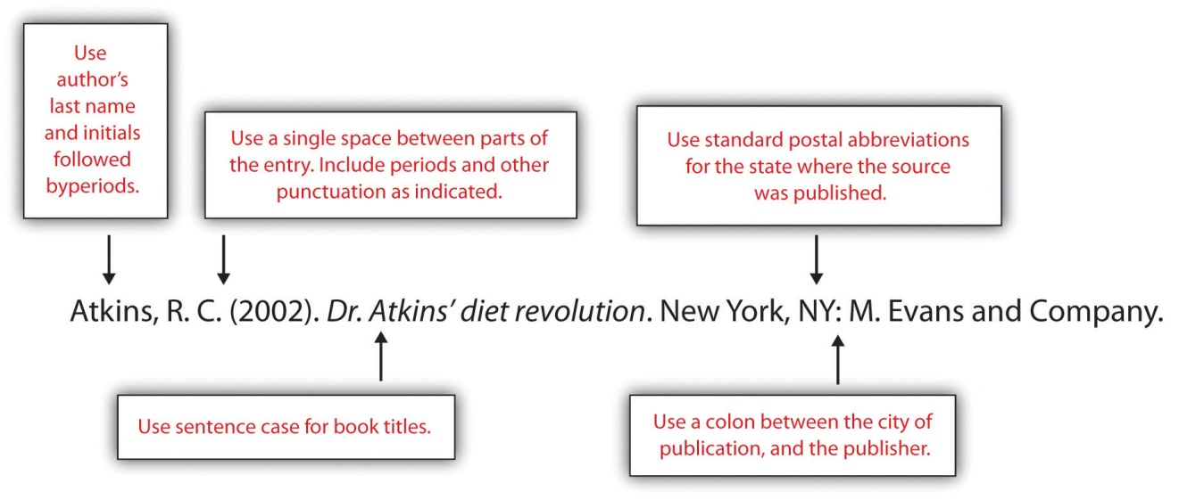

Sample Journal Article Entry
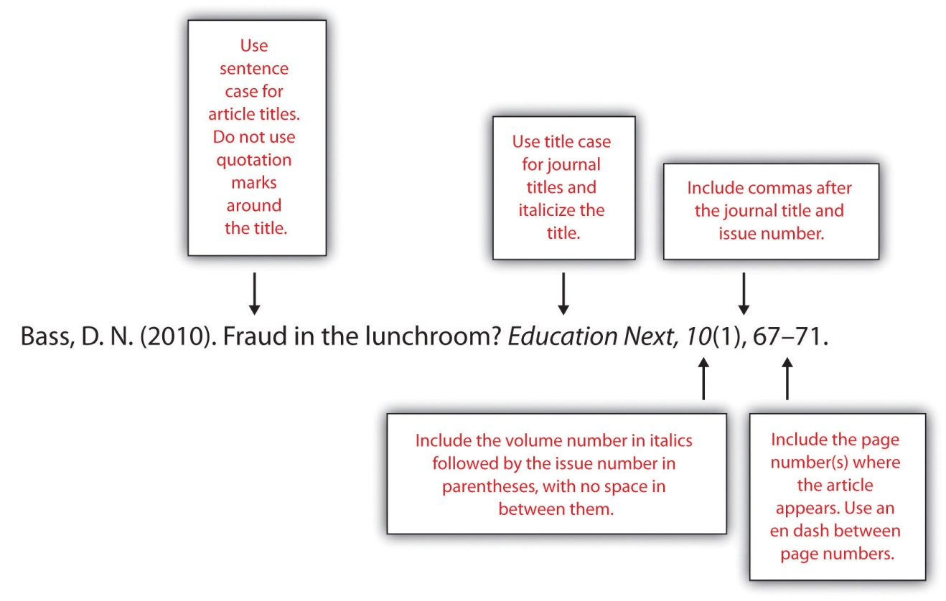

Tip
If you are sourcing a chapter from a book, do not italicize the title of the chapter; instead, use double quotes. You also need to include the pages of the chapter within the book. (You do italicize the title of the book, similar to the journal article example above.)
The following box provides general guidelines for formatting the reference page. For the remainder of this chapter, you will learn about how to format reference entries for different source types, including multi-author and electronic sources.

Formatting the References Section: APA General Guidelines
- Include the heading References, centred at the top of the page. The heading should not be boldfaced, italicized, or underlined.
- Use double-spaced type throughout the references section, as in the body of your paper.
- Use hanging indentation for each entry. The first line should be flush with the left margin, while any lines that follow should be indented five spaces. (Hanging indentation is the opposite of normal indenting rules for paragraphs.)
- List entries in alphabetical order by the author’s last name. For a work with multiple authors, use the last name of the first author listed.
- List authors’ names using this format: Smith, J. C.
- For a work with no individual author(s), use the name of the organization that published the work or, if this is unavailable, the title of the work in place of the author’s name.
- For works with multiple authors, follow these guidelines:
- For works with up to and including seven authors, list the last name and initials for each author.
- For works with more than seven authors, list the first six names, followed by ellipses, and then the name of the last author listed.
- Use an ampersand before the name of the last author listed.
- Use title case for journal titles. Capitalize all important words in the title.
- Use sentence case for all other titles—books, articles, web pages, and other source titles. Capitalize the first word of the title. Do not capitalize any other words in the title except for the following:
- Proper nouns
- First word of a subtitle
- First word after a colon or dash
- Use italics for book and journal titles. Do not use italics, underlining, or quotation marks for titles of shorter works, such as articles.

Tip
There are many word processing programs and websites available that allow you to just plug in your referencing information and it will format it to the style required. If you decide to use such a program, you must still check all your references against your referencing guide because the way those programs and sites piece the information together may not be the exact way you are expected to do so at your school. Always double check!

Writing at Work
Citing other people’s work appropriately is just as important in the workplace as it is in school. If you need to consult outside sources to research a document you are creating, follow the general guidelines already discussed, as well as any industry-specific citation guidelines. For more extensive use of others’ work—for instance, requesting permission to link to another company’s website on your own corporate website—always follow your employer’s established procedures.

Formatting Reference Page Entries
As is the case for in-text citations, formatting reference entries becomes more complicated when you are citing a source with multiple authors, various types of online media, or sources for which you must provide additional information beyond the basics listed in the general guidelines. The following sections show how to format reference entries by type of source.

Print Sources: Books
For book-length sources and shorter works that appear in a book, follow the guidelines that best describe your source.

A Book by Two or More Authors
List the authors’ names in the order they appear on the book’s title page. Use an ampersand (&) before the last author’s name.
Campbell, D. T., & Stanley, J. C. (1963). Experimental and quasi-experimental designs for research. Boston, MA: Houghton Mifflin.

An Edited Book with No Author
List the editor or editors’ names in place of the author’s name, followed by Ed. or Eds. in parentheses.
Myers, C., & Reamer, D. (Eds.). (2009). 2009 nutrition index. San Francisco, CA: HealthSource, Inc.

An Edited Book with an Author
List the author’s name first, followed by the title and the editor or editors. Note that when the editor is listed after the title, you list the initials before the last name.
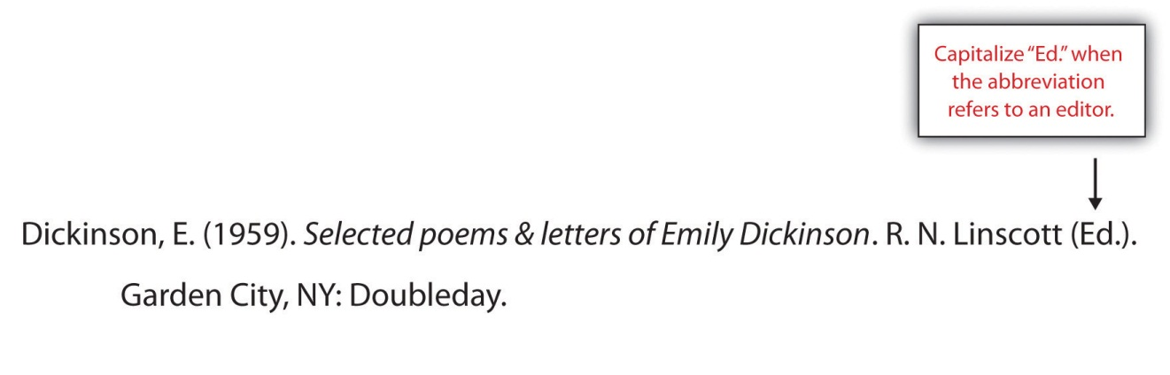

Tip
The previous example shows the format used for an edited book with one author—for instance, a collection of a famous person’s letters that has been edited. This is different from an anthology, which is a collection of articles or essays by different authors. For citing works in anthologies, see the guidelines later in this section.

A Translated Book
Include the translator’s name after the title, and at the end of the citation, list the date the original work was published. Note that for the translator’s name, you list the initials before the last name.
Freud, S. (1965). New introductory lectures on psycho-analysis (J. Strachey, Trans.). New York, NY: W. W. Norton. (Original work published 1933).

A Book Published in Multiple Editions
If you are using any edition other than the first, include the edition number in parentheses after the title.
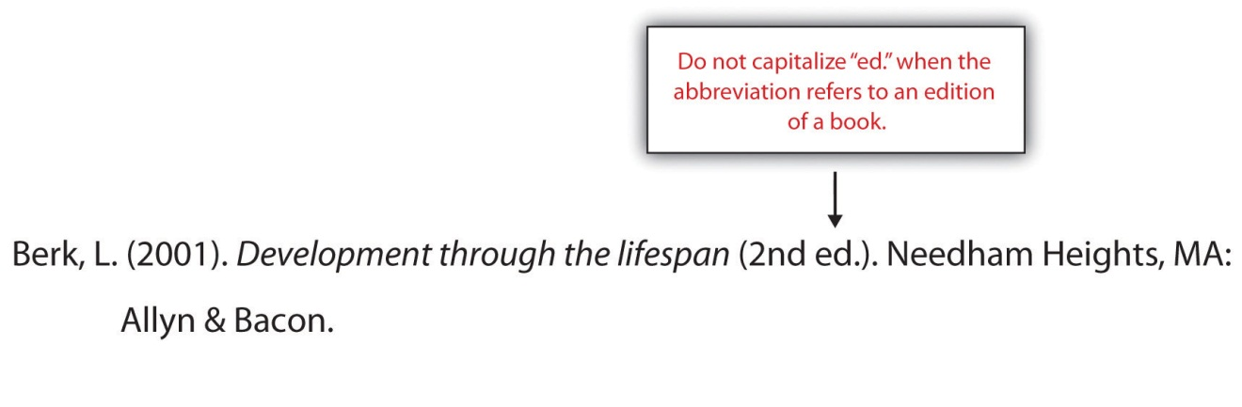

A Chapter in an Edited Book
List the name of the author(s) who wrote the chapter, followed by the chapter title. Then list the names of the book editor(s) and the title of the book, followed by the page numbers for the chapter and the usual information about the book’s publisher.
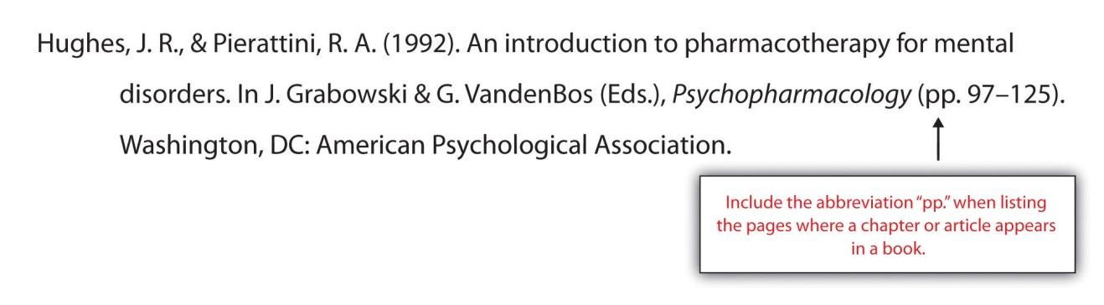

A Work That Appears in an Anthology
Follow the same process you would use to cite a book chapter, substituting the article or essay title for the chapter title.
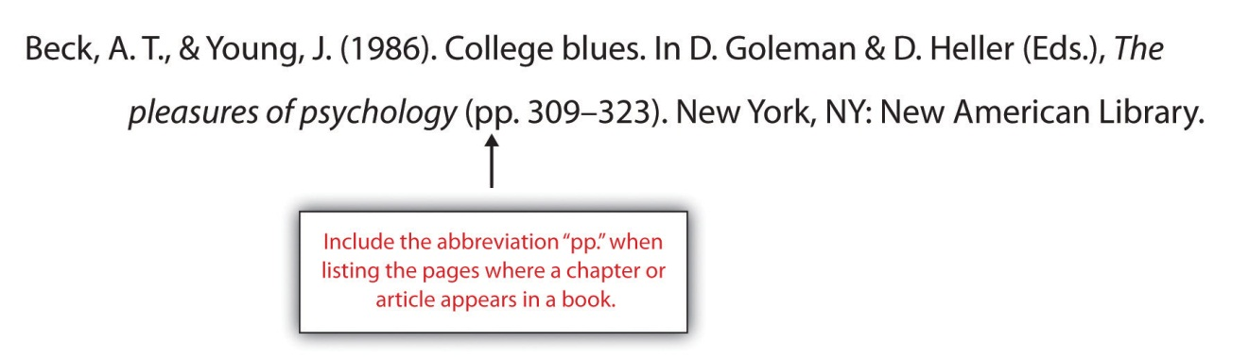

An Article in a Reference Book
List the author’s name if available; if no author is listed, provide the title of the entry where the author’s name would normally be listed. If the book lists the name of the editor(s), include it in your citation. Indicate the volume number (if applicable) and page numbers in parentheses after the article title.
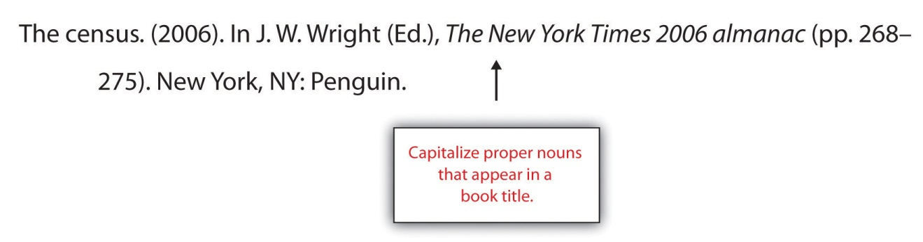

Two or More Books by the Same Author
List the entries in order of their publication year, beginning with the work published first.
Swedan, N. (2001). Women’s sports medicine and rehabilitation. Gaithersburg, MD: Aspen Publishers.
Swedan, N. (2003). The active woman’s health and fitness handbook. New York, NY: Perigee.
If two books have multiple authors, and the first author is the same but the others are different, alphabetize by the second author’s last name (or the third or fourth, if necessary).
Carroll, D., & Aaronson, F. (2008). Managing type II diabetes. Chicago, IL: Southwick Press.
Carroll, D., & Zuckerman, N. (2008). Gestational diabetes. Chicago, IL: Southwick Press.

Books by Different Authors with the Same Last Name
Alphabetize entries by the authors’ first initial.
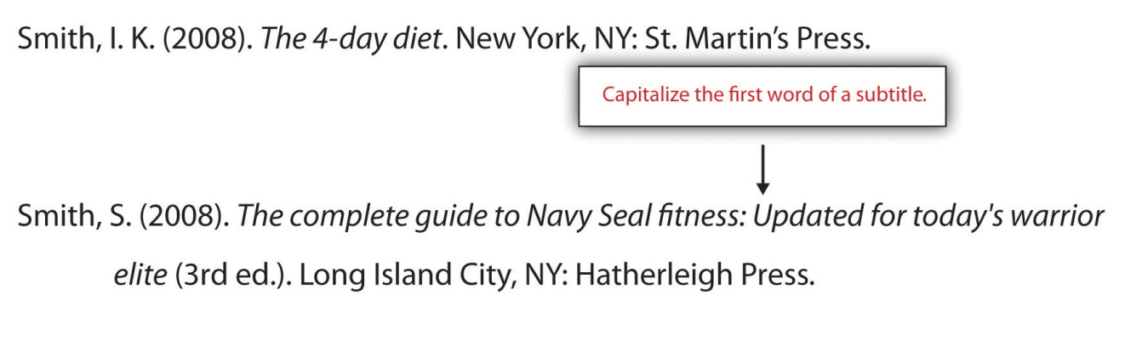

A Book Authored by an Organization
Treat the organization name as you would an author’s name. For the purposes of alphabetizing, ignore words like the in the organization’s name (e.g., a book published by the American Heart Association would be listed with other entries whose authors’ names begin with A.)
American Psychiatric Association. (1994). Diagnostic and statistical manual of mental disorders DSM-IV (4th ed.). Arlington, VA: American Psychiatric Publishing.

A Book Authored by a Government Agency
Treat these as you would a book published by a non-governmental organization, but be aware that these works may have an identification number listed. If so, include the number in parentheses after the publication year.
U.S. Census Bureau. (2002). The decennial censuses from 1790 to 2000(Publication No. POL/02-MA). Washington, DC: US Government Printing Offices.

Print Sources: Periodicals

An Article in a Scholarly Journal
Include the following information:
- Author or authors’ names
- Publication year
- Article title (in sentence case, without quotation marks or italics)
- Journal title (in title case and in italics)
- Volume number (in italics)
- Issue number (in parentheses)
- Page number(s) where the article appears
DeMarco, R. F. (2010). Palliative care and African American women living with HIV. Journal of Nursing Education, 49(5), 1–4.

An Article in a Journal Paginated by Volume
In journals, page numbers are continuous across all the issues in a particular volume. For instance, the winter issue may begin with page 1, and in the spring issue that follows, the page numbers pick up where the previous issue left off. (If you have ever wondered why a print journal did not begin on page 1, or wondered why the page numbers of a journal extend into four digits, this is why.) Omit the issue number from your reference entry.
Wagner, J. (2009). Rethinking school lunches: A review of recent literature. American School Nurses’ Journal, 47, 1123–1127.

An Abstract of a Scholarly Article
At times you may need to cite an abstract—the summary that appears at the beginning of a published article. If you are citing the abstract only, and it was published separately from the article, provide the following information:
- Publication information for the article
- Information about where the abstract was published (for instance, another journal or a collection of abstracts)
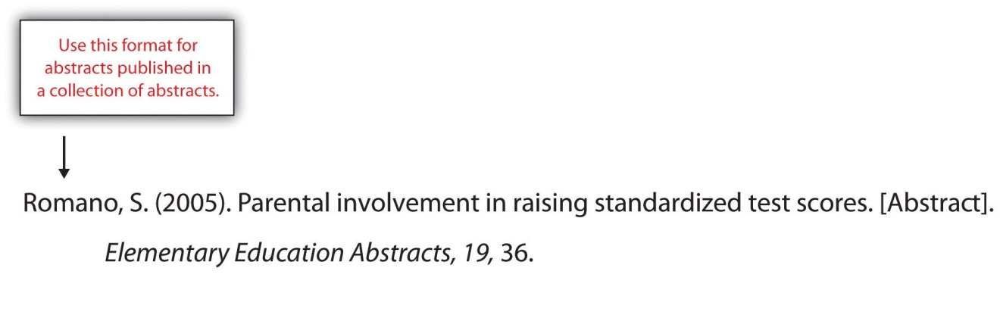
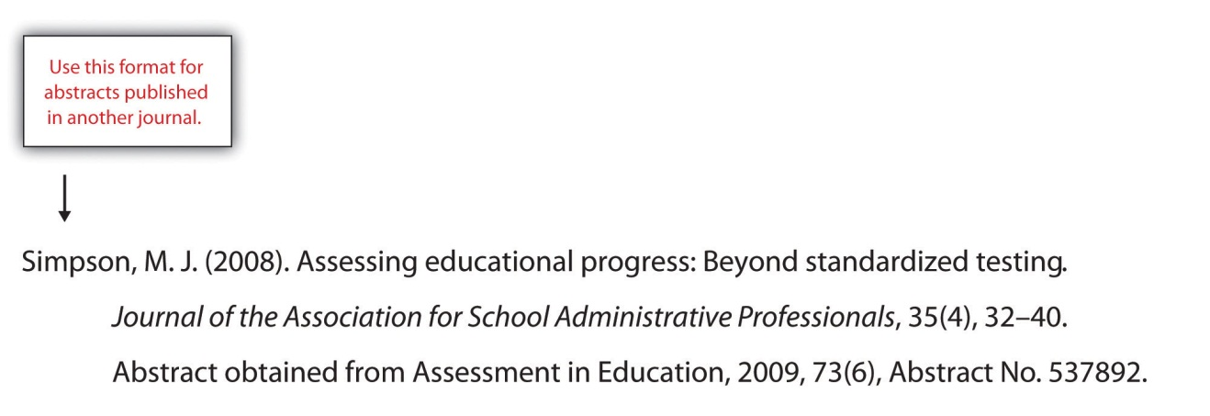

A Journal Article with Two to Seven Authors
List all the authors’ names in the order they appear in the article. Use an ampersand before the last name listed.
Barker, E. T., & Bornstein, M. H. (2010). Global self-esteem, appearance satisfaction, and self-reported dieting in early adolescence. Journal of Early Adolescence, 30(2), 205–224.

Tremblay, M. S., Shields, M., Laviolette, M., Craig, C. L., Janssen, I., & Gorber, S. C. (2010). Fitness of Canadian children and youth: Results from the 2007–2009 Canadian Health Measures Survey. Health Reports, 21(1), 7–20.

A Journal Article with More Than Eight Authors
List the first six authors’ names, followed by a comma, an ellipsis, and the name of the last author listed. The article in the following example has 16 listed authors; the reference entry lists the first six authors and the 16th, omitting the seventh through the 15th.
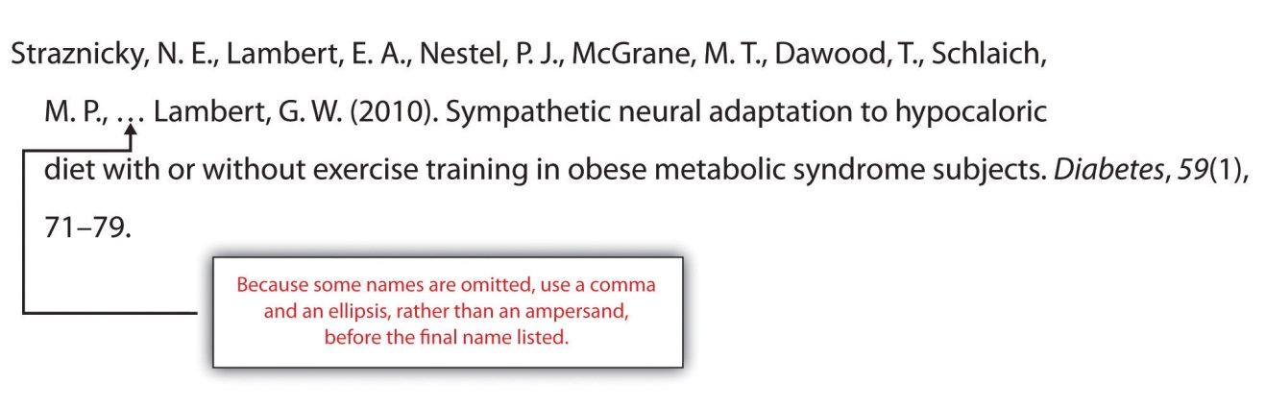

Writing at Work
The idea of an eight-page article with 16 authors may seem strange to you—especially if you are in the midst of writing a 10-page research paper on your own. More often than not, articles in scholarly journals list multiple authors. Sometimes, the authors actually did collaborate on writing and editing the published article. In other instances, some of the authors listed may have contributed to the research in some way while being only minimally involved in the process of writing the article. Whenever you collaborate with colleagues to produce a written product, follow your profession’s conventions for giving everyone proper credit for their contribution.

A Magazine Article
After the publication year, list the issue date. Otherwise, magazine articles as you would journal articles. List the volume and issue number if both are available.
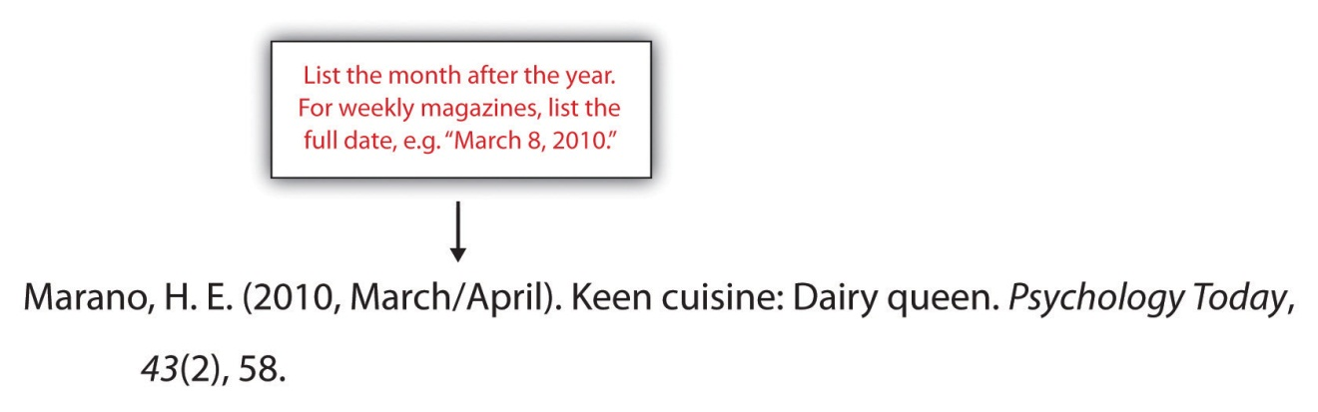

A Newspaper Article
Treat newspaper articles as you would magazine and journal articles, with one important difference: precede the page number(s) with the abbreviation p. (for a single-page article) or pp. (for a multipage-page article). For articles that have non-continuous pagination, list all the pages included in the article. For example, an article that begins on page A1 and continues on pages A4 would have the page reference A1, A4. An article that begins on page A1 and continues on pages A4 and A5 would have the page reference A1, A4–A5.

A Letter to the Editor
After the title, indicate in brackets that the work is a letter to the editor.
Jones, J. (2009, January 31). Food police in our schools [Letter to the editor]. Rockwood Gazette, p. A8.

A Review
After the title, indicate in brackets that the work is a review and state the name of the work being reviewed. (Note that even if the title of the review is the same as the title of the book being reviewed, as in the following example, you should treat it as an article title. Do not italicize it.)
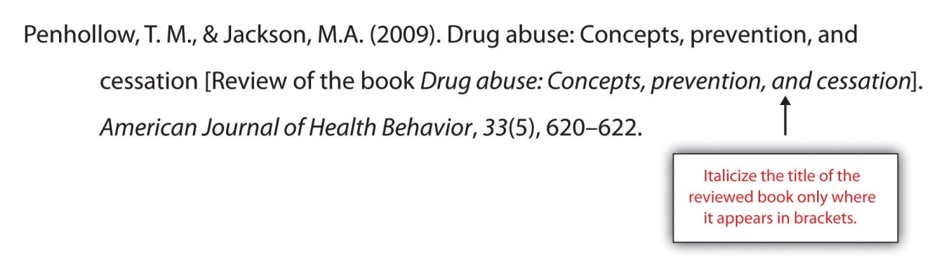

Electronic Sources

Citing Articles from Online Periodicals: URLs and Digital Object Identifiers (DOIs)
Whenever you cite online sources, it is important to provide the most up-to-date information available to help readers locate the source. In some cases, this means providing an article’s URL, or web address. (The letters URL stand for uniform resource locator.) Always provide the most complete URL possible. Provide a link to the specific article used, rather than a link to the publication’s homepage.
As you likely know, web addresses are not always stable. If a website is updated or reorganized, the article you accessed in April may move to a different location in May. The URL you provided may become a dead link. For this reason, many online periodicals, especially scholarly publications, now rely on DOIs rather than URLs to keep track of articles.
A DOI is a digital object identifier—an identification code provided for some online documents, typically articles in scholarly journals. Like a URL, its purpose is to help readers locate an article. However, a DOI is more stable than a URL, so it makes sense to include it in your reference entry when possible. Follow these guidelines:
- If you are citing an online article with a DOI, list the DOI at the end of the reference entry.
- If the article appears in print as well as online, you do not need to provide the URL. However, include the words electronic version after the title in brackets.
- In all other respects, treat the article as you would a print article. Include the volume number and issue number if available. (Note, however, that these may not be available for some online periodicals.)

An Article from an Online Periodical with a DOI
List the DOI if one is provided. There is no need to include the URL if you have listed the DOI.
Bell, J. R. (2006). Low-carb beats low-fat diet for early losses but not long term. OBGYN News, 41(12), 32. doi:10.1016/S0029-7437(06)71905-X

An Article from an Online Periodical with No DOI
List the URL. Include the volume and issue number for the periodical if this information is available. (For some online periodicals, it may not be.)
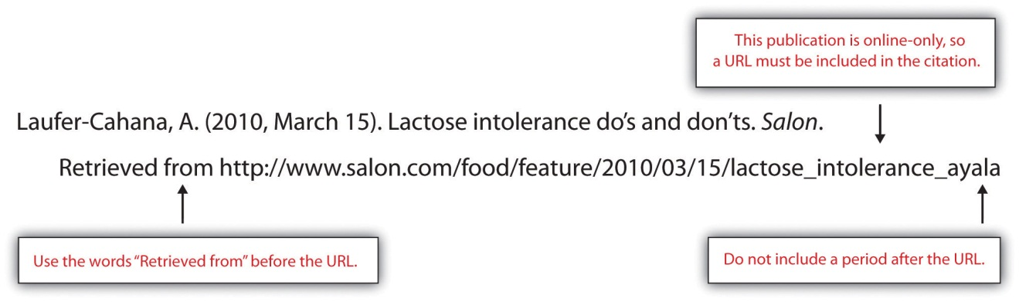
Note that if the article appears in a print version of the publication, you do not need to list the URL, but do indicate that you accessed the electronic version.
Robbins, K. (2010, March/April). Nature’s bounty: A heady feast [Electronic version]. Psychology Today, 43(2), 58.

A Newspaper Article
Provide the URL of the article.
McNeil, D. G. (2010, May 3). Maternal health: A new study challenges benefits of vitamin A for women and babies. The New York Times. Retrieved from http://www.nytimes.com/2010/05/04/health/04glob.html?ref=health

An Article Accessed through a Database
Cite articles accessed through a database the same way you would normally cite a print article. Provide database information only if the article is difficult to locate.

Tip
APA style does not require the item number or accession number for articles retrieved from databases. You may choose to include it if the article is difficult to locate or the database is an obscure one. Check with your instructor for specific requirements for your course.

An Abstract of an Article
Format article abstracts as you would an article citation, but add the word Abstract in brackets after the title.
Bradley, U., Spence, M., Courtney, C. H., McKinley, M. C., Ennis, C. N., McCance, D. R.…Hunter, S. J. (2009). Low-fat versus low-carbohydrate weight reduction diets: Effects on weight loss, insulin resistance, and cardiovascular risk: A randomized control trial [Abstract]. Diabetes,58(12), 2741–2748. http://diabetes.diabetesjournals.org/content/early/2009/08/23/db00098.abstract

A Nonperiodical Web Document
The ways you cite different nonperiodical web documents may vary slightly from source to source, depending on the information available. In your citation, include as much of the following information as you can:
- Name of the author(s), whether an individual or organization
- Date of publication (Use n.d. if no date is available.)
- Title of the document
- Address where you retrieved the document
If the document consists of more than one web page within the site, link to the homepage or the entry page for the document.
American Heart Association. (2010). Heart attack, stroke, and cardiac arrest warning signs. Retrieved from http://www.americanheart.org/presenter.jhtml?identifier=3053

An Entry from an Online Encyclopedia or Dictionary
Because these sources often do not include authors’ names, you may list the title of the entry at the beginning of the citation. Provide the URL for the specific entry.
Addiction. (n.d.) In Merriam-Webster’s online dictionary. Retrieved from http://www.merriam-webster.com/dictionary/addiction

Graphic Data
When citing graphic data—such as maps, pie charts, bar graphs, and so on—include the name of the organization that compiled the information, along with the publication date. Briefly describe the contents in brackets. Provide the URL where you retrieved the information. (If the graphic is associated with a specific project or document, list it after your bracketed description of the contents.)
US Food and Drug Administration. (2009). [Pie charts showing the percentage breakdown of the FDA’s budget for fiscal year 2005]. 2005 FDA budget summary. Retrieved from mhttp://www.fda.gov/AboutFDA/ReportsManualsForms/Reports/BudgetReports/2005FDABudgetSummary/ucm117231.htm

An Electronic Book
Electronic books may include books available as text files online or audiobooks. If an electronic book is easily available in print, cite it as you would a print source. If it is unavailable in print (or extremely difficult to find), use the format in the example. (Use the words Available from in your citation if the book must be purchased or is not available directly.)
Chisholm, L. (n.d.). Celtic tales. Retrieved from http://www.childrenslibrary.org/icdl/BookReader?bookid= chicelt_00150014&twoPage=false&route=text&size=0&fullscreen=false&pnum1=1&lang= English&ilang=English

A Chapter from an Online Book or a Chapter or Section of a Web Document
Chapters and sections from online books or web documents are treated similarly to their print counterparts with the addition of retrieval information. Include the chapter or section number in parentheses after the book title.
Hart, A. M. (1895). Restoratives—Coffee, cocoa, chocolate. In Diet in sickness and in health (VI). Retrieved from http://www.archive.org/details/dietinsicknessin00hartrich

A Dissertation or Thesis from a Database
Provide the author, date of publication, title, and retrieval information. If the work is numbered within the database, include the number in parentheses at the end of the citation.
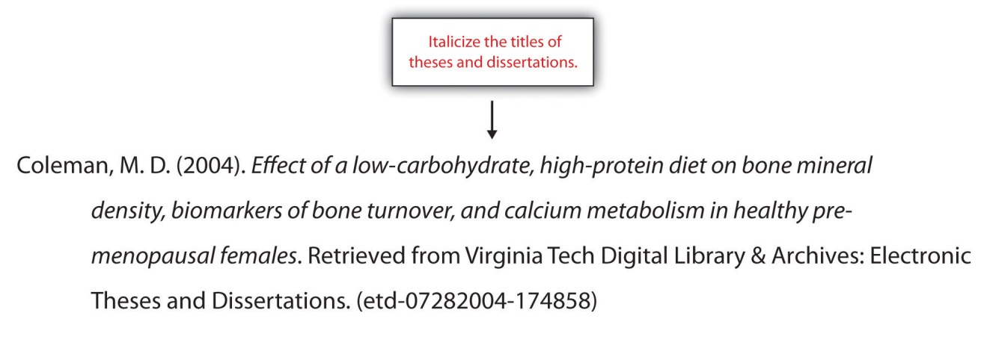

Computer Software
For commonly used office software and programming languages, it is not necessary to provide a citation. Cite software only when you are using a specialized program, such as the nutrition tracking software in the following example. If you download software from a website, provide the version and the year if available.
Internet Brands, Inc. (2009). FitDay PC (Version 2) [Software]. Available from http://www.fitday.com/Pc/PcHome.html?gcid=14

A Post on a Blog or Video Blog
Citation guidelines for blogs are similar to those used for discussion forum postings. Briefly describe the type of source in brackets after the title.
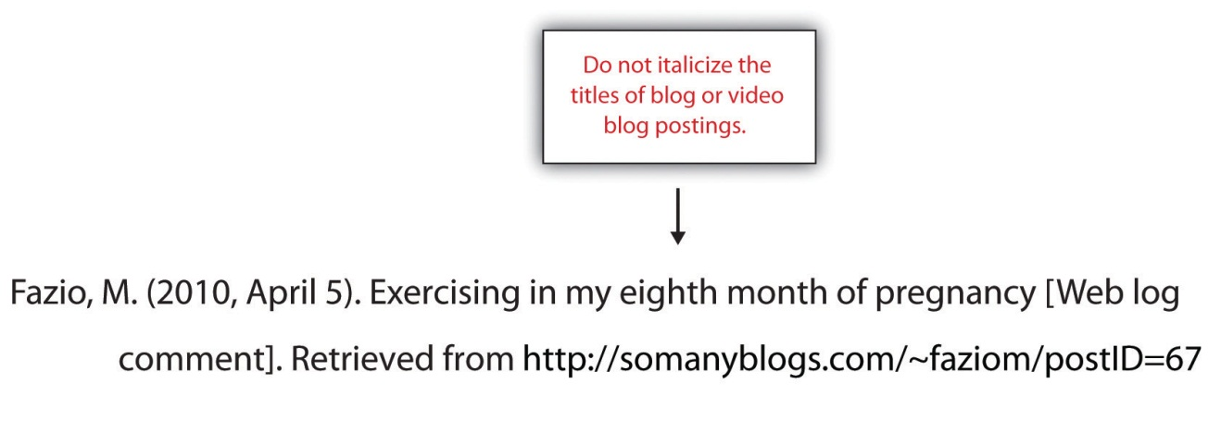

Writing at Work
Because the content may not be carefully reviewed for accuracy, discussion forums and blogs should not be relied upon as a major source of information. However, it may be appropriate to cite these sources for some types of research. You may also participate in discussion forums or comment on blogs that address topics of personal or professional interest. Always keep in mind that when you post, you are making your thoughts public—and in many cases, available through search engines. Make sure any posts that can easily be associated with your name are appropriately professional, because a potential employer could view them.

A Television or Radio Broadcast
Include the name of the producer or executive producer; the date, title, and type of broadcast; and the associated company and location.
West, Ty. (Executive producer). (2009, September 24). PBS special report: Health care reform [Television broadcast]. New York, NY, and Washington, DC: Public Broadcasting Service.

A Television or Radio Series or Episode
Include the producer and the type of series if you are citing an entire television or radio series.
Couture, D., Nabors, S., Pinkard, S., Robertson, N., & Smith, J. (Producers). (1979). The Diane Rehm show [Radio series]. Washington, DC: National Public Radio.
To cite a specific episode of a radio or television series, list the name of the writer or writers (if available), the date the episode aired, its title, and the type of series, along with general information about the series.
Bernanke, J., & Wade, C. (2010, January 10). Hummingbirds: Magic in the air [Television series episode]. In F. Kaufman (Executive producer), Nature. New York, NY: WNET.

A Motion Picture
Name the director or producer (or both), year of release, title, country of origin, and studio.
Spurlock, M. (Director/producer), Morley, J. (Executive producer), & Winters. H. M. (Executive producer). (2004). Super size me. United States: Kathbur Pictures in association with Studio on Hudson.

A Recording
Name the primary contributors and list their role. Include the recording medium in brackets after the title. Then list the location and the label.
Smith, L. W. (Speaker). (1999). Meditation and relaxation [CD]. New York, NY: Earth, Wind, & Sky Productions.

Székely, I. (Pianist), Budapest Symphony Orchestra (Performers), & Németh, G. (Conductor). (1988). Chopin piano concertos no. 1 and 2 [CD]. Hong Kong: Naxos.

A Podcast
Provide as much information as possible about the writer, director, and producer; the date the podcast aired; its title; any organization or series with which it is associated; and where you retrieved the podcast.
Kelsey, A. R. (Writer), Garcia, J. (Director), & Kim, S. C. (Producer). (2010, May 7). Lies food labels tell us. Savvy consumer podcast [Audio podcast]. Retrieved from http://www.savvyconsumer.org/podcasts/050710

Self-Practice EXERCISE 9.4
Using the guidelines above and your JIBC APA Reference Guide, identify what each of these types of sources are based on their identifying characteristics and under which categories you would find them in the reference guide. Choose the answer that best describes each example.
- Baudrillard, Jean. For a Critique of the Political Economy of the Sign. Trans. Charles Levin. Saint Louis: Telos, 1981.
- A book with two authors
- A multi-volume work
- An article in a journal
- A book with one author
- United States Drug Enforcement Administration. (2014). The Dangers and consequences of marijuana abuse. Retrieved from http://www.justice.gov/dea/docs/dangers-consequences-marijuana-abuse.pdf
- Online government document
- Online task force report, corporate author
- Online codes and standards
- A blog
- Watson, S. (2003). Antigone. In R. Sullivan & M. Levene (Eds.), Short Fiction: An Anthology (pp. 323-329). Don Mills, Ont.: Oxford University Press. (Original work published 1979)
- A short story reprinted in an anthology
- A chapter in a book
- A multi-volume book
- A book with three authors
- Gilbert, Elliot. “The Ceremony of Innocence: Charles Dickens’s A Christmas Carol.” PMLA 90 (1975): 22-31.
- An online journal article
- An academic article
- A chapter in a book
- A newspaper article
- Ogborne, A.C., Smart, R.G., & Adlaf, E.M. (2000). Self-reported medical use of marijuana: A survey of the general population. Canadian Medical Association Journal, 162(12), 1685. Retrieved from http://ecmaj.ca.cgi
- An online academic journal article
- An online authored report, non-governmental organization
- An online academic journal article by multiple authors
- An e-version of a print book
- David, L. (Producer) & Guggenheim, D. (Director). (2006). An Inconvenient Truth [Motion Picture]. United States: Lawrence Bender Productions.
- A CD-ROM
- A television series
- A video/DVD
- A blog
- Jaynes, J. 1986 Consciousness of the voices of the mind. Canadian Psychology 27. 128-137.
- An online journal article
- An academic journal article
- A book
- A magazine article
- Spiro, M.D. (1983). Introduction: Thirty years of kibbutz research. In E. Krause (Ed.), The sociology of the kibbutz: Studies in Israeli society II. New Brunswick, NJ: Transaction Books.
- A book
- A chapter
- An edited book
- All of the above
- Kamel, F., Tanner, C., Umbach, D., Hoppin, J., Alavanja, M., Blair, A.,… Sandler, D. (2007). Pesticide exposure and self-reported Parkinson’s disease in the agricultural health study. Am J Epidemiol, 165: 364-374.
- An online academic article with eight or more authors
- A book with eight or more authors
- A print journal article with eight or more authors
- A chapter in an edited book
- McPartland, J.M., & Pruitt, P.L. (1997). Medical marijuana and its use by the immunocompromised. Alternative Therapies in Health and Medicine, 3(3), 39-45. doi: 10.1080/102825
- An online newspaper article
- An online article with DOI
- A chapter of a book from an online library
- All of the above

Some examples taken from:
Writing Commons. (2014, September). Open Text. Retrieved from http://writingcommons.org/format/apa/675-block-quotations-apa

Answers

- D. Although two names are given, only the first is the author; the second is a translator. It is a book because it has a city and publisher.
- A. Starts with “United States” = good chance it is a government-produced document
- A. The title of the book contains “anthology,” which means collection of stories, and “fiction” refers to stories. We know it is a book because of the city and publisher.
- B. There are actually three titles given here: the article, a book within the title of the article, the journal name PMLA (Publications of the Modern Language Association). There are also a volume number after PMLA and page numbers.
- C. There are three authors, URL, and title of journal, identifying it as an online article with multiple authors.
- C. The keywords identifying it as a video/DVD are director, producer, and motion picture
- B. The title of journal and article, and the page numbers identify it as a journal article, but there is no URL so we know it is not online.
- D. There are two titles, one italicized and one not, so it is part of a bigger source; the second name followed by “Ed.” shows this was an edited book; we know it is a book because of the city and publisher.
- C. The title of journal and article, with page numbers, identifies it as a journal article, but not online as there is no URL. More than eight authors are listed.
- B. It is identified as a journal article because the journal title is given, and the name of the article. There is no URL but there is a DOI, identifying it as being online.

Sample Reference Page
Review the following example from Jorge’s paper on evaluating low-carbohydrate diets. This is an example of how to piece all of your referencing information into one section.
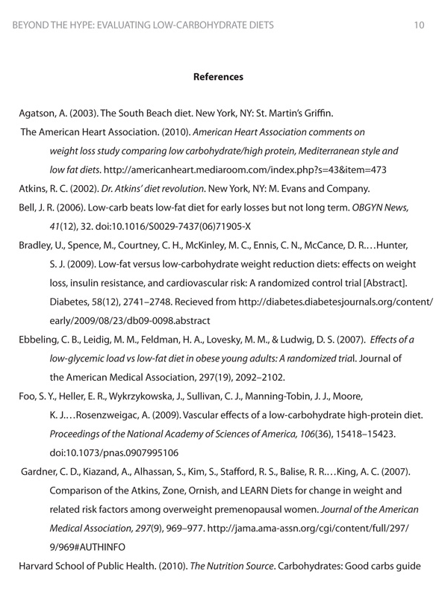
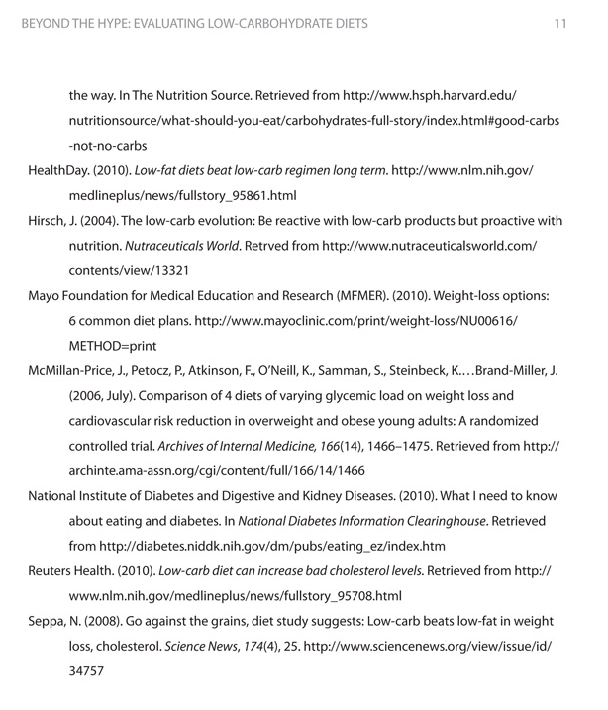

Assignment 3 (2.5%)
Using the JIBC APA Reference Guide, compile a reference page consisting of the six sources given below. You will need to apply the required formatting for each of the references as well as the page as a whole. You will have to look at each of the sources and the information that is given for each: there may be some extra information you will need to omit from the references.
1. Identify what type of source this is from the information given.
2. Find the example of that type of source in the reference guide.
3. Decide what information you need and do not need for each.
4. Compose each individual source’s reference.
5. On a separate page, combine the references you created for the six sources into a correctly formatted reference page.
Submit this assignment to your instructor for grading. (2.5%)
Referencing information for Assignment 3
1. American Music Teacher, August-Sept 1999 v49 (1) p34(5) 1998 National Survey of High School Pianists. Harold Kafer; Richard Kennel
2. The Economist (US), June 1, 1996 v339 n7968 p79(1) The food of the gods.
3. Current Directions in Psychological Science, Dec 2005 v14 i6 p317(4) Music and Cognitive Abilities. Glenn E. Schellenberg
4. Nursing interventions: effective nursing treatments / [edited by] Gloria M. Bulechek, Joanne C. McCloskey. Philadelphia: Saunders, c1999. 3rd ed Includes bibliographical references and index. ISBN: 072167724X Fenwick Stacks Call Number: RT48 .N8833 1999
5. Kok, S.C. (2005). Music and learning. In Hoffman, B. (Ed.), Encyclopedia of Educational Technology.Retrieved: March 28, 2008, from http://coe.sdsu.edu/eet/articles/musiclearning/start.htm
6. Tuning up young minds: music lessons give kids a small IQ advantage.B. Bower. Science News 165.25 (June 19, 2004): p389(1). (446 words)

Checklist 9.1 Reference Page Reminder
Just to review, your final reference page needs to:
- Start on an fresh page after your last page of writing
- Be titled “Reference Page” or “References”
- Be in alphabetical order based on the author’s last name
- Be double spaced
- Have hanging indents

Tip
In APA style, book and article titles are formatted in sentence case, not title case. Sentence case means that only the first word is capitalized, along with any proper nouns.

KEY TAKEAWAYS
- In APA papers, in-text citations usually include the name(s) of the author(s) and the year of publication.
- In-text citations correspond to entries in the references section, which provide detailed referencing information about a source.
- Entries in the references section include as much of the following information as possible:
- Print sources. Author(s), date of publication, title, publisher, page numbers (for shorter works), editors (if applicable), and periodical title (if applicable).
- Online sources (text based). Author(s), date of publication, title, publisher or sponsoring organization, and DOI or URL (if applicable).
- Electronic sources (non-text based). Details about the creator(s) of the work, title, associated company or series, and date the work was produced or broadcast. The specific details provided will vary depending on the medium and the information that is available.
- Electronic sources (text based). If widely available in print form, it is sometimes unnecessary to provide details about how to access the electronic version. Check the guidelines for the specific source type.

Journal entry #9
Write a paragraph or two responding to the following.
- What did you find the most straightforward/easy about citations?
- What did you find more difficult about citations?
- What did you find the most straightforward/easy about composing references?
- What did you find more difficult about composing references?
- What concerns you most about referencing citations? What will you do to address this?
Remember as mentioned in the Assessment Descriptions in your syllabus:
- You will be expected to respond to the questions by reflecting on and discussing your experiences with the week’s material.
- When writing your journals, you should focus on freewriting—writing without (overly) considering formal writing structures—but remember that it will be read by the instructor, who needs to be able to understand your ideas.
- Your instructor will be able to see if you have completed this entry by the end of the week but will not read all of the journals until week 11.

