Communication Beginnings:
An Introductory Listening and Speaking Text for English Language Learners
By Della Jean Abrahams

© 2018 Della Jean Abrahams

This work is licensed under a
Creative Commons Attribution-NonCommercial 4.0 International License
You are free to:
- Share — copy and redistribute the material in any medium or format
- Adapt — remix, transform, and build upon the material

The licensor cannot revoke these freedoms as long as you follow the license terms.
Under the following terms:
- Attribution — You must give appropriate credit, provide a link to the license, and indicate if changes were made. You may do so in any reasonable manner, but not in any way that suggests the licensor endorses you or your use.
- NonCommercial — You may not use the material for commercial purposes.

This publication was made possible by PDXOpen publishing initiative

Published by Portland State University Library
Portland, OR 97207-1151

Cover design by Della Jean Abrahams

Photo from Pixabay.com, CC0

This book is dedicated to my parents for teaching me the importance of education and to Emad Albidah for reminding me how joyous learning a new language can be.

Thank you also to the Portland State University Library for the PDXOpen publishing grant and to Karen Bjork for assisting with the process so graciously. A thank you also to Dr. Nike Arnold and her graduate Materials Design course for collaborating on this project with me, and most of all a huge thank you to the Intensive English Language Program at PSU for introducing me to hundreds of English language learners from every corner of the globe, many of whom continue to inspire me to this day.

Background and Rationale
This textbook is designed for advanced beginner-low intermediate English language learners. The target audience for this book is an academic English program in a university setting, but with slight modifications, it can be adapted to meet the needs of adult learners in community classrooms.

The book is composed of 7 chapters with brief descriptions in the table of contents on the next page. Each chapter includes listening and speaking components such as dialogues, interviews, discussions and conversation activities. Each chapter also focuses on 10 target words from the New General Service List of English vocabulary and reviews basic grammar points. The textbook includes an audio component that consists of recorded conversations of native and non-native English speakers, as well as links to additional listening resources on the web.

It is my hope that this text can create and facilitate a communicative and productive learning environment for students and their instructors. Because of the open access format of this textbook, learners from around the world may also potentially benefit from the content and improve language skills independently by downloading this book free of charge. Lastly and importantly, there are currently very few open access textbooks in the field of ESL, and it is my hope that creating this one will inspire additional instructors to create their own in the near future.

Enjoy!
Table of Contents
Chapter 1- Learning how to speak and listen in English: Page 1-11
- Tips and strategies for increasing and retaining learning
- Advice on learning English in a university setting

Chapter 2- Introductions: Page 12-24

  - Describing yourself and other people
    - Grammar points
      - Third person singular ‘s’
      - Subject pronouns and possessive adjectives

Chapter 3- Talking about travel and experiences: Page 25-36

  - Intonation in English
    - Grammar points
      - WH and Yes/No question formation

Chapter 4- Discussing food and eating: Page 37-50

- Understanding Conversational English with reduced speech
    - Grammar points
      - Contractions in English

Chapter 5- Describing places around town: Page 51-64
- Addresses and place descriptions
    - Grammar points
      - Past tense verbs
      - Ordinal and cardinal numbers

Chapter 6- Communicating about hobbies and routines: Page 65-73

- Agreeing and Disagreeing in English
    - Grammar points
      - Using so, too, neither and either
      - Adverbs of frequency

Chapter 7- Discussing jobs and university majors: Page 74-85

  - Word and syllable stress in English
    - Grammar points
      - Future tense verbs

Script and Answer Key: Page 86-91

Vocabulary List
Chapter 1
important (adj.) information (n.) opinion (n.) discuss (v.) response (n.)
apply (v.) knowledge (n.) strategy (n.) environment (n.) success (n.)

Chapter 2
interest (n.) country (n.) social (adj.) individual (adj./noun) community (n.)
describe (v.) relationship (n.) generation (n.) favorite (adj.) education (n.)

Chapter 3
view (n./v. ) produce (v.) develop (v.) remember(v.) decide (v.)
argue (v.) achieve (v.) challenge (n./v.) introduce (v.) ability (n.)

Chapter 4
process(n./v.) increase (n./v.) product (n.) allow (v.) suggest (v.)
national (adv.) quality (n.) international (adj.) specific (adj.) avoid (v.)

Chapter 5
public (adj./n.) business (n.) region (n.) population (n.) advantage (n.)
modern (adj.) natural (adj.) traditional (adj.) purchase (n./v.) market (n.)

Chapter 6:
believe (v.) reason(n.) experience (n./v.) create (v.) outdoors (n.)
mind (n.) artistic (adj.) foreign (adv.) necessary (adj.) benefit (n.)

Chapter 7

degree (n.) service (n.) together (adv.) consider ( v.) position (n.)
project (n.) opportunity (n.) interview (n./v.) successful (adj.) demanding (adj.)

Vocabulary words selected from: http://www.newgeneralservicelist.org/

Vocabulary Glossary

ability (n.) The power or skill to do something.
achieve (v.) To get or reach something by working hard.
advantage (n.) Something that is good; a benefit.
allow (v.) To permit someone to have or do something.
apply (v.) To make a request for something such as a job.
argue (v.) To give reasons for or against something.
artistic (adj.) Having or showing the skill of an artist.
avoid (v.) To stay away from something or someone.
believe (v.) To think something is true.
benefit (n.) A good or helpful result of something.
business (n.) A company that makes or sells things for money.
challenge (n./v.) A difficult problem.
community (n.). A group of people who live in the same area.
consider ( v.) To think about something carefully.
country (n.) An area of land controlled by a government.
create (v.) To make or build something.
decide (v.) To make a choice about something.
degree (n.) A diploma earned at a university such as a bachelor’s or master’s.
demanding (adj.) Something that needs a lot of time and hard work.
describe (v.) To say what something looks or feels like.
develop (v.) To cause something to grow or become bigger.
discuss (v.) To talk about an idea or subject with someone.
education (n.) The process of teaching and learning.
environment (n.) The people and things that are around you in life.
experience (n./v.). A skill you get by doing something.
favorite (adj.) A person or thing that is liked more than others.
foreign (adv.) From a different country.
generation (n.) A group of people who are about the same age.
important (adj.). Something that has a big effect on someone’s life.
increase (n./v.) To become bigger in amount or number.
individual (adj./n.) One person or part of a larger group.
Information (n.) Facts or details that tell you about something.
interest (n.) Something that you enjoy doing or learning about.
international (adj.) Involving two or more countries.
interview (n./v. A meeting where people ask each other questions.
introduce (v.) To make someone or something known by name.
knowledge (n.) Information, skills, and understanding that you have gotten through learning
or experience.
market (n.). A place to buy something.
mind (n.) The part of a person that thinks and remembers.
modern (adj.) Something related to a new style.
national (adv.) Relating to a whole country or nation.
natural (adj.) Something from nature; not made by humans.
necessary (adj.) Something so important that you must have it.
opinion (n.) Your idea or belief about a subject.
opportunity (n.) The chance to do something.
outdoors (n.) Outside of a building; not inside.
population (n.) The number of people who live in a place.
position (n.) The place where someone or something is.
process(n./v.) A series of actions that produce something.
produce (v.) To make or create something.
product (n.) Something that is made to be sold.
project (n.) A task that needs to be worked on for some time.
public (adj./n.) Something available to anyone, not private.
purchase (n./v.) To buy something with money.
quality (n.) How good or bad something is.
reason(n.) A fact that explains why something is how it is.
region (n.) A part of a country that is separate or different.
remember(v.) To keep an idea or image in your mind.
relationship (n.) The way people are connected to one another, such as a family.
response (n.) Something that is said or written as a reply.
service (n.) A company that provides something to the public, like cable TV or internet.
social (adj.) Someone who enjoys being with other people.
specific (adj.) Something special or particular.
strategy (n.) A plan of steps for achieving something.
success (n.) When you achieve what you want.
successful (adj.) Doing well at something you want; earning a lot of money, fame or respect.
suggest (v.) To say that something should be chosen.
together (adv.) When two things or two people are with each other.
traditional (adj.) A way of thinking or doing that has been done by people for a long time.
view (n./v. ) An opinion or way of thinking about something.

Chapter 1- Learning English at a University

In this chapter, you will learn about:
- Tips and strategies for learning English in a university setting
- Tips and strategies for improving listening and speaking skills in English
- How to identify syllables in English words

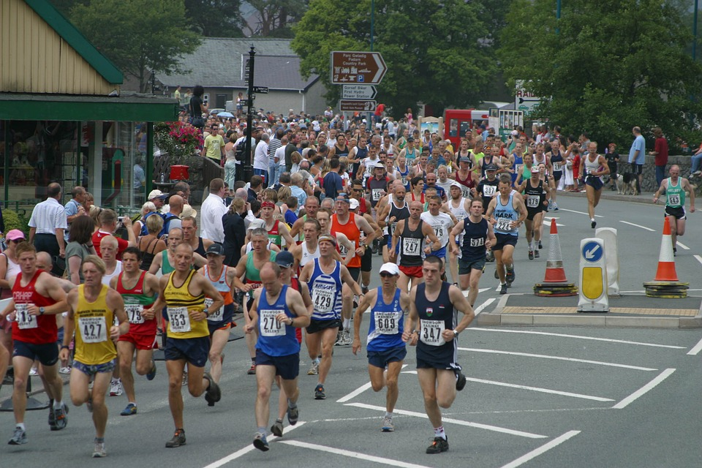
Marathon, by Gwyndafh, CC0

Learning a language is like running in a race. There is a lot of warm-up and a lot of practice before you can do well. However, if you try hard, you can win.

Discussion questions:

- Read the sentences above. How is learning a language similar to running a race? What are some similarities between the two activities? What are some differences?
- When a person runs a race, they need to warm up their muscles before they start. Is learning a new language similar? How can you warm up before speaking in a second language?

Learning English at a University

Maybe you have studied at a university before, but learning a new language is a special goal that needs a special set of tools in order to succeed.

This chapter will discuss three sets of learning tips to help you get on a great start to learning English.

- General learning tips for university classes
- Tips for improving speaking and listening skills
- Tips for learning vocabulary in a second language

--------------------------------------------------------------------

General Learning Tips for English Learners

Follow the learning tips below to improve your language learning.
Remember that learning must happen in the class with your teacher and classmates but also outside of class in your own time. Use English as much as possible!

In class  - Speak only English as much as possible  - Sit by someone who doesn’t speak your language in class  - Ask a lot of questions when you don’t understand  - Before you translate a word in your dictionary to your language, try to understand the word from its context (the words around it)  - When the teacher asks a question, raise your hand to answer. Don’t be afraid to try.  - Be brave and speak- don’t be shy to try your English skills | Outside of class  - Use resources available to you at your school  - Use conversation partners and tutors  - Visit your teacher’s office hours for questions and practice  - Go to free parties and events on campus with English speakers  - Go to community events where English is spoken  - Listen to the news, radio, and TV in English  - Review old vocabulary words and listen again to practice audio quizzes

Discussion questions:

- How many of the learning strategies listed do you already use?
- What are 2 or 3 new strategies from the lists that you can try this week?
- Do you use any other learning strategies that are different from the ones discussed here?

Tips for Improving Speaking and Listening Skills

Improving your speaking and listening skills in English requires a lot of time and effort. However, with knowledge and use of some learning strategies, your English abilities will grow quickly.

Speaking and listening are skills that are closely connected. Improving one of them will help you improve the other. Remember this as you study English. Also, remember that improving your reading, grammar and writing skills in English will also help you improve your speaking and listening. Try to use and practice all part of the English language together.

Speaking | Listening
- Speak in English as often as possible, not only in class | - Listen in English as often as possible, not only in class
- Find good English speakers to practice with | - Listen to activities that you can read at the same time
- Use grammar rules in your speaking | - Listen to something 3 or 4 times
- Listen to pronunciation of words then repeat | - Listen and write what you hear
- Practice using correct stress, intonation and rhythm of English | - Listen actively: notice what you understand and what you don’t
- Spend at least 30-60 minutes every day of the week speaking in English | - Spend at least 30-60 minutes every day of the week listening to English

Listening Practice

Part 1 Directions: After reading about learning strategies on the pages before, listen to the story below about Kaori, a Japanese student who has moved to the United States to study English.
As you listen, try to hear the answers to the questions below. Take some notes by the questions. After you listen, discuss your answers to the questions with your partner.

Chapter 1_ Activity 1

Discussion questions:

- Why does Kaori feel shy to speak in her English class?

- Why isn’t Kaori’s English improving?

- What can she do to change her feelings?
woman walking_CC0_Free-photos

- Do you understand how Kaori feels? Why or why not?

Part 2. Now listen to another story about Kaori. Has she changed anything about her learning habits? Is she feeling more successful? Listen and answer the questions below.

Chapter 1_ Activity 2

Discussion questions:

- What are 2 of the changes Kaori made at school?

- Why does she feel better now?

- What is the main idea of these two stories?

Learning Tips for Vocabulary Words

In order to successfully learn vocabulary, you will need to understand and use the new word a lot. Using the same strategy each time you learn a new word will help you remember new vocabulary. Follow the steps below while you are learning English and your vocabulary will increase quickly.

- Step 1:
Look at the spelling of the word and listen carefully to how it is pronounced.

- Step 2:
Using an English dictionary, find the meaning of the new word and the part of speech. Is it a noun? Is it a verb?

- Step 3:
Study how the word is used in context ( inside of a sentence or paragraph).

- Step 4:
Quiz yourself on the word. Use flashcards often.
Can you remember the word’s meaning and how it is spelled? Can you easily use it in a sentence?

- Step 5:
Review and recycle the new word until you can easily remember it.

Apply these steps to the chapter one vocabulary words on the next page.

Chapter 1 Vocabulary

important (adj.) information (n.) opinion (n.) discuss (v.) response (n.)

apply (v.) knowledge (n.) strategy (n.) environment (n.) success (n.)

Part 1 Directions: Use your dictionary to find the meaning for the vocabulary words in the box. Then write the words from the box next to their definitions below.

Vocabulary Words Definitions

1. ____________________________________: A plan of steps for achieving something.
2. ____________________________________: To talk about an idea or subject with someone.
3. ____________________________________ : Something that has a big effect on someone’s life.
4. ____________________________________ : The people and things that are around you in life.
5. ____________________________________ : Something that is said or written as a reply.
6. ____________________________________: To make a request for something such as a job.
7. ____________________________________: Facts or details that tell you about something.
8. ____________________________________: Your idea or belief about a subject.
9. ___________________________________: When you achieve what you want.
10. ___________________________________: Information, skills, and understanding that you
have gotten through learning or experience.

Part 2 Directions: Read the questions below. Find and underline each vocabulary word in the questions. Then ask your partner the questions.

- What kind of environment is good for studying?
- What information did you learn in class yesterday?
- Do you like to discuss your opinions in class?
- What do you need to do to be a successful student?

Listening tip: Syllables

When you listen to a word in English, you can hear different parts of the word. These parts are called ‘syllables’.

For example, -the word paper has two parts: pa - per
-the word beautiful has three parts: beau- ti- ful
- the word love only has one part: love

Knowing how many syllables a word has will help you be able to pronounce the word correctly. It will also help you be able to spell the word.

How do you find the syllables in a word?

- A dictionary will mark the syllables in a word like this: pa - per
- Study the spelling of the word- Every syllable needs at least 1 vowel pa- per
- Put your hand under your chin and say the word. Each time your chin touches your hand counts as one syllable.
- Listen carefully to each sound you can hear in the word.

Practice hearing syllables below with the chapter 1 vocabulary words:

Directions: Listen to the pronunciation of the vocabulary words. Write the vocabulary word then listen again and write the number of syllables that you hear in each word. The first word has been done for you.
Mark the syllables on each of the words.

Chapter 1 Vocabulary

- Im-por-tant (3) 2. ________________________ 3. _________________________

4. ________________________ 5. ________________________ 6. ________________________

7. ________________________ 8. ________________________ 9. ________________________

10. ________________________

Using Vocabulary in Context

Part A Directions: Read the paragraph and try to complete the missing words with the chapter 1 vocabulary words. You many need to make a word plural.

important (adj.) information (n.) opinion (n.) discuss (v.) response (n.)

apply (v.) knowledge (n.) strategy (n.) environment (n.) success (n.)

On the first day of English class, there is a lot of ______________________________________ that you will talk about and__________________________________________ with your teacher and classmates. It is very _________________________________________that you pay attention, so you don’t miss anything. Your teacher will ask you questions and will wait for your ___________________________________________________. In American classrooms, the _____________________________________________ is interactive, which means the teacher and the students talk to each other a lot. Also, it is common for the students to talk in groups or pairs a lot and share ideas or ________________________________________________ about something. On the first day, your teacher might share a new learning_______________________________________ or tip that will help increase your _______________________________________ in the class. Before too long, you will have a lot of ___________________________________ in your brain, and you will improve your English in no time. You might even use your new English skills to ___________________________________________ for a student job or a place on a university team! Good luck!

Part B Directions: Listen below and check your answers in the paragraph above.

Chapter 1_ Activity 3

Part C Directions: Practice reading the paragraph with a partner. Take turns reading the paragraph out loud and practicing correct pronunciation of the vocabulary words.

Find someone who….

Directions: You must find a classmate who says “yes” to the points below.

First, think of how to find the information using a question.
Then, ask your classmates the questions and write their names if they say “yes”.
If they say “no”, ask a different classmate.
Try to find a different name for each question.

Question Name of classmate who says “yes”

Example) wants to study English for two years. _______Naif_____________

Q: Do you want to study English for two years?
A: Yes, I do.

- likes to learn new information ______________________________
- wants to apply for a job in the United States ______________________________
- likes to discuss interesting news topics ______________________________
- has strong opinions ______________________________
- thinks learning English is an important skill ______________________________
- wants to speak English at a future job ______________________________
- likes to speak with Americans on the weekends ______________________________
- enjoys movies and TV shows in English ______________________________
- has a good strategy for learning English ______________________________
- likes the environment of a university ______________________________

Discussion Activity: Choosing a University

Directions: You and your best friend have just finished high school and want to choose a university to attend together. You have narrowed it to two choices, but you can’t decide which one you want to go to. Both schools have accepted you. Which one will you choose? You must agree with your friend.

University A University B
Samford Hall, by TPSDave, CC0 Sumner School, by TPSDave, CC0

-In a small community - in the middle of a big city
-Quiet neighborhood - loud and noisy
-Not close to restaurants or shopping - next to many restaurants and shops
-500 students -25,000 students
-No public transportation - close to public transportation
-$ 35,000.00 per year tuition - $25,000.00 per year tuition

1.Which university will you choose to attend? ___________________________

2. What are three reasons why you will choose the university and not the other?

- ______________________________________________
- ______________________________________________
- ______________________________________________

Chapter 1 Review

Learning English isn’t easy, but you can improve quickly if you try hard!

- Remember and use the learning tips in this chapter.
- Apply the strategies discussed in this chapter to your vocabulary learning.
- Notice the number of syllables in words.
- Use English as often as you can outside of the classroom!

Extra listening practice:

Should College be Free?
http://www.elllo.org/english/Mixer076/T083-College.htm

Studying Habits
http://www.elllo.org/english/0751/T799-Tini-Study.htm

Chapter 2: Introductions and Greetings

In this chapter, you will learn how to:

- Describe yourself and other people
- Learn how to use follow-up questions and phrases in a conversation

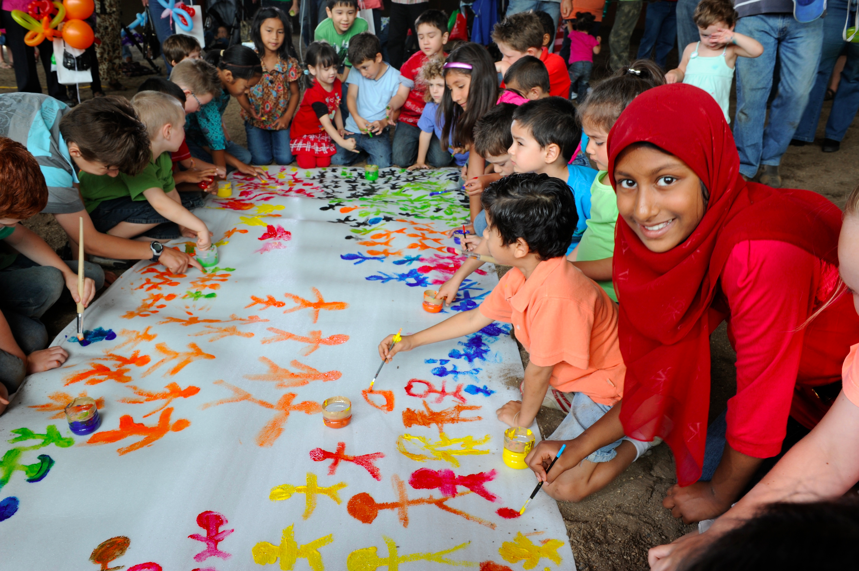

DIAC images - Harmony Day, CC BY 2.0

Discussion Questions:

- Look at the photo of Harmony Day, a holiday in Australia. What do you think the holiday is about?

- How do the people in the photo know each other? What are they doing?

Chapter 2 Vocabulary

interest (n.) country (n.) social (adj.) individual (adj./noun) community (n.)

describe (v.) relationship (n.) generation (n.) favorite (adj.) education (n.)

Part 1 Directions: Use your dictionary to find the meaning for the vocabulary words in the box above. Then write the words from the box next to their definitions below.

Vocabulary word Definition

      - ___________________________________: Something that you enjoy doing or learning about.

2. ___________________________________: The process of teaching and learning.
3. ____________________________________ : To say what something looks or feels like.
4. ____________________________________ : An area of land controlled by a government.
5. ____________________________________ : The way people are connected to one another,
such as a family.

6. ___________________________________ : A group of people who are about the same age.

7. ____________________________________: Someone who enjoys being with other people.
8. ____________________________________: A person or thing that is liked more than others.
9. ____________________________________:A group of people who live in the same area.
10. ____________________________________: One person or part of a larger group.

Part 2 Directions: Read the questions below. Find and underline each vocabulary word in the questions. Then ask your partner the questions.

- Are you a social person? Do you prefer to spend time individually?

- What is your favorite thing about your community in your country?

- How is your generation different from your parents’ generation?

Part 3 Directions: Listen to the pronunciation of the vocabulary words. Write the vocabulary word then listen again and write the number of syllables that you hear in each word. The first word has been done for you. Mark the syllables on each of the words.

Chapter 2 Vocabulary

- In-ter-est (3) 2. ________________________
3. _________________________ 4. ________________________
5. ________________________ 6. ________________________
7. ________________________ 8. ________________________
9. ________________________ 10. ________________________

Listening for details and main ideas

Part A Directions: Listen to the person introduce herself and describe her interests. Then answer the questions below.

Chapter 2_ Activity 1_ part A

- Where does Samantha go to school? ____________________________________
- How many years has Samantha been in college? ____________________________________
- What job would Samantha like in the future? ____________________________________
- What are Samantha’s hobbies? __________________________________________________________
- What is the main idea of this listening? Circle one.
- Samantha’s life in college b) Samantha’s life
c) Samantha’s hobbies d) Samantha’s family

Part B Directions : Now listen to Samantha talk about her grandmother. After you listen, answer the questions below.

Chapter 2_Activity 1_ Part B

- How old is Samantha’s grandmother? ______________________________
- How many years was Samantha’s grandmother a teacher? _____________________
- What are Samantha’s grandmother’s hobbies?
____________________________________________________________________
- Which of Samantha’s hobbies does her grandmother not like? ____________________________________________________________________
- Which hobby do they do together? ____________________________

-------------------------------------------------------------------------------------------------------------------

Part C Directions: Using the information you heard about Samantha and her grandmother, complete the chart below.

 | Samantha | Her grandmother
Age
Hobbies
Dislikes

Part D Directions: Discuss the questions below with your partner or in a small group.

- Do you think Samantha and her grandmother are more similar to each other or more different?

- Why do you think different generations have different hobbies?
  - What hobbies are popular for people in your generation?
  - What hobbies were popular in your grandparents’ generation?

Grammar Tip: Subject Pronouns and Possessive Adjectives

Subject Pronouns Possessive Adjectives
I -- My
You -- Your
She -- Her
He -- His
It -- Its
We -- Our
They -- Their

- Subject pronouns are used when you are talking about the person as the subject of the sentence. They are often followed by a verb.

Examples: I am a student. She is a teacher. They like to travel.

- Possessive adjectives are used when you are talking about something that belongs to a person or place. They are often followed by a noun.

Examples: My car is red. Their bus is late. Our classroom is big.

Thought, by TeroVesalainen, CC0

Practice: Answer the questions below using complete sentences. Then underline the subject pronouns in your answers and circle the possessive adjectives.

- Where are you from? _______________________________________________________________________

- What language do you speak? ______________________________________________________________

- What is your hobby? ________________________________________________________________________

- What is your favorite color? ________________________________________________________________
Grammar Tip: 3rd person “s”

In English, when you talk about another person or thing, the verb always has an “s” added to it.

Subject Verb Object

I | like | pizza.
You | like | pizza.
He  She  It | likes | pizza.
We | like | pizza.
They | Like | pizza.

The 3rd person “s” is always used when talking about another person in the present tense.

Do not use the 3rd person “s”:

- for negative sentences

- to talk about the past or future

Examples:

- Third person “s”: She likes pizza.
  - Negative: She doesn’t like pizza.

- Third person “s”: He speaks English.
  - Past tense: He didn’t speak English.
  - Future tense: He will speak English.

Practice 1: Listen to the statements. Circle the form of the verb that you hear.
Chapter 2_ Listening to verbs

- a) like b) likes
- a) play b) plays
- a) take b) takes
- a) eat b) eats
- a) read b) reads
- a) ride b) rides
- a) speak b) speaks

Practice 2: Ask your partner the 5 questions and write their complete answers below. Use the correct form of the third person pronoun or possessive adjective and the 3rd person form of the verb.

      - What is your name?
      - Where are you from?
      - What language do you speak?
      - What is your hobby?
      - What is your favorite food?

1. _____________________________________________________________________________________________________

2. _____________________________________________________________________________________________________

3. _____________________________________________________________________________________________________

4. _____________________________________________________________________________________________________

5. ______________________________________________________________________________________________________

Homework Survey

Directions: Practice your English outside of the classroom. Find 5 Americans or strong users of English and ask them the questions below. Write their complete answers. Use correct grammar in your answers.

Remember to first introduce yourself and to thank the person when you are finished.

“Hello, I’m an English student. My name is ___________________.”
“Do you have a minute to help me with my homework?”
“ Thank you very much. It’s nice to meet you. ”

Person #1 | Answers
What is your name?
Where are you from?
What is your job?
Can you suggest a good restaurant?

Person #2 | Answers
What is your name?
Where are you from?
What is your job?
Can you suggest a good restaurant?

Person #3 | Answers
What is your name?
Where are you from?
What is your job?
Can you suggest a good restaurant?

Person #4 | Answers
What is your name?
Where are you from?
What is your job?
Can you suggest a good restaurant?

Person #5 | Answers
What is your name?
Where are you from?
What is your job?
Can you suggest a good restaurant?

Chapter 2_ Activity 2 Listening to a Conversation

Directions: Listen to Abdullah and Amy talk about the activities that they like to do. Fill in the blanks in the conversation below with the vocabulary words that you hear. After you listen, practice reading the conversation with a partner.

Chapter 2_ activity 2

Abdullah: Hey Amy, how are you?

Amy: Hi Abdullah, I’m good. How are you?

Abdullah: I’m good. I’m working on a project for my class.

Amy: Oh, really? What is it about?

Abdullah: I have to _________________________ my ________________ for a presentation.

Amy: Oh, that sounds interesting. What are your _______________________ activities to do?

Abdullah: Well, I’m a really____________________________ person, so I like to hang out with friends and do things in my _________________________________. What about you?

Amy: Me too! I’m also a social person, but I like to do ____________________ activities as well.

Abdullah: Tell me more. Like what?

Amy: For example, I really enjoy reading. Do you?

Abdullah: Yes, I do. But, I believe this hobby was more popular in previous_________________ in my country.

Amy: Really?

Abdullah: Yes, today people my age like to use social media and the internet.

Amy: Cool. I understand. I think it’s the same in my _________________________________.

Abdullah: Cool. I think it’s that way in many _____________________________ now. Well, I
have to go now. See you around!

Amy: OK. Nice talking to you. Good luck on your project!
Speaking tip: Follow up questions and phrases

When you are talking with someone in English, there are many ways to keep a conversation going. One way is to use follow-up questions. After you answer a question, return the question with these phrases:

- What about you?
- How about you?
- Why? Really?
- Interesting. Tell me more.

Friends, by Free-Photos, CC0

Practice : Go back to the conversation on the page before between Amy and Abdullah and listen to how the speakers use the follow-up questions and phrases.

Practicing Conversations

Directions: Now practice writing a conversation of your own. Work with your partner to write a conversation. Introduce yourselves and talk about your hobbies and interests. Use follow-up questions and statements and include 5 of the Chapter 2 vocabulary words in your conversation.

- _________________________________________________________________________________________________
- _________________________________________________________________________________________________
A. _________________________________________________________________________________________________
B. _________________________________________________________________________________________________
A.___________________________________________________________________________________________________
B . _________________________________________________________________________________________________
B. __________________________________________________________________________________________________
- __________________________________________________________________________________________________
- __________________________________________________________________________________________________
A. ___________________________________________________________________________________________________
B. ____________________________________________________________________________________________________
- __________________________________________________________________________________________________
- __________________________________________________________________________________________________
A. ____________________________________________________________________________________________________
B. ____________________________________________________________________________________________________
A._____________________________________________________________________________________________________

Chapter 2 Review
In this chapter, you learned:

- Grammar tips for talking about other people
- Some follow-up questions to use in conversations

Extra listening practice about meeting people and talking about hobbies

- http://elllo.org/video/1351/1398-Adam-Personality.htm

- http://www.elllo.org/english/Mixer/66-BestQ.html

- http://www.elllo.org/english/Mixer001/T017-Introductions.htm

- http://www.elllo.org/english/0051/094-Diana-Hobby.htm

- http://www.elllo.org/english/0901/T928-Naomi-FreeTime.htm

Brainstorming,by RawPixel, CC0

Chapter 3: Talking about Travel and Experiences

In this chapter, you will learn about:
- Wh and Yes/ No question formation
- Intonation in English
- Opening, closing and extending basic conversations

Road, by Esudroff, CC0

“ The world is a book, and those who do not travel read only a page”
- Saint Augustine

Discussion questions:

- Read the quotation above. What does it mean?
- Do you like to travel? Why or why not?

Chapter 3 Vocabulary

view (n./v. ) produce (v.) develop (v.) remember(v.) decide (v.)

argue (v.) achieve (v.) challenge (n./v.) introduce (v.) ability (n.)

Part 1 Directions: Use your dictionary to find the meaning for the vocabulary words in the box above. Then write the words from the box next to their definitions below.

1. ___________________________________: An opinion or way of thinking about something.
2. ___________________________________: To get or reach something by working hard.
3. ___________________________________ : To make someone or something known by name.
4. ____________________________________ : The power or skill to do something.
5. ____________________________________ : To cause something to grow or become bigger.
6. ___________________________________ : To make a choice about something.
7. ____________________________________: To keep an idea or image in your mind.
8. ____________________________________: A difficult problem.
9. ___________________________________: To give reasons for or against something.
10. ___________________________________: To make or create something.

Part 2: Syllables

Directions: Listen to the pronunciation of the vocabulary words. Write the number of syllables that you hear in each word. The first word has been done for you.

Chapter 3 Vocabulary

view___1_____ produce_____ develop_____ remember________ decide______

argue________ achieve_____ challenge____ introduce________ ability________

Chapter 3_ Activity 2

Part 1 Directions: Read the conversation and complete the missing words with the chapter 3 vocabulary words below. You will not use three of the words.

view produce develop remember decide argue achieve challenge introduce ability

Sam : Hey Tina! I haven’t seen you all year! How was your trip to Brazil last year?

Tina: Hey Sam! I know! It’s been a long time since I’ve seen you. My trip was great. I had a few _____________________________ that were kind of difficult, but it was a good trip overall.

Sam: How did you ____________________________ to visit Brazil? Had you traveled there before?

Tina: No, I hadn’t, but my friend _______________________________________________ me to some Brazilian people and they were very nice, so I bought a ticket and went.

Sam: Cool! Do you ______________________________________ any interesting things that you did while you were there?

Tina: Well, my friend that I went with actually _____________________________________ short travel films, so he made a movie about our trip. It shows all the places we went. I’ll give you the website, so you can watch it.

Sam: Wow! That sounds great! It’s not easy to travel with a friend. Did you _____________________________________ or fight with each other?

Tina: No, not really. We got along great, and we had so much fun.

Sam: That’s great to hear. Would you return in the future?

Tina: Yes, definitely! If I have the _________________________________, I will return in the future.

Sam: Cool. Well, it’s great to see you!

Tina: You too! See you around!

Sam: You too! Bye!

Part 2 Directions: Listen and check your answers then practice reading the conversation with a partner.
Chapter 3_ Activity 2
Grammar Point: Questions in English

There are two types of questions in English: Yes/ No questions and WH questions.

- Yes/No questions
  - Begin with these verbs: Do/ Does or Is / Are
  - They are answered with a “Yes” or a “No”.

The be verb (is/are) is used to start questions when a noun or adjective follows the subject.

Question: Is Ms. Brown a teacher? Question: Are the students happy?
(noun) (adjective)
Answer: Yes, she is. Answer: No, they aren’t.

The verbs ‘do’ or ‘does’ are used to start questions when a verb follows the subject.

- Question: Does she work here? Question: Do they speak English?
(verb) (verb)
Answer: No, she doesn’t. Answer: Yes, they do.

WH questions
- Follow the same grammar rules, but they begin with the question words:
  - Who, What, When, Where, How, Why
  - WH questions have longer answers, not just “yes” or “no”

- Where does she live? 2) When is your class?
She lives downtown. I have class on Monday and Wednesday.

--------------------------------------------------------------------------------------------------------
Practice: Look at the answers below. Write a question that matches the answer. Think carefully about the grammar in the answer.

- ____________________________________________________________________?
Answer: No, they are from Canada.

- ____________________________________________________________________?
Answer: She works at a bank.

- ____________________________________________________________________?
Answer: My birthday is June 22nd.

4. ______________________________________________________________________?
Answer: Yes, I’m a student here.

Discussion Activity

You and your best friend are taking a vacation for spring break. You are deciding between two kinds of vacations. First, ask your partner the WH questions below, so you understand what kind of vacation they like.

- What kind of weather do you like?
- Do you want to exercise or relax on vacation?
- Do long flights annoy you?
- What is your budget (how much money can you spend)?
- How long do you want to go for?

Now, study the information below about the two vacations. Together, with your partner, choose one vacation. You must agree with your partner on the same vacation.

Which vacation will you choose? Why?

Freerider, by Up-Free, CC0  Vacation #1: Ski Vacation in Canada  - 2 hour flight from Portland  - Cold, snowy weather  - Hotel includes hot tub and swimming pool  - English language is spoken  - Breakfast and dinner included  - Opportunities to ski and snowboard  - $3,000.00 for 6 days | Maldives, by TPSDave, CC0  Vacation #2: Beach vacation in the Maldives  - 18 hour flight from Portland  - Hot, sunny weather  - Hotel is right on the beach  - Some English is spoken  - No meals included  - Opportunities to swim and dive  - $3,500.00 for 5 days

Speaking Tip: Intonation

In the English language, the sound of a person’s voice goes up or down when they say the last word of a question or sentence. This difference in sound is called “intonation”.

Study the examples below. Listen to the different sounds of the speaker’s voice here

WH questions = falling intonation (voice goes down)

- Where are you from?
- What is your job?

Yes/No questions = rising intonation (up)

- Are you a student?
- Is he your brother?

Statements = falling intonation (down)
- The class is on Monday.
- The bus stop is next to my apartment.

Exclamations (excited speech!) = rising then falling intonation (up then down)

- That’s amazing!

- Wow!
Practicing Intonation

Practice activity 1

Listening for Intonation

Directions: Listen to the questions and circle the type of intonation you hear.

- Up down 3. Up down 5. Up down

- Up down 4. Up down 6. Up down

Practice Activity 2

Directions: Using the intonation examples on the previous page, decide if the questions and statements below have rising or falling intonation. Draw an up or down arrow next to each number. The first one has been done for you.

- Do you like to travel?
- I travel as often as I can.
- What is your favorite country?
- Are you from Japan?
- I love to travel!

Practice activity 3
Directions: Ask your partner the questions below. Practice using correct intonation.

Partner A-
- Where are you from?
- When was your last vacation?
- Do you like to travel on trains?

Partner B-

- What is your name?
- Have you been to New York City?
- Where is your favorite place to travel in the world?

Speaking Tip: Conversation Continuers
These words are used to show interest or understanding in a conversation and to make conversations last longer. Study them and include them in your English conversations.

To show interest | To show concern | To show excitement | To follow up
· Really?  · Tell me more.  · Why?  · Hmmmm…  · That’s interesting. | · Oh, that’s too bad.  · I’m sorry to hear that.  · Really?  · What happened?  · I understand.  What can I do to help? | · Cool!  · Awesome!  · That’s great!  · Wow! | · What about you?  · Tell me about you.  · Enough about me.  Let’s talk about you.

Directions: Using the words and phrases from above, work with a partner to complete the conversation below. Then practice reading the conversation using correct intonation.

A: Hey! How are you?
B: I’m not that good.
A:__________________________________________________________________________________________________
B: Well, I missed my flight. Now I have to pay extra to fly tomorrow.
A:__________________________________________________________________________________________________
B: Yeah. __________________________________________________________________________________________?
A: Well, I’m actually great! I feel so happy today!
B:_________________________________________________________________________________________________?
A: I just got married this weekend.
B: ________________________________________________________________________________________________.
A: I know! I’m so happy. But, I’m also feeling worried because of my busy schedule.
B:_________________________________________________________________________________________________.
A: I’m going on a vacation next week, but I have so much work to do before then.
B:_________________________________________________________________________________________________.
A: Well, good luck with your flight tomorrow!
B: Thanks! It was nice to see you!
A: You too! See you later!
B: Bye!
Speaking fluency practice
Ask the questions below to your classmates. Use the conversation phrases on the page before to keep the conversation going back and forth.

- Do you like to travel?
- What is your favorite place you have traveled to?
- Do you like to travel alone or with people?
- When was your last trip?
- Do you like to fly on airplanes?
- Is it expensive to travel around your country?
- Do you like to achieve something when you travel or just relax?
- How do you decide where to go when you travel? Do you plan in advance?
- What do you remember about your best travel experience?
- When will you go on your next trip?
Hiking, by Maxmann,0
Homework survey

Directions: Ask five Americans or good speakers of English about their travel experiences. Listen and write their answers below.

Plane, by Holgi, CC0

Person 1
Do you like to travel?
Where is your favorite place to travel?
How often do you travel?
How many countries have you travelled to?
Where should I travel in the U.S.?

Person 2

Do you like to travel?
Where is your favorite place to travel?
How often do you travel?
How many countries have you travelled to?
Where should I travel in the U.S.?

Person 3
Do you like to travel?
Where is your favorite place to travel?
How often do you travel?
How many countries have you travelled to?
Where should I travel in the U.S.?

Person 4
Do you like to travel?
Where is your favorite place to travel?
How often do you travel?
How many countries have you travelled to?
Where should I travel in the U.S.?

Person 5
Do you like to travel?
Where is your favorite place to travel?
How often do you travel?
How many countries have you travelled to?
Where should I travel in the U.S.?

Chapter 3 Review
In this chapter, you learned about:
- How to make WH and Yes/No questions in English
- How intonation sounds in questions and statements in English
- Useful phrases for continuing conversations

Extra Listening Practice about travel
- http://www.elllo.org/english/0701/T736-Keren-Options.htm
- http://www.elllo.org/english/0401/448-Greg-TravelTips.htm
- http://www.elllo.org/english/0001/050-David-Travel.htm
- http://www.elllo.org/english/0151/192-Nicoleta-Travel.htm
- http://www.elllo.org/english/1251/1257-Daniel_Hana-Vacations.htm

Car, by Free-Photos, CC0

Chapter 4: Discussing food

In this chapter, you will learn about:
- Understanding Conversational English
- Describing food in English
- Using contracted speech in English

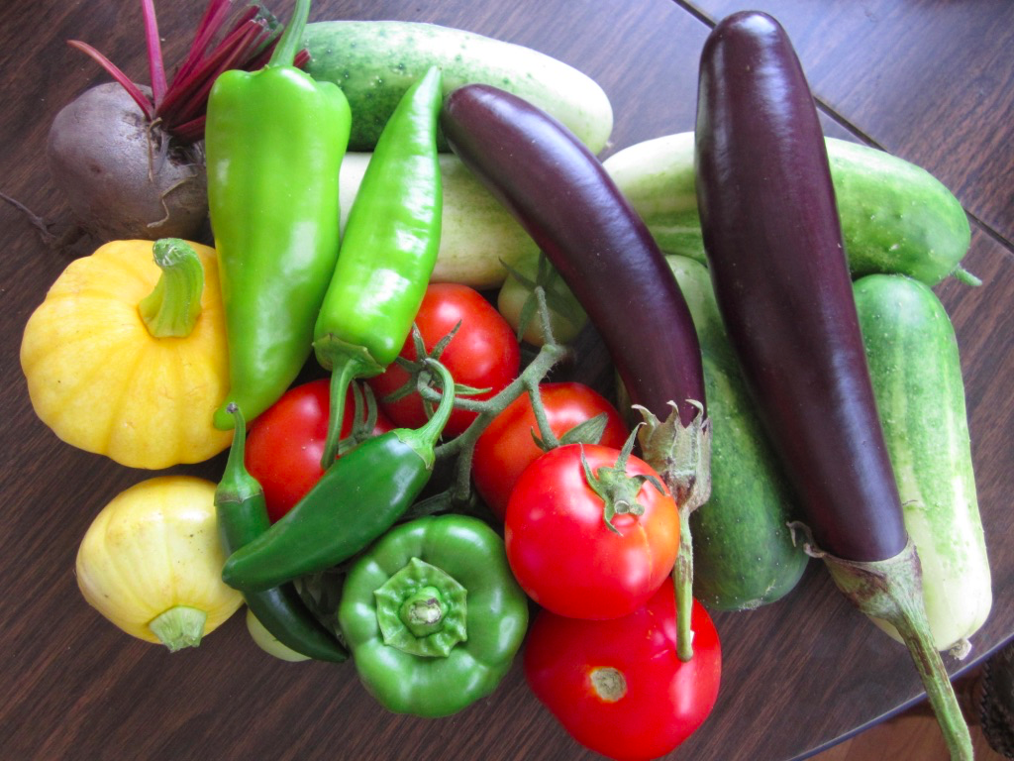
Garden vegetables. Photo courtesy of the author

“Tell me what you eat, and I will tell you who you are.”
- Jean Anthelme Brillat-Savarin

Discussion Questions:

- Read the quotation above. What does this quotation mean?
- Do you agree with this statement?
- What are your favorite foods? What do these foods say about you as a person?

Chapter 4 Vocabulary

process(n./v.) increase (n./v.) product (n.) allow (v.) suggest (v.)

national (adj.) quality (n.) international (adj.) specific (adj.) avoid (v.)

Part 1 Directions: Use your dictionary to find the meaning for the vocabulary words in the box. Then write the words from the box next to their definitions below.

1. ____________________________________: A series of actions that produce something.
2. ____________________________________: How good or bad something is.
3. ____________________________________ : Something special or particular.
4. ____________________________________ : To say that something should be chosen.
5. ____________________________________ : Relating to a whole country or nation.
6. ___________________________________ : To become bigger in amount or number.
7. ____________________________________: Involving two or more countries.
8. ____________________________________: To permit someone to have or do something.
9. ___________________________________: Something that is made to be sold.
10. ___________________________________: To stay away from something or someone.

Part 2: Syllables

Directions: Listen to the pronunciation of the vocabulary words. Write the number of syllables that you hear in each word. The first word has been done for you.

Chapter 4 Vocabulary

process___2____ increase_______ product_______ allow_______ suggest_______

national_______ quality_______ international_______ specific_______ avoid_______

Chapter 4_ Activity 2

Part 1 Directions: Read the paragraph and fill in the missing words with the chapter 4 vocabulary words. Some words might be used more than one time. You may need to change the form of the words. You will not use one of the words.

process increase product allow suggest national quality international specific avoid

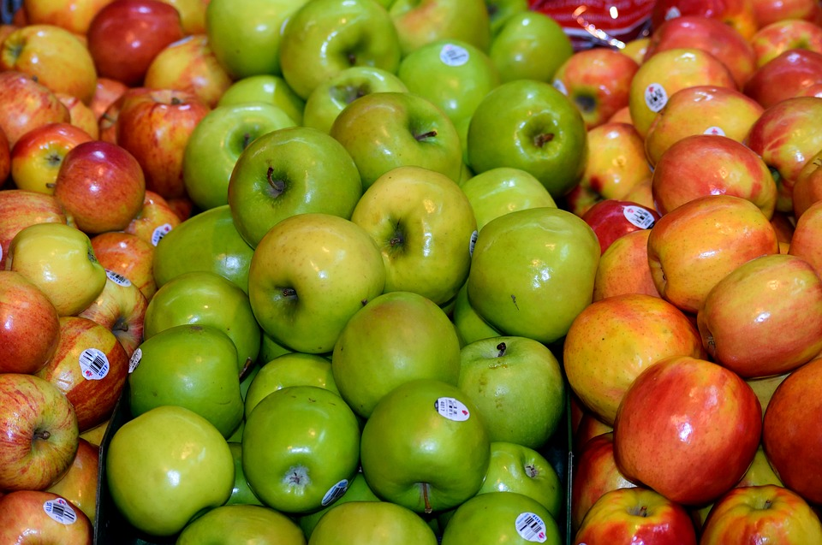
It’s important to know where food comes from. Do you know where yours comes from? In the United States, a lot of food goes through a long _____________________________________ before it arrives in the grocery store. Some ________________________________like milk are produced _______________________________, meaning in the United States. However, some products are ________________________________________and are imported from other countries. Let’s look at some ________________________________________________________examples. Most beef in the United States is produced nationally. For this reason, the __________________________________________of beef is good in the United States. It is fresh. However, some fruits, like mangos or coconuts are not grown in the U.S. They are shipped to the U.S. from other countries. Some people _______________________________________________eating foods that are not local. It is a good idea, but sometimes, this_________________________________________the price of some foods. Some shoppers ___________________________________________ themselves to buy international ___________________________________________once in awhile, but not often. Other shoppers don’t care and buy whatever is the cheapest. In the U.S., you can find almost any product. Next time, think about where something came from when you buy it! Look for the sticker on the label.

Apples, by PaulBr75, CC0

Chapter 4_ Activity 2

Part 2 Directions: Listen and check your answers to the exercise on the page before. Then listen again and answer the questions below. Discuss with a partner.

Part A. Listening for details

- What kind of food does the speaker say is produced in the U.S.?

- What are the two examples of foods that are imported from other countries?

- Why do some people avoid buying products from outside of the U.S.?

Part B. Discussion- Answer the questions below then compare with a partner.

- What are three foods produced locally in your country?

- What are some common foods that your country imports from other countries?

- What is your favorite food from another country?

Speaking Activity: Food Habits and Likes

Directions: Find a classmate who has says “yes” to the questions below. If they say “yes”, write their name. If they say “no”, ask a different classmate.

Question Classmate’s name who says “yes”

Example) Do you like broccoli? ____Azumi ____________________

Q: Do you like broccoli?
A: Yes, I do.

1. Do you like green tea? _______________________________
2. Do you cook really well? ________________________________
3. Do you love American food? _________________________________
4. Do you like sushi? __________________________________
5. Do you like falafel? _________________________________
6. Do you know a lot of restaurants in Portland? ________________________________
7. Do you like vegetables? ________________________________
8. Do you like to drink milk? ________________________________
9. Do you like pineapple on your pizza? ________________________________
10. Do you like salad? _________________________________
11. Do you drink more than 8 glasses of water per day ? _____________________________
12. Can you make delicious pasta? _________________________________
13. Do you like chocolate? __________________________________
14. Are you on a diet? __________________________________
15. Do you drink coffee every day? __________________________________

Chapter 4 Homework Survey: Eating Out

Directions: Ask 5 Americans or strong users of English the questions below. Listen and write their answers.

Use conversation strategies to ask follow up questions and show interest.

And remember to thank the people after you interview them.

Salad, by Ponce_Photography, CC0

Question | Answer
What is one of your favorite local restaurants?
What kind of food do they have?
What do you usually order?
How often do you eat at restaurants?

Question | Answer
What is one of your favorite local restaurants?
What kind of food do they have?
What do you usually order?
How often do you eat at restaurants?

Question | Answer
What is one of your favorite local restaurants?
What kind of food do they have?
What do you usually order?
How often do you eat at restaurants?

Question | Answer
What is one of your favorite local restaurants?
What kind of food do they have?
What do you usually order?
How often do you eat at restaurants?

Question | Answer
What is one of your favorite local restaurants?
What kind of food do they have?
What do you usually order?
How often do you eat at restaurants?

Adjectives used to describe food

Watch this presentation and study the vocabulary below to learn about describing food.
- It is ____________________________ .

- It tastes / smells / looks / feels ________________.

Taste or flavor  - Good Delicious  - Sweet Salty  - Sour Fresh  - Stale Spicy | Smell  - Good Amazing  - Strong Bad  - Fishy Fruity
Look  - Fresh Delicious  - Tasty Bad | Texture or feel  - Hot Cold  - Crunchy Smooth  - Chewy Crispy  - Fried Creamy

India, by Travel Advisor, CC0

- How do you think the food in this picture smells? How does it taste? How does it look?

- Have you eaten food like this before? Where does it come from?

Listening Homework Practice Quizzes

Directions: Click on the links below to listen to the audio files about food. Listen two or three times until you understand most of the speaking. Then answer the questions on the forms.

- Foods in the United States

- Italian food

- Comfort food

-------------------------------------------------------------------

Practicing Fluency: Talking about food

Directions: Talk about the questions below with your classmates. Keep the conversation going with continuing questions and phrases like “Why” or “Tell me more”.

1. Who buys the groceries in your family?
2. How often do you skip breakfast?
3. Do you avoid eating foods with a lot of calories?
4. What is your favorite fruit to eat?
5. What kind of products do you always buy for your kitchen?
6. Do you prefer coffee or tea in the morning?
7. What is the most famous national food in your country?
8. Can you suggest a good restaurant?
9. Do you think the quality of food is good in America?
10. Do you like to try new international foods?
11. What is your favorite kind of desert?
12. Is it OK to gain weight in your culture?
13. How can you increase the number of fruits and vegetables that you eat?
14. Do you like a specific food for breakfast?
15. What was the last food you cooked for yourself
Speaking and Listening Tip: Reduced speech
Directions: Reduced speech is used when people are talking quickly or informally. It is not used in writing. Study and listen to the examples below then practice reading the conversation at the bottom.

Some common examples of reduced speech:
Unreduced language Reduced Speech
Can you = Kanya
Give me = gimme
I have to = I hafta
I’ve got to = I gotta
Could you = Couldja
A lot of = A lotta
Are you = Arya
Going to = Gonna
Want to = wanna
How about you? How bouchu?
Do you want to? D’ya wanna?
See you soon! Seeya soon!

Unreduced speech :
A: Hey! Want to go to a restaurant later?
B: No, I can’t! I’m going to go to the party. Are you going to go?
A: Yes, but I have to pick up a lot of snacks on the way.
B: No problem. Do you want to stop by the mall too? I’ve got to buy a birthday present. How about you?
A: Perfect! I want to buy one too. Could you call me when you’re close to my house?
B: Sure! See you soon!

Reduced speech:
A: Hey! Wanna go to a restaurant later?
B: No, I can’t! I’m gonna go to the party? Arya gonna go?
A: Yes, but I have to pick up a lotta snacks on the way.
B: No problem. D’ya wanna stop by the mall too? I’ve gotta buy a birthday present. How bouchu?
A: Perfect! I wanna buy one too. Couldja call me when you’re close to my house?
B: Sure! Seeya soon!

Grammar Tip: Contractions

Contractions are two words joined together by an apostrophe ( ’ ). They are used in casual or informal speaking and writing.

Some common examples of contractions

I am = I’m He is = He’s She is = She’s We are = we’re

I have = I’ve You have = You’ve We have = we’ve

Will not = won’t Should not = shouldn’t Is not = isn’t Were not = weren’t

Cannot = Can’t Do not = don’t I will = I’ll

Practice: Listening for contractions

Directions: Listen to the conversations. Write in the missing contractions that you hear.

Conversation 1

- Do you know how to make lasagna?
B. No, I ____________________________________________.

- Can you teach me?
B. No, I ___________________________________. I ____________________________ know how either.

Conversation 2

- Hi, is Bob home?
B. No, he ______________________________________.
- OK. Is Sheila?
B. No, she ______________________________________.

Conversation 3

- Hey, __________________________________ going to the cafe. Want to come?
B. No, I ___________________________________ . _________________________ got some things to do.

A. Ok. We ___________________________ be there long. ___________________________call you later.
B. Ok!

Discussion Activity: What will you buy?

You are grocery shopping with your family. Your shopping list is written below.
However, you only have $50.00 to spend! What will you buy? What will you have to cross off your list?

Directions:

1. With your group, calculate how much it will cost to buy everything on your list.

Write that number here ____________.

2. Next, talk with your group to cross items off your list, so that you will spend $50.00 or less.

3. Cross off the items you will not buy.

4. Write your final total for your grocery trip here: ___________________

2 bags of chips at $3.00 each 2 quarts of milk at $ 4.00 each

2 loaves of bread at $3.50 each 1 bag of carrots at $3.00

1 bag of 6 apples at $4.00 1 pound of cheese at $6.00 per pound

3 lemons at $. 99 3 onions at $1.00 each

2 pounds of chicken at $3. 50 per pound 1 carton of eggs at $3.00

1 pound of rice at $4.00 per pound 1 pound of bananas at $2.00 per pound

1 quart of ice cream at $4.00 1 pound of fish at $13.00 per pound

Restaurant Review Field Trip
Directions:
1.With your group, choose a Portland restaurant to go to that you have not visited. It must be a local restaurant, not a chain restaurant or a fast food restaurant.
2. Go to the restaurant and eat a meal. Be polite and remember to pay a tip at the end (15-20% of the total bill is common in the U.S.).
Restaurant, By Karriezhu, CC0
3. While you are there, take a photo of the food you order.

4. Answer the questions below after you are finished eating.

---------------------------------------------------------------------------------------------------------------------
1. What is the name of the restaurant you visited? _____________________________________________
2. What kind of food do they have? ____________________________________________________________
3. What did you order? _______________________________________________________________________
4. How did the food taste? Describe it using adjectives.
__________________________________________________________________________________________
5. How many stars would you give the food? 1 2 3 4 5
6. How was the service? Describe it using adjectives.

__________________________________________________________________________________________
7. How much did your meal cost? __________________________
8. Would you recommend this restaurant to a friend? Yes Maybe No
Why? ____________________________________________________________________________________

Chapter Review

In this chapter, you learned
- How to describe food using adjectives
- How to say and hear common reduced speech in English
- How to say and write contractions

Extra listening practice about food

- http://www.elllo.org/english/0901/T939-Mari-Food.htm

- http://www.elllo.org/english/0101/112-Diana-Food.htm

- http://www.elllo.org/english/Mixer001/T018-JunkFood.htm

- http://www.elllo.org/english/0301/319-Raphael-Food.htm

- http://www.elllo.org/english/1401/1424-KatieGilda-FoodWeHate.htm

- http://www.elllo.org/english/Games/G065-JN-Food.htm

Blueberries, By Conderdesign, CC0

Chapter 5: Describing places around Town

In this chapter you will learn about:

- Describing places and listening to directions
- Using numbers for addresses
- Listening to past tense regular verb endings

Copenhagen, Denmark by Tpsdave, CC0

Discussion questions:

- The picture above shows a European city, Copenhagen, Denmark. Have you visited Europe before?

- Do you think the city looks like a nice place to live? Why or why not?
Chapter 5 Vocabulary

public (adj./n.) business (n.) region (n.) population (n.) advantage (n.)

modern (adj.) natural (adj.) traditional (adj.) purchase (n./v.) market (n.)

Part 1 Directions: Use your dictionary to find the meaning for the vocabulary words in the box. Then write the words from the box next to their definitions below.

1. ____________________________________: A company that makes or sells things for money.
2. ____________________________________: Something available to anyone, not private.
3. ____________________________________ : A way of thinking or doing that has been done by people
for a long time.
4. ____________________________________ : To buy something with money.
5. ____________________________________ : Something that is good; a benefit.
6. ___________________________________ : Something related to a new style.
7. ____________________________________: Something from nature; not made by humans.
8. ____________________________________: A place to buy something.
9. ____________________________________: A part of a country that is separate or different.
10. ___________________________________: The number of people who live in a place.

Part 2: Syllables

Directions: Listen to the vocabulary words. Write the words and the number of syllables that you hear in each word. The first word has been done for you.

Chapter 5 Vocabulary

1. ____Pu-blic (2)____ 2.____________________ 3.____________________ 4._______________

5._______________________________ 6._________________________ 7. __________________________

8. _______________________________ 9. _________________________ 10. _________________________

Activity 2
Directions: Read the conversation and complete the missing words with the chapter 5 vocabulary words. You will not use two of the words.

public (adj./n.) business (n.) region (n.) population (n.) advantage (n.)

modern (adj.) natural (adj.) traditional (adj.) purchase (n./v.) market (n.)

Amy: Hi Abdullah. What’s new? I haven’t seen you in a long time!
Abdullah: Hey, Amy! Actually, a lot has changed in my life recently. I graduated from my university, and now I’m looking for a new home.
Amy: Wow! Congratulations on finishing university. Where are you looking for a home?
Abdullah: Well, I’d like to stay in this ___________________________________. I really like this area.
Amy: Are you looking to rent or _____________________________________ a home?
Abdullah: Well, right now, I think I’d like to rent.
Amy: Cool. I actually know an available apartment.
Abdullah: Really? Tell me about it.
Amy: It’s a _______________________ apartment and is located downtown by lots of
_________________________________. It has a lot of windows with _____________________________
light. It’s also close to ____________________________________ transportation.
Abdullah: That sounds great.
Amy: I agree. And because the ________________________________________ is not very high in the
neighborhood, the apartments are more affordable.
Abdullah: Yes, this is a great _____________________________________________.
Amy: If you like the way this apartment sounds, I can give you the number to call.
Abdullah: Great. I really appreciate that. Thank you so much, Amy!
Amy: You’re welcome, Abdullah! See you around! Bye!

Part 2 Directions: Now listen to the conversation and check your answers. Then practice reading the conversation with a partner.

Chapter 5_ Activity 2

Speaking Fluency Practice : Housing and Neighborhoods

Directions: Talk about the questions below with your classmates. Ask follow up questions like, “Why?” or “ Really?” or use phrases like “tell me more” to make the conversation keep going.

1. Would you choose to live in a big house or a small house? Why?

2. Do you want to live close to businesses and shopping? Why?

3. Would you like to live close to people or far from them?

4. Do you like living in a busy city or a quiet town more? Why?

5. Do you want to live in a modern neighborhood or a traditional one? Why?

6. Do you want to live close to nature? Why or why not?

7. Is the housing market expensive in your country? Why?

8. Is it important to have public transportation where you live? Why or why not?

9. What are three things you want to have in your neighborhood?

10. Is it important to live close to your family? Why or why not?

Residential home, by ArtisticOperations, CC0

Asking for and giving directions

There are many ways to ask for directions in English.

- Ask for a specific place

- Excuse me, where is the bank?

- The bank is in front of the hotel.

- Excuse me, do you know where the mall is?

- The mall is across from the park.

The prepositions below are used to describe where places are in a city.
In front of behind up/down the street on the corner between

around the corner to the right of / to the left of across from

across the street from Next to /Beside at the end of the block

2) Ask for the address of a place

- Excuse me, can you tell me the address of the bank?

- The bank is located at 1234 S.W. 12th St.

- Excuse me, could you give me the address of the hospital?

- The hospital is located at 176 N. 23rd Ave.

Addresses in English often have shortened words:
- Ave. = Avenue St. = Street Blvd.= Boulevard Rd. = Road
- N. = North S. = South E. = East W. = West

Addresses use both ordinal and cardinal numbers
- Ordinal = first, second, third Cardinal= one, two, three

Watch this video for specific information on how to say numbers in English:
- Ordinal and Cardinal numbers presentation

Speaking Practice Activity
Partner A: Ask your partner the questions and follow their answers on the map.

Examples: A: Where is the park?
B: The park is between the post office and the bus station.
1. Where is the city library?
2. What is across from the fire station?
3. What is on the corner of 5th Ave. and Main St.?
4. What is next to the post office?
5. What is behind the River Park?
6.Where is the post office?
Partner B: Ask your partner the questions and follow their answers on the map.

1. Where is the city park?
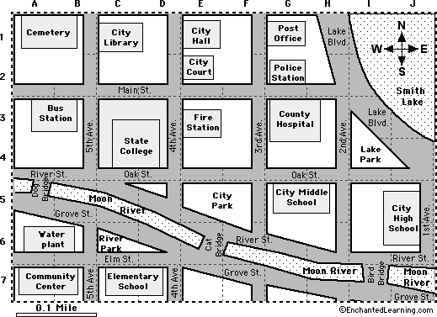
2. What is between the cemetery and the city hall?
3. What is on the corner of River St. and 1st Ave.?
4. Where is the County Hospital?
5. What is across from the elementary school?
6. What is on the corner of River St. and First Ave.?

http://www.michellehenry.fr/ville3.htm
Homework Listening: Directions on a map

Directions: Listen as the person describes the location of places on the map. Circle true or false.
Directions on a map

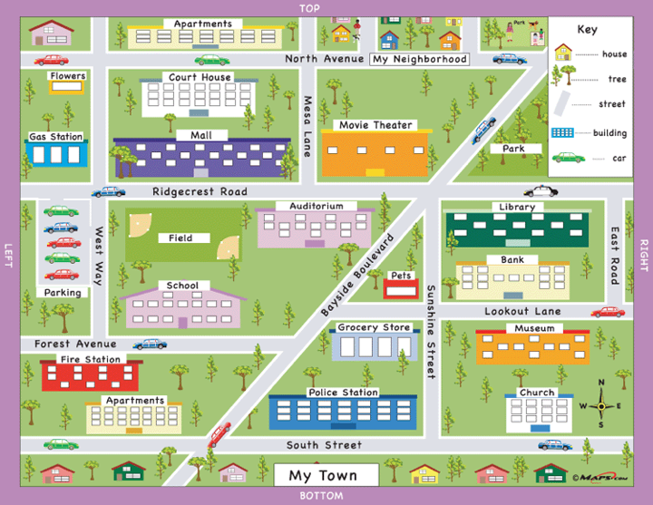

1. True False 2. True False 3. True False 4. True False 5. True False

6. True False 7. True False 8. True False 9. True False 10. True False

11. True False 12.True False 13. True False 14. True False 15. True False

Listening Practice: Using a Map

Part 1. Watch this video and answer the questions below: My day at PSU

- What is the address for the University Center?

- What is the address of the gym?

- Where do they do their homework?

- What is the address of the library?

- What restaurant do they eat at?

- How many blocks is the restaurant from the library?

- What is the address of the person’s house?

Part 2. Explore the map of PSU in the video here: http://map.pdx.edu/#/map

Adjectives for Describing Cities and Neighborhoods

Cities and towns come in all sizes. Some are big, and some are small. Each city or town has many neighborhoods, which are groups of houses or apartments where people know each other. The people in your neighborhood are called your neighbors.

There are many ways to describe cities and neighborhoods:

- Size: big, huge, large, tiny, small, medium

- Location: Downtown, in a suburb (next to a city), in the city, out of the city, rural

- Feel: busy, loud, quiet, convenient, exciting, modern, traditional, green, crowded, safe, dangerous

Example:

- What is your city like?
- My city is small and rural. It is not a big city. It is quiet.

- What is your neighborhood like?
  - My neighborhood is quiet and safe. It is not busy or dangerous.

-----------------------------------------------------------------------------------------
Practice: Ask your partner about their hometown. Try to find three similarities and three differences between you and your partner’s hometowns.

- What is your hometown like?
- What is your neighborhood like?
- Is your city safe or dangerous?
- Is your city crowded?
- Is your neighborhood green?
- Is your neighborhood busy?
similarities | Differences

Discuss

Discussion Activity: Describing Houses

Part 1 Directions: You are choosing a new house to buy. The list below has some qualities of houses. Put the list in order of importance for you. Write 1-10 next to each quality. Number 1 is the most important thing for you.

_______ a big size
_______ a modern style
_______ a large yard or garden outside
_______ close to shopping and restaurants
_______ a parking space for a car
_______ friendly neighbors
_______ a good price
_______ a fireplace
_______ a quiet neighborhood
_______ a nice kitchen

Part 2. Imagine you are buying the house with your partner. Compare your lists and choose the most important 3 qualities. You must agree.

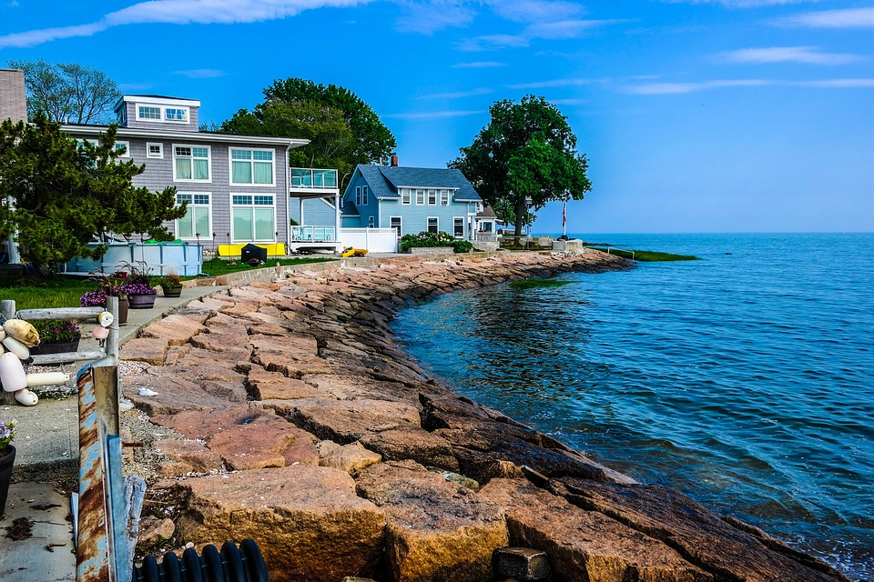
Beachfront house, by Marcilinobobe, CC0
Listening Practice: Listening for details about houses

Directions: Watch this video about four houses that are for sale : Describing houses
Answer the questions below.

House #1
- How far is the house from the city? ________________________________________
- How many bedrooms does the house have? ________________________________________
- What kind of animals can you have at the house? ________________________________________
- How much does the house cost? ________________________________________

House #2
- How many people live in the town? ________________________________________
- How many bedrooms does the house have? ________________________________________
- Does the house have a back yard? ________________________________________
- How much does the house cost? ________________________________________

House #3
- Where is the apartment? ________________________________________
- How many bedrooms does the apartment have? ________________________________________
- Where can you walk to from the apartment? ________________________________________
- How much does the apartment cost? ________________________________________

House #4
- How many bedrooms does the house have? ________________________________________
- Does the home have a swimming pool? ________________________________________
- How much does the house cost? ________________________________________

House #5
- Where is the home? ________________________________________
- How many bedrooms does the house have? ________________________________________
- How much does the house cost? ________________________________________

Which home would you choose to buy? _________________________________________

Why? _______________________________________________________________________________________________

Grammar Tip: Regular Past Tense Verb Endings

In English, all regular verbs end with ‘ed’
Some verbs change their spelling, but others do not.

There are three different ways to pronounce past tense regular verb endings:

/id/ /t/ /d/

Wanted helped called
Needed looked cleaned

Follow these rules:

- If the base verb ends with the sound /t/ or /d/ = /id/

/id/
- Paint = painted

- If the base verb ends with the sounds /p/, /f/, /x/, /sh/, /ch/ /k/ = /t/
/t/
- Watch = watched
/t/
- Wash = washed

- If the base verb ends with any other sound = /d/
/ d/
- Play = played

The sounds of /t/ and /d/ are very similar, but the sound of /id/ is very different because it has an extra syllable added to the verb.

A native speaker of English will quickly notice if a verb that should have one syllable is pronounced with two.

For example:

/id/
Paint = 1 syllable painted = 2 syllables

/t/ /id/
Help = 1 syllable helped = 1 syllable not helped = 2 syllables

Turn to the next page to practice listening to the different sounds of past tense verb endings.
Listening Practice: Past Tense Verb Endings
Past Tense Verb Endings

Part 1 Directions: Listen to the past tense verbs. Check the box that has the sound of the verb ending you hear.

 | /t/ | /d/ | /id/
1
2
3
4
5
6
7
8
9
10

Part 2 Directions: Listen to the person talk about visiting Japan. Write the missing verbs that you hear. Next, practice reading the paragraph with a partner. Use the correct pronunciation for the past tense verbs.

Past tense verb endings_ part 2

Last year, I ________________________________________ to Japan. It was so beautiful. I _____________________ to see some local places, so I __________________________ to many people and _______________________________ to make friends. I made some Japanese friends and they ___________________________ some Japanese food for me. We also _______________________ around Tokyo and _________________________ in a nearby forest. It was a great time. I really _________________________ visiting Japan.

Chapter 5 Review
In this chapter, you learned about:
- Directions in a city
- Talking about houses
- Using ordinal and cardinal numbers
- Past tense verb endings

Extra listening practice about travel

- http://www.elllo.org/english/Mixer101/T107-City.htm

- http://www.elllo.org/english/Mixer101/T106-Place.htm

- http://www.elllo.org/english/0701/T734-Keren-Places.htm

- http://www.elllo.org/english/Mixer001/T005-City.html

- http://www.elllo.org/english/0551/551-Mark-CityCountry.html

- http://www.elllo.org/english/0851/T861-Mari-NYTokyo.htm

Rainbow, by Free-Photos, CC0

Chapter 6: Communicating about hobbies and routines

In this chapter, you will learn about:
- Agreeing and disagreeing in English
- Using adverbs of frequency to discuss routines

Rowing boat at a lake, by Hschmider, CC0

Discussion questions:

- Look at the picture above. What hobbies can be done in the place in the picture?
- What are three of your favorite hobbies?
- Do you prefer indoor or outdoor hobbies? Why?
- How often do you do your hobbies?

Chapter 6 Vocabulary

believe (v.) reason(n.) experience (n./v.) create (v.) outdoors (n.)

mind (n.) artistic (adj.) foreign (adj.) necessary (adj.) benefit (n.)

Part 1 Directions: Use your dictionary to find the meaning for the vocabulary words in the box. Then write the words from the box next to their definitions below.

1. ____________________________________: To think something is true.
2. ____________________________________: The part of a person that thinks and remembers.
3. ____________________________________ : Something so important that you must have it.
4. ____________________________________ : To make or build something.
5. ____________________________________ : A good or helpful result of something.
6. ___________________________________ : Outside of a building; not inside.
7. ____________________________________: Having or showing the skill of an artist.
8. ____________________________________: From a different country.
9. ___________________________________: A fact that explains why something is how it is.
10. ___________________________________: A skill you get by doing something.

Part 2: Syllables

Directions: Listen to the pronunciation of the vocabulary words. Write the number of syllables that you hear in each word. The first word has been done for you.

Chapter 6 Vocabulary

believe___2_____ reason_______ experience_______ create_______

outdoors_______ mind _______ artistic_______ foreign_______ necessary_______

benefit_______

Chapter 6_ Activity 1

Directions: Read the conversation and try to complete the missing words with the vocabulary words in the box.

believe (v.) reason(n.) experience (n./v.) create (v.) outdoors (n.)

mind (n.) artistic (adj.) foreign (adj.) necessary (adj.) benefit (n.)

Sara: Hey David! How are you?

David : Hey Sarah! I’m great. I just got home from a trip. It was a great ______________________.

Sara: Cool! Where did you go?

David: I went camping _________________________ in nature.

Sara: Oh really? How often do you go camping?

David: Camping is one of my favorite hobbies, so I go often in the summertime.

Sara: I never go camping. Why do you like it?

David: I can give you several ________________________________________. First, camping has many positive ________________________________ for a person’s ______________________________ and body. It makes you feel relaxed and at peace to be in nature. Also, it is great to be away from the busy city. I ___________________________ it is important and ____________________________ to take a break from the crowded city sometimes. In my opinion, camping is the best way to relax.

Sara: That sounds great. I should try it.

David: Yes, you should. What are your hobbies, Sara?

Sara: Well, I like traveling to ____________________________ countries and I also like to _____________________ things. I enjoy being _________________________ and doing things like drawing and painting.

David: Cool. Those sound like great hobbies, too.
Sara: Thanks. I have to go now, so I’ll see you around.
David: OK! Nice to talk to you. See you later.

Now listen and check your answers. After, practice reading the conversation with a partner.
Chapter 6_Activity 1

Grammar Tip: Agreeing and Disagreeing

Question: Do you prefer tennis or swimming? Why?

Tennis, by Roby0059,CC0 Swimmer, by Skeeze, CC0

------------------------------------------------------------------------------------------------
It is important to know how to agree or disagree with someone or something.
In English, there are some easy phrases you can use:

Positive statement Agree Disagree
“I love swimming” “Me too!” “Oh, really? I don’t!”

Negative statement
“I don’t like playing tennis” “Me neither” “Oh, really? I do!”

Practice

Partner A: Read statements #1-4 below to your partner.
Partner B: Agree or disagree with your partner using the phrases above. Then switch roles for statements #5-8.

- I love running!
- I don’t like video games.
- I hate sports.
- I love homework.

- I love going to the gym.
- I hate cooking!
- I love reading about politics.
- I enjoy driving cars.

Listening Practice: Agreeing and Disagreeing

Chapter 6_ Activity 2

Part 1 Directions: Listen to the conversations. Does the person agree or disagree with their friend? Circle agree or disagree.

- Agree disagree

- Agree disagree

- Agree disagree

- Agree disagree

- Agree disagree

- Agree disagree
----------------------------------------------------------------------------------------------------

Part 2 Directions: Look at the two pictures of hobbies below. What are the hobbies? Which hobby has more benefits? Why? Discuss your answer with your partner.

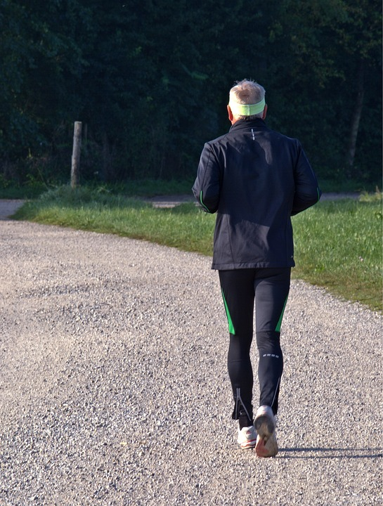

Photographer, by Jarmoluk, CC0 Jogger, by Antranias CC0
Speaking Fluency Practice

Directions: Find a classmate who says “yes” to the questions below. If the classmate you ask says “no”, ask a different classmate. Write the name of the person who says “yes”.

Question | Name of classmate who says “yes”
- Do you believe a hobby can make a person happy?
- Do you like to create artistic things in your free time?
- Do you like to visit foreign countries?
- Do you think being outdoors can bring benefits to a person’s mind?
- Do you like physically challenging hobbies?
- Do you have experience trying many kinds of hobbies?
- Do you think having a hobby is a necessary part of life?
8. Do you have a hobby that you do every day?

Grammar tip: Adverbs of frequency

To talk about routines and how often you do something, adverbs of frequency are used. Depending on how often you do something, a different adverb is used. Study the adverbs and examples below.

(0%) (5%) (10%) (25%) (70%) (90%) (100%)
Never rarely occasionally sometimes often usually always

Question: How often do you _____(verb)_______.

Answer: I _( adverb of frequency)___ ___(verb)______.

Examples:

How often do you go to the gym? I rarely go to the gym.

How often do you wake up early? I often wake up early.

How often do you eat breakfast? I never eat breakfast.

Listening Practice:

Chapter 6 Activity 3

Listen to the person describing how often they do their hobbies. Write the missing adverbs of frequency as you hear them.

In my free time, I ___________________________ like to relax and do activities outdoors. On the weekends, I ______________________________________________ take a walk or ride my bike. I ______________________________ go hiking in the mountains. I ____________________ go to the gym, but I ________________________________ lift weights and do exercises at home. My routine is different on weekdays. After I go to work, I ________________ cook dinner and read on the couch. I ______________________________ watch TV and use the internet, but I _______________________ watch movies. My routine stays the same most weeks.

Speaking Activity

Directions: Complete the table below with the activities you usually do each day of the week. Then compare schedules with your partner using the questions below. Include adverbs of frequency in your answers. Write your partner’s answers in complete sentences.

 | Sunday | Monday | Tuesday | Wednesday | Thursday | Friday | Saturday
Morning
Afternoon
Evening

- How often do you go to the gym?
________________________________________________________________________________________________________
- How often do you go to the library?
________________________________________________________________________________________________________
- How often do you eat breakfast?
________________________________________________________________________________________________________
- How often do you hang out with your friends?
________________________________________________________________________________________________________
- How often do you go out to restaurants?
________________________________________________________________________________________________________
- How often do you _______________________________________? ________________________________________________________________________________________________________
Chapter Review:
In this chapter, you learned about:
- Agreeing and disagreeing in English
- Using adverbs of frequency to discuss your routine and hobbies

Extra listening practice about routines and hobbies

- http://www.elllo.org/english/Mixer001/T020-MoreTime.htm

- http://www.elllo.org/english/1151/T1191-Alex-Biking.html

- http://www.elllo.org/english/1051/1092-Gareth-Routine.htm

- http://www.elllo.org/english/1301/T1331-amy-morning-routine.htm

- http://www.elllo.org/english/0301/344-Eli-Japan.htm

- http://www.elllo.org/english/0551/584-Terri-BikeP3.html

Concert, by Robert Z Ziemi, CC0

Chapter 7: Discussing Jobs

In this chapter you will learn about:
- Syllable stress in English
- Using future tense verbs

Tea Field, by Unsplash, CC0 Welder, by Voltamax, CC0

Teacher, by JerryKimbrell, CC0 Soldiers, by Skeeze, CC0

Discussion questions:

- Look at the four pictures above. What jobs do the people have in the pictures?
- Which job looks the hardest? Which job looks the easiest?
- What education is needed for each of the jobs?
- Which of the jobs would you like to do the most? Which would you like to do the least? Why?

Chapter 7 Vocabulary

degree (n.) service (n.) together (adv.) consider ( v.) position (n.)

project (n.) opportunity (n.) interview (n./v.) successful (adj.) demanding (adj.)

Part 1 Directions: Use your dictionary to find the meaning for the vocabulary words in the box. Then write the words from the box next to their definitions below.

1. ____________________________________: The chance to do something.
2. ____________________________________: A task that needs to be worked on for some time.
3. ____________________________________: To think about something carefully.
4. ____________________________________: A meeting where people ask each other questions.
5. ____________________________________: A company that provides something to the public, like
cable TV or internet.

6. ____________________________________: The place where someone or something is.
7. ____________________________________: Doing well at something you want; earning a lot of
money, fame or respect.

8. ____________________________________: A diploma earned at a university such as a
Bachelor’s or Master’s.

9. ____________________________________: Something that needs a lot of time and hard work.
10. ___________________________________: When two things or two people are with each other.

Part 2: Syllables

Directions: Listen to the pronunciation of the vocabulary words. Write the number of syllables that you hear in each word. The first word has been done for you.

Chapter 7 Vocabulary

degree__2______ service________ together________ consider________ Position________

project________ opportunity________ interview________ successful ______ demanding_______

Chapter 7_ Activity 2

Part A Directions: Read the conversation below and try to fill in the blank lines with the vocabulary words from the box. Do not use one word more than one time. You will not use two of the words.

degree (n.) service (n.) together (adv.) consider ( v.) position (n.)

project (n.) opportunity (n.) interview (n./v.) successful (adj.) demanding (adj.)

Emad: Hi Susan. How are you? I didn’t see you in class last week.
Susan: Hey Emad. I’m good. I was out of town. What did I miss in class?
Emad: We talked about how to find job ______________________________________ that match our university _______________________.
Susan: Oh, that sounds really useful. Can you give me your notes?
Emad: Sure. We can review them ________________________________________ before our next class.
Susan: Great. Thanks. Was the lecture useful?
Emad: Yes, it was really useful. The professor told us that in order to be _____________________ with our job searches in the future, we should ____________________ a lot of positions.
Susan: What does that mean?
Emad: That means, we should try to get __________________________________________ at several different jobs. This way we will have more chances to a get a good job.
Susan: I see. That makes sense.
Emad: She also told us about the career center on campus. They offer many
_________________________________________ that help students who are looking for jobs.
Susan: That is good to know. Is there anything else I missed?
Emad: We also talked about our final __________________________________ for this class. I can tell you more about it later.
Susan: OK. Thanks so much for your help!
Emad: You’re welcome! See you at our next class.
Susan: OK. See you then! Bye.

Now listen to the conversation and check your answers :
Chapter 7_ activity 1
Speaking Activity: Jobs Survey
Directions: Find a classmate who says “yes” to the questions below. If they say yes, write their name. If they say no, ask a different person. Try to get different names for each question.
Question Name of Classmate who says “yes”
1. Do you want a job where you work together with people? _____________________________
2. Do you want a job where you do different projects every day? ____________________________
3. Have you been to a job interview before? _____________________________
4. Would you consider a job in customer service? ______________________________
5.Do you want to be successful at your job? ______________________________
6. Do you want to work for a demanding boss? ______________________________
7. Do you know of any job opportunities for your major? ______________________________
8. Do you know where you want to work in the future? ______________________________
9. Do you want to be the boss at your job? ______________________________
10. Do you think work is fun? ______________________________
Notes, by Conger Design, CC0

Listening activity: Listening for details about jobs

There are many different types of jobs, both good and bad. Listen to the 4 people talk about their jobs. After you listen, answer the questions below.

https://media.pdx.edu/media/listening+about+job+schedules/0_6kkh7033

What is their name? | What is their job? | What is their work schedule? | Do they like their job? Why or why not?

Continue to the next page….
Part 2 Directions: After listening to the people talk about their jobs in part 1 on the page before, answer the questions below.

- Which person do you think likes their job the best? ______________________
- Which person likes their job the least? ______________________
- In your opinion, which of the jobs is the most difficult? _______________________
Why? ________________________________________________________________
4. Which of the jobs seems the easiest? _______________________________________
Why? _________________________________________________________________

Part 3 Directions: Think about all of the jobs you know about in English. Make a list below of the easiest and the hardest jobs you can think of. Then compare your list with a partner and discuss your opinions. Do you have any of the same jobs on your lists? Which of the jobs would you like to do the most? Why?

Easy jobs | Difficult jobs

Speaking Tip: Syllable Stress

A: Did you say your major is teaching English?

B: No! I said teaching SPAnish.

---------------------------------------------------------------------------------------------------

When you need to stress or emphasize a word in English so another person understands you, you can pronounce the syllables of the word differently. This is called “stress”.

Syllable stress= Making a word or syllable louder or higher, so it is noticed by listeners.

Rules:

· Stress the first syllable of: Most two-syllable nouns (examples: PENcil, JACKet)
Most two-syllable adjectives (examples: LOVEly , HAPpy)

· Stress the last syllable of: Most two-syllable verbs (examples: reQUIRE, deCIDE)

· Stress the middle syllable of: Most three syllable words ( toMAto, comPUter)

-----------------------------------------------------------------------------------------------
Practice
Read the conversation below with a partner. Practice saying the stressed syllables louder and higher.

A: Hey! what are you studying?
B: I’m studying biology.
A: Did you say geOlogy?
B: No, I said biOlogy.
A: Oh, sorry! Cool. Biology sounds interesting. What kind of job do you want?
B: I want to be a climate scientist.
A: A WHAT?
B: A CLImate scientist. They study the weather and how it changes.
A: Oh! Cool. Good luck!
B: Thanks!
Homework Activity Jobs Survey

Directions: Practice speaking English outside of the classroom. Introduce yourself to 4 Americans. Tell them you are an English student and ask them if they can help with you with your homework. When you are finished, say ‘thank you’.

Ask each person the questions below. Listen and write their answers.

What is your job?
How many hours do you work every week?
Do you like your job? Why or why not?
What is your dream job?

What is your job?
How many hours do you work every week?
Do you like your job? Why or why not?
What is your dream job?

What is your job?
How many hours do you work every week?
Do you like your job? Why or why not?
What is your dream job?

What is your job?
How many hours do you work every week?
Do you like your job? Why or why not?
What is your dream job?

Grammar Tip: Future Tense

In English, there are two common ways to talk about future plans or events:

- Future plans that are already made use the form: “be going to” + another verb.

- I am going to study in France next year.
- She is going to take a class with that professor next semester.
- Are you going to get a job when you graduate?

2. Facts or promises use the form: “will” + another verb.

- The semester will start on Monday.
- I will call you after class. I promise!
- She will be late to work today.
-------------------------------------------------------------------------------------------

Practice

Directions: Work with a partner to complete the conversation using the future tense. Think carefully about which form to use. Then practice reading the conversation together.

A: Hey! _____________________________________________________( you / study) here next semester?
B: Hey! No, _______________________________________________(I / plan) to study here because I have a job offer.
A: Cool! When ______________________________________________________________(you / start) the job?
B: ________________________________________________________________________(I /start) next April.
A: Where is the job?
B: _________________________________________________________________(the job/ be) in San Francisco.
A: Wow! That’s great! I hope it is a good job.
B: Thanks!! Me too!

Speaking Fluency Practice

Directions: Read the questions below and think about your answers. Then discuss the questions with a partner or in a small group.

- Does the job you want require a specific university degree? Which degree?
- Do you want to work in customer service? Why or why not?
- Do you want a job that is physically demanding? Why or why not?
- What kind of projects do you enjoy doing?
- Are there lots of opportunities for jobs in your country?
- What does it take to be successful in a job?
- Have you been to a job interview before? Did you get the position?
- What is a normal salary for a beginning job in your country?
- What kind of job does your (father /mother / sister/ brother) have?
- What kind of jobs do not attract you?

Welder, by Pexels, CC0

Chapter Review

In this chapter, you learned about:
- Jobs and majors in English
- Syllable stress
- Using future tense verbs

Extra listening practice:

- http://www.elllo.org/english/0701/T749-Tim-GoodJob.htm

- http://www.elllo.org/english/Mixer001/T008-DreamJob.htm

- http://www.elllo.org/english/Games/G049Jobs.htm

- http://www.elllo.org/english/Mixer001/T011-FirstJob.htm

- http://www.elllo.org/english/Mixer001/T002-Badjob.html

graduation, by StockSnap,CC0

Script and Answer Key

Chapter 1

- Listening activity 1 script

Kaori is an English learner from Japan. She is in her first semester at a university in the U.S. state of Oregon. She is very excited to be learning English. In class, Kaori feels a little shy and mostly sits by another Japanese student. Together they translate words and talk in Japanese during the break. Sometimes her teacher calls her name to answer questions, but otherwise, Kaori doesn’t raise her hand or speak much during class. She is afraid of making a mistake when she speaks. On the weekends, Kaori chats with her family in Japan and watches movies in Japanese on the computer. Kaori has been in the United States for two months now, but she doesn’t feel like her speaking and listening skills are improving. She is disappointed.

- Listening activity 2 script

Kaori, an English student from Japan, went to talk with her teacher about her listening and speaking skills. She told her teacher that she didn’t feel like she was improving, and that she was having a hard time with her English studies. Her teacher gave her some ideas, and Kaori tried some of them that week. Instead of sitting by the other Japanese student in her class, Kaori sat by Mohammed, a student from Kuwait. They spoke in English the whole class and agreed to be study partners outside of class as well. Kaori also started going to the conversation partners and practiced her English outside of class. In class, Kaori tried raising her hand when the teacher asked questions. Suddenly, Kaori felt like her English was really improving. The changes that she made helped her learn English more quickly and easily.

- Activity 3 Answer Key

On the first day of English class, there is a lot of ________information________ that you will talk about and________discuss______________ with your teacher and classmates. It is very ______important____________that you pay attention, so you don’t miss anything. Your teacher will ask you questions and will wait for your ________response___________. In American classrooms, the ______environment____________ is interactive, which means the teacher and the students talk to each other a lot. Also, it is common for the students to talk in groups or pairs a lot and share ideas or _________opinions__________ about something. On the first day, your teacher might share a new learning______strategy________ or tip that will help increase your ____success__________ in the class. Before too long, you will have a lot of _____knowledge______ in your brain, and you will improve your English in no time. You might even use your new English skills to ______apply_______ for a student job or a place on a university team! Good luck!
Chapter 2

- Activity 1 A script
Hello, my name is Samantha. I’m nineteen years old and I’m from the United States. I have a big family with 6 brothers and two dogs. I graduated from high school last year. Now I’m at a freshman at a university in California. My major is Business. This semester I’m taking 3 classes. I’m really busy, but I like college so far. In the future I would like to work in advertising. I am interested in social media and like using the internet in my free time. I don’t really like watching TV that much, but I like taking pictures with my camera around my neighborhood.

- Activity 1 B script

My grandma also lives with us. Because she is from a different generation, she has different interests. She is 89 years old and used to be a teacher. She worked in an elementary school for 39 years teaching children math. She loved her job. These days she spends her time doing crossword puzzles and reading books. She doesn’t like technology or using the internet, but she loves gardening and being outside. I like spending time with her outside, too.

- Activity_ Listening for third person “s” Answers

- a) like
- b) plays
- a) take
- b) eats
- a) read
- a) ride
- a) speak

- Activity 2 : Answers

Abdullah: Hey Amy, how are you?
Amy: Hi Abdullah, I’m good. How are you?
Abdullah: I’m good. I’m working on a project for my class.
Amy: Oh, really? What is it about?
Abdullah: I have to ___describe_ my ___interests__ for a presentation.
Amy: Oh, that sounds interesting. What are your __favorite___ activities to do?
Abdullah: Well, I’m a really__social___ person, so I like to hang out with friends and do things in my ____community__. What about you?
Amy: Me too! I’m also a social person, but I like to do __individual__ activities as well.
Abdullah: Tell me more. Like what?
Amy: For example, I really enjoy reading. Do you?
Abdullah. Yes, I do. But, I believe this hobby was more popular in previous ____generations___ in my country.
Amy: Really?
Abdullah: Yes, today people my age like to use social media and the internet.
Amy. Cool. I understand. I think it’s the same in my __country__.
Abdullah. Cool. I think it’s that way in many ___countries___ now. Well, I have to go now. See you around!
Amy: OK. Nice talking to you. Good luck on your project!

Chapter 3

- Activity 2 Answers
Sam : Hey Tina! I haven’t seen you all year! How was your trip to Brazil last year?
Tina: Hey Sam! I know! It’s been a long time since I’ve seen you. My trip was great. I had a few ______challenges_______ that were kind of difficult, but it was a good trip overall.
Sam: How did you _____decide_______ to visit Brazil? Had you traveled there before?
Tina: No, I hadn’t, but my friend ___introduced____ me to some Brazilian people and they were very nice, so I bought a ticket and went.
Sam: Cool! Do you ___remember______ any interesting things that you did while you were there?
Tina: Well, my friend that I went with actually ___produces_____ short travel films, so he made a movie about our trip. It shows all the places we went. I’ll give you the website, so you can watch it.
Sam: Wow! That sounds great! It’s not easy to travel with a friend. Did you ____argue____ or fight with each other ?
Tina: No, not really. We got along great, and we had so much fun.
Sam: That’s great to hear. Would you return in the future?
Tina: Yes, definitely! If I have the __ability___, I will return in the future.
Sam: Cool. Well, it’s great to see you!
Tina: You too! See you around!
Sam: See you! Bye!

Chapter 4

- Activity 2 Answers

It’s important to know where food comes from. Do you know where yours comes from? In the United States, a lot of food goes through a long ___process_____ before it arrives in the grocery store. Some ___products_____ like milk are produced ___nationally____, meaning in the United States. However, some products are _____international_____ and are imported from other countries. Let’s look at some ___specific_____ examples. Most beef in the United States is produced nationally. For this reason, the ____quality____ of beef is good in the United States. It is fresh. However, some fruits, like mangos or coconuts are not grown in the U.S. They are shipped to the U.S. from other countries. Some people ___avoid___ eating foods that are not local. It is a good idea, but sometimes, this ___increases___ the price of some foods. Some shoppers ___allow____ themselves to buy international ____products_____ once in awhile, but not often. Other shoppers don’t care and buy whatever is the cheapest. In the U.S., you can find almost any product. Next time, think about where something came from when you buy it! Look for the sticker on the label.

- Listening for contractions Answers

Conversation 1

- Do you know how to make lasagna?
B. No, I __don’t________.

- Can you teach me?
B. No, I ___Can’t___. I ___Don’t _____ know how either.

Conversation 2

- Hi, is Bob home?
B. No, he __isn’t____.
- OK. Is Sheila?
B. No, she __isn’t____.

Conversation 3

- Hey, __we’re____ going to the cafe. Want to come?
B. No, I __shouldn’t__ . __I’ve_____ got some things to do.

A. Ok. We __won’t__ be there long. I’ll call you later.
B. Ok!

Chapter 5

- Activity 1 answers
Amy: Hi Abdullah. What’s new? I haven’t seen you in a long time!
Abdullah: Hey, Amy! Actually, a lot has changed in my life recently. I graduated from my university, and now I’m looking for a new home.
Amy: Wow! Congratulations on finishing university. Where are you looking for a home?
Abdullah: Well, I’d like to stay in this ___region__. I really like this area.
Amy: Are you looking to rent or __purchase__ a home?
Abdullah: Well, right now, I think I’d like to rent.
Amy: Cool. I actually know an available apartment.
Abdullah: Really? Tell me about it.
Amy: It’s a __modern____ apartment and is located downtown by lots of __businesses_. It has a lot of windows with __natural__ light. It’s also close to ___public___ transportation.
Abdullah: That sounds great.
Amy: I agree. And because the ___population___ is not very high in the neighborhood, the apartments are more affordable.
Abdullah: Yes, this is a great __advantage___.
Amy: If you like the way this apartment sounds, I can give you the number to call.
Abdullah: Great. I really appreciate that. Thank you so much, Amy!
Amy: You’re welcome, Abdullah! See you around! Bye!

- Past tense verb endings Answers

 | /t/ | /d/ | /id/
1 | stopped
2 |  |  | visited
3 |  | opened
4 |  |  | painted
5 |  | remembered
6 | helped
7 | worked
8 |  |  | tasted
9 |  | saved
10 | Missed

- Past tense verb endings part 2
Last year, I _________Traveled ___________________ to Japan.
It was so beautiful. I ___wanted_____ to see some local places, so I ___Talked_____ to many people and _____tried____________ to make friends. I made some Japanese friends and they ___ cooked___ some Japanese food for me. We also __walked__ around Tokyo and ___ hiked____ in a nearby forest. It was a great time. I really __liked____ visiting Japan.
Chapter 6

- Activity 1 script
Sara: Hey David! How are you?
David : Hey Sarah! I’m great. I just got home from a trip. It was a great ____experience____.
Sara: Cool! Where did you go?
David: I went camping ____outdoors______________________ in nature.
Sara: Oh really? How often do you go camping?
David: Camping is one of my favorite hobbies, so I go often in the summertime.
Sara: I never go camping. Why do you like it?
David: I can give you several ____reasons____________________. First, camping has many positive ___benefits_____ for a person’s ___mind____ and body. It makes you feel relaxed and at peace to be in nature. Also, it is great to be away from the busy city. I ___believe____ it is important and ___necessary___ to take a break from the crowded city sometimes. In my opinion, camping is the best way to relax.
Sara: That sounds great. I should try it.
David: Yes, you should. What are your hobbies, Sara?
Sara: Well, I like traveling to ____foreign______ countries and I also like to ___create___ things. I enjoy being __artistic___ and doing things like drawing and painting.
David: Cool. Those sound like great hobbies, too.
Sara: Thanks. I have to go now, so I’ll see you around.
David: OK! Nice to talk to you. See you later.

- Activity 2 answers
- Disagree 2. Agree 3. Disagree 5. Disagree 6. Disagree 7. Agree

- Activity 3 script and answers

In my free time, I ____always____ like to relax and do activities outdoors. On the weekends, I ___usually___ take a walk or ride my bike. I ___sometimes___ go hiking in the mountains. I ___never__ go to the gym, but I ____occasionally____ lift weights and do exercises at home. My routine is different on weekdays. After I go to work, I __usually___ cook dinner and read on the couch. I ____sometimes____ watch TV and use the internet, but I ___rarely____ watch movies. My routine stays the same most weeks.

Chapter 7

- Activity 1 Answers
Emad: Hi Susan. How are you? I didn’t see you in class last week.
Susan: Hey Emad. I’m good. I was out of town. What did I miss in class?
Emad: We talked about how to find job __opportunities__ that match our university __degrees__.
Susan: Oh, that sounds really useful. Can you give me your notes?
Emad: Sure. We can review them __together__ before our next class.
Susan: Great. Thanks. Was the lecture useful?
Emad: Yes, it was really useful. The professor told us that in order to be ___successful__ with our job searches in the future, we should ____consider___ a lot of positions.
Susan: What does that mean?
Emad: That means, we should try to get ___interviews__ at several different jobs. This way we will have more chances to a get a good job.
Susan: I see. That makes sense.
Emad: She also told us about the career center on campus. They offer many ___services__ that help students who are looking for jobs.
Susan. That is good to know. Is there anything else I missed?
Emad: We also talked about our final __project__ for this class. I can tell you more about it later.
Susan: OK. Thanks so much for your help!
Emad: You’re welcome! See you at our next class.
Susan: OK. See you then! Bye.

