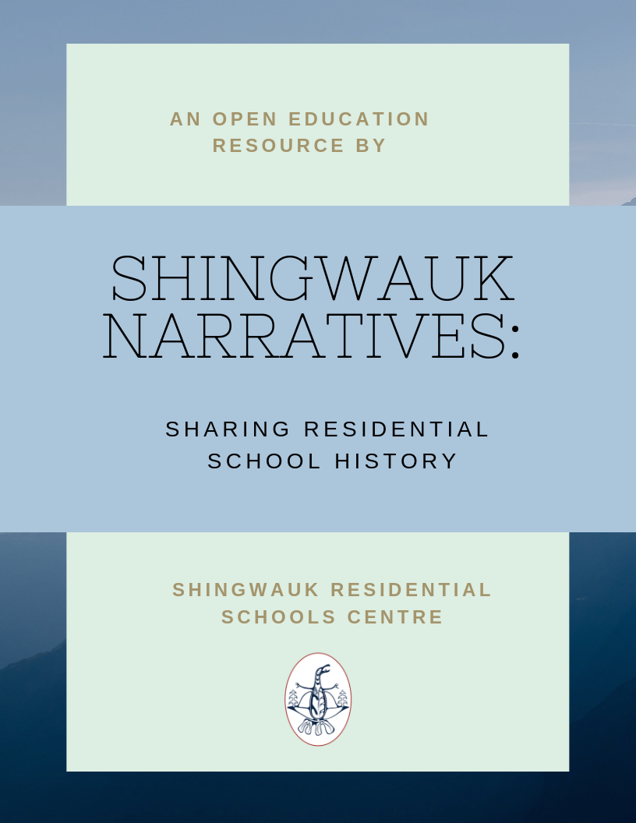

Shingwauk Narratives: Sharing Residential School History

Shingwauk Narratives: Sharing Residential School History

Jenna Lemay, Shingwauk Residential Schools Centre

Shingwauk Residential Schools Centre

Sault Ste. Marie, Ontario

Shingwauk Narratives: Sharing Residential School History by Shingwauk Residential Schools Centre is licensed under a Creative Commons Attribution-NonCommercial 4.0 International License, except where otherwise noted.

Contents
- Introduction
- Student Experience
- Fire Drills
- Student Death - Cemetery Register
- Student Death Part 1: Frederick Oshkapukeda
- Student Death Part 2
- Student Death Part 3
- Student Death Part 4: William Sahgucheway
- Print Shop
- Indigenous Clothing
- Indigenous Languages
- The Myth of Indifferent Parents
- Staffing
- Staffing Issues 1878-1879
- Staff Qualifications and Retention
- Staff and Student Relationships
- Historical Context
- Wilson and the North-West Rebellion

Introduction
The Shingwauk Residential Schools Centre (SRSC) holds letter books of the first principal of the Shingwauk Residential School, Rev. Edward F. Wilson, and the fourth principal Rev. George L. King. The letters range in date from 1875-1904, and include a wealth of information about the early history of Shingwauk and Wawanosh. Descriptions for the 10 books included in this collection can be found here on the Algoma Archives Website.
The letter books incorporate topics such as funding, staffing, student life, religious missions to aboriginal communities, and more which is not known to the wider public. By digitizing this information we are able to provide both physical and intellectual access to the information, preserve the information for future generations, and teach people about the early history of the Residential School system. Education about the Residential School system in the elementary and high school curriculum is part of the TRC’s Calls to Action (all 94 can be viewed here). However, this education should not stop once students graduate high school. As Canadian citizens we need to continue to educate ourselves about the history of the Residential School system in order to better understand survivors and First Nations communities. According to the TRC, “ongoing public education and dialogue are essential to reconciliation.”
As part of this education process we are sharing stories compiled from the information in the letter books in this open educational resource. The SRSC has more in depth information on the topics covered in these stories and we encourage visits from those wishing to learn more.

PART I

Student Experience

Chapter 1

Fire Drills
Old buildings are notoriously vulnerable to fire, and so Shingwauk needed to have some kind of fire plan in place. This was especially important considering the first iteration of Shingwauk, built in Garden River, burnt down just 6 days after opening. The boys at the school were trained in the Fire Brigade, basically a line of students who would pass buckets of water back and forth in order to fight any flames that might break out in the building.
The following excerpt highlights the experience of two brothers at Shingwauk who were involved in the Fire Brigade, John and Joseph Esquimau. During the Christmas exams in 1876, John, aged approximately 22, won the Bishop’s prize for best conduct, the first division prize for progress, and the first prize for scripture and catechism.
His younger brother Joseph, aged approximately 14, won the Bishop’s prize for best general progress, the first prize in second division for progress, the second class prize for English, and the Fire Brigade prize.

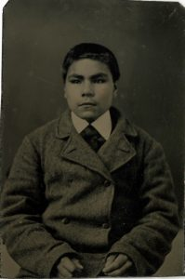

In a letter to Bishop Fauquier, the Bishop of Algoma, in Letter Book 2014-117/001(001), Wilson tells a story about how Joseph beat his brother by one prize:
“Our examinations are just over – [John] Esquimau gets your prize for good conduct and Joseph Esquimau the other one for general advancement in all branches. In this he is one ahead of his brother – how it was – the following little anecdote will show. Among the prizes to be competed for was one to the Fire Brigade – for knowing the rules well and being prompt in obeying orders – [John] Esquimau as captain formed his brigade in line for passing pails but put Hander Number 4 in Number 1’s place and vice versa – Number 4 was Joseph – and I said to him you are in the wrong place you lose a mark – “No sir,” he replied, “I know it’s the wrong place but Captain put me here and I obeyed his orders” – a regular soldier’s reply. The Captain in consequence lost a mark and Joseph beat him in the total.”

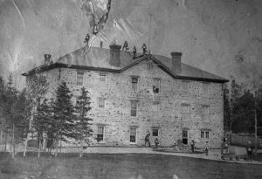

Chapter 2

Student Death - Cemetery Register
The next few chapters of this ebook deal with student illness and death in Residential Schools.
This information can often be upsetting, and if you are experiencing distress please contact the Indian Residential School Crisis Line at 1-866-925-4419
The collection of this information is a work in progress. If you know of someone who passed away at Shingwauk and is buried in the cemetery there, or you see incorrect information here, please contact the Shingwauk Residential Schools Centre.
Student death in Residential Schools can be a difficult subject to talk about, but it is an important one. Out of the 150,000 students who attended Residential Schools, at least 3,000 of them died, with researchers estimating that the actual number may be far greater (Truth and Reconciliation Commission, 2015; Wiles, 2015). Many of these deaths were unreported, or if reported included very minimal information, often leaving out the cause of death and the name of the student (Truth and Reconciliation Commission, 2015). Often, parents were not told what happened to their children and were left to wonder what became of them when they never came home.
Understanding the impact this had on other students and Indigenous communities is important to understanding the Residential School Legacy. When the Truth and Reconciliation Commission was conducting their research, they wrote a 255 page report dedicated just to Missing Children and Unmarked Burials, even though the topic was not originally part of their mandate (Truth and Reconciliation Commission, 2015). The National Centre for Truth and Reconciliation has picked up this work and is currently in the process of developing a memorial register to honour those who died at Residential School.
Statistics based on known burials in the Shingwauk Cemetery
Total number of burials: 109
Total number of students: 72 (65%)
Student age range: 5-20 years old
Average age of students when they passed: 13 years old
Common causes of death: Tuberculosis and related illnesses (48.5%), brain related illnesses (10%), pneumonia, drowning, typhoid fever
List of student home communities by region:
Southwestern Ontario (38%)- Moraviantown, Muncey, Sarnia, Walpole Island
Manitoulin Island (12%)- Little Current, Sheguiandah, Sheshegwaning Sucker Creek, Whitefish River
Mid-Ontario (10%) – Cape Croker, Rama, Saugeen, Christian Island
Quebec (10%)- Kahnawake, Oka, St. Regis
Northeastern Ontario (10%) – Michipicoten, Missanabie, Spanish River
Northwestern Ontario (5%) – Fort William, Lake Nipigon
Alberta (1%) – Blackfoot Crossing
Name | Date of Death | Approx. Age | Cause of Death | Home Community | Role | Notes
Mrs. William Stratton | 1871 |  |  | Sault Ste. Marie | Community member | Buried before the land was donated to the school
Mabel Laurie Wilson | Sep 30, 1873 |  | Pneumonia | Sault Ste. Marie | Staff family | Originally buried in Collingwood, body later moved to Shingwauk Cemetery
Hannah Weezhoo | Jan 30, 1876 | 13 | Brain disease | Walpole Island | Student
Solomon Corning | May 18, 1876 | 8 | Tuberculosis | Sarnia | Student
Susan Stratton | Apr 30, 1876 |  |  | Sault Ste. Marie | Community member | Also worked for the Wilson’s as a nurse
baby Stratton | Nov 5, 1876 |  |  | Sault Ste. Marie | Community member
John Rodd | Nov 28, 1877 | 16 | Cerebro spinal meningitis | Sarnia | Student
Frederick Oshkapukeda | May 17, 1879 | 15 | Tuberculosis | Lake Nipigon | Student
Louis Morris Minwahsin | Sep 18, 1879 | 13 | Tuberculosis | Michipicoten | Student
Sarah Fauquier | Nov 4, 1881 |  |  | Sault Ste. Marie | Bishop’s wife | Died in New York State, buried at Shingwauk Spring 1882
Frederick Dawson Fauquier | Dec 7, 1881 | 64 |  | Sault Ste. Marie | Bishop of Algoma | Died in Toronto, buried at Shingwauk Spring 1882
Charlie Penahsewa | Jan 5, 1882 | 11 | Typhoid fever | Sheshegwaning | Student
Benjamin Beaconsfield Chegauns | Jan 16, 1882 | 14 | Tuberculosis | Michipicoten | Student
Peter Jacobs | Feb 8, 1882 | 9 |  | Sarnia | Student
William Saguhcheway | May 16, 1882 | 19 | Inflammation of the bowels | Walpole Island | Student
Simon Altman | Jun 4, 1882 | 11 | Pneumonia | Walpole Island | Student
Henry Grey Austin | Jun 1882 or Apr 9, 1883
Martha Mark | Apr 1, 1885 | 8 | Tuberculosis | Christian Island | Student
Annie Howe | Sep 7, 1885 | 7 | Tuberculosis
Matilda Esquimau | Feb 18, 1886 | 5 mo. |  |  |  | Possibly the daughter of John Esquimau or Joseph Esquimau
Charles Mortimer Greene | Jan 23, 1888 |  |  |  | Clergy family
Jane Warner | Mar 3, 1888 | 10 |  | Walpole Island | Student
David Etukitsininani | Apr 23, 1888 | 17 | Tuberculosis | Blackfoot Crossing, Alberta | Student | Wilson brought him and another Blackfoot boy to Shingwauk after the Northwest Rebellion in 1885
Florence Pritchard | Jan 12, 1889
Peter Jones Stone | Feb 26, 1889 | 11 | Scrofula |  | Student
Mary Kadah | Sep 8, 1889 | 17 |  | Sheshegwaning | Student
Blanche Madden | Jan 7, 1890 | 5 |  |  | Student
Asa Peters | May 6, 1890 | 10 | Tuberculosis | Walpole Island | Student
Josephine Sampson | May 23, 1890 | 14 | Tuberculosis | Sheshegwaning | Student
Edward Waukay | Jun 3, 1890 | 17 | Tuberculosis | Cape Croker | Student
Caroline Waukay | Jun 9, 1890 | 11 | Tuberculosis | Cape Croker | Student
William Esquimau | Apr 2, 1891 | 11 | Tuberculosis | Little Current | Student
Mary Petuhwepejhik | Dec 13, 1891 | 12 |  | Sheshegwaning | Student
Llwellyn Jackson | Jul 10, 1893 | 10 |  | Sarnia | Student
John Clifford Madden | Aug 13, 1896 | Infant | Cholera
Andrew Stacey | May 19, 1897 | 11 | Drowning | Kahnawake | Student
John Stratton | Dec 28, 1898
Robert White | May 1, 1899 | 19 | Pneumonia | Walpole Island | Student
Alexander Knaggs | Jun 30, 1899 | 14 | Pneumonia | Walpole Island | Student
William Stonefish | Mar 13, 1901 | 14 | Typhoid fever | Moraviantown | Student
Mary Semo | Mar 6, 1902 | 15 | Tuberculosis | St. Regis | Student
Isaac Shebahgezhis | Sep 9, 1902 | 10 | Tuberculosis | Spanish River | Student
Isaac Kezhihgobinis | Oct 3, 1902 | 12 | Typhoid fever | Sucker Creek | Student
Henry Kechego | May 21, 1903 | 12 | Tuberculosis | Muncey | Student
Albert Penance | Jul 30, 1903 | 14 | Heart failure | Walpole Island | Student
Isaac Thomas | Mar 5, 1904 | 12 | Tuberculosis | Walpole Island | Student
Elliot Sampson | Nov 3, 1904 | 14 | Tuberculosis | Walpole Island | Student
Simon Jacobs | Feb 22, 1905 | 19 | Tuberculosis | Moraviantown | Student
Julia Jacobs | Apr 6, 1905 | 13 | Tuberculosis | Walpole Island | Student
Lawson Musouesh Kodawa | Oct 9, 1905 | 14 | Tuberculosis | Whitefish River | Student
Sara Skilliter | Dec 9, 1905 | 7 | Typhoid fever | Fort William | Student
Julia Masug | Feb 15, 1906 | 13 | Congestion of brain | Walpole Island | Student
Andrew Johnson | Mar 7, 1906 | 17 | Tuberculosis and typhoid fever | Walpole Island | Student
Dora Isaacs/Jacobs | Mar 27, 1906 | 13 | Tuberculosis | Walpole Island | Student
Edward Wilfred Lacelle | May 7, 1906 | 1 | Meningitis
Frank Grey | Jan 12, 1907 | 7 | Meningitis | Sarnia | Student
Jacob Grey | Apr 30, 1907 | 9 | Peritonitis | Sarnia | Student
Willis R. Fisher | Jan 14, 1911 | 15 | Tuberculosis | Sarnia | Student | Died at the hospital
Peter Stacey | Jul 30, 1911 | 20 | Drowning | Kahnawake | Former student | Was working as a miner at time of death, drowned near Bellevue Park
Kathleen Fuller | 1912 |  |  |  | Staff family
Sinclair Spaniel | Mar 14, 1912 | 15 | Tuberculosis | Spanish River | Student
Frank Spaniel | Mar 14, 1912 | 17 | Tuberculosis | Spanish River | Student
Leslie E. Fuller | Nov 28, 1912 | 16 |  |  | Staff family
baby McGillivray | Mar 1912 | still born
Lucy Kezhekobsuse | Jan 14, 1913 | 10 | Tuberculosis | Whitefish River | Student
Thomas S. Skilliter | Jul 12, 1913 | 18 | Tuberculosis | Fort William | Student
Fred “Michael” Fuller | Nov 18, 1913 |  | Tuberculosis |  | Staff family
Isaac Cornwall | Jul 23, 1914 | 85 | Old age
Andrew Wahcaneh | Jan 10, 1916 | 18 | Tuberculosis | Muncey | Student
Ruby Curley | Mar 2, 1916 | 9 | Tuberculosis meningitis |  | Student
Wilfred Lacelle | Jun 25, 1916 | 7 | Pneumonia |  | Staff family
Carrie Vincent | Apr 18, 1917 | 7 | Tuberculosis | Missanabie | Student
Mary A. Fuller | Sep 10, 1917 | 51 | Pernicious anemia |  | Staff
Margaret Emery | Feb 12, 1918
Charles Ningishkung | Feb 9, 1919 | 13 | Pneumonia | Rama | Student
Frank Oshkapukeda | Feb 13, 1919 | 13 | Pneumonia | Lake Nipigon | Student
Solomon Kahgee | Jul 18, 1919 | 12 | Tuberculosis | Saugeen | Student
Mary Tobico | Jul 1, 1923 | 14 | Tuberculosis | Saugeen | Student
Roy Richards | May 11, 1924 | 15 | Tuberculosis |  | Student
Ida Annie McNeil | Jan 18, 1925 | 50 |  |  | Staff
Evelyn Boonus/Barnes | Mar 15, 1927 | 14 | Endocarditis | Saugeen | Student
Percival Lacelle | Aug 20, 1928 | 16 | Tuberculosis |  | Student | Family was living in Sault Ste. Marie? Died in a house on Parliament Street
Gowan Gilmor | Sep 1, 1928 | 78 | Old age |  | Clergy
Peter Beavois | Nov 20, 1929 | 8 | Drowning | Oka | Student
Louise Isaac | Dec 30, 1929 | 12 | Tuberculosis | Ground Hog | Student
Lily Nicholas | Feb 15, 1936 | 14 | Scarlet fever | Quebec | Student
Myrtle Riley | Jun 6, 1936 | 15 | Tubercular meningitis |  | Student | Possibly buried at Walpole Island not Shingwauk
Norma Soney | Oct 29, 1937 | 10 | Pneumonia | Walpole Island | Student | Possibly buried in Wallaceburg not Shingwauk
Maurice John Greaves | Dec 6, 1937 | 25 | Strep |  | Staff
Howard Greenbird | Dec 10, 1937 | 7 | Whooping cough | Walpole Island | Student
Mary Martin | Dec 16, 1937 | 7 | Tubercular meningitis | Oka | Student
Lulu Margaret Bottrell | Feb 9, 1938 |  |  |  | Staff
Beulah Henry | Nov 18, 1938 | 13 | Appendicitis | Muncey | Student
Alfred Greaves | Feb 15, 1940 | 61 | Brain abscess |  | Clergy | Died at Muskoka Hospital for Consumptives
Dudley Shilling | Aug 15, 1940 | 16 | Drowning | Rama | Student
Leo Eugene Kicknosway | May 8, 1942 | 15 | Acute dilation of stomach | Walpole Island | Student
Doreen Wilson | Sep 8, 1942 | 14 | Brain abscess | Quebec | Student
Fred Nahwahgezhik | Nov 2, 1943 | 15 | Rheumatic fever and pancarditis | Sheguiandah | Student
Benjamin Philip Fuller | Dec 7, 1945 | 81 | Intestinal obstruction |  | Principal | Died on Manitoulin Island
Agnes McGraw | Oct 28, 1950
Alice Elizabeth Fuller | Apr 14, 1955 |  |  |  | Staff family
Francis Bertram Wilson | Dec 11, 1956 |  |  |  | Student
Seymour Hayes | Jun 24, 1957
Annie Morrow | Sep 28, 1967 |  |  |  | Clergy family
David John MacKenzie | Apr 23, 1970
Helena Ann Hayes | Mar 18, 1973
Benna Fuller | Jan 28, 1977 |  |  |  | Staff
Noel Thomas | 1983 |  |  |  |  | Cremains
Dorothy Lillian Ford | Aug 19, 1983 |  |  |  |  | Cremains

Chapter 3

Student Death Part 1: Frederick Oshkapukeda
A number of students died at Shingwauk, one of them being Frederick Oshkapukeda. He was born Ningwinnena “My Son”, and lived in Chief’s Bay on Lake Nipigon, south of what is now known as Gull Bay. Ningwinnena was the son of Oskapukeda, who was a younger son of Chief Muhnedooshans. Muhnedooshans was one of the Anishinaabe chiefs who travelled to Sault Ste Marie in 1850 to sign the Robinson-Superior Treaty. After leaving Lake Nipigon for Shingwauk, Ningwinnena was baptized in October of 1878 and was given the name Frederick, after his supporter Bishop Frederick Fauquier. Unfortunately, Frederick spent most of his time at Shingwauk in the sick room, having contracted tuberculosis from his mother who had died of the disease some years before. He died on May 17, 1879, with Principal Wilson and some other students attending him.

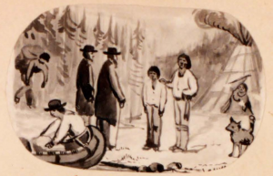

When Frederick died, he was the only child from the Lake Nipigon area in an Anglican Residential School. At the time, Wilson was trying to set up an Anglican Mission in the area, so details of Wilson’s first meeting with Frederick, his time at the school, his illness, and his death, were published in The Church Guardian magazine in Halifax, Nova Scotia. This report and the great amount of detail in it is a notable exception to the rule of unreported student deaths. Oshkapukeda was allowed contact with his son, was given the option to visit Frederick while he was sick, and was promptly informed of his death, a chance the majority of other parents and guardians were not given.
Frederick is buried in the Shingwauk cemetery next to Bishop Fauquier. Although his grave was originally marked with a slate, this marker has been lost and the exact location of his grave is unknown – there is enough space on either side of Bishop Fauquier’s grave to accommodate a burial.

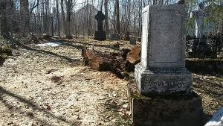

A digitized version of the full report, which Wilson copied into Letter Book 2013-012/001, can be read here.

Chapter 4

Student Death Part 2
Frederick Oshkapukede was not the only student who died during the early years of the Shingwauk Residential School. Between the opening of the School in 1874 and 1882, at least eight other students died while in residence at Shingwauk, and two other former students died at home. They died from a variety of illnesses including tuberculosis, meningitis, and typhoid fever. These illness resulted from a combination of poor living conditions, an immune system weakened by emotional trauma and malnutrition, and poor working and sanitary conditions at the school (Truth and Reconciliation Commission, 2015). A large number of students contracted these and other illnesses, and while many survived the following are the stories of the students who did not make it through. The majority of the students who died at Shingwauk were buried in the Shingwauk Cemetery, but out of all the students mentioned below and in following chapters, only the markers for John Rodd’s and William Sahgucheway’s graves remain. This chapter will discuss the first three deaths at the School.
The first student who died at Shingwauk was Hannah Weezhoo. Called Naswahbequa “Looking Three Ways” by her family, she entered the school in 1874 when the new stone building opened on Queen Street after the original schoolhouse in Garden River burnt down. Hannah was from Walpole Island, and her family had already been Christianized and were part of the Church of England (i.e. the Anglican Church). She was learning the laundry trade but died suddenly on Jan 30, 1876 of an undescribed brain disease. Buried three days later, she was the first student buried in the Shingwauk cemetery, which was not consecrated until later that summer. Hannah’s grave was marked with a wooden slab painted white which included her name, date of death, and a bible verse. This marker does not survive and the exact location of Hannah’s grave is unknown.

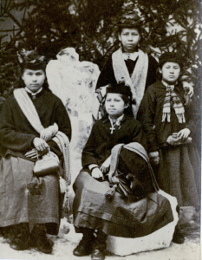

Solomon Corning died only a few months after Hannah, on May 18, 1876. Shebahjewun “Flowing Through a Gap” came to Shingwauk from the Sarnia Reserve in September of 1875 when he was only seven years old. Wilson noted in his register that Solomon was scrofulous when he came to the school. Scrofula is a type of tuberculosis that occurs outside the lungs, also known as the King’s Evil (Healthline, n.d.). According to the Shingwauk Principal, Solomon did not make much progress while at the School, and died from a scrofulous abscess in his neck after only attending the school for eight months. Like Hannah, he was buried in the Shingwauk cemetery before it could be consecrated. Solomon’s grave marker would have been similar to Hannah’s, and it too does not survive.
John Rodd, also known as Nahwegahbowh “Stand in the Middle” is the first death recorded in Wilson’s letter books in the University Archives (the letter books begin in late 1876, after Hannah and Solomon’s deaths). John Rodd had been at the School since it originally opened in Garden River in 1873. He was eleven years old at the time from Sarnia, and was one of Wilson’s first students. John ran away with his brother Pilate and student William Grey sometime in late 1875 or early 1876, but all three were brought back within a few weeks. John became a printing apprentice and helped to print the Algoma Missionary News and Shingwauk Journal.

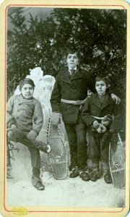

He became ill in early November 1877 with a “bilious attack” which usually means headache, abdominal pain, vomiting, etc. The doctor was not sent for until John’s symptoms became more serious five days before his death. He died from cerebro spinal meningitis on November 28, 1877 at around 10 in the morning. A funeral was held for him a few days later and he was buried in the Shingwauk cemetery. Wilson wrote to John’s mother to explain the circumstances of his death, and in the Spring she wrote back asking for John’s body to be exhumed and sent to Sarnia. Wilson objected to this, saying it would be very unpleasant since it had been so long already, and it was better to leave him where he was. However, Wilson offered Mrs Rodd a room at Shingwauk for the summer so she could come and visit John’s grave and stay with her other son Pilate. It doesn’t seem as though she took him up on this offer, since there are no further letters confirming details. Through his printing apprenticeship, John had $7 in his Savings Account, which went to Pilate after John’s death. A more detailed account of John’s time at the school, his death, and his funeral was published in the February 1878 issue of Algoma Missionary News which can be read here.

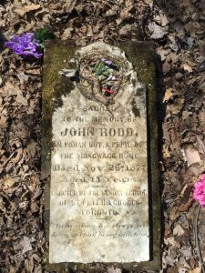

Chapter 5

Student Death Part 3
Continuing the discussion of student death in the early years of the Shingwauk Residential School, this chapter highlights the experiences four students who died while at Shingwauk. Three of the students died in the winter of 1882 when a typhoid fever epidemic was raging at the school and at Garden River.
Louis Morris was a boy from Michipicoten who entered Shingwauk on June 19, 1877 at age thirteen. He was a non-Christian when he came, and went by Wuswadeens “Little Man Over There”. Wilson described him as having a “delicate chest”, usually an early sign of consumption. He became sick with inflammation of the lungs in December of 1877 but had recovered enough by January of 1878 to return to his studies and other activities. Louis was also described as being earnest about religion, and he was baptized on October 27, 1878 along with Frederick Oshkapukeda and Benjamin Beaconsfield (see below). His supporter, Mrs Maynard, chose his Christian name Louis Morris Wilkins, but Wilkins was generally left off his name. Louis became sick again in the Spring of 1879 with bronchitis and inflammation of the lungs, at the same time Frederick was sick with the same symptoms and dying of consumption. Louis seemed to be sick on a off throughout the summer with lung issues before himself dying of consumption on Sept 18, 1879. He is buried in an unknown spot in the Shingwauk cemetery with his grave marker missing. It was likely similar to the markings which disappeared from Hannah, Solomon, and Frederick’s graves.

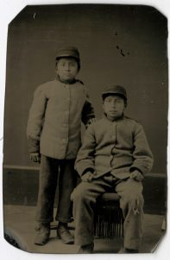

In January of 1882, the school was hit with a typhoid fever epidemic. Typhoid fever is caused by a type of Salmonella bacteria in water or food. Five boys at the school came down with the illness, two of them eventually died from it. Garden River was also hit with typhoid fever, and sixteen people there died, with forty more ill. After one boy had died from the fever (Charlie Penahsewa, see below), Wilson set up a meeting with doctors from the village as well as Chiefs Augustin Shingwauk and Buhkwujjenene from Garden River on January 26 to assess the sanitary conditions at the school and to assure the public that everything possible was being done to care for the boys and stop the spread of the disease. They were satisfied with the conditions and Garden River parents with children in the homes decided not to remove those children. Augustin Shingwauk then wrote a letter which was sent around to all the Reserves explaining the situation: two boys from Sarnia, Peter Jacobs and Willie West, and one boy from Walpole Island, Wesley Sandys, were all sick but did not seem to be in danger. The disease had spread all over Garden River with one person in each family sick, but those at Shingwauk were well taken care of in a large, well ventilated dormitory that had been converted in to a hospital.
By January 28 another boy had contracted the fever in addition to the three still sick. On January 30, one of these boys was doing very poorly and was sent to Wawanosh for a change of air (a common remedy at the time for almost any illness). Doctors were in daily to check on the boys and Wilson had brought in a First Nations woman to nurse them. Wilson stated that he had more faith in this woman’s ability to care for the children than he had in the doctor, and he felt she was very clever and knew what she was doing. By the end of February the epidemic had passed and the three boys who survived were all well again.
Charlie Ahyahans Penahsewa was the first boy to die in the typhoid fever epidemic. He was a Roman Catholic Oddawa boy from Blind River who came to the school on July 5, 1881 at the age of ten. His parents had signed an agreement for him to continue attending Shingwauk until the summer of 1886. He became sick at the end of December with symptoms including head and chest pain and delirium. On December 26 Wilson wrote to Charlie’s mother Mary Endawas to tell her that Charlie had been very sick the past week, but that the doctor and the nurse were tending to him. Despite their care Charlie died on January 5, 1882, was buried in the Shingwauk cemetery the next day, and Wilson wrote to his mother to give her the news two days later. No grave marker is left for Charlie and it is unknown where in the cemetery he is buried.
Despite being sick at the same time as the typhoid fever epidemic, Benjamin Beaconsfield died of consumption, not typhoid. He came from Michipicoten with the name Chegauns “Little Man Close By”. He was ten years old when he was registered at Shingwauk on June 19, 1877. For the first few months of his time at the School, he was unsupported, and Wilson wrote many letters trying to find a Sunday School or an individual who could guarantee the funds. It is unknown what kind of effect a lack of support had on the children, what kind of clothes and food they were given, but it seems likely that Wilson would have fed and clothed them as if they did have support, hoping to later make up the deficit. Benjamin was a little sickly in February on 1878, but seemed to recover. Wilson thought he may have been baptized in Michipicoten and not given a Christian name, but he couldn’t find out for sure, so decided to baptize him at the Shingwauk Home. Benjamin was baptized on October 27, 1878 along with Louis Morris and Frederick Oshkapukeda, and his Christian name was chosen by his supporter Mrs Clarke. During the 1878 Christmas exams Benjamin won first prize, and he was described as a “dear, loveable boy” making very good progress. In the summer of 1880 Benjamin stayed at Shingwauk, stating that he had no home to go to. He was sick again in the winter of 1880/1881, but was better by January 24 when he told Wilson he was “not sick anymore, only lazy”. He seemed to have been sick on and off throughout 1881, becoming confined to a bed in the hospital room in winter of 1881/1882. He died of consumption on January 16, 1882 and was buried in the Shingwauk cemetery the next day. As with many of the other students who died, his grave is no longer marked.
The last boy to die during the typhoid outbreak was Peter Jacobs. Not much is known about Peter, except that he came from Sarnia and that his father was Edward Jacobs. He may have been the young boy who was sent to Wawanosh when he became extremely sick at the end of January 1882. He died from typhoid fever on February 8, 1882 and was buried in the Shingwauk cemetery the next day, with no surviving grave marker.
Since the majority of students who died at Shingwauk do not have grave markers still visible in the cemetery, a cairn was erected on May 12, 1988 dedicated to all those buried in the cemetery.

Chapter 6

Student Death Part 4: William Sahgucheway
William Sahgucheway was one of the most prominent students at Shingwauk in the 1870’s and 1880’s, and his death was also the death which affected Edward F. Wilson the most during the early years of the Institution. William attended the Residential School for 6 or 7 years during which time he accompanied Wilson to England and on a missionary trip up Lake Superior, was training to teach and eventually enter the ministry, and was captain at the School.
Added in to the School Register on June 17, 1875 at age 13, William came from Walpole Island in southern Ontario not far from Detroit. Called Wahsashkung “Giving Light”, he was raised by his uncle James Thomas and his wife, after his parents William White and Wahwahsemooqua died when he was young. While at the Institution, William converted to Christianity and, according to Wilson, became very earnest in his religion. Although originally apprenticing as a printer, by 1878 William expressed a desire to be a teacher, and so switched to studying that instead. Students studying to be teachers or ministers devoted all their time to this and so consequently were exempt from household duties such as cooking, cleaning, or farming chores.
During this time, parents or guardians of students were expected to sign agreements for students to stay at the Institution for a certain number of years (usually five or six depending on how old they were when they entered the school). However, William’s uncle seemed reluctant to sign the agreement, and Letter Book 2013-012/001 includes a letter William wrote to his uncle asking permission to stay at the school so he could continue his education and eventually become a teacher. William began studying in Wilson’s office in the mornings with the other boys learning to be teachers or missionaries, and so spent a lot of time with Wilson. The two became very close over the years, and Wilson trusted no other boy at the school more than William. Consequently, William was given high level responsibilities such as the captainship of the school (i.e. Head Boy), which included the authority to bring back runaway boys, which William did when Jeffrey and Talfourd Brisette and Sampson Ojibway ran away in July of 1881. William was one of the only boys allowed to attend Wilson during his illness in the Spring of 1880 – Letter Book 2014-017/001(002) includes letters written in William’s hand paraphrasing Wilson’s words. Letter Book 2013-012/001 includes a recommendation letter that Wilson wrote for William in order for him to get summer work which reads “William Sahgucheway of Walpole Island is a strong, active, willing, honest, good tempered boy who will work well for anyone who will employ him.”
In the fall of 1880, William’s younger brother Elijah, with whom he was very close, became extremely ill and was unable to return to Shingwauk when it reopened after Wilson’s illness. William remained home with him, writing letters to Wilson informing him of his brother’s condition. Elijah remained sick throughout the winter and spring of 1881 before passing away from an unknown illness on May 29, 1881. William was very upset by the passing of his brother, and talked of him often at the school.

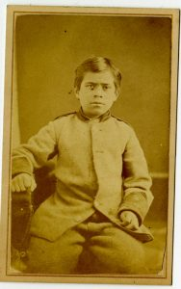

When William himself became sick a year later with severe enteritis, Wilson wrote that William was very upset about Elijah and quoted him saying “I did so love Elijah…I want to go to him”. When William passed away on May 16, 1882, Wilson was extremely distraught, and wrote letters telling people he was “bowed down with grief” and that William “was my adopted child and I loved him as my own son”. He even stated multiple times that this death affected his as no other had since the death of his mother 20 years before. Wilson was still depressed months after William’s death, writing “I hardly feel I can keep up my work without him”. These strong feelings towards William led Wilson to write a memoir about him which was eventually published as a chapter in his book Missionary Work Among the Ojebway Indians, which can be read here. This chapter includes more information about William, including information about his illness and final hours. Part of this chapter was originally published over several issues of Algoma Missionary News starting with the obituary in June of 1882 which can be read here. A draft of this obituary is written in Letter Book 2013-012/002.
William’s family, Mr and Mrs Thomas, were informed of his death on the same day he died, and he was buried in the Shingwauk cemetery on May 18, 1882. Wilson told the Thomas’ that they could come and retrieve the body if they wanted to, since William wanted to be buried beside his brother on Walpole Island. Due to the long time it took to mail letters back and forth from Shingwauk to Walpole Island, there was some confusion about the wishes of the family regarding William’s burial. The Thomas’ originally seemed very insistent that the body be sent to Walpole for burial, but they seem to have only desired this if the body was not already buried. They did not realize that William had been buried quickly, and were angry with Wilson for holding the body from them. Wilson tried to explain that exhuming the body would be unpleasant, and that a lead coffin would be needed to ship the body otherwise the boats would not take it. The family eventually consented to leaving the body in the Shingwauk cemetery, and Wilson began raising money for a gravestone, giving $25 of the required $75-100 himself. The rest of the money was collected from students, staff, and Church Sunday Schools supporting the Institution, and the gravestone was erected sometime in the fall of 1882. It is still visible in the graveyard today, one of the few remaining markers from the early years of the Shingwauk Residential School.

Chapter 7

Print Shop
During the late 19th century, the Shingwauk Residential School operated on the Industrial school model where students spent part of their time at school work and part of their time learning a trade. These trades usually supported the school in some way and included farming, carpentry, bootmaking, tailoring, printing, blacksmithing, and more. Some of these trades were taught on school grounds, with the shops part of the building complexes, while some other trades were apprenticed in the town. From 1876 until 1883 Shingwauk operated its own print shop where students learned the trade by printing Algoma Missionary News and The Peace Pipe.
Four boys apprenticed in the shop, with two of them working at a time on alternate weeks. The two weeks they were not in the print shop were spent in class. Generally, they started their apprenticeship after being in the Institution for 2 years. The first four boys to work in the print shop were David McGrah age 13, William Sahguhcheway age 14, Willie Riley age 12, and John Rodd age 13. When the shop first opened, there was no professional teacher to show the boys what to do, it was just Wilson who was also learning as he went along. The boys worked to fold and sew the papers for the magazine together, sometimes working long hours in order to get the issues out on time. The winter of 1877 was so cold that the boys had to work all through the night to finish printing otherwise the printing press and other equipment would freeze over. The type originally used in the first small printing press, as well as the AMN frontpiece, were carved in the carpentry shop by carpentry apprentice Adam Kiyoshk.

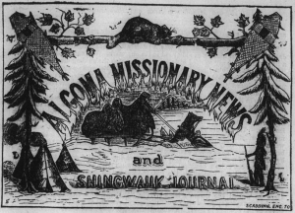

In 1877 Wilson bought a more professional printing press and equipment from a local shop which was closing down. This allowed him to make Algoma Missionary News a monthly magazine of better quality. It also increased the students’ workload as they had to begin printing 1500-2000 issues every month instead of every two months. The printers had different holidays from the other students due to the year round requirements of their work. In the summer of 1877 William Sahguhcheway and David McGrah were sent home for summer holidays early so that they would be at Shingwauk to print AMN while the other boys were away. The boys were given a small salary for their work, part of it given to them as money to pay for their board and part of it put into a Savings Account for them. This Savings money was inaccessible to the boys until they left the school at which point it was meant to be used to purchase the tools needed to continue working their trade. First year apprentice boys were paid $1/week and second year boys paid $2/week.
In 1878 Wilson bought a second larger Washington press and found a professional to teach the boys. Mr Reid rented out the shop and was paid a small salary to teach the boys to print AMN. Due to this added help, Wilson began to expand the work of the shop by publishing The Peace Pipe, a magazine written in both English and Ojibwe in addition to Algoma Missionary News. One of the more prominent students in the school, John Esquimau, was paid a small salary to edit this magazine. Unfortunately, The Peace Pipe only ran for a short time as Wilson could only find 200 subscribers rather than the 500 needed to not print the magazine at a loss.

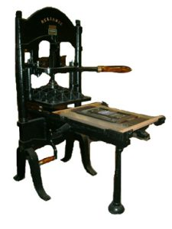

In the fall of 1879, the print shop was temporarily closed, and the printing of AMN outsourced to a local printer named Mr Biggings. This was probably due to professional problems Wilson was having with Mr Reid – he was often late with his work and Wilson would find mistakes in the final printed versions which should have been corrected. Despite these problems, the print shop reopened in January 1880 with Mr Reid as the head still. The problems continued though and Wilson eventually hired a new man, Mr Dudley from St John’s, Newfoundland, who worked part time as a printer and part time as an accountant for the Institution. In the Fall of 1881, the print shop moved to a larger space once occupied by the laundry which had moved to Wawanosh. This new space allowed book binding to be added as a trade in conjunction with the print shop.
New boys were eventually brought into the trade as apprentice boys died (John Rodd) or switched to different trades (William Sahguhcheway and Willie Riley worked to be teachers). Other boys who worked in the print shop include Johnny Daniel who attended Shingwauk from 1875-1880, Joseph Kahgaug who attended from 1877-1882, Charlie McGrah who attended from 1875-1881, Fred Mookomaun who attended from 1877-1883, Fred Obotossaway who attended from 1875-1880, David Osahgee who attended from 1877-1886, Adam Pedahtig who attended from 1878-1884, Jack Rodd who attended from 1875-1879, and Pilate Rodd who attended from 1875-1882.
The print shop closed sometime in 1882 or 1883 and AMN was published locally by Mr Biggings, who had temporarily taken on printing duties before. All the print stock, including the equipment, was sold in order to finance the new sash and door factory being created at Shingwauk. Once the work shifted permanently to Biggings, no more students were apprenticed and the trade ceased to be offered at the Institution.

Chapter 8

Indigenous Clothing
Indigenous clothing and hair can hold a great amount of meaning for the people who wear it and the people who see it. It can be used to reflect social order, gender, age, marital status, family affiliation, and much more (McCord Museum, 2013). For many students going to Residential School, their clothing and hairstyle would have been an important connection to their home communities and families, and a marker of their individuality. Therefore it was a prime target for assimilationist tactics. Ben Barry, an associate professor of equity, diversity, and inclusion at the Ryerson Fashion School, states that “fashion is obviously a field that perpetuates colonialism against Canadian Indigenous people” (McKay, 2016). When children came to Residential Schools, their handmade clothing was often discarded, and survivors speak of it being ridiculed and burned (Truth and Reconciliation Commission, 2015). They were made to wear westernized clothing which was often an identical uniform and could be poor in quality and not proper for weather conditions. Childrens’ hair was often cut into identical styles, further stripping them of a connection to their culture and individuality.
Clothing was often used as a way to show the progress of the student and the benefits of the school in “civilizing” Indigenous people. Before and after photos are common throughout Residential School history and sometimes show a mish-mash of clothing from multiple different cultures, rather than an accurate representation. Indigenous clothing was widely mocked by the settler community and seen as a sign of savagery. Later, it was greatly misappropriated and treated as a costume devoid of meaning.

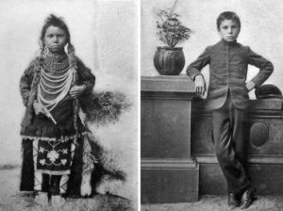

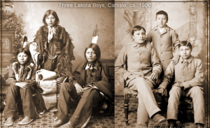

At Shingwauk, students were expected to wear European clothing. Most of this clothing was donated by patrons of the school, or paid for by their monetary donations. When supporting a student, a Sunday School or individual could either pay $75 a year and have Wilson sort out the clothing, or they could pay $50 and were expected to send 1 coat, 2 suits of clothes, 3 shirts, 4 pairs of socks, 2 caps (1 winter 1 summer), 1 pair of boots, 1 muffler, 1 pair of mitts, 2 pairs of winter drawers, 2 undervests, and 4 pocket handkerchiefs. These could be gently used or handmade by donors like the various different Ladies Sewing Societies. These expected clothing donations, as well as the monetary donations, often fell far short of the needs of the school and students. The quality of these clothing items is unknown, but in the later years of the system, survivors have spoken about feeling embarrassed due to the low quality of their clothing (Truth and Reconciliation Commission, 2015).
At various times the school was in desperate need of clothing, especially warm winter clothing like mits, caps, and coats, and many boys would have to continue on without these necessary items. Wilson commented in 1880 to a donor that they had 53 boys at the school but only 3 coats, and that the rest would have to be bought. However, the school was chronically underfunded and it’s hard to know if sufficient clothing was actually purchased. While there’s no evidence of students in the early years of Shingwauk dying of exposure, in the later years of the system students who ran away from other schools with clothing not suited to the winter climate sometimes did not make it home due to the poor clothing they received from the school.
In 1877, 4 years after the school first opened, Wilson decided to design a uniform for the students. The “uniform” part of the outfit consisted just of a coat and cap with the rest of the clothing still donated by patrons. Originally the winter coat and cap were black or grey tweed with scarlet piping and had brass buttons with the Shingwauk logo, and the summer outfit consisted of a dark blue overshirt with a band at the waist, a dark Garibaldi hat with a peacock feather, and grey trousers. For a while, the winter coats were made by the Hudson’s Bay Company, but later were made by local tailors and donors due to the expense. Girls uniforms were dresses in dark blue serge with red trim for winter, and were the same in summer but made out of cotton instead.

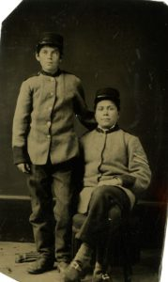

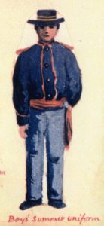

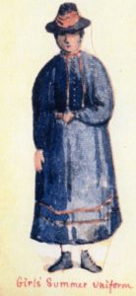

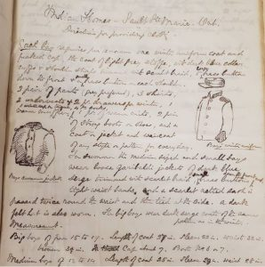

Wilson wanted the students to look very westernized, and often sent Shingwauk students home for the holidays in their uniforms because he felt they would be safer on the steamboats wearing that as opposed to any clothing which might come from their home. The uniforms were reserved for occasions like that when the boys would be out in public, such as trips to the church on Sundays, funding tours, or public events like the arrival of the Marquis of Lorne to Sault Ste Marie in 1881. The rest of the time the uniforms would be in storage.
Before the 1920s, attendance at Residential Schools was not compulsory, and principals had little power to retain students and stop them from running away, or stop parents from pulling them out of the school at any time. To combat this, many principals tried to fine parents for breaking attendance agreements, or in the case of Shingwauk, for taking school clothing. Wilson would fine parents anywhere from $5-$15 if their children failed to return when they had gone home with their uniforms. Being so far from his students’ home communities, Wilson often had a very difficult time trying to collect these fines, and tried to enlist the local Indian Agents to get the money. There are numerous letters to government officials such as the Superintendent General of Indian Affairs (at the time it was John A. Macdonald) asking for help and authority to collect the money. If the students did eventually return to the school, the charges would be dropped; most students did come back, and few clothing fines were actually collected.
In 1887, William Solomon actually travelled to Shingwauk after hearing a rumour that his son Wesley was going around without a shirt. Wilson looked into the situation and found that Wesley had ripped his shirt and thrown it away during free play time outside. He continued to play for a while before the teacher, Mr Mitchell, noticed this and brought him a new shirt. The Truth and Reconciliation Commission found multiple other examples of parents complaining about the quality of their children’s clothing, showing that they were not indifferent towards their children, and often took great pains to make sure that they were well cared for. This often included sending their children to school with beautiful handmade clothing, not knowing it would be discarded for clothing of poorer quality.
Today, many Indigenous people are using clothing as a way to retain their culture and proudly display their heritage. Riley Kucheran is a PhD student in the Fashion program at Ryerson University who is studying Indigenous fashion and received the 2019 Pierre Elliott Trudeau Foundation Scholarship for his work (Ryerson, 2019; CBC, 2019). Indigenous fashion designers are integrating traditional designs and techniques into their clothing, and supporting them is a great way to bring respect back to Indigenous style. Indigenous Fashion Week is an important event which highlights these designers; the event takes place in Toronto, Vancouver, and Ottawa (where it was held just this past week). More information about Toronto Indigenous Fashion Week can be found here, and a list of designers highlighted at Vancouver Indigenous Fashion Week can be found here.

Chapter 9

Indigenous Languages
In most Residential Schools, the main language was either French or English, and Indigenous languages were suppressed, sometimes violently. Many students came to the institutions with little or no knowledge of English and had a hard time adjusting to the new language. Due to the restrictions placed on their first languages, many students completely lost the ability to speak or understand those languages, which further separated them from their families and communities. In the early years at Shingwauk, restrictions on Ojibwe, the most common Indigenous language spoken by the students, were much more relaxed than in later years and at other schools. E.F. Wilson spoke Ojibwe, also known as Anishinaabemowin, fluently, and allowed the students to speak it on fairly regular occasions. Later, more restrictions were placed and punishments were carried out if students were caught speaking their language at any time. Language revitalization is a prominent topic now, which the Government and many post-secondary schools are playing a role in. Communities are also strongly focused on this, and different teaching tools are being developed, such as the Wiikwemkoong Anishinaabemowin Language App.
Language is an important part of culture and carries a lot of information about various aspects of that culture. According to the Assembly of First Nations in 1994 “language is necessary to define and maintain a world view. For this reason, some First Nation elders will say knowing or learning the native language is basic to any deep understanding of a First Nation way of life” (Truth and Reconciliation Commission, 2015). Especially for an oral society, language is a foundation of culture (Indigenous Corporate Training, 2019). Without this important connection to a language and its history, people lose their sense of identity and belonging within that culture. Stripping students of their language was a prominent part of colonization and assimilation. Many students did not know any English when they arrived as Residential Schools, and many survivors talk about the hard time they had adjusting to the new language (Truth and Reconciliation Commission, 2015). Children could be severely punished for speaking their language, including having needles stuck in their tongues. Some were even punished for not doing something asked of them in a language they did not yet understand (Truth and Reconciliation Commission, 2015). Many students eventually lost the ability to speak and understand their language, which further separated them from their culture by obstructing their ability to communicate with their families and communities when they went home.
In the early years of Shingwauk, students were encouraged to speak only English, and Wilson set up a system to try and ensure this in a “fun” way. In the Fourth Annual Report of the school in 1878, Wilson wrote “We also have a plan by which the boys are induced, in a good humoured way, to keep a check on one another about talking Indian. A certain number of buttons, of a particular pattern, are given out to the boys, every Saturday, five each to boys who can scarcely speak English at all, two to each of those who can talk a little, and none to those who can talk well. If any boy hears another talk Indian, he says to him, “Give me your button,” and when Saturday comes round again, each boy produces his buttons and receives nuts in exchange; after which a redistribution is made.” It does not seem as though students were punished for losing buttons, but in 1884, Wilson reported that none of the children at the school spoke their language after 6 months attendance, and that this was achieved through strictness and sometimes punishment.
Names are part of language and culture and often were changed for Christian/European names. Last names sometimes were translated rather than expressed in Anishinaabemowin. Benjamin Shingwauk became Benjamin Pine, and Johnny Wigwaus became Johnny Birchbark. Wilson stated that if the Indigenous surname was “not euphonious” the Christian name of father might be made into a surname, e.g. John to Johnson, or the name could be translated e.g. Keezhik to Sky. If the students did not already have a Christian first name, Wilson referred to them in letters to supporters as English translations of their names, such as Little Elk instead of Ahtikoons and Little Spirit Bird instead of Muhnedoopenass.
As a result of their treatment at school in regards to language use, some survivors raised their children without their Indigenous language, speaking to them only in English, either because they had lost it themselves, or did not want their children to experience the punishments they did for speaking their Indigenous language (Truth and Reconciliation Commission, 2015). This contributed to further loss of language as it was perpetuated through the generations. Even after the majority of Residential Schools had closed or were only operating as boarding houses, the Sixties Scoop continued the eradication of languages by removing children from families who may have raised them with their Indigenous languages, and placing them in white families who spoke either English or French (Anderson, 2018).
Many missionaries, including Wilson, could understand and speak Indigenous languages, but they often used these languages as a tool of colonialism – to bring Christianity and English to the Indigenous people. According to the Truth and Reconciliation Commission (2015), although missionaries worked “to soften the impact of imperialism, they were also committed to making the greatest changes in the culture and psychology of the colonized.” They used the languages, but only in the process of working to undermine and exterminate them. “Most nineteenth-century missionaries attempted to learn Aboriginal languages and… often translated prayers, hymns, and scripture… This did not necessarily reflect a respect for Aboriginal culture. Rather, knowledge of the language served as a tool for undermining the culture” (Truth and Reconciliation Commission, 2015). In the early years at Shingwauk, Wilson allowed students to speak their language (generally Ojibwe, also known as Anishinaabemowin), but usually only in the context of religious activities. When boys prayed and dedicated themselves to Christ, Wilson originally encouraged them to do so in their own language. Students often sang hymns in both English and Ojibwe, and the print shop at the school printed both an Ojibwe hymn book and an Ojibwe prayer book. The print shop also printed The Peace Pipe, an Ojibwe version of the Algoma Missionary News magazine, which Wilson wrote and edited. This was intended for parents and community members to give them information about the school as well as news from Christian communities. Wilson stated in one of his letters that “The Peace Pipe will be just as helpful as schooling in civilizing Indians”, showing that the use of Indigenous language was meant as a way to push forward colonization and assimilation.
Government policies had a strong effect on the use of Indigenous languages in Residential Schools. Principals were often instructed that most of their attention should be focused on fluency in English and the eradication of the use of Indigenous languages. Consequently, school inspectors often viewed the continued use of Indigenous languages as a sign of failure (Truth and Reconciliation Commission, 2015). The Indian Affairs Report from 1895 stated that “so long as he keeps his native tongue, so long he will remain a community apart” (Yesno, 1970), showing that the goal was not just fluency in English, but the destruction of Indigenous languages. Some principals set fixed times for their students to speak their languages, as an effort to slowly phase them out. Wilson allowed students at Shingwauk to speak their languages for a few hours on Saturdays during the first few years of the school’s operation. The Government discouraged this, and Hayter Reed, the Superintendent of Indian Affairs, stated in 1890 that “at most the native language is only to be used as a vehicle of teaching and should be discontinued as such as soon as practicable” (Truth and Reconciliation Commission, 2015). Principals often reported on success in suppressing Aboriginal languages, and Wilson often described the progress of the students in learning English based off of their ability and willingness to read the Bible.
As a result of the Residential School Legacy and colonization, most Aboriginal languages in Canada are critically endangered, with some only having a handful of elderly speakers (Truth and Reconciliation Commission, 2015). Many communities are working to revitalize their languages, and the Truth and Reconciliation Commission’s Calls to Action include protecting rights to languages, teaching them as credit courses, and Government assistance in revitalization. The right to language is also specifically acknowledged in the United Nations Declaration of the Rights of Indigenous Peoples. In 2002, the Government of Canada promised $160 million for the creation of a centre for Aboriginal languages and culture, as well as a national language strategy (Truth and Reconciliation Commission, 2015). However, the Government reverted from this promise in 2006 and instead pledged $5 million per year for the Aboriginal Languages Initiative, which had been established in 1998. The Aboriginal Languages Initiative is a Government run program as opposed to something Aboriginal people have power over (Truth and Reconciliation Commission, 2015).
The Government plans for language initiatives changed again this year with the passage of Bill C-91 the Indigenous Languages Act on June 21, 2019. This act is meant to recognize Indigenous language rights and provides $333.7 million over 5 years and $115.7 million per year after to support reclamation, revitalization, strengthening, and maintenance of Indigenous languages and promotion of their use, as well as to establish the office of the Commissioner of Indigenous Languages. Provincially, Nunavut is currently the only province with a language protection act, and Inuit is one of the three official languages of the province (along with English and French) (Indigenous corporate Training Inc, 2019). According to the Truth and Reconciliation Commission (2015), “If the preservation of Aboriginal languages does not become a priority both for governments and for Aboriginal communities, then what the residential schools failed to accomplish will come about through a process of systematic neglect.” With this new national Bill, and the declaration by UNESCO of 2019 as the Year of Indigenous Languages, hopefully many of the endangered Indigenous languages will begin to make a comeback. Algoma University is an important site for language revitalization, with Shingwauk Kinoomaage Gamig having the only Anishinaabemowin B.A. program in the country, and Anishinaabemowin intensive programs are being run on the campus by Survivors of the Shingwauk Residential School.

Chapter 10

The Myth of Indifferent Parents
One of the colonial motivations for putting children in Residential Schools was the misconception that Indigenous parents were unfit and unable to care for their children. Indigenous people were viewed as drunkards, thieves, lazy, selfish, and emotionally uncaring, among other horrible traits. This was far from the truth for the majority of parents who cared deeply for their children. A common response from Shingwauk Principal George Ley King to parents who wanted to remove their sons from the Residential School was “if you truly had his best interest at heart, you would not try to interrupt his education.”
However, most of the parents who wanted to remove their children were doing so in their best interest, as the child may have complained of lack of food, lack of proper clothing, poor sanitary conditions, or of various physical abuses among other terrible circumstances at Residential School.
This myth of the indifferent parent has persisted past the Residential School system. It was prevalent during the Sixties Scoop where children were removed from Indigenous families and fostered with white families. This practice continues today with the inordinate number of Indigenous children in the foster care system.
The majority of settlers, especially those working in government or the Residential School System, believed that Indigenous parents did not care about their children or their education. It was thought that parents simply let their children run amok at home without giving them any kind of education, and that they did not care enough to give them a Western education. People who believed this were completely ignorant of the traditional Indigenous education system of looking, listening, and learning, which often gave children all the knowledge they needed to be able to live a good life (Miller, 1996). This traditional passing of knowledge was administered with a great deal of patience and love, and survivors have spoken about how safe, loved, and well taken care of they felt in their communities (Truth and Reconciliation Commission, 2015). Just because Indigenous parents were ambivalent about Western teaching styles does not mean they did not care about the children’s education.
Many parents wrote letters to the school to inquire about how their children were doing in class work or how they were progressing at their trade. Lack of proper education was often an argument used by parents to gain the discharge and return of their children. George Ley King received a letter from the father of E. Wrightman which he said was “written of course in the usual style of an Indian parent trying to keep his boy from school”. The letter stated that the child was not learning fast enough, that he wasn’t learning a trade, and other complaints about his education, all legitimate reasons to want to remove a child from a class or school. However, King viewed these instead as excuses in order to bring the child home to do work so the parents could be lazy.
Residential School staff often told the children that their parents did not care about them or their education (Truth and Reconciliation Commission, 2015) and despite the evidence to the contrary, many of those children began to believe it was true. Many children felt abandoned and unloved by parents who sent them far away, did not come to visit, did not write, or did not send them money to come home (Truth and Reconciliation Commission, 2015). But parents often had no choice in the matter. Once education became compulsory, parents were threatened with hefty fines or jail for non-compliance. Likewise, families may not have been able to afford to send travel money for the children to come home, especially if the child had been sent to a school far away from their home community. This lack of options made parents feel helpless and even more upset at losing their children to a far away school where contact was extremely limited (Truth and Reconciliation Commission, 2015). If parents were working to remove their children from the school, the children would not be made aware of this, and any correspondence related to the topic of leaving the school was screened and not passed on to the child.
Parents were often extremely distraught at having to send their children away. Survivor Alma Scott, who attended the Fort Alexander school in Manitoba, recounts “I can still remember my mom and dad looking at us, and they were really, really sad looking. My dad’s shoulders were just hunched, and he, to me, it looked like his spirit was broken” (Truth and Reconciliation Commission, 2015). Oshkapukeda, the father of Ningwinnena, who was renamed Frederick Oshkapukeda when he came to Shingwauk, was profoundly sad at sending his son away, but felt that it was best for his education. “I know I shall be sad without him, I shall weep often for him, but I want him to be taught, and I will try to control myself until he returns to see me next summer…I know I shall lie awake at night and grieve the loss of my boy. We Indians cannot bear to be parted from our children, but it is right that he should go. If my heart is too heavy for me to bear, I shall come to Red Rock and get on the Fire Ship and come to see him” (quoted in Wilson, 1886)
For children who had passed away at the school, parents or guardians would try to attend the funeral if they were informed with enough time to travel. Some even tried to get the body of their child returned to their home community for burial. This was the case with William Sahguhcheway’s aunt and uncle. William’s brother Elijah had died at home a year before William, and on his deathbed William expressed a strong desire to be buried beside his brother. However, Principal Edward Wilson and William were very close and Wilson selfishly wanted to keep the body at Shingwauk so he could visit the grave. Although he made it sound like he was giving the family options, suggesting they come pick the body up or pay for a lead coffin, neither of those were possible for them and so the body was buried in the Shingwauk cemetery against the original wishes of William’s family and of William himself.
Staff at the schools believed that parents were a bad influence on their children, and Principal George Ley King wanted to completely ban children from going home for summer holidays. Officials thought that parents would encourage children to revert back to “savage ways” and cause students to forget all they learned in Residential School. A lot of what students would have been picking up from their parents would have been traditional knowledge and activities, things like language, medicine and fruit gathering, fishing ,hunting, etc. These would be considered leisure activities by the settler communities and so seen as evidence that parents were encouraging their children to “loaf” when in fact these activities were both culturally significant and helping to sustain the community.
A common belief was that parents were selfish and only wanted their children home so that they did not have to work. King was convinced that the majority of parents who were trying to remove their children from Shingwauk were only doing so because they had their own interests in mind, and he urged them to put their children first by leaving them at school. He stated to a Department of Indian Affairs representative that “parents can have no legitimate excuse for keeping their boys at home”.
However, parents were often working in their children’s best interest by trying to remove them or refusing to send them back because they had found out about the bad conditions at the school or abuse the child had experienced. The parents of Shingwauk students Charles Noah and Jacob Pheasant were fortunate enough to be able to hire a solicitor to argue on their behalf for the discharge of their children from the school in the 1890s. This was a particularly concerted effort on the part of the parents since it was actually illegal for Indigenous people to hire a lawyer until 1951 (Griner, 2013). King was always extremely frustrated when students did not return after the summer holidays and blamed this on bad parenting, he said “their parents are worse than foolish in detaining them on the Reserve”. His use of the word detaining is interesting because it makes it seem like the children want to return but the parents are selfishly preventing them. It’s also reflective of what the Residential School System was doing with children by detaining them at schools and not allowing them to return home for years.
Another clear sign that parents cared for their children was that they came to visit them while at the schools. The family of George and Abram Esquimaux came and camped outside the Shingwauk for a few weeks during the summer of 1898, likely because George and Abram were denied holiday leave that year. Many parents also came to visit and care for their children themselves when they were sick, spending as much time as needed to ensure the child was well again. These visits were often discouraged though, and if parents did come they would either be denied access to their children or their visit would be highly controlled (Truth and Reconciliation Commission, 2015).
When parents could not come to visit, they often wrote letters to their children or to the principal to see how their children were, but as mentioned before correspondence was monitored so children were unable to talk about any abuses they were experiences, or even about school activities or other students. Both Wilson and King wrote letters to parents especially in regards to children’s health. This is in contrast to later years of the system when parents were not even informed that their child was sick, let alone whether they had passed away.
Where bad parenting did exist, those parents were likely Residential School Survivors themselves and the lack of parenting skills was a direct result of the system and not something inherent in the Indigenous population. Many Survivors have spoken about the lack of socialization they received at Residential School which led to them not being able to interact properly with spouses and children (Truth and Reconciliation Commission, 2015). Emotional trauma coping mechanisms may have manifested as domestic abuse and alcoholism, further perpetuating harmful myths about Indigenous parents and Indigenous people in general.
Racist thoughts about Indigenous people as parents continued into the later years of the Residential School system and beyond it with the Sixties Scoop. The Scoop involved a series of child welfare policies which led to a large number of Indigenous children being removed from their homes and adopted out to white families. Indigenous children lost connection to their language, culture, and communities and were often treated poorly and made to be ashamed of their Indigenous heritage (CBC, 2019). Many see this as a continuation of the Residential School system just under a different name. The removal of Indigenous children has continued into the present with the outrageous number of Indigenous children in the foster care system. More than half the children in the system are Indigenous even though Indigenous children make up only 7.7% of Canadian children under 14, and the issue has been referred to as a humanitarian crisis (Brake, 2018). The Canadian Government recently passed Bill C-92 which hands back control over child welfare to Indigenous people and allows those children to be cared for in culturally appropriate ways which recognize and celebrate their heritage.

Miller, J.R. Shingwauk’s Vision: A History of Native Residential Schools. Toronto: University of Toronto Press, 1996.

PART III

Staffing

Chapter 11

Staffing Issues 1878-1879
The staffing of Residential Schools directly affected the daily lives of students, and many Survivors talk about the lasting impact of the way they were treated by staff. Understanding who worked at Shingwauk and why they were hired can help expand our understanding of the legacy of Residential Schools. The following is an in-depth account of the staffing issues experienced by the first principal of Shingwauk, Edward Francis Wilson, in 1878-1879. This information comes from Letter Book 2013-112/001 (001), and a description of the book can be found here on the Algoma Archives website.
E.F. Wilson seemed to have a lot of difficulty hiring staff to work at the two schools during 1878-1879. One issue was finding a woman to work as the Lady Superintendent at Wawanosh. Miss Browne started at the school in October of 1877 but wanted to leave by June of 1878. Wilson wrote a great deal of letters to supporters across Canada and in England looking for someone to replace her, but he was having trouble finding someone and was worried that Miss Browne would leave without someone to replace her. Wawanosh was also dealing with funding issues and Wilson started to feel that the only solution was to close the school. However, upon finding out this plan, Miss Browne offered to stay on for Winter 1878-79 at half pay in order to keep the school open. Wilson was incredibly thankful for this and mentioned it in almost every letter for a few weeks. Come Spring 1879 Miss Browne tendered her resignation again, finding the work too lonely, and she planned to leave in June. Wilson again wrote to a great deal of people looking for a replacement and eventually found Miss Carry, who he was immensely satisfied with.
The hiring situation for couples at the school was much more dramatic. These couples seemed to have been hired to deal with general grounds and maintenance, tailoring, cooking, laundering, etc depending on the skills of the man and woman. In 1878 Wawanosh had Mr and Mrs Booth but they decided to leave for an unknown reason, so Wilson started writing letters to find a replacement, as well as a separate couple to work at Shingwauk doing the above described tasks for the school in addition to duties for Wilson’s family. Former students Adam Kiyoshk and Alice Wawanosh, recently married, came to work at Shingwauk as carpenter and cook but were not happy with the salary, and thinking they could get something better down south they left. There seemed to be a great deal of confusion in hiring replacement couples since it was all done by letter, Wilson himself in contact with applicants as well as with applicants through Mrs Fauquier (the Head Directress of the Wawanosh Committee and wife of the Bishop of Algoma) and other third parties in England. Consequently, multiple couples were hired at the same time. Mr and Mrs Hardeman were hired through Mrs Fauquier, but Wilson didn’t know if they were coming for sure, so George Paddon and his wife were hired for Shingwauk to replace Adam and Alice and Mr and Mrs Rankin were hired to replace Mr and Mrs Booth at Wawanosh. The Hardemans did show up though, so Wilson had them working in the garden while he figured out what to do with the other couples.
Wilson soon fired the Rankins as Mrs Rankin was required to work “willfully and cheerfully” under Miss Browne and was “very ill-suited to this task”. Charles Cottrell and his wife had been hired in England around the same time as the other couples, but did not arrive until after the Rankins were gone. They replaced the Rankins but then moved to Shingwauk as there was trouble with the Paddons. While Wilson was away on a missionary tour, Mr Paddon was fired by Mrs Wilson for displaying drunkenness (a clear breach of his contract) and creating a disturbance. He left that night without his wife, but returned the next day and refused to leave. After arguing with Mrs Wilson and Reverend Appleby, the couple eventually left. Since the Cottrells replaced the Paddons, this left the Wawanosh positions open for the Hardemans.

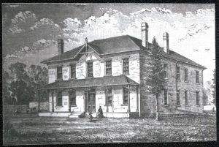

The Cottrells came with their own set of problems though. The agreement they signed in England was for them to work at Shingwauk for 4 years, and part of this agreement was that Wilson would withhold a portion of their quarterly payment to be paid out at the end of their contract, in order to ensure that they stayed for the full 4 years. When they arrived, Wilson realized Mrs Cottrell was pregnant, and therefore he did not think that the couple could properly carry out their duties, so they were sent to work at Wawanosh. Charles Cottrell felt that therefore the original agreement was null and he wanted to be paid in full. Wilson refused to do this and Cottrell argued, so Wilson said he would have to let them go if they could not agree with this method of payment. However they decided to stay when they switched to Shingwauk after the Paddons left. The Wilsons travelled to England during the summer of 1879, and the Cottrells were left in charge of the grounds. When Wilson returned there was a disagreement when Mrs Cottrell did not do something she was asked to do, and Mr Cottrell got very heated, the police were called, and he spent the night in jail and the couple was fired the next day.
A previous employee, John Taylor, and his wife were hired to replace the Cottrells at Shingwauk. Taylor had previously worked there as a farm hand of some kind, but was evidently terrible at this job, creating a lot of damage and costing the school a large amount of money. He also was a nuisance to Wilson after he was fired by constantly asking for the money he was owed (he was on the same type of contract as the Cottrells and had money held back from each paycheck). Wilson felt that Taylor had breached his contract by not staying as long as he was supposed to in addition to causing damage, and so refused to pay him the money. When he was hired back along with his wife in October of 1879, it was again for a 4 year contract with money held back to be paid at the end.
Staffing issues continued to cause problems over the course of the school’s history, and more information can be found in the records held at the Shingwauk Residential School Centre.

Chapter 12

Staff Qualifications and Retention
The Residential School system as a whole had a difficult time with hiring and retaining staff. Teachers and other staff members were often hired by the religious organization running the school rather than approved by any government body or policy (Truth and Reconciliation Commission, 2015). Because of this the focus was more on the person’s religious devotion rather than their teaching experience and qualifications. Pay was low and living conditions were often poor, leading to an extremely high turnover rate at schools across the country (Truth and Reconciliation Commission, 2015). Even in the early years of the system, Shingwauk and Wawanosh were not immune to these problems.
The First Lady Superintendent for Wawanosh, Madame Capelle, was hired because she expressed a strong desire for missionary work. After six weeks of working, she was fired in part for her lack of religious devotion. She did not like attending church and preferred to read the Bible alone rather than in a Bible class with her students, and the principle, Edward Wilson, felt that this was not appropriate for someone in this position. The third Lady Superintendent, Miss Carry, was hired because she was a clergyman’s daughter. Although these women had some experience working with children, Wilson was more concerned with their religious experience and feelings rather than how well they could teach the girls at Wawanosh
The pay at Shingwauk and Wawanosh was extremely poor. Staff were given a yearly salary of between $250-$350 depending on their position, which, considering inflation, comes out to less than $15,000 a year in today’s money. Two staff members, Adam Kiyoshk and Alice Wawanosh, left their positions as carpenter and cook at Shingwauk because they felt they could get better pay in similar positions elsewhere. This amount was brought even lower by the pay system Wilson used in an attempt to retain staff: he kept 10% of the pay back, intending to pay it out at the end of the staff member’s contract (generally 4 years). This however was not enough incentive, and between 1876-1879 almost no one stayed their full contract. Wilson himself also took a low salary, supporting a family of 11 on less than $30,000, and he complained that he could get twice as much if he went back to England.
While board was given in addition to salary, living conditions were not ideal, especially at Wawanosh. Miss Browne, the second Lady Superintendent, left her position because she found the job too lonely. She was the only staff member in the building, with the grounds couple often working outside and living in their own separate cottage. She was also expected to work seven days a week supervising the girls, with no time for her own pursuits and relationships.
Shingwauk may also have had a hard time in retaining staff because of the difficulty of working for the Wilsons. Edward Wilson often had arguments with his staff over the quality of their work and their desire for better pay (i.e. a higher salary without the 10% held back). Fanny Wilson may have been particularly difficult to work with, as Madame Capelle complained that she often lied and Mrs Coville, the Wilson’s laundress, was overheard complaining about her.
The lack of qualifications and retention of staff greatly affected the quality of the education the students received, contributing to the failure of Residential Schools as an education system.

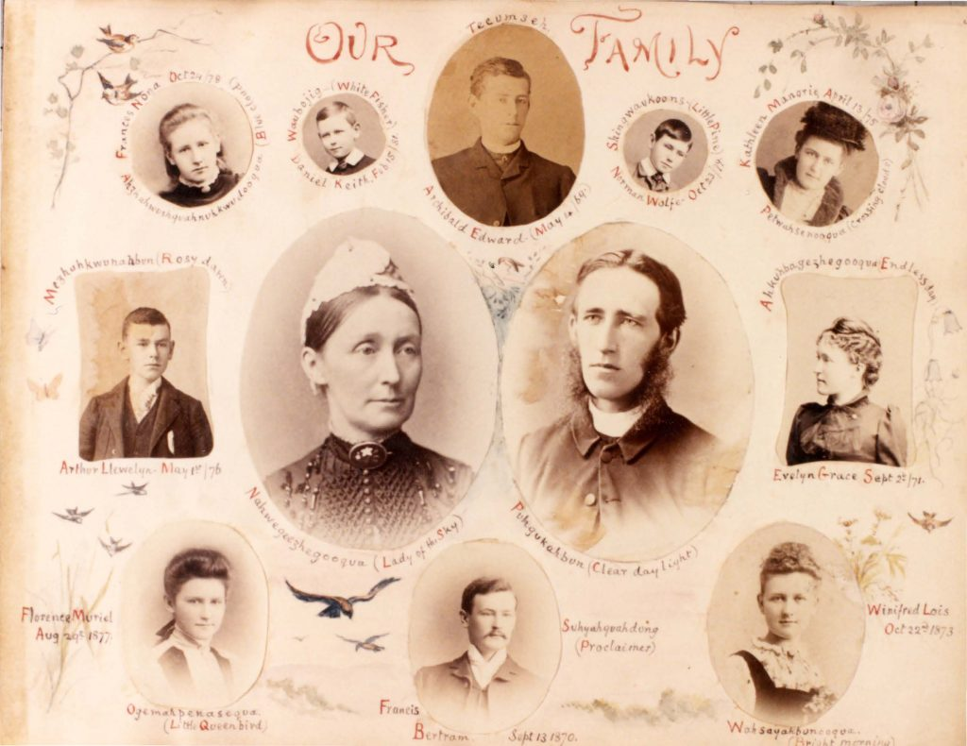

Chapter 13

Staff and Student Relationships
It is clear from survivor testimonials that the relationships between staff and students were often extremely negative, with staff participating in a wide variety of different abuses against their students (Truth and Reconciliation Commission, 2015). However, despite the overwhelming amount of bad teachers, there were teachers that genuinely cared about the children. Edward F. Wilson is a good example of this.
He developed a close relationship with many of his students, and worked hard to get them in to situations where they could support themselves. He did this especially with students who shared his interest in and love of the Christian religion. He encouraged John and Joseph Esquimau and William Sahguhcheway to pursue their interest in the church and tried to get them into Huron College to continue their studies which would allow them to be ordained in the Anglican Church. In the meantime he got John a job as a teacher and minister’s apprentice in Garden River, and the same with Joseph at the Nipigon Mission.
At one point, Willie Riley, one of Wilson’s particular favourites, was considering leaving the school as he was anxious to go home to care for his mother who was a widow and very poor. In order to ensure that Willie Riley continued his education, Wilson offered Shepagooqua a position at the school, knowing Willie would be very pleased with the arrangement. This awareness and acceptance of student connections with their families is in sharp contrast to the later Residential School system where some students were forced to stay at the school all year round, and the loss of their language made contact with their families difficult (Truth and Reconciliation Commission, 2015).

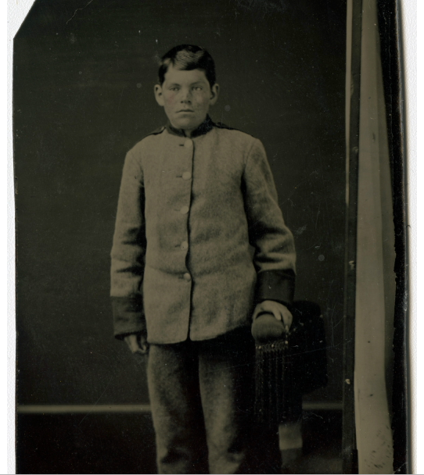

Whenever there was sickness in the school, Wilson became very anxious about the boys’ health, sometimes writing hourly updates to the doctor before he could arrive. If the sickness was particularly severe, or a student had recently died, Wilson became even more worried, and often stayed up all night monitoring the sick to make sure their condition was stable, administering medicines when required. Student death affected him strongly, and almost a year after Frederick Oshkapakeda’s death, Wilson wrote to Frederick’s father Oshkapakeda and mentioned that he often visited Frederick’s grave to think about him.
In his 1883 memoir Missionary Work Among the Ojebway Indians, Wilson wrote
The first thing, I felt, was to draw the children around me, and let them feel that I cared for them and really sought their good. I regarded them all as my children. A good proof that I had in some measure gained their affection and confidence was that many of those who had been with us the previous winter, and had been home during the summer for their holidays, had of their own accord come back again, some of them a great distance, and all seemed anxious to get on and learn all they could.
This shows that Wilson’s clear affection for the children was evident to them, and it made them trust him and want to come back to the school to learn more from him. Despite the large number of teachers who treated the students in Residential Schools extremely poorly, there are survivors who recalled staff members who took the time to show they cared (Truth and Reconciliation Commission, 2015), and Wilson is a rare example of this.

PART IV

Historical Context

Chapter 14

Wilson and the North-West Rebellion
This Monday, June 3, will be the 134th anniversary of the end of the North-West Rebellion. The Rebellion was a violent uprising by Metis and First Nations people in Saskatchewan and Alberta against the Canadian Government. Food scarcity such as the depletion of the buffalo and droughts caused stress both among the Metis and First Nations as well as among the settlers. Land issues were also a grievance that was not being addressed by the government to the satisfaction of the Metis and First Nations. The Rebellion was defeated by the federal troops and the leaders were punished by the Government. Poundmaker and Big Bear were convicted and sent to prison, while eight other leaders were hanged in the largest mass hanging in Canadian history. Louis Riel was convicted and hanged in a widely publicised trial. On the 23rd of May this year, Prime Minister Justin Trudeau travelled to Poundmaker First Nation in Saskatchewan to exonerate Chief Poundmaker of his unjust and wrongful treason conviction. This is an important step in the path towards reconciliation and an acknowledgement of the disrespectful treatment of Plains Indigenous Peoples by the Canadian Government.

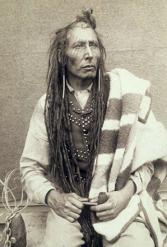

The first principal of Shingwauk, E.F. Wilson, wrote many letters laying out his thoughts on, and reaction to, the North-West Rebellion. These give an interesting insight into Wilson’s feelings towards First Nations and Metis communities and highlight the motivations behind his push for further Residential Schools. In direct reaction to the Rebellion, Wilson came up with the idea to create “Branch Institutions” which led to the creation of the Elkhorn Residential School in Elkhorn, Manitoba by Wilson and his brother, Wilberforce Wilson.
On April 17, 1885, in Letter Book 2014-017/001(003), Wilson wrote a letter to the Editor of The Mail (a magazine or newspaper, publishing location unknown). Often when he wrote letters to Editors they were intended for publication, but it is unknown if this particular letter was ever published. In this letter he seems sympathetic to the grievances of the First Nations and Metis people, while arguing that the Residential School system is the solution.
Wilson describes their troubles, saying “white people have deprived them of their means of existence and they see nothing but starvation staring them in the face”. This statement seems to be sympathetic and understanding of the fault that colonial communities have in destroying traditional lifeways. He then says “And what has been done to make up to the Indians for their losses? The Government, we cannot deny, has dealt very liberally with these poor people, – but the question is, has it been dealt wisely?” Here he very much seems to take the “white saviour” view by saying that the Government has given help “very liberally”, which appears to be contradictory to his previous statement and does not acknowledge that the help the Government is giving is to solve a problem that they created. Wilson then continues, elaborating on the last part of that statement saying “Would it not have been better to have been less eager about the immediate possession of those vast hunting grounds, and to have limited for a score of years or so the progress of the surveyor with his chain? Would it not have been better gradually to have drawn those 50,000 roaming Indians within the coils of civilization instead of shutting them up suddenly onto Reserve lands like prison houses and compelling them to farm or die?” The last part of this statement shows some sympathy for the horrible situation that the First Nations and Metis communities are in, but he clearly still thinks that Reserves are a necessary part of the solution to the “Indian problem”. He further elaborates on his solution by saying “I maintain, and I think I have common sense, justice, and wisdom on my side, that the only way to deal with the Indians is to take their children while still young and train them up in the path of Christianity and civilization”.
Interestingly, Wilson constantly refers to Dr Barnardo as his role model in what he wants to do for First Nations children. Dr Barnardo was an Englishman who ran an orphanage in London, England, which cared for the large amount of homeless children living on the streets on London. He also took in children who were not homeless, but living in very poor situations. Very early on in his career, he was accused of kidnapping children to fill his orphanage. He openly confessed to this, calling it “philanthropic abduction”. This is a very apt phrase and perfectly describes the feelings of those involved in the Residential School System as well as the Sixties Scoop. The fact that Wilson gives Dr Barnardo such high praise really highlights how he feels about his work at the Residential School. Wilson states that Dr Barnardo “gets the children – gets hold of the children before they are greatly contaminated and brings them up to be useful members of society”.
Since Wilson views Residential Schools as the solution to the problem he presented at the beginning of the letter, he wants to be able to expand on his work at Shingwauk in order to “help” more people. To do this, he proposes establishing Branch Institutions at strategic places in the North-West. He also proposes “this summer [i.e. summer 1885] to go and bring down from the North West some 30-40 of those young braves whose fathers and uncles have taken up weapons against us – because poor fellows they are feeling the pangs of starvation, and in their ignorance imagine that they can stay the tide of immigration which is depriving them of their homes and hunting grounds”. He plans to bring these children to Shingwauk, separating them far from their families, which was the tactic used especially in later years of the Residential School system to remove the influence of parents and communities on the children. Though he shows some sympathy, he sees assimilation as inevitable and colonial ways as the only right ways, with no room for reciprocal knowledge sharing.
Near the end of the letter, Wilson states “I love the Indians. I love my Indian boys and believe in their capabilities as fully and as fervently as Dr Barnardo believes in his street Arab”. He does care for the children and their communities, but is misguided in his views of the best way to help them. He is going about showing his love in the wrong way and does not see the faults in his plan.

