Adaptive Learning Pilot:

Building Brightspace LeaP Learning Paths

Prepare.

Getting Started

INITIAL STEPS
- Build the module content in Brightspace
- Add module (LeaP) questions to the Question Library
  - Create a folder structure using Sections. The recommended structure is as follows, Module # > Learning Objective > Questions.
  - There are two ways to add questions to the Question Library:
    - build questions directly in Brightspace
    - use the Test/Quiz Question Generator to generate a question file (.csv) and then import the questions into the appropriate section(s) in the Question Library.
- Prepare the Learning Objectives Import File (.csv).
To keep the Learning Objectives area of LeaP organized ensure that the.csv file is completed using the following guidelines. Once Learning Objectives have been uploaded to LeaP they cannot be removed.
  - Set the first objective Parent ID at “0”. Next, name the Title after the Module #. Then, Have the Description match the title. Ensure that the Leaf? column remains blank.
  - Enter the Learning Objectives in the subsequent rows. The Parent ID for each should be set to “1” (Why? This step makes our first row, entitled Module #, the Parent of the Learning Objectives which will create a consistent folder structure in LeaP). Enter the Learning Objective in both the Title and Description cells. For each of the Learning Objectives ensure that the Leaf? column contains “y”.
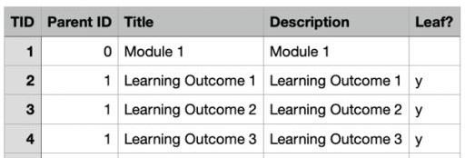

Build.

Create a Brightspace LeaP
- In the course navigate to Content and locate the appropriate module. Using the
Existing Activities menu select Brightspace LeaP.
- Give the Brightspace LeaP a name. If using the LeaP as a review tool the following name is suggested: Module Title – Review

- Click Create and Insert.
- Locate the LeaP link in the Module Content and click on the title of the LeaP.

Learning Objectives (.csv)
- In the Learning Objectives section click on the Imported folder.
- Next, click on the Upload New learning objectives item.
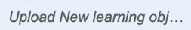
- Using the Choose File button open the Learning Objectives .csv file.
- Click Upload New learning objectives.
- Locate and select the learning objectives from the menu.
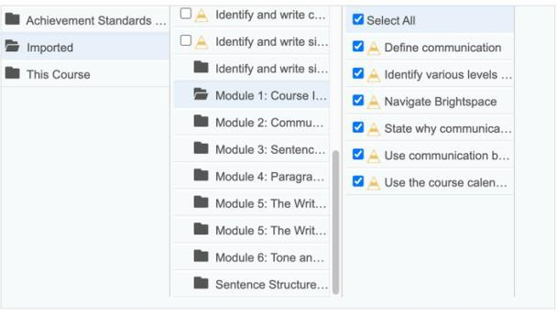
- Click Continue.

Content
- From the Content tab, select This Course as the content source for the Learning Path.
- Click Continue.

Settings
- From the Settings tab, choose the amount of Questions Per Learning Objective that will be displayed in the learning path tests.
- Select Start with a diagnostic test. This setting will test learners before displaying un- mastered content.
- Select Hide mastered content. Mastered content is determined based on diagnostic test results.
- Scroll down and click Advanced Settings.
  - Select Exclude content text and use only learning objective text when choosing practice questions and remediation materials.
  - Select Exclude content text and use only learning objective text when choosing recommended reading.

Confirmation
- Review and confirm the Learning Objectives, Content, and Settings.
- Click Create LeaP.

Edit.
To edit a learning path, locate the LeaP link in the Module Content and click on the title of the LeaP.

Content Repositories
From Content Repositories tab you can select from any of the available Learning Object Repositories (LORs) for additional sources of LeaP content.
Note: You cannot de-select This Course.

CONTENT VISIBILITY
From the Content Repositories tab under the Content Source column click on This Course. It is possible to set any course content items to Hidden or Visible.
Why set content to Hidden? LeaP may recommend that Module Introductions, Summaries, or Course Common Elements or other irrelevant items as study materials.
Note: Visibility settings will be the same in all learning paths in a course.
Note: If using a LOR you will not be able to set content as Hidden, all content will be visible.

Questions
All multiple choice and true/false questions in the Question Library are automatically available for use in a Learning Path.

QUESTION VISIBILITY
From the Questions tab it is possible to set any questions to Hidden or Visible.
Note: If there are questions for graded assessments in the Question Library it is advisable to set them to
Hidden under the Questions tab in LeaP.

Content Alignments
Learning Objectives are mapped to Visible Content and Questions under the Content Alignments tab.

ENFORCING ALIGNMENT
- Select a Learning Objective.
- In the Content column LeaP will show all course content it has mapped to the Learning Objectives. The higher the percentage in the blue bubble the closer the relation to the Learning Objective.
Note: To manually map content to Learning Outcomes click on the blue bubble and readjust the percentage.

- In the Questions column LeaP will show all questions it has mapped to the Learning Objectives and Content.
Note: To manually map questions click on the blue bubble and readjust the percentage.
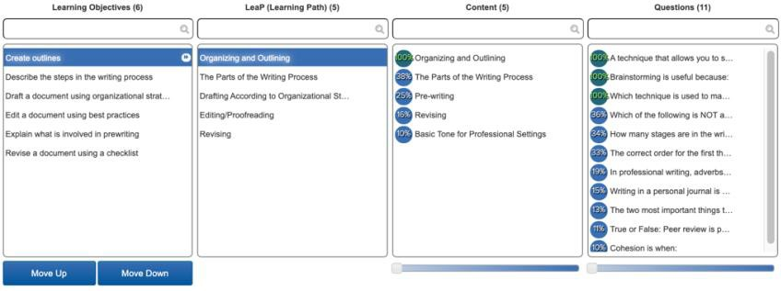

Maintain.

Considerations
- Learning paths continue to evolve over time, questions or content created after a learning path may be mapped to previous LeaP learning paths.
Note: Content or questions added to a course after a learning path has been built may be displayed if learning paths are not edited afterwards.
- Learning paths are not responsive and are not ideal for mobile devices.
- Content links to YouTube videos do not display in LeaP. Ensure YouTube links are embedded in module content items.

