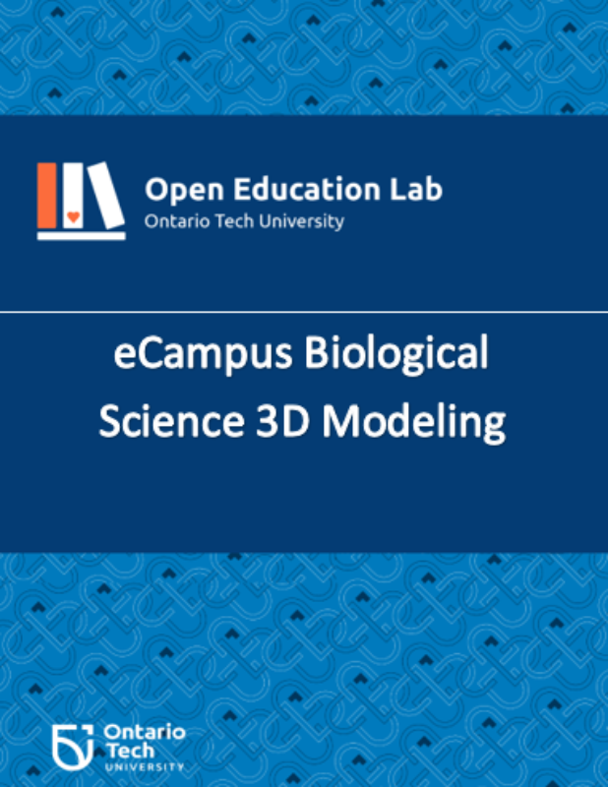

eCampus Biological Science 3D Modeling

eCampus Biological Science 3D Modeling

Pranjal Saloni and Sarah Stokes

eCampus Biological Science 3D Modeling Copyright © 2024 by Pranjal Saloni and Sarah Stokes. All Rights Reserved.

Contents
- Introduction
- Acknowledgment
- Main Body
- DNA Replication Bubble
- DNA to RNA Translation
- Chromosomes of Mitosis and Meiosis
- Resources

1

Introduction

Brief summary
This project creates 3D printable models that instructors can use to illustrate lecture content, and students and teaching assistants can manipulate the models to better facilitate understanding of the physical space and relationships of biological systems, organs, and cells. It supports experiential learning for biological science courses and increases access to enhanced learning for diverse groups of students. In order to help learning in biological science courses, we will offer a library of 3D-printable files for significant biology models. These files can be used to both augment textbook content and improve hands-on learning in the lab.

Why was it developed?
Conventionally published textbooks offer various support materials, including test banks, illustrations, and teacher resources, but sometimes fall short in providing practical experiences. Since different learners process and understand information differently, it’s critical for educators to provide instructional materials in a range of formats. This was considered when developing the project. Because 3D printed biological models give students many ways to engage, learn, and demonstrate their knowledge, they support Universal Design for Learning (UDL) in ways that many other resources do not. Additionally, the immersive quality of 3D printed models enhances the dynamic and participatory nature of learning as students become more involved in the learning process and engage numerous senses by interacting and investigating 3D printed biological models.

2

Acknowledgment

Authors
Sarah Stokes, Pranjal Saloni, Lidya Salim

Funding Acknowledgement
This resource is funded by the Government of Ontario. The views expressed in this publication are the views of the author(s) and do not necessarily reflect those of the Government of Ontario.

About the Open Education (OE) Lab
Ontario Tech University is proud to host the OE Lab – a student-run, staff-managed group that brings content and technological expertise to the timely creation of high quality OER that will be used directly in an Ontario Tech course by Ontario Tech students.


Thank you to the students employed by the OE Lab for working hard to make this project a reality!
Editors: Noopa Kuriakose, Zainab Nomani, Divya Sharma, Maria tifanny vera Martinez, Umer Bashir, Aalina Shahid, Ghufran Shahid
Project Managers: Pranjal Saloni, Sarah Stokes

How to Attribute This Work
Suggested Attribution for This Work: eCampus Biological Science 3D Modeling produced by the OE Lab at Ontario Tech University, 2024, licensed under a CC BY NC SA 4.0 International License, unless otherwise noted.




1

DNA Replication Bubble

Printable Files
Please find the 3D printable files here.

Design 1

Reference Models
https://sketchfab.com/3d-models/dna-replication-model-3122da8323374eb5bf9ed4736c0de563

Images

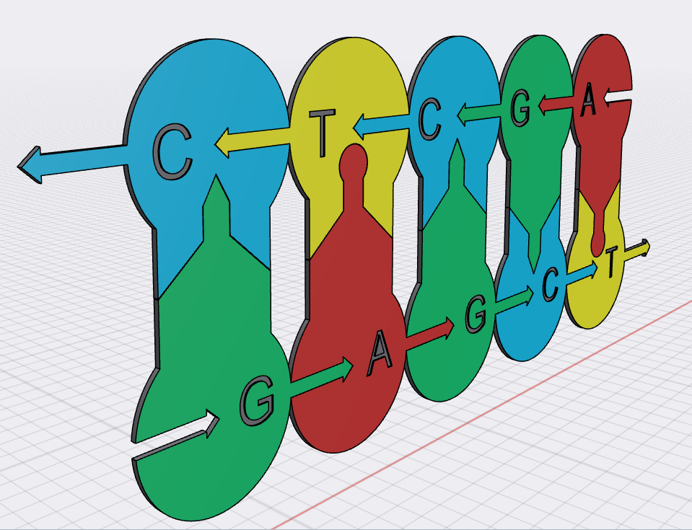

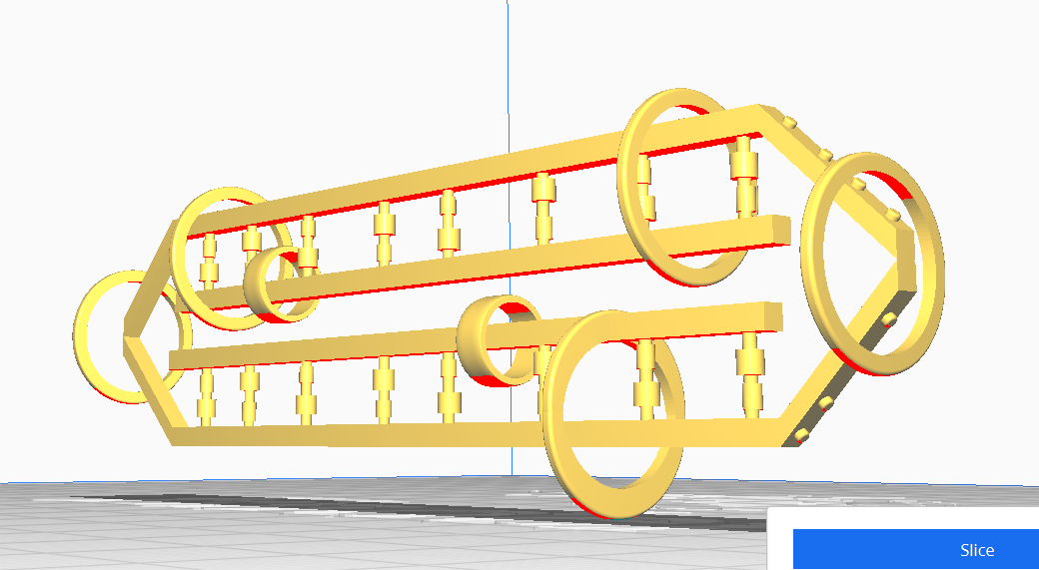

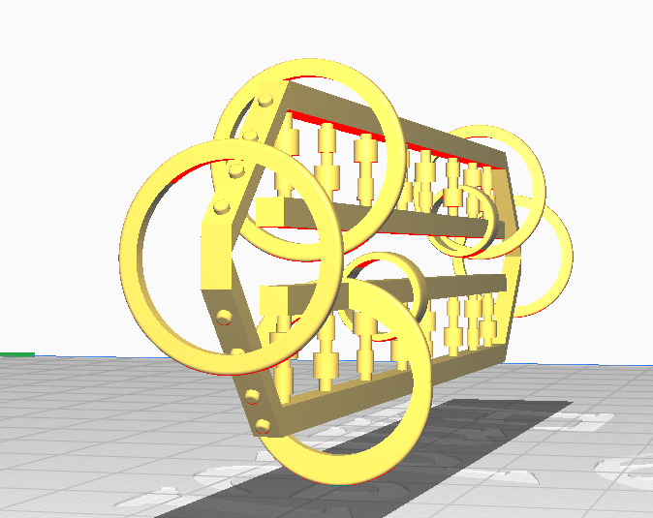

Prototype

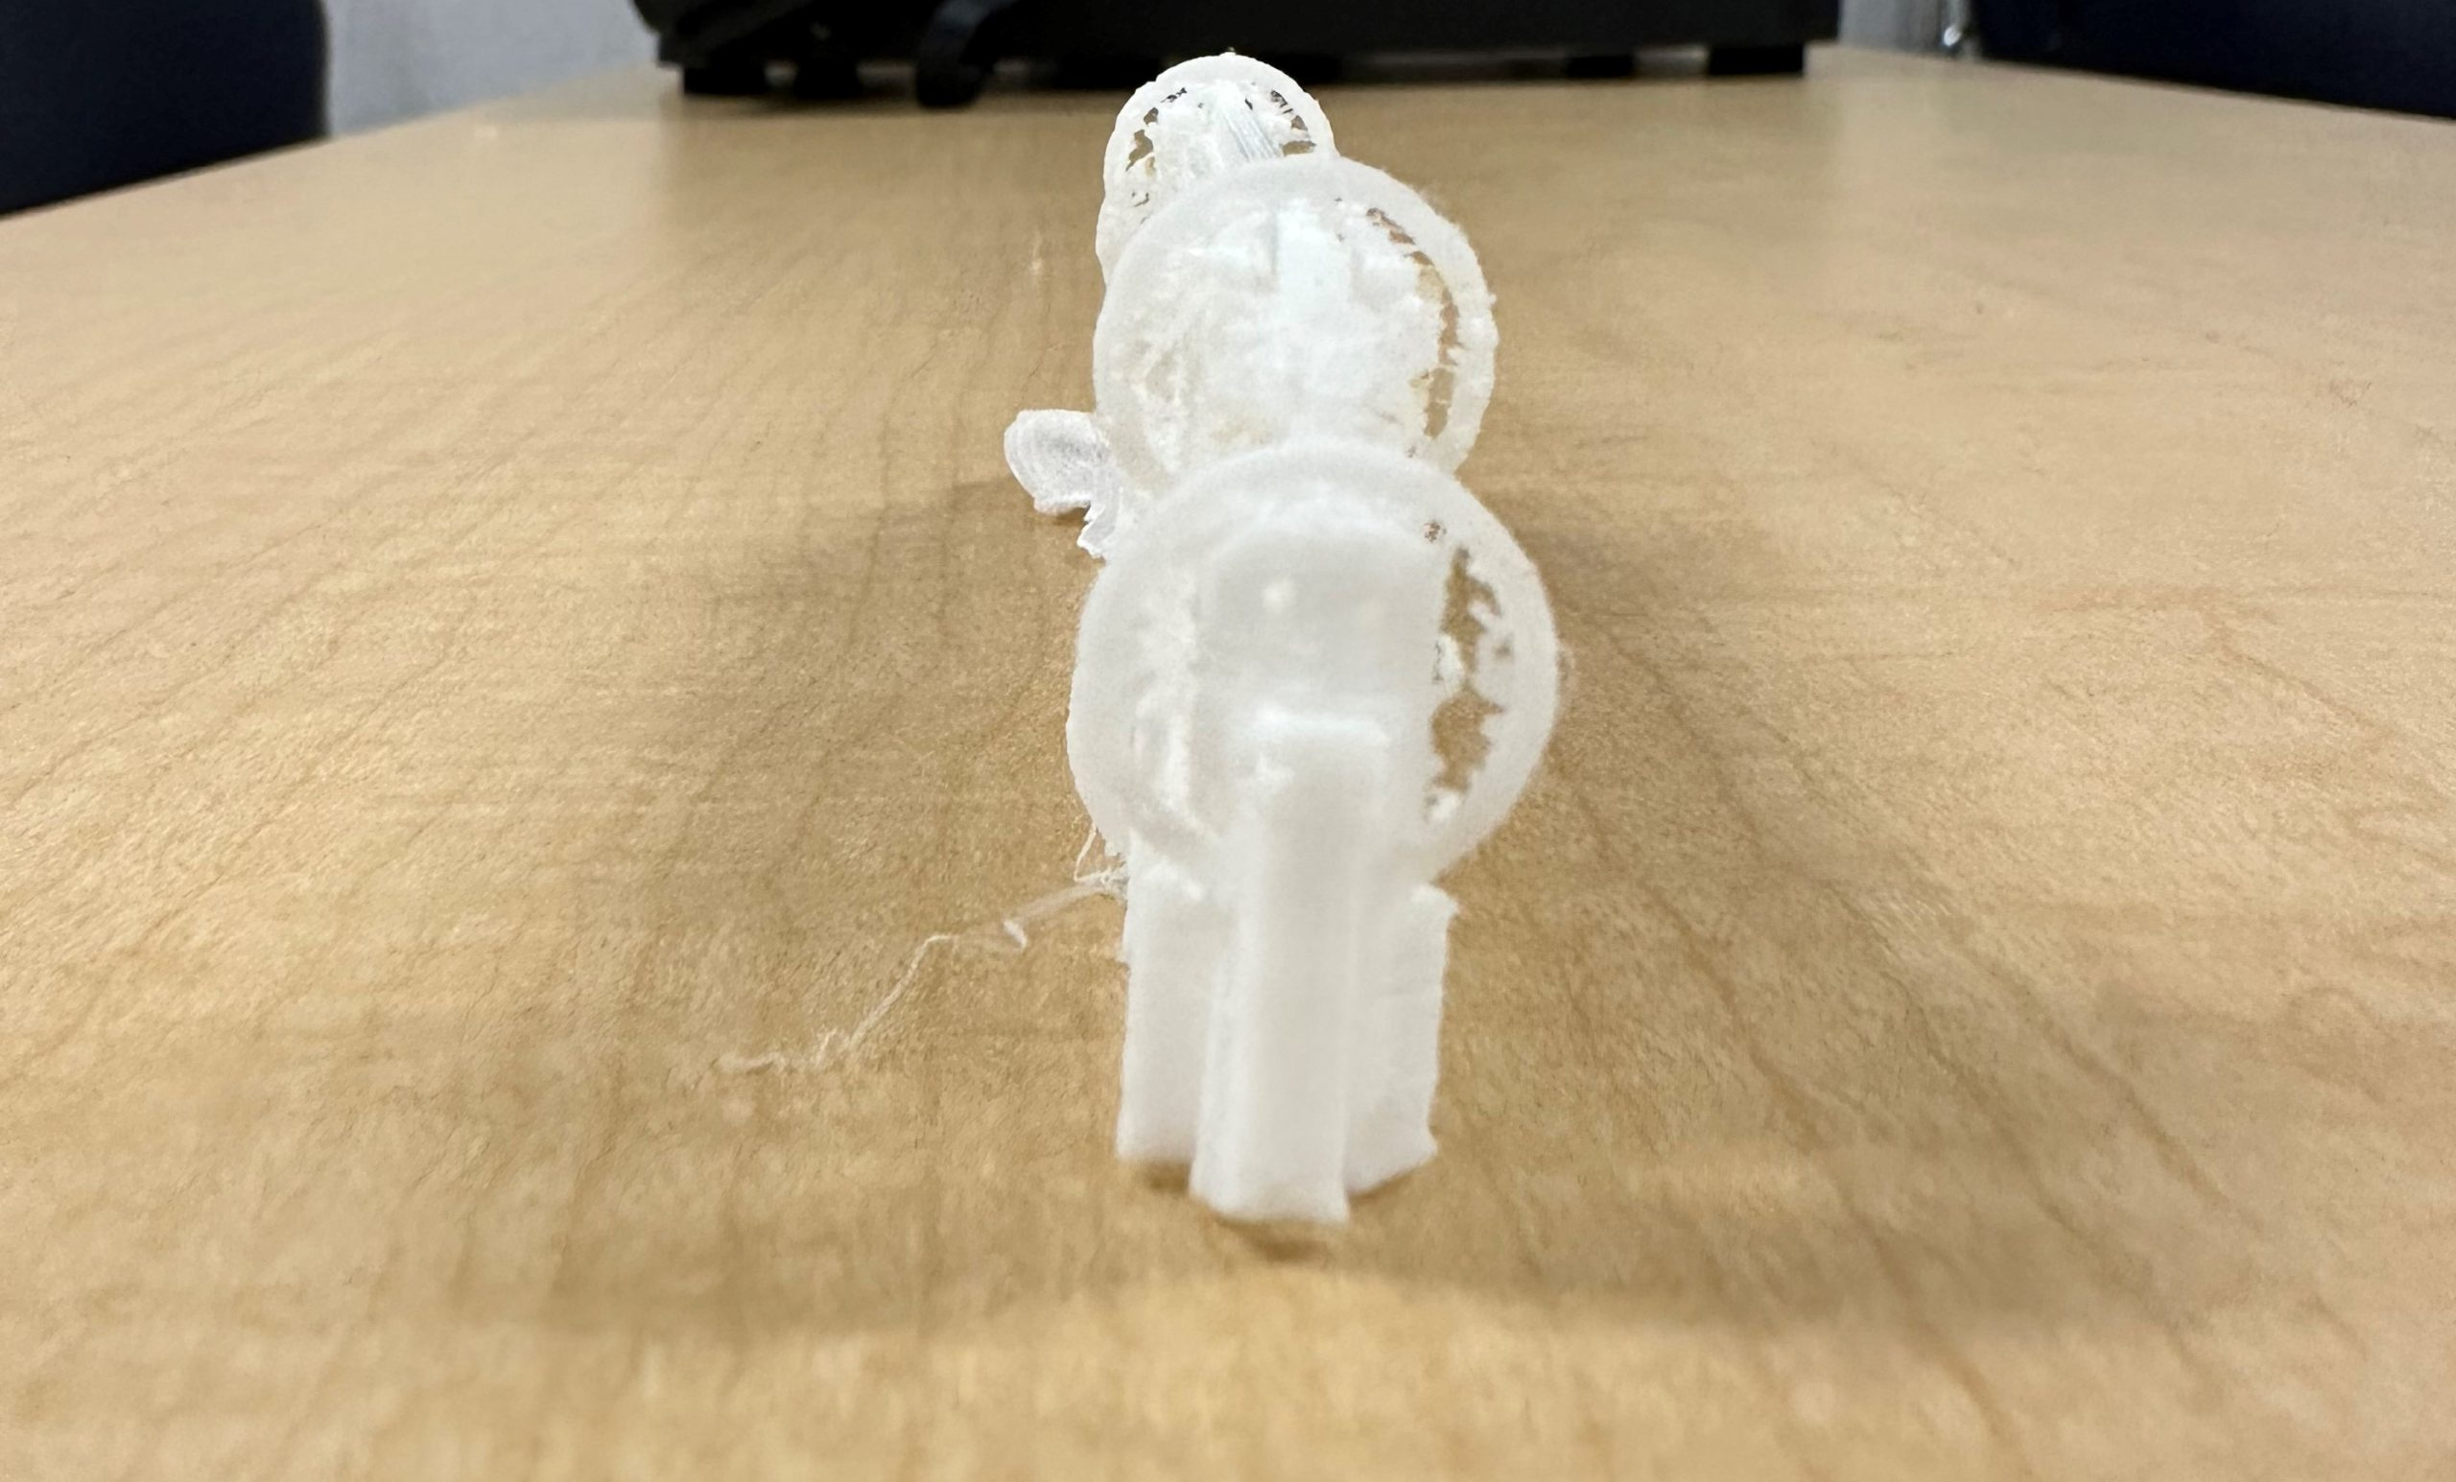

Notes
- The model was printed using white PLA only. With coloured PLA, printed prototype should look similar to that in computer image.
- This model is a miniature prototype, hence some smaller details are unclear. Adjust the size of the model before printing for a much clearer model.
- Keep filament / PLA temperature above 250 degree Celsius.

Design 2
To print each part separately, please use this link to access separate part files.

Reference Model
One or more interactive elements has been excluded from this version of the text. You can view them online here: https://ecampusontario.pressbooks.pub/biologicalscience3dmodelling/?p=25#oembed-1

Images
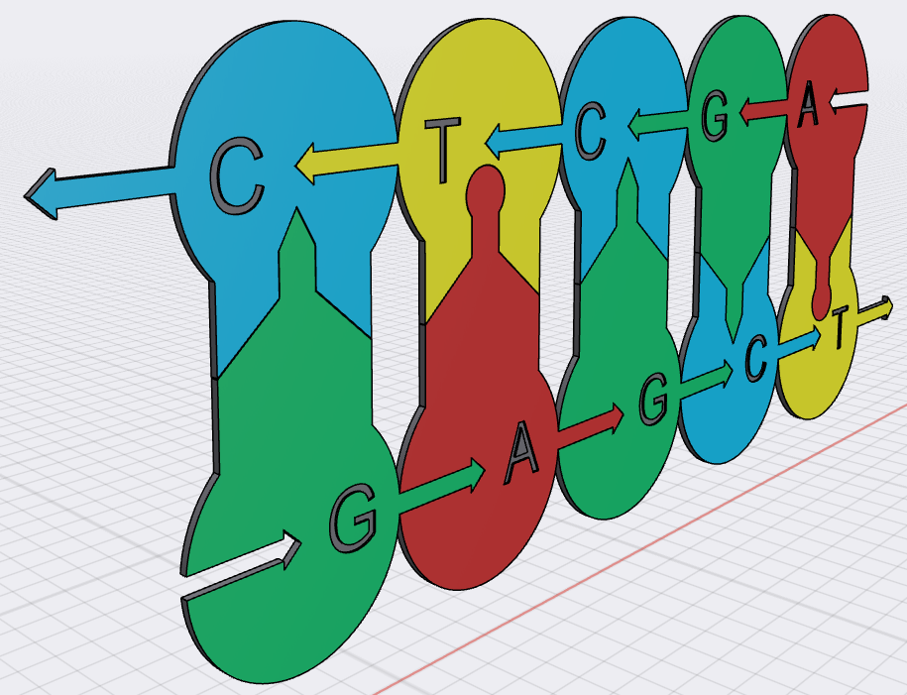

Prototype

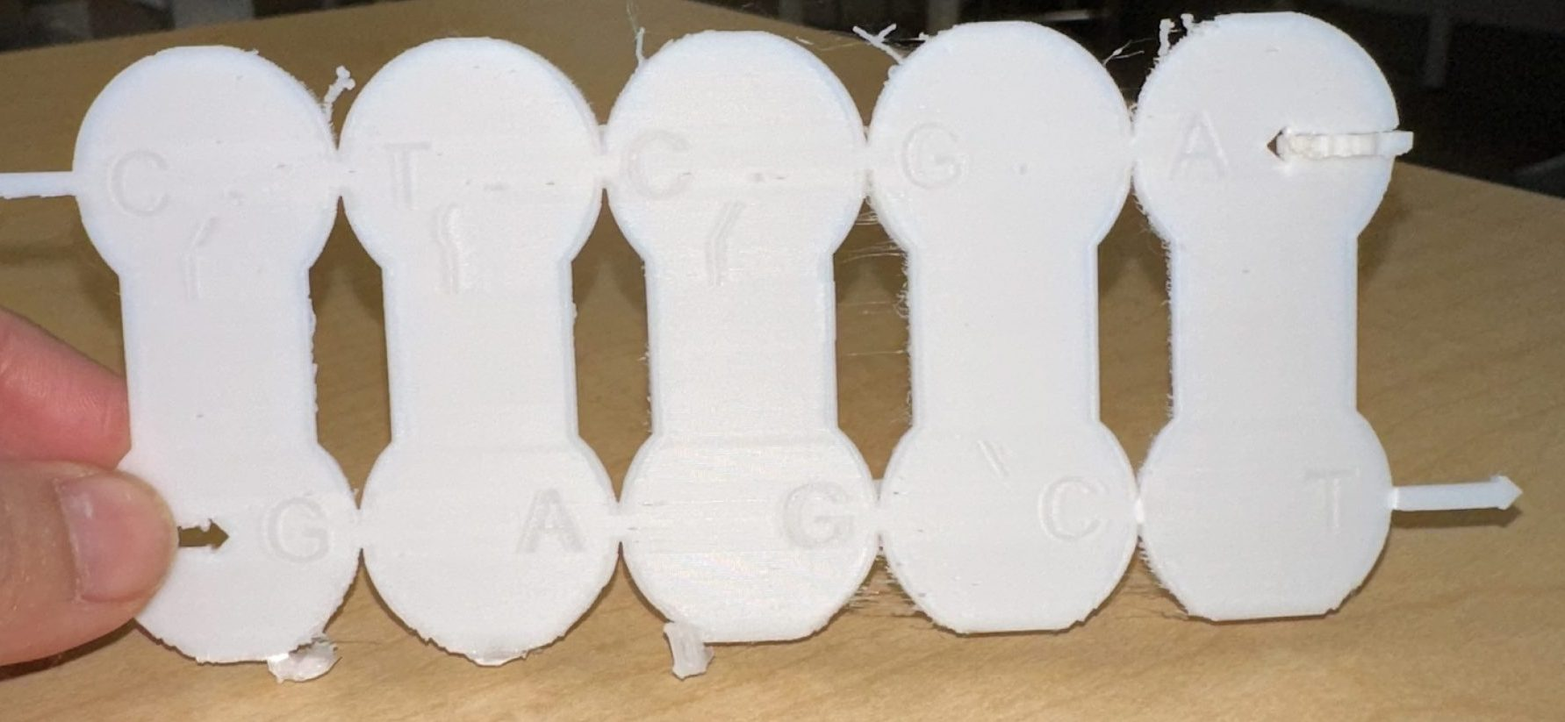

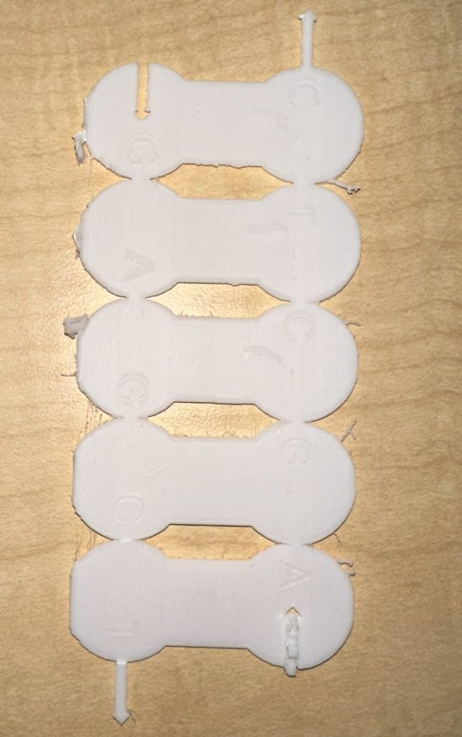

Points to Note
- The model was printed using white PLA only. With coloured PLA, printed prototype should look similar to that in computer image.

2

DNA to RNA Translation

Printable Files
Please find the 3D printable files here.
To print each part separately, please use this link to access separate part files.

Reference Models
https://pinshape.com/items/33850-3d-printed-dnarna-building-settranscription-and-translation-model
https://www.printables.com/model/80861-dna-rna-manipulatives

Images

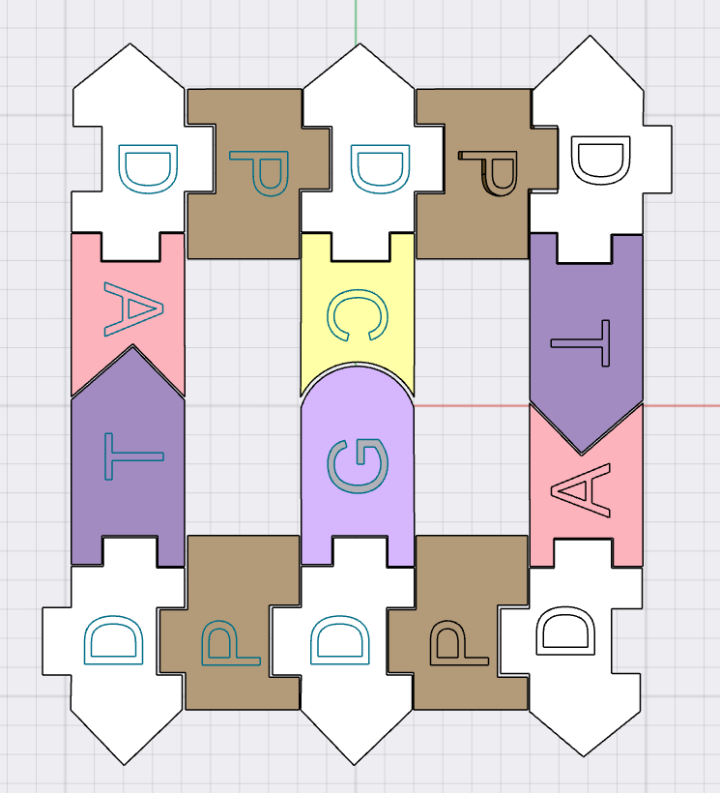

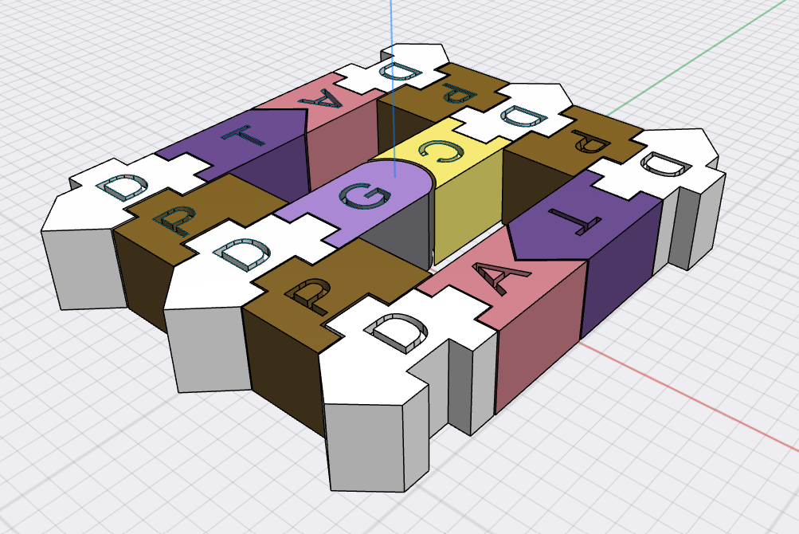

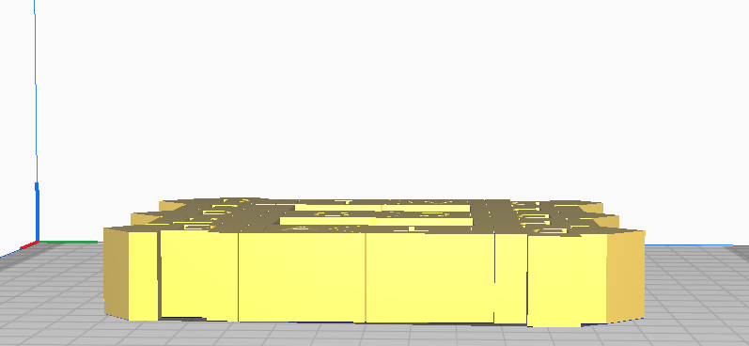

Prototype

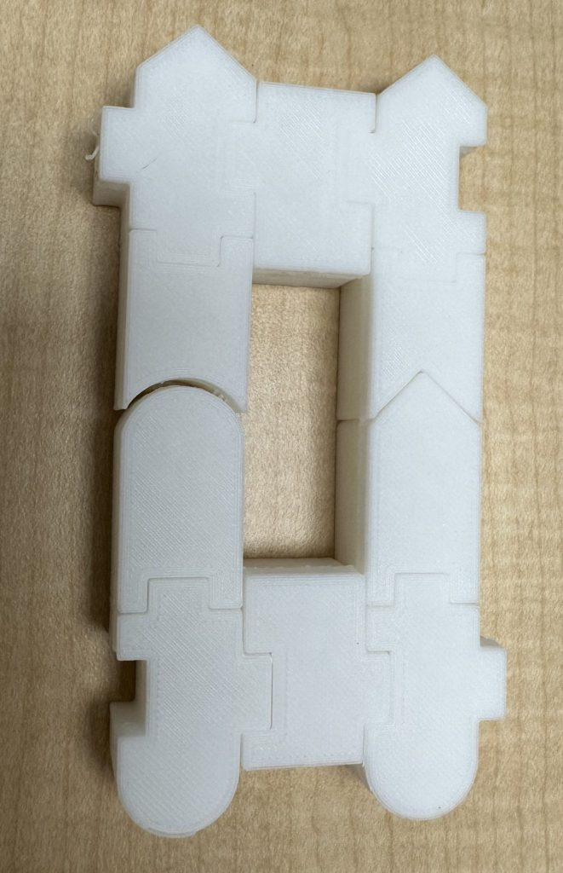

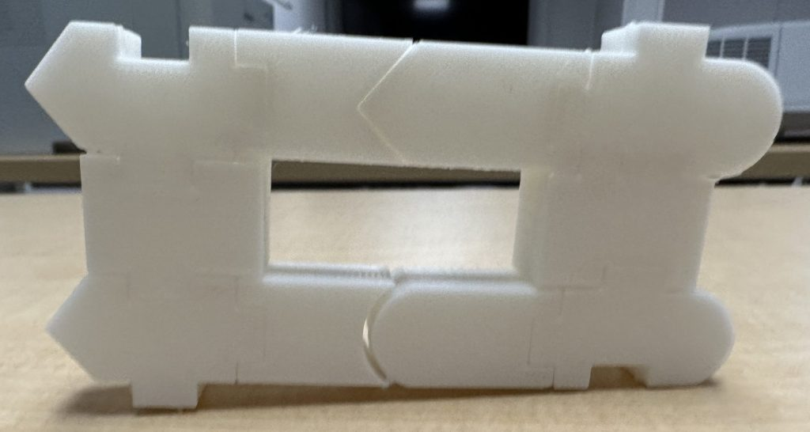

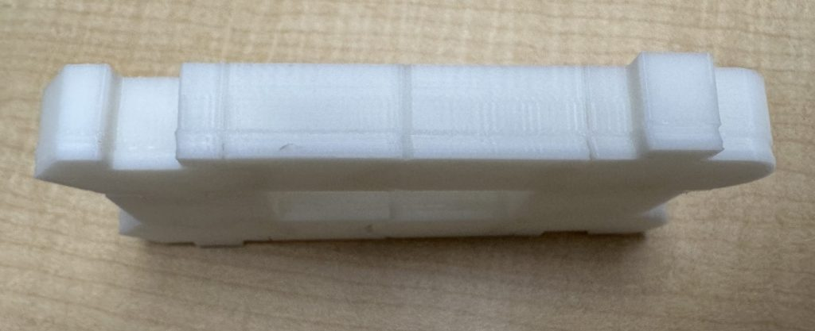

Points to Note
- The model was printed using white PLA only. With coloured PLA, printed prototype should look similar to that in computer image.
- The letters on the blocks were added in the second version after these pictures were taken. The final files have these updates so the models should look like the computer pictures above.
- This model can work as a “pull apart” model with different print settings.
- This model is a miniature prototype, hence only one row and column is shown.

3

Chromosomes of Mitosis and Meiosis

Printable Files
Please find the 3D printable files here.
To print each part separately, please use this link to access separate part files.

Reference Model
https://commons.wikimedia.org/wiki/File:Chromosomes_3D_printed_and_mietosis.jpg

Images

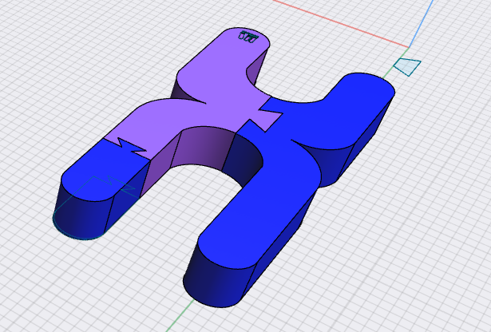

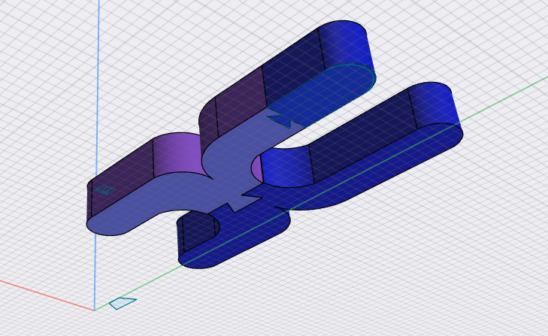

Prototype

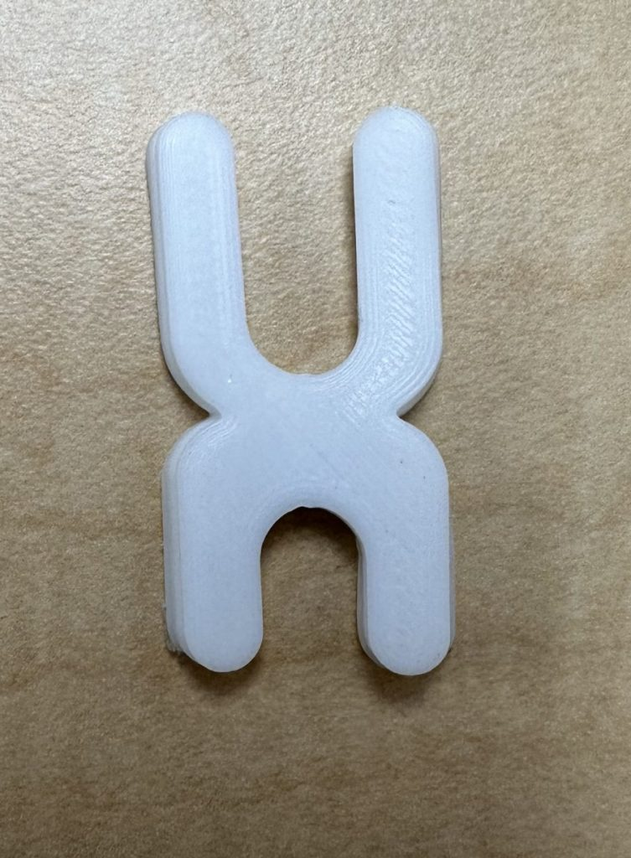

Note – The parts of this model can also be printed separately and act as a “put together” or “pull apart” demonstration. Please refer to picture below.

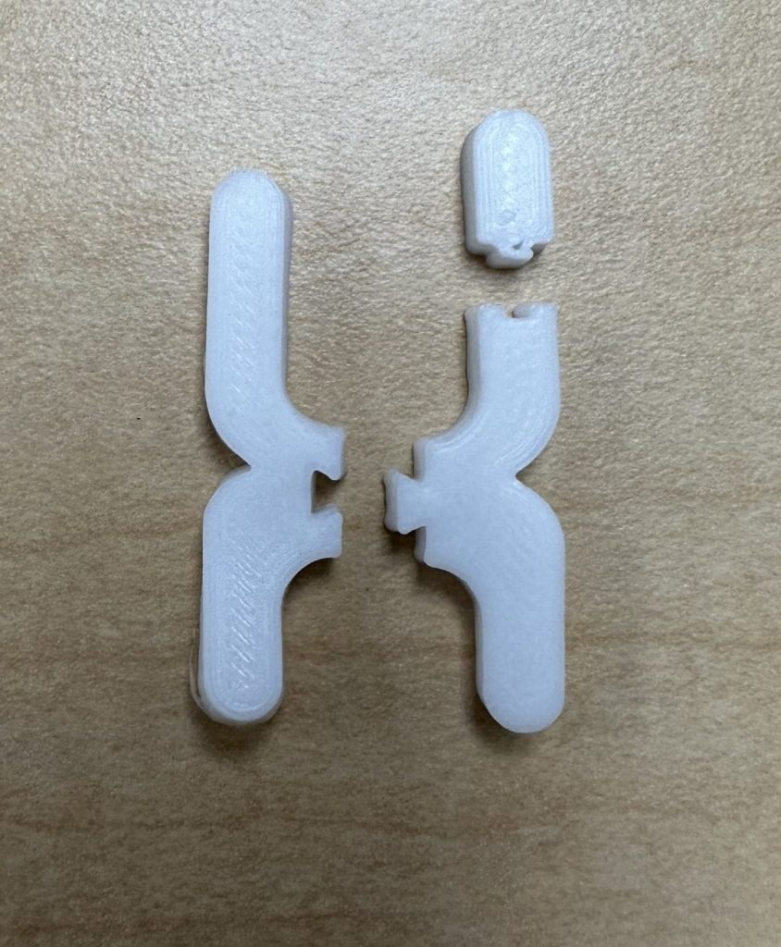

Points to Note
- The model was printed using white PLA only. With coloured PLA, printed prototype should look similar to that in computer image.
- This model can work as a “pull apart” model with different print settings. Use different filament / PLA colours for Mitosis and Mieosis (like in the computerized pictures).
- Each colour is texturized for those who are colour blind.

1

Resources
- Transcription, translation and replication. ATDBio. (n.d.). https://atdbio.com/nucleic-acids-book/Transcription-Translation-and-Replication
- Libretexts. (2022, December 24). 7.3B: DNA replication in Eukaryotes. Biology LibreTexts. https://bio.libretexts.org/Bookshelves/Microbiology/Microbiology_(Boundless)/07%3A_Microbial_Genetics/7.03%3A_DNA_Replication/7.3B%3A_DNA_Replication_in_Eukaryotes
- Transcription, translation and replication. ATDBio. (n.d.-a). https://atdbio.com/nucleic-acids-book/Transcription-Translation-and-Replication

