Module 1: Introduction to Systematic Reviews

The first module in the series The Essentials of Conducting Systematic Reviews explores the rationale for systematic reviews, types of systematic reviews, and systematic review research quality considerations.
The author of this module is:
Sandra McKeown, Health Sciences Librarian at Queen's University.
At the end of this module, learners will be able to:
- Discuss the role and purpose of systematic reviews;
- Identify different types of systematic review questions;
- Identify different types of systematic review designs;
- Recognize the steps of a systematic review;
- Discuss the importance of using rigorous methods to conduct high-quality systematic reviews.
Suggested citation:
McKeown S. Module 1: introduction to systematic reviews. In: McKeown S, Ritonja J, editors. The essentials of conducting systematic reviews [Internet]. Kingston (ON): Office of Professional Development and Educational Scholarship, Queen’s University; 2025 Jun 3. Available from: https://healthsci.queensu.ca/sites/opdes/files/modules/Conducting-Systemic-Review/#/.

Lesson 1: Purpose and History of Systematic Reviews

Purpose of Systematic Reviews
Systematic reviews aim to provide a comprehensive, unbiased synthesis of all existing evidence that answers a specific research question using rigorous and transparent methods.¹
Evidence-based practice in healthcare can be defined as the integration of best available research with clinical expertise and patient values to inform decision-making. Systematic reviews are an integral part of the evidence-based practice movement because they make it quicker and easier for healthcare providers and policy makers to make decisions based on the best research evidence.
Consider the below figure which positions evidence-based decision making as a function of integrating:
- The best available research evidence;
- Population characteristics, states, needs, values, and preferences;
- and resources such as practitioner expertise and insight.
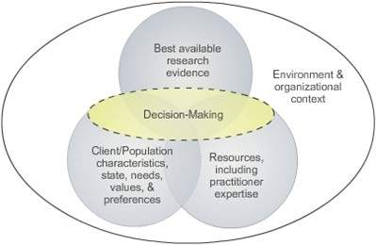
Figure 1: Evidence-based practice model.²

Systematic reviews help address information overload and expediate evidence-based practice.
The goal of a systematic review then, is to attempt to find, appraise, and synthesize all of the research evidence that can answer a specific clinical question. This saves healthcare providers and policy makers from having to invest copious amounts of time trying to find and appraise all the research evidence themselves. It also provides them with high-level evidence to base their decision-making on.³

Systematic Reviews Facilitate Evidence-based Practice
A quick Google image search for “evidence pyramid” will display endless interpretations of the research evidence hierarchy. One thing that all evidence pyramids agree upon though, is that systematic reviews are considered higher level evidence than individual studies.
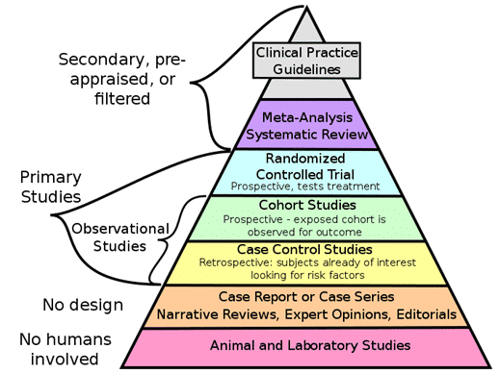
Figure 2: Pyramid of research evidence.⁴

Systematic reviews and meta-analyses are a type of pre-appraised, secondary research. While systematic reviews often include clinical studies, they can also summarize preclinical or animal studies.

Secondary research | Primary research
- E.g., systematic reviews,  meta-analyses, scoping reviews, umbrella reviews, etc.  - The summary and/or synthesis of existing research.  - Research ethics approval often unnecessary (if synthesizing publicly available primary research data). | - E.g., randomized controlled trials, cohort studies, qualitative studies, etc.  - The collection of data from research subjects, experiments, or observation.  - Research ethics approval often necessary.

Advantages of Systematic Reviews Include:
- The ability to formally compare the results of different studies to establish generalizability of findings and consistency of results;
- The ability to identify reasons for inconsistency in results across studies;
- The ability of systematic reviews with meta-analyses to increase the precision of the overall result.

A Timeline for the Rise of Systematic Reviews
Late 1970's - Emergence of Evidence-Based Medicine
Archie Cochrane criticizes the lack of critical summaries of trials behind healthcare interventions.⁵ Health services researchers in Oxford start preparing the ground for evidence-based medicine by beginning a series of systematic reviews on the effectiveness of specific healthcare interventions.⁵
1993 - The Cochrane Collaboration
Following the first Cochrane Colloquium in Oxford, the Cochrane Collaboration (now simply referred to as Cochrane), was founded.⁵ Cochrane was one of the earliest international research organizations to produce and publish systematic reviews. More information at: https://www.cochrane.org/(opens in a new tab).
1996 - JBI
JBI (formerly the Joanne Briggs Institute) was established as a research institute in Australia, producing systematic reviews on nursing, midwifery and multi-disciplinary health care topics.⁶ More information at: https://jbi.global/(opens in a new tab).
2000 - The Campbell Collaboration
Donald Campbell, a member of the National Academy of Sciences in the USA, "advocated the idea that governmental reforms can be seen as societal experiments to which scientific rules of evidence can be applied. He believed that scientific evidence could be generated to estimate the effects of governmental reforms, resulting in better informed policy and practice, and ultimately improving people’s well-being."⁷
Support for this idea from social and behavioural scientists and social practitioners led to the creation of The Campbell Collaboration.⁷ More information at https://www.campbellcollaboration.org/(opens in a new tab).
Today - Global Cooperation for Advancing Systematic Reviews
In 2024, Cochrane, JBI, and the Campbell Collaboration released a call to action for facilitating better global interagency collaboration to enable the pooling of expertise and knowledge in the field of evidence-based practice.⁸ Their goal is to have a more holistic and nuanced understanding of complex issues, leading to improved decision-making at both local and global levels.⁸
An article co-published in five journals (Campbell Collaboration, Cochrane, Collaboration for Environmental Evidence, Guidelines International Network, JBI) introduces the acronym for SHOW ME the evidence, which describes the features of a harmonized approach to reliably getting research evidence to those who need it.⁹ Progress for this initiative can be tracked on the Evidence Synthesis Infrastructure Collaborative(opens in a new tab) website.
While the Cochrane Database of Systematic Reviews established itself early on as the leading journal and database for systematic reviews in health care, most systematic reviews are conducted outside of the auspices of international research collaborations.

Systematic Reviews vs. Traditional Reviews
- Systematic reviews are a type of literature/narrative review;
- Understanding the differences between a traditional literature review and a systematic review is key to effectively consuming and conducting them;
- Comparing the purpose and methods of traditional literature reviews and systematic reviews can help make the distinction more obvious;
- Systematic reviews address specific lines of inquiry, rather than being a type of catch all as articulated in the table below when contrasted with a traditional review;
- As explained later in the module, systematic reviews are a family of research synthesis approaches with significant overlap rather than a single methodology.
Journal articles in MEDLINE database, which can be accessed via PubMed(opens in a new tab), are tagged with publication type descriptors. Below is a comparison of MEDLINE publication types for review articles (i.e. traditional literature reviews) and systematic review articles.
Review | Systematic Review(opens in a new tab)
Review(opens in a new tab): an article published after examination of published material on a subject.  It may be comprehensive to various degrees and the time range of material scrutinized may be broad or narrow, but most often reviews of the current literature are desired.  The textual material examined may be equally broad and can encompass, in medicine specifically, clinical material as well as experimental research or case reports.¹⁰ | Systematic review(opens in a new tab): a review of primary literature in health and health policy that attempts to identify, appraise, and synthesize all the empirical evidence that meets specified eligibility criteria to answer a given research question.  Its conduct uses explicit methods aimed at minimizing bias in order to produce more reliable findings that can be used to inform decision making.¹¹  Meta-analysis(opens in a new tab): using a quantitative method of combining the results of independent studies and synthesizing summaries and conclusions.¹²

Example of a Traditional Literature Review Article:

Liauchonak I, Qorri B, Dawoud F, Riat Y, Szewczuk MR. Non-nutritive sweeteners and their implications on the development of metabolic syndrome. Nutrients. 2019; 11(3):644. https://doi.org/10.3390/nu11030644(opens in a new tab).

As you can see, the methods used to collect evidence and the types of evidence included are not tightly prescribed, instead a curated selection of evidence was used that logically advances the author team’s goals.
As such, traditional literature reviews may inherit the biases and perspectives of its authors and the authors cited. However, traditional literature review publications can still be highly informative and valuable for deepening our understanding of a topic.

Example of a Systematic Review Article:

Azad MB, Abou-Setta AM, Chauhan BF, et al. Nonnutritive sweeteners and cardiometabolic health: a systematic review and meta-analysis of randomized controlled trials and prospective cohort studies. CMAJ. 2017;189(28):E929-E939. https://doi.org/10.1503/cmaj.161390(opens in a new tab).

In the systematic review example, the process of identifying studies that met pre-determined eligibility criteria to address a focused clinical question is described in some detail. The outcomes of interest are also pre-determined and specific.
Unlike the traditional literature review example, the systematic review example has a structured abstract with distinct, labeled sections for Introduction, Methods, Results and Discussion/Interpretation.
Another way to think about the differences between traditional literature reviews and systematic reviews is to distinguish between problems that require clarification and insight from problems that require data.¹³
For example, a traditional literature review may be more appropriate for conducting chronological, interpretive, or thematic analyses of the literature, whereas a systematic review may be the preferred methodology for synthesizing data.
The following are helpful points to consider from the perspective article: Time to challenge the spurious hierarchy of systematic over narrative reviews?¹³
- Systematic reviews are generally placed above narrative reviews in an assumed hierarchy of secondary research evidence;
- We argue that systematic reviews and narrative reviews serve different purposes and should be viewed as complementary;
- Conventional systematic reviews address narrowly focused questions; their key contribution is summarizing data;
- Narrative reviews provide interpretation and critique; their key contribution is deepening understanding.

Key Points
- Systematic reviews evolved as a methodology in response to the need for synthesized research evidence to help healthcare providers make informed decisions.
- Systematic reviews use rigorous, systematic, and transparent methods aimed at minimizing bias to produce more reliable findings for drawing conclusions and making decisions in clinical practice.
- Systematic reviews are useful tools that accomplish a specific purpose rather than being universally superior to traditional literature reviews.

References
- Aromataris E, Munn Z. Chapter 1: JBI systematic reviews. In: Aromataris E, Munn Z (Editors). JBI Manual for Evidence Synthesis. JBI; 2020. Accessed June 5, 2022. https://jbi-global-wiki.refined.site/space/MANUAL(opens in a new tab).
- Spring B, Hitchcock K. (2010) Evidence-based practice in psychology. In I.B. Weiner & W.E. Craighead (Editors.) Corsini’s Encyclopedia of Psychology. 4th edition. John Wiley & Sons, Inc.; 2009: 603-607. Accessed June 5, 2022. https://onlinelibrary.wiley.com/doi/book/10.1002/9780470479216(opens in a new tab).
- Higgins JPT, Green S (Editors). Cochrane Handbook for Systematic Reviews of Interventions version 5.0.0. The Cochrane Collaboration; 2008: 6. https://training.cochrane.org/handbook/archive/v5.0.0/.(opens in a new tab)
- CFCF. File: Research Design and Evidence.svg. Updated August 3, 2021. Accessed June 5, 2022. https://commons.wikimedia.org/wiki/File:Research_design_and_evidence.svg(opens in a new tab).
- Chandler J, Cumpston M, Thomas J, et al. Chapter I: Introduction. In: Higgins JPT, Thomas J, Chandler J, et al. (Editors). Cochrane Handbook for Systematic Reviews of Interventions version 6.3. Updated February 2022. Accessed June 5, 2022. www.training.cochrane.org/handbook(opens in a new tab).
- Our History. Accessed June 5, 2022. https://jbi.global/our-history(opens in a new tab).
- History. Accessed May 2, 2025. https://www.campbellcollaboration.org/about/history/(opens in a new tab)
- Jordan Z, Welch V, Soares-Weiser K. Unlocking the power of global collaboration: building a stronger evidence ecosystem together. JBI Evidence Synthesis 22(6):p 947-948, June 2024. https://doi.org/10.11124/jbies-24-00073(opens in a new tab).
- Lavis JN, Grimshaw JM, Stewart R, Elliott J, Moy W, Meerpohl JJ. SHOW ME the evidence: Features of an approach to reliably deliver research evidence to those who need it. Cochrane Database of Systematic Reviews 2024, Issue 11. Art. No.: ED000170. https://doi.org/10.1002/14651858.ED000170(opens in a new tab).
- National Library of Medicine. National Center for Biotechnology Information. Review [Publication Type]. Accessed June 5, 2022. https://www.ncbi.nlm.nih.gov/mesh/68016454(opens in a new tab).
- National Library of Medicine. National Center for Biotechnology Information. Systematic Review [Publication Type]. Accessed June 5, 2022. https://www.ncbi.nlm.nih.gov/mesh/2028176(opens in a new tab).
- National Library of Medicine. National Center for Biotechnology Information. Meta-analysis [Publication Type]. Accessed June 5, 2022. https://www.ncbi.nlm.nih.gov/mesh/68017418(opens in a new tab).
- Greenhalgh T, Thorne S, Malterud K. Time to challenge the spurious hierarchy of systematic over narrative reviews?. Eur J Clin Invest. 2018;48(6):e12931. doi:10.1111/eci.12931(opens in a new tab).

Lesson 2: Types of Systematic Review Questions
Types of Systematic Review Questions
In the early years of systematic review research, there was a heavy focus on synthesizing trials to answer questions about the effectiveness of healthcare interventions. Today, systematic reviews are conducted to answer a wide range of clinical, and even non-clinical, questions to facilitate evidence-based decision making in different specialties and professions.

Intervention / effectiveness
Assess the effectiveness/safety of a treatment, vaccine, device, preventative measure, procedure, or policy etc.¹⁴
Example:


Diagnostic test accuracy
Assess the accuracy of a test, device or scale to aid diagnosis.¹⁴
Example:


Prognosis
Describe and predict the course of individuals with a disease or health condition.¹⁴
Example:


Etiology and risk
Assess the relationship (association) between certain factors and the development of a disease, condition or other health outcome.¹⁵
Example:


Prevalence and incidence
Assess proportional data (often percentages) of a population experiencing a particular disease or condition.¹⁶
Example:


Cost/economic evaluation
Assess intervention costs, costs relative to benefits, intervention resource use/costs and/or cost effectiveness in addition to a range of other questions about the intervention.¹⁷
Example:


Experience
Investigate perspectives and experiences of an intervention or health condition.¹⁴
Example:


Knowledge Check
Enter the question type for the systematic review titles provided below.

Signs and symptoms to determine if a patient presenting in primary care or hospital outpatient settings has COVID‐19.
Diagnostic test accuracy

Antibiotic prophylaxis for preventing bacterial endocarditis following dental procedures.
Intervention/effectiveness

Parents' and informal caregivers' views and experiences of communication about routine childhood vaccination.
Experience/perspective

Development of type 2 diabetes mellitus in people with intermediate hyperglycaemia.
Prognosis

Lesson 3: Types of Systematic Review Approaches/Designs
Systematic Review Approaches
While traditional systematic reviews that investigate the effectiveness of healthcare interventions take a quantitative approach to answering a clinical question, a qualitative systematic review approach is useful for investigating healthcare perspectives and experiences. Combining quantitative and qualitative evidence using a mixed-methods systematic review approach allows researchers to investigate complex questions such as why interventions may produce different results for different people in different situations.¹⁸
Quantitative Systematic Reviews
Quantitative research relies on data that are observed or measured to examine questions about the sample population.¹⁹
Quantitative evidence includes research into effectiveness, incidence, prevalence, etiology of disease, psychometric properties, and measurement of physical characteristics, quality of life, and satisfaction with care.²⁰
Systematic reviews of quantitative data may include a statistical synthesis (meta-analysis) and/or non-statistical approaches (e.g., narrative synthesis).
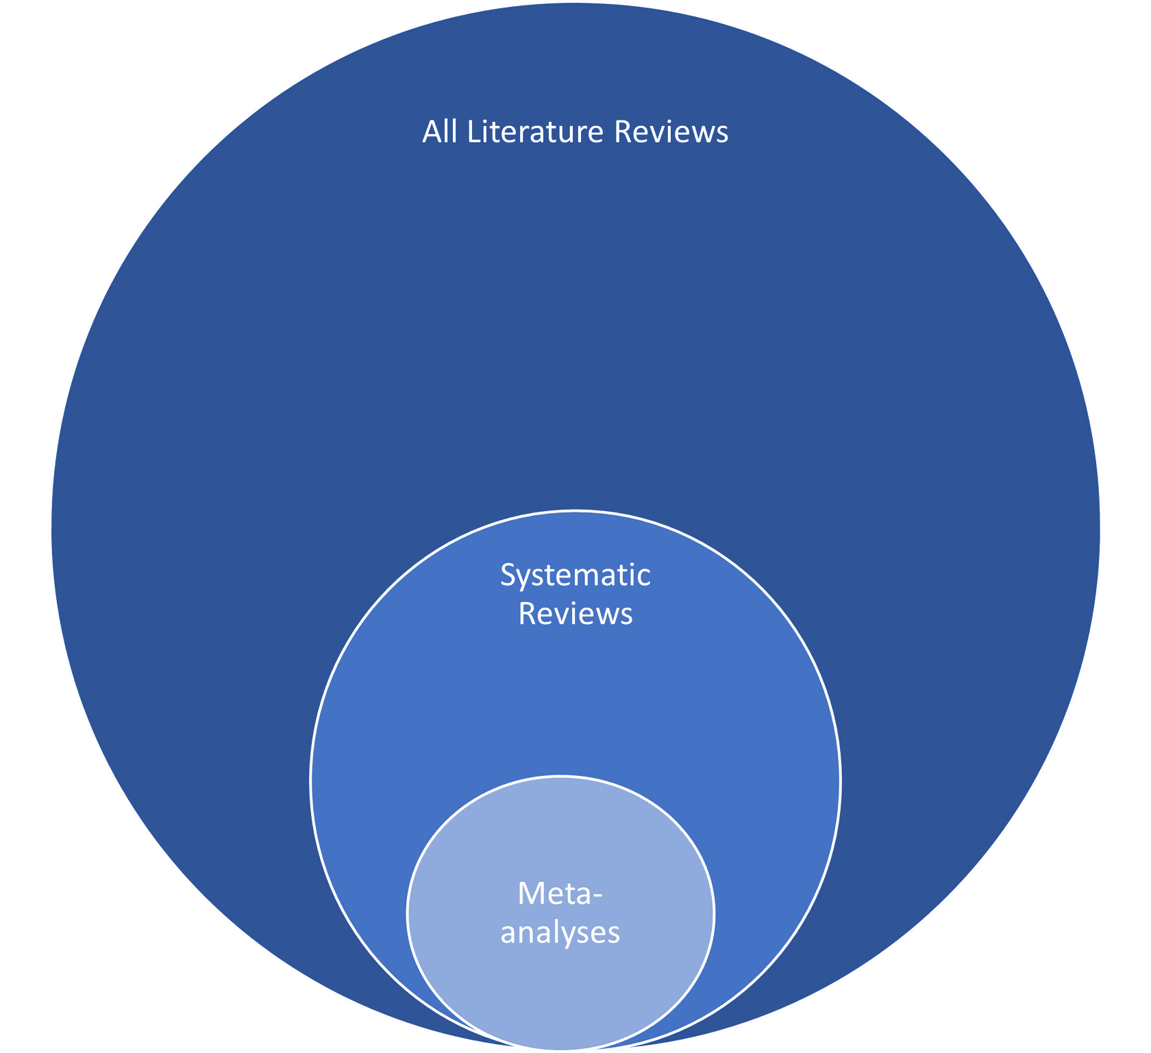
Figure 3: Relationship between literature reviews, systematic reviews, and meta-analyses (not to scale).
Sub-types of Quantitative Systematic Reviews
- With meta-analysis
- Meta-analysis refers to the statistical technique for combining the results of individual quantitative studies to generate an average result.
- This aims to generate a more precise estimate of the intervention effects and reduces uncertainty¹⁴ often shown as a forest plot (Figure 4).
- Meta-analysis should be reserved for quantitative systematic reviews where
the results of studies are homogeneous (i.e., considered similar enough from a clinical and methodological point of view).²⁰⁻²¹
- Meta-analyses are complicated and you’ll need to have specialized training or involve an expert to be able to do one successfully.
Figure 4: Generic forest plot.²²
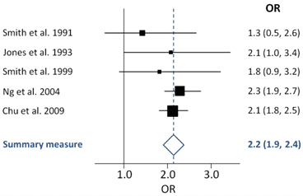

- With network meta-analysis
- Combines direct and indirect estimates across a network of interventions in a single analysis.²³
Figure 5: Example of a network diagram with four competing interventions and information on the presence of multi-arm randomized trials.²³
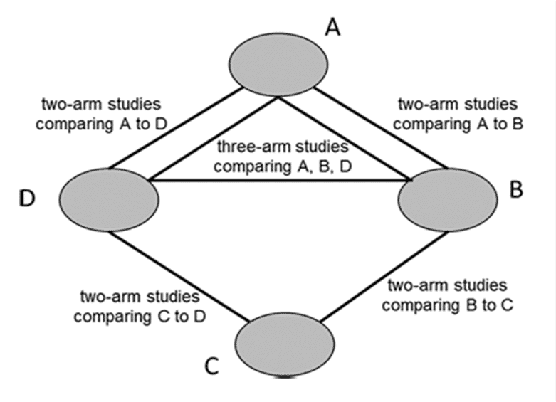

- Without meta-analysis
- There are situations in which a meta-analysis can be more of a hindrance than a help.²⁴
- If studies are widely different (e.g., in terms of exposure/intervention, length of follow-up, population), a meta-analysis may be meaningless.
- Often it is nonsensical to combine all included studies in a single meta-analysis, as there is a mix of comparisons of different exposures/interventions with different comparators.²⁴
- Overall, it is important not to combine outcomes that are too diverse.
- Narrative synthesis can be conducted as the primary mechanism of data synthesis when meta-analysis is not possible.²⁰

Qualitative Systematic Reviews
(a.k.a. Qualitative Evidence Syntheses)
Where quantitative approaches are appropriate for examining who has engaged in a behavior or what has happened and while experiments can test particular interventions, these techniques are not designed to explain why certain behaviors occur. Qualitative approaches are typically used to explore new phenomena and to capture individuals’ thoughts, feelings, or interpretations of meaning and process.²⁵
Qualitative research involves collecting and analyzing non-numerical data, such as participants’ words, to understand concepts, opinions or experiences.²⁵
Qualitative research covers a wide variety of methods and methodologies
that provide holistic, in-depth accounts and attempt to reflect the complicated, contextual, interactive, and interpretive nature of our social world.²⁶
Examples of synthesis methods for qualitative research include:²⁷
- meta-ethnography;
- grounded theory;
- meta-narrative;
- thematic synthesis;
- meta-study;
- clinical interpretive synthesis;
- framework synthesis.
Rather than using re-interpretation and theory generation, JBI takes a meta-aggregation approach to enable generalizable statements as recommendations to guide practitioners and policy makers.²⁸

Mixed-Methods Systematic Reviews
Mixed-methods research integrates techniques from quantitative and qualitative paradigms to tackle research questions that can be best addressed by mixing these two traditional approaches.²⁹
Mixed-methods systematic reviews can incorporate the findings of quantitative evidence (e.g., effectiveness research) and qualitative evidence (e.g., research into patient, carer, or other’s experience) to increase the usefulness of those findings to inform policy and practice.³⁰
Mixed-methods systematic reviews can allow for:³⁰
- An examination of the degree of agreement between quantitative and qualitative data to validate or triangulate results/findings;
- Identification of discrepancies within the available evidence;
- Determination of whether the quantitative and qualitative data address different aspects of a phenomenon of interest;
- One type of data that can explore, contextualize or explain the findings of the other type of data.

Knowledge Check
Match the quantitative systematic review characteristics with the sub-type most closely associated with it:
- Quantitative systematic review without meta-analysis
- Quantitative systematic review with meta-analysis
- Quantitative systematic review with network meta-analysis
- Combines direct and indirect estimates across a group of interventions in one analysis (3)
- Statistical technique for combining the results of individual quantitative studies (2)
- If included studies are widely different or lack a coherent methodology (1)

Systematic Reviews by Another Name
Newer forms of reviews that are considered part of the systematic review family include rapid reviews (when time is of the essence)³¹ and overviews of reviews (when there are multiple systematic reviews available for a related question).¹⁴
Overview of Reviews/Umbrella Reviews
Most systematic reviews synthesize the results of primary studies. Systematic reviews that synthesize results from multiple systematic reviews on related research questions are called overviews of reviews / umbrella reviews.
Example:

Rapid Reviews/Rapid Systematic Reviews
Systematic reviews that are accelerated through streamlining or omitting specific methods are referred to as rapid reviews / rapid systematic reviews.
Example:


Systematic Reviews vs. Scoping Reviews
Both systematic reviews and scoping reviews fall under the broader category of “knowledge synthesis” / “research synthesis” / “evidence synthesis.”
Despite having a similar and rigorous methodological framework, systematic reviews and scoping reviews serve different purposes.
Scoping reviews are commonly used to map evidence on a topic and identify main concepts, theories, sources, and knowledge gaps,³² or to clarify working definitions and conceptual boundaries of a topic or field.³³
Authors of the methodology paper: Systematic review or scoping review? Guidance for authors when choosing between a systematic or scoping review approach, propose that if a review question addresses the feasibility, appropriateness, meaningfulness or effectiveness of a certain treatment or practice, then a systematic review is likely the most valid approach.³⁴ The authors offer the following indications for the two different review types:
Some indications for systematic reviews: | Some indications for scoping reviews:
- To uncover the international evidence;  - To confirm current practice/ address any variation/ identify new practices;  - To identify and inform areas for future research;  - To identify and investigate conflicting results;  - To produce statements to guide decision-making. | - To identify the types of available evidence in a given field;  - To clarify key concepts/ definitions in the literature;  - To examine how research is conducted on a certain topic or field;  - To identify key characteristics or factors related to a concept;  - As a precursor to a systematic review;  - To identify and analyze knowledge gaps.

Notice the difference in the stated objectives of these two review types:
Systematic Review Example
Objective: The aim of this study was to evaluate the impact of pharmacist presence or pharmacist-led antimicrobial stewardship interventions on appropriate prescribing of antibiotics in the emergency department (ED).

Scoping Review Example
Objective: The objective of this scoping review was to identify the available evidence on antimicrobial stewardship programs for teaching medical students about rational antimicrobial use, including the content taught and the method of instruction used.

Lesson 4: Systematic Review Steps and Resources
Systematic Review Steps
There is general acceptance about the main steps of a systematic review:³⁵
- Formulate a review question;
- Define inclusion and exclusion criteria;
- Locate studies through searching;
- Select studies for inclusion;
- Assess the quality of studies;
- Extract data;
- Analyse and synthesize relevant studies;
- Present and interpret the results.
The Cochrane Consumers and Communication Group created the following infographic to highlight the steps of a systematic review that authors follow.³⁶
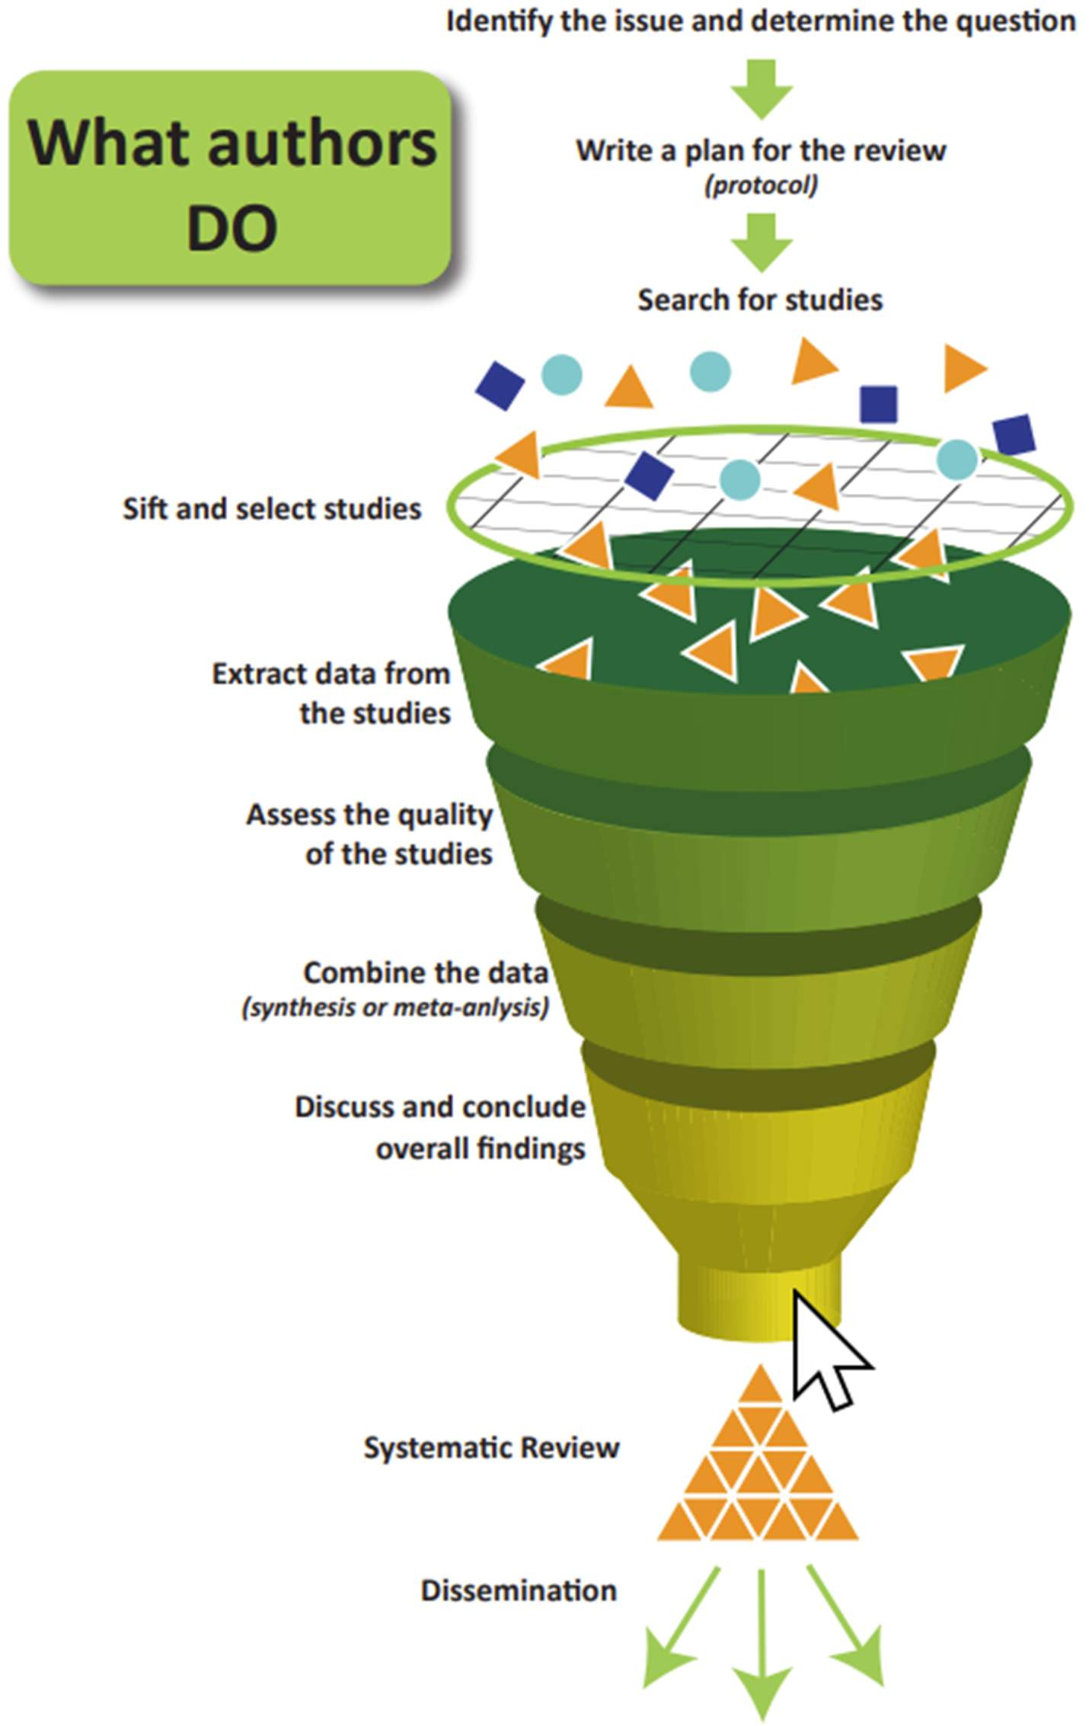
Figure 6: Infographic showing the steps of a systematic review.

Setting Your Review Up for Success
In the early stages of planning a systematic review, there are steps authors can take to help ensure they are not duplicating research efforts, that their review question is actually feasible, and that they have the resources for conducting a high-quality systematic review. Specifically, authors should determine the following before fully embarking on a systematic review:
- That there is not a recent systematic review publication or systematic review protocol addressing the same research question;
- That studies are available that would address your research question and/or inclusion criteria;
- That you have, on your review team, the expertise and resources needed to produce a high-quality systematic review;
- That you have time to do the review well.
Checking for Similar Publications and Protocols
As a first step of conducting a systematic review, you want to be confident that the same review has not been recently published or coming down the research pipeline. Duplication of efforts is a waste of time and resources and contravenes the premise of creating systematic reviews to reduce the amount of literature clinicians need to find and appraise to make informed decisions. This can be proactively managed by searching for systematic reviews that have been published and for systematic review protocols that have been registered or published.
Where to search for published systematic reviews and protocols:
- International research collaborations: e.g., search Cochrane Library or JBI EBP Database;
- Bibliographic databases: e.g., search PubMed/Ovid MEDLINE, Embase, PsycINFO, Web of Science, etc., (some databases allow you to limit to systematic review publication types which often include protocols);
- Other databases/resources: e.g., search Trip medical database, Epistemonikos, and Google Scholar for systematic review publications and protocols;
- Protocol registries and repositories.

PROSPERO is the international prospective register of systematic reviews.


Protocols can also be found in repositories such as Open Science Framework.

Checking that Necessary Studies Exist
When developing your research question and considering the inclusion/exclusion criteria for eligible studies it’s important to be aware of the amount and type of research studies that are actually available. Making assumptions about the existence of certain research and study designs may lead to screening hundreds or thousands of literature search results only to find out there are next to no studies meeting your eligibility criteria and you need to go back to the planning stage.
A preliminary search should be conducted if:
- You are not already aware of studies, or are unsure if there will be enough studies, to answer your research question.
- You are unsure what types of study designs might address your research question (which can help refine your inclusion and exclusion criteria).
This preliminary search does not have to be comprehensive or systematic. It can be achieved using basic or advanced searching in bibliographic databases (e.g., PubMed/MEDLINE, Embase, etc.). or Google Scholar.
Considering Team Expertise and Experience
When conducting a systematic review, it is advisable to include expertise in:
- The topic area under review;
- Systematic review methodology, including statistical expertise if conducting a meta-analysis;
- Searching for studies;
- Different disciplines, as appropriate, to include perspectives that may help avoid assumptions or terminology stemming from an over-reliance on a single discipline.
While many academic and hospital libraries offer systematic review support for literature searching, a survey of libraries that support medical schools in Ontario suggests there is currently insufficient review methodology and biostatistics support available to researchers.³⁷ First-time systematic review authors are encouraged to work with experienced reviewers and to receive relevant training to help set themselves up for success.
Working as a team not only spreads the effort, but ensures that tasks such as the selection of studies for eligibility, data extraction and rating the certainty of the evidence will be performed by at least two people independently, minimizing the likelihood of errors.³⁸

Systematic Review Timeline Considerations
The length of time to conduct a systematic review will depend on a number of factors such as the scope of the topic and the amount of evidence available, and the number of and expertise of team members. One research study found that the mean length for a systematic review was 67.3 weeks.³⁹
Cochrane provides a timeline for their reviews as follows:⁴⁰
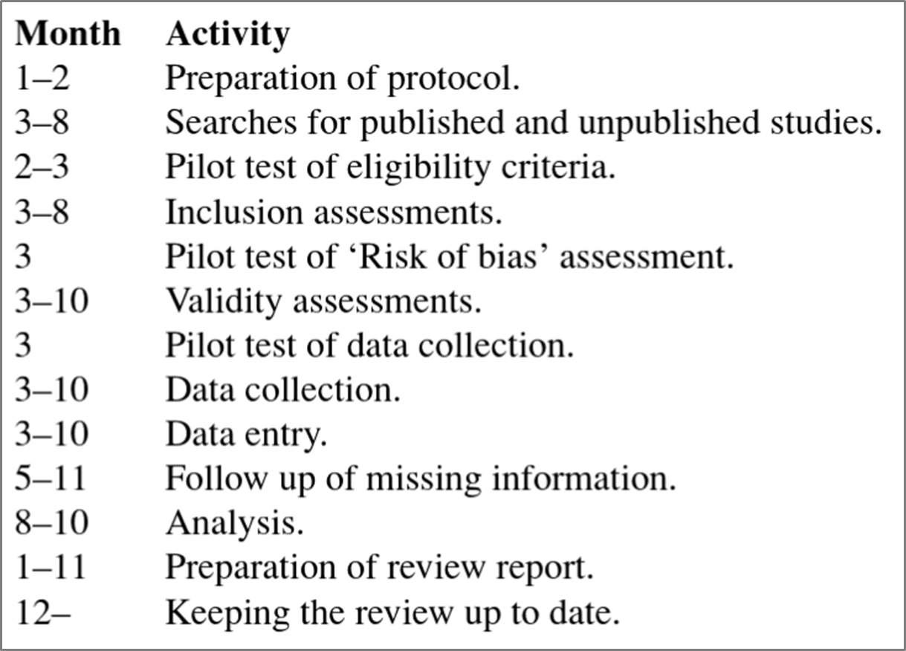
Systematic Review Resources and Guidelines
There is no shortage of manuals and guides to help you learn the ins and outs of doing a systematic review. While guidance from international research collaborations like Cochrane and JBI are the gold standard, these resources have been developed for researchers conducting and publishing Cochrane and JBI reviews and may be intimidating for new researchers or students. In such cases, student or introductory guides may be a more accessible starting point.
Guidance from International Research Collaborations
The following handbooks are freely available online:

Link: https://training.cochrane.org/handbook


Link: https://training.cochrane.org/handbook-diagnostic-test-accuracy

Link: https://community.cochrane.org/mecir-manual.(opens in a new tab)


Link: https://jbi-global-wiki.refined.site/space/MANUAL

Other Guides and Resources
Check your library for access.

Link: https://study.sagepub.com/doingasystematicreview2e/student-resources/about-the-book(opens in a new tab)


Link: https://us.sagepub.com/en-us/nam/an-introduction-to-systematic-reviews/book245742


Link: https://us.sagepub.com/en-us/nam/systematic-approaches-to-a-successful-literature-review/book270933
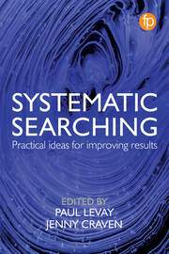
Link: https://www.routledge.com/Systematic-Searching-Practical-ideas-for-improving-results/Levay-Craven/p/book/9781783303731

Systematic Review Reporting Standards
It is crucial for systematic review authors to clearly report their methods and findings so that readers can properly appraise how well the systematic review was conducted, an essential component of evidence-based decision making. Transparent reporting can also facilitate the replication of research methods to verify the findings.
PRISMA
While international research collaborations like Cochrane and JBI provide their own detailed reporting instructions for authors, many journals endorse PRISMA (Preferred Reporting Items for Systematic Reviews and Meta-Analyses). The PRISMA 2020 Statement that was published in 2021 consists of a checklist and a flow diagram, and is intended to be accompanied by the PRISMA 2020 Explanation and Elaboration document.⁴¹⁻⁴²
PRISMA 2020 Checklist
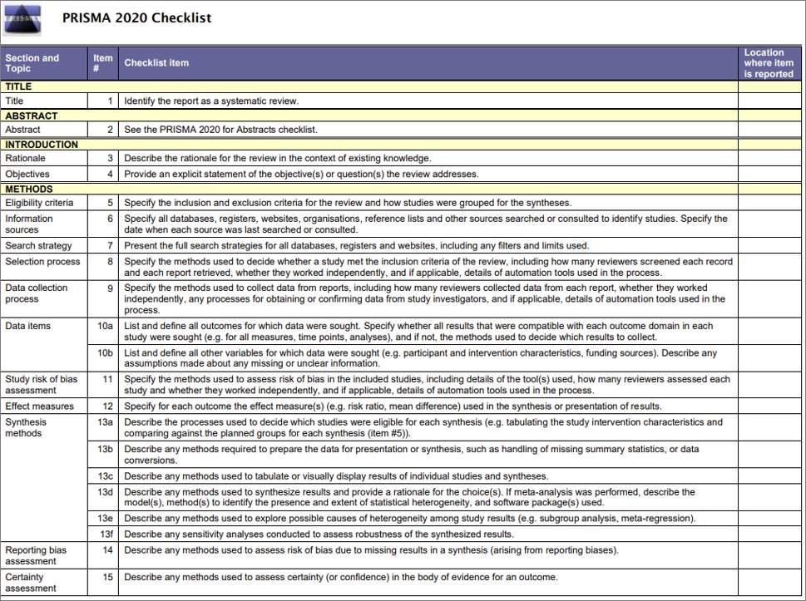
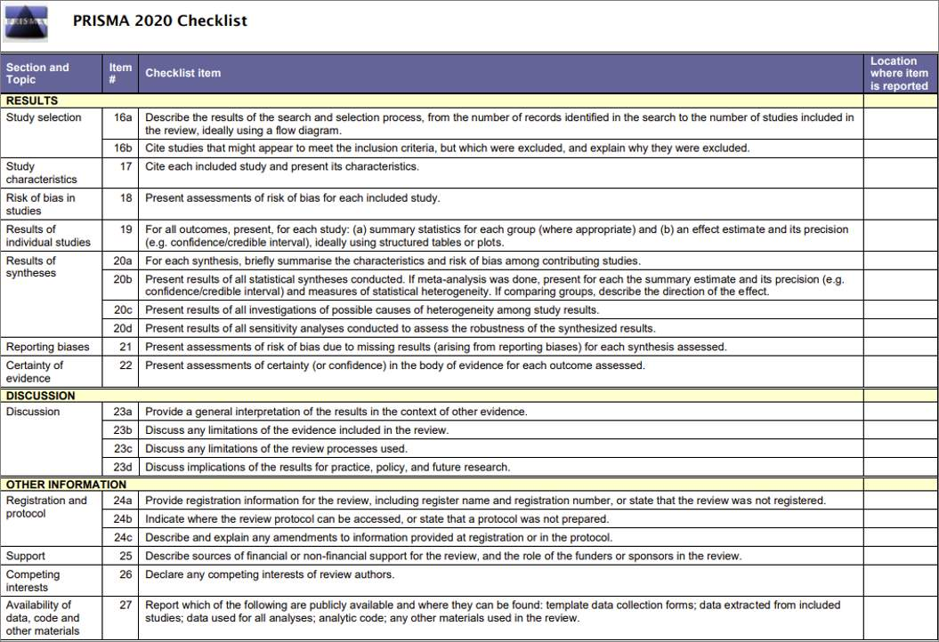
PRISMA Extensions
PRISMA also provides many extensions for reporting different aspects of a systematic review (e.g., PRISMA for Abstracts, PRISMA for Protocols, and PRISMA for Searching) in addition to extension for different review types (e.g., PRISMA for Diagnostic Test Accuracy and PRISMA for Network Meta-Analyses).

Knowledge Check
Please place the steps of conducting a systematic review into the correct order:
- Extract data (5)
- Locate studies through searching (3)
- Assess the quality of studies (6)
- Analyze and synthesize relevant studies (7)
- Formulate a review question (1)
- Define inclusion and exclusion criteria (2)
- Select studies for inclusion (4)
- Present and interpret the results (8)

Lesson 5: Systematic Review Quality Considerations
The Mass Production of Systematic Reviews
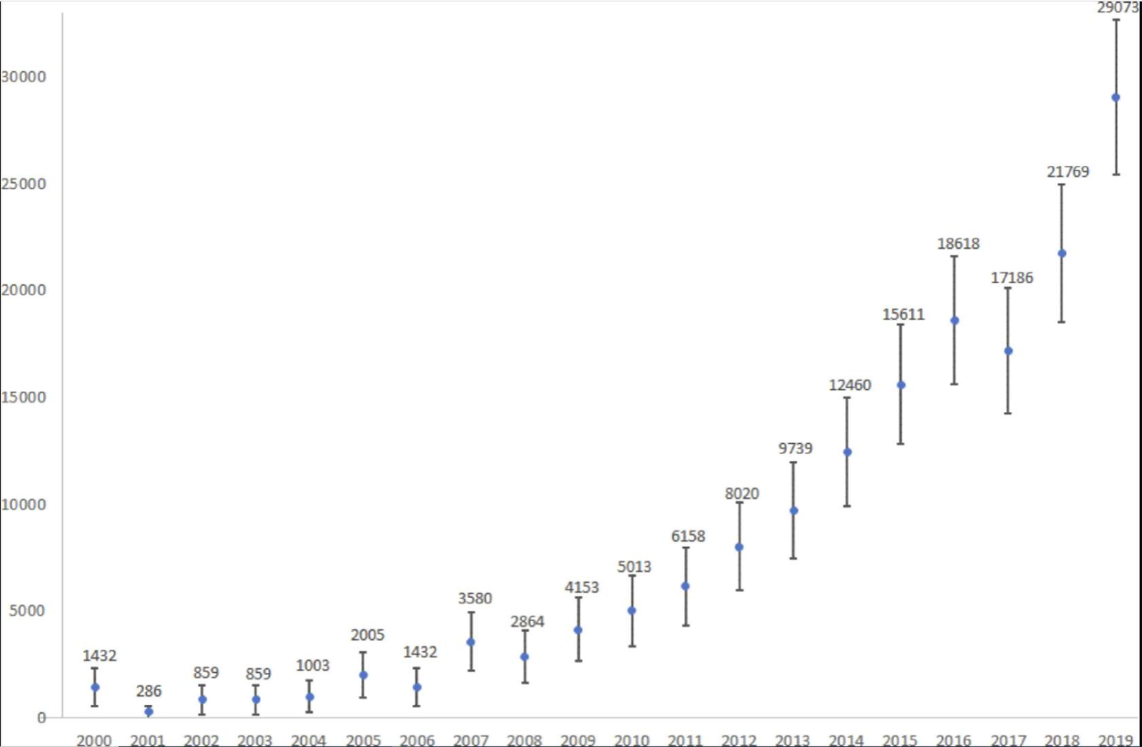
Figure 7: Estimated number of systematic reviews indexed in MEDLINE (via PubMed) per year (including 95% CI), 2000–2019.⁴³
In 2019, a total of 80 systematic reviews were published per day!⁴³
In 2021, the number had already increased to 135 per day!⁴⁴
While a steady rise of high-quality systematic reviews would be a welcome trend in any profession, the reality is that many of these systematic reviews are redundant, misleading, and conflicting,⁴⁵ which makes their use in evidence-based practice more challenging. Synthesized research evidence becomes less efficient for healthcare practitioners and policy makers than intended if they are just switching from having to collect and appraise numerous primary research studies to numerous systematic reviews.
Several factors come into play when examining why systematic review publications are on a steep incline. Please navigate through the process tabs below for more details.
Factor 1 - The ever-increasing number of studies
- The ever-increasing number of primary studies means that there is a continuously expanding body of literature to synthesize.⁴⁶
Factor 2 - Publish or Perish
- Researchers face pressures to publish (or perish) in order to advance their careers.⁴⁷ Academic institutions have been criticized for rewarding quantity over quality of research articles and contributing to the problem of unnecessary publications.
Factor 3 - New and expanding journal publications
- New biomedical journals are being created all the time, including predatory journals, which increases the number of publishing options available to authors. Additionally, some biomedical journals are steadily increasing the number of articles they publish each year.⁴⁸
Factor 4 - Student assignments and research projects
- More undergraduate and graduate students are now conducting systematic reviews as course assignments or research projects.
Factor 5 - Industry financial influence
- Favourable findings from industry-sponsored research can be used as a way to market products and increase profits.⁴⁹

Characteristics of High-Quality Systematic Reviews
High-quality systematic reviews take care to employ methods that will minimize the risk of error and bias during the research process. As mentioned earlier, international research collaborations like Cochrane and JBI are the gold standard for producing systematic reviews and many of these review teams involve methodologists/biostatisticians and librarians.

Measures that authors can take to increase the quality of a systematic review include:
- Publish or register a review protocol to increase transparency. This can help readers investigate the likelihood of outcome reporting bias;
- Employ comprehensive search strategies across multiple databases to identify all eligible studies and minimize selection bias;
- Include research evidence in the form of “grey literature” (i.e. unpublished studies) such as conference materials, preprint articles, and data from clinical trials registries, as appropriate, to reduce publication bias;
- Attempt to include non-English studies to reduce language bias;
- Consider heterogeneity (variation across individual studies) and only perform a meta-analysis of all, or some, of the studies when appropriate;
- Comply with systematic review reporting guidelines to increase reproducibility and transparency.

Impact of Suboptimal Systematic Reviews
Poor or flawed systematic review methods (whether intentional or not) lead to misleading results, bias, and research waste.
Suboptimal and low-quality systematic reviews diminish their usefulness for evidence-based practice⁴³ and can be exploited as marketing tools.⁴⁶
“Living systematic reviews” could address the redundancy of systematic review research.⁴³
Navigating through the discrepancies of redundant, misleading, and conflicting systematic reviews can even be demanding for practitioners who are well trained in evidence-based medicine and highly conversant on these methods⁴⁵

Importance of Appraising Systematic Reviews
As is the case with primary research studies, not all systematic reviews are created equal. Flawed research design and/or execution can introduce bias and lead to misleading results.
No research study should be taken at face value. Critical appraisal tools for systematic reviews specifically, include AMSTAR 2, which can help walk you through important questions about the methodology and reporting to consider before relying on the findings of any review.⁵⁰
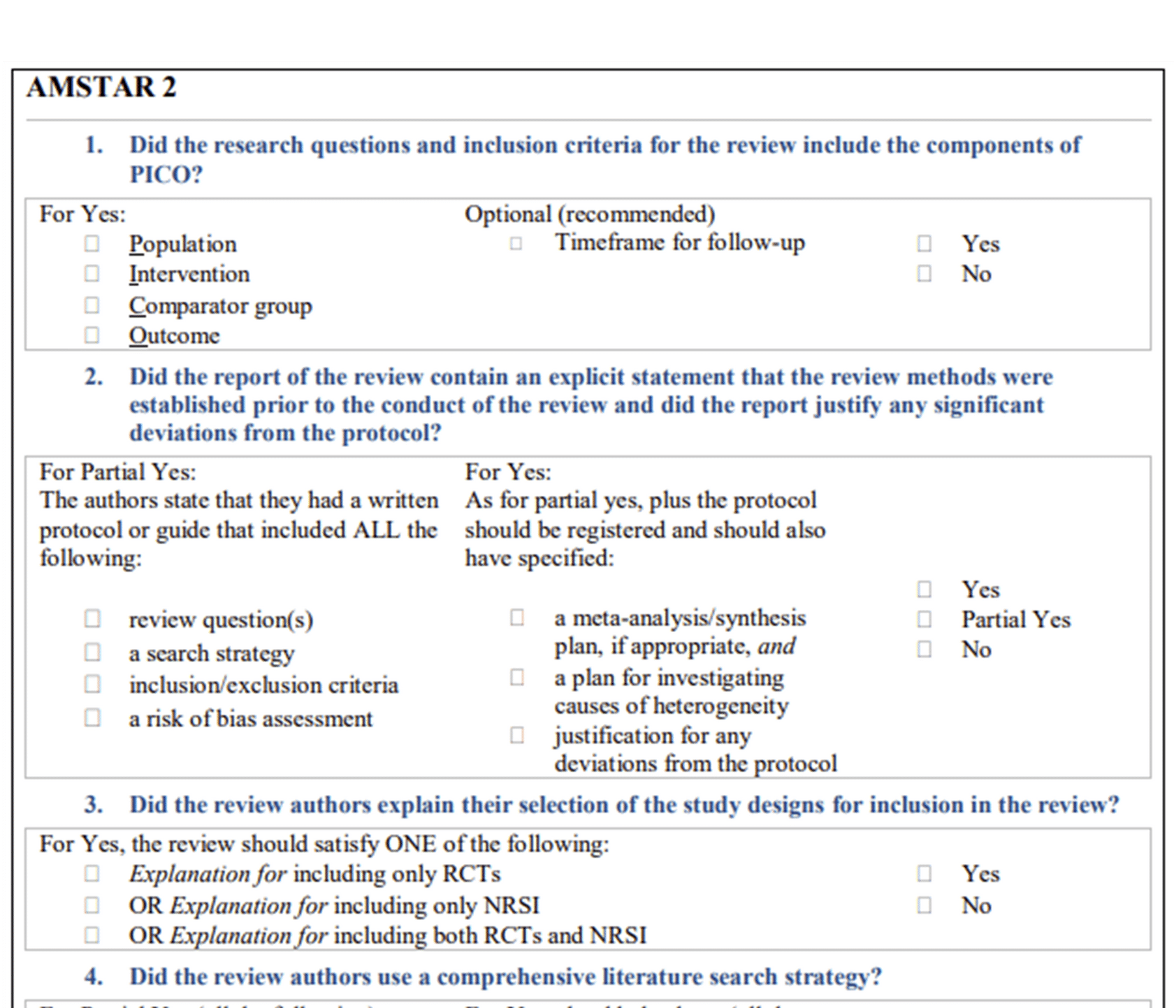
Figure 8: Extract from the AMSTAR 2 tool.

Critical Appraisal Checklists for Systematic Reviews:
- AMSTAR 2(opens in a new tab)
- CASP Systematic Review Checklist(opens in a new tab)
- JBI Checklist for Systematic Reviews(opens in a new tab)

Knowledge Check
Taking shortcuts when conducting systematic reviews is one way that bias can be introduced into the research process. Match the systematic review research shortcomings below with the most specific type of bias that may result or be indicated.
- Only searched one database
- Protocol not available
- Non-English studies not included
- Grey literature not included
- Publication bias (4)
- Language bias (3)
- Outcome reporting bias (2)
- Selection bias (1)

Congratulations! You have completed Module 1: Introduction to Systematic Reviews.

