Module 4: Selecting Studies
The fourth module in the series The Essentials of Conducting Systematic Reviews explores how to select studies relevant to your review.
The authors of this module are:
Lucy Mackrell, PhD candidate at Queen's University.
Dr. Jennifer Ritonja, Scientist at BC Cancer.
Sandra McKeown, Health Sciences Librarian at Queen's University.
At the end of this module, learners will be able to:
- Identify the key steps of the screening process;
- Apply inclusion and exclusion criteria during title/abstract and full-text screening;
- Describe and document the screening process in accordance with PRISMA guidelines.

Suggested citation:
Mackrell L, Ritonja J, McKeown S. Module 4: selecting studies. In: McKeown S, Ritonja J, editors. The essentials of conducting systematic reviews [Internet]. Raynard E, translator. Kingston (ON): Office of Professional Development and Educational Scholarship, Queen’s University; 2025 Jun 3. Available from: https://healthsci.queensu.ca/sites/opdes/files/modules/selecting-studies-m4.

Lesson 1: Introduction to Study Selection
When conducting systematic reviews, it is common for the comprehensive search to retrieve hundreds or thousands of records that could be reports of studies that are eligible for inclusion. A process of study selection is necessary to identify studies that truly meet the eligibility criteria of the review. Software tools for reviews can be used to manage the screening process more efficiently (see Module 8).
Note: this module covers study selection for systematic reviews in general. Detailed information on review-specific screening can be found in the following resources:

Systematic Review Type | Resources
Interventions | Cochrane Handbook for Systematic Reviews of Interventions
Qualitative evidence | Cochrane-Campbell Handbook for Qualitative Evidence Synthesis  Cochrane Handbook for Systematic Reviews of Interventions. Chapter 21: Qualitative evidence
Economic evidence | JBI Manual for Evidence Synthesis. Chapter 6: Systematic Reviews of Economic Evidence  Cochrane Handbook for Systematic Reviews of Interventions. Chapter 20: Economic evidence
Etiology and risk | JBI Manual for Evidence Synthesis Chapter 7: Systematic reviews of etiology and risk
Diagnostic test accuracy | Cochrane Handbook for Systematic Reviews of Diagnostic Test Accuracy
Patient-reported outcome measures | COSMIN Guideline for Systematic Reviews of Outcome Measurement Instruments
Mixed methods | JBI Manual for Evidence Synthesis Chapter 8: Mixed methods systematic reviews

Terminology
Screening
- The term screening is often used interchangeably with selecting studies. Screening refers to activities that are part of the broader study selection process and it occurs in two-stages:
- The first stage of screening involves examining the titles and abstracts of records from the search for study eligibility. Irrelevant records are excluded and potentially relevant records move on to the next stage of screening.
- The second stage of screening involves examining the full-text reports (of records that were included in the first stage) for study eligibility.
Reports
The terms “article”, “report”, and “study” are often used interchangeably. However, in the context of systematic reviews, each term has a specific meaning:
- Article: This generally refers to a manuscript published in a scholarly, peer-reviewed journal or other academic publication.
- Report: This generally refers to a written piece that may or may not be formally published. It can include scholarly, peer-reviewed journal articles, or grey literature such as conference papers, dissertations/theses, preprints, technical reports, etc.
- Study: This generally refers to a piece of research conducted to answer a particular question. A study could either be reported in one individual report/article or across multiple reports.
This is the terminology that will be used in the module. In particular, the term “report” will be used as a collective term referring to both published and unpublished full text works that are examined in the second stage of the screening process.
Study Selection Steps
Below are the general study selection steps to ensure the process is conducted consistently and systematically, which will help to reduce bias and improve the reliability of the review:^{1,2}
- Merge search results (removing duplicate records/references of the same report).
- Determine the review authors for the screening process.
- Pilot test initial eligibility ‘checklist’ and making necessary changes.
- Examine titles and abstracts of records from the search.
- Retrieve the full text of potentially relevant reports.
- Examine full-text reports for compliance of studies with eligibility criteria.
- Link multiple reports of the same study.
- Correspond with authors where appropriate.
Let’s look at each of these steps in more detail!
1 - Merge Search Results
Search results from all databases and information sources should be merged together to screen the records as one batch, whenever possible. In the past, review authors used Microsoft Excel or reference managers (e.g., EndNote) for this purpose, but nowadays there are many free and subscription-based software tools for reviews that can make the screening process more efficient.
One of the major benefits of merging search results is that it can facilitate the process of removing duplicate search records/references before screening so that review authors don't have to screen the same report multiple times.
2 - Determine Authors for Screening
At least two review authors are needed for the screening process. While having review authors familiar with the topic area and definitions can be beneficial for the screening process, it is also recommended to include review authors with different expertise.^{1,3-4}
It is recommended that dual screening occurs for both the title/abstract and full-text screening stages, meaning each record/report is screened by 2 review authors independently. This does not mean that only 2 review authors can participate in dual screening, and it is not uncommon for larger review teams to have multiple authors divide up the work.
Research supports that dual screening reduces the possibility that relevant reports are incorrectly excluded.^{3,5-6} It also reduces the possibility that selection is influenced by a single reviewer’s biases.¹
3 - Pilot Test the Eligibility 'Checklist'
Pilot testing is a preliminary step in the screening process, where the inclusion and exclusion criteria (developed into a checklist) are applied to a small sample of records/reports. This step ensures that multiple reviewers interpret and apply the eligibility criteria consistently.²⁻³ It also helps refine and clarify criteria in the screening checklist, resolve any ambiguities, and train reviewers for both the title/abstract and full text screening stages.
Typically, 6-8 studies are selected for the pilot test, representing a mix of eligibility: 2-3 that are clearly eligible, 2-3 that are clearly ineligible, and 2-3 that are ambiguous. Each reviewer independently assesses the study at both screening stages (record/report). The results are then compared to identify similarities and discrepancies, which inform adjustments to the criteria or screening process before proceeding.
Ideally, all review authors involved in the screening process should participate in the pilot test, screening studies together to identify discrepancies and address grey areas as they arise.⁷
4 - Examine Titles and Abstracts
As mentioned, the first stage of screening refers to examining the titles and abstracts of records from the search to remove obviously irrelevant reports.¹ This involves applying an eligibility checklist and resolving disagreements between the review authors conducting dual screening. This step will be covered in detail in the next lesson of this module.
5 - Retrieve Full Text of Reports
For records that appear to meet the inclusion criteria, or when a definite decision cannot be made based on the title and abstract alone, the next step is to retrieve the full text.^{3,8} Some software tools for reviews, such as Covidence and DistillerSR, can help facilitate a bulk upload of full text reports (i.e. PDFs) for records that move to full text screening. In other cases, review authors may decide to track down the full text reports individually.
Some full-text reports may be freely available or open access and can be retrieved by doing a quick title search in Google Scholar or PubMed.
If a subscription is required for access, review authors can contact their library about how to retrieve these full-text reports, if not already familiar with the process.
If the full-text is not available freely or via library/institution subscription, the study should not be ignored. Many institutions have library staff who can assist with retrieving a copy of the report from another library, if necessary.

6 - Examine Full-Text Reports
As mentioned, the second stage of screening refers to examining full-text reports for the records included in the first stage of screening. Similar to the first stage of screening, this involves applying an eligibility checklist and resolving disagreements between the review authors conducting dual screening. This step will be covered in detail later in the module.
7 - Link Multiple Reports of the Same Study
Systematic reviews treat studies (not reports) as the primary unit of interest. Since a single study may be presented in multiple reports, review authors must identify and link all reports that correspond to the same study.¹
Multiple reports of the same study can occur in various forms, from identical manuscripts to reports presenting different study outcomes or results at varying time points.⁷ Estimates of the prevalence of multiple reports of the same study range from 1.4% to 28%, with some studies having as many as five.⁹⁻¹⁰ If inadvertently included more than once in a meta-analysis, multiple reports of the same study can introduce substantial bias.¹¹
It can sometimes be difficult to detect multiple reports of the same study. There can be different sample sizes, outcomes, and authors.¹⁰ Therefore, some ‘detective work’ by the review authors may be required.¹ The Cochrane Handbook suggests using the following criteria to compare reports:¹
- Trial identification numbers (e.g. ClinicalTrials.gov(opens in a new tab) Identifier, ISRCTN, Universal Trial Number);¹²
- Author names;
- Location and setting;
- Shared methodology (e.g. intervention(s), outcomes);
- Population similarities (e.g. number of participants);
- Date and duration of the study.
Once multiple reports of the same study are identified, they should be collated so that the study, rather than each individual report, serves as the primary unit of interest in the review. Review authors must select and justify which report will be treated as the primary source for study results, particularly when conflicting results are presented across reports. However, secondary reports should not be discarded or excluded, as they may provide additional outcome measures or valuable information about the study's design and conduct.¹
8 - Correspond with Authors as Appropriate
If questions about a study’s eligibility cannot be resolved from the full-text report, additional information (e.g., missing details about the population, methods, results, etc.) can be requested from the corresponding study author of the report. However, this process requires time and resources, and responses are not guaranteed, especially for older studies. It is advisable to set a response deadline in advance. If contacting authors is impractical, the studies can be excluded and listed as “potentially relevant” in an appendix.³

Knowledge Check
Matching
Arrange the following study selection steps in the correct order:
- Examine full-text reports (6)
- Link multiple reports of the same study (7)
- Examine titles and abstracts (4)
- Determine review authors for screening (2)
- Pilot test eligibility criteria (3)
- Merge search results (1)
- Retrieve full text of reports (5)
- Correspond with study authors as appropriate (8)

References
- Lefebvre C, Glanville J, Briscoe S, Featherstone R, Littlewood A, Metzendorf M-I, Noel-Storr A, Paynter R, Rader T, Thomas J, Wieland LS. Chapter 4: Searching for and selecting studies [last updated March 2025]. In: Higgins JPT, Thomas J, Chandler J, Cumpston M, Li T, Page MJ, Welch VA (editors). Cochrane Handbook for Systematic Reviews of Interventions version 6.5.1 Cochrane, 2025. Available from cochrane.org/handbook(opens in a new tab).
- Institute of Medicine (US) Committee on Standards for Systematic Reviews of Comparative Effectiveness Research; Eden J, Levit L, Berg A, et al., editors. Finding What Works in Health Care: Standards for Systematic Reviews. Washington (DC): National Academies Press (US); 2011. Available from: https://www.ncbi.nlm.nih.gov/books/NBK209518/(opens in a new tab).
- Systematic Reviews. CRD's guidance for undertaking reviews in health care. Centre for Reviews and Dissemination, University of York, 2009.
- Muka T, Glisic M, Milic J, et al. A 24-step guide on how to design, conduct, and successfully publish a systematic review and meta-analysis in medical research. European Journal of Epidemiology. 2020;35:49-60. https://doi.org/10.1007/s10654-019-00576-5(opens in a new tab).
- Waffenschmidt S, Knelangen M, Sieben W, Bühn S, Pieper D. Single screening versus conventional double screening for study selection in systematic reviews: a methodological systematic review. BMC Medical Research Methodology. 2019; 19:1-9. https://doi.org/10.1186/s12874-019-0782-0.(opens in a new tab)
- Gartlehner G, Affengruber L, Titscher V, et al. Single-reviewer abstract screening missed 13 percent of relevant studies: a crowd-based, randomized controlled trial. Journal of Clinical Epidemiology. 2020;121:20-28. https://doi.org/10.1016/j.jclinepi.2020.01.005(opens in a new tab).
- Elia N, von Elm E, Chatagner A, Pöpping DM, Tramèr MR. How do authors of systematic reviews deal with research malpractice and misconduct in original studies? A cross-sectional analysis of systematic reviews and survey of their authors. BMJ Open. 2016;6(3):e010442.
https://doi.org/10.1136/bmjopen-2015-010442.(opens in a new tab)
- Ames H, Booth A, J. N. Chapter 6: Selecting studies and sampling. Draft version. In: Noyes J, Harden A, eds. Cochrane-Campbell Handbook for Qualitative Evidence Synthesis, Version 1. London: Cochrane; 2024.
- von Elm E, Tramer M, Jüni P, Egger M. Does duplicate publication of trials introduce bias in systematic reviews? A systematic review. Paper presented at: 11th Cochrane Colloquium. 2003.
- von Elm E, Poglia G, Walder B, Tramer MR. Different patterns of duplicate publication: an analysis of articles used in systematic reviews. JAMA. 2004;291(8):974-980.
https://doi.org/10.1001/jama.291.8.974(opens in a new tab).
- Tramèr MR, Reynolds DJM, Moore RA, McQuay HJ. Impact of covert duplicate publication on meta-analysis: a case study. BMJ. 1997;315(7109):635-640.
https://doi.org/10.1136/bmj.315.7109.635(opens in a new tab).
- Liu S, Bourgeois FT, Dunn AG. Identifying unreported links between ClinicalTrials.gov trial registrations and their published results. Research Synthesis Methods. 2022; 13: 342-352.
https://doi.org/10.1002/jrsm.1545(opens in a new tab).
You have completed Lesson 1 of 4 of Module 4: Selecting Studies. Please use the navigation bar to navigate to the next lesson.

Lesson 2: Title and Abstract Screening
After merging search records and removing duplicate references from the systematic review search, the records must undergo screening for eligibility using the titles and abstracts. In this first stage of screening, review authors should generally be over-inclusive.¹
Managing Screening Volume
Given that the systematic review search typically yields hundreds to thousands of records to screen, the volume may seem overwhelming. Software tools for reviews can make the process of merging search results, removing duplicate references, and screening records more efficient (See Module 8).
Screening speed typically ranges from 60 to 200 title/abstracts per hour, meaning the process can be completed fairly efficiently.¹³⁻¹⁴ At this stage, most of the records retrieved from the search are typically excluded. To limit the possibility of excluding eligible studies, it is recommended that authors err on the side of over-inclusion during this stage.¹⁻³
Creating a Checklist
The process of screening each record using their title and abstract begins with creating a “checklist” using the inclusion and exclusion criteria developed for the review. The title and abstract are compared against the inclusion criteria, such as study population, intervention and outcomes of interest.³ Exclusion criteria, such as non-peer-reviewed articles, are also applied at this stage.
Let’s look at an example of a checklist using the review question we created in Module 2:
"In adults aged 50 and older with a previous history of ischemic stroke (P), how does use of statin therapy (I) compare to no use of statin therapy (C) in terms of ischemic stroke recurrence (O), as measured by randomized controlled trials and cohort studies (S)?"
As a reminder, here are the eligibility criteria we created:
Inclusion Criteria | Exclusion Criteria
Population: Adults aged 50 and older with a previous history of ischemic stroke  Intervention: Statin therapy  Comparison: No use of statin therapy  Outcome: Recurrence of ischemic stroke  Study Design: Randomized controlled trials and cohort studies | Reviews, commentaries, editorials, case reports.

We can then create a checklist of this eligibility criteria (version 1):
 | Question | Yes | No | Unclear
Inclusion Criteria
Population | Does the population include adults aged 50 and older with a previous history of ischemic stroke?
Intervention | Does the study examine the use of statin therapy?
Comparison | Does the study compare the intervention to no use of statin therapy (i.e., placebo, another treatment, or usual care)?
Outcome | Is the primary (or secondary) outcome recurrence of ischemic stroke?
Study Design | Is the study design either a randomized controlled trial or a cohort study?
Exclusion criteria
Publication Type | Is the publication type a review, commentary, editorial, or case report?

This checklist serves as a guide when screening records for eligibility, and ensures that all studies are evaluated consistently and systematically. Our example includes the full eligibility criteria, listed as questions. If there are additional restrictions (e.g., publication date), they can also be included here.
For each question, there are options of “yes”, “no”, and “unclear”. In many cases, it can be unclear from the title and abstract alone whether a given eligibility criteria is met. For a record to be considered eligible at this stage, all inclusion criteria answers need to be 'yes' or 'unclear', and the exclusion criteria answers need to be 'no' or 'unclear'. However, if the record fails to meet at least one of the inclusion criteria (i.e., ‘no’ is checked), the record is excluded and will not proceed to the full text review. At this stage of screening, documenting the reasons for exclusion is not necessary.⁴

Streamlining the Checklist
To streamline the screening process, the full eligibility criteria may not be used during the title and abstract screening stage. This is because it can be challenging to assess all criteria based solely on the title and abstract. For instance, determining the Comparison (C) and Study Design (S) PICO elements is often difficult when relying only on the titles and abstracts, so these criteria are typically not assessed at this stage. Outcomes (O) are also not always clearly reported in titles and abstracts, and so this can also be left to the next stage of screening (if necessary).
Based on this, we can decide to remove the ‘Comparison’ and ‘Study Design’ criteria, and shorten our checklist as follows (version 2):
 | Question | Yes | No | Unclear
Inclusion Criteria
Population | Does the population include adults aged 50 and older with a previous history of ischemic stroke?
Intervention | Does the study examine the use of statin therapy?
Outcome | Is the primary (or secondary) outcome recurrence of ischemic stroke?
Exclusion criteria
Publication Type | Is the publication type a review, commentary, editorial, or case report?

Another option, is to also simplify the inclusion and exclusion criteria. In the case of our example, we may not be able to determine whether the Population (P) PICO element includes adults aged 50 and older or whether the Outcome (O) is ischemic stroke or another type of stroke.
We can further simplify the checklist as follows (version 3):
 | Question | Yes | No | Unclear
Inclusion Criteria
Population | Does the population include adults with a previous history of stroke?
Intervention | Does the study examine the use of statin therapy?
Outcome | Is the primary (or secondary) outcome recurrence of stroke?
Exclusion criteria
Publication Type | Is the publication type a review, commentary, editorial, or case report?

The degree of “fine-tuning” the checklist is up to the discretion of the review team. Having a broader capture of records using ‘relaxed’ eligibility criteria at this stage decreases the likelihood an eligible study is missed. However, it will also increase the number of reports that must undergo the full text screening stage, which is more time-consuming.
Practice Scenario
Let’s look at an example of how to apply this checklist to the abstract and title screening. Imagine during our search, we retrieved the following record:¹⁵
Title: Evaluating the Impact and Cost-Effectiveness of Statin Use Guidelines for Primary Prevention of Coronary Heart Disease and Stroke.
Abstract Background: Statins are effective in the primary prevention of atherosclerotic cardiovascular disease. The 2013 American College of Cardiology/American Heart Association (ACC/AHA) guideline expands recommended statin use, but its cost-effectiveness has not been compared with other guidelines.
Methods: We used the Cardiovascular Disease Policy Model to estimate the cost-effectiveness of the ACC/AHA guideline relative to current use, Adult Treatment Panel III guidelines, and universal statin use in all men 45 to 74 years of age and women 55 to 74 years of age over a 10-year horizon from 2016 to 2025. Sensitivity analyses varied costs, risks, and benefits. Main outcomes were incremental cost-effectiveness ratios and numbers needed to treat for 10 years per quality-adjusted life-year gained.
Results: Each approach produces substantial benefits and net cost savings relative to the status quo. Full adherence to the Adult Treatment Panel III guideline would result in 8.8 million more statin users than the status quo, at a number needed to treat for 10 years per quality-adjusted life-year gained of 35. The ACC/AHA guideline would potentially result in up to 12.3 million more statin users than the Adult Treatment Panel III guideline, with a marginal number needed to treat for 10 years per quality-adjusted life-year gained of 68. Moderate-intensity statin use in all men 45 to 74 years of age and women 55 to 74 years of age would result in 28.9 million more statin users than the ACC/AHA guideline, with a marginal number needed to treat for 10 years per quality-adjusted life-year gained of 108. In all cases, benefits would be greater in men than women. Results vary moderately with different risk thresholds for instituting statins and statin toxicity estimates but depend greatly on the disutility caused by daily medication use (pill burden).
Conclusions: At a population level, the ACC/AHA guideline for expanded statin use for primary prevention is projected to treat more people, to save more lives, and to cost less compared with Adult Treatment Panel III in both men and women. Whether individuals benefit from long-term statin use for primary prevention depends more on the disutility associated with pill burden than their degree of cardiovascular risk.
Now let’s apply our checklist to see if this record is eligible:
 | Question | Yes | No | Unclear
Inclusion Criteria
Population | Does the population include adults with a previous history of stroke? |  | X
Intervention | Does the study examine the use of statin therapy? | X
Outcome | Is the primary (or secondary) outcome recurrence of stroke? |  | X
Exclusion criteria
Publication Type | Is the publication type a review, commentary, editorial, or case report? |  | X

We can see from our example that this record would not be eligible, given both the Population (P) and Outcome (O) criteria are not met. Although the record examines the use of statin therapy, it clearly mentions in both the title and abstract that its focus is on primary prevention (i.e., first occurrence) of stroke, with cost-effectiveness as the main outcome—not stroke recurrence.
It’s expected that a record's eligibility might not be entirely clear from the title and abstract. In situations where you are uncertain, it is advisable to select the 'unclear' option. This allows for a closer evaluation during the full text review stage.
Knowledge Check
Let’s look at another example of a record retrieved from the literature search:¹⁶
Title: Statin therapy after first stroke reduces 10-year stroke recurrence and improves survival.
Abstract Objective: To determine whether statin therapy after hospital discharge affects ischemic stroke recurrence and long-term mortality in patients admitted for a first-ever occurrence of ischemic stroke.
Methods: This was a retrospective observational study involving linked hospitalization and death records. The cohort comprised a series of 794 consecutive, first-ever acute ischemic stroke patients from the Athenian Stroke Registry, admitted to the acute stroke unit and the general medicine and neurology ward of our institutions since January 1997 for whom there was available information covering a 10-year follow-up period. Cox proportional hazards model was used to identify risk factors for stroke recurrence and death.
Results: The recurrence rate was 16.3% among stroke patients not receiving a statin after hospital discharge compared with 7.5% among those who received statin therapy (p = 0.002). Cox regression analyses revealed only statin therapy postdischarge to be a significant independent predictor of stroke recurrence (adjusted hazard ratio [HR], 0.65, 95% confidence interval [CI] 0.39 to 0.97, p < 0.01). Similarly, patients receiving a statin had a significantly lower mortality during the 10-year period after the acute cerebrovascular event (adjusted HR, 0.43; 95% CI 0.29 to 0.61, p < 0.01).
Conclusions: Prescribing statin therapy upon hospital discharge to patients with first-ever acute stroke lowers the risk of 10-year stroke recurrence and improves survival.
Multiple choice
Inclusion criteria: Does the population include adults with a previous history of stroke?
- Yes (correct)
- No
Multiple choice
Inclusion criteria: Does the study examine statin therapy as the intervention?
- Yes (correct)
- No
Multiple choice
Inclusion criteria: Is the primary (or secondary) outcome recurrence of stroke?
- Yes (correct)
- No

Multiple choice
Exclusion criteria: Is the publication type a review, commentary, editorial, or case report?
- Yes
- No (correct)

Multiple choice
In the first stage of title and abstract screening, would this record advance to full text screening?
- Yes (correct)
- No
We can see that this record meets the eligibility criteria of our checklist and would proceed to full-text screening. We can also see that if we applied the full eligibility criteria at the title and abstract stage, it might be difficult to determine eligibility here. For example, while the Population (P) is described as patients diagnosed with a first-ever acute ischemic stroke, the age of the participants is unclear. This means we will need to examine the full text report in the next stage of screening to determine whether this eligibility criterion is met.
Resolving Disagreements for Titles/Abstracts
After review authors have independently screened the titles and abstracts of all records, their results are compared. Records deemed eligible by both review authors proceed to the full-text screening stage, while those deemed ineligible by both are excluded from the review.
For reports where review authors disagree, the conflict can be resolved in several ways:¹
- Discussion and consensus: The review authors that conducted the screening discuss disagreements and try to resolve by reaching a consensus.^{3,8}
- Third-party resolution: A third review author makes the final decision, typically a senior researcher with topic expertise.^{1,3,8}
- Overinclusion: At the title/abstract stage, any report marked as eligible by at least one reviewer proceeds to full text screening for further evaluation.^{4,8}
Disagreements are common and often due to simple oversight or different interpretations. Planning how to handle them in advance helps keep the review process smooth and consistent.
While measures of inter-rater reliability (e.g., percent agreement between reviewers, Kappa statistic)³ are sometimes reported during the screening process, it is generally recommended not to include them in the final publication. These metrics can give a misleading impression of precision in the review process, and are not required by PRISMA reporting guidelines.

References
- Lefebvre C, Glanville J, Briscoe S, Featherstone R, Littlewood A, Metzendorf M-I, Noel-Storr A, Paynter R, Rader T, Thomas J, Wieland LS. Chapter 4: Searching for and selecting studies [last updated March 2025]. In: Higgins JPT, Thomas J, Chandler J, Cumpston M, Li T, Page MJ, Welch VA (editors). Cochrane Handbook for Systematic Reviews of Interventions version 6.5.1 Cochrane, 2025. Available from cochrane.org/handbook(opens in a new tab).
- Institute of Medicine (US) Committee on Standards for Systematic Reviews of Comparative Effectiveness Research; Eden J, Levit L, Berg A, et al., editors. Finding What Works in Health Care: Standards for Systematic Reviews. Washington (DC): National Academies Press (US); 2011. Available from: https://www.ncbi.nlm.nih.gov/books/NBK209518/(opens in a new tab).
- Systematic Reviews. CRD's guidance for undertaking reviews in health care. Centre for Reviews and Dissemination, University of York, 2009.
- Muka T, Glisic M, Milic J, et al. A 24-step guide on how to design, conduct, and successfully publish a systematic review and meta-analysis in medical research. European Journal of Epidemiology. 2020;35:49-60. https://doi.org/10.1007/s10654-019-00576-5(opens in a new tab).
- Ames H, Booth A, J. N. Chapter 6: Selecting studies and sampling. Draft version. In: Noyes J, Harden A, eds. Cochrane-Campbell Handbook for Qualitative Evidence Synthesis, Version 1. London: Cochrane; 2024.
- Shemilt I, Khan N, Park S, Thomas J. Use of cost-effectiveness analysis to compare the efficiency of study identification methods in systematic reviews. Systematic Reviews. 2016;5:1-13.
https://doi.org/10.1186/s13643-016-0315-4(opens in a new tab).
- Edwards P, Clarke M, DiGuiseppi C, Pratap S, Roberts I, Wentz R. Identification of randomized controlled trials in systematic reviews: accuracy and reliability of screening records. Statistics in Medicine. 2002;21(11):1635-1640. https://doi.org/10.1002/sim.1190(opens in a new tab).
- Heller DJ, Coxson PG, Penko J, Pletcher MJ, Goldman L, Odden MC, Kazi DS, Bibbins-Domingo K. Evaluating the impact and cost-effectiveness of statin use guidelines for primary prevention of coronary heart disease and stroke. Circulation. 2017 Sep 19;136(12):1087-1098. https://doi.org/10.1161/circulationaha.117.027067.(opens in a new tab)
- Milionis HJ, Giannopoulos S, Kosmidou M, Panoulas V, Manios E, Kyritsis AP, Elisaf MS, Vemmos K. Statin therapy after first stroke reduces 10-year stroke recurrence and improves survival. Neurology. 2009 May 26;72(21):1816-22. https://doi.org/10.1212/wnl.0b013e3181a711cb(opens in a new tab).
You have completed Lesson 2 of 4 of Module 4: Selecting Studies. Please use the navigation bar to navigate to the next lesson.

Lesson 3: Full Text Screening
After identifying potentially eligible reports during title and abstract screening, the next stage is to screen the full text of these reports. Full text screening is the stage where reviewers obtain the complete report of potentially eligible studies to determine whether they fully meet the review’s inclusion and exclusion criteria. This step ensures that only studies that truly align with the review question are included in the review.
At this stage, the number of items to screen should be substantially lower, making the process more manageable. The time required to screen each full text will vary widely depending on factors such as the complexity of the eligibility criteria and the use of software tools for reviews. On average, it can take about 20 minutes per report.
Adapting the Checklist
Full text screening follows a similar approach to title and abstract screening - it involves creating and applying a checklist using the inclusion and exclusion criteria. This checklist may be identical to the one that was created for the first stage of screening, but in general it tends to be more detailed and must include all of the inclusion and exclusion criteria.
For our review question, we can go back to using version 1 of the checklist that we created in the previous lesson (with the 'Unclear' option removed), which included all details of our inclusion and exclusion criteria:

 | Question | Yes | No
Inclusion Criteria
Population | Does the population include adults aged 50 and older with a previous history of ischemic stroke?
Intervention | Does the study examine the use of statin therapy?
Comparison | Does the study compare the intervention to no use of statin therapy (i.e., placebo, another treatment, or usual care)?
Outcome | Is the primary (or secondary) outcome recurrence of ischemic stroke?
Study Design | Is the study design either a randomized controlled trial or a cohort study?
Exclusion criteria
Publication Type | Is the publication type a review, commentary, editorial, or case report?

For a report to meet the eligibility criteria at the full text stage, it must meet all inclusion criteria and none of the exclusion criteria. Reasons for exclusion should be recorded using broad categories (e.g., incorrect study population, different outcomes of interest, etc.).
Note that "a single failed eligibility criterion is sufficient for a study to be excluded from a review. In practice, therefore, eligibility criteria for each study should be assessed in order of importance, so that the first ‘no’ response can be used as the primary reason for exclusion of the study, and the remaining criteria need not be assessed."¹

Making Final Decisions
Unlike the initial stage of title and abstract screening, the ‘Unclear’ option is not used during full-text screening. Decisions must be definitive - either ‘Yes’ or ‘No’; if uncertainty remains, it may indicate that the eligibility criteria need refinement, or that additional information is needed from the study authors to determine eligibility.⁸
Practice Scenario
For our review question, let’s look at an example report with a potentially eligible study (click to open): Cumulative Effects of LDL Cholesterol and CRP Levels on Recurrent Stroke and TIA(opens in a new tab).¹⁷
- Does the study population include adults aged 50 and older with a previous history of ischemic stroke?
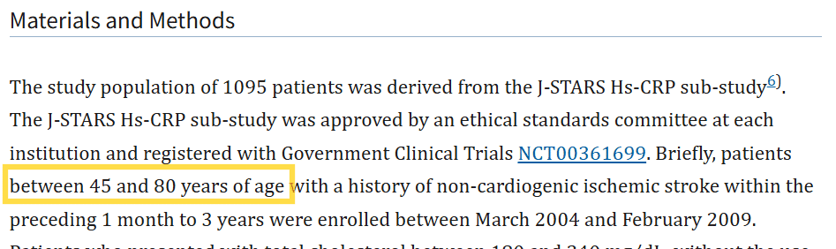
Population: Yes – we can see in the Materials and Methods section that the study population includes adults ages 50 and older.
It’s important to recognize that not all studies will neatly fit the eligibility criteria. Some nuances may be required. In this case, although the lower age limit is 45, the majority of participants appear to be 50 or older, which aligns with our criteria. It’s helpful to decide in advance how your review team will handle similar cases, to ensure consistency and transparency.
- Does the study examine the use of statin therapy as an intervention?
Does the study compare the intervention to no use of statin therapy (i.e., placebo, another treatment, or usual care)?
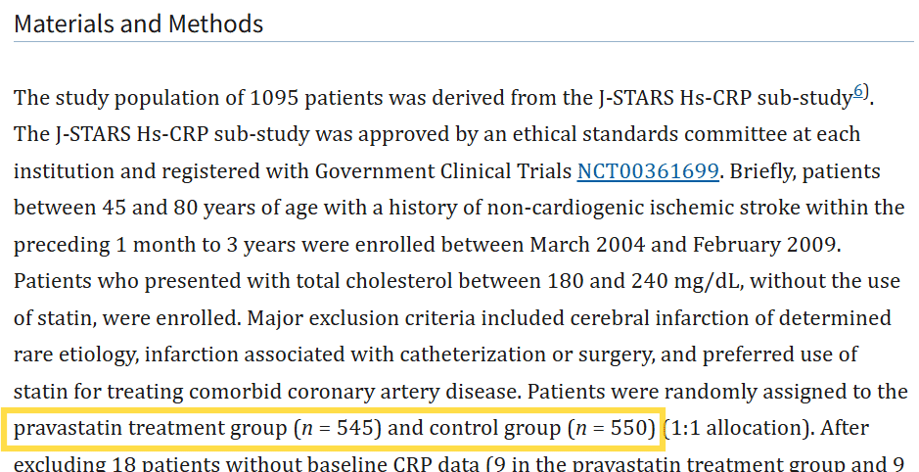
Intervention: Yes – we can see in the Materials and Methods section that the intervention group is a pravastatin treatment (i.e., a statin). This is also evident when looking at the Results section.
Comparison: Yes – we can see in the Materials and Methods section that the comparison is a control group (i.e., no treatment). This is also evident when looking at the Results section.
- Is the primary (or secondary) outcome recurrence of ischemic stroke?
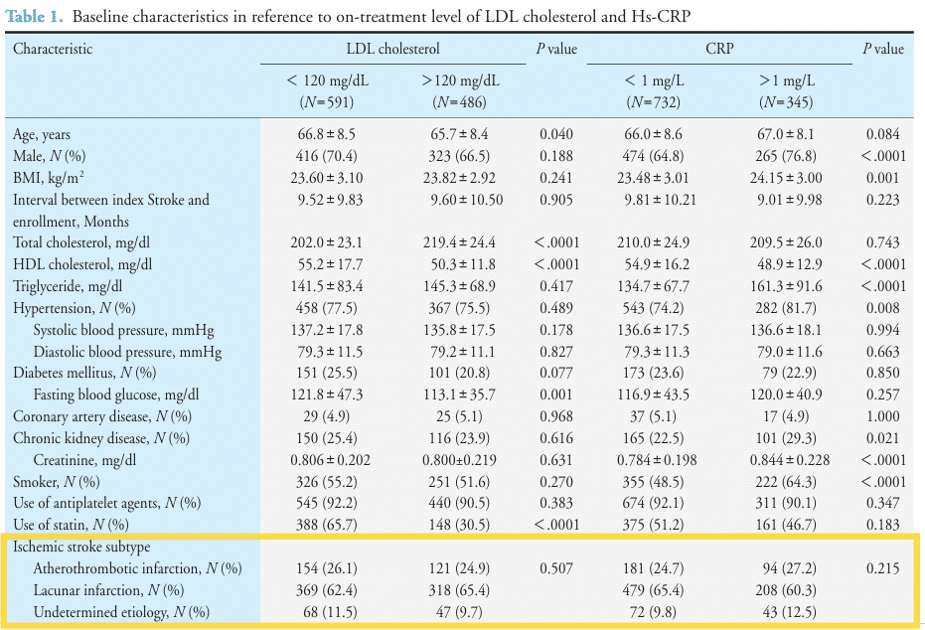
Click on image to zoom in.
Outcome: Yes - while the study objective only mentions “recurrent strokes”, 85% of all strokes are ischemic. We can also see in Table 1 they list the ischemic stroke subtypes.
This is another scenario that shows not all studies will neatly fit the eligibility criteria. For instances like this, it’s important that the review team determine how to handle studies that might not specifically list the type of stroke.
- Is the study design either a randomized controlled trial or a cohort study?
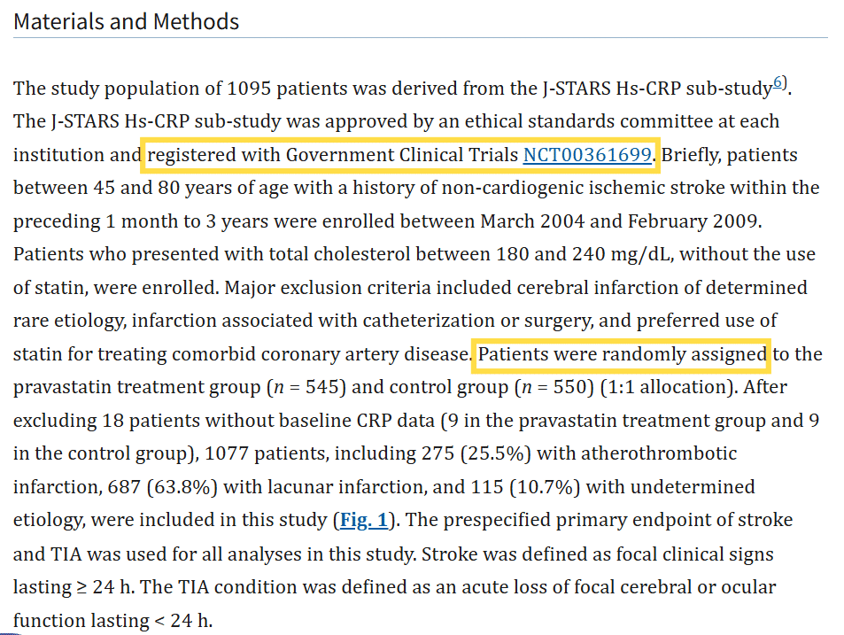
Study Design: Yes – while not explicitly mentioned in this randomized controlled trial, we can see in the Materials and Methods section that a clinical trial number is provided, and that patients were randomly assigned to treatment of pravastatin or a control group. This is also evident in Figure 1.

- Is the publication type a review, commentary, editorial, or case report?
No – this is a published study of primary data.
Therefore, the study in this report is eligible for our review (i.e., it meets all of the inclusion criteria and none of the exclusion criteria).
When the full-text screening is complete, the final set of reports for eligible studies can now proceed to data extraction.

Resolving Disagreements for Full-Text Reports
Any disagreements that arise during full-text screening must be resolved. Given the importance of decisions at this stage, it is recommended that disagreements are resolved using third-party resolution, where a third review author with topic expertise makes the final decision.^{1,3} In some cases, resolving disagreements using a panel of review authors with similar expertise can be used, depending on the review’s design.

Knowledge Check
Multiple choice
Which of the statements below is true?
- Review authors should track reasons for study exclusion at the title/abstract and full text screening stages.
- Review authors should track reasons for study exclusion for all eligibility criteria at the full text screening stage.
- Review authors should track the primary reason for study exclusion at the full text screening stage. (Correct)
The correct answer is c: Authors need to track the primary reason for study exclusion at the full text screening stage.
Eligibility criteria for each study should be assessed in order of importance, so that the first ‘no’ response can be used as the primary reason for exclusion of the study, and the remaining criteria need not be assessed.¹
At the title/abstract screening stage, authors are simply looking to remove irrelevant records, and do not need to track their reasons for exclusion.
References
- Lefebvre C, Glanville J, Briscoe S, Featherstone R, Littlewood A, Metzendorf M-I, Noel-Storr A, Paynter R, Rader T, Thomas J, Wieland LS. Chapter 4: Searching for and selecting studies [last updated March 2025]. In: Higgins JPT, Thomas J, Chandler J, Cumpston M, Li T, Page MJ, Welch VA (editors). Cochrane Handbook for Systematic Reviews of Interventions version 6.5.1 Cochrane, 2025. Available from cochrane.org/handbook(opens in a new tab).
- Systematic Reviews. CRD's guidance for undertaking reviews in health care. Centre for Reviews and Dissemination, University of York, 2009.
- Ames H, Booth A, J. N. Chapter 6: Selecting studies and sampling. Draft version. In: Noyes J, Harden A, eds. Cochrane-Campbell Handbook for Qualitative Evidence Synthesis, Version 1. London: Cochrane; 2024.
- Kitagawa K, Hosomi N, Nagai Y, Kagimura T, Ohtsuki T, Maruyama H, Origasa H, Minematsu K, Uchiyama S, Nakamura M, Matsumoto M; J-STARS collaborators. Cumulative effects of LDL cholesterol and CRP levels on recurrent stroke and TIA. J Atheroscler Thromb. 2019 May 1;26(5):432-441. https://doi.org/10.5551/jat.45989(opens in a new tab).
You have completed Lesson 3 of 4 of Module 4: Selecting Studies. Please use the navigation bar to navigate to the next lesson.

Lesson 4: Reporting the Study Selection Process
In a systematic review, it’s necessary to keep a clear record of how studies are identified, screened, and selected. This ensures transparency, allowing others to reproduce the process, and supports the creation of a PRISMA flow diagram.
Throughout the selection process, it is essential to track the number of records/reports at each stage of screening. This can easily be done using software tools for reviews or otherwise tracked using reference managers or spreadsheets.
The methods section of your review should describe the study selection process transparently (i.e., explicit, clearly documented, and reproducible).^{3,8} Below is an excerpt showing the relevant criteria (Item #8) in the methods section of the PRISMA 2020 Checklist:¹⁸
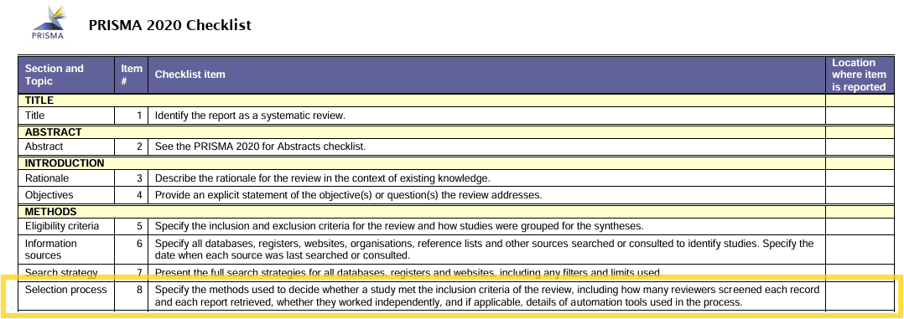
Click on image to zoom in.
The results section of your review should document the number of search records identified up to the number of studies included in the review, ideally using a flow diagram.¹⁸ Below is an excerpt showing the relevant criteria (Items #16a and 16b) in the results section of the PRISMA 2020 Checklist:¹⁸
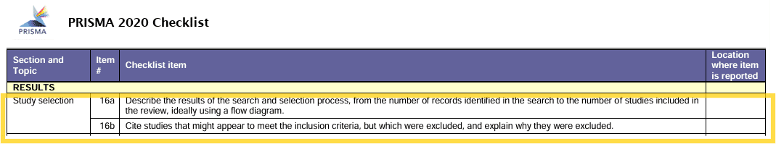
Click on image to zoom in.
PRISMA Flow Diagram
The PRISMA flow diagram should be used to show your screening process, including:
- The number of search records identified. If feasible, report the number of records identified from each database, register, and information source searched (rather than the total number across all databases/registers/information sources).
- The number of duplicate records/reference removed.
- The number of records screened at the title/abstract stage, including the number of records excluded.
- The number of reports sought for full text retrieval.
- The number of reports screened at the full text stage, including the number of reports excluded and the reason(s) for exclusion.
- The number of studies included in the review.
- The number of reports of included studies.
Below is the PRISMA 2020 flow diagram for new systematic reviews which included searches of databases and registers only. Note that there are different templates of the PRISMA 2020 flow diagram available that differentiate between new and updated reviews, and different sources searched. Flow diagrams can also be generated using a Shiny App.
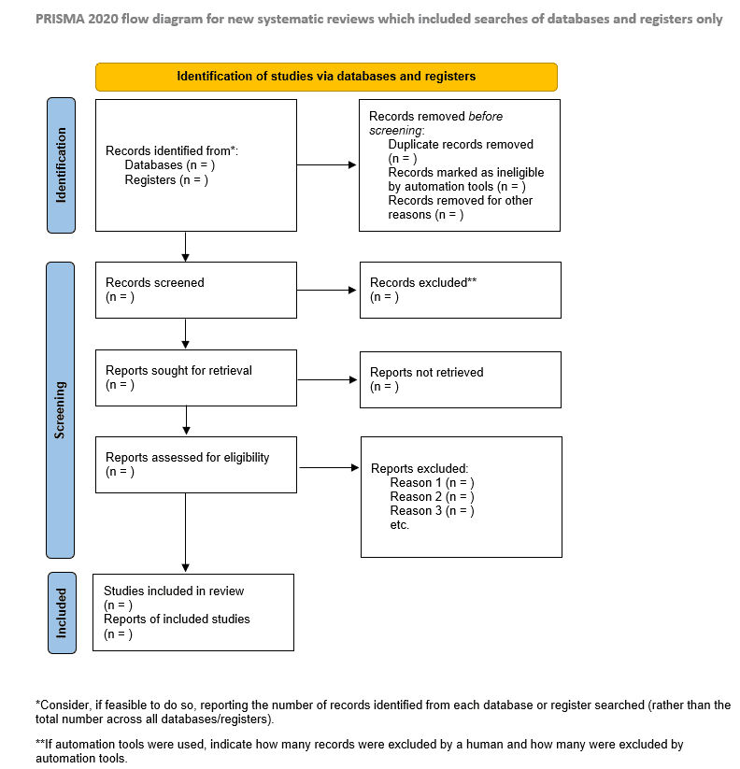

Study Selection FAQs
The following are frequently asked questions (FAQs) about the study selection process, along with their answers.
What if I don't see an abstract?
If you do not see an abstract for a record in the first stage of screening, and you cannot quickly find one, the record should be included for the next step of screening reports if the title doesn't seem irrelevant.⁴ Recall from Module 3 that is important to include abstracts along with the references when exporting search results.
What if I can't find the full text?
If the full-text report is not readily available, the report should not be ignored. Many institutions have library staff who can assist in retrieving a copy of the report from another library if it is not available freely or via a library/institutional subscription.
Note that if your search retrieves conference abstracts for oral presentations, posters, and other non-paper formats, the abstract may be the only "report" available for that record. In such cases the review authors can try contacting the corresponding author of the study for additional information. But again, this process requires time and resources, and responses are not guaranteed, especially for older studies. If contacting authors is impractical, the studies can be excluded and listed as “potentially relevant” in an appendix.³
What if the full text is in another language?
As mentioned previously in other modules, it is strongly recommended that studies in any language are considered. In the first stage of screening, titles and abstracts from bibliographic databases will have an English translation of non-English language records. Translation tools like Google Translate, DeepL, or ChatGPT can help determine eligibility for full-text reports. While these tools are generally not suitable for data extraction and synthesis, they are typically sufficient for assessing inclusion criteria.⁸
Final Points
- Selecting studies is a crucial step in the systematic review process. Accurate selection directly influences the quality, reliability, and transparency of systematic reviews. Missteps at this stage can lead to the inclusion of irrelevant studies, or exclusion of relevant studies, which can bias review outcomes​​.
- It’s important to have detailed eligibility criteria, a structured screening process, and clear documentation to ensure consistency and minimize bias when selecting studies.
Knowledge Check
Multiple choice
What process(es) are appropriate for resolving disagreements at the full text stage of screening?
- Discussion and consensus
- Third-party resolution
- Overinclusion
- All of the above
The correct answer is: third-party resolution.
However, in the titles/abstracts stage of screening, any of these three options for resolving disagreements are suitable.
Congratulations! You have completed the final lesson of Module 4: Selecting Studies.
References
- Systematic Reviews. CRD's guidance for undertaking reviews in health care. Centre for Reviews and Dissemination, University of York, 2009.
- Muka T, Glisic M, Milic J, et al. A 24-step guide on how to design, conduct, and successfully publish a systematic review and meta-analysis in medical research. European journal of epidemiology. 2020;35:49-60. https://doi.org/10.1007/s10654-019-00576-5(opens in a new tab).
- Ames H, Booth A, J. N. Chapter 6: Selecting studies and sampling. Draft version. In: Noyes J, Harden A, eds. Cochrane-Campbell Handbook for Qualitative Evidence Synthesis, Version 1. London: Cochrane; 2024.
- Page MJ, McKenzie JE, Bossuyt PM, Boutron I, Hoffmann TC, Mulrow CD, Shamseer L, Tetzlaff JM, Akl EA, Brennan SE, Chou R, Glanville J, Grimshaw JM, Hróbjartsson A, Lalu MM, Li T, Loder EW, Mayo-Wilson E, McDonald S, McGuinness LA, Stewart LA, Thomas J, Tricco AC, Welch VA, Whiting P, Moher D. The PRISMA 2020 statement: an updated guideline for reporting systematic reviews. BMJ. 2021 Mar 29;372:n71. https://doi.org/10.1136/bmj.n71(opens in a new tab).

