Module 6: Assessing Risk of Bias
The sixth module in the series The Essentials of Conducting Systematic Reviews explores risk of bias and how it’s assessed during systematic reviews. Within the timeline of a systematic review, risk of bias assessments occurs after or concurrently with data extraction.
The authors of this module are:
Dr. Jennifer Ritonja, Scientist at BC Cancer.
Matthew Jalink, PhD candidate at Queen's University.
At the end of this module, learners will be able to:
- Define bias and risk of bias in the context of research studies;
- Explain the importance of risk of bias assessments in systematic reviews;
- Describe the key steps involved in the risk of bias assessment process;
- Identify commonly used tools for assessing risk of bias for different study designs.
Suggested citation:
Ritonja J, Jalink M. Module 6: assessing risk of bias. In: McKeown S, Ritonja J, editors. The essentials of conducting systematic reviews [Internet]. Kingston (ON): Office of Professional Development and Educational Scholarship, Queen’s University; 2025 Nov 28. Available from: https://healthsci.queensu.ca/sites/opdes/files/modules/assessing-risk-of-bias-m6/#/.

Lesson 1: Introduction to Data Extraction
What is Bias?
Bias is defined as “systematic error in the design or conduct of a study.”¹ This can arise from flaws in the selection of study participants, how data is measured and collected, what data is chosen to be presented, and more.
When bias is present, the observed study results will usually (but not always) differ from the true effect.¹ This means it can give misleading or incorrect results.
Bias may cause a study to underestimate or overestimate the true effect. This can affect both the direction of effect (e.g., favouring or disfavouring an intervention) and its magnitude (e.g., small or large impact). In extreme cases, bias can render a study’s findings entirely misleading by creating an effect when none exists, known as a spurious association.
Bias vs. Imprecision
Bias is different than imprecision.¹
Bias refers to systematic error. This means that if the same study were repeated multiple times, it would consistently produce results that deviate from the truth in the same direction. In other words, it would give the wrong answer.
Conversely, precision refers to random error. This means that if a study were repeated, it would produce varying results due to chance or sampling variation. On average, these results would average out to the correct answer over time.
This concept is illustrated in the figure below, where the central ‘bullseye’ represents the true effect of an association. Bias shifts the results away from the bullseye, while imprecision scatters them around it.
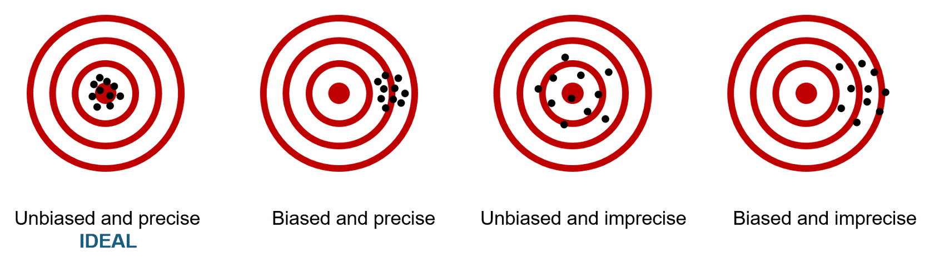
Figure 1: The relationships between systematic and random error.
RoB Assessments in Systematic Review Research
In systematic reviews, risk of bias (RoB) assessments evaluate the potential for systematic error in each included study.^{2,3}
While sometimes used synonymously with the terms “critical appraisal” or “study quality”, “risk of bias” is a distinct term. This term refers to the likelihood that aspects of a study’s design or conduct may lead to misleading results.^{1,2} It can be impossible to determine whether a study actually has bias, and as mentioned earlier, bias doesn’t always result in findings that differ from the true effect. Therefore, instead of saying a study has bias, it’s more appropriate to say a study has a risk of bias, which helps indicate how trustworthy its findings are.
Risk of bias assessment involves examining various aspects of a study’s design and conduct. Key areas examined include:^{2,3}
- How study participants were selected and followed up,
- Methods of randomization and blinding,
- How the intervention or exposure was measured, including any changes over time,
- How outcomes were measured,
- The potential influence of confounding factors,
- How missing data were handled,
- How results were presented and reported.
While tools vary, most rate studies using categories such as “low”, “some concerns”, or “high” risk of bias, rather than assigning numerical scores. We’ll look at these key areas and tools in more detail in Lesson 2.
Why Conduct Risk of Bias Assessments?
In order to draw valid and reliable conclusions in a systematic review, review authors must carefully consider the potential limitations of the included studies.² Risk of bias assessments support this process by evaluating how trustworthy a study’s results are, and therefore how much confidence we can place in its findings.
Studies assessed as having a high risk of bias are more likely to produce a misleading result, which can affect the overall conclusions for a review.⁴ Because clinical practice and policy decisions depend on high-quality research, it’s essential to generate evidence that is valid, reliable and meaningful.
Beyond assessing study validity, risk of bias assessments serve several other important purposes:
- Informs evidence synthesis:⁵ assessing the risk of bias helps guide decisions about combining studies for quantitative synthesis (e.g., meta-analysis) and interpretation of these results. In many cases, it may not be appropriate to pool or interpret pooled estimates if many studies have a high risk of bias, as it could lead to false conclusions.
- Supports transparent decision-making:⁴ Reporting risk of bias provides transparency about the quality of the evidence and how it was assessed.
- Contributes to GRADE assessments:⁶ Risk of bias is a key domain in the GRADE (Grading of Recommendations Assessment, Development and Evaluation) approach, which is used to rate the overall certainty of evidence. We’ll take a closer look at this approach in Module 7.
- Highlights limitations:⁶ Assessing risk of bias can highlight common methodological weaknesses in a field, which may help explain reasons for varying results across studies, in addition to guiding future research.
An Essential Component of the Review Process
Risk of bias assessments are a critical part of systematic reviews. Yet, if you’ve examined published reviews, you may have noticed that many (even recent ones) omit this step.⁷ This omission contradicts established recommendations and guidelines, which emphasize that systematic reviews must include risk of bias assessments.^{3,4,6} These expectations are also outlined in the PRISMA guidelines, as shown below:⁸
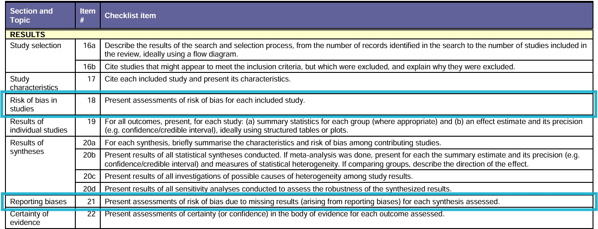
Image of the PRISMA 2020 Checklist showing the relevant bias components.
Knowledge Check
Why is it important to conduct risk of bias assessments in a systematic review? (Select all that apply).
A) To evaluate how much confidence we can place in the study findings.
B) To help explain variation across studies.
C) To support transparent and informed decision-making.
D) To ensure all studies report statistically significant results.
E) To identify potential sources of systematic error that may distort results.
The correct answers are: A, B, C, E.
References
- Szklo M, Nieto FJ, ProQuest. Epidemiology : beyond the basics [Internet]. Fourth edition. Burlington, Massachusetts: Jones & Bartlett Learning; 2019.
- Higgins JP, Altman DG, Gøtzsche PC, et al. The Cochrane Collaboration's tool for assessing risk of bias in randomised trials. BMJ. 2011;343:d5928 doi:10.1136/bmj.d5928.(opens in a new tab)
- Boutron I, Page MJ, Higgins JPT, Altman DG, Lundh A, Hróbjartsson A. Chapter 7: Considering bias and conflicts of interest among the included studies [last updated August 2022]. In: Higgins JPT, Thomas J, Chandler J, Cumpston M, Li T, Page MJ, Welch VA (editors). Cochrane Handbook for Systematic Reviews of Interventions version 6.5. Cochrane, 2024. Available from cochrane.org/handbook(opens in a new tab).
- Methods Guide for Effectiveness and Comparative Effectiveness Reviews [Internet]. Rockville (MD): Agency for Healthcare Research and Quality (US); 2008-. Available from: https://www.ncbi.nlm.nih.gov/books/NBK47095/.(opens in a new tab)
- Viswanathan M, Patnode CD, Berkman ND, et al. Recommendations for assessing the risk of bias in systematic reviews of health-care interventions. J Clin Epidemiol. 2018;97:26-34. doi:10.1016/j.jclinepi.2017.12.004(opens in a new tab).
- Schünemann H, Brożek J, Guyatt G, Oxman A, editors. GRADE handbook for grading quality of evidence and strength of recommendations. Updated October 2013. The GRADE Working Group, 2013. Available from guidelinedevelopment.org/handbook(opens in a new tab).
- Lindsay, C., Blancquaert, I. & Rousseau, F. Tools used to appraise the quality of studies included in systematic reviews and meta-analyses in human genetics: a systematic review. Eur J Hum Genet (2025). https://doi.org/10.1038/s41431-025-01861-6.(opens in a new tab)
- Page MJ, McKenzie JE, Bossuyt PM, et al. The PRISMA 2020 statement: an updated guideline for reporting systematic reviews. BMJ. 2021;372:n71. Published 2021 Mar 29. doi:10.1136/bmj.n71(opens in a new tab).
You have completed Lesson 1 of 3 of Module 6: Assessing Risk of Bias. Please use the navigation bar to navigate to the next lesson.

Lesson 2: Steps in the Data Extraction Process
Risk of Bias Tools
In this lesson, we’ll explore how risk of bias tools are typically structured, commonly used tools, and their limitations.
Risk of Bias ≠ Critical Appraisal
While the terms “critical appraisal” and “risk of bias” are sometimes used interchangeably in systematic reviews, they represent related but distinct concepts.
As discussed earlier, risk of bias specifically refers to a study’s internal validity, evaluating whether results are trustworthy and free from bias.
In contrast, critical appraisal traditionally encompasses overall study quality, including aspects such as clarity of reporting and generalizability, which do not reflect whether the study’s findings are accurate or valid. And thus, by definition, it does not necessarily include interval validity.
As a result, risk of bias tools are distinct from critical appraisal tools.
Critical appraisal tools often combine several aspects (i.e. reporting completeness, generalizability, and interval validity), which can dilute the focus of bias, and in some cases, not even include an evaluation of internal validity. Additionally, many popular critical appraisal tools (e.g., Newcastle-Ottawa Scale, JADAD Scale) use numerical scoring, which are shown to lead to unreliable and misleading results.^{10,11} These scores can obscure important methodological flaws by overemphasizing aspects unrelated to internal validity.
Because of these limitations, assessments based on critical appraisal tools may fail to highlight key risks of bias. For these reasons, many leading organizations for systematic reviews (e.g., Cochrane, JBI).^{3,4,12} now recommend only using risk of bias tools.
General Structure of RoB Tools
There are numerous tools available for assessing risk of bias. While specific tools vary depending on study design and discipline, most share a common structure designed to guide reviewers through a structured process.^{3,4}
Tools are typically composed of distinct domains, each designed to evaluate a specific type of bias in a study. To determine the risk of bias within each domain, reviewers are guided using specific signaling questions that help structure their evaluation. This process results in a domain-level rating, which is then used to inform an overall risk of bias rating for the study (see figure below).^{3,4}
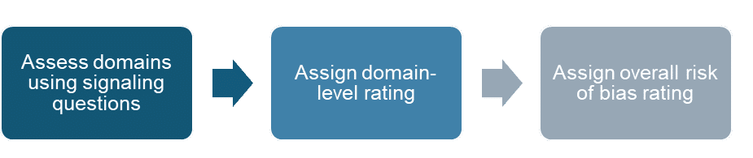
Figure 2: General structure of risk of bias tools.
Let’s look at each of these more closely!
1. Assess Domains Using Signaling Questions
Risk of bias tools are typically composed of distinct domains, each designed to evaluate a specific type of bias in a study. Common domains include:^{2,13,14}
- Bias due to study design,
- Bias due to deviations from intended interventions or exposures,
- Bias due to missing data,
- Bias in measurement of outcomes,
- Bias in selection or reporting of results,
- Bias due to confounding (especially in non-randomized studies).
Within each domain, tools provide signaling questions to help reviewers identify specific concerns. They are designed to help reviewers systematically evaluate specific aspects of study conduct and reporting within each domain.
Signaling questions prompt reviewers to consider relevant details (e.g., “Was the allocation sequence adequately concealed”), and typically offer response options such as Yes, Probably Yes, Probably No, No, or No Information. Reviewers are also asked to provide justifications for their responses based on the reported methods and conduct of the study.^{2,13,14}
2. Assign Domain-Level Ratings
Based on the responses to the signaling questions, reviewers assign a domain-level judgement. These judgements are usually categorized into three levels of risk: Low, Some Concerns, or High. Each rating should be supported by justifications drawn from the study, and reviewers are also asked to explain why a particular judgement was chosen.^{2,13,14}
3. Assign Overall RoB Rating
Some tools also guide reviewers to make an overall risk of bias judgment for each study or outcome, based on the domain-level assessments. This overall rating helps summarize the findings and inform other review decisions, such as evidence grading.
In many tools, the overall risk of bias is determined by the highest domain-level rating. For example, if a study is rated Low risk in all domains except one, which is rated High, the overall risk of bias would be considered High. However, this approach can vary depending on the tool and the review team’s protocol for synthesizing domain-level judgments.^{2,13,14}
What About Other Domains?
There are several other areas assessed by critical appraisal tools that are often conflated with risk of bias, but generally fall outside its scope.¹⁵ These include:
Funding
- Studies funded by industry are generally associated with more favourable results related to an intervention (e.g., pharmaceuticals, medical devices).¹⁶
- Debate remains regarding whether such funding constitutes a unique form of bias, but the GRADE approach incorporates concerns about funding under the domain of publication bias. Review authors should therefore document and report funding sources for each study.
Applicability (Indirectness)
- Applicability refers to whether study results are generalizable to the intended population. For e.g., a study excluding patients with comorbidities may yield less broadly useful evidence, even if results are unbiased.
- This is captured under the GRADE domain of indirectness, which captures concerns due to generalizability.
Precision (Imprecision)
- Precision refers to the degree of random error in study results. Tight confidence intervals indicate precise estimates, whereas wide intervals usually reflect insufficient data or high variability.
- Imprecision is not a form of bias but can lower confidence in evidence, and is addressed by the GRADE domain of imprecision.
Reporting Bias and Poor Reporting
- Reporting bias arises when the likelihood of reporting or publishing certain results (typically positive and statistically significant ones) is increased, affecting what evidence is available.
- Poor reporting refers to lack of well presented features of the study design and results, which make it difficult to appraise the study design and results accurately.
- Both factors are considered in risk of bias assessments and can influence certainty of evidence within the GRADE domain of publication bias.
Types of Tools
Risk of bias tools are complex and should not be used without a thorough understanding of their structure and application. This lesson does not provide detailed instructions on how to use specific tools. Instead, it offers an overview to help learners recognize the importance of selecting an appropriate tool and next steps toward to use the tool effectively.
Once a tool is selected, learners are strongly encouraged to:
- Read the tool’s guidance documentation carefully.
- Review examples of its application in published reviews.
- Seek mentorship or training if needed to ensure proper use.
Table 1: Summary of Commonly Used Risk of Bias Assessment Tools.
Tool Name | Purpose | Applicable Study Types | Bias Domains Assessed
RoB 2(opens in a new tab)  (Risk of Bias 2)² | Assesses risk of bias in randomized controlled trials | Randomized controlled trials | - Randomization process  - Deviations from the intended interventions  - Missing outcome data  - Measurement of the outcome  - Selection of reported result
ROBINS-I-V2(opens in a new tab)  (Risk Of Bias In Non-randomized Studies - of Interventions); an update to the pervious version¹⁴ | Evaluates risk of bias in studies assessing the effectiveness or safety of interventions (e.g., treatments, programs) | Non-randomized studies (e.g., cohort studies, quasi-experimental designs) where interventions were not randomly assigned | - Confounding  - Selection of participants  - Classification of intervention  - Deviations from intended intervention  - Missing data  - Measurement of outcomes  - Selection of reported results
ROBINS-E(opens in a new tab)  (Risk Of Bias In Non-randomized Studies - of Exposures)¹³ | Assesses risk of bias in studies evaluating the effects of exposures (e.g., environmental, occupational, behavioral, or lifestyle factors) | Observational epidemiologic studies such as cohort, case-control, cross-sectional, and time-series studies | - Confounding  - Measurement of the exposure  - Selection of participants  - Post-exposure interventions  - Missing data  - Measurement of outcomes  - Selection of reported results
QUADAS-2(opens in a new tab) (Quality Assessment of Diagnostic Accuracy Studies)¹⁷ | Assess risk of bias and applicability in diagnostic accuracy studies (e.g., how well a test detects a condition compared to a reference standard) | Studies evaluating the accuracy of diagnostic tests | - Patient selection  - Index test  - Reference standard  - Flow and timing
PROBAST (opens in a new tab)(Prediction model Risk of Bias ASsessment Tool)¹⁸ | Assess risk of bias and applicability in prediction model studies (e.g., models that predict disease risk or outcomes) | Prediction model development, validation, updating (diagnostic or prognostic) | - Participants  - Predictors  - Outcome  - Analysis
JBI Tools(opens in a new tab)¹⁹ | Assess methodological quality and risk of bias for diverse study types; support transparent and systematic study appraisal in evidence syntheses | Various (e.g., randomized controlled trials, quasi-experimental, cohort, cross-sectional, etc.) | - Selection bias  - Performance bias  - Reporting bias  - Confounding  - Information bias  - Other study-specific sources of bias
The U.S. National Toxicology Program has created an interactive tool(opens in a new tab) that showcases an extensive list of risk of bias tools and critical appraisal tools. It offers guidance to help users select appropriate tools based on study design, type of review (e.g., qualitative vs. quantitative), relevant bias domains, and additional considerations such as whether the tool has been validated and the methodology used in its development.
Although the webpage refers to “risk of bias tools,” many of the listed tools do not address all bias domains and are more accurately categorized as critical appraisal tools. Nevertheless, this resource serves as a useful starting point for identifying suitable tools.
Limitations of RoB Tools
Like all tools, risk of bias tools have limitations. While they are generally preferred by experts over broader critical appraisal tools, it’s important for users to be aware of their constraints:^{4,20}
- Subjectivity: Even with structured signaling questions, reviewer judgements can vary, especially when study reporting is unclear. This can lead to inconsistent ratings across reviewers.
- Time-intensive: Applying detailed tools can be time-consuming, especially for large reviews or studies with multiple outcomes. This is especially true when you consider the need for proper training to use the tools effectively.
- Tool-specific rules: Different tools have different rules for assigning domain-level judgments and an overall rating, which can be confusing or inconsistently applied across reviews. This can also make it difficult to easily switch between tools.
Knowledge Check
What risk of bias tool would be best suited for each of the following systematic review questions?
- In working adults, how does occupational noise exposure compared to low or no occupational noise exposure affect the risk of myocardial infarction as measured in observational studies?
- ROBINS-E
- ROBINS-I
- PROBAST
- RoB 2
The correct answer is: ROBINS-E. ROBINS-E is designed specifically for non-randomized studies of exposure effects such as occupational noise exposure.
- Among younger adults with anxiety, does cognitive behavioral therapy compared to alternative treatments improve anxiety symptom outcomes in non-randomized controlled trials?
- ROBINS-E
- ROBINS-I
- PROBAST
- RoB 2
The correct answer is: ROBINS-I. ROBINS-I is designed specifically for non-randomized studies of intervention effects.
- What is the diagnostic accuracy of breast cancer screening prediction models for detecting early breast cancer in asymptomatic women?
- ROBINS-E
- ROBINS-I
- PROBAST
- RoB 2
The correct answer is: PROBAST. PROBAST are designed specifically for diagnostic accuracy studies, including prediction models.
- What is the effectiveness of the Mediterranean diet compared to a control diet on weight loss in adults with obesity in randomized controlled trials?
- ROBINS-E
- ROBINS-I
- PROBAST
- RoB 2
The correct answer is: RoB 2. RoB 2 is designed specifically for randomized studies of interventions.
References
- Higgins JP, Altman DG, Gøtzsche PC, et al. The Cochrane Collaboration's tool for assessing risk of bias in randomised trials. BMJ. 2011;343:d5928 doi:10.1136/bmj.d5928.(opens in a new tab)
- Boutron I, Page MJ, Higgins JPT, Altman DG, Lundh A, Hróbjartsson A. Chapter 7: Considering bias and conflicts of interest among the included studies [last updated August 2022]. In: Higgins JPT, Thomas J, Chandler J, Cumpston M, Li T, Page MJ, Welch VA (editors). Cochrane Handbook for Systematic Reviews of Interventions version 6.5. Cochrane, 2024. Available from cochrane.org/handbook(opens in a new tab).
- Methods Guide for Effectiveness and Comparative Effectiveness Reviews [Internet]. Rockville (MD): Agency for Healthcare Research and Quality (US); 2008-. Available from: https://www.ncbi.nlm.nih.gov/books/NBK47095/.(opens in a new tab)
- Hartling L, Milne A, Hamm MP, et al. Testing the Newcastle Ottawa Scale showed low reliability between individual reviewers. J Clin Epidemiol. 2013;66(9):982-993. doi:10.1016/j.jclinepi.2013.03.003.(opens in a new tab)
- Crowe M, Sheppard L. A review of critical appraisal tools show they lack rigor: Alternative tool structure is proposed. J Clin Epidemiol. 2011;64(1):79-89. doi:10.1016/j.jclinepi.2010.02.008(opens in a new tab).
- Munn Z, Stone JC, Aromataris E, et al. Assessing the risk of bias of quantitative analytical studies: introducing the vision for critical appraisal within JBI systematic reviews. JBI Evid Synth. 2023;21(3):467-471. Published 2023 Mar 1. doi:10.11124/JBIES-22-00224(opens in a new tab).
- Higgins JPT, Morgan RL, Rooney AA, et al. A tool to assess risk of bias in non-randomized follow-up studies of exposure effects (ROBINS-E). Environ Int. 2024;186:108602. doi:10.1016/j.envint.2024.108602(opens in a new tab).
- Sterne JA, Hernán MA, Reeves BC, et al. ROBINS-I: a tool for assessing risk of bias in non-randomised studies of interventions. BMJ. 2016;355:i4919. Published 2016 Oct 12. doi:10.1136/bmj.i4919(opens in a new tab).
- National Health and Medical Research Council. Assessing risk of bias. NHMRC Guidelines for Guidelines. Accessed September 9, 2025. https://www.nhmrc.gov.au/guidelinesforguidelines/develop/assessing-risk-bias(opens in a new tab)
- Lundh A, Lexchin J, Mintzes B, Schroll JB, Bero L. Industry sponsorship and research outcome. Cochrane Database Syst Rev. 2017;2(2):MR000033. Published 2017 Feb 16. doi:10.1002/14651858.MR000033.pub3(opens in a new tab).
- Whiting PF, Rutjes AW, Westwood ME, et al. QUADAS-2: a revised tool for the quality assessment of diagnostic accuracy studies. Ann Intern Med. 2011;155(8):529-536. doi:10.7326/0003-4819-155-8-201110180-00009(opens in a new tab).
- Wolff RF, Moons KGM, Riley RD, et al. PROBAST: A Tool to Assess the Risk of Bias and Applicability of Prediction Model Studies. Ann Intern Med. 2019;170(1):51-58. doi:10.7326/M18-1376(opens in a new tab).
- Barker TH, Stone JC, Sears K, et al. Revising the JBI quantitative critical appraisal tools to improve their applicability: an overview of methods and the development process. JBI Evid Synth. 2023;21(3):478-493. Published 2023 Mar 1. doi:10.11124/JBIES-22-00125(opens in a new tab).
- Tomlinson E, Cooper C, Davenport C, et al. Common challenges and suggestions for risk of bias tool development: a systematic review of methodological studies. J Clin Epidemiol. 2024;171:111370. doi:10.1016/j.jclinepi.2024.111370(opens in a new tab).
You have completed Lesson 2 of 3 of Module 6: Assessing Risk of Bias. Please use the navigation bar to navigate to the next lesson.

Lesson 3: Conducting RoB Assessments
There are numerous steps when undertaking risk of bias assessments during a systematic review. The exact steps taken might differ by the type of risk of bias tool used, but this is a general overview of the typical steps you might take:^{3,4}
1. Develop a RoB Assessment Plan
The risk of bias tool should be selected during the protocol stage.^{3,4} The choice of tool depends on the review question and types of studies included in the review, as described in Lesson 2. This means that before the review begins, the review authors should have a clear understanding of which study designs are likely to be considered. Depending on the review’s scope, multiple tools may be needed.
Creating a detailed plan at the protocol stage helps reduce the risk of inadvertently introducing bias into the systematic review process. It ensures that appropriate methods are selected, applied consistently and fairly across all evidence, and that post hoc decisions based on study results are avoided.
When developing the risk of bias assessment plan, it’s essential to thoroughly review the guidance documentation provided with the selected tool. Most tools include a “Planning Stage” section, which should be completed during the protocol stage. This section helps review authors clarify key aspects of the study context and methodology that may influence bias judgments.
Below is an example of this section for the ROBINS-E tool(opens in a new tab):¹³
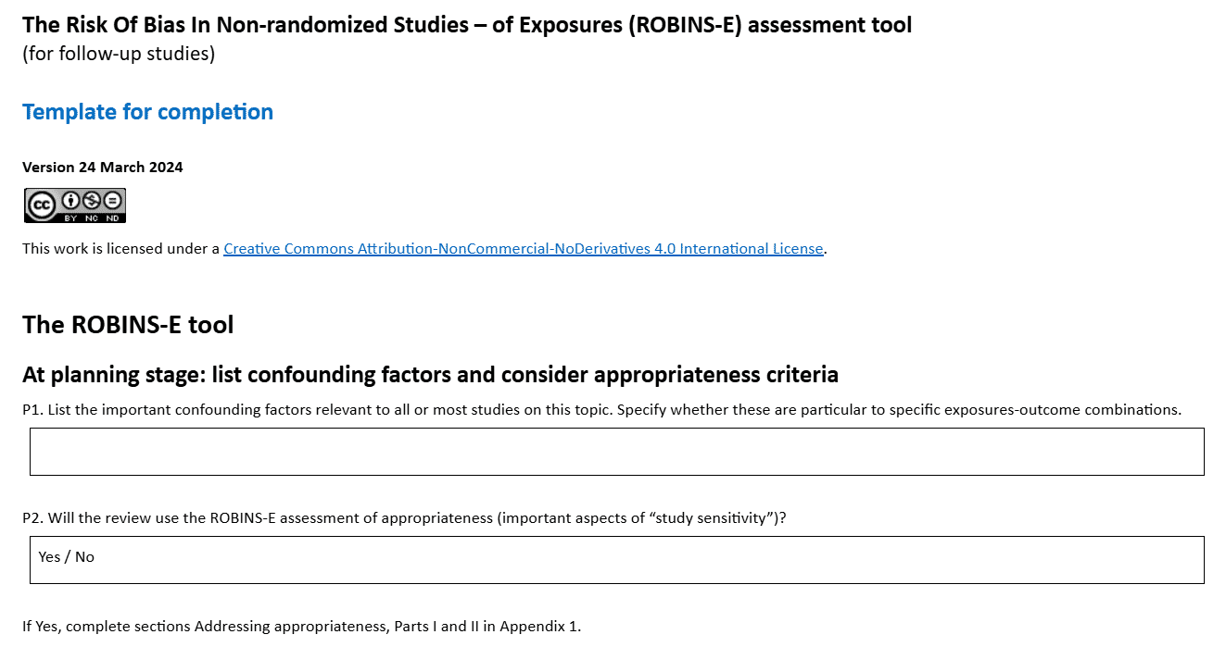
Image of the ROBINS-E tool showing the planning stage.
When planning the risk of bias stage, also consider the following:³
- How review authors will be trained to ensure consistent application of the tool,
- How discrepancies and conflicts will be resolved,
- How to decisions and justifications will be documented,
- How to integrate of risk of bias assessments into the overall synthesis and interpretation of results.
- Select Review Authors
At least two review authors should independently conduct the risk of bias assessments. Each author should be trained on the tool and potential issues that may arise.^{3,4,20}
Risk of bias assessment requires a degree of methodological expertise and review authors should be well-trained in how to identify different types of study designs. For this reason, some recommend against using trainees to conduct risk of bias assessments, since these assessments can be impetrative to the final conclusions of the review.²
- Adapt the RoB Tool as Needed
Not all signaling questions in a risk of bias tool will be relevant for every review. For example, if a review focuses on the prevalence of a condition as reported in cross-sectional studies (i.e., studies conducted at a single time point), signaling questions related to time-varying confounding may not be applicable. In such cases, the review team may choose to omit these questions or pre-specify how they will be handled (e.g., assigning a default rating), to simplify the assessment process.
Additionally, authors may choose to add signaling questions to a domain if they believe it will support clearer or more consistent bias judgments. For example, a review team might add a signaling question about the source of funding if they consider it relevant to the selection or reporting of results domain.
Any modifications to the tool, such as removing, adding, or reinterpreting signaling questions, must be clearly justified and documented in both the protocol and the final review report. This ensures transparency and helps readers understand how bias was assessed.
- Pilot Test the Tool
Before assessments begin, review authors should pilot test the risk of bias tool on a small sample of studies (typically at least 3 studies thought to represent a range of bias concerns).³ Review authors should provide feedback to identify issues and revise tools or training as needed, and to ensure that all required aspects are being evaluated.
- Perform RoB Assessments
Next, risk of bias assessments are conducted independently, following the methods outlined by the selected tools. Since review authors become familiarized with the study content during data extraction, some experts suggest conducting risk of bias assessments concurrently, as this approach can be both practical and time-saving.^{3,4}
Each review author should make judgments for each risk of bias domain, followed by an overall risk of bias rating. The rationale for each judgment, as well as the process for reaching consensus, should be clearly documented.^{3,4}
While some tools assess risk of bias at the study level, assessments should ideally be conducted separately for different outcomes or specific results presented in a study. This approach depends on the scope of the review, allowing for the fact that biases may impact outcomes or results differently.
- Resolve Discrepancies and Conflicts
Once two review authors have independently completed the risk of bias assessments, their results should be compared and any conflicts identified. Conflicts should be resolved by domain, rather than across the entire assessment for each study. This allows reviewers to focus on specific areas of disagreement (e.g., confounding, selection bias, outcome measurement) and apply domain-specific expertise to reach a more accurate judgment.^{3,4}
Where review authors disagree, conflicts can be resolved in two ways:^{3,4}
- Discussion and consensus: The review authors who conducted the assessments discuss their differing judgments within each domain and attempt to reach consensus.
- Third-party resolution: If consensus cannot be reached, a third review author (typically a senior researcher with topic or methodological expertise) makes the final decision. If the disagreement is complex or has broader implications, the full review team may decide to discuss it collectively. Some teams also use domain leads, which are review authors who oversee consistency and decision-making within a specific bias domain across all studies.
At this stage, disagreements are common and should be expected. Planning how to handle them in advance helps keep the review process smooth and consistent. This stage should not be rushed, as the final results could have important implications for the findings of the review.
Similar to study selection, while measures of inter-rater reliability (e.g., percent agreement between reviewers, Kappa statistic) are sometimes reported, it is generally recommended not to include them in the final publication.³ These metrics can give a misleading impression of precision in the review process, and are not required by PRISMA guidelines.
7. Integrating RoB into Evidence Synthesis
We’ll explore this topic further in Module 7: Interpreting and Disseminating Results. As a quick overview, these assessments are used in the final evidence synthesis in a number of ways:^{3,4,6}
- Present findings of the risk of bias assessment. This is typically done both in tabular format and described in text to provide a comprehensive overview.
- Incorporate findings into the GRADE approach. Risk of bias is one of several domains considered in the GRADE framework. The overall quality of evidence may be downgraded depending on the severity of the risk of bias.
- Conduct preplanned analyses using the risk of bias assessments. Often, sensitivity analyses are performed by excluding studies identified as having a high risk of bias, helping to test the robustness of the findings.

Knowledge Check
Put the following steps into the correct order for conducting risk of bias assessments:
- Step 1 - Develop a risk of bias assessment plan
- Step 2 - Select review authors
- Step 3 - Adapt the risk of bias tool, as needed
- Step 4 - Pilot test the tool
- Step 5 - Perform risk of bias assessments
- Step 6 - Resolve discrepancies and conflicts
- Step 7 - Integrating risk of bias into evidence synthesis

Module Summary
In summary, risk of bias assessments are critical for evaluating the internal validity of research studies in a systematic review. Here are some key points:
- Bias refers to systematic error in the design or conduct of a study, while risk of bias refers to the likelihood that aspects of a study’s design or conduct may lead to misleading results.
- Risk of bias tools are preferred over general critical appraisal tools when assessing internal validity.
- There are numerous tools available (e.g., RoB 2, ROBINS-I), each designed for specific study designs and scopes. These tools are structured around domains, each targeting a specific source of potential bias, and use signaling questions to guide reviewers in making transparent and consistent judgments.
- Limitations of these tools include subjectivity, time intensity, and varying tool-specific rules.
- While the exact process may vary depending on the tool, all risk of bias assessments should involve careful planning, training, and pilot testing. Once assessments are complete, there should be a clear plan for how the results will be incorporated into the review.
Overall, understanding and applying risk of bias tools correctly is essential for conducting high-quality evidence syntheses and making informed decisions based on research findings.
References
- Higgins JP, Altman DG, Gøtzsche PC, et al. The Cochrane Collaboration's tool for assessing risk of bias in randomised trials. BMJ. 2011;343:d5928 doi:10.1136/bmj.d5928.(opens in a new tab)
- Boutron I, Page MJ, Higgins JPT, Altman DG, Lundh A, Hróbjartsson A. Chapter 7: Considering bias and conflicts of interest among the included studies [last updated August 2022]. In: Higgins JPT, Thomas J, Chandler J, Cumpston M, Li T, Page MJ, Welch VA (editors). Cochrane Handbook for Systematic Reviews of Interventions version 6.5. Cochrane, 2024. Available from cochrane.org/handbook(opens in a new tab).
- Methods Guide for Effectiveness and Comparative Effectiveness Reviews [Internet]. Rockville (MD): Agency for Healthcare Research and Quality (US); 2008-. Available from: https://www.ncbi.nlm.nih.gov/books/NBK47095/.(opens in a new tab)
- Schünemann H, Brożek J, Guyatt G, Oxman A, editors. GRADE handbook for grading quality of evidence and strength of recommendations. Updated October 2013. The GRADE Working Group, 2013. Available from guidelinedevelopment.org/handbook(opens in a new tab).
- Higgins JPT, Morgan RL, Rooney AA, et al. A tool to assess risk of bias in non-randomized follow-up studies of exposure effects (ROBINS-E). Environ Int. 2024;186:108602. doi:10.1016/j.envint.2024.108602(opens in a new tab).
- Tomlinson E, Cooper C, Davenport C, et al. Common challenges and suggestions for risk of bias tool development: a systematic review of methodological studies. J Clin Epidemiol. 2024;171:111370. doi:10.1016/j.jclinepi.2024.111370(opens in a new tab).
- da Costa BR, Beckett B, Diaz A, et al. Effect of standardized training on the reliability of the Cochrane risk of bias assessment tool: a prospective study. Syst Rev. 2017;6(1):44. Published 2017 Mar 3. doi:10.1186/s13643-017-0441-7(opens in a new tab).
Congratulations! You have completed the final lesson of Module 6: Assessing Risk of Bias.

