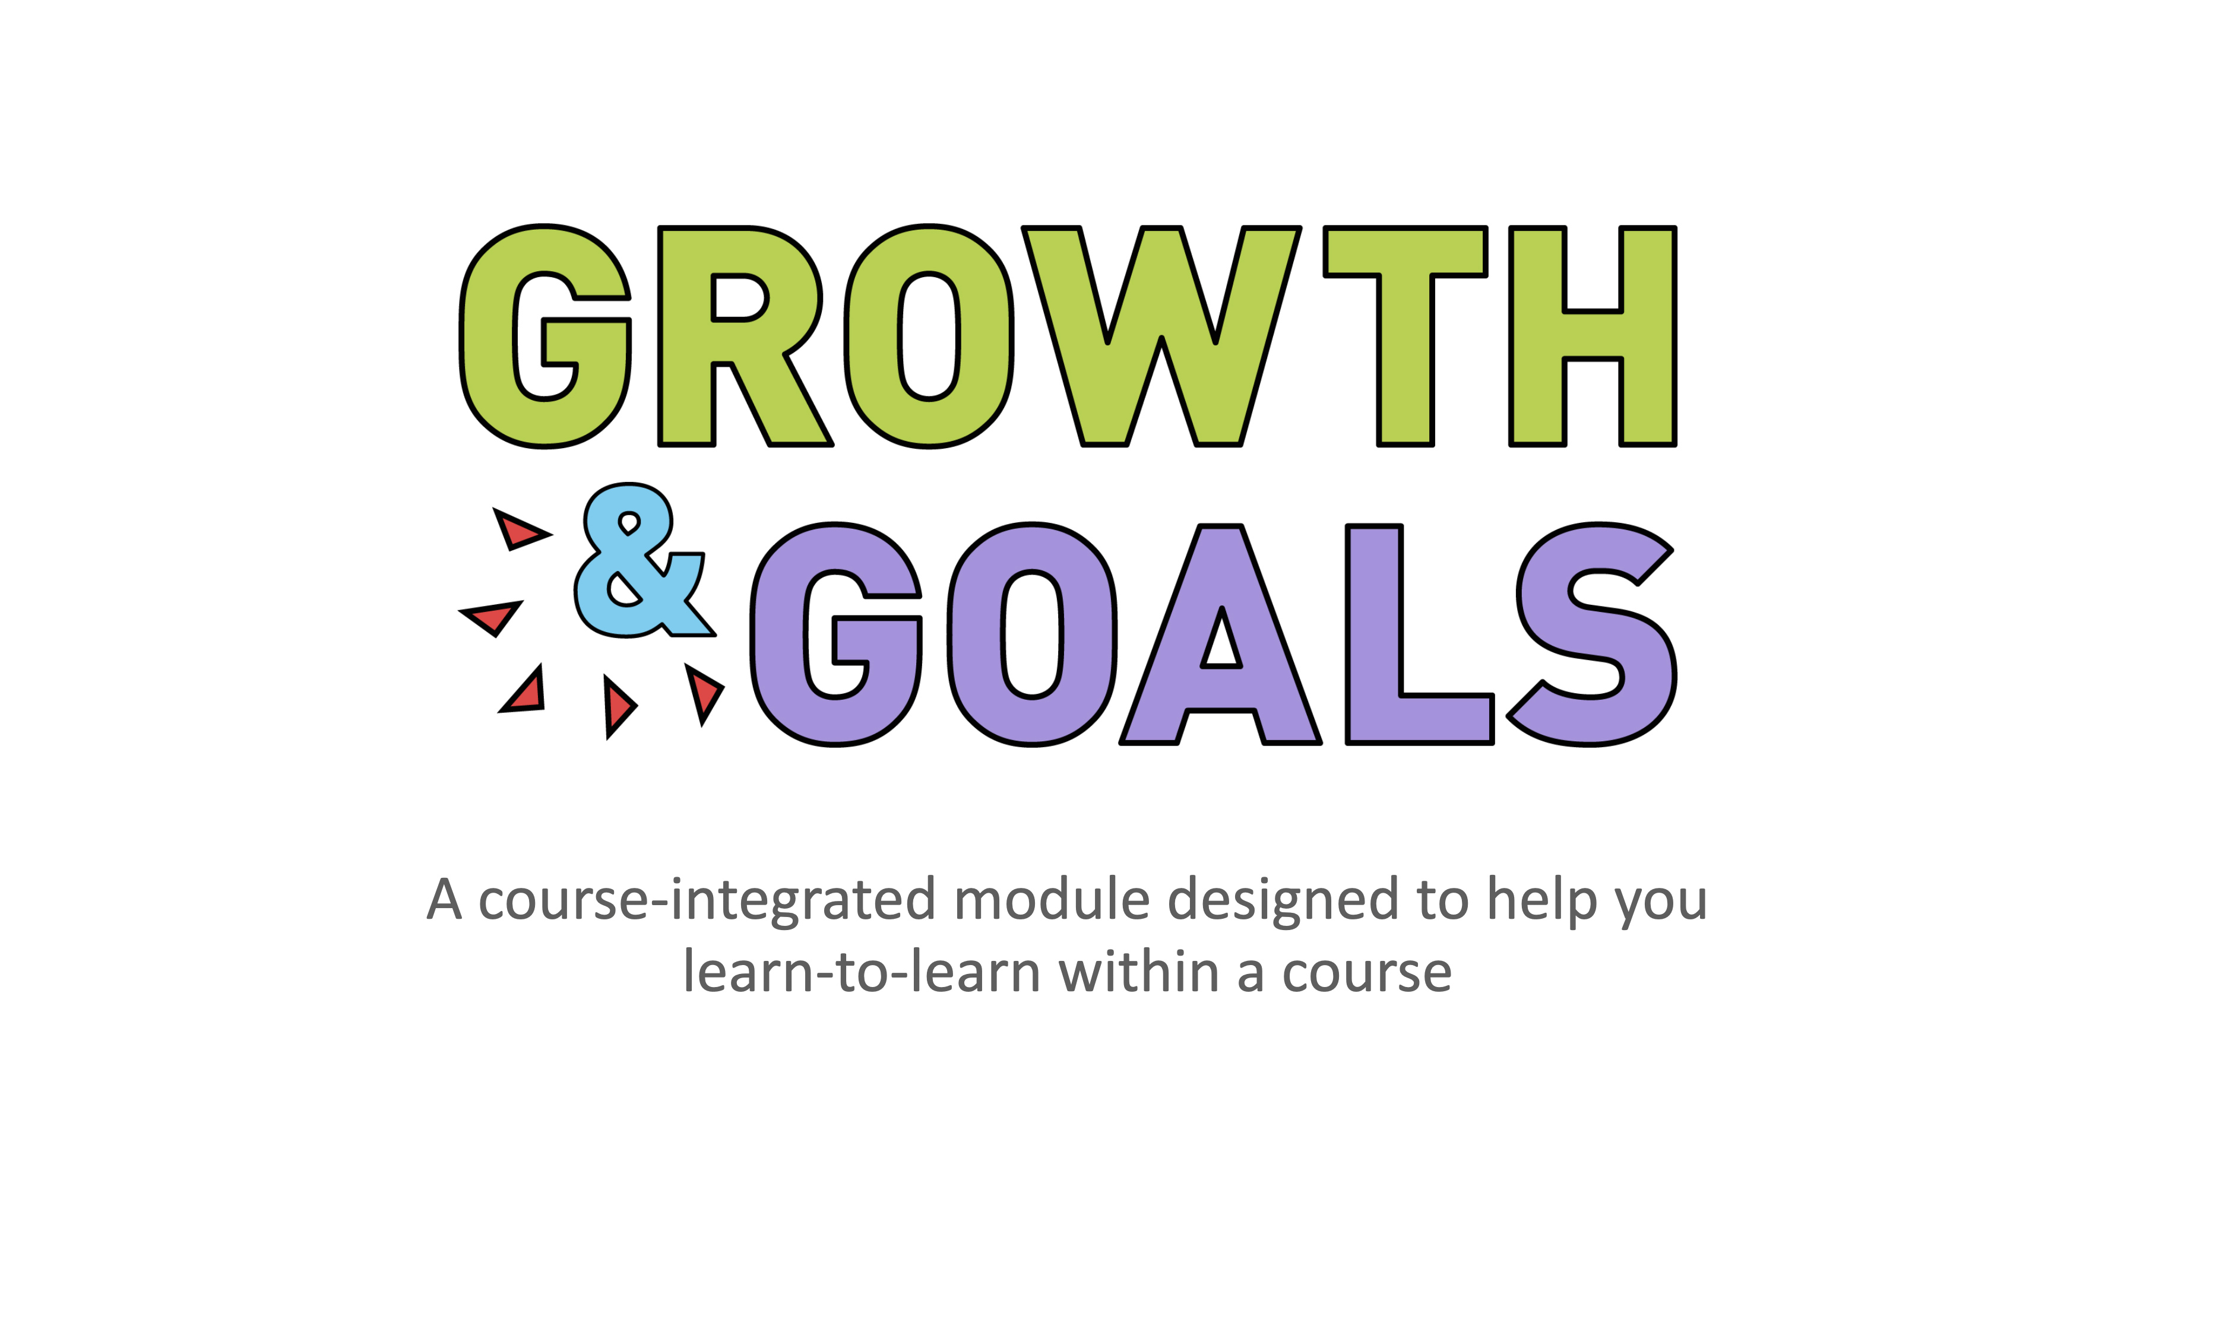

Growth & Goals: a course-integrated module to better equip students with learning skills

Growth & Goals: a course-integrated module to better equip students with learning skills

Alison Flynn, Elizabeth Campbell Brown, Emily O'Connor, Ellyssa Walsh, Fergal O'Hagan, Gisèle Richard, and Kevin Roy

Growth & Goals: a course-integrated module to better equip students with learning skills by Alison Flynn, Elizabeth Campbell Brown, Emily O'Connor, Ellyssa Walsh, Fergal O'Hagan, Gisèle Richard, and Kevin Roy is licensed under a Creative Commons Attribution-NonCommercial-ShareAlike 4.0 International License, except where otherwise noted.

Contents
- Information for professors
- Welcome! Time to own your learning!
- Intended learning outcomes
- An overview of the Growth and Goals module
- Reflect phase
- Mindful qualities
- The mindful learner...
- What is a mindset?
- Plan phase
- Metacognition
- Act phase
- Check-in before a major assessment
- Check-in after a major assessment
- Check-in before the final assessment
- Course wrap-up and next steps
- Glossary
- About the authors

Information for professors
Thank you for your interest in this module! Here are some tips when integrating the module into a course.

Customizing the module for your own use
We have a detailed set of instructions you can use, with the general principles being:
- Copy this eBook to create your own version. Not in Ontario? You can use another version of the module ([XML]).
- Create a copy of each activity.
- Customize the activities to suit your course (e.g., the expected learning outcomes should be specific to your course). Places to be modified are indicated with square brackets.
- Add each activity link to the relevant section of this eBook so that students can access each activity.
- Add the instructions, module weighting, and deadlines to your syllabus.

Valuing the module in the course
- We suggest giving a percentage of the final grade to the module. Historically, the achievement rate is good if at least a small bonus is given (e.g. 2%). We recommend that the module be evaluated on the basis of completion and not on the responses or grade obtained in the activities.
- Add questions about the module to your assessments in the course, but do not ask personal questions. This demonstrates the importance you place on long-term student learning.
- Discuss the module and results in your course (anonymously) and give your recommendations. In the other courses, students were very curious about the responses and strategies of their peers, and the discussions were very lively.
- Invite a student who has already used the module in your class to share their experiences.

Versions of the module
We have two versions of the module, each available in French and English:
Version 1: To be integrated in the courses (FR, EN). This is the ideal version to meet students where they are, at the time of their learning, with an application that is important to them (the course and their program).
Version 2: Independent (FR, EN). This version can be used in any context, such as a course where the teacher has not integrated the module, a larger program, sports, music, etc.

For more information, please contact
Please visit the Flynn Research Group website for more information.

Chapter

Welcome! Time to own your learning!

Welcome! Time to own your learning!


This Growth & Goals module is designed to help you take greater control of your learning process and guide you through essential components of becoming an efficient and effective learner.
We will achieve these aims by:
- Helping you learn metacognition skills so you may monitor and decide what to do for your learning.
- Guiding you through the process of self-regulated learning (SRL)and goal-setting, which will help you make your goals more attainable.
- Exploring the differences that your mindset can have and teaching you to develop a growth mindset.
- Explore and develop the concepts of mindfulness and resilience.

This video explains the purpose behind the module in more detail, including a bit about how learning works (transcript).

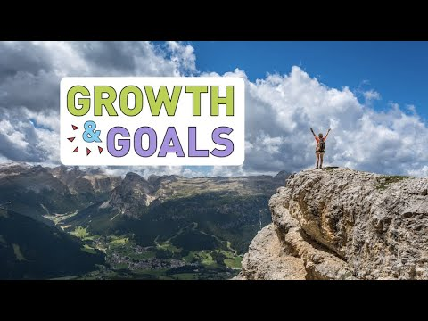
A YouTube element has been excluded from this version of the text. You can view it online here: https://ecampusontario.pressbooks.pub/growthandgoalscourse/?p=303
Learning can be difficult and that’s okay! Success takes effort and requires dedication and at times it can be very frustrating. Research has shown that the best learning is happening when it feels the most difficult so don’t worry if you’re feeling this way; it means you’re on the right track!1 Even your professors have struggled (and failed!) too! The goal of this module is to help you develop learning skills and strategies to help you gain success — not only in university but also in your career and even your personal life.
In the past, students found some aspects of the module challenging because it took them out of their comfort zone but they found it was well worth the effort.

“I’ve never met a successful person who had an easy path.” —Robyne Hanley-Dafoe

See what actual students have to say about this module Transcript (.pdf, 55kb):
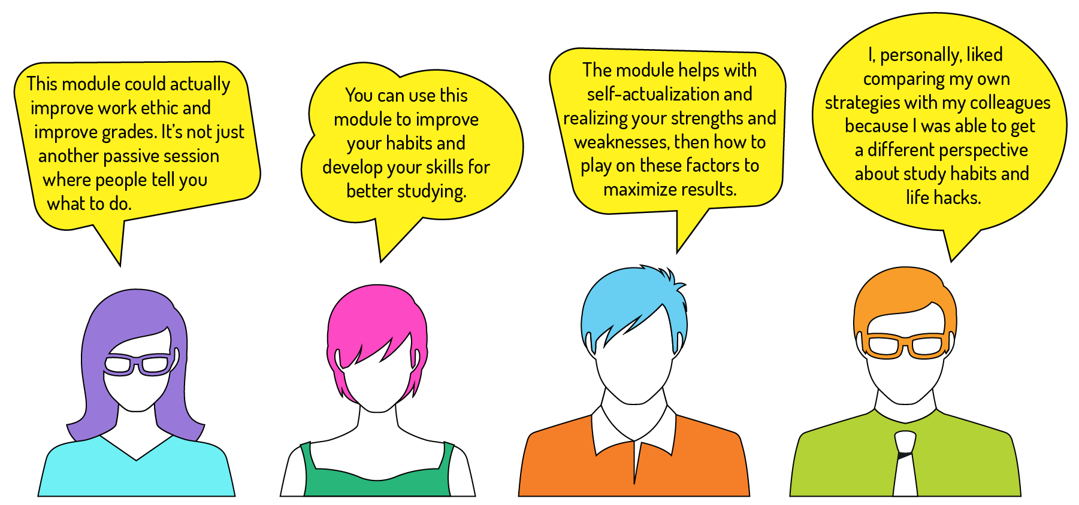

What is self-regulated learning (SRL) and why should I use it?
Self-Regulated Learning means taking strategic control of how you approach your goals and being prepared and willing to face any challenges and seize any opportunities that might arise as you work to make your goals your reality.2

The self-regulated learning cycle
The SRL cycle has three phases: reflect, plan, and act.
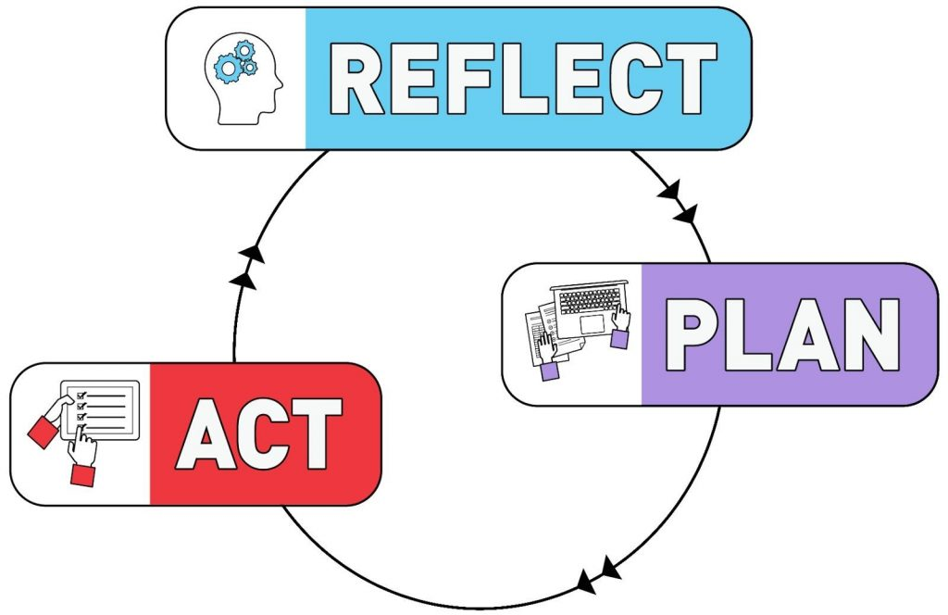
- The REFLECT phase involves looking back on past performances to identify your strengths and the areas you think you need to focus on. You’ll also identify your learning beliefs, your mindset when faced with challenges and your existing knowledge. Finally, you will set and refine the goals you want to achieve.
- During the PLAN phase, you will identify strategies and develop a plan and schedule to achieve your goals from the reflect phase.
- Now that you have goals and a plan it’s time to enter the ACT phase. Here you will carry out your plan, continually monitoring your progress and making adjustments as you feel necessary.
The SRL cycle will repeat multiple times this semester – How did your plan come together? What would you change? What goals did you realize? What goals need more work?
Once the course is finished, you can keep using the SRL cycle in other courses or aspects of your life.
REFERENCES
- Brown, P.C.; Roediger III, H.L.; McDaniel, M.A. Make It Stick: The Science of Successful Learning. Harvard University Press: Cambridge, MA, 2014.
- Zimmerman, B. J. Am. Educ. Res. J. 2008, 45, 166–183.

Chapter

Intended learning outcomes

Intended Learning Outcomes
Overall goals:
Learning does not occur by accident! In this module, we hope to empower you to take greater ownership of your learning, set strategic goals with a defined pathway to achieving them, and develop increased autonomy.
Short-term learning outcomes:
1) Use the concept of self-regulated learning and its associated 3-phase learning cycle to:

    - Describe self-regulated learning in your own words
    - Describe each of the three phases of the self-regulated learning cycle in your own words
    - Identify common myths about learning
    - Self-assess study habits and thinking
    - Rate personal feelings towards a course
2) Use the concept of mindfulness to:

    - Develop and practice your present-time awareness
    - Recognize that thoughts and feelings are natural products of the mind, and by exercising control, you can let them pass without becoming entangled or distracted
    - Learn to not be overpowered by emotions or thoughts in directing your actions
    - Practice developing mindful awareness through meditation activities
    - Incorporate mindfulness into daily activities
    - Apply the mindfulness skills learned in the Growth & Goals module to future courses and life challenges
3) Use the concept of mindset to:

    - Describe a growth and fixed mindset in your own words
    - Identify growth and fixed mindset statements
    - Transform fixed mindset statements into growth mindset statements
    - Construct strategies to deal with failure and build resiliency (Note: this learning outcome is currently not addressed but will be added to the module)
4) Use goal-setting skills to:

    - Identify and construct SMART goals
    - Construct a personalized schedule for a university semester to achieve goals
    - Define and refine your priorities and use them to set your own goals for a course or personal endeavour
5) Use the concept of metacognition to:

    - Rate your current ability towards the course’s learning outcomes and provide an explanation for your rating
    - Identify resources and strategies that you will use to reach your goals
    - Explain to what extent the skills acquired from the module can be used in other settings
    - Apply skills from the Growth & Goals module to other courses and life challenges (Note: this learning outcome is currently not addressed but will be added to the module)
    - Describe the course’s intended learning outcomes in your own words (Note: this learning outcome is currently not addressed but will be added to the module)
Long-term learning outcomes:
Learners who complete this module will ideally use the new concepts and skills in new contexts, develop greater self-awareness, ability to self-correct and self-monitor, set and achieve SMART goals in any aspect of their lives, develop greater efficacy for learning, experts in their own learning, become better able to embrace and take risks, including accepting failure and bouncing back (resiliency).
What are your intended learning outcomes for the module?
In this section, write down the learning outcomes you wish to achieve with this module by referring back to the list of intended learning outcomes we provided. Re-read the list and reflect on which learning outcomes you feel you need to focus on, or which outcomes you feel would be especially valuable to you and your learning.
If you are using the PDF version or are unable to access the interactive activity, don’t worry! Write your answers on paper.
Be sure to write these intended learning outcomes down and save them in a safe place, or copy the text into a document to save to your device. You will refer back to these learning outcomes later to see if you have met your personal goals!

An interactive or media element has been excluded from this version of the text. You can view it online here:
https://ecampusontario.pressbooks.pub/growthandgoalscourse/?p=185
Now that you have written down your goals, let’s take a look at the knowledge, strategies, and approaches that will help you reach them.

Chapter

An overview of the Growth and Goals module

An overview of the Growth and Goals module
There are a number of activities linked to this module. After completing each activity, you will be emailed a copy of your responses. You will need to refer back to some of your responses at different points in the semester so be sure to save these emails in a safe place!
The first Growth & Goals cycle takes about 2 hours to complete, although some students may find it useful to spend more or less time. There are a number of activities, interspersed with information before and after each activity. The activities are intended to be completed in the order in which you encounter them in the module.
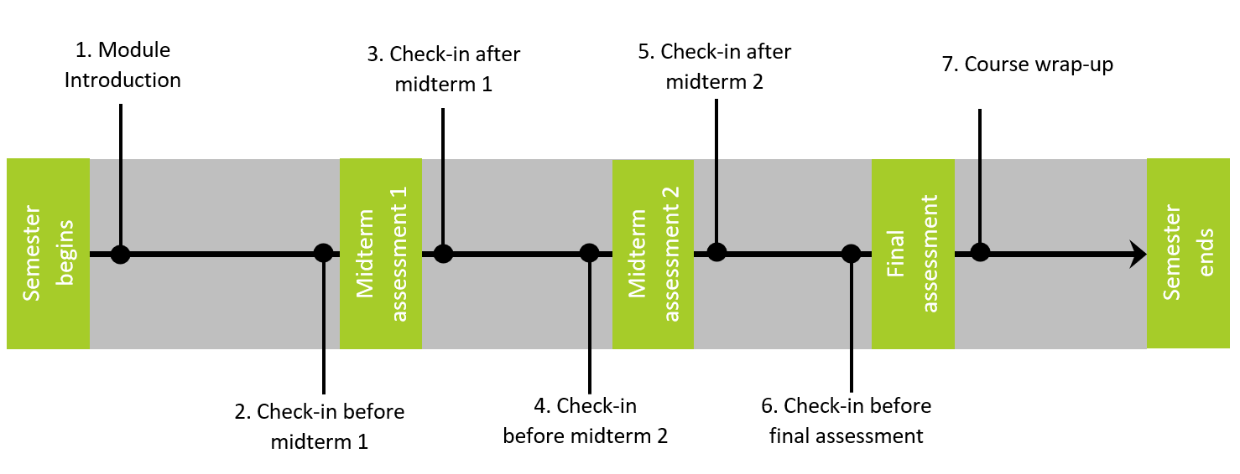
The Growth & Goals cycle will repeat before and after midterms and before and after the final exam, but will take less time to complete compared to this first cycle. Please consult your syllabus to find out what weighting this module is given in your course.

Now that you’ve been briefly introduced to the content of this module, please take a minute and complete [link to ACTIVITY 1]!

Chapter

Reflect phase

Reflect phase
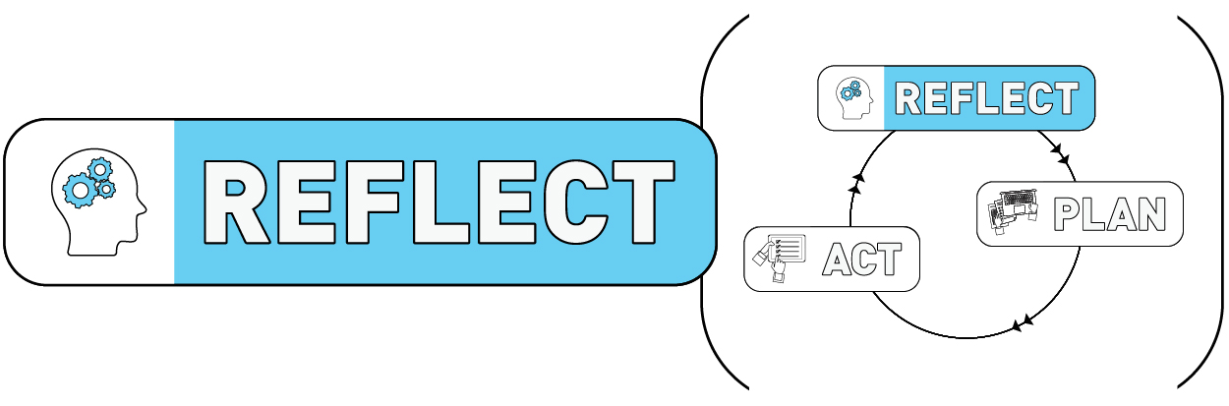

Are your study strategies effective? Do you believe myths about learning?

Meet Tracy, who is about to write her final exam in this course.
In the next activity, you’ll see how she’s been preparing throughout the semester and decide if you see any similarities to your own approaches. You’ll see if you believe some common myths about learning.1 You’ll also be asked to rate opposing words to help you take stock of your feelings on this subject as you start the course.2
Complete [link to ACTIVITY 2].
Now that you’ve reflected on your feelings towards this course, let’s move on to discuss the concept of mindfulness. In the next couple of chapters, you will reflect on your present-time awareness and mindful qualities; both of which are necessary skills to self-regulated learning and will help you stay focused this semester.
REFERENCES
- “You Probably Believe Some Learning Myths: Take Our Quiz To Find Out.” NPR, 22 Mar. 2017, http://www.npr.org/sections/ed/2017/03/22/520843457/you-probably-believe-some-learning-myths-take-our-quiz-to-find-out.
- Xu, X.; Lewis, J. E. J. Chem. Educ. 2011, 88 (5), 561–568.

Chapter

Mindful qualities

Mindful qualities

Present-time awareness, acceptance, and disentangling from your thoughts
“The feeling that any task is a nuisance will soon disappear if it is done in mindfulness.” – Thích Nhat Hanh
We spend a lot of our time in the past, caught in regret about past failures or in the future, worrying about possible future failures or things that we would sooner be doing; rather than in the present, where we are doing what shapes our lives. In order to be a good self-regulated learner, you need to be aware of your thoughts, feelings and behavioural tendencies towards your learning so you can loosen the control that thoughts and feelings have over your behaviour and get out of automatic ways of responding that lead you away from your learning goals.
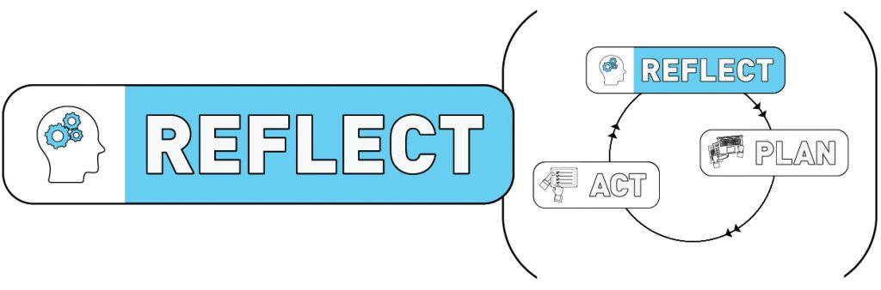
Mindfulness is a practice that allows you to develop present-time awareness of thoughts, feelings and accept thoughts and feelings as natural products of your mind that you can observe and let pass without becoming entangled, distracted and off track. Through the module, you will work on activities that will help you to develop these essential qualities.

Chapter

The mindful learner...

The mindful learner…
“Be where you are, otherwise you will miss your life.” – Buddha
How present are you?
Distraction is an inherent part of student life. Apart from thoughts and worries about the next test or assignment due date, paying the rent etc., being constantly plugged in, social media, multi-tasking interfere with our ability to alert ourselves to important information and direct and maintain our attention on that information.

Activity 3 asks you to reflect on your present-time awareness and how present you are in your day-to-day experiences. Research shows that persons who engage in practices that build mindful qualities have greater levels of present-time awareness. Zen meditation practitioners, for example, score higher on average than individuals who do not practice mindful awareness. Mindful awareness among Zen practitioners correlated with the number of years they had been practicing. In the same study, mindful awareness was also associated with greater well-being.1
Complete [add link to ACTIVITY 3].
Reflect on your responses. Are there particular times and places that you are more or less present? We will check in again later in the module to see whether your focus has changed over time.
Where does your mind take you?
Mindful qualities extend beyond being aware of present-time experience to how you are experiencing your thoughts, feelings and actions. Activity 3 asked you to consider scenarios relating to social and learning situations and how you would respond in your thoughts, feelings and actions.

It’s quite normal for us to react in ways that are emotion-filled and cause us to behave in ways that don’t really work for us. In the social situation, perhaps you responded by thinking “What did I do to make them upset?”. Perhaps you felt anxious, or maybe angry that a friend would walk right by without acknowledging you. Perhaps you responded by returning the snub or anxiously texting to see what’s wrong.
In the performance situation, perhaps you responded by feeling sad and disappointed with yourself; by thinking “I am such a phony. Why should I bother?” As a consequence, you may have avoided future work as it made you anxious that you would fail.
As a mindful learner, we want to learn ways that we can skillfully respond to these situations rather than react automatically in ways that might not work very well for us.
Qualities of the mindful learner
The mindful learner has three qualities essential to self-regulated learning. The mindful learner is able to:
- Maintain awareness in the present moment;
- Know their thoughts and feelings relating to learning; and
- Not be overpowered by emotions or thoughts in directing their actions.
Having mindful skills allows you to “unhook” from unpleasant thoughts (e.g., “I can’t do this”) and feelings (e.g., fear, anxiety, boredom) that would otherwise cause to avoid and/or distract yourself from certain activities, (e.g., writing a paper). While mindfulness activities are not designed to reduce stress, students participating in such programs have reported reductions in distress during exam periods.
Developing mindful qualities
Mindful qualities are skills built through practice. You will start by doing simple activities to develop mindful awareness and practice these skills in different situations. Research shows that these activities can improve attention and energy, even after being practiced for a short time (i.e., 5 days).

The following activities are taken from the Frantic World website. Frantic World has information and resources to help build mindful awareness that can be found here.
Mindfulness of the body and breath
The first mindfulness practice will get you to practice drawing your attention to your own breath and holding your attention while you allow thoughts and feelings to enter and leave your mind.
This exercise is a great place to start with mindfulness and takes about 8 minutes to complete.
Mindfulness of Body and Breath Meditation (begin meditation here).
Transcript (.pdf, 115 KB).
Practice this exercise for the next 5 days. Also, take time to notice how present you are in your daily activities (see Mindfulness in Everyday Life below). After some practice with this exercise, you may wish to explore more mindfulness exercises. Links to progressions on this exercise from Frantic World are provided below.
Body Scan Meditation (begin meditation here)- This is often the foundation of meditation. Here, we develop the essential skill of opening up to our experience as it is unfolding, right now.
Transcript (.pdf, 96 KB).
Three Minute Breathing Space (begin meditation here) – This is a short exercise that you can use at any time during the day. Practice this exercise, especially when you don’t need it (i.e., when you aren’t stressed) to develop your present time awareness.
Transcript (.pdf, 84 KB).
Sounds and Thoughts Meditation (begin meditation here)- This is a good follow-up to the Body and Breath Meditation. It helps you develop awareness around how you receive internal thoughts and external sounds.
Transcript (.pdf, 87 KB).
The Befriending Meditation (begin meditation here) – This meditation introduces and develops the important quality of self-compassion or caring for yourself. With all of the ups and downs of school and relationships, this is particularly relevant to student life.
Transcript (.pdf, 87 KB).
Mindfulness in everyday life
Being mindful is not just about sitting on a cushion and breathing. You can incorporate mindfulness into many of your daily life activities. Over the week try the following, once per day:
Mindful eating – When eating your next meal, take the time to notice the feel of the utensil, your movements while eating and of course the taste and texture of the food you are eating. Single out every bite and chew, paying attention to each of the activities involved in eating.

Mindfully brushing your teeth – Take the time to notice grasping your toothbrush and toothpaste. Notice squeezing the toothpaste onto the brush, turning the tap to run the water, the movements of brushing and sensation of the toothbrush in your mouth.
Mindfully showering – To mindfully experience showering, notice turning and adjusting the taps, stepping into the shower, the feel of the wet shower floor, the sensation of the water striking your skin, the feeling of soap lather and shampoo and the feel of the towel drying your skin after, remarking on the fresh feeling you get.
Mindful relating – The next time you are chatting with your friends or family members, take the time to really notice what they are saying, while noticing your tendency to think of your reply or to interrupt.

Other activities can also be done mindfully. For example, putting on and tying your shoes, waiting in line at the grocery store or simply waking up and taking a mindful breath before preparing yourself for the day can help build your awareness.
Now that you have an idea of what mindfulness can bring to your learning experience, let’s move on to talk about another quality of the mind – the growth mindset.

REFERENCES
- Brown, K.W. & Ryan, R.M. The benefits of being present: Mindfulness and its role in psychological well-being. Journal of Personality and Social Psychology, 2003, 84, 822–848.

Chapter

What is a mindset?

What is a mindset?
“Mindsets are beliefs – beliefs about yourself and your most basic qualities and abilities.”1
What is a growth mindset?
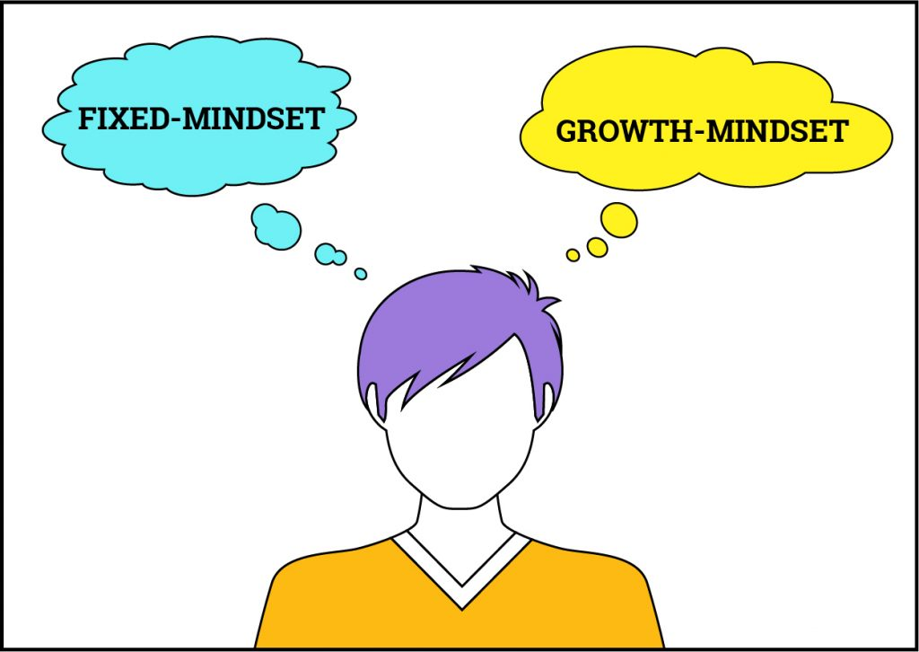
According to Carol Dweck from her book Mindset: The New Psychology of Success,“[In a growth mindset,] people believe their most basic abilities and qualities can be developed and cultivated through dedication and hard work. Brains and talent are just the starting point. This view creates a love of learning and a resilience that is essential for great accomplishment. Virtually all great people have had these qualities.”2 Another way to state this would be: Great learners are made, not born.
What is a fixed mindset?
“In a fixed mindset, most people believe their basic qualities, like their intelligence or talent, are simply fixed traits. They spend their time documenting their intelligence or talent instead of developing them. They also believe that talent alone creates success–without effort. They’re wrong.”2
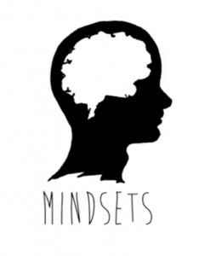

Click here to watch a video that illustrates the difference between a fixed and a growth mindset.3


So what do you do if you have a fixed mindset? This video may help!4

Success comes through effort and failure

As you watch this video, consider the ways you can relate this famous failure to your own experiences with effort, failure and success.5
You can watch more inspiring videos about the amount of effort and failure it can take before achieving success or continue on with the module.6
You will soon be able to identify a growth versus a fixed mindset.
Recognize and change your fixed mindset voice
There are four main steps to changing from a fixed to a growth mindset.2

Learn to hear your fixed mindset voice
To get the most out of the learning opportunities in this course, you need to recognize when your own mindset might be getting in the way of your learning and use strategies to change it.
Transcript (.pdf, 80kb)
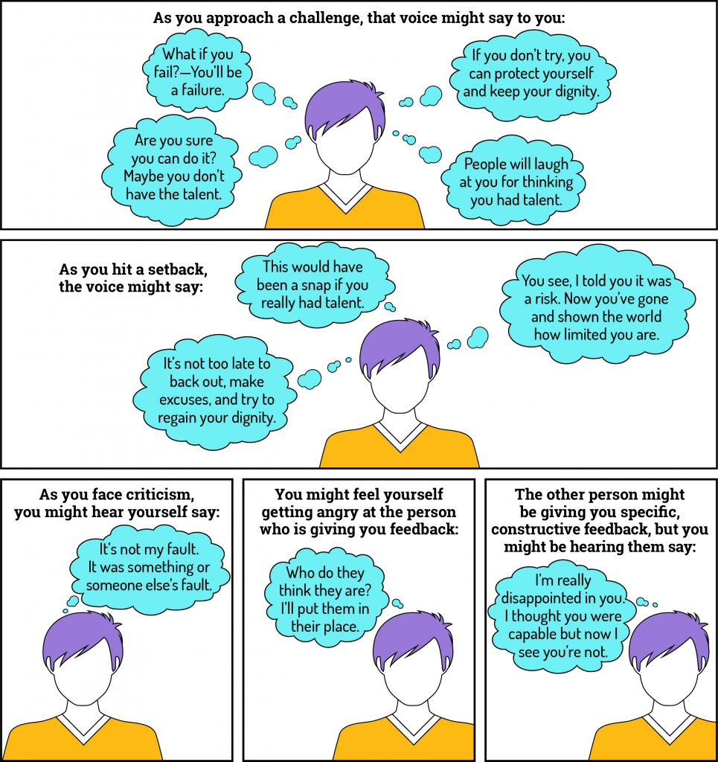
Recognize that you have a choice
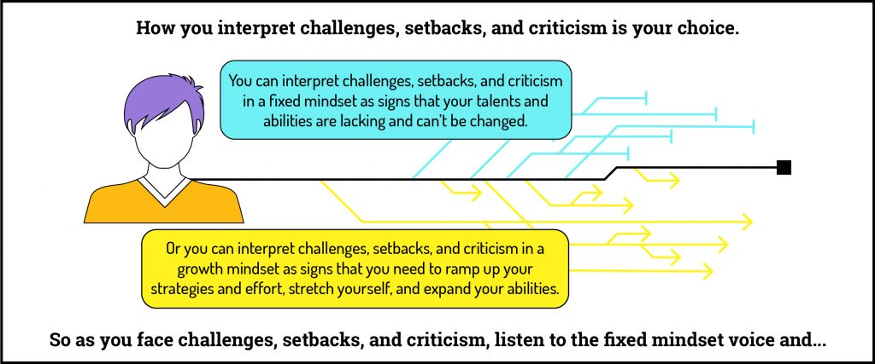

Talk back with a growth mindset voice

Take the growth mindset action

With practice you can learn to decide which voice you will listen to and act on.
Ideally, you will:
- Take on the challenge wholeheartedly
- Learn from your setbacks and try again
- Hear the criticism and act on it
Practice listening to both and acting on the growth mindset voice. See how you can make it work for you. As we go through the next activities, try to be mindful of the voice you’re hearing.
Set your priorities
As part of the reflect phase of self-regulated learning, it is important to have a clear vision of your priorities.
Complete [link to ACTIVITY 4] to practice identifying fixed and growth mindset statements and help you achieve this clarity.

REFERENCES
- MindsetWorks. mindsetworks.com
- Dweck, C. S. Mindset: The New Psychology of Success; Gildan Media Corp, 2007.
- Mindsets: Fixed Versus Growth. youtu.be/M1CHPnZfFmU
- The dirty little secret about growth mindset. youtu.be/zionUl13Dko
- James Dyson discusses success through failure. https://youtu.be/t7oyP-Wm9Iw
- Failure playlist: https://goo.gl/rTMQ4e

Chapter

Plan phase

Plan phase
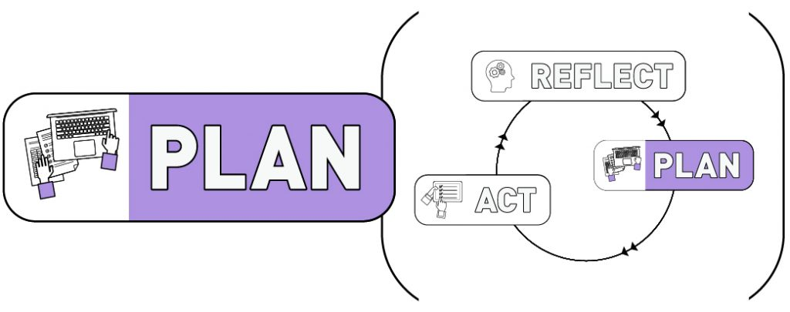
Planning for success
Achieving success with SRL and a growth mindset requires knowing your priorities and setting goals.
During the reflect phase you outlined your priorities. Now, with these priorities in mind, you can set your goals. In the plan phase you will chart your course to attaining your goals through:
- Deciding on strategies
- Planning your time
- Identifying resources you need

What is a SMART goal?

In this section, you will develop and refine brainstormed goals and transform them into actionable statements that you will be able to work toward during this course. Your brainstormed goals will become SMART ones.
People who set SMART goals are more likely to achieve their target. Let’s take a look at the components of SMART goals. Transcript (.pdf, 11kb).
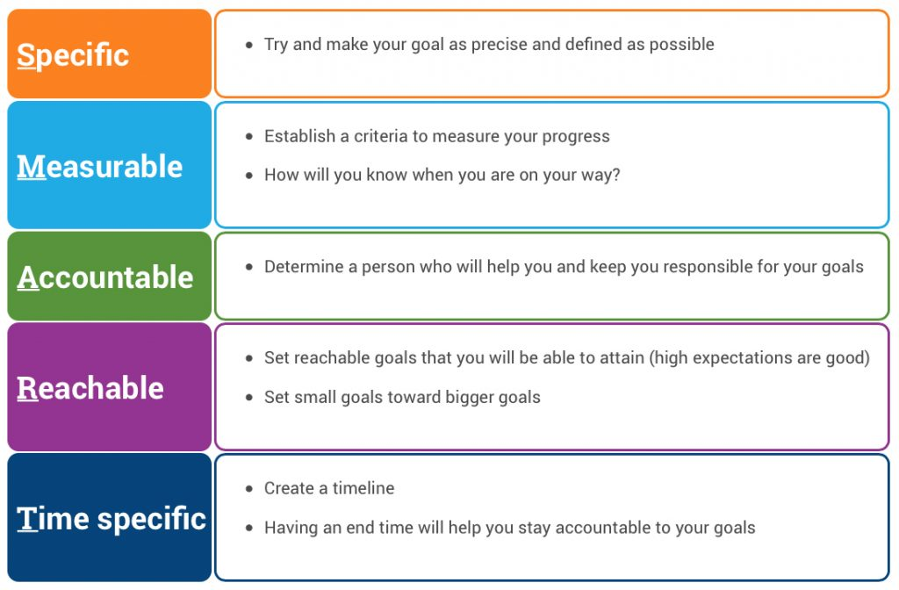
Complete [link to ACTIVITY 5] to identify, define, and refine your SMART goals.
This process will help you clarify and refine your goals to make them more achievable.

Chapter

Metacognition

Metacognition
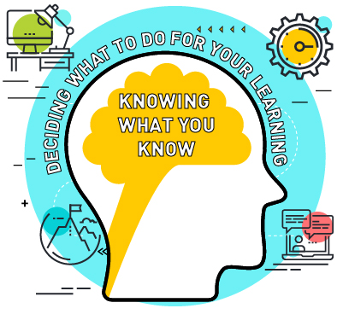
Metacognition is thinking about your own thinking and it has two parts:
■ Knowing what you know
■ Deciding what to do for your learning
The next two activities will help you identify what you know and what to do about your learning and how to schedule your time.
At this early stage in the course, you’ll use [link to ACTIVITY 6] to identify how well you know the prerequisite knowledge and skills for this course. The activity will also ask you about your study strategies and to decide what you will do for your learning, including resources that can help you achieve your goals. The most successful students will seek help to achieve their goals.

Let’s check back in with Tracy

Tracy thought that just reading over her notes before an exam really worked for her, but she still wasn’t reaching her course goals. She started trying out a new study strategy—testing herself throughout the semester. She found her performance improved, she could more easily remember the things she needed to know for the exam without cramming, and her grades increased.
Planning your time

Watch Shaina schedule her semester.
You can use whatever technology you wish to do this, such as the calendar on your phone, a spreadsheet, software such as Asana, scheduling software, paper (!), etc.
Instead of an in-module activity, take some time to plan your semester NOW and put your schedule somewhere that you’ll see or notice it frequently.

Chapter

Act phase

Act phase
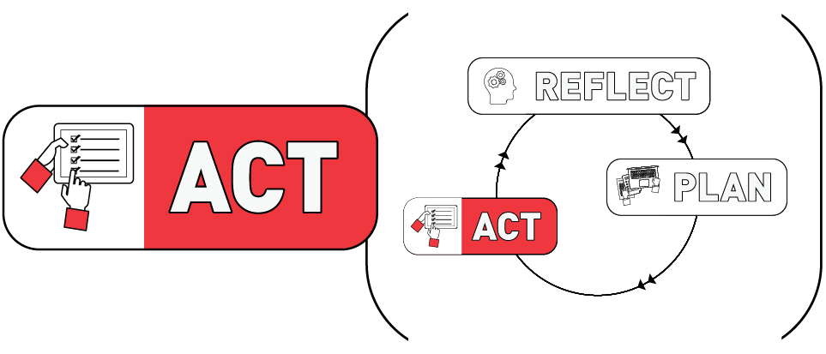
It’s time to act!
At the beginning of this module we looked at how Tracy was preparing for her semester (Activity 2).
Hopefully as you’ve worked through this module, you have set your priorities and goals, decided on a schedule (that you’ve put in a visible place), and have identified study strategies and resources. Now you’re ready to act!
During the semester, keep asking yourself:
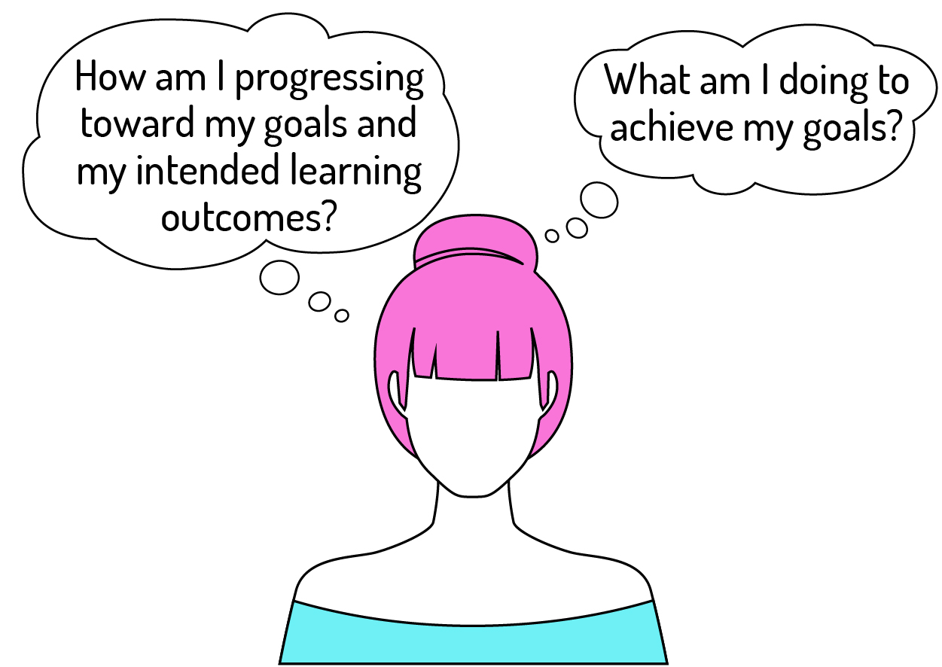
Set a reminder for yourself to come back before your first major assessment and do the check-in so that you can reflect on the progress you’re making, revise your plans if necessary and then act on them. You may want to add other reminders to your calendar or planner now, too. These could include revisiting sections in the module, such as mindfulness.
Be mindful, keep working toward a consistent growth mindset and have a great semester!

Chapter

Check-in before a major assessment

Check-in before a major assessment

In [link to ACTIVITY 7], you’ll check on your progress in the course up to this point to see how you’re doing and prepare for the upcoming [assessment]. Be sure to reflect on your goals, answers, and make any necessary adjustments to your plan. Change tactics and seek new sources of help/support if existing ones aren’t working.

Chapter

Check-in after a major assessment

Check-in after a major assessment
Now that you’ve finished a major assessment in the course, you can take some time to check back in with your goals, reflect on how things went, and plan improvements (if necessary).
Complete [link to ACTIVITY 8].

Chapter

Check-in before the final assessment

Check-in before the final assessment
In this activity, you’ll check back in with your goals, plan, and progress to see how you’re doing and prepare for the upcoming [final assessment]. Click [link to ACTIVITY 9] to complete the activity!

Chapter

Course wrap-up and next steps

Course wrap-up and next steps
This last questionnaire will help you reflect on your experiences this semester and plan for your next steps.
Click to complete [link to ACTIVITY 10].
Congratulations on completing the module! We encourage you to set a reminder to return to the sections that you’d like to continue working on. You can also use the independent version of the module for other courses or other aspects of your life (English, French).

1

Glossary
Act Phase

Befriending Meditation

Body Scan Meditation

Fixed Mindset

Growth Mindset

Learning Outcomes

Metacognition

Mindful Learner

Mindful qualities

Mindfulness

Mindfulness of Body and Breath Meditation

Mindset

Plan Phase

Present-time awareness

Reflect Phase

Resiliency

Self-Monitoring

Self-regulated Learning (SRL) Cycle

SMART Goal

Sounds and Thoughts Meditation

Three Minute Breathing Space

2

About the authors

About the authors

The Growth & Goals Module is developed by members of the Flynn Research Group at the University of Ottawa. The Flynn Research group is primarily focused on Chemistry Education Research (CER) and works to develop innovative tools and methods to support students learning.
The Growth & Goals module is a Self-Regulated Learning (SRL), Growth Mindset, and Metacognition Module for post-secondary learning and beyond. The module allows students to address their strengths and weaknesses, to identify their current mindset towards their goals and learning, and to develop the SRL skills necessary to take control of their learning. University students have to learn in many different formats, often confront failure, and manage many different course and life expectations simultaneously. To be successful, students need to know and continually monitor their learning plus develop autonomy and professional capacity skills. The Growth & Goals module aims to help students with this and to develop the framework and skills necessary to manage their learning and be successful in a post-secondary setting. For more information, visit our website here.

Meet the team:
Alison Flynn

Alison Flynn is a bilingual Associate Professor in the Department of Chemistry and Biomolecular Sciences at the University of Ottawa. She is a 3M National Teaching Fellow, Canada’s highest recognition for excellence in education at the post-secondary level and a member of the Global Young Academy. Her work includes developing open-access online learning tools and flipped course structures to support student learning, especially in high enrolment classes. Her research group studies student learning in organic chemistry. As uOttawa’s 2016 Chair in University Teaching, she developed and is evaluating this Growth & Goals Module for students.
Elizabeth Campbell Brown

Elizabeth Campbell Brown has been an instructional designer at the University of Ottawa’s Teaching and Learning Support Service for the past 19 years. Her interest in current brain research and how it challenges our former understanding of the brain, learning and, therefore, how we design for learners made working on the Growth & Goals module a compelling project to participate in. Most of her work over the past 5 years has focused on developing fully online courses and workshops, collaborating with faculty from across disciplines in both French and English.
Ellyssa Walsh

Ellyssa Walsh is a third year honours B.Sc. Biomedical Sciences student at the University of Ottawa. She lead the transition of the Growth & Goals module into Pressbooks. Ellyssa worked to format, edit, and review the module so that it can be published in more accessible ways for students. Ellyssa also worked on formulating an interactive version of the module, as well as a non-course specific version that can act as a self-help guide for students or other professionals. Ellyssa is an active member in her school community and believes that students should have ample opportunities to enrich their education and experiences at university.
Emily O’Connor

Emily O’Connor is a professional engineer and a 4th year honours B.Sc. Psychology student at the University of Ottawa. She was part of the development and evaluation teams of Growth & Goals and acted as project manager for the team from 2017–2019. She worked on improving the content and the usability of the module through feedback from both students and instructors. She also analyzed the data collected from the pilot implementation to evaluate the effects of the module. She was involved in supporting module adopters through implementation in their classes.
Fergal O’Hagan

Fergal O’Hagan is an Associate Professor, Teaching Intensive at Trent University, Peterborough, ON. O’Hagan’s disciplinary background in Kinesiology lead him to a successful 20 year career as a physical medicine rehabilitation clinician and program developer. After completion of his PhD at the University of Toronto, O’Hagan joined the Department of Psychology at Trent. Since 2008 he has been teaching and conducting research relating to injury rehabilitation and prevention. More recently he has been researching ways to enhance learning in post-secondary settings, including implementation, development and research on the Growth and Goals module.
Gisèle Richard

Gisèle Richard is a specialist with uOttawa’s Teaching and Learning Support Service with extensive experience in graphic design, user interface, user experience, and as a design specialist.

Kevin Roy

Kevin Roy is a medical student at the University of Ottawa. Kevin also completed an Honours Bachelor of Science in Biomedical Sciences at the University of Ottawa. Kevin is driven to help reduce the financial barriers that students face to access post-secondary education in Canada. Kevin is passionate about the student experience and has organized many social and networking events for his peers through his involvement in student government.

